Science Stage 5 – Reactions
Teacher resource book 1 of 3 (TRB1)
1. How do substances combine to make new substances?
Creation date: 6 February 2026.
Contents
Overview 3
Glossary 3
1.1 Law of conservation of mass 6
Conservation of mass 7
Student resource – conservation of mass 12
Investigating mass changes 14
Student resource – investigating mass changes 20
1.2 Nomenclature 24
Naming compounds 25
Student resource – naming compounds 32
Naming compounds dominoes 35
Student resource – naming compounds dominoes 36
1.3 Writing chemical formulas 37
Molecular and ionic formula 38
Covalent compounds 38
Student resource – covalent compounds 40
Ionic compounds 42
Student resource – ionic compounds 49
Compounds with polyatomic ions 54
Student resource – compounds with polyatomic ions 56
Elements with variable valency 58
Student resource – elements with variable valency 61
1.4 In the balance 63
Balancing equations 63
Student resource – balancing equations 67
1.5 Chemical reactions 70
Synthesis reactions 70
Student resource – synthesis reactions 75
Decomposition reactions 77
Student resource – decomposition reactions 81
Displacement reactions 84
Acid metal reactions 87
Student resource – acid metal reactions 91
1.6 The pH scale 96
pH of common substances 96
Student resource − the pH scale 101
Testing household chemicals with a natural indicator 104
Student resource – testing household chemicals with a natural indicator 109
1.7 pH changes in a neutralisation reaction 113
Neutralisation reactions 113
Investigating pH changes in a neutralisation reaction 115
Student resource – investigating pH changes in a neutralisation reaction 120
Evidence base 124

Overview
Stage and learning area: Stage 5 Science
Description: this resource complements the Reactions program of learning. It aims to serve as a teacher reference, offering practical strategies and ideas to enrich teaching practices and create engaging learning environments. The activities should be adapted to suit students' needs.
Duration: while timing will vary based on the mode of delivery, differentiation strategies employed and class or school context, this series of activities should take approximately 14 hours.
Risk management: teachers are advised to undertake a risk assessment before conducting any classroom investigation or experiment. For more information on developing risk assessments, see Risk Assessment – a pre-requisite for risk control.
This resource book elaborates on many of the activities in the Reactions sample program of learning. Some activities also reference the Reactions slide deck (identified as RXN PPT throughout this document).

Glossary
Tier 3 words are those that are relevant for learning subject-specific content. More information is provided in the ‘Vocabulary in context’ document found on the Stage 5 reading – Vocabulary in context page. A glossary containing Tier 3 vocabulary, related to the essential question ‘How do substances combine to make new substances?’ has been provided below. The Guide for planning and implementing explicit vocabulary instruction can be used by teachers across all curriculum areas.
Table 1 – glossary of key terms for Reactions TRB1
Term | Definition
Acid | A substance that produces hydrogen ions in aqueous solutions.
Activity series | A list in which the metals are ranked from the most reactive to the least reactive, in order of their ease to give away electrons.
Base | A substance that produces hydroxide ions in aqueous solutions.
Covalent (bond) | A chemical bond formed by the sharing of electrons between 2 atoms, each of which donates an equal number of electrons (NESA 2025).
Decomposition (reaction) | A chemical reaction in which a complex reactant (that consists of multiple components or molecules) breaks down into 2 or more simpler products (NESA 2025).
Displacement (reaction) | A chemical reaction in which one atom (or group of atoms) is replaced by another atom (or group of atoms) in a compound (NESA 2025).
Ionic (bond) | A very strong chemical bond formed by the transfer of one or more electrons from one atom to another atom; the ions are held together by electrostatic attraction (NESA 2025).
IUPAC | Acronym for the International Union of Pure and Applied Chemistry, an authority on chemical terminology and nomenclature (NESA 2025).
IUPAC nomenclature | It is a method for naming chemical compounds according to the rules established by the International Union of Pure and Applied Chemistry.
Law of conservation of mass | Mass in a closed system remains constant. It cannot be created or destroyed, only rearranged. This means the total mass of reactants before a chemical reaction must equal the total mass of products after the reaction.
Neutralisation reaction | A chemical reaction in which an acid reacts with a base to produce a salt and water.
pH | A measure of the acidity or alkalinity of a solution (NESA 2025).
Synthesis | A reaction in which simpler substances (elements or compounds) combine to form a complex substance (compound).  A reaction in which a more complex compound is produced from simpler compounds (also called ‘combination reaction’) (NESA 2025).

1.1 Law of conservation of mass
Table 2 – learning intentions and success criteria for ‘1.1 Law of conservation of mass’
We are learning: | I can:
- to describe the law of conservation of mass in chemical reactions | - define the law of conservation of mass  - account for mass changes in chemical reactions  - distinguish between open and closed systems
- to make accurate observations and measurements | - use an electronic balance to accurately measure mass  - calculate mass changes that occur in a chemical reaction
- to predict the outcome of a scientific investigation. | - predict mass changes in open and closed systems based on knowledge and observations.
Teacher background information
The law of conservation of mass is a complex concept for most students. It underpins all the topics addressed in this focus area, including cases where the law does not seem to apply. To support students in developing a deep understanding of the law of conservation of mass, teachers should be aware of its key ideas and of students’ misconceptions about mass changes in chemical reactions.
Mass changes in chemical reactions can only be understood by considering the systems (conditions) in which they occur. Hence, students revisit the concept of open and closed systems (discussed in the Stage 5 Energy focus area). Without understanding open and closed systems, students might think that mass changes mean ‘matter that is lost or gained’ rather than recognising that matter can be exchanged with the environment (the mass is ‘moved’ to other components of the system). Knowledge of chemical reactions operating within a broader system also enables the understanding of reaction rates, including how they may be manipulated by modifying reaction conditions (system components). Hence, the concepts of open and closed systems serve as unifying ideas that help students develop a deep understanding of the law of conservation of mass.
Particle-level reasoning is important to ensure students go beyond the rote memorisation of the law of conservation of mass. To help teachers achieve this goal, ‘Johnston’s triangle’ is introduced in TRB2 as a framework for describing chemical reactions at macroscopic, microscopic and symbolic levels. Weighing the reactants and products of chemical reactions or balancing chemical reactions, is, on its own, insufficient for students to develop a holistic understanding of this central idea in chemistry.
As teachers, we aim to guide students from simply learning the law of conservation of mass – which states that matter is neither created nor destroyed – to a deeper understanding that in a chemical reaction, the only change is in how particles are arranged and the system boundaries, not the total amount of matter or matter–energy.
Some common misconceptions that may impede knowledge constructions in this topic include:
- mass disappears in chemical reactions
- gases have little or no mass
- atoms change into other atoms in chemical reactions
- the law of conservation of mass applies to everything
- mass and weight are the same
- balancing equations is purely a mathematical activity.

Conservation of mass
Checkpoint: activate prior knowledge from the Stage 4 Change focus area by asking students to classify changes as physical or chemical using RXN PPT ‘1.1 Checkpoint’. If students need reinforcement, refer to section ‘2.1 Physical and chemical changes’ in the ‘Stage 4 Change’ resource package to revisit the concepts of physical and chemical changes, focusing on key characteristics and examples of each:
- water evaporating – physical
- burning wood – chemical
- rusting – chemical
- salt dissolving in water – physical.
Note: this brief introductory activity is grounded in the principles of discordant thinking pedagogy. It tackles students' preconceptions about mass changes during combustion. Through a visual demonstration and data analysis, students challenge their ideas using the Predict-Explain-Observe-Explain framework. This serves as a foundation for a thorough exploration of the law of conservation of mass and its key role in understanding chemical reactions.
This short lesson sequence is designed to be teacher-driven, while students write their responses in the Student resource – conservation of mass.
- Provide students with a copy of the Student resource – conservation of mass.
- Define the ‘law of conservation of mass’ as mass in a closed system remains constant. It cannot be created or destroyed, only rearranged and use the slides RXN PPT ‘1.1 Law of conservation of mass’ (3 slides) to show students that in chemical reactions:
- atoms are rearranged but cannot be created or destroyed
- all atoms present in the reactants of a chemical reaction will also be found in its products
- the mass of the reactants must equal the mass of the products.
- Discuss what the term ‘conserve’ means, as students answer question 1 in Student resource – conservation of mass. Emphasise that in science, ‘conserve’ means that a quantity, such as energy or mass, is neither created nor destroyed – the amount remains constant.
- Start a class discussion by asking students what they understand about combustion reactions. Ask them what happens when something burns. Ask them to identify or describe some examples of combustion reactions they are familiar with.
- Using the PEOE (Predict-Explain-Observe-Explain) scaffold, ask students to predict what happens to the mass of steel wool when it is burned in a Bunsen burner flame and explain their prediction. After the demonstration, ask students to record their observations, discuss the results and amend their explanations if necessary. This is designed to address the common misconception that when substances burn, they ‘disappear’.
- Conduct a teacher demonstration to burn steel wool and measure mass changes.
- Weigh a tennis ball-sized piece of steel wool.
- Hold it in the Bunsen burner flame using metal tongs.
- Reweigh after burning.
Figure 1 – mass of steel wool before and after burning
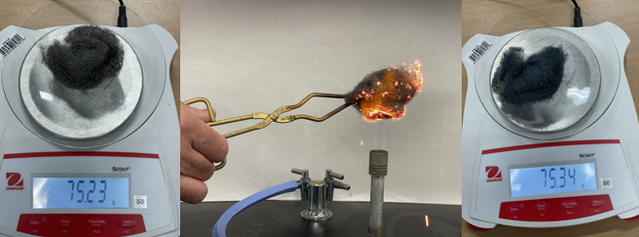
Note: the mass displayed in 1 is the mass of the watch glass and steel wool.
Note: steel wool will not produce a typical flame, but it is easy to see when it is burning. Once alight, remove it from the flame to show students, then return it to the flame to ensure it has burned completely. Consequently, do not pack the steel wool too tightly before burning.
- Explain to students that steel wool burns because it has extremely fine strands that create a large surface area, allowing the iron to react rapidly with oxygen in the air (oxidation) when ignited by a spark or heat, creating a self-sustaining glow of iron oxide. This is unlike a solid steel bar, which dissipates heat. The high surface area of steel wool enables a rapid, intense release of energy as iron reacts with oxygen, producing heat and light.
- Explain to students why the mass of the steel wool increased when it was burned. As the steel wool burns, it reacts with oxygen to form solid iron (III) oxide according to the equation. 2Fe + 3O₂ → 2Fe₂O_{3.} The increase in mass is due to the addition of oxygen.
Sample responses: Student resource – conservation of mass
Note: additional stimulus information has been removed from the sample response.
- What does the term ‘conserve’ mean?
In chemistry, it refers to the amount of something (such as energy or mass) remaining constant.
- Use the following scaffold to predict what will happen to the mass of steel wool when it burns in a Bunsen burner flame and explain your prediction. Complete the ‘Predict’ and ‘Explain’ columns in the scaffold before the demonstration. Record your observations in the ‘Observe‘ column when watching the demonstration. Finally, complete the ‘Explain’ column by writing the amended explanation.
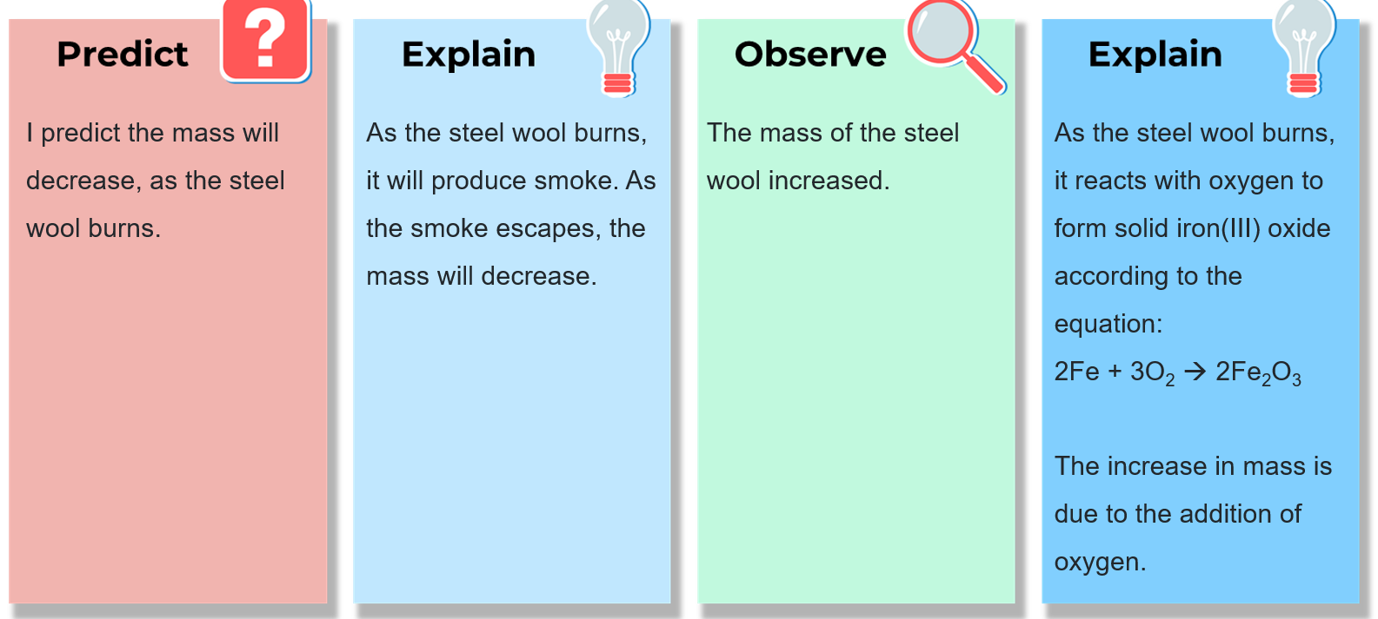
- Predict what will happen to the mass of steel wool when it burns.
The mass will decrease.
- Explain your prediction.
As the iron burns, it will break down and be lost as smoke.
- What did you observe and was it consistent with your prediction?
Before burning, the total mass of the steel wool and watch glass was 75.23 g. After burning, the combined mass increased to 75.34 g, indicating a mass gain.
- Rewrite your explanation if necessary.
Steel wool is mainly composed of iron. When burned, the iron reacts with oxygen in the air to form a new compound, iron oxide.
iron + oxygen → iron oxide
The increase in mass results from the formation of iron oxide, in which oxygen from the air combines with iron, increasing its mass.
- Determine the mass of oxygen that reacted with iron.
75.23 g − 72.34 g = 0.11 g

Student resource – conservation of mass
The law of conservation of mass states that ‘matter cannot be created or destroyed’.
- What does the term ‘conserve’ mean?
- Use the following scaffold to predict what will happen to the mass of steel wool when it burns in a Bunsen burner flame and explain your prediction. After the demonstration, record the observations and amend your explanation if necessary.
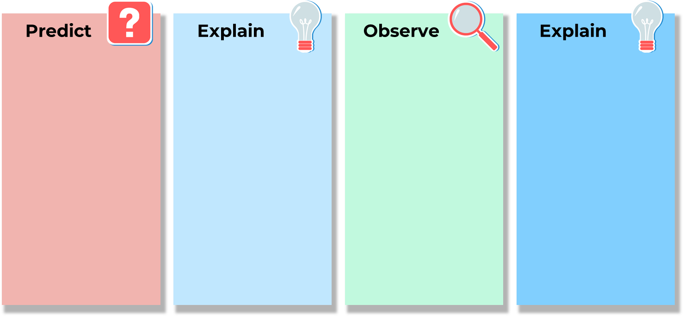
- Predict what will happen to the mass of steel wool when it burns.
- Explain your prediction.
- What did you observe and was it consistent with your prediction?
- Rewrite your explanation if necessary.
- Determine the mass of oxygen that reacted with iron.

Investigating mass changes
In the previous activity, students observed that the steel wool gained mass during combustion. At first glance, it may seem that mass is not conserved. This happens because the chemical reaction was not considered within its immediate environment. Air (oxygen) was a component of the reaction but was not accounted for in the mass change calculations. Together, the steel wool and the air form a ‘system’ – a boundary within which the combustion reaction occurs. The next activity aims to help students better describe how mass changes occur in chemical reactions occurring in both open and closed systems.
The purpose of these investigations is to monitor mass changes during chemical reactions so that students can become familiar with the features of mass changes in open and closed systems. The set-ups in Investigations 1 and 2 represent open systems, so mass is lost to the surroundings. On the other hand, the set-up in Investigation 3 represents a closed system, so the mass should remain constant. The intent is for students to arrive at this conclusion themselves while answering the follow-up questions in Student resource – investigating mass changes. However, the distinction between open and closed systems will be further unpacked using RXN PPT ‘1.1 Open and closed systems’ after the investigations.
Mass is conserved in all chemical reactions that occur in closed or isolated systems; however, in open systems, matter can be introduced into or lost to the surroundings. Hence, mass is not conserved in chemical reactions occurring in open systems.
- Students follow the procedures in Student resource – investigating mass changes to carry out a series of reactions and monitor mass changes. The equipment requirements for each mini investigation are outlined in Table 3.
Table 3 – equipment required for the mini investigations
Investigation | Equipment list
Burning a craft stick | - 1 × craft stick  - 1 × watch glass  - 1 × electronic balance  - Matches
Vinegar and sodium hydrogen carbonate | - 20 mL of vinegar  - 2 × 250 mL beakers  - 5 g of sodium bicarbonate  - 1 × electronic balance
Vinegar and sodium hydrogen carbonate in a flask covered with a balloon | - 20 mL of vinegar  - 1 × 50 mL beaker  - 1 × 250 mL conical flask  - 5 g of sodium bicarbonate  - 1 × electronic balance  - 1 × balloon
- Move around the room and support students as they complete Investigation 1.
- Move around the room and support students as they complete Investigation 2.
- Show students RXN PPT ‘1.1 Vinegar and sodium hydrogen carbonate set-up’ to explain the set-up for Investigation 3. Move around the room and support students as they complete Investigation 3. Figure 2 shows the set-up once the reaction is complete.
Figure 2 – vinegar and sodium bicarbonate after the reaction has taken place
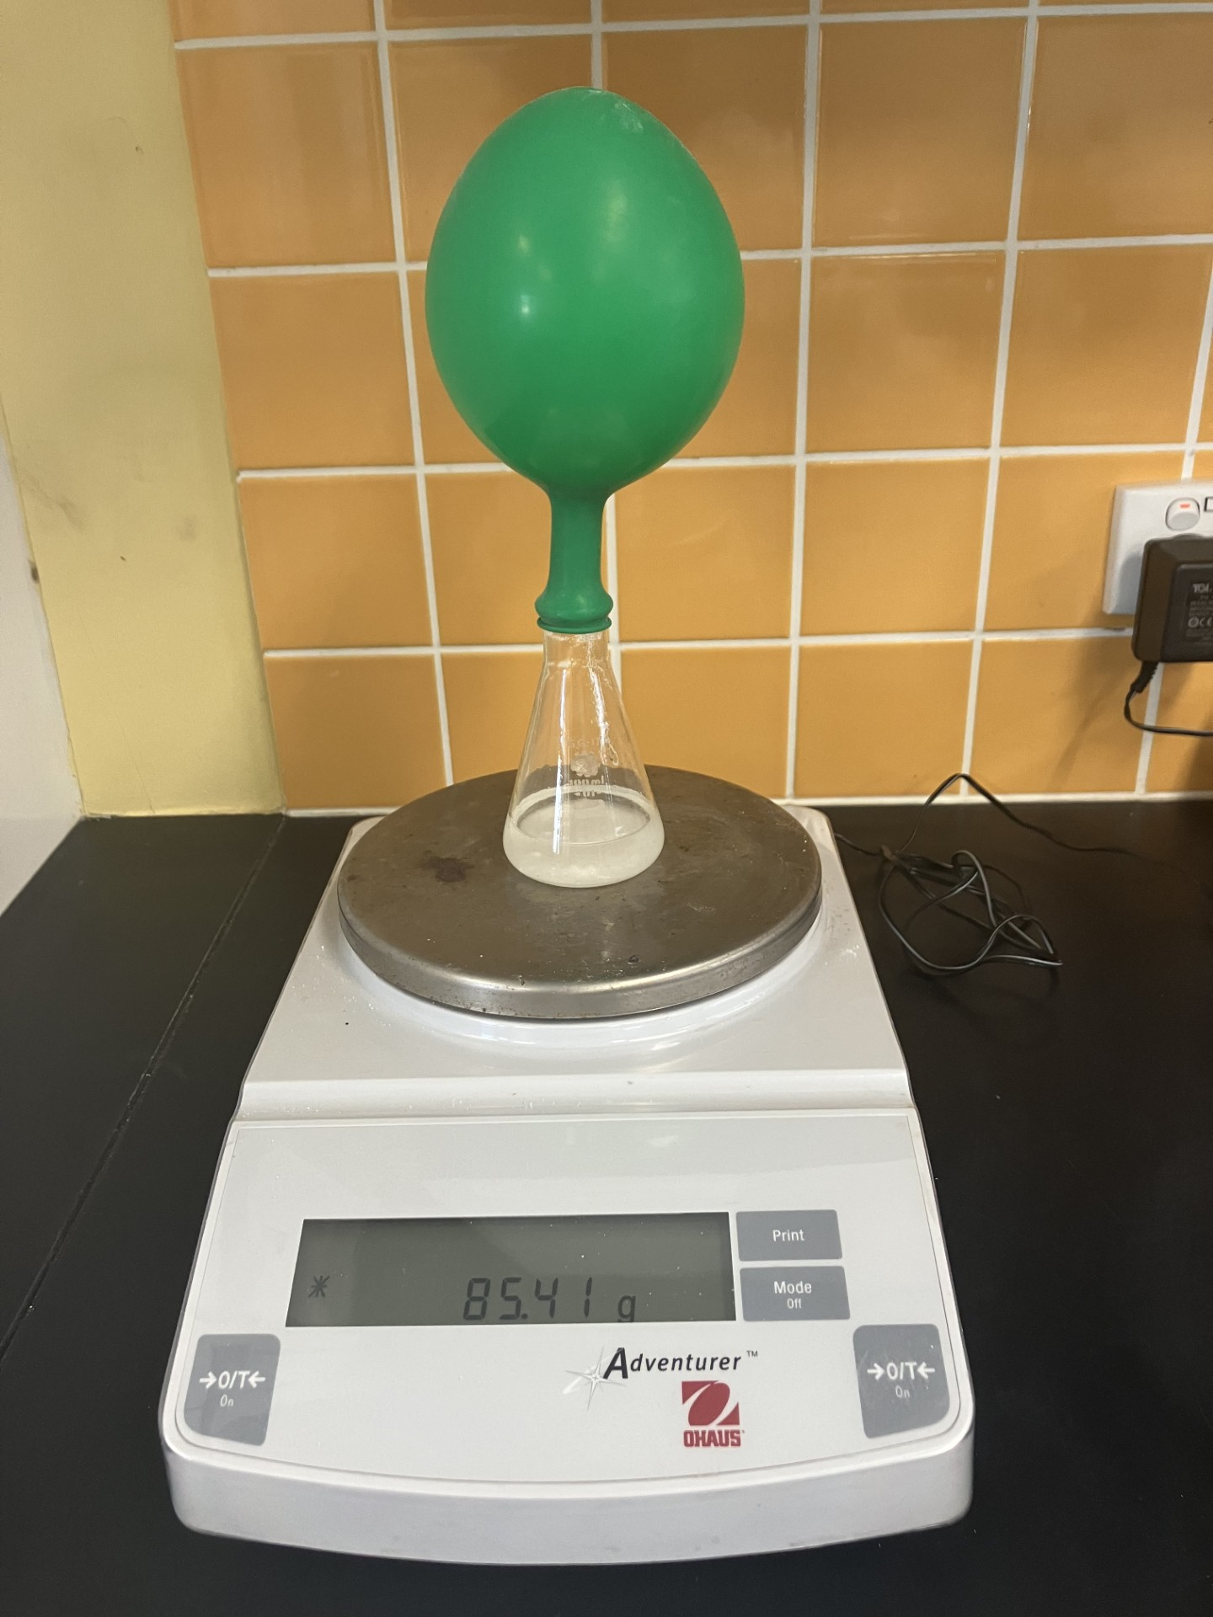
- After completing the investigations, discuss the follow-up questions to highlight the differences between open and closed systems and provide a definition of each using RXN PPT ‘1.1 Open and closed systems’.
Note: the exact values of the masses and volumes are not critical, but accurate measurements are essential. If sufficient balances are available, conduct the reactions directly on the balances and track the mass changes throughout the process. Students can record these measurements over time and create data plots. If possible, they could also connect the balances to a data logger for automated data collection.
Sample response: Student resource – investigating mass changes
Note: additional stimulus information has been removed from the sample response.
Investigation 1 (burning a craft stick)
Results
Table 4 – results of Investigation 1
Material | Mass before burning (g) | Mass after burning (g) | Change in mass (g)
Craft stick | 31.2 | 30.6 | −0.6
Explain the results.
The mass decreases because the carbon in the wood reacts with oxygen to form carbon dioxide (a gas), which is released into the surroundings.
Note: wood is a complex substance primarily consisting of cellulose, which is a long-chain polymer containing carbon, hydrogen and oxygen. Complete combustion should produce carbon dioxide and water, but incomplete combustion is likely to occur, producing carbon (soot) and carbon monoxide. Combustion of wood is a complex reaction beyond the scope of the course.
Investigation 2 (vinegar and sodium bicarbonate in a beaker)
Results
Table 5 – results of Investigation 2
Materials | Mass before (g) | Mass after (g)
Beaker and vinegar | 127.4
Sodium bicarbonate | 5.0
Beaker + vinegar (ethanoic acid) + sodium bicarbonate |  | 130
Total mass (g) | 132.4 | 130
Change in mass: −2.4 g
Explain the results.
The mass decreases because when vinegar and sodium bicarbonate react, they produce carbon dioxide gas which escapes into the surroundings.
sodium bicarbonate + vinegar (ethanoic acid) → sodium ethanoate + water + carbon dioxide
NaHCO₃(s) + CH₃COOH(aq) → CH₃COONa(aq) + H₂O(l) + CO₂(g)
Note: students do not need to produce this equation, but showing it helps explain mass loss. It also provides a good chance to introduce later concepts about states. If the chemical equation seems challenging, use the word equation to aid understanding.
Investigation 3 (vinegar and sodium bicarbonate in a flask sealed with a balloon)
Results
Table 6 – results of Investigation 3
Materials | Mass before (g) | Mass after (g)
Balloon and sodium bicarbonate | 32.3
Conical flask and vinegar (ethanoic acid) | 109.8
Conical flask + vinegar (ethanoic acid) + sodium bicarbonate + balloon |  | 142.1
Total mass (g) | 142.1 | 142.1
Explain the results
The vinegar and sodium bicarbonate react to produce carbon dioxide gas, but the mass remains the same because the balloon traps it, preventing it from escaping into the surroundings.
Note: the mass may decrease slightly because some of the gas will escape due to a poor seal between the balloon and the flask.
Follow-up questions
- Compare the results of the 3 investigations.
The mass decreased in the first 2 reactions but remained the same in the third reaction.
- How was the set-up in Investigation 3 (vinegar and sodium bicarbonate in a flask sealed with a balloon) different to the first 2 investigations?
It was sealed to prevent the loss of gaseous reactants or products.
- What term do we use to describe this type of system (in Investigation 3)?
A closed system.

Student resource – investigating mass changes
Investigation 1 (burning a craft stick)
Procedure
- Weigh the craft stick and the watch glass.
- Light the craft stick, hold it over the watch glass and allow it to burn until it goes out.
- Place the remaining craft stick on the watch glass, reweigh and record the results.
Results
Table 1 – results of Investigation 1
Material | Mass before burning (g) | Mass after burning (g) | Change in mass (g)
Craft stick
Explain the results.
Investigation 2 (vinegar and sodium bicarbonate in a beaker)
Procedure
- Pour 20 mL of vinegar (also called ethanoic acid) into a 250 mL beaker and weigh.
- Weigh out approximately 5 g (record exact mass) of sodium bicarbonate.
- Add the sodium bicarbonate to the vinegar.
- Once the reaction has stopped, reweigh the beaker and its contents.
Results
Table 2 – results of Investigation 2
Materials | Mass before (g) | Mass after (g)
Beaker and vinegar
Sodium bicarbonate
Beaker + vinegar (ethanoic acid) + sodium bicarbonate
Total mass (g)
Change in mass:
Explain the observations.
Investigation 3 (vinegar and sodium bicarbonate in a flask sealed with a balloon)
Procedure
- Pour 20 mL of vinegar into a 250 mL conical flask and weigh.
- Weigh out approximately 5 g (record exact mass) of sodium bicarbonate.
- Place the sodium bicarbonate in the balloon as pictured in Figure 1.
Figure 1 – vinegar (ethanoic acid) and sodium bicarbonate set-up
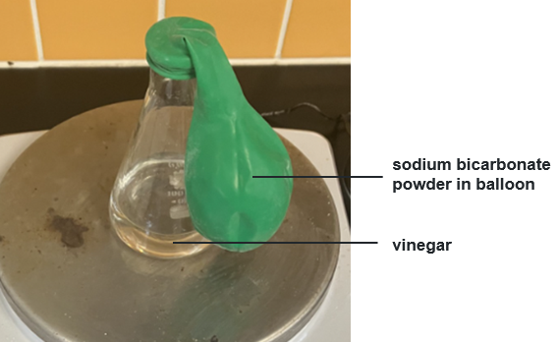
- Weigh the set-up.
- Tip the balloon so the sodium bicarbonate is added to the vinegar.
- Once the reaction has stopped, reweigh the flask and its contents.
Results
Table 3 – results of Investigation 3
Materials | Mass before (g) | Mass after (g)
Balloon and sodium bicarbonate
Conical flask and vinegar (ethanoic acid)
Conical flask + vinegar (ethanoic acid) + sodium bicarbonate + balloon
Total mass (g)
Explain the results.
Follow-up questions
- Compare the results of the 3 investigations.
- How was the set-up in Investigation 3 (vinegar and sodium bicarbonate in a flask sealed with a balloon) different to the first 2 investigations?
- What term do we use to describe this type of system (in Investigation 3)?

1.2 Nomenclature
Table 7 – learning intention and success criteria for ‘1.2 Nomenclature’
We are learning: | I can:
- to describe chemical compounds. | - distinguish between ionic and covalent compounds  - name simple ionic compounds using IUPAC naming conventions  - name ionic compounds containing polyatomic ions using IUPAC naming conventions  - name simple covalent compounds consisting of 2 elements using IUPAC naming conventions.
Teacher background information
Ionic compounds form when electrons are transferred between atoms (typically from a metal to a non-metal), producing positively charged ions (cations) and negatively charged ions (anions).
These ions combine in specific ratios to balance the total positive and negative charges, forming an electrically neutral compound. Each ion has a specific charge, so only one ratio yields a net charge of zero.
Examples of ionic compounds:
- sodium chloride (NaCl): sodium forms Na⁺ ions and chloride forms Cl⁻ ions. These charges balance in a 1:1 ratio.
- magnesium oxide (MgO): magnesium forms Mg²⁺ ions and oxygen forms O²⁻ ions, which also balance in a 1:1 ratio.
- sodium oxide (Na₂O): sodium forms Na⁺ ions and oxygen forms O²⁻ ions. Two sodium ions are required to balance the −2 charge on the oxide ion, resulting in a fixed 2:1 ratio.
- aluminium chloride (AlCl₃): aluminium forms Al³⁺ ions and chloride forms Cl⁻ ions. Three chloride ions are required to balance the +3 charge on the aluminium ion, producing a fixed 1:3 ratio.
In covalent compounds, atoms share electrons to achieve a stable noble gas configuration. As a result, the ratio in which atoms combine is not fixed and can vary depending on how many electrons are shared to achieve this configuration. This allows the same elements to form a range of different compounds with different formulas and properties.
An example of a covalent compound is the oxides of nitrogen. Nitrogen and oxygen are both nonmetals and can share electrons in multiple ways, forming several covalent compounds, each with a different nitrogen-to-oxygen ratio. Examples of nitrogen oxides include:
- dinitrogen monoxide (N₂O): nitrogen:oxygen = 2:1
- nitrogen monoxide (NO): nitrogen:oxygen = 1:1
- dinitrogen trioxide (N₂O₃) nitrogen:oxygen = 2:3
- nitrogen dioxide (NO₂) nitrogen:oxygen = 1:2
- dinitrogen tetroxide (N₂O₄) nitrogen:oxygen = 2:4 (or 1:2)
- dinitrogen pentoxide (N₂O₅): nitrogen:oxygen = 2:5.
Because covalent compounds can form in multiple ratios, prefixes such as ‘mono’, ‘di’, ‘tri’, ‘tetra’ and ‘penta’ are used to indicate the number of each type of atom present in the compound.

Naming compounds
The International Union of Pure and Applied Chemistry (IUPAC) has established the rules for naming chemical compounds. It plays a key role in standardising chemical terminology, nomenclature and measurements globally. Its main roles include:
- standardising chemical names and formulas – the IUPAC develops rules for naming chemical compounds, enabling scientists worldwide to communicate clearly and consistently
- creating standard symbols and terminology – the IUPAC defines and standardises the terms, symbols and units used in chemistry
- publishing reference data – it provides data such as atomic weights, constants and the periodic table.
Checkpoint 1: activate prior knowledge from the Stage 4 Periodic table focus area using RXN PPT ‘1.2 Checkpoint 1’ (3 slides), which asks students to:
- classify a selection of elements as metals and non-metals
- use the periodic table to determine the number of electrons in a neutral sodium atom and a sodium ion
- classify compounds as ionic or covalent.
Sample answers are provided in each of the slides.
- Display RXN PPT ‘1.2 Types of compounds’ to support students in recalling the definition of ‘ionic compounds’ and ‘covalent compounds’.
- Introduce students to the concept of ionic compounds being made from monatomic ions or polyatomic ions using RXN PPT ‘1.2 Ionic compounds’. The concept of ‘polyatomic ion compounds’ will be unpacked further in later lessons.
- Provide students with a copy of the periodic table in the Data Book: Science 7–10. Outline the rules for naming ionic compounds using magnesium chloride as an example on RXN PPT ‘1.2 Naming ionic compounds’, then discuss the other examples on the slide.
Note: these rules are simplified to just refer to metals and non-metals when determining the order in which elements are named.
- Students apply their understanding and complete Student resource – naming compounds.
Checkpoint 2: check for understanding using the RXN PPT ‘1.2 Checkpoint 2’ to see whether students can name Na₂O (sodium oxide) and AlCl₃ (aluminium chloride) from their formulas.
- Use RXN PPT ‘1.2 Polyatomic ions’ to outline the features of polyatomic ions and provide a table of common ions and their charge. Define ‘polyatomic ions’ as a charged group of ions that tend to behave as a single entity.
- Outline the naming conventions for compounds with polyatomic ions using RXN PPT ‘1.2 Naming compounds with polyatomic ions’.
- Show the slide RXN PPT ‘1.2 More polyatomic ions’ to illustrate some more examples of polyatomic ions, particularly ammonium as a positively charged example.
Differentiation: question 2 in the student resource contains compounds that consist of only metals and the ions on slide RXN PPT ‘1.2 Polyatomic ions’. Question 3 has more complex examples, including ions from RXN PPT ‘1.2 More polyatomic ions’.
- Students name compounds containing polyatomic ions in Student resource – naming compounds.
Checkpoint 3: check for understanding using the RXN PPT ‘1.2 Checkpoint 3’ to see whether students can name Ca(NO₃)₂ (calcium nitrate) and Mg(OH)₂ (magnesium hydroxide) from their formula.
- Explain that due to the charge of ions in ionic compounds, there is only one way that they can combine, but elements in covalent compounds can combine in a variety of ratios. We need to use prefixes such as ‘mono’, ‘di’, ‘tri’, ‘tetra’ and ‘penta’ to distinguish between them.
- Use the example of compounds of nitrogen and oxygen on slide RXN PPT ‘1.2 Naming covalent compounds’ (2 slides) to illustrate the need for prefixes and outline the naming conventions for covalent compounds.
- Students name simple covalent compounds given the formula in Student resource – naming compounds.
Checkpoint 4: RXN PPT ‘1.2 Checkpoint 4’ requires students to name a variety of ionic and covalent compounds. The compounds and their IUPAC name are outlined in Table 8.
Table 8 – sample response for Checkpoint 4
Compound formula | Type of compound | IUPAC name
KCl | ionic | potassium chloride
Ca(NO₃)₂ | ionic | calcium nitrate
N₂O | covalent | dinitrogen monoxide
Na₂O | ionic | sodium oxide
PCl₃ | covalent | phosphorous trichloride
MgI₂ | ionic | magnesium iodide
Ba(OH)₂ | ionic | barium hydroxide
Differentiation: to extend students, add Tables 9 and 10 to the student resource. Table 9 contains complex polyatomic ions.
Use the information in Table 9 to name the compounds in Table 10.
Table 9 – more polyatomic ions
Name | Formula
phosphate | PO₄³⁻
hydrogen carbonate | HCO₃⁻
ethanoate | CH₃COO⁻
ammonium | NH₄⁺
Table 10 – extension of polyatomic ions
Formula | Name
Na₃PO₄
NaHCO₃
CH₃COOK
NH₄NO₃
AlPO₄
NH₄Cl
Sample response: Student resource – naming compounds
Note: additional stimulus information has been removed from the sample response.
- Name the following ionic compounds shown in Table 11.
Table 11 – ionic compounds
Formula | Name
NaCl | sodium chloride
Na₂O | sodium oxide
MgO | magnesium oxide
AlCl₃ | aluminium chloride
Al₂O₃ | aluminium oxide
CaS | calcium sulfide
K₃N | potassium nitride
CaF₂ | calcium fluoride
KI | potassium iodide
- Use the information in Table 12 to name the following compounds with polyatomic ions in Table 13.
Table 12 – compounds with polyatomic ions
Formula | Name
CaSO₄ | calcium sulfate
Ca(OH)₂ | calcium hydroxide
NaOH | sodium hydroxide
Na₂CO₃ | sodium carbonate
K₂SO₄ | potassium sulfate
MgCO₃ | magnesium carbonate
Mg(NO₃)₂ | magnesium nitrate
LiNO₃ | lithium nitrate
- Name the following covalent compounds.
Table 13 – covalent compounds
Formula | Name
CO₂ | carbon dioxide
HF | hydrogen fluoride
PCl₃ | phosphorous trichloride
PCl₅ | phosphorous pentachloride
CCl₄ | carbon tetrachloride
SO₂ | sulfur dioxide
CS₂ | carbon disulfide
- Name the following compounds.
Table 14 – extension of polyatomic ions
Formula | Name
Na₃PO₄ |  | sodium phosphate
NaHCO₃ |  | sodium hydrogen carbonate
CH₃COOK |  | potassium ethanoate
NH₄NO₃ |  | ammonium nitrate
AlPO₄ |  | aluminium phosphate
NH₄Cl |  | ammonium chloride

Student resource – naming compounds
Ionic compounds
Ionic compounds typically consist of metals and nonmetals. To name ionic compounds, name the metal first and modify the name of the non-metal to end in ‘-ide’.
Example: MgCl₂ is magnesium chloride.
- Name the ionic compounds shown in Table 1.
Table 1 – ionic compounds
Formula | Name
NaCl
Na₂O
MgO
AlCl₃
Al₂O₃
CaS
K₃N
CaF₂
KI
Polyatomic ions
Table 2 shows some of the more common polyatomic ions you will encounter in Stage 5.
Table 2 – polyatomic ions
Name | Formula
sulfate | SO₄²⁻
carbonate | CO₃²⁻
nitrate | NO₃⁻
hydroxide | OH⁻
Most compounds containing polyatomic ions will contain a metal ion and the polyatomic ion. To name them, simply name the metal first (from the periodic table), followed by the name of the polyatomic ion.
- Use the information in Table 2 to name the following compounds with polyatomic ions in Table 3.
Table 3 – compounds with polyatomic ions
Formula | Name
CaSO₄
Ca(OH)₂
NaOH
Na₂CO₃
K₂SO₄
MgCO₃
Mg(NO₃)₂
LiNO₃
Covalent compounds
Non-metals in covalent compounds can combine in a variety of ratios. Prefixes such as ‘mono’ (1), ‘di’ (2), ‘tri’ (3),‘tetra’ (4) and ‘penta’ (5) are used to denote the number of each atom in covalent compounds.
Note: the prefix ‘mono’ is not applied to the first element in the compound.
- Name the following covalent compounds in Table 4.
Table 4 – covalent compounds
Formula | Name
CO₂
HF
PCl₃
PCl₅
CCl₄
SO₂
CS₂

Naming compounds dominoes
This activity is designed to consolidate and check students' understanding of naming compounds and to break up a theory-based lesson sequence.
- Print out a set of dominoes from Student resource – naming compounds dominoes for each group and cut to size. The original can be found at Naming compounds dominoes (Canva).
- Instruct students to begin with the ‘Start/NaCl’ domino and show them how to sequence the dominoes. Tell students that there is only one possible sequence and that if they do it correctly, they should all finish on the same domino, which has the formula CuS. There is no corresponding name for this. Once complete, students tell you which domino is final to confirm that they are correct.
Note: you may choose to print, laminate and cut out the dominoes before printing to produce a class set that can be reused. They are currently in the correct order, so they will need to be cut out before giving them to students.

Student resource – naming compounds dominoes
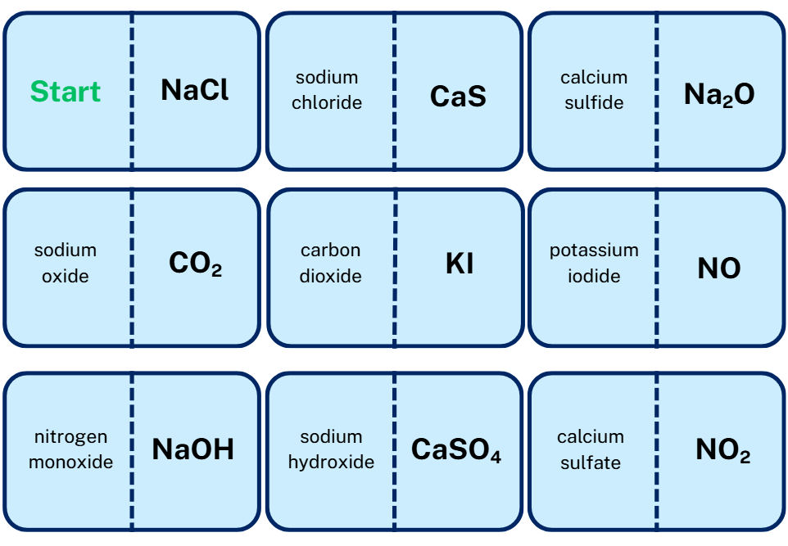
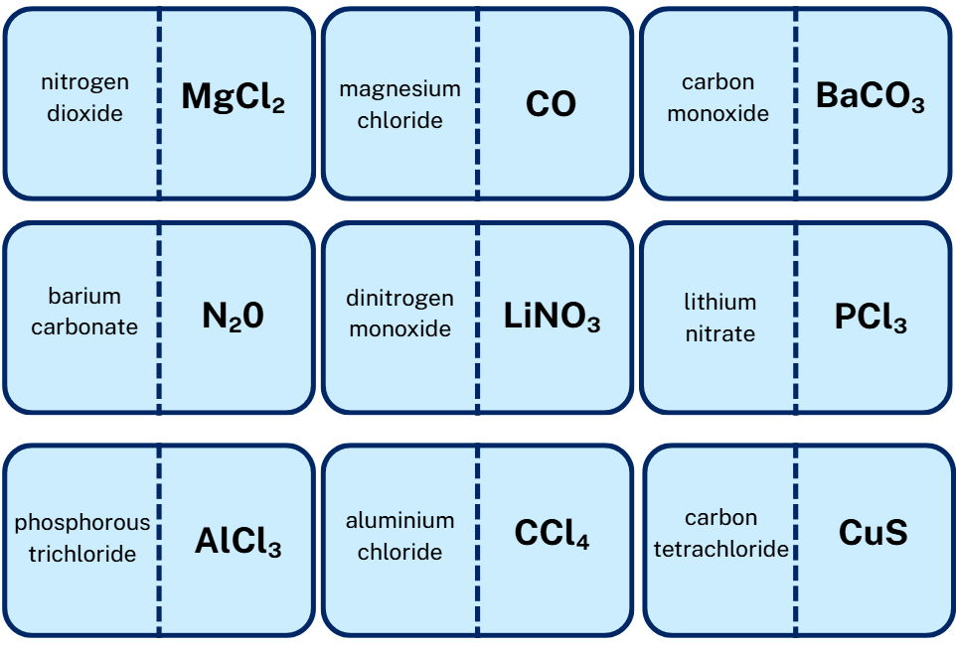

1.3 Writing chemical formulas
Table 15 – learning intentions and success criteria for ‘1.3 Writing chemical formulas’
We are learning: | I can:
- to describe chemical compounds | - distinguish between ionic and molecular formulas  - construct the formula for named covalent compounds using IUPAC conventions  - construct the formula for ionic compounds using IUPAC conventions  - construct the formula and name compounds containing elements with variable valency, such as lead, copper and iron, using IUPAC conventions.
- to process information and data. | - determine valency from the periodic table to construct a chemical formula.
Teacher background information
What is valency?
Valency refers to the number of electrons an atom must gain, lose, or share to reach a stable, full outer shell, known as a noble gas configuration. For atoms with only one electron shell, this stable configuration is 2 electrons. For atoms with more than one shell, the stable state generally includes 8 electrons in the outer shell (applicable to elements in the first 2 rows of the periodic table).
Valency can often be predicted by counting the electrons in an atom’s outermost shell. Atoms form chemical bonds to attain these stable electron arrangements. The electrons in the outer shell, called ‘valence electrons’, are key to bonding. During chemical reactions, atoms may gain, lose or share valence electrons to form bonds.

Molecular and ionic formula
- Review valency before introducing the concept of constructing chemical formulas for ionic and covalent compounds. Students first learned about valency in the Stage 5 Materials focus area.
- Distinguish between ‘ionic formula’ and ‘molecular formula’ using RXN PPT ‘1.3 Molecular formula’ and RXN PPT ‘1.3 Ionic formula’. Tell students that molecules are discrete units and the molecular formula indicates every atom in the molecule, while ionic substances exist in a 3-dimensional lattice structure and the formula only indicates the simplest ratio of each element. Explain to students that:
- a lattice is a consistent, repeating 3-dimensional array of particles. In ionic substances, this lattice is made up of alternating positive and negative ions bonded by strong electrostatic attractions between oppositely charged particles.
- the lattice extends infinitely in all directions, creating a continuous structure rather than discrete units or molecules. Each ion is surrounded by several ions of opposite charge, which maximises the attractive forces and enhances the stability of the solid.
- an ionic lattice is a continuous, repeating network, not made up of separate, independent molecules. Consequently, the chemical formula of an ionic compound does not describe a single particle. Still, it indicates the simplest whole-number ratio of ions that repeats throughout the entire 3-dimensional lattice.

Covalent compounds
- Revise how to construct covalent compounds by unpacking the steps in the Student resource – covalent compounds. Use a worked example to help students recall how to construct the chemical formula.
Checkpoint 1: most students will be able to work from the prefixes in the name to write the formula for simple covalent compounds, but check their understanding by asking them to write formulas for nitrogen dioxide (NO₂) and phosphorous trichloride (PCl₃) using RXN PPT ‘1.3 Checkpoint 1’. If they need more assistance, refer to the slides RXN PPT ‘1.2 Naming covalent compounds’ (2 slides).
- Students write the formula for simple covalent compounds in the Student resource – covalent compounds, using a periodic table if necessary.
Sample response: Student resource – covalent compounds
Note: additional stimulus information has been removed from the sample response.
Write the formula for the following covalent compounds by writing the symbol for each element in the same order as the name and add subscripts to indicate the number of each type of atom.
Table 16 – molecular formula for covalent compounds
Name | Formula
carbon monoxide | CO
sulfur dioxide | SO₂
carbon tetrafluoride | CF₄
nitrogen trichloride | NCl₃
dinitrogen pentoxide | N₂O₅
sulfur trioxide | SO₃
dihydrogen monoxide | H₂O

Student resource – covalent compounds
To construct a molecular formula for covalent compounds, follow these steps:
      - Write the symbols of the non-metals in the compound. The element that appears first (left to right) goes first.
      - Interpret prefixes in the compound name to show the number of atoms of each element. Table 1 outlines the subscript used for each prefix.
      - Place the numbers as subscripts after their relevant element symbol. Do not write a subscript for 1.
Example: carbon dioxide
- C O
- C 2O
- CO₂
Table 1 – chemical formula prefixes and subscripts
Prefix | Subscript
mono | NA no subscript for 1 is used.
di | 2
tri | 3
tetr or tetra | 4
pent or penta | 5
Write the formula for the following covalent compounds by writing the symbol for each element in the same order as the name and add subscripts to indicate the number of each type of atom.
Table 2 – molecular formula for covalent compounds
Name | Formula
carbon monoxide
sulfur dioxide
carbon tetrafluoride
nitrogen trichloride
dinitrogen pentoxide
sulfur trioxide
dihydrogen monoxide

Ionic compounds
Note: this activity explains why and how atoms form ionic compounds, enabling students to determine the formulas of ionic compounds. Ideally, if students understand how and why ionic bonds form, they should be able to work out the formula by determining the ratio of the elements that need to combine so that each attains a stable electron configuration through the transfer of electrons.
Questions 1 to 8 in the Student resource – ionic compounds are designed to develop this understanding. If students progress well through these questions, allow them to attempt question 9 without introducing any strategies. If students face difficulties with these concepts after attempting questions 1 to 8, then introduce the strategies in RXN PPT ‘1.3 Strategies for writing ionic formula’ (3 slides).
In these questions, the cations have been ordered to highlight patterns related to the groups in the periodic table.
- Use slide RXN PPT ‘1.3 Noble gases’ to review the characteristics of noble gases from the Stage 5 Materials focus area.
- Review the definition of valency from the Stage 5 Materials focus area as ‘The number of chemical bonds that an atom can make with a univalent atom, such as hydrogen’ (NESA 2025). Tell students that for ionic compounds, the valency equates to the number of electrons that atoms need to gain or lose to achieve the noble gas configuration. Use slide RXN PPT ‘1.3 Valency’ to guide students to complete question 1 in Student resource – ionic compounds, where they will determine the electron configuration and valency of 4 atoms.
- Use the content in RXN PPT ‘1.3 Why atoms bond’ to review why elements bond to achieve a noble gas electron configuration. Ask students: ‘Which is more stable, a neutral sodium atom or a positively charged sodium ion?’ Then demonstrate why the ion is more stable by comparing its electron configuration to that of neon.
- Use RXN PPT ‘1.3 How atoms bond’ to demonstrate how atoms achieve the noble gas electron configuration through the transfer of electrons.
- Use RXN PPT ‘1.3 The periodic table’ to illustrate how it can be used to determine the number of electrons each atom needs to gain or lose to achieve a noble gas electron configuration. Emphasise that all atoms in the same group have the same number of electrons in their outer shell.
Checkpoint 2: check if students can use their periodic table to determine the number of electrons that atoms need to gain or lose to achieve the noble gas electron configuration using RXN PPT ‘1.3 Checkpoint 2’.
- Use the diagrams on slides RXN PPT ‘1.3 Determining the ionic formula’ (5 slides) to show why atoms combine in certain ratios so that students can determine the ionic formula.
- Teach students a strategy for writing ionic formula using RXN PPT ‘1.3 Strategies for writing ionic formula’ (3 slides). Students complete questions 1 to 9 on ionic compounds in the Student resource – ionic compounds. Questions 1 to 8 aim to develop students’ understanding so they can work out the formula in question 9.
Checkpoint 3: check if students can determine the formula for magnesium fluoride (MgF₂) and potassium oxide (K₂O) using RXN PPT ‘1.3 Checkpoint 3’.
Differentiation: depending on your students’ needs, you may choose to guide them through questions 1 to 8 of Student resource – ionic compounds and the first few examples in question 9 before releasing responsibility. Table 2 in question 8 of the student resource could also be modified to include a column that incorporates the information from the previous question about the number of electrons to gain or lose, as shown below in Table 17. This would allow students to focus solely on the ratio. If students require additional support, provide the strategies on RXN PPT ‘1.3 Strategies for writing ionic formula 2’ (slides 2 and 3 of 3).
Table 17 – differentiated table for question 8
Element A | Electrons to lose | Element B | Electrons to gain | Ratio A:B | Formula
sodium (Na) | 1 | chlorine (Cl) | 1
potassium (K) | 1 | chlorine (Cl) | 1
magnesium (Mg) | 2 | chlorine (Cl) | 1
calcium (Ca) | 2 | chlorine (Cl) | 1
aluminium (Al) | 3 | chlorine (Cl) | 1
sodium (Na) | 1 | oxygen (O) | 2
potassium (K) | 1 | oxygen (O) | 2
magnesium (Mg) | 2 | oxygen (O) | 2
calcium (Ca) | 2 | oxygen (O) | 2
aluminium (Al) | 3 | oxygen (O) | 2
sodium (Na) | 1 | nitrogen (N) | 3
potassium (K) | 1 | nitrogen (N) | 3
magnesium (Mg) | 2 | nitrogen (N) | 3
calcium (Ca) | 2 | nitrogen (N) | 3
aluminium (Al) | 3 | nitrogen (N) | 3
Sample response: Student resource – ionic compounds
Note: additional stimulus information has been removed from the sample response.
- Use your periodic table to complete the tiles below to show the same information as for Chlorine.
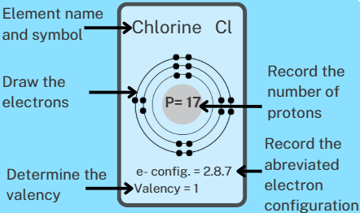
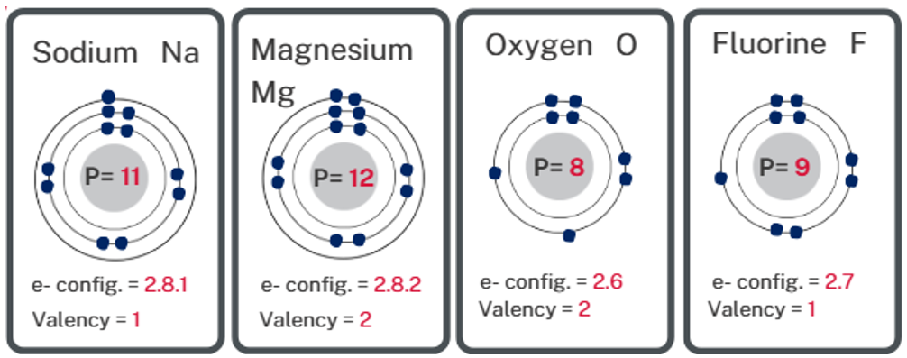
- Complete the following cloze passage:
Atoms bond to become more stable. In ionic compounds, they do this by donating or accepting electron(s) to achieve a complete outer (valence) shell. This is known as a noble gas electron configuration.
To form ionic compounds, metal atoms tend to lose/donate electrons to achieve a noble gas configuration, while non-metal atoms tend to gain/accept electrons to achieve a noble gas configuration.
- Locate the following elements on the periodic table and determine how many electrons they need to gain or lose to achieve a stable configuration.
Determine the charge of the ions formed when they gain or lose an electron.
Table 18 – forming ions
Element | Gain | Lose | Charge
sodium (Na) |  | 1 | +1
potassium (K) |  | 1 | +1
magnesium (Mg) |  | 2 | +2
calcium (Ca) |  | 2 | +2
aluminium (Al) |  | 3 | +3
oxygen (O) | 2 |  | −2
chlorine (Cl) | 1 |  | −1
fluorine (F) | 1 |  | −1
nitrogen (N) | 3 |  | −3
- If magnesium needs to lose 2 electrons, how many chlorine atoms would it need to combine with?
Two.
- Write the formula for magnesium chloride.
MgCl₂.
- If oxygen needs to gain 2 electrons, how many sodium atoms would it need to combine with?
Two.
- Write the formula for sodium oxide.
Na₂O.
- Determine the ratio that the following pairs of atoms would need to combine so they both achieve a complete outer shell, and then write the formula.
Table 19 – determining ratio
Element A | Element B | Ratio A:B | Formula
sodium (Na) | chlorine (Cl) | 1:1 | NaCl
potassium (K) | chlorine (Cl) | 1:1 | KCl
magnesium (Mg) | chlorine (Cl) | 1:2 | MgCl₂
calcium (Ca) | chlorine (Cl) | 1:2 | CaCl₂
aluminium (Al) | chlorine (Cl) | 1:3 | AlCl₃
sodium (Na) | oxygen (O) | 2:1 | Na₂O
potassium (K) | oxygen (O) | 2:1 | K₂O
magnesium (Mg) | oxygen (O) | 1:1 | MgO
calcium (Ca) | oxygen (O) | 1:1 | CaO
aluminium (Al) | oxygen (O) | 2:3 | Al₂O₃
sodium (Na) | nitrogen (N) | 3:1 | Na₃N
potassium (K) | nitrogen (N) | 3:1 | K₃N
magnesium (Mg) | nitrogen (N) | 3:2 | Mg₃N₂
calcium (Ca) | nitrogen (N) | 3:2 | Ca₃N₂
aluminium (Al) | nitrogen (N) | 1:1 | AlN
- Write the formula for the following ionic compounds.
Table 20 – formula for ionic compounds
Name | Formula
sodium fluoride | NaF
potassium fluoride | KF
magnesium sulfide | MgS
calcium sulfide | CaS
aluminium fluoride | AlF₃
sodium sulfide | Na₂S
potassium iodide | KI
magnesium iodide | MgI₂
calcium fluoride | CaF₂
aluminium sulfide | Al₂S₃
sodium phosphide | Na₃P
barium chloride | BaCl₂
magnesium bromide | MgBr₂

Student resource – ionic compounds
Valency is defined as ‘The number of chemical bonds an atom can make with a univalent atom, such as hydrogen’ (NESA 2025).
- Use your periodic table to complete the tiles below to show the same information as for Chlorine.
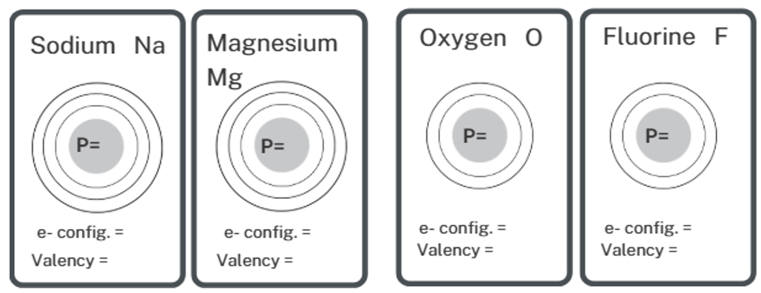
- Complete the following cloze passage using the word bank.
Atoms bond to become more _________. In ionic compounds, they do this by donating or accepting electron(s) to achieve a complete outer (_________) shell. This is known as a _________ gas electron configuration.
To form ionic compounds, metal atoms tend to _________ electrons to achieve a noble gas configuration, while non-metal atoms tend to _________ electrons to achieve a noble gas configuration.
Word bank: valence, accept, stable, electrons, noble, donate
- Locate the following elements on the periodic table and determine how many electrons they need to gain or lose to achieve a stable configuration.
Determine the charge of the ion formed when they gain or lose an electron.
Table 1 – forming ions
Element | Gain | Lose | Charge
sodium (Na)
potassium (K)
magnesium (Mg)
calcium (Ca)
aluminium (Al)
oxygen (O)
chlorine (Cl)
fluorine (F)
nitrogen (N)
- If magnesium needs to lose 2 electrons, how many chlorine atoms would it need to combine with?
- Write the formula for magnesium chloride.
- If oxygen needs to gain 2 electrons, how many sodium atoms would it need to combine with?
- Write the formula for sodium oxide.
- Determine the ratio that the following pairs of atoms would need to combine so they both achieve a complete outer shell, and then write the formula.
Table 2 – determining ratio
Element A | Element B | Ratio A:B | Formula
sodium (Na) | chlorine (Cl)
potassium (K) | chlorine (Cl)
magnesium (Mg) | chlorine (Cl)
calcium (Ca) | chlorine (Cl)
aluminium (Al) | chlorine (Cl)
sodium (Na) | oxygen (O)
potassium (K) | oxygen (O)
magnesium (Mg) | oxygen (O)
calcium (Ca) | oxygen (O)
aluminium (Al) | oxygen (O)
sodium (Na) | nitrogen (N)
potassium (K) | nitrogen (N)
magnesium (Mg) | nitrogen (N)
calcium (Ca) | nitrogen (N)
aluminium (Al) | nitrogen (N)
- Write the formula for the following ionic compounds
Table 3 – formula for ionic compounds
Name | Formula
sodium fluoride
potassium fluoride
magnesium sulfide
calcium sulfide
aluminium fluoride
sodium sulfide
potassium iodide
magnesium iodide
calcium fluoride
aluminium sulfide
sodium phosphide
barium chloride
magnesium bromide

Compounds with polyatomic ions
- Explain that polyatomic ions combine in the same way as single-atom ions. They must combine in a ratio that balances their charges, producing a net charge of zero. Emphasise the importance of brackets. RXN PPT ‘1.3 Writing formula with polyatomic ions’ (3 slides) has examples of the commonly used ions and their valency and uses the balancing charges method to write the formula, while RXN PPT ‘1.3 Writing formula with polyatomic ions alternate’ uses the down-and-across method.
- Students write formulas for compounds containing common polyatomic ions from Table 1 in the Student resource – compounds with polyatomic ions.
Sample response: Student resource – compounds with polyatomic ions
Note: additional stimulus information has been removed from the sample response.
Table 21 – formula for compounds containing polyatomic ions
Name | Formula
sodium hydroxide | NaOH
potassium nitrate | KNO₃
magnesium hydroxide | Mg(OH)₂
calcium nitrate | Ca(NO₃)₂
aluminium hydroxide | Al(OH)₃
sodium sulfate | Na₂SO₄
potassium carbonate | K₂CO₃
magnesium sulfate | MgSO₄
calcium carbonate | CaCO₃
aluminium carbonate | Al₂(CO₃)₃

Student resource – compounds with polyatomic ions
Use your periodic table and Table 1 to write the chemical formula for these compounds containing polyatomic ions in Table 2.
Table 1 – valencies of polyatomic ions
Name | Formula | Valency
sulfate | SO₄²⁻ | 2
carbonate | CO₃²⁻ | 2
nitrate | NO₃⁻ | 1
hydroxide | OH⁻ | 1
Table 2 – formula for compounds containing polyatomic ions
Name | Formula
sodium hydroxide
potassium nitrate
magnesium hydroxide
calcium nitrate
aluminium hydroxide
sodium sulfate
potassium carbonate
magnesium sulfate
calcium carbonate
aluminium carbonate

Elements with variable valency
- Explain that some metals can have multiple valencies. For example, iron can have a valency of 2 or 3 and can therefore bond with Cl in 2 ways: FeCl₂ and FeCl₃. These are completely different compounds, so we need to give them unambiguous names. To do this, we add a Roman numeral after the metal's name to indicate its valency:
- In FeCl₂, iron must have a valency of 2; therefore, it is iron (II) chloride.
- In FeCl₃, iron must have a valency of 3; therefore, it is iron (III) chloride.
- Students name and write formulas for compounds containing metals with variable valencies in the Student resource – elements with variable valency.
Checkpoint 4: use RXN PPT ‘1.3 Checkpoint 4’ to ask students to write the formulas for the following mix of compound types:
- calcium chloride: CaCl₂
- magnesium nitrate: Mg(NO₃)₂
- carbon disulfide: CS₂
- potassium hydroxide: KOH
- sulfur dioxide: SO₂
- aluminium oxide: Al₂O₃
- sodium nitride: Na₃N
- barium chloride: BaCl₂.

Sample response: Student resource – elements with variable valency
Note: additional stimulus information has been removed from the sample response.
- Complete the following table by writing formulas for this type of compound. For these metals, you cannot determine the valency from the periodic table, but it is given in the name. You will still need to use the periodic table to determine the valency of the non-metal.
Table 22 – naming compounds containing metals with variable valency
Name | Formula
copper (II) chloride | CuCl₂
iron (II) fluoride | FeF₂
copper (I) chloride | CuCl
lead (II) iodide | PbI₂
iron (II) oxide | FeO
copper (I) oxide | Cu₂O
lead (II) sulfide | PbS
iron (III) oxide | Fe₂O₃
lead (II) oxide | PbO
- Determine the valency of the metal in each of the following compounds to write an unambiguous name for each.
Table 23 – formula of compounds containing metals with variable valency
Formula | Name
FeCl₂ | iron (II) chloride
FeCl₃ | iron (III) chloride
Cu₂S | copper (I) sulfide
CuS | copper (II) sulfide
PbO₂ | lead (IV) oxide
PbI | lead (II) iodide

Student resource – elements with variable valency
Some metals, including iron, copper and lead, can have multiple valencies. To provide an unambiguous name, we add Roman numerals after the name of the metal to indicate its valency. For example, in FeCl₂, iron must have a valency of 2; therefore, it is iron(II) chloride.
Table 1 – metals with variable valency
Metal | Possible valency
Copper | 1 or 2
Iron | 2 or 3
Lead | 2 or 4
- Complete the following table by writing formulas for this type of compound. For these metals, you cannot determine the valency from the periodic table, but it is given in the name. You will still need to use the periodic table to determine the valency of the non-metal.
Table 2 – naming compounds containing metals with variable valency
Name | Formula
copper (II) chloride
iron (II) fluoride
copper (I) chloride
lead (II) iodide
iron (II) oxide
copper (I) oxide
lead (II) sulfide
iron (III) oxide
lead (II) oxide
- Determine the valency of the metal in each of the following compounds to write an unambiguous name for each.
Table 3 – formula of compounds containing metals with variable valency
Formula | Name
FeCl₂
FeCl₃
Cu₂S
CuS
PbO₂
PbI

1.4 In the balance
Table 24 – learning intentions and success criteria for ‘1.4 In the balance’
We are learning: | I can:
- to describe a range of chemical reactions | - identify the number of atoms of elements in the reactants and products  - recognise when to use a coefficient or subscript in a chemical equation  - balance chemical equations given the reactants and products
- to process data and information. | - use molecular model kits to represent simple chemical reactions.

Balancing equations
Chemical equations must be balanced to show that mass is conserved in a chemical reaction. This means that atoms are neither created nor destroyed – they are only rearranged to form new substances (products).
Balancing chemical equations reinforces the law of conservation of mass, demonstrating that atoms are conserved during chemical reactions. While substances change, the number and type of atoms remain constant. Atoms rearrange as bonds (in reactants) break and reform (in products).
Balancing a chemical equation is important because it:
- accurately represents what happens in a chemical reaction
- shows that atoms are conserved at the particle level
- allows scientists to correctly predict the mass of products from a known mass of reactants.
If an equation is unbalanced, it does not correctly represent the reaction and is therefore scientifically incorrect.
Note: in this section, we are only focusing on describing the numerical processes for balancing chemical equations. The states of the reactants and products will be introduced later.
Checkpoint 1: activate prior knowledge about chemical formula and check for understanding using RXN PPT ‘1.4 Checkpoint 1’ (4 slides).
- Relate the law of conservation of matter to chemical equations by stating that atoms cannot be created or destroyed in a chemical reaction but undergo rearrangements. Then illustrate this with the synthesis of water in RXN PPT ‘1.4 The need to balance’ (4 slides). Use these slides to guide students in counting the hydrogen and oxygen atoms on each side of the equation and ultimately in developing a balanced equation. It is recommended to physically model the process using the molecular model while presenting the slides, as this is what students will be doing in the next activity.
- Provide students with molecular kits so they can address question 1 in the Student resource – balancing equations. Question 1 a. has been modelled using RXN PPT ‘1.4 The need to balance. RXN PPT ‘1.4 Molecular model activity’ (8 slides) includes images of the unbalanced and balanced arrangements of the models and can be used to guide and provide feedback to students where necessary. It is important to draw students’ attention to the law of conservation of mass, that is:
- the number of atoms in the reactant molecules equals the number of atoms in the product molecules.
- the mass of the reactant molecules equals the mass of the product molecules.
Differentiation: an optional activity to support students' understanding of the law of conservation of matter is to weigh the reactants' and products' molecular models to illustrate whether mass is conserved.
Checkpoint 2: ensure students can balance the equation for the decomposition of water using the RXN PPT ‘1.4 Checkpoint 2’. (Answer: 2H₂O → O₂ + 2H₂.)
- Continue to guide students through the process of counting the number of each type of atom on either side of the equation to check if it is balanced and make adjustments by adding coefficients when necessary, using ‘RXN PPT 1.4 Balancing equations’ (7 slides).
Checkpoint 3: check that students can balance the equation for the reaction between hydrochloric acid and magnesium hydroxide using RXN PPT ‘1.4 Checkpoint 3’.
2HCl + Mg(OH)₂ → MgCl₂ + 2H₂O
Sample response: Student resource – balancing equations
Note: additional stimulus information has been removed from the sample response.
- Write a balanced chemical equation under the word equation.
- hydrogen + oxygen → water
2H₂ + O₂ → 2H₂O
- water → hydrogen + oxygen
2H₂O → O₂ + 2H₂
- methane + oxygen → carbon dioxide + water
CH₄ + 2O₂ → CO₂+ 2H₂O
- nitrogen + hydrogen → ammonia
N₂ + 3H₂ → 2NH₃
- Balance the following equations.
- N₂ + 2O₂ → 2NO₂
- Na₂CO₃ → Na₂O + CO₂
- 2HCl + Ca → CaCl₂ + H₂
- 2Na + 2H₂O → 2NaOH + H₂
- 2Al(OH)₃ + 3H₂SO₄ → Al₂(SO₄)₃ + 6H₂O
- C₂H₅OH + 3O₂ → 2CO₂ + 3H₂O

Student resource – balancing equations
Table 1 illustrates how to construct molecular models for some common elements and compounds.
Table 1 – molecular models
Model | Name | Formula
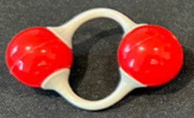 | oxygen | O₂
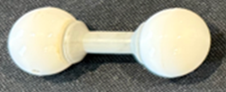 | hydrogen | H₂
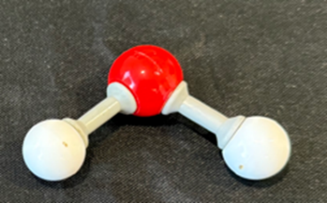 | water | H₂O
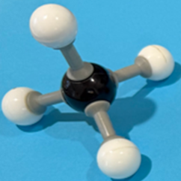 | methane | CH₄
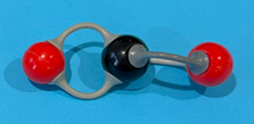 | carbon dioxide | CO₂
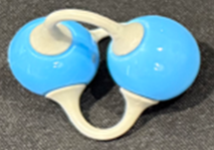 | nitrogen | N₂
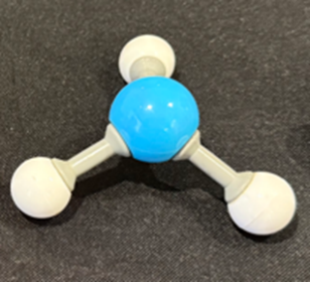 | ammonia | NH₃
- Use the molecular model kits to construct the reactants and products for the following word equations. Count the number of each type of atom in the reactants and compare it to the number of atoms in the products. If they are not equal on either side (reactants or products), make more models until they are balanced. Write a balanced chemical equation under the word equation.
- hydrogen + oxygen → water
- water → hydrogen + oxygen
- methane + oxygen → carbon dioxide + water
- nitrogen + hydrogen → ammonia
- Balance the following equations.
- N₂ + O₂ → NO₂
- Na₂CO₃ → Na₂O + CO₂
- HCl + Ca → CaCl₂ + H₂
- Na + H₂O → NaOH + H₂
- Al(OH)₃ + H₂SO₄ → Al₂(SO₄)₃ + H₂O
- C₂H₅OH + O₂ → CO₂ + H₂O

1.5 Chemical reactions
Table 25 – learning intentions and success criteria for ‘1.5 Chemical reactions’
We are learning: | I can:
- to describe a range of chemical reactions | - distinguish between synthesis, decomposition and displacement reactions  - write balanced equations, including the states of the chemical, for synthesis and decomposition reactions when given the reactants and products  - predict the products of, and write word and balanced equations for displacement reactions
- to follow a planned procedure to undertake a safe investigation. | - assemble and use identified equipment to conduct an investigation  - use appropriate personal protective equipment  - identify the steps to minimise or eliminate the risks.

Synthesis reactions
Checkpoint 1: activate prior knowledge by asking students to identify 2 indicators of a chemical reaction using RXN PPT ‘1.5 Checkpoint 1’.
- Before the lesson, order the equipment indicated in the Student resource – synthesis reactions for each group of students.
- Use RXN PPT ‘1.5 Synthesis of water’ to illustrate the formation of a new substance through the rearrangement of atoms. Refer students back to the previous activity where they broke and formed bonds with the molecular model kits.
- Describe the essential features of a synthesis reaction using RXN PPT ‘1.5 Synthesis reactions’ (slide 1 of 2) and illustrate with further examples in RXN PPT ‘1.5 Synthesis reactions’ (slide 2 of 2).
- Provide students with a copy of the Student resource – synthesis reactions. Read through the procedure and lead a discussion on the safety precautions to be followed during the investigation. Guide students in identifying the risks and ways to mitigate them.
Note: magnesium burns extremely hot and produces a very bright light. Caution students against touching the burning magnesium or looking directly at the flame. It may take a while for the magnesium to ignite, but instruct students that as soon as it does, they should look away and observe only through their peripheral vision. Magnesium burns best when held at the top of the ‘blue cone’ in the Bunsen burner flame and it may take a while. In the images below, the crucible had relatively thin walls. It worked extremely well.
- Students follow the procedure in Student resource – synthesis reactions to burn magnesium to form magnesium oxide to illustrate a synthesis reaction and make observations of the indicators of a chemical reaction.
Figure 3 – magnesium and the crucible before burning
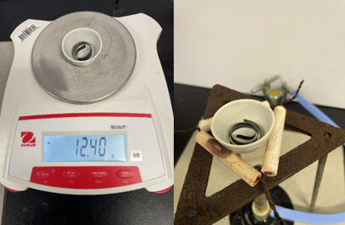
Figure 4 – set-up for the synthesis of magnesium oxide in a crucible
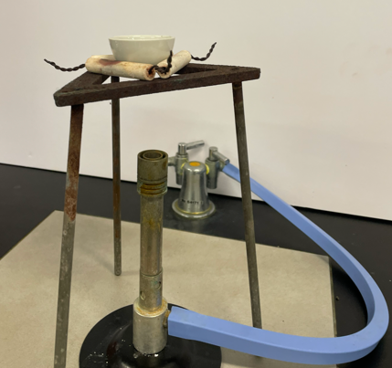
Figure 5 – magnesium and the crucible after burning
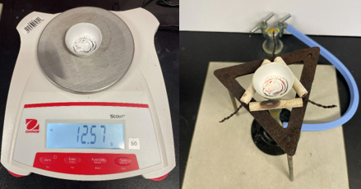
- Discuss the results and guide students through follow-up questions 1 to 6 in Student resource – synthesis reactions.
- Introduce the inclusion of states in equations using the combustion of magnesium reaction that was just completed using RXN PPT ‘1.5 – States’ and ask students to add states to their answer for question 5.
- Have a class discussion to identify the states of each component of synthesis reactions identified in RXN PPT ‘1.5 – Balancing synthesis equations with states’ (2 slides). Then, students balance the reactions in question 7 by adding states and coefficients.
Sample response: Student resource – synthesis reactions
Note: additional stimulus information has been removed from the sample response.
Results
Table 26 – results for the synthesis reaction
Mass of magnesium and crucible before burning (g) | Mass of magnesium and crucible after burning (g) | Change in mass (g)
12.4 | 12.57 | + 0.17
Follow-up questions
- What was the white powder that formed during the reaction?
Magnesium oxide.
- During the reaction, the magnesium reacted with oxygen to form magnesium oxide. Write a balanced equation for the reaction.
2Mg(s) + O₂(g) → 2MgO(s)
- Explain the change in mass.
When magnesium reacted with oxygen to form magnesium oxide, the mass of the gaseous oxygen was added to the mass of the solid magnesium, increasing its mass.
- Balance the following synthesis equations, including appropriate states.
2H₂(g) + O₂(g) → 2H₂O(l)
4Fe(s)+ 3O₂(g) → 2Fe₂O₃(s)
N₂(g) + 2O₂(g) → 2NO₂(g)
C(s) + O₂(g) → CO₂(g)

Student resource – synthesis reactions
Follow the procedure to observe the synthesis of magnesium oxide.
Equipment list
- 1 × Bunsen burner  - 1 × 15 cm strip of magnesium  - 1 × pipe clay triangle | - 1 × crucible  - 1 × electric balance  - 1 × tripod
Procedure
Caution: do not look directly at the burning magnesium.
- Clean the magnesium with emery paper.
- Loosely curl the magnesium into a ball so it fits in the crucible.
- Weigh the crucible and magnesium and record the combined mass
- Set up the apparatus as shown in Figure 1.
Figure 1 – set-up for the synthesis of magnesium oxide
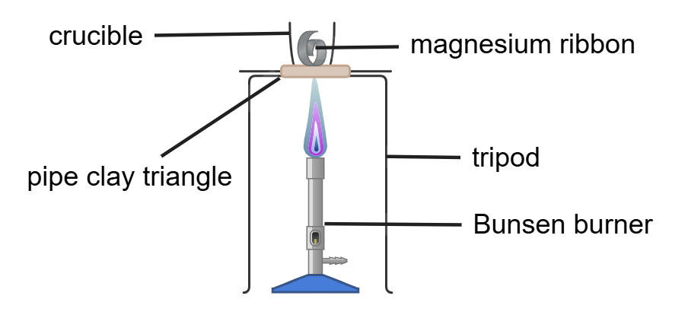
- Heat the crucible until the magnesium ignites
- When it stops burning, allow it to cool and then reweigh the crucible and contents.
Results
Table 1 – results for synthesis reaction
Mass of magnesium and crucible before burning (g) | Mass of magnesium and crucible after burning (g) | Change in mass (g)
Follow-up questions
- What was the white powder that formed during the reaction?
- During the reaction, the magnesium reacted with oxygen to form magnesium oxide. Write a balanced equation for the reaction.
- Explain the change in mass.
- Balance the following synthesis equations, including appropriate states.
H₂ + O₂ → H₂O
Fe + O₂ → Fe₂O₃
N₂ + O₂ → NO₂
C + O₂ → CO₂

Decomposition reactions
- Before the lesson, order the equipment required for the decomposition reactions investigations, including a voltameter if available. The equipment is outlined in Table 27.
Table 27 – equipment requirements
Investigation | Equipment list
Electrolysis of water demonstration | - Hofmann voltameter  - 1 × power pack  - 2 × electrical wires with banana plugs or alligator clips  - A few drops of 0.5 Mol L⁻¹ sulfuric acid
Decomposition of copper carbonate | - Copper carbonate powder  - 1 × side-arm test tube or test tube with stoppered delivery tube, as shown in Figure 1 of Student resource – decomposition reactions.  - Limewater (calcium hydroxide solution)  - 1 × Bunsen burner  - Safety glasses
- Outline the characteristics of decomposition reactions using the decomposition of water as an example, using RXN PPT ‘1.5 – Decomposition reactions’ (2 slides).
- Demonstrate the decomposition of water by electrolysis using a Hofmann voltameter. A photo of the apparatus in use is in RXN PPT ‘1.5 Decomposition of water’. Test the gases to show students the confirmatory tests for oxygen and hydrogen gas.
Figure 6 – a ‘before’ and ‘after’ diagram showing the electrolysis of water
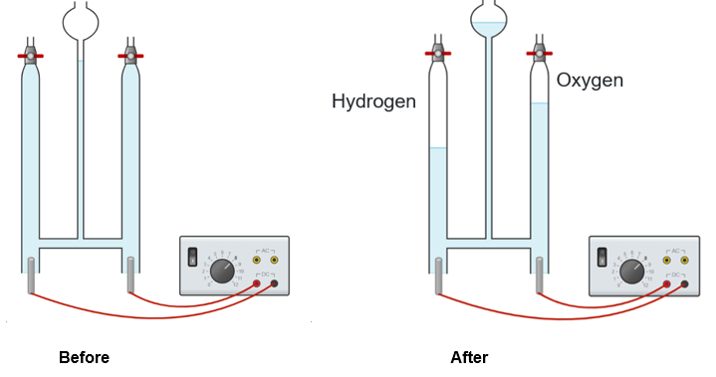
Image created using Chemix and is licensed under the Chemix Terms of Service.
Electrolysis of water demonstration
Use a 0.5 Mol L⁻¹ sulfuric acid solution instead of distilled water to ensure it conducts electricity. Pure water will not conduct electricity. Connect the leads to the DC and set the transformer to 8 V. Bubbles of gas will begin to form at the electrodes, displacing water from the tubes. Hydrogen will form at the negative electrode. Oxygen will form at the positive electrode.
Gas tests
Collect a sample of the gas from the negative electrode into a test tube and place a lit match in the mouth of the test tube. If a loud pop sound is heard, this confirms that the gas is hydrogen.
Collect a sample of the gas from the positive electrode in a test tube and place a glowing splint into the test tube. If it re-ignites, this confirms that the gas is oxygen.
Important note: ignite the gases well away from the voltameter. Do not light the gas directly from the voltameter tap.
- Show slide RXN PPT ‘1.5 – Decomposition of copper carbonate’ to illustrate the set-up for the practical investigation to decompose copper carbonate.
Note: select whichever set-up matches the available equipment. If students hold the test tubes in test tube holders, ensure the mouths of the test tubes point away from them. Also, stress that it is essential to disconnect the tube from the limewater before removing the heat. Amend the student resource to suit your equipment set-up.
- Students follow the procedure in Student resource – decomposition reactions to decompose copper carbonate.
- Allow students the opportunity to attempt follow-up questions 1 to 4, then lead a class discussion to guide students to the correct answers.
- Students write balanced equations for more decomposition reactions Student resource – decomposition reactions. They may need some assistance with writing the states of the reactants and products.
- Discuss the answers using slide RXN PPT ‘1.5 Energy and decomposition reactions’ and then tell students that decomposition reactions require an input of energy and identify the type of energy required for each of the reactions they just balanced.
Sample response: Student resource – decomposition reactions
Note: additional stimulus information has been removed from the sample response.
- Record your observations below.
What happened to the copper carbonate? | It turned black.
What else was produced? | Bubbles of gas were produced.
What happened to the limewater? | It turned cloudy.
- Which observations indicated a chemical reaction?
The colour change of the copper carbonate and the production of gas suggest that a new substance has formed. These are the indicators of a chemical change.
- What did the observations about the limewater indicate?
The gas produced during the decomposition of copper carbonate was carbon dioxide.
- There are only 2 products from the decomposition of copper carbonate. Given your answer to question 3, try to complete the equation.
CuCO₃(s) → CuO(s) + CO₂(g)
More decomposition reactions
Balance the following decomposition equations, including appropriate states.
2H₂O(l) → 2H₂(g) + O₂(g)
2H₂O₂(l) → 2H₂O(l) + O₂(g)
Na₂CO₃(s) → Na₂O(s) + CO₂(g)
CaCO₃(s) → CaO(s) + CO₂(g)
2AgCl(s) → 2Ag(s) + Cl₂(g)

Student resource – decomposition reactions
Follow the procedure to observe the decomposition of copper carbonate.
Equipment list
- 1 × spatula of copper carbonate powder  - 1 × side-arm test tube or test tube with stoppered delivery tube as shown in Figure 1 | - 20 mL limewater  - 1 × Bunsen burner  - Safety glasses
Procedure
- Place a spatula of copper carbonate in the test tube.
- Half-fill a second test tube with limewater.
- Connect the test tube using a delivery tube, similar to Figure 1 below.
Figure 1 – decomposition of copper carbonate apparatus
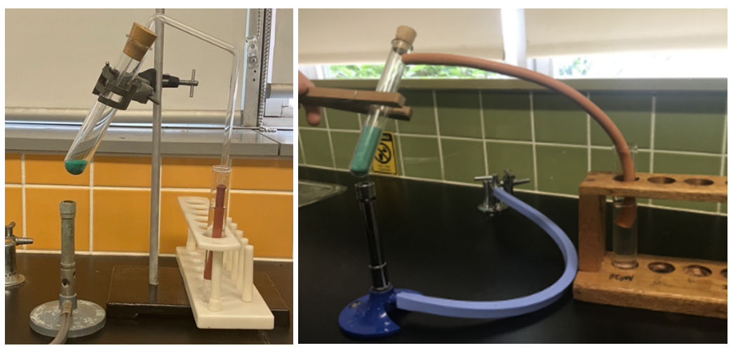
- Heat the copper carbonate and record your observations.
Do not remove the Bunsen burner until you have removed the tube from the limewater. When you stop heating, the test tube cools and the gas inside contracts, creating a partial vacuum. This can pull limewater through the tubing and back into the hot test tube, which may crack the hot glass.
Follow-up questions
- Record your observations below.
What happened to the copper carbonate?
What else was produced?
What happened to the limewater?
- Which observations indicated a chemical reaction?
- What did the observations about the limewater indicate?
- There are only 2 products from the decomposition of copper carbonate. Given your answer to question 3, try to complete the equation.
CuCO₃(s) →
More decomposition reactions
Balance the following decomposition equations, including appropriate states.
H₂O → H₂ + O₂
H₂O₂ → H₂O + O₂
Na₂CO₃ → Na₂O + CO₂
CaCO₃ → CaO + CO₂
AgCl → Ag + Cl₂

Displacement reactions
- Define ‘displacement reactions’ as a chemical reaction in which one atom (or group of atoms) is replaced by another atom (or group of atoms) in a compound using RXN PPT ‘1.5 Displacement reactions’.
- Explain that a more active metal will displace a less active metal from solution. RXN PPT ‘1.5 Metal displacement’ shows zinc displacing copper from a solution, with zinc and copper as an example.
Note: metals react by donating their valence (outer-shell) electrons. More reactive metals, such as sodium, tend to give up their electrons easily, while less reactive metals, such as gold and copper, hold onto them more tightly and are less likely to release their valence electrons. The activity series of metals, discussed later, ranks metals by reactivity.
- Demonstrate metal displacement by placing steel wool (iron) in a 1 Mol L⁻¹ solution of copper sulfate. Leave it in long enough to show the solid copper forming on the steel wool.
Figure 7 – iron (steel wool) displacing copper from the solution
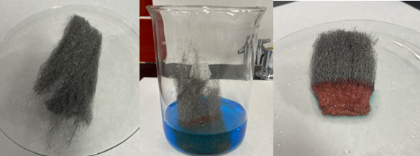
- Tell students:
- The blue solution in the beaker is copper sulfate, consisting of copper cations (Cu²⁺) and sulfate anions (SO₄²⁻).
- The steel wool contains iron (Fe). When steel wool is immersed in a copper sulfate solution, the iron atoms lose their valence electrons and become iron cations (Fe²⁺), which dissolve in the solution.
- The released electrons are captured by copper cations, which are reduced to form copper metal (Cu).
- The copper metal deposits as a reddish film on the steel wool because it is insoluble in water. Consequently, the original copper sulfate solution is gradually transformed into iron sulfate.
- This process is known as a ‘displacement reaction’, where iron displaces copper from the solution. The visual sign of this change is the solution turning from blue to colourless.
Checkpoint 2: ask students to write the word equation for the demonstration using RXN PPT ‘1.5 Checkpoint 2’.
Iron (s) + copper (II) sulfate (aq) → copper(s) + iron (II) sulfate (aq)
- Introduce the activity series using RXN PPT ‘1.5 Activity series of metals’ and explain how to use it to predict the products of metal displacement reactions. The speaker notes provide detailed guidance for unpacking the activity series with students.
RXN PPT ‘1.5 Activity series of metals’ ranks metals from most reactive to least reactive, based on how readily they lose their valence electrons in chemical reactions. Metals higher up this series react readily with substances such as water, oxygen, and acids, while metals at the bottom are more stable and less likely to react. The activity series helps us predict the products of chemical reactions, particularly displacement reactions, in which a more reactive metal can displace a less reactive metal from its compound.
In addition to predicting the products of metal displacement reactions, it also helps to explain real-world applications, such as:
- rusting and corrosion prevention: a more reactive metal, such as zinc, is coated on iron and it ionises in preference to iron, thus preventing rusting of iron
- some metals like sodium, calcium, magnesium and aluminium require more energy to extract from their ores as compared to the less reactive metals like copper or gold.
Checkpoint 3: ask students which combination of reactants would produce a reaction and complete the word equation using RXN PPT ‘1.5 Checkpoint 3’.
calcium (s) + magnesium nitrate (aq) → calcium nitrate (aq) + magnesium (s)

Acid metal reactions
- Before the lesson, order the equipment outlined in the Student resource – acid metal reactions for each group of students.
- Tell students that when metals react with acids, the metals displace the hydrogen from the solution and are also considered displacement reactions.
- Use the slide RXN PPT ‘1.5 Acid metal reactions’ to guide students in how to predict the products of acid-base reactions:
- provide the general equation: acid + metal → salt + hydrogen→
- identify that a salt is an ionic compound
- outline how to write the word equation for a reaction between magnesium and hydrochloric acid.
- Display RXN PPT ‘1.5 Common acids and the salts they produce’ and outline:
- the table shows some common acids and the salts they produce
- in a salt, the positive ion (cation) comes from the metal and the negative ion (anion) from the acid
- different examples of common acids reacting with a metal and show that hydrogen gas is always produced.
- Students follow the procedure in the Student resource – acid metal reactions to conduct a qualitative investigation into the reaction between magnesium and hydrochloric acid. Students confirm the gas is hydrogen using the pop test.
- Students write word equations for acid + metal reactions in Student resource – acid metal reactions. Use RXN PPT ‘1.5 Writing the balanced equation’ to model how to write the balanced equation.
- Allow students the opportunity to attempt the follow-up questions, then lead a class discussion to guide students to the correct answers.
Differentiation: this resource focuses only on 3 common acids and group 1 and 2 metals for simplicity. Students could be exposed to a greater range of acids and metals.
Note: this slide outlines steps for writing the word equation. In the resource, the first few examples students complete will be for reactions for which they have already written word equations. When students are asked to produce a balanced equation from the names of the reactants, it can be quite overwhelming, so it is important to break it down step by step. The slide also shows where students need to access information from to address each component. When working through the slide, make sure students have access to a periodic table and the table mentioned in the notes.
Sample response: Student resource – acid metal reactions
Note: additional stimulus information has been removed from the sample response.
Follow-up questions
- Describe 2 observations when you added the magnesium to the acid.
Bubbles of gas were produced. The magnesium seemed to disappear.
- What did these observations indicate?
A new substance was formed, indicating a chemical reaction occurred.
- What happened when you exposed the gas to the match?
The gas was ignited and a pop sound was heard.
- What did this indicate?
The gas was hydrogen.
- Given your answer to question 4, complete the following chemical equation and balance it.
Mg + 2HCl → MgCl₂ + H₂
Writing equations for acid-metal reactions
- Complete the word equations.
hydrochloric acid + sodium → sodium chloride + hydrogen
nitric acid + calcium → calcium nitrate + hydrogen
sulfuric acid + magnesium → magnesium sulfate + hydrogen
hydrochloric acid + potassium → potassium chloride + hydrogen
nitric acid + sodium → sodium nitrate + hydrogen
sulfuric acid + potassium → potassium sulfate + hydrogen
- Write balanced equations for these reactions.
hydrochloric acid + sodium → sodium chloride + hydrogen
2HCl + 2Na → 2NaCl + H₂
nitric acid + calcium → calcium nitrate + hydrogen
2HNO₃ + Ca → Ca(NO₃)₂ + H₂
sulfuric acid + magnesium → magnesium sulfate + hydrogen
H₂SO₄ + Mg → MgSO₄ + H₂
hydrochloric acid + lithium → lithium chloride + hydrogen
2HCl + 2Li → 2LiCl + H₂
nitric acid + potassium → potassium nitrate + hydrogen
2HNO₃ + 2K → 2KNO₃ + H₂
sulfuric acid + calcium.→ calcium sulfate + hydrogen
H₂SO₄ + Ca → CaSO₄ + H₂

Student resource – acid metal reactions
When metals react with acids, they displace hydrogen from the solution and are considered displacement reactions.
General equation: acid + metal → salt + hydrogen
Example: hydrochloric acid + magnesium → magnesium chloride + hydrogen
A salt is an ionic compound. This reaction involves the combination of a metal (magnesium) with the acid's negative ion (chloride).
Practical investigation
Follow the procedure to observe the reaction of magnesium and hydrochloric acid.
Equipment list
- 3 cm strip of magnesium  - 1 Mol L⁻¹ hydrochloric acid | - 1 × medium test tube and stopper  - Safety glasses
Procedure
- Add 1 Mol L⁻¹ HCl to a medium test tube until it is approximately one-third full.
- Add a 3 cm strip of magnesium to the acid and loosely stopper the tube as seen in Figure 1.
- Once enough gas has been produced that it is pushing the stopper out, light a match, unstopper the test tube and bring the match to the mouth of the test tube as shown in Figure 2.
Figure 1 – magnesium in hydrochloric acid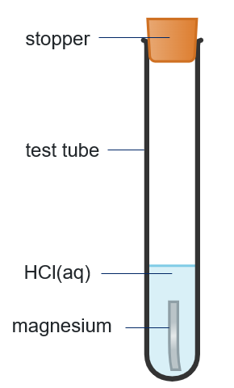 | Figure 2 – testing the gas  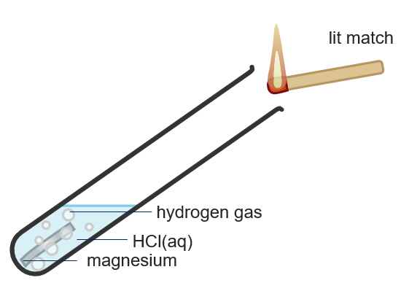
Follow-up questions
- Describe 2 observations when you added the magnesium to the acid.
- What did these observations indicate?
- What happened when you exposed the gas to the match?
- What did this indicate?
- Given your answer to question 4, complete the following chemical equation and balance it.
Mg + HCl →
Writing equations for acid-metal reactions
Table 1 – common acids and the salts they produce
Acid name | Formula | Salt
hydrochloric acid | HCl | metal chloride
sulfuric acid | H₂SO₄ | metal sulfate
nitric acid | HNO₃ | metal nitrate
- Complete the word equations.
hydrochloric acid + sodium →
nitric acid + calcium →
sulfuric acid + magnesium →
hydrochloric acid + potassium →
nitric acid + sodium →
sulfuric acid + potassium →

Steps for writing the balanced equation
- Recall the general equation: acid + metal → salt + hydrogen
- Determine the salt produced (refer to Table 1).
- Write the word equation.
For example: hydrochloric acid + magnesium → magnesium chloride + hydrogen
- Work out the formula of each species. For example:
- hydrochloric acid is HCl (recall from Table 1)
- magnesium is Mg (symbol from periodic table)
- magnesium chloride is MgCl2 (use valencies from periodic table or Table 2 for polyatomic ions)
- hydrogen is H2 (remember it is diatomic).
- Write down the formulas, then balance the reactants and products. For example:
2HCl(aq) + Mg(s) → MgCl2(aq) + H2(g)
Table 2 – polyatomic ions
Name | Formula | Valency
sulfate | SO₄²⁻ | 2
carbonate | CO₃²⁻ | 2
nitrate | NO₃⁻ | 1
hydroxide | OH⁻ | 1
- Write balanced equations for these reactions.
hydrochloric acid + sodium →
nitric acid + calcium →
sulfuric acid + magnesium →
hydrochloric acid + lithium →
nitric acid + potassium →
sulfuric acid + calcium →

1.6 The pH scale
Table 28 – learning intentions and success criteria for ‘1.6 The pH scale’
We are learning: | I can:
- to describe a range of chemical reactions | - define acidic and basic substances  - define the pH scale  - classify common substances as acidic or basic based on their pH
- to follow a planned procedure to undertake a safe and reliable investigation. | - identify hazards, determine potential risks and relevant control measures  - follow steps in the procedure to systematically record pH and colour change data for a range of chemical substances.

pH of common substances
- Before starting this lesson sequence, remind students that many substances they use every day, such as vinegar, lemon juice in salad dressings, baking soda in making cakes and soap for cleaning, have different levels of acidity or basicity. In this topic, they will learn to:
- identify whether a substance is acidic, neutral or basic;
- measure pH
- understand how the pH scale classifies and compares the acidity and basicity of a range of chemical substances.
- Show RXN PPT ‘1.6 Acidity and basicity’ to:
- define the terms ‘acid’ and ‘base’ in terms of hydrogen ions and hydroxide ions
- point out that the acids are covalent molecular substances, but they produce hydrogen ions in aqueous solutions, as illustrated by the model of HCl
- highlight how bases are different, as illustrated by the NaOH lattice, which dissociates into the constituent ions Na⁺ and OH⁻
- remind students that an aqueous solution is a substance dissolved in water
- emphasise that the definitions of acids and bases, acids releasing hydrogen ions (H⁺) and bases releasing hydroxide ions (OH⁻) are only valid when the substances are dissolved in water.
- Use the slide RXN PPT ‘1.6 What is pH?’ to define the term ‘pH’ and how it relates to the concentration of hydrogen ions.
- Show slide RXN PPT ‘1.6 Logarithmic scale versus a linear scale’ to unpack how the logarithmic scale is different from the linear scale and why it is essential to use a logarithmic scale for pH.
- Use slide RXN PPT ‘1.6 pH scale’ to show the range of the pH scale and highlight how the colours on the universal indicator colour chart correspond to this scale.
- Identify the different ways to measure pH using slide RXN PPT ‘1.6 How can we measure pH?’ and outline the differences between using a pH meter and an indicator.
- Use slides RXN PPT ‘1.6 pH simulation’ (4 slides) to give stepwise instructions for using the PhET simulation pH scale.
- Instruct students to complete Student resource – the pH scale using information from the simulation. Guide students to compare the pH of chemical substances in the table with that of pure water, classify them as acidic, basic or neutral and answer the questions.
Checkpoint: instruct students to refer to the stimulus in the RXN PPT ‘1.6 Checkpoint’ to compare the pH values of different substances with the pH of pure water to determine whether they are acidic or basic, and to answer the question using mini whiteboards or in their workbooks.
Refer to the pH values given in Table 29 below and choose the correct option.
  - Vinegar is more acidic than lemon juice because its higher pH means a more acidic solution.
- Baking soda is slightly acidic because its pH is higher than that of water.
- Lemon juice is similar to vinegar in acidity, as their pH values are not significantly different.
- Baking soda is slightly basic because its pH is higher than that of water.
Table 30 contains an explanation for each response.
Table 29 – pH data for various substances
Substance | pH
Pure water | 7.0
Vinegar | 3.0
Baking soda | 9.0
Lemon juice | 2.0
Oven cleaner | 12
Table 30 – the explanation for correct and incorrect responses
Option | Explanation
A | Incorrect. Vinegar has a higher pH (3) than lemon juice (2) which means it is less acidic.
B | Incorrect. Baking soda is basic, not acidic, because its pH value is higher than that of pure water.
C | Incorrect. Lemon juice is more acidic than vinegar because it has a lower pH. The pH scale is logarithmic. Although the pH of lemon juice differs by one, the concentration of hydrogen ions is 10 times higher in lemon juice than in vinegar.
D | Correct. Baking soda is slightly basic because its pH is higher (9) than water's (7), but it is not very high, such as 13 or 14.
Sample response: Student resource – the pH scale
Note: additional stimulus information has been removed from the sample response.
pH of common substances
Complete the second column of the table by running the PhET simulation pH scale. Complete the last column by classifying each substance as acidic, basic or neutral based on its pH value.
Table 31 – pH of chemical substances
Substance | pH | Acidic, basic or neutral
Battery acid | 1:00 | Very acidic because its pH is much lower than 7.
Blood | 7.40 | Mildly basic because its pH is slightly higher than 7.
Chicken soup | 5.80 | Acidic because its pH is lower than 7.
Coffee | 5.00 | Acidic because its pH is lower than 7.
Drain cleaner | 13.00 | Very basic because its pH is much higher than 7.
Hand soap | 10.00 | Basic because its pH is higher than 7.
Milk | 6.50 | Mildly acidic because its pH is closer to 7.
Orange juice | 3.50 | Acidic because its pH is much lower than 7.
Soda pop | 2.50 | Acidic because its pH is much lower than 7.
Spit | 7.50 | Slightly basic because its pH is much lower than 7.
Vomit | 2.00 | Very acidic because its pH is much lower than 7.
Water | 7.00 | Neutral.
- Rank the following substances from the most acidic (first) to the most basic (last).
Word bank: water, coffee, orange juice, battery acid, drain cleaner, blood
Provide your ranking and the reasoning behind your ranking.
- Battery acid (most acidic)
- Orange juice
- Coffee
- Water
- Blood
- Drain cleaner (most basic)
The ranking is determined by comparing the pH values. The lower the pH, the more acidic the substance. The higher the pH, the more basic the substance.
- What patterns do you notice between the pH of substances and their use in everyday life?
Generally, food items such as orange juice, chicken soup and coffee are slightly acidic, whereas cleaners, such as detergents and drain cleaners, are basic. Some chemicals, such as battery acid, have a very low pH. Blood, milk and water have pH values close to neutrality.

Student resource − the pH scale
Introduction
‘pH’ is a logarithmic scale used in science to show how many hydrogen ions are in a solution. It shows the quantitative measure of acidity or basicity of aqueous or other liquid solutions. The pH scale goes from zero to 14:
- A pH of 7 means the solution is neutral (like water).
- A pH less than 7 means the solution is acidic (like lemon juice).
- A pH greater than 7 means the solution is basic or alkaline (like soap or baking soda).
The lower the pH, the more acidic it is. The higher the pH, the more basic it is.
Figure 1 – the colour range of the universal indicator with the corresponding pH values
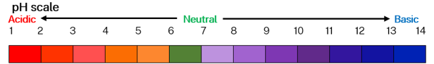
pH of common substances
Complete the second column of the table by running the PhET simulation pH scale. Complete the last column by classifying each substance as acidic, basic or neutral based on its pH value.
Table 1 – pH of chemical substances
Substance | pH | Acidic, basic or neutral
Battery acid
Blood
Chicken soup
Coffee
Drain cleaner
Hand soap
Milk
Orange juice
Soda pop
Spit
Vomit
Water
- Rank the following substances from the most acidic (first) to the most basic (last).
Word bank: water, coffee, orange juice, battery acid, drain cleaner, blood
Provide your ranking and the reasoning behind your ranking.
- What patterns do you notice between the pH of substances and their use in everyday life?

Testing household chemicals with a natural indicator
- Introduce the concept of natural indicators by telling students that natural indicators are substances found in plants that change colour when they come into contact with acids or bases. Give examples such as red cabbage, beetroot, turmeric, tea, and flowers like petunia and rose.
- Use an example of red cabbage and explain that red cabbage contains a natural pigment called anthocyanin, which changes colour in acidic and basic substances. This makes red cabbage a natural pH indicator. State that:
- in acidic solutions, the indicator turns red or pink
- in neutral solutions, it stays purple
- in alkaline solutions, it turns blue, green, or yellow depending on the base. If it is mildly basic, the colour is blue or green, but for very basic solutions, it is yellow.
- Tell students the pigment is extracted by blending red cabbage with water or soaking it in hot water. The resulting purple solution can be used to test a variety of household substances. They will be investigating red cabbage.
- Provide the preprepared red cabbage indicator to students. The procedure for preparing the indicator can be found in Preparation of a red cabbage indicator.
- Refer to the Student resource – testing household chemicals with a natural indicator for equipment and the list of household chemicals. Outline the steps in the procedure and demonstrate how to use the indicator to test household chemicals.
- Discuss the follow-up investigation questions with students.
Figure 8 – equipment set-up and results for testing household chemicals with a natural indicator and a universal indicator
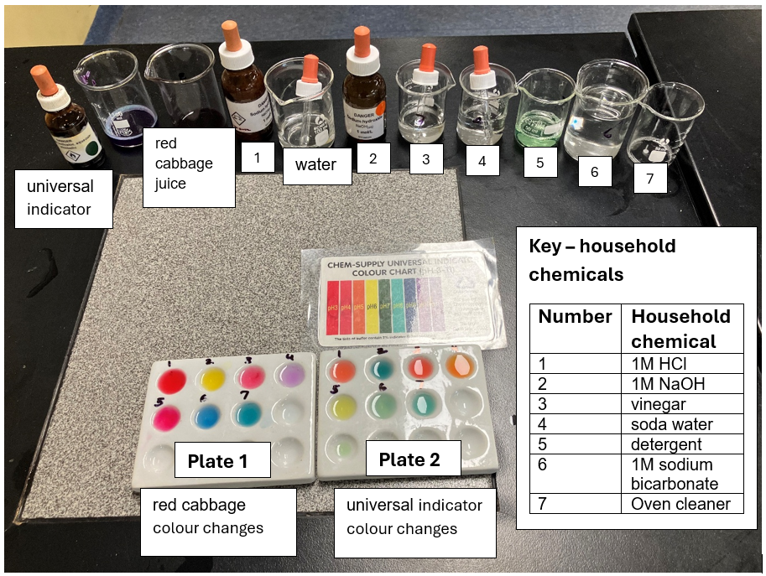
- Instruct students to complete the experiment, record their observations in the results table and answer the discussion questions.
Preparation of a red cabbage indicator
- Chop a quarter of a red cabbage into small pieces. Smaller pieces help release more pigment.
- Place the chopped cabbage into a blender.
- Add about 100 mL of water, just enough to cover the cabbage. Add a little more water if needed.
- Blend the mixture until the cabbage is finely pulped and the water turns a deep purple colour.
- Sieve or filter the blended mixture using a strainer or filter paper to separate the liquid from the cabbage pieces.
- Collect the purple liquid in a clean container. This is your red cabbage indicator.
Note: if a blender is not available, skip to the alternative method below.
Alternative method (without a blender)
- Place the chopped cabbage leaves into a 500 mL beaker.
- Pour boiling water over the leaves until they are fully covered.
- Leave the mixture to sit for 10 to 15 minutes. The hot water helps the pigment dissolve.
- Strain the liquid into another beaker to remove the leaves.
- Cool the indicator before use.
Note: if you want students to prepare the red cabbage indicator, include the procedure in the student resource.
Sample response: Student resource – testing household chemicals with a natural indicator
Note: additional stimulus information has been removed from the sample response.
Risk assessment
Table 32 – risk assessment for testing household chemicals with a natural indicator investigation
Hazard | Risk | Control measures
Household chemicals like soda water, vinegar and sodium bicarbonate | Skin or eye irritation | - Wear safety glasses.  - Avoid spills and clean up immediately.
Detergent, oven cleaner | Skin or eye irritation | - Wear safety glasses.  - Rinse immediately if contact occurs.
Glassware | Cuts or breakage | - Handle carefully.  - Report broken glass and dispose of it according to the teacher's instructions.
Universal indicator | Staining of skin or clothing | - Avoid spills.  - Wash hands with soap after use.
Results
Table 33 – observations for testing household chemicals with a natural indicator and a universal indicator
Well number | Household chemical | Colour with red cabbage indicator | Colour with universal indicator | Estimated pH | Classification
1 | 1 Mol L⁻¹ HCl | Dark red | Red | 3 or below | Acid
2 | 1 Mol L⁻¹ NaOH | Yellow | Blue | 9 | Base
3 | Vinegar | Pink | Light red | 4–5 | Acid
4 | Soda water | Light purple | Orange | 5–6 | Acid
5 | Detergent | Dark purple | Yellow | 6 | Acid
6 | 1 Mol L⁻¹ sodium bicarbonate | Blue | Light green | 8 | Base
7 | Oven cleaner | Green | Bluish green | 9 | Base
Discussion questions
- Which household chemicals are acidic? Use the evidence from the results table to support your response.
Hydrochloric acid, soda water, vinegar and detergent are acidic. The red cabbage indicator turned pink or red, and the universal indicator turned red, orange or yellow in these solutions. The estimated pH from the universal indicator colour chart was about 3 to 6, supporting this classification.
- Which chemicals were basic? Use the evidence from the results table to support your response.
Sodium hydroxide, sodium bicarbonate and oven cleaner were basic. The red cabbage indicator turned blue, green or yellow, and the universal indicator turned blue or purple. The estimated pH was around 9 to 11.
- Is the universal indicator more useful than the red cabbage indicator for determining whether the given substance is acidic, basic or neutral? Give reasons for your response.
The universal indicator is more useful than the red cabbage indicator for determining whether a substance is acidic, basic or neutral. This is because the universal indicator produces a wide range of colours that correspond to estimated pH values on a colour chart. For example, a red colour indicates an acidic solution (pH about 1 to 3), orange or yellow indicates a mildly acidic solution (pH about 4 to 6) and green indicates a neutral solution (pH 7). Similarly, light blue indicates a mildly basic solution (pH about 8 to 9). Dark blue or purple indicates a basic solution (pH about 11 to 14).
The red cabbage indicator also changes colour in response to acids and bases, but it shows fewer distinct colour changes, making it harder to match to specific pH values.

Student resource – testing household chemicals with a natural indicator
Background information
Red cabbage contains a pigment called anthocyanin, which changes colour in acidic and basic substances. This makes red cabbage a natural pH indicator.
The pigment is extracted by blending the red cabbage with water or soaking it in hot water. The resulting purple solution can be used to test a variety of household substances:
- In acidic solutions, the indicator turns red or pink.
- In neutral solutions, it stays purple.
- In alkaline solutions, it turns blue, green, or yellow depending on the base. If it is mildly basic, the colour is blue or green, but for very basic solutions, it is yellow.
You will investigate the colour change of red cabbage in different household chemicals.
The purpose of this investigation is to compare the colour changes of a natural indicator (red cabbage indicator) with a universal indicator when testing household chemicals and classifying them as acidic, basic or neutral.
Equipment list
- Universal indicator (dropper bottle) | - White vinegar
- 1 Mol L⁻¹ hydrochloric acid (dropper bottle) | - Soda water
- 1 Mol L⁻¹ sodium hydroxide (dropper bottle) | - Detergent
- 1 Mol L⁻¹ sodium bicarbonate solution (dropper bottle) | - Oven cleaner
- Spotting plates | - Droppers
- Red cabbage indicator | - 6 × 50 ml beakers
- Universal indicator colour chart
Risk assessment
Use the information on the chemical labels and the equipment used to identify hazards and complete the risk assessment table below.
Table 1 – risk assessment for testing household chemicals with a natural indicator investigation
Hazard | Risk | Control measures
Figure 1 – equipment set-up for testing household chemicals with a natural indicator investigation
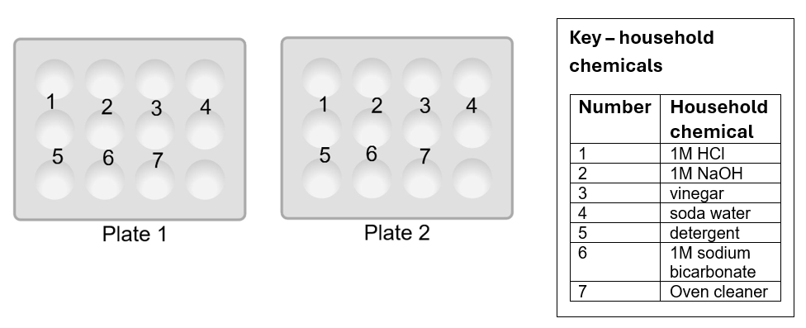
Image created using Chemix and is licensed under the Chemix Terms of Service.
Procedure
- Label 2 spotting plates with wells numbered one to 7, using a marker.
- Add 5 drops of each household chemical to the corresponding wells on both plates.
- Add one drop of red cabbage indicator to each well on Plate 1.
- Add one drop of universal indicator to each well on Plate 2.
- Observe and record the colour changes.
- Compare the colours shown by the natural indicator and the universal indicator.
- Estimate the pH of each substance using a universal indicator colour chart and classify it as acidic, basic or neutral.
Results
Table 2 – observations for testing household chemicals with a natural indicator and a universal indicator
Well number | Household chemical | Colour with red cabbage indicator | Colour with universal indicator | Estimated pH | Classification
1 | 1 Mol L⁻¹ HCl
2 | 1 Mol L⁻¹ NaOH
3 | Vinegar
4 | Soda water
5 | Detergent
6 | 1 Mol L⁻¹ sodium bicarbonate
7 | Oven cleaner
Discussion questions
- Which household chemicals are acidic? Use the evidence from the results table to support your response.
- Which chemicals were basic? Use the evidence from the results table to support your response.
- Is the universal indicator more useful than the red cabbage indicator for determining whether the given substance is acidic, basic or neutral? Give reasons for your response.

1.7 pH changes in a neutralisation reaction
Table 34 – learning intentions and success criteria for ‘1.7 pH changes in a neutralisation reaction’
We are learning: | I can:
- to describe a range of chemical reactions | - define neutralisation reactions  - predict the products of a neutralisation reaction  - describe the changes in pH in neutralisation reactions
- to use the right tools to make accurate observations and measurements | - use digital tools to measure the pH of different chemical substances  - compare how precise the digital and visual methods are in measuring pH
- to follow a planned procedure to undertake a valid investigation. | - use a pH meter to accurately and correctly record pH data  - use universal indicator to estimate the pH of a given solution  - identify errors in the investigation procedure and the use of tools, such as a pH meter, that can impact the results.

Neutralisation reactions
- Show slide RXN PPT ‘1.7 Neutralisation reactions’ (slide 1 of 2) to define ‘neutralisation reactions’ by giving an example. Illustrate the reaction between hydrogen ions and hydroxide ions using the space-filling model shown in the slide.
- Ask students if they have come across any neutralisation reactions in everyday life. Provide some examples, such as using antacid tablets to neutralise stomach acid or sodium bicarbonate to neutralise bee stings.
- Use slide RXN PPT ‘1.7 Neutralisation reactions’ (slide 2 of 2) to outline how to predict the products of a neutralisation reaction based on the type of acid and base used. Recall that, similar to the reaction between an acid and a metal, a salt is also produced during a neutralisation reaction.
Checkpoint: display slide RXN PPT ‘1.7 Checkpoint’. Students predict the salts produced in the neutralisation reactions and write their relevant chemical formulas in their workbooks or on mini whiteboards.
Refer to RXN PPT ‘1.7 Checkpoint – sample answer’ for sample answers.
Table 35 – salts formed in the neutralisation reactions
Acid | Base | Salt | Chemical formula of the salt
hydrochloric acid | sodium hydroxide | sodium chloride | NaCl
sulfuric acid | sodium hydroxide | sodium sulfate | Na₂SO₄
nitric acid | potassium hydroxide | potassium nitrate | KNO₃
hydrochloric acid | calcium hydroxide | calcium chloride | CaCl₂

Investigating pH changes in a neutralisation reaction
- Use slides RXN PPT ‘1.7 Neutralisation reaction examples’ (2 slides) to explain the use of neutralisation reactions in everyday applications such as treating heartburn, testing soil pH and neutralising the acidic soil with bases. Similarly, explain why it is essential to test the pH of wastewater and brushing teeth to prevent tooth decay.
- Refer to the method in the Student resource – investigating pH changes in a neutralisation reaction. Show slides RXN PPT ‘1.7 Equipment set-up for a neutralisation reaction’. Explain that it is essential to calibrate the pH meter to ensure it provides accurate readings.
Note: a pH meter is calibrated by thoroughly rinsing the electrode with distilled water, then immersing it in a pH 7 standard buffer and waiting until the reading stabilises. Repeat this process with at least 2 more standard buffer solutions at pH 4 and 10. Refer to the pH meter manual for instructions on entering and exiting calibration modes.
- Demonstrate to students how to properly clean the pH meter by thoroughly rinsing the bulb of the pH meter with distilled water and wiping it gently with a paper towel. Explain that if the pH meter is not correctly calibrated, it will produce a ‘systematic error’, meaning the same amount will offset every measurement. For example, if the pH of distilled water is measured as 7.4, the reading is consistently 0.4 units higher than the true value. Tell students that if beakers or the pH meter are not rinsed thoroughly, they may contaminate the solutions being tested. This will introduce ‘random errors;, leading to inconsistent and unreliable pH measurements.
- Tell students that molarity, represented as ‘Mol L⁻¹’, is a measure of concentration. It tells us how concentrated a solution is by showing how much of a substance is dissolved in a certain amount of liquid. For example, a 1 Mol L⁻¹ solution is half as concentrated as a 2 Mol L⁻¹ solution and twice as concentrated as a 0.5 Mol L⁻¹ solution.
- Outline the process to dilute the solution. Show students that adding 50% water (5 mL NaOH and 5 mL distilled water) will dilute the solution to half its original concentration, that is, to 0.5 M NaOH. Similarly, adding 80% water (2 mL NaOH and 8 mL water) will dilute it to one-fifth of its original concentration. Refer to the student resource for the dilution procedure.
Table 36 – preparing diluted samples of NaOH
Volume of 1 Mol L⁻¹ NaOH | Volume of distilled water (mL) | Total volume of the solution (mL) | Concentration of NaOH (Mol L⁻¹)
10 | 0 | 10 | 1
5 | 5 | 10 | 0.5
2 | 8 | 10 | 0.2
Differentiation: to support students with learning needs and avoid the complexity around dilution, you can refer to a 0.5 Mol L⁻¹ solution as dilute and a 0.2 Mol L⁻¹ solution as very dilute.
- Students analyse the investigation data. Then, they complete questions related to the investigation and compare the precision of digital tools, such as a pH meter, with visual methods, such as a pH indicator.
Sample response: Student resource – investigating pH changes in a neutralisation reaction
Note: additional stimulus information has been removed from the sample response.
Results
Table 37 – neutralisation of hydrochloric acid with different concentrations of sodium hydroxide
Acid | Base | Initial pH | Final pH | Colour change | Drops of base added
0.1 Mol L⁻¹ HCl | 1 Mol L⁻¹ NaOH | 1.16 | Above 12 | Red to purple | 15–18
0.1 Mol L⁻¹ HCl | 0.5 Mol L⁻¹ NaOH | 1.16 | Above 12 | Red to purple | 30–34
0.1 Mol L⁻¹ HCl | 0.2 Mol L⁻¹ NaOH | 1.16 | Above 12 | Red to purple | 60–64
Questions
- Write a balanced chemical equation for the reaction between sodium hydroxide and hydrochloric acid.
$$NaOH(aq) +HCl(aq)→NaCl(aq) + H_{2}O(l)$$
- Describe how the pH of the hydrochloric acid solution changed as sodium hydroxide was added dropwise.
As sodium hydroxide was added dropwise, the pH gradually increased from a low value (pH 1.17) toward neutrality, then became basic (above 12) when more sodium hydroxide was added. This observation is supported by the universal indicator, which changed from red to orange or yellow, then green, and finally purple as the solution became neutral and then basic.
- Did the number of drops of sodium hydroxide needed to neutralise the hydrochloric acid change with different concentrations of sodium hydroxide solution or stay the same? Explain your reasoning.
Yes, fewer drops of concentrated sodium hydroxide (1 Mol L⁻¹) were needed to completely neutralise the 0.1 Mol L⁻¹ hydrochloric acid than were needed for the very dilute one
(0.2 Mol L⁻¹). For example, 60 drops of 0.2 Mol L⁻¹ sodium hydroxide were required to neutralise HCl completely, compared with only 30 drops of 0.1 Mol L⁻¹ NaOH and 15 drops of
1 Mol L⁻¹ NaOH.
Recall, ‘precision’ is the extent to which repeated measurements of the same item are close to each other. A method is considered more precise if its readings are tightly grouped, showing very little variation from trial to trial.
- You have been given 2 sets of pH readings for the same sample of lemon juice. Each set was collected using a different method:
- Method A: a calibrated digital pH meter
- Method B: universal indicator solution.
The following table shows the pH of lemon juice measured by 2 different methods.
Table 38 – pH results for lemon juice measured by using a pH meter (method A) and universal indicator (method B)
 |  |  | pH
 | Trial 1 | Trial 2 | Trial 3 | Trial 4 | Trial 5 | Trial 6
Method A | 2.18 | 2.19 | 2.18 | 2.20 | 2.20 | 2.19
Method B | 2.0 | 2.0 | 3.0 | 2.0 | 2.0 | 3.0
- Analyse the results given in the table above and state which method is more precise. Explain the reasons for your choice.
Precision is about consistency in repeated measurements. In the first data set (method A), the pH values range from 2.18 to 2.20, a difference of 0.02 units. This shows that each measurement is close to the others, indicating high precision.
In contrast, the values in the second data set (method B vary widely, ranging from 2.0 to 3.0, a difference of 1.0 unit. This large variation means the measurements are inconsistent and are not precise.
- Which of the 2, the universal indicator or the pH meter, provided more accurate results? Why?
A pH meter provides more accurate results as compared to a universal indicator because a calibrated pH meter gives a precise numerical value (up to 2 decimal places) for the pH of a solution, for example, 2.18. A universal indicator only provides an estimated pH based on colour change, such as 2.0, which can be subjective depending on the observer's interpretation.
- Identify the sources of errors that may have affected your results.
The errors may include some or all of the following:
- inconsistent drop sizes
- not rinsing beaker 4 in between repetitions
- not completely drying beaker 4 would dilute the hydrochloric acid solution
- a poorly calibrated pH meter will give inaccurate readings
- difficulty matching colours with the universal indicator colour chart will give errors in the pH.

Student resource – investigating pH changes in a neutralisation reaction
In this task, you will be investigating the changes in pH of an acid when you neutralise it with a base.
Equipment list
- Hydrochloric acid 0.1 Mol L⁻¹ (30 mL)  - Sodium hydroxide 1 Mol L⁻¹ (25 mL)  - Universal indicator solution  - pH meter  - 4 × 100mL beakers | - Stirring rod  - 10 mL measuring cylinder  - Safety glasses  - 3 × droppers or Pasteur pipettes  - Buffer solution (for calibration)
Procedure
- Label the beakers ‘1’, ‘2’, ‘3’ and ‘4’.
- Add 10 ml of 1 Mol L⁻¹ NaOH to beaker 1.
- Dilute sodium hydroxide using the table below. For example, add 5 mL of 1 Mol L⁻¹ NaOH and 5 mL of distilled water to beaker 2. Similarly, add 2 mL of 1 Mol L⁻¹ NaOH and 8 mL of distilled water to beaker 3.
Table 1 – preparing diluted samples of NaOH
Volume of 1 Mol L⁻¹ NaOH (mL) | Volume of distilled water (mL) | Total volume of the solution (mL) | Concentration of NaOH (Mol L⁻¹)
10 | 0 | 10 | 1
5 | 5 | 10 | 0.5
2 | 8 | 10 | 0.2
Figure 1 – equipment set-up for investigating pH changes in a neutralisation reaction
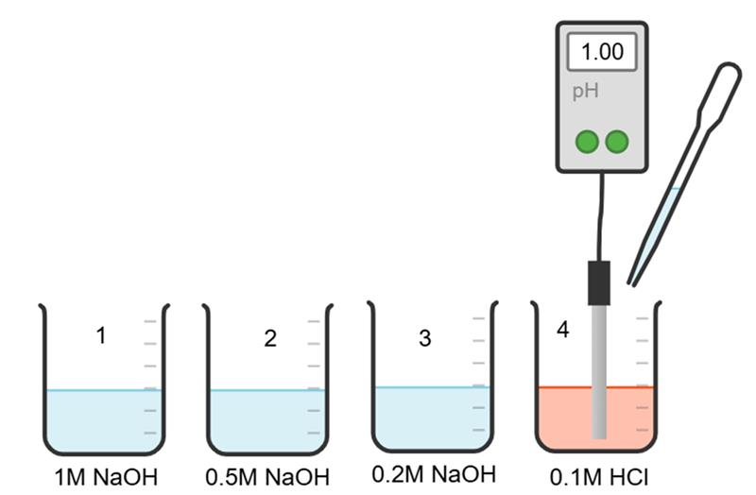
Image created using Chemix and is licensed under the Chemix Terms of Service.
- Measure 10 mL of 1 Mol L⁻¹ HCl and pour it into beaker 4.
- Add 2 drops of universal indicator to beaker 4 containing hydrochloric acid and record the colour. Use a calibrated pH meter to record the pH.
- Add sodium hydroxide solution from beaker 1 dropwise, while stirring gently.
- Continue adding sodium hydroxide until the solution changes to a purple colour. Count and record the number of drops required to achieve the colour change and the pH.
- Rinse beaker 4 thoroughly and dry it. Repeat steps 4 to 7 with 0.5 Mol L⁻¹ sodium hydroxide (beaker 2) and 0.2 Mol L⁻¹ sodium hydroxide solutions (beaker 3).
Results
Table 2 – neutralisation of hydrochloric acid with different concentrations of sodium hydroxide
Acid | Base | Initial pH | Final pH | Colour change | Drops of base added
0.1 Mol L⁻¹ HCl | 1 Mol L⁻¹ NaOH
0.1 Mol L⁻¹ HCl | 0.5 Mol L⁻¹ NaOH
0.1 Mol L⁻¹ HCl | 0.2 Mol L⁻¹ NaOH
Questions
- Write a balanced chemical equation for the reaction between sodium hydroxide and hydrochloric acid.
- Describe how the pH of the hydrochloric acid solution changed as sodium hydroxide was added dropwise.
- Did the number of drops of sodium hydroxide needed to neutralise the hydrochloric acid change with different concentrations of sodium hydroxide solution or stay the same? Explain your reasoning.
Recall, ‘precision’ is the extent to which repeated measurements of the same item are close to each other. A method is considered more precise if its readings are tightly grouped, showing very little variation from trial to trial.
- You have been given 2 sets of pH readings for the same sample of lemon juice. Each set was collected using a different method:
- Method A: digital pH meter
- Method B: universal indicator solution.
The following table shows the pH of lemon juice measured by 2 different methods.
Table 3 – pH results for lemon juice measured by using a pH meter (method A) and universal indicator (method B)
 |  |  | pH
 | Trial 1 | Trial 2 | Trial 3 | Trial 4 | Trial 5 | Trial 6
Method A | 2.18 | 2.19 | 2.18 | 2.20 | 2.20 | 2.19
Method B | 2.0 | 2.0 | 3.0 | 2.0 | 2.0 | 3.0
- Analyse the results given in the table above and state which method is more precise. Explain the reasons for your choice.
- Which of the 2, the universal indicator or the pH meter, provided more accurate results? Why?
- Identify the sources of errors that may have affected your results.

Evidence base
This resource contains NSW Curriculum and syllabus content. The NSW Curriculum is developed by the NSW Education Standards Authority (NESA). This content is prepared by NESA for and on behalf of the Crown in right of the State of New South Wales. The material is protected by Crown copyright.
Please refer to the NESA Copyright Disclaimer for more information https://www.nsw.gov.au/education-and-training/nesa/copyright.
NESA holds the only official and up-to-date versions of the NSW Curriculum and syllabus documents. Please visit NESA https://www.nsw.gov.au/education-and-training/nesa and NSW Curriculum https://curriculum.nsw.edu.au.
Science 7–10 Syllabus © NSW Education Standards Authority (NESA) for and on behalf of the Crown in right of the State of New South Wales, 2023.
01. Data Book: Science 7–10 © NSW Education Standards Authority (NESA) for and on behalf of the Crown in right of the State of New South Wales, 2023.
AITSL (Australian Institute for Teaching and School Leadership Limited) (n.d.) Learning intentions and success criteria [PDF 251 KB], AITSL, accessed 18 July 2024.
Brookhart SM (2018) ‘Appropriate Criteria: Key to Effective Rubrics’, Frontiers in Education, volume 3(22):1–12, doi:10.3389/feduc.2018.00022, accessed 6 February 2025.
CESE (Centre for Education Statistics and Evaluation) (2020) What works best in practice, NSW Department of Education, accessed 26 March 2026.
——(2021) Growth goal setting – what works best in practice, NSW Department of Education, accessed 26 March 2026.
——(2025) What Works Best 2025, NSW Department of Education, accessed 26 March 2026.
Fisher D and Frey N (1 November 2009) ‘Feed Up, Back, Forward’, ASCD (Association for Supervision and Curriculum Development): Educational Leadership magazine, 67(3), accessed 18 July 2024.
Griffin P (2017) Assessment for Teaching, Cambridge University Press, Port Melbourne, Victoria.
Hattie J and Timperley H (2007) ‘The Power of Feedback’, Review of Educational Research, 77(1): 81–112, doi:10.3102/003465430298487.
NESA (NSW Education Standards Authority) (2025) ‘Glossary’, Science 7–10 Syllabus, NSW Curriculum website, accessed 30 April 2026.
Panadero E and Jonsson A (2013) ‘The use of scoring rubrics for formative assessment purposes revisited: A review’, Educational Research Review, 9:129–144, doi:10.1016/j.edurev.2013.01.002, accessed 18 July 2024.
Sherrington T (2019) Rosenshine’s Principles in Action, John Catt Educational Limited, Melton, Woodbridge.
University of Colorado (2026) ‘pH scale: Version 1.7.4’, Chemistry, PhET (Physics Education Technology) Interactive Simulations website, accessed 26 March 2026.
Wiliam D (2017) Embedded Formative Assessment, 2nd edn, Solution Tree Press, Bloomington, IN.

© State of New South Wales (Department of Education), 2026
The copyright material published in this resource is subject to the Copyright Act 1968 (Cth) and is owned by the NSW Department of Education or, where indicated, by a party other than the NSW Department of Education (third-party material).
Copyright material available in this resource and owned by the NSW Department of Education is licensed under a Creative Commons Attribution 4.0 International (CC BY 4.0) license.

This license allows you to share and adapt the material for any purpose, even commercially.
Attribution should be given to © State of New South Wales (Department of Education), 2026.
Material in this resource not available under a Creative Commons license:
- the NSW Department of Education logo, other logos and trademark-protected material
- material owned by a third party that has been reproduced with permission. You will need to obtain permission from the third party to reuse its material.
Links to third-party material and websites
Please note that the provided (reading/viewing material/list/links/texts) are a suggestion only and implies no endorsement, by the New South Wales Department of Education, of any author, publisher, or book title. School principals and teachers are best placed to assess the suitability of resources that would complement the curriculum and reflect the needs and interests of their students.
If you use the links provided in this document to access a third-party's website, you acknowledge that the terms of use, including licence terms set out on the third-party's website apply to the use which may be made of the materials on that third-party website or where permitted by the Copyright Act 1968 (Cth). The department accepts no responsibility for content on third-party websites.

