Science Stage 5 – sample assessment task
Reactions
Creation date: 16 January 2026.

Contents
About this assessment task 2
Purpose of the resource 2
When and how to use 2
Assessment task notification 4
Task description 5
Assessment task – rate of a chemical reaction 6
Part 1 – conducting an investigation 6
Part 2 – scientific investigation questions (20 marks) 10
Question 1 (2 marks) 10
Question 2 (2 marks) 10
Question 3 (3 marks) 10
Question 4 (4 marks) 11
Question 5 (1 mark) 11
Question 6 (3 marks) 11
Question 7 (5 marks) 12
Teacher notes 15
Practical investigation – teacher checklist 16
Information for laboratory technicians 18
Preparation of the reactants 18
Evidence base 20

About this assessment task

Purpose of the resource
This assessment task is linked to the learning in the Reactions program of learning for Stage 5 students. The task is designed to assess students’ understanding of factors that affect the rate of a chemical reaction and skills in conducting a first-hand investigation and analysing data to draw conclusions.

When and how to use
This assessment task involves students conducting an experiment to investigate how reactant concentration affects the rate of reaction. This assessment task should take around 2 hours; however, timing may vary based on students’ learning needs and the school’s context. In the first lesson, students work in groups of 3 or 4 to plan and conduct the experiment. In the following lesson, students complete the investigation-related questions independently. They will need to refer to the information gathered in the previous lesson to answer these questions.
This assessment task should be implemented after teaching the content in Teacher resource book 2 (TRB2). As an effective assessment practice, it is highly recommended that teachers clarify the task’s instructions with their students and address any questions before implementing the task.
To help facilitate this task, the following is included:
- Teacher notes – including an equipment list, sample results and a practical investigation checklist.
- Information for laboratory technicians – including instructions for making solutions A and B.
Marking criteria and sample responses can be found on the Science Statewide Staffroom SharePoint in the document ‘science-S5-reactions-assessment-task-marking-guidelines’. Only members of the Science Statewide Staffroom can access this resource. For assistance, please email science7-12@det.nsw.edu.au.
Risk assessment: teachers are advised to undertake a risk assessment before conducting any classroom investigation or experiment. For more information on developing risk assessments, see Risk Assessment – a pre-requisite for risk control.
Discuss the risk assessment with students before they start the investigation.

The common grade scales can be used to report student achievement in both primary and junior secondary years in all NSW schools.
When grading students’ level of achievement in Stage 5, refer to the course performance descriptors. Course performance descriptors provide holistic descriptions of typical achievement at different grade levels in a specific course.

Assessment task notification
Name of task: the rate of a chemical reaction
Type of task: conducting a first-hand investigation
Weighting: [the weighting of the assessment task is a school-based decision.]
Submission details: [schools complete this section – include any important details about submission, format of the task, word limits and submission procedures.]
Outcomes:
A student:
- explains the factors that affect the rate of chemical reactions SC5-RXN-02
- develops questions and hypotheses for scientific investigation SC5-WS-02
- designs safe, ethical, valid and reliable investigations SC5-WS-03
- follows a planned procedure to undertake safe, ethical, valid and reliable investigations
SC5-WS-04
Science 7–10 Syllabus © NSW Education Standards Authority (NESA) for and on behalf of the Crown in right of the State of New South Wales, 2023.

Task description
In this task, you will investigate the reaction between 2 chemicals, reactants A and B. Both chemicals are colourless; however, they turn blue upon reaction.
A (colourless) + B (colourless) → Product (blue)
When the solution turns blue, the reaction is complete. The time taken for the solution to turn blue is a measure of the reaction time. From the reaction time, the reaction rate can be calculated.
In this assessment task, you will investigate how changing the concentration of one of the reactants (reactant A) affects the rate of reaction. This task is divided into 2 parts:
- Part 1 – conducting an investigation – you will work in a small group to conduct an investigation to collect data on how changing the concentration of reactant A affects the reaction rate.
- Part 2 – scientific investigation questions – you will use the data collected in Part 1 to answer the investigation questions individually.
You will only be assessed on Part 2. However, you will need to refer to the information collected in Part 1 – conducting an investigation to complete the questions in Part 2.

Assessment task – rate of a chemical reaction

Part 1 – conducting an investigation
Name:
To complete this part, you will work with your group to conduct an investigation into how varying the concentration of reactant A affects the rate of reaction between reactants A and B.
List the names of your group members below.
Equipment list (per group)
- 40 mL reactant A  - 50 mL reactant B  - 1 × waste container or beaker  - 3 × test tubes with stoppers  - 4 × 50 mL beakers  - 2 × plastic droppers | - 2 × 25 mL measuring cylinders  - 1 × test tube rack  - 1 × stopwatch  - 1 × marker for labelling the beakers and the test tubes  - 1 × set of safety glasses per student
General instructions
- You will need to work with the specified amounts of reactants A and B. No extra reactant will be provided.
- Use separate labelled measuring cylinders for measuring reactants A and B.
- Wear safety glasses during the investigation.
- Wash your hands thoroughly with soap and water after completing your investigation and follow the instructions regarding risk assessment given by your teacher.
- Make sure you have all the necessary equipment before starting the experiment.
- Rinse the test tubes and measuring cylinders between trials.
- Dispose of used solutions in a waste bin, as directed by your teacher.
Instructions for modifying the concentration of the reactant A
Note: this procedure is for making the reactant A stock solutions that you will use in the investigation.
- Label the 2 measuring cylinders as ‘A’ and ‘B’.
- Label 3 beakers as ‘A1’, ‘A2’ and ‘A3’ and the last one as ‘water’.
- Using the measuring cylinder labelled ‘A’ and a plastic dropper to make fine adjustments, if necessary, measure the volumes of water in Table 1. Transfer the water into the correctly labelled beaker.
- Using the measuring cylinder labelled ‘A’ and a plastic dropper to make fine adjustments, if necessary, measure the volumes of reactant A outlined in Table 1. Transfer the measured volumes of reactant A into the beakers labelled ‘A1’, ‘A2’ and ‘A3’.
- Mix the reactant and water by swirling the beakers gently.
Table 1 – diluting solution A to prepare solutions A1, A2 and A3
Solution | Volume of reactant A (mL) | Volume of distilled water (mL) | Total volume (mL)
A1 | 20 | 0 | 20
A2 | 10 | 10 | 20
A3 | 5 | 15 | 20

Procedure for conducting the investigation on the effect of concentration on the rate of reaction
Before conducting the investigation plan with your group, identify which group member will do each part of the procedure. For example, one person can mix the reactants while another uses the stopwatch to record the time taken for the product to form (identified by the sudden colour change). Coordination is important to ensure that data is properly collected and recorded.
- Use a separate measuring cylinder for measuring reactants A and B.
- Using measuring cylinder A and a new plastic dropper, measure 5 mL of reactant A1 and add it to the test tube labelled ‘A1’.
- Measure 5 mL of reactant B, add it to the test tube labelled ‘A1’ and start the stopwatch immediately. Mix by inverting the stoppered test tube once as shown in Figure 1.
Figure 1 – the inversion of the test tube and the colour change after the reaction
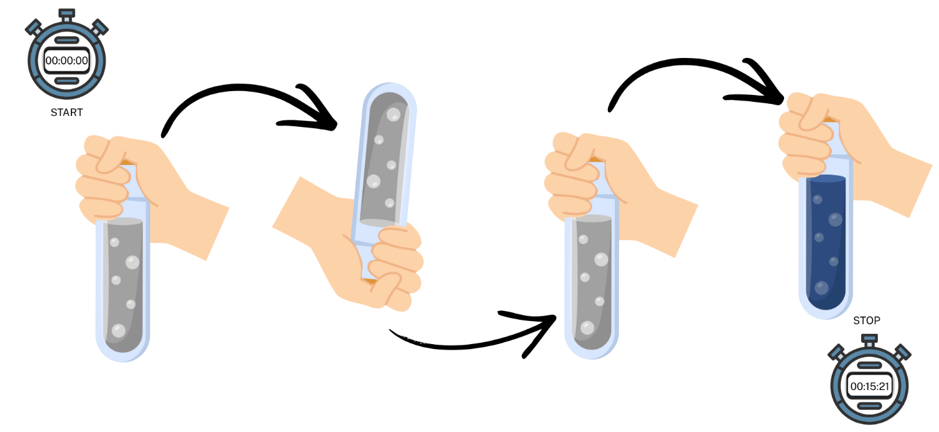
- Stop the stopwatch when the blue colour appears, which is the sign that the chemical reaction is complete.
- Record the time taken to react in Table 2.
- Rinse the test tube labelled ‘A1’ and stopper thoroughly with water. Drain all the water and repeat steps 2 to 5 twice.
- Repeat steps 2 to 6 with solutions A2 and A3, and test tubes labelled A2 and A3.
Results
Collect and record the raw data for the time to react (in seconds) for each solution.
Table 2 – raw data from the investigation of the effect of concentration on the rate of reaction
Solution |  | Time to react (sec)
 | Trial 1 | Trial 2 | Trial 3
A1
A2
A3

Part 2 – scientific investigation questions (20 marks)
Complete the following questions. You may need to refer to the information that you collected in Part 1 – conducting an investigation.

Question 1 (2 marks)
Identify the independent and dependent variables.
Independent variable:
Dependent variable:

Question 2 (2 marks)
Describe the variables you controlled.

Question 3 (3 marks)
Explain how the variables you controlled ensured the validity of your investigation.

Question 4 (4 marks)
One of the chemicals used in this investigation is dilute sulfuric acid. According to the manufacturers, sulfuric acid is a corrosive chemical and has the following hazard pictogram:
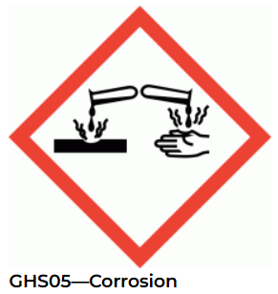 | In addition, the safety data sheet (SDS) for sulfuric acid has the following hazard statement: ‘Causes severe skin burns and eye damage’ (Chemwatch 2025).
Source: Chemwatch 4519-16 MINI SDS.
List 2 precautions you should take when working with a dilute sulfuric acid solution and explain your reasoning.

Question 5 (1 mark)
Rank the reactants used in the investigation (A1, A2 and A3) from the lowest to the highest concentration.

Question 6 (3 marks)
Using the data in Table 2 (Part 1), calculate the mean time to react and the relative rate of reaction for solutions A1, A2 and A3. Record your results in Table 3.
Table 3 – summary data from the investigation of the effect of concentration on the rate of reaction
Solution | Mean time to react (seconds) | Relative rate of reaction  (1/mean time to react) (s⁻¹)
A1
A2
A3

Question 7 (5 marks)
A group of students conducted the same experiment as you, but they investigated the reaction rate for 4 solutions of varying concentrations. The compositions of solutions A1 to A4 are shown in Table 4.
Table 4 – volume of reactant A and distilled water in each solution A1 to A4 dilution
Solution | Volume of reactant A (mL) | Volume of distilled water (mL) | Total volume (mL)
A1 | 20 | 0 | 20
A2 | 10 | 10 | 20
A3 | 5 | 15 | 20
A4 | 15 | 5 | 20
- Rank the solutions the students used (A1, A2, A3 and A4) from the lowest to the highest concentration. (1 mark)
While completing the investigation, students forgot to record their data for solution A4. The data students collected for the reactions of A1, A2 and A3 are shown in Table 5 and the graph in Figure 2.
Table 5 – summary data for the relative rate of reaction for each concentration
Reactant | Mean time to react (seconds) | Rate of reaction (1/mean time to react) (s⁻¹)
A1 | 20 | 0.05
A2 | 45 | 0.02
A3 | 90 | 0.01
A4 | Data not recorded | Data not recorded
Figure 2 – the effect of concentration on the relative rate of reaction

- Using the data collected in this investigation (refer to Table 4 and Table 5), predict the rate of reaction for solution A4. Show this prediction by drawing a column for solution A4 on the graph above. (1 mark)
- Using your understanding of collision theory and the effect of concentration on the rate of reaction, explain your reasoning for the predicted rate of reaction for solution A4. (3 marks)

Teacher notes
If students need support in preparing the diluted solutions (A1, A2, and A3), pre-prepared diluted solutions could be provided. Refer to Information for laboratory technicians for preparing the diluted solutions.
Equipment list
These are the equipment requirements for a group of 3 to 4 students. For a class of 30 students, you will need 8 sets of the listed materials and equipment:
- 40 mL reactant A  - 50 mL reactant B (Note: it contains 1 M H₂SO₄)  - 1 × waste beaker  - 3 × test tubes with stoppers  - 4 × 50 mL beakers | - 2 × plastic droppers  - 2 × 25 mL measuring cylinders  - 1 × test tube rack  - 1 × stopwatch  - 1 × marker for labelling the beakers and test tubes  - 1 × safety glasses per student
Figure 1 – example trolley set-up for a class set of equipment required for students to complete the investigation
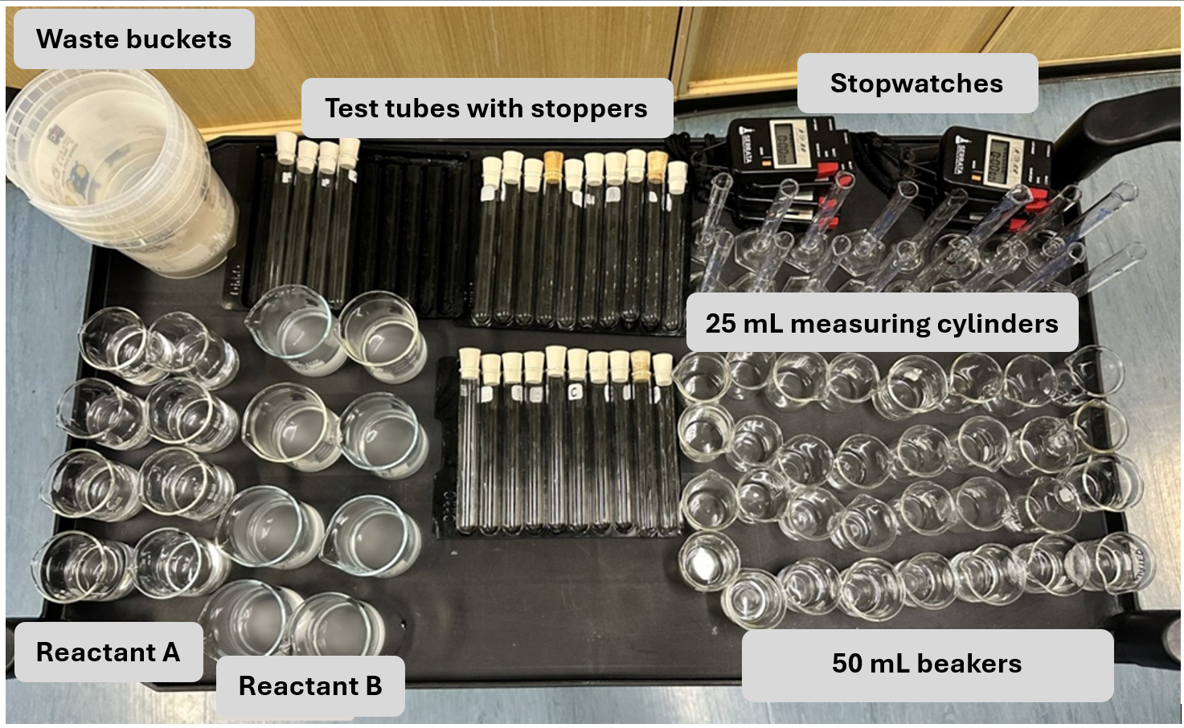
Sample results
Figure 2 – example of colour at reaction completion
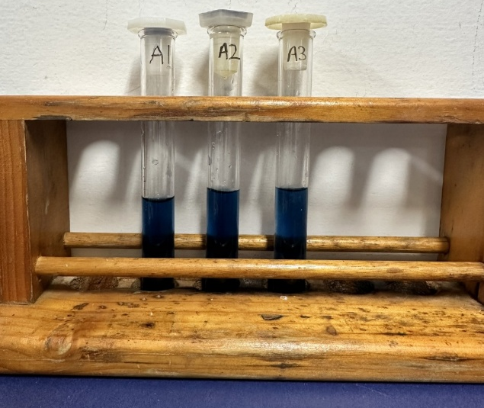
Table 1 – sample data for the investigation of the effect of concentration on the rate of reaction
Solution | Mean time to react (seconds) | Rate of reaction (1/mean time to react) (s⁻¹)
A1 | 15 | 0.06
A2 | 30 | 0.03
A3 | 60 | 0.02

Practical investigation – teacher checklist
Preparation
☐ Before data collection, trial the prepared solutions to ensure their concentrations are suitable. The reaction time should not be too long, which may hinder students from collecting sufficient data, nor too short, which could increase the likelihood of errors.
Note: if the reaction is taking a long time or the colour is too faint for students to observe easily, teachers can increase the concentration of the sodium metabisulfite. If the reaction is occurring too quickly for students to record results, reactant A can be further diluted with distilled water.
☐ Check that all equipment and chemicals are prepared and labelled correctly.
☐ Ensure safety equipment (such as safety glasses) is available.
☐ Prepare extra chemicals and spare equipment for errors or breakages.
Safety management
☐ Ensure that students handle chemicals and equipment safely.
☐ Group students strategically for safety and efficiency.
☐ Maintain supervision and visibility of all students.
Post-practical
☐ Ensure students know proper disposal procedures for chemicals and waste.
☐ Provide clearly labelled waste containers for the disposal of chemicals. Chemicals may be disposed of down the sink when the experiments are complete.
☐ Ensure students return all equipment to the designated area and clean up the workbench.
☐ Collect students’ data to redistribute at the start of the next lesson or provide sample data to absent students to complete Part 2 – scientific investigation questions under exam conditions.
Note: the method used in this task to calculate the relative rate of reaction is the following:
$$\frac{1}{mean time to react} =relative rate of reaction$$
This concept will require unpacking with students to help them understand how it calculates a rate of reaction. If students require additional support, the task could be modified to ask them to record the mean reaction time rather than to calculate the relative reaction rate.
If students require additional support in conducting the investigation, the teacher or laboratory technician may complete the dilutions of solution A before the experiment. Students can then be supplied with the pre-prepared solutions A1, A2 and A3 to complete the investigation.

Information for laboratory technicians

Preparation of the reactants
The instructions below are for preparing 500 mL of reactant A and 1000 mL of reactant B. The quantities required for a class will vary based on class size and the number of students in each group. Ensure additional chemicals are available to account for student errors.
Equipment list
- 0.40 g sodium metabisulfite  - 5.35 g potassium iodate  - 5.0 mL 1 M sulfuric acid  - 4.0 g soluble starch  - 2 L distilled water  - 1 L conical flask | - 1 L volumetric flask  - 1 L beaker  - 1 L measuring cylinder  - 1 × spatula  - 1 × hotplate  - 1 × stirring rod
Reactant A
- Weigh 5.35 g of potassium iodate.
- Place the potassium iodate into a 500 mL volumetric flask and dissolve it into 200 mL of distilled water.
- Top up to the 500 mL mark with distilled water.
- The resulting solution is 0.05 Mol L⁻¹.
To differentiate the task, the laboratory technician may complete the reactant A dilutions (A1, A2 and A3) in place of the students. Refer to the table below to prepare different concentrations of solution A by adding varying amounts of distilled water, as shown.
Table 6 – preparing diluted solutions
Diluted solution | Volume of reactant A (mL) | Volume of distilled water (mL) | Total volume of solution (mL) | Concentration (Mol L⁻¹)
A1 | 200 | 0 | 200 | 0.05
A2 | 100 | 100 | 200 | 0.025
A3 | 50 | 150 | 200 | 0.0125
Reactant B
- Make a paste with starch and distilled water in a 1 L beaker.
- Add approximately 800 mL of boiling water and stir to combine.
- Boil for a few minutes on a hotplate and then allow the beaker to cool.
- Pour the starch solution into a conical flask. Add 0.40 g sodium metabisulfite and 5.0 mL 1 Mol L⁻¹ sulfuric acid.
- Top up the solution to the 1 L mark with distilled water.
Notes
- Sodium metabisulfite solution (reactant B) has a short shelf life and it is recommended to prepare it fresh before the assessment task.
- Starch solution has a poor shelf life and can become mouldy if kept for too long. It is recommended to prepare it fresh before the assessment task.
- Refer to the safety data sheet (SDS) for the disposal of chemicals.

Evidence base
This resource contains NSW Curriculum and syllabus content. The NSW Curriculum is developed by the NSW Education Standards Authority (NESA). This content is prepared by NESA for and on behalf of the Crown in right of the State of New South Wales. The material is protected by Crown copyright.
Please refer to the NESA Copyright Disclaimer for more information https://www.nsw.gov.au/education-and-training/nesa/copyright.
NESA holds the only official and up-to-date versions of the NSW Curriculum and syllabus documents. Please visit NESA https://www.nsw.gov.au/education-and-training/nesa and NSW Curriculum https://curriculum.nsw.edu.au.
Science 7–10 Syllabus © NSW Education Standards Authority (NESA) for and on behalf of the Crown in right of the State of New South Wales, 2023.
01. Data Book: Science 7–10 © NSW Education Standards Authority (NESA) for and on behalf of the Crown in right of the State of New South Wales, 2023.
Brookhart SM (2018) ‘Appropriate Criteria: Key to Effective Rubrics’, Frontiers in Education, volume 3(22):1–12, doi:10.3389/feduc.2018.00022, accessed 6 February 2025.
CESE (Centre for Education Statistics and Evaluation) (2020) What works best: 2020 update, NSW Department of Education, accessed 18 July 2024.
——(2020) What works best in practice, NSW Department of Education, accessed 18 July 2024.
——(2021) Growth goal setting – what works best in practice, NSW Department of Education, accessed 18 July 2024.
Chemwatch (2025) Chemwatch: 4519-16 MINI SDS sulfuric acid 1M solution, ChemWatch website, accessed 4 November 2025.
Fisher D and Frey N (1 November 2009) ‘Feed Up, Back, Forward’, ASCD (Association for Supervision and Curriculum Development): Educational Leadership magazine, 67(3), accessed 6 February 2025.
Griffin P (2017) Assessment for Teaching, Cambridge University Press, Port Melbourne, Victoria.
Hattie J and Timperley H (2007) ‘The Power of Feedback’, Review of Educational Research, 77(1): 81–112, doi:10.3102/003465430298487, accessed 15 July 2024.
Panadero E and Jonsson A (2013) ‘The use of scoring rubrics for formative assessment purposes revisited: A review’, Educational Research Review, 9:129–144, doi:10.1016/j.edurev.2013.01.002, accessed 6 February 2025.
Sherrington T (2019) Rosenshine’s Principles in Action, John Catt Educational Limited, Melton, Woodbridge.
Wiliam D. (2017). Embedded Formative Assessment, 2nd edn, Solution Tree Press, Bloomington, IN.

© State of New South Wales (Department of Education), 2026
The copyright material published in this resource is subject to the Copyright Act 1968 (Cth) and is owned by the NSW Department of Education or, where indicated, by a party other than the NSW Department of Education (third-party material).
Copyright material available in this resource and owned by the NSW Department of Education is licensed under a Creative Commons Attribution 4.0 International (CC BY 4.0) license.

This license allows you to share and adapt the material for any purpose, even commercially.
Attribution should be given to © State of New South Wales (Department of Education), 2026.
Material in this resource not available under a Creative Commons license:
- the NSW Department of Education logo, other logos and trademark-protected material
- material owned by a third party that has been reproduced with permission. You will need to obtain permission from the third party to reuse its material.
Links to third-party material and websites
Please note that the provided (reading/viewing material/list/links/texts) are a suggestion only and implies no endorsement, by the New South Wales Department of Education, of any author, publisher, or book title. School principals and teachers are best placed to assess the suitability of resources that would complement the curriculum and reflect the needs and interests of their students.
If you use the links provided in this document to access a third-party's website, you acknowledge that the terms of use, including licence terms set out on the third-party's website apply to the use which may be made of the materials on that third-party website or where permitted by the Copyright Act 1968 (Cth). The department accepts no responsibility for content on third-party websites.

