Science Stage 5 (Year 9) – Materials
Teacher resource book 3 of 3 (TRB3)
3. What makes hydrocarbons so useful and potentially so harmful?
Creation date: 20 March 2025
Contents
Overview 3
Glossary 4
An approach to teaching chemistry 7
3.1 Is it organic or inorganic? 9
Introduction to organic and inorganic compounds 9
3.2 Hydrocarbons are everywhere 19
What are hydrocarbons? 19
Fractional distillation 19
Using the crude oil fractions 27
3.3 Give them a name 29
Naming organic compounds 29
3.4 All things combustion (practical investigation) 39
Complete and incomplete combustion 39
Comparing incomplete and complete combustion (practical investigation) 45
3.5 How have we used hydrocarbons? 52
Exploring the use of hydrocarbons – class discussion 52
Exploring the use of hydrocarbons – collaborative research 53
Think-Pair-Share 56
3.6 Polymer raw ingredients 57
Introduction to polymers 57
3.7 Properties of polymers 63
Investigating the properties of polymers (practical investigation) 64
3.8 So many polymers 75
A physical survey of the local area 76
Analysing survey data 79
3.9 Is it biodegradable? 84
Is a biodegradable plastic always good? 85
What happens to plastic in the soil? 86
Investigating the biodegradability of different packaging materials 90
3.10 Microplastics 91
Microplastics – a threat to the environment 91
Microplastics case study 92
3.11 Sustainable alternatives 95
Assessing the impacts of single-use packaging materials 96
Designing an infographic 107
Appendix A – investigation design scaffold 109
Appendix B – sample product polymers 119
Evidence base 120

Overview
Stage and learning area: Stage 5 Science
Description: this resource complements the Materials program of learning. It aims to serve as a teacher reference, offering practical strategies and ideas to enrich teaching practices and create engaging learning environments. The activities should be adapted to suit students’ needs.
Duration: while timing will vary based on the mode of delivery, differentiation strategies employed and class or school context, this series of activities should take approximately 17 hours.
Risk management: teachers are advised to undertake a risk assessment before conducting any classroom investigation or experiment. For more information on developing risk assessments, see Risk Assessment – a pre-requisite for risk control.
This teacher resource book elaborates on many of the activities in the Materials sample program of learning. Some activities also reference the Materials slide deck (identified as MAT PPT throughout this document).

Glossary
Tier 3 words are those that are relevant for subject-specific content. More information is provided in the ‘Vocabulary in context’ document found at the Stage 5 reading strategies page. The Guide for planning and implementing explicit vocabulary instruction can be used by teachers across all curriculum areas.
Table 1 – glossary of key terms for Materials TRB3
Term | Definition | Source
Alkane | An organic compound that consists entirely of single-bonded carbon and hydrogen atoms having the general formula C_{n}H_{2n+2}, as methane (CH₄), ethane (C₂H₆) and that lacks any other functional groups. | NESA 2025
Bioaccumulation (of a substance) | The build-up of substances (especially toxins) in an organism over time. | NESA 2025
Biodegradability | The ability of a material to decompose as a result of the action of living organisms, especially bacteria. | NESA 2025
Biopolymer | Natural polymers produced by or derived from living organisms. | Science direct 2025
Covalent (bond) | A chemical bond formed by the sharing of electrons between 2 atoms, each of which donates an equal number of electrons. | NESA 2025
Crude oil | Oil as it is found naturally in underground reservoirs; a raw natural resource made from hydrocarbons that formed over millions of years from the remains of animals and plants. | NESA 2025
Flexibility (as it relates to Materials) | The ability of a material to deform elastically and return to its original shape when the applied stress is removed.  Note: flexibility is a Tier 2 word, as it has other meanings that are not subject-specific and can be used across multiple disciplines. | Adapted from Wikipedia
Hydrocarbons | A group of compounds containing only hydrogen and carbon, such as methane (CH₄), ethene (C₂H₄) and but-1-yne(C₄H₆). | NESA 2025
Incomplete combustion | A chemical reaction in which a fuel reacts with limited oxygen gas (O₂). Can lead to the formation of carbon, as soot (C), or carbon monoxide (CO). | NESA 2025
Ionic (bond) | A very strong chemical bond formed by the transfer of one or more electrons from one atom to another atom; the ions are held together by electrostatic attraction. | NESA 2025
IUPAC | Acronym for the International Union of Pure and Applied Chemistry, an authority on chemical terminology and nomenclature. | NESA 2025
Microplastics | Small particles of plastic in the environment, generally smaller than 5 millimetres in size. | NESA 2025
Mixture | A combination of 2 or more substances where these substances do not undergo a chemical reaction to bond together, and each part in the mixture retains its own properties. | Adapted from Mixtures and solutions (RSC)
Oil resistant | The ability of a material, especially rubber or synthetic polymers, to withstand the swelling and deteriorating effects of various types of oils. | MacLellan Rubber – Oil Resistance Definition
Opaque | Does not allow light to pass through, so everything on the other side of the material is not visible. | Adapted from Primary Science Online
Qualitative | To use descriptive explanations involving features, characteristics or properties to identify important components. Data and information that is not numerical in nature. | NESA 2025
Quantitative | Data or components that can be expressed or measured numerically, including chemical formulae or numbers. | NESA 2025
Renewable | A resource that cannot be exhausted. A resource that can be restored in a human lifetime. | NESA 2025
Tensile strength | The maximum stress that the material can withstand before breaking, when pulled or stretched. | Adapted from Wikipedia
Translucent | Allows some light to pass through it, so objects on the other side are not clearly visible. | Adapted from Primary Science Online
Transparent | Allows light to pass through so everything on the other side of the material is clearly visible. | Adapted from Primary Science Online
Valency | The number of chemical bonds that an atom can make with a univalent atom, such as hydrogen. | NESA 2025
Water resistant | Stops water from soaking in. | Adapted from The Britannica Dictionary

An approach to teaching chemistry
Teaching chemistry often presents a unique challenge: helping students make sense of abstract concepts they cannot directly observe. Concepts such as atoms, molecules, bonding and chemical reactions reflect concepts at a microscopic level. Yet, students observe these phenomena through macroscopic changes, such as colour shifts, gas production or temperature changes. Bridging this divide between what students can observe and what occurs at the particle level is crucial for deep understanding, and this is where Johnstone’s triangle serves as a powerful tool for teachers.
Figure 1 – Johnstone’s triangle

Johnstone’s triangle provides a framework for teaching and learning chemistry by highlighting 3 interconnected ways of thinking:
- The macroscopic level – what students can see, touch and measure during experiments (for example, bubbles forming when magnesium reacts with acid).
- The sub-microscopic (or particulate) level – what is happening at the level of atoms, ions, and molecules (for example, hydrogen ions reacting with magnesium atoms to form hydrogen gas).
- The symbolic level – how we represent chemical phenomena using formulas, equations, symbols and diagrams (for example, Mg + 2HCl → MgCl₂ + H₂).
Students often struggle because classroom explanations or textbooks might shift between these levels without making the connections clear. For example, a student might observe a fizzing reaction (macroscopic), be shown an equation (symbolic), but never fully grasp what is occurring at the particle level (sub-microscopic).
By deliberately planning lessons and explanations that make these connections explicit, teachers can help students transition more confidently between levels and develop a more comprehensive understanding of chemical processes. This approach not only fosters conceptual development but also helps to clarify common misconceptions by elucidating the relationship between what students observe, envision and represent.
Activities throughout this teacher resource book aim to support teachers in applying Johnstone’s triangle in the delivery of learning.
Table 2 – an example of using Johnstone’s triangle when comparing table salt and sugar
Macroscopic | Microscopic | Symbolic
Salt (sodium chloride)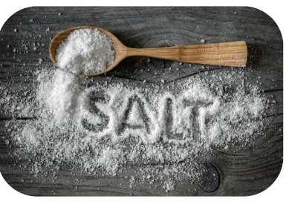 | Lattice of sodium ions and chlorine ions.  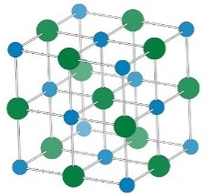 | NaCl
Sugar (sucrose)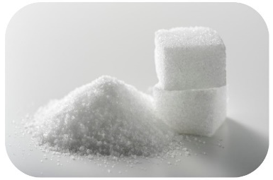 | A sucrose molecule is made up of carbons, hydrogens and oxygens covalently bonded together.  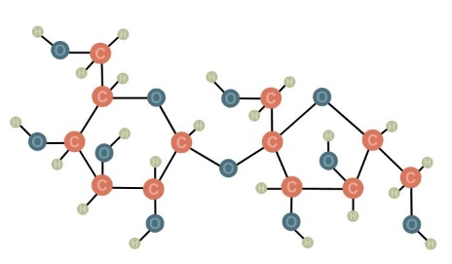 | C₁₂H₂₂O₁₁
Both sugar and salt appear very similar, and they share some similar properties, such as dissolving in water. | At the particle level, they are very different. Sodium chloride has ionic bonds. Sucrose has covalent bonds. | They are made from different elements.

3.1 Is it organic or inorganic?
Table 3 – learning intention and success criteria for 3.1 Is it organic or inorganic?
We are learning: | I can:
- to describe the chemical properties of materials and their uses. | - recognise a C–H bond  - identify why a compound is inorganic or organic based on its bonding  - provide examples of inorganic and organic compounds and their uses.
Prior knowledge checkpoint: What do you recall about compounds from past lessons? List 2 facts and an example about compounds.
Answers may include: compounds are substances composed of 2 or more different elements that are chemically bonded. The quantity of each element in a compound has a fixed ratio. Examples include H₂O, CO₂, and CH₄. There are 2 main types of compounds: covalent compounds and ionic compounds.

Introduction to organic and inorganic compounds
Teacher background information
The terms ‘organic’ and ‘inorganic’ are used in a range of contexts and students may have prior understandings that are misconceptions. Table 4 outlines some common misconceptions that teachers should attempt to identify and correct during teaching in this component of the Materials focus area.
Table 4 – common misconceptions about organic and inorganic compounds
Misconception | Reason
Organic refers to all things natural. | Not everything natural is organic. For example, minerals that exist in the Earth’s crust are also natural substances, but they are inorganic compounds.
Organic refers to food that is grown without the use of pesticides. | ‘Organic’ is a chemical term that refers to a specific group of compounds. It is a much broader term that includes substances beyond food, such as fuels like petrol and diesel.
Organic substances only come from living things and cannot be synthesised in a laboratory. | Organic compounds such as plastics can be synthesised in a lab.
Any chemical substance that has carbon is organic. | Carbon dioxide or carbon monoxide are compounds of carbon that are inorganic. It is carbon-hydrogen bonds that deem something organic.
Activity instructions
Inform students that today's lesson will focus on distinguishing between 2 major categories of compounds and their corresponding branches of chemistry: organic and inorganic.
Note: a discussion may be necessary to clarify what constitutes organic food. The term ‘organic’ in the context of food refers to farming practices and food production methods, rather than the chemical composition of the food itself.
- Describe the characteristics of organic and inorganic compounds using the information provided in Table 5.
- Show MAT PPT ‘3.1 Comparing organic and inorganic molecules’. Speaker notes have been provided on the slide to unpack the information with students, and additional notes are provided in Table 5.
- Unpack features of the various organic substances. Ask students, ‘What atom is bonded to carbon in these compounds?’. Answer: They all contain C–H bonds.
- Use the models of inorganic substances on the slide to describe their features. Point out that they do not contain a C–H bond.
Note: physical models of organic and inorganic molecules may be used to support students' understanding.
Table 5 – comparing organic and inorganic compounds.
 | Organic compounds | Inorganic compounds
Characteristics | - Always contain carbon  - Contains carbon-hydrogen bonds.  - If there is more than one carbon atom in the compound, there will be carbon-carbon bond(s) | - May or may not contain carbon
Where are they found? | - In living things  - In dead things (were once living)  - Foods (which come from living things)  - Fuels (hydrocarbons which come from living things)  - Plastics | - Often found in non-living systems such as the atmosphere, water and minerals  - May be used by living things, for example, water, oxygen and carbon dioxide.  - Can be man-made compounds
Examples | - Hydrocarbons such as methane (CH₄)  - Carbohydrates such as glucose (C₆H₁₂O₆)  - Alcohols such as ethanol (C₂H₅OH) | - Water (H₂O)  - Salts such as sodium chloride (NaCl)  - Metals  - Carbon dioxide (CO₂)  - Sodium hydroxide (NaOH)
- Provide the student with Student resource – organic and inorganic compounds. Students classify a range of compounds as organic or inorganic and provide their reasoning.
Note: some substances contain carbon and hydrogen that are inorganic. This is because, despite containing carbon and hydrogen, they do not contain C–H bonds. An example is sodium bicarbonate (NaHCO₃). Advanced students could be taught this, but it is beyond the requirements of the Science 7–10 Syllabus.
Sample responses: Student resource – organic and inorganic compounds
Table 6 – sample answers for Student resource – organic and inorganic compounds
Substance and formula | Organic or inorganic? | Reasoning | Use
Methane  CH₄ | Organic | Contains C–H bonds | The main component of natural gas. Natural gas is used as a fuel source, usually in gas stoves.
Hydrochloric acid  HCl | Inorganic | Does not contain C–H bonds | A common reagent in chemical reactions to produce other chemicals.
Glucose  C₆H₁₂O₆ | Organic | Contains C–H bonds | The primary energy source for all living things. Also used as a sweetener in foods.
Water  H₂O | Inorganic | Does not contain carbon and therefore does not have C–H bonds | Essential for all living things. Used as a solvent in many chemical processes.
Ethanol  C₂H₅OH | Organic | Contains C–H bonds | Found in alcoholic beverages. Used in hand sanitiser to kill bacteria.
Carbon dioxide  CO₂ | Inorganic | Does not contain C–H bonds | Carbonated soft drinks, CO₂ fire extinguishers.
Calcium carbonate CaCO₃ | Inorganic | Does not contain C–H bonds | Cement and concrete production.
Acetic acid (Vinegar)  C₂H₄O₂ | Organic | Contains C–H bonds | Acetic acid is a product of microbial activity used in cooking and as a cleaning agent.
Sucrose  C₁₂H₂₂O₁₁ | Organic | Contains C–H bonds | Naturally occurring sugar, which is used as a sweetener in food and drink
Sodium hypochlorite  NaClO | Inorganic | Does not contain hydrogen; therefore, it does not contain C–H bonds | Also called bleach, it is used as a cleaning product and a stain remover.
Ammonia  NH₃ | Inorganic | Does not contain carbon and therefore does not have C–H bonds | Ammonia is a primary source of nitrogen in fertiliser production.
Butane  C₄H₁₀ | Organic | Contains C–H bonds | Used as a fuel in portable gas barbecues.
Canola oil  C₅₇H₁₁₀O₆ | Organic | Contains C–H bonds | Used for cooking, especially frying food.
Cellulose (wood)  (C₆H₁₀O₅)_{n} | Organic | Contains C–H bonds | Raw material for paper production.
Lactose  C₁₂H₂₂O₁₁ | Organic | Contains C–H bonds | A sugar found in milk. It is used as a filler in food and pharmaceuticals.
Propane  C₃H₈ | Organic | Contains C–H bonds | Used as a fuel in liquid petroleum gas (LPG).
Citric acid  C₆H₈O₇ | Organic | Contains C–H bonds | Naturally found in citrus fruits. Used in food production.
Titanium dioxide  TiO₂ | Inorganic | Does not contain carbon and therefore does not have C–H bonds | Used as a white pigment in paints and coatings.
Sodium hydroxide  H₂SO₄ | Inorganic | Does not contain carbon and therefore does not have C–H bonds | Used to make soaps and detergents.
- What elements are present in all organic compounds? ___Carbon and hydrogen___.
- List the substances in the table that fall under the category of being a hydrocarbon. Hydrocarbons contain only carbon and hydrogen atoms.
Propane, methane, butane
- What is the main use of the hydrocarbons listed?
Fuel source
- List all the substances that are found in foods that come from or are produced by living things.
Citric acid, lactose, cellulose, canola oil, sucrose, glucose, acetic acid, ethanol
Note: explaining the origin of each of these substances in foods will enhance students' understanding of why they fall into the category of organic. For example, all the substances ending in ‘ose’ are types of sugars (or carbohydrates). Carbohydrates are found in plants. Alcohols, such as ethanol, are produced through fermentation, a process that involves microorganisms.
- What do these substances have in common? Hint: look at their chemical formula.
They all contain carbon, hydrogen and oxygen in different combinations.
- Compare the elements found in organic substances to those found in inorganic substances. Which one has more elements?
Elements found in the organic substances: C, H, O
Elements found in the inorganic substances: C, H, S, O, Ti, N, Cl, Ca
Generally, inorganic substances have a broader range of elements, whereas organic substances are limited to a smaller number of elements.
Note: some organic molecules also contain other elements, such as nitrogen and phosphorus, which are not included in this activity.
Checkpoint: What clues will you look for to determine if a compound is organic?
Sample response: the presence of carbon, which contains a C–H covalent bond.

Student resource – organic and inorganic compounds
Use the dichotomous key to determine if a substance is organic or inorganic. To complete step 3 in the dichotomous key, you will have to either build a molecular model or look one up to determine if the substance has carbon-hydrogen bonds. Use research to complete the remainder of the table.
Dichotomous key for classifying substances as organic or inorganic
- Does the chemical substance contain carbon and hydrogen atoms? | Yes – go to question 2.  No – this substance is inorganic.
- Does the chemical substance have a metal atom(s)? | Yes – this substance is inorganic.  No – go to question 3.
- Does the substance have C–H bonds? | Yes – this substance is organic.
Table 1 – classification of organic and inorganic substances
Substance and formula | Organic or inorganic? | Reasoning | Use
Methane
CH₄
Hydrochloric acid
HCl
Glucose
C₆H₁₂O₆
Water
H₂O
Ethanol
C₂H₅OH
Carbon dioxide
CO₂
Calcium carbonate CaCO₃
Acetic acid (Vinegar)
C₂H₄O₂
Sucrose
C₁₂H₂₂O₁₁
Sodium hypochlorite
NaClO
Ammonia
NH₃
Butane
C₄H₁₀
Canola oil
C₅₇H₁₁₀O₆
Cellulose (wood)
(C₆H₁₀O₅)_{n}
Lactose
C₁₂H₂₂O₁₁
Propane
C₃H₈
Citric acid
C₆H₈O₇
Titanium dioxide
TiO₂
Sodium hydroxide
H₂SO₄
- What elements are present in all organic compounds? ____________________.
- List the substances in the table that fall under the category of being a hydrocarbon. Hydrocarbons contain only carbon and hydrogen atoms.
- What is the main use of the hydrocarbons listed?
- List all the substances that are found in foods that come from or are produced by living things.
- What do these substances have in common? Hint: look at their chemical formula.
- Compare the elements found in organic substances to those found in inorganic substances. Which one has more elements?

3.2 Hydrocarbons are everywhere
Table 7 – learning intentions and success criteria for 3.2 Hydrocarbons are everywhere
We are learning: | I can:
- to explain the use of materials based on their physical properties | - define fractional distillation  - describe how hydrocarbons are separated from crude oil  - explain how hydrocarbons are separated to form useful products
- to use the cause-and-effect relationship to make predictions. | - predict where fractions will be removed during fractional distillation based on boiling point.

What are hydrocarbons?
- Share Frayer diagram templates from MAT PPT ‘3.2 Frayer diagram’ or ask students to construct them in their workbooks.
- With teacher support or as a small-group research task, students create a Frayer diagram for the terms ‘crude oil’, a ‘mixture’, and a ‘hydrocarbon’. The glossary provides the terms, and the MAT PPT offers sample answers for each term.
- Unpack the terms with students to explain that hydrocarbons are extracted from crude oil. Emphasise that crude oil is a mixture of a wide range of hydrocarbons with various uses.

Fractional distillation
- Watch the short video on Fractional Distillation (4:05). Students respond to questions related to the video. Highlight key terms that are necessary to understand:
- Fraction – hydrocarbons with similar boiling points
- Condensation – the change of state from gas to liquid
- Break down the process of fractional distillation into steps:
- Heating: crude oil is heated in a furnace until it vaporises.
- Entering the column: the hot vapour enters a tall fractioning column, which is cooler at the top and hotter at the bottom.
- Condensation: as the vapour rises, different hydrocarbons condense at different heights depending on their boiling points. Longer-chain molecules have a higher boiling point, so they condense at lower temperatures, and shorter-chain molecules condense at higher temperatures.
- Collection: the condensed fractions (such as petrol, diesel and bitumen) are collected and used as fuels or products in the petrochemical industry.
- Briefly recap distillation as a technique for separating liquid mixtures, such as crude oil, based on the difference in boiling points. Link it to students' prior learning on separation techniques in the Stage 4 Solutions and mixtures focus area.
- Show MAT PPT ‘3.2 Fractional distillation diagram’. Lead a discussion about the processes occurring and label the components of the diagram. Students label the diagram in the Student resource – fractional distillation.
- Ask students to predict where specific hydrocarbons might condense (form a liquid) based on their boiling points in the fractionating column and explain their reasoning using cause-and-effect relationships.
- Butane has a boiling point of −0.5 °C – it will be removed in the petrol fraction.
- Octane has a boiling point of 125.7 °C – it will be removed in the petrol fraction.
- C₁₄H₃₂ has a boiling point of 253.57 °C – it will be removed in the kerosene fraction.
Checkpoint: Why do larger hydrocarbons condense lower in the column?
Sample response: larger hydrocarbons condense or turn into a liquid at higher temperatures due to their higher boiling points. Temperatures are highest at the bottom of the fractionating column, as it is closest to the furnace, where the crude oil hydrocarbon mixture is converted into a gas.
Optional teacher demonstration: fractional distillation can be demonstrated in the laboratory. A simple mixture of water and ethanol (50:50) can be heated to separate the ethanol, which will boil at approximately 78 ± 0.5 °C. The equipment diagram in Figure 2 shows an equipment setup that may be used to separate the substances. A very small sample of the distillate can be placed in a watch glass and ignited to demonstrate that it exhibits different properties from the mixture that was placed in the round-bottom flask.
Figure 2 – diagram of fractional distillation of a liquid mixture in the science laboratory
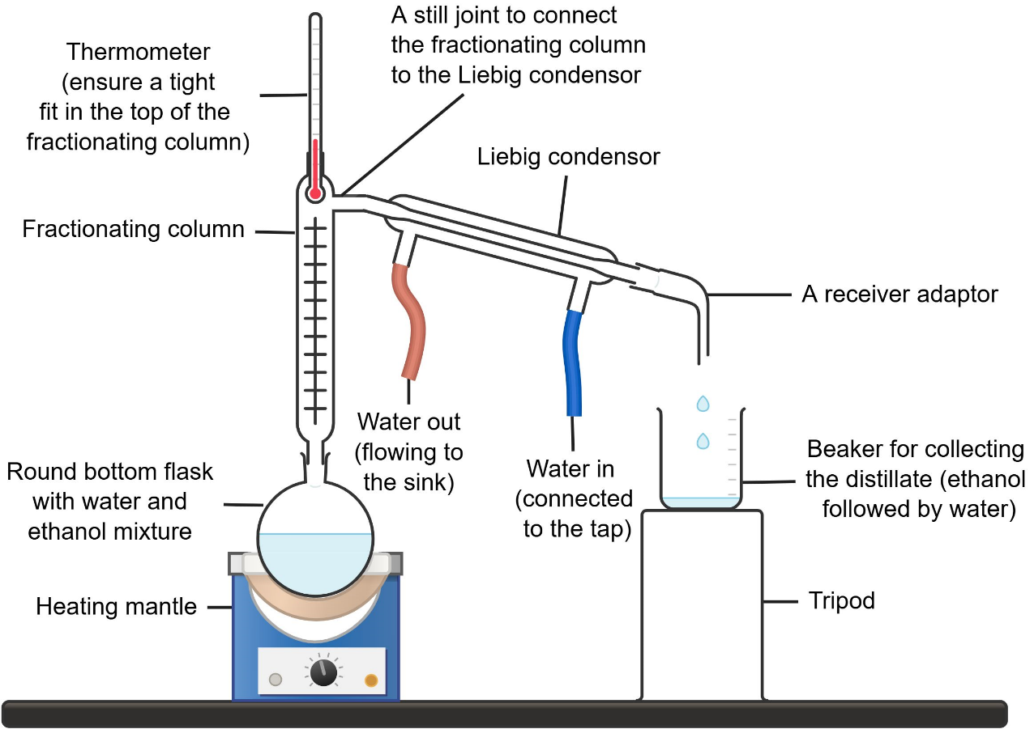
This work has been generated using Chemix.
Figure 3 – annotated example of a school laboratory fractional distillation setup
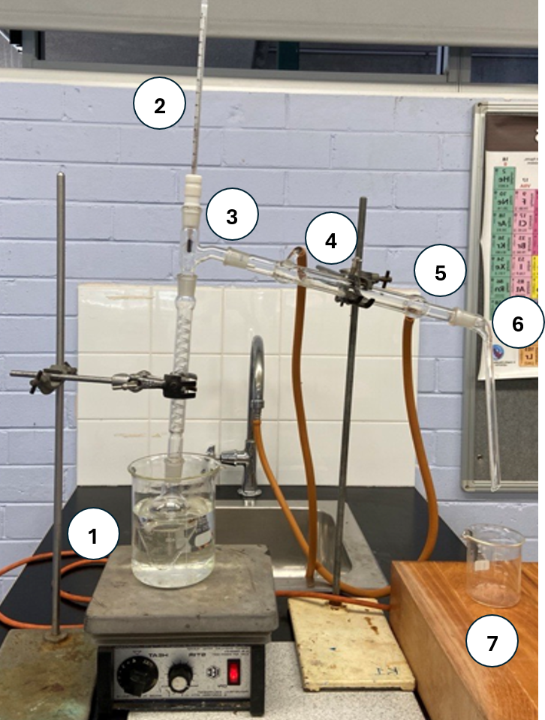
1. 50:50 mixture of ethanol and water in the flask
2. Ensure the fractionating column is closed using the thermometer case to prevent the escape of vapours into the surroundings. If vapours are lost, it will hinder the collection of the distillate, such as ethanol. The thermometer is used to monitor the temperature at which the distillate begins to collect. This temperature corresponds to the boiling point of the substance being distilled. For example, in this case, ethanol starts to appear at around 78–79 °C, which matches its known boiling point. This indicates that the collected distillate is likely pure ethanol.
3. A still joint to connect FC to the Liebig condenser.
4. Connect the rubber tubing for collecting warm water to the upper outlet of the condenser. This tubing will flow into the sink.
5. Connect the rubber tubing from the tap to the bottom inlet of the condenser for effective cooling of vapours.
6. A receiver adapter collects the distillate and directs it into a beaker.
7. A beaker collects the distillate. This solution will be ethanol*
*The equipment setup shows a water bath being used to heat the solution; however, this will not allow the water to reach a sufficiently high temperature to be distilled. To collect the water distillate, a heating mantle will be required with a round-bottom flask.
Checkpoint: What physical property do we use to separate crude oil into its useful fractions? Why do they need to be separated?
Boiling point. They need to be separated because the different fractions have different uses; for example, paraffin wax is used for candles and crayons, while kerosene is used for jet fuel.
Sample response: Student resource – fractional distillation
- What is fractional distillation used for in the context of crude oil?
It is used to separate crude oil into different components or fractions based on their boiling points.
- Why do different fractions separate in the fractionation column at different levels?
Each fraction of the crude oil has a different boiling point. The fractionation column ranges in temperature, and the fractions condense (turn back into liquid) at various temperatures within the column, allowing them to be separated.
- What happens to crude oil before it enters the fractionation column?
It is heated to a high temperature, turning most of it into vapour.
- Name 2 examples of fractions obtained from crude oil.
Any 2, such as diesel, kerosene, petrol, or liquid petroleum gas.

Sample response – labelling the diagram of fractional distillation
Figure 4 – completed diagram of fractional distillation
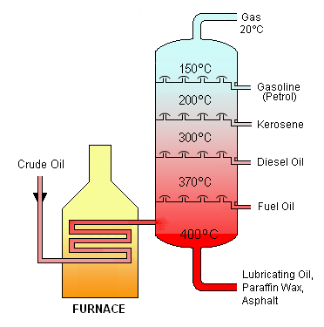
‘Crude Oil Distillation’ via Wikimedia Commons is licensed under the CC BY-SA 3.0 license.

Student resource – fractional distillation
Watch the video Fractional Distillation (4:05) and complete the comprehension questions below:
- What is fractional distillation used for in the context of crude oil?
- Why do different fractions separate in the fractionation column at different levels?
- What happens to crude oil before it enters the fractionation column?
- Name 2 examples of fractions obtained from crude oil.
Label the following on the diagram of fractional distillation.
- Crude oil
- 400 °C
- Liquid petroleum gas (LPG)
- Furnace
- Very long hydrocarbons (lubricating oil, paraffin wax, asphalt)
- 150°C
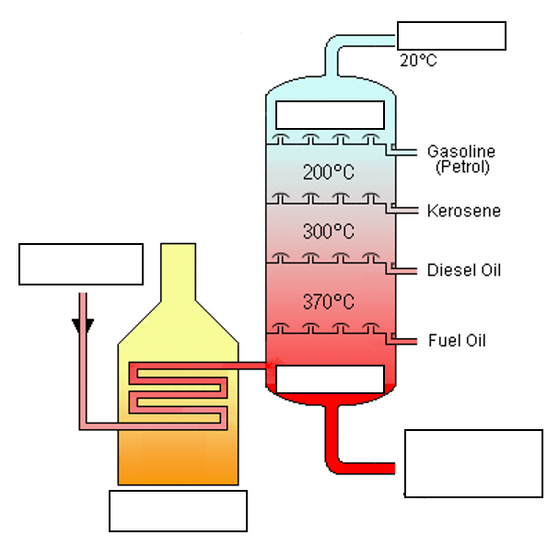
‘Crude Oil Distillation’ via Wikimedia Commons is licensed under the CC BY-SA 3.0 license.

Using the crude oil fractions
Background information
Table 8 – crude oil fraction properties and uses
Fraction | Boiling range (°C) | Carbon chain size | Main uses
Refinery gases | <30 | C1–C4 | Liquid petroleum gas for gas bottles. Used for BBQs and gas heaters.
Petrol | 30–70 | C5–C8 | Fuel for vehicles with internal combustion engines (most cars).
Naphtha | 60–160 | C7–C13 | Used to produce plastics, synthetic fibres and detergents. Used as a solvent in industrial processes.
Kerosene/Paraffin | 160–250 | C11–C16 | Fuel for jet engines. Used in some heaters and portable stoves. Sometimes used in degreasing and cleaning machinery.
Diesel oil | 250–320 | C14–C20 | Diesel fuels are used in cars, trucks, trains and various types of equipment, including tractors and other vehicles. Fuel for backup generators.
Lubricating oil | 300–370 | C20–C50 | Engine oils and lubricating oils for machinery to reduce wear and tear. Waxes and greases are used to make candles, food packaging and waterproofing materials. Used in cosmetics and skincare.
Fuel oil | 350–600 | C20–C70 | Used in industrial boilers and furnaces where high temperatures are required.
Bitumen/residue | >600 | >C70 | Mixed with gravel to make asphalt for roads. Used to waterproof roofs.
Activity instructions
- Highlight the various fractions of crude oil using information from Table 8.
Note: information on the various fractions varies slightly between sources. Students may locate information that differs from that in Table 8 during the research task.
- In small groups, students research an assigned hydrocarbon fraction. Have them research and create a short presentation on their selected fraction’s uses and properties for their peers to view. The presentation should include:
- the name of the fraction
- approximate boiling point range
- how the boiling point range relates to its position in the fraction distillation column
- the approximate number of carbon atoms in the molecules, which indicates the size of the hydrocarbons in the fraction
- a use of the fraction.
- Each group presents to the class about their fraction.
Differentiation: fractions can be assigned to groups of students according to their differentiation needs. Simpler fractions include refinery gas, petrol and diesel oil. More complex fractions encompass naphtha, lubricating oil, fuel oil and bitumen/residue.
Advanced students could explore catalytic cracking to produce smaller, more useful hydrocarbons from longer-chain hydrocarbons.

3.3 Give them a name
Table 9 – learning intention and success criteria for 3.3 Give them a name
We are learning: | I can:
- to describe the similarities and differences between materials based on their chemical properties. | - build molecular models of the first 8 alkanes  - identify the functional group of an organic compound  - identify and name the first 8 alkanes  - draw the structure of the first 8 alkanes  - name some simple alkenes, alkynes, alcohols and carboxylic acids.

Naming organic compounds
The International Union of Pure and Applied Chemistry (IUPAC) plays a key role in standardising chemical terminology, nomenclature and measurements globally. Its main roles include:
- Standardising chemical names and formulas – the IUPAC develops rules for naming chemical compounds, enabling scientists worldwide to communicate clearly and consistently.
- Creating standard symbols and terminology – the IUPAC defines and standardises the terms, symbols and units used in chemistry.
- Publishing reference data – it provides data such as atomic weights, constants and the periodic table.
- Show MAT PPT ‘3.3 The role of IUPAC’ and outline the role of the International Union of Pure and Applied Chemistry (IUPAC).
- Define chemical nomenclature as a set of rules to generate systematic names for chemical compounds. Show MAT PPT ‘3.3 Naming organic compounds’ to unpack how prefixes and suffixes are used to name organic compounds.
- Provide students with a copy of the Student resource – naming organic compounds and unpack the rules for naming simple organic compounds. Review the tables of prefixes and suffixes and unpack the examples.
Rules for naming organic compounds
- Count the number of carbon atoms in the longest continuous chain. Use this number to determine the prefix.
- Identify the functional group to determine the suffix.
- Write the prefix followed by the suffix to name the organic compound.
- Students’ complete Problem set 1 in the handout by first constructing models of the C1 to C8 alkanes and then using the naming rules to determine the name of each alkane. Students draw a simple structural diagram of the alkanes.
- Students complete Problem set 2 to identify a wider range of organic compounds, including alkenes, alkynes, alcohols and carboxylic acids. Sample responses are provided in MAT PPT ‘3.3 Naming organic compounds’.
Differentiation: the number of alkenes, alkynes, alcohols and carboxylic acids to be named could be reduced. The complexity could be reduced by walking the student through the process of counting carbon atoms and identifying the functional group to name the compounds.
Note: condensed formulas are sometimes used in this resource for convenience. However, structural formulas (which show how the atoms in a molecule are bonded to each other) are used in the student resource.

Sample response: Student resource – naming organic compounds
Molecular models for C1 to C8 alkanes:
Figure 5 – methane  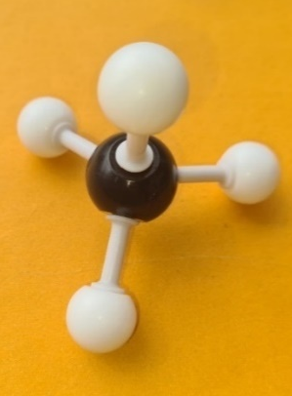 | Figure 6 – ethane  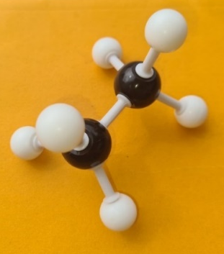
Figure 7 – propane  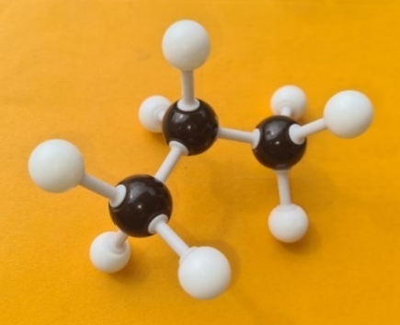 | Figure 8 – butane  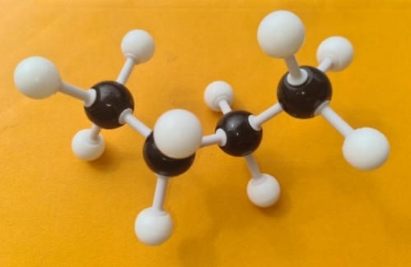
Figure 9 – pentane  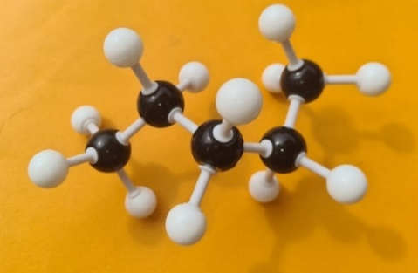 | Figure 10 – hexane  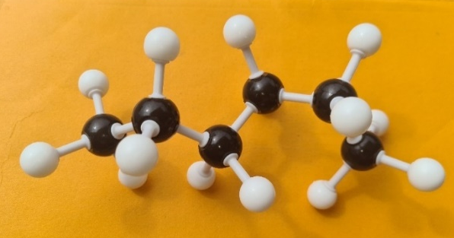
Figure 11 – heptane  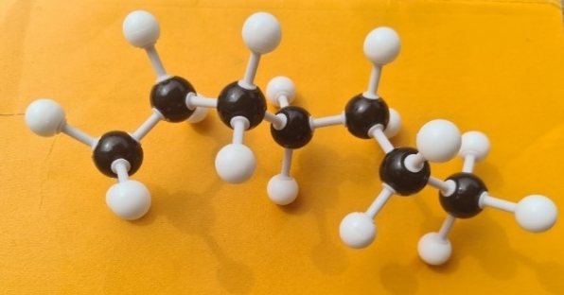 | Figure 12 – octane  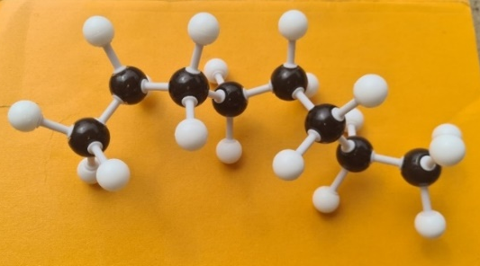

Table 10 – sample responses for Problem set 1 naming and drawing the C1 to C8 alkanes
IUPAC name | Number of carbon atoms/functional group | Structure
Methane | 1 | 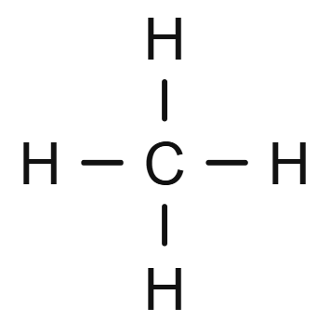
Ethane | 2 | 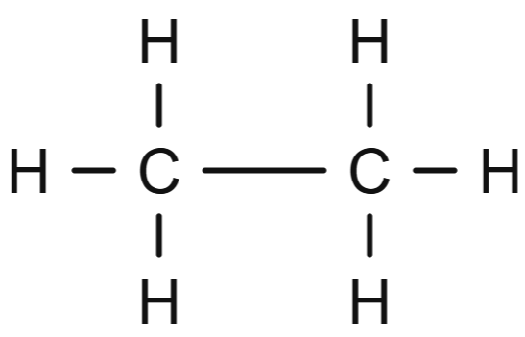
Propane | 3 | 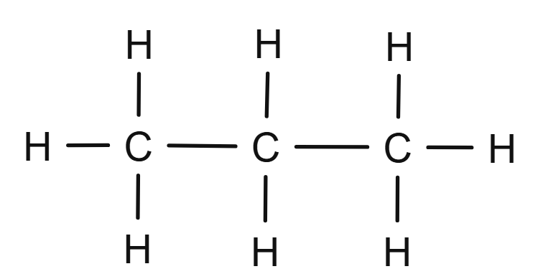OR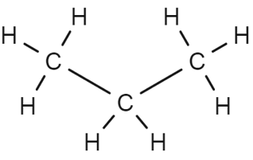
Butane | 4 | 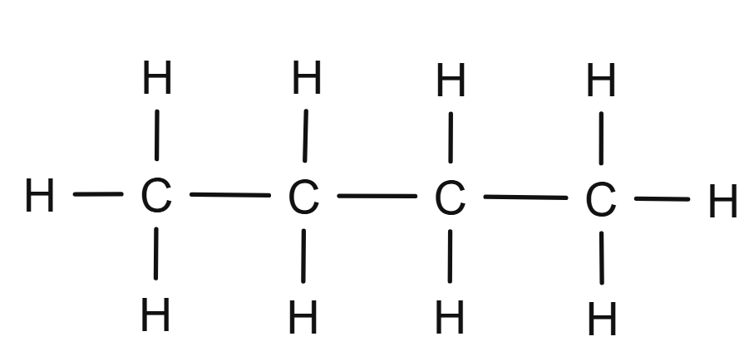OR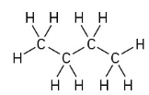
Pentane | 5 | 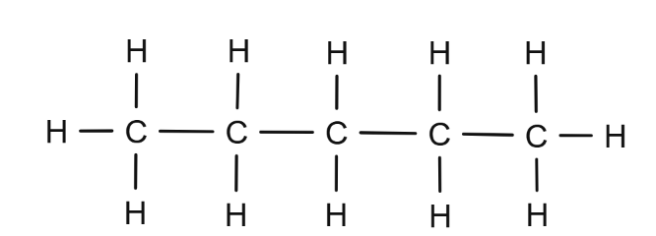  OR  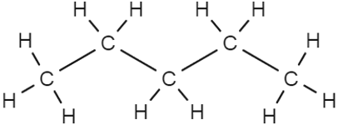
Hexane | 6 | 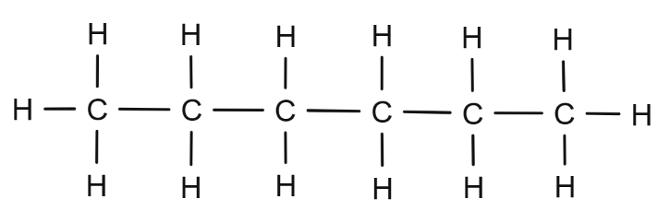  OR  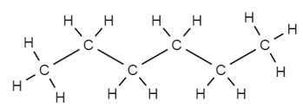
Heptane | 7 | 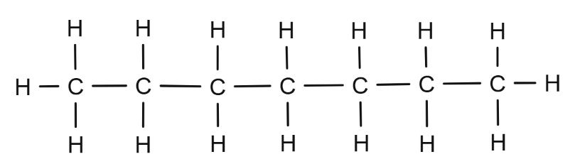  OR  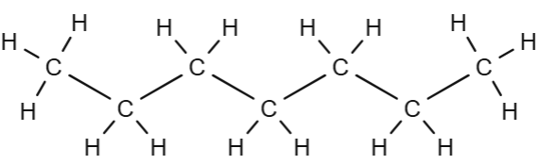
Octane | 8 | 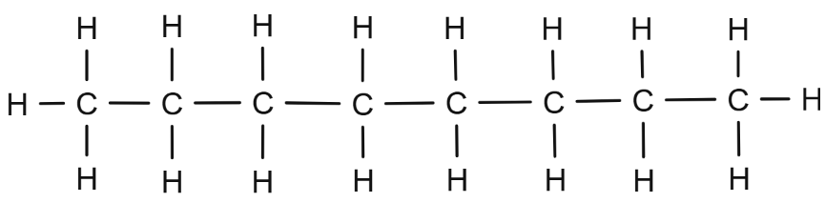  OR  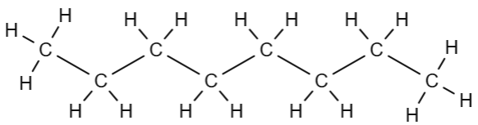
Table 11 – sample responses for Problem set 2 naming organic compounds
Structure | Prefix (# of carbon atoms) | Suffix (functional group) | IUPAC name
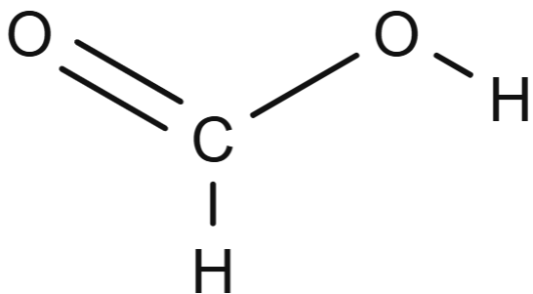 | meth-  (1) | -anoic acid  (carboxylic acid) | methanoic acid
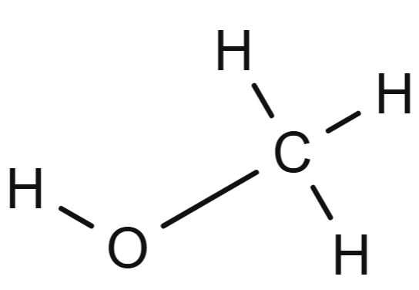 | meth-  (1) | -anol  (alcohol) | methanol
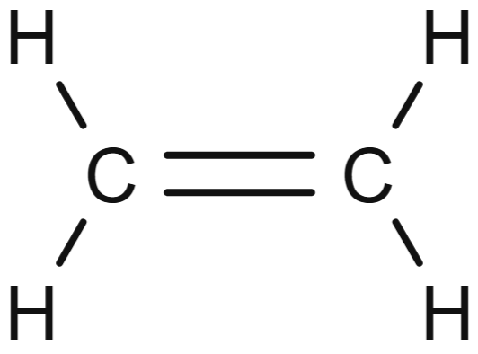 | eth-  (2) | -ene  (alkene) | ethene
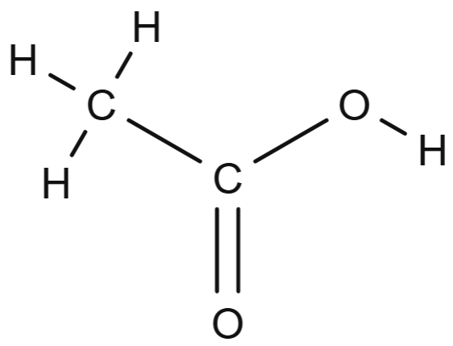 | eth-  (2) | -anoic acid  (carboxylic acid) | ethanoic acid
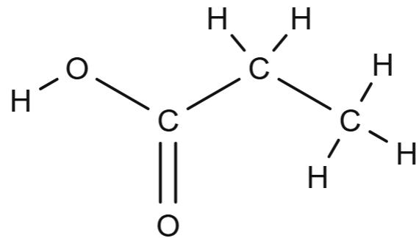 | prop-  (3) | -anoic acid  (carboxylic acid) | propanoic acid
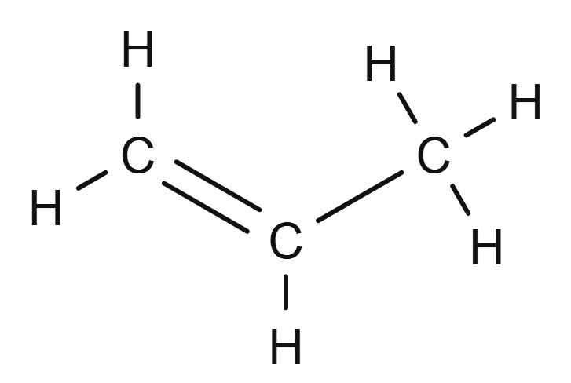 | prop-  (3) | -ene  (alkene) | propene
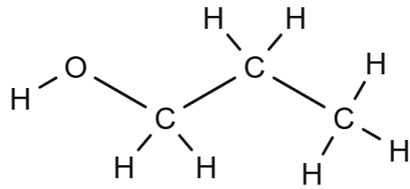 | prop-  (3) | -anol  (alcohol) | propanol

Student resource – naming organic compounds
In this activity, you will learn how to use prefixes and suffixes to name organic compounds using IUPAC nomenclature.
Nomenclature – naming system
Prefix (start of a word) – tells you how many carbon atoms are in the longest chain
Suffix (end of a word) – tells you the type of bond or functional group
Functional group – a specific group of atoms or bonds within a molecule that is responsible for the characteristic chemical reactions of that compound.
Rules for naming organic compounds
      - Count the number of carbon atoms in the longest continuous chain. Use this number to determine the prefix.
      - Identify the functional group to determine the suffix.
      - Write the prefix followed by the suffix to name the organic compound.
Table 1 – common prefixes for organic compounds
Number of carbon atoms | Prefix |  | Number of carbon atoms | Prefix
1 | Meth- |  | 5 | Pent-
2 | Eth- |  | 6 | Hex-
3 | Prop- |  | 7 | Hept-
4 | But- |  | 8 | Oct-
Table 2 – common suffixes for organic compounds
Type of compound | Suffix | Meaning | Diagram of bonds or functional groups | Example
Alkane | -ane | Contains single bond(s) between carbon atoms | 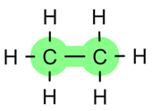 | Ethane
Alkene | -ene | Contains one double bond between carbon atoms | 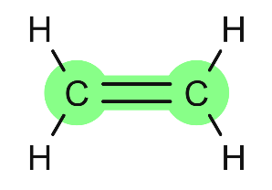 | Ethene
Alkyne | -yne | Contains one triple bond between carbon atoms | 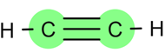 | Ethyne
Alcohol | -anol | Contains a hydroxyl group (–OH) | 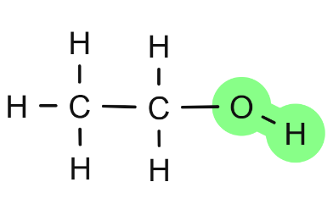 | Ethanol
Carboxylic acid | -anoic acid | Contains a carboxyl group (–OOH) | 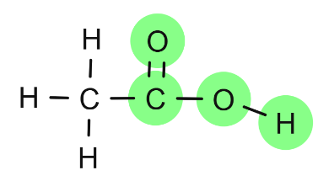 | Ethanoic acid

Problem set 1
Build a molecular model of alkanes with between 1 and 8 carbons. Identify the IUPAC names for the alkanes in Table 3 and draw the corresponding structural formulas for each.
Table 3 – naming and drawing the C1 to C8 alkanes
IUPAC name | Number of carbon atoms/functional group | Structure
 | 1
 | 2
 | 3
 | 4
 | 5
 | 6
 | 7
 | 8

Problem set 2
Use the naming rules to determine the name of each of these compounds.
Table 4 – naming organic compounds problem set
Structure | Prefix (# of carbon atoms) | Suffix (functional group) | IUPAC name
 | Meth-  (1) | -OOH (anoic acid) | Methanoic acid

3.4 All things combustion (practical investigation)
Table 12 – learning intentions and success criteria for 3.4 All things combustion
We are learning: | I can:
- to explain the use of materials based on their chemical properties | - define complete and incomplete combustion  - give an example of complete and incomplete combustion  - identify the products of complete and incomplete combustion  - compare the products of complete and incomplete combustion  - compare the energy released by complete and incomplete combustion
- to design a safe and valid investigation | - identify the types of data that need to be collected in an investigation  - identify hazards and mitigate risks in an investigation  - design a valid and safe investigation
- to use cause and effect relationships to make predictions. | - identify simple relationships  - make logical predictions based on cause-and-effect relationships  - provide reasoning for my predictions.

Complete and incomplete combustion
Note: students should complete the worksheet Student resource – igniting understanding – complete or incomplete? during the following class discussion and demonstration. Sample responses for the worksheet are included in MAT PPT ‘3.4 Complete combustion and 3.4 Incomplete combustion’.
- Begin by lighting a candle and placing a beaker above it, while facilitating the discussion. Ensure the beaker is positioned high enough above the candle to allow for an adequate oxygen supply, enabling the candle flame to burn cleanly.
- Ask the students what combustion is and facilitate a discussion until an appropriate definition is arrived at, such as ‘combustion is the reaction of a substance with oxygen’. Ask the students what they notice about the combustion of the candle wax. They should notice that the flame is clean, and water condenses on the inside of the beaker. They may observe that the candle flame has a small blue component at its outer edge. Most of the flame is yellow.
- Next, examine the blue flame of a Bunsen burner. Explain that complete combustion of a hydrocarbon occurs when there is an excess of oxygen, resulting in carbon dioxide and water as the only products. The open holes on the collar allow for maximum oxygen to mix with the gas, promoting complete combustion. Discuss the properties of complete combustion, which include a clear flame, low pollutants, a blue flame and high energy output.
- Burn a splint of wood or examine the yellow flame of a Bunsen burner. Students should observe that this flame is not clean, producing soot and leaving behind solid carbon. Explain that incomplete combustion occurs when there is insufficient oxygen, preventing the hydrocarbon from fully reacting. The closed holes on the collar of the Bunsen burner decrease the amount of oxygen available for combustion. Incomplete combustion produces a combination of carbon monoxide, carbon (soot) and water. Define incomplete combustion: Incomplete combustion of a hydrocarbon occurs when the hydrocarbon reacts with a limited supply of oxygen, and the hydrocarbon is not fully oxidised.
- Write the word equations for the combustion of a hydrocarbon such as methane, showing how the products change in incomplete combustion.
$$Complete combusion$$
$$Methane\left(g\right)+Oxygen\left(g\right)→Carbon dioxide\left(g\right)+Water\left(g\right)$$
4CH₄ (g) + 8O₂ (g) à 4CO₂ (g) +8H₂O (g)
$$Incomplete combustion$$
$$Methane\left(g\right)+Oxygen\left(g\right)→Carbon monoxide\left(g\right)+Carbon dioxide\left(g\right)+water(g)$$
4CH_{4(g)} + 7O_{2(g)} à 2CO_{(g)}+ 2CO_{2(g)} +8H₂O_{(g)}
Differentiation: students may be shown the chemical equations for both complete and incomplete combustion to illustrate how the products change when there is an insufficient amount of oxygen. Note that this may be the students’ first exposure to chemical equations.
- Ask the students where they have observed complete and incomplete combustion before. Add these examples to their worksheets.
- Explain to students the dangers of incomplete combustion. For instance, combustion heaters burn fuels like gas, kerosene or wood to generate heat. If there isn’t enough oxygen in the room, the fuel can’t burn completely, leading to incomplete combustion. The carbon monoxide produced is colourless, odourless and poisonous. Inhaling carbon monoxide can prevent oxygen from reaching your organs and brain, which can quickly result in unconsciousness or even death. Combustion heaters should only be used in well-ventilated areas with sufficient fresh air for complete combustion.
Checkpoint: What is a key characteristic of complete combustion? (MAT PPT ‘3.5 Checkpoint’)
- It produces soot and carbon monoxide
- It occurs in the presence of a limited supply of oxygen
- It produces carbon dioxide and water as the main products
- It has a yellow flame.
Table 13 – checkpoint sample answer and explanation
Response | Correct/  Incorrect | Explanation
A | Incorrect | This response describes a characteristic of incomplete combustion. Incomplete combustion occurs when there is insufficient oxygen, resulting in the production of soot and carbon monoxide.
B | Incorrect | This response describes incomplete combustion. Complete combustion requires an adequate supply of oxygen.
C | Correct | N/A
D | Incorrect | A yellow flame is typically associated with incomplete combustion, indicating inefficient burning. Complete combustion is indicated by a blue flame, which shows a clean burn.

Student resource – igniting understanding – complete or incomplete?
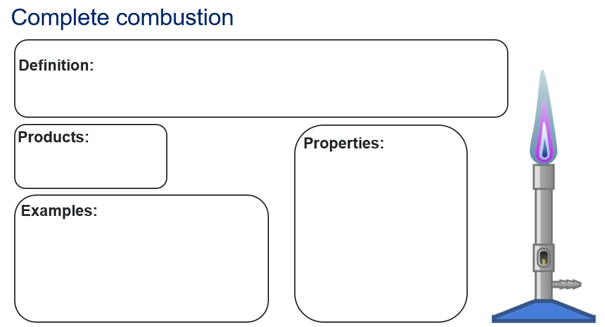
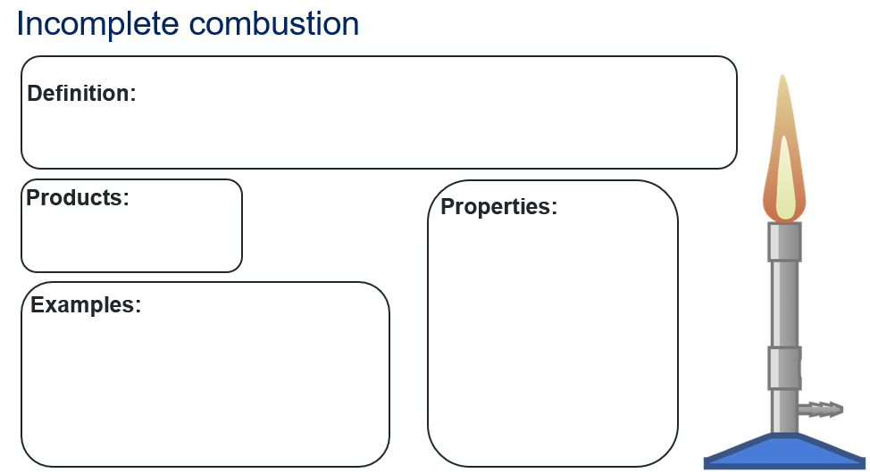

Comparing incomplete and complete combustion (practical investigation)
- Pose the problem: ‘How can we determine which type of combustion provides the most energy?’ Students may recall that they compared the efficiency of appliances in the Energy focus area.
- Students complete the ‘predict’ section of a Predict-Observe-Explain (POE) activity (MAT PPT ‘3.4 Predict-Observe-Explain’) related to the question of which type of combustion provides the most energy.
- Guide students as they design and conduct an investigation to compare the energy output of the blue and yellow flames from a Bunsen burner. Students will only need to collect and record data. They do not need to graph it or complete a comprehensive discussion. Appendix A – investigation design scaffold may be used to support students in designing their investigation.
Checkpoint: check in with individual and small groups of students regularly as they design and conduct their investigations to ensure they have a strong understanding of the steps involved in investigation design and the concepts they are investigating. Ask questions such as:
- What is the main question you are trying to answer with your investigation?
- Why is it important to compare the energy output of different flame types?
- Can you explain the steps you will take to conduct your investigation?
- What materials are you using? Why did you choose them?
- What is your independent variable in this investigation?
- How will you ensure that this is a fair test?
- What do you predict will happen when you heat the water with the blue flame versus the yellow flame?
- After conducting the investigation, students will record their observations of the temperature change for each type of combustion. Show MAT PPT ‘3.4 Calculation of energy transferred to the water’ and guide students to calculate the energy transferred to the water using the following formula:
The energy transferred to the water as thermal energy, $E_{thermal}$, can be calculated by the formula:
$E_{thermal}=mass of water \left(m\right)× 4.18 \left(c\right)×change in termperature \left(∆T\right)$. Where:
- m is the mass of water (g)
- c = 4.18 JK⁻¹g⁻¹ is the specific heat capacity of water (the energy required to raise the temperature of 1 gram of water by 1 °C).
- ∆T is the change in temperature of water (°C).
- Students assess their results and respond to the observer, explaining the components of the POE scaffold. Students should have found that the blue flame (complete combustion) transferred more heat to the 100 mL of water. Tell students that the blue flame provides more energy because the methane hydrocarbon can be completely burned, as there is enough oxygen for the reaction to proceed.
Checkpoint 2 (MAT PPT ‘3.4 Calculation of energy transferred to the water’):
A car engine burns petrol (a hydrocarbon) to release energy, which is used to move the car. An air filter cleans the air that goes to the motor. To burn properly, the engine requires a sufficient supply of oxygen, which is obtained from the air. An air filter helps clean the air before it enters the engine.
      - What would happen if the air filter became dirty or clogged?
      - What type of combustion is likely to occur?
      - Will more or less energy be released? Explain why.
      - What products will be produced in the combustion reaction?
Checkpoint sample response
- Not enough oxygen will be able to get to the engine, where combustion takes place.
- Incomplete combustion.
- Less energy. The car will be less fuel-efficient because incomplete combustion does not fully burn the fuel. Instead of the petrol being burnt to produce carbon dioxide and water, it will produce carbon monoxide, carbon and water.
- Carbon, carbon monoxide, carbon dioxide and water.

Sample investigation design
Purpose of the investigation
To determine which type of combustion provides the most energy.
Aim
To determine which type of combustion produces the greatest increase in water temperature, complete or incomplete combustion.
Variables
Table 14 – overview of the variables
Variables | Explanation
Independent variable  (the variable that you will change)  - type of combustion | How will this variable be changed?  - The blue and yellow flames of a Bunsen burner will be tested.
Dependent variable  (the variable you will measure)  - temperature increase of the water | How will you measure this variable?  - A digital temperature sensor will be used to measure the temperature of water before heating and after 2 minutes of heating.
Controlled variables  (the variables that you will keep the same) | How will each variable be controlled?
- volume of water | - 100 mL of water will be used
- beaker size | - A 250 mL beaker will be used
- distance of the beaker from the Bunsen burner | - the beaker will be placed on a tripod to keep the distance consistent
- position of the sensor in the beaker of water | - the sensor will be supported by a retort stand and clamp so that the tip is in the middle of the beaker
- heating time of the water | - the water will be heated for 2 minutes
Experiment control  A control will not be used in this investigation. | What is the experiment control? Why is it needed or not needed in this investigation?  Blue and yellow Bunsen burner flames are being compared to each other. The primary goal is to compare the flames under identical conditions.
Equipment and materials
Table 15 – list of the equipment and materials that are needed for the investigation
Equipment | Quantity
Bunsen burner | 1
Matches | 1 box
Tripod | 1
Wire gauze mat | 1
Retort stand | 1
Boss head | 1
Clamp | 1
250 mL beaker | 2
Thermometer or digital temperature sensor | 1
Safety goggles | 1 per student in the group
Stopwatch or timer | 1
water | 200 mL
Method
- Set up the equipment as shown in the diagram below.
- Pour 100 mL of water into beaker A, which will be heated with the blue flame.
- Secure the temperature sensor to a retort stand using a boss head and clamp.
- Place beaker A on the tripod. Immerse the temperature sensor so that the tip of the sensor is in the middle of the beaker.
- Record the initial temperature of the water in beaker A.
- Light the Bunsen burner and adjust it to produce a blue flame. Heat the water in beaker A for 2 minutes using the blue flame.
- After 2 minutes, record the final temperature of the water in beaker A.
- Pour 100 mL of water into beaker B, which will be heated with the yellow flame.
- Repeat steps 3–7 using beaker B and adjust the Bunsen burner to produce a yellow flame.
Note: allow all equipment to cool before packing it away. Ensure that all soot is cleaned off the beakers before they are packed away.
Diagram
Figure 13 – equipment setup to test water temperature
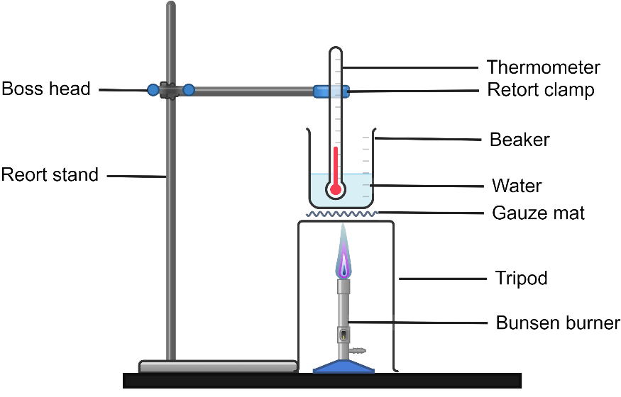
This work has been generated using Chemix.
Results
Table 16 – change in water temperature after heating for 2 minutes
Bunsen setting | Initial temperature (ºC) | Final temperature (ºC) | Temperature increase (ºC)
Blue flame | 24 | 36 | 12
Yellow flame | 24 | 33 | 9
Table 17 – energy transferred to the water by complete and incomplete combustion
Bunsen setting | ∆T (change in temperature °C) | Mass of water (g) | Energy transferred to the water  E_{thermal} = mass of water × 4.18 × ∆T (J)
Blue flame | 12 | 100 | 5016
Yellow flame | 9 | 100 | 3762

3.5 How have we used hydrocarbons?
Table 18 – learning intention and success criteria for 3.5 How have we used hydrocarbons?
We are learning: | I can:
- to explain the use of materials based on their chemical properties. | - outline a past use of hydrocarbons  - outline a current use of hydrocarbons  - describe how the use of hydrocarbons has changed  - recognise that the environmental impacts of the use have changed the use of a hydrocarbon compound.
Note: these activities cover the past and current use of specific hydrocarbon compounds. In lesson 3.2, there was an activity on the uses of the crude oil fractions, rather than the use of individual hydrocarbons.

Exploring the use of hydrocarbons – class discussion
- Begin the activity by discussing how hydrocarbons have been used over time. Recall the uses of the crude oil fractions covered in an earlier lesson, and explain that in this lesson, we will delve deeper into the use of specific hydrocarbons (rather than fractions or groups of hydrocarbons). Discuss and create a list identifying the various uses of hydrocarbons.
- To stimulate the discussion, consider sharing some past and current uses of hydrocarbons, such as:
- Explain that the use of hydrocarbons is not new. The ancient Egyptians and Greeks used pitch for waterproofing, while the Romans employed oil as a lubricant and burning oil as a weapon. The pitch used by ancient Egyptians was bitumen, a thick petroleum-based substance found near the Dead Sea. Throughout history, hydrocarbons have served as a source for heating, cooking and lighting.
- Discuss the role of plastics in our society and explain that plastics are made from hydrocarbons like ethene and propene. It is crucial to note how their significance has evolved over time. Initially, plastics were regarded as essential materials due to their versatility, durability and low cost. They became integral to various industries, from packaging to construction. However, as awareness of the environmental impacts of plastics has grown, our perception and use of these materials have started to shift. Issues such as plastic pollution, waste management and the depletion of natural resources have prompted society to rethink its reliance on plastics. This has led to a rising emphasis on sustainable alternatives, recycling initiatives and policies aimed at reducing plastic consumption.

Exploring the use of hydrocarbons – collaborative research
Preparation: before the class, create a shared slide deck that all students can access. Include an instruction slide as the first slide. A sample is included in the MAT PPT ‘3.6 Using hydrocarbons’.
- Divide the class into small groups and allocate each group a specific hydrocarbon.
- Outline the requirements for each slide (see Table 18) and the qualities of an effective slide.
- Student groups present their slides to the class.
Effective slides use:
- clear and concise text
- readable fonts – consider style and size
- graphics
- engaging backgrounds that do not distract from content
- highlighting to emphasise key points
- animations to emphasise and highlight without distracting the audience.
Table 19 – details of slides for the hydrocarbon presentation
Slide number | Include on this slide:
Slide 1 | - the name of the hydrocarbon  - the formula for the hydrocarbon  - an image of the structure of the hydrocarbon  - an image of the hydrocarbon itself.
Slide 2 | - an explanation of how the hydrocarbon has been used in the past  - an explanation of how the hydrocarbon is used now  - the environmental impacts of its use  - relevant images.
Differentiation: produce a list of websites and a slide template for students to use as they complete this task.
Checkpoint: use the slide MAT PPT ‘3.5 Checkpoint – How have we used hydrocarbons?’ Students match the hydrocarbons to their uses.

Table 20 – sample information students may gather for past and current uses of a range of hydrocarbons
Hydrocarbon compound | Past uses | Current uses | Environmental impacts of the use of hydrocarbons
Methane (CH₄) | Methane generated in sewers was burned in sewer gas destructor lamps (streetlights). These lamps were used in London from the 1890s until approximately the 1940s. | Methane is the main component of natural gas, which is used for cooking, heating and generating electricity. It is piped to houses through underground gas pipes. | Methane is a greenhouse gas that can contribute to global warming. It is 25 times more effective than carbon dioxide at trapping heat in the atmosphere. When methane is burnt, it combusts to produce carbon dioxide and water. The production of carbon dioxide contributes to greenhouse gas emissions.
Ethane (C₂H₆) | Before the 1960s, ethane was burned along with methane (the 2 hydrocarbons were not separated) as a fuel for cooking and heating. | Ethane is a crucial raw material for producing ethylene, another hydrocarbon, which is used to make a wide range of plastics, solvents and antifreeze. | When ethane is burned as part of natural gas, it produces the greenhouse gas carbon dioxide, which contributes to the greenhouse effect. When ethane is released into the air (at oil and gas fields), it can react with sunlight and other chemicals to form ground-level ozone, which pollutes the air.
Ethene (C₂H₄) | From approximately 1923 to 1940, Ethene was used as an anaesthetic during surgeries. | Ethene is widely used to make plastic polymers. Ethene (also called ethylene) is important in ripening fruit. | Most ethene is used to make plastics. If these plastics are not recycled properly, they can end up in landfills or oceans. Pollution from plastics is harmful to animals and the ecosystem.
Acetylene (C₂H₂) | In the late 1800s, acetylene was burned in carbide or acetylene gas lamps. These lamps were installed on cars, bicycles and in homes. | Acetylene is used as a fuel for welding and cutting steel because it produces a lot of heat. | Manufacturing acetylene can produce toxic byproducts and use large amounts of energy, increasing industrial waste and emissions.
Benzene (C₆H₆) | In the late 1800s, benzene was used in aftershave because of its sweet smell. | Benzene is used in the manufacture of a large number of chemicals that contribute to the production of plastics such as polystyrene, synthetic fibres, detergents and as a degreasing agent. | Benzene is a highly toxic substance that can cause cancer. Vapours contribute to air pollution, and spills can contaminate the soil and water. The use of benzene is now heavily restricted due to its health and environmental consequences.

Think-Pair-Share
Students use the information from the class discussion, their research, and the shared slide deck to answer the question: How has our use of hydrocarbons changed over time? Encourage them to consider a range of uses, including plastics, from both historical and modern perspectives, as well as the environmental impacts associated with their use. A Think-Pair-Share template is included in the MAT PPT ‘3.5 Think-Pair-Share’.

3.6 Polymer raw ingredients
Table 21 – learning intention and success criteria for 3.6 Polymer raw ingredients
We are learning: | I can:
- to identify the use of polymers based on their physical and chemical properties. | - define polymer and monomer  - identify the different types of raw materials used for making polymers  - classify polymers as synthetic polymers or biopolymers.

Introduction to polymers
Prior knowledge checkpoint: complete questions 1–4 for prior understanding of hydrocarbons and organic compounds (MAT PPT ‘3.6 Checkpoint’).
- Introduce polymers by watching the video Introduction to plastics (2:36).
- Show MAT PPT ‘3.6 Polymers’. Define polymers as large molecules made up of smaller building blocks called monomers. Using the slide MAT PPT ‘3.6 Polymers versus plastics’, explain that the term ‘plastics’ is commonly used, but they are subsets of polymers.
- Use an analogy to help students understand polymers. A paper clip represents a monomer, which is a small molecule that can join with others to form a larger structure. Link several paper clips together to show the polymerisation process, where many monomers chemically bond to create a polymer chain. The long chain of connected paper clips illustrates how polymers consist of repeating units.
- Students use molecular model kits to construct ball and stick models of polyethylene consisting of 3–5 monomers. The steps for making polyethylene are outlined on the MAT PPT ‘3.6 Structure of polymers’ slide.
Extension: students construct a model of branched polyethylene and predict its density (closely or loosely packed polymer chains) based on its structure compared to that of linear polyethylene.
High-density polyethylene (HDPE) – has long, straight chains with minimal branching, allowing chains to pack closely together. This results in a denser, stronger plastic.
Low-density polyethylene (LDPE) – has many branches, preventing the chains from packing tightly. This results in a softer, more flexible plastic with lower density.
- Provide a brief overview of polymers and their importance, emphasising their role in everyday materials like plastics and synthetic fibres. The overview may include:
- Versatility – different structures give polymers a wide range of properties, from stretchy and flexible to rigid and tough.
- Durability – many polymers are resistant to water, chemicals, and decay, making them suitable for applications such as packaging, construction, and clothing.
- Lightweight nature – polymers are often used as a lighter alternative to metal or glass in products such as containers, car parts, and electronics.
- Students complete a Frayer diagram to define the term 'polymer'. A blank template and sample responses are included in MAT PPT ‘3.6 Frayer diagram – polymers’.
Differentiation: provide a modified Frayer’s diagram with word bank (MAT PPT ‘3.6 Frayer diagram – polymers (with word bank)’.
- Explain the main raw materials for making polymers (MAT PPT ‘3.6 Raw materials for polymers’).
- Provide students with Student resource – raw materials for polymers. Students use the information on polymers and their raw materials to answer questions about them. This is a comprehension activity where students need to extract the information from the resource. It is not expected that students will know and remember the polymers and monomers used in the activity.
- Show MAT PPT ‘3.6 Comparison of raw materials’ to explain the advantages and disadvantages of using crude oil and plant-based raw materials in polymer production.
Sample response: Student resource – raw material for polymers
- Classify each of the polymers in Table 1 as either a synthetic polymer or a biopolymer.
Table 1 – polymer types and their raw materials
Polymer | Type (synthetic polymer or biopolymer) | Raw material | Uses of the polymer
Polyethylene | Synthetic | Ethene (from crude oil) | Plastic bags, bottles
Polystyrene | Synthetic | Styrene (from crude oil) | Foam packaging, cups
Nylon | Synthetic | Hexamethylenediamine and adipic acid (from crude oil) | Clothing, ropes, string
Polyester | Synthetic | Ethylene glycol and terephthalic acid (from crude oil) | Clothes, soft drink bottles
Polylactic acid (PLA) | Biopolymer | Lactic acid (from fermented plant starch) | Compostable plastic cutlery, films
Cellulose | Biopolymer | Glucose (from plant cells) | Cellophane bags, rayon and viscose fabrics, disposable cutlery and plates
Polypropylene | Synthetic | Propene (from crude oil) | Car parts, bottle caps, chemical bottles
Polyvinyl chloride (PVC) | Synthetic | Vinyl chloride | Plumbing pipes, floor coverings, chairs
Rubber (natural) | Biopolymer | Latex (from rubber tree sap) | Balloons, gloves, tyres
- Draw a line to match each polymer product with the raw material it is likely made from. Use the table in question 1.
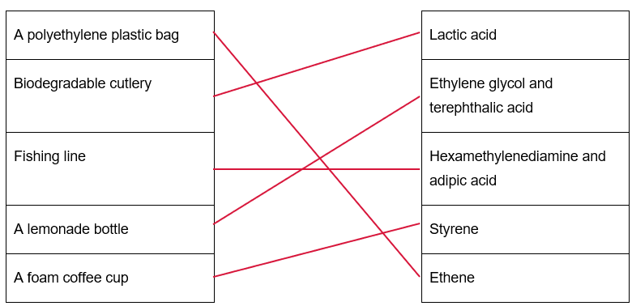
- Answer true or false for the following statements:
All polymers are made from fossil fuels. | False
Biopolymers are typically derived from living organisms or their products. | True
Nylon and polyester are made from renewable plant sources. | False
Corn and sugarcane can be used to make biodegradable plastics. | True

Student resource – raw materials for polymers
A polymer is a large molecule made from repeating smaller units called monomers. Polymers can be either synthetic (made from crude oil products) or biopolymers (produced by living organisms).
- Classify each of the polymers in Table 1 as either a synthetic polymer or a biopolymer.
Table 1 – Polymer types and their raw materials
Polymer | Type (synthetic polymer or biopolymer) | Raw material | Uses of the polymer
Polyethylene |  | Ethene (from crude oil) | Plastic bags, bottles
Polystyrene |  | Styrene (from crude oil) | Foam packaging, cups
Nylon |  | Hexamethylenediamine and adipic acid (from crude oil) | Clothing, ropes, string
Polyester |  | Ethylene glycol and terephthalic acid (from crude oil) | Clothes, soft drink bottles
Polylactic acid (PLA) |  | Lactic acid (from fermented plant starch) | Compostable plastic cutlery, films
Cellulose |  | Glucose (from plant cells) | Cellophane bags, rayon and viscose fabrics, disposable cutlery and plates
Polypropylene |  | Propene (from crude oil) | Car parts, bottle caps, chemical bottles
Polyvinyl chloride (PVC) |  | Vinyl chloride | Plumbing pipes, floor coverings, chairs
Rubber (natural) |  | Latex (from rubber tree sap) | Balloons, gloves, tyres
- Draw a line to match each polymer product with the raw material it is likely made from. Use the table in question 1.
A polyethylene plastic bag |  | Lactic acid
Biodegradable cutlery |  | Ethylene glycol and terephthalic acid
Fishing line |  | Hexamethylenediamine and adipic acid
A lemonade bottle |  | Styrene
A foam coffee cup |  | Ethene
- Answer true or false for the following statements:
All polymers are made from fossil fuels.
Biopolymers are typically derived from living organisms or their products.
Nylon and polyester are made from renewable plant sources.
Corn and sugarcane can be used to make biodegradable plastics.

3.7 Properties of polymers
Table 22 – learning intentions and success criteria for 3.7 Properties of polymers
We are learning: | I can:
- to describe the use of polymers based on their physical and chemical properties | - identify the properties of different types of polymers  - describe the properties of the different types of polymers  - link the properties of the polymer to its uses
- to design a safe and valid investigation | - describe the purpose of the investigation  - conduct a risk assessment to manage safety  - outline suitable tests to test the properties of polymers  - asses the type data that needs to be collected
- to solve problems. | - select suitable strategies to test properties  - identify suitable polymers for particular uses  - use evaluation criteria, to assess which properties make a polymer suitable for a particular use.
Background information
Plastics Identification Codes are numerical symbols, usually ranging from 1–7, enclosed in a triangular recycling symbol. These codes identify the type of plastic material a product is made from, helping consumers and recycling facilities in sorting plastics effectively. Each number corresponds to a specific polymer type and indicates whether the plastic can be recycled and how it should be processed for recycling. These codes are typically located at the bottom or back of plastic products, such as bottles, containers and packaging. By understanding these codes, individuals can make informed choices about recycling and properly disposing of plastic materials, which helps reduce environmental waste.

Investigating the properties of polymers (practical investigation)
Activity preparation
Note: to prepare for this activity, collect some polymer samples that can be tested. Where possible, select items that have a Plastics Identification Code, allowing for the determination of the polymer type. Use a range of polymer types to enable students to observe the variation in properties.
Equipment requirements for this investigation will vary based on the student’s investigation design. This list is based on the suggested property tests outlined in the sample student response. The equipment is for a group of students.
- 6–10 different types of polymer samples | - 1 × boss head and clamp
- 1 × dropper bottle of vegetable oil | - 2 × mass carriers
- 1 × dropper bottle of water | - 200 g of slotted masses
- 1 × retort stand | - Paper towel
Activity instructions
- Show students the collected polymer samples. Identify the type of polymer each test item is made of using the ‘plastics identification codes’ on the item/packaging to identify the polymer. A sample table is provided in MAT PPT ‘3.7 Polymers in common items’. Update this based on your collection of items.
- Facilitate a discussion on the properties of polymers. Introduce the concepts of strength (tensile properties), flexibility, transparency and opacity, heat resistance, water resistance and oil resistance. Consult the Glossary for definitions of these terms.
- Tell students that they will test the properties of a range of different polymers to learn how these properties determine the uses of the materials. Provide the students with a copy of the Student resource – investigating the properties of polymers. Guide students through:
- identifying the purpose of the investigation
- identifying properties of polymers that can be tested
- outlining a method that can be used to test the properties of the polymers
- conducting a risk assessment to identify potential hazards, the risks they pose and ways that the risks can be mitigated
- producing an appropriate table to collect data
- conducting the investigation to collect qualitative and/or quantitative data on each of the polymers
- discussing the limitations of the investigation
- solving problems based on the properties of polymers.
Extension: students can first make qualitative observations to develop a conceptual understanding and then collect quantitative data for more precise analysis.
- Guide students in analysing the data by identifying patterns in the properties of different polymers. For example, items made up of LDPE, such as cling wrap and bin liners, are flexible and resistant to water and oil. Similarly, PVC is flexible, but unlike LDPE, it is also strong. Refer to the speaker notes in MAT PPT ‘3.8 Investigating properties of polymers’.
- Lead the class discussion on the diverse properties of polymers and guide students to draw conclusions by applying their findings on the properties of polymers to how they are related to the specific uses. Refer to the MAT PPT ‘3.8 Linking properties to uses’.
Checkpoint 2: a scenario-based question on choosing an ideal polymer for a specific use based on the properties. Refer to MAT PPT ‘3.8 Checkpoint’.

Sample response: Student resource – investigating the properties of polymers
Note: student responses may vary depending on the types of tests administered and the methods used. The methods outlined in this sample response illustrate one approach to testing certain properties of polymer materials.
Outline the purpose of the investigation.
The purpose of the investigation is to examine the properties of various types of polymers. This information can then be used to make informed decisions about the appropriate applications of polymers.
List as many properties of polymers as you can think of and circle the ones you can test in a school laboratory.
Strength, elasticity, flexibility, hardness, transparency, density, durability, heat resistance, melting point, thermal conductivity, biodegradability, resistance to chemicals, UV resistance.
Describe a method for testing the properties of polymers and determine whether the test collects qualitative or quantitative data. If the test is quantitative, specify the units used to measure the property. If it is qualitative, outline the categories in which the polymers will be classified. An example of a qualitative measure has been provided.
Table 23 – outline of how each polymer property can be tested
Property test and method | Type of data (quantitative or qualitative)
Flexibility  - Take a sample of the plastic and fold or bend it in half, then open it again.  - Look for creases, cracks or a colour change in the sample.  - Record the result:  - Flexible: the substance bends easily without any visible damage.  - Moderately flexible: the substance bends, but a crease is visible in the surface.  - Low flexibility: the substance resists bending.  - Very low flexibility: the substance is brittle/breaks, or cracks. | Qualitative
Transparency test
- Hold the polymer sample 10 cm in front of a light source and observe the amount of light that passes through.
- Describe the transparency and record the result:
- Transparent: allows light to pass through so everything on the other side of the material is clearly visible.
- Translucent: allows some light to pass through it so objects on the other side are not clearly visible.
- Opaque: does not allow light to pass through, so everything on the other side of the material is not visible.
Strength test
- Secure the plastic sample in a loop to a clamp on a retort stand.
- Hook a mass carrier onto the plastic loop.
- Gradually add 20 g masses until the polymer snaps.
- Record the final mass. Note the force and any other signs of stress, such as stretching or cracking.
Water resistance
- Place the polymer sample on a dry surface.
- Use a dropper to place 2 drops of water onto the surface.
- Record observations:
- If the water beads, then the plastic is water repellent.
- If the water spreads out on the surface, it may allow absorption or adhesion of water, which means it has lower water resistance.
- Clean off the water and inspect the surface of the polymer for any changes. Record if a change is observed.
Oil resistance
- Place the polymer sample on a dry surface.
- Use a dropper to place 2 drops of cooking oil on the polymer. Leave the oil for some time.
- Record observations:
- Beading indicates that the polymer is oil resistant.
- If the oil spreads out, then it is less oil resistant.
- Wipe the oil off the surface and observe if there is any discolouration or change to the polymer.
Identify any hazards that may lead to a risk of injury in this investigation. Outline how the risk will be minimised with control measures.
Table 24 – risk assessment
Hazard | Risk | Mitigation
Sharp edges on plastic samples | Cuts or abrasions on hands | Handle the plastics carefully. Wear gloves if needed.
Breaking plastic during flexibility testing | Eye injuries | Wear safety glasses. Bend plastics facing away from the body and not toward others.
Dropping weights during strength testing | Foot or hand injuries | Use a tray to contain the weights. Wear enclosed shoes.
Evaluate the validity of the investigation
- Reflect on how you conducted the tests. Were there any tests where your results might not be reliable or fair? How could they be improved?
The strength test was not reliable. To compare the different polymer types in the samples, they should be the same size and thickness. This test could be improved if we were able to obtain samples of each polymer type that are made to the same thickness and size.
Application of polymer properties
- Explain why high-density polypropylene (HDPE) would not be suitable as a cling film for covering food.
HDPE is a rigid and relatively thick plastic. In our flexibility test, it did not bend easily and maintained its shape when force was applied. Cling film needs to be thin and flexible so it can wrap tightly around food containers. Because HDPE is too stiff and lacks any stretch, it would not be suitable for this purpose.
- A company wants to make a flexible, waterproof raincoat. Based on your test results, which plastic would be most suitable? Justify your answer using evidence from your investigation.
The most suitable plastic for raincoats, based on our investigation, is polyvinyl chloride (PVC). In the flexibility test, PVC bent easily without cracking, and in the water resistance test, water beaded up on its surface, showing it is hydrophobic. This makes it both flexible and waterproof, which are essential properties for a comfortable and protective raincoat.
- A manufacturer is switching from glass bottles to plastic bottles to package a cleaning product. What additional testing could be done to ensure the plastic is suitable for its purpose?
Further testing could involve assessing the chemical resistance to ensure the plastic does not react with or degrade when in contact with cleaning chemicals. We could immerse the plastic in the cleaning solution and observe any changes in texture, colour or weight. Drop tests could also be performed to confirm that the plastic container can endure accidental falls without cracking or leaking.
- If you were tasked with creating a new biodegradable plastic bag, which properties would be most important to test and why?
The most important properties to test would be flexibility, strength, water resistance and biodegradability. Flexibility is essential for easily holding contents and for tying the bag. Strength ensures it can support items without tearing. Water resistance is crucial for protecting against light rain or wet items. Lastly, biodegradability should be evaluated by placing the plastic in soil or compost conditions and observing how it breaks down over time, ensuring it doesn’t persist in the environment like conventional plastics.

Student resource – investigating the properties of polymers
Outline the purpose of the investigation.
List as many properties of polymers as you can think of and circle the ones you can test in a school laboratory.
Describe a method for testing the properties of polymers and determine whether the test collects qualitative or quantitative data. If the test is quantitative, specify the units used to measure the property. If it is qualitative, outline the categories in which the polymers will be classified. An example of a qualitative measure has been provided.
Table 1 – outline of how each polymer property can be tested
Property test and method | Type of data (quantitative or qualitative)
Flexibility  - Take a sample of the plastic and fold or bend it in half, then open it again.  - Look for creases, cracks or a colour change in the sample.  - Record the result:  - Flexible: the substance bends without any visible damage  - Moderately flexible: the substance bends, but a crease is visible in the surface  - Low flexibility: the substance resists bending  - Very low flexibility: the substance is brittle/breaks, or cracks | Qualitative
Identify any hazards that may lead to a risk of injury in this investigation. Outline how the risk will be minimised with control measures.
Table 2 – risk assessment
Hazard | Risk | Mitigation
Breaking the plastics, leading to sharp edges | Cuts, eye injury from breaking plastics | Handle the plastics carefully. Wear safety glasses.

Modify the table to suit the tests that you have conducted. Add a unit to any quantitative test column headings. Record the results for each plastic tested.
Table 3 – the properties of a range of polymers
Object | Plastic type | Transparency/Opacity | Flexibility | Strength | Water resistance | Oil resistance | Additional comment

Evaluate the validity of the investigation
- Reflect on how you conducted the tests. Were there any tests where your results might not be reliable or fair? How could they be improved?
Application of polymer properties
- Explain why high-density polypropylene would not be suitable as a cling film for covering food.
- A company wants to make flexible, waterproof raincoats. Based on your test results, which plastic would be most suitable? Justify your answer using evidence from your investigation.
- A manufacturer is switching from glass bottles to plastic for packaging a cleaning product. What additional testing could be done to ensure the plastic is suitable for its purpose?
- If you were tasked with creating a new biodegradable plastic bag, which properties would be most important to test and why?

3.8 So many polymers
Table 25 – learning intentions and success criteria for 3.8 So many polymers
We are learning: | I can:
- to describe the use of polymers based on their physical and chemical properties | - locate the recycling code on the items  - identify the polymer using the recycling code  - link the properties of the polymer to its uses
- to design an investigation (a physical survey). | - describe the purpose of a survey  - ensure safety  - identify the types of data that need to be collected in a survey.
Prior knowledge checkpoint: name a polymer and describe how its specific properties make it suitable for a particular application.
Sample answer
Polymer name: polyethylene (PE)
Properties linked to uses:
- Its flexibility and transparency make it ideal for packaging films and plastic bags, providing both durability and visibility of contents.
- Its moisture-resistant properties are useful in food packaging.
- Its chemical resistance allows for the safe containment of various substances, making it suitable for use in containers and bottles.
Note: students may give other examples.

A physical survey of the local area
Note: students will need a laptop with internet access, a clipboard and gloves for this activity.
Planning the survey
- Engage students by asking the following questions:
- How much plastic do you think is littering our local environment?
- Where might we find it?
- What types of plastic products might be found?
- Explain the Recycling codes (also known as Plastics Identification Codes) and their purpose to students using MAT PPT ‘3.8 Decoding plastic identification numbers’.
- Discuss the purpose of the survey: to identify the types and quantities of polymer waste in a local area.
- Select a local area to investigate, such as school grounds, a school recycling bin or a nearby park. For example, examining polymer-based items such as drink bottles, food containers, packaging and stationery commonly found in schools or local parks.
- Support students to complete a risk assessment in their notebooks.
Note: instruct students to wear gloves when examining items, avoid sharp objects and refrain from handling hazardous items.
- Instruct students to make a list of equipment required for the survey. For example, gloves, a clipboard, a pen and a data recording sheet.
Data collection
- Discuss the type of data that students can collect for analysis. For example, the name of the item and the type of polymer from which it is made. Ensure students can use the recycling codes to distinguish between different types of polymers. If an item does not have a recycling code, leave the table cell blank.
Recycling codes are typically located at the bottom or side of items and can be used to identify the type of plastic or polymer used in their manufacture. If the recycling code does not have a number, students can research the relevant website to obtain information about the product details. Alternatively, Appendix B provides a list of items that students may find with their likely polymer identification.
Note: a spreadsheet containing sample data and data representations is included in the resource package – Materials sample polymer survey.
Differentiation: to support students learning English as an additional language or dialect (EAL/D), a data collection table is provided in the student resource.
Extension: students create their own table for data collection. Remove the table from the student resource.

Student resource – a physical survey of the local area
Purpose of the survey
Risk assessment: complete the table below.
Table 1 – risk assessment for a physical survey of polymers in the local area
Hazard | Risk | Mitigation
Example  Water spillage | Example  Risk of slipping on spilled water | Example  Clean up any spills immediately and use appropriate containers
[add more rows as required]
A sample data collection table is given below. Add more rows as required.
Table 2 – items collected in the survey of ______________ area
Item | Recycling number | Polymer abbreviation
[add more rows as required]

Analysing survey data
Guide students to organise and group the data collected for analysis. When students have gathered the survey data on polymers, it is essential to assist them in organising it logically, clearly and in an easily analysable way.
- Group data by categories. Start by categorising the collected items to identify patterns or trends. Categories may include:
- Item type – classify items based on packaging/non-packaging type (for example, packaging such as food packaging, bottles, containers, or non-packaging such as stationery items (pens, markers), disposable razors, garden tools, plastic parts).
- Polymer type – use the polymer name abbreviation, such as PET, HDPE or LDPE.
- Recyclability – separate recyclable items from non-recyclable ones. Check your local council's website to know exactly which items are accepted in kerbside recycling (A–Z of Waste & Recycling).
- Summarise the data by creating tally tables for:
- each polymer type
- item type
- recyclable/non-recyclable types.
Differentiation: to support students learning English as an additional language or dialect (EAL/D), provide tables to students with labelled column headings (for example, item type and tally/count).
Extension: students use Microsoft Excel to organise data.
- Students create visual representations, such as bar graphs or pie charts, to make it easier for readers to interpret the collected data. Sample data representations are provided in MAT PPT ‘3.9 Data visualisation – sample graphs’.
- Students compare data to draw conclusions. Refer to the questions in the Student resource – a physical survey of the local area.
Checkpoint: How does the use of polymers in packaging contribute to overall waste patterns? Give examples to support your response.
- Draw students’ attention towards the 2 key points in their response:
- Not all packaging materials are recyclable, nor are they always recycled due to various constraints. For instance, the lack of kerbside collection for certain recyclable items can force people to transport them to drop-off locations, which discourages recycling. Additionally, contamination issues arise, such as mixed plastics or dirty food packaging, for example unwashed yoghurt containers made from PP or PET, which are often rejected by recycling plants.
- Single-use items contribute to a considerable proportion of plastic pollution.
Checkpoint sample answer
The use of polymers in packaging contributes significantly to overall waste patterns because packaging is often designed for single-use purposes, leading to a high volume of waste. For example, materials like PET (used in plastic bottles) and LDPE (used in plastic bags and wraps) are widely used in packaging but are often discarded after a single use. This results in enormous amounts of plastic waste in landfills and the environment.
Additionally, while some packaging polymers such as PET and HDPE are recyclable, others, like LDPE and polystyrene, are less commonly recycled due to contamination issues or other constraints. This imbalance creates challenges in managing packaging waste.
Overall, the reliance on polymers for packaging, particularly for single-use items, contributes significantly to plastic pollution, underscoring the need for more sustainable alternatives, improved recycling systems and increased consumer awareness to mitigate its environmental impact.

Student resource – analysing survey data
Create a tally table for polymer type.
Create a tally table for item type (packaging/non-packaging)
Create a tally table for recyclable and non-recyclable types.
Create a column graph using the tally tables.
Polymer type

Item type (packaging versus non-packaging)

Questions
Answer the following questions using the data collected in your survey.
- Which polymer was most abundant in the area surveyed?
- Are some polymers more likely to be recyclable? Provide examples.
- What percentage of polymers is used for packaging compared to non-packaging applications?
- Is there a specific type of polymer that is more commonly used in packaging than in non-packaging applications? Name the polymer.
- How does using polymers in packaging affect overall waste patterns? Provide examples to support your answer.

3.9 Is it biodegradable?
Table 26 – learning intentions and success criteria for 3.9 Is it biodegradable?
We are learning: | I can:
- to describe the use of polymers based on their physical and chemical properties | - define biodegradable and compostable  - identify the properties of a biodegradable material  - describe the conditions required for a polymer to biodegrade
- to communicate scientific arguments in a scientific report | - identify evidence to support an argument about biodegradability of polymers  - use scientific terminology appropriately  - write a scientific report about the biodegradability of different plastics
- to design a valid investigation | - identify risks and ensure safety in a practical investigation on biodegradability of polymers  - identify the types of data that can be collected to assess the biodegradability of polymers  - identify and implement appropriate controlled variables
- to evaluate proposed solutions to problems. | - determine the biodegradability of different polymers  - evaluate claims using scientific knowledge and findings from the polymer investigation.
Prior knowledge checkpoint: What can you recall about the various types of packaging materials from earlier lessons? Think of 2 facts about these materials.
Checkpoint sample response
Student responses may include the information outlined in Table 26.
Table 27 – types of packaging materials.
Packaging material | Facts/properties | Examples
LDPE | Lightweight, flexible, moisture resistant | Plastic bags and bread wraps
PET | Lightweight, clear, strong and durable | Beverage bottles
PP | Heat resistant, can be easily moulded into different shapes, strong and durable | Bottle caps, yoghurt/butter containers

Is a biodegradable plastic always good?
- Introduce the concept of degradability of packaging material by recapping the survey findings covered in the previous content point and asking questions such as:
- What happens to these materials when they are thrown away?
- Do they degrade or persist in the environment?
- Describe the life cycle of plastics derived from crude oil and biomass. Emphasise that both types of plastics frequently end up in landfills instead of being recycled, which poses a concern for the environment. MAT PPT ‘3.9 Life cycle of plastics’ outlines the life cycle of crude oil, plastics and biomass-sourced plastics.
- Define the terms ‘biodegradable’ and ‘compostable’ using slide MAT PPT ‘3.9 Biodegradable vs compostable polymers’. Emphasise that not all biodegradable polymers are compostable. This means they cannot be placed in the green compost waste bin at home, nor can they be added to a home compost.
- Watch the video Is bioplastic the “better” plastic? (9:48).
- Explain that not all bioplastics are biodegradable using the slide MAT PPT ‘3.9 Bioplastics’. It is essential to emphasise that plastics labelled as ‘bioplastics’ are not necessarily environmentally friendly. Plant sources can be used to make plastics that are chemically identical to those derived from crude oil, in that they cannot biodegrade.
- Discuss the importance of minimising plastic use whenever possible, rather than concentrating on 'bioplastics', which might not necessarily be derived from plant-based sources.

What happens to plastic in the soil?
- Provide a brief overview of the journal article What happens to plastic in the soil? and its purpose (studying soil plastic pollution and biodegradability). Students will need to be provided a copy of the article (printed or digital).
Differentiation: What happens to plastic in the soil? (9:40) is a YouTube clip that shows the text and reads it to the students as they follow along. This may support students' access to the text.
- Highlight the significance of the article’s findings for addressing environmental challenges.
- Instruct students to skim the article to identify key sections: introduction, methods, results and conclusions. Ask them to underline or highlight important points regarding the types of plastics tested, the methods employed and the factors influencing biodegradation.
- Discuss the article with students and encourage them to ask questions related to the article before they attempt questions in the student resource.
Note: focus on the physical changes discussed in the study. Clarify the significance of the control group in this investigation. For example, a control group does not receive the treatment or manipulation being tested. It provides a standard against which the effects of the experimental treatment can be measured, ensuring that any observed changes in the properties of the polymers are solely due to the type of environment to which they are exposed.
- Students complete the questions in the Student resource – what happens to plastic in the soil?
Differentiation: to support students learning English as an additional language or dialect (EAL/D), read the article together and explain the meanings of the key terms used in the study. Provide sentence starters for the answers.
Extension: provide an additional question: What are the key challenges in replicating this experiment in a high school laboratory?
Checkpoint: How can you apply the findings from this study to real-world decisions about managing plastic waste?
Answer: The findings highlight the need to focus on alternatives to plastics, such as L/LDPE, which are highly resistant to degradation. They also stress the importance of improving waste treatment processes to minimise environmental pollution from plastics that degrade into the environment.
The points to consider include:
- reducing the use of disposable plastic, such as shopping bags and disposable water bottles, and opt for reusable alternatives instead
- avoiding plastic packaging for food items
- recycling disposable plastics appropriately.
Sample response: Student resource – what happens to plastic in the soil
- What types of plastics were tested, and how were they prepared for the experiment?
The plastics tested included high-density polyethylene (HDPE), linear low-density polyethylene (L/LDPE) and polyethylene terephthalate (PETE). The plastics were cut into 3.4 mm discs.
- What were the 3 different environments used to test the plastics, and why was a control group included?
The 3 environments included wastewater treatment sludge, fresh soil mixed with water and aged soil mixed with water. The control group had no soil contact. This allowed a baseline to be established for comparing any changes in the plastics.
- What does the presence of cracks, pits and ridges on the plastic surfaces suggest about the long-term behaviour of these plastics in the environment?
Plastics can be broken down into smaller pieces over time, forming microplastics. This means that over time, an increasing number of microplastics will be found in the environment.
- How can you apply the findings from this study to real-world decisions about managing plastic waste?
It is clear from this study that we should be concerned about the environmental impacts of plastics. We need to learn more about how plastics behave in the environment to better understand their long-term effects.
- Explain why it may be difficult to complete this experiment in a school laboratory.
This experiment may be challenging to repeat in a typical high school lab due to several factors.
- Specialised equipment, such as a Scanning Electron Microscope (SEM), is an advanced and costly tool used to investigate the physical changes in plastics. It is not typically available in a high school setting.
- While obtaining soil and wastewater sludge could be feasible, handling wastewater sludge from treatment processes might require specific safety protocols to ensure that harmful pathogens are not present.
- The 32-day period might be challenging to manage in a high school environment, as students would need to monitor the experiment over a prolonged duration. This could necessitate careful planning and longer lab sessions or supervision.

Student resource – What happens to plastic in the soil?
Complete these questions after reading the article What happens to plastic in the soil?
- What types of plastics were tested, and how were they prepared for the experiment?
- What were the 3 different environments used to test the plastics, and why was a control group included?
- What does the presence of cracks, pits and ridges on the plastic surfaces suggest about the long-term behaviour of these plastics in the environment?
- How can you apply the findings from this study to real-world decisions about managing plastic waste?
- Explain why it may be difficult to complete this experiment in a school laboratory.

Investigating the biodegradability of different packaging materials
Note: Materials assessment task – option 1 covers this content point. If the Materials assessment task – option 2 is used to assess learning, students should still design and conduct the investigation into the biodegradability of different packaging materials.
Further information for conducting this activity, including scaffolds for the planning and reporting of the investigation, is provided in Materials assessment task – option 1. These may be used even if the activity is not used as an assessment task.
- Students design and conduct a controlled scientific investigation that tests the relative biodegradability of a range of rubbish bin liners.
- Students write a scientific report to communicate the findings of the investigation.

3.10 Microplastics
Table 28 – learning intentions and success criteria for 3.10 Microplastics
We are learning: | I can:
- to explain the impact of polymers on the environment | - define microplastics  - define bioaccumulation  - describe the harmful effects of microplastics
- to communicate scientific arguments. | - identify evidence to support an argument  - use scientific terminology appropriately  - communicate using different forms.
Prior knowledge checkpoint: quick recall activity. Name 2 human activities that contribute to plastic pollution.
Answers could include:
- Littering: discarding plastic items, such as bottles, bags and wrappers, in public spaces contributes directly to plastic pollution in the environment.
- Improper waste disposal: disposing of plastic waste in general rubbish bins or leaving it in areas not designated for recycling results in plastics ending up in landfills, rivers and oceans.

Microplastics – a threat to the environment
- Introduce microplastics by watching the video Investigating microplastics in Australia's tropical marine waters (1.58) or reading Microplastics: Small Particles, Big Threat.
- Show MAT PPT ‘3.10 What are microplastics?’ to define the term ‘microplastics’ and explain the sources of microplastics in the environment. Show slide MAT PPT ‘3.10 Fate of microplastics’ to facilitate a discussion about the sources of microplastics, how they enter the environment and where they end up.
- Watch the video Microplastics entering the food chain (3:52).
- Show slide MAT PPT ‘3.10 Bioaccumulation’ to define the term ‘bioaccumulation’ and explain the toxic effects of microplastics.

Microplastics case study
- Display slide MAT PPT ‘3.10 What is a case study’ and outline the key features of a case study.
- Share the Student resource – researching a case study with students.
- Students research a case study on the effects of microplastics and bioaccumulation on the health of organisms and the environment. A list of case studies to choose from is provided in the Student resource – researching a case study.
Differentiation: the case studies provided vary in complexity. You may choose to have students work on a particular case study that suits their reading and scientific literacy levels.
- Students engage with the case study to extract key information that can be communicated in a poster. MAT PPT ‘3.11 Poster layout’ and ‘3.11 Quality criteria for poster design’ can be used to outline the details of the poster requirements.
Note: case studies are often published in scientific journals, and the complexity of these studies may be too high for Stage 5 students. Additional links to articles summarising the case studies have been included, as these may be more accessible for students.
- Students present their poster to the class in a 2–3-minute presentation.
Differentiation: support students by providing a scaffold for the poster, and some sentence starters.

Student resource – researching a case study
You will research a case study regarding the effects of microplastics and bioaccumulation on the health of organisms and the environment. Subsequently, you will design a poster to communicate your findings to the class. The poster should educate others about the case study and highlight its key insights.

Steps for designing a poster
- Choose a case study from the following:
- Shearwater birds
- The sorrow of shearwaters
- Adrift Lab classifies new disease caused by plastic ingestion by Lord Howe Island seabirds.
- National Geographic Mapping microplastics
- Case Study: Mapping microplastic pollution in search of solutions.
- Marine ecosystems: Arctic sea ice
- Microplastics in the Marine Realms of the Arctic with Special Emphasis on Sea Ice.
- Plastic mulch in farming
- Farms study shows plastic mulch is contaminating agricultural fields
- Agricultural plastic pollution reduces soil function even under best management practices.
- Moreton Bay
- Thousands of tonnes of microplastics found in Moreton Bay
- Plastic pollution in Moreton Bay sediments, Southeast Queensland, Australia.
- Use the internet to gather information about your chosen case study. Look for details on:
- the location and environment of the case study
- the effects of the microplastics on wildlife and/or humans
- solutions or actions proposed to address the issue.
- Create a poster to present your findings. Your poster should include:
- title: a clear and engaging title
- case study details: include all key information on location, problems caused by microplastics, and their implications for the environment and health of organisms.
- Add relevant images or diagrams to illustrate the key components, such as:
- a food chain showing bioaccumulation of microplastics
- organisms affected by microplastic pollution
- relevant data from the case study to emphasise the scale of the problem.
- Share your poster with the class in a short 2–3-minute presentation. Explain the key points of your case study, including the problem, impacts and solutions.

3.11 Sustainable alternatives
Table 29 – learning intentions and success criteria for 3.11 Sustainable alternatives
We are learning: | I can:
- to assess the use of materials based on their properties  - to evaluate different approaches to solving problems | - identify the alternative materials to conventional plastics  - describe the advantages of the alternative materials over conventional plastics  - describe the challenges in replacing conventional plastics with alternative materials  - make a judgement on the use of alternative materials
- to communicate scientific arguments. | - identify evidence to support an argument  - use scientific terminology appropriately  - communicate using different forms.
Prior knowledge checkpoint: What are 3 things made from plastics that you have replaced with non-plastic materials?
Sample answers could include:
- reusable shopping bags instead of plastic bags
- stainless steel or bamboo straws instead of plastic straws
- glass or metal containers instead of plastic bottles for drinks
- wooden or metal cutlery instead of plastic cutlery.

Assessing the impacts of single-use packaging materials
- Set the scene for the need to have action on reducing the use of plastics:
- Show students MAT PPT ‘3.11 Plastic use data’, which outlines OECD data on plastic use to illustrate how the use is increasing exponentially.
- Show students MAT PPT ‘3.11 Plastic disposal’ slides to highlight how much plastic is not recycled and ends up in landfills.
- Provide students with the Student resource – assessing the impacts of single-use packaging products and access to a computer.
- Facilitate a brainstorming activity where students identify single-use packaging and materials. For example, plastic shopping bags, soft drink bottles, plastic cups, drinking straws, tea bags and packaging peanuts, among others. Select 6 items that students will research.
Note: including products made using bioplastics is a good opportunity to consolidate students' understanding that not all bioplastics are the same. For example, Bio-PET is not compostable, but it is recyclable. PLA, on the other hand, is both recyclable and compostable in industrial composting settings.
- Guide students in identifying the conventional polymer used to make each product and the alternative material(s) used to make the product. Alternative materials may include:
- polylactic acid (PLA)
- polyhydroxyalkanoates (PHA)
- starch-based plastics
- algae-based polymers
- polymers derived from microorganisms (PHB)
- paper and cardboard
- glass
- aluminium
- Students then conduct research on each of the alternatives to the crude oil-sourced polymers to evaluate them against the criteria outlined in the student resource. Table 29 can be used to support the evaluation through targeted questioning.
Table 30 – questions to facilitate the evaluation of alternative materials for single-use packaging and products
Lifecyle stage | Questions to explore
Raw material extraction/production | - Is the raw material renewable or finite?  - Does it require less energy compared to conventional plastics?  - Does it require less water compared to conventional plastics?  - Are harmful chemicals released during its production?
Manufacturing the polymer | - How much energy is required to make the material?  - Does the process emit fewer greenhouse gases than conventional plastics?  - How does it affect air, water and soil quality?
Use phase | - Does the material perform as well as conventional plastics for its intended use?  - Does it have any advantages over conventional plastics?
Disposal | - Is the material biodegradable, compostable (industrial or home), or recyclable?  - How does its breakdown affect ecosystems (such as microplastic pollution or toxic byproducts)?
Sample response: Student resource – assessing the impacts of single-use packaging products
Compile a list of packaging products made from crude oil-derived polymers and identify an alternative material that could replace them.
Table 31 – single-use packaging products and the materials they are made from
Product | Crude oil-derived material | Alternative material | Alternate material source
Plastic shopping bags | Polyethylene (PE) | Paper  Starch-based plastic  Cotton material | Trees  Potatoes  Cotton
Soft drink bottles | Polyethylene terephthalate (PET) | Bio-PET  Glass | Sugar cane  Silica sand, sodium carbonate and limestone
Packaging peanuts | Expanded polystyrene | Corn starch foam | Corn
Tea bags | Polypropylene (PP) | Polylactic acid (PLA) | Corn, cassava or sugarcane
Disposable plastic cups | Polyethylene terephthalate (PET) | Polylactic acid (PLA) | Corn, cassava or sugarcane
Drinking straws | Polypropylene (PP) | Polyhydroxyalkanoates (PHA) | Bacterial fermentation of sugars and fats
Conduct an environmental impact assessment on these alternate materials using internet research. Consider these categories in your assessment:
- Raw material extraction – is it renewable or finite?
- Energy use in production – low, moderate or high
- Pollution –emissions, water use, chemical byproducts
- Biodegradability – how long does it take to break down?
- Recyclability – can it be easily reused or recycled?
- End-of-life disposal – landfill, incineration, industrial compost, or home compost?
Record your findings in Table 2 below.

Table 32 – evaluation of alternative materials (not crude oil-based)
Material | Renewable source? | Energy use | Pollution | Biodegradable | Recyclable | End of life
Paper | Renewable | Medium | Low | Yes – in most environments | Yes | Compost, recycle
Glass | Finite | High | Low | No | Yes | Recycle
BioPET | Renewable | Medium to high | Similar to PET (less crude oil, but still some emissions) | No | Yes | Recycle
Cornstarch foam | Renewable | Low to medium | Low | Yes – home compostable | No | Compost
PLA | Renewable | Medium | Medium | Yes – industrial compostable | Sometimes | Compost
PHA | Renewable | Medium to high | Low | Yes – home compostable | No | Compost

Outline the advantages and disadvantages of bioplastics made from plant-based sources.
Table 33 – the advantages and disadvantages of bioplastics made from plant-based sources
Advantages | Disadvantages
- Renewable raw materials – made from plants like corn or sugarcane, reducing reliance on finite fossil fuels.  - Lower carbon footprint – producing bioplastics generally emits less CO₂ than producing petrochemical plastics.  - Biodegradability – some (like PLA or PHA) can break down under specific composting conditions, reducing long-term waste. | - Industrial composting is often required – many bioplastics will not degrade in home compost or landfill (for example, PLA needs high heat and humidity).  - Contamination of recycling streams – bioplastics can disrupt traditional plastic recycling if not properly sorted and segregated.  - Some types still produce microplastics – not all bioplastics are biodegradable so they will have the same problems in the environment as crude oil-based polymers.  - Land and water use – growing crops for bioplastics can compete with food production and require fertiliser, water and energy.  - Higher cost – currently more expensive to produce than crude oil-based polymers.
Assess the environmental impacts of plant-based bioplastics as alternatives to crude oil-based plastics.
Plant-based bioplastics are derived from renewable biological sources, including corn starch, sugarcane and potato starch. In contrast, traditional plastics are derived from crude oil, a non-renewable fossil fuel. While bioplastics are often marketed as more environmentally friendly, their overall impact relies on several factors, including the methods of production, usage and disposal.
One major benefit of plant-based bioplastics is that their raw materials are renewable. Unlike crude oil, which takes millions of years to form and is being used up faster than it is replaced, plants can be regrown each season. This means bioplastics reduce our reliance on finite fossil fuels. Additionally, the production of some bioplastics, such as polylactic acid (PLA), tends to produce fewer greenhouse gas emissions compared to the manufacturing of crude oil-based plastics like polyethylene.
However, producing bioplastics still consumes significant amounts of water and energy. Cultivating the raw materials can result in land clearing, habitat loss and the application of fertilisers and pesticides, which may harm the environment. If food crops are used to make bioplastics, it can also raise concerns about food security.
When it comes to disposal, many plant-based bioplastics are marketed as biodegradable or compostable. This can help reduce the amount of plastic waste found in landfills and the ocean. However, most bioplastics only break down in industrial composting facilities, which are not widely available. If disposed of in a standard landfill or the environment, they may not degrade any faster than traditional plastics.
Crude oil-based plastics are durable and recyclable, but recycling rates are often low, and they contribute significantly to microplastic pollution. They also release more harmful chemicals during production, and they can persist in the environment for hundreds of years.
In conclusion, plant-based bioplastics offer several environmental benefits, including the use of renewable resources and the production of fewer emissions. However, their advantages depend on the methods of production and disposal. While they may lessen some environmental impacts compared to crude oil plastics, they are not a flawless solution and require careful management to ensure true sustainability. A more effective approach is to lessen our dependence on single-use packaging entirely. By opting for reusable, refillable or minimal packaging options, we can significantly reduce waste generation, resource consumption and pollution. Reducing single-use packaging tackles the root of the issue rather than merely substituting one disposable material for another.

Student resource – assessing the impacts of single-use packaging products
Create a list of packaging products made from crude oil-derived polymers and then identify an alternative material that could be used in their place.
Table 1 – single-use packaging products and the materials they are made from
Product | Crude oil-derived material | Alternative material | Alternate material source
Conduct an environmental impact assessment on these alternate materials using internet research. Consider these categories in your assessment:
- Raw material extraction – Is it renewable or finite?
- Energy use in production – low, moderate or high
- Pollution –emissions, water use, chemical byproducts
- Biodegradability – How long does it take to break down?
- Recyclability – Can it be easily reused or recycled?
- End-of-life disposal – landfill, incineration, industrial compost, or home compost?

Table 2 – evaluation of alternative materials (not crude oil-based)
Material | Renewable source? | Energy Use | Pollution | Biodegradable | Recyclable | End of life

Outline the advantages and disadvantages of bioplastics made from plant-based sources.
Table 3 – the advantages and disadvantages of bioplastics made from plant-based sources
Advantages | Disadvantages
The verb ‘assess’ requires you to make a judgement about something. You may be asked to assess:
- value – Is it useful?
- quality – Is it good/bad, effective/ineffective?
- results – whether or not a desired outcome is or can be achieved
- size – the degree or magnitude of something.
Assess the environmental impacts of plant-based bioplastics as alternatives to crude oil-based plastics.
Self-assessment for assessing response
- I have explained what plant-based bioplastics are made from
- I have given examples of bioplastics
- I have briefly explained how crude oil-based plastics are made
- I used the information from the evaluation table to explain various factors such as biodegradability and recyclability
- I have made a judgement about the value of plant-based bioplastics as alternatives to crude oil
- I have supported my judgement with reasoning supported by examples or evidence
- My response is clearly structured in paragraphs, with correct use of scientific language

Designing an infographic
- Divide the students into small groups of 2–3.
- Show slide MAT PPT ‘3.11 Alternative materials for polymers’. Students recall a list of alternative materials. A sample list is below:
- Polylactic acid (PLA)
- Polyhydroxyalkanoates (PHA)
- Starch-based plastics
- Polymers derived from microorganisms (PHB)
- Paper and cardboard
- Glass
- Aluminium.
- Students classify the above list as biodegradable and non-biodegradable. MAT PPT ‘3.11 Sample answer’ provides a sample response to guide students.
- Show students MAT PPT ‘3.11 Steps for an infographic’, MAT PPT ‘3.11 Structure of an infographic’ and MAT PPT ‘3.11 Quality criteria for an infographic’.
- Students draw on their previous research and understanding to create an infographic about the advantages and disadvantages of a particular alternative material. They may need to conduct additional research to gather all the necessary information for their infographic. Table 30 – questions for exploring the lifecycle stages of a material may be used to guide student research.
Table 34 – questions for exploring the lifecycle stages of a material
Lifecyle stage | Questions to explore
Production and synthesis | - Is the material renewable or non-renewable?  - Does it require less energy or water compared to conventional plastics?  - Are harmful chemicals released during its production?
Manufacturing | - Does the process emit fewer greenhouse gases?  - How does it affect air, water and soil quality?
Disposal | - Is the material biodegradable, compostable or recyclable?  - How does its breakdown affect ecosystems (such as microplastic pollution or toxic byproducts)?

Appendix A – investigation design scaffold
Purpose of the investigation
Outline the purpose of the investigation that you are planning. Be as specific as possible.
Aim
The aim tells us what you are testing. It should include a link between the dependent and independent variables.
Variables
Identify and outline the variables to be measured, controlled and manipulated to ensure the investigation yields valid and reliable results.
Variables | Control measures
Independent variable  (the variable that you will change) | How will this variable be changed?
Dependent variable  (the variable you will measure) | How will you measure this variable?
Controlled variables  (the variables that you will keep the same) | How will each variable be controlled?
Experiment control | What is the experiment control? Why (is it/not) needed in this investigation?
Equipment and materials
List the equipment and materials that are needed for the investigation.
Equipment | Quantity/Size
[add more rows as required]
Risk assessment
Identify the hazard, the risk associated with the hazard and mitigation, or management of the risks associated with the investigation by filling out the table below.
Hazard | Risk | Mitigation
Example  Water spillage | Example  Risk of slipping on spilled water. | Example  Clean up any spills immediately and use appropriate containers.
[add more rows as required]
Method
Develop a step-by-step procedure outlining how you will conduct the investigation. Include a diagram showing the setup of the experiment.
Evaluation of investigation design
Use the checklist below to evaluate your method design.
Component | Evidence | Assessment
What are the independent and dependent variables in the experiment? Are they clearly defined? | IV is …  DV is … | ☐ Complete  ☐ Partially complete  ☐ Incomplete
Have all controlled variables been identified and accounted for? | List the controlled variables and how they are controlled. | ☐ Complete  ☐ Partially complete  ☐ Incomplete
Is there a control group included in the experiment? If not, why is it not necessary? |  | ☐ Complete  ☐ Partially complete  ☐ Incomplete
Is the experimental procedure clearly outlined in a step-by-step format? |  | ☐ Complete  ☐ Partially complete  ☐ Incomplete
Are the steps logical and easy to follow? |  | ☐ Complete  ☐ Partially complete  ☐ Incomplete
Are all the necessary materials and equipment listed? Are they appropriate for the experiment? |  | ☐ Complete  ☐ Partially complete  ☐ Incomplete
Does the method allow the inquiry question to be answered? |  | ☐ Complete  ☐ Partially complete  ☐ Incomplete
Are all necessary safety precautions mentioned and explained? |  | ☐ Complete  ☐ Partially complete  ☐ Incomplete
Can the experiment be repeated by others using the described method? Are there any steps that might lead to variability? |  | ☐ Complete  ☐ Partially complete  ☐ Incomplete
Is the sample size adequate to support reliable conclusions? |  | ☐ Complete  ☐ Partially complete  ☐ Incomplete
How will the data be collected? Are the data collection methods reliable and valid? |  | ☐ Complete  ☐ Partially complete  ☐ Incomplete
What potential sources of error could affect the results? How are they minimised? |  | ☐ Complete  ☐ Partially complete  ☐ Incomplete
What methods will be used to analyse the data? Are these methods appropriate for the type of data collected? |  | ☐ Complete  ☐ Partially complete  ☐ Incomplete
Are there any potential biases or subjective judgments in the experimental design? How are they controlled? |  | ☐ Complete  ☐ Partially complete  ☐ Incomplete
Is the method valid? (Are all variables controlled or accounted for? Does the method allow you to answer the inquiry question? Have you used a control?) |  | ☐ Complete  ☐ Partially complete  ☐ Incomplete
Is the method reliable? (Is the sample size large enough, has it been repeated under the same conditions to gain the same results?) |  | ☐ Complete  ☐ Partially complete  ☐ Incomplete
A neat, labelled diagram of the experiment set up is included. |  | ☐ Complete  ☐ Partially complete  ☐ Incomplete

Evaluate your method. Ensure that you include evidence supporting your evaluation.
Refine your method by making any changes necessary. Include your updated method below.
Carry out your investigation to gather the necessary data.
Results (data collection)
Record your data in the table below.
[Independent variable] | [Dependent variable] | Qualitative observations
[add more rows as required]
Analysing the data
- Decide if the data should be represented in a column (discrete data) graph or a line (continuous data) graph.
- Add appropriate:
- title
- axis labels
- axis titles
- axis scales
- data points to the graph.

- Identify any anomalous data. This may need to be removed or accounted for.
- Add a line of best fit or columns as appropriate.
- Use your data to describe any patterns or trends that you observe.
Draw a conclusion from your data. What is your recommendation? Include evidence from your data to support your conclusion.

Appendix B – sample product polymers
Item | Material (Polymer) | Polymer abbreviation
Soft plastic food wrappers (such as bread bags, chip packets) | Polypropylene or polyethylene | PP or LDPE
Takeaway containers | Polystyrene or polypropylene | PS or PP
Milk bottle caps | Polypropylene | PP
Disposable cutlery and straws | Polystyrene or polypropylene | PS or PP
Plastic grocery bags | Low-density polyethylene (LDPE) | LDPE
Cling wrap | Polyvinyl chloride (PVC) or polyethylene | PVC
Empty yoghurt and butter containers | Polystyrene or polypropylene | PS or PP
Water and beverage drink bottles (such as soft drinks or water) | Polyethylene terephthalate (PET) | PET
Packaging from online shopping (such as bubble wrap or plastic mailers) | Low-density polyethylene (LDPE) | LDPE
Plastic envelopes or parcel bags | Polypropylene or polyethylene | PP or LDPE
Wrappers from electronic devices or gadgets | Polypropylene | PP
Damaged plastic toys | Polystyrene | PS
Plastic parts from furniture or household décor | Polypropylene or polystyrene | PS or PP
Empty shampoo, conditioner or body wash bottles | High-density polyethylene (HDPE) or PET | HDPE
Single-use razors | Polypropylene handles with steel blades | PP
Plastic pump spray bottles (such as cleaning or cosmetic products) | High-density polyethylene (HDPE) | HDPE
Broken plastic hangers | Polystyrene or polypropylene | PS or PP
Garment bags from dry cleaning | Polyethylene | LDPE
Packaging from new clothes (such as tags or clips) | Polypropylene or polyethylene | PP or HDPE
Empty pens or markers | Polystyrene or polypropylene | PS or PP
Plastic rulers | Polystyrene | PS
Plastic folders, sheet protectors or document sleeves | Polypropylene | PP
Broken plant pots | Polypropylene | PP
Plastic garden tools or components | Polypropylene | PP
Empty milk bottles | High-density polyethylene (HDPE) | HDPE
Juice bottles | Polyethylene terephthalate (PET) | PET
Plastic jar lids or caps | Polypropylene | PP
Plastic film from multipacks (such as bottled water or canned drinks) | Low-density polyethylene (LDPE) | LDPE

Evidence base
This resource contains NSW Curriculum and syllabus content. The NSW Curriculum is developed by the NSW Education Standards Authority. This content is prepared by NESA for and on behalf of the Crown in right of the State of New South Wales. The material is protected by Crown copyright.
Please refer to the NESA Copyright Disclaimer for more information https://educationstandards.nsw.edu.au/wps/portal/nesa/mini-footer/copyright.
NESA holds the only official and up-to-date versions of the NSW Curriculum and syllabus documents. Please visit the NSW Education Standards Authority (NESA) website https://educationstandards.nsw.edu.au and the NSW Curriculum website https://curriculum.nsw.edu.au.
Science 7–10 Syllabus © NSW Education Standards Authority (NESA) for and on behalf of the Crown in right of the State of New South Wales, 2023.
Aldosari S, Khan M and Rahatekar S (2020) ‘Manufacturing carbon fibres from pitch and polyethylene blend precursors: a review’ Journal of Materials Research and Technology Vol 9, doi: 10.1016/j.jmrt.2020.05.037, accessed 22 January 2025.
Australian Institute of Marine Science (10 September 2020) ‘Investigating microplastics in Australia's tropical marine waters’ [video], Australian Institute of Marine Science, YouTube, accessed 22 January 2025.
Brookhart SM (2018) ‘Appropriate Criteria: Key to Effective Rubrics’, Frontiers in Education, volume 3(22):1–12, doi:10.3389/feduc.2018.00022, accessed 14 January 2025.
CBC News: The National (11 March 2017) ‘Microplastics entering the food chain’ [video], CBC News: The National, YouTube, accessed 22 January 2025.
CESE (Centre for Education Statistics and Evaluation) (2020) What works best in practice, NSW Department of Education, accessed 14 January 2025.
——(2020) What works best: 2020 update, NSW Department of Education, accessed 14 January 2025.
——(2021) Growth goal setting – what works best in practice, NSW Department of Education, accessed 14 January 2025.
DW Planet A (6 February 2021) ‘Is bioplastic the “better” plastic?’ [video], DW Planet A, YouTube, accessed 22 January 2025.
Fisher D and Frey N (1 November 2009) ‘Feed Up, Back, Forward’, ASCD (Association for Supervision and Curriculum Development): Educational Leadership magazine, 67(3), accessed 14 January 2025.
Giebel B and Cime S (2022) ‘What happens to plastic in the soil?, Environmental Science Journal for Teens, June 2022, accessed 23 June 2025.
Griffin P (2017) Assessment for Teaching, Cambridge University Press, Port Melbourne, Victoria.
Hattie J and Timperley H (2007) ‘The Power of Feedback’, Review of Educational Research, 77(1): 81–112, doi:10.3102/003465430298487.
Panadero E and Jonsson A (2013) ‘The use of scoring rubrics for formative assessment purposes revisited: A review’, Educational Research Review, 9:129-144, doi:10.1016/j.edurev.2013.01.002, accessed 14 January 2025.
PBS & WGBH Educational Foundation (n.d.) ‘Introduction to Plastics’ [video], PBS & WGBH Educational Foundation, PBS Learning Media website, accessed 22 January 2025.
Petro Online (n.d.) ‘8 Everyday Products That Use Hydrocarbons’, PIN Petrochemical Chemical & Energy, accessed 15 January 2025.
Quadra Chemicals Inc (n.d.) ‘Industrial Uses of Heptane’, Bell Chem, accessed 14 January 2025.
Sherrington T (2019) Rosenshine’s Principles in Action, John Catt Educational Limited, Melton, Woodbridge.
The Editors of Encyclopaedia Britannica (13 Jan 2025) Methane, Britannica, accessed 13 January 2025.
——(13 Jan 2025) Hydrocarbon, Britannica, accessed 13 January 2025.
U.S. Department of Energy (n.d.) Consumer Guide to Recycling Codes [PDF 452 KB], U.S. Department of Energy, accessed 12 January 2025.
U.S. Energy Information Administration (17 November 2022) ‘Gasoline explained’, Independent Statistics and Analysis U.S. Energy Information Administration, accessed 14 January 2025.
William D (2017) Embedded Formative Assessment, 2nd edn, Solution Tree Press, Bloomington, IN.

© State of New South Wales (Department of Education), 2025
The copyright material published in this resource is subject to the Copyright Act 1968 (Cth) and is owned by the NSW Department of Education or, where indicated, by a party other than the NSW Department of Education (third-party material).
Copyright material available in this resource and owned by the NSW Department of Education is licensed under a Creative Commons Attribution 4.0 International (CC BY 4.0) license.

This license allows you to share and adapt the material for any purpose, even commercially.
Attribution should be given to © State of New South Wales (Department of Education), 2025.
Material in this resource not available under a Creative Commons license:
- the NSW Department of Education logo, other logos and trademark-protected material
- material owned by a third party that has been reproduced with permission. You will need to obtain permission from the third party to reuse its material.
Links to third-party material and websites
Please note that the provided (reading/viewing material/list/links/texts) are a suggestion only and implies no endorsement, by the New South Wales Department of Education, of any author, publisher, or book title. School principals and teachers are best placed to assess the suitability of resources that would complement the curriculum and reflect the needs and interests of their students.
If you use the links provided in this document to access a third-party's website, you acknowledge that the terms of use, including licence terms set out on the third-party's website apply to the use which may be made of the materials on that third-party website or where permitted by the Copyright Act 1968 (Cth). The department accepts no responsibility for content on third-party websites.

