Science Stage 5 (Year 9) – Materials
Teacher resource book 2 of 3 (TRB2)
2. Why do atoms bond?
Creation date: 20 March 2025
Contents
Overview 2
Glossary 2
2.1 Valency – use it, lose it or share it 4
The periodic table and valency 5
Let’s practise 12
2.2 From elements to compounds – the noble gas connection 15
Achieving a noble gas configuration 16
2.3 Ionic bonding 19
Modelling cations and anions 19
Forming ionic compounds 25
2.4 Covalent bonding 30
Modelling covalent bonds 30
Diatomic molecules 36
2.5 Metallic bonding 40
Metallic bonding reading passage 41
2.6 Bonds and beyond – exploring the properties of bonds 45
Investigating the properties of materials 46
Uses of materials 63
Evidence base 67

Overview
Stage and learning area: Stage 5 Science
Description: this resource complements the Materials program of learning. It aims to serve as a teacher reference, offering practical strategies and ideas to enrich teaching practices and create engaging learning environments. The activities should be adapted to suit students’ needs.
Duration: while timing will vary based on the mode of delivery, differentiation strategies employed and class or school context, this series of activities should take approximately 7 hours.
Risk management: teachers are advised to undertake a risk assessment before conducting any classroom investigation or experiment. For more information on developing risk assessments, see Risk Assessment – a pre-requisite for risk control.
This teacher resource book elaborates on many of the activities in the Materials sample program of learning. Some activities also reference the Materials slide deck (identified as MAT PPT throughout this document).

Glossary
Tier 3 words are those that are relevant for subject-specific content. More information is provided in the ‘Vocabulary in context’ document found at the Stage 5 reading strategies page. The Guide for planning and implementing explicit vocabulary instruction can be used by teachers across all curriculum areas.
Table 1 – glossary of key terms for Materials TRB2
Term | Definition | Source
Compound | A substance containing 2 or more atoms of different elements bonded together in a fixed ratio. | NESA 2024
Covalent bond | A chemical bond formed by sharing one or more electron pairs between atoms. | Adapted from Britannica 2024
Element | One of a class of substances that consists entirely of atoms of the same atomic number, and which cannot be further divided by chemical methods. | NESA 2024
Ionic bond | A very strong chemical bond formed by the transfer of one or more electrons from one atom to another atom. The ions are held together by electrostatic attraction. | Adapted from NESA 2024
Ionic compound | A chemical compound consisting of oppositely charged ions, held together by electrostatic attraction. | Adapted from Britannica 2024
Metallic bond | A type of chemical bond formed between positively charged metal ions and the delocalised electrons surrounding them. | NESA 2024
Valency | The number of chemical bonds that an atom can make with a univalent atom, such as hydrogen. | NESA 2024

2.1 Valency – use it, lose it or share it
Table 2 – learning intention and success criteria for 2.1 Valency – use it, lose it or share it
We are learning: | I can:
- to describe the chemical properties of materials. | - draw the electron configuration of the first 18 elements  - identify the number of electrons an atom needs to gain, lose or share to achieve a stable electron configuration  - define valency.
Background (teacher information only)
The concept of valency in science has a long and rich history. In 1797, Joseph Proust developed the Law of Definite Proportions, which states that ‘a given chemical compound always contains the same elements in the same proportions by mass’. For example, water consists of 11.2% hydrogen and 88.8% oxygen by mass. This law led to the development of 2 other significant ideas in chemistry: atoms, by John Dalton in 1805, and the mole, by Amedeo Avogadro in 1812. According to Dalton, each element consists of a different type of atom. Avogadro’s Law states that ‘equal volumes of any gas at the same temperature and pressure contain the same number of particles (molecules)’, called the mole. Subsequently, with the advancements in our understanding of atomic structure and bonding, it became evident that the concept of atomic valency elegantly explains many macroscopic properties of matter. For instance, each mole of water comprises 1 mole of oxygen and 2 moles of hydrogen. At the atomic level, each water molecule consists of 1 oxygen atom bonded to 2 hydrogen atoms. Oxygen has an atomic valency of 2 (−2), while the hydrogen atom has a valency of 1 (+1). Thus, in forming a water molecule, the valencies mathematically describe how a stable water molecule is formed. This manner of forming a molecule satisfies 2 important principles of atomic structure and bonding: (1) all the molecule's atoms have attained noble gas configurations, and (2) there are no charge imbalances in the product.

The periodic table and valency
Students learn about the periodic table of elements in the Stage 4 Periodic table and atomic structure focus area. To understand valency, students need to understand atomic structure and the trends in the periodic table.
Prior knowledge checkpoint: ask the students to draw a diagram showing their understanding of the structure of an atom on mini whiteboards. Encourage them to add details about the charge, location and mass of subatomic particles.
A sample response is provided in the MAT PPT ‘2.1 Model of an atom’.
- Revise atomic structure by showing students the MAT PPT ‘2.1 Model of an atom’. Remind students that atoms are composed of subatomic particles called protons, neutrons and electrons. Point out that electrons are negatively charged, protons are positively charged, and neutrons are neutral. Explain to students that understanding how electrons behave is essential for chemical bonding.
- Provide students with a copy of the Student resource – electron configuration and valency. Tell students that most of the information is revision from Stage 4 when students modelled the atomic structure of the first 18 elements in the periodic table. Show MAT PPT ‘2.1 Electron configuration’ and outline the procedure of filling in the electrons.
- Display the Science 7–10 Data Book – Ground state electron configurations of elements with atomic numbers 1 to 18. Work with students to progress through the steps 1–3 in the Student resource – electron configuration and valency.
Note: investing time in having students draw the electron configuration in the format outlined in the MAT PPT ‘2.1 Electron configuration’ will make it easier for students to understand bonding. This method prepares them to construct more complex bonding arrangements and create electron dot diagrams in Stage 6 Chemistry.
- Now that students have completed the electron configurations for the first 18 elements, pose the questions in Table 3 to revise the trends in the periodic table, which will help them construct their knowledge of chemical bonding. Show students MAT PPT ‘2.1 The periodic table’ so they can see that the layout of their worksheet is the same as the periodic table (with the transition metals removed where the vertical dotted line is drawn). Students can annotate their abbreviated periodic table with the groups (columns) and periods (rows).
Table 3 – question prompts to revise the patterns in the periodic table
Question | Teacher explanation
What do you notice about the number of electrons in the atoms of each element? | - The number of electrons is the same as the number of protons.
What do you notice about the number of electrons in the outer shell? | - In each group (column), the atoms of the different elements have the same number of electrons in their outer shell.  - Moving across a period (from left to right in each row of the periodic table), the number of electrons in the outer shell increases by 1.  - The atoms of the elements in the first period (row) have only one shell, so the maximum number of electrons in the outer shell is 2.  - The atoms of the elements in the last group (group 18) have a full set of electrons in their outer shells.  - Helium has 2 electrons.  - Neon and argon both have 8 electrons each.
What do you notice about the periods (rows) in the periodic table? | - The number of electron shells increases as you move down the periodic table.  - Atoms of the elements in period 1 have 1 shell.  - Atoms of the elements in period 2 have 2 shells.  - Atoms of the elements in period 3 have 3 shells.
Application to an unfamiliar situation  Predict the electron arrangement for calcium, which has an atomic number of 20. | Data: calcium is located in group 2, period 4. Its atomic number is 20.  Answer:  - The number of protons in calcium atoms is equal to the element’s atomic number. Therefore, calcium has 20 protons.  - The electrons are equal to the number of protons in the ground state, so the calcium atom has 20 electrons.  - Calcium is in period 4, so its atoms must have 4 electron shells each.  - Calcium is in group 2, so its atoms will have 2 electrons each in their outer shells.  Note: when students first learn about electron configuration, the third electron shell is often described as holding a maximum of 8 electrons. The 2-8-8-2 rule for the first 20 elements is often referenced. It should be emphasised that this only works for the first 20 elements, as the third electron shell can accommodate up to 18 electrons.
- Tell students that noble gases in group 18 have a stable electron configuration and do not react with other elements. This is because the outside shell is full. The atoms of elements (not in group 18) want a full outer shell like the noble gases. To do this, they need to bond with other atoms to get a full outer shell of electrons.
- Define valency as ‘the number of chemical bonds that an atom can make with a univalent atom such as hydrogen’ (NESA 2023). Use the following points to unpack valency further:
What is valency?
- Valency describes the number of electrons an atom needs to gain, lose or share to achieve a stable electron configuration (noble gas configuration) – thus, a full outer shell. If an atom has 1 electron shell, then its stable electron configuration is 2 electrons. If the atom has more than 1 electron shell, then its stable electron configuration is 8 electrons in its outer shell (this is true for the elements in the first 2 rows of the periodic table).
- Valency can usually be predicted by counting the number of electrons in an atom’s outermost shell.
- To achieve stable electron configurations, many atoms form chemical bonds with other atoms. Electrons in the outermost shell of atoms, called valence electrons, are involved in chemical bond formation.
- During chemical bonding, atoms may give away valence electrons to other atoms, or alternatively, acquire valence electrons from other atoms. They may also share valence electrons with other atoms.
- Show MAT PPT ‘2.1 The periodic table’ and remind the students that the period number is the row number and can be used to identify how many electron shells the element has, and the group number refers to the columns in the periodic table.
- Period number = number of electron shells
- Atomic number = the number of protons = the number of electrons
- Each group has the same number of valence electrons.
- Draw examples on the board to demonstrate how to determine the valency of an atom. For example:
- Lithium is in Period 2, meaning lithium atoms have 2 electron shells. The outermost shell can accommodate 8 electrons. However, lithium is in group 1, meaning it has 1 electron in its outer shell. To gain a full outer shell, it will lose the single electron in its second shell (because this is easier than gaining 7 electrons). This means it has a valency of 1. Note that after losing its valence electron, Li will have only 1 electron shell with 2 electrons – this is the stable configuration of the Li ion, as it has the same electron arrangement as the noble gas, helium.
- Fluorine is in Period 2, meaning that fluorine atoms have 2 electron shells. The outermost shell can accommodate 8 electrons. However, fluorine is in group 17, meaning it has 7 electrons in its outer shell. To gain a full outer shell, it will gain 1 electron (because this is easier than losing 7 electrons). This means it has a valency of 1. Note that after gaining a valence electron, the fluorine ion will have 8 electrons in its outer shell – this is the same electron configuration as the noble gas, neon.
- Group 14 elements have 4 electrons in their outer shell. To achieve a full outer shell (noble gas configuration), they need to gain or lose 4 electrons. Because both gaining and losing 4 electrons would require significant energy, these elements often share electrons instead.
- Group 18 elements are called noble gases. These atoms already have a full outer shell of electrons, making them very stable. As a result, they do not need to gain or lose any electrons, and they rarely form chemical bonds. This means their valency is 0. Their full outer shell makes them chemically unreactive.
- Students work through the first 18 elements, determine the valency, and record it on their worksheet.

Student resource – electron configuration and valency
Complete this Electron configuration and valency worksheet by following the steps below:
- Determine the number of protons in each element. The number of protons is the same as the element's atomic number. The atomic number can be found in the Science 7–10 Data Book – Ground state electron configurations of elements with atomic numbers 1 to 18 or the periodic table.
- Use small dots to represent the electron configuration of the first 18 elements. Use the following rules:
- Always start with the first shell and work outwards
- The first shell (closest to the nucleus) can hold a maximum of 2 electrons
- The second shell can hold a maximum of 8 electrons
- The third shell can hold a maximum of 8 electrons.
- Draw the electrons in pairs as shown in the chlorine example, so it is easier to count the electrons and determine the trends in the electron configurations.
- Record the abbreviated electron configuration for each element.
- Determine the valency of each element. You must determine how many electrons the atoms need to gain, lose or share to have a full outer shell. You will learn more about this in future lessons.
- Optional extension: students could be shown and then practise drawing the Lewis electron dot diagrams for the first 18 elements. A Lewis structure is a simplified representation of the valence electrons and their arrangement in atoms and molecules to help understand bonding.
Figure 1 – Lewis electron dot diagrams for hydrogen, carbon, oxygen and neon
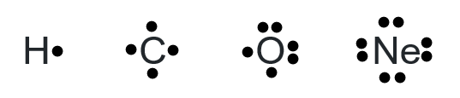

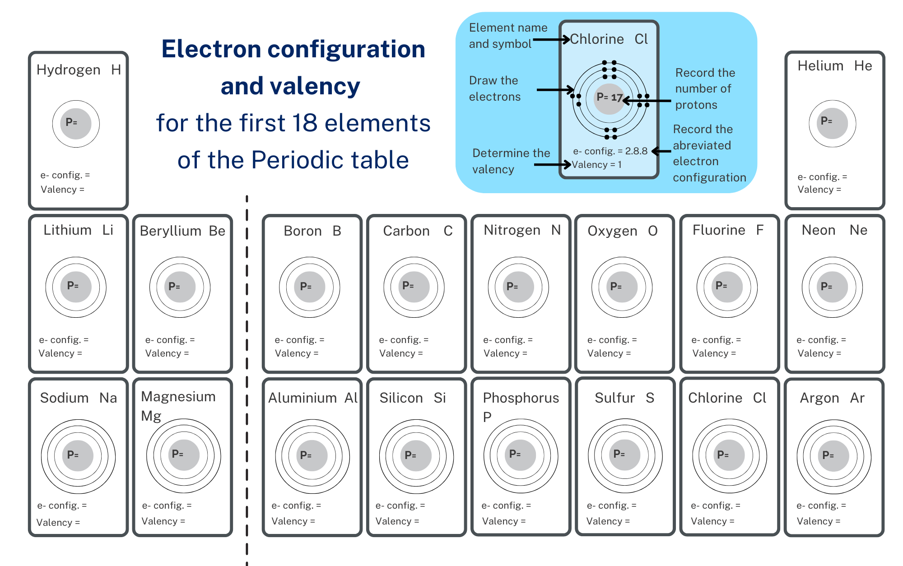

Let’s practise
The following questions and answers can be used to practise interpreting information from the periodic table related to valency. If your students are confident with the concept, these questions may be in exit tickets. Alternatively, they could be used as practice to consolidate understanding. Additional examples may be needed until the students gain competency in answering the questions.
Sample responses: Student resource – let’s practise
- How many electron shells does sodium have? | 3
- How many electrons does nitrogen have? | 7
- How many valence electrons does nitrogen have? | 5
- What is the valency of helium? | 0
- What is the valency of beryllium? | 2
- Will it gain or lose electrons to have a full outer shell? | lose
- How many will it gain or lose? | lose 2
- Identify an element that will gain one electron to fill its outer shell. | Hydrogen, fluorine or chlorine
- Identify an element that has a noble gas configuration. | Helium, neon or argon
- What is the electron configuration of magnesium? | 2.8.2
- Which element has the electron configuration of 2.4? | Carbon
- Do noble gases lose or gain electrons? | No, they have a full outer shell.
Differentiation: a challenge question has been included to extend students' understanding.
Some elements can have more than one valency. For example, iron can have a valency of 2 or 3. Explain what it means for an element to have more than one valency, using iron as an example.
Challenge question sample answer
When an element has more than one valency, it can lose or share different numbers of electrons to form stable compounds. Valency is the number of electrons an atom can lose, gain or share to have a full outer shell, which makes the atom stable.
Using iron as an example:
Iron may lose 2 electrons from its outer shell, giving it a valency of 2. Sometimes, an iron atom can lose 3 electrons from its outer shell, thus giving it a valency of 3. For example, 1 atom of iron with a valency of 2 can combine with 2 atoms of chlorine (valency 1) to form iron (II) chloride. Similarly, an iron atom of valency 3 can combine with 3 chlorine atoms to form iron (III) chloride.
The ability of iron to have more than one valency means it can be flexible in how it bonds with other atoms. This flexibility is due to iron's electron arrangement, allowing it to lose either 2 or 3 electrons to achieve a stable outer shell.

Student resource – let’s practise
Use a periodic table to determine the answers to the following questions.
- How many electron shells does sodium have?
- How many electrons does nitrogen have?
- How many valence electrons does nitrogen have?
- What is the valency of helium?
- What is the valency of beryllium?
- Will it gain or lose electrons to have a full outer shell?
- How many will it gain or lose?
- Identify an element that will gain one electron to fill its outer shell.
- Identify an element that has a noble gas configuration.
- What is the electron configuration of magnesium?
- Which element has the electron configuration of 2.4?
- Do noble gases lose or gain electrons?

2.2 From elements to compounds – the noble gas connection
Table 4 – learning intention and success criteria for 2.2 From elements to compounds – the noble gas connection
We are learning: | I can:
- to describe the chemical properties of materials. | - describe noble gas configuration  - describe the purpose of a chemical bond  - explain the link between noble gas configuration and chemical bonding  - identify and name the 3 types of bonds: ionic, covalent and metallic.
Checkpoint (MAT PPT 2.2 Checkpoint): ask the students to draw the electron shell configuration of aluminium (atomic number 13) on mini whiteboards and identify its valency.
Sample response
Figure 2 – sample response electron configuration of aluminium
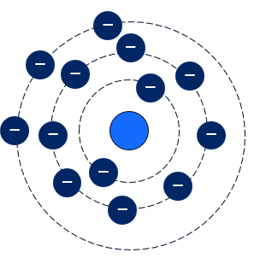The valency of aluminium is 3.
Note: the negative symbols do not necessarily need to be drawn in, and the student may pair the electrons as shown in the activity in 2.1.

Achieving a noble gas configuration
- Work through the MAT PPT ‘2.2 Noble gases’, to MAT PPT ‘2.2 the octet rule and the periodic table’ slides to explain how the elements achieve noble gas configuration. Detailed speaker notes are included on each slide to facilitate explicitly teaching the students how atoms achieve a noble gas configuration by losing, gaining or sharing electrons.
- Show MAT PPT ‘2.2 Achieving noble gas configuration 1/3’. Use the speaker notes and animations to unpack how atoms can gain or lose electrons to achieve a noble gas configuration through ionic bonding.
- Show MAT PPT ‘2.2 Achieving noble gas configuration 2/3’. Use the speaker notes and animations to unpack how some atoms will share electrons to fill their outer shell. This occurs in covalent bonding between 2 or more non-metal atoms.
- Show MAT PPT ‘2.2 Achieving noble gas configuration 3/3’. Use the speaker notes and animations to unpack how metals bond together in a lattice with a sea of delocalised electrons.
Checkpoint (MAT PPT): students match the type of bonding to the relevant information on the slide. Students could show their understanding using mini whiteboards so that all students can show their understanding of the types of chemical bonds.
Note: through the MAT PPT ‘2.2 Achieving noble gas configuration’ slides, students need to gain an understanding of how the type of elements can inform the type of bond that they will form.
- Are all the elements non-metals? Yes Covalent bond
- Are there metal and non-metal elements? Yes Ionic bond
- Are the elements metals? Yes Metallic bond
- Provide students with a copy of the Student resource – identifying the bond type in compounds. Students use their periodic table to determine if each atom in a compound is a metal or a non-metal and then classify the compound as ionic or covalent.
Table 5 – sample response classifying compounds as ionic or covalent
Compound | List the elements | Element 1 (Metal or non-metal?) | Element 2 (Metal or non-metal?) | Bond type
Water (H₂O) | Hydrogen  Oxygen | H – non-metal | O – non-metal | covalent
Sodium chloride (NaCl) | Sodium  Chlorine | Na – metal | Cl – non-metal | ionic
Iron (III) oxide (Fe₂O₃) | Iron  Oxygen | Fe – metal | O – non-metal | ionic
Carbon dioxide (CO₂) | Carbon  Oxygen | C – non-metal | O – non-metal | covalent
Methane (CH₄) | Carbon  Hydrogen | c– non-metal | H – non-metal | covalent
Magnesium oxide (MgO) | Magnesium  Oxygen | Mg – metal | O – non-metal | ionic

Student resource – identifying the bond type in compounds
Use your periodic table to identify if the atoms in each of the compounds below is a metal or a non-metal and then classify them as an ionic compound or a covalent compound.
Remember:
- ionic compounds form between a metal and a non-metal
- covalent compounds form between a non-metal and a non-metal.
Table 1 – classifying compounds as ionic or covalent compounds
Compound | List the elements | Element 1 (Metal or non-metal?) | Element 2 (Metal or non-metal?) | Bond type
Water (H₂O)
Sodium chloride (NaCl)
Iron (III) oxide (Fe₂O₃)
Carbon dioxide (CO₂)
Methane (CH₄)
Magnesium oxide (MgO)
Note: metallic bonding, the type of bonding that occurs in metals, is not covered here.

2.3 Ionic bonding
Table 6 – learning intention and success criteria for 2.3 Ionic bonding
We are learning: | I can:
- to describe the chemical properties of materials. | - describe ionic bonding  - identify examples of ionic compounds  - state which types of elements ionic bonds can form between  - demonstrate how atoms transfer electrons to achieve a stable electron configuration  - describe what happens to electrons when an ionic bond is formed.
Checkpoint: check students' prior understanding of ionic bonding using true or false questions. The questions and answers are provided in the MAT PPT 2.3 Checkpoint.

Modelling cations and anions
In this activity, students will use the PhET simulation Build an atom to create models of cations and anions and learn how they are formed. The detailed instructions for working with the simulation are in the Student resource – modelling cations and anions.
- Introduce the activity by explaining that atoms must either gain or lose an electron for an ionic bond to form. The process of gaining and losing electrons forms ions, which are charged atoms.
- Define the terms ‘ion’, ‘cation’ and ‘anion’.
- An ion is an atom or molecule with a net electric charge due to the loss or gain of one or more electrons.
- A cation is a positively charged ion.
- An anion is a negatively charged ion.
- Students complete the Student resource – modelling cations and anions.
Sample response: Student resource – modelling cations and anions
- What is the charge on the neutral hydrogen atom? ____0____
- Explain why the hydrogen atom is electrically neutral.
The hydrogen atom is electrically neutral because the number of negatively charged electrons is the same as that of positively charged protons.
- Hydrogen has space to accept another electron in its outer shell. What do you notice when you add another electron?
When an extra electron is added to the neutral hydrogen atom, the label changes from ‘neutral atom’ to ‘- ion’. A ‘- ion’ is also called a cation.
- Look in the ‘Net Charge’ box. What is the net charge of the hydrogen ion? ___-1_____ This can be written $H^{-}$.
- Draw the electron configuration of the negative hydrogen ion ($H^{-}$)
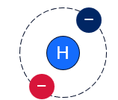
- What do you notice when you remove the electron from the hydrogen atom?
When an electron is removed from the neutral hydrogen atom, the label changes from ‘neutral atom’ to ‘+ ion’. A ‘+ ion’ is also called a cation.
- Draw the electron configuration of the positive hydrogen ion. It can be written as H⁺.
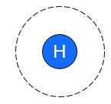
- What do you notice about the net charge of the oxygen atom?
The net charge of the oxygen atom without electrons is −8.
- What do you notice about the net charge of the oxygen atom every time you add an electron?
The net charge decreases every time an electron is added to the oxygen atom.
- Will the neutral oxygen atom be more likely to gain or lose electrons to achieve a full outer shell of electrons? Explain why.
The neutral oxygen atom has 6 electrons in its outer shell. It needs 2 extra electrons to achieve a full outer shell, so it will likely gain electrons.
- How many electrons did you add? _____2_______.
- What is the net charge on the ion? _____−2______.
- Draw the electron configuration and add the symbol for an oxygen ion.
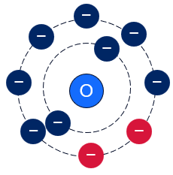
Checkpoint: the students will set individual goals to achieve while playing the games in the PhET simulation. For example, get 4 out of 5 questions correct, complete 2 of the 4 games or get 3 questions in a row correct without help.

Student resource – modelling cations and anions
Carefully follow the instructions identified in the grey box and respond to the questions as you construct cations and anions.
Open the PhET simulation Build an atom.
- Select the Atom tab.
- Build a hydrogen atom by adding 1 proton and 1 electron. You should see neutral atom written at the top right of the model.
- Open the Net Charge box.
- What is the charge on the neutral hydrogen atom? _____________
- Explain why the hydrogen atom is electrically neutral.
- Hydrogen has space to accept another electron in its outer shell. What do you notice when you add another electron?
- Look in the ‘Net Charge’ box. What is the net charge of the hydrogen ion? _____________.
- Draw the electron configuration of the negative hydrogen ion ($H^{-}$)
Remove an electron to reset the hydrogen atom to neutral.
Hydrogen can also lose an electron to achieve noble gas configuration. Remove the electron.
- What do you notice when you remove the electron from the hydrogen atom?
- Draw the electron configuration of the positive hydrogen ion. It can be written as H⁺.
Build an oxygen atom by adding 8 protons and 8 neutrons to the nucleus.
- What do you notice about the net charge of the oxygen atom?
Add the appropriate number of electrons to each electron shell to build the neutral oxygen atom.
- What do you notice about the net charge of the oxygen atom every time you add an electron?
- Will the neutral oxygen atom be more likely to gain or lose electrons to achieve a full outer shell of electrons? Explain why.
Add electrons to create a full outer shell.
- How many electrons did you add? _________.
- What is the net charge on the ion? ____________.
- Draw the electron configuration and add the symbol for an oxygen ion.
Note: an ion is an atom that has acquired a net charge by gaining or losing electrons. When an atom loses electrons, it becomes positively charged, called a cation. When an atom gains electrons, it becomes negatively charged, called an anion.
- When your teacher has checked your work, select the Game tab at the bottom of the page and choose one of the games to play to test your understanding of ions, charge and neutral atoms.

Forming ionic compounds
Note: students will construct ionic compounds using jigsaw pieces in this activity. This can be completed digitally or by a cut-and-paste activity.
- Digital option: extract MAT PPT ‘2.3 Ionic compounds and chemical formula’ from the MAT PPT and save it in a separate slide deck for students. Copy the slide 10 times so students can make 10 different ionic compounds.
- Hard copy option: print a copy of Student resource – ionic compounds jigsaw for each student. The jigsaw pieces could be laminated for repeated use.
- Tell students that for a bond to form between 2 ions, the charges need to balance so that the overall molecule is neutral. To gain this balance, there is not always a 1:1 ratio of cations to anions. This ratio tells us the simplest whole-number ratio of ions needed to balance the charges.
- Show MAT PPT ‘2.3 Magnesium + oxygen’ and guide students as they:
- identify the type of bonding
- identify how many electrons are in the outer shell of magnesium and oxygen
- identify if each atom needs to gain or lose electrons to fill the outer shell
- move the electrons to show how magnesium and oxygen will bond by forming a Mg²⁺ and O²⁻ ions
- determine the chemical formula for magnesium oxide.
- Show MAT PPT ‘2.3 Magnesium + chlorine’ and guide students as they:
- identify the type of bonding
- identify how many electrons are in the outer shell of magnesium and chlorine
- identify if each atom needs to gain or lose electrons to fill the outer shell
- move the electrons to show how magnesium and chlorine will bond through the formation of Mg²⁺ and Cl⁻ ions
- determine the chemical formula for magnesium chloride.
- Show MAT PPT ‘2.3 Ionic compounds’. Students use the provided word bank to complete the sentences, which outline the types of ions formed by metals and non-metals and electrostatic forces that hold the ions together.
- Facilitate the ionic compound jigsaw activity:
- Assign individual students their own copy of the slide deck (MAT PPT ‘2.3 Ionic compounds and chemical formula’) or a printed copy of the Student resource – ionic compounds jigsaw.
- Students construct 10 different ionic compounds using the provided anions and cations.
- Students name each of their compounds.
- Students count the number of each ion required to make a neutral compound and write the chemical formula.
Differentiation: the ion names could be removed from the jigsaw pieces for an additional challenge. The students develop the model using their understanding of valency to determine the charge of each metal and non-metal ion.
- Move around the room and check students' progress on making ionic compounds, naming the compounds and writing the chemical formula. Possible compounds that students will construct are outlined in Table 7. Additional information on the compound that can be used for class discussions is provided.
Note: the compounds produced in this activity contain monatomic ions only. Polyatomic ions have been left out.
Table 7 – sample compounds from the ionic compound jigsaw activity
Ionic compound jigsaw | Compound name | Chemical formula | Additional information
 | Sodium chloride | NaCl | Table salt is found naturally and is used in cooking.
 | Sodium fluoride | NaF | Used in dental products to prevent tooth decay.
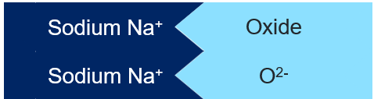 | Sodium oxide | Na₂O | Used in glass and ceramics production.
 | Lithium chloride | LiCl | Used in air conditioning systems as a desiccant (drying agent).
 | Lithium fluoride | LiF | Used in enamels and glazes for ceramics.
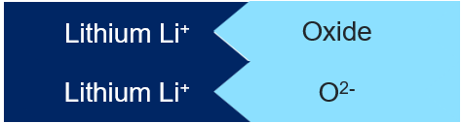 | Lithium oxide | Li₂O | Used in lithium-ion batteries.
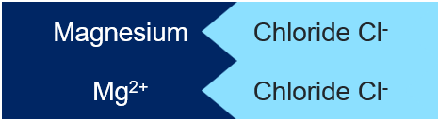 | Magnesium chloride | MgCl₂ | Used as a supplement to treat magnesium deficiency.
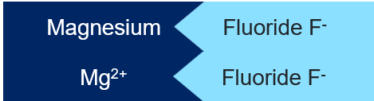 | Magnesium fluoride | MgF₂ | Used in antireflective coatings on lenses (eyeglasses).
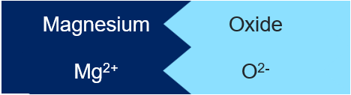 | Magnesium oxide | MgO | Added to cement to increase its strength and shorten setting time.
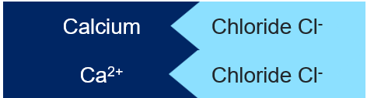 | Calcium chloride | CaCl₂ | Used as a desiccant (drying agent) and in food preservation.
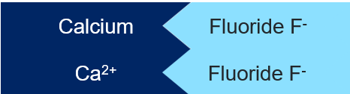 | Calcium fluoride | CaF₂ | Used in the production of lenses and prisms.
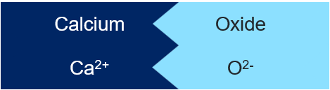 | Calcium oxide | CaO | Also known as quicklime. Used in steel making, cement production.

Student resource – ionic compounds jigsaw
 | 

 | 
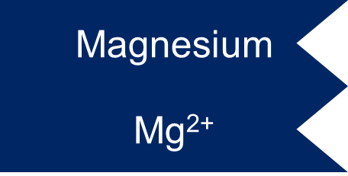 | 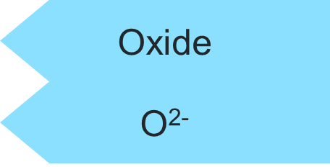
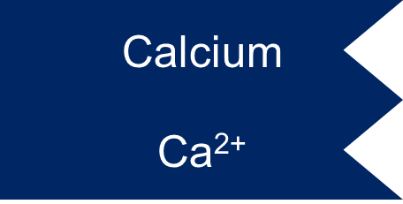

2.4 Covalent bonding
Table 8 – learning intention and success criteria for 2.4 Covalent bonding
We are learning: | I can:
- to describe the chemical properties of materials. | - describe covalent bonding  - identify examples of covalent compounds  - construct models of covalent molecules  - define diatomic molecules  - list examples of diatomic molecules  - construct chemical formulas of ionic compounds.

Modelling covalent bonds
In this activity, students will dive deeper into covalent bonding. The activity will require molecular model kits so that students can create models of various covalent compounds to better understand bonding between non-metal atoms.
- Revise the definition of covalent bonding and valency. Unpack the term univalent, including the ‘uni’ prefix. Show a hydrogen atom from the molecular model kit and point out that it has one hole, which represents 1 bond that it can make, and state that this makes it univalent (valency = 1).
- Provide each student with the Student resource – creating covalent compounds. Provide each group of students with a molecular model kit. Instruct the students to:
- set out the coloured atoms in order from the least holes to the most holes
- complete Table 1 to identify each type of atom and relate the number of holes to its valency.
Figure 3 – molecular model kit components

- Use the think-aloud routine to guide students through the steps required to complete the first row in Table 2. For example:
- Fluorine, F, has 7 electrons in its outer shell.
- It needs to gain 1 more electron to achieve a stable (noble gas) electron configuration.
- So, it has a valency of 1 and can make 1 chemical bond with a univalent atom like hydrogen.
- Direct students to observe a halogen (green) atom representing fluorine.
- Connect a single bond between fluorine and hydrogen.
- Therefore, one fluorine atom bonds with one hydrogen atom by sharing one electron.
- We write the formula as HF.
- Draw the diagram showing only each atom's outer (valence) electrons, the shared pair, and count out the number of electrons in each orbit to confirm that each now has a stable electron configuration.
- Relate the diagram of the valence shells showing the covalent bonds to the molecular model. Tell them that the grey post represents the sharing of electrons to make a covalent bond.
- Use the ‘I do, we do, you do’ strategy for gradual release of responsibility to work through modelling and documenting information on covalent bonds for the remaining rows in Table 2.
For more information on gradual release of responsibility, see the technique guides for modelling, scaffolding and independent practice.
Sample answers: Student resource – creating covalent compounds
Table 9 – atoms in the molecular model kit
Colour | Element or group | Number of holes (bond places) | Valency | Diagram of valence shell
 | Hydrogen | 1 | 1 | 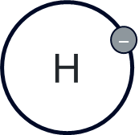
 | Carbon | 4 | 4 | 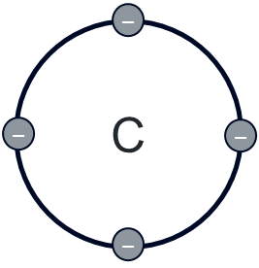
 | Oxygen | 2 | 2 | 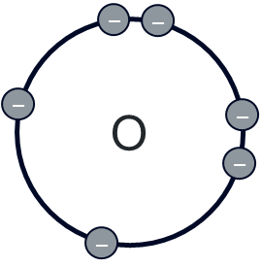
 | Nitrogen | 3 | 3 | 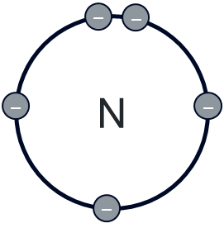
 | Sulfur | 2 | 2 | 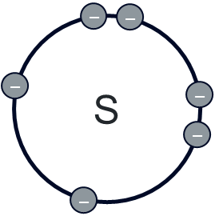
 | Halogen (for example: fluorine, chlorine) | 1 | 1 | 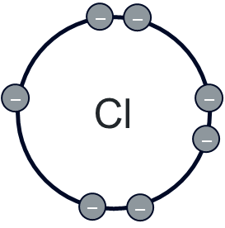
Table 10 – covalent compounds formed when hydrogen bonds with non-metals: sample response
Element bonding with hydrogen(s) | Valency of the element | Number of hydrogens that it can bond with | Diagram of valence electron configurations | Formula
Oxygen (O) | 2 | 2 | 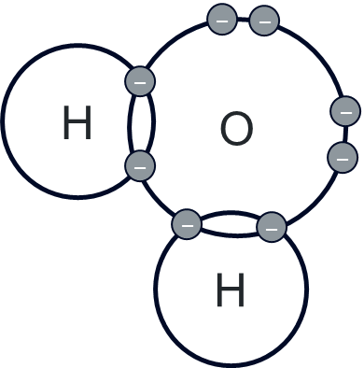 | H₂O
Fluorine (F) | 1 | 1 | 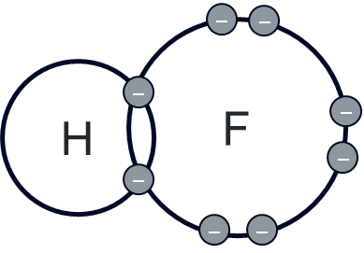 | HF
Nitrogen (N) | 3 | 3 | 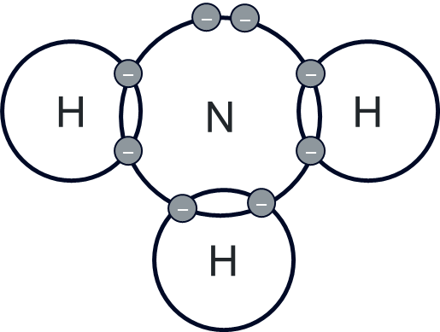 | NH₃
Carbon (C) | 4 | 4 | 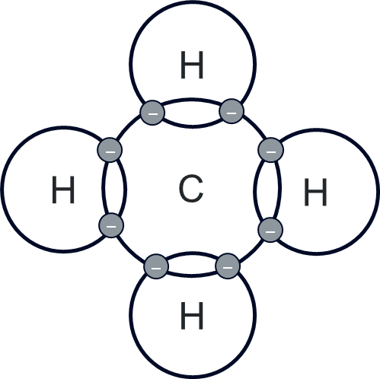 | CH₄
Chlorine (Cl) | 1 | 1 | 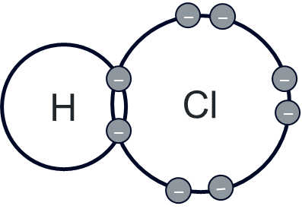 | HCl
Sulfur (S) | 2 | 2 | 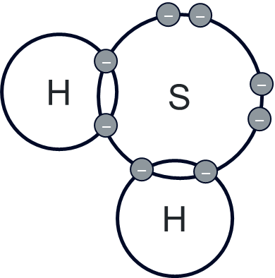 | H₂S

Student resource – creating covalent compounds
Complete the table to summarise the information about each atom in the molecular model kit.
Table 1 – atoms in the molecular model kit
Colour | Element or group | Number of holes (bond places) | Valency | Diagram of valence shell
 | Hydrogen
 | Carbon
 | Oxygen
 | Nitrogen
 | Sulfur
 | Halogen (for example: Fluorine, Chlorine)
Modelling covalent compounds
Determine the covalent structure that can be formed with hydrogen by each of the elements below.
- Record the valency and the number of hydrogens the element can bond with.
- Build a model of the compound with the molecular model kit.
- Draw a diagram to represent the electron arrangement in the compound.
- Write the formula for the compound by using a subscript number after each element to denote the number of that atom in the compound. For example, H₂O has 2 hydrogens and 1 oxygen.
Table 2 – covalent compounds formed when hydrogen bonds with non-metals
Element bonding with hydrogen(s) | Valency of the element | Number of hydrogens that it can bond with | Diagram of valence electron configurations | Formula
Oxygen (O) | 2 | 2 |  | H₂O
Fluorine (F)
Nitrogen (N)
Carbon (C)
Chlorine (Cl)
Sulfur (S)

Diatomic molecules
- Explore the covalent bonds in elements that exist as diatomic molecules. Use the following points to define diatomic molecules:
- some elements naturally exist as diatomic molecules, meaning that 2 atoms of the same element bond together
- examples include H₂, O₂, N₂, Cl₂, Br₂, I₂ and F₂
- Use the Socratic method of questioning to guide students in understanding diatomic molecules. Ensure that all class members are engaged to maximise the benefits of this technique. Sample questions have been provided for working through the oxygen molecule in Table 11 – Socratic questioning prompts. Additional diatomic molecules may also be covered using this method.
Note: providing students with paper and counters to represent oxygen atoms' valence electron shells will assist them in determining that a double bond is required for O₂ to form. As you move through the questioning activity, students can rearrange the valence electrons to demonstrate how the oxygen atoms can share 2 pairs of electrons to fill their outer shell.
Further information on Effective teacher questioning and Key questioning strategies is available on the department’s website.
- Provide students with a molecular model kit and a copy of the Student resource – diatomic molecules. Work through the following steps with the students:
- Students build models of the diatomic molecules H₂, Cl₂, O₂ and N₂.
- Students record the number of bonds that are formed in each molecule.
- Students draw the electron configurations of each molecule to show how the electrons are shared.
- Show students how to draw the structural formula for each molecule using a single line to represent a single bond, 2 lines to represent a double bond and 3 lines to represent a triple bond.
- Check students’ responses and provide feedback where required to correct their understanding of the concept. Sample answers are provided in Table 12 – diatomic molecules sample response.
Note: introducing students very briefly to structural formulas here will prepare them for drawing the structure of simple alkanes in Teacher resource book 3 (TRB3).
Table 11 – Socratic questioning prompts
Teacher prompts | Expected response and key points
Draw the electron configuration for a single oxygen atom on the board. Examine the electron configuration of oxygen (2, 6).  - How many electrons are in the first shell?  - How many electrons are in the outer shell?  - Considering the valence electron shell, is the oxygen atom chemically stable?  - How could it achieve this stability? | 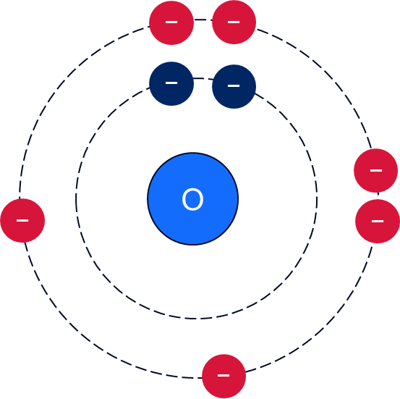  - Two.  - Six.  - No, it needs to gain 2 electrons to fill its outer shell.  - By sharing or gaining 2 electrons.
Oxygen is an essential element for many living things. It is readily found as an element in nature and comprises approximately 20% of the air we breathe. Its chemical formula is O₂.  - If oxygen has 6 electrons in its outer shell, how does it exist in elemental form in nature?  - Each bond represents a pair of electrons shared between 2 atoms. What term is used to describe 2 pairs of electrons shared between atoms? | - Oxygen atoms can bond with each other to become stable by forming a molecule called O₂, which is known as oxygen gas. Each oxygen atom has 6 electrons in its outer shell and needs 2 more to become stable. To achieve this, 2 oxygen atoms share 2 pairs of electrons with each other, forming a covalent bond. This means that each oxygen atom shares 2 of its electrons and also gains access to 2 electrons from the other oxygen atom.  - A double bond.
- Why do diatomic molecules such as O₂ and N₂ exist in nature? | - Diatomic molecules form because the atoms share electrons, which helps them achieve a stable electron configuration.
- What type of bond is formed between 2 oxygen atoms?  - How do you know what type of bond it is? | - A covalent bond.  - Oxygen is a non-metal. Covalent bonds form between non-metal atoms. The atoms are also sharing electrons, which is a feature of covalent bonding.
Table 12 – diatomic molecules sample response
Diatomic molecule | Number of bonds | Diagram of electron configuration | Structural formula
Hydrogen gas (H₂) | 1 | 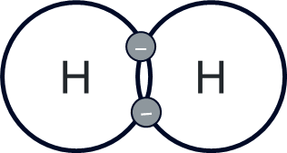 | 
Chlorine gas (Cl₂) | 1 | 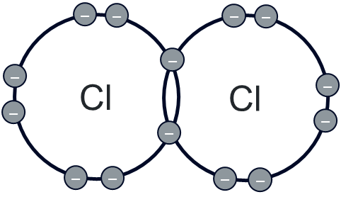 | 
Oxygen (O₂) | 2 | 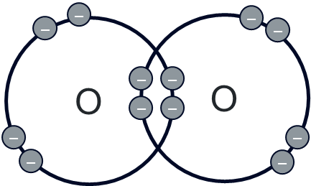 | 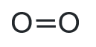
Nitrogen gas (N₂) | 3 | 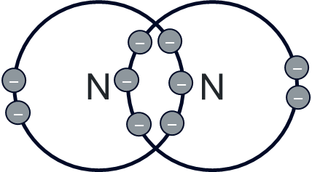 | 

Student resource – diatomic molecules
Modelling diatomic molecules
Some elements naturally exist as diatomic molecules. The prefix ‘di’ means 2 or double, so a diatomic molecule has 2 of the same atoms.
- Use the molecular model kit to make each diatomic molecule below.
- Count the number of grey joiners representing the bonds and record the number of bonds in column 2.
- Draw a valence electron diagram of each molecule in the third column.
- Draw the structural formula for each molecule.
Table 1 – diatomic molecules
Diatomic molecule | Number of bonds | Diagram of electron configuration | Structural formula
Hydrogen gas (H₂)
Chlorine gas (Cl₂)
Oxygen (O₂)
Nitrogen gas (N₂)

2.5 Metallic bonding
Table 13 – learning intention and success criteria for 2.5 Metallic bonding
We are learning: | I can:
- to describe the chemical and physical properties of materials. | - describe metallic bonding  - identify examples of metallic bonding  - identify properties of metallic bonding that make metals suitable for certain uses.
Prior knowledge checkpoint: An ion is:
- a neutral atom with no charge
- an atom or molecule with a positive or negative charge
- a type of molecule made of 2 or more atoms
- an atom with a complete outer shell
Table 14 – prior knowledge checkpoint answer and elaboration
Option | Correct/Incorrect | Reasoning
A | Incorrect | A neutral atom has an equal number of protons (positively charged) and electrons (negatively charged), which means it has no overall charge. This is not an ion because ions are defined as atoms or molecules with an overall positive or negative charge due to the loss or gain of electrons.
B | Correct | This is the correct answer.
C | Incorrect | An ion can be a single atom, like Na⁺ or Cl⁻, or it can be a group of atoms, such as a sulfate ion (SO₄²⁻)
D | Incorrect | This response describes a stable atom, often referred to as having a noble gas configuration, but does not necessarily mean the atom is an ion. Some ions achieve stability through a full outer shell, but not all ions have a complete outer shell, and not all atoms with complete outer shells are ions.

Metallic bonding reading passage
- Show a sample of solid metal such as a piece of copper, magnesium or iron. Tell students it is essentially a giant structure of atoms arranged in a regular pattern. In this activity, they will learn more about the metallic bonding that gives metals their properties.
- Provide students with the Student resource – metallic bonding. Students engage with the text and then respond to the questions on metallic bonding.
Differentiation: definitions for unfamiliar terms, such as ‘electrostatic’, ‘malleable’ and ‘ductile’, could be provided to support students in interpreting the text.
- Students' understanding of the properties of materials may be extended by showing GCSE Chemistry – Metallic Bonding (3:31), which covers metallic bonding and the properties of some alloys.
Sample responses: Student resource – metallic bonding
- What is a ‘sea of electrons’ in metallic bonding?
Metal atoms form positive ions (cations), which means they have lost their valence electrons. The valence electrons move freely among the network of metal ions.
- Explain why metals are good conductors of heat and electricity.
Metals are good conductors of electricity and heat due to the presence of the delocalised electrons (sea of electrons). The electrons are able to move freely throughout the metal.
- Give 2 examples of metals and their uses that are explained by metallic bonding.
Copper is a very good conductor of electricity, so it is used in electrical wiring. Copper is very ductile, which means it is easily made into wires.
Gold is used to make jewellery. One of the characteristics of gold jewellery is its shine or lustre, which can be attributed to the metallic bonding.
- Describe how electrostatic attraction between metal ions and the sea of electrons contributes to the structure and properties of metals.
In metals, atoms lose their valence electrons, creating positively charged metal ions. The positive ions are arranged in a lattice structure. The released negative electrons form a sea of free-moving electrons. The electrostatic attraction between the positively charged metal ion and the negatively charged free electrons holds the metal structure together in a tightly packed structure. The layers of metal ions can slide over each other without breaking the bond, as the sea of electrons can adjust to hold the structure together. This is why metals tend to be malleable and ductile. The delocalised electrons are able to move freely throughout the metal, and this allows electricity and heat to be conducted through the metal.

Student resource – metallic bonding
Metals are essential materials in our world. They are used in everything from buildings and bridges to electronic devices and kitchen utensils. But what makes metals so useful? One of the key reasons is the unique type of bonding that occurs between metal atoms, known as metallic bonding. Understanding metallic bonding helps explain why metals have such a wide range of uses in our everyday lives. From the strength of steel beams in buildings to the conductivity of copper in your smartphone, metallic bonding is the science behind many of the materials we use.

What is metallic bonding?
Metallic bonding is a type of chemical bonding that occurs between metal atoms. In metallic bonding, metal atoms release their valence electrons (delocalised electrons), which become free to move throughout a network of atoms.
How does metallic bonding work?  Formation of positive ions: metal atoms lose electrons from their outer shell, becoming positively charged ions (cations).  Sea of electrons: the released electrons do not belong to any specific atom. Instead, they move freely among the positive ions.  Electrostatic attraction: the positively charged metal ions are held together by the attraction to the negatively charged electrons that move around them. | 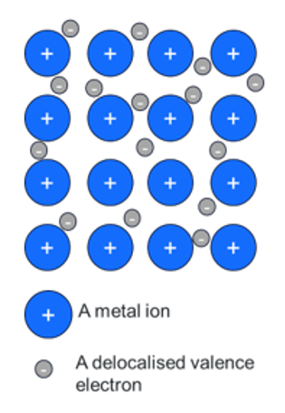

Metallic bonding gives metals their characteristic properties
- High electrical conductivity – the free-moving electrons can carry an electric charge.
- Malleability and ductility – metals can be hammered into shapes (malleable) and drawn into wires (ductile) because the ions can move without breaking the metallic bond.
- Lustre – the sea of electrons reflects light, giving metals their shiny appearance.
- Thermal conductivity – the free electrons can transfer heat quickly.

Metallic bonding questions
- What is a ‘sea of electrons’ in metallic bonding?
- Explain why metals are good conductors of heat and electricity.
- Give 2 examples of metals and their uses that are explained by metallic bonding.
- Describe how electrostatic attraction between metal ions and the sea of electrons contributes to the structure and properties of metals.

2.6 Bonds and beyond – exploring the properties of bonds
Table 15 – learning intentions and success criteria for 2.6 Bonds and beyond – exploring the properties of bonds
We are learning: | I can:
- to explain the use of materials based on their physical and chemical properties | - make observations about the physical and chemical properties of ionic, covalent and metallic substances  - compare the physical and chemical properties of ionic, covalent and metallic substances  - explain how the physical and chemical properties of each substance influence its practical uses in everyday life
- to design a safe investigation. | - explain why we are doing this investigation  - conduct a risk assessment  - select an appropriate method to test a property.
Prior knowledge checkpoint: metallic bonding explains the properties of metals. Recall as many properties of metals as you can.
Checkpoint sample answer:
Metals are malleable – they can be hammered into shapes.
Metals are ductile – they can be pulled into thin wires and sheets.
Metals have a high lustre – they reflect light and can be very shiny.
Metals are good conductors of electricity and heat – the free-moving electrons transfer energy through the metal.

Investigating the properties of materials
This activity is focused on investigation design and getting students to understand that investigations in science are not always controlled experiments. In this investigation, students conduct a series of tests to ascertain the properties of the materials and then relate these to their uses.
Background information
The typical properties of covalent, ionic and metallic substances are outlined in Table 16.
Table 16 – typical properties of covalent, ionic and metallic substances
Property | Covalent | Ionic | Metallic
Malleability | Variable | Brittle | Malleable
Melting point | Low | High | High
Conductivity | Generally poor | Only when in a solution or molten | Excellent
Soluble in water | Often insoluble | Often soluble | Insoluble
Preparation
This activity may be completed by individual groups or could be set up to have groups of students move between the different tests at stations.
Equipment:
- 1 × multimeter or a simple electric circuit  - 1 × 50 mL beaker  - 1 × stirring rod  - 1 × distilled water wash bottle  - 1 × conductivity sensor  - 1 × hot plate  - 2 × aluminium foil trays  - 1 × spotting tile (9 wells)  - 1 × 2M HCl dropper bottle | - Sodium chloride  - Paraffin wax  - Calcium chloride  - Sugar  - 5 × small pieces of aluminium  - 5 × small pieces of copper wire  - 5 × small pieces of magnesium ribbon
Facilitating the activity
- Show students a sample of sugar and salt and explain that you cannot tell if something is ionic or covalent just by looking at it. However, simple tests can be done to check its properties, which can then be used to classify the substance as ionic or covalent. Metallic substances have visible characteristics that can often be used to classify them.
- Inform students about the purpose of the investigation. The aim of this investigation is to explore the differences between ionic, covalent and metallic substances by examining their physical and chemical properties. The characteristics of these substances influence the types of applications they are suitable for.
- Outline the properties of substances that can be determined through appropriate tests. A summary is provided in Table 17.
Table 17 – properties of substances
Property | Elaboration
Appearance | Appearance includes the lustre (dull or shiny) and colour.
Melting point | The point at which a solid substance turns to a liquid.
Boiling point | The point at which the substance starts to turn to a gas.
Solubility in water | Will the substance dissolve in water?
Electrical conductivity | If the substance has ions or electrons that are free to move around it can conduct electricity.
Brittleness or malleability | A brittle substance will break when an external force is applied, whereas a malleable substance will bend or change shape.
Reactivity with acid | Evidence of a chemical reaction includes the production of gas, which is often visible as bubbles or fizzing, temperature change, and colour change.
- Students read through the procedures in the Student resource – properties of ionic, covalent and metallic substances (practical investigation) and identify which test they represent. In doing this, students demonstrate their ability to select an appropriate test for each property. Sample responses are provided in Table 18.
- Guide students to develop a risk assessment for the procedures involved in the investigation.
- Students conduct the tests on the different substances and record the results in the Student resource – properties of ionic, covalent and metallic substances (practical investigation).
- Discuss students’ results and identify any anomalies if they occurred. For example, distilled water should not show conductivity. However, a reading may have occurred if the distilled water was contaminated or the conductivity sensor was not calibrated.
- Students respond to the analysis questions.
Sample responses: Student resource – properties of ionic, covalent and metallic substances (practical investigation)
- Classify the test substances as metallic, ionic or covalent and note this in the second column of Table 3.
- Match the properties with the correct procedure for testing the property.
Table 18 – sample response – procedures for testing the properties of substances
Property | Test procedure
Appearance | Look at the substance and describe its lustre, colour, state at room temperature and texture.  Word bank to help with the descriptions: shiny, dull, translucent, opaque, solid, liquid, crystalline, no crystals, colourless.
Malleability | Try to bend the substance.  - If it bends, the substance is malleable. Record Yes in the table.  - If it cannot be bent, the substance is brittle. Record No in the table.
Conductivity of the solid | There are 2 possible methods for this test. You only need to do one.  Option 1: multimeter  - Place a small amount of the test substance in a well plate.  - Set the multimeter to the correct setting (continuity).  - Place the 2 probes on the test substance to test if the solid substance is conductive.  - If the multimeter beeps the substance conducts electricity.  - If there is no beep then the substance does not conduct electricity.  Option 2: simple electric circuit  - Construct a simple circuit with a power pack, 3 banana leads and a light globe.  - Test that the light globe works by touching the free banana plugs together.  - Test each solid test substance by placing the 2 free banana plugs on the test substance (without touching the banana plugs).  - If the light turns on, the substance conducts electricity. Record Yes in the appropriate column of the results table.  - If the light does not turn on the substance does not conduct electricity. Record No in the appropriate column of the results table.
Solubility in water | - Place a small amount of each substance into a 50 mL beaker  - Add a few millilitres of distilled water  - Gently stir the mixture with a stirring rod.  - Observe if the substance dissolves in water. Record Yes or No in the relevant column for each substance.
Conductivity in solution | This test should only be conducted for substances that dissolve in water. The solutions from the solubility test should be used.  Conductivity probe  - Dissolve a small amount of the substance in distilled water (this was done in the solubility test).  - Place the conductivity probe into the solution and record the conductivity.  - Rinse the probe with distilled water before testing the next substance.  The conductivity value depends on the capacity of the aqueous solution to conduct electricity. Strong electrolytes generate a large number of ions, resulting in high conductivity values. Weak electrolytes result in low conductivity, while non-electrolytes should indicate no conductivity.
Melting point | - Divide 2 foil pie dishes into 4 sections and label one for each test substance.  - Place the foil pie dishes on a cold hot plate and gently add a small amount of each substance ($\frac{1}{4}$ spatula for the substances that are not pure metals).  - Turn on the hot plate and observe the order in which the substances melt. Do not heat the substances longer than 5 minutes (two substances should melt in this time).  - Record ‘low’ for substances that melted quickly and ‘high’ for substances that did not. If a substance is a liquid at room temperature, its melting point can be recorded as ‘very low’.
Reactivity with hydrochloric acid | - Draw a grid in your notebook to represent the well plate. Label each well with the name of the substances.  - Place a very small amount of each test substance in the wells of a spotting tile.  - Add a few drops of 2M HCl to one substance at a time.  - Observe if the substance bubbles or fizzes. This indicates that the substance reacts with the acid. Record Yes in the appropriate column if it reacts, or No if nothing is observed.  - Rinse the well plate for the next group.
- Conduct a risk assessment for the above procedures. Identify possible hazards and risks and find ways to mitigate them.
Table 19 – sample risk assessment
Hazard | Risk | Mitigation
Water spillage | Risk of slipping on spilled water | Clean up any spills immediately and use appropriate containers.
Hotplate | Burns, fire | Tie long hair back. Do not touch hot equipment. Only heat the substance for a maximum of 5 minutes. Do not leave the hotplate unattended.
Chemicals | Burns, eye irritation, and inhalation | Wear safety glasses. Read the Safety Data Sheet (SDS) for chemicals before use. Wash your hands if they come into contact with a chemical.
Handling glassware | Breakage could cause cuts | Inspect glassware for cracks. Handle carefully. Clean up broken glass with a dustpan and brush.
Heating the substances | Inhalation of fumes | Do not heat the substances for extended periods. Only heat a very small amount. Ventilate the room.

- Conduct the investigation by following the procedures and document the results.
Table 20 – properties of ionic, covalent and metallic substances
Substance | Type of bonding | Appearance | Malleable? (Yes/No) | Conductivity as a solid (Yes/No) | Soluble? (Yes/No) | Conductivity of solution (Yes/No) | Melting point (Low/High) | Reactive with acid (Yes/No)
Distilled water (H₂O) | Covalent | Clear liquid | N/A | N/A | N/A | 0 | Very low | No
Sugar  (C₁₂H₂₂O₁₁) | Covalent | White crystalline solid | No | No | Yes | 0 | Low | No
Paraffin wax (C_{n}H_{2n+2}) | Covalent | White waxy solid | No | No | No | N/A | Low | No
Calcium chloride (CaCl₂) | Ionic | White crystalline solid | No | No | Yes | Yes | High | No
Sodium chloride (NaCl) | Ionic | White/translucent crystalline solid | No | No | Yes | Yes | High | No
Aluminium (Al) | Metallic | Shiny, silver colour | Yes | Yes | No | N/A | High | Yes
Copper (Cu) | Metallic | Shiny, pink/orange colour | Yes | Yes | No | N/A | High | No
Magnesium (Mg) | Metallic | Slightly shiny, silver colour | Yes | Yes | No | N/A | High | Yes
Analysing the results
- Which type of substances (ionic, covalent or metallic) have a lower melting point?
Covalent substances such as water, sugar and paraffin had the lowest melting point. Water is liquid at room temperature, and the sugar and paraffin could be melted on the hot plate.
- Which type of substances are malleable?
The metals aluminium, magnesium and copper were malleable.

- Which substance conducts electricity as a solid? Why does this type of bonding allow electricity to be conducted through it?
The 3 metals (aluminium, copper and magnesium) conducted electricity. This is because in those metals, their atoms bond via metallic bonding. The electrons are delocalised and able to move freely throughout the lattice of positive metal ions. The free-flowing electrons allow electric current to pass through the solid.
- Summarise the results in a table that outlines the properties of ionic, covalent and metallic substances in general.
Table 21– summary of the properties of ionic, covalent and metallic substances
Property | Ionic | Covalent | Metallic
Appearance – lustre | Dull | Dull | Shiny
Malleable | No | No | Yes
Conductivity as a solid | No | No | Yes
Conductivity in a solution | Yes | No | No
Soluble in water | Yes | Sometimes | No
Melting point | High | Low | High
Reactive with acid | No | No | Yes
- Polyethylene is a type of plastic made from ethylene, which has the chemical formula C₂H₄. Using your knowledge of bonding and the properties of substances, outline a property of polyethylene that would make it useful for insulating an electrical wire.
Polyethylene consists of carbon and hydrogen atoms. Therefore, its atoms are linked by covalent bonds. Covalent substances do not conduct electricity; therefore, polyethylene would be suitable for insulating an electrical wire.

Student resource – properties of ionic, covalent and metallic substances (practical investigation)
The physical and chemical properties of a substance are directly related to the type of bonding between its atoms, which determines how the atoms are held together and how they interact with each other. This, in turn, influences the uses of the substance.
- Classify the test substances as metallic, ionic or covalent and note this in the second column of Table 3.
- Match the properties with the correct procedure for testing the property in Table 1. The first one has been done for you.
Properties: Appearance, malleability, conductivity of solid, solubility, conductivity of the substance in solution, melting point, reactivity with an acid.
Table 1 – procedures for testing the properties of substances
Property | Test procedure
Appearance | Look at the substance and describe its lustre, colour, state at room temperature and texture.  Word bank to help with the descriptions: shiny, dull, translucent, opaque, solid, liquid, crystalline, no crystals, colourless.
Try to bend the substance.
- If it bends, the substance is malleable. Record Yes in the table.
- If it cannot be bent, the substance is brittle. Record No in the table.
There are 2 possible methods for this test. You only need to do one.
Option 1: multimeter
- Place a small amount of the test substance in a well plate.
- Set the multimeter to the correct setting (continuity).
- Place the 2 probes on the test substance to test if the solid substance is conductive.
- If the multimeter beeps the substance conducts electricity.
- If there is no beep then the substance does not conduct electricity.
Option 2: simple electric circuit
- Construct a simple circuit with a power pack, 3 banana leads and a light globe.
- Test that the light globe works by touching the free banana plugs together.
- Test each solid test substance by placing the 2 free banana plugs on the test substance (without touching the banana plugs).
- If the light turns on the substance conducts electricity. Record Yes in the appropriate column of the results table.
- If the light does not turn on the substance does not conduct electricity. Record No in the appropriate column of the results table.
- Place a small amount of each substance into a 50 mL beaker
- Add a few millilitres of distilled water
- Gently stir the mixture with a stirring rod.
- Observe if the substance dissolves in water. Record Yes or No in the relevant column for each substance.
This test should only be conducted for substances that dissolve in water. The solutions from the solubility test should be used.
Conductivity probe
- Dissolve a small amount of the substance in distilled water (this was done in the solubility test).
- Place the conductivity probe into the solution and record the conductivity.
- Rinse the probe with distilled water before testing the next substance.
The conductivity value depends on the capacity of the aqueous solution to conduct electricity. Strong electrolytes generate a large number of ions, resulting in high conductivity values. Weak electrolytes result in low conductivity, while non-electrolytes should indicate no conductivity.
- Divide 2 foil pie dishes into 4 sections and label one for each test substance.
- Place the foil pie dishes on a cold hot plate and gently add about a small amount of each substance (1/4 spatula for the substances that are not pure metals).
- Turn on the hot plate and observe the order in which the substances melt. Do not heat the substances longer than 5 minutes. (Two substances should melt in this time).
- Record ‘low’ for substances that melted quickly and ‘high’ for substances that did not melt. If a substance is a liquid at room temperature, its melting point can be recorded as ‘very low’.
- Draw a grid in your notebook to represent the well plate. Label each well with the name of the substances.
- Place a very small amount of each test substance in the wells of a spotting tile.
- Add a few drops of 2M HCl to one substance at a time.
- Observe if the substance bubbles or fizzes. This indicates that the substance reacts with the acid. Record Yes in the appropriate column if it reacts, or No if nothing is observed.
- Rinse the well plate for the next group.
- Conduct a risk assessment for the above procedures. Identify possible hazards and risks and find ways to mitigate them.
Table 2 – risk assessment
Hazard | Risk | Mitigation
Example  Water spillage | Example  Risk of slipping on spilled water. | Example  Clean up any spills immediately and use appropriate containers.
[add more rows as required]

- Conduct the investigation by following the procedures outlined in Table 1 and document the results in Table 3.
Table 3 – properties of ionic, covalent and metallic substances
Substance | Type of bonding | Appearance | Malleable? (Yes/No) | Conductivity as a solid | Soluble? (Yes/No) | Conductivity of solution | Melting point (Low/High) | Reactive with acid (Yes/No)
Distilled water (H₂O) |  |  | N/A | N/A | N/A | 0 | Low | No
Sugar (C₁₂H₂₂O₁₁)
Paraffin (C_{n}H_{2n+2}) |  |  |  |  |  | N/A
Calcium chloride (CaCl₂)
Sodium chloride (NaCl)
Aluminium (Al) |  |  |  |  |  | N/A
Copper (Cu) |  |  |  |  |  | N/A
Magnesium (Mg) |  |  |  |  |  | N/A
Analysing the results
- Which type of substances (ionic, covalent or metallic) have a lower melting point?
- Which type of substances are malleable?

- Which substance conducts electricity as a solid? Why does this type of bonding allow electricity to be conducted through it?
- Summarise the results in a table that outlines the properties of ionic, covalent and metallic substances in general.
Table 4 – summary of the properties of ionic, covalent and metallic substances
Property | Ionic | Covalent | Metallic
- Polyethylene is a type of plastic made from ethylene, which has the chemical formula C₂H₄. Using your knowledge of bonding and the properties of substances, outline a property of polyethylene that would make it useful for insulating an electrical wire.

Uses of materials
This activity is designed to consolidate students’ understanding that the properties of materials determine what they are used for.
- Lead a discussion about the properties of the ionic, covalent and metallic substances and how these properties relate to their uses.
- Provide students with a copy of Student resource – uses of metals. Unpack the stimulus with students and then support students as they work through the questions. Sample answers are provided below.
Sample answers: Student resource – uses of metals
- Which material is the strongest overall? Titanium alloy
- Which material is the lightest? Aluminium
- Which material would be the worst for a wet environment? Explain why.
Steel alloy would not be ideal for a wet environment because its corrosion resistance is poor. Metals prone to rusting will corrode quicker when exposed to water.
- Why would a heavy metal be a disadvantage in spacecraft design?
A lot of energy in the form of fuel is required to lift the space craft into orbit. A heavy object will require more energy/fuel than a lighter object. Therefore, the lighter the spacecraft the less energy that would be required to get it into space.
- Imagine you are designing a spacecraft engine part. Which metal or metal alloy from Table 1 would you choose? Justify your response using properties.
From the metals outlined in Table 1, titanium alloy would be the most suitable for a spacecraft engine part. A spacecraft needs to be able to cope with very high temperatures and a lot of force. The very high tensile strength (900 MPa) means that titanium alloy can withstand a lot of force without breaking. The alloy also has excellent heat resistance which makes it more likely to withstand the high temperatures than steel and aluminium. The density of titanium alloy (4.5 g/cm³) tells us that it is lighter than steel which will help keep the overall weight of the spacecraft down.
Note: use question 5 as an opportunity to teach students about referring to data in their responses. Claim-Evidence-Reasoning can be used to support the writing.

Student resource – uses of metals
Use the stimulus on metal alloys to respond to questions 1–5.
An alloy is formed when 2 or more elements are mixed, where at least one is a metal. Alloys improve the properties of the original metal, such as making it stronger, lighter, or more resistant to rust and heat. Titanium alloys are metals made by mixing titanium with other metals such as aluminium or vanadium. Steel is an alloy made by mixing a small amount of carbon into iron.
Alloying (the process of mixing a metal with one or more elements) changes the metallic bonding by introducing atoms of different sizes and types. This disrupts the regular metal lattice, leading to stronger, harder and sometimes more corrosion-resistant materials, but usually making them less malleable.
Table 1 – comparing the properties of metal alloys
Property | Titanium alloy | Steel (alloy) | Aluminium
Density (g/cm³) | 4.5 | 7.8 | 2.7
Tensile strength (Mpa) | 900 | 400–550 | 300
Corrosion resistance | Excellent | Poor | Good
Heat resistance | Excellent | Good | Poor
Key vocabulary
Density – a measure of how tightly packed the particles in a substance are. Density is calculated by dividing the mass of the substance by its volume.
Tensile strength – a maximum stress that the material can withstand before breaking, when pulled or stretched.
Corrosion resistance – the ability of a material to withstand the destructive effects of corrosion, a process where a material degrades due to chemical reactions with the environment.
Heat resistance – the ability of a material to withstand exposure to high temperatures without losing its structural integrity or properties.
- Which material is the strongest overall? ____________________
- Which material is the lightest? _______________________
- Which material would be the worst for a wet environment? Explain why.
- Why would a heavy metal be a disadvantage in spacecraft design?
- Imagine you are designing a spacecraft engine part. Which metal or metal alloy from Table 1 would you choose? Justify your response using properties.

Evidence base
This resource contains NSW Curriculum and syllabus content. The NSW Curriculum is developed by the NSW Education Standards Authority. This content is prepared by NESA for and on behalf of the Crown in right of the State of New South Wales. The material is protected by Crown copyright.
Please refer to the NESA Copyright Disclaimer for more information https://educationstandards.nsw.edu.au/wps/portal/nesa/mini-footer/copyright.
NESA holds the only official and up-to-date versions of the NSW Curriculum and syllabus documents. Please visit the NSW Education Standards Authority (NESA) website https://educationstandards.nsw.edu.au and the NSW Curriculum website https://curriculum.nsw.edu.au.
Science 7–10 Syllabus © NSW Education Standards Authority (NESA) for and on behalf of the Crown in right of the State of New South Wales, 2023.
Brookhart SM (2018) ‘Appropriate Criteria: Key to Effective Rubrics’, Frontiers in Education, volume 3(22):1–12, doi:10.3389/feduc.2018.00022, accessed 10 January 2024.
CESE (Centre for Education Statistics and Evaluation) (2020) What works best: 2020 update, NSW Department of Education, accessed 10 January 2024.
——(2020) What works best in practice, NSW Department of Education, accessed 10 January 2024.
——(2021) Growth goal setting – what works best in practice, NSW Department of Education, accessed 10 January 2024.
Fisher D and Frey N (1 November 2009) ‘Feed Up, Back, Forward’, ASCD (Association for Supervision and Curriculum Development): Educational Leadership magazine, 67(3), accessed 10 January 2024.
Griffin P (2017) Assessment for Teaching, Cambridge University Press, Port Melbourne, Victoria.
Hattie J and Timperley H (2007) ‘The Power of Feedback’, Review of Educational Research, 77(1): 81–112, doi:10.3102/003465430298487.
Panadero E and Jonsson A (2013) ‘The use of scoring rubrics for formative assessment purposes revisited: A review’, Educational Research Review, 9:129–144, doi:10.1016/j.edurev.2013.01.002, accessed 10 January 2024.
PhET interactive simulations (2024) Build an Atom‬‬‬‬‬‬‬‬‬‬‬‬‬‬‬‬‬‬‬‬‬‬‬‬‬‬‬‬‬‬‬‬‬‬‬‬‬‬‬‬: Atom‬‬‬‬‬‬‬‬‬‬‬‬‬‬‬‬‬‬‬‬‬‬‬‬‬‬‬‬‬‬‬‬‬‬‬‬‬‬‬‬‬‬‬‬‬‬‬‬‬‬‬‬‬‬‬‬‬‬‬‬‬‬‬‬‬‬‬‬‬‬‬‬‬‬‬‬‬‬‬‬‬‬‬‬‬‬‬‬‬‬‬‬‬‬‬‬‬‬‬‬‬‬‬‬‬‬‬‬ [simulation], University of Colorado, accessed 18 December 2024.‬‬‬‬‬‬‬‬
Sherrington T (2019) Rosenshine’s Principles in Action, John Catt Educational Limited, Melton, Woodbridge.
Wiliam D (2017) Embedded Formative Assessment, 2nd edn, Solution Tree Press, Bloomington, IN.

© State of New South Wales (Department of Education), 2025
The copyright material published in this resource is subject to the Copyright Act 1968 (Cth) and is owned by the NSW Department of Education or, where indicated, by a party other than the NSW Department of Education (third-party material).
Copyright material available in this resource and owned by the NSW Department of Education is licensed under a Creative Commons Attribution 4.0 International (CC BY 4.0) license.

This license allows you to share and adapt the material for any purpose, even commercially.
Attribution should be given to © State of New South Wales (Department of Education), 2025.
Material in this resource not available under a Creative Commons license:
- the NSW Department of Education logo, other logos and trademark-protected material
- material owned by a third party that has been reproduced with permission. You will need to obtain permission from the third party to reuse its material.
Links to third-party material and websites
Please note that the provided (reading/viewing material/list/links/texts) are a suggestion only and implies no endorsement, by the New South Wales Department of Education, of any author, publisher, or book title. School principals and teachers are best placed to assess the suitability of resources that would complement the curriculum and reflect the needs and interests of their students.
If you use the links provided in this document to access a third-party's website, you acknowledge that the terms of use, including licence terms set out on the third-party's website apply to the use which may be made of the materials on that third-party website or where permitted by the Copyright Act 1968 (Cth). The department accepts no responsibility for content on third-party websites.

