Science Stage 5 (Year 9) – sample assessment task
Materials
Option 2 – polymers
Creation date: 21 February 2025.

Contents
About this assessment task 2
Purpose of the resource 2
When and how to use 2
Assessment task notification 4
Task description 5
Student workbook – polymers 6
Evidence base 18

About this assessment task

Purpose of the resource
There are 2 options available for assessing the Materials focus area. This assessment task is ‘option 2’ linked to the learning in the Materials program of learning for Year 9 students. Only one of the options should be implemented.
The ‘Polymers’ sample assessment task is designed to assess students':
- understanding of polymers
- understanding of biodegradability and the environmental impact of packaging materials
- skills in designing a controlled investigation, problem-solving and communicating evidence-based arguments.
The task involves a deep exploration of qualitative and quantitative data – students demonstrate their understanding of relevant scientific concepts by answering a set of questions.

When and how to use
Students complete the task individually, as an in-class assessment task to assess student learning after completing the Materials unit of work. The task could be conducted under examination conditions and should take approximately 50 minutes to complete.
Note: The sample responses for this task are available on the Science statewide staffroom SharePoint (staff only). To access this resource, you will need to be a member of the Science statewide staffroom or contact the science curriculum team at science7-12@det.nsw.edu.au.
Differentiation: Appropriate adjustments should be made to this task to support students with a disability. For further information refer to the Inclusion and differentiation advice 7–10.

The Common Grade Scale can be used to report student achievement in both primary and junior secondary years in all NSW schools.
When grading students’ level of achievement in Stage 5, refer to the Course performance descriptors. Course performance descriptors provide holistic descriptions of typical achievement at different grade levels in a specific course.

Assessment task notification
Name of task: Polymers
Type of task: Scientific literacy and comprehension assessment
Weighting: [the weight of the assessment task is a school-based decision]
Submission details:
Date | [Schools to complete this section]
Time to complete the task | [Schools to complete this section. For example, 50 minutes writing time + 5 minutes reading time].
Equipment | [Schools to complete this section. For example, a pen, highlighter and calculator].
Outcomes being assessed:
A student:
- assesses the uses of materials based on their physical and chemical properties
SC5-MAT-01
- designs safe, ethical, valid and reliable investigations SC5-WS-03
- selects suitable problem-solving strategies and evaluates proposed solutions to identified problems SC5-WS-07
- communicates scientific arguments with evidence, using scientific language and terminology in a range of communication forms SC5-WS-08
Science 7–10 Syllabus © NSW Education Standards Authority (NESA) for and on behalf of the Crown in right of the State of New South Wales, 2023.

Task description
This task will explore the properties of materials, including polymers, and how they are chosen for specific uses, such as making a new, eco-friendly soccer ball cover. In this task, you will respond to stimulus information and questions about the properties of materials and polymers. The task contains 3 parts:
- Part A – physical and chemical properties of substances (6 marks)
- Part B – assessing the use of materials (7 marks)
- Part C – biodegradable and compostable materials (24 marks).

Student workbook – polymers
Instructions
You have [insert time] minutes of reading time and then [insert time] minutes to complete this task.
Carefully read the stimulus material provided and use it to develop your responses.
[Schools to insert any other instructions related to the task]

Introduction
Polymers are large substances made up of repeating chemical units and strong covalent bonds that hold them together. Their special feature is that they can be designed to have different physical and chemical properties, making them incredibly useful in a wide range of products. Polymers play a big role in modern life, from everyday items like plastic bottles and clothing to specialised uses in sports equipment and medical devices.
Many polymers are made from raw materials found in crude oil. The process of making them often involves separating hydrocarbons from crude oil and transforming them into new substances. However, many of these polymers are not biodegradable, which means they can stay in the environment for a long time if not managed properly. This has led to problems like environmental pollution and microplastics building up in ecosystems.
To address these issues, scientists and companies are working on eco-friendly solutions, such as creating biodegradable polymers and finding better ways to recycle and manage polymer waste. By understanding the properties of different polymers, we can make smarter choices about how we use and dispose of them to reduce their environmental impact.
This assessment task will explore the properties of materials, including polymers, and how they are chosen for specific uses, such as making a new, eco-friendly soccer ball cover.

Part A – physical and chemical properties of substances (6 marks)
Use the information in Table 1 to complete the questions in Part A.
Table 1 – comparison of the chemical and physical properties of ionic, covalent and metallic substances
Property | Covalent | Ionic | Metallic
Malleable | No | No | Yes
Melting point | Low | High | High
Conducts electricity as a solid | No | No | Yes
Conducts electricity as a liquid or in solution | No | Yes | Yes
Soluble in water | No* | Yes* | No
Reacts with acid | No | No | Yes
*Usually, but there are exceptions
- A yellow solid was observed to be insoluble (did not dissolve) but could conduct electricity. What type of substance (covalent, ionic or metallic) is it most likely to be? (1 mark)

Use the information in the scenario below and Table 1 above to answer questions 2 and 3.
Scenario: A group of students believes they can identify an ionic, covalent or metallic substance by striking it with a hammer and testing its solubility. They developed a procedure based on this information, and the flowchart below outlines the method they intend to use to identify substances.
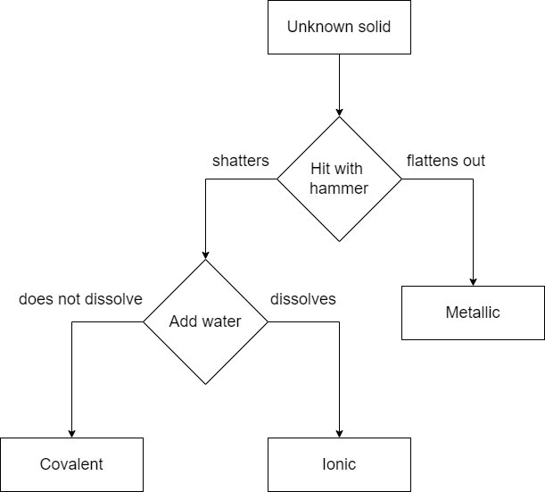
This work has been generated using draw.io online.
- You suspect that their procedure is incomplete. Outline an additional test that should be included and any additional equipment needed. (2 marks)
- Explain how the additional test will ensure the method produces reliable data. (3 marks)

Part B – assessing the use of materials (7 marks)
Use the stimulus information below, including Table 2 and Table 3, to respond to questions 4 and 5.
A sports equipment company wants to make a new eco-friendly soccer ball cover (the outer layer of the material around the ball). This outer layer needs to be:
- strong and hard to damage (abrasion-resistant)
- water-resistant
- better for the environment (biodegradable or less harmful than current materials).
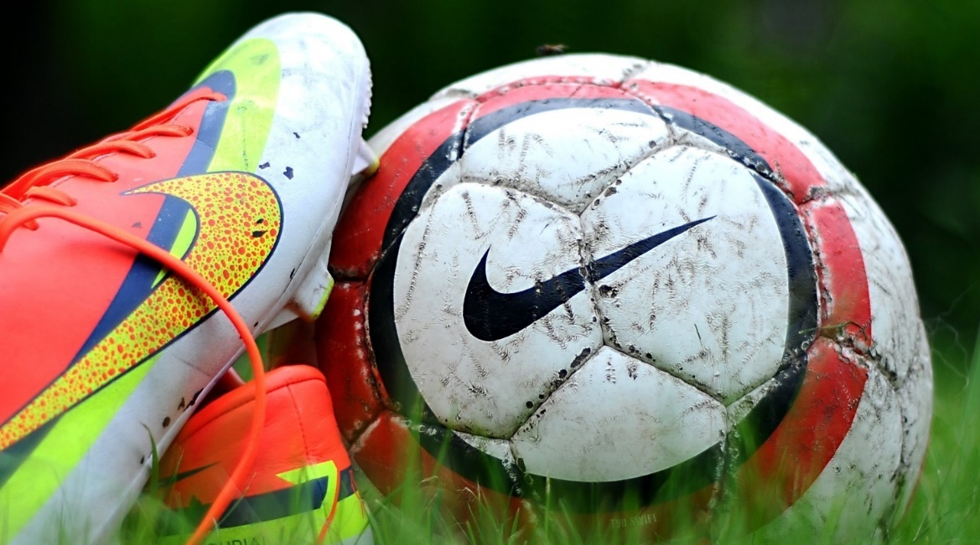
‘Close up of soccer cleats and ball’Close-up photography of Nike soccer cleats and soccer balls on green grass field during daytime by peakpx is licensed under CC0 1.0.
The table below shows information about 3 possible materials. Use this data to decide which material is the best choice for the new soccer ball cover.
Table 2 – properties of materials
Material | Tensile strength* (MPa) | Water resistance | Biodegradability | Cost (per m²)
(A) Plant-based polymer | 35 | Good (keeps its shape in water for approximately 2 weeks) | High (breaks down in about one year) | $8
(B) Synthetic polyurethane | 45 | Excellent (keeps its shape in water for a long time) | Very low (minimal breakdown over decades) | $5
(C) Natural latex | 25 | Moderate (softens if soaked for more than one week) | Moderate (breaks down in about 5 years) | $7
Table 3 – key terms
Term | Description
Tensile strength | How much force a material can handle before it breaks or stretches too far. Megapascals (MPa) are a unit of measurement for describing pressure.
Water resistance | How well a material can stop water from soaking in or causing damage.
Biodegradability | The ability of a material to decompose due to the action of living organisms, especially bacteria.
Cost per square meter (per m2) | How much money you will need to pay for a piece of material that is one meter long and one meter wide.
- List TWO important considerations when deciding which material is best (for example, strength, water resistance, biodegradability, cost) and suggest reasons why each one matters for a soccer ball cover. (4 marks)
- State which material (A, B or C) fits the company’s needs the most and present a balanced (including positives and limitations) scientific argument that justifies your choice. Support your argument with evidence from Table 2. (3 marks)

Part C – biodegradability and compostable materials (24 marks)
Use the information in the ‘Fact sheet: Australian composting standards’ to respond to questions 6–13 in the spaces provided.
Fact sheet: Australian composting standards
What is compostability?  Compostability means a product can break down into natural materials (like organic matter and water) under composting conditions.  Benefits: Reduces waste going to landfill and returns nutrients to the soil. | Two different Australian standards  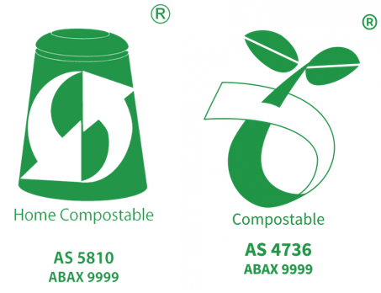  Image credit: Australasian Bioplastics Association
Commercial Compostable (or compostable) – Australian Standard AS 4736
Key features:
- High temperatures – commercial composting facilities usually reach around 50–70°C
- Controlled conditions – temperature, moisture, and oxygen levels are carefully managed
- Timeframe – products must break down by at least 90% in around 6 months
- Disintegration – materials must physically disintegrate into small pieces (often less than 2 mm)
- No harmful effects – the compost produced should not harm plants or soil organisms
Common examples:
- Compostable cups, cutlery, and packaging material labelled ‘AS 4736’ or ‘Compostable’.
Why commercial?
- These systems are more closely monitored, ensuring faster breakdown and better outcomes for large volumes of compostable waste.

Home Compostable – Australian Standard AS 5810
Key features:
- Lower temperatures – home compost bins usually reach lower temperatures (around 20–40°C)
- Less controlled conditions – moisture/oxygen levels vary more than in commercial sites
- Timeframe – products must break down by at least 90% (similarly strict) but may take longer due to cooler conditions – often up to 12 months
- Disintegration – materials must still break apart so that no large fragments remain
- No harmful effects – the resulting compost should be safe for plants, soil, and wildlife
Common examples:
- Some compostable bags or wraps specifically labelled ‘AS 5810’ or ‘Home Compostable’.
Why home?
- Many people want to compost their kitchen or yard waste at home rather than sending it to industrial facilities.
Table 4 – comparing commercial and home composting standards
Feature | Commercial (AS 4736) | Home (AS 5810)
Temperature | Higher (50–70°C) | Lower (20–40°C)
Time to break down | Approximately 6 months | Up to 12 months
Conditions | Highly controlled (oxygen, moisture) | Less controlled, natural
Scale | Large-scale facilities | Small-scale, backyard bins
Testing and requirements | Strict disintegration and safety tests | Similar tests to commercial, adapted to lower temperatures
Examples | Compostable cups and plates. | Home compostable bags, wraps
- Define ‘compostable’ in your own words. (1 mark)
- List 2 key differences between Commercial Compostable (AS 4736) and Home Compostable (AS 5810) based on temperature and timeframe. (2 marks)
- Why is it useful to have 2 separate Australian Standards (AS 4736 and AS 5810) for certifying compostable products? (2 marks)

Questions 9 and 10 also refer to the information below.
Scenario:
Your school is deciding between 2 types of lunch packaging for the canteen:
Packaging A: Labelled ‘Commercially Compostable (AS 4736)’
Packaging B: Labelled ‘Home Compostable (AS 5810)’
- Your school only has small, unheated compost bins in each garden area. Which packaging would likely be more suitable? Explain your choice. (3 marks)
- Suggest one possible disadvantage of choosing the other type of packaging in this specific school context. (1 mark)
For questions 11–13, refer to the information below.
Scenario: a teacher wants to run a quick classroom experiment to see if a small sample of Packaging X (Commercially Compostable) shows any early signs of degradation (breaking down) in a home compost bin after one month.
- Using the fact sheet, name one factor that would affect the results of this mini-experiment and explain why it matters. (2 marks)
- A student conducted an experiment to compare the suitability of composting for disposing of packaging X and packaging Y. Photographs were taken of the samples of each plastic at the start and after one month of being stored on a windowsill in a container of soil.
Table 5 – student results
Packaging | Samples on day 1 | Samples after one month in soil
Packaging X | 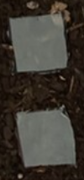 | 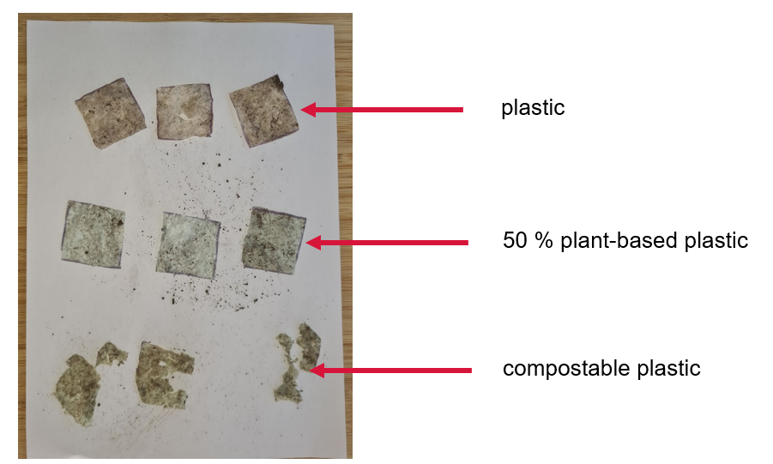
Packaging Y | 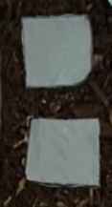
- Compare the level of decomposition of Packaging X and Packaging Y after one month in soil. (2 marks)
- What claims could be made about the suitability of composting for disposing of Packaging X? Support your response with evidence. (3 marks)

- Write a step-by-step method for a valid, controlled experiment to investigate the inquiry question. Ensure that variables are clearly defined and that your method will collect reliable data. (8 marks)
Inquiry question: Which packaging (Packaging X or Packaging Y) is most suitable for composting in a home compost bin?

Evidence base
This resource contains NSW Curriculum and syllabus content. The NSW Curriculum is developed by the NSW Education Standards Authority. This content is prepared by NESA for and on behalf of the Crown in right of the State of New South Wales. The material is protected by Crown copyright.
Please refer to the NESA Copyright Disclaimer for more information https://educationstandards.nsw.edu.au/wps/portal/nesa/mini-footer/copyright.
NESA holds the only official and up-to-date versions of the NSW Curriculum and syllabus documents. Please visit the NSW Education Standards Authority (NESA) website https://educationstandards.nsw.edu.au and the NSW Curriculum website https://curriculum.nsw.edu.au.
Science 7–10 Syllabus © NSW Education Standards Authority (NESA) for and on behalf of the Crown in right of the State of New South Wales, 2023.
ABA (Australasian Bioplastics Association) (2024) ABA - Australasian Bioplastics Association [website], accessed 24 February 2025.
Brookhart SM (2018) ‘Appropriate Criteria: Key to Effective Rubrics’, Frontiers in Education, volume 3(22):1–12, doi:10.3389/feduc.2018.00022, accessed 6 February 2025.
CESE (Centre for Education Statistics and Evaluation) (2020) What works best: 2020 update, NSW Department of Education, accessed 18 July 2024.
——(2020) What works best in practice, NSW Department of Education, accessed 18 July 2024.
——(2021) Growth goal setting – what works best in practice, NSW Department of Education, accessed 18 July 2024.
Fisher D and Frey N (1 November 2009) ‘Feed Up, Back, Forward’, ASCD (Association for Supervision and Curriculum Development): Educational Leadership magazine, 67(3), accessed 6 February 2025.
Griffin P (2017) Assessment for Teaching, Cambridge University Press, Port Melbourne, Victoria.
Hattie J and Timperley H (2007) ‘The Power of Feedback’, Review of Educational Research, 77(1): 81–112, doi:10.3102/003465430298487, accessed 15 July 2024
Panadero E and Jonsson A (2013) ‘The use of scoring rubrics for formative assessment purposes revisited: A review’, Educational Research Review, 9:129–144, doi:10.1016/j.edurev.2013.01.002, accessed 6 February 2025.
Sherrington T (2019) Rosenshine’s Principles in Action, John Catt Educational Limited, Melton, Woodbridge.
Wiliam D (2017) Embedded Formative Assessment, 2nd edn, Solution Tree Press, Bloomington, IN.

© State of New South Wales (Department of Education), 2025
The copyright material published in this resource is subject to the Copyright Act 1968 (Cth) and is owned by the NSW Department of Education or, where indicated, by a party other than the NSW Department of Education (third-party material).
Copyright material available in this resource and owned by the NSW Department of Education is licensed under a Creative Commons Attribution 4.0 International (CC BY 4.0) license.

This license allows you to share and adapt the material for any purpose, even commercially.
Attribution should be given to © State of New South Wales (Department of Education), 2025.
Material in this resource not available under a Creative Commons license:
- the NSW Department of Education logo, other logos and trademark-protected material
- material owned by a third party that has been reproduced with permission. You will need to obtain permission from the third party to reuse its material.
Links to third-party material and websites
Please note that the provided (reading/viewing material/list/links/texts) are a suggestion only and implies no endorsement, by the New South Wales Department of Education, of any author, publisher, or book title. School principals and teachers are best placed to assess the suitability of resources that would complement the curriculum and reflect the needs and interests of their students.
If you use the links provided in this document to access a third-party's website, you acknowledge that the terms of use, including licence terms set out on the third-party's website apply to the use which may be made of the materials on that third-party website or where permitted by the Copyright Act 1968 (Cth). The department accepts no responsibility for content on third-party websites.

