Science Stage 5 (Year 9) – sample assessment task
Materials
Option 1 – investigating the biodegradability of rubbish bin liners
Creation date: 21 February 2025.

Contents
About this assessment task 2
Purpose of the resource 2
When and how to use 2
Assessment task notification 5
Task description 5
Marking rubric 7
Student workbook 10
Planning the investigation to gather data 10
Implications and conclusions 18
Recommendation for your principal 19
Student report 1 – scientific report 21
Student report 2 – principal recommendation report 23
Appendix A – sample results 24
Evidence base 29

About this assessment task

Purpose of the resource
There are 2 options available for assessing the Materials focus area. This assessment task is Option 1 and is linked to the learning in the Materials program of learning for Stage 5 students. Only one of the 2 options should be implemented.
The ‘Investigating the biodegradability of rubbish bin liners’ assessment task aims to evaluate students' understanding of the biodegradability and environmental effects of packaging materials, alongside their proficiency in designing a controlled investigation and conveying their findings. This task entails students planning, collecting and analysing primary (first-hand) data, and presenting their findings in a scientific report and a recommendation report. It engages students in exploring socioscientific issues and fostering awareness of how science contributes to solving problems affecting our societies.

When and how to use
Students will plan and conduct an investigation to determine the biodegradability of various rubbish bin liners. Each student will individually complete the investigation report and the recommendation report to the principal. Students will need to collect data regularly over an extended period. Accommodations will need to be made in programming lessons to allow for this.
Note: the outcomes ‘selects and uses a range of tools to process and analyse data’ (SC5-WS-05) and ‘analyses data from investigations to identify trends, patterns and relationships, and draws conclusions’ (SC5-WS-06) will not be assessed in this task. You may assist students in creating suitable tables and graphs for collecting and analysing their data, or provide them with a second-hand dataset. It is recommended that the scaffold for collecting data (provided in this task) be adapted according to individual investigation plans. For example, if students collect quantitative data, they follow the steps provided in Analysing the data. However, if they collect only qualitative data, they can rank the rubbish bin liners based on their relative biodegradability and leave out steps 1–5 in Analysing the data.

The Common Grade Scale can be used to report student achievement in both primary and junior secondary years in all NSW schools.
When grading students’ level of achievement in Stage 5, refer to the Course performance descriptors. Course performance descriptors provide holistic descriptions of typical achievement at different grade levels in a specific course.

Teachers' guide to implementing this assessment task
- This assessment task should be implemented after students have been taught how to plan an investigation. The topic of the biodegradability of polymers should be taught concurrently with the investigation in this task. Students will have completed learning the content before the assessment task is finalised, ensuring they possess all the knowledge necessary to attend to all the task’s activities.
- Explain the purpose of the assessment task to your students, including its organisation, length and student-generated products (see Task description). Review the task’s Marking rubric.
- Set up small groups of students – they will collaborate on planning and conducting the investigations and any other aspects of the data processing and analysis as determined by the teacher. Emphasise that, despite the collaboration, each student must maintain their own workbook and produce individual reports for assessment.
Note: if students cannot generate usable data, they may use the sample data provided in Appendix A. Modify the information in the Appendix to make it meaningful to your students.
- Teachers will only mark the scientific report and principal recommendation report. The workbook does not need to be assessed. Teachers can provide feedback on students’ responses in the workbook.
- The student workbook contains several tables with prompts that students should address during the course of the assessment task. They should use their responses to answer the questions in the scientific report (Student report 1). Students may require guidance and support when transforming the information in the workbook tables to the scientific report.
- Similarly, provide students with any support they require to construct their principal recommendation report (Student report 2).

Equipment requirements
Students will design their own investigation methods for this task. As a result, equipment needs may differ based on each student's investigation design. Some suggested equipment includes:
- thermometer
- electronic balance
- measuring cylinder
- universal indicator.
Additionally, students may negotiate for the following materials:
- reusable plastic containers or pots
- soil, sand or compost
- a variety of rubbish bin liners made from different polymers
- permanent markers
- rulers.

Assessment task notification
Name of task: investigating the biodegradability of rubbish bin liners.
Type of task: practical investigation. Students will use the data generated in the investigation to produce a scientific report and recommendation report for assessment.
Weighting: [the weight of the assessment task is a school-based decision].
Submission details: [schools complete this section – include any important details about submission, format of the task, word limits, and submission procedures].
Outcomes being assessed:
A student:
- assesses the uses of materials based on their physical and chemical properties
SC5-MAT-01
- designs safe, ethical, valid and reliable investigations SC5-WS-03
- communicates scientific arguments with evidence, using scientific language and terminology in a range of communication forms SC5-WS-08
Science 7–10 Syllabus © NSW Education Standards Authority (NESA) for and on behalf of the Crown in right of the State of New South Wales, 2023.

Task description
As our society becomes increasingly aware of environmental issues, the impact of waste, particularly packaging materials, has come under scrutiny. With landfills overflowing and plastic pollution becoming a critical concern, finding sustainable packaging solutions has never been more important. Biodegradable packaging materials present a promising alternative, yet their effectiveness in real-world conditions remains a key question. Biodegradability refers to the capacity of organic materials (such as the polymers used to make rubbish bin liners) to be broken down by living organisms (such as bacteria and fungi) into simpler substances. Biodegradability reduces waste accumulation and minimises pollution. It supports sustainable practices by allowing materials to return to the natural environment.
Supermarkets now offer a growing range of polymer (plastic) rubbish bin liners, including plant-based, compostable and environmentally friendly options, alongside those made from traditional plastics.
In this assessment task, you will plan and conduct an investigation to determine the biodegradability of a range of rubbish bin liners.
This assessment task has 2 components. You will:
- design and conduct a scientific investigation that tests the relative biodegradability of a range of rubbish bin liners
- write a scientific report and a recommendation report for your principal for the bin liner that is most biodegradable.

Marking rubric
Table 1 – marking rubric for the scientific report
Criteria | Level 1 | Level 2 | Level 3 | Level 4
Background and problem statement  (SC5-MAT-01 Materials and SC5-WS-08 Communicating) | Provides a basic or incomplete description of bin liner materials.  Limited discussion of environmental consequences.  The problem statement is unrelated to the investigation’s purpose. | Describes bin liner materials but lacks depth or clarity.  Mentions environmental consequences in general terms.  The problem statement is vague. | Provides a detailed description of bin liner materials and their polymer composition with minor omissions.  Mentions environmental consequences and states the problem with some clarity. | Provides a thorough and accurate description of bin liner materials and their polymer composition.  Clearly describes the environmental consequences of traditional plastic bin liners.  Clearly defines the problem being investigated.
Investigation design – method  (SC5-WS-03 Planning investigations) | The method does not permit the investigation to be replicated.  Limited or no mention of variable control.  Risk management may not be addressed. | Method is somewhat clear but lacks detail or structure.  Some variable control is mentioned but not fully explained.  Risk management is briefly mentioned. | Provides a mostly clear step-by-step procedure.  Explains experimental design with minor omissions in variable control.  Risk management is addressed but not in detail. | Provides a clear, logical and replicable step-by-step procedure (includes quantities, sample sizes and other information).  Effectively explains how the experimental design controls variables and allows measurement of the independent variable’s effect on the dependent variable.  Clearly describes risk management.
Discussion and conclusion  (SC5-MAT-01 Materials and  SC5-WS-08 Communicating) | Findings are summarised with minimal detail.  Limited or unclear discussion of biodegradability, hypothesis, and experimental limitations. | Provides a general summary of findings but lacks depth in analysis.  Mentions biodegradability and hypothesis connection but lacks clear reasoning.  Basic mention of reliability and validity. | Summarises findings and trends with minor omissions.  Discusses biodegradability and relates findings to the hypothesis.  Addresses reliability, validity, and precision but lacks depth.  Mentions uncertainties or unexpected results with some explanation. | Summarises findings effectively, identifying trends and patterns.  Clearly discusses biodegradability and relates findings to the hypothesis.  Evaluates reliability, validity, and precision with detailed explanations.  Acknowledges uncertainties and unexpected results with logical reasoning.
Table 2 – marking rubric principal recommendation report
Criteria | Level 1 | Level 2 | Level 3 | Level 4
Understanding of plastic material properties  (SC5-MAT-01) | Demonstrates a limited understanding of plastics' properties and biodegradability, with minimal evaluation. | Demonstrates an adequate understanding of plastics' properties and biodegradability, with basic evaluation of uses. | Demonstrates a clear understanding of physical and chemical properties of plastics and links them to biodegradability.  Evaluates their uses with some depth. | Demonstrates a sophisticated understanding of the physical and chemical properties of plastics and how these relate to biodegradability.  Evaluates their suitability for various uses with insightful discussion.
Scientific communication  (SC5-WS-08) | Provides a limited recommendation with minimal evidence or scientific reasoning.  May not be appropriate for the audience.  Minimal use of scientific language and terminology. | Provides a reasonable recommendation but may lack depth in scientific justification or ethical considerations.  Somewhat appropriate for the audience.  Some use of scientific language and terminology. | Presents a strong, evidence-based recommendation with scientific arguments and some ethical considerations.  Mostly appropriate for the audience.  Uses scientific language and terminology accurately. | Provides a persuasive, well-justified, evidence-based recommendation, linking findings and scientific concepts to the school’s needs.  The recommendation report is appropriate for the audience.  Uses scientific language and terminology accurately, while ensuring that its meaning is clear.

Student workbook
This booklet will guide you through the process of designing a scientific investigation. Working through the steps outlined below will help you understand how to plan an experiment, collect and analyse data, draw conclusions based on your findings and create a recommendation.
You have been given the problem ‘Which rubbish bin liner is biodegradable?’ to solve. You are to design an investigation to answer the inquiry question.

Planning the investigation to gather data
Respond to the questions below in the space provided next to the question. These questions will help guide your investigation planning.
Planning questions | Response
What information do you know about commonly used rubbish bin liners, biodegradable materials and their environmental impacts?
What data do you need to collect to answer the inquiry question?
How will you collect your data?
What risks are involved? How will you manage the risks?
Do you need an experimental control? If so, describe how your control samples will be set up.
What will be the sample size?
How many times will you repeat the experiment?
How will you collect, record and organise your data?
What is your hypothesis?

Investigation design
Variables
Identify and outline the variables to be measured, controlled and manipulated to ensure the investigation yields valid and reliable results.
Independent variable | How will this variable be changed?
Dependent variable | How will you measure this variable?
Controlled variables | How will each variable be controlled?
Experiment control | What is the experiment control? Why is it needed or not needed in this investigation?

Equipment and materials
List the equipment and materials that are needed for the investigation. Include the size and quantity in your list.
[add more rows as required]
Risk assessment
In the table below, indicate the hazards, risks and describe how you will mitigate the identified risks.
Table 1 – risk assessment
Hazard | Risk | Mitigation
Example  Water spillage | Example  Risk of slipping on spilled water. | Example  Clean up any spills immediately and use appropriate containers.
 |  | [add more rows as required]

Evaluation of investigation design
Use the checklist below to evaluate your method design.
Table 2 – evaluation of investigation design
Component | Evidence | Assessment
What are the independent and dependent variables in the experiment? Are they clearly defined? | IV is …  DV is… | ☐ Complete  ☐ Partially complete  ☐ Incomplete
Have all controlled variables been identified and accounted for? | List the controlled variables and how they are controlled. | ☐ Complete  ☐ Partially complete  ☐ Incomplete
Is there a control group included in the experiment? If not, why is it not necessary? |  | ☐ Complete  ☐ Partially complete  ☐ Incomplete
Is the experimental procedure clearly outlined in a step-by-step format? |  | ☐ Complete  ☐ Partially complete  ☐ Incomplete
Are the steps logical and easy to follow? |  | ☐ Complete  ☐ Partially complete  ☐ Incomplete
Are all the necessary materials and equipment listed? Are they appropriate for the experiment? |  | ☐ Complete  ☐ Partially complete  ☐ Incomplete
Does the method allow the inquiry question to be answered? |  | ☐ Complete  ☐ Partially complete  ☐ Incomplete
Are all necessary safety precautions mentioned and explained? |  | ☐ Complete  ☐ Partially complete  ☐ Incomplete
Is it possible for others to repeat the experiment using the described method? Are there any steps that could introduce variability? |  | ☐ Complete  ☐ Partially complete  ☐ Incomplete
Is the sample size adequate to support reliable conclusions? |  | ☐ Complete  ☐ Partially complete  ☐ Incomplete
How will the data be collected? |  | ☐ Complete  ☐ Partially complete  ☐ Incomplete
What are the potential sources of error that could impact the results? How are they minimised? |  | ☐ Complete  ☐ Partially complete  ☐ Incomplete
What methods will be used to analyse the data? Are these methods appropriate for the type of data collected? |  | ☐ Complete  ☐ Partially complete  ☐ Incomplete
Are there any potential biases or subjective judgments in the experimental design? How are they managed? |  | ☐ Complete  ☐ Partially complete  ☐ Incomplete
Is the method valid? (Are all variables controlled or accounted for, have you used a method, and does the method allow you to answer the inquiry question?) |  | ☐ Complete  ☐ Partially complete  ☐ Incomplete
Is the method reliable? (Is the sample size large enough, has it been repeated under the same conditions to gain the same results?) |  | ☐ Complete  ☐ Partially complete  ☐ Incomplete
Is a neat, labelled diagram of the experiment set up included? |  | ☐ Complete  ☐ Partially complete  ☐ Incomplete

Carry out your investigation to gather the necessary data.
Results (data collection)
Modify the column headings in the table based on the variables identified previously. Record your data in Table 3.
Table 3 – [insert an appropriate title for your table here]
[Independent variable] | [Dependent variable] | Qualitative observations
 |  | [add more rows as required]
Analysing the data
- Decide if the data should be represented in a column (discrete data) or a line (continuous data) graph.
- Add (an) appropriate:
- title
- axis labels
- axis titles
- axis scales
- key
- data points to the graph.

- Identify any anomalous data. This may need to be removed or accounted for.
- Add a line of best fit or columns as appropriate.
- Use your data to describe any patterns or trends you observe.

Implications and conclusions
Discuss the implications of the data. The table below highlights points to consider.
Points to consider | Response
What do these results mean?
Which material biodegrades the fastest?
Which material biodegrades the most?
How significant are the differences between materials?
Are there any unexpected results?
Are the results valid, reliable and *precise?
Relate the findings to your hypothesis.
*’Precise’ is irrelevant if you collect qualitative data.

Recommendation for your principal
Prepare a formal, evidence-based report for your school’s principal, recommending which rubbish bin liners should be purchased. Use a Claim-Evidence-Reasoning (CER) framework (see the table below) to structure your argument. Your report should include information on biodegradability and polymers used for rubbish bin liners so that your principal can make an informed decision. Use the scaffold below to construct your recommendation to your principal.
Recommendation report planning
This scaffold may assist in structuring the recommendation to the principal. This scaffold should be used for planning purposes only. Considerations when preparing your report include:
- using clear and concise language suitable for an audience of a principal
- ensuring that your writing is clear and connected
- providing any relevant graphs, charts or tables to support your argument
- ensuring proper formatting, including headings and subheadings, for clarity and structure
- using evaluative language to persuade the principal to accept your recommendation.
Table 4 – recommendation report planning
Section | Planning notes
Introduction
Briefly introduce the purpose of the report and the importance of selecting environmentally friendly rubbish bin liners for the school.
Background
Provide background information explaining biodegradability and the different polymers used in rubbish bin liners.
Claim
State your recommendation for the type of rubbish bin liners that should be purchased based on their biodegradability.
Evidence
Provide information on the biodegradability of different types of rubbish bin liners.
Reasoning
Explain why the recommended rubbish bin liners are the most suitable choice for the school.
Justify your recommendation by connecting the evidence gathered in your investigation.
Conclusion
Summarise your recommendation and key points discussed in the report.
Reinforce the importance of selecting environmentally friendly rubbish bin liners for the school's sustainability efforts.

Student report 1 – scientific report
- Provide a background and problem statement.
- In your background, describe the materials used for making bin liners, including their polymer composition.
- Complete your introduction by briefly describing the environmental consequences of using traditional plastic bin liners.
- Finally, describe the problem you are addressing in this investigation.
- Provide a hypothesis for your investigation. A high-quality scientific hypothesis must:
- be testable
- contain a prediction
- be based on scientific theory.
- Method:
- Write a step-by-step procedure outlining the methodology of the investigation (indicate the equipment used in your procedure, but do not list them).
- Explain how your experimental design allows you to determine the effect of the independent variable on the dependent variable, with all other variables effectively controlled.
- Explain how you managed the risks identified in your investigation.
- Discussion:
- Summarise your investigation’s findings, including any trends or patterns you have identified in your analysis.
- Comment on the biodegradability of the bin liners you tested.
- How certain can you be of your conclusion?
- Are there any unexpected results or observations that you cannot explain?
- Are the results valid, reliable and precise?
- Relate the findings to your hypothesis.
- Evaluate your method, based on the data you collected.
- Ensure that you include evidence supporting your evaluation.
- If you were to repeat your investigation, what changes will you make to your methodology? For example, you may refine the method to improve the accuracy or precision of your data.
- Conclusion:
- Draw a conclusion from your data. Include evidence from your data to support your conclusion.

Student report 2 – principal recommendation report
General instructions
- Your recommendation report should be no more than one A4 page, 1.5-spaced and 12 pt font.
- Title: provide a suitable title based on the investigation you conducted.
- Body (2 paragraphs)
- State the problem (approximately 3 to 4 sentences) addressed in this investigation.
- Summarise the investigation and findings in about 3 to 4 sentences. Be sure to include some data and evidence-based conclusions.
- Recommendation (1 paragraph)
- Advise the principal on the type of bin liners your school ought to use, providing your justification. Connect this to the issue you examined in this task and incorporate pertinent scientific concepts. Use evaluative or persuasive language to persuade the principal to accept your recommendation (around 10 sentences).

Appendix A – sample results
If students are unable to gather a set of results, they may use this collection of images showcasing sample outcomes. Based on the images, they can make qualitative observations to draw conclusions. Three types of plastics were tested: conventional plastic, 50% plant-based plastic, and compostable plastic. Each piece of plastic measured 4 cm by 4 cm and was placed in a container filled with fresh garden soil that had been composted and mulched previously (in triplicate). They were covered with 1 cm of soil and kept damp. Suggestions on how data may be collected from the photos is provided for teacher reference in Table 4 and Table 5.
Figure 1 – week 2 results
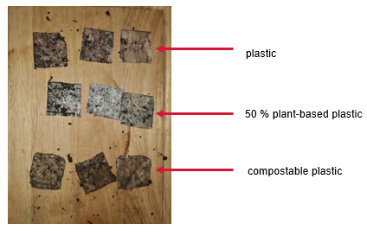
Figure 2 – week 3 results
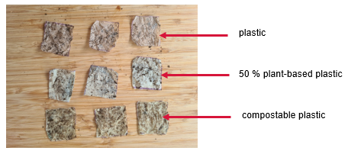
Figure 3 – week 4 results
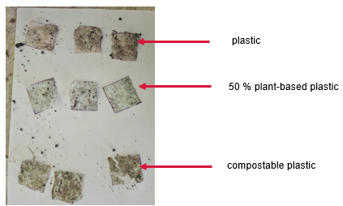

Figure 4 – week 5 results
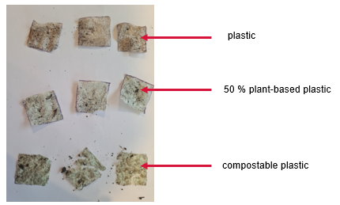
Figure 5 – week 6 results
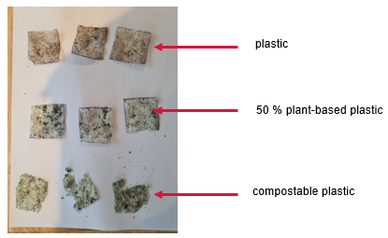
Figure 6 – week 7 results
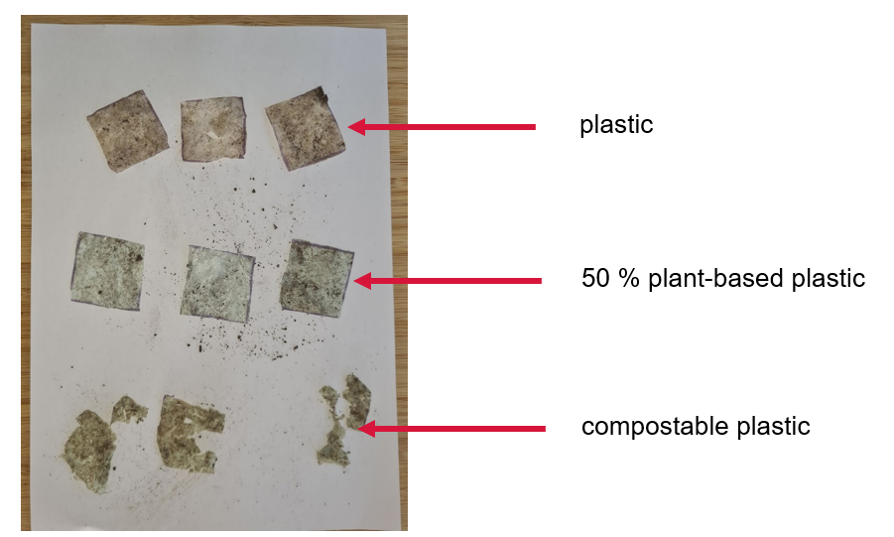
Students can report these observations qualitatively. For instance, they may indicate the level of degradation based on the estimated proportion of undegraded material. To achieve this, they could devise an arbitrary criterion to signify the level of biodegradation:
Table 4 – degradation scale that could be used as arbitrary level of biodegradation
Proportion of material that is not degraded (%) | Score
0 | 0
1-50 | 1
>50 | 2
Note: the table above may be adjusted to alter the range of estimated degradation (for instance, 1–25%, 26–50%, and so on).
Table 5 – sample student data table
Week | Biodegradation score
Week | Plastic | 50% plant-based plastic | Compostable plastic
1 | 0 | 0 | 0
3 | 0 | 0 | 1
5 | 0 | 1 | 1
7 | 0 | 2 | 2

Evidence base
This resource contains NSW Curriculum and syllabus content. The NSW Curriculum is developed by the NSW Education Standards Authority. This content is prepared by NESA for and on behalf of the Crown in right of the State of New South Wales. The material is protected by Crown copyright.
Please refer to the NESA Copyright Disclaimer for more information https://educationstandards.nsw.edu.au/wps/portal/nesa/mini-footer/copyright.
NESA holds the only official and up-to-date versions of the NSW Curriculum and syllabus documents. Please visit the NSW Education Standards Authority (NESA) website https://educationstandards.nsw.edu.au and the NSW Curriculum website https://curriculum.nsw.edu.au.
Science 7–10 Syllabus © NSW Education Standards Authority (NESA) for and on behalf of the Crown in right of the State of New South Wales, 2023.
Brookhart SM (2018) ‘Appropriate Criteria: Key to Effective Rubrics’, Frontiers in Education, volume 3(22):1–12, doi:10.3389/feduc.2018.00022, accessed 6 February 2025.
CESE (Centre for Education Statistics and Evaluation) (2020) What works best: 2020 update, NSW Department of Education, accessed 18 July 2024.
——(2020) What works best in practice, NSW Department of Education, accessed 18 July 2024.
——(2021) Growth goal setting – what works best in practice, NSW Department of Education, accessed 18 July 2024.
Fisher D and Frey N (1 November 2009) ‘Feed Up, Back, Forward’, ASCD (Association for Supervision and Curriculum Development): Educational Leadership magazine, 67(3), accessed 6 February 2025.
Griffin P (2017) Assessment for Teaching, Cambridge University Press, Port Melbourne, Victoria.
Hattie J and Timperley H (2007) ‘The Power of Feedback’, Review of Educational Research, 77(1): 81–112, doi:10.3102/003465430298487, accessed 15 July 2024
Panadero E and Jonsson A (2013) ‘The use of scoring rubrics for formative assessment purposes revisited: A review’, Educational Research Review, 9:129–144, doi:10.1016/j.edurev.2013.01.002, accessed 6 February 2025.
Sherrington T (2019) Rosenshine’s Principles in Action, John Catt Educational Limited, Melton, Woodbridge.
Wiliam D (2017) Embedded Formative Assessment, 2nd edn, Solution Tree Press, Bloomington, IN.

© State of New South Wales (Department of Education), 2025
The copyright material published in this resource is subject to the Copyright Act 1968 (Cth) and is owned by the NSW Department of Education or, where indicated, by a party other than the NSW Department of Education (third-party material).
Copyright material available in this resource and owned by the NSW Department of Education is licensed under a Creative Commons Attribution 4.0 International (CC BY 4.0) license.

This license allows you to share and adapt the material for any purpose, even commercially.
Attribution should be given to © State of New South Wales (Department of Education), 2025.
Material in this resource not available under a Creative Commons license:
- the NSW Department of Education logo, other logos and trademark-protected material
- material owned by a third party that has been reproduced with permission. You will need to obtain permission from the third party to reuse its material.
Links to third-party material and websites
Please note that the provided (reading/viewing material/list/links/texts) are a suggestion only and implies no endorsement, by the New South Wales Department of Education, of any author, publisher, or book title. School principals and teachers are best placed to assess the suitability of resources that would complement the curriculum and reflect the needs and interests of their students.
If you use the links provided in this document to access a third-party's website, you acknowledge that the terms of use, including licence terms set out on the third-party's website apply to the use which may be made of the materials on that third-party website or where permitted by the Copyright Act 1968 (Cth). The department accepts no responsibility for content on third-party websites.

