Science Stage 5 (Year 9) – sample assessment task
Environmental sustainability
Creation date: 21 July 2025

Contents
About this assessment task 2
Purpose of the resource 2
When and how to use 2
Assessment task notification 3
Task description 3
Assessment task – How can food be sustainable? 10
Section 1 – analysing data on food waste 10
Section 2 – solving the problem of food waste 16
Evidence base 21

About this assessment task

Purpose of the resource
This assessment task is linked to the learning in the Environmental sustainability program of learning for Stage 5. The task is designed to assess students' understanding of the impact of human activity on the natural world and their skills in analysing data and problem-solving.

When and how to use
This assessment task should be completed after students have covered most of the content in the Environmental sustainability focus area. Students will investigate the issue of food waste and its environmental effects by answering examination-style questions.
Before attempting the examination-style questions, students must independently research methods for reducing food waste at home. They should consider the food waste in their own households and develop solutions to minimise it. There will be questions that require them to apply information from this research.
It is recommended that students be supplied with the infographics and stimulus material in the assessment notification, and that teachers unpack them with their students before the examination.
The suggested length of the examination component of the task is 60 minutes. The assessment task should be conducted under examination conditions.
Note: marking guidelines are provided in Teacher support material. Sample responses are provided in a separate document in the Science statewide staffroom (SWS). NSW Department of Education teachers must be members of the Science SWS to access the file Environmental sustainability assessment task sample answers. To join, go to Statewide staffrooms and select ‘science’.
The Common Grade Scale can be used to report student achievement in both primary and junior secondary years in all NSW schools.
When grading students’ level of achievement in Stage 5, refer to the course performance descriptors. Course performance descriptors provide holistic descriptions of typical achievement at different grade levels in a specific course.

Assessment task notification
Name of task: Addressing the food waste problem
Type of task: secondary source data analysis and problem-solving examination
Weighting: [The weight of the assessment task is a school-based decision.]
Submission details: [Schools complete this section – include any important details about submission, format of the task, and submission procedures]
Outcomes:
A student:
- analyses the impact of human activity on the natural world SC5-ENV-01
- analyses data from investigations to identify trends, patterns and relationships, and draws conclusions SC5-WS-06
- selects suitable problem-solving strategies and evaluates proposed solutions to identified problems SC5-WS-07
Science 7–10 Syllabus © NSW Education Standards Authority (NESA) for and on behalf of the Crown in right of the State of New South Wales, 2023.

Task description
Context
The Australian Government Department of Climate Change, the Environment and Water defines food waste as ‘Food intended for human consumption that is thrown away.’
Food can be wasted at every point along the food supply chain, from farms, food processing and manufacturing, transport and distribution, hospitality, retail and households.
Most of us have experience with cleaning the fridge or pantry of uneaten, out-of-date food and throwing it away in the garbage bin. Perhaps you have seen what is regularly thrown out at the local supermarket.
You will complete a series of examination-style questions on food waste and its environmental consequences.
The assessment will focus on the following content and skills:
- how to interpret and extract data and information in tables, graphs and infographics
- how to identify limitations in data and information (validity and reliability)
- human impacts on the environment
- the effect of greenhouse gas emissions on climate and ecosystems
- strategies for reducing household food waste
- challenges or barriers to reducing food waste and how they can be overcome
- develop evaluation criteria that could be used to assess the effectiveness of an implemented strategy to reduce household food waste.
Before the examination, you should:
- read and interpret the infographics and stimulus provided in the ‘Preparation guide’
- identify the causes of food waste in your home
- conduct research on ways to reduce food waste and apply them to your household
- identify barriers and solutions to the success of implementing the food waste reduction strategy in your home
- create a criteria to assess the success of your strategy.

Preparation guide
The examination contains 2 sections.
Section 1 – analysing data on food waste
Figures 1 to 3 are a set of infographics on the impact of food waste. You should carefully analyse the infographic and ensure that you understand the information that it contains to prepare for the examination.
Figure 1 – visual representation of data on the environmental impacts of food production
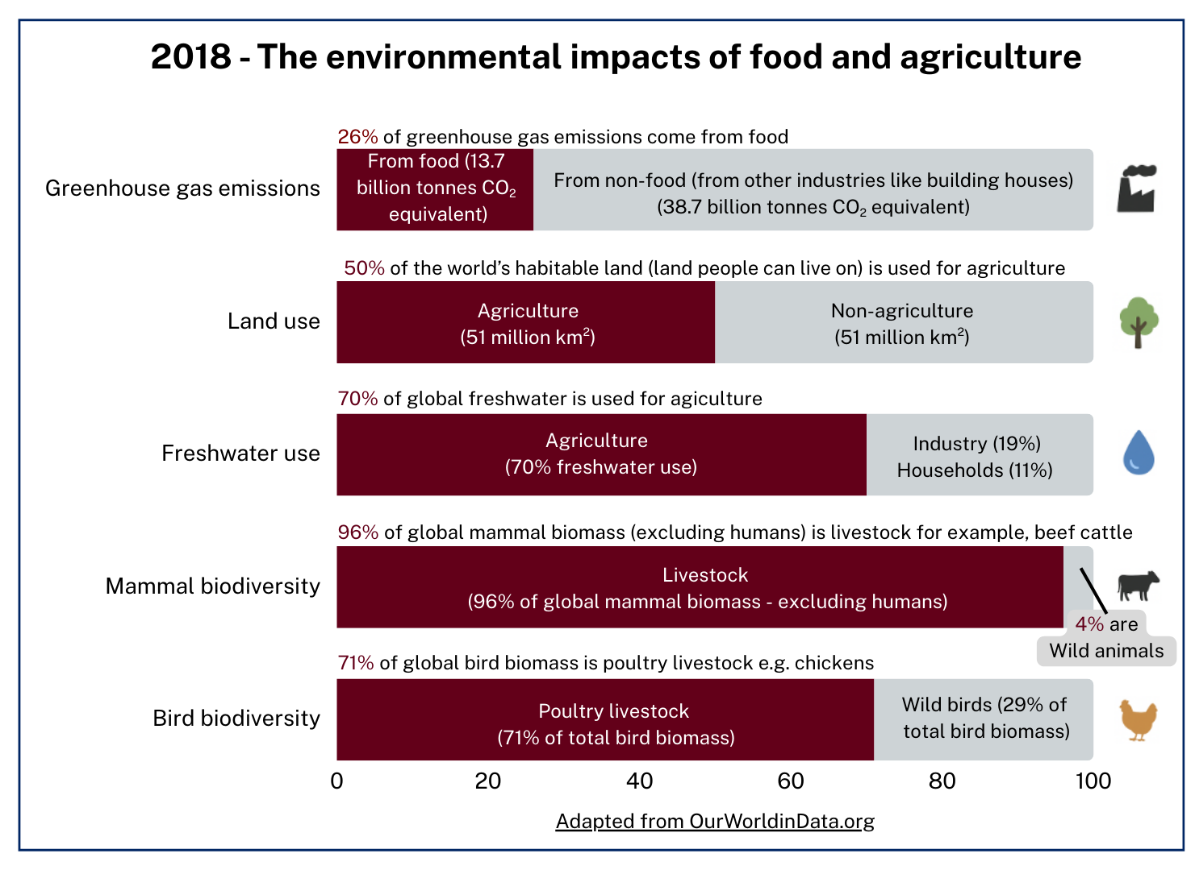Adapted from Environmental Impacts of Food Production by Hannah Ritchie, Pablo Rosado and Max Roser is licensed under CC BY 4.0.

Figure 2 – visual representation of greenhouse gas emissions from food eaten and wasted
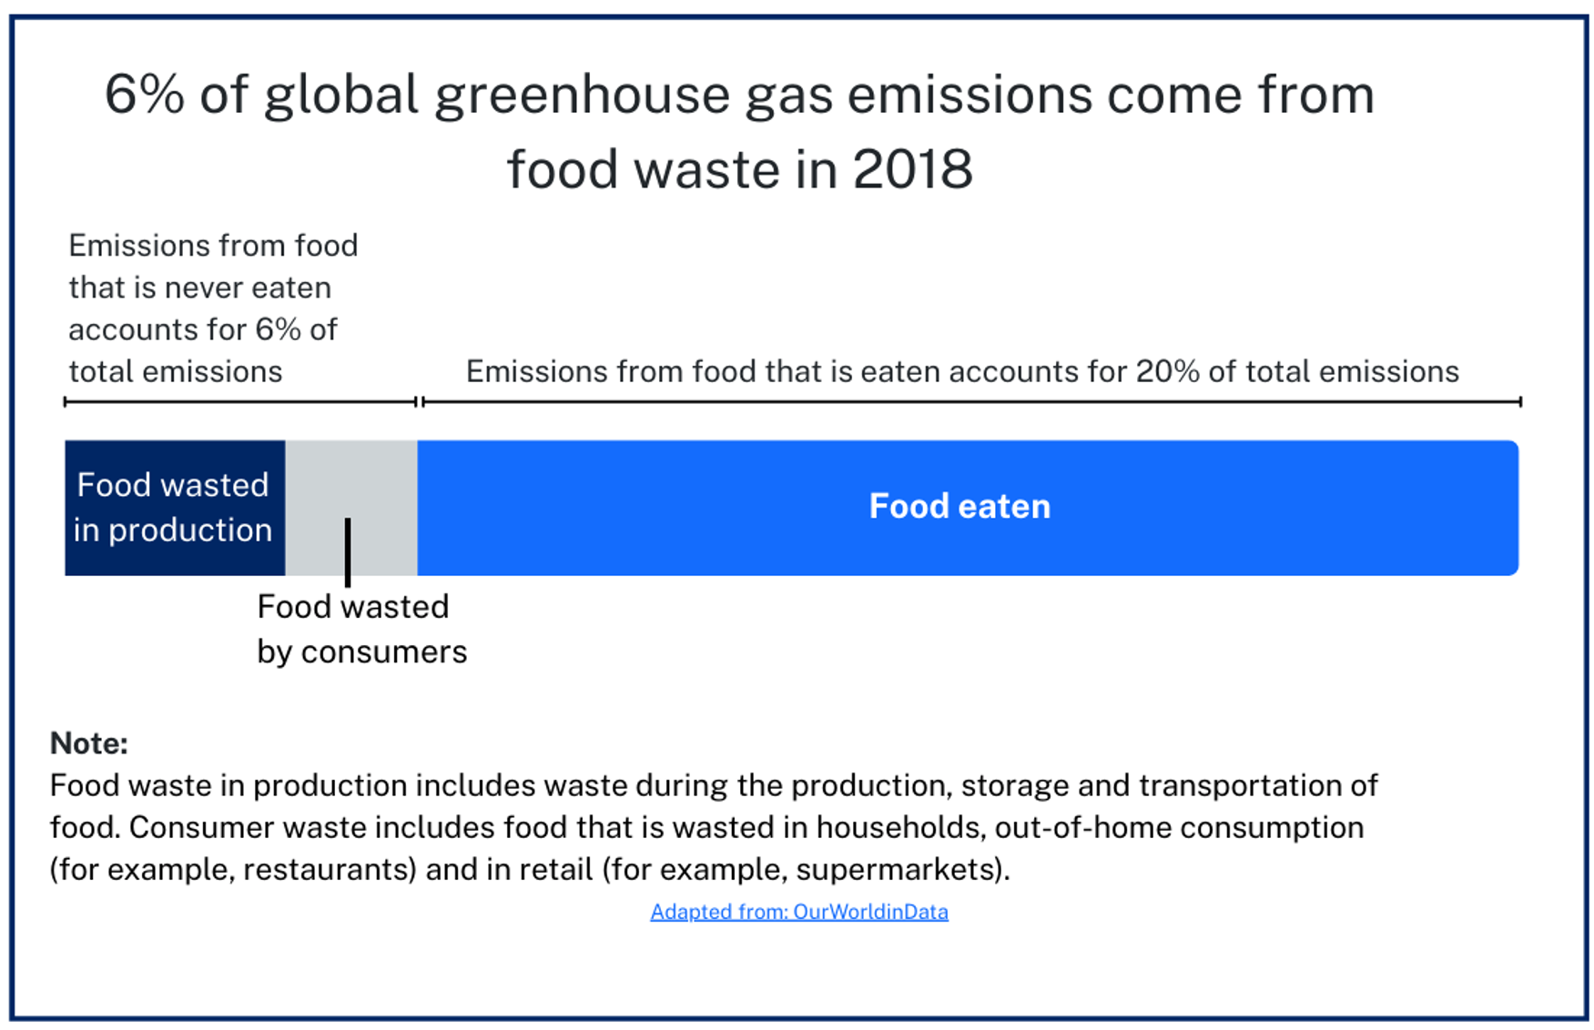
Adapted from Food waste is responsible for 6% of global greenhouse gas emissions by Hannah Ritchie, licensed under CC BY 4.0.
Figure 3 – 2019 and 2020 Food waste per capita (kg), per year, in different countries

Adapted from Food waste per capita by the United Nations Environment Programme – processed by Our World in Data is licensed under CC BY 4.0.
Section 2 – solving the problem of food waste
For this extended response, you will be provided with the stimulus materials ‘Australia’s food waste problem’ and ‘Why do Australian homes waste food?’. Carefully read them and make sure you understand the information they contain. Section 2 also requires you to draw on previous research that you must conduct on:
- the cause of food waste in your home
- strategies you could use to reduce food waste
- a method of evaluating the effectiveness of the strategy.

Australia’s food waste problem
Food waste is a big issue in Australia. It affects the environment and costs a lot of money. A government study in 2021 found that:
🍽️ Australians throw out about 7.6 million tonnes of food every year. That’s about 312 kg per person.
💰 This waste costs the Australian economy about $36.6 billion each year.
🏠 Households are the biggest contributors to food waste. They generate about 30% of the total waste, amounting to around 2.5 million tonnes annually. For a family, this can cost up to $2500 a year.
🌏 Food waste makes up around 3% of Australia’s greenhouse gas emissions, contributing to climate change.
💧 Around 2600 gigalitres of water are used to grow food that ends up wasted. That is the same amount of water as 5 Sydney Harbours.
🌱 More than 25 million hectares of land are used to grow food that gets wasted. That is bigger than the entire state of Victoria.
Adapted from Reducing Australia’s food waste by the Australian Government and is licensed under CC BY 4.0.

Why do Australian homes waste food?
Researchers asked participants to select the reasons why food was wasted at home. They found that:
- 18% said family members do not always finish their meals
- 14% said too much food gets cooked
- 11% said food is stored in the fridge or freezer for too long.
Families with children under 16 were more likely to say meals were left unfinished (34% compared with 18% overall).
When asked why food was thrown away in the last few months, the main reasons selected were:
- 32% were not sure if food was still safe to eat by looking, smelling or tasting it
- 23% did not think anyone would actually eat the leftovers, so they threw them away
- 18% did not understand expiry or ‘use by/best before’ dates, so they threw food out
- 14% did not know how to use the food
- 12% were not sure if it was safe to reheat.
Adapted from Food Waste Australian Household Attitudes and Behaviours (PDF 1.2 MB) by Fight Food Waste Cooperative Research Centre and is licensed under CC BY 4.0.

Assessment task – How can food be sustainable?

Section 1 – analysing data on food waste
Question 1
Before examining food waste, it is essential to note that growing food can have a significant environmental impact. Carefully study the following infographic that highlights the environmental impacts of food production and answer questions 1a to 1d.
Figure 4 – visual representation of data on the environmental impacts of food production
Adapted from Environmental Impacts of Food Production by Hannah Ritchie, Pablo Rosado and Max Roser is licensed under CC BY 4.0.

- Identify one environmental concern related to food production highlighted in the infographic. State the corresponding percentage data. (2 marks)
- If global food demand increases in the next decade, how might this affect land use? (2 marks)
- There are some uncertainties or limitations in the data presented in the infographic. Explain one limitation. (Hint: do all types of agriculture have this level of impact? For example, consider the organic farming of native plants). (2 marks)

- How can we check the reliability of the data sources used in this infographic?
(2 marks)

Question 2
Analyse the infographic (Figure 1) and the graph (Figure 2) and answer questions 2a to 2e.
Figure 5 – visual representation of greenhouse gas emissions from food eaten and wasted
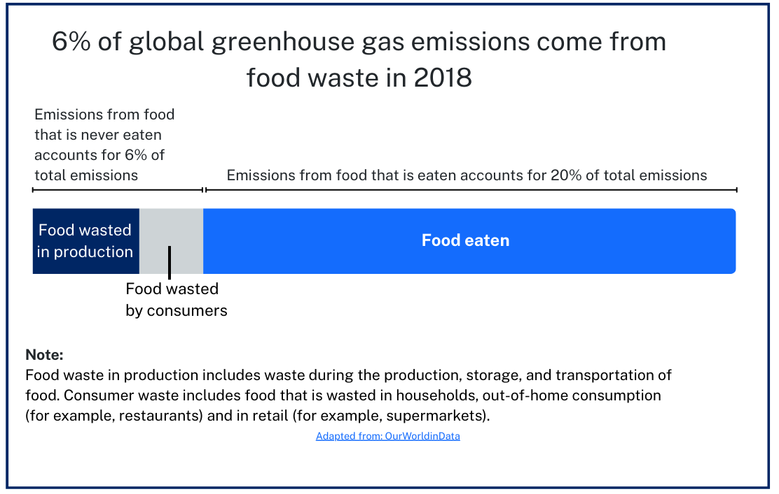
Adapted from Food waste is responsible for 6% of global greenhouse gas emissions by Hannah Ritchie and is licensed under CC BY 4.0.
Figure 6 – 2019 and 2020 food waste per capita (kg), per year, in different countries

Adapted from Food waste per capita by the United Nations Environment Programme – processed by Our World in Data and is licensed under CC-BY-4.0.
- What does Figure 3 reveal about food waste and greenhouse gas emissions? How does food waste occur? (2 marks)
- Multiple choice: Which part of the graph in Figure 2 does Figure 3 provide detailed data for? Circle the correct answer. (1 mark)
- Food wasted in production
- Food wasted by consumers
- Food eaten
- Percentage greenhouse gas contribution
- Multiple choice: Referring to Figure 3, what might explain the reduction in in-home food waste from 2019 to 2022 in Australia and New Zealand? Circle the correct answer. (1 mark)
- Government policy on reducing in-home food waste
- The increase in retail waste in Australia and New Zealand from 2019 to 2022
- More people are eating out, and therefore, less food waste at home is produced
- The fact that there is more household food waste in Australia and New Zealand compared to the United States
- Identify a similarity and a difference in the food waste trends between Australia, New Zealand and the United States. (2 marks)
- Explain why it is important to look at how food contributes to greenhouse gas emissions. (4 marks)

Examination continues on next page.

Section 2 – solving the problem of food waste
Further investigation of the food waste problem
As you read the following article on Australia’s problem with food waste, consider how you can help solve this issue in your household and how these facts might influence your family members to reduce food waste.
Australia’s food waste problem
Food waste is a big issue in Australia. It affects the environment and costs a lot of money. A government study in 2021 found that:
🍽️ Australians throw out about 7.6 million tonnes of food every year. That’s about 312 kg per person.
💰 This waste costs the Australian economy about $36.6 billion each year.
🏠 Households are the biggest contributors to food waste. They generate about 30% of the total waste, amounting to around 2.5 million tonnes annually. For a family, this can cost up to $2500 a year.
🌏 Food waste makes up around 3% of Australia’s greenhouse gas emissions, contributing to climate change.
💧 Around 2600 gigalitres of water are used to grow food that ends up wasted. That is the same amount of water as 5 Sydney Harbours.
🌱 More than 25 million hectares of land are used to grow food that gets wasted. That is bigger than the entire state of Victoria.
Adapted from Reducing Australia’s food waste by the Australian Government and is licensed under CC BY 4.0.
As you read the following on what causes food waste in Australian homes, think of how you could solve the potential causes of food waste in your home.
Figure 7 – survey data on the leading causes of household food waste
Why do Australian homes waste food?
Researchers asked participants to select the reasons why food was wasted at home. They found:
• 18% said family members do not always finish their meals
• 14% said too much food gets cooked
• 11% said food is stored in the fridge or freezer for too long.
When asked why food was thrown away in the last few months, the main reasons selected were:
• 32% were not sure if food was still safe to eat by looking, smelling or tasting it
• 23% did not think anyone would actually eat the leftovers, so they threw them away
• 18% did not understand expiry or ‘use by/best before’ dates, so they threw food out
• 14% did not know how to use the food
• 12% were not sure if it was safe to reheat.
Adapted from Food Waste Australian Household Attitudes and Behaviours (PDF 1.2 MB) by Fight Food Waste Cooperative Research Centre and is licensed under CC BY 4.0

Question 3
Implementing a food waste strategy at home
Describe a strategy to reduce food waste in YOUR household. Use information from Figures 3 and 4 to support your response. You may use subheadings to structure your response: (10 marks)
- the cause(s) of food waste in your home
- a strategy to reduce food waste
- how you could influence others in the household to use the strategy
- two possible barriers to the success of the strategy, and an outline of a solution
- criteria that could be used to assess the success of the strategy.

Evidence base
This resource contains NSW Curriculum and syllabus content. The NSW Curriculum is developed by the NSW Education Standards Authority. This content is prepared by NESA for and on behalf of the Crown in right of the State of New South Wales. The material is protected by Crown copyright.
Please refer to the NESA Copyright Disclaimer for more information https://educationstandards.nsw.edu.au/wps/portal/nesa/mini-footer/copyright.
NESA holds the only official and up-to-date versions of the NSW Curriculum and syllabus documents. Please visit the NSW Education Standards Authority (NESA) website https://educationstandards.nsw.edu.au and the NSW Curriculum website https://curriculum.nsw.edu.au.
Science 7–10 Syllabus © NSW Education Standards Authority (NESA) for and on behalf of the Crown in right of the State of New South Wales, 2023.
Brookhart SM (2018) ‘Appropriate Criteria: Key to Effective Rubrics’, Frontiers in Education, volume 3(22):1–12, doi:10.3389/feduc.2018.00022, accessed 6 February 2025.
CESE (Centre for Education Statistics and Evaluation) (2020) What works best: 2020 update, NSW Department of Education, accessed 18 July 2024.
——(2020) What works best in practice, NSW Department of Education, accessed 18 July 2024.
——(2021) Growth goal setting – what works best in practice, NSW Department of Education, accessed 18 July 2024.
Department of Climate Change, Energy, the Environment and Water (n.d.) Reducing Australia’s food waste, Department of Climate Change, Energy, the Environment and Water website, accessed 12 March 2025.
End Food Waste Australia (n.d.) Designing effective interventions to reduce household food waste, End Food Waste Australia website, accessed 15 March 2025.
Fight Food Waste Cooperative Research Centre (2019) Food waste: Australian household attitudes and behaviours national benchmarking study summary report [PDF 1.2 MB], Fight Food Waste Cooperative Research Centre, accessed March 2025.
Fisher D and Frey N (1 November 2009) ‘Feed Up, Back, Forward’, ASCD (Association for Supervision and Curriculum Development): Educational Leadership magazine, 67(3), accessed 6 February 2025.
Griffin P (2017) Assessment for Teaching, Cambridge University Press, Port Melbourne, Victoria.
Hattie J and Timperley H (2007) ‘The Power of Feedback’, Review of Educational Research, 77(1): 81–112, doi:10.3102/003465430298487, accessed 15 July 2024
Panadero E and Jonsson A (2013) ‘The use of scoring rubrics for formative assessment purposes revisited: A review’, Educational Research Review, 9:129–144, doi:10.1016/j.edurev.2013.01.002, accessed 6 February 2025.
ReFED, Inc (n.d.) Food Waste Data—Causes & Impacts, ReFED website, accessed 15 March 2025.
Ritchie H (2020) Food waste is responsible for 6% of global greenhouse gas emissions, Our World in Data, accessed 12 March 2025.
Ritchie H, Rosado P and Roser M (2019) Environmental Impacts of Food Production, Our World in Data, accessed 12 March 2025.

Sherrington T (2019) Rosenshine’s Principles in Action, John Catt Educational Limited, Melton, Woodbridge.
State of New South Wales, Love Food Hate Waste (n.d.) Love Food Challenge, Love Food Hate Waste website, accessed 15 March 2025.
United Nations Environment Programme (2024) Food waste per capita, Our World in Data, accessed 12 March 2025.
Wiliam D (2017) Embedded Formative Assessment, 2nd edn, Solution Tree Press, Bloomington, IN.
World Wide Fund for Nature Australia (n.d.) Reducing food waste, WWF Australia website, accessed 15 March 2025.
© State of New South Wales (Department of Education), 2025
The copyright material published in this resource is subject to the Copyright Act 1968 (Cth) and is owned by the NSW Department of Education or, where indicated, by a party other than the NSW Department of Education (third-party material).
Copyright material available in this resource and owned by the NSW Department of Education is licensed under a Creative Commons Attribution 4.0 International (CC BY 4.0) license.

This license allows you to share and adapt the material for any purpose, even commercially.
Attribution should be given to © State of New South Wales (Department of Education), 2025.
Material in this resource not available under a Creative Commons license:
- the NSW Department of Education logo, other logos and trademark-protected material
- material owned by a third party that has been reproduced with permission. You will need to obtain permission from the third party to reuse its material.
Links to third-party material and websites
Please note that the provided (reading/viewing material/list/links/texts) are a suggestion only and implies no endorsement, by the New South Wales Department of Education, of any author, publisher, or book title. School principals and teachers are best placed to assess the suitability of resources that would complement the curriculum and reflect the needs and interests of their students.
If you use the links provided in this document to access a third-party's website, you acknowledge that the terms of use, including licence terms set out on the third-party's website apply to the use which may be made of the materials on that third-party website or where permitted by the Copyright Act 1968 (Cth). The department accepts no responsibility for content on third-party websites.

