Science Stage 5 (Year 9) – Environmental sustainability
Teacher resource book 2 of 2 (TRB2)
2. What actions are we taking to support a more sustainable future?
Creation date: 21 July 2025
Contents
Overview 2
Glossary 2
2.1 Causes of environmental pollution 5
Environmental pollution 5
Implications of pollution 11
2.2 Sustainable harvesting by Aboriginal and Torres Strait Islander Peoples 22
Deep ecological understandings 24
Kinship and Totems 25
Brewarrina fish traps and the Murray cod 27
Nation Totem research 32
2.3 Reduce, reuse, recycle 37
Australia’s waste problem 38
The 3 R’s 50
2.4 How do we recycle materials? 55
The recycling process 56
Return and earn 58
2.5 Innovations in recycling 63
Women in Science – Veena Sahajwalla 64
Practical investigation – mealworms and polystyrene 67
Practical investigation – worms and black soldier fly larvae food waste processing 75
2.6 How has human activity caused environmental pollution? 85
CFCs and the hole in the ozone layer 86
Food waste 90
2.7 Assessment task 96
Evidence base 97

Overview
Stage and learning area: Stage 5 Science
Description: this resource complements the Environmental sustainability program of learning. It aims to serve as a teacher reference, offering practical strategies and ideas to enrich teaching practices and create engaging learning environments. The activities should be adapted to suit the needs of students.
Duration: while timing will vary based on the mode of delivery, differentiation strategies employed and class or school context, this series of activities should take approximately 9 hours.
Risk management: teachers are advised to undertake a risk assessment before conducting any classroom investigation or experiment. For more information on developing risk assessments, see Risk Assessment – a pre-requisite for risk control.
This resource book elaborates on many of the activities in the Environmental sustainability sample program of learning. Some activities also reference the Environmental sustainability slide deck (identified as ENV PPT throughout this document).

Glossary
Tier 3 words are those that are relevant for subject-specific content. More information is provided in the ‘Vocabulary in context’ document found at the Stage 5 reading strategies page. The Guide for planning and implementing explicit vocabulary instruction can be used by teachers across all curriculum areas.
Differentiation: to support students learning English as an additional language or dialect (EAL/D) with vocabulary development, refer to EAL/D learners and reading vocabulary. An additional column may be added to the glossary table for EAL/D students to write the definition in their home language.
Table 1 – glossary of key terms for Environmental sustainability TRB2
Term | Definition
Agriculture | Agriculture involves producing plants and animals for food and valuable materials such as textiles and timber. It encompasses not only the cultivation of these resources but also the responsible use of natural resources to grow food, supply materials for industries and generate energy. It includes the fertilisers essential for crop growth, the land cleared for livestock farming, the effects on ecosystems and the methods of transporting and processing agricultural products.
Air pollution | Harmful substances in the atmosphere that negatively affect human health, animals, plants and the environment. These substances, called pollutants, can be solids (like dust or smoke), liquids (like aerosols) or gases (like carbon monoxide, nitrogen oxides or sulfur dioxide).
Chlorofluorocarbon (CFC) | A synthetic chemical containing atoms of carbon (C), chlorine (Cl), and fluorine (F) that damages the ozone layer if they are released into the atmosphere.
Environmental pollution | Environmental pollution is the addition of any substance, or any form of energy, such as heat, sound or radioactivity, to the environment at a rate faster than it can be dispersed, diluted, decomposed or recycled. (NESA 2025)
Evaluate | Make a judgment based on criteria; determine the value of. (NESA 2025)
Implications | A possible effect, consequence, or result of an action or idea.
Industrialisation | The process by which a society or country transitions from a predominantly agricultural and handmade economy to one based on industry, factories, and machines.
Kinship | A key aspect of Aboriginal cultures and values. It includes the importance of all relationships and of being related to and belonging to the land (NESA 2025).
Ozone layer | The ozone layer is a region of the Earth’s upper atmosphere (the stratosphere, about 15–35 km above the surface) that contains a high concentration of ozone (O₃) molecules.
Recycle (waste) | To collect waste materials and process them so they can be used again to make new products.
Reliability | An extent to which repeated observations and/or measurements taken under identical circumstances will yield similar results (NESA 2025).
Sustainability | The patterns of activities that meet the needs of the present generation without compromising the ability of future generations to meet their needs (NESA 2025).
Sustainable harvesting | The practice of collecting natural resources (such as plants, animals, fish or timber) at a rate that allows the population or ecosystem to renew itself and continue providing those resources in the future.
Totems | The recognition of plants, animals and natural phenomena as belonging to particular social groups or moieties (NESA 2024).
Validity | The extent to which the processes and resultant data measure what was intended (NESA 2025).
Waste management | Effective waste management involves handling and disposing of waste properly to safeguard the environment and public health. It encompasses the collection, transportation, treatment, and disposal of waste in ways that minimise harm to nature.

2.1 Causes of environmental pollution
Table 2 – learning intentions and success criteria for ‘2.1 Causes of environmental pollution’
We are learning: | I can:
- to discuss the impact of environmental pollution on the natural world | - define environmental pollution  - describe types and causes of environmental pollution  - discuss the implications of environmental pollution
- to analyse data from investigations to identify relationships. | - describe trends in air pollution data  - use air pollution data to make predictions  - describe the relationship between air pollution and impacts on human health and crop yields.
This lesson introduces students to the main types and causes of environmental pollution, including both human and natural sources. Students identify pollution types, list examples and explore their impacts on health, the environment, and food security. Using images, videos and data, students analyse real-world examples, focusing especially on air pollution’s effects globally and locally. The lesson encourages critical thinking about pollution’s consequences and possible solutions.

Environmental pollution
- To activate students' prior knowledge, view the slide ENV PPT ‘2.1 Environmental issues’ to view the image of a polluted landscape. Ask students to make observations to answer the following questions:
- What environmental issues can we see in this image?
- What is the cause of the environmental issues?
- What are the effects of these environmental issues?
Note: students should be able to recognise common types of environmental pollution, such as air and water pollution. They should also be able to identify the main causes of pollution, such as human activity. Students may also recognise natural events such as bushfires and volcanic eruptions, which can contribute to air pollution. Additionally, students might outline some effects of pollution, including its impact on human health.
- Define ‘environmental pollution’ as: the addition of any substance, or any form of energy, such as heat, sound or radioactivity, to the environment at a rate faster than it can be dispersed, diluted, decomposed or recycled. These harmful substances are called pollutants.
- Show ENV PPT ‘2.1 Environmental pollution’ to outline the 5 main types of pollution. This slide is animated to bring up one definition at a time. Read the definition aloud and ask students to determine which type of environmental pollution it belongs to. The animation will draw an arrow to the correct term (the definitions are also outlined in Table 3).
Table 3 – types of pollution
Term | Definition
Air pollution | Harmful substances in the atmosphere that negatively affect human health, animals, plants and the environment.
Water pollution | The contamination of water bodies by harmful substances, like chemicals or microorganisms, lowers water quality.
Land pollution | The depositing of solid or liquid waste materials on land or underground in a manner that can contaminate the soil.
Sound pollution | Unwanted or excessive sound, measured as exceeding 65 decibels (dB). It can also be referred to as noise pollution.
Light pollution | The presence of any unwanted, inappropriate or excessive artificial lighting in an outdoor environment.
- Show slide ENV PPT ‘2.1 Causes of pollution’. This slide is animated to bring up one term at a time. Read the cause of pollution and definition in the slide notes aloud, and ask students to categorise each cause of pollution as human activity or natural. The animation will move each term to the correct category. Table 4 and Table 5 outline the human and natural causes of environmental pollution, respectively.
Table 4 – human activity that causes environmental pollution
Term | Speaking points
Industrialisation | The development of industries on a wide scale in a country or region. The use of chemicals and fuel in factories leads to environmental pollution through air and water contamination.
Agriculture | This includes growing and harvesting crops, as well as raising animals and livestock. Agriculture contributes to environmental pollution through various practices, including the use of fertilisers and pesticides, deforestation, water overuse and greenhouse gas emissions from livestock and machinery.
Transportation | The movement of people or goods from one place to another via cars, trucks, planes, boats or trains. Transportation contributes to environmental pollution through the release of harmful gases and particles from vehicles, thereby exacerbating air pollution.
Waste management | The activities that include collecting, destroying and disposing of waste. Poor waste management practices, such as open dumping and inadequate disposal, lead to environmental pollution by contaminating soil, water and air with harmful substances.
Table 5 -– natural causes of environmental pollution
Term | Definition
Volcanic eruption | The expulsion of gases, rock fragments and/or molten lava from within the Earth through a vent onto the Earth's surface or into the atmosphere. The release of sulphur dioxide gas and volcanic ash can lead to air pollution and the development of acid rain, impacting water systems.
Bushfire | An unplanned vegetation fire. Bushfires cause environmental pollution by releasing pollutants, such as smoke and ash, into the atmosphere, thereby impacting air and water quality.
- Students are to complete the Student resource – environmental pollution summary table. Students should:
- draw or insert an image that represents each type of environmental pollution
- record the definition for each type of environmental pollution
- list the possible causes for each type of environmental pollution.

Sample response: Student resource – environmental pollution summary
Table 6 – environmental pollution summary table sample response
Environmental pollution type | Image or drawing | Definition | Cause(s) of pollution
Air pollution | 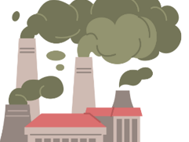 | The presence of chemical, physical or biological substances in the atmosphere lowers air quality. | Industrialisation, Agriculture, Transportation, Waste management, Volcanic eruption, Bushfire
Water pollution | 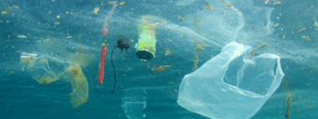 | The contamination of water bodies by harmful substances, such as chemicals or microorganisms, lowers water quality. | Industrialisation, Agriculture, Waste management, Bushfire
Land pollution | 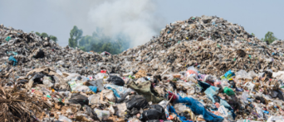 | The depositing of solid or liquid waste materials on land or underground in a manner that can contaminate the soil. | Agriculture, Waste management
Sound pollution |  | Unwanted or excessive sound, measured as exceeding 65 decibels (dB). It can also be referred to as noise pollution. | Industrialisation, Transportation, Volcanic eruption
Light pollution |  | The presence of any unwanted, inappropriate, or excessive artificial lighting in an outdoor environment. | Industrialisation

Student resource – environmental pollution summary table
Table 1 – environmental pollution summary table
Environmental pollution type | Image or drawing | Definition | Cause(s) of pollution
Air pollution
Water pollution
Land pollution
Sound pollution
Light pollution

Implications of pollution
- Watch the video Air Pollution 101 (3:52) in ENV PPT ‘2.1 Implications of pollution’. Students complete a 3-minute quick write to reflect on the video, using the following question as a prompt: ‘What are the impacts of air pollution?’. Facilitate a discussion based on the students' quick write responses.
A quick write is a short, focused writing activity that encourages students to write continuously for a brief period. The goal is to help students organise their thoughts, practice writing fluency and engage with a topic or prompt without worrying about spelling, grammar or structure.
Quick write sample response
Air pollution can have negative effects on both the environment and humans. Air pollution contributes to an increase in Earth’s atmospheric temperature. This can lead to more extreme weather events. Smog is a type of air pollution that reduces visibility and has serious health effects, such as irritated eyes and respiratory issues. Air pollution can increase other health concerns like cancer and congenital disabilities.
- Watch the video Coronavirus: Smog pollution in Delhi vanishes - BBC News (0:42) on slide ENV PPT ‘2.1 The world’s most polluted city’. Use the information and questions below to facilitate a class discussion:
- More than 99% of the population lives in areas where the air pollution exceeds the World Health Organisation's air quality guidelines and is responsible for millions of deaths each year worldwide. It is important to understand the implications of air pollution, so that finding solutions to this problem is a priority.
- Delhi’s air pollution index hit 418 on 14 November 2024, which is classified as ‘severe’, according to IQAir, a Swiss-based Air Quality Index monitoring group. A ‘good’ rating is between zero and 50. This makes Delhi the most polluted capital city in the world.
- Delhi has long struggled with high levels of pollution. However, there was a brief period in recent years that saw a significant decrease in air pollution in Delhi.
- During the COVID-19 lockdowns, noticeable changes occurred in air pollution levels across many countries. When India imposed a nationwide lockdown on 25 March 2020, it covered 1.3 billion people, making it the largest lockdown in the world.
- What pattern did you see in the images presented? Students should identify the pattern of clearer skies during the COVID-19 lockdowns.
- What do you think caused the change in air quality? Students should recognise the reduction of air pollution and smog during the COVID-19 lockdowns.
- What types of human activities changed, or stopped, during the lockdowns? Students may suggest that many pollution-causing human activities ceased during COVID-19, including vehicle use, factory work, and air travel.
- Students analyse data from the webpage Our World in Data – Air Pollution to understand the health and environmental impacts of air pollution using real data. They then complete Student resource – air pollution case study to further analyse the impacts of air pollution.
Sample response: Student resource – air pollution case study
- Identify the total estimated annual number of deaths attributed to air pollution (outdoor and indoor).
8,080,000 (8.08 million) deaths annually.
- What other risk factors from the data presented may be related to other types of environmental pollution?
Unsafe water use and unsafe sanitation may be related to water pollution.
- What general trends can you observe in the annual number of deaths attributed to air pollution for the countries shown?
Low-income and lower-middle-income countries, such as those in parts of Africa and Asia, have higher annual estimated deaths attributed to air pollution per 100,000 people compared to high-income and developed countries, including Australia, North America and parts of Europe.
- Compare the range of estimated number of deaths per year attributed to air pollution in Australia and India. Calculate the difference in range between Australia and India.
Country | Australia | India | Difference in ranges
Number of deaths per year per 100,000 people | 0 to 50 | 200 to 250 | 200
- The data in the graph above provides the number of deaths per 100,000 people. Suggest a reason for displaying the data in this way.
The data displayed as the number of deaths per 100,000 people accounts for variations in population sizes among different countries worldwide. Displaying the data in this way has made it easier to compare.
- Australia’s population in 2025 is 27 million (27,000,000) people. Using the highest end of the range indicated for Australia, calculate the actual number of deaths per year attributed to air pollution in Australia in 2025. Show your reasoning.
Step 1: The highest death rate from air pollution in Australia = 50 deaths per 100,000
Step 2: Australia’s population in 2025 = 27,000,000
Step 3: Calculate the number of deaths for Australia’s population
$$\frac{50}{100,000} x 27,000,000=13,500$$
13,500 annual deaths are attributed to air pollution in Australia.
- It is expected that Australia’s population will increase by approximately 2% per year. Using the highest end of the range indicated for Australia, predict the expected number of deaths attributed to air pollution in Australia in 2026. Show your reasoning.
Step 1: The highest death rate from air pollution in Australia = 50 deaths per 100,000
Step 2: Australia’s population in 2025 = 27,000,000
Step 3: Australia’s population will increase by 2% by 2026
Step 4: Calculate Australia’s estimated increase in population in 2026
$$\frac{2}{100} x 27,000,000=540,000$$
Step 4: Calculate Australia’s estimated population in 2026
$$27,000,000+540,000=27,540,000$$
Step 4: Calculate the number of deaths for Australia’s estimated population
$$\frac{50}{100,000} x 27,540,000=13,770$$
Approximately 13,770 annual deaths in Australia may be attributed to air pollution in 2026.
- Explain why nitrogen oxides (NO_{x}) are considered significant pollutants and describe how they affect agricultural productivity.
Nitrogen oxides (NOx) are considered significant pollutants because they are among the most widely emitted harmful gases worldwide and have multiple adverse effects on the environment and human activities. NOx gases can directly damage crop cells, reducing their health and growth. Additionally, NOx acts as a precursor to the formation of ozone, an airborne toxin that can further harm crops by lowering their yields. NOx also contributes to the creation of particulate matter aerosols, which absorb and scatter sunlight, thereby limiting the amount of light that crops receive and affecting photosynthesis.
These combined effects of NOx lead to decreased agricultural productivity, with studies showing that high levels of NOx emissions correspond to lower crop yields in many regions. For example, reducing NOx emissions by about half could potentially increase crop yields by up to 25% for winter crops in China and by significant amounts in Europe and India as well. Therefore, NOx pollution not only impacts air quality and human health but also poses a serious threat to food security by limiting crop production.
Exam-style question
- Discuss 2 impacts of a named type of environmental pollution.
Air pollution is a type of environmental pollution where the presence of harmful gases or particulate matter lowers air quality. Air pollution has a negative impact on human health, accounting for approximately 8.08 million deaths worldwide each year. Air pollution also contributes to a reduction in food security and crop yields worldwide, as air pollutants impair the plant's ability to photosynthesise, limiting energy production and growth.

Student resource – air pollution case study
Use the data provided in the resource to answer the questions below. Show all calculations clearly and explain your reasoning where applicable. For the discussion question, provide detailed explanations and examples.
Air pollution causes millions of deaths annually. Air pollution – the excess of outdoor and indoor particulate matter and ozone – is a risk factor for many leading causes of death, including heart disease, stroke, lower respiratory infections, lung cancer, diabetes and chronic obstructive pulmonary disease (COPD).
Source: Our World in Data, Air pollution
Figure 1 – the estimated annual number of deaths by risk factor
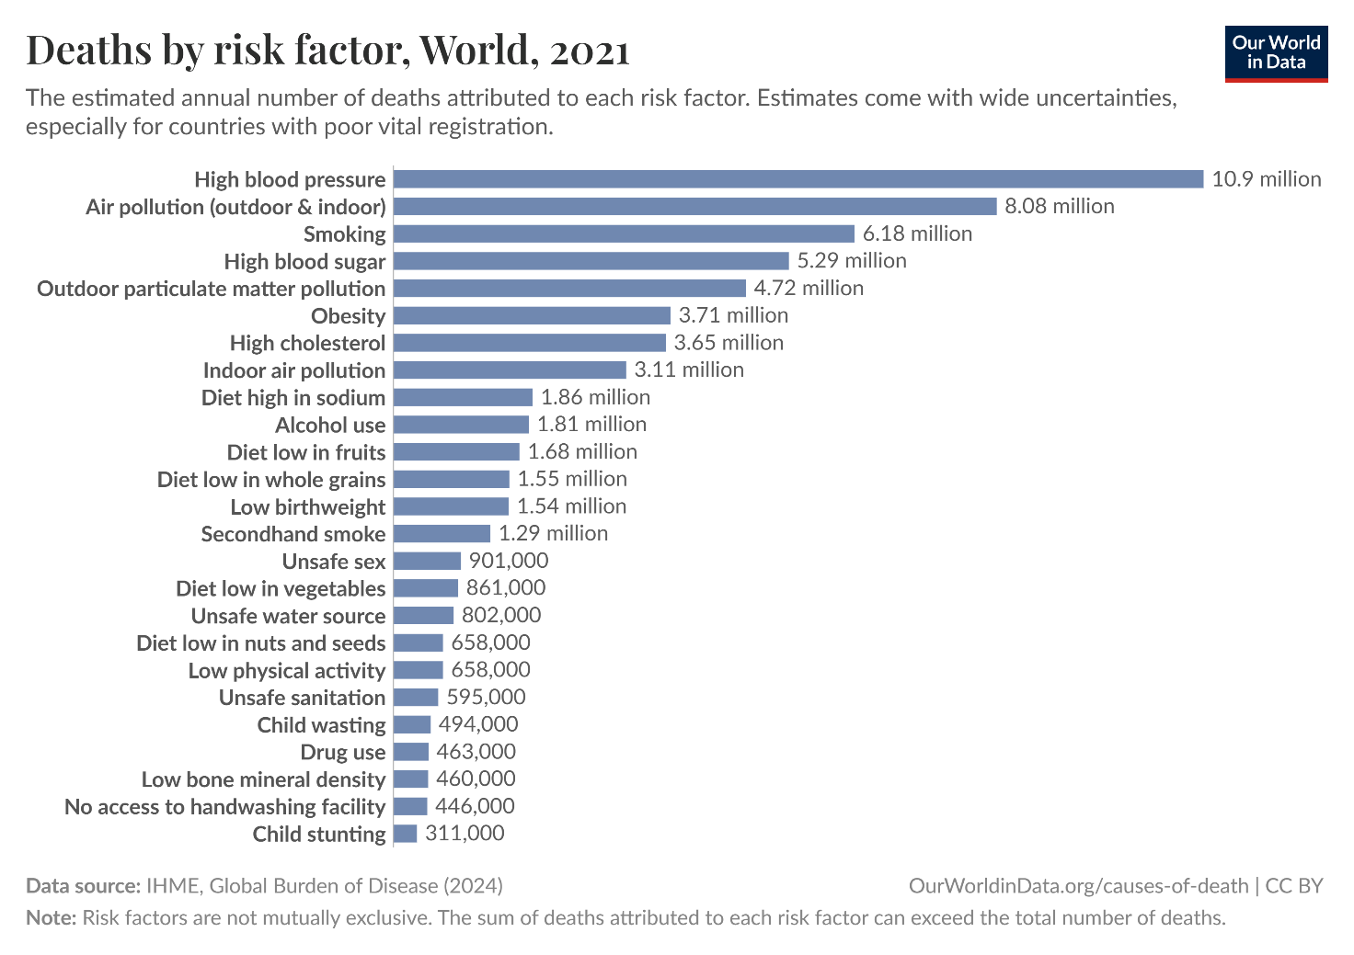
‘Deaths by risk factor, World, 2021’ by Our World in Data is licensed under CC BY 4.0.
- Identify the total estimated annual number of deaths attributed to air pollution (outdoor and indoor).
- What other risk factors from the data presented may be related to other types of environmental pollution?
Who is most affected by air pollution?
Air pollution is a health and environmental problem worldwide, with significant variations in severity across different countries. Death rates from air pollution are highest in low- to middle-income nations. The impact of air pollution is generally greater in both low- and middle-income countries for 2 main reasons: indoor pollution is often high in low-income nations because of reliance on solid fuels for cooking, and outdoor air pollution tends to worsen as countries industrialise and move from low to middle incomes. Low-income nations include Afghanistan, Madagascar and Ethiopia. Lower-middle-income nations include India, Papua New Guinea and Vietnam.
Source: Air pollution by Our World in Data.
Figure 2 – the estimated annual number of deaths attributed to air pollution per 100,000 people
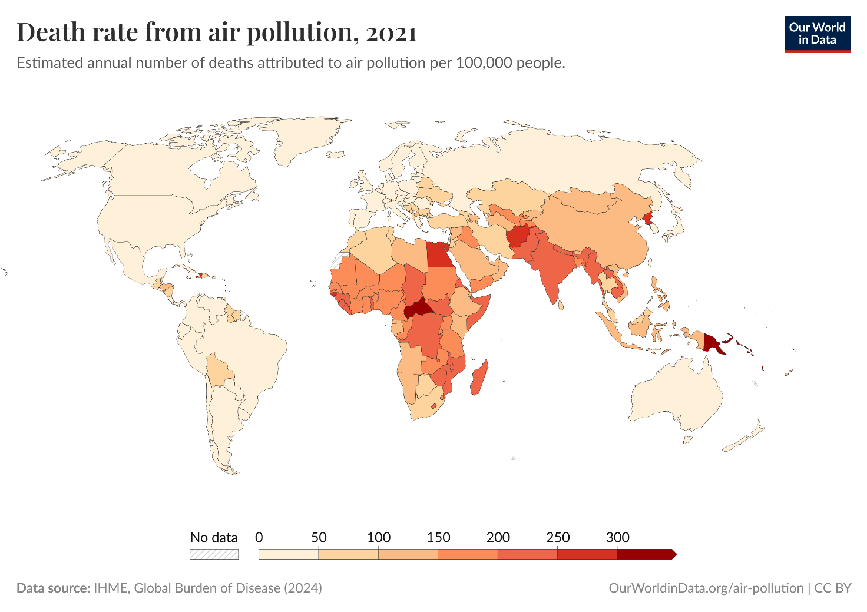
Legend: The colours on the world heat map correspond to the colours in the key. For example,
Australia is shaded cream, which the key indicates represents 0 to 50 deaths per 100,000 people caused by air pollution. India is shaded orange, corresponding to 200 to 250 deaths per 100,000 people.
Death rate from air pollution, 2021 by Our World in Data is licensed under CC BY 4.0.
- What general trends can you observe in the annual number of deaths attributed to air pollution for the countries shown?
- Compare the range of estimated numbers of deaths per year attributed to air pollution in Australia and India. Calculate the difference in range between Australia and India.
Country | Australia | India | Difference in ranges
Number of deaths per year per 100,000 people
- The data in the graph above provides the number of deaths per 100,000 people. Suggest a reason for displaying the data in this way.
- Australia’s population in 2025 is 27 million (27,000,000) people. Using the highest end of the range indicated for Australia, calculate the actual number of deaths per year attributed to air pollution in Australia in 2025. Show your reasoning.
- It is expected that Australia’s population will increase by approximately 2% per year. Using the highest end of the range indicated for Australia, predict the expected number of deaths attributed to air pollution in Australia in 2026. Show your reasoning.
How does air pollution impact our food sources?
Air pollution hinders photosynthesis and harms overall plant health. When large amounts of dust particles accumulate on leaf surfaces, they can raise leaf temperature, cause tissue damage and block stomata. This dust buildup also damages chloroplasts and reduces their numbers, lowering the plant's photosynthetic efficiency. Additionally, once air pollution settles, it contaminates the soil, exposing plant roots to harmful pollutants. This impairs their ability to absorb essential nutrients and water. Since water is crucial for photosynthesis, this further limits the plant's ability to produce energy and grow.
Source: Pollution and crops | Stanford Report.
Access the Pollution and crops report by Stanford Report. Use the information in the report to answer question 8.
- Explain why nitrogen oxides (NO_{x}) are considered significant pollutants and describe how they affect agricultural productivity.
Exam-style question
- Discuss 2 impacts of a named type of environmental pollution.

2.2 Sustainable harvesting by Aboriginal and Torres Strait Islander Peoples
Table 7 – learning intentions and success criteria for ‘2.2 Sustainable harvesting by Aboriginal and Torres Strait Islander Peoples’
We are learning: | I can:
- to describe the need for sustainable resource use to reduce impact on the natural world | - define sustainable harvesting practices  - explain how Aboriginal and Torres Strait Islander Peoples demonstrate deep ecological understandings
- to identify trends in data to make predictions | - describe trends in data on the Murray cod  - make predictions about the impact of cultural protocols on the Murray cod population
- to assess the validity of secondary sources. | - select appropriate sources of information  - use criteria for evaluating the validity of secondary sources about Aboriginal and Torres Strait Islander Peoples.
Checkpoint: deliver a checkpoint on the previous lesson’s content (see slide ENV PPT ‘2.2 Checkpoint – quick quiz on previous content’).
Mini challenge (MC):
Which of the following are examples of environmental pollution? (Select all that apply)
- smoke released from factory chimneys into the air
- leaves falling naturally from trees in autumn
- chemicals leaking into a river from a nearby farm
- the sound of birds singing in a forest
- excessive outdoor lighting in a city at night
Challenge (C): list 2 human activities that cause air pollution and describe how they contribute to it.
Checkpoint sample response
Mini challenge (MC): the correct answers are highlighted in the above checkpoint.
Challenge (C): list 2 human activities that cause air pollution and describe how they contribute to it.
Two human activities that cause air pollution are industrialisation and transportation. Industrialisation releases harmful gases and chemicals into the atmosphere through factory emissions. Transportation also contributes to air pollution by releasing exhaust gases from cars, trucks, planes and other vehicles, which contain pollutants like carbon monoxide and nitrogen oxides.
Aboriginal and Torres Strait Islander Histories and Cultures
When planning and programming content relating to Aboriginal and/or Torres Strait Islander Histories and Cultures, teachers are encouraged to:
- involve local Aboriginal communities and/or appropriate knowledge holders in determining suitable resources, or use Aboriginal and/or Torres Strait Islander-authored or endorsed publications
- read the principles and protocols relating to teaching and learning about Aboriginal and/or Torres Strait Islander Histories and Cultures and the involvement of local Aboriginal communities.
The Australian Institute of Aboriginal and Torres Strait Islander Studies (AIATSIS) Guide to evaluating and selecting education resources has been developed to assist teachers in selecting appropriate resources for teaching about Aboriginal and Torres Strait Islander Histories, Cultures and Languages respectfully and effectively.
This activity focuses on exploring sustainable harvesting practices through the lens of Aboriginal and Torres Strait Islander People’s deep ecological knowledge and cultural protocols. Students will learn how Aboriginal and Torres Strait Islander people manage natural resources to maintain environmental balance, drawing on examples such as seasonal movements, fire practices and sustainable harvesting of plants and animals. The lesson emphasises the role of kinship and totem systems in guiding resource use and protection. Through case studies of the Brewarrina Fish Traps and the Murray cod, students will investigate the intersection of cultural practices and ecological sustainability. Finally, students will research an Aboriginal Nation Totem, linking cultural responsibilities to environmental stewardship, and critically evaluate sources to deepen their understanding of Aboriginal Histories and ecological knowledge.

Deep ecological understandings
Background information
There is historical evidence of many Aboriginal groups regularly moving across Country as a large group to a different location. These movements were well-planned and organised events and occurred with the intention of regulating the food supply. An example of this is when the Pambalong clan, who lived in what is now known as the Newcastle region, would spend the warmer months harvesting seafood and living near the sea. During cooler months, these groups moved further inland and relied on land animals and plants for food. These groups would continue to cycle between coastal and inland locations, allowing for the plant and animal populations of each location to recuperate in their absence. This demonstrates deep ecological understandings of the seasonality of plants, breeding patterns of animals and the sustainable harvesting practices required to maintain a balanced ecosystem.
(Miromaa Aboriginal Language & Technology Centre 2018)
The Meriam Peoples of Mer Island in the Torres Strait have long practised the sustainable harvest of ketai (a climbing form of yam), that provides a staple vegetable food resource. When digging for the tubers, only new tubers are harvested and care is taken to ensure that the parent tuber remains undisturbed. This practice demonstrates a botanical understanding that the parent tuber will continue to produce new tubers if it is undamaged.
(Australian Curriculum, Assessment and Reporting Authority [ACARA] 2010)
- Define ‘sustainable harvesting practices’ as methods of extracting resources that do not deplete populations or harm the environment. It requires a deep ecological understanding to use resources within an ecosystem while preserving its health. Tell students that Aboriginal and Torres Strait Islander Peoples have developed sustainable harvesting practices and cultural protocols based on profound ecological knowledge.
- Use the background information above to outline an example of deep ecological understanding in the Torres Strait Islander community.
- Explore a local example of how Aboriginal people in your area demonstrate deep ecological understandings of the local environment, such as traditional fire practices, seasonal food gathering or water management techniques specific to the Country they live on. The background information above offers some examples of Aboriginal and Torres Strait Islander Peoples' ecological understandings of the local environment.
Note: the examples provided above may not be relevant for all Aboriginal groups across NSW. Teachers are encouraged to engage with local community groups and seek relevant local examples.

Kinship and Totems
Kinship is a system that defines how people are connected to each other and guides their relationships within the community and the land. It is a complex and sophisticated system of social organisations, covering responsibilities, roles and reciprocal bonds, determining how people are related, who one can marry and who is responsible for supporting whom. Kinship systems vary across cultural groups throughout Australia and the Torres Strait Islands.
Totems are an important part of many Aboriginal and Torres Strait Islander kinship systems, linking individuals to their community, Country and cultural responsibilities. A Totem is a natural object (like a plant or animal) that holds spiritual significance and represents an Aboriginal or Torres Strait Islander Person’s identity, connections and cultural responsibilities. Again, Totems are varied across cultural groups and unique to the individual within their community. In some cultural groups, individuals may have multiple Totems that represent their Nation, clan, family group and personal identity.
There are cultural protocols associated with Totems, including rules that prohibit a person from hunting and eating their Totems. Individuals have a responsibility to learn about, care for and protect the Totem and its environment.
Source: The University of Sydney, Totems
- Watch the video Aboriginal Kinship Presentation: Totems (3:51) on slide ENV PPT ‘2.2 Kinship and Totems’ and ask students the questions included in Table 8.
Table 8 – questions and sample responses for the video ‘Aboriginal Kinship Presentation: Totems’
Question | Sample response
What does a personal Totem recognise? | A person’s strengths and weaknesses.
How do Totems guide Aboriginal people to balance the protection and consumption of resources? | The Totem system is a balanced approach, where one group of Aboriginal people is responsible for protecting a resource, while the other group can consume the resource. This system ensures sustainability by preventing overuse, allowing the resource to be shared in a way that respects cultural responsibilities and maintains ecological balance.
Which Totem animal would all Aboriginal people from Wiradjuri Country have in common? What type of Totem is this? | The Wiradjuri People’s Nation Totem is the goanna (Goo-gar).

Brewarrina Fish Traps and the Murray cod
- Students answer 3 quick questions to establish their general understanding of the Murray-Darling basin:
- What is Australia’s longest river? The Murray River.
- Which states does Australia’s longest river run through? The Murray River flows through New South Wales, Victoria, and South Australia.
- What is an endangered species that is found in the Murray-Darling Basin? The Murray cod.
- Students conduct a case study on sustainable practices using the Murray cod as an example. Access the Case Study: Brewarrina Fish Traps and the Murray Cod. You can save and print a PDF copy of the case study by selecting File, then Download.
- Support students in completing the Student resource – case study: Brewarrina Fish Traps and the Murray cod and the Murray cod case study.
Adjustment: if the student requires a screen reader, use the following online public view link: Student resource – case study: Brewarrina Fish Traps and the Murray Cod
Note: teachers may choose to include a Torres Strait Islander example of the use of fish traps as a sustainable harvesting practice. The arc-shaped fish traps on Erub Island in the Torres Strait are constructed so that at high tide the boulders are completely covered by water, and when the tide recedes, the trapped fish, crabs and other marine animals can be easily harvested. The Erubam Le Peoples of Erub Island have a familial responsibility for the fish traps and continue to use and maintain them today. More information can be found at: ACARA | Teacher Background Information | Investigating how First Nations Australians have developed sustainable harvesting practices and cultural protocols based on deep ecological understandings.
Figure 1 – preview of Case study – Brewarrina Fish Traps and the Murray cod
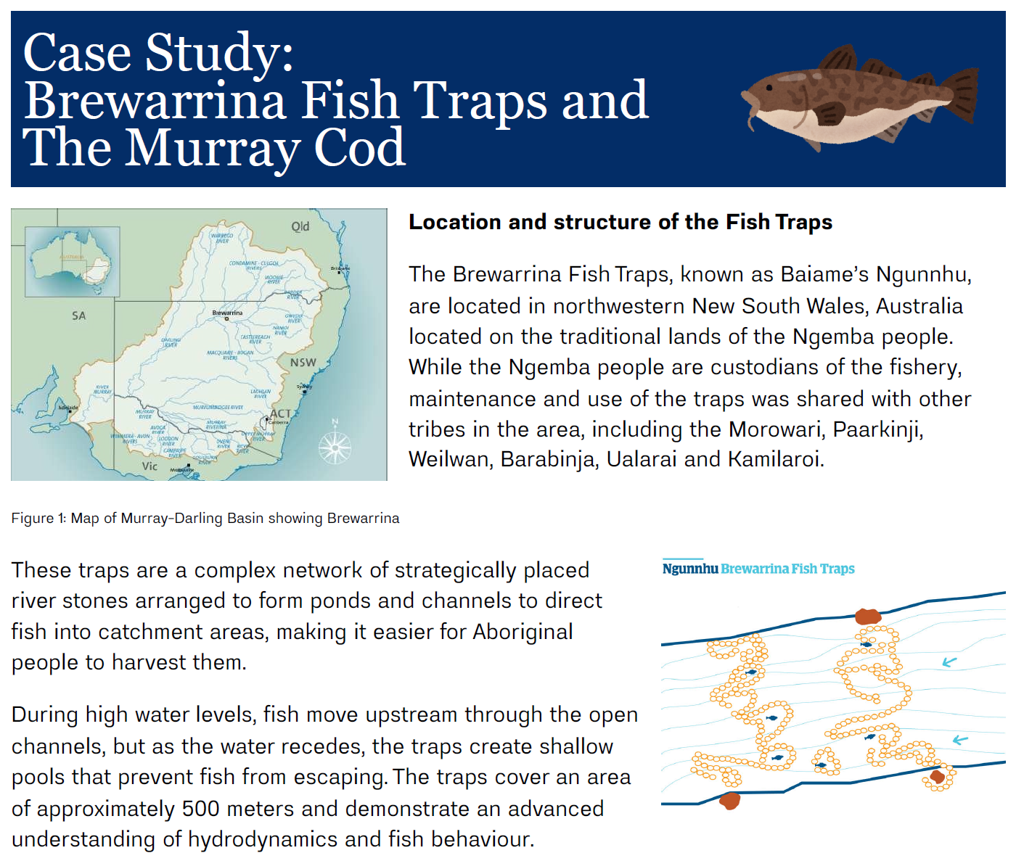
Note: the example provided in the case study may not be relevant for all Aboriginal groups across NSW. Teachers are encouraged to engage with local community groups and seek relevant examples from their local area.
Sample response: Student resource – Brewarrina Fish Traps and the Murray cod case study
- Referring to Figure 6, what general trends can you observe in the annual commercial catch of Murray cod over this time period?
The annual commercial catch (tonnes) of Murray cod from the South Australia inland fishery has decreased at a relatively steady rate between 1960 and 1990. From 1990 to 1993, no data was recorded due to a moratorium on Murray cod fishing, followed by a consistent rise in annual commercial catch (in tonnes) until 2002.
- Figure 6 shows that there was a moratorium on commercial and recreational fishing of the Murray cod between 1990 and 1993. A ‘moratorium’ is a temporary ban on catching a specific fish species. Think of a possible reason for imposing a moratorium on the Murray cod and support your answer with data from the graph.
A moratorium could be enforced to allow the Murray cod population a chance to replenish. By preventing the fishing of the population, they may have a chance to reach breeding age and reproduce successfully, increasing the overall population. This is supported by the data in Figure 6, which shows a steady increase in annual commercial catch (tonnes), potentially directly related to an increase in Murray cod population.
- How does a moratorium on the Murray cod relate to the cultural protocols of Aboriginal Peoples?
A moratorium on the Murray cod could relate to Aboriginal cultural protocols, as both prevent the fishing of the Murray cod to an extent. If the Murray cod is an individual’s Totem, they are prohibited from harming or eating the animal. This concept is similar to a moratorium, but it is applied to all people.
- Referring to Figure 7, what general trends can you observe in the graph presented on the length of Murray cod?
The length of the Murray cod has decreased compared to historic data.
- Suggest a possible explanation for the data trends seen in Figure 7.
The Murray cod are being caught earlier in their lives, before they have a chance to grow larger.
- What sustainable harvesting practices could support an improvement in the Murray cod’s length data?
The sustainable harvesting practice of not catching pregnant or juvenile fish could support an increase in average length.

Student resource – case study: Brewarrina Fish Traps and the Murray cod
Access the Student resource – Case study: Brewarrina Fish Traps and the Murray cod on Canva. Use the information and data presented to complete the following questions.
- Referring to Figure 6, Murray cod commercial catch from the South Australian inland fishery 1951/52 to 2002/03, what general trends can you observe in the annual commercial catch of Murray cod over this time period?
- Figure 6 shows that there was a moratorium on commercial and recreational fishing of the Murray cod between 1990 and 1993. A ‘moratorium’ is a temporary ban on catching a specific fish species. Think of a possible reason for imposing a moratorium on the Murray cod and support your answer with data from the graph.
- How does a moratorium on the Murray cod relate to cultural protocols of Aboriginal Peoples?
- Referring to Figure 7, what general trends can you observe in the graph presented on the length of Murray cod?
- Suggest a possible explanation for the data trends seen in Figure 7.
- What sustainable harvesting practices could support an improvement in the Murray cod’s length data?

Nation Totem research
- Refer to slide ENV PPT ‘2.2 Nation Totem research’ to explain the research task students will complete. Students complete a research task on an Aboriginal Nation Totem. They choose the Aboriginal Country that they currently live on, or another that is significant to them. For the chosen Country, students will research the Nation Totem by investigating the following:
- the name of the Nation Totem, and the Aboriginal language name for the Totem if available
- an image of the Nation Totem
- the Aboriginal Country of the Nation Totem
- the vulnerability status of the Nation Totem
- at least one type of environmental pollution affecting the Nation Totem, outline the cause of the pollution, and describe its impact on the Nation Totem.
- outline one other threat to the Nation Totem’s population and support this with data
- explain how the cultural protocols of the Totem system can protect and support the population of the Nation Totem.
- Students will then present their research in the form of a scientific poster.
Note: it is advised to consult with your local AECG to confirm the Country that the school is located in and the Nation Totem for that local area.
When conducting research, it is crucial to incorporate information from valid secondary sources.
It is also important when completing research about Aboriginal and Torres Strait Islander histories and cultures, to ensure that secondary sources selected do not cause harm to Aboriginal and Torres Strait Islander students but rather foster trust and build a sense of pride for all. The Australian Institute of Aboriginal and Torres Strait Islander Studies (AIATSIS) have developed a guide to evaluating and selecting education resources. Familiarise yourself with this resource before presenting this section of the activity.
By using the criteria presented, we can evaluate the validity of a secondary source in relation to its content on Aboriginal and Torres Strait Islander histories or culture.
- Explain why it is important to critically evaluate sources, especially when researching Aboriginal and Torres Strait Islander Histories and Cultures. Emphasise respect, accuracy and the risk of misinformation or cultural appropriation.
Discuss the difference between primary and secondary sources, focusing on how secondary sources interpret or analyse primary information. Present the criteria for integrity-based considerations for assessing the cultural appropriateness and educational quality of resources (AIATSIS Guide to evaluating and selecting education resources). Ensure that students understand each criterion clearly.
- Students use the AIATSIS Guide to evaluating and selecting education resources for assessing the cultural appropriateness and educational quality of resources to evaluate the validity of one secondary-source used in the research in relation to its content on Aboriginal and Torres Strait Islander Histories or Culture.
Differentiation
Product: to further support students, the Nation Totem research task may be completed as a group activity.
To extend students, individuals or groups may give a short presentation to the class on the findings of the Nation Totem research task.
Author's own image (Canva)
Figure 2 – sample response – scientific poster for Nation Totem
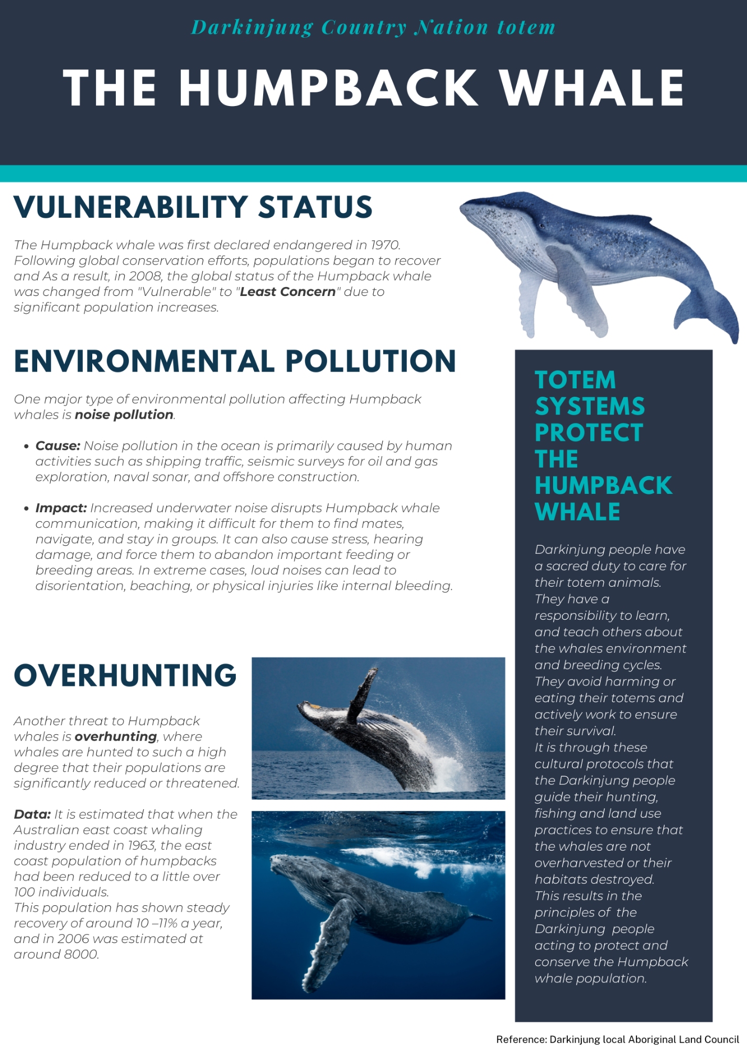
Sample response – Student resource – criteria for evaluating sources
To create the scientific poster on the Humpback whale, I used information from the Darkinjung Local Aboriginal Land Council website as the whale is the Nation Totem of the Darkinjung Nation.
Using the AIATSIS framework as a criteria, we can determine this source as valid.
The information on this website was written by Mob, that is by Aboriginal people to be displayed on a website with the target audience being other Aboriginal people, as well as the general public. The information on the website does not portray any racist or deficit views.

2.3 Reduce, reuse, recycle
Table 9 – learning intentions and success criteria for ‘2.3 Reduce, reuse, recycle’
We are learning: | I can:
- to analyse the need for alternative resource use to reduce impact on the natural world | - define ‘reduce’, ‘reuse’ and ‘recycle’  - identify strategies to reduce waste
- to use data to draw conclusions | - outline trends in Australia’s waste  - use evidence to draw conclusions about Australia’s waste
- to assess the validity of secondary sources. | - define accuracy, reliability and validity  - assess the validity of information from secondary sources using relevant criteria.
Note: students in Stage 3 have studied waste management within the Focus area ‘Science and technology – Knowledge of our world and beyond inspires sustainable solutions’. Key concepts studied include:
- how recyclable, reusable, renewable, biodegradable and compostable materials enhance sustainability
- ways to collect and process waste to reduce pollution or increase the sustainable use of materials
- a plan to implement a sustainable practice in a community that addresses an identified environmental concern
- how Aboriginal and/or Torres Strait Islander Peoples’ sustainable practices continue to protect the environment
Students may need support to recall key concepts.
Checkpoint: deliver a checkpoint on prior knowledge of pollution and waste management. See ENV PPT ‘2.3 Checkpoint – quick quiz on previous content’.
Mini challenge (MC): multiple choice question
Burying our waste underground in a landfill is an example of which type of pollution?
- air pollution
- light pollution
- land pollution – correct answer
Challenge (C): define waste management.
Super challenge (SC): describe one implication of pollution.
Checkpoint sample response
Challenge (C): the activities that involve collecting, destroying and disposing of waste. Poor waste management practices, such as open dumping and inadequate disposal, result in environmental pollution by contaminating soil, water and air with harmful substances.
Super challenge (SC): air pollution can aggravate respiratory health conditions, leading to death.

Australia’s waste problem
This activity helps students understand how waste is organised and managed locally and across Australia. Using examples and data, students learn about proper bin use, recycling programs and waste disposal methods. They develop skills to evaluate information about waste issues from media sources critically.
Through everyday scenarios, students apply the concepts of ‘Reduce, Reuse, and Recycle’, and explore additional strategies like ‘Rethink’ and ‘Refuse’ to make sustainable choices. The goal is to build students’ knowledge and encourage responsible waste management habits.
- Use the waste examples provided on ENV PPT ‘2.3 Organising our waste’ to discuss how we organise waste. Use the following questions as prompts:
- Which bin should these items go in?
- Do you have any other household bins in your local council area? (For example: blue lid bin for paper or cardboard.)
- What other ways can we organise and dispose of waste? (For example: return and earn for cans and bottles.)
Note: some local council areas have additional bins/different bin lid colour allocations. Check to ensure this is relevant to your local area.
Students must understand the state of waste and recycling in Australia. As this is a topic that is often discussed in the media, it is also vital that students know how to analyse the validity of information from sources on this topic.
- Students watch the video Waste Crisis As Landfills Become Dangerously Full (7:24). They then engage in a Think-Pair-Share activity to reflect on the content of the video. Suggested prompts include: What surprised you most about the waste crisis in Australia, and what can you do as an individual to help reduce landfill waste? Students' responses will vary because of their prior understanding of waste management.
- The Student resource – Australia’s waste problem supports students in critically evaluating a news headline about waste generation in Australia by analysing recent data. Begin by explaining that media headlines often simplify complex data, so it’s important to verify claims using reliable sources. Present the headline from the article and unpack the data sources with students, including explaining headline waste to them. Ask them to assess whether it reflects the reality suggested by the data by completing the worksheet.
Note: headline waste refers to the combined total of ash and core waste, which includes solid waste and liquid hazardous waste produced by the municipal (MSW), construction and demolition (C&D), and commercial and industrial (C&I) sectors, as well as biosolids.
Ash typically refers to the residue left after the combustion or incineration of waste materials. It can include bottom ash (heavier particles collected at the bottom of an incinerator) and fly ash (lighter particles carried with flue gases). Ash may contain various chemicals and requires careful handling and disposal.
Core waste generally refers to the main types of waste generated across key sectors. It includes solid waste and liquid hazardous waste produced by the municipal solid waste (MSW), construction and demolition (C&D), and commercial and industrial (C&I) sectors, as well as biosolids (organic matter from wastewater treatment).
- Provide students with Student resource – evaluating the validity of a secondary source to help them analyse the validity of the National waste and resource recovery report 2024. Use the scaffold to guide students in assessing the source’s reliability (author credibility, bias and currency), accuracy (consistency with other sources) and overall validity (relevance and combined reliability and accuracy).
Sample response: Student resource – Australia’s waste problem
- Evaluate the accuracy of the headline. Identify any possible sources of uncertainty seen in the data and suggest any possible alternative explanations.
The headline is not accurate. Although Australia is recycling more waste than previously, we are still generating an increased amount of waste each year. Figure 2 shows an increase in waste generated in Australia between 2016-17 and 2022-23. This is further supported by Figure 4, which states an 8% increase in waste generation between the same period. The uncertainty around this headline may have been due to Figure 4 showing a 5.9% decrease in waste disposed of between 2016-17 and 2022-23. This decrease in waste disposal can be attributed to the increase in recycling rates during this period, as shown in Figure 4. This could lead to the misconception that waste generation rates are lower than in previous years.
- Reflecting on the data provided, write your own news headline that is more accurate.
Australia is recycling more waste than ever.
- What data supports the accuracy of your headline? Develop an evidence-based argument to support your headline.
Figure 3 shows that of the 76 million tonnes of waste generated in the 2022-23 financial year, 47 million tonnes were recycled. This shows that a large proportion of the waste generated in 2022-23 was recycled. Figure 4 supports this, showing a 17.5% increase in waste recycled and reused in 2022-23 compared to 2016-17.
Sample response – Student resource – Is the secondary source reliable, accurate and valid?
Table 10 – assessment of secondary source reliability, accuracy and validity
Question | Answer (Y/N/Cannot be determined) | Evidence to support
Reliability
Has someone with an appropriate scientific background written the source? What are their qualifications? | Yes | This information was written by Dr Joe Pickin, a waste specialist with a PhD in the environmental economics of waste and over 20 years of experience as a researcher, analyst and consultant. It was co-authored by Jennifer Macklin, a Senior Research Fellow with 15 years’ experience in applied behaviour change and social research.
Is the source published on a credible medium? | Yes | It is published on the Department of Climate Change, Energy, the Environment and Water website. This website is reputable because it is managed by the Australian Government, which ensures the accuracy of the information published on it.
Is there evidence of bias? | No | Facts that are consistent with information from other reliable sources have been provided. Emotional or persuasive language is not used to sway the audience. There is no evidence of misinterpretation or exaggeration of information to bias the audience.
Is the information current? (Consider the topic being investigated and research being conducted in the field) | Yes | The report was finalised on 20 January 2025, with information in the report current to 1 July 2023.
Is the information consistent with at least 2 other reliable sources? | Yes | This information is consistent with data from other reliable sources, including the NSW Environmental Protection Agency and the Australian Bureau of Statistics.
Conclusion |  | The source is:  ☒ reliable  ☐ not reliable
Accuracy
Is the information in this source consistent with accepted or referenced values or sources? | Yes | This information is consistent with information on peer-reviewed journal articles from the Australian Energy Producers journal and the Journal of Material Cycles and Waste Management.
Conclusion |  | The source is:  ☒ accurate  ☐ not accurate
Validity
Is the information in this source relevant to the question or topic being investigated? | Yes | The topic being investigated is waste production and recycling in Australia. This source includes data on waste generation, source streams, materials and fates.
Is the information reliable and accurate (see above)? | Yes | See the above explanation for reliability and accuracy.
Conclusion |  | The source is:  ☒ valid  ☐ not valid

Student resource – Australia’s waste problem
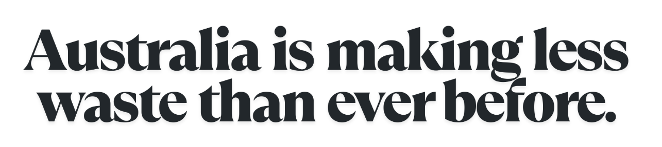
This is a recent headline in an article. Is this true? To find out, you will evaluate this headline, using data extracted from the National waste and resource recovery report 2024 (Figures 1 to 4).
This report indicates that during the 2022–23 financial year, Australia generated an estimated 75.6 million tonnes (Mt) of waste, compared to 70 million tonnes (Mt) generated during the 2016–17 financial year.
The report also shows the resource recovery rates. Figure 3 shows the portion of waste that was recycled, reused, or the energy recovered by the jurisdiction for the 2022–23 financial year. Figure 4 outlines the changes in waste figures from the 2016–17 financial year to the 2022–23 financial year.
Figure 1 – waste generated (tonnes) by state or territory, 2022–23
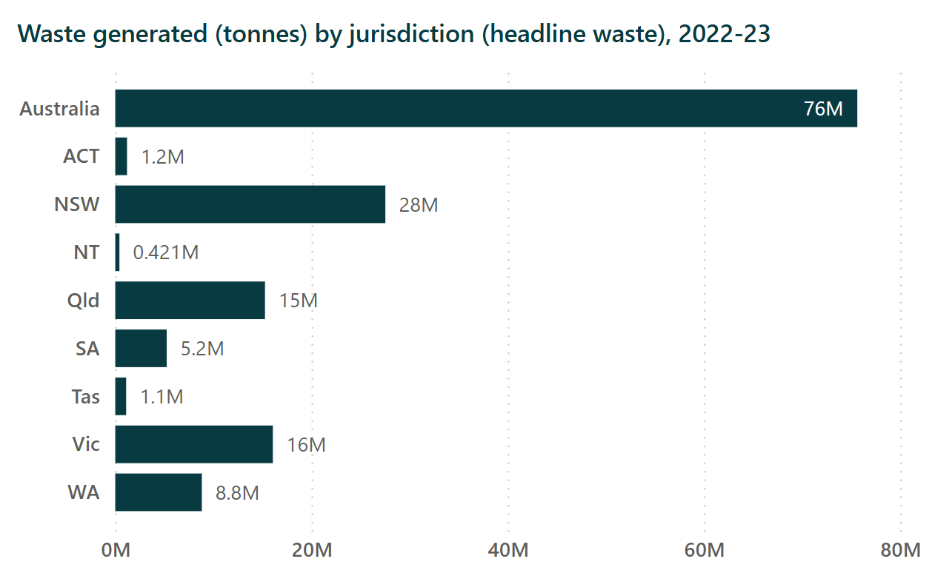
‘Waste generated (tonnes) by jurisdiction (headline waste), 2022-23’ by BehaviourWorks is licensed by CC BY 4.0.
Figure 2 – waste generated (tonnes), Australia, 2016–17 to 2022–23
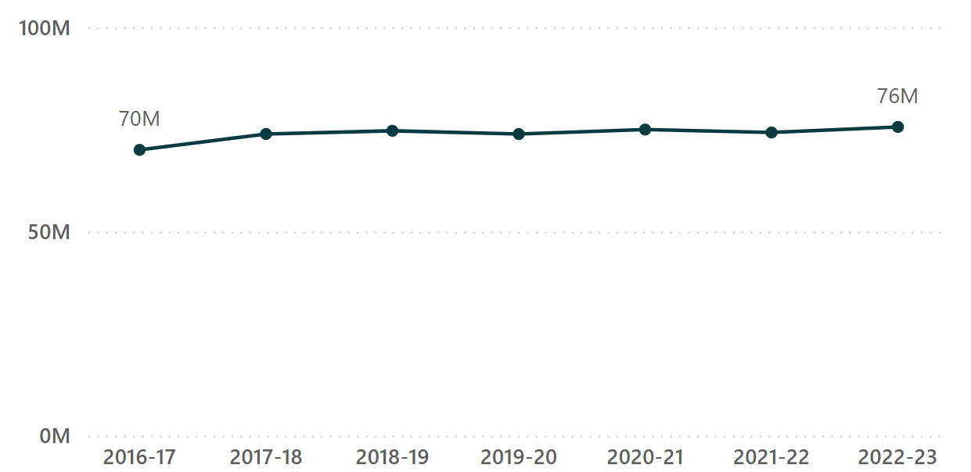
Waste generated (tonnes) (headline waste), Australia, 2016-17 to 2022-23 by BehaviourWorks is licensed by CC BY 4.0.
Figure 3 – waste and resource recovery by state or territory, 2022–23
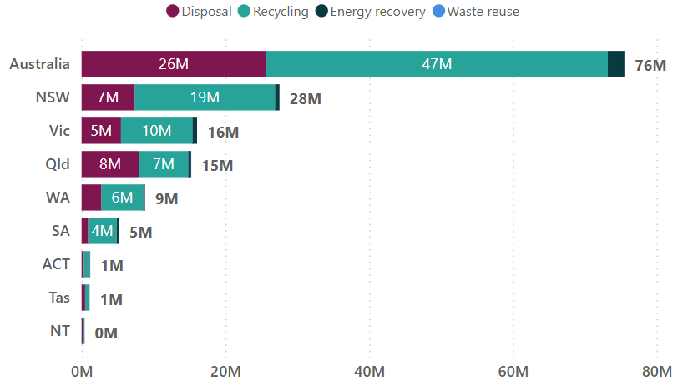
Waste and resource recovery by jurisdiction, 2022-23 by BehaviourWorks is licensed by CC BY 4.0.
Figure 4 – change in waste figures, Australia
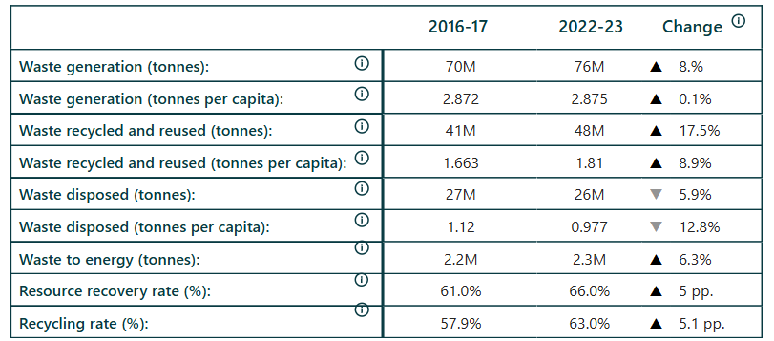
Change in headline waste figures, Australia by BehaviourWorks is licensed by CC BY 4.0.
Refer to the stimulus above to answer the following questions:
- Evaluate the accuracy of the headline. Identify any possible sources of uncertainty seen in the data and suggest any possible alternative explanations.
- Reflecting on the data provided, write your own news headline that is more accurate.
- What data supports the accuracy of your headline? Develop an evidence-based argument to support your headline.

Student resource – evaluating the validity of a secondary source
Use this guide to evaluate the validity of the website, National waste and resource recovery report 2024. Remember, for a source to be valid, it must be both reliable and accurate. Therefore, you will assess the source's reliability, accuracy and validity to determine its overall validity.
Tips for a quick check for validity
Look at the source and where it has been published to get a quick overview of its validity. You will still need to assess the source's reliability, accuracy and validity to ensure you have evidence to support the judgement of validity.
Tips for a quick check for accuracy
Compare the data with information provided by reputable sources such as the Australian Energy Producers journal (https://www.publish.csiro.au/ep) and the Journal of Material Cycles and Waste Management (https://www.researchgate.net/publication/391136536_Journal_of_Material_Cycles_and_Waste_Management).
Table 1 – examples of valid and invalid sources
Valid sources are: | Valid sources are not:
Educational textbooks (being mindful of the date of publication) | General fiction books
Educational and government institution webpages | Non-educational web pages
Peer-reviewed scientific journals and articles | Articles in popular magazines
Encyclopaedias | Discussion blogs on social media

Is the secondary source reliable, accurate and valid?
Table 2 – a scaffold to assess the reliability, accuracy and validity of secondary sources
Question | Answer (Y/N/Cannot be determined) | Evidence to support
Reliability
Has someone with an appropriate scientific background written the source? What are their qualifications?
Is the source published on a credible medium?
Is there evidence of bias?
Is the information current? (Consider the topic being investigated and research being conducted in the field.)
Is the information consistent with at least 2 other reliable sources?
Conclusion |  | The source is:  ☐ reliable  ☐ not reliable
Accuracy
Is the information in this source similar to information accepted or referenced values?
Conclusion |  | The source is:  ☐ accurate  ☐ not accurate
Validity
Is the information in this source relevant to the question or topic being investigated?
Is the information reliable and accurate (see above)?
Conclusion |  | The source is:  ☐ valid  ☐ not valid

The 3 R’s
- Define the 3 R’s: reduce, reuse and recycle, using ENV PPT ‘2.3 The 3 R’s. Then ask students to share examples of how they reduce, reuse or recycle waste in their everyday lives.
Note: some organisations have expanded the R’s to identify 5 R’s and even up to 7 R’s. These additional R’s offer numerous strategies for managing our waste. For example:
- Refuse waste by declining single-use cutlery like straws and disposable cutlery, or having a ‘no junk mail’ sign on your letter box.
- Rethink our approach to daily life, which generates waste, such as avoiding individually packaged items.
- Using ENV PPT ‘2.3 The waste hierarchy’, explain to students the hierarchical nature of dealing with waste.
- Provide students with Student resource – waste in everyday life. They will use different coloured highlighters or pens to read through each scenario and identify examples of reducing, reusing or recycling waste. Students then answer questions about opportunities to deal with waste in a more preferable way.
Sample response – Student resource – waste in everyday life scenario
- Read the 2 short stories below outlined in the blue border box. Choose 3 different coloured highlighters or pens:
- use one colour to highlight examples of reducing waste (using less)
- use a second colour to highlight examples of reusing things (using something again instead of throwing it away)
- use a third colour to highlight examples of recycling (turning old things into new things).
Scenario 1: nephew’s birthday present
Ben’s nephew is turning 3, and he wants to buy him a birthday present. He visits the local toy store and selects toys that have no packaging, contrasting with those that have extensive packaging. He chooses a card with a dinosaur and a big 3 on the front. He approaches the register and pays for his items. When the toy store worker asks if he would like a printed receipt, he declines. The worker asks if he would like a bag for the items, and Ben says ‘No thanks, I’ll just carry them.’
When he gets home, Ben opens the cupboard and finds the basket full of gift bags that he saved from the ones he received. He chooses a toy he thinks his nephew would like and puts it in the box. He writes on the card, places it in the envelope and adds it to the bag. He then remembers an old remote-control car that he has sitting at the top of his cupboard. It was a toy that he had as a kid, and his nephew loves playing with it whenever he comes over. Ben was going to throw it out next week, but decided to add it to the gift bag instead, as a bonus present for his nephew.
On the day of his nephew’s party, once he has finished opening his present, Ben helps his sister tidy up by taking the gift bags, wrapping paper and card envelopes out to the recycling bin.
- Identify one strategy that Ben could have used to reduce waste in this situation further.
Ben could have made his own card from materials he already had at home, rather than buying a new one.
Scenario 2: breakfast smoothies
Grace enjoys homemade fruit smoothies for breakfast. On Sunday, she prepared her smoothies for the week ahead. Grace drove to her local supermarket and started in the fresh produce section. As she shopped, she noticed some fruit had plastic packaging on it, and others did not. She chose the fruit that did not have packaging. She picked up 3 apples and, instead of putting them in a plastic produce bag, placed them straight in the trolley. She continued shopping until she had all the fruit she needed. She went to the self-serve checkout and set up her grocery bag. As she scanned each item, she packed it in her bag.
Once Grace got home, she unpacked all the fruit and threw her receipt in the recycling bin. She washed the fruit and chopped it all up. She placed the chopped fruit in containers and put them in the freezer. She then went out the back and put all the fruit scraps in the compost bin.
- Identify one strategy that Grace could have used to reduce waste in this situation further.
Grace could have opted not to print a receipt at the self-serve checkout.
- The ‘Reduce, Reuse, Recycle’ concept gained widespread popularity in the 1970s. The first Earth Day helped introduce the slogan to address environmental issues. Since then, the way we manage our waste has been evolving. Today, we are better at reducing what we use, organising our waste, and recycling more effectively. As our understanding grows, the 3 R’s have expanded to include actions like Rethink and Refuse, encouraging us to make smarter, more sustainable choices from the start.
Suggest one strategy that Ben or Grace could use to either Rethink or Refuse waste in the scenarios presented.
Ben could rethink his gift option to give his nephew an experience, such as a day at the zoo, rather than buying a toy.
OR
Grace could rethink and source as much produce as possible from the ‘imperfect’ produce section of the grocery store, as the appearance doesn’t matter once it will be chopped up for smoothies anyway.

Student resource – waste in everyday life
- Read the 2 short stories below outlined in the blue border box. Choose 3 different coloured highlighters or pens:
- use one colour to highlight examples of reducing waste (using less)
- use a second colour to highlight examples of reusing things (using something again instead of throwing it away)
- use a third colour to highlight examples of recycling (turning old things into new things).
Scenario 1: nephew’s birthday present
Ben’s nephew is turning 3, and he wants to buy him a birthday present. He visits the local toy store and selects toys that have no packaging, contrasting with those that have extensive packaging. He chooses a card with a dinosaur and a big 3 on the front. He approaches the register and pays for his items. When the toy store worker asks if he would like a printed receipt, he declines. The worker asks if he would like a bag for the items, and Ben says, ‘No thanks, I’ll just carry them.’
When he gets home, Ben opens the cupboard and finds the basket full of gift bags that he saved from the ones he received. He chooses a toy he thinks his nephew would like and puts it in the box. He writes on the card, places it in the envelope and adds it to the bag. He then remembers an old remote-control car that he has sitting at the top of his cupboard. It was a toy that he had as a kid, and his nephew loves playing with it whenever he comes over. Ben was going to throw it out next week, but decided to add it to the gift bag instead, as a bonus present for his nephew.
On the day of his nephew’s party, once he has finished opening his present, Ben helps his sister tidy up by taking the gift bags, wrapping paper and card envelopes out to the recycling bin.
- Identify one strategy that Ben could have used to reduce waste in this situation further.
Scenario 2: breakfast smoothies
Grace enjoys homemade fruit smoothies for breakfast. On Sunday, she prepared her smoothies for the week ahead. Grace drove to her local supermarket and started in the fresh produce section. As she shopped, she noticed some fruit had plastic packaging on it, and others did not. She chose the fruit that did not have packaging. She picked up 3 apples and, instead of putting them in a plastic produce bag, placed them straight in the trolley. She continued shopping until she had all the fruit she needed. She went to the self-serve checkout and set up her grocery bag. As she scanned each item, she packed it in her bag.
Once Grace got home, she unpacked all the fruit and threw her receipt in the recycling bin. She washed the fruit and chopped it all up. She placed the chopped fruit in containers and put them in the freezer. She then went out the back and put all the fruit scraps in the compost bin.
- Identify one strategy that Grace could have used to reduce waste in this situation further.
- The ‘Reduce, Reuse, Recycle’ concept gained widespread popularity in the 1970s. The first Earth Day helped introduce the slogan to address environmental issues. Since then, the way we manage our waste has been evolving. Today, we are better at reducing what we use, organising our waste, and recycling more effectively. As our understanding grows, the 3 R’s have expanded to include actions like Rethink and Refuse, encouraging us to make smarter, more sustainable choices from the start.
Suggest one strategy that Ben or Grace could use to either Rethink or Refuse waste in the scenarios presented.

2.4 How do we recycle materials?
Table 11 – learning intentions and success criteria for ‘2.4 How do we recycle materials?’
We are learning: | I can:
- to analyse the need for effective management to reduce impact on the natural world | - outline how recyclable materials are sorted and processed  - complete a flowchart of the process to recycle materials  - apply the pillars of sustainability to develop evaluation criteria
- to evaluate strategies proposed to solve problems. | - develop criteria to evaluate the Return and Earn program  - make a judgement of the Return and Earn program.
Checkpoint: deliver a checkpoint on the previous lesson’s content using ENV PPT ‘2.4 Checkpoint – quick quiz on previous content’.
Mini challenge (MC): multiple-choice question
Which of the following waste reduction strategies is the most preferable?
- recycle
- refuse
- reduce
Challenge (C): define recycling.
Checkpoint sample response
Mini challenge (MC): Which of the following waste reduction strategies is the most preferable?
- recycle – incorrect answer, recycling helps, but still uses energy and happens after waste is made.
- refuse – correct answer.
- reduce – incorrect answer, reducing limits waste, but does not stop it completely, like refusing does.
Challenge (C): define recycling.
Recycling involves collecting waste materials and processing them into new products.

The recycling process
- Students watch What happens to your recycling on the Sunshine Coast? (6:10) in ENV PPT ‘2.4 The recycling process’.
- Students then create a flow chart identifying how recyclable materials are sorted and processed using the Student resource – the recycling process flowchart.
Sample response – Student resource – the recycling process flowchart
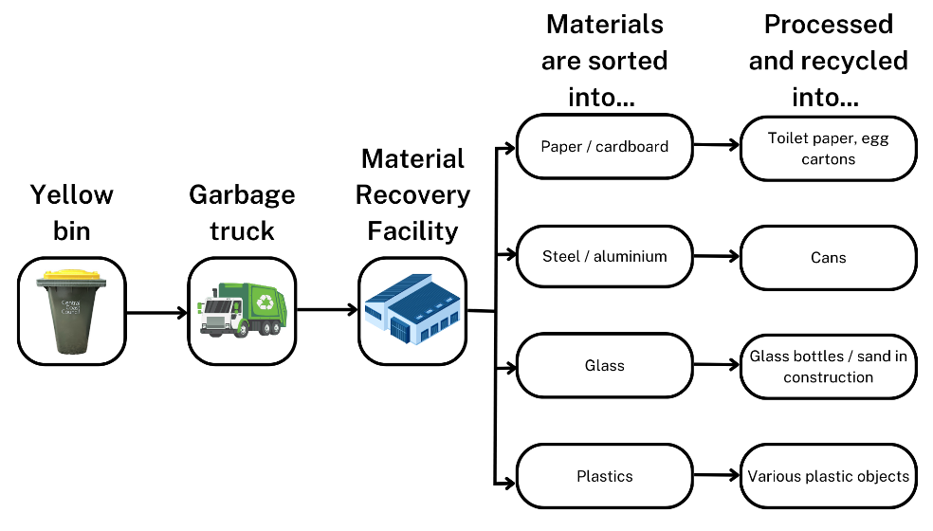

Student resource – the recycling process flowchart
Complete the flowchart below to identify how recyclable materials are sorted, processed and recycled.
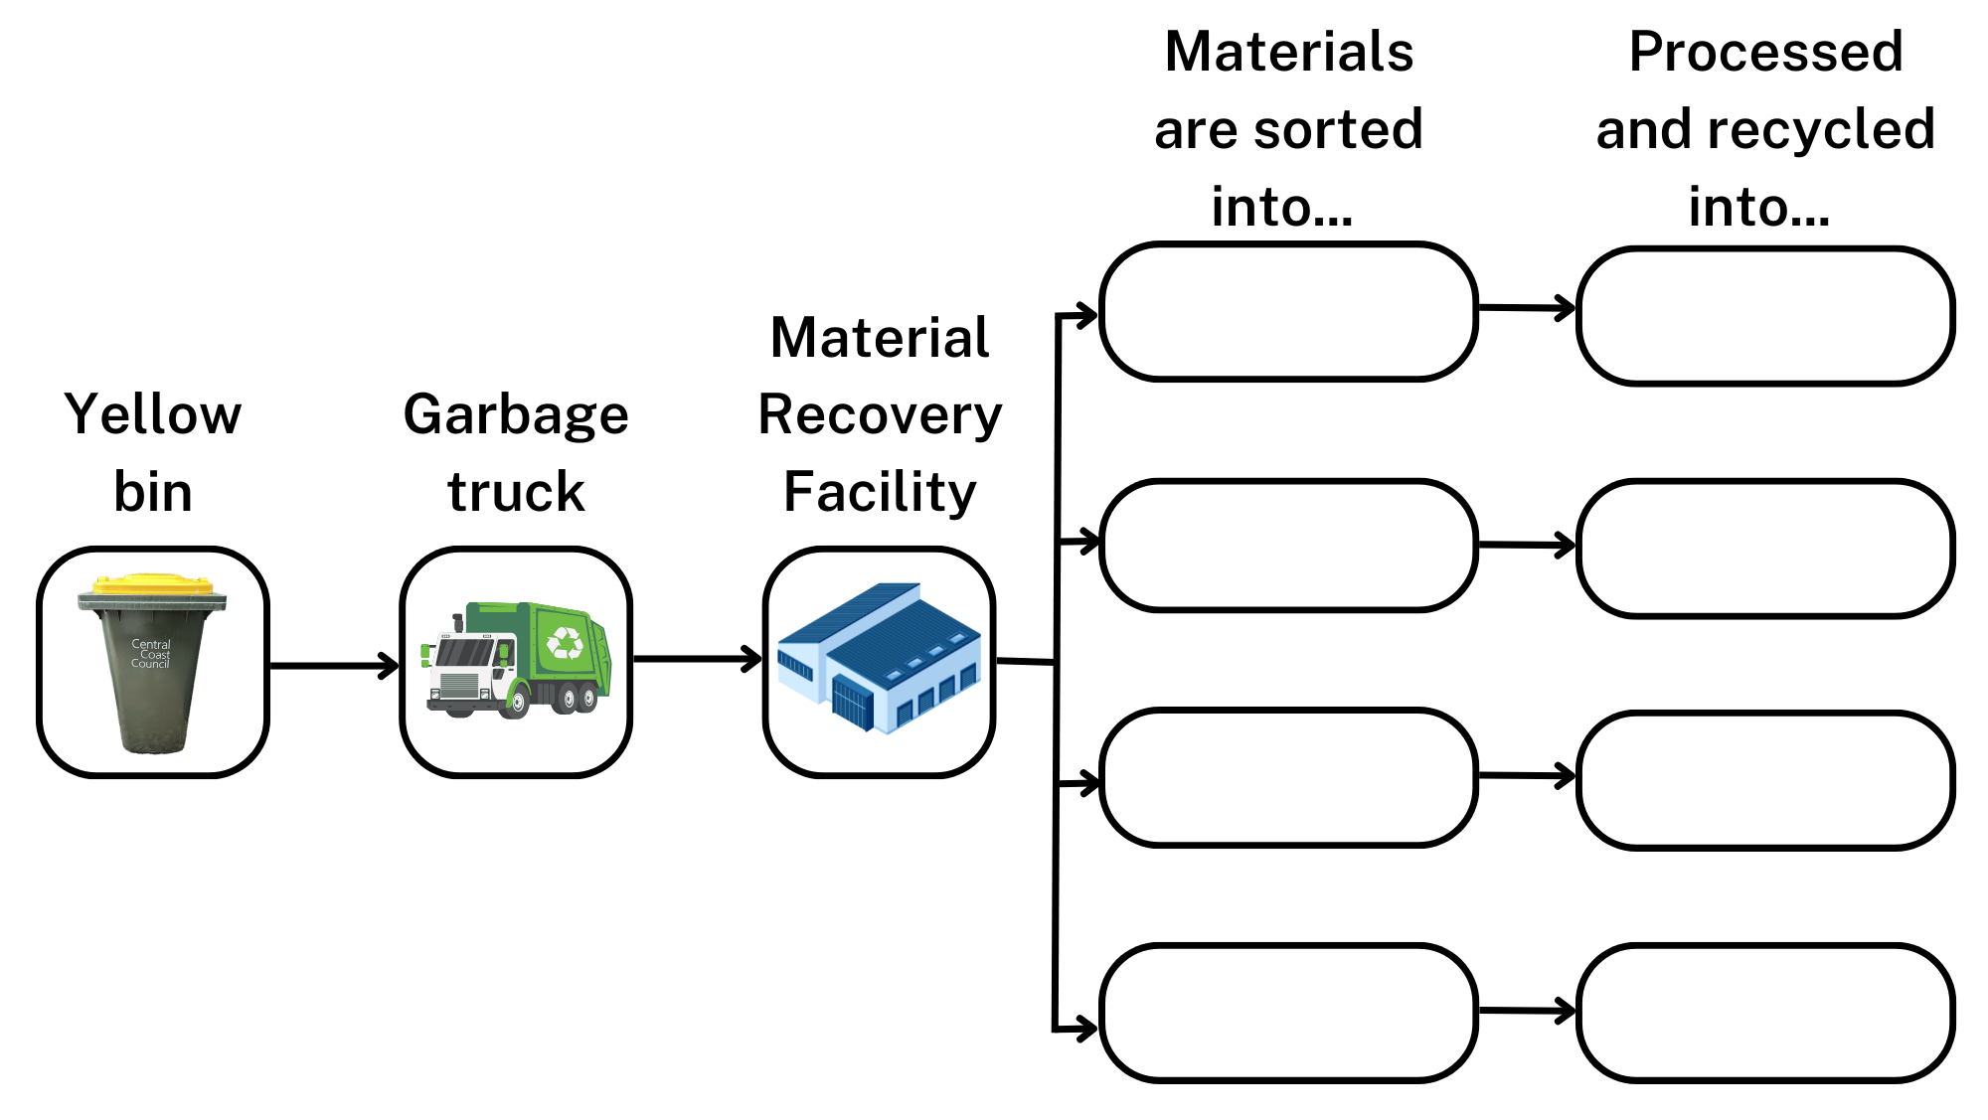

Return and earn
- Students will evaluate the Return and Earn program as a solution to Australia’s waste problem. The first step in completing this evaluation is to teach students how to develop evaluation criteria relevant to the problem. When teaching our students how to develop evaluation criteria, it may be helpful to use an example to demonstrate how the judgment of something may change based on the developed criteria. Show ENV PPT ‘2.4 Developing evaluation criteria’ to support students in understanding how to develop criteria for evaluation.
- Reflecting on the 3 pillars of sustainability covered in ENV PPT ‘1.2 Defining sustainability’, develop criteria to evaluate the Return and Earn program. Refer to question 1 in Student resource – evaluating the Return and Earn program sample response.
- Students will need access to computers for this activity. The average household recycles 75 bottles and cans through the Return and Earn program per trip. Students can use this average, to calculate the impact of the Return and Earn program using the Return and Earn impact calculator. Students can then use this data and information from the website to complete the evaluation scaffold for the Return and Earn program, located as part of the Student resource – evaluating the Return and Earn program.
Sample response – Student resource – evaluating the Return and Earn program
Using the pillars of sustainability, develop criteria relevant to the return and earn program.
Evaluation criteria could include:
Environment:
- effectiveness in reducing litter and pollution in the community
- contribution to conserving natural resources through recycling rates
- minimisation of environmental impact during collection, processing, and transportation
- use of environmentally friendly materials and processes.
Equity:
- accessibility of the program to diverse community members, including marginalised groups
- promotion of community engagement and education about sustainability
- fairness in the distribution of benefits, such as incentives or job opportunities
- enhancement of community well-being and social cohesion through participation.
Economy:
- cost-effectiveness and financial sustainability of the project
- creation of local jobs or economic opportunities related to recycling operations
- support for local businesses or partnerships that align with sustainable practices
- contribution to the local economy without compromising environmental or social values.
Table 12 – sample response – evaluation of the Return and Earn program
Evaluation question | Evidence
Identify the program. | Return and Earn
Describe how the program works. | Individuals collect eligible waste containers (bottles and cans) and take them to a return point to deliver them for recycling and receive a 10-cent reimbursement per container.
Explain the purpose of the program. | The purpose of the program is to reduce the amount of recyclable materials that end up in landfills.
What are the benefits of the program? | The benefits of the program include:  - a total of 13,431,549,802 containers have been recycled through the program since December 2017  - a total of 1,152,103 tonnes of materials recycled to date  - approximately 281,730,201 kilograms of CO₂ emissions avoided.
What are the limitations of the program? | The limitations of the program are:  - only certain bottles and cans are eligible to participate in the program, resulting in some drink containers still going to landfill  - it may be difficult for some people living in rural and remote locations to access a return point, resulting in the containers being added to landfill instead.
What is the criterion on which the judgment is based? | The criterion is: Does the program reduce pollution?
What is the judgment of the program? | The overall judgement of the Return and Earn program is that it is an effective program to reduce pollution.
Checkpoint: What types of environmental pollution could the Return and Earn program reduce?
Sample response
The Return and Earn program could reduce litter pollution by encouraging people to return containers instead of discarding them. This helps decrease land pollution and plastic waste in the environment. It may also reduce water pollution by preventing containers from entering waterways.

Student resource – evaluating the Return and Earn program
Pillars of sustainability
Environment – protecting ecosystems, reducing pollution, and conserving resources.
Equity – promoting well-being, equity, and community development.
Economy – supporting economic growth without harming the environment or society.
Using the pillars of sustainability, develop criteria relevant to the Return and Earn program.
The criteria to evaluate the return and earn program are:
Evaluating the Return and Earn program
Use the following websites and tools to collect evidence to evaluate the Return and Earn program.
- Return and earn homepage
- Return and Earn impact calculator
- NSW EPA Return and Earn
- TOMRA Return and Earn collection
Explore these resources carefully to collect relevant information and data. Use the evidence you find to complete the evaluation scaffold provided.
Table 1 – evaluation of the Return and Earn program
Evaluation question | Evidence
Identify the program.
Describe how the program works.
Explain the purpose of the program.
What are the benefits of the program?
What are the limitations of the program?
What is the criterion on which the judgment is based?
What is the judgement of the program?

2.5 Innovations in recycling
Table 13 – learning intentions and success criteria for ‘2.5 Innovations in recycling’
We are learning: | I can:
- to analyse the need for alternative resource use to reduce impact on the natural world | - describe a recycling innovation  - explain the impact of the innovation on Australia’s waste
- to analyse data from investigations to identify relationships | - draw a conclusion based on evidence from collected data  - identify sources of uncertainty in an investigation
- to evaluate strategies proposed to solve problems. | - evaluate a claim about reduction in waste by an invertebrate  - evaluate a claim using the C-E-R scaffold.
Checkpoint: deliver a checkpoint on the previous lesson’s content. See slide ENV PPT ‘2.5 Checkpoint – quick quiz on previous content’.
Mini challenge (MC): true or false question.
True or False? Recycled glass can be used in construction to make road base.
- true – correct answer
- false
Challenge (C): list 3 items that can be recycled at a Material Recovery Centre (MRC).
Super challenge (SC): describe the impact of a local recycling program.
Checkpoint sample response
Mini challenge (MC):
- true
Challenge (C): plastic punnet, metal can, plastic bottle.
Super challenge (SC): the Return and Earn program reduces the amount of recyclable materials (bottles and cans) ending up in landfill, decreasing carbon dioxide emissions.

Women in Science – Veena Sahajwalla
- Display ENV PPT ‘2.5 Women in Science: Veena Sahajwalla’. Students watch and listen to Recycling revolutionary Veena Sahajwalla turns old clothes into kitchen tiles | Australian Story (29:01) up to time 5:15. If time permits, the whole video can be shown to students to share more details on the 2 technologies she has developed.
- Provide students with access to computers. Display ENV PPT ‘2.5 A good news story’ to outline the activity. Students will choose one of Veena Sahajwalla’s key inventions, Green steel or Green ceramics. They will then complete research on the invention to produce a good news story article using the Student resource – a good news story template. In the article, students should include the following information:
- a catchy headline
- the name of the scientist
- the scientist’s qualifications
- the name of the innovation
- the year it was invented
- a description of the innovation
- a description of how the innovation can be used
- an explanation of the impact of the innovation on Australia’s waste.
Note: the news article template can be edited online using Canva. To download a copy of the news article template, use this link: Student resource – a good news story. A sample student response is provided in Figure 3.
Figure 3 – sample response: a good news story
Adapted from: Recycling revolutionary Veena Sahajwalla turns old clothes into kitchen tiles | Australian Story (29:01)

Student resource – a good news story
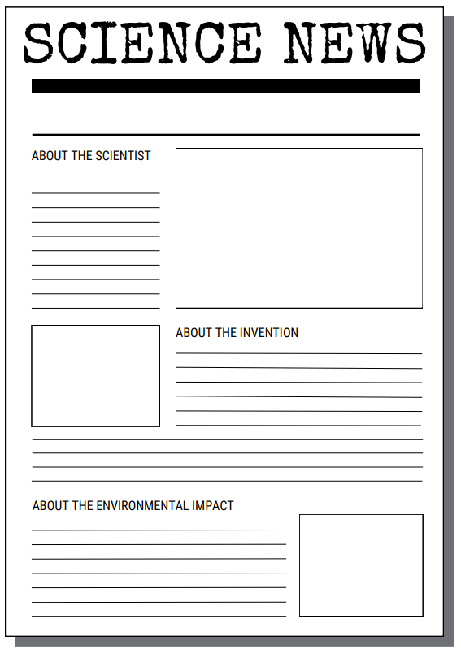

Practical investigation – mealworms and polystyrene
Preparation
Before the lesson, you will need to source the equipment required for this investigation.
Note: this investigation can be run in small groups or as a whole-class activity.
The following equipment is needed for this investigation:
- 3 × small containers per group  - polystyrene (minimum size of 2.5 cm cubed)  - 40 × Mealworms with substrate (oat bran or similar)  - 1 × potato (or 2 × moist cotton wool buds as alternative)  - 1 × pair of gloves | - 1 × forceps  - 1 × knife  - 1 × electronic scales  - 1 × pen  - 1 × pair of scissors  - 1 × ruler
Tips for sourcing the polystyrene: try to recycle polystyrene packaging where possible. It often comes as sheets or blocks that can be cut into smaller cubes.
If you need to purchase polystyrene, it can be bought from craft supply stores as spheres or cubes. Many purchased spheres/cubes have smooth edges and may have a waxy coating. You will need to cut the shape or score it to enable the worms to access the polystyrene. Purchasing new polystyrene materials for this experiment is strongly discouraged in the spirit of environmental sustainability.
Size of polystyrene: avoid using polystyrene cubes smaller than 2.5 cm³. As polystyrene is a light material, changes in small cubes may not be accurately measured using scales that record less than 4 decimal places.
Sourcing mealworms: mealworms can be purchased at pet supply stores. They are sold in containers by weight, but even small containers can have many worms. One container may be divided into multiple groups. Mealworms are often sold in a container with a substrate, which is often oat bran or similar. This can be used as a control test.
Storing mealworms: keep mealworms in small containers with small ventilation holes. Keep at room temperature in a dark space. A minimum of 20 mealworms per container is recommended to obtain measurable results over a short period of time.
Ethical considerations: mealworms are classified as invertebrates. Therefore, the restrictions placed within the Animal Research Act of 1985 and the Prevention of Cruelty to Animals Act 1979 do not apply to using mealworms in scientific inquiry. Mealworms must be purchased from a pet store in accordance with Animals in Schools. In addition to the polystyrene, mealworms must be supplied with moisture in the form of potato slices or a damp cotton ball. Once the experiment has concluded, mealworms may be ethically disposed of by freezing them for approximately 48 hours and then placing them in the garbage.
Facilitating the investigation
- Introduce recycling innovations by watching the video Stanford study shows mealworms can eat toxic plastic additives (1:27) on slide ENV PPT ‘2.5 Practical investigation – mealworms and polystyrene’.
- Complete a practical investigation to determine if mealworms eat polystyrene. The procedure to be followed is included in Student resource – mealworms and polystyrene (practical investigation).
- Students record their results and use the C-E-R scaffold to evaluate the Stanford report claim: ‘Mealworms could be the solution to our plastic problem.’ The information in the scaffold, such as helpful hints and sentence starters, may be edited or removed as per their students’ learning needs.
Figure 4 – sample set up of practical investigation – mealworms and polystyrene
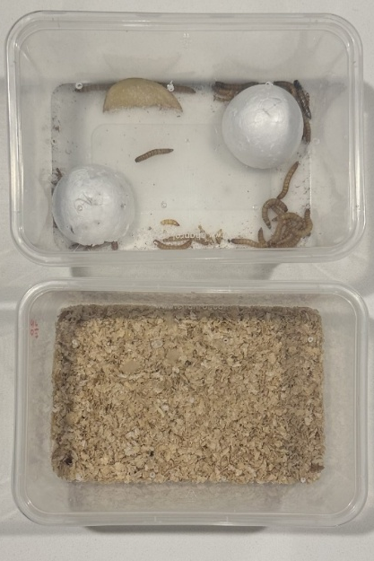
Sample response – Student resource – mealworms and polystyrene
Table 14 – observations table for mealworms and polystyrene practical investigation
Element of investigation | Observations
The polystyrene | The polystyrene has decreased in size, has multiple holes and channels through the block, and mealworms have burrowed into it. The control polystyrene showed no change in size or appearance.
The mealworms | Two mealworms are deceased, while most are still active in movement, and some have shed their exoskeletons.
The container | The container contains evidence of waste matter. The control container showed no waste or damage.
Table 15 – data table for polystyrene mass
Polystyrene block number | Initial mass (g) | Final mass (g) | Difference (g)
1 | 1.5 | 0.6 | 0.9
2 | 1.6 | 0.8 | 0.8
3 (control) | 1.6 | 1.6 | 0.0

- Evaluate the Stanford report’s claim using data from the investigation.
Table 16 – evaluating the claim
Claim | Evidence | Reasoning
Your response  Mealworms could be the solution to our plastic problem | Your response  In the experiment, the polystyrene reduced in size, and the mealworms created holes in the blocks. The mealworms also began excreting white waste. The data shows that the mass of the polystyrene decreased in the containers with mealworms, while no mass loss was observed in the control container without mealworms. This suggests that the mealworms were responsible for the reduction in polystyrene mass. | Your response  Based on this evidence, it can be concluded that mealworms do eat polystyrene, a type of plastic and could be the start of a solution to recycling waste polystyrene.
Using the template above to structure your answer, evaluate the claim ‘Mealworms could be the solution to our plastic problem.’
The claim that ‘Mealworms could be the solution to our plastic problem’ is supported by the evidence collected in the investigation. Evidence from the investigation demonstrated that the polystyrene blocks decreased in size and developed holes due to the mealworms' activity. Additionally, the data indicated a reduction in the mass of polystyrene in the samples that were in the same container as the mealworms. The investigation also observed that the mealworms began producing white waste as a result of consuming the plastic.
Based on this evidence, it can be concluded that mealworms do eat polystyrene, a type of plastic. Further research is needed to determine the suitability of this approach as a solution to recycling waste polystyrene.
Next steps
Consider the waste excretion of the mealworms. What is a further area of research that could be conducted to continue to solve the issue of waste polystyrene?
Scientists could analyse the chemical composition of the mealworm waste to test what chemical components the polystyrene has been broken down into. They could also test whether the mealworm waste is safe to use as organic fertiliser and assess the impact of polystyrene on the growth and development of mealworms.

Student resource – mealworms and polystyrene (practical investigation)
A report from Stanford University has claimed, ‘Mealworms could be the solution to our plastic problem.’ You will investigate and evaluate this claim.
Aim: the aim of this investigation is to determine if mealworms eat polystyrene.
Procedure:
- Using scissors, put 6 small holes in the lid of each small container to provide ventilation. Ensure holes are small enough that the mealworms cannot escape.
- Wearing gloves, use forceps to place a minimum of 20 mealworms into 2 of the containers. Leave the third container empty – it will serve as a control with no mealworms.
- Use the knife to cut small wedges of potato and place one in each container.
- If required, use the scissors to cut polystyrene into blocks. Ensure blocks are not too small for recording their mass.
- Using the pen, label the block of polystyrene with numbers or letters.
- Using the scales, weigh each block of polystyrene and record the initial mass before placing it into one of the containers with mealworms and into the control container.
- Keep all containers, including the control, under the same environmental conditions throughout the investigation.
- After 3 to 5 days, weigh the polystyrene again using the scales and record their mass. Make observations about the condition of the polystyrene and any other relevant details (waste output).
- Once the investigation has concluded, place the containers with mealworms in the freezer for a period of 48 hours. After this time, you may dispose of them in the garbage.
Results:
- Make observations of the different elements of the investigations:
Table 1 – observations table for mealworms and polystyrene practical investigation
Element of investigation | Observations
The polystyrene
The mealworms
The container
- Record data of polystyrene mass.
Table 2 – data table for polystyrene mass
Polystyrene block number | Initial mass (g) | Final mass (g) | Difference (g)
Evaluating the claim:
- Evaluate the Stanford report’s claim using data from the investigation.
Claim | Evidence | Reasoning
State the claim being investigated. | Provide reliable information from experiments, facts or a reliable source that supports the claim. | Explain how the evidence supports the claim.
Helpful hints  Ensure keywords and ideas from the claim and investigation are aligned. | Sentence starters  In the experiment…  The data shows…  One piece of evidence is… | Sentence starters  The evidence supports the claim because…  Based on this evidence, it can be concluded that…
Your response | Your response | Your response
Using the template above to structure your answer, evaluate the claim ‘Mealworms could be the solution to our plastic problem.’
Next steps:
Consider the waste excretion of the mealworms. What is a further area of research that could be conducted to continue to solve the issue of waste polystyrene?

Practical investigation – worms and black soldier fly larvae food waste processing
Note: this investigation is an alternative to the mealworm and polystyrene investigation, demonstrating the high efficiency of black soldier fly larvae in breaking down polystyrene waste.
- Tell students the following information about black soldier fly larvae as an innovation in recycling:
- using black soldier fly larvae to process food waste is an innovative method to reduce the environmental impact of household food waste
- many local councils in NSW are now collecting household food waste and using black soldier fly larvae to process this waste on an industrial scale
- the processed waste is then used as a high-quality fertiliser for gardens and for agriculture.
- Provide students with a copy of the Student resource – comparing the food waste efficiency of worms and black soldier fly larvae. Unpack the aim, hypothesis and method with the class.
- Either conduct the practical investigation in small groups or as a class. Facilitate the collection of data over multiple lessons.
Note:
Sourcing black soldier fly larvae: black soldier fly larvae can be purchased at pet supply stores. They are sold in containers by weight, but even small containers can have many larvae.
Sourcing garden worms: garden worms can also be purchased from pet stores. Tiger worms are more efficient at processing food waste and are commonly used in worm farms, where they are often found in composts.
Storing black soldier fly larvae and worms: keep larvae and worms in small containers with food (compost) with small ventilation holes. Keep at room temperature in a dark space.
Ethical considerations: black soldier fly larvae and worms are classified as invertebrates. Therefore, the restrictions placed within the Animal Research Act of 1985 and the Prevention of Cruelty to Animals Act 1979 do not apply.
Differentiation: students could be involved in the design of the investigation to extend their understanding of designing a controlled investigation.
Figure 5 – investigation setup
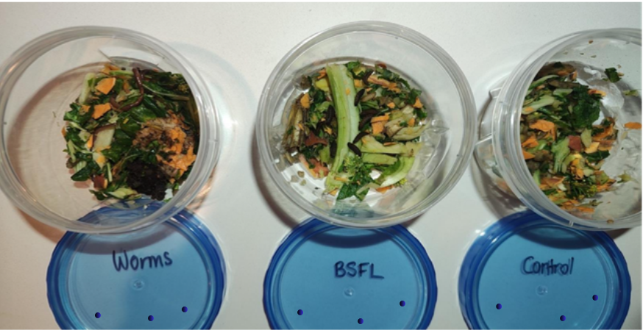
Depth study ideas: you could choose to conduct a depth study to explore food waste in greater depth. Some ideas include:
- reflect on the ecological role and how both organisms are used in the processing of organic industrial waste, and assess the potential application of the more efficient decomposer as a FOGO (food organics and garden organic) waste management option at your school or at home?
- investigate the rate at which each organism processes food waste. Possible independent variables include the size of the food, variety of food, organic vs nonorganic food, larval stage used, number of organisms used or the temperature at which decomposition occurs.
Sample response – Student resource – comparing the food waste efficiency of worms and black soldier fly larvae
Results
Table 17 – partial results table for mass of food waste over time when exposed to worms and black soldier fly larvae
Day | Mass of food waste (g) |  |  | Notes and Observations  (include: temperature and moisture observations, texture, colour and smell of the compost)
Day | Worms | BSFL | Control
0 | 50 | 50 | 50 | No smell
2 | 48 | 45 | 50 | Worms – some processing, but mostly still food, with moisture on the walls and a noticeable smell.  BSFL – food is starting to turn dark and look broken down, with moisture on the walls of the containers, and a noticeable smell.  Control – no evident decomposition. A strong smell is evident.
Note: Table 17 contains an example of the data collected for day 0 and day 2 only. More rows can be added to record additional observations.
Table 18 – percentage decrease in food waste by decomposer
Treatment | Initial mass (g) | Final mass (g) | % decrease in mass
Worms | 50 | 15 | 70
BSFL | 50 | 5 | 90
Control | 50 | 45 | 10
Note: the container containing the food waste and organisms is an open system. Mass is lost from the food waste due to respiration (CO₂ and water) to the air, and the worms and the BSFL gain mass. The mass loss in the control can be explained by loss of moisture to the air and decomposition by microorganisms initially present on the food.
Figure 6 – sample results table
Discussion:
The black soldier fly larvae decomposed the food waste the fastest, with a 90% decrease in mass over 14 days. Worms also broke down the waste effectively, with a 70% decrease over 14 days, but at a slower rate compared to the larvae. The control, which had no decomposers, showed only a 10% decrease, most likely due to natural drying or microbial activity. This shows that living decomposers play a much bigger role in breaking down organic material than natural processes alone.
The compost from the worm container is dark and crumbly. The compost from the black soldier fly larvae is slightly more broken down, with a wetter texture and reduced smell. The control container has much less decomposition, and much of the original food material is visible, making it poor-quality compost.
Possible errors include not controlling variables such as moisture, temperature, or the type of food waste, which can all affect decomposition. The sample size was small (only one container of each type), which reduces reliability. Additional repeat measurements could be obtained, and greater care could be taken to control the test environment.
The results suggest that black soldier fly larvae could be a highly efficient option for managing food waste, reducing it rapidly. Worms, while slower, may produce higher-quality compost. Future research could test larger sample sizes, use different types of food waste, or investigate combining worms and larvae to see if decomposition and compost quality can be balanced. This has real-world implications for sustainable waste management and reducing landfill contributions.
Conclusion:
The investigation showed that black soldier fly larvae decomposed food waste the fastest, reducing the mass by 90% within 14 days, compared to worms at 70% and the control at only 10%. This supports the hypothesis that black soldier fly larvae process food waste more quickly than worms.

Student resource – comparing the food waste processing efficiency of worms and black soldier fly larvae
Overview
In this scientific investigation, you will compare the efficiency of food waste processing between the more traditional composting worms and a newer and more innovative approach that uses black soldier fly larvae. Australian companies like GoTerra and EntoTech Innovations use advanced biological technologies, including black soldier fly larvae, to rapidly break down organic waste, thereby reducing landfill impact and producing valuable by-products such as protein-rich animal feed and nutrient-dense compost. This approach is innovative because it offers a sustainable, scalable, and natural solution to the growing problem of food waste, transforming waste into resources while lowering greenhouse gas emissions.
When these organisms help decompose the food waste, mass is lost from the system as water and carbon dioxide through the process of respiration.
Your task is to design and perform a fair test to compare how effectively worms and black soldier fly larvae process food waste. You will collect and analyse data on waste reduction, then evaluate which organism is more efficient. Consider how this technology might be used at your school or at home.
Claim: according to the Urban Worm Company, ‘Black soldier fly larvae (BSFL) process food waste significantly faster than composting worms. BSFL can be 75 to 100 times more efficient at processing waste’.
Aim: to compare the efficiency of food waste breakdown and compost production by worms and black soldier fly larvae.
Hypothesis: if black soldier fly larvae (BSFL) process food waste faster than worms, then the food waste mass (g) will decrease more rapidly over the same period.
Method:
Independent variable: type of decomposer (worms versus black soldier fly larvae)
Dependent variable: amount of food waste processed (determined by mass reduction)

Controlled variables:
- amount, size and type of food waste used
- temperature and moisture conditions
- duration of the investigation
- container type and size
Equipment:
- 20 × composting worms  - 20 × black soldier flies (BSFL)  - 3 × 50 g food waste (with identical composition) | - 3 × identical containers with lids with a similar number and size of air holes.  - Gloves  - 1 × electronic balance
Procedure:
- Chop food waste into similar-sized pieces and mix to ensure uniformity. Place 50 g of food waste in each container.
- Label the 3 containers: Worms, BSFL, and control.
- Record, in the table, the initial mass of food waste in each container.
- Add 20 worms to the worm container.
- Add 20 black soldier fly larvae to the BSFL container.
- Leave the control container without any decomposers.
- Keep all containers in the same environment, maintaining similar temperature and moisture conditions.
- Monitor and record temperature and moisture observations every 2 days, and record any visible changes in texture, colour, and smell of the compost.
- Every 2 days, carefully remove the decomposers and measure the remaining mass of food waste. Mix the food waste and carefully return the decomposers.
- Continue observations for 14 days.
- Calculate the percentage reduction in food waste mass for each container over time.
$$Percentage decrease= \frac{initial mass \left(g\right)-final mass (g)}{final mass (g)} ×100$$
- Graph the data collected (mass vs time).
Results:
Record your observations and measurements in the table below.
Table 1 – mass of food waste over time when exposed to worms and black soldier fly larvae
Day | Mass of food waste (g) |  |  | Notes and Observations  (for example, texture, colour and smell of the compost)
Day | Worms | BSFL | Control
0
2
4
6
8
10
12
14
Table 2 – percentage decrease in food waste by decomposer
Treatment | Initial mass (g) | Final mass (g) | % decrease in mass
Worms
BSFL
Control
Figure 1 – food waste mass reduction over time by treatment
Discussion:
Write a discussion for the investigation. In your discussion, you should:
- compare the rate of decomposition between worms, BSFL and the control
- discuss the quality and characteristics of the compost produced
- discuss errors and limitations of the investigation
- include scientific implications and suggestions for future research.
Conclusion:
Summarise the findings of the investigation and the significance of the results using claim, evidence and reasoning. Do not forget to state if the hypothesis was supported or refuted.

2.6 How has human activity caused environmental pollution?
Table 19 – learning intentions and success criteria for ‘2.6 How has human activity caused environmental pollution?’
We are learning: | I can:
- to discuss the impact of environmental pollution on the natural world | - describe human activities that damage the ozone layer  - outline the strategy used to solve the hole in the ozone layer  - research and develop a plan for reducing school food waste
- to analyse data from investigations to identify relationships | - analyse the relationship between human activities and the hole in the ozone layer and food waste
- to analyse a proposed solution to a problem. | - identify and analyse strategies to solve the problems of the hole in the ozone layer and food waste.
Checkpoint: deliver a checkpoint on the previous lesson’s content using ENV PPT ‘2.6 Checkpoint – quick quiz on previous content’.
Challenge (C): describe how innovations such as green ceramics can improve sustainability.
Super challenge (SC): assess the importance of sustainable solutions to waste management, including the use of mealworms and green ceramics.
Checkpoint sample response
Challenge (C): innovations like green ceramics improve sustainability by turning waste materials, such as old clothes and industrial waste, into useful products like kitchen tiles. This reduces the amount of waste sent to landfill, conserves natural resources by reducing the need for new raw materials, and lowers pollution from manufacturing processes.
Super challenge (SC): sustainability solutions like mealworms and Green ceramics are important because they offer new ways to reduce environmental pollution and manage waste more effectively. Mealworms can help break down plastics like polystyrene, which are difficult to recycle, potentially reducing plastic pollution. Green ceramics recycles textile and industrial waste into useful products, reducing landfill and conserving resources. However, while promising, these solutions need further development and research to understand their long-term impacts and how they can be scaled up. Overall, such innovations are crucial steps toward a more sustainable future.

CFCs and the hole in the ozone layer
In this activity, students will explore how human activities have caused environmental pollution, focusing specifically on the example of chlorofluorocarbons (CFCs) and the hole in the ozone layer. Students will investigate the cause-and-effect relationship between human actions and environmental damage, understand the global response to this issue, and reflect on how solutions can lead to positive environmental change.
- Introduce the lesson, displaying ENV PPT ‘2.6 CFCs and the hole in the ozone layer’ and watching Whatever happened to the hole in the ozone layer? - Stephanie Honchell Smith (5:12).
- Students will need access to computers to complete this activity. Students will use information from the video and conduct research using a range of resources to deepen their understanding of the ozone layer issue. The Student resource – CFCs and the hole in the ozone layer will guide students in organising their findings on environmental pollution, including its causes, impacts, solutions and outcomes.
Note: CFCs and the hole in the ozone layer have been selected because they are a global problem that demonstrate a clear cause-and-effect relationship between human activity and environmental pollution concerns. Other topics could include space junk, fossil fuel-powered vehicles or the oceanic garbage patch.
Sample response – Student resource – CFCs and the hole in the ozone layer
Question | Information
Name of environmental pollution concern. | The hole in the ozone layer.
Type of environmental pollution. | Air pollution
Describe the problem.  (What damage is occurring to the environment? Who is impacted by this problem?) | CFCs damage the ozone layer by breaking down ozone (O₃) molecules in the stratosphere. When the ozone molecules are broken down, this thins the ozone layer and creates holes, which allow more harmful UV rays to reach Earth's surface. This can lead to increased skin cancer rates for humans as well as harm the growth of plants, impacting food security.
Outline the cause of the problem.  (What human activities cause the problem?) | CFCs were commonly used in everyday human-made products such as refrigerators, air conditioners, aerosol sprays, insulation and cleaning products. CFCs get released into the atmosphere during the manufacturing, use, and disposal of these products. Once in the atmosphere, they are broken down by UV light, releasing chlorine atoms that destroy ozone molecules.
Describe the solution to the problem.  (How is the problem being fixed?) | The solution was the Montreal Protocol, signed in 1987. Nearly every country is committed to stopping the production and use of CFCs and finding safer alternatives for these products, reducing the release of harmful chemicals into the atmosphere.
Discuss the impact of the solution.  (What changed/will change after the solution was implemented) | As a result of the Montreal Protocol, the ozone layer is slowly rebuilding. According to recent assessments, the ozone layer is expected to return to 1980 levels by around 2040 globally. This has led to a reduction in harmful UV radiation entering the Earth’s atmosphere, and reducing negative impacts on humans, plants and animals.

Student resource – CFCs and the hole in the ozone layer
Using the video Whatever happened to the hole in the ozone layer? - Stephanie Honchell Smith (5:12) and your own research, answer the following questions to help you understand CFCs (chlorofluorocarbons) and their impact on the environment.
Question | Information
Name of environmental pollution concern.
Type of environmental pollution.
Describe the problem.
(What damage is occurring to the environment? Who is impacted by this problem?)
Outline the cause of the problem.
(What human activities cause the problem?)
Describe the solution to the problem.
(How is the problem being fixed?)
Discuss the impact of the solution.
(What changed/will change after the solution was implemented)

Food waste in schools
In preparation for the Environmental sustainability – assessment task (which explores global and household food waste), students can look at school food waste.
- Share data on food waste at NSW public schools on slides ENV PPT ‘2.8 Food waste in NSW Public school data’ (2 slides).
- Share further information on organic food waste in schools using the website Solving organic waste – NSW School infrastructure. In Program resources – Teaching resources – Whole School Training, there is a supporting SOW High school student presentation that could be used to explain the connections between school food waste and sustainability. Suggested speaking points include:
- noticing that a large portion of school waste is organic, including leftover food, fruit peels, and other biodegradable materials
- recognising that when organic waste goes to landfill, it produces methane gas – a greenhouse gas significantly more potent than carbon dioxide in contributing to global warming
- understanding that food waste contributes significantly to climate change, not just by wasting resources but also by increasing greenhouse gas emissions
- explaining how managing food waste connects to sustainability
- seeing that composting organic waste can turn it into nutrient-rich soil for gardens, creating a natural cycle and reducing landfill
- connecting these ideas to sustainability: protecting the environment, supporting community wellbeing, and saving money on waste disposal
- encouraging students to think about how organic waste impacts the environment and what benefits come from managing it properly
- prompting students to consider what steps our school can take to reduce food waste and become more sustainable
- Talk students through slide ENV PPT ‘2.8 Food waste – solving the problem of food waste’, which clarifies the 4-step process for innovation. In small groups, students research and develop a plan for reducing food waste in their school. Students work through a modified design thinking process where they:
- Step 1: define the problem.
- Step 2: ideate and focus. Ideate or brainstorm solutions. Then, review the solutions and focus on one that has a high impact and low effort.
- Step 3: prototype and pitch. Outline a procedure for implementing the solution and then design a pitch to the school’s Principal.
- Step 4: evaluate. Reflect on how they will evaluate the solution to determine its success.
Note: students should follow a similar process when analysing their household’s food waste in preparation for the assessment task.
Sample response for the Student resource – food waste in schools.
Process | Notes
Step 1: define the problem | Our school generates a significant amount of food waste, approximately 23kg of organic waste daily, totalling up to 4.6 tonnes per year. This waste is sent to a landfill and produces 9.66 tonnes of CO₂ equivalent greenhouse gases annually. This is a serious environmental issue that contributes to climate change. We need a sustainable approach to reducing food waste and lowering our school’s carbon footprint.
Step 2: ideate and focus  Ideate or brainstorm solutions. Then, review the solutions and focus on one that has a high impact and low effort. | Brainstormed solutions:  - introduce compost bins around the school  - run a student-led food waste awareness campaign  - start a ‘share table’ for uneaten, unopened food  - use waste data to educate students at assemblies  - partner with a local farm or council compost facility  - have ‘waste-free Wednesdays’ with student competitions.  Chosen solution:  Introduce compost bins around the school and create a simple composting system managed by an environmental club.  Why?  This solution has a high impact (reducing emissions by 6.9 tonnes of CO₂) and requires minimal effort (just bins, signs and a roster). It is easy to start small and scale up.
Step 3: prototype and pitch  Outline a procedure for implementing the solution and then design a pitch to the school’s Principal. | Prototype:  - place labelled compost bins near eating areas  - train student volunteers to monitor the bins and educate others  - create simple posters explaining what can go in the compost  - start with just the canteen area for 2 weeks as a trial  - monitor how much compostable waste is collected  - compost it onsite in garden beds  - pitch to the principal.  Dear Principal,  Our school currently produces 4.6 tonnes of food waste yearly, releasing 9.66 tonnes of greenhouse gases. By composting, we could reduce this by 6.9 tonnes of CO₂. We propose a student-led composting initiative with bins near the canteen. It's low-cost, environmentally impactful, and connects to the Science and Geography curriculum. We’d love your support in running a 2-week trial. This could position our school as a sustainability leader on the Central Coast.  Kind regards,  Year 9 Science class
Step 4: evaluate  Reflect on how they will evaluate the solution to determine its success. | We will measure the success of our solution by:  - weighing how much compostable material is collected each week  - comparing the food waste data before and after implementation  - surveying students and staff on their awareness and participation  - monitoring contamination rates (non-compostables in bins)  - tracking the amount of greenhouse gas emissions avoided using simple carbon calculators  - if the trial yields strong results, we will expand the program to other areas of the school and incorporate it into Year 9 science lessons on sustainability.

Student resource – food waste in schools
Based on the food waste data from NSW Public schools, develop a plan to reduce food waste in our school. Use the 4-step process for innovation to clarify and communicate your plan.
- Average food waste per NSW school student is 7kg a year.
- An average NSW Central Coast school wastes 23kg of organic waste in one day (note other areas of the state would have similar data).
- 4.6 tonnes of food waste per school per year is being sent to landfill.
- 9.66 tonnes of CO₂ equivalent greenhouse gases are going into our atmosphere per school per year.
- Composting this food waste would avoid 6.9 tonnes of greenhouse gases by releasing only natural 2.76 tonnes of CO₂ equivalent greenhouse gases.
Process | Notes
Step 1: define the problem
Step 2: ideate and focus
Ideate or brainstorm solutions. Then, review the solutions and focus on one that has a high impact and low effort.
Step 3: prototype and pitch
Outline a procedure for implementing the solution and then design a pitch to the school’s Principal.
Step 4: evaluate
Reflect on how they will evaluate the solution to determine its success.

2.7 Assessment task
The Environmental sustainability – assessment task is unpacked in a separate document found on the Planning, programming and assessing science 7–10 webpage under Environmental sustainability.

Evidence base
This resource contains NSW Curriculum and syllabus content. The NSW Curriculum is developed by the NSW Education Standards Authority. This content is prepared by NESA for and on behalf of the Crown in right of the State of New South Wales. The material is protected by Crown copyright.
Please refer to the NESA Copyright Disclaimer for more information https://educationstandards.nsw.edu.au/wps/portal/nesa/mini-footer/copyright.
NESA holds the only official and up-to-date versions of the NSW Curriculum and syllabus documents. Please visit the NSW Education Standards Authority (NESA) website https://educationstandards.nsw.edu.au and the NSW Curriculum website https://curriculum.nsw.edu.au.
Science 7–10 Syllabus © NSW Education Standards Authority (NESA) for and on behalf of the Crown in right of the State of New South Wales, 2023.
ABC News In-depth (21 February 2021) 'Recycling revolutionary Veena Sahajwalla turns old clothes into kitchen tiles | Australian Story' [video], ABC News In-depth, YouTube, accessed 26 May 2025.
AIATSIS (Australian Institute of Aboriginal and Torres Strait Islander Studies) (n.d.) Guide to Evaluating and Selecting Education Resources, Australian Institute of Aboriginal and Torres Strait Islander Studies, accessed 26 May 2025.
AITSL (Australian Institute for Teaching and School Leadership Limited) (n.d.) Learning intentions and success criteria [PDF 251 KB], AITSL, accessed 2 May 2025.
Arc En Cotech Ltd (n.d.) From wasteful to resourceful, Arc En Cotech Ltd website, accessed 8 September 2025.
Australian Government Department of Climate Change, Energy, the Environment and Water (2024) National Waste and Resource Recovery Report 2024, Australian Government website, accessed 26 May 2025.
Awabakal Language and Culture (n.d.) Collected Writings on the Awabakal People, Awabakal Language and Culture website, accessed 26 May 2025.
BBC News (24 April 2020) 'Coronavirus: Smog pollution in Delhi vanishes - BBC News' [video], BBC News, YouTube 26 May 2025.
Brookhart SM (2018) ‘Appropriate Criteria: Key to Effective Rubrics’, Frontiers in Education, volume 3(22):1–12, doi:10.3389/feduc.2018.00022, accessed 6 February 2025.
CESE (Centre for Education Statistics and Evaluation) (2020) What works best: 2020 update, NSW Department of Education, accessed 18 February 2025.
——(2020) What works best in practice, NSW Department of Education, accessed 18 May 2025.
——(2021) Growth goal setting – what works best in practice, NSW Department of Education, accessed 6 February 2025.
Fisher D and Frey N (1 November 2009) ‘Feed Up, Back, Forward’, ASCD (Association for Supervision and Curriculum Development): Educational Leadership magazine, 67(3), accessed 18 May 2025.
GoTerra (n.d.) GoTerra [website], accessed 8 September 2025.
Griffin P (2017) Assessment for Teaching, Cambridge University Press, Port Melbourne, Victoria.
Hattie J and Timperley H (2007) ‘The Power of Feedback’, Review of Educational Research, 77(1): 81–112, doi:10.3102/003465430298487.
Jordan R (19 December 2019) ‘Stanford researchers show that mealworms can safely consume toxic additive-containing plastic’, Stanford University, accessed 26 May 2025.
——(1 June 2022) ‘Less air pollution leads to higher crop yields, Stanford-led study shows’, Stanford University, accessed 26 May 2025.
National Geographic (October 16 2017) 'Air Pollution 101 | National Geographic' [video], National Geographic, YouTube, accessed 26 May 2025.
NESA (New South Wales Education Standards Authority) (n.d.) Aboriginal and Torres Strait Islander principles and protocols, NESA website, accessed 26 May 2025.
New South Wales Department of Education (n.d.) ‘Guide for planning and implementing explicit vocabulary instruction’, Universal Resources Hub, Department of Education website, accessed 26 May 2025.
New South Wales Department of Education (n.d.) ‘Stage 5 reading – Vocabulary in Context’, Literacy and numeracy, Department of Education website, accessed 26 May 2025.
New South Wales Department of Education School Infrastructure (n.d.) Solving Organic Waste, Department of Education website, accessed 26 May 2025.
New South Wales Department of Education School Infrastructure (n.d.) ‘Teaching Resources’, Solving Organic Waste, Department of Education website, accessed 26 May 2025.
New South Wales Government (n.d.) Return and Earn [website], accessed 26 May 2025.
New South Wales Government (n.d.) Return and Earn Impact Calculator [website], accessed 26 May 2025.
New South Wales Legislation (2025) Animal Research Act of 1985 No 123, NSW legislation website, accessed 19 August 2025.
——(2024) Prevention of Cruelty to Animals Act 1979 No 200, NSW legislation website, accessed 19 August 2025.
Panadero E and Jonsson A (2013) ‘The use of scoring rubrics for formative assessment purposes revisited: A review’, Educational Research Review, 9:129–144, doi:10.1016/j.edurev.2013.01.002, accessed 18 May 2025.
Sherrington T (2019) Rosenshine’s Principles in Action, John Catt Educational Limited, Melton, Woodbridge.
TED-Ed (19 April 2023) 'Whatever happened to the hole in the ozone layer? - Stephanie Honchell Smith' [video], TED-Ed, YouTube, accessed 26 May 2025.
Sunshine Coast Council (7 August 2024) 'What happens to your recycling on the Sunshine Coast?' [video], Sunshine Coast Council, YouTube, accessed 5 June 2025.
The Project (1 November 2024) 'Waste Crisis As Landfills Become Dangerously Full' [video], The Project, YouTube, accessed 26 May 2025.
TOMRA (2025) NSW Return and Earn Locations, TOMRA website, accessed 26 May 2025.
University of Sydney (12 August 2015) 'Aboriginal Kinship Presentation: Totems' [video], The University of Sydney, YouTube, accessed 5 June 2025.
Urban Worm Company (n.d.) Black Soldier Fly Larvae: Pest or Partner?, Urban Worm Company website, accessed 26 May 2025.
Wiliam D (2017) Embedded Formative Assessment, 2nd edn, Solution Tree Press, Bloomington, IN.

© State of New South Wales (Department of Education), 2025
The copyright material published in this resource is subject to the Copyright Act 1968 (Cth) and is owned by the NSW Department of Education or, where indicated, by a party other than the NSW Department of Education (third-party material).
Copyright material available in this resource and owned by the NSW Department of Education is licensed under a Creative Commons Attribution 4.0 International (CC BY 4.0) license.

This license allows you to share and adapt the material for any purpose, even commercially.
Attribution should be given to © State of New South Wales (Department of Education), 2025.
Material in this resource not available under a Creative Commons license:
- the NSW Department of Education logo, other logos and trademark-protected material
- material owned by a third party that has been reproduced with permission. You will need to obtain permission from the third party to reuse its material.
Links to third-party material and websites
Please note that the provided (reading/viewing material/list/links/texts) are a suggestion only and implies no endorsement, by the New South Wales Department of Education, of any author, publisher, or book title. School principals and teachers are best placed to assess the suitability of resources that would complement the curriculum and reflect the needs and interests of their students.
If you use the links provided in this document to access a third-party's website, you acknowledge that the terms of use, including licence terms set out on the third-party's website apply to the use which may be made of the materials on that third-party website or where permitted by the Copyright Act 1968 (Cth). The department accepts no responsibility for content on third-party websites.

