Science Stage 5 (Year 9) – Environmental sustainability
Teacher resource book 1 of 2 (TRB1)
1. How can science help us understand Earth's changes over time and guide us toward a sustainable future?
Creation date: 21 July 2025
Contents
Overview 3
Glossary 4
1.1 Activating knowledge for environmental sustainability 7
Questions to activate prior knowledge 7
1.2 What is sustainability? 14
Setting the scene for sustainability 14
UN Sustainable Development Goals (SDGs) 15
1.3 Using science to solve sustainability problems 19
Identifying biodiversity problems 20
Understanding the biodiversity problem – invasive species 22
Understanding the biodiversity problem – other biodiversity problems 35
1.4 How about this weather? 47
The difference between weather and climate 48
Comparing local weather with local climate 49
1.5 What is the data telling us? 56
What’s the state of Australia’s climate? 57
What is the state of the world’s climate? 68
1.6 Is there something natural about the greenhouse effect? 78
A greenhouse supports life 79
1.7 How is the greenhouse effect being enhanced? 86
Analysing the data on global emissions and temperature 87
What is the impact of the enhanced greenhouse effect? 103
Modelling the enhanced greenhouse effect 106
1.8 How can we reduce greenhouse gas emissions? 116
Is the transition to household solar reducing greenhouse gas emissions? 117
Can we just remove the carbon from the atmosphere? 121
1.9 Cause and effect – industrialisation and global temperatures 124
When did the current rise in global greenhouse gas emissions start? 126
Does this increase in greenhouse gas emissions correlate with increased global temperatures? 127
1.10 The consequences of climate change 130
What are the characteristics of climate change? 131
The consequences of climate change 136
Ocean acidification 146
1.11 Climate change and the water cycle 161
Climate change and the water cycle 163
Rising sea levels 171
The effect of climate change on ecosystems 177
1.12 Satellites are on the job 181
How satellites collect data 182
Satellite data to evaluate climate change 185
Evidence base 190

Overview
Stage and learning area: Stage 5 Science
Description: this resource complements the Environmental sustainability program of learning. It aims to serve as a teacher reference, offering practical strategies and ideas to enrich teaching practices and create engaging learning environments. The activities should be adapted to suit students’ needs.
Duration: while timing will vary based on the mode of delivery, differentiation strategies employed and class or school context, this series of activities should take approximately 18 hours.
Risk management: teachers are advised to undertake a risk assessment before conducting any classroom investigation or experiment. For more information on developing risk assessments, see Risk Assessment – a pre-requisite for risk control.
This resource book elaborates on many of the activities in the Environmental sustainability sample program of learning. Some activities also reference the Environmental sustainability slide deck (identified as ENV PPT throughout this document).

Glossary
Tier 3 words are those that are relevant for subject-specific content. More information is provided in the ‘Vocabulary in context’ document found at the Stage 5 reading strategies page. The Guide for planning and implementing explicit vocabulary instruction can be used by teachers across all curriculum areas.
Differentiation: to support students learning English as an additional language or dialect (EAL/D) with vocabulary development, refer to EAL/D learners and reading vocabulary. An additional column may be added to the glossary table for EAL/D students to write the definition in their home language.
Table 1 – glossary of key terms for Environmental sustainability TRB1
Term | Definition
Atmosphere | The layer of gases that surrounds a planet like a protective blanket. For Earth, the atmosphere is mostly made up of nitrogen (78%) and oxygen (21%), with small amounts of other gases like argon (0.934%), carbon dioxide (0.042%), methane (1.92 ppm), nitrous oxide (0.33 ppm) and ozone (0.07 ppm).
Biodiversity | The variety of all living organisms on Earth, including plants, animals, microorganisms, and the ecosystems they form.  It encompasses 3 main levels: genetic diversity (differences within species), species diversity (the variety of species in an area), and ecosystem diversity (the range of ecosystems in a region).
Carbon budget | The maximum amount of carbon dioxide (CO₂) that can be emitted into the atmosphere while still having a good chance of limiting global warming to a specific temperature target, like 1.5°C or 2°C above pre-industrial levels.
Climate change | A long-term change in regional or global climate patterns, for example, annual precipitation, frequency of weather events (NESA 2025).
Ecosystem | An ecosystem is a community of living organisms (biotic factors, such as plants, animals and microorganisms) interacting with each other and with their non-living environment (abiotic factors, such as air, water, soil and sunlight) in a specific area.  These interactions create a system where energy flows and nutrients cycle, sustaining life within the ecosystem.
Enhanced greenhouse effect | The amplification of the natural greenhouse effect, caused by the increased levels of greenhouse gases (like carbon dioxide, methane and nitrous oxide) from human activities.  These extra greenhouse gases trap more heat in the Earth's atmosphere, leading to global warming and climate change.
Environmental pollution | Environmental pollution is the addition of any substance, or any form of energy, such as heat, sound or radioactivity, to the environment at a rate faster than it can be dispersed, diluted, decomposed or recycled
Evaluate | Make a judgment based on criteria; determine the value of (NESA 2025).
Greenhouse effect | A heating effect due to heat rays from the ground being absorbed by some of the gases in the atmosphere (NESA 2025).
Greenhouse gases | Gases that trap heat in the Earth's atmosphere. They allow sunlight radiation energy into the atmosphere but prevent some of the Earth's heat from escaping back into space, much like the glass walls of greenhouses trap heat, causing warmer temperatures than their surroundings.  The primary greenhouse gases are carbon dioxide (CO₂), methane (CH₄), water vapour (H₂O), nitrous oxide (N₂O) and ozone (O₃).
Industrialisation | The transformation of an economy from mainly farming and manual work to one focused on machines and large-scale production of goods and services.  As cities grew and industrialisation spread, vast amounts of forests were cleared to make way for new buildings and infrastructure and to provide wood for fuel.
Natural greenhouse effect | The process by which certain gases in Earth's atmosphere trap heat from the Sun, keeping the planet’s climate warm and stable enough to support life.
Nature | The entirety of the natural world, encompassing all living things (biodiversity) and non-living components (geodiversity) of the Earth.  This includes plants, animals, microorganisms, ecosystems, landforms, water, climate, and the dynamic processes that shape them.  Nature is a complex system where living organisms interact with non-living elements to sustain life on Earth.
Reliability | The extent to which repeated observations and/or measurements taken under identical circumstances will yield similar results (NESA 2025).
Satellite | A satellite is anything that orbits another object in space. It can be artificial, such as a man-made device sent to orbit the Earth, Moon or another planet to gather data or facilitate communication. It can also be natural, like the Moon, which orbits the Earth.
Sustainability | The patterns of activities that meet the needs of the present generation without compromising the ability of future generations to meet their needs (NESA 2025).
Validity | The extent to which the processes and resultant data measure what was intended (NESA 2025).
Water cycle | The continuous movement of water on Earth, as it changes between liquid, gas and solid, involves processes such as evaporation, condensation and precipitation.

1.1 Activating knowledge for environmental sustainability
Table 2 – learning intention and success criteria for ‘1.1 Activating knowledge for environmental sustainability’
We are learning to: | I can:
- make connections in our learning. | - recall information from previous science lessons that will be needed for this unit.

Questions to activate prior knowledge
This activity revisits key science concepts essential to understanding environmental sustainability. Students will connect prior knowledge from earlier stages to this theme using a guided class discussion.
- Use the questions provided in the Student resource – questions to activate prior knowledge to guide a whole-class discussion. Encourage students to respond based on what they already know. Use their answers to clarify misconceptions and build a shared foundation for upcoming lessons. The graph in question 4 is provided in the ENV PPT ‘1.1 Analysing temperature anomaly data’. This can be projected so that students can be supported through interpreting the data.
- Introduce the Environmental sustainability focus area to students by outlining the concepts that will be taught using the Microsoft Whiteboard: sustainability, climate science, impacts of present-day climate change, and alternative resource use including recycling.
Sample response: Student resource – questions to activate prior knowledge
- Match the term with the definition and the example.
Note: the colours show the alignment between the term, definition and example.
Term |  | Definition |  | Example
Natural phenomena |  | A conclusion we make based on observations and prior knowledge. |  | Lightning during a thunderstorm.
Inference |  | Information we gather using our senses (sight, smell, touch, taste or hearing). |  | Dark clouds in the sky mean it is going to rain.
Observation |  | Events that happen in nature without human control. |  | The sky is cloudy.
- List 5 abiotic factors that could influence the health of a fish living in a local creek.
temperature, acidity, dissolved oxygen, rainfall, water nutrient levels
- Identify the 3 main types of models used by scientists. Give an example of each.
- mathematical model, for example, $F=ma$
- conceptual model, for example, food web
- physical model, for example, solar system model
- The following question on a temperature anomaly graph uses the Bureau of Meteorology's sea and surface temperatures models using data until 2024.
Note: graphs and infographics have been removed from the sample responses. Please view them in the relevant student resource.
- What is the temperature anomaly (departure from the average) for 2024 for the sea surface temperature and surface air (temperature in the air just above the ground)?
air: 0.8 °C, sea: 0.5 °C
- What is the trend in temperature anomalies for both measurements?
Both sea surface temperature and air temperature are increasing over time.
- Predict what the temperature anomalies will be in 2040 for both measurements.
Approximately 1.4 °C for both.
- What would be the effect of using alternate energy sources, such as wind turbines and solar panels, on the environment?
Reduced greenhouse gas emissions and therefore slowed climate change. Lower air and water pollution. Potential negative impact on area required for land use and wildlife habitats.
Working scientifically content questions:
- What makes first-hand data valid and reliable? Give an example.
Valid – the extent to which the processes and resultant data measure what was intended.
For example, when measuring the temperature of boiling water, you use a calibrated digital thermometer instead of relying on the water bubbling. You also control variables such as water volume and heat source. You are measuring what you intended.
Reliable – the extent to which repeated observations and/or measurements taken under identical circumstances will yield similar results.
For example, to measure the boiling point of water, complete repeat trials using the same thermometer, amount of water and heat source and achieve the same results.
- How do you evaluate claims in science? Describe 4 criteria you could use.
- Before accepting a claim as true, always question it and verify.
- Check the data is related to the variables being measured.
- Check the reasoning used to link the evidence with the claim is strong.
- Assess the reliability of the sources of data and information – reliable sources include scientific journals, reputable universities and expert authorities.
- Look for bias in the analysis and conclusions drawn. Verify whether the claim originates from a source with a vested interest in it.
- Use logical reasoning – the claim should make sense based on scientific principles.
Note: 6 examples have been provided, students only need to provide 4 examples.

Student resource – questions to activate prior knowledge
The following questions support the recall of content previously taught in science, helping you kickstart your learning in the Environmental sustainability focus area.
- Match the term with the definition and the example.
Term |  | Definition |  | Example
Natural phenomena |  | A conclusion we make based on observations and prior knowledge. |  | Lightning during a thunderstorm.
Inference |  | Information we gather using our senses (sight, smell, touch, taste or hearing). |  | Dark clouds in the sky mean it is going to rain.
Observation |  | Events that happen in nature without human control. |  | The sky is cloudy.
- List 5 abiotic factors that could influence the health of a fish living in a local creek.
- Identify the 3 main types of models used by scientists. Give an example of each.
- The following question on a temperature anomaly graph uses the Bureau of Meteorology's sea and surface temperatures models using data until 2024.
Figure 1 – temperature anomaly data modelling
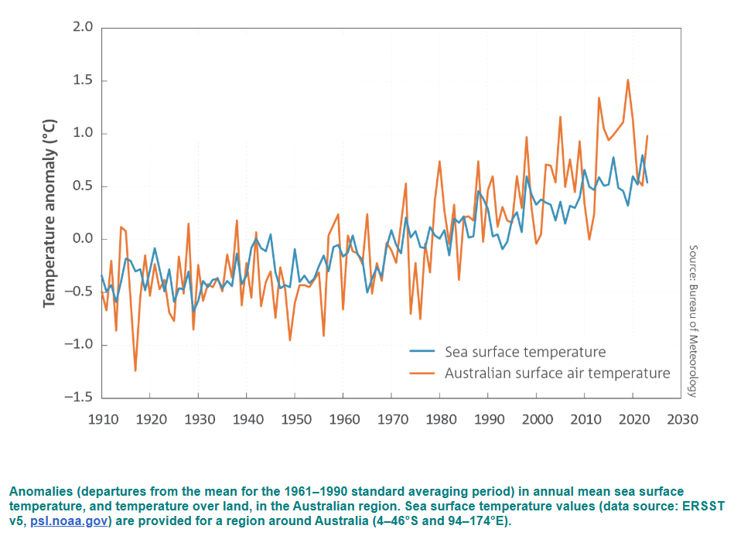
Australia’s climate has warmed since national records began in 1910 is reproduced by permission of the Bureau of Meteorology © 2025 Commonwealth of Australia.
- What is the temperature anomaly (departure from the average) for 2024 for the sea surface temperature and surface air (temperature in the air just above the ground)?
- What is the trend in temperature anomalies for both measurements?
- Predict what the temperature anomalies will be in 2040 for both measurements.
- What would be the effect of using alternate energy sources, such as wind turbines and solar panels, on the environment?
Working scientifically content questions:
- What makes first-hand data valid and reliable? Give an example.
- How do you evaluate claims in science? Describe 4 criteria you could use.

1.2 What is sustainability?
Table 3 – learning intentions and success criteria for ‘1.2 What is sustainability?’
We are learning to: | I can:
- identify the impact of human activity on the natural world. | - define sustainability  - describe the 3 principles of sustainability  - identify how the UN’s sustainable development goals (SDGs) support sustainability using a case study.

Setting the scene for sustainability
Sustainability can be defined as: ‘the patterns of activities that meet the needs of the present generation without compromising the ability of future generations to meet their needs’ (NESA 2025).To better understand how sustainability works in practice, we can break it down into 3 interconnected pillars:
Environment: protecting ecosystems, reducing pollution and conserving resources.
Equity: promoting well-being, equity and community development.
Economy: supporting economic growth without harming the environment or society.
- Watch the video What is Sustainability (3:06) on ENV PPT ‘1.2 Setting the scene for sustainability’ while students reflect on the questions below. Facilitate a discussion by inviting students to share their reflections with a partner or with the whole group.
- What does sustainability mean to you?
- Why is sustainability important?
- Show slide ENV PPT ‘1.2 Defining sustainability’. Students record the definition of sustainability and the 3 pillars or principles of sustainability. Discuss examples of how the 3 pillars are important in the students’ local area. For example, identify potentially vulnerable local environments, highlight local business practices that are important to the local economy and identify potential local equity issues around basic needs (housing, food, well-being).
Checkpoint: without looking at your notes, write a definition of sustainability and list its 3 principles.
Checkpoint sample response
Sustainability means using resources in a way that does not harm the environment or deplete them. It’s about ensuring we have clean air, water and food in the future. The 3 principles of sustainability are:
- Environment: looking after nature by using resources carefully and keeping the air, land and water clean.
- Equity: making sure everyone is treated fairly and has what they need to live a good life.
- Economy: helping businesses and jobs grow in ways that don’t hurt people or the planet.

UN Sustainable Development Goals (SDGs)
The United Nations Sustainable Development Goals (SDGs) are a set of 17 global goals adopted by all UN member states in 2015 as part of the 2030 Agenda for Sustainable Development. They provide a framework for developing and maintaining peace and prosperity for people and the planet. They address a range of global challenges, including poverty, inequality, climate change, environmental degradation, peace and justice.
The SDGs offer an excellent framework for integrating sustainability into the curriculum and helping students understand how their actions can contribute to a more sustainable and fairer world.
- Show slide ENV PPT ‘1.2 UN Sustainable Development Goals’ to introduce students to the 17 United Nations SDGs by watching the short video Do you know all 17 SDGs? (1:24). As a class, explore the UN SDG website.
- Display ENV PPT ‘1.2 Case studies’ and briefly outline each case study for the class.
- Divide the class into small groups and assign each a case study. In their groups, students use the UN SDG website to discuss and record:
- Identify the principles of sustainability that are addressed in the case study.
- How does this project align with any of the SDGs?
Note: a sample response is provided for each case study after the lesson instructions.
- Students share their results with the class. Sample responses are provided in the slide notes and below.
Differentiation
Content: the activity below replaces the previous one. It is an alternative way to teach the content, and it is not meant to be additional work.
Students assess the principles and goals of sustainability by judging the UN SDGs against the following 3 views on sustainability. They then present arguments for each perspective on sustainability.
- View 1: Wurundjeri knowledge holder and Elder Aunty Joy Murphy Wandin AO: ‘We belong to the land. And we take care of the land. We respect this land. And we should only ever take from the land what we can give back to the land. And we say to everyone, not just Aboriginal people, but to everyone, that there is a place on this land for everyone; everyone has a place. So, it’s their responsibility to nurture and to look after this place like our ancestors did for many, many thousands of years for the future generations.’
- View 2: Native American proverb: ‘Take only what you need and leave the land as you found it.’
- View 3: Ancient Kenyan proverb: ‘Treat the Earth well: it was not given to you by your parents, it was loaned to you by your children’.
Optional: explore further world views of sustainability and reflect with the class on how they compare to the UN’s SDGs.
Note: to maintain a positive focus on the world’s sustainability challenges, optional short videos such as those listed below could be shown to students. These videos highlight how the world is making progress (often by using scientific ideas), which could be shown and discussed with the class:
- What Earth in 2125 could look like (5:13) – Iseult Gillespie. What our future could look like if we harness our current science and technology to create a sustainable world.
- The good news you might have missed (8:49) – Angus Hervey. Stories of progress from advances in clean energy to declining rates of extreme poverty, crime and disease.
- Are we the last generation – or the first sustainable one? (13:37) – Hannah Ritchie. How we can be the first generation of humans to achieve sustainability.
Sample response: Case studies (ENV PPT 1.2 Case studies)
Case study 1: solar power in rural communities
- The project supports all 3 pillars of sustainability. It helps the environment by reducing pollution from kerosene lamps. It supports the economy by creating jobs for local people. It also supports social well-being by improving health and helping children study at night.
- This project aligns with SDG 7 – Affordable and Clean Energy because it gives the village clean, reliable electricity. It also supports SDG 3 – Good Health and Well-being, as reducing air pollution leads to improved health. SDG 8 – Decent Work and Economic Growth is also addressed because it creates local jobs.
Case study 2: plastic-free supermarket initiative
- This project supports environmental sustainability by reducing plastic waste and using biodegradable packaging. It also supports social sustainability by encouraging people to change their habits and consider their impact on the planet. There is an economic benefit too, as reusable systems can save money over time.
- This project aligns with SDG 12 – Responsible Consumption and Production, because it reduces waste and promotes sustainable packaging. It also supports SDG 13 – Climate Action by helping reduce pollution that contributes to environmental damage.
Case study 3: sustainable agriculture in Australia
- This farm uses environmental sustainability by protecting soil health with crop rotation and natural fertilisers. Collecting rainwater also helps save water. Social and economic sustainability are demonstrated through the practice of selling produce locally, which supports the local community and reduces pollution from transportation.
- This project supports SDG 2 – Zero Hunger, because it grows healthy food in a sustainable way. It also connects with SDG 12 – Responsible Consumption and Production by using natural resources wisely, and SDG 13 – Climate Action, because it reduces emissions by selling food locally.

1.3 Using science to solve sustainability problems
Table 4 – learning intentions and success criteria for ‘1.3 Using science to solve sustainability problems’
We are learning to: | I can:
- explain the impact of human activity on the natural world | - identify the threats to biodiversity  - describe the effect of a loss in biodiversity on environmental sustainability
- describe data from investigations to identify relationships | - describe the trend in biodiversity for 2 environments  - identify the validity of information on the threats and solutions to biodiversity from secondary sources
- describe a proposed solution to a problem. | - use a cause-and-effect relationship to make predictions on sustainability.
Checkpoint: show ENV PPT ‘1.3 Checkpoint – Quick quiz on previous content’.
Mini challenge (MC): Which of the following best describes the 3 main principles of sustainability?
- environment, equity and economy
- energy, equality and exploration
- ecology, efficiency and education
- emissions, enterprise and ethics
Challenge (C): for the correct answer, provide an example of each principle in action.
Super challenge (SC): explain how one of the UN Sustainable Development Goals supports the environment.
Checkpoint sample response
Mini challenge:
- correct answer
- incorrect answer – while energy use and equality are important topics in sustainability, ‘exploration’ is not one of the 3 core principles.
- incorrect answer – ecology, efficiency and education can all support sustainability, but they are specific strategies, not the overarching 3 principles.
- incorrect answer – these are also related ideas, but emissions are just one environmental concern, enterprise is a type of economic activity, and ethics is a guiding value.
Challenge:
- environment – reducing pollution in rivers
- equity – promoting equal access to education and healthcare
- economy – growing businesses without damaging ecosystems
Super challenge: Goal 15 – Life on land. This goal focuses on protecting, restoring and promoting the sustainable use of ecosystems, managing forests sustainably, combating desertification and halting biodiversity loss.

Identifying biodiversity problems
- Unpack key terminology (nature, biodiversity and ecosystem) with students using ENV PPT ‘1.3 Key terms’ (3 slides). Students record definitions for key terms.
- Facilitate a class discussion on biodiversity loss by displaying ENV PPT ‘1.3 Images of biodiversity loss’ (2 slides). Use the images shown to demonstrate how each one highlights a problem for biodiversity or sustainability. Sample discussion prompts are available in the slide notes.
- Display ENV PPT ‘1.3 Images of protection of biodiversity’ (2 slides) to discuss how biodiversity is being maintained through targeted strategies such as environmental monitoring and national parks. Sample discussion prompts are provided in the slide notes.
- Show students data on how wildlife populations are changing on slide ENV PPT ‘1.3 Do we have a biodiversity problem?’. Explain to students that scientific research enables us to identify the problems facing biodiversity and sustainability. Ask the class what this data demonstrates in relation to trends in biodiversity.
When supporting students to comprehend the data and information in infographics, the following could be used:
Explicitly teach infographic features: model how to identify and interpret elements such as titles, labels, legends, icons, arrows, colour codes and data scales.
Use think-aloud: verbally unpack what each part of the infographic shows and how the components relate to the scientific content.
Break down complex visuals: chunk large or data-heavy infographics into smaller parts as part of a slow reveal and examine each section step-by-step.
Encourage annotation: have students circle, highlight or label key features directly on the infographic to aid understanding.
Connect to written texts: prompt students to explain the infographic using sentences or paragraphs, reinforcing interpretation through writing.
- Introduce the 5 biggest threats to biodiversity by showing slide ENV PPT ‘The 5 big threats to biodiversity’. Discuss local examples of each threat:
- changes in land and sea use (deforestation, urban expansion)
- overexploitation of resources (hunting, fishing, logging)
- climate change (rising temperatures, ocean acidification)
- pollution (plastics, harmful chemicals, air and water pollution)
- invasive species (introduced species disrupting ecosystems).
Note: in this lesson, invasive species, changes in land use (such as deforestation), and overexploitation (in fisheries) are examined in detail. The other threats to biodiversity and environmental sustainability will be explored later in this focus area.
Checkpoint: quick quiz
- Identify a sustainability problem the world has.
- Why is the issue you identified in part (a) a problem for sustainability?
- Name 3 main threats to biodiversity.
Checkpoint sample response
- Deforestation
- Deforestation is a problem because it destroys habitats, increases carbon levels in the atmosphere, and reduces the Earth’s capacity to absorb carbon dioxide. This impacts ecosystems, drives climate change and makes it more difficult for future generations to enjoy clean air, stable weather and biodiversity.
- Any 3 of the following: changes in land and sea use, overexploitation of resources, climate change, pollution and invasive species.

Understanding the biodiversity problem – invasive species
Provide students with the Student resource – invasive species, a biodiversity problem. Support the class as they work through a set of comprehension questions relating to each infographic or data representation in Student resource – invasive species, a biodiversity problem.
Differentiation
Process: create cloze passages with word banks to guide students’ analysis of the data and information.
Product: allow students to choose how they demonstrate their understanding of biodiversity issues. For example, instead of just answering questions, students can synthesise the information to create a new infographic, develop a slideshow for parents, or suggest a solution to the state government on how to address local biodiversity concerns.
Sample response: Student resource – invasive species, a biodiversity problem.
Note: graphs and infographics have been removed from the sample responses. Please view them in the relevant student resource.
- How invasive species spread (refer to Figure 1 in the student resource).
- List the 4 stages of species invasion.
Transport, introduction, establishment and spread.
- What is an alien species?
A species found in a region mainly due to human activities.
- What is a driver of biological invasion?
Anything that leads to changes in nature that helps invasive species spread.
- Where invasive species occur worldwide (refer to Figure 2 in the student resource).
- Approximately how many established alien marine and alien terrestrial species are in Australia, and how many freshwater species are in south-eastern Australia?
South-eastern Australia is home to 8000–10000 terrestrial and freshwater species and 50–100 marine species.
- Where are the most alien species? Why do you think this is so?
Europe. This is because Europe is characterised by extensive transportation, significant population movement and intensive agriculture.
- Which region of the world has the fewest number of alien species? Why do you think this is so?
Antarctica, parts of Africa, and central Asia. These regions have potentially less human impact on the environment.
- What does the distribution of terrestrial data gaps mean? Why would certain areas have these gaps in data?
Less research is conducted on invasive species in these areas, possibly due to a lack of funding for this research or different government priorities.
- What drives species invasion? (refer to Figure 3 in the student resource). For each stage of invasion, what driver is most important? For each stage, discuss why this might be so.
Transport – economic. Nations with lower border biosecurity budgets tend to allow more species to be transported into their countries.
Introduction – economic. Nations with lower border biosecurity budgets tend to allow more species to be introduced to their land and sea ecosystems.
Establishment – land/sea use change. Disturbed or altered environments (such as building a seaport) can allow invasive species to integrate into existing food webs.
Spread – land/sea use change. Changed environments (for example, cleared land for cattle farming) provide space and less species diversity for invasive species to spread.
- Consequences of invasive species (refer to Figure 4 in the student resource).
- Looking at the data, what 2 pieces of data stand out to you? Why?
Various possible answers. Examples:
- Invasive species have contributed to 60% of all extinctions. This shows how significant the impact is on biodiversity.
- The annual economic cost of invasive species is $423 billion worldwide in 2029. This highlights how important it is for countries to prevent and manage invasive species.
- What would be the estimated global annual economic cost of invasive species in 2030?
Approximately $3000 billion or $3 trillion.
- Invasive species management options (refer to Figure 5 in the student resource).
- For terrestrial environments, identify 3 management actions for terrestrial and closed water systems with high values for current availability and effectiveness, and medium values for ease of use.
Horizon scanning, diagnostics, biological control and/or public engagement.
Note: 4 actions have been provided in the sample response. However, students only need to provide 3 actions.
- Why do you think marine and connected water systems are more complex to manage?
They are less accessible and less visible, making it challenging to create barriers to species movement.
- Propose an appropriate mix of management actions for your local environment. Justify your choice.
For cane toads in northern NSW, we could apply a thorough risk analysis, conduct surveillance to identify their locations, implement physical eradication through collection events, use chemical control of the tadpoles, and engage the public on an ongoing basis.
- Write a short statement on how scientific understanding has provided solutions to invasive species to support sustainability.
Science helps track the spread of invasive species so that actions can be taken promptly. Scientific research helps us understand how invasive species harm native plants and animals by outcompeting them or spreading disease. This knowledge has led to improved methods for controlling or removing invasive species. These management solutions support sustainability by protecting native ecosystems and helping them recover.

Student resource – invasive species, a biodiversity problem
Figure 1 – information on how invasive species spread
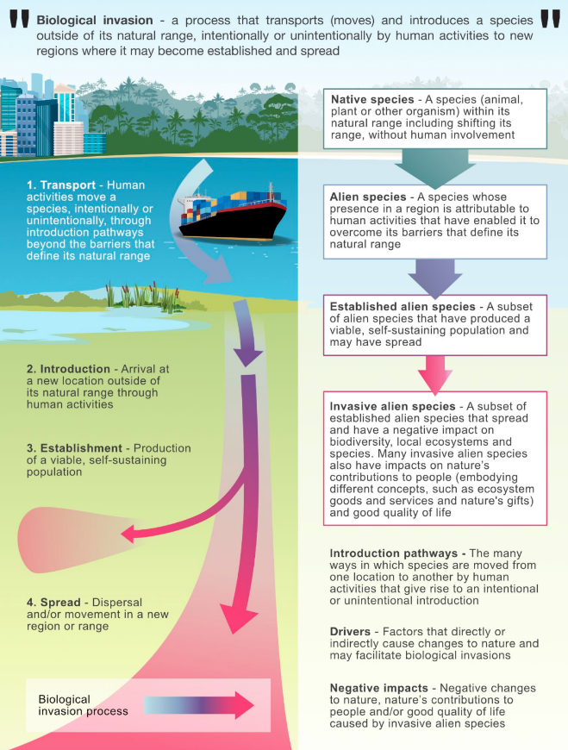
'Q&A: Major global report reveals how climate, land use and trade drive ‘invasive species’' by various Carbon Brief authors is licensed under CC BY-NC-ND 4.0.
- Answer the following questions based on the ‘How invasive species spread’ infographic. Use Figure 1 to answer the following questions.
- List the 4 stages of species invasion.
- What is an alien species?
- What is a driver of biological invasion?
Figure 2 – data on where invasive species occur worldwide
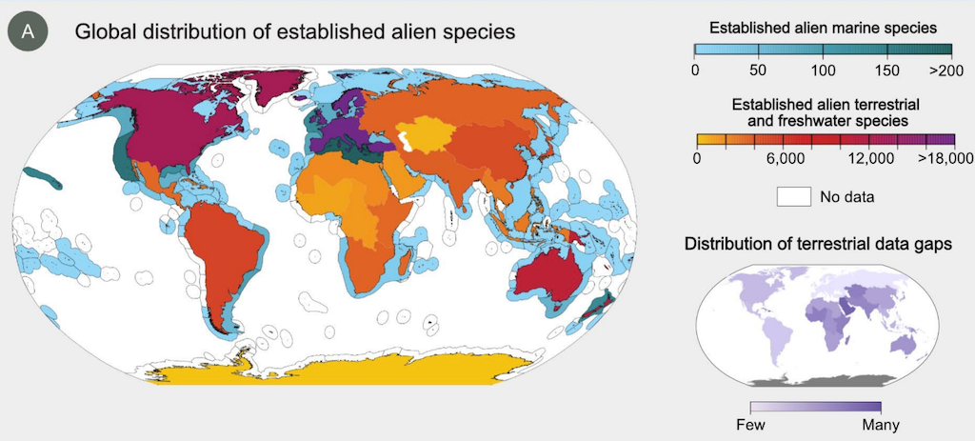
'Q&A: Major global report reveals how climate, land use and trade drive ‘invasive species’' by various Carbon Brief authors is licensed under CC BY-NC-ND 4.0.

- Answer the following questions based on the ‘Where invasive species occur worldwide’ infographic. Use Figure 2 to answer the questions.
- Approximately how many established alien marine and alien terrestrial species are in Australia, and how many freshwater species are in south-eastern Australia?
- Where are the most alien species? Why do you think this is so?
- Which region of the world has the fewest number of alien species? Why do you think this is so?
- What does the distribution of terrestrial data gaps mean? Why would certain areas have these gaps in data?
Figure 3 – information on what drives species invasion?
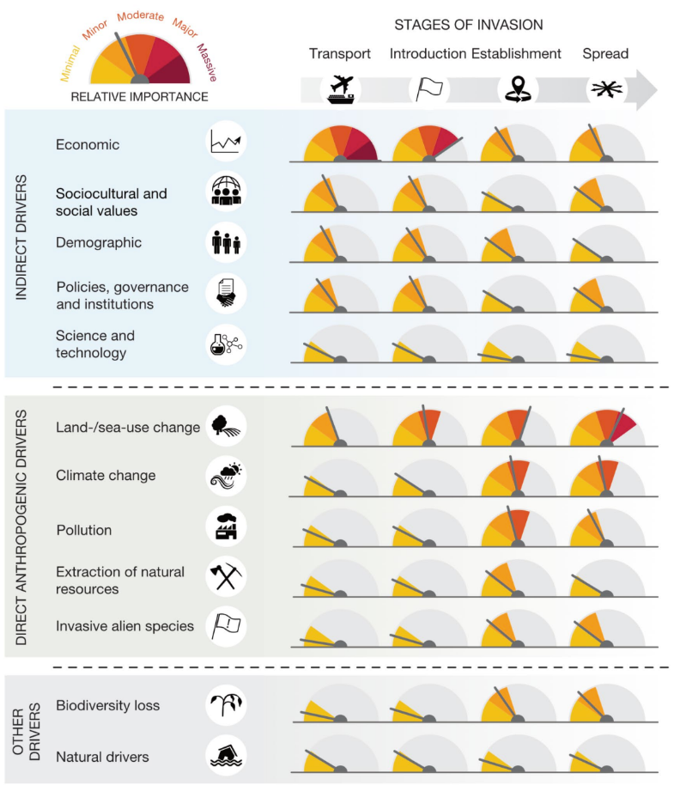
'Q&A: Major global report reveals how climate, land use and trade drive ‘invasive species’' by various Carbon Brief authors is licensed under CC BY-NC-ND 4.0.

- Answer the following questions based on the ‘What drives species invasion?’ infographic. Use Figure 3 to answer the questions. For each stage of invasion, what driver is most important? For each stage, discuss why this might be so.
Figure 4 – information and data on the consequences of invasive species
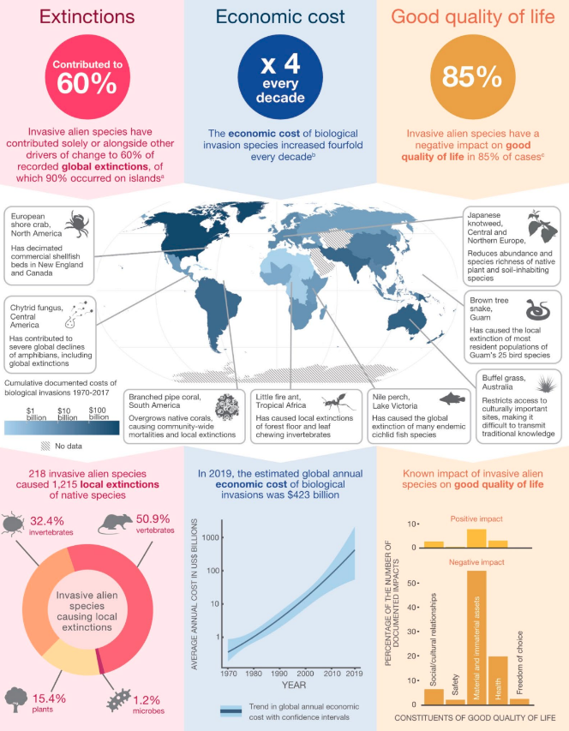
'Q&A: Major global report reveals how climate, land use and trade drive ‘invasive species’' by various Carbon Brief authors is licensed under CC BY-NC-ND 4.0.
- Answer the following questions based on the ‘Consequences of invasive species’ infographic. Use Figure 4 to answer the questions.
- Looking at the data, what 2 pieces of data stand out to you? Why?
- What would be the estimated global annual economic cost of invasive species in 2030?

- Answer the following questions based on the ‘Invasive species management options’ infographic. Use Figure 5 to answer the following questions.
Figure 5 – information on invasive species management options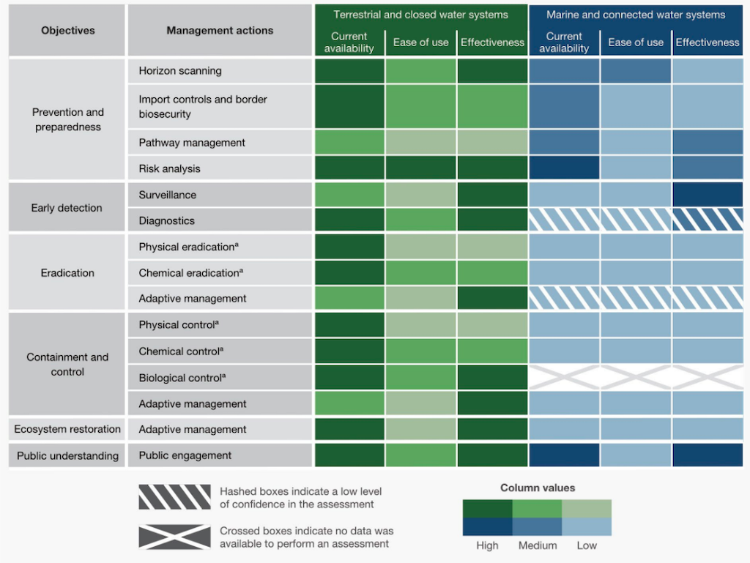
Q&A: Major global report reveals how climate, land use and trade drive ‘invasive species’' by various Carbon Brief authors is licensed under CC BY-NC-ND 4.0.
- For terrestrial environments, identify 3 management actions for terrestrial and closed water systems with high values for current availability and effectiveness, and medium values for ease of use.

- Why do you think marine and connected water systems are more complex to manage?
- Propose an appropriate mix of management actions for your local environment. Justify your choice.
- Write a short statement on how scientific understanding has provided solutions to invasive species to support sustainability.

Understanding the biodiversity problem – other biodiversity problems
In this activity, students will explore threats to biodiversity and possible solutions. To do this, they will:
- examine patterns and trends in data
- investigate relationships between variables
- explore the cause-and-effect impact of deforestation or overfishing on biodiversity
- understand how scientific knowledge is used to draw valid conclusions and address biodiversity issues.
This activity can be completed in small groups or as a whole-class discussion. Each group is provided with data and information on a specific threat to biodiversity, along with possible solutions to explore. Two options have been provided; students only need to complete one option:
- Student resource – changes in land use through deforestation
- Student resource – overexploitation of resources through overfishing.
Note: students will need access to computers to use the stimulus materials in these resources.
Sample response: Student resource – changes in land use through deforestation
Note: graphs and infographics have been removed from the sample responses. Please view them in the relevant student resource.
- Losses in global forests (refer to Figure 1 in the student resource).
- During what decade did deforestation of tropical forests peak? What has been the trend for the deforestation of tropical forests since then? By extrapolating, approximately when will tropical forests start to have a net gain in area?
In the 1980s and early 1990s. There has been a decreasing trend in the deforestation of tropical forests. By approximately 2060, tropical forests will be in net area gain.
- What has happened to temperate forests since 1990? Why do you think that is?
There has been a net gain in temperate forest area. This is possibly due to land management practices that encourage the regrowth of forests worldwide.
- Expansion of agricultural land (refer to Figure 2 in the student resource).
- Explain the trend for forest percentage data.
The percentage of forested land has decreased over time as land is cleared for cultivating crops and grazing land.
- Identify one positive trend in this data. Explain a possible reason for this occurrence.
The areas of land with wild grassland and shrubs have increased by 2% from 1950 to 2018. This may be due to improved conservation and restoration of these areas worldwide.
Deforestation solutions
- Deforestation in eastern Australia (refer to Deforestation fronts factsheet – eastern Australia in the student resource).
- List the key drivers of deforestation in Eastern Australia on page 1.
Livestock, forestry, fire and drought, and cropping.
- Use the information on key responses on page 2 to develop a plan to reduce deforestation in eastern Australia.
To reduce deforestation, we can strengthen state vegetation laws and increase funding to protect forests. Farmers should be rewarded for allowing forests to regenerate naturally through carbon farming and land restoration programs. Supporting deforestation-free beef production will help lessen pressure on forests used for grazing. More areas need protection, and native forest logging should gradually be replaced with plantations.
- Write a brief statement on how scientific understanding has provided sustainable solutions to problems related to deforestation.
Science has helped identify the main causes of deforestation, such as livestock and crop farming. This knowledge has resulted in better laws, programs to reward farmers for protecting forests, and efforts to monitor deforestation in beef supply chains. This will promote the sustainability of agriculture and natural forests.
Sample response: Student resource – overexploitation of resources through overfishing
Note: graphs and infographics have been removed from the sample responses. Please view them in the relevant student resource.
- Worldwide wild fishery production (refer to Figure 1 in the student resource).
- Where are we seeing a decline in wild capture fishery production since 2019?
East Asia and Pacific, Europe and Central Asia, Latin America, Middle East and North Africa and North America.
- Which dataset shows the most variation? (Consider the frequency and magnitude of increases and decreases in the data trend for each area.) Why could this be?
Latin America and the Caribbean. One example could be due to variability in their fish stocks due to fishing pressure. Other examples could include: regulatory changes such as seasonal closures, natural disasters, economic factors such as market demand and stock health.
- Compare East Asia and Pacific capture fishery production to all other areas in 2022.
In 2022, East Asia and Pacific produced 36 million tonnes of wild fish. This is compared to approximately 52.5 million tonnes for all the other world areas. The production from East Asia equals 68.6% of all capture fishery production worldwide.
- Global fish stock (refer to Figure 2 in the student resource).
- How can the percentage of fish stocks that are overfished be higher than the percentage of fish caught that are overfished?
The 2 graphs use different measures of sustainability. Thus, overfishing accounts for 34% of fish stocks (population size), which is equivalent to 21% of fish catch (weight).
- What does this data suggest about global fishing practices in the future as overfished fish stocks decline?
If overfished fish stock collapses, maximally fished stock might become targeted, leading to possible overfishing and decline.
Overfishing solutions
Students engage with the Marine Stewardship Council (MSC) – Sustainable fishing website, watch the listed videos and answer the questions provided for each video.
- Video 1: Sustainable fishing explained (2:54)
- What is the maximum sustainable yield?
- How does the adoption of sustainable methods impact biodiversity in the ocean?
- Fishers collaborate with fisheries scientists to understand how the fish population changes over time due to births, deaths and migrations in and out of the fishery. This helps determine how much fish can be sustainably caught without overfishing.
- Sustainable fishing methods reduce bycatch and prevent overfishing, preventing population collapse, thus helping to sustain a balance among different species in the ocean. This promotes greater biodiversity and ensures that no single marine species is overexploited.
- Video: Sustainable seafood for the future: The three principles of the MSC Fisheries Standard (0:52)
- Describe the 3 principles and identify how each uses scientific understanding to solve a problem relating to sustainability.
Sustainable fish stocks: this principle ensures that fishing is conducted at a level that allows fish populations to remain healthy and productive over time. Scientific assessments of fish population dynamics and reproductive rates are used to set sustainable catch limits, preventing overfishing and ensuring the long-term viability of the species.
Minimising environmental impact: this principle focuses on reducing the impact of fishing activities on the marine ecosystem. Scientific studies on ecosystem interactions and habitat health guides the development of fishing methods that minimise damage to marine habitats and non-target species, helping to preserve biodiversity and maintain ecosystem functions.
Effective management: this principle highlights the importance of strong governance and management systems that can adapt to changing environmental conditions and scientific discoveries. It involves applying policies based on scientific research to oversee fisheries, enforce regulations and ensure compliance with sustainability standards.
- Summarise how scientific understanding provided solutions to the problem of overfishing.
Scientific research has helped us understand fish population dynamics (migration), reproduction rates (births and deaths), and the impacts of overfishing (reducing biodiversity). This knowledge has led to solutions like setting catch limits, using selective fishing gear to reduce bycatch, and protecting breeding areas. These strategies help maintain healthy fish stocks and ensure sustainable fishing practices.

Student resource – changes in land use through deforestation
- Losses in global forests. Use Figure 1 to answer the following questions.
Figure 1 – data on global forest losses
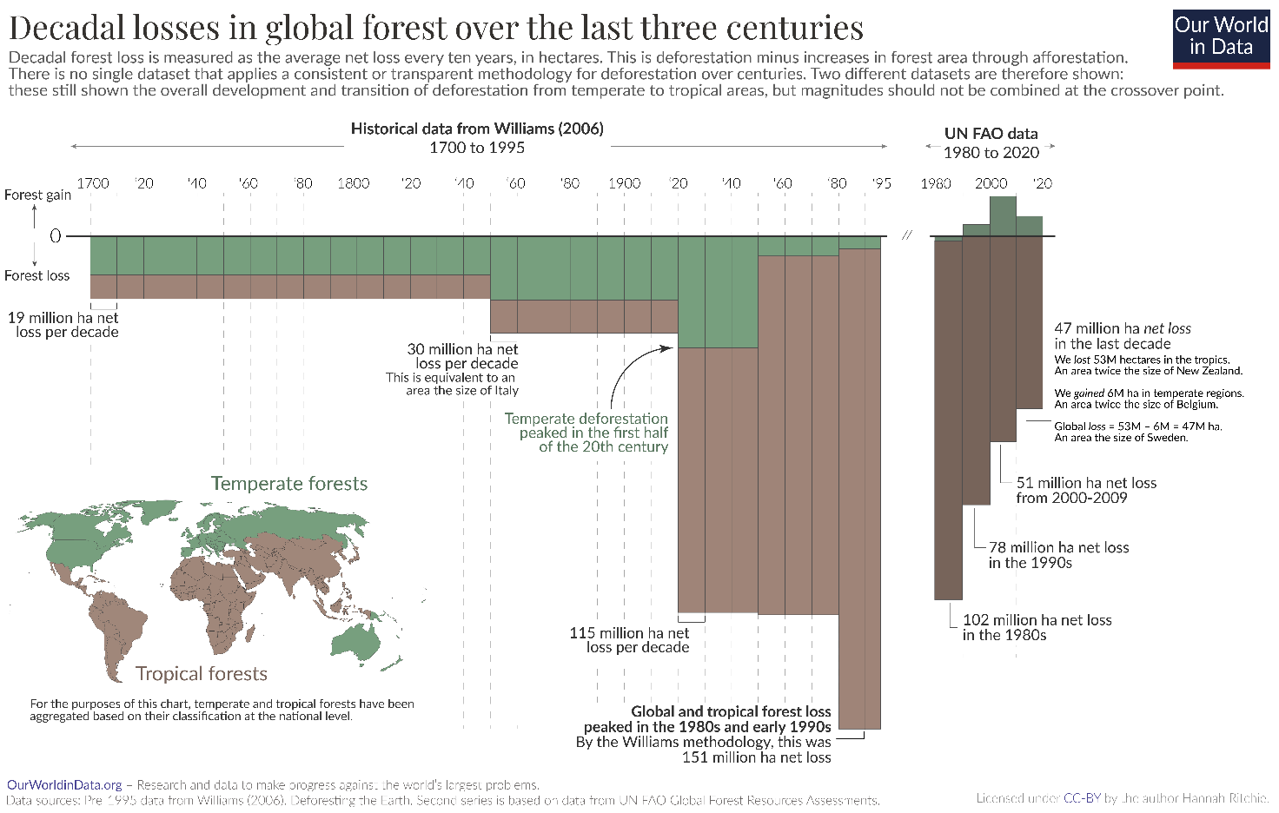
'Global deforestation peaked in the 1980s. Can we bring it to an end?' by Hannah Ritchie is licensed under CC BY 4.0.
- During what decade did deforestation of tropical forests peak? What has been the trend for the deforestation of tropical forests since then? By extrapolating, approximately when will tropical forests start to have a net gain in area?
- What has happened to temperate forests since 1990? Why do you think that is?
- Expansion of agricultural land. Use Figure 2 to answer the following questions.
Figure 2 – data on the expansion of agricultural land
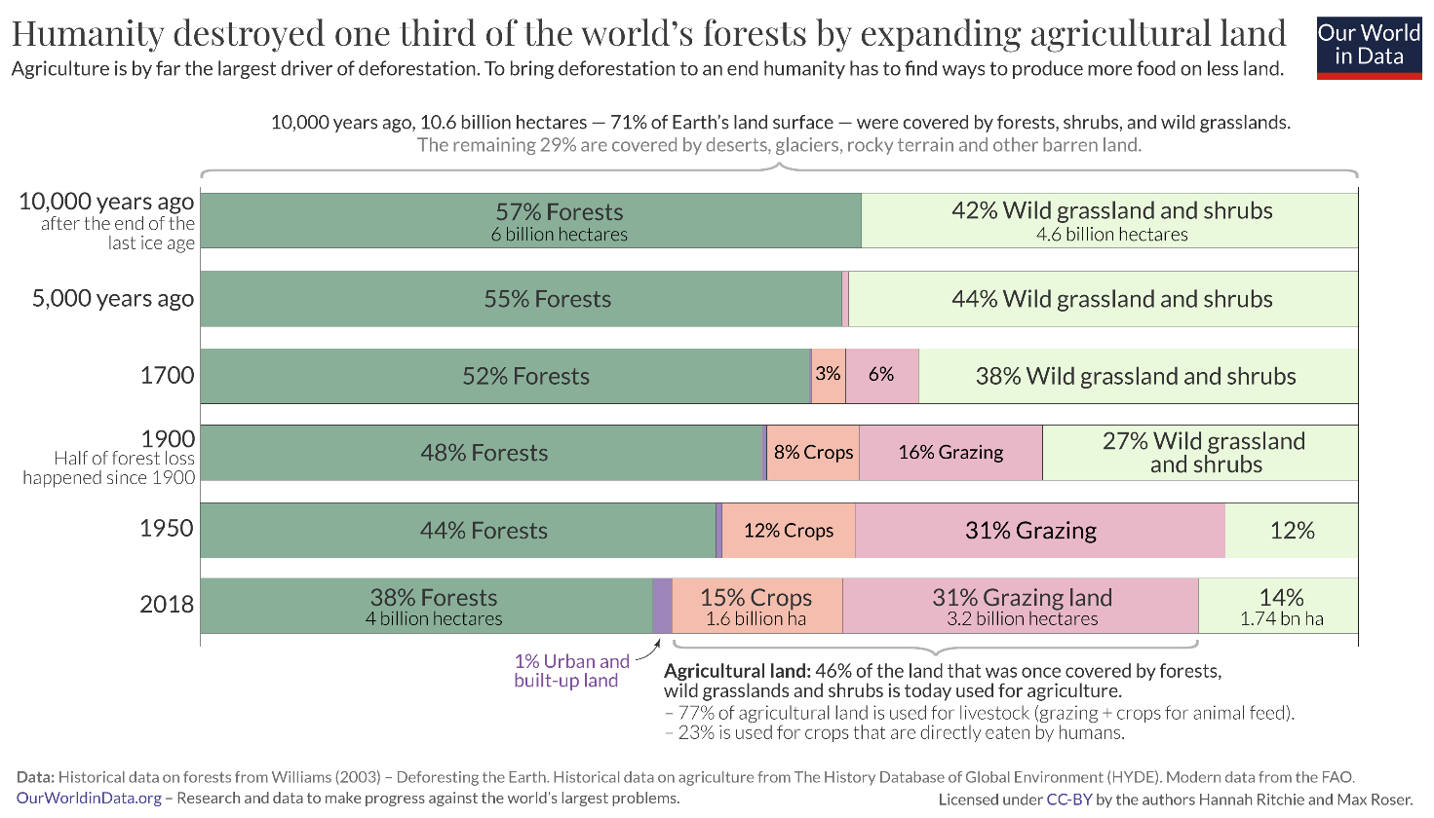
'The world has lost one-third of its forest, but an end of deforestation is possible' by Hannah Ritchie is licensed under CC BY 4.0.
- Explain the trend for forest percentage data.
- Identify one positive trend in this data. Explain a possible reason for this occurrence.

Deforestation solutions
- Deforestation in eastern Australia. Use the information in Deforestation fronts factsheet – eastern Australia to answer the following questions.
- List the key drivers in deforestation in eastern Australia on page 1.
- Use the information on key responses on page 2 to develop a plan to reduce deforestation in eastern Australia.
- Write a brief statement on how scientific understanding has provided sustainable solutions to problems related to deforestation.

Student resource – overexploitation of resources through overfishing
- Worldwide wild fishery production infographic. Use Figure 1 to answer the following questions.
Figure 1 – worldwide wild fishery capture data
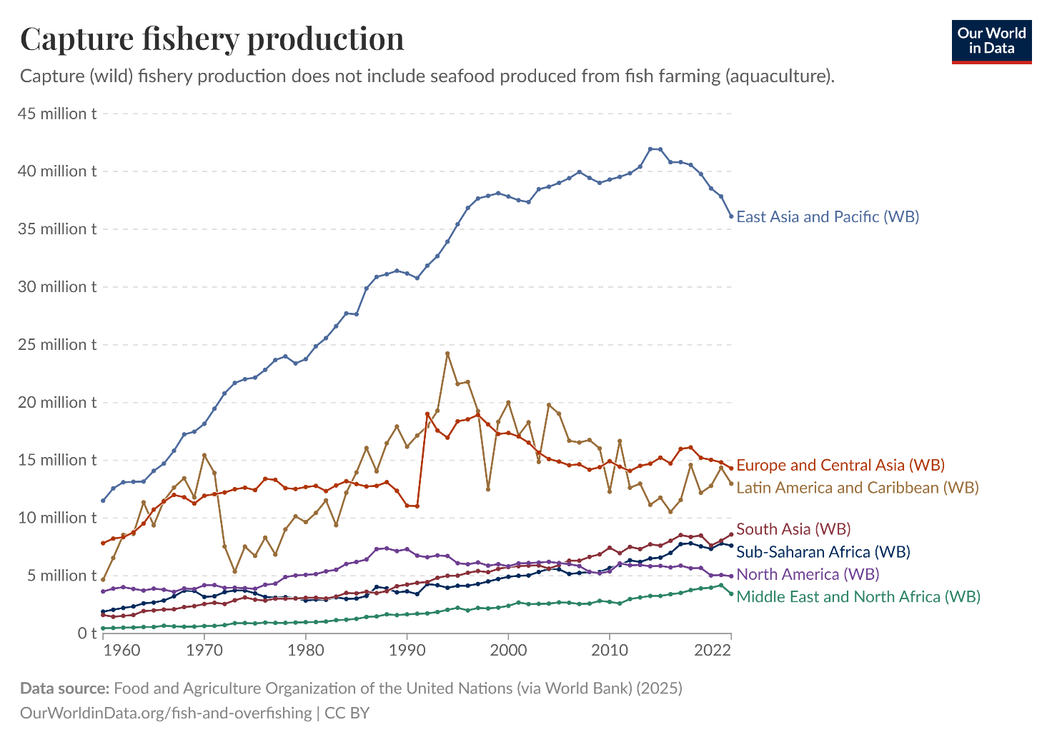
'Fish and overfishing' by Hannah Ritchie is licensed under CC BY 4.0.
- Where are we seeing a decline in wild capture fishery production since 2019?
- Which dataset shows the most variation? (Consider the frequency and magnitude of increases and decreases in the data trend for each area.) Why could this be?
- Compare East Asia and Pacific capture fishery production to all other areas in 2022.
- Global fish stock infographic. Use Figure 2 to answer the following questions.
Figure 2 – data on global fish stocks
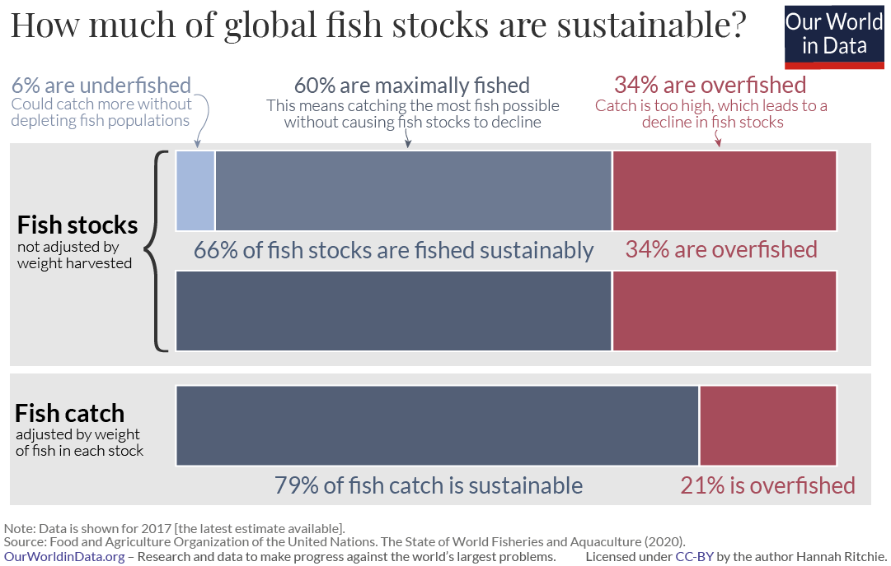
Legend: this infographic presents 2 different ways to measure the sustainability of global fishing as of 2017. The data are presented as stacked bar graphs. The top graph shows the proportions of fish stocks (population size) in the underfished, maximally fished and overfished categories. In contrast, the bottom graph shows the total weight of fish catch in the sustainable and overfished categories.
'Fish and overfishing' by Hannah Ritchie is licensed under CC BY 4.0.
- How can the percentage of fish stocks that are overfished be higher than the percentage of fish caught that are overfished?
- What does this data suggest about global fishing practices in the future as overfished fish stocks decline?
Overfishing solutions
- Use the information in the videos to answer the following questions.
Video: Sustainable fishing explained (2:54)
- What is the maximum sustainable yield?
- How does the adoption of sustainable methods impact biodiversity in the ocean?

- Video: Sustainable seafood for the future: The three principles of the MSC Fisheries Standard (0:52)
- Describe the 3 principles and identify how each uses scientific understanding to solve a problem relating to sustainability.
- Summarise how scientific understanding provided solutions to the problem of overfishing.

1.4 How about this weather?
Table 5 – learning intention and success criteria for ‘1.4 How about the weather?’
We are learning to: | I can:
- analyse data to identify patterns. | - define weather and climate  - describe the differences between weather and climate  - describe patterns in local weather and climate data.
Checkpoint: deliver a checkpoint on the previous lesson’s content. See slide ENV PPT ‘1.4 Checkpoint – quick quiz on previous content’.
Mini challenge (MC): multiple choice question
What is biodiversity?
- The number of forests in a country
- The variety of different species of plants, animals and microorganisms in an area
- The amount of pollution in the environment
- The size of a single animal population.
Challenge (C): give an example of a threat to biodiversity. Why is this a threat?
Super challenge (SC): provide a solution to this threat.
Checkpoint sample response
Mini challenge:
- incorrect answer – this is too narrow. Biodiversity is not just about forests; it includes all ecosystems, from oceans and grasslands to deserts and wetlands.
- correct answer
- incorrect answer – pollution can impact biodiversity, but it’s not what biodiversity means. This answer mixes up a threat to biodiversity with the definition itself.
- incorrect answer – this only describes population size for one species, which is just one small part of biodiversity. Biodiversity looks at the variety of species, not just the count of one.
Challenge: invasive species prey on or outcompete native species. They have contributed to 60% of recorded extinctions, decreasing biodiversity.
Super challenge: enforce strict biosecurity measures at borders to prevent the entry of invasive species into a country. This should be accompanied by public education on the risks of entering a country with an invasive species.

The difference between weather and climate
- Ask students: ‘What’s the weather like today? How would you describe it?’ Record student responses and compare them to a local weather forecast for the day. Note similarities and differences.
- Ask students to think-pair-share the following question: ‘Have we described weather or climate?’ to lead a discussion about the difference.
- Students write definitions for weather and climate using slide ENV PPT ‘1.4 Defining weather and climate’.
- Display ENV PPT ‘1.4 The difference between weather and climate’ and outline the key differences by unpacking the table on the slide.
Checkpoint 2: conduct a quick quiz where students determine whether the following scenarios are related to weather or climate. The correct answers are shown in bold.
- It rained heavily last night (weather).
- Summers are generally hot and wet here (climate).
- Today’s maximum temperature is 24°C (weather).
- This region has relatively low average rainfall (climate).

Comparing local weather with local climate
In this activity, students will explore the difference between weather and climate using real data from the Bureau of Meteorology. By examining daily maximum temperatures from their local area, students will compare short-term weather data with long-term climate averages to identify patterns, trends and anomalies. This hands-on activity builds their skills in data analysis while deepening their understanding of key climate concepts.
- Provide students with access to the Bureau of Meteorology Climate Data Online temperature data for their local area. Search for maximum temperature data for a whole year (for example, 2025) for the weather station closest to your location. For example:
- Select ‘Map search’
- zoom to your local area
- select ‘Daily maximum temp’
- click on a weather station
- click on the ‘Daily max. temperature’ data for a weather station nearest your location.
Figure 1 – BOM climate data local area search
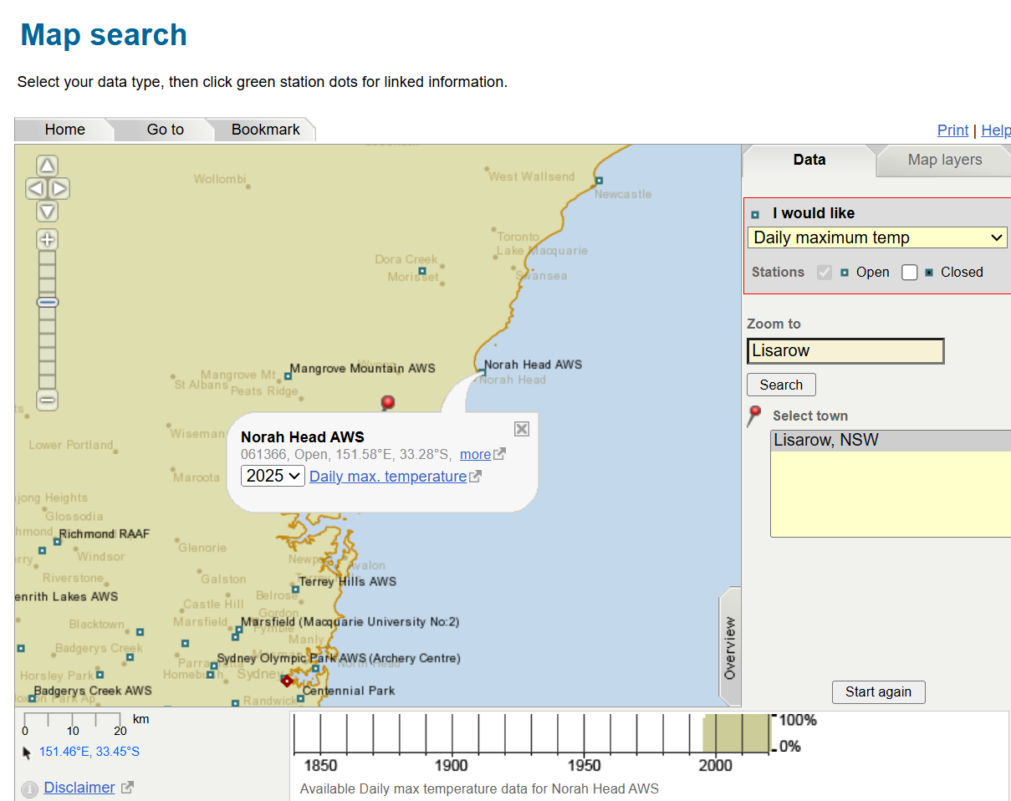
'Bureau of Meteorology climate data online’ by Bureau of Meteorology, © Commonwealth of Australia, is licensed under CC BY 4.0.
- Provide students with the Student resource – comparing local weather with local climate. Students extract the information from the webpage to complete the table.
- Students then compare the weather data (for one year) to the climate data (for 30 years or more) and record their observations, noting any patterns over the year and any inconsistencies in the data.
- Display the ‘Plot statistics and this year’ line graph on the Daily maximum temperature webpage. Figure 2 illustrates where to find this feature on the website. Figure 3 displays the graphical comparison of maximum temperatures.
Students should observe the grey and green plot lines. Ask them to compare this year’s maximum temperature data with the mean maximum temperatures for all years using the graph. They should identify the overall pattern of maximum temperatures throughout the year and note any differences between this year’s data and the historical averages. Finally, they should compare their observations from the graph with the table they reviewed in the previous step.
Figure 2 – plot statistics and this year
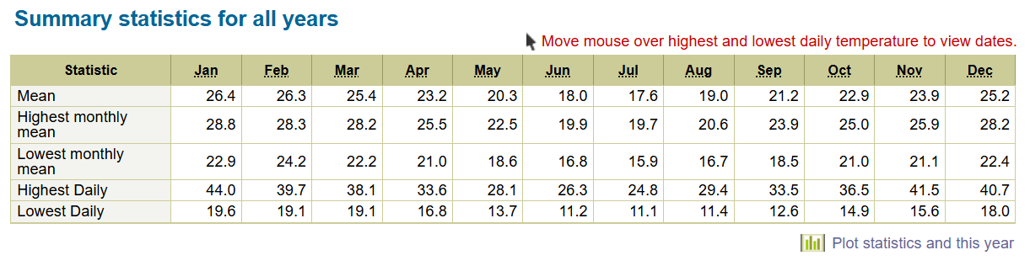'Bureau of Meteorology daily maximum temperature’ by Bureau of Meteorology, © Commonwealth of Australia is licensed under CC BY 4.0.
Figure 3 – comparing maximum temperatures
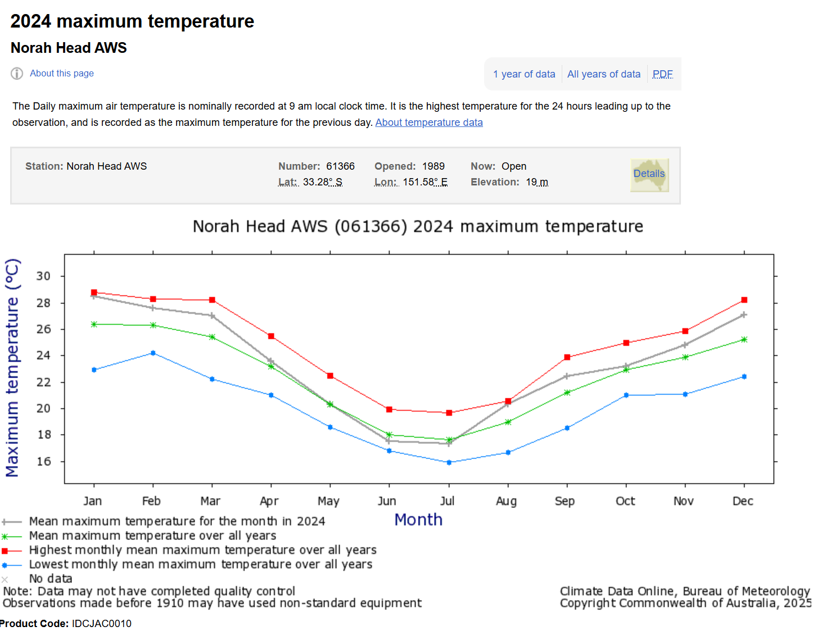Bureau of Meteorology 2024 maximum temperature by Bureau of Meteorology © Commonwealth of Australia is licensed under CC BY 4.0.
Optional: repeat this process for local rainfall, noting patterns for both a recent year and long-term averages.
Sample response: Student resource – comparing local weather with local climate
Table 6 – local maximum temperature for Norah Head
Month | Monthly mean (°C)
Month | Year: 2024 | All years
Jan | 39.6 | 28.8
Feb | 36.9 | 28.3
Mar | 30.5 | 28.2
Apr | 28.7 | 25.5
May | 23.7 | 22.5
Jun | 21.4 | 19.9
Jul | 21.5 | 19.7
Aug | 28.2 | 20.6
Sep | 27.8 | 23.9
Oct | 29.2 | 25.0
Nov | 28.4 | 25.9
Dec | 36.3 | 28.2
What patterns in maximum temperature over the year are evident?
There is a clear drop in temperature from April (28.7°C) to a yearly minimum in June (21.4°C). There is a cool part of the year from May to July with a sharp increase in August (28.2°C), with high temperatures persisting through to December.
The first part of the year (January to April) shows a steady decrease in temperature. After August, temperatures remain high and reasonably stable.
What inconsistencies in the data are evident when one year is compared to all years?
2024 experienced consistently higher temperatures compared to previous years. Every month recorded a higher daily temperature than the long-term average indicating that 2024 was an unusually warm year. The largest increases occurred in the summer months (January, February and December). For example, the highest daily temperature in January 2024 is 39.6°C, which is almost 11°C higher than the average of 28.8°C. August is also significantly warmer than usual, 28.2°C compared to the average of 20.6°C.

Student resource – comparing local weather with local climate
Table 1 – local maximum temperature (weather and climate)
Month | Monthly mean (°C)
Month | Year: _______ | All years
Jan
Feb
Mar
Apr
May
Jun
Jul
Aug
Sep
Oct
Nov
Dec
What patterns in maximum temperature over the year are evident?
What inconsistencies in the data are evident when one year is compared to all years?

1.5 What is the data telling us?
Table 7 – learning intentions and success criteria for 1.5 What is the data telling us?
We are learning to: | I can:
- analyse data to identify trends and relationships in climate data. | - develop criteria and make a judgment on the validity of information from secondary sources  - describe the relationship between identified climate data variables, for example, temperature over time  - extrapolate information from climate data.
Checkpoint: deliver a checkpoint on the previous lesson’s content using ENV PPT ‘1.5 Checkpoint – quick quiz on previous content’.
Mini challenge (MC): multiple choice question
What is the main difference between climate and weather?
- Weather describes long-term patterns; climate describes daily conditions.
- Climate describes long-term patterns; weather describes daily conditions.
- Climate changes every hour; weather changes over decades.
- Weather and climate mean the same thing.
Challenge (C): What weather patterns are observed for your local area over a year? Have these varied from long-term weather patterns? If so, how?
Checkpoint sample response
Mini challenge:
- incorrect answer – this is the reverse of the truth. Weather is short-term (like today’s rain or tomorrow’s temperature), while climate is about patterns over many years.
- correct answer
- incorrect answer – this is flipped. Climate changes slowly over a long period of time, while weather can change quickly, even within hours.
- incorrect answer – they are related but not the same. Weather is short-term conditions; climate is long-term trends.
Challenge: various answers, for example, average monthly maximum temperatures peak at about 28°C in January, and these drop to an average maximum temperature of 19°C in July.

What’s the state of Australia’s climate?
In this lesson, students evaluate the credibility of climate data by examining how Australia’s leading science organisations, the Commonwealth Scientific and Industrial Research Organisation (CSIRO) and the Bureau of Meteorology (BOM), collect, analyse and report climate trends. They will explore the State of the Climate report, assess the authority and scientific methods behind it, and interpret real climate data to identify patterns, relationships and future projections.
- Inform students that every 2 years, Australian government agencies, the Commonwealth Scientific and Industrial Research Organisation (CSIRO) and the Bureau of Meteorology (BOM), release the State of the Climate report for Australia. Show the report and focus on the key points on pages 2 and 3.
- Ask the students ‘How do we know that this report and the data collected by CSIRO and the BOM for this report are valid and reliable?’ Guide a whole-class discussion to assess the credibility of the CSIRO and BOM using the ENV PPT ‘1.5 What’s the state of Australia’s climate?’ (5 slides) which unpacks the following criteria:
- authority and expertise
- use of scientific methods
- government affiliation and funding
- transparency and peer review
- regular updates and real-time data.
- Watch the video: State of the Climate 2024 (2:15) by the Bureau of Meteorology, see slide ENV PPT ‘1.5 State of Australia’s climate 2024 – the data’. Students list the data that would need to be collected and analysed to determine the trends in Australia’s climate.
Sample list:
- CO₂ gas concentrations in the atmosphere
- temperature at the land and sea surfaces
- frequency of extreme heat days
- frequency of dangerous fire weather days
- intensity of rainfall events
- pH of oceans
- frequency of marine heatwaves
- sea levels
- Students analyse data on temperature anomalies, extreme heat events and rainfall. Find the relevant section for each of these in the State of the Climate 2024 report: temperature anomalies (page 2), extreme heat events (page 5), and rainfall (page 8). Students use the relevant data and information in the report to answer the following Australian climate data analysis questions:
- Describe what the graph or representation of the climate data is trying to show.
- Is there a relationship between the 2 variables evident in the climate data? Describe this relationship. Is there a trend in this relationship? If so, what is this trend?
- Use the graph of the climate data to extrapolate what could happen in the future for this climate data.
Note: start by modelling how to answer the questions using one set of climate data. Then, guide students as they work in pairs with a second set. Finally, have them complete the questions independently with a third set. Refer to slides ENV PPT ‘1.5 State of the climate 2024’ (3 slides) for worked examples and the Student resource – What’s the state of Australia’s climate?
Optional: further datasets could also be explored.
Sample response: Student resource – What’s the state of Australia’s climate?
Note: graphs and infographics have been removed from the sample responses. Please view them in the relevant student resource.
- Temperature anomalies (refer to Figure 1 in the student resource).
- Describe what the graph or representation of the climate data is trying to show.
The graph illustrates the changes in temperature anomalies (differences from the 1961–1990 average) of Australian surface air temperature anomalies and nearby sea surface temperature changes from 1910 to 2020, relative to the 1961–1990 average.
- Is there a relationship between the 2 variables evident in the climate data? Describe this relationship. Is there a trend in this relationship? If so, what is the nature of this trend?
Yes, there is a clear relationship between 2 variables: Australian surface air temperature and sea surface temperature. Both variables show a similar pattern over time – when one rises or falls, the other often follows.
Trend: both the land and sea surface temperatures have generally risen since 1910. Although the land air temperature shows more short-term variation (with sharper increases and decreases), both variables reveal a strong long-term warming trend.
- From the graph of the climate data, extrapolate what could happen in the future for this climate data.
If the current trend persists, Australian surface air temperatures and sea surface temperatures are likely to continue rising. This indicates that Australia will face even warmer climates, with higher average temperatures over land and surrounding oceans.
- Extreme heat days (refer to Figure 2 in the student resource)
- Describe what the graph or representation of the climate data is trying to show.
The graph illustrates the number of days each year when Australia's daily mean temperature was in the warmest 1% of records for that month, from 1910 to 2023.
- Is there a relationship between the 2 variables evident in the climate data? Describe this relationship. Is there a trend in this relationship? If so, what is the nature of this trend?
Yes, there is a relationship over time: as the years progress, the number of extreme heat days increases.
Trend: before 1950, extreme heat days were uncommon and few in number. After 1970, the number of extreme heat days began to rise steadily. There has been a sharp rise in recent decades, especially after 2000, with some years experiencing over 30–40 extreme heat days.
- From the graph of the climate data, extrapolate what could happen in the future for this climate data.
If the current trend continues, Australia is likely to experience even more extreme heat days each year. The frequency of extreme heat events is expected to continue rising, leading to more prolonged and intense heatwaves in the future.
- Rainfall decline (refer to Figure 3 in the student resource)
- Describe what the graph or representation of the climate data is trying to show.
The map illustrates rainfall patterns across Australia from April to October over the past 30 years (1994–2023), compared to historical records from 1900 to 1993.
- Is there a relationship between the 2 variables evident in the climate data? Describe this relationship. Is there a trend in this relationship? If so, what is the nature of this trend?
Yes, there is a relationship between location and rainfall levels.
Trend: southern Australia, parts of Western Australia, South Australia, and Victoria have experienced a significant decline in rainfall. Most southern regions are shown in shades of orange and red, highlighting below-average to historically low rainfall. Conversely, some areas in northern Australia are experiencing average or above-average rainfall, although these are less widespread.
- From the graph of the climate data, extrapolate what could happen in the future for this climate data.
If the current trend persists, southern Australia is likely to face drier conditions from April to October. This could result in more frequent droughts, greater strain on water resources, and effects on agriculture and ecosystems in the area.
Data talk (optional task): data talks help support student data literacy, thinking and engagement. Youcubed by Stanford University has a data talk called NASA Data Talk – Land Temperature that is relevant to the content taught in this lesson sequence.

Student resource – What’s the state of Australia’s climate?
Carefully examine the data in the graph or infographics and use it to answer the questions below.
- Refer to Figure 1 to answer the questions on temperature anomalies.
Figure 1 – sea surface and Australian surface air temperature anomaly
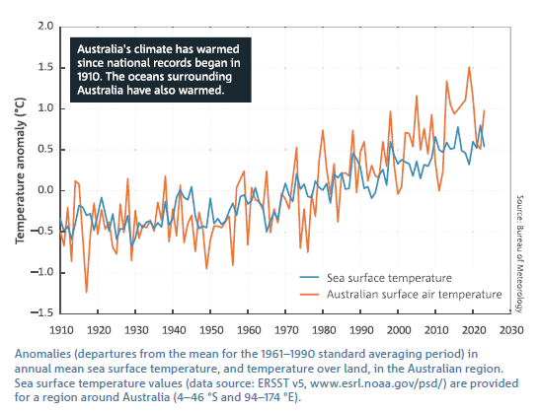
'State of the Climate 2024’ is reproduced by permission of the Bureau of Meteorology © 2025 Commonwealth of Australia.
- Describe what the graph or representation of the climate data is trying to show.
- Is there a relationship between the 2 variables evident in the climate data? Describe this relationship. Is there a trend in this relationship? If so, what is the nature of this trend?
- From the graph of the climate data, extrapolate what could happen in the future for this climate data.
- Refer to Figure 2 to answer the questions about the number of extreme heat days
Figure 2 – number of extreme heat events in Australia
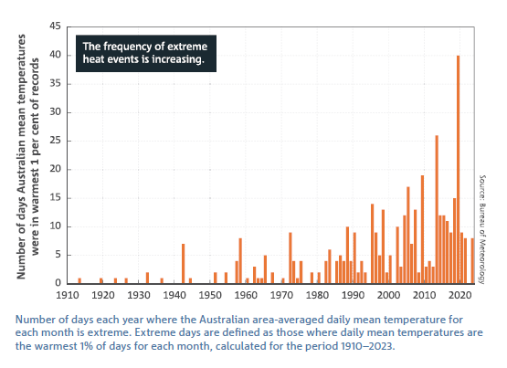
'State of the Climate 2024’ is reproduced by permission of the Bureau of Meteorology © 2025 Commonwealth of Australia.
- Describe what the graph or representation of the climate data is trying to show.
- Is there a relationship between the 2 variables evident in the climate data? Describe this relationship. Is there a trend in this relationship? If so, what is the nature of this trend?
- From the graph of the climate data, extrapolate what could happen in the future for this climate data.

- Refer to Figure 3 to answer the questions about rainfall decline.
Figure 3 – Australia rainfall decile ranges 1994 to 2023
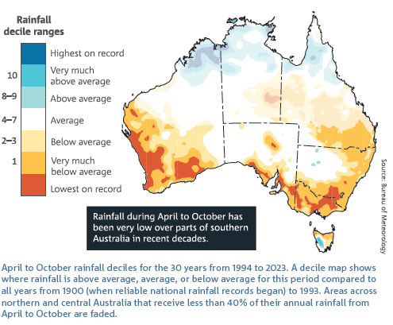
'State of the Climate 2024’ is reproduced by permission of the Bureau of Meteorology © 2025 Commonwealth of Australia.
Note: in statistics, a decile range refers to a grouping of data into 10 equal parts, with each part representing 10% of the total data.
- Describe what the graph or representation of the climate data is trying to show.
- Is there a relationship between the 2 variables evident in the climate data? Describe this relationship. Is there a trend in this relationship? If so, what is the nature of this trend?
- From the graph of the climate data, extrapolate what could happen in the future for this climate data.

What is the state of the world’s climate?
Students, with teacher support, search for data similar to the Australian CSIRO and BOM data previously examined from the State of the Climate 2024 report. They then respond to the world climate data analysis questions for up to 3 sets of data. This activity can be completed as a modelled, guided or independent task, depending on student needs. Examples of 3 datasets that can be analysed are provided on the slides, ENV PPT ‘1.5 Our World in data – Data catalogue’ (3 slides), and in Student resource – What is the state of Australia’s climate?
- Share world climate data from the Our World in Data – data catalogue and search for climate change. Students complete the World climate data analysis questions below in relation to 3 sets of data:
- Is the data from a valid secondary source? What criteria did you use to make this judgment?
- Describe what the graph or representation of the climate data is showing.
- Is there a relationship between 2 variables evident in the climate data? If so, describe this relationship. Is there a trend in this relationship? If so, what is the nature of this trend?
- From the graph of the climate data, extrapolate what could happen in the future for this climate data.
- How does this world climate data compare to what is in the State of the Climate 2024 report? Note: this question should be omitted if similar data cannot be accessed.
Differentiation:
Process: instead of having students find the connections in the data themselves, provide them with a list of data that needs to be collected and analysed to determine the trends in Australia’s climate. Provide the relevant graphics related to this data in the State of the Climate report and in the Our World in Data – Data catalogue.

Sample response: Student resource – What is the state of the world's climate?
Note: the infographics have been removed from the sample response. They can be found in the student resource.
- Global annual temperature anomaly 1850–2025 (refer to Figure 1 in the student resource).
- Is the data from a valid secondary source? What criteria did you use to make this judgment?
Yes, the Met Office is the United Kingdom’s equivalent to the BOM. As a government agency, it is publicly accountable and must follow national standards and protocols.
Their information is not driven by commercial interests, reducing the risk of bias.
- Describe what the graph or representation of the climate data is showing.
It describes the difference in global average land-sea surface temperatures from 1850 to 2025, compared to the 1861–1890 mean.
- Is there a relationship between the 2 variables evident in the climate data? If so, describe this relationship. Is there a trend in this relationship? If so, what is the nature of this trend?
Yes, there is a relationship between temperature anomaly and time. This is most evident from 1964 to 2025, when global temperature anomalies increased steadily.
- From the graph of the climate data, extrapolate what could happen in the future for this climate data.
Temperature anomalies are expected to continue rising.
- How does this world climate data compare to what is in the State of the Climate 2024 report? (You will only be able to answer if there is similar data.)
This is consistent with the data in the State of the Climate 2024 report, which illustrates how Australian surface air temperature anomalies (deviations from the 1961–1990 average), along with surrounding sea surface temperature anomalies, have risen from 1910 to 2020.
- Global temperature anomalies by month (refer to Figure 2 in the student resource).
- Is the data from a valid secondary source? What criteria did you use to make this judgment?
Yes, the Copernicus Climate Change Service (C3S) is run on behalf of the European Union. Like CSIRO and BOM, it is staffed by expert climate scientists, meteorologists and data specialists.
- Describe what the graph or representation of the climate data is showing.
Global temperature anomalies from the mean monthly temperature for the period 1991–2020, for each month of the year from 1940 to 2024.
- Is there a relationship between 2 variables evident in the climate data? If so, describe this relationship. Is there a trend in this relationship? If so, what is the nature of this trend?
Yes, each month shows a trend of increasing positive temperature anomalies over time.
- From the graph of the climate data, extrapolate what could happen in the future for this climate data.
The difference in monthly temperatures from the 1991–2020 average could continue to rise for each month of the year.
- How does this world climate data compare to what is in the State of the Climate 2024 report? (You will only be able to answer if there is similar data.)
The State of the Climate 2024 report did not provide monthly temperature data.
- Sea surface temperature anomalies (refer to Figure 3 in the student resource).
- Is the data from a valid secondary source? What criteria did you use to make this judgment?
Yes, like CSIRO, BOM, and C3S, the Hadley Centre uses high-quality scientific methods.
Advanced computer models are used to simulate climate systems. Observational data is gathered from satellites, weather stations and ocean buoys. Their research is published in peer-reviewed journals and is used in major climate assessments, such as the IPCC (Intergovernmental Panel on Climate Change) reports.
- Describe what the graph or representation of the climate data is showing.
The average sea surface temperature (measured at a depth of 20 cm) anomalies (compared to baseline period 1861–1890) for the Northern Hemisphere, Southern Hemisphere and the world.
- Is there a relationship between the 2 variables evident in the climate data? If so, describe this relationship. Is there a trend in this relationship? If so, what is the nature of this trend?
There is an evident relationship between global sea surface temperature anomalies and time. Sea surface temperature anomalies have increased since 1975 compared to baseline average temperatures from 1861–1890.
- From the graph of the climate data, extrapolate what could happen in the future for this climate data.
Sea temperature anomalies would continue to increase, leading to consequences for environmental sustainability.
- How does this world climate data compare to what is in the State of the Climate 2024 report? (You will only be able to answer if there is similar data.)
This data is consistent with sea surface temperature anomalies as reported in the State of the Climate 2024 report. This is an evident increase in sea surface temperature anomalies compared to baseline data. However, the State of the Climate 2024 report uses data from 1961–1990 as the baseline average sea temperature data.

Student resource – What is the state of the world's climate?
- Refer to the data in the graph or infographic and answer the questions on global annual temperature anomaly 1850–2025.
Figure 1 – global annual temperature anomaly 1850-2025
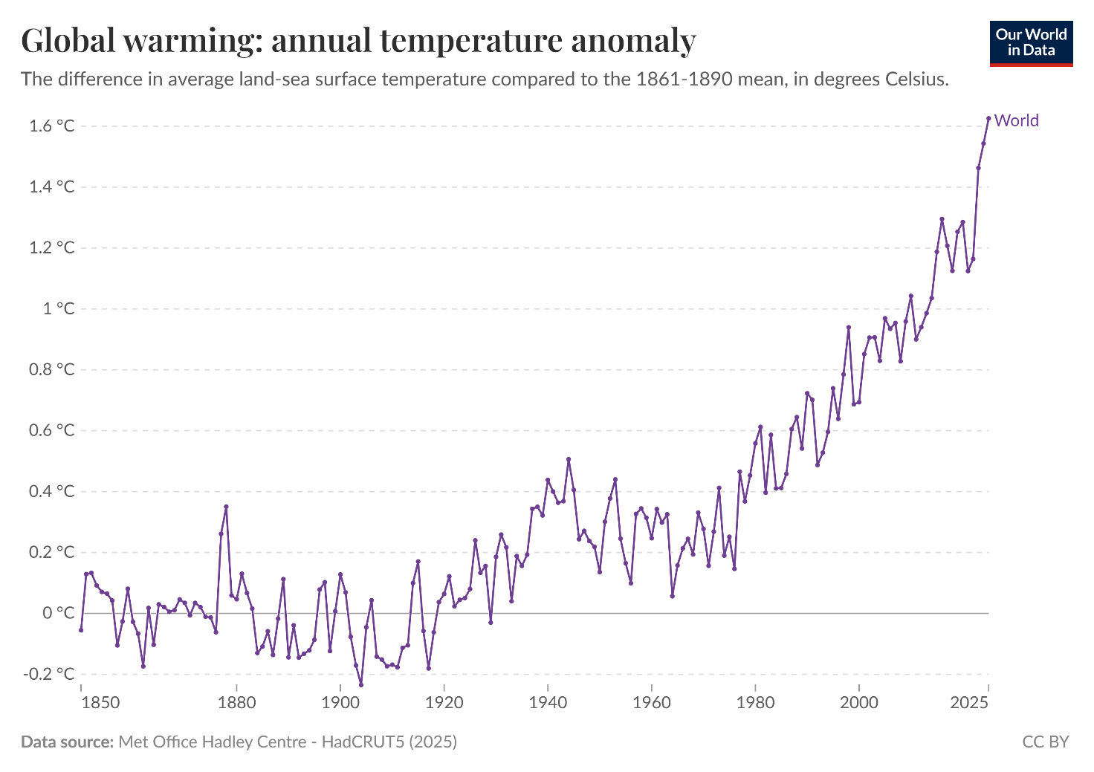
'Global warming: annual temperature anomaly' by Our World in Data is licensed under CC BY 4.0.
- Is the data from a valid secondary source? What criteria did you use to make this judgment?

- Describe what the graph or representation of the climate data is showing.
- Is there a relationship between the 2 variables evident in the climate data? If so, describe this relationship. Is there a trend in this relationship? If so, what is the nature of this trend?
- From the graph of the climate data, extrapolate what could happen in the future for this climate data.
- How does this world climate data compare to what is in the State of the Climate 2024 report? (You will only be able to answer if there is similar data.)

- Refer to the data in the graph or infographic and answer the questions on global temperature anomalies by month.
Figure 2 – graphs of global temperature anomalies by month
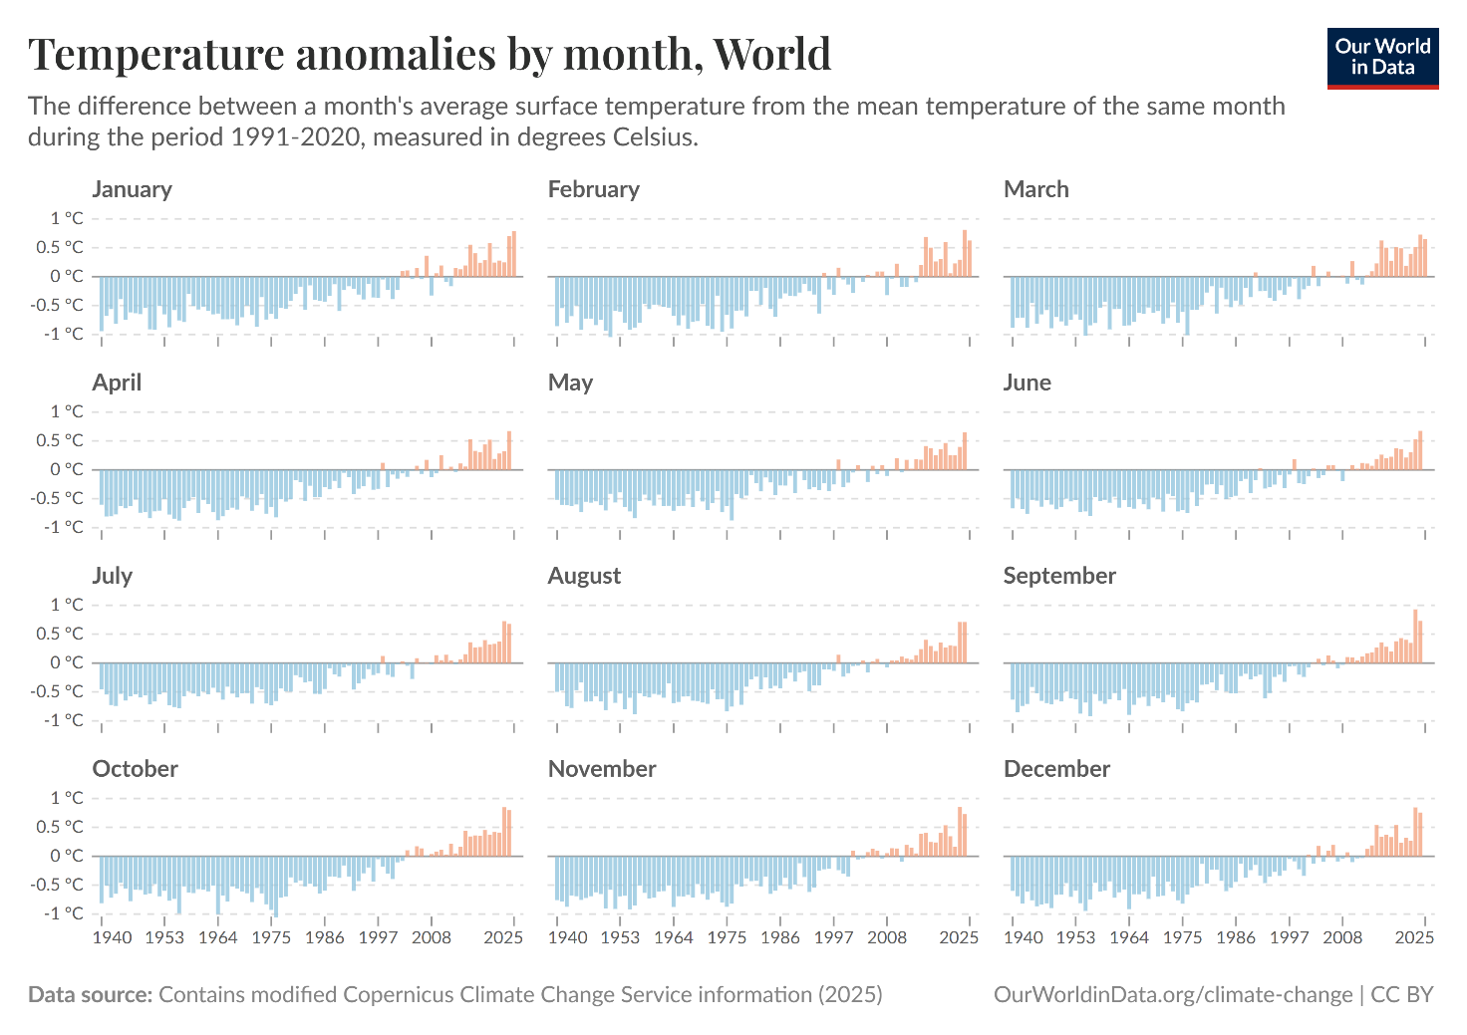
'Temperature anomalies by month, World’ by Our World in Data is licensed under CC BY 4.0.
- Is the data from a valid secondary source? What criteria did you use to make this judgment?

- Describe what the graph or representation of the climate data is showing.
- Is there a relationship between 2 variables evident in the climate data? If so, describe this relationship. Is there a trend in this relationship? If so, what is the nature of this trend?
- From the graph of the climate data, extrapolate what could happen in the future for this climate data.
- How does this world climate data compare to what is in the State of the Climate 2024 report? (You will only be able to answer if there is similar data.)

- Refer to the data in the graph or infographic and answer the questions on sea surface temperature anomalies.
Figure 3 – graphs sea surface temperature anomalies
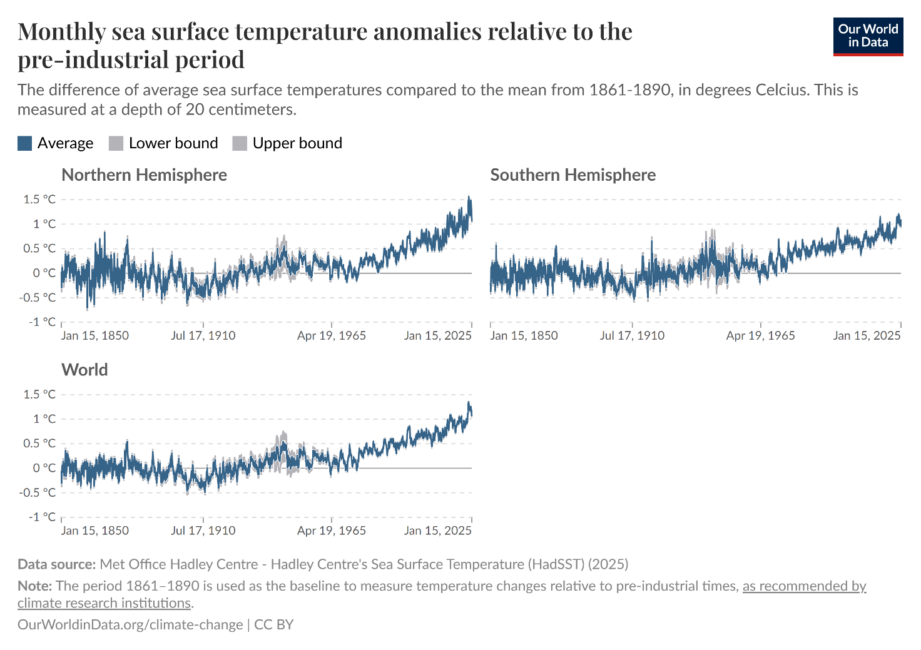
'Monthly sea surface temperature anomalies relative to the pre-industrial period’ by Our World in Data is licensed under CC BY 4.0.
- Is the data from a valid secondary source? What criteria did you use to make this judgment?

- Describe what the graph or representation of the climate data is showing.
- Is there a relationship between the 2 variables evident in the climate data? If so, describe this relationship. Is there a trend in this relationship? If so, what is the nature of this trend?
- From the graph of the climate data, extrapolate what could happen in the future for this climate data.
- How does this world climate data compare to what is in the State of the Climate 2024 report? (You will only be able to answer if there is similar data).

1.6 Is there something natural about the greenhouse effect?
Table 8 – learning intentions and success criteria for ‘1.6 Is there something natural about the greenhouse effect?’
We are learning to: | I can:
- explain the impact of the greenhouse effect on the natural world | - define the natural greenhouse effect  - explain how the natural greenhouse effect influences climate  - explain how the natural greenhouse effect supports life on Earth
- analyse data from investigations to identify relationships | - explain the relationship between the greenhouse effect and the temperature of the atmosphere
- use a suitable problem-solving strategy (scientific models). | - use a model of the greenhouse effect to  - make predictions  - simplify complex ideas  - demonstrate relationships.
Checkpoint: deliver a checkpoint on the previous lesson’s content using ENVPPT ‘1.6 Checkpoint– quick quiz on previous content’.
Mini challenge (MC): What makes the CSIRO a valid source of information and data?
Challenge (C): What trend is evident in Australia’s climate data?
Checkpoint sample response
Mini challenge: the CSIRO uses reliable scientific methods, expert researchers and peer-reviewed data to provide accurate and trustworthy information.
Challenge: there is a clear trend of rising average temperatures, more frequent extreme weather events such as heatwaves, and changes in rainfall patterns with some regions becoming drier over time.

A greenhouse supports life
This lesson introduces students to the natural greenhouse effect that traps heat and keeps the planet habitable. Students will explore how greenhouse gases naturally regulate global temperature and why this process is essential for supporting life using a combination of simulations, models, discussions and diagrams.
- Highlight that today’s lesson is about understanding the Earth's ‘natural blanket’, the natural greenhouse effect. The next lesson will look at human influence on the enhanced greenhouse effect.
- Define atmosphere and greenhouse gases using ENV PPT ‘1.6 The natural greenhouse effect – definitions’.
- Display ENV PPT ‘1.6 The natural greenhouse effect – think-pair-share (1)’. Students complete a think-pair-share for the question ‘What would happen to Earth’s temperature if there were no atmosphere?’ A sample response is provided in the notes of the slide.
- Demonstrate what would happen if there were no greenhouse gases in the atmosphere using the PhET Greenhouse Effect simulation by following these steps:
- Select Waves.
- Ensure that the ‘cloud’, ‘energy balance’ and ‘surface thermometer’ check boxes are ticked (selected).
- Click on ‘start sunlight’ to start the simulation.
- Discuss with students the energy changes that are occurring in the simulation, focusing on the following:
- Energy in sunlight is shown as the yellow waves.
- After sunlight reaches the ground, it is absorbed and emitted by the ground as red (infrared) waves. Some of the red waves move through the atmosphere and are released to space, while the rest are reflected back to the ground by the atmosphere. The reflected red waves warm the Earth’s surface (note the increased temperature indicated by the thermometer).
- Clouds reflect incoming sunlight to space, thus reducing the amount of sunlight that reaches the Earth’s surface.
- Notice the energy balance at the top of the atmosphere. The energy entering and leaving the atmosphere is balanced (net = 0).
- Next, set the greenhouse gas concentration to zero, as shown in Figure 4.
Figure 4 – greenhouse effect simulation
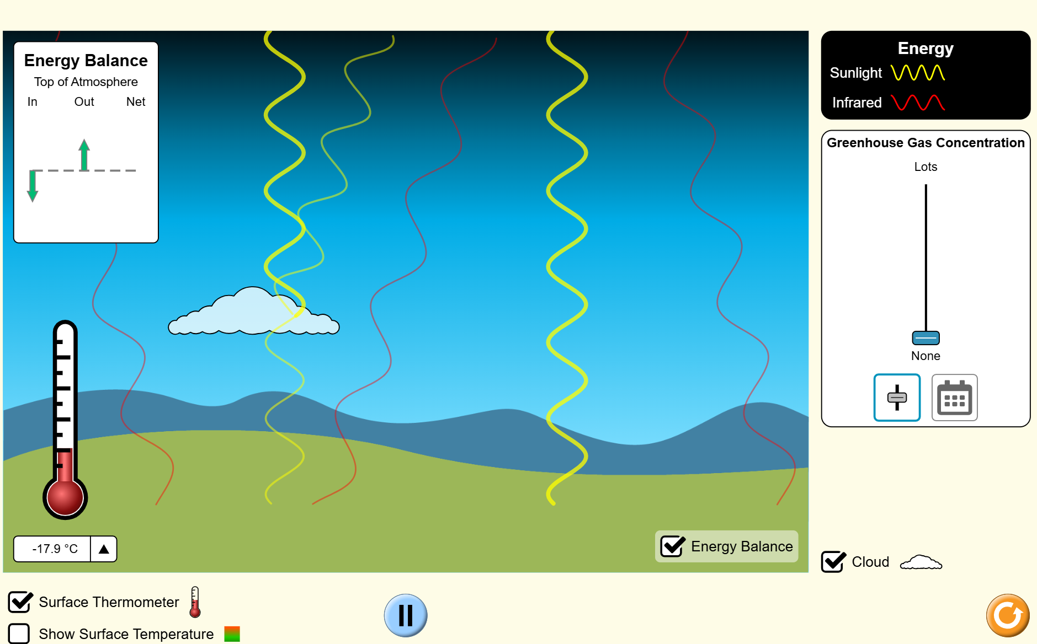
Observe temperature when moved to zero.
'Greenhouse effect’ by PhET Interactive Simulations is licensed under CC BY 4.0
- Ask the students to predict: ‘What will happen to the temperature on Earth if there are no greenhouse gases in the atmosphere? What happens to the energy from the Sun once it reaches the surface?
Teacher tip: pause here and record predictions on the board – some students may think the temperature will rise indefinitely without realising the role of heat retention.
- Run the simulation with zero greenhouse gases. Highlight how incoming sunlight (shortwave radiation) passes through the atmosphere and hits the Earth. Point out that almost all the infrared (longwave) energy escapes back into space.
- Ask students ‘What’s happening to the heat that Earth gives off?’ ‘Why isn’t the surface getting warmer?’
- Now increase the greenhouse gas concentration (for example, to medium or high): Students observe how greenhouse gases absorb and re-radiate infrared radiation. Emphasise the change in energy flow – more heat is trapped near the surface.
- Use the discussion prompts in Table 9 to support a discussion about the greenhouse effect.
Table 9 – discussion prompts
Discussion prompt | Information to support the discussion
What difference did you notice with the energy as greenhouse gas levels increased? How is this related to Earth’s actual temperature? | As the greenhouse gas concentration increases, the amount of infrared energy that stays near the surface increases. This increased Earth's temperature.
Why is the natural greenhouse effect important to life on Earth? | The natural greenhouse effect is important because it keeps Earth warm enough to support life by trapping some of the Sun’s heat in the atmosphere. Without it, the planet would be too cold for most living things to survive.
- Present the Canva presentation on the natural greenhouse effect. Students draw a diagram that demonstrates how the natural greenhouse effect occurs. Include information on natural sources of greenhouse gases.
- Demonstrate a simple model of the natural greenhouse effect (see Table 10 – teacher instructions for the natural greenhouse effect modelling activity). Students are to make predictions of cause and effect, observe the phenomenon, and then explain the cause and effect using the predict-observe-explain (POE) approach at each step. Discuss how this model simplifies complex ideas and demonstrates relationships. Display ENV PPT ‘1.6 Modelling the natural greenhouse effect’ to work through a series of questions with the students.
Table 10 – teacher instructions for the natural greenhouse effect modelling activity
Component | Details
Equipment | - 2 × thermometers  - 1 × 1.25 L bottle  - 1 × ball of plasticine
Procedure | - Place an incandescent light 10 cm away from the bulb of the thermometer.  - Measure and record the temperature.  - Seal a thermometer in a large, clear plastic bottle using plasticine.  - Place an incandescent light 10 cm from the bulb of the thermometer.  - Measure and record the temperature inside the bottle.  Note: incandescent bulbs produce a significant amount of heat as they generate light by heating a filament. This heat directly raises the temperature inside the plastic bottle, simulating the greenhouse effect. Fluorescent bulbs produce much less heat because they generate light through gas excitation rather than heating a filament.
Diagram | Figure 5 – modelling the natural greenhouse effect  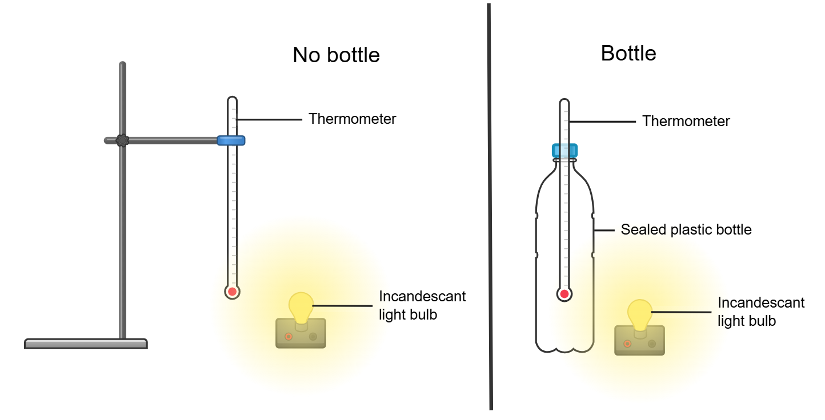  This work has been generated using Chemix.
- Recall the definition of climate from activity ‘1.4 The difference between weather and climate’. Complete a think-pair-share for the question ‘How does the natural greenhouse effect influence global climate and support life?’ Refer to Student resource – a greenhouse supports life and slide ENV PPT ‘1.6 The natural greenhouse effect – think-pair-share (2)’. A sample response is provided in the slide notes.
- To reinforce the concepts, develop a Frayer diagram with students showing how the natural greenhouse effect influences the global climate. See slide ENV PPT ‘1.6 The natural greenhouse effect – Frayer diagram’ and ENV PPT ‘1.6 The natural greenhouse effect – Frayer diagram (sample response)’.
Sample response: Student resource – a greenhouse supports life
Figure 6 – Frayer diagram of the natural greenhouse effect
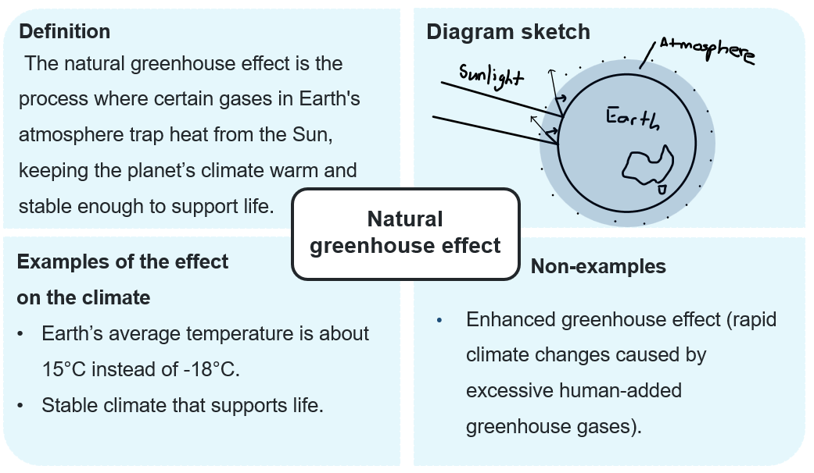
Checkpoint:
      - Explain why the greenhouse effect is essential for life on Earth.
      - How does the greenhouse effect affect Earth's climate?
Checkpoint sample response
- The greenhouse effect is crucial for life on Earth because it keeps the temperature warm enough for living organisms to survive. Without it, Earth would be too cold for most life forms.
- The greenhouse effect influences Earth's climate by keeping the average temperature stable. It ensures that heat from the Sun is trapped in the atmosphere, creating conditions suitable for ecosystems, weather patterns and agriculture.

Student resource – a greenhouse supports life
Defining the natural greenhouse effect
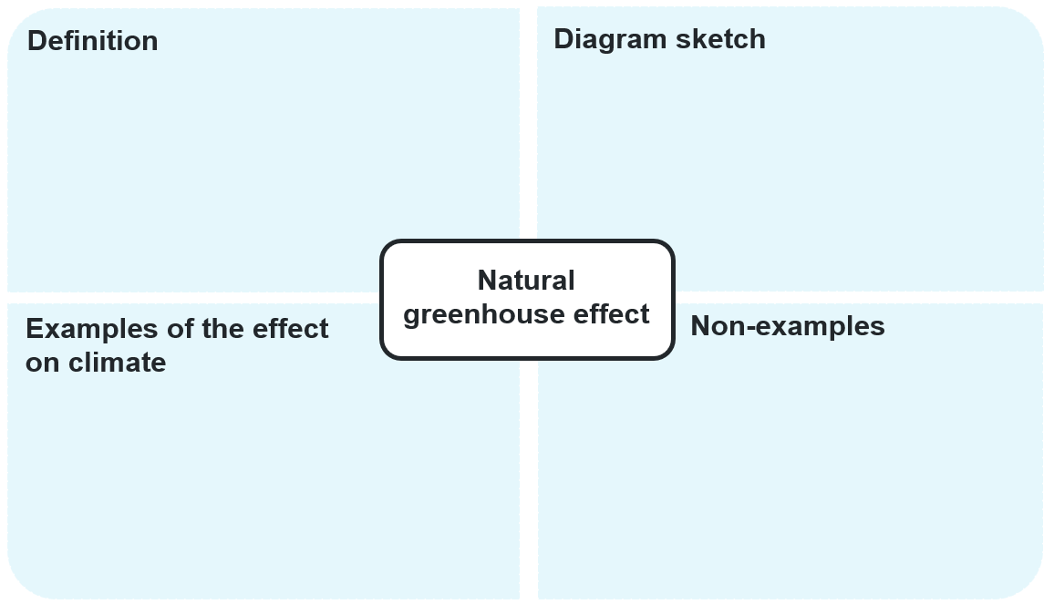

1.7 How is the greenhouse effect being enhanced?
Table 11 – learning intentions and success criteria for ‘1.7 How is the greenhouse effect being enhanced?’ (ENV PPT)
We are learning to: | I can:
- analyse the impact of greenhouse gas emissions on the natural world | - explain what the enhanced greenhouse effect is  - explain the impact of the enhanced greenhouse effect on ecosystems
- analyse data from investigations to identify trends and relationships | - describe the relationship between greenhouse gas emissions and global mean temperatures  - analyse the validity of secondary source information and data
- use a suitable problem-solving strategy (scientific models). | - use a model to explain the greenhouse effect  - use a model to make predictions on cause and effect.
Checkpoint: deliver a checkpoint on the previous lesson’s content using ENV PPT ‘1.7 Checkpoint – quick quiz on previous content’.
Mini challenge (MC): multiple choice question
Why is the greenhouse effect important for life on Earth?
- It makes the Earth colder and safer.
- It traps heat, keeping the Earth warm enough to support life (correct answer).
- It blocks sunlight from reaching the Earth.
- It causes all weather to stop.
Challenge (C): name 3 greenhouse gases.
Super challenge (SC): How do greenhouse gases affect the climate?
Checkpoint sample response
Mini challenge:
- incorrect answer – this is the opposite of what the greenhouse effect does. Without it, Earth would be much colder, not safer; it would actually be too cold for most life to survive.
- correct answer
- incorrect answer – the greenhouse effect doesn’t block sunlight. Sunlight still enters, but greenhouse gases trap some of the heat that would otherwise escape back into space.
- incorrect answer – the greenhouse effect does not stop weather. In fact, changes in the greenhouse effect can influence weather patterns.
Challenge: carbon dioxide, methane, nitrous oxide.
Super challenge: greenhouse gases trap heat in the Earth's atmosphere, making the planet warmer. This warming changes the climate by causing an increase in average long-term temperatures.

Analysing the data on global emissions and temperature
In this activity, students investigate the enhanced greenhouse effect by analysing real-world climate data. They will develop critical thinking skills via guided analysis, modelling and structured responses, helping them to draw evidence-based conclusions about climate science.
- Define enhanced greenhouse effect. Explain what parts per million (ppm) and parts per billion (ppb) are and provide examples using greenhouse gases. See slides ENV PPT ‘1.7 The enhanced greenhouse effect – definitions (1 of 2) and (2 of 2)’.
- Provide students with the Student resource – analysing the data on global emissions and temperature. Show information and data from the Bureau of Meteorology's State of the Climate 2024 report, focusing on greenhouse gases, and support students in answering the comprehension questions in question 1 of the Student resource – analysing the data on global emissions and temperature.
- Students summarise information on the 3 major greenhouse gases using the Bureau of Meteorology – State of the Climate 2024 – Greenhouse gases in a table (Question 2).
- Show the graph of CO₂ measured at Kennaook/Cape Grim (Tasmania); refer to slide ENV PPT ‘1.7 Analysing data on global emissions and temperature’. Think aloud to model answering question 3 in Student resource – analysing the data on global emissions and temperature.
- Show the graph of the concentrations and growth rates of all 3 major greenhouse gases for the past 2000 years. Refer to slide ENV PPT ‘11.7 Major greenhouse gas levels’. Guide students as they answer question 4 in Student resource – analysing the data on global emissions and temperature.
- Define carbon budget using ENV PPT ‘1.7 Carbon budget – definition’.
- Show the infographic of Australia’s Carbon Budget (2010–2019). See slide ENV PP ‘1.7 Australia’s carbon budget’. Students answer question 5 in Student resource – analysing the data on global emissions and temperature.
- Show the information and data on the site Bureau of Meteorology – State of the Climate 2024 – Future climate. For the graph of the Australian average annual temperature relative to the 1850–1900 baseline, students answer question 6 in Student resource – analysing the data on global emissions and temperature. See slide ENV PPT ‘1.7 Australia’s average annual temperature’.
Sample response: Student resource – analysing the data on global emissions and temperature
- Read the opening section of Bureau of Meteorology – State of the Climate 2024 – Greenhouse gases Bureau of Meteorology – State of the Climate 2024 – Greenhouse gases and answer the following questions:
- What is the primary cause of climate change since the 1850−1900 period?
The increase of greenhouse gases in the atmosphere.
- By how much has the atmospheric concentration of carbon dioxide (CO₂) increased from 1750 to 2023?
51%
- Why is reducing methane emissions considered an important short-term strategy for managing climate change?
Reducing methane emissions is considered an important short-term strategy because methane has a high global warming potential (81 times that of CO₂ over 20 years) but only stays in the atmosphere for about a decade, so reducing methane can quickly lower warming.
- What human activity is the largest source of nitrous oxide emissions?
The use of nitrogenous fertilisers in agriculture.
- Read the opening section of Bureau of Meteorology – State of the Climate 2024 – Greenhouse gases and complete the table for the 3 major greenhouse gases:
Table 12 – sample response for greenhouse gas emission trends
Greenhouse gas | Trend in atmospheric concentration | 2023 global annual mean concentration
Carbon dioxide (CO₂) | Steadily rising; 51% increase since 1750 | 419.2 ppm
Methane (CH₄) | A rapid increase of over 10 ppb per year since 2020 | 1,919 ppb
Nitrous oxide (N₂O) | Steadily rising; growth over 1 ppb per year in the recent decade | 337 ppb
Note: the infographics have been removed from the sample response. They can be found in the student resource.
- Analyse the graph in Figure 1 and answer the questions about hourly CO₂ levels.
- Describe the pattern in the data.
The data show a steady increase in hourly background CO₂ concentration (in ppm) from approximately 330 ppm in 1976 to over 415 ppm by 2024. The increase is not linear – it accelerates over time, meaning the rate of increase grows larger each decade.
- What is the relationship between the variables?
The variables are time (years) and CO₂ concentration (ppm). There is a positive, accelerating relationship – as time progresses, CO₂ levels consistently rise, and the rate of that rise becomes faster.
- What is the data showing us?
From 1980 to 1989, CO₂ rose by 14 ppm. From 1990 to 1999, it rose by 16 ppm. From 2000 to 2009, it rose by 19 ppm. From 2010 to 2019, it rose by 23 ppm.
This pattern of increasingly larger rises each decade shows clear evidence that CO₂ concentration is not only increasing but doing so at a faster and faster rate.
- Is the information valid?
Yes, it is valid as the data comes from the CSIRO, a reputable scientific organisation.
- Analyse the graph in Figure 2 and answer the questions about greenhouse gas concentrations over time.
- Describe the pattern in the data and the relationship between the variables.
The graph shows the concentrations of 3 major greenhouse gases, carbon dioxide (CO₂), methane (CH₄), and nitrous oxide (N₂O), over the past 2,000 years. For most of that time, levels remained relatively stable. However, there’s a dramatic, sharp rise in all 3 gases starting in the 1800s, accelerating even more steeply in the 20th and 21st centuries.
- What is the data showing us?
The variables are time (years) on the x-axis and concentration of each gas (y-axis, note the break in the scale).
There is a very steep, exponential increase in concentrations of all 3 gases in recent centuries, especially since the Industrial Revolution.
- Is the information valid?
Yes, it is valid. The source is the CSIRO, a trusted government scientific institution.
- Analyse the graph in Figure 3 and answer the questions about Australia’s carbon budget 2010–2019.
- List the emissions that contribute to the natural greenhouse effect.
Bushfires, rivers and lakes.
- List the emissions that contribute to the enhanced greenhouse effect.
Coal, oil, gas, cement, agriculture and waste, logging, crops and livestock.
- List the ways the environment can absorb carbon dioxide.
Land use change, coastal vegetation/estuaries, natural land ecosystems, geological weathering and oceans.
- Why are fossil fuel exports' emissions so significant, and why is it part of Australia’s carbon budget?
Australia exports a significant amount of coal, oil and gas. When these are combusted, they contribute to the carbon dioxide emissions in various countries.
- Why is there such a large uncertainty in Australia’s carbon budget? (Hint: read the information above the infographic to find the answer.)
Australia's annual net carbon budget varies greatly from year to year because of changes in natural CO₂ sinks (natural ecosystems). Australia can be a significant net source of CO₂ in one year (for example, due to many bushfires that year), then become carbon neutral the next, and later turn into a large net CO₂ sink in the following year.
- Analyse the graph in Figure 4 and answer the questions about Australia’s average annual temperature over time.
- Describe the pattern in the data.
The graph indicates that average annual temperatures in Australia remained fairly steady from 1910 to around 1950, with some fluctuations. From the 1970s onwards, temperatures have increased gradually, with an increasingly sharp upward trend. According to climate models, this trend is expected to continue rising rapidly into the future.
- What is the relationship between the variables?
The graph shows the relationship between time (x-axis) and average annual temperature compared to 1850–1900 (y-axis). There is a positive correlation – as time progresses, temperatures rise. The observed trend (dark blue and black lines) matches model predictions (shaded areas), indicating strong consistency between the data and climate models.
- What is the 2040 temperature predicted to be like relative to 1850–1900?
By 2040, the average annual temperature in Australia is projected to be about 2°C above pre-industrial levels. This aligns with the orange-shaded area, which displays future climate simulations. It exceeds the 1.5°C warming threshold and hits the 2°C global warming equivalent marked on the graph.
- Is the information valid?
Yes, the information is valid due to the following:
- source – CSIRO, a trusted and authoritative scientific organisation
- data and models – the observed data (from historical records) aligns well with climate model simulations
- methodology – 20-year running averages and multiple models are used, increasing the data’s reliability
- the range of uncertainty is also shown, giving transparency to the model projections.

Student resource – analysing the data on global emissions and temperature
- Read the opening section of Bureau of Meteorology – State of the Climate 2024 – Greenhouse gases Bureau of Meteorology – State of the Climate 2024 – Greenhouse gases and answer the following questions:
- What has been identified as the primary cause of climate change since the 1850−1900 period?
- By how much has the atmospheric concentration of carbon dioxide (CO₂) increased from 1750 to 2023?
- Why is reducing methane emissions considered an important short-term strategy for managing climate change?
- What human activity is the largest source of nitrous oxide emissions?

- Read the opening section of Bureau of Meteorology – State of the Climate 2024 – Greenhouse gases and complete the table for the 3 major greenhouse gases:
Table 1 – greenhouse gas emission trends
Greenhouse gas | Trend in atmospheric concentration | 2023 global annual mean concentration

- Analyse the graph in Figure 1 and answer the questions about hourly CO₂ levels.
Figure 1 – CO₂ measured at Kennaook/Cape Grim (Tasmania)
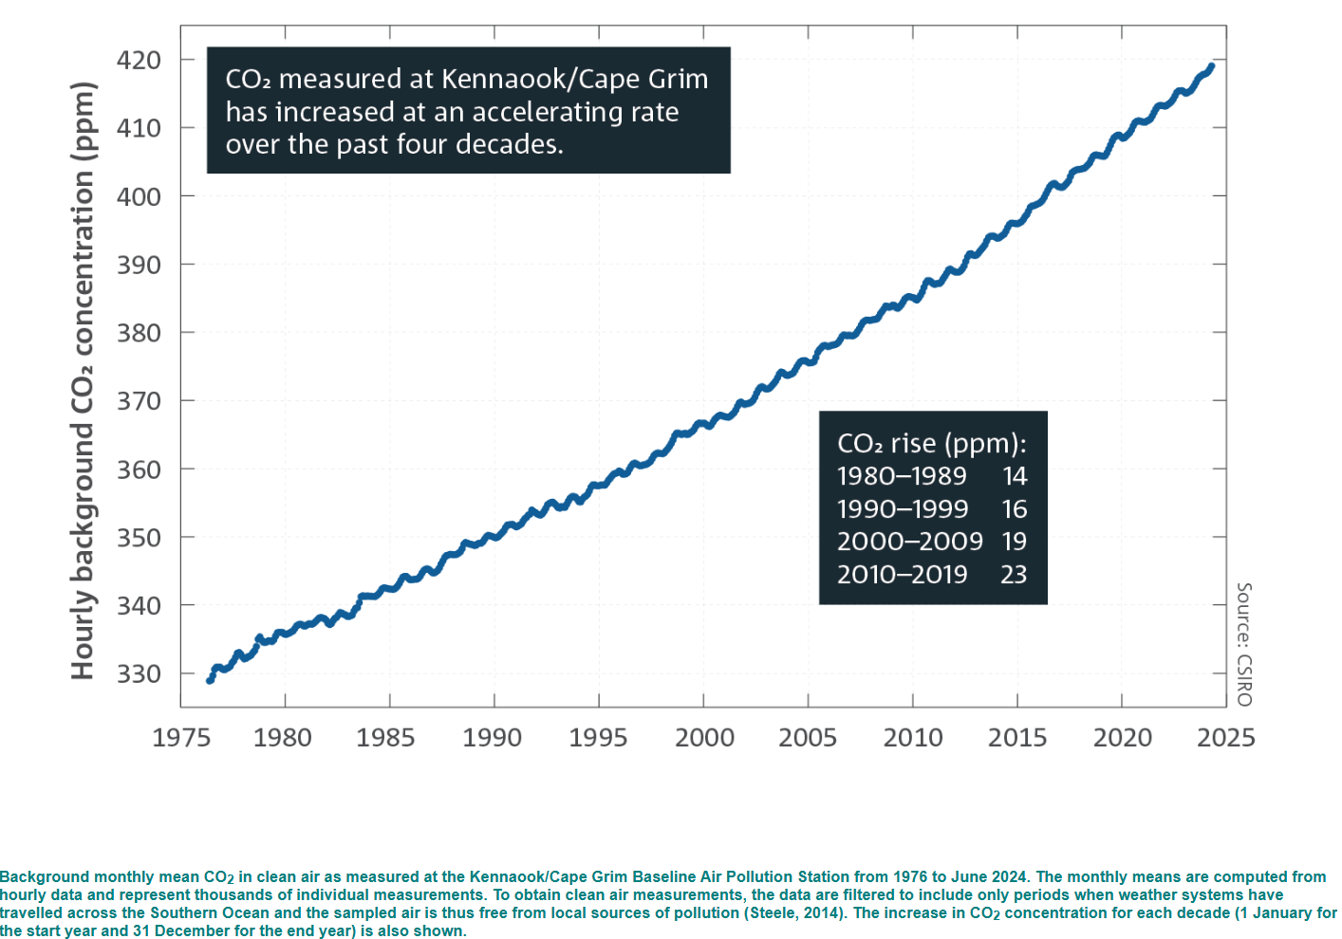
‘Greenhouse gases’ © Copyright CSIRO Australia.
- Describe the pattern in the data.
- What is the relationship between the variables?
- What is the data showing us?
- Is the information valid?
- Analyse the graph in Figure 2 and answer the questions about greenhouse gas concentrations over time.
Figure 2 – greenhouse gas concentrations over time
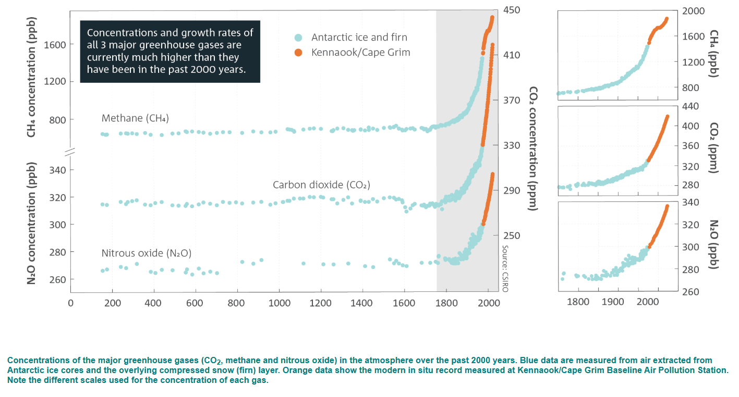
‘Greenhouse gases’ © Copyright CSIRO Australia.
- Describe the pattern in the data and the relationship between the variables.
- What is the data showing us?
- Is the information valid?
- Analyse the graph in Figure 3 and answer the questions about Australia’s carbon budget 2010–2019.
Figure 3 – Australia’s carbon budget 2010-2019
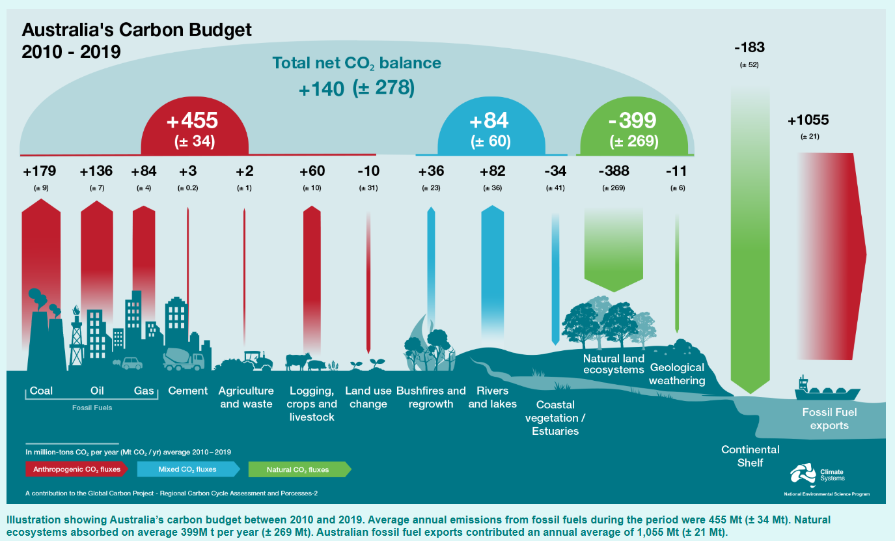
‘Greenhouse gases’ © Copyright CSIRO Australia.
- List the emissions that contribute to the natural greenhouse effect.
- List the emissions that contribute to the enhanced greenhouse effect.
- List the ways the environment can absorb carbon dioxide.
- Why are fossil fuel exports' emissions so significant, and why is it part of Australia’s carbon budget?
- Why is there such a large uncertainty in Australia’s carbon budget? Read the information above the infographic to find the answer.
- Analyse the graph in Figure 4 and answer the questions about Australia’s average annual temperature over time.
Figure 4 – graph of Australia’s average annual temperature over time
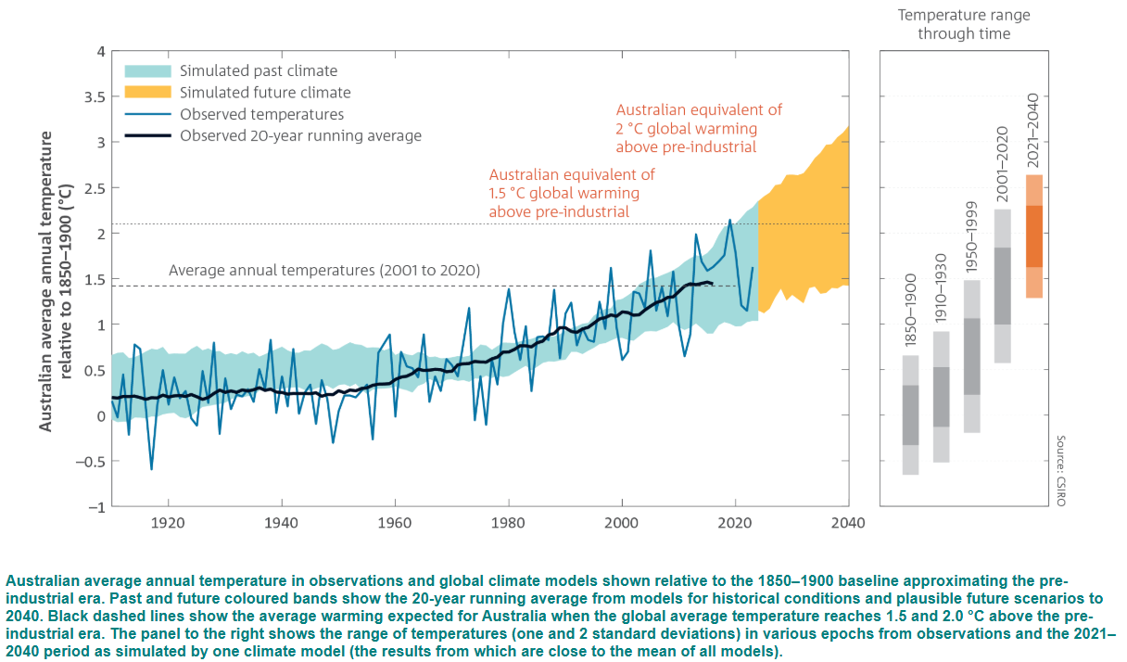
‘Future climate’ © Copyright CSIRO Australia.
- Describe the pattern in the data.
- What is the relationship between the variables?
- What is the 2040 temperature predicted to be like relative to 1850–1900?
- Is the information valid?

What is the impact of the enhanced greenhouse effect?
- Share information on Bureau of Meteorology – State of the Climate 2024 – Future climate and highlight the Projections of Australia’s future climate conditions.
- Provide students with the Student resource – What is the impact of the enhanced greenhouse effect? Students use the information on the website to complete a table summarising 5 future climate trends and describe the possible impacts on ecosystems for each.
Sample response: Student resource – What is the impact of the enhanced greenhouse effect?
Table 13 – the impact of the enhanced greenhouse effect on ecosystems’?
Climate condition | Future trend | Potential impact on ecosystems
Continued warming with more hot days and marine heatwaves | Ongoing temperature rise; more extreme heat events | Increased coral bleaching (for example, Great Barrier Reef), loss of habitat for heat-sensitive species, shifts in species distribution towards cooler areas, and increased marine species mortality.
Decreased cool-season rainfall and prolonged droughts | Less rainfall during winter/spring; more extended drought periods | Reduced water availability stressing freshwater ecosystems, drying of wetlands causing a decline in amphibian populations, and increasing tree mortality in forests.
Longer fire seasons and more dangerous fire weather | More extended periods are suitable for bushfires, especially in the south and east | Loss of fire-sensitive species, changes in forest composition, destruction of animal habitats, soil erosion, and ecosystem collapse in severely burnt areas.
Sea level rise and more frequent extreme sea levels | Steady rise in sea levels; coastal flooding events become more common | Loss of coastal habitats like mangroves and salt marshes, saltwater intrusion into freshwater ecosystems, displacement of coastal species, and increased erosion of nesting beaches for marine turtles.
Continued ocean warming and acidification | Oceans become warmer and more acidic. | Coral reef degradation, decline in shell-forming organisms (for example, molluscs, plankton), disruption of marine food webs, and loss of biodiversity in marine ecosystems.

Student resource – What is the impact of the enhanced greenhouse effect?
Using the information in Projections of Australia’s future climate conditions, summarise 5 future climate trends and describe the possible impact of the enhanced greenhouse effect on ecosystems.
Table 1 – the impact of the enhanced greenhouse effect on ecosystems
Climate condition | Future trend | Potential impact on ecosystems

Modelling the enhanced greenhouse effect
In this activity, students will complete an investigation to model the enhanced greenhouse effect by recording the change in temperature of a closed system as carbon dioxide (CO₂) levels are changed.
- Provide students with a copy of Student resource – modelling the enhanced greenhouse effect. Unpack the method so they understand each step.
- Support students to set up the equipment as outlined in the procedure in the Student resource – modelling the enhanced greenhouse effect.
Note: this activity could be modified to use thermometers if temperature probes are unavailable. It could also be conducted as a demonstration, sharing the data with students to process using Microsoft Excel.
If the school has a carbon dioxide sensor, it can be used to demonstrate the difference in CO₂ levels in each bottle. If no CO₂ sensor is available, arbitrary units could be applied, for example, a normal CO₂ level and an increased CO₂ level.
Effervescent tablets or dry ice could be used as an alternative source of CO₂. A risk assessment must be created for each of these alternatives.
- Support students to conduct the investigation and collect the required data.
- Support students to construct the graph in Microsoft Excel and then respond to the discussion questions.
Sample response: Student resource – modelling the enhanced greenhouse effect
Background:
What is the greenhouse effect, and why is it important for the Earth’s climate?
The greenhouse effect is the process by which certain gases in Earth's atmosphere, such as carbon dioxide and methane, trap heat from the Sun. This keeps the planet warm enough to support life. Without the greenhouse effect, Earth would be too cold for most living things to survive. However, human activities, such as burning fossil fuels, are increasing concentrations of greenhouse gases in the atmosphere, leading to excessive warming and climate change.
How do the concentrations of greenhouse gases in the atmosphere contribute to the greenhouse effect?
Higher concentrations of greenhouse gases trap more heat in the atmosphere, intensifying the greenhouse effect and increasing the Earth's temperature.
Hypothesis: use the ‘If … then … because …’ format to develop a hypothesis for the effect of the different gases on the air temperature.
If more CO₂ is added to the bottle, then the air temperature will be higher when a heat lamp is brought near it. This is because CO₂ is a greenhouse gas that absorbs or traps the heat from the heat lamp.
Results:
Figure 7 – sample graph of temperature over time when modelling the greenhouse effect
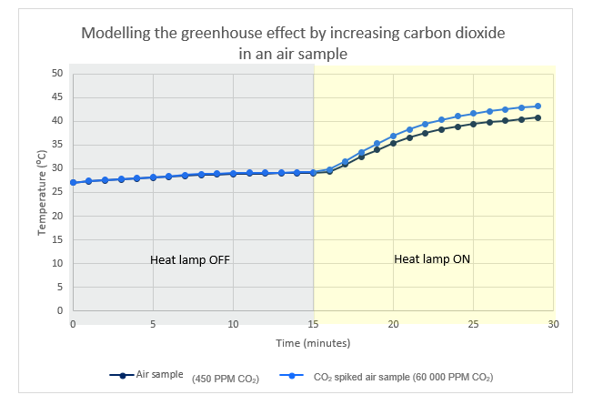
Source: student investigation.
CO₂ spiked air sample (60 000 PPM CO₂)
(450 PPM CO₂)
Discussion questions:
Refer to your data to explain what the results from the investigation show.
The data shows that when the heat lamp was turned on, both the normal air sample and the CO₂ spiked sample increased in temperature. However, the CO₂-spiked air sample (60,000 ppm CO₂) heated up faster and reached a higher temperature compared to the normal air sample (450 ppm CO₂). This demonstrates that increased carbon dioxide levels trap more heat, modelling the greenhouse effect.
Define the enhanced greenhouse effect and outline the factors contributing to increased atmospheric carbon dioxide.
The enhanced greenhouse effect refers to the intensification of Earth’s natural greenhouse effect resulting from higher concentrations of greenhouse gases, such as carbon dioxide, methane and nitrous oxide, caused by human activities.
Factors contributing to increased atmospheric carbon dioxide include the burning of fossil fuels (coal, oil and natural gas) for energy and transportation, deforestation (which reduces the number of trees that absorb CO₂), industrial activities, cement production and agricultural practices.
What are the implications of the results obtained from this investigation? How can these findings be related to real-world climate scenarios?
The investigation shows that higher carbon dioxide levels trap more heat, leading to higher temperatures. In reality, this is happening worldwide, driving global warming, melting polar ice caps, and causing rising sea levels and more extreme weather events such as stronger storms, droughts and floods. It also disrupts ecosystems and threatens food security.
How can this investigation be broadened or modified to explore other aspects of the greenhouse effect?
This investigation could be broadened by examining other greenhouse gases (such as methane or water vapour) and comparing their effects, measuring the cooling time after the heat source is turned off, testing different concentrations of CO₂ to see how various levels influence temperature change, or simulating cloud cover or aerosols to assess their cooling impacts.
Evaluate the effectiveness of this model.
This model effectively demonstrates the core principle that higher carbon dioxide levels lead to increased heat retention. It provides a clear visual of how CO₂ concentration affects temperature rise. However, it has limitations: it simplifies the atmosphere, which is far more complex. It uses significantly higher CO₂ levels than those naturally present in Earth's atmosphere. Other factors influencing Earth's climate, such as oceans, clouds and other gases, are not included. Overall, it offers a good starting point for understanding the greenhouse effect; however, for a complete picture, it should be complemented with more detailed models and real-world data.

Student resource – modelling the enhanced greenhouse effect
Aim: to model the enhanced greenhouse effect.
Background:
The greenhouse effect is a natural phenomenon that plays a crucial role in regulating the Earth's temperature. Just as a greenhouse traps heat to create a warm environment for plants, the Earth’s atmosphere acts as a giant blanket, letting sunlight in while keeping some heat from escaping back into space. Certain gases, known as greenhouse gases, such as carbon dioxide, water vapour and methane, are responsible for this effect. In this activity, we will explore the fascinating concept of the enhanced greenhouse effect by creating a model that illustrates how varying concentrations of carbon dioxide affect air temperature.
What is the greenhouse effect, and why is it important for the Earth’s climate?
How do the concentrations of greenhouse gases in the atmosphere contribute to the greenhouse effect?
Hypothesis: use the ‘If … then … because …’ format to develop a hypothesis for the effect of the different gases on the air temperature.
Equipment:
- 2 clear sample bottles (with a neck wide enough for a carbon dioxide sensor. Soda stream bottles work well)
- rubber stopper with a small hole for temperature probes (or plasticine)
- 1 tsp of sodium bicarbonate
- 20 mL white vinegar
- 200 mL beaker
- heat lamp
- 30 cm ruler
- 2 temperature probes and data logging software
- 1 carbon dioxide sensor
Procedure:
- Label the bottles ‘air only’ and ‘added CO₂.’
- Set up the data logger with the 2 temperature probes. Set the software to display a graph with temperature on the y-axis and time on the x-axis. Set the frequency of measurements to 1 minute.
- Place the carbon dioxide sensor into the bottle labelled air only. Measure the carbon dioxide level of the air inside (it should be close to 450 ppm) and record the measurement. Remove the sensor and seal the bottle with the stopper and temperature probe.
- Place the bicarbonate soda in the beaker and add the vinegar. Leave it to sit until the gas bubbles settle. Gently pour the CO₂ gas into the CO₂ labelled bottle (The CO₂ gas will be sitting just above the liquid and, because it is heavier than air, can be poured). Seal the bottle with the stopper and temperature probe.
- Place both bottles 30 cm from the heat lamp. DO NOT turn the heat lamp on. Start the data logger and allow it to run for 10 minutes.
- Turn the heat lamp on and continue collecting data for 15 minutes.

Results:
Export the collected data into an Excel spreadsheet.
To turn the data into a graph:
- Adjust the column headings to represent the data contained in them, such as Air sample temperature (°C).
- Highlight the relevant columns (time, temperature, air, temperature CO₂, and temperature CH₄, if applicable).
- Select ‘Insert’, and then in the ‘Charts’ section, select ‘Scatter with Smooth Lines and Markers’.
Figure 1 – inserting a scatter plot using Excel
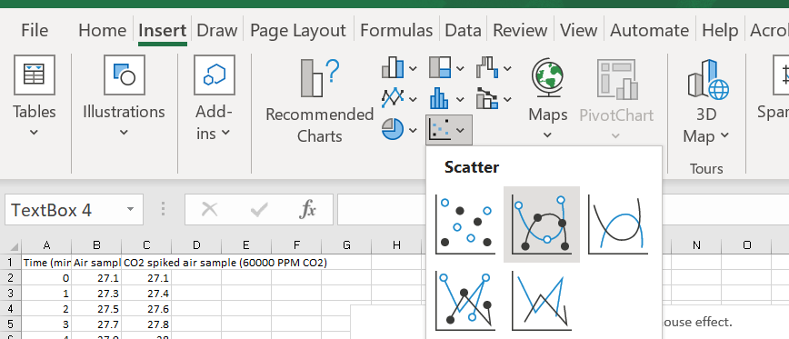
- A graph should appear in the spreadsheet. Click on the graph and select the ‘+’ symbol. Tick ‘Axis titles’. Click on each axis title and enter appropriate titles.
Figure 2 – editing axis titles in Excel
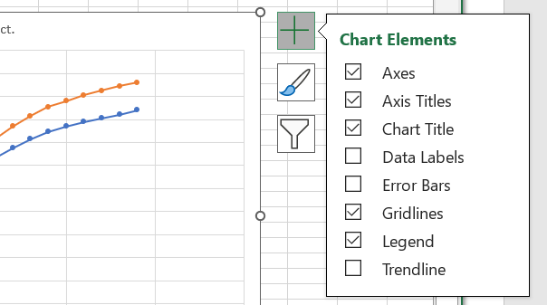
- Give the graph a descriptive title.
- Shade and label the area of the graph where the heat lamp was off. You can insert a rectangle and adjust the transparency to achieve this.
Figure 3 – shading and labelling the graph in Excel
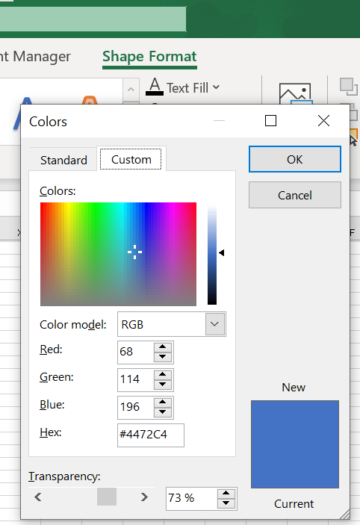
- Shade and label the area of the graph where the heat lamp was on (Insert shape and adjust the colour and transparency).
- Paste a copy of the graph below.
Discussion questions:
Refer to your data to explain what the results from the investigation show.
Define the enhanced greenhouse effect and outline the factors contributing to increased atmospheric carbon dioxide.
What are the implications of the results obtained from this investigation? How can these findings be related to real-world climate scenarios?
How can this investigation be broadened or modified to explore other aspects of the greenhouse effect?
Evaluate the effectiveness of this model.

1.8 How can we reduce greenhouse gas emissions?
Table 14 – learning intentions and success criteria for ‘1.8 How can we reduce greenhouse gas emissions?’
We are learning to: | I can:
- analyse the impact of greenhouse gas emissions on the natural world | - explain the advantages and limitations of methods to reduce greenhouse gas emissions
- analyse data to identify relationships | - analyse data to help explain the effect of transitioning to greenhouse gas emission reduction methods
- analyse proposed solutions to a problem. | - assess claims using the claim-evidence-reasoning (C-E-R) scaffold.
Checkpoint: deliver a checkpoint on the previous lesson’s content using ENV PPT ‘1.8 Checkpoint – quick quiz on previous content’.
Mini challenge (MC): show students data on CO₂ concentration and global average temperature anomaly (refer to slide ENV PPT ‘1.7 Analysing the data on global emissions and temperature’ and ENV PPT ‘1.7 Major greenhouse gas level’). What is the overall trend shown in the data?
Challenge (C): explain how increasing CO₂ levels contribute to changes in the global climate. Include one effect this may have on ecosystems.
Checkpoint sample response
Mini challenge: both CO₂ concentration and global average temperature anomaly are increasing over time.
Challenge: rising CO₂ levels enhance the greenhouse effect by trapping more heat in the atmosphere, leading to global warming. This can cause ecosystem disruptions, such as coral bleaching due to warmer ocean temperatures.

Is the transition to household solar reducing greenhouse gas emissions?
In this lesson, students apply their understanding of renewable energy, specifically solar power, to evaluate whether transitioning to household solar reduces greenhouse gas emissions. Using a claim-evidence-reasoning (C-E-R) framework, students analyse real-world data from Australian and international sources, including household solar output, energy consumption and emissions statistics.
- Recall with students that in the Energy focus area, we learnt solar is a form of renewable energy commonly used in Australian households. Optional: show CSIRO data showing the uptake in rooftop solar in Australia from 2011 to the present.
- Provide students with the Student resource – Is the transition to household solar reducing greenhouse gas emissions? Share the C-E-R scaffold on slide ENV PPT ‘1.8 Transitioning to solar C-E-R scaffold’. Explain that you will model using this scaffold to answer the question: Does transitioning to household solar use in Australia reduce greenhouse gas emissions?
- Display slide ENV PPT ‘1.8 Transitioning to solar – the claim’. Discuss the question as a class and co-create a claim. For example, ‘Using solar energy for household electricity generation will reduce greenhouse gas emissions’.
- Share evidence for this claim with the class. This could include:
- reading the section on Australia's contribution to global greenhouse gas emissions in What are the sources of carbon dioxide in the atmosphere? by CSIRO, and highlighting data on Australia’s contribution to greenhouse gases compared to the rest of the world, and data on carbon emissions from energy production as a percentage of total carbon emissions in Australia
- noting Australia’s per-capita CO₂ emissions from the International Energy Agency webpage
- viewing data on the cleanest sources of energy from Our World in Data. Noting that solar has much less emissions than coal, oil or gas, but more than hydropower, wind and nuclear energy
- highlighting data on the contribution of solar to Australia’s energy generation by the Australian Government Department of Climate Change, Energy, the Environment and Water
- sharing energy bills or solar monitoring data to demonstrate greenhouse gas reductions linked to solar use and discuss how the data highlights the benefits and limitations of using solar power for household electricity. Sample data is included on slide ENV PPT ‘1.8 Transitioning – the data’.
Note: key points from this evidence are highlighted in the C-E-R scaffold on slide ENV PPT ‘1.8 Transitioning to solar – the evidence’.
- Guide students through the reasoning stage of their C-E-R response. Ask them to write a short explanation discussing whether the evidence supports the claim that using household solar reduces greenhouse gas emissions. Encourage students to highlight both the benefits and limitations shown in the data. Once written, have students share and discuss their reasoning with a partner or the class. Refer to the sample response on slide ENV PPT ‘1.8 ‘Transitioning to solar – reasoning’ to support this discussion.

Sample response: Student resource – Is the transition to household solar reducing greenhouse gas emissions?
Claim | Evidence | Reasoning
Your response  Using solar energy for household electricity generation will reduce greenhouse gas emissions. | Your response  - Australia is the world's 14th highest emitter, contributing just over 1% of global emissions.  - Energy (burning fossil fuels to produce electricity) contributed 32.6% of Australia’s total emissions in 2023. Solar contributed 16% of total electricity generation in 2022–23 in Australia.  - Australia is ranked 12th in the world for per-capita CO₂ emissions.  - Using solar energy produces fewer emissions than coal, oil and gas. However, it produces more (during panel production) than hydropower, wind and nuclear energy.  - Solar energy is limited to daytime, sunny conditions, unless with battery storage. | Your response  - Burning fossil fuels to generate electricity is a major source of greenhouse gas emissions, contributing 32.6% of Australia’s total emissions in 2023.  - Since solar energy produces far fewer emissions than coal, oil and gas, increasing the use of solar power for household electricity can significantly reduce these emissions. Although manufacturing solar panels does release some emissions, solar energy is still a cleaner option overall.  - With Australia being one of the highest emitters per person, switching more households to solar power would help lower the country's total greenhouse gas output.

Student resource – Is the transition to household solar reducing greenhouse gas emissions?
Claim | Evidence | Reasoning
State the claim being investigated. | Provide reliable information from experiments, facts or a reliable source that supports the claim. | Explain how the evidence supports the claim.
Helpful hints  Ensure keywords and ideas from the claim and investigation are aligned. | Sentence starters  In the experiment …  The data shows …  One piece of evidence is … | Sentence starters  The evidence supports the claim because …  Based on this evidence, it can be concluded that …
Your response | Your response | Your response

Can we just remove the carbon from the atmosphere?
- Provide students with the Student resource – Can we just remove the carbon from the atmosphere? Ask them to investigate the claim: ‘Will carbon capture and storage reduce greenhouse gas emissions?’
- Students develop a claim, analyse the evidence and highlight key evidence for and/or against the claim. They then use this evidence to make an informed judgment on the claim in their reasoning.
Example information sources:
- International Energy Agency (IEA): Carbon Capture Utilisation and Storage
- Geoscience Australia: Carbon capture and Storage.
Differentiation:
Content: these teaching and learning activities model and require analysis of the methods to reduce greenhouse gas emissions; however, developing or researching and sharing a list of advantages and limitations is suitable for this knowledge and understanding content. Note that this would not align with the working scientifically content identified for this lesson, and the learning intentions and success criteria would need to be adjusted accordingly.
- Students could be given a choice in the greenhouse gas reduction method they choose to investigate.
- Students could work independently or in small groups to investigate the claims.
Extension: students can complete the C-E-R scaffold for a different method of reducing greenhouse gas emissions, such as wind, hydropower and geothermal energy, building energy-efficient houses, using electric vehicles for transportation, reforestation, sustainable agricultural practices, or recycling.

Sample response: Student resource – Can we just remove the carbon from the atmosphere?
Claim | Evidence | Reasoning
Your response  Carbon capture and storage (CCS) can reduce greenhouse gas emissions by capturing CO₂ from industrial processes and storing it underground, preventing it from entering the atmosphere. | Your response  - Globally, there are around 45 commercial CCS facilities in operation, capturing over 50 million tonnes of CO₂ annually from industries like power generation and fuel processing.  - In Australia, the Moomba CCS project in South Australia has begun operations, already storing 340,000 tonnes of CO₂ since October 2024, with an expected annual capacity of 1.7 million tonnes.  - CCS is particularly useful for reducing emissions from industrial processes that are hard to decarbonise, such as steel and cement manufacturing. | Your response  Carbon capture and storage (CCS) works by capturing CO₂ emissions from sources like power plants and industrial facilities, then transporting and storing the CO₂ deep underground in geological formations. This process prevents CO₂ from entering the atmosphere, reducing greenhouse gas emissions. The operation of 45 commercial CCS facilities worldwide, capturing over 50 million tonnes of CO₂ annually, demonstrates the technology's effectiveness. In Australia, the Moomba CCS project has already stored 340,000 tonnes of CO₂, with plans to store up to 1.7 million tonnes yearly. CCS is especially important for industries like steel and cement manufacturing, where emissions are difficult to eliminate through other means. Therefore, implementing CCS can significantly reduce greenhouse gas emissions by capturing and storing CO₂ that would otherwise contribute to climate change.

Student resource – Can we just remove the carbon from the atmosphere?
Claim | Evidence | Reasoning
State the claim being investigated. | Provide reliable information from experiments, facts or a reliable source that supports the claim. | Explain how the evidence supports the claim.
Helpful hints  Ensure keywords and ideas from the claim and investigation are aligned. | Sentence starters  In the experiment …  The data shows …  One piece of evidence is … | Sentence starters  The evidence supports the claim because …  Based on this evidence, it can be concluded that …
Your response | Your response | Your response

1.9 Cause and effect – industrialisation and global temperatures
Table 15 – learning intentions and success criteria for ‘1.9 Cause and effect – industrialisation and global temperatures’
We are learning to: | I can:
- explain the impact of greenhouse gas emissions on the natural world | - analyse CO₂ data from the Keeling Curve  - analyse temperature data from NASA  - summarise the relationship between industrialisation and the rise in global temperatures
- explain data to identify trends, patterns and relationships. | - describe the patterns and trends in global atmospheric CO₂ and temperature data over time  - describe the relationship between global atmospheric CO₂ and temperature levels  - use graphs to extrapolate data and draw conclusions.
Checkpoint: deliver a checkpoint on the previous lesson’s content. See slide ENV PPT ‘1.9 Checkpoint – quick quiz on previous content’.
Mini challenge (MC): list an advantage and a limitation to using solar energy to reduce greenhouse gas emissions.
Challenge (C): How would you justify your reasoning when testing a claim? (Clue: What does C-E-R stand for?)
Super challenge (SC): using evidence, write a brief recommendation to the Prime Minister on what the country should do to reduce Australia’s greenhouse gas emissions.
Checkpoint sample response
Mini challenge:
Advantage: solar energy is renewable and does not produce greenhouse gas emissions during electricity generation.
Limitation: solar energy depends on sunlight, so it may not produce power consistently during cloudy weather or at night.
Challenge: I would use the C-E-R framework to justify my reasoning:
C – Claim: make a clear statement
E – Evidence: support it with data or research
R – Reasoning: explain how the evidence supports the claim using scientific principles.
Super challenge:
Dear Prime Minister,
I recommend investing substantially in solar energy infrastructure in both urban and regional areas to reduce Australia's greenhouse gas emissions. Solar energy has become increasingly affordable, offering clean electricity without harmful emissions. Additionally, funding carbon capture and storage (CCS) technology for industries still dependent on fossil fuels could help lower emissions in the short term. Combining renewable energy with CCS provides a balanced, evidence-based approach to addressing climate change.
Kind regards,
A Year 9 science student

When did the current rise in global greenhouse gas emissions start?
This lesson explores the timeline and causes of the current increase in global greenhouse gas emissions by analysing real-world data from the Keeling Curve and other long-term records. It is a teacher-led activity that encourages students to think critically and ask questions. It can be conducted as a class discussion. Students will explore how atmospheric carbon dioxide levels have changed over time, identify key patterns and trends, and link this rise to major historical events such as the Industrial Revolution. Through guided analysis of graphs, videos and datasets, students will develop vital data literacy skills and enhance their understanding of the connection between human activity and climate change.
- Share the website and graph: The Keeling Curve: Carbon dioxide concentration at Mauna Loa Observatory.
- Look at the one-week graph as a class. Facilitate a discussion and conduct a class ‘see, think, wonder’. Record any observations of patterns and relationships or any further questions the students have. You may come back to address these throughout the activity.
- Look at the one-month, 6-month, one-year, 2-year, and full records of the Mauna Loa Observatory data graphs. Again, record any observations and questions. Draw students' attention to the seasonal variations in CO₂ levels.
- Watch the video How Scientists Measure Carbon Dioxide in the Air (2:24) to clarify possible questions. See slide ENV PPT ‘1.9 How scientists measure carbon dioxide in the air’.
- Watch Science Bulletins: Keeling’s Curve – The Story of CO₂ (3:37) video to clarify possible questions. See slide ENV PPT ‘1.9 The Keeling curve – The story of CO₂’.
- Outline the Industrial Revolution using ENV PPT ‘1.9 The Industrial Revolution’. Tell students that the Industrial Revolution started around 1750. This started the widespread adoption of coal, oil and gas as fuel sources for factories, transportation and heating. As cities grew and industrialisation spread, vast amounts of forests were cleared to make way for new buildings, infrastructure and to provide wood for fuel.
- Knowing when the Industrial Revolution occurred, now look at the graphs for 1700–present, 2K years, 10K years, 800K years and 70M years. Again, record any observations and questions.
- Clarify any possible questions by exploring the FAQ section of The Keeling Curve website.
Note: further information and data can be explored at CO₂ emissions: How much CO₂ does the world emit? Which countries emit the most? at Our World in Data.
Extension: students can engage with ANSTO datasets for the lesson series on Historic greenhouse gas concentrations from Antarctic ice core sampling, where they will process information and data in Excel and then analyse the results.

Does this increase in greenhouse gas emissions correlate with increased global temperatures?
- Share the website Global Temperature – Earth Indicator by NASA. Students work independently to record observations of the graph of the global land-ocean temperature index and the time series world map. Facilitate a class discussion, encouraging students to share their observations and questions, including trends of global CO₂ data and global temperature data. Possible observations and questions may include:
- an upward trend in temperature anomalies over the past century, indicating that global temperatures are rising
- there are noticeable peaks in temperature anomalies around certain years, such as 1942, indicating these years experienced unusually high temperatures
- the temperature anomalies fluctuate annually, with some years experiencing notable rises while others have milder changes
- the fluctuations in temperature anomalies were less pronounced in the mid-20th century than they have been in recent years
- How do temperature anomalies influence weather patterns, ecosystems and biodiversity? What potential consequences might they have for various regions?
- What are the main factors driving the rise in global temperatures? Are there particular human activities linked to these shifts?
- Why do certain areas, like the Arctic, show more significant temperature changes than others? What might be the implications for those regions?
- Share information on the website: The three-minute story of 800,000 years of climate change with a sting in the tail by Dr Ben Henley and Professor Nerilie Abram. Highlight the graphs that combine data on CO₂ levels and temperature anomalies. Encourage students to identify the correlation between CO₂ levels and temperature anomalies by facilitating a class discussion as they analyse the graphs. Additionally, use the provided websites on Dr Ben Henley and Professor Nerilie Abram to unpack the credibility of these scientists and their research. This will help students critically evaluate the sources of scientific information and understand the importance of credible expertise in interpreting climate data.
- The video Why reducing our carbon emissions matters (a little story about climate change) (3:32) summarises and reinforces the understanding from this lesson and previous lessons in this focus area. In conclusion, students answer the following questions as outlined in slide ENV PPT ‘1.9 Why carbon emissions matter’. The following is a sample response to the questions on the video.
Sample responses
What pattern is observed in global CO₂ and temperature levels since the Industrial Revolution?
Since the Industrial Revolution (around 1750), CO₂ levels in the atmosphere have risen sharply due to human activities such as burning fossil fuels. This is shown by the sharp increase in the gradient of the graph on the video. At the same time, global average temperatures have also steadily increased, especially over the past 100 years.
What relationship is evident between global CO₂ and temperature levels?
There is a strong link between CO₂ levels and global temperature. As CO₂ increases, it traps more heat in the atmosphere, causing the Earth's temperature to rise. This is known as the greenhouse effect.
If the current trend continues for global CO₂ and temperature levels, extrapolate what could occur in the next 10, 20 or even 100 years?
If current trends continue:
- In 10–20 years, we may experience more frequent heatwaves, rising sea levels and stronger storms.
- In 100 years, CO₂ levels could more than double compared to pre-industrial times, and global temperatures could rise by 2–4°C or more. This could lead to major changes in weather patterns, ecosystems, agriculture and human health.

1.10 The consequences of climate change
Table 16 – learning intentions and success criteria for ‘1.10 The consequences of climate change’
We are learning to: | I can:
- discuss the impact of climate change on the natural world | - identify the characteristics of climate change  - describe the consequences of climate change for people and the economy
- analyse data from investigations to identify relationships | - describe trends in ocean acidification data  - use ocean acidification data to make predictions  - describe the relationship between ocean acidification and impacts on shellfish
- analyse proposed solutions to a problem. | - use data to make predictions about the pH of surface water  - evaluate claims using the claim-evidence-reasoning (C-E-R) scaffold.
Checkpoint: deliver a checkpoint on the previous lesson’s content using ENV PPT ‘1.10 Checkpoint – quick quiz on previous content’.
Mini challenge (MC): What impacts from the start of the Industrial Revolution initiated climate change?
Challenge (C): What does the Keeling Curve represent?
Super challenge (SC): What is the relationship between global greenhouse gas emissions and global mean temperatures since the Industrial Revolution, compared to natural cycles?
Checkpoint sample response
Mini challenge: the widespread increase in burning fossil fuels released large amounts of carbon dioxide, a greenhouse gas, into the atmosphere.
Challenge: the Keeling Curve illustrates the ongoing rise in carbon dioxide levels in Earth's atmosphere since 1958.
Super challenge: since the Industrial Revolution, global greenhouse gas emissions, especially carbon dioxide from human activities, have increased sharply, causing a significant rise in global mean temperatures. This recent warming is much faster and greater than changes seen in natural climate cycles over the past 800,000 years.

What are the characteristics of climate change?
This activity introduces students to the key characteristics of climate change, helping them distinguish between what truly defines long-term climate shifts and what does not. By first clarifying the definition of climate change as a persistent alteration in global or regional climate patterns, students learn to differentiate it from short-term weather events and unrelated environmental issues. They will then distinguish between examples and non-examples of climate change characteristics, developing their ability to analyse information critically. Students will engage with regional climate data and collaborative group work, investigating specific consequences through a first-hand investigation.
- Define climate change: a long-term change in regional or global climate patterns, for example, annual precipitation, frequency of weather events (NESA 2023). See slide ENV PPT ‘1.10 Climate change – definition’.
- Provide students with the Student resource – What are the characteristics of climate change? Ask students to sort the items on the list into examples and non-examples of climate change and to give reasons for their choice.
- As a class, discuss how the characteristics have been classified and the reasoning behind each choice, using slides ENV PPT ‘1.10 The characteristics of climate change’ (2 slides). Note: these slides are animated so that when each characteristic is selected, it will move to the correct position. A sample response has been provided in Table 17.
Table 17 – sample response for ‘Student resource – What are the characteristics of climate change?’
Observation or event | Is this a characteristic of climate change? | Reason
Rising global temperatures | Yes | Earth's average surface temperature is increasing due to the enhanced greenhouse effect.
Rising sea levels | Yes | Caused by melting ice and the thermal expansion of warming ocean water.
A volcanic eruption | No | While they can temporarily affect the climate, these events are natural and not a primary cause of long-term climate change.
Ozone layer depletion | No | This is an environmental issue caused by CFCs, which is not directly related to climate change.
More frequent and intense weather events | Yes | Climate change increases the likelihood of heatwaves, droughts, floods and stronger storms.
A cold winter | No | Weather is short-term; climate is long-term. A single cold event doesn't disprove climate change.
Littering | No | This is a pollution problem affecting ecosystems, not the climate system directly.
Melting polar ice | Yes | Warmer temperatures cause ice sheets and glaciers to melt, contributing to sea level rise.
An earthquake | No | Geological activity affects Earth's structure, not its climate.
Ocean acidification | Yes | CO₂ absorbed by the oceans lowers pH levels, harming marine ecosystems, such as coral reefs.
Changing precipitation patterns | Yes | Some areas are becoming wetter, while others are drier. Shifting weather patterns are a key impact.
Ecosystem disruption and species migration | Yes | Organisms are shifting their ranges or facing extinction due to changing climates.
A hot December | No | Weather is short-term; climate is long-term.
A solar eclipse | No | This is an astronomical event unrelated to Earth's climate systems.
A long-term trend in the weather | Yes | Climate change refers to lasting shifts in climate patterns, not short-term changes.
Car-related pollution | No | This is a pollution problem affecting ecosystems, not the climate system directly.

Student resource – What are the characteristics of climate change?
Identify if each item listed is a characteristic of climate change or not and give a brief reason for your choice.
Table 1 – identifying the characteristics of climate change
Observation or event | Is this a characteristic of climate change? | Reason
Rising global temperatures
Rising sea levels
A volcanic eruption
Ozone layer depletion
More frequent and intense weather events
A cold winter
Littering
Melting polar ice
An earthquake
Ocean acidification
Changing precipitation patterns
Ecosystem disruption and species migration
A hot December
A solar eclipse
A long-term trend in the weather
Car-related pollution

The consequences of climate change
Checkpoint 2: activate students’ prior knowledge on climate change using ENV PPT ‘1.10 Checkpoint 2 – quick quiz on previous content’.
Mini challenge (MC): multiple choice question
Which of the following correctly defines the term ‘climate’?
- Climate describes long-term patterns of atmospheric conditions (correct answer).
- Climate describes daily weather conditions.
- Climate changes every hour.
- Climate only refers to temperature, not rainfall or other weather elements.
Challenge (C): What trends are evident in Australia’s climate data?
Super challenge (SC): name one way climate change affects people.
Checkpoint sample response
Mini challenge (MC)
- correct answer
- incorrect answer – this is incorrect because ‘climate’ refers to the average weather conditions over a long period (typically decades) in a particular region. Daily conditions describe ‘weather,’ not climate.
- incorrect answer – this is incorrect because climate does not change hourly; short-term fluctuations are called weather. Climate refers to long-term weather patterns and averages observed over years, not hours.
- incorrect answer – climate describes the long-term patterns and averages of various weather conditions in a region, not just temperature. It includes other important elements such as rainfall, humidity, wind and atmospheric pressure.
Challenge: Australia’s climate data shows trends of higher temperatures (both surface and sea temperatures), and less average rainfall.
Super challenge: Climate change causes an increase in severe weather events, such as fires and floods. This causes damage to people’s homes, leading to financial and emotional distress.
Background information
Climate change impacts all aspects of life. It is already putting stress on our planet – on people and all living things, on economies and on governments.
Communities around the world are increasingly losing habitable land, homes and sites of cultural significance. Our reliable sources of food and fresh water are shrinking. Additionally, our health suffers as summers get hotter and air quality declines during bushfire seasons. But we're not the only species being deeply affected. Climate change impacts all living beings on Earth. As the oceans warm, coral reefs bleach and perish, causing many fish and other marine creatures to lose their habitats. Animals and plants are also having to move their homes to stay within suitable living conditions. Mammals, reptiles, fish, insects, plants, fungi and other species are maturing, reproducing, flowering or fruiting at different times now to keep pace with temperature shifts. This results in the food sources each depends on to feed themselves and their young often not being available when needed.
Climate change is damaging the Earth’s capacity to act as a life support system, for us and for Earth’s many other species.
- Display ENV PPT ‘1.10 The impacts of climate change’. Students watch What are the impacts of climate change? (9:36). Ask students to respond to the following questions:
- Outline one way that humans are being affected by climate change.
- Outline one way that plants or animals are being affected by climate change.
Sample responses
- Humans are being affected by climate change, as people who live in coastal or island homes are losing their land and homes due to sea level rise. This results in social and mental health issues.
- As seasons such as spring are becoming shorter, this impacts a plant’s ability to flower and the timing may be incorrect for the pollinating insects to complete pollination.
- Divide the class into groups of 4 and provide them with a copy of the Student resource – the consequences of climate change (jigsaw activity). Students will need access to computers to complete this activity.
- Using information provided on the Regional climate change snapshots webpage, students will select and download the report relevant to their area. Each student will engage with the text to complete one component of the research task.
- Student 1 – negative impacts on human health
- Student 2 – increased risk of infrastructure damage
- Student 3 – negative impact on the agriculture industry
- Student 4 – decrease in water availability.
- Students report back to their groups so that each student has a complete set of information about the impacts of climate change on a given area.
More information on how to implement the Jigsaw strategy can be found on the Digital Learning selector.
Jigsaw is a cooperative learning strategy where students are assigned one aspect of a topic. They then meet with members from other groups who are assigned the same aspect. After mastering the material, they return to their initial group and teach the material to their group members. It:
- supports educators to differentiate learning
- enables each student to specialise in one aspect of a topic, with each student's part being essential to the completion of the task
- builds students' comprehension, cooperation, communication and problem-solving skills.
Differentiation
Process:
Students could choose a different region from their own and download the report from the Regional climate change snapshots webpage. They can then compare the data from that region to their own to understand how the impacts of climate change vary or align across different areas.
Product:
Students could create informative posters on one or more of the consequences of climate change.

Sample response: Student resource – the consequences of climate change (jigsaw activity)
Selected region: Central West and Orana
Negative impacts on human health |  | Increased risk of infrastructure damage
Describe the consequences of climate change on human health.  Long stretches of days with temperatures of 35°C or more can cause more people to get sick and increase the number of deaths. By 2090, areas like Central West and Orana could have 49 more hot days each year if high pollution levels continue. |  | Describe the consequences of climate change on infrastructure.  Climate change may increase the risk of damage to infrastructure due to increases in extreme weather events, such as fires and floods.
Identify the factors of climate change that have a negative impact on human health.  Increased number of hot days. |  | Identify the factors of climate change that increase the risk of damage to infrastructure.  Increase in severe fire weather.
Provide data to support how these factors have a negative impact on human health.  Long periods of very hot days, where the temperature reaches 35°C or more, can cause more people to get sick or even die. By the year 2090, places like the Central West and Orana might have 49 more really hot days each year if there are high levels of pollution. |  | Provide data to support how these factors increase the risk of damage to infrastructure.  If pollution continues to worsen, the Central West and Orana could experience more than twice as many severe fire days annually by 2090. During the Black Summer bushfires, extreme fire weather was the main cause of many homes being destroyed.
Negative impact on the agricultural industry |  | Decrease in water availability
Describe the consequences of climate change on the agricultural industry.  More hot days may decrease the suitability of certain types of agriculture within the region, such as mixed livestock and cropping. The reduction in average rainfall might also have significant effects on water supplies used for crop irrigation and livestock. A decline in cold nights could impact agriculture because some plant species need cold temperatures to flower and survive. |  | Describe the consequences of climate change on water availability.  Climate change might cause less water availability due to decreased rainfall, leading to reduced flow into key rivers like the Macquarie and Castlereagh. The Macquarie Marshes could suffer from drier conditions and higher temperatures, which might increase evaporation. This would result in less water for plants and fewer waterbirds able to breed.
Identify the factors of climate change that have a negative impact on the agricultural industry.  - Increased number of hot days  - Decrease in the number of cold nights  - Decrease in average rainfall. |  | Identify the factors of climate change that decrease water availability.  - Decrease in average rainfall  - Increased number of hot days.
Provide data to support how these factors have a negative impact on the agricultural industry.  The region heavily relies on farming, so changes in rainfall and hotter temperatures can have a significant impact. If pollution continues to rise, regions such as the Central West and Orana may experience more than 3 times as many hot days, and there could be 80% fewer cold nights each year by 2090. Also, rain is expected to drop by 11% every year in this area by 2090 if emissions stay high. |  | Provide data to support how these factors decrease water availability.  By 2090, yearly rainfall is expected to go down by about 10% if emissions are low, and by 11% if emissions are high. The Central West and Orana areas could have 24.7 more hot days each year by 2050 if pollution continues to increase. These changes could cause significant problems with the water availability.

Student resource – the consequences of climate change (jigsaw activity)
- Go to the Regional climate change snapshots webpage. Download the report for the area where you live.
- Each group member is responsible for completing one section of the student resource using information from the report.
- When all sections are finished, share your information with your group so that everyone has each section completed.

Consequences of climate change
Selected region:
Negative impacts on human health |  | Increased risk of infrastructure damage
Describe the consequences of climate change on human health. |  | Describe the consequences of climate change on infrastructure.
Identify the factors of climate change that have a negative impact on human health. |  | Identify the factors of climate change that increase the risk of damage to infrastructure.
Provide data to support how these factors have a negative impact on human health. |  | Provide data to support how these factors increase the risk of damage to infrastructure.
Negative impact on the agricultural industry |  | Decrease in water availability
Describe the consequences of climate change on the agricultural industry: |  | Describe the consequences of climate change on water availability:
Identify the factors of climate change that have a negative impact on the agricultural industry: |  | Identify the factors of climate change that decrease water availability:
Provide data to support how these factors have a negative impact on the agricultural industry: |  | Provide data to support how these factors decrease water availability:

Ocean acidification
Background information
Rising atmospheric CO₂ levels increase the uptake of CO₂ by the oceans, which absorb 26% of annual global emissions. This affects the oceans’ carbonate chemistry and lowers their pH, a process known as ocean acidification. The pH changes in surface waters are mainly driven by increasing CO₂ in the atmosphere, leading to more CO₂ being absorbed, which reacts with water to produce hydrogen ions, thus lowering pH. It is important to understand that this shift refers to increased acidity, not that the ocean becomes truly acidic. The ocean remains alkaline but is becoming less so.
The current rate of pH change in open ocean surface waters is about 10 times faster than at any time in the past 65 million years, and recent decades have seen an increase in acidification. Some ecosystems are now subjected to conditions outside the pH ranges experienced before 1850, during the pre-industrial era.
This series of activities guides students through an exploration of how rising atmospheric CO₂ levels result in increased absorption of CO₂ by the ocean, causing changes in ocean pH that ultimately impact marine life, with a focus on shellfish.
- Use slide ENV PPT ‘1.10 Ocean acidification’ to teach students that increased carbon dioxide in the atmosphere is absorbed into the ocean, leading to ocean acidification.
- Provide students with Student resource – ocean acidification practical investigation. Introduce students to the concept of pH as a measure of how acidic or alkaline something is.
Note: content on pH is located in the Stage 5 Reactions focus area. Considering your school's scope and sequence, students may not have covered pH yet. A brief introduction to the concept is included in the student resource; however, students may require additional support to understand this concept fully. This is also an opportunity to address common misconceptions with students, for example:
- Not all acids are ‘bad’ or ‘toxic’.
- The ocean is not turning to acid; instead it is reaching the lower limits of its acceptable range.
- Students complete ‘Test 1 – testing for carbon dioxide’. Tell students that in chemistry, we can test a gas to find out if it is carbon dioxide by reacting it with calcium hydroxide (also known as limewater). The clear calcium hydroxide will react with the carbon dioxide to form a precipitate, which causes the solution to become cloudy. Students should observe the clear calcium hydroxide turn cloudy, indicating that the combustion of the candle produced carbon dioxide. ENV PPT ‘1.10 Test 1: testing for carbon dioxide’ provides a sample response for the expected observations from this test.
- Students complete ‘Test 2 – How does carbon dioxide impact the pH of water?’. Tell students pH is the measure of how acidic a substance is. The lower the pH, the more acidic the substance, and the higher the pH, the more alkaline the substance. We can use a universal indicator to measure the pH of a substance. In this test, students should observe the universal indicator change from green to yellow as the carbon dioxide dissolves in the water to form carbonic acid.
- Display slides ENV PPT ‘1.10 Ocean acidification data’ (2 slides) to support students as they complete the secondary data analysis section of Student resource – ocean acidification practical investigation.
- Use slides ENV PPT ‘1.10 Shellfish industry in NSW’ and ENV PPT ‘1.10 Impact on shellfish’ to teach students about the importance of the shellfish industry in NSW and how ocean acidification may impact this industry. Key information to discuss includes:
- The shellfish industry in NSW is a major contributor to the economy.
- This industry contributes over $113 million to the economy and employs over 2,321 people in both full time and part time work. Source: NSW Department of Primary Industries – Aquaculture (2023)
- Shellfish are farmed all along the NSW coastline. By economic value, oyster production is the main aquaculture activity in NSW. The oyster industry in 2022–2023 was worth $77.6 million. Source: NSW Department of Primary Industries – Aquaculture (2023).
- The image on slide ENV PPT ‘1.10 Shellfish industry in NSW’ shows the location of oyster aquaculture areas currently in NSW estuaries spread along the entire length of the NSW coast, from the Tweed River on the Queensland border to Wonboyn Lake adjacent to the Victorian border.
- Impacts of ocean acidification on marine ecosystems include changes in reproduction, organism growth and physiology, species composition and distributions, food web structure, nutrient availability, and reduced calcification rates. The latter is particularly important for species that produce shells or skeletons of calcium carbonate, such as corals and shellfish. Ocean acidification is occurring along with changes in ocean warming and deoxygenation, resulting in compounded stresses on the marine environment.
- The changes are expected to reduce the capacity of coral reefs, including those of the Great Barrier Reef, to survive and grow. The growth of many carbonate-producing organisms along the southern Australian shelf, including commercially important shellfish, is also likely to be impacted in the future as acidification continues with rising atmospheric CO₂.
- Set up the demonstration outlined in Table 18. This activity demonstrates shell dissolution, where shells start to dissolve in acidic environments.
Note: this investigation demonstrates an exaggerated form of shell dissolution, where existing calcium carbonate shells can start to dissolve, leading to weakened structures that are more susceptible to damage and breakage. This is different to ‘reduced calcification’. Students should be made aware that many marine animals, such as corals, oysters, muscles and clams, build their shells from calcium carbonate (CaCO₃). When carbon dioxide (CO₂) dissolves in seawater, it forms carbonic acid, which lowers the pH of the water and reduces the carbonate ion availability in the water. With fewer carbonate ions, it becomes harder for these organisms to build and maintain their shells and skeletons. This can lead to thinner, weaker shells, slower growth and increased mortality.
As an alternative to completing Test 3 – the effect of acid on shells, students could watch and listen to Ocean Acidification and Oyster Shells Lab (9:38) and discuss the results.
- The data from both experiments is used to complete the Claim, Evidence, Reasoning (C–E–R) scaffold to test the claim that climate change could erase the shellfish industry. Teacher notes and sample answers are included below.
Table 18 – teacher instructions for facilitating the demonstration of Test 3 – the effect of acid on shells
Component | Details
Equipment | You will need the following equipment for the demonstration:  - 50 mL hydrochloric acid (0.1 M)  - 2 × shells (eggshells can be used as a substitute)  - 2 × dissection trays  - 2 × 50mL measuring cylinder  - 2 × burettes  - 2 × retort stands with burette clamps  - 2 × small filter funnels
Procedure | - Set up the equipment as shown in Figure 8, label one setup ‘acid’, and the other ‘control’ (distilled water).  - Ensure the valve is in the closed position. Measure 50 mL of hydrochloric acid (0.1 M) and pour into the burette setup labelled ‘acid’.  - Ensure the valve is in the closed position. Measure 50 mL of distilled water and pour it into the burette setup labelled ‘control’.  - Place a small, flat shell in the centre of each dissection tray and position it under the respective burette.  - Students make observations of the shells' condition and complete a scientific diagram.  - Slowly open the pipette valve to allow a steady drip onto the centre of the shell beneath each burette.  - After 24 hours, or once all the acid/water has been released, students make observations of the shells and make a second scientific sketch.
Diagram | Figure 8 – equipment set up for Investigation  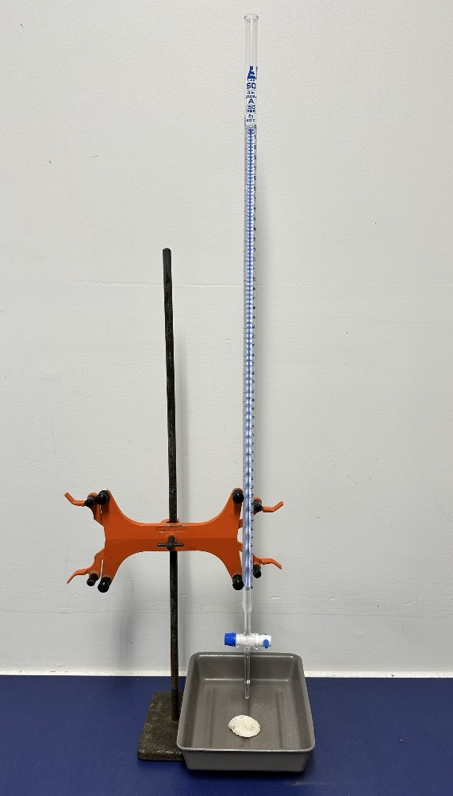
Sample response: Student resource – ocean acidification practical investigation
Note: graphs and infographics have been removed from the sample responses. Please view them in the relevant student resource.
Test 1 – testing for carbon dioxide
Observations
At the beginning of the test the calcium hydroxide (limewater) solution was clear. After combusting the candle in the beaker, the calcium hydroxide changed to have a cloudy/milky appearance. Therefore, burning the candle produced carbon dioxide.
Test 2 – How does carbon dioxide impact the pH of water?
Observations
Table 19 – sample results for Test 2 – How does carbon dioxide impact the pH of water?
Initial pH | Final pH | Difference in pH
7 | 5 | 2
Did the carbon dioxide make the water more acidic or more alkaline? acidic.
Secondary data analysis
- Describe the trends seen in the pH of surface waters around Australia from 1982 to 2022.
Between 1982 and 2022, there has been a decrease in the pH of surface water around Australia. The northern waters of Australia have seen a 0.06 decrease in pH, whereas the southern waters around Australia have seen a 0.07 decrease in pH.
- The current ocean pH is approximately 8.1 and is projected to decline further between 0.15 and 0.5 pH units by 2100 (Ocean acidification 2024). Based on the information represented in Figure 5, explain which organisms are likely to be impacted the most?
If the ocean pH decreases by 0.15 to 0.5 units, it will be between 7.6 and 7.95. According to Figure 5, corals are most at risk because they have a very narrow pH range for survival and reproduction, making them likely to face the greatest consequences. Other organisms such as crabs, snails, mussels and shellfish can tolerate lower pH levels (7.4–9.9 and 7.4–8.4, respectively). However, while these species may survive at a pH of 7.6, they will be living at the lower end of their tolerance and could experience reduced growth or weaker shells.
Test 3 – the effect of acid on shells
Table 20 – sample response for the effect of acid on shells investigation results
Treatment | Diagram – before | Diagram – after | Observation
Control (distilled water) |  |  | There was no visible change to the shell's surface.
Acid | 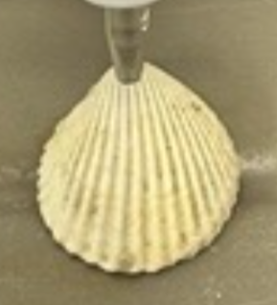 |  | There is visible damage where the acid dripped onto the shell, which has caused a hole to form in the shell.
Evaluating the claim
Table 21 – sample response for creating an evidence-based claim
Claim | Evidence | Reasoning
Climate change could erase the shellfish industry | In the first experiment, the addition of carbon dioxide to the water showed a decrease in the pH of the water from 7 to 5.  Figure 4 shows that from 1982 to 2022, the pH of surface water around Australia has decreased by 0.06 to 0.07.  Figure 5 shows that the lowest pH that shellfish can tolerate is 7.5.  The second experiment showed that when the shell was exposed to acid, it broke down its surface, forming a hole. | Based on this evidence, it can be concluded that over time, as the ocean becomes more acidic (lower pH), there will be damage caused to the shells of marine organisms. This will have a negative impact on the shellfish industry, as shellfish will find it harder to survive.
Use the template above to structure your answer, and evaluate the claim ‘Climate change could erase the shellfish industry.’
The claim that climate change could erase the shellfish industry is valid. Evidence from Test 2 showed that adding carbon dioxide to the water caused a decrease in pH from 7 to 5. This is supported by data from Figure 4, which indicates that between 1982 and 2022, there has been a 0.06–0.07 decrease in the pH of surface water around Australia. Figure 5 displays the optimal pH ranges for marine organisms, with the lowest pH that shellfish can tolerate being 7.5. Test 3 demonstrated that shells exposed to acidic conditions suffered damage; when exposed to acid, the shell’s surface broke down, creating a hole.
Based on this evidence, it can be concluded that over time, as the ocean becomes more acidic (lower pH), there will be damage caused to the shells of marine organisms. This will have a negative impact on the shellfish industry, as shellfish will struggle to survive.

Student resource – ocean acidification practical investigation
You are going to investigate the following claim:
Climate change could erase the shellfish industry.

Test 1 – testing for carbon dioxide
In chemistry, we can test a gas to find out if it is carbon dioxide by reacting it with calcium hydroxide (also known as limewater). The clear calcium hydroxide will react with the carbon dioxide to form a precipitate, which causes the solution to become cloudy.
Aim: to test the product of combustion for the presence of carbon dioxide.
Method:
- Fix a short candle to the bottom of a large beaker (500–1000 mL) using a piece of sticky putty.
- Pour approximately 20 mL of calcium hydroxide (limewater) into the base of the beaker.
- Light the candle and allow it to burn for a moment before setting a tile over top of the beaker. This will capture the gas produced during the combustion process in the beaker.
- Once the candle has burnt out, gently swirl the beaker while holding the tile in place.
- Observe any change in the appearance of the calcium hydroxide.
Figure 1 – equipment setup to test if combustion of candle wax produces carbon dioxide
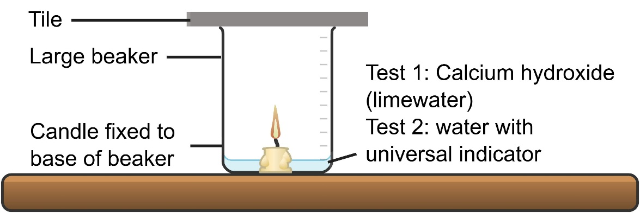
This work has been generated using Chemix.
Observations
At the beginning of the test the calcium hydroxide (limewater) solution was ______________. After combusting the candle in the beaker, the calcium hydroxide changed to have a ___________ appearance. Therefore, burning the candle produced ___________ ____________.

Test 2 – How does carbon dioxide impact the pH of water?
pH is the measure of how acidic a substance is. The lower the pH, the more acidic the substance, and the higher the pH, the more alkaline the substance. We can use a universal indicator to measure the pH of a substance by observing the colour and matching it to the chart below.
Figure 2 – the pH scale for universal indicator
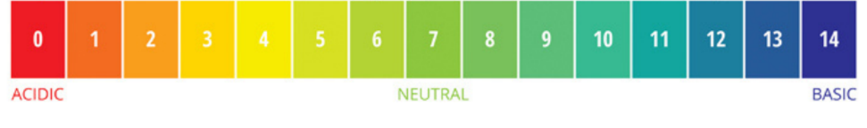
Aim: to observe how carbon dioxide affects the pH of water.
Method:
- Fix a short candle to the bottom of a large beaker (500–1000 mL) using a piece of sticky putty.
- Pour approximately 20 mL of water into the base of the beaker and add a few drops of universal indicator.
Note: the universal indicator and water mixture should be green. If it is not green, you should re-rinse your beaker and start again.
- Light the candle and allow it to burn for a moment before setting a tile over top of the beaker. This will capture the gas produced during the combustion process in the beaker.
- Once the candle has burnt out, gently swirl the beaker while holding the tile in place.
- Observe any change in the appearance of the water and the universal indicator solution.
Figure 3 – equipment setup to test the effect of carbon dioxide gas on the pH of water
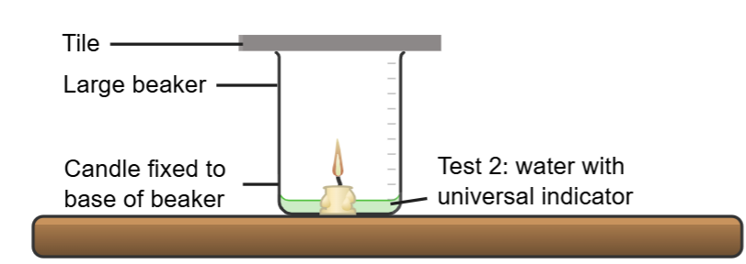
This work has been generated using Chemix.
Observations
Table 1 – pH of water before and after exposure to carbon dioxide from combustion
Start pH | Finish pH | Change in pH
Did the carbon dioxide make the water more acidic or more alkaline? ______________________.
Secondary data analysis
Figure 4 – the pH change of surface waters around Australia between 1982 and 2022
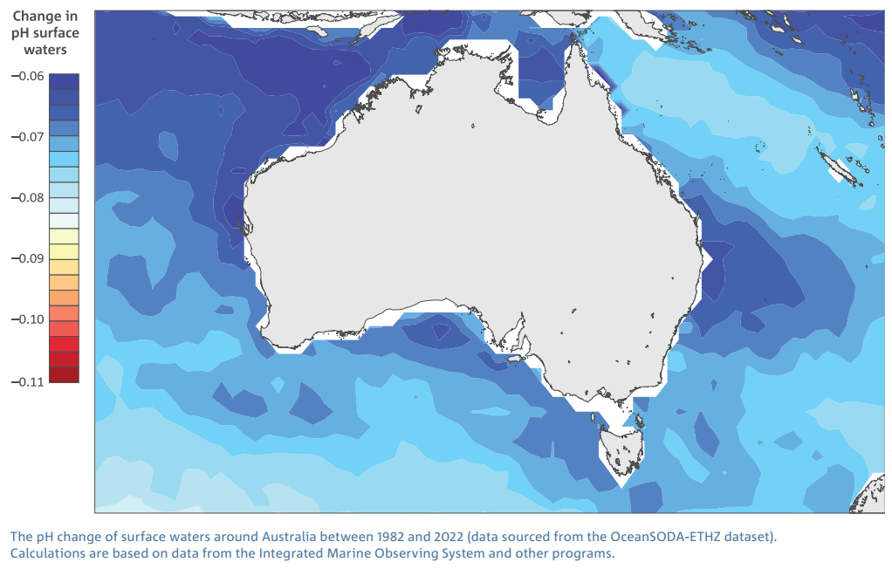
The pH change of surface waters around Australia between 1982 and 2022 © Copyright CSIRO Australia.
Describe the trends seen in the pH of surface waters around Australia from 1982 to 2022 (Figure 4).
Figure 5 – optimal pH range of aquatic organisms
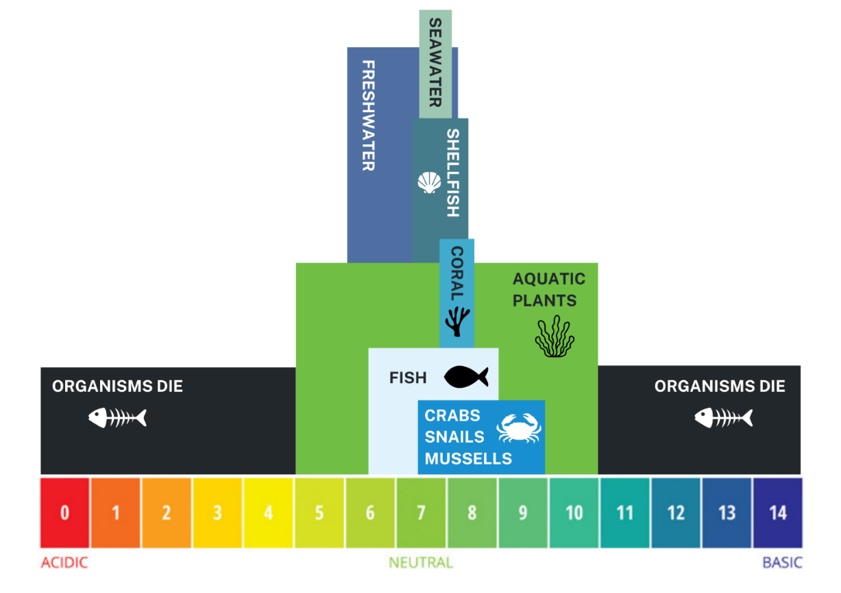
Source: adapted from the “pH of Water.” Fundamentals of Environmental Measurements. 19 Nov. 2013. Web
- The current ocean pH is approximately 8.1 and is projected to decline further between 0.15 and 0.5 pH units by 2100 (Ocean acidification 2024). Based on the information represented in Figure 5, explain which organisms are likely to be impacted the most?

Test 3 – the effect of acid on shells
Aim: to observe the effect of acid on shells
In this demonstration, a shell will be placed in a tray and a weak acid will be dropped onto the shell over a period of time. This will be compared to a control using the same setup with distilled water instead of acid. This demonstration is designed to show how acid affects calcium carbonate in existing shells.
Observations
Draw a diagram of the shells before the treatments are applied to them. After the treatments are applied, draw another diagram and record any observed changes to the shell.
Table 1 – the effect of acid on shells investigation results
Treatment | Diagram – before | Diagram – after | Observation
Control (distilled water)
Acid

Evaluating the claim
Use the template below to structure your response, and evaluate the claim ‘Climate change could erase the shellfish industry’. Refer to the investigations you've conducted and the information you've gathered.
Claim | Evidence | Reasoning
State the claim being investigated. | Provide reliable information from experiments, facts or a reliable source that supports the claim. | Explain how the evidence supports the claim.
Helpful hints  Ensure keywords and ideas from the claim and investigation are aligned. | Sentence starters  In the experiment …  The data shows …  One piece of evidence is … | Sentence starters  The evidence supports the claim because …  Based on this evidence, it can be concluded that …
Your response  Climate change could erase the shellfish industry | Your response | Your response
Use the template above to structure your answer, and evaluate the claim ‘Climate change could erase the shellfish industry.’

1.11 Climate change and the water cycle
Table 22 – learning intentions and success criteria for ‘1.11 Climate change and the water cycle’
We are learning to: | I can:
- discuss the impact of climate change on the natural world | - identify that climate change causes changes to the water cycle  - describe the consequences of changes to the water cycle for ecosystems
- analyse data from investigations to identify relationships. | - describe trends in global climate data  - use global climate data to make predictions  - describe the relationship between global temperature and impacts on ice sheet mass and sea level.
Checkpoint: deliver a checkpoint on students’ prior knowledge of the water cycle and ecosystems using ENV PPT ‘1.11 Checkpoint – quick quiz on previous content’.
Mini challenge (MC): multiple choice question
Which of the following are part of the water cycle?
- rain, sun and glaciers
- the ocean, grass and sun
- glaciers, sun and grass
- Rain, the ocean and glaciers
Challenge (C): define the term ‘ecosystem’.
Super challenge (SC): How do living things depend on water?
Checkpoint sample response
Mini challenge:
- incorrect answer – the ‘sun’ is not a direct part of the water cycle but provides the energy for it to occur.
- incorrect answer – while the ocean is a key component of the water cycle, grass is not a major part of the cycle (though plants do play a role in transpiration), and ‘sun’ is an energy source, not a water cycle component itself. This option also omits processes like rain and glaciers.
- incorrect answer – the ‘sun’ is not a direct part of the water cycle but provides the energy for it to occur. Grass is not a major part of the cycle (though plants do play a role in transpiration).
- correct answer
Challenge: a system formed by the interaction of all living organisms (plants, animals, humans) with each other and with the physical elements of the environment in which they live.
Super challenge: living things depend on water to survive because it is essential for processes like digestion, temperature regulation and transporting nutrients. Many organisms, such as fish and aquatic plants, also live in water, relying on it as their habitat. Without water, most life forms could not carry out basic biological functions.

Climate change and the water cycle
This activity aims to deepen students' understanding of the water cycle and its connection to climate change. Students begin by exploring the components and processes of the water cycle through a Frayer diagram and a visual model. They then predict how changes in temperature and rainfall can impact different parts of the cycle and ecosystems. Using NASA’s Global Temperature website, students analyse real-world data on temperature, ocean warming, ice sheet mass and sea levels to identify trends and relationships. Their knowledge is consolidated through a first-hand investigation into the impact of melting ice sheets on sea levels. Throughout the lesson, students develop critical thinking about how climate change drives changes within the water cycle and affects the environment.
Note: students should have learned about the water cycle in Stage 4 Geography. This activity revisits the concept in a science context, so some students may need additional support to complete the Frayer diagram effectively. To assist students, consider reviewing key water cycle vocabulary and processes before they begin. Providing sentence starters or guiding questions can help students articulate their definitions and examples.
- Provide students with a copy of Student resource – water cycle Frayer diagram. Students develop a Frayer diagram of the water cycle. See slide ENV PPT ‘1.11 Water cycle Frayer diagram’.
Differentiation: display Slide ENV PPT ‘1.11 Water cycle Frayer diagram sentence starters’ to support students in completing the Frayer diagram summary.
- Show students a model of the water cycle on slide ENV PPT ‘1.11 The water cycle’ and Student resource – changes to the water cycle. Students use the model of the water cycle, and the evidence in the question prompts, to make predictions about the impact of changes to one aspect of the water cycle on other aspects of the cycle.
Data talk (optional task): Data talks help support student data literacy, thinking and engagement. Youcubed by Stanford University has a data talk called NASA Data Talk – Sea Level Rise that is relevant to the content taught in this lesson sequence.
- Provide students with the Student resource – secondary data investigation and provide them with access to computers for this activity. Students will access the website Global Temperature by NASA. By using the drop-down menu under Earth Indicators at the top of the webpage they will view and compare multiple datasets, including:
- Global temperature
- Ocean warming
- Ice sheets
- Sea level.
- Students make observations of the trends of global data and answer questions in the Student resource – secondary data investigation. They will describe the relationship between global temperature, ocean temperature, ice sheet mass and sea levels. Students should be able to identify how changes in one part of the water cycle can impact another. They may also recognise climate change as the cause of these changes in the water cycle.
Differentiation: guide the students through the analysis of each webpage by projecting it on the board. Unpack the information and support students in responding to each question.
Sample response: Student resource – water cycle Frayer diagram
Figure 9 – Frayer diagram of the water cycle
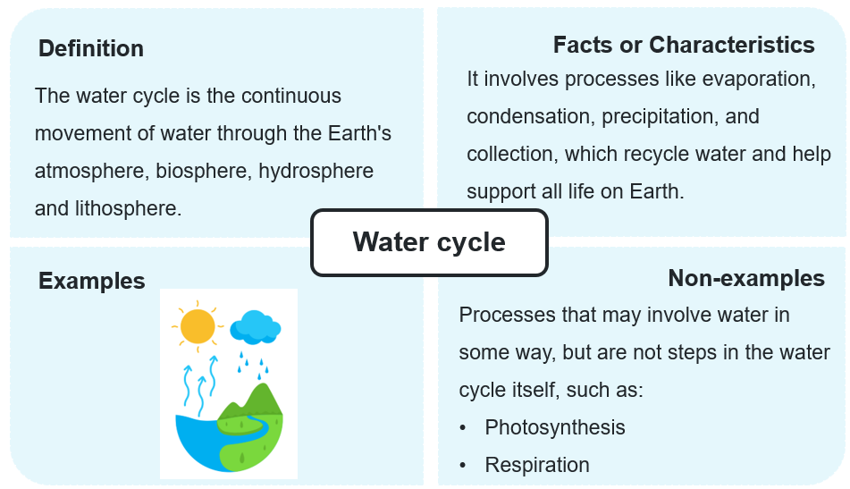
WAM PPT ‘1.11 Water cycle Frayer diagram sample response’
Sample response: Student resource – changes to the water cycle
- Evidence shows that the Earth’s average surface temperature has increased approximately 1.4 degrees Celsius since 1880. Predict the impact of increased overall surface temperature on evaporation and transpiration.
An increase in Earth's surface temperature is likely to accelerate both evaporation and transpiration. Warmer temperatures cause more water evaporating from oceans, lakes and rivers. Similarly, plants will lose more water through transpiration as the heat increases.
- Climate models suggest that by 2090, average annual rainfall in NSW could drop by 11% under a high-emissions scenario. Explain how this reduction in rainfall might affect the populations of plant and animal species.
A decrease in rainfall can reduce the availability of fresh water for plants and animals. Plants might find it harder to grow or reproduce, resulting in less food and habitat for animals. Animal populations that rely on specific water sources or damp environments may decline or be forced to migrate.

Sample response: Student resource – secondary data investigation
Data trends in climate change variables
- Describe the trends seen in global surface temperatures (see Global temperature webpage).
This graph shows that global surface temperature has increased 1.47ºC since 1880.
- Describe the trends seen in ocean heat content (see Ocean warming webpage).
The data shows an increase in ocean heat energy of 372 zettajoules between 1955 and 2021.
- Describe the trends seen in ice sheet mass (see Ice sheets webpage).
The graphs show a decrease in ice mass for Antarctica and Greenland. Antarctica is losing ice at an average of 136 billion tons annually, while Greenland is losing about 267 billion tons each year.
- Describe the trends seen in sea level (see Sea level webpage).
The graph shows a 92.2 mm increase in sea level since 1993.
Relationships between climate change variables
- Describe the relationship between global surface temperature and ocean heat content.
As surface temperature increases, ocean temperature also increases.
- Describe the relationship between ocean heat content and ice sheet mass.
As ocean temperatures increase, the mass of ice sheets in locations such as Antarctica and Greenland decreases.
- Describe the relationship between ice sheet mass and sea level.
As the mass of sea ice sheets decreases, sea levels increase.

Student resource – water cycle Frayer diagram
Figure 1 – Frayer diagram of the water cycle
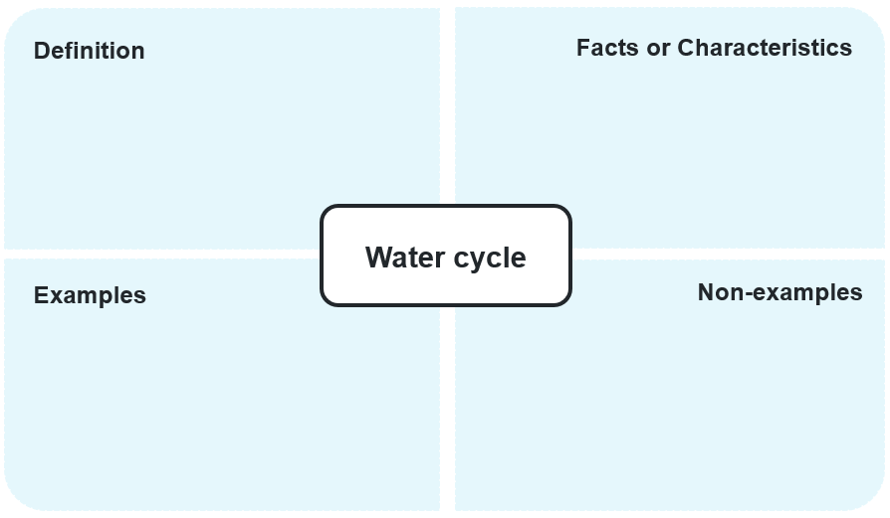

Student resource – changes to the water cycle
Figure 1 – the water cycle
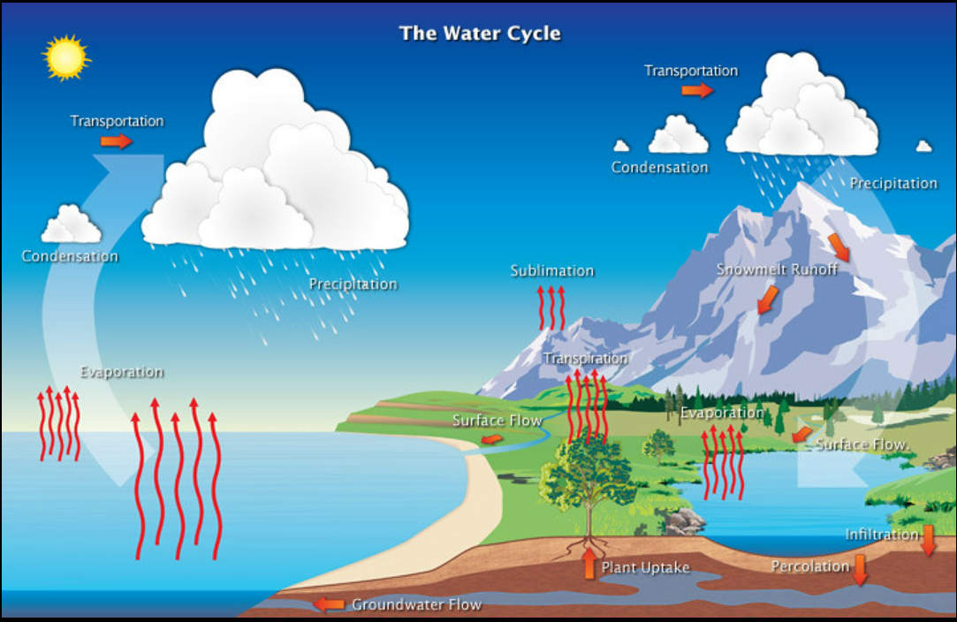
The water cycle by NOAA National Weather Service Jetstream is licensed under CC BY 2.0
- Evidence shows that the Earth’s average surface temperature has increased approximately 1.4 degrees Celsius since 1880. Predict the impact of increased overall surface temperature on evaporation and transpiration.
- Climate models suggest that by 2090, average annual rainfall in NSW could drop by 11% under a high-emissions scenario. Explain how this reduction in rainfall might affect the populations of plant and animal species.

Student resource – secondary data investigation
Access this website: Global Temperature by NASA.
By using the drop-down menu under Earth Indicators at the top of the webpage, you will view and compare multiple datasets, including:
- Global temperature
- Ocean warming
- Ice sheets
- Sea level
For each of the identified data sources, complete the questions below to describe the trends and relationships between climate change variables.
Data trends in climate change variables
- Describe the trends seen in global surface temperatures (see Global temperature webpage).
- Describe the trends seen in ocean heat content (see Ocean warming webpage).
- Describe the trends seen in ice sheet mass (see Ice sheets webpage).
- Describe the trends seen in sea level (see Sea level webpage).
Relationships between climate change variables
- Describe the relationship between global surface temperature and ocean heat content.
- Describe the relationship between ocean heat content and ice sheet mass.
- Describe the relationship between ice sheet mass and sea level.

Rising sea levels
- Provide students with a copy of the Student resource – melting ice sheets and sea level to model the effect of melting ice sheets on sea level.
- Prompt students to look at the image of the equipment setup on slide ENV PPT ‘1.11 Predict–Explain–Observe–Explain’ (2 slides) and ask students to complete the ‘predict’ and ‘explain’ components of a P-E-O-E scaffold.
- Facilitate the practical investigation to demonstrate the impact of melting ice sheets on sea level. Figure 10 shows the equipment set up for the investigation and Figure 11 shows how the ‘sea level’ rises as the ice sheet melts. This is compared to sea ice, such as icebergs, which do not cause a rise in sea levels when they melt.
- Students complete the ‘observe’ and ‘explain’ components of the P-E-O-E scaffold in the Student resource – melting ice sheets and sea level and answer the remaining questions.
Note: when sea ice melts, it simply turns into liquid water with the same mass and volume as what it had already displaced. Therefore, there is no net change in sea level from sea ice. Ice sheets, on the other hand, are located on land and do not displace seawater when frozen, so when they melt, they add volume to the sea, causing the sea levels to rise.
Figure 10 – equipment set up for Investigation: melting ice sheets and sea level  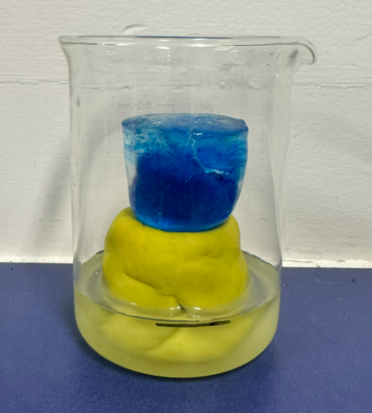 | Figure 11 – sample results from the Investigation: melting ice sheets and sea level  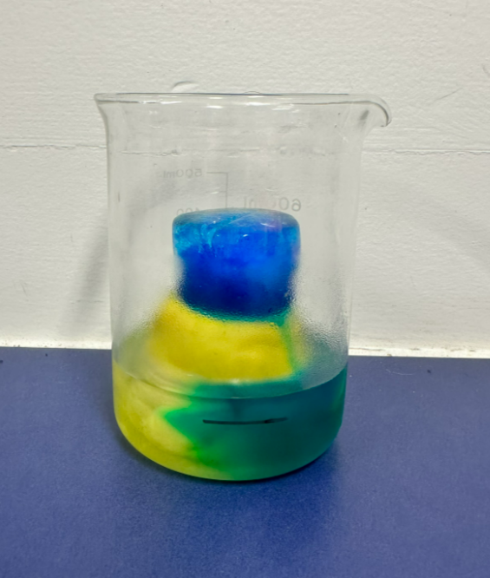

Sample response: Student resource – melting ice sheets and sea level
Diagram
Draw a labelled diagram of the investigation setup.
Figure 12 – sample student diagram
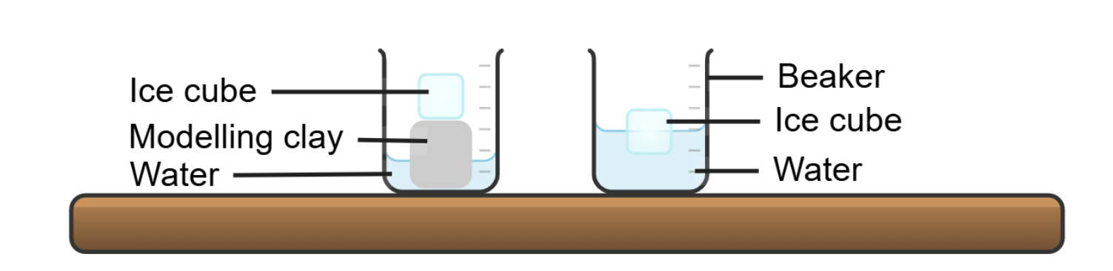
This work has been generated using Chemix.
Results
Table 23 – sample results: the change in water height between melting sea ice and melting ice sheets
Treatment | What did it represent? | What was observed?
Ice cube in water | Sea ice and icebergs represent ice in the ocean, not on land. | The water level did not rise as the ice melted.
Ice cube on modelling clay | It represents ice sheets, which are continental glaciers (on land). | The water level rose as the ice melted.
Discussion and conclusion
- Outline how each item of the investigation represents an aspect of the water cycle.
The ice cubes represent ice sheets or glaciers or sea ice, such as icebergs on Earth, while the modelling clay represents land, and the water represents the ocean.
- What conclusion can be drawn from the results of this investigation?
As the ice on the modelling clay melted, it flowed into the water below, raising the water level. The ice cube in the water displaced the same volume that it occupied once melted, so the water level did not rise. Therefore, the melting of ice sheets or glaciers causes the sea level to rise, whereas the melting of sea ice does not.
- Using the results from the investigation, explain how this investigation can be used as a model to represent the effect of melting ice sheets on sea levels.
This investigation models how melting ice sheets contribute to rising sea levels. In the experiment, when the ‘ice sheet’ melts, the water level in the container rises, just as melting glaciers and ice sheets on continents add more water to the oceans. This demonstrates that melting ice directly contributes to sea level rise, helping us understand a major effect of climate change. By estimating the volume of water in ice sheets, we can predict how much sea levels could increase, which helps identify, monitor and protect low-lying areas where possible.

Student resource – melting ice sheets and sea level
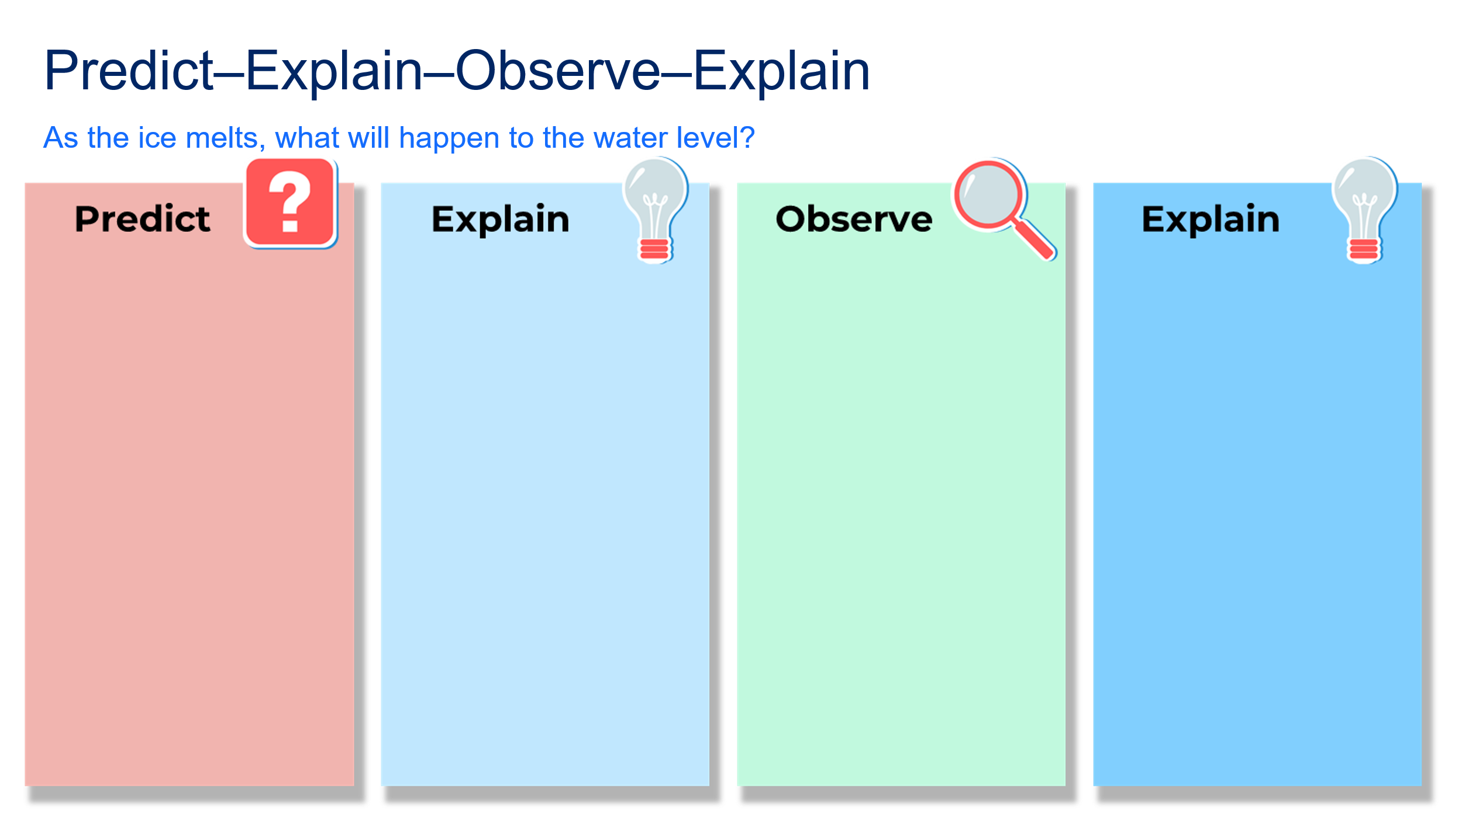
This practical investigation aims to develop a model to explore the impact of melting ice sheets on sea levels.
Aim: to observe how melting ice sheets will affect sea levels.
Equipment
- 2 × large beakers
- 1 × handful of modelling clay
- 2 × large ice cubes coloured with food dye (they should be approximately the same size)
- 1 × marker
- 150 mL water
- 100 mL measuring cylinder
Procedure
- Take a handful of modelling clay and shape it into a cylinder. Place the modelling clay inside one of the beakers, ensuring there is space between the edge of the beaker and the modelling clay.
- Pour 50 mL of water around the sides of the modelling clay.
- Mark the water level on the side of the beaker with the marker and set the beaker aside.
- Place 100mL of water in the second beaker. Add one ice cube and immediately mark the water level on the side of the beaker with a marker.
- Place one large ice cube on top of the modelling clay, lightly pressing it down into the clay.
- Keep the beakers at room temperature and allow the ice to melt.
- After 30 minutes or once the ice has completely melted, record the water level in the beakers using the marker.
- Measure the change in height of the water using a ruler.

Results
Table 1 – the change in water height between melting sea ice and melting ice sheets
Treatment | What did it represent? | What was observed?
Ice cube in water
Ice cube on modelling clay
Discussion and conclusion
- Outline how each item of the investigation represents an aspect of the water cycle.
- What conclusion can be drawn from the results of this investigation?
- Using the results from the investigation, explain how this investigation can be used as a model to represent the effect of melting ice sheets on sea level.

The effect of climate change on ecosystems
- Using the map on slide ENV PPT ‘1.11 The effect of climate change on ecosystems’ (2 slides), explain to students the location of Warraber Island in the Torres Strait Islands. Students watch and listen to The race against the rising seas | Healing Country (5:03).
- Provide students with the Student resource – the effect of climate change on ecosystems to explore the effect of rising sea levels on the Warraber Island ecosystem.
Sample response: Student resource – the effect of climate change on ecosystems
- Identify Warraber Island on the map shown.
Figure 13 – map of Torres Strait Islands with Warraber Island identified
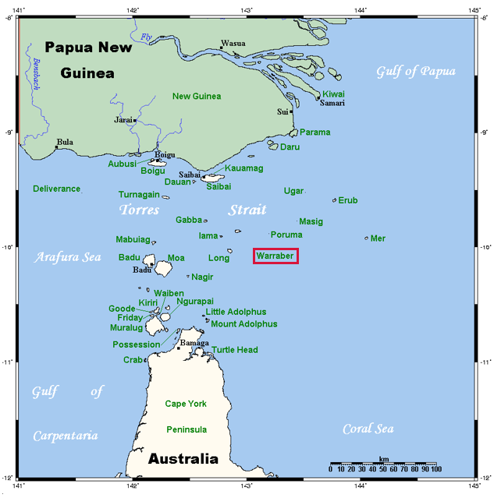
TorresStraitIslandsMap by Kelisi is licensed under CC-BY-SA 3.0.
- Describe the issue facing the Torres Strait Islander Peoples of Warraber.
The Torres Strait Islander Peoples of Warraber are confronting the problem of rising sea levels. Warraber is a low-lying sandy island experiencing shoreline erosion caused by sea level rise.
- Explain the effect of sea level rise on the plants of Warraber.
Sea level rise leads to coastal erosion, which washes away the support for plant roots and causes their death.
- Explain the effect of sea level rise on the animals of Warraber.
The loss of sand banks caused by rising sea levels leaves migrating birds without a resting spot on their way to Papua New Guinea, which could result in their death.

Student resource – the effect of climate change on ecosystems
- Identify Warraber Island on the map shown.
Figure 1 – map of Torres Strait Islands
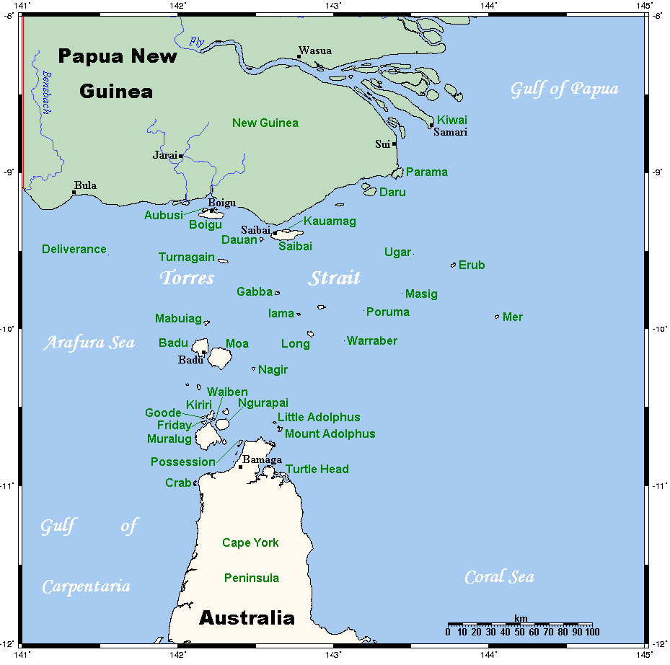
TorresStraitIslandsMap by Kelisi is licensed under BY-SA 3.0.
- Describe the issue facing the Torres Strait Islander Peoples of Warraber.
- Explain the effect of sea level rise on the plants of Warraber.
- Explain the effect of sea level rise on the animals of Warraber.

1.12 Satellites are on the job
Table 24 – learning intentions and success criteria for ‘1.12 Satellites are on the job’ (ENV PPT)
We are learning to: | I can:
- discuss the impact of climate change on the natural world | - describe how satellites collect climate data  - examine how satellite images can be used to evaluate the impact of climate change
- use data to draw conclusions | - use evidence to draw conclusions about the impact of climate change on ice cover
- develop evaluation criteria. | - outline suitable criteria for evaluating ice cover data.
Checkpoint: deliver a checkpoint on the previous lesson’s content. See slide ENV PPT ‘1.12 Checkpoint – quick quiz on previous content’.
Mini challenge (MC): name 3 main components of the water cycle.
Challenge (C): describe one way climate change affects the water cycle.
Super challenge (SC): explain how rising ocean temperatures affect the mass of ice sheets.
Checkpoint sample response
Mini challenge (MC): evaporation, condensation and precipitation.
Challenge (C): climate change raises global temperatures, which accelerates evaporation and can change rainfall patterns, leading to droughts in some regions and floods in others.
Super challenge (SC): as ocean temperatures rise, the warmer water causes ice sheets, like those in Antarctica and Greenland, to melt more quickly. This melting decreases the ice sheet mass and leads to rising sea levels.

How satellites collect data
A satellite is any object that orbits another celestial body in space. While natural satellites like Earth and the Moon exist, the term often refers to artificial satellites – human-made spacecraft launched into orbit. For this lesson, a satellite is defined as an artificial body placed in orbit around Earth, the Moon or another planet to collect information or enable communication.
Satellites serve many purposes, including communication, weather forecasting, navigation and observing Earth. There are different types of satellites, such as geostationary satellites that remain fixed over one spot on Earth, and polar orbiting satellites that circle the planet from pole to pole, providing detailed global data.
These satellites are equipped with multiple sensors that detect different types of energy reflected or emitted from the Earth's surface. Examples include multi-spectral sensors that capture data across various wavelengths of light and thermal sensors that measure heat.
Data collection happens through remote sensing, a process that measures electromagnetic radiation from the Earth using instruments such as cameras and sensors. This information is transmitted back to Earth via satellite dishes for further analysis.
Satellite data is widely used in environmental monitoring and climate science to track changes such as deforestation, melting ice sheets, and ocean temperatures, helping scientists understand and respond to global changes.
- Using slide ENV PPT ‘1.12 Satellites’, teach students the definition of satellites and differentiate between the broad definition of satellites and satellites as technology.
- Students will need access to computers for this activity. They will investigate how satellites collect data on ocean temperatures, sea levels, forest cover and ice cover. Using the Student resource – how satellites collect data, students will record the methods and sensor types used for each variable.
Sample response: Student resource – how satellites collect data
Table 25 – sample response: satellite data collection methods
Data type | How is this data being collected? | Sensor type | Example image
Ocean temperatures | Ocean temperature can be measured by detecting and analysing the infrared radiation emitted by the ocean surface. This radiation's intensity and wavelengths correspond to the surface temperature. | - Infrared | 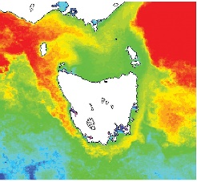  CSIRO ScienceImage 10719 NOAA polar orbiting satellites obtain the data generating sea surface temperature images Polar orbiting satellites obtain the data to generate sea surface temperature images.by CSIRO is licensed under CC BY 3.0.
Sea level | Sea-surface height can be measured by the time it takes for radar or laser pulses to reach the ocean surface and reflect back to the spacecraft. | - Radar  - Laser | 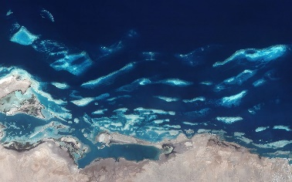  A satellite view of the Red Sea coast along Saudi Arabia by Axelspace Corp is licensed under CC BY-SA 4.0.
Forest cover | Forested areas reflect and absorb light differently compared to other land types. Satellites measure forest cover by analysing how light is reflected back to them from the Earth's surface. | - Multi-spectral imaging  - Radar | 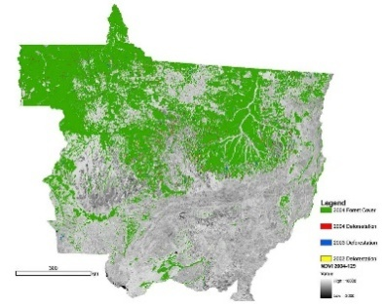  NASA Satellite Measures Deforestation by NASA is licensed under PDM 1.0.
Ice cover | Satellites measure ice cover by measuring reflected solar radiation and thermal radiation. | - Radar  - Laser | 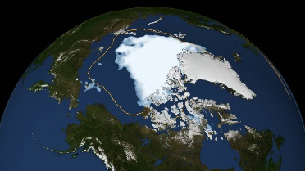  Arctic Sea Ice Shrinks To New Low In Satellite Era by NASA is licensed under CC BY 2.0.

Student resource – how satellites collect data
Investigate how satellites gather information about different aspects of climate change. For each data type listed below, research and fill in the table by:
- describing how the data is collected by satellites
- listing the type of sensor used (such as radar, infrared, laser, or multi-spectral imagery)
- finding and including an example image that shows this data.
Table 1 – satellite data collection methods
Data type | How is this data being collected? | Sensor type | Example image
Ocean temperatures
Sea level
Forest cover
Ice cover

Satellite data to evaluate climate change
In this activity, students will analyse a series of satellite images showing changes in ice cover over time.
The focus is on developing students’ skills in interpreting remote sensing data and understanding how long-term satellite observations reveal a consistent global decline in ice cover. Students will critically evaluate the data by distinguishing between short-term weather events and long-term climate trends, learning the scientific criteria for selecting reliable satellite data.
This activity supports students in drawing evidence-based conclusions about the impacts of climate change and in appreciating the role of satellites in monitoring environmental changes worldwide.
- Students watch NASA's Research on Climate Change | Above and Beyond (6:03); refer to slide ENV PPT ‘1.12 Satellite data to evaluate climate change’.
- Students will need access to computers for the following activity. Provide students with Student resource – satellite data to evaluate climate change. Students will access a series of NASA satellite images of ice cover (listed below). Guide students to use the slider by selecting the double arrow on the curtain separating the before and after images and moving it left and right. Encourage them to compare the images. Remind them to select ‘Image details’ in the bottom left corner of the image to read about each image and complete the worksheet.
Satellite images of ice cover
- Grand Plateau Glacier Retreats
- Patagonia Glacier retreat, Chile
- Mýrdalsjökull Then and Now
- St. Patrick Bay Ice Caps Nearly Gone
- Breakup at Land Glacier
- Oldest Arctic Sea Ice is Disappearing
- Shrinking glaciers in New Zealand
- Arctic Sea Ice Reaches Annual Low
- Snow in Southern California
Sample response: Student resource – satellite data to evaluate climate change
- Describe the patterns and trends seen in the satellite images of ice cover.
All the satellite images reveal a typical pattern of declining ice cover in recent years compared to earlier data. This indicates a persistent trend of decreasing ice cover over time.
- Can it be concluded that the observed pattern is limited to a single area or region?
No, the reduction in ice cover seems to occur across various continents and in both the Northern and Southern Hemispheres, indicating it is a worldwide trend.
- Calculate the average number of years between the satellite images of ice cover.
27 years.
- What conclusion could scientists draw about the impact of climate change based on the data from these images?
It can be concluded that climate change is causing higher temperatures, which leads to faster ice melting and makes it harder for ice to freeze again as quickly and extensively as before. As a result, there is a global drop in overall ice cover.
- Look at the following images: Snow in Southern California Explain why scientists would not use these images as data to evaluate the impact of climate change.
These images show snow cover caused by a storm in Southern California. Taken on 10 and 26 February 2023, they depict a short-term weather event. Because this reflects a temporary occurrence rather than a long-term trend, the data would not be useful for studying the long-term impacts of climate change.
- Identify the criteria that scientists should use to determine whether these satellite images are suitable for evaluating the impact of climate change.
The criteria should include that satellite images are collected over an extended period and that consistent data can be gathered from locations worldwide, rather than being limited to a specific region.

Student resource – satellite data to evaluate climate change
NASA’s Images of Change gallery features satellite images of different locations on Earth, showing change over time periods ranging from centuries to days. In this activity, you will view a series of satellite images of ice cover.
The satellite images you will explore are:
- Grand Plateau Glacier Retreats
- Patagonia Glacier retreat, Chile
- Mýrdalsjökull Then and Now
- St. Patrick Bay Ice Caps Nearly Gone
- Breakup at Land Glacier
- Oldest Arctic Sea Ice is Disappearing
- Shrinking glaciers in New Zealand
- Arctic Sea Ice Reaches Annual Low
- Snow in Southern California
Instructions:
- Access the images listed above using the provided links or resource.
- Use the slider tool to compare the before-and-after images by clicking and dragging the double arrow on the dividing curtain left and right.
- Observe and note the changes in ice cover over time for each location.
- Click on ‘Image details’ in the bottom left corner of each image to read more information about the location, time period and significance of the changes.
- Record your observations by completing the questions below.
Questions:
- Describe the patterns and trends seen in the satellite images of ice cover.
- Can it be concluded that the observed pattern is limited to a single area or region?
- Calculate the average number of years between the satellite images of ice cover.
- What conclusion could scientists draw about the impact of climate change based on the data from these images?
- Look at the following images: Snow in Southern California. Explain why scientists would not use these images as data to evaluate the impact of climate change.
- Identify the criteria that scientists should use to determine whether these satellite images are suitable for evaluating the impact of climate change.

Evidence base
This resource contains NSW Curriculum and syllabus content. The NSW Curriculum is developed by the NSW Education Standards Authority. This content is prepared by NESA for and on behalf of the Crown in right of the State of New South Wales. The material is protected by Crown copyright.
Please refer to the NESA Copyright Disclaimer for more information https://educationstandards.nsw.edu.au/wps/portal/nesa/mini-footer/copyright.
NESA holds the only official and up-to-date versions of the NSW Curriculum and syllabus documents. Please visit the NSW Education Standards Authority (NESA) website https://educationstandards.nsw.edu.au and the NSW Curriculum website https://curriculum.nsw.edu.au.
Science 7–10 Syllabus © NSW Education Standards Authority (NESA) for and on behalf of the Crown in right of the State of New South Wales, 2023.
ABC Indigenous (10 September 2021) ‘The race against the rising seas | Healing Country' [video], ABC Indigenous, YouTube, accessed 26 May 2025.
AITSL (Australian Institute for Teaching and School Leadership Limited) (n.d.) Learning intentions and success criteria [PDF 251 KB], AITSL, accessed 18 May 2025.
American Museum of Natural History (25 August 2014) ‘Science Bulletins: Keeling Curve – The Story of CO2' [video], American Museum of Natural History, YouTube, accessed 5 June 2025.
ANSTO (Australian Nuclear Science and Technology Organisation) (n.d.) ‘Historic greenhouse gas concentrations from Antarctic ice core sampling’, Data sets, ANSTO website, accessed 26 May 2025.
Australian Government Department of Climate Change, Energy, the Environment and Water (n.d.) Electricity generation, Australian Government, accessed 26 May 2025.
Australian Museum (25 January 2021) ‘What are the impacts of climate change?' [video], Australian Museum, YouTube, accessed 5 June 2025.
Brookhart SM (2018) ‘Appropriate Criteria: Key to Effective Rubrics’, Frontiers in Education, 3(22):1–12, doi:10.3389/feduc.2018.00022, accessed 6 February 2025.
BOM (Bureau of Meteorology) (n.d.) Climate Data, BOM website, accessed 26 May 2025.
——(n.d.) 2024 maximum temperature – data graph, BOM website, accessed 26 May 2025.
——(n.d.) ‘Future climate’, State of the Climate, BOM website, accessed 26 May 2025.
——(n.d.) ‘Greenhouse gases’, State of the Climate, BOM website, accessed 26 May 2025.
——(n.d.) ‘Report at a glance’, State of the Climate, BOM website, accessed 26 May 2025.
Canva (n.d.) The natural greenhouse effect – design project, Canva, accessed 26 May 2025.
Carbon Brief (2023) Q&A: Major global report reveals how climate, land use and trade drive invasive species, Carbon Brief website, accessed 26 May 2025.
CESE (Centre for Education Statistics and Evaluation) (2020) What works best: 2020 update, NSW Department of Education, accessed 18 February 2025.
——(2020) What works best in practice, NSW Department of Education, accessed 18 July 2024.
——(2021) Growth goal setting – what works best in practice, NSW Department of Education, accessed 6 February 2025.
CSIRO (Commonwealth Scientific and Industrial Research Organisation) (n.d.) PV and Batteries – photovoltaic (PV) dashboard, CSIRO website, accessed 26 May 2025.
——(n.d.) ‘What are the sources of carbon dioxide in the atmosphere? Australia's contribution to global greenhouse gas emissions’, Climate Change Q&A, CSIRO website, accessed 26 May 2025.
——(2024) State of the Climate, CSIRO website, accessed 26 May 2025.
Discovery (11 January 2020) ‘NASA's Research on Climate Change | Above and Beyond [video]', Discovery, YouTube, accessed 26 May 2025.
Fisher D and Frey N (1 November 2009) ‘Feed Up, Back, Forward’, ASCD (Association for Supervision and Curriculum Development): Educational Leadership magazine, 67(3), accessed 18 May 2025.
Geoscience Australia (2024) Carbon capture and storage, Australian Government, accessed 26 May 2025.
Griffin P (2017) Assessment for Teaching, Cambridge University Press, Port Melbourne, Victoria.
Hattie J and Timperley H (2007) ‘The Power of Feedback’, Review of Educational Research, 77(1): 81–112, doi:10.3102/003465430298487.
Henley B and Abram N (13 June 2017) ‘The three-minute story of 800,000 years of climate change with a sting in the tail’, The Conversation, accessed 26 May 2025.
IEA (International Energy Agency) (n.d.) Australia: emissions, IEA website, accessed 26 May 2025.
——(n.d.) Carbon Capture Utilisation and Storage, IEA website, accessed 26 May 2025.
MSC (Marine Stewardship Council) (n.d.) Sustainable fishing, MSC website, accessed 26 May 2025.
MSC (Marine Stewardship Council) – Sustainable seafood (3 February 2015) ‘Sustainable seafood for the future: The three principles of the MSC Fisheries Standard [video]', MSC – Sustainable seafood, YouTube, accessed 26 May 2025.
——(28 February 2022) ‘Sustainable fishing explained [video]', MSC – Sustainable seafood, YouTube, accessed 26 May 2025.
NASA (National Aeronautics and Space Administration) (n.d.) Global Temperature – Earth Indicator, NASA website, accessed 26 May 2025.
——(n.d.) Images of Change, NASA website, accessed 26 May 2025.
New South Wales Department of Education (2025) ‘Conservation and Preservation Through Astronomy with Dr Kirsten Banks [video]', STEM Education, Department of Education website, accessed 21 August 2025.
New South Wales Department of Primary Industries and Regional Development, Aquaculture, NSW Government website, accessed 29 September 2025.
New South Wales Government (n.d.) Regional climate change snapshots, AdaptNSW website, accessed 26 May 2025.
Our World in Data (n.d.)Climate Change Data Catalogue Our World in Data, accessed 26 May 2025.
——(n.d.) Climate Change Impacts Data Explorer: annual temperature anomaly, Our World in Data website, accessed 26 May 2025.
——(n.d.) Temperature anomalies by month – country level, Our World in Data website, accessed 26 May 2025.
——(n.d.) Monthly sea surface temperature anomalies relative to the pre-industrial period, Our World in Data website, accessed 26 May 2025.
Panadero E and Jonsson A (2013) ‘The use of scoring rubrics for formative assessment purposes revisited: A review’, Educational Research Review, 9:129–144, doi:10.1016/j.edurev.2013.01.002, accessed 18 May 2025.
PhET Interactive Simulations (n.d.) Greenhouse Effect, University of Colorado website, accessed 26 May 2025.
Ritchie H (10 February 2020) ‘What are the safest and cleanest sources of energy?’, Our World in Data website, accessed 26 May 2025.
——(19 September 2023) ‘Global deforestation peaked in the 1980s’, Our World in Data website, accessed 26 May 2025.
Ritchie H and Roser M (2020) CO₂ emissions, Our World in Data website, accessed 26 May 2025.
——(2024) ‘Fish and Overfishing’, Our World in Data website, accessed 26 May 2025.
Ritchie H and Spooner F (10 October 2024) ‘The 2024 Living Planet index reports a 73% average decline in wildlife populations – what’s changed since the last report?’, Our World in Data website, accessed 26 May 2025.
Science On a Sphere (SOS) (n.d.) Satellites: Paths and Positions, National Oceanic and Atmospheric Administration website, accessed 5 June 2025.
Scripps Institution of Oceanography (n.d.) The Keeling Curve, Scripps Institution of Oceanography website, accessed 26 May 2025.
Scripps Oceanography (13 April 2018) ‘How Scientists Measure Carbon Dioxide in the Air' [video], Scripps Oceanography, YouTube, accessed 5 June 2025.
Sherrington T (2019) Rosenshine’s Principles in Action, John Catt Educational Limited, Melton, Woodbridge.
Stanford University (n.d.) Data talks, Stanford Graduate School of Education, accessed 21 August 2025.
The Conversation (13 June 2017) ‘Why reducing our carbon emissions matters (a little story about climate change)' [video], The Conversation, YouTube, accessed 5 June 2025.
The Watershed Project Channel (3 May 2020) ‘Ocean Acidification and Oyster Shells Lab' [video], The Watershed Project Channel, YouTube, accessed 26 May 2025.
UCLA (14 April 2021) ‘What is Sustainability' [video], UCLA YouTube, accessed 5 June 2025.
UN (United Nations) (n.d.) The 17 Goals – Sustainable Development Goals, UN website, accessed 26 May 2025.
Wiliam D (2017) Embedded Formative Assessment, 2nd edn, Solution Tree Press, Bloomington, IN.
World Wildlife Fund (WWF) (2022) Explore the deforestation fronts ­– deforestation fronts factsheet – eastern Australia, WWF website, accessed 26 May 2025.

© State of New South Wales (Department of Education), 2025
The copyright material published in this resource is subject to the Copyright Act 1968 (Cth) and is owned by the NSW Department of Education or, where indicated, by a party other than the NSW Department of Education (third-party material).
Copyright material available in this resource and owned by the NSW Department of Education is licensed under a Creative Commons Attribution 4.0 International (CC BY 4.0) license.

This license allows you to share and adapt the material for any purpose, even commercially.
Attribution should be given to © State of New South Wales (Department of Education), 2025.
Material in this resource not available under a Creative Commons license:
- the NSW Department of Education logo, other logos and trademark-protected material
- material owned by a third party that has been reproduced with permission. You will need to obtain permission from the third party to reuse its material.
Links to third-party material and websites
Please note that the provided (reading/viewing material/list/links/texts) are a suggestion only and implies no endorsement, by the New South Wales Department of Education, of any author, publisher, or book title. School principals and teachers are best placed to assess the suitability of resources that would complement the curriculum and reflect the needs and interests of their students.
If you use the links provided in this document to access a third-party's website, you acknowledge that the terms of use, including licence terms set out on the third-party's website apply to the use which may be made of the materials on that third-party website or where permitted by the Copyright Act 1968 (Cth). The department accepts no responsibility for content on third-party websites.

