Science Stage 5 (Year 9) – Energy
Teacher resource book 4 of 4 (TRB4)
How can we make better energy choices for the future?
Creation date: 15 July 2024.
Updated: 13 February 2026.
Contents
Overview 3
Introduction 3
4.1 Past and future energy use 4
Instructions 4
Australia’s current energy use 4
Understanding past trends in energy use 6
Why do we need to develop alternative energy sources? 6
Where does our energy go? 9
4.2 Sustainable energy use 13
Background information 13
Sustainable transport 13
Instruction 14
Exploring sustainable transport 14
Vehicle standards 15
Australia’s energy consumption (EGY PPT) 19
4.3 Evaluating nuclear energy in Australia 20
Preparation 20
Instructions 20
4.4 Transitioning to net zero 23
Background information 23
Instructions 23
How many new generators will we need? 27
4.5 Truths, lies and the in between 34
Preparation 34
Instructions 34
Appendix 37
Slow-reveal graphs 37
Evidence base 38

Overview

Introduction
Stage and learning area: Stage 5 Science
Description: this resource complements the Energy program of learning. It aims to serve as a teacher reference, offering practical strategies and ideas to enrich teaching practices and create engaging learning environments. The activities should be adapted to suit the needs of students.
Duration: while timing will vary based on the mode of delivery, differentiation strategies employed and class or school context, this series of activities should take approximately nine 60-minute lessons.
Risk management: Teachers are advised to undertake a risk assessment before conducting any investigation or experiment in their classrooms. For more information on developing risk assessments, see WHS risk management.
This resource book contains elaborations on many of the activities in the Energy program. Some activities also reference the Energy PowerPoint (identified as EGY PPT throughout this document).

4.1 Past and future energy use
Students use published data to describe our past and current energy use. Information is presented using infographics and Slow-reveal graphs. Students use this information to identify key issues around energy use in Australia.
Table 1 – learning intentions and success criteria for 4.1 ‘Past and future energy use’
We are learning: | I can:
- how to make informed decisions about the best energy sources to use  - to represent and organise data and information to find patterns and calculate useful values. | - identify Australia’s largest energy sources and uses  - describe a relevant issue or development affecting Australia’s energy use  - explain why we need to develop alternative sources of energy.

Instructions

Australia’s current energy use
Present the infographic on Australian energy statistics in 2021–2022 (EGY PPT '4.1 Australian energy statistics’), which is also shown in Figure 1 as a stimulus for class discussion.
Figure 1 – Australian Energy Statistics summary infographic 2022–2023 highlighting key figures from the Australian Energy Update 2024
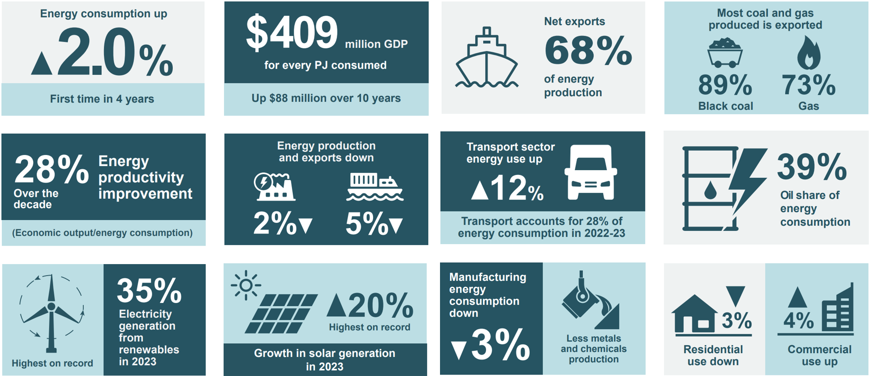
’Key figures from the Australian Energy Update 2024’ by Australian Government Department of Climate Change, Energy, the Environment and Water (2024) is licensed under CC BY 4.0.
Use the See-Think-Wonder thinking routine to engage students in thinking about the energy challenges we are experiencing in Australia. Prompts for facilitating this activity are included in Table 2.
For further information about facilitating the See-Think-Wonder thinking routine, select See-Think-Wonder in the resource links at the bottom of the landing page.
Table 2 – discussion prompts for See-Think-Wonder
Thinking routine | Prompt
See – What do you see? | - What do you notice about the energy consumption and production data?  - Which areas show an increase in energy efficiency or production?  Encourage students to observe specific details like percentages, trends, or changes over time.
Think – What do you think about that? | - What else is going on here?  - What do you see that makes you say that?
Wonder – What does it make you wonder? | - What questions remain for you?  Encourage students to think forward about innovation and its potential impact on energy trends or consider how these figures might have differed in the past or in another country.
Summarise important issues and trends that surfaced in the class discussions and record them for future reference – categorise them into good, bad and interesting. Examples may include renewable and non-renewable energy sources, electricity generation or efficiency.

Understanding past trends in energy use
Use the slow-reveal graph process, which is explained fully in the Appendix, to interrogate Figure 17, Australian electricity generation fuel mix from the Australian Energy Update Report 2023 (page 30), showing the changes in the fuel used to generate electricity in Australia over the past 25 years. The slow-reveal graph process is modelled in EGY PPT ‘4.1 Slow-reveal graphs – a column graph’ (5 slides) and includes question prompts in the speaker notes for each slide.
Slow-reveal graphs are an instructional tool that teachers can use to help students make sense of data. They involve stripping a graph of most of its content, such as headings, axis labels, numbers and keys. As more components are added, students can refine their interpretation of the data representation. Slow Reveal Graphs provides more information on this instructional tool.

Why do we need to develop alternative energy sources?
Watch Black Balloons – Greenhouse Gas (0:45) and use the Pose, Pause, Bounce, Pounce (PDF 557 KB) questioning technique to run a class discussion around the following questions on promoting energy awareness and the importance of alternative energy.
Research shows that increasing wait time after questioning improves the number and quality of responses. Pausing after asking the question and before selecting a student to respond ensures that all students think about the answer. Pausing after a student responds can also lead to the student providing additional elaboration.

Promoting energy awareness
- How does the use of black balloons in the video act as an analogy to represent CO₂ emissions?
The black balloons act as an analogy to show how much CO₂ is produced when we use electricity in our homes. Every balloon represents a certain amount of CO₂, making it easier to understand the invisible gas.
Why do you think the Victorian Government chose this method to communicate energy consumption and pollution?
The Victorian Government probably chose this method because it's simple and easy to visualise the amounts of invisible CO₂ produced. Seeing balloons fill a room helps people realise how much pollution they create, even if they do not notice it in everyday life.
- What everyday household uses of energy contribute to creating these ‘black balloons’ of CO₂?
Our household energy use for heating, air conditioning, cooking, or leaving lights on all contribute to producing CO₂.
- Can you think of alternative actions or habits that could reduce the number of balloons created?
We could reduce these ‘balloons’ by switching off appliances when not needed, using energy-efficient appliances, or even installing solar panels to use renewable energy instead of coal-generated electricity.

The importance of alternative energy
Reflecting on the video, why do you think developing and switching to alternative energy sources is urgent?
It is urgent to switch to alternative energy because the amount of CO₂ we’re putting into the atmosphere contributes to climate change. If we don’t reduce our emissions, it will lead to more global warming, which has negative effects like rising sea levels and extreme weather.
- What are some alternative energy sources you know of, and how could they reduce the impact shown by the black balloons?
Alternative energy sources like solar, wind, and hydroelectric power* produce relatively very little CO₂, which can help reduce the number of ‘black balloons’ created when we use electricity.
Note: * Hydroelectric power stations produce significant CO₂ during construction due to the large amount of concrete required to build a dam. However, they produce very little CO₂ after construction compared to most non-renewable power stations.
- The video’s intent is to motivate households to take action. Is it effective in inspiring changes in energy usage?
Yes, the video is effective because it makes the problem of CO₂ visible and easy to understand. People might not realise how much CO₂ they produce, but seeing the black balloons filling the room shows the impact. However, it only describes the problem and doesn’t suggest clear solutions. The message could be even more powerful if it showed how easy it is to make small changes.
Dig deeper: What additional information would you need to make this message more powerful and for households to take further action? Construct a KWL chart to guide your research and response.
Table 3 – KWL sample response
What do I know? | What do I want to know? | What have I learnt?
I know that using electricity creates CO₂, and we must reduce it to help the environment. | What specific actions can I take to reduce my energy use, like switching to renewable energy or using more energy-efficient appliances? I'd also like to know how much CO₂ I can save by making these changes. | I learned that switching to renewable energy, like solar panels, can reduce a household’s CO₂ emissions by up to 80%. I also discovered that using energy-efficient appliances, like LED lights, can reduce electricity use by about 75%. Simple actions like turning off lights and using less heating or cooling can save hundreds of kilograms of CO₂ each year. This helps both the environment and saves money on energy bills.

Where does our energy go?
Use the slow-reveal graph method to unpack the Sankey diagram in EGY PPT ‘4.1 Slow-reveal graph – a Sankey diagram’ (4 slides) to introduce students to Australian energy production and use. The Sankey diagram in Figure 2 (also used in the EGY PPT) is a simplified version of the Australian Energy Update 2023 (energy.gov.au). Discussion prompts are provided in the speaker notes for each slide.
Figure 2 – a simplified version of the Australian Energy Flows 2021-2022 diagram. All units are in Petajoules (PJ)
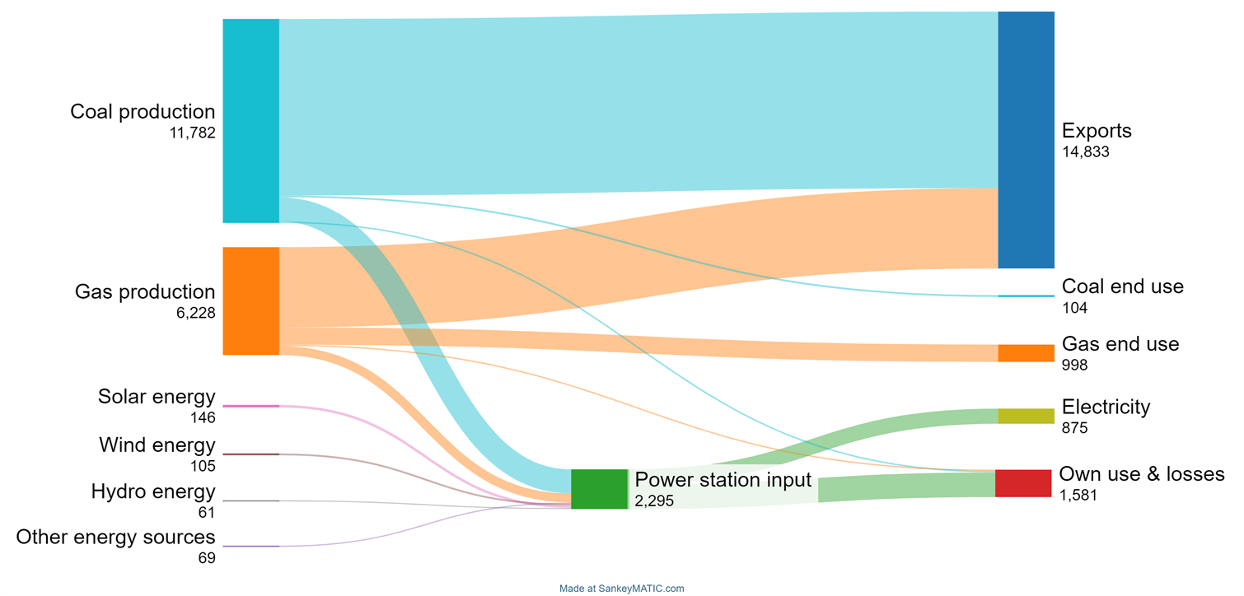
This work has been generated using SankeyMATIC. Any copyright subsisting in this work is owned by © State of New South Wales (Department of Education) 2024.
Note: view this diagram online to interact and customise.
Provide students with a copy of Student resource – Where does our energy go?. Students complete the activity by using the final Sankey diagram on the board.
Sample response:
- Divide and label the bar below to demonstrate the percentage of the energy generated or extracted in Australia that is:
- exported to other countries
- consumed as electricity or other means
- wasted or lost during production (own use and losses)
Total energy = 14,833 + 104 + 998 + 875 + 1,581 = 18,391 PJ
% exported = 14,833 / 18,391 ⨯ 100 = 80.7%
% consumed as electricity or other means = (104 + 998 + 875) / 18,391 ⨯ 100 = 10.7%
% wasted or lost during production = 1,581 / 18,391 ⨯ 100 = 8.6%
10.7%
8.6%
Wasted or lost during production
Consumed
80.7%
Exported
Note: the Australian Energy Update 2023 uses the petajoule (PJ) as the unit of energy for describing energy used nationally. This unit will likely be unfamiliar to students. The Australian Energy Update 2023 includes an infographic to introduce readers to this unfamiliar unit of energy.
Figure 3 – infographic explaining the petajoule from the Australian Energy Update 2023
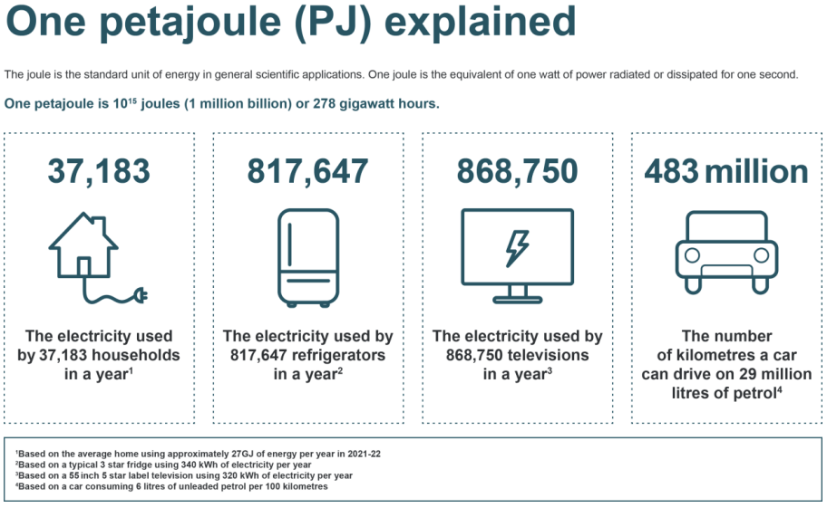
‘Australian Energy Update 2023’ by the Department of Climate Change, Energy, the Environment and Water is licensed under CC-BY 4.0.
Figure 4 could be used as an alternative information source for the above activity to reduce complexity. It highlights Australia’s role as an energy exporter but does not explore the relationship between energy generation and use.
Figure 4 – Australian energy trade 2021-2022 from the Australian Energy Update 2023
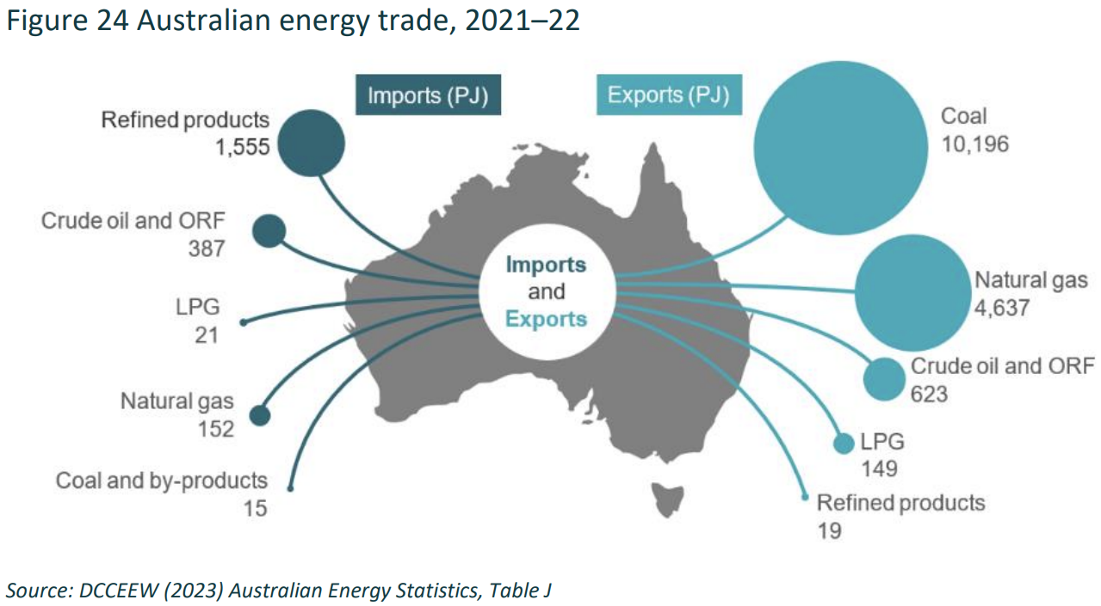
‘Australian Energy Update 2023’ by the Department of Climate Change, Energy, the Environment and Water is licensed under CC-BY 4.0.

Student resource – Where does our energy go?
- Divide and label the bar below to demonstrate the percentage of the energy generated or extracted in Australia that is:
- exported to other countries
- consumed as electricity or other means
- wasted or lost during production (own use and losses).

4.2 Sustainable energy use
Students investigate how to improve the sustainability of transport used in their community by conducting a survey of transport used by class members and exploring vehicle efficiency and energy consumption by transport both nationally and internationally.
We are learning: | I can:
- how we can use energy more efficiently  - how to make informed decisions about the best energy sources to use  - to systematically collect and record data, information, evidence and findings. | - conduct a survey of transport options used by their class  - extract information about vehicle emission standards from reliable sources  - describe the impact of vehicle choice on CO2 emissions and running costs.

Background information

Sustainable transport
When recognising the importance of transport in meeting its Sustainable Development Goals, the UN broadly defined sustainable transport as:
“the provision of services and infrastructure for the mobility of people and goods—advancing economic and social development to benefit today’s and future generations—in a manner that is safe, affordable, accessible, efficient, and resilient, while minimising carbon and other emissions and environmental impacts.”
Mobilizing Sustainable Transport for Development (PDF 5017 KB)
More generally, sustainable transport refers to the services and systems that help people and goods move around safely, easily and affordably. These services and systems should benefit the economy, the community and the environment. In terms of energy use, this means designing energy-efficient systems and relying more on cleaner energy sources.

Instruction

Exploring sustainable transport
Display stimulus images showing examples of sustainable transport options (see EGY PPT ‘4.2 Sustainable transport’).
Discuss the following questions
- What is transport, and why is it important for me and my community?
- What are the types of transport used in our local community?
- What do I know about making transport use more sustainable?
Watch Daniel O’Doherty in Catalyst: Impact of coming to school on carbon emissions (3:14) (ABC 2009) as he determines his hypothesis and then designs and conducts a study about carbon emissions. Daniel was the 2008 ‘Action Against Climate Change’ Eureka Schools Prize winner. Use Think-Pair-Share to respond to the ‘Things to think about’ questions on the Catalyst website.
The Sleek Geeks Science Eureka Prize is awarded each year by the Australian Museum. It encourages students to communicate a scientific concept in a way that is accessible and entertaining to the public while painlessly increasing their science knowledge.
Design and conduct a class survey of transport used to get to school.
Summarise the survey results by:
- constructing an appropriate table or graph
- making 2 observations and proposing an inference based on each.
Observations only report what is perceived through the senses, without assumptions or explanations, while inferences are interpretations or conclusions drawn from those observations.

Vehicle standards
Use the data in Table 4 or search for specific vehicle data on the Green Vehicle Guide to complete questions 1–4, comparing the CO₂ emissions, fuel consumption and annual fuel cost for a range of vehicles.
Table 4 – vehicle standards (Green Vehicle Guide)
Vehicle | Release year | Fuel type | Fuel consumed (L/100km) | CO2 emissions per km (g/km)
Large family sedan 1 | 2004 | Petrol | 11.1 | 266
Large family sedan 2 | 2018 | Petrol | 7.6 | 193
Large family sedan 3 | 2022 | Electric | 0* | N/A**
Small car | 2018 | Electric/petrol hybrid | 3.4 | 80
* electric vehicle does not consume fuel but uses 134 Wh/km of electrical energy from battery.
**The CO₂ emissions will vary depending on the source of electricity used to charge the battery.
Note: comparison data from the Green Vehicle Guide can be exported as a CSV file for more detailed analysis.
Summarise the data collected by answering these questions:
- Which vehicles were the most and least fuel efficient?
The 2022 electric vehicle is the most fuel-efficient because it uses no fuel. The 2018 hybrid car is also very efficient, using 3.4 L/100 km. The least fuel-efficient vehicle is the 2004 petrol sedan, which consumes 11.1 L/100 km.
- What patterns were observed in the efficiency and carbon dioxide emissions of vehicles analysed?
There is a clear pattern that newer vehicles, especially those using electric or hybrid technology, are more fuel-efficient. Older petrol vehicles tend to consume more fuel, which likely results in higher CO₂ emissions. Electric vehicles, which don’t use petrol, would have significantly lower CO₂ emissions unless the electricity used comes from non-renewable sources.
- What assumptions allow cars to be compared in this way? Hint: think about controlled variables.
One assumption is that all vehicles are being driven under similar conditions, such as driving in major cities or highways, with similar driving habits and over similar terrain.
- Explain the importance of improving the efficiency of the vehicles we drive.
Improving vehicle efficiency is important because it reduces fuel consumption and lowers CO₂ emissions, helping to combat climate change. More efficient vehicles also reduce fuel costs for drivers, making transportation more affordable. As electric and hybrid technologies become more common, we can reduce our dependence on fossil fuels and make transportation more sustainable.

Student resource – vehicle standards
Vehicle standards include standard measurements such as fuel consumed and CO2 emissions. Vehicle standards are used to provide a fair comparison of vehicles. Fuel efficiency is an important factor to consider when choosing a car, as it directly affects running costs and environmental impact. In this activity, you will compare the fuel efficiency of different vehicles by analysing their fuel consumption and emissions data. By understanding how much fuel a car uses and how far it can travel on a given amount of fuel, you can make informed decisions about which cars are more economical and environmentally friendly.
Table 1 – vehicle efficiency and carbon emissions
Vehicle | Release year | Fuel type | Fuel consumed (L/100km) | CO₂ emissions per km (g/km)
Large family sedan 1 | 2004 | Petrol | 11.1 | 266
Large family sedan 2 | 2018 | Petrol | 7.6 | 193
Large family sedan 3 | 2022 | Electric | 0* | N/A**
Small car | 2018 | Electric/petrol hybrid | 3.4 | 80
*This electric vehicle does not consume fuel but uses 134 Wh/km of electrical energy from battery.
**The CO₂ emissions will vary depending on the source of electricity used to charge the battery.
- Which type of vehicle is the most and least fuel-efficient?
- What patterns were observed in the efficiency and carbon dioxide emissions?
- What assumptions allow cars to be compared in this way? Hint: think about controlled variables.
- Explain the importance of improving the efficiency of the vehicles we drive.

Australia’s energy consumption (EGY PPT)
Display graphs of the Energy consumption by sector for selected sectors by energy source (EGY PPT ‘4.2 Australia’s energy consumption’ (2 slides)).
Use Think-Pair-Share to discuss what this data tells us about:
- where we use the most energy
- what changes in behaviour and/or improvements in efficiency could make a positive impact on reducing our energy use
- how these changes can contribute to meeting our energy demands sustainably.
Optional activities
Students could explore the UN Energy dashboard (spreadsheet) to identify what data is available. Useful data includes CO₂ production, along with energy production and use by sector in world regions over time. The TES_CO2, Energy time series and Energy balance sheets are the most relevant.
Students could use this data to create an energy story that highlights one trend in energy demand and support it with a figure or quantitative information.

4.3 Evaluating nuclear energy in Australia
Table 5 – learning intentions and success criteria for 4.3 ‘Evaluating nuclear energy in Australia’
We are learning: | I can:
- how to make informed decisions about the best energy sources to use  - to select strategies to solve scientific problems and to evaluate our solutions. | - evaluate the development of an alternative energy source to meet our energy needs  - support my evaluation with evidence  - reflect on which types of information have the most impact on my energy decisions.
Students evaluate nuclear energy as an alternative energy source. A human continuum activity explores their current thinking and how evidence informs their position.

Preparation
Create a set of position cards with the statements ‘strongly agree’, ‘agree’, ‘disagree’ and ‘strongly disagree’ around the room or on the floor in the correct order.
Confirm that you have access to the resource 'Does nuclear power have a future in Australia?' (ABC Story lab), which will be used as the stimulus for this activity. It provides a quick snapshot of key facts and figures that could inform learning activities about nuclear energy.

Instructions
Display the statement ‘Australia should be using nuclear power for all our electricity needs’ on the board and ask students to position themselves on a continuum from ‘strongly agree’ to ‘strongly disagree’.
Note: it is important to explain to students that this activity has no right or wrong answer and that they can change their minds at any time. After each statement is read out and participants have positioned themselves, invite participants to share their thoughts about the statement. Try to ensure a range of views are discussed.
Learn more about human continuum activities.
Invite participants to express their thoughts using the following prompts.
- What was your thinking when you moved to the position of ‘strongly agree’, ’agree’, ‘disagree’ or ’strongly disagree’? What influenced your thoughts and decisions?
- You may find it appropriate to invite someone from the opposition position to provide feedback and share their thought processes.
- To avoid having all participants standing at one position, invite a small number of participants to volunteer to play the following role, reflect on the question that those perspectives and then position themselves on the scale:
- a university student who pays for the electricity at their rental property
- the owner of a mine that extracts uranium ore
- an environmental activist.
Show students the first set of data in Does nuclear power have a future in Australia? and ask them to reposition themselves on the continuum. Survey one or 2 students (one who moved and one who stayed put).
Note: each data tile has a Tell me more button to explore the data further. Review one or 2 examples if students express interest in or surprise about a specific statement.
Repeat the repositioning activity for each piece of data.
Ask students to write a reflection on their position and response to the presented data. Which types of data affected them the most? Which were the 3 strongest points that helped to inform your final position?
Students could be asked to keep track of their position – maintaining a recording sheet of their position over time. Students could sketch on a personal continuum or collect counters to represent the number of changes.
Figure 5 – sample tracking of human continuum placement with annotations for the reason for shifting positions. The number 1 is the location that the student started on the continuum. The additional numbers are annotated to record why the student moved.
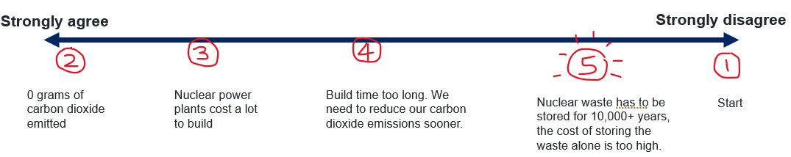

4.4 Transitioning to net zero
Table 6 – learning intentions and success criteria for 4.4 ‘Transitioning to net zero’
We are learning: | I can:
- how to make informed decisions about the best energy sources to use  - to select strategies to solve scientific problems and to evaluate our solutions  - to represent and organise data and information to find patterns and to calculate useful values. | - extract relevant information from tables and graphs  - convert between units and calculate values to compare alternative energy options  - explain how selecting sources of energy contributes to meeting Australia’s commitment to net zero.
Students explore Australia’s plans to meet our future energy needs and use current data and calculations to describe what this will require in practical terms.

Background information
The Government has committed through legislation to reduce Australia’s greenhouse gas emissions by 43% below 2005 levels by 2030 and net zero by 2050.
The Australian Energy Market Operator (AEMO) publishes its plan for transitioning Australia’s energy systems to meet this commitment every 2 years.
The 2024 Integrated System Plan (ISP) (AEMO) was the most current plan available when this resource was published.

Instructions
Watch How much land does it take to power the world? (4:47).
Complete the questions in the ‘Think’ tab of the TED-Ed site. There are 5 multiple-choice questions and 3 short-answer questions. Use the Pose, Pause, Bounce, Pounce (PDF 557 KB) questioning strategy when calling on students to share their answers to the short answer questions.
Sample answers
1. (A), 2 (A), 3 (B), 4 (C), 5 (D)
6. What factors must be considered when deciding which energy sources we use? Why?
Factors include space, cost, environmental impact, and availability of resources like wind or sunlight. Different energy sources work better in different areas – wind power needs windy places, while solar power works best in sunny regions. The cost of building power plants and their long-term efficiency also affect the decision.
7. What are some reasons we continue to use fossil fuels even though we have cleaner energy options available?
Fossil fuels are still widely used because they are fairly cheap and can generate large amounts of electricity. The infrastructure for fossil fuels is already in place, making it convenient and quick to produce energy. However, they contribute to greenhouse gases and climate change.
8. Explain some of the reasons why a single power source can't be the best option to power the entire world.
No single power source can meet all needs because different regions can access different resources. For example, some places have lots of wind for wind power, while others have more sunlight for solar power. Additionally, some power sources, like nuclear, are expensive to build and produce waste. We need a mix of energy sources to cover different needs and reduce greenhouse gas emissions.
Figure 6 – EGY PPT ‘4.4 Future energy demands 2050 capacity needs’ shows the planned electricity capacity needed to meet our 2050 commitments for net zero
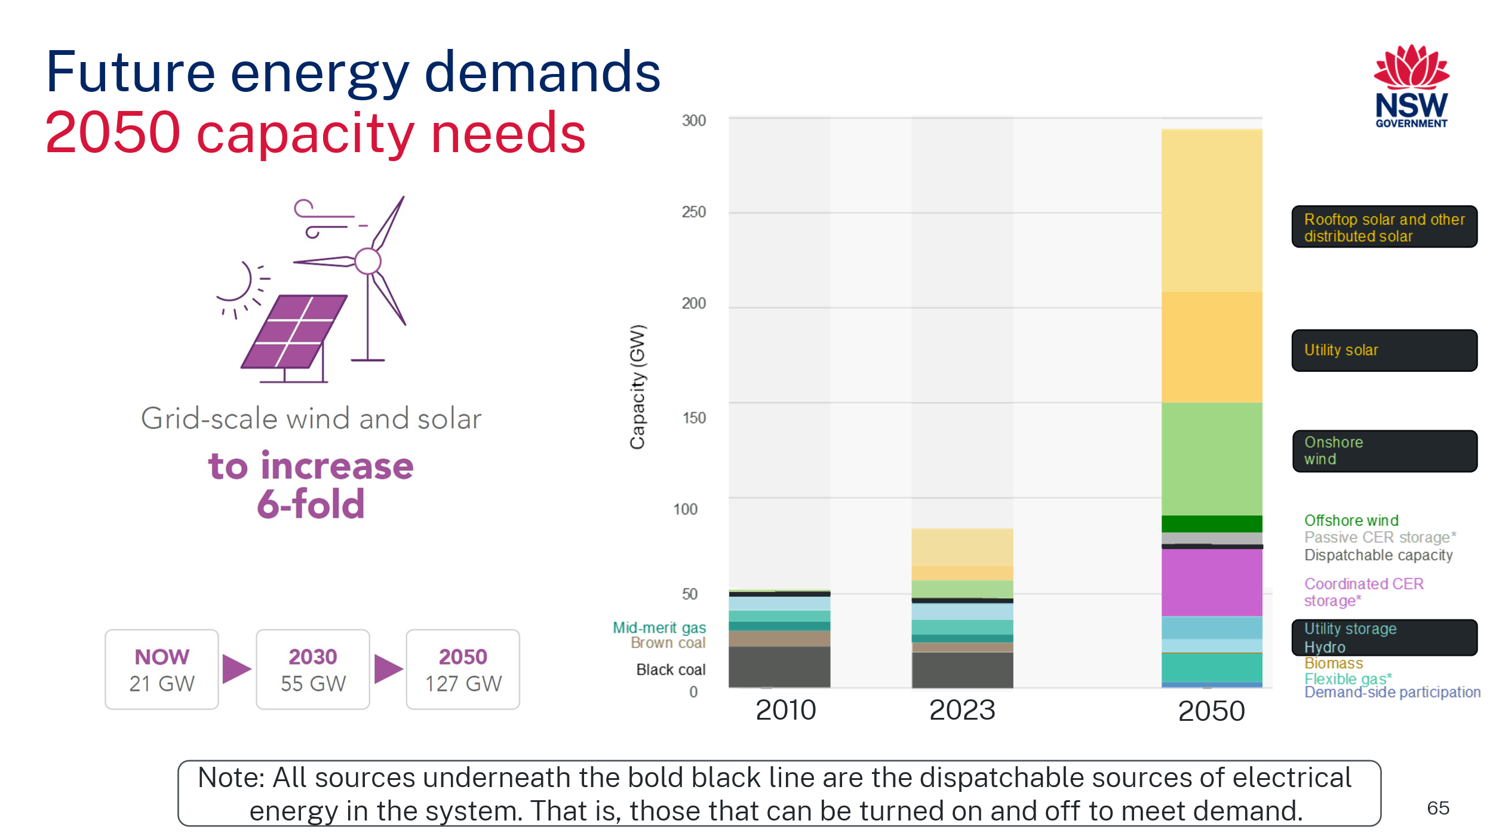
Images adapted from the 2024 Integrated System Plan (ISP) by AEMO are licensed under CC-BY 4.0.
Note: The graph has been simplified to highlight our past, current and future energy needs as outlined in the 2024 ISP (AEMO).
There are several new terms in the graph. Describe any unfamiliar terms using the information outlined in Table 7.
Table 7 – key terms for interpreting the future energy demands graph from AEMO
Key term | Definition | Things this includes
Coordinated CER storage | All Consumer Energy Resources (CER) that generate or store electricity can alter supply in response to external signals.  Passive CER storage describes consumer storage that cannot be centrally controlled. | - Rooftop solar  - Residential and community batteries  - Electric vehicles.
Dispatchable capacity | The total amount of electricity can be quickly adjusted to meet the demand when people need it. It is like having electricity available ‘on demand,’ ready to be used whenever needed. | - Gas  - Hydro  - Battery storage  - Biomass  - Coal.
Intermittent capacity | The total sources of electricity are not always available due to external factors that cannot be controlled. | - Solar (rooftop = on residential and commercial properties, utility = large solar farms purpose-built for supplying the grid with energy).  - Wind (onshore = land-based, offshore = over the ocean).
Demand-side participation | Other Consumer Energy Resources (CER) that use electricity that can be turned off in response to external signals to reduce demand at peak times | - Air-conditioners.  - Hot water heaters.  - Electric vehicle chargers.
Guide students to annotate the features of each source of energy on the graph, including whether the source is:
- renewable or non-renewable
- dispatchable or intermittent.
Students should identify non-renewable sources, including gas, black coal, and brown coal (noting that coal is not included in our plan for 2050). All other sources are renewable. All sources below the black line are dispatchable, and everything above the line is intermittent.

How many new generators will we need?
How much energy will we need in 2050?
Demonstrate how to extract information from the graph, EGY PPT ‘4.4 Future energy demands’ to complete the table estimating our current and future energy needs.
Students then extract information from the graph to complete Table 2 (in the student resource) to estimate our future energy needs. The answers are provided in Table 8.
- Extract information from the graph to complete Table 2, estimating our current and future energy needs.
Table 8 – summary of current and future energy capacity needs
Energy source | Current capacity in 2023 (GW) | Capacity needed by 2050 (GW) | New capacity required (GW)
Onshore wind | 10 | 60 | 50
Rooftop solar and other distributed solar | 25 | 85 | 60
How many new generators will need to be built to provide our energy in 2050?
- How many additional wind turbines will need to be built?
From our previous calculation we determined we need wind turbines to produce 50 GW of electricity. 1 GW = 1,000 MW, therefore a total of 50,000 MW is needed. Each turbine produces up to 2.5 MW
$$\frac{50,000}{2.5}=20,000 wind turbines$$
Students then estimate the number and cost of new generation units (of onshore wind and rooftop solar systems) that will need to built by 2050 to meet our energy needs using data in Table 8 and Table 9, and graph on EGY PPT ‘4.4 Future energy demands 2050 capacity needs’.
Table 9 – estimated capital costs and land requirements for selected generation technologies*
Technology | Unit size | Estimated building cost (capital cost) per unit | Land required per unit (km²)
Onshore wind | 2.5 MW | $7.5 million | 1
Rooftop solar | 10 kW | $13,000 | Using existing roof area
Large scale nuclear | 1000 MW | $8.7 billion | 3.4
*Unit sizes are indicative only, and the cost of building each has been extracted from CSIRO’s GenCost 2023-24 report. The land required per unit has been estimated.
Note: the Levelised Cost Of Electricity (LCOE) is a more effective but complex way of comparing building and generating electricity costs. The LCOE considers capital costs, the lifetime of a generator and the running costs.
- How many more houses will need to install rooftop solar?
Each house's rooftop solar system produces up to 10 kW, and we need to build a total of 60 GW of rooftop solar systems. 1 GW = 1,000 MW = 1,000,000 kW, therefore a total of 60,000,000 kW is needed.
$$\frac{60,000,000}{10}=6,000,000 houses$$
What resources will be needed?
- How much will building the wind turbines and rooftop solar systems cost?
Wind turbine cost = 20,000 turbines ⨯ $7,500,000 per turbine = $150,000,000,000 or $150 billion.
Rooftop solar cost = 6,000,000 houses ⨯ $13,000 per house = $78,000,000,000 or $78 billion.
- How much land would be needed?
Wind turbine land requirement = 20,000 turbines ⨯ 1 km2 per turbine = 20,000 km²
Rooftop solar is generally fitted to the existing rooftop area and does not require additional land.
What if?
- Imagine that scientists and engineers improved the design and operation of a wind turbine to produce 2% more energy.
- What would happen to the number of wind turbines needed?
Improving the efficiency of wind turbines would reduce the number of turbines needed to be built. If each turbine produced 2% more energy, then we would need to build 2% fewer turbines.
- How much money could be saved?
2% of 20,000 is 20,000 x 0.02 ≈ 392 less turbines. This could save 392 x $7,500,000 ≈ $4 billion.
- Australian scientists are world leaders in developing high-efficiency solar cell technology. Describe the impact of improving the efficiency of solar cells by 5%.
As with more efficient wind turbines, improving the efficiency of solar cells would reduce the number of solar panels required to meet our energy needs. People might be able to save money by installing fewer solar panels while still generating enough electricity to meet their needs.
- Use the information in Table 1 (student resource table) to estimate the number of large-scale nuclear reactors needed to create the same total capacity as new wind and rooftop solar panels and calculate the cost.
Total capacity = wind + solar = 50 GW + 60 GW = 110 GW
A typical nuclear reactor can generate 1000 MW = 1 GW. Therefore, we would need to build approximately 110 nuclear reactors.
Total cost: 110 reactors ⨯ $8.7 billion per reactor = $957 billion.
Reflection
- What impact does improving the efficiency of renewable energy technologies have on meeting our planned goals for transitioning to net zero?
Improving the efficiency of renewable technologies will help us meet our goals by making it cheaper and reducing the number of new generators we need to build.
Checkpoint: students make and justify a claim using Claim-Evidence-Reasoning (C-E-R), predicting a possible future energy demand and suggesting reasons why alternative energy sources may be needed.

Student resource – How many new generators will we need?
Use the graph and table to answer the questions on the next page.
Australia’s past, current and predicted future energy capacity
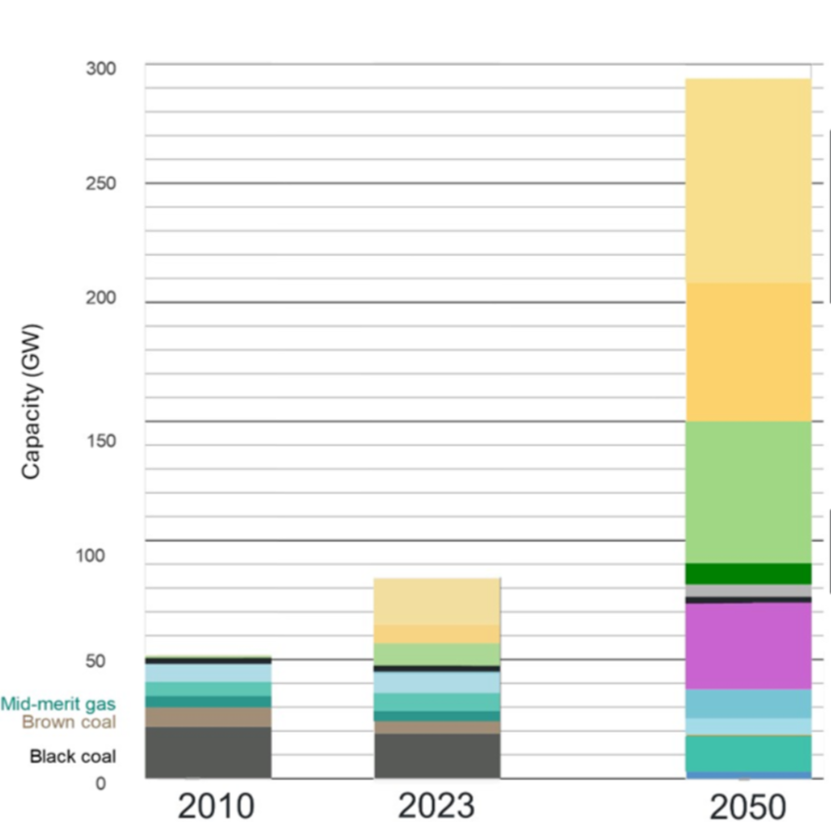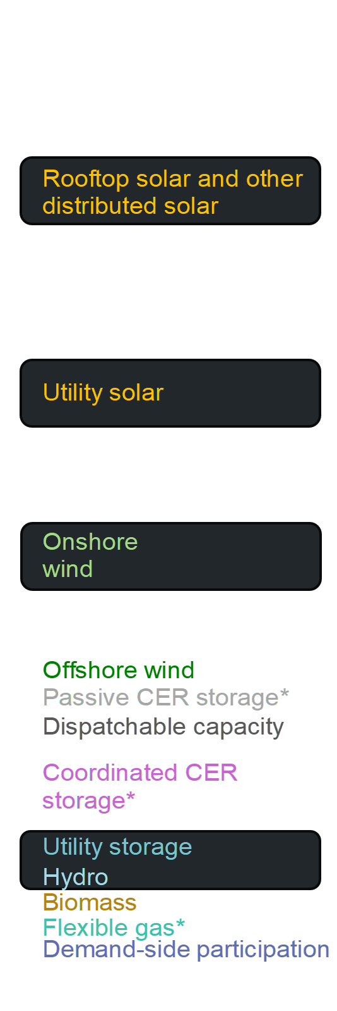
Table 1 – estimated capital costs and land requirements for selected generation technologies
Technology | Unit size | Estimated building cost (capital cost) per unit | Land required per unit (km²)
Onshore wind | 2.5 MW | $7.5 million | 1
Rooftop solar | 10 kW | $13,000 | Using existing roof area
Large scale nuclear | 1000 MW | $8.7 billion | 3.4

How much energy will we need in 2050?
- Extract information from the graph to complete Table 2, estimating our current and future energy needs.
Table 2 – summary of current and future energy capacity needs
Energy source | Current capacity in 2023 (GW) | Capacity needed by 2050 (GW) | New capacity required (GW)
Onshore wind
Rooftop solar and other distributed solar
How many new generators will need to be built to provide our energy in 2050?
- How many additional wind turbines will need to be built?
- How many more houses will need to install rooftop solar?
What resources will be needed?
- How much will building the wind turbines and rooftop solar systems cost?
- How much land would be needed?
What if?
- Imagine that scientists and engineers improved the design and operation of a wind turbine to produce 2% more energy.
- What would happen to the number of wind turbines needed?
- How much money could be saved?
- Australian scientists are world leaders in developing high-efficiency solar cell technology. Describe the impact of improving the efficiency of solar cells by 5%.
- Use the information in Table 1 to estimate the number of large-scale nuclear reactors needed to create the same total capacity as new wind and rooftop solar panels and calculate the cost.
Reflection
- What impact does improving the efficiency of renewable energy technologies have on meeting our planned goals for transitioning to net zero?

4.5 Truths, lies and the in between
Table 10 – learning intentions and success criteria for 4.5 ‘Truths, lies and the in-between’
We are learning: | I can:
- how to make informed decisions about the best energy sources to use  - to select strategies to solve scientific problems and to evaluate our solutions. | - evaluate claims made about alternative sources of energy  - develop evidence-based arguments.
Students interrogate claims made about sources of energy and participate in a silent debate. They are presented with a range of truthful, false or deceptive claims and work in groups to explore a range of perspectives and decide which claims warrant further investigation.

Preparation
- Print copies of EGY PPT ‘4.5 Truths, lies and the in-between’ (4 slides) on A4 paper – you will need one energy source for each group of 3 or 4 students.
- Print copies of EGY PPT ‘4.5 Claims about energy – blank template’ on A3 paper– you will need one per group.
- Ensure you have markers available for annotating changes and scissors to cut out each claim.

Instructions
- Divide the class into groups of 3 to 4 students and allocate each group one energy source.
- Provide each group with a copy of the Claims about energy poster template (Figure 7) and the ‘Truths, lies, and the in-between’ claims (Figure 8) for one source of energy.
Figure 7 – an example blank evaluation poster template from EGY PPT ‘4.5 Claims about energy – blank template’
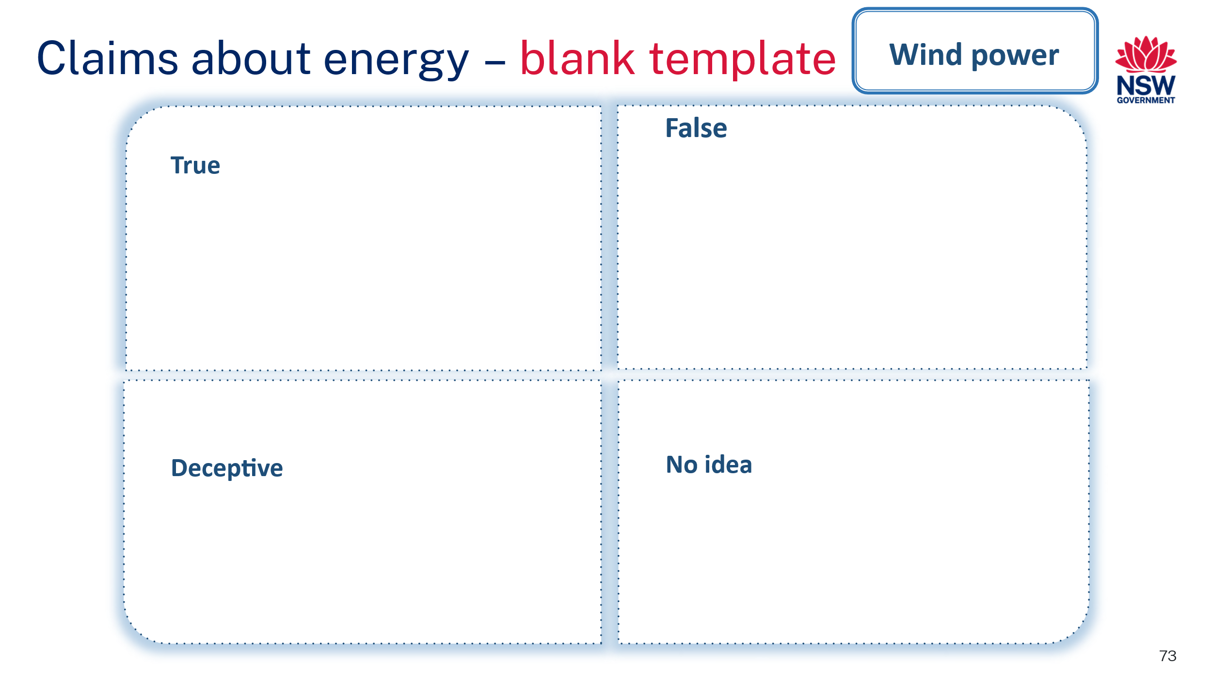
- Instruct students to cut out the individual claims and, as a group, attempt to find a consensus on where each claim should be placed.
Figure 8 – sample claims about wind power from EGY PPT ‘4.5 Truths, lies and the in between (2)’
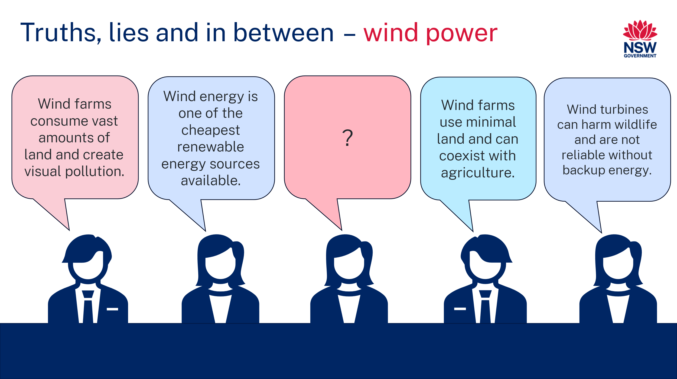
- Instruct students to rotate tables to review the placement of claims for the next group's energy source.
- Students should move any claims they think are in the wrong spot. For each claim moved, they draw an arrow and annotate their reasoning (as shown in Figure 9). EGY PPT ‘4.5 Claims about energy – sample’ can be used to demonstrate this to students.
Figure 9 – worked example showing how a student may annotate
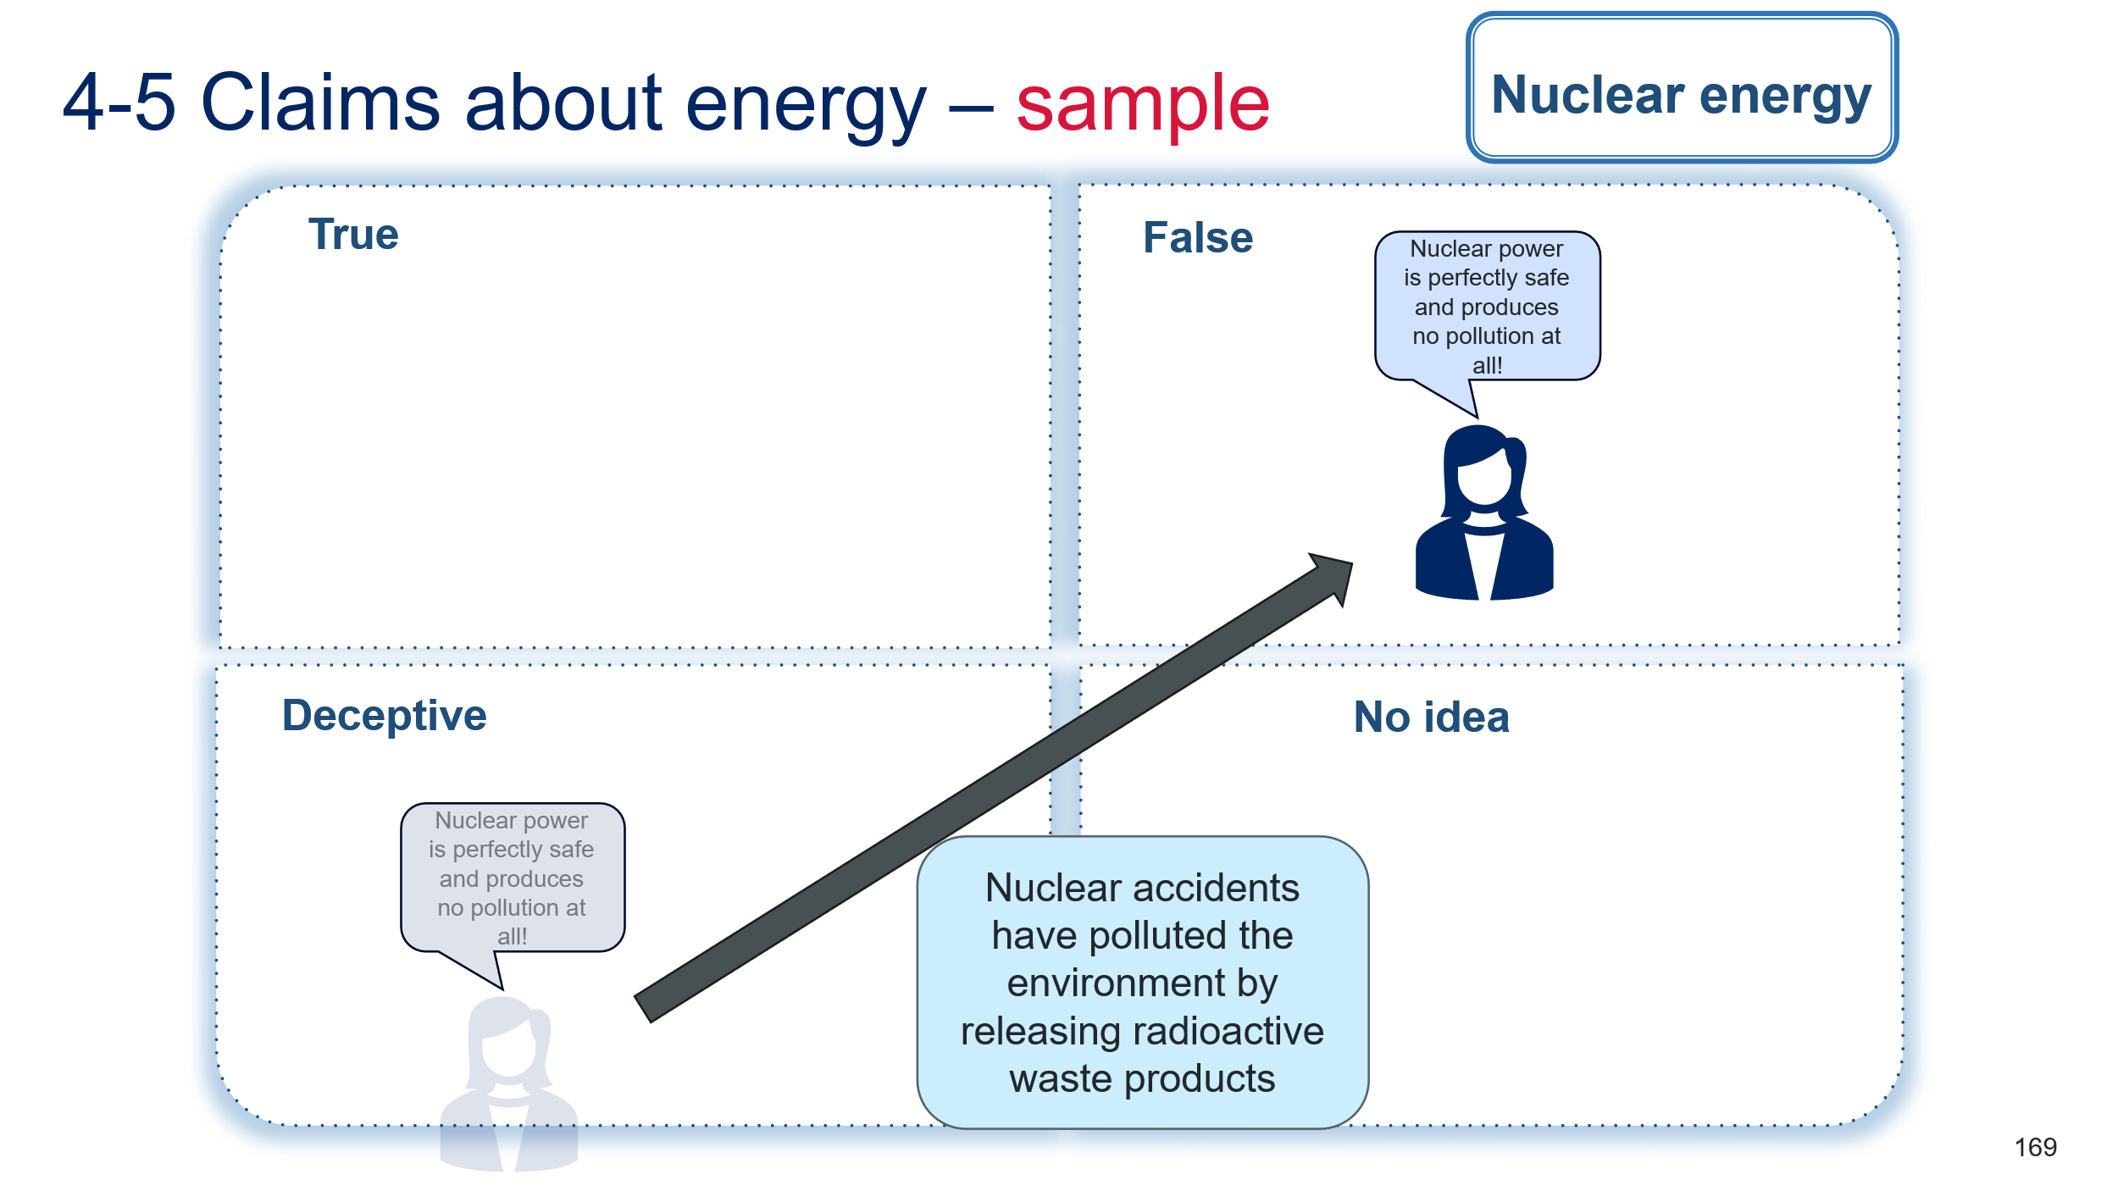
- Students continue rotating until each group has evaluated each set of claims and returned to their initial energy source.
- Facilitate a discussion about the changes and reasoning observed for each energy source. Ask students the following questions.
- Which claims were most contentious?
- What evidence is required to evaluate them properly?
- Where could you look for this evidence?

Appendix

Slow-reveal graphs
The slow-reveal graph is a method for improving student comprehension of complex graphs. A graph is revealed sequentially, allowing students to appreciate all of its features. The graph is initially stripped of all contexts so that students can first observe the shape and pattern of the data.
Additional elements, including scales, labels, titles and legends, are introduced in sequence, and students interrogate the additional information each adds to the overall interpretation of the graph.
Teachers should focus student attention on the following questions.
- What type of data each graph is displaying?
- What new information is shown in each step?
- How does it improve our understanding of the data?
Table 11 – the slow-reveal graph process
Step | Teacher action | Question prompts
1 | Present slide of graph stripped of context (that is, no titles, labels, scales, legend) | What do you notice? What do you wonder?
2 | Reveal the next slide, including an additional graph feature | What new information did we just learn?  What do you notice about [feature]?  Add more guiding questions to explore the new feature.
3+ | Repeat for each new feature.
Further information and examples are available on the Slow Reveal Graphs website.

Evidence base
This resource contains NSW Curriculum and syllabus content. The NSW Curriculum is developed by the NSW Education Standards Authority (NESA). This content is prepared by NESA for and on behalf of the Crown in right of the State of New South Wales. The material is protected by Crown copyright.
Please refer to the NESA Copyright Disclaimer for more information https://www.nsw.gov.au/education-and-training/nesa/copyright.
NESA holds the only official and up-to-date versions of the NSW Curriculum and syllabus documents. Please visit NESA https://www.nsw.gov.au/education-and-training/nesa and NSW Curriculum https://curriculum.nsw.edu.au.
Science 7–10 Syllabus © NSW Education Standards Authority (NESA) for and on behalf of the Crown in right of the State of New South Wales, 2023.
ABC (Australian Broadcasting Corporation and Education Services Australia Ltd) (24 September 2009) 'Catalyst: Impact of coming to school on carbon emissions’ [video], Catalyst, ABC Education website, accessed 15 July 2024.
The Australian Museum (2024) Sleek Geeks Science Eureka Prize, Australian Museum website, accessed 15 July 2024.
Bilicic G and Scroggins S (12 April 2023) ‘2023 Levelized Cost of Energy+’, Lazard, accessed 15 July 2024.
Bogart S (2014) SankeyMATIC [website], accessed 15 July 2024.
Brookhart SM (2018) ‘Appropriate Criteria: Key to Effective Rubrics’, Frontiers in Education, volume 3(22):1–12, doi:10.3389/feduc.2018.00022, accessed 15 July 2024.
CESE (Centre for Education Statistics and Evaluation) (2020) What works best: 2020 update, NSW Department of Education, accessed 15 July 2024.
——(2020) What works best in practice, NSW Department of Education, accessed 15 July 2024.
——(2021) Growth goal setting – what works best in practice, NSW Department of Education, accessed 15 July 2024.
DCCEEW (Department of Climate Change, Energy, the Environment and Water) (2023) Australian Energy Update 2023, Australian Government Department of Climate Change, Energy, the Environment and Water website, accessed 15 July 2024.
DITRDCA (Department of Infrastructure, Transport, Regional Development, Communications and the Arts) (2024) Green Vehicle Guide [website], accessed 15 July 2024.
Fisher D and Frey N (1 November 2009) ‘Feed Up, Back, Forward’, ASCD (Association for Supervision and Curriculum Development): Educational Leadership magazine, 67(3), accessed 15 July 2024.
Griffin P (2017) Assessment for Teaching, Cambridge University Press, Port Melbourne, Victoria.
Harvard College and Harvard Graduate School of Education (2022) ‘See, Think, Wonder’, Resources, Project Zero website, accessed 15 July 2024.
Hattie J and Timperley H (2007) ‘The Power of Feedback’, Review of Educational Research, 77(1): 81–112, doi:10.3102/003465430298487.
Mercer D and Leslie T (12 June 2024) ‘Does nuclear power have a future in Australia? These numbers will help cut through the debate’, ABC Story Lab, accessed 15 July 2024.
Panadero E and Jonsson A (2013) ‘The use of scoring rubrics for formative assessment purposes revisited: A review’, Educational Research Review, 9:129–144, doi:10.1016/j.edurev.2013.01.002, accessed 15 July 2024.
Sherrington T (2019) Rosenshine’s Principles in Action, John Catt Educational Limited, Melton, Woodbridge.
Slowrevealgraphs.com (n.d.) Introduction - Slow Reveal Graphs, slowrevealgraphs.com, accessed 15 July 2024.
TED-Ed (17 March 2021) ‘How much land does it take to power the world?’ [video], TED-Ed, YouTube, accessed 15 July 2024.
United Nations (2016) ‘Mobilizing sustainable transport for development’, High-level Advisory Group on Sustainable Transport, United Nations website, accessed 15 July 2024.
United Nations Statistics division (2024) Energy Statistics Dashboards, Energy Statistics Section, accessed 15 July 2024.
Wiliam D (2017) Embedded Formative Assessment, 2nd edn, Solution Tree Press, Bloomington, IN.

© State of New South Wales (Department of Education), 2024
The copyright material published in this resource is subject to the Copyright Act 1968 (Cth) and is owned by the NSW Department of Education or, where indicated, by a party other than the NSW Department of Education (third-party material).
Copyright material available in this resource and owned by the NSW Department of Education is licensed under a Creative Commons Attribution 4.0 International (CC BY 4.0) license.

This license allows you to share and adapt the material for any purpose, even commercially.
Attribution should be given to © State of New South Wales (Department of Education), 2024.
Material in this resource not available under a Creative Commons license:
- the NSW Department of Education logo, other logos and trademark-protected material
- material owned by a third party that has been reproduced with permission. You will need to obtain permission from the third party to reuse its material.
Links to third-party material and websites
Please note that the provided (reading/viewing material/list/links/texts) are a suggestion only and implies no endorsement, by the New South Wales Department of Education, of any author, publisher, or book title. School principals and teachers are best placed to assess the suitability of resources that would complement the curriculum and reflect the needs and interests of their students.
If you use the links provided in this document to access a third-party's website, you acknowledge that the terms of use, including licence terms set out on the third-party's website apply to the use which may be made of the materials on that third-party website or where permitted by the Copyright Act 1968 (Cth). The department accepts no responsibility for content on third-party websites.

