Science Stage 5 (Year 9) – Energy
Teacher resource book 3 of 4 (TRB3)
How does knowledge of electric circuits help us use electricity wisely?
Creation date: 15 July 2024
Updated: 13 February 2026.
Contents
Overview 3
3.1 Introduction to circuits 4
Background information 4
Exploring electric circuits 5
Electric circuit analogies 13
3.2 Constructing electric circuits 22
Preparation 22
Instructions 22
Student resource 25
3.3 Voltage and current in electric circuits (Ohm’s law) 29
Preparation 29
Instructions 30
Practical investigation – Investigating the relationship between voltage and current 31
3.4 Series and parallel circuits 38
Preparation 38
Instructions 39
Practical investigation – investigating current and voltage in a series and parallel circuit 40
Student resource – series and parallel circuits 43
3.5 Power and energy 46
Preparation 46
Instructions 47
Practical investigation – making an electric water heater 47
Student resource 49
3.6 Energy efficiency and electrical appliances 53
Preparation 53
Instructions 53
Student resource – comparing appliances to make informed decisions 55
3.7 Energy bill 57
Appendix A 63
Electric circuit symbols 63
Appendix B – sample data for Ohm’s law 64
Appendix C – sample data on series and parallel circuit investigation 67
Evidence base 69

Overview
Stage and learning area: Stage 5 Science
Description: this resource complements the Energy program of learning. It aims to serve as a teacher reference, offering practical strategies and ideas to enrich teaching practices and create engaging learning environments. The activities should be adapted to suit the needs of students.
Duration: while timing will vary based on the mode of delivery, differentiation strategies employed and class or school context, this series of activities should take approximately 9 × 60-minute lessons.
Risk management: Teachers are advised to undertake a risk assessment before conducting any investigation or experiment in their classrooms. For more information on developing risk assessments see WHS risk management.
This resource book elaborates on many of the Energy program's activities. Some activities also reference the Energy PowerPoint (identified as EGY PPT throughout this document).

3.1 Introduction to circuits
Table 1 – learning intention and success criteria for 3.1 ‘Introduction to circuits’
We are learning: | I can:
- to construct and compare electric circuits. | - identify different types of electric circuits  - compare energy transformations in different types of electric circuits  - use analogies to explain electric circuits  - identify the benefits and limitations of electric circuit models.

Background information
Students should understand some concepts related to electric circuits, as they are included in the Stage 3 K–6 Science and Technology Syllabus (2017) and (2024).
The term ‘energy’ is commonly used in everyday language but is also an abstract scientific concept. As such, students possess various ideas about energy based on their everyday experiences. These include non-scientific ideas about batteries, electrical energy, current and power, which may lead to confusion or alternate conceptions.
Table 2 – common misconceptions about electric circuits
Misconception | Correction
Electric charges are used up in the circuit. | Electric charges transfer energy from the battery to circuit components, such as a load, but they are not used up in the circuit.
A battery produces electrical energy. | A battery does not produce energy; it has limited stored energy.
Energy moves through the wires, so there is a delay in electron movement. | Electrical energy is transferred by the movement of ‘particles’ called ‘charge carriers’, which are part of conductors. The nature of the charge carrier depends on the type of conductor: in metals, the charge carriers are electrons. They are part of the conducting wires and start moving when the circuits are closed.

Exploring electric circuits
This activity is intended to make students’ thinking about electricity visible to teachers so that teachers may address incorrect ideas and misconceptions (Table 2).

Preparation
The following equipment is required for this lesson:
- Conducting wires
- Light globe on stand
- Switch
- Battery (9 V) or power pack
- Handheld battery-operated fan
- Electric toaster
- Hand-cranked generator

Instructions
- Demonstrate how to set up the simple circuit shown in Figure 1.
Figure 1 – a simple circuit consisting of a battery, a light globe, and a switch
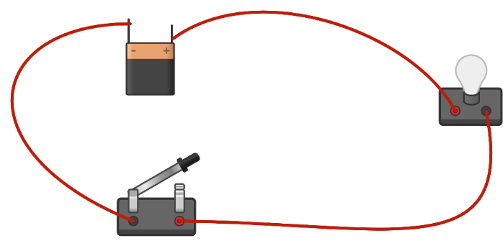
This work has been generated using Chemix.
- Ask the students to predict what will happen when the switch is closed. Most students will predict that the bulb will light up.
Ask the students:
- Why does it light up?
- Where does it get the energy to light up?’
These questions target the misconception that the ‘battery is producing energy’. Explain to students that the battery stores energy and does not produce energy. When connected to an electrical circuit, batteries transform the stored energy (which, in this case, is chemical energy) into electrical energy. The light bulb then transforms this electrical energy into light and heat energy.
This may be further illustrated by asking students to consider why battery-powered devices such as mobile phones and laptop computers must be recharged periodically (indicating that the batteries in those devices are energy stores and not energy generators).
- Close the switch and discuss any follow-up questions from students.
- Ask the students to predict what will happen if the length of the wires is increased. Ask students:
- Will the bulb light up immediately, or will there be some time lag?
- Provide a reason for your prediction.
Most students predict the bulb will take longer to light up because energy has to travel a greater distance.
Repeat the same demonstration but with longer wires. Explain that electricity propagates through the wire almost instantaneously when the switch is closed. Any slight delay caused by a longer wire is negligible compared to this rapid propagation.
This targets the misconception that ‘energy travels through the wires, so it takes time for energy transformation’. The movement of charged particles at all points along the wires is instantaneous, without delay. Therefore, regardless of the length of the wire, the bulb will light up as soon as the switch is closed.
- Set up the 3 stations listed below:
Station 1: A handheld battery-operated fan.
Station 2: An electric toaster.
Station 3: A hand-cranked generator with a light globe
Note: Stations 1 and 2 can be replaced by other circuits, such as charging a mobile phone or an electric kettle, and the questions can be modified accordingly.
- Instruct students to go to each station, follow the instructions in the student resource, record their observations, and explain the reasoning behind their observations in the table provided in the student resource.
- Students share their responses with the class, reflect on their responses and make changes, as required, based on class discussion and teacher feedback.
Note: the circuits shown gradually increase in complexity. The circuits in Stations 1 and 2 are not visible, so the students must apply their understanding of the teacher's demonstration and discussion to make and explain their predictions. Station 3 involves an energy transformation to produce the electricity and a second transformation similar to the abovementioned demonstration.
Stations 1 and 2 are common electric circuits students encounter daily, so the template can be modified to include only observations and explanations for this section.
Figure 2 – a handheld battery-operated fan  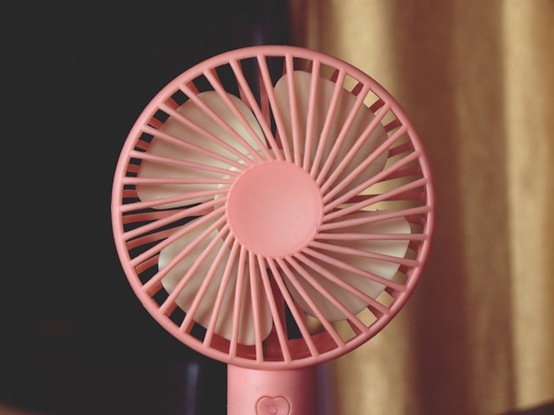  ‘A mini pink fan closeup photo’ by Chandan Chaurasia is licensed under Unsplash License. | Figure 3 – a hand-cranked generator  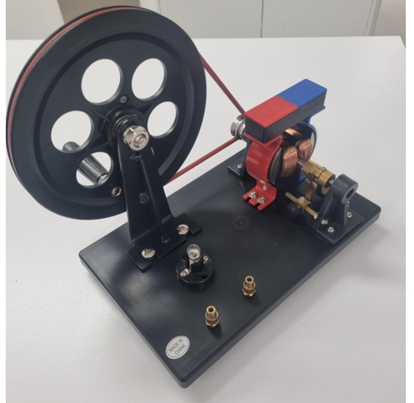

Table 3 – sample response – exploring electric circuits
Station | Instruction | Observation | Explanation (explain the observations using your understanding of energy)
Station 1 – a handheld battery-operated fan. | Press the power button (red). | When the power button is pressed, the fan blades spin, and sound is produced. | The fan blades spin because the circuit is closed when the power button is pressed, allowing the battery's stored energy to be transformed into kinetic and sound energy.
Station 2 – an electric toaster. | Turn on the toaster. | When the toaster was turned on, the filament inside it turned red and heated up. | The toaster heats up by converting electrical energy from the power outlet into heat energy. The radiated heat energy from the filament toasts bread.  Note: refer to heat transfer by radiation that students covered in the Stage 4 ‘Change’ focus area.
Station 3 – a hand-cranked generator set up. | Turn the handle slowly and then gradually increase the speed. | As the handle is turned faster, the light bulb starts glowing brighter. | Turning the handle faster increases the speed at which the rotor is spinning in the generator, which increases the amount of electrical energy generated, as shown by the globe's brightness.
Compare and contrast the energy transformations and the electric circuits at each station.
Student responses may include:
- All 3 stations involved energy transformations. Electrical energy was converted into kinetic energy in the fan, while it was converted into heat energy in the fan and toaster. In contrast, in the generator, kinetic energy was transformed into electrical energy, which in turn was transformed into light energy.
- All appliances and devices need an energy source to work. The fan has a battery (thus an energy store), while the toaster and hand-cranked generator do not. Hence, while the fan can continue to operate when it is not connected to an energy source, the toaster and generator must be connected to their energy sources to operate.
- The circuit components can vary. For example, an electrical energy source can be the mains power outlet (as in a toaster) or a battery (handheld fan).
Differentiation:
Provide the keywords (circuit, energy transformation, kinetic energy, electrical energy, heat energy) to support EAL/D students in developing their explanations.
Use Frayer diagrams to support students in developing their understanding of key terms. A template is provided in the EGY PPT.
Extension: students can represent the energy transformations as energy flow diagrams (covered in TRB1).

Student resource – exploring electric circuits
Go to each station and follow the instructions in the second column of the table below. Record your observations and explanations for each station to complete the table. In your explanation, use your understanding of energy to explain your observations.
Exploring electric circuits
Station | Instruction | Observation | Explanation
Station 1 – a handheld battery-operated fan. | Press the power button (red).
Station 2 – an electric toaster. | Turn on the toaster.
Station 3 – a hand-cranked generator set up. | Turn the handle slowly and then gradually increase the speed.
Compare and contrast the energy transformations and the electric circuits at each station.

Electric circuit analogies
Scientists and educators often use models and analogies to describe the operation of electrical circuits at the atomic level. However, it is essential to realise that multiple models and analogies are needed to explain phenomena related to electricity and energy, as they all have some limitations. Indeed, no single model or analogy can explain all the features of electricity simultaneously. The following activities introduce various analogies to describe the operation of electrical circuits.

Preparation
You will need the following equipment for this activity:
- A bag of 60 counters
- Two small containers, such as ice cream containers
- Class size, minus 5 paper cups. For example, if there are 30 students, then you need 25 cups
- Individual whiteboards.

Instructions

Analogy 1 – moving cups
This role-play analogy illustrates energy transfer and transformation in electrical circuits. Table 4 outlines the number of students for each role.
Table 4 – student roles for the role-play analogy
Role | Number of students
Battery | One
Load | One
Conducting wire | The remaining students (18 in this example)
In this analogy, the:
- counters represent electrical potential energy
- paper cups represent the electrons moving around the conducting path of the circuit
- transfer of counters from one cup to the next in a cycle represents the transfer of energy through the circuit
- the box of counters held by the battery represents the amount of stored energy; when no counters remain, the battery is ‘flat.’
- the number of counters given to each cup represents the potential difference or voltage of the battery
- adding counters to a cup by the battery represents the increase of electric potential energy
- the load removes some counters from a cup, representing the transformation of electric potential energy into another form.
Instructions
- The students forming the conducting wire join tables to form a circuit and sit at the tables, as shown in the figure below.
Figure 4 – layout for the role play analogy. The numbers 1 to 18 represent students representing conducting wire. Each student has a paper cup. The red arrows represent the direction of electron flow from the negative to the positive terminals of the battery. Two students represent the battery, one as the positive terminal and the other as the negative terminal. One student assumes the role of the ‘load’ in an electrical circuit (such as a light bulb or resistor).
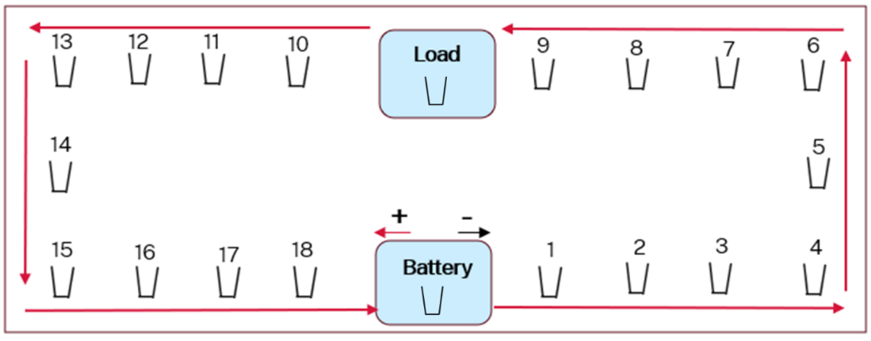
- The student acting as a battery has a bag of counters on the table (Figure 4).
- All students place a paper cup in front of them, including the battery and load.
- When the teacher signals to start, the student who represents the battery transfers 4 counters from the bag into their cup.
- When the battery passes their cup with counters to the student sitting to their right (Student 1 in Figure 4) all students pass their cup to the person on their right at the same time. (Student 18 would pass their empty cup to the battery)
Note: the battery drives the movement of cups – all students should watch the battery and pass their cup each time the battery passes their cup to Student 1.
- The battery continues to add counters to each empty cup in front of them before passing the cup to the student on their right.
- When the student acting as the load receives a cup with counters, they take out 4 counters and place them into the empty container under the table, taps the table (to show the energy transformation), and then pass their empty cup to continue the cycle.
- Continue passing cups until the battery runs out of counters and all energy has been transformed by the load.
Strengths: features of an electric circuit demonstrated by this analogy
- Charged particles (cups) are conserved around the circuit (for every cup that leaves the battery, one returns), but energy (counters) is transferred from the battery to the load, where it is transformed – note that energy is not consumed but is instead removed from the system (transferred to the surroundings).
- Charged particles (cups) move at the same rate at all points in the circuit.
- Energy is transformed by the load, so the charge carriers leaving the battery have more energy than those returning to the battery.
- The amount of energy transformed by the load every second increases if:
- the current (rate the cups are passed) increases
- the voltage (the number of counters added to each cup) increases.
Limitations: features of an electric circuit that are not demonstrated (or are misrepresented)
- It does not account for how the electrical resistance of the load influences the rate at which current flows around the circuit.
- This analogy shows a delay in energy transfer from the battery to the load – when a circuit is completed, energy transformation at the load begins almost immediately.
- It does not demonstrate that loads can transform electrical energy into different forms, such as heat, light and kinetic energy.
- The number of electrons moving around a circuit is vastly greater than demonstrated in this analogy – a current of 1 A is equivalent to $6×{10}^{18}$ electrons moving past a point every second.
Note: the drift velocity (the speed at which electrons migrate around a circuit) is approximately 1 metre per minute.
Take the model even further:
Adding a second load in a series
If we add a second load at another point in the circuit, we would say that these components are connected in series.
Repeat the steps as before, but each load must share an equal portion of the counters this time. If the battery added 4 counters per cup, each would take 2 counters. This demonstrates that loads in series have the same current but must share the voltage.
Adding a second load in parallel
Add a second load at a table behind the first and reconfigure the conducting path so that it splits into separate paths when travelling past the loads and combines again afterwards before returning to the battery.
Note: the concept of series and parallel circuits will be addressed later in this unit.

Analogy 2 – ropes
Differentiation: the rope role-play analogy is a simpler way to demonstrate the movement of electric charges in an electric circuit. It can be used instead of the ‘moving cups analogy’.
Materials required
- A long, flexible rope loop.
Table 5 – student roles for the role-play analogy
Role | Number of students
Conducting wire | All except one student.
Load | One student with garden gloves on.
Battery | Teacher.
- Choose a large open space in or outside the classroom where students can stand and move around.
- Arrange the students in a circle, ensuring they have enough space to stretch the rope.
- The students hold the rope in front of them.
- When the teacher signals start, the students move the loop of rope around in a clockwise direction. The student who represents the load holds the rope firmly with their gloves. This slows down the loop.
- Explain the following points to students. Go through each point, one at a time.
Table 6 – comparing the rope analogy to the features of an electric circuit
Rope analogy | Electric circuit
Students stand and pass the rope around the circle. | Conducting wires direct the charge carriers around a circuit.
The teacher initiates the movement of the rope in one direction. | The battery pushes charge carriers (electrons) around the circuit to create the electric current.
All parts of the rope start to move simultaneously. | All charge carriers start to move simultaneously around a circuit.
The student with gloves experiences friction and feels their hands warming up (through the gloves). | The load transforms electrical energy into other forms (light, kinetic, thermal).
The tighter the grip on the rope by the student with gloves, the slower the rope moves. More effort is required to keep the rope moving at the same pace. | The greater the load's resistance, the lower the current in the circuit. A higher voltage is required to maintain the same current.
- Discuss the limitations of this analogy with students.
- This analogy oversimplifies the features of an electric circuit.
- It does not model the range of energy transformation by a load such as light or kinetic energy.
- It does not model voltage in an electric circuit.

Analogy 3 – water pump
- Explain to students that although models and analogies help us visualise the processes and understand what is happening at the atomic level, every analogy has some limitations and cannot explain all the features of a process. So, one more analogy is required to understand the features of an electric circuit.
Note: a water analogy can be a valuable teaching tool in developing an initial conceptual understanding of electric circuits; however, it has some limitations.
- Play Introduction to Circuit Analysis – Water Analogy (2:37) in EGY PPT ‘3.1 The water pump analogy’.
Figure 5 – water pump analogy for the electric circuit
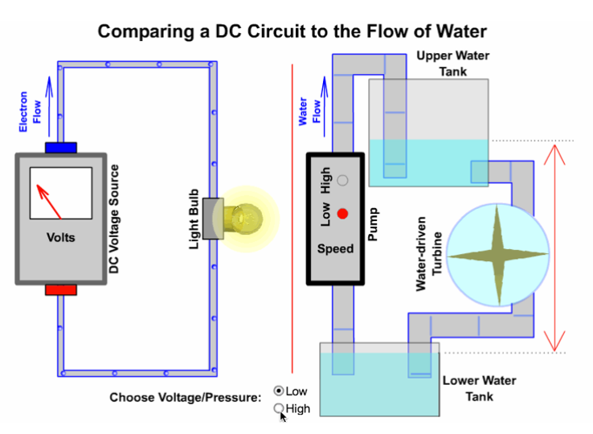
- Use the mapping features of the water analogy given in the table below to explain the features of an electric circuit. Go through one point at a time.
Table 7 – mapping the features of the water analogy to their target concepts in an electric circuit
Water pump analogy | Electric circuit
Water | Charge carriers: water represents the charge carriers (electrons)
Water pump: it takes in water at a low pressure and pumps it out at a higher pressure. | Battery:  - The charge carriers leave the battery with higher energy and return with lower energy.  - The low water pressure in this analogy refers to the battery's positive terminal, and high pressure is the battery's negative terminal.  - Water moves from high pressure to low pressure. Similarly, the charge carriers (electrons) move from the battery's negative terminal to the positive terminal, as they have a negative charge, so they are repelled by the negative terminal and attracted by the positive terminal of the battery
Difference in water pressure. | Potential difference:  - The difference in water pressure between the lower tank and upper tank represents the difference in electrical potential energy.  - This difference in electric potential energy is called potential difference or voltage.
The water flow rate is determined by the amount of water flowing through the pipe per second. | The current is the rate of flow of charge carriers (amount of charge per second).
The water wheel transforms the potential energy stored in water into kinetic energy. | A load converts electrical energy into other forms of energy. For example, a light globe converts electrical energy into light and heat energy, and a fan converts electrical energy into kinetic energy.
Note: the direction of conventional current is opposite to the movement of electrons because when the concept of electric current was developed, it was defined based on the movement of positive charges. The electrons were discovered later, but the convention of the direction of electric current still stayed the same.
- Discuss the following points with students to clear some alternate conceptions they may develop by using the water analogy:
- The areas indicated as high pressure in the water analogy align with high potential energy in the electric circuit, and those indicated as low pressure align with low potential energy in the electric circuit. This means that different parts of the electric circuit have different electrical potential energy. There is a change in electrical potential energy after the charge carriers pass through the load, as the load transforms electrical potential energy to some other form of energy. For example, a light globe converts heat and light energy, whereas a fan converts electrical energy into kinetic energy (movement).
- The movement of charge constitutes an electric current. In the water analogy, the movement of water represents the flow of charge. However, unlike water, the charged particles form part of the conducting material (wires). If the water pipe is broken, water will leak, whereas electric charge does not leak, as the charge carriers are part of the conducting wires. The flow of charge carriers stops only if the circuit is broken.
Checkpoint: students compare any 2 analogies. Refer to EGY PPT ‘3.1 Venn diagram – analysing electric circuit analogies’. A sample answer is provided.

3.2 Constructing electric circuits
Table 8 – learning intentions and success criteria for ‘Constructing electric circuits’
We are learning: | I can:
- how to construct and compare electric circuits  - to systematically collect and record data, information, evidence and findings. | - describe the components of an electric circuit  - draw electric circuits using circuit symbols  - construct electric circuits.
In the K–6 Science and Technology Syllabus (2024), students are introduced to simple circuits and circuit symbols in Stage 3. Circuits are not covered in Stage 4. To activate this prior knowledge and cover the range of students' understanding, it is advised to revisit circuit symbols and components of an electric circuit now.

Preparation
Ensure that each student has:
- a laptop or computer
- internet access.

Instructions
- Students review prior learning on electric circuits by matching key terms with their definitions in the student resource. Sample answers are provided on EGY PPT ‘3.2 Review electric circuits’ (2 slides) along with instructions in the speaker notes.
- Students complete the table on electric circuit components and symbols provided in the student resource. Refer to EGY PPT ‘3.2 Electric circuit symbols’ when reviewing answers with the class.
- Explain to students that
- a single electrochemical cell is represented by a long and a short parallel line. In everyday language, we sometimes refer to an electrochemical cell as a battery. For example, a battery in a remote-controlled toy or a torch is an electrochemical cell.
- Batteries are a collection of cells (for example, a car battery) representing a collection of long and short parallel lines in electric circuit diagrams. In each case, the long line represents the positive terminal, and the short line represents the negative terminal. For clarity, a positive sign is sometimes placed next to the positive terminal of a battery. The EGY PPT ‘3.2 Electric circuit symbols’ includes the symbols used for cells and batteries.
Note: the table in EGY PPT ‘3.2 Electric circuit symbols’ does not include the circuit symbol for a variable resistor, as this table includes the circuit symbols of the commonly used equipment in the electricity practical investigations. However, if you want to include it in the table, refer to the electric circuit symbols in Appendix A.
- Refer to EGY PPT ‘3.2 Constructing circuits’ to demonstrate the different steps for constructing a simple circuit using the PhET circuit construction kit.
- Refer to EGY PPT ‘3.2 Electron movement versus conventional current’, to show the direction of electron movement and the conventional current in the PhET circuit construction kit.
- Students follow the instructions in the student resource below to use the PhET circuit construction kit to construct an electric circuit with a light bulb (load), conducting wires, a switch and a battery with an open and closed switch.
Figure 6 – a simple circuit consisting of a light bulb, conducting wires, a battery, and a switch (open)
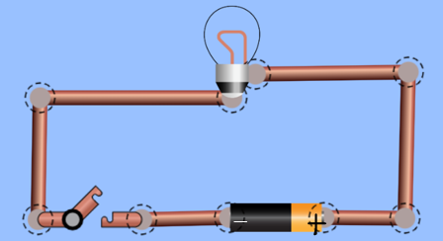
’ PhET: circuit construction kit Simulation’ by PhET Interactive Simulations, University of Colorado Boulder, licensed under CC BY 4.0.
Note: the dotted circles represent the joints between the wires, switch, a battery and a light bulb.
- Students construct more circuits by adding a paper clip, pencil and eraser, and more batteries or bulbs. They record their observations in a table and complete questions.
Note: use the terms ‘conductors’ and insulators’ when explaining the actions of these objects. The concept of conductors and insulators is addressed in the Stage 4 ‘Change’ focus area.
- Provide appropriate time for students to complete the questions in the student resource.
- Review questions with the class. Sample answers are provided in the speaker notes in EGY PPT ‘3.2 Constructing circuits – questions’.
Checkpoint: display the question in EGY PPT ‘3.2 Checkpoint’. Students can complete their responses on individual whiteboards.

Student resource

Electric circuit
A diagram of an electric circuit below shows the main components of a circuit.
A diagram of an electric circuit
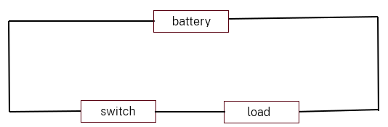
Match the words listed below with their meanings.
Word | Meaning
Electric circuit | It transforms electrical energy into another type of energy.
A conducting path | It controls the flow of electric charge in the circuit.
Battery | A complete loop of conducting material through which electric charges flow.
Load | It stores energy.
Switch | It is needed for the flow of electric charge in the circuit.

Electric circuit symbols
Scientists use symbols to represent the components of an electric circuit. Using standard symbols (scientific nomenclature), we can describe the construction of electrical circuits.
The source of electrical energy can be a single electrochemical cell, a battery, a power pack or the mains power outlet.
- A single electrochemical cell is represented by a long and a short parallel line. In everyday language, we sometimes refer to an electrochemical cell as a battery. For example, a battery in a remote-controlled toy or a torch is an electrochemical cell.
- Batteries are a collection of cells represented by a series of long and short parallel lines in electric circuit diagrams. In each case, the long line represents the positive terminal, and the short line represents the negative terminal. For clarity, a positive sign is sometimes placed next to the positive terminal of a battery.
- A powerpack provides a controlled supply of electrical energy. It has adjustable voltage settings, generally in the range of 0–12 Volts.
Complete the table by drawing the symbols of each electrical circuit component.
Electric circuit component | Circuit symbol
Battery
Electrochemical cell
Light globe
Switch (open)
Switch (closed)
Resistor
Voltmeter
Ammeter
Conducting wire

Constructing electric circuits
Instructions
Record your observations for each step in the table below.
- Use the PhET: circuit construction kit (by selecting Intro) to construct an electric circuit with a light bulb (load), conducting wires, switch and a battery when:
- the switch is open.
- the switch is closed.
- Repeat Step 1 by adding a paper clip to the circuit.
- Repeat Step 2 by replacing the paper clip with other items, such as a pencil/ eraser/ coin, another battery and a bulb.
Changing the load in the electric circuit
Load | Observations – Does the globe light up?
Light bulb | Switch open:  Switch closed:
Light bulb + paper clip
Light bulb + pencil
Light bulb + eraser
Questions
- Construct a circuit diagram for the circuit in Step 1a (with a closed switch).
- Suggest why the observations varied when you changed the load in the circuit.
- Predict and explain what will happen if you add another battery to the circuit. Construct this circuit, observe, and explain if your observation differs from your prediction.
- Predict what will happen if the wire is connected to the pencil's wooden sides instead of the graphite. Explain your prediction.

3.3 Voltage and current in electric circuits (Ohm’s law)
Students investigate the relationship between voltage and current.
Table 9 – learning intentions and success criteria for ‘Voltage and current in electric circuits (Ohm's law)’
We are learning: | I can:
- how to construct and compare electric circuits  - to systematically collect and record data, information, evidence, and findings  - to represent and organise data and information to find patterns and to calculate useful values. | - implement safe work practices and manage risks  - assemble, construct, and manipulate identified equipment to perform the investigation  - follow the planned procedure and identify and respond to errors if they occur  - select and use equipment correctly, including digital technologies, to make observations with precision  - organise data into graphs and tables.
Once students understand the features of an electric circuit, they can be introduced to the quantitative aspects of voltage and current.

Preparation
The following equipment is required for each student group:
- Powerpack
- Light globe
- Fixed resistor (10 ohm)
- Switch
- 6 connecting wires
- 2 digital multimeters OR 1 ammeter and 1 voltmeter
Note: a multimeter can replace the analog ammeter and voltmeter. Digital multimeters are more precise and easier to read than analog meters, which are more prone to parallax error.
Figure 7 – possible equipment for this experiment
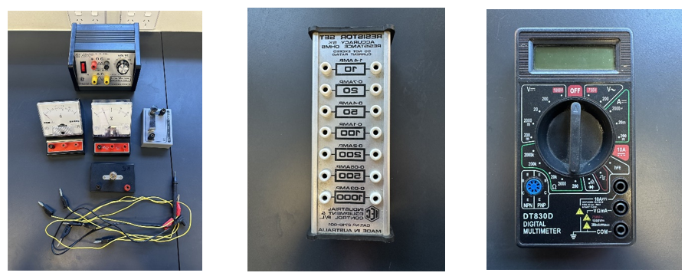

Instructions
- Students use the Think-Pair-Share strategy to describe current and voltage using their understanding of the energy analogies completed in an earlier lesson.
- Discuss the definitions with the class. Refer to EGY PPT ‘3.3 Voltage and current’.

Practical investigation – Investigating the relationship between voltage and current
- Show students how to set up an ammeter in an electric circuit. Refer to EGY PPT ‘3.3 Experiment set up for measuring current’. Explain that:
- to measure the current in a particular circuit, an ammeter must be placed directly in the circuit so the current flows through it
- ammeters are placed ‘in series,’ which means in line with the load.
- Instruct students to construct a circuit as shown in EGY PPT ‘3.3 Experiment set up for measuring current’ by following the instructions in the slide.
- Show students how to set up a voltmeter in an electric circuit. Refer to EGY PPT ‘3.3 Experiment set-up for measuring voltage’ to show how a voltmeter is connected in parallel to the fixed resistor. Explain that:
- to measure the potential difference between 2 points in a particular circuit, the voltmeter must be placed ‘in parallel’ across the 2 points.
- it only draws a very small amount of current, so it does not significantly affect the current flowing in the circuit.
- a voltmeter is placed between the 2 points across the load in an electric circuit because it measures the change in electrical potential energy transformed by the load to other forms of energy. This change in electric potential energy is called the potential difference. If there are multiple loads, for example, if you have multiple light globes in a circuit, then you will need to connect a voltmeter across each one to measure the potential difference (voltage across each).
- Instruct students to construct a circuit as shown in EGY PPT ‘3.3 Experiment set-up for measuring voltage’ by following the instructions in the slide.
- If using an analog ammeter and voltmeter, show students how to read the scale of these devices directly in front rather than from an angle. Discuss how random errors, such as a parallax error, may affect the accuracy of the results if the device is read at an angle.
- Explain to students why it is essential to ensure that the needle of the analog meters coincides with zero before use. Discuss how systematic errors arise if this is not done. Most meters can be adjusted by turning the screw at the centre of the dial.
Note: ammeters, voltmeters and multimeters must be connected the right way around – match terminals to avoid negative values. Swap the connections if any of these meters show negative values.
- Instruct students to work in groups to construct a circuit to measure current and voltage. Display EGY PPT ‘3.3 An experiment set-up for measuring current and voltage’.
- Check circuits for each student group to ensure the ammeter and voltmeter are connected correctly.
- Instruct students to follow the instructions in the student resource below to conduct the practical investigation, record results for current and voltage.
- Provide 2 graph papers to each student. They plot a graph of voltage versus current for a fixed resistor and a light globe and answer questions on analysing the collected data.
- Explain to students that although voltage is the independent variable (ranging from 2 to 12 volts), it is plotted on the y-axis. Likewise, current is the dependent variable, but it is plotted on the x-axis. This allows the resistance, which equals the slope of the voltage versus current graph, to be calculated. If the data obtained by students is not suitable, sample data is provided in Appendix B.
Differentiation:
Teachers may provide the template for the results table and graph to support students with low numeracy skills. The axes can be labelled to help students with graphing.
Extension
- Students could record and analyse data in an MS Excel spreadsheet. They can use the graphing tools and functions in Excel to plot a graph and calculate the average and slope of a straight line.
- Refer to EGY PPT ‘3.3 Ohm’s law’ to explain how resistance can be determined from voltage and current.
- Explain how to use Ohm’s law equation to calculate current, voltage or resistance. Refer to EGY PPT ‘3.3 Ohm’s law equation’.
- Students complete the questions on Ohm’s law. Refer to EGY PPT ‘3.3 Ohm’s law calculations (1)’.
Differentiation: to extend students, refer to EGY PPT ‘3.3 Ohm’s law calculations (2)’.
Checkpoint: (answers provided in EGY PPT ‘3.3 Ohm’s law calculations’
Describe the shape of the graphs plotted in 1. Predict how the slope of 1a would change if the resistance of the fixed resistor is doubled. Explain your predictions.

Student resource – investigating the relationship between voltage and current
This experiment aims to investigate the relationship between current and voltage.
Equipment:
- Powerpack
- Light globe
- Fixed resistor (10 ohm)
- Switch
- 2 digital multimeters OR 1 ammeter and 1 voltmeter
- 6 connecting wires.
Risk assessment: carry out a thorough risk assessment before conducting this experiment.
Hazard | Risk | Mitigation
Procedure:
- Set up the equipment with a power pack connected to an ammeter, light globe, switch, and voltmeter according to the teacher’s instructions.
Note: ammeters, voltmeters and multimeters must be connected correctly around – match terminals to avoid negative values. If any of these meters show negative values, swap the connections.
- Start with the power supply set at 2 volts and close the switch.
- Record the ammeter and voltmeter readings in the results table.
- Repeat Step 3 by changing the voltage on the powerpack to 4, 6, 8, 10 and 12 volts.
- Repeat Steps 1 to 4 for another trial
- Repeat Steps 1 to 5 by replacing the light globe with a resistor (10 ohm).
- Calculate the ratio $voltage/current$ for each pair of values, complete the last column of the results table below.

Results table – voltage versus current for a simple circuit
Load | Power supply voltage (Volts, V) | Current, $I$ (A) |  |  | Voltage across the load, $V_{load}$ (V) |  |  | $$\frac{V_{load}}{I}$$
Load | Power supply voltage (Volts, V) | Trial 1 | Trial 2 | Mean | Trial1 | Trial 2 | Mean | $$\frac{V_{load}}{I}$$
Light globe | 2
Light globe | 4
Light globe | 6
Light globe | 8
Light globe | 10
Light globe | 12
Resistor | 2
Resistor | 4
Resistor | 6
Resistor | 8
Resistor | 10
Resistor | 12
Analysing investigation data
- Plot the voltage across load versus current, with voltage on the y-axis and current on the x-axis for:
- a fixed resistor
- a light globe.
- Plot a line of best fit for 1a (fixed resistor) and calculate its slope.
- Describe the relationship between current and voltage using evidence from the data in your investigation.

3.4 Series and parallel circuits
Table 10 – learning intentions and success criteria for ‘Series and parallel circuits'
We are learning: | I can:
- how to construct and compare electric circuits  - to select and use appropriate tools to make accurate observations and measurements  - to systematically collect and record data, information, evidence, and findings  - to represent and organise data and information to find patterns and to calculate useful values. | - construct series and parallel circuits and make qualitative observations  - measure current and voltage in a series and parallel circuit and record quantitative data  - select appropriate tools to make accurate and precise measurements.
Students investigate series and parallel circuits and collect qualitative and quantitative data. Before students make any current or voltage measurements, revisit the electric circuit analogies and questions covered in the EGY PPT.

Preparation
The following equipment is required for each student group:
- 3 light globes
- Power pack
- 2 digital meters OR an ammeter and a voltmeter
- A set of conducting wires
- Resistor pack
Note: a multimeter can replace the analog ammeter and voltmeter. Digital multimeters are more precise and easier to read than analog meters, which are more prone to parallax error.

Instructions
Checkpoint: review prior learning on electric circuits. Refer to the Diagnostic questions 1 and 2 in EGY PPT ‘3.4 Diagnostic question’ (2 slides).
- Introduce the topic by explaining to students that there can be more than one continuous path between the two terminals of the cell. When there is only one possible path for the electric current, it is described as a series circuit. When there are 2 or more possible paths, it is described as a parallel circuit.
- Show series and parallel circuits (5:02).
- Instruct students to work individually or in pairs to draw the following circuit diagrams on individual whiteboards:
- a simple circuit consisting of an electrochemical cell, a switch and 3 light globes in series
- a circuit simple circuit consisting of an electrochemical cell, a switch and 3 light globes in parallel.
- Quickly check the circuit diagrams and display EGY PPT ‘3.4 Series and parallel circuits’. Explain the common errors that students have made in their circuit diagrams. For example, incorrect circuit symbols.
- Alternatively, after Step 2, display the circuit diagrams in EGY PPT ‘3.4 Series and parallel circuits’ on the board and instruct students to construct a series and a parallel circuit, disconnect one of the light globes and observe what happens in each circuit.

Practical investigation – investigating current and voltage in a series and parallel circuit
- Students set up a simple circuit with a powerpack and one light globe, as shown in EGY PPT ‘3.4 A series circuit’.
- Students make predictions about the change in the brightness of a globe when 2 more similar globes are added to a series circuit and provide reason(s) for their predictions.
- Students add 2 similar light globes in series with the light globe in the circuit and record qualitative observations on the change in brightness of the globe. (EGY PPT ‘3.4 A series circuit – 3 light globes’).
- Display EGY PPT ‘3.4 The equipment set-up for measuring current and voltage in a series circuit with light globes’, which show the equipment setup for measuring current and voltage in a series circuit in the.
Note: before students start recording the data for the following circuit, check for each student group to ensure the ammeter and voltmeter are connected correctly.
- Instruct students to connect an ammeter in series to measure the electric current flowing out of the power supply and into each light globe and record their results in a table in the student resource.
- Remind students to measure the voltage across each light globe by connecting a voltmeter in parallel across each light globe, one at a time.
- Students set up a simple circuit with a power pack and one light globe.
- Students make predictions about the change in the brightness of the first globe when 2 or more similar globes are added in parallel and provide reason/s for their predictions. Refer to the (EGY PPT ‘3.4 A parallel circuit’)
- Students add 2 similar light globes in parallel to the light globe in the circuit (EGY PPT ‘3.4 A parallel circuit’) and record qualitative observations on the change in brightness of the globe.
- Display EGY PPT ‘3.4 Measuring current and voltage in a parallel circuit’.
- Instruct students to connect an ammeter in series to measure the electric current flowing out of the power supply and into each light globe and record their results in a table in the student resource.
- Remind students to measure the voltage across each light globe by connecting a voltmeter in parallel across each light globe, one at a time.
- Connect the voltmeter in parallel to each light globe and measure the voltage across each one in the series circuit. Record the results in the table below.
Note: encourage students to refer to their results table when completing the discussion section. Appendix B provides sample data for this investigation on series and parallel circuits.
Discussion – sample answers
- Compare the current and voltage values in a series and parallel circuits.
The table below contains sample response based on the results in Appendix B.
Circuit | Current | Voltage
Series | The current in the series circuit stays the same (0.1 A). | The voltage is shared between the 3 globes. The total voltage across three globes is 5.43 V, which is slightly less than the supplied voltage (6 V).
Parallel | The current adds to 1.15 A. | The voltage across each light globe in a parallel circuit is consistent (5.18 to 5.22 V), which is slightly less than the supplied voltage (6 V).
- How does the value of current vary at different points in:
- a series circuit?
- a parallel circuit?
Note: point out to students that the current is the same at all points in a series circuit, but the voltage is shared among the loads. The total voltage in a series circuit is the sum of the voltage across each load. In contrast, the voltage is the same across each parallel path in a parallel circuit, but the current is shared between them. The total current is the sum of the current through each path.
- Support your answers in question 2 with evidence from the data collected in your investigation.
Note: refer to the table legend. Students should refer to data collected in their investigation.
Checkpoint: solve problems related to current and voltage for circuits with multiple components. Refer to Checkpoints 1 and 2 in EGY PPT ‘Checkpoint’ (2 slides).

Student resource – series and parallel circuits
Risk assessment: before conducting this activity, conduct a thorough risk assessment and implement all safety measures according to the teacher’s instructions.
Equipment:
- 3 light globes
- Powerpack
- 2 digital meters OR an ammeter and a voltmeter
- A set of conducting wires
- Resistor pack
Procedure
- Set up a simple circuit with a light globe and power pack at 6 volts.
Predict the change in brightness of the globe when you add 2 similar globes in series to the light globe already in the circuit. Will the brightness of the first globe increase, decrease or stay the same? Give a reason for your prediction.
- Add another 2 globes in series. Observe and record any change in the brightness of the globes. Do your observations match your prediction?
- Connect an ammeter in series to measure the electric current flowing out of the power supply and into each light globe. Record your results in the table below.
- Connect the voltmeter in parallel to each light globe and measure the voltage across each one in the series circuit. Record the results in the table below.
The current and voltage in a series circuit
Load | Current (A) | Voltage (V)
Globe 1
Globe 2
Globe 3
- Set up a simple circuit with a light globe and power pack at 6 volts.
- Predict the change in brightness of the globe when you add 2 similar globes in parallel to the light globe already in the circuit. Will the brightness of the original globe increase, decrease or stay the same? Give a reason for your prediction.
- Add another 2 globes in parallel. Observe and record any change in the brightness of the globes. Do your observations match your prediction?
- Connect an ammeter in series to measure the electric current flowing out of the power supply and into each light globe. Record your results in the table below.
- Connect the voltmeter in parallel to each light globe and measure the voltage across each one in the series circuit. Record the results in the table below.
The current and voltage in a parallel circuit
Load | Current (A) | Voltage (V)
Globe 1
Globe 2
Globe 3
Discussion
- Construct a circuit diagram for the experiment set up of a series and a parallel circuit.
- Compare the current and voltage values in series and parallel circuits.
- How does the value of current vary at different points in:
- a series circuit?
- a parallel circuit?
- Describe using the evidence from the data collected in your investigation.

3.5 Power and energy
Table 11 – learning intentions and success criteria for ‘Power and energy'
We are learning: | I can:
- how we can use energy more efficiently  - to select and use appropriate tools to make accurate observations and measurements  - to systematically collect and record data, information, evidence, and findings  - to represent and organise data and information to find patterns and to calculate useful values. | - safely construct a heating circuit  - use the collected data to calculate the percent efficiency  - use knowledge of scientific concepts to draw conclusions that are consistent with evidence  - assess the validity and reliability of first–hand data.
In this activity, students construct a heating circuit, investigate the relationship between power and energy and explore energy efficiency.

Preparation
The following equipment is required for each student group:
- Powerpack
- 2 digital meters OR an ammeter and a voltmeter
- A set of conducting wires with alligator clips
- Thermometer
- 50 cm Nichrome wire
- Beaker
- Water
Figure 8 – equipment for the power and energy investigation
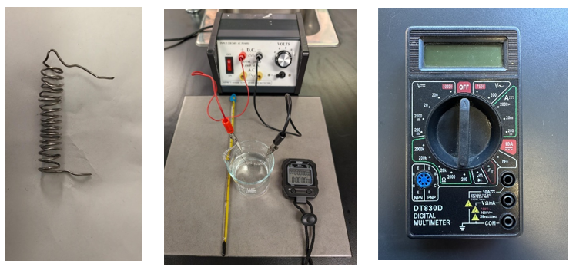
Note: a multimeter can replace the analog ammeter and voltmeter. Digital multimeters are more precise and easier to read than analog ones, which are more prone to parallax errors.

Instructions
- Activate prior learning by asking questions about power and energy (covered in 1.5 Calculating efficiency). Refer to the question in EGY PPT ’3.5 Energy’. Students complete this on individual whiteboards.
- Revisit the concept of power and the units for measuring power. Refer to EGY PPT ‘3.5 Electric power’.

Practical investigation – making an electric water heater

Instructions
- Display EGY PPT ‘3.5 Making your own electric water heater’ to show students how to set up the electric circuit for this investigation.
- Instruct students to follow instructions in the student resource to conduct the practical investigation.
- Instruct students to ensure that the nichrome coil does not touch the bottom or sides of the beaker.
Note: check the circuit set up for each group before students start collecting data.to ensure the ammeter is connected in series with the nichrome wire and the voltmeter is parallel across it.
- Explain how to calculate the amount of energy transformed by the nichrome coil. Refer to EGY PPT ‘3.5 Calculation of energy transformed by the nichrome wire’).
- Explain how to calculate the amount of energy transformed by the water in the beaker. Refer to EGY PPT ‘3.5 Calculation of energy absorbed by the water’.
- Explain how to calculate the energy efficiency of the nichrome coil. Refer to EGY PPT ‘3.5 Calculation of energy efficiency’.
- Students complete the results table, including the calculations on the energy efficiency of the nichrome coil.
Checkpoint: students complete the analysis of results and answer questions provided in the student resource. Refer to EGY PPT ‘3.5 Checkpoint – 2’.
Differentiation: this is an extension activity. Refer to EGY PPT ‘3.5 Extension activity’.
Students predict the effect of doubling the length of the nichrome coil on the current and the power consumption of this circuit and then test their prediction by repeating the experiment with 100 cm nichrome wire.
Students predict and explain which would heat the water more rapidly, a long or a short nichrome coil if the supplied voltage and the amount of water are the same for both.

Student resource

Making my own electric water heater (practical investigation)
This experiment aims to investigate the energy efficiency of a heating circuit.
Risk assessment: carry out a thorough risk assessment before conducting this experiment.
Hazard | Risk | Mitigation
hot water | burns or scalds from heated water | limit water temperature to a safe level. Do not touch the hot water or equipment
Add more rows as required. Identify all hazards, the relevant risks and suggestions for mitigating them. The first one is done as an example.
Procedure
- Add 100 mL of water to a glass beaker and set up the equipment according to your teacher’s instructions.
- Wrap a 50 cm nichrome wire into a coil.
- Connect the wire leads to either end of the nichrome coil and place it in the beaker. Ensure the nichrome coil does not touch the bottom or sides of the beaker.
- Connect a voltmeter to measure the voltage across the coil and an ammeter to measure the current through the circuit and connect it to a power pack.
- Place the thermometer in the beaker, ensuring it does not touch the coil.
- Set the power pack to 2 V DC.
- Record the voltage (V) and the current ($I$) in the results table below.
- Measure and record the temperature of the water for 6 minutes.
- Repeat Steps 1 to 8 with the power pack set at 4 V, then 6 V.

Results table – energy efficiency of a nichrome wire heating water
Voltage across the coil (V) | Current (A) | Initial temperature, $T_{i}$ (°C) | Final temperature, $T_{f}$ (°C) | Temperature change, $∆T=T_{f}-T_{i}$ (°C) | P (Watts) = VI | The energy transformed by the nichrome coil, $E_{electrical}=VIt$ (J) | Energy transferred to water, $E_{thermal}=418×∆T$ (J) | % Efficiency

- Calculate the amount of energy transformed by the nichrome coil at 2, 4 and 6 V using the formula, $E_{electrical}= VIt$ and complete the relevant column in the results table.
- Calculate the energy transferred to water using the following formula and complete the relevant column in the results table.
$$E_{thermal}=mass of water \left(m\right)×4.18 (c)×change in temperature(∆T)$$
Where:
- m is the mass of water (g)
- $c=4.18 JK^{-1}g^{-1}$ is the specific heat capacity of water (the energy required to raise the temperature of 1 gram of water by 1 degree Celsius)
- $∆T$ is the change in temperature of the water (°C).
Note: for this activity, the mass of water is 100 g therefore $m×c=418$, $E_{thermal}=418×∆T$
- Calculate the % efficiency using the following formula and complete the relevant column in the results table.
$$\% efficiency= \frac{Useful energy output{ (E}_{thermal})}{Total energy input (E_{electrical})} × 100$$
Analysis of results
- Compare your results with other groups in your class and provide reasons for differences.
- How does the power vary with an increase in applied voltage?
- How can you improve the reliability of this investigation?

3.6 Energy efficiency and electrical appliances
Students compare different appliances using the energy rating label.
Table 12 – learning intentions and success criteria for ‘Energy efficiency and electrical appliances'
We are learning: | I can:
- how to make informed decisions about energy efficiency  - to select strategies to solve scientific problems and to evaluate our solutions. | - describe the relationship between the star rating and energy efficiency  - use the energy rating label to calculate the running cost of an appliance  - make informed decisions about appliances based on the purchase cost and running cost  - justify claims using scientific knowledge and findings from investigations.

Preparation
Ensure that each student has:
- a laptop or computer
- internet access.

Instructions
- Engage students by posing a question on energy usage. Refer to EGY PPT ‘3.6 Energy efficiency’.
- Students engage with the data for the different appliances to identify the difference in the running cost of the appliances. Refer to EGY PPT ‘3.6 Energy cost’.
- Explain the term ‘energy rating’ of appliances. Refer to EGY PPT ‘3.6 Energy rating’.
- Explain the term ‘star ratings’ of appliances and the criteria used to determine these ratings. Refer to EGY PPT ‘3.6 Star rating’.
- Show students how to use the energy rating label to calculate the running cost of an appliance. Refer to EGY PPT ‘3.6 Calculating running cost from the energy rating label’.
- Students explore how to make savings by using the energy rating label. Refer to EGY PPT ‘3.6 How much are you saving?’
- Explain how to use the star rating to calculate the running cost of the electrical appliances.
- Students complete the Student resource to compare similar appliances with different star ratings and calculate the savings based on the star ratings using the Energy Rating Calculator and the purchase cost of the appliance to make informed decisions about long-term savings. Refer to the student resource for details.
Checkpoint: refer to questions in the student resource. Students should justify their claim using EGY PPT ‘3.6 C-E-R scaffold’.
Differentiation: provide a scaffold for calculations, as explained in the examples given in this section.

Student resource – comparing appliances to make informed decisions
Jane plans to buy a clothes dryer with a very high energy rating, as shown in Figure 1. Will it save money in the long run? Your task is to compare the energy efficiency and cost of the appliance below with similar appliances and help your friend decide whether it is cost-effective.
Figure 1 – the energy rating label of an 8kg clothes dryer
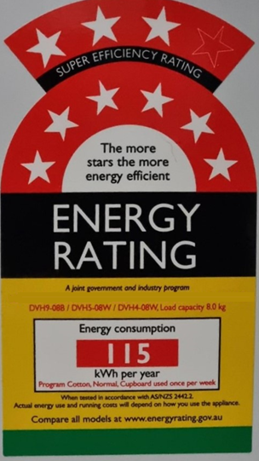
- Use the information in the label to complete the first row of the table below. Estimate the one-year and 10-year running costs assuming an electricity tariff of $0.5432 / kWh.
- Select 2 other 8 kg clothes dryers from the Energy rating calculator website use the information on their star rating labels to complete the next two rows of the table.
Clothes dryer model | Star rating | Energy consumption per year (kWh) | 1-year running cost ($) | 10-year running cost ($)
Dryer 1
Questions
- Explain which appliance will save you more on your energy bill. Use evidence from your table to support your choice.
- If the purchase cost of the dryer in the Figure 1 is $1,421, calculate the appliance's total cost over 10 years (total cost = purchase cost + running cost over 10 years).
- Research the purchase cost of the other 2 dryers you have selected and calculate their total costs over 10 years.
- Which dryer is most cost-effective out of the 3 dryers you have researched? Explain using the evidence from your calculations to support your claim.

3.7 Energy bill
Students explore options to reduce energy usage and save on energy bills.
Note: although this topic is not mentioned in the syllabus, it is included to provide a different perspective on energy usage and cost.
Table 13 – learning intentions and success criteria for ‘Energy bill'
We are learning: | I can:
- how we can use energy more efficiently  - how to make informed decisions about the best energy sources to use  - to select strategies to solve scientific problems and to evaluate our solutions. | - read an energy bill  - make informed choices about savings on my electricity bill.
Explain the main components of the energy bill using a sample bill. Refer to Bill guides to look at sample electricity bills and time slots for peak, off-peak and shoulder periods, as they may vary slightly depending on the provider.
- In electricity bills, tariff means the charge rate paid for energy.
- The usage charges are calculated based on the cost per kilowatt hour provided by the energy provider and the usage time and period.
- The peak hour is the period of high demand; the off-peak refers to the period with low demand, and the shoulder period is between these periods.
Print and distribute a copy of the electricity bills in Figure 9 and Figure 10. Project EGY PPT ‘3.7 Comparing energy bills’. Students analyse the energy bills to respond to the questions on the slide.

Figure 9 – screenshot of the energy bill for household A
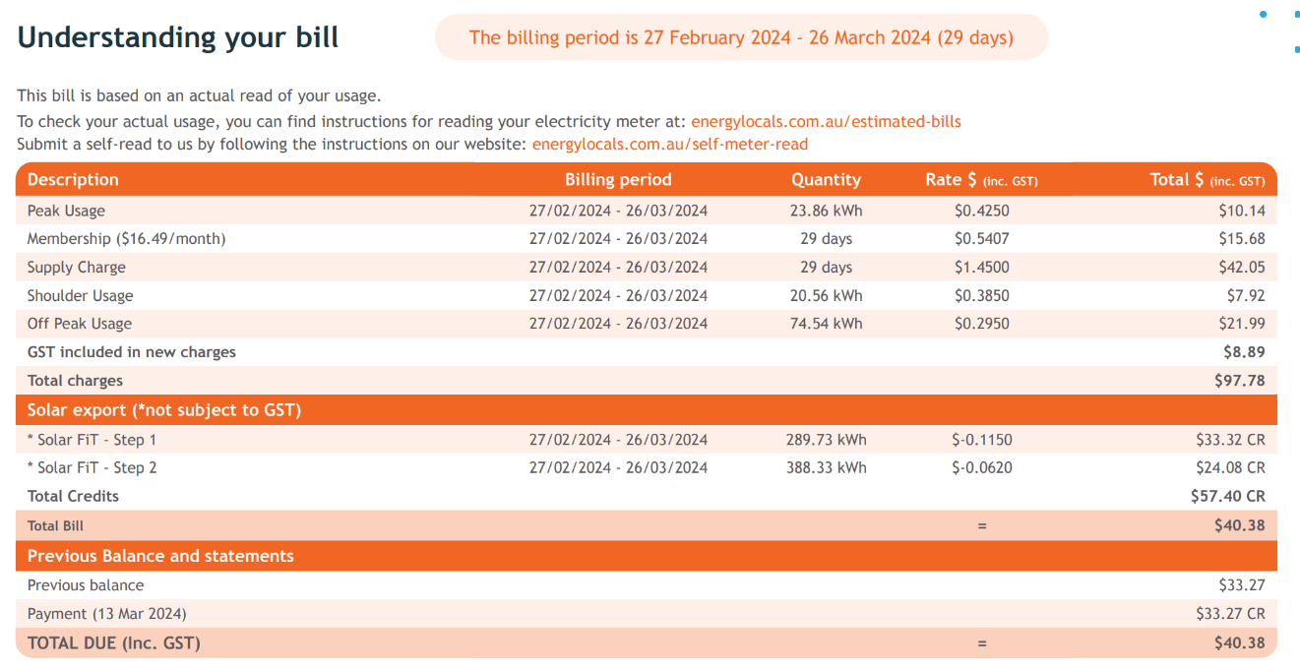
Figure 10 – screenshot of the energy bill for household B
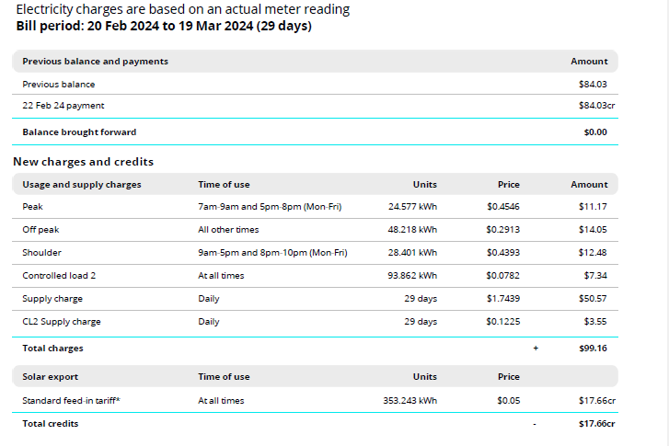

Analysing data
Compare their energy bills and answer the following questions. Support your responses with data from the energy bills.
- Calculate the energy usage for each client in kWh.
Add the energy usage in all periods (peak, off-peak and shoulder) and the supply charges.
For client A: total energy usage $= \left(23.86 + 20.56 + 74.54\right)kWh = 118.96 kWh$
For client B: total energy usage = $\left(24.577 + 48.18 + 28.401\right)kWh = 101.96 kWh$
Note: (To compare similar values, control load 2 is ignored for client B). Control load 2 is a fairly complex concept; it need not be addressed in this lesson.
- Explain which client has a better energy plan.
Hint: Refer to the charges for peak, off-peak, shoulder, supply, and the credits due to solar export. Encourage students to use the evidence from the data to make informed decisions.
Table 14 – the comparison of the different items in the electricity bills for clients A and B
Client | Peak rate | Off-peak rate ($) | Shoulder rate ($) | Credit due to solar export ($) | Supply charge
A | 0.4250 | 0.2950 | 0.3850 | 0.1150 & 0.0620 | 1.4500
B | 0.4546 | 0.2913 | 0.4393 | 0.05 | 1.7439
Client A has a better energy plan because its peak, shoulder and supply charges per unit are lower than client B's. This means that if both clients use the same amount of energy, it will cost Client B more than Client A. Furthermore, the solar credit rate for Client A is higher than that for Client B, which will further reduce the energy usage cost for Client A.
- If clients A and B have the same number and dimensions of solar panels, explain why they might differ in the solar export data.
Sample answer
Table 15 – comparison of solar exports for clients A and B
Client | Solar export units (kWh) |  | Solar export rate per unit ($) |  | Solar credit
A | 289.73 | 388.33 | 0.1150 | 0.0620 | 33.32 | 24.08
B | 353.243 |  | 0.05 |  | 17.66

The following factors may contribute to the difference in the solar export data of 2 clients:
- climate conditions (for example, the variation in the amount of sunlight due to different weather conditions like rainfall
- the efficiency of the solar panels
- location of the house
- Outline some recommendations for behavioural changes for each client to reduce their energy bill.
- Limit the use of energy-intensive appliances during peak periods when electricity rates are higher. Complete tasks like laundry and dishwashing during off-peak hours.
- Avoid running heating or cooling systems excessively during peak times. Set the thermostat to energy-efficient levels to reduce consumption.
- Schedule tasks that require more energy, such as running the dishwasher or charging electric vehicles, during off-peak hours when rates are lower.
- Maximise solar energy utilisation during shoulder periods to offset electricity usage and reduce overall energy bills.
Going further
Understanding solar data: Students with solar panels can analyse solar consumption and export data, comparing energy bills before and after the panels are installed.
Resource consumption report (SCOUT) provides information about a school's electricity consumption throughout the year. It can be used to compare electricity usage to the previous year, compare it to the state average, and ascertain whether efforts to keep costs or usage low are working. Teachers can also use the school solar data as a stimulus for this section and create questions on the data.

Appendix A

Electric circuit symbols
Figure 11 – common symbols for the components of electric circuits
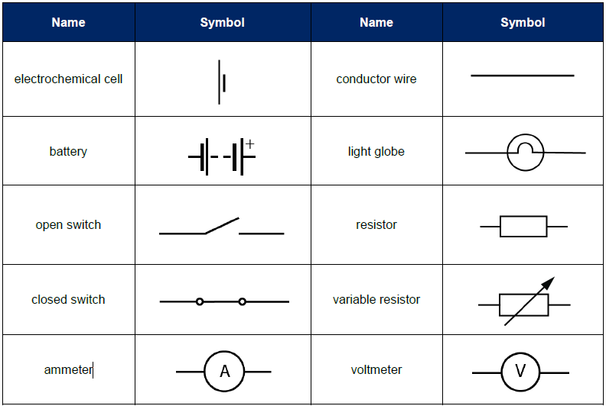
This screenshot is from the Data Book published by NESA.

Appendix B – sample data for Ohm’s law
Table 16 – voltage versus current for a simple circuit
Load | Power supply voltage (Volts, V) | Current, $I$ (Amperes, A) |  |  | Voltage across the load, $V_{load}$ (V) |  |  | $$\frac{V_{load}}{I}$$
Load | Power supply voltage (Volts, V) | Trial1 | Trial 2 | Mean | Trial1 | Trial 2 | Mean | $$\frac{V_{load}}{I}$$
Fixed resistor (10 Ohm) | 2 | 0.20 | 0.20 | 0.20 | 1.85 | 1.89 | 1.87 | 9.35
Fixed resistor (10 Ohm) | 4 | 0.35 | 0.35 | 0.35 | 3.52 | 3.51 | 3.52 | 10.04
Fixed resistor (10 Ohm) | 6 | 0.50 | 0.50 | 0.50 | 5.10 | 5.10 | 5.10 | 10.20
Fixed resistor (10 Ohm) | 8 | 0.70 | 0.70 | 0.70 | 6.98 | 6.96 | 6.97 | 9.96
Fixed resistor (10 Ohm) | 10 | 0.90 | 0.90 | 0.90 | 8.86 | 8.82 | 8.84 | 9.82
Fixed resistor (10 Ohm) | 12 | 1.10 | 1.10 | 1.10 | 10.68 | 10.66 | 10.67 | 9.70
Light globe | 2 | 0.12 | 0.11 | 0.12 | 1.95 | 1.95 | 1.95 | 16.96
Light globe | 4 | 0.17 | 0.17 | 0.17 | 3.66 | 3.66 | 3.66 | 21.53
Light globe | 6 | 0.21 | 0.21 | 0.21 | 5.32 | 5.20 | 5.26 | 25.05
Light globe | 8 | 0.25 | 0.25 | 0.25 | 7.30 | 7.26 | 7.28 | 29.12
Light globe | 10 | 0.29 | 0.29 | 0.29 | 9.22 | 9.20 | 9.21 | 31.76
Light globe | 12 | 0.32 | 0.32 | 0.32 | 11.17 | 11.15 | 11.16 | 34.88

Analysing data (sample graphs)
Figure 12 – V vs I graph for a 10-ohm fixed resistor. The trendline (shown as a dotted line) overlaps the plotted line.
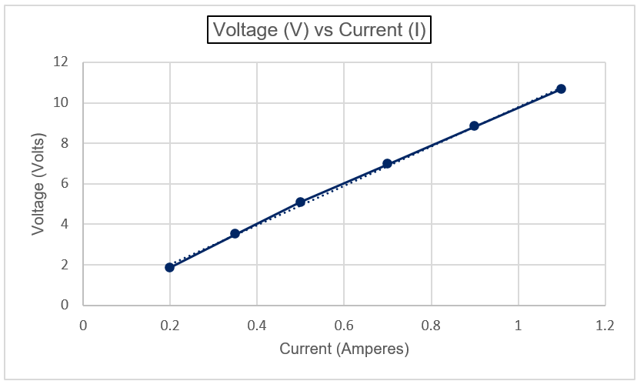
Figure 13 – V vs I graph for a light globe
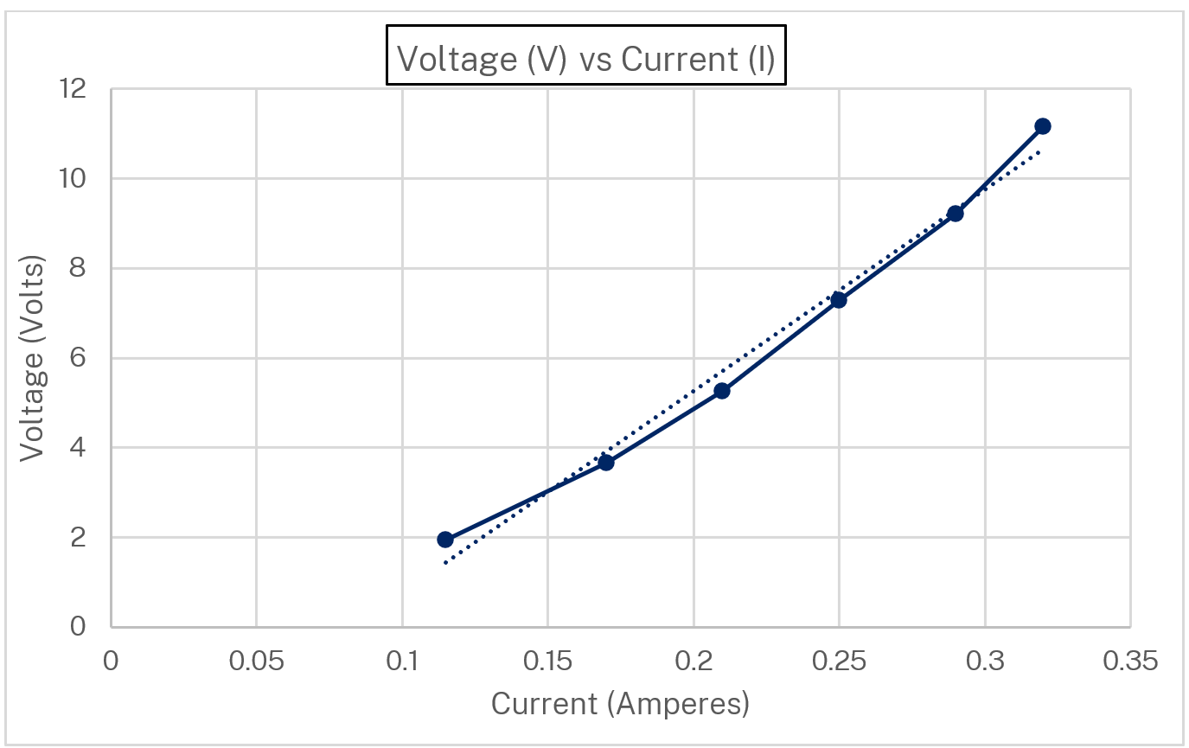
The trend line is shown as a dotted line. The graph is a curve rather than a straight line that shows that although the current varies with the voltage, the relationship is not perfectly linear as for a fixed resistor.
Note: when assigning axes on graphs, the independent variable is plotted on the x-axis and the dependent variable on the y-axis. However, in this case, this is reversed because the ratio of voltage to current is important, as resistance can be calculated from the slope of the straight line.
Figure 14 – V vs I graph for a fixed resistor and a light globe on the same axes
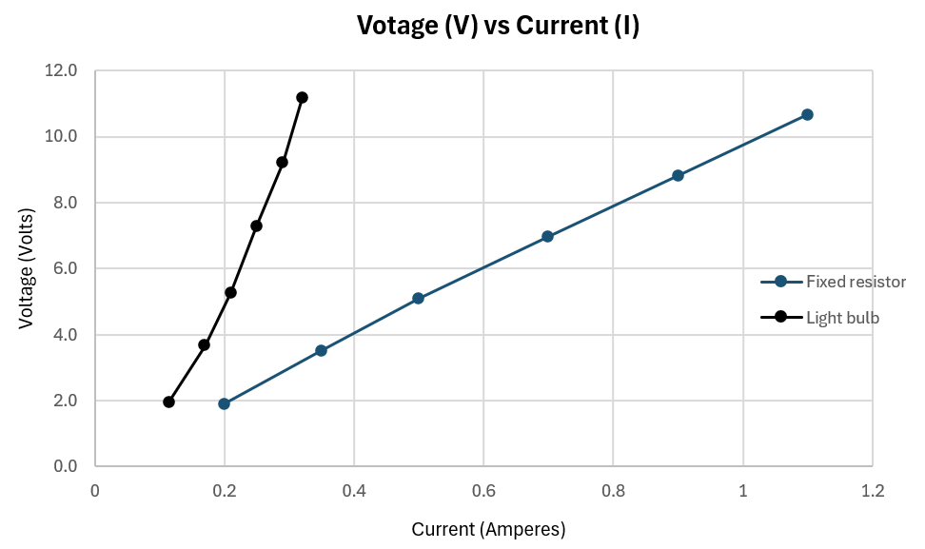
The resistance can be calculated from the slope of the V vs I graph. The slope function in Excel was used to calculate the slope. Alternatively, the following slope formula can be used for calculating slope (m):
$$m= \frac{{y_{2}-y_{1} }_{ }}{x_{2}-x_{1} }$$
The slope of the straight line for a fixed resistor (Figure 12) is 9.716. The resistor used in this investigation was 10 ohm, so the experimental results were very close to the known value.
On the other hand, the graph of V vs I for a light globe (Figure 13) is a curve rather than a straight line. The slope can be calculated from the trend line.

Appendix C – sample data on series and parallel circuit investigation
Table 17 – current and voltage in a series and parallel circuit with 3 light globes and a power pack set at 6 volts
Circuit | Current (A) | Voltage (V)
Series | Globe 1: 0.10 | Globe 1: 1.58
Series | Globe 2: 0.10 | Globe 2: 2.19
Series | Globe 3: 0.10 | Globe 3: 1.66
Total |  | 1.58 + 2.19 + 1.66 = 5.43
Parallel | Globe 1: 0.58 | Globe 1: 5.22
Parallel | Globe 2: 0.37 | Globe 2: 5.20
Parallel | Globe 3: 0.20 | Globe 3: 5.18
Total | 0.58 + 0.37 + 0.20 = 1.15
Note: the shaded cells (blue and pink) show the quantities that remain constant. The grey cells show the total voltage for a series circuit and the total current for a parallel circuit.
In the series circuit:
- the current (highlighted blue) stays the same (0.1 A).
- the voltage is shared between the three globes. The voltage across the three globes add to 5.43 V, which is slightly less than the supplied voltage (6 V).
In the parallel circuit:
- the voltage across each light globe (highlighted pink) is consistent (5.18 to 5.22 V) and slightly lower than the supplied voltage (6 V).
- the current adds to 1.15 A.
Table 18 – current and voltage in a series and parallel circuit with 3 different resistances and a power pack set at 6 V
Circuit | Current (A) | Voltage (V)
Series | Resistor 1: 0.06 | Resistor 1: 0.68
Series | Resistor 2: 0.06 | Resistor 2: 1.34
Series | Resistor 3: 0.06 | Resistor 3: 3.46
Total |  | 0.68 + 1.34 + 3.46 = 5.48
Parallel | Resistor 1: 0.84 | Resistor 1: 5.01
Parallel | Resistor 2: 0.08 | Resistor 2: 4.98
Parallel | Resistor 3: 0.02 | Resistor 3: 4.97
Total | - + 0.08 + 0.02 = 0.94
Note: the shaded cells (blue and pink) show the quantities that remain constant. The grey cells show the total voltage for a series circuit and the total current for a parallel circuit.
In the series circuit:
- the current (highlighted blue) stays the same (0.06 A)
- the voltage is shared between the three resistors. The total voltage across the three resistors is 5.48 V, which is slightly less than the supplied voltage (6 V).
In the parallel circuit:
- the current is shared between the three resistors. The total current in the circuit is the sum of the current flowing through each resistor (0.94A)
- the total voltage across each light globe in a parallel circuit (highlighted pink) is consistent (4.97 to 5.01 V) and slightly lower than the supplied voltage (6 V).

Evidence base
This resource contains NSW Curriculum and syllabus content. The NSW Curriculum is developed by the NSW Education Standards Authority (NESA). This content is prepared by NESA for and on behalf of the Crown in right of the State of New South Wales. The material is protected by Crown copyright.
Please refer to the NESA Copyright Disclaimer for more information https://www.nsw.gov.au/education-and-training/nesa/copyright.
NESA holds the only official and up-to-date versions of the NSW Curriculum and syllabus documents. Please visit NESA https://www.nsw.gov.au/education-and-training/nesa and NSW Curriculum https://curriculum.nsw.edu.au.
Science 7–10 Syllabus © NSW Education Standards Authority (NESA) for and on behalf of the Crown in right of the State of New South Wales, 2023.
Science 7–10 Data Book © NSW Education Standards Authority (NESA) for and on behalf of the Crown in right of the State of New South Wales, 2023.
Australian Energy Regulator (AER) (2023) Your energy bill, Australian Energy Regulator website, accessed 15 July 2024.
Brookhart S M (2018) ‘Appropriate Criteria: Key to Effective Rubrics’, Frontiers in Education, volume 3(22):1–12, doi:10.3389/feduc.2018.00022, accessed 15 July 2024.
CESE (Centre for Education Statistics and Evaluation) (2020) What works best: 2020 update, NSW Department of Education, accessed 15 July 2024 .
——(2020) What works best in practice, NSW Department of Education, accessed 15 July 2024.
——(2021) Growth goal setting – what works best in practice, NSW Department of Education, accessed 15 July 2024.
Dervisevic H (3 March 2024) ‘What household appliances use the most energy? Here's a breakdown, plus tips on how to save money’, ABC News, accessed 15 July 2024.
Energy Rating (n.d.) Energy Rating Calculator, Energy Rating website, accessed 15 July 2024.
Fisher D and Frey N (1 November 2009) ‘Feed Up, Back, Forward’, ASCD (Association for Supervision and Curriculum Development): Educational Leadership magazine, 67(3), accessed 15 July 2024.
Griffin P (2017) Assessment for Teaching, Cambridge University Press, Port Melbourne, Victoria.
Hattie J and Timperley H (2007) ‘The Power of Feedback’, Review of Educational Research, 77(1): 81–112, doi:10.3102/003465430298487.
IOPSpark (2024) Electrical circuits, Institute of Physics website, accessed 15 July 2024.
Panadero E and Jonsson A (2013) ‘The use of scoring rubrics for formative assessment purposes revisited: A review’, Educational Research Review, 9:129–144, doi:10.1016/j.edurev.2013.01.002, accessed 15 July 2024.
PhET Interactive Simulations (2024) Circuit construction kit, University of Colorado, accessed 15 July 2024.
Santiago J (9 February 2009) 'Introduction to Circuit Analysis - Water Analogy' [video], John Santiago, YouTube, accessed 15 July 2024.
Sherrington T (2019) Rosenshine’s Principles in Action, John Catt Educational Limited, Melton, Woodbridge.
STEM Learning Ltd. (2004) Big idea: Electricity and magnetism, STEM Learning website, accessed 15 July 2024.
Wiliam D (2017) Embedded Formative Assessment, 2nd edn, Solution Tree Press, Bloomington, IN.

© State of New South Wales (Department of Education), 2024
The copyright material published in this resource is subject to the Copyright Act 1968 (Cth) and is owned by the NSW Department of Education or, where indicated, by a party other than the NSW Department of Education (third–party material).
Copyright material available in this resource and owned by the NSW Department of Education is licensed under a Creative Commons Attribution 4.0 International (CC BY 4.0) license.

This license allows you to share and adapt the material for any purpose, even commercially.
Attribution should be given to © State of New South Wales (Department of Education), 2024.
Material in this resource not available under a Creative Commons license:
- the NSW Department of Education logo, other logos and trademark–protected material
- material owned by a third party that has been reproduced with permission. You will need to obtain permission from the third party to reuse its material.
Links to third–party material and websites
Please note that the provided (reading/viewing material/list/links/texts) are a suggestion only and implies no endorsement, by the New South Wales Department of Education, of any author, publisher, or book title. School principals and teachers are best placed to assess the suitability of resources that would complement the curriculum and reflect the needs and interests of their students.
If you use the links provided in this document to access a third–party's website, you acknowledge that the terms of use, including licence terms set out on the third–party's website, apply to the use which may be made of the materials on that third–party website or where permitted by the Copyright Act 1968 (Cth). The department accepts no responsibility for content on third–party websites.

