Science Stage 5 (Year 9) – Energy
Teacher resource book 2 of 4 (TRB2)
How do we choose the best energy source for making electricity?
Creation date: 15 July 2024.
Updated: 13 February 2026.
Contents
Overview 3
Introduction 3
2.1 Renewable energy 4
Preparation 4
Instructions 5
What is renewable energy? 5
Estimating the percentage of properties with solar power 5
2.2 Generating electricity 14
Instructions 14
Creating an energy story – the National Energy Market (NEM) 14
2.3 Thermal generation using coal, gas and nuclear 23
Instructions 23
Anatomy of a thermal power station 23
Follow the energy 25
Optional – nuclear energy 28
2.4 Wind and hydroelectric power 30
Instructions 30
Wind power 30
Hydroelectric power 31
Summary 33
2.5 Practical investigation – solar power 34
Preparation 34
Equipment required 34
Instructions 35
Solar panel efficiency 35
2.6 Making informed decisions 37
Instructions 37
Comparing sources of energy 38
Summarise 39
Student resource – sources of energy summary sheet 42
Evidence base 44

Overview

Introduction
Stage and learning area: Stage 5 Science
Description: this resource complements the Energy program of learning. It aims to serve as a teacher reference, offering practical strategies and ideas to enrich teaching practices and create engaging learning environments. The activities should be adapted to suit the needs of students.
Duration: while timing will vary based on the mode of delivery, differentiation strategies employed and class or school context, this series of activities should take approximately nine 60-minute lessons.
Risk management: Teachers are advised to undertake a risk assessment before conducting any investigation or experiment in their classrooms. For more information on developing risk assessments see WHS risk management.
This resource book elaborates on many of the Energy program's activities. Some activities also reference the Energy PowerPoint (identified as EGY PPT throughout this document).

2.1 Renewable energy
Table 1 – learning intentions and success criteria for ‘Renewable energy’
We are learning: | I can:
- how to make informed decisions about the best energy sources to use  - to systematically collect and record data, information, evidence and findings  - to represent and organise data and information to find patterns and calculate useful values. | - define renewable sources of energy and identify examples  - collect and record data from Google Maps and add it to the class dataset  - calculate the percentage of properties that have solar power from a sample  - estimate the percentage of properties with rooftop solar  - calculate the per capita solar capacity using given data  - compare the installed solar capacity of different countries.
Students explore their initial understanding of renewable energy, gather and analyse local data on solar power use, and use data to estimate the uptake of rooftop solar in their area.

Preparation
Students will require access to computers and Google Maps for this lesson.
A student resource is provided. It is designed to be assigned digitally so that students can access links and type their responses. If the student resource is printed, the response boxes will need to be adjusted to an appropriate size for the responses.

Instructions

What is renewable energy?
Draw out students' prior understanding of renewable energy. Students can respond on individual whiteboards and hold them up. Call on students to read out their responses and draw out their understanding. Use the following prompts.
- List the first 3 things that come to mind when you hear ‘renewable energy’.
- List as many energy sources as you can (for example, solar energy).
- On a scale of 0–10, rate how much of our energy comes from fossil fuels like coal, oil and gas (0 is none, and 10 is all our energy).
- Are there any signs of renewable energy use in our community?
Share or swap responses to create a class summary of keywords, energy sources, estimated percentages and signs of renewable energy use.
Display EGY PPT ‘2.1 Frayer diagram – renewable energy’. Students complete the Frayer diagram to record their understanding of renewable energy sources.

Estimating the percentage of properties with solar power
Ask the students: What do you think is the percentage of households in your suburb (or town/city) that generate electricity using solar power (known as rooftop solar)? Create a ‘human continuum’ by asking students to position themselves on an imaginary line across the classroom, going from 0% at one end to 100% at the other in response to the question.
Ask students how they could gather data to estimate the percentage.
Note: c class survey of those with rooftop solar panels at their house or building using the responses ‘Yes’, ‘No’ and ‘Not sure’ generates quick feedback to inform their response. Allow students to reposition themselves on the human continuum.
Provide students with a copy of the Student resource – Solar power usage.
Students use Google Maps of their local area to collect data samples (by block, street or as appropriate) to inform their estimates of the percentage of houses with rooftop solar. Model the sampling, recording and calculation processes for students to ensure all students understand what to look for (EGY PPT ‘2.1 Estimating the percentage of properties with rooftop solar’).
Figure 1 – a screenshot of Google Maps and sample calculation from (EGY PPT). In the screenshot, the blue dots indicate the properties in this block, and the properties with rooftop solar are shown in red rectangles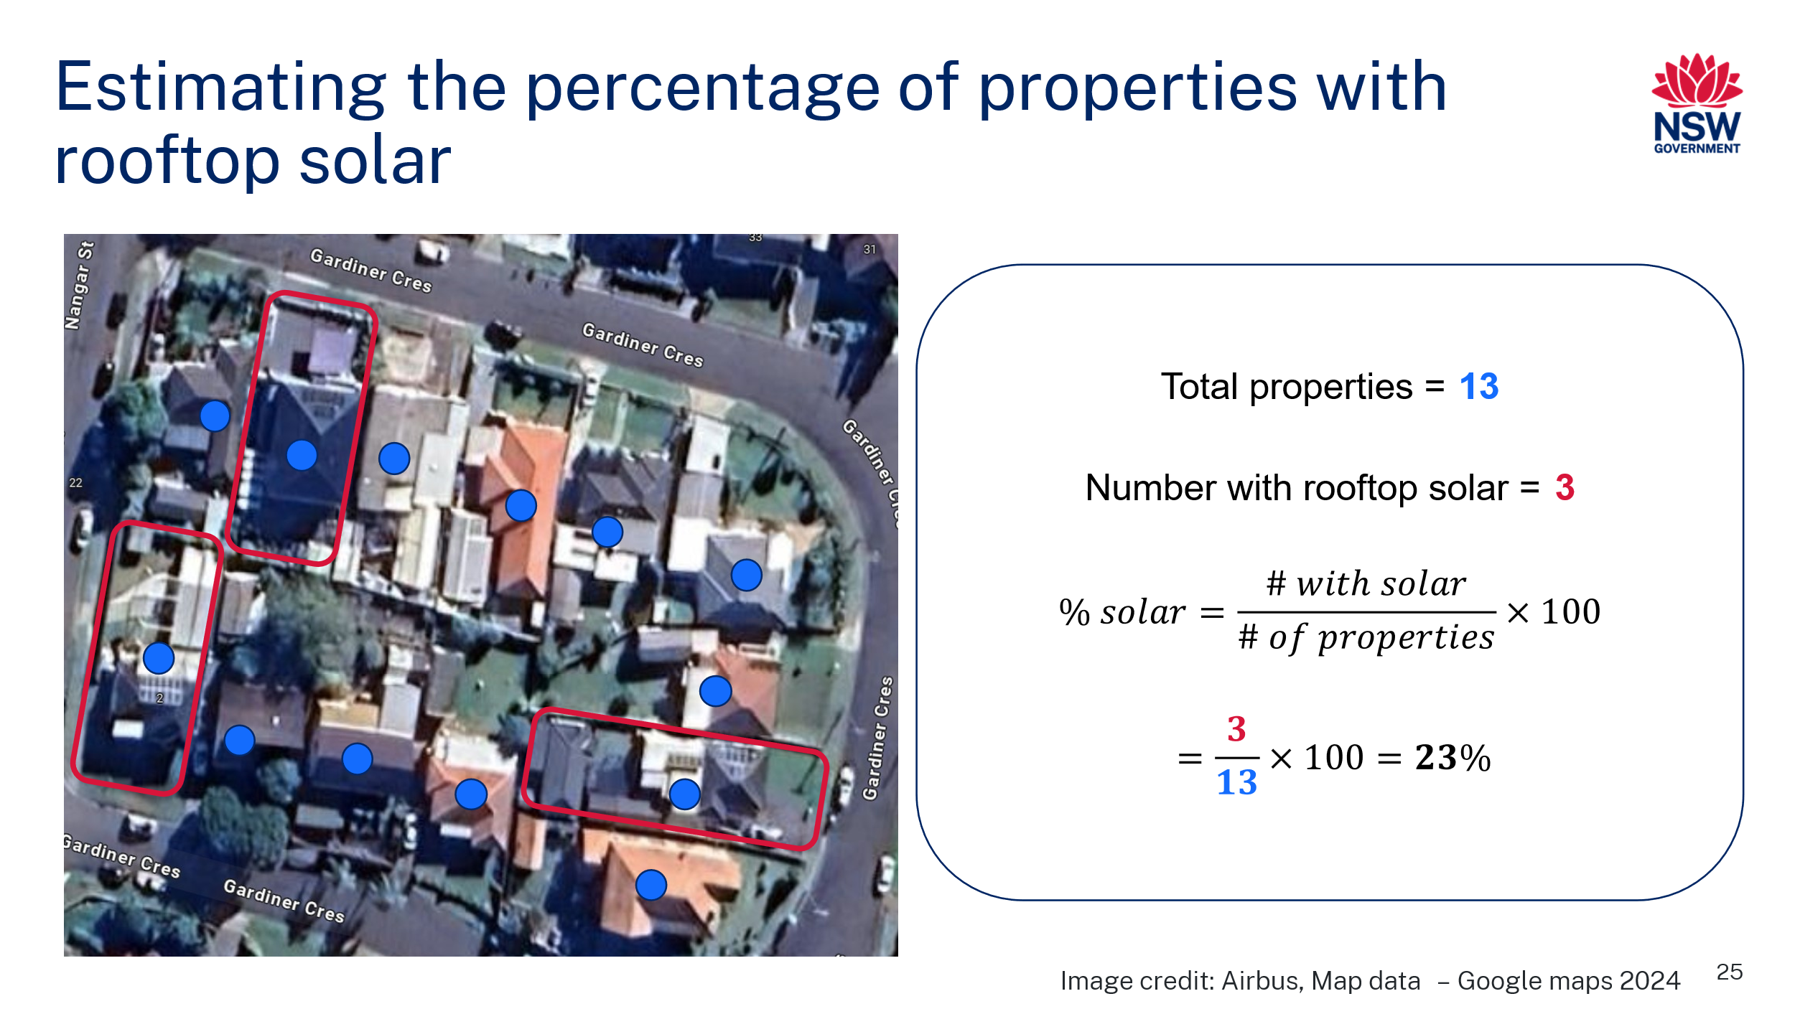
Teacher prompts for the student resource – solar power usage
- What percentage of properties in your town or suburb have solar energy?
Note: answers will vary.
- Using Google Maps satellite view, we can estimate the percentage of houses with solar power. First, we need to sample some areas. Identify 4 locations and record the data in the table below.
Note: answers will vary. To assist students counting, they could take a screenshot of the area they are surveying and use a digital marker to highlight the houses with solar.
- Calculate the mean percentage of properties surveyed with rooftop solar.
Note: to answer this question, students will need to calculate:
$$=\frac{Sum of \% with solar}{number of samples} x 100$$
- What was the range of values for the percentage of properties with rooftop solar observed in the samples?
Note: to answer this questions student will need to calculate the range using the formula:
$$range=highest value-lowest value$$
- Were there any patterns where high or low amounts of solar were found? What factors might affect this?
Note: students may be able to identify that some areas have a higher percentage of rooftop solar than others. Factors such as income or the ability to access government grants to install solar may affect the distribution of solar panels. Factors such as house height and the spacing of neighbouring buildings may also influence the uptake of solar panels.
- How does the percentage calculated from our sampled data compare with our initial estimates?
Note: responses will vary. This is an opportunity to talk about sampling technique to estimate values.
- Where else could we find data to improve our estimates?
Note: students could respond in a variety of ways. They could suggest looking for data sources such as CSIRO data showing the uptake in rooftop solar in Australia or Our World in Data – Electricity generation from solar power.
Differentiation
Going deeper: collating and summarising the data as a class dataset using a histogram or boxplot will allow students to ‘go beyond the mean’ and explore the range and variation of the data to ask and answer more refined questions about the uptake of rooftop solar.
Going bigger: explore CSIRO data showing the uptake in rooftop solar in Australia from 2011 to the present. Students can use this data to identify and describe trends in the size, location and uptake rate in NSW and compare it to other states. Alternatively, they could explore the uptake of solar power globally using a data source like Our World in Data (see further questions).
Project Installed solar energy capacity, 2022 from Our World in Data on the board, and tell students that installed solar energy capacity describes the total capacity of solar power systems that have been installed. This includes rooftop solar panels that may be installed on residential homes, businesses or schools, as well as solar farms used to generate electricity on a larger scale.
Instruct students to access Installed solar energy capacity, 2022 from Our World in Data and answer the questions in the student resource.
- List the countries with over 75 GW of solar energy capacity.
China, the United States and Japan each have over 75 GW of capacity.
- Identify areas of the world that have very low solar energy capacity.
South-East Asia, Africa, the Middle East, and the Northwest of South America have lower installed solar capacity than the rest of the world.
- Compare Australia's installed solar energy capacity to that of other countries. Use quantitative information and calculations to support your response.
Australia has a large capacity, currently ranking fifth in the world for installed solar capacity with around 27 GW total. However, China and the United States have significantly more than we do (approximately 15 times and 4 times, respectively).
Students select a table and sort the 2022 column to see the solar energy capacity from highest to lowest. Define per capita for students. Per capita means ‘per person’ and describes an average per individual within a population. Students should then extract information from the data.
- Calculate the per capita installed solar capacity of the top 7 countries.
Table 2 – sample response – Installed solar energy capacity and population of the top 7 countries in terms of installed solar energy capacity.
Country | Installed solar capacity (kW) | Population | Per capita solar capacity (kW/person)
China | 393,030,000 | 1,422,584,937 | 0.28
United States | 113,020,000 | 343,477,332 | 0.33
Japan | 78,830,000 | 124,370,947 | 0.63
Germany | 66,550,000 | 84,548,234 | 0.79
India | 63,150,000 | 1,438,069,597 | 0.04
Australia | 26,790,000 | 26,451,125 | 1.01
Italy | 25,080,000 | 59,499,452 | 0.42
Source: International Renewable Energy Agency (2023). Interact with this data online on Our World in Data.
Note: the installed solar capacity is recorded in this table as kilowatts (kW), whereas the data from Our World in Data is recorded in gigawatts (GW). One gigawatt is equivalent to 1,000,000 watts. Converting the data into kilowatts makes it easier for students to understand the amount of solar capacity per capita. For example, using gigawatts as the unit, China would have 2.76 × 10⁻⁷.
Differentiation: the installed solar capacity could be removed, and students could extract the data from Our World in Data and convert the units to kilowatts.
- How does Australia’s per capita installed solar capacity compare with other countries?
Australia’s per capita solar capacity is very high, with approximately 1 kW of installed capacity for every person. This is 2 to 3 times higher than in countries with higher total capacity.
- When comparing the uptake of solar energy in different countries, which is a more useful indicator to compare the total capacity or the per capita capacity in different countries? Justify your response.
Per capita capacity is a more useful indicator than total capacity because it provides a fair comparison. Countries have different population sizes, so a large country might have more total solar power, but that does not mean each person uses more. Per capita tells us how much solar energy each person has access to. It reflects the extent to which individuals or households have adopted solar energy.
- Extract the information required to write a reference for the information you have collected from the Our World in Data page. Hint: Click on reuse this work and scroll down to citations – this website has done the work for you!
“Data Page: Solar energy capacity” is part of the following publication: Hannah Ritchie, Pablo Rosado and Max Roser (2023) - “Energy”. Data adapted from the International Renewable Energy Agency. Retrieved from https://ourworldindata.org/grapher/installed-solar-pv-capacity [online resource]

Student resource – solar power usage
Solar panels convert radiant energy from the Sun into electrical energy, which can be used to power electrical devices in the home. Solar energy is a renewable and sustainable energy source that helps reduce the reliance on fossil fuels.
- What percentage of properties in your town or suburb have solar energy? _______%
- Using Google Maps satellite view, we can estimate the percentage of houses with solar power. First, we need to sample some areas. Identify 4 locations and record the data in the table below.
Table 1 – houses with solar panels in [insert name of suburb/town/city]
The suburb or area sampled | Number of properties | Number of properties with solar | % of properties with rooftop solar  $$\% solar=\frac{\# with solar}{\# of properties}×100$$
- Calculate the mean percentage of properties surveyed with rooftop solar.
- What was the range of values for the percentage of properties with rooftop solar observed in the samples?
- Were there any patterns where high or low amounts of solar were found? What factors may affect this?
- How does the percentage calculated from our sampled data compare with our initial estimates?
- Where else could we find data to improve our estimates?
Installed solar energy capacity describes the total capacity of solar power systems that have been installed. This includes rooftop solar panels that may be installed on residential homes, businesses or your school, as well as solar farms that generate electricity on a larger scale. Assume that a typical rooftop solar system has a generating capacity of 10 kW.
Interact with the installed solar energy capacity data at Our World in Data. Select the Map and then answer the following questions.
- List the countries with over 75 GW of solar energy capacity.
- Identify the world's areas with very low solar energy capacity.
- Compare Australia's installed solar capacity to that of other countries. Use quantitative information and calculations to support your response.
Select the table. Sort the 2022 column to see the solar energy capacity from highest to lowest. Use the data to answer the next questions.
- Calculate the per capita installed solar capacity of the top 7 countries.
Installed solar energy capacity and population by country in 2022. The countries included are the top 7 in terms of installed solar energy capacity. Data source: International Renewable Energy Agency (2023). Interact with this data online on Our World in Data.
Table 2 – solar capacity by country
Country | Installed solar capacity (kW) | Population | Per capita solar capacity (kW/person)
China | 393,030,000 | 1,422,584,937
United States | 113,020,000 | 343,477,332
Japan | 78,830,000 | 124,370,947
Germany | 66,550,000 | 84,548,234
India | 63,150,000 | 1,438,069,597
Australia | 26,790,000 | 26,451,125
Italy | 25,080,000 | 59,499,452
- How does Australia’s per capita installed solar capacity compare with other countries?
- When comparing the uptake of solar energy in different countries, which is a more useful indicator to compare the total capacity or the per capita capacity in different countries? Justify your response.
- Extract the information required to write a reference for the information you have collected from the Our World in Data page. Hint: Select reuse this work and scroll down to citations – this website has done the work for you!

2.2 Generating electricity
Table 3 – learning intentions and success criteria for ‘Generating electricity’
We are learning: | I can:
- how to make informed decisions about the best energy sources to use  - to systematically collect and record data, information, evidence and findings  - to represent and organise data and information to find patterns and to calculate useful values. | - describe the energy sources used to generate electricity in Australia  - select and extract quantitative data from a data dashboard  - support a claim with evidence.  - select a suitable graph or image to describe a trend in the generation of electricity
In this activity, students access real-time data to improve their understanding of where and how electricity is generated. They then use the National Energy Market (NEM) Dashboard to identify patterns in the energy sources used and tell an energy story.

Instructions

Creating an energy story – the National Energy Market (NEM)
The National Energy Market (NEM) Dashboard (AEMO 2024b) uses units, including the Megawatt (MW) and Gigawatt (GW), to describe the rate at which energy is generated and consumed. A dual number line may help students understand and compare these units by plotting matching values on number lines scaled for each unit side by side (see EGY PPT ‘2.2 Units of power’).
The NEM Dashboard also uses megawatt-hours (MWh) or gigawatt-hours (GWh) to describe the total electrical energy generated over a period of time. Students will need to use similar units later in this unit to calculate power bills and energy usage for appliances and personal electricity bills.
Use the information below and EGY PPT ‘2.2 Units of power’ to define the units: watt, megawatt and gigawatt.
What is a watt?
A watt is a unit of power that measures the rate at which energy is used or generated. It describes how much energy is consumed or produced per second. For example, a 40 W light globe uses 40 joules of energy per second (40 W = 40 J/s).
A megawatt (MW)
A megawatt is equal to 1 million watts (1 MW = 1,000,000 W).
Megawatts are used to describe the power output of large-scale energy sources like electrical power plants because they generate large amounts of electrical energy. Using megawatts makes it easier to understand and compare the energy generated by power plants as well as overall energy production or consumption.
A gigawatt (GW)
A gigawatt is equal to 1000 megawatts or 1 billion watts (1GW = 1,000 MW =1,000,000,000 W).
Gigawatts are used to describe power output in large-scale power plants and energy use on a global scale. They provide an appropriate scale to understand national or global energy production and consumption where megawatts and kilowatts would be too small.
Show students the National Energy Market (NEM) Dashboard and explore what the data can show (EGY PPT ‘2.2 Energy sources in Australia’). Demonstrate how to use the dashboard to extract information for one or more of the following scenarios:
- Compare the current percentage use of renewables and non-renewable energy sources in South Australia and NSW.
- View the energy mix over the last 48 hours or 3 months in Victoria and describe trends in the electricity generated from wind and solar sources.
- Identify the times of the day when the electricity demand is highest or lowest.
Set a series of fact-finding, making inferences and evaluating tasks that require students to explore the dashboard filters and features. A sample activity has been provided in the Student resource – creating an energy story. Move around the room to ensure students understand how to engage with the data and check their underlying data skills (percentage, units and prefixes, reading different graphs). Pause and re-teach skills where required.
Once students have engaged with the platform, challenge them to use the data to create two truths and a lie. For each data representation set, students:
- Take a screenshot of the data representation.
- Determine what the data representation is communicating.
- Construct 3 ‘facts’, which contain 2 truths and one lie.
- Students swap their work with another and try to identify the lie.
- Students should state their reason for the identified lie.
A sample is provided and could be shown to the students to consolidate their understanding.
Call on students to provide examples of the identified lies and outline their reasoning. Lead a discussion about how data representations and their interpretations can be misleading in some cases and the importance of critically evaluating the source of data, the way it is represented and the way it has been interpreted.
Two truths and a lie are used with data representations to encourage critical thinking and promote deeper understanding. By identifying the lie in peers' work, students practice identifying inaccuracies or misrepresentations in data, a skill that is valuable in interpreting real-world data.
Figure 2 – a screenshot from the NEM Dashboard shows the fuel mix in NSW
Note: this screenshot was used to develop the sample answers provided.
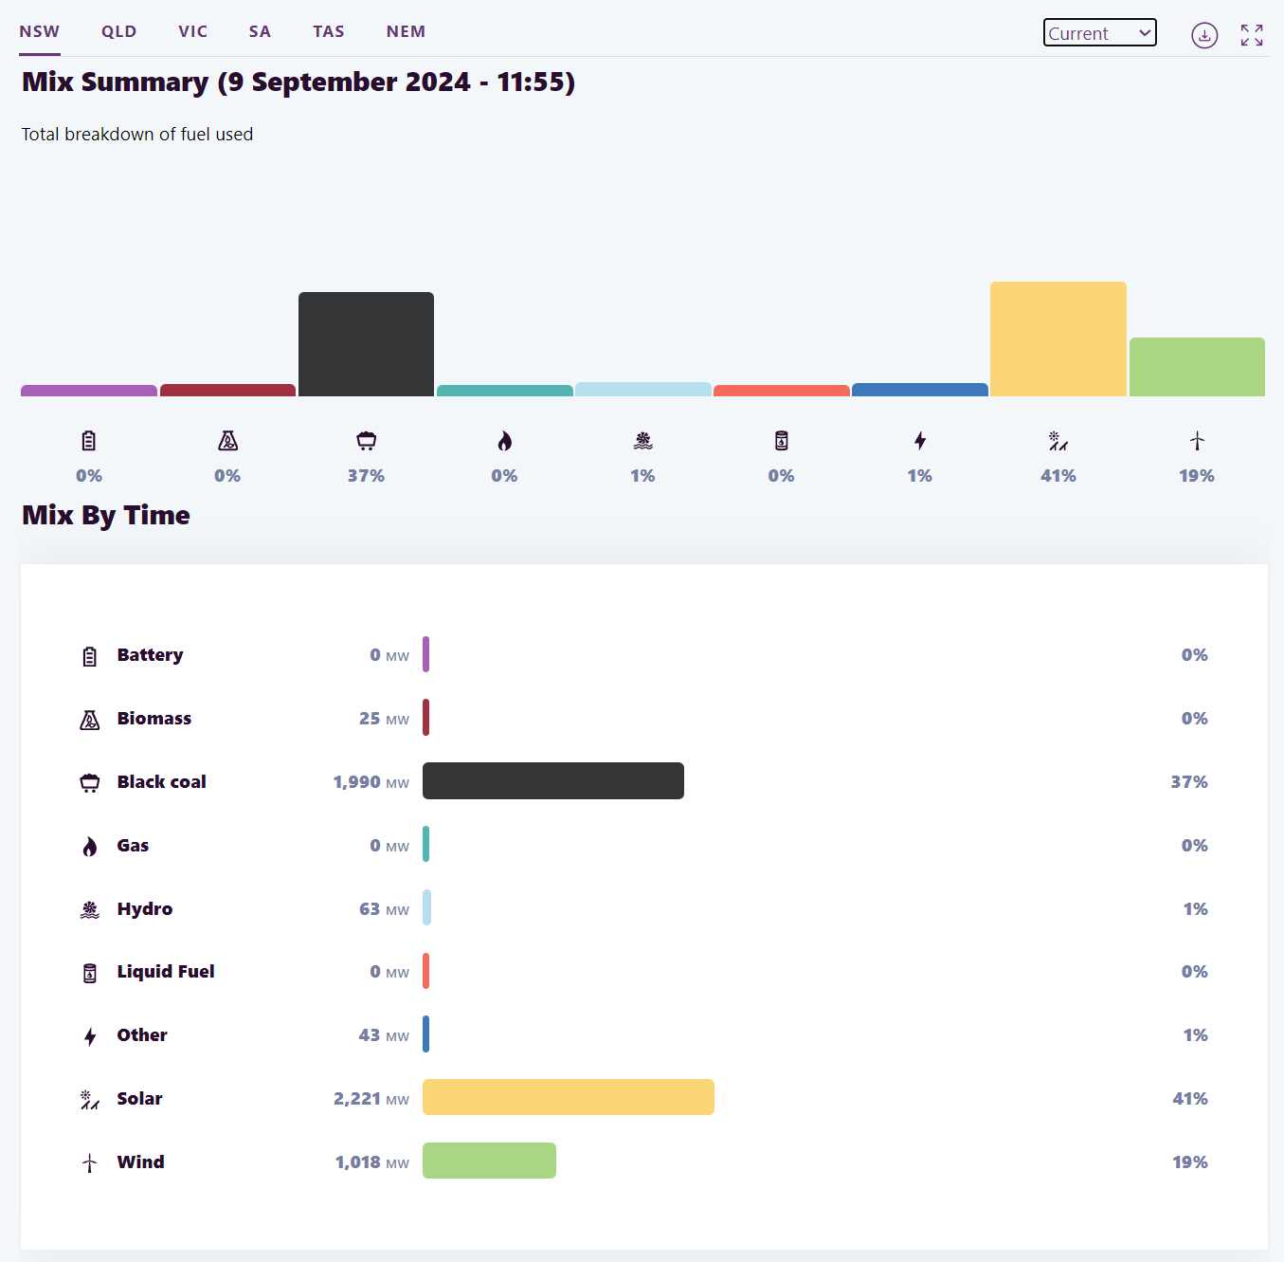
‘Mix Summary (9 September 2024 – 11:55’ by AEMO is licensed under CC-BY 4.0.
Sample response: Student resource – creating energy stories
- What proportion of NSW electricity production currently comes from coal power plants?
Using data in Figure 3, 1,990 MW or 37% of NSW electricity is generated from coal power plants.
- Convert the units to write this amount in gigawatts. (Hint: 1 GW = 1000 MW).
$1990 MW ÷1000=1.990 GW$ ($1 GW=1000 MW)$
Note: this question provides an opportunity to refer to the Science 7–10 (2023) Data Book to familiarise students with decimal fractions and multiples. The Data Book defines the prefixes mega and giga.
- Which state has the highest proportion of electrical energy generated from renewable resources?
As of 12:05 pm on 9 September 2024, Tasmania currently has the highest proportion of electrical energy generated from renewable resources – 100% (48% hydroelectric, 52% wind)
- In South Australia, when, in the last 48 hours, was the highest amount of energy generated from solar power, and what was the total energy in megawatt-hours (MWh)?
The maximum power output from solar generation in the last 48 hours in South Australia was between 9 and 10 am on 7 September 2024, and the total energy generated was 430 MWh.
- Which state has the ‘greenest’ energy system? Justify your answer.
Tasmania—Over the last 12 months (September 2023—September 2024), Tasmania has generated most of its electricity from renewable sources. Only 5% of electricity generated was from gas, with the remainder produced from hydro and wind sources.
- Evaluate this claim, ‘Tasmania produces more wind power than Victoria’.
This claim is not true. Victoria generally produces more wind power than Tasmania. Over the last 48 hours, Tasmania produced an average of around 350 MW, while Victoria produced around 1000 MW.
- Reference the website from which the above data was collected. Hint: Author (Year) Title of webpage, Name of website, URL, accessed Day Month Year.
AEMO (Australian Energy Market Operator) (2024b). NEM Data Dashboard, AEMO, https://aemo.com.au/energy-systems/electricity/national-electricity-market-nem/data-nem/data-dashboard-nem accessed 20 September 2024.
Figure 3 – sample response for 2 Truths and a Lie
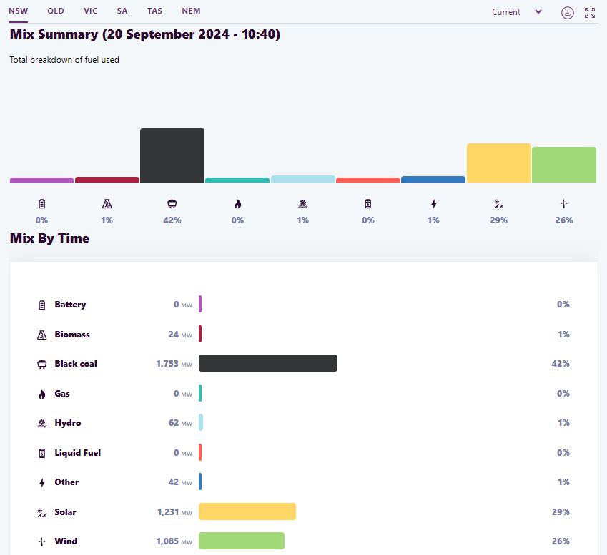
’Mix Summary (20 September 2024 0 10:40)’ by AEMO is licensed under CC-BY 4.0.
Write 2 truths and a lie in any order:
- Renewable energy accounts for 57% of the energy mix in NSW (This response is a lie, as it does not take into account the point in time. This percentage is correct for 20 September 2024 at 10:40 am, but it is not the mean energy mix for NSW).
- Black coal accounts for 42% of the energy mix in NSW at 10:40 am on 20 September 2024.
- There is 2402 MW of power produced by renewables in NSW at 10:40 am on 20 September 2024.
Differentiation
Tiered instruction: the Australian Energy Statistics map June 2023 is an alternative source of information for the above activity. Most values on the map are expressed as percentages, and the information is presented as a single snapshot in time. Compared to the units and time series used in the NEM Dashboard, the map's reduced complexity may enable a wider range of students to engage in the energy story-telling activity. Key trends have already been annotated for students, requiring fewer steps for them to complete the task.
Dig deeper: OpenNEM is an alternative dashboard that provides much more information about the generation and trade of electrical energy in Australia. It is real-time and also provides corresponding emissions information.

Student resource – creating an energy story
The National Energy Market (NEM) data dashboard lets you view real-time data about energy demand and generation in Australia.
Open the website and select Fuel Mix. Navigate between the different views and view the information to answer the following questions.
- What proportion of NSW electricity production currently comes from coal power plants?
- Convert the units to write this amount in gigawatts (Hint: 1 GW = 1000 MW).
- Which state has the highest proportion of electrical energy generated from renewable resources?
- In South Australia, when, in the last 48 hours, was the highest amount of energy generated from solar power, and what was the total energy in megawatt-hours (MWh)?
- Which state has the ‘greenest’ energy system? Justify your answer.
- Evaluate this claim, ‘Tasmania produces more wind power than Victoria’.
- Reference the website from which the above data was collected. Hint: Author (Year) Title of webpage, Name of website, URL, accessed Day Month Year.
Two truths and a lie!
Now that you are familiar with the National Energy Market (NEM) Dashboard, select one data representation to write some facts about. Two facts should be true, and one should be a lie. Test your peers to see if they can identify the lie.
Insert a screenshot of your chosen data representation (for example, a graph):

Write 2 truths and a lie in any order:
- [insert fact]
- [insert fact]
- [insert fact]

2.3 Thermal generation using coal, gas and nuclear
Students compare the structure and function of thermal power stations and model the energy transfers involved.
Table 4 – learning intentions and success criteria for ‘Thermal generation using coal, gas and nuclear’
We are learning: | I can:
- how we can use energy more efficiently  - how to make informed decisions about the best energy sources to use  - to represent and organise data and information to find patterns and to calculate useful values. | - outline the key parts of a thermal power station  - read a Sankey diagram  - calculate the efficiency of power stations  - use diagrams to describe the energy flow in a power station system.

Instructions

Anatomy of a thermal power station
Watch a video showing the components of a thermal power station using coal as a fuel: Energy 101: Electricity Generation (5:18).
Note: this video is designed for a US audience, but Australia's operating principles are similar. End the video at 3:15 as the remainder outlines the USA power grid, which is irrelevant for Science 7–10.
Assign students to either coal, gas or nuclear power. Have each student locate a simple schematic diagram of their respective power station and sketch it into workbooks. For example:
- Coal-fired power plant
- Nuclear power plant
- Gas power plant.
In groups of 3, have students compare their diagrams to identify similarities and differences. A sample response is provided in Table 5.
Table 5 – sample response summarising key similarities and differences between coal, gas and nuclear power stations
Similarities | Differences
Heat generation: all 3 power stations use a fuel source to generate heat. In the coal and gas power stations, fuel is combusted to release stored chemical energy.  Steam production: in each case, the heat is used to convert water into steam, which drives turbines to generate electricity.  Turbine and generator system: each uses a turbine connected to a generator. The steam turns the turbine, which is connected to the generator. This kinetic energy is transformed into electrical energy.  Cooling system: each power station has a cooling system that condenses the steam back into water after it passes through the turbine. The water is then reused in the cycle.  Energy transformations: thermal à kinetic à electrical | Fuel source: coal power stations burn coal, gas power stations burn natural gas, and nuclear power stations use uranium, which undergoes nuclear fission.  Reactor vessel: nuclear power stations have a reactor vessel connected to a sealed water circuit. A second water or steam circuit drives the turbine and cools it.  Containment building: nuclear reactor vessels are housed inside a containment building to prevent the release of radioactive materials into the environment.
Note: ensure that students can correctly identify and describe (a) the main components of thermal power stations, including the fuel, water circuit, turbine, generator and cooling system. (b) the processes and energy transformations occurring, including the transformation of stored energy in the fuel to thermal energy (heating water to steam), thermal to kinetic energy (pressurised steam turning the turbine) and kinetic energy to electrical energy (turbine is connected to and spins the rotor in a generator).

Follow the energy
Review energy flows Sankey diagram provided in Australian Energy Update 2023 focussing on the power station input and output. See Figure 4 for a simplified version of the diagram based on the same data.
Figure 4 – Sankey diagram showing energy inputs (left-hand side) and outputs (right-hand side) for electrical power stations in Australia.
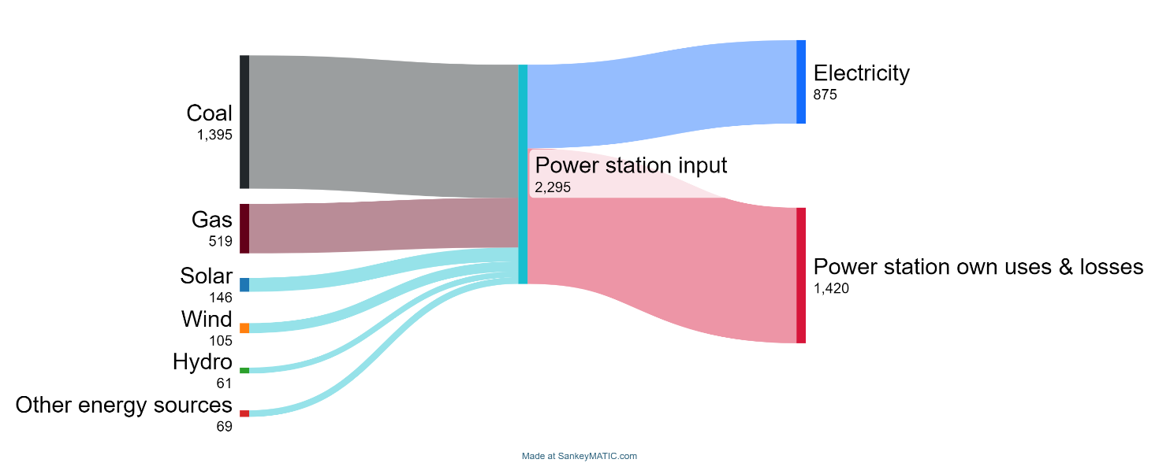
Source: Australian Energy Update 2023.
Note: access and customise this diagram created using SankeyMATIC.
Use the See-Think-Wonder routine to interrogate the information provided in the diagram.
Use the information in the diagram to calculate the average efficiency of electricity generation.
$$\% efficiency =\frac{Electricity output}{Power station inpu}×100$$
Compare the coal power station schematic with the corresponding Sankey diagram showing the energy flows – a sample Sankey diagram for a coal power station is included in (EGY PPT ‘2.3 Coal power generation efficiency’). Students annotate their schematic diagram to show where energy is lost in the process.
Figure 5 – Sankey diagram showing the energy transfers in a typical coal power plant. The diagram illustrates the inefficiencies in the process of generating electricity from coal. For a typical coal power plant, only 30% of the initial energy is output as useful electrical energy. The remainder is lost in exhaust gases, wasted thermal energy and overcoming the friction of turbine components.
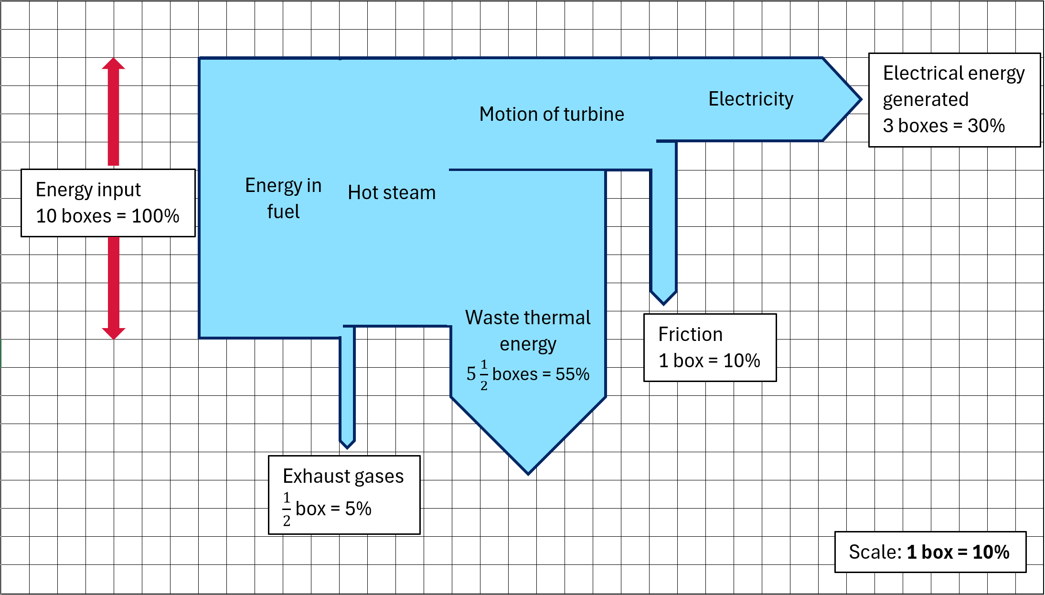
Guide students in identifying a system based on a coal power plant's energy transfers and transformation. Students then construct a work-energy bar chart using the information provided in Figure 5. A sample response is also provided in Figure 6.
Figure 6 – flow chart and work energy bar charts describing electricity generation in a coal power plant.
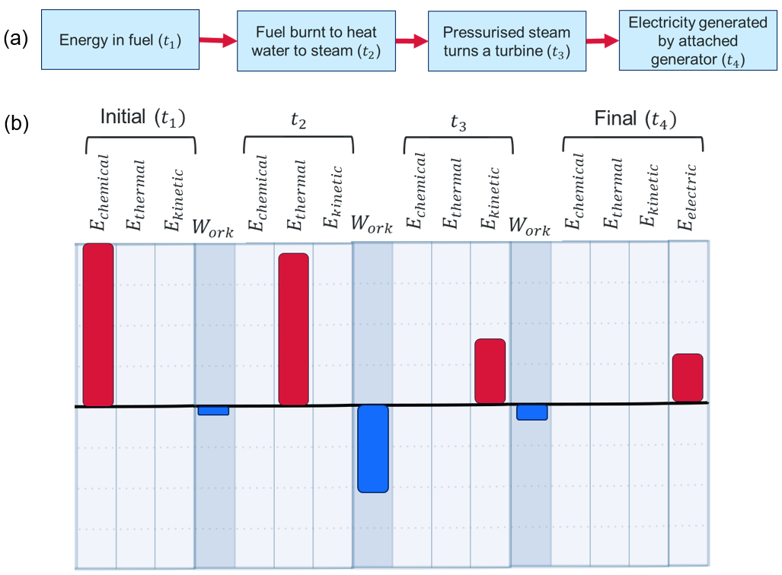
Note: annotation for the sample response in Figure 6 (a) The flow chart describes the stages of generation, covering fuel combustion through to the generation of electricity at the generator. (b) Work energy bar chart describing the corresponding energy transformations. The red bars illustrate the energy stored in the system at each stage, which decreases over time as energy is lost to the surroundings. The blue bars illustrate the energy transferred to the surroundings (negative work). Less than one-third of the energy stored in coal is eventually transformed into useful electrical energy.
Differentiation
Make it concrete: use Energy cubes to model the energy transfers and transformations occurring in a coal power station. Students use whiteboards, and the information provided in Figure 6 to tell an energy story. Scaffolding the selection of the system to include areas on whiteboards for coal, water, turbine, and electrical grid may assist some students in getting started. Note: students may identify different systems and still correctly model the energy flows.

Optional – nuclear energy
Note: Students will examine nuclear reactions in Stage 5 Reactions. You may choose to engage with some of this learning now or revisit it when students have learned the basics of nuclear reactions.
Figure 7 (a) is a simple diagram of a nuclear fission process. In the first frame, a neutron is about to be captured by the nucleus of a uranium-235 atom. In the second frame, the neutron is absorbed, and the nucleus is briefly turned into a highly excited uranium-236 atom. In the third frame, the uranium-236 atom has fissioned, resulting in two fission fragments (cesium-137 and rubidium-95) and 4 neutrons with large amounts of kinetic energy.
The energy initially stored in the mass of uranium-235 is used to heat water, create steam, and drive a turbine.
Figure 7 – representations of a nuclear fission reaction (a) a diagram of the nuclear fission process (b) a nuclear equation for the same fission reaction (c) a word equation for the reaction
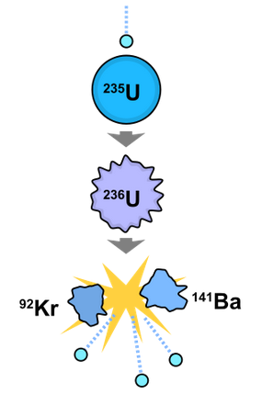
(a)
(b)
$${}_{92}^{235}U+{}_{0}^{1}n→{}_{55}^{137}{Cs}+{}_{37}^{95}{Rb}+4{}_{0}^{1}n$$
$${}_{ }^{137}{Cs}$$
$${}_{ }^{95}{Rb}$$
(c)
A uranium nucleus is bombarded with a neutron and fissions to produce the fission fragments cesium-137 and rubidium-95, along with 4 high-energy neutrons
Image in (a) adapted from Nuclear fission by Wikimedia Commons is licensed under CC0.
Waste products of nuclear energy generation
The fragments produced in each reaction can be slightly different, and together, these fragments (the ‘spent fuel’) are part of the waste products a nuclear power station produces. The cesium-137 fragments produced in this reaction are highly radioactive and long-lasting, making them one of the most dangerous waste products. If released into the environment, they can contaminate an area for hundreds of years. Cesium-137 can be taken up by living organisms and passed up the food chain to be concentrated in a process called bioaccumulation.
The Most Radioactive Places on Earth (11:17) (Veritasium 2014) tours and measures radiation levels at sites around the world, including Chernobyl, Fukushima, nuclear power stations, Einstein’s apartment and uranium mines.

2.4 Wind and hydroelectric power
Students investigate how hydroelectric and wind are used as energy sources to generate electricity. They could support this with a practical investigation using simple motors or fans.
Table 6 – learning intentions and success criteria for ‘Wind and hydroelectric power’
We are learning: | I can:
- how we can use energy more efficiently  - how to make informed decisions about the best energy sources to use  - to systematically collect and record data, information, evidence and findings  - to represent and organise data and information to find patterns and to calculate useful values. | - describe the 2 types of hydroelectric power station  - list the advantages and disadvantages of generating electricity from hydroelectric and wind sources of energy  - draw a scaled and annotated diagram  - draw energy-flow diagrams to describe energy changes in wind and hydroelectric power stations.

Instructions

Wind power
Watch How do wind turbines work? - Rebecca J. Barthelmie and Sara C. Pryor (5:02). Ask students the following questions:
- List all the factors that affect the efficiency of a wind turbine.
- The size and orientation of the blades.
- The blades' aerodynamic design.
- The amount of wind turning the rotor.
- The largest offshore wind turbines are 150 meters tall at the central hub and have a blade diameter of 250 m. Draw a scale diagram of a wind turbine using these dimensions. Annotate the diagram to show how features and technologies are used to improve its efficiency.
Figure 8 – scale diagram of a large offshore wind turbine
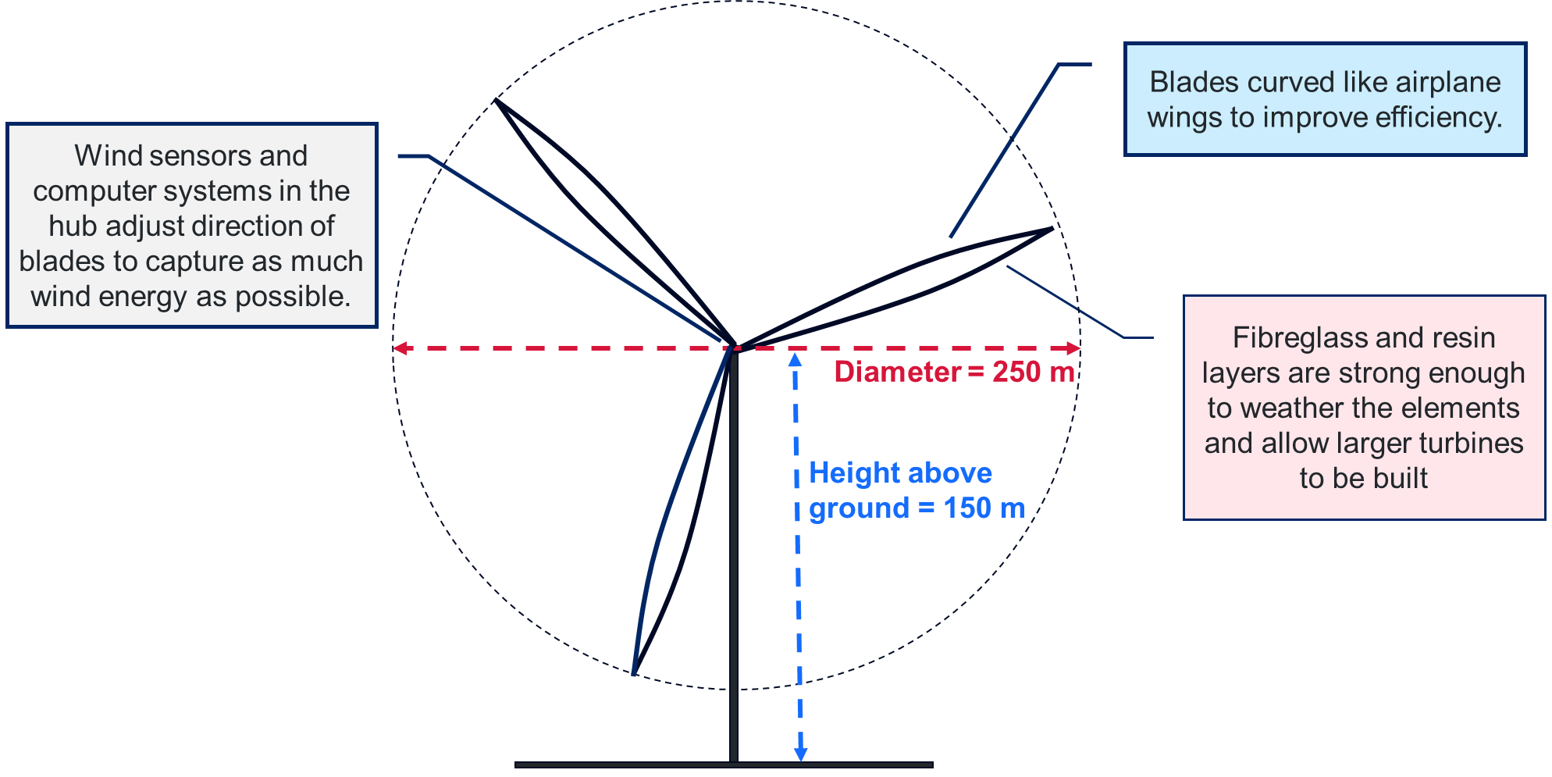

Hydroelectric power
Watch Hydropower 101 (3:12). Provide students with the two questions below and then watch the clip again to assist students in writing their responses.
- Summarise the 2 main types of hydroelectric power stations.
- Dam: these involve building a dam to create a reservoir where water can be stored and released to generate electricity when needed. The stored gravitational potential energy of water in the dam is used to drive a turbine. Some stations may also use pumped-storage hydroelectricity (known as ‘pumped hydro’).
- Run-of-river: these rely on a river's natural flow. They divert part of the river's flow to turn a turbine and generate electricity.
- For each type, list advantages and disadvantages.
Dam:
- Advantages:
- They are more reliable and can be controlled to produce electricity when needed most or ‘on demand’.
- Pumped hydro can also use excess energy generated during the day and store it for use at peak times.
- They are cost-competitive, meaning that they generate electricity relatively cheaply once built.
- Disadvantages:
- Large dams impact the local environment, for example, changing habitats and affecting fish movement.
- Building a dam may also require people in river-side towns to move home.
- Dam failures can be catastrophic, potentially causing loss of life for those downstream.
- CO₂ is produced during construction, particularly due to the large amounts of cement used.
Run of river:
- Advantages:
- Less disruption to the local environment.
- Lower risk of failure.
- Disadvantages:
- Requires reliable river flow for generating electricity – may be more intermittent.
Online resources: Snowy Hydro have produced a suite of resources, including videos, fact sheets, activity sheets, hands-on activities, lesson plans and interactive resources for teaching about hydroelectric power. These resources can be accessed through the Snowy STEM academy website (Snowy Hydro 2024b). Wiradjuri astrophysicist and science communicator Kirsten Banks also delivers a series of videos on the Science of the Snowy Scheme with Kirsten Banks (Snowy Hydro 2024a).

Summary
Students draw energy flow diagrams and/or work-energy bar charts to describe the energy transfers and transformations in:
- wind power stations
- hydroelectric power stations
- pumped hydroelectric power stations.
Sample diagrams are included in (EGY PPT ‘2.4 Wind power energy flows’, EGY PPT ‘2.4 Pumped hydroelectric energy flows – charging’ and EGY PPT ‘2.4 Pumped hydroelectric energy flows – generating’).
Note: this is an opportunity to conduct a practical investigation to demonstrate how a turbine generates electricity. Simple motors and fans are essentially small generators as well. Instead of supplying electrical energy to make them spin, try spinning them and measuring the electrical energy generated using digital multimeters, LEDs or even another motor.
Additional resources: Snowy Hydro produces a range of hands-on, interactive and print resources that can be accessed free and online at Snowy STEM academy and The Science of the Snowy Scheme with Kirsten Banks.

2.5 Practical investigation – solar power
Students explore how to optimise the efficiency of solar panels through a practical investigation.
Table 7 – learning intentions and success criteria for ‘Practical investigation – solar power’
We are learning: | I can:
- how we can use energy more efficiently  - to select and use appropriate tools to make accurate observations and measurements  - to systematically collect and record data, information, evidence and findings  - to represent and organise data and information to find patterns and to calculate useful values. | - describe how electricity is produced from solar energy sources  - accurately measure and compare current in a simple circuit  - determine the angle to orient a solar panel for maximum efficiency

Preparation
Does the school have rooftop solar? If so, you can access a web-based report showing live and historical data on the electrical energy it generates.
Watch the video instructions for the practical investigation A New Angle on Photovoltaic Solar Panel Efficiency (6:12) and ensure you have sufficient equipment for students to work in small groups.
Check the weather forecast for the day. This investigation is best done outside in a sunny area but can be done inside if benches receive direct sunlight.

Equipment required
Each student group will need:
- Cardboard
- Small solar panel (preferably 6 V or more with alligator clips attached)
- Digital multimeter with probes or banana leads
- Masking tape
- Protractor
- Ruler

Instructions

Solar panel efficiency
Complete instructions are provided on the A New Angle on Photovoltaic Solar Panel Efficiency—TeachEngineering website, including a set of video instructions.
Differentiation
Run the investigation as a class demonstration with students using Predict-Explain-Observe-Explain to predict and explain the angles that produce the maximum solar cell efficiency.
Going further – set the solar panel to its optimal position and shade different parts of its surface. Explore the impact of shading on panel efficiency. To investigate the impact of shading further, try changing the setting on the multimeter to measure voltage.
Applying understanding – students predict how the optimal angles change over a day or a year.
Digging deeper – watch the video How do solar panels work? – Richard Komp (4:58).
The Perimeter Institute provides a short summary of the PEOE strategy: Tools for Teaching Science: Predict, Explain, Observe, Explain (PEOE).

Case study
Complete a guided reading on Solar power: Printed flexible solar achieves efficiency record (Willetts 2024) to explore how printed solar panels using perovskite inks can reduce costs and open new options for generating electricity.
Figure 9 – scientists have produced the largest flexible, plastic solar cells in Australia – 10 times the size of what they were previously able to – thanks to a new solar cell printer that has been installed at CSIRO.
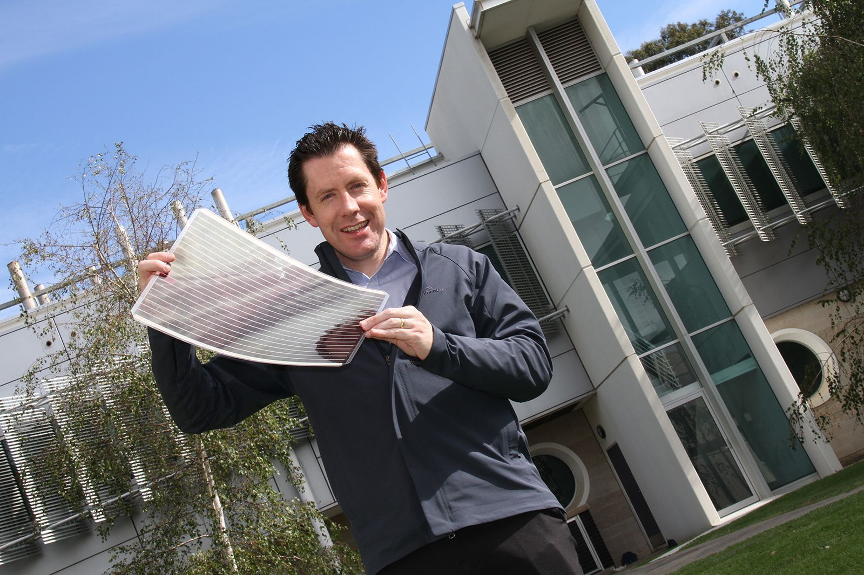
‘RS32208_PE1502’ by CSIRO is licensed under CC-BY 4.0.

2.6 Making informed decisions
Table 8 – learning intentions and success criteria for ‘Making informed decisions’
We are learning: | I can:
- how to make informed decisions about the best energy sources to use  - to select strategies to solve scientific problems and to evaluate our solutions. | - list criteria for choosing the best energy source for generating electricity  - outline advantages and disadvantages of using renewable and non-renewable energy sources.

Instructions
Write the essential question on the board ‘How do we choose the best energy source for generating electricity?’
Ask students to suggest what ‘best’ means.
Students brainstorm their responses to the essential question using Think-Pair-Share.
Add headings to the board:
- Efficiency
- Environmental impact
- Costs and economics
- Technology
- Other
Group student ideas under these headings at the front of the room and lead a discussion about the factors that affect this decision.

Comparing sources of energy
Introduce key terms for categorising electricity generation as renewable, non-renewable, dispatchable, and intermittent.
Key terms
Dispatchable sources are electricity sources whose power output can be adjusted to meet usage needs; essentially, they are ‘on-demand’ electricity. Dispatchable capacity includes gas, hydroelectric, battery storage, and biomass.
Intermittent sources of electricity are not always available due to external factors that cannot be controlled. Sources of intermittent electricity include solar and wind.
In small groups or individually, students categorise common energy sources in the quadrants of the comparing sources of energy table. A sample answer is shown in Figure 10. This slide and a blank version are included in EGY PPT ‘ 2.6 Comparing sources of energy’.
Figure 10 – a sample response for the summary table comparing energy sources for generating electricity in terms of their renewability and dispatchability
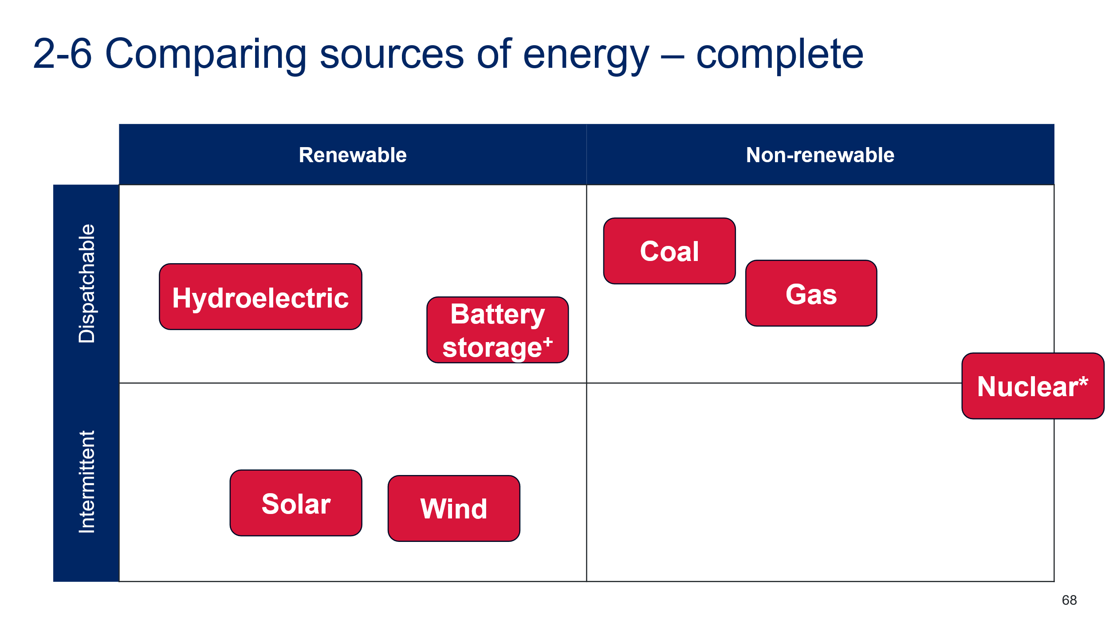
* Nuclear power cannot be turned on and off to meet the electricity demand but produces a continuously steady output. Therefore, it does not meet the definition of dispatchable or intermittent power.
+ Battery storage has been classified here as renewable because, like pumped hydro, batteries are often used to ‘firm’ intermittent renewable technologies such as solar and wind.

Summarise
Provide students with a digital or printed copy of the Sources of energy summary sheet. Instruct students to draw on the learning throughout prior lessons to complete as much of the table as possible. Prompt students to recall the advantages and disadvantages of each energy source. Students could then use internet research to add further information to their sources of energy summary sheet.
Some of the information has been pre-filled. This could be removed if students could extract data from secondary sources. The 2024 Integrated System Plan (ISP) (AEMO 2024a) and GenCost 2023-24 report (Graham et al. 2024) contain relevant and up-to-date information for this purpose. These are highly-technical documents containing complex language and data. If using these resources with students, consider limiting the scope to a few pages at a time and provide structured reading exercises to support student understanding.

Table 9 – sources of energy summary sheet – sample response
Source of energy | Relative cost (LCOE) $/MWh | Technological considerations | Advantages | Disadvantages
Coal with CCS | $155–$250 | Carbon Capture and Storage (CCS) technology has not yet been demonstrated commercially. | Established technology in Australia; dispatchable – can adjust generation to meet demand. | Non-renewable energy source. Produces high CO₂ emissions. It is expensive.
Gas with CCS | $120–$200 | CCS technology has not yet been demonstrated on a commercial scale. | Established technology in Australia; dispatchable. | Non-renewable energy source. Produces high CO₂ emissions. It is expensive. The cost of gas can change quickly.
Nuclear | $140–$235 (large-scale)  $230–$380 (SMR) | Complex technology: Small Modular Reactors (SMRs) have not yet been demonstrated commercially. | Steady and reliable generation of electricity. Low CO₂ emissions. | Non-renewable and very expensive. It cannot easily adjust generation to meet demand. Radioactive waste products must be managed, and accidents can be catastrophic.
Wind | $50–$90 (onshore)  $105–$180 (offshore) | Mature technology designed to maximise efficiency. | Cheap and renewable. Offshore: Less land use impact; Higher energy yield. | Requires high-wind locations for efficient generation of electricity. The generation of electricity is intermittent. Offshore: More expensive.
Hydro-electric | $50–$100 | There are limited suitable sites for building hydro stations. | Renewable energy source. Reliable baseload power. Dispatchable–pumped hydro stores energy for peak use. | The building of dams affects the environment and may have social impacts.
Solar (PV) | $35–$65 | Rapidly advancing technology improves efficiency and reduces costs. | Renewable energy source. It is the cheapest new energy source. | Requires large land areas. Electricity generation is intermittent generation as it relies on sunlight.
Levelised Cost of Electricity (LCOE): a measure of the average cost per unit of electricity generated, accounting for all the costs over the plant’s lifetime, including initial investment, operations, maintenance and fuel. Values used have been rounded to the nearest $5 for ease of understanding and are based on estimates for 2030 (see Apx Table B.10, p 92) of the GenCost 2023-24 report (CSIRO).
Carbon capture and storage (CCS): CCS is any way we collect, reuse, and store CO₂ released during power production. Coal and gas estimates include lower greenhouse gas emissions using CCS technologies.

Student resource – sources of energy summary sheet
Source of energy | Relative cost (LCOE) $/MWh | Technological considerations | Advantages | Disadvantages
Coal with CCS | $155–$250
Gas with CCS | $120–$200
Nuclear | $140–$235 (large-scale)  $230–$380 (SMR)
Wind | $50–$90 (onshore)  $105–$180 (offshore)
Hydro-electric | $50–$100
Solar (PV) | $35–$65
Levelised Cost of Electricity (LCOE): a measure of the average cost per unit of electricity generated, accounting for all the costs over the plant’s lifetime, including initial investment, operations, maintenance and fuel. Values used have been rounded to the nearest $5 for ease of understanding and are based on estimates for 2030 (see Apx Table B.10, p92) of the GenCost 2023-24 report (CSIRO) for full details.
Carbon capture and storage (CCS): CCS is any way we collect, reuse and store CO₂ released during power production. Coal and gas estimates include lower greenhouse gas emissions using CCS technologies.

Evidence base
This resource contains NSW Curriculum and syllabus content. The NSW Curriculum is developed by the NSW Education Standards Authority (NESA). This content is prepared by NESA for and on behalf of the Crown in right of the State of New South Wales. The material is protected by Crown copyright.
Please refer to the NESA Copyright Disclaimer for more information https://www.nsw.gov.au/education-and-training/nesa/copyright.
NESA holds the only official and up-to-date versions of the NSW Curriculum and syllabus documents. Please visit NESA https://www.nsw.gov.au/education-and-training/nesa and NSW Curriculum https://curriculum.nsw.edu.au.
Science 7–10 Syllabus © NSW Education Standards Authority (NESA) for and on behalf of the Crown in right of the State of New South Wales, 2023.
AEMO (2024a) 2024 Integrated System Plan (ISP), AEMO website, accessed 15 July 2024.
AEMO (2024b) NEM Data Dashboard, AEMO website, accessed 15 July 2024.
Brookhart SM (2018) ‘Appropriate Criteria: Key to Effective Rubrics’, Frontiers in Education, volume 3(22):1–12, doi:10.3389/feduc.2018.00022, accessed 15 July 2024.
CESE (Centre for Education Statistics and Evaluation) (2020) What works best: 2020 update, NSW Department of Education, accessed 15 July 2024.
——(2020) What works best in practice, NSW Department of Education, accessed 15 July 2024.
——(2021) Growth goal setting – what works best in practice, NSW Department of Education, accessed 15 July 2024.
Commonwealth of Australia (Geoscience Australia) (2021) NationalMap [website], accessed 15 July 2024.
CSIRO (n.d.) PV and Batteries - Australian Housing Data, CSIRO website, accessed 15 July 2024.
Department of Climate Change, Energy, the Environment and Water (DCCEEW) (2023) Australian Energy Update 2023, Australian Government Department of Climate Change, Energy, the Environment and Water website, accessed 15 July 2024.
——(2024) Australian Energy Statistics, DCCEEW website, accessed 15 July 2024.
El Idrissi Y A (12 February 2024) ‘Solar Panel Series vs Parallel: Wiring, Differences, and Your Right Choice’, Renewable Wise, accessed 15 July 2024.
Energynownews (4 October 2011) ‘Energy 101: Electricity Generation’ [video], energynownews, YouTube, accessed 15 July 2024.
Fisher D and Frey N (1 November 2009) ‘Feed Up, Back, Forward’, ASCD (Association for Supervision and Curriculum Development): Educational Leadership magazine, 67(3), accessed 15 July 2024.
Graham P, Hayward J and Foster J (2024) GenCost 2023‐24 Final report, CSIRO website, accessed 15 July 2023.
Griffin P (2017) Assessment for Teaching, Cambridge University Press, Port Melbourne, Victoria.
Harvard College and Harvard Graduate School of Education (2022) ‘See, Think, Wonder’, Resources, Project Zero website, accessed 15 July 2024.
Hattie J & Timperley H (2007) ‘The Power of Feedback’, Review of Educational Research, 77(1): 81–112, doi:10.3102/003465430298487.
McConnell D, Holmes à Court S, Tan S and Cubrilovic N (n.d.) OpenNEM [website], accessed 15 July 2024.
Muller D (18 December 2014) ‘The Most Radioactive Places on Earth’ [video], Veritasium, YouTube, accessed 15 July 2024.
Panadero E and Jonsson A (2013) ‘The use of scoring rubrics for formative assessment purposes revisited: A review’, Educational Research Review, 9:129–144, doi:10.1016/j.edurev.2013.01.002, accessed 15 July 2024.
PI (24 August 2020) ‘Tools for Teaching Science: Predict, Explain, Observe, Explain (PEOE)’ [video], Perimeter Institute for Theoretical Physics, YouTube, accessed 15 July 2024.
Sherrington T (2019). Rosenshine’s Principles in Action, John Catt Educational Limited, Melton, Woodbridge.
Snowy Hydro (2024a) ‘Science of the Snowy Scheme with Kirsten Banks’, Education Resources, Snowy Hydro website, accessed 15 July 2024.
Snowy Hydro (2024b) Snowy STEM academy, Snowy Hydro website, accessed 15 July 2024.
SPU Physics Department (2020) Representing Energy – Energy Cubes, Representing Energy website, accessed 15 July 2024.
Student Energy (18 May 2015) ‘Hydropower 101’ [video], Student Energy, YouTube, accessed 15 July 2024.
TeachEngineering (2 September 2023) ‘A New Angle on Photovoltaic Solar Panel Efficiency’ [video], TeachEngineering, YouTube, accessed 15 July 2024.
TED-Ed (6 January 2016) ‘How do solar panels work? - Richard Komp’ [video], TED-Ed, YouTube, accessed 15 July 2024.
TED-Ed (23 April 2021) ‘How do wind turbines work? - Rebecca J. Barthelmie and Sara C. Pryor’ [video], TED-Ed, YouTube, accessed 15 July 2024.
Wiliam D (2017) Embedded Formative Assessment, 2nd edn, Solution Tree Press, Bloomington, IN.
Willetts R (14 March 2024) Solar power: Printed flexible solar achieves efficiency record, CSIRO website, accessed 15 July 2024.

© State of New South Wales (Department of Education), 2024
The copyright material published in this resource is subject to the Copyright Act 1968 (Cth) and is owned by the NSW Department of Education or, where indicated, by a party other than the NSW Department of Education (third-party material).
Copyright material available in this resource and owned by the NSW Department of Education is licensed under a Creative Commons Attribution 4.0 International (CC BY 4.0) license.

This license allows you to share and adapt the material for any purpose, even commercially.
Attribution should be given to © State of New South Wales (Department of Education), 2024.
Material in this resource not available under a Creative Commons license:
- the NSW Department of Education logo, other logos and trademark-protected material
- material owned by a third party that has been reproduced with permission. You will need to obtain permission from the third party to reuse its material.
Links to third-party material and websites
Please note that the provided (reading/viewing material/list/links/texts) are a suggestion only and implies no endorsement, by the New South Wales Department of Education, of any author, publisher, or book title. School principals and teachers are best placed to assess the suitability of resources that would complement the curriculum and reflect the needs and interests of their students.
If you use the links provided in this document to access a third-party's website, you acknowledge that the terms of use, including licence terms set out on the third-party's website apply to the use which may be made of the materials on that third-party website or where permitted by the Copyright Act 1968 (Cth). The department accepts no responsibility for content on third-party websites.

