Science Stage 5 (Year 9) – Energy
Teacher resource book 1 of 4 (TRB1)
How can we improve energy efficiency?
Creation date: 15 July 2024.
Updated: 13 February 2026.
Contents
Overview 3
Introduction 3
About this unit 3
Big ideas of science related to energy 4
1.1 Getting to know each other (optional) 5
Preparation 5
Instructions 5
1.2 Representing energy 6
Background – revising key ideas about energy from Stage 4 Change 6
Systems 6
Examples of energy representations in Science 7–10 7
Learning activities 11
Revising Stage 4 Energy 11
Energy cubes 12
Constructing energy flow diagrams 17
Constructing a work-energy bar chart 21
Energy representations of a block and ramp system 26
Energy representations of some mechanical and electrical systems 28
Student resource – representing energy 32
1.3 Understanding efficiency 34
Preparation 34
Instructions 34
Sample questions 37
1.4 Calculating efficiency 43
Instructions 43
Practice question set 47
1.5 Improving energy efficiency 56
Preparation 56
Instructions 56
Appendix 58
Evidence base 59

Overview

Introduction
Stage and learning area: Stage 5 Science
Description: this resource complements the Energy program of learning. It aims to serve as a teacher reference, offering practical strategies and ideas to enrich teaching practices and create engaging learning environments. The activities should be adapted to suit the needs of students.
Duration: while timing will vary based on the mode of delivery, differentiation strategies employed and class or school context, this series of activities should take approximately 9, 60-minute lessons.
Risk management: Teachers are advised to undertake a risk assessment before conducting any investigation or experiment in their classrooms. For more information on developing risk assessments see WHS risk management.
This resource book elaborates on many of the Energy program's activities. Some activities also reference the Energy PowerPoint (identified as EGY PPT throughout this document).

About this unit
This unit is designed to extend students' understanding of energy concepts discussed in the Stage 4 Change focus area. Energy is an abstract idea, and extended instruction is crucial to developing a strong foundational knowledge of this topic.
Scientists use visualisation tools to make abstract ideas concrete. This is true of energy, and several visualisation tools (called representations) are commonly used. Students should become familiar with some such representations. However, teachers should ensure that students understand the scientific concepts underlying energy representations.
The topic of energy is contemporary and widely discussed in the media. Terms such as the ‘cost of electricity’, ‘energy pricing’, ‘energy mix’ and ‘alternative energy sources’ are prevalent in the media.
By gaining competence and fluency in dealing with these ideas in this unit, students will be better equipped to understand and contribute to these discussions. Skills in accessing and analysing energy-related data and information, including sensemaking and developing evidence-based conclusions, are critical to achieving this. The learning activities in this program enable the development of those skills.
The concepts of matter and energy are central to our understanding of physical phenomena. The principle that energy is conserved in closed and isolated systems has been verified through many scientific investigations, and, to date, there are no known exceptions to it. In this focus area, students apply the law of conservation of energy to understand, account for and analyse a range of physical phenomena. Using precise language and representations of energy supports deep understanding and may avoid common student misconceptions. Guiding students in making choices when analysing the energy in a system prepares them for applying their understanding.

Big ideas of science related to energy
The total amount of energy in the universe is always the same but can be transferred from one energy store to another during an event (Bell et al 2010).
“Many processes or events involve changes and require an energy source to make them happen. Energy can be transferred from one body or group of bodies to another in various ways. In these processes, some energy becomes less easy to use. Energy cannot be created or destroyed. Often, once energy has been released, some of it is no longer available in a form that is as convenient to use.” (Bell et al. 2010)
The concept of open and closed systems is included in the Science 7–10 Syllabus (2023) in Stage 4 – Change. During the initial implementation, students in Stage 5 may not have completed this prior learning. Until students have completed Change, additional instruction must be included to address this content.

1.1 Getting to know each other (optional)
Table 1 – learning intention and success criteria for ‘Getting to know each other’
We are learning: | I can:
- about each other’s interests and experiences. | - reflect on and describe my experiences in Science 7–10 so far  - describe something interesting about one of my peers.

Preparation
Save a copy of the Getting to know each other activity to your Amplify account. If you do not have an account, you can create one for free on the Amplify Classroom site using your department Google account.
Edit screen 4 to include details about yourself, and review or edit the questions and activities on the other slides. If necessary, slides can be deleted to shorten the activity.
Use the Assign button to share the activity with students. You can share directly with a Google classroom or create a single session code.

Instructions
- Share the invite code with students and have them complete each screen at their own pace. You could add the QR code to the EGY PPT ‘1.1 Getting to know each other’ slide.
- Navigate the screens from the Desmos teacher dashboard to track student progress and share feedback.
Note: the  option hides student names when reviewing the dashboard on a projector screen.

1.2 Representing energy
Table 2 – learning intentions and success criteria for ‘Representing energy’
We are learning: | I can:
- to describe energy  - to represent and organise data and information to find patterns and to calculate useful values. | - choose a suitable system when solving energy problems and identify whether it is open, closed or isolated  - describe how energy is stored and transferred in familiar everyday systems  - construct work-energy bar charts and energy flow diagrams to describe energy changes for everyday events.

Background – revising key ideas about energy from Stage 4 Change

Systems
In Stage 4 Change, students learned about systems (‘Define open and closed systems to describe how energy is transferred into and out of systems, and how it cycles within a system’). Scientists employ systems thinking to study complex phenomena. This allows them to identify and investigate the components of systems and the interactions between components (that is, studying phenomena at different scales).
There are 3 types of systems: open, closed and isolated.
- An open system transfers energy and mass between it and its surroundings. Therefore, the mass and total energy of an open system may change over time. When energy enters an open system from its surroundings, its total energy content increases. Conversely, the total energy content of an open system decreases when it loses energy to its surroundings. Scientists describe the energy going into and out of an open system as the work done on the system (work can be positive, meaning that it increases the energy of the system, or negative, where the system’s energy content decreases). The amount of work done is another way of expressing the amount of energy transferred. Living things, for example, are open systems as they exchange energy between themselves and their surroundings. They consume energy-storing molecules (food) and release energy to the environment by doing work (for example, moving, talking, walking and breathing).
- A closed system does not allow matter to be transferred to its surroundings. However, energy can still be transferred into and out of the system. Hence, the total energy of a closed system may change over time as energy is transferred between the system and its surroundings. A sealed cup containing hot coffee is an example of a closed system, as energy is transferred between the coffee cup and its surroundings.
- An isolated system does not allow matter or energy to be transferred to its surroundings. Hence, the total energy of an isolated system remains constant over time. Note: in real life, it is basically impossible to create an isolated system as there is almost always some energy leaking out (or in), even if it is tiny. When describing a system as isolated in this unit of work, we are modelling an ideal system to simplify analysis. A thermos is a good approximation of an isolated system as the energy transferred to the surroundings is extremely low.

Examples of energy representations in Science 7–10
In Science 7–10, students will use representations to describe, explain or predict energy processes in systems. Representations such as flow charts, Sankey diagrams and work-energy bar charts help students understand and apply energy processes when problem-solving. The following example will illustrate how the same energy transfer and transformation system can be represented differently.
A block, initially at rest, slides down a ramp. The gravitational potential energy stored in the system is transformed into kinetic energy and a small amount of thermal energy due to friction.

Flowcharts
Represented as a flow chart, this sequence of energy transformations may be summarised as follows:
Gravitational potential energy kinetic energy + thermal energy
This flowchart representation is easily read but provides no other information about the system. Importantly, it does not indicate how much of the initial gravitational potential energy store is transformed into kinetic and thermal energy, including the amount left over after the work is done.
Note: flowcharts are introduced here as they are the basis for the other energy representations discussed in this learning sequence. However, they will not be used further in this unit.

Energy flow diagrams
Figure 1 shows an energy flow diagram. The system in the example consists of the ramp, block and Earth. These components are contained within the circle, indicating the system's boundary. Everything outside of the circle represents the surroundings or environment. The arrows indicate that the block's gravitational potential energy is transformed into kinetic and thermal energy. The system is defined as isolated because the arrows do not cross the circle's circumference.
Teacher note: as indicated in Table 3, energy flow diagrams are the only energy representations in Stage 5 that consider the system being investigated. Arrows that cross the circumference of the circle in energy flow diagrams indicate energy that is added to or taken out of the systems. Hence, they indicate that those systems are open.
Students may need clarification about the process of defining systems. Although this topic is addressed in Stage 4 – Change, teachers should reinforce the basic concepts for doing this.
In science, the definition of a system is quite fluid. The components that make up a system depend on what is being studied. For example, the following are all examples of systems – they vary in their scale of operation:
Cells " tissues " organs " organ/body systems " individuals " species " population " ecosystem " biosphere
Each level represented in this sequence may be considered a system on its own or a component of a larger system.
Similarly, a pull-back car moving across a table may be considered to be a system or a component of a larger system:
- System = Car
- System = Car + table
- System = Car + table + air
- System = Car + Car + table + air + person
When the components of a system change, the energy changes and interactions will also change.
Figure 1 – energy flow diagram of a block, ramp and Earth
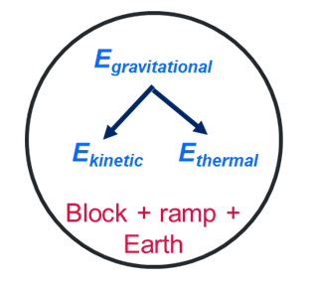
Note: an explanation of the nomenclature for denoting the different energy types is provided in the Appendix.

Work-energy bar charts
Work-energy bar charts are bar charts that quantitatively display energy transformations. Figure 2 shows the work-energy bar chart for the system described in Figure 1. Each column represents an energy type in the system (in this example, gravitational potential, kinetic and thermal energy). The work-energy bar chart displays the energy distribution at 2 time points (t₁ representing an initial time point and t₂, a later time point). t₁ and t₂ are separated by a column that indicates the work done between the time points (in the above example, this is the work done on the sliding block). The heights of the columns indicate the quantitative distribution of the energy: the total heights of the kinetic and thermal energy bars at t₂ equals the gravitational potential energy at t₁. Hence, the work-energy bar chart shows that (1) the system is isolated, (2) the total energy is conserved and (3) most of the gravitational potential energy transformed is stored as kinetic energy at t₂.
Figure 2 – a work-energy bar chart
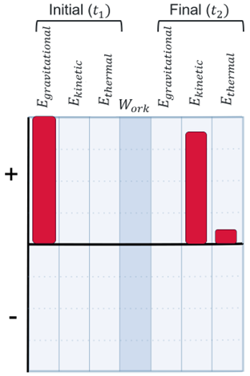

Sankey diagram
Sankey diagrams are modified flowcharts describing energy transfer and transformation in systems. They contain the system components, their relative quantities and the direction of flow. Figure 3 shows the Sankey diagram for an inclined plane system. The components on the left of a Sankey diagram indicate the inputs, while the outputs are shown on the right. As shown in Figure 3, the 100 J of gravitational potential energy stored in the block is transformed into 90 J of kinetic energy and 10 J of thermal energy. Sankey diagrams can depict complex and multi-stage energy transformations, as discussed later in this focus area.
Figure 3 – Sankey diagram of a block moving down a ramp
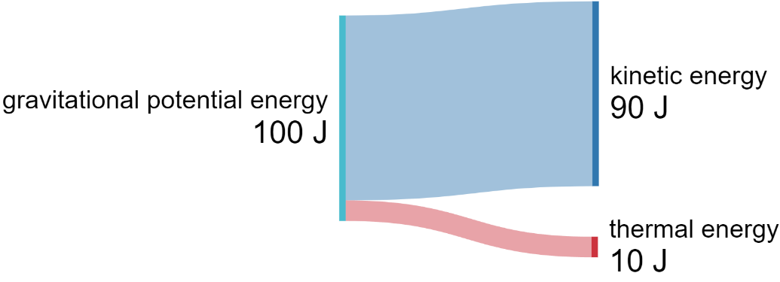

Strengths and limitations of the energy representations
Table 3 – summary of the strengths and limitations of common representations used to describe energy processes
Representation | Flow chart | Work-energy bar chart | Energy flow diagram | Sankey diagram
Define the system. |  |  | 
Identify energy transformations.
Can represent open, closed and isolated systems.
Describe how energy is shared between stores.

Learning activities

Revising Stage 4 Energy
- Revise the key ideas described in the Background, including:
- the law of conservation of energy.
- definitions of open, closed and isolated systems
- energy types, such as kinetic, potential and thermal.
EGY PPT ‘1.2 Revising energy’ contains the key terms that can be unpacked.

Energy cubes
Energy cubes are a concrete and manipulable model for representing energy. They effectively model open, closed and isolated systems and emphasise the law of conservation of energy.
Students use energy cubes to represent ‘chunks’ of energy, with each cube’s side labelled as a different storage mechanism. They construct, negotiate and enact energy stories that represent given scenarios.

Preparation
- To use energy cubes in the classroom, you will need:
- individual whiteboards and markers (enough for one per group of 3 students)
- sets of small wooden, plastic or Lucite cubes.
The Representing Energy – Energy cubes website provides learning resources to support modelling activities using energy cubes.

Instructions
- Explain the Energy cube rules to students (EGY PPT ‘1.2 Energy cube rules’).
Energy cube rules
- Each cube represents a 'chunk of energy’.
- The objects in which the energy is contained are represented by regions on a whiteboard.
- The form energy is stored in must be indicated on the face of the cube that is 'up'.
- When the form of energy changes, the cube must be turned to show a different face.
- When energy is transferred, a cube must be moved from its original location on the whiteboard to another.
- Demonstrate a toy car scenario using EGY PPT ‘1.2 Pull-back car scenario’ to show students how to complete the energy cubes activity. This example is also outlined in Table 4.
- Provide students with a range of other scenarios to complete energy cube representations.
Table 4 – shows the energy cube activity for a pull-back toy car
Step | Example
Step 1 – choose the system and identify the initial and final times. | Describe the scenario: a pull-back toy car is at rest at t₁. You pull the car back to wind up the spring in it (t₂) and then release it, and it moves forward (t₃).  System: the car, table and air. The surroundings are everything else.  Time ($t_{1}$): car is at rest on the table  Time ($t_{2}$): force is applied to the car to pull it backwards, coiling the spring, and it is again at rest.  Time ($t_{3}$): the car is released. It moves forward but soon slows down. The spring uncoils as this happens.  Figure 4 – diagram showing the change in the state of the spring caused by pulling the car back at $t_{1}, t_{2}$ and $t_{3}$  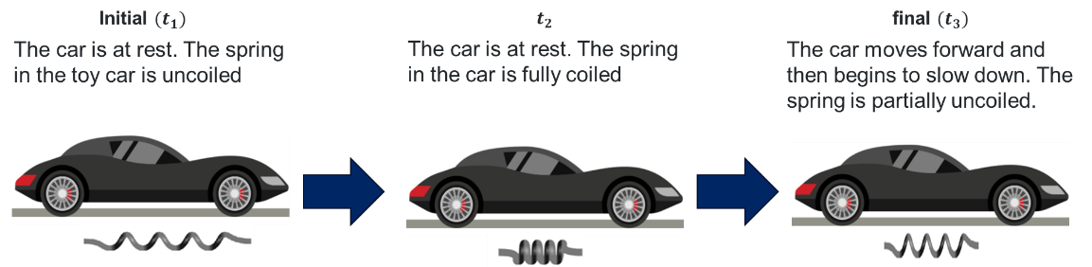  ‘Retro Sports Car’ by Vectorportal.com is licensed under CC BY 4.0. This image has been edited using draw.io online, and includes image content from Chemix.
Step 2 – represent the problem. | - Define the energy transfers and transformations: The work done on the car by pulling it back has increased its elastic potential energy. As the car moves across the table, the elastic potential energy is converted to kinetic and thermal energy.  - Student groups begin by marking out regions on their individual whiteboards to represent each component within the system.  Figure 5 – initial setup of an individual whiteboard with a region for each of the interacting components in the system.  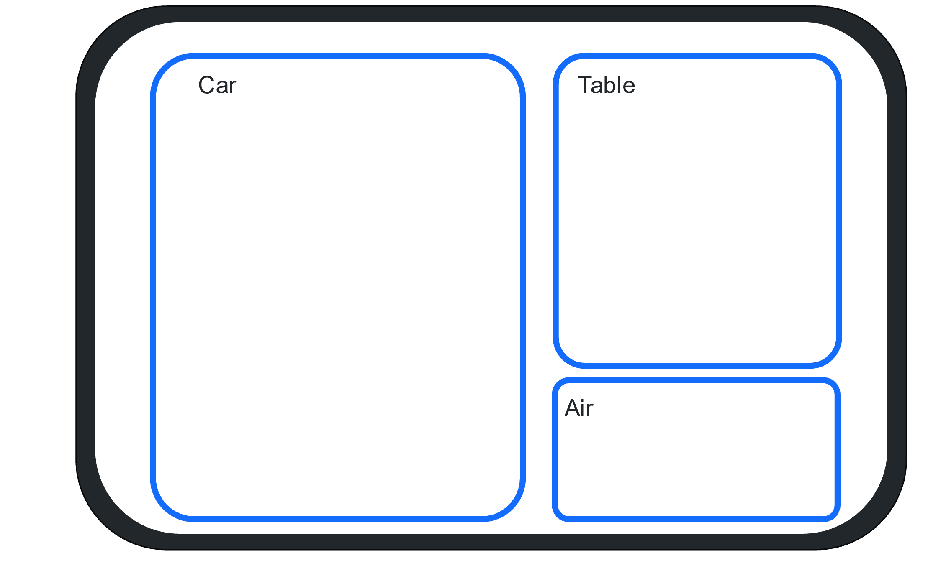  As the system's energy is initially zero at t1, no energy cubes are on the whiteboard in Figure 5.  - Energy cubes are added according to the rules to represent an initial point in time for the scenario (Figure 6).  Figure 6 – example of individual whiteboard representing the system's energy at (t₂) for a pull-back car.  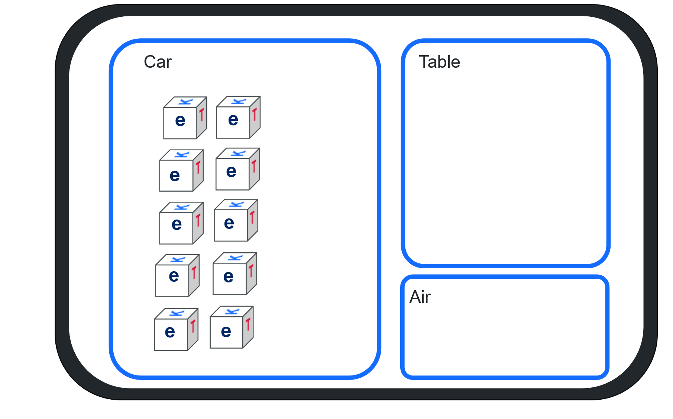  The whiteboard in Figure 6 shows the 3 interacting components of the system – car, table and air (Activity 1). Adding the 10 energy cubes to the car at t₂ represents the work done on the car as it is pulled back. In other words, the car gains 10 cubes of energy due to the pullback. The other regions do not have any cubes. The near faces of the energy cubes show ‘e’ for elastic potential energy. In this representation, 10 energy cubes of elastic potential energy are stored in the car.  - Student groups then move and rotate the energy cubes to represent the energy transfers and transformations that occur until they reach the final time of the scenario (Figure 7).  Figure 7 – example of individual whiteboard representing the system’s energy at the final point in time (t₃) for a pull-back car.  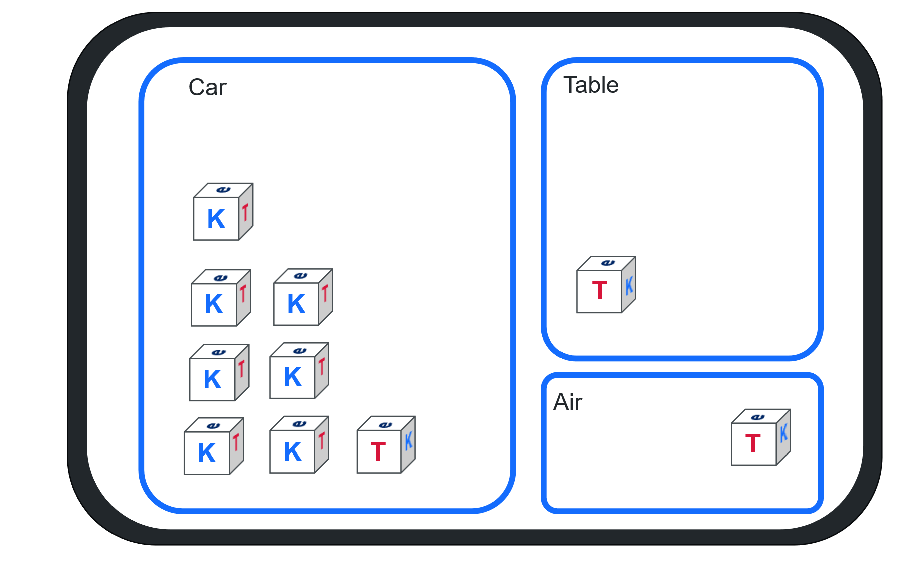  One energy cube is moved to the ‘table’ component and another to the ‘air’ component. The letters on the energy cubes’ near faces are changed to denote energy transformation. The car, which had 10 units of elastic potential energy at t₂, now has 7 energy cubes of kinetic energy (K) and 1 cube of thermal energy (T). The table and the air contain only thermal energy cubes (T). Note that the total number of cubes has not changed. This illustrates an isolated system whose total energy remains constant over time. The changing faces of the cubes indicate that the system’s energy has been transformed and is now stored differently.
Step 3 – describe the energy transfers and transformations represented by the energy cubes. | Sample response: the system consists of a pull-back toy car, a table and the air. At t₁, work was done on the car by pulling it back, causing its spring to coil, storing elastic potential energy (E_{elastic}). At t₂, the car was at rest and had 10 units of elastic potential energy (stored in the coiled spring). Then, the car was released, causing it to move forward. During this process, some of the elastic potential energy was transformed into kinetic energy (E_{kinetic}). At t₃, the car has 7 units of kinetic energy stored in its motion. Also, friction between the car and the table and air transformed some elastic potential energy into thermal energy (E_{thermal}). Therefore, the car, table and air had 1 unit of thermal energy each. As energy was added to the system between t₁ and t₂, but no matter was added or removed, this is a closed system.

Constructing energy flow diagrams

Preparation
- No equipment is required for this activity as it is a conceptualisation activity to consolidate prior learning.
- A blank template for constructing energy representations is provided in the Student resource – representing energy. The template may be placed in a shared online space (such as Google Classroom or Microsoft Teams) or printed for students to insert into their notebooks.
Summary of the steps for constructing energy flow diagrams
Energy flow diagrams help illustrate energy transfers and transformations in a system. To create an energy flow diagram:
- Draw a circle around all objects included in the system.
- Objects outside the circle are part of the surroundings.
- Arrows inside the circle show energy transformations within the system.
- Arrows crossing the circle’s boundary indicate energy transfers to or from the surroundings.

Instruction
- Display EGY PPT ‘1.2 Energy flow diagrams’ and describe what an energy flow diagram represents.
- Demonstrate the construction of energy flow diagrams using the 2 examples in EGY PPT ‘1.2 Charging a pull-back car (t1 to t2)’ and EGY PPT ‘1.2 Discharging a pull-back car (t2 and t3)’.
- Putting it together: use worked examples to describe constructing an energy flow diagram to represents the entire sequence t₁ to t₃ (see example in Table 5).
Table 5 – steps for analysing energy changes and example analysis of a pull-back car
Step | Example
Step 1 – choose the system and identify the initial and final times. | Describe the scenario: a pull-back toy car is at rest at t₁. You pull the car back to wind up the spring in it (t₂) and then release it, and it moves forward (t₃).  System: the car and table. The surroundings are everything else, including the person and air.  Time ($t_{1}$): car is at rest on the table  Time ($t_{2}$): force is applied to the car to pull it backwards, coiling the spring, and it is again at rest.  Time ($t_{3}$): the car is released. It moves forward but soon slows down. The spring uncoils as this happens.  Figure 8 – diagram showing the change in the state of the spring caused by pulling the car back at $t_{1}$ and $t_{2}$ and then releasing it so that it moves forward until $t_{3}$  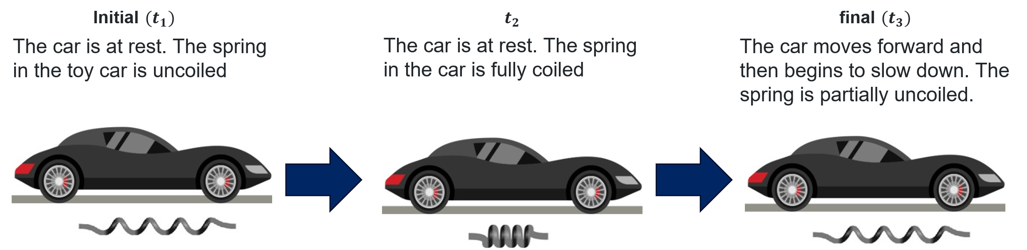  ‘Retro Sports Car’ by Vectorportal.com is licensed under CC BY 4.0. This image has been edited using draw.io online, and includes image content from Chemix.
Step 2 – represent the problem. | Define the energy transfers and transformations: the work done on the car by pulling it back has increased the system’s elastic potential energy. As the car moves across the table, the elastic potential energy is transformed into kinetic and thermal energy.  Represent the energy transfer: draw the energy flow diagram.  Figure 9 – An energy flow diagram for the pull-back toy car between t₁ and t₃. The system, represented by the circle, contains the toy car and the table.  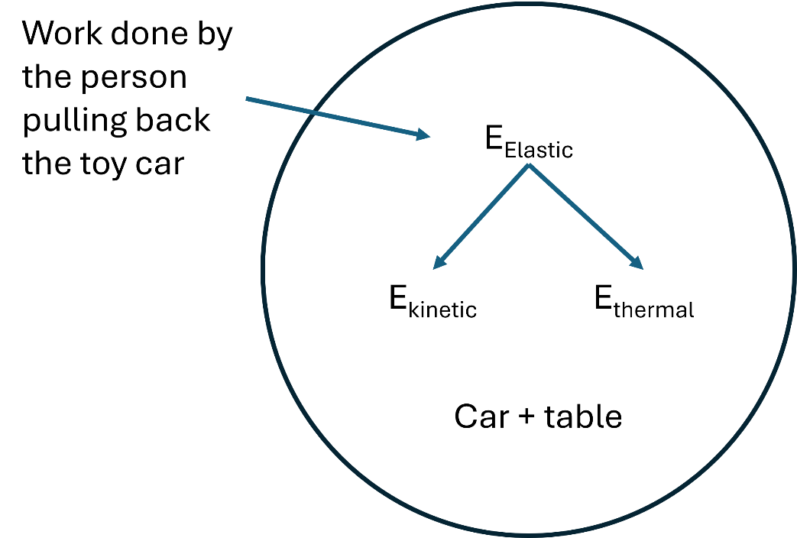  The arrow indicates that pulling back the car increases its elastic potential energy. Since the person pulling back the car is not part of the system, the arrow representing this force is shown to cross the system circle’s circumference.
Step 3 – describe the system and energy transfers and transformations represented in the Energy flow diagram. | Sample response: the system consists of a pull-back toy car and a table. At t₁, work was done on the car by pulling it back, causing its spring to coil and increasing the elastic potential energy (E_{elastic}) stored in the system. At t₂, the car was at rest and had maximum elastic potential energy (stored as elastic potential energy in the spring). Then, the car was released, causing it to move forward. During this process, some of the elastic potential energy was transformed into kinetic energy (E_{kinetic}) at t₃. Also, friction between the car and the table transformed some elastic potential energy into thermal energy (E_{thermal}).  The system’s energy increased between $t_{1}$ and $t_{2}$, as work was done on the car by the force (from the surroundings) pulling it backwards. Matter is not added or removed; therefore, this is a closed system.
Checkpoint: the pull-back car system described in this activity is closed. What changes can you make to it to make it an isolated system?
Sample answer: If the system includes the person pulling back the car, it becomes isolated (the system's total energy remains constant.

Constructing a work-energy bar chart

Preparation
- No equipment is required for this activity as it is a conceptualisation activity to consolidate prior learning.
- A blank template for constructing energy representations is provided in the Student resource. The template may be placed in a shared online space (such as Google Classroom) or printed for students to insert into their notebooks.

Instruction
Describe how a work-energy bar chart represents energy transformations.
A work-energy bar chart shows the energy in a system at 2 different times using bars. Here is how to read one:
- Initial energy (left side): bars represent different types of stored energy (for example, elastic potential, kinetic, thermal).
- Energy flow (centre): the shaded bar shows energy added to or removed from the system. Energy added or removed from a system is usually described as work, $W_{ork}$ or $W_{ext}$.
- Final energy (right side): bars represent energy stored in the system at a later time.
Demonstrate how to construct a work-energy bar chart using the scenario outlined in Table 6 and in EGY PPT ‘1.2 Work-energy bar chart – pull-back toy car (isolated system)’.
Table 6 – steps to analyse a scenario to construct a work-energy bar chart
Step | Example
Step 1 – choose the system and identify the initial and final times. | Describe the scenario: a pull-back toy car is at rest at t₁. You pull the car back to wind up the spring in it (t₂) and then release it, and it moves forward (t₃).  System: the person (you), car and table. The surrounding is everything else, including the air.  Note: the person pulling the car is now part of the system. The initial energy at t₁ is assumed to be stored chemical energy.  Time ($t_{1}$): car is at rest on the table.  Time ($t_{2}$): force is applied to the car to pull it backwards, coiling the spring, and it is again at rest.  Time ($t_{3}$): the car is released. It moves forward but soon slows down. The spring uncoils as this happens.  Figure 10 – diagram showing the change in the state of the spring caused by pulling the car back at $t_{1}$ and $t_{2}$ and after release at $t_{3}$  ‘Retro Sports Car’ by Vectorportal.com is licensed under CC BY 4.0. This image has been edited using draw.io online, and includes image content from Chemix.
Step 2 – represent the problem. | Define the energy transfers and transformations: the work done on the car by pulling it back has increased its elastic potential energy. As the car moves across the table, the elastic potential energy is converted to kinetic and thermal energy.  Represent the energy transfer: draw the work-energy bar chart.  - Energy at t₁: 3 units of energy are stored as chemical potential energy.  - Energy at t₂: 3 units of energy are stored as elastic potential energy.  - Energy at t₃: energy is conserved but transformed into kinetic (2 units) and thermal energy (1 unit).  - Energy flow ($W_{ork}$): no energy has been added or removed from the system.  Figure 11 – work energy bar chart for the person-car-table system  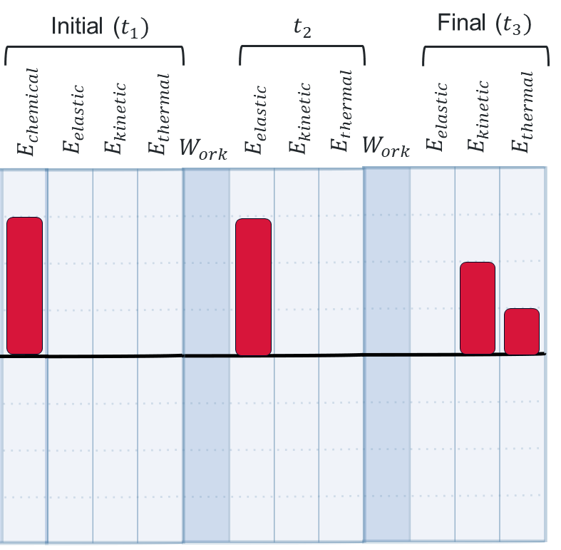  Note: work-energy bar charts illustrate the relative proportions of energy stored, added to or removed from a system. No units are specified, so students can choose convenient heights for each bar that reflect the approximate proportions of energy. In this example, we chose to start with 3 units of chemical potential energy and assumed that the transformation into elastic potential energy was 100% efficient. We have also estimated that around two-thirds of the elastic potential energy is transformed into kinetic energy. Thus, teachers may use any number of energy units in their examples, as long as those numbers (before and after transformation) are consistent with the law of energy conservation.
Step 3 – describe the system and energy transfers and transformations represented in the Energy flow diagram. | Sample response: the work-energy bar chart shows that at t₂, the car contained only 3 units of elastic potential energy. At t₃, the elastic potential energy is transformed into 2 units of kinetic energy and 1 unit of thermal energy.  The work-energy bar chart also shows that no work was done on the system (there were no energy transfers into or out of the system). The system's total energy remained constant, indicating an isolated system.  Note: Teachers should check that students can describe the energy transfers and transformations in terms of the relevant systems and the law of energy conservation.
Checkpoint (EGY PPT ‘1.2 Checkpoint’ and sample answer)
Consider the pull-back car example but with the following changes: the system consists of you and the car. The table and the air are external to the system. In your notebooks or on whiteboards, show the energy transfers and transformations using a work-energy bar chart (use the template provided in Student resource – representing energy). Hint: use the following energy flow diagram to help you construct your work-energy bar chart.
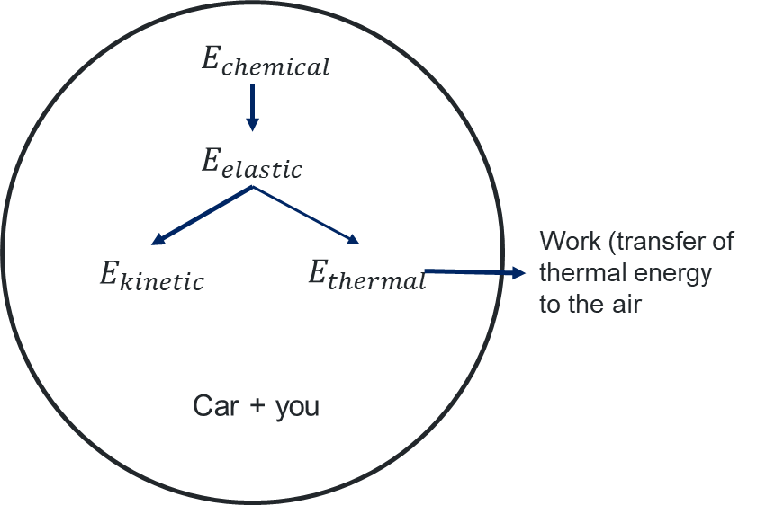
Sample response:
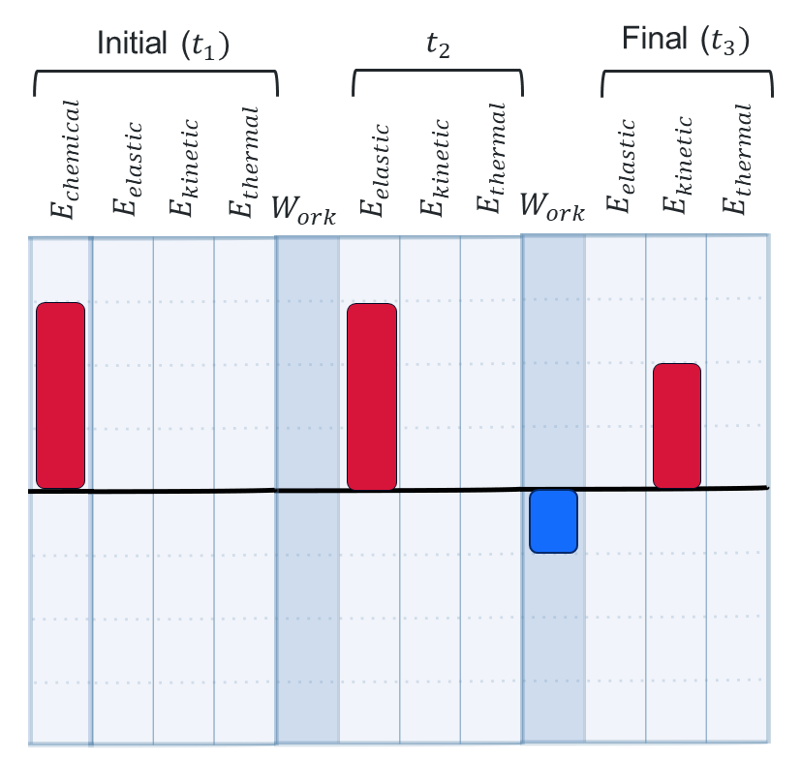
As before, the car had 3 units of elastic potential energy at t₂ and 2 units of kinetic energy at t₃. Since the thermal energy was lost to the air (not part of the system), it is shown in the ‘Work’ column (1 unit). It has negative units because energy from the system was lost to its surroundings.

Energy representations of a block and ramp system

Preparation
- Equipment: an inclined plane system, such as a block sliding down a ramp.
- A blank template for constructing energy representations is provided in the Student resource – representing energy. The template may be placed in a shared online space (such as Google Classroom) or printed for students to insert into their notebooks.

Instruction
- Set up a block and ramp system (for example, a book sliding down an inclined plane). Ask students to describe energy changes verbally:
- Choose the system and identify the initial and final points in time ($t_{1}$ and $t_{2}$).
- Ask students to identify the energy transfers and transformations that occur when the block slides down the ramp.
- Students construct energy representations (energy flow diagram and work-energy bar chart) for the energy transfers and transformations.
- Students describe the information in the energy representations.
Table 7 – sample problem-solving steps for a block sliding down a ramp (EGY PPT ‘1.2 A block sliding down a ramp – sample answer’)
Step | Example
Step 1 – Choose the system and identify the initial and final times | System: block, ramp and Earth.  The surroundings is everything else.  Initial time ($t_{1}$): block is at rest at the top of the ramp.  Final time ($t_{2}$): the block moves at maximum speed just as it reaches the bottom of the ramp.
Step 2 – represent the problem. | Draw pictorial representations of the block and ramp at $t_{1}$, and $t_{2}$ along with an energy flow diagram and work-energy bar chart to show the energy transfers.  Figure 12 – pictorial representation of a block sliding down a ramp  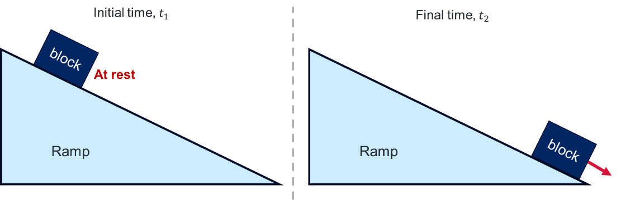  Figure 13 – energy flow diagram and work-energy bar chart for a block sliding down a ramp  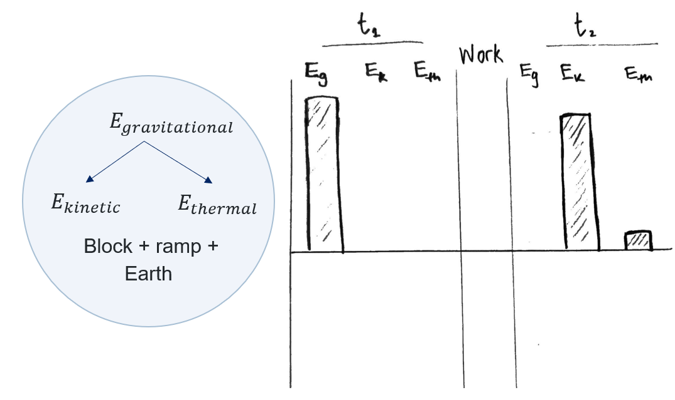
Step 3 – describe the system and energy transfers and transformations depicted in these energy representations. | The gravitational potential energy at $t_{1}$ has been mostly transformed into kinetic energy in the block's motion at t₂, with a small amount stored as thermal energy due to heating from the friction force between the block and ramp. The total energy is conserved, making this an isolated system.

Energy representations of some mechanical and electrical systems

Preparation
- Set up stations in the classroom where students can engage with various mechanical and electrical toys and devices involving energy transfer and transformations. On benches, setup:
- Mechanical toys. A yo-yo, wind-up toy, pull-back car, slingshot, bouncy balls and windmills.
- Electrically powered devices: Electric fans and/or globes connected to hand-cranked generators or solar cells via a simple circuit.
- The student resource provides a blank template for constructing energy representations. The template may be placed in a shared online space (such as Google Classroom) or printed for students to insert into their notebooks.
Figure 14 – examples of toys that can be used to demonstrate energy transformations

Figure 15 – equipment for demonstrating energy transfers and transformations in electric circuits.
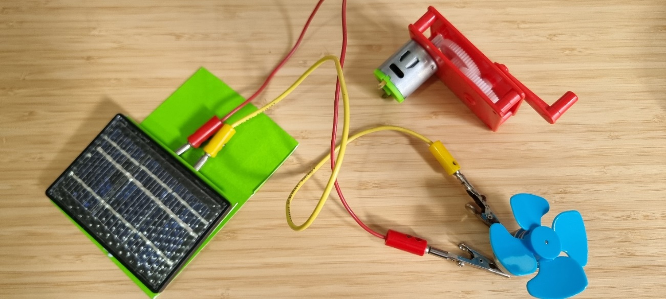

Instruction
- Demonstrate how the energy toys and devices work.
- Students complete a Think-Pair-Share activity on the energy transfers and transformations that occur when the toys and devices are operational. Each student should be prepared to answer the following questions:
- What type(s) of energy are input into the system?
- What type(s) of energy are output from the system when the toy or device is operating?
- If more than one type of output energy is evident, which is the dominant type?
- Students record their problem-solving for each ‘energy toy’. A sample response is provided in Table 8 (also available in the EGY PPT ‘1.2 Solar cell and electric fan’). Note: Students are provided with a template to record their discussions and responses at each station.
Note: if there is enough equipment for each student group to experiment with the electric circuit system, they could qualitatively investigate the factors affecting the speed of the motor output in the solar cell system. Try adding a piece of masking tape to the rotor so students can more easily observe the rotation speed.
Table 8 – sample problem-solving steps for a solar-powered fan
Step | Example
Step 1 – choose the system and identify the initial and final times. | System: Solar cell and electric fan.  The surroundings includes the lamp.  Initial time ($t_{1}$): the lamp is off, and the fan is not moving.  Final time ($t_{2}$): the lamp is on, and the fan is spinning.
Step 2 – represent the problem. | Draw pictorial representations of the solar cell and fan at $t_{1}$, and $t_{2}$ along with an energy flow diagram and work-energy bar chart to show the energy transfers.  Figure 16 – representations of a solar-powered fan  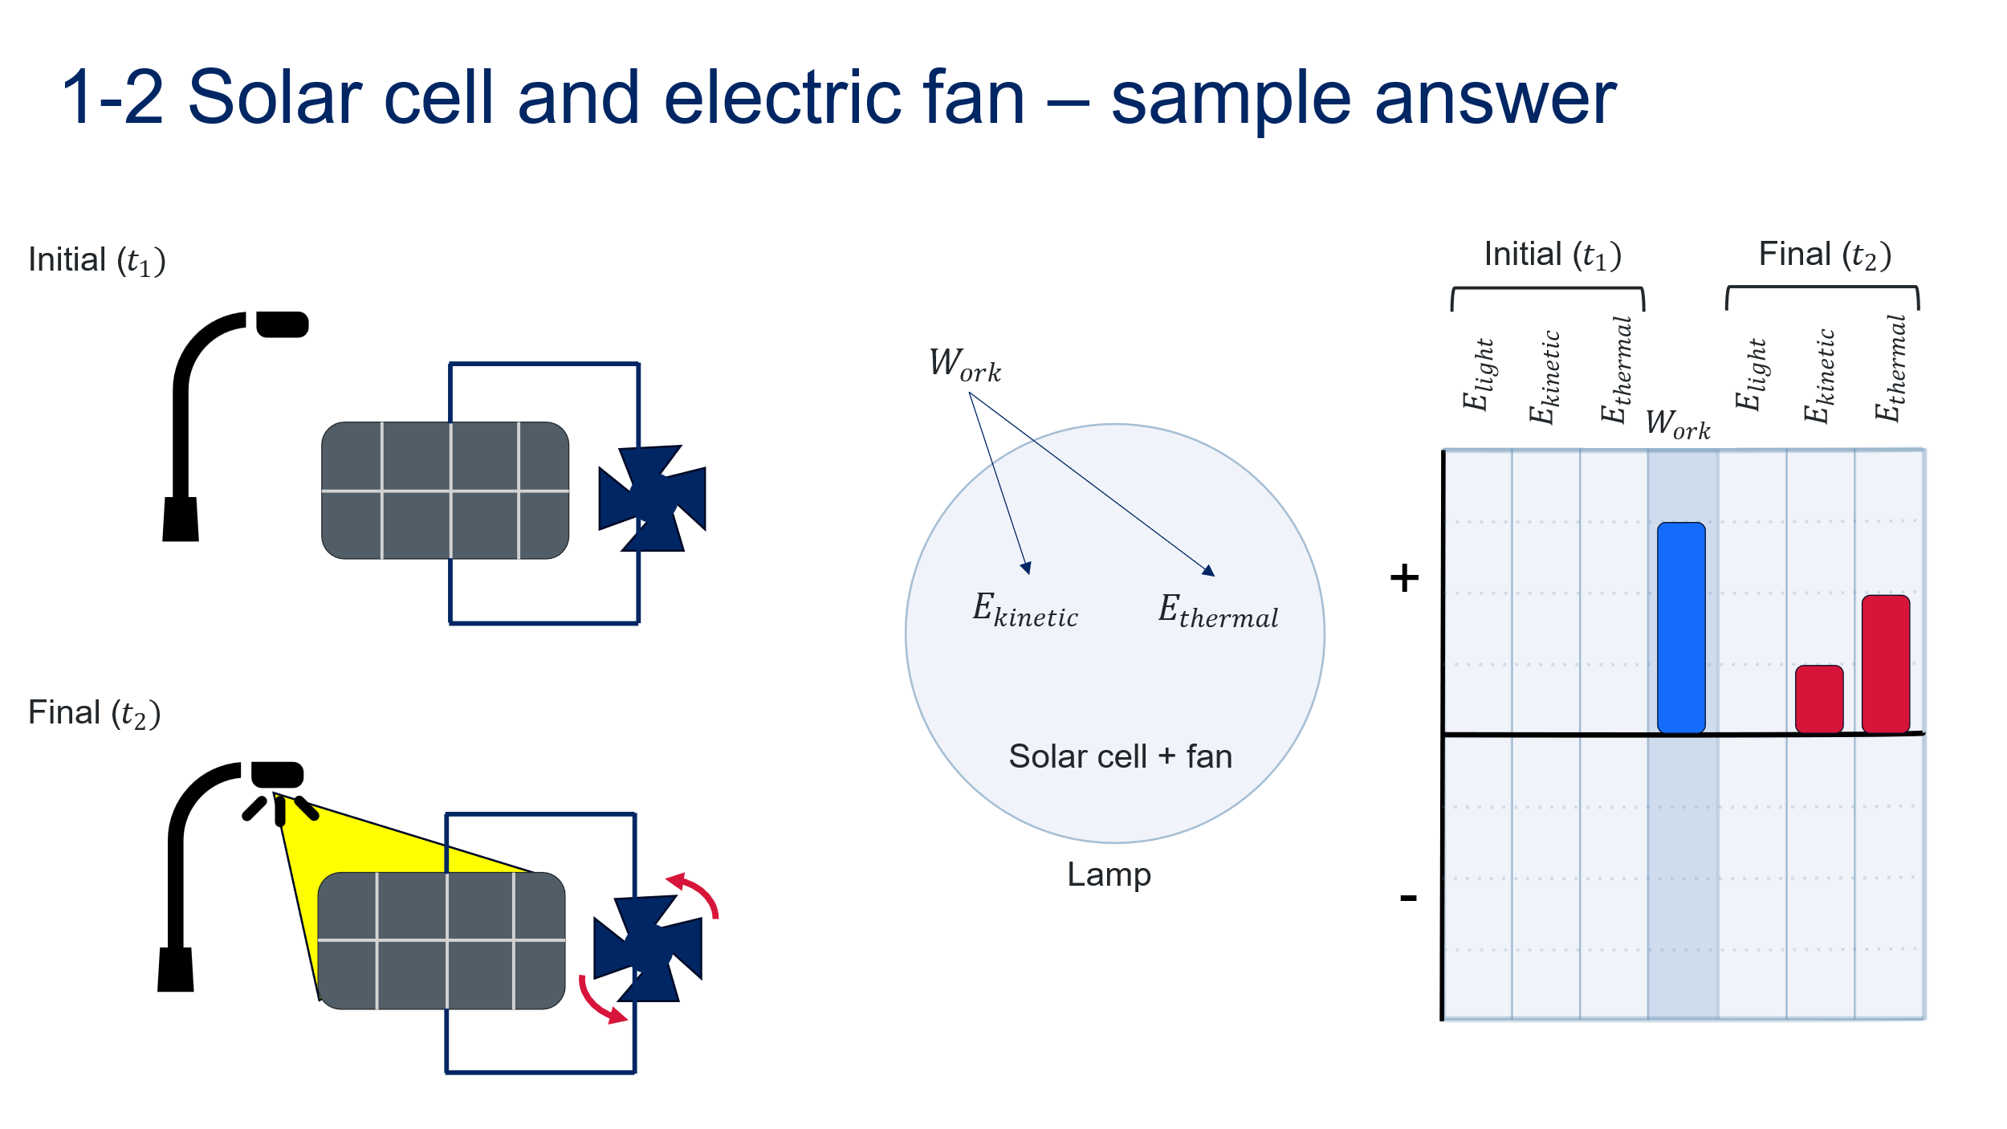
Step 3 – describe the system, energy transfers, and transformations shown in the energy representations. | A small portion of the energy added to the system (work done by the lamp’s light on the solar cell) has been transformed into a kinetic store in the motion of the fan at $t_{2}$. However, most of the work done on the system goes to increasing its thermal energy. This is due to electrical resistance and solar cell inefficiencies.  As the system's total energy changes but no matter is exchanged with the surroundings, this is a closed system.
Note: including or excluding other objects from these systems would change the analysis. For example, if the lamp is included in the system, the system changes from closed to isolated. This occurs because light from the lamp would initially be included in the system’s total energy. The energy initially stored in the light is transformed into kinetic and thermal energy without changing the system's total energy.
Checkpoint: students test their understanding of energy representation by accessing the interactive on the Universe and More website. Demonstrate the first example by completing the following steps.
- Select an event.
- Play the video
- Select the system.
- Add the required energy bars (and work if it is an open system).
- Add the amounts of energy to each side and click Check.
Differentiation: the PhET simulation Energy Skate Park includes a simplified version of a work-energy bar chart, showing how energy is stored within the skater-ramp-Earth system at a given point in time. The simulation also uses simplified terms to describe each energy store. Increasing the friction will transform some of the system's energy into thermal energy. Students can use the simulation to explore energy conservation within a system by changing the shape of the ramp, the friction and the gravity and observing the energy bar chart over time. Teaching resources for using PhET simulations are included in the Teaching Resources tab for each resource (free registration required).
Figure 17 – screenshot from the Energy Skate Park interactive simulation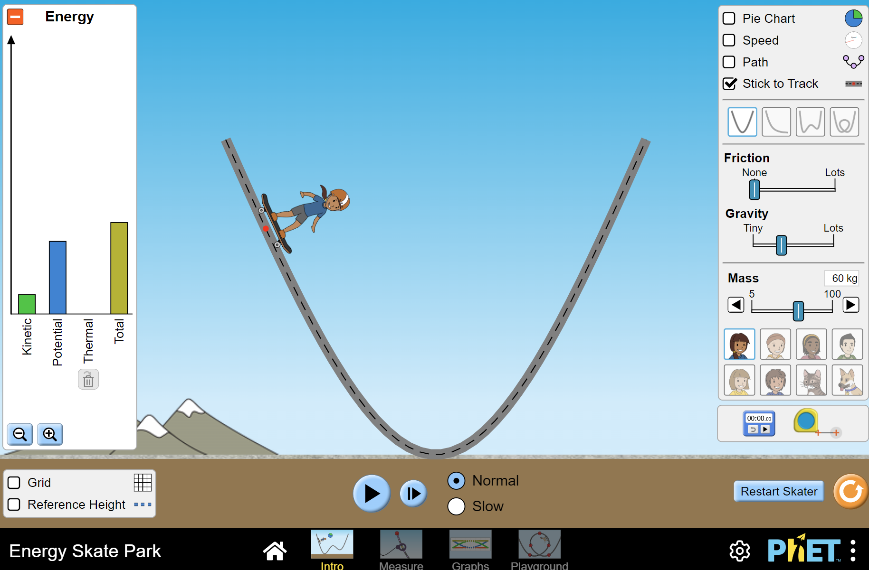
‘Energy Skate Park PhET Interactive Simulations’ by University of Colorado Boulder is licensed under CC BY 4.0.

Student resource – representing energy
Representing energy problems or scenarios.
Step | Response
Step 1 – choose the system and identify the initial and final times. | System:  The surroundings is  Initial time ($t_{1}$):  Final time ($t_{2}$):
Step 2 – represent the problem. | Draw pictorial representations of the system at $t_{1}$, and $t_{2}$.
 | Draw an energy flow diagram to show the energy transfers.
Draw a work-energy bar chart to show the energy transfers.
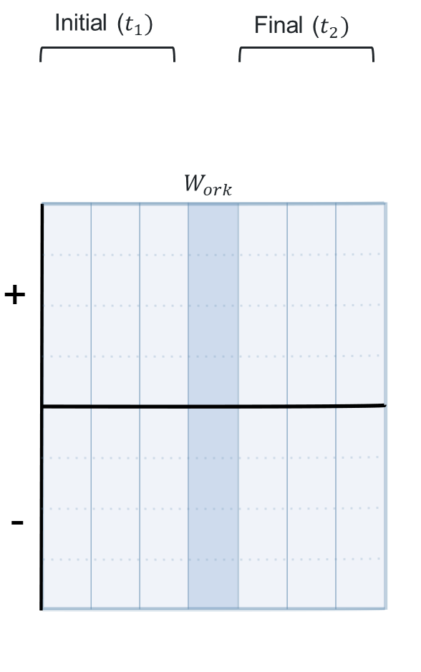
Step 3 – apply models and laws. | Describe the energy transfer and transformations in the system.

1.3 Understanding efficiency
Table 9 – learning intentions and success criteria for ‘Understanding efficiency’
We are learning: | I can:
- how to use energy more efficiently  - to represent and organise data and information to find patterns and to calculate useful values. | - define energy efficiency  - describe the efficiency of a device in terms of the useful energy output and wasted energy  - draw a Sankey diagram to represent the energy efficiency of a device
Efficiency is a key concept in the Energy focus area and is applied to the generation and use of energy. Optimising and/or improving efficiency is developed as an important pathway to sustainable energy use.

Preparation
Ensure that students have access to graph paper with 1 cm squares.
Halved A4 sheets of paper or other loose paper.

Instructions
Due to its common usage in everyday conversation, students will have a range of understandings of the term ‘energy’. Many of the conceptions can help them understand energy efficiency in the focus area, but some may not. Surfacing student understanding before continuing may help address alternate conceptions.
- Ask students the following question: ‘What do we mean when we say something is efficient?’. Encourage students to write their thoughts on a half-A4 piece of paper so they can be shared randomly with classmates. Students may find it easier to describe efficiency related to sport, supermarket shopping or other day-to-day activities. Swap responses and ask students to read out interesting examples.
- Complete the Frayer diagram for efficiency (EGY PPT ‘1.3 Frayer diagram – efficiency’)
- Provide students with a definition and some characteristics.
- Encourage students to write a few correct sentences using energy efficiency in the examples and non-examples sections.
- Review student responses. Take note of the non-examples in Figure 18 and address them if brought up by students.
Figure 18 – sample response Frayer diagram – efficiency
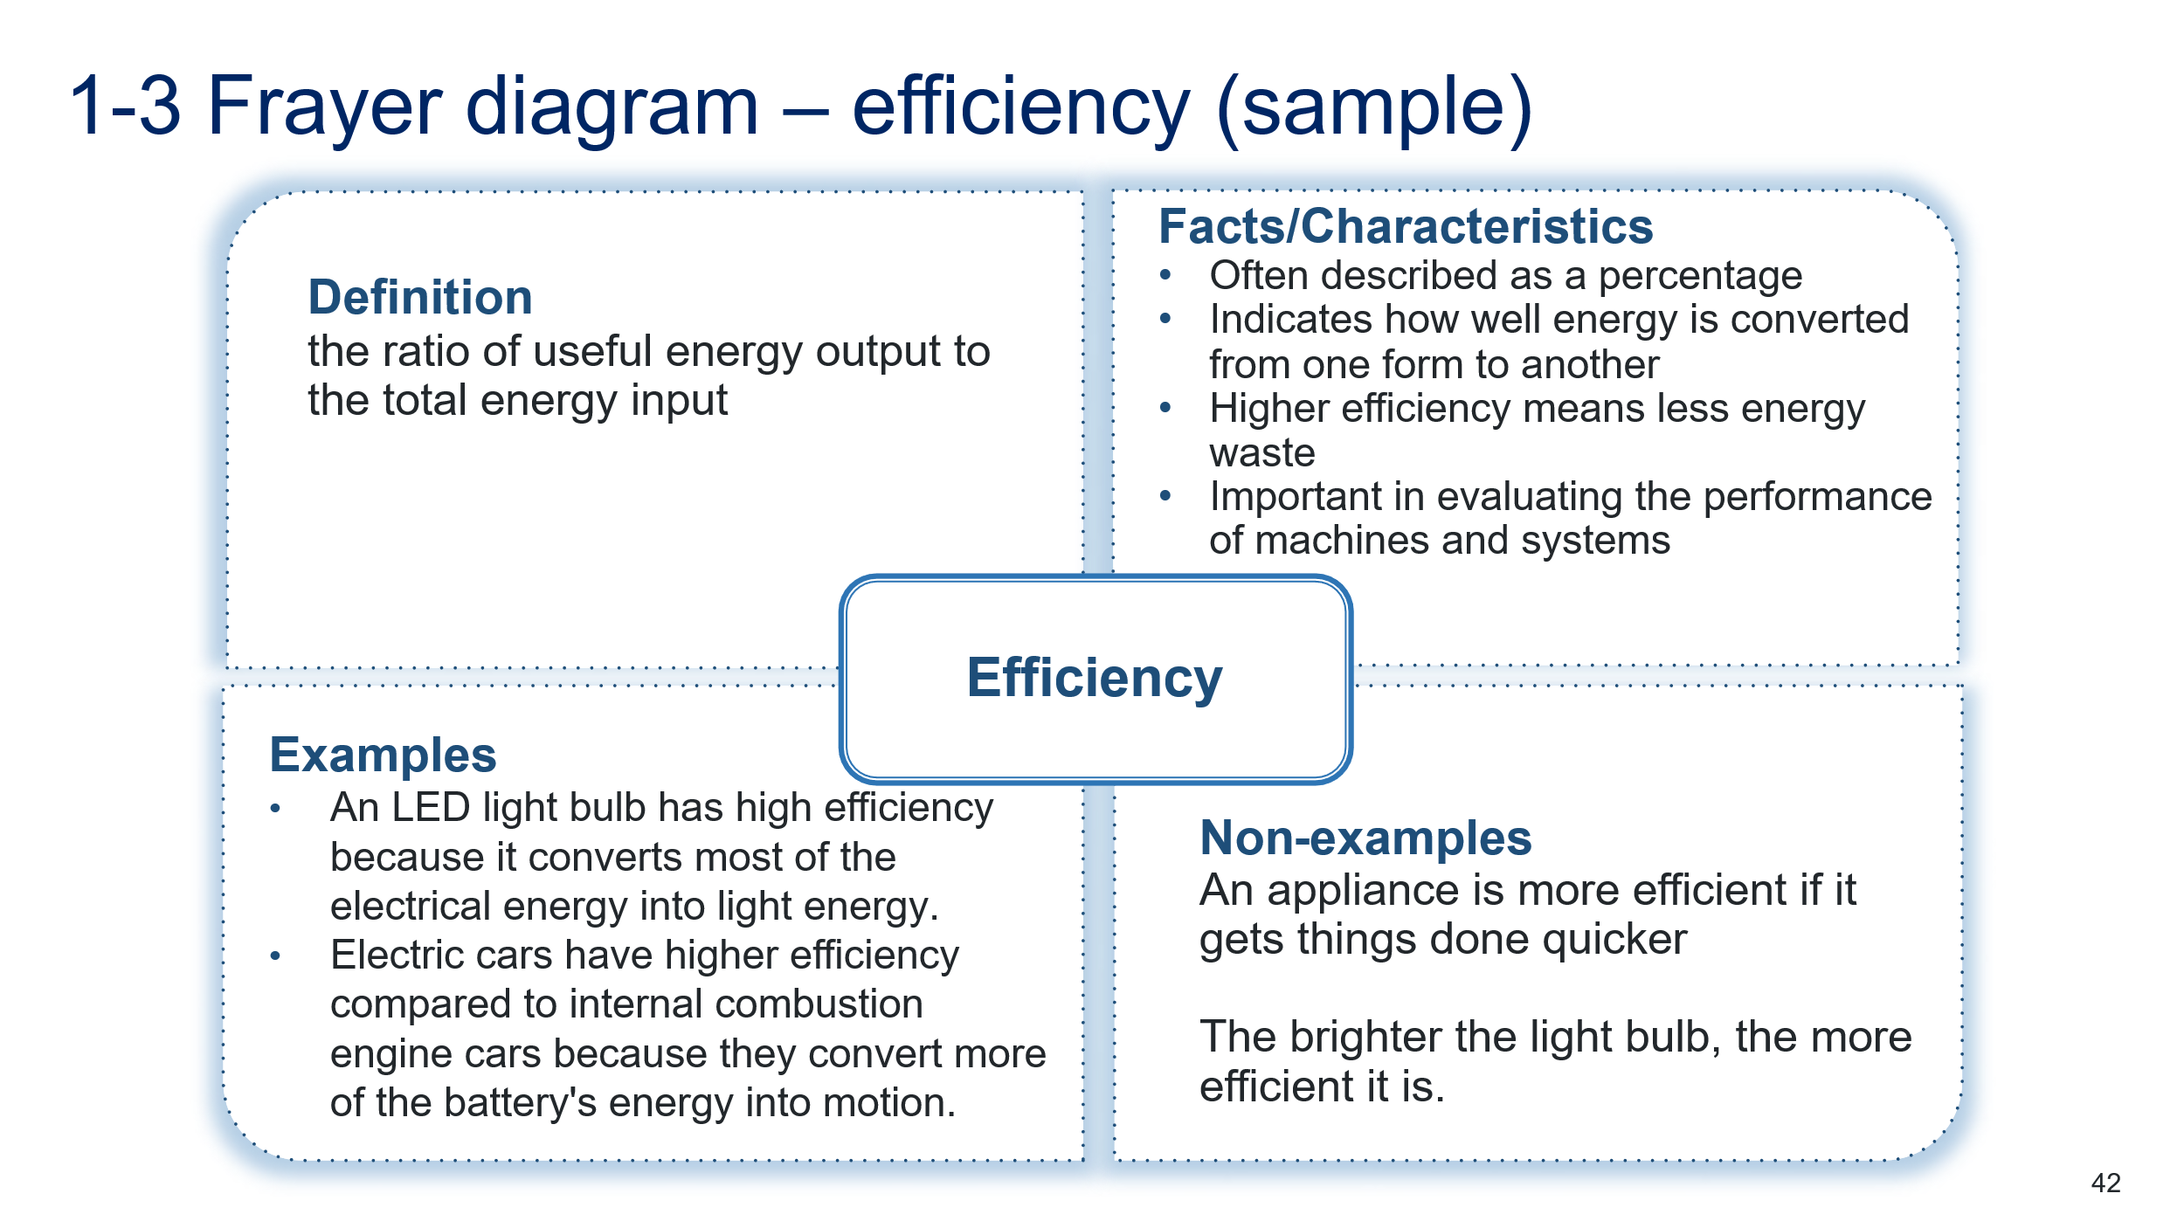
Note: NESA defines efficiency in its glossary as ‘The ratio of the work done, or energy developed by a machine or engine, to the energy supplied to it’ (NESA 2024).
- Introduce the Sankey diagram (4:25) (Godfrey 2015) as a tool for describing efficiency in energy processes. Sankey diagrams (Physics Fox) have further information on creating and using Sankey diagrams to describe energy transfers and transformations.
- Demonstrate the steps to draw a Sankey diagram using, as an example, a fluorescent light globe that produces 30 J of useful energy output for every 100 J of energy input, with the remainder lost as wasted output. Figure 19 is included in the EGY PPT ‘1.3 Sankey diagrams’ to facilitate this activity.
- Step 1: Decide on your scale – for example, 1 square equals 10 J
- Step 2: Plot energy input
- Step 3: Plot wasted output energy
- Step 4: Plot useful output energy
- Step 5: Add labels
Figure 19 – sample Sankey diagram for a fluorescent light globe with annotations included to demonstrate how each value is represented on the diagram
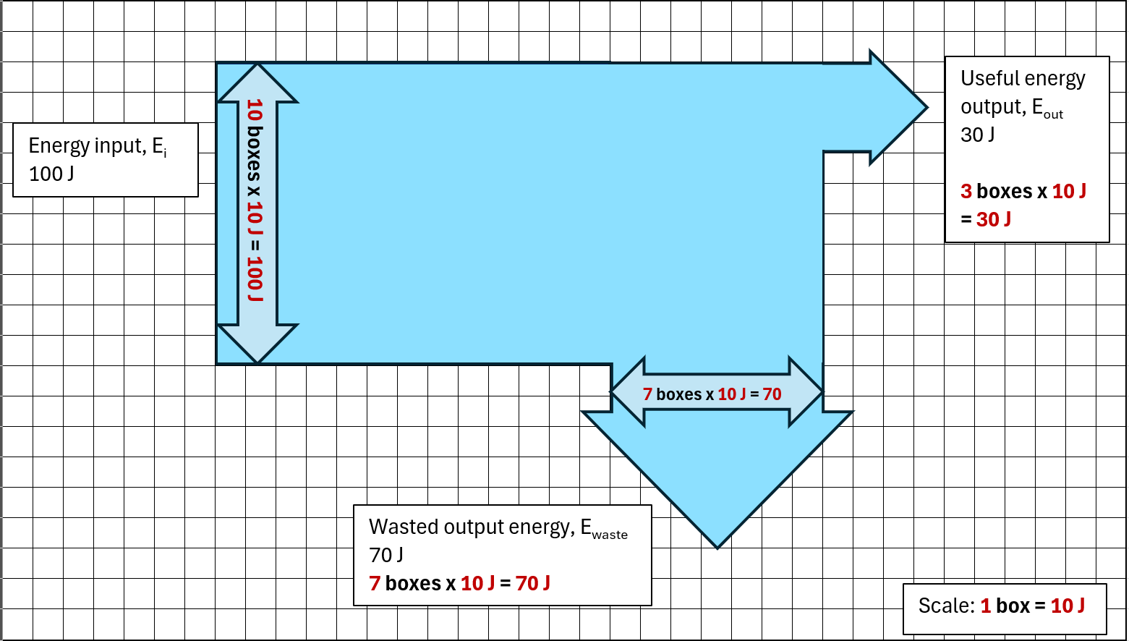
- Provide students with grid paper. Ask students to draw a Sankey diagram that describes a light globe that is twice as efficient. For example, a globe that produces 2 times the amount of useful energy output (2 ⨯ 30 J = 60 J) from the same amount of energy input (100 J) would be twice as efficient.
Figure 20 – Sankey diagram for a light globe that is twice as efficient as the globe described in Figure 20
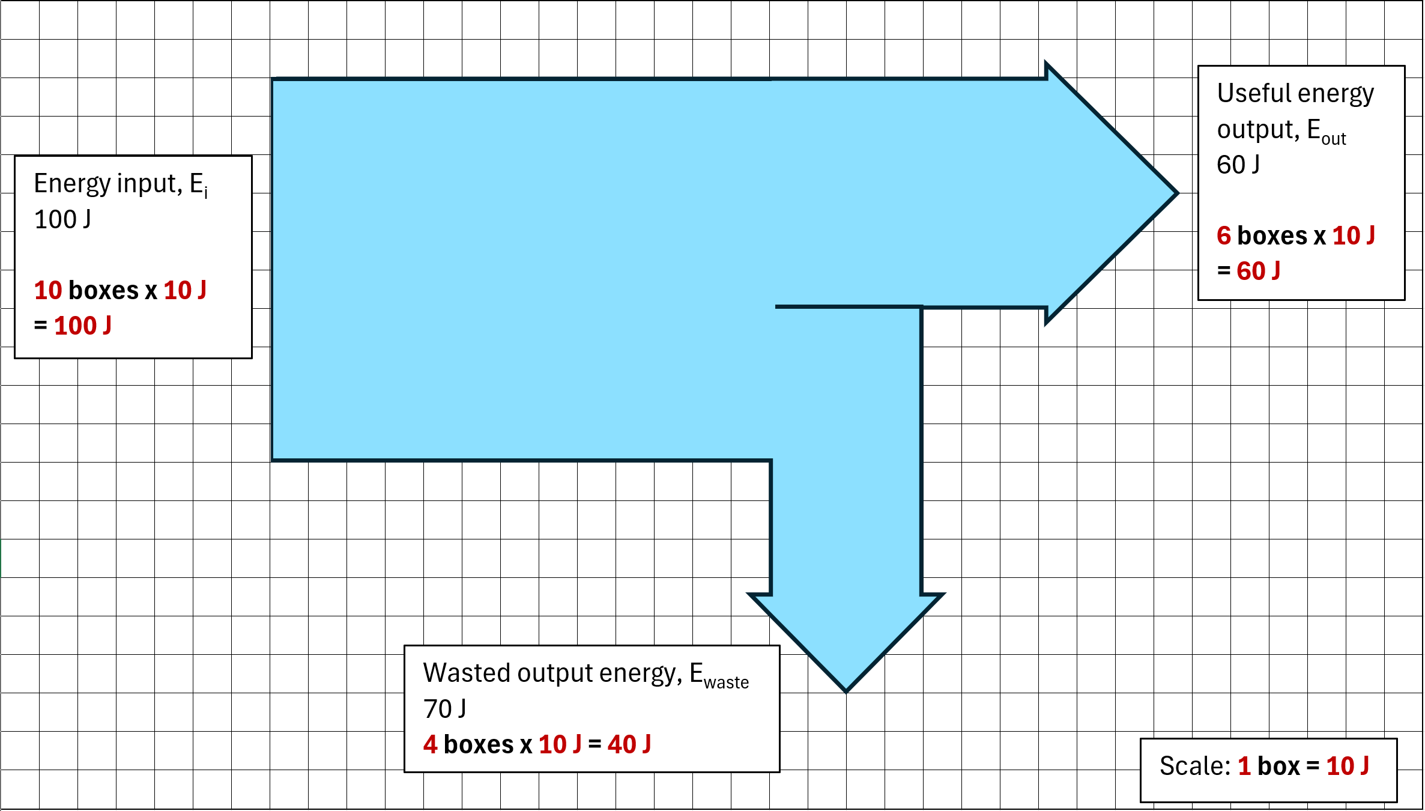
Note: creating Sankey diagrams from data tables on a computer generally requires special software or add-ins. Free online tools that can be accessed using a web browser. For example, SankeyMATIC (Bogart 2014) is an open-source tool. (They welcome attribution as ‘Diagram created using SankeyMATIC’, but it is not required).
- Explore other examples of more complicated Sankey diagrams in the sample questions and describe the energy stories they might tell.

Sample questions
- When charging a phone with 50 units of electrical energy, the phone battery stores 30 units as chemical energy, and the remaining energy is lost as heat. Draw a Sankey diagram for the phone charger and calculate the amount of energy lost as heat.
Figure 21 – sample response to question 1
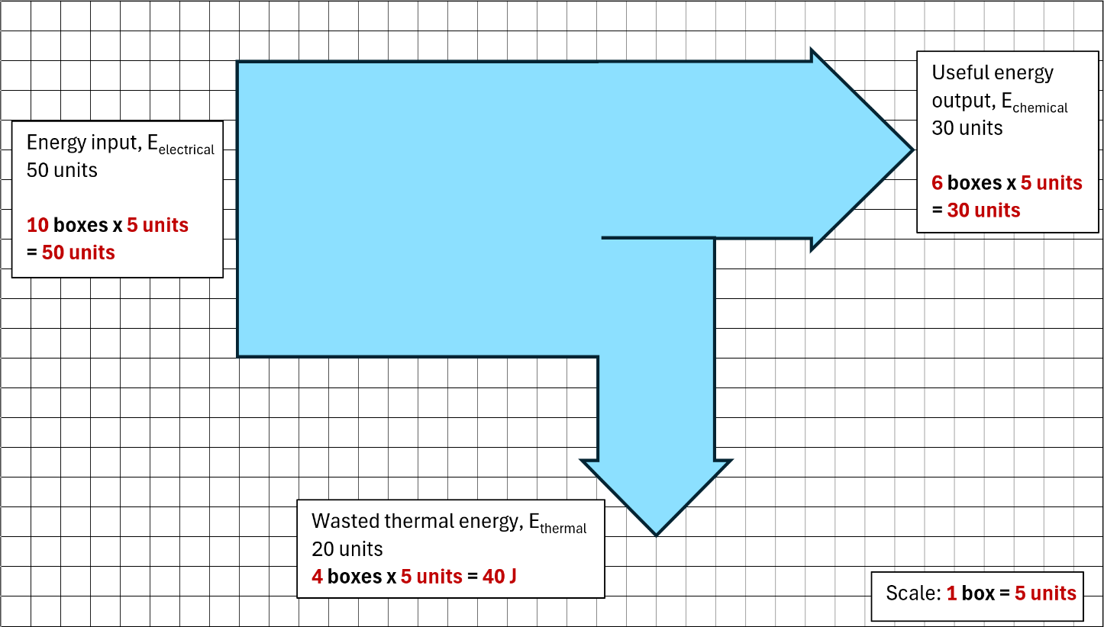
- When a car uses its brakes to slow down, the kinetic energy stored in the system is transformed. 350 J of energy is transformed into the thermal energy of the disc brakes, and 50 J is transformed into sound energy. Complete the scale and estimate the initial kinetic energy of the system using the information in the Sankey diagram (Figure 22).
Figure 22 – Sankey diagram showing energy transformations that occur when a car applies its brakes and comes to a stop
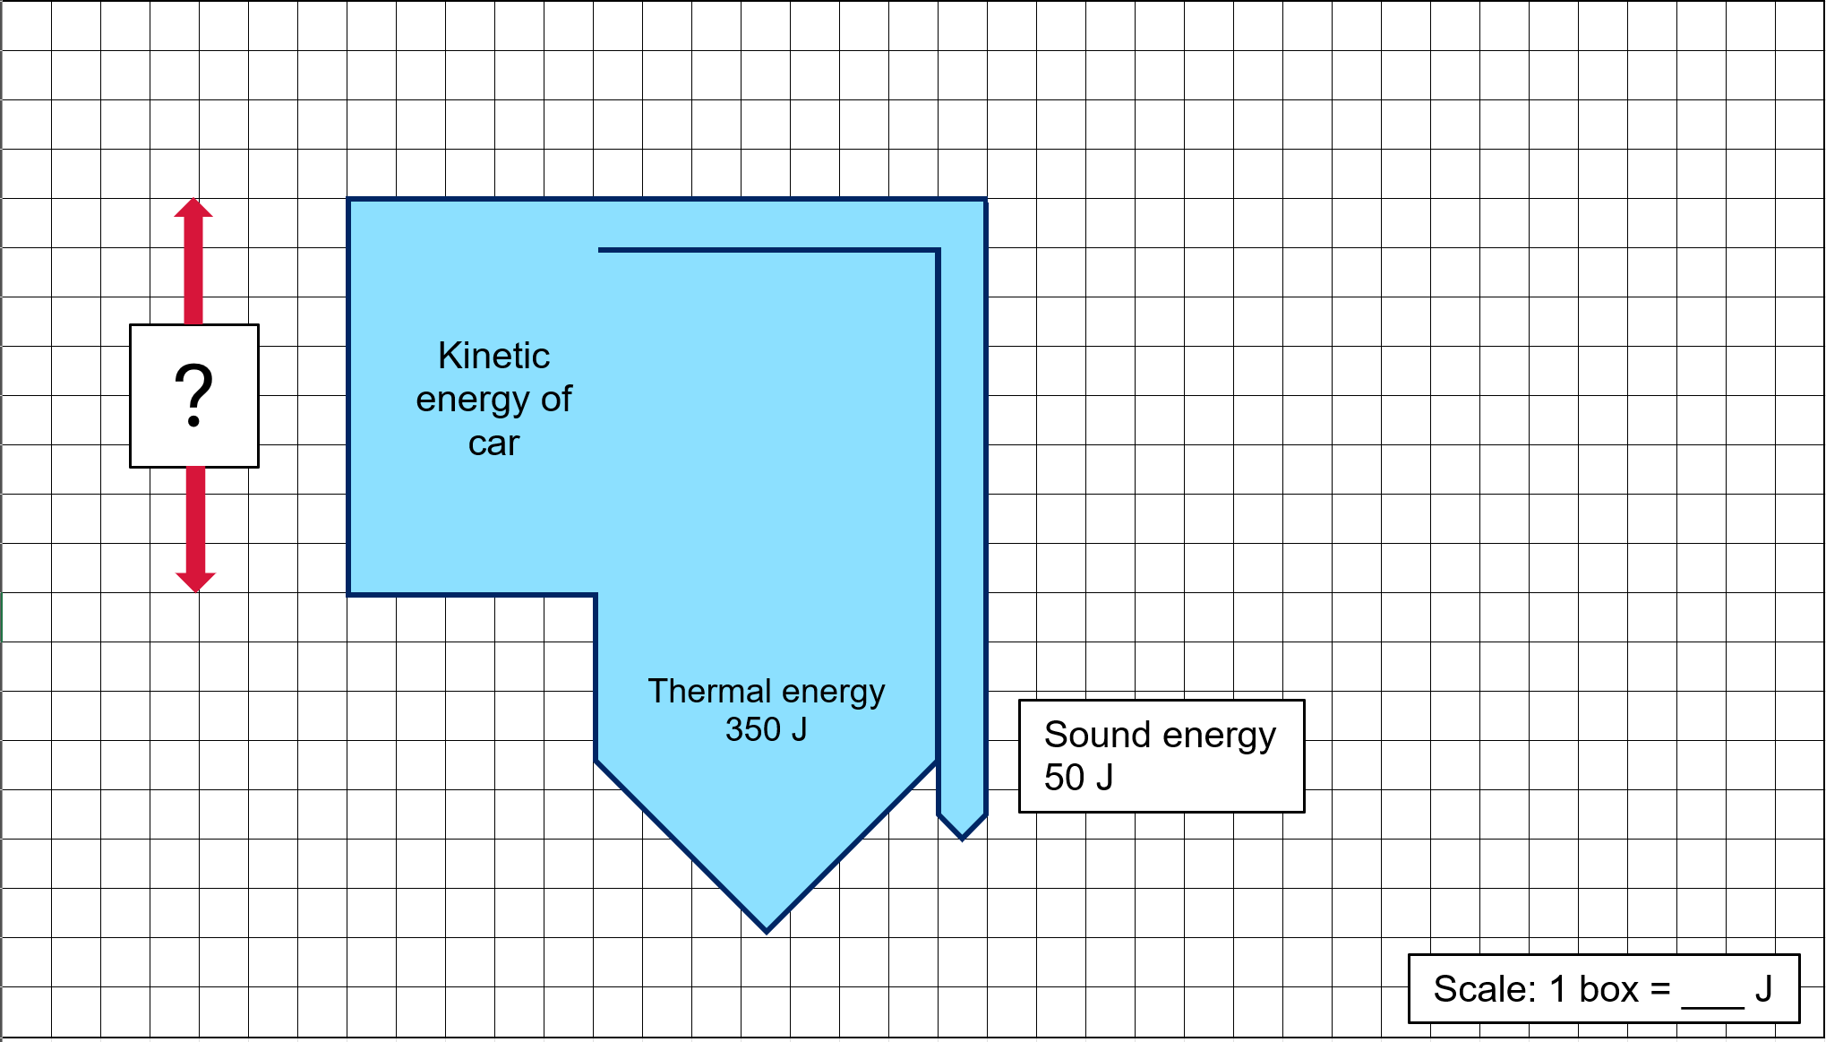
Thermal energy = 350 J and is 7 boxes wide. Therefore, the scale is 350 J / 7 boxes = 50 J per box.
The car's initial kinetic energy is 400 J. Eight boxes at 50 J per box = 400, or 350 J + 50 J = 400 J.
Note: in Sankey diagrams representing energy processes, it is common to show useful energy flowing horizontally to the right while wasted energy is directed downwards. This convention helps to separate the 2 types of energy visually and clearly illustrates the efficiency of a process. When a car applies its brakes, both the thermal and sound energy are wasted energy. Regenerative braking systems in hybrid and electric vehicles recover energy that would be wasted in braking, transforming the kinetic energy into electrical energy for storage in a battery. More than half of the energy wasted can be recovered in this way.
- A solar-powered water pump uses solar panels to transform solar energy into electrical energy. It is then used to drive a motor that pumps water, pushing it through water pipes. The energy transformations are shown in Figure 23.
Figure 23 –energy transformations in a solar-powered water pump
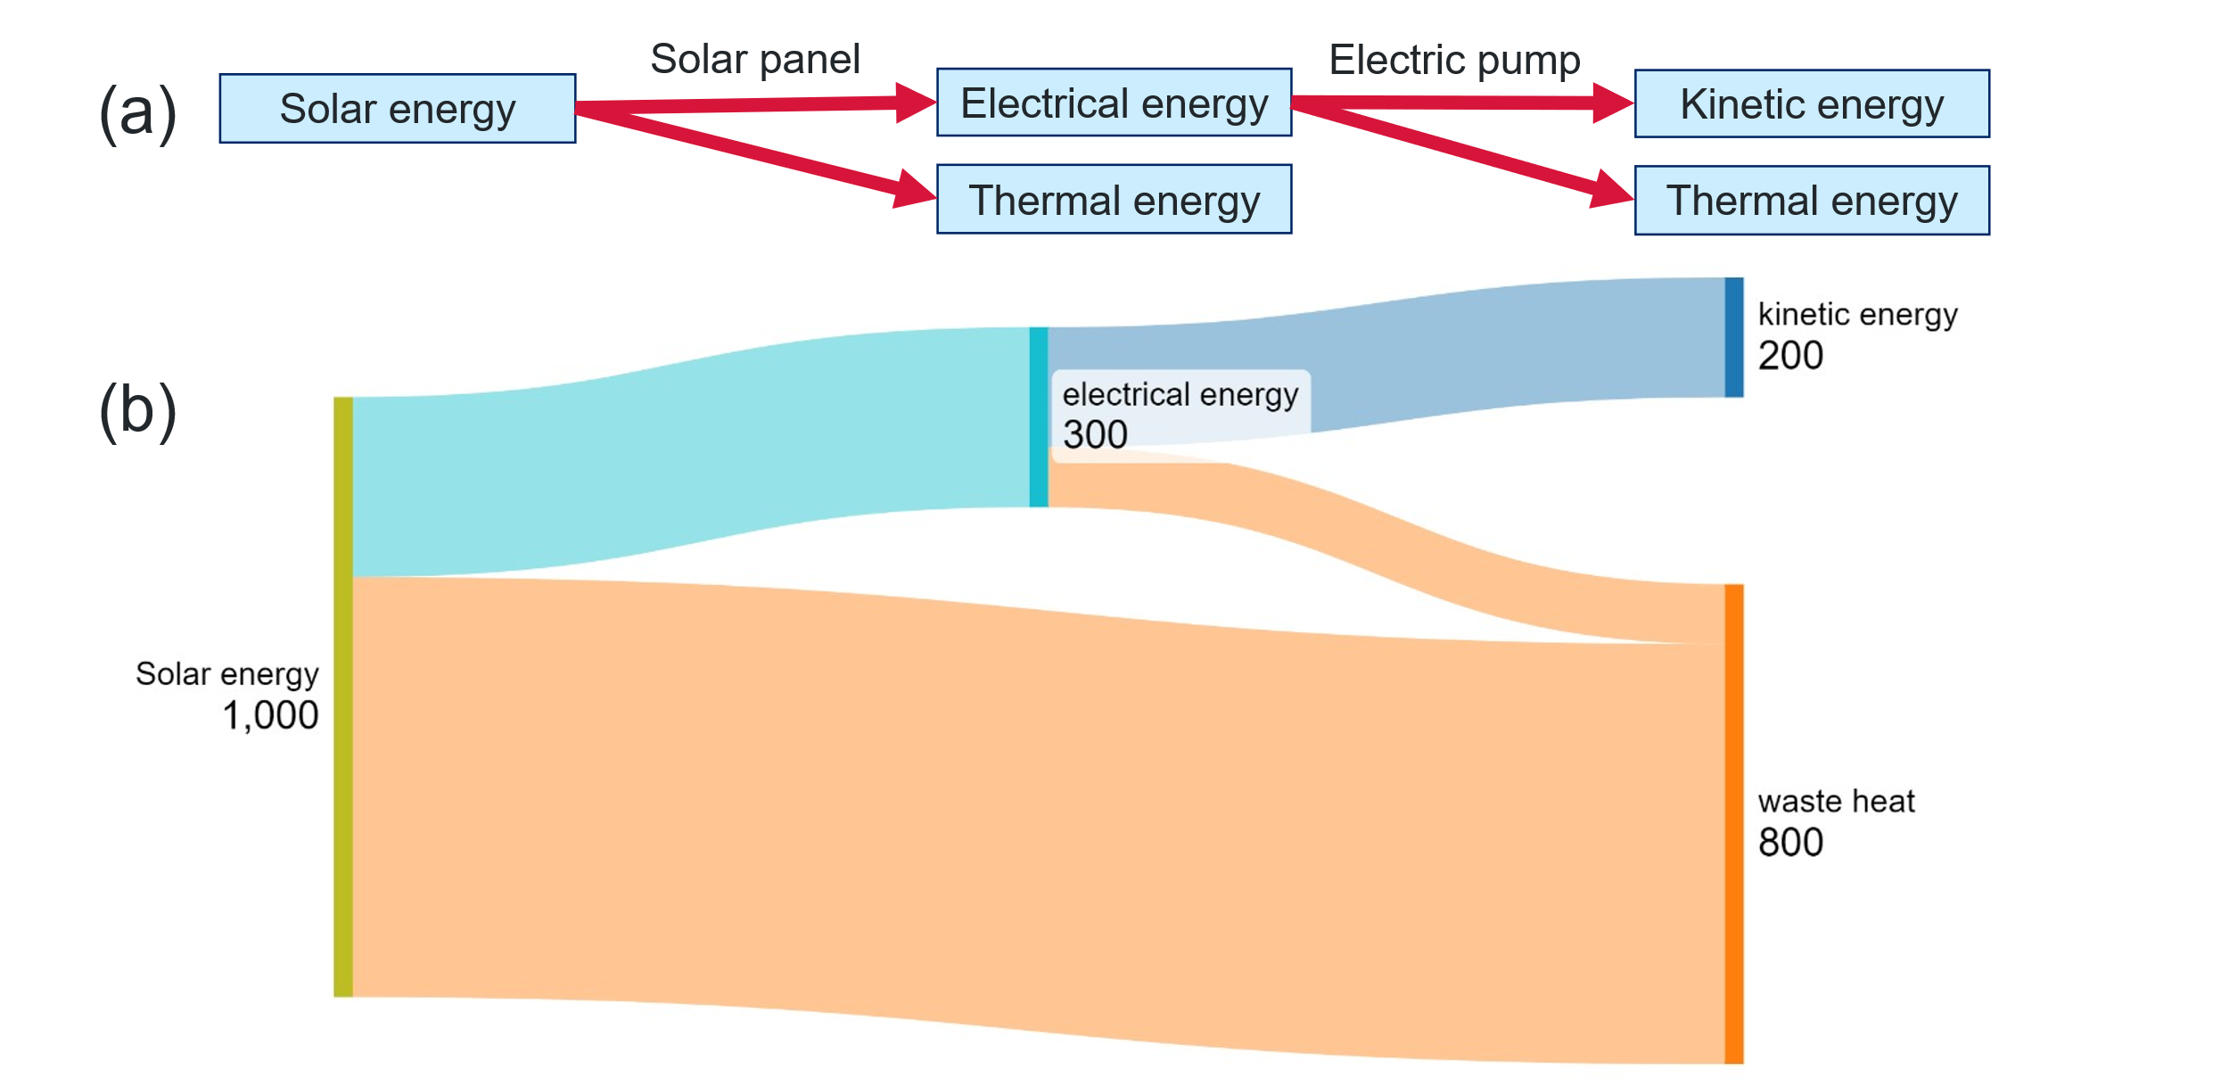
- How many of the 1000 units of solar energy inputted is transformed into useful energy output as kinetic energy?
Two hundred units of kinetic energy is output from the initial 1000 units of solar energy.
- Which energy transformation results in the largest amount of wasted energy? Use information from the diagram to support your response.
The transformation of solar energy to electrical energy produces mostly waste heat. Of the 1000 solar energy units, only 300 are transformed into electrical energy.
- Challenge question: consider the energy changes as a ball bounces. Construct a Sankey diagram to describe the energy lost after each bounce, as shown in Figure 24.
Figure 24 – image of a ball bouncing

Figure 25 – sample response to question 6. A Sankey diagram showing the energy decreasing over time in ball-Earth system, as energy is lost to the surroundings after each bounce.
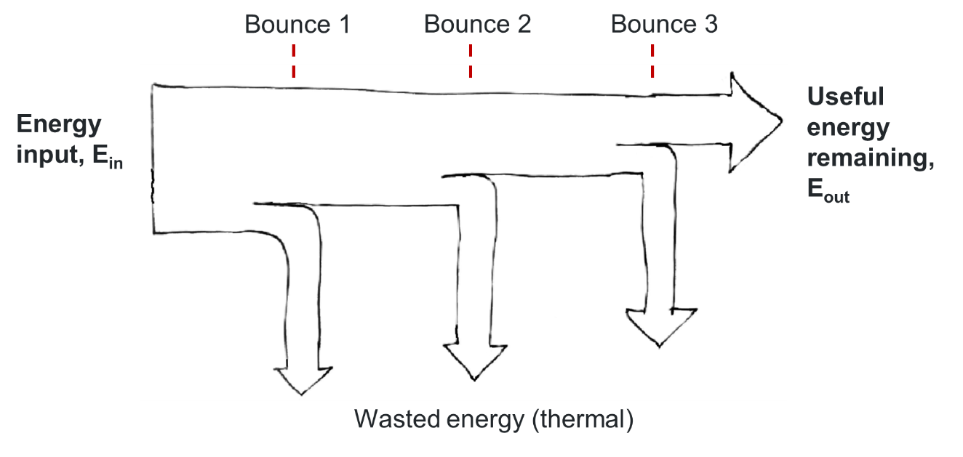
Expect significant variation in responses as students estimate proportions and make choices about the level of detail to include. When reviewing responses, look out for:
- labels showing energy in, energy out and wasted energy
- labels describing how energy is stored in the system (for example, gravitational potential energy, kinetic energy, thermal energy or elastic energy)
- the width of the arrows shows wasted energy at energy bounce (equal or decreasing over time).
Note: the Physics Fox Sankey Diagrams website has further reading, examples of Sankey diagrams, and multiple-choice questions. This website could be set for students to complete as pre-reading for this lesson or as further practice questions for students to apply their learning.

1.4 Calculating efficiency
Students quantitatively describe the efficiency of appliances and energy processes using units such as joules, kilojoules and watts.
Table 10 – learning intentions and success criteria for ‘Calculating efficiency’
We are learning: | I can:
- how to use energy more efficiently  - to systematically collect and record data, information, evidence and findings  - to represent and organise data and information to find patterns and to calculate useful values. | - create Sankey diagrams to describe the efficiency of appliances and processes  - extract relevant information from tables and diagrams  - calculate the percentage efficiency using energy inputs and outputs.

Instructions
Quantifying efficiency
- Introduce the efficiency equation. $\% efficiency=\frac{E_{useful}}{E_{input}}×100$, where E_{input} is the energy input into a system, and E_{useful} is the energy output (work done) by it.
- Apply the equation to complete the examples in Table 11 using a gradual release of responsibility (I do, we do, you do) strategy. This table is also provided in EGY PPT ‘1.4 Calculating efficiency questions’.
Table 11 – question sequence for question 2
$E_{input}$ (J) | $E_{output}$ (J) | % efficiency | Question/instruction
1,000 | 800 | ? | I do: Calculate the efficiency.
1,500 | ? | 60% | We do: Find the energy output.
? | 600 | 75% | We do: Find the energy input.
2,000 | ? | 50% | We do: Find the energy output.
1,200 | 600 | ? | You do: Calculate the efficiency.
? | 300 | 25% | You do: Find the energy input.
800 | ? | 40% | You do: Find the energy output.
Table 12 – sample responses for question 2
$E_{input}$ (J) | $E_{output}$ (J) | % efficiency
1,000 | 800 | 80%
1,500 | 900 | 60%
450 | 600 | 75%
2,000 | 1,000 | 50%
1,200 | 600 | 50%
1,200 | 300 | 25%
800 | 320 | 40%
Units of energy and power
- Write ‘milli-‘and ‘kilo-‘ on the board and brainstorm all the words using these prefixes that students are familiar with.
Milli- words | Kilo- words
- Millimetre (mm)  - Millisecond (ms)  - Millilitre (mL) |  | - Kilometre (km)  - Kilogram (kg)  - Kilowatt (kW)  - Kilobyte (KB)  - Kilojoule (kJ)
- Ask students to identify as many other prefixes as possible that describe fractional and multiple units.
Students may identify any of the other prefixes included in Figure 26.
- Introduce the unit prefixes and symbols in the Science 7–10 data book.
Figure 26 – decimal fractions and multiples
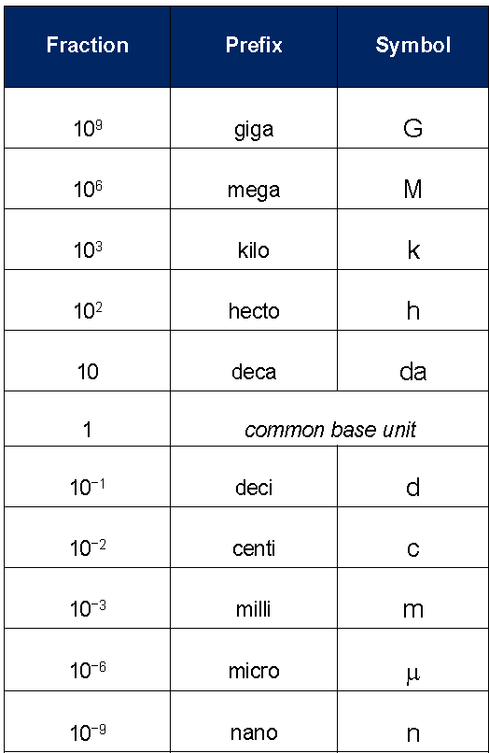
Source: Science 7–10 Data Book (NESA 2023)
What is a watt?
A watt is a unit of power that measures the rate at which energy is used or generated. It describes how much energy is consumed or produced per second. For example, a 40 W light globe uses 40 joules of energy per second. (40 W = 40 J/s)
- Practise converting between and representing quantities of energy and power using at least the following units:
- joules (J) and kilojoules (kJ) for energy (see EGY PPT ‘1.4 Energy conversions’). The sample responses are provided in Table 13.
- watts (W), kilowatts (kW) and milliwatts (mW) for power (see EGY PPT ‘1.4 Power conversions’). The sample responses are provided in Table 14.
Note: the red text below is an example of a student response.
Table 13 –sample response for energy unit conversions, where students complete the blanks. The student-facing version appears on EGY PPT ‘1.4 Energy conversions’.
Joules (J) | Kilojoules (kJ) | Instruction
5,000 | 5,000 J / 1,000 J/kJ = 5 kJ | I do
0.5 kJ x 1,000 J/kJ = 500 J | 0.5 | We do
7,500 | 7,500 J = 7.5 kJ | You do
2,000 J = 2 kJ | 2 | You do
Table 14 – sample power unit conversions where students complete the blanks. The student-facing version appears on EGY PPT ‘1.4 Power conversions’.
Milliwatts (mW) | Watts (W) | Kilowatts (kW) | Instruction
1,000 W x 1,000  = 1,000,000 mW, | 1,000 | 1,000 W / 1,000  = 1 kW | I do
0.5 kW x 1,000 W/kW x 1,000  = 500,000 mW | 0.5 kW x 1,000  = 500 W | 0.5 | We do
2,500 | 2.5 | 0.0025 | You do
3,000,000 | 3,000 | 3 | You do

Practice question set
Display EGY PPT ‘1.4 Practice questions’ (2 slides) on the board. Have the students work through the range of problems. Move around the room and check individual students' understanding. Sample answers are provided for each question below.
Understanding Sankey diagrams
- Draw a basic Sankey diagram to represent the following energy transformation in a light bulb:
- Electrical power input: 40 W
- Useful light output: 5 W
- Waste heat output: 35 W
- Label the arrows with the appropriate energy values and types.
Figure 27 – sample response for questions 1 and 2
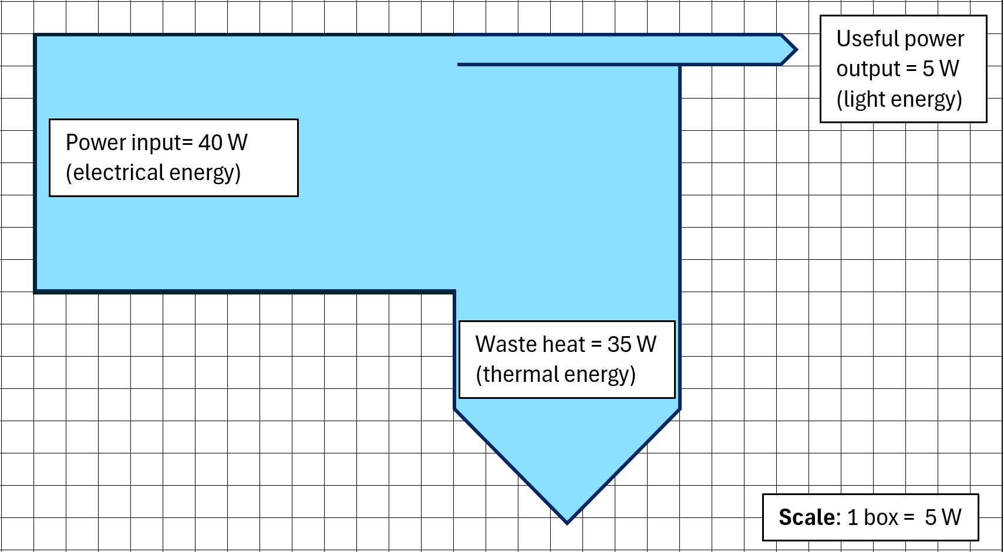

Calculating energy efficiency
- Use the Sankey diagram you created in Question 1 to calculate the light bulb's efficiency.
Use the formula:
$$\% efficiency=\frac{Useful energy output}{Total energy input}×100$$
OR
$$\% efficiency=\frac{E_{useful}}{E_{input}}×100$$
$$\% efficiency=\frac{E_{useful}}{E_{input}}×100=\frac{5}{40}×100=12.5\%$$
- Interpret the efficiency of the light bulb. What does this tell you about its performance?
An efficiency of 12.5% is quite low, meaning most of the energy input is wasted. Only 1/8 of the energy input is usefully transformed into light. This light globe does not perform well.
Comparing energy efficiencies
- Create Sankey diagrams for 2 different motors:
- Motor A: total energy input 200 J, useful mechanical energy output 60 J, waste heat energy output 140 J.
- Motor B: total energy input 400 J, useful mechanical energy output 100 J, waste heat energy output 300 J.
Figure 28 – sample response for question 5. Sankey diagrams for motors A and B.
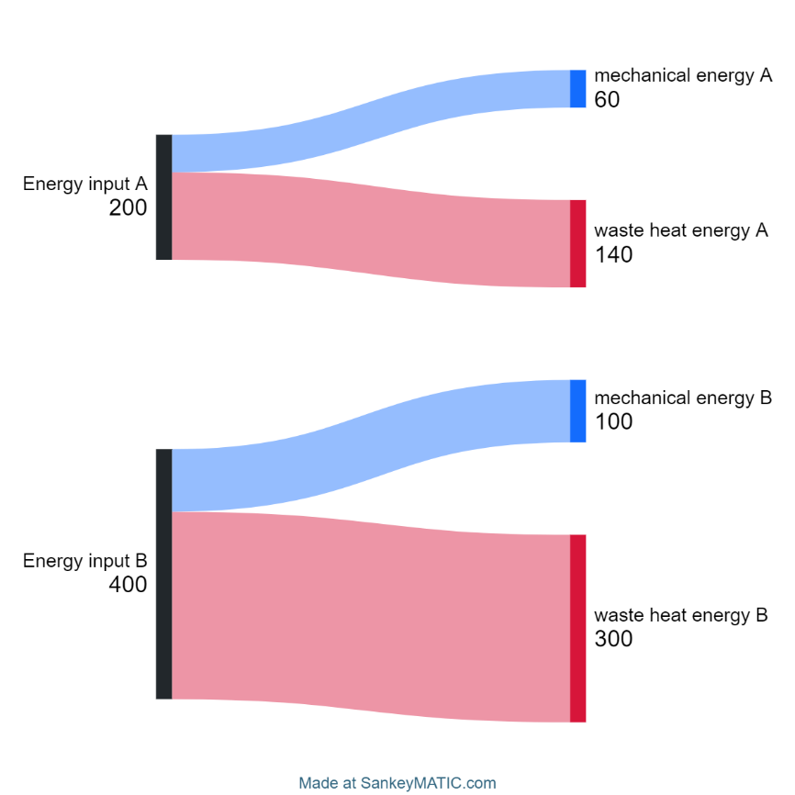
This work has been generated using SankeyMATIC.com. Any copyright subsisting in this work is owned by © State of New South Wales (Department of Education) 2024.

- Calculate the efficiency of each motor.
Motor A
$$\% efficiency=\frac{60}{200}×100=30\%$$
Motor B
$$\% efficiency=\frac{100}{400}×100=25\%$$
- Which motor is more efficient and why?
Motor A (30% efficient) is more efficient than motor B (25% efficient). Even though the mechanical energy output of motor B was greater than that of A, the ratio of useful energy output to energy input was lower and a greater proportion of the energy was wasted.
- Discuss the implications of using more efficient motors.
Using more efficient motors requires less energy to complete each task. This will reduce energy consumption, resulting in cost savings and possibly reducing environmental impact through reduced CO₂ emissions.
Application in renewable energy
- Create a Sankey diagram to represent the energy flow in a solar panel system where:
- Solar energy input: 500 J
- Electrical energy output: 100 J
- Energy lost as heat: 350 J
- Energy lost due to reflection: 50 J.
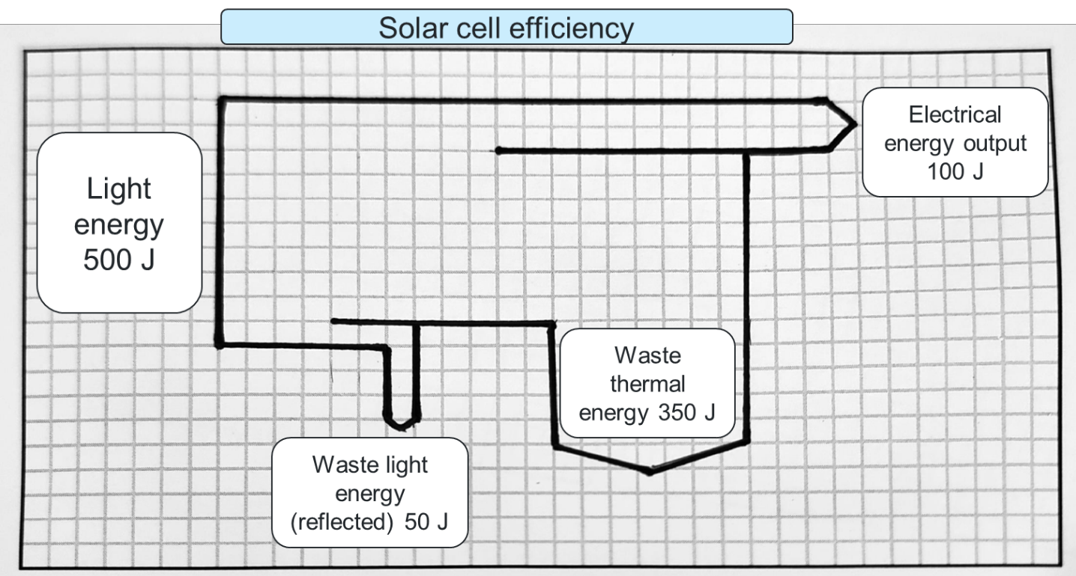

- Calculate the efficiency of the solar panel system.
$$\% efficiency=\frac{100}{500}×100=20\%$$
- Discuss the factors that might affect the efficiency of solar panels in real-world applications and propose potential improvements.
The angle and direction in which they are fitted on the roof will affect their efficiency. Panels facing north generally generate more useful electrical energy each day. Cloudy weather will also limit efficiency, as less of the light energy will reach the panel to be transformed into electrical energy.
Data interpretation and communication
Give students a Sankey diagram as a stimulus that represents energy use in transportation (for example, an internal combustion car engine as in Figure 29).
- Calculate the overall efficiency.
- Communicate your findings in a short report. Include recommendations for improving energy efficiency in transportation systems.
Figure 29 – sample Sankey diagrams describing the energy transfers and transformations occurring in an internal combustion engine (ICE) vehicle.
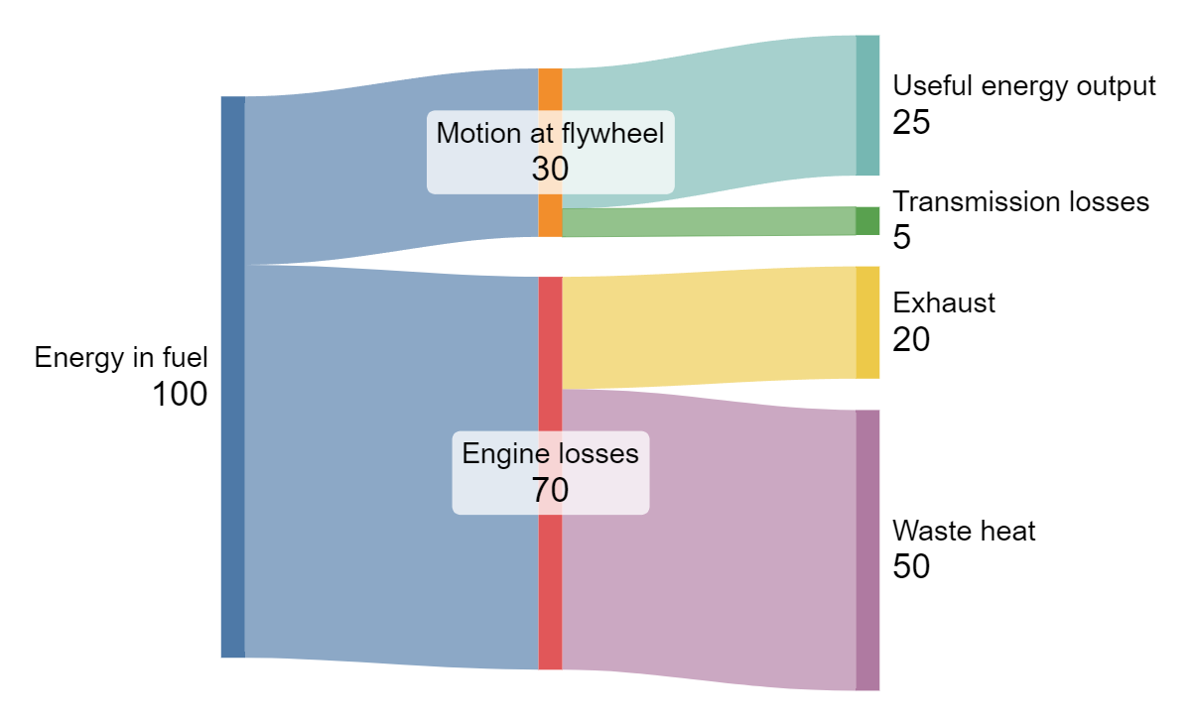
This work has been generated using SankeyMATIC.com. Any copyright subsisting in this work is owned by © State of New South Wales (Department of Education) 2024.
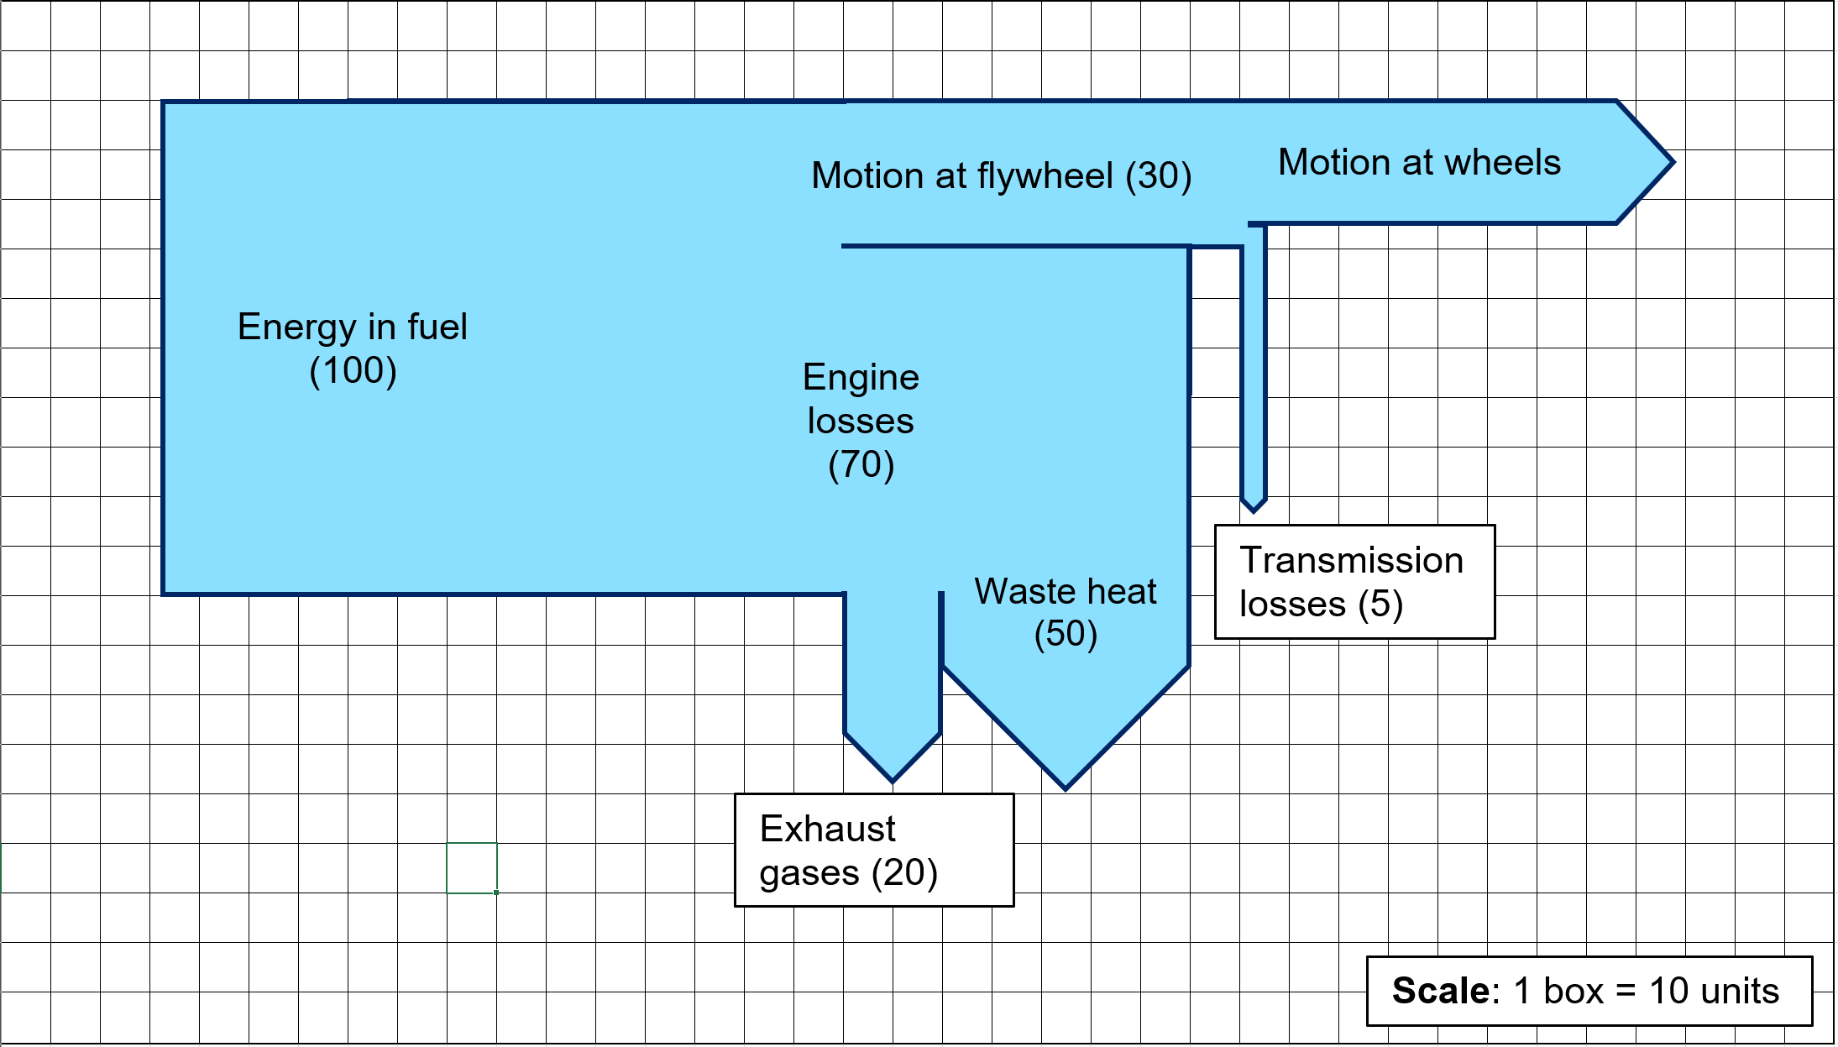
Note: some of the components of an internal combustion engine (ICE) will be unfamiliar to many students. If using this example, provide information as required to ensure students can effectively engage with the relevant energy concepts. The flywheel in an ICE is a rotating mechanical device designed to store rotational energy. It plays an important role in smoothing out the engine's power delivery and improving efficiency. The engine transforms energy in short bursts as fuel is combusted in each cylinder. The flywheel stores some of this energy to maintain a consistent rotational speed. As energy is transferred through the cars’ transmission system (gears and shafts), friction transforms some energy into heat, further reducing efficiency.
Sample response for question 13
Efficiency of an Internal Combustion Engine (ICE)
Introduction: An engine's efficiency is measured by how much of the input energy (from fuel) is converted into useful output energy to move the vehicle.
Energy input and losses: The total energy input from fuel in the engine is 100 units. This is the maximum available energy to power the engine. However, not all of this energy is used to move the vehicle. A significant portion is lost in the exhaust gases and waste heat. In this case, 70 units of energy are lost as heat and gases, which means this energy is not available for useful work.
Some energy (30 units) is stored as motion in the flywheel, which helps keep the engine running smoothly. This energy is not immediately used but helps maintain the engine’s rotation.
Useful energy output: 25 units of useful energy actually reach the wheels and help move the car. This is the energy that performs the desired work—moving the vehicle forward.
Transmission losses: Before the energy reaches the wheels, 5 units of energy are lost in the transmission system. These losses occur due to friction and other inefficiencies as the power is transferred from the engine to the wheels.
Calculating efficiency: To calculate the efficiency of the engine, we use the following formula.
$$\% efficiency=\frac{E_{useful}}{E_{input}}×100$$
In this case:
$$\% efficiency=\frac{25}{100}×100=25\%$$
This means that only 25% of the fuel's energy is used to move the vehicle, while the remaining 75% is lost in various forms, mainly as heat and in the transmission system.
Conclusion: The internal combustion engine in this example is only 25% efficient, meaning a large proportion of the energy is lost as waste heat and through the transmission system. Improving engine efficiency would involve reducing these losses to better use the fuel's energy.
What to look for in responses:
Students:
- have extracted relevant qualitative and quantitative information from the Sankey diagram
- have outlined energy transformations
- applied calculations to determine the percent efficiency of at least one process
- structured their response logically and effectively using scientific formats.
Checkpoint: students look at the Sankey diagram showing how energy flows in photosynthesis (Figure 30). Write a summary of the energy processes. Use quantitative and qualitative information from the diagram to explain what is happening – including scientific terms and calculations to support your explanation.
Figure 30 – Sankey diagram of a photosynthesis reaction
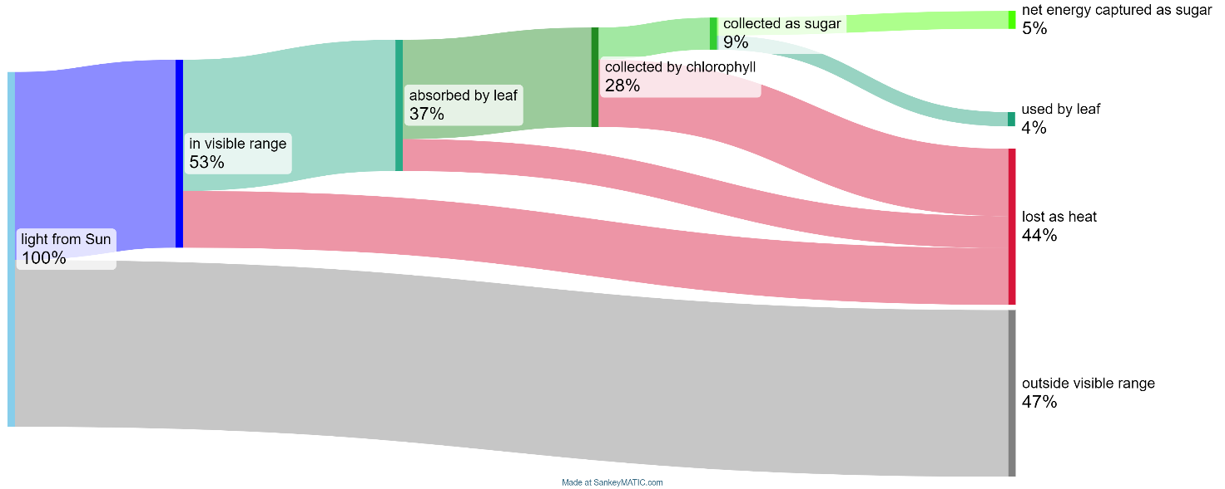
This work has been generated using SankeyMATIC.com. Any copyright subsisting in this work is owned by © State of New South Wales (Department of Education) 2024.
What to look for in responses:
Students:
- have extracted relevant qualitative and quantitative information from the Sankey diagram
- have outlined energy transformations
- applied calculations to determine the % efficiency of at least one process
- structured their response logically and effectively using scientific formats.

1.5 Improving energy efficiency
Table 15 – learning intentions and success criteria for ‘Improving energy efficiency’
We are learning: | I can:
- how we can use energy more efficiently  - to systematically collect and record data, information, evidence and findings  - to select strategies to solve scientific problems and to evaluate our solutions. | - extract relevant information from a case study  - explain how a business or individual can improve their energy efficiency.
Students revisit the energy demonstrations introduced in 1.2 Representing energy and suggest ways to improve the efficiency of energy transfers or transformations. They then explore a case study demonstrating how efficiency can be improved in households or businesses.

Preparation
If students cannot access the Internet for this activity, case studies can be printed and distributed to them in class. Each case study is suitable for printing on a single, double-sided sheet of paper.

Instructions
Each student or student group selects a case study from the energy.gov.au Publications page (for example, Indulge Chocolates).
They use the issue, action and impact scaffold (EGY PPT ‘1.5 Summarising case studies’) to summarise the information in the case study and report back to the class.
- Issue: identify the key energy use issues from the case study, such as the amount of energy consumed and the activities or processes that contribute most to the total.
- Action: outline the change(s) made to improve energy efficiency and identify any resources required to make the change.
- Impact: explain the improvements that were observed and how they improved the business.
Indulge Fine Belgian Chocolates case study
Issue: the business had high energy costs due to lighting, heating, cooling, and equipment use.
Action:
To reduce energy use, they:
- turned off lights and unplugged equipment when not in use
- set the air conditioner to 25°C or higher in summer
- used excess heat from chocolate-making machines to warm the store in winter, eliminating the need for a heater
- installed energy-efficient LED lights and a new refrigerator
- added extra shading to the building to reduce cooling needs.
Impact:
These changes saved $1,600 annually and allowed the business to grow by 20% without increasing energy consumption.
Alternate activity: model efficiency improvements in motors and mechanical systems, such as reducing friction for a car rolling down a ramp or heating water using a hot plate or Bunsen burner.

Appendix
Figure 31 – representing different types of energy stores in energy flow diagrams and work-energy bar charts.
Motion energy examples (adapted from Chow et al 2018)
Name of energy | Label | Short label | Storage mechanism | Measured property
Kinetic energy | $$E_{kinetic}$$ | $$E_{k}$$ | Stored in the motion of the object | Speed
Thermal energy | $$E_{thermal}$$ | $$E_{th}$$ | Stored in the molecular and atomic motion | Temperature
Interaction (potential) energy examples (adapted from Chow et al 2018)
Name of energy | Label | Short label | Storage mechanism | Measured property
Gravitational energy | $$E_{gravitational}$$ | $$E_{g}$$ | Stored in the interaction between the object and Earth (Earth’s gravitational field) | Vertical position
Elastic energy | $$E_{elastic}$$ | $$E_{e}$$ | Macroscopic: stored in stretch or compression of object (shape change) | Length (stretch or compression)
Chemical energy | $$E_{chemical}$$ | $$E_{int}$$ | Stored in interactions between particles | Number of chemical species
Electrical energy | $$E_{electrical}$$ | $$E_{elec}$$ | Stored in the interactions between charged particles | Voltage, current and time
Note: $W_{ork}$ or $W_{ext}$ (Work external) is used to describe energy flowing into or out of the system (the work done on or by the system on the surroundings).
In Stage 6 Physics, $U$ and $K$ are also used to represent potential and kinetic energy, respectively, in physics formulas.

Evidence base
This resource contains NSW Curriculum and syllabus content. The NSW Curriculum is developed by the NSW Education Standards Authority (NESA). This content is prepared by NESA for and on behalf of the Crown in right of the State of New South Wales. The material is protected by Crown copyright.
Please refer to the NESA Copyright Disclaimer for more information https://www.nsw.gov.au/education-and-training/nesa/copyright.
NESA holds the only official and up-to-date versions of the NSW Curriculum and syllabus documents. Please visit NESA https://www.nsw.gov.au/education-and-training/nesa and NSW Curriculum https://curriculum.nsw.edu.au.
Science 7–10 Syllabus © NSW Education Standards Authority (NESA) for and on behalf of the Crown in right of the State of New South Wales, 2023.
Science 7–10 Data Book © NSW Education Standards Authority (NESA) for and on behalf of the Crown in right of the State of New South Wales, 2023.
Bell D, Rosa D, Hubert D, Fernandez de la Garza G, Lena P, Millar R, Reiss M, Rowell P and Yu W (2010) Principles and big ideas of science education (W Harlen, eds), Association for Science Education.
Bogart S (2014) SankeyMATIC [website], accessed 15 July 2024.
Blackman M (2024) Energy Bar Charts, Universe and more website, accessed 15 July 2024.
Brookhart SM (2018) ‘Appropriate Criteria: Key to Effective Rubrics’, Frontiers in Education, volume 3(22):1–12, doi:10.3389/feduc.2018.00022, accessed 15 July 2024.
CESE (Centre for Education Statistics and Evaluation) (2020a) What works best: 2020 update, NSW Department of Education, accessed 15 July 2024.
——(2020b) What works best in practice, NSW Department of Education, accessed 15 July 2024.
——(2021) Growth goal setting – what works best in practice, NSW Department of Education, accessed 15 July 2024.
Chow N, Fish D, Foyle K & Pope D (2018) A Deeper Understanding of Energy [PDF 1.54 MB], Perimeter Institute for Theoretical Physics, accessed 25 March 2022.
Department of Climate Change, Energy, the Environment and Water (DCCEEW) (2013) Energy efficiency improvements - Indulge Chocolates, energy.gov.au, accessed 15 July 2024.
——(2024) Publications, energy.gov.au, accessed 15 July 2024.
Fisher D & Frey N (1 November 2009) ‘Feed Up, Back, Forward’, ASCD (Association for Supervision and Curriculum Development): Educational Leadership magazine, 67(3), accessed 15 July 2024.
Griffin P (2017) Assessment for Teaching, Cambridge University Press, Port Melbourne, Victoria.
Hattie J & Timperley H (2007) ‘The Power of Feedback’, Review of Educational Research, 77(1): 81–112, doi:10.3102/003465430298487.
Mr Godfrey (26 February 2015) ‘The 5 steps to drawing a perfect Sankey diagram’ [video], Mr Godfrey, YouTube, accessed 15 July 2024.
Panadero E and Jonsson A (2013) ‘The use of scoring rubrics for formative assessment purposes revisited: A review’, Educational Research Review, 9:129–144, doi:10.1016/j.edurev.2013.01.002, accessed 15 July 2024.
Sherrington T (2019) Rosenshine’s Principles in Action, John Catt Educational Limited, Melton, Woodbridge.
SPU Physics Department (2020) Representing Energy – Energy Cubes, Representing Energy website, accessed 25 March 2022.
Sustainable Energy Authority of Ireland (SEAI) (n.d.) Energy in Action [PDF 1143 KB], Sustainable Energy Authority of Ireland, accessed 15 July 2024.
Van Heuvelen A and Zou X (2001) ‘Multiple representations of work–energy processes’, American Journal of Physics, 69(2):184–194, doi:10.1119/1.1286662, accessed 25 March 2022.
Wiliam D (2017) Embedded Formative Assessment, 2nd edn, Solution Tree Press, Bloomington, IN.

© State of New South Wales (Department of Education), 2024
The copyright material published in this resource is subject to the Copyright Act 1968 (Cth) and is owned by the NSW Department of Education or, where indicated, by a party other than the NSW Department of Education (third-party material).
Copyright material available in this resource and owned by the NSW Department of Education is licensed under a Creative Commons Attribution 4.0 International (CC BY 4.0) license.

This license allows you to share and adapt the material for any purpose, even commercially.
Attribution should be given to © State of New South Wales (Department of Education), 2024.
Material in this resource not available under a Creative Commons license:
- the NSW Department of Education logo, other logos and trademark-protected material
- material owned by a third party that has been reproduced with permission. You will need to obtain permission from the third party to reuse its material.
Links to third-party material and websites
Please note that the provided (reading/viewing material/list/links/texts) are a suggestion only and implies no endorsement, by the New South Wales Department of Education, of any author, publisher, or book title. School principals and teachers are best placed to assess the suitability of resources that would complement the curriculum and reflect the needs and interests of their students.
If you use the links provided in this document to access a third-party's website, you acknowledge that the terms of use, including licence terms set out on the third-party's website apply to the use which may be made of the materials on that third-party website or where permitted by the Copyright Act 1968 (Cth). The department accepts no responsibility for content on third-party websites.

