Science Stage 5 (Year 9) – sample program of learning
Energy
Creation date: 15 July 2024. Updated: 13 February 2026.
Contents
Rationale 4
Overview 4
Navigating the resources 9
Lesson sequence 11
1 How can we improve energy efficiency? 12
1.1 Getting to know each other (optional) 12
1.2 Representing energy 12
1.3 Understanding efficiency 15
1.4 Calculating efficiency 17
1.5 Improving energy efficiency 18
2 How do we choose the best energy source for generating electricity? 20
DS.1 Explaining the task and planning data collection 20
2.1 Renewable energy 21
2.2 Generating electricity 23
2.3 Thermal generation using coal, gas and nuclear 24
2.4 Wind and hydroelectric power 26
2.5 Practical investigation – solar power 28
2.6 Making informed decisions 29
3 How does knowledge of electric circuits help us use electricity wisely? 31
3.1 Introduction to circuits 31
3.2 Constructing electric circuits 33
3.3 Voltage and current in electric circuits (Ohm’s Law) 34
3.4 Series and parallel circuits 37
3.5 Power and energy 39
3.6 Energy efficiency and electrical appliances 41
3.7 Energy bill 42
DS.2 Conducting classroom energy use audit 43
DS.3 Analysing collected data 43
4 How can we make better energy choices for the future? 45
4.1 Past and future energy use 45
4.2 Sustainable energy use 47
DS.4 Exploring options for action 49
DS.5 Identifying constraints and selecting an idea for action 50
DS.6 Developing your action proposal 50
4.3 Evaluating nuclear energy in Australia 51
4.4 Transitioning to net zero 52
4.5 Truths, lies and the in between 53
5 Depth study sharing and reflection 54
DS.7 Communicating the proposal 54
DS.8 Reflecting on the proposed actions and evaluating plans 55
Overall program evaluation 56
Evidence base 57

Rationale
This sample program of learning has been developed by the NSW Department of Education. NSW Education Standards Authority (NESA) defines programming as ‘the process of selecting and sequencing learning experiences which enable students to engage with syllabus outcomes and develop subject-specific skills and knowledge’ (NESA 2024).
This program has been developed to assist teachers in NSW Department of Education schools in creating learning contextualised to their classroom. It has suggested timeframes that may need to be adjusted by the teacher to align with the school calendar and meet the learning needs of their students. The program may provide links to web pages outside the department’s website. These links are a source of information or activities that may be suitable for delivering the course content. These sites are managed by organisations, companies or individuals outside of our control, and the department is not responsible for the information or subsequent links on these web pages.

Overview
After completing the units in this program of learning, students will understand that:
- energy is conserved in every event and process that occurs in nature
- the work done on an open system by an external force or process increases the system’s energy
- the energy transformed over time in electrical devices can be predicted and measured
- electrical appliances transform energy in electrical circuits.
- there is a range of energy sources that could be used to generate electricity (and each has its advantages/disadvantages)
- access to accurate data is critical to making informed decisions about energy use
- their personal choices contribute to global energy use
- establishing standards to compare energy options helps us make informed personal, national, and global decisions about our future energy use.
Prior learning
In the Stage 4 Change focus area, students:
- describe how systems can store energy in different forms, including thermal, elastic, chemical, and gravitational energy
- define open and closed systems to describe how energy is transferred into and out of systems and how it cycles within a system
- use a range of representations to illustrate energy transfers and transformations
- apply the law of conservation of energy to familiar examples.
In Stage 3 – Electrical energy can be transferred and transformed, students:
- recognise that an electrical circuit transfers electrical energy from a source through a pathway to a device that transforms electrical energy into other forms of energy
- plan and construct simple electrical circuits to model the transfer and transformation of energy
- identify renewable and non-renewable energy sources
- research and present information describing the impact on resources and the environment of using a renewable or a non-renewable resource to generate electricity
Transfer of learning
Students will be able to use their learning to:
- evaluate claims made in scientific and non-scientific media relating to energy use
- access and analyse relevant data to engage in debates on local, national and global issues
- make informed choices about personal energy use, including behaviours and selection of technologies
- develop the foundational knowledge for Stage 6 Physics.
Table 1 – energy program key information
Feature | Details
Outcomes | A student:  - evaluates current and alternative energy use based on ethical and sustainability considerations SC5-EGY-01  - selects and uses scientific tools and instruments for accurate observations SC5-WS-01 (Observing)  - follows a planned procedure to undertake safe, ethical, valid and reliable investigations SC5-WS-04 (Conducting investigations)  - selects and uses a range of tools to process and represent data SC5-WS-05 (Processing data and information)  - analyses data from investigations to identify trends, patterns and relationships, and draws conclusions SC5-WS-06 (Analysing data and information)  - selects suitable problem-solving strategies and evaluates proposed solutions to identified problems SC5-WS-07 (Problem solving)  - communicates scientific arguments with evidence, using scientific language and terminology in a range of communication forms SC5-WS-08 (Communicating)  Science 7–10 Syllabus © NSW Education Standards Authority (NESA) for and on behalf of the Crown in right of the State of New South Wales, 2023.
Assessment | Depth study on optimising energy use
Duration | 10 weeks
Special materials and equipment | - A selection of toys to demonstrate energy transfers and transformations  - Data loggers with temperature sensors  - Plug power meters  - Digital multimeters  - Hygrometer or digital equivalent for measuring humidity  - Solar cells (see 2.5 Practical investigation – solar power)  - Electric hobby motors and fans
Risk management: Teachers are advised to undertake a risk assessment before conducting any classroom investigation or experiment. For more information on developing risk assessments see WHS risk management.

Navigating the resources
This section provides information for teachers to navigate the teacher resource books and the supporting PowerPoint for Energy. All content in these resources is aligned with the topics in the program. For example, the topic '1.2 Engaging with energy’ in the Energy program is aligned with '1.2 Engaging with energy activities’ in Teacher Resource Book 1 and supporting PowerPoint documents. Should the activities in the program contain additional information, such as practical investigation instructions, student worksheets and more, you will find it in the corresponding teacher resource book. The supporting PowerPoint document contains student-facing information, such as learning intentions and success criteria and checks for understanding for each topic in the program.
Table 2 – resource coding for cross-referencing between the program and supplementary resources
Coding in this resource | Document that it is referring to
TRB1 | Teacher resource book 1 – Energy
TRB2 | Teacher resource book 2 – Energy
TRB3 | Teacher resource book 3 – Energy
TRB4 | Teacher resource book 4 – Energy
EGY PPT | Slide deck – Energy
DS.1 – DS.8 | Energy depth study assessment task  - Assessment task – Energy  - Learning journal – Energy  - Audit and budget template – Energy  - Thermal comfort recording sheet – Energy

Lesson sequence
Table 3 – general scope of the unit
Element | Week 1 | Week 2 | Week 3 | Week 4 | Week 5 | Week 6 | Week 7 | Week 8 | Week 9 | Week 10
Essential question | How can we improve energy efficiency? |  | How do we choose the best energy source for generating electricity? |  | How does knowledge of electric circuits help us use electricity wisely? |  |  | How can we make better energy choices for the future? |  | Depth study sharing and reflection
Syllabus content group | Law of conservation of energy  (6 hours*) |  | Sources of energy  (6 hours*) |  | Electrical energy  (10 hours*) |  |  | Global future energy needs, Energy in context  (6 hours*) |  | Assessment  (3 hours*)
Depth study |  |  | DS.1 |  | DS.2 | DS.3 | DS.4 | DS.5 | DS.6 | DS.7 and DS.8
*The hours indicated are approximate and may be adjusted.

1 How can we improve energy efficiency?
Students will understand how energy is conserved across different systems and how this principle helps optimise energy use.
Revisit basic energy concepts from Stage 4, including open and closed systems, representations of energy (for example, energy transfer diagrams, work-energy bar charts, energy cubes), and the law of conservation of energy. Introduce the concept of energy efficiency and representations using Sankey diagrams to model and calculate energy efficiency in various scenarios, including mechanical systems and electrical appliances, with keystone examples for teaching.
Table 4 – How can we improve energy efficiency?
Content | Teaching and learning activities | Registration and evaluation notes
This activity includes activities designed for students at the beginning of Year 9. | 1.1 Getting to know each other (optional)  Complete Getting to know each other activity on Amplify Classroom: activity to get to know students and where they are at. Additional information in (TRB1).
Law of conservation of energy  - Use the law of conservation of energy, and calculations, to explain that total energy is maintained in energy transfers and transformations in a closed system  Processing data and information  - Select and use a range of representations to organise data and information, including graphs, keys, models, diagrams, tables, and spreadsheets | 1.2 Representing energy  Revising Stage 4 Energy (TRB1 and EGY PPT)  Revise key ideas about energy from Stage 4 content focus areas.  Energy cubes (TRB1 and EGY PPT)  Students use energy cubes to represent ‘chunks’ of energy, with each cube’s side labelled as a different storage mechanism. They construct, negotiate and enact energy stories that represent given scenarios.  Constructing energy flow diagrams (TRB1 and EGY PPT)  Outline the steps for constructing energy flow diagrams using worked examples. Revise the concept of open and closed systems and how they can be defined in energy flow diagrams.  Checkpoint: students describe changes required to make the closed system described for the pull-back car scenario an isolated system (TRB1 and EGY PPT).  Constructing a work-energy bar chart (TRB1 and EGY PPT)  Describe how a work-energy bar chart represents energy transformations.  Demonstrate how to construct a work-energy bar chart using a pull-back car scenario.  Differentiation: the PhET simulation Energy Skate Park includes a simplified version of a work-energy bar chart, showing how energy is stored within the skater-ramp-Earth system at specific points in time. The simulation also uses simplified terms to describe each energy store. Friction transforms some of the system's energy into thermal energy. Students can use the simulation to explore energy conservation within a system by changing the shape of the ramp, the friction and the gravity and observing the energy bar chart over time. Teaching Resources for using PhET simulations are included in the Teaching Resources tab for each resource (free login required).  Checkpoint: modify a work-energy bar chart in response to changes in the choice of system.  Energy representations of a block and ramp system (TRB1 and EGY PPT)  Demonstrate a block and ramp system and ask students to identify the energy transfers and transformations that occur as the block slides down the ramp.  Students construct energy representations (energy flow diagram and work-energy bar chart) for the energy transfers and transformations that occur.  Energy representations of some mechanical and electrical systems (TRB1 and EGY PPT)  Students engage with various mechanical and electrical toys and devices which involve energy transfers and transformations. Students apply their understanding of energy representations to construct energy flow diagrams and work-energy bar charts.  Checkpoint: Students test their understanding of energy representation by accessing the Energy bar charts interactive on the Universe and More website. Demonstrate the first example by (1) selecting an event, (2) playing the video, (3) selecting the system, (4) adding the required energy bars (and work if it is an open system), (5) adding the amounts of energy to each side, and (6) selecting ‘Check’ to show how automatic feedback is provided.
Law of conservation of energy  - Explain efficiency in relation to energy transfers  Processing data and information  - Select and use a range of representations to organise data and information, including graphs, keys, models, diagrams, tables, and spreadsheets | 1.3 Understanding efficiency  Explore students’ everyday use of the term ‘efficiency’.  - Each student writes a response to the question ‘What do we mean when we say something is efficient?’ on a slip of paper or whiteboard.  - Complete a Frayer diagram to define energy efficiency as the ratio of useful energy output to the total energy input (TRB1 and EGY PPT).  Note: NESA defines efficiency as ‘the ratio of the work done, or energy developed, by a machine or engine to the energy supplied to it’ (NESA 2024).  Introduce Sankey diagrams as a tool for describing efficiency in energy processes. Demonstrate how to construct a Sankey diagram (EGY PPT and TRB1).  Figure 1 – sample Sankey diagrams comparing the energy efficiency of systems  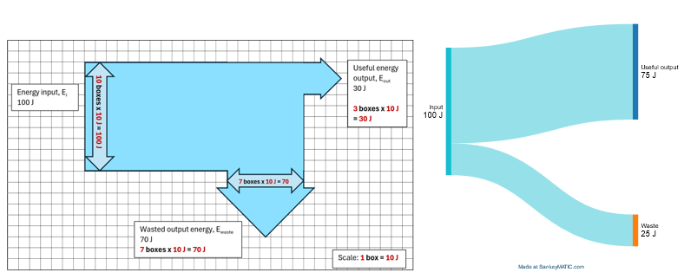  Students complete questions by creating and extracting information from Sankey diagrams (TRB1).  SankeyMATIC is a free online tool for creating and sharing Sankey diagrams. This site allows users to access and modify many of the diagrams produced in this unit.  The Physics Fox Sankey Diagrams website has further readings, examples of Sankey diagrams, and a set of multiple-choice questions. This website could be set for students to complete as pre-reading for this lesson or as further practice questions for students to apply their learning.  1.4 Calculating efficiency  Introduce the efficiency equation.  $$\% efficency=\frac{E_{useful}}{E_{input}}×100$$  Complete calculations using the efficiency equation (TRB1 and EGY PPT).  Brainstorm words that use the prefixes milli and kilo. Introduce electrical energy and power units and prefixes for milli and kilo (J, kJ, mW, W and kW). The Science 7–10 Data Book has a reference table for unit prefixes.  Demonstrate and practice unit conversions related to energy and power (TRB1 and EGY PPT).  Complete worked examples demonstrating the conversion between mathematical and graphical Sankey representations of energy transformations (TRB1 and EGY PPT).  Checkpoint: Students study the Sankey diagram, which shows how energy flows during photosynthesis. They write a summary of the energy processes. After that, students will use quantitative and qualitative information from the diagram to explain what is happening – they must include scientific terms and calculations to support their explanation (TRB1 and EGY PPT).
Law of conservation of energy  - Explain how to improve energy efficiency in energy transfers and transformations  Conducting investigations  - Extract information from a wide range of reliable secondary sources and acknowledge these sources using an accepted referencing style | 1.5 Improving energy efficiency  Students engage with case studies and extract information on businesses' energy efficiency and productivity (TRB1 and EGY PPT).  Students:  - identify the key energy use issues from the case study, such as the amount of energy consumed and the activities or processes that contribute most to the total  - outline the change(s) made to improve energy efficiency and identify any resources required to make the change  - explain the improvements that were observed and how they improved the business.  Alternate activity: model efficiency improvements in motors and mechanical systems, such as reducing friction for a car rolling down a ramp or heating water using a hot plate or Bunsen burner.

2 How do we choose the best energy source for generating electricity?
Exploring various energy sources and their application in generating electricity. Energy sources should include those most relevant to Australia, including wind, solar, coal and gas. Each can be evaluated in terms of efficiency, costs, practicality and sustainability.
Thermal sources for electricity generation can be broadly grouped, and their relative efficiency, costs and startup times can be compared. (Nuclear could be grouped here even though it is not used in Australia).
Students can engage with scientific, technological, and mainstream media to understand key technological developments that enhance electricity generation and extract relevant information for evaluation. This would include news articles, extracts from the CSIRO GenCost report, energy.gov.au energy flows and annual summary data.
Table 5 – How do we choose the best energy source for generating electricity?
Content | Teaching and learning activities | Registration and evaluation notes

DS.1 Explaining the task and planning data collection
Additional information for this activity can be found in DS.1 in the Energy sample assessment task. Completing this depth study as an assessment task is optional. Students are required to undertake at least one depth study every year. The completion of this depth study would cover the requirements in Year 9, and account for the practical depth study in Stage 5.
The various data collection activities in the depth study task have been collated into Excel workbooks: Thermal comfort recording sheet for teachers.xlsx and Energy audit and Budget template.xlsx. These files may assist in developing data processing and analysis skills in students. They replace the corresponding tables in the assessment task document, and the EGY Student Learning Journal.
Hand out the depth study assessment task notification and explain the task to students.
This depth study takes approximately 8 hours of class time and includes group and individual submissions. For detailed instructions, refer to the assessment task and student learning journal.
Students complete a pre-survey on energy use at school.
Gauge students’ knowledge of thermal comfort and introduce this concept. Then, students explore thermal comfort using guiding questions, setting the scene for a depth study.
Set up temperature and humidity monitoring stations in each science classroom to collect data over a period of 2 weeks.
Sources of energy  - Identify different types of energy sources  - Describe how electrical energy can be produced from different types of sources  Conducting investigations  - Extract information from a wide range of reliable secondary sources and acknowledge these sources using an accepted referencing style.  Processing data and information  - Select and extract information from texts, diagrams, flow charts, tables, databases, graphs and multimedia resources  - Calculate a range of descriptive statistics using SI units. | 2.1 Renewable energy  What is renewable energy? (TRB2 and EGY PPT)  Activate prior learning of ‘renewable energy’ and create a class summary of keywords, energy sources, estimated percentage use and signs of renewable use in the community.  Complete a Frayer diagram for renewable energy, defining renewable and non-renewable resources in terms of whether they are exhaustible or restorable within a human life span.  Estimating the percentage of properties with solar power (TRB2 and EGY PPT)  Students estimate the percentage of properties in their local area with rooftop solar power and then use Google Maps to calculate this percentage.  Students access data about installed solar energy capacity in 2022 at Our World in Data. They extract information and then represent the data in terms of per capita solar capacity to interrogate data representations and the information that they provide. Students will conclude that Australia’s per capita solar capacity exceeds that of countries with a higher installed solar capacity.  Students write a reference for the solar energy capacity data to acknowledge the source of the data used to respond to the questions.  Optional activity: explore CSIRO data showing the uptake in rooftop solar in Australia from 2011 to the present. Students will identify and describe trends in the size, location and rate of uptake in NSW and compare them to other states.  2.2 Generating electricity  Creating an energy story – the National Energy Market (NEM) (TRB2)  Define measures of power working from a simple electrical appliance, light globe or phone battery to anchor units, including mW, kW and MW (TRB2 and EGY PPT).  Show students the National Energy Market (NEM) Dashboard and explore what the data can show. Demonstrate how to use the dashboard to extract information. Students explore fuel mix by state and over different time periods to extract information and answer questions.  Conduct a two-truths-and-a-lie activity. Students select a data representation and construct 3 facts (two truths and one lie) using information extracted from the NEM Dashboard. Students swap their work with another, try to identify the lie and explain why they think it is a lie.  Differentiation  Tiered instruction: the Australian Energy Statistics map June 2023 is an alternative source of information for the above activity. Most values on the map are expressed as percentages, and the information is presented as a single snapshot in time. Compared to the units and time series used in the NEM Dashboard, the map's reduced complexity may enable a wider range of students to engage in the energy story-telling activity. Key trends have already been annotated for students, requiring fewer steps for them to complete the task.  Dig deeper: OpenNEM is an alternative dashboard that could be used as an alternative data source for this activity. It provides much more information about the generation and trade of electrical energy in Australia. It is real-time and provides corresponding emissions information.
Sources of energy  - Identify different electricity sources  - Describe how electrical energy can be produced from different types of sources  Conducting investigations  - Extract information from a wide range of reliable secondary sources and acknowledge these sources using an accepted referencing style. | 2.3 Thermal generation using coal, gas and nuclear  Anatomy of a thermal power station (TRB2)  Watch the video showing the components of a thermal power station using coal as a fuel Energy 101: Electricity Generation (5:18).  In small groups, students locate a simple schematic diagram of either a coal, gas or nuclear power station. They sketch and compare their features and identify common design elements.  Follow the energy (TRB2 and EGY PPT)  Review energy flows Sankey diagram provided in Australian Energy Update 2023, focussing on the power station input and output (Figure 2). Use this information to calculate the average efficiency of electricity generation.  Students compare the coal power station schematic with the corresponding Sankey diagram showing the energy flows – a sample Sankey diagram for a coal power station is included in EGY PPT. Students annotate their schematic diagram to show where energy is lost in the process.  Figure 2 – Sankey diagram showing energy inputs and outputs for electrical power stations in Australia. Data from Australian Energy Update 2023.  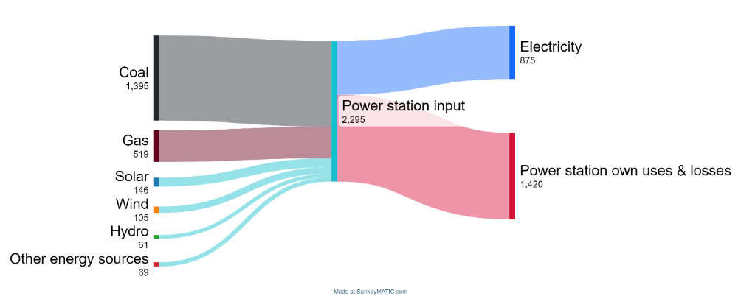  Note: access and customise this diagram created using SankeyMATIC.  Compare the coal power station schematic with the corresponding Sankey diagram showing the energy flows.  Figure 3 – Sankey diagram showing the energy flows for a coal power station  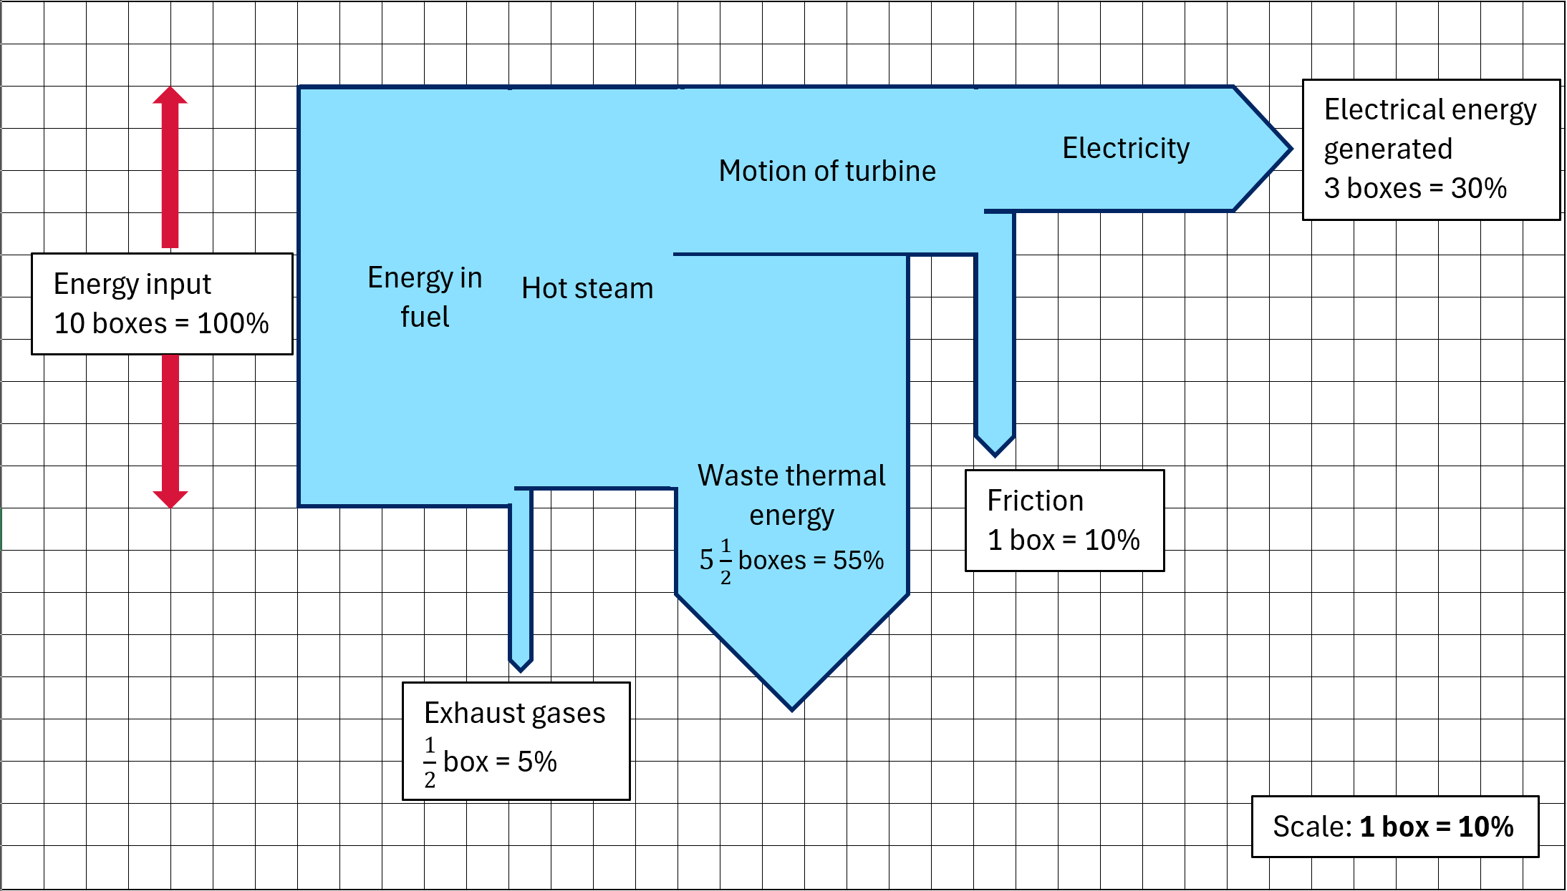  Differentiation: make it concrete – use energy cubes to model the energy transfers and transformations occurring in a coal power station. Students use whiteboards, and the information provided in Figure 3 to tell an energy story.  2.4 Wind and hydroelectric power  Wind power (TRB2)  Watch How do wind turbines work? - Rebecca J. Barthelmie and Sara C. Pryor (5:02).  Sketch and annotate a scale diagram of a wind turbine using the information provided in the video, including technologies used to improve their efficiency.  Hydroelectric power (TRB2)  Watch Hydropower 101 (3:12) (Student Energy) and summarise the 2 main types of hydroelectric power stations:  - dam  - run of river.  For each type, students list advantages and disadvantages.  Summary (TRB2 and EGY PPT)  Draw energy flow diagrams and work-energy bar charts to describe the energy flows in wind power, hydroelectric and pumped hydropower stations.  Snowy Hydro produces a range of hands-on, interactive and print resources that can be accessed free and online at Snowy STEM academy and The Science of the Snowy Scheme with Kirsten Banks. For example, demonstrating how a turbine generates electricity from wind or moving water using motors, fans, and digital multimeters.
Sources of energy  - Describe how electrical energy can be produced from different types of sources  Conducting investigations  - Assemble, construct and manipulate identified equipment to perform the investigation  - Follow the planned procedure and identify and respond to errors if they occur  - Systematically and accurately collect and record data, information, evidence and findings | 2.5 Practical investigation – solar power  Complete a practical investigation to determine how the angle of a solar panel affects how efficiently it transforms energy from the Sun into electrical energy. Instructions and student worksheets can be found at A new angle on Photovoltaic Solar Panel Efficiency (6:12).  Demonstration: run the investigation as a class demonstration with students using Tools for Teaching Science: Predict, Explain, Observe, Explain (1:45) to predict and explain the angles that produce the maximum solar cell efficiency.  Going further: set the solar panel to its optimal position and shade different parts of the panel's surface. Explore the impact of shading on panel efficiency. Try changing the setting on the multimeter to measure voltage and investigate the effect of shading further.  Applying understanding: Students predict how the optimal angles change over a day or a year.  Digging deeper: watch: How do solar panels work? - Richard Komp (4:58).  Case study (TRB2): complete a guided reading of Solar power: Printed flexible solar achieves efficiency record (CSIRO) to explore how printed solar panels using perovskite inks can reduce costs and open new options for generating electricity.
Sources of energy  - Describe how electrical energy can be produced from different types of sources  - Evaluate the advantages and disadvantages of using renewable and non-renewable sources of energy to generate electricity, including efficiency, economical and technological considerations  Problem-solving  - Develop evaluation criteria relevant to identified problems | 2.6 Making informed decisions  Revisit the essential question, ‘How do we choose the best energy source for generating electricity?’ (TRB2). Ask students to suggest what ‘best’ means in this context. Students respond using Think-Pair-Share.  Lead a discussion with the class about their responses by adding headings (Efficiency, environmental impact, costs and economics, technology and others) to the board and grouping student responses under each category.  Comparing sources of energy (TRB2 and EGY PPT)  Introduce the terms ‘dispatchable’ and ‘intermittent’ to describe energy sources.  Students categorise common sources of energy used to generate electricity by placing them in one of the quadrants of the comparing sources of energy table.  Students summarise available energy sources regarding their relative cost, technological considerations, advantages and disadvantages in a table.

3 How does knowledge of electric circuits help us use electricity wisely?
Table 6 – How does knowledge of electric circuits help us use electricity wisely?
Content | Teaching and learning activities | Registration and evaluation notes
Electrical energy  - Identify the elements of a complete circuit  - Construct circuits and draw circuit diagrams that contain several components to show the flow of electricity through a complete circuit  Conducting investigations  - Follow the planned procedure and identify and respond to errors if they occur  Processing data and information  - Select and use a range of representations to organise data, including graphs, keys, models, diagrams, tables and spreadsheets | 3.1 Introduction to circuits  Exploring electric circuits (TRB3)  Demonstrate how to set up a simple circuit and ask questions related to the elements of the circuit.  Students interact with simple circuits at stations, such as a hand-cranked generator circuit, a handheld fan and a toaster to explore different types of simple circuits. Students document their observations and explain the reasoning behind their observations in the context of energy transfer and transformations.  Differentiation: provide the keywords to support EAL/D students in developing their explanations. They can complete their observations and engage in group discussions to develop explanations.  Use Frayer diagrams to support students in developing their vocabulary. A template is provided in the EGY PPT.  Extension: students can represent the energy transformations as energy flow diagrams (covered in TRB1).  Electric circuit analogies (TRB3 and EGY PPT).  Students explore 2 analogies for understanding and predicting circuit behaviour:  - the ‘moving cups analogy’  - the ‘water pump analogy’.  Unpack with students how each of these analogies represents the components of an electric circuit and the flow of electric current in a circuit.  Describe the strengths and limitations of each analogy.  Differentiation: to support students with learning needs, a simpler analogy (rope analogy) can be used to explain the features of an electric circuit (TRB3).  Checkpoint: students use a Venn diagram to compare the mapping of components or features across each analogy. They analyse both analogies and represent their understanding of an electric circuit and the interdependence of its various components in their analysis. Refer to 3.1 Venn diagram in EGY PPT.  3.2 Constructing electric circuits  Review the different components of a simple electric circuit. Refer to (TRB3 and 3.2 Review electric circuits EGY PPT).  Differentiation: to support EAL/D students, prior learning can be reviewed by carrying out an alternate activity, where students match the word with its meaning rather than writing the definition in their own words. Refer to 3.2 Review electric circuits alternate activity in EGY PPT.  Introduce a list of circuit symbols to represent the different components of a simple electric circuit (3.2 Electric circuit symbols in EGY PPT)  Students use the PhET interactive simulation (3.2 Constructing circuits in EGY PPT and TRB3) to construct circuits containing multiple components, such as a switch, conducting wire, and battery, draw circuit diagrams of simple circuits and answer questions (3.2 Constructing circuits – Questions in EGY PPT).  Checkpoint: use a hinge question to assess students’ understanding of electric circuits and circuit symbols. Refer to 3.2 Checkpoint in (EGY PPT).
Electrical energy  - Conduct an investigation to determine the relationship between voltage (V), current (I), and resistance (R), as described by Ohm’s law (V=IR)  Observing  - Select and use equipment correctly, including digital technologies, to make observations to increase the accuracy of measurements appropriate to the task  - Make a series of observations with precision  Conducting investigations  - Implement safe work practices and manage risks  - Assemble, construct and manipulate identified equipment to perform the investigation  - Follow the planned procedure and identify and respond to errors if they occur  - Systematically and accurately collect and record data, information, evidence and findings  Processing data and information  - Select and use a range of representations to organise data and information, including graphs, keys, models, diagrams, tables and spreadsheets  Analysing data and information  - Describe relationships between variables  Processing data and information  - Calculate a range of descriptive statistics using SI units. | 3.3 Voltage and current in electric circuits (Ohm’s Law)  Activate prior learning by revisiting the features of an electric circuit using the Think-Pair-Share strategy. Address any misconceptions around understanding of voltage and current (Refer to Table 2: Common misconceptions about electric circuits in TRB3 3.1).  Explain definitions of voltage and current and the SI units for each quantity. Refer to slide 3.3, Voltage and current in EGY PPT and TRB3.  Practical investigation – investigating the relationship between voltage and current (TRB3 and EGY PPT)  Students construct a simple circuit using a light globe and a fixed resistor to measure current (3.3 An experiment set up for measuring current in EGY PPT) and voltage (3.3 An experiment set up for measuring voltage in EGY PPT).  Students investigate the relationship between voltage and current in a simple circuit using a light globe and a fixed resistor (3.3 An experiment set up for measuring current and voltage in EGY PPT and TRB3).  Students analyse the firsthand data to derive a relationship between current and voltage and determine the relative resistance of the components of an electric circuit from a graph of voltage versus current.  Differentiation  To support students with low numeracy skills, teachers may provide the template for the results table and graph. The axes can be labelled to help students with graphing.  Extension:  Students could record and analyse data in an MS Excel spreadsheet. They can use the graphing tools and functions in Excel to plot a graph and calculate the average and slope of a straight line.  Define resistance and its SI units. Outline Ohm's law (V=IR) and perform calculations to determine voltage/current/resistance. Refer to 3.3 Ohm’s law (EGY PPT).  Students use Ohm’s law equation to calculate current, voltage or resistance. Refer to slide 3.3 Ohm’s law equation (EGY PPT).  Students complete the questions on Ohm’s law. Refer to slide 3.3 Ohm’s law calculations – 1 in the EGY PPT and TRB3.  Differentiation: to extend students, refer to slide 3.3 Ohm’s law calculations – 2 in the EGY PPT. These calculations involve multiple steps, including unit conversions for some quantities.  Checkpoint (EGY PPT 3.3)  Describe the shape of the graphs plotted in 1. Predict how the slope of 1a would change if the resistance of the fixed resistor is doubled. Explain your predictions.
Electrical energy  - Measure and compare voltage and current at different points in series and parallel circuits  Conducting investigations  - Implement safe work practices and manage risks  - Assemble, construct and manipulate identified equipment to perform the investigation  - Follow the planned procedure and identify and respond to errors if they occur  - Systematically and accurately collect and record data, information, evidence and findings | 3.4 Series and parallel circuits  Checkpoint: use diagnostic questions to assess prior understanding of series and parallel circuits. Refer to 3.5 diagnostic questions 1 and 2 in EGY PPT.  Outline the difference between series and parallel circuits. Show the Series & Parallel Circuits (5:02) video.  Students work individually or in pairs to draw circuit diagrams for a series and a parallel circuit. Refer to 3.4 Series and parallel circuit slide (EGY PPT).  Practical investigation – investigating current and voltage in a series and parallel circuit EGY PPT and TRB3  Students construct series and parallel circuits with multiple components and make qualitative observations and quantitative measurements. Refer to slides 3.4 A series circuit, 3.4 A parallel circuit, 3.4 The equipment set up for measuring current and voltage in a series circuit with light globes and 3.4 Measuring current and voltage in a parallel circuit with light globes in EGY PPT and TRB3.  Students process and analyse data and draw conclusions.  Students compare the data collected from series and parallel circuits to determine the trends in voltage and current.  Checkpoint: solve problems related to current and voltage for circuits with multiple components. Refer to Checkpoints 1 and 2 in EGY PPT slides 3 and 4.
Electrical energy  - Conduct an investigation to compare the energy transformed over time in model circuits or appliances  Observing  - Select and use equipment correctly, including digital technologies, to make observations to increase the accuracy of measurements appropriate to the task  - Make a series of observations with precision  Conducting investigations  - Implement safe work practices and manage risks  - Assemble, construct and manipulate identified equipment to perform the investigation  - Follow the planned procedure and identify and respond to errors if they occur  - Systematically and accurately collect and record data, information, evidence and findings | 3.5 Power and energy  Prior learning: activate prior learning by asking questions about power and energy (covered in 1.4 Calculating efficiency). Refer to the diagnostic question in TRB3 and slides 3.5 in EGY PPT).  Explore: Students investigate the relationship between Power and energy and the SI units for these quantities. Refer to slide 3.5 Electric power in the EGY PPT.  Practical investigation – making my own electric water heater (TRB3 and EGY PPT).  Students make their own electric water heater, calculate the percent efficiency, analyse the collected data, and discuss the sources of error in the investigation. Refer to slides 3.5: Making your own electric water heater, 3.5 Calculation of energy transformed by the nichrome wire, 3.5 Calculation of energy absorbed by the water, and 3.5 Calculation of energy absorbed by the water in the EGY PPT and TRB3.  Differentiation: support students with low numeracy skills with calculations. Provide students with an MS Excel spreadsheet pre-populated with the formulas. They can identify trends in the collected data to determine the relationship between power, energy and energy efficiency.  Extension: conduct alternate activity to interrogate the secondary sourced data.  Checkpoint: Refer to 3.5 Checkpoint – 2 in the EGY PPT.
Electrical energy  - Investigate the energy star ratings of a range of appliances and explain the criteria used to determine these ratings.  Processing data and information  - Select and extract information from texts, diagrams, flow charts, tables, databases, graphs and multimedia resources  Analysing data and information  - Assess the validity and reliability of first-hand data  - Synthesise data and information to develop evidence-based arguments | 3.6 Energy efficiency and electrical appliances  Recap ‘electric power’ and energy. Refer to the diagnostic questions in slide 3.6 Energy efficiency in the EGY PPT.  Students engage with the data for the different appliances to identify the difference in the running cost of the appliances. Refer to slide 3.6 Energy cost in the EGY PPT.  Unpack the terms ‘energy’ and ‘star rating’ of common household appliances. Students compare appliances and rank them in order from highest energy consumption to lowest energy consumption. Refer to slides 3.6 Energy rating, 3.6 Star rating and 3.6 Calculating running cost from the energy rating label in the EGY PPT.  Students investigate how to make savings by using the energy rating label. Refer to slide 3.6 How much are you saving? (EGY PPT), and use the Energy Rating website’s Energy Rating Calculator to compare different brands and make informed decisions about purchasing cost-effective appliances (TRB3).  Differentiation: provide a stepwise method for calculating appliance running costs to support students. Refer to EGY PPT.  Checkpoint: students answer scenario-based questions using the Claim-Evidence-Reasoning scaffold to justify their claims. Refer to 3.6 C-E-R scaffold for making informed choices about electrical appliances in the EGY PPT.  3.7 Energy bill  This is not called out in the syllabus, but it is included to provide a different perspective on energy usage and cost. It does provide students with a real-world context for exploring energy use and ways that the energy use could be reduced.  Students engage with the sample energy bills and identify the different components of the bill (TRB3).  Students explore options to reduce energy usage and save money on energy bills.
Observing  - Make a series of observations with precision  Conducting investigations  - Follows a planned procedure to undertake safe, ethical, valid and reliable investigations  Processing data and information  - Select and use a range of representations to organise data and information, including graphs, keys, models, diagrams, tables and spreadsheets | DS.2 Conducting classroom energy use audit  Additional information for this activity can be found in DS.2 in the Energy sample assessment task.  Students work in groups to explore the factors that may impact the room's thermal comfort and how to manage it responsibly. Refer to the instructions in the assessment task and student learning journal.  Students conduct an audit of the appliances in the room, calculate and estimate the energy use and cost, and record this information in their learning journal. They will then use this information to develop a proposal to optimise energy use at school.  DS.3 Analysing collected data  Additional information for this activity can be found in DS.3 in the Energy sample assessment task.  Analyse collected thermal comfort and energy audit data to identify trends or patterns and describe the relationships between temperature or humidity and classroom thermal comfort.  Guiding questions to support analysis are provided in the learning journal template.

4 How can we make better energy choices for the future?
Table 7 – How can we make better energy choices for the future?
Content | Teaching and learning activities | Registration and evaluation notes
Global future energy needs  - Examine data to identify past trends in energy use, and predict possible future demands at a state, national and global level  Processing data and information  - Select and extract information from texts, diagrams, flow charts, tables, databases, graphs and multimedia resources | 4.1 Past and future energy use  Australia’s current energy use (TRB4 and EGY PPT)  Students investigate Australia’s current energy statistics using the Australian Energy Statistics summary infographic 2021–2022 as a stimulus for discussion. They use the See-Think-Wonder (Project Zero) thinking routine to engage students in thinking about the energy challenges we are experiencing in Australia.  Understanding past trends in energy use (TRB4 and EGY PPT)  Examine data using the slow-reveal graph method to interrogate the Australian electricity generation fuel mix graph over time.  Why do we need to develop alternative energy sources? (TRB4)  Watch Black Balloons – Greenhouse Gas (0:45) and explore how the Victorian Government uses an analogy (black balloons) to represent CO₂ emissions from household energy use. Students answer questions requiring them to consider how this analogy helps explain the impact of energy consumption and the importance of developing alternative energy sources. Students assess the techniques used to encourage action and how models like this can effectively communicate complex scientific ideas.  Where does our energy go? (TRB4 and EGY PPT)  Investigate Australian energy production and use by examining the simplified Australian Energy Flows 2021–2022 Sankey diagram using the slow-reveal graph method. This diagram is included as a 4.1 Slow-reveal graph – a Sankey diagram EGY PPT, and discussion prompts are provided in the speaker notes.  Figure 4 – a simplified version of the Australian Energy Flows 2021–2022 diagram. View this diagram online to interact and customise. All units are in Petajoules (PJ).  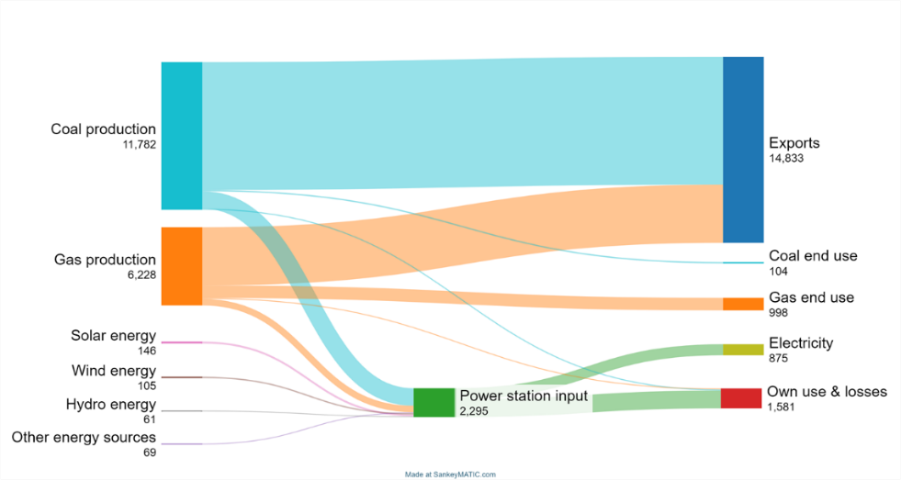  This work has been generated using SankeyMATIC. Any copyright subsisting in this work is owned by © State of New South Wales (Department of Education) 2024.  Students extract values from the Sankey diagram, including the total energy exported to other countries, energy consumed as electricity and energy wasted due to own use and losses and represent the data in a bar graph.
Global future energy needs  - Evaluate ways to optimise current energy use  - Explain reasons for the development of alternative sources of energy  Global future energy needs  - Evaluate ways to optimise current energy use  Problem-solving  - Select suitable strategies and implement them to solve an identified problem | 4.2 Sustainable energy use  Sustainable transport (TRB4 and EGY PPT)  Explore prior understanding of sustainable transport by showing stimulus images and brainstorming as a class. For example, buses, trains, cycle paths and bicycles may be considered more sustainable than each student travelling by private vehicle to school.  Watch Daniel O’Doherty in Catalyst: Impact of coming to school on carbon emissions (3:14) as he determines his hypothesis and then designs and conducts a study about carbon emissions related to school transport. Students respond to questions related to the video.  Students design and conduct a class survey of the transport they use to get to school daily and discuss ways to optimise their energy use.  Vehicle standards (TRB4)  Investigate the role of motor vehicles in contributing to carbon dioxide emissions by analysing data on the Green Vehicle Guide and answering questions about vehicle efficiency.  Summarise collected data to identify patterns, discuss assumptions used and explain the importance of improving vehicle efficiency.  Australia’s energy consumption  Review Australia’s energy consumption by sector to identify which sector(s) use the most energy. Using think-pair-share, discuss how changes to behaviours and improvements to efficiency could help us sustainably meet our energy demands.  Optional activities  Students could explore the UN Energy dashboard and identify the type of data provided, including the range of years, regions and countries for which data is available. Useful data includes CO₂ production and energy production and use by sector for world regions over time. The TES_CO₂, Energy time series and Energy balance sheets are most relevant.  Students should use this data to create an ‘energy story’ that identifies and describes one trend in our energy demand and supports it with a figure or quantitative information.
Global future energy needs  - Evaluate ways to optimise current energy use  - Explain reasons for the development of alternative sources of energy  Global future energy needs  - Evaluate ways to optimise current energy use  Problem-solving  - Select suitable strategies and implement them to solve an identified problem  - Evaluate different approaches used to solve problems | DS.4 Exploring options for action  Additional information for this activity can be found in DS.4 in the Energy sample assessment task.  Students read case studies demonstrating actions to improve energy use in residential, business, and industrial scenarios (Assessment task teaching notes).  Use the issue-action-impact scaffold (Assessment task teaching notes) to summarise the information in one of the case studies and report back to the class.  Explore classroom temperature and energy audit data and identify issues and changes needed to reduce energy usage and/or maintain thermal comfort.  DS.5 Identifying constraints and selecting an idea for action  Additional information for this activity can be found in DS.5 in the Energy sample assessment task.  Students use guiding questions in the EGY Student Learning Journal to identify resources and constraints for improving thermal comfort.  Student groups select a shortlist of potential actions to improve thermal comfort.  DS.6 Developing your action proposal  Additional information for this activity can be found in DS.6 in the Energy sample assessment task.  Student groups develop an action proposal, including:  - all required steps  - budget and resource requirements  - who would be responsible for actions  - success criteria and method for measuring the impact of actions.
Global future energy needs  - Explain reasons for the development of alternative sources of energy  Energy in context  - Use data, evidence and research to evaluate the development of alternative energy sources to meet and reduce global energy demand  Problem-solving  - Assess the solutions proposed based on the relevant evaluation criteria  - Evaluate different approaches used to solve problems  - Evaluate claims using scientific knowledge and findings from investigations  - Use cause-and-effect relationships and models to explain ideas and make predictions | 4.3 Evaluating nuclear energy in Australia  Pose the following statement: ‘Australia should be using nuclear power for all our electricity needs’. In response to the statement, students position themselves along the classroom continuum from strongly agree to strongly disagree.  Provide and discuss information about nuclear power by displaying Does nuclear power have a future in Australia? on the board. Go through the data story one at a time and provide opportunities for students to reposition themselves after each piece of information. Additional information for this activity is provided in TRB4.  Students write a reflection on their final position and justify which were the 3 strongest points that informed their position.  4.4 Transitioning to net zero  Watch the video How much land does it take to power the world? (4:47). Complete the questions in the ‘Think’ tab of the TED-Ed site. There are 5 multiple-choice questions and 3 short-answer questions. Use the Pose, Pause, Bounce, Pounce (PDF 557 KB) questioning strategy to encourage all students to develop answers to the short answer questions.  Students analyse data about past, current and future energy demands. The graph shows the planned electricity capacity needed to meet our 2050 commitment to net zero.  How many new generators will we need? (TRB4 and EGY PPT)  Estimate the number and cost of new generation units (for example, onshore wind and rooftop solar systems) that will be needed to meet the 2050 net zero target.  Calculate the changes in cost or other factors if the efficiency of these systems was improved by a small percentage.  Optional: compare the relative numbers and costs of building equal-capacity nuclear power stations.  Checkpoint: Students make and justify a claim using CER - Claim Evidence Reasoning (7:24), which predicts a possible future energy demand and suggests reasons why alternative energy sources may be needed.  4.5 Truths, lies and the in between  Students interrogate a range of claims made in the media about different energy sources (TRB4 and EGY PPT).  In groups, claims about a source of energy are categorised as either true, false, deceptive or no idea.  Groups rotate and assess the categorisation of claims by the previous group. They change the position of any claims and annotate their reasoning. Groups rotate through each energy source before returning to their initial position.  As a whole-class activity, students discuss which claims were most contentious, what evidence might be required to evaluate them and identify who might be a reputable source of this evidence.

5 Depth study sharing and reflection
Table 8 – depth study sharing and reflection
Content | Teaching and learning activities | Registration and evaluation notes
Law of conservation of energy  - Explain how to improve energy efficiency in energy transfers and transformations  Global future energy needs  - Evaluate ways to optimise current energy use  Problem-solving  - Assess the solutions proposed based on the relevant evaluation criteria  Communicating  - Present scientific arguments using evidence, correct scientific language and terminology, as appropriate to audience and purpose | DS.7 Communicating the proposal  Additional information for this activity can be found in DS.7 in the Energy sample assessment task.  Students prepare a presentation for the school executive that explains thermal comfort issues and proposes a sustainable solution.  They should include data from thermal comfort surveys and energy audits to help justify their proposals. Encourage students to communicate their ideas using photographs and diagrams.  Student groups share their work with peers or other school community members.  A gallery walk may be used to encourage reflection and discussion.  DS.8 Reflecting on the proposed actions and evaluating plans  Additional information for this activity can be found in DS.8 in the Energy sample assessment task.  Checkpoint: students complete a reflection on their proposed plan and submit it with their completed journal for marking.  Reflection includes the following questions:  - What were the strengths and weaknesses of our plan?  - How could the proposal and action be improved?  - How can we communicate to engage others to try our ideas?

Overall program evaluation
Collating ongoing evaluations and reflecting on the program's strengths and areas for development creates opportunities to enhance student outcomes. The following prompts can be used to support your evaluation of the program:
- Did the program assist all students in improving their learning?
- How could the sequencing of the program be improved?
- What did the student evaluations of the program indicate? How can these be actioned to improve the program?
- The strategies and resources that were most effective for student learning were …
- Teaching strategies and resources that would benefit from review and refinement are …

Evidence base
This resource contains NSW Curriculum and syllabus content. The NSW Curriculum is developed by the NSW Education Standards Authority (NESA). This content is prepared by NESA for and on behalf of the Crown in right of the State of New South Wales. The material is protected by Crown copyright.
Please refer to the NESA Copyright Disclaimer for more information https://www.nsw.gov.au/education-and-training/nesa/copyright.
NESA holds the only official and up-to-date versions of the NSW Curriculum and syllabus documents. Please visit NESA https://www.nsw.gov.au/education-and-training/nesa and NSW Curriculum https://curriculum.nsw.edu.au.
Science 7–10 Syllabus © NSW Education Standards Authority (NESA) for and on behalf of the Crown in right of the State of New South Wales, 2023.
Science 7–10 Data Book © NSW Education Standards Authority (NESA) for and on behalf of the Crown in right of the State of New South Wales, 2023.
ABC (Australian Broadcasting Corporation and Education Services Australia Ltd) (24 September 2009) 'Catalyst: Impact of coming to school on carbon emissions’ [video], Catalyst, ABC Education website, accessed 15 July 2024.
AEMO (2024) NEM Data Dashboard, AEMO website, accessed 15 July 2024.
AITSL (n.d.). Learning intentions and success criteria [PDF 251 KB], AITSL, accessed 15 July 2024.
AITSL (2017) ‘Feedback Factsheet’, AITSL, accessed 15 July 2024.
Blackman M (2024) Energy Bar Charts, Universe and more website, accessed 15 July 2024.
Bogart S (2014) SankeyMATIC [website], accessed 15 July 2024.
Brookhart S (2011). How to Assess Higher-Order Thinking Skills in Your Classroom, Hawker Brownlow Education, Victoria.
CESE (Centre for Education Statistics and Evaluation) (2020a) What works best in practice, NSW Department of Education, accessed 15 July 2024.
——(2020b) What works best: 2020 update, NSW Department of Education, accessed 15 July 2024.
Commonwealth of Australia (Geoscience Australia) (2021) NationalMap [website], accessed 15 July 2024.
CSIRO (n.d.) PV and Batteries - Australian Housing Data, CSIRO website, accessed 15 July 2024.
DCCEEW (Department of Climate Change, Energy, the Environment and Water) (2013) Energy efficiency improvements - Indulge Chocolates, energy.gov.au, accessed 15 July 2024.
——(2023) Australian Energy Update 2023, Australian Government Department of Climate Change, Energy, the Environment and Water website, accessed 15 July 2024.
——(2024) Publications, energy.gov.au, accessed 15 July 2024.
DITRDCA (Department of Infrastructure, Transport, Regional Development, Communications and the Arts) (2024) Green Vehicle Guide [website], accessed 15 July 2024.
El Idrissi Y A (12 February 2024) ‘Solar Panel Series vs Parallel: Wiring, Differences, and Your Right Choice’, Renewable Wise, accessed 15 July 2024.
Energynownews (4 October 2011) ‘Energy 101: Electricity Generation’ [video], energynownews, YouTube, accessed 15 July 2024.
Harvard College and Harvard Graduate School of Education (2022) ‘See, Think, Wonder’, Resources, Project Zero website, accessed 15 July 2024.
McConnell D, Holmes à Court S, Tan S and Cubrilovic N (n.d.) OpenNEM [website], accessed 15 July 2024.
Mercer D and Leslie T (12 June 2024) ‘Does nuclear power have a future in Australia? These numbers will help cut through the debate’, ABC Story Lab, accessed 15 July 2024.
NESA (NSW Education Standards Authority) (2022) ‘Proficient Teacher Standard Descriptors’, Proficient Teacher, NESA website, accessed 15 July 2024.
——(2022) ‘Programming’, Understanding the curriculum, NESA website, accessed 15 July 2024.
——(2022) ‘Advice on units’, Programming, NESA website, accessed 15 July 2024.
PI (24 August 2020) ‘Tools for Teaching Science: Predict, Explain, Observe, Explain (PEOE)’ [video], Perimeter Institute for Theoretical Physics, YouTube, accessed 15 July 2024.
Rosenshine B (2012) ‘Principles of Instruction: Research-Based Strategies That All Teachers Should Know’, American Educator, 36(1):12–19 accessed 15 July 2024.
Snowy Hydro (2024a) ‘Science of the Snowy Scheme with Kirsten Banks’, Education Resources, Snowy Hydro website, accessed 15 July 2024.
——(2024b) Snowy STEM academy, Snowy Hydro website, accessed 15 July 2024.
Student Energy (18 May 2015) ‘Hydropower 101’ [video], Student Energy, YouTube, accessed 15 July 2024.
Sustainable Energy Authority of Ireland (SEAI) (n.d.) Energy in Action [PDF 1143 KB], Sustainable Energy Authority of Ireland, accessed 15 July 2024.
TeachEngineering (2 September 2023) ‘A New Angle on Photovoltaic Solar Panel Efficiency’ [video], TeachEngineering, YouTube, accessed 15 July 2024.
TED-Ed (6 January 2016) ‘How do solar panels work? - Richard Komp’ [video], TED-Ed, YouTube, accessed 15 July 2024.
——(17 March 2021) ‘How much land does it take to power the world?’ [video], TED-Ed, YouTube, accessed 15 July 2024.
——(23 April 2021) ‘How do wind turbines work? - Rebecca J. Barthelmie and Sara C. Pryor’ [video], TED-Ed, YouTube, accessed 15 July 2024.
United Nations Statistics division (2024) Energy Statistics Dashboards, Energy Statistics Section, accessed 15 July 2024.
Wiliam D (2013) ‘Assessment: The bridge between teaching and learning’, Voices from the Middle, 21(2):15–20, accessed 15 July 2024.
——(2017) Embedded Formative Assessment, 2nd edn, Solution Tree Press, Bloomington, IN.
Willetts R (14 March 2024) Solar power: Printed flexible solar achieves efficiency record, CSIRO website, accessed 15 July 2024.
Wisniewski B, Zierer K and Hattie J (2020) ‘The Power of Feedback Revisited: A Meta-Analysis of Educational Feedback Research’, Frontiers In Psychology, 10:3087, doi:10.3389/fpsyg.2019.03087, accessed 15 July 2024.

© State of New South Wales (Department of Education), 2024
The copyright material published in this resource is subject to the Copyright Act 1968 (Cth) and is owned by the NSW Department of Education or, where indicated, by a party other than the NSW Department of Education (third-party material).
Copyright material available in this resource and owned by the NSW Department of Education is licensed under a Creative Commons Attribution 4.0 International (CC BY 4.0) license.

This license allows you to share and adapt the material for any purpose, even commercially.
Attribution should be given to © State of New South Wales (Department of Education), 2024.
Material in this resource not available under a Creative Commons license:
- the NSW Department of Education logo, other logos and trademark-protected material
- material owned by a third party that has been reproduced with permission. You will need to obtain permission from the third party to reuse its material.
Links to third-party material and websites
Please note that the provided (reading/viewing material/list/links/texts) are a suggestion only and implies no endorsement, by the New South Wales Department of Education, of any author, publisher, or book title. School principals and teachers are best placed to assess the suitability of resources that would complement the curriculum and reflect the needs and interests of their students.
If you use the links provided in this document to access a third-party's website, you acknowledge that the terms of use, including licence terms set out on the third-party's website apply to the use which may be made of the materials on that third-party website or where permitted by the Copyright Act 1968 (Cth). The department accepts no responsibility for content on third-party websites.

