Science Stage 5 – Data science 2
Sample assessment task – student notification
Creation date: 1 October 2026

Contents
Assessment task notification 2
Task description 3
Data science 2 assessment task – data analysis 4
Task datasets 9
References 12

Assessment task notification
Name of task: Data analysis
Type of task: secondary data investigation
Weighting: [the weight of the assessment task is a school-based decision].
Submission details: [schools complete this section – include any important details about submission, format of the task, word limits, and submission procedures.]
Outcomes being assessed
A student:
- assesses the use of scientific knowledge and data in evidence-based decisions and when verifying the legitimacy of claims SC5-DA2-01
- analyses data from investigations to identify trends, patterns and relationships, and draw conclusions SC5-WS-06
- selects suitable problem-solving strategies and evaluates proposed solutions to identified problems SC5-WS-07
Science 7–10 Syllabus © NSW Education Standards Authority (NESA) for and on behalf of the Crown in right of the State of New South Wales, 2023.

Task description
This assessment task will be completed under examination conditions in class. You will be given a scenario on a familiar issue and datasets to answer a series of questions. You will be required to:
- construct an investigable scientific question using a given claim
- justify why the constructed question is investigable
- use descriptive statistics, such as standard deviation, to analyse datasets
- describe and compare trends in data
- recognise the difference between correlation and causation
- make an evidence-based conclusion
- assess a given proposal using evaluation criteria and data.

Data science 2 assessment task – data analysis
Name:
Time for task: [time for students to complete the task is a school-based decision.]
Equipment: use a blue or black pen or pencil to write your answers.
Instructions
- Engage with the scenario below to familiarise yourself with the context of the task.
- Engage with the Task datasets provided to gain an overview of the data provided.
- Answer the questions by using evidence from the datasets to support your ideas.
Scenario
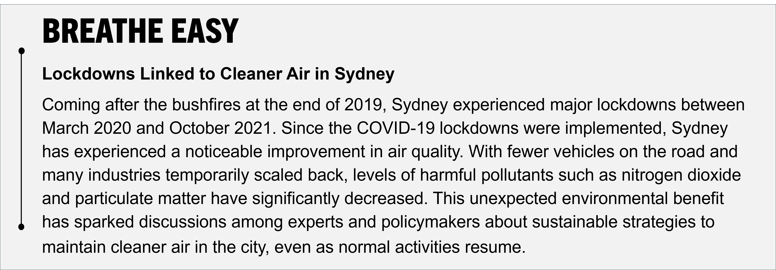
Recently, a newspaper article claimed:
‘Air quality in Sydney has improved since the COVID-19 lockdowns.’
This claim has been widely circulated across Sydney, but how accurate is it? As a scientist, you need to evaluate claims like these using data from credible sources.
In this task, you will use multiple datasets to assess the validity of this claim.
Question 1 (5 marks)
- Rewrite the claim so that it is a clear, testable, investigable question. (2 marks)
- Explain why the question you have written is investigable. (3 marks)
Question 2 (5 marks)
Table 1 in Task datasets shows the mean and standard deviation for particulate matter (PM_{2.5}) and nitrogen dioxide (NO₂) for each year from 2019 to 2023. These have been calculated from large datasets.
- Which year(s) have the lowest and highest mean annual particle matter and nitrogen dioxide? Using the standard deviation data, explain which year appears to have the most consistent mean annual particulate matter and nitrogen dioxide. (3 marks)
- Explain why it is important to look at both the mean and standard deviation when interpreting data. (2 marks)
Question 3 (8 marks)
- Compare the trends and patterns shown in Table 2, Figures 1, and 2 in Task datasets (3 marks).
- Does the data show a correlation, causation, or both between PM_{2.5} levels and asthma admissions? Refer specifically to the PM_{2.5} data in Table 1 and the asthma hospital admission data in Figure 2 in Task datasets (2 marks).
- Suggest a future investigation that could help establish causation (3 marks).
Question 4 (3 marks)
Using the data in Table 1, Table 2 and Figure 1 in Task datasets, provide a conclusion for your investigable question (Question 1a). In your response, include relevant data to support your reasoning.
Question 5 (5 marks)
Another section of the newspaper article contains the following information:
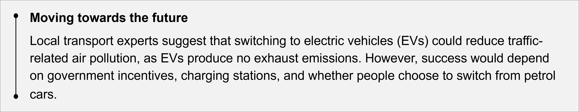
One of your colleagues investigates the claim that switching to EVs could reduce traffic-related air pollution. They conduct a secondary-source investigation. After reviewing various publications and data sources, they apply several criteria to evaluate the evidence supporting the claim in the following table.
Table 1 – evaluation criteria for the proposal
Criteria | Yes | No
Evidence-based – is the suggestion supported by reliable data or expert advice? |  | ü
Practical feasibility – can the decision work with the available infrastructure (for example, charging stations, electricity supply)? |  | ü
Economic viability – does the decision consider affordability, costs and incentives? | ü
Social acceptance – are people likely to adopt or support the decision? | ü
Environmental impact – will the decision meaningfully reduce pollution and emissions? | ü
Equity and accessibility – does the decision ensure fair access for all community groups? |  | ü
Long-term sustainability – will the decision continue to be effective and beneficial in the future? | ü
Assess the proposal against the evaluation criteria and the data provided. What factors might affect its success, and what potential limitations should the council consider?

Task datasets
Instructions:
Use the tables and graphs in this task dataset to help you answer the questions. Refer to the data when providing your responses.
Table 2 – mean annual particulate matter (PM_{2.5}) concentration and standard deviations
 | Particulate matter (μg/m³) |  | Nitrogen dioxide (pphm)
Year | Mean | Standard deviation | Mean | Standard deviation
2019 | 10.2 | 4.6 | 0.9 | 0.3
2020 | 7.5 | 3.6 | 0.8 | 0.3
2021 | 6.3 | 1.6 | 0.7 | 0.3
2022 | 4.6 | 1.4 | 0.6 | 0.3
2023 | 6.3 | 0.6 | 0.8 | 0.4
PM_{2.5} = particulate matter that is 2.5 micrometres or smaller in diameter
NO₂ = nitrogen dioxide
pphm = parts per hundred million (1 pphm = 1 part of a substance per 100,000,000 parts of air)
μg/m³ = micrograms per cubic metre (1 μg/m³ = 1 millionth of a gram of a substance in 1 cubic metre of air)
Source: adapted from Air Quality NSW and licensed under CC BY 4.0.
Table 3 – Sydney traffic volume
Year | Average daily vehicle count
2019 | 33,623
2020 | 29,010
2021 | 26,546
2022 | 29,930
2023 | 28,385
Source: adapted from Transport for NSW and licensed under CC BY 4.0.
Figure 1 – air quality data (PM_{2.5} and NO₂)
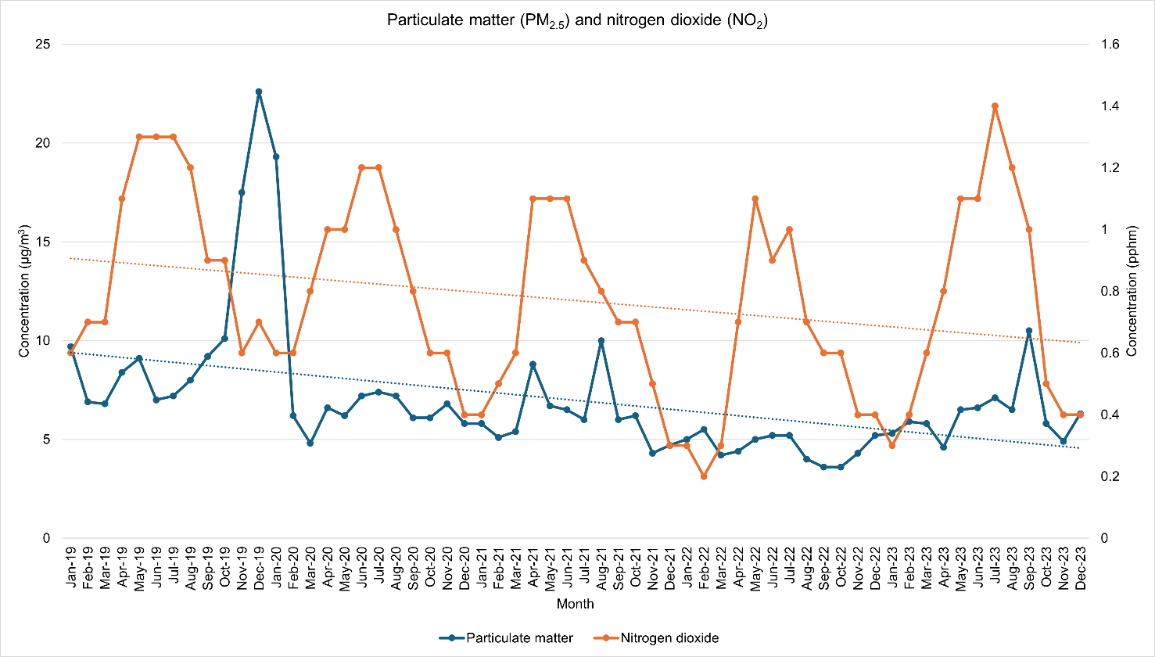
In Figure 1, the left vertical axis shows concentration in μg/m³ for particulate matter (blue line) and the right vertical axis shows concentration in pphm for nitrogen dioxide (orange line).
Source: adapted from Air Quality NSW and licensed under CC BY 4.0.
Figure 2 – monthly asthma-like illness admissions in Sydney hospitals
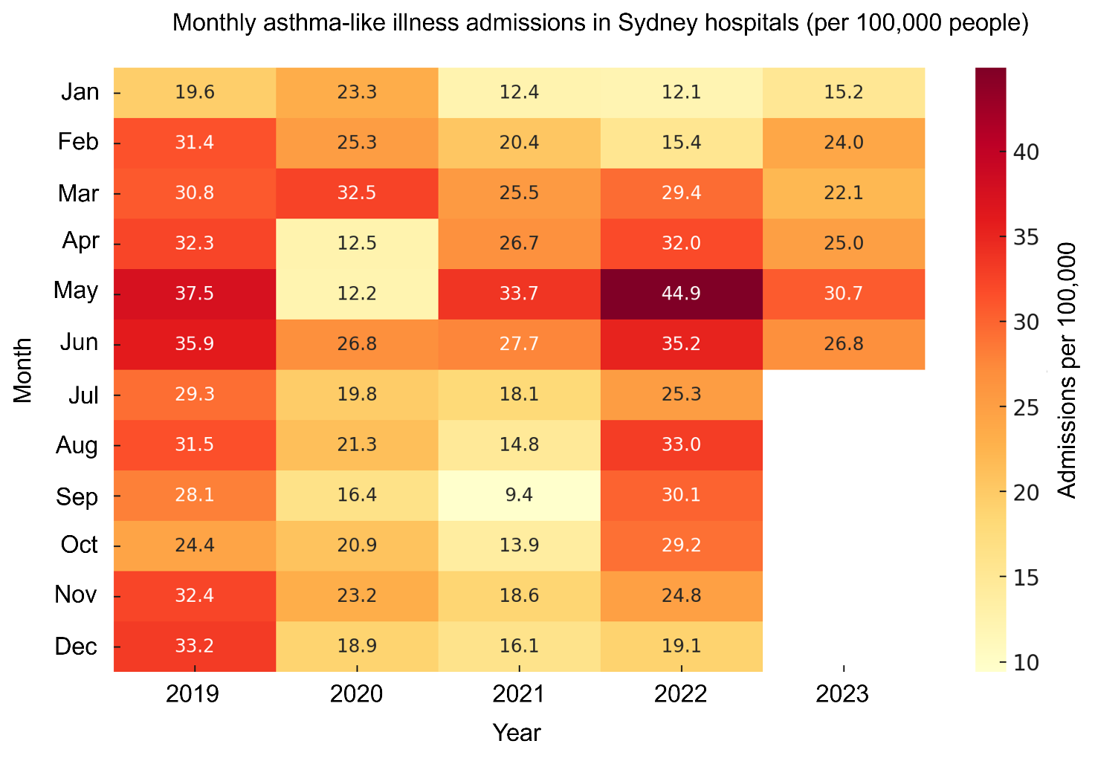
Source: adapted from HealthStatsNSW and licensed under CC BY 4.0.

References
This resource contains NSW Curriculum and syllabus content. The NSW Curriculum is developed by the NSW Education Standards Authority (NESA). This content is prepared by NESA for and on behalf of the Crown in right of the State of New South Wales. The material is protected by Crown copyright.
Please refer to the NESA Copyright Disclaimer for more information https://www.nsw.gov.au/education-and-training/nesa/copyright.
NESA holds the only official and up-to-date versions of the NSW Curriculum and syllabus documents. Please visit NESA https://www.nsw.gov.au/education-and-training/nesa and NSW Curriculum https://curriculum.nsw.edu.au.
Science 7–10 Syllabus © NSW Education Standards Authority (NESA) for and on behalf of the Crown in right of the State of New South Wales, 2023.
Data Book: Science 7–10 © NSW Education Standards Authority (NESA) for and on behalf of the Crown in right of the State of New South Wales, 2023.
Air Quality NSW (n.d.) Air quality: Data download facility [data set], Air Quality NSW, accessed 1 September 2025.
State of New South Wales NSW Ministry of Health (2025) Asthma emergency department presentations (monthly) [data set], HealthStats NSW website, accessed 27 August 2025.
Transport for NSW (2025) Traffic Volume Viewer [data set], Transport for NSW website, accessed 27 August 2025.

© State of New South Wales (Department of Education), 2026
The copyright material published in this resource is subject to the Copyright Act 1968 (Cth) and is owned by the NSW Department of Education or, where indicated, by a party other than the NSW Department of Education (third-party material).
Copyright material available in this resource and owned by the NSW Department of Education is licensed under a Creative Commons Attribution 4.0 International (CC BY 4.0) license.

This license allows you to share and adapt the material for any purpose, even commercially.
Attribution should be given to © State of New South Wales (Department of Education), 2025.
Material in this resource not available under a Creative Commons license:
- the NSW Department of Education logo, other logos and trademark-protected material
- material owned by a third party that has been reproduced with permission. You will need to obtain permission from the third party to reuse its material.
Links to third-party material and websites
Please note that the provided (reading/viewing material/list/links/texts) are a suggestion only and implies no endorsement, by the New South Wales Department of Education, of any author, publisher, or book title. School principals and teachers are best placed to assess the suitability of resources that would complement the curriculum and reflect the needs and interests of their students.
If you use the links provided in this document to access a third-party's website, you acknowledge that the terms of use, including licence terms set out on the third-party's website apply to the use which may be made of the materials on that third-party website or where permitted by the Copyright Act 1968 (Cth). The department accepts no responsibility for content on third-party websites.

