Science Stage 5 – Data science 2 – Part A
Teacher resource book: Essential question 2
How do we analyse large datasets to support scientific investigations?
Creation date: 1 October 2026
Contents
Glossary 3
2.1 Large datasets 6
Features, use and applications of large datasets 8
Student resource – large datasets in science 16
2.2 Descriptive statistics techniques 21
Calculating descriptive statistics – mean, median and standard deviation 21
Student resource – bird survey 31
Student resource – how to calculate descriptive statistics in Microsoft Excel 34
Calculating and representing descriptive statistics – quartiles and box plots 37
Student resource – quartiles and box plots 44
2.3 Univariate and bivariate analysis 47
Understanding univariate and bivariate analysis of datasets 48
Univariate analysis of a dataset 49
Student resource – univariate analysis of daily temperature and ice cream sales dataset 58
Student resource – constructing univariate representations in Microsoft Excel 62
Bivariate analysis of a dataset 67
Student resource – bivariate analysis of daily temperature and ice cream sales dataset 74
Student resource – constructing a scatter plot in Microsoft Excel 76
2.4 Univariate and bivariate analysis of a large dataset 79
Fine particle pollution – secondary source investigation 79
Student resource – fine particle pollution secondary source investigation 98
2.5 Correlation and causation 102
Correlation and causation 102
Student resource – correlation and causation comprehension 106
Determining causation 110
Student resource – determining causation 113
2.6 Validating scientific findings 116
The role of large datasets and statistical analysis in validating findings 117
Student resource – validating scientific findings 120
2.7 Making evidence-based decisions 123
Making evidence-based decisions about a familiar issue – secondary-source investigation 124
Student resource – making evidence-based decisions to solve a problem 140
Evidence base 151

Glossary
Tier 3 words are those that are relevant for subject-specific content. More information is available in the ‘Vocabulary in context’ document on the Stage 5 reading – Vocabulary in context page. The Guide for planning and implementing explicit vocabulary instruction can be used by teachers across all curriculum areas.
Differentiation: to support students learning English as an additional language or dialect (EAL/D) with vocabulary development, refer to EAL/D learners and reading vocabulary. An additional column may be added to the glossary table for EAL/D students to write the definition in their home language.
Table 1 – glossary of key terms for Data science 2 – Part A – Essential question 2
Term | Definition
Analyse (scientifically) | To consider in detail for the purpose of finding meaning or relationships, and identifying patterns, similarities and differences (NESA 2023).
Bivariate analysis | A type of statistical analysis involving 2 variables which aims to explain how changes in one variable affect the other (NESA 2023).
Causal | Two variables with a relationship which indicates that one event is the result of the occurrence of the other event (NESA 2023).
Correlational relationship | A relationship that measures the strength of interdependence of 2 variables (NESA 2023).
Data | Information that is collected, organised and analysed for various purposes. It can be in the form of numbers, text, images or any other format that can be processed. Data can be represented using techniques such as tables, graphs and textual explanations (NESA 2023).
Dataset | A collection of numbers or values relating to a particular subject. Datasets are normally presented in tables or represented by graphs. For example, the test scores of each student in a particular class (NESA 2023).
Descriptive analysis | The analysis of statistics that quantitatively describe or summarise features of a collection of information (NESA 2023).
Descriptive statistics | Statistics that quantitatively describe or summarise features of a collection of information (NESA 2023).
Extrapolate/extrapolation | Occurs when the fitted model, such as a line of best fit, is used to make predictions using values that are outside the range of the original data upon which the fitted model was based (NESA 2023).
Large dataset | A dataset that must be of a size to be statistically reliable and require computational analysis to reveal patterns, trends and associations (NESA 2023).
Mean | The sum of values in a dataset divided by the total number of values in the dataset. Also called the average (NESA 2023).
Prediction | A statement or estimate about what will happen in the future, often based on available evidence, past experiences or statistical analysis (NESA 2023).
Range (of a dataset) | The difference between the highest and lowest values in a dataset (NESA 2023).
Statistical analysis | The collection, organisation and interpretation of data to develop patterns and trends (NESA 2023).
Statistics | A collection of numerical facts or other data (NESA 2023).
Univariate | An analysis, study, or dataset that involves only one variable (NESA 2023).

2.1 Large datasets
Table 2 – learning intention and success criteria for ‘2.1 Large datasets’
We are learning: | I can:
- to describe how large datasets are used to investigate questions and claims. | - define a ‘large dataset’ and provide examples  - outline the features and benefits of using large datasets  - outline methods of collection and the uses and applications of large datasets.
Background information on large datasets
The information in the tables below provides a concise summary of:
- the benefits of using large datasets in science (see Table 3)
- examples of large datasets (see Table 4).
This information is designed for teachers’ use. Teachers may discuss it with students at their discretion.
Table 3 – benefits of using large datasets in science
Benefit | Explanation
Improved accuracy and reliability | Large datasets reduce the impact of outliers, systematic errors and random errors, leading to more precise and reliable conclusions.
Detection of patterns and trends | Large datasets allow scientists to identify correlations, patterns or trends that may not be apparent in smaller datasets.
Enhanced predictive power | Large datasets provide more data, which allows models and simulations to make better predictions about future events or outcomes.
Support for complex research questions | Large datasets enable the study of complex systems, such as climate change or human genomics, where multiple factors need to be assessed and extensive data is required for meaningful analysis.
Table 4 – examples of large datasets
Dataset | Description
ANSTO | - The Australian Nuclear Science and Technology Organisation (ANSTO) provides a collection of real-world scientific datasets for secondary school students. These datasets cover topics such as atmospheric measurements, groundwater sustainability, isotopic analysis and conservation efforts to combat illegal wildlife trade.  - Each dataset is accompanied by a worksheet and a Microsoft Excel-compatible data file, supporting activities such as graphing, data interpretation and scientific inquiry.
Bureau of Meteorology | - The Bureau of Meteorology (BOM) provides a comprehensive suite of climate datasets through its Climate Data Online portal. These datasets span a wide range of meteorological variables, including temperature, rainfall, evaporation, cloud cover and solar radiation.  - Data is available at daily and monthly intervals, spanning numerous weather stations across Australia, with some with records dating back to the mid-1800s. You can access this information via an interactive map and text search tools, with options to download data in various formats.
CSIRO | - These educational datasets are designed to integrate real-world scientific data into classroom learning. They are based on recent Commonwealth Scientific and Industrial Research Organisation (CSIRO) research and cover topics such as ocean carbon dioxide levels, water quality and air pollution.  - A teacher's guide accompanies each dataset and is available in 3 levels: novice, expert and programmer.
FrogID | - The Australian Museum’s FrogID Map & Data webpage hosts a citizen scientists dataset that maps frog species across Australia.  - The dataset includes georeferenced audio recordings, species identifications and temporal data, enabling analysis of frog distribution patterns and responses to environmental change. The data can be searched and sorted by location, species or time.

Features, use and applications of large datasets
Check for understanding 1: check students’ prior knowledge of what a ‘dataset’ is using the multiple-choice question in 2.1 PPT ‘Check for understanding 1’.
Which statement best describes a dataset?
- A single measurement taken during an investigation, such as the temperature of a beaker at a single point in time.
- A set of instructions for a computer to follow when processing data.
- A collection of related data values typically organised in a specific format, such as tables, graphs and spreadsheets for easy retrieval and analysis.
- A simplified representation of a system or phenomenon, such as a diagram of the water cycle.
If students cannot recall what a ‘dataset’ is, refer to the Stage 4 Data science 1 unit.
Table 5 – check for understanding 1 explanation for each response
Response | Explanation
A | A dataset is not a single measurement. One measurement is just a single data point. A dataset is a collection of many related measurements that can be analysed together.
B | This describes a computer program or algorithm, not a dataset. A dataset contains values or measurements, not instructions for a computer.
C | This is the correct response.
D | This describes a scientific model, which is a visual or conceptual representation used to explain something. A dataset contains raw or organised data that can be used to build models or analyse trends, but it is not a model itself.
- As a hook for the lesson, display 2.1 PPT ‘How much data is enough?’ and ask students some questions that make them consider the confidence that is instilled by large datasets. Example questions may include:
- Would you trust a weather forecast based on data from 3 days?
- Would you trust a climate trend based on data from 30 years?
- Would you trust a medical study based on a study with 5 people?
- Would you trust a study based on 50,000 people?
- Define a ‘large dataset’ as a dataset that must be of a size to be statistically reliable and require computational analysis to reveal patterns, trends and associations using 2.1 PPT ‘Defining large dataset’.
- Distinguish between ‘small datasets’ and ‘large datasets’. Explain that:
- a ‘small dataset’ has only a few data points, such as the heights of 10 students in a class. It is easy to manage but may not show clear patterns.
- a ‘large dataset’ contains many data points (hundreds to millions), such as daily temperature records for an entire term.
- large datasets are more likely to reveal trends and patterns, produce more reliable conclusions and allow scientists to make predictions. Because they contain so much information, they usually require computers and data-analysis software to manage and interpret.
Note: it may be necessary to clarify the difference between ‘big data’ and a ‘large dataset’. The terms ‘big’ and ‘large’ are often interchangeable, but there is a difference between the 2 types of datasets. ‘Large datasets’ are simply datasets with a high volume of entries that require computational analysis. By contrast, ‘big data’ refers to datasets that are not only large but also complex, fast-moving and diverse, and may require advanced tools and techniques to process effectively.
- Provide students with the Student resource – large datasets in science.
- Support students to match the features of large datasets to their descriptions in question 1 of the student resource. The answers can be displayed and discussed using 2.1 PPT ‘Features of large datasets’.
- As a class, engage with the ‘Benefits of large datasets’ text. Model how to skim and scan the text to find the information to complete Table 2 in the student resource. Display 2.1 PPT ‘Benefits of collecting and using large datasets’ to talk through the expected response.
- Display 2.1 PPT ‘Uses of large datasets’ (5 slides) to unpack the uses of large datasets using specific examples. Large datasets are used to:
- identify patterns and trends
- monitor change
- investigate relationships between variables
- evaluate scientific claims
- make predictions
- support decision-making
- compare data.
- Direct students to complete question 3 of the student resource to match the uses of large datasets with their description (see Table 3).
Check for understanding 2: use the true or false statements in 2.1 PPT ‘Check for understanding 2’ to check students’ understanding of large datasets. The answers and an explanation of the false statement are provided in Table 6.
Table 6 – check for understanding 2 sample response for statements and their explanations
Statement | Explanation
Large datasets make scientific conclusions more reliable by reducing the influence of random errors. | True
Large datasets always prove that one variable causes another. | False. Large datasets can show strong correlations, but correlation does not prove causation because other variables may influence the results. A scientific investigation is needed to test whether one variable actually causes changes in another, while accounting for other variables.
Large datasets can reveal patterns or trends that may not be evident in smaller ones. | True
- Display 2.1 PPT ‘Collection of data’ and unpack how large datasets are made by collating many individual measurements. Use the speaker notes to unpack further examples of each way data can be collected. Emphasise that scientists use standardised methods so that measurements collected by different people, instruments or locations can be accurately compared.
Sample response: Student resource – large datasets in science
Note: additional stimulus information has been removed from the sample response.
- Match the features of large datasets with an appropriate description in Table 1 below:
- organised and structured
- many observations
- suitable for statistical analysis
- collected over time and/or across many locations
- representative of a larger population or system
- multiple variables.
Table1 – features of large datasets
Feature | Description
Many observations | Large datasets contain hundreds, thousands or even millions of data points, providing substantial evidence for analysis.
Collected across time and/or across many locations | Data is often gathered repeatedly over long periods or from many different places, allowing scientists to investigate changes and compare locations.
Multiple variables | Large datasets commonly include several related variables that can be analysed individually or compared to identify relationships.
Representative of larger population or system | The large number of observations provides a more representative sample, reducing the influence of unusual results and increasing confidence in conclusions.
Organised and structured | Data is stored in tables or databases, so it can be sorted, filtered, graphed and analysed efficiently using statistical tools.
Suitable for statistical analysis | Large datasets allow descriptive statistics, such as the mean, median, range and standard deviation, to be calculated to summarise and interpret the data.
- Engage with the text ‘Benefits of large datasets’ and summarise the benefits into Table 2.
Table2 – benefits of large datasets
Benefit | Why is it beneficial? | Example
Reveal patterns and trends | Large datasets allow scientists to identify long-term patterns, trends and cycles that may not be visible in smaller datasets. | Detecting changes in average annual rainfall over the past 100 years.
Provides stronger evidence | A large number of observations gives scientists greater confidence that their conclusions are supported by evidence rather than a few isolated results. | Comparing thousands of health records to investigate the spread of a disease.
Reduces the influence of unusual results | Outliers and random errors have less impact when conclusions are based on many observations instead of only a few. | Determining the average daily temperature from many years of data rather than one week.
Allows comparisons | Data collected across different locations or time periods can be compared to identify similarities, differences and changes. | Comparing rainfall between coastal and inland regions of Australia.
Supports statistical analysis | Large datasets allow descriptive statistics, such as the mean, median, range and standard deviation, to be calculated, helping summarise and interpret the data. | Calculating the mean and variability of river water levels over several decades.
Supports evidence-based decision-making | Reliable data helps governments, scientists and communities make informed decisions and plan for the future. | Using long-term climate data to improve bushfire preparedness or water management.
Enables predictions and forecasting | Patterns identified in large datasets can be used to develop models that estimate future events or conditions. | Forecasting seasonal weather or predicting the likelihood of flooding.
- Match the use of large datasets to the appropriate description.
Table 3 – matching activity
Use |  | Description
Compare data |  | Scientists analyse many observations to detect patterns or changes over time that are not obvious in small datasets.
Investigate relationships |  | Descriptive statistics, such as the mean, median, range and standard deviation, describe the centre and spread of the data.
Identify patterns and trends |  | Large datasets provide a substantial body of evidence to support or refute scientific claims.
Evaluate scientific claims |  | Large datasets allow comparisons between different locations, time periods or groups.
Make predictions |  | Patterns identified in historical data can predict future events or conditions.
Summarise data |  | Repeated measurements allow scientists to track changes in natural or human systems over time.
Support decision-making |  | Scientists examine whether 2 or more variables are related.
Monitor change |  | Governments, scientists and organisations use evidence from large datasets to inform policies and decisions.
- Outline 2 methods of collecting data for large datasets.
Answers may include:
- Sensors, such as temperature sensors or weather stations, can gather data automatically.
- Data can be collected by satellites. Satellite data includes surface temperature, cloud cover and vegetation coverage.
- Scientists can collect data through field investigations, such as bird counts and river turbidity tests.
- Data collected in laboratories with specialised instruments, such as mass spectrometers, are used to measure gas concentrations in ice core samples.
- Data can be collated through reporting, for example, disease notifications and vaccination data.
- Citizen scientists can collect data. We can all contribute to data collection through citizen scientist projects. An example is FrogID. FrogID is a nationwide citizen scientist project that uses a free smartphone app to capture frog calls, providing vital data that helps scientists understand and conserve frog populations and their environments across Australia.

Student resource – large datasets in science
A ‘large dataset’ is a collection of many observations or measurements about the same topic. It usually contains hundreds, thousands or even millions of data points collected over time, and across different locations or from many individuals. Unlike a small dataset, a large dataset provides enough information for scientists to identify patterns, trends and relationships that would otherwise be difficult to detect. Large datasets should not be confused with big data. ‘Big data’ refers to datasets that are so large, complex or rapidly generated that they require specialised computer systems to store and analyse them. In contrast, many large datasets can be analysed using spreadsheets and common statistical software.
- Match the features of large datasets with an appropriate description in Table 1 below:
- organised and structured
- many observations
- suitable for statistical analysis
- collected over time and/or across many locations
- representative of a larger population or system
- multiple variables.
Table 1 – features of large datasets
Feature | Description
 | Large datasets contain hundreds, thousands or even millions of data points, providing substantial evidence for analysis.
 | Data is often gathered repeatedly over long periods or from many different places, allowing scientists to investigate changes and compare locations.
 | Large datasets commonly include several related variables that can be analysed individually or compared to identify relationships.
 | The large number of observations provides a more representative sample, reducing the influence of unusual results and increasing confidence in conclusions.
 | Data is stored in tables or databases so it can be sorted, filtered, graphed and analysed efficiently using statistical tools.
 | Large datasets allow descriptive statistics, such as the mean, median, range and standard deviation, to be calculated to summarise and interpret the data.
Benefits of large datasets
Large datasets offer many advantages for scientists because they contain many observations collected over time, across different locations or from many individuals. By analysing many data points rather than only a few, scientists can make conclusions that are better supported by evidence and more representative of the system being studied.
One of the main benefits of a large dataset is that it can reveal patterns and trends that may not be visible in a small dataset. For example, analysing more than 100 years of rainfall records allows scientists to identify long-term changes in climate that would not be obvious from just a few years of data.
Large datasets also reduce the influence of unusual results. Every investigation may contain random errors or outliers that differ from the majority of the data. When scientists analyse many observations, these unusual results have less effect on the overall conclusions, increasing confidence that the findings reflect the true pattern.
Another benefit is that large datasets allow comparisons between different groups, locations or time periods. For example, scientists can compare rainfall between different regions of Australia or examine how temperatures have changed over several decades. These comparisons help scientists identify similarities, differences and changes in natural systems.
Large datasets are also valuable because they support statistical analysis. Scientists use descriptive statistics, such as the mean, median, range and standard deviation, to summarise large amounts of data. These statistics make it easier to describe the typical values in a dataset and understand how much the data varies.
Many large datasets contain several variables, allowing scientists to investigate relationships between them. For example, researchers may examine how rainfall, temperature and soil moisture are related, helping them to better understand the factors that influence crop growth or ecosystem health.
Evidence from large datasets also supports informed decision-making. Governments, scientists and community organisations use information from large datasets to guide decisions about issues such as water management, biodiversity conservation, disease control and climate adaptation. Because these decisions are based on a substantial body of evidence rather than a small number of observations, they are more likely to be reliable.
Finally, large datasets can predict future events or conditions. By identifying patterns in historical data, scientists can develop models that forecast weather, estimate future river levels or predict the spread of diseases. Although predictions are not always exact, they provide valuable information that helps people prepare for future challenges.
For these reasons, large datasets are an essential tool in modern science. They help scientists understand complex systems, evaluate evidence with greater confidence and make data-supported decisions.
- Engage with the text ‘Benefits of large datasets’ and summarise the benefits into Table 2.
Table 2 – benefits of large datasets
Benefit | Why is it beneficial? | Example
Reveal patterns and trends | Large datasets allow scientists to identify long-term patterns, trends and cycles that may not be visible in smaller datasets. | Detecting changes in average annual rainfall over the past 100 years.
- Match the use of large datasets to the appropriate description in Table 3 below.
Table 3 – matching activity
Use |  | Description
Compare data |  | Scientists analyse many observations to detect patterns or changes over time that are not obvious in small datasets.
Investigate relationships |  | Descriptive statistics, such as the mean, median, range and standard deviation, describe the centre and spread of the data.
Identify patterns and trends |  | Large datasets provide a substantial body of evidence to support or refute scientific claims.
Evaluate scientific claims |  | Large datasets allow comparisons between different locations, time periods or groups.
Make predictions |  | Patterns identified in historical data can predict future events or conditions.
Summarise data |  | Repeated measurements allow scientists to track changes in natural or human systems over time.
Support decision-making |  | Scientists examine whether 2 or more variables are related.
Monitor change |  | Governments, scientists and organisations use evidence from large datasets to inform policies and decisions.
- Outline 2 methods of collecting data for large datasets.

2.2 Descriptive statistics techniques
Table 7 – learning intentions and success criteria for ‘2.2 Descriptive statistics techniques’
We are learning: | I can:
- to describe how datasets are used to investigate questions and claims. | - define ‘descriptive statistics’ and ‘descriptive analysis’  - outline the benefits of descriptive statistical analysis techniques using examples  - outline the features of a box plot and the information they communicate
- to process data from investigations | - calculate mean, median and standard deviation  - process data in a Microsoft Excel workbook
- to analyse data from investigations. | - interpret descriptive statistics to describe trends and patterns in a dataset  - evaluate a claim using descriptive analysis.

Calculating descriptive statistics – mean, median and standard deviation
This activity introduces students to median and standard deviation calculations and interpretation using a smaller dataset before applying them later to larger datasets.
Check for understanding 1: determine students’ prior knowledge of mean, mode and range, including how to calculate them using a given dataset. Using 2.2 PPT ‘Check for understanding 1’ (2 slides), students match the term to its definition and use the formula functions in Microsoft Excel to find the mean, mode and range of the data presented on the slide. Answers are provided in Figure 1 and Figure 2.
If students struggle with what mean, mode, and range are, how to use formula functions in Microsoft Excel to find these values or what these values tell us about a dataset, refer back to‘1.2 Analysing data to reteach concepts’ in Stage 4 Data science 1.
Figure 1 – check for understanding 1 sample response for key terms and their definitions
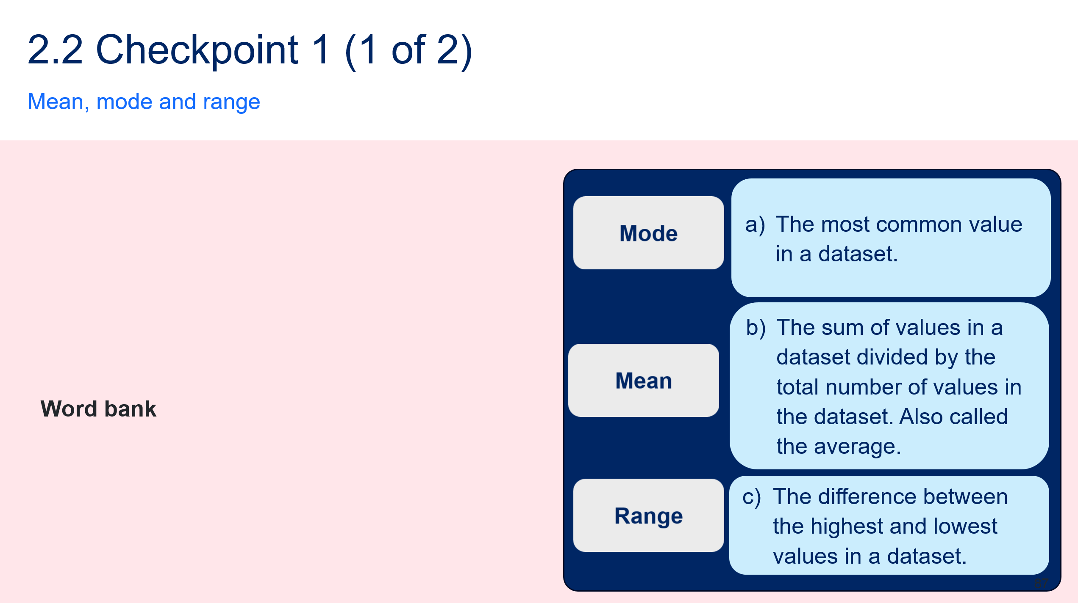
Figure 2 – check for understanding 1 calculations
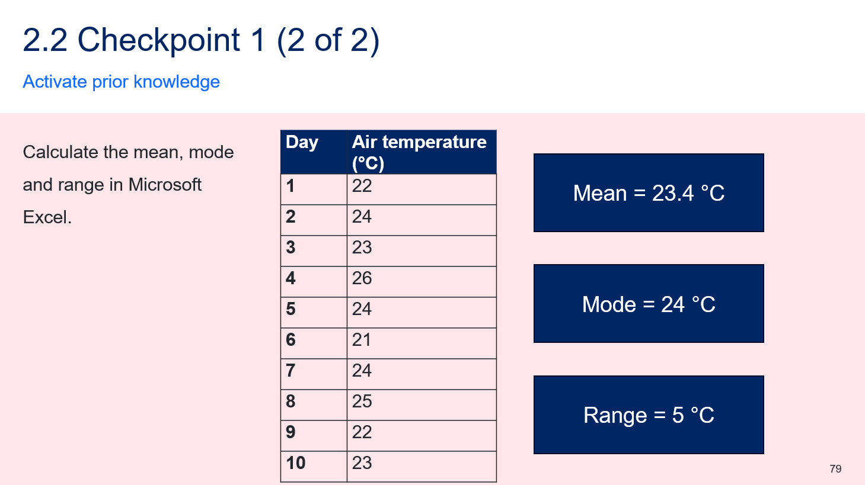
- Define ‘descriptive statistics’ and ‘descriptive analysis’ using the definitions and examples on 2.2 PPT ‘Defining descriptive statistics and descriptive analysis’ (2 slides). Clarify the difference between descriptive statistics and descriptive analysis by explaining that:
- ‘descriptive statistics’ involves summarising data through calculations like mean, median, mode, range and standard deviation. These values help summarise the data effectively.
- in contrast, ‘descriptive analysis’ provides the overall context. It involves interpreting what the numbers indicate, such as identifying patterns. Essentially, it explains or interprets the statistical data.
Note: this is a skills-based activity that focuses on a student’s ability to calculate a descriptive statistic rather than to interpret it.
- Define the term ‘median’ and outline what the median can tell you about a dataset using 2.2 PPT ‘Defining the median’.
- Outline how the median is calculated differently depending on whether the dataset has an odd or even number of data points using 2.2 PPT ‘Determining the median’:
- If the number of data points is odd, the median is the middle value.
- If the number of data points is even, the median is the average of the 2 middle values.
Check for understanding 2: check students’ understanding of how to determine the median in a dataset with an even number of values and a dataset with an odd number of values. Display 2.2 PPT ‘Check for understanding 2’ which is animated to reveal the questions and worked responses one at a time. The worked example is also provided in Figure 3.
Figure 3 – check for understanding 2 worked example
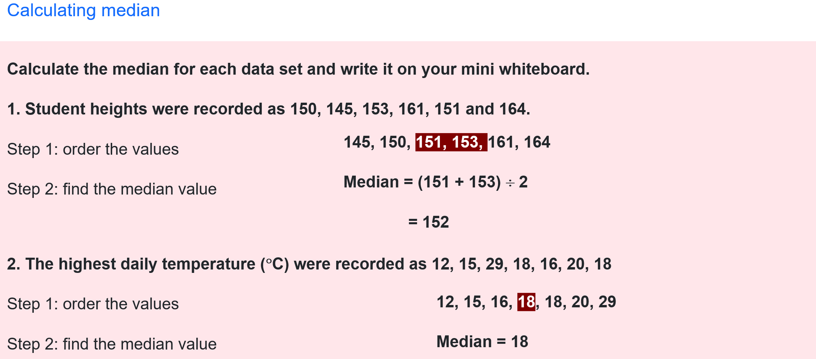
- Unpack a scenario with a dataset using 2.2 PPT ‘Median vs mean as a descriptive statistic’. Demonstrate how the median and mean differ, point out how the outlier distorts the mean and explain that the median is a more realistic value for typical plant seed yield.
- Model how to calculate the median using the data on slide 2.2 PPT ‘Median vs mean as a descriptive statistic’ in Microsoft Excel.
- Type the data into a blank spreadsheet.
- Select a blank cell and type =AVERAGE(highlight all seeds produced data) and press Enter. The value ‘26.7’ should come up. This is the mean value.
- Select another blank cell and type =MEDIAN(highlight all seeds produced data) and press Enter. The value ‘22’ should come up.
- Type Mean and Median next to the relevant calculations to show students how to represent their data meaningfully.
Figure 4 – screenshot of Microsoft Excel data and descriptive statistics
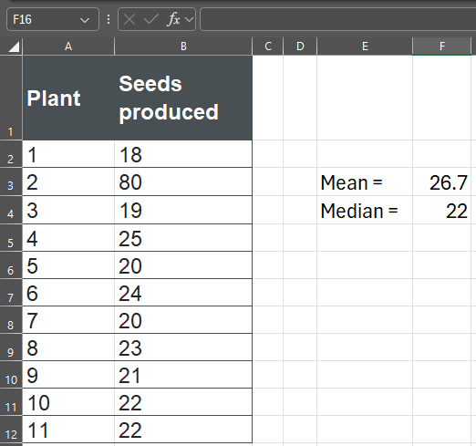
- Provide students with access to computers and the Student resource – bird survey so that they can use Microsoft Excel to independently practice calculating the mean and median for a new dataset. An additional student resource can be provided to support students step by step through Microsoft Excel steps (see Student resource – how to calculate descriptive statistics in Microsoft Excel).
- Check that students have calculated the correct mean and median for each park in the dataset (see ‘Sample response: Student resource – bird survey’). If students did not get the correct value, they have likely made an error when transferring the data into Microsoft Excel. This is an opportunity to discuss data integrity and that the statistical calculations are only as accurate as the data entered. Challenge these students to identify and correct the error.
- Guide students to answer questions 1 to 3 related to the interpretation of the mean and median of the dataset.
- Define the term ‘standard deviation’ and outline what standard deviation can tell you about a dataset using 2.2 PPT ‘Defining standard deviation’.
Use the Microsoft Excel function STDEV.P in most situations instead of STDEV.S.
- STDEV.P calculates the population standard deviation and should be used when your dataset represents the entire set of values you are analysing. It calculates the standard deviation by dividing by $n$ (the total number of data values).
- STDEV.S calculates the sample standard deviation and is designed for situations where your dataset is only a sample drawn from a larger population. It divides by $n$ − 1, which corrects for the tendency of small samples to underestimate the variability of the whole population.
For most school science investigations, students analyse all the data they have collected rather than a statistical sample from a larger population. Therefore, STDEV.P is usually the most appropriate function.
- Explain how the standard deviation can provide insights into a dataset using 2.2 PPT ‘Unpacking standard deviation’ and speaker notes. Two datasets are presented, which have the same mean but have different standard deviations. Students should understand that a smaller standard deviation means the values lie closer to the mean than in a dataset with a larger standard deviation.
- Outline the steps required to calculate the standard deviation of data values in a Microsoft Excel workbook using the following steps or by using 2.2 PPT ‘How to calculate standard deviation in Microsoft Excel’ (4 slides).
- Open a blank Microsoft Excel spreadsheet.
- Enter the data from 2.2 PPT ‘Unpacking standard deviation’, leaving out the values for mean and standard deviation.
- Select an empty cell under ‘Group A (steps)’.
- Type = to bring up the formula list.
- Select STDEV.P from the drop-down list.
- Highlight the cells containing the relevant data (‘Group A [steps]’) and then close the brackets.
- Press Enter.
- Repeat steps a to g for the ‘Group B’ data, asking students to walk you through the steps.
Check for understanding 3: show students 2.2 PPT ‘Check for understanding 3’. Students identify the formula that correctly calculates the standard deviation of the data in the tables using Microsoft Excel.
Figure 5 – check for understanding 3 data
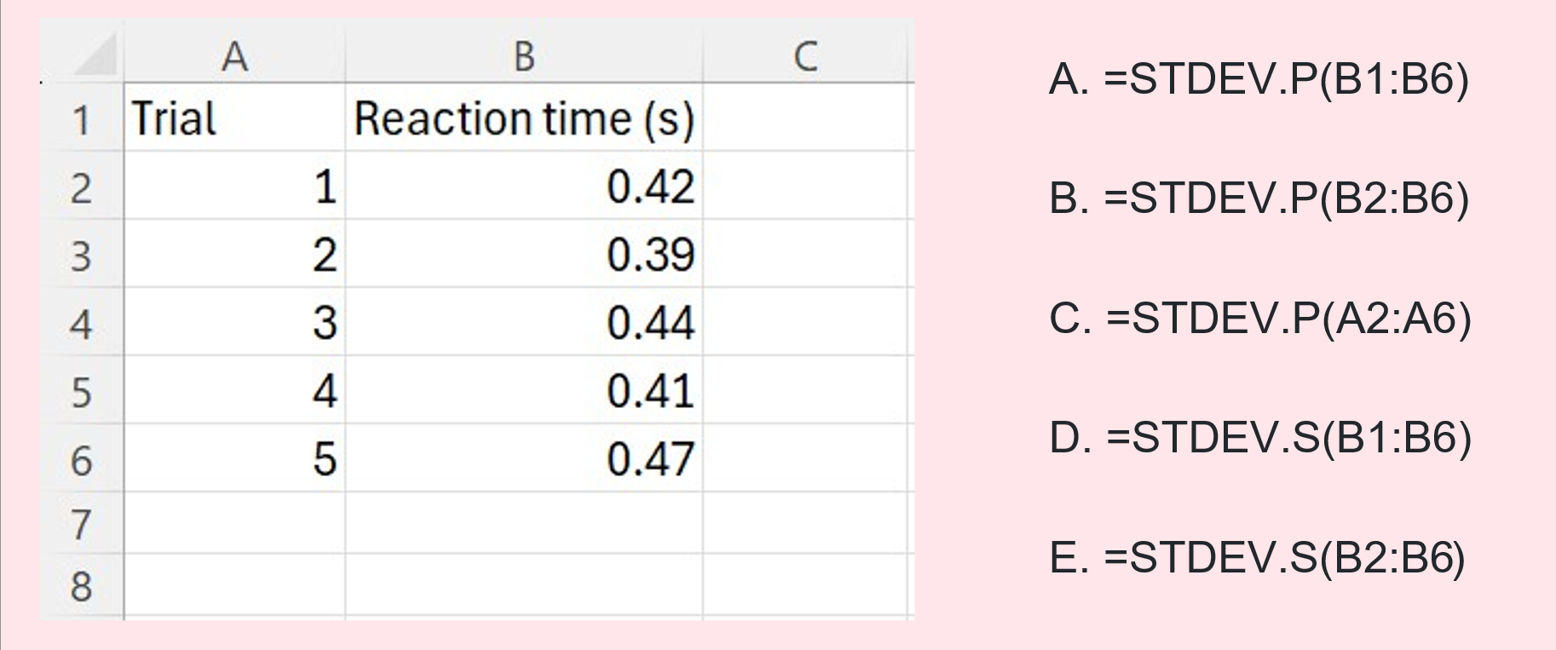
Table 8 – check for understanding 3 explanation for each response
Response | Explanation
A | This formula is incorrect because it includes cell B1, which is the column B heading.
B | This is the correct Microsoft Excel formula.
C | This formula is incorrect because it uses data in column A (Trial).
D | This formula is incorrect. It uses STDEV.S rather than STDEV.P and includes cell B1.
E | This formula is incorrect. It uses STDEV.S rather than STDEV.P.
- Refer students back to the Student resource – bird survey and the Microsoft Excel workbook. Students can now use the Student resource – how to calculate descriptive statistics in Microsoft Excel to help them calculate the standard deviation for the Park A and Park B data.
- Support students to respond to questions 4 to 6 in the student resource. Use the sample responses to provide feedback on students’ descriptive analysis.
Note: standard deviation alone can be confusing and difficult for students to interpret because it is expressed in the same units as the data and does not show how large the variation is relative to the mean.
Calculating the coefficient of variation helps by showing the magnitude of variation relative to the mean, making it easier to understand the variation in context. Since the coefficient of variation is expressed as a percentage, it allows straightforward comparison across datasets, even when they have different units or scales. Additionally, because coefficient of variation values are typically between 0% and 100%, it gives a clear, bounded measure of relative variability. The coefficient of variation is unpacked below as a differentiation activity.
Differentiation: extend students by introducing the coefficient of variation using the information below. The coefficient of variation is also included as an extension activity in several activities in this resource book.
Teach students the coefficient of variation using 2.2 PPT ‘Coefficient of variation’ to outline its purpose and how it is calculated. Students can then calculate the coefficient of variation for the bird survey data by using the equation in their Microsoft Excel spreadsheet. The Microsoft Excel formula is: =(standard deviation/mean)*100).
$$Coefficient of variation= \frac{standard deviation}{mean}×100$$
A low coefficient of variation means that the data points are close to the average (less spread out), while a high coefficient of variation means the data varies a lot (more spread out).
Sample response: Student resource – bird survey
Note: additional stimulus information has been removed from the sample response.
Figure 1 – Microsoft Excel data for Park A and Park B rainbow lorikeet observations
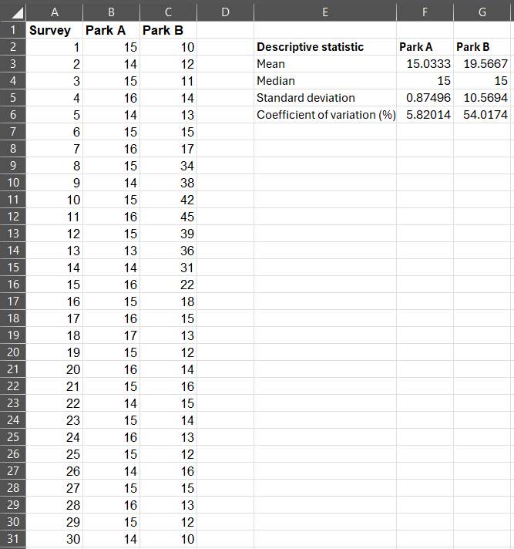
Descriptive analysis questions
- What does the mean tell you about Park A and Park B?
The mean tells us the average number of rainbow lorikeets observed during a survey. Park B has a higher mean than Park A, indicating that, on average, more rainbow lorikeets were observed in Park B. However, Park B's higher mean is influenced by the period when many birds gathered during the flowering event.
- What does the median tell you about Park A and Park B?
The median is the middle value of the rainbow lorikeets data when the survey results are arranged from smallest to largest. In Park A, the median is similar to the mean, showing that a typical survey contained about the average number of birds. In Park B, the median represents a typical survey better than the mean because it is less affected by the unusually high bird counts recorded during the flowering event.
- Which park had the greater difference between the mean and median? What does this tell you about the data?
Park B had the greater difference between the mean and the median. This indicates that the data is not evenly distributed because several unusually high bird counts increased the mean. The smaller difference between the mean and median in Park A suggests that the bird counts were more evenly distributed, with no unusually high values strongly influencing the mean.
- Add ‘Standard deviation’ to the descriptive statistics column in the Microsoft Excel spreadsheet. Select the cell for the standard deviation of Park A and use the formula =STDEV.P to calculate the value. Repeat for Park B in the appropriate cell. What does the standard deviation tell you about this data?
The standard deviation tells us how much the bird numbers varied between surveys. Park A has a much smaller standard deviation than Park B, showing that the number of rainbow lorikeets was relatively consistent from one survey to the next. Park B has a much larger standard deviation, indicating that bird numbers varied greatly over time, likely because of the flowering event that attracted large flocks.
- Which statistic provides the strongest evidence that the bird numbers in Park A are stable over time?
The standard deviation provides the strongest evidence that the bird numbers in Park A are stable over time. A small standard deviation means that the survey results were close to the mean, so similar numbers of rainbow lorikeets were observed in most surveys.
- A park ranger says ‘Visitors usually see about 20 rainbow lorikeets in Park B.’ Use the descriptive statistics to evaluate this claim.
The descriptive statistics only partly support the claim. The mean for Park B is about 20 rainbow lorikeets (rounded to the nearest whole number), so this is the average number observed across all surveys. However, the median is lower, indicating that in half the surveys 15 or fewer birds were observed. In addition, the large standard deviation shows that bird numbers varied greatly between surveys. This means that visitors could see far fewer or many more than 20 rainbow lorikeets depending on when they visit. Therefore, stating that visitors ‘usually’ see about 20 rainbow lorikeets may be misleading because the mean is influenced by the period when many birds gathered during the flowering event.

Student resource – bird survey
Two ecologists investigated the abundance of rainbow lorikeets in 2 different parks. Each completed 30 one-hour bird surveys:
- Park A is an urban park where food is available throughout the year, so bird numbers are usually consistent.
- Park B is a national park where flowering events attract large flocks on some days, resulting in much greater variation in bird numbers.
Table 1 – Park A and Park B rainbow lorikeet observations
Survey | Park A | Park B | Survey | Park A | Park B
1 | 15 | 10 | 16 | 15 | 18
2 | 14 | 12 | 17 | 16 | 15
3 | 15 | 11 | 18 | 17 | 13
4 | 16 | 14 | 19 | 15 | 12
5 | 14 | 13 | 20 | 16 | 14
6 | 15 | 15 | 21 | 15 | 16
7 | 16 | 17 | 22 | 14 | 15
8 | 15 | 34 | 23 | 15 | 14
9 | 14 | 38 | 24 | 16 | 13
10 | 15 | 42 | 25 | 15 | 12
11 | 16 | 45 | 26 | 14 | 16
12 | 15 | 39 | 27 | 15 | 15
13 | 13 | 36 | 28 | 16 | 13
14 | 14 | 31 | 29 | 15 | 12
15 | 16 | 22 | 30 | 14 | 10
Instructions – calculating the mean and the median
- Open a Microsoft Excel spreadsheet and save it in your Science files.
- Copy the data in Table 1 into Sheet 1.
- Create a separate table in a blank space in Sheet 1 for the descriptive statistics (see Figure 1).
Figure 1 – descriptive statistics table
Descriptive statistic | Park A | Park B
Mean
Median
- Select the cell for the mean of Park A and use the Microsoft Excel formula =AVERAGE to calculate the value. Repeat for Park B in the appropriate cell.
- Select the cell for Park A and use the Microsoft Excel formula =MEDIAN to calculate the value. Repeat for Park B.
Descriptive analysis questions
- What does the mean tell you about Park A and Park B?
- What does the median tell you about Park A and Park B?
- Which park had the greater difference between the mean and median? What does this tell you about the data?
- Add ‘Standard deviation’ to the descriptive statistics column in the Microsoft Excel spreadsheet. Select the cell for the standard deviation of Park A and use the formula =STDEV.P to calculate the value. Repeat for Park B in the appropriate cell. What does the standard deviation tell you about this data?
- Which statistic provides the strongest evidence that the bird numbers in Park A are stable over time?
- A park ranger says ‘Visitors usually see about 20 rainbow lorikeets in Park B.’ Use the descriptive statistics to evaluate this claim.

Student resource – how to calculate descriptive statistics in Microsoft Excel
Instructions: use the ‘How to’ cards to calculate a range of descriptive statistics.
Median
- Select an empty cell.
Figure 1 – selecting an empty cell to input the formula
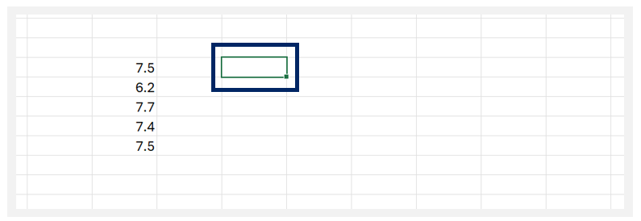
- Type = to bring up the formula list.
- Select MEDIAN from the drop-down list.
Figure 2 – inputting and selecting the median formula from the drop-down list
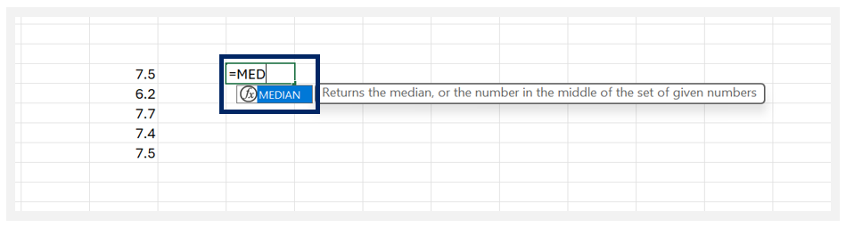
- Highlight the cells containing the data to be analysed to select them.
Figure 3 – highlighting the cell containing the data to be analysed
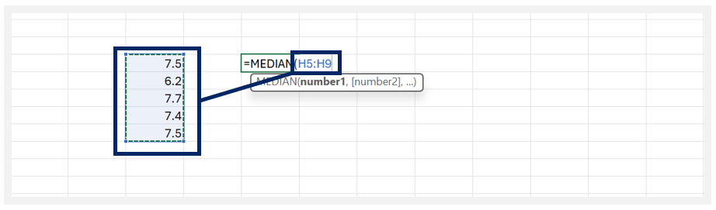
- Type ) to confirm your selection.
Figure 4 – confirming the data range
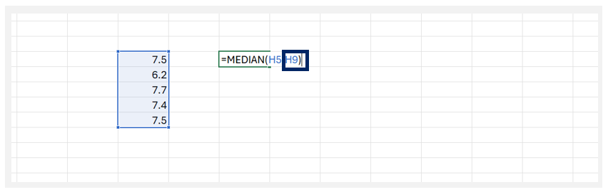
- Press Enter.
Figure 5 – initiating the formula to produce the median for the dataset
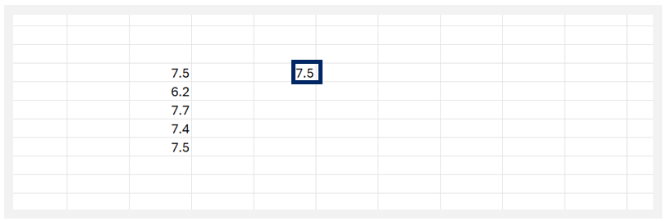
Standard deviation
- Select an empty cell beneath the data.
Figure 6 – selecting an empty cell to input the formula
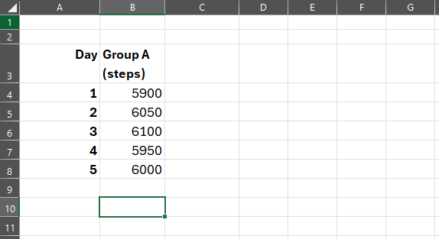
- Type = to bring up the formula list.
- Select STDEV.P from the drop-down list.
Figure 7 – inputting and selecting the STDEV.P formula from the drop-down list
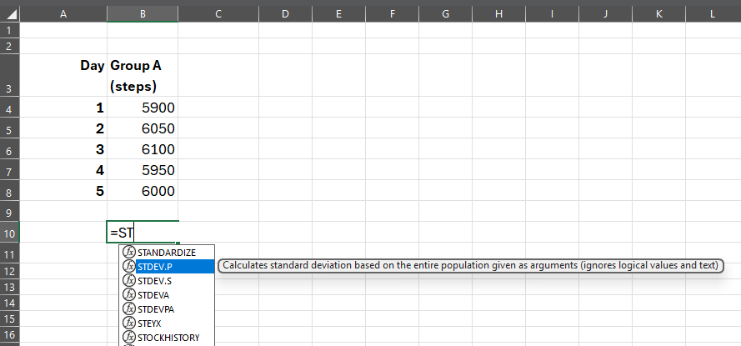
- Highlight the cells containing the data to be analysed to select them.
Figure 8 – highlighting the cell containing the data to be analysed
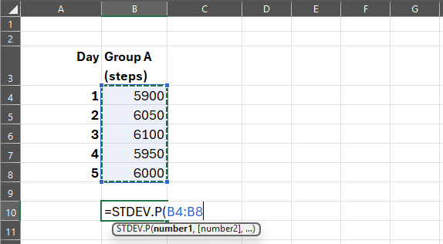
- Type ) to confirm your selection and press Enter.
Figure 9 – confirming the data range
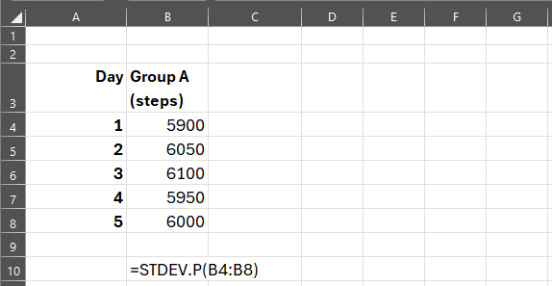

Calculating and representing descriptive statistics – quartiles and box plots
- Provide students with Student resource – quartiles and box plots. Teach students about quartiles using 2.2 PPT ‘Quartiles’, highlighting the following:
- A ‘quartile’ is a value that divides a rank-ordered dataset into 4 equal parts, each representing 25% of the total observations. Quartiles serve as boundary points that highlight the distribution and spread of the data, rather than just the centre.
- When a dataset is arranged in order from smallest to largest, it can be divided into 4 equal parts called ‘quartiles’. Each quartile contains 25% of the data in the dataset.
- As you unpack quartiles and the boundary values used to describe data arranged into quartiles, using the speaker notes in 2.2 PPT ‘Quartiles’, have students complete Table 1 in the Student resource – quartiles and box plots. A sample response is provided in Table 1 in ‘Sample response: Student resource – quartiles and box plots’.
Note: students may ask why there is no Quartile 4 (Q4) if the data has been split into 4 quartiles. Address this by explaining that although we divide the data into 4 parts, we name only the dividing points, not each quarter. Therefore, Quartile 1 (Q1), Quartile 2 (Q2) and Quartile 3 (Q3) are best described as the boundaries that split the data into the 4 quartiles.
- Define a ‘box plot’ as a graphical representation of a dataset that summarises its distribution using the 5-number summary (minimum, lower quartile (Q1), median (Q2), upper quartile (Q3) and maximum) using 2.2 PPT ‘Components of a box plot’. Teach students how to use the box plot to identify the mean, median, quartiles and any possible outliers using the diagram on the slide and the slide speaker notes.
- As you teach students about box plots, ask them to complete Table 2 in the Student resource – quartiles and box plots. Information for teaching students is available in the slide notes of the 2.2 PPT ‘Components of a box plot’ and in the sample response in Table 2 in ‘Sample response: Student resource – quartiles and box plots’.
- Direct students to Figure 3 in the Student resource – quartiles and box plots and unpack the box plot with students. Students should identify features of the dataset from the box plot and calculate the range and interquartile range.
Note: the interquartile range (IQR) measures the spread of the middle 50% of data in a set, helping us understand variability that is not influenced by outliers. To calculate it, subtract the value at the 25th percentile (lower quartile [Q1]) from the value at the 75th percentile (upper quartile [Q3]):
IQR = Q3 − Q1.
- Display 2.2 PPT ‘Unpacking a box plot’ (2 slides) to go through the answers to question 3 of the Student resource – quartiles and box plots. The slides include animations and notes to support this.
Note: students may be unsure which quartiles Q1 and Q3 belong to. When dividing data into quartiles, include boundary values in the lower group. This means that Q1 is part of the first quartile (with values less than or equal to it) and Q3 is part of the third quartile (not the fourth).
Check for understanding 4: use slide 2.2 PPT ‘Check for understanding 4’ to check for students' understanding of how to interpret a box plot. The question and answers are provided in Figure 6.
Figure 6 – check for understanding 4 sample response for interpreting box plots
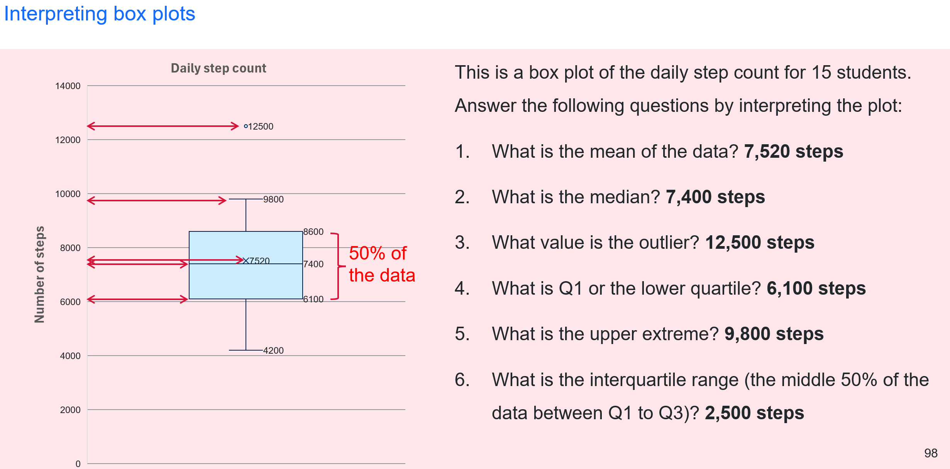
- Display 2.2 PPT ‘Comparing data using box plots’ to explain to students how data from different groups can be compared using multiple box plots. Use the speaker notes on the slide to unpack the provided box plots for Park A and Park B, showing the number of rainbow lorikeets observed in 30 one-hour surveys (this data was used in a previous lesson and should be familiar to students).
- Ask students a series of questions about the box plots on 2.2 PPT ‘Comparing data using box plots’ (see Figure 7) to guide their understanding of how box plots can be used to analyse data. Students can respond on mini whiteboards, with cold calling used to ask for student reasoning. The questions and discussion prompts are provided in Table 9.
Figure 7 – rainbow lorikeets observed in 30 one-hour surveys at Park A and Park B

Table 9 – box plot questions and discussion prompts about rainbow lorikeet observations
Question | Discussion prompts
What is the median for each park? | - The median is the horizontal line visible in the coloured box in each box plot.  - The median for both parks is 15.
What is the upper extreme for each park? | - The upper extreme is the highest data point in the dataset, excluding any outliers.  - The upper extreme for Park A is 17 and Park B is 39.
What is the range for each park? | - The range can be determined by the difference between the lowest data point and the highest data point:  - Park A range is 17 − 13 = 4  - Park B range is 45 − 10 = 35.
Which dataset has the larger interquartile range? | - The box represents the interquartile range.  - Park B has the larger interquartile range.
Which dataset is more variable? | - The width of the box tells us the interquartile range. The larger the box, the larger the interquartile range (IQR). Therefore, the data is more variable.  - The length of the whiskers shows the spread of the upper and lower 25% of the data, excluding outliers. The longer the whiskers, the more variable the data.  - The Park B data is more variable. It has the greater IQR and longer whiskers.
Which dataset is more consistent? | - A more consistent dataset would have a smaller range.  - Park A is more consistent because it has a smaller box and shorter whiskers.
Which dataset appears skewed? | - A box plot can show skewness by revealing whether the data is spread more towards the lower or higher values.  - A skewed dataset is not symmetrical because one side of the distribution has a longer whisker than the other.  - The location of the median can also tell us if the data is skewed. If the median is in the middle of the box, the data is likely to be symmetrical. If the median is closer to Q1 or Q3, the data is skewed.  - Park B is skewed because the median is closer to Q1 and the upper whisker is much longer than the lower whisker.
Which dataset contains possible outliers? | - Outliers are represented by dots outside of the whiskers of the box plot.  - Park B appears to have 2 outliers.
Which park would it be easiest to predict the number of birds that would be sighted? | - Park A, because the box plot is more compact, indicating that the number of sightings is more consistent.
Sample response: Student resource – quartiles and box plots
Note: additional stimulus information has been removed from the sample response.
- Complete Table 1 while the teacher unpacks the features of quartiles.
Table 1 – unpacking quartiles
Value | Description
Q1 – lower quartile | - The value that marks the end of the first quarter of the dataset  - The middle number between the minimum value and the median  - Highlights where the lowest 25% of the data values stop
Q2 – median | - The middle number of the entire dataset  - Divides the dataset in half, so 50% of the data values are above it and 50% are below it
Q3 – upper quartile | - The value that marks the end of the third quarter of the dataset  - The middle number between the maximum value and the median  - Highlights where the top 25% of the data values begin
- Complete Table 2 below to summarise the components of a box plot.
Table 2 – sample response to unpack components of a box plot
Value | Description
Q1 – lower quartile | - The value that marks the end of the first quarter of the dataset  - The middle number between the minimum value and the median  - Highlights where the lowest 25% of the data values stop
Q2 – median | - The middle number of the entire dataset  - Divides the dataset in half, so 50% of the data values are above it and 50% are below it
Q3 – upper quartile | - The value that marks the end of the third quarter of the dataset  - The middle number between the maximum value and the median  - Highlights where the top 25% of the data values begin
Upper extreme | - The highest value in the dataset that is not considered to be an outlier  - Also known as the ‘maximum value’
Lower extreme | - The lowest value in the dataset that is not considered to be an outlier  - Also known as the ‘minimum value’
Outlier | - Data points that sit outside the expected range of the dataset  Note: Microsoft Excel uses the interquartile range method to determine outliers. To find the upper outlier, you can use the formula Q3 + 1.5 × IQR. To find the lower outlier, you can use the formula Q1 − 1.5 × IQR.
Interpreting data in box plots
- Identify the following descriptive statistics of the dataset using the box plot in Figure 3.
Mean | 80.5 bpm (beats per minute)
Median | 81 bpm
Maximum | 95 bpm
Minimum | 64 bpm
- Calculate the following descriptive statistics of the dataset using the box plot in Figure 3.
Range | Maximum – minimum = 95 – 64 = 31 bpm
Interquartile range | Q3 − Q1 = 90 – 70 = 20 bpm

Student resource – quartiles and box plots
Quartiles
Figure 1 – quartiles in a dataset
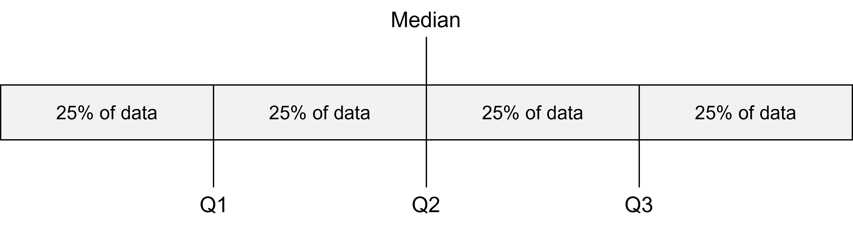
- Complete Table 1 while the teacher unpacks the features of quartiles.
Table 1 – unpacking quartiles
Value | Description
Q1 – lower quartile
Q2 – median
Q3 – upper quartile
Box plots
Figure 2 – components of a box plot
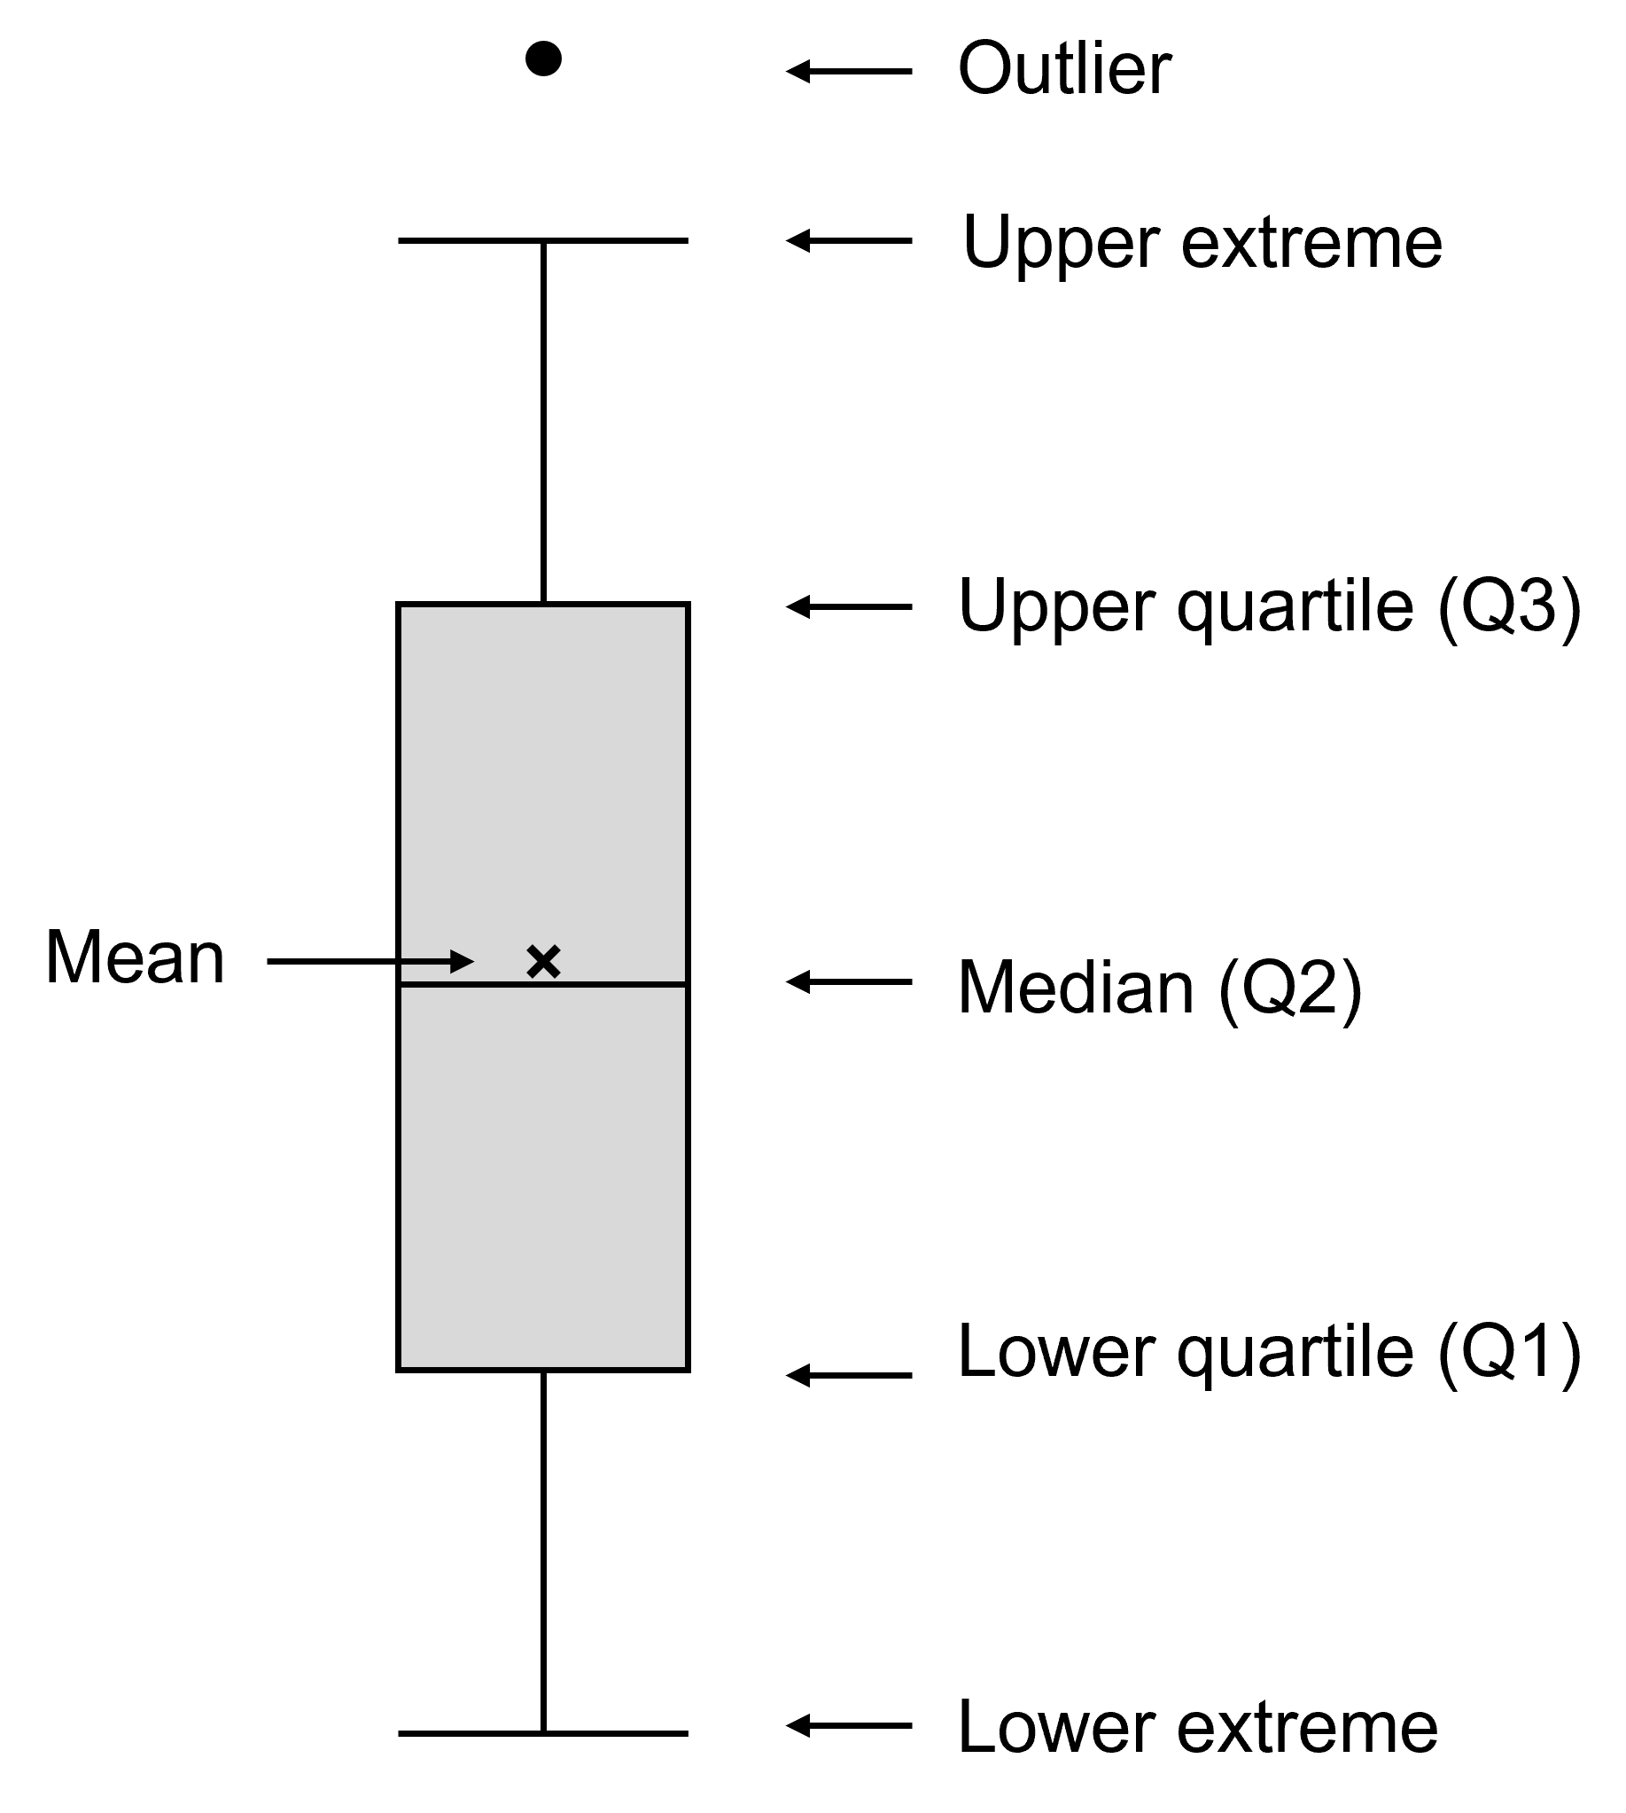
- Complete Table 2 below to summarise the components of a box plot.
Table 2 – components of a box plot
Value | Description
Q1 – lower quartile
Q2 – median
Q3 – upper quartile
Upper extreme
Lower extreme
Outlier
Interpreting data in box plots
Figure 3 – mean heart rate of Year 10 students at rest
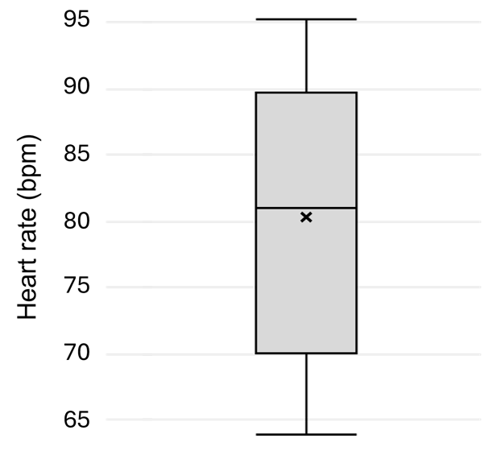
- Identify the following descriptive statistics of the dataset using the box plot in Figure 3.
Mean
Median
Maximum
Minimum
The interquartile range (IQR) shows how spread out the middle half (middle 50%) of the data is. To calculate the IQR, find the values at Q1 and Q3, then subtract Q1 from Q3:
IQR = Q3 − Q1.
- Calculate the following descriptive statistics of the dataset using the box plot in Figure 3.
Range
Interquartile range

2.3 Univariate and bivariate analysis
Table 10 – learning intentions and success criteria for ‘2.3 Univariate and bivariate analysis’
We are learning: | I can:
- to identify how data is used to investigate questions and claims | - outline the features of univariate and bivariate analysis  - identify questions that can be investigated with a univariate analysis  - conduct a univariate analysis to answer a question  - identify questions that can be investigated with a bivariate analysis  - conduct a bivariate analysis to answer a question
- to process data from investigations | - identify when to use a histogram or box plot for univariate analysis  - construct a histogram and a box plot in Microsoft Excel  - construct a scatter plot in Microsoft Excel
- to analyse data from investigations | - describe and analyse patterns and trends in data  - interpret a histogram and a box plot  - interpret a scatter plot  - interpolate and extrapolate information from a line of best fit to make predictions  - use evidence to construct a conclusion to respond to an investigable question
- to solve problems using data. | - select suitable descriptive statistics and/or representations to conduct a univariate analysis  - select a suitable representation to conduct a bivariate analysis.
Note: the activities in this sequence involve a non-scientific dataset with 50 data points. The content learned in this sequence is applied to a large scientific dataset in ‘2.4 Univariate and bivariate analysis of a large dataset’.

Understanding univariate and bivariate analysis of datasets
- Display 2.3 PPT ‘Univariate and bivariate analysis of datasets’ to unpack the features of each type of dataset analysis.
- Show students a range of investigable scientific questions using 2.3 PPT ‘Scientific questions’ and unpack how each one would involve a univariate or a bivariate analysis. Provide the reasoning for each question.
- To further consolidate students’ understanding of univariate analysis, deliver the following scenario to students:
- Imagine you have a spreadsheet with thousands of rows of weather data. Each column records something different, such as temperature, rainfall, humidity and wind speed.
- For univariate analysis, you ignore all the other columns and look at just one column, for example, daily temperature.
- You can then ask questions like
- What is the average temperature in location X? (Mean.)
- What temperature occurs most often in location X? (Mode.)
- How much do temperatures vary at location X? (Range, standard deviation.)
- Were there any unusually hot or cold days?
- Use 2.3 PPT ‘Univariate analysis of a dataset’ and 2.3 PPT ‘Bivariate analysis of a dataset’ to show students that the dataset does not determine the type of analysis, but rather the question asked does. Both slides demonstrate this with the familiar dataset related to rainbow lorikeet observations.
- Display PPT 2.3 ‘Compare a univariate and bivariate analysis’ to demonstrate how box plots can be used for a univariate analysis and line graphs can be used for a bivariate analysis. The comprehensive speaker notes on the slide unpack the types of questions each analysis can answer.

Univariate analysis of a dataset
This activity introduces students to conducting a univariate analysis of a simple dataset before they conduct one on a large dataset in the next lesson sequence.
Check for understanding 1: display 2.3 PPT ‘Check for understanding 1’ to check students' understanding of univariate analysis using a multiple-choice question.
A scientist collected data on 200 eucalyptus trees. The dataset includes tree height, trunk diameter, canopy width and location.
Which investigation is an example of univariate analysis?
- Investigating whether taller trees have wider trunks.
- Comparing tree height with the canopy width.
- Describing the typical height and variation in height of eucalyptus trees.
- Investigating whether the trunk diameter differs between locations.
Table 11 – check for understanding 2 sample responses and elaborations
Response | Elaboration
A | This is incorrect because it investigates the relationship between 2 variables.
B | This is incorrect because it investigates the relationship between 2 variables.
C | This is the correct answer. Only one variable, tree height, is being analysed. The scientist could describe its centre, spread, shape and any unusual values.
D | This is incorrect because it investigates the relationship between 2 variables.
- Display a copy of the Microsoft Excel workbook ‘2.3 Univariate and bivariate analysis’ and unpack the data provided with students:
- the dataset has 3 columns and 50 sets of paired data
- the data was recorded over 50 days
- the maximum daily temperature was recorded, along with the daily ice cream sales.
- Guide a discussion about the types of questions that could be investigated using univariate analysis and the information provided in Table 12.
Table 12 – possible questions that could be answered using univariate analysis
Question for univariate analysis | How could it be investigated?
What was the typical daily maximum temperature over the 50 days? | Calculate mean and median. This will indicate the centre, or typical value, of the data.
How much did daily maximum temperature vary? | Construct a box plot which will show the range and interquartile range.
How were the daily maximum temperatures distributed? | Construct a histogram. A histogram will show the shape of the data and where certain temperature ranges were more frequent.
What temperature range occurred most frequently? | Construct a histogram and identify the interval with the highest frequency.
What was the typical number of ice creams sold each day? | Calculate the mean and median.
How much did daily ice cream sales vary? | Construct a box plot which will show the range and interquartile range.
How were the daily ice cream sales distributed? | Construct a frequency histogram to show the data's shape and spread.
Check for understanding 2: display 2.3 PPT ‘Check for understanding 2’ and check students' understanding of appropriate ways to investigate different questions that require a univariate analysis. The stimulus, questions and answers are shown in Figure 8.
Figure 8 – check for understanding 2 stimulus, questions and answers
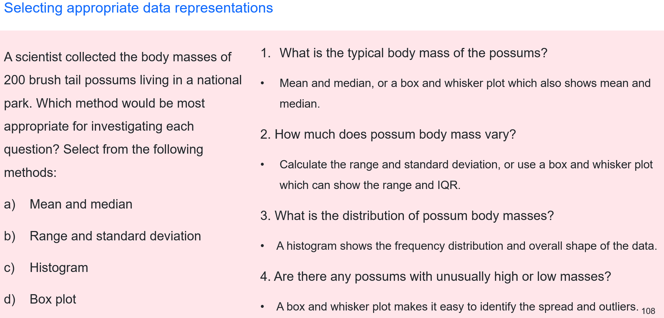
- Provide students with access to a digital device, a copy of the Microsoft Excel workbook ‘2.3 Univariate and bivariate analysis’ and the Student resource – constructing univariate representations in Microsoft Excel which steps them through how to make a histogram and a box plot in Microsoft Excel.
- Model for students how to conduct a univariate analysis of the dataset to answer selected questions based on temperature, ideally so they understand how to produce a histogram and a box plot. The instructions for conducting a univariate analysis are:
- Determine the question (related to one variable) that will be answered.
- Identify which descriptive statistics and/or representation will be most suited to help determine the answer.
- Calculate the appropriate descriptive statistics. Select statistics that help answer the question, such as
- mean and median – to identify the centre or typical value
- range and standard deviation – to identify the spread or variation
- minimum and maximum – to identify any extremes
- Create a suitable representation to reveal features that may not be obvious from the raw data. For numerical data, this could include a
- histogram (see Student resource – constructing univariate representations in Microsoft Excel for instructions on how to create a histogram)
- box plot (see Student resource – constructing univariate representations in Microsoft Excel for instructions on how to create a box plot)
- Explain what the statistics and patterns mean and draw a conclusion to answer the question.
Differentiation: the Student resource – univariate analysis of daily temperature and ice cream sales dataset provides a narrower focus for the univariate analysis, with highly scaffolded steps to support students through the descriptive statistics, suitable representations and interpretation of data.
- Guide students to conduct a univariate analysis of the dataset to answer selected questions based on ice cream sales.
Note: reinforce with students that calculating statistics is not analysis. Analysis occurs when students use those statistics and representations to describe and interpret the variable's characteristics.
Sample response: Student resource – univariate analysis of daily temperature and ice cream sales dataset
Note: additional stimulus information has been removed from the sample response.
Univariate analysis – What temperature range occurred most frequently during the 50 days?
- What variable from the dataset is being analysed? | Daily maximum temperature
- How many variables are being analysed? | One
- Which method would be most useful for answering the investigation question? | ☐ Calculate the mean and median  ☐ Calculate the standard deviation  ☒ Construct a histogram  ☐ Construct a scatter plot
- Outline why you selected this method.
A histogram will organise the temperature into ranges and the tallest column will show the range that occurred most frequently.
Note: you could point out to students that the value with the highest frequency is called the ‘mode’. Students learned about mode in Stage 4 Data science 1.
- Construct a histogram using Microsoft Excel to represent the data for the variable being investigated. Insert a screenshot below:
Figure 1 – a sample student histogram for the daily maximum temperature variation over 50 days

Note: the bin size was adjusted to 3 to represent the data in the histogram (see Figure 1).
- Use your histogram to answer the following questions.
Which temperature interval has the tallest bar? | 24°C to 27°C
How many days had temperatures within this interval? | 11 days
Which temperature interval occurred least frequently? | 36°C to 39°C
- Interpret the results to complete the descriptive analysis below to answer the question being investigated.
The most frequently occurring temperature range was 24°C to 27°C. Temperatures within this range occurred on 11 of the 50 days. Therefore, the daily maximum temperature most often fell in the 24°C to 27°C range during the 50 days.
Univariate analysis – How much did daily ice cream sales vary over the 50 days?
- What variable from the dataset is being analysed? | Daily ice cream sales
- How many variables are being analysed? | One
- Which method(s) would be most useful for answering the investigation question? | ☒ Construct a box plot  ☐ Calculate the standard deviation  ☐ Construct a histogram  ☒ Calculate the range
- Outline why you selected this method(s).
The range is suitable because the question asks about variation in sales. A box plot also shows the range, but it also shows other useful information about variation in the data, including the interquartile range (the spread of the middle 50% of the data).
- Calculate the range of the data by subtracting the minimum value from the maximum value.
Range = maximum (153) − minimum (45)
Range = 108 ice cream sales
Note: students can use Microsoft Excel to calculate the range by first calculating the Min value and Max value. The formulas are:
=MIN(highlight variable)
=MAX(highlight variable)
=(MAX value) − (MIN value)
- Construct a box plot using Microsoft Excel to represent the data for the variable being investigated. Insert a screenshot below:
Figure 2 – a sample student box plot for ice cream sales per day

Note: you can add data labels to the box plot to make it easier for students to identify actual values.
- Use your box plot to answer the following questions.
Does the range shown on the box plot match your calculated value? | Yes
What is the interquartile range (IQR) of the data? | 110.75 − 72 = 38.75 ice cream sales
What is the median? | 89.5 ice cream sales
How much of the data sits in Quartile 3? | 25% of the data
- What does the interquartile range (IQR) tell you about the data?
The interquartile range tells us the spread of the middle 50% of the data. Therefore, the middle 50% of ice cream sales varies by 38.75 ice creams.
- Complete the univariate analysis by answering the original question: How much did daily ice cream sales vary over the 50 days? Refer to key data in your response.
Daily ice cream sales varied considerably over the 50 days. Daily sales ranged from a low of 45 ice creams to a high of 153 ice creams. This gives a range of 108 ice creams, showing a large difference between the lowest and highest daily sales.
The lower quartile was 72 ice creams and the upper quartile was 110.75 ice creams, giving an interquartile range (IQR) of 38.75 ice creams. This means that the middle 50% of daily sales were spread across approximately 39 ice creams, from 72 to 110.75.
The median was 89.5 ice creams, meaning that half of the days had sales below 89.5 and half of the days had sales above 89.5.
Overall, daily ice cream sales varied substantially across the 50 days. Sales ranged from 45 to 153 ice creams per day, while the middle 50% of days had sales between 72 and 110.75 ice creams. Therefore, the range and IQR provide evidence that the number of ice creams sold was not consistent from day to day.

Student resource – univariate analysis of daily temperature and ice cream sales dataset
A dataset was collected on the maximum daily temperature and ice cream sales at a beach in Coffs Harbour over 50 days. The data is provided in Microsoft Excel workbook ‘2.4 Univariate and bivariate analysis’. You are going to conduct a univariate analysis to answer 2 separate questions:
- What temperature range occurred most frequently during the 50 days?
- How much did daily ice cream sales vary over the 50 days?
Univariate analysis – What temperature range occurred most frequently during the 50 days?
- What variable from the dataset is being analysed?
- How many variables are being analysed?
- Which method would be most useful for answering the investigation question? | ☐ Calculate the mean and median  ☐ Calculate the standard deviation  ☐ Construct a histogram  ☐ Construct a scatter plot
- Outline why you selected this method.
- Construct a histogram using Microsoft Excel to represent the data for the variable being investigated. Insert a screenshot below:
- Use your histogram to answer the following questions:
Which temperature interval has the tallest bar?
How many days had temperatures within this interval?
Which temperature interval occurred least frequently?
- Interpret the results to complete the descriptive analysis below to answer the question being investigated.
The most frequently occurring temperature range was ___________ to ___________°C. Temperatures within this range occurred on _____________ of the 50 days. Therefore, _______ ___________________________________________________________________________.
Univariate analysis – How much did daily ice cream sales vary over the 50 days?
- What variable from the dataset is being analysed?
- How many variables are being analysed?
- Which method(s) would be most useful for answering the investigation question? | ☐ Construct a box plot  ☐ Calculate the standard deviation  ☐ Construct a histogram  ☐ Calculate the range
- Outline why you selected this method(s).
- Calculate the range of the data by subtracting the minimum value from the maximum value.
- Construct a box plot using Microsoft Excel to represent the data for the variable being investigated. Insert a screenshot below:
- Use your box plot to answer the following questions:
Does the range shown on the box plot match your calculated value?
What is the interquartile range (IQR) of the data?
What is the median?
How much of the data sits in Quartile 3?
- What does the interquartile range (IQR) tell you about the data?
- Complete the univariate analysis by answering the original question: How much did daily ice cream sales vary over the 50 days? Refer to key data in your response.

Student resource – constructing univariate representations in Microsoft Excel
Constructing a histogram
A histogram is a useful way to represent numerical data when conducting a univariate analysis. It groups values into intervals, or bins, and shows how frequently values occur within each interval. Histograms are particularly useful for large datasets where patterns in the data may be difficult to identify by looking at a table of individual values. The shape of a histogram can help you quickly identify important features of a single variable, including:
- typical values – where most of the data is concentrated
- spread – how widely the values are distributed
- shape – whether the data is symmetrical, skewed or has multiple peaks
- unusual values – values or groups of values that appear separated from the rest of the data.
- Copy or type the data from Figure 1 below into the cells of a spreadsheet if the data has not already been provided in a spreadsheet.
- Select all the cells containing the data on the variable that you are investigating.
Figure 1 – selection of data being analysed which will be used to create a histogram
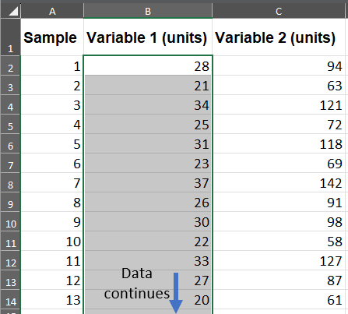
- Select Insert in the toolbar and then select the icons outlined to select the Histogram (see Figure 2).
Figure 2 – how to select the histogram graph type in Microsoft Excel
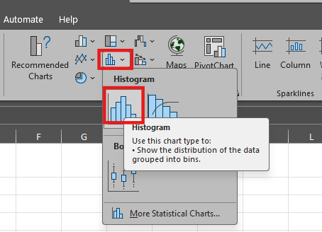
- Select Chart Elements by selecting the + icon and then select the Axis Titles box (see Figure 3).
Figure 3 – how to modify the Chart Elements in Microsoft Excel
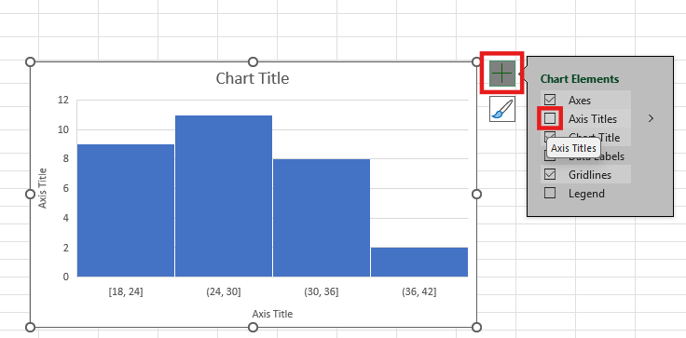
- Edit the chart title and axis labels (see Figure 4):
- the chart title should describe the variable being investigated
- the y-axis title should be changed to ‘Frequency’
- the x-axis title should be changed to ‘Name of the variable (units)’.
Figure 4 – what to write for the title and axis labels on a histogram
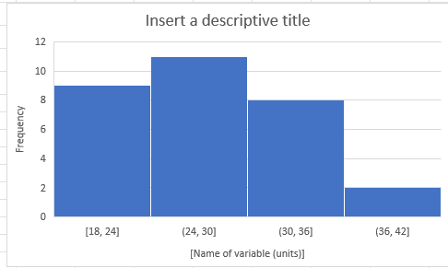
- Modifying the bin widths can help with interpreting the histogram. To modify the bin widths, select the bins on the graph. Then select Axis Options, select Bin width and change the number to the preferred bin width (see Figure 5).
Figure 5 – how to modify the bin widths for a histogram in Microsoft Excel
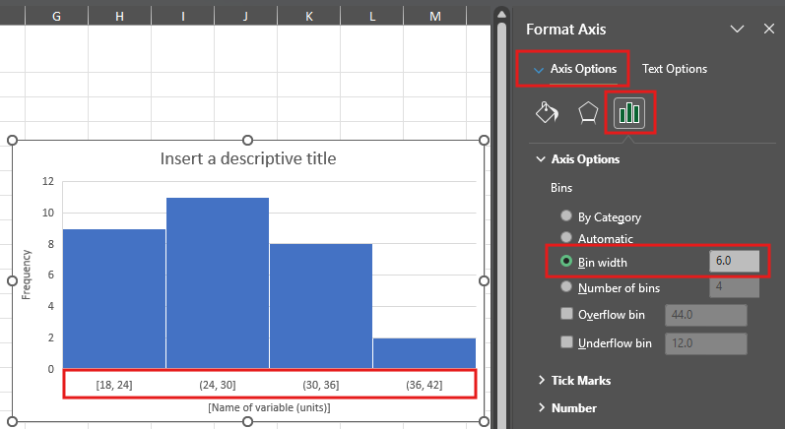

Constructing a box plot
A box plot (or box-and-whisker plot) is a useful way to represent numerical data when conducting a univariate analysis. It summarises the data using key values, including the median, quartiles and range and can also show potential outliers.
A box plot can help you quickly identify important features of a single variable, including:
- typical values – the median ($x$) shows the middle value of the dataset
- spread – the box and whiskers show how widely the data values are spread
- variability – the interquartile range (IQR) shows the spread of the middle 50% of values
- skewness – the position of the median and relative lengths of the box sections and whiskers can indicate whether the data is symmetrical or skewed
- potential outliers – unusually high or low values may be displayed separately from the whiskers as dots.
Box plots are particularly useful for summarising large datasets and for quickly describing the centre, spread and shape of the data.
- Copy or type the data from the table into the cells of a spreadsheet if the data has not already been provided in a spreadsheet.
- Select all the cells containing the data on the variable that you are investigating (see Figure 6).
Figure 6 – selection of data being analysed which will be used to create a box plot
- Select Insert in the toolbar and then select the icons outlined to select the Box and Whisker plot (see Figure 7).
Figure 7 – how to select the box plot graph type in Microsoft Excel
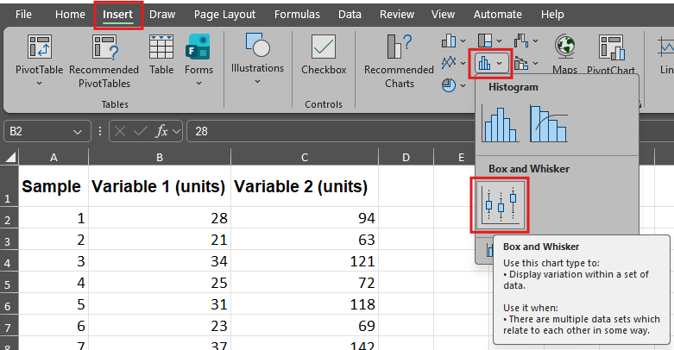
- Add a label to the ‘y-axis’. Select Chart Elements by selecting the + icon. Then, select the arrow next to Axis Titles and then select the box for Primary Vertical (see Figure 8).
Figure 8 – how to add a label to the y-axis of a box plot
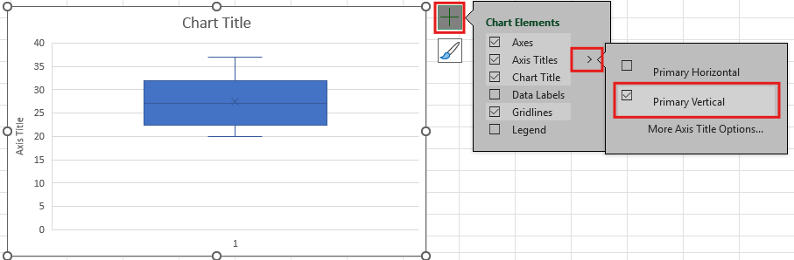
- Give the box plot an appropriate title that describes the variable being investigated. Write the variable and units on the y-axis.

Bivariate analysis of a dataset
This activity introduces students to bivariate analysis using a simple dataset before they conduct a univariate analysis of a large dataset in the next lesson sequence.
- Recall that a ‘bivariate analysis’ is an analysis that investigates if there is a relationship between 2 variables. Tell students it is usually used to answer questions such as:
- What pattern exists between [variable 1] and [variable 2]?
- How does [variable 1] change as [variable 2] changes?
- Is there a relationship between [variable 1] and [variable 2]?
Check for understanding 3: activate prior knowledge of the types of questions that require a bivariate analysis to answer using 2.3 PPT ‘Check for understanding 3’. Pose the scenario:
A scientist monitors a creek ecosystem at 40 different sites. At each site, they record water temperature, dissolved oxygen concentration, water depth, number of aquatic insect species and the pH of the water. Which 3 questions could be answered using a bivariate data analysis?
- What was the typical dissolved oxygen concentration across the creek sites?
- Does dissolved oxygen concentration change as water temperature increases?
- Is there a relationship between water depth and the number of aquatic insect species?
- How much did pH vary between the sampling sites?
- Do sites with higher pH have more aquatic insect species?
Table 13 – check for understanding 3 sample responses and elaborations
Response | Elaboration
A | This response is incorrect. This question requires a univariate analysis because it looks at only one variable – dissolved oxygen concentration.
B | This response is correct. The question investigates the relationship between 2 variables.
C | This response is correct. The question investigates the relationship between 2 variables.
D | This response is incorrect. This question investigates only one variable – the variation in pH.
E | This response is correct. The question seeks to investigate the relationship between 2 variables.
- Display the Microsoft Excel workbook ‘2.3 Univariate and bivariate analysis’ and guide a discussion about the types of questions that could be investigated using a bivariate analysis using the information provided in Table 14.
Table 14 – possible questions that could be answered using bivariate analysis
Questions for bivariate analysis | How could it be investigated?
Is there a relationship between the daily maximum temperature and the number of ice creams sold? | Creating a scatter plot. Look at the direction and strength of the relationship.  You could also calculate the correlation coefficient.
How does the number of ice creams sold change as the daily maximum temperature increases? | Create a scatter plot of the data and add a line of best fit. The overall trend can be examined.
Are there days when ice cream sales do not follow the overall relationship with temperature? | Construct a scatter plot of the data. Add a line of best fit and examine points that are unusually far away from the line.
- Provide students with access to a digital device, a copy of the Microsoft Excel workbook ‘2.3 Univariate and bivariate analysis’ and the Student resource – bivariate analysis of daily temperature and ice cream sales dataset.
- Guide students through how to conduct a bivariate analysis of the dataset. Table 15 provides step-by-step instructions for working through the bivariate analysis to answer the question ‘How does the number of ice creams sold change as daily maximum temperature increases?’
How to conduct a bivariate analysis
- Determine the question (related to 2 variables) that will be answered.
- Clearly identify the 2 variables and their units. Where appropriate, identify the independent and dependent variable.
- Construct an appropriate representation that will display the 2 variables in a way that will help answer the question:
- A scatter plot is useful when both variables are numerical. Each point represents a pair of measurements from the same observation. A scatter plot can identify the direction, form and strength of the relationship, as well as any unusual data points. You may also add a line of best fit to show the overall trend.
- Side-by-side box plots are useful when comparing a numerical variable between 2 or more groups or categories. The box plots make it possible to compare the median, spread, range and outliers between the 2 or more groups.
- A line graph is useful when investigating how a numerical variable changes across an ordered variable, particularly time. Connecting consecutive observations helps show how the variable changes from one measurement to the next.
- Grouped or segmented column graphs can be useful when investigating an association between categorical variables. They allow you to compare the frequency or proportion of observations in different categories.
- Describe the relationship between the variables.
- Extension step: quantify the relationship where appropriate. This could include calculating a statistic such as a correlation coefficient.
- Explain what the relationship means in terms of the scientific situation being investigated.
- Draw a conclusion to answer the original question using evidence from the analysis.
Note 1: bivariate analysis can be summarised as ‘Question Represent Describe Quantify Conclude’. This resource guides students through that process.
Note 2: the correlation coefficient is beyond the requirements for Stage 5; however, it may be useful extension work for capable students.
Table 15 – instructions for guiding students through the bivariate analysis
Step in bivariate analysis | Teacher notes and instructions
Determine the question. | - The question has been provided in the student resource for this investigation.  - The question is: How does the number of ice creams sold change as daily maximum temperature increases?
Identify the 2 variables and their units. | - Support students to identify the 2 variables as:  - daily maximum temperature (°C)  - daily ice cream sales.
Construct an appropriate representation that displays the variables so the question can be answered. | - Refer students to Table 1 in the Student resource – bivariate analysis of daily temperature and ice cream sales dataset to teach them how to select the appropriate representation.  - The data for both identified variables is numerical. Therefore, a scatter plot is suitable.  - Model, while students follow along, how to construct a scatter plot using the Student resource – constructing a scatter plot in Microsoft Excel.
Describe the relationship between the variables. | Features that can be described include:  - direction – Does generally increase or decrease as $x$ increases (positive, negative or no clear relationship)?  - form – What shape does the overall pattern follow (linear, non-linear or curved)?  - strength – How closely do the points follow the overall pattern (strong, moderate, weak)?
Explain what the relationship means in terms of the scientific situation being investigated. | - This particular dataset is not related to a scientific concept as such; however, students can relate the relationship to the question and variables being investigated.  - Students can restate the relationship. They can explain the pattern in context. Ask ‘Why might this relationship occur?’ Students may provide a plausible explanation such as ‘On hotter days, people may be more likely to buy ice creams because they are seeking cold foods to help them feel cooler.’  - Prompt students to consider other factors which may affect ice cream sales, such as the day of the week. This is particularly valuable, as it discourages students from assuming the relationship automatically demonstrates causation.
Draw a conclusion. | - Instruct students to draw on their bivariate analysis to construct a conclusion that responds to the original question.
Sample response: Student resource – bivariate analysis of daily temperature and ice cream sales dataset
Note: additional stimulus information has been removed from the sample response.
- Identify why this question requires a bivariate analysis of data and not a univariate analysis.
The question is bivariate because it investigates the relationship between 2 variables: daily maximum temperature and the number of ice creams sold.
The question asks how ice cream sales change as temperature increases, so the 2 variables must be analysed together to determine whether they are related.
A univariate analysis would analyse only one of these variables, such as investigating the typical daily maximum temperature or how much ice cream sales varied. It would not show whether temperature changes are associated with changes in ice cream sales.
- Identify the variables that are being investigated.
Daily maximum temperature and daily sales of ice creams.
- Which type of representation is suitable to display the 2 variables so that the question can be answered?
A scatter plot is the most suitable representation because both variables are numerical. A scatter plot displays each day’s temperature and ice cream sales as a paired data point, allowing us to identify the direction, strength and form of the relationship, as well as any outliers.
- Construct the representation using Microsoft Excel and paste a copy below:

- Describe the relationship between the variables.
A strong, positive linear relationship exists between daily maximum temperature and ice cream sales. As the daily maximum temperature increases, the number of ice creams sold generally increases. The points cluster closely around the line of best fit, showing a strong relationship.
- What does the pattern or trend in the graph tell us about the 2 variables?
The trend shows that warmer days are generally associated with higher ice cream sales. As the daily maximum temperature increases, the number of ice creams sold tends to increase.
- Draw a conclusion. Answer the original question using evidence from the analysis.
The analysis shows that ice cream sales increase as daily maximum temperature increases. The data points cluster closely around the line of best fit, showing a strong, positive linear relationship between the 2 variables. For example, on days around 18°C to 20°C, approximately 45 to 60 ice creams were sold, while on days around 35°C to 38°C, approximately 125 to 150 ice creams were sold. This provides evidence that warmer days are associated with higher ice cream sales.
- Use the scatter plot to predict the number of ice cream sales for the following daily maximum temperatures:
- 15°C | Approximately 28 ice cream sales
- 35°C | Approximately 130 ice cream sales
Note: this question requires students to extrapolate (go beyond the data trend) and interpolate (look within the data trend) to predict ice cream sales. Check that students have used the line of best fit to determine their answers, not the data values on the scatter plot.

Student resource – bivariate analysis of daily temperature and ice cream sales dataset
A dataset was collected on the maximum daily temperature and ice cream sales at a beach in Coffs Harbour over 50 days. The data is provided in Microsoft Excel Workbook ‘2.4 Univariate and bivariate analysis’. You will conduct a bivariate analysis to answer the question: How does the number of ice creams sold change as the daily maximum temperature increases?
- Identify why this question requires a bivariate analysis of data and not a univariate analysis.
- Identify the variables that are being investigated.
Choosing a representation of the data
When scientists investigate 2 variables, they need ways to represent the data that make it easier to identify whether a relationship exists between them. The most appropriate representation depends on the type of data collected and the question being investigated.
Before selecting a representation, identify the 2 variables being investigated and determine whether each is numerical, categorical or ordered. Then, consider what you are trying to find out.
Table 1 – a decision matrix for selecting a suitable representation for bivariate analysis
If you want to investigate … | Consider using …
A relationship between 2 numerical variables | Scatter plot
Differences in numerical data between groups | Side-by-side box plots
Change in a numerical variable over time | Line graph
An association between categorical variables | Grouped or segmented column graph
- Which type of representation is suitable to display the 2 variables so that the question can be answered?
- Construct the representation using Microsoft Excel and paste a copy below:
- Describe the relationship between the variables.
- What does the pattern or trend in the graph tell us about the 2 variables?
- Draw a conclusion. Answer the original question using evidence from the analysis.
- Use the scatter plot to predict the number of ice cream sales for the following daily maximum temperatures:
- 15°C
- 35°C

Student resource – constructing a scatter plot in Microsoft Excel
A scatter plot is a useful representation for bivariate analysis when both variables are numerical. It allows you to display 2 variables on the same graph so that you can investigate whether there is a relationship between them.
A scatter plot can help you identify:
- the direction of the relationship – positive, negative or no clear relationship
- the form of the relationship – for example, linear or non-linear
- the strength of the relationship – how closely the points follow the overall pattern
- any outliers – individual points that do not follow the general pattern.
When appropriate, you can also add a line of best fit to make the overall trend easier to see.
- Copy or type the data from the table into the cells of a spreadsheet if the data has not already been provided in a spreadsheet.
- Select all the data for the 2 variables being investigated.
Figure 1 – how to select the data for the 2 variables
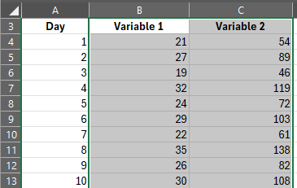
- Navigate to the Insert tab and then select Insert Scatter (X, Y) or Bubble Chart (see Figure 2).
Figure 2 – how to select the ‘Insert Scatter (X, Y) or Bubble Chart
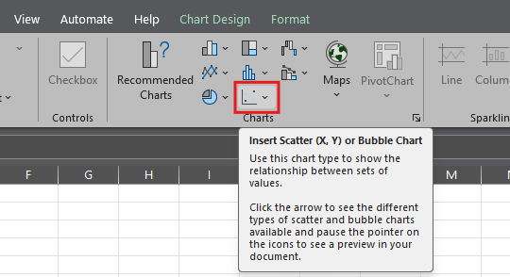
- Select Scatter from the list (see Figure 3).
Figure 3 – how to select the scatter plot
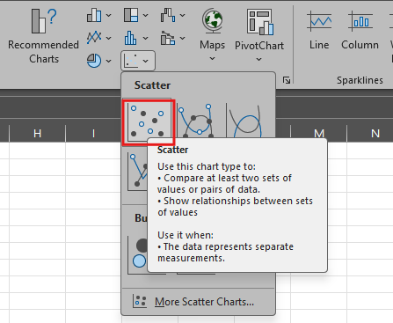
- Select the Chart Design tab. Navigate to the Add Chart Element, then Axis Titles, and select Primary Horizontal and Primary Vertical (see Figure 4).
Figure 4 – how to add axis labels to the plot
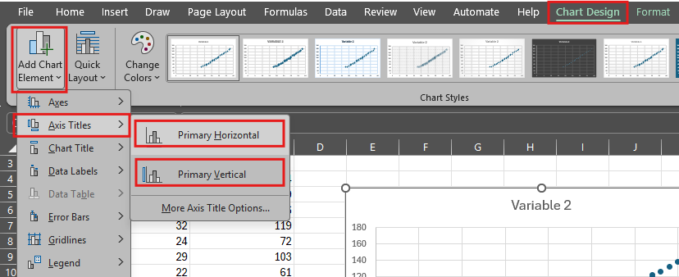
- Select the chart title and replace it with the question being investigated. Select the axis labels and modify them as needed (see Figure 5).
Figure 5 – how to replace the chart title and axis labels
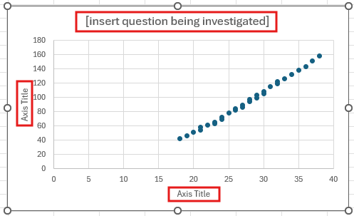
- Select the Chart Design tab. Navigate to the ‘Add Chart Element icon, then select Trendline and choose Linear if the data appears to form a straight line (see Figure 6).
Figure 6 – how to add a linear trendline
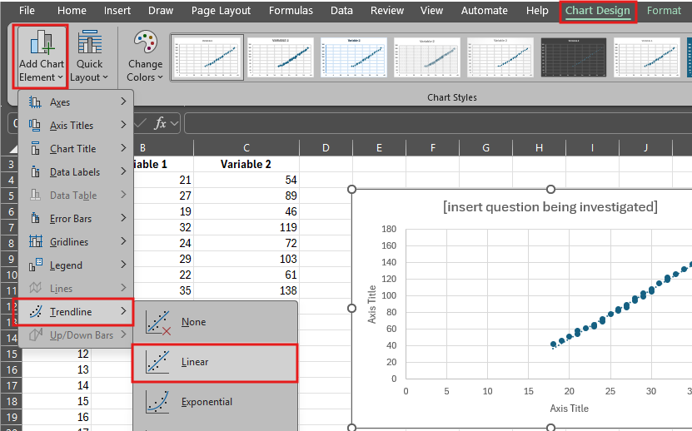

2.4 Univariate and bivariate analysis of a large dataset
Table 16 – learning intentions and success criteria for ‘2.4 Univariate and bivariate analysis of a large dataset’
We are learning: | I can:
- to analyse how data is used to investigate questions and claims | - develop and test an investigable scientific question using a large dataset  - conduct a univariate analysis of a variable in a large dataset  - conduct a bivariate analysis of 2 variables in a large dataset  - construct a conclusion to the investigable question
- to process data in a large dataset | - calculate a range of descriptive statistics, including mean and standard deviation  - select and construct an appropriate graph to represent data
- to analyse data from investigations. | - describe trends and patterns in a large dataset  - describe the impact of missing and inconsistent data on descriptive analysis  - draw evidence-based conclusions from a dataset to answer a question.

Fine particle pollution – secondary source investigation
In this activity, students will analyse a large, long-term air-quality dataset in Microsoft Excel to investigate patterns in fine-particle concentrations. They will review background information to develop scientific questions, then complete univariate and bivariate analyses to support evidence-based conclusions.
Note: the data in the Microsoft Excel workbook ‘2.4 Fine particle pollution dataset’ has been adapted from the dataset provided by ANSTO in their Monitoring fine particle air pollution in Newcastle activity. Worked examples for the statistical analysis and representations used in the sample answers are also provided in separate sheets of the workbook.
ANSTO Education Resources also provides a student worksheet that was used to develop the student resource.
- Provide students with access to a laptop or similar device, access to the Microsoft Excel workbook ‘2.4 Fine particle pollution dataset’ and the Student resource – fine particle pollution secondary source investigation.
- Introduce the activity using 2.4 PPT ‘Air quality in Newcastle’ (1 of 2), to highlight the context of the data found in the large dataset.
- Guide students to engage with the information in the Student resource – fine particle pollution secondary source investigation under the heading ‘Fine particle air pollution in Newcastle’.
- Clarify the meaning of any abbreviations, units or chemical symbols used in the dataset, including those in Table 17, using 2.4 PPT ‘Air quality in Newcastle’ (2 of 2).
- Outline if and how the substances listed contribute to air quality using Table 17.
Table 17 – abbreviations used in ‘2.4 Fine particle pollution dataset’
Abbreviation, unit or chemical symbol | Name | How it contributes to air quality
(NH₄)₂SO₄ | ammonium sulfate | A secondary pollutant that forms fine particulate matter (PM₂₅), degrading air quality and affecting respiratory health.
OMH | organic matter from hydrogen | A pollutant from fuel combustion that contributes to organic aerosols and to the formation of smog.
BC | black carbon | A pollutant (soot) from incomplete combustion that degrades air quality and contributes to atmospheric warming.
H | hydrogen | Not a pollutant, but part of compounds that participate in atmospheric chemical reactions affecting air quality.
Na | sodium | Not typically a pollutant, but it contributes to natural particulate matter (sea salt) in the air.
Al | aluminium | A particulate pollutant from soil and industry that can degrade air quality when present as fine particles.
Si | silicon | A particulate pollutant (such as silica dust) that can negatively impact air quality and respiratory health.
S | sulfur | A pollutant precursor that forms sulfur dioxide (SO₂), contributing to acid rain and secondary particle formation.
K | potassium | A tracer of pollution from biomass burning that contributes to airborne particulate matter.
Ca | calcium | Not typically a pollutant, but it contributes to coarse particulate matter from natural and construction sources.
Ti | titanium | A minor particulate pollutant from dust and industrial sources with limited impact on air quality.
Mn | manganese | A toxic pollutant from industrial emissions that can degrade air quality at high concentrations.
Fe | iron | A particulate pollutant from dust and vehicles that contributes to airborne particles and chemical reactions.
Zn | zinc | A toxic pollutant from tyres and industry that contributes to harmful particulate matter.
Pb | lead | A highly toxic pollutant that significantly degrades air quality and poses serious health risks.
ng/m³ | nanograms per cubic metre | Not a pollutant, but a unit used to measure the concentration of substances in the air.
Note: data was not collected for fine particle concentration in December 2002, January 2003 and January 2006, so this information is missing in ‘Sheet 1 – Fine particle concentration’ of the Microsoft Excel workbook ‘2.4 Fine particle pollution dataset’.
- Lead a discussion about the types of questions that could be investigated with a univariate analysis using the questions and notes provided in Table 18.
Table 18 – example questions that can be answered using univariate analysis of the fine air pollution dataset
Question for univariate analysis | Teacher notes
How much did atmospheric [insert selected fine particle] concentration vary in Mayfield between 1998 and 2019? | - Students should analyse the spread of all concentration measurements for the selected particle across the monitoring period.  - Useful statistics could include range, interquartile range (IQR), standard deviation and median.  - A useful representation would be a box plot.
What was the typical concentration of [insert selected fine particle] in Mayfield between 1998 and 2019? | - Students should analyse the centre and distribution of all concentration measurements to determine a representative value.  - Useful statistics could include the mean and median.  - Useful representation would be a histogram or box plot.  - Students could compare the mean and median and consider the shape of the distribution and presence of outliers when deciding which statistic best represents a ‘typical’ concentration.
Were there unusually high concentrations of [insert selected fine particle] during the monitoring period? | - Students should analyse the distribution and outliers of the particle concentrations. Identify measurements that are substantially higher than most observations.  - A suitable representation could be a box plot.  - Students should identify unusually high values or outliers and describe how unusual they are relative to the rest of the data.
What was the typical concentration of manganese fine particle pollution before the closure of the Delta Manganese plant? | - Students will need first to filter the dataset to measurements before the plant closure, then conduct a univariate analysis of manganese concentration for that period only.  - Useful statistics could be the mean and median.  - Useful representations could be a box plot or a histogram.
- Guide students to complete ‘Part A – univariate analysis’ in the Student resource – fine particle pollution secondary source investigation. Students will explore and analyse the dataset to identify the time period covered, recognise missing data, develop a scientific question that can be tested using univariate analysis, identify and calculate suitable descriptive statistics, and identify and construct a suitable representation of the data.
Differentiation: while the Student resource – fine particle pollution secondary source investigation is quite open-ended, the sample response provides 3 possible questions and analyses that the teacher can guide where required. Adjust the level of support based on student needs.
- Lead a discussion about the types of questions that could be investigated with a bivariate analysis using the questions and notes provided in Table 19. The last 3 examples have been modelled in the sample response for the Student resource – fine particle pollution secondary source investigation.
Table 19 – example questions that can be answered using bivariate analysis of the fine air pollution dataset
Question for bivariate analysis | Teacher notes
How did [insert fine particle] concentration change over time? | - Students should plot the fine particle investigated against time in a line graph.  - Students can look for seasonal fluctuations, large spikes that indicate a sudden rise due to some sort of event and large drops in concentration at a point which could show that something changed in the environment (such as closure of a metal factory).
Is there a relationship between the concentration of [insert fine particle] and [insert another fine particle]? | - Students would need to plot the data using a scatter plot and add a line of best fit.  - Students can look for a positive, negative or no relationship between the fine particles.  - Outliers may make it difficult to interpret the representation. For example, aluminium and silicon appear to follow a positive trend (when one increases, so does the other); however, the outliers push most data points together, making the trend difficult to interpret.  - If a positive relationship is found in the data, this may be attributed to them coming from the same source.
How did manganese concentration change over time? | - Students should plot manganese concentration against time in a line graph.  - Students could draw on stimulus material to relate the change in concentration observed to the closure of the Delta Manganese plant.
How did iron concentration change over time? | - Students should plot iron concentration against time in a line graph.  - Students could draw on the stimulus material to relate the change in concentration observed to the closure of the BHP iron and steel works in 1999.
How does atmospheric salt concentration change over time? | - Students should plot salt concentration against time in a line graph.  - A line graph of this data will show that there seems to be a somewhat consistent seasonal fluctuation.
- Support students to complete ‘Part B – bivariate analysis’ in the Student resource – fine particle pollution secondary source investigation. Students will explore and analyse the dataset to develop a question that can be tested using bivariate analysis, represent the data using a line or scatter plot, analyse the patterns seen in the data and respond to their scientific question.
Sample response: Student resource – fine particle pollution secondary source investigation
Note: the sample response below includes an alternative analysis for 3 fine particle pollutants – salt, manganese (Mn) and iron (Fe).
Additional stimulus information has been removed from the sample response.
- Open the dataset and navigate to ‘Sheet 1 – Fine particle concentration’.
- Over what time period was the data collected?
The data was collected over 21 years, from 1998 to 2019.
- The dataset provided is incomplete. Identify what data is missing and explain how this may affect the dataset's quality.
Data is missing for December 2002, January 2003 and January 2006. Missing data can limit the reliability and completeness of an analysis. This can reduce the accuracy of calculated statistics and distort trends and patterns, especially if the missing months coincide with periods of unusually high or low fine-particle concentrations.
- Drawing on the information in the stimulus and dataset, select one fine particle pollutant and develop a scientific question that could be answered using a univariate analysis. Hint: remember that a univariate analysis looks at only one variable.
Pollutant | Salt | Manganese (Mn) | Iron (Fe)
Question | How much did atmospheric salt concentration vary in Mayfield? | How much did atmospheric manganese (Mn) concentration vary in Mayfield? | How much did atmospheric iron (Fe) concentration vary in Mayfield?
- Use Microsoft Excel formulas to calculate the mean, median and standard deviation of the fine particle pollutant you are investigating.
Pollutant | Salt | Manganese (Mn) | Iron (Fe)
Mean concentration (ng/m³) | 1,181.07 | 64.74 | 122.13
Median concentration (ng/m³) | 1,071.67 | 5.66 | 88.90
Standard deviation | 723.21 | 100.33 | 146.86
- Describe what the descriptive statistics tell you about the data
Salt | Salt had a mean of 1,181.07 ng/m³ and a median of 1,071.67 ng/m³. The mean is moderately higher than the median, suggesting that some higher-concentration measurements may be pulling the mean upward. The relatively large standard deviation (723.21 ng/m³) indicates that salt concentrations varied considerably throughout the monitoring period.
Manganese (Mn) | Manganese has a mean of 64.74 ng/m³, but a much lower median of only 5.66 ng/m³. This very large difference indicates a strongly skewed distribution – most manganese measurements were relatively low, but some very high concentrations substantially increased the mean. The standard deviation (100.33 ng/m³) is also greater than the mean, indicating very high variability. Therefore, the median is more likely to indicate a typical manganese concentration than the mean.
Iron (Fe) | Iron has a mean concentration of 122.13 ng/m³ and a median of 88.90 ng/m³. The higher mean suggests that some relatively high iron measurements pull the mean upwards. The standard deviation of 146.86 ng/m³ indicates that iron concentrations varied widely across the monitoring period.
- Select between a histogram and a box plot to represent the data based on the question you have chosen. Use Microsoft Excel to make your representation.
Note: for the questions posed in this sample response, students could select either a histogram or a box plot to represent the data. Both representations have been provided for each fine particle:
- a histogram shows the distribution of the fine particle concentrations – where most measurements occur, how widely values are spread, whether the data is skewed and whether there are unusually high concentration ranges
- a box plot summarises the spread more efficiently, showing the median, IQR, overall spread and potential outliers.
Figure 1 – sample frequency histogram for salt concentration in Mayfield

Figure 2 – sample frequency histogram for manganese (Mn) concentration in Mayfield

Figure 3 – sample frequency histogram for iron (Fe) concentration in Mayfield

Use Microsoft Excel to create a box plot for the fine particle pollutant you are investigating.
Figure 4 – sample box plot for salt concentration in Mayfield

Figure 5 – sample box plot for manganese (Mn) concentration in Mayfield

Figure 6 – sample box plot for iron (Fe) concentration in Mayfield

- Complete the univariate analysis to respond to the original question, drawing on evidence from the data. You can also draw on information from the stimulus material if relevant.
Salt | Atmospheric salt concentration varied considerably in Mayfield. The mean concentration was 1,181.07 ng/m³, with a standard deviation of 723.21 ng/m³. The large standard deviation shows that individual salt concentrations often differed substantially from the mean.  The box plot also shows a widespread in concentrations. The middle 50% of measurements ranged from about 600 ng/m³ to 1,600 ng/m³, with a median of 1,071.67 ng/m³. The whiskers extend from near 0 ng/m³ to just over 3,000 ng/m³, showing concentrations across a broad range.  Several concentrations were unusually high, including values above approximately 3,100 ng/m³, with the highest near 3,750 ng/m³. These high values help explain why the mean is slightly higher than the median.  Overall, atmospheric salt concentration was highly variable in Mayfield. Most measurements clustered around 600 ng/m³ to 1,600 ng/m³, but concentrations sometimes rose much higher. The large standard deviation and widespread in the box plot support this variability.
Manganese (Mn) | Atmospheric manganese concentration was highly variable in Mayfield. The mean concentration was 64.74 ng/m³, with a standard deviation of 100.33 ng/m³. The standard deviation is larger than the mean, indicating that manganese concentrations were very widely spread.  The median concentration was only 5.66 ng/m³, which is much lower than the mean of 64.74 ng/m³. This indicates that most manganese concentrations were relatively low, but a few very high measurements pulled the mean upward.  The box plot supports this interpretation. The middle 50% of measurements range from very low concentrations to about 100 ng/m³, while the upper whisker extends to about 235 ng/m³. There are also numerous unusually high concentrations, with outliers extending from approximately 275 ng/m³ to over 500 ng/m³.  Overall, manganese concentration varied considerably in Mayfield. Most measurements were relatively low, but there were occasional periods of very high manganese concentration. The large standard deviation, substantial difference between the mean and median and numerous high outliers all indicate this variability.
Iron (Fe) | Atmospheric iron concentration varied considerably in Mayfield. The mean concentration was 122.13 ng/m³, with a standard deviation of 146.86 ng/m³. The standard deviation is larger than the mean, indicating that iron concentrations were widely spread and that measurements varied substantially.  The median concentration was 88.90 ng/m³, which is lower than the mean of 122.13 ng/m³. This suggests the distribution is skewed by some high iron concentrations pulling the mean upwards.  The box plot supports this interpretation. The middle 50% of measurements were concentrated approximately between 55 ng/m³ and 130 ng/m³, while the upper whisker extends to approximately 220 ng/m³. There are numerous unusually high concentrations above the upper whisker, including several between approximately 250 ng/m³ and 700 ng/m³. One particularly extreme measurement of approximately 1,700 ng/m³ is substantially higher than the rest of the data.  Overall, atmospheric iron concentration in Mayfield varied widely. Most measurements were relatively low and clustered within a much narrower range, but occasional very high concentrations greatly increased the overall variability. The large standard deviation supports this – the mean is higher than the median and the box plot shows numerous high outliers.
Part B – bivariate analysis
- Dive deeper into the pollutant you have selected for univariate analysis by selecting a second variable and developing a question that can be investigated using a bivariate analysis.
Variable 1 | Salt | Manganese (Mn) | Iron (Fe)
Variable 2 | Time | Time | Time
Question | How did atmospheric salt concentration change over time in Mayfield? | How did atmospheric manganese concentration change over time in Mayfield? | How did atmospheric iron concentration change over time in Mayfield?
- Select an appropriate graph type to answer your question and use Microsoft Excel to construct the representation.
Figure 7– sample line graph of the atmospheric concentration of salt in Mayfield

Figure 8 – sample line graph of the atmospheric concentration of manganese (Mn) in Mayfield

Figure 9 – sample line graph of the atmospheric concentration of iron (Fe) in Mayfield

- Describe the pattern seen in the graph. Refer to both variables and identify cyclical trends, fluctuations or spikes that might be seen.
Salt | The graph shows how the atmospheric salt concentration changes over time. Concentrations fluctuate regularly, suggesting a possible cyclical or seasonal pattern. There are also several large spikes, including values above 3,500 ng/m³, showing that salt concentrations were unusually high at certain times. Overall, concentrations appear to increase slightly in later years.
Manganese (Mn) | The graph shows how the atmospheric manganese concentration changes over time. Concentrations fluctuate greatly between 1998 and 2007, with several large spikes reaching approximately 500 ng/m³. After 2007, concentrations drop sharply and remain consistently low, with only one small spike around 2009.
Iron (Fe) | The graph shows how the atmospheric iron concentration changes over time. Concentrations were high and fluctuated widely from 1998 to 1999, then dropped sharply around 2000. After this, concentrations remained fairly low with small fluctuations. There is one unusually large spike in 2009, reaching approximately 1,700 ng/m³.
- Using your data analysis and the information provided in ‘Fine particle air pollution in Newcastle‘ or further research, draw a conclusion to the question you posed.
Salt | Atmospheric salt concentration fluctuated considerably over time in Mayfield between 1998 and 2019. Rather than showing a consistent increase or decrease, the graph shows a repeating pattern of peaks and troughs, suggesting a seasonal or cyclical relationship between time and salt concentration.  Salt concentrations frequently fell below 500 ng/m³ and then increased to above 1,500 ng/m³ to 2,000 ng/m³. There were also occasional unusually high concentrations above 3,000 ng/m³, including peaks around 2004, 2009 to 2010 and 2019. The size of the fluctuations varied between years, but the repeating pattern occurred throughout much of the monitoring period.  Mayfield's proximity to the Newcastle coast may explain this pattern. Sea spray is a likely source of atmospheric salt, and seasonal changes in wind direction, wind speed, rainfall and other weather conditions could affect how much sea salt is transported to and remains in the atmosphere.  Overall, atmospheric salt concentration did not simply increase or decrease over time. Instead, it varied considerably with a repeating seasonal pattern, suggesting that seasonal environmental conditions influence atmospheric salt concentrations in Mayfield.
Manganese (Mn) | Manganese concentrations were high and varied greatly between 1998 and 2007, with several spikes above 300 ng/m³ and a maximum of approximately 500 ng/m³. After 2007, concentrations decreased sharply and generally remained below 0 ng/m³, except for a small spike around 2009. This change may be connected to the closure of the Delta Manganese plant in Mayfield. Overall, the data suggest that local industrial activity was a major source of atmospheric manganese and that concentrations remained much lower after the plant closed.
Iron (Fe) | Atmospheric iron concentrations were relatively high in 1998 and early 1999, with several measurements between approximately 200 ng/m³ and 700 ng/m³. Around late 1999, concentrations decreased substantially and were generally below 200 ng/m³ for the remainder of the monitoring period, except for one extreme spike in 2009.  The decrease around 1999 coincides with the closure of the BHP iron and steel works in October 1999. The lower concentrations observed after this time are consistent with removing a major potential source of iron-containing particles. However, other sources of atmospheric iron may also have contributed to the measurements, so the graph does not demonstrate that the closure alone caused the decrease.  One extreme spike occurred around 2009, when iron concentration reached approximately 1,700 ng/m³. This differs sharply from the general pattern after 1999. The stimulus identifies a major dust storm in September 2009 that transported large quantities of red dust from inland NSW to the coast. As soil and mineral dust can contain iron, this event provides a plausible explanation for the unusually high concentration.  Overall, atmospheric iron concentrations were generally higher during 1998 to 1999 and much lower from late 1999 onwards. The major exception was an extreme spike in 2009, which may be associated with the major dust storm. Therefore, the data suggests that both changes in local industrial activity and short-term natural events may have influenced atmospheric iron concentrations in Mayfield.

Student resource – fine particle pollution secondary source investigation
Fine particle air pollution in Newcastle
The data for this activity was collected at an air sampling station in Mayfield between 1998 and 2019. The Newcastle region has a long history of heavy industry, including iron, steel and other metal production; chemical and fertiliser production, and petroleum and coal-tar processing. Mayfield is close to Newcastle’s highly industrialised areas and port, through which significant quantities of coal are exported annually to Asia. Newcastle is also located near several coal-fired power stations.
During the sampling period, several important industrial changes occurred. Newcastle’s major Broken Hill Proprietary Company (BHP) iron and steel works closed in October 1999, including its blast furnaces, and the Delta Manganese plant in Mayfield also ceased operating. Several nearby coal-fired power stations subsequently closed: Munmorah in July 2012, Redbank in August 2014 and Wallerawang C in November 2014. Another significant change was the withdrawal of leaded petrol from sale in NSW in January 2001. However, lead remains a legacy pollutant in the community because fine lead particles accumulated in the soil, particularly near busy roads, when petrol contained high levels of lead. These particles can be resuspended and detected in the air. Concentrations may be higher during winter temperature inversions when a layer of warmer air traps cooler air and pollutants close to the ground.
The Mayfield station also detects fine particle pollution from natural events. Dust storms occur when strong winds lift sand and dust from dry, exposed soils and transport them over hundreds or thousands of kilometres. A major dust storm in September 2009 carried millions of tonnes of red dust from inland NSW to the coast. Severe bushfires also affected the Hunter region during the sampling period, including in 1998, 2001 to 2003 and 2019. These events increased smoke and black carbon levels, appearing in the data as individual spikes above longer-term seasonal trends.
Air was sampled over 24 hours, from midnight to midnight, every Wednesday and Sunday. All values in the Microsoft Excel workbook represent concentrations of fine particles with a diameter of 2.5 micrometres or less. Concentrations are measured in nanograms per cubic metre of sampled air (ng/m³), where one nanogram is one-billionth of a gram.
This information has been adapted from Data sets by Australian Nuclear Science and Technology Organisation (ANSTO).
Part A – univariate analysis
- Open the dataset and navigate to 1. Fine particle concentration.
- Over what time period was the data collected?
- The dataset provided is incomplete. Identify what data is missing and explain how this may affect the dataset's quality.
- Drawing on the information in the stimulus and dataset, select one fine particle pollutant and develop a scientific question that could be answered using a univariate analysis. Hint: remember that a univariate analysis looks at only one variable.
Pollutant
Question
- Use Microsoft Excel formulas to calculate the mean, median and standard deviation of the fine particle pollutant you are investigating.
Mean concentration (ng/m³)
Median concentration (ng/m³)
Standard deviation (ng/m³)
- Describe what the descriptive statistics tell you about the data.
- Select between a histogram and a box plot to represent the data based on the question you have chosen. Use Microsoft Excel to make your representation.
- Complete the univariate analysis to respond to the original question, drawing on evidence from the data. You can also draw on information from the stimulus material if relevant.
Part B – bivariate analysis
- Dive deeper into the pollutant you have selected for univariate analysis by selecting a second variable and developing a question that can be investigated using a bivariate analysis.
Variable 1
Variable 2
Question
When conducting a bivariate analysis, graphical representations can help you identify trends and patterns in the data:
- A scatter plot is useful when both variables are numerical. Each point represents a pair of measurements from the same observation. A scatter plot can identify the direction, form and strength of the relationship, as well as any unusual data points. You may also add a line of best fit to show the overall trend.
- A line graph is useful when investigating how a numerical variable changes across an ordered variable, particularly time. Connecting consecutive observations helps show how the variable changes from one measurement to the next.
- Select an appropriate graph type to answer your question and use Microsoft Excel to construct the representation.
- Describe the pattern seen in the graph. Refer to both variables and identify cyclical trends, fluctuations or spikes.
- Using your data analysis and the information provided in ‘Fine particle air pollution in Newcastle‘ or further research, draw a conclusion to the question you posed.

2.5 Correlation and causation
Table 20 – learning intentions and success criteria for ‘2.5 Correlation and causation’
We are learning: | I can:
- to explain how data is used to investigate questions and claims | - explain the difference between ‘correlation’ and ‘causation’  - outline the conditions that must be met to determine causation
- to analyse data from investigations. | - identify patterns in a dataset  - identify instances of positive, negative and no correlation in a dataset  - use data to draw conclusions  - suggest improvements to an investigation that would enhance the quality of a conclusion.

Correlation and causation
- Define ‘causation’ and ‘correlation’ using 2.5 PPT ‘Correlation’ and 2.5 PPT ‘Causation’, and use the information below to reinforce that association alone is not enough – there must be a directly explained cause:
- a ‘correlation’ measures the strength of the relationship between 2 variables without implying that one causes the other
- a ‘causal’ relationship indicates that one event directly causes another or that a change in one variable produces a change in another variable.
- correlation does not imply causation – even if 2 variables are related, it does not mean that one is responsible for changing the other. Understanding the difference between correlation and causation is essential when analysing data. These concepts help us determine whether 2 variables are simply related or whether one actually causes the other.
- To deepen students' thinking on correlation and causation, share graphs from the website Spurious Correlations and discuss the saying ‘Correlation is not causation.’ Each of these graphs appears to show a relationship; however, one does not cause a change in the other variable.
- Provide students with the Student resource – correlation and causation comprehension.
- Engage with the text, modelling, jointly constructing, or having students independently extract and summarise information to respond to questions about correlation and causation.
- Facilitate a class discussion of the comprehension questions to check students' understanding of ‘correlation’ and ‘causation’. Sample responses have been provided in ‘Sample response: Student resource – correlation and causation comprehension’.
Differentiation: introduce students to the correlation coefficient ($r$ value), which measures the strength and direction of a linear relationship between 2 variables using 2.5 PPT ‘Correlation coefficient’ (3 slides).
Check for understanding 1: use 2.5 PPT ‘Check for understanding 1’ to check students’ understanding of ‘correlation’. Instruct students to match each scatter plot to the correct type of correlation and indicate their response on mini whiteboards. Encourage students to justify their choices by describing the trend of the data points. Sample answers are provided on the slide and in Table 21.
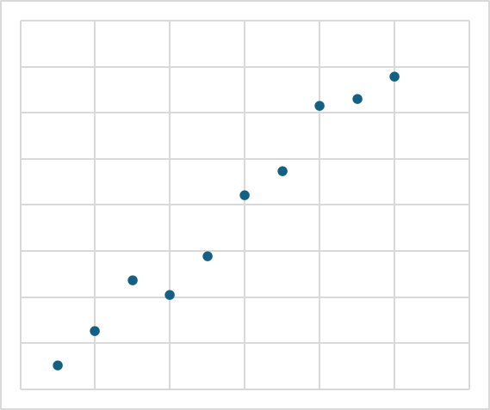
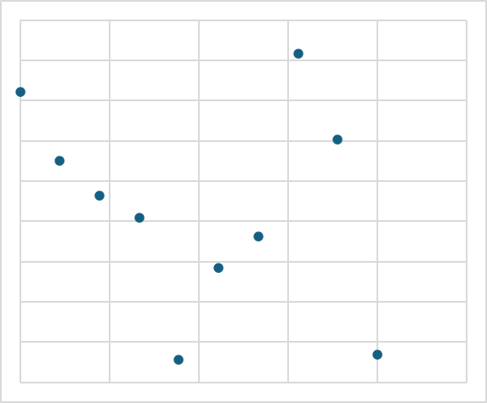
Table 21 – check for understanding 1 sample response and elaboration
Graph | Type of correlation | Elaboration
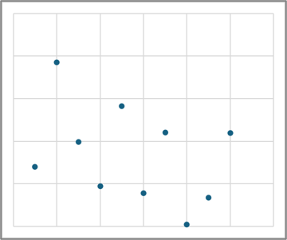 | No correlation | The points are scattered randomly with no clear relationship.
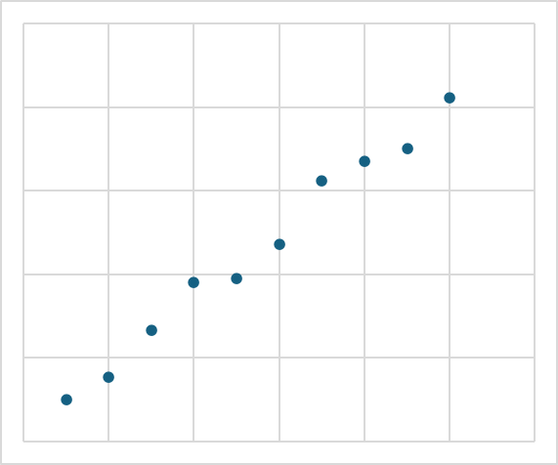 | Positive correlation | The points closely follow an upward trend (as $x$ increases, $y$ increases).
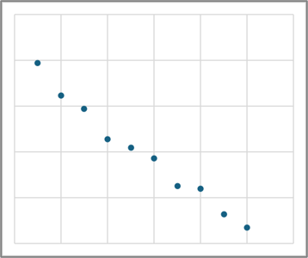 | Negative correlation | The points follow a clear downward trend (as $x$ increases, $y$ decreases).
 | Positive correlation | There is a general upward trend, though it is slightly more spread than in Graph 2.
 | No correlation | The points are widely scattered with no clear relationship.
Sample response: student resource – correlation and causation comprehension
Note: additional stimulus information has been removed from the sample response.
Comprehension questions
- Outline the key difference between ‘correlation’ and ‘causation’.
‘Correlation’ shows a relationship between 2 variables, whereas ‘causation’ shows that one variable directly causes a change in another.
- Explain why correlation does not always mean causation.
Two variables can be related because of another variable. For example, hot weather may cause both ice cream sales and sunburn, rather than one causing the other.
- Describe the conditions to prove causation.
A change in one variable causes a change in another. The cause precedes the effect and no other variables explain the relationship.
Extension questions
- Outline a common mistake people make when interpreting correlation.
A common mistake is assuming that if 2 variables are related, one must cause the other, which is not always the case.
- Explain why it is important for scientists and researchers to distinguish between correlation and causation.
It ensures conclusions are accurate and grounded in real cause-and-effect relationships, which is important for making reliable predictions and decisions.
- A study shows that people who drink more water perform better in exams. Why should we be cautious about concluding causation?
Other variables, such as improved study habits or overall health, could explain the relationship. Drinking water may not directly cause better exam performance.

Student resource – correlation and causation comprehension
Instructions: extract and summarise key points from the text to answer the comprehension questions about correlation and causation.
Correlation vs Causation
A ‘correlation’ describes the strength and direction of the relationship between 2 variables. It shows whether variables tend to change together, but it does not prove that one causes the other. For example, sunglasses sales and beach visits both increase during summer (see Figure 1). While they are related, buying sunglasses does not cause people to go to the beach or vice versa. Instead, other factors, such as warmer weather, may influence both of these variables.
Figure 1 – beach visits and sunglasses sold in different months of the year

There are 3 main types of correlation (see Figure 2):
- no correlation – data points appear randomly scattered with no visible pattern, trend or direction. No correlation means the variables are unrelated.
- positive correlation – shows an upward-trending relationship in which 2 variables increase together. Data points cluster around an upward-sloping line, indicating that as the x-axis value increases, the y-axis value also increases.
- negative correlation – indicates an inverse relationship between 2 variables, where one variable decreases as the other increases (or vice versa). Data points trend downwards from left to right, often with a line of best fit that has a negative gradient.
Figure 2 – the types of correlation
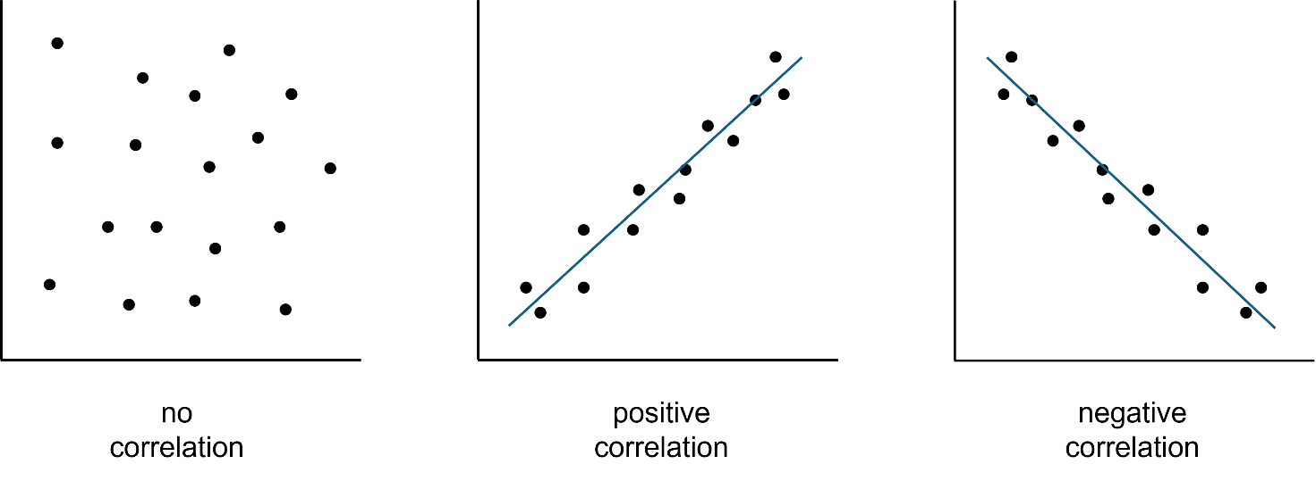
What is ‘causation’?
A ‘causal’ relationship means that one variable directly causes a change in another. This claim is stronger than correlation and requires clear evidence.
Figure 3 shows that as exercise intensity increases, heart rate rises. These variables are correlated. Additional scientific evidence suggests this may be causal – increasing exercise intensity increases the muscles' demand for oxygen and nutrients. In response, the heart beats faster to increase blood flow to the working muscles. Therefore, increasing exercise intensity increases heart rate. Scientists can provide stronger evidence for this causal relationship by conducting a controlled experiment in which they deliberately change exercise intensity, measure heart rate and control other factors that could affect heart rate.
Figure 3 – the effect of exercise intensity on heart rate

Just because 2 variables correlate does not mean one causes the other. This is a common misunderstanding.
To establish causation, we need to show that:
- changing the independent variable results in a corresponding change in the dependent variable
- the effect occurs after the cause
- other explanations have been ruled out.
Comprehension questions
- Outline the key difference between ‘correlation’ and ‘causation’.
- Explain why correlation does not always mean causation.
- Describe the conditions to prove causation.
Extension questions
- Outline a common mistake people make when interpreting correlation.
- Explain why it is important for scientists and researchers to distinguish between correlation and causation.
- A study shows that people who drink more water perform better in exams. Why should we be cautious about concluding causation?

Determining causation
In this activity, students will analyse a dataset showing the relationship between water given and plant growth. They will evaluate whether the data demonstrates a causal relationship by applying the understanding of the conditions for causation.
- Activate prior knowledge of the difference between a correlational and causal relationship by facilitating a class discussion (see Correlation and causation). Review the conditions for establishing causation, which include showing that changing the independent variable results in a corresponding change in the dependent variable, that the effect occurs after the cause and that any other variable cannot explain the effect.
Check for understanding 2: check students’ prior knowledge of describing relationships in a graph using a series of questions in 2.5 PPT ‘Check for understanding 2’. Students can display their answers on mini whiteboards.
Table 22 – check for understanding 2 questions and answers
Question | Answer
Identify the 2 variables in the dataset. | Screen brightness and battery life.
Describe the relationship shown in the graph. | There is a negative relationship – as the screen brightness increases, the battery life decreases.
Interpolate the battery life at 65%. | Approximately 8.25 hours.
Can we say that increasing brightness causes battery life to decrease? Explain whether this is a fair conclusion based on the data. | No, it suggests a relationship but does not prove causation (other factors may affect battery life).
- Provide students with the Student resource – determining causation and use the scenario and the dataset to teach students how causation can be established in science.
- Guide students in analysing the results and promote further understanding by addressing and discussing the questions.
Sample response: Student resource – determining causation
Note: additional stimulus information has been removed from the sample response.
Questions
- Describe the overall trend seen in plant growth over the 9 weeks.
The trend in plant growth shows a linear increase as the amount of water increases from 50 mL to 150 mL. This indicates that, within this range, plant growth increases consistently in an approximately linear pattern as water increases.
- Does the graph suggest a correlation between the amount of water and plant growth? Explain your reasoning.
Yes, the graph suggests a positive correlation between water amount and plant growth. As the independent variable (water) increases, the dependent variable (plant growth) also increases. This appears to be a strong positive relationship within the tested range. However, correlation is based only on the observed variable and data range and may not apply outside it.
- Why does deliberately changing water volume provide stronger evidence for causation than simply observing plants that naturally receive different amounts of water?
It is a controlled investigation which aims to eliminate the impact of the other variables influencing the growth of the bean plants. Observing plants that naturally receive different amounts of water would make it impossible to ensure other variables were not influencing the result.
- The trend in the graph between 50 mL and 150 mL appears to be a linear increase in plant growth. What is the risk of using this trend to predict plant growth at higher amounts of water (for example, 200 mL or 250 mL)?
The trend between 50 mL and 150 mL shows a linear increase in plant growth, but it may be risky to assume this continues at higher water volumes, as the relationship may not remain the same outside the measured range. Plants need water to grow, but too much water can reduce growth. This means that after a certain point, plant growth may level off or even decrease rather than continue increasing in a straight line. Therefore, predictions at 200 mL or 250mL are uncertain because they require extrapolating beyond the collected data, where the pattern may change. We cannot assume a pattern continues without supporting data.
- Based on the scenario and data, can we conclude that the amount of water added caused the plant growth? Why or why not?
We cannot definitively establish causation from this graph alone. Although the experiment suggests a relationship, causation requires more than a trend or pattern. We would need to ensure all other variables (for example, light, soil, temperature, plant type) are controlled and that the results are repeatable. Additionally, because the data covers only a limited range of water amounts, we cannot be certain the trend continues beyond 150 mL.
- Suggest one improvement to the experimental design that would help more accurately determine whether water causes increased plant growth.
An improvement would be to include a wider range of water amounts (for example, 0 mL and above 150 mL). This would help determine whether the relationship is truly linear or whether there is an optimal amount of water for plant growth.

Student resource – determining causation
Scenario
A group of Year 10 agriculture students investigated how the amount of water added to bean plants affected their growth over time. To ensure the test was valid, students used 5 treatment groups, each receiving a different amount of water throughout the investigation. The treatment groups received 50 mL, 75 mL, 100 mL, 125 mL or 150 mL of water per week.
Each treatment group contained 50 plants, all grown in the same type of soil, watered at the same time, placed in identical pots, and kept in the same location to ensure equal exposure to sunlight and temperature range. The same bean species was used and all plants were the same height.
Students measured and recorded the plants' height at the beginning of the experiment and again after 9 weeks, then calculated the growth. Table 1 summarises the investigation data. The raw data table that students used has not been provided.
Results
Table 1 – volume of water given and mean growth
Amount of water given to plant (mL) | Mean growth (cm)
50 | 8.9
75 | 11.8
100 | 14.5
125 | 17.0
150 | 16.1
Figure 1 – mean growth of bean plants over 9 weeks with different amounts of water

Questions
- Describe the overall trend seen in plant growth over the 9 weeks.
- Does the graph suggest a correlation between the amount of water and plant growth? Explain your reasoning.
- Why does deliberately changing water volume provide stronger evidence for causation than simply observing plants that naturally receive different amounts of water?
- The trend in the graph between 50 mL and 150 mL appears to be a linear increase in plant growth. What is the risk of using this trend to predict plant growth at higher amounts of water (for example, 200 mL or 250 mL)?
- Based on the scenario and data, can we conclude that the amount of water added caused the plant growth? Why or why not?
- Suggest one improvement to the experimental design that would help more accurately determine whether water causes increased plant growth.

2.6 Validating scientific findings
Table 23 – learning intention and success criteria for ‘2.6 Validating scientific findings’
We are learning: | I can:
- to assess the use of data when verifying the legitimacy of claims. | - outline the role of large datasets and statistics in validating scientific findings  - explain why large datasets are more reliable than smaller datasets  - identify how statistical analysis helps scientists make sense of data and measure uncertainty.
Teacher background information on validating findings
The information in Table 24 provides a concise summary of the role of large datasets and statistical analysis in validating scientific findings.
Table 24 – the role of large datasets in the validation of scientific findings
Role | Explanation
Reduces the influence of outliers | Large, high-quality datasets reduce the impact of individual extreme values, including outliers and anomalies due to possible errors, so erroneous data points are less likely to distort conclusions. Statistical tools help identify overall patterns in the data and distinguish genuine trends from isolated or anomalous results.
Improves the reliability of observed patterns | With more data points, patterns are less likely to be due to random chance because sampling error decreases and trends become more stable and repeatable. Statistical analysis helps test hypotheses and determines whether observed relationships are strong enough to support valid conclusions.
Allows for more confident generalisations | Large datasets can be more representative of the population under study, allowing broader conclusions to be drawn with greater confidence. Statistical analysis also quantifies uncertainty, such as the likelihood that the results occurred by chance, thereby strengthening confidence in the validity of the findings.

The role of large datasets and statistical analysis in validating findings
Note: this content point has been addressed throughout the learning in Essential question 2. This activity provides an opportunity to consolidate this.
- Provide students with the Student resource – validating scientific findings.
- Activate students’ prior knowledge of how to extract and summarise key points from a text to answer questions.
- Engage with the text in the student resource as a class, supporting students in highlighting key points related to the comprehension questions.
- Model or jointly construct responses to the comprehension questions (students can do this independently if they can).
- Facilitate a class discussion to check student understanding using ‘Sample response: Student resource – validating scientific findings’.
Check for understanding: check students’ understanding of validating scientific findings using the multiple-choice question on slide 2.6 PPT ‘Check for understanding’. Instruct students to engage with the question and respond with a show of hands.
What does it mean to validate a scientific finding?
- To prove a result is true beyond any doubt.
- To collect as much data as possible, regardless of trend.
- To support or confirm a result using additional evidence.
- To show that one unusual result is significant.
Table 25 – check for understanding sample response and elaboration
Response | Elaboration
A | This is incorrect because science does not claim absolute certainty. Instead, results are supported by evidence rather than proven beyond all doubt.
B | This is incorrect because validation is not just about the quantity of data. It is about confirming consistency and reliability.
C | This is the correct answer.
D | This is incorrect because a single unusual result might be an outlier, not a validation of a finding.
Sample response: Student resource – validating scientific findings
Note: additional stimulus information has been removed from the sample response.
Comprehension questions
- Explain what it means to validate a scientific finding.
‘Validating a scientific finding’ means checking that the investigations leading to the conclusion were properly conducted and that the data was properly analysed. It involves supporting or confirming results using further evidence to increase confidence that a conclusion is reliable and based on trustworthy information. Reliability is an important aspect of validity because validation involves checking whether results are repeatable and consistent and whether similar methods yield similar results.
This ensures that the conclusion is not based on random chance or limited evidence but that it is supported by data that has been collected and analysed appropriately.
- Explain one reason why large datasets make scientific findings more reliable.
Large datasets make scientific findings more reliable by reducing the influence of unusual results, called ‘outliers’, that can distort patterns in small datasets. They also allow scientists to use statistical methods and models alongside primary data analysis to strengthen confidence in the results. This makes trends clearer and conclusions more dependable.
- A student claims that a new fertiliser improves plant growth after testing it on 2 plants for one week. Give one reason, based on the text, why this result may not be well validated.
The result may not be well validated because the sample size is too small, with only 2 plants observed for one week. In a small dataset, a single unusual result can strongly affect the overall pattern, making the conclusions unreliable or attributable to chance.
- How does statistical analysis help scientists make sense of data and measure uncertainty?
Statistics help scientists identify patterns and trends using graphs and averages. They also let scientists quantify uncertainty by estimating how confident they can be in their results and deciding whether the evidence is strong or weak.
- Why do large datasets allow scientists to make more confident generalisations?
Large datasets allow scientists to make more confident generalisations because they include many observations, which helps establish clear and consistent patterns in the data. This makes it easier to identify what is typical in the dataset and reduces the influence of unusual results, or outliers. As a result, findings are more likely to reflect the overall pattern rather than a few unexpected cases, making generalisations more reliable beyond the group studied.

Student resource – validating scientific findings
Instructions: engage with the text to answer the given questions.
When scientists investigate a question, they collect data and use it to draw conclusions. However, reaching a result is not the final step in science. Scientists must also validate their findings. ‘Validation’ means supporting or confirming results with further evidence. It does not mean proving that something is absolutely true. Instead, validation increases confidence that a conclusion is reliable and based on trustworthy information.
One important part of validation is checking whether results are repeatable and consistent. If an investigation is repeated under similar conditions and the same pattern reappears, scientists are more confident that the results reflect something real rather than chance. If different scientists using similar methods obtain similar results, this further increases confidence in the findings.
Figure 1 – tomato plants growing in pots under different conditions  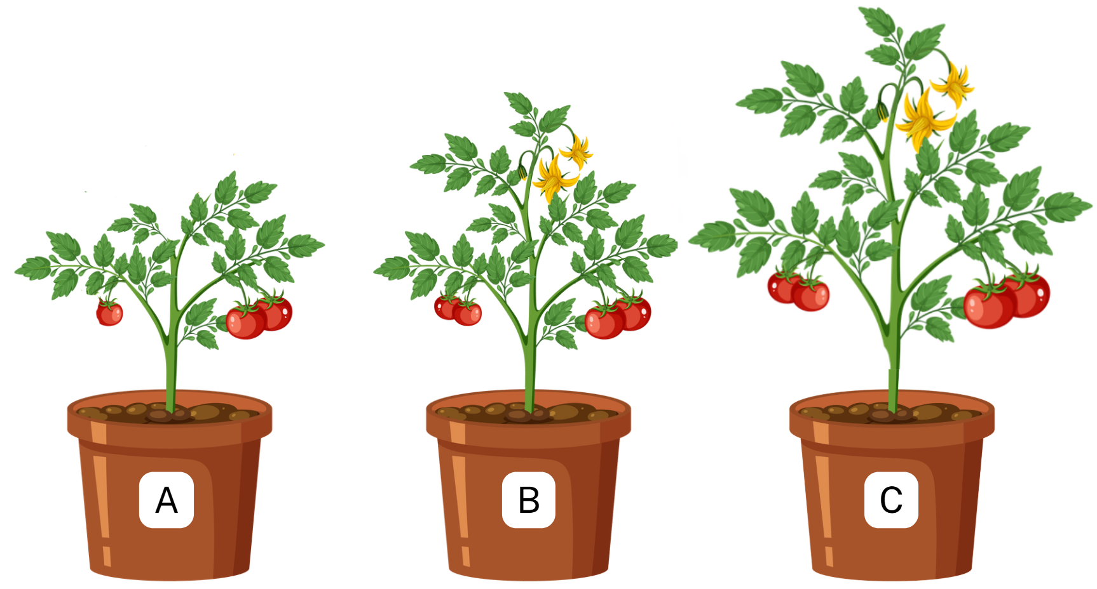 | The size of a dataset plays a major role in the reliability of a conclusion. Imagine 2 groups of students testing how sunlight affects plant growth. One group measures 4 plants and notices that one plant has grown much taller than the others. This unusual result may distort the pattern and lead the group to overestimate sunlight's effect on growth. Another group measures one hundred plants. In this case, one unusual plant’s growth makes little difference to the overall pattern because it is only one data point among many.
Because of this, large datasets reduce the influence of ‘outliers’, which are values that differ greatly from most others. However, outliers can be critical to scientific discovery because they can reveal new, unexpected information. Determining whether an outlier is a random error (noise) or is meaningful requires investigating its source, context and consistency with other variables. Meaningful outliers are valid, unique data points that can reveal new patterns, while errors (noise) are undesirable, random or erroneous data.
Large datasets also make patterns clearer and reduce the likelihood that results are due to chance. When a trend appears across many observations, scientists are more confident that it reflects a real effect rather than normal variation.
Large datasets also allow scientists to make stronger generalisations. Scientists want their findings to apply beyond the group they studied. When results are based on many observations, scientists can be more confident that the findings are not limited to a small or unusual sample.
Statistics are another important tool for validating scientific findings. They help scientists organise, summarise and interpret data. Graphs, means and other descriptive statistics show what is happening overall rather than focusing on individual values. Without statistics, it would be difficult to recognise important patterns in large datasets.
Because large datasets contain more information, scientists can apply different statistical approaches to check whether patterns remain consistent across the data. This strengthens confidence in the results because conclusions are not dependent on a single method of analysis.
Finally, statistics allow scientists to quantify uncertainty. All data contains some natural variation and no scientific conclusion is perfectly certain. Statistical tools help scientists estimate how confident they can be in their findings. A result supported by strong evidence has lower uncertainty, while one based on limited or unclear data has higher uncertainty.
Together, large datasets and statistical analysis help scientists validate ideas, improve accuracy and make evidence-based decisions. They allow conclusions to be tested, challenged and strengthened over time, which is essential to scientific progress.
Comprehension questions
- Explain what it means to validate a scientific finding.
- Explain one reason why large datasets make scientific findings more reliable.
- A student claims that a new fertiliser improves plant growth after testing it on 2 plants for one week. Give one reason, based on the text, why this result may not be well validated.
- How does statistical analysis help scientists make sense of data and measure uncertainty?
- Why do large datasets allow scientists to make more confident generalisations?

2.7 Making evidence-based decisions
Table 26 – learning intentions and success criteria for ‘2.7 Making evidence-based decisions’
We are learning: | I can:
- to assess the use of scientific knowledge and large datasets in making evidence-based decisions | - make evidence-based decisions on vaccine timing using data from large datasets  - assess the implications of the proposed decision
- to identify and evaluate proposed solutions to problems. | - identify the ‘Define, Examine, Create or Identify, Decide and Evaluate’ (D.E.C.I.D.E) framework as a structured process to solve problems  - create evaluation criteria for the proposed solutions to the problem of timing and prioritising target groups of the influenza vaccination  - assess proposed solutions to the problem using the developed evaluation criteria  - outline the limitations of a decision  - suggest additional data that could improve the quality of a recommendation.

Making evidence-based decisions about a familiar issue – secondary-source investigation
In this activity, students will solve a problem. In the process, they will analyse large datasets, calculate descriptive statistics and use their findings to make an evidence-based decision about a familiar issue, namely their identified problem. They will then consider the potential impact of that decision and reflect on how their analysis supports evidence-based conclusions.
- Provide students with the problem about when a pharmacy needs to begin its influenza advertisement and which groups to prioritise using 2.7 PPT ‘Problem statement’. Inform students that:
- temperature data informs the timing of flu vaccinations because influenza transmission is highly sensitive to environmental conditions, particularly cold, dry air, which increases the likelihood of outbreaks
- by analysing ambient temperature and humidity trends, public health officials can predict when the flu virus will begin to spread rapidly, ensuring vaccination efforts occur just before the peak, allowing sufficient time for immunity to build.
- Teach students about the strategy they will use to solve the identified problem using 2.7 PPT ‘D.E.C.I.D.E framework’. The slide's speaker notes include further guidance for unpacking the strategy with students.
- Provide students with access to laptops or similar devices and the Microsoft Excel workbook ‘2.7 Making evidence-based decisions’.
- Unpack the dataset for the students, highlighting the following:
- the workbook has 5 tabs
- Sheet 1 contains raw data on all influenza cases reported in NSW in 2023
- Sheet 2 summarises the data from Sheet 1 into weekly case counts
- Sheet 3 contains raw data on minimum and maximum daily temperatures in Sydney in 2023
- Sheet 4 contains the data from Sheet 3, summarised as weekly mean minimum and maximum daily temperatures
- Sheet 5 contains the data from Sheets 2 and 4, side by side, for comparison.
- there are coloured boxes into which students will enter the appropriate formulas for calculating the descriptive statistics.
- Revisit how to calculate descriptive statistics using Microsoft Excel if required (see 2.2 Descriptive statistics techniques).
- Before students begin the activity, unpack what is meant by an evidence-based decision in this context, including using evidence to support conclusions and constructing scientific arguments, and emphasise that these decisions:
- use scientific knowledge and data
- are supported by evidence from the dataset
- explain how the evidence justifies the conclusion
- follow a claim–evidence–reasoning structure
- are evaluated by considering the quality and limitations of the evidence.
Check for understanding: check students’ understanding of making evidence-based decisions using 2.6 PPT ‘Check for understanding’ (2 slides). Students are to write a number from 1 to 4 on a mini whiteboard to indicate which of the statements below are evidence-based decisions. The statements and elaboration of the answers is provided in Table 27.
Table 27 – check for understanding sample response and elaboration
Statement | Elaboration
- We should start the influenza vaccination campaign in June because it feels like that is when people start getting sick. | Not evidence-based – this statement is based on personal opinion or feeling rather than data. It does not cite any evidence, patterns or analysis to justify the decision.
- The vaccination program should begin earlier in the year because scientific data shows that influenza cases usually increase during the colder months, so starting earlier helps protect people before the risk rises. | Evidence-based – this statement refers to scientific data and uses a known pattern (higher influenza cases in colder months) to justify the decision. The reasoning links the evidence to the campaign timing.
- We should start the influenza vaccination campaign in June because the data shows that influenza cases start rising from August, especially in younger age groups, and this increase occurs as the mean minimum and maximum temperatures drop. | Evidence-based – this statement uses specific data (timing of case increases, affected age groups and temperature trends) and clearly explains how this information supports the decision.
- We should only vaccinate adults because they can book appointments more easily. | Not evidence-based – this statement is based on convenience rather than scientific data. It does not use evidence on influenza risk, case patterns or population vulnerability to support the decision.
- Provide students with Student resource – making evidence-based decisions to solve a problem and teach students how to use the D.E.C.I.D.E. framework to make evidence-based decisions to solve problems.
- Teach students how to make an evidence-based decision to solve the provided problem by completing each part of the student resource outlined below. To support this, see ‘Sample response: Student resource – making evidence-based decisions to solve a problem’.
- In ‘Part A – defining the problem’, remind students that the strategy they are using to solve the identified problem is D.E.C.I.D.E. Revisit the problem statement using 2.7 PPT ‘Problem statement’ to teach students how to define the problem and any constraints for solving it.
- In ‘Part B – examine the data’, examine the data with students by processing and analysing the data in the Microsoft Excel workbook ‘2.7 Making evidence-based decisions – activity’ to respond to the questions provided. In this section, students will also use cause-and-effect relationships to make a prediction.
- In ‘Part C – create evaluation criteria’, create evaluation criteria and teach students how to develop them to determine how they will judge which solution to the problem is best.
- In ‘Part D – identify solutions’, identify solutions and work with students to develop suitable solutions to the problem, outlining their strengths and weaknesses to evaluate the different approaches to solving it.
- In ‘Part E – decide using evidence’, decide, using evidence, how to select the most appropriate solution proposed in Part D (completing the evaluation of different approaches to solving the problem) and make an evidence-based recommendation to solve the problem.
- In ‘Part F –evaluate and refine’, teach students to reflect on their recommendation, assessing the implications of the decision made, evaluating the proposed solution against the relevant evaluation criteria from Part C and outlining any limitations in the data.
Differentiation: provide support by giving students a version of the dataset with key cells (for example, the highest and lowest values) shaded to highlight important evidence for the decision. This may help focus their attention on the most relevant data points and reduce the cognitive load of scanning through large datasets.
Sample response: Student resource – making evidence-based decisions activity
Note: additional stimulus information has been removed from the sample response.
Part A – defining the problem
- Scientists do not jump straight to answers. They first define the problem. As a class, define the problem.
The problem is deciding when Sydney pharmacies should begin administering influenza vaccinations and which groups to prioritise to reduce infection rates while using resources effectively.
- Why is this a problem that needs to be solved?
This is a problem because starting vaccinations too early may waste resources, while starting them too late may leave people unprotected before influenza cases rise.
- Identify constraints for solving the problem.
Constraints include limited resources, uncertainty about data patterns, regional variation and the need to base decisions on reliable evidence.
Part B – examine data
Table 1 – sample responses mean and standard deviation
Factor | Mean | Standard deviation
Total cases | 2,009.6 | 1,841.8
Male | 987.6 | 912.8
Female | 1,021.2 | 929.3
Type A | 1,195.2 | 796.9
Type B | 780.9 | 1,045.8
Untyped | 33.4 | 58.2
Age 0–4 | 270.5 | 265.4
Age 5–9 | 394.1 | 428.9
Age 10–14 | 234.8 | 265.7
Age 15–19 | 145.7 | 139.5
Age 20–24 | 84.1 | 68.1
Age 25–29 | 93.2 | 74.8
Age 30–34 | 120.5 | 108.8
Age 35–39 | 139.3 | 138.6
Age 40–44 | 122.3 | 120.3
Age 45–49 | 83.0 | 73.5
Age 50–54 | 66.6 | 51.1
Age 55–59 | 50.1 | 38.6
Age 60–64 | 48.7 | 35.6
Age 65–69 | 41.5 | 29.1
Age 70–74 | 35.3 | 25.0
Age 75–79 | 30.8 | 20.2
Age 80–84 | 22.5 | 15.6
Age 85+ | 26.7 | 20.8
Use the data and graphs in ‘Sheet 2 – Total weekly influenza cases’ of the workbook to answer the following questions.
- Which type of influenza infection had the highest standard deviation? What does that indicate about the data?
Influenza Type B had the greatest standard deviation. The high standard deviation (much higher than the mean) indicates that Type B influenza cases vary widely from week to week. Some weeks have very few cases (for example, 19, 38), while others have extremely high numbers (for example, 4,111, 3,716). This high variability suggests that Type B outbreaks are less consistent but can surge significantly at certain times.
- Which age group had the highest number of reported cases in the year?
The 5 to 9 age group had the highest number of reported cases (20,494 cases).
- Which week ending had the highest number of reported influenza cases? Which has the lowest?
The week ending 7/07/2023 recorded the highest number of reported influenza cases at 7,954.
The week ending 17/02/2023 recorded the fewest reported influenza cases at 298.
- Was there a significant difference between the number of male and female infections? How much did they differ in the week with the highest number of cases?
Overall, infection rates did not differ significantly between males and females. In the week with the highest number of reported cases (07/07/2023), there were 3,919 male cases and 4,032 female cases. This was a small difference of 113 cases in favour of females, indicating that gender is not a major factor influencing influenza infection rates.
- Which type of influenza was most prevalent throughout the year? Did this pattern change at any point?
Influenza Type A was the most prevalent throughout the year. Type A cases outnumbered Type B and Untyped cases for 41 weeks. This pattern changed in the week ending 16/06/2023, when Type B cases outnumbered Type A and Untyped cases for 11 weeks, although Type A remained dominant overall. This suggests Type A drives seasonal outbreaks.
- Do the reported case numbers for people aged 15 to 19 follow the same pattern as the other age groups? Are there any anomalies?
The 15 to 19 age group generally follows the same seasonal trend as other age groups, with increases during cooler months and decreases in warmer months. They show lower overall case numbers than younger groups (for example, the 5 to 9 age group).
At the week ending 8/12/2023, this group shows a spike that does not occur in the other age groups. This stabilises again in the following week.
Navigate to ‘Sheet 3 – Daily Sydney temperature’ in the workbook and calculate the descriptive statistics in Table 2 for the annual minimum and maximum temperatures.
Table 2 – sample response for descriptive statistics
Descriptive statistic | Minimum temperature | Maximum temperature
Mode | 15.6 | 21.6
Median | 14.6 | 23.4
Mean | 14.6 | 23.8
Standard deviation | 4.5 | 4.5
Use the data and graphs in ‘Sheet 3 – Daily Sydney temperature’ and ‘Sheet 4 – Weekly Sydney temperature’ of the workbook to answer the following questions.
- Which week recorded the lowest maximum temperature? What was the minimum temperature at that time?
The lowest maximum temperature was recorded in the week ending 23/06/2023. In that week, the minimum temperature was 7.1°C.
- How many weeks did the weekly average maximum temperature fall below the annual average? What about the lowest minimum temperature?
The annual average minimum temperature was 14.6°C and the annual average maximum temperature was 23.8°C. There were 26 weeks when the weekly average maximum temperature was below the annual average and 25 weeks when the weekly average minimum temperature was below the annual average.
- Were there any times when the weekly average minimum temperature was equal to or close to (within 0.5°C) the annual average? What about the maximum temperature?
The annual average minimum temperature was 14.6°C and the maximum was 23.8°C. There were 3 weeks when the average minimum temperature was within 0.5°C of the annual average: 21/04/2023 (14.4°C), 28/04/2023 (15.0°C) and 27/10/2023 (15.0°C).
There were 5 weeks when the average maximum temperature was within 0.5°C of the annual average: 7/04/2023 (23.4°C), 21/04/2023 (23.4°C), 28/04/2023 (23.6°C), 27/10/2023 (24.0°C) and 10/11/2023 (23.6°C).
- Using the data, explain why the standard deviation of maximum temperature for the week ending 22/12/2023 is significantly higher than in other weeks.
The standard deviation of maximum temperature for the week ending 22/12/2023 was 5.5, more than double the average standard deviation. In Sheet 3, the recorded temperatures fluctuated significantly throughout the week, with a high of 35.3°C on 16/12/2023 and a low of 18.5°C on 20/12/2023, which may have resulted from heatwaves followed by cooler days. This large variation within the week resulted in a higher standard deviation.
- Compare the standard deviations of the maximum and minimum temperatures across the annual and weekly datasets and explain any differences you observe.
The standard deviation of the annual maximum and minimum temperatures is 4.5, roughly double the average weekly standard deviation. However, specific weeks (such as late December) can show an unusually high standard deviation because extreme weather can vary sharply over a short timeframe. Over a full year, temperatures fluctuate with the seasons, leading to greater variation than in weekly data, where daily temperatures are more similar.
Standard deviation measures how far values are from the mean. A higher standard deviation indicates greater variation, so the annual standard deviation is higher because there is more variability across the year than within a single week. Climate varies most across the year, while short-term variation occurs during extreme events.
Use the data in the workbook to test each statement below. Decide whether the evidence supports or contradicts the statement and explain your reasoning with specific examples from the data.
- Weeks with a mean maximum temperature above 30°C have fewer than 2,000 reported influenza cases.
The data supports this statement. The only weeks with mean maximum temperatures above 30°C were the week ending 10/03/2023 (30.6°C) and the week ending 15/12/2023 (31.8°C). Both weekly totals were below 2,000: 610 cases for the week ending 10/03/2023 and 1,452 cases for the week ending 15/12/2023.
- In the 5 weeks with the highest total influenza cases, the 5 to 9 age group has the highest number of cases in at least 3 of those weeks.
The data supports this statement. The top 5 weeks by total cases ended on: 07/07/2023 (7,954), 30/06/2023 (7,330), 14/07/2023 (6,387), 23/06/2023 (5,384) and 21/07/2023 (4,762).
The 5 to 9 age group is the largest single age group in 3 of those weeks: 23/06/2023 (1,224), 30/06/2023 (1,864) and 07/07/2023 (1,776). In the other 2 weeks, on 14/07/2023 and 21/07/2023, the 0 to 4 age group is the largest single age group, .
- Average total influenza cases are higher in weeks when the mean maximum temperature is below 20°C than in weeks when it is 20°C or higher.
The data supports this statement. The data shows that the average total influenza cases in weeks with a mean maximum temperature below 20°C is higher than in weeks with a mean maximum temperature above 20°C. For weeks with a mean maximum temperature below 20°C, the average total number of influenza cases is 4,250. For the weeks with a mean maximum temperature above 20°C, the average total influenza cases is 1,263.
- Lower mean minimum temperatures cause higher influenza case numbers.
This statement is partially supported but not causally established. The data and graph in Sheet 5 show a correlation between the 2 variables, but they do not establish causation. The data shows a clear pattern, but other factors cannot be ruled out. There are also colder weeks when the total number of reported influenza cases is relatively low compared with other weeks, for example, the weeks ending on 16/06/2023 and 28/07/2023.
An epidemiologist studied influenza over many years and established the cause-and-effect relationship shown below.
‘In lower temperatures, there is more indoor contact, resulting in increased transmission leading to higher influenza cases.’
- Using the patterns in the data and the cause-and-effect relationship, predict how a change in the temperature pattern (for example, colder temperatures starting earlier in the year) could affect influenza cases. Explain how this could influence the timing of the vaccination program.
If colder temperatures began earlier in the year, influenza cases would likely rise earlier as well. The data supports this, showing cases rising sharply during colder periods and peaking at approximately 7,954 cases. Earlier cold conditions would likely lead to earlier increases in indoor contact and transmission. As a result, the vaccination program would need to begin earlier to ensure immunity develops before cases rise.
Part C – create evaluation criteria
Before choosing a solution, scientists decide how they will judge which solution is best. This ensures solutions can be compared fairly, as they are measured against the same predetermined criteria rather than shifting, subjective ones. This reduces bias and leads to accurate, evidence-based decision-making, making it easier to identify the solution that best solves the problem.
As a class, develop the evaluation criteria to assess the proposed solution to the problem.
☐ The strategy begins before influenza cases rise, allowing time for immunity to develop.
☐ The timing is supported by clear patterns and trends in the data, not by assumptions or guesses.
☐ The strategy targets high-risk or high-case age groups identified in the dataset.
☐ The decision is based on consistent evidence across multiple data points, not a single week or an anomaly.
☐ The strategy is practical and realistic to implement (for example, aligns with healthcare capacity and public behaviour).
☐ The reasoning clearly explains how the evidence supports the decision.
Part D – identify solutions
In this step, we do not yet decide which solution to go with. We generate multiple possible solutions using the data patterns to justify each option. In this section, we also need to consider the strengths and weaknesses of each strategy to decide on the best solution in the next section, ‘Decide using evidence’.
Using the data, identify at least 3 possible strategies. Outline the strengths and weaknesses of each strategy.
Strategy 1
One possible solution is to begin vaccination in April, before influenza cases rise significantly. The data shows that case numbers are relatively low at the start of the year, ranging from approximately 298 to 500 cases per week, before rising rapidly to a winter peak of 7,954 cases.
Starting in April would allow time for immunity to develop before this sharp increase. A major strength of this approach is that it is preventive and closely aligns with the observed seasonal trend in the data, maximising protection before transmission increases. However, a potential weakness is that starting too early may reduce public urgency and could result in resources being used before demand increases.
Strategy 2
Another option is to begin vaccination during the early stages of the peak period, when case numbers are already rising rapidly. The data shows that cases rise quickly from low levels to several thousand per week, eventually peaking at 7,954.
This approach may increase public awareness and uptake, as people are more likely to seek vaccination when cases are visibly rising. However, the major weakness of this strategy is that it is reactive rather than preventative. By the time vaccination begins, transmission is already well underway, so immunity will develop too late to prevent the initial spread of the virus. As a result, this approach is less effective at reducing overall case numbers.
Strategy 3
A third option is to begin vaccination in April, prioritising the 5 to 9 age group before expanding to other groups. The dataset shows this age group has the highest mean number of cases (approximately 394) and the highest weekly peak (1,864), indicating it is a key contributor to influenza transmission. Targeting this group first may reduce the spread of influenza across the wider community, as infections in this group are likely to spread to households and other age groups.
The main strength of this approach is that it uses data to target the most significant transmission group, making it highly efficient and impactful. However, the weakness is that it requires more complex planning and coordination, as prioritising one group over others may delay access for some individuals.
Part E – decide using evidence
Make an evidence-based recommendation for the best solution to the identified problem.
The most effective strategy is to begin influenza vaccination in April and prioritise the 5 to 9 age group. Data shows that influenza cases are very low at the start of the year (approximately 298 to 500 cases per week) but increase rapidly, peaking at 7,954 cases during the colder months. Starting vaccination in April allows sufficient time for immunity to develop before this sharp increase.
Additionally, the 5 to 9 age group has the highest mean number of cases (approximately 394) and the highest recorded weekly value (1,864), indicating that this group drives transmission. Targeting this group first is likely to reduce overall community spread, making this approach both preventative and highly effective.
Part F – evaluate and refine
Use your analysis of influenza cases and temperature data to consider the broader implications of your decision.
- Evaluate the proposed solution using the created criteria from Part C.
The proposed solution meets the evaluation criteria to a high standard because it begins before influenza cases rise, which is essential for prevention. The dataset shows that cases remain low early in the year, at approximately 298 to 500 cases per week, before rising sharply to a peak of 7,954 cases during winter. Beginning vaccination in April ensures that immunity develops before this increase, directly addressing the timing criterion. Consistent data trends also support the strategy, including a clear seasonal pattern of higher case counts during colder periods.
Additionally, the decision targets the 5 to 9 age group, which has the highest mean number of cases (approximately 394) and the highest weekly peak (1,864), indicating a key role in transmission. The strategy uses multiple sources of evidence, including age distribution and seasonal patterns, rather than relying on a single data point.
While the prioritised rollout may require more coordination, it remains practical within a structured vaccination program. Overall, the solution strongly satisfies all criteria and is well supported by evidence.
- What assumptions did you make and how might they affect your conclusion?
One key assumption is that the patterns observed in the 2023 dataset will persist in future years, particularly the seasonal increase from low case numbers (approximately 298 to 500) to a winter peak of 7,954. If this pattern shifts, for example, due to changes in climate or virus behaviour, the timing of the vaccination program may need to be adjusted.
Another assumption is that the 5 to 9 age group will continue to have the highest transmission rates, as indicated by their mean (approximately 394) and peak (1,864). If transmission patterns change and another age group becomes more significant, prioritising this group may be less effective.
Additionally, the strategy assumes that vaccine effectiveness and the time required to develop immunity are consistent across the population. If immunity develops more slowly in certain groups, such as the elderly, the timing may need to be reconsidered. If these assumptions do not hold, they could undermine the strategy's effectiveness.
- What are the limitations of using influenza data for all of NSW but temperature data only from Sydney? How might regional differences across the state affect your conclusions?
A key limitation is that influenza case data covers all of NSW, while the temperature data is specific to Sydney. This mismatch between environmental conditions and reported disease patterns can affect the accuracy of conclusions about the relationship between temperature and influenza cases.
Different regions of NSW experience varying climates, with some areas colder or with different seasonal patterns than Sydney. As a result, influenza outbreaks may occur earlier or be more severe in other regions than in Sydney. This limitation suggests that the findings are most reliable for Sydney and may not fully represent patterns across all of NSW.
- If the vaccination program started in the month you suggested, how might influenza cases in Sydney change?
If the vaccination program begins in April, influenza cases in Sydney would likely decline during the peak winter period. The data shows that cases can peak at 7,954 during peak weeks, but early vaccination would mean a larger proportion of the population has developed immunity before then. This would likely reduce both the peak height and the overall number of cases. As a result, the seasonal increase in cases would be less severe and the spread of influenza would be slowed.
- What other impacts could this timing have on the wider community?
Starting vaccination in April could have several positive impacts on the wider community. Reducing influenza cases during peak periods would likely ease pressure on healthcare services, particularly in winter, when cases typically peak (up to 7,954 cases).
Additionally, targeting school-aged children could reduce transmission in schools, leading to lower absenteeism and improved continuity of learning. Reduced transmission among children may also protect more vulnerable groups, such as the elderly, by limiting the spread of infection within households and the community.
- How might targeting the age group you selected affect overall influenza numbers?
Targeting the 5 to 9 age group is likely to significantly reduce overall influenza case numbers because this group has the highest mean number of cases (approximately 394) and the highest weekly peak (1,864). This suggests that they are a major contributor to transmission.
Reducing infection rates in this group would also reduce influenza spread to other age groups, such as family members and the broader community. This would create a cascading effect – lowering cases in one key group reduces overall transmission.
- What other data would help you make a more confident recommendation and how could this additional information change your advice?
Additional data would improve the confidence and accuracy of the recommendation. For example, vaccination uptake rates by age group would help determine how effectively the program reaches the target population. Hospitalisation and severity data would show which groups are most at risk of serious outcomes, not just infection.
Multi-year influenza data would confirm whether the pattern observed in 2023, including the increase from approximately 298 to 500 cases to a peak of 7,954, is consistent over time. Regional data across NSW would also help align influenza trends with local climate conditions, addressing the limitation of using Sydney-only temperature data. This additional information could refine both the timing and prioritisation of the vaccination strategy, making it more effective.

Student resource – making evidence-based decisions to solve a problem
A Sydney pharmacy must decide when to begin providing the influenza vaccination and which groups to prioritise. Beginning too early may waste resources and beginning too late may reduce protection before cases rise. The pharmacy has asked you to use influenza and temperature data to solve this problem.
You will access reported influenza case data for NSW in 2023 and mean minimum and maximum temperature data for Sydney to investigate whether temperature extremes might be related to influenza outbreaks throughout the year.
In this activity, you will analyse NSW influenza case data for 2023 and Sydney temperature data to identify patterns and explore how temperature extremes might influence influenza outbreaks, helping you to consider the timing of flu vaccinations.
Part A – defining the problem
- Scientists do not jump straight to answers. They first define the problem. As a class, define the problem.
- Why is this a problem that needs to be solved?
- Identify constraints for solving the problem.

Part B – examine data
Examining the data is an important part of the problem-solving process. In this section, you will not only process data through calculation, you will also analyse it to identify trends and patterns. This analysis will help you identify solutions and choose the best one using evidence.
Open the provided Microsoft Excel workbook ‘2.7 Making evidence-based decisions – activity’, navigate to ‘Sheet 1 – All reported influenza cases’ and calculate the descriptive statistics in Table 1 below for the influenza case data.
Table 1 – mean and standard deviation
Factor | Mean | Standard deviation
Total cases
Male
Female
Type A
Type B
Untyped
Age 0–4
Age 5–9
Age 10–14
Age 15–19
Age 20–24
Age 25–29
Age 30–34
Age 35–39
Age 40–44
Age 45–49
Age 50–54
Age 55–59
Age 60–64
Age 65–69
Age 70–74
Age 75–79
Age 80–84
Age 85+
Use the data and graphs in ‘Sheet 2 – Total weekly influenza cases’ of the workbook to answer the following questions.
- Which type of influenza infection had the highest standard deviation? What does that indicate about the data?
- Which age group had the highest number of reported cases in the year?
- Which week ending had the highest number of reported influenza cases? Which had the lowest?
- Was there a significant difference between the number of male and female infections? How much did they differ in the week with the highest number of cases?
- Which type of influenza was most prevalent throughout the year? Did this pattern change at any point?
- Do the reported case numbers for people aged 15 to 19 follow the same pattern as the other age groups? Are there any anomalies?
Navigate to ‘Sheet 3 – Daily Sydney temperature’ in the workbook and calculate the descriptive statistics in Table 2 for annual minimum and maximum temperatures.
Table 2 – descriptive statistics
Descriptive statistic | Value
Mode
Median
Mean
Standard deviation
Use the data and graphs in ‘Sheet 3 – Daily Sydney temperature’ and ‘Sheet 4 – Weekly Sydney temperature’ of the workbook to answer the following questions.
- Which week reported the lowest maximum temperature? What was the minimum temperature at that time?
- How many weeks did the weekly average maximum temperature fall below the annual average? What about the lowest minimum temperature?
- Were there any times when the weekly average minimum temperature was equal to or close to (within 0.5°C) the annual average? What about the maximum temperature?
- Using the data, explain why the standard deviation of maximum temperature for the week ending 22/12/2023 is significantly higher than in other weeks.
- Compare the standard deviations of the maximum and minimum temperatures across the annual and weekly datasets and explain any differences you observe.
Use the data in the workbook to test each statement below. Decide whether the evidence supports or contradicts the statement and explain your reasoning with specific examples from the data.
- Weeks with a mean maximum temperature above 30°C have fewer than 2,000 reported influenza cases.
- In the 5 weeks with the highest total influenza cases, the 5 to 9 age group has the highest number of cases in at least 3 of those weeks.
- Average total influenza cases are higher in weeks when the mean maximum temperature is below 20°C than in weeks when it is 20°C or higher.
- Lower mean minimum temperatures cause higher influenza case numbers.
An epidemiologist studied influenza over many years and established the cause-and-effect relationship shown below.
‘In lower temperatures, there is more indoor contact, resulting in increased transmission leading to higher influenza cases.’
- Using the patterns in the data and the cause-and-effect relationship, predict how a change in temperature pattern (for example, colder temperatures starting earlier in the year) could affect influenza cases. Explain how this could influence the timing of the vaccination program.
Part C – create evaluation criteria
Before choosing a solution, scientists decide how they will judge which solution is best. This ensures solutions can be compared fairly, as they are measured against the same predetermined criteria rather than shifting, subjective ones. This reduces bias and leads to accurate, evidence-based decision-making, making it easier to identify the solution that best solves the problem.
As a class, create the evaluation criteria to assess the proposed solution to the problem.
Part D – identify solutions
In this step, we do not yet decide which solution to go with. We generate multiple possible solutions using the data patterns to justify each option. In this section, we also need to consider the strengths and weaknesses of each strategy to decide on the best solution in the next section, ‘Decide using evidence’.
Using the data, identify at least 3 possible strategies. Outline the strengths and weaknesses of each strategy.
Strategy 1
Strategy 2
Strategy 3
Part E – decide using evidence
Make an evidence-based recommendation for the best solution to the identified problem.
Part F – evaluate and refine
Use your analysis of influenza cases and temperature data to consider the broader implications of your decision.
- Evaluate the proposed solution using the created criteria from Part C.
- What assumptions did you make and how might they affect your conclusion?
- What are the limitations of using influenza data for all of NSW but temperature data from only Sydney? How might regional differences across the state affect your conclusions?
- If the vaccination program started in the month you suggested, how might influenza cases in Sydney change?
- What other impacts could this timing have on the wider community?
- How might targeting the age group you selected affect overall influenza numbers?
- What other data would help you make a more confident recommendation and how could this additional information change your advice?

Evidence base
This resource contains NSW Curriculum and syllabus content. The NSW Curriculum is developed by the NSW Education Standards Authority (NESA). This content is prepared by NESA for and on behalf of the Crown in right of the State of New South Wales. The material is protected by Crown copyright.
Please refer to the NESA Copyright Disclaimer for more information https://www.nsw.gov.au/education-and-training/nesa/copyright.
NESA holds the only official and up-to-date versions of the NSW Curriculum and syllabus documents. Please visit NESA https://www.nsw.gov.au/education-and-training/nesa and NSW Curriculum https://curriculum.nsw.edu.au.
Science 7–10 Syllabus © NSW Education Standards Authority (NESA) for and on behalf of the Crown in right of the State of New South Wales, 2023.
ABS (Australian Bureau of Statistics) (n.d.) Correlation and causation, ABS website, accessed 10 September 2025.
——(2021) ‘Australia’, 2021 Census All persons QuickStats, accessed 10 January 2026.
AITSL (Australian Institute for Teaching and School Leadership Limited) (2017) Learning intentions and success criteria [PDF 251 KB], AITSL, accessed 18 July 2024.
——(2017) Feedback fact sheet, AITSL, accessed 18 July 2024.
ANSTO (Australian Nuclear Science and Technology Organisation) (n.d.) Monitoring fine particle air pollution in Newcastle [data set], ANSTO website, accessed 11 June 2025.
——(n.d.) ‘Data sets’, ANSTO, accessed 22 September 2026.
Australian Centre for Disease Control (2025) NNDSS (National Notifiable Diseases Surveillance System) public dataset – influenza (laboratory confirmed) [data set], Australian Centre for Disease Control website, accessed 14 September 2026.
BoM (Bureau of Meteorology) (n.d.) Climate data online [data set], BoM website, accessed 11 June 2025.
Bradley P (24 Feb 2021) ‘Gregor Mendel’s Pea Experiment’ [video], Pat Bradley, YouTube, accessed 10 June 2025.
Brookhart S (2011) How to Assess Higher-Order Thinking Skills in Your Classroom, Hawker Brownlow Education, Victoria.
Brookhart SM (2018) ‘Appropriate Criteria: Key to Effective Rubrics’, Frontiers in Education, 3(22):1–12, doi:10.3389/feduc.2018.00022, accessed 6 February 2025.
CESE (Centre for Education Statistics and Evaluation) (2025) What Works Best 2025, NSW Department of Education, accessed 26 March 2026.
——(2025) What Works Best 2025 – practical guides, NSW Department of Education, accessed 18 July 2024.
Dadonaite B and Ritchie H (2019) Rotavirus deaths that were preventable in children under five [data set], Our World in Data website, accessed 14 September 2026.
Department of Climate Change, Energy, the Environment and Water (2025) ‘Riverina Murray Climate Change Snapshot’, NARCliM (NSW and Australian Regional Climate Modelling), AdaptNSW, Department of Climate Change, Energy, the Environment and Water, accessed 31 July 2026.
DHMO (Dihydrogen Monoxide Research Division) (n.d.) DHMO [website], accessed 10 September 2025.
Fisher D and Frey N (1 November 2009) ‘Feed Up, Back, Forward’, ASCD (Association for Supervision and Curriculum Development): Educational Leadership Magazine, accessed 18 July 2024.
Griffin P (2017) Assessment for Teaching, Cambridge University Press, Port Melbourne, Victoria.
Hattie J and Timperley H (2007) ‘The Power of Feedback’, Review of Educational Research, 77(1):81–112, doi:10.3102/003465430298487.
Johns Hopkins Whiting School of Engineering (16 July 2020) ‘Paper Helicopter (Hopkins Engineering At Home)’ [video], Johns Hopkins Whiting School of Engineering, YouTube, accessed 10 September 2025.
Met Office – Science and Services (28 Aug 2019) ‘How do climate models work?’ [video], Met Office – Science and Services, YouTube, accessed 10 June 2025.
NESA (NSW Education Standards Authority) (n.d.) ‘Proficient Teacher: Standard descriptors’, Proficient Teacher accreditation, NSW Government website, accessed 18 July 2024.
——(n.d.) ‘Planning and supporting student learning’, Use the curriculum, NSW Curriculum website, accessed 17 July 2026.
——(n.d.) ‘Selecting and sequencing’, Planning and supporting student learning, NSW Curriculum website, accessed 17 July 2026.
——(2022) ‘Advice on units’, Programming, NESA website, accessed 18 July 2024.
——(2023) ‘Glossary’, Science 7–10 Syllabus, NSW Curriculum website, accessed 16 September 2026.
NCSU (North Carolina State University) Libraries (1 May 2014) ‘Peer Review in 3 Minutes’ [video], libncsu, YouTube, accessed 10 September 2025.
NOAA GML (National Oceanic and Atmospheric Administration Global Monitoring Laboratory) (n.d.) Trends in CO₂, CH₄, N₂O, SF₆, NOAA GML website, accessed 10 January 2026.
NOVA PBS Official (6 Aug 2024) ‘How Vera Rubin Broke Barriers in Astronomy | NOVA | PBS’ [video], NOVA PBS Official, YouTube, accessed 10 June 2025.
NSW Ministry of Health (2025) Proportion of adults meeting physical activity guidelines [data set], Data.NSW website, accessed 5 March 2026.
Panadero E and Jonsson A (2013) ‘The use of scoring rubrics for formative assessment purposes revisited: A review’, Educational Research Review, 9:129–144, doi:10.1016/j.edurev.2013.01.002, accessed 18 July 2024.
Peter CR (2024) ‘12.5: Interpretation of r-Values’, Statistics: Open for Everyone, LibreTexts, accessed 9 September 2025.
Ramsey D (1 May 2019) ‘Will blue light from electronic devices increase my risk of macular degeneration and blindness?’, Harvard Health Publishing blog, accessed 10 September 2025.
RealAlexClark (28 July 2025) ‘Your MICROWAVE Isn’t Convenient—It’s CARCINOGENIC’ [video], RealAlexClark, YouTube, accessed 21 December 2025.
Rosenshine B (2012) ‘Principles of Instruction: Research-Based Strategies That All Teachers Should Know’, American Educator, 36(1):12–19, accessed 6 February 2025.
SciShow Space (5 July 2017) ‘How Vera Rubin Found the First Direct Evidence for Dark Matter | Great Minds’ [video], SciShow Space, YouTube, accessed 10 June 2025.
Sherrington T (2019) Rosenshine’s Principles in Action, John Catt Educational Limited, Melton, Woodbridge.
TED-Ed (13 Mar 2013) ‘How Mendel's pea plants helped us understand genetics – Hortensia Jiménez Díaz’ [video], TED-Ed, YouTube, accessed 10 June 2025.
Troeger C, Khalil IA, Rao PC, Cao S, Blacker BF, Ahmed T and Kang G (2018) Rotavirus vaccination and the global burden of rotavirus diarrhea among children younger than 5 years, JAMA Pediatrics, 172(10):958-965.
TRR 181 Energy Transfers in Atmosphere and Ocean (22 September 2017) ‘TRR181 Climate Models easily explained’ [video], TRR 181 Energy Transfers in Atmosphere and Ocean, YouTube, accessed 10 June 2025.
Vigen T (n.d.) Spurious Correlations, Tyler Vigen website, accessed 10 August 2026.
Wiliam D (2013) ‘Assessment: The bridge between teaching and learning’, Voices from the Middle, 21(2):15–20, accessed 18 July 2024.
——(2017) Embedded Formative Assessment, 2nd edn, Solution Tree Press, Bloomington, IN.
Wisniewski B, Zierer K and Hattie J (2020) ‘The Power of Feedback Revisited: A Meta-Analysis of Educational Feedback Research’, Frontiers in Psychology, 10(3087), doi:10.3389/fpsyg.2019.03087, accessed 18 July 2024.
Yan D and Blumwald E (2023) ‘Scientific Article for Students: How do bacteria help plants?’ (Appleton J and Firth F eds), Science Journal for Kids and Teens, accessed 21 July 2026.

© State of New South Wales (Department of Education), 2026
The copyright material published in this resource is subject to the Copyright Act 1968 (Cth) and is owned by the NSW Department of Education or, where indicated, by a party other than the NSW Department of Education (third-party material).
Copyright material available in this resource and owned by the NSW Department of Education is licensed under a Creative Commons Attribution 4.0 International (CC BY 4.0) license.

This license allows you to share and adapt the material for any purpose, even commercially.
Attribution should be given to © State of New South Wales (Department of Education), 2026.
Material in this resource not available under a Creative Commons license:
- the NSW Department of Education logo, other logos and trademark-protected material
- material owned by a third party that has been reproduced with permission. You will need to obtain permission from the third party to reuse its material.
Links to third-party material and websites
Please note that the provided (reading/viewing material/list/links/texts) are a suggestion only and implies no endorsement, by the New South Wales Department of Education, of any author, publisher, or book title. School principals and teachers are best placed to assess the suitability of resources that would complement the curriculum and reflect the needs and interests of their students.
If you use the links provided in this document to access a third-party's website, you acknowledge that the terms of use, including licence terms set out on the third-party's website apply to the use which may be made of the materials on that third-party website or where permitted by the Copyright Act 1968 (Cth). The department accepts no responsibility for content on third-party websites.

