Science Stage 4 – Solutions and mixtures
Teacher resource book 3 of 3 (TRB3)
3. How can the properties of substances be used to separate different types of matter?
Creation date: 19 January 2026.
Contents
Overview 3
Glossary 3
3.1 Classifying matter 6
Types of matter 6
Student resource – types of matter 9
Classifying matter 11
Student resource – classifying matter 16
Modelling substances 21
Student resource – modelling substances 24
3.2 Separating mixtures 26
Physical properties and separation 26
Student resource – physical properties and separation 31
The Brewarrina fish traps – separation techniques 33
Student resource – Brewarrina fish traps 35
Separation techniques practical investigation 36
Student resource – separating mixtures 43
3.3 Separation techniques – evaporation, boiling and distillation 46
Recovering salt from a solution 46
Student resource – recovering a salt from a solution 49
Distillation 51
Student resource – distillation 54
3.4 Separation challenge 56
Separation – guided investigation 57
Student resource – separation challenge 64
3.5 Separation of mixtures in industry 70
Industrial separations 70
Student resource – industrial separation techniques 75
3.6 Modelling water pollution 77
Watershed model 78
Water purification 79
Student resource – water purification investigation 85
Evidence base 88

Overview
Stage and learning area: Stage 4 Science
Description: this resource complements the Solutions and mixtures program of learning. It aims to serve as a teacher reference, offering practical strategies and ideas to enrich teaching practices and create engaging learning environments. The activities should be adapted to suit students’ needs.
Duration: while timing will vary based on the mode of delivery, the differentiation strategies employed, and the class or school context, this series of activities should take approximately 13 hours.
Risk management: teachers are advised to undertake a risk assessment before conducting any classroom investigation or experiment. For more information on developing risk assessments, see Risk Assessment – a pre-requisite for risk control.
This resource book elaborates on many of the activities in the Solutions and mixtures sample program of learning. Some activities also reference the Solutions and mixtures slide deck (identified as SOL PPT throughout this document).

Glossary
Tier 3 words are those that are relevant for subject-specific content. More information is provided in the ‘Vocabulary in context’ document found on the Stage 5 reading – Vocabulary in context page. A glossary containing Tier 3 vocabulary related to the essential question ‘How can the properties of substances be used to separate different types of matter?’ has been provided below. The Guide for planning and implementing explicit vocabulary instruction can be used by teachers across all curriculum areas.
Table 1 – glossary of key terms for Solutions and mixtures TRB3
Term | Definition
Atom | The smallest unit of an element.
Compound | A substance containing 2 or more atoms of different elements bonded together in a fixed ratio (NESA 2025).
Element | One of a class of substances which consists entirely of atoms of the same atomic number, and which cannot be further divided by chemical methods (NESA 2025).
Heterogeneous mixture | A mixture in which the substances are not evenly distributed and can be seen as separate parts.
Homogeneous mixture | A mixture in which the substances are evenly distributed throughout and cannot be seen as separate parts.
Immiscible | Describes 2 liquids that do not mix together and instead form separate layers.
Miscibility | The ability of 2 liquids to mix together completely to form a single, uniform solution.
Miscible | Describes 2 liquids that can mix to form a homogenous solution.
Mixture | A combination of 2 or more different substances that are not chemically bonded.
Particle theory | The kinetic theory of matter states that all matter consists of tiny indivisible particles that are constantly moving (NESA 2025).
Polluted | Contaminated or made impure by harmful substances (NESA 2025).
Pure substance | A substance consisting of only one type of element or compound.
Winnowing | A method of using air current (such as wind) to separate lighter substances from heavier components.
Yandying | A separation technique that uses the properties of density to separate a substance.

3.1 Classifying matter
Table 2 – learning intention and success criteria for 3.1 Classifying matter
We are learning: | I can:
- to describe the properties of substances. | - describe the properties of atoms, mixtures and compounds  - distinguish between elements, compounds and mixtures  - draw particle diagrams to represent homogeneous and heterogeneous mixtures  - classify matter based on its particle composition  - construct a model to show the changes in particle arrangement as a solid dissolves in a solvent.

Types of matter
Checkpoint 1: check students’ understanding of matter by asking ‘What is matter?’ The definition is provided in SOL PPT ‘3.1 Checkpoint 1’.
- Display SOL PPT ‘3.1 Frayer diagram’ (2 slides). Students complete a Frayer diagram for the term ‘matter’. A sample response is provided on the second slide.
- Introduce the classification of matter by unpacking a dichotomous key and particle diagrams on SOL PPT ‘3.1 Classifying matter key’. A script is provided in the speaker notes to facilitate outlining pure substances (elements and compounds) and mixtures (heterogeneous and homogeneous).
- Show SOL PPT ‘3.1 Key terms’ and ask students which terms related to classifying matter match each definition. Unpack each term with the class. To consolidate student understanding:
- students could be shown a copy of the periodic table to gain a better understanding of the terms ‘atom’ and ‘element’
- students could be shown some molecular models of basic compounds such as water (H₂O) and carbon dioxide (CO₂).
- Students complete the Student resource – types of matter to build their vocabulary for the topic as they complete the cloze passage to define the key terms.
- Show SOL PPT ‘3.1 Properties of matter’ and use the information to support students to complete a summary table of elements, compounds and mixtures in Student resource – types of matter.
Sample response: Student resource – types of matter
‘Atoms’ are the smallest particles that make up matter. When a substance is made up of only one type of atom, it is called an ‘element’. On the other hand, ‘compounds’ are substances made of fixed groups of different atoms.
Substances that are made up of only one type of particle (either atoms or groups of atoms), or have a fixed ratio of particles, are known as ‘pure substances’. In contrast, ‘mixtures’ contain varying amounts or different types of particles.
A substance is called ‘homogeneous’ if its composition is uniform throughout, while it is called ‘heterogeneous’ if its composition is not the same throughout.
Table 3 – properties of elements, compounds and mixtures
Feature | Element | Compound | Mixture
Type of particle(s) | Contains one type of atom (one type of particle). | Contains 2 or more types of atoms (one type of particle). | Contains 2 or more types of particles (elements and/or compounds) mixed together.
Bonding between the particles | Atoms may exist on their own or be bonded together in molecules (for example, O₂). | The atoms in the compound are chemically bonded. | The elements and/or compounds in the mixture are not bonded together.
Ratio of particles | All particles are the same type. | All particles are the same type. Fixed ratio of atoms. | Variable ratio of particles.
Separation | Elements cannot be separated into simpler substances. | Compounds cannot be separated with physical methods because the atoms are bonded together. They can be separated using chemical reactions. | Mixtures can be separated using physical methods because the particles are not bonded.
Example | Oxygen (O₂). | Water (H₂O). | Saltwater solution (NaCl and H₂O).

Student resource – types of matter
Complete the cloze passage to summarise information on types of matter.
_______________ are the smallest particles that make up matter. When a substance is made up of only one type of atom, it is called an _______________. On the other hand, ________________ are substances made of fixed groups of different atoms.
Substances that are made up of only one type of particle (either atoms or groups of atoms), or have a fixed ratio of particles, are known as ________________. In contrast, _________________ contain varying amounts or different types of particles.
A substance is called ________________ if its composition is uniform throughout, while it is called _________________ if its composition is not the same throughout.
Word bank: atoms, element, compounds, pure substances, mixtures, homogeneous, heterogeneous
Complete the table to compare elements, compounds and mixtures.
Table 1 – properties of elements, compounds and mixtures
Feature | Element | Compound | Mixture
Type of particle(s)
Bonding between the particles
Ratio of particles
Separation
Example

Classifying matter
In this activity, students will learn how to classify matter as a pure substance or a mixture. They will also learn how to identify further whether a pure substance is an element or a compound, and they will be able to observe mixtures and state whether they are homogeneous or heterogeneous.
- Before the lesson, collect some physical examples of pure substances and mixtures for students to observe and classify. Substances may include muddy water, salad dressing, orange juice with pulp, cordial or dry cake mix.
- Provide students with a copy of the Student resource – types of matter. Project SOL PPT ‘3.1 Classifying matter key’ onto the board and revise the dichotomous key for classifying matter into a pure substance or mixture. A script is provided in the speaker notes if required.
- Tell students that they will be using the key to identify examples of different types of pure substances and mixtures.
- Direct students to make observations of the 4 images provided in Table 1 of Student resource – classifying matter. Students record the number of types of particles present and use this information to determine if the example is a mixture or a pure substance. Check students’ understanding before moving on.
- Direct students to the ‘Elements and compounds’ section of the Student resource – classifying matter. Read the stimulus to students, then ask them to identify the elements and compounds found in air.
- Show students a range of substances such as:
- muddy water
- tap water
- salad dressing with oil and herbs
- orange juice with pulp
- Vegemite
- cordial
- dry cake mix.
- Discuss the difference between homogeneous and heterogeneous mixtures. Students identify which mixtures are homogeneous and which are heterogeneous and justify their choices.
Sample response: Student resource – classifying matter
Note: the stimulus material from the student resource is not included in the sample response.
Pure substances and mixtures
Table 4 – classification of pure substances and mixtures: sample response
Image | How many types of atoms are present? | How many types of particles are present? | Pure substance or mixture? | Justify your decision
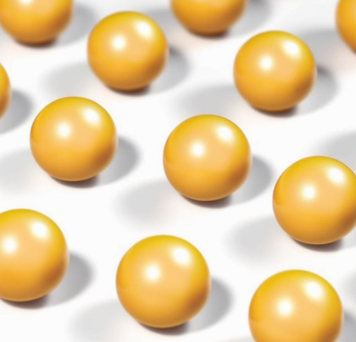 | 1 | 1 | Pure substance | There is only one type of particle in this substance.
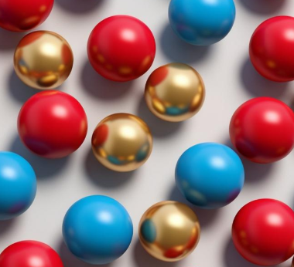 | 3 | 3 | Mixture | There are 3 different particles in this substance.
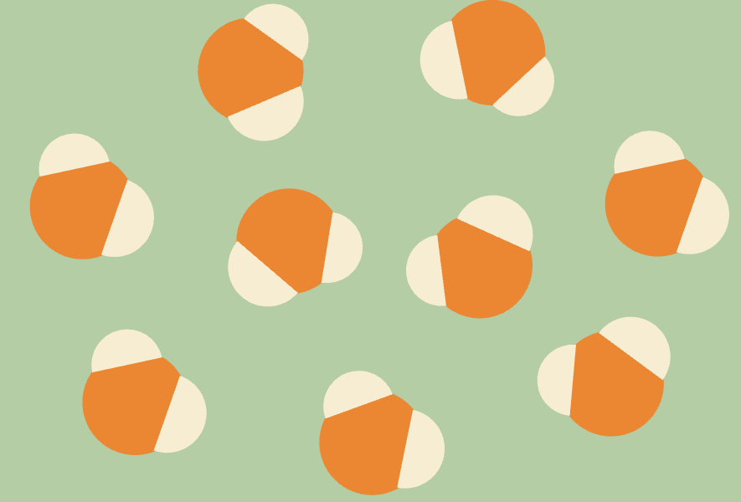 | 2 | 1 | Pure substance | There is only one type of particle in this substance.
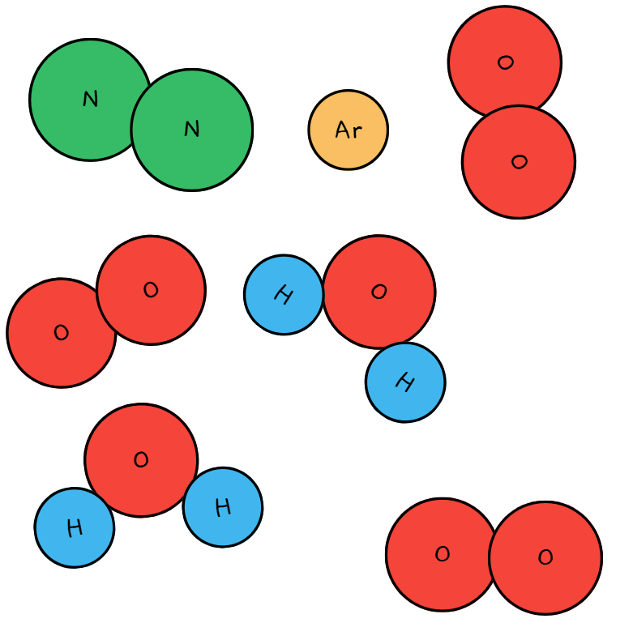 | 4 | 5 | Mixture | This substance contains 5 different substances mixed together.
Elements and compounds
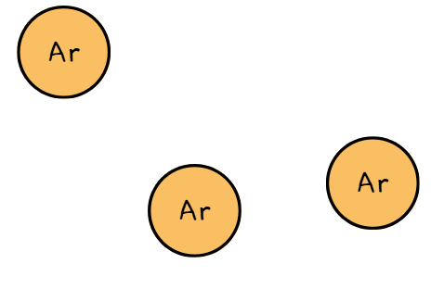  Element (argon) | 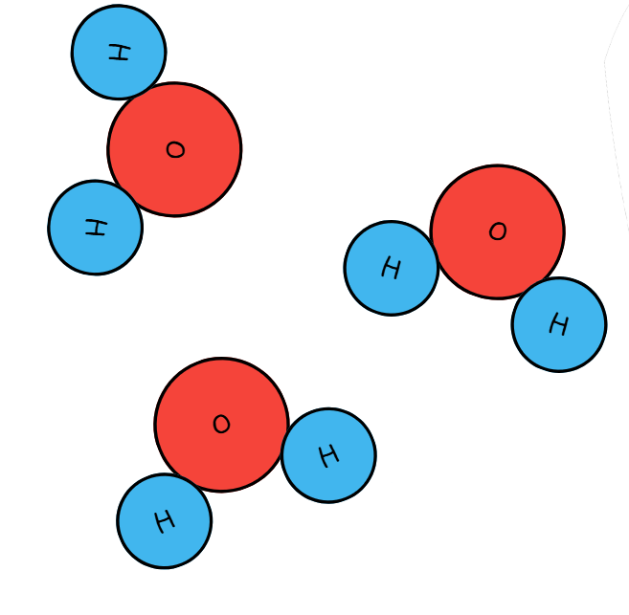  Compound (water) | 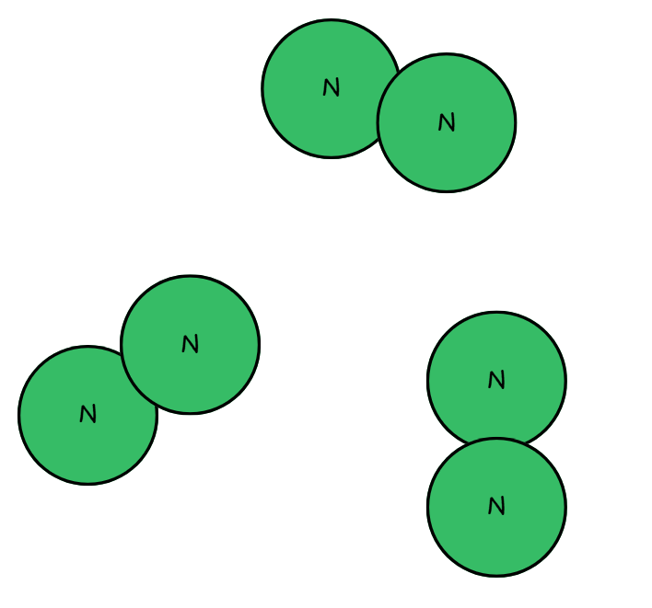  Element (nitrogen)
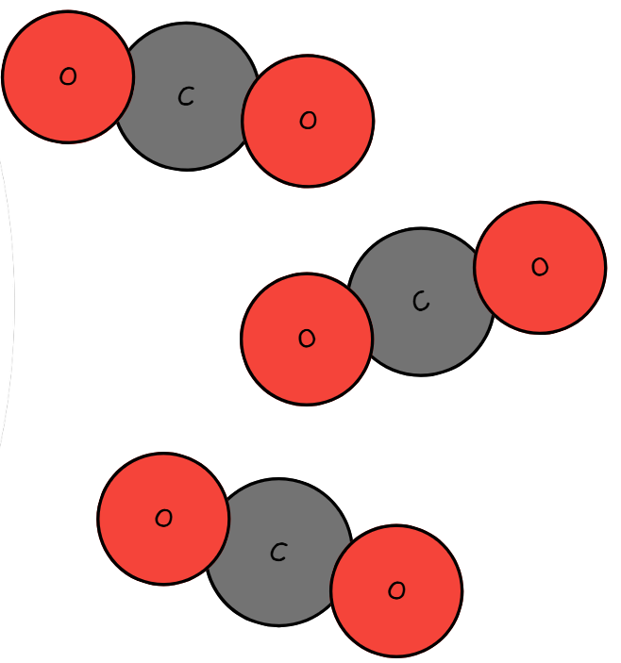  Compound (carbon dioxide) | 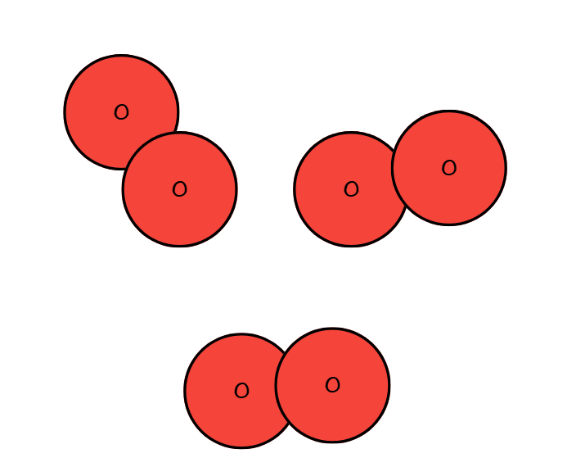  Element (oxygen) | 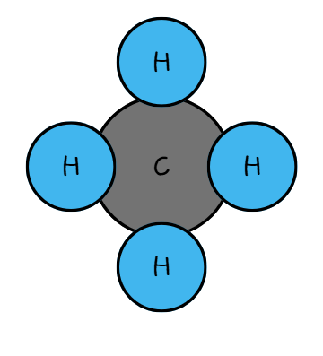  Compound (methane)
Mixtures
Table 5 – classification of substances as homogeneous or heterogeneous mixtures: sample response
Substance | Homogeneous or heterogeneous? | Justify your decision
Muddy water | Heterogeneous | You can see the dirt and water separately. The top of the water is clearer than the bottom.
Tap water | Homogeneous | The liquid looks the same throughout.
Salad dressing with oil and herbs | Heterogeneous | There is an oil layer on the dressing. There are pieces of herbs floating in the liquid. The mixture is not evenly distributed.
Orange juice with pulp | Heterogeneous | The pulp is settled lower in the bottle. The orange juice mixture is not evenly distributed.
Vegemite | Homogeneous | The consistency and colour of the Vegemite are the same throughout.
Dry cake mix | Homogeneous | The colour is even throughout the powdered cake mix. There is no difference in the texture or appearance of the mixture.
Cordial | Homogenous | The colour is even throughout the solution. There is no solute sitting at the bottom of the container.
- Describe what a homogeneous substance should look like in your own words.
A homogeneous substance looks completely the same all the way through. You cannot see any separate parts or bits because everything is mixed evenly.
- Describe what a heterogeneous substance should look like in your own words.
A heterogeneous substance looks uneven, and you can see the different bits or layers. The parts are not mixed evenly and look different in places.
- Draw a particle diagram to represent a homogeneous mixture and a heterogeneous mixture.
Homogeneous mixture   | Heterogeneous mixture  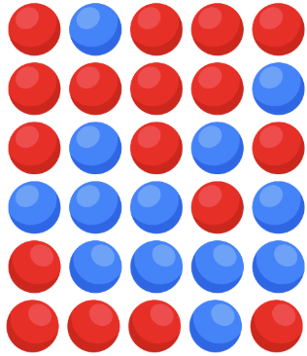

Student resource – classifying matter
We sometimes represent particles of matter with simple symbols. Different atoms can be represented using different shapes and colours. If a particle has more than one atom, then you will see the atoms joined together.
Use the dichotomous key in Figure 1 to complete each mini activity.
Figure 1 – classification of matter
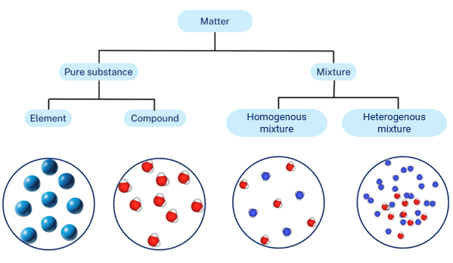
Image created using Canva and MolView.
Pure substances and mixtures
Atom – the basic building block of matter. They make up everything around us.
Particle – a general term that refers to any small piece of matter. Particles can include single atoms or groups of atoms that are held tightly together by forces.
Pure substance – a substance consisting of only one type of element or compound.
Mixture – a combination of 2 or more substances that are not chemically bonded.
Look at each image in Table 1 to identify the substance it represents. State how many different types of particles are present in the substance and determine if it is a pure substance or a mixture.
Table 1 – classification of pure substances and mixtures
Image | How many types of atoms are present? | How many types of particles are present? | Pure substance or mixture? | Justify your decision
Elements and compounds
Read the definitions for ‘element’ and ‘compound’ below, and then read the information on the composition of air.
Element – a substance made up of only one type of atom.
Compound – a substance made up of 2 or more atoms of different elements bonded together in a fixed ratio.
Air is a mixture of elements and compounds. Air is a homogeneous mixture of various elements and compounds, primarily nitrogen (N₂) and oxygen (O₂), along with argon (Ar), carbon dioxide (CO₂), water vapour (H₂0) and very small amounts of other gases such as methane (CH₄).
Each of the images represents a pure substance of an element or a compound. Each of these pure substances combines in air to make a mixture. Label each pure substance as an element or a compound.
_________________ | _______________ | _______________
_________________ | _________________ | _________________
Mixtures
Mixtures can be homogeneous or heterogeneous. A homogeneous mixture occurs when the substances are evenly distributed throughout and cannot be seen as separate parts. A heterogeneous mixture occurs when the substances are not evenly distributed and can be seen as separate parts.
Observe the solutions provided by your teacher and classify the substances in Table 2 as homogeneous or heterogeneous mixtures.
Table 2 – classification of substances as homogeneous or heterogeneous mixtures
Substance | Homogeneous or heterogeneous? | Justify your decision
Muddy water
Tap water
Salad dressing with oil and herbs
Orange juice with pulp
Vegemite
Dry cake mix
Cordial
- Describe what a homogeneous substance should look like in your own words.
- Describe what a heterogeneous substance should look like in your own words.
- Draw a particle diagram to represent a homogeneous mixture and a heterogeneous mixture.
____________________________________ | _____________________________________

Modelling substances
Checkpoint 2: display SOL PPT ‘3.1 Checkpoint 2’ to check students’ understanding of the key terms: ‘atom’, ‘mixture’, ‘pure substance’, ‘homogeneous’ and ‘heterogeneous’. Use a choral response or mini whiteboards to collect responses from all students (Refer to response systems for more information on checking for understanding). The statements and answers are outlined below:
- A substance or mixture that is different throughout. Heterogeneous.
- Substance made up of only one type of particle, or having a fixed ratio of particles. Pure substance.
- The smallest particle that makes up matter. Atom.
- Substance made up of varying amounts of different particles. Mixture.
- A substance or mixture that is the same throughout. Homogeneous.
- Provide students with items that they can use to make a particle model to represent pure substances, a homogeneous mixture and a heterogeneous mixture. Items may include differently coloured plasticine, differently coloured beads and building bricks.
- Provide students with a copy of the Student resource – modelling substances. Students work in small groups to develop a model to represent the different substances. Students evaluate their models using the evaluation criteria.
Checkpoint 3: display SOL PPT ‘3.1 Checkpoint 3’. Students match particle diagrams to descriptions of their contents. A screenshot of the slide and the answers is provided in Figure 1.
Figure 1 – checkpoint 3 slide and sample answers
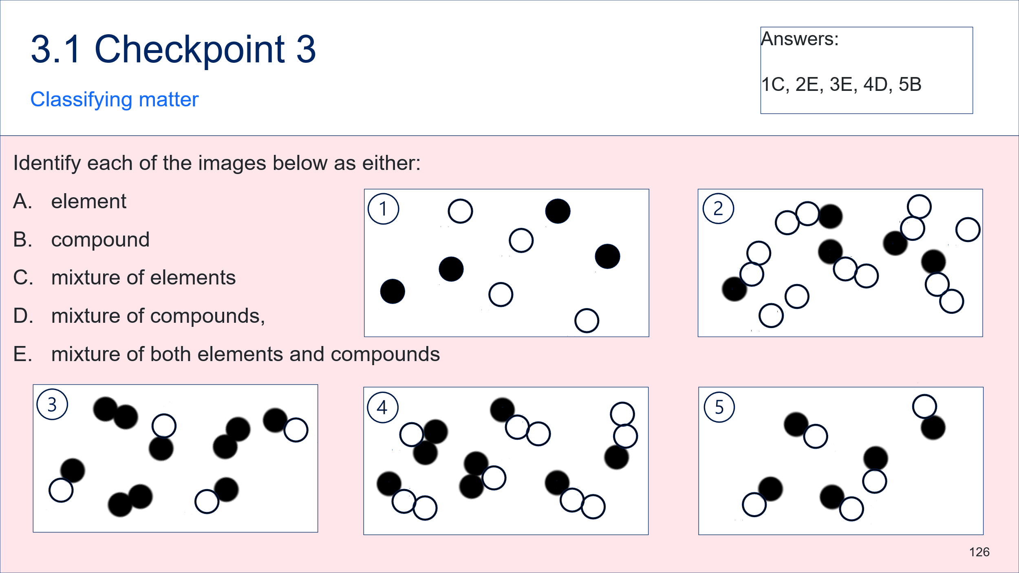
Sample response: Student resource – modelling substances
Draw a diagram to represent each of your models in the space below. Include appropriate labels.
Pure substance – gold  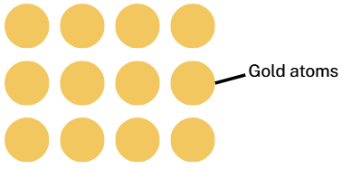 | Pure substance – water (compound)  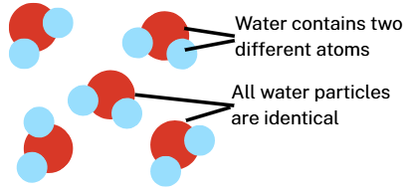
Homogeneous mixture – salt water  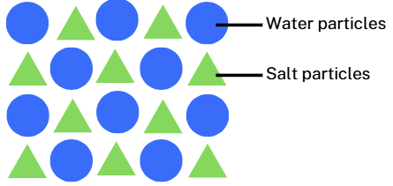 | Heterogeneous mixture – salad dressing  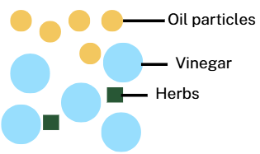
Note: students may represent compounds using a particular shape or object rather than using actual atom ratios. Students will learn about molecules and compounds in the Periodic table and atomic structure focus area.
Scientific model evaluation checklist
😃 – Clearly meets the criteria
😐 – Partially meets the criteria or unsure
☹️ – Does not meet the criteria
Table 6 – scientific model evaluation criteria
Evaluation criteria | 😃 | 😐 | ☹️
1. The model presents the key scientific ideas clearly. | ☒ | ☐ | ☐
2. The model is consistent with current scientific understanding. | ☒ | ☐ | ☐
3. The model is easy to interpret. | ☒ | ☐ | ☐
- Limitations of the model – What does it not show well?
It does not show the atoms moving or interacting.
- How could this model be improved?
Use labels to show which colours represent which elements.
Indicate the proportions of atoms in the compound.

Student resource – modelling substances
Work in small groups to create a model to represent each of the following:
- a pure substance made of an element
- a pure substance made of a compound
- a homogeneous mixture
- a heterogeneous mixture.
Draw a diagram to represent each of your models in the space below. Include appropriate labels.
Scientific model evaluation checklist
This checklist is designed to help you evaluate scientific models. For each question below, indicate how well the model meets the criteria using the following scale:
😃 – Clearly meets the criteria
😐 – Partially meets the criteria or unsure
☹️ – Does not meet the criteria
Table 1 – scientific model evaluation criteria
Evaluation criteria | 😃 | 😐 | ☹️
1. The model presents the key scientific ideas clearly. | ☐ | ☐ | ☐
2. The model is consistent with current scientific understanding. | ☐ | ☐ | ☐
3. The model is easy to interpret. | ☐ | ☐ | ☐
- Limitations of the model – What does it not show well?
- How could this model be improved?

3.2 Separating mixtures
Table 7 – learning intentions and success criteria for 3.2 Separating mixtures
We are learning: | I can:
- to explain how the properties of substances enable the separation of mixtures | - identify separation techniques to separate a mixture  - identify the physical property used by different separation techniques  - explain how the physical properties of substances can be used to separate mixtures  - outline techniques used by Aboriginal and/or Torres Strait Islander Peoples to separate mixtures
- to follow a procedure to conduct a practical investigation | - assemble and use appropriate equipment to separate mixtures
- to solve problems and propose solutions. | - devise a strategy to separate an unknown mixture  - select an appropriate separation technique based on the physical properties of the substances in the mixture  - evaluate the suitability of a sequence of separation techniques for separating a mixture using given criteria.

Physical properties and separation
- Display SOL PPT ‘3.2 Physical properties’ to define a physical property as a ‘characteristic of a material or substance that can be observed or measured without changing what the substance is made of’.
- Tell students that the differences in the physical properties of substances are what make it possible to separate them from a mixture. Display SOL PPT ‘3.2 Separating mixtures based on physical properties’ and play the video Elements of Chemistry: Separating Mixtures (6:25), which outlines how the components of a mixture can be separated from one another by taking advantage of differences in the physical properties of the substances in the mixture.
- Use Table 8 to list examples of properties that can be used to separate mixtures on the board, and discuss how each property can be used to separate mixtures.
Table 8 – physical properties that can help separate mixtures
Property | How it can be used to separate a mixture | Example
Particle size | If substances in a mixture have different particle sizes, a sieve or filter can separate them. Smaller particles pass through the gaps while larger particles are trapped.  Hand picking can also be used to separate a substance from a mixture where appropriate. | Sieving sand at the beach to remove stones or shells.
Boiling point | Different substances change state (liquid to gas) at different temperatures. Heating a mixture can cause one substance to evaporate or boil while the other remains behind. | Separating salt from salt water by boiling off the water, leaving solid salt behind.
Solubility | Some substances dissolve in a liquid while others do not. A dissolved substance forms a solution, while insoluble solids can be removed by filtration. | Separating salt from a salt–sand mixture by dissolving the salt in water and filtering out the sand.
Density | Substances with different densities may float or sink in a liquid, allowing them to be separated by skimming, settling or decanting.  Mixtures may be separated by spinning them in a centrifuge (the components will separate in order of their densities). | Plastic waste floats on the surface of the sea and can be skimmed from the water.  Centrifugation of blood to separate its components.
Miscibility | Some liquids mix (miscible) and others do not (immiscible). Immiscible liquids form layers that can be separated by decanting or a separating funnel. | Oil and water can be separated by decanting the oil off the top of the water.
Magnetic | Magnetic materials can be removed from a mixture using a magnet. | Separating iron filings from sand using a magnet.
Mass | Lighter particles may be carried farther by moving air or fall more slowly than heavier particles, allowing separation by winnowing or airflow.  OR  Centrifugation | Separating husks from grains or seeds using winnowing or yandying methods.
Checkpoint 1: display SOL PPT 3.2 ‘Checkpoint 1’. Students complete the missing words in the sentence ‘A mixture can be separated because the particles of each substance have different ___________ ___________ such as boiling point, ______________ and _______________.’ Check students’ answers using mini whiteboards.
Students should state: ‘A mixture can be separated because the particles of each substance have different physical properties.
Students may identify any of the physical properties outlined in 8 in their response.
- Provide students with a copy of the Student resource – physical properties and separation.
- Display SOL PPT ‘3.2 Winnowing’ and play the video The Dark Emu Story | The Oldest Bakers (1:25). Tell students that:
- the husk and grain occur together, forming a natural mixture
- this video demonstrates a deep understanding of the physical properties of the materials being separated.
- Students complete the questions related to the video in the Student resource – physical properties and separation.
- Engage with the separating mixtures text in the Student resource – physical properties and separation. Model how to highlight a separation technique in one colour and the physical property that is used in that separation technique in another colour.
- Support students to identify and highlight the remaining separation techniques and physical properties.
Sample response: Student resource – physical properties and separation
- What is the name of the separation technique used?
Winnowing.
- Outline the steps Aboriginal people used to separate native seeds from their husks.
Aboriginal people used a 2-step process to separate native seeds from their husks. The first step was threshing or grinding, which loosened the seeds from their husks. The second step was winnowing, where the mixture was tossed into the air. The wind carried away the lighter husks while the heavier grains fell back to the ground.
- What is the physical property that allows the husk to be separated from the seeds?
Mass of the different components.
Read the text on separating mixtures and then:
- highlight the separation techniques identified in the text in one colour.
- highlight the physical property that is used in each separation technique in a second colour.
Separating mixtures
Many materials around us are found as mixtures. A mixture contains 2 or more substances that are not chemically bonded, so each substance retains its own physical properties. Because the particles are not joined, the substances in a mixture can often be separated using different separation techniques that rely on these physical properties.
One way to separate a mixture is by sieving. Sieving works when solid particles have different sizes. Smaller particles can pass through the holes in the sieve, while larger particles are trapped on top. This technique can be used to separate sand from gravel because the sand particles are much smaller than the gravel particles.
Another technique is filtration. Filtration is used when a solid is insoluble in a liquid. The liquid particles can flow through the tiny spaces in the filter paper, but the solid particles are too large to pass through and become trapped. For example, sand can be separated from water by filtration because it does not dissolve in water and its particles remain solid.
Evaporation can be used to separate a dissolved solid from a liquid. This works because the liquid has a lower boiling point and can change into a gas when heated, while the solid does not evaporate and stays behind. Salt can be separated from salt water by evaporation because water turns into water vapour, leaving the salt particles behind.
Magnetic separation is useful when one of the substances in a mixture is magnetic. Magnetic materials are attracted to a magnet, while non-magnetic materials are not. Iron filings can be separated from sand because iron is magnetic and sand is not.
Decanting can be used when a solid has settled at the bottom of a liquid or when 2 liquids have different densities. The less-dense liquid stays on top and can be carefully poured off without disturbing the heavier substance beneath. Muddy water can be separated by allowing the mud to settle and then pouring off the clear water.

Student resource – physical properties and separation
Watch the video The Dark Emu Story | The Oldest Bakers (1:25) and answer questions 1 to 3.
- What is the name of the separation technique used?
- Outline the steps Aboriginal people used to separate native seeds from their husks.
- What is the physical property that allows the husk to be separated from the seeds?
Read the text on separating mixtures and then:
- highlight the separation techniques identified in the text in one colour.
- highlight the physical property that is used in each separation technique in a second colour.
Separating mixtures
Many materials around us are found as mixtures. A mixture contains 2 or more substances that are not chemically bonded, so each substance retains its own physical properties. Because the particles are not joined, the substances in a mixture can often be separated using different separation techniques that rely on these physical properties.
One way to separate a mixture is by sieving. Sieving works when solid particles have different sizes. Smaller particles can pass through the holes in the sieve, while larger particles are trapped on top. This technique can be used to separate sand from gravel because the sand particles are much smaller than the gravel particles.
Another technique is filtration. Filtration is used when a solid is insoluble in a liquid. The liquid particles can flow through the tiny spaces in the filter paper, but the solid particles are too large to pass through and become trapped. For example, sand can be separated from water by filtration because it does not dissolve in water and its particles remain solid.
Evaporation can be used to separate a dissolved solid from a liquid. This works because the liquid has a lower boiling point and can change into a gas when heated, while the solid does not evaporate and stays behind. Salt can be separated from salt water by evaporation because water turns into water vapour, leaving the salt particles behind.
Magnetic separation is useful when one of the substances in a mixture is magnetic. Magnetic materials are attracted to a magnet, while non-magnetic materials are not. Iron filings can be separated from sand because iron is magnetic and sand is not.
Decanting can be used when a solid has settled at the bottom of a liquid or when 2 liquids have different densities. The less-dense liquid stays on top and can be carefully poured off without disturbing the heavier substance beneath. Muddy water can be separated by allowing the mud to settle and then pouring off the clear water.

The Brewarrina fish traps – separation techniques
Aboriginal and Torres Strait Islander Peoples use a range of different separation techniques, including winnowing, yandying, cold pressing, steam distillation, hand picking and many more. In this activity, students will engage with a text about the Brewarrina fish traps located on the traditional lands of the Ngemba people and identify how Aboriginal people sustainably harvested fish by filtering with rocks and hand picking.
- Display Brewarrina fish traps and the Murray Cod and read through the text with the class.
- Display the AIATSIS Map of Indigenous Australia and zoom in to Brewarrina to provide students with additional context around the Aboriginal language groups that live near the valuable water source where the Brewarrina fish traps are located.
- Ask students to identify the 2 separation techniques identified in the text (filtering and hand picking).
- Display SOL PPT ‘3.2 Brewarrina fish traps’ to lead a discussion about the separation techniques used to harvest the Murray cod.
- Students summarise their learning in the Student resource – Brewarrina fish traps.
Sample response: Student resource – Brewarrina fish traps
Access the Brewarrina fish traps and the Murray Cod text and then summarise information about the separation techniques used by Aboriginal people to harvest fish sustainably.
Separation technique 1 | Filtering
Used by | While the Ngemba people are custodians of the fishery, maintenance and use of the traps were shared with other tribes in the area, including the Morowari, Paarkinji, Weilwan, Barabinja, Ualarai and Kamilaroi.
Purpose | To trap fish in smaller ponds so that they can be harvested and eaten.
Description of process | The river stones were strategically placed to form ponds and channels that would trap fish and allow water to filter through and continue downstream.
Physical property used in separation | Particle size. The fish are the large objects, while small objects and water can pass through the rock wall filter.
Separation technique 2 | Hand picking
Used by | While the Ngemba people are custodians of the fishery, maintenance and use of the traps were shared with other tribes in the area, including the Morowari, Paarkinji, Weilwan, Barabinja, Ualarai and Kamilaroi.
Purpose | Hand picking ensures that the fish are sustainably harvested.
Description of process | Aboriginal people would catch small fish and release any that were of breeding age or size, so the Murray cod population could be maintained into the future. Then some of the Murray cod could be caught and eaten.
Physical property used in separation | Physical size of the fish.

Student resource – Brewarrina fish traps
Access the Brewarrina fish traps and the Murray Cod text and then summarise information about the separation techniques used by Aboriginal people to harvest fish sustainably.
Separation technique 1
Used by
Purpose
Description of process
Physical property used in separation
Separation technique 2
Used by
Purpose
Description of process
Physical property used in separation

Separation techniques practical investigation
In this activity, conduct a series of demonstrations and short, practical experiences to support students’ understanding of the different separation techniques. Draw on students’ problem-solving skills to identify the separation techniques required and the physical property that is exploited.
Before the lesson, determine which mixtures students will separate and source the equipment required for demonstration and practical investigations. Adjust the instructions below based on decisions about which techniques will be demonstrated and which ones will be conducted by students.
Note: evaporation and distillation will be covered in 3.3 Separation techniques – evaporation, boiling and distillation.
- Provide students with a copy of the Student resource – separating mixtures. Students should complete the table as each demonstration or practical is conducted.
- Demonstrate how a centrifuge can be used to separate a liquid mixture that contains components with different densities (if available). Tomato sauce can be separated into a denser tomato component and a clear, watery component. Tell students:
- instead of waiting for particles to settle slowly under gravity, the centrifuge accelerates sedimentation
- a centrifuge spins samples at a high speed, creating a strong, outward force
- this force pushes denser particles outward faster than less-dense liquids
- this same principle is used to separate blood into useful components such as plasma.
- Show students a mixture of oil and water. Students use think-pair-share to discuss and propose a suitable method of separation. Students may suggest decanting as a suitable method. Decanting is the general technique of carefully pouring off a liquid from another substance that remains behind. Demonstrate this by pouring off the oil.
- Demonstrate how a separating funnel can be used to separate immiscible liquids. Tell students:
- a separating funnel is a piece of laboratory equipment used to separate 2 immiscible liquids (liquids that do not mix), such as oil and water
- a separating funnel applies the same principle as decanting (density differences) but allows the layers to be separated more accurately and without mixing them again.
- Propose the problem: ‘We are mining salt and need to separate the salt from sand. How can we separate them?’ Guide students to consider the properties of salt and sand (salt is soluble and can be dissolved in water, and the heterogeneous mixture can then be separated using a filter).
- Show students a filter paper and a filter funnel. Demonstrate how to fold it and place it in the filter funnel. Tell students:
- a filter is used to separate an undissolved solid from a solution
- filtering works because the filter (in this case, filter paper) has tiny pores that allow the liquid to pass through while trapping the undissolved solid particles
- the solid that remains on the filter paper is called the ‘residue’, and the liquid that passes through the filter is called the ‘filtrate’
- a dissolved solid, such as a salt, can pass through the filter paper.
- Provide student groups with a mixture of sand and salt (1 teaspoon sand and 1 teaspoon salt). Students use think-pair-share to discuss and select a suitable method of separation. Guide students to identify filtration as a suitable method after adding water to dissolve the salt.
- Students conduct the separation by:
- folding the filter paper and placing it in the filter funnel (adding a small amount of water helps keep it in place)
- adding water (25 to 50 mL) to the sand and salt mixture and gently stirring until the salt dissolves
- pouring the mixture into the filter funnel a little at a time and allow it to pass through the filter paper
- rinsing the beaker out with a little more water to wash out the sand and any remaining salt solution.
- Now that students have a solution of salt water, ask them to consider how the salt and the water could be separated if we wanted to recover the salt. Students use think-pair-share to discuss and select a suitable method of separation. Guide students to identify that evaporation or boiling can be used to remove the water, leaving the salt crystals. Tell students that they will recover the salt in a future lesson.
Note: reserve the students’ filtered salt solutions for the next lesson sequence, 3.3 Separation techniques – evaporation, boiling and distillation. In this lesson sequence, students will boil the water to observe how the salt can be recovered from the solution.
- Provide student groups with a mixture of iron filings and sand. Lead a discussion about the properties of each substance to identify that magnetism can be used to remove the iron filings. Students remove the iron filings from the mixture and place them in a separate dish.
- Provide students with grain and husks (alternatively, use rice and paper scraps from a hole punch). Students should recall the winnowing process used by Aboriginal people to separate the grain from the husk. Students use the winnowing technique to separate the husks (or paper) from the grain.
- Provide students with a mixture of sand and flour and a sieve. Students sieve the mixture to separate it. Tell students that:
- sieving is a type of filtration
- sieving separates particles of different sizes
- sieves can be many different sizes or grades
- a fishing net is a type of sieve that removes fish from water
- sieves are used in baking to remove lumps in flour and other ingredients
- different-sized sieves can be used to grade rocks so that they can be sold in uniform sizes.
- Provide students with an unknown mixture such as gravel, sand, iron filings and small pieces of cork. Challenge students to identify appropriate separation techniques to recover the components in the mixture. Students conduct the separation using their identified procedure, then evaluate it against the given criteria. A suggested sequence which assumes the pieces of cork are larger than the sand is:
- remove the iron filings with a magnet
- sieve to remove the sand from the mixture
- add water, and decant water and cork through a sieve to remove the cork
- gravel should be the only substance remaining.
Sample response: Student resource – separating mixtures
Note: stimulus material and additional instructions have been removed from the sample response.
Table 9 – mixtures and separation techniques sample response
Mixture | Components | Separation technique | Physical property used to separate | Limitations or other comments
Tomato sauce | Tomato solids, water and other ingredients | Centrifuging | Density | Not all the ingredients are separated, for example, the sugar.
Oil and water mixture | Oil and water | Decantation | Solubility | It is difficult to pour off only the oil from the mixture as some water also comes out. A separating funnel makes it easier to separate the 2 liquids.
Salt water | Salt and water | Distillation or evaporation | Boiling point | Evaporation only captures the salt, whereas distillation can also recover the water.
Iron and sand | Iron filings and sand | Magnetic separation | Magnetism | If the sand is slightly wet, the iron filings stick to it and the magnet does not remove all of them.
Unprocessed grain | Grain and husk | Winnowing | Mass | Some husk is firmly attached to the grain and needs to be threshed off before further winnowing.
Sand and flour | Sand and flour | Sieving (filtering) | Particle size | Some of the smaller pieces of sand go through the sieve. A finer sieve is needed to remove all sand completely.
You have been given an unknown mixture. Determine which separation techniques, in which order, will best separate the components of the mixture.
Mixture components: | Sand, gravel, cork and iron filings.
Identify the physical property that can be used to separate each substance from the mixture.
Table 10 – identifying physical properties to separate substances from the mixture
Substance | Physical properties | Separation technique
Sand | - Insoluble  - Small particle size | Sieve (which allows the sand to pass through).
Gravel | - Insoluble  - Large particle size | Sieving will separate gravel from sand, and decanting will separate the cork from the gravel if water is added.
Cork | - Insoluble  - Large particles size  - Very low density | Floatation and decanting (the cork will float on water).
Iron filings | - Magnetic | Magnetic separation.
Identify the sequence in which the separation techniques should be used for the best result.
Magnetic separation to remove iron, sieving to remove sand and floatation and decanting into a sieve to remove the cork. Gravel will remain at the end.
Test your separation techniques and sequence, and then evaluate the suitability of your strategy based on the following criteria:
Table 11 – criteria for separation techniques
Criteria | Judgement
All substances are recovered | Yes, all substances were recovered.
Substances are pure | The iron and sand are mostly pure. However, there is water on the cork and gravel. It will be pure once the water evaporates.
The procedure is efficient (fewest steps possible) | The procedure cannot be conducted in fewer steps, so it is efficient.
Minimal loss of material | There was minimal loss. A small amount of iron was difficult to remove from the magnet completely. A couple of tiny pieces of cork ended up going through the sieve with the sand.
Safe and practical | Yes, safety glasses were worn to prevent sand or other substances from entering the eyes.

Student resource – separating mixtures
Your task is to separate each mixture listed in Table 1. To do this, you will:
- select a suitable separation technique that uses equipment on the equipment list
- consider any risks when using the technique
- perform or observe the separation of the mixture
- complete Table 1 to summarise the techniques used, the physical property used to separate the mixture and any other comments or observations.
Equipment list
- Sieves  - Containers  - Evaporating basin  - Tripod  - Gauze  - Centrifuge (if available) | - Matches  - Bunsen burners  - Paper  - Beakers  - Magnets  - Hotplates
Table 1 – mixtures and separation techniques
Mixture | Components | Separation technique | Physical property used to separate | Limitations or other comments
Tomato sauce
Oil and water mixture
Salt water
Iron filings and sand
Unprocessed grain | Grain and husk
Sand and flour
You have been given an unknown mixture. Determine which separation techniques, in which order, will best separate the components of the mixture.
Mixture components:
Identify the physical property that can be used to separate each substance from the mixture.
Table 2 – identifying physical properties to separate substances from the mixture
Substance | Physical properties | Separation technique
Identify the sequence in which the separation techniques should be used for the best result.
Test your separation techniques and sequence, and then evaluate the suitability of your strategy based on the following criteria:
Table 3 – criteria for separation techniques
Criteria | Judgement
All substances are recovered
Substances are pure
The procedure is efficient (fewest steps possible)
Minimal loss of material
Safe and practical

3.3 Separation techniques – evaporation, boiling and distillation
Table 12 – learning intentions and success criteria for 3.3 Separation techniques – evaporation, boiling and distillation
We are learning: | I can:
- to explain how the properties of substances enable the separation of mixtures | - separate a mixture using boiling and distillation  - outline techniques that can be used to separate mixtures and link the choice of each technique to a physical property
- to follow a procedure to conduct a safe, practical investigation. | - follow a given procedure to filter a mixture and recover the solute  - follow a risk assessment to reduce the risk of injury  - use appropriate personal protective equipment when conducting a practical investigation.

Recovering salt from a solution
Note: in 3.2 Separating mixtures, students filtered a salt and sand solution. Students will need access to this salt solution in this activity. Alternatively, a salt solution can be made up by dissolving approximately 1 teaspoon of salt in 50 mL of water.
- Provide students with 50 mL of salt solution.
- Ask students to consider how the salt and the water could be separated if we wanted to recover the salt. Students use a think-pair-share to discuss and select a suitable method of separation. Guide students to identify that evaporation can be used to remove the water, leaving the salt crystals.
- Tell students that sea salt is collected by removing the water from seawater:
- Seawater is pumped or channelled into large, shallow ponds called ‘salt pans’.
- These ponds maximise surface area to speed up evaporation.
- As water leaves, the remaining solution becomes more concentrated.
- Eventually the salt begins to form solid crystals in a process called ‘crystallisation’.
- Salt is then collected and packaged for use.
- Display SOL PPT ‘3.3 Using boiling to recover a dissolved solid’ to show the equipment set-up to separate the seawater to recover the salt. Tell students that using heat will speed up the process compared to how salt is recovered in salt pans.
Note: ensure students know to turn the Bunsen burner off when there is still water in the bottom of the basin, allowing the last of the solution to evaporate from the residual heat. If the Bunsen burner is left on for too long, the solution becomes very concentrated and forms bubbles which can eject hot salt crystals from the evaporating basin.
- Provide students with a copy of Student resource – recovering salt from a solution. Students heat their saltwater solution to recover the salt.
- Pose the question to students: ‘Given a saltwater solution, how could we also recover the water?’ Lead a discussion to recall changes of state and the properties of water (evaporation, boiling point and condensation). Tell students that:
- distillation is a separation technique used to separate a liquid from a solution or to separate liquids with different boiling points
- it works because different substances boil at different temperatures
- distillation works by heating the mixture in a distillation flask. The substance with the lowest boiling point evaporates first and forms a vapour. The vapour travels into a condenser, which is cooled by running water. The vapour cools and condenses back into a liquid. The liquid is collected in a separate container.
Sample response: Student resource – recovering a salt from a solution
- What kinds of substances can be separated using boiling?
A solute and a solvent in solution, for example, a solid that is dissolved in a liquid. When the liquid evaporates, the solute is left behind in solid form.
- What is the physical property that allows this separation?
This separation technique relies on the boiling point. The water boils at 100°C, leaving the salt behind.

Student resource – recovering a salt from a solution
When a solid is dissolved in a liquid, it forms a solution. For example, salt dissolved in water. To separate the solute (the dissolved solid) from the solvent (the liquid), we can use processes that rely on differences in how easily each substance changes state.
Evaporation occurs when a liquid slowly changes into a gas at temperatures below its boiling point. As the solvent (water) evaporates, it leaves the solute (salt) behind. This is often used to recover solids, such as in the production of sea salt.
Boiling is a faster process where a liquid changes to a gas throughout the entire liquid at a specific temperature (its boiling point). Boiling can be used to remove the solvent quickly. The solute remains because it has a much higher boiling point and does not evaporate under these conditions.
Equipment list
- 1 × evaporating basin  - 1 × pipeclay triangle  - 1 × tripod | - 1 × Bunsen burner  - 1 × box of matches  - 50 mL saltwater
Figure 1 – apparatus for boiling a mixture to remove the solvent
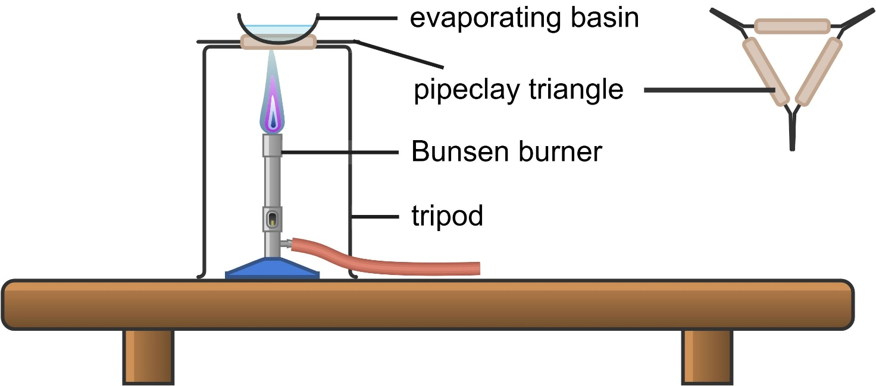
Image created using Chemix.
Risk assessment
Table 1 – risk assessment
Hazard | Risk | Management
Hot salt spitting from the evaporating basin | Burns or eye damage | - Turn the Bunsen burner off before all the water evaporates.  - Wear safety glasses.
Hot equipment | Burns | - Do not touch hot equipment.  - Let the equipment cool before packing it up.
Procedure
- Set up the equipment as shown in the diagram. Pour the salt water into the evaporating basin.
- Close the collar on the Bunsen burner and light it.
- Turn the Bunsen burner collar to open (blue flame).
- Observe the solution while the water boils. Turn the Bunsen burner off when some water remains in the solution. The residual heat will help with continued evaporation.
- Once the evaporating basin has cooled for some time, observe the salt crystals that have formed in the base.
Reflection
- What kinds of substances can be separated using boiling?
- What is the physical property that allows this separation?

Distillation
Checkpoint: display SOL PPT ‘3.3 Checkpoint’ to activate students’ prior knowledge about distillation by asking them to identify a description that represents distillation. Use a choral response or mini whiteboards to collect responses from all students.
Which of the following describes distillation?
- Separating a solid from a liquid using filter paper
- Heating a solution to evaporate the liquid, then condensing it back into a liquid
- Allowing a solid to settle at the bottom of a container before pouring off the liquid
- Using a sieve to separate the particles of different sizes
Table 13 – checkpoint response explanation
Choice | Explanation
A | This is incorrect. This describes filtration, not distillation. Filtration works because solid particles are too large to pass through the filter, while the liquid passes through.
B | This is correct. Distillation works by heating a liquid so it vaporises, then cooling the vapour so it condenses back into a liquid. This allows the liquid to be separated from dissolved substances or from other liquids with different boiling points.
C | This is incorrect. This describes decanting. It relies on density differences, where heavier particles settle, allowing the liquid to be carefully poured off.
D | This is incorrect. This describes sieving, which separates solids based on particle size rather than boiling point.
- Provide students with a copy of the Student resource – distillation.
- Display SOL PPT ‘3.3 Distillation’ to show the distillation apparatus set-up. Show students the actual equipment used in distillation and describe how it works:
- The heating mantle heats the mixture.
- As each substance in the mixture reaches its boiling point, it boils (liquid to gas), and the gas rises to the distillation head.
- The thermometer measures the temperature of the gas (this is useful when separating liquids with different boiling points).
- The gas moves into the condenser. The condenser is a special piece of equipment designed to cool the gas vapour and turn it back into liquid. It consists of an inner tube through which the gas flows and an outer jacket through which cold water flows.
- Once the gas has condensed into liquid inside the condenser, it then flows out through the glass tube into the receiving beaker or flask.
- Demonstrate distillation to recover water from a copper sulfate solution. Copper sulfate is used so that students can observe that the distillate is clear (water), and as the water is boiled off, the copper sulfate becomes deeper in colour as it concentrates.
- Pour a small volume of copper sulfate solution into the distillation flask.
- Add a few boiling chips to help the liquid boil smoothly.
- Set up the distillation apparatus with the flask connected to the condenser and a receiving container at the end.
- Run cold water through the condenser, entering from the bottom and leaving from the top.
- Turn on the heating mantle and heat the copper sulfate solution.
- As the solution heats, the water boils and forms steam.
- The steam passes into the condenser, where it cools and condenses back into liquid water.
- Collect the distillate in the receiving flask.
- Observe that the blue copper sulfate solution remains in the distillation flask, while the liquid collected is clear water.
Note: do not boil all the water away.
Sample response: Student resource – distillation
- What kinds of substances can be separated using distillation?
In the example shown, the mixture is a solution of a solid dissolved in a liquid.
Mixtures of liquids can also be separated by distillation if their boiling points differ.
- What is the physical property that allows this separation?
This separation technique relies on the boiling points of the substances in the mixture being different so that as each boiling point is reached, the corresponding substance boils and then condenses out of the mixture.
- Record your observations of the distillation process.
The blue copper sulfate solution became a deeper blue colour as the volume reduced. A clear liquid (water) condensed into the receiving beaker.
- Why was water able to be collected in the receiving beaker?
Water has a boiling point of 100°C, which is lower than that of copper sulfate.
- Outline how the distillation apparatus separates the copper sulfate solution into its components.
When the solution is heated in a distillation flask, the water (the solvent) reaches its boiling point at around 100°C and changes from a liquid into a gas (water vapour). The dissolved copper sulfate does not evaporate because it has a much higher boiling point and remains as a solid in the flask. The water vapour then travels into a condenser, where it is cooled by circulating cold water and condenses back into a liquid. This liquid, now pure (distilled) water, is collected in a separate container, while the copper sulfate is left behind in the original flask. In this way, distillation separates the solvent from the solute based on their different boiling points.

Student resource – distillation
Your teacher will demonstrate distillation with an apparatus similar to the one in Figure 1. Use the diagram and your observations of the demonstration to help you answer the questions.
Figure 1 – apparatus for distillation
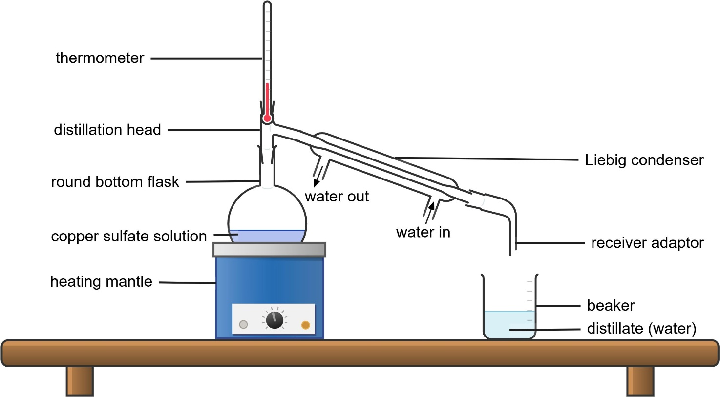
Image created using Chemix.
- What kinds of substances can be separated using distillation?
- What is the physical property that allows this separation?
- Record your observations of the distillation process.
- Why was water able to be collected in the receiving beaker?
- Outline how the distillation apparatus separates the copper sulfate solution into its components.

3.4 Separation challenge
Table 14 – learning intentions and success criteria for 3.4 Separation challenge
We are learning: | I can:
- to explain how the properties of substances enable the separation of mixtures | - identify the physical properties of substances in a mixture by drawing on prior knowledge  - identify the appropriate separation techniques to separate a mixture
- to plan a valid and safe investigation | - identify the hazards, risks and ways to mitigate the risk in an investigation  - plan a sequence of steps to separate a mixture in a flow chart  - construct a procedure to outline the steps to separate the components of a mixture
- to follow a procedure to conduct a practical investigation | - assemble and use equipment to separate a mixture  - mitigate risks in an investigation  - record observations accurately using the correct units
- to solve problems and propose solutions. | - devise a strategy to separate an unknown mixture  - select appropriate separation technique based on the physical properties of the substances in the mixture  - evaluate the suitability of a sequence of separation techniques for separating a mixture using given criteria.

Separation – guided investigation
- Before the lesson, order the equipment required for each group.
- Magnet (individually wrapped)  - Mixture (5 g copper sulfate, 5 g iron filings and 20 g sand)  - Beakers  - Tripods  - Filter paper | - Stirring rod  - Filter funnel  - Retort ring  - Retort stand  - Pipeclay triangle | - Evaporating basin  - Bunsen burner  - Matches  - Digital scale
Note: magnets should be wrapped in cling wrap or put inside a resealable plastic bag before the magnetic extraction of iron filings to facilitate easy removal of the filings.
- Provide students with the mixture in a beaker and tell them that it contains iron filings, copper sulfate (a type of salt) and sand of known amounts (known to the teacher).
- Provide students with a copy of the Student resource – separation challenge. Students identify the physical properties of each substance and then complete a Venn diagram to compare them. SOL PPT ‘3.4 Venn diagram’ (2 slides) contains a template and a sample response to facilitate discussion of students’ responses.
- Students analyse their Venn diagram to select an appropriate separation technique to separate each of the 3 components of the mixture, justifying their choices in the Student resource – separation challenge. Prompt students to consider the sequence of techniques, as this can be important for effectively separating mixtures.
- Lead a class discussion to ensure appropriate choices and reasoning have been provided and to discuss the consequences of performing the separation techniques in different orders.
- Use the information on SOL PPT ‘3.4 Constructing a flowchart’ to explain the purpose and construction of a flowchart before the class co-constructs a flowchart outlining the ordered steps they will follow to separate the components of their mixture. SOL PPT ‘3.4 Flowchart example’ can be used to help students refine their flowcharts once they have attempted it on their own or in their groups.
- Students then write a procedure for their separation using the constructed flowchart to guide them. They should be reminded of the scientific method quality criteria.
- As a class, co-construct the risk assessment (safety considerations) for their investigation.
- Students conduct the separations. The recovered metal filings can be weighed. The recovered sand and copper sulfate should be left to dry by evaporation and be weighed later.
- Present the true masses on the board and discuss possible reasons for any differences.
Sample response: Student resource – separation challenge
Part 1 – physical properties
- List the physical properties of each component of the mixture.
Table 15 – physical properties of each component in the mixture sample response
Copper sulfate | Iron filings | Sand
- Soluble in water  - Not magnetic  - Solid at room temperature  - Small particles  - Bright, blue crystals | - Insoluble in water  - Magnetic  - Solid at room temperature  - Small particles  - Grey, metallic colour | - Insoluble in water  - Not magnetic  - Solid at room temperature  - Small particles  - Light brown or yellow grains
- Complete the Venn diagram to compare the physical properties of copper sulfate, iron filings and sand.
Figure 2 – comparison of physical properties of copper sulfate, iron filings and pebbles: sample student response
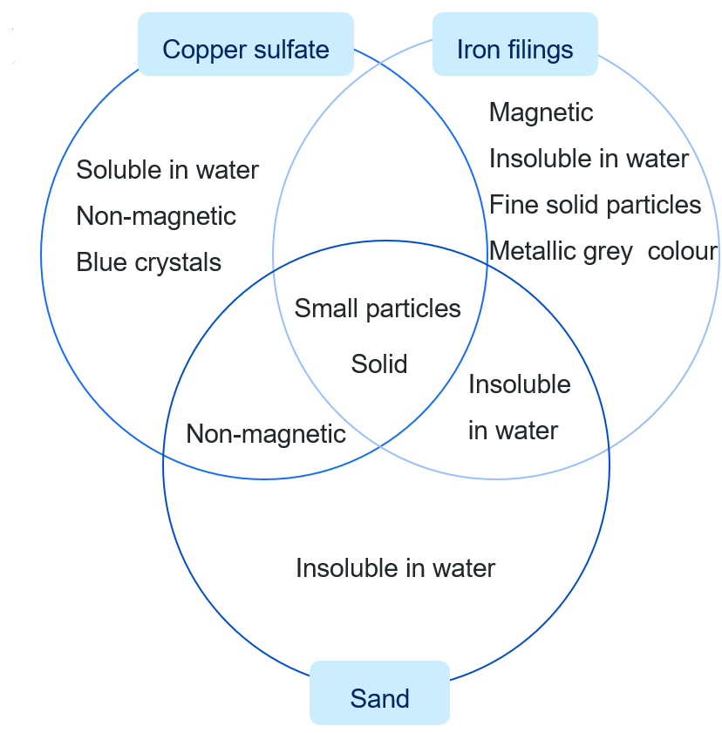
Part 2 – selecting separation techniques
- Use the scaffold below to list the unique physical properties of each substance and select a separation technique to extract that substance based on those properties.
Table 16 – summary of separation techniques sample student response
Substance | Physical properties | Separation techniques | Explanation
Copper sulfate | Soluble | Add water, then use filtration, followed by evaporation | This will dissolve the copper sulfate but not the other 2 materials, which can then be filtered out of the solution. Evaporating the water from the solution will yield copper sulfate.
Iron filings | Magnetic | Magnetic separation | Only the iron filings will stick to a magnet, allowing them to be removed.
Sand | Insoluble  Particle size | Filtering | Sand is insoluble, so when water is added to dissolve soluble substances, the insoluble sand can be separated by filtration.
Part 3 – planning the separation
- Construct a flowchart showing the sequence of the separation techniques:
Figure 3 – flowchart showing how to separate copper sulfate, sand and iron filings
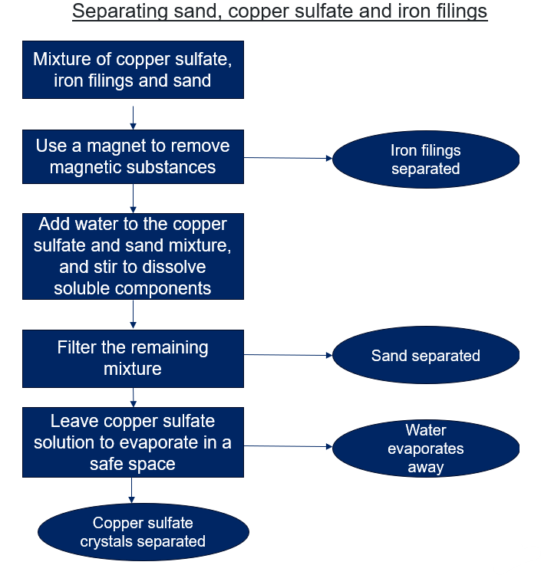
Part 4 – writing a method
- Complete the scaffold below to write a method for the complete separation of the 3 substances in your mixture.
Equipment list
- Mixture sample  - 200 mL beaker  - 60 mL distilled water  - Stirring rod  - Retort stand | - Filter paper  - Filter funnel  - Evaporating basin  - Bunsen burner  - Retort ring | - Tripod  - Pipeclay triangle  - Electronic scale  - Magnet (wrapped in cling film)
Procedure
- Use a magnet to remove the iron filings from the mixture. Gently stir the mixture occasionally to ensure all iron filings are removed before moving on.
- Add approximately 50 mL of water to the remaining mixture and stir with a stirring rod until the copper sulfate is dissolved.
- Fold a piece of filter paper and place it into a filter funnel. Hold it in place with a small amount of distilled water.
- Place the filter funnel in a retort ring over a beaker. Pour the mixture into the filter funnel, adding more liquid as the filtrate moves through the filter paper.
- Rinse the beaker with some extra distilled water to remove the remaining mixture and pour it into the filter.
- Place the filtrate into an evaporating basin.
- Optional step: set the evaporating basin on a pipeclay triangle over a Bunsen burner and boil away half of the water. Turn off the Bunsen before the last of the water boils away.
- Leave the sand to dry by evaporation on the filter paper. Leave the copper sulfate to dry by evaporation in the evaporating basin.
- Weigh the components using an electronic scale to see how much of each substance recovered.
Risk assessment
Table 17 – risk assessment
Hazard | Risk | Management
Copper sulfate crystals jumping out of the evaporating basin | Burns or eye damage | - Wear safety glasses.  - Turn off the Bunsen burner before all the water evaporates.
Broken ceramics or glassware | Cuts | - Inspect equipment before use, especially when used for heating.  - Clean up breakages safely.
Steam or hot liquid splashing | Scalding or burns | - Maintain a safe distance from equipment while evaporation is underway.  - Wear safety goggles.
Hot equipment | Burns | - Do not touch hot equipment with bare hands.  - Leave equipment to cool before moving or packing away.
Part 5 – results
- Conduct your separation and record the masses of the 3 substances below. Provide possible explanations for any differences between your measured masses and the initial masses as provided by your teacher.
Table 18 – sample student response to Part 5
Substance | Measured mass after separation (g) | Initial mass (g) (provided by teacher) | Possible explanation for any changes in mass
Sand | 30 | 30 | No change.
Iron filings | 9 | 10 | A small amount of iron filings may have remained in the mixture or stuck to the cling wrap or magnet.
Copper sulfate | 8.5 | 10 | Some dissolved copper sulfate may have been lost in the filter paper or not fully evaporated during heating.

Student resource – separation challenge
Scenario: a mining company has collected a sample from a newly discovered site. The sample was expected to contain valuable copper sulfate crystals, but during collection, it became contaminated with sand and iron filings from nearby equipment.
The company needs your help as a team of scientists to separate the mixture into its individual components so that each material can be reused.
Part 1 – physical properties
- List the physical properties of each component of the mixture.
Table 1 – physical properties of each component in the mixture
Copper sulfate | Iron filings | Sand
- Complete the Venn diagram to compare the physical properties of copper sulfate, iron filings and sand.
Figure 1 – comparison of physical properties of copper sulfate, iron filings and pebbles
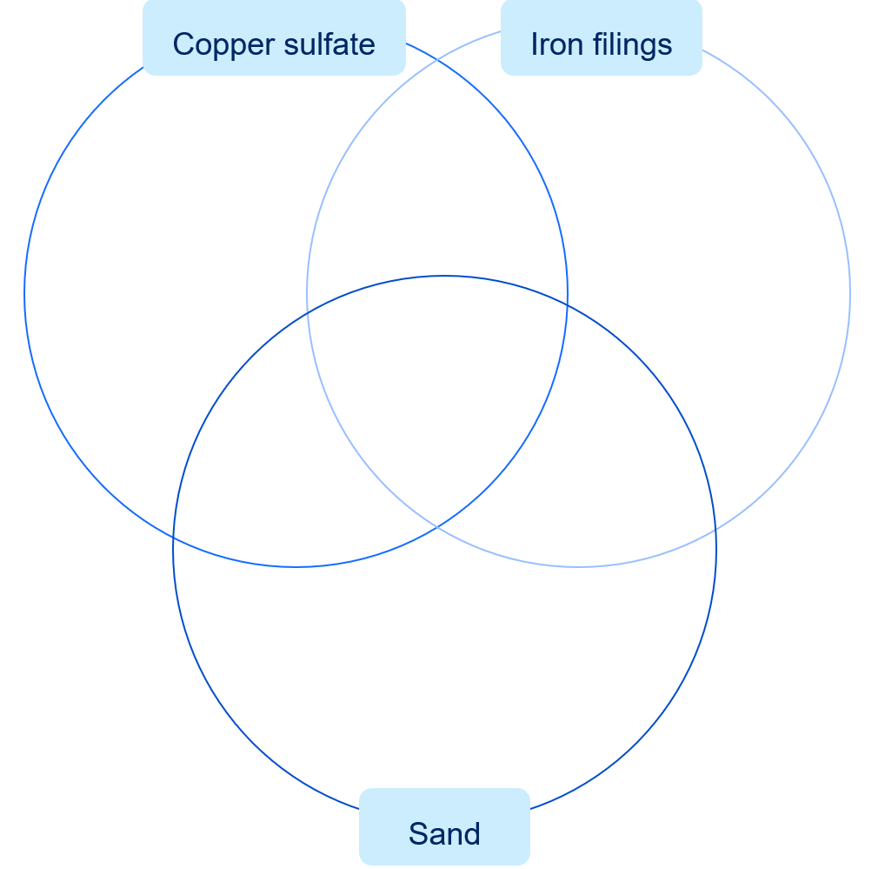
Part 2 – selecting separation techniques
- Use the scaffold below to list the unique physical properties of each substance and select a separation technique to extract that substance based on those properties.
Table 2 – summary of separation techniques
Substance | Physical properties | Separation technique | Explanation
Copper sulfate
Iron filings
Sand
Part 3 – planning the separation
- Construct a flowchart showing the sequence of the separation techniques:
- Start with a clear purpose as a title.
- Identify the process you are trying to show.
- Use a square box to represent a process.
- Use a round shape to represent where a substance has been removed.
- Use arrows to connect the steps showing the order.
Part 4 – writing a method
- Complete the scaffold below to write a method for the complete separation of the 3 substances in your mixture.
Equipment list
Procedure
Risk assessment
Table 3 – risk assessment
Hazard | Risk | Management
Part 5 – results
- Conduct your separation and record the masses of the 3 substances below. Provide possible explanations for any differences between your measured masses and the initial masses as provided by your teacher.
Table 4 – summary of results
Substance | Measured mass after separation (g) | Initial mass (provided by teacher) (g) | Possible explanation for any differences in mass

3.5 Separation of mixtures in industry
Table 19 – learning intentions and success criteria for 3.5 lesson sequence
We are learning: | I can:
- to explain how the properties of substances enable the separation of mixtures | - identify some common separation techniques  - outline the separation technique used in sugar production, salt production, refining petroleum and in dairy cream production  - explain an industrial process that uses a separation technique  - produce an infographic that communicates information about the separation techniques used in an industrial process
- to conduct a secondary source investigation. | - locate sources of information relevant to the topic being investigated  - extract relevant information from a text  - document the sources used in a reference list.

Industrial separations
- Tell students that many industrial processes use separation techniques. Display SOL PPT ‘3.5 Industrial processes’ to define an ‘industrial process’ as any large-scale, organised method used to transform raw materials into useful products using specialised equipment and controlled conditions.
- Display SOL PPT ‘3.5 Industrial separation techniques’ and play the video How do we separate the seemingly inseparable? - Iddo Magen (4:24) to provide a hook for the second-hand investigation.
- Hand out the Student resource – industrial separation techniques and tell students that industrial processes such as milk production, sugar production, petroleum refining and salt production use separation techniques.
- Students research the use of a separation technique in an industrial process.
- Working in pairs, students select one of these examples or another industrial process and design an infographic poster summarising the method as per the instructions in the student resource below.
- Place the infographics around the room and have students provide feedback on their peers’ work as they move from one poster to the next. Tell students:
- You will now participate in a ‘gallery walk’ to view the infographics produced by your peers.
- Visit each poster and spend 2 to 3 minutes looking at it. Using sticky notes, write 2 stars (things you liked) and one wish (a suggestion for improvement) for each poster.
- Stick your notes on each poster as you go. When you have finished providing feedback on your peers’ posters, return to your own poster and read the feedback.
Sample response: Student resource – industrial separation techniques
Research how these separation techniques are used in the listed industrial processes.
Table 20 – sample responses summarising separation techniques used in industrial processes
Separation technique | Industrial process | Description
Evaporation | Salt production | In the salt industry, seawater is pumped into large, shallow ponds called ‘evaporation ponds’. The heat from the Sun causes the water to evaporate slowly, leaving behind dissolved salts as solid crystals. This process is repeated until the salt concentration is high enough to harvest. The salt can then be collected, cleaned and packaged for use in food, chemicals and road safety (de-icing in cold countries).
Crystallisation | Sugar production | Sugar is produced from sugarcane or sugar beet juice by a process that uses crystallisation. First, the juice is purified and concentrated by heating to remove excess water. As the solution becomes supersaturated, sugar begins to form crystals. These sugar crystals are separated, dried and refined to make the pure white sugar we use in food and drinks. This process ensures the sugar is uniform in size, easy to store and free from unwanted impurities.
Distillation | Petroleum refining | Crude oil, a mixture of many hydrocarbons, is separated in oil refineries using fractional distillation. The crude oil is heated until it vaporises and then passed into a tall column called a ‘fractionating tower’. Different hydrocarbons condense at different levels of the tower depending on their boiling points. For example, petrol condenses near the top (lower boiling point), while diesel, kerosene and lubricating oils condense lower down (higher boiling points). This process is essential for providing fuels, plastics and many other materials used in everyday life.
Centrifugation | Cream production in the dairy industry | In the dairy industry, centrifuges are used to separate cream from milk. The milk is placed in a rapidly spinning drum. Because cream is less dense than milk, the spinning motion forces the heavier milk to the outside while the lighter cream collects in the middle. This allows dairy producers to make cream, butter and skim milk efficiently.
Create an infographic
In pairs, create an infographic on the use of one industrial separation technique. You may select one of the above or any other technique.
Each infographic should have:
- the separation technique(s) used (description and diagram)
- an industrial use outlined
- an explanation of why this method is effective.
Figure 4 – a sample infographic outlining how centrifugation is used in milk production
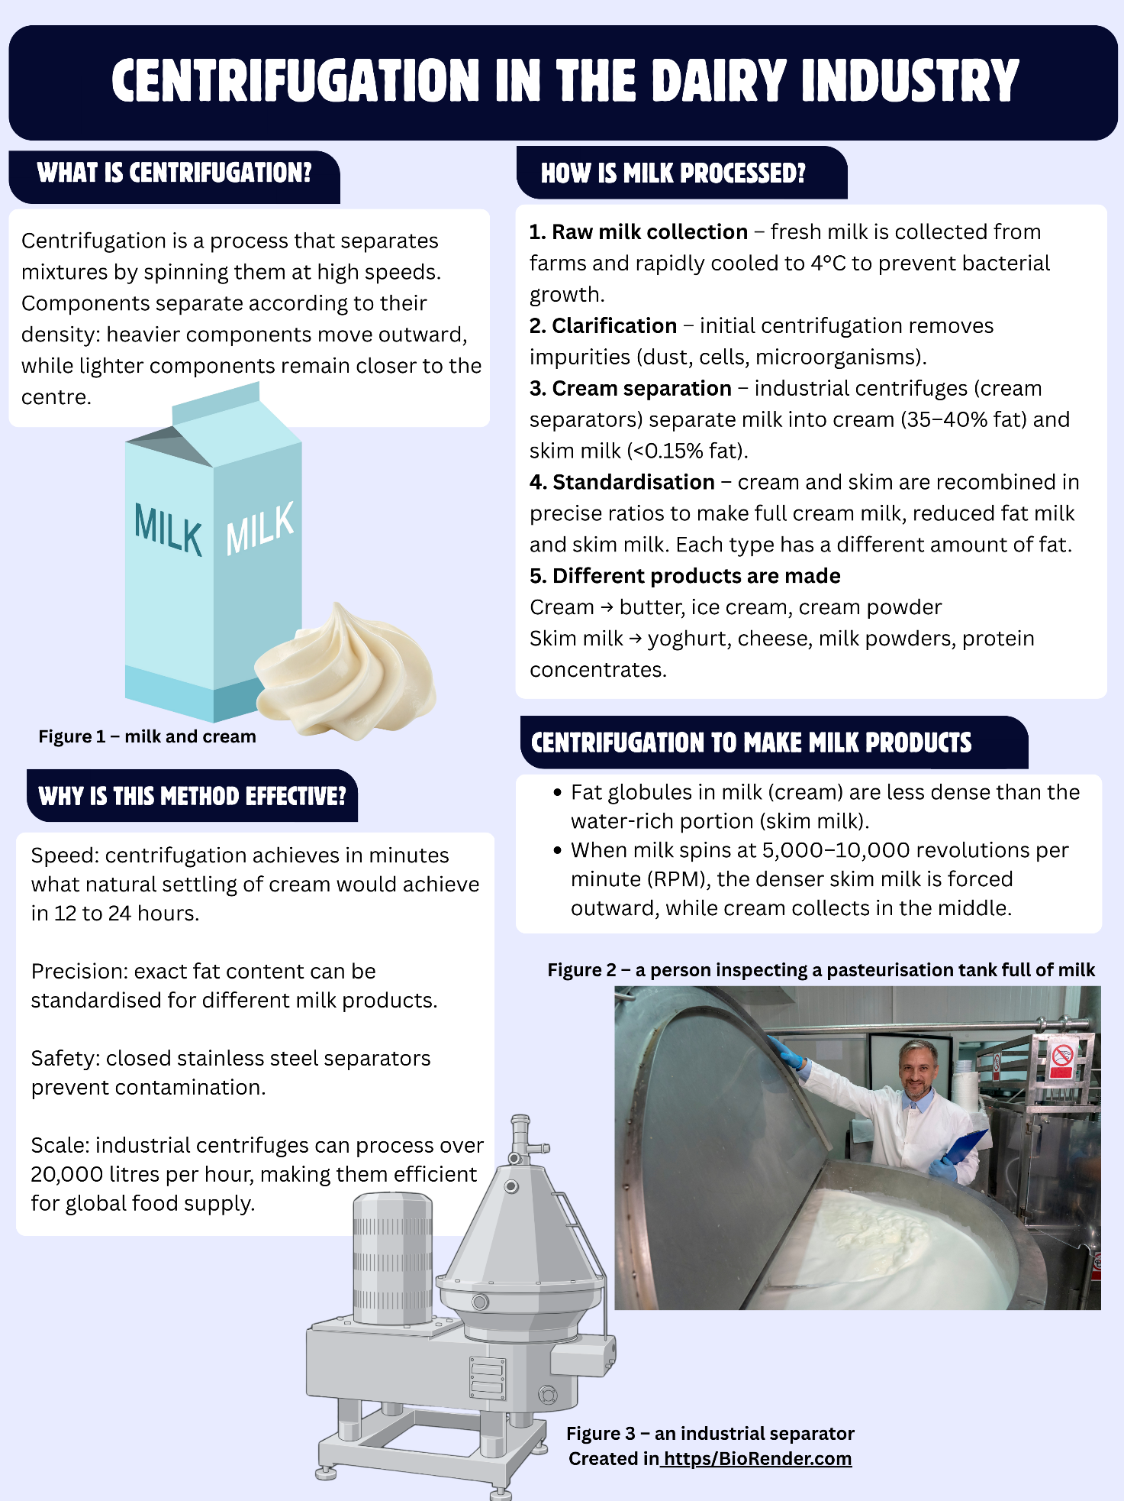
Reference list
Table 21 – reference list for the creation of the infographic
Author(s) | Year published | Name of source | Publisher | URL
Dairy Australia | No date | Dairy Production | Dairy Australia Limited | https://www.dairy.com.au/education/students/about-australian-dairy/dairy-production
National Farmers Federation | 2021 | The milk making process explained | AustralianFarmers | https://farmers.org.au/lifestyle/the-milk-making-process-explained/
Tetra Pak | No date | Dairy and juice separators and how they work | Tetra Pak International S.A. | https://www.tetrapak.com/en-anz/insights/cases-articles/basics-of-separation
bioRender | No date | Centrifugal separator | bioRender app | https://app.biorender.com/
Huading Separation Technology | 2024 | The Science Behind Milk Separation | Huading Separation Technology | https://www.huading-separator.com/new/the-science-behind-milk-separation/

Student resource – industrial separation techniques
Research how these separation techniques are used in the listed industrial processes.
Table 1 – summary of separation techniques used in industrial processes
Separation technique | Industrial process | Description
Evaporation | Salt production
Crystallisation | Sugar production
Distillation | Petroleum refining
Centrifugation | Cream production in the dairy industry
Create an infographic
In pairs, create an infographic on the use of one industrial separation technique. You may select one of the above or any other technique.
Each infographic should have:
- the separation technique(s) used (description and diagram)
- an industrial use outlined
- an explanation of why this method is effective.
Reference list
A reference list is an important part of any publication because it shows where your information comes from and supports the quality of your work. Science is based on evidence, so including a reference list makes your work more trustworthy and transparent by identifying the sources of your data, ideas and explanations. It also gives credit to the original authors and researchers, helping you to avoid plagiarism. Referencing strengthens your claims by showing that your ideas are supported by reliable evidence, and it allows others, such as your teacher, to check your sources or explore the topic further.
Table 2 – reference list for the creation of the infographic
Author(s) | Year published | Name of source | Publisher | URL

3.6 Modelling water pollution
Table 22 – learning intentions and success criteria for 3.6 Modelling water pollution
We are learning: | I can:
- to explain how the properties of substances enable the separation of mixtures | - describe and model how water becomes polluted (creating a mixture)  - make a model to show how water can become polluted
- to plan a safe and valid investigation | - design an investigation to remove pollutants from water  - identify appropriate materials to remove pollutants from water  - identify a control to use for comparing the water treatments
- to follow a procedure to conduct a safe and valid practical investigation | - assemble appropriate equipment to remove pollutants from water  - employ safe work practices and manage risks
- to evaluate strategies for solving problems. | - devise a strategy to filter a polluted water sample  - use evaluation criteria to compare the treated water sample to the original polluted water sample  - evaluate the suitability of the separation techniques used to remove the pollutants in a water sample.

Watershed model
A watershed model is a representation of a specific area of land where all the water that falls as precipitation (for example, rain and snow) drains into a common outlet, such as a river, lake or ocean. The model visually demonstrates how water flows through the landscape, highlighting the interactions between land use, topography and water quality. This model will allow students to model how a body of water can become polluted.
- Define ‘polluted’ as ‘Contaminated or made impure by harmful substances’ using SOL PPT ‘3.6 Polluted water’ (NESA 2025).
- Students watch Make Your Own Watershed (7:17) to learn about watershed models in SOL PPT ‘3.6 Make your own watershed’.
- Students design and construct a watershed model in groups to show how water behaves in an environment.
- Students add pollutants to components of the model and then simulate rain to explain how a body of water can become polluted.
- Students collect about 200 mL of polluted water from their model for the next activity.
Model-making ideas
- Container base – use a large, shallow plastic bin or tray as the base for your model.
- Land formation – use objects under a piece of foil to shape the land.
- Bodies of water – make shallow areas in the foil where water will collect to represent lakes, with rivers flowing into them.
- Land use areas – designate distinct sections for different land uses.
- Urban area – use small pieces of plastic or paper to represent pollution in built-up areas.
- Agricultural area – use tea leaves to represent topsoil (which may erode when water goes over it). Use cocoa powder to represent fertiliser.
- Roads – draw some roads onto the model with a permanent marker. Apply some oil to represent pollution from cars and trucks.
- Vegetation – add small plants or bits of moss to represent natural vegetation, which can help demonstrate the role of plants in absorbing water and reducing runoff.
- Rain simulation – use a spray bottle to mist the model, simulating rain gently. Students observe how the water flows through the landscape, carrying pollutants into the bodies of water.
- Pollutants and human impacts – use a sprinkle of sesame seeds to represent rubbish, a sprinkle of cinnamon to represent one type of pollutant (for example, fertiliser) and cocoa for another. These should be sprinkled where they are most relevant for the particular pollutant.

Water purification
- Provide students with their ‘polluted water’ samples collected from their watershed models built in the last activity. Depending on the quantity collected, it may be necessary to add more water and pollutants for this activity.
- Provide students with access to a range of materials that could be used to filter the polluted water samples. Materials may include:
- Cotton wool  - Filter paper  - Sieves  - Pasteur pipettes  - Fabric | - Gravel  - Coarse sand  - Fine sand  - Sponge  - Activated charcoal | - Funnels  - Paper towel  - Beakers  - Separating funnel  - Plastic drink bottles
- Students work in groups to complete the Student resource – water purification investigation to plan, construct and assess their own water filter.
Note: students can construct the water filter using the instructions provided by Sydney Water, or design and build their own using materials found at home that they bring to class.
- Students observe the clarity (cloudiness), colour, odour and visible particles before and after filtration to assess how well the filter worked.
- Students analyse the suitability of the parameters used to assess water purity.
Note: students should be reminded not to sample any water used in this investigation. Even though the water may look clean, it has not been treated to remove chemical or microbial contaminants.
Sample response: Student resource – water purification investigation
Aim: to test the effectiveness of a student-made water filter in purifying a water sample.
Equipment list
- 250 mL polluted sample of water  - 1 × 600 mL plastic bottle  - 2 × 250 mL beaker  - 5 × cotton wool pieces  - 50 g fine sand  - 3 × 3 cm gauze fabric | - 50 g coarse sand  - 100 g gravel  - 2 × test tubes  - 1 × test tube rack  - 1 × Pasteur pipette  - 1 × watch glass
Controlled variable
A sample of the original polluted water is used to compare the filtrate against.
Procedure
- Qualitatively observe and record visual features (clarity, colour, odour and visible particles) of the polluted water sample.
- Extract a representative sample of the polluted water and place it in a test tube for comparison later.
- Use a Pasteur pipette to remove the oil film from the polluted water and place it in a watch glass.
- Make a sieve out of gauze fabric and skim the floating debris from the top of the water.
- Cut a plastic bottle in half and invert the top half to form a funnel.
- Add layers of filtering material into the bottle funnel in the following order:
- cotton wool
- fine sand
- coarse sand
- gravel
- Set the bottle filter over a 250 mL beaker and pour the remaining polluted water sample into the filter.
- Qualitatively observe and record visual features (clarity, colour, odour and visible particles) of the filtered water sample.
- Place a sample of the filtered water into a test tube and compare it to the original polluted water sample.
Risk assessment
Table 23 – risk assessment
Hazard | Risk | Management
Polluted water may contain microbial contaminants | Illness | - Wash your hands after the investigation.  - Wear safety glasses.  - Do not drink the water.
Broken glassware | Cuts | - Place all glass equipment on stable surfaces, away from the edges of benches.  - Follow correct clean-up procedures.
Water spills | Slips and falls | - Clean up spills immediately
Improper waste disposal | Negative environmental impact | - Dispose of pollutants and polluted water as directed by the teacher.
Results
Table 24 – observations
Parameter | What to look for | Before filtering | After filtering
Clarity (cloudiness) | Is the water clear or cloudy? Can you see through it? | Murky, unclear water. | Less murky and some visibility through the water is possible.
Colour | Is the water coloured? (For example, yellow, grey or brown.) | Dark brown. | Paler brown colour.
Odour | Does the water have a smell? | Mild, earthy smell. | No odour.
Visible particles | Can you see specific particles? | Tea leaves, pieces of plastic, brown solids and an oily layer. | Only very fine particles in water.
Justification of design
Table 25 – justifying the materials used
Material | What pollutant did it remove? | Why did you choose it?
Pasteur pipette | Oil. | There was only a small amount of oil on the surface, and it was not appropriate to use a separating funnel at this point due to the amount of other contaminants.
Gauze sieve | Floating tea leaves and pieces of plastic that were floating. | There were some larger pollutants with lower density that either floated on the surface or rose towards the surface. These could be scooped out.
Coarse and fine sand | Larger remaining particles like tea leaves. | The sand allows water to flow through it. It does not absorb water and traps large particles.
Cotton wool | Small particles, such as cocoa powder, used to represent farm fertiliser. | The fine structure of the cotton wool allowed water to pass through it while trapping finer particles.
Discussion
- How suitable are these parameters in determining the purity of the water you have filtered?
The parameters of clarity, colour, odour and visible particles are useful for assessing how much physical material has been removed from the water. They give us a good indication of visual and physical improvements, which show that the filtration process has worked to some extent. However, these parameters alone cannot confirm the water’s overall purity. They do not account for microscopic or dissolved substances, so while they are suitable for a simple comparison, they cannot confirm if the water is truly clean or safe.
- Why should you not drink the water you have filtered, even if it looks clean and clear?
Even if the filtered water looks clean and clear, it may still contain harmful microorganisms, such as bacteria and viruses, as well as dissolved pollutants, including pesticides and heavy metals. These contaminants are invisible to the naked eye and are not removed by basic filtration methods, such as those used in this experiment. Without treatment, such as chemical disinfection or boiling, the water could still pose serious health risks. That is why visual appearance alone should never be used to judge whether water is safe to drink.

Student resource – water purification investigation
Aim: to test the effectiveness of a student-made water filter in purifying a water sample.
Equipment list
Controlled variable
Procedure
Results
Table 1 – observations
Parameter | What to look for | Before filtering | After filtering
Clarity (cloudiness) | Is the water clear or cloudy? Can you see through it?
Colour | Is the water coloured? (For example, yellow, grey or brown.)
Odour | Does the water have a smell?
Visible particles | Can you see specific particles?
Justification of design
Table 2 – justifying the materials used
Material | What pollutant did it remove? | Why did you choose it?
Discussion
- How suitable are these parameters in determining the purity of the water you have filtered?
- Why should you not drink the water you have filtered, even if it looks clean and clear?

Evidence base
This resource contains NSW Curriculum and syllabus content. The NSW Curriculum is developed by the NSW Education Standards Authority (NESA). This content is prepared by NESA for and on behalf of the Crown in right of the State of New South Wales. The material is protected by Crown copyright.
Please refer to the NESA Copyright Disclaimer for more information hhttps://www.nsw.gov.au/education-and-training/nesa/copyright.
NESA holds the only official and up-to-date versions of the NSW Curriculum and syllabus documents. Please visit NESA https://www.nsw.gov.au/education-and-training/nesa and NSW Curriculum https://curriculum.nsw.edu.au.
Science 7–10 Syllabus © NSW Education Standards Authority (NESA) for and on behalf of the Crown in right of the State of New South Wales, 2023.
ABC Indigenous (25 July 2023) ‘The Dark Emu Story | The Oldest Bakers’ [video], ABC Indigenous, YouTube, accessed 19 March 2026.
AITSL (Australian Institute for Teaching and School Leadership Limited) (n.d.) Learning intentions and success criteria [PDF 251 KB], AITSL, accessed 18 July 2025.
Australian Institute of Aboriginal and Torres Strait Islander Studies (AIATSIS) (n.d.) Map of Indigenous Australia, AIATSIS website, accessed 19 March 2026.
CESE (Centre for Education Statistics and Evaluation) (2020) What works best in practice, NSW Department of Education website, accessed 18 July 2025.
——(2025) What Works Best 2025, NSW Department of Education website, accessed 26 March 2026.
Conceptual Academy (3 April 2015) ‘Elements of Chemistry: Separating Mixtures’ [video], Conceptual Academy, YouTube, accessed 19 January 2026.
Dauphin Island Sea Lab (1 April 2020) ‘Make Your Own Watershed’ [video], Dauphin Island Sea Lab, YouTube, accessed 12 July 2025
Fisher D and Frey N (1 November 2009) ‘Feed Up, Back, Forward’, ASCD (Association for Supervision and Curriculum Development): Educational Leadership magazine, 67(3), accessed 18 July 2024.
Griffin P (2017) Assessment for Teaching, Cambridge University Press, Port Melbourne, Victoria.
Hattie J and Timperley H (2007) ‘The Power of Feedback’, Review of Educational Research, 77(1):81–112, doi:10.3102/003465430298487 accessed 18 July 2024.
NESA (NSW Education Standards Authority) (2025) ‘Glossary’, Science 7–10 Syllabus 2023, NSW Curriculum website, accessed 10 April 2026.
Sherrington T (2019) Rosenshine’s Principles in Action, John Catt Educational Limited, Melton, Woodbridge.
Sydney Water (n.d.) ‘Water quality and filtration’, Drinking water, Sydney Water website, accessed 18 August 2025.
TED-Ed (10 May 2016) ‘How do we separate the seemingly inseparable? - Iddo Magen’ [video], TED-Ed, YouTube, accessed 19 March 2026
Wiliam D. (2017). Embedded Formative Assessment, 2nd edn, Solution Tree Press, Bloomington, IN.

© State of New South Wales (Department of Education), 2026
The copyright material published in this resource is subject to the Copyright Act 1968 (Cth) and is owned by the NSW Department of Education or, where indicated, by a party other than the NSW Department of Education (third-party material).
Copyright material available in this resource and owned by the NSW Department of Education is licensed under a Creative Commons Attribution 4.0 International (CC BY 4.0) license.

This license allows you to share and adapt the material for any purpose, even commercially.
Attribution should be given to © State of New South Wales (Department of Education), 2026.
Material in this resource not available under a Creative Commons license:
- the NSW Department of Education logo, other logos and trademark-protected material
- material owned by a third party that has been reproduced with permission. You will need to obtain permission from the third party to reuse its material.
Links to third-party material and websites
Please note that the provided (reading/viewing material/list/links/texts) are a suggestion only and implies no endorsement, by the New South Wales Department of Education, of any author, publisher, or book title. School principals and teachers are best placed to assess the suitability of resources that would complement the curriculum and reflect the needs and interests of their students.
If you use the links provided in this document to access a third-party's website, you acknowledge that the terms of use, including licence terms set out on the third-party's website apply to the use which may be made of the materials on that third-party website or where permitted by the Copyright Act 1968 (Cth). The department accepts no responsibility for content on third-party websites.

