Science Stage 4 – Solutions and mixtures
Teacher resource book 2 of 3 (TRB2)
2. How can solutions be explained using particle theory?
Creation date: 19 January 2026.
Contents
Overview 3
Glossary 3
2.1 Solubility 6
What dissolves in water? 6
Student resource – solutions 11
Modelling solubility 14
Student resource – modelling solubility 16
2.2 Concentrations of solutions 17
Comparing the concentration of solutions 17
Student resource – comparing the concentration of solutions 22
Unsaturated, saturated and supersaturated 25
Student resource – exploring types of solutions 30
2.3 Planning an investigation 34
Instructor’s relay 35
Fairy bread 38
Using quality criteria to refine a method 39
Student resource – refining a method 42
2.4 Solubility 46
Measuring the solubility of substances 47
Student resource – measuring the solubility of substances 57
2.5 Temperature and solubility 65
Planning for testing the effect of temperature on solubility 66
Student resource – the effect of temperature on solubility (Scaffold 1) 72
Student resource – the effect of temperature on solubility (Scaffold 2) 75
Solubility and temperature – practical investigation 78
Student resource – solubility and temperature practical investigation 81
Evidence base 84

Overview
Stage and learning area: Stage 4 Science
Description: this resource complements the Solutions and mixtures program of learning. It aims to serve as a teacher reference, offering practical strategies and ideas to enrich teaching practices and create engaging learning environments. The activities should be adapted to suit students’ needs.
Duration: while timing will vary based on the mode of delivery, the differentiation strategies employed, and the class or school context, this series of activities should take approximately 9 hours.
Risk management: teachers are advised to undertake a risk assessment before conducting any classroom investigation or experiment. For more information on developing risk assessments, see Risk Assessment – a pre-requisite for risk control.
This resource book elaborates on many of the activities in the Solutions and mixtures sample program of learning. Some activities also reference the Solutions and mixtures slide deck (identified as SOL PPT throughout this document).

Glossary
Tier 3 words are those that are relevant for subject-specific content. More information is provided in the ‘Vocabulary in context’ document found on the Stage 4 reading – Vocabulary in context page. A glossary containing Tier 3 vocabulary related to the essential question ‘How can solutions be explained using particle theory?’ has been provided below. The Guide for planning and implementing explicit vocabulary instruction can be used by teachers across all curriculum areas.

Table 1 – glossary of key terms for Solutions and mixtures TRB2
Term | Definition
Concentration | A quantitative measure of the amount of solute and solvent in a solution. Often represented in units of g/L or parts per million (ppm).
Concentrated | A qualitative term for a solution that contains a large amount of solute relative to the solvent.
Dilute | A qualitative term for describing a solution that contains a small amount of solute relative to the amount of solvent. It is low in concentration.
Dilution | The process of adding solvent to a solution to reduce its concentration.
Dissolve | The process of dispersing a solute in a solvent.
Insoluble | Unable to be dissolved (NESA 2025).
Mass | The amount of matter in an object (NESA 2025).
Matter | A physical substance; anything that has mass and occupies space (NESA 2025).
Particle theory | The kinetic theory of matter that all matter consists of tiny indivisible particles that are constantly moving (NESA 2025).
Saturated | A chemical solution which contains the maximum amount of solute that can be dissolved in a solution (NESA 2025).
Solubility | The maximum amount of a substance that can dissolve in a given volume of solvent at a particular temperature.
Soluble | Capable of being dissolved (NESA 2025).
Solute | A substance that is dissolved by a solvent (NESA 2025).
Solution | A mixture made up of a solvent and a dissolved solute (NESA 2025).
Solvent | A substance, especially a liquid, that can dissolve other substances (NESA 2025).
Supersaturated | A chemical solution which contains more than the maximum amount of solute that can be dissolved in a solution (NESA 2025).

2.1 Solubility
Table 2 – learning intentions and success criteria for 2.1 Solubility
We are learning: | I can:
- to explain the properties of substances | - classify substances as soluble or insoluble in water based on observations  - identify the solute and solvent in a solution  - model a solution using particle theory
- to conduct a scientific investigation | - use the correct equipment to measure volume  - accurately measure the volume of solutions with a measuring cylinder  - make observations about the solubility of substances  - record observations accurately.

What dissolves in water?
Checkpoint 1: display SOL PPT ‘2.1 Checkpoint 1’. students agree or disagree with statements about a sugar solution. An explanation for each statement can be found in Table 3.
Table 3 – checkpoint 1 response explanation
Statement | True or false | Explanation
You cannot see the sugar in the solution. | True | When sugar dissolves, the particles separate and spread evenly throughout the water. They become too small to see with the naked eye, forming a transparent solution.
The sugar is in a liquid state in the solution | False | Sugar does not melt when it dissolves. It remains in the solid state, but the particles become so small and evenly dispersed that they cannot be seen.
You cannot see sugar in the solution, so it is not there. | False | Stating option C is ‘True’ indicates that the student is still operating primarily at the observational, macroscopic level and does not understand that the solute may still be present even when it is not visible.  A dissolved solute is still present even if it cannot be seen.
If you tasted the water, you would taste the sugar in the solution. | True | The dissolved sugar particles remain in the water.
This table has been adapted from Best Evidence Science Teaching by STEM Learning, licensed under CC BY-NC 4.0
- Provide students with a copy of the Student resource – solutions.
- Read the passage on solutions with the students to unpack the key terms ‘solution’, ‘solute’, ‘solvent’, ‘soluble’, ‘insoluble’ and ‘solubility’. Students then identify the solute, solvent and solution in the given scenarios.
- Provide students with access to equipment to test the solubility of a range of solids (such as sand, sugar, salt, flour, calcium carbonate and instant coffee). Students conduct an investigation to determine which substances are soluble and which are insoluble.
Note: provide students with warm water to help ensure the dissolution of soluble substances.
- Guide students through completing the remaining questions, where they
- identify the evidence that a substance is insoluble
- identify the solute and solvent in solutions where a substance dissolves
- describe how the solubility of a substance could be determined.
Note: students may think that cloudy substances are soluble if no solid settles at the bottom of the beaker. A cloudy or opaque mixture indicates that solid particles are suspended in the solvent rather than dissolved. Given time, these particles will settle to the bottom. When a substance is soluble, it forms a transparent (clear) solution because the solute particles are evenly distributed throughout the solvent at the particle level.
Sample response: Student resource – solutions
Identify the solution, solute and solvent in the following scenarios:
Table 4 – identification of solute, solvent and solution sample response
Scenario | Solute | Solvent | Solution
A vinegar cleaning mix is made by adding a few drops of dishwashing liquid to the vinegar. | Dish liquid | Vinegar | Vinegar cleaning mix
Cocoa powder is stirred into warm milk to make a hot chocolate. | Cocoa powder | Milk | Hot chocolate
Watercolour pigment is mixed with water to create paint. | Colour pigment | Water | Paint
Record the results from the investigation in Table 5.
Table 5 – soluble and insoluble substances investigation sample response
Substance added | Soluble or insoluble? | Other observations
Sand | Insoluble | The solid sank to the bottom.
Sugar | Soluble | The solid completely disappeared. The water remained clear.
Salt | Soluble | The solid dissolved quickly. The water stayed clear.
Flour | Insoluble | The water went cloudy. Visible clumps of flour settled at the bottom of the beaker. Some of the flour settled out of the water after 5 minutes.
Calcium carbonate | Insoluble | The water became cloudy. Solids settled at the bottom of the beaker. The calcium carbonate settled out of the water over time.
Instant coffee | Soluble | The powder mixed into the water, turning it brown. There were no solids at the bottom of the beaker.
Outline the evidence that a substance is insoluble.
The insoluble substances left visible solids at the bottom of the beaker and many particles suspended in the solvent (water), making the solution cloudy.
For each of the soluble substances, identify the solvent, solute and the resulting solution.
Table 6 – classification of substances into solute, solvent and solution
Solute | Solvent | Solution
Sugar | Water | Sugar solution
Salt | Water | Salt water
Instant coffee | Water | Coffee
Complete the cloze passage using the word bank to describe how you can determine the solubility of sugar.
Word bank: sugar, volume, investigation, saturated, beaker, solubility, water
To find out how much sugar can dissolve in water, you can carry out a simple investigation. First, measure a known volume of water using a measuring cylinder and pour it into a beaker. Next, add small amounts of sugar to the water while stirring. Keep adding sugar until no more dissolves and some remains at the bottom of the beaker. This indicates that the solution has become saturated.
Record the total mass of sugar added before it stopped dissolving. The solubility of sugar in water can then be calculated by dividing the mass of the sugar dissolved by the volume of water used. Note that the solubility of a substance changes with temperature.

Student resource – solutions
Read the stimulus below, then use it to answer the questions.
When a substance mixes evenly with a liquid so that it seems to disappear, we say it has dissolved. The mixture that forms is called a ‘solution’. A solution consists of 2 parts: the solute and the solvent. The solute is the substance that dissolves. For example, in salt water, the salt is the solute. The solvent is the substance (usually a liquid) that a solute will dissolve in. In salt water, the solvent is the water.
A substance that dissolves in a liquid is called ‘soluble’. Salt and sugar are soluble in water. A substance that does not dissolve in a liquid is called ‘insoluble’. Sand is insoluble in water because it settles to the bottom instead of dissolving.
The solubility of a substance describes how much of it can dissolve in a given amount of solvent. For example, a small amount of salt dissolves easily in water, but if you keep adding more, it eventually stops dissolving.
Identify the solution, solute and solvent in the following scenarios:
Table 1 – identification of solute, solvent and solution
Scenario | Solute | Solvent | Solution
A vinegar cleaning mix is made by adding a few drops of dishwashing liquid to the vinegar.
Cocoa powder is stirred into warm milk to make a hot chocolate.
Watercolour pigment is mixed with water to create paint.
Soluble and insoluble substances investigation
- Measure 100 mL of water into each of the 6 × 250 mL beakers. Label the beaker with sand, sugar, salt, flour, calcium carbonate and instant coffee.
- Add one spatula of sand to the beaker labelled ‘sand’ and stir for one minute. Repeat for the remaining substances and beakers.
- Leave the beakers for 5 minutes to let any undissolved particles settle to the bottom.
- Look closely at the contents of each beaker and identify whether the substance added was ‘soluble’ or ‘insoluble’. Record observations in Table 2.
Record the results from the investigation in Table 2.
Table 2 – soluble and insoluble substances investigation
Substance added | Soluble or insoluble? | Other observations
Sand
Sugar
Salt
Flour
Calcium carbonate
Instant coffee
Outline the evidence that a substance is insoluble.
For each of the soluble substances, identify the solvent, solute and the resulting solution in Table 3.
Table 3 – classification of substances into solute, solvent and solution
Solute | Solvent | Solution
Complete the cloze passage using the word bank to describe how you can determine the solubility of sugar.
Word bank: sugar, volume, investigation, saturated, beaker, solubility, water
To find out how much sugar can dissolve in water, you can carry out a simple ______________. First, measure a known ______________ of water using a measuring cylinder and pour it into a beaker. Next, add small amounts of ______________ to the water while stirring. Keep adding sugar until no more dissolves and some remains at the bottom of the ______________. This indicates that the solution has become ______________.
Record the total mass of sugar added before it stopped dissolving. The ______________ of sugar in water can then be calculated by dividing the mass of the sugar dissolved by the volume of ______________ used. Note that the solubility of a substance changes with temperature.

Modelling solubility
- Tell students that solutions can be modelled using particle theory by representing how the particles of the solute and solvent interact at a microscopic level.
- When a solute dissolves in a solvent, its particles separate and become evenly distributed among the solvent particles.
- According to particle theory, all matter consists of tiny particles that are constantly moving. In a solution, solute particles move among solvent particles, filling the spaces between them.
- The attractive forces between solute and solvent particles are strong enough to keep the solute evenly mixed.
- The process of solvent particles breaking apart and dispersing evenly throughout a solvent to form a solution is called ‘dissolution’.
- Display SOL PPT ‘2.1 Sugar in water’ and watch Sugar In Water (5:20). The video examines the dissolution of sugar in water, referring only to water and sugar particles and how these will be rearranged during dissolution.
- Provide students with 2 differently coloured pieces of plasticine. Tell the students that one colour represents the water particles (solvent) and the other colour represents the sugar (solute). Students use plasticine to model the steps involved in dissolving sugar (starting with an undissolved solid and progressing to dissolution).
- Provide students with Student resource – modelling solubility.
- Review the sequence of steps in SOL PPT ‘2.1 Modelling sugar dissolving in water’ to highlight similarities and differences between the students’ models.
- Students draw a diagram to represent the steps in their model of the dissolution of sugar.
- Define ‘dissolution’ as the process in which a solute breaks down and disperses evenly throughout a solvent, forming a solution. Students respond to the prompt: ‘Outline how your model represents the process of dissolution.’
- Relate the plasticine model to simple drawn particle models that represent a pure substance and a solution (mixture). That is, different-coloured or differently sized ‘particles’ represent the different substances in the solution.
Sample response: Student resource – modelling solubility
- Sketch each step of your model in the space provided below.
Step 1  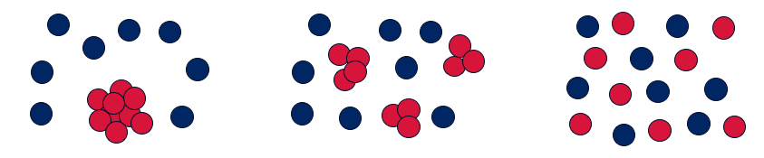 | Step 2 | Step 3
- Outline how your model represents the process of dissolution.
My model shows how a solid (sugar) starts as a large clump (the large red clump), then begins to break apart as it is surrounded by water molecules (the little blue balls). As the particles fully separate and are surrounded by water, they spread evenly. This represents sugar dissolving in water to form a sugar solution.

Student resource – modelling solubility
Using 2 colours of plasticine provided, create a model that represents a solid dissolving in water in a sequence of at least 3 steps.
- Sketch each step of your model in the space provided below.
Step 1
Step 2
Step 3
- Outline how your model represents the process of dissolution.

2.2 Concentrations of solutions
Table 7 – learning intentions and success criteria for 2.2 Concentration of solutions
We are learning: | I can:
- to explain the properties of substances | - identify examples of concentrated and dilute solutions  - identify the solute and solvent in a solution  - draw a particle diagram to represent dilute and concentrated solutions  - describe solutions using the terms ‘dilute’, ‘concentrated’, ‘saturated’ and ‘supersaturated’
- to identify strategies to solve problems. | - use intensity of colour to describe concentration qualitatively  - use collected data to determine an unknown concentration of a solution qualitatively.

Comparing the concentration of solutions
- Define the terms ‘concentration’, ‘dilute’ and ‘concentrated’ using SOL PPT ‘2.2 Defining concentration’ (2 slides). Use the slide notes to unpack the unit g/L and ppm for quantitatively describing concentration. Use the visual diagram to provide students with an example of qualitatively describing concentration.
Checkpoint 1: display SOL PPT ‘2.2 Checkpoint 1’, which contains definitions for ‘solute’, ‘solvent’, ‘solution’, ‘dilute’ and ‘concentrated’. Students use mini whiteboards to communicate the correct definition that matches each word bank term. Alternatively, the class can use a choral response to call out the term for each definition.
Figure 1 – checkpoint 1 answers
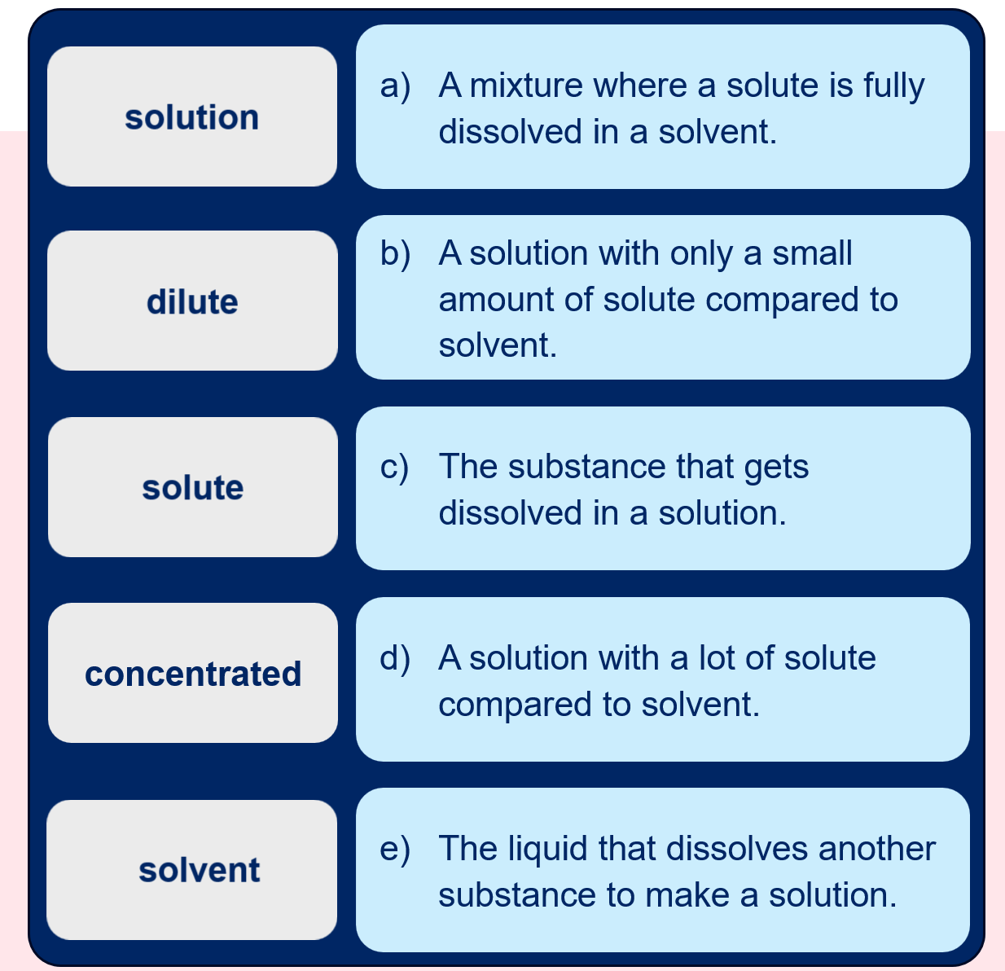
- Display SOL PPT ‘2.2 Representing concentration with the particle model’ to describe the properties of dilute and concentrated solutions.
- Provide students with a copy of Student resource – comparing the concentration of solutions. Students make dilutions of cordial or coloured water to observe how the solution’s colour fades as it is diluted. Each group will need the following equipment for this investigation:
- 1 × 100 mL measuring cylinder  - 200 mL of concentrated cordial or water with food colouring  - 6 × 250 mL beakers | - 1 × marker to label the beakers  - 1 × 100 mL solution of unknown concentration (labelled ‘unknown’)
- Students follow the procedure in the student resource to make the 6 concentrations of solutions and make observations about the colour intensity of the solution.
- Provide students with a solution of unknown concentration. Students judge its concentration by comparing the colour to the colours of the solutions in their investigation.
Sample response: Student resource – comparing the concentration of solutions
List some examples of solutions that are dilute and solutions that are concentrated.
Table 8 – examples of dilute and concentrated solutions
Dilute | Concentrated
- Cordial with water added  - Weak tea  - Salt water | - Dishwashing liquid  - Fabric softener  - Cordial (undiluted)  - Maple syrup
You have been given a concentrated solution of cordial or food colour. This is the solute for your investigation. The solvent used in this investigation is water.
Table 9 – colour of solutions with different concentrations using red food colouring as the solute sample response
Solution | Volume of solute (mL) | Volume of solvent (mL) | Colour
A | 10 | 90 | Very faint pink, almost clear
B | 75 | 25 | Dark pink colour
C | 100 | 0 | Very dark red, opaque
D | 25 | 75 | Pale pink
E | 50 | 50 | Pink
F | 0 | 100 | Clear
Discussion questions
- Rank the concentrations in order from most dilute to most concentrated. Record the order in the space below.
F, A, D, E, B, C
- Collect a beaker of solution with an ‘unknown’ concentration from your teacher. Compare the colours and determine their positions in the order of concentration. Check your answer with the teacher.
Answers will vary.
- Describe how you determined the order of the concentrations.
The order of the concentration can be determined by comparing the ratio of solute (red cordial) to the solvent (water) in each mixture. A higher solute volume and a lower solvent volume mean the solution is more concentrated because there is more solute per unit of water. For example, Solution C has a solute to solvent ratio of 100:1, which is much darker in colour compared to Solution B with a ratio of 75:25.
OR
The colour intensity provides a visual reference for the cordial’s concentration. The paler the colour, the more dilute the solution. The darker the colour, the more concentrated the solution.
- Draw a particle diagram representing a weak solution and a strong solution. Show the solute and solvent particles in your diagram (label them).
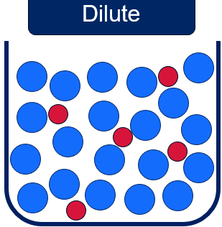  This solution is dilute as the number of red particles (the solute) is small compared to the number of solvent particles (the blue). The red-to-blue (solute-to-solvent) ratio is 5:20 (which can be simplified to 1:5). | Solute  Solvent  | 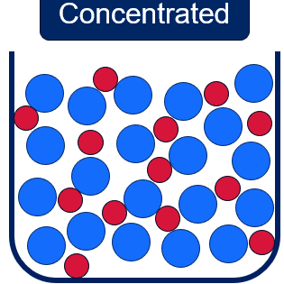  This solution is more concentrated because there are more solute particles per solvent particle. The red-to-blue (solute-to-solvent) ratio is 13:20.

Student resource – comparing the concentration of solutions
Dilute (in relation to a solution) – a solution that contains a small amount of solute relative to the amount of solvent. It is low in concentration.
Concentrated (in relation to a solution) – a solution that contains a large amount of solute relative to the amount of solvent.
List some examples of solutions that are dilute and solutions that are concentrated.
Table 1 – examples of dilute and concentrated solutions
Dilute | Concentrated
You have been given a concentrated solution of __________________. This is the solute for your investigation. The solvent used in this investigation is _______________.
Follow the procedure below to make the solutions:
- Label each of the 6 beakers (A, B, C, D, E and F).
- Use ‘Volume of solute’ in Table 2 to determine how much solute to measure and add it to the relevant beaker.
- Use ‘Volume of solvent’ in Table 2 to determine how much water to measure and add it to the relevant beaker.
- Make observations of the colour intensity of each concentration and record it in Table 2.
Table 2 – colour of solutions with different concentrations using red food colouring as the solute
Solution | Volume of solute (mL) | Volume of solvent (mL) | Colour
A | 10 | 90
B | 75 | 25
C | 100 | 0
D | 25 | 75
E | 50 | 50
F | 0 | 100
Discussion questions
- Rank the concentrations in order from most dilute to most concentrated. Record the order in the space below.
- Collect a beaker of solution with an ‘unknown’ concentration from your teacher. Compare the colours and determine their positions in the order of concentration. Check your answer with the teacher.
- Describe how you determined the order of the concentrations.
- Draw a particle diagram representing a weak solution and a strong solution. Show the solute and solvent particles in your diagram (label them).

Unsaturated, saturated and supersaturated
A good explanation of supersaturation is provided in the YouTube video Supersaturation Finally Explained & Demonstrated (4:53). This video is for teachers’ background understanding and goes beyond the level required of Year 7 students.
- Display SOL PPT ‘2.2 Types of solutions’. Use the speaker notes to define the terms ‘unsaturated’, ‘saturated’ and ‘supersaturated’ and lead a discussion on the definition of ‘soluble’ and the continuum of dissolution, outlining the varying degrees of solubility of different substances and at different temperatures.
Checkpoint 2: display SOL PPT ‘2.2 Checkpoint 2’, which contains an image of 3 solutions. Students identify the solutions as unsaturated, saturated and supersaturated. Student understanding of key terms is assessed before progressing to the next activity. The answers to the question are provided in Figure 2.
Figure 2 – checkpoint 2 answer
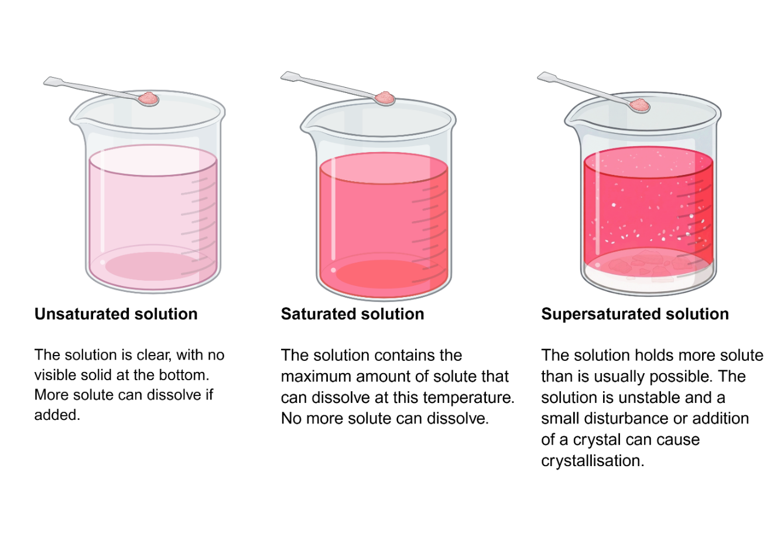
Image created in https://BioRender.com.
- Students access PhET Interactive Simulations – Concentration online. Students use the simulation to respond to the questions in the Student resource – exploring types of solutions to compare the properties of unsaturated and saturated solutions.
- Move around the room to assist students in following the instructions to complete the simulation.
- Before students reach question 8 in the student resource, tell them that the PhET simulation does not show supersaturated solutions. Display SOL PPT ‘2.2 Supersaturated solutions’ to remind students that a supersaturated solution contains more than the usual maximum amount of dissolved solute. The solution is very unstable, meaning any disturbance can cause it to crystallise.
- Play the YouTube video Supersaturated Solutions - Working with Sodium Acetate (6:37) to show students what happens to a supersaturated solution when a seed crystal is added.
- Students then complete the summary table in the resource comparing the properties of unsaturated, saturated and supersaturated solutions.
Differentiation: provide a word bank for students to fill in the various properties of the different strength solutions. The word bank is provided in Table 2 of the Student resource – exploring types of solutions.
Sample response: Student resource – exploring types of solutions
Set the solute to Drink mix and select Solid.
- Identify the solvent, solute and solution in this scenario.
The solvent is water, the solute is the drink mix and the solution is the drink.
Move the concentration sensor into the water as shown in the image below.
Figure 3 – a screenshot of the PhET simulation showing how to measure the concentration
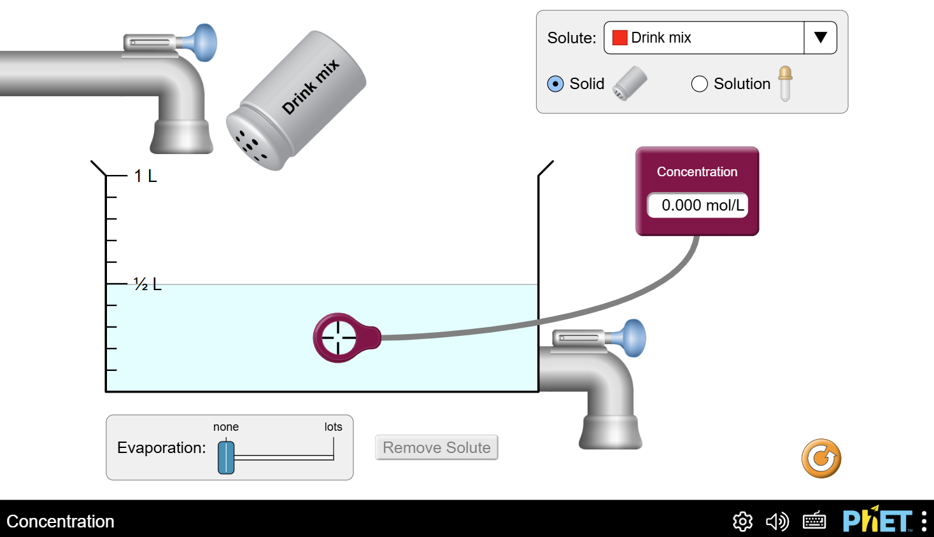
‘PhET Interactive Simulations –Concentration’ by University of Colorado Boulder is licensed under CC BY 4.0
- What is the concentration at the start of the activity? Note: mol/L stands for moles per litre, a unit of concentration. It tells us how much of a solute can dissolve in one litre of a solution.
0 mol/L.
Select the Drink mix, then shake it to add solute to the solvent.
- What happened to the colour of the solution and the concentration of the solution?
The colour of the solution changed from pale blue (representing pure water) to pale pink. The concentration increased to 0.247 mol/L.
Note: the concentration will vary based on student data.
Continue adding the solute until Saturated! appears.
- What do you notice about the solution? Hint: look at the bottom of the container.
The colour of the solution became darker as more drink mix was added, and the solid drink mix settled at the bottom of the container.
- What is the concentration of the solution at the saturation point?
5.960 mol/L.
Add more solute to the solution.
- What do you notice about the solution? Hint: look at the concentration and the bottom of the container.
The colour does not change, and the concentration does not increase if more solute is added. The amount of undissolved drink mix sitting in the bottom of the container continued to increase.
Add water (solvent) to the solution by opening the tap.
- Record your observations (for example, colour, concentration and presence of solids).
The colour became lighter as water was added. The concentration of the solution decreased. All of the solid drink mix has now dissolved.
- Complete Table 10 to summarise the properties of unsaturated, saturated and supersaturated solutions.
Note: the PhET simulation does not address supersaturated solutions, so this will need to be covered separately in the lesson.
Table 10 – sample student response for Table 1
Property | Unsaturated solution | Saturated solution | Supersaturated solution
Description | Contains less solute than can be dissolved. | Contains the maximum amount of solute that can dissolve at a given temperature. | Contains more solute than can remain dissolved at a given temperature.
Effect of adding more solute | Contains more solute than can be dissolved. | More solute will not dissolve. Solute settles at the bottom of the beaker. | Any additional solute will cause the excess to crystallise.
Effect of temperature | Solubility can increase with temperature. | Solubility can increase with temperature. | Becomes unstable. Excess will crystallise upon cooling or upon disturbance.
Stability | Stable under given conditions. | Stable under given conditions. | Unstable under given conditions.
Visual appearance | Clear with no visible solute particles. | Clear with possible undissolved solute at the bottom of the solution. | It may appear clear initially, but it can become cloudy or form crystals with disturbance.

Student resource – exploring types of solutions
Use PhET Interactive Simulations – Concentration to follow the instructions in the grey boxes and answer the questions on exploring types of solutions.
Set the solute to Drink mix and select Solid.
- Identify the solvent, solute and the solution in this scenario.
Move the concentration sensor into the water as shown in the image below.
Figure 1 – PhET simulation image
‘PhET Interactive Simulations –Concentration’ by University of Colorado Boulder is licensed under CC BY 4.0
- What is the concentration at the start of the activity? Note: mol/L stands for moles per litre, a unit of concentration. It tells us how much of a solute can dissolve in one litre of a solution.
Click the Drink mix, then shake it to add solute to the solvent.
- What happened to the colour of the solution and the concentration of the solution?
Continue adding the solute until Saturated! appears.
- What do you notice about the solution? Hint: look at the bottom of the container.
- What is the concentration of the solution at the saturation point?
Add more solute to the solution.
- What do you notice about the solution? Hint: look at the concentration and the bottom of the container.
Add water (solvent) to the solution by opening the tap.
- Record your observations (for example, colour, concentration and presence of solids).
- Complete Table 1 to summarise the properties of unsaturated, saturated and supersaturated solutions. A bank of responses is provided below the table to assist you.
Table 1 – summary of solution properties
Property | Unsaturated solution | Saturated solution | Supersaturated solution
Description
Effect of adding more solute
Effect of temperature
Stability
Visual appearance
Table 2 – word bank of responses to complete Table 1
More solute will not dissolve. Solute settles at the bottom of the beaker. | Solubility can increase with temperature. | Solubility can increase with temperature.
Becomes unstable. Excess will crystallise upon cooling or upon disturbance | Contains less solute than can be dissolved. | Stable under given conditions.
Stable under given conditions. | Any additional solute will cause the excess to crystallise. | Contains more solute than can remain dissolved at a given temperature.
Contains the maximum amount of solute that can dissolve at a given temperature. | Unstable under given conditions. | Clear with no visible solute particles.
Clear with possible undissolved solute at the bottom of the solution. | Contains more solute than can be dissolved. | It may appear clear initially, but it can become cloudy or form crystals with disturbance.

2.3 Planning an investigation
Table 11 – learning intention and success criteria for 2.3 Planning an investigation
We are learning: | I can:
- to plan and carry out a valid investigation | - write a detailed materials list for an investigation  - assess an equipment list using quality criteria and suggest improvements  - write a procedure that another person can follow  - asses a procedure for a scientific investigation using quality criteria and suggest improvements.
Note: these activities aim to introduce students to the characteristics of a good procedure. Teachers may choose to conduct one or both of these activities, depending on class needs, before moving on to the third activity, where students learn to use quality criteria to refine a method. This will prepare students for 2.4 Solubility, in which they will design a method to test the solubility of substances.
Checkpoint 1: show students a poorly written procedure using SOL PPL ‘2.3 Checkpoint 1 (1 of 2)’. Use cold-calling to select students to identify errors, and then students can use mini whiteboards to correct each step. The slide is animated to show each error (nine callout boxes appear separately upon a click). SOL PPT ‘2.3 Checkpoint 1 (2 of 2)’ can be used to model a procedure that includes an appropriate level of detail.
Figure 4 – checkpoint 1 stimulus: a poor-quality procedure
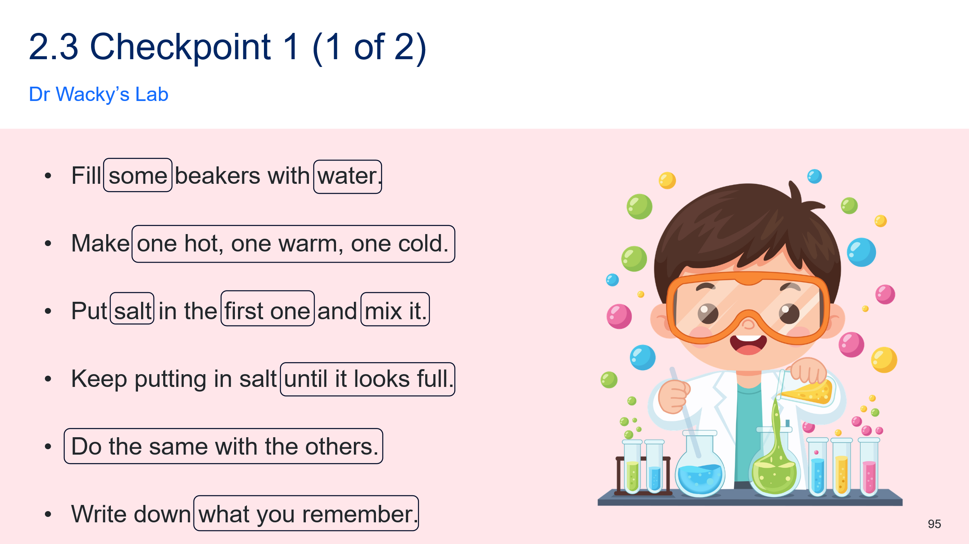
Figure 5 – checkpoint 1 sample response: an improved procedure
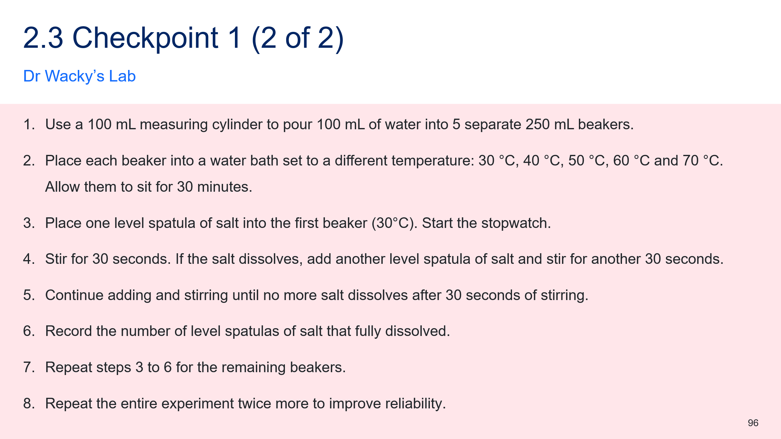

Instructor’s relay
The purpose of this activity is to introduce the characteristics of a ‘good’ procedure.
- In pairs, one student is an ‘instructor’ and the other is a ‘doer’. The doers are provided with mini whiteboards and a whiteboard marker (or pen and paper), and the instructors are provided with a picture. Each pair of students sits back-to-back.
- Without identifying the picture or showing it to the doer, the instructor must guide the doer to draw it by giving them one instruction at a time, following a series of steps.
- At the end, the students compare the drawing to the original and discuss ways the drawing could have been made more accurate.
- The partners swap roles, then a class discussion on the features of a ‘good’ procedure follows.
Note: it should be made explicit to students that clear, detailed, specific instructions are essential to achieve a purpose (in this case, replicating an image).
The pictures to be given to the instructor can be selected from those provided below or any others of your choice. These should be printed and cut out so they are ready to give to the ‘instructor’ in each pair of students.
Figure 6 – instructor’s relay image 1

Figure 7 – instructor’s relay image 2
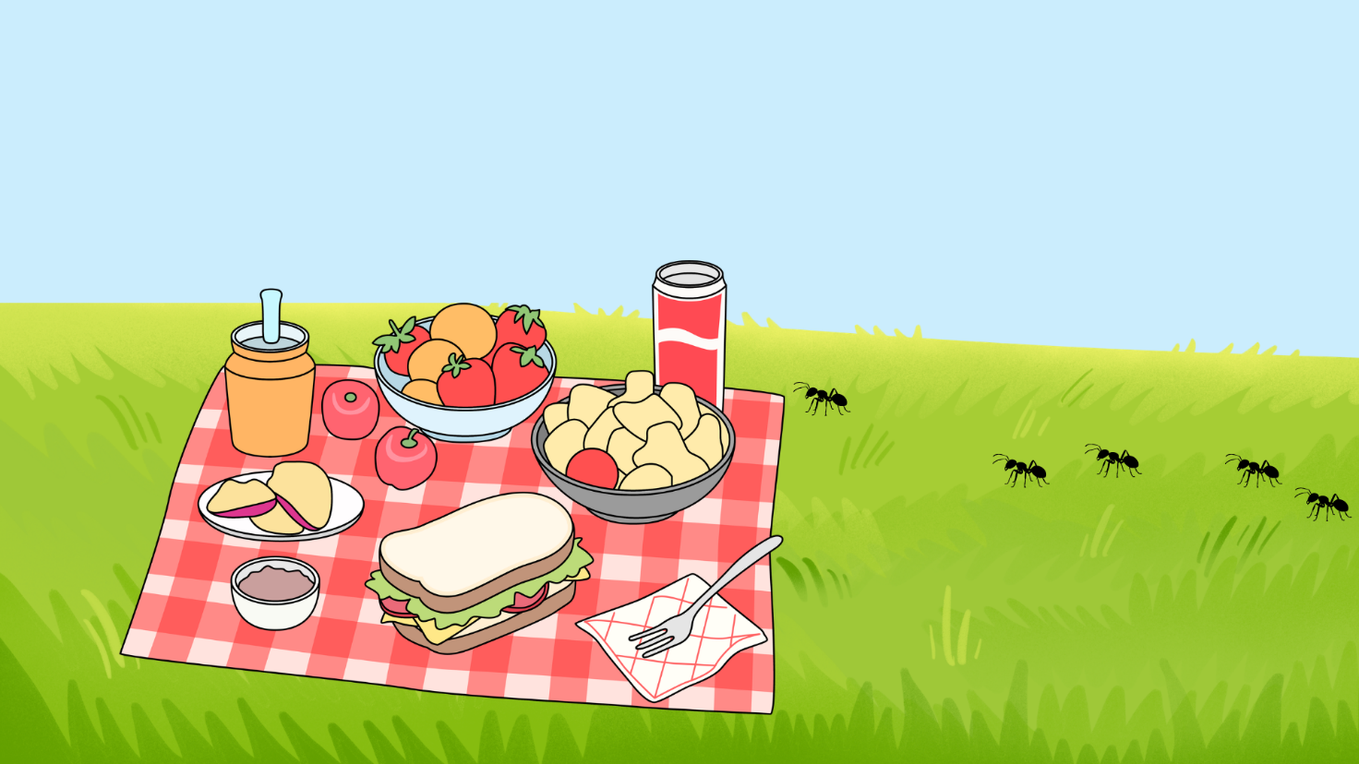
Figure 8 – instructor’s relay image 3
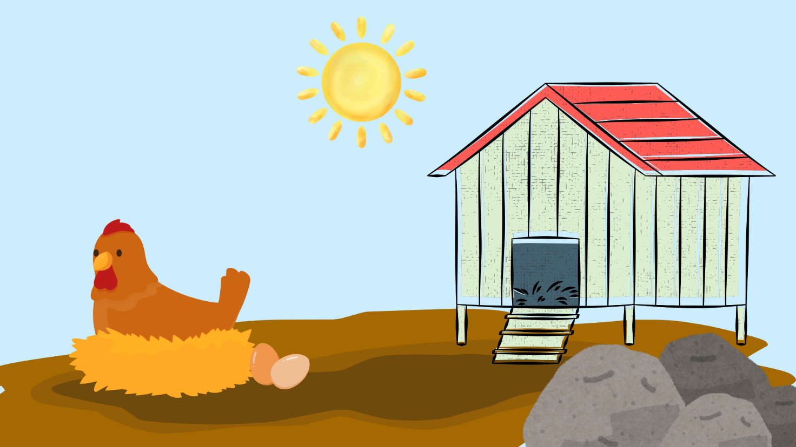
Figure 9 – instructor's relay image 4
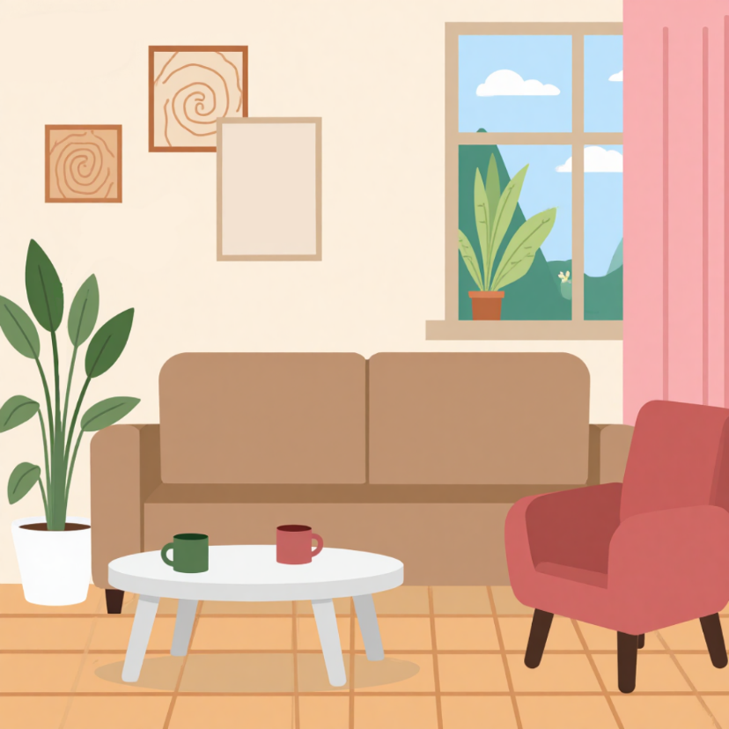

Fairy bread
- Each student writes a procedure for making fairy bread as a series of numbered steps.
- Select a few students to read out their methods and perform each step exactly as given by the student.
Note: be literal in following the instructions, for example, if a student says, ‘Put the butter on the bread’, place the tub of butter on the slice of bread. This will help students understand the level of specificity required in a procedure to ensure it can be performed consistently by another person.
- After each attempt at making fairy bread, discuss as a class what further characteristics are essential in a procedure (for example, sequence of steps or quantities).
- Once complete, discuss the use of quality criteria using SOL PPT ‘2.3 Quality criteria (2 slides)’ and discuss how to use the criteria with students.
Sample fairy bread procedure
Method: how to make fairy bread
- Take one slice of bread and place it flat on a clean plate or surface.
- Use a butter knife to spread a thin, even layer of butter across the entire surface of the bread.
- Open the container or packet of cake sprinkles.
- Gently shake the sprinkles over the buttered surface so it is evenly covered.
- Lightly press the sprinkles into the butter using the flat of your hand or the knife to help them stick.
- Cut the slices into triangles or halves for serving.

Using quality criteria to refine a method
- Tell students that a good scientific method addresses the following:
- It identifies the equipment and materials that are required to perform the investigation.
- It identifies the variables being investigated, including the independent, dependent and controlled variables.
- It contains information on how to mitigate risks, usually in the form of a risk assessment.
- It contains a detailed list of steps that need to be followed in order to carry out the investigation
- Recall that in the ‘Instructor’s relay’ and/or ‘Fairy bread’ activities, students learned how important it was to give clear and accurate instructions so that a task can be completed correctly. Tell students that in science, it is important for scientists to follow the methods used by other scientists to verify their findings.
- Use SOL PPT ‘2.3 Quality criteria’ (2 slides) to unpack the questions students should consider when developing an equipment list and a procedure.
- Provide students with the Student resource – refining a method. Students read the provided method and use the quality criteria to identify areas for improvement. Support students in annotating the document to address any missing information and make refinements. A sample response is provided below.
Sample response: Student resource – refining a method
The sample annotations are identified in bold text.
Aim: to investigate how the temperature of water affects the time taken for sugar to dissolve in a cup of tea.
Equipment list  - 3 × 200 mL beakers  - 50 g sugar (enough for 1 teaspoon per trial)  - 1 × teaspoon (measuring spoon)  - Thermometer  - Stopwatch | Missing equipment  - 1 × kettle to boil water  - 1 × 100 mL plastic measuring cylinder  - 1 × stirring rod
Variables  Independent variable: water temperature (°C).  Dependent variable: the time for sugar to dissolve (minutes:seconds).  Controlled variables: water, amount of sugar and type of sugar. | Improved controlled variables  - the amount of water (100 mL per trial)  - how the solution is stirred (one stir per second)
Procedure  - Label 3 beakers: ‘cold’, ‘room temperature’ and ‘hot’.  - Pour iced water into the cold beaker, water from the tap into the room temperature beaker and water from a kettle into the hot beaker.  - Measure and record the temperature of each beaker with a thermometer.  - Measure one level teaspoon into a beaker and start the timer.  - Stir at a constant speed – one stir per second.  - Once the sugar is no longer visible, stop the stopwatch and record the time.  - Repeat steps 3 to 6 until all temperatures have been tested 3 times. | Verbs are highlighted in yellow. Step 6 does not start with a verb. It could be reworded to: ‘Stop the stopwatch once the sugar is no longer visible and record the time.’  Repetition was not included in this investigation. It could be repeated to improve the reliability of the results.

Student resource – refining a method
Read the provided method, then annotate it with improvements based on your assessment, using the quality criteria for the equipment list and procedure.
Aim: to investigate how the temperature of water affects the time taken for sugar to dissolve in a cup of tea.
Equipment list
- Beakers
- Sugar
- 1 × teaspoon (measuring spoon)
- Thermometer
- Stopwatch
Variables
Independent variable: water temperature.
Dependent variable: the time for sugar to dissolve.
Controlled variables: water, amount of sugar and type of sugar.
Procedure
- Label 3 beakers: ‘cold’, ‘room temperature’ and ‘hot’.
- Pour iced water into the cold beaker, water from the tap into the room temperature beaker and water from a kettle into the hot beaker.
- Measure and record the temperature of each beaker with a thermometer.
- Measure one level teaspoon into a beaker and start the timer.
- Stir at a constant speed – one stir per second.
- Once the sugar is no longer visible, stop the stopwatch and record the time.
- Repeat steps 3 to 6 until all temperatures have been tested.

Aim: to investigate how the temperature of water affects the time taken for sugar to dissolve in a cup of tea.
Equipment list
- Beakers
- Sugar
- 1 × teaspoon (measuring spoon)
- Thermometer
- Stopwatch
Variables
Independent variable: water temperature.
Dependent variable: the time for sugar to dissolve.
Controlled variables: water, amount of sugar and type of sugar.
Procedure
- Label 3 beakers: ‘cold’, ‘room temperature’ and ‘hot’.
- Pour iced water into the cold beaker, water from the tap into the room temperature beaker and water from a kettle into the hot beaker.
- Measure and record the temperature of each beaker with a thermometer.
- Measure one level teaspoon into a beaker and start the timer.
- Stir at a constant speed – one stir per second.
- Once the sugar is no longer visible, stop the stopwatch and record the time.
- Repeat steps 3 to 6 until all temperatures have been tested.
Equipment list quality criteria
☐ Have I included all required equipment? (Think carefully about everything that needs to be done.)
☐ Have I included the quantity of each item?
☐ Have I included the size of the equipment needed?
☐ Is the most suitable equipment being used?

Procedure quality criteria
☐ Have I included a verb at the start of each step?
☐ Have I included details about how I will change the independent variable?
☐ Have I included details about how I will measure the dependent variable?
☐ Have I included details about the variables I will keep the same to ensure a fair test? (Controlled variables.)
☐ Have I included appropriate units for measurement? (For example, mL for volume.)
☐ Have I included the number of times the investigation will be carried out? (Repetition.)
☐ Is my procedure detailed enough for someone else to carry it out exactly?
☐ Does the order of my steps make sense for what I am trying to do?

2.4 Solubility
Table 12 – learning intentions and success criteria for 2.4 Solubility
We are learning: | I can:
- to explain the properties of substances | - define solubility  - identify which substances have high solubility  - summarise information on the solubility of substances in tables and graphs
- to plan a scientific investigation | - identify the purpose of the investigation  - identify the independent, dependent and controlled variables  - identify the data that needs to be collected to measure solubility  - identify appropriate equipment for an investigation  - outline a method for an investigation
- to conduct a scientific investigation | - use equipment correctly and safely to conduct an investigation to determine the solubility of substances in water  - make and record observations about the solubility of substances  - record data precisely in a table  - record observations accurately
- to process data and information | - calculate the mean of a dataset  - identify which data should be graphed  - select an appropriate type of graph to represent the solubility of different substances  - construct a column graph.

Measuring the solubility of substances
- Define ‘solubility’ as the amount of a substance that can dissolve in a given amount of a solvent. Identify common units used for representing solubility, including g/L or g/100 mL.
- Provide students with the Student resource – measuring the solubility of substances. Tell students that they will plan and conduct an investigation to determine the solubility of 4 substances: sodium chloride (table salt), sucrose (sugar), magnesium sulfate (Epsom salts) and sodium bicarbonate (bicarb soda).
- Lead a class discussion on how they could determine the solubility of the substances. The aim of the discussion is to help them realise that they will need to:
- use a known volume of water
- add a small amount of the substance at a time until it dissolves
- keep adding more of the substance until it no longer dissolves
- know the mass of the beaker of water at the start and at the end of the test so they can determine the mass of solute added to the solvent.
- Tell students that the method includes:
- an equipment list of everything that is needed to carry out the investigation
- the variables, including the independent, dependent and any controlled variables
- a procedure that outlines the set of steps that need to be followed in order to carry out the investigation
- a risk assessment which outlines the possible safety risks and strategies to minimise them.
- Support students through planning the investigation using the question prompts and discussion points in Table 13. Co-construct a procedure for the investigation. The sample student response can serve as a guide for students to develop an appropriate procedure.
Table 13 –discussion points and teacher notes to guide the development of the investigation
Question prompt | Discussion points and teacher notes
What is the aim or purpose of this experiment? | - To determine the solubility of 4 different solutes.  - Remind students that a good aim should be a single sentence that starts with ‘to investigate’ or ‘to determine’ and identifies the independent and dependent variables. Students record an aim for the investigation.
What are we changing in this experiment? | - The variable that is changed is called the ‘independent variable’.  - The independent variable in this investigation is the type of solute.
What are we measuring or observing? | - This question is calling out the dependent variable.  - The dependent variable in this investigation is the solubility of the substance.  - Students will measure the mass of solute added to 100 mL of water to calculate the solubility.
What do we need to control (keep the same) to make it a fair test? | - The controlled variables in this investigation are the volume of water used in each test and the water temperature.  - If the volume of water is not measured, we would not be able to determine the solubility of each substance accurately.  - Temperature, as it can affect how much solute can be dissolved in a solvent.
What equipment do we need to conduct this investigation? | Students will need:  - a measuring cylinder to measure the volume of the solvent (water) in millilitres (mL)  - an electronic balance to measure the mass of solute added to the water. This can be done by weighing the beaker before and after adding the solute, then subtracting the solute’s mass to determine how much was added  - a container of each substance  - a spatula for transferring the solute  - a stirring rod.
Differentiation: extend students by adjusting the volume of water used in the investigation, and teach students how to calculate the concentration using the equation:
$$Solubility (g/100mL)= \frac{amount of solute dissolved (g)}{volume of solvent (mL)}×100$$
- Discuss the tables provided in the student resource. There is one table for each solute and a summary table presenting the collated mean data for each solute. The individual tables document the raw data for the investigation, and the combined table summarises the investigation data.
- Students conduct the practical investigation following the planned procedure to collect data on the solubility of the 4 substances.
Note 1: student groups could be allocated different substances to collect solubility data (3 repeats per substance), or they could complete one repeat of each substance, then share their data to collate a class dataset.
Note 2: an additional step could be added to the end of the method to filter out any remaining solids. Wetting the filter paper before filtration will reduce errors in the final solution mass caused by using dry filter paper.
- Ask students which type of graph they think would be appropriate for representing the summary data. Students should recognise that the data is categorical (different solutes), so a column graph is appropriate.
- Guide students to construct a column graph to represent their results by watching the video Constructing vertical column graphs (4:11) and following the step-by-step instructions in SOL PPT ‘2.4 Constructing a column graph’ (2 slides). Display SOL PPT ‘2.4 Quality criteria for a column graph’ to help students evaluate their column graph and make improvements.
- Students answer the discussion questions in the student resource. Use the Sample response to support students in developing their answers. SOL PPT ‘2.4 Annotated sample graph’ can be used to show an example of the graphed experimental data.
Sample response: Student resource – measuring the solubility of substances
Write an aim for the investigation.
To determine the solubility of 4 different solutes.
Identify the variables in the investigation.
Independent variable | Different solutes
Dependent variable | The solubility of the solute in water
Controlled variables | The volume of water used for each trial.  The temperature of the water will be kept the same (20°C).  Note: students can collect a large beaker of water directly from the tap. Using this stock of water will likely help to ensure that each trial is conducted at a very similar temperature. Students should still measure the water temperature during the investigation.
List the equipment you will need to conduct this investigation.
- 1 × 100 mL measuring cylinder  - 4 × spatulas  - 4 × stirring rods  - 1 × electronic balance  - 4 × 250 mL beakers | - 200 g of sodium chloride (table salt)  - 200 g of sucrose (sugar)  - 200 g of sodium bicarbonate (bicarb soda)  - 200 g of magnesium sulfate (Epsom salts)  - 1 × permanent marker
Outline the procedure you will follow to conduct this investigation.
- Label the 4 beakers, one for each solute.
- Measure 100 mL of water using a measuring cylinder and pour it into each of the labelled beakers.
- Measure the mass of each labelled beaker of water. Record the mass in the corresponding table for each solute.
- Each student in the group is allocated a solute. Each student uses the spatula to add a spatula of solute at a time to their beaker. Stir with the stirring rod until the solute dissolves, then add another spatula of solute.
- Continue adding and dissolving solute until it no longer dissolves.
- Each beaker is weighed on the electronic balance, and the final mass is recorded in the appropriate table.
- Repeat steps 2 to 6 two more times.
Note: rather than have each group repeat the investigation, a class dataset could be collated, allowing students to collect repeats without using a significant amount of solute per group.
Table 14 – the amount of sodium chloride that will dissolve in water
Trial | Volume of water (mL) | Temperature of water (°C) | Start mass of beaker (g) | End mass of beaker (g) | Mass of solute dissolved (g)
1 | 100 | 20 | 201.0 | 218.1 | 17.1
2 | 100 | 20 | 204.1 | 218.9 | 14.8
3 | 100 | 20 | 203.2 | 221.3 | 18.1
Note: the expected mass of sodium chloride that can dissolve in 100 mL of water at 20°C is 35.8 g.
Table 15 – the amount of sucrose that will dissolve in water
Trial | Volume of water (mL) | Temperature of water (°C) | Start mass of beaker (g) | End mass of beaker (g) | Mass of solute dissolved (g)
1 | 100 | 20 | 201.2 | 345.5 | 144.3
2 | 100 | 20 | 204.3 | 360.1 | 155.8
3 | 100 | 20 | 203.1 | 351.2 | 148.1
Note: the expected mass of sucrose that can dissolve in 100 mL of water at 20°C is 201 g.
Table 16 – the amount of magnesium sulfate that will dissolve in water
Trial | Volume of water (mL) | Temperature of water (°C) | Start mass of beaker (g) | End mass of beaker (g) | Mass of solute dissolved (g)
1 | 100 | 20 | 201.1 | 226.2 | 25.1
2 | 100 | 20 | 204.1 | 234.9 | 30.8
3 | 100 | 20 | 203.3 | 239.0 | 26.7
Note: the expected mass of magnesium sulfate that can dissolve in 100 mL of water at 20°C is 35.6 g.
Table 17– the amount of sodium bicarbonate that will dissolve in water
Trial | Volume of water (mL) | Temperature of water (°C) | Start mass of beaker (g) | End mass of beaker (g) | Mass of solute dissolved (g)
1 | 100 | 20 | 201.2 | 206.9 | 5.7
2 | 100 | 20 | 204.1 | 210.7 | 6.6
3 | 100 | 20 | 203.0 | 211.1 | 8.1
Note: the expected mass of sodium bicarbonate that can dissolve in 100 mL of water at 20°C is 9.6 g.
Calculate the mean solubility of each solute.
Table 18 – mean solubility of different substances at room temperature (20°C)
Solute | Solubility (g/100 mL)
Sodium chloride | 33.3
Sucrose | 149.4
Magnesium sulfate | 27.5
Sodium bicarbonate | 6.8
Note: the student-collected data above differ from the actual reference values. If the water temperature fluctuates by even a few degrees, it can affect how much solute dissolves. Inconsistent stirring or impatience while waiting for substances to dissolve can cause a lower recorded value. The larger crystals of magnesium sulfate will dissolve more slowly than a finer solute. Tap water’s mineral content varies and can affect solubility.
- What type of graph should be used to represent the mean of the data in Table 18? Provide your reasoning.
A column graph is used because the independent variable produces categorical data.
- Draw a graph to represent the solubility of the 4 solutes.
Figure 10 – sample student graph of the solubility of 4 solutes at a certain temperature

Discussion questions
- Which solute was most soluble?
Sucrose was the most soluble in water, with a mean solubility of 149.4 g/100 mL.
- How did you decide the point of saturation for each solute?
The saturation point was determined as the point at which some of the solid solute did not dissolve.
- Suggest 2 improvements to increase the validity of the method.
The mass of the final substance included some undissolved solute, so the calculated solubility is slightly higher. This can be overcome by filtering the solution to remove the solid before weighing.
Our stirring may have been inconsistent, and we were impatient with waiting for substances to dissolve. If we had used a magnetic stirrer and waited longer to see if more solute would dissolve, it might have led to a higher calculated solubility.
Use the information in Figure 1 (in the student resource) to answer questions 4 to 6.
- Compare your results for sodium chloride and magnesium sulfate to the expected values indicated in Figure 1.
According to the graph in Figure 1, sodium chloride has a solubility of approximately 36 g/100 mL and magnesium sulfate has a solubility of approximately 35 g/100 mL in water. Our data for sodium chloride is 2.7 g/100 mL lower, at 33.3 g/100 mL. The data for magnesium sulfate is 7.5 g/100 mL less than the expected value of 27.5 g/100 mL.
- The Dead Sea is saturated with salt (sodium chloride). The temperature of the Dead Sea ranges from 20 to 37°C. Using Figure 1, predict how much salt is dissolved in the seawater.
Approximately 36 g of salt is dissolved in every 100 mL of water in the Dead Sea. The solubility of salt in water increases very slightly between 20 and 37°C (by less than 0.5 g/100 mL, according to the graph).
- Vihaan wants to grow crystals of magnesium sulfate for a class demonstration. He adds 50 g of magnesium sulfate to 100 mL of water at 60°C. He then lets the solution cool to room temperature. At what temperature will crystals start to form as the solution cools?
At 60°C, all 50 g of magnesium sulfate will dissolve in water. According to the graph in Figure 1, a solution saturated at 50 g/100 mL will have a temperature of approximately 44.5°C, and crystals will start to form as the temperature drops below 44.5°C.

Student resource – measuring the solubility of substances
The ability of a substance to dissolve in a given amount of water is called ‘solubility’. Solubility depends on the type of solute, temperature and interactions between the solute and solvent particles. In this investigation, you will measure how much of different solutes can dissolve in water at room temperature, record your data and present it in a graph to compare which substances are most and least soluble.
Write an aim for the investigation.
Identify the variables in the investigation.
Independent variable
Dependent variable
Controlled variables
Identify the equipment you will need to conduct this investigation.
Equipment list quality criteria
☐ Have I included all required equipment? (Think carefully about everything that needs to be done.)
☐ Have I included the quantity of each item?
☐ Have I included the size of the equipment needed?
☐ Is the most suitable equipment being used?
Outline the procedure you will follow to conduct this investigation.
Procedure quality criteria
☐ Have I included a verb at the start of each step?
☐ Have I included details about how I will change the independent variable?
☐ Have I included details about how I will measure the dependent variable?
☐ Have I included a labelled diagram of my setup?
☐ Have I included details about the things I am keeping the same to ensure a fair test? (Controlled variables.)
☐ Have I included appropriate units for measurement? (For example, mL for volume.)
☐ Have I included the number of times the investigation will be carried out? (Repetition.)
☐ Is my procedure detailed enough for someone else to carry it out exactly?
☐ Does the order of my steps make sense for what I am trying to do?
Risk assessment
Table 1 – risk assessment for the solubility investigation
Hazard | Risk | Management
Glass breakage | Cuts | - Keep the bench clean and tidy.  - Pay attention while working at the workbench.  - Follow safe clean-up procedures.  - Notify the teacher when the glass is broken so that the breakage can be cleaned up appropriately.
Spills | Slips and falls | - Keep benches dry.  - Clean up spills immediately with a paper towel.
Dust from powders/granules | Eye or respiratory irritation | - Scoop the solids gently.  - Wear safety glasses.  - Wash your hands at the end of the investigation.
Results
Record your results in the provided tables. Check the table captions to ensure you are entering data for the correct solute.
Table 2 – the amount of sodium chloride that will dissolve in water
Trial | Volume of water (mL) | Temperature of water (°C) | Start mass of beaker (g) | End mass of beaker (g) | Mass of solute dissolved (g)
1
2
3
Table 3 – the amount of sucrose that will dissolve in water
Trial | Volume of water (mL) | Temperature of water (°C) | Start mass of beaker (g) | End mass of beaker (g) | Mass of solute dissolved (g)
1
2
3
Table 4 – the amount of magnesium sulfate that will dissolve in water
Trial | Volume of water (mL) | Temperature of water (°C) | Start mass of beaker (g) | End mass of beaker (g) | Mass of solute dissolved (g)
1
2
3
Table 5 – the amount of sodium bicarbonate that will dissolve in water
Trial | Volume of water (mL) | Temperature of water (°C) | Start mass of beaker (g) | End mass of beaker (g) | Mass of solute dissolved (g)
1
2
3
Calculate the mean solubility of each solute and record it in Table 6.
Table 6 – mean solubility of different substances at room temperature (20°C)
Solute | Solubility (g/100 mL)
Sodium chloride
Sucrose
Magnesium sulfate
Sodium bicarbonate
- What type of graph should be used to represent the mean of the data in Table 6? Provide your reasoning.
- Draw a graph to represent the solubility of the 4 solutes.

Discussion questions
- Which solute was most soluble?
- How did you decide the point of saturation for each solute?
- Suggest 2 improvements to increase the validity of the method.
Figure 1 – the solubility of sodium chloride and magnesium sulfate in water at different temperatures

This image has been created using data from Solubility table by Wikipedia.
Use the information in Figure 1 to answer questions 4 to 6.
- Compare your results for sodium chloride and magnesium sulfate to the expected values indicated in Figure 1.
- The Dead Sea is saturated with salt (sodium chloride). The temperature of the Dead Sea ranges from 20°C to 37°C. Using Figure 1, predict how much salt is dissolved in the seawater.
- Vihaan wants to grow crystals of magnesium sulfate for a class demonstration. He adds 50 g of magnesium sulfate to 100 mL of water at 60°C. He then lets the solution cool to room temperature. At what temperature will crystals start to form as the solution cools?

2.5 Temperature and solubility
Table 19 – learning intentions and success criteria for 2.5 Temperature and solubility
We are learning: | I can:
- to explain the properties of substances | - conduct an experiment to investigate the effect of temperature on the solubility of a substance  - describe the effect of temperature on the solubility of different substances
- to plan a valid scientific investigation | - identify the equipment required to conduct an investigation on the effect of temperature on solubility  - list the steps required to conduct an investigation on the effect of temperature on solubility  - use quality criteria to refine my procedure  - identify hazards and risks in an investigation and plan how they can be mitigated
- to follow a procedure to conduct a safe and valid scientific investigation | - use equipment correctly and safely to conduct an investigation to determine the solubility of substances in water  - make and record observations about the solubility of substances in g/100 mL  - record data correctly in a table  - record observations accurately
- to process data and information | - calculate the mean of a dataset  - identify which data should be graphed  - select an appropriate type of graph to represent the collected data  - construct a column graph
- to solve problems and propose solutions. | - describe the cause-and-effect relationship between temperature and solubility  - use a graph to model the relationship between temperature and solubility.

Planning for testing the effect of temperature on solubility
In this activity, students will apply their understanding of the scientific method to plan an investigation to test how temperature affects the solubility of sugar. They will use the method in the next activity Solubility and temperature – practical investigation.
- Provide students with a copy of the Student resource – the effect of temperature on solubility (Scaffold 1).
Differentiation: two scaffolds are provided for planning the investigation. Student resource – the effect of temperature on solubility (Scaffold 1) is better suited to students who have a stronger grasp of the processes required to write a method. Student resource – the effect of temperature on solubility (Scaffold 2) contains additional detail, such as a cloze passage, to help students construct a plan for the investigation.
- Lead a class discussion to guide students in identifying the equipment required, the purpose, the variables and the type of data which will be collected for an investigation into how temperature can affect solubility. Question prompts to facilitate this discussion are provided in Table 20.
Table 20 – discussion points and teacher notes for planning the discussion
Question | Discussion prompts and teacher notes
What is the aim or purpose of this experiment? | - The aim of the investigation is to determine whether temperature affects the amount of a substance that dissolves.
What equipment would be required to study how temperature impacts a substance’s solubility in water? | - List the equipment on the board as identified by the students:  - beaker  - thermometer  - stirring rod  - measuring cylinder  - solute (for example, sugar)  - digital scales (to measure the solute’s mass).  - Prompt students to update their lists to include the quantity and size of the equipment, for example, 1 × 100 mL measuring cylinder.  - Students will need a way to get water at different temperatures (for example, a Bunsen burner, a kettle, ice cubes or an electric water bath).
What are we changing in this experiment? | - The variable being changed is called the ‘independent variable.’  - In this investigation, the independent variable is the temperature of the water in which the solute is dissolved.
What are we measuring or observing? | - This question is referring to the ‘dependent variable’.  - In this investigation, the dependent variable is the amount of solute that dissolves in water.
What do we need to control (keep the same) to make it a fair test? | The controlled variables help us to ensure that the independent variable causes change in the dependent variable. They help to ensure the investigation is valid.  In this investigation, the controlled variables include:  - the amount of solute  - the volume of water (solvent)  - stirring method or time and the size of the beaker.
- Outline how the different temperatures will be achieved using one of the methods in Table 21. The method chosen will depend on the resources available. Note that the syllabus content point only requires a qualitative investigation.
Table 21 – methods for controlling temperature
Option 1 | Option 2
Mix beakers of different temperatures:  - iced water (no ice)  - a ratio of 50:50 iced water (no ice) and tap water  - tap water  - a ratio of 50:50 tap water and hot water  - hot water | - Set water baths to 30°C, 40°C, 50°C, 60°C and 70°C.  - Place a beaker of water in each water bath, allowing 30 minutes for the temperatures to adjust.
- In pairs, students then construct and refine methods for this investigation in the Student resource – the effect of temperature on solubility (Scaffold 1).
- Discuss risks and construct a risk assessment with the class to identify hazards and the risks associated with them and ways to mitigate the risks. Students document the information in the risk assessment table in the Student resource – the effect of temperature on solubility (Scaffold 1).
- Students use the quality criteria to self-assess their method and make refinements.
Note: students will use their refined method to conduct the investigation. This is outlined in the next activity Solubility and temperature – practical investigation.
Sample response: Student resource – the effect of temperature on solubility
Note: the sample response does not contain all the stimulus material from the student resource. The sample response is for the differentiated version of the student resource, but it does serve as a sample response for either version completed by students.
Equipment list
- 150 mL water (tap, iced and hot)  - 300 g sugar  - 1 × spatula | - 5 × 250 mL beakers  - 1 × 100 mL measuring cylinder  - 1 × stirring rod  - 1 × stopwatch
Variables
Independent variable | The temperature of the water (cold, room temperature, warm and hot).
Dependent variable | The number of spatulas of sugar that dissolved.
Controlled variables | The volume of water used for each trial.  The time and speed of the stirring.
Procedure
- Label 4 beakers: ‘cold’, ‘room temperature’, ‘warm’ and ‘hot’.
- Pour 50 mL of water into each beaker using a measuring cylinder. Use the following combinations:
- cold using iced water
- room temperature using water from the tap
- warm using a combination of hot and room temperature water
- hot using hot water.
- Measure one level spatula of sugar into the first beaker and start the stopwatch.
- Stir the mixture at a constant speed for 2 minutes.
- If the sugar has completely dissolved, add another level spatula of sugar and stir for 2 minutes.
- Continue adding one spatula of sugar at a time until no more sugar will dissolve.
- Record the number of spatulas of sugar that dissolved.
- Repeat steps 3 to 7 for each of the treatments 3 times.
Risk assessment
Table 22– sample risk assessment for the effect of temperature on solubility investigation
Hazard | Risk | Management
Hot water | Scalding and burns | - Do not handle hot beakers with your bare hands.  - Use heatproof gloves.
Spilled water | Slips and falls | - Wipe up spills immediately and walk carefully around the workspace.
Broken glass | Cuts | - Handle glassware gently and keep it on stable, flat surfaces.  - Clean up broken glass immediately with a dustpan and brush.

Student resource – the effect of temperature on solubility (Scaffold 1)
Aim
To find out how changing the temperature of water affects how much sugar can dissolve in it.
A good scientific method has 3 main parts:
- Equipment list – a detailed list of everything that is needed to carry out the investigation.
- Procedure – the set of steps that need to be followed in order to carry out the investigation.
- Variables – the independent, dependent and controlled variables are identified.
- Risk assessment – outlines the possible safety risks and strategies to minimise them.
Equipment list
Equipment list quality criteria
☐ Have I included all required equipment? (Think carefully about everything that needs to be done.)
☐ Have I included the quantity of each item?
☐ Have I included the size of the equipment needed?
☐ Is the most suitable equipment being used?
Variables
Independent variable
Dependent variable
Controlled variables
Procedure
1
2
3
4
5
6
7
Procedure quality criteria
☐ Have I included a verb at the start of each step?
☐ Have I included details about how I will change the independent variable?
☐ Have I included details about how I will measure the dependent variable?
☐ Have I included a labelled diagram of my setup?
☐ Have I included details about the things I am keeping the same to ensure a fair test? (Controlled variables.)
☐ Have I included appropriate units for measurement? (For example, mL for volume.)
☐ Have I included the number of times the investigation will be carried out? (Repetition.)
☐ Is my procedure detailed enough for someone else to carry it out exactly?
☐ Does the order of my steps make sense for what I am trying to do?
Risk assessment
Table 1 – risk assessment
Hazard | Risk | Management

Student resource – the effect of temperature on solubility (Scaffold 2)
Aim
To find out how changing the temperature of water affects how much sugar can dissolve in it.
A good scientific method has 3 main parts:
- Equipment list – a detailed list of everything that is needed to carry out the investigation.
- Procedure – the set of steps that need to be followed in order to carry out the investigation.
- Variables – the independent, dependent and controlled variables are identified.
- Risk assessment – outlines the possible safety risks and strategies to minimise them.
Equipment list
Use the word bank to complete the equipment list.
Word bank: iced, 200 mL, 4, 100 mL, hot, room temperature
- 150 mL water _______, ________ and _______
- 350 g sugar
- 1 x spatula
- ___ × ______ beakers
- 1 × ______ measuring cylinder
- 1 × stirring rod
- 1 × stopwatch
Variables
Use the word bank to complete the variables.
Word bank
- The volume of water used for each trial.
- The number of spatulas of sugar that dissolved.
- The time and speed of the stirring.
- The temperature of the water (cold, room temperature, warm and hot).
Independent variable
Dependent variable
Controlled variables
Procedure
Use the word back to complete the procedure.
Word bank
2 minutes, 2 minutes, 3 to 7, level spatula of sugar, measuring cylinder, 50 mL, stopwatch, no more sugar will dissolve, the number of spatulas of sugar
- Label 4 beakers: ‘cold’, ‘room temperature’, ‘warm’ and ‘hot’.
- Pour _______ of water into each beaker using a ___________ ____________. Use the following combinations:
- cold using iced water
- room temperature using water from the tap
- warm using a combination of hot and room temperature water
- hot using hot water.
- Measure one level spatula of sugar into the first beaker and start the _________________.
- Stir the mixture at a constant speed for _________.
- If the sugar has completely dissolved, add another ______________________________ and stir for __________________.
- Continue adding one spatula of sugar at a time until ________________________________ ________________________________________________________________________
- Record ____________________________________ that dissolved.
- Repeat steps ___________ for each of the treatments 3 times.
Risk assessment
Identify the risks associated with each hazard and list a way to manage or reduce the risk.
Table 1 – risk assessment
Hazard | Risk | Management
Hot water | Scalding
Spilled water
Broken glass

Solubility and temperature – practical investigation
Note: the purpose of the investigation is to establish that higher temperatures will increase the solubility of a substance. However, to enable students to construct tables and graphs from their results, simple quantitative observations can be recorded, such as water temperature and the number of spatulas of sugar that can be completely dissolved. This will then allow a column graph to be constructed.
- Create small student groups (3 or 4 students). Each group selects one of their written methods (developed in the previous activity Planning for testing the effect of temperature on solubility) to follow when conducting their investigation into the effect of temperature on the solubility of sugar.
- Check the suitability of the method each group selects and refine it as required before continuing.
- Support the students in constructing a suitable table to record the results of the investigation. An example is provided in Table 23.
- Students conduct their investigation and record their results.
- Guide students to construct a column graph to represent their results. Refer back to SOL PPT ‘2.4 Quality criteria for a column graph’ and SOL PPT ‘2.4 Annotated sample graph’ to support students in completing their graphs.
- As a class, discuss any trends observed and conclusions drawn. Students respond to reflection questions.
Sample response: Student resource – solubility and temperature practical investigation
Construct a table to record the results of the investigation. Use the table quality criteria to ensure you include everything you need.
Table 23 – sample results table for the student-designed investigation on the effect of temperature on the amount of sugar that will dissolve in water
Water temperature | Amount of sugar dissolved (heaped spatulas)
Water temperature | Trial 1 | Trial 2 | Trial 3 | Mean
Cold | 4 | 3 | 3 | 3.3
Room temperature | 9 | 10 | 9 | 9.3
Warm | 20 | 19 | 21 | 20.0
Hot | 31 | 29 | 30 | 30.0
Construct a column graph to represent the mean data from the investigation.
Figure 11 – sample column graph

- Describe any pattern(s) or relationship(s) you observed?
The results show that the warmer the water, the more sugar dissolves. This means warmer water can dissolve more sugar.
- Write an appropriate conclusion for your investigation. Remember to respond to the aim of the investigation.
The results indicate that sugar solubility increases with temperature. The warmer the water that is used, the more sugar is dissolved. This suggests that higher temperatures provide more kinetic energy to water molecules, allowing them to interact with and separate from sugar particles more effectively. Therefore, temperature positively affects the solubility of sugar in water.

Student resource – solubility and temperature practical investigation
Construct a table to record the results of the investigation. Use the table quality criteria to ensure you include everything you need.
Table quality criteria
☐ Is the independent variable in the first column?
☐ Is there space to record trial data for each treatment?
☐ Is there a column to calculate the mean result for each treatment?
☐ Does the table have a label or heading?
☐ Are units noted in the column headings where required?
Construct a column graph to represent the mean data from the investigation.
A column graph is used for categorical data (groups) or discrete numerical data. The graph needs to have labelled axes, with the independent variable (water) on the horizontal axis and the dependent variable (number of spoons of sugar dissolved) on the vertical axis.
Steps to construct a column graph
- Label the axes, including units if appropriate.
- Decide on an appropriate vertical scale for the data.
- Decide on an appropriate column width, ensuring that each column is the same width and that there are equal spaces between columns.
- Using a pencil and a ruler, draw a column for each temperature with the height of the column corresponding to the number of spoonfuls of dissolved sugar at that temperature.
- Include an informative title that links the independent and dependent variables.
________________________________________________________

Reflection questions
- Describe any pattern(s) or relationship(s) you observed?
- Write an appropriate conclusion for your investigation. Remember to respond to the aim of the investigation.
Aim: to find out how changing the temperature of water affects how much sugar can dissolve in it.

Evidence base
This resource contains NSW Curriculum and syllabus content. The NSW Curriculum is developed by the NSW Education Standards Authority (NESA). This content is prepared by NESA for and on behalf of the Crown in right of the State of New South Wales. The material is protected by Crown copyright.
Please refer to the NESA Copyright Disclaimer for more information https://www.nsw.gov.au/education-and-training/nesa/copyright.
NESA holds the only official and up-to-date versions of the NSW Curriculum and syllabus documents. Please visit NESA https://www.nsw.gov.au/education-and-training/nesa and NSW Curriculum https://curriculum.nsw.edu.au.
Science 7–10 Syllabus © NSW Education Standards Authority (NESA) for and on behalf of the Crown in right of the State of New South Wales, 2023.
AITSL (Australian Institute for Teaching and School Leadership Limited) (n.d.) Learning intentions and success criteria [PDF 251 KB], AITSL, accessed 18 July 2024.
Edpuzzle Curriculum (17 July 2019) ‘Sugar In Water’ [video], Edpuzzle Curriculum, YouTube, accessed 5 May 2025.
Fisher D and Frey N (1 November 2009) ‘Feed Up, Back, Forward’, ASCD (Association for Supervision and Curriculum Development): Educational Leadership magazine, 67(3), accessed 18 July 2024.
Griffin P (2017) Assessment for Teaching, Cambridge University Press, Port Melbourne, Victoria.
Hattie J and Timperley H (2007) ‘The Power of Feedback’, Review of Educational Research, 77(1):81–112, doi:10.3102/003465430298487 , accessed 18 July 2024.
Merck (n.d.) Solubility Table for Water at Temperature, Merck website, accessed 20 March 2026.
NESA (NSW Education Standards Authority) (2025) ‘Glossary’, Science 7–10 Syllabus 2023, NSW Curriculum website, accessed 10 April 2026.
NHMRC (2005) ‘Sodium bicarbonate’, Australian Drinking Water Guidelines – Part 5: Fact sheets – Drinking Water Treatment Chemicals, Australian Drinking Water Guidelines website, accessed on 20 March 2026.
NSW Department of Education (2025) What Works Best 2025, NSW Department of Education website, accessed 26 March 2026.
Panadero E and Jonsson A (2013) ‘The use of scoring rubrics for formative assessment purposes revisited: A review’, Educational Research Review, 9:129–144, doi:10.1016/j.edurev.2013.01.002, accessed 18 July 2024.
PhET Interactive Simulations (n.d.) Concentration, University of Colorado Boulder, accessed 15 July 2025.
Sherrington T (2019) Rosenshine’s Principles in Action, John Catt Educational Limited, Melton, Woodbridge.
Wiliam D (2017) Embedded Formative Assessment, 2nd edn, Solution Tree Press, Bloomington, IN.
Wikipedia (n.d.) Sucrose, Wikipedia website, accessed 20 March 2026.

© State of New South Wales (Department of Education), 2026
The copyright material published in this resource is subject to the Copyright Act 1968 (Cth) and is owned by the NSW Department of Education or, where indicated, by a party other than the NSW Department of Education (third-party material).
Copyright material available in this resource and owned by the NSW Department of Education is licensed under a Creative Commons Attribution 4.0 International (CC BY 4.0) license.

This license allows you to share and adapt the material for any purpose, even commercially.
Attribution should be given to © State of New South Wales (Department of Education), 2026.
Material in this resource not available under a Creative Commons license:
- the NSW Department of Education logo, other logos and trademark-protected material
- material owned by a third party that has been reproduced with permission. You will need to obtain permission from the third party to reuse its material.
Links to third-party material and websites
Please note that the provided (reading/viewing material/list/links/texts) are a suggestion only and implies no endorsement, by the New South Wales Department of Education, of any author, publisher, or book title. School principals and teachers are best placed to assess the suitability of resources that would complement the curriculum and reflect the needs and interests of their students.
If you use the links provided in this document to access a third-party's website, you acknowledge that the terms of use, including licence terms set out on the third-party's website apply to the use which may be made of the materials on that third-party website or where permitted by the Copyright Act 1968 (Cth). The department accepts no responsibility for content on third-party websites.

