Science Stage 4 – Solutions and mixtures
Teacher resource book 1 of 3 (TRB1)
1. How do the states of matter shape water’s journey and behaviour on Earth?
Creation date: 19 January 2026.
Contents
Overview 3
Glossary 3
1.1 The states of matter 7
The states of matter 9
Student resource – movement of water around Earth 15
Heating water – practical investigation 17
Student resource – heating water practical investigation 25
1.2 Changes in the state of matter 30
Particle theory of matter 31
Student resource – particle theory of matter 36
Changes in state 38
1.3 Buoyancy 41
Introducing buoyancy 41
Plasticine boats – practical investigation 43
Student resource – plasticine boats practical investigation 49
1.4 Density 53
Calculating density 54
Student resource – calculating density 59
Comparing the density of substances – practical investigation 62
Student resource – comparing the density of metals practical investigation 67
Density of irregular-shaped objects practical investigation 70
Student resource – density of irregular-shaped objects practical investigation 74
1.5 Density and water 78
Density of water – practical investigation 78
Student resource – density of water practical investigation 83
Density of liquids and gases 86
Student resource – density tower 88
Buoyancy and density revisited 91
Student resource – density and buoyancy data 95
1.6 Surface tension 99
Introducing surface tension 99
Effect of surface tension – practical investigation 101
Student resource – effect of surface tension practical investigation 106
Reducing surface tension – practical investigation 110
Student resource – reducing surface tension practical investigation 114
Evidence base 117

Overview
Stage and learning area: Stage 4 Science
Description: this resource complements the Solutions and mixtures program of learning. It aims to serve as a teacher reference, offering practical strategies and ideas to enrich teaching practices and create engaging learning environments. The activities should be adapted to suit students' needs.
Duration: while timing will vary based on the mode of delivery, the differentiation strategies employed and the class or school context, this series of activities should take approximately 10 hours.
Risk management: teachers are advised to undertake a risk assessment before conducting any classroom investigation or experiment. For more information on developing risk assessments, see Risk Assessment – a pre-requisite for risk control.
This resource book elaborates on many of the activities in the Solutions and mixtures sample program of learning. Some activities also reference the Solutions and mixtures slide deck (identified as SOL PPT throughout this document).

Glossary
Tier 3 words are those that are relevant for subject-specific content. More information is provided in the ‘Vocabulary in context’ document found on the Stage 4 reading – Vocabulary in context page. A glossary containing Tier 3 vocabulary related to the essential question ‘How do the states of matter shape water’s journey and behaviour on Earth?’ has been provided below. The Guide for planning and implementing explicit vocabulary instruction can be used by teachers across all curriculum areas.

Table 1 – glossary of key terms for Solutions and mixtures TRB1
Term | Definition
Adhesive force | Forces that cause molecules of different substances to be attracted to each other.
Boiling | Boiling occurs when a liquid turns into a vapour (a change of state) at its boiling point. It is a physical change, meaning the molecules do not change chemically during the process.
Buoyancy | The tendency of an object to rise upward or float in a fluid (NESA 2025).
Cohesive force | Forces that cause molecules of the same substance to be attracted to each other.
Compound | A substance containing 2 or more atoms of different elements bonded together in a fixed ratio (NESA 2025).
Condensation | The process by which a gas changes into a liquid as it cools. When the temperature of a gas decreases, its molecules slow down, become closer together and form a liquid.
Density | A measure of how tightly packed the particles in a substance are. Density is the amount of mass per unit of volume of a substance, and is calculated by dividing the mass of the substance by its volume (the units are g cm⁻³) (NESA 2025).
Deposition | When a gas changes directly into a solid without first becoming a liquid.
Evaporation | The process by which a liquid, such as water, changes into a gas or vapour state, usually due to an increase in temperature (NESA 2025).
Fluid | A substance that can flow and take the shape of its container. Fluids include liquids and gases.
Force | A push or pull between objects, which may cause one or both objects to change speed, and/or direction of their motion, and/or their shape (NESA 2025).
Gas | A state of matter where the particles are far apart and move freely, filling the entire space in which they are contained.
Liquid | A state of matter where particles are close together but can move past each other, giving the substance a fixed volume but not a fixed shape.
Mass | The amount of matter in an object (NESA 2025).
Matter | A physical substance; anything that has mass and occupies space (NESA 2025).
Melting point | The temperature at which a substance transitions from a solid phase to a liquid phase under standard atmospheric pressure (NESA 2025).
Particle theory | The kinetic theory of matter states that all matter consists of tiny indivisible particles that are constantly moving (NESA 2025).
Pressure | The force a gas or liquid exerts on the walls of its container or on other surfaces due to particles colliding with them.
Qualitative | To use descriptive explanations involving features, characteristics or properties to identify important components. Data and information that is not numerical in nature (NESA 2025).
Quantitative | Data or components that can be expressed or measured numerically, including chemical formulae or numbers (NESA 2025).
Solid | A state of matter where the particles are closely packed and vibrate in place, giving a definite shape and volume.
Solidification | The process where a liquid turns into a solid when it is cooled.
Sublimation | When a solid changes directly into a gas without first becoming a liquid.
Surface tension | The effect caused by molecular cohesion that makes a liquid seem as though it has a skin on its surface (NESA 2025).

1.1 The states of matter
Table 2 – learning intentions and success criteria for 1.1 The states of matter
We are learning: | I can:
- to identify the properties of substances | - define matter  - identify the 3 states of matter  - outline the properties of solids, liquids and gases  - outline the changes of state that happen as water is heated  - identify ways in which water moves on Earth  - annotate a diagram of the water cycle  - identify plateaus on a temperature-time graph where a change of state is occurring.
- to follow a procedure to conduct a safe and valid practical investigation | - identify ways to manage risks in an investigation  - light a Bunsen burner safely  - conduct investigations safely by following work health and safety (WHS) practices  - record observations and measurements accurately.
Note: address any alternative conceptions that may arise. Common examples are provided in Table 3.
Table 3 – alternative conceptions and corresponding accepted conceptions for states of matter
Alternative conceptions | Accepted conceptions
‘Steam is water gas’ (Australian Academy of Science n.d.). | ‘Steam is a very small collection of condensed liquid water suspended in the air’ (Australian Academy of Science n.d.).
‘Smoke is a gas’ (Australian Academy of Science n.d.). | ‘Smoke is a combination of small solid particles (often carbon) suspended in the air’ (Australian Academy of Science n.d.).
Gases do not have weight. | Gases have weight because they have mass.
Since gases are not affected by gravity, they do not fall like solids and liquids. | Gases are affected by gravity, just like solids and liquids. Gravity pulls gas particles towards Earth, which is why air (a mixture of gases) forms our atmosphere and why gases tend to settle in lower areas when released.
Gases are light, liquids are heavier than gases and solids are the heaviest. | Gases are not lighter than liquids. They are less dense because their particles are more spread out.
There is no space between the particles of solids. | There is a small amount of space between the particles in solids, just much less than in liquids or gases.
The particles of solids cannot move. | Particles in a solid are packed tightly together so they cannot move around freely. They do move; they vibrate in place.
Matters that can be poured from one container to another are liquids. | Matter that can be poured is called a fluid. Both gases and liquids are fluids. Some small, powdered solids, such as sugar or sand, can also be poured.
If a solid is heated, the particles get bigger. | At higher temperatures, molecules have more kinetic energy, move faster and occupy more space. The particles themselves do not get larger.
Boiling and evaporating are the same thing. | Boiling happens at a set temperature for a pure substance. Evaporation can happen at any temperature if a particle can gain enough kinetic energy to escape the surface.
This table has been adapted from Chemical and physical properties and Changing substances from Chemical sciences big ideas by Australian Academy of Science, which is licensed under CC BY-NC-SA 4.0.

The states of matter
Note: this activity involves a demonstration, and equipment must be prepared before the lesson.
- Define the term ‘matter’ using a Frayer diagram. SOL PPT ‘1.1 Matter’ can be used to unpack the definition, characteristics, examples and non-examples. When unpacking examples of matter, ask students to contribute additional examples. Unpack each non-example, drawing students’ attention to the fact that they do not have mass and do not occupy space – that is, they do not have volume.
Frayer diagrams are graphic organisers that help students develop or deepen their understanding of unfamiliar concepts by defining the term and identifying examples and non-examples. They:
- support educators with introducing new words or concepts in the classroom
- activate students’ prior knowledge of a topic and clarify potential misconceptions
- model what a deep understanding of a term entails.
- Introduce the states of matter by conducting a demonstration to show students that solids, liquids and gases have mass and occupy space.
- Hold up some solid objects and explain that solid objects all have mass. This can be demonstrated using scales. Tell students that these objects have specific volumes and shapes.
Checkpoint 1 (SOL PPT ‘1.1 Checkpoint 1’): show students 2 solid objects with different masses and volumes (for example, a brick and a basketball). Ask students which object has the greatest mass to ascertain students’ understanding of mass and unit conversions. Ask students which object has a greater volume to check that they understand a larger object occupies a larger volume.
- Pour some water into a beaker while it is sitting on a set of scales. Tell students that the water has mass and read the mass on the scales. Point out that the water also has a specific volume which could be measured with a measuring cylinder, but that its shape is not fixed.
- Place an uninflated balloon on the scales and tare the scales. Tell students that taring the scales to read 0 g means we do not take the balloon’s mass into account. Ask students to predict the balloon’s mass after it is inflated. Blow up the balloon and place it on the scales. Read the value (it should be between 5 and 20 g, depending on the size of the balloon) and explain that gases also have mass. Tell students that they also have volume and shape, but these are not fixed. The gas particles will move around to fill the entire container.
- Ask students, ‘Do you think a gas can be poured like a liquid?’ Demonstrate that it can be poured by mixing a small amount of bicarbonate soda and vinegar in a large beaker. Gently pour the gas (not the liquid solution) over a lit candle to show that the carbon dioxide (CO₂) gas extinguishes the flame. The same demonstration of pouring gas can be done using a CO₂ sensor to show how the CO₂ concentration increases as the gas is poured. Tell the students that in future lessons, they will learn more about density. The reason the gas can be poured in this manner is that the CO₂ gas is heavier than many of the other gases in the air, such as oxygen (O₂₎ and nitrogen (N₂) gases.
- Present the Canva presentation ‘1.1 States of matter’ (slides 1 to 3) to unpack the properties of matter (note that this is not the SOL PPT):
- The amount of material in an object is called mass. It is measured in grams (g) or kilograms (kg).
- The amount of space an object occupies is called volume. It is measured in cm³ or m³.
- Density refers to the amount of mass in a given volume (mass divided by volume).
- Matter can exist in different states – solids, liquids and gases.
- All matter is made of particles that move and interact.
Note: there are 5 states of matter: solid, liquid, gas, plasma and Bose-Einstein condensate (BEC). This information is for teachers only. Stage 4 students need not be taught about these additional states of matter.
Plasma
- Extremely hot, energetic state where electrons are stripped from atoms
- Found in flames, lightning and stars
Bose-Einstein condensate (BEC)
- Occurs at temperatures very close to absolute zero
- Particles clump together and behave as a single quantum unit
This resource refers only to the 3 states of matter commonly found in everyday conditions: solid, liquid and gas.
- Introduce the states of matter as solid, liquid and gas and outline the properties of each using slides 4 to 7 of the Canva presentation ‘1.1 States of matter’. Students summarise the characteristics in a table in their workbooks. A sample response is provided on slide 8 of the Canva presentation and in Table 4 below.
Table 4 – summary of the properties of solids, liquids and gases
Characteristic | Solid | Liquid | Gas
Shape | Fixed | Takes the shape of its container | Fills the entire container
Volume | Fixed | Fixed | Not fixed
Particle arrangement | Tightly packed regular pattern | Close but not in a fixed pattern | Far apart and randomly arranged
Particle movement | Vibrate in place | Slide past each other | Move freely at high speed
Forces between the particles | Strong | Moderate | Negligible
- Students consolidate this learning through observations made in Types of matter: solids, liquids and gases. Students summarise their observations from the interactive activity and use their understanding of matter to classify 10 samples as solids, liquids or gases in their workbooks. Sample answers are provided in Table 5 below.
Table 5 – sample answers for the observations in the Types of matter: solids, liquids and gases interactive activity
Sample | Observations | Classification
Ice | Particles are close together and vibrating but held in position. Fixed shape and size. | Solid
Aluminium can | Particles are close together and vibrating but held in position. Fixed shape and size. | Solid
Water | Particles are close together but can move around. Fixed size, but shape can change. | Liquid
Liquified petroleum gas (LPG) in a pipe | Particles move quickly, and only the container (or pipe) prevents them from spreading in all directions. Shape and size change to fit the container. | Gas
Argon gas in a light bulb | Particles move quickly, and only the container (or glass) prevents them from spreading in all directions. Shape and size change to fit the container. | Gas
Copper pipe | Particles are close together and vibrating but held in position. Fixed shape and size. | Solid
Kerosene | Particles are close together but can move around. Fixed size, but shape can change. | Liquid
Helium | Particles move quickly, and only the container (or glass) prevents them from spreading in all directions. Helium’s shape and size change to fit the container. | Gas
Diamond | Particles are close together and vibrating but held in position. Fixed shape and size. | Solid
LPG in a cylinder | Particles are close together but can move around. Fixed size, but shape can change. | Liquid
Note: it may be helpful to explain to students that LPG is stored as a liquid under pressure in a cylinder. Once it is at normal atmospheric pressure, it will turn into a gas.
- Provide students with the Student resource – movement of water around Earth.
- Display SOL PPT ‘1.1 Movement of water on Earth’ (2 slides) and play the video How does the water cycle move water around the earth? (2:18). Students extract information from the video to match the key terms to their descriptions and then annotate a diagram of the water cycle.
- Annotate the water cycle diagram with the processes that are occurring. Use arrows to indicate the direction of water movement and label each process.
Sample responses: Student resource – movement of water around Earth
- Match the terms in the word bank to the descriptions of water movement or processes.
Condensation | Water vapour in the air cools and changes into tiny liquid water droplets, forming clouds or fog.
Evaporation | The Sun heats liquid water in oceans, lakes and rivers, turning it into water vapour (a gas).
Transpiration | The process by which plants release water vapour through small pores (stomata) in their leaves into the air.
Precipitation | When water droplets in clouds join together and become heavy, they fall to the Earth’s surface. If it falls as rain, there is no state change. However, if it freezes as it falls, it can form snow or hail.
Infiltration | Some of the water that falls to Earth soaks into the ground and becomes groundwater.
Runoff | Water flows over the land’s surface and into rivers, lakes and oceans.
Melting | When temperatures rise, ice and snow from mountains and glaciers melt, turning from solid to liquid water.
- Annotate the water cycle diagram, using the word bank, with the processes that are occurring. Use arrows to indicate the direction of water movement and label each process.
Figure 1 – the water cycle sample response
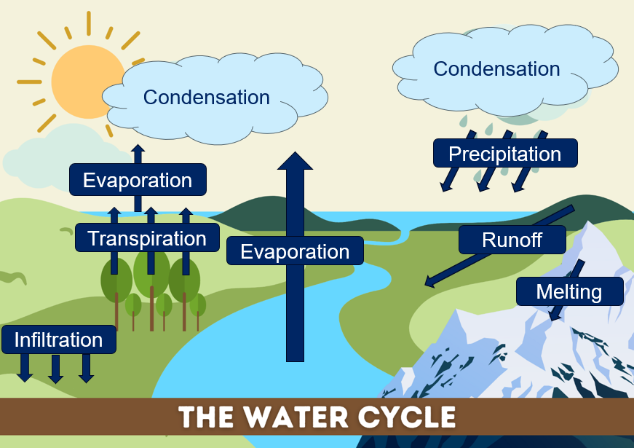

Student resource – movement of water around Earth
Water is constantly moving around our planet in a continuous cycle known as the water cycle. The Sun provides the energy that drives this movement.
- Match the terms in the word bank to the descriptions of water movement or processes.
Word bank: Condensation, Precipitation, Evaporation, Infiltration, Transpiration, Melting, Runoff.
Water vapour in the air cools and changes back into tiny liquid water droplets, forming clouds or fog.
The Sun heats liquid water in oceans, lakes and rivers, turning it into water vapour (a gas).
The process by which plants release water vapour through small pores (stomata) in their leaves into the air.
When water droplets in clouds join together and become heavy, they fall to the Earth’s surface. If it falls as rain, there is no state change. However, if it freezes as it falls, it can form snow or hail.
Some of the water that falls to Earth soaks into the ground and becomes groundwater.
Water flows over the land's surface and into rivers, lakes and oceans.
When temperatures rise, ice and snow from mountains and glaciers melt, turning from solid to liquid water.
- Annotate the water cycle diagram, using the word bank, with the processes that are occurring. Use arrows to indicate the direction of water movement and label each process.
Figure 1 – the water cycle
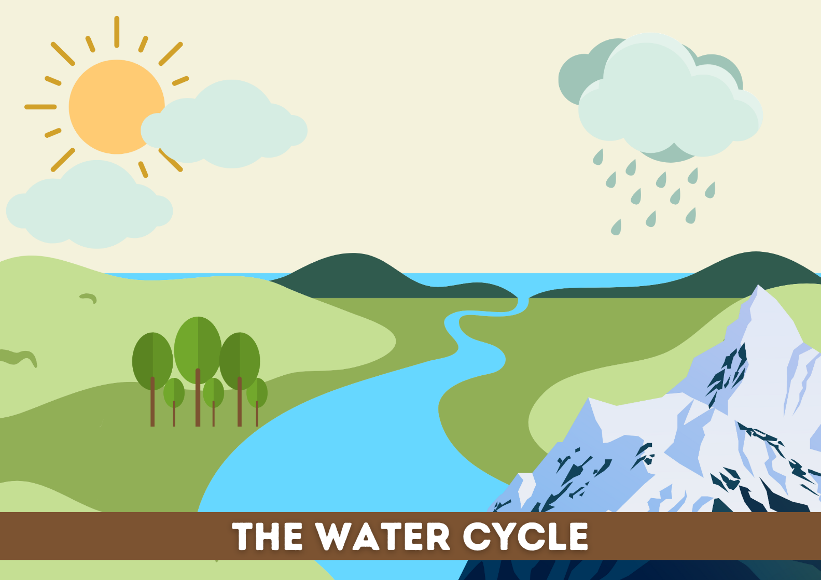

Heating water – practical investigation
In this investigation, students will observe how the temperature of water changes as it is heated over time and identify the changes in state from solid to liquid to gas. They will record data and graph their results to visualise the change in temperature over time.
Note: an equipment list for each student group is included in the Student resource – heating water practical investigation. The investigation works best with ice made from distilled water.
- Explain the investigation by highlighting the following:
- Students will record the temperature of ice water each minute as it is heated.
- Students will identify state changes by observing points where the temperature remains constant despite continued heating.
- A line graph will be drawn to show the temperature change over time.
- Demonstrate how to assemble the apparatus using SOL PPT ‘1.1 Apparatus setup’.
Note: a hotplate may be used in place of a Bunsen burner. If used, adjust the student resource.
- Read through the risk management section of the Student resource – heating water practical investigation. Remind students that:
- a hazard is anything that has the potential to cause harm
- a risk is the chance that a hazard will cause harm, and how severe that harm could be
- management is the steps taken to reduce or control the risks so activities can be done safely.
- Support students to complete the management column of the risk assessment in the Student resource – heating water practical investigation.
- Read through the method sections of the Student resource – heating water practical investigation. Remind students how to use a thermometer appropriately and how to light a Bunsen burner using the SOL PPT ‘1.1 Lighting the Bunsen burner’. Tell students that adding a small amount of water to the beaker with ice helps ensure even heating and reduces the risk of cracking.
Checkpoint 2 (SOL PPT ‘1.1 Checkpoint 2’)
Read each statement below and decide whether it is True or False. Where a statement is false, reword it to a true statement.
- You should always light the Bunsen burner with the air hole fully open. False – a Bunsen burner should always be lit with the air hole closed.
- Long hair should be tied back and loose clothing secured before using a Bunsen burner. True.
- You should strike the match after turning on the gas when lighting a Bunsen burner. False – you should light the match before turning on the gas tap.
- When not in use for short periods of time, the Bunsen burner should be left on the yellow safety flame. True.
- Students conduct the investigation. Instruct students to turn off their Bunsen burner once the temperature has stabilised for 3 minutes (and the water is boiling). Students should leave their equipment to cool and return to their desks.
- If required, revise how to construct a line graph using SOL PPT ‘1.1 Constructing a line graph’.
Checkpoint 3 (SOL PPT ‘1.1 Checkpoint 3’ [2 slides])
Check for prior knowledge and understanding of line graph structure by asking students to identify the key components missing from a sample graph. The graph and sample response are provided in SOL PPT ‘1.1 Checkpoint 3’ (2 slides).
- Instruct students to graph their experimental results, highlighting that the x-axis represents time in minutes and the y-axis represents temperature in degrees Celsius. Note that students record the temperature every minute in their table, and the graph axis is scaled in 2-minute intervals; therefore, students will need to consider how to plot each value.
Differentiation: students can use Microsoft Excel or a similar program to graph their results data.
- Assist students in identifying where changes of state have taken place by looking for plateaus or periods of time where the temperature remains consistent – a sample annotated graph is included in SOL PPT ‘1.1 Investigation data’.
- Discuss each of the questions in the Student resource – heating water practical investigation using the discussion prompts provided in Table 8 to analyse student results and promote further understanding.
Sample response: Student resource – heating water practical investigation
Label the equipment shown in the diagram in Figure 2.
Figure 2 – sample response for labelled equipment diagram
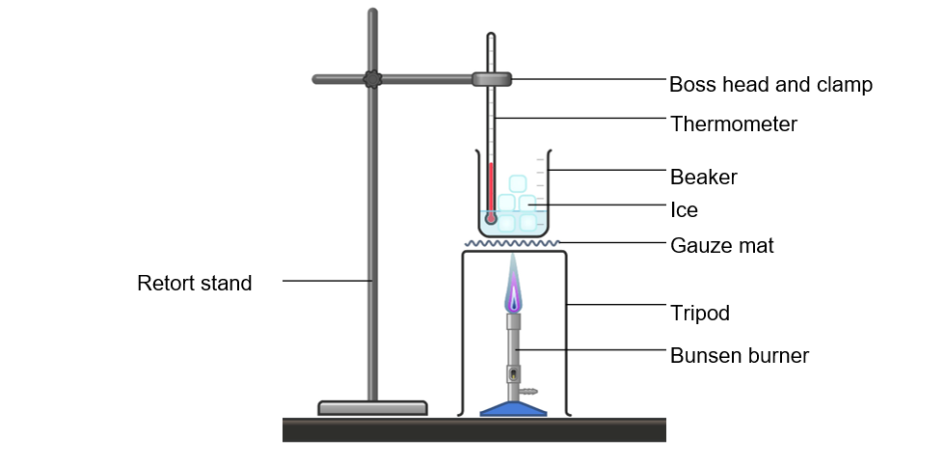
Image created using Chemix.
Complete the ‘Management’ column of the risk assessment in Table 6.
Table 6 – risk assessment sample response
Hazard | Risk | Management
Spilled water | Someone may slip on the spilled water and injure themselves. | - Maintain a clear workspace.  - Clean up spills as soon as they happen.  - Be observant at all times.
Broken glass | Someone may cut themselves on broken glass. | - Inspect the beaker for chips or cracks before use.  - Maintain a clean workspace.  - Notify the teacher when the glass is broken so that the breakage can be cleaned up appropriately.
Hot objects | Someone may burn themselves. | - Do not touch the tripod or beaker during the investigation.  - Let the equipment completely cool before packing it away.
Bunsen burner flame | Someone may burn themselves. | - Long hair is tied back.  - Loose clothing is not used in the lab (for example, sleeves may be pushed up).  - The Bunsen burner is either turned off or on the safety flame when it is not being used to heat.
Note: there may be other hazards and risks that are not included here. Consider all hazards and risks, and the appropriate ways to manage them, when conducting an investigation.

Table 7 – sample data for the heating water practical investigation

Time (minutes) | Temperature (°C)
0 | 0
1 | 0
2 | 0
3 | 0
4 | 0
5 | 1
6 | 5
7 | 8
8 | 11
9 | 17
10 | 26
11 | 35
12 | 40
13 | 48
14 | 59
15 | 69
16 | 79
17 | 88
18 | 92
19 | 98
20 | 100
21 | 100
22 | 100
23 | 100

Figure 3 – sample student graph showing change in temperature over time

Note: ideally, students should draw a smooth, curved line on their graph, rather than joining the dots. The slight deviations in the students’ graphs are due to equipment limitations and variations in measurement timings.
Table 8 – points to support students’ completion of the discussion questions
Question | Discussion points and teacher notes
During the investigation, how could you tell that the water was changing state? | Answers may include:  - Ice starts to lose its original shape and becomes smaller.  - Puddles or drops of liquid water form around the melting ice.  - Small bubbles appear as water starts to boil.  - Steam or water vapour can be seen rising from the surface.  - The volume of liquid water decreases over time.  Elaboration:  - When a substance such as water is heated, energy is transferred to the particles.  - The temperature increases because the particles move faster (kinetic energy increases).  - Eventually, the particles have enough energy to overcome the forces holding them together, and this is when a change of state occurs.  - During the change of state, its temperature remains the same, but the arrangement of particles changes.  - Plateaus or flat areas on a heating curve indicate points where the substance is changing state, such as from solid to liquid or liquid to gas.
What is the term for the process of ice transforming into liquid water, and at what temperature does this occur? Use your graph to identify the temperature at which the ice melted. | - When ice turns into water, it is called melting.  - Ice typically begins melting at 0°C. However, students are expected to identify the temperature from their experiment results by observing the temperature range of the first plateau on their graph. This may not be 0°C, depending on factors such as thermometer calibration and water purity (which can alter the melting point).
What is the term for the process of water transforming into water vapour?  At what temperature do you think this occurred? Use your graph to identify the temperature at which the water boiled. | - In this investigation, ‘boiling’ is the process by which liquid water turns into water vapour.  - Water’s boiling point is typically 100°C.  - Students are expected to identify the temperature from their experimental results by observing the temperature range of the second plateau on their graph. This may not be 100°C due to factors such as thermometer calibration and impurities in the water (which can change the boiling point).  Elaboration:  - This is an opportunity to discuss the difference between boiling and evaporation, especially if students say that liquid water turning into water vapour is called evaporation.  - Boiling is a rapid process that occurs throughout the liquid, not just at the surface. Bubbles of vapour form within the liquid and rise to the surface. The temperature remains constant during boiling because energy is used to overcome interparticle forces rather than to raise the temperature.  - Evaporation is a slow process that occurs only at the surface of a liquid at any temperature. It does not produce bubbles. The particles with the highest energy can evaporate.

Student resource – heating water practical investigation
Have you ever wondered what happens to the temperature of ice as it melts and then heats to its boiling point? In this experiment, you will track how the temperature of water changes as heat is applied, from ice-cold to boiling. By carefully measuring and recording temperature changes over time, you will observe key points in the heating process, such as when ice melts, water warms and eventually boils (changes of state).
Aim
To investigate how the temperature and state of ice and water change as they are heated.
Equipment list
- 1 × 250 mL beaker  - 1 × 100 mL measuring cylinder  - 1 × retort stand  - 1 × boss head and clamp  - Ice cubes (enough to fill half the beaker)  - 1 × Bunsen burner | - 1 × box of matches  - 1 × tripod  - 1 × gauze mat  - 1 × thermometer (digital or alcohol-based)  - 1 × stopwatch
Procedure
- Fill a 250 mL beaker halfway with ice cubes and add 50 mL of water.
- Place the beaker on top of the tripod.
- Insert a thermometer into the ice water and record the starting temperature.
- Light the Bunsen burner and begin heating the beaker.
- Record the temperature every minute.
- Continue recording the temperature until the water has been boiling for 3 minutes.

Label the equipment shown in the diagram in Figure 1.
Figure 1 – equipment setup for heating water investigation
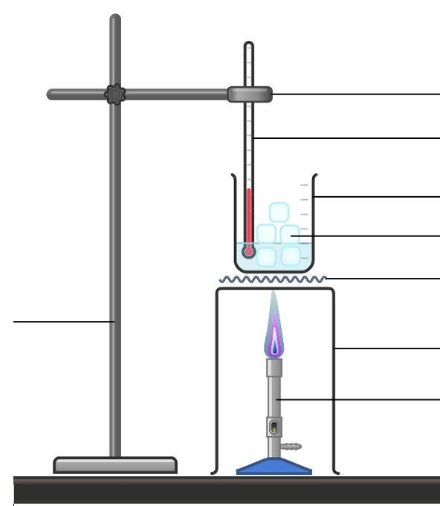
Image created using Chemix
Risk management
Complete the management column of the risk assessment in Table 1.
Table 1 – risk assessment
Hazard | Risk | Management
Spilled water | Someone may slip on the spilled water and injure themselves.
Broken glass | Someone may cut themselves on broken glass.
Hot objects | Someone may burn themselves.
Bunsen burner flame | Someone may burn themselves.
Results
Record your results in Table 2.
Table 2 – temperature of ice water heated with a Bunsen burner over time

Time (minutes) | Temperature (°C)

Plot a graph showing how the water temperature changed throughout your investigation.
Figure 2 – temperature of water heated with a Bunsen burner over time
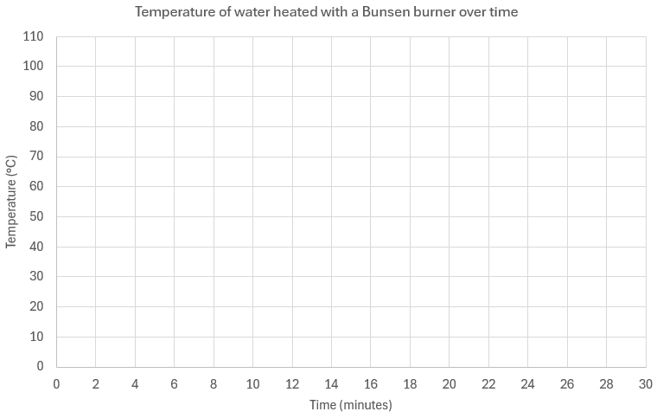
Discussion
- During the investigation, how could you tell that the water was changing state?
- What is the term for the process of ice transforming into liquid water, and at what temperature does this occur? Use your graph to identify the temperature at which the ice melted.
- What is the term for the process of water transforming into water vapour? At what temperature do you think this occurred? Use your graph to identify the temperature at which the water boiled.

1.2 Changes in the state of matter
Table 9 – learning intention and success criteria for 1.2 Changes in the state of matter
We are learning: | I can:
- to describe the properties of matter | - represent and describe the particle arrangements for solids, liquids and gases  - describe the arrangement and movement of particles as matter changes state.
There is a range of misconceptions that students may have formed throughout their learning related to states of matter. These should be addressed as they arise. Some of these alternative conceptions and the accepted conceptions are outlined in Table 10.
Table 10 – alternative conceptions and corresponding accepted conceptions for the particle theory of matter
Alternative conceptions | Accepted conceptions
‘Bubbles in boiling water contain air.’ | ‘Bubbles in boiling water contain water vapour (gaseous form of water).’
‘Steam is water gas.’ | Steam is not gaseous water. Gaseous water is called ‘water vapour’. Steam is a very small collection of condensed liquid water suspended in the air.
‘Melting and dissolving are the same.’ | ‘Melting is a change in state from solid to liquid. Dissolving occurs when a substance (solid) breaks into such small components in a solvent that they cannot be seen in a solution.’
‘When water in a container evaporates, the water has soaked into the container.’ | ‘Liquid water evaporates and becomes water vapour in the air.’
‘Boiling water produces steam, which then condenses to form clouds.’ | ‘Liquid water evaporates and becomes water vapour in the air. As the water vapour cools, it condenses into small collections of liquid water (steam or clouds).’
‘Cold water leaks through a glass of water, making the outside wet.’ | ‘Water vapour in the air condenses on the cold glass, forming droplets on its surface.’
‘An evaporated substance becomes lighter when it turns into a gas.’ | ‘Matter is conserved at all states, and its mass does not change.’
This table has been adapted from ‘Changing substances’ from Primary connections by Australian Academy of Science and is licensed under CC BY-NC-SA 4.0 (Australian Academy of Science n.d.).

Particle theory of matter
Learn more about the particle model from the Primary Connections Chemical and physical properties webpage. Learn more about the particle position and motion at the Science Connections Chemical sciences webpage.
- Activate students’ prior knowledge from the previous lesson, where students boiled water and graphed the heating curve. Show students the video Heating Matter and Changes in State (2:40) to illustrate how the particles behave at each stage of the investigation. The video is provided in SOL PPT ‘1.2 Heating matter and changes in state’.
Note: the Melting and Boiling Simulation also shows the behaviour of water molecules in the solid, liquid and gas states. It could be used alongside or as an alternative to the Heating Matter and Changes in State (2:40) video.
- Show SOL PPT ‘1.2 Particle theory of matter’ (5 slides). Use the slide notes to unpack the key principles of the particle theory of matter and how they relate to the properties of solids, liquids and gases:
- All substances are made of particles.
- Particles are in constant motion.
- Spaces exist between particles.
- Particles have attractive forces between them.
- Adding or removing heat changes the particle movement and spacing.
- Provide students with the Student resource – particle theory of matter. Students draw a diagram to represent the arrangement of particles in a solid, a liquid and a gas, and write a description of each state. Students respond to a question to predict what will happen to a balloon placed in the freezer.
- Check students’ responses to ascertain their understanding of the particle theory of matter. Re-teach concepts where necessary.
Differentiation: to provide additional practice for students to understand the behaviour of particles in matter, students can complete the interactive activity Types of matter: Solids, liquids and gases. This resource steps students through identifying the arrangement and behaviour of particles in different states.
Checkpoint 1 (SOL PPT ‘1.2 Checkpoint 1’)
Compared to the particles of a liquid, the particles of a gas:
- vibrate slowly.
- move freely and quickly.
- are tightly packed and cannot move.
- move over each other slowly.
Table 11 – checkpoint 1 response explanation
Response | Explanation
A | Incorrect. Gas particles have a lot of energy and move around.
B | This is the correct response.
C | Incorrect. The particles in a gas can move about and are not generally tightly packed.
D | Incorrect. Particles moving over each other tend to describe liquids.
Differentiation
Challenge students to apply their understanding of the particle model to explain real-world scenarios involving states of matter. For example:
‘Why can you compress air in a bicycle pump, but not water in a syringe?’ You can compress air in a bicycle pump because the particles in a gas are far apart, leaving plenty of space between them. When you push the pump handle, the particles are forced closer together, allowing the air to occupy less space. Water, on the other hand, is a liquid. The particles in a liquid are already close together with very little space between them. When you try to push the plunger of a syringe filled with water, there’s no room for the water particles to move closer, so the water cannot be compressed as easily as air can.
Sample response: Student resource – particle theory of matter
Draw a representation of the particle arrangement in a solid, a liquid and a gas, and then describe each state of matter. In your description, refer to the relative strength of the attractive forces between the particles, the motion of the particles and the spaces between the particles.
Table 12 – representations of matter sample response
Type of matter | Diagram | Description
Solid | 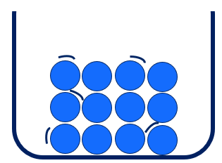 | Solids have a fixed shape and volume because their particles are held tightly by strong forces and can only vibrate. This close packing makes solids incompressible and rigid.
Liquid | 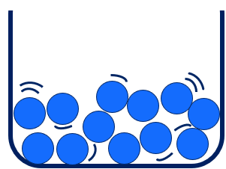 | Liquids have a fixed volume but no fixed shape. They take the shape of their container and can flow because particles can move while still attracting each other. Liquids are only slightly compressible.
Gas | 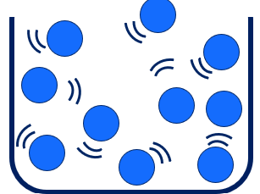 | Gases have no fixed shape or volume. They expand to fill their container and are highly compressible because the spaces between the particles are large and the forces of attraction are negligible.
- What happens to the spacing between the water particles as the temperature is increased?
The spaces between the particles increase in size as the temperature rises. This occurs because the particles move around much more and bounce off each other.
- How does the speed of the particles change as the temperature increases?
The particles gain energy and move faster as the temperature increases.
- Predict what will happen to a balloon filled with air if it is placed in the freezer.
When the balloon is placed in the freezer, it will get smaller.
- Explain your prediction.
The balloon shrinks as the air inside it cools. The air particles move more slowly, so they hit the sides of the balloon less often and with less force. As a result, the balloon will shrink.
Note: because of the weaker collisions, the internal pressure of the balloon drops compared to the atmospheric pressure outside the balloon.

Student resource – particle theory of matter
Draw a representation of the particle arrangement in a solid, a liquid and a gas, and then describe each state of matter. In your description, refer to the relative strength of the attractive forces between the particles, the motion of the particles and the spaces between the particles.
Table 1 – representations of matter
Type of matter | Diagram | Description
Solid
Liquid
Gas
- What happens to the spacing between the particles as the temperature is increased?
- How does the speed of the particles change as the temperature increases?
- Predict what will happen to a balloon filled with air if it is placed in the freezer.
- Explain your prediction.

Changes in state
- Outline the terminology used to describe different changes in state, explaining what occurs during each state change in terms of heat energy and particle movement using SOL PPT ‘1.2 Describing changes of state’ (7 slides). The information is also summarised in Table 13.
- Students should draw and annotate the flowchart of changes in state in their workbooks and annotate it with notes as each slide is unpacked.
Checkpoint 2: display SOL PPT ‘1.2 Checkpoint 2’ to check students’ understanding of the changes of state.
Match each change of state with the correct description.
- Particles gain energy and the substance changes directly from solid to gas. 2. Sublimation
- Particles lose energy and the substance changes from a gas directly to a solid. 4. Deposition
- Particles gain energy and the substance changes from solid to liquid. 3. Melting
- Particles lose energy and the substance changes from gas to liquid. 1. Condensation
- Revisit the idea that changes of state occur as a result of a gain or a loss of energy when a substance is heated or cooled. See Particle theory of matter.
Figure 4 – flowchart showing named changes of state
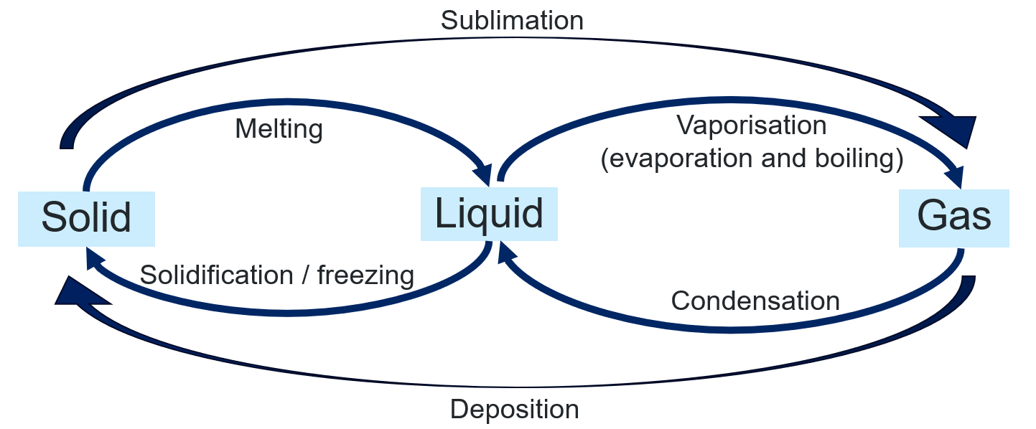
Table 13 – description of named changes of state
Name | Change of state | Description
Condensation | Gas → liquid | The particles in a gas lose energy, slowing down and moving closer together to form a liquid.
Deposition | Gas → solid | The particles in a gas lose energy, move more slowly and come closer together as attractive forces between them become significant, forming a liquid.
Vaporisation (includes boiling and evaporation) | Liquid → gas | Liquid particles gain energy, move faster and overcome attractive forces, allowing them to spread far apart and form a gas.
Melting | Solid → liquid | Solid particles gain energy and vibrate more until they overcome some of the attractive forces holding them in fixed positions, allowing them to move past one another as a liquid.
Solidification (freezing) | Liquid → solid | Liquid particles lose energy, move more slowly and become arranged in fixed positions as attractive forces lock them into a solid structure.
Sublimation | Solid → gas | Solid particles gain enough energy to completely overcome attractive forces and move directly into the gas state without becoming a liquid.
Checkpoint 3: display SOL PPT ‘1.2 Checkpoint 3’ and ask students:
Why do substances change from one state to another when heated?
- Heating causes particles to rise upwards.
- Heat energy causes particles to gain or lose mass.
- Added heat energy makes particles move faster and spread apart.
- Heat forces the particles to become larger.
Table 14 – checkpoint 3 response explanation
Response | Explanation
A | Incorrect. Heating a substance increases the kinetic energy of its particles, but the particles themselves do not simply rise upwards. In fluids such as liquids and gases, warmer regions rise upwards due to convection, but this is the movement of the fluid as a whole, not the individual particles.
B | Incorrect. Heating does not change the mass of particles.
C | This is the correct response.
D | Incorrect. Heat does not make particles larger. Instead, it increases their movement and separation.
Checkpoint 4: display SOL PPT ‘1.1 Checkpoint 4’ to check students’ understanding of the changes of state. Ask students, ‘What are the correct terms for the changes of state during the heating of water, and at what temperatures do they typically occur?’
Answer: Solid → Liquid is melting and it occurs at 0°C. Liquid → Gas is boiling and it occurs at 100°C.

1.3 Buoyancy
Table 15 – learning intentions and success criteria for 1.3 Buoyancy
We are learning: | I can:
- to describe the properties of substances | - define ‘buoyancy’  - describe how shape can affect the volume of an object  - relate the volume of an object to the amount of water displaced and if it will float or not
- to plan an investigation | - identify the independent, dependent and controlled variables in an investigation  - identify ways to manage risks in an investigation
- to safely follow a planned procedure | - conduct investigations safely by following WHS practices  - follow a written procedure for an investigation  - control variables in an investigation  - record observation and measurements.

Introducing buoyancy
- Introduce the concept of ‘buoyancy’ using SOL PPT ‘1.3 Introducing buoyancy’. Tell students that:
- ‘buoyancy’ is the upward force exerted by a fluid (a liquid or gas) on an object immersed in it, opposing the force of gravity.
- a ‘fluid’ is any substance that does not have a fixed shape and its particles can move freely past each other. Fluids are liquids or gases. For example, boats float on water (a fluid), and a hot air balloon floats through the air (also a fluid).
- Display SOL PPT ‘1.3 How does buoyancy work?’ Recall (from the Forces focus area) that gravity is the force that pulls all objects towards the centre of the Earth and gives them weight. Tell students that:
- ‘buoyant force’ is the upward force that acts on an object in a fluid. It explains why some things float and others sink.
- the duck is made of lightweight plastic and contains a lot of air inside it. Its weight is small compared to the buoyant force of the water. The duck's weight force pulls it down into the water, but the buoyant force pushes up on it, causing it to float.
- whether or not an object floats or sinks depends on the forces involved. If the weight force is greater than the buoyant force, then the object will sink. If the buoyant force and the weight force balance, the object will float.
Checkpoint 1: display the multiple-choice question on SOL PPT ‘1.3 Checkpoint 1’ and use a choral response or mini whiteboards to collect answers from all students.
Which statement best describes why some objects float?
- Water pushes lighter objects upward more strongly than heavier ones.
- A buoyant force acting upward balances the object’s weight force.
- Floating objects are always hollow or filled with air.
- Gravity stops acting on objects once they reach the surface.
Table 16 – checkpoint 1 response explanation
Response | Explanation
A | Incorrect. Students selecting this response may have the misconception ‘lighter objects float’. The ability of an object to float is not about the object being ‘lighter’ or ‘heavier’, but rather its density compared to the density of water. The upward buoyant force exerted by water depends on the volume of water displaced by the object. Some heavy objects (like ships) can float because they displace enough water to counteract their weight.
B | Correct. An object floats when the upward buoyant force from the fluid is equal to the downward force of gravity (weight) acting on the object. This balance of forces determines whether the object rises, sinks or stays in place.
C | Incorrect. While being hollow or filled with air can decrease an object's overall density and help it float, not all floating objects are hollow or contain air. Floating is determined by the object's overall density. Objects with a density less than that of water will float, whether they are solid, hollow or filled with air.
D | Incorrect. Gravity always acts on objects regardless of their position. When an object floats, it is because the upward buoyant force exerted by the water balances or exceeds the downward force of gravity. Not because gravity has stopped acting.

Plasticine boats – practical investigation
In this investigation, students will explore how an object’s shape affects its ability to float by using a fixed mass of plasticine to create different boat designs. Students learn that the volume of a boat affects the amount of water it displaces, which allows it to float. They will test whether their plasticine boats float or sink, then reshape them and repeat the experiment while keeping the boats’ mass constant.
Note: the equipment list is provided in the Student resource – plasticine boats practical investigation.
- Tell students that when a boat sits in the water, it pushes water out of the way – this is called ‘displacement’. The more water is displaced, the greater the buoyant force. Even though boats are heavy, they are shaped to displace a lot of water, which helps them to float.
- Explain the investigation by highlighting the following:
- Students will create 5 different ‘boat’ shapes (which will modify the amount of water they can displace) and predict whether they will float or sink.
- Students will measure and record the mass of each ‘boat’ before placing it in the water.
- Each ‘boat’ should have the same mass.
- Students fill their ‘boat’ with water and then pour the water into a measuring cylinder to find the volume of the boat’s interior.
- Students will place each ‘boat’ into the water, observe whether it floats or sinks and then record their results.
- Discuss safety considerations and read through the procedure outlined in the Student resource – plasticine boats practical investigation.
- Revise variables with students and have them identify the independent, dependent and controlled variables for the investigation.
- The independent variable is the one that is changed on purpose – in this case, the volume of the boat (which affects the amount of water it can displace).
- The dependent variable is the factor that changes in response to the independent variable – in this case, it is a qualitative observation, such as ‘float’ or ‘sink’.
- Controlled variables are the factors that are kept constant during an investigation. In this investigation, the mass of the plasticine is kept constant and the water is kept constant (because salt water and fresh water have different densities and affect how objects float).
- Students conduct the investigation in small groups.
Note: suggestions for boat shapes may include a:
- long, narrow canoe
- wider, deeper boat
- flat-bottomed raft.
Sample data has been provided in Table 20 for reference. For a 50 g plasticine boat to float, it must displace at least 50 mL of water. The internal volume does not equal the displaced volume; however, it is an approximation and a useful way to compare changes in the boats and whether those changes will determine whether they will float.
- Lead discussion about students’ predictions, including their reasoning, and their observations. Guide students in analysing their results and promote further understanding by addressing and discussing the questions in Table 17.
Table 17 – discussion points and teacher notes for the plasticine boat practical investigation
Question | Discussion points and teacher notes
How did changing the shape affect floating or sinking? | - Students should have found that the larger the boat's internal volume, the higher it sits in the water. Increasing the internal (hollow) space means the boat displaces more water, thereby increasing the upward buoyant force acting on it.  - If the boat's internal volume was greater than 50 mL, it should have floated. This is because 50 mL of water weighs 50 g, which equals the boat’s mass.  - Thin-walled boats allow a boat with greater volume, reducing the boat's overall density (mass divided by volume).  - Boats with thicker walls or smaller internal spaces have a smaller total volume, meaning less water is displaced, so the boat sinks lower in the water or even goes completely underwater.
What was the best boat design for keeping the plasticine afloat? | - This can be linked to the previous question and may vary across groups. The best boat design is likely the one with the largest internal volume.
Each of your boats had the same mass. What does that tell you about mass and whether something will float or sink? | - Mass alone does not determine whether something will float or sink.  - In your response, emphasise that the boat's shape affects its internal volume, which determines whether it will float or sink. In the following lesson, shape and volume will be linked to the concept of density.
Checkpoint 2 (SOL PPT ‘1.3 Checkpoint 2’)
All 5 of your plasticine boats had the same mass. Which factor best explains why some floated and others sank?
  - The colour of the plasticine
- The shape of the boat changed how much water was displaced
- How quickly you placed it in the water
- The temperature of the water
Table 18 – checkpoint 2 response explanation
Response | Explanation
A | Option A is incorrect as colour does not affect buoyancy.
B | Option B is correct. All boats had the same mass, so differences in floating or sinking were due to how each boat’s shape affected its volume and the amount of water it displaced.
C | Option C is incorrect because placement speed may cause temporary splashing or tipping, but it does not affect whether the boat ultimately floats or sinks once settled.
D | Option D is incorrect because small temperature changes in typical classroom conditions have negligible effects on water. Therefore, this would not explain why some boats sank while others floated.
Sample response: Student resource –plasticine boats practical investigation
Note: only the sections of the resource with sample responses are shown here.
Independent variable: volume of the boat (which changes the amount of water it can displace)
Dependent variable: whether the boat sinks or floats
Controlled variables: mass of the boat and the same water will be used.
Table 19 – risk assessment sample response
Hazard | Risk | Management
Spilled water | Someone may slip on the spilled water and injure themselves. | - Maintain a clear workspace.  - Clear up any spills as soon as they happen.  - Be observant at all times.
Broken glass | Someone may cut themselves. | - Maintain a clear workspace.  - Clear up any breakages with a dustpan and brush as soon as they happen.  - Do not pick up broken glass by hand.
Table 20 – sample data for the plasticine boats practical investigation
Boat sketch | Mass (g) | Internal volume (mL) | Prediction (float or sink) | Observations (float or sink)
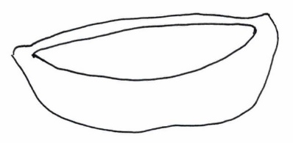 | 50 | 30 | Float | Sink
Note: if the boat's internal volume exceeds 50 mL, it should float because it displaces more than 50 mL of water (1 mL of water weighs 1 g).
- How did changing the shape affect the volume of the boat?
Making the boat’s walls thinner allowed the boat’s shape to be larger, increasing its internal volume.
- How did changing the volume affect floating or sinking?
The larger the volume, the higher the boat could float in the water. The boat with a 60 mL volume sat relatively low in the water, whereas the boat with a 90 mL volume sat significantly higher. All boats with a volume of less than 50 mL sank.
- What was the best boat design for keeping the plasticine afloat? Explain your reasoning.
The round-shaped boat, which held 90 mL of water, floated the best. This boat displaces the most water. The mass of water displaced exceeds the mass of the boat, allowing it to float.
- Each of your boats had the same mass. What does that tell you about mass and whether something will float or sink?
Mass does not determine whether something floats or sinks. The object's shape or volume can affect how it sits in the water by changing the amount of water that is displaced.

Student resource – plasticine boats practical investigation
Have you ever noticed how some objects float effortlessly while others sink, even if they are made of the same material? The shape of an object plays a crucial role in whether it floats or sinks in water. Ships and canoes are carefully designed to help them stay on the surface.
Aim
To determine whether the volume of a plasticine boat will change the amount of water displaced and cause it to float or sink when placed in water.
Equipment list
- 1 × container of water  - 50 g plasticine | - 1 × digital scales  - 1 × 100 mL measuring cylinder
Variables
Independent variable:
Dependent variable:
Controlled variable:
Procedure
- Create a boat shape using 50 g of plasticine.
- Measure the mass of the boat to ensure it is still 50 g. If the mass has changed for some reason, adjust the boat’s mass to 50 g.
- Fill the boat with water and then pour the water from the boat into a measuring cylinder. Record the volume of the boat in Table 2.
- Sketch the shape of the boat in Table 2.
- Predict if the boat will float or sink.
- Carefully place the boat into the water and observe whether it floats or sinks. Record this data in Table 2.
- Repeat steps 1 to 6 with a new boat shape.
Risk management
Table 1 – risk assessment
Hazard | Risk | Management
Spilled water | Someone may slip on the spilt water and injure themselves.
Broken glass | Someone may cut themselves.
Results
Table 2 – predictions and observations about boat shape (volume) on its ability to float in water
Boat sketch | Mass (g) | Volume (mL) | Prediction (float or sink) | Observations (float or sink)
Discussion questions
- How did changing the shape affect the volume of the boat?
- How did changing the volume affect floating or sinking?
- What was the best boat design for keeping the plasticine afloat? Explain your reasoning.
- Each of your boats had the same mass. What does that tell you about mass and whether something will float or sink?

1.4 Density
Table 21 – learning intentions and success criteria for 1.4 Density
We are learning: | I can:
- to describe the properties of substances | - calculate the density of an object using $ρ=\frac{m}{V}$  - rearrange the density equation to find the volume and mass of an object  - calculate the density of regularly shaped objects by calculating their volume and measuring their mass  - calculate the density of irregularly shaped objects using the water displacement method to determine volume
- to plan a safe investigation | - identify risks associated with spilled water and broken glass  - outline steps to manage risks in an investigation
- to follow a procedure to conduct a safe and valid practical investigation | - measure the volume and mass of an object  - control variables in an investigation  - conduct investigations safely by following WHS practices  - record observations and measurements
- to assess the reliability of gathered data. | - compare investigation data to accepted density values for materials  - identify factors that may affect the accuracy of a measurement  - suggest improvements to the methodology of an experiment.

Calculating density
In this activity, students draw on their observations from the Student resource – plasticine boats practical investigation completed in 1.3 Buoyancy highlighting that the boat's shape determined whether it would float or sink.
- Display SOL PPT ‘1.4 Introducing density’ to introduce ‘density’ as a measure of how tightly the particles in a substance are packed, highlighting links to particle theory.
- Display SOL PPT ‘1.4 Volume’ to introduce ‘volume’ as the amount of space that an object or substance occupies, outlining examples of common units used to measure volume.
- Display SOL PPT ‘1.4 Calculating density’ to unpack the formula for calculating density, including the symbols and units of measurement.
- Demonstrate how to calculate density using the formula $ρ=\frac{m}{V}$ and how to rearrange the formula to change the subject using SOL PPT ‘1.4 Rearranging the density equation’ (2 slides). Animations and speaker notes on the slides help students learn to rearrange equations using algebraic methods.
Differentiation: if students are unable to rearrange the equation using algebra, they can be shown the triangle method for rearranging simple equations. See SOL PPT ‘1.4 Calculating density with an equation triangle’ (2 slides).
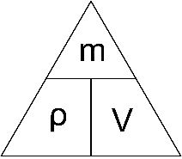
Checkpoint 1 (SOL PPT ‘1.4 Checkpoint 1’)
A metal cube has a mass of 120 g and each side measures 3.0 cm. What is the density of the cube?
- 4.44 g cm⁻³
- 0.225 g cm⁻³
- 40.0 g cm⁻³
- 13.3 g cm⁻³
Table 22 – checkpoint 1 response explanation
Response | Explanation
A | This is the correct answer.  Volume = 3.0 cm × 3.0 cm × 3.0 cm = 27.0 cm³  Density = 120 g ÷ 27.0 cm3 = 4.44 g cm⁻³
B | Incorrect. Students who selected this answer have used volume divided by mass.
C | Incorrect. Students who selected this answer have used mass divided by side length. They did not first calculate the volume.
D | Incorrect. Students who selected this answer have used mass divided by area of one face.
- Provide students with the Student resource – calculating density and time to complete the calculations. Support students in solving problems as required, using a gradual release of responsibility. Worked solutions for each question in the student resource are provided in SOL PPT ‘1.4 Calculating density – worked solutions’ (8 slides).
Sample response: Student resource – calculating density
- A piece of wood has a mass of 150 g and a volume of 75 cm³. What is the density of the wood?
Given:  Mass = 150 g  Volume = 75 cm³ | Solution:  $$Density=\frac{Mass}{Volume}$$  $$Density=\frac{150}{75}=2$$  Answer: 2 g cm⁻³
- A coin weighs 50 g and has a volume of 2.5 cm³. What is the density of the coin?
Given:  Mass = 50 g  Volume = 2.5 cm³ | Solution:  $$Density=\frac{Mass}{Volume}$$  $$Density=\frac{50}{2.5}=20$$  Answer: 20 g cm⁻³
- A metal ball has a mass of 200 g and a volume of 100 cm³. What is the density of the metal ball?
Given:  Mass = 200 g  Volume = 100 cm³ | Solution:  $$Density=\frac{Mass}{Volume}$$  $$Density=\frac{200}{100}=2$$  Answer: 2 g cm⁻³
- A plastic bottle has a mass of 120 g and a volume of 150 cm³. What is the density of the plastic bottle?
Given:  Mass = 120 g  Volume = 150 cm³ | Solution:  $$Density=\frac{Mass}{Volume}$$  $$Density=\frac{120}{150}=0.8$$  Answer: 0.8 g cm⁻³
- A rock has a density of 2.5 g cm⁻³ and a volume of 8 cm³. What is the mass of the rock?
Given:  Density = 2.5 g cm⁻³  Volume = 8 cm³ | Solution:  $$Mass=Density×Volume$$  $$Mass=2.5×8=20$$  Answer: 20 g
- A large cooking pot is filled with 12 L of olive oil. The oil has a density of 0.92 g cm⁻³. What is the total mass of the olive oil in the pot? Hint: you will need to convert the volume to cm³.
Given:  Density = 0.92 g cm⁻³  Volume = 12 L = 12,000 mL which is the equivalent of 12,000 cm³ | Solution:  $$Mass=Density×Volume$$  $$Mass=0.92×12,000=11,040$$  Answer: 11,040 g
- A piece of metal has a mass of 250 g and a density of 5 g cm⁻³. What is the volume of the metal?
Given:  Mass = 250 g  Density = 5 g cm⁻³ | Solution:  $$Volume=\frac{Mass}{Density}$$  $$Density=\frac{250}{5}=50$$  Answer: 50 cm³
- A plastic container has a mass of 400 g and a density of 0.8 g cm⁻³. What is the volume of the plastic container?
Given:  Mass = 400 g  Density = 0.8 g cm⁻³ | Solution:  $$Volume=\frac{Mass}{Density}$$  $$Volume=\frac{400}{0.8}$$  Answer: 500 cm³

Student resource – calculating density
‘Density’ is a measure of how tightly packed the particles in a substance are. Density is the amount of mass per unit of volume of a substance. Density can be calculated using the formula:
$$ρ=\frac{m}{V}$$
Every substance, whether it is a solid, liquid or gas, has its own density. Density is an important concept that helps us to understand why all objects behave the way they do in different environments. Density helps scientists and engineers make important decisions, including when designing ships and submarines, and understand why certain materials feel heavier than others of the same size.
Table 1 – density reference guide
Term | Symbol | Unit of measure
Density | $ρ$(Greek letter Rho) | g cm⁻³ or kg m⁻³
Mass | m | g or kg
Volume | V | cm³ or m³
Use the formula $ρ=\frac{m}{V}$ to answer the following questions, showing all working out.
- A piece of wood has a mass of 150 g and a volume of 75 cm³. What is the density of the wood?
- A coin weighs 50 g and has a volume of 2.5 cm³. What is the density of the coin?
- A metal ball has a mass of 200 g and a volume of 100 cm³. What is the density of the metal ball?
- A plastic bottle has a mass of 120 g and a volume of 150 cm³. What is the density of the plastic bottle?
- A rock has a density of 2.5 g cm⁻³ and a volume of 8 cm³. What is the mass of the rock?
- A large cooking pot is filled with 12 L of olive oil. The oil has a density of 0.92 g cm⁻³. What is the total mass of the olive oil in the pot? Hint: you will need to convert the volume to cm³.
- A piece of metal has a mass of 250 g and a density of 5.0 g cm⁻³. What is the volume of the metal?
- A plastic container has a mass of 400 g and a density of 0.8 g cm⁻³. What is the volume of the plastic container?

Comparing the density of substances – practical investigation
In this investigation, students will determine the density of various metal cubes by measuring their dimensions and mass. Using a ruler, they will record the height, width and depth of each cube to calculate its volume. They will then use a digital balance to measure its mass. By applying the density equation, students will compare their calculated densities with accepted values from the Science 7–10 (2023) Data Book. This activity emphasises the importance of accurate measurement, potential variations in expected dimensions and factors that may affect experimental accuracy.
When conducting this investigation, emphasis should be placed on a student’s ability to:
- employ safe work practices and manage risks in accordance with WHS practices
- assemble and use appropriate equipment and resources
- follow the planned procedure, including measuring and controlling variables
- record observations and measurements accurately
- use a reliable secondary source.
Figure 5 – density cubes
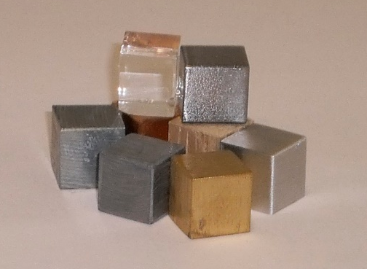
‘dichtheid-cm3-2’ by la riviere is licensed under CC BY 2.0.
Note: cubes made of other materials can be used.
Instructions
- Explain the investigation by highlighting the following:
- Students measure the height, width and depth of each cube accurately and use this data to calculate the cube’s volume. Remind students that although the cubes are expected to have sides of 1 cm (or 2 cm), slight variations may occur. Therefore, they must measure each cube themselves using a ruler to ensure accuracy.
- Students measure the mass of each cube accurately with the digital balance.
- Their results will be compared to the values found in the Science 7–10 (2023) Data Book.
Note: density values for each metal can be found in the Science 7–10 (2023) Data Book. The relevant page of the data book can be provided to students, or the data can be placed in an alternative table as described below.
- Discuss safety considerations for this investigation. If a lead metal cube is used, the associated risks of handling lead should be addressed.
- Outline the experimental procedure as outlined in the Student resource – comparing the density of metals practical investigation.
- Guide students in analysing their results and promote further understanding by addressing and discussing the questions in Table 23. Sample answers are provided at the end of the teacher's instructions.
Table 23 – discussion points and teacher notes for the comparing the density of metals practical investigation
Question | Discussion points and teacher notes
Were your calculated densities the same as the accepted values in the Science 7–10 (2023) Data Book? | - This will vary from group to group, but most calculated densities should be close to the accepted values.
What factors may have affected your data and its accuracy? | - Student responses may include mention of measurement error or the limitations of the measuring equipment available.  - In discussions about accepted values and measured values, highlight the following points:  - These values are calculated at 25°C and 100 kPa. If these conditions were not met in the school laboratory, it could have impacted the accuracy of the results.  - Systematic and random errors may occur, including incorrectly reading, calculating or recording measurements.  - Instrument precision. A ruler typically has a smallest division of 1 mm, so the measurement uncertainty is ±0.5 mm for each reading.  - Multiplication of error. Because volume = H×W×L, even a small error in one dimension will be multiplied by 3, producing a larger total error.  - The precision of the scales can influence the result. If they measure to 1 g, the measurement uncertainty is ±0.5 g. However, if the scales are calibrated to the nearest 0.1 g, the measurement uncertainty is ±0.05 g.  - Extend the discussion to consider how using equipment with greater precision can improve measurement accuracy. For example, the use of callipers to collect accurate measurements of the cube's dimensions.  Figure 6 – callipers  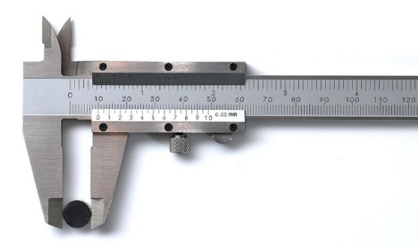  ‘Calliper detail view’ by Simon A. Eugster is licensed under CC BY-SA 3.0.
Differentiation: challenge students by having them calculate the percentage error for each cube using the formula below, and compare their experimental value to the accepted values in the data book.
$$percentage error=\frac{measured value -accepted value}{accepted value}×100$$
Sample response: Student resource – comparing the density of metals practical investigation
Table 24 – sample data for the comparing the density of metals practical investigation
Substance | Height (cm) | Width (cm) | Depth (cm) | Volume (cm³) | Mass (g) | Density (g cm⁻³)
Aluminium | 1.0 | 1.0 | 1.0 | 1.0 | 2.68 | 2.68
Copper | 1.0 | 1.0 | 1.0 | 1.0 | 8.29 | 8.29
Iron | 1.0 | 1.0 | 1.0 | 1.0 | 7.16 | 7.16
Lead | 1.0 | 1.0 | 1.0 | 1.0 | 10.72 | 10.72
Zinc | 1.0 | 1.0 | 1.0 | 1.0 | 6.63 | 6.63
- Compare your data to the accepted values. Are they the same, or are they higher or lower?
Our calculated densities were close to the accepted values but not identical. For example, our aluminium cube had a calculated density of 2.68 g cm⁻³, while the accepted value is 2.70 g cm⁻³. The copper cube had a density of 8.29 g cm⁻³, compared with the accepted value of 8.9 g cm⁻³.
- What factors may have affected your data and its accuracy?
Some of the density cubes were scratched or dented. This may have reduced the cubes’ mass, resulting in lower calculated densities. We measured the cubes with a ruler with 1 mm markings, so the ruler is not very precise for measuring small lengths. The scales were zeroed for each measurement, but they may need to be calibrated.

Student resource – comparing the density of metals practical investigation
Different substances have different densities because they contain different amounts of mass per unit of volume. Some materials, like metals, are very dense because their particles are tightly packed. In contrast, others, like foam, have much lower densities because there is more space between particles. Understanding density helps explain why some objects float while others sink, and why certain materials are stronger or heavier than others even if they are the same size.
The volume of a cube can be calculated using the formula $H×W×D$, where:
H = height
W = width
D = depth
Density can be calculated using the formula $ρ=\frac{m}{V}$, where:
ρ = density
m = mass
V = volume
Aim
To calculate and compare the density of different substances.
Equipment list
- 4 × 1 cm (or 2 cm) cubes made from different metals (for example, copper, iron, lead and zinc)
- 1 × digital balance (accurate to 2 decimal places if possible)
- 1 × ruler
Method
- Measure the height, width and depth of the first cube with the ruler and record the data in Table 1.
- Calculate the volume of the cube.
- Place the cube on the digital balance and record its mass in Table 1.
- Calculate the density of the cube.
- Repeat for the other cubes.
- Compare calculated densities to accepted values.
Risk management
Table 1 – risk assessment
Hazard | Risk | Management
Lead metal | Ingestion of lead metal, lead oxide or lead salt particles can be toxic. | Wash your hands thoroughly with soap and water after handling lead metal.
Results
Table 2 – calculated density of different metals
Substance | Height (cm) | Width (cm) | Depth (cm) | Volume (cm³) | Mass (g) | Density (g cm⁻³)
Table 3 – accepted density values of metals (from the Science 7–10 Data Book)
Metal | Density (g cm⁻³) at 25°C and 100 kPa
Aluminium | 2.70
Copper | 8.96
Iron | 7.86
Lead | 11.3
Zinc | 7.14
- Compare your data to the accepted values. Are they the same, or are they higher or lower?
- What factors may have affected your data and its accuracy?

Density of irregular-shaped objects practical investigation
In this investigation, students will measure the volume, mass and density of regular and irregular shaped objects using the water displacement method. By submerging each object in a measuring cylinder, they will calculate its volume from the change in water level. They will then measure the mass with a digital balance and calculate the density using the density formula. This activity helps students understand how an object’s shape affects displacement and density calculations.
When conducting this investigation, emphasis should be placed on a student’s ability to:
- employ safe work practices and manage risks using WHS practices
- assemble and use appropriate equipment and resources
- follow the planned procedure, including measuring and controlling variables
- record observations and measurements accurately.
Note: a 1 L measuring cylinder has been used in this investigation. If these are not available, smaller measuring cylinders can be used. However, this will require adjusting the starting volume and may require modifying the objects tested to ensure they fit within the cylinder.
Instructions
- Introduce the concept of ‘water displacement’ and how it can be used to determine the volume of an object by watching How taking a bath led to Archimedes’ principle - Mark Salata (3:01) (see SOL PPT ‘1.4 Density of irregular shaped objects’) and use the summary below to prompt discussion.
- The video tells the story of Archimedes and the discovery he made when tasked with determining whether a goldsmith had mixed silver into a crown.
- Archimedes realised that by measuring the crown’s volume through water displacement, he could calculate its density.
- This led to the discovery of Archimedes’ Principle, which uses the volume of water an object displaces when submerged to determine its volume.
- Explain the investigation by reading through the Student resource – density of irregular-shaped objects practical investigation.
Note: it is important to inform students that 1 mL is equivalent to 1 cm³ when working with water volumes. This is why we can use the volume in millilitres (mL) and the mass in grams (g) to calculate the density directly in grams per cubic centimetre (g cm⁻³). It is also important to note that measuring the object’s mass before placing it in the water ensures the correct mass is recorded.
- Discuss the safety considerations involved in the investigation. Two hazards, spilled water and broken glass, have been identified in the student resources. Students should identify the risks associated with each hazard and how to mitigate or manage them.
- Students follow the procedure to measure the density of a range of irregular-shaped objects.
Differentiation (SOL PPT ‘1.4 Unpacking density calculations’): provide support by breaking down the required calculations into a fill-in-the-blank format with a worked example. This approach helps students who struggle with multistep mathematical processes, allowing them to focus on interpreting results rather than being overwhelmed by the calculations.
- Guide students in analysing their results and promote further understanding by addressing and discussing the questions in the student resource. Sample responses are provided below.
Sample response: Student resource – density of irregular-shaped objects practical investigation
Table 25 – risk assessment sample response
Hazard | Risk | Management
Spilled water | Someone may slip on the spilled water and injure themselves. | - Maintain a clear workspace.  - Clear up any spills as soon as they happen.  - Always be observant.
Broken glass | Someone may cut themselves on broken glass. | - Maintain a clear workspace.  - Notify the teacher for assistance with clearing up any breakages as soon as they happen.  - Use a dustpan and brush to clean up broken glass.
Results
Table 26 – sample data for the density of irregular-shaped objects practical investigation
Object | Mass (g) | Initial volume (cm³) | Final volume (cm³) | Volume of object (cm³) | Density (g cm⁻³)
Glass marble | 5.26 | 50 | 53 | 3 | 1.75
Bar magnet | 51.10 | 50 | 72 | 22 | 2.32
Rubber stopper | 5.48 | 50 | 55 | 5 | 1.10
Metal bolt | 14.76 | 50 | 53 | 3 | 4.92
Metal teaspoon | 19.71 | 50 | 52 | 2 | 9.86
Small rock | 10.22 | 50 | 56 | 6 | 1.70
- What factors may have affected your accuracy in this investigation?
Our accuracy may have been affected by the precision with which we measured the volume of displaced water. When reading a measuring cylinder, parallax error can occur if the meniscus is not viewed at eye level. Air bubbles attached to the object might have increased the volume of displaced water. We may also have added slightly more or less than 50 mL of water between trials, which could have alter the starting point and affected our results. Errors in reading the balance or water spillage during lowering of the object could also have altered the mass or volume readings.
Note: this is an opportunity to clarify the difference between random and systematic errors. For instance, a systematic error happens if the balance does not read zero when nothing is weighed. This causes every mass measurement to be off by the same amount, leading to density values that are consistently higher or lower than the true value. This type of systematic error is also called bias. A random error might happen if a student reads the meniscus on the measuring cylinder at an incorrect angle.
- How could you modify this investigation to find the volume of objects that float rather than sink?
For floating objects, we can carefully submerge them entirely to displace their full volume. To do this precisely, a wire can be used to gently push the object just below the water surface. Alternatively, attaching the floating object to a heavy sinker, such as a metal washer, allows the entire setup to sink. By measuring the total displaced volume and subtracting the sinker’s known volume, we can determine the volume of the floating object.
- Two irregular objects, X and Y, each have a mass of 50 g. When submerged in water, object X raises the water level by 10 mL, while object Y raises it by 8 mL. Explain what these results tell you about the densities of X and Y.
Both objects have the same mass, but object X takes up more space in the water than object Y. This means object X has a larger volume. Since density equals mass divided by volume, the object with the larger volume (X) must have a lower density. Object Y displaces less water, so it has a smaller volume and therefore a higher density than object X.

Student resource – density of irregular-shaped objects practical investigation
Density is a fundamental property of matter that helps us understand why some objects float while others sink. It is determined by the relationship between an object’s mass and its volume.
Archimedes showed that to find the density of an object, you need to find its mass and volume. The mass of an object can be measured using scales. If the object is not regular, it can be difficult to measure its volume. Archimedes figured out that when an object is submerged in water, the amount the water rises by equals the volume of the object.
In this investigation, you will measure both the mass and volume of different objects and use the density formula to calculate their densities. By comparing your results, you will see that each material has a unique density that influences its behaviour in water and other substances.
Density can be calculated using the formula: $ρ=\frac{m}{V}$
where: ρ = density m = mass V = volume
Aim
To determine the volume and density of a range of objects.
Equipment list
- 1 × ___________________  - 1 × ___________________  - 1 × stick  - 1 × metal bolt | - 1 × metal spatula  - 1 × small rock  - 1 × 50 cm cotton thread | - 1 × balance (digital or analogue)  - 1 × 250 mL beaker  - 1 × 100 mL measuring cylinder
Procedure
- Place the object on the balance. Record the mass in Table 2.
- Use the beaker to fill the measuring cylinder with exactly 50 mL of water.
- Record the initial volume (V₁) in Table 2.
- Tie the thread around the object and carefully lower the object into the measuring cylinder.
- Record the final volume (V₂) in Table 2.
- Remove the object and check if the measuring cylinder needs to be topped up to 50 mL again.
- Repeat steps 1 to 6 for the remaining objects.
- Calculate the volume of each object by subtracting the initial volume (V₁) from the final volume (V₂).
- Calculate the density of each object using $ρ=\frac{m}{V}$.
Risk management
Table 1 – risk assessment
Hazard | Risk | Management
Spilled water
Broken glass
Results
Table 2 – summary of results
Object | V₁ Initial volume (cm³) | V₂ Final volume (cm³) | V₂–V₁ Volume of object (cm³) | Mass (g) | Density (g cm⁻³)
- What factors may have affected your accuracy in this investigation?
- How could you modify this investigation to find the volume of objects that float rather than sink?
- Two irregular objects, X and Y, each have a mass of 50 g. When submerged in water, object X raises the water level by 10 mL, while object Y raises it by 8 mL. Explain what these results tell you about the densities of X and Y.

1.5 Density and water
Table 27 – learning intentions and success criteria for 1.5 Density and water
We are learning: | I can:
- to describe the properties of substances | - measure the mass and volume of objects and substances  - calculate the density of water and other substances using $ρ=\frac{m}{V}$  - rearrange the density calculation to make m or V the subject of the equation
- to safely follow a planned procedure | - conduct investigations safely  - use the correct equipment for measuring volume  - record observations and measurements  - compare investigation data to the accepted density value for a material.
Note: at the end of this lesson, students should be able to revise the definition of ‘buoyancy’ from 1.3 Buoyancy to emphasise the relevance of density. Refer to Buoyancy and density revisited for further details.

Density of water – practical investigation
In this investigation, students determine the density of water by measuring the mass and volume of a sample. They will use a measuring cylinder to measure the volume of water and a digital balance to determine its mass. By applying the density formula, students calculate the density of water and compare their results to the accepted value of 1.0 g cm⁻³. They will also consider potential sources of error and discuss how measurement precision affects their findings.
When conducting this investigation, emphasis should be placed on a student’s ability to:
- employ safe work practices and manage risks in accordance with WHS practices
- assemble and use appropriate equipment and resources
- follow the planned procedure, including measuring and controlling variables
- record observations and measurements accurately.
Instructions
- Outline the investigation by highlighting the following:
- Students must measure the volume of the water accurately.
- The density equation will be used to determine the density of the water.
- Their result will be compared with the accepted value of 1.0 g cm⁻³.
- Read through the procedure in the Student resource – density of water practical investigation with students.
Note: highlight that the beaker is used only to transfer water to the measuring cylinder. It should not be used to measure the volume of the water sample.
Checkpoint: display SOL PPT ‘1.5 Checkpoint’ to check students understanding of how to manage cracked glassware.
Before beginning the investigation, you carefully inspect the glass measuring cylinder and notice a visible crack along the side. What should you do next?
- Use the cylinder carefully to avoid the crack getting worse.
- Inform the teacher and do not use the cracked cylinder.
- Tape the crack with sticky tape and continue the experiment.
- Fill the cylinder slowly to avoid putting pressure on the crack.
Table 28 – checkpoint response explanation
Response | Explanation
A | Incorrect – careful handling does not eliminate the risk of glass breaking, so continued use of cracked glassware is unsafe and contravenes proper lab procedure.
B | Correct – a cracked glass measuring cylinder is unsafe to use because it can break unexpectedly, causing injury or spilling hazardous substances. The correct procedure is to stop using the equipment immediately and report it to the teacher so it can be replaced.
C | Incorrect – the use of sticky tape does not restore the strength or safety of glass, so the crack still weakens the cylinder and poses the same risk of sudden breakage.
D | Incorrect – filling slowly does not guarantee safety. Even without rapid pressure changes, cracks can spread suddenly, causing breakage and possible injury.
- Students conduct the investigation to calculate the density of water.
- Guide students in analysing their results and promote further understanding by addressing and discussing the questions using sample responses and student responses.
Note: this investigation could initially be carried out using an analogue balance and then repeated with a digital balance to illustrate improvements in measurement accuracy. Likewise, conducting the experiment multiple times or gathering class data would enable students to calculate the mean density, showing how repeated trials improve data reliability by reducing the influence of random error.
Differentiation: challenge students to calculate the percentage error between their measured density and the accepted value of 1.0 g cm⁻³ using the formula below. This task supports deeper understanding and provides a useful basis for explaining their results.
$$percentage error=\frac{measured value -accepted value}{accepted value}×100$$
Sample response: Student resource – density of water practical investigation
Table 29 – risk assessment sample response
Hazard | Risk | Management
Spilled water | Someone may slip on the spilled water and injure themselves. | - Maintain a clear workspace.  - Clear up any spills as soon as they happen.  - Always be observant.
Broken glass | Someone may cut themselves on broken glass. | - Maintain a clear workspace.  - Notify the teacher for assistance with clearing up any breakages as soon as they happen.  - Use a dustpan and brush to clean up broken glass.
Table 30 – sample data for the density of water practical investigation
Object | Calculation key | Mass (g)
Empty measuring cylinder | Mass A | 136.57
Measuring cylinder and 50 mL of water | Mass B | 185.84
Water | Mass B − Mass A | 185.84 − 136.57 = 49.27
- Calculate the density of water.
$$ρ=\frac{m}{V}$$
$$ρ=\frac{49.27}{50}$$
$ρ=0.985$g cm⁻³
Note: student responses will differ based on their own collected data.
- Was your experimental result the same as the accepted value of 1.0 g cm⁻³?
No, it was 0.015 gcm⁻³ below the accepted value of 1.0 gcm⁻³.
Note: student responses will differ based on their own collected data.
- What factors may have affected your accuracy?
The 100 mL measuring cylinder is only accurate to ±0.5 mL, which may have affected the result. Parallax error when reading the measuring cylinder may have occurred.
Note: student responses may mention measurement error, limitations of the available measuring equipment or calculation errors.
- How could you improve the experiment to get your calculated value closer to the accepted value?
Use a more accurate piece of equipment to measure volume, such as a volumetric flask.
Note: suggestions may include using a balance with greater accuracy, repeating the experiment, gathering class data to calculate an average, or investigating the conditions used to determine the accepted value and mimicking them.

Student resource – density of water practical investigation
Density is an important property of substances, influencing everything from how objects behave in water to how fluids interact in everyday life. In this investigation, you will determine the density of water by carefully measuring its mass and volume, then comparing your results with the accepted value of 1.0 g cm⁻³. This process will help you develop essential scientific skills, including precise measurement, accurate data recording and an understanding of how small errors can impact results.
Aim
To determine the density of water.
Equipment list
- 1 × 100 mL measuring cylinder
- 1 × balance (digital or analogue)
- 1 × 250 mL beaker
Procedure
- Place the empty measuring cylinder on the balance.
- Find the mass of the empty measuring cylinder (mass A) and record the data in Table 2.
- Use the beaker to fill the measuring cylinder with exactly 50 mL of water.
- Place the measuring cylinder back on the balance.
- Find the mass of the measuring cylinder and water (mass B) and record the data in your table.
- Calculate the mass of the water by subtracting the mass of the empty measuring cylinder from the mass of the measuring cylinder and water (mass B minus mass A).
- Calculate the density of the water.
Risk management
We must manage any safety risks before beginning our investigation. Complete Table 1 below to describe the potential risks and how they can be managed.
Table 1 – risk assessment
Hazard | Risk | Management
Spilled water
Broken glass
Results
Table 2 – summary of results
Object | Calculation key | Mass (g)
Empty measuring cylinder | Mass A
Measuring cylinder and 50 mL of water | Mass B
Water | Mass B − Mass A
Analysis
- Calculate the density of water.
- Was your experimental result the same as the accepted value of 1.0 g cm⁻³?
- What factors may have affected your accuracy?
- How could you improve the experiment to get your calculated value closer to the accepted value?

Density of liquids and gases
- Revisit the description of ‘density’ provided 1.4 Density. Using SOL PPT ‘1.5 Density of gases’, show students that gases and liquids also have a density. Begin by watching The Density of Gases (1:49). Have students consider the following questions after watching the video:
- Compare the different gases used in the experiment. Students should observe that the different gases have different densities.
- How did the density of the different gases affect how they behaved? Students should observe that air is less dense that carbon dioxide gas and floated, and the dichloroethane gas was denser than carbon dioxide and sank.
- Perform a teacher demonstration of a density tower using 50 mL of water (with blue food colouring), 50 mL of oil and 50 mL of glycerine.
- Write the densities of the 3 substances on the board. Water equals 1 g cm⁻³, vegetable oil equals 0.91 g cm⁻³ and glycerine equals 1.26 g cm⁻³.
- Tell students that immiscible liquids can be poured in any order and they will separate (so the oil could be put in before the water, but it will still end up on top). Miscible liquids can mix but will appear separate for a period of time if added from the most dense to the least dense (water and glycerine are miscible).
- Ask the students which liquid is the densest. They should identify glycerine. Add the glycerine to the measuring cylinder.
- Gently pour in the oil, followed by the water, and allow students to observe that the coloured water immediately settles above the glycerine and below the oil.
- Allow the liquids to settle and discuss the observations with students. Show students the 3 objects to be added into the density column: cork, grape and metal bolt.
- Call on some students to measure the density of the 3 objects using the displacement method.
- Students make predictions about where these objects will settle in the density tower.
Figure 7 – density tower example
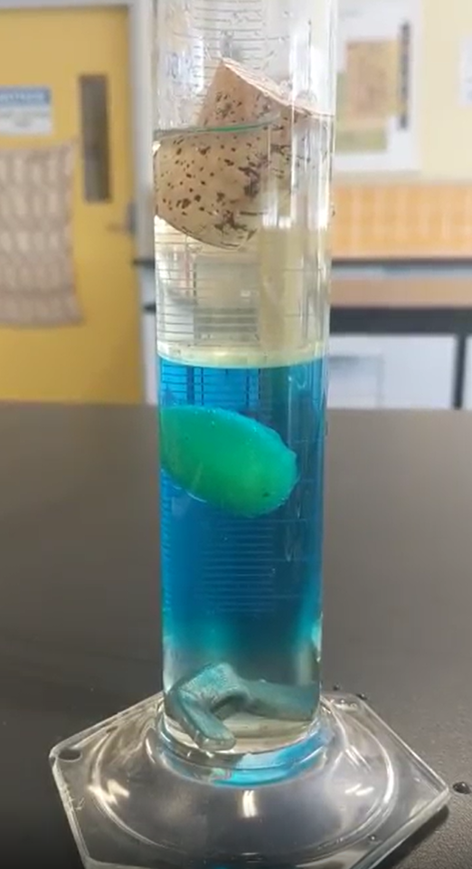
- As an optional activity, students can apply the previous observations and consider how the varied number of particles within a liquid affects the density and the behaviour by constructing a sugar density tower using the Student resource – density tower. Ensure students receive explicit guidance on how to measure their liquids carefully as directed.
Sample response: Student resource – density tower
Note: the stimulus material for Student resource – density tower has been removed from the sample response.
- Which of the beakers contains the most dense solution?
Beaker 1 is the most dense solution as it contains the most sugar in the solution.
- Which of the beakers contains the least dense solution?
Beaker 6 is the least dense as it contains no sugar.
- Consider the solutions and determine which order they should be poured into the measuring cylinder. Identify the order below.
The solutions should be added from most dense to least dense to reduce the mixing between the solutions. The order is beaker 1, 2, 3, 4, 5, 6.

Student resource – density tower
A density tower works because substances have different densities. Denser substances form the base of the tower, while less dense substances float on these layers.
Equipment list
- 600 mL water
- 70 g Sugar
- 5 × 50 mL beakers
- 1 × 100 mL measuring cylinder
- A few drops of food colouring (red, blue, green and yellow)
- 1 × electronic scale
Procedure
Examine Table 1 below closely. You will need to be precise in your measurements when preparing each solution for your tower.
Table 1 – Density column solutions
Beaker number | Amount of water (mL) | Amount of sugar (g) | Drops of food colouring
1 | 50 | 25 | 2 blue, 1 red
2 | 50 | 20 | 1 yellow, 1 red
3 | 50 | 15 | 2 green
4 | 50 | 10 | 2 yellow
5 | 50 | 5 | 2 blue
6 | 50 | 0 | 2 red
- Which of the beakers contains the most dense solution?
- Which of the beakers contains the least dense solution?
- Consider the solutions and determine which order they should be poured into the measuring cylinder. Identify the order below.
- Complete the diagram below, including labels of your final tower:
Figure 1 – density tower diagram
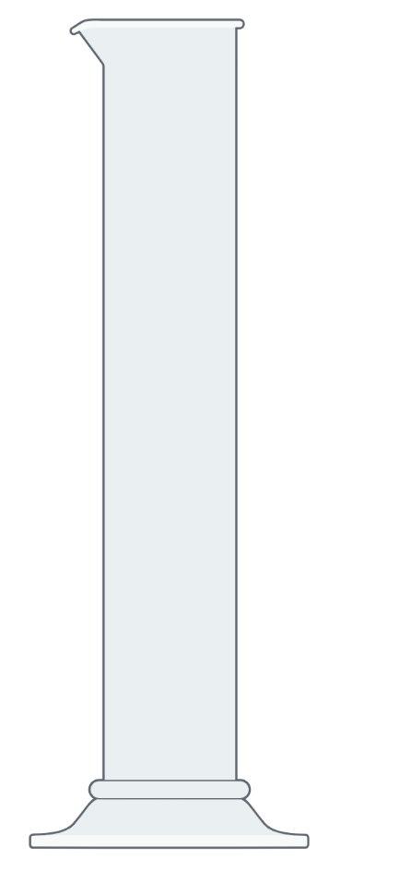
Image created in https://BioRender.com.
- Explain how the layers of the tower were created. Your response should list the layers in order and include the words ‘sugar’, ‘particles’ and ‘density’.

Buoyancy and density revisited
Note: this section allows for the concepts of buoyancy and density to be linked and the ideas from previous lessons to be consolidated.
- Revisit the descriptions of ‘buoyancy’ and ‘density’ provided in 1.3 Buoyancy and 1.4 Density. During a whole-class discussion, students provide reasoning for why objects float, showing the connection between density and buoyancy. Include highlighting the following points from SOL PPT ‘1.5 Buoyancy and density revisited’.
- Buoyancy is the upward force exerted by a fluid (a liquid or gas) on an object immersed in it, opposing the force of gravity.
- There are spaces between the particles in a substance.
- The larger the spaces between the particles of a substance, the lower its density.
- Students will apply their understanding to consolidate their learning through completion of Student resource – density and buoyancy data. This task includes analysing and interpreting various data, including graphs and tables, as well as performing density calculations.
Sample response: Student resource – density and buoyancy data
- What is the density of water? 1 g cm-3
- What is the density of blood? 2 g cm-3
- What is the density of methylated spirits? 0.8 g cm-3
- Which substance has the greatest density? Iron.
- Which substance has the lowest density? Apple.
- List the substances that would float on water. Explain your reasoning.
Ice, methylated spirits, cork and apple will float on water because their densities are lower than that of water.
- Which substance has the density closest to an object with a mass of 20 g and a volume of 7 cm³? Explain your answer.
$$ρ=\frac{m}{V}$$
$$ρ=\frac{20 g}{7 {cm}^{3}}$$
$$ρ={2.85 g cm}^{-3}$$
According to the graph, the substance closest to 2.85 g cm⁻³ is aluminium, which has a density of 3 g cm⁻³.
- Which substance has the density closest to an object with a mass of 9 g and a volume of 11 cm³? Explain your answer.
$$ρ=\frac{m}{V}$$
$$ρ=\frac{9 g}{11 {cm}^{3}}$$
$$ρ={0.81 g cm}^{-3}$$
The substance closest to 0.81 g cm⁻³ is methylated spirits or ice as both are approximately 0.8 g cm⁻³.
- Examine the picture of a ball and water in a beaker in Figure 2. Which of the substances from the graph in Figure 1 would most resemble the level of floatation of the ball?
As the ball floats on the water, its density is less than 1. The items in the graph with a density less than 1 are ice, cork and apple.
- Students conducted an investigation to test which objects float or sink in water. Their data is shown in Table 31.
Table 31 – investigation data testing if objects will float or sink in water
Object | Mass (g) | Volume (cm³) | Outcome (float or sink)
Coin | 5 | 1 | Sink
Rubber ball | 20 | 40 | Float
Piece of wood | 30 | 60 | Float
Piece of plastic | 10 | 15 | Float
Rock | 50 | 20 | Sink
Sponge | 8 | 40 | Float
- Use the data in Table 31 to calculate the density of each object and record it in Table 32.
Table 32 – calculating the density of each object
Object | Working including formula | Density (g cm⁻³)
Coin | $$ρ= \frac{m}{V}$$  $$ρ= \frac{5}{1}$$ | 5
Rubber ball | $$ρ= \frac{m}{V}$$  $$ρ= \frac{20}{40}$$ | 0.5
Piece of wood | $$ρ= \frac{m}{V}$$  $$ρ= \frac{30}{60}$$ | 0.5
Piece of plastic | $$ρ= \frac{m}{V}$$  $$ρ= \frac{10}{15}$$ | 0.6
Rock | $$ρ= \frac{m}{V}$$  $$ρ= \frac{50}{20}$$ | 2.5
Sponge | $$ρ= \frac{m}{V}$$  $$ρ= \frac{8}{40}$$ | 0.2
- Of the objects that floated, is there a pattern with their density?
All the objects that floated have a density less than 1 g cm⁻³. This means they all have a density lower than that of the liquid (water) they are floating on.
- Using the data, predict what would happen if a new object with density 1.1 g cm⁻³ was placed in water.
As the object has a density greater than 1, it would sink.

Student resource – density and buoyancy data
Use Figure 1 to answer the following questions.
Figure 1 – densities of common substances
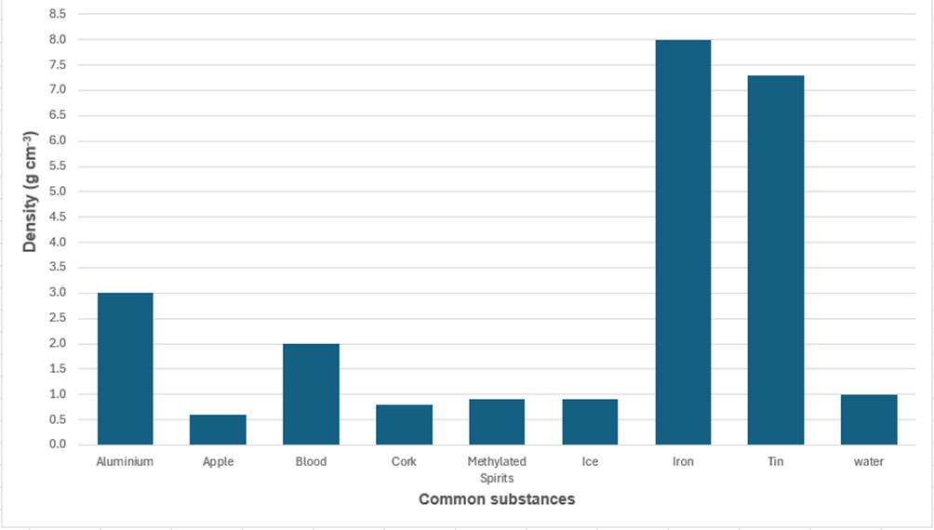
Source: graph generated from student investigation data
- What is the density of water? ______________________
- What is the density of blood? ___________________
- What is the density of methylated spirits? __________________
- Which substance has the greatest density? ______________________
- Which substance has the lowest density? _____________________
- List the substances that would float on water. Explain your reasoning.
- Which substance has the density closest to an object with a mass of 20 g and a volume of 7 cm³? Explain your answer.
- Which substance has the density closest to an object with a mass of 9 g and a volume of 11 cm³? Explain your answer.
- Examine the diagram of a ball and water in a beaker in Figure 2.
Figure 2 – a ball and water in a beaker
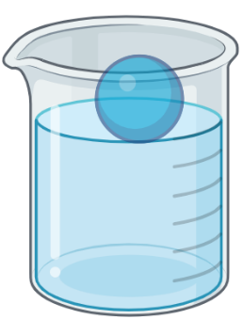
Image created in https://BioRender.com.
- Which of the substances in the graph most closely resembles the floatation level of the ball?
- Students conducted an investigation to test which objects float or sink in water. Their data is shown in Table 1.
Table 1 – investigation data testing if objects will float or sink in water
Object | Mass (g) | Volume (cm³) | Outcome (float or sink)
Coin | 5 | 1 | Sink
Rubber ball | 20 | 40 | Float
Piece of wood | 30 | 60 | Float
Piece of plastic | 10 | 15 | Float
Rock | 50 | 20 | Sink
Sponge | 8 | 40 | Float
- Use the data in Table 1 to calculate the density of each object and record it in Table 2.
Table 2 – calculating the density of each object
Object | Working including formula | Density (g cm⁻³)
Coin
Rubber ball
Piece of wood
Piece of plastic
Rock
Sponge
- Of the objects that floated, is there a pattern with their density?
- Using the data, predict what would happen if a new object with density 1.1 g cm⁻³ was placed in water.

1.6 Surface tension
Table 33 – learning intentions and success criteria for 1.6 Surface tension
We are learning: | I can:
- to describe the properties of substances | - define surface tension  - distinguish between adhesive and cohesive forces
- to plan a valid investigation | - identify the purpose of an investigation  - identify variables (independent, dependent and controlled)  - identify the type of data required for an investigation
- to safely follow a planned procedure. | - follow a planned procedure  - mitigate risks in an investigation  - collect qualitative data in an investigation.

Introducing surface tension
- Remind students about forces of attraction and the terms ‘attract’ and ‘repel’ (see also Forces focus area):
- ‘Repel’ means to push away.
- ‘Attract’ means to pull towards.
- Introduce the concept of ‘surface tension’ using SOL PPT ‘1.6 Introducing surface tension’ (4 slides), highlighting the following key points:
- Surface tension contributes to phenomena such as the shape of a drop of liquid, the formation of bubbles, the shape of a meniscus and for some organisms to be able to walk on water.
- Surface tension occurs due to cohesive forces of attraction between molecules within a liquid, which act in all directions and pull the molecules inward. This net inward attraction makes the liquid’s surface hard to penetrate, resulting in a thin ‘skin’ or layer that behaves like a stretched elastic membrane.
- Liquids will always try to form the most energy-efficient shape, the one that has the least surface area (for example, bubbles).
- The stronger the cohesive forces, the higher the surface tension.
- The forces on molecules at the surface of a liquid are not balanced. Molecules at the surface are held bound to neighbouring molecules (adjacent to them as well as below them in the liquid column). However, the surface molecules are not bound to air molecules above them. This causes the liquid’s surface to come together, creating surface tension.
- Adhesive forces occur between molecules of the liquid and other surfaces.
- When adhesive forces are stronger than cohesive forces, the liquid tends to spread on a surface. For instance, adding water to a glass creates adhesive bonds between water molecules and the glass. These adhesive forces are stronger than the cohesive forces holding the water molecules together, causing the water to spread across the surface. Conversely, when cohesive forces are stronger, the liquid forms droplets or a curved meniscus.
- The balance between cohesive and adhesive forces determines how a liquid interacts with different surfaces.
- Remind students that in Observing the Universe, they completed an investigation where they used pipe cleaners of different shapes to investigate how this affected the shapes of soap bubbles (see Observing the Universe TRB 1 – 1.9 From observation to questions). In that investigation, students found that regardless of the frame’s shape, bubbles always form spheres. Link this investigation to surface tension by explaining the mechanics of this to students using the points below:
- The bubbles will always form spherical shapes due to the surface tension of the soap film.
- This experiment demonstrates that the cohesive forces in the soap solution cause bubbles to adopt the most efficient shape, minimising surface area and forming spheres.
- Surface tension in the liquid pulls the surface particles together, forming the shape with the least surface area (a sphere).
- Use the checkpoint question below to revise variables in the context of an investigation to determine the effect of the shape of wire frames on bubble shape.
Checkpoint 1 (SOL PPT ‘1.6 Checkpoint 1’)
A student sets up the bubble‑blowing investigation with 3 different pipe-cleaner frames (circle, triangle, star) using the same bubble mixture. She blows bubbles through each shape and records her observations.
Identify the independent, dependent and controlled variables in this investigation.
The shape of the pipe‑cleaner frame Independent variable
Keeping the bubble mixture recipe the same Controlled variable
The bubble’s shape Dependent variable

Effect of surface tension – practical investigation
In this investigation, students will explore how surface tension affects the shape, size and movement of liquid droplets on different surfaces. Students will examine how the same liquid behaves on various surfaces, such as a glass slide, a waxed slide, copper and plastic. Through their observations, students will analyse how cohesive and adhesive forces influence the interactions between liquids and surfaces.
- Order the following equipment for each group of students:
- 1 × glass slide  - 1 × waxed glass slide  - 1 × 2 cm² piece of copper | - 1 × 2 cm² piece of plastic  - 1 × plastic dropper  - 1 × small beaker of water
Note: a regular glass slide can be waxed by rubbing its surface with a candle.
- Revise the terms ‘qualitative data’ and ‘quantitative data’ using SOL PPT ‘1.6 Types of data’.
Qualitative data is information that is not numerical and can include descriptions of features, characteristics or properties.
Quantitative data is information that can be expressed or measured numerically, such as chemical formulae or numbers.
Checkpoint 2 (SOL PPT ‘1.6 Checkpoint 2’)
Classify each of the following observations as qualitative or quantitative.
The salt dissolves completely in the water. Qualitative.
The concentration of the sugar solution is 10 g/L. Quantitative.
The sugar solution is clear and colourless. Qualitative.
The mixture appears cloudy. Qualitative.
The oil floats on top of the water. Qualitative.
The density of water is 1 g cm⁻³. Quantitative.
The solution took 45 seconds to become clear. Quantitative.
The vinegar has a strong, sour smell. Qualitative.
Carbon dioxide gas is denser than oxygen gas. Qualitative.
- Outline the investigation by reading through the method with students and highlighting that observations are to be qualitative and may include the shape and height of the droplets and how easily the liquid moves across the surfaces.
- Tell students they will be making qualitative observations of the shape and height of the droplets as it is difficult to measure these in a school lab. Unpack the reference guide for describing the water droplets (Table 1 in Student resource – effect of surface tension practical investigation) and show them photographs of droplets on 2 surfaces using SOL PPT ‘1.6 Effect of surface tension – practical investigation’.
- Students conduct the investigation and collect the qualitative data.
- Guide students in analysing their results and promote further understanding by addressing and discussing adhesive and cohesive forces.
- Guide students to understand that the interaction between a liquid and a surface depends on the balance between cohesive and adhesive forces. Diagrams and information have been included in Table 34 to support this discussion.
Table 34 – the relationship between water droplet size and shape and the cohesive and adhesive forces at work
Water droplet and surface interaction | Adhesive and cohesive forces
Droplets that are flatter or more spread out indicate stronger adhesive forces at the surface than cohesive forces within the liquid. Water molecules are more strongly attracted to the surface than to one another.
Adhesive forces > Cohesive forces
Droplets that are rounded (hemispherical) have relatively balanced adhesive and cohesive forces.
Adhesive forces ≈ Cohesive forces
Droplets that are more spherical have strong cohesive forces that pull water molecules tightly together. The droplet has less contact with the surface, indicating that the cohesive forces are much greater than the adhesive forces.
Adhesive forces < Cohesive forces
Sample response: Student resource – effect of surface tension practical investigation
- What is the purpose of this investigation?
To observe how the shape of water droplets changes on different surfaces.
- What are the independent, dependent and controlled variables in this investigation?
Independent variable: the surface types (glass, waxed glass, plastic and copper).
Dependent: the behaviour of the water droplet (shape, height, spread and movement).
Controlled: the amount of water in a droplet and how the droplet is applied to the surface (carefully with a plastic dropper).
- What type of data is being collected in this investigation?
Qualitative data (shape, relative height, relative spread and movement).
Table 35 – qualitative observations of water droplets on different surfaces (partial sample response)
Surface | Diagram | Droplet shape | Droplet height | Droplet movement
Glass |  | Flattened disc | Low, flat | Slow
Copper |  | Tall, spherical | High | Fast
Analysis
- Rank the droplet shape from most spherical to least spherical by surface type.
Copper, Waxed glass, Plastic and Glass.
Note: the order of droplet shapes may vary depending on the cleanliness and condition of each surface. For example, copper can form an oxide layer when exposed to air, which increases adhesion and causes water to spread more evenly. A clean, polished copper surface, however, may have lower adhesive forces and produce a more rounded droplet. Small differences in surface texture, contamination (such as oil or dust) or temperature can also affect how easily water spreads or adheres.
- On which surface were there the greatest adhesive forces between the water and the surface? Justify your response.
The strongest adhesive forces were observed on the glass slide when the droplet was small and flat, suggesting that water molecules had a strong affinity for the glass. When the slide was tilted, the water temporarily adhered to it before gradually sliding off. This demonstrates a strong adhesion between the water molecules and the glass.
- On which surface were the cohesive forces between the water molecules greater than the adhesive forces?
The cohesive forces were greater than the adhesive forces on the copper surface. This is shown by the water droplet sitting tall and round, rather than spreading out like on glass. Additionally, the droplet rolled off the copper rapidly when the surface was tilted.
Note: answers may vary, as more than one surface may have tall, spherical droplets that slide off quickly, indicating that the cohesive forces on that surface are greater than those on the others.

Student resource – effect of surface tension practical investigation
Have you ever noticed how raindrops bead up on a raincoat but spread out across your skin? This happens because of how water molecules interact with one another and with different materials.
Water molecules are strongly attracted to one another – this is called ‘cohesion’. Cohesive forces make water droplets hold together in a rounded shape. Water molecules can also be attracted to other materials – this is called ‘adhesion’. Adhesive forces make water spread out or ‘stick’ to a surface.
The balance between adhesion and cohesion determines the shape, size and movement of a water droplet. In this investigation, you will observe how water behaves on a range of surfaces and describe how the forces of adhesion and cohesion affect the results.
- What is the purpose of this investigation?
- What are the independent, dependent and controlled variables in this investigation?
- What type of data is being collected in this investigation?
Equipment list
- 1 × glass slide  - 1 × waxed glass slide  - 1 × 2 cm² piece of copper | - 1 × 2 cm² piece of plastic  - 1 × plastic dropper  - 1 × small beaker of water
Procedure
- Using the plastic dropper, place a drop of water onto the glass slide.
- Observe the shape, height and spread of the droplet and use Table 1 as a guide to describe the droplet shape, height and spread. Record the observations in Table 3
- Tilt the slide and observe how easily the droplet moves. Record the observations in Table 3.
- Repeat steps 1 to 3 using the other surfaces (waxed slide, copper and plastic).
Table 1 – reference guide for describing water droplets
Feature | Descriptor
Shape | - Rounded or dome  - Curbed or rounded  - Flat, spread out or disc shape
Height | - High  - Medium  - Low
Spread | - Small area  - Medium area  - Large area
Movement | - Fast (the droplet quickly slid off the surface)  - Slow (the droplet slowly rolled across the surface)  - Sticks firm (the droplet does not move)
Note: you can use other descriptive words to describe the shape, height, spread and movement of the droplets.
Risk management
Table 2 – risk assessment
Hazard | Risk | Management
Spilled liquid | Someone may slip on the spilled liquid and injure themselves. | - Maintain a clear workspace.  - Clear up any spills as soon as they happen.  - Always be observant.
Broken glass | Someone may cut themselves on broken glass. | - Maintain a clear workspace.  - Notify the teacher for assistance with clearing up any breakages as soon as they happen.  - Always be observant.
Results
Table 3 – qualitative observations of water droplets on different surfaces
Surface | Diagram | Droplet shape | Droplet height | Droplet movement
Glass
Waxed glass
Plastic
Copper
Analysis
- Rank the droplet shape from most spherical to least spherical by surface type.
- On which surface were there the greatest adhesive forces between the water and the surface? Justify your response.
- On which surface were the cohesive forces between the water molecules greater than the adhesive forces?

Reducing surface tension – practical investigation
In this investigation, students explore how adding dishwashing liquid reduces the surface tension of water. By carefully placing a paperclip on the water’s surface, they observe how surface tension allows it to float. When dishwashing liquid is added, it disrupts the cohesive forces between water molecules, reducing surface tension and causing the paperclip to sink. This investigation helps students understand how surface tension can be changed by adding different substances and connects to a real-world example.
- Watch This Is Why Water Striders Make Terrible Lifeguards | Deep Look (3:33) and discuss with students how water tension is beneficial for water striders. Read through the text in the Student resource – reducing surface tension practical investigation. Discuss why surface tension is important for the survival of water insects and how changes in the surface tension can disrupt the food chain.
- Discuss the purpose of an investigation and ask students to propose the aim of this investigation. Students should set an aim, such as ‘To observe how the addition of dishwashing liquid affects the surface tension of water’.
- Outline the investigation by highlighting the following:
- It is possible to add substances to water that reduce surface tension.
Note: it is important to emphasise the word ‘reduce’ here rather than ‘remove’ to avoid misconceptions.
- Student observations are to be qualitative and will describe the position of the paperclip before and after the addition of dishwashing liquid.
- Outline the experimental procedure in the Student resource – reducing surface tension practical investigation.
- Students conduct the investigation and collect qualitative data on the effect of adding dishwashing detergent to the surface tension of the water.
Differentiation: provide support by offering students sentence starters and frames (listed below) to help structure and guide their recorded observations.
‘Before the soap was added, the paperclip was ___.’
‘After the soap was added, the paperclip ___.’
- Guide students in analysing their results and promote further understanding by addressing and discussing the questions in the Student resource – reducing surface tension practical investigation.
Sample response: Student resource – reducing surface tension practical investigation
Note: stimulus material has been removed from the sample response.
Aim
To observe the impact of detergent on the surface tension of water.
Analysis
- What happened to the paperclip when the dishwashing liquid was added? Describe your observations.
The paperclip was able to float on the surface of the water until the detergent was added. The paperclip quickly sank to the bottom of the beaker after the detergent was added.
- How does this investigation demonstrate the effect of dishwashing liquid on surface tension?
When dishwashing liquid is added, it reduces the water’s surface tension, weakening the force that holds the paperclip on the surface. As a result, the paperclip sinks, showing how dishwashing liquid disrupts the water’s surface tension.
- Why was the paperclip able to float on the water before the dishwashing liquid was added?
The paperclip was able to float on the water before the dishwashing liquid was added because of surface tension. Surface tension is a force that acts on the surface of a liquid, causing the molecules at the surface to stick together and form a ‘skin’. The weight of the paperclip is spread out over the surface area of the water, allowing it to float without sinking.
- What forces were acting on the paperclip before and after the dishwashing liquid was introduced?
The paperclip was affected by attractive forces (both cohesive and adhesive) and gravity, both before and after adding dishwashing liquid. Before the dishwashing liquid was added, the cohesive forces between water molecules created surface tension that was strong enough to support the paperclip. Adhesive forces between the water and the paperclip also helped keep it afloat. Once the dishwashing liquid was introduced, it disrupted these cohesive forces, weakening the surface tension. As a result, the paperclip could no longer be supported and sank due to gravity.
- Outline one reason surface tension is important to understand.
Students may respond with a variety of reasons, for example:
- If chemicals that pollute waterways reduce the surface tension, this can disrupt the food chain because water insects will be unable to walk on the surface.
- Surface tension affects how sprays work (for example, pesticide sprayers and perfume bottles). Adjusting the surface tension of a liquid changes how they behave.
- Explain how a population of water striders may be impacted if a pond where they live became polluted with detergent.
Pollution of a pond with detergent can have a serious impact on the population of water striders. Water striders rely on the surface tension of water to ‘walk’ across its surface.
Detergents are designed to reduce surface tension. When detergent enters the pond, it breaks down the cohesive forces between water molecules, weakening or even eliminating the surface tension. As a result, water striders can no longer remain on top of the water. They may sink, struggle to move or drown.
If water striders can no longer use the pond’s surface, their ability to feed, breed and avoid predators will be severely impacted. This could lead to a decline in their population or even local extinction if the pollution is severe or long-lasting. Additionally, this change could affect the pond ecosystem, as water striders are both predators (feeding on insects) and prey (for birds and other animals).

Student resource – reducing surface tension practical investigation
Surface tension is caused by water molecules attracting one another, forming a tight film at the water’s surface. This layer can support small insects, such as water striders, allowing them to stand and move across ponds and streams without sinking.
Many aquatic insects rely on surface tension to hunt, escape predators and lay eggs. Their light bodies and water-repellent legs help them stay on the water’s surface.
Some pollutants, including detergents, oils and certain pesticides, reduce surface tension by interfering with the attraction between water particles. When surface tension is reduced, the water surface becomes weaker, making insects more likely to sink and drown. This can reduce insect populations and disrupt food webs, affecting fish, birds and other animals that depend on insects for food. Protecting water quality is therefore important not only for chemical safety, but also for maintaining the physical properties of water that many organisms rely on to survive.
In this investigation, you will use a paperclip to model an insect and see how detergent affects its ability to sit on the surface of water.
Aim
Equipment list
- 1 × 250 mL beaker  - 200 mL distilled water  - 1 × paperclip | - 5 mL dishwashing liquid  - 1 × plastic dropper
Variables
Independent variable: the presence or absence of detergent in the water.
Dependent variable: surface tension (whether the paperclip can sit on the surface or not).
Controlled variables:
- Distilled water is used.
- The same paperclip is used.
- The same method of placing the paperclip gently onto the water is used.
Procedure
- Fill a beaker with 200 mL of distilled water.
- Carefully place the paperclip into the beaker so that it floats on the surface of the water.
- Using the plastic dropper, carefully add a drop of dishwashing liquid to the surface of the water.
- Record your observations.
Analysis
- What happened to the paperclip when the dishwashing liquid was added? Describe your observations.
- How does this investigation demonstrate the effect of dishwashing liquid on surface tension?
- Why was the paperclip able to float on the water before the dishwashing liquid was added?
- What forces were acting on the paperclip before and after the dishwashing liquid was introduced?
- Outline one reason surface tension is important to understand.
- Explain how a population of water striders may be impacted if a pond where they live became polluted with detergent.

Evidence base
This resource contains NSW Curriculum and syllabus content. The NSW Curriculum is developed by the NSW Education Standards Authority (NESA). This content is prepared by NESA for and on behalf of the Crown in right of the State of New South Wales. The material is protected by Crown copyright.
Please refer to the NESA Copyright Disclaimer for more information https://www.nsw.gov.au/education-and-training/nesa/copyright.
NESA holds the only official and up-to-date versions of the NSW Curriculum and syllabus documents. Please visit NESA https://www.nsw.gov.au/education-and-training/nesa and NSW Curriculum https://curriculum.nsw.edu.au.
Science 7–10 Syllabus © NSW Education Standards Authority (NESA) for and on behalf of the Crown in right of the State of New South Wales, 2023.
Australian Academy of Science (n.d.) ‘Alternative conceptions’, Changing substances, Primary Connections website, accessed 20 April 2026.
Bruce C (n.d.) ‘Melting and Boiling Simulation’, SimBucket Science Simulations, PBS Learning Media website, accessed 9 October 2025.
CESE (Centre for Education Statistics and Evaluation) (2020) What works best 2020 update, NSW Department of Education, accessed March 2025.
——(2020) What works best in practice, NSW Department of Education website, accessed March 2025.
——(2021) Growth goal setting – what works best in practice, NSW Department of Education website, accessed March 2025.
Education Services Australia Ltd. (2016) Types of matter: Solids, liquids and gases, Scootle website, accessed 14 October 2025.
NESA (NSW Education Standards Authority) (2025) ‘Glossary’, Science 7–10 Syllabus 2023, NSW Curriculum website, accessed 10 April 2026.
Next Generation Science (11 March 2025) ‘Heating Matter and Changes in State’ [video], Next Generation Science, YouTube, accessed 10 March 2025.
NSW Department of Education (n.d.) ‘Search result for: lead*’, Appendix D chemicals research, Chemical Safety in Schools, NSW Department of Education website, accessed March 2025.
Tatar E (2011) ‘Prospective Primary School Teachers’ Misconceptions about States of Matter’, Educational Research and Reviews, 6(2):197–200, accessed 14 October 2025.
TED-Ed (7 September 2012) ‘How taking a bath led to Archimedes’ principle - Mark Salata’ [video], TED-Ed, YouTube, accessed 10 March 2025.
Wiliam D (2017) Embedded Formative Assessment, 2nd edn, Solution Tree Press, Bloomington, IN.

© State of New South Wales (Department of Education), 2026
The copyright material published in this resource is subject to the Copyright Act 1968 (Cth) and is owned by the NSW Department of Education or, where indicated, by a party other than the NSW Department of Education (third-party material).
Copyright material available in this resource and owned by the NSW Department of Education is licensed under a Creative Commons Attribution 4.0 International (CC BY 4.0) license.

This license allows you to share and adapt the material for any purpose, even commercially.
Attribution should be given to © State of New South Wales (Department of Education), 2026.
Material in this resource not available under a Creative Commons license:
- the NSW Department of Education logo, other logos and trademark-protected material
- material owned by a third party that has been reproduced with permission. You will need to obtain permission from the third party to reuse its material.
Links to third-party material and websites
Please note that the provided (reading/viewing material/list/links/texts) are a suggestion only and implies no endorsement, by the New South Wales Department of Education, of any author, publisher, or book title. School principals and teachers are best placed to assess the suitability of resources that would complement the curriculum and reflect the needs and interests of their students.
If you use the links provided in this document to access a third-party's website, you acknowledge that the terms of use, including licence terms set out on the third-party's website apply to the use which may be made of the materials on that third-party website or where permitted by the Copyright Act 1968 (Cth). The department accepts no responsibility for content on third-party websites.

