Science Stage 4 (Year 7) – sample assessment task
Solutions and mixtures
Creation date: 18 August 2025

Contents
About this assessment task 2
Purpose of the resource 2
When and how to use 2
Assessment task notification 3
Task description 3
Solutions and mixtures examination 4
Part A 5
Part B 9
Evidence base 14

About this assessment task

Purpose of the resource
This assessment task is linked to the learning in the Solutions and mixtures program of learning for Stage 4 students. The task is designed to assess students’ understanding of separation techniques, skills in planning and conducting scientific investigations and problem solving.

When and how to use
This assessment task should be delivered after completing the Solutions and mixtures unit of work. Allow 60 minutes for students to complete their responses.
Part A of the task assesses students’ ability to plan an investigation and apply problem-solving skills to suggest improvements to a presented method. Students are required to design a method to separate a mixture of 3 substances, using a flowchart at first, and then produce a complete written procedure from their flowcharts.
Part B of the task is a series of written questions that assess the Solutions and mixtures content.
The assessment is worth 40 marks overall, with 20 marks each allocated to Part A and Part B.
Note: the sample responses for this task are available on the Science statewide staffroom SharePoint (staff only). To access this resource, you will need to be a member of the Science statewide staffroom or contact the science curriculum team at science7-12@det.nsw.edu.au.
The Common Grade Scale can be used to report student achievement in both primary and junior secondary years in all NSW schools.
When grading students’ level of achievement in Stage 4, refer to the course performance descriptors. Course performance descriptors provide holistic descriptions of typical achievement at different grade levels in a specific course.

Assessment task notification
Name of task: Solutions and mixtures examination
Type of task: examination
Weighting: [the weight of the assessment task is a school-based decision].
Submission details: [schools complete this section – include any important details about submission, format of the task, word limits, and submission procedures]
Outcomes:
A student:
- explains how the properties of substances enable separation in a range of techniques
SC4-SOL-01
- plans safe and valid investigations SC4-WS-03
- identifies problem-solving strategies and proposes solutions SC4-WS-07
Science 7–10 Syllabus © NSW Education Standards Authority (NESA) for and on behalf of the Crown in right of the State of New South Wales, 2023.

Task description
In this task you will complete examination-style questions on the solutions and mixtures focus area.
The assessment has 2 parts that contribute to the total mark:
- Part A (20 marks) – planning investigations and problem-solving
- Part B (20 marks) – knowledge and understanding of the Solutions and mixtures topic
You should ensure you have the following equipment for the task:
- pen and/or pencil
- calculator.

Solutions and mixtures examination
Name |  | Class
Instructions
- Read the question carefully before responding.
- Complete all questions.
- You will need a calculator and a pen.
- You have [teacher to insert time] minutes to complete the task.
- [teacher to insert any other appropriate instructions].

Part A (20 Marks)
Read carefully through the following scenario before responding to the questions in Part A.
A group of students were given a mixture of sand, iron filings and salt in their science laboratory and asked to separate the 3 substances from each other.
- Construct a flowchart to identify the steps the students could use to separate their mixture. (4 marks)
- Complete the following table to identify the physical property used in each of the following separation techniques that the students decided to use. (3 marks)
Separation technique | Physical property of the material that is used for the separation
magnetic separation
filtration
evaporation
- Write a scientific method for the separation of the components of the students’ mixture:
- List all of the equipment required to separate the mixture. (2 marks)

- Outline the procedure (3 marks)
- Identify 2 hazards in this investigation and outline risks and management strategies in the table. (2 marks)
Hazard | Risk | Management

- After successfully separating the materials in the mixture, the students measured the masses of each of the substances they extracted. They measured the mass of each substance on some filter paper, but also recorded the separate mass of each filter paper used. Their results are shown in the table below.
- Determine the net mass of each substance extracted and record in the appropriate column (show all working in the table). (2 marks)
Substance | Mass of separated substance on filter paper (g) | Mass of clean dry filter paper (g) | Net mass of separated substance (g)
iron filings | 18.9 | 0.4
sand | 24.9 | 0.4
salt | 20.2 | 0.4
- The students were then told that the original mixture was composed of 20 g of each of iron filings, sand and salt. Suggest reasons for any differences between the net masses calculated in the table above. (4 marks)

Part B (20 Marks)
- Draw particles to represent the states of matter in each of the sealed containers below. (3 marks)
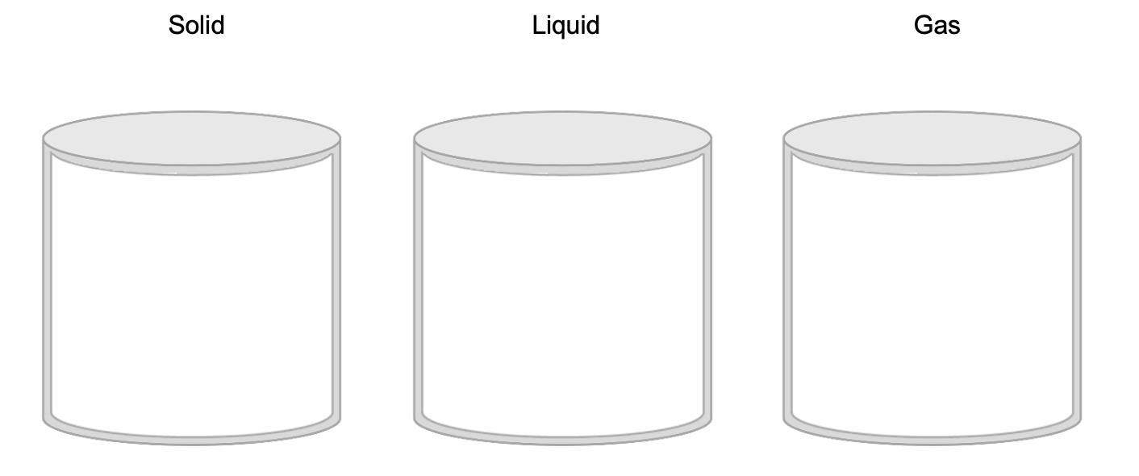
- Match each of these changes of state to the correct scientific term. The first example has been completed for you. There is one extra term that does not match. (2 marks)
Change from solid to liquid
Change from gas to liquid
Sublimation
Condensation
Melting
Change from solid to gas
Boiling

- Read the information below and answer the questions 3a and 3b.
Aboriginal Peoples used a 2-step process to separate native grains from their husks. The husk and grain occur together, forming a natural mixture. The first step loosened the grains from their husks. The second step was winnowing, where the mixture was tossed into the air. The wind carried away the lighter husks while the heavier grains fell back to the ground. This demonstrates a deep understanding of the physical properties of the materials being separated.
- Using the information from the text, explain how the properties of grains and husks help them to be separated through winnowing when the wind blows. (2 marks)
- Could you use winnowing to separate a mixture of sand and salt? Explain your reasoning. (3 marks)

- Sally wanted to make some sugar syrup by mixing sugar and water.
- Identify the solute, solvent and solution. (3 marks)
solute
solvent
solution
- Sally observes that some of the sugar she added to the syrup mixture did not dissolve, no matter how much she stirred the mixture. Explain how she could get more sugar to dissolve in the water. (2 marks)

- The graph below outlines temperature changes over time as a beaker is heated over a Bunsen burner. Initially, the beaker contained ice cubes, and the temperature was 0°C.
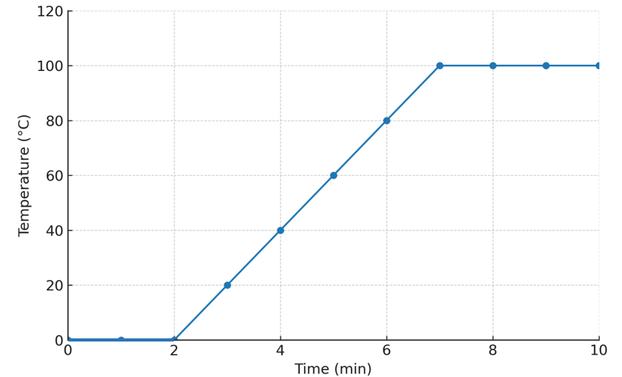
This work has been generated using artificial intelligence. Any copyright subsisting in this work is owned by © State of New South Wales (Department of Education) 2025.
- Outline what is happening to the ice in the beaker between 0 and 2 minutes. Refer to the graph and particle theory in your answer. (3 marks)
- Describe the trends in the graph between 2 and 10 minutes. (2 marks)

Evidence base
This resource contains NSW Curriculum and syllabus content. The NSW Curriculum is developed by the NSW Education Standards Authority. This content is prepared by NESA for and on behalf of the Crown in right of the State of New South Wales. The material is protected by Crown copyright.
Please refer to the NESA Copyright Disclaimer for more information https://educationstandards.nsw.edu.au/wps/portal/nesa/mini-footer/copyright.
NESA holds the only official and up-to-date versions of the NSW Curriculum and syllabus documents. Please visit the NSW Education Standards Authority (NESA) website https://educationstandards.nsw.edu.au and the NSW Curriculum website https://curriculum.nsw.edu.au.
Science 7–10 Syllabus © NSW Education Standards Authority (NESA) for and on behalf of the Crown in right of the State of New South Wales, 2023.
Australians Together (n.d.) Separating mixtures – Student Handout 1, accessed 21 July 2025, https://australianstogether.org.au/assets/Curriculum-Resources/Y7-Science-ACSSU113-ACSHE223-120-121-ACSIS125-Separating-mixtures-Student-Handout-1.pdf
Cane S (1987) ‘Australian Aboriginal subsistence in the Western desert’, Human Ecology, 15:391–434, https://doi.org/10.1007/BF00887998.
CESE (Centre for Education Statistics and Evaluation) (2020) What works best: 2020 update, NSW Department of Education, accessed 18 July 2024.
——(2020) What works best in practice, NSW Department of Education, accessed 18 July 2024.
——(2021) Growth goal setting – what works best in practice, NSW Department of Education, accessed 18 July 2024.
Griffin P (2017) Assessment for Teaching, Cambridge University Press, Port Melbourne, Victoria.
Hattie J and Timperley H (2007) ‘The Power of Feedback’, Review of Educational Research, 77(1): 81–112, doi:10.3102/003465430298487, accessed 15 July 2024
Sherrington T (2019) Rosenshine’s Principles in Action, John Catt Educational Limited, Melton, Woodbridge.
Wiliam D (2017) Embedded Formative Assessment, 2nd edn, Solution Tree Press, Bloomington, IN.
© State of New South Wales (Department of Education), 2025
The copyright material published in this resource is subject to the Copyright Act 1968 (Cth) and is owned by the NSW Department of Education or, where indicated, by a party other than the NSW Department of Education (third-party material).
Copyright material available in this resource and owned by the NSW Department of Education is licensed under a Creative Commons Attribution 4.0 International (CC BY 4.0) license.

This license allows you to share and adapt the material for any purpose, even commercially.
Attribution should be given to © State of New South Wales (Department of Education), 2025.
Material in this resource not available under a Creative Commons license:
- the NSW Department of Education logo, other logos and trademark-protected material
- material owned by a third party that has been reproduced with permission. You will need to obtain permission from the third party to reuse its material.
Links to third-party material and websites
Please note that the provided (reading/viewing material/list/links/texts) are a suggestion only and implies no endorsement, by the New South Wales Department of Education, of any author, publisher, or book title. School principals and teachers are best placed to assess the suitability of resources that would complement the curriculum and reflect the needs and interests of their students.
If you use the links provided in this document to access a third-party's website, you acknowledge that the terms of use, including licence terms set out on the third-party's website apply to the use which may be made of the materials on that third-party website or where permitted by the Copyright Act 1968 (Cth). The department accepts no responsibility for content on third-party websites.

