Science Stage 4 – Periodic table and atomic structure
Teacher resource book 1 of 2 (TRB1)
1. How can we describe and classify matter?
Creation date: 20 March 2026
Contents
Overview 2
Glossary 2
1.1 Classifying matter 5
Elements, compounds and mixtures 5
Student resource – elements 7
Properties of elements 7
Student resource – physical properties of elements 11
1.2 Physical properties of elements 13
Physical properties of metals, non-metals and metalloids – a secondary source investigation 13
Student resource – physical properties of metals, non-metals and metalloids – a secondary source investigation 17
Investigating electrical conductivity 19
Student resource – investigating electrical conductivity 24
1.3 Properties and uses of materials 27
Alloys 27
Student resource – alloys 31
The properties of elements, compounds and alloys and their uses 34
Student resource – properties and uses of materials 42
1.4 Thermal conductivity investigation 47
Investigating the thermal conductivity of metals 47
Student resource – investigating thermal conductivity 52
Evidence base 58

Overview
Stage and learning area: Stage 4 Science
Description: this resource complements the Periodic table and atomic structure program of learning. It aims to serve as a teacher reference, offering practical strategies and ideas to enrich teaching practices and create engaging learning environments. The activities should be adapted to suit the needs of students.
Duration: while timing will vary based on the mode of delivery, the differentiation strategies employed and class or school context, this series of activities should take approximately 9 hours.
Risk management: teachers are advised to undertake a risk assessment before conducting any classroom investigation or experiment. For more information on developing risk assessments, see Risk Assessment – a pre-requisite for risk control.
This resource book elaborates on many of the activities in the Periodic table and atomic structure sample program of learning. Some activities also reference the Periodic table and atomic structure slide deck (identified as PRT PPT throughout this document).

Glossary
Tier 3 words are those that are relevant for subject-specific content. More information is provided in the ‘Vocabulary in context’ document found on the Stage 4 reading – Vocabulary in context page. A glossary containing Tier 3 vocabulary related to the essential questions ‘How can we describe and classify matter?’ and ‘How can we demonstrate the similarities and differences between atoms?’ has been provided below. The Guide for planning and implementing explicit vocabulary instruction can be used by teachers across all curriculum areas.
Table 1 – glossary of key terms for Periodic table and atomic structure TRB1
Term | Definition
Alloy | A substance composed of 2 or more metals (or, sometimes, a metal and a nonmetal) mixed together (NESA 2023).
Atom | The smallest particle that makes up matter.
Atomic number | The number of protons in the nucleus of an atom; used to order the chemical elements in the periodic table (NESA 2023).
Compound | A substance containing 2 or more atoms of different elements bonded together in a fixed ratio (NESA 2023).
Conduction | The transfer of heat or electricity through a substance or between substances that are in direct contact with each other (NESA 2023).
Element | One of a class of substances which consists entirely of atoms of the same atomic number, and which cannot be further divided by chemical methods (NESA 2023).
Matter | A physical substance; anything that has mass and occupies space (NESA 2023).
Metal | A shiny, often hard, substance characterised by high electrical and thermal conductivity.
Metalloid | An element that has properties intermediate between those of metals and nonmetals, such as arsenic and silicon (NESA 2023).
Period | Horizontal row on the periodic table of elements indicating energy levels.
Periodic table | A table in which all the known chemical elements are arranged in rows and columns so that elements with similar chemical properties lie in the same column (NESA 2023).
Qualitative | To use descriptive explanations involving features, characteristics or properties to identify important components. Data and information that is not numerical in nature (NESA 2023).
Quantitative | Data or components that can be expressed or measured numerically, including chemical formulae or numbers (NESA 2023).
Subatomic | Denoting a particle which is smaller than an atom (NESA 2023).
Thermal | Properties or phenomena associated with heat, temperature, or the transfer of energy due to temperature differences (NESA 2023).

1.1 Classifying matter
Table 2 – learning intention and success criteria for ‘1.1 Classifying matter’
We are learning: | I can:
- to identify the common physical properties of elements and relate them to their uses. | - distinguish between an element, a compound and a mixture  - annotate a periodic table to distinguish between metals, non-metals and metalloids  - describe the physical properties of elements  - identify commonly used elements and relate their use to their physical properties.

Elements, compounds and mixtures
- Activate prior knowledge by displaying PRT PPT ‘1.1 Properties of matter’ to revise the properties of elements, compounds and mixtures from the Solutions and mixtures focus area.
- Display PRT PPT ‘1.1 Element, compound or mixture?’ and ask students to distinguish between elements, compounds and mixtures using the examples on the slide.
Checkpoint: display PRT PPT ‘1.1 Checkpoint’ to check students' understanding of the following key terms:
- atoms – the smallest particles that make up matter
- heterogeneous – a mixture that is not uniform in composition
- homogeneous – a mixture that is uniform in composition
- pure substance – a substance made up of only one type of particle or having a fixed ratio of particles
- mixture – a combination of 2 or more different substances that are combined physically, not chemically.
- Use PRT PPT ‘1.1 Periodic table of elements’ and tell students that:
- an element is ‘One of a class of substances which consists entirely of atoms of the same atomic number, and that cannot be further divided by chemical methods’ (NESA 2023).
- all known elements are summarised in the periodic table of elements
- there are only 92 naturally occurring elements in the universe and the majority of matter exists as compounds and mixtures
- all elements above uranium are man-made
- every material we know is made up of one or more of these elements.
- Students complete the Frayer diagram on the term ‘element’ in Student resource – elements, given the NESA definition of an ‘element’. A sample response is provided in PRT PPT ‘1.1 Elements Frayer diagram (sample response)’.
Sample response: Student resource – elements
- Complete the following Frayer diagram on elements.
Figure 1 – ‘elements’ Frayer diagram (sample response)
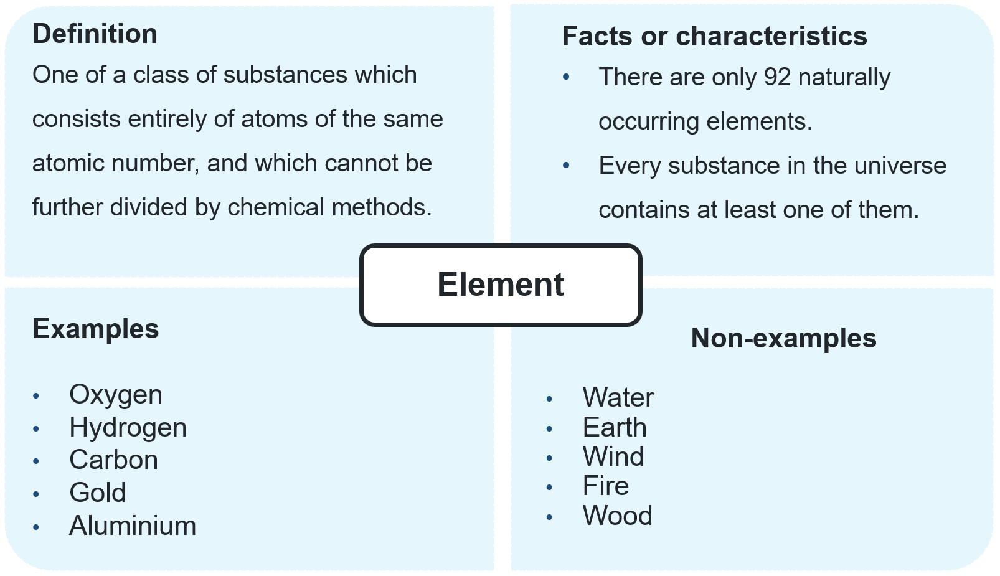

Student resource – elements
- Complete the following Frayer diagram on elements.
Figure 1 – ‘elements’ Frayer diagram
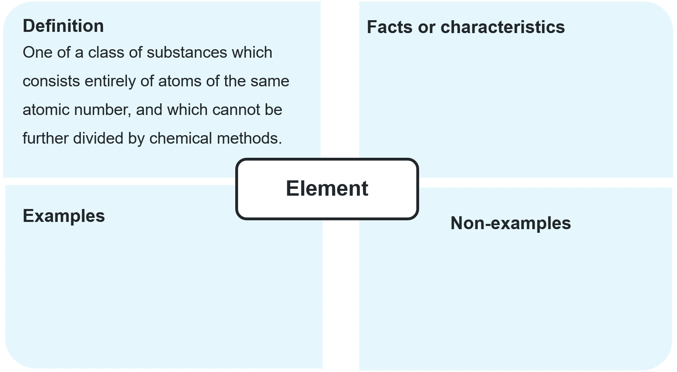

Properties of elements
- Provide students with a copy of the periodic table from the Data Book: Science 7–10 and provide the following instructions:
- Construct a key to identify metals, non-metals and metalloids in the blank space on the page.
- Number each column from 1 to 18. These are called ‘groups’. Students will need to pay attention to the group number to know how to colour their periodic table throughout the next steps in the activity.
- Present PRT PPT ‘1.1 Properties of elements’ (5 slides) while guiding students to:
- complete Table 1 in Student resource – physical properties of elements by writing a brief description of each property (column 2).
Differentiation: provide support by giving students a partially completed table that includes every second description and alternate examples.
- colour the metals, non-metals and metalloids on their periodic table according to the instructions in the slide notes.
- Display PRT PPT ‘1.1 Location of metals, non-metals and metalloids’ and support students to colour the remaining sections of their periodic table according to the key they developed. Provide additional context to the properties of metals, non-metals and metalloids:
- metals are elements that are generally shiny, malleable, ductile, and good conductors of heat and electricity. Most elements in the periodic table are metals. They are mostly solid at room temperature, except for mercury, which is liquid. Metals are located on the left and centre of the periodic table, including alkali metals, alkaline earth metals, transition metals and post-transition metals
- non-metals are elements that are usually dull, brittle (if solid), and poor conductors of heat and electricity. There are only 17 naturally occurring non-metals in the periodic table. Non-metals can exist in solid, liquid or gaseous states at room temperature. Non-metals are found on the right side of the periodic table, except for hydrogen, which is a non-metal, despite being placed in group 1.
- metalloids are elements with intermediate properties between metals and non-metals. They can behave as either metals or non-metals, depending on the reaction, and are often semiconductors, making them useful in electronics. Metalloids are located along the zigzag line that separates metals and non-metals, starting from boron (B) to polonium (Po).
- Lead a discussion about the uses of elements in everyday life and how they relate to their physical properties. Examples have been provided in the Sample response: Student resource – properties of elements. Students should complete column 3 of Table 1 in the Student resource – physical properties of elements throughout the discussion.
Sample response: Periodic table annotations
Note: the periodic table does not appear in the student resource. It should be provided in the Data Book: Science 7–10.
Figure 1 – periodic table showing metals, non-metals and metalloids
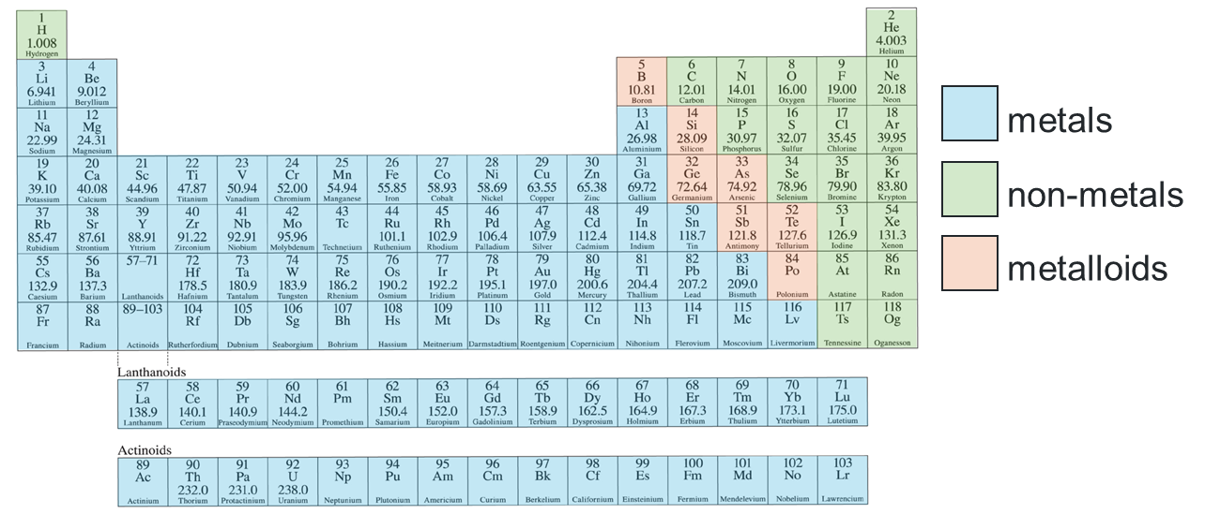
This image has been adapted from Data Book: Science 7–10 from Science 7–10 Syllabus (2023) by NESA.
Sample response: Student resource – physical properties of elements
Complete Table 1 by summarising the information delivered by the teacher to:
- write a brief description of each physical property
- provide an example of a use of an element that relies on the property identified.
Table 1 – physical properties of elements (sample response)
Property | Description | Example (and use)
Physical state | The physical state of an element, whether if it is a solid, liquid or gas, is determined under standard atmospheric pressure and temperature. | Helium is a gas at standard atmospheric pressure, which makes it useful for party balloons because it is lighter than other gases in the air.
Lustre | If an element is shiny when polished, it is said to have lustre. | Gold is lustrous and is used in jewellery.
Malleability | If the element can be hammered into sheets, it is said to be malleable. | Aluminium can be hammered and rolled into very thin sheets without breaking, making it suitable for foil.
Ductility | If the element can be drawn into wires, it is said to be ductile. | Copper is ductile and is used in electrical wiring and cables.
Thermal conductivity | The transfer of heat through a substance or between substances that are in direct contact with each other. | Copper has high thermal conductivity and is used in cooking pots.
Electrical conductivity | The transfer of electricity through a substance or between substances that are in direct contact with each other. | Copper has high electrical conductivity and is used in electrical wiring.
Melting point | The temperature at which a substance transitions from a solid phase to a liquid phase under standard atmospheric pressure. | Tungsten has a high melting point and is used as a filament in light bulbs.
Boiling point | The temperature at which a substance transitions from a liquid phase to a gas phase under standard atmospheric pressure. | Mercury has a high boiling point and has been used in thermometers in the past because it remains a liquid over a large temperature range.

Student resource – physical properties of elements
Complete Table 1 by summarising the information delivered by the teacher to:
- write a brief description of each physical property
- provide an example of a use of an element that relies on the property identified.
Table 1 – physical properties of elements
Property | Description | Example (and use)
Physical state
Lustre
Malleability
Ductility
Thermal conductivity
Electrical conductivity
Melting point
Boiling point

1.2 Physical properties of elements
Table 3 – learning intentions and success criteria for ‘1.2 Physical properties of elements’
We are learning: | I can:
- to explain an element’s physical properties | - investigate and distinguish between metals, non-metals and metalloids  - investigate the electrical conductivity of different elements  - predict the classification of an element based on its properties
- to process data and information. | - extract information from reliable sources such as International System of Units (SI) data books or the Data Book: Science 7–10  - organise collected data in a table  - convert from degrees Celsius to Kelvin.

Physical properties of metals, non-metals and metalloids – a secondary source investigation
Checkpoint 1: use PRT PPT ‘1.2 Checkpoint 1’ to check students' understanding of the properties of elements. Students match physical properties to their definition:
- If the element can be drawn into wires, it is said to be ductile.
- The transfer of heat through a substance or between substances that are in direct contact with each other is thermal conductivity.
- If an element is shiny when polished, it is said to have lustre.
- The transfer of electricity through a substance or between substances that are in direct contact with each other is electrical conductivity.
- If the element can be hammered into sheets, it is said to be malleable.
- Students conduct a secondary source investigation to complete Table 1 in the Student resource – physical properties of metals, non-metals and metalloids – a secondary source investigation. Provide students with access to SI data books, if available, or to page 9 of the Data Book: Science 7–10. Students will be able to extract the melting point, boiling point (in degrees Celsius) and density from the data book.
- Display PRT PPT ‘1.2 degrees Celsius to Kelvin’ and tell students that:
- the SI unit for temperature is Kelvin (K)
- SI units are an international system of units
- Kelvin measures temperature starting at absolute zero (the lowest possible temperature, where particles have minimal thermal motion) instead of the freezing point of water, like in degrees Celsius
- to convert from degrees Celsius to Kelvin, simply add 273. To convert from Kelvin to degrees Celsius, simply subtract 273.
- Students convert the melting points and boiling points in their table to Kelvin and record them in the appropriate columns. Use the gradual release of responsibility to support students as needed. Display PRT PPT ‘1.2 Physical properties of some elements’ so that students can check if their calculations are correct.
- Support students to extract information from their collated data to respond to questions about the properties of metals, non-metals and metalloids. Additional teacher notes have been included in the sample response to support further understanding of elements and their classification.
Sample response: Student resource – physical properties of metals, non-metals and metalloids – a secondary source investigation
- Complete the following table (see Table 1) using the provided data book, then answer the following questions.
Table 1 – comparing the properties of elements (sample response)
Element | Melting point (°C) | Melting point (K) | Boiling point (°C) | Boiling point (K) | Density  (g/cm⁻³)
boron | 2300 | 2573 | 3660 | 3933 | 2.34
copper | 1085 | 1358 | 2572 | 2845 | 8.96
oxygen | −219 | 54 | −183 | 90 | 0.00129
silicon | 1410 | 1683 | 3267 | 3540 | 2.33
silver | 962 | 1235 | 2212 | 2485 | 10.5
gold | 1064 | 1337 | 2856 | 3129 | 19.3
neon | −249 | 24 | −256 | 17 | 0.000814
- List the elements from the highest to the lowest melting point.
Boron, silicon, copper, gold, silver, oxygen, neon.
- List the elements from the highest to the lowest boiling point.
Boron, silicon, gold, copper, silver, oxygen, neon.
- Which 2 elements in the list have the highest melting and boiling points? Are they metals, non-metals or metalloids?
Boron and silicon. They are metalloids.
Note: some metals have higher melting and boiling points than these metalloids; however, they were not analysed in this investigation.
- Which 3 elements have the next highest melting and boiling points? Are they metals, non-metals or metalloids?
Copper, gold and silver. They are metals.
- Which 2 elements have the lowest melting and boiling points? Are they metals, non-metals or metalloids?
Oxygen and neon. They are non-metals.
Note: the melting and boiling points of metals in the periodic table vary. The most notable may be mercury, which melts at −39 C and boils at 357 C. This is closer to the properties of non-metals in terms of melting point and boiling point than most metals.
- List the elements from the table in order of decreasing density.
Gold, silver, copper, boron, silicon, oxygen, neon.
- Which element has the highest density? Can you draw a conclusion about its density and its position on the periodic table?
Gold has the highest density. It is positioned toward the bottom of the periodic table, where denser elements are found.
- Compare metals, non-metals and metalloids identified in Table 1. Are there any patterns in the data?
The metals identified in Table 1 have high densities, melting points and boiling points. They are all solids at room temperature. Non-metals, on the other hand, tend to have low densities, melting points and boiling points. All of the non-metals in the table are gases at room temperature. The metalloids have high melting and boiling points, but their densities are between those of metals and non-metals.
Note: this response draws on the available information in the data and does not represent trends across the entire periodic table. For example, not all metals have higher densities than metalloids, such as potassium and magnesium.

Student resource – physical properties of metals, non-metals and metalloids – a secondary source investigation
- Complete the following table (see Table 1) using the provided data book, then answer the following questions
Table 1 – comparing the properties of elements
Element | Melting point (°C) | Melting point (K) | Boiling point (°C) | Boiling point (K) | Density  (g/cm⁻³)
boron
copper
oxygen
silicon
silver
gold
neon
- List the elements from the highest to the lowest melting point.
- List the elements from the highest to the lowest boiling point.
- Which 2 elements in the list have the highest melting and boiling points? Are they metals, non-metals or metalloids?
- Which 3 elements have the following highest melting and boiling points? Are they metals, non-metals or metalloids?
- Which 2 elements have the lowest melting and boiling points? Are they metals, non-metals or metalloids?
- List the elements from the table in order of decreasing density.
- Which element has the highest density? Can you draw a conclusion about its density and its position on the periodic table?
- Compare metals, non-metals and metalloids identified in Table 1. Are there any patterns in the data?

Investigating electrical conductivity
- Before the lesson, prepare samples of plastic sulfur. To do this:
- Gently heat sulfur in a test tube over a Bunsen burner inside a well-ventilated fume hood. Do not allow the sulfur to boil or burn.
- Once the sulfur has liquified, pour it into a beaker of cold water to form ‘plastic sulfur’.
- Remove the plastic sulfur from the water and allow it to try. It will form strands that can then be cut into pieces and used in the electrical conductivity investigation.
- Model how to set up the circuit for the investigation or use slide PRT PPT ‘1.2 Investigating the electrical conductivity of elements’. Each group will require a transformer, a lamp in a holder, 3 electrical leads and 2 alligator clips. A range of elements, such as small pieces of copper, zinc, aluminium, iron, carbon (as graphite and as coal), silicon and plastic, as well as sulfur, are also required for each group.
- Students follow the instructions in Student resource – investigating electrical conductivity to conduct an investigation to test the conductivity of some elements. Students will also record observations about the lustre for each sample.
- Direct students to engage with the stimulus material on metals, non-metals and metalloids in the Student resource – investigating electrical conductivity. Students use this information to predict the classification of each element as a metal, non-metal or metalloid. Students should then check their predictions using the colour-coded periodic table that they produced in activity 1.1 Properties of elements.
Note: it is not possible to test the conductivity of most non-metals in a school laboratory, so this investigation can be quite limiting. To emphasise that metals are good conductors and non-metals are not, add some compounds to the list and ask students to classify them as ‘compounds’ or ‘elements’.
‘Metalloids’ are defined as having properties between metals and non-metals, which can lead to the misconception that metalloids conduct electricity. Pure metalloid elements are poor electrical conductors.
Many metals may appear dull due to an oxide layer on their surfaces. This can typically be removed with sandpaper, revealing a shiny surface.
Graphite is an exception to the rule, being a non-metal that conducts electricity.
Checkpoint 2: display PRT PPT ‘1.2 Checkpoint 2’. Students demonstrate their understanding by identifying the characteristic properties of metals from a list of properties. Students use mini whiteboards to select the properties that relate to metals from a list and provide the correct property for those that are not consistent with metals:
- Good electrical conductor
- Brittle metals are malleable
- Good thermal insulator metals are good thermal conductors
- Lustrous
- Ductile
Sample response: Student resource – investigating electrical conductivity
Note: stimulus material has been removed from the sample response.
Results
Table 1 – lustre and conductivity of elements (sample response)
Element | Appearance  (dull or lustrous) | Conducts electricity  (yes or no)
iron | lustrous | yes
coal (carbon) | dull | no
copper | lustrous | yes
silicon | Shiny | no
zinc | lustrous | yes
sulfur | dull | no
graphite (carbon) | dull | yes
aluminium | lustrous | yes
Metals are usually shiny (this is called ‘lustre’). They are good conductors, meaning heat and electricity can pass through them easily. This is why metals are often used for things like wires and cooking pans.
Non-metals are usually dull (not shiny). They are poor conductors, so heat and electricity do not pass through them easily. Because of this, they are often used as insulators (materials that stop the flow of heat or electricity).
Metalloids have mixed properties. They can be slightly shiny and are not good conductors of electricity. However, when a metalloid is mixed with a small amount of some other elements, the conductivity increases. This makes them useful in technology like computers and phones.
Use the information above to predict if each element is a metal, non-metal or metalloid and record it in column 2 of Table 2. Record your reasoning in column 3.
Table 2 – predicting the type of element based on properties (sample response)
Element | Prediction of element type | Reasoning | Actual element type
iron | metal | The element is both lustrous and conducts electricity. | metal
coal (carbon) | non-metal | The element is dull and does not conduct electricity. | non-metal
copper | metal | The element is both lustrous and conducts electricity. | metal
silicon | metalloid | The element is shiny but does not conduct electricity. | metalloid
zinc | metal | The element is both lustrous and conducts electricity. | metal
sulfur | non-metal | The element is dull and does not conduct electricity. | non-metal
Graphite (carbon)* | metalloid * | The element is dull and does not conduct electricity.* | non-metal*
aluminium | metal | The element is both lustrous and conducts electricity. | metal
*Graphite is an exception to the rule that non-metals do not conduct electricity. This form of carbon can conduct electricity, hence why students may think it is a metalloid.
Check the classification of each of the elements using the periodic table that you have previously coloured. Record the actual element type in column 3 of Table 2.
Note: students may think that graphite is a metalloid because it conducts electricity like metals, yet it is not lustrous, making it more like a non-metal. Upon checking the periodic table, students will see that carbon is a non-metal. Graphite has a unique layered structure that allows electricity to pass through it, even though it is classified as a non-metal.

Student resource – investigating electrical conductivity
- Describe the appearance of each of the elements you have been provided with as lustrous or dull and record this in Table 1.
- Set up the following circuit using a transformer, 3 electrical wires, a light globe and 2 alligator clips.
Figure 1 – circuit for testing conductivity
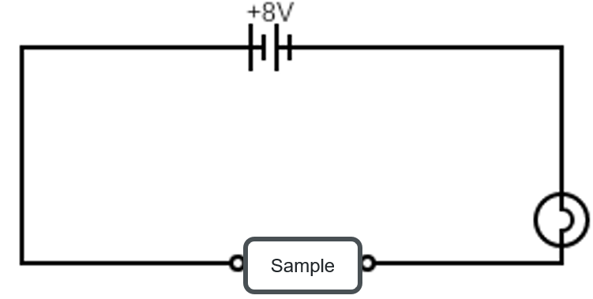
- Confirm the light bulb is working by bringing the alligator clips together.
- Connect the alligator clips to either side of the element being tested and record whether the light bulb comes on. If the light turns on, the sample does conduct electricity. If the light does not turn on, it does not conduct electricity. Record the result in Table 1 under conductivity.
Results
Table 1 – lustre and conductivity of elements
Element | Appearance  (dull or lustrous) | Conducts electricity  (yes or no)
iron
coal (carbon)
copper
silicon
zinc
sulfur
graphite
aluminium
Metals are usually shiny (this is called ‘lustre’). They are good conductors, meaning heat and electricity can pass through them easily. This is why metals are often used for things like wires and cooking pans.
Non-metals are usually dull (not shiny). They are poor conductors, so heat and electricity do not pass through them easily. Because of this, they are often used as insulators (materials that stop the flow of heat or electricity).
Metalloids have mixed properties. They can be slightly shiny and are not good conductors of electricity. However, when a metalloid is mixed with a small amount of some other elements, the conductivity increases. This makes them useful in technology like computers and phones.
Use the information above to predict if each element is a metal, non-metal or metalloid and record it in column 2 of Table 2. Record your reasoning in column 3.
Table 2 – predicting the type of element based on properties
Element | Prediction of element type | Reasoning | Actual element type
iron
coal (carbon)
copper
silicon
zinc
sulfur
graphite
aluminium
Check the classification of each of the elements using the periodic table that you have previously coloured. Record the actual element type in column 3 of Table 2.

1.3 Properties and uses of materials
Table 4 – learning intentions and success criteria for ‘1.3 Properties and uses of materials’
We are learning: | I can:
- to explain how the properties of materials influence their use | - define ‘alloy’ and identify examples of alloys  - explain how to select a material for a specific use based on its properties  - explain how the availability of a material influences its use
- to process data and information | - extract data and information on alloys from text and tables
- to use data to draw conclusions. | - write a testable statement  - identify the data required to support or refute a testable statement.

Alloys
- Define an ‘alloy’ as a homogeneous mixture composed of 2 or more metals (or, sometimes, a metal and a non-metal).
- Show PRT PPT ‘1.3 Alloys’ to illustrate some examples and uses of alloys.
- Show PRT PPT ‘1.3 What is the difference between iron and steel?’ to illustrate the distinction between iron and steel.
- Use PRT PPT ‘1.3 Gold karats’ to show students what is meant by 24, 18 and 9 karat gold. For example, 24-karat is 99.9% pure gold, while 18-karat is 75% pure gold. Emphasise that we do not make jewellery from 24-karat gold because it is too soft and that 9-karat gold is much harder because it is an alloy.
- Use PRT PPT ‘1.3 Gold jewellery’ to show students how composition influences the appearance of gold alloys.
Checkpoint: display PRT PPT ‘1.3 Checkpoint’ and ask students:
- What properties of gold relate to its use? (Lustre – it is shiny and used for jewellery. Malleable – it can be hammered into very thin sheets for jewellery use. Conducts electricity – can be used in electronics components.)
- Why is gold alloyed? (To increase its hardness for use in jewellery.)
- Provide students with a copy of the Student resource – alloys. Support students to interpret the table of properties for gold, copper, aluminium and their alloys (see Table 1 in the student resource) so that they can summarise the effects of alloying on the properties of a material.
- Support students to recognise that the summary of information they have collected is based on a limited amount of data, based on the properties of 3 metals and their alloys. To conclude that the alloying of metals changes the properties in this way, they would need to look at a greater range of metals and alloys. Students can then respond to question 2 in the student resource.
- Tell students that they need to come up with a testable statement that can be answered by using secondary source research. With varying levels of support, students will need to:
- identify a metal that is used in multiple alloys
- develop a testable statement such as, ‘Alloys of copper have lower electrical conductivity than pure copper’.
- construct a suitable table to collect the secondary data.
- Provide students with access to computers to conduct a secondary source investigation to test their statement about the impact of alloying on the properties of a specific metal. Students collect data on different alloys of a particular metal and then draw a conclusion based on the testable statement.
Sample response: Student resource – alloys
Note: stimulus material has been removed from the sample response.
- Table 1 (in the student resource) summarises the differences between aluminium, copper and gold and their alloys. Use the data in the table to complete Table 2 to summarise the effects of alloying on the properties of the material.
Table 2 – effect of alloying on the properties of metals (sample response)
Property | Effect of alloying  (increases or decreases)
Melting point (°C) | Decreases
Hardness | Increases
Strength | Increases
Electrical conductivity | Decreases
Thermal conductivity | Decreases
Ductility | Decreases
Reactivity | Decreases
- Can you conclude that alloying has this effect on these properties? Justify your answer.
No, because this data is only for 3 metals and one of their alloys. To be more conclusive, you would need to look at the properties of a greater range of alloys of a greater range of metals.
- Write a testable statement about the impact of alloying on one of these properties for one of these metals.
Copper alloys have lower electrical conductivity than pure copper.
- Conduct a secondary source investigation to test your statement. Summarise your findings in a suitable table.
Table 3 –effect of alloying on the electrical conductivity of copper (sample response)
Metal/alloy | % copper | Main alloying element | Electrical conductivity (S/m)
Pure copper | 99.9 | none | 5.9
Brass | 60–70 | zinc | 1.5–2.0
Bronze | 85–90 | tin | 0.7–1.2
Phosphor bronze | 94–96 | tin, phosphorous | 1.0–1.5
Beryllium copper | 97–9 | beryllium | 1.2–2.0
Cupronickel | 70–90 | nickel | 0.3–0.6
- Write a conclusion for your testable statement.
Pure copper has an electrical conductivity of 5.9 S/m, whereas all the copper alloys studied had an electrical conductivity of 2 S/m or less. Therefore, pure copper has greater electrical conductivity than its alloys.

Student resource – alloys
An alloy is a material composed of 2 or more metals (or sometimes, a metal and a non-metal) mixed together. Alloys are usually made to improve a material's properties for a particular purpose. For example, steel is a mixture of iron and carbon and it is stronger than pure iron.
Table 1 – properties of aluminium, copper, gold and their alloys
Property | Aluminium | Aluminium/ zinc alloy | Copper | Copper/ tin alloy | Gold | Gold/copper alloy
Melting point (°C) | 660 | 380–500 | 1085 | 380-500 | 1064 | 800–1000
Hardness (relative) | Soft | Harder than aluminium | Soft | Harder than copper | Soft | Harder than gold
Strength | Moderate | Stronger than aluminium | Moderate | Stronger than copper | Moderate | Stronger than gold
Electrical conductivity | Very good | Good | Excellent | Good | Excellent | Good
Thermal conductivity | 237 (very good) | 150 (good) | 413 (excellent) | <110 (good) | 310 | 60–100
Note: the alloy values are not exact because they vary with composition.
- Table 1 summarises the differences between aluminium, copper and gold and their alloys. Use the data in the table to complete Table 2 to summarise the effects of alloying on the properties of the material.
Table 2 –effect of alloying on the properties of metals
Property | Effect of alloying  (increases or decreases)
Melting point (°C)
Hardness
Strength
Electrical conductivity
Thermal conductivity
- Can you conclude that alloying has this effect on these properties? Justify your answer.
- Write a testable statement about the impact of alloying on one of these properties for one of these metals.
- Conduct a secondary source investigation to test your statement. Summarise your findings in a suitable table.
Insert your table here.
- Write a conclusion for your testable statement.

The properties of elements, compounds and alloys and their uses
- Provide students with a copy of the Student resource – properties and uses of materials. Draw students’ attention to Table 1 in the student resource to lead a discussion about the differences between the element – aluminium, the compound – aluminium oxide, and an aluminium/zinc alloy:
- Although all 3 substances contain aluminium, they are very different materials because their particles are arranged differently and bonded differently.
- Aluminium is an element, meaning it is made from only one type of atom. Because it has metallic bonding, it is shiny, malleable, ductile and conducts heat and electricity well.
- Aluminium oxide is a compound formed when aluminium chemically reacts with oxygen. The aluminium and oxygen atoms are chemically bonded in a fixed ratio (Al₂O₃), creating a completely new substance with properties distinct from those of aluminium metal.
- In alloys, the different-sized atoms disrupt the regular arrangement of metal atoms. This makes it harder for layers of atoms to slide past each other, so alloys are usually harder and stronger than pure metals.
- Pure aluminium is lightweight and easy to shape, but it can be too soft for some engineering purposes. Adding zinc improves strength, making aluminium/zinc alloys useful in the aircraft and transport industries.
- Unlike compounds, alloys can vary in composition. Changing the amount of zinc alters the alloy's properties.
- Use PRT PPT ‘1.3 Uses of aluminium, its alloys and compounds’ (3 slides) and Table 1 to guide class discussion to support students in answering questions 1 and 2 in the Student resource – properties and uses of materials. Students should refer back to Table 1 in the student resource to predict the most suitable material for each purpose.

Table 5 – teacher information for materials and their uses discussion
Use | What are the necessary properties for the purpose of this use? | Suitable material | Reasoning
Sandpaper – used for smoothing surfaces such as wood | Sandpaper needs to withstand high heat and high friction to smooth a surface.  It needs to be made of a material harder than the one it is used on. | aluminium oxide | Aluminium oxide is extremely hard and durable, allowing it to scratch, grind and wear away other materials. It has a very high melting point, which will allow it to withstand the heat produced from friction during sanding. Unlike softer substances, the particles do not break down quickly during use, making the sandpaper long-lasting and effective for smoothing.
Spark plugs – a device used in petrol engines to ignite the fuel–air mixture inside the engine cylinder | The material must withstand very high temperatures and resist chemical reactions within the engine. It also needs to provide electrical insulation between the components. | aluminium oxide | Aluminium oxide is used as the ceramic insulator surrounding the central electrode. Aluminium oxide is a poor conductor of electricity, so it prevents the electrical current from escaping to other parts of the engine. It can also withstand extremely high temperatures and rapid temperature changes without melting or cracking. This makes it ideal for use inside car engines, where conditions are very hot and harsh.
Overhead transmission lines – used for transmitting electricity over long distances | Excellent electrical conductivity. Low density for reduced weight. Ductility is required to draw the material into wires. It needs to be corrosion-resistant, as it is exposed to the weather. | aluminium | Aluminium is commonly used in power lines because it is a good conductor of electricity and lightweight.  Electrical energy needs to travel long distances through transmission lines with as little energy loss as possible. Aluminium conducts electricity well because it has high electrical conductivity.  Although copper is a better electrical conductor, aluminium is much lighter and less expensive. The lower density of aluminium means powerlines place less stress on towers and supports, especially over long distances.  Aluminium is also resistant to corrosion because it forms a thin protective layer of aluminium oxide on its surface. This helps powerlines withstand exposure to rain, oxygen and changing weather conditions.  Another important property is ductility. Aluminium can be drawn into long wires without breaking, making it suitable for manufacturing cables.
Aeroplane parts – such as wings and the main body | Strong material to withstand forces involved in take-off, flying and landing. Lightweight material to reduce the force required to move the plane and reduce fuel use. Resistant to corrosion. | aluminium alloy | Aluminium alloys are widely used in aircraft construction because they combine low density with high strength.  Aeroplanes need materials that are strong enough to withstand high forces during take-off, flight and landing, but that are also light enough to reduce fuel consumption. Pure aluminium is lightweight, but it is too soft for many structural parts of an aircraft.  By combining aluminium with other metals such as zinc, magnesium or copper, engineers can create alloys with improved strength and hardness. These alloys are much stronger than pure aluminium while still remaining relatively lightweight.  Aluminium alloys are also resistant to corrosion because aluminium naturally forms a protective oxide layer on its surface.

- Unpack Table 2 in the student resource and discuss the properties of copper, copper oxide and a copper/tin alloy, which is also known as bronze. Show PRT PPT ‘1.3 Uses of copper, its alloys and its compounds’ (2 slides) to prompt students to use the data in Table 2 of the student resource to address question 4.
- Explain to students that the reason metals conduct electricity is that they contain electrons, a type of subatomic particle, which are free to move. When another metal is mixed with it, it impedes electron flow, reducing conductivity.
Sample response: Student resource – properties and uses of materials
Note: stimulus material has been removed from the sample response.
Distinguish between an element, a compound and an alloy.
An element is a pure substance consisting of only one type of atom. A compound is a substance made of 2 or more elements chemically bonded in a fixed ratio. An alloy is a type of homogeneous mixture containing 2 or more metals, or sometimes a metal and a non-metal.
Part 1
Compare the properties of aluminium, aluminium oxide and aluminium/zinc alloy in Table 1 and use the information to answer questions 1 and 2.
- Which material:
- has the highest melting point? | Aluminium oxide
- has the lowest density? | Aluminium
- would be a good electrical and thermal insulator? | Aluminium oxide
- Use the information in Table 1 to justify which material would be best suited to the following uses:
- sandpaper
Material | Aluminium oxide
Justification | It has a high melting point and is very hard, so it would last longer than aluminium and aluminium/zinc alloy.
- overhead transmission lines
Material | Aluminium
Justification | It has the highest electrical conductivity, which is the primary function. Current-carrying wires will heat up, so a high melting point is important. It has the lowest density. Being lighter means it will put less strain on the towers. The lighter it is, the less strain it will put on the towers. It is ductile and would not corrode.
- aeroplane parts
Material | Aluminium/zinc alloy
Justification | Aeroplane parts need to be strong but light. Although the alloy is slightly denser than pure aluminium, the greater strength is more important.
- the white part of a spark plug
Material | Aluminium oxide
Justification | Aluminium oxide has a very high melting point and is an electrical insulator, making it suitable for its purpose in a car engine.
Read the following stimulus and answer the question 3:
Aluminium is the most abundant metal in the Earth’s crust, making up approximately 8.2% of its mass. Although common, it is never found in its pure form in nature. It is always a compound, most commonly aluminium oxide, found in the bauxite ore. Although separating aluminium from its ore is very energy-intensive, aluminium remains a relatively affordable material.
- Explain why aluminium is used in so many everyday products.
Aluminium is used in many everyday products because it is abundant and widely available, making it relatively affordable. It is also lightweight, strong and useful for many practical applications.
Part 2
Compare the properties of copper, copper oxide and copper/tin alloy in Table 2 and use the information to answer question 4.
- Justify which material would be best suited to the following uses:
- sword
Material | Copper/tin alloy
Justification | It is harder and stronger than copper and not as brittle as copper oxide.
- saucepans
Material | Copper
Justification | A saucepan needs to transfer heat through its base to its contents. Copper is the best thermal conductor and has a high melting point, so it can withstand heat.
- electrical wiring
Material | Copper
Justification | It is the best electrical conductor and its ductility allows it to be drawn into wire. Electrical wires get hot, so having a high melting point is beneficial and its low reactivity means that it will retain its integrity for a long time.

Read the following stimulus and answer question 5:
Despite being 15th in abundance in the Earth’s crust, copper is the third most consumed industrial metal (after iron and aluminium) because of its superior conductivity. We use more copper than more abundant metals like titanium or manganese because copper tends to form highly concentrated deposits that are much easier and cheaper to refine.
- Explain why copper is used in so many everyday products.
Copper is used in many everyday products because it is an excellent conductor of electricity and heat. Although it is less abundant than some other metals, copper forms concentrated deposits that are easier and cheaper to extract and refine, making it practical and widely used.

Student resource – properties and uses of materials
Distinguish between an element, a compound and an alloy.
Part 1
Compare the properties of aluminium, aluminium oxide and aluminium/zinc alloy in Table 1 and use the information to answer questions 1 and 2.
Table 1 – comparing the properties of aluminium, aluminium oxide and aluminium zinc/alloy
Property | Aluminium | Aluminium oxide | Aluminium/zinc alloy
Melting point (°C) | 660 | 2072 | 380–500
Hardness (relative) | Soft | Extremely hard | Harder than aluminium
Strength | Moderate | Very high | Stronger than aluminium
Electrical conductivity | Very good | Poor | Good
Thermal conductivity | 237 (very good) | 30 (poor) | 150 (good)
Ductility | High | Not ductile | Moderate
Density (g/cm³) | 2.7 | 4.0 | Slightly higher than aluminium
Reactivity | High, but forms a protective oxide layer | Very stable | Similar to aluminium
Approximate cost ($/kg) | 2–4 | 1–3 | 3–6
- Which material:
- has the highest melting point?
- has the lowest density?
- would be a good electrical and thermal insulator?
- Use the information in Table 1 to justify which material would be best suited to the following uses:
- sandpaper
Material
Justification
- overhead transmission lines
Material
Justification
- aeroplane parts
Material
Justification
- the white part of a spark plug
Material
Justification
Read the following stimulus and answer question 3:
Aluminium is the most abundant metal in the Earth’s crust, making up approximately 8.2% of its mass. Although common, it is never found in its pure form in nature. It is always a compound, most commonly aluminium oxide, found in the bauxite ore. Although separating aluminium from its ore is very energy-intensive, aluminium remains a relatively affordable material.
- Explain why aluminium is used in so many everyday products.
Part 2
Compare the properties of copper, copper oxide and copper/tin alloy in Table 2 and use the information to answer question 4.
Table 2 – comparing the properties of copper, copper oxide and copper/tin alloy
Property | Copper | Copper oxide | Copper/tin alloy
Melting point (°C) | 1085 | 1235 | 380–500
Hardness (relative) | Soft | Hard | Harder than copper
Strength | Moderate | Low | Stronger than copper
Electrical conductivity | Excellent | Poor | Good
Thermal conductivity | 413 (excellent) | 20ish (poor) | <110 (good)
Ductility | High | Not (brittle) | Moderate
Density (g/cm³) | 8.9 | 6.2 | 8.8
Reactivity | Low | More reactive | Very low
Approximate cost ($/kg) | 8–12 | 5-8 | 10–20
- Justify which material would be best suited to the following uses:
- sword
Material
Justification
- saucepans
Material
Justification
- electrical wiring
Material
Justification

Read the following stimulus and answer question 5:
Despite being 15th in abundance in the Earth’s crust, copper is the third most consumed industrial metal (after iron and aluminium) because of its superior conductivity. We use more copper than more abundant metals like titanium or manganese because copper tends to form highly concentrated deposits that are much easier and cheaper to refine.
- Explain why copper is used in so many everyday products.

1.4 Thermal conductivity investigation
Table 6 – learning intentions and success criteria for ‘1.4 Thermal conductivity investigation’
We are learning: | I can:
- to explain how the properties of materials influence their use | - compare the physical properties of different metals and metal alloys
- to process data and information | - accurately extract data and information from texts, tables and graphs  - accurately calculate the mean and range from a dataset
- to use data to identify relationships and draw conclusions. | - assess the reliability of the collected data  - evaluate the method used in the investigation.

Investigating the thermal conductivity of metals
Note: while this investigation is not comparing metals, non-metals and metalloids, it is comparing the properties of different types of metals and metal alloys and focusing on the development of Working scientifically skills.
- Provide students with a copy of the Student resource – investigating thermal conductivity.
- Show students how to set up the apparatus for investigating thermal conductivity, either through demonstration or by referring to the diagram in the Student resource – investigating thermal conductivity. Modifications may be needed, depending on the equipment available. Conductivity rods (individual metals) or conductivity wands (5 to 6 metal rods joined in the centre) are suitable for this investigation. Try to have a range of pure metals and alloys for students to test.
Figure 1 – images of a conductivity wand and conductivity rods
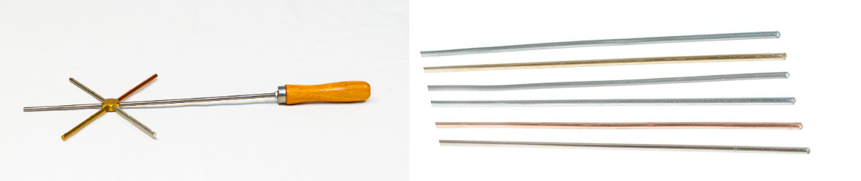
- Lead a discussion about the procedure and highlight safety considerations.
- Students then carry out the investigation by following the procedure in the Student resource – investigating thermal conductivity. Record the result and complete the follow-up questions. Support students in evaluating the reliability of their collected data by comparing it to published values.
Sample response: Student resource – investigating thermal conductivity
Results
Table 2 – time for matches to fall (sample response)
Metal | Time for the match to fall (s) |  |  |  | Range
Metal | Trial 1 | Trial 2 | Trial 3 | Mean | Range
iron | 56.0 | 62.0 | 50.0 | 56.0 | 6
copper | 20.0 | 19.0 | 22.0 | 20.3 | 3
brass | 51.0 | 48.0 | 52.0 | 50.3 | 4
aluminium | 36.0 | 40.0 | 35.0 | 37.0 | 5
Note: the actual values of these results will vary greatly depending on the rod thickness, the distance between the Bunsen burner and the rod, and the amount of wax.
Conclusion
Copper is the most conductive, followed by aluminium, brass and iron.
Complete these follow-up questions:
- Identify a variable that was difficult to control and how this could influence the reliability of your results.
The amount of wax used to secure the match. Using less wax could cause it to melt more quickly, reducing the time it takes for the match to fall.
- Add a column to the results table (see Table 2) and calculate the range for each set of data.
The range has been added to the sample results table. Students’ responses will vary depending on the data they collect (see Table 2).
- Assess the reliability of your gathered data by comparing your results to the data in Table 2.
The average results were consistent with the published data, but the ranges for some metals overlapped, compromising the reliability of the results.
- Evaluate this method for ranking these metals in order of thermal conductivity and suggest any improvements that could be made.
Although there was a broad range in the values for some metals, the overall results were consistent with published data, indicating that the procedure is valid. The experiment could be improved by conducting more trials and using a more effective method for measuring heat transfer, rather than timing how long it takes for the wax to melt. Perhaps using an infrared thermometer could provide more quantitative data.
Note: this evaluation is based on these sample results. Your students’ results may be more or less consistent.
Table 3 – actual thermal and electrical conductivity values
Metals | Thermal conductivity (W/mK) | Electrical conductivity  (S/cm)
copper | 413 | 64.1
aluminium | 237 | 40.8
iron | 94 | 11.2
brass | 111 | 16.7
zinc | 123 | 18.2
- Is there a relationship between thermal and electrical conductivity? Use the data in Table 3 to justify your response.
The metals in the table all range from good to excellent thermal and electrical conductivity. The pattern of values for thermal and electrical conductivity is the same. For example, copper has the highest thermal and electrical conductivity, while iron has the lowest for both. For this limited dataset, it appears that materials with high thermal conductivity also have high electrical conductivity.
- Consolidate what you have learned about the properties of metals and non-metals by completing Table 4.
Table 4 – properties of metals and non-metals (sample response)
Property | Metals | Non-metals
lustre | lustrous | dull
electrical conductivity | good conductors | poor conductors (insulators)
thermal conductivity | good conductors | poor conductors (insulators)
ductility | ductile | not ductile (brittle)
malleability | malleable | not malleable (brittle)
- Based on the information provided in the table, describe 3 tests you could use to distinguish between metal and non-metal elements.
- Lustre – metals appear shiny and non-metals typically do not.
- Test for electrical conductivity by placing the sample in a circuit with a light globe. If the light comes on, it is a conductor and therefore a metal (graphite is the exception).
- Malleability – hit it with a hammer. Metals can be beaten into shape, so they should flatten out. Non-metals are typically brittle and will shatter.

Student resource – investigating thermal conductivity
In everyday life, metals are chosen for specific purposes based on their heat-transfer properties. For example, the base of a saucepan is often made from copper or aluminium to allow heat to spread quickly and evenly. At the same time, the materials used for handles are chosen because they conduct heat poorly, preventing burns. This ability of a material to transfer heat is known as ‘thermal conductivity’.
Thermal conductivity depends on the structure of the material. In metals, heat is transferred efficiently due to particle motion and the presence of mobile electrons, which can carry energy through the material. However, not all metals conduct heat equally well. Differences in atomic structure, density and bonding can influence how quickly heat energy is transferred.
Understanding these differences is important in science and engineering, as it informs the selection of materials for applications such as cooking equipment, building materials, electronic heat sinks and thermal insulation systems.
In this investigation, you will compare the thermal conductivity of different metals by observing how quickly heat is transferred through each material.
Aim: to rank the following metals from the highest to the lowest, in terms of their thermal conductivity.
Equipment
- 4 × different metal rods with the same diameter (or a conductivity wand if available)  - 1 × paraffin wax candle  - 2 × retort stands  - 2 × boss heads and clamps | - 1 × Bunsen burner  - 1 × heat mat  - 1 × stopwatch  - 1 × ruler  - matches
Risk assessment
Table 1 – risks and mitigation for hazards in the thermal conductivity investigation
Hazard | Risk | Mitigation
Hot metal rods | Burns | Allow the rods to cool before conducting another trial or if repeating the investigation.
Bunsen burner | Burns | Hair should be tied back. Use the yellow flame between trials so that the Bunsen burner is clearly visible.
Variables
Independent variable: | The type of metal.
Dependent variable: | The time it takes for the heat to melt the wax and make the match fall.
Controlled variable: | The distance the match is placed from the end of the rod.  The location of the flame at the end of the rod.  The rods are all the same diameter.
Figure 1 – apparatus for thermal conductivity experiment
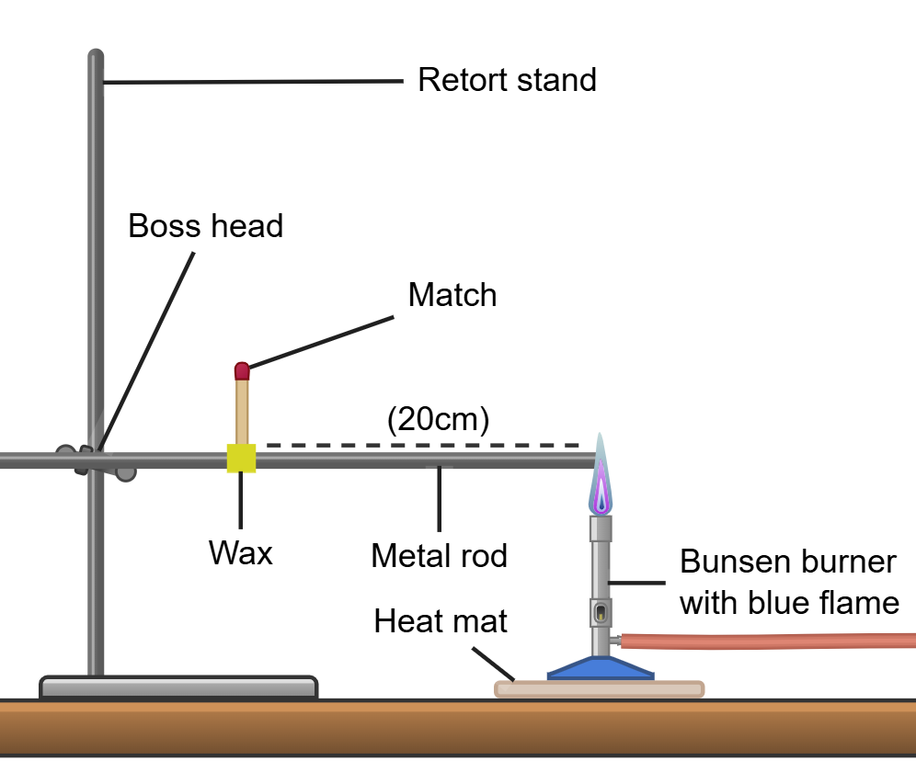
Image created using Chemix and is licensed under the Chemix Terms of Service.
Procedure
- Set up the apparatus as shown in Figure 1.
- Light the candle and use the melted wax to stick the match to the rod 20 cm from the end, as shown in Figure 1.
- Light the Bunsen burner and use the blue flame to heat the tip of the metal rod. Start the stopwatch.
- Stop the stopwatch when the match falls and record the time.
- While the rod cools, repeat the procedure for the second metal on a second setup.
- Repeat the process for each metal until you have completed 3 trials for each.
Results
Table 2 – time for matches to fall
Metal | Time for the match to fall (s) |  |  |  | Range
Metal | Trial 1 | Trial 2 | Trial 3 | Mean
Conclusion
Complete these follow-up questions:
- Identify a variable that was difficult to control and how this could influence the reliability of your results.
- Add a column to the results table (see Table 2) and calculate the range for each set of data.
- Assess the reliability of your gathered data by comparing your results to the data in Table 2.
- Evaluate this method for ranking these metals in order of thermal conductivity and suggest any improvements that could be made.
Table 3 – actual thermal and electrical conductivity values
Metals | Thermal conductivity (W/mK) | Electrical conductivity  (S/cm)
copper | 413 | 64.1
aluminium | 237 | 40.8
iron | 94 | 11.2
brass | 111 | 16.7
zinc | 123 | 18.2
- Is there a relationship between thermal and electrical conductivity? Use the data in Table 3 to justify your response.
- Consolidate what you have learned about the properties of metals and non-metals by completing Table 4.
Table 4 – properties of metals and non-metals
Property | Metals | Non-metals
lustre
electrical conductivity
thermal conductivity
ductility
malleability
- Based on the information provided in the table, describe 3 tests you could use to distinguish between metal and non-metal elements.

Evidence base
This resource contains NSW Curriculum and syllabus content. The NSW Curriculum is developed by the NSW Education Standards Authority (NESA). This content is prepared by NESA for and on behalf of the Crown in right of the State of New South Wales. The material is protected by Crown copyright.
Please refer to the NESA Copyright Disclaimer for more information https://www.nsw.gov.au/education-and-training/nesa/copyright.
NESA holds the only official and up-to-date versions of the NSW Curriculum and syllabus documents. Please visit NESA https://www.nsw.gov.au/education-and-training/nesa and NSW Curriculum https://curriculum.nsw.edu.au.
Science 7–10 Syllabus © NSW Education Standards Authority (NESA) for and on behalf of the Crown in right of the State of New South Wales, 2023.
Data Book: Science 7–10 © NSW Education Standards Authority (NESA) for and on behalf of the Crown in right of the State of New South Wales, 2023.
AITSL (Australian Institute for Teaching and School Leadership Limited) (n.d.) Learning intentions and success criteria [PDF 251 KB], AITSL, accessed 18 July 2024.
——(2017) ‘Feedback Factsheet’, AITSL, accessed 18 July 2024.
CESE (2021) Growth goal setting – what works best in practice, NSW Department of Education, accessed 6 February 2025.
——(2025) What Works Best 2025, NSW Department of Education, accessed 26 March 2026.
——(2025) What Works Best 2025 – practical guides, NSW Department of Education, accessed 3 June 2026.
Fisher D and Frey N (1 November 2009) ‘Feed Up, Back, Forward’, ASCD (Association for Supervision and Curriculum Development): Educational Leadership magazine, 67(3), accessed 18 July 2024.
Griffin P (2017) Assessment for Teaching, Cambridge University Press, Port Melbourne, Victoria.
Hattie J and Timperley H (2007) ‘The Power of Feedback’, Review of Educational Research, 77(1):81–112, doi:10.3102/003465430298487.
NCBI (National Center for Biotechnology Information) (n.d.) Atomic Radius in the Periodic Table of Elements [data set], PubChem website, accessed 23 October 2025.
——(n.d.) Boiling Point in the Periodic Table of Elements [data set], PubChem website, accessed 23 October 2025.
——(n.d.) Density in the Periodic Table of Elements [data set], PubChem website, accessed 23 October 2025.
NESA (NSW Education Standards Authority) (2023) ‘Glossary’, Science 7–10 Syllabus, NSW Curriculum website, accessed 30 April 2026.
Panadero E and Jonsson A (2013) ‘The use of scoring rubrics for formative assessment purposes revisited: A review’, Educational Research Review, 9:129–144, doi:10.1016/j.edurev.2013.01.002, accessed 18 July 2024.
Sherrington T (2019) Rosenshine’s Principles in Action, John Catt Educational Limited, Melton, Woodbridge.
TED-Ed (22 Nov 2012) ‘The genius of Mendeleev's periodic table – Lou Serico’ [video], TED-Ed, YouTube, accessed 20 October 2025.
University of Colorado (2026) Rutherford Scattering: version 1.1.28‬‬‬‬‬‬‬‬‬‬‬‬‬‬‬‬‬‬‬‬‬‬‬‬‬‬‬‬‬‬‬, PhET (Physics Education Technology) Interactive Simulations website, accessed 12 September 2025.‬‬‬‬‬‬‬
Wiliam D (2017) Embedded Formative Assessment, 2nd edn, Solution Tree Press, Bloomington, IN.

© State of New South Wales (Department of Education), 2026
The copyright material published in this resource is subject to the Copyright Act 1968 (Cth) and is owned by the NSW Department of Education or, where indicated, by a party other than the NSW Department of Education (third-party material).
Copyright material available in this resource and owned by the NSW Department of Education is licensed under a Creative Commons Attribution 4.0 International (CC BY 4.0) license.

This license allows you to share and adapt the material for any purpose, even commercially.
Attribution should be given to © State of New South Wales (Department of Education), 2026.
Material in this resource not available under a Creative Commons license:
- the NSW Department of Education logo, other logos and trademark-protected material
- material owned by a third party that has been reproduced with permission. You will need to obtain permission from the third party to reuse its material.
Links to third-party material and websites
Please note that the provided (reading/viewing material/list/links/texts) are a suggestion only and implies no endorsement, by the New South Wales Department of Education, of any author, publisher, or book title. School principals and teachers are best placed to assess the suitability of resources that would complement the curriculum and reflect the needs and interests of their students.
If you use the links provided in this document to access a third-party's website, you acknowledge that the terms of use, including licence terms set out on the third-party's website apply to the use which may be made of the materials on that third-party website or where permitted by the Copyright Act 1968 (Cth). The department accepts no responsibility for content on third-party websites.

