Science Stage 4 – sample assessment task
Periodic table and atomic structure
Creation date: 20 March 2026

Contents
About this assessment task 2
Purpose of the resource 2
When and how to use 2
Assessment task notification 3
Task description 4
Marking rubric 5
Investigating alternatives 8
Email attachments – sources of data and information 9
Part A – do your research 11
Part B – prepare your briefing 14
Evidence base 17

About this assessment task

Purpose of the resource
This assessment task is linked to the learning in the Periodic table and atomic structure program of learning for Stage 4 students. The task is designed to assess students’ understanding of the properties of elements and skills in processing, representing and analysing data.

When and how to use
This assessment task should be delivered over approximately one lesson after the Periodic table and atomic structure focus area has been taught. Students will work individually to complete the task. The first component requires students to complete research for their briefing by analysing secondary data. In the second component, they will use this information to form a judgement and prepare an informed CEO (chief executive officer) briefing based on the evidence provided.
The final briefing may be submitted as a written document (as outlined in the task), or the task can be adapted so that students present their findings in a slide deck, video, poster or another suitable format.
Note: the sample responses for this task are available on the Science Statewide Staffroom SharePoint (staff only). To access this resource, you will need to be a member of the Science Statewide Staffroom or contact the Science curriculum team at science7-12@det.nsw.edu.au.
The common grade scale can be used to report student achievement in both primary and junior secondary years in all NSW schools.
When grading students’ level of achievement in Stage 5, refer to the course performance descriptors. Course performance descriptors provide holistic descriptions of typical achievement at different grade levels in a specific course.

Assessment task notification
Name of task: investigating alternative metals
Type of task: secondary data source investigation
Weighting: [the weighting of the assessment task is a school-based decision]
Submission details: [schools complete this section – include any important details about submission, format of the task, word limits and submission procedures]
Outcomes:
A student:
- explains how uses of elements and compounds are influenced by scientific understanding and discoveries relating to their properties SC4-PRT-01
- uses a variety of ways to process and represent data SC4-WS-05
- uses data to identify trends, patterns and relationships, and draw conclusions SC4-WS-06
Science 7–10 Syllabus © NSW Education Standards Authority (NESA) for and on behalf of the Crown in right of the State of New South Wales, 2023.

Task description
In this task, you will prepare a briefing for the CEO of a fictional company. You will be provided with an email, along with email attachments, containing some data for you to analyse and respond to. There are 2 parts to this task:
- Part A – do your research – you are required to analyse the provided secondary data, construct and interpret graphs and compare information from multiple sources.
- Part B – prepare your briefing – you will use the scientific evidence from Part A to make a judgment of a metal candidate to replace copper in a prepared briefing for the company's CEO.

Marking rubric
Table 1 – marking rubric for the sample assessment task – Periodic table and atomic structure – Part A
Criteria | Level 1 | Level 2 | Level 3 | Level 4
Construct a line graph of the cost of copper metal versus time (Part A, Q1)  SC4-WS-05 | A partially constructed line graph is included with some appropriate features. Many features are missing or incorrect.  Or  A column graph has been used to represent the data. | Data is plotted on a line graph but includes inaccuracies in scale, units or labelling. | A mostly correctly drawn line graph, including:  - appropriate title  - axes labelled with variables and units where applicable  - accurately plotted data  - an appropriate scale on each axis | A correctly drawn line graph, including:  - appropriate title  - axes labelled with variables and units where applicable  - accurately plotted data  - an appropriate scale on each axis
Identify and describe patterns or relationships in the data (Part A, Q2)  SC4-WS-06 | Provides a basic description of each graph. No comparison is provided between the 2 graphs. | Descriptions of the graph are partly correct but incomplete. Provides a simple statement about whether a relationship between the 2 graphs is evident. | Descriptions of the graph are correct and supported with data. States whether there is a possible relationship between the 2 graphs. | Descriptions of the graphs are clear, accurate and supported with data. Clearly and confidently states whether there is a possible relationship between the 2 graphs.
Compare data to form a conclusion (Part A, Q3)  SC4-WS-06 | Comparisons are vague; some aspects may be incorrect or do not support any conclusion. | Some relevant comparisons are made, but may be incomplete, partially inaccurate or lead to a weak conclusion. | Comparisons are mostly accurate and support a reasonable conclusion, though details may be limited. | Comparisons are detailed, accurate and clearly support a well-reasoned conclusion.
Explain differences in the properties of metals (Part A, Q4 and Q5)  SC4-PRT-01 and  SC4-WS-06 | Explanations are vague and may include incorrect information, with little or no reference to the stimulus material. | Explanations are partially correct but incomplete or contain errors, with simple or brief references to the stimulus material. | Explanations are mostly correct and relate properties to behaviour, with clear links to the stimulus material when describing differences between metals. | Explanations clearly link properties to behaviour, with detailed scientific reasoning, consistently supported by accurate references to the stimulus material.
Table 2 – marking rubric for the sample assessment task – Periodic table and atomic structure – Part B
Criteria | Level 1 | Level 2 | Level 3 | Level 4
Use data as evidence in the briefing  SC4-PRT-01 and  SC4-WS-06 | Evidence is missing, incorrect or unrelated to the conclusion. | Some relevant evidence is included, but it may be incomplete or partially incorrect. | Evidence is mostly accurate and supports key points, though it may lack depth. | The evidence is accurate, well-chosen and clearly supports the conclusion.
Justify the recommended metal using scientific reasoning  SC4-PRT-01 and  SC4-WS-06 | Identifies a metal to replace copper. The recommendation is unsupported or scientifically incorrect. | The recommendation uses some reasoning but contains gaps or inaccuracies. | The recommendation is supported by correct scientific reasoning and relevant data. | The recommendation is supported by detailed scientific explanations and accurate references to data.
Discuss limitations and uncertainties in the dataset  SC4-PRT-01 and  SC4-WS-06 | Demonstrates a limited ability to discuss limitations and uncertainties.  Statements are vague or irrelevant. | Demonstrates a basic ability to discuss limitations and uncertainties.  Some relevant limitations are noted but weakly explained. | Demonstrates a sound ability to discuss limitations and uncertainties.  The explanation identifies relevant issues and how they affect conclusions. | Demonstrates a thorough ability to discuss limitations and uncertainties.  The explanation clearly identifies uncertainties, missing information and their impact on reliability.

Investigating alternatives
You are a materials scientist at ElectroNova Industries and you have just received the following email from your manager assigning you a task.
Email from: Dr A Roman, Director of Materials Research
To: Materials Science team
Subject: task assignment – briefing on copper replacement metals
Hi team
As part of our ongoing review of material costs, we are assessing potential alternatives to copper for use in our electrical wiring products. Copper prices have become much more expensive, and the executive team needs clear, evidence-based guidance before committing to changes.
Attached is a dataset describing 7 candidate metals (M1 to M7), including information such as conductivity, density, reactivity, ductility, melting point and approximate cost. There is also a graph showing the change in electric vehicle sales over the last few years. Note this demand, plus note that electric vehicles require a significant amount of copper.
You are required to prepare a short briefing for the CEO that:
- presents a clear comparison of the metals
- identifies trends in the data
- justifies which metal(s) most closely match copper’s useful properties
- explains conductivity and reactivity differences using scientific reasoning
- provides a final recommendation, including limitations of the dataset.
Please ensure your briefing is written in a concise, professional style suitable for senior leadership.
Regards
Dr A Roman
Director of Materials Research
ElectroNova Industries

Email attachments – sources of data and information
Table 1 – cost of copper metal between 2019 and 2025
Year | Mean copper cost per kg (AUD)
2019 | 4.21
2020 | 4.34
2021 | 6.57
2022 | 6.17
2023 | 5.99
2024 | 6.56
2025 | 7.40
Figure 1 – global electric car sales between 2019 and 2025

Table 2 – physical properties of metal alternatives
Metal | Density  (g/cm³) | Electrical conductivity  (S/m × 10⁶) | Reactivity with air | Reactivity with water | Approximate cost (AUD/kg) | Melting point (°C) | Ductility  (1–5 scale*)
M1 | 2.7 | 28 | Slow | No reaction | 1.60 | 660 | 4
M2 | 7.9 | 35 | Fast | Slow | 0.60 | 230 | 2
M3 | 8.9 | 50 | No reaction | No reaction | 6.80 | 1085 | 4
M4 | 10.5 | 60 | Slow | No reaction | 12.00 | 962 | 4
M5 | 5.9 | 42 | Fast | Fast | 0.40 | 98 | 1
M6 | 4.5 | 30 | Slow | Slow | 7.50 | 1668 | 3
M7 | 7.1 | 46 | Slow | No reaction | 2.50 | 419 | 4
*Ductility scale: 1 = brittle, 5 = very ductile
Note: these metals are fictional, and the data have been adapted for this assessment.

Part A – do your research
- Construct a line graph showing the change in the cost of copper over time using the data in Table 1. Include an appropriate title, correct labels and units and a suitable scale.

- Identify and describe any patterns or relationships between the data shown in your graph and the graph shown in Figure 1.
- The information card below contains information about the physical properties and common uses of copper.
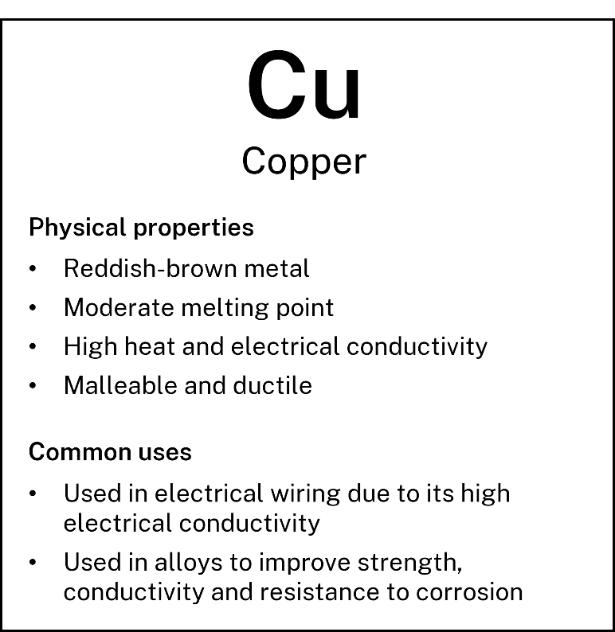
Using Table 2 and your graph, identify which metal or metals have properties most similar to copper and explain your reasoning.
- The accounts department at ElectroNova has been arguing for using M2 based on cost and conductivity. Use the information in Table 2 to explain why this is not a good option.
- Using Table 2, discuss how reactivity might influence a metal’s suitability for electrical wiring.

Part B – prepare your briefing
You are required to prepare a short briefing for the CEO that:
- presents a clear comparison of the metals
- identifies trends in the data
- justifies which metal(s) most closely match copper’s useful properties
- explains conductivity and reactivity differences using scientific reasoning
- provides a final recommendation, including limitations of the dataset
Please ensure your briefing is written in a concise, professional style suitable for senior leadership.

Evidence base
This resource contains NSW Curriculum and syllabus content. The NSW Curriculum is developed by the NSW Education Standards Authority (NESA). This content is prepared by NESA for and on behalf of the Crown in right of the State of New South Wales. The material is protected by Crown copyright.
Please refer to the NESA Copyright Disclaimer for more information https://www.nsw.gov.au/education-and-training/nesa/copyright.
NESA holds the only official and up-to-date versions of the NSW Curriculum and syllabus documents. Please visit NESA https://www.nsw.gov.au/education-and-training/nesa and NSW Curriculum https://curriculum.nsw.edu.au.
Science 7–10 Syllabus © NSW Education Standards Authority (NESA) for and on behalf of the Crown in right of the State of New South Wales, 2023.
Data Book: Science 7–10 © NSW Education Standards Authority (NESA) for and on behalf of the Crown in right of the State of New South Wales, 2023.
Brookhart SM (2018) ‘Appropriate Criteria: Key to Effective Rubrics’, Frontiers in Education, volume 3(22):1–12, doi:10.3389/feduc.2018.00022, accessed 6 February 2025.
CESE (2021) Growth goal setting – what works best in practice, NSW Department of Education, accessed 18 July 2024.
——(2025) What Works Best 2025, NSW Department of Education, accessed 26 March 2026.
——(2025) What Works Best 2025 – practical guides, NSW Department of Education, accessed 3 June 2026.
Fisher D and Frey N (1 November 2009) ‘Feed Up, Back, Forward’, ASCD (Association for Supervision and Curriculum Development): Educational Leadership magazine, 67(3), accessed 6 February 2025.
Griffin P (2017) Assessment for Teaching, Cambridge University Press, Port Melbourne, Victoria.
Hattie J and Timperley H (2007) ‘The Power of Feedback’, Review of Educational Research, 77(1): 81–112, doi:10.3102/003465430298487, accessed 15 July 2024
IEA (International Energy Agency) (2025) Global electric car sales, 2014–2024 [data set], IEA website, accessed 10 November 2025
Macrotrends LLC (2025) Copper Prices | Historical chart | Data | 1959–2026 [data set], Macrotrends website, accessed 10 November 2025
Panadero E and Jonsson A (2013) ‘The use of scoring rubrics for formative assessment purposes revisited: A review’, Educational Research Review, 9:129–144, doi:10.1016/j.edurev.2013.01.002, accessed 6 February 2025.
Sherrington T (2019) Rosenshine’s Principles in Action, John Catt Educational Limited, Melton, Woodbridge.
Wiliam D (2017) Embedded Formative Assessment, 2nd edn, Solution Tree Press, Bloomington, IN.

© State of New South Wales (Department of Education), 2026
The copyright material published in this resource is subject to the Copyright Act 1968 (Cth) and is owned by the NSW Department of Education or, where indicated, by a party other than the NSW Department of Education (third-party material).
Copyright material available in this resource and owned by the NSW Department of Education is licensed under a Creative Commons Attribution 4.0 International (CC BY 4.0) license.

This license allows you to share and adapt the material for any purpose, even commercially.
Attribution should be given to © State of New South Wales (Department of Education), 2026.
Material in this resource not available under a Creative Commons license:
- the NSW Department of Education logo, other logos and trademark-protected material
- material owned by a third party that has been reproduced with permission. You will need to obtain permission from the third party to reuse its material.
Links to third-party material and websites
Please note that the provided (reading/viewing material/list/links/texts) are a suggestion only and implies no endorsement, by the New South Wales Department of Education, of any author, publisher, or book title. School principals and teachers are best placed to assess the suitability of resources that would complement the curriculum and reflect the needs and interests of their students.
If you use the links provided in this document to access a third-party's website, you acknowledge that the terms of use, including licence terms set out on the third-party's website apply to the use which may be made of the materials on that third-party website or where permitted by the Copyright Act 1968 (Cth). The department accepts no responsibility for content on third-party websites.

