Science Stage 4 (Year 7) – Observing the Universe
Teacher resource book 2 of 2 (TRB2)
Space science – from ancient ideas to modern understanding
Creation date: 27 June 2024

Contents
Overview 4
Preamble 4
Diagnostic questions 5
2.1 Introducing Space science – What do you know? 6
2.2 Trace space back to you 7
Student resource – trace space back to you 8
2.3 Unlocking the Universe 11
James Webb Space Telescope 11
Student resource – unlocking the Universe 17
Square Kilometre Array Observatory (SKAO) 18
Student resource – the SKAO 21
2.4 What is in the centre of our Solar System? 23
Models of the Universe and Solar System 23
Student resource – models of the Universe 28
Solar System Scope 29
Student resource – Solar System Scope 29
2.5 The scale of the Solar System (practical investigation) 31
Pocket Solar System 32
The size of the Solar System 34
Student resource – the size of the Solar System 35
Earth vs Moon – modelling the Earth and Moon (practical investigation) 39
2.6 Seasons (secondary-source investigation) 43
Part 1 – analysing the data 44
Consolidation 52
Student resource – Seasons Part 1 – analysing the data 54
Part 2 – the location of the Sun 60
Student resource – Seasons Part 2 – The location of the Sun 62
Part 3 – modelling the temperature of the seasons 66
Student resource – Seasons Part 3 – modelling the temperature of the seasons 69
2.7 Exploring the phases of the Moon (practical investigation) 72
Introduction 72
Part 1 – Stellarium 73
Part 2 – Moon phase calendar 74
Part 3 – Daily Moon Guide 75
Part 4 – modelling the phases of the Moon 76
Student resource – exploring the phases of the Moon 81
2.8 Eclipses (practical investigation) 86
Prior knowledge 86
Part 1 – summarising information 86
Part 2 – solar eclipse – digital simulation 88
Student resources – eclipses 90
2.9 Tides (secondary-source investigation) 92
Investigating tides 92
Student resource – tides 98
Fishbone diagram 101
2.10 Aboriginal and Torres Strait Islander Peoples’ knowledge of the Moon and tides 102
Instructions 103
Student resource – Aboriginal traditions about the Moon and tides 105
2.11 How Aboriginal and Torres Strait Islander peoples use stars to predict weather (practical investigation) 106
Background information 106
Introduction 107
Modelling stellar scintillation (practical investigations) 107
Student resource – modelling stellar scintillation 110
2.12 Aboriginal and Torres Strait Islander Peoples’ sky stories 112
Teacher instructions 112
Evidence base 116

Overview
Stage and learning area: Stage 4 Science
Description: this resource complements the ‘Observing the Universe’ program of learning. It aims to serve as a teacher reference, offering practical strategies and ideas to enrich teaching practices and create engaging learning environments. The activities should be adapted to suit students' needs.
Duration: while timing will vary based on the mode of delivery, differentiation strategies employed and class or school context, this series of activities should take approximately 14 hours.
Risk management: teachers are advised to undertake a risk assessment before conducting any investigation or experiment. For more information on developing risk assessments, see Risk Assessment – a pre-requisite for risk control.
This resource book elaborates on many of the activities in the Observing the Universe learning program. Some activities also reference the Observing the Universe OTU PowerPoint (identified as the OTU PPT throughout this document).

Preamble
The night sky and space science are fascinating and create an excellent opportunity to encourage student engagement and questioning. Set up a wonder wall, a space on your wall where students can place notes and encourage students to place their questions on the wall. These can become the centre of class discussions or the seed for future lessons or projects. There are a range of ways to manage your wonder wall – you may allow your students to place questions on the wall as they think of them or dedicate a period of time within the class to this. Make time during the lesson to address questions or use them as a stimulus for conversations or extension lessons.
The sequence of content groups in this document has been addressed in a different order from the syllabus. The last content group in the syllabus, Observing the Universe in context, was placed at the beginning of space science. Australia has played an important role in space science since the 1950s through our involvement with rocket launches and space tracking. Our world-leading space facilities are strengthening the space industry and providing Australia with enhanced technological capabilities. By engaging students with how space technologies and services such as weather forecasting, internet access and GPS benefit all Australians, the study of space science will have meaning and relevance to them.

Diagnostic questions
The OTU PPT includes diagnostic questions about space modified from the University of York’s Science Education Group’s Best Evidence in Science Teaching.
Diagnostic assessments provide evidence of what ideas a student can recall from previous teaching or whether they hold misunderstandings that could hinder progression. Diagnostic questions that are short and focused on a single idea can be used most effectively in lessons.
In activities 2.4 to 2.9, diagnostic questions are suggested to ascertain prior knowledge at the beginning of the lesson or to use as a hinge question during learning. This will provide information to the teacher to determine whether students have the necessary understanding to move on to the next concept. The slide notes explain how the questions can be used to identify misunderstandings and include suggestions for addressing these.
Students should complete the questions individually. The question can be displayed at the front of the class, and students are asked to indicate their support for each answer using a digital quiz (for example, Kahoot!) or mini whiteboards.

2.1 Introducing Space science – What do you know?
Table 1 – learning intention and success criteria for ‘Introducing Space science – What do you know?’
Learning intention | Success criteria
We are reviewing our understanding of the universe. | I can:  - describe the cause of day and night  - explain seasons on Earth  - Identify the planets in our solar system  - describe eclipses and phases of the Moon.
Images of the night sky are not only beautiful but also serve as windows to the wonders of space and provide an effective way to engage students in the topic of space science. Encourage students to ask questions, make observations and share their knowledge of space science. Sample images that can be used as discussion starters have been included in OTU PPT 2.1 Introducing space science – What do you know?
As primary schools transition from the Science and Technology K–6 Syllabus (2017) to the Science and Technology K–6 Syllabus (2024), students entering Year 7 will have varied knowledge and understanding of space science. To ascertain students’ knowledge, understanding and misconceptions, it is suggested that you conduct the pretest included in the Welcome to Year 7 science Amplify activity (slides 18–28). This activity may be edited to suit your students.
The resource Welcome to Year 11 on the Science Statewide Staffroom (members only) includes videos on how to set up an account and use Amplify effectively in your classroom.

2.2 Trace space back to you
This activity introduces the connections between advances in space science, our understanding of the Universe, and the practical applications of enhanced technology and knowledge in our lives. It provides a focal point for the study of space science while introducing students to the importance of space research in their everyday lives and the intrinsic value of space exploration.
Table 2 – learning intentions and success criteria for ‘Trace space back to you’
Learning intentions | Success criteria
We are learning the benefits of research into space and the Universe. | I can:  - identify a range of items that have been developed or improved because of research into space exploration.  - make connections between technological advances and their impact on my quality of life.
We are learning to process and represent information. | I can:  - find relevant information in multimedia resources.

Student resource – trace space back to you
Space exploration does not impact you, right? Well, think again. In this activity, you will learn how the research and technology behind space exploration affect our lives.
Go to the website Trace space back to you. Select Explore home.
Explore the house
- Enter each room in the house and the outside space.
- Identify objects developed or improved because of space exploration.
- Select the objects to learn more. Then, select the arrow to learn why it was developed, watch videos and learn more about the product.
- Select 4 objects to learn more about. Include at least one object relating to clothing, health, comfort and being from outside. Complete the table below.
Location | Object | Use | Why was it developed?
Visit the city
- Explore the different locations in the city and the technologies within each location.
- Select one object from 4 locations and complete the table below.
Location | Object | Use | Why was it developed?
Applications in my life
- List the items identified in the activity that you have used. Beside each item, indicate how often you would use the item.
Example: water filtration bottle – for when I go camping.
- ‘Space research has significantly impacted the technologies that we use in our everyday lives. It has improved the quality of our lives.’ Justify this statement.
Note: you can say this statement is correct or not, but you must say why.

2.3 Unlocking the Universe
This activity supports the content group ‘Observing the Universe in context.’ It is included at the beginning of Space Science to introduce the importance of space research and Australia’s role in this.
In this activity, students will investigate the James Webb Space Telescope (JWST) and the Square Kilometre Array Observatory (SKAO) and learn how technological advances have increased our knowledge of the Universe.
Reading scientific text is a skill that should be taught, modelled and practised. In this activity, students will be guided through the process of skimming and scanning a text to identify key information. They will also practice writing an explanation. If needed, they can use the C-E-R scaffold to support them in writing their explanation.
Table 3 – learning intentions and success criteria for ‘Unlocking the Universe (JWST and SKA)’
Learning intentions | Success criteria
We are learning how recent advances in scientific tools used for observation have increased our knowledge of the Universe. | I can:  - explain how the JWST and SKAO have helped us learn about the Universe.
We are learning to process and represent information. | I can:  - skim a scientific text to get a general idea of the text.  - scan a text to identify key points.

James Webb Space Telescope
To ascertain students’ knowledge of space technology, undertake a Think-Pair-Share activity using the question, ‘What technologies do astronomers use to observe the Universe?’. Depending on the knowledge displayed in their answers, you may need to ask further questions, such as:
- What do optical telescopes detect? Visible light.
- What factors affect how effective optical telescopes are? Particles in the atmosphere, light pollution.
- Where are optical telescopes placed to minimise these factors? On tops of mountains where the air is thinner and less polluted, and away from light sources.
- What other types of telescopes are used to observe the Universe? Radio and infrared telescopes.
After this discussion, introduce the James Webb Space Telescope (JWST) by displaying images taken by it on the Webb Home webpage.
Students open the NASA web page ‘What is the James Webb Space Telescope?’ and answer the questions in the OTU PPT James Webb Space Telescope slide.
Suggested answers:
The sample answers include additional information that can be explained to the students as they complete the task. This information is not outlined on the provided website and is intended to help students understand the new content.
- What is the James Webb Space Telescope?
It is the largest and most powerful space telescope ever built. It is as wide as a tennis court and as tall as a three-storey building.
Additional information: the JWST can see further than any telescope before it. It has a very large mirror composed of 18 hexagonal segments that help to reflect the light. It differs from other space telescopes because it does not observe the Universe with visible light but uses infrared light.
- List 4 tasks the JWST will be able to do.
a. Scientists can look at what the Universe was like 200 million years after the Big Bang.
b. Capture images of some of the first galaxies ever formed.
c. Observe objects in our solar system from Mars outwards.
d. Look inside dust clouds to see where new planets and stars form.
e. Examine the atmospheres of planets orbiting other stars.
- What type of radiation does the JWST detect?
Infra-red.
Additional information: the JWST sees in a different part of the electromagnetic spectrum to our eyes. We see visible light. However, the JWST sees infrared light like a night vision security camera. Because JWST uses infrared light, it can see into dust clouds, allowing us to see things that were previously hidden from view (think about the special cameras police use when looking for a suspect at night … there may be no visible light so that the suspect can be seen, but they can be seen with an infrared camera).
- What are exoplanets, and why would we want to study their atmospheres?
An exoplanet is a planet orbiting another star. By studying their atmospheres,’ we can find out if they hold the building blocks for life.
- When was the JWST launched?
25th December 2021.
Inform students that we will now find out what the JWST has discovered since its launch in December 2021.
Open the webpage Exploring Our Solar System with Webb.
This webpage is recommended as it contains the most current and accurate information about the discoveries of the JWST. However, the language may be challenging for some Year 7 students. To assist students with reading and comprehending this webpage and then being able to find the appropriate information to complete the task, the teacher may need to:
- Read the introductory text (down to the heading ‘Planets’) together. Identify language that may be new or challenging for students. Develop a word bank. This should include technical and evaluative language terms (Table of evaluative language in scaffolds in OTU PPT). Discuss the meaning of the language and vocabulary and why it is used.
- Technical vocabulary, such as ‘spatial resolution’ and ‘infrared instruments,’ is used to provide accuracy and help establish the source’s credibility.
- The text also uses evaluative language such as ‘revolutionising’ and ‘exquisite sensitivity’ to engage the reader and generate enthusiasm about the advances achieved with the JWST.
- Connectives are used to link ideas in texts, for example, ‘This led to…’ and ‘However…’ (see scaffolds in OTU PPT).
- Dot points are used to summarise and organise information in an easily-accessible way.
Differentiation: select one or 2 of the suggested grammatical features to focus on with your class. These include technical vocabulary, evaluative language, connectives and summarising techniques. If your students have more advanced comprehension and writing skills, you may challenge them with other grammatical features, such as complex noun groups.
- Demonstrate to students how to skim a text. Skim the whole web page to identify the heading, subheadings and 3 informative images with their captions to determine the general idea of the text.
Skimming happens when the reader is unfamiliar with a text and skims to get the general idea. Some strategies to use include:
- read the first and last paragraphs
- look for general information
- use headlines, page layout, graphs, diagrams and charts, pictures and highlights.
- Demonstrate how to scan the text to identify information about the technologies the JWST uses and the significant discoveries each technology has allowed. Model how the text could be unpacked to identify causal language that indicates the impact of technology or discovery. For example, (‘by studying… we can learn more’ and ‘help astronomers understand’).
Scanning happens when the reader knows something about the text but wants to discover more by scanning for specific information and keywords. Strategies to use include:
- looking over the text quickly to locate words and sentences that link to what you need to find out
- using content pages, first and last sentences in a paragraph, subheadings, captions, bold keywords, hyperlinks and others.
Additional information about skimming and scanning is available from Skimming and scanning: Teaching strategies for reading comprehension (PDF 223 KB) by the Queensland Department of Education.
- Students then scan the text to complete the table, identifying technologies the JWST uses, the discoveries these technologies have allowed and the impact of that discovery. Model how to do this for the first technology and discovery, work with the students to complete the second discovery and then allow them to complete the activity independently as they become competent at retrieving the information from the text.
.
Table 4 – sample response – JWST
Technology | Discovery | Impact – Why is this important?
Near-infrared camera | Map the atmosphere and surface of objects in our solar system. | We can better understand the chemistry of the solar system's outer regions.
Near-infrared camera | New Jetstream in Jupiter’s atmosphere. | We can learn about the interactions between the different layers of the planet’s atmosphere.
Near-infrared camera | Rings and atmosphere of Uranus | Increase our understanding of the weather on similar planets.
Near-infrared camera | Carbon on Europa (one of Jupiter’s moons). | Europa probably has a subsurface ocean.
Near-infrared camera | DART impact | We could see the effect of NASA trying to move an asteroid.
Near-infrared spectrograph | Confirmed water vapour around a comet in the asteroid belt. | This suggests that water ice from the early solar system can be maintained in that area.
Spectroscopy | Determine the composition, shape and structure of different kinds of ice in the solar system. | We can determine the temperature of the object where the ice is located.
Spectroscopy | Searching for the ‘building blocks of life’ – water, carbon dioxide and ammonia. | There is no contamination from Earth to disrupt the study.

Student resource – unlocking the Universe
Summarise information from the website Exploring Our Solar System with Webb.
Technology | Discovery | Impact – Why is this important?
Near-infrared camera instrument
Near-infrared camera instrument
Near-infrared camera instrument
Near-infrared camera instrument
Near-infrared camera instrument
Near-infrared spectrograph
Spectroscopy
Spectroscopy

Square Kilometre Array Observatory (SKAO)
Introduce the students to the SKAO by watching a video such as the Current infrastructure (2:57) and take a short virtual tour of the facility.
Support students in practising skimming and scanning techniques to answer questions using the SKAO website. Use the same processes for skimming and scanning as for the JWST activity; however, instead of looking for subheadings in the text, the subheadings are links to pages within the website.
Identify key content that should be summarised and guide students through note-taking.
Students create a collage or other visual representation to answer the question: ‘How have advances in science increased our knowledge of space and the Universe?’
SKAO offers a range of Citizen Science projects that may deepen students’ understanding of radioastronomy and research processes.
Sample response
- Skim and scan the SKA Observatory website to answer the following questions. Describe how you applied skimming and scanning to locate the information on the website.
Question | Response | Skimming and scanning techniques
What is the SKAO, and what does it study? Select 3 goals. | The Square Kilometre Array Observatory (SKAO) consists of 197 radio telescopes that are connected together. There are 2 locations – one in South Africa and one in Western Australia on the traditional lands of the Wajarri Yamaji.  Three of SKAO’s main goals include:  - studying first stars, galaxies and black holes  - find out if Einstein’s theory of gravity was right  - looking for how planets form, how life begins on a planet and searching for extraterrestrial life. | I skimmed the headings under the ‘Explore’ section and selected ‘The SKA telescopes.’ I then scanned the information, looking for the keywords telescope and SKA.  To find the SKA project's goals, I skimmed the headings for the phrase ‘Goals’. There were 9 goals, so I scanned each to find the topic sentence's main idea.
What kind of telescopes are used by SKAO, and how are they arranged? | Radio telescopes are used. There are 197 dish antennas in South Africa and 131 072 tree-like antennas in Australia. They are connected to a fast supercomputer. | I went back to the section on the SKA telescopes. Then I scanned the text for light and radio telescopes.
Why do some of the antennas look like Christmas trees? | Wire antennas are more efficient than dishes at low frequencies, so they are used in Australia. They have different wire lengths to collect a range of frequencies. | I skimmed the ‘Telescopes’ page, and the telescopes in the picture for SKA-Low did not look like other telescopes. When I opened that page, the pictures looked like Christmas trees, so I scanned the text to see the appearance of the dish and Christmas tree.
How does the SKAO work with other countries to learn about space? | Some antennas are in South Africa, and some are in Australia. Other countries that collaborated on the project include Canada, China, Italy, the Netherlands, Portugal, Spain, Switzerland and the United Kingdom. | I skimmed the headings to find ‘Partners’. Then, I found a sub-heading SKAO members. I scanned this page to identify the countries collaborating on this project.
- Discuss the significance of having the SKA located in remote areas like the Karoo desert in South Africa and the Murchison region in Australia.
Remote locations reduce radio frequency interference from human activities, providing clearer observations of faint cosmic signals.
- Outline one potential impact of the SKAO project.
One significant impact of the Square Kilometre Array (SKA) is its potential to improve our understanding of the Universe vastly. The SKA will be the world's largest and most sensitive radio telescope, capable of exploring the cosmos with unprecedented detail. This enhanced observational power will allow scientists to study the formation and evolution of galaxies, stars and planets. Capturing incredibly faint radio signals from distant parts of the Universe will provide insights into cosmic evolution's early stages and the Universe's distribution of matter. They will also be able to detect gravitational waves through the timing of pulsars, which can help test Einstein's theory of general relativity in extreme conditions.
- Create a collage or other appropriate representation to answer the question: ‘How have advances in science increased our knowledge of space and the Universe?’. The collage should show advances in science and technology and illustrate what we have learned through this technology.
Figure 1 – partial collage of images relating to JWST and SKAO
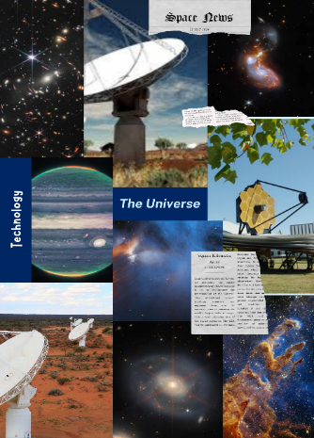

Student resource – the SKAO
Open the SKAO webpage. Use your skimming and scanning skills to read the text and answer the questions below.
- Skim the website’s home page by scrolling or opening the ‘hamburger’ in the top-left corner. Find the appropriate pages to answer the questions below, then scan the page to answer them.
Describe how you applied skimming and scanning to locate the information on the website.
Question | Response | Skimming and scanning techniques
What is the SKAO, and what does it study? Select 3 goals.
What kind of telescopes are used by SKAO, and how are they arranged?
Why do some of the antennas look like Christmas trees?
How does the SKAO work with other countries to learn about space?

- Discuss the significance of having the SKA located in remote areas like the Karoo desert in South Africa and the Murchison region in Australia.
- Outline one potential impact of the SKAO project.
- Create a collage or other appropriate representation to answer the question: ‘How have advances in science increased our knowledge of space and the Universe?’. The collage should show advances in science and technology and illustrate what we have learned through this technology.

2.4 What is in the centre of our Solar System?
Table 5 – learning intentions and success criteria for ‘What is in the centre of our Solar System?’
Learning intentions | Success criteria
We are learning how scientists use scientific models to increase our understanding of the Universe. | I can:  - explain how models are used in science to describe the Universe  - describe historical and current models of our solar system  - explain how and why models of the solar system have changed.
We are learning to process and represent information. | I can summarise information from a variety of sources.

Models of the Universe and Solar System
Review prior learning
Select one of the prior learning activities
Option 1: use the diagnostic questions (3 slides) in ‘The Sun’ in the OTU PPT to ascertain students’ prior knowledge of the Sun and its place in the solar system. Address any misconceptions, as described in the notes beneath the slides, before proceeding with this lesson about models of the Universe.
Option 2: make a series of statements and ask students to position themselves along a continuum of agreement. The website Positioning activities contains advice for facilitating a continuum activities. Statements may vary depending on class discussions and interests. Students must be able to justify their positions.
Some examples of statements include:
- I am confident that I understand how models are used to describe our Universe.
- If the Earth is the size of a tennis ball, the Sun would be the size of a basketball.
- The Sun is the centre of the Universe.
- The Sun is the centre of our solar system.
Introduction
Display the ‘What do we think we know’ slide in the OTU PPT, which has the quote:
Agent K in the movie Men in Black said “One thousand five hundred years ago, everybody knew the Earth was the centre of the Universe. Five hundred years ago, everybody knew the Earth was flat … Imagine what you’ll know tomorrow”.
(Sonnenfeld 1997)
Use the quote to introduce models of our solar system and how they have changed as new evidence has come to light.
Ask the students what this quote means and how it is relevant to space science (Think-Pair-Share).
Facilitate a discussion by asking the students to describe our solar system. This activity could be conducted as a silent discussion. (Students each have a different coloured marker or pencil. They write their ideas on a piece of butcher’s paper without speaking. There should be an even mix of the colours. Encourage equal input from all participants, which will be visible through the amount of each colour on the paper.)
Explain that our model of the solar system represents our current understanding based on our observations. As new evidence is discovered, the model may be modified or updated.
Although we know the solar system's main structure, new details are still being discovered. For example, in 2003, a ‘10th planet’ was discovered; in 2006, Pluto was no longer categorised as a planet, and there is evidence for an undiscovered ninth planet in our solar system (The evidence for an undiscovered ninth planet in our solar system (8:19)).
Video and note-taking
Before watching the following video, How astronomy came of age: changing models of the solar system (7:52), ask the students, ‘What subheadings could we use if we were to write a summary of the information in the video?’. Check understanding through brainstorming of key ideas, which become the cues in the table below.
The teacher should model how to construct notes under these subheadings using established processes, such as bullet points, direct quotes from the audio and sketching an image. Teachers could model the use of Cornell notes using a think-aloud. View the video a second time and complete the table.
Additional information for the teacher on using the Cornell Note Taking System.
Students then write a summary, Models of the solar system, from their notes in their table.
Differentiation: after watching the video, give students a cloze passage to complete instead of making their own notes.
Watch the video together as a class, pause and discuss the content at key points.
Table 6 – sample response – models of the Universe Cornell notes
Cues | Notes
Ancient Greek  - model of the Universe  - diagram | Earth is at the centre of the solar system (Universe). The moon, sun and stars orbit in perfect circles around it.  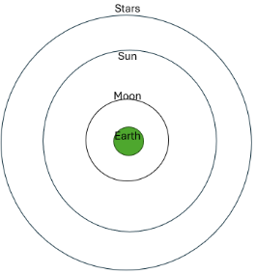
- evidence | The model explained the movement of the Sun, Moon and Planets across the sky. The Earth is stationary, as we would feel the Earth’s movement.
- problem | Some celestial objects wandered back and forth and did not fit the model.
- solution | Modify the model to include more circles.
Later astronomers’ modifications:  - Copernicus and Kepler (when) | Sixteenth century: the Sun is at the centre of the solar system. This is a simpler explanation of the movement of the planets.
- Galileo (when) | Seventeenth century: built and used telescopes – observed moons orbiting Jupiter. This suggested that not everything revolves around Earth.
Models – Why use them?  When to replace them | Explain available observations and data. Enable predictions to be made.  When new ones provide better explanations.
Where are optical telescopes located? | High on islands, in space
Other technology used for observing space? | Probes on planets – Mars

Summary – Changing models of the Universe
Ancient Greeks used a model to explain their observation of the movement of the Moon, Sun and stars in the sky. It depicted the Earth at the centre, with the Moon, Sun, and stars orbiting around it in perfect circles. Although the Earth's movement could explain their observations, this was deemed impossible as they would have felt it. However, the movement of some objects did not fit the model. They wandered back and forth across the sky, so the ancient Greeks modified their model by including more perfect circles.  In the sixteenth century, Copernicus and Kepler changed the model to put the Sun at the centre. In the seventeenth century, Galileo built and used a telescope to observe the moons of Jupiter. This showed that not all objects revolved around the Earth and elegantly explained the planets' movement in the sky.  Scientists use models to explain observations and make predictions. New models replace old ones when they provide better explanations. | 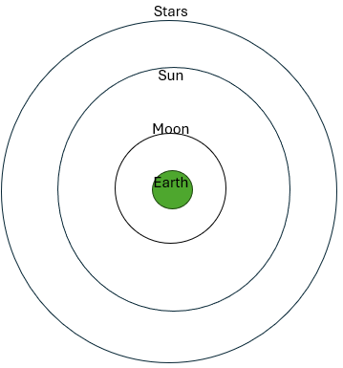
Checkpoint:
Students draw simple diagrams on mini whiteboards showing how the solar system models have changed over time as they are introduced.
Differentiation:
Challenge students by examining the following statement: ‘Better tools mean better evidence, which helps us develop better theories about how the Universe works.’
What does the term ‘better’ mean in this context? What does this statement mean? How does it relate to our understanding of the Universe?

Student resource – models of the Universe
Watch the video How astronomy came of age: changing models of the solar system (7:52).
Write keywords or questions in the ‘Cues’ column. Make short notes in the second column. You may need to stop and pause the video or watch it more than once. Then, write a summary of the video.
Cues | Notes

Summary

Solar System Scope
The Solar System Scope is an easy-to-use online model that allows students to view our current solar system model. Open the Solar System Scope and start the online model. Guide students through the instructions on the student resource to explore the simulation.

Student resource – Solar System Scope
Open the Solar System Scope and click start the online model.
Navigation
Zoom in and out using the scroll wheel on your mouse.
Change the angle of view by holding down the mouse's left button and moving it around.
Observations
Explore the simulation to make observations about the location of the Sun, Moon and Earth during the different phases of the Moon and eclipses.
- Tilt the solar system to a bird's-eye view. Adjust the zoom settings until you can see the Moon and the Earth.
- Select the play button. Adjust the ‘time forward’ to +30 minutes/sec. Observe the rotation of the Earth compared to other planets.
- Adjust the ‘time forward’ to +3 hours/sec. Observe the rotation of the Earth compared to the Sun. Note the motion of the Moon compared to the Sun and the Earth.
- Adjust the ‘time forward’ to +1.6 days/sec. Observe the motion of the Moon around the Earth.
- Identify when the different phases of the Moon occur.
- The New Moon occurs when the Moon is positioned between the Sun and the Earth.
- The Full Moon is when the Earth is positioned between the Sun and the Moon.
- A waxing moon occurs as the Moon appears to become fuller from a New Moon to a Full Moon.
- A waning moon occurs as the Moon decreases in fullness, transitioning from a Full Moon to a New Moon.
- Note how long it takes for the Moon to orbit the Earth once.
- Tilt the solar system so that the planets are in a horizontal plane.
- Adjust the time to +10 days/sec. Observe the location of the Moon compared to the Sun and Earth when the Earth sees a Full Moon and a New Moon from this aspect.
- Allow the simulation to progress until the Earth experiences a Lunar eclipse (New Moon). Now, allow it to progress until the Earth experiences a Solar eclipse. Observe the relative locations of the Sun, Moon and Earth.

2.5 The scale of the Solar System (practical investigation)
The importance of models and scale in space
Adapted from Solar System and beyond Key concept (University of York Science Education Group 2018). In-text citations were removed.
Students need to understand the correct scientific model to explain observable phenomena caused by the movement of the Earth, Sun, and Moon. If they use an incorrect model, they will likely form further misunderstandings. About a quarter of 11 – and 12-year-olds are using incorrect models.
In a study (n=25 for each age range), about half of students aged 11–12 thought that night and day were caused by the movement of the Sun, with just 20% giving the correct explanation; by age 13 or 14, about half could explain how day and night are caused by the Earth spinning on its axis. Students might maintain their misunderstandings by keeping work on the Solar System simple and descriptive. A review of astronomy education research (1974–2008) identified the need for teachers to use physical models to scaffold learning and challenge misunderstanding.
One problem with solar system models is the difficulty of scale. If the Earth is modelled as the size of a soccer ball, the Moon would be the size of a tennis ball orbiting at 6.6 m from the Earth (generally, in an adjacent classroom). On the same scale, the Sun would be the size of a (spherical) ten-storey building about 2.6 kilometres away. Diagrams of the Solar System in books and on posters are often poorly drawn and not to scale, leading to persistent misunderstandings. There is evidence that students typically have a poor understanding of the scale of space, and it is recommended that there is a greater focus on teaching distance and size to help explain astronomical phenomena more clearly.
Because students will be coming into Year 7 with a wide range of background knowledge and understanding and with the above information in mind, the writers of this resource have included this series of activities on the scale of the solar system, even though scale is not specifically mentioned in the Science 7–10 Syllabus. This will assist you in dispelling students’ misconceptions and improving their understanding so they can clearly explain the predictable and observable phenomena on Earth.
Table 7 – learning intention and success criteria for ‘The scale of the Solar System’
Learning intention | Success criteria
We are learning how scientists use scientific models to increase our understanding of the Universe. | I can:  - use a model to describe objects in space  - explain some difficulties when describing the size and distance of objects in space  - explain what scale means when describing the size of solar system models.
Ascertain prior knowledge: students complete the size of space question: ‘How big is the Earth compared to the Sun?’ in the OTU PPT.
Differentiation: there are 3 activities provided here. Depending on the knowledge and understanding your students bring from primary school, you could select to use any one or more of these activities. The first is a simple demonstration of the relative position of the solar system components that can be completed in the classroom. The second is a more detailed scaled representation of the planetary size and distance from the Sun. This task requires the class to go outside to an area about the size of a school oval. The final task focuses on the relative size of the Moon and Earth and the distance between them.

Pocket Solar System
This activity quickly and easily demonstrates to students the relative distance between components of the solar system. You will need a roll of receipt paper or similar.
Note: Pluto is used to represent the outer limits of the solar system for modelling purposes only because the scaled distance of the Sun to Pluto fits nicely into the scale lengths of the human body. The ‘end’ of the solar system is complex and is defined differently depending on the context and criteria used. It should be emphasised that Pluto is not a planet and is used for scaling purposes only.
- Distribute a piece of receipt paper approximately 180 cm long to each student. Students then follow these steps.
- Tear off a piece of paper about the length of your arm span. This is also approximately your height.
- Mark the Sun at one end of the paper and Pluto at the other.
- Fold the paper in half, unfold the paper and draw a line in the crease mark to mark the orbit. Place Uranus on the orbit.
- Refold the paper in half and fold it in half again – it is now folded into quarters. Draw an orbit line and add Neptune at halfway between Uranus and Pluto. Then, Saturn’s orbit is added halfway between the Sun and Uranus.
- Fold the Sun to meet Saturn and add Jupiter’s orbit on the fold line.
- Fold the Sun to meet Jupiter and add the asteroid belt orbit on the fold line.
- Fold the Sun to meet the asteroid belt and add Mars’ orbit on the fold line.
- Fold the Sun to meet Mars, leave it folded and fold it in half again. Unfold the paper, and there will be 3 fold lines. Add Mercury to the crease closest to the Sun, Venus on the next fold and Earth on the final fold.
This simple model of the Universe represents the relative distances between components of the solar system.
Facilitate a discussion about the model's strengths and limitations, the place of simple models in science, and how this model could be improved.
- Strengths – easy to understand, simplified scale.
- Limitations – accuracy, linear, limited detail, does not address the size or movement of the planets.
- Very simple models are useful in science to make difficult concepts accessible for building foundational knowledge or to emphasise only the essential information or one aspect of the system. They can also be used to stimulate curiosity and critical thinking.

The size of the Solar System
This activity can be used to model the size and distances in the solar system at the same scale. You will need a circle of yellow card 1 metre in diameter to represent the Sun. In this activity, the Sun is positioned at the edge of the school oval. Teachers may choose a different point suited to their school’s location. This exercise demonstrates to students that the planets are extremely small in comparison to the Sun and that the distances in space are extremely large in comparison to the size of the Sun and planets.
Students draw all the planets at the size indicated in the student resource – The size of the Solar system.
Take the students outside and place the Sun and a student at the edge of the school oval.
Position students to indicate where the planets would be in the school oval, considering the scaled distances indicated in the table. You will likely only have Mercury, Venus and possibly Earth on the school grounds.
Students then need to estimate, using Google Maps, where the other planets would be located outside the school grounds according to the scaled distances listed: for example, at the railway station, at the shopping centre, in the adjoining suburb, at the tip, or in the soccer fields. Mercury has been completed.
Lead a discussion on how the distances in space affect our capacity to gather information about it.

Student resource – the size of the Solar System
Planet | Scaled size (diameter) | Scaled distance from the centre of the Sun | Position of planet
Sun | 1 m | NA | Edge of the school oval
Mercury | 3.4 mm | 41 m | Middle of the school oval
Venus | 8.6 mm | 107 m
Earth | 9.1 mm | 163 m
Mars | 4.8 mm | 559 m
Jupiter | 102.7 mm | 1.025 km
Saturn | 83.6 mm  (8.36 cm) | 2062 m  (2.062 km)
Uranus | 33.7 mm  (3.37 cm) | 3232 m  (3.2 km)
Neptune | 32.6 mm  (3.26 cm) | 4248 m  (4.22 km)

Earth vs Moon – modelling the Earth and Moon (practical investigation)
In this activity, students will explore the scale of the Earth and the Moon.
Equipment:
For this activity, you will need a basketball, tennis balls and balls of various sizes. Polystyrene balls provide a good variety of sizes.
Introduce models
Show a picture of a model car with the scale visible. In this example, the scale is 1:10. Ask the students what 1:10 means. Answer: 1 cm on the model car equals 10 cm on a real car.
Explain that a scale model shows the size of all parts of an object or system changed (increased or decreased) by the same amount.
Applying scale models to the Moon and Earth
Hold up a basketball. Ask the students, ‘If a basketball is used as a model of the Earth, what do you think one centimetre on the basketball will represent on the Earth?'. Answer: The Earth is approximately 50 million times bigger than the basketball. Therefore, 1 centimetre on the basketball equals 50 million centimetres or 500 km.
Display a range of balls of several sizes – tennis balls and a variety of others smaller than a basketball. Pose the question, ‘If the Earth is the size of this basketball, how big would a model of the Moon be?’. Ask the students to select a ball from the displayed selection to represent the Moon. Answer: It will be tennis ball-sized, but do not announce this yet.
Place the basketball Earth at the front of the room. Ask the students to take their Moon and stand at a distance they think the Moon would be from the Earth if it were at this scale. Lead a discussion on what information they used to decide on the size of the ball representing the Moon and how far away to stand.
Tell students that, on this scale, the tennis ball is the nearest approximation to the size of the Moon. Show the students how far away they should be from the basketball (they should be approximately 7.7 m from the basketball).
The International Space Station (ISS) is a large spacecraft in low Earth orbit that serves as a space environment research laboratory. It is a collaborative project involving multiple countries, including the United States, Europe, Japan, and Canada. The ISS orbits the Earth at an average altitude of approximately 420 kilometres (260 miles) and travels at a speed of about 28,000 kilometres per hour (17,500 miles per hour). It is 108 m long and orbits the Earth at an altitude of 400 km.
Ask the students, ‘If 1 centimetre on a basketball represents 500 km, how big would the ISS be in our scale model?’
Sample answer with working:
The International Space Station (ISS) is 109 m long.
$Size of the ISS= \frac{109 m}{500, 000 m} x 1cm$ = 0.000218 cm
Note: this is approximately 0.0022 mm, smaller than a human hair's width.
The ISS is approximately 400 km from Earth.
$$Scale distance= \frac{400 km}{500 km} x 1 cm=0.8 cm$$
Therefore, the ISS would be approximately 0.000218 cm long and only 0.8 cm away from the basketball.
Checkpoint: display the diagnostic question ‘The size of space. How big is the Moon compared to the Earth?’ in the OTU PPT.
Students draw Figure 2 – annotated scaled diagram of the Earth and Moon. They should use a ruler and compass to draw the Moon with a diameter of 1 cm. On this scale, the Earth’s diameter is 3.7 cm. Add annotations to indicate the actual diameters of the Earth and Moon as shown. The distance between the Earth and the Moon should also be proportionately scaled (110.6 cm). Explain that a scale break is used to depict the distance between the Earth and the Moon since, at this scale, this length is too large to be drawn in their books.
Note: in the diagram below, the Moon’s diameter is represented as 1 cm. The Earth’s diameter and the distance between the Earth and the Moon are proportionately scaled. Thus, when placed end-to-end, about 111 Moons can fit in the space between the Earth and the Moon.
Figure 2 – annotated scaled diagram of the Earth and Moon
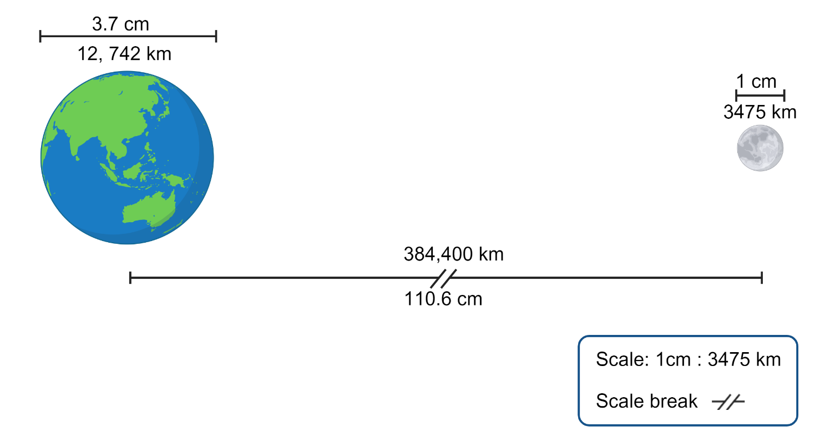
This work has been generated using BioRender.com. Any copyright subsisting in this work is owned by © State of New South Wales (Department of Education) 2024.
Watch a video such as How small are we in the scale of the universe? (4:07) or Our Universe is SO big, it's mindblowing! (7:04). Lead a discussion on the challenges in estimating size and distance in space. These could include perceptions such as the Moon appearing close and the Sun seeming far away, the Moon appearing larger when it rises and sets, the large size differences among celestial objects, the vast distances in space and our lack of experience in determining the size of objects at great distance.
Checkpoint: Exit ticket – identify 3 ways models, such as a solar system model, can help us learn about the Universe around us.
Checkpoint sample response
Models help us understand the Universe around us by allowing us to visualise and explore things that are too big, small, complex, or far away to observe directly. For example, the pocket solar system model allowed us to explore the scale of the solar system, revealing the vast distances between the planets and the Sun. This was useful because the actual distances are so huge that we cannot easily imagine them.

2.6 Seasons (secondary-source investigation)
Table 8 – learning intentions and success criteria for ‘Seasons (secondary-source investigation)’
Learning intentions | Success criteria
We are learning how scientists use scientific models to increase our understanding of the Universe. | I can:  - use models to make predictions and observations  - explain the relationship between the seasons and the positions of the Sun and the Earth
We are learning to process and represent information. | I can:  - plot data accurately on a graph  - analyse data from various sources to identify patterns  - use a computer simulation to make accurate observations
In this activity, students will use various strategies to investigate the cause of the seasons. It consists of 3 parts. Students will:
- analyse a simple dataset to observe patterns in the hours of sunlight and temperature in the northern and southern hemispheres
- use Stellarium to explore the movement of the Sun and its distance from the Earth
- model the changes in hours of sunlight and temperature during the different seasons.
Note: a common misconception is that the seasons are caused by differences in the distances of the Earth from the Sun, either due to the tilt of the Earth’s axis or the elliptical orbit of the Earth. This activity is designed to address this misconception explicitly.
Assess prior knowledge: Students complete ‘Changing seasons – questions about summer in the hemispheres’ in the OTU PPT.
Alternatively, ask students what the names of the seasons are and when they occur in the Southern Hemisphere. Are they the same in the Northern Hemisphere? Why?
Sample answer:
In the Southern Hemisphere, summer occurs from December to February, Autumn from March to May, Winter from June to August and Spring from September to November. The seasons have the same names in the northern hemisphere but occur at opposite times of the year. Winter: December–February; Spring: March–May; Summer: June–August; Autumn: September–November. They occur at opposite times of the year because of the Earth’s tilt and its revolution around the Sun. For example, it is summer here when the Southern Hemisphere is tilted towards the Sun. The Northern Hemisphere is tilted away from the Sun, so it is winter there.

Part 1 – analysing the data
Provide students with the worksheet to complete. They will use data from the website, timeanddate to process and analyse data to identify patterns and trends in the hours of daylight and temperature across the year.
For question 1:
- Use a globe to identify the location of Longyearbyen.
- Explain that the data for time is NOT a decimal. For example, 2:50 means 2 hours and 50 minutes, not 2 and a half hours.
- If your students are using Microsoft Excel to graph the data, they will need to: in the Format Cells box, select Custom in the Category list. Select h:mm (for hours and minutes) in the Type list, and then select OK.

Sample response

- What patterns do you observe in the graph?
Antarctica has 24 hours of daylight during November, December and January (summer) and 24 hours of darkness during May, June and July (winter).
Longyearbyen, in the Northern Hemisphere, has 24 hours of daylight in May, June and July and 24 hours of darkness in November, December and January. This is the opposite of Antarctica.
- Complete the Venn diagram to compare and contrast the average number of sunlight hours in Longyearbyen (red) and Antarctica (blue).
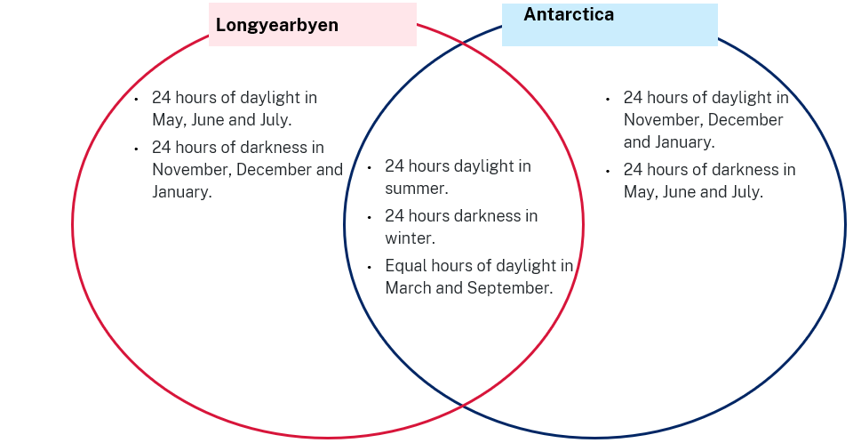

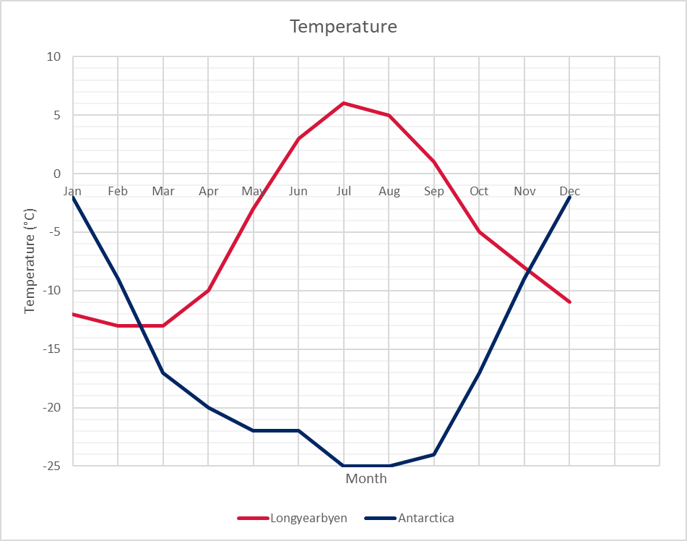
- What patterns do you observe in the graph? How does this compare to the daylight hours data?
Antarctica is warmer in November, December and January when there are more daylight hours. Longyearbyen is warmer in June, July and August when daylight is longer.
- Investigate the amount of sunlight per month at your home.
- Mark the approximate location of your town on the map of Australia.
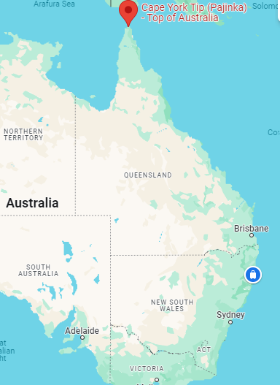
- Go to the website: timeanddate (https://www.timeanddate.com/sun/australia/sydney). Enter your town into the search window. Look at the sun graph for your town to see how the hours of daylight and night change through the year. Move the slider until you find today’s date and fill in the table below. Ignore the hours of twilight (this is for a school at Jervis Bay).
Figure 3 – Sun graph for Jervis Bay
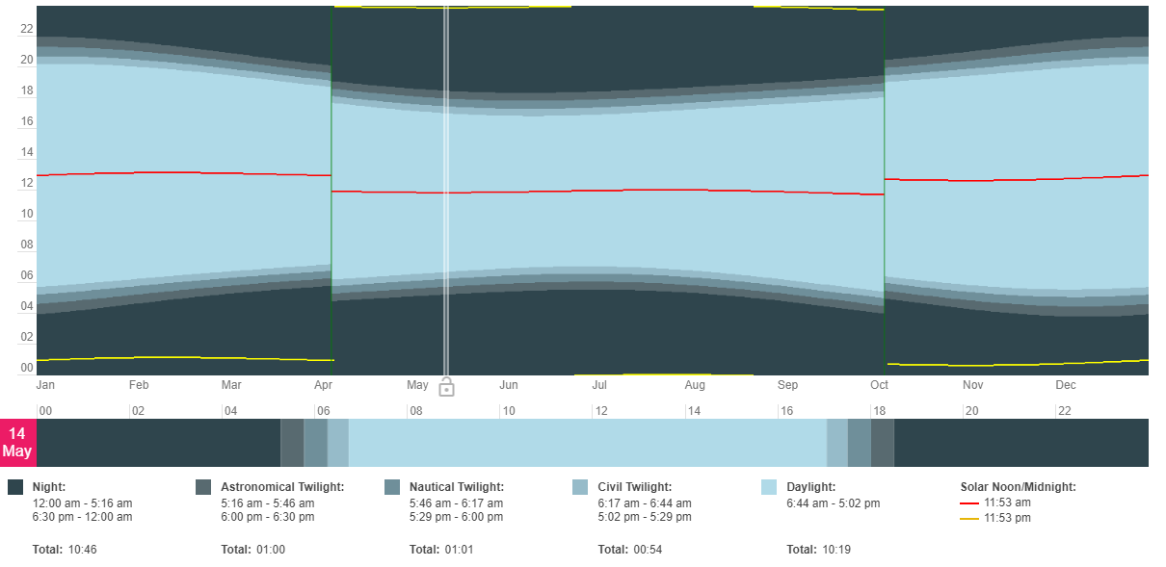

https://www.timeanddate.com/sun/@6615605, Jervis Bay, Australian Capital Territory, Australia, © timeanddate.com
Table 9 – sample response – daylight hours for Jervis Bay
Date | Hours of daylight (hours:minutes) | Hours of night (hours:minutes)
Today (14 May) | 10:19 | 10:46
19 Mar | 12:10 | 9:00
20 Jun | 9:48 | 11:11
22 Sep | 12:07 | 9:04
21 Dec | 14:31 | 5:54
Note: the number of hours of daylight added to the hours of night does not equal 24 hours. This discrepancy is due to the hours of twilight. There are 3 kinds of twilight – civil, nautical, and astronomical – each with different start and end times. This data has not been included in the student worksheet to avoid complexity.
- What do you notice about how the hours of daylight and night change throughout the year?
The number of daylight hours is longest in summer and shortest in winter. There is approximately 5 hours more daylight in summer than in winter and approximately 5 hours less at night in summer than in winter. The number of daylight hours in spring and autumn is similar, and the night hours are similar in autumn and spring.
- Repeat with Cape York (closer to the equator).
Figure 4 – Sun graph for Cape York
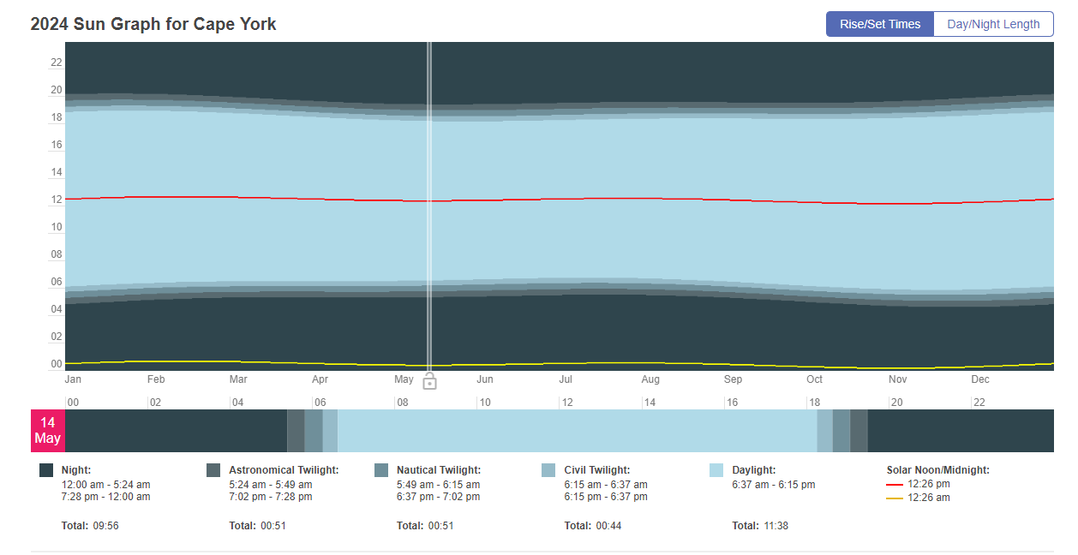
https://www.timeanddate.com/sun/@2142268,. Cape York, Queensland, Australia, © timeanddate.com
Table 10 – sample response – daylight hours for Cape York
Date | Hours of daylight (hours: minutes) | Hours of night (hours: minutes)
Today (14 May) | 11:38 | 9:56
19 Mar | 12:07 | 9:33
20 Jun | 11:30 | 9:59
22 Sep | 12:06 | 9:34
21 Dec | 12:45 | 8:39
- What do you notice?
The daylight hours in Cape York are slightly longer in summer than in winter. They are similar lengths in Spring and Autumn, and there is little variation in daylight hours across the year.
Select the Day/Night Length tab above the graph.
Figure 5 – Sun graph for Cape York
- 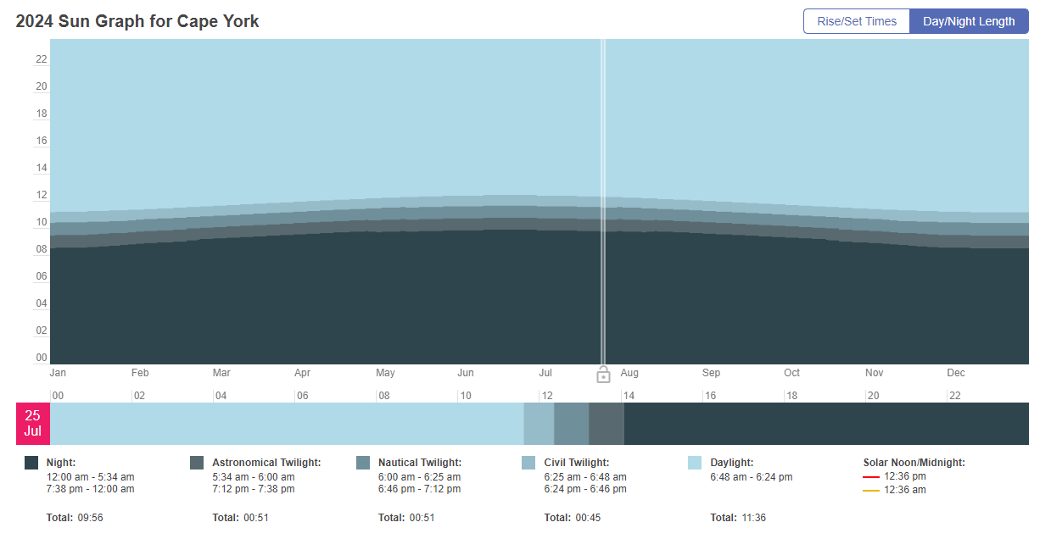

https://www.timeanddate.com/sun/@6615605, Cape York, Qld, Australia © timeanddate.com
Figure 6 – Sun graph for Sydney
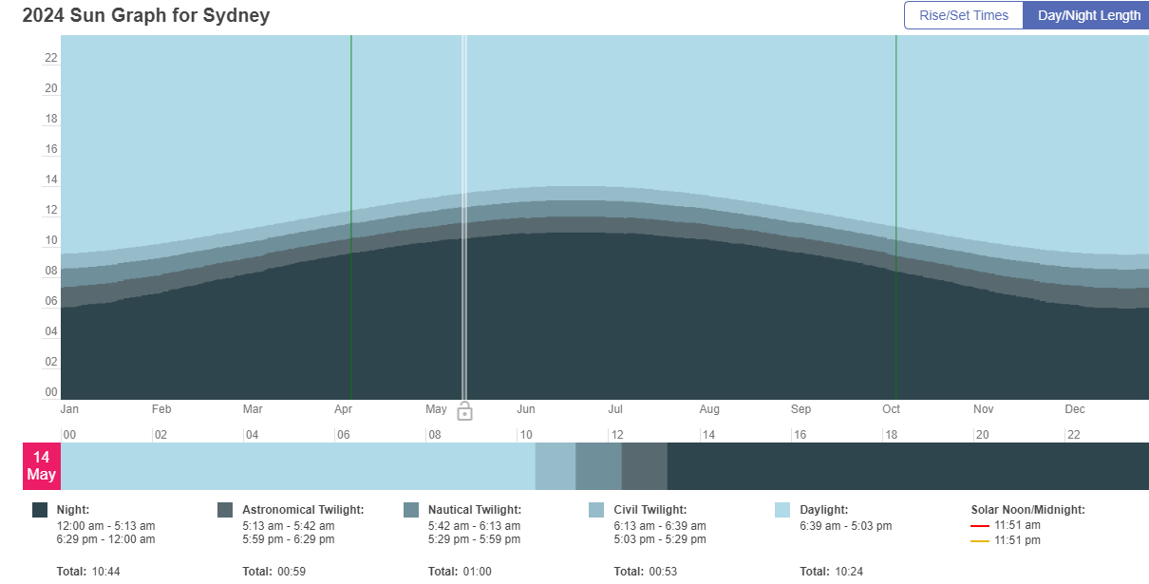
https://www.timeanddate.com/sun/australia/sydney, Sydney, New South Wales, Australia, © timeanddate.com
Figure 7 – Sun graph for Davis, Antarctica
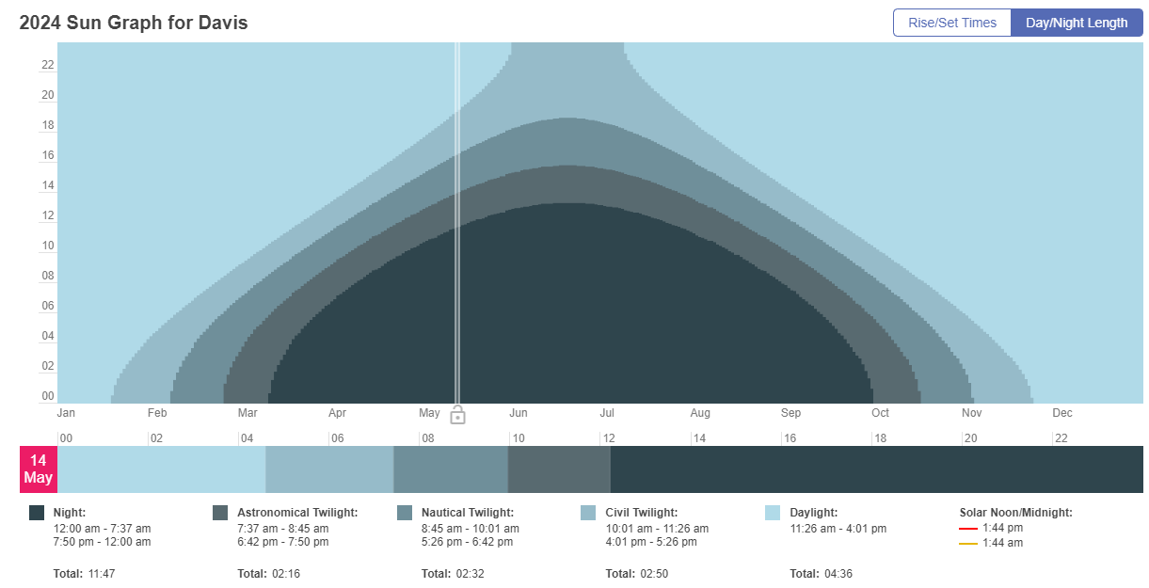
https://www.timeanddate.com/sun/antarctica/davis, Davis, Antarctica, © timeanddate.com
- Compare the shape of this graph for Cape York to the shape of the graph for Sydney and the Antarctic (Davis Base).
The shape of the graph is flatter for Cape York than Sydney because it is closer to the Equator. The daylight hours do not vary as much in Cape York as in Sydney. The graph for Antarctica shows that the minimum daylight hours occur in June–July (the southern winter).
- Propose a reason for the patterns that you have observed.
The Earth is spherical and tilted on its axis. Therefore, the angle at which sunlight reaches different parts of the world varies considerably. Countries closer to the equator experience less seasonal variations in their daylight lengths than countries closer to the equator. For example, in a calendar year, Cape York has little variation in daylight lengths (maximum-minimum), while Antarctica shows large seasonal variations. Sydney, located approximately midway between Cape York and Antarctica, had an intermediate level of daylight length variation.

Consolidation
Bring the group back together to discuss their observations and interpretation.
Checkpoint (OTU PPT 2.6 Seasons)
In the North and South Poles, data show variations in the number of daylight hours and average temperatures throughout the year. Based on your observations, which of the following statements is true?
- During the summer months in the North Pole, there are fewer daylight hours and lower temperatures compared to the winter months.
- During the summer months in the South Pole, there are more daylight hours and higher temperatures compared to the winter months.
- During the winter months in the North Pole, there are more daylight hours and higher temperatures compared to the summer months.
- During the winter months at the South Pole, there are fewer daylight hours but higher temperatures than in the summer months.
Note: the correct answer is B. Students understand that during summer, at both poles, the days are longer and the temperature averages are higher compared to winter.

Student resource – Seasons Part 1 – analysing the data
The table below contains the average hours of sunlight per month for Longyearbyen (77:22N, 15:64E), which is in Norway and a location in Antarctica with a similar latitude (68:35S, 77:59E).
Location | Jan | Feb | Mar | Apr | May | Jun | Jul | Aug | Sep | Oct | Nov | Dec
77:22N, 15:64E  Longyearbyen, Norway | 0 | 2:21 | 11:20 | 19:26 | 24 | 24 | 24 | 23:14 | 14:30 | 4:05 | 0 | 0
68:35S, 77:59E Antarctica | 24 | 22:57 | 13:40 | 4:16 | 0 | 0 | 0 | 1:27 | 10:34 | 19:36 | 24 | 24
- Plot this data on graph paper.
Note: the times are recorded in hours and minutes. For example, 2:50 means 2 hours and 50 minutes.
- Give the graph a title.
- Add the remaining months of the year along the horizontal axis.
- Plot the data points for Longyearbyen and join the dots with a red line.
- Plot the points for Antarctica and join the points on the plot with a blue line.

- What patterns do you observe in the graph?
- Complete the Venn diagram to compare and contrast the average number of sunlight hours in Longyearbyen (red) and the Antarctic (blue).
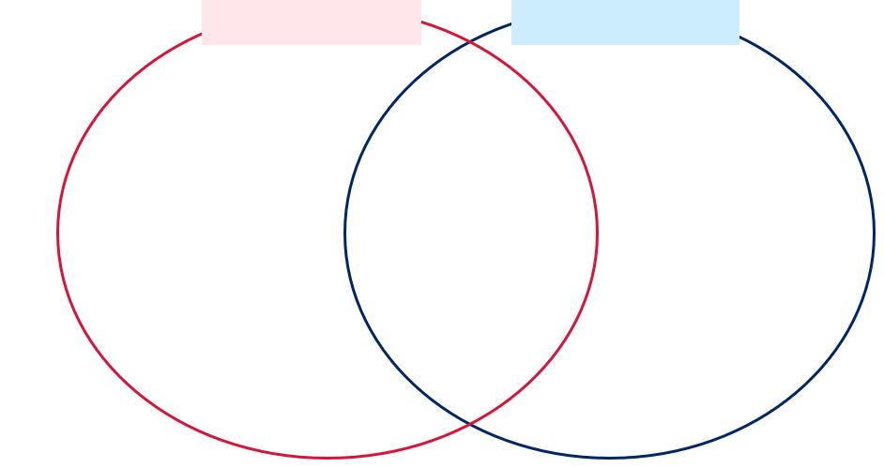
The table below contains the average monthly temperature for Longyearbyen and Antarctica.
Location | Jan (°) | Feb (°) | Mar (°) | Ap (°) | May (°) | Jun (°) | Jul (°) | Aug (°) | Sep (°) | Oct (°) | Nov (°) | Dec (°)
77:22N, 15:64E  Longyearbyen, Norway | -12 | -13 | -13 | -10 | -3 | 3 | 6 | 5 | 1 | -5 | -8 | -11
68:35S 77:59E Antarctica | -2 | -9 | -17 | -20 | -22 | -22 | -25 | -25 | -24 | -17 | -9 | -2
- Plot this data on graph paper.
- Give the graph a title.
- Add the months of the year along the horizontal axis.
- Plot the data points.
- Join the points on the plot with a line. Red is used for Longyearbyen data, and blue is used for Antarctica data.

- What patterns do you observe in the graph? How does this compare to the daylight hours data?
- Investigate the amount of sunlight per month at your home.
- Mark the approximate location of your town on Australia's map.
Figure 8 – map of Eastern Australia
Map data ©2020 Google CNES / Astrium, Maxar Technologies
- Go to the website: timeanddate (https://www.timeanddate.com/sun/australia/sydney). Enter your town into the search window. Look at the sun graph for your town to see how the hours of daylight and night change through the year. Move the slider until you find today’s date and fill in the table below. Ignore the hours of twilight.
Date | Hours of daylight | Hours of night
Today (add the date)
19 Mar
20 Jun
22 Sep
21 Dec
- What do you notice about how the hours of daylight and night change throughout the year?
- Repeat with Cape York (closer to the equator).
Date | Hours of daylight | Hours of night
Today (add the date)
19 Mar
20 Jun
22 Sep
21 Dec
- What do you notice?
- Select the Day/Night Length tab above the graph. Repeat for Sydney and the Antarctic. Compare the shape of the Cape York graph with the graph for Sydney and the Antarctic.
- Propose a reason for the patterns that you have observed.

Part 2 – the location of the Sun
Note: it is strongly recommended that teachers familiarise themselves with the Stellarium interactive planetarium tool to ensure the best outcome for students during this activity. It is well worth the time investment.
Introduce students to Stellarium Web, an interactive planetarium tool. Allow the students to familiarise themselves with the website. Features that they may explore are:
- adding and removing the atmosphere
- changing the day, date and time
- changing the aspect by moving the Earth
- zooming in and out on objects.
Guide the students as they explore changes to the Sun's path through the year. The student resource provides detailed instructions.
Sample response
What do you notice about where the Sun rises as the year progresses?
The Sun does not always rise in the same place. It does not always rise at due East. It rises at due East twice a year.
What do you notice about the position of the Sun in the sky at noon as the year progresses?
The Sun is higher in the sky in summer than in winter.
Table 11 – sample response – distance to the Sun (AU)
Location | Jan | Feb | Mar | Apr | May | Jun | Jul | Aug | Sep | Oct | Nov | Dec
Murwillumbah | 0.98 | 0.99 | 1.00 | 1.00 | 1.01 | 1.02 | 1.02 | 1.01 | 1.00 | 1.00 | 0.99 | 0.98
Los Angeles | 0.98 | 0.99 | 1.00 | 1.00 | 1.01 | 1.02 | 1.02 | 1.01 | 1.00 | 1.00 | 0.99 | 0.98
What do you notice about the distance of your location from the Sun?
The distance of the Earth from the Sun does not change significantly.
Do you think the changes in the distance between the Earth and the Sun significantly impact the changes in temperature between summer and winter? Explain your reasoning. (The C-E-R scaffold may help you compose your answer).
No, the changes in the distance between the Earth and the Sun do not significantly impact the changes in temperature between summer and winter. The average distance between the Sun and the Earth does not change significantly, so it could not cause a change in temperature and seasons. The distance to the Sun is shortest in December and January. Although it is summer in the Southern hemisphere, it is winter in the Northern hemisphere. This confirms that the change in distance from the Sun does not cause seasons.
Note: this is a common misconception and must be addressed explicitly and in detail to correct it.

Student resource – Seasons Part 2 – The location of the Sun
- Open the website: https://stellarium-web.org.
Select the location button at the bottom left of the screen.
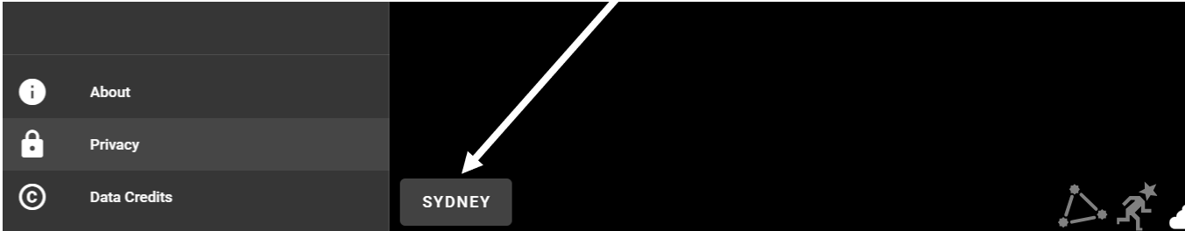
- Enter the name of your town, select the hand lens icon and select from the drop-down.
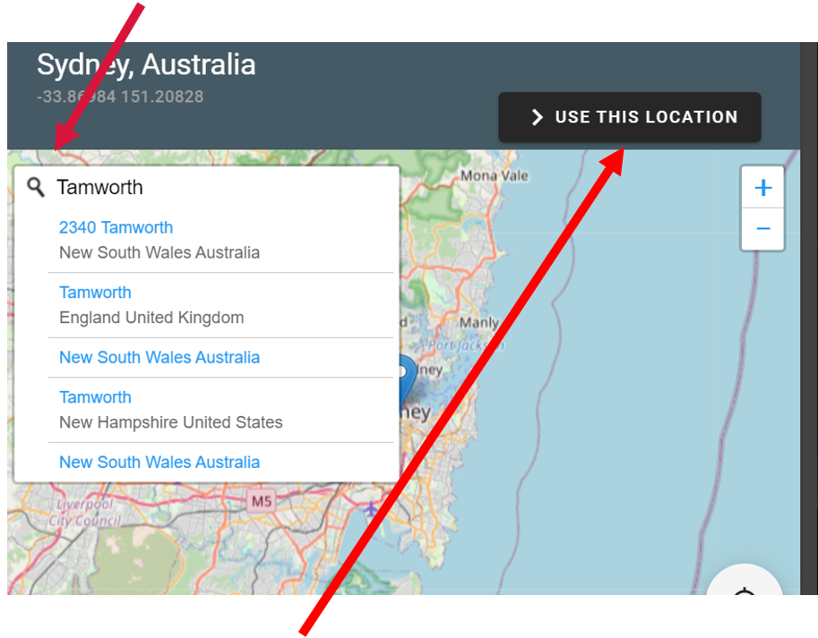
- Select the use this location button. Your town will now appear in the bottom left of the screen.

- Drag the screen to the left so that the East appears about one-third of the way from the right of the screen.
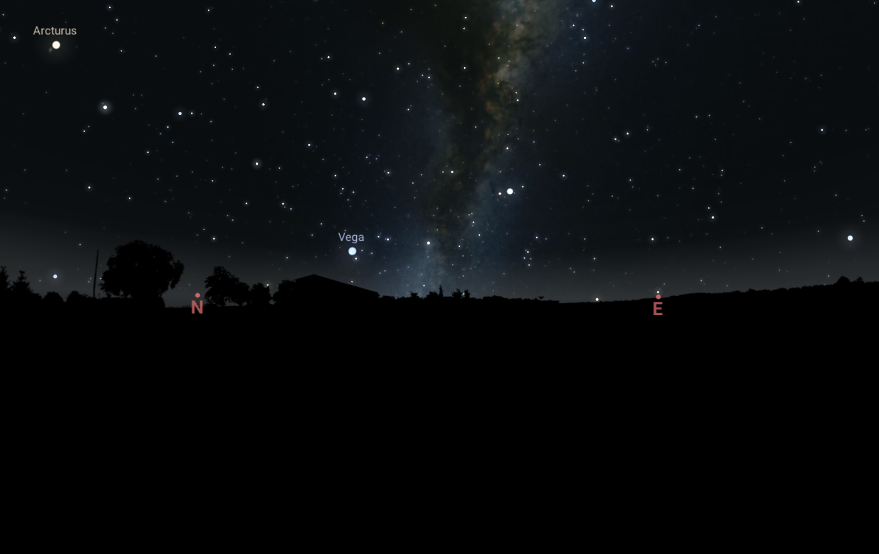
- Select the time button at the bottom right of the screen.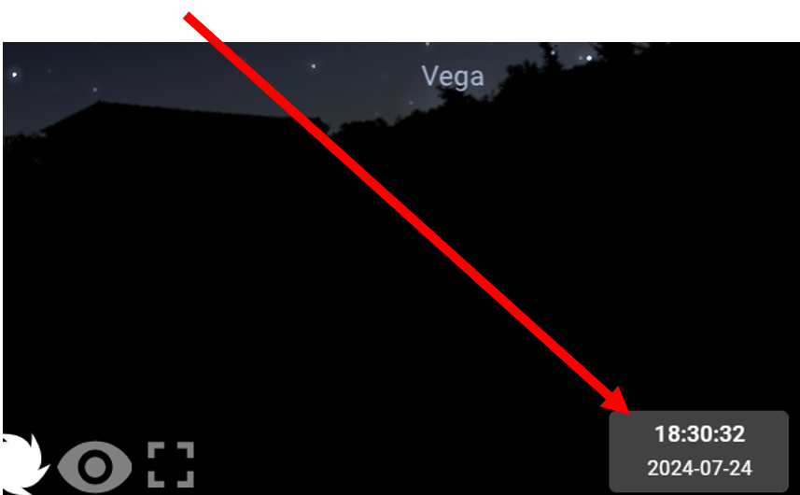
- Set the time to 7 am.
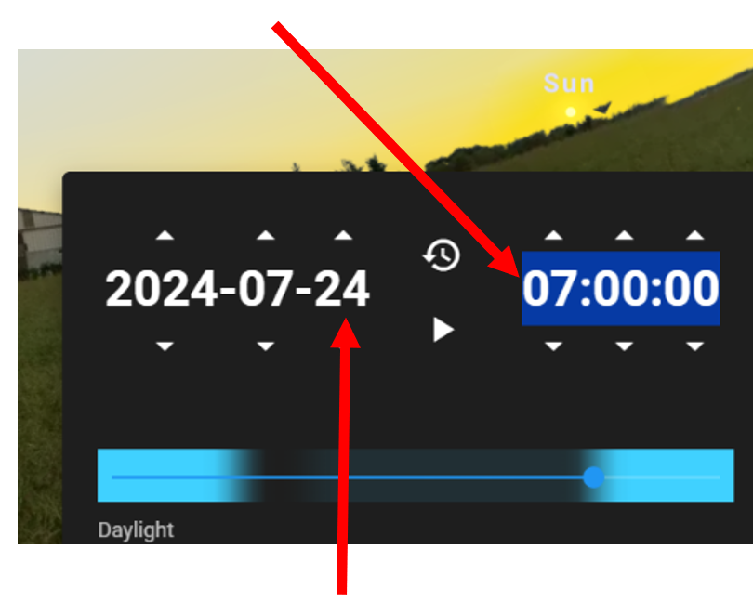
- Advance the date one day at a time.
What do you notice about where and when the Sun rises as the year progresses?
- Set the time to noon. Advance the date by month and record your observations.
What do you notice about the position of the Sun in the sky at noon as the year progresses?
- Return to today’s date and noon.
- Select the Sun to bring its information to the screen by double-clicking on it. The distance to the Sun at your current location is shown in Astronomical Units (AU). An astronomical unit (AU) is a unit of measurement used in astronomy to describe distances within our solar system. One astronomical unit is the average distance between the Earth and the Sun, approximately 150 million kilometres. It helps astronomers understand and compare the distances between planets, asteroids, and other celestial objects in our solar system.
Record the distance to the Sun in Astronomical Units (AU) in the table below.
Table 1 – the distance to the sun in Astronomical units
Location | Jan | Feb | Mar | Apr | May | Jun | Jul | Aug | Sep | Oct | Nov | Dec
Los Angeles
- Change your location to Los Angeles (Northern Hemisphere) and complete the table.
What do you notice about the distance of your location from the Sun?
Do you think the changes in the distance between the Earth and the Sun significantly impact the changes in temperature between summer and winter? Explain your reasoning. (The C-E-R scaffold may help you compose your answer.)

Part 3 – modelling the temperature of the seasons
Remind the students that, in the previous activity, they learned that the Earth’s distance from the Sun changes minimally throughout the year. Therefore, this is not the cause of the different temperatures in different seasons. Ask them what they learnt about the Sun’s position in the sky in summer and winter. Students need a clear understanding that the Sun is higher in the sky and more overhead in summer than in winter, and because of the Earth’s tilt, there is a larger difference in the position of the Sun in each season as we move further from the Equator. In this activity, they will use a model to investigate the effect of the angle of the Sun’s rays on Earth's temperature. Instructions are provided in the student resources that follow. It is suggested that the teacher demonstrates the set-up of the equipment prior to the students commencing the activity. Keep the equipment set up for the demonstration following the student activity.
Equipment required per group of students:
- A lightbox or small torch
- Retort stand
- Boss head and clamp
- 2 sheets of graph paper.
Sample response
- In this model, what represents:
- the Sun?
The light.
- the surface of the Earth?
The graph paper.
- What season is indicated when the light is at:
- 90° to the paper?
Summer
- 45° to the paper?
Winter
- Account for the difference in the temperature between the light striking at 90° and at 45°. You may use a diagram to assist your explanation.
When light strikes the paper at 90°, the light and heat are concentrated over a smaller area than when they strike at 45°. Thus, the temperature in the lit-up area is higher when the lamp is at 90° than at 45°.
Conclusion
The model shows that when the Sun is directly overhead, as it is in summer (summer/winter), its rays are heating a larger (larger/smaller) area. Therefore, those areas will heat up more (more/less) than those where the Sun’s rays strike the Earth at a lower angle.
When the Sun is at a lower angle, as it is in winter (summer/winter), its rays are spread over a smaller (larger/smaller) area. This means that at the lower angle, less (less/more) radiation strikes any point on the surface. Therefore, areas with the Sun at a lower angle will heat less (less/more) than areas with the Sun at 90°. This means that in winter, the surface of the Earth is cooler (warmer/cooler).
Differentiation
An extension question is included for students who have a thorough understanding of the role the angle of the Sun’s rays striking the Earth plays in regulating temperature.
Areas near the Equator do not have distinct summers and winters – it is hot all year round. Polar regions, even in summer when they have 24 hours of light, only become slightly warmer, not hot, in summer. Use your knowledge of the Earth’s tilt and the angle at which the Sun’s rays hit the Earth to explain why this occurs. You may want to use a torch and model of the Earth to investigate why this happens.
A suitable answer would be:
The Earth revolves around the Sun, tilted on its axis. The Sun’s rays at the Equator always strike the Earth at an angle close to 90°; therefore, it is always hot near the Equator. The tilt of the Earth means that in Summer, the Polar regions experience 24 hours of light. However, because of the curvature of the Earth, the rays are spread over a much greater area than at the Equator, so they cannot warm these areas significantly.
Demonstration: use the equipment setup from the above activity but replace the thermometer with a light meter set up in the middle of the lit area. Show that even though the same amount of light leaves the lightbox in both scenarios, the light intensity on the paper is less when the light strikes the paper at 45º than at 90º. This demonstrates that light intensity, like temperature, is less in winter than in summer.
Checkpoint: check for understanding with students completing the hinge question ‘Hot summer days – Why is it hotter in summer?’ in the OTU PPT. A sample response appears in the speaker notes in the PowerPoint.

Student resource – Seasons Part 3 – modelling the temperature of the seasons
Aim: to use a model to determine the effect of the angle of the Sun’s rays on the temperature of the Earth.
Method:
- Set up the equipment as shown below. Adjust the lightbox or torch to point straight down onto the graph paper (90º).
Equipment set up
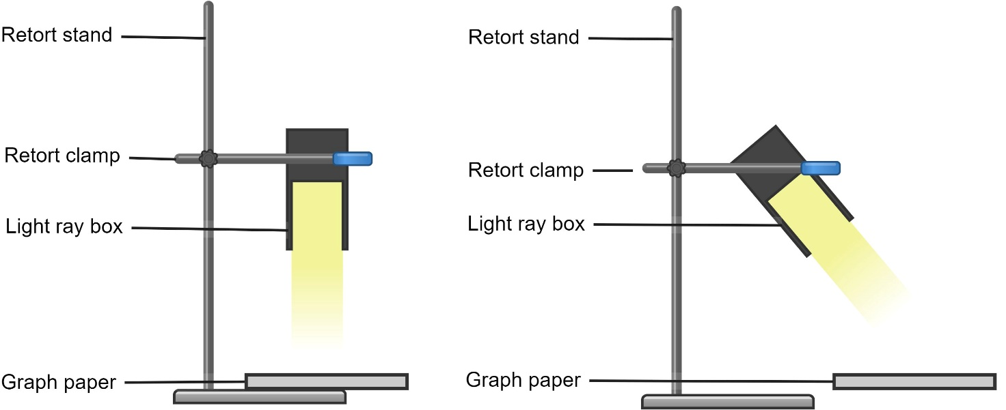
- Turn on the light and adjust the height of the lightbox so there is a clear circle of light on the graph paper.
- Measure the distance between the light box and the paper and trace around the pool of light.
- Place the thermometer in the centre of the pool of light and record the temperature at the start and after 5 minutes.
- Replace the graph paper with a new sheet. Turn the clamp so that the light is at an angle of about 45º to the paper but still the same distance from the paper.
- Repeat steps 3 and 4.
- Count the number of squares illuminated on each graph paper sheet.
Results:
The angle of light striking paper | Starting temperature (°C) | Temperature after 5 minutes (°C) | Area of paper being lit (number of squares)
Light at 90° to paper
Light at 45° to paper
Discussion:
- In this model, what represents:
- the Sun? _____________
- the surface of the Earth? __________
- What season is indicated when the light is at:
- 90° to the paper? _____________
- 45° to the paper? ______________
- Account for the difference in the temperature between the light striking at 90° and at 45°. You may use a diagram to assist your explanation.
Conclusion
The model shows that when the Sun is directly overhead, as it is in _______________ (summer/winter), its rays are heating a ___________ (larger/smaller) area. Therefore, those areas will heat up _________ (more/less) than those where the Sun’s rays strike the Earth at a lower angle.
When the Sun is at a lower angle, as it is in _____________ (summer/winter), its rays are spread over a _________ (larger/smaller) area. This means that at the lower angle, _______ (less/more) radiation strikes any surface point. Therefore, areas with the Sun at a lower angle will heat __________ (less/more) than areas where the Sun is at 90°. This means that in winter, the surface of the Earth is _______________ (warmer/cooler).
- Extension question:
Areas near the Equator do not have distinct summers and winters – it is hot all year round. Polar regions, even in summer when they have 24 hours of light, become warm in summer. Use your knowledge of the Earth’s tilt and the role of the angle at which the Sun’s rays hit the Earth to explain why this occurs. You may want to use a torch and model of the Earth to investigate why this happens.
Use your knowledge of the Earth’s tilt and the role of the angle at which the Sun’s rays hit the Earth to explain why this occurs. You may want to use a torch and model of the Earth to investigate why this happens.

2.7 Exploring the phases of the Moon (practical investigation)
Table 13 – learning intention and success criteria for ‘Exploring the phases of the Moon’
Learning intention | Success criteria
We are learning how scientists use models to increase our understanding of the Universe. | I can:  - describe the phases of the Moon  - explain why the phases of the Moon occur.

Introduction
Assess prior learning: in the OTU PPT, students answer the diagnostic question ‘Which picture shows how the Sun, Moon and Earth move?’
Several misconceptions about the Moon can be addressed in this activity. These include the following:
- you can only see the Moon at night
- the shape of the Moon changes
- the Moon does not rotate.
Ask students when they can see the Moon. If they say only at night, take them outside and look up to see the Moon.
Note: this will depend on the phase of the Moon and the time of day that you are teaching the class.

Part 1 – Stellarium
This activity may be conducted as a whole class or individually.
- Direct the students to Stellarium Web.
- Remove the atmosphere and the landscape to make the Moon easier to see.
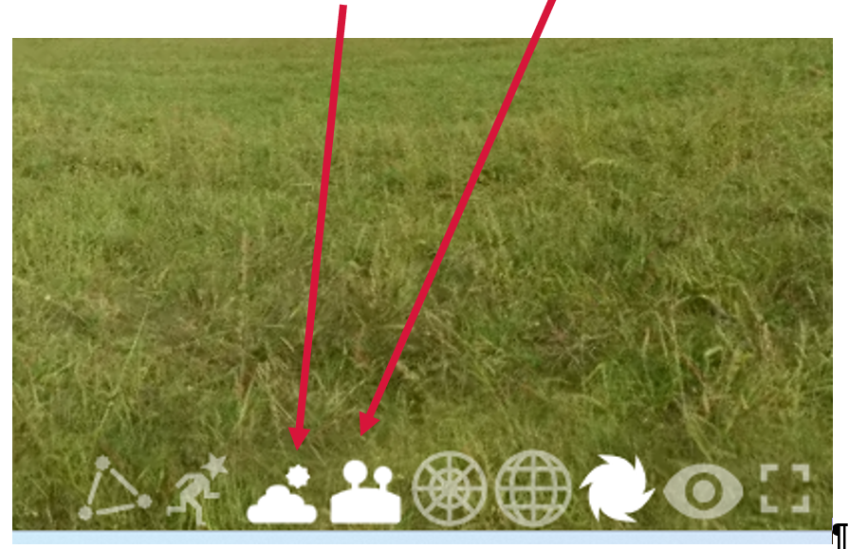
- Search for the Moon in the search bar.
- Zoom in so that the Moon is visible.
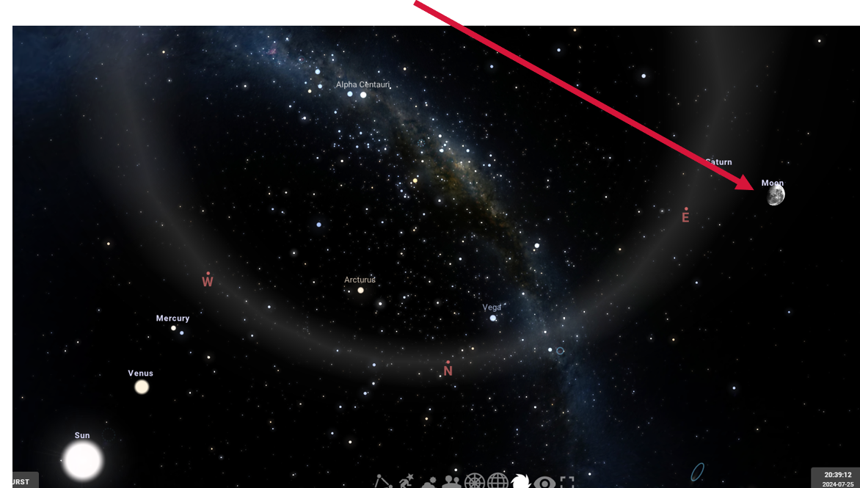
- Use the date button to move through one month day by day and make observations about the Moon. You will need to move the screen to follow the path of the Moon through the month.
- Ask the students to observe how views of the Moon change throughout the month. What patterns do they observe? Students should be able to observe that the Moon appears in different parts of the sky each night, sometimes not visible at all and that it changes shape.
Complete this activity with a sharing exercise. Throw a ball to represent the Moon to a student. As the students catch the ball, they share one observation or thought about Earth’s Moon. They will then throw ‘the Moon’ to another student who will share an observation or insight. This continues for several rounds.

Part 2 – Moon phase calendar
Introduce the term ‘phases of the Moon.’ As the Moon orbits Earth, its apparent shape changes from our perspective on the ground. These phases result from the changing positions of the Moon, Earth, and Sun, and they occur in a cycle that repeats approximately every 29.5 days – a lunar month.
Explain that because of our different perspectives, the phases of the Moon appear different in the Northern and Southern hemispheres. The acronyms COD and DOC can be used to remember the phases. In the Southern Hemisphere, the First quarter looks like a ‘C’ (crescent on the left), while the Last quarter looks like a ‘D’ (crescent on the right). The Full Moon, between these phases, looks like an ‘O.’ (COD – C first, O full, D last)
In the Northern Hemisphere, the First quarter looks like a ‘D’ (crescent on the right), while the Last quarter looks like a ‘C’ (crescent on the left). The Full Moon, between these phases, looks like an ‘O.’ (DOC – D first, O full, C last). Provide the students with a hard copy of the Moon phases calendar for your current month. This can be copied from the moon calendar. Students will use this to explore the phases of the Moon over one month.
Sample responses
- How far apart are each of these phases of the Moon?
The 4 main phases of the Moon are approximately one week apart.
- Compare the apparent shape of the Moon on the first and last day of the month.
The Moon’s shape is slightly more advanced than at the beginning of the month.
- When is the next full Moon?
Answers will vary depending on when you are doing this activity.
- How many days are there between full Moons?
There are 29 days between full Moons.
Discuss answers to understand student thinking.

Part 3 – Daily Moon Guide
Direct students to the NASA Daily Moon Guide. Students follow instructions in the student resource, exploring the phases of the moon to answer questions about the Moon’s phases. Note that the Moon has 8 phases. For simplicity, not all the phases are investigated in this activity.
Table 14 – sample response – phases of the Moon
Phase | How much of the illuminated side of the Moon is visible from Earth? | Rises | Sets
New Moon | Invisible from the Earth. The Sun illuminates the other side of the Moon. | Sunrise | Sunset
Waxing crescent | Most of the Moon’s dayside faces away from Earth. Only a small segment is visible from Earth. | Soon after sunrise | Soon after sunset
First quarter | We can see half the illuminated side | Noon | Midnight
Full Moon | We see the entire dayside of the Moon | Sunset | Sunrise
Waning gibbous | Most of the Moon’s dayside is in view | In the afternoon | Before sunrise

Part 4 – modelling the phases of the Moon
Equipment
- Pencil or bamboo skewer (one per group)
- White Styrofoam ball (one per group)
- Light source with a bright, clear incandescent bulb.
Activity
Model the Moon Phases using the NASA classroom activity included in the webpage – Educator Guide: Moon Phases. The Moon Phases Demonstration models the activity in video format. It is suggested that the activity be carried out in groups rather than individually. Demonstrate the setup described in the Educator guide to the students.
Students answer the questions in the student resource.
Sample answers
- If the Moon is directly between you and the Sun, how much of the Moon’s surface is reflecting light to the Earth?
The Moon is not reflecting any light on Earth.
- What is this phase of the Moon called?
New Moon.
- Now move the Moon in an anticlockwise direction around you about 45º. Draw how much of the Moon is illuminated now.

- What is this phase of the Moon called?
A waxing crescent.
- Continue to rotate anticlockwise, moving 90° from the starting position (out to your side). Draw how much of the Moon is illuminated now.

- What is this phase of the Moon?
First quarter.
- Draw the position of the Sun, Earth and Moon at this phase.

Yellow = Sun
Dark blue = Earth
Mid blue = Moon
Note: this diagram shows the relative positions of the Earth, Sun and Moon. However, their sizes and distances are not to scale.
- Move the Moon so that it is directly behind your original position. Draw how much of the Moon is illuminated.

- What is this phase of the Moon?
Full moon.
- Draw the position of the Sun, Earth and Moon at this phase.

Yellow = Sun
Dark blue = Earth
Mid blue = Moon
Note: this diagram shows the relative positions of the Earth, Sun and Moon. However, their sizes and distances are not to scale.
- Continue to move anticlockwise so the Moon is out to your side again, as in step 5, but on your other side. Draw how much of the Moon is illuminated.


- What is this phase of the Moon?
Last quarter.
- Draw the position of the Sun, Earth and Moon at this phase.

Yellow = Sun
Dark blue = Earth
Mid blue = Moon
Note: this diagram shows the relative positions of the Earth, Sun and Moon. However, their sizes and distances are not to scale.
- Move the Moon another 45º in an anticlockwise direction. Draw how much of the Moon is illuminated. Draw how much of the Moon is illuminated.

- What is this phase of the Moon?
Waning crescent.
- Draw the position of the Sun, Earth and Moon at this phase.

Yellow = Sun
Dark blue = Earth
Mid blue = Moon
Note: this diagram shows the relative positions of the Earth, Sun and Moon. However, their sizes and distances are not to scale.
Checkpoint: students complete the ‘Movement of the Moon’ diagnostic questions in the OTU PPT.

Student resource – exploring the phases of the Moon

Moon phase calendar
Use the Moon phase calendar provided by your teacher to complete this activity.
- Draw a box around the following:
- New Moon
- First quarter Moon
- Full Moon
- Last quarter Moon.
- How far apart are each of these phases of the Moon?
- Compare the apparent shape of the Moon on the first and last day of the month.
- When is the next full Moon?
- How many days are there between full Moons?

Daily Moon Guide
Go to the NASA Daily Moon Guide website. Scroll down and select the Southern Hemisphere from the options on the right-hand side of the screen.
- What is today’s phase of the Moon?
- Progress through one full month by clicking the right arrow after the date to see how the phases of the Moon change.
- Select the DETAILS box to find more information about each phase of the Moon and complete the table below. You may need to select the More button to find the necessary information.
Phase | How much of the illuminated side of the Moon is visible from the Earth? | Rises | Sets
New Moon
Waxing crescent
First quarter
Full Moon
Waning gibbous

Modelling the phases of the Moon
In this model, you are the Earth, the Sun is the light source, and the Moon is a polystyrene ball.
- If the Moon is directly between you and the Sun, how much of the Moon’s surface reflects light on Earth?
- What is this phase of the Moon?
- Now move the Moon in an anticlockwise direction around you of about 45º. Draw how much of the Moon is illuminated now.
- What is this phase of the Moon?
- Continuing to move anticlockwise, move the Moon to be halfway to being behind you (out to your side). Draw how much of the Moon is illuminated now.
- What is this phase of the Moon?
- Draw the position of the Sun, Earth and Moon at this phase.
- Move the Moon so that it is directly behind your original position. Draw how much of the Moon is illuminated.
- What is this phase of the Moon?
- Draw the position of the Sun, Earth and Moon at this phase.
- Continue to move anticlockwise so the Moon is out to your side again, as in step 5, but on your other side. Draw how much of the Moon is illuminated.
- What is this phase of the Moon?
- Draw the position of the Sun, Earth and Moon at this phase.
- Move the Moon another 45º in an anticlockwise direction. Draw how much of the Moon is illuminated.
- What is this phase of the Moon?
- Draw the position of the Sun, Earth and Moon at this phase.

2.8 Eclipses (practical investigation)
Table 15 – learning intentions and success criteria for ‘Eclipses (practical investigation)
Learning intentions | Success criteria
We are learning how scientists use scientific models to increase our understanding of the Universe. | I can:  - describe solar and lunar eclipses  - explain why eclipses occur.
We are learning to communicate scientific concepts. | I can write an explanation using a C-E-R scaffold.

Prior knowledge
Introduce the lesson by showing the students images of solar and lunar eclipses. Then, based on the students' experiences, facilitate a discussion of eclipses.

Part 1 – summarising information
Watch What creates a total solar eclipse? (3:46) and Science 101 Lunar eclipse (3:17). As students watch the videos, they fill in a T-chart showing the features of a solar and lunar eclipse, including diagrams showing the positions of the Sun, Moon and Earth. Then, they write a definition for each.
Sample response
Solar eclipse | Lunar eclipse
A solar eclipse occurs when the Moon passes between the Earth and the Sun, blocking all or part of the Sun's light.  A solar eclipse occurs when the shadow of the Moon passes across the Earth.  The Moon moves between the Earth and the Sun so that the Sun is blocked from sight.  The sky will turn black, and stars will be visible.  The Sun will appear as a hole in the sky; only the corona of the Sun will be visible.  This only happens when the Sun, Moon and Earth align perfectly. | A lunar eclipse occurs when the Earth passes between the Sun and the Moon, causing the Earth's shadow to fall on the Moon.  A lunar eclipse occurs when the Earth’s shadow blocks the Sun’s light from reaching the Moon.  The Earth moves between the Moon and the Sun.  In a total lunar eclipse, the Moon will appear red.  This occurs during a Full Moon when the Earth, Moon and Sun align.
Figure 9 – solar eclipse diagram
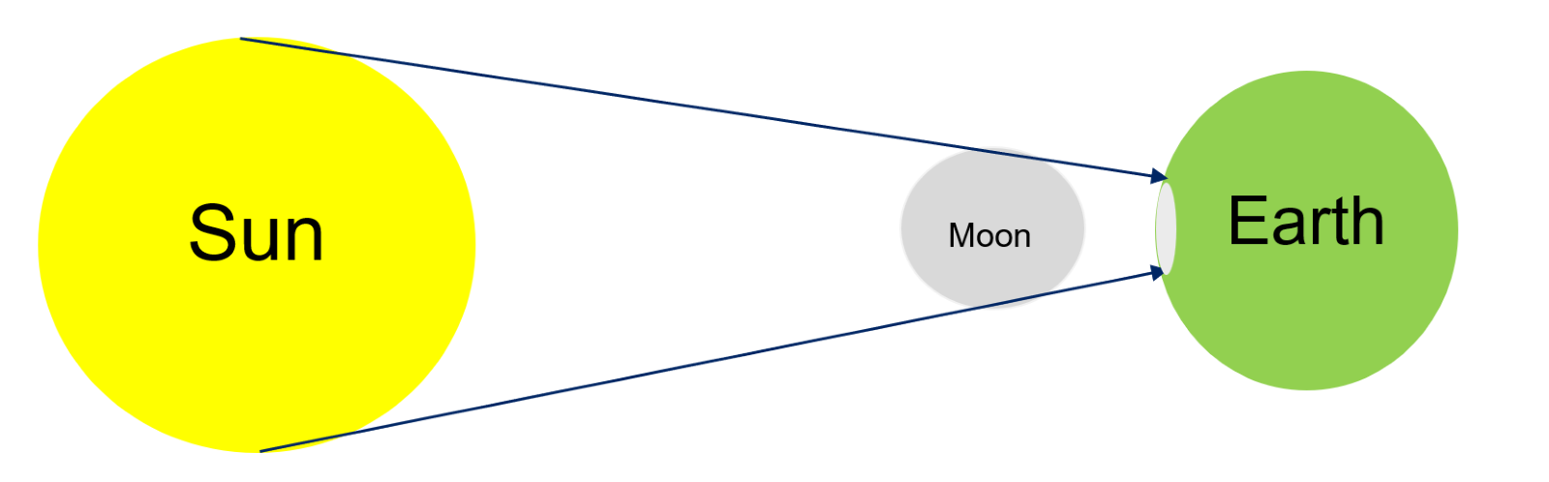
A solar eclipse occurs when the Moon passes between the Earth and the Sun, blocking all or part of the Sun's light.
Figure 10 – lunar eclipse diagram
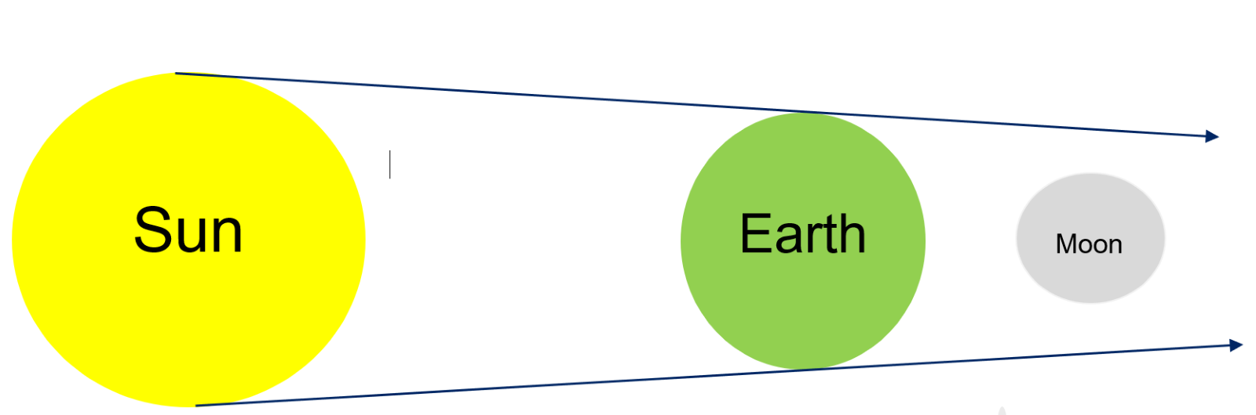
A lunar eclipse occurs when the Earth passes between the Sun and the Moon, causing the Earth's shadow to fall on the Moon.

Part 2 – solar eclipse – digital simulation
View the Eclipse 2017 simulation. Allow students a few minutes to familiarise themselves with the animation and make general observations. Encourage students to make observations, ask questions and identify trends while familiarising themselves with the simulation to develop problem-solving and critical thinking skills. Discuss any initial observations that they make.
Features:
- The VIEW tab at the bottom of the simulation allows the perspective to be changed.
- The speed of the animation can be adjusted using the bottom tab.
- The location can be selected in the tab on the right of the screen. The default location is Kansas City, which experienced a total eclipse of the Sun in 2017.
Sample response
- Use the VIEW tab to select the Earth view.
- Increase the time rate (for example, 5 min/sec). This increases the animation speed.
- Click the Play button to start the animation and watch the path of the Moon across the Earth and the corresponding eclipse of the Sun.
Select another location (Click the + button in the location box and select type in the name of a city or town) and observe any similarities and differences.
The Earth passed fully in front of the Sun, as seen from Kansas City. Only the top half of the Sun was covered when watched from Los Angeles. The eclipse occurred 1.5 hours later in Kansas City than in Los Angeles.
Add your hometown as a location and play the simulation. What do you notice? Explain your observations.
The eclipse was not visible from Australia.
Select the location ‘Kansas City’ and the ‘Earth/Moon/Sun’ view.
Increase the time rate to 1 hour/second and adjust the date to 20 August 2017. Watch the animation to identify the location of the Sun, Moon and Earth for the total solar eclipse at 4:07 a.m. on 22 August 2017.
The Moon is between the Sun and the Earth.

Student resources – eclipses

Summarising information
Watch a video such as What creates a total solar eclipse? (3:46). As you watch the video, fill in the T-chart below showing the features of a solar and lunar eclipse. Include diagrams showing the positions of the Sun, Moon and Earth. Then, they write a definition for each.
Solar eclipse | Lunar eclipse
Definition | Definition

Digital simulation
View the Eclipse 2017 simulation.
- Use the VIEW tab to select the Earth view.
- Increase the time rate (for example, 5 min/sec). This increases the animation speed.
- Click the Play button to start the animation and watch the path of the Moon across the Earth and the corresponding eclipse of the Sun.
Add your hometown as a location and play the simulation. What do you notice? Explain your observations.
Select the location Kansas City and the Earth/Moon/Sun view.
Increase the time rate to 1 hour/second and adjust the date to 20 Aug 2017. Watch the animation to identify the location of the Sun, Moon and Earth for the total solar eclipse on 22 August 2017.

2.9 Tides (secondary-source investigation)
Table 16 – learning intentions and success criteria for ‘Tides (secondary-source investigation)’
Learning intentions | Success criteria
We are learning to process and represent information. | I can:  - extract information from videos, graphs and texts.
We are learning to look for patterns in data. | I can:  - explain the relationship between the orbit of the Moon and the tides.  - explain the relationship between the phases of the Moon and tide height.
Engage students with tides by showing photos of the range of tides at the Bay of Fundy. The Bay of Fundy is located on the Atlantic coast of Canada. The bay is known for having the highest tidal range in the world. Because of the bay's unique shape, the difference in water level between high and low tide can be as much as 14 meters. Hopewell Rocks is a time-lapse video showing the rise and fall of the water from sunrise to sunset at one part of the Bay of Fundy.
Closer to home are the Tidal waves at Talbot Bay, Australia (2:52) on the Kimberly coast. David Attenborough narrates this video.

Investigating tides
Provide the students with the student resource Tides. View the video Tides (to 1:46) and discuss. Watch it again and pause to allow the students to answer questions 1 to 3.

Students work through the remainder of the resource.
Sample response
- Both the Sun and the Moon exert a force of gravity on the Earth. Which has the greater effect on the Earth and why?
The Moon exerts the greater force of gravity because it is closer to the Earth.
- Draw a picture of the Moon and Earth to show where high and low tides occur on the Earth.
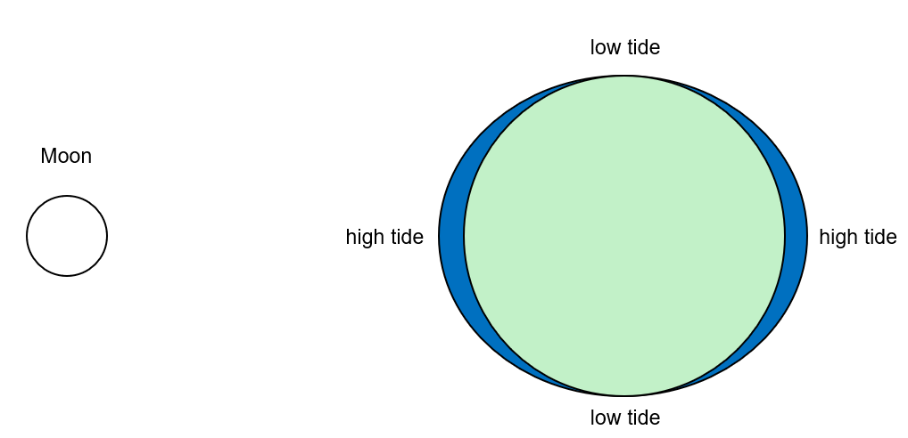
- How many high and low tides occur in a day? Why?
There are 2 high and 2 low tides each day because, in a 24-hour period (1 day), any part of the Earth will face the Moon once and be on the opposite side of the Moon once. These will be the 2 high tides. The times in between will be when a low tide occurs.
Figure 11 – tide heights for Brunswick Heads (May 24)

- Look carefully at the graph above. What patterns do you see in the tide heights?
The high tides and low tides are not always the same height. The highest and lowest tides occur in a regular pattern, with extreme tidal events occurring at consistent intervals. This pattern appears to repeat approximately every 14 days.
- Open the Moon phase calendar. Add the following phases of the moon to the graph above: First quarter, Full Moon, Last quarter and New Moon.
See the labels on the graph above.
- What pattern do you notice between the moon's phases and tide height?
The highest and lowest tides occur during the full moon and new Moon phases. This suggests that these extreme tidal events are associated with the alignment of the Earth, Moon, and Sun with the lunar cycle.
Open Tides and extreme tide events (PDF 1.46MB).
- Skim and highlight the text to identify:
- the title of the document?
- the main headings and subheadings?
- 5 key terms or phrases.
- 2 informative images and their captions.
- Scan and highlight the text to:
- identify the different types of tides.
- explain the link between the relative positions of the Sun, Moon and Earth and the type of tide.
- Summarise the following information using a fishbone graphic organiser.
- Write the main topic on the head of the fish.
- Write the main categories on each of the bones of the fish.
- Add the details in your own words under each category.
- Write a summary explaining the link between the relative positions of the Sun, Moon, and Earth, as well as tides on Earth, in the form of C-E-R in the tail of the fish.

Figure 11 – tides fishbone diagram sample response
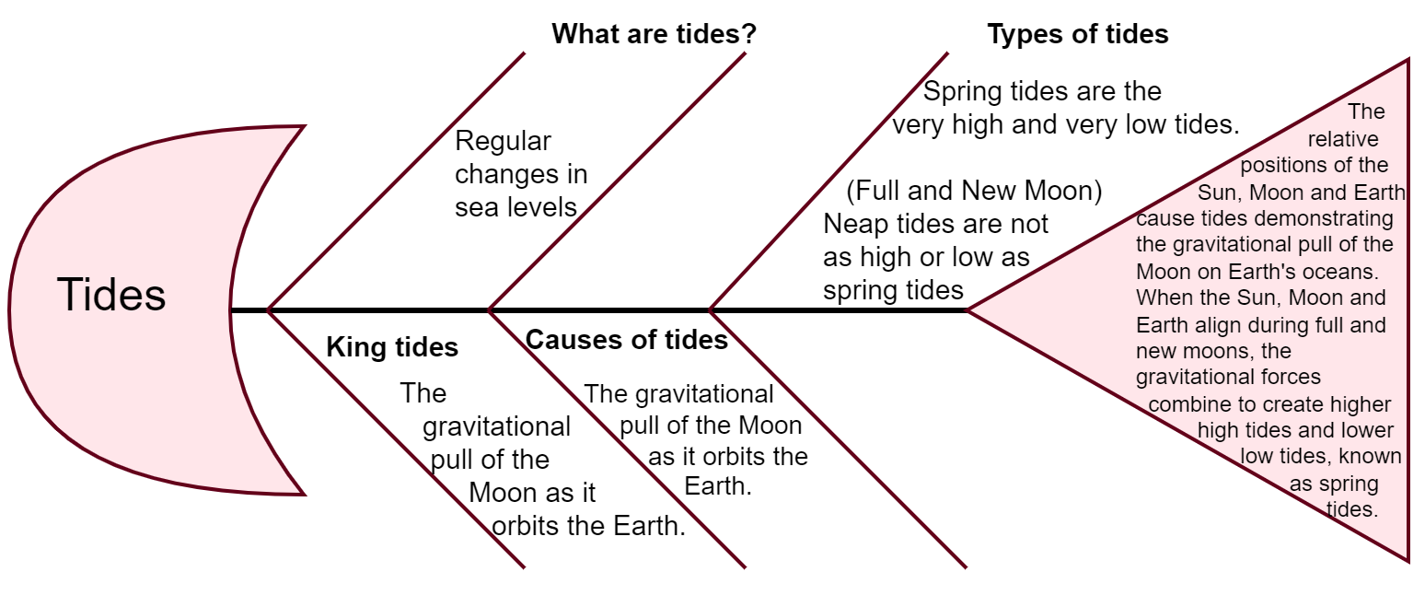

Checkpoint
What is the main cause of tides on Earth?
- The gravitational pull of the Moon and the Sun on the Earth's oceans.
- The rotation of the Earth on its axis.
- The Earth's distance from the Moon changes throughout the month.
- Winds and ocean currents push the water back and forth.
The correct answer is A.
Response B is incorrect because This answer is incorrect because the Earth's rotation affects the timing of the tides but not the cause.
Response C is incorrect because although the distance between the Earth and the Moon does vary slightly due to the Moon's elliptical orbit and has a small effect on tide height, it is not the primary cause of tides.
Response D is incorrect because winds and ocean currents can cause local variations in water movement (such as waves or surface currents). However, they do not cause the rise and fall of sea levels associated with tides.

Student resource – tides
- Both the Sun and the Moon exert a force of gravity on the Earth. Which has the greater effect on the Earth and why?
- Draw a picture of the Moon and Earth to show where high and low tides occur on the Earth.
- How many high and low tides occur in a day? Why?
Figure 12 – tide heights for Brunswick Heads (May 24)

- Look carefully at the graphs above. What patterns do you see in the tide heights?
- Open the Moon phase calendar. Add the following phases of the moon to the graph above: First quarter, Full Moon, Last quarter and New Moon.
- What pattern do you notice between the moon's phases and tide height?
Open Tides and extreme tide events (PDF 1.46MB)
- Skim and highlight the text to identify:
- the title of the document?
- the main headings and subheadings?
- 5 key terms or phrases.
- 2 informative images and their captions.
- Scan and highlight the text to:
- identify the different types of tides.
- explain the link between the relative positions of the Sun, Moon, and Earth and the type of tide.
- Summarise the following information using a fishbone graphic organiser.
- Write the main topic on the head of the fish.
- Write the main categories on each of the bones of the fish.
- Add the details in your own words under each category.
- Write a summary explaining the link between the relative position of the Sun, Moon and Earth in the form of C-E-R in the tail of the fish.

Fishbone diagram
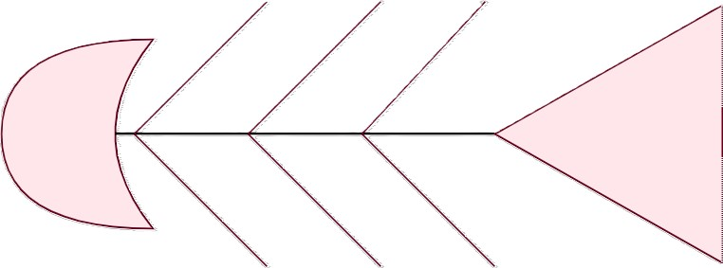

2.10 Aboriginal and Torres Strait Islander Peoples’ knowledge of the Moon and tides
Aboriginal and Torres Strait Islander Histories and Cultures
Planning and programming
When planning and programming content relating to Aboriginal and Torres Strait Islander histories and cultures, teachers are encouraged to:
- involve local Aboriginal communities and/or appropriate knowledge holders in determining suitable resources or use Aboriginal or Torres Strait Islander-authored or endorsed publications.
- read the principles and protocols relating to teaching and learning about Aboriginal and Torres Strait Islander histories and cultures and the involvement of local Aboriginal communities.
The Australian Institute of Aboriginal and Torres Strait Islander Studies (AIATSIS) Guide to evaluating and selecting education resources has been developed to assist teachers in selecting appropriate resources for respectfully and effectively teaching Aboriginal and Torres Strait Islander histories, cultures, and languages.
Table 17 – learning intentions and success criteria for Aboriginal and Torres Strait Islander Peoples’ knowledge of the moon and tides
Learning intention | Success criteria
We are learning about how observations are used by Aboriginal and Torres Strait Islander Peoples to understand their environment. | I can explain how Aboriginal and Torres Strait Islander Peoples connected the phases of the Moon with the monthly variations in tides.

Instructions
Explain that while we have learnt that the Moon goes through phases as it orbits the Earth, Aboriginal and Torres Strait Islander Peoples used cultural stories passed on over generations and their own observations to connect the phases of the Moon to the variation in tides.
Students access the first 3 paragraphs of Mathematics, moon phases and tides.
Provide students with resources on Aboriginal traditions about the Moon and tides. Students work with a partner and use the website to complete the second and third columns of the table. The answers are found in the first 3 paragraphs. The fourth column can be completed by using their own knowledge from the previous lesson on the phases of the moon and tides.
Note: the answers are in bold.
Table 18 – Aboriginal traditions about the Moon and tides sample answers
Aboriginal People | Story | Phases of the Moon | Type of tide
Yolgnu tradition, coastal Arnhem Land | Moon man, Ngalindi, is filled with water as he rises. He is viewed as fat and lazy. | Full Moon | Spring
 | Ngalindi kills his sons for not sharing their food. His wives attack him with an axe, carving out his body. | Waning Moon | Neap
 | Ngalindi dies for 3 days | New Moon | Spring
 | Ngalindi resurrects and grows | Waxing Moon | Neap
Palawa, Tasmania | Sun Man and Moon Woman rose together on the first day, but Sun Man was faster than their wife, and she gradually fell behind. | New Moon | Spring
 | Sun Man illuminates more of her each night to encourage her to catch up. | Waxing Moon | Neap
 | Eventually, she is fully lit on the opposite side of the sky. | Full Moon | Spring
After reviewing the students’ work, pose the following questions for discussion.
- At what stage of the Moon cycle do the Coastal Aboriginal people believe is the best time to go fishing? Explain why this is the best time.
The waxing and waning Moon is the best time to go fishing because this is when there will be neap tides. Neap tides are not as strong as spring tides, which stir up the sediment and make the water cloudy. This makes it harder for the fish to see the lures and for the fishermen to see the fish. Therefore, fewer fish will be caught.
- Does it matter that Aboriginal nations have different traditions about whether the Moon and Sun are male or female? Explain your answer.
It does not matter whether the Sun and Moon are seen as male or female. Both stories show that the Aboriginal people could use the Moon's shape and relate it to the tides to inform their hunting and fishing activities.
Checkpoint: students summarise their learning using the word-phrase-sentence template (available in OTU PPT 2.10).

Student resource – Aboriginal traditions about the Moon and tides
Aboriginal people | Story | Phases of the Moon | Type of tide
Yolgnu tradition, coastal Arnhem Land | Moon man, Ngalindi, is filled with water as he rises. He is viewed as fat and lazy.
 |  | Waning Moon
 |  |  | Spring
 |  |  | Neap
Palawa, Tasmania |  | New Moon
 | Sun Man illuminates more of her each night to encourage her to catch up.
 |  | Full Moon | Spring

2.11 How Aboriginal and Torres Strait Islander peoples use stars to predict weather (practical investigation)
In this activity, students will model the scintillation of stars caused by moisture and turbulence in the atmosphere. They will discuss the model's strengths and weaknesses and relate their learnings to their understanding of Aboriginal and Torres Strait Islander Peoples.
Table 19 – learning intentions and success criteria for ‘How Aboriginal and Torres Strait Islander Peoples use stars to predict weather (practical investigation)’
Learning intentions | Success criteria
We are learning about how observations are used by Aboriginal and Torres Strait Islander Peoples to understand their environment. | I can:  - explain how Aboriginal and Torres Strait Islander Peoples used the twinkling of stars to predict weather patterns.
We are learning how scientists use models to increase our understanding of the Universe. | I can:  - use a model to show why stars twinkle.

Background information
Aboriginal and Torres Strait Islander Peoples have long used astronomical observations to predict weather and seasonal changes. These observations include:
Moon halos: Aboriginal Peoples, including the Euahlayi and Kamilaroi Peoples, have cultural records linking moon halos with impending rain. Halos often precede low-pressure systems, bringing rain and cooler temperatures. A Moon halo is an optical illusion that causes a large bright ring to surround the Moon. This ring is caused by light refracting off ice crystals in the upper atmosphere.
Stellar scintillation: Variations in star brightness (twinkling), caused by atmospheric disturbances like changes in air density, temperature, humidity, and turbulence, have been used for millennia by Aboriginal and Torres Strait Islander Peoples to determine the moisture in the air and thus predict the weather. The rapid twinkling of stars signals the onset of the monsoon season (kuki) on the island of Mer in the Torres Strait. A monsoon is a weather pattern that has high winds and heavy rainfall. Knowing the correlation between stellar scintillation and wind strength also helps gauge safe travel times during fishing expeditions.
Note: the term ‘twinkling’ is used by scientists to describe the variations in stellar brightness. It is also used to distinguish between planets and stars, as planets do not have variations in brightness and, therefore, do not twinkle.
Astronomical navigation: the Torres Strait Islander Peoples use the position of stars, including the constellation Tagai and the Milky Way, to determine seasonal changes and navigation.
For more detailed information on Aboriginal and Torres Strait Islander People’s use of stars to identify weather phenomena, see Indigenous Use of Stellar Scintillation to Predict (PDF 3.92MB).

Introduction
Introduce the concept that Aboriginal and Torres Strait Islander Peoples used stars to identify weather patterns, including predictions of monsoons, windy weather and humidity and discuss examples. Images of moon halos or twinkling stars may be used to support the discussion. Discuss the importance of predicting winds or knowing when the monsoons will start when someone lives on islands and relies on the sea for food.

Modelling stellar scintillation (practical investigations)
Provide each group of students with a bowl of water. Direct students to half submerge a pencil half into the water at an angle. Ask them, ‘What do you notice about the pencil?’ It will appear bent or broken. Ask the students, ‘What do your legs look like when standing in water?’
Explain to the students that when light travels from one material (like air) into another (like water), the light appears to bend. This makes the pencil and their legs appear different. When starlight travels through the Earth’s atmosphere, it travels through air containing different amounts of water (humidity) and at different temperatures. This is the same as if the light goes through a bowl of water. Just like the pencil in the water appears to bend, the light from the stars changes as it moves through the atmosphere.
Explain to the students that:
- stellar scintillation, or twinkling of the stars, is caused by the turbulent mixing of air with different temperatures and densities in the Earth’s atmosphere. The turbulence causes the light from stars to bend, scatter and change intensity as it passes through the atmosphere.
- a monsoon is a weather pattern with high winds and heavy rainfall. Monsoon weather patterns are associated with shifts in atmospheric conditions. During the build-up to a monsoon, there are substantial changes in the atmospheric pressure, temperature and humidity levels. These changes in the atmosphere enhance the turbulence (movement), which causes the light to bend and scatter more than usual, leading to a change in the twinkling of the stars as observed by humans on the ground. Aboriginal people could use this observation to predict the onset of a monsoon.
Provide the students with the remaining equipment, and they will undertake the method in the student resource.
Sample response for discussion questions
- What changes do you observe in the appearance of the light when you look through the water compared to looking through the air?
When seen through water, the light is less intense and spreads out with colours shimmering on the edges.
- What changes do you observe in the appearance of the light when looking through still water compared to when the water is being disturbed or moving?
When the water is still, the light from the 'stars' (the holes in the foil) appears steady and clear. The 'stars' shine consistently without much flickering or twinkling. When the water is moving, the light appears to twinkle or flicker.
- How does the movement of the water in the model help demonstrate how the Earth's atmosphere affects the light from stars?
The moving water bends and changes the direction of the light, similar to how the Earth's atmosphere causes real starlight to twinkle. The movement in the water creates waves and turbulence, which makes the light appear to dance or shimmer, just like we see when we look at stars in the night sky.
- Why do you think the light twinkles more when there are more atmospheric disturbances?
The light twinkles more when there are more atmospheric disturbances because these disturbances cause the air to move around a lot. When the air moves, it bends and changes the direction of the light coming from the stars.
When the atmosphere is calm, the light from the stars travels in a relatively straight path to our eyes, so the stars look steady. However, the path of light keeps changing when the atmosphere is turbulent, with lots of moving air (like wind or temperature changes). This makes the stars appear to twinkle or flicker more. So, the more disturbances in the atmosphere, the more the light's path changes, causing the stars to twinkle more.
- How do you think different atmospheric conditions (like temperature or humidity) might affect the twinkling of stars?
Changing the humidity of the air changes the amount of water in the air. Water vapour can lead to additional scattering of light and alter the path of the light, making the stars look like they twinkle.
- Can this experiment be related to the real-life observations made by Aboriginal and Torres Strait Islander Peoples about stellar scintillation and weather prediction? Explain.
Yes, the experimental and real-life observations are related. When the monsoon season is approaching, the high winds and rainfall cause more disturbances in the atmosphere, which causes the stars to twinkle more.
Checkpoint: complete a word-phrase-sentence activity to check for understanding. The OTU PPT includes a template for this.

Student resource – modelling stellar scintillation
When we look at the stars, they appear to twinkle. This is called stellar scintillation.
Aim
To model how atmospheric disturbances cause the scintillation (twinkling) of stars.
Equipment
- Clear glass or plastic container
- Water
- Aluminium foil
- Torch or other light source
- Skewer or another sharp object
- Glitter or small reflective particles (optional)
Method
- Fill the clear container with water.
- Poke small holes in the aluminium foil to represent stars with a skewer.
- Shine the torch onto the foil and observe the light shining through the holes. Do not stare at the light.
- Place the foil behind the bowl of water and observe the ‘stars’ through the water.
- Gently move the bowl so that the water moves.
- Optional: add a small amount of glitter or reflective particles to the water to enhance the visual effect.
- Observe the light and note how it twinkles or flickers.
Discussion questions
- What changes do you observe in the light when it moves through air compared to when it moves through water?
- What changes do you observe when the water is still versus moving?
- How does the movement in the water model atmospheric effects on starlight?
- Why do you think the light twinkles more when there are more disturbances?
- How do you think different atmospheric conditions (like temperature or humidity) might affect the twinkling of stars?
- Can this experiment be related to the real-life observations made by Aboriginal and Torres Strait Islander Peoples about stellar scintillation and weather prediction? Explain.

2.12 Aboriginal and Torres Strait Islander Peoples’ sky stories
Table 20 – learning intention and success criteria for ‘Aboriginal and Torres Strait Islander Peoples’ sky stories’
Learning intention | Success criteria
We are learning about how observations are used by Aboriginal and Torres Strait Islander Peoples to understand their environment. | I can describe how Aboriginal people used the seasonal changes in the stars to inform them of seasonal changes on the ground and guide them in hunting and gathering.
This activity allows students to work collaboratively to gather information from secondary sources, acknowledge their sources, and present a short slide deck presentation to their peers. From the 8 examples provided, students should gain an understanding of the Aboriginal Peoples’ use of the annual appearance of stars to predict seasonal change, which they linked to the behaviour of plants and animals. In Australia, many plants used for food or medicines are seasonal, so it is critical for people to know how the plants, animals, weather, and stars are interconnected.

Teacher instructions
Introduction – ask students if they know how to use the stars to navigate. Some students may know of using the Southern Cross to provide direction. In this activity, they will learn how Aboriginal and Torres Strait Islander Peoples used the seasonal changes in the stars to understand, predict and explain nature – to determine when it was time to hunt certain foods or when it was safe to enter the water.
Divide the class into 8 groups. Allocate each group to one of the topics in Table 21. Each group is to present a one-minute slide deck (maximum 3 slides) explaining how the Aboriginal and Torres Strait Islander Peoples use their knowledge of the stars to inform them of seasonal changes in the weather or the correct time to hunt or gather a particular food source. The slide deck should show an image of the star or star cluster and an image of the seasonal activity.
The table below provides each group of students with one topic for investigation and a web page link.
Table 21 – sources of information for ‘Aboriginal and Torres Strait Islander Peoples’ Sky Story traditions’
Group | Topic for investigation | Web page
1 | Malleefowl | Australia’s first astronomers – the sky as a calendar
2 | Dingoes | Stories from the sky: astronomy in Indigenous knowledge
3 | Baidam, the shark | Stories from the sky: astronomy in Indigenous knowledge
4 | Harvesting ants in western Victoria | Stories from the sky: astronomy in Indigenous knowledge
5 | Stellar scintillation | Stories from the sky: astronomy in Indigenous knowledge
6 | Emu in the Sky/Celestial Emu | Seasonal foods and Aboriginal astronomy: Case study – the Celestial Emu
7 | Star brightness | Australian Indigenous Astronomy – Star brightness
One source is provided for each story, and students are to search for and access at least one more source of information. This is an opportunity to introduce students to correctly acknowledging sources. Display the table in the OTU PPT. Students copy this and record the author, date published, title, URL, and date accessed for each source they use.
Table 22 – acknowledging sources of information
Author | Date published | Title | URL | Date accessed
The OTU PPT also provides instructions for the activity, a table acknowledging resources and summarising information.
When students present their slide deck to the class, the teacher co-constructs a summary of the observation and what it meant to the Aboriginal and Torres Strait Islander Peoples with the students.
Table 23 – sample of summary of information gathered
Star observation | What it meant
When the Neilloan (mallee fowl constellation) disappears from the northwest sky in late September – early October. | The Boorong People of northwestern Victoria knew it was time to gather mallee fowl eggs.
When the Pleiades star cluster rises just before the morning sun. | This signifies the start of winter to the Pitjantjatjara people of the Central Desert and tells them that dingoes are breeding and will soon be giving birth to pups.
Baidam the shark (stars of the Big Dipper) appears in the evening.  When his nose touches the horizon just after sunset. | This tells Torres Strait Islander Peoples that they must plant their gardens with sugarcane, sweet potato and bananas.  The shark breeding season has begun, and people should stay out of the water – it is very dangerous!
Stellar scintillation (twinkling). | Allows the Torres Strait Islander Peoples to determine the amount of moisture and turbulence in the atmosphere, allowing them to predict weather patterns and seasonal change.
When the star Arcturus rises in the evening. | It tells the Wergaia people of western Victoria that it is time to harvest ant larvae.
When the Celestia Emu rises in the sky at dusk, appearing as a running female.  When high in the sky at dusk – it appears as a male sitting on eggs. | It signals the start of the Emu breeding season – the best time to harvest emu eggs for food.  Most of the eggs will have embryos in them, so should not gather eggs.
When Arcturus appears in the dawn sky at the start of the wet season. | Yolngu people begin harvesting corms of the spike rush.
Particular bright stars: Parna appears in the morning sky.  Wolta – the wild turkey constellation.  Wilto – the eagle star. | Signals to the Kaurna people of the Adelaide area that annual autumn rains will soon arrive and that they need to build large, water-proof huts.  Signals the start of the hot season.  Signals the start of Spring.
Checkpoint: students complete the following cloze passage:
Aboriginal and Torres Strait Island Peoples’ traditions link the position of the stars at different times of the year to seasonal events on Earth. This allowed them to gather food and fibre at the safest and most productive time and to prepare for seasonal weather conditions.
The cloze passage is available in the OTU PPT.
Differentiation: The cloze passage can be differentiated by providing a list of words or allowing the students to determine the missing words themselves. The most able students could be asked to write 2 sentences summarising their understanding of how the Aboriginal and Torres Strait Islander Peoples used their observations of the stars in their daily lives.

Evidence base
This resource contains NSW Curriculum and syllabus content. The NSW Curriculum is developed by the NSW Education Standards Authority (NESA). This content is prepared by NESA for and on behalf of the Crown in right of the State of New South Wales. The material is protected by Crown copyright.
Please refer to the NESA Copyright Disclaimer for more information https://www.nsw.gov.au/education-and-training/nesa/copyright.
NESA holds the only official and up-to-date versions of the NSW Curriculum and syllabus documents. Please visit NESA https://www.nsw.gov.au/education-and-training/nesa and NSW Curriculum https://curriculum.nsw.edu.au.
Science 7–10 Syllabus © NSW Education Standards Authority (NESA) for and on behalf of the Crown in right of the State of New South Wales, 2023.
Australian Curriculum (n.d.) Australian Curriculum Teacher background information, Australian Curriculum Teacher background information, accessed 3 Jun 24.
Blum S (22 April 21) ‘How to Easily Memorize All Eight Phases of the Moon’, Lifehacker, 29 August 2024.
Brookhart SM (2018) ‘Appropriate Criteria: Key to Effective Rubrics’, Frontiers in Education, volume 3(22):1–12, doi:10.3389/feduc.2018.00022, accessed 13 September 2024.
CESE (Centre for Education Statistics and Evaluation) (2020) What works best: 2020 update, NSW Department of Education, accessed 18 July 2024.
—— (2020) What works best in practice, NSW Department of Education, accessed 18 July 2024.
—— (2021) Growth goal setting – what works best in practice, NSW Department of Education, accessed 18 July 2024.
CSIRO Australia (n.d.) Our observatory, CSIRO SKA website, accessed 7 June 2024.
Department of Industry, Science and Resources (n.d.) The SKA project in Australia, Department of Industry, Science and Resources website , accessed 23 May 2024.
English K–10 Syllabus © NSW Education Standards Authority (NESA) for and on behalf of the Crown in right of the State of New South Wales, 2022.
Fisher D and Frey N (1 November 2009) ‘Feed Up, Back, Forward’, ASCD (Association for Supervision and Curriculum Development): Educational Leadership magazine, 67(3), accessed 13 September 2024.
Griffin P (2017) Assessment for Teaching, Cambridge University Press, Port Melbourne, Victoria.
Hattie J and Timperley H (2007) ‘The Power of Feedback’, Review of Educational Research, 77(1): 81–112, doi:10.3102/003465430298487.
Panadero E and Jonsson A (2013) ‘The use of scoring rubrics for formative assessment purposes revisited: A review’, Educational Research Review, 9:129–144, doi:10.1016/j.edurev.2013.01.002, accessed 13 September 2024.
Sherrington T (2019) Rosenshine’s Principles in Action, John Catt Educational Limited, Melton, Woodbridge.
SKAO (2024) SKAO, SKA Observatory website, accessed 11 June 2024.
Sonnenfeld B (director) (1997) Men in Black [motion picture], Columbia Pictures and Amblin Entertainment, New York.
State of New South Wales (Department of Education) (n.d.) ‘Metacognition - a key to unlocking learning: key insights for teaching practice’, CESE, NSW Department of Education website, accessed 22 May 2024.
Thorsen S (n.d.) 78°35'00.0"S, 77°58'59.9"E — Sunrise, Sunset, and Daylength, May 2024, timeanddate website, accessed 1 May 2024.
University of York Education Group (2021) ‘Big idea: Earth in space’, Best Evidence Science Teaching, STEM Learning website, accessed 22 July 2024.
Wells M University of York Science Education Group (2018) Topic PES1: Solar System and beyond Key concept (age 11-14) PES1.1: Planets and the Solar System [PDF 260.19 KB], STEM Learning website, accessed 22 July 2024.
Wiliam D (2017) Embedded Formative Assessment, 2nd edn, Solution Tree Press, Bloomington, IN.
© State of New South Wales (Department of Education), 2024
The copyright material published in this resource is subject to the Copyright Act 1968 (Cth) and is owned by the NSW Department of Education or, where indicated, by a party other than the NSW Department of Education (third-party material).
Copyright material available in this resource and owned by the NSW Department of Education is licensed under a Creative Commons Attribution 4.0 International (CC BY 4.0) license.

This license allows you to share and adapt the material for any purpose, even commercially.
Attribution should be given to © State of New South Wales (Department of Education), 2024.
Material in this resource not available under a Creative Commons license:
- the NSW Department of Education logo, other logos and trademark-protected material
- material owned by a third party that has been reproduced with permission. You will need to obtain permission from the third party to reuse its material.
Links to third-party material and websites
Please note that the provided (reading/viewing material/list/links/texts) are a suggestion only and implies no endorsement, by the New South Wales Department of Education, of any author, publisher, or book title. School principals and teachers are best placed to assess the suitability of resources that would complement the curriculum and reflect the needs and interests of their students.
If you use the links provided in this document to access a third-party's website, you acknowledge that the terms of use, including licence terms set out on the third-party's website apply to the use which may be made of the materials on that third-party website or where permitted by the Copyright Act 1968 (Cth). The department accepts no responsibility for content on third-party websites.

