Science Stage 4 (Year 7) – Observing the Universe
Teacher resource book 1 of 2 (TRB1)
How do observation and investigation guide scientific endeavours?
Creation date: 27 June 2024.
Contents
Overview 4
1.1 Getting to know you 5
Amplify activity 5
1.2 How do scientists work? 6
Pencil puncture (practical investigation) 6
What do you know about science? 7
Teacher information 7
Student resource – hexagonal thinking 11
Student resource – hexagonal thinking (reverse) 12
1.3 Observing in science (practical investigations) 13
Making observations with popping corn 13
Instructions 13
Mystery box 17
1.4 Branches of science 18
Sort the branches of science 18
Teacher information 18
Student resource – sort the branches of science 21
‘Scientree’ 23
Teacher information 23
Student resource – ‘Scientree’ 26
Science is transdisciplinary 27
Student resource – How is science transdisciplinary? 28
1.5 Why collaborate? (secondary-source investigation) 30
Set the scene – COVID 19 30
International collaborative projects 30
Advantages of collaboration in science 33
1.6 The power of scientific theories and laws 36
Background information 36
Exploring theories and laws 37
Comparing theories and laws 37
1.7 Introducing the Working scientifically processes 40
Working scientifically in context 40
Student resource – Working scientifically processes 43
1.8 Science sleuth 44
Observations vs non-observations 44
Review prior learning 44
Student resource – Observation or not? 46
Animal tracks 46
Defining observations and inferences 48
How do we know about Mungo Culture? 50
Instructions 50
Student resource – How do we know about Mungo Culture? 53
1.9 From observations to questions (practical investigation) 54
Prior learning 54
Bubbleology – asking questions 54
Preparation 55
Sample ‘think aloud’ script for developing questions and exploring the bubbles 55
1.10 Measure up 58
Analog and digital measuring devices 58
Student resource – digital vs analog 61
Measuring our environment 63
Student resource – measuring the environment 64
1.11 Putting it all together 65
What’s this for? 66
Teacher information 66
Student resource 69
The Bunsen burner (practical investigation) 70
Parts of the Bunsen burner 70
Using a Bunsen burner 70
Student resource – the Bunsen burner 73
Salty tales (practical investigation) 75
Storytelling 75
Observe and predict – from story to science 75
Student resource – Why add salt? 78
1.12 Can plants sense gravity? (practical investigation) 83
Geotropism 84
Preparation 84
Conducting the activity 85
Student resource – Can plants sense gravity? 87
1.13 Applying the Working scientifically processes (practical investigation) 90
Bouncing balls 90
Exploring the impact of ball pressure on bounce height 91
Student resource – bouncing balls 93
The best reusable cup 99
Part A – planning the experiment 99
Part B – conducting the experiment 102
Student resource – Which is the best reusable cup? 103
1.14 Introducing secondary-source investigations – investigating global warming 106
Student resource – investigating global warming 110
Evidence base 113

Overview
Stage and learning area: Stage 4 Science
Description: this resource complements the ‘Observing the Universe’ program of learning. It aims to serve as a teacher reference, offering practical strategies and ideas to enrich teaching practices and create engaging learning environments. The activities should be adapted to suit students' needs.
Duration: while timing will vary based on the mode of delivery, differentiation strategies employed and class or school context, this series of activities should take approximately 18 hours.
Risk management: Teachers are advised to undertake a risk assessment before conducting any classroom investigation or experiment. For more information on developing risk assessments, see Risk Assessment – a pre-requisite for risk control.
This resource book contains elaborations on many of the activities in the Observing the Universe learning program. Some activities also reference the Observing the Universe PowerPoint (identified as OTU PPT throughout this document).

1.1 Getting to know you
Table 1 – learning intention and success criteria for ‘Getting to know you’
Learning intention | Success criteria
We are reviewing what we know about science. | I can:  - make simple predictions and test them  - recall scientific terminology  - make connections between scientific terms.

Amplify activity
Students should complete slides 1–11 on the Amplify activity Welcome to Year 7 science. Slides 7 and 8 provide good talking points to facilitate a class discussion or encourage students to share their thoughts in small groups.
Pacing can be added to the slides to keep the students from progressing ahead. For more information on how to use Amplify in your classroom, see the Welcome to Year 11 resource on the Science Statewide Staffroom (members only). It includes videos on setting up an account and instructions on using Amplify effectively in your classroom.
Complete slides 12–17 to determine students’ thoughts on science. This activity may initiate a discussion on what the students think about science, their experiences of science and what they expect to learn this year.

1.2 How do scientists work?
Table 2 – learning intention and success criteria for ‘How do scientists work?’
Learning intention | Success criteria
We are learning how scientific observations help us increase our knowledge of the Universe. | I can:  - identify that science uses observations and builds new knowledge through investigations.

Pencil puncture (practical investigation)
Conduct a simple inquiry activity using Predict-Observe-Explain. Ask the students to write in their workbooks what might happen if a resealable plastic bag is filled with water and pencils are pushed through the sides (prediction). Instruct the students to fill a resealable plastic bag with water and seal it. Try not to have air bubbles in the bag. Ask them to predict what will happen if they poke a regular-shaped pencil through the bag. Students test their prediction by pushing pencils through the sides of the resealable plastic bag. Students record their observations and attempt to explain why no water was spilled. Using the notes below, facilitate a discussion on why the bag does not leak. Finally, relate this activity to how scientists observe the world around them and test their predictions.
Figure 1 – a compostable resealable plastic bag with pencils inserted through the sides
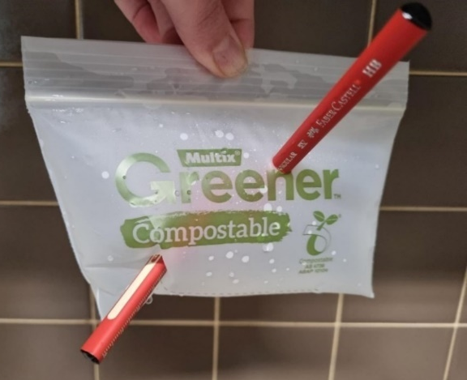

Why doesn’t the bag leak?
The bag does not leak when pencils are poked through it because of the properties of the plastic it is made of and the nature of the pencil’s shape.
- Material flexibility – the plastic used in the bags, such as polyethylene, is very flexible and has elastic properties. When the pencil is pushed through the bag, the plastic stretches and forms a tight seal around the pencil.
- Plastic's hydrophobic nature – the plastic used in the bag is hydrophobic and repels water, helping to prevent water from seeping through any small gaps that might form around the pencil.
- Pencil shape – pencils have a smooth, cylindrical shape that allows them to penetrate the plastic without causing significant tears or damage. Its sharp point helps to make a clean entry.
- Surface tension – water has a high surface tension, so it does not easily flow through small openings. When the pencil is inserted, the water molecules stick together and resist flowing out through the tiny space between the pencil and the plastic.

What do you know about science?

Teacher information
Hexagonal thinking is an effective way to assess prior knowledge by allowing students to connect concepts visually. Students demonstrate their understanding by arranging hexagons representing different ideas or topics and connecting them based on perceived relationships, providing teachers with valuable insights into student understanding, gaps and misconceptions.
Introduce the lesson by explaining to students that because they come from many different primary schools, they will have different experiences in science. This activity aims to see what students already know about science investigations. It is not a test, but it will provide the teacher with information about prior learning.
You may have learnt that science, observations and new knowledge are interconnected. Some examples of this are below.
- Early last century, a scientist, Alexander Fleming, returned from a holiday to find mould growing on a Petri dish of Staphylococcus bacteria. He observed that the bacteria did not grow near the mould. Show the original image of Fleming’s plate, pointing out the bacteria and mould. He carried out scientific experiments to show that fungi could destroy bacteria. This new knowledge led to the development of antibiotics, a vital tool to treat bacterial infections.
- In 2019, doctors observed that patients in their hospital were dying from an unusual form of pneumonia. Molecular biologists used scientific processes to identify the genetic makeup of the virus that caused the disease (COVID-19). This new knowledge enabled the development of new COVID-19 tests (PCR testing and home testing kits) to monitor infections in populations.
Print the hexagonal cards with the definitions on the back. The cards could be laminated for reuse. Distribute the sets of hexagonal cards and arrows to groups of students.
Instruct students to arrange the hexagons so that each side of a hexagon connects with another hexagon containing a related term. Encourage students to use the arrows to indicate the direction of the connection if needed. Emphasise that connections should be based on logical relationships. For example, testable questions lead to predictions, which can be tested via a scientific investigation.
The cards may need to be rearranged several times until students are satisfied that their pattern illustrates the strongest connection between the terms. Encourage students to challenge each other’s thinking and explore alternative connections. When the students are happy with the arrangement of their hexagons, they should write as many sentences as possible from the array of terms in the hexagons.
Facilitate a class discussion on the sentences that students have constructed.
Figure 2 – partial sample response for the hexagonal thinking activity
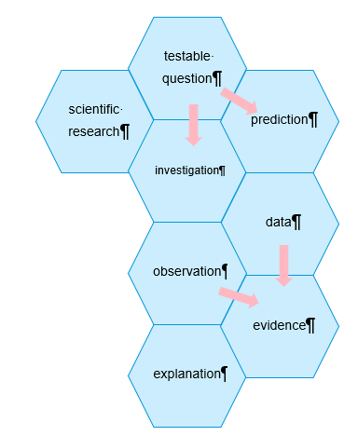
Sample statements that could be constructed
- Scientific inquiry starts with a testable question and prediction that can be investigated.
- Data is needed to form evidence.
- Scientific explanations require evidence.
Differentiation: some students may need additional support to construct sentences. Table 3 could be used instead of constructing the sentences using the hexagons as the stimulus. Students use one term or phrase from each column to create sentences describing how scientists work.
Table 3 – jumbled terms and phrases. Students pick a term or phrase from each column (A–E) to form logical statements about scientists and scientific research.
A | B | C | D | E
Scientists | can be used | that can be | to provide evidence | investigation.
Patterns in data | to testable questions | can be tested | changed in an | testable questions.
Predictions | are the factors | to gather data | to investigate | to make observations.
Scientific research | use | to identify | relationships | for our predictions.
Variables | uses investigations | experiments | by using our senses | between variables.
Below are sample student responses using the differentiated activity (Table 3 – jumbled terms and phrases):
- Scientists use experiments to investigate testable questions.
- Patterns in data can be used to identify relationships between variables.
- Predictions to testable questions can be tested by using our senses to make observations.
- Scientific research uses investigations to gather data to provide evidence for our predictions.
- Variables are factors that can be changed in an investigation.

Student resource – hexagonal thinking
senses
observation
investigation
testable questions
scientific research
prediction
variable
data
explanation
evidence
patterns
relationships

Student resource – hexagonal thinking (reverse)
An investigation is the systematic process of exploring and studying a question to gather data and draw conclusions.
A scientific observation is the process of carefully monitoring and recording phenomena or events as they occur.
A question that can be answered through investigation and observation.
Senses are the ways we gather information about the world around us.
A prediction is a statement about what will happen in the future based on current knowledge.

A prediction is a statement about what will happen in the future based on current knowledge.
Senses are the ways we gather information about the world around us.
Scientific research is a systematic and methodical process used to investigate natural phenomena.
A testable question is a question that can be answered through investigation and observation.

An explanation is an account of the reasoning behind a phenomenon or observation.
Data is information that is collected, organised, and analysed for various purposes. It can take many forms.
A variable is any factor, that can exist in different amounts or types and can be changed or controlled in an experiment.

Relationships refer to the connections or associations between two or more variables or phenomena.
Patterns refer to regularities or repeated sequences observed in data or natural phenomena.
Evidence refers to the data and observations that support or refute a hypothesis, theory, or scientific claim.

1.3 Observing in science (practical investigations)
Table 4 – learning intention and success criteria for ‘Observing in science’
Learning intention | Success criteria
We are learning how observations help us increase our knowledge of the Universe. | I can:  - distinguish between quantitative and qualitative observations  - use my senses to make observations  - use tools to make measurements  - compare the accuracy of quantitative and qualitative observations  - use my observations to make an inference.

Making observations with popping corn
In this activity, students make qualitative observations of popping corn and then discuss how they could make their observations more precise by making quantitative observations.

Instructions
Highlight the importance of observation skills in science, noting that small observations often lead to significant scientific discoveries. For instance, Alexander Fleming discovered penicillin after observing mould contaminating his bacterial culture plates. (This is also an example of how Fleming’s prior training enabled him to realise the significance of his observations and inferences.)
- Students draw up a four-column table, as shown in Table 5 – observations of popping corn sample answer (OTU PPT has a template that may be displayed for students to copy).
- Encourage the students to use as many senses as possible to make observations while popping some corn and record their observations in columns 1 and 2 of Table 5. Students should record one observation per row in the table.
- Discuss their observations. Students should identify the sense used to make each of the qualitative observations.
- Ask the students how to make their observations more accurate or precise. For example:
- measuring the size of the corn before and after popping
- weighing the corn before and after popping
- measuring the temperature of the corn before and after popping
- counting the number of pops per 10-second period.
- Repeat the activity, this time improving the accuracy of the observations made above by counting the number of corn kernels popping per 10-second period and using instruments such as a ruler, digital scales, thermometers or other suitable technologies. Record the observations in columns 3 and 4 of Table 5.
Table 5 – observations of popping corn sample answer
Qualitative observation | Sense used | How can this measurement be made quantitative? | Quantitative observation
The popped corn is larger than the unpopped corn. | Sight | Measure the corn diameter with a ruler. | Unpopped ____ mm  Popped ____ mm
Most of the corn has popped. | Sight | Count the number of corn kernels to start with and the number of unpopped corn kernels at the end. Calculate the percentage popped. | 95% of the corn has popped.
The corn took a while to start popping. More and more corn popped, and then it slowed down until no more popped. | Hearing | Count the number of pops in each 10-second period. | 0, 0, 0, 5, 10, 20, 20,10, 5, 1, 0, 0, 0
The corn had no smell at the start. After popping it smelt delicious or buttery (or whatever the students suggest). | Smell | Not possible. | Not applicable.
The corn is cool at the start. After popping, it is warm. | Touch | Measure the temperature of the corn in the pan or beaker at the start and when finished popping. | The temperature at the start:  ___ ° C  The temperature after popping:  ___ ° C
The popped corn kernels are lighter than the unpopped corn. | Touch | Use digital scales to weigh a sample of 20 unpopped kernels, and 20 popped corn kernels. | Weight of 20 kernels before: ____ g.  Weight of 20 kernels after popping: ____ g.  This is ____ % less than the unpopped corn.
Discuss the nature of qualitative and quantitative observations in science. Introduce the terms ‘objective’ and ‘subjective’, and describe how objective information is better for comparison as it is less likely to be subjected to biases and opinions.
Emphasise the need for both qualitative and quantitative observations in science depending on the purpose of the data. For example, food scientists developing popcorn should consider factors such as taste, which can only be observed qualitatively. However, they also need to consider other factors, such as the percentage of corn popped, which are quantitative observations.
Checkpoint: classify each of the following observations as qualitative or quantitative (OTU PPT).
- The mother tested the temperature of the baby’s milk by putting some drops on her wrist.
- We had 15 mm of rain in the last 24 hours.
- The weather is very humid.
- The beach was littered with plastic bottles.
- The animals in Antarctica are not afraid of humans.
- The car took 8 seconds to reach a speed of 100 km/hr.
- The baby gained 0.5 kg in weight last week.
- Weeds are invading the national park.
- The child had a red and itchy rash all over his stomach.
Checkpoint sample answer
Qualitative observations:
- The mother tested the temperature of the baby’s milk by putting some drops on her wrist.
- The weather is very humid.
- The beach was littered with plastic bottles.
- The animals in Antarctica are not afraid of humans.
- Weeds are invading the national park.
- The child had a red and itchy rash all over his stomach.
Quantitative observations:
- We had 15 mm of rain in the last 24 hours.
- The car took 8 seconds to reach a speed of 100 km/hr.
- The baby gained 0.5 kg in weight last week.

Mystery box
Instructions for this activity are available from the Perimeter Institute.
Note: to participate in this activity, you must register to the Perimeter Institute website.
- Add The Nature of Science to your shopping cart (no cost) and select Complete order and then select Download now.
- Open the downloaded zip file. Open the The Nature of Science PDF.
- Locate Activity 2: Mystery Containers. The lesson plan on page 13 contains information on how to prepare for and conduct the activity.
- A student worksheet is provided on pages 17 and 18.
This activity emphasises the importance of making observations and drawing inferences without knowing the expected answer, thus modelling the scientific process.

1.4 Branches of science
Table 6 – learning intention and success criteria for ‘Branches of science’
Learning intention | Success criteria
We are learning how scientists work together to increase our knowledge of the Universe. | I can:  - identify some branches of science  - classify various science fields into their branches or sub-branches  - explain how some branches of science are connected.

Sort the branches of science

Teacher information
In this activity, students are presented with a list of problems and must identify the type of scientist and the branch of science that could help solve them. The students rearrange the cards in the student resource to match the corresponding problem, branch of science and scientist.
Table 7 – the correct response for the ‘Sort the branches’ activity
Problem | Scientist | What branch of science?
My lemon tree has curly leaves. Who can help me figure out what is wrong with it? | Horticulturist (biologist) | Horticulture (biology)
Why are there so many mosquitoes around this camping spot? | Entomologist (biologist) | Entomology (biology)
Why aren’t there as many frogs in my backyard as there used to be? | Environmental scientist (biologist) | Environmental science (biology)
My pool has turned green. What should I do to fix it? | Chemist | Chemistry
Why is the beach eroding so much this summer? | Oceanographer (geologist) | Oceanography (geology)
Why do Mum’s high-heeled shoes make holes in the dirt when my runners don’t? | Physicist | Physics
My doctor says I must finish my entire course of antibiotics, even if I feel better in the middle of the course. Why? | Microbiologist (biologist) | Microbiology (biology)
Why doesn’t plastic break down? | Polymer chemist | Polymer chemistry
How do aeroplanes stay in the air? | Aerospace engineer | Aerospace engineering
How does the electricity get to the light? | Electrical engineer (physics) | Electrical engineering (physics)
Why is the dirt at my place brown but red at Gran’s? | Soil scientist (geologist) | Soil science (Geology)
Why are fireworks coloured? | Chemist | Chemistry
Differentiation
A glossary of terms could be developed using a Frayer diagram. The facts or characteristics quarter (top right) could be replaced with a diagram or the word used in a sentence.
Students may be challenged to develop their own problems and conduct research to discover what branch of science would investigate the problem.
Figure 3 – sample response of a Frayer diagram
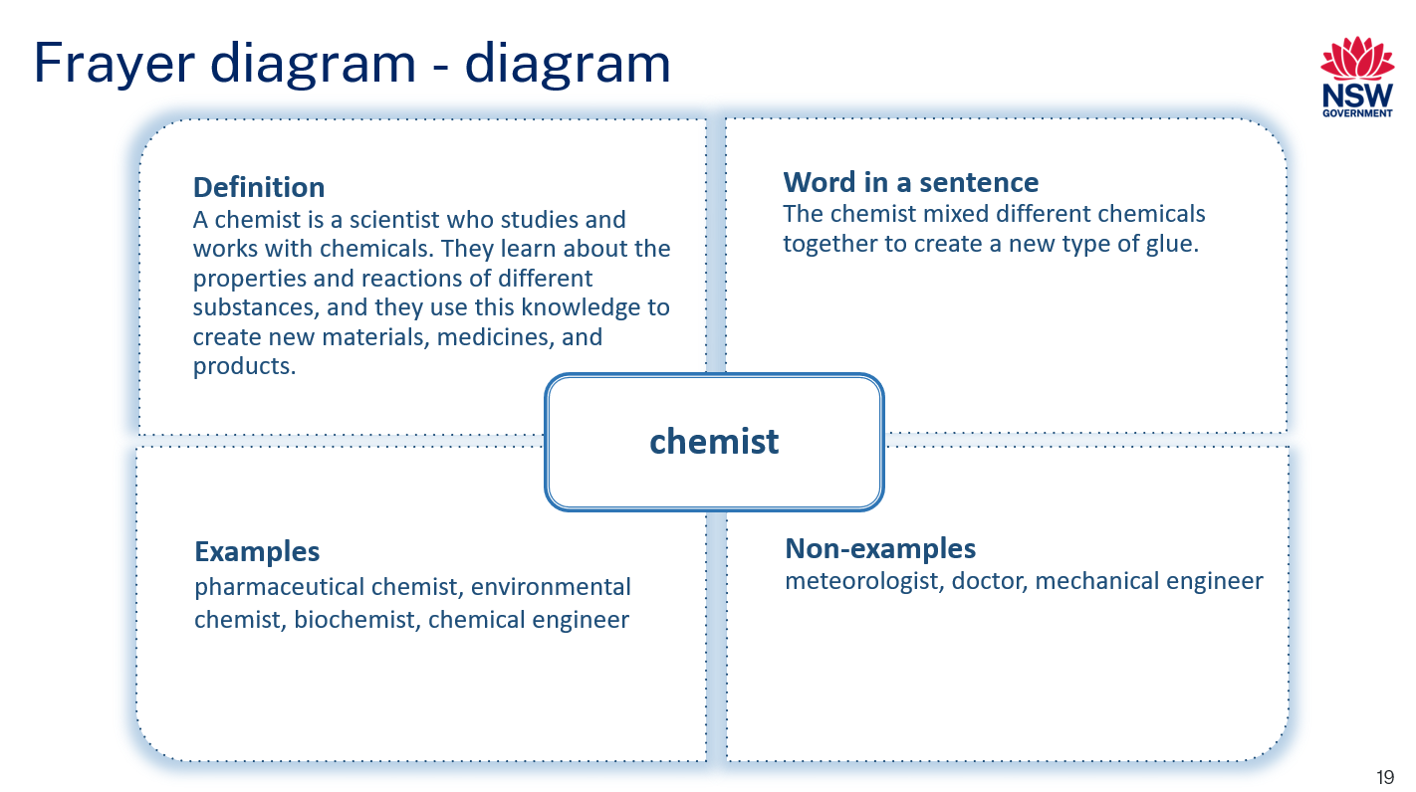

A copy of the above Frayer diagram is provided in the OTU PPT, which can be used as a worked example.

Student resource – sort the branches of science
Cut up the table below and match the correct scientist and branch of science with the problem.
Problem | Scientist | What branch of science?
My lemon tree has curly leaves. Who can help me figure out what is wrong with it? | Oceanographer (geologist) | Microbiology (biology)
Why are there so many mosquitoes around this camping spot? | Aerospace engineer | Chemistry
Why aren’t there as many frogs in my backyard as there used to be? | Soil scientist (geologist) | Polymer chemistry
My pool has turned green. What should I do to fix it? | Environmental scientist (biologist) | Horticulture (biology)
Why is the beach eroding so much this summer? | Chemist | Electrical engineering (physics)
Why do Mum’s high-heeled shoes make holes in the dirt when my runners don’t? | Polymer chemist | Entomology (biology)
My doctor says I have to finish my entire course of antibiotics, even if I feel better in the middle of the course. Why? | Electrical engineer (physics) | Chemistry
Why doesn’t plastic break down? | Horticulturist (biologist) | Aerospace engineering
How do aeroplanes stay in the air? | Microbiologist (biologist) | Environmental science (biology)
How does the electricity get to the light? | Chemist | Soil science (Geology)
Why is the dirt at my place brown but red at Gran’s? | Entomologist (biologist) | Physics
Why are fireworks coloured? | Physicist | Oceanography (geology)

‘Scientree’

Teacher information
Provide each student with a copy of the ‘Scientree’ and a set of science images. Alternatively, this activity could be assigned to the students digitally by providing them with the Branches of science slide in the OTU PPT.
Students label the branches of the ‘Scientree’ and glue the images on the appropriate branch. A sample response is included below.
Remind students that scientists work collaboratively, and some images could belong to more than one branch of science. For example, where would the tablets belong? Do they belong to the chemistry branch? Or does it overlap with biology because they are used to treat or prevent disease? Encourage discussion in small groups to challenge and clarify their reasoning behind the placement of the images.
Follow this activity with a gallery walk. Encourage students to examine and reflect on similarities and differences between their work and the work of others.
Differentiation: the OTU PPT includes a slide so the ‘Scientree’ can be co-constructed on the board. See 1.4 Branches of Science in the OTU PPT.
Figure 4 – sample response for a 'Scientree'
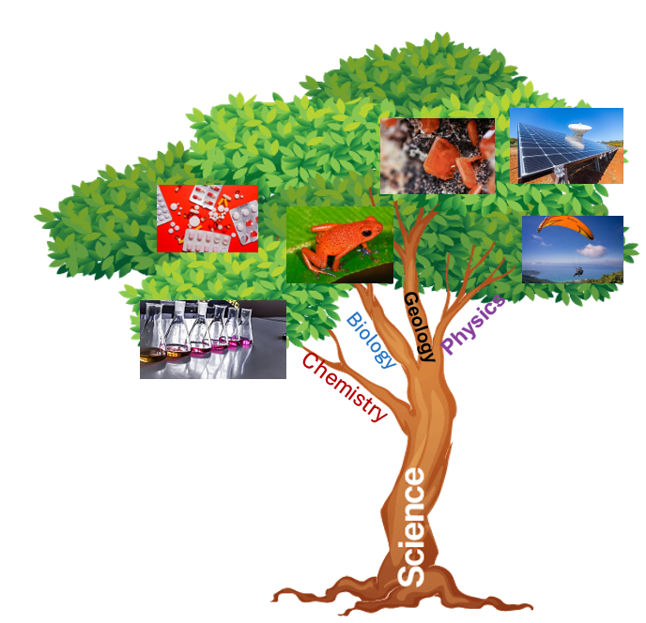
Note: this image does not include all items for this classification activity.
Example of the interdisciplinary nature of science
Several branches of science contribute to the development of solar panels.
- Physics – this branch studies the fundamental principles of energy and matter. Understanding the photovoltaic effect, the process by which solar panels convert sunlight into electricity, falls under physics.
- Chemistry – Chemistry is involved in developing the materials used in solar panels, such as the semiconductors that make up the photovoltaic cells.
- Materials science – this interdisciplinary field focuses on the properties of materials and their applications. Developing new materials and coatings is crucial for improving the efficiency and durability of solar panels.
- Electrical engineering – this branch applies the principles of electricity and electronics to design and develop solar panel systems, including the inverters and other components that convert and manage the electricity produced.
- Environmental science – this field studies the impact of human activities on the environment. Developing and using solar panels are part of efforts to reduce carbon emissions and promote sustainable energy sources.
- Renewable energy studies – this interdisciplinary field focuses on developing and implementing renewable and sustainable energy sources, including solar energy.

Student resource – ‘Scientree’


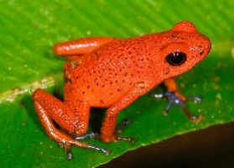 | 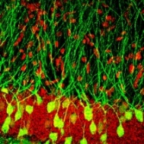 | 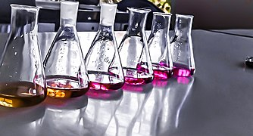
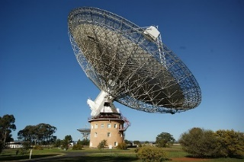 | 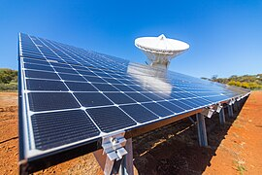 | 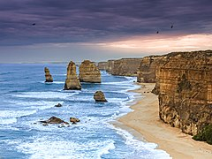
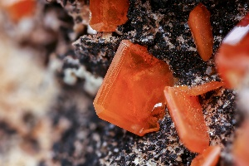 |  | 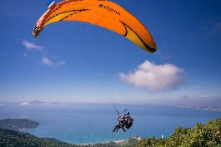
 | 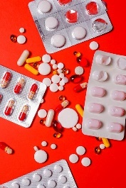 | 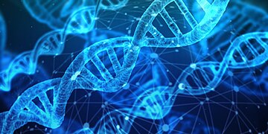
- Use the terms ‘biology’, ‘geology’, ‘physics’ and ‘chemistry’ to label the branches of your ‘Scientree’ and glue them into your workbook.
- Each branch is divided into smaller branches, and some branches get tangled together. Science is like this too. Label some of the smaller branches.
- Cut out the images above and glue them onto the ‘Scientree’ according to the field of study. Some may overlap branches.

Science is transdisciplinary
Provide students with the student resource – How is science transdisciplinary? Read through the text with the students and then lead a discussion on how this applies to their local context.

Student resource – How is science transdisciplinary?

What is transdisciplinary science?
Transdisciplinary science is a way of studying the world that brings together knowledge from different areas. Instead of focusing on just one subject, like math or biology, transdisciplinary science combines ideas and methods from many subjects to solve complex problems. It also includes knowledge from outside of school, like what people know from their daily lives or jobs.
Provide an example of a time when you combined science with another subject at school.

Why is transdisciplinary science important?
The world is full of complicated problems that can't be solved by just one field of science. For example, climate change affects the environment, the economy and health. To understand and solve these problems, scientists must work together and use knowledge from many different areas.
Provide one example where scientists have worked with other professionals to solve a problem in society.

How does transdisciplinary science work?
Bringing together different fields – scientists from different backgrounds come together to share their knowledge and ideas. For example, a team might include a biologist, a chemist, and a social scientist working on an environmental project.
Involving the community – transdisciplinary science also includes knowledge from people who are not scientists. For example, farmers, local leaders, and businesses can all provide important information about how climate change affects their lives and work.
Solving real-world problems – the goal is to find practical solutions that work in the real world. This means creating new methods and ideas that go beyond traditional subjects.

Examples of transdisciplinary science
Public health – to stop the spread of diseases, doctors work with scientists who study how diseases spread and with people who study human behaviour to understand how to encourage healthy habits.
Identify a public health campaign that aims to prevent a disease. Think about the TV advertisements you may have seen.
Environmental projects – scientists study pollution by combining chemistry (to understand the pollutants), biology (to see how they affect living things), and social sciences (to see how they impact communities).
Sustainability – engineers, environmental scientists and economists collaborate to create sustainable energy solutions. They also listen to local communities to ensure that their solutions are practical and beneficial for everyone.
Outline an environmental or sustainability project in your community.

Benefits of transdisciplinary science
Better solutions – scientists can develop more effective and innovative solutions by combining different types of knowledge.
Real-world impact – solutions that consider many different factors and perspectives are more likely to work in real life.
Collaboration and learning – scientists learn from each other and the community, leading to new ideas and approaches.

1.5 Why collaborate? (secondary-source investigation)
Table 8 – learning intention and success criteria for ‘Why collaborate? (secondary-source investigation)’
Learning intention | Success criteria
We are learning how scientists work together to increase our knowledge of the universe. | I can:  - identify examples of collaborative projects in science  - list the benefits of collaboration in scientific research.

Set the scene – COVID 19
Use the COVID-19 timeline slide in the OTU PPT to introduce how collaboration between institutions and countries allowed the rapid development of knowledge about the SARS-COV-2 virus and the unprecedented rapid spread of the disease.

International collaborative projects
Show students the photograph of the International Space Station (ISS) in the OTU PPT and discuss using the notes beneath the slide.
You could show a video on Space Plants - How Are They Adapting? (4:27) to provide additional context for the type of research conducted on the ISS.
Students draw the table ‘Collaborations in science’ and complete it for ISS as displayed in the OTU PPT.
Using a Jigsaw learning strategy, students investigate different collaborative science projects to determine the benefits of collaboration in various research settings. Divide the class into home groups of 4. Each student in a home group selects one of the projects to research using the sources provided in the OTU PPT. The students who select the same project should then work together to collect information on the project's purpose, who was involved in the collaboration, and the benefits of the collaboration and complete the next row of the table. These students are now the ‘experts’ on this project. Experts return to their home group and present their information, allowing all members of the home group to complete 3 more rows of the table.
Table 9 provides some suggestions for answers. Large amounts of detail are not required. The important idea is that collaboration advances science.
Table 9 – international collaborative projects sample answers
Project | What is the purpose of the project? | Who is collaborating? | What are the benefits of collaboration?
International Space Station (ISS) | The ISS orbits approximately 400 km above the Earth. It allows experiments to be conducted in low-gravity environments and research into living and working in space, allowing humans to travel further into space than ever before. | Space agencies from USA, Russia, Europe (10 countries), Brazil, Canada and Japan. | Allows new perspectives and approaches to scientific challenges.  The cost of expensive experiments is shared.  Groups of experiments share the same launches and crew time.
Human Genome Project | Mapped all the 100,000 (approximately) genes in humans. Allows scientists to determine the cause of genetic diseases such as Muscular dystrophy and Alzheimer’s disease. | Researchers from 20 universities across the USA, UK, France, Germany, Japan and China. | Used the skills of engineering, biology and computer science experts to map the genome in 2 years less time than anticipated. Information on every part of the human genome is publicly available – this has led to a greater awareness and openness to sharing data in biomedical research.
CERN – the European Council for Nuclear Research | Development of technology applied to high-energy physics, from material science to computing. Developed the World Wide Web. Discovering the sub-atomic particles. | Twenty-two member states and 6 associate member states. | Model for global collaboration, pooling of expertise – attracts 70% of the world’s particle physics community.  Expense is shared.
International Cancer Genome Consortium | Launched in 2008 to fully map the genetic faults in the 50 most common cancers, which will lead to the development of preventative strategies, markers for early detection of disease, better diagnosis and new therapies. | Australia, Canada, China, France, Germany, India, Italy, Japan, Spain, UK, USA. | Skills and knowledge from around the world are used. It provides large data sets, linking data on different cancers from across the globe.  Information will be made available freely to cancer researchers around the world.  Removes the costs associated with collecting primary data.
Human Cell Atlas | To map what every cell in the human body looks like in 3D. | Three thousand two hundred members from 1700 institutes in 99 countries. | Biologists, doctors, technologists, computational scientists, software engineers and mathematicians work together on this project.  The data and maps are freely available to transform healthcare worldwide.  Funded from around the world.
LIGO Scientific Collaboration | To detect cosmic gravitational waves rippling through space-time caused by the collision of black holes billions of light years away. | Initially, in 1997, the USA, Italy, and Germany were involved. Now, 103 institutions in 18 countries are involved. | Allowed the building of improved detectors and contributions of 1000 scientists worldwide to analyse data.
Gemini Telescopes | 2 × 8 m optical/infrared telescopes in Hawaii and Chile will provide the best views of the most distant stars. Allow scientists to collect data on astronomical events billions of years ago. | USA, Canada, Chile, Brazil, Argentina, Korea. | Astronomers in member countries can apply for time on Gemini for their research.
Consultative Group for International Agricultural Research | Battling hunger through developing sustainable agriculture. Allows the global community to respond better to inter-related issues of poverty, hunger, population growth and environmental degradation. Aiming to achieve the Sustainable Development Goals by 2030. | Fifteen research centres in countries around the world. | Combining the knowledge and skills of 9000 scientists to respond to emerging development issues.  Built the largest and most frequently accessed network of gene banks worldwide.

Advantages of collaboration in science
Ask students how collaborating with others allowed them to complete the jigsaw activity. Possible responses may include:
- time was saved because the work was shared
- they were able to improve on each other’s work.
Ask the students to look at the examples of collaboration, including the ISS, to determine the benefits of collaboration in science. Write each benefit on a sticky note and stick it on the whiteboard.
Students view all sticky notes or ideas, decide which are similar and start to form groups (affinity diagram). Possible groupings could be:
- increased sharing of knowledge leads to
- recent discoveries
- higher quality discoveries
- increased learning by scientists
- tackling complex problems from different angles
- access to specialised knowledge and skills that may not be available at one institution.
- more innovation and creativity lead to
- creation of new research ideas
- creation of new approaches to problems.
- pooling of resources and technologies leads to
- access to resources that may not have been, which leads to
- more being achieved in less time
- lower cost for each scientist
- Scientists checking each other’s work leads to
- increased accuracy, which leads to
- higher quality research
- greater diversity of people leads to
- the results of the research are available to all countries
- the collaboration will be more inclusive and representative of a wider society
- greater diversity of ideas may lead to a greater variety of solutions to problems
- scientists can specialise in their own fields and use experts from other fields
- reduced bias – by considering a range of ideas, scientists won't focus on their own ideas.
Differentiation: the sentence stems above could be provided on the board to prompt students’ idea generation.
Students then create a concept map of these benefits on a digital template or pen and paper. A template for a concept map is available on the digital learning selector.
Checkpoint
Exit ticket – referring to the learning intentions and success criteria, students undertake a 3-2-1 on things I learned today (OTU PPT). Students list 3 things they learned today, 2 questions about those things, and one reason why it is important to know about them. Note that responses must be addressed at the start of the next lesson.

1.6 The power of scientific theories and laws
Table 10 – learning intention and success criteria for ‘The power of scientific theories and laws’
Learning intention | Success criteria
We are learning how scientists use observations to form theories and laws. | I can:  - define a scientific theory  - define a scientific law  - distinguish between theories and laws.

Background information
Two terms frequently used in science are ‘theories’ and ‘laws’. While they may seem interchangeable in everyday language, within scientific contexts, they hold distinct meanings and serve different purposes. Understanding these differences is crucial.
Theories – a theory is a well-substantiated explanation of some aspect of the natural world based on a large body of evidence, observations and experimentation. Theories are comprehensive knowledge frameworks that seek to explain phenomena and are supported by vast empirical data. They are dynamic and subject to refinement or revision as new evidence emerges.
Theories provide a deeper understanding of how and why natural phenomena occur, often by proposing underlying mechanisms or principles.
Examples of scientific theories include the Theory of Evolution, the Germ Theory of Disease, the Theory of Relativity, the Big Bang Theory and the Theory of Plate Tectonics.
Laws – scientific laws, on the other hand, describe observed patterns or relationships in nature that are consistent and universally applicable under specific conditions. Some laws are expressed as concise mathematical statements (for example, F = ma), while others are not (for example, Mendel’s law of independent assortment).
Unlike theories, laws do not attempt to explain the underlying mechanisms or causes behind observed phenomena. Laws are often derived from repeated observations and experiments and are considered fundamental principles of nature.
Examples of scientific laws include Newton's Laws of Motion, the Law of Conservation of Energy, the Laws of Thermodynamics and the Law of Universal Gravitation.

Exploring theories and laws

Comparing theories and laws
Watch a video such as What’s the difference between a scientific law and theory? - Matt Anticole (5:11) with the class. Ask the students to brainstorm the difference between theories and laws in groups. Emphasise to students the importance of observations and repeated experiments in developing theories and laws.
Students complete a Venn diagram illustrating similarities and differences between a theory and a law. An editable template of a Venn diagram is included in the OTU PPT. This may be used to support class discussions. Some suggested answers are also provided.

Theories
Ask the students what a theory is and suggest examples of theories. Display their responses on the board.
Display the slide, ‘What scientific theory is represented here?’. Ask students for their suggestions. Ask why it is called a scientific theory. Explain that evolution is a theory and is based on evidence. Theories are not simple guesses or hypotheses. They are comprehensive explanations that are supported by a vast body of evidence.
Refer to the list on the board and ask if these theories are based on evidence. Guide students to divide the list into scientific theories (based on evidence) and non-scientific ideas.

Laws
Ask the students if they can suggest some laws. They will most likely suggest laws relating to driving and other societal laws. Again, list their suggestions on the board.
Display the slide ‘What scientific law is represented here?’. Ask for student suggestions. Explain to students that this slide shows Newton’s law of gravitation or gravity.
Refer to the list of laws written on the board and work with students to classify them as scientific or non-scientific.

Debunked theories
Working in pairs, students select one of the debunked theories on the debunked theories slide in the OTU PPT. Students research what their selected theory explained and why it was debunked. Detailed explanations are not required. Each pair then reports on their theory to the class. Ask the students: Why were all these theories debunked? The common thread is that evidence was discovered through observation and experiments that the existing theory could not explain.
Students use their example of a debunked theory to answer the following question:
- Does having a theory disproved or adjusted weaken the credibility of science?
Sample response
The miasma theory (Hippocrates, 4th century BC) said that contagious diseases, such as cholera, were caused by miasma – ‘bad air’ – produced from rotting organic matter. A range of infectious diseases were also said to be caused by miasma.
In the 1800s, John Snow noted a link between contaminated water sources and cholera outbreaks. Robert Koch and Louis Pasteur conducted repeated experiments to show a link between germs and disease. The germ theory states that specific microscopic organisms cause specific diseases. By the late 1800s, it replaced the Miasma theory.
Thus, disproving or modifying theories does not weaken science's credibility. It shows that science is dynamic and changes when new evidence becomes available.
Checkpoint question: Which statement best explains the difference between a scientific theory and a scientific law? (The correct answer is option A).
A. A theory explains a wide range of phenomena supported by evidence and experimentation, while a law describes a specific relationship observed in nature.
B. A theory is a well-tested and widely-accepted explanation for a natural phenomenon, while a law predicts future events based on past observations.
C. A theory is a proven fact about the natural world, while a law is a tentative explanation that may change over time.
D. A theory is a simple explanation for a complex phenomenon, while a law is a complex explanation for a simple phenomenon.

1.7 Introducing the Working scientifically processes
Table 11 – learning intention and success criteria for Introducing the Working scientifically processes
Learning intention | Success criteria
We are learning how scientists work to increase our knowledge of the Universe. | I can list the Working scientifically processes used by scientists for undertaking investigations.
This activity introduces students to the Working scientifically processes by considering a well-known Australian problem – the bleaching of the Great Barrier Reef. You could also choose a local problem.

Working scientifically in context
Present the students with the following problem: A marine biologist observes that large parts of the Great Barrier Reef are bleaching. How would the marine biologist investigate this problem?
In small groups, students brainstorm all the steps scientists may take to investigate this problem. Gather the students' answers and write these on the board. Prompt students so that all the Working scientifically processes in the flow chart below are on the board randomly.
Possible suggestions could be:
- Making observations: the coral is bleaching or losing its colour
- Ask questions about observations: Is all the coral in an area affected? What has changed in the area recently? Are the numbers of animals living in the coral affected? Has the area been bleached before? How long has it been bleached?
- Find out what is already known. Research – find out what other areas have had this problem. Find out what has caused coral bleaching in other areas. Find out if the area has been bleached before.
- Make a prediction based on the following scientific knowledge – the coral bleaches because the water temperature is too high.
- Plan some experiments – gather data for past water temperatures and measure current temperatures. Plan some experiments with coral in tanks and vary the temperature to match what has happened in the ocean.
- Conduct the experiments.
- Record the results – record how much coral died in the tanks.
- Analyse the results – compare results in tanks at different temperatures with the recorded temperature in the ocean.
- Make a conclusion – When the temperature in the ocean rises above ____degrees, the coral will bleach.
- Let other scientists know what the experiments showed – publish the results in a scientific magazine, talk to environmental agencies, government.
- Explain that these processes together are called the Working scientifically processes and explain that there is an order in which scientists carry out these processes. Model how to draw a flow chart by completing the first 2 or 3 processes.
Provide each group of students with the ‘Student resource – Working scientifically processes’ table. Students cut these out and discuss them in groups to arrange the processes in the correct order. Discuss with the groups of students why they have arranged the steps, and when they are correct, the students paste the flow chart into their book (or copy it to their device). The Working scientifically processes slide in the OTU PPT can be used to demonstrate the correct order for students.
Making a large copy of the flowchart and displaying it in the laboratory will allow the teacher to regularly refer to the Working scientifically processes as you explore them over future lessons.

Figure 5 – the Working scientifically processes
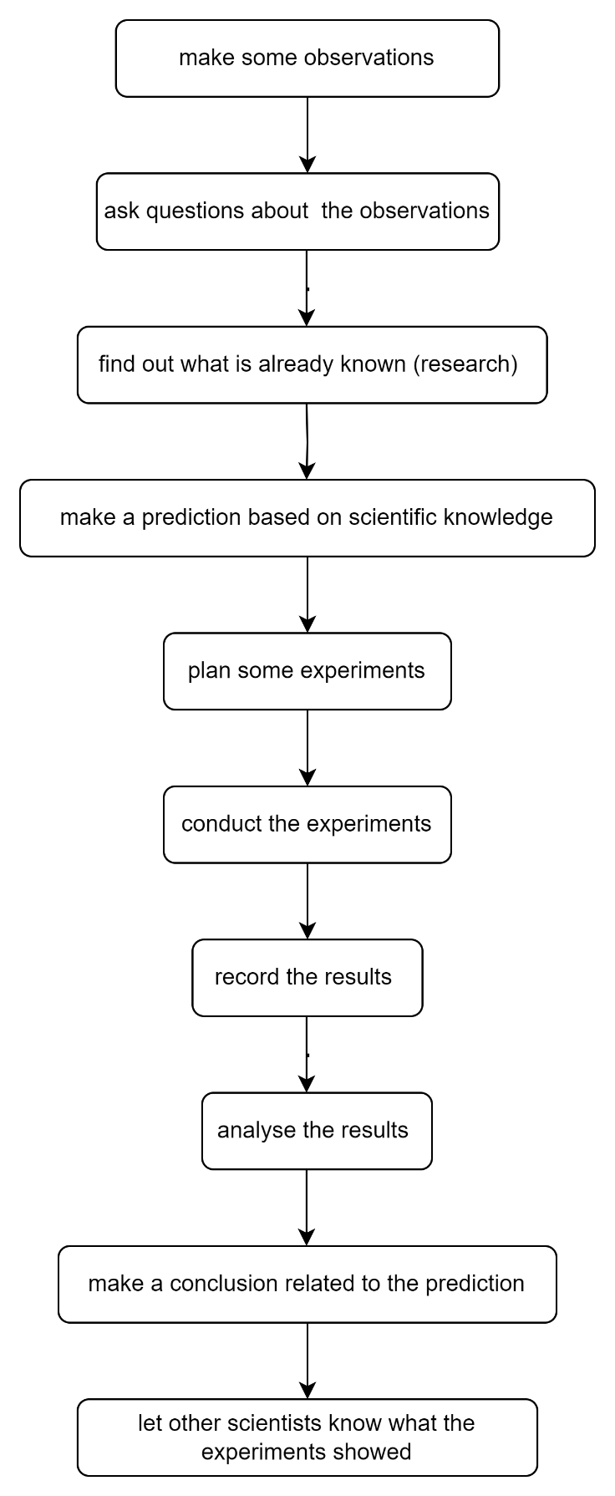

Student resource – Working scientifically processes
plan some experiments | record the results of the experiments
analyse the results | make a prediction based on scientific knowledge
make some observations | make a conclusion related to the prediction
ask questions about observations | let other scientists know what the experiments showed
conduct the experiments | find out what is already known (research)

1.8 Science sleuth
Table 12 – learning intentions and success criteria for Science sleuth
Learning intentions | Success criteria
We are learning:  - how observations help scientists increase our knowledge of the Universe  - to communicate scientific concepts. | I can:  - distinguish between an observation and an inference  - write an evidence-based explanation.

Observations vs non-observations

Review prior learning
Ask students what they recall from the last activity about the process scientists use to undertake a scientific investigation. Explain that now we will drill down into the steps in the Working scientifically processes to find out how each is done. Ask students what the first step in the Working scientifically process is. The following task is to refresh students’ knowledge of scientific observations from their learning in the Science and Technology K–6 course.
Copy the set of statements in the student resource and distribute a set to each student or group of students. Students use rapid-fire matching to classify each statement as ‘observation’ or ‘not observation.’ This activity should be completed within a short time limit. Students then provide reasoning for their categorisation of the statements.
Remind students that observation in science involves using our senses and scientific tools to gather information to answer questions and construct explanations.
Sample response
Table 13 – a sample response for observations and non-observations
Observations | Non-observations
The music is loud. | Quiet music will calm the students.
The temperature outside is 20 degrees Celsius. | The glistening water looks happy in the sunlight.
I see birds flying in the sky. | I need to wear a coat today.
The leaves on the trees are green. | The sky is angry today.
The water in the glass is cold. | I think it will rain tomorrow.
Scientific observations are descriptions of events or phenomena. The non-observations in Table 13 are not solely descriptions of observations but include interpretations and predictions.

Student resource – Observation or not?
Sort the statements below into ‘observation’ or ‘non-observation’.
The sky is blue.
The sky is angry today.
I will need to wear a coat today.
Quiet music will calm the students.
The water in the glass is cold.
I see birds flying in the sky.
The leaves on the trees are green.
I think it will rain tomorrow.
The glistening water looks happy in the sunlight.
The temperature outside is 20 degrees Celsius.

Animal tracks
Introduce the term ‘inference’, as a conclusion or explanation based on observations and what is already known. It is an educated guess about what might be happening. Emphasise the difference between an observation and an inference. An observation is what you directly notice or measure, while an inference is the interpretation or conclusion drawn from your observations.
For example:
- Observation – the plant's leaves are wilted.
- Inference – the plant needs water.
Ask what other inferences could be made. Possible answers include the plant having a disease, not receiving enough light or nutrients, or having been in the frost.
Guide the students through the Tricky tracks activity. This activity includes teacher guidance (including sample answers), a presentation and a student worksheet.
Teacher note: the tricky tracks activity is an ideal opportunity to introduce the process of writing an explanation using the Claims-Evidence-Reasoning scaffold with the Think Aloud technique to model it. The modelling can be demonstrated in question 1 and completed through a joint construction in question 6. A scaffold for Claim-Evidence-Reasoning has been provided in the OTU PPT.
Causal connectives can be introduced at this point. Causal connectives are words that link one statement to another. Examples of causal connective are ‘thus’, ‘therefore’, ‘so’, ‘due to’, ‘because of, consequently, hence, for this reason, then, when, unless. A slide of connectives is included in the scaffolds in the OTU PPT.
Table 14 – sample response for the C-E-R animal tracks activity – What do you think has happened?
Claim | Evidence | Reasoning
State an answer to the question/prompt. | Provide reliable information from experiments, facts or a reliable source that supports the claim. | Explain how the evidence supports the claim.
Helpful hints  Use keywords and ideas from the question as you write your claim. | Sentence starters  In the experiment…  The data shows…  One piece of evidence is… | Sentence starters  The evidence supports the claim because…  Based on this evidence, it can be concluded that…
Your response  Two animals went looking for food. They met, and the larger-footed animal chased the other in circles. | Your response  The image shows that the footprints get further apart as the 2 animals get closer together. Where the 2 sets of footprints come together, many prints go around each other in one spot. | Your response  Based on the evidence, it can be inferred that the speed of both animals increased as they got closer together. Some sort of interaction likely took place; for example, the animal with the larger feet may have chased the smaller animal in an attempt to eat it.
Checkpoint: using examples, how would you explain the difference between an observation and an inference to a friend? Use Think-Pair-Share so that students can refine their explanations and examples.
Checkpoint sample response
An observation describes an object, event or phenomenon made using senses or instruments. For example, if you see that the sky is grey and you feel raindrops, that is an observation, and so is measuring the volume of rain in an hour. An inference is a conclusion you draw based on your observations, often requiring an interpretation of those observations. For instance, if you observe the grey sky, you might infer that it will rain soon. Observations are about what you directly sense or measure, while inferences are the ideas you form based on those observations.

Defining observations and inferences
Watch a video such as Observations and Inferences - What's the Difference (2:34). Co-construct a T-chart (OTU PPT – Defining observations and inferences T-chart) showing the differences between an observation and an inference.
Provide students with the image of the cracked window (OTU PPT). Encourage students to make as many observations as possible. Then, they can brainstorm possible inferences or explanations for the observations made. Construct a T-chart to show the observations and inferences that can be made.
Lead a discussion emphasising different inferences that can be made from the same observations and that more observations may lead to more accurate inferences.
Figure 6 – window
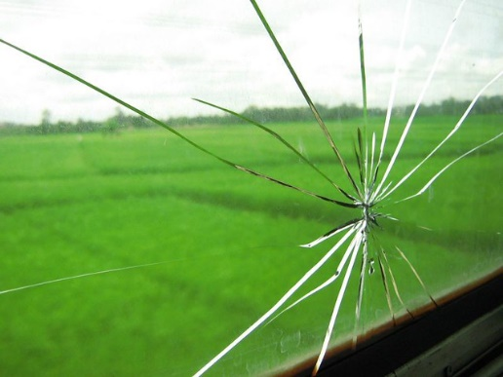
‘Broken Window’ by Adi Setiawan is licensed under CC BY-NC-SA 2.0.
Sample response – window
Observations | Inferences
There are cracks in the window.  The cracks all come from one point.  There is a large grassy area outside the window.  There is a shorter area of grass close to the window. | Something small hit the window to crack the window.  A stone hit the window when the grass was being mown.  The window is in a building next to a farm.  The window is in a tractor.

How do we know about Mungo Culture?
Aboriginal and Torres Strait Islander Histories and Cultures
When planning and programming content relating to Aboriginal and/or Torres Strait Islander Histories and Cultures, teachers are encouraged to:
- involve local Aboriginal communities and/or appropriate Knowledge Holders in determining suitable resources, or use Aboriginal and/or Torres Strait Islander-authored or endorsed publications
- read the principles and protocols relating to teaching and learning about Aboriginal and/or Torres Strait Islander Histories and Cultures and the involvement of local Aboriginal communities.
The Australian Institute of Aboriginal and Torres Strait Islander Studies (AIATSIS) Guide to evaluating and selecting education resources has been developed to assist teachers in selecting appropriate resources for teaching about Aboriginal and Torres Strait Islander Histories, Cultures, and Languages respectfully and effectively.

Instructions
Students watch Mungo Episode 6 Ancient People (6:48), access OTU PPT ‘How do we know about the Mungo Culture?’ and then complete the student worksheet to explore observations and inferences about Mungo Culture.
Sample response – How do we know about the Mungo Culture?
- Identify 3 observations and the corresponding inferences made in the video.
Observations | Inferences
Stones are not consistent with the local geology. | Stone artifacts were brought from other areas.
More than 460 fossilised human footprints were discovered. | Children, adolescents and adults made the footprints.
Uneven weight distribution in footprints. | A lady was carrying a baby.
The pattern of the small footprints indicates that a child left the main group, went around the outside and met back up further down the track. | A child misbehaved and ran away for a while.
Male footprints from the same side that alternates with a small hole. | The person had a stick on a hook, like crutches.  A person was pushing a canoe across the mud and the canoe wiped away the prints from one side of the body.
Marks from a spear sliding on the ground with knuckle marks next to it. | A person picked the spear up from the ground.
- Other inferences have been made. However, the observations supporting them have not been outlined in the video. In the table below, list 3 inferences and add corresponding observations that could have been made.
Inference | Possible observation
People traded stone tools and materials over long distances. | Stone axes found at Mungo originated from quarries in Victoria, hundreds of kilometres away, indicating trade and exchange networks.
The person threw the spear. | There would have been uneven weight distribution in footprints because the person's weight shifted forward during the throw.
The Mungo people cooked fish by covering it with mud and hot coals. | Archaeologists found a fish tail covered in mud near cooking areas and evidence of cracked, dried mud consistent with cooking methods.
- The video states, ‘They would have traded cloaks, stone tools, hardwood, all your spears …’ Why is the word ‘would have’ important?
The term ‘would have’ is important because it indicates that the information is based on second-hand knowledge or inference rather than direct, first-hand observation.

Student resource – How do we know about Mungo Culture?
Watch the video Mungo Episode 6 Ancient People (6:48) and answer the questions below.
- Identify 3 observations and the corresponding inferences made in the video.
Observations | Inferences
- Other inferences have been made. However, the observations supporting them have not been outlined in the video. In the table below. list 3 inferences and add corresponding observations that could have been made.
Inference | Possible observation
- The video states, ‘They would have traded cloaks, stone tools, hardwood, all your spears …’ Why is the word ‘would have’ important?

1.9 From observations to questions (practical investigation)
Table 15 – learning intentions and success criteria for ’From observations to questions (practical investigation)’
Learning intention | Success criteria
We are learning how observations help scientists increase our knowledge of the Universe. | I can:  - develop testable questions based on my observations  - carry out an investigation designed to answer questions.

Prior learning
Activate prior knowledge by conducting a think-pair-share activity to answer the question, ‘How do scientists investigate problems?’ You may need to refer students to the Working scientifically processes flow chart (in 1.7 Introducing the Working scientifically processes).
Answers should include information such as making accurate observations, asking questions, carrying out experiments and gathering data.
Review the Working scientifically processes, highlighting that asking questions follows observations.

Bubbleology – asking questions
In this activity, students will ask questions that they can test about making bubbles. They will devise a way to investigate the question by undertaking a practical investigation to find the answer. Ensure that students focus on asking testable questions based on previous observations. This process can be demonstrated using the ‘think aloud’ technique before encouraging students to develop their own questions and tests.

Preparation
For this activity, you will need the following:
- bubble mix for the class
- 4 cups water
- ½ cup detergent
- 4 tsp glycerine
- spare ingredients for the bubble mix. Students may ask, ‘Is the glycerine necessary to make bubbles?’
- for each group of students
- 50 mL beaker
- stirring rod
- straws
- graph grid printed on acetate
- other materials that may be useful to test when making bubbles. For example, cotton buds, pipe cleaners, and wire.

Sample ‘think aloud’ script for developing questions and exploring the bubbles
‘Today, we will explore how to use our observations to develop testable questions using bubbles! I will demonstrate how to do this by thinking out loud, and then you will get a chance to try it yourself. Let us start by thinking about some things we have observed about bubbles.
We know that bubbles can be of different sizes, float or sink, and sometimes pop quickly while others last longer. Now, let us use these observations to ask a testable question.
Hmm, what am I curious about? I wonder, "Does the size of the bubble affect how long it lasts before popping?" This is a good start because it is based on something we observed. But how can we test this?
To test this question, I could create bubbles of different sizes and time how long each bubble lasts before popping. If I notice that bubbles of certain sizes last longer than others, I will have an answer to my question.’
Demonstrate how to create a bubble.
- Wet the surface on which the bubbles will be made.
- Dip the end of the straw into the bubble mix.
- Gently blow through the straw.
- Blow the mixture onto the graph grid to measure the size of the bubble. The diameter of the bubble can then be measured.
“Science is all about being curious and finding ways to answer our questions through experiments. So now let us all investigate the same question together. Can someone share an observation they may have made about bubbles and a question they are curious about?”
Select one question, and all the students will investigate this question with your guidance.
“All right, now it is your turn! What are you curious about? Remember, your question should be something you can test with an experiment. Once you have your question, think about how you would test it. What materials will you need? What steps would you follow?
Let us see what interesting questions and experiments you can develop about bubbles.’
Possible questions that may be asked include:
- How big can I make a bubble before it bursts?
- What other materials can I use to make a bubble?
- Will adding more detergent make the bubbles bigger?
- Will adding glycerine make the bubbles last longer?
- Can I make a bubble in a bubble?
- How many bubbles can I make inside a bubble?
- Can I cut a bubble into 2 parts without it breaking?
- Does adding glycerine change the size of the bubbles?
- What happens if I blow a bubble on a dry surface?
- Can I make a bubble of a different shape?
- Can I make a tower of bubbles?
Students plan and undertake an investigation to address their questions.
Conclude this activity by facilitating small group or whole class reflections on how observations and curiosity lead to testable questions. Were all questions testable? If not, why not? Prompt the class to analyse why some questions are testable, and some are not.
Differentiation
Students may be challenged to catch and hold a bubble with wet and dry hands. They should find that they may be unable to catch the bubble with dry hands. Have the students propose an explanation for this result. Explain the reasons below:
- Wet hands maintain the surface tension, while dry hands disrupt it.
- Surface tension – bubbles rely on surface tension to maintain their shape. Water molecules attract each other, creating a 'skin' on the bubble's surface.
- Dry hands – the oils and dryness of your skin break the bubble's surface tension, causing it to pop.
- Wet hands – the water on your hands blends seamlessly with the water in the bubble's film, maintaining the surface tension and preventing the bubble from popping.
Checkpoint:
State 3 criteria that make for a good scientific question.
Sample response: A good question is testable, identifies what is being investigated and focuses on collecting evidence or data.

1.10 Measure up
Table 16 – learning intention and success criteria for ‘Measure up’
Learning intention | Success criteria
We are learning to use scientific equipment to make observations. | I can:  - compare the range, sensitivity and accuracy of analog and digital instruments used to measure weight  - use measuring instruments to measure aspects of the environment  - record measurements correctly using the correct units.
This activity has 2 parts. In the first part, students investigate and compare analog and digital devices designed to measure the same variable. In the second part, they use various devices to measure aspects of the environment.

Analog and digital measuring devices
Display pairs of digital and analog measuring devices that students may be familiar with. Examples include analog and digital bathroom scales, analog and digital kitchen scales, wall clock and digital clocks, analog and digital thermometers, and analog and digital tyre pressure gauges.
Students to move around and determine the following.
- What do the analog devices have in common?
- They all use a scale of numbers read by looking at where a marker points.
- The whole scale is visible.
- It would be possible to estimate the reading between marks on the scale.
- What do the digital devices have in common?
- They all display a number to represent the measurement.
- The whole scale of numbers is not visible.
- It would not be possible to read between values displayed.
Spring balance vs electronic balance
Demonstrate how to use a spring balance, including using the spring balance with the most appropriate range. Explain how to use and how to tare an electronic balance. Explain that taring removes the mass of the watch glass (or other vessel used to contain the substance being measured) so that only the object being weighed is measured. Provide each group with spring balances, an electronic balance, some small objects up to 500 g weight and a 50 g mass carrier. Students weigh the objects using each device, record their measurements and answer questions 1 to 4.
Thermometer vs temperature probe
Students take a watch glass and measure 5 g of salt using digital scales. The salt will be used soon but should be placed aside for now.
Demonstrate to students how to use a digital thermometer or temperature probe.
Provide students with a 250 mL beaker filled with ice, a small amount of water and a digital thermometer or probe. Students take measurements of the temperature, record results and answer questions.
The students sprinkle the salt into their beaker of ice and gently stir it with a stirring rod. Instruct the students to measure the temperature with the thermometer and the temperature probe and record their results. The students should be able to notice that the temperature has dropped below zero. Depending on the range of your alcohol thermometers, they may be unable to read temperatures below zero, which is outside their range. In contrast, the temperature probe will be able to collect a reading. Students answer questions on the worksheet about the range of readings. You may need to provide them with the range of reading for the digital device.
Suggested answers to Digital vs Analog
- Which device was easier to read?
Digital. You just have to read the number. You do not have to work out what each mark on the scale represents.
- Which measuring device is more sensitive?
The digital device is more sensitive because it measures to more decimal places.
- The 50 g mass weighs exactly 50 g. Which measuring instrument was more accurate? Explain your answer.
The digital device is more accurate because it correctly measures the 50 g mass carrier. The analog devices gave several different readings. The digital device also minimises the human error involved in reading the scale.
- Which device was more sensitive when reading temperature? Explain your answer.
The digital thermometer was more sensitive. It reads to more decimal places.
- What range of temperatures can each device measure?
The analog thermometer can measure from 0 to 110 degrees (or insert values appropriate to your thermometers). The digital thermometer can measure from -20°C to 200°C (or insert the values appropriate for your device).
- Your deep freezer at home is set to -15°C to -18°C. Explain which thermometer you would use to measure the temperature of your deep freezer.
The digital thermometer would be the most suitable because it has a greater range. It can measure to -20°C.

Student resource – digital vs analog

Spring balance vs electronic balance
- Use the spring balance and electronic balance to measure the weight of each object.
The weight of objects was measured using analog and digital measuring devices.
Object | Weight (g) spring balance | Weight (g) electronic balance
- Which device was easier to read? Explain your answer.
- Which measuring device is more sensitive? Explain your answer.
- The 50 g mass weighs exactly 50 g. Which measuring instrument was more accurate? Explain your answer.

Thermometer vs temperature probe
Weigh 5 g salt using the digital scales and set aside.
Measure the temperature of a beaker of ice water with analog and digital thermometers.
Sprinkle the salt over the ice, stir gently with a stirring rod and record the temperature.

Temperature of ice and ice plus salt
Substance | Temperature °C on analog thermometer | Temperature °C on digital thermometer or probe
Water with no salt
Water with salt
- Which device provided the more precise reading of the temperature?
- What range of temperatures can each device measure?
- Your deep freezer at home is set to -15°C to -18°C. Explain which thermometer you would use to measure the temperature of your deep freezer.
- Write a sentence explaining why the range of a measuring instrument is an important consideration when selecting equipment for an investigation.

Measuring our environment
Demonstrate to students how to use various instruments to measure aspects of our environment.
Instruments could include:
- wet or dry thermometer or hygrometer
- thermometer or temperature probe
- lux meter
- sound meter
- anemometer
- trundle wheel or 15 m tape measure.
If digital sensors are available they can be used and the results can be compared. Take the students outside and make measurements in a variety of settings, allowing all students to practice using the instruments and observe a range of measurements.

Student resource – measuring the environment
Environmental factor | Measuring instrument | Location | Measurement

1.11 Putting it all together
This activity is conducted in 3 parts designed to be carried out over a sequence of lessons.
- What’s this for? Students will learn about the laboratory equipment they will be using in subsequent parts of this activity.
- The Bunsen burner – how to safely use a Bunsen burner. Students will use the Bunsen burner in Salty tales.
- Salty tales – investigate the science behind adding salt to your pasta water.
Table 17 – learning intentions and success criteria for ‘Putting it all together’
Learning intentions | Success criteria
We are learning to plan and conduct safe and valid investigations | I can:  - safely follow a planned procedure to heat water and measure the temperature accurately  - identify the variable that is being measured  - identify the variable that is being changed.
We are learning to use scientific equipment to make accurate observations. | I can measure temperature accurately.
We are learning to process and represent information. | I can record measurements in a table and plot data accurately on a graph.
We are learning to look for patterns in data. | I can accurately interpret data in a line graph.
Differentiation: Year 7 students have not been introduced to the concept of and use of the term 'variables' in this task. Language such as ‘quantity that we change’ and ‘quantity we measure’ is suggested. However, if your students are ready to use dependent, independent and controlled variables, they can be introduced at this point.

What’s this for?

Teacher information
Students will learn about the laboratory equipment they will use in parts 2 and 3 of this activity.
Use a question ball to check students’ prior knowledge of science equipment. Toss a small soft ball to a student. The student with the ball provides an example, and then the ball is tossed to another student, who provides a different example.

Instructions
Review the Working scientifically processes and highlight that we are now moving on to more work on planning and conducting investigations. Explain that the science laboratory has pieces of equipment that are used to carry out practical experiments.
Instruct students to draw the table below, with the columns to fill a page. Do not draw any rows at this stage.
Table 18 – sample table for equipment information
Equipment | Drawing | Use
Provide each group of students with:
- a tray containing a Bunsen burner, tripod, heat-proof mat, wire gauze, 250 mL beaker, thermometer, boss head, clamp, retort stand, stirring rod, 100 mL measuring cylinder
- a copy of the table of equipment in the student resource below.
Students cut out each equipment label. The group decides on the allocation of labels to each item of equipment and considers its use. Move around the room and provide feedback to the groups on their equipment labelling.
Lead a discussion on each piece of equipment and its use. Explain the use of two-dimensional drawings in science and demonstrate how to draw each piece of equipment on the board.
A good line diagram (OTU PPT):
- is drawn in pencil
- has crisp, sharp lines without shading
- has any straight lines drawn with a ruler
- is drawn in 2 dimensions
- has the openings of containers not closed off with a line
- is large enough to show the important details
- has each component labelled with a rule line without arrowheads
- has label lines that do not cross over.
Note: arrowheads are only used to denote movement or process.
Fun fact: note that the Bunsen burner has a capital B because it is named after Robert Bunsen, the scientist (chemist) who invented it!
The students put the name of the piece of equipment in the table, copy the diagram from the board and write what it is used for in their table. After each piece of equipment, the students rule a line across the table and start a new row.
How to read a measuring cylinder
Ask students to compare the beaker and the measuring cylinder and suggest which is more accurate for measuring volume. Then, demonstrate how to read a measuring cylinder using the following steps:
- Have the measuring cylinder on a flat surface.
- View the scale at eye level.
- Read the bottom of the meniscus.
The minimum division of measurement that can be made is half of the smallest division on the device. In the example below, the lines represent 1 mL, so the minimum measurement division is 0.5 mL. Therefore, this should be read as 21.5 mL. There is no need to introduce ‘plus or minus 0.5’ to year 7.
Figure 7 – measuring volume using a meniscus
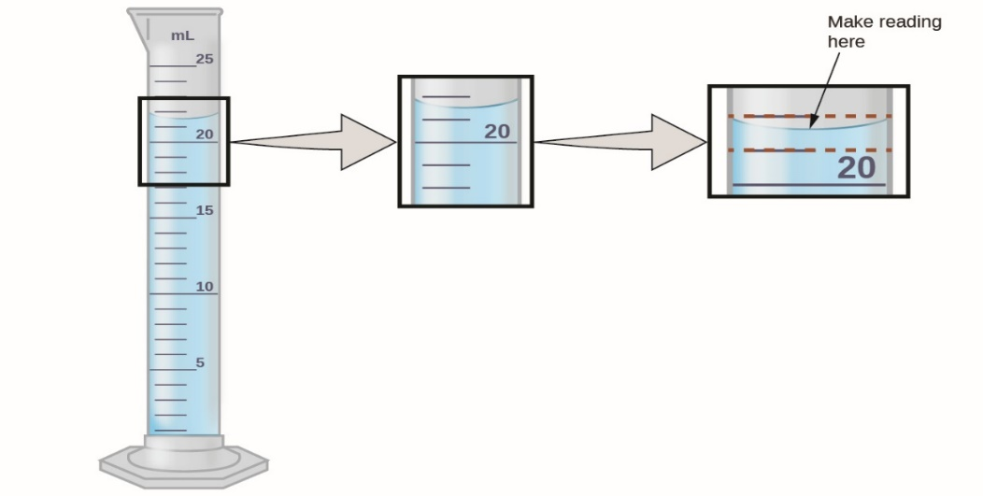
Measuring volume by Unknown Author is licensed under CC BY-NC-SA 4.0.
Have the students measure 100 mL of water using the increments on a beaker. They then pour this into the 100 mL measuring cylinder and compare the readings. Students will likely observe that the amount of water is not exactly 100 mL. Explain to the students that beakers are not designed to measure volume accurately. Hence, selecting the correct piece of equipment for a task is important.
Checkpoint: show individual students a range of measuring cylinders with different volumes and have them read the volume. Identify the students facing difficulty reading the scale and re-teach the skills where required.

Student resource
Cut out the labels and match them to the piece of equipment.
beaker | thermometer
test tube | wire gauze
tripod | retort stand
Bunsen burner | clamp
stirring rod | boss head
heat proof mat | thermometer
measuring cylinder | tongs

The Bunsen burner (practical investigation)
Equipment
- Bunsen burner
- Heat-proof mat
- Crucible tongs
- Pieces of broken porcelain.

Parts of the Bunsen burner
In the last activity, students learnt that the Bunsen burner is used in the science laboratory to heat substances. It is vitally important that it is used correctly and safely.
Show the students the Bunsen burner, identifying the barrel, collar, hole(s), and base. Demonstrate to students how to draw and label a scientific diagram. Students draw a diagram of a Bunsen burner and label the barrel, hose, collar and base. Considerations include:
- clarity – neat and clear labels that are legible
- placement – place the label close to the component so that labels do not cross each other.

Using a Bunsen burner

Lighting the Bunsen burner
Demonstrate each step below. Discuss safety considerations during the demonstration. Emphasise points such as the need to have long hair tied back and the correct positioning of equipment on a lab bench. Students complete the student worksheet as the teacher progresses through the demonstration.
- Put on your safety glasses.
- Place the Bunsen burner on a heat-proof mat.
- Connect the hose to the gas outlet.
- Close the holes on the Bunsen burner.
- Light the match or gas lighter.
- Open the gas tap.
- Bring the match or lighter near the top of the Bunsen burner.
Allow the students to practice lighting a Bunsen burner and changing the collar to open and close the holes.
Note: some students may not be comfortable with lighting matches and may need to be taught this skill. Alternatively, a gas lighter may be used.

Explore the Bunsen burner flame
Guide the students to explore the Bunsen burner flame, making observations of flame colour, visibility and time taken to heat a piece of porcelain to complete the table and answer the questions on the student resource. Emphasise key points such as:
- the blue flame is hotter and cleaner, so it is used for heating
- when not in use, the yellow flame should be used
- never leave a Bunsen burner unattended.
Sample responses
Table 19 – sample response for the characteristics of the Bunsen burner flames
Characteristic | Hole closed | Hole open
flame colour | Yellow/orange | Blue
visibility | Clearly visible | Difficult to see
The time taken to become red hot | Does not become red hot. Porcelain is covered with soot. | _____ seconds
Based on what you learned about the Bunsen burner, which flame should you use for each of the following and why?
When the Bunsen burner is not being used for heating, we should use the yellow flame because it is clearly visible and cooler than the blue flame.
When the Bunsen burner is used for heating, we should use the blue flame because it is hotter and burns more cleanly.
Checkpoint: you are walking past a group of students using a Bunsen burner to heat a substance in a beaker. Make 3 observations to help you tell if they are using the incorrect flame. Give 2 reasons for using the correct flame.
Checkpoint sample response
If the flame is high, yellow, sooty and wavering, they are using the incorrect flame for heating and the holes must be closed.
The blue flame is the correct flame for heating substances because it is hotter and cleaner than the yellow flame.

Student resource – the Bunsen burner

Lighting the Bunsen burner
Follow these steps every time you light a Bunsen burner.
- Put on your ___________ ___________.
- Place the Bunsen burner on a ________ __________ ________.
- Connect the hose to the ______ __________.
- Close the ____________ on the Bunsen burner.
- Light the match or gas lighter.
- Open the ______ _______.
- Bring the match or lighter near the _____ of the Bunsen burner.

Exploring the Bunsen burner flame
- Compare the colour of the flame with the air hole closed and open.
- Use tongs to heat a small piece of porcelain in the flame with the air hole closed and record how long it takes to become red hot.
- Repeat step 9 with the hole open. Describe any changes in the appearance of the porcelain.
Table 20 – comparing the Bunsen burner settings
Characteristic | Hole closed | Hole open
Flame colour
Visibility
Time taken for porcelain to become red hot

Based on what you learned about the Bunsen burner, which flame should you use for each of the following and why?
When the Bunsen burner is not being used for heating:

When the Bunsen burner is used for heating:

Salty tales (practical investigation)

Storytelling
Introduce this activity by engaging students in storytelling about salt. Recall that in the last activity, we discovered that salt lowers the freezing point of water. Various stories could be used, some of which are outlined in the table below. These stories provide a context for the practical investigation conducted later.
Table 21 – salty tales and their scientific explanations
Story | Scientific explanation
When fishing, Dad sprinkles salt over the ice, saying it keeps the fish colder. If he does not have salt, he soaks newspaper in the ocean and puts it over the ice. | The salt lowers the freezing point (which makes the esky colder). This helps to keep the fish fresher for longer. The ocean is a mixture which contains a lot of salt. Using seawater can have a similar effect to sprinkling salt over the ice.
When we go camping, we freeze salty water to make block ice. The salty ice keeps everything colder for longer. | Salty water ice freezes at a lower temperature than regular water, so it is colder. Even if the salty ice melts, it is colder than fresh water.
The council sprinkles salt on the road when it snows. | With no salt on the road, water would freeze at 0°C. When salt is added, the temperature must be colder before it will freeze. So, adding salt to the road helps to reduce the ice on the road and makes it safer to drive.
Involve students by asking them to tell stories about using salt similarly.

Observe and predict – from story to science
Guide the conversation by using the observations made in the storytelling to create testable questions and inferences for forming an investigation. These become the aim and prediction. Propose a new story: Grandma adds salt to her pasta water because it makes it cook faster. Provide the students with the student resource, ‘Why add salt?’. Students investigate, focusing on using scientific tools and instruments to gather accurate data and develop graphing skills.
Notes:
Before the students conduct the investigation, demonstrate the correct use and setup of equipment. This could include points such as why the thermometer bulb must be in the middle of the water rather than sitting on the bottom of the beaker and parallax error when using a thermometer. The correct use of digital scales, including taring the scales, should also be demonstrated.
To ensure that the thermometers are not broken, use thermometers that read to at least 110°C and instruct the students to turn off the Bunsen burners once the temperature reaches 105°C.
Provide the students with distilled water, as tap water may have dissolved salts that will affect the results.
Graphing skills
Graphing skills should be explicitly taught in this activity. Invariably, students come to Year 7 Science keen to draw column charts. Here, they will be learning to draw line graphs. Explain to students that:
- column charts are used for discreet data
- line graphs are used for continuous data.
It is suggested that labelled and scaled axes are initially provided for students in Year 7 to reduce cognitive load. Ensure you explain the placement of the axes as follows:
- the time is placed on the X-axis
- the quantity we are measuring (in this case, temperature) is placed on the Y-axis.
The scale allocation should also be explained as equal divisions for equal amounts. Students can then focus on plotting points. Encourage students to look for a trend in their points before joining them up so that if there is a significant outlier it should not be included.
Note: this investigation could introduce the concept of an experimental control. The effect of adding salt to the water is compared to the control, which has no salt added. This allows us to determine that the salt has changed the water's boiling point. Variables may be introduced at this point. However, they will be taught more explicitly in Activity 1.12. Can plants sense gravity?
Complete the activity by discussing the results as a class. Guide the students in writing an appropriate description of the shape of the graphs and what they show. Other areas for discussion include the consistency of collected data, any problems encountered using the equipment, and any questions the results raise. This discussion could lead to further related investigations, such as 'Does the amount of salt added to water change its freezing or boiling point?’
Sample answers:
What does the shape of the graph show?
The graph shows that the temperature of fresh and saltwater increases steadily as it is heated. From ___ seconds, the graph levels off. This means there is no increase in temperature, and this is the temperature at which the water boils. The freshwater graph levels off at 100°C, and the saltwater boils at 103°C.
How did adding salt to water affect the boiling point?
Adding salt to the water increased the boiling point of the water to 103°C.

Note: for additional support in teaching students how to interpret tables, draw graphs and interpret graphs, please refer to the Data 1 resource package produced by the NSW Department of Education Numeracy team which is related to this activity.

Student resource – Why add salt?
Aim
Does adding salt to water allow it to heat to a higher temperature?
Prediction
When salt is added to the water,
the boiling point will…
because…

Equipment
- water
- salt (NaCl)
- 2 x250 ml beaker
- measuring cylinder
- spatula
- electronic balance
- stirring rod
- thermometer
- Bunsen burner
- tripod
- gauze mat
- retort stand
- boss head
- retort clamp
- matches
- rubber stopper with a hole to fit a thermometer (this may be used to protect the thermometer from breakages)
- safety goggles

Method
- Use the measuring cylinder to measure 100 mL of water and pour it into a 250 ml beaker. Repeat for a second beaker.
- Label one beaker ‘salt water’ and the other ‘freshwater’.
- Weigh 20 g of salt using the electronic balance.
- Add the salt to the saltwater beaker and stir until all the salt dissolves.
- Set up the equipment as shown in the picture below.
- Place the thermometer in the centre of the beaker with fresh water and record the temperature.
- Light the Bunsen burner and record the temperature in the table every 30 seconds until:
- the temperature remains the same for 30 seconds. This is the boiling point.
OR
- if the temperature reaches 105°C.
- Repeat steps 4 to 5 with the beaker of salt water.
- Graph your results on the grid provided. Use a different colour for each beaker of water.
Diagram
Equipment setup for boiling water
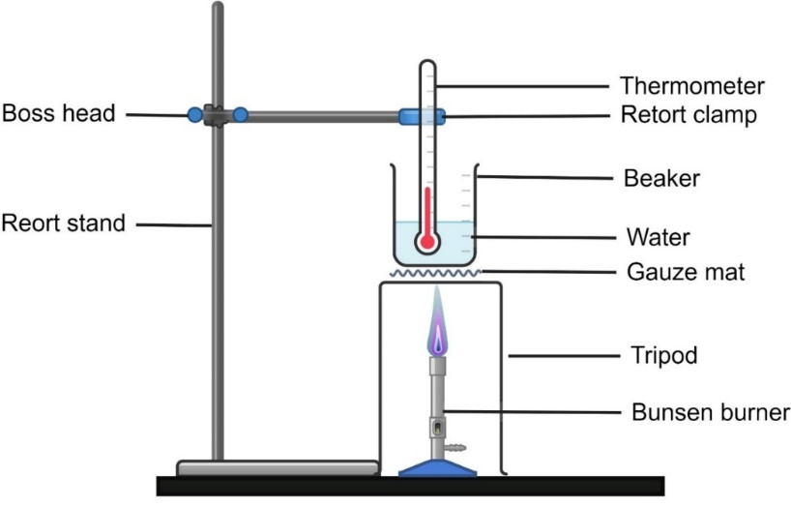
Results:
Temperature of water with and without salt over time.
Stopwatch time (min:sec) | Time (seconds) | Temperature (°C) no salt | Temperature (°C) with salt
0:00
0:30
1:00
1:30
2:00
2:30
3:00
3:30
4:00

Discussion
Look for the point at which the temperature levelled out for the plain and salt water. This is the boiling point. Identify the boiling point for the fresh water and the salt water.
Freshwater boiling point:
Saltwater boiling point:
What does the shape of the graph show?
Conclusion
How did adding the salt to the water affect the boiling point?

1.12 Can plants sense gravity? (practical investigation)
Table 22 – learning intentions and success criteria for ‘Can plants sense gravity? (practical investigation)’
Learning intentions | Success criteria
We are learning how scientists design valid experiments. | I can:  - follow a planned procedure to make a series of observations and measurements over a period of time  - identify an independent and dependent variable and some controlled variables
We are learning to communicate scientific concepts. | I can:  - draw annotated diagrams  - make an evidence-based claim.
Checkpoint (extended):
Conduct a short quiz to determine students’ knowledge of variables. Provide the following scenario: An agricultural scientist is planning an experiment to determine if a new fertiliser works better as a solution or pellets.
Checkpoint sample response
- What might the agriculture scientist need to measure for this experiment?
The scientist would need to measure how tall the plants grew each week.
- What would the scientist change in the experiment?
They would change the type of fertiliser the plants were given.
- What would the scientist keep the same in the experiment?
The type of plant, amount of water, sun and fertiliser, soil type and pot size would be kept the same.
- Why is it important to keep some things the same in an experiment? What could happen in this experiment if some things were not kept the same?
It is important to keep some things the same in an experiment to ensure the results are accurate and only affected by the variable you are testing. For example, if the amount of water changed, this could affect the growth of the plants, and the scientist could not accurately determine the effect of the fertiliser.
- If you were experimenting to see which type of ball bounces the highest, what would you change, and what would you measure?
Change – the type of ball. Measure – the height of the bounce.
- If you were testing how fast different toy cars go on a track, what might you change, and what would you need to measure?
Change – the type of toy car. Measure – the speed of the car (by measuring the time it takes to travel 2 m).

Geotropism
Geotropism is a response of plants to gravity. Roots are positively geotropic – they grow down, towards the pull of gravity, while shoots are negatively geotropic and grow up, against the pull of gravity. In this activity, students change the positioning of seeds to determine if this affects the direction in which roots and shoots grow from a germinating seed. This activity allows students to make observations of the roots and shoots over time. Students are not required to understand the mechanism of geotropism.

Preparation
Soak the beans in water for 24 hours before use to hasten germination. Eight bean seeds are required for each group of students.

Conducting the activity
Initiate a discussion by asking, 'Do plants sense gravity?’ Follow this with probing questions such as ‘Why do you think that…?’ ‘How could we demonstrate...?’, ‘I wonder…’. At this point, the concept of variables, which are all the factors that can be changed in an investigation, is introduced.
Introduce the investigation the students will undertake, outlining the activity. Identify the independent (bean orientation) and dependent (direction of root or shoot growth) variables and discuss their role in the investigation. Discuss the need for 2 jars to receive the same treatment.
Discuss the importance of making observations over a period of time and emphasise the need to maintain high-quality records consistently over time. For example, studying animal behaviour to determine migration patterns, feeding habits and mating rituals.
Students conduct the investigation. Observations should be made over a period of 10–15 days to gather evidence. Students are recording qualitative data. Discuss with them the types of observations that they should be making. These could include:
- where on the bean the roots and shoots develop
- the colour of the roots and shoots
- direction of growth of the roots and shoots
- branching of the roots and shoots.
This is an opportunity to support students in completing tables to record accurate qualitative observations. Encourage them to include as much detail as possible. Remind students of how to draw scientific diagrams. Model how to annotate the diagrams. Explain that annotations are brief descriptions written next to the label. They provide additional information that explains, elaborates on or emphasises the visual elements of a diagram.
The OTU PPT ‘Annotating a Picture or Diagram’ provides an example of an annotated diagram. The Victorian Department of Education provides a method of teaching annotations. Students annotate their diagrams in subsequent science lessons until day 10.
Provide students with the C-E-R scaffold and explain how it can structure their scientific explanations. Support the students in completing the scaffold to develop a conclusion based on their findings.
Optional activity: this activity can be extended by moving half of the jars to a sunny bench or windowsill on day 10. The shoots should change colour from white to green within a day or 2 and will turn towards the light source. A discussion can be undertaken about the need for shoots to be both negatively geotropic and positively phototropic.

Student resource – Can plants sense gravity?
Aim
To determine if the direction in which a seed is planted changes the direction of the roots and stem growth.
Variables
Independent variable:
Dependent variable:
Controlled variables:
Prediction
When the seeds are placed in different positions,
the roots will…
because…
Equipment
- 2 tall beakers or gas jars
- Sand
- 8 bean seeds
- 2 sheets of blotting paper or chromatography paper
- 30 cm ruler
Method
- Soak the bean seeds in water for 24 hours.
- Dampen a piece of blotting paper with water.
- Wrap it around the inside of the gas jar.
- Half-fill the jar with sand.
- Carefully slide 4 beans between the glass and the blotting paper, about halfway down the jar, so they are equally spread around the gas jar. Each bean should be ‘facing’ a different direction – the curve of the bean can be facing up, down, left or right. Do not tear the blotting paper.
- Repeat steps 2–5 for the second jar.
- Fill the jars with sand. Moisten the sand.
- Place the jars in a dark cupboard where they will not be disturbed.
- Monitor the beans daily. Ensure that the sand is damp, and record your observations consistently. Your observations will include the direction in which the roots and shoots grow and their length and colour.
- Draw annotated diagrams in the results section each day you observe your beans until day 10.
Diagram
Diagram of equipment setup
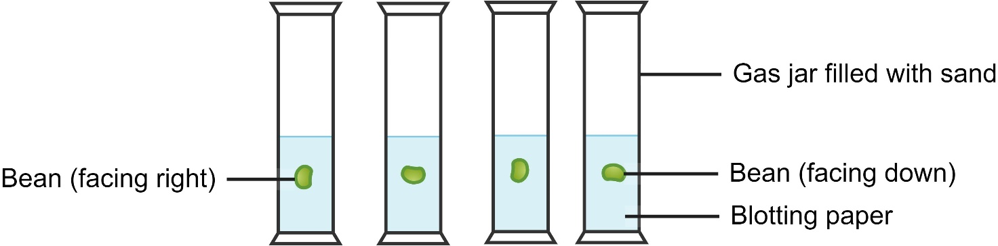

Results
Observations of bean growth – draw diagrams and record data
Day | Jar 1 observations | Jar 2 observations
1
2
3
4
6
7
8
9
10
Use Claim-Evidence-Reasoning to draw a conclusion.

1.13 Applying the Working scientifically processes (practical investigation)
Table 23 – learning intentions and success criteria for applying the Working scientifically processes
Learning intentions | Success criteria
We are learning to use scientific equipment to make accurate observations. | I can make accurate measurements of the length.
We are learning to plan valid investigations | I can identify the independent, dependent and controlled variables in an investigation.
We are learning to process and represent information | I can plot data accurately on a graph
We are learning to analyse data and information. | I can interpret graphs to identify patterns and trends.
We are learning to communicate scientific concepts. | I can construct an evidence-based claim.

Bouncing balls
In this activity, students investigate the effect of air pressure on a bouncing ball. The lesson will focus on systematically investigating questions by identifying and controlling variables, making accurate measurements and undertaking multiple trials.
The types of variables and their relationship to the investigation aim, hypothesis, table and graph structure should be taught in this lesson and reviewed regularly in subsequent lessons.
This activity could model how scientists collaborate. Each group could investigate a different variable that affects a ball's bounce. The results could be collated, and the ‘best’ conditions for the highest ball bounce could be determined.

Exploring the impact of ball pressure on bounce height
With a basketball on hand as a prompt, discuss all the characteristics of a basketball that make it appropriate for its purpose. For example, the grip, the pressure, the material it is made of, and bounciness.
Facilitate a discussion on the factors affecting how high a basketball will bounce. This could include the surface, the ball pressure, the height at which it is dropped or the force at which it is thrown down. Pose the students with the question – ‘I wonder what affects how high a basketball will bounce?’
Discuss the systematic process scientists use when answering testable questions – reviewing existing knowledge, formulating hypotheses, designing experiments, testing one variable at a time, repeating experiments and processing and analysing the data to draw conclusions. This activity is focused on identifying and controlling variables in an investigation that tests the impact of ball pressure on a basketball's bounce height.
Use the prompts below to guide the investigation.
- Identify the independent variable as the ball pressure and discuss how this can be changed.
- Identify the dependent variable as the bounce height. This will change as the ball pressure changes and will be measured.
- Identify the variables that will be controlled, such as surface, drop height and type and size of ball and discuss how these could be controlled.
Point out features of a well-designed table using the points below, with reference to the results table in the student resource.
- Title
- Column headings
- Units included in the heading
- No units included in the body of the table
- First column contains the quantity to be changed (independent variable)
- Second column contains the quantity to be measured (dependent variable).
Graphing skills should be explicitly taught in this activity. Students often struggle with determining which variable should be placed on each axis and the scale allocation on the axes. It is suggested that labelled and scaled axes are initially provided for students in Year 7 to reduce cognitive load. Ensure you explain the placement of the axes as follows:
- the independent variable (in this case, ball pressure) is placed on the X-axis
- the dependent variable (in this case, bounce height) is placed on the Y-axis.
The scale allocation should also be explained as equal divisions for equal amounts. Students can then focus on plotting points. Encourage students to look for a trend in their points before joining them up so that it should not be included if there is a significant outlier.
Differentiation: although students have previously been required to tabulate and graph data, they are still developing this skill and should be supported in this process. Add or remove scaffolding of tables and graphs as required for your students.
Support the students in analysing their data, looking for patterns and trends. Use this information to develop an evidence-based conclusion.
This activity focuses on a systematic approach to presenting and analysing data and writing an evidence-based conclusion in science. At this point, you may introduce the discussion section to your students.
Checkpoint: finish this sentence: ‘Identifying and controlling variables in an experiment is important because …’. Give 2 examples of how we do this in the basketball experiment.
Checkpoint sample response
Identifying and controlling variables in an experiment is important because it ensures we can accurately determine the cause-and-effect relationship. We want to see how ball pressure affects the bounce height in the basketball bounce experiment. To do this accurately, we need to control other variables like the surface on which the ball bounces, the height from which the ball is dropped, and the type and size of the ball. For example, if we did not control the drop height, we would not know if a higher bounce was due to increased ball pressure or just a higher drop.

Student resource – bouncing balls
Aim: To determine how the pressure of a basketball changes its bounce height.
Variables
Independent variable:
Dependent variable:
Controlled variables:
Prediction
When the pressure is decreased in the basketball, the ball height will…
because…
Equipment
- Basketball
- Bike pump with a pressure gauge
- 2 × 1-metre rulers or measuring tape
- Masking tape
- Video recording device
Method
- Arrange 2 × 1 m rulers so that they are head to tail to measure 2 m and tape them to the wall.
- Set up a video camera so that the 2 m is in its viewfinder.
- Make sure the ball pressure is 8 psi.
- Hold the basketball so the bottom of the ball is at the 2 m mark.
- Start the video.
- Drop the ball.
- Allow it to bounce.
- Stop the recording.
- Watch the recording to measure the bounce height (measure from the bottom of the basketball).
- Repeat the drop 5 times.
- Repeat steps 3 to 10 with 4 different lower ball pressures.
Diagram
Draw a labelled diagram of your set-up here.
Results
Record the raw data for bounce height at different pressures in the table below.
Table of raw data for bounce height at different pressures
 | Bounce height (____)
Ball pressure (psi) | Trial 1 | Trial 2 | Trial 3 | Trial 4 | Trial 5 | Mean
Design a table to record the mean bounce height for each ball pressure. The table should include a heading and column headings with units of measurement.
Plot your results on the grid below. Join the points with a smooth line.

Compare the mean value at 8psi with trial measurements at this pressure. What do you notice?
The mean is the average of a set of numbers. It helps us see the overall trend or typical value in a group of numbers. Conducting multiple trials or repeats allows one to calculate a mean, lowering the effect of non-typical results.
Conclusion: use the Claim-Evidence-Reasoning scaffold to write a conclusion to your experiment.
Claim: state an answer to the question or prompt. | Evidence: provide reliable information from experiments, facts or a reliable source that supports the claim. | Reasoning: explain how the evidence supports the claim.
Helpful hints: use keywords and ideas from the question as you write your claim. | Sentence starters:  In the experiment …  The data shows …  One piece of evidence is … | Sentence starters:  The evidence supports the claim because …  Based on this evidence, it can be concluded that …
Your response: | Your response: | Your response:

The best reusable cup
This activity has 2 parts. In Part A, the teacher will guide the students through using the Working scientifically processes to design a practical investigation to find out which is the best reusable cup.
In Part B, the students undertake the investigation planned for Part A.
Each group of students will require 3 reusable cups of the same size and made of different materials.
Note: if reusable cups are not available, you could adjust this experiment to use aluminium cans or glass beakers with different insulation materials wrapped around the outside.

Part A – planning the experiment
Have a brief class discussion about reusable cups and why people use them. Propose the following problem you need to solve:
‘I need to buy a reusable cup, but there are many different types. I don’t know which one will keep my coffee, hot chocolate or tea hot for the longest time.’
Provide the students with the student resource – the best reusable cup. Ask the students, ‘What would be the first step I need to take to determine what reusable cup to buy?’
Go through the scenario, one step at a time, referring to the Working scientifically processes learnt in 1.7. (provided in OTU PPT 1.13). Students propose suggestions for what needs to be done and complete the table. Grey shaded text shows teacher suggestions or instructions.
Table 24 – applying the Working scientifically processes
Working scientifically processes | For this investigation
Observation | There are so many different reusable cups. I do not know which one is the best.
Ask questions | Have the students propose questions. For example:  - What are the reusable cups made of?  - Do reusable cups come in different sizes?  - Do all reusable cups have lids?
Research | Students propose what they need to find out:  Research why particular materials are used to make reusable cups.  Give students time to research this or have a class discussion. If students have not mentioned insulation, discuss the need for this.
Predict | Since we now know that reusable cups are made of materials that are good insulators (heat moves through them slowly), you need to make a prediction about which cup will keep hot liquid the hottest.  Hot liquid will remain hottest in the ______ cup because________.
Plan an experiment | Ask: ‘How could we test this?’  - Select 3 reusable cups made of different materials.  - Pour 250 ml of boiling water into each cup.  - Measure the temperature every 2 minutes for 10 minutes.
Conduct the experiment | The cups will be made of (Insert the materials your cups are made of).  Temperature will be measured using a thermometer or temperature probe. (Select which device the students will use.)  Explain that you will provide the 250ml of boiling water in a beaker. Ask the students what safety precautions would need to be taken.  Use a cloth to hold the beaker of boiling water.
Gather the results – processing data | Ask the students how they will record their measurements.  Record the temperature every 2 minutes in a table.  Remind students that the independent variable (time) is listed in the first column of the table and the dependent variable (temperature) in the second column. We need 3 columns to record the temperature because we repeat the experiment 3 times (in 3 different reusable cups – like the 3 trials with the basketball).
Analyse the data and draw conclusions | Ask the students, ‘Having all this data in the table, what do we need to do now?’  Graph the data to compare how quickly the cups lose heat.  Clearly state which cup kept the liquid hottest, then rank the other cups.
Propose a solution to the problem | The ______________ cup is the best because it will keep coffee/tea/hot chocolate the hottest.
Communicate the information | Tell other people. You could report this to your family and friends.

Part B – conducting the experiment
In this part, the students undertake the investigation they planned in Part A, working through the Working scientifically processes.
Preparation:
- Provide students with 3 reusable cups of the same size made of tempered glass, polypropylene, stainless steel (or other materials, such as bamboo).
- Use lids if a thermometer or temperature probe can be inserted through them. Do not use lids if a thermometer or temperature probe cannot be inserted through them.
- Use an urn to provide boiling water, which you will pour into beakers for the students.
Graphs: when they have completed their experiment, remind students that they will need to draw a graph of their data.
Differentiation: depending on your students’ competency with drawing graphs, you may provide the graph axes with labels and scales or have a class discussion about what quantity is placed on each axis and how to scale the axes.

Student resource – Which is the best reusable cup?
Working scientifically processes | For this investigation
Observation | There are so many different reusable cups. I do not know which one is the best.
Ask questions
Research
Predict
Plan an experiment
Conduct the experiment
Gather the results – processing data
Analyse the data and draw conclusions
Propose a solution to the problem
Communicate the information

Table of results – temperature of different reusable cups over time
Time (minutes) | Cup 1 Temperature  (° C) | Cup 2 Temperature  (° C) | Cup 3 Temperature  (° C)
0
2
4
6
8
10

1.14 Introducing secondary-source investigations – investigating global warming
Table 25 – learning intentions and success criteria for ‘Introducing secondary-source investigations – investigating global warming’
Learning intentions | Success criteria
We are learning how secondary-sources can be used for an investigation. | I can identify the type of data sourced from other scientists when they were investigating the causes of global warming.
We are learning to use data to identify trends, patterns and relationships. | I can identify trends in historical climate data.
This activity aims to show that scientists may conduct investigations without undertaking hands-on laboratory experiments. They may look for patterns in the data collected by other scientists and determine if there is a relationship between different data sets. An outline of the investigation into climate change is used as an example. However, the focus is on the Working scientifically processes rather than a deep knowledge of climate change – it is simply an example.
Introducing secondary-source investigations in the OTU PPT steps students through applying the Working scientifically process in this type of investigation. A question sheet for students is provided at the end of the instructions.
This introduction to secondary-sourced investigations is important because much of the study of the next content group, space science, involves secondary-sourced investigations.
Instructions
Have the large, laminated copy of the Working scientifically processes in full view of the class. You will refer to it as you progress through the Investigating global warming in the OTU PPT.
Introduce this lesson by asking students, ‘What is the first step in a scientific investigation?’ Recall that we have conducted laboratory experiments in the last few lessons to investigate our observations and questions. Today, we will look at another way of conducting a scientific investigation of an observation.
The teacher steps through the OTU PPT, Investigating global warming. The PowerPoint is animated, and the slide notes provide information, discussion prompts, and answers to the questions in the student resource. As you progress through the PowerPoint, students answer the questions in the student resource.
Sample answers:
- What observations about the climate were scientists making in the 1980s that were causing them concern?
Scientists observed an increasing number of severe storms, such as hurricanes and cyclones, that destroyed buildings. They also observed that many lakes that had always had water were drying up. Scientists observed that glaciers and the polar ice caps were melting.
- What questions did the scientists need to investigate?
What is happening with the climate to cause these changes?
- What data did the scientists study?
Scientists studied global temperature records.
- What prediction did the scientists make?
Scientists predicted that carbon dioxide levels may be connected to increasing global temperatures.
Teacher note: technically, this is a hypothesis, as the prediction is based on a scientific theory. However, students in Stage 4 only learn about making predictions, and the hypothesis is addressed in Stage 5.
- How did they investigate this?
Scientists examined data about carbon dioxide levels in the atmosphere over thousands of years. To do this, they analysed the gases trapped in ice core samples collected in Antarctica.
- What did the data show was happening to carbon dioxide levels over the last 800,000 years?
Over the 800,000 years, carbon dioxide levels have fluctuated (gone up and down) between 220 and 250 ppm roughly every 100,000 years. Recently, they have gone up to 400,000 ppm – almost double!
- What did the scientists find when comparing the temperature and carbon dioxide data for the last 1000 years?
Temperature and carbon dioxide levels remained fairly constant from 1000 to 1900. However, both have risen significantly since 1900, much more than in the past.
- What significant change in how we live has occurred over the last 200 years?
Over the last 200 years, there has been a movement from an economy predominantly agricultural and handicrafts to one dominated by industry and machine manufacturing. The Industrial Revolution saw a rapid increase in the use of new sources of power – coal, gas, electricity, the internal combustion engine and new means of transport.
- How has this changed the atmosphere?
The burning of fossil fuels releases carbon dioxide into the atmosphere. This change in the atmosphere's composition – Carbon dioxide has increased from approximately 200 ppm to 400 ppm over the last 200 years since the beginning of the Industrial Revolution.
Checkpoint (extended): read the following scenario and answer the following question.
It is reported in the news that, in an island nation, many young children are contracting measles. This disease can be effectively prevented by vaccination. World health scientists are concerned about this outbreak and want to find out why this is occurring. They wonder if this results from hygiene, weather conditions or lower-than-ideal vaccination rates. They gather data from the island nation and weather and world health organisations about the hygiene, weather and vaccination rates for measles, both in this and in other island nations. An analysis of the data shows that the only difference between this nation and other nearby island nations is a lower-than-ideal vaccination rate. This has happened since there was a cyclone 3 years ago when the local health service lost many of its facilities. The scientists determine how many people need to be vaccinated and, in consultation with the nation’s government, organise for an aid agency to visit the nation to provide free vaccinations for all children under 5 years old.
By referring to the Working scientifically processes, determine if the health scientists carried out a scientifically valid investigation.
Suggested answer
The scientists carried out a scientifically valid investigation because:
- they observed the large numbers of children contracting measles in the island nation
- they questioned why this is occurring
- they made some predictions as to why it may be happening
- they carried out an investigation by gathering data from a number of sources – the nation, weather and world health organisations for this island and other islands
- they analysed this data and found that the only difference between this and other island nations was the lower-than-ideal vaccination rate
- they concluded that this was because of a cyclone damaging local health services facilities and determined how many people needed vaccination
- they communicated their findings with the nation’s government and organised a free vaccination program.

Student resource – investigating global warming
- What observations about the climate were scientists making in the 1980s that were causing them concern?
- What questions did the scientists need to investigate?
- What data did the scientists study?
- What prediction did the scientists make?
- How did they investigate this?
- What did the data show was happening to carbon dioxide levels over the last 800,000 years?
- What did the scientists find when comparing the temperature and carbon dioxide data for the last 1000 years?
- What significant change in how we live has occurred over the last 200 years?
- How has this changed the atmosphere?
Checkpoint: read the following scenario and answer the question that follows.
The news reports that, in an island nation, large numbers of young children are contracting measles. This disease can be effectively prevented by vaccination.
World health scientists are concerned about this outbreak and want to discover why it is occurring. They wonder if it results from hygiene, weather conditions or lower-than-ideal vaccination rates.
They gather data from the island nation and weather and world health organisations about the hygiene, weather and vaccination rates for Measles, both in this and in other island nations. An analysis of the data shows that the only difference between this nation and other nearby island nations is a lower-than-ideal vaccination rate. This has happened since there was a cyclone 3 years ago when the local health service lost many of its facilities.
The scientists determine how many people need to be vaccinated and, in consultation with the nation’s government, organise for an aid agency to visit the nation to provide free vaccinations for all children under 5 years old.
By referring to the Working scientifically processes, determine if the health scientists carried out a scientific investigation. Provide your reasoning.

Evidence base
This resource contains NSW Curriculum and syllabus content. The NSW Curriculum is developed by the NSW Education Standards Authority (NESA). This content is prepared by NESA for and on behalf of the Crown in right of the State of New South Wales. The material is protected by Crown copyright.
Please refer to the NESA Copyright Disclaimer for more information https://www.nsw.gov.au/education-and-training/nesa/copyright.
NESA holds the only official and up-to-date versions of the NSW Curriculum and syllabus documents. Please visit NESA https://www.nsw.gov.au/education-and-training/nesa and NSW Curriculum https://curriculum.nsw.edu.au.
Science 7–10 Syllabus © NSW Education Standards Authority (NESA) for and on behalf of the Crown in right of the State of New South Wales, 2023.
Brookhart SM (2018) ‘Appropriate Criteria: Key to Effective Rubrics’, Frontiers in Education, volume 3(22):1–12, doi:10.3389/feduc.2018.00022, accessed 13 September 2024.
CESE (Centre for Education Statistics and Evaluation) (2020) What works best: 2020 update, NSW Department of Education, accessed 18 July 2024.
CESE (2020) What works best in practice, NSW Department of Education, accessed 18 July 2024.
CESE (2021) Growth goal setting – what works best in practice, NSW Department of Education, accessed 18 July 2024.
Fisher D and Frey N (1 November 2009) ‘Feed Up, Back, Forward’, ASCD (Association for Supervision and Curriculum Development): Educational Leadership magazine, 67(3), accessed 13 September 2024.
Griffin P (2017) Assessment for Teaching, Cambridge University Press, Port Melbourne, Victoria.
Hattie J and Timperley H (2007) ‘The Power of Feedback’, Review of Educational Research, 77(1): 81–112, doi:10.3102/003465430298487.
Lallensack R (29 Dec 2021) ‘Ten Scientific Discoveries From 2021 That May Lead to New Inventions’, Smithsonian MAGAZINE, accessed 2 April 2024.
LPI learning (n.d.) Explore All About Ice (That's a N(ice) Temperature, LPI Learning website, accessed 26 March 2024.
Muskopf S (30 May 2016) ‘Identify Controls and Variables with the Simpsons’, Biology Corner, accessed 11 April 2024.
NSW Department of Education (2017) Mungo Episode 6 Ancient People (6:48), NSW Department of Education, accessed 30 January 2026.
NESA (NSW Education Standards Authority) (2022) ‘Proficient Teacher Standard descriptors’, Proficient Teacher, NESA website, accessed 11 March 24.
Panadero E and Jonsson A (2013) ‘The use of scoring rubrics for formative assessment purposes revisited: A review’, Educational Research Review, 9:129–144, doi:10.1016/j.edurev.2013.01.002, accessed 13 September 2024.
Sherrington T (2019) Rosenshine’s Principles in Action, John Catt Educational Limited, Melton, Woodbridge.
State Government of Victoria, Australia (17 January 2024) ‘Guided reading’, Literacy Teaching Toolkit, State Government of Victoria, Australia website , accessed 26 June 2024.
State of New South Wales (Department of Education) (n.d.) ‘Learning intentions and success criteria - Effective assessment practices – a guide for teachers and leaders’, Effective assessment practices – a guide for teachers and leaders, NSW Department of Education website, accessed 30 September 2024.
Unknown author (n.d.) 1.7: The Reliability of a Measurement, LibreTexts Chemistry, accessed 30 August 2024.
Valenzuela J (3 March 2022) ‘Boosting Critical Thinking Across the Curriculum’, Edutopia, accessed 11 April 2024.
Wiliam D (2017) Embedded Formative Assessment, 2nd edn, Solution Tree Press, Bloomington, IN.
Wiliam D and Leahy S (2015) Embedding formative assessment: practical techniques for K-12 classrooms, Learning Sciences International, US.
Writing in Secondary Resource Hub (n.d.) ‘Grammar Guide’, Writing in Secondary Resource Hub, NSW Department of Education website, accessed 19 March 2024.

© State of New South Wales (Department of Education), 2024
The copyright material published in this resource is subject to the Copyright Act 1968 (Cth) and is owned by the NSW Department of Education or, where indicated, by a party other than the NSW Department of Education (third-party material).
Copyright material available in this resource and owned by the NSW Department of Education is licensed under a Creative Commons Attribution 4.0 International (CC BY 4.0) license.

This license allows you to share and adapt the material for any purpose, even commercially.
Attribution should be given to © State of New South Wales (Department of Education), 2024.
Material in this resource not available under a Creative Commons license:
- the NSW Department of Education logo, other logos and trademark-protected material
- material owned by a third party that has been reproduced with permission. You will need to obtain permission from the third party to reuse its material.
Links to third-party material and websites
Please note that the provided (reading/viewing material/list/links/texts) are a suggestion only and implies no endorsement, by the New South Wales Department of Education, of any author, publisher, or book title. School principals and teachers are best placed to assess the suitability of resources that would complement the curriculum and reflect the needs and interests of their students.
If you use the links provided in this document to access a third-party's website, you acknowledge that the terms of use, including licence terms set out on the third-party's website apply to the use which may be made of the materials on that third-party website or where permitted by the Copyright Act 1968 (Cth). The department accepts no responsibility for content on third-party websites.

Strawberry poison-dart frog by Marshal Hedin is licensed under CC BY 2.0
sparse granule cells by Jason Snyder is licensed under CC BY 2.0
Biuret reaction to proteins by Балакина Наталья is licensed under CC BY 4.0
Parkes Observatory, New South Wales, Australia by Ian Sutton is licensed under CC BY 2.0
New Norcia solar by European Space Agency is licensed under CC BY-SA 3.0 IGO
12 apostles 2019 by VH-MEL34.T is licensed under CC-BY-SA 4.0
Red Raw Minerals by Глеб Коровко is licensed under Legal Simplicity
Coloured Powders and Brush by Venus HD Make-up & Perfumeis licensed under Legal Simplicity
Person Riding on Parachute by Quang Nguyen Vinh is licensed under Legal Simplicity
White Sydney Opera House by Rijan Hamidovic is licensed under Legal Simplicity
Yellow and White Red Pills on Blister Pack by A Shvets is licensed under Legal Simplicity
DNA strands by gerait is licenced under CC0 1.0

