Science Stage 4 (Year 8) – Living systems
Teacher resource book 2 of 2 (TRB2)
How do ecosystems maintain stability?

Creation date: 27 January 2026
Contents
Overview 2
Glossary 2
2.1 What is an ecosystem? 7
Components of ecosystems 7
Biotic and abiotic components 9
2.2 Interactions in an ecosystem 13
Biotic and abiotic interactions 13
Practical investigations – interactions in an ecosystem 20
2.3 Energy and matter in ecosystems 31
Producers, consumers and decomposers 31
Ecological energy pyramids 36
Food webs 39
2.4 A local ecosystem 43
Fieldwork: local area observations 43
Creating a local food web and ecological energy pyramid 49
2.5 Ecological energy pyramids 54
Creating written texts 54
2.6 Changes in populations 62
Factors that change populations 62
Introduction of the cane toad 63
2.7 Endangered and extinct species 70
Declaring species as endangered or extinct 70
Australia’s unique context 76
Evidence base 78

Overview
Stage and learning area: Stage 4 Science
Description: this resource complements the Living systems program of learning. It aims to serve as a teacher reference, offering practical strategies and ideas to enrich teaching practices and create engaging learning environments. The activities should be adapted to suit students' needs.
Duration: while timing will vary based on the mode of delivery, differentiation strategies employed, and class or school context, this series of activities should take approximately 18 hours.
Risk management: teachers are advised to undertake a risk assessment before conducting any classroom investigation or experiment. For more information on developing risk assessments, see Risk Assessment – a pre-requisite for risk control.
This resource book elaborates on many of the activities in the Living systems sample program of learning. Some activities also refer to the Living systems slide deck (identified as LIV PPT throughout this document).

Glossary
Tier 3 words are relevant to learning subject-specific content. More information is provided in the ‘Vocabulary in context’ document found at the Stage 4 reading – vocabulary in context page. It is also important that Tier 2 vocabulary be explicitly taught to students to support their understanding and comprehension of texts. These words appear more frequently in texts, so students are less likely to learn them without assistance.
The Guide for planning and implementing explicit vocabulary instruction and Word consciousness- learning sequence resource can be used by teachers across all curriculum areas. It provides a process for planning and implementing explicit vocabulary instruction.
Table 1 – glossary of Tier 3 words in content for essential question 2 of the Living systems focus area
Term | Definition
Abiotic | Any non-living part of an ecosystem that influences living organisms in an ecosystem.
Biotic | Any living component that affects an ecosystem.
Data | Information that is collected, organised and analysed for various purposes. It can be in the form of numbers, text, images or any other format that can be processed. Data can be represented using techniques such as tables, graphs and textual explanations (NESA 2023).
Decomposers | Living things such as fungi and bacteria that break down dead organic material (NESA 2023).
Ecological energy pyramid | A graphical representation of the flow of energy through different trophic levels in an ecosystem (NESA 2023).
Ecosystem | A system formed by the interaction of all living organisms (plants, animals, humans) with each other and with the physical elements of the environment in which they live.  While an ecosystem may be synonymous with a specific environment, the ‘system’ approach enables a focus on the various components and their interconnected nature (NESA 2023).
Endangered (species) | Facing a very high risk of extinction in the wild due to rapid population decline or loss of habitat (NESA 2023).
Energy | The capacity to do work or to cause a change.
Energy pyramid | A model that shows the flow of energy from one trophic level to the next in an ecosystem.
Evidence | Valid and/or reliable data that can be used to support a particular theory, hypothesis, idea or conclusion (NESA 2023).
Explanation | A scientific explanation provides an account of a phenomenon through descriptive statements about how that phenomenon came to be (NESA 2023).
Extinct | No longer existing because all members of the species have died (NESA 2023).
Food chain | A linear sequence showing how energy and nutrients move through an ecosystem as one living thing eats another, starting with a producer (like a plant) and moving up through consumers (herbivores, carnivores, omnivores) to predators
Food web | A series of interconnected food chains that outlines feeding relationships in an ecosystem (NESA 2023).
Habitat | The place where an animal or plant can live (NESA 2023).
Interactions | Actions or influences between components and within and between systems (NESA 2023).
Interdependency | The condition of being dependent on each other. The state of being mutually dependent or dependent on each other (NESA 2023).
Investigate | Plan, inquire into and draw conclusions about (NESA 2023).
Mass | The amount of matter in an object (NESA 2023).
Matter | A physical substance; anything that has mass and occupies space (NESA 2023).
Mean | The sum of values in a data set divided by the total number of values in the data set. Also called the average (NESA 2023).
Megafauna | A group of large or giant animals, typically vertebrates, that lived during prehistoric times or still exist today. Some examples of extinct megafauna include the woolly mammoth, sabre-toothed tiger, Irish elk, giant ground sloths and the dodo bird (NESA 2023).
Pattern | A data pattern is a recognisable structure, sequence or relationship that frequently occurs in a dataset.
Population | A group of individuals of the same species living and interbreeding within a given area.
Predator | An organism, usually an animal, that hunts, kills and consumes other animals (prey) for energy and nutrients.
Prediction | A statement or estimate about what will happen in the future, often based on available evidence, past experiences or statistical analysis (NESA 2023).
Prey | An organism that is hunted, captured and consumed by another organism, known as a predator, for energy and nutrients
Qualitative | To use descriptive explanations involving features, characteristics or properties to identify important components. Data and information that is not numerical in nature (NESA 2023).
Quantitative | Data or components that can be expressed or measured numerically, including chemical formulae or numbers (NESA 2023).
Range (of a dataset) | The difference between the highest and lowest values in a dataset (NESA 2023).
Relationship | The connection between the independent and dependent variables.
Secondary sources/ information | Sources of information that have been collected, processed, interpreted and published by others, for example census data, newspaper articles and images or information in a published report (NESA 2023).
SI | The International System of Units (SI) is a system of measurement based on agreed standards units, such as metre, second and gram (NESA 2023).
Species | A single, specific type of living organism (NESA 2023).
System | A set of components in the natural and made environments that interact. An understanding of natural complex systems requires the integration and application of concepts from more than one science discipline (NESA 2023).
Trend | The general direction of data in a table or graph (typically only derived from line graphs or scatter plots with a line of best fit). It may indicate correlation, but it is not necessarily causation.
Trophic level | The hierarchical position of organisms in a food chain or food web based on their feeding relationships and energy transfer (NESA 2023).

2.1 What is an ecosystem?
Table 2 – learning intention and success criteria for 2.1 ‘What is an ecosystem?’
We are learning: | I can:
- to identify the structure and components of an ecosystem. | - define ecosystem  - identify biotic and abiotic components of an ecosystem.

Components of ecosystems
- Show students LIV PPT ‘2.1 Similarities of ecosystems’ and discuss similarities between each of the ecosystems shown. Students should identify that each ecosystem has both living (plants and animals) and non-living components (water, snow and sunlight). Living and nonliving things in each ecosystem are interconnected. Each ecosystem can be negatively affected by human activities, such as pollution.
- Students complete a Frayer diagram to understand the components of an ecosystem. LIV PPT ‘2.1 Ecosystems Frayer diagram’ explains Frayer diagrams, and a completed sample is provided on LIV PPT ‘2.1 Ecosystems Frayer diagram – sample response’.
Student sample – Ecosystem Frayer diagram
Figure 1 – Frayer diagram of ecosystems
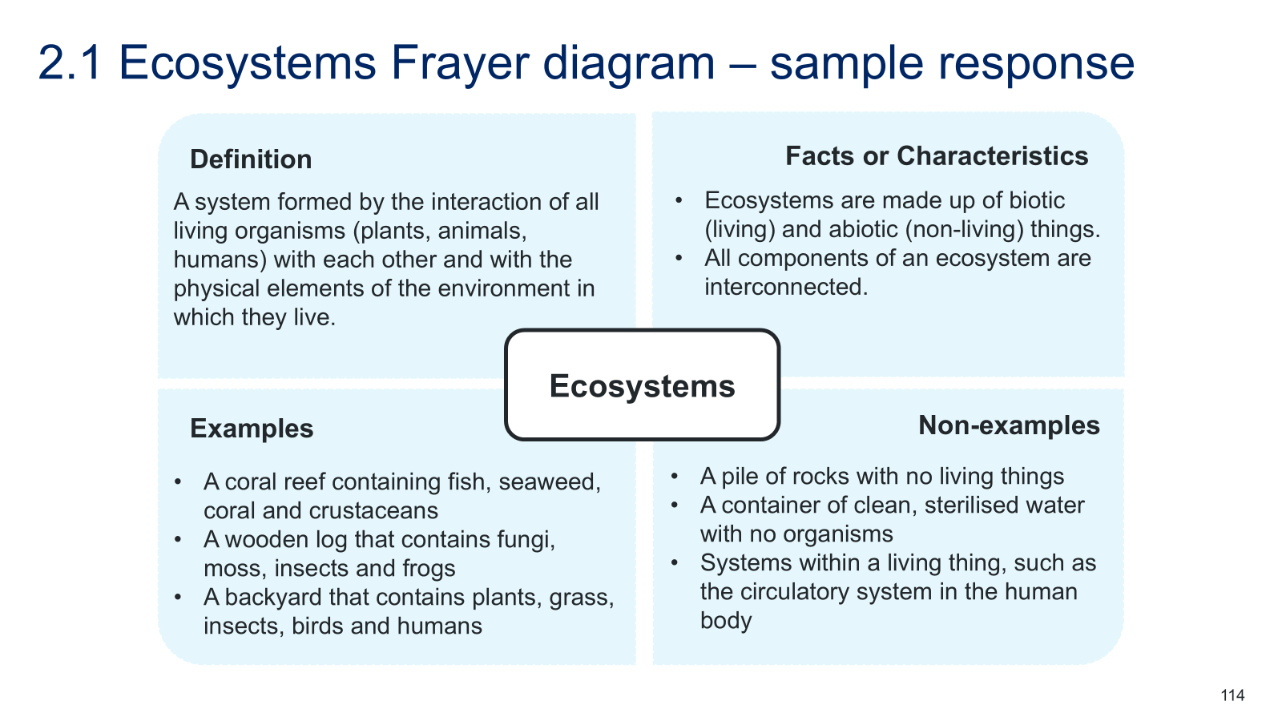

Student resource – ecosystems Frayer diagram
Figure 1 – Frayer diagram of ecosystems
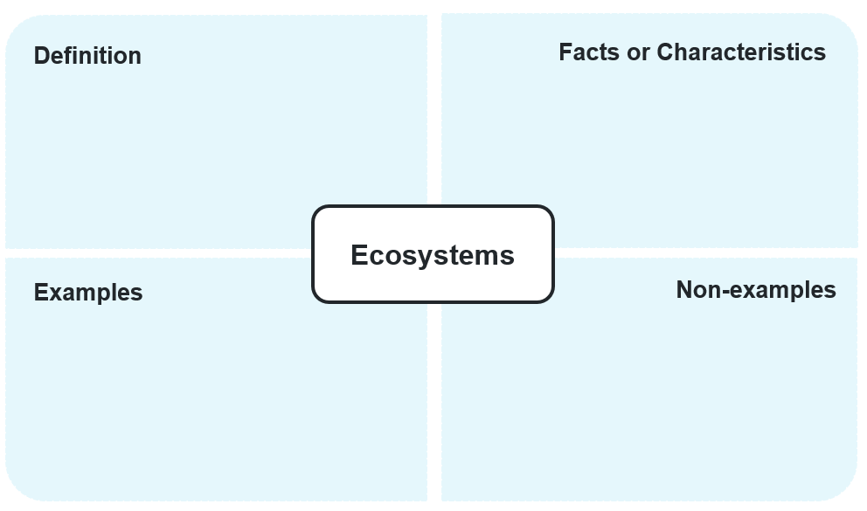

Biotic and abiotic components
Biotic factors in an ecosystem are the living components of an environment and the effects they have on other organisms. This includes not just the organisms themselves (like plants, animals, fungi and microorganisms), but, more importantly, the interactions between living things that shape how an ecosystem functions. Biotic factors include:
- food availability
- predator/prey relationships
- competition for resources and mates
- diseases.
Abiotic factors in an ecosystem are the non-living parts of an environment that affect how organisms survive, grow and reproduce. Abiotic factors interact with organisms because they influence where they can live, how well they can grow and reproduce, and which species are suited to ecosystems. Abiotic factors include conditions and resources such as:
- light availability
- water availability
- pH (of water and soil for example)
- salinity
- soil type
- nutrient availability
- air or water temperature
- wind speed
- gas concentrations (in the water or atmosphere)
- humidity.
- Show students LIV PPT ‘2.1 Components of an ecosystem – Biotic’ to unpack the definition of biotic components of the ecosystem with examples. Unpack the etymology of ‘bio’ which means ‘living’. Emphasise that simply listing organisms does not explain how an environment works. Ecologists focus on biotic interactions because these interactions drive population size, survival and the structure of the ecosystem.
- Show students LIV PPT ‘2.1 Components of an ecosystem – Abiotic’ to teach students the definitions of and examples of abiotic components of ecosystems. Tell students that the prefix ‘a’ at the start of the word means ‘not’, so ‘abio’ therefore means ‘non-living’. Emphasise that when we identify the abiotic factors of an environment, we focus on the interactions or variations in the factors that affect the ecosystem. For example, soil type may be important for a particular ecosystem (so that a wombat can make burrows, or so that a tree can plant its roots).
- Take students to a local ecosystem to make observations of biotic and abiotic components. Ask them to record their observations in the Student resource – biotic and abiotic components of a local ecosystem. Examples of local ecosystems could include a fish tank in a school classroom, a creek on school grounds, a park near the school or a local water system. Support students to identify the abiotic and biotic factors which may influence the ecosystems’ balance. This is also a good opportunity to start demonstrating how some of the abiotic factors may be measured.
Note: Environmental and zoo education centres can provide support to teachers across NSW. These centres may offer fieldwork excursions, resources or specialist knowledge about ecosystems in your local area. Teachers are encouraged to contact their local Environmental and zoo education centres for support to explore relevant living systems content.
Sample response – Biotic and abiotic components of a local ecosystem
Local ecosystem: school creek
Table 3 – biotic factors in a local ecosystem
Biotic factor | How it affects the ecosystem
Predation | Fish eat aquatic insects and tadpoles.
Competition | The ducks and the fish are competing for similar food sources.  Weeds are competing with native plants for resources such as light and water.
Invasive species | A cat (introduced species) was seen carrying a bird in its mouth.  Carp are present in the creek (introduced species).
Disease | A gum tree was damaged by a borer insect (parasite)
Table 4 – abiotic factors in a local ecosystem
Abiotic factor | How it affects the ecosystem
Light availability | Less grass is growing beneath the trees where it is shaded.  More aquatic plants can be seen in the shallower water.
Water flow | Mosquitos were seen in the stagnant water pools.
pH of water | Many aquatic organisms have a narrow pH tolerance.
Water temperature | Shallower pools will cool down and heat up more than deeper parts of the creek which affect which organisms can survive in the different parts.

Student resource – biotic and abiotic components of a local ecosystem
Local ecosystem: ___________________________
Explore the local ecosystem to make observations of the biotic and abiotic factors and how they affect the ecosystem.
Table 1 – biotic factors in a local ecosystem
Biotic factor | How it affects the ecosystem
Table 2 – abiotic factors in a local ecosystem
Abiotic factor | How it affects the ecosystem

2.2 Interactions in an ecosystem
Table 5 – learning intentions and success criteria for ‘2.2 Interactions in an ecosystem’
We are learning: | I can:
- to describe the role and function of components of ecosystems | - describe biotic interactions of an ecosystem, including predation, food availability and competition  - describe the interaction between biotic and abiotic components of an ecosystem
- to predict the outcome of an investigation | - predict how one ecosystem component may impact another
- to process and represent data. | - calculate the mean of a dataset  - construct a table to summarise the mean data  - construct a column graph.

Biotic and abiotic interactions
- Deliver the checkpoint question on the previous lesson’s content. See LIV PPT ‘2.2 Checkpoint – quick quiz on previous content’.
Checkpoint: quick quiz on content from a previous lesson.
Mini challenge: What is the difference between biotic and abiotic components of an ecosystem?
Biotic components are living, while abiotic components are non-living.
Challenge: Define an ecosystem.
An ecosystem is a system formed by the interactions among all living organisms (plants, animals, humans) and the physical elements of the environment in which they live.
Super challenge: A local ecosystem has an apple tree. An apple falls from the tree, hits the ground, and then starts to rot. Is the rotten apple classified as a biotic or abiotic component? Why?
A biotic component, because even though it is now dead, it was once alive.
- Students watch and listen to Abiotic and Biotic Factors (2:39) to understand examples of interactions between biotic and abiotic components of an ecosystem. To consolidate this learning, students answer the questions in Table 6.
Table 6 – sample responses for Abiotic and Biotic factors video
Question | Sample response
What 3 abiotic components of an ecosystem do plants interact with to survive? | Sunlight, water, nutrients.
Outline an example of an interaction between a biotic and an abiotic factor. | Some turtles bury themselves in soil to stay cool when it is hot.  Plants use water and sunlight to photosynthesise.
- Using LIV PPT ‘2.2 Biotic interactions (1–2)’, teach students the definitions of food availability, competition and predation. Expand students’ understanding of predation using LIV PPT ‘2.2 Slow reveal graph (1–4)’ to unpack a predator–prey graph.
- Complete the Student resource – identifying biotic and abiotic interactions to teach students about interactions between biotic and abiotic components in an ecosystem. Use LIV PPT ‘2.2 Identifying biotic and abiotic interactions (1–7)’ to support each stage of the worksheet.
- Label each column of organisms as an abiotic or a biotic component.
- Label how the abiotic components of water availability, soil pH and light availability interact with the biotic component, grass.
- Label how the grass is a food source and the competition that exists between organisms for the grass as a food source.
- Label the interactions of light availability and water availability with organisms.
- Label the biotic interactions between the various animals represented, for example predator–prey relationships.
- Students complete the Student resource – describing interactions in ecosystems, using the information in the worksheet they completed above. Once students have finished, use the marking criteria and sample responses on LIV PPT ‘2.2 Describing interactions in ecosystems (1–2)’ to model the peer marking of sample student responses. Following this, students can work in pairs to mark each other’s work.
Sample response: Student resource – identifying biotic and abiotic interactions
Figure 2 – sample response of interactions of biotic and abiotic factors in an ecosystem
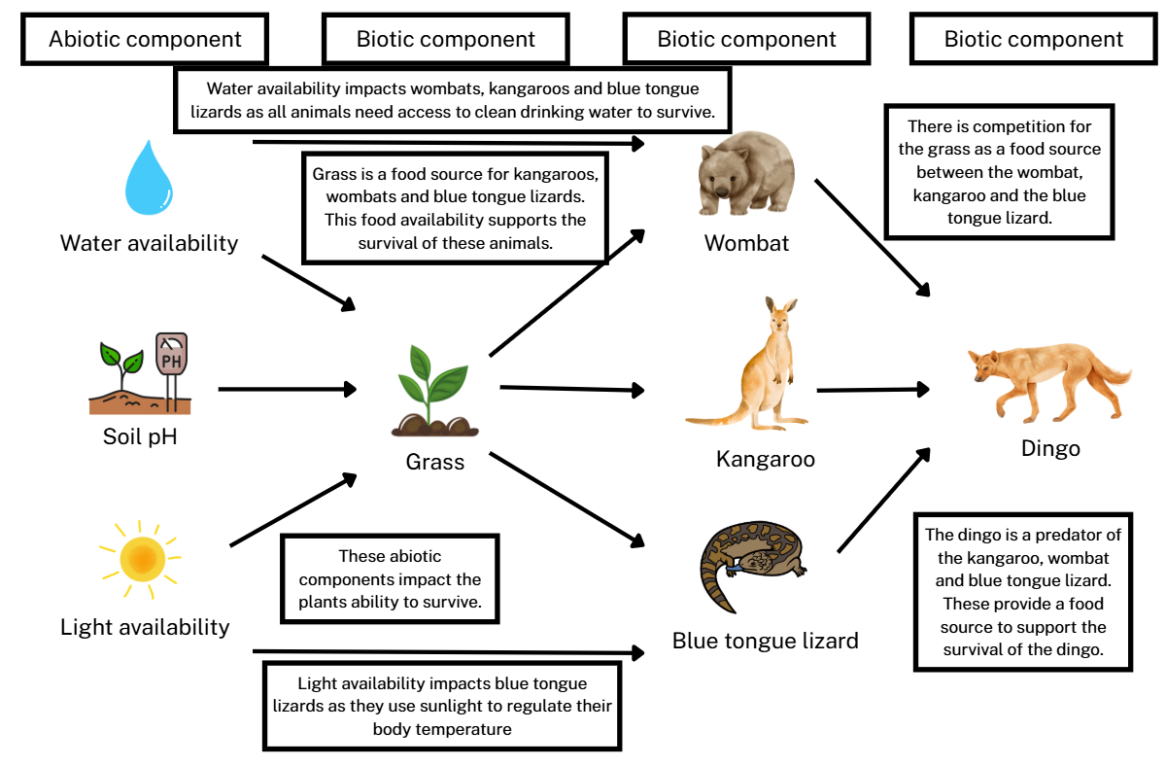
Sample response: Student resource – describing interactions in ecosystems
- Describe the interaction between the dingo and the kangaroo.
The interaction between the dingo and the kangaroo is an example of predation. The dingo is a predator that hunts, kills and eats kangaroos. The kangaroo is the prey in this relationship, as it is chased, captured and eaten by the dingo.
- Predict which organisms would be directly impacted by a reduction in the amount of grass available in the ecosystem.
If the amount of grass in the ecosystem is reduced, the kangaroo, wombat and blue-tongue lizard would be directly affected because they all depend on grass as a food source. These creatures compete for the limited grass available. As grass becomes scarcer, it will be harder for each of them to find enough food to survive.

Student resource – identifying biotic and abiotic interactions
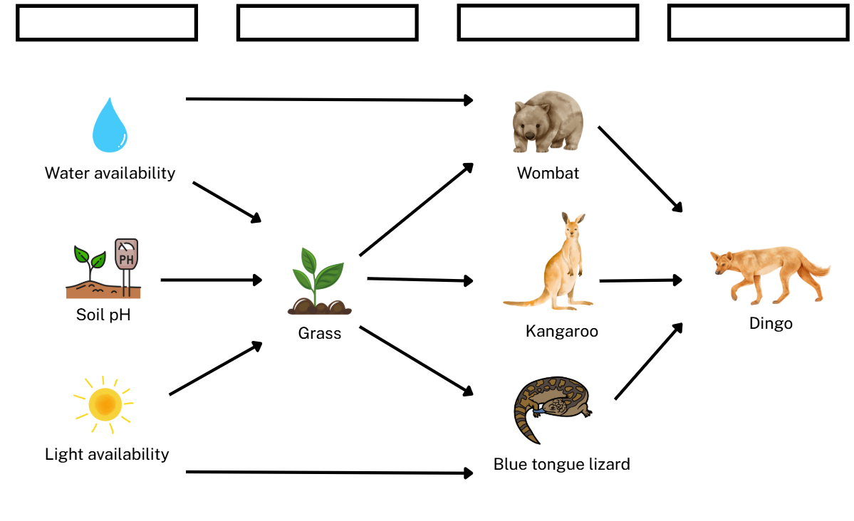

Use the following information to annotate the worksheet above. For example, first label each column as an abiotic component or a biotic component. Then use the rest of the information to describe the interaction between the biotic and abiotic components.
- Biotic component (used more than once)
- Abiotic component
- There is competition for the grass as a food source between the wombat, kangaroo and the blue-tongue lizard.
- Water availability affects wombats, kangaroos and blue-tongue lizards, as all animals need access to clean drinking water to survive.
- The dingo is a predator of kangaroos, wombats and blue-tongue lizards. These provide a food source to support the survival of the dingo.
- Light availability affects blue-tongue lizards, as they use sunlight to regulate their body temperature.
- Grass is a food source for kangaroos, wombats and blue-tongue lizards. This food availability supports the survival of these animals.

Student resource – describing interactions in ecosystems
Use the previous worksheet, Student resource – identifying biotic and abiotic interactions, to answer the following questions:
- Describe the interaction between the dingo and the kangaroo.
- Predict which organisms would be directly impacted by a reduction in the amount of grass available in the ecosystem.

Practical investigations – interactions in an ecosystem
- Complete 2 practical investigations to observe the interactions between biotic and abiotic components in an ecosystem. Student resource – practical investigations: practical investigation 1 – birds in the playground is designed to support students in understanding the interactions between food availability (biotic) and birds present in the playground (biotic). Student resource – practical investigations: practical investigation 2 – plants in the playground is designed to support student understanding of the interactions between light availability (abiotic) and plant growth (biotic).
Note: students can collect data for both investigations within the same lesson. Teachers may wish to divide the class into 2 groups, having students collect data for each investigation at the same time, then swapping investigations to collate class data later. Alternatively, a camera can be set up to record the birds at different times of day for students to review later.
The sample data show the counts of birds obtained at each period during a school day. Comparing bird numbers during the periods after recess and lunch with those at other times of the school day helps students identify trends in the data. However, this data-collection frequency may not be feasible in schools. If so, teachers can modify the frequency to suit the conditions at their schools. Alternatively, if completing these practicals is not feasible due to logistical reasons, the sample data provided below may be used.
Practical investigation 1 – birds in the playground
Equipment
The following equipment is required for this investigation:
- A location in the playground
- Stopwatch.
Procedure
- Choose a location in the school playground with high student traffic during break times.
- Students observe the playground area for a period of 10 minutes, counting the number of birds that are present in the space during the time.
Note: for best results, choose a location in the school where students often drop food on the ground during recess and lunch times. The highest number of birds is likely to occur after break times. It may be effective to collate data from multiple classes across different periods of the day to show a trend of an increasing bird population after break times. Alternatively, the playground area can be filmed for 10 minutes per period for analysis in class.
- Using the collated data, calculate the mean and range of data on birds in the playground. Direct students to tabulate and graph the mean data.
Figure 3 – equipment set up for Investigation: birds in the playground
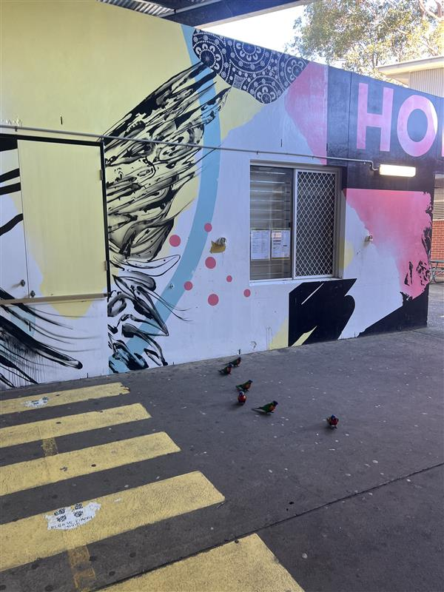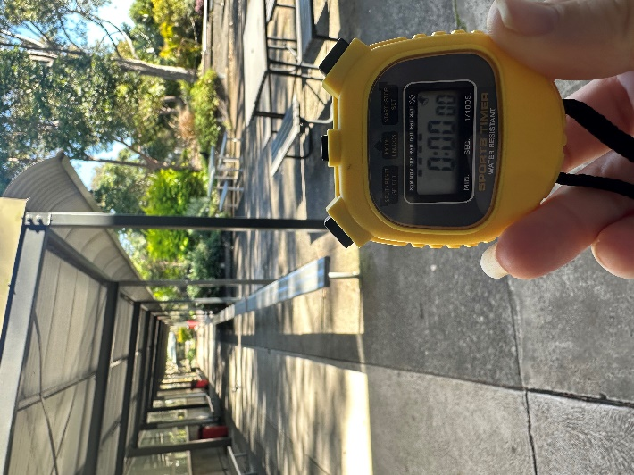
Note: facilitate a class discussion to help students identify the trend of increasing bird numbers following break times. Students should observe that birds are attracted to the increased food availability in the playground after break times. Discuss with students that although the food left by students may not be entirely natural or once living, the ecosystem component of food availability is classified as a biotic factor.
Practical investigation 2 – plants in the playground
Equipment:
The teacher will need to order the following equipment for this investigation:
- A location in the playground with plant life in full sun
- A similar location in the playground that has significant shadows
- Quadrats.
Procedure:
- Choose 2 grassy locations in the school playground, one in bright sunlight and the other in a shaded space.
- Students throw 3 random quadrants out to each space and record the percentage of coverage of plants in each quadrat.
Note: for best results, select a shaded spot within the school where plant growth has been influenced by low light.
Collecting data from multiple classes can be beneficial, as it allows for building a larger dataset over time that can be revisited in the Data Science 2 focus area. Teachers may use the optional slide in LIV PPT ‘2.2 Practical Investigation – plants in the playground’ to assist students in correctly using quadrats.
Teachers might also find the optional slides LIV PPT ‘2.2 Annotated example of a table’, LIV PPT ‘2.2 From table to graph’ and LIV PPT ‘2.2 Annotated sample graph’ helpful for guiding students in creating tables and graphs during investigations.
Figure 4 – equipment set up for Investigation: plants in the playground
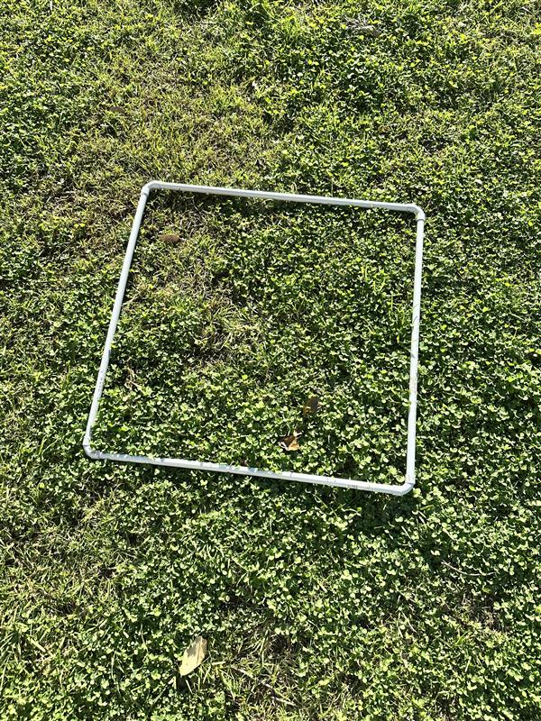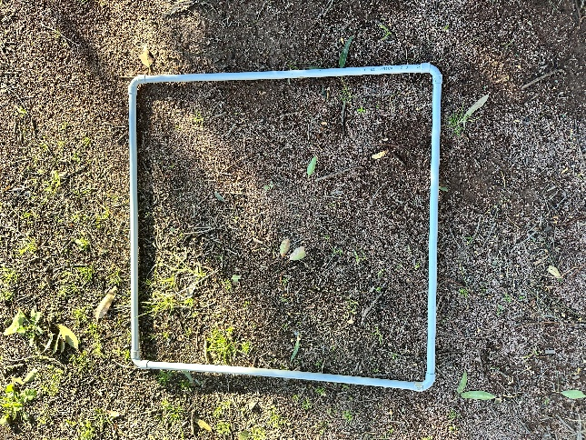

Sample response: Student resource – practical investigations
Practical investigation 1 – birds in the playground
- Observe the number of birds in the playground. Are birds classified as biotic or abiotic components?
Biotic.
- What other biotic and abiotic components of this ecosystem could be observed? Identify each component as either biotic or abiotic.
Biotic – presence of food scraps, presence of many insects such as ants and flies, 3 different types of birds competing for food scraps.
Abiotic – air temperature, availability of water (there is a sprinkler on the grass), wind speed, light availability.
- Create a graph to represent the mean number of birds in the playground during all periods of the day.
Figure 5 – sample results for investigation: Birds in the playground
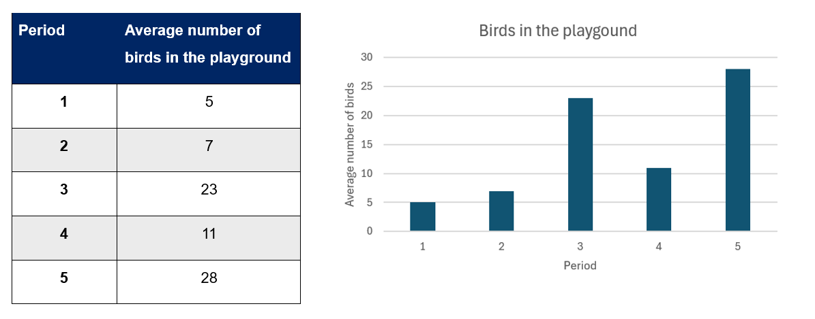
- What trends do you observe in the data presented above?
There is an increase in the number of birds during the periods following break times (periods 3 and 5).
- Provide a reason for the patterns in the data observed in this investigation.
During break times, students drop food scraps on the playground floor. This increases food availability, attracting more birds to this area of the playground after break times.
- Is food availability classified as a biotic or abiotic component of an ecosystem?
Biotic.
- With reference to the excerpt above, predict how the food availability in this ecosystem may change during school holiday periods. How might this impact the birds in this ecosystem?
The excerpt states that ‘school playgrounds are littered with food scraps following break times’. However, during school holidays, there are no students at school to drop food scraps. This would reduce food availability for birds during school holidays. This may force birds to find alternative food sources during this time; otherwise, they may struggle to survive.
Practical investigation 2 – Plants in the playground
- Observe the percentage of plant coverage in the playground. Are plants classified as biotic or abiotic components? Provide reasoning.
Biotic. Plants are classified as biotic components because they are living organisms. They grow, reproduce and carry out life processes such as photosynthesis, which distinguishes them from non-living (abiotic) components of the environment.
- The results should indicate whether light availability has an impact on the growth of plants. Is light availability classified as a biotic or abiotic component? Provide reasoning.
Abiotic. Light availability is classified as an abiotic component because it is a non-living environmental factor that can affect plant growth. Light itself is not alive, but it influences biological processes such as photosynthesis, which in turn affects plant growth.
- Create a graph to represent the mean percentage of plant coverage in each location of the playground. Remember to include a key to show the data for full sun and shaded areas on the same graph.
Figure 6 – sample results for investigation: Plants in the playground
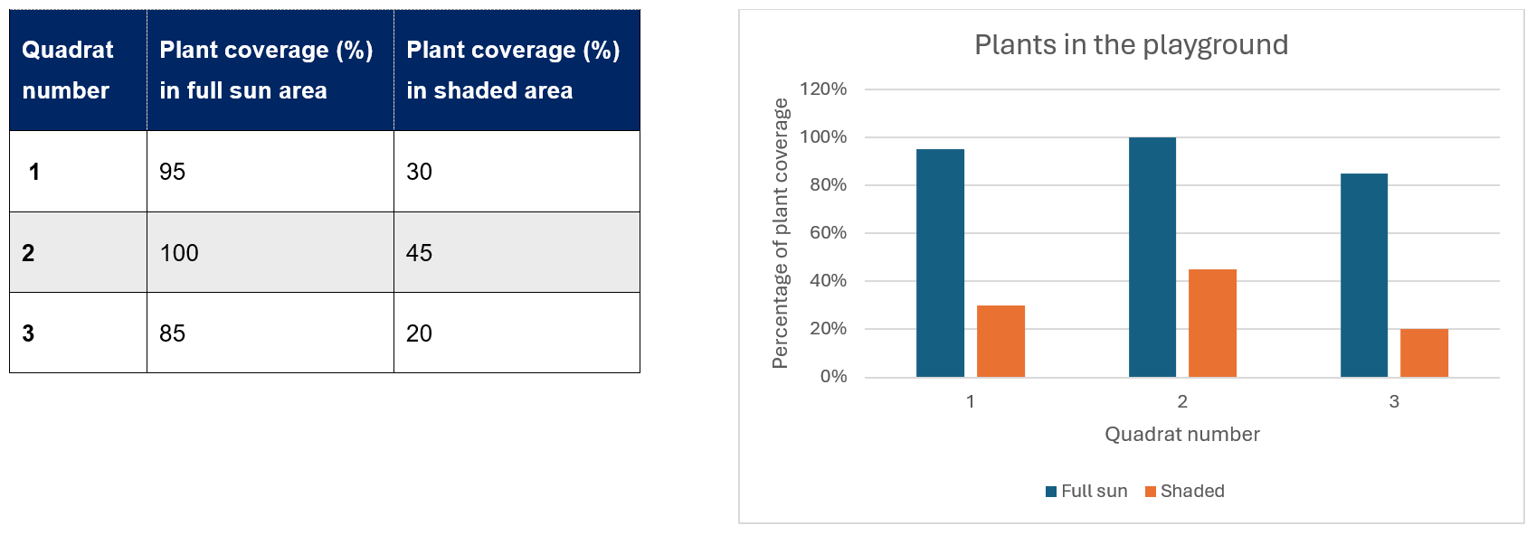
- What trends do you observe in the data presented above?
In areas with higher light availability, plant coverage was higher. In areas with low light availability, plant coverage was lower.
- Provide a reason for the patterns in the data observed in this investigation.
Plants require sunlight to photosynthesise and grow. The areas with low light availability had too little sunlight for plants to survive.
- Predict one other biotic component of this ecosystem that may be impacted by the amount of plant coverage in the playground. How might this component be affected?
Grasshoppers are a biotic component that may be impacted by plant coverage. Grasshoppers use grass and other plants for food and shelter. If plant cover is limited, grasshoppers may not survive in that area.

Student resource – practical investigations
Practical investigation 1 – birds in the playground
You are to make observations of the number of birds in an area of the playground at different times of day.
Table 1 – birds observed in the playground at points through the day
Period | Number of birds
- Observe the number of birds in the playground. Are birds classified as biotic or abiotic components?
- What other biotic and abiotic components of this ecosystem could be observed? Identify each component as either biotic or abiotic.
- Create a graph to represent the mean number of birds in the playground during all periods of the day.

- What trends do you observe in the data presented above?
- Provide a reason for the patterns in the data observed in this investigation.
- Is food availability classified as a biotic or abiotic component of an ecosystem?

An excerpt from a newspaper article highlights the impact that eating food scraps left at schools may have on native Australian bird populations:
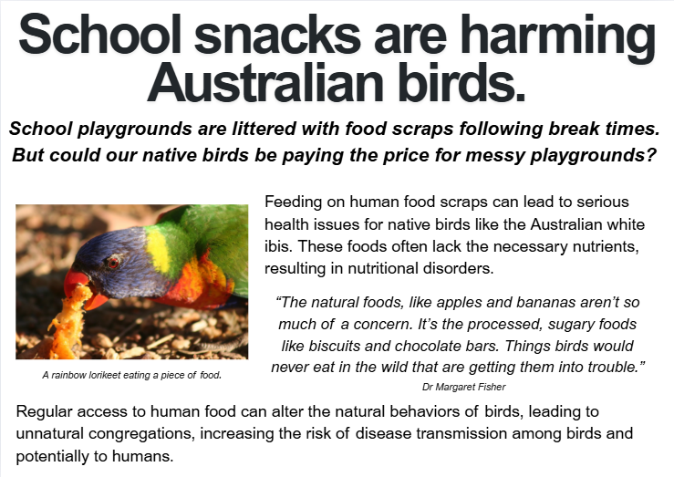
- With reference to the excerpt above, predict how the food availability in this ecosystem may change during school holiday periods. How might this impact the birds in this ecosystem?

Practical investigation 2 – plants in the playground
You are to observe the percentage of plant coverage in 2 areas of the playground with different levels of light availability.
Quadrat number | Plant coverage (%) in full sunlit area | Plant coverage (%) in shaded area
1
2
3
- Observe the percentage of plant coverage in the playground. Are plants classified as biotic or abiotic components? Provide reasoning.
- The results should indicate whether light availability has an impact on the growth of plants. Is light availability classified as a biotic or abiotic component? Provide reasoning.
- Create a graph to represent the mean percentage of plant coverage in each location of the playground. Remember to include a key to show the data for full sun and shaded areas on the same graph.

- What trends do you observe in the data presented above?
- Provide a reason for the patterns in the data observed in this investigation.
- Predict one other biotic component of this ecosystem that may be impacted by the amount of plant coverage in the playground. How might this component be affected?

2.3 Energy and matter in ecosystems
Table 7 – learning intentions and success criteria for ‘2.3 Energy and matter in ecosystems’
We are learning: | I can:
- to describe the role and function of components of an ecosystem | - describe the role of producers, consumers and decomposers in an ecosystem  - identify trophic levels of an ecosystem
- to process and represent data | - represent information using an ecological energy pyramid diagram  - represent information using a food web diagram
- to communicate scientific ideas. | - communicate using ecological energy pyramids and food web diagrams.

Producers, consumers and decomposers
- Deliver the checkpoint question on the previous lesson’s content. See LIV PPT ‘2.3 Checkpoint – quick quiz on previous content’.
Checkpoint: quick quiz on content from a previous lesson.
Mini challenge: competition in an ecosystem can occur between organisms of the same species.
TRUE.
Challenge: identify 3 resources that different bird species might compete for within an ecosystem.
Food, water, shelter.
Super challenge: explain how predation can affect the population size of both predators and prey in an ecosystem. Use an Australian example to support your answer.
Predation influences population sizes by regulating prey numbers and, consequently, predator numbers. For example, in an Australian ecosystem, dingoes hunt kangaroos. If the dingo population grows, they might reduce the number of kangaroos. With fewer kangaroos available for food, the dingo population could then decline due to the lack of nourishment. This interaction helps maintain a balance between the 2 populations.
- Support students to activate prior knowledge on food chains and food webs by completing the Student resource – prior learning on food chains and food webs.
Sample response: Student resource – prior learning on food chains and food webs
- Draw a line to the correct definition of each term.
Term |  | Definition
Producer |  | An organism that obtains energy by consuming other organisms, either plants or animals.
Consumer |  | An organism that breaks down dead plants and animals, and releases nutrients back into the environment to be available for other organisms.
Decomposer |  | An organism that creates its own food, typically using energy from sunlight or chemical reactions.
- Use the following information to construct a food chain.
Grass Grasshopper Magpie
- State whether the following statements are TRUE or FALSE.
- The direction of the arrow in a food chain shows the direction that energy is passed through an ecosystem.
True
- The same amount of energy is passed from each level of the food chain to the next level.
False: Some energy is lost at each level due to metabolic processes, so less energy is passed up the chain.
- Multiple food chains can make up a food web.
True
- Here is an example of a food web from a rural backyard. Using 2 different coloured pens/highlighters, identify the producers and consumers in the food web.
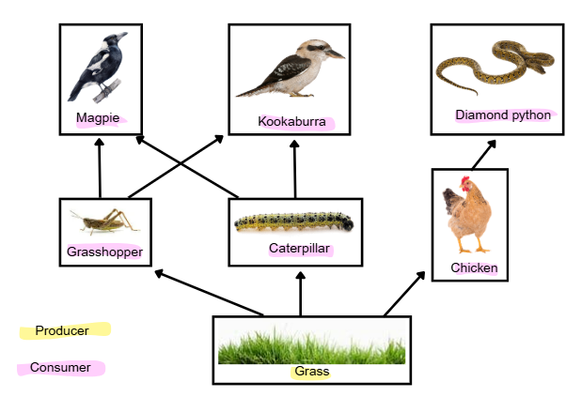
Note: teachers may modify this activity to differentiate the consumers into primary and secondary consumers.

Student resource – prior learning on food chains and food webs
- Draw a line to the correct definition of each term.
Term |  | Definition
Producer |  | An organism that obtains energy by consuming other organisms, either plants or animals.
Consumer |  | An organism that breaks down dead plants and animals, and releases nutrients back into the environment to be available for other organisms.
Decomposer |  | An organism that creates its own food, typically using energy from sunlight or chemical reactions.
- Use the following information to construct a food chain.
- Grass uses sunlight to create its own energy.
- Grasshoppers eat grass to gain energy.
- Magpies eat insects such as grasshoppers to gain energy.
- State whether the following statements are TRUE or FALSE.
- The direction of the arrow in a food chain shows the direction that energy is passed through an ecosystem.
- The same amount of energy is passed from each level of the food chain to the next level.
- Multiple food chains can make up a food web.
- Here is an example of a food web from a rural backyard. Using 2 different coloured pens/highlighters, identify the producers and consumers in the food web.
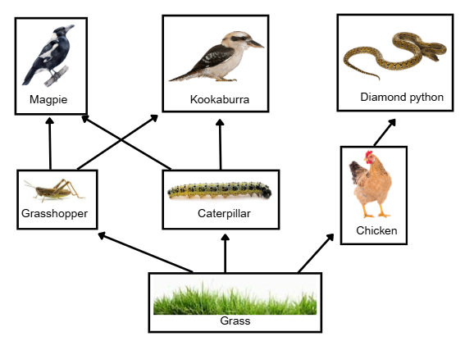

Ecological energy pyramids
- Show students LIV PPT ‘2.3 Producers, consumers and decomposers’ to teach students the definitions and examples of producers, consumers and decomposers in an ecosystem.
- Using LIV PPT ‘2.3 Ecological energy pyramid (1–2)’, teach students about biomass and trophic levels.
- Support students to complete Student resource – cycling energy and matter to understand how producers, consumers and decomposers are essential for energy and matter to be cycled through ecosystems. Emphasise that decomposers complete the cycle and return nutrients to the soil, making them available for use. You may also note to students that decomposers do not often appear in food webs but are still an important part of ecosystems. The sample response is also provided on LIV PPT ‘2.3 Cycling energy and matter’.
Sample response: Student resource – cycling energy and matter
Figure 7 – sample response demonstrating the cycling of matter and energy through an ecosystem
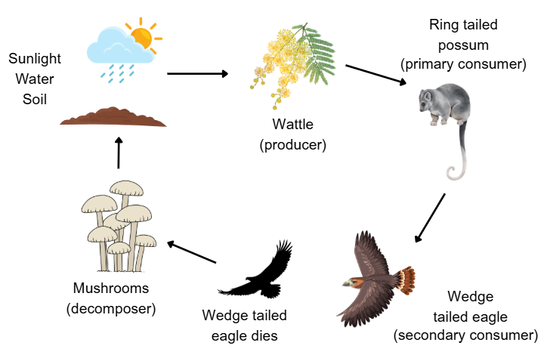

Student resource – cycling energy and matter
Use the following information to complete the diagram, showing how matter and energy cycle through an ecosystem.
Figure 1 – activity to demonstrate the cycling of matter and energy through an ecosystem
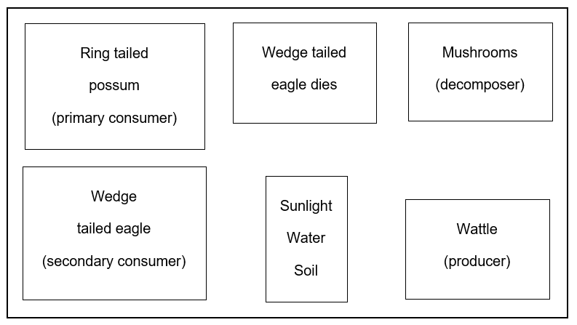
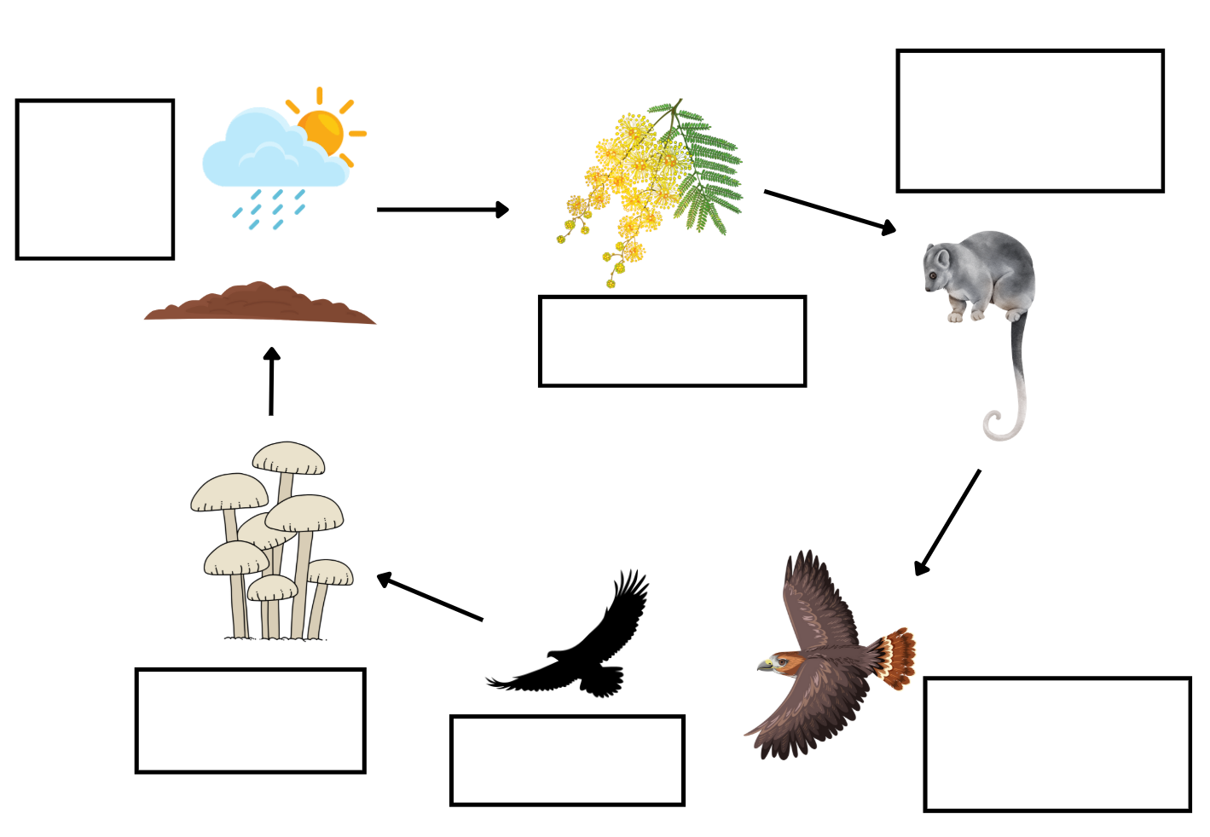

Food webs
Note: students may be familiar with terminology such as producer, consumer and decomposer. However, since students are learning about trophic levels in this sequence, it is also important to emphasise terminology such as primary consumer, secondary consumer and tertiary consumer. It makes clear that not all consumers are the same – they occupy different positions and receive different amounts of energy.
This helps students understand that as you move up the pyramid, less energy is available at each trophic level. This is because only a small proportion of energy is transferred from one level to the next (most is lost as heat). The terminology makes it easier for students to link:
- Position in the pyramid → amount of energy available
- Higher trophic level → less energy available → fewer organisms supported.
Due to energy loss, most ecosystems rarely have more than 4 or 5 trophic levels, as there is not enough energy left to support additional levels. There are also generally fewer individuals at higher trophic levels than at lower ones due to energy loss at each level.
- Students complete the Student resource – marine food web to construct a food web. Support students to identify the trophic levels of each organism. Each trophic level is colour-coded to help teachers check whether students have completed the task correctly. Teachers should also check that the arrows point in the correct direction within the food web and that all organisms are present (Figure 8).
Note: teachers can use the optional slide, LIV PPT ‘2.3 Constructing a food web’, to support students in correctly constructing food webs.
- Students will require access to computers for this activity. Students complete the Ecological pyramid interactive by placing the organisms in the correct place on the ecological pyramid, then answer the provided questions. Teachers will need to check student responses for the ecological pyramid using Figure 9.
Sample response: Student resource – marine food web
Figure 8 – sample response of a food web of the Julian Rocks Ngthungulli Nature Reserve ecosystem
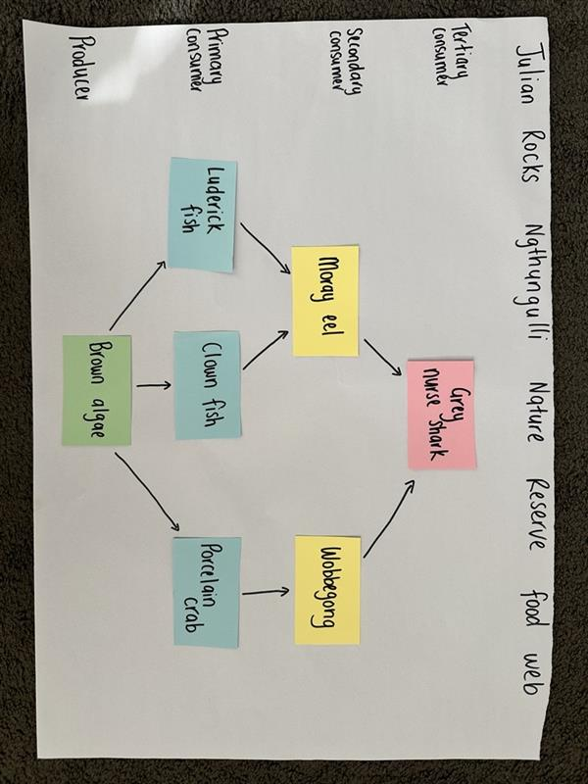
Sample response: ecological pyramid interactive
Figure 9 – sample response for the ecological energy pyramid interactive activity
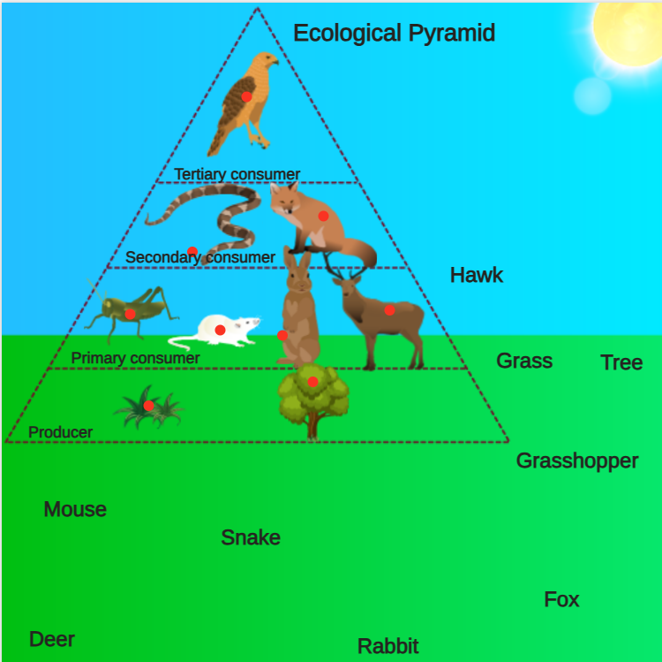

Student resource – marine food web
Ecosystem type: marine ecosystem
Ecosystem location: Julian Rocks Nguthungulli Nature Reserve, Byron Bay, NSW
Ecosystem description: Julian Rocks Nguthungulli Nature Reserve is a protected area located about 2.5 kilometres off Main Beach in Byron Bay, within the Cape Byron Marine Park in northern New South Wales. The reserve includes 2 small islands and spans over 4,000 hectares. Its unique location, where warm tropical and cool temperate ocean currents meet, supports an extraordinary diversity of marine life, with more than 1,000 species found in its surrounding waters.
For this activity, you will need:
- 1 × butcher’s paper
- 1 × marker
- 1 × glue stick
- 1 × pink card or sticky note
- 2 × yellow card or sticky notes
- 3 × blue card or sticky notes
- 2 × green card or sticky notes
Use the information in the table below to complete the following steps.
- Write the names of the marine organisms on the assigned coloured card.
- Use the information about each organism’s diet to organise the cards on the butcher’s paper to create a food web.
- Using the marker, identify the producers, primary consumers, secondary consumers and tertiary consumers.
Table 1 – marine organisms of the Julian Rocks Nguthungulli Nature Reserve
Organism name | Card colour | Organism description
Luderick fish | Blue | This fish is an herbivore, feeding on brown algae.
Moray eel | Yellow | This predator hides in rock crevices to prey on fish as they swim by.
Porcelain crab | Blue | This crustacean eats brown algae.
Clown fish | Blue | This fish is an herbivore, feeding on brown algae.
Grey nurse shark | Pink | This predator eats moray eels, wobbegongs and different types of fish.
Wobbegong | Yellow | Crustaceans are a key food source for the wobbegong.
Brown algae | Green | This organism uses energy from the sun to create its own food.

2.4 A local ecosystem
Table 8 – learning intentions and success criteria for ‘2.4 A local ecosystem’
We are learning: | I can:
- to describe the role and function of components of an ecosystem | - identify organisms in a local ecosystem  - identify trophic levels of a local ecosystem  - describe the movement of energy and matter through a local ecosystem
- to process and represent data | - represent information using an ecological energy pyramid diagram  - represent information using a food web diagram
- to communicate scientific ideas. | - communicate using ecological energy pyramids and food web diagrams.

Fieldwork: local area observations
- Deliver the checkpoint question on the previous lesson’s content. See LIV PPT ‘2.4 Checkpoint – quick quiz on previous content’.
Checkpoint: quick quiz on content from a previous lesson.
Mini challenge: What term correctly refers to a consumer at the top level of the ecological pyramid shown in the diagram?
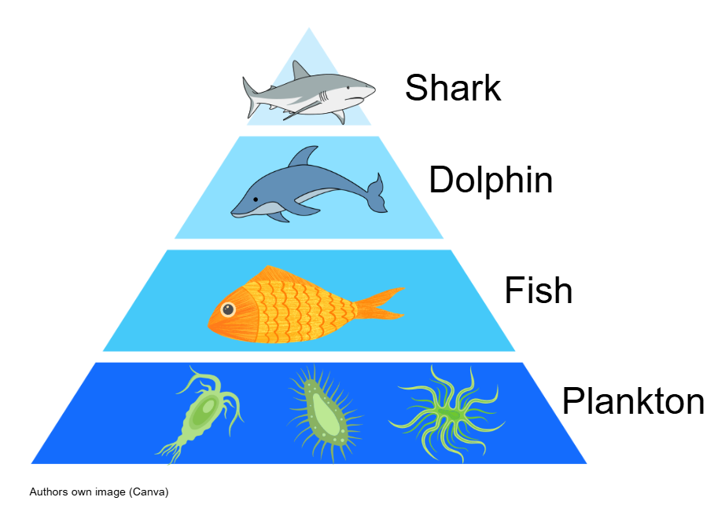
Tertiary consumer (there are 3 consumer trophic levels; hence, organisms in the top trophic level are called tertiary consumers).
Challenge: In a food web, what does the direction of the arrow represent?
The arrow represents the direction of energy flow and nutrient transfer from the organism being eaten to the organism that consumes it.
Super challenge: Why is the pyramid shape used to model ecological energy pyramids significant?
The shape of an ecological pyramid, usually wider at the base and narrower at the top, signifies that energy, biomass and population numbers decrease at each higher trophic level. This structure illustrates that roughly 90% of energy is lost as heat between levels, with only about 10% transferred, demonstrating the efficiency of energy flow and limiting the number of top predators.
- Students carry out fieldwork to observe organisms that form an ecosystem in a local area. To record the organisms present, students complete the Student resource – local area observations. Students identify each organism by name and include a photograph or sketch where possible. Once students have returned to class and have access to a computer, they research what each identified organism eats to complete the table.
Note: Environmental and zoo education centres can support teachers across NSW. They may offer fieldwork excursions, resources or specialist knowledge about ecosystems in your local area. Teachers are encouraged to contact their local Environmental and zoo education centre for support in exploring relevant content on living systems.
Remind students to look for other indicators of organisms in the ecosystem, such as sounds, tracks, scat and evidence of dead organisms.
Sample response: Student resource – local area observations
Table 9 – local area observations sample response
Name of ecosystem: dry sclerophyll bushland
Organism | Diet | Image/sketch
cicada | plant sap | 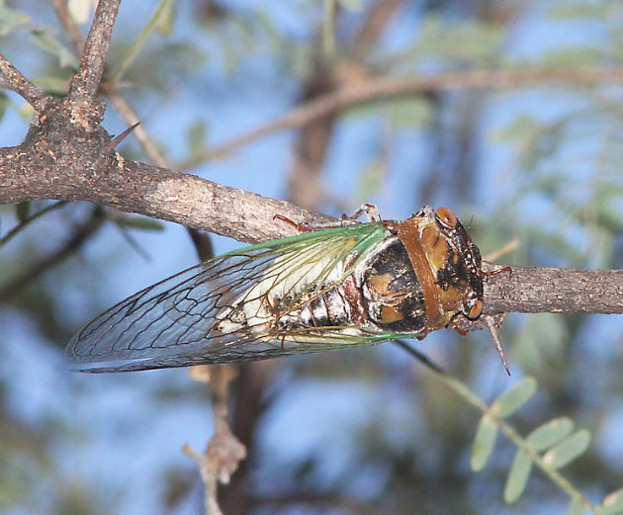
spear grass | producer | 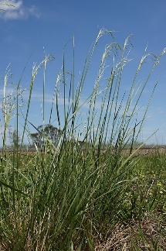
goanna | insects, spiders, birds, eggs, small reptiles and mammals | 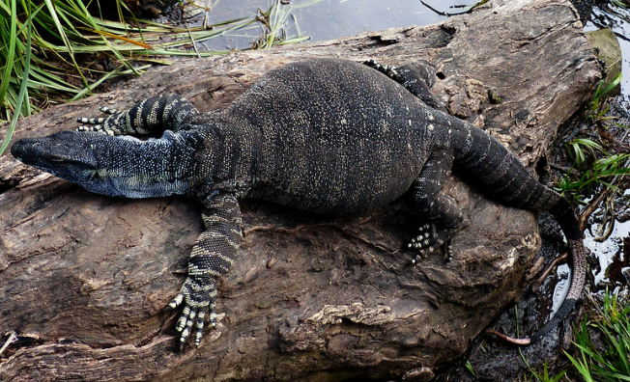
mountain blue gum | producer | 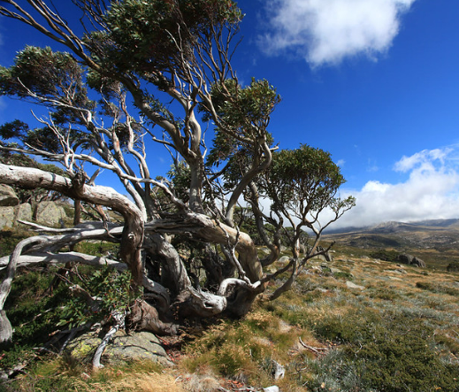
spotted tail quoll | insects, spiders, frogs and toads, small reptiles and mammals | 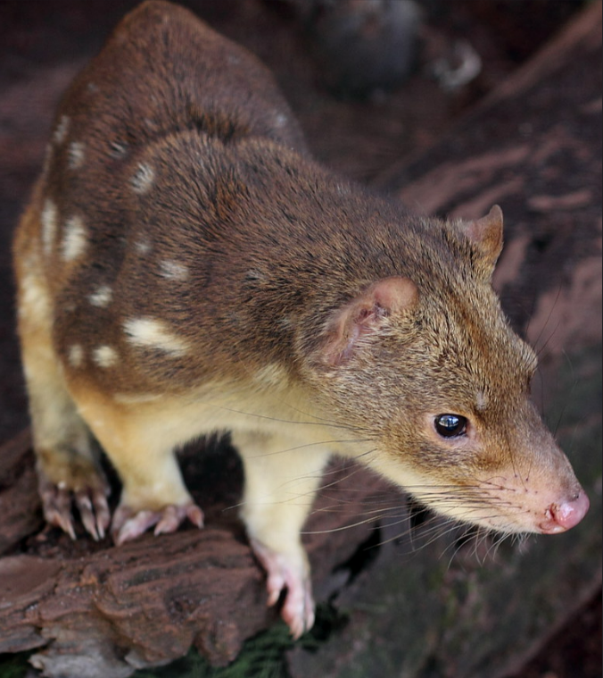
wattle | producer | 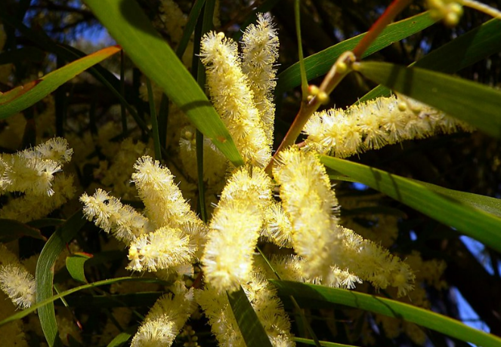
flying fox | flowers and fruit | 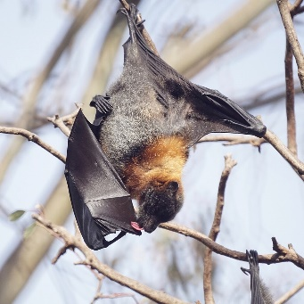
kookaburra | insects, frogs, small reptiles and mammals | 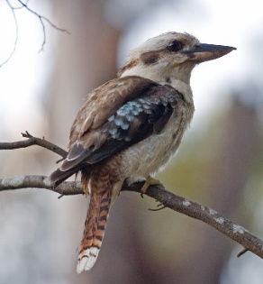
possum | leaves, some shrubs (mainly wattles), flowers and fruit | 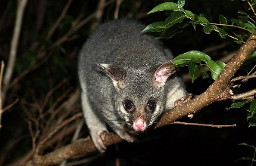
wallaby | grasses, leaves and fruit | 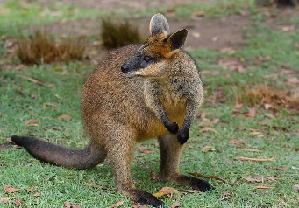
magpie | insects, frogs, small lizards and meat scraps | 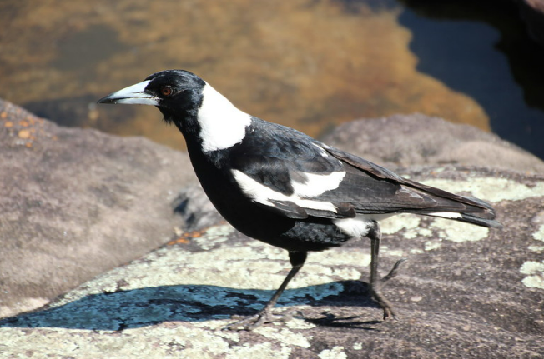
echidna | insects, spiders, worms and other invertebrates | 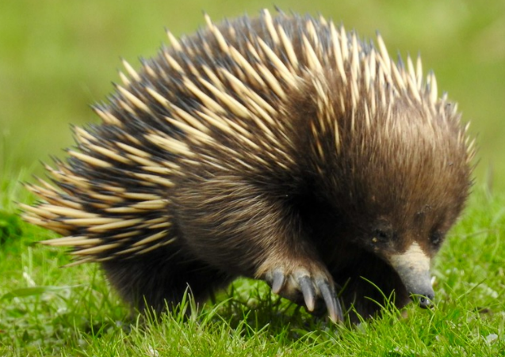
grasshopper | leaves, shoots and roots | 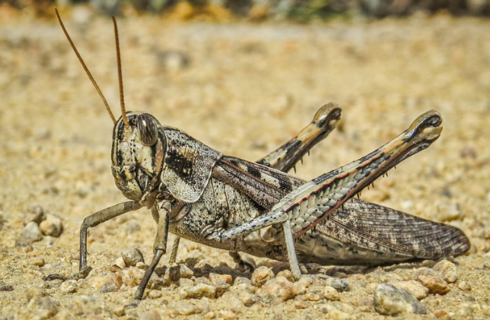
wedge-tailed eagle | small reptiles and mammals, rabbits, possums, foxes and feral cats | 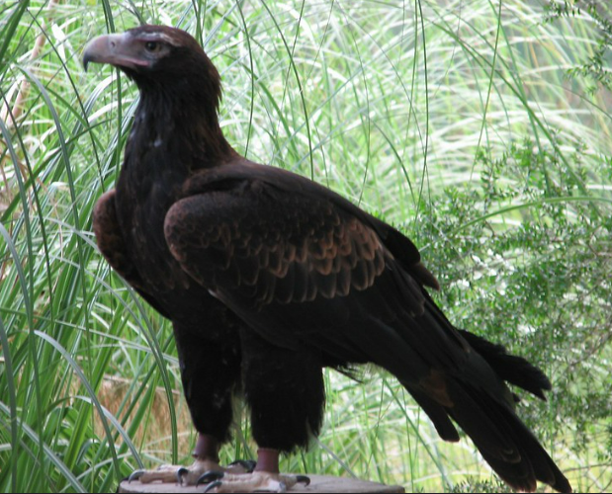
frog | insects and worms | 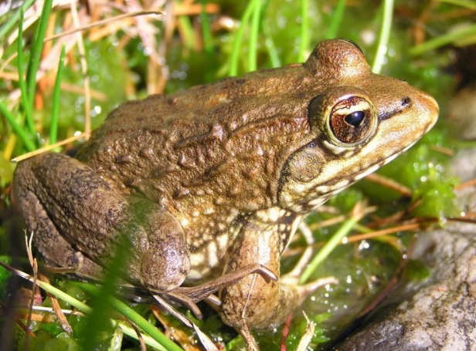
Image copyright
CICADA (9-10-10) blue haven rd, patagonia, scc, az -01 by Sloalan is available in the public domain.
Austrostipa aristiglumis plant7 by Harry Rose is licensed under CC BY 2.0.
Goanna. Australia. by Bernard Spragg is available in the public domain.
Charlotte Pass 1, Kosciuszko National Park by Australian Alps is licensed under CC BY-NC-ND 2.0.
Spotted-tailed quoll by quollism is licensed under CC BY 2.0.
Coast Wattle. Australia. by Bernard Spragg is available in the public domain..
Fruit bat (flying fox) by Mike’s birds is licensed under CC BY 2.0.
Kookaburra portrait by Diliff is licensed under CC BY-SA 3.0.
Creating habitat for wildlife such as the Brushtail possum, by Brisbane City Council is licensed under CC BY 2.0.
Wallaby at Australia Zoo by Sheba is licensed under CC BY-SA 2.0.
Australian Magpie. Gymnorhina tibicen by Alison Klein is available in the public domain.
Echidna on the move by CazzJj is available in the public domain.
Grasshopper armor by FotoGrazio is licensed under CC BY-NC-ND 2.0.
Wedge-tailed Eagle by magdalena_b is available in the public domain.
Cape River Frog - Amietia fuscigula - Cape Town 3.jpg by Abu Shawka is available in the public domain.

Student resource – local area observations
Name of ecosystem: __________________________
Table 1 – local area observations
Organism | Diet | Image/sketch

Creating a local food web and ecological energy pyramid
- Students use the information from the Student resource – local area observations to create a food web. Note that students do not have to include all organisms observed in the ecosystem. However, students should try to include at least one producer and 3 trophic levels of consumers.
Sample response: a local food web
Figure 10 – sample response of a food web of the dry sclerophyll bushland ecosystem
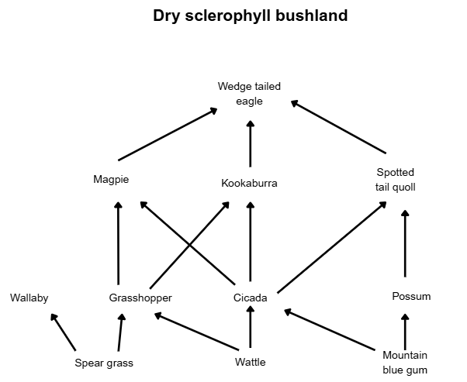

- Students use information from the food web to construct an ecological energy pyramid. The template found in Student resource – creating a local food web and ecological energy pyramid may be used to support students.
Sample response: a local ecological energy pyramid
Figure 11 – sample response of an ecological energy pyramid of the dry sclerophyll bushland ecosystem
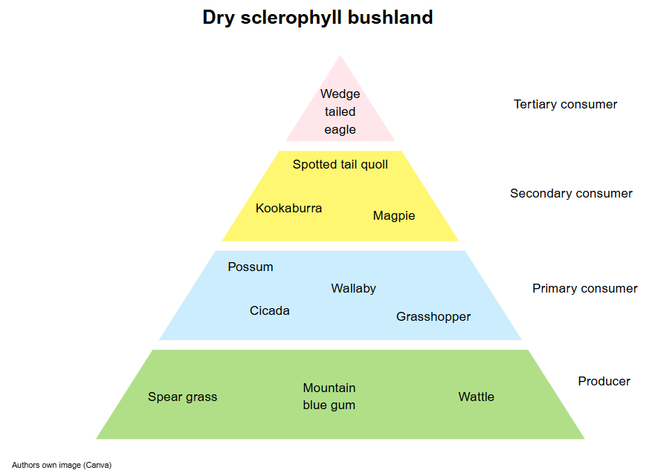
90% of the energy in a trophic level is used or lost to the environment. Only 10% moves to the next trophic level
- Students complete a description of how energy and matter move through this specific ecosystem. Students should include the names of organisms present in the food web they constructed.
Sample response: Student resource – creating a local food web and ecological energy pyramid
Describe how energy and matter move through the ecosystem you have observed.
Energy and matter move through the dry sclerophyll bushland ecosystem, starting with producers such as spear grass, wattle and mountain blue gum. These plants use sunlight to produce energy through photosynthesis.
Primary consumers, such as the wallaby, grasshopper, cicada and possum, feed on producers to obtain energy. These organisms are then eaten by secondary consumers, such as the magpie (which eats grasshoppers), the kookaburra (which eats cicadas), and the spotted-tailed quoll (which preys on both cicadas and possums).
At the top of the food web is the wedge-tailed eagle, a tertiary consumer that gains energy by eating the magpie, kookaburra and spotted-tailed quoll.
At each trophic level, energy is transferred from one organism to another, but only about 10% is passed on. The rest is lost as heat, movement or waste.
Matter, such as nutrients, also cycles through the ecosystem as organisms consume one another, eventually die and decompose, returning nutrients to the soil to support producers again.

Student resource – creating a local food web and ecological energy pyramid
A local food web
Ecosystem:


A local ecological energy pyramid
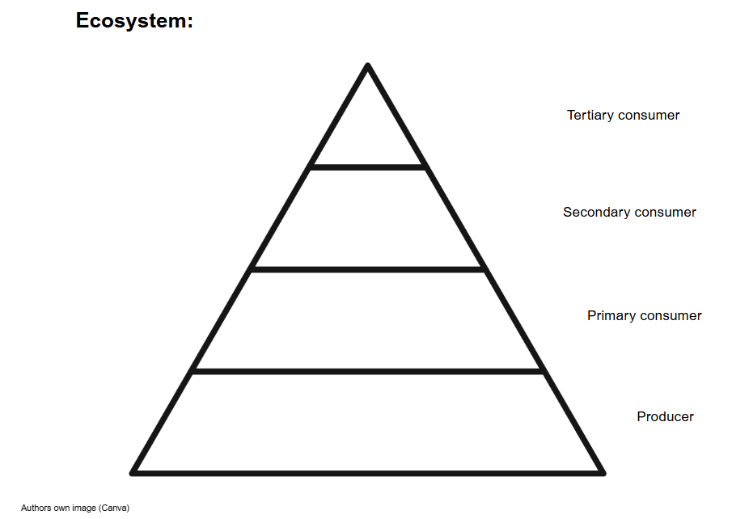
Describe how energy and matter move through the ecosystem you have observed.

2.5 Ecological energy pyramids
Table 10 – learning intentions and success criteria for ‘2.5 Ecological energy pyramids’
We are learning: | I can:
- to explain the role and function of components of an ecosystem | - describe the structure of an ecological energy pyramid  - explain the change in biomass between the trophic levels of an ecosystem  - explain the change in energy available at each trophic level of an ecosystem
- to communicate scientific ideas. | - describe the purpose and structure of an explanatory text  - construct an explanatory text about a specific ecosystem.

Creating written texts
Note: teachers may find support for creating written texts in the Science 7–10 (2023) – Advice on writing: Science 7–10 document.
Teachers may also be supported in teaching this activity by completing the Literacy – writing in science microlearning module.
- Deliver the checkpoint question on the previous lesson’s content. See slide LIV PPT ‘2.5 Checkpoint – quick quiz on previous content’.
Checkpoint: quick quiz on content from a previous lesson.
Mini challenge: True or false: A consumer can feed at multiple trophic levels.
True.
Challenge: In an ecological energy pyramid, which level has the greatest biomass?
The bottom layer (producers).
Super challenge: bushfires can destroy many producers very quickly, leading to changes at higher levels of the food pyramid. Choose an ecosystem you are familiar with and describe how losing many of the producers in that ecosystem would affect the top consumer.
In the Australian bush ecosystem, producers such as eucalyptus trees and grasses provide food for herbivores like kangaroos and wombats. If a bushfire destroys many of these producers, herbivores will have less food and their numbers may drop. This means top consumers like wedge-tailed eagles and dingoes would struggle to find enough prey. As a result, their populations could also decrease or move to other areas.
- Use LIV PPT ‘2.5 Explanatory texts’ to explain to students the purpose and structure of an explanatory text.
- Using Student resource – creating written texts, guide students to complete an explanatory text on ecological energy pyramids. The question is also provided on LIV PPT ‘2.5 Student resource’. Support students in building a word bank of Tier 2 and Tier 3 vocabulary of related scientific terminology before they plan their explanatory text using Table 1 – explanatory text with sentence starters. LIV PPT ‘2.5 Planning an explanatory text’ and LIV PPT ‘2.5 Marking criteria’ can be used to support students further.
- After students have written their explanatory text, LIV PPT ‘2.5 Sample responses (1–3)’ can be used to show students 2 sample responses in reference to the marking criteria and markers' feedback. Provide students with the opportunity to revise their explanatory text after reviewing the sample responses and feedback, then prompt them to use the marking criteria in Table 2 of Student resource – creating written texts to peer-mark their final responses in pairs.
Sample response: explanatory text
How the energy pyramid shows energy and matter at each trophic level
This energy pyramid illustrates how energy and biomass diminish at each trophic level in a terrestrial ecosystem. At the base are producers, such as grass and trees, which generate energy through photosynthesis. These producers form the first trophic level and contain the most energy and biomass; however, some of the energy they generate is used for their own growth, so less energy is available to primary consumers. Only 10% of the energy is transferred to the primary consumers, while 90% is used for bodily functions or lost to the environment as heat. Primary consumers, such as parrotfish, feed on seaweed to obtain energy. Secondary consumers such as sharks eat parrotfish, and tertiary consumers, like killer whales, are at the top of the food chain. As energy moves up each level, a significant portion is lost as heat or used for vital processes like movement and growth. This explains why there are fewer organisms at higher levels and why the pyramid tapers towards the top. The pyramid shape effectively demonstrates that energy decreases as it ascends the food chain, helping scientists understand population sizes and feeding relationships within ecosystems.

Student resource – creating written texts
Write an explanation of how this energy pyramid shows the amount of energy and matter at each trophic level. (9 marks)
Figure 1 – an ecological pyramid of a terrestrial ecosystem
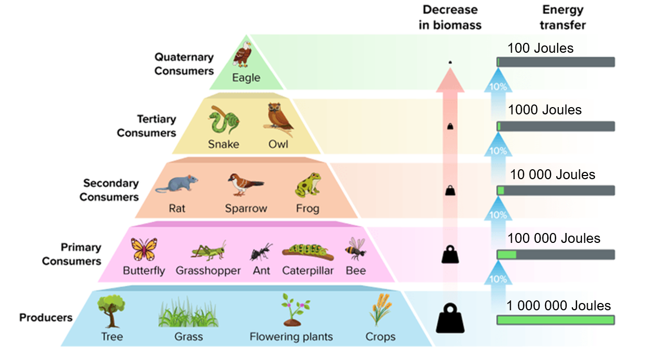
Ecological Pyramid with energy and biomass by CK-12 Foundation is licenced under CC BY-SA 4.0. The energy values are arbitrary units which have been applied.
Word bank
biomass  producer  photosynthesis  matter | trophic level  primary consumer  food chain  pyramid | secondary consumer  tertiary consumer  energy

Table 1 – explanatory text with sentence starters
Part of the text | Purpose | Sentence starters
Title | States the topic. | How the energy pyramid shows …
Introduction | Introduces what the explanation is about. | An energy pyramid shows how …  Energy pyramids are used to represent …
Body paragraph | Explains (relates cause, effect and how) how the energy pyramid works using detail, scientific terminology and examples. | At the base of the pyramid ...  As energy moves up ...  This means that ...  For example …
Conclusion | Summarises the main idea. | In conclusion, energy pyramids help us …

Table 2 – marking criteria for explanatory text
Criteria | Marks – descriptors | Syllabus outcome and content
Understanding of living systems  (scientific explanation of energy transfer, trophic levels and the roles of organisms in food chains) | 3 – demonstrates a comprehensive understanding of the functions and relationships of organisms within ecosystems, including energy transfer and biomass across trophic levels.  2 – demonstrates a sound understanding with minor omissions or inaccuracies.  1 – demonstrates limited understanding with underdeveloped or partially correct ideas.  0 – no relevant scientific understanding shown. | SC4-LIV-01  Describes the role, structure and function of a range of living systems and their components
Use of scientific vocabulary  (appropriate Tier 2 and 3 vocabulary) | 2 – uses scientific vocabulary appropriately and consistently (for example, producers, consumers, energy transfer, biomass, trophic level).  1 – some appropriate vocabulary used, though with minor errors or inconsistencies.  0 – minimal or inaccurate use of scientific terminology. | SC4-WS-08  Present findings and ideas in a range of communication forms, including using relevant scientific terms, as appropriate to the audience and purpose
Structure of a written explanatory text (follows the conventional structure: introduction, body, conclusion) | 2 – follows a clear and logical structure appropriate to a scientific explanation (introduction, body: cause/effect/why, conclusion).  1 – mostly follows the structure of scientific texts, with some structural lapses or weak transitions.  0 – lacks structure or presents information in an illogical or incomplete format. | SC4-WS-08  Create written texts to communicate scientific concepts using conventional scientific text structures
Communication of ideas for purpose and audience  (clarity, flow and appropriate tone for a scientific audience) | 2 – communicates clearly and logically, with ideas suited to a scientific audience; maintains an appropriate tone and coherence throughout.  1 – communicates some ideas clearly but may lack consistency in tone, clarity or flow.  0 – lacks clear communication; difficult for the audience to follow. | SC4-WS-08  Present findings and ideas in a range of communication forms as appropriate to the audience and purpose

2.6 Changes in populations
Table 11 – learning intentions and success criteria for ‘2.6 Changes in populations’
We are learning: | I can:
- to describe the role, structure and function of ecosystems | - describe factors that lead to changes in population, including habitat destruction, disease, introduced species and conservation actions  - explain the impact of the introduction of the cane toad on native Australian organisms
- to identify questions and make predictions that will guide scientific investigations | - construct an inquiry question to guide the investigation  - predict the impact of cane toads on a named Australian organism
- to extract and organise data from secondary sources | - extract information from texts, diagrams and graphs about population data
- to communicate scientific ideas. | - present findings of an investigation as a scientific poster.

Factors that change populations
- Deliver the checkpoint question on the previous lesson’s content. See LIV PPT ‘2.6 Checkpoint – quick quiz on previous content’.
Checkpoint: quick quiz on content from a previous lesson.
Mini challenge: Why is the amount of energy lower at the top of the pyramid (the highest trophic level) than at the bottom (the lowest trophic level)?
The energy available is lower at the top of the pyramid because less energy is transferred to each subsequent trophic level.
Challenge: What usually happens to the energy that is not passed on to the next trophic level?
The energy that is not passed to the next trophic level is usually lost as heat through metabolic processes, inefficient transfer, excretion and decomposition.
Super challenge: Why are there usually fewer top predators than herbivores in an ecosystem?
Fewer top predators exist than herbivores because energy is lost at each trophic level. This leads to limited food and energy availability for supporting large populations of predators at the highest level.
- Use LIV PPT ‘2.6 Factors that change populations’ to teach students about the multiple factors that change populations. Explain to them that many factors can change the populations of organisms, and we will explore just a few.

Introduction of the cane toad
- Students watch and listen to Invasion Of The Deadly Cane Toads - Australia with Simon Reeve – BBC (4:11) (LIV PPT ‘2.6 Introduction of the cane toad) to learn about the impact of the cane toad on native Australian animals. To consolidate this learning, students answer the questions in Table 12.
Table 12 – sample responses for Invasion of the deadly cane toads video
Question | Sample response
Why is the cane toad so deadly to native Australian animals? | Cane toads have glands on their heads that contain toxins. These toxins quickly kill Australian animals that try to eat them.
What was the purpose of introducing cane toads to Australia? | Cane toads were introduced to Australia to control a beetle population destroying sugar cane crops.
- Students will need access to computers and the internet to complete this activity. Students access the webpage Australia's Cane Toad Catastrophe to examine secondary-source data on the introduction and spread of cane toads. Students will use the Student resource – introduction of the cane toad to identify trends and patterns in data on cane toad populations.
- Use LIV PPT ‘2.6 The cane toad ecosystem’ to discuss with students the impact that cane toads have when introduced to an ecosystem. Students will then choose one of the organisms in Figure 12 to examine how cane toads affect it: Freshwater crocodile, Goanna or Northern Quoll. Secondary data has been provided for each organism on the Student resource – secondary-source data factsheet. Students will use the scientific poster template provided to identify the impact of the cane toad on the population of the chosen organism. Students are only required to complete the scientific poster for one of the organisms provided. A sample response is given in Figure 12.
Note: the scientific poster template is designed for A3 size. Students can edit the template using this online version. The scientific poster template can be edited online using Canva. To download a copy of the scientific poster template, use this link: Scientific poster template – Cane toads.
Click File, then make a copy, to allow students to edit this document.
Sample response: Student resource – introduction of the cane toad
- Using Figures 2.1–2.5, describe the patterns and trends seen in cane toad distribution in Australia between 1990 and 2024.
There is a general trend of increasing cane toad population numbers and density over time in Australia. Between 2010 and 2014, the cane toad population spread further across northern Australia into Western Australia. There has been a significant increase in the cane toad population in northern NSW. Over time, the cane toad population has spread further inland.
- Using Figure 2.6, describe the trends seen in recorded cane toad sightings per period.
There is an overall trend of increasing cane toad sightings over time. The highest recorded cane toad sightings occurred between 2010 and 2019.
Sample response: Student resource – scientific poster template
Figure 12 – sample response of a scientific poster detailing the impact of the cane toad on the freshwater crocodile population
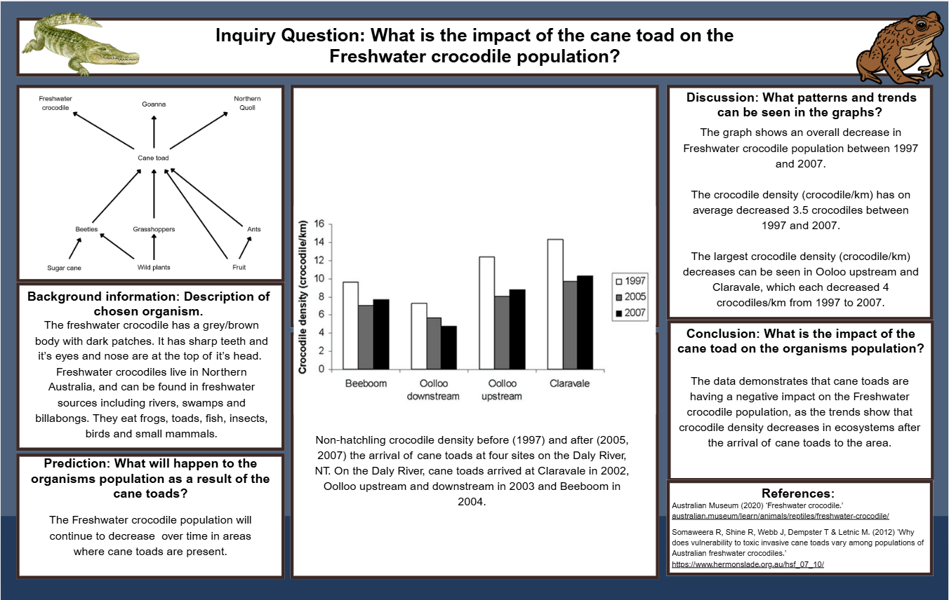

Student resource – introduction of the cane toad
Use the information from Australia's Cane Toad Catastrophe to answer the following questions.
- Using Figures 2.1–2.5, describe the patterns and trends seen in cane toad distribution in Australia between 1990 and 2024.
- Using Figure 2.6, describe the trends seen in recorded cane toad sightings per period.

Student resource – secondary-source data factsheet

Freshwater crocodile
Background information:
The Freshwater Crocodile is smaller and more slender than the Saltwater Crocodile, with a grey to brown body covered in dark patches. Its eyes and nostrils sit atop its head, and it has sharp teeth that are visible even when its mouth is closed. These crocodiles live in freshwater habitats such as rivers, billabongs, swamps and lagoons across northern Australia. The Freshwater Crocodile feeds on a variety of animals, including insects, fish, frogs and toads, turtles, birds and mammals.
Secondary-source data:
Figure 1 – non-hatchling crocodile density before and after the arrival of cane toads at 4 sites on the Daly River, NT
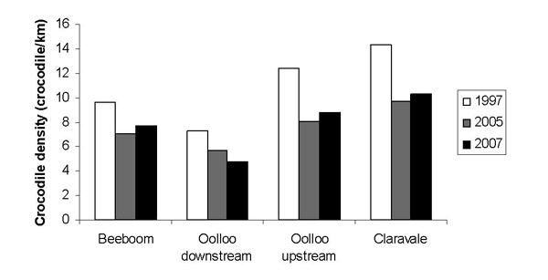
Non-hatchling crocodile density before (1997) and after (2005, 2007) the arrival of cane toads at 4 sites on the Daly River, NT. On the Daly River, cane toads arrived at Claravale in 2002, Oolloo upstream and downstream in 2003 and Beeboom in 2004.
References:
Australian Museum (2020) ‘Freshwater crocodile’, australian.museum/learn/animals/reptiles/freshwater-crocodile/.
Letnic M (2007) ‘The impact of cane-toads on the trophic cascades of freshwater ecosystems in the Northern Territory’, https://www.hermonslade.org.au/hsf_07_10/.

Goanna
Background information:
There are several species of goannas (or monitor lizards) in Australia. The Yellow-spotted Monitor is a species of goanna. It is a large lizard native to tropical parts of Australia. It has a brown body with big yellow spots on its back and bands of colour on its tail. Females typically grow to about 90 cm long, while males can reach up to 1.5 m. These monitors eat a variety of animals, including fish, frogs/toads, crabs, birds, rodents, insects and even other lizards.
Secondary-source data:
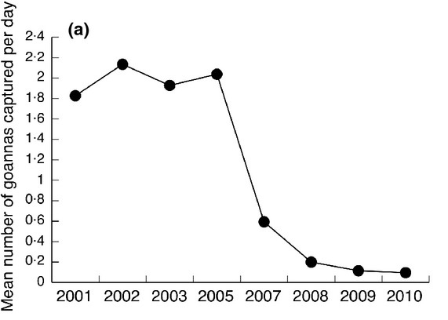
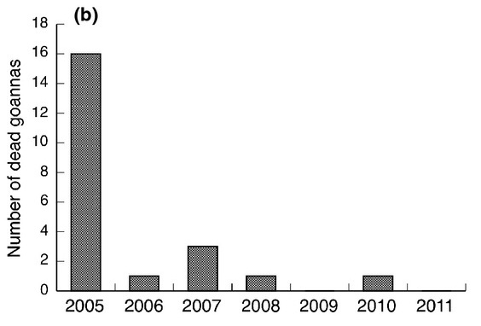
Figure 2– impacts of cane toad invasion on goannas

(a) Mean annual numbers of goannas (yellow-spotted monitors) captured per day in the years preceding and following cane toad arrival in 2005; (b) opportunistic observations of numbers of dead yellow-spotted monitors found per year since the arrival of toxic invasive cane toads
References:
Australian Wildlife Conservancy (2025). Yellow-spotted Monitor’, https://www.australianwildlife.org/animals/yellow-spotted-monitor.
Smith JA and Brown LM (2013) ‘Invader impact clarifies the roles of top-down and bottom-up effects on tropical snake populations’, https://besjournals.onlinelibrary.wiley.com/doi/10.1111/1365-2435.12044.

Northern Quoll
Background information:
The Northern Quoll is the smallest type of quoll found in Australia. It has a reddish-brown body covered in white spots, a pointy snout, and a long tail without spots. Northern Quolls are found across northern Australia. They are hunters that eat a variety of animals, including small mammals, birds, lizards, snakes and frogs or toads.
Secondary-source data:
Figure 3 – Northern Quoll population data over time
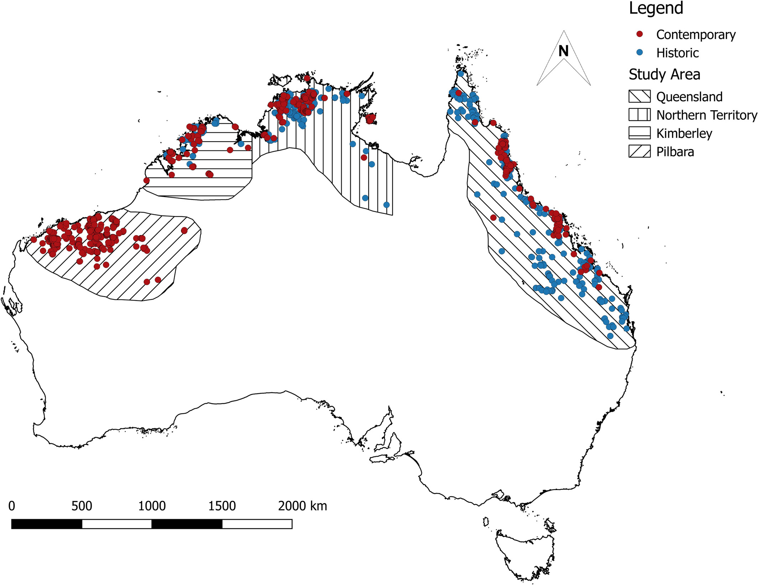
Northern quoll presence records across each of the 4 populations. Blue markers represent historic presence records (before cane toad introduction), and maroon markers represent contemporary presence records (after cane toad introduction). Populations are represented by varying line patterns. Northern quoll presence records is CC BY 4.0.
References:
Department of Climate Change, Energy, the Environment and Water (2023) ‘Northern Quoll’, dcceew.gov.au/environment/biodiversity/threatened/action-plan/priority-mammals/northern-quoll/ .
Moore, H. A., et al. (2019) ‘Topographic ruggedness and rainfall mediate geographic range contraction of a threatened marsupial predator’, https://onlinelibrary.wiley.com/doi/10.1111/ddi.12982.

2.7 Endangered and extinct species
Table 13 – learning intentions and success criteria for ‘2.7 Endangered and extinct species’
We are learning: | I can:
- to describe the role, structure and function of ecosystems | - define endangered and extinct organisms  - identify examples of endangered and extinct Australian organisms
- to extract and organise data from secondary sources | - interpret data on global and local threatened species
- to communicate scientific ideas. | - present findings appropriate to the audience and purpose by constructing a keeper talk.

Declaring species as endangered or extinct
- Deliver the checkpoint question on the previous lesson’s content. See LIV PPT ‘2.7 Checkpoint – quick quiz on previous content’.
Checkpoint: quick quiz on content from a previous lesson.
Mini challenge: Where were cane toads first introduced to Australia?
Queensland.
Challenge: How might conservation actions change populations?
Conservation actions can significantly impact wildlife populations by providing habitats, reducing threats and promoting recovery.
(Teacher note: discuss as appropriate)
Here are some ways conservation actions can change populations:
- Establishing and managing protected areas, which provide safe havens for wildlife, reduces habitat destruction and allows species to thrive.
- Eradicating invasive species: by controlling and removing invasive species, conservation efforts can help native species recover and thrive.
- Sustainable management of ecosystems: this includes practices like sustainable agriculture and habitat restoration that benefit both wildlife and human communities.
- Restoration of habitats: by restoring degraded habitats, conservation can help wildlife populations recover and thrive.
Super challenge: Why are cane toads a threat to native Australian organisms?
Cane toads have glands on their heads that contain toxins. These toxins quickly kill native Australian animals that try to eat them, reducing their populations.
- Use LIV PPT ‘2.7 Endangered species’ and LIV PPT ‘2.7 Extinct species’ to teach students the categories under which organisms may be classified as either endangered or extinct in Australia.
- Use LIV PPT ‘2.7 Factors for extinction’ to support students in classifying human activities and natural factors that may lead to an organism becoming endangered or extinct.
Table 14 – sample responses for classifying human activities and natural factors
Key term | Human activity or natural factor?
Introduced species | Human activity
Natural disasters | Natural
Habitat destruction | Human activity
Disease | Natural
Overharvesting | Human activity
- Students will require access to computers and the internet to complete this activity. Students complete a summary of one extinct Australian organism, the Thylacine, and one endangered Australian organism, the Southern Corroboree Frog. Students can access information on the Thylacine from the webpage, The last thylacine, and complete a summary of the information on the Student resource – endangered and extinct species. Students can then watch and listen to Corroboree Frog Keeper Talk at Taronga Zoo Sydney (7:25) on LIV PPT ‘2.7 Corroboree frog’ and use information from the Southern Corroboree Frog - profile factsheet to complete the summary table in the Student resource – endangered and extinct species.
Sample response: Student resource – endangered and extinct species
Table 15 – summary of information about the Thylacine sample response
Scientific name | Thylacinus cynocephalus
Common name | Tasmanian Tiger (Thylacine)
Status | Extinct
Image/sketch | 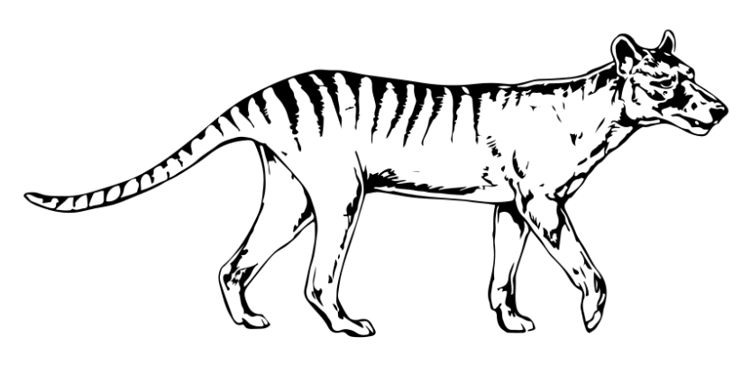
Habitat | Australian mainland, Tasmania and Papua New Guinea
Threats/factors for extinction | - Habitat loss due to land clearing for the farming of sheep and cattle.  - Hunting was encouraged through government payments for killing Thylacines.  - Introduced diseases from wild dogs.
Table 16 – summary of information about the Southern Corroboree Frog sample response
Scientific name | Pseudophryne corroboree
Common name | Southern Corroboree Frog
Status | Critically endangered
Image/sketch | 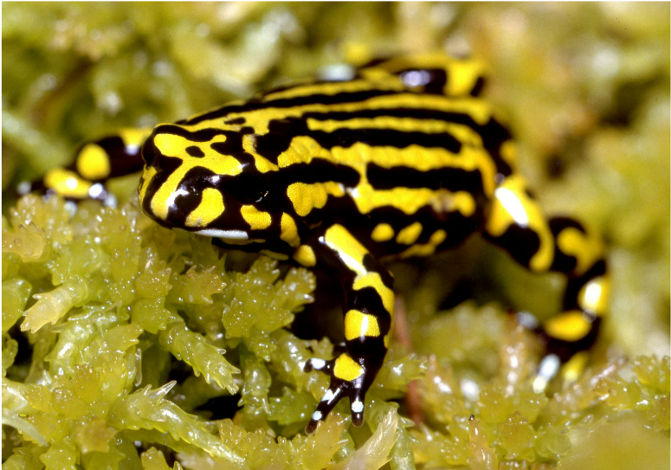
Habitat | The Southern Corroboree frog lives in the Kosciuszko National Park in NSW. During the warmer months, they live in small pools and damp grassy areas. In winter, the frogs burrow under the snow.
Threats/factors for extinction | - Exposure to disease (chytrid fungus).  - Damage to breeding sites by feral pigs and horses.
Protective actions | - Breeding insurance populations at Taronga Zoo to be re-released into wild habitat.  - Protection of breeding sites.

Student resource – endangered and extinct species
Table 1 – summary of information about the Thylacine
Scientific name
Common name
Status
Image/sketch
Habitat
Threats/factors for extinction

Table 2 – summary of information about the Southern Corroboree Frog
Scientific name
Common name
Status
Image/sketch
Habitat
Threats/factors for extinction
Protective actions

Australia’s unique context
- Show students LIV PPT ‘2.7 Globally threatened species (1–2)’ to help students understand global trends in threatened species. Ask students to identify trends in the data provided. Facilitate a class discussion on potential reasons for these trends. Refer to the speaker’s notes in LIV PPT for discussion prompts.
- Show students LIV PPT ‘2.7 NSW threatened species’ to help them understand trends in endangered and extinct organisms in NSW over time. Ask students to identify trends in the data presented. Support a class discussion on possible reasons for these trends. See presenter notes in LIV PPT for discussion prompts.
- Show students LIV PPT ‘2.7 Australia’s unique context’ to teach students about the unique context within Australia that leads to high rates of endangered organisms.
- Students will require access to computers and the internet to complete this activity. Access the Threatened species webpage to select your local region. This will generate a list of threatened species found in the selected bioregion. Students can select an organism from the list to view its hyperlinked fact sheet. They can then use the information from the fact sheet to create a keeper talk script of 1–2-minutes on the chosen endangered species. Students can subsequently present the keeper talk to the class either as a presentation or a video. Show students LIV PPT ‘2.7 Endangered organism keeper talk’ to guide them in constructing their script.
Sample response: script for endangered species keeper talk
Hello, everyone! I’m [Name], a keeper at the Australian Reptile Park, and today I’m introducing you to a fascinating but endangered creature – the Grey Snake.
The Grey Snake is a small, venomous, front-fanged snake. Adults reach around 60 centimetres in length. They're grey to olive in colour, with pale bellies and, as adults, often lose the dark head markings seen in babies.
This snake lives in southern inland New South Wales, along rivers and swamps. They prefer wetlands with clay soil, where they can hide in cracks, among logs, under rocks or in old burrows. At night, they come out to hunt frogs, which are their main food source.
The Grey Snake is listed as Endangered, as the species faces many threats. One of the main threats to the Grey Snake is poisoning from cane toads, as mentioned earlier. Frogs are their main food source. Other threats to this species include habitat loss from farming, changes to water systems, and predation by introduced species such as cats and foxes.
So, what can we do to help? Scientists and land managers are working to control damaging animals such as pigs, cats, foxes and cane toads. They are also managing and protecting water systems to ensure wetlands can flood properly and the snakes have suitable habitats to recover.
The Grey Snake is an important part of Australia’s wildlife. With the right actions, we can give it a chance to survive into the future.

Evidence base
This resource contains NSW Curriculum and syllabus content. The NSW Curriculum is developed by the NSW Education Standards Authority (NESA). This content is prepared by NESA for and on behalf of the Crown in right of the State of New South Wales. The material is protected by Crown copyright.
Please refer to the NESA Copyright Disclaimer for more information https://www.nsw.gov.au/education-and-training/nesa/copyright.
NESA holds the only official and up-to-date versions of the NSW Curriculum and syllabus documents. Please visit NESA https://www.nsw.gov.au/education-and-training/nesa and NSW Curriculum https://curriculum.nsw.edu.au.
Science 7–10 Syllabus © NSW Education Standards Authority (NESA) for and on behalf of the Crown in right of the State of New South Wales, 2023.
AITSL (Australian Institute for Teaching and School Leadership Limited) (n.d.) Learning intentions and success criteria [PDF 251 KB], AITSL, accessed 27 March 2025.
Australian Museum (2020) ‘Freshwater crocodile’ Reptiles, Australian Museum website, accessed 29 August 2025.
Australian Wildlife Conservancy (2025) Yellow-spotted Monitor’, Explore Wildlife, Australian Wildlife Conservancy website, accessed 29 August 2025.
BBC Studios (11 Apr 2014) ‘Invasion Of The Deadly Cane Toads – Australia with Simon Reeve [video]’, BBC Studios, YouTube, accessed 12 November 2025.
Brookhart SM (2018) ‘Appropriate Criteria: Key to Effective Rubrics’, Frontiers in Education, volume 3(22):1–12, doi:10.3389/feduc.2018.00022, accessed 27 March 2025.
CESE (Centre for Education Statistics and Evaluation) (2020) What works best: 2020 update, NSW Department of Education, accessed 27 March 2025.
——(2020) What works best in practice, NSW Department of Education, accessed 27 March 2025.
——(2021) Growth goal setting – what works best in practice, NSW Department of Education, accessed 27 March 2025.
DCCEEW (Department of Climate Change, Energy, the Environment and Water) (2023) ‘Northern Quoll’, DCCEEW website, accessed 22 February 2026.
Finter R (12 August 2024) ‘Australia’s Cane Toad Catastrophe’, Storymaps, accessed 29 August 2025.
Fisher D and Frey N (1 November 2009) ‘Feed Up, Back, Forward’, ASCD (Association for Supervision and Curriculum Development): Educational Leadership magazine, 67(3), accessed 27 March 2025.
Griffin P (2017) Assessment for Teaching, Cambridge University Press, Port Melbourne, Victoria.
Hattie J and Timperley H (2007) ‘The Power of Feedback’, Review of Educational Research, 77(1): 81–112, doi:10.3102/003465430298487.
Letnic M (2007) The impact of cane-toads on the trophic cascades of freshwater ecosystems in the Northern Territory, The Herman Slade Foundation, accessed 27 March 2025.
Mark Drollinger (29 March 2013) ‘Abiotic and Biotic Factors [video]’, Mark Drollinger, YouTube, accessed 12 November 2025.
Moore HA., Dunlop JA, Valentine LE, Woinarski JC, Ritchie EG, Watson DM and Nimmo DG (2019) ‘Topographic Ruggedness and Rainfall Mediate Geographic Range Contraction of a Threatened Marsupial Predator’, Diversity and Distributions, https://onlinelibrary.wiley.com/doi/10.1111/ddi.12982.
National Geographic (2025) Unicellular vs. Multicellular, National Geographic, accessed 27 March 2025.
NESA (NSW Education Standards Authority) (2023) ‘Data Book: Science 7–10', Teaching resources, NESA, accessed 22 February 2026.
Panadero E and Jonsson A (2013) ‘The use of scoring rubrics for formative assessment purposes revisited: A review’, Educational Research Review, 9:129–144, doi:10.1016/j.edurev.2013.01.002, accessed 27 March 2025.
Sherrington T (2019) Rosenshine’s Principles in Action, John Catt Educational Limited, Melton, Woodbridge.
Smith JA and Brown LM (2013) ‘Invader impact clarifies the roles of top-down and bottom-up effects on tropical snake populations’, Functional Ecology, 27(2):351-361, doi/10.1111/1365-2435.12044.
Taronga Zoo Sydney (n.d.) ‘Corroboree Frog Keeper Talk at Taronga Zoo Sydney [video]’, Taronga Zoo Sydney, YouTube, accessed 12 November 2025.
Wiliam D (2017). Embedded Formative Assessment, 2nd edn, Solution Tree Press, Bloomington, IN.

© State of New South Wales (Department of Education), 2026
The copyright material published in this resource is subject to the Copyright Act 1968 (Cth) and is owned by the NSW Department of Education or, where indicated, by a party other than the NSW Department of Education (third-party material).
Copyright material available in this resource and owned by the NSW Department of Education is licensed under a Creative Commons Attribution 4.0 International (CC BY 4.0) license.

This license allows you to share and adapt the material for any purpose, even commercially.
Attribution should be given to © State of New South Wales (Department of Education), 2026.
Material in this resource not available under a Creative Commons license:
- the NSW Department of Education logo, other logos and trademark-protected material
- material owned by a third party that has been reproduced with permission. You will need to obtain permission from the third party to reuse its material.
Links to third-party material and websites
Please note that the provided (reading/viewing material/list/links/texts) are a suggestion only and implies no endorsement, by the New South Wales Department of Education, of any author, publisher, or book title. School principals and teachers are best placed to assess the suitability of resources that would complement the curriculum and reflect the needs and interests of their students.
If you use the links provided in this document to access a third-party's website, you acknowledge that the terms of use, including licence terms set out on the third-party's website apply to the use which may be made of the materials on that third-party website or where permitted by the Copyright Act 1968 (Cth). The department accepts no responsibility for content on third-party websites.

