Science Stage 4 (Year 8) – Living systems
Teacher resource book 1 of 2 (TRB1)
How does the structure and organisation of multicellular organisms allow them to function optimally?
Creation date: 27 January 2026
Contents
Overview 3
Glossary 3
1.1 Introduction to living systems 8
What are living systems? 8
From cells to systems 11
1.2 The digestive system 17
Structure and role of the digestive system 17
Modelling the processes and functions of the digestive system – practical investigation 24
Relating structures and specialised cells in the digestive system to function 31
1.3 The respiratory system 38
Structure and role of the respiratory system 38
Modelling the processes and functions of the respiratory system – practical investigation 43
Relating structures and specialised cells in the respiratory system to function 49
1.4 The circulatory system 56
Structure and role of the circulatory system 56
Modelling blood circulation around the body 71
Relating structures and specialised cells in the circulatory system to function 73
1.5 The excretory system 81
Structure and role of the excretory system 81
Modelling the processes and function of the excretory system 85
Relating the structures and specialised cells to function 89
1.6 Body systems working together 94
Providing needs for organisms 94
Interactions between body systems 96
1.7 Body systems malfunction 105
Diseases and disorders in body systems 105
Investigating impacts on body systems and the organism (secondary-source investigation) 106
1.8 Plant systems 115
Flower dissection – practical investigation 123
Observing specialised cells and tissues in plants – practical investigation 133
Comparing like-for-like 143
Evidence base 146

Overview
Stage and learning area: Stage 4 Science
Description: this resource complements the Living systems program of learning. It aims to serve as a teacher reference, offering practical strategies and ideas to enrich teaching practices and create engaging learning environments. The activities should be adapted to suit students’ needs.
Duration: while timing will vary based on the mode of delivery, differentiation strategies employed, and class or school context, this series of activities should take approximately 14 hours.
Risk management: teachers are advised to undertake a risk assessment before conducting any classroom investigation or experiment. For more information on developing risk assessments, see Risk Assessment – a pre-requisite for risk control.
This resource book elaborates on many of the activities in the Living systems sample program of learning. Some activities also reference the Living systems slide deck (identified as LIV PPT throughout this document).

Glossary
Tier 3 words are those that are relevant for subject-specific content. More information is provided in the ‘Vocabulary in context’ document found at the Stage 4 reading – vocabulary in context page. It is also important that Tier 2 vocabulary be explicitly taught to students to support their understanding and comprehension of texts. These words appear more frequently in texts, so students are less likely to learn them without assistance.
The Guide for planning and implementing explicit vocabulary instruction and Word consciousness-learning sequence resource can be used by teachers across all curriculum areas. It provides a process for planning and implementing explicit vocabulary instruction.
Table 1 – glossary of Tier 3 words in content for essential question 1 of the Living systems focus area
Term | Definition
Body system (Organ system) | A body system is a group of organs in an animal that work together to perform a specific function. For example, the digestive system includes organs such as the mouth, stomach and intestines, along with associated glands. Its job is to break down food and absorb nutrients that the body needs for energy and other functions.
Cell | The fundamental building block of living organisms. All cells have a fluid-filled interior enclosed by a membrane. Cells may contain internal structures called organelles and external structures such as cell walls.
Characteristic | A distinguishing aspect (including features and behaviours) of an object, material, living thing or event (NESA 2023).
Chemical digestion | Chemical digestion is the process of breaking down molecules into smaller ones that the body can absorb and use for energy, growth and repair. This occurs in the presence of chemicals such as acids, enzymes and bile.
Data | Information that is collected, organised and analysed for various purposes. It can be in the form of numbers, text, images or any other format that can be processed. Data can be represented using techniques such as tables, graphs and textual explanations (NESA 2023).
Digestion | The process by which the body breaks down food, both physically and chemically, so it can be used for energy, building tissues and repairing the body.
Disease | An illness or condition of the body affecting the way an organism, or parts of an organism, or its organs, function (NESA 2023).
Disorder | A disturbance of physical, mental or genetic health (NESA 2023).
Ecosystem | A system formed by the interaction of all living organisms (plants, animals, humans) with each other and with the physical elements of the environment in which they live (NESA 2023).
Enzyme | Substances that speed up a chemical reaction without being consumed in the reaction.
Evidence | Valid and/or reliable data that can be used to support a particular theory, hypothesis, idea or conclusion (NESA 2023).
Explanation | A scientific explanation provides an account of a phenomenon through descriptive statements about how that phenomenon came to be (NESA 2023).
Interactions | Actions or influences between components and within and between systems (NESA 2023).
Interdependency | The condition of being dependent on each other. The state of being mutually dependent or dependent on each other (NESA 2023).
Living system | A living system is one that takes in energy and materials from its surroundings and uses them to stay alive, grow and reproduce. Living systems can adapt to internal and external changes. This includes things as small as a single cell or as big as an ecosystem.
Model | A mathematical, conceptual or physical representation that describes, simplifies, clarifies or provides an explanation of the structure, workings or relationships within an object, system or idea. Models can provide a means of testing and predicting behaviour within limited conditions. Models may be physical or exist in digital form (NESA 2023).
Multicellular organism | Multicellular organisms consist of many specialised cells arranged into tissues, organs and body systems. These specialised cells work cooperatively to perform various life functions.
Nutrient | A substance needed by organisms to live and grow. For example, carbohydrates, fats and proteins.
Organ | Organs are structures within organisms designed for specific functions. Each organ is made up of different tissues that work together. For example, the kidneys of mammals are organs that excrete (remove) metabolic wastes.
Organism | An organism is a living thing and can be made up of one cell (such as bacteria) or many cells (such as plants and animals). Organisms show characteristics of life, such as movement and response to stimuli.
Peristalsis | The involuntary, wave-like muscle movements in the digestive tract that push food through the digestive system.
Phloem | A tissue in vascular plants that transports organic nutrients, particularly sugars, from leaves to other parts of the plant, including roots, stems and developing fruits (NESA 2023).
Plant systems | The organisation of various organs and tissues that work together to support a plant’s growth and survival.
Qualitative | To use descriptive explanations involving features, characteristics or properties to identify important components. Data and information that is not numerical in nature (NESA 2023).
Quantitative | Data or components that can be expressed or measured numerically, including chemical formulae or numbers (NESA 2023).
Relate | To establish a connection or association between two or more things, often by identifying similarities, connections, or shared characteristics (NESA 2023).
Scientific equipment | The specialised tools, instruments and devices used in scientific research and experiments to measure, observe, collect data and analyse results.
Secondary sources/ information | Sources of information that have been collected, processed, interpreted and published by others, for example, census data, newspaper articles and images or information in a published report (NESA 2023).
Specialised cell | A cell in a multicellular organism that has a unique structure and function, allowing it to carry out a specific job, such as carrying oxygen or contracting to produce movement.
System | A set of components in the natural and made environments that interact. An understanding of natural complex systems requires the integration and application of concepts from more than one science discipline (NESA 2023).
Tissue | An organised collection of similar specialised cell types, such as nervous tissue or connective tissue.
Xylem | A type of plant tissue responsible for transporting water and dissolved minerals from the roots to the rest of the plant (NESA 2023).

1.1 Introduction to living systems
Table 2 – learning intention and success criteria for ‘1.1 Introduction to living systems’
We are learning: | I can:
- to describe the structure of living systems and their components. | - define living system  - identify examples of living systems such as body systems, plant systems and ecosystems  - identify components of body systems, plant systems and ecosystems  - outline that components of living systems are interdependent on each other  - identify what cells, tissues and organs are, including examples  - explain that cells form tissues and that tissues form organs.

What are living systems?
The purpose of this activity is to introduce students to living systems and to link the content groups so students can see how they connect within the unit. Students will gain an overview of body systems, plant systems and ecosystems. They will be introduced to the idea that living systems are composed of many interacting components.
- Define the term living system with examples using LIV PPT ‘1.1 Defining living system’.
Note: the definition of ‘system’ is also provided in the speaker notes of the slide in LIV PPT ‘1.1 Defining living system’. This is to help students define a living system, as the term ‘system’ is part of its definition.
- Introduce students to the living systems in this focus area: body (organ) systems, plant systems and ecosystems by defining the terms using LIV PPT ‘1.1 Types of living systems (3 slides)’.
- Assign LIV PPT ‘1.1 Which system does it belong to? (1–3)’ to students digitally. Ask students to identify relevant components of body (organ) systems, plant systems and ecosystems. Students are presented with images of components related to a human body (organ) system (respiratory), plant systems and ecosystems. Students select the components that relate to the system on each slide, then drag the image over. Note that students do not need to select a label for each image; the labels are provided only to help students identify each image.
- Facilitate class discussion using LIV PPT ‘1.1 Which system does it belong to? (4 of 4)’ to check that students have correctly identified the components of each system.
Figure 1 – sample response for ‘1.1 Which system does it belong to? (4 of 4)’
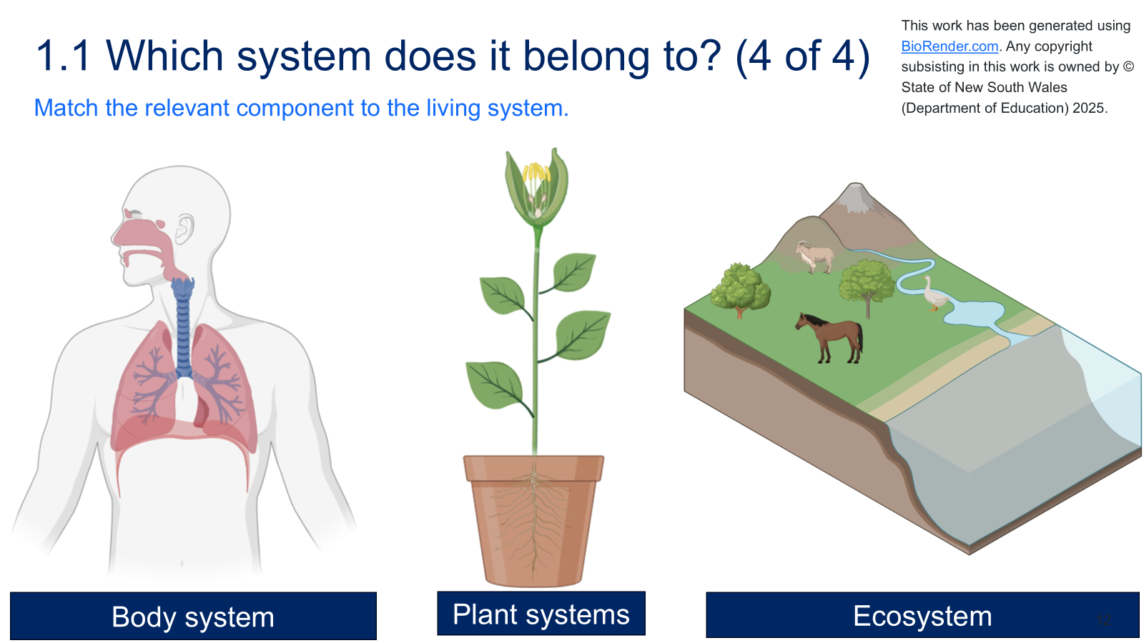
- Body system: this image shows a human body system, specifically the respiratory system (students should have learned about this in Stage 3). Components of this body system include the upper respiratory system, the diaphragm and the lower respiratory system.
- Plant systems: this image shows a whole organism, a plant, made up of different systems within the plant, such as the flower, stem with leaves and root system.
- Ecosystem: this shows an ecosystem containing living and non-living things. The ecosystem comprises living things such as trees, horses, geese and goats, as well as non-living components such as water and soil nutrients. An ecosystem is a system of systems (a super system) in that it represents the interaction of animal and plant systems (biotic) and environmental systems (the spheres).
- Students Think-Pair-Share to answer the questions in the LIV PPT ‘1.1 Parts of living systems’ to outline that systems are made up of many interdependent components. Sample responses to the questions are provided in the slide's speaker notes and in Sample student responses (Think-Pair-Share).
- Think: students independently engage with the questions on the slide and consider a response.
- Pair: students pair up with a classmate and share their responses.
- Share: students will share their responses with the class in a whole-class discussion.
Sample student responses (Think-Pair-Share)
- I can see the lungs and diaphragm. (Body system) There are roots, a stem, leaves and a flower. (Plant systems) There are trees, animals, water and grass. (Ecosystems)
- The systems are all made up of different parts. The parts have a different job. The parts work together for a purpose.
- If the roots are damaged, they could not absorb water and the plants might die. If there was no water, the plants would not be able to grow and animals would have nothing to drink.
Checkpoint: provide students with the word bank and incomplete sentences in LIV PPT ‘1.1 Checkpoint 1’ to assess their understanding of what a living system is and the types of living systems in this focus area. A sample response is provided in Figure 2.
Figure 2 – checkpoint 1 sample response
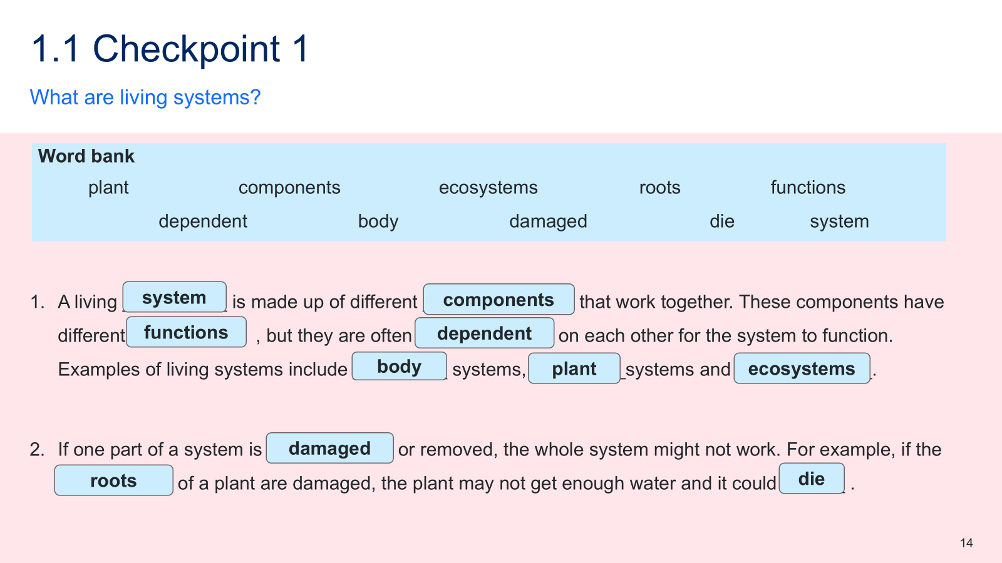

From cells to systems
Students should have prior knowledge of the organisation of life from cells to organisms, as covered in ‘Cells and classification’ in Year 7. To begin this sequence of activities, a prior knowledge assessment will be conducted to evaluate students' understanding.
- Inform students that humans are multicellular organisms and the body is made up of many organ systems, the digestive system being an example, using LIV PPT ‘1.1 Humans as organisms’.
Checkpoint 2: assess students' understanding of the organisation of life, from cells to systems, including cellular specialisation and its role in tissue function, using LIV PPT ‘1.1 Checkpoint 2’. A sample response is provided in Figure 3. If students are having difficulty recalling this information or have a misunderstanding, reteach the relevant concepts using the Stage 4 resource Cells and classification, activity 2.5 Multicellular organisms.
Figure 3 – checkpoint 2 sample response
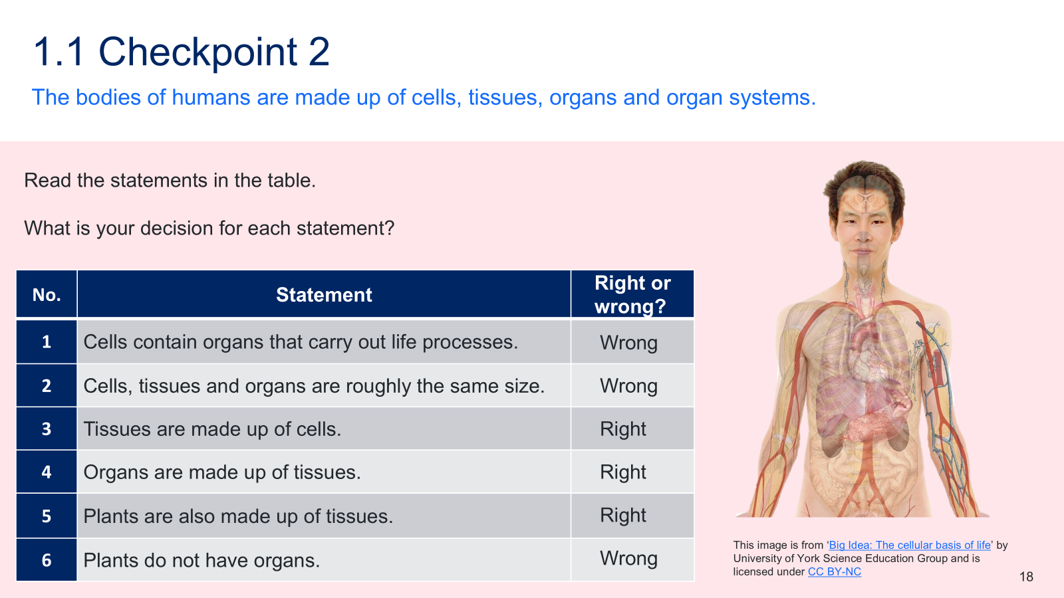
- Inform students about the importance of understanding the levels of organisation in multicellular organisms – from the entire organism to organ systems, organs, tissues, and, finally, cells – to help make sense of how the human body and plants function, using LIV PPT ‘1.1 The organisation of life’. Each level is composed of the level below it, and each structure has a specific role in keeping the body alive and working properly.
- Review students’ understanding of cells, including the role of specialised cells in multicellular organisms and the arrangement of specialised cells in tissues and organs, using the checkpoint questions in LIV PPT ‘1.1 Checkpoint 3’. These questions are designed to activate prior learning from the Stage 4 ‘Cells and classification’ focus area, particularly the content on cells.
Checkpoint 3: assess students' prior knowledge of specialised cells, their roles and the relationship between cells and tissues using LIV PPT ‘1.1 Checkpoint 3.’ Provide students with the questions below and ask them to construct a response in their book.
Specialised cells and their role
- What are specialised cells? Provide some examples of specialised cells in the body.
Specialised cells have specific structures and functions that enable them to perform specific tasks in the body. To perform those functions, specialised cells have unique sizes, shapes and cellular components. For example, red blood cells carry oxygen, nerve cells transmit signals, and muscle cells help with movement.
- Why are specialised cells important in multicellular organisms?
Specialised cells are important in multicellular organisms because they allow the body to perform a wide range of functions efficiently. Each type of specialised cell is adapted to perform specific tasks, which help the organism survive.
- Using an example, describe the relationship between specialised cells and tissues.
Specialised cells work together to form tissues. They differ in size, shape and cellular components, enabling them to perform specialised functions in tissues. For example, nerve cells are long and have branches, so they can send electrical signals. Many nerve cells together form nerve tissue that carries messages around the body.
If students are having difficulty recalling this information or have a misunderstanding, reteach the relevant concepts using the Stage 4 resource Cells and classification, activity 2.5 Multicellular organisms.
- Explain the interrelationship between cells, tissues and organs, using the information in LIV PPT ‘1.1 Organisation of the human body’ and LIV PPT ‘1.1 The interrelationship between cells, tissues and organs 1–6’.
- Present LIV PPT ‘1.1 The interrelationship between cells, tissues and organs (slide 1 of 6)’ to provide students with the flow chart structure that they copy into their books. As each slide is covered in LIV PPT ‘1.1 The interrelationship between cells, tissues and organs (slide 2–5)’, students summarise the information as a flow chart in their books to explain the interrelationship between cells, tissues and organs.
- Facilitate class discussion to check students’ understanding of the interrelationship between cells, tissues, organs and systems, using the completed flow chart in LIV PPT ‘1.1 The interrelationship between cells, tissues and organs (slide 6 of 6)’. The discussion points are in the speaker notes on the slide and below:
- Cells are the basic building blocks of life. They provide structure for the body, take in nutrients from food, convert those nutrients into energy and carry out specialised functions. Specialised cells carry out specific functions. For example, a muscle cell contracts, and a red blood cell carries oxygen around the body.
- Tissues are groups of specialised cells working together to do a specific job. For example, muscle tissue helps with movement.
There are 4 types of tissue in the body. These are muscle tissue, connective tissue, epithelial tissue and nerve tissue.
Connective tissue: supports and links different parts of the body. It is the most abundant and diverse tissue type, including bone, blood, fat (adipose), cartilage, tendons and ligaments.
Muscle tissue: allows for movement through contraction. The 3 types are skeletal (voluntary movement), smooth (found in internal organs) and cardiac (heart muscle).
Epithelial tissue: forms protective barriers and covers body surfaces, such as the skin and the linings of the digestive tract and airways. It plays roles in protection, secretion, excretion, diffusion and absorption.
Nerve tissue: found in the brain, spinal cord and nerves. It is responsible for coordinating and controlling many body activities.
- An organ is made up of 2 or more different tissues working together to perform a specific function. For example, the heart has muscle tissue (to pump blood) and connective tissue (for structural support).
- A system is a group of organs working together to perform various functions in the body. For example, the circulatory system includes the heart and blood vessels to transport oxygen and nutrients around the body.
- Provide students with the Student resource – cells, tissues and organs to unpack examples of cells, tissues and organs in the human body and how they are interrelated.
- Model how to complete the activity by matching the first box, ‘muscle cells are specialised for contraction’, to the correct tissue and then to the organ.
- Jointly construct the remainder, or students complete the activity independently. This enables students to use examples from their prior knowledge to illustrate the interrelationship between cells, tissues and organs.
- Facilitate class discussion to determine students’ understanding of the relationship between the specific cells, tissues and organs, using the sample response and slide notes in LIV PPT ‘1.1 From cell to organ’.
Sample response: Student resource – cells, tissues and organs
Figure 4 – sample response for ‘1.1 From cell to organ’
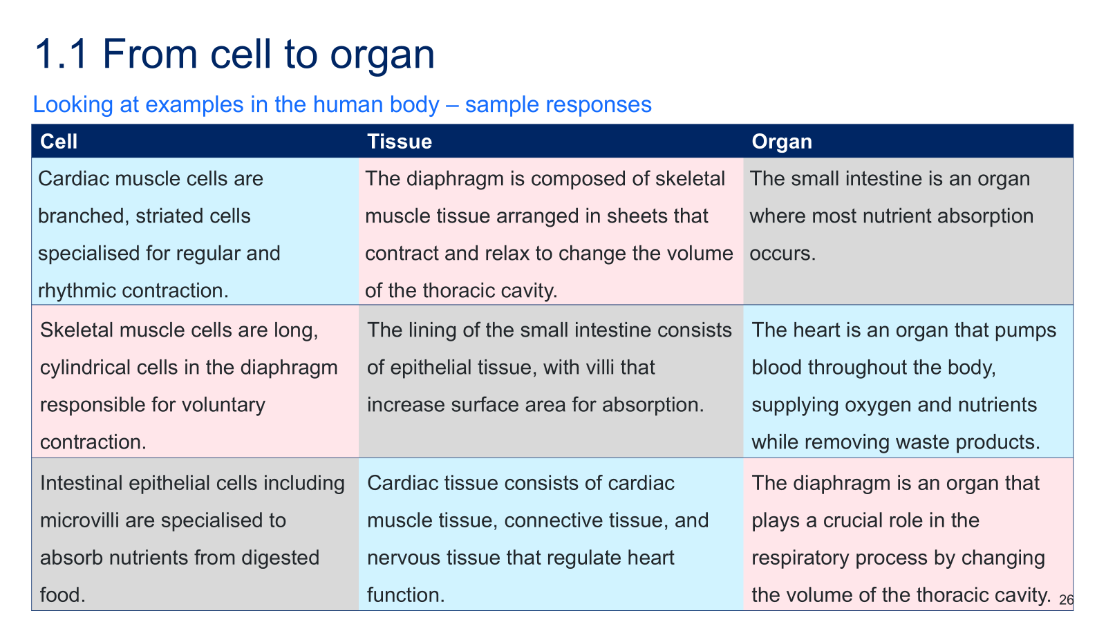
Checkpoint 4: provide students with the cloze passage in the LIV PPT ‘1.1 Checkpoint 4’ to assess their understanding of the interrelationships between cells, tissues and organs. A sample response is provided in Figure 5.
Figure 5 – checkpoint 4 sample response
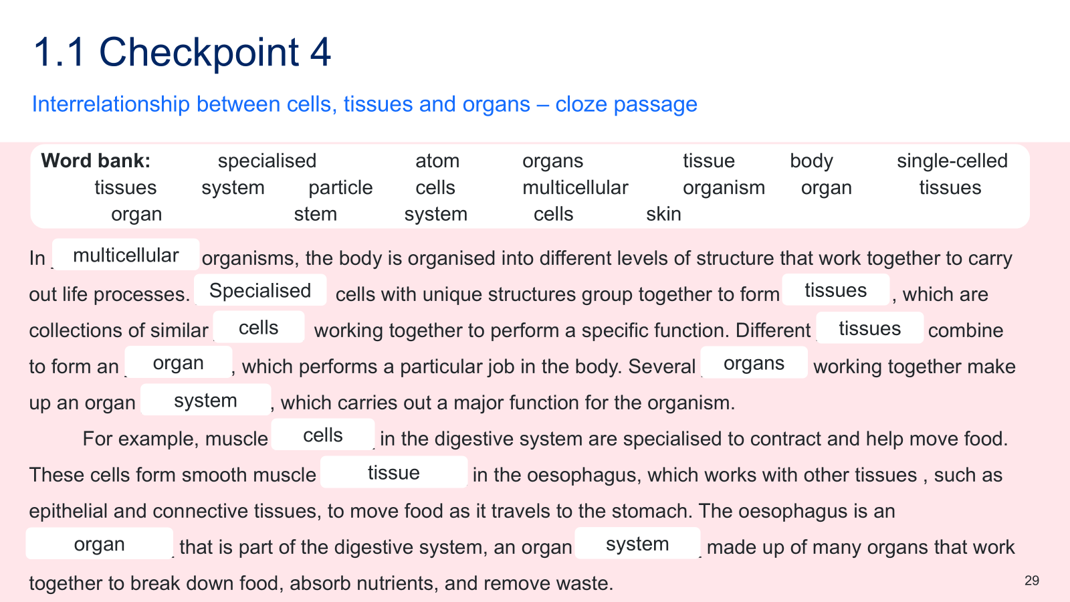

Student resource – cells, tissues and organs
Instructions: use different coloured pencils to match each specialised cell to the correct tissue and organ. Alternatively, rewrite the matching cell, tissue and organ descriptions in your book.
Table 1 – a range of cells, tissues and organs that are mismatched
Cell | Tissue | Organ
Cardiac muscle cells are branched, striated cells specialised for regular and rhythmic contraction. | The diaphragm is composed of skeletal muscle tissue arranged in sheets that contract and relax to change the volume of the thoracic cavity. | The small intestine is an organ where most nutrient absorption occurs.
Skeletal muscle cells are long, cylindrical cells in the diaphragm responsible for voluntary contraction. | The lining of the small intestine consists of epithelial tissue, with villi that increase surface area for absorption. | The heart is an organ that pumps blood throughout the body, supplying oxygen and nutrients while removing waste products.
Intestinal epithelial cells, including microvilli, are specialised to absorb nutrients from digested food. | Cardiac tissue consists of cardiac muscle tissue, connective tissue and nervous tissue that regulate heart function. | The diaphragm is an organ that plays a crucial role in the respiratory process by changing the volume of the thoracic cavity.

1.2 The digestive system
Table 3 – learning intentions and success criteria for ‘1.2 The digestive system’
We are learning: | I can:
- to describe the role, structure and function of body systems and their components | - identify the organs of the digestive system  - identify the role of the digestive system  - model processes of the digestive system, such as physical and chemical digestion  - describe how structures and specialised cells in the digestive system relate to their function
- to extract, process and represent data. | - identify key points in a text  - summarise key points to annotate and complete a flow chart of the digestive system  - use a flow chart to represent information about the processes and functions of the digestive system.
Note: physical digestion is referenced in this activity. This is synonymous with mechanical digestion, as both terms refer to physical processes, such as chewing and muscle contractions, that break down food into smaller particles to facilitate more efficient chemical digestion. In physical digestion, the chemical makeup of the food is not altered.

Structure and role of the digestive system
Checkpoint 1: determine students’ prior knowledge of the main organs of the human digestive system and their function (Stage 3 content) using LIV PPT ‘1.2 Checkpoint 1.’ A sample response has been provided in Figure 6. Instructions on how to respond when students provide a range of answers are in the speaker notes on the slide.
Note: students will not need to use all the words in the word bank. The intent of checkpoint 1, is to determine if students can first identify the organs of the digestive system and then match the organs of the digestive system to their function. The lungs and heart are not part of the digestive system and, therefore, should not be used in this activity.
Figure 6 –checkpoint 1 sample response
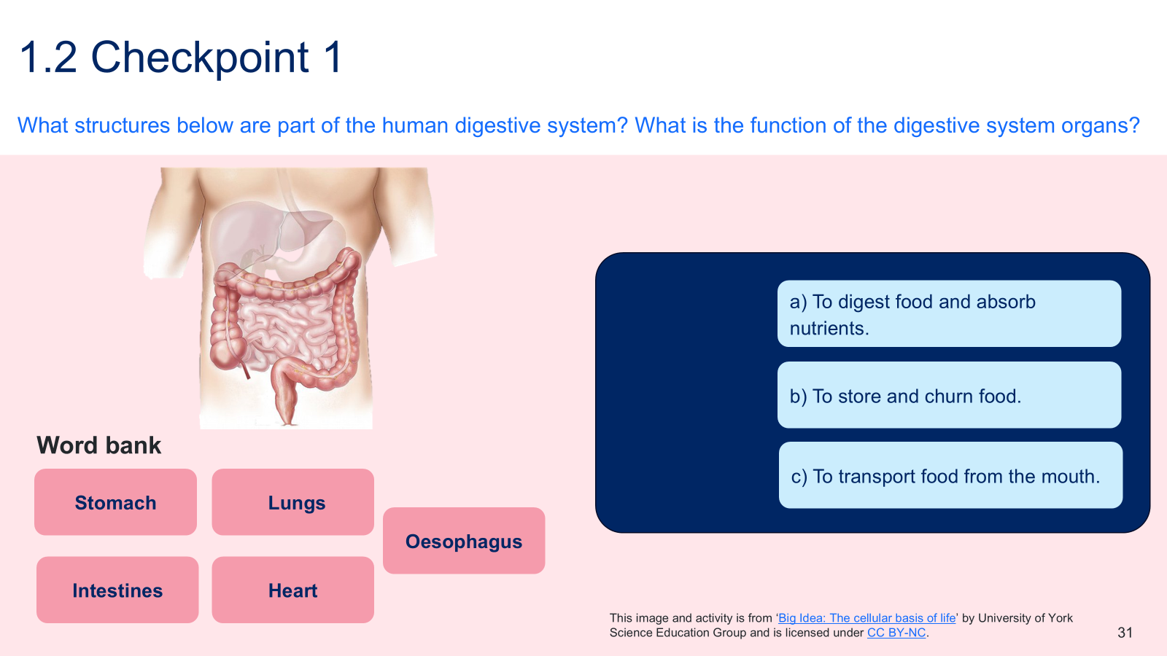
- Provide students with the digestive system text in the Student resource – structure and function of the digestive system, either digitally or printed.
- As a class, engage with the text to complete the ‘Labelling the organs of the digestive system’ activity. Explicitly teach students how to scan a text. Model strategies for identifying keywords (for example, highlighting) and locating and interpreting information in a text. The key information in this text concerns the organs of the digestive system, their characteristics and their locations.
For more information and instructions on how to teach students to scan and locate information in a text, refer to Stage 4 reading – Literal comprehension.
- Model how to use an identified key point to label organs on the digestive system diagram. For example, as the teacher describes, ‘Digestion begins in the mouth, where physical digestion takes place as the teeth break food into smaller pieces during chewing’, students will label the mouth on the digestive system diagram. Continue to model, jointly construct or ask students to independently label the remainder of the digestive system diagram.
- Facilitate class discussion using the sample response in LIV PPT ‘1.2 Organs in the digestive system’ to check students' understanding of the organs in the digestive system, including the salivary glands, mouth, liver, oesophagus, gall bladder, stomach, small and large intestines, pancreas, rectum and anus. The locations of these organs in the body are shown in the figure below.
Figure 7 – sample response for ‘1.2 Organs in the digestive system’
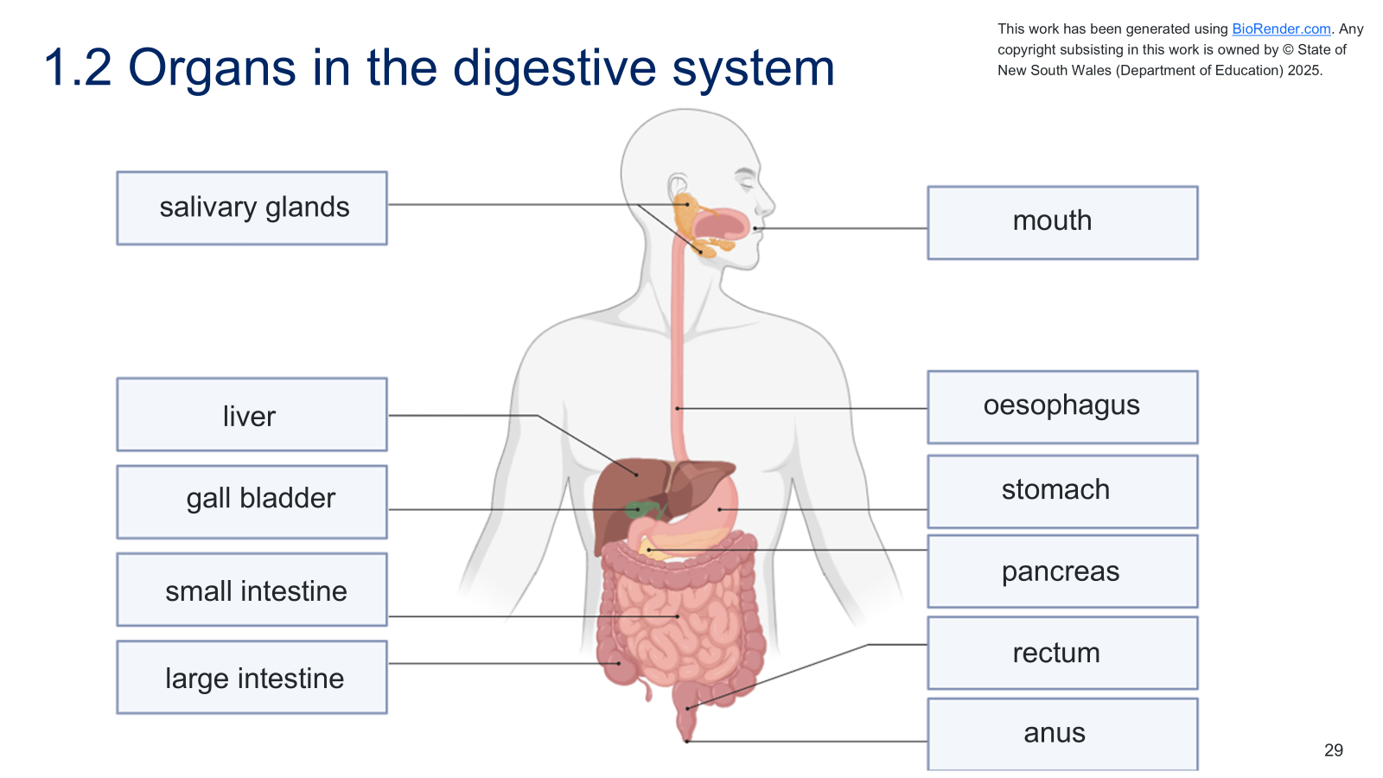
- Facilitate a class discussion by asking students to identify the role of the digestive system in the human body (this information is in the text given to students). The response is below:
- The role of the digestive system is to break down food into nutrients the body can absorb and use.
Checkpoint 2: assess students' understanding of the role of the digestive system using the multiple-choice question in LIV PPT ‘1.2 Checkpoint 2’.
Identify the role of the digestive system.
A. To store food so the body has a constant energy supply.
B. To move food through the body so it can exit as waste.
C. To break down food into nutrients the body can absorb and use.
D. To transport nutrients and oxygen to all parts of the body.
Information on why students may have selected incorrect responses is provided below and in the slide's speaker notes.
Table 4 – checkpoint response explanation
Response | Explanation
A | Students may associate the stomach with food ‘storage’ and assume that's its main role. This response confuses temporary storage in the stomach with the main purpose of digestion, which is nutrient breakdown and absorption.
B | Students may focus on the food’s journey through the body and its eventual elimination. This response overemphasises elimination and overlooks the essential role of nutrient absorption.
C | This is the correct response.
D | Students may confuse digestion with circulation because nutrients are eventually delivered to cells. This response confuses the roles of the circulatory and digestive systems.

Sample response: Student resource – structure and function of the digestive system
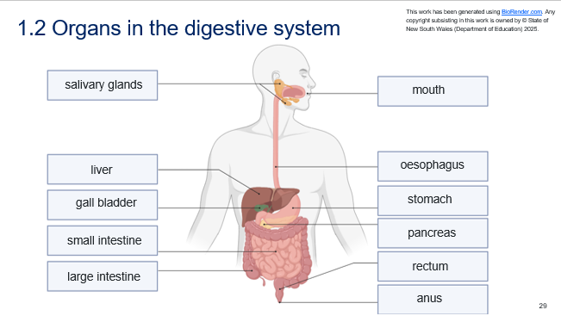

Student resource – structure and function of the digestive system
Instructions: engage with the ‘The digestive system’ text and use the words in bold to label the digestive system diagram.
The digestive system text
The digestive system is a group of organs that work together to digest the food you eat and absorb its nutrients for energy, growth and repair. Digestion begins in the mouth, where physical digestion occurs as the teeth break down food into smaller pieces. At the same time, chemical digestion begins as the salivary glands (located under the tongue and near the jaw) release saliva containing enzymes that start breaking down carbohydrates. The tongue then pushes the food mixture to the back of the mouth, triggering the swallowing reflex that moves food into the oesophagus. The food is then pushed down the oesophagus, a muscular tube in the chest, using a wave-like movement called peristalsis, which helps propel it into the stomach. The stomach, a J-shaped organ on the left side of the body under the ribs, continues physical digestion by churning the food, and continues chemical digestion by mixing it with strong acids and enzymes that break down proteins.
The partially digested food moves into the small intestine, a long, coiled tube in the centre of the abdomen, where digestion is completed. Nutrients are then absorbed into the bloodstream. Although the liver, gall bladder and pancreas are not involved in digestion, they are important accessory organs that release substances important for digestion. The liver, located in the upper right abdomen, produces bile to emulsify fats. Bile is either transported directly to the small intestine or stored in the gall bladder, a small pouch beneath the liver, then released into the small intestine when needed. The pancreas, located behind the stomach, produces and secretes (releases) enzymes into the small intestine to help digest carbohydrates, fats and proteins. Any remaining waste enters the large intestine, a wider tube that surrounds the small intestine and absorbs water. Finally, waste is stored in the rectum and exits the body through the anus.
This work has been generated using artificial intelligence. Any copyright subsisting in this work is owned by © State of New South Wales (Department of Education) 2025.

Labelling the organs of the digestive system – word bank
anus | gall bladder | large intestine | liver | mouth | stomach
oesophagus | pancreas | rectum | salivary glands | small intestine
Figure 1 – an unlabelled diagram of the digestive system
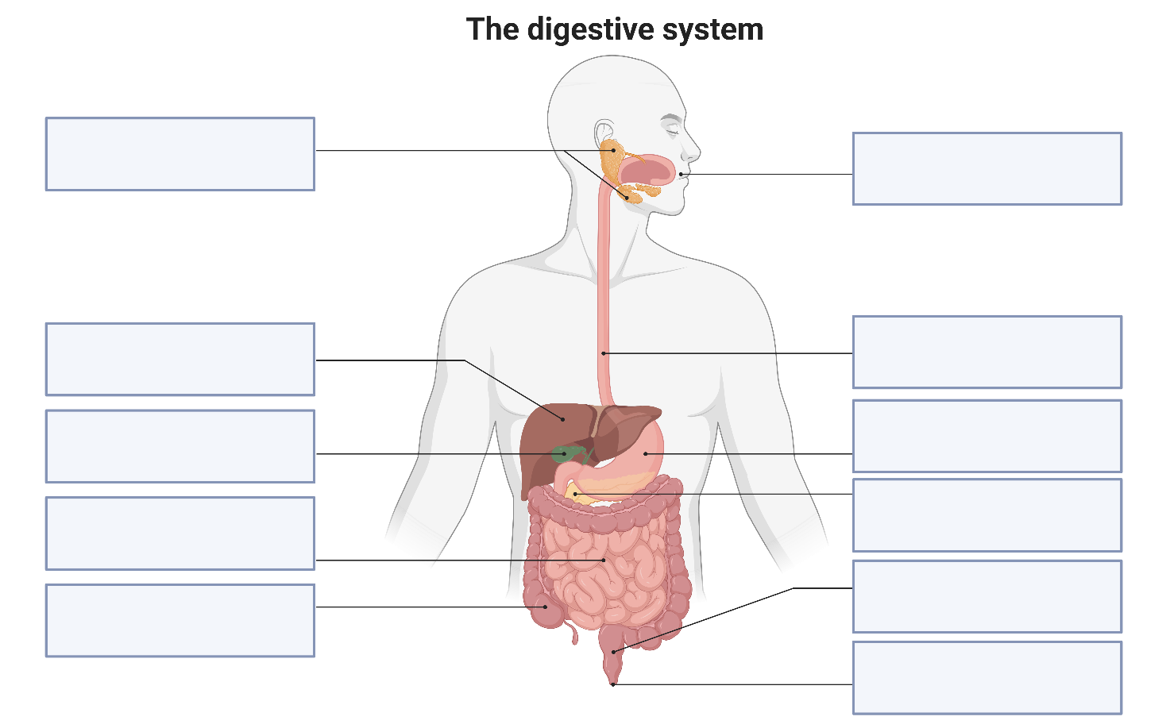
This work has been generated using BioRender.com. Any copyright subsisting in this work is owned by © State of New South Wales (Department of Education) 2025.

Modelling the processes and functions of the digestive system – practical investigation
To build this model, equipment must be ordered in advance. Students should work in groups of 3–4. Order the Equipment listed in the Student resource – modelling the digestive system. Students will also need water to build this model.
- Recall what a model is and outline the use of models in science LIV PPT ‘1.2 Models in science.’ Inform students that they will use models to describe the processes and functions of body systems, starting with the digestive system.
- Introduce students to the digestive system model by telling them they are going to build a hands-on (physical) model of the digestive system to demonstrate and describe how the human body breaks down food, absorbs nutrients, and gets rid of waste.
- Explore the equipment list and procedure in the Student resource – modelling the digestive system to determine the equipment required and how to create the model.
- Discuss safety considerations for students when building the model, including
- wearing safety goggles and gloves (gloves are optional)
- not consuming any of the food items or other substances
- cleaning up any spillages that occur immediately to prevent slipping
- washing hands after the activity
- Instruct students to complete ‘Describing the processes and functions of the digestive system’ in the student resource. Students will describe the processes and functions of the digestive system in a flow chart as they are building the model.
Note: students may not be familiar with flow charts. If students are not familiar with flow charts, define them as visual tools for representing processes or systems. Flow charts can help understand processes and systems and communicate complex information. The flow chart students are using will illustrate the processes in the body's digestive system to aid understanding of digestion.
- Students may need to refer to ‘The digestive system text’ to support relating the steps in the model to the digestive processes and function. Use Table 5 to support students what the materials of the model represent and to relate the steps of the model to the process/function in the digestive system.
Differentiation: include sentence starters for each component of the flow chart to help students describe processes in the digestive system. For example:
Cell
Basic building …
Specialised cells carry out …
Tissue
Groups of similar …
Types include …
Organ
Made up of 2 or more …
For example, the heart …
System
Groups of organs …
For example, the circulatory …
- Facilitate a class discussion of the student resource, Describing the processes and functions of the digestive system, using the sample response on the slide, LIV PPT ‘1.2 Modelling the digestive system (2 slides)’ to check students’ understanding of how the model relates to the processes and function of the digestive system. The sample responses are also in Figure 8 and Figure 9.
Table 5 – relating steps in the model to the digestive process/function
Step of the model | What the materials represent and why | Link between the model and the digestion process/function
- Place 5 crackers into a resealable zip sandwich bag. Add a small amount of water and a drop of dishwashing liquid. Seal the bag and gently mash the crackers with your hands. | The resealable zip sandwich bag represents the mouth. The crackers are food. Water represents saliva, and dishwashing liquid represents the enzymes released by the salivary glands. | Mashing the cracker simulates physical digestion (chewing). The liquid softens and starts to ‘break down’ the food, as in chemical digestion by enzymes. This initiates carbohydrate digestion in the mouth.
- Transfer the crushed crackers from the resealable zip sandwich bag into a stocking to simulate swallowing. Squeeze the food mixture through the stocking using your fingers. | The tube/stocking represents the oesophagus. The movement of your fingers to push the food down mimics the oesophagus's muscle contractions. | This model of peristalsis – the wave-like muscle movement that pushes food from the mouth to the stomach. No digestion occurs here; only transport.
- Transfer the food mixture into another resealable zip sandwich bag. Add 5 drops of vinegar. Seal the bag, then gently squeeze the mixture with your hands. | The second resealable zip sandwich bag is the stomach. The vinegar represents stomach acid. Your hands simulate the stomach’s muscular walls. | Squishing the bag mimics churning (physical digestion), and the acid simulates the chemical digestion of proteins. The stomach breaks food into smaller pieces using acid and enzymes.
- Line the inside of the stocking with a paper towel. Pour the mixture into the lined stocking, then add 2 drops of each of the different-coloured food dyes. | The stocking represents the small intestine, and the paper towel represents the villi – tiny finger-like structures that absorb nutrients. The coloured liquids represent bile (from the liver and gall bladder) and enzymes (from the pancreas). Dropper bottles represent these accessory organs. | These accessory organs release substances into the small intestine to aid digestion:  • Bile breaks down fats  • Enzymes break down proteins, carbohydrates and fats, supporting chemical digestion.
- Squeeze the mixture through the stocking over a tray. Watch the liquid absorb into the towel. | The stocking is the small intestine, and the paper towel represents the villi – tiny finger-like structures that absorb nutrients. | As you squeeze, the liquid (nutrients) is absorbed into the paper towel, like how nutrients pass through villi into the bloodstream. This models absorption in the small intestine.
- Transfer the remaining mixture in the stocking onto a paper towel and press gently. | The stocking on the paper towel is the large intestine. It absorbs any remaining moisture. | Pressing out the liquid simulates water absorption in the large intestine. This turns the waste into a more solid form, forming faeces.
- Push the remaining solid mixture through the cut end of the stocking into the tray. | The end of the stocking represents the rectum and anus. | This shows faeces being eliminated – the final stage in which waste is expelled from the body through the anus. The rectum stores waste before this occurs.
Sample response: Student resource – modelling the digestive system
Figure 8 – sample response for ‘1.2 Modelling the digestive system (slide 1)’
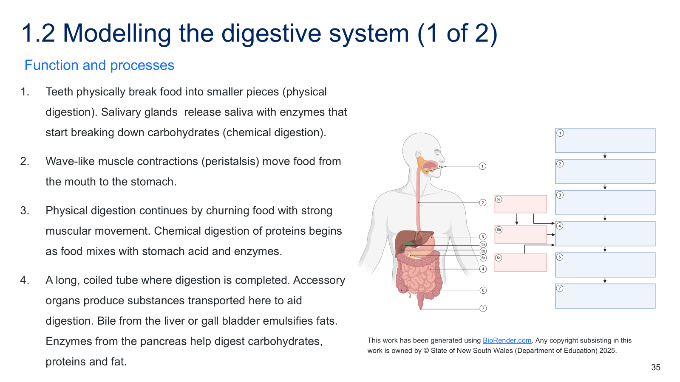
Figure 9 – sample response for ‘1.2 Modelling the digestive system (slide 2)’
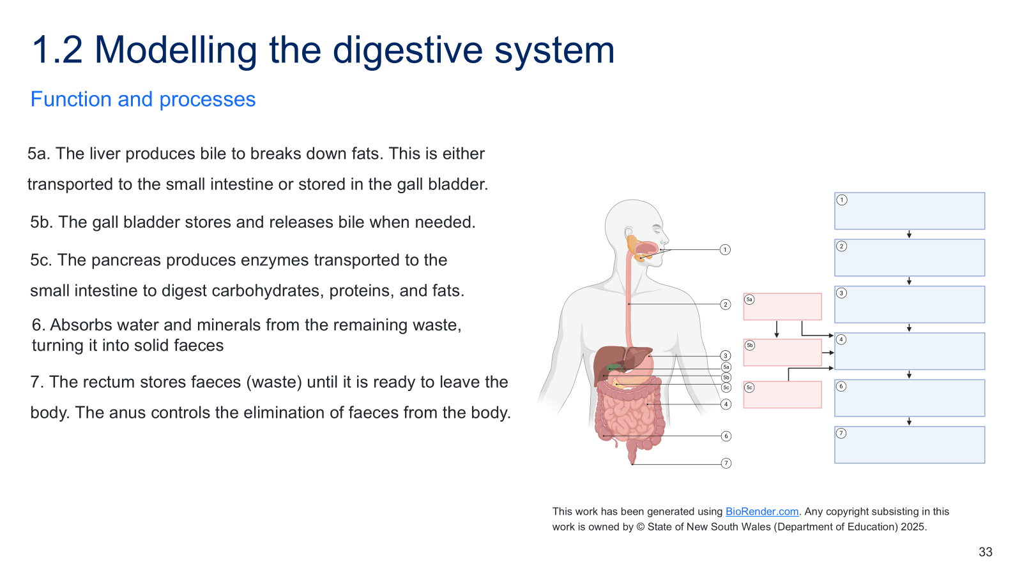

Student resource – modelling the digestive system
Equipment
- 2 x resealable zip sandwich bags
- 5 x crackers
- 1 x dropper bottle with dishwashing detergent
- 1 x dropper bottle with vinegar
- 1 x thin nylon stocking with the end cut off
- 1 x roll paper towel
- 1 x plastic tray
- Water
- 3 x dropper bottles with different coloured food dye.
Procedure
- Place 5 crackers into a resealable zip sandwich bag. Add a small amount of water and a drop of dishwashing liquid. Seal the bag and gently mash the crackers with your hands.
- Transfer the crushed crackers from the resealable zip sandwich bag into a stocking to simulate swallowing. Squeeze the food mixture through the stocking using your fingers.
- Transfer the food mixture into another resealable zip sandwich bag. Add 5 drops of vinegar. Seal the bag, then gently squeeze the mixture with your hands
- Line the inside of the stocking with a paper towel. Pour the mixture into the lined stocking, then add 2 drops of each of the different-coloured food dyes.
- Squeeze the mixture through the stocking over a tray. Watch the liquid absorb into the towel.
- Move the remaining mixture in the stocking onto a paper towel and press gently.
- Push the remaining solid mixture through the cut end of the stocking into the tray.
Describing the processes and functions of the digestive system
Instructions: use the Student resource – structure and function of the digestive system and the model to complete the flow chart describing the processes involved in digestion.
Figure 1 – flow chart and diagram to model the processes and functions of the digestive system
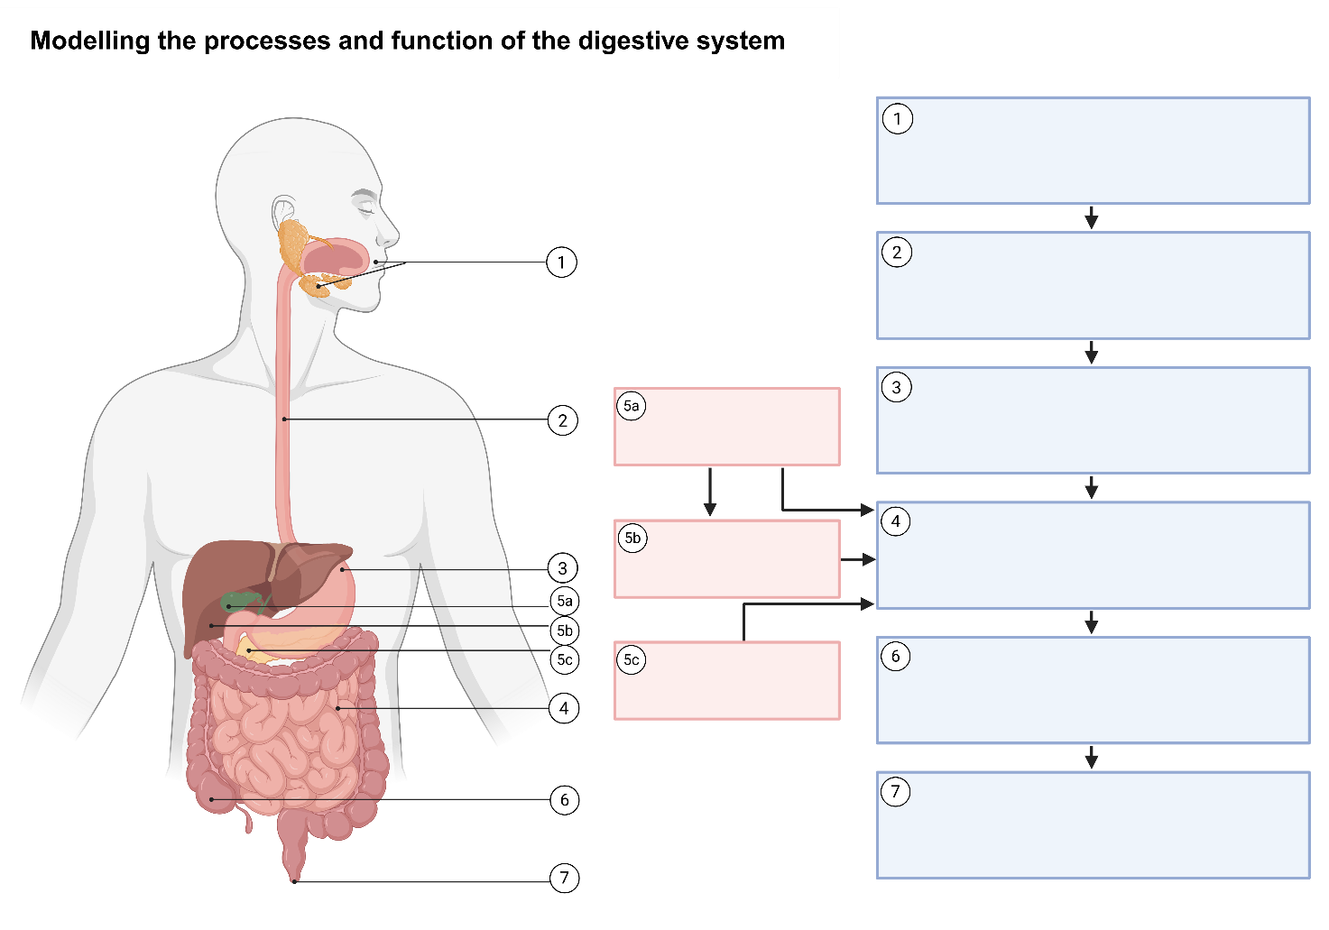
This work has been generated using BioRender.com. Any copyright subsisting in this work is owned by © State of New South Wales (Department of Education) 2025.

Relating structures and specialised cells in the digestive system to function
- Reiterate that humans are multicellular organisms and the body is made up of many organ systems, the digestive system being an example that students just studied. Determine students’ prior knowledge of content about specialised cells.
Checkpoint 3: assess student prior knowledge of specialised cells using LIV PPT ‘1.2 Checkpoint 3.’
What is a specialised cell?
A. A cell that can become any type of cell in the body.
B. A cell that is only found in animals.
C. A cell that has a specific structure to do a specific function.
D. A cell that is exactly the same as every other cell in the body
If students are having difficulty recalling this information or have a misunderstanding, reteach the relevant concepts using the Cells and classification resource pack, 2.6 Multicellular organisms.
Table 6 – checkpoint 3, response explanation
Response | Explanation
A | This describes a stem cell, not a specialised cell. Specialised cells already have a set role. Students may confuse specialised cells with stem cells, which are undifferentiated and can become specialised.
B | Specialised cells are found in both plants and animals. Students might mistakenly think specialised cells are a feature of animals only, possibly because earlier lessons focused on human biology.
C | This is the correct response.
D | This is the opposite of what a specialised cell is. Specialised cells differ in structure and function. Students may not yet grasp that differentiation leads to diverse cell types with distinct roles, or they might assume all cells are similar because they all have basic structures like a cell membrane.
- Inform students that in this learning sequence, they will see how the organs and specialised cells are structured to perform very specific functions, such as breaking down food and absorbing nutrients.
- Use LIV PPT ‘1.2 The digestive system recall.’ to recall the structures and function of the digestive system. Inform students that in Year 7, they learned that specialised cells have unique structures that help them perform specific functions in the body.
- Use LIV PPT ‘1.2 Organisation of structures in the digestive system’ to outline that these cells work together to form tissues, which make up organs, and that these organs are organised into larger organ systems, such as the digestive system.
- Teach students how the structures of the digestive system and the specialised cells within it enable it to carry out the essential function of breaking down food and absorbing nutrients from the broken-down food. Inform students that in each organ, specialised cells have a structure that allows them to carry out a specific function – whether it’s moving food, absorbing nutrients, or protecting the body from bacteria or acid.
- Hand out the Student resource – relating structure to function of the digestive system to students and outline the activity's purpose.
Note: the steps below follow the phases of ‘I do-we do-you do’, using the principles of gradual release of responsibility to determine when to transition students from modelled to guided to independent practice.
Also note that not all specialised cells or tissues for each organ have been identified. More may be explored if students can manage the cognitive load of all the specialised cell types and tissue types. Although there are many types of epithelial cells, they are referred to more broadly in this activity to facilitate understanding of the necessary concepts for Year 8 students.
- Use LIV PPT ‘1.2 Relating structure to function (1 of 5)’ to outline the function of the oesophagus and how its structures (including specialised cells) relate to that function in the digestive system. Sample answers are in Table 7.
- Use LIV PPT ‘1.2 Relating structure to function (2 of 5)’ to jointly construct the function of the stomach and how its structures (including specialised cells) relate to that function in the digestive system. Sample answers are in Table 7
Note: this activity does not cover all structures and functions of the digestive organs. For example, the stomach doesn’t just churn food; it also produces acid and enzymes. Discuss this with students to prevent an incomplete understanding of the digestive system.
- Using LIV PPT ‘1.2 Relating structure to function (3 – 5), students independently complete the remainder of Table 1 – relating structure to function in the student resource.
- Facilitate a class discussion using the sample response in Table 7 to assess students' understanding of how the structures of the digestive system and the specialised cells enable the system to carry out its functions. Examples of discussion points are provided below:
- Smooth muscle cells are long and elastic, allowing the oesophagus walls to squeeze and relax in waves. This involuntary action pushes food from the mouth to the stomach.
- Epithelial cells of the small and large intestines have finger-like projections (microvilli) that increase surface area, helping more nutrients to be absorbed quickly. Their thin shape and tight arrangement help nutrients pass into the blood more easily. This structure helps the small intestine absorb digested food quickly and efficiently.
- Tightly packed water-absorbing epithelial cells have projections on their surfaces designed to increase surface area. This helps the large intestine absorb more water, keeping it for the body and forming solid waste from what is left.
- Reiterate that each part of the digestive system is made up of specialised cells with a shape or structure that helps them perform a very specific job. These cells group together to form tissues that make up the organs of the digestive system, which carry out their functions.
Note: while this activity has focused on the structure of organ components and some of the organs' functions, we need to look at how the system works. Emphasise to students that the whole system works together for a purpose, to break down food into nutrients the body can absorb and use.
Checkpoint 4: assess students’ understanding of how structure relates to digestive function using LIV PPT ‘1.2 Checkpoint 4.’
Students construct their responses on a mini whiteboard or an A4 piece of paper.
1. The name of a specialised cell (choose one).
Epithelial cell with microvilli
Smooth muscle cell
Skeletal muscle cell
2. One key structural feature of that cell.
3. How does that structural feature help it perform its function in the digestive system?
Sample student response:
1. The name of a specialised cell (choose one)
Epithelial cell with microvilli.
2. One key structural feature of that cell.
Has many tiny finger-like projections called microvilli on the surface.
3. How does that structural feature help it perform its function in the digestive system?
This increases surface area to absorb more nutrients faster.
Sample response: Student resource – relating structure to function of the digestive system
Table 7 – sample response for how structure relates to function in the digestive system
Component of the digestive system | Cell-to-organ structure | Function of the organ | How the structure of the organ relates to its function
Oesophagus | Smooth muscle cell → muscle tissue → oesophagus | Uses mechanical/physical movement (peristalsis) to push food from the mouth to the stomach | Smooth muscle cells are long and elastic, allowing the oesophagus walls to squeeze and relax in waves. This involuntary action pushes food from the mouth to the stomach.
Stomach | Epithelial cells + smooth muscle cells → epithelial and muscle → stomach | Mixes food through physical churning and chemical digestion using acid and enzymes to break down proteins. | Epithelial cells form a barrier, produce mucus for protection, and release substances for chemical digestion.  Smooth muscle cells are long and flexible, allowing them to contract in layers and churn food for physical digestion.
Small intestine | Epithelial cells (with microvilli) → epithelial tissue → small intestine | Completes digestion of all food types and absorbs nutrients into the bloodstream. | Epithelial cells have finger-like projections (microvilli) that increase surface area, helping more nutrients to be absorbed quickly. Their thin shape and tight arrangement help nutrients pass into the blood more easily.  This structure helps the small intestine absorb digested food quickly and efficiently.
Large intestine | Water-absorbing epithelial cells → epithelial tissue → large intestine (lining of) | Absorbs water from remaining food and compacts waste into faeces. | Tightly packed water-absorbing epithelial cells have projections on their surfaces that increase surface area. This helps the large intestine absorb more water, keeping it for the body and forming solid waste from what is left.
Anus | Skeletal muscle cells + protective epithelial cells → muscle tissue + epithelial tissue → anus | Controls when faeces leave the body and eliminates them. | The long, thick shape of skeletal muscle cells provides the strength needed to keep the anus closed and enables voluntary control. Their striped pattern allows them to contract quickly and intentionally, so we can consciously decide when to use the toilet.

Student resource – relating structure to function of the digestive system
Instructions: complete the table to relate the structures and specialised cells in the digestive system to their function.
Table 1 – relating structure to function
Component of the digestive system | Cell-to-organ structure | Function of the organ | How the structure of the organ relates to function
Oesophagus | Smooth muscle cell → muscle tissue → oesophagus
Stomach | Epithelial cells + smooth muscle cells → epithelial and muscle → stomach
Small intestine | Epithelial cells (with microvilli) → epithelial tissue → small intestine
Large intestine | Water-absorbing epithelial cells → epithelial tissue → large intestine (lining of)
Anus | Skeletal muscle cells + protective epithelial cells → muscle tissue + epithelial tissue → anus

1.3 The respiratory system
Table 8 – learning intentions and success criteria for ‘1.3 The respiratory system’
We are learning: | I can:
- to describe the role, structure and function of body systems and their components | - identify the organs of the respiratory system  - identify the role of the respiratory system  - model a process and function of the respiratory system, breathing  - describe how the structures and specialised cells in the respiratory system relate to their function
- to extract, process and represent data. | - identify key points in a text (the respiratory system)  - summarise the identified key points relating structures and specialised cells to respiratory system function.

Structure and role of the respiratory system
Checkpoint 1 (LIV PPT): determine students’ prior knowledge of the main organs of the human respiratory system and their function (Stage 3 content) using LIV PPT ‘1.3 Checkpoint 1.’ A sample response has been provided in Figure 10. Instructions for responding when students provide a range of answers are in the speaker notes on the slide.
Note: in this activity, not all the words in the word bank will be matched to a function. The intent of checkpoint 1 is to determine whether students can first identify the organs of the respiratory system and then match them to their functions. The stomach and heart are not part of the digestive system and therefore do not align with the definition; these terms remain in the word bank.
Figure 10 –checkpoint 1 sample response
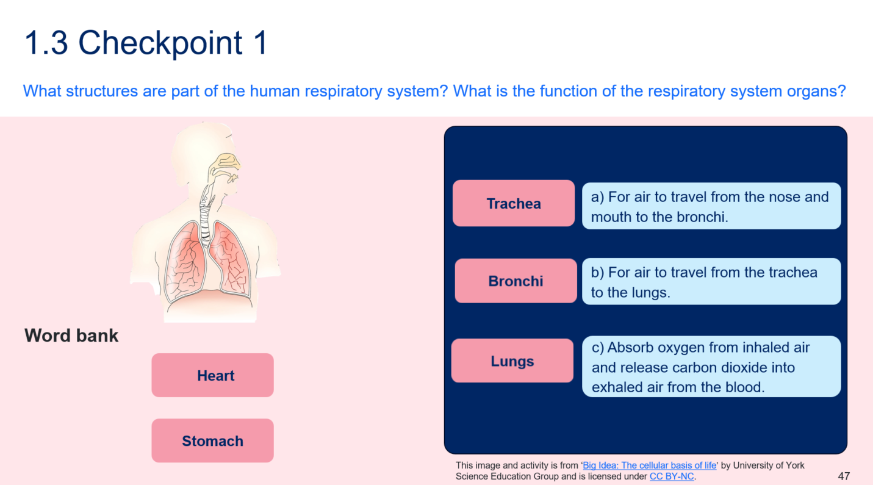
- Provide students with the Student resource – labelling the respiratory system. Review how to identify key points in a text.
- Watch the How your lungs work (5:21) video, a multimedia text, to annotate a diagram with the organs of the respiratory system, identify its role in the human body and summarise information to answer comprehension questions given in the LIV PPT ‘1.3 The respiratory video.’
Note: it may be helpful to clarify the distinction between breathing and respiration. Breathing is the process of exchanging gases through inhalation (breathing in) and exhalation (breathing out). Respiration is a metabolic process that occurs in all living cells, including plant and animal cells. It is the process by which energy is released from glucose, enabling all the other chemical processes needed for life.
- Facilitate class discussion to check students' understanding of the organs in the respiratory system using LIV PPT ‘1.3 Organs in the respiratory system.’
Checkpoint 2 (LIV PPT): assess students' understanding of the role of the respiratory system and the function of the organs in the respiratory system using LIV PPT ‘1.3 Checkpoint 2.’ (2 slides). A sample response for checkpoint 2 (1 of 2) is provided in Figure 11 and Checkpoint 2 (2 of 2) is below.
What is the role of the respiratory system?
A. To circulate oxygen and nutrients to all parts of the body
B. To break down oxygen so the body can use it for energy
C. To move air through the body so it can cool the internal organs
D. To take in oxygen from the air and remove carbon dioxide from the body
Information on why students may have selected incorrect responses is provided in Table 9 and in the slide's speaker notes.
Figure 11 – checkpoint 1 (1 of 2) sample response
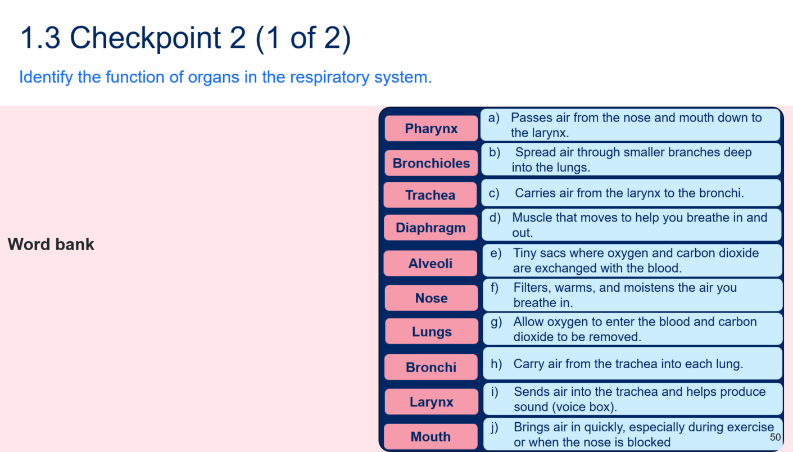

Table 9 – checkpoint 1 (2 of 2) response explanation
Response | Explanation
A | This is the function of the circulatory system, not the respiratory system. Students may confuse the role of the lungs (which oxygenate the blood) with that of the heart and blood vessels (which distribute oxygen and nutrients). They may also see the word ‘oxygen’ and assume it must be correct.
B | Oxygen is not broken down; it is used in cellular respiration (inside mitochondria) to help release energy from glucose, not from the oxygen itself. Students often confuse the use of oxygen in respiration with the idea of ‘breaking down’ molecules, such as food. This reflects confusion between digestive and cellular respiration.
C | While air movement in the respiratory system helps cool the organs, cooling the organs is not its purpose. Students may associate air movement with a cooling effect (e.g., breathing heavily when hot or exercise-related panting), leading to this incorrect conclusion.
D | This is the correct response.
Sample response: Student resource – labelling the respiratory system
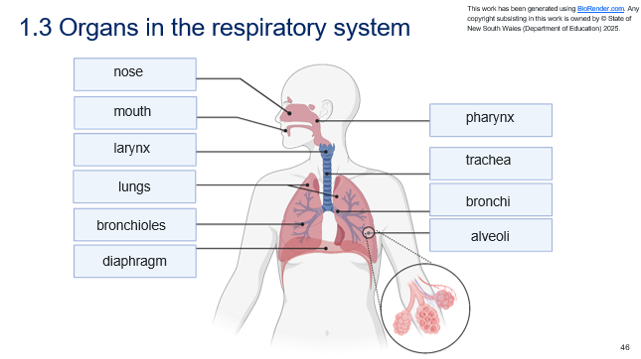

Student resource – labelling the respiratory system
Word bank
larynx | bronchioles | lungs | diaphragm | bronchi
mouth | nose | trachea | pharynx | alveoli
Figure 1 – an unlabelled diagram of the human respiratory system
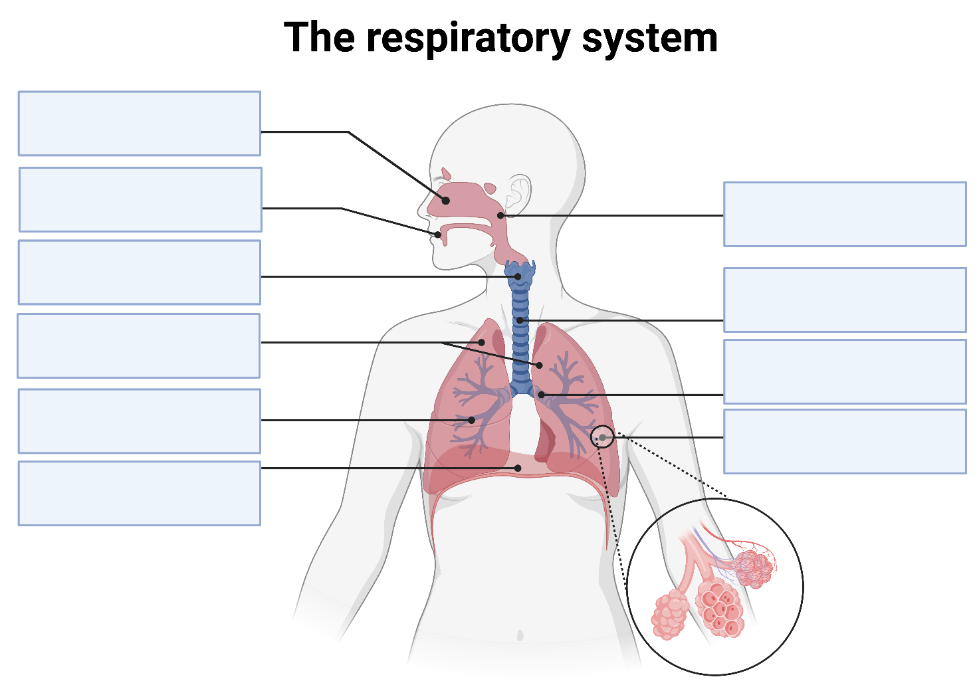
This work has been generated using BioRender.com. Any copyright subsisting in this work is owned by © State of New South Wales (Department of Education) 2025.

Modelling the processes and functions of the respiratory system – practical investigation
To build this model, equipment must be ordered in advance. Students should work in groups of
3–4. Order the equipment listed in the Student resource – modelling the respiratory system to build this model.
- Recall what a model is and why models are used in science. Tell students a model is a mathematical, conceptual or physical representation that describes, explains, simplifies, clarifies or helps predict a scientific phenomenon. For example, physical models, analogies and diagrams.
- Tell students models can be used in science to:
- explain how things work. For example, models help show the structure and function of things (such as how the heart pumps blood or how digestion happens)
- understand things we can’t easily see. Some things are too small (such as atoms or cells) or too far away (such as planets), so we use models to represent them
- simplify complex ideas. Systems such as the human body or ecosystems have many parts. A model helps break them down into smaller, easier-to-learn parts
- make predictions or test ideas. Scientists use models to see what might happen if something changes (for example, weather models or food chain simulations)
- communicate scientific thinking. Models help scientists and students share ideas clearly – whether through diagrams, physical replicas or written explanations.
- Introduce students to the respiratory system model by telling them that they are going to build a hands-on model of the respiratory system to describe how the human body undertakes gas exchange, bringing oxygen into the body and removing carbon dioxide from it.
- Engage with the equipment list and procedure in the Student resource – modelling the respiratory system. Discuss safety considerations for students when building the model, such as using scissors to cut the balloon's top off.
- Instruct students to complete ‘Table 1 – relating the model to the structure, processes and functions of the respiratory system’ in the Student resource – modelling the respiratory system as they construct and use the model. Table 10 can be used to facilitate class discussion with students or support students in completing the student resource.
- Students Think-Pair-Share to respond to questions in the LIV PPT ‘1.3 Modelling the respiratory system’, including the strengths and limitations of the model in representing the process of breathing in the respiratory system.
Note: there are sample responses to the discussion questions in the speaker notes in LIV PPT ‘1.3 Modelling the respiratory system’.
- Facilitate a class discussion on the ‘share’ component of the Think-Pair-Share activity to assess students' understanding of the model and how it illustrates the breathing process in the respiratory system. Notes to support this discussion are available in the sample responses in the speaker notes in LIV PPT ‘1.3 Modelling the respiratory system’.
- The model explains breathing by showing that the lungs do not actively draw in air; instead, the diaphragm alters the space and pressure in the chest to facilitate air flowing in and out.
- The model demonstrates how the lungs expand and contract during breathing, with the balloon inside the bottle inflating and deflating, helping students visualise the changes in the lungs during inhalation and exhalation.
- The model has limitations, including the absence of alveoli. In real lungs, alveoli are essential for gas exchange, but the model does not depict them. The balloon can inflate and deflate, but this does not illustrate gas exchange. Another limitation is that there is only ‘one lung’; however, humans have 2 lungs. This might lead to the misconception that we only breathe with one lung or that both lungs always function the same way.
Sample response: Student resource – modelling the respiratory system
Table 10 – sample response to relate the constructed model to the processes and functions of the respiratory system
Part of the model | Part of the respiratory system is represented | Process happening in the model | Process and function in the respiratory system
Bottle | Chest cavity | The bottle contains structures that demonstrate airflow, such as a balloon and a straw. | Represents the chest cavity, which houses and protects the lungs. In real life, the rib cage moves slightly during breathing to help the lungs expand.
Straw | Trachea | Provides the passageway for airflow between the balloon and the exterior. | The trachea carries air from the nose and mouth to the lungs. It allows oxygen-rich air to enter and carbon dioxide-rich air to exit.
Balloon inside the bottle | Lungs | Fills with air when the bottom balloon is pulled down and empties when it is pushed up. | The lungs expand to draw in air during inhalation and contract to push air out during exhalation. This allows oxygen to enter the lungs and carbon dioxide to be removed from the body.
Balloon covering the bottom of the bottle | Diaphragm | The balloon's extension and relaxation at the bottom of the bottle change the bottle's volume. As a result, air pressure inside the bottle changes. Changes in air pressure cause air to enter or leave the balloon (attached to the straw in the bottle), which inflates and deflates.  Pulled down = air goes into the balloon; pushed up = air goes out of the balloon. | The diaphragm is a muscle that contracts and moves downwards, increasing the space in the chest cavity and lowering pressure, allowing air to rush into the lungs. When it relaxes and moves upwards, the space in the chest cavity is decreased, increasing pressure, pushing air out of the lungs during exhalation.

Student resource – modelling the respiratory system

Equipment
- 1 x 1.5 L clear plastic bottle (with the bottom cut off)
- 2 x balloons
- 1 x straw
- 1 x elastic band
- 1 x small ball of plasticine
- 1 x pair scissors

Procedure
- Cut off the top (neck) of one balloon and stretch it over the bottle's base.  - Place the straw into the top of the other balloon and secure it tightly with an elastic band. Be careful not to crush the straw.  - Insert the straw (the end without the balloon) into the hole in the bottle lid and secure it with plasticine to create an airtight seal around the bottle's mouth.  - Pull down on the balloon at the base of the bottle.  - Write down your observations when you pull the balloon at the base of the bottle downwards and when you release it. | Figure 1 – the model set up  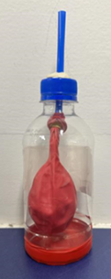
Table 1 – relating the model to the structure, processes and functions of the respiratory system
Part of the model | Part of the respiratory system, the model’s part represents | Process happening in the model | Process and function in the respiratory system
Bottle
Straw
Balloon inside the bottle
Balloon covering the bottom of the bottle

Relating structures and specialised cells in the respiratory system to function
Note: this activity does not address all structures and functions of the respiratory organs. For example, the diaphragm is under both voluntary and involuntary control. The skeletal muscles in the diaphragm (covered in this activity) do not contract without our conscious thought. The internal smooth muscles in the diaphragm, like those of the digestive system and the heart, operate involuntarily. We cannot directly instruct them to work, nor can we stop them from working – they function automatically. Most of the time, the diaphragm functions involuntarily, but we can control it.
Ensure students are aware of the model's simplifications. This mitigates an incomplete understanding of the specialised cells and tissues of the respiratory organs and their functions.
- Recall the structures and functions of the respiratory system, and understand that specialised cells have unique structures that enable them to perform specific functions in the body.
- Use ‘The respiratory system' text in the Student resource – relating structure and specialised cells to function to teach students how to extract and summarise key points to relate the structures and specialised cells of the respiratory system to their function.
- Provide students with ‘The respiratory system’ text. Unpack Table 1 in the student resource, to inform students of the key points to look for in the text.
Note: use principles of gradual release of responsibility to determine when to move through modelled, guided and independent practice for extracting and summarising key points from texts.
- Explicitly teach students how to scan a text. Model the identification and highlighting of key points. Illustrate how information is presented in texts, tables and graphics, including headings and subheadings.
- Explicitly teach students how to summarise in their own words, using the identified key points to complete the ‘trachea’ row of Table 1 in the student resource. Sample answers have been provided in Table 12.
- As a class, use the scanning method to highlight specific information and keywords in the text to complete the second row in the table, ‘bronchi.’ Emphasise that students should summarise this information in their own words, not copy it verbatim from the text.
- Students should attempt to complete the remainder of the table independently.
- Facilitate a class discussion to assess student understanding of how the structure and specialised cells of the respiratory system relate to their function, using Table 12.
- Ask students to answer the question in the student resource, ‘Why is the respiratory system important for the human body?’
- Facilitate class discussion using the sample response to the question: ‘Why is the respiratory system important for the human body?’
Checkpoint 3 (LIV PPT): assess students’ understanding of how structure relates to respiratory function using LIV PPT ‘1.3 Checkpoint 3’.
Which of the following best explains how the structure of the respiratory system supports its function?
A. The diaphragm is made of smooth muscle, so it can beat like the heart and push air through the lungs.
B. The trachea and bronchi are lined with ciliated epithelial cells that help trap and expel dust and microbes from the airways.
C. The alveoli have thick, strong walls to protect the lungs from air pressure changes.
D. The lungs are filled with blood so oxygen can dissolve directly into the bloodstream.
Information on why students may have selected incorrect responses is provided below and in the slide's speaker notes.
Table 11 – checkpoint 3 response explanation
Response | Explanation
A | Students may confuse muscle types or think all muscles ‘beat’ like the heart; they may not yet grasp that the diaphragm is a skeletal muscle that contracts for breathing, not for pumping.
B | This is the correct response.
C | Students might think thicker = stronger = better protection, not realising that gas exchange requires thin walls.
D | Students may mistakenly assume the lungs are filled with blood rather than understanding that oxygen passes into the capillaries next to the alveoli.
Sample response: Student resource – relating structure and specialised cells to function
Table 12 – sample response for how structure relates to function in the respiratory system
Component of the respiratory system | Cell-to-organ structure | Function of the organ | How structure relates to the function
Trachea | Ciliated epithelial cells → Ciliated epithelial tissue with cartilage → Trachea | Carries air to and from the lungs and helps trap dust and microbes. | Ciliated epithelial cells have tiny hair-like organelles (cilia) that beat rhythmically to move mucus and trap dust, bacteria and other particles, propelling them up and out of the airways.  The cartilage rings surrounding the trachea help keep the airways open and prevent them from collapsing as air moves through.
Bronchi | Ciliated epithelial cells → Ciliated epithelial tissue with cartilage → Bronchi | Bronchi are airways that branch off from the trachea and lead into the lungs. | The ciliated epithelial cells continue to filter and trap particles. The branching structure increases surface area for airflow, and cartilage plates support the airway.
Alveoli | Flat epithelial cells → Simple epithelial tissue → Alveoli | Site of gas exchange – net movement of oxygen from inhaled air to blood, while carbon dioxide moves from the blood to exhaled air. | The epithelial cells in the alveoli are thin and flat, making the alveolar walls just one cell thick. This thin barrier allows rapid, efficient gas diffusion. The numerous alveoli create a large surface area to maximise gas exchange. The tissue is moist, helping gases dissolve before they pass across the alveolar walls.
Diaphragm | Skeletal muscle cells → Skeletal muscle tissue → Diaphragm | Contracts and relaxes. The movements of the diaphragm change pressure in the chest cavity, resulting in changes to lung volume. | Skeletal muscle cells are long and striped. They contract under voluntary control. Their length and strength enable the diaphragm to contract downwards forcefully during inhalation and relax upwards during exhalation, creating changes in chest volume, resulting in the pressure changes necessary to move air in and out of the lungs.
Why is the respiratory system important for the human body?
The respiratory system is responsible for gas exchange between your body and the environment. It takes in oxygen when you inhale and removes carbon dioxide when you exhale. Oxygen is essential for cellular respiration – the process cells use to produce energy. Carbon dioxide is a waste product that must be removed to prevent harm to the body. By exchanging these gases, the respiratory system ensures cells can function properly.

Student resource – relating structure and specialised cells to function
The respiratory system text
The respiratory system is essential for bringing oxygen into the body so cells can carry out cellular respiration to release energy, and for removing carbon dioxide, a waste product that can be harmful if it builds up. Without the respiratory system, the body’s cells would not be able to function properly. The main organs in the respiratory system are the nose, mouth, trachea, bronchi, lungs and diaphragm, as shown in Figure 1. These parts work together to move air in and out of the body and facilitate gas exchange.
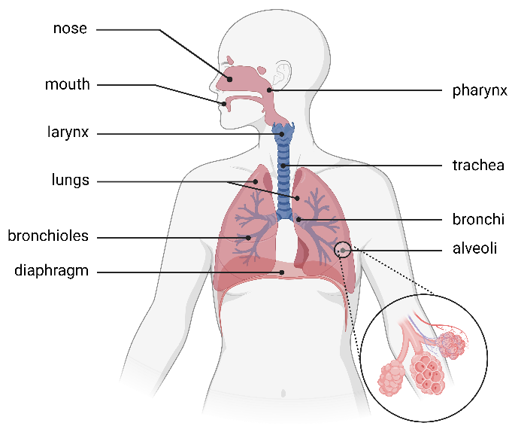  Figure 1 – a labelled diagram of the respiratory system | Air usually enters through the nose or mouth. The inside of the nose contains small hairs and mucus, which help trap dust, pollen and germs before the air travels deeper into the body. The air then moves down the trachea, or windpipe, which is held open by strong cartilage rings. The trachea splits into 2 bronchi, one for each lung, which then branch into smaller and smaller tubes called bronchioles. These tubes distribute air throughout the lungs. At the ends of the bronchioles are tiny, round air sacs called alveoli where gas exchange takes place.
Relating structure to function  The trachea and bronchi are lined with specialised ciliated epithelial cells with tiny hair-like structures called cilia (Figure 2, tall blue columned cells), which move in a wave-like motion. Cilia sweep the mucus and trapped particles upwards toward the throat, where they can be swallowed or coughed out. This protects the lungs and keeps the airways clear. |  |  | Figure 2 – the lining of the bronchi is made up of specialised cells, including the epithelial cell with cilia  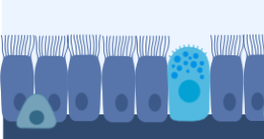
Figure 3 – gas exchange occurring in the alveoli and the cell structure of the alveolar walls  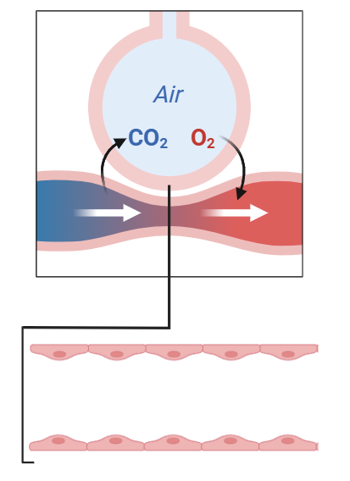 |  | Gas exchange occurs in the alveoli at the end of the bronchioles, where oxygen diffuses through the thin alveolar walls into the surrounding capillaries, and carbon dioxide in the blood moves into the alveoli to be exhaled, as shown in Figure 3. The alveoli are ideally suited to this job. They are tiny, numerous (millions in each lung) and only one cell thick. Each alveolus contains flat, very thin epithelial cells that facilitate the movement of gases across the surface, as shown in Figure 3. This thin barrier between the air in the lungs and blood in capillaries allows for efficient movement of oxygen and carbon dioxide, which is essential for the respiratory system to function effectively.
The diaphragm, a dome-shaped sheet of muscle located beneath the lungs, controls the movement of air in and out of the lungs. The diaphragm is made of skeletal muscle cells, which are long, striped and able to contract powerfully and repeatedly. When the diaphragm contracts and descends, the chest cavity enlarges, and air is drawn into the lungs. When it relaxes, the chest cavity becomes smaller, and air is pushed out. This process, called ventilation, is essential for breathing. The structure of skeletal muscle cells – being strong and able to respond quickly – allows the diaphragm to contract and relax rhythmically to support regular breathing throughout the day. The internal smooth muscles in the diaphragm operate involuntarily. Involuntary muscles function automatically without conscious control. Most of the time, the diaphragm functions involuntarily, but we can control it (for example, when we take a deep breath). |  |  |  | Figure 4 – the chest cavity showing how the diaphragm contracts and relaxes during inhalation and exhalation  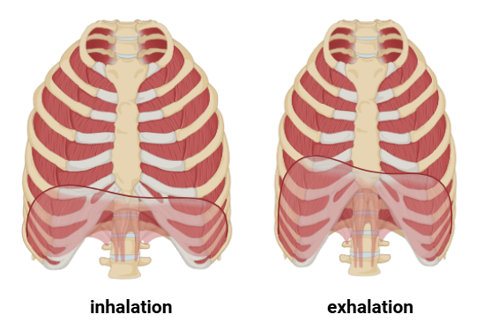  Figure 5 – skeletal muscle cell, which makes up the diaphragm  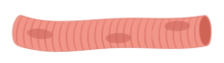
This text has been generated using artificial intelligence. Any copyright subsisting in this work is owned by © State of New South Wales (Department of Education) 2025.
The images in this work have been generated using BioRender.com. Any copyright subsisting in this work is owned by © State of New South Wales (Department of Education) 2025.
Relating structure and specialised cells to function
Instructions: complete the table to relate the structures and specialised cells in the respiratory system to their function.
Table 1 – relating structure and specialised cells to function using the text
Component of the respiratory system | Cell to organ structure | Function of the organ | How structure relates to the function
Trachea | Ciliated epithelial cells → Ciliated epithelial tissue with cartilage → Trachea
Bronchi | Ciliated epithelial cells → Ciliated epithelial tissue with cartilage → Bronchi
Alveoli | Flat epithelial cells → Simple epithelial tissue → Alveoli
Diaphragm | Skeletal muscle cells → Skeletal muscle tissue → Diaphragm
Why is the respiratory system important for the human body?

1.4 The circulatory system
Table 13 – learning intentions and success criteria for ‘1.4 The circulatory system’
We are learning: | I can:
- to describe the role, structure and function of body systems and their components | - identify the organs and structures of the circulatory system  - identify the role of the circulatory system  - model the circulation of blood around the body  - describe how the structures and specialised cells in the circulatory system relate to their function
- to extract, process and represent data. | - identify key points in the circulatory system text  - summarise key information to annotate a model of the circulatory system.

Structure and role of the circulatory system
Checkpoint 1 (LIV PPT): determine students’ prior knowledge of the main organs of the human circulatory system and their function (Stage 3 content) using LIV PPT ‘1.4 Checkpoint 1’. A sample response has been provided in Figure 12. Instructions on how to respond when students provide a range of answers are in the slide's speaker notes.
Note: students will not need to use all the words in the word bank. The intent of checkpoint 1, is to determine whether students can first identify the organs of the circulatory system and then match each organ to its function. The lungs and stomach are not part of the circulatory system and, therefore, are not aligned with a definition; these terms remain in the word bank.
Figure 12 – prior knowledge checkpoint 1 sample response
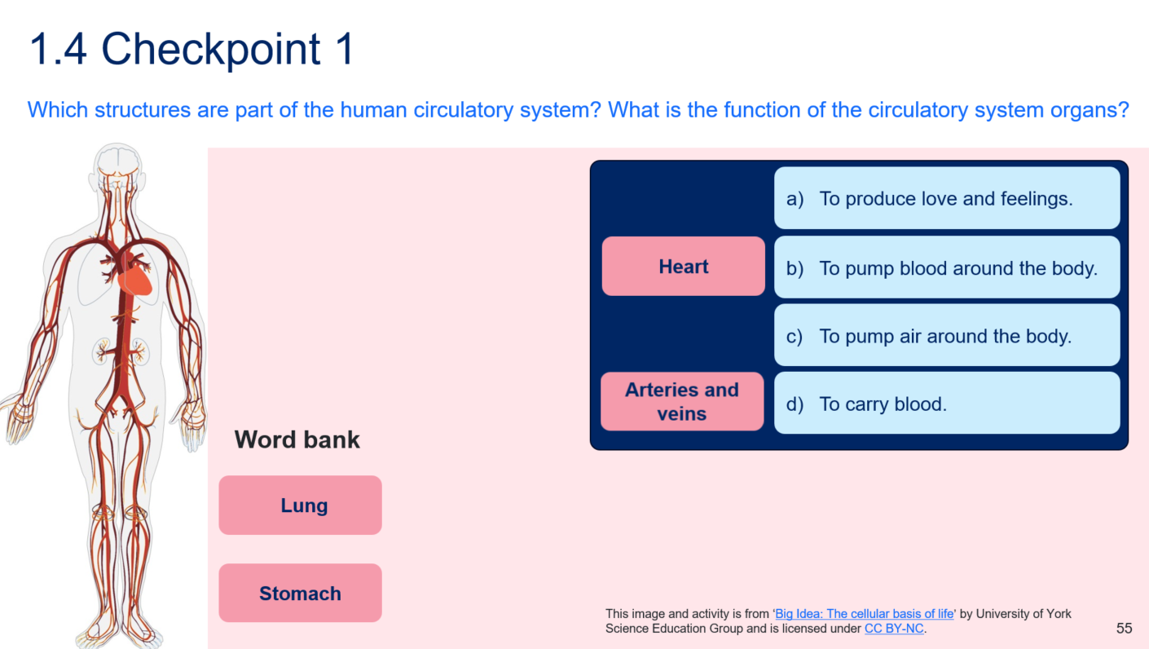
- Hand out the Student resource – labelling the circulatory system and engage students with each information card. Students use the information on the cards to label the components of the circulatory system in the Student resource – labelling the circulatory system.
- Use the completed labelled diagram of the circulatory system in LIV PPT ‘1.4 Components of the circulatory system’ to facilitate class discussion to check student understanding of the structures in the circulatory system.
- The heart is the main organ of the circulatory system, located in the chest between the lungs. It is a muscular organ that pumps blood continuously throughout the body via a network of blood vessels. The heart connects to major arteries and veins.
- Arteries are large blood vessels within the body that carry blood away from the heart.
- Veins are large blood vessels that return blood to the heart.
- Capillaries are very thin, tiny blood vessels. They are found throughout the body between arteries and veins, connecting larger blood vessels to body tissues.
Figure 13 – answers to the student resource ‘labelling the circulatory system’
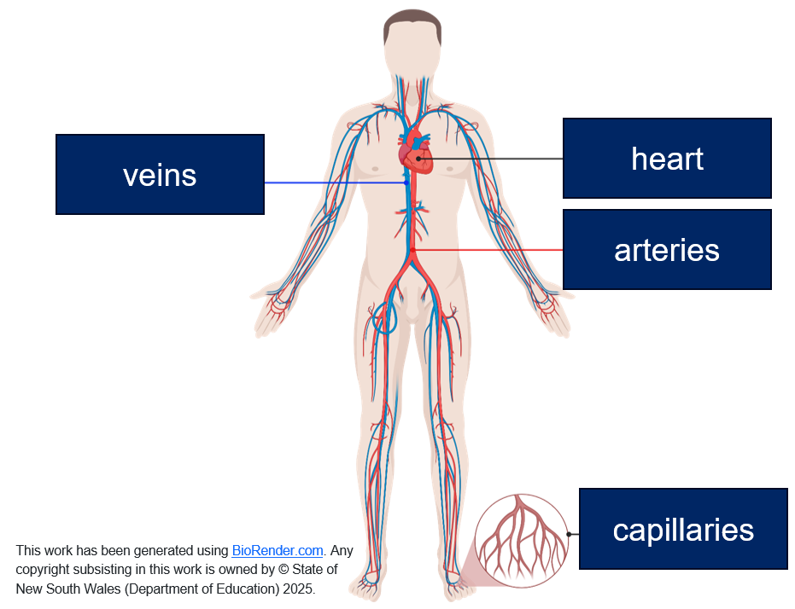
- Provide students with the Student resource – the race through the circulatory system text and questions.
- Engage with the information as a class to identify key points for the comprehension questions. Using the principles of gradual release of responsibility, model summarising key points to answer questions, then, where applicable, move students through guided and independent practice.
- Facilitate class discussion of the comprehension questions using the ‘Sample student response – the race through the circulatory system’ to determine students’ understanding of the role of the heart, what is carried in the blood and the role of the circulatory system. Reiterate that the heart is the main organ of the circulatory system because it pumps blood around the body through a network of blood vessels.
Checkpoint 2: assess students’ understanding of the role of the circulatory system using LIV PPT ‘1.4 Checkpoint 2.’
Which of the following best describes the role of the circulatory system?
A. To transport oxygen, nutrients and wastes around the body.
B. To pump blood to muscles.
C. To transport oxygen around the body.
D. To help the body digest food.
Table 14 – checkpoint response explanations
Response | Explanation
A | This is the response which best describes the role of the circulatory system.
B | The circulatory system delivers blood to all parts of the body, not just to muscles. Muscles are more tangible to students because of exercise or movement, so they overgeneralise the role of the circulatory system’s delivery of blood to muscles only.
C | Blood also carries nutrients and waste products; oxygen is only one of the substances it transports. Students may see oxygen as the only substance transported in the blood.
D | Digestion is carried out by the digestive system, not the circulatory system. Students may know that blood carries nutrients, so they might confuse the delivery of nutrients (circulatory) with the breakdown of food (digestive).
- Provide students with the Student resource – blood flow through the heart. Inform students that they will now examine how blood flows through the heart.
- Show students the labelled diagram of the heart in LIV PPT ‘1.4 Structure of the heart’ and unpack the structure of the heart. This slide will support students with annotating the movement of blood around the heart.
- The heart is a muscular organ about the size of a fist.
- The heart is made up of 4 chambers, 2 atria and 2 ventricles. The left ventricle has thicker walls than the right ventricle.
- The heart has 4 valves to ensure one-way flow of blood. Valves open and close in response to pressure changes, preventing backflow.
- Major blood vessels include the vena cava, pulmonary arteries, pulmonary veins and aorta.
- Students re-engage with Student resource – the race through the circulatory system if required. (Information to complete the activity for blood flow through the heart can be attained from this text.)
Note: the colour red indicates oxygenated blood, typically carried in arteries. The exception to arteries carrying only oxygenated blood is the pulmonary arteries, which connect the heart to the lungs. Deoxygenated blood from the heart travels to the lungs via the pulmonary arteries to pick up more oxygen.
The colour blue indicates deoxygenated blood, typically carried in veins. The exception to veins carrying only deoxygenated blood is the pulmonary veins, which connect the lungs to the heart. Oxygenated blood from the lungs travels back to the heart via the pulmonary veins, then is pumped around the body.
- Show how to annotate the unlabelled diagram of the heart in the student resource with blue or red arrows to indicate the movement of oxygenated and deoxygenated blood through the heart, and write the associated step in the table in the Student resource – blood flow through the heart (an example has been provided on the student resource and in LIV PPT ‘1.4 Blood flow around the heart’).
- Instruct students to colour some parts of the heart and blood vessels blue to show where deoxygenated blood travels, and other parts red to show where oxygenated blood travels.
- Students complete the remainder of the Student resource – blood flow through the heart.
- Facilitate class discussion to assess student understanding of how blood flows around the heart using LIV PPT ‘1.4 Blood flow around the heart’ and Figure 14.
Sample student response – the race through the circulatory system
- What is the primary function of the heart in the human body?
To pump blood around the body through blood vessels.
- Identify the 4 chambers in the heart.
Right atrium, right ventricle, left atrium and left ventricle.
- Identify where the blood is oxygenated in the body.
In the lungs.
- Identify the primary substances transported from the heart to the body’s cells.
Oxygen and nutrients.
- Identify the respiratory waste product carried back to the lungs by the blood.
Carbon dioxide.
- Identify 2 types of blood vessels mentioned in the text. Outline their roles.
Arteries carry oxygenated blood away from the heart to the body. Veins carry deoxygenated blood back to the heart from the body.
- Why is it important for blood to keep moving around the body?
It is important so that oxygen and nutrients can be delivered to cells and that waste products, like carbon dioxide, can be removed.
- How do you think the body would be affected if the heart stopped beating?
If the heart stops beating, blood flow would cease, preventing cells from receiving oxygen and nutrients. Waste would accumulate, leading to death.
- Why do you think the author compared arteries to highways?
The author compared arteries to highways because they branch out and carry blood to many parts of the body, like roads that enable cars to reach different destinations.
Figure 14 – sample answer annotated heat diagram
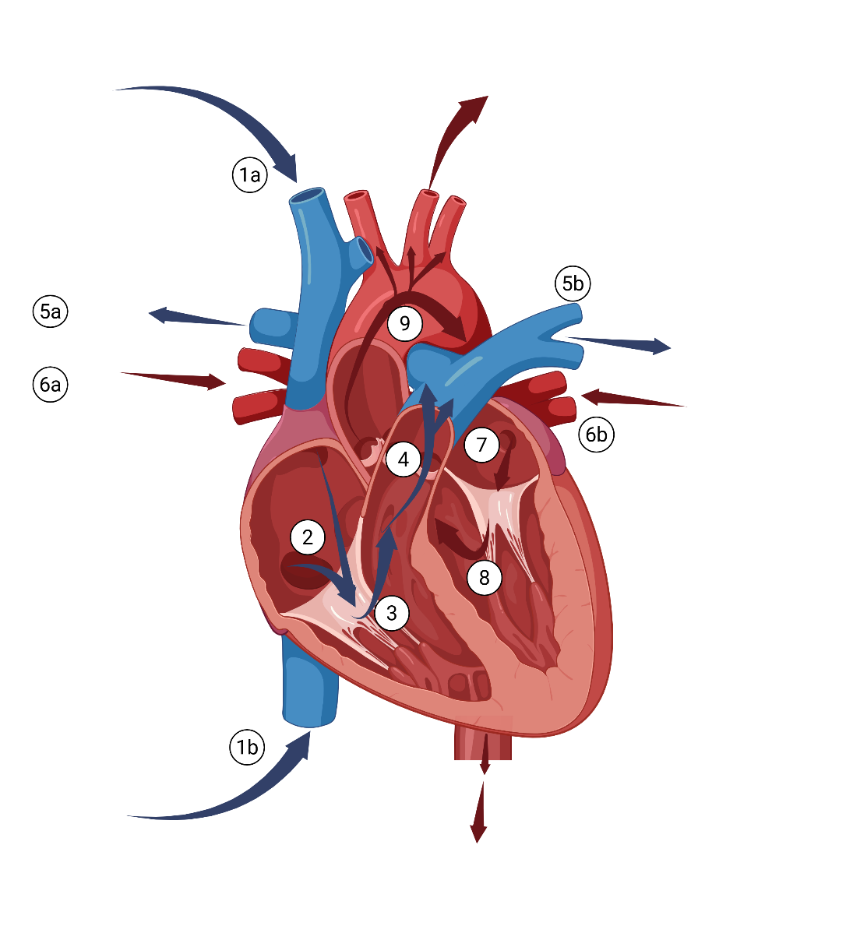
This work has been generated using BioRender.com. Any copyright subsisting in this work is owned by © State of New South Wales (Department of Education) 2025
Table 15 – heart diagram annotations
Step | Outline what is happening here
1a and 1b | Deoxygenated blood returns to the heart from the body via the superior vena cava (1a) and inferior vena cava (1b).
2 | Both veins (inferiors and superior vena cava) empty into the right atrium.
3 | The deoxygenated blood flows from the right atrium to the right ventricle.
4 | The right ventricle pumps blood into the pulmonary arteries.
5a and 5b | Deoxygenated blood is pumped through the right pulmonary artery (5a) to the right lung and through the left pulmonary artery (5b) to the left lung.
6a and 6b | Oxygenated blood travels back from the right lung through the right pulmonary vein (6a) and from the left lung in the left pulmonary vein (6b).
7 | Oxygenated blood travels from the left atrium into the left ventricle.
8 | Oxygenated blood travels into the left atrium.
9a and 9b | Blood is pumped into the aorta where oxygen-rich blood is carried to the upper part of the body (9a) and lower part of the body (9b).

Student resource – labelling the circulatory system
Use the information on the cards below and the word bank to label the components of the circulatory system.
Card 1: heart  - Main organ of the circulatory system.  - Located in the chest between the lungs.  - Connects to major arteries and veins. | Card 2: arteries  - Large blood vessels that carry blood away from the heart to body tissues.  - Found deep within the body.
Card 3: veins  - Large blood vessels that return blood back to the heart from body tissues.  - Found closer to the skin surface than arteries. | Card 4: capillaries  - Very thin, tiny blood vessels.  - Found throughout the body between arteries and veins.  - Connect larger blood vessels to body tissues.
Word bank
arteries | heart | veins | capillaries
Figure 1 – an unlabelled diagram of the human circulatory system
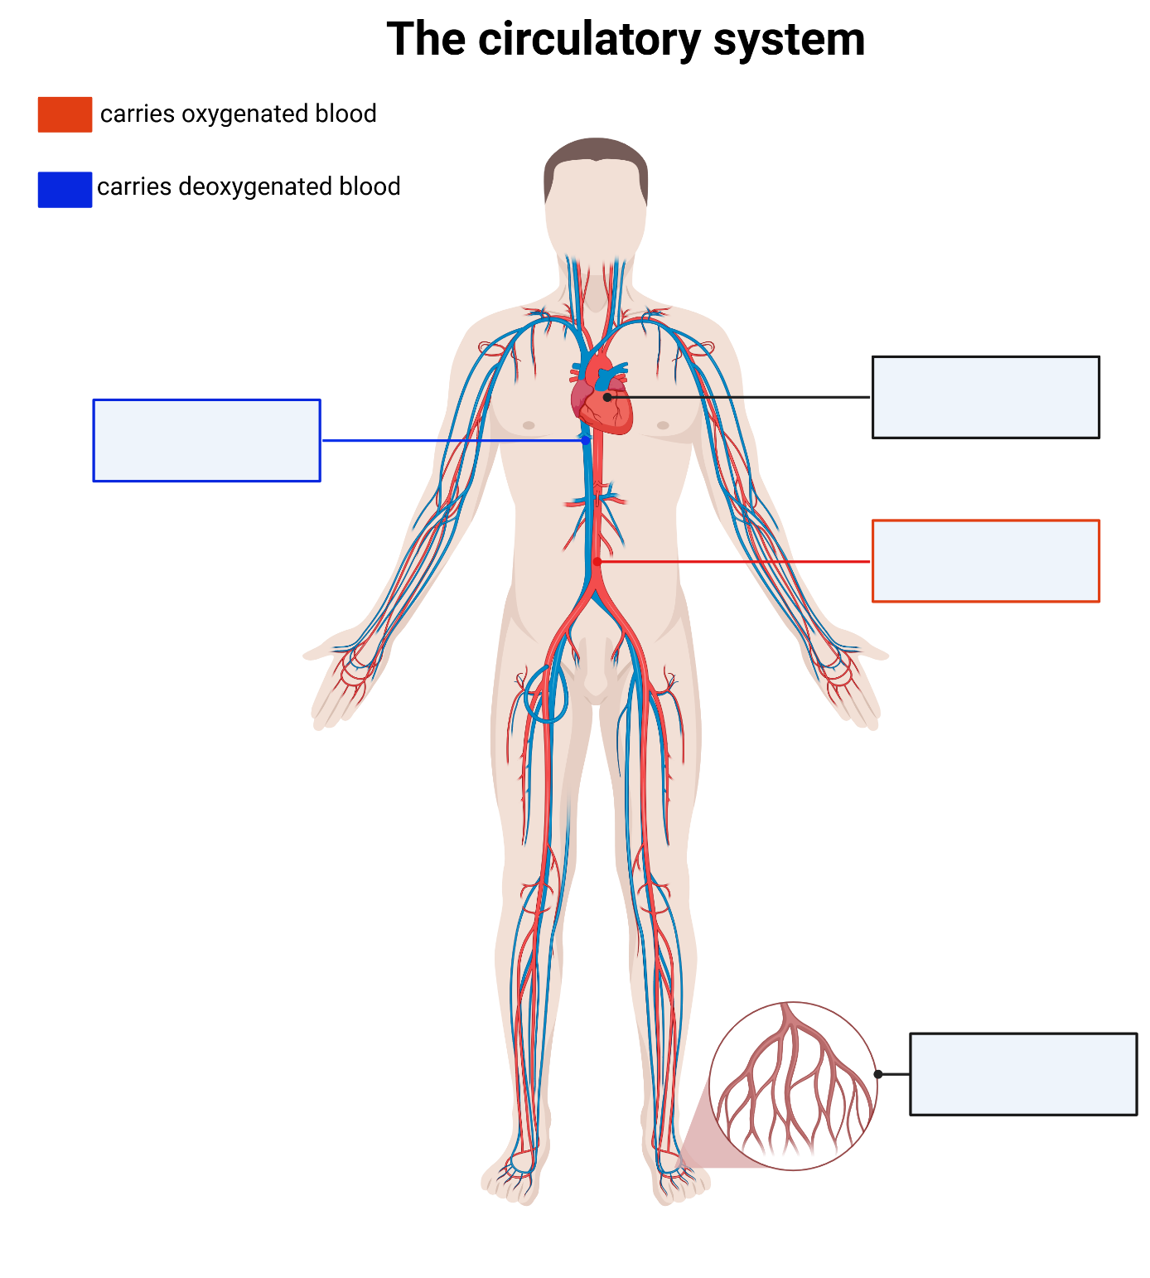
This work has been generated using BioRender.com. Any copyright subsisting in this work is owned by © State of New South Wales (Department of Education) 2025.

Student resource – the race through the circulatory system
Circulatory system text
Deep inside every human body, something incredible is always happening, even when a person is fast asleep. The heart, a strong and steady muscle, beats without stopping, pumping blood through a maze of tubes called blood vessels. This is the start of the blood’s amazing journey through the circulatory system.
The journey begins when oxygen-poor (deoxygenated) blood from the upper body (brain, eyes, face, arms and hands) returns to the heart through a vein, the superior vena cava, and blood from the lower body (stomach, intestines, kidneys, legs and feet) returns through another vein, the inferior vena cava. Both veins enter the right atrium.
From the right atrium, deoxygenated blood flows into the right ventricle, which pumps it through the pulmonary arteries to the lungs. The right pulmonary artery supplies deoxygenated blood to the right lung, and the left pulmonary artery supplies deoxygenated blood to the left lung. In the lungs, the blood releases carbon dioxide and collects fresh oxygen.
Oxygen-rich (oxygenated) blood then travels back to the heart through the pulmonary veins into the left atrium. It flows into the left ventricle, where a powerful contraction sends it out through the aorta.
From the aorta, arteries carrying oxygenated blood branch like highways, transporting blood away from the heart to every part of the body. Some arteries travel upward to the brain, eyes and face; others extend outward to the arms and hands; and many downward through the chest and stomach to the liver, kidneys, intestines, and then on to the legs and feet. As blood moves through tiny capillaries in each body part, it delivers oxygen and nutrients to cells and collects carbon dioxide and other waste products. The oxygen-poor blood then begins its return trip through the veins, the superior or inferior vena cava, back to the right atrium to start the cycle again.
This journey never ends. Day and night, the circulatory system works quietly and quickly, keeping the body healthy and alive. It’s like a hidden highway, always moving, always helping – even when no one notices.

Questions
- What is the primary function of the heart in the human body?
- Identify the 4 chambers in the heart.
- Identify where the blood is oxygenated in the body.
- Identify the primary substances transported from the heart to the body’s cells.
- Identify the respiratory waste product carried back to the lungs by the blood.
- Identify 2 types of blood vessels mentioned in the text. Outline their roles.
- Why is it important for blood to keep moving around the body?
- How do you think the body would be affected if the heart stopped beating?
- Why do you think the author compared arteries to highways?

Student resource – blood flow through the heart
Instructions: use the labelled heart diagram in the PowerPoint and the text on the race through the circulatory system to show how blood flows around the heart. Colour the parts of the heart and vessels blue where deoxygenated blood travels and red where oxygenated blood travels.
Step | Outline what is happening here
1a and 1b | Deoxygenated blood returns to the heart from the body via the superior vena cava (1a) and inferior vena cava (1b).
2
3
4
5a and 5b
6a and 6b
7
8
9a and 9b
Figure 1 – an unlabelled diagram of the heart
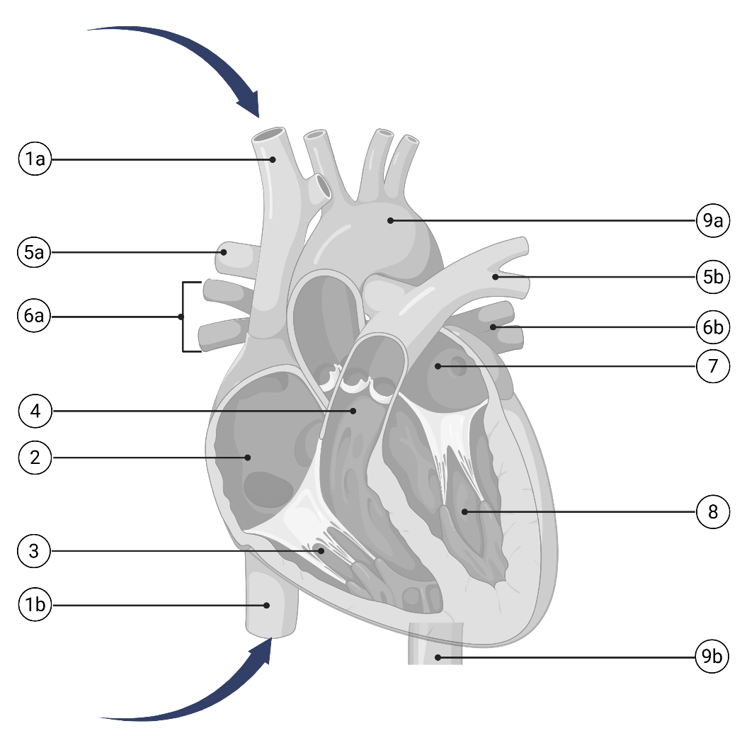
This work has been generated using BioRender.com. Any copyright subsisting in this work is owned by © State of New South Wales (Department of Education) 2025.

Modelling blood circulation around the body
For this activity, provide each group of 3–4 students with glue, scissors and butcher’s paper, one set per group. Each group will also need to be given a hard copy of the Student resource – modelling the movement of blood around the body. Students will use the information learned in Structure and role of the circulatory system to construct a model of the circulatory system, showing how oxygenated and deoxygenated blood are pumped around the body.
- Review student understanding of the structure and role of the circulatory system.
- Inform students that they will be constructing a model for how blood circulates around the body.
- Hand out the Student resource – modelling the movement of blood around the body; one per group of 3–4.
- Outline the guiding principles for planning the student model using LIV PPT ‘1.4 Guiding principles for planning your model’.
- Work with groups, or students work independently within their group, to use the Images for the model to construct a draft plan for their model in their book.
- Once the teacher approves the draft plan and students act on the feedback, they construct the model on the butcher’s paper. A sample response is provided in LIV PPT ‘1.4 Modelling blood flow around the body (1 of 2)’.
- Students work in their groups to discuss and write responses to the questions about the constructed model in LIV PPT ‘1.4 Modelling blood flow around the body (2 of 2)’.
- Facilitate a class discussion to check students’ understanding of the model, how it models the process of blood flow around the body, and the model’s limitations, using LIV PPT ‘1.4 Modelling blood flow around the body (2 of 2)’.

Student resource – modelling the movement of blood around the body

Images for the model
Figure 1 – the heart  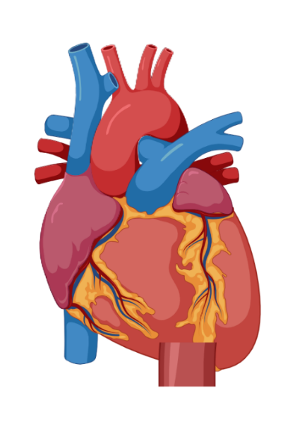 | Figure 2 – the liver and stomach  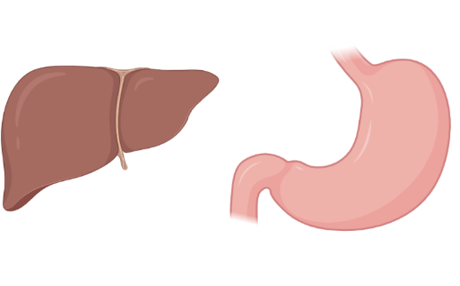
Figure 3 – the lungs (left lung and right lung)  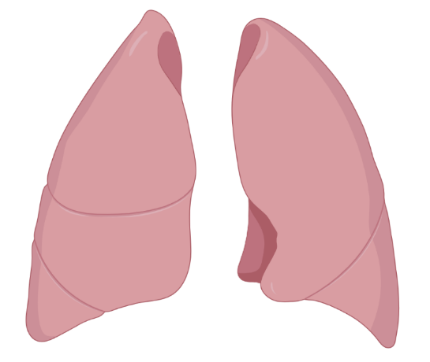 |  | Figure 4 – a text box to represent the upper body  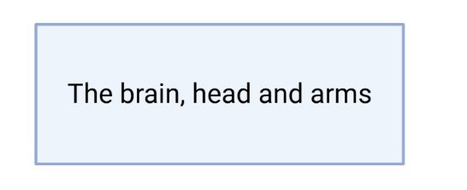  Figure 5 – a text box to represent the lower body  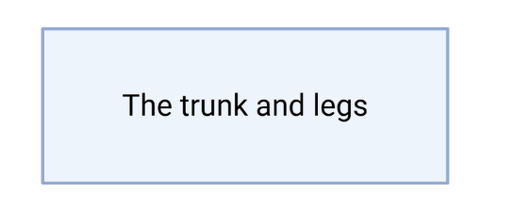
This work has been generated using BioRender.com. Any copyright subsisting in this work is owned by © State of New South Wales (Department of Education) 2025.

Relating structures and specialised cells in the circulatory system to function
- Relate the structure of the components of the circulatory system and specialised cells to their function. Provide students with Student resource – relating structures to function in the circulatory system.
- Review student understanding of the structure of components of the circulatory system.
- Use LIV PPT ‘1.4 Function of components of the circulatory system’ to work with students to outline the function of each component of the circulatory system. Refer to the speaker notes on the slide for more explicit instructions on using the information to complete the student resource.
- Use Table 16 to facilitate class discussion, ensuring that students provide the correct function for each structure in the student resource.
- Work with students to develop explanations of how the structure of components in the circulatory system relates to their function, using Table 16. For example, this could include reiterating the structure and function of components of the circulatory system, such as the heart, and then asking questions like ‘How does the structure support the function?’ A specific example for the heart could be, ‘How do the thick muscular walls of the heart support the heart's ability to pump blood?’ and so on.
Differentiation: provide students with a cloze passage in Table 1 in the Student resource – relating structures to function in the circulatory system to support students in relating the structures to the function. Use Table 16 below to create these cloze passages.
- Facilitate class discussion of the completed student activity, Table 1, in the Student resource – relating structures to function in the circulatory system to check students’ understanding of how structure relates to function. Question prompts such as ‘How does the structure of the arteries support its function?’ could be asked to support student thinking. The teacher can use Table 16 to facilitate this discussion.
Checkpoint 3: determine student understanding of how structures and specialised cells in the circulatory system are related to their function using LIV PPT ‘1.4 Checkpoint 3’. Students are provided statements with a word missing and a word bank to complete.
- The heart can pump blood strongly because it has thick __________ walls, especially in the left ventricle.
- Arteries can carry blood under high pressure because they have thick, elastic __________ that stretch and recoil.
- Veins can return blood to the heart because they have a wide __________ that allows blood to flow easily at low pressure.
- Capillaries can exchange materials easily because their walls are only __________ cell thick.
- Cardiac muscle cells can beat continuously because they contain many ____________ that constantly supply energy.
Sample responses are provided on the slide and below.
1. Muscular
2. Walls
3. Lumen
4. One
5. Mitochondria

Table 16 – sample response to relate structure to function in the circulatory system
Component | Structure | Diagram | Function | How structure relates to function
Heart | - Muscular organ with 4 chambers (2 atria, 2 ventricles)  - Thick muscular walls (especially the left ventricle)  - Valves keep blood flowing one way | Figure 1 – unlabelled diagram of the heart  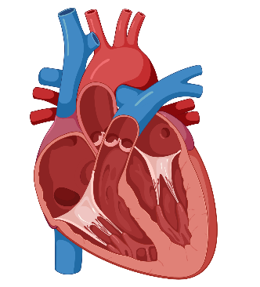 | Pumps blood all around the body to deliver oxygen and nutrients and remove wastes. | The thick, muscular walls (especially in the left ventricle) enable strong contractions that pump blood throughout the body. The 4 chambers separate oxygenated from deoxygenated blood, making circulation more efficient. Valves prevent blood from flowing backwards, ensuring it always flows in the right direction.
Arteries | - Thick, muscular walls  - Contains elastic tissue that stretches and recoils  - Round in shape and have a small lumen (the hollow part where blood flows) | Figure 2 – an unlabelled diagram of an artery cross-section   | Carry blood away from the heart at high pressure to the rest of the body. | Thick, muscular walls resist the high pressure of blood as it leaves the heart. Elastic tissue stretches and recoils, helping push blood smoothly along. A narrow lumen keeps pressure high, so blood moves quickly to body tissues.
Veins | - Thinner walls than arteries  - Wide lumen (bigger space inside)  - Contain valves | Figure 3 – an unlabelled diagram of a vein cross-section  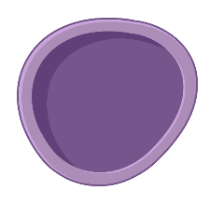 | Carry blood back to the heart at lower pressure. | Thinner walls are sufficient because blood pressure is lower. A wide lumen allows a larger volume of blood to flow back to the heart. Valves prevent blood from pooling in the limbs and stop it from flowing backwards.
Capillaries | - Tiny blood vessels that are only one cell wide  - Branch out from arteries and converge into veins  - Form large branching networks between arteries and veins  - Walls are thin | Figure 4 – an unlabelled diagram of a capillary cross-section  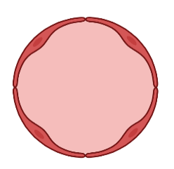 | Where the exchange of gases (oxygen and carbon dioxide), nutrients and waste occur between the blood and body cells. | Tiny diameter means blood flows slowly, giving time for exchange to occur. Walls only 1 cell thick allow for the rapid exchange of oxygen, nutrients and waste products between blood and cells. Large networks increase the surface area for many exchanges at once.
Specialised cell – red blood cell | - Small and round with a biconcave (dimpled) shape  - No nucleus  - Flexible structure | Figure 5 – an unlabelled diagram of a red blood cell  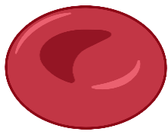 | Carries oxygen from the lungs to the body’s cells and carries carbon dioxide from body cells back to the lungs. | A biconcave (dimpled) shape increases the surface area for the transport and release of oxygen. No nucleus gives extra room to transport more oxygen. Flexibility lets them squeeze through tiny capillaries to reach every cell in the body.
Specialised cell – cardiac muscle cells | - Long and branched  - Striped appearance (striated)  - Contains many mitochondria | Figure 6 – an unlabelled diagram of a cardiac muscle cell  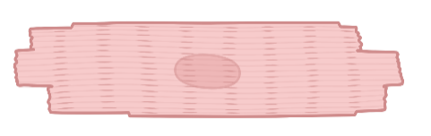 | Makes the heart contract and relax repeatedly and rhythmically without stopping. | The branching shape creates strong connections with neighbouring cells, so the whole heart contracts as one unit. Striations (stripes) show organised fibres that contract strongly and rhythmically. Many mitochondria supply the energy needed for continuous heartbeats.

Student resource – relating structures to function in the circulatory system
Instructions: read through the descriptions of function in the PowerPoint to relate the structure to the functions of components of the circulatory system.
Table 1 – relating structure to function in the circulatory system
Component | Structure | Diagram | Function | How structure relates to function
Heart | - Muscular organ with 4 chambers (2 atria, 2 ventricles)  - Thick muscular walls (especially the left ventricle)  - Valves keep blood flowing one way | Figure 1 – unlabelled diagram of the heart
Arteries | - Thick, muscular walls  - Contains elastic tissue that stretches and recoils  - Round in shape and have a small lumen (the hollow part where blood flows) | Figure 2 – an unlabelled diagram of an artery cross-section
Veins | - Thinner walls than arteries  - Wide lumen (bigger space inside)  - Contain valves | Figure 3 – an unlabelled diagram of a vein cross-section
Capillaries | - Tiny blood vessels that are only one cell wide  - Branch out from arteries and converge into veins  - Form large branching networks between arteries and veins  - Walls are thin | Figure 4 – an unlabelled diagram of a capillary cross-section
Specialised cell – red blood cell | - Small and round with a biconcave (dimpled) shape  - No nucleus  - Flexible structure | Figure 5 – an unlabelled diagram of a red blood cell
Specialised cell – cardiac muscle cells | - Long and branched  - Striped appearance (striated)  - Contains many mitochondria | Figure 6 – an unlabelled diagram of a cardiac muscle cell
This work has been generated using BioRender.com. Any copyright subsisting in this work is owned by © State of New South Wales (Department of Education) 2025.

1.5 The excretory system
Table 17 – learning intentions and success criteria for ‘1.5 The excretory system’
We are learning: | I can:
- to describe the role, structure and function of body systems and their components | - identify the organs and structures of the excretory system  - identify the role of the excretory system  - model the process and function of the excretory system  - describe how the structures and specialised cells in the excretory system relate to their function
- to extract, process and represent data. | - identify key points in the excretory system text  - summarise the identified key points to complete the table, showing how the structures and specialised cells of the excretory system contribute to its function.

Structure and role of the excretory system
Note: this is the first time students may have heard of the excretory system; it is not addressed in the K–6 Science and Technology Syllabus (2024).
- Define the excretory system and identify its role using LIV PPT ‘1.5 Introduction to the excretory system’.
- Provide students with a copy of Student resource – labelling the excretory system.
- Project the urinary system 3D model on the board. Click through each of the components, such as the kidneys, ureters, bladder and urethra, to show students their locations in the body.
Note: the urinary system 3D model shows only the organs and structures responsible for urine production and elimination. The other structures and organs of the excretory system – the lungs and skin – are not included in this 3D model. Students will have one remaining label on their diagram after the teacher has shown the organs of the urinary system – the skin. Remember, the lungs are not part of this diagram because students learned about them in the respiratory system. However, their role as an excretory organ is mentioned in this activity.
- Students label the excretory system in the student resource as the teacher shows them the components. Use LIV PPT ‘1.5 Labelling the excretory system’ to further facilitate class discussion about the locations of the organs. Question prompts to support students in outlining the locations include asking where the kidneys are located in relation to the ribs, which components of the excretory system are linked by the ureters and so on.
- There are 2 kidneys, located below the ribs on the right and left sides of the body.
- The ureters are thin tubes that carry urine from each kidney to the bladder.
- The bladder is a hollow, muscular organ in the lower abdomen that stores urine.
- The urethra is a tube that carries urine from the bladder to the outside of the body.
- As each organ or structure is labelled, outline the function of each organ/structure using the speaker notes in LIV PPT ‘1.5 Labelling the excretory system’. Work with students to summarise the function to complete the table in the Student resource – labelling the excretory system.
Checkpoint 1: determine student understanding of the function of each organ in the excretory system and the role of the excretory system using LIV PPT ‘1.5 Checkpoint 1’ (2 slides). A sample response to checkpoint 1 (1 of 2) is provided in Figure 15 and checkpoint 1 (2 of 2) is provided below).
Identify the role of the excretory system.
A. To absorb nutrients from digested food.
B. To remove extra water, salts and carbon dioxide from the body.
C. To pump blood to deliver oxygen.
D. To control breathing and supply oxygen to the blood.
Information on why students might have chosen incorrect responses is given in Table 18 and in the speaker notes of the slide.
Figure 15 – checkpoint 1 (1 of 2) sample response
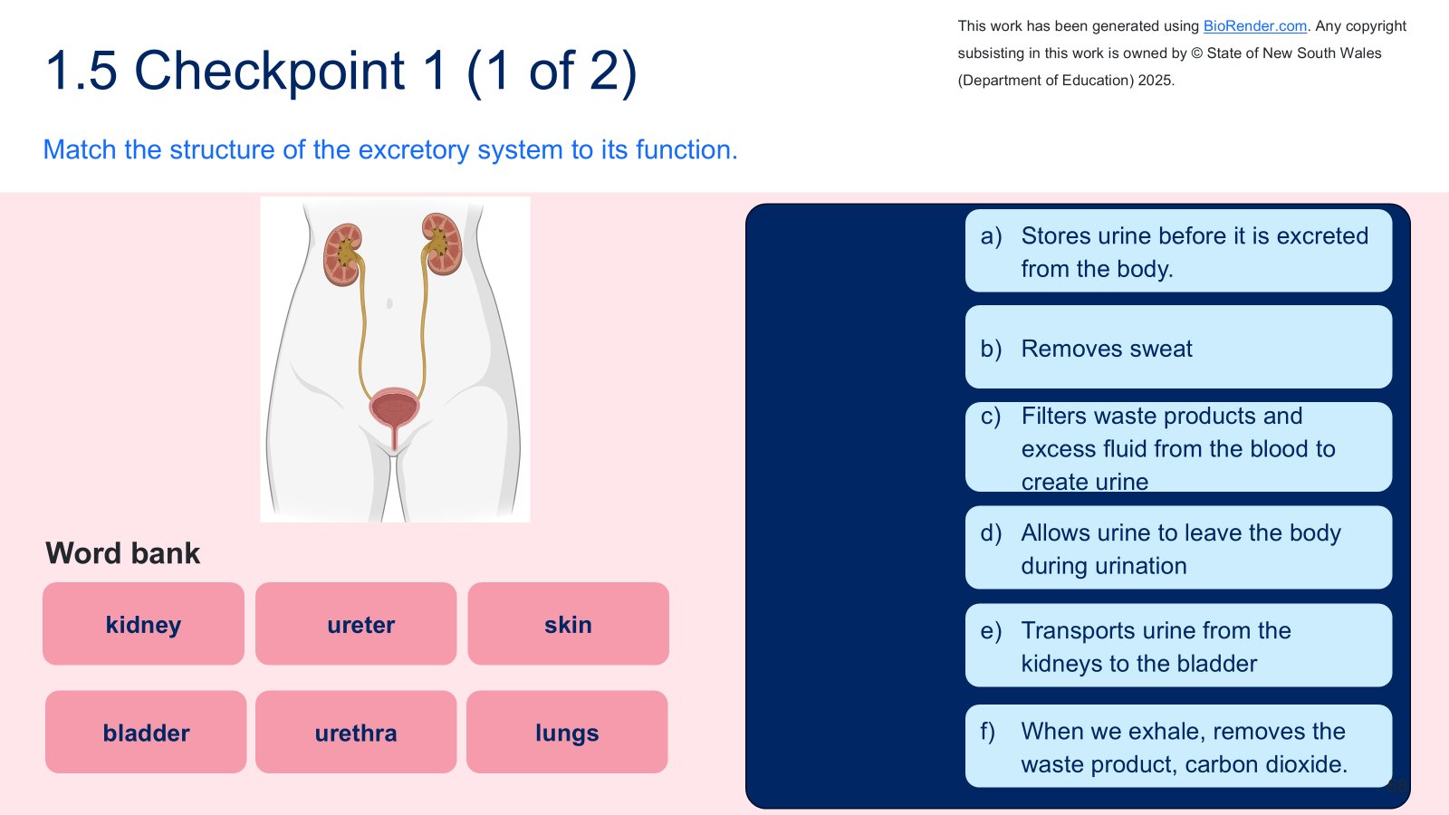
Table 18 – checkpoint 1 (2 of 2) response explanation
Response | Explanation
A | This is the role of the digestive system, not the excretory system. Students may know food and waste are linked, so they may confuse nutrient absorption (digestive system) with waste removal (excretory system).
B | This is the correct response.
C | This is the role of the circulatory system. Students may know that the kidneys are linked to the blood (since the kidneys filter blood), so they may incorrectly think that the excretory system’s role is blood transport.
D | This is the role of the respiratory system. Students may confuse getting rid of carbon dioxide (a waste gas excreted by the kidneys) with the kidneys’ role in waste removal.

Student resource – labelling the excretory system
Instructions: use the simulation and the teacher's explanation to label the organs and structures of the excretory system and outline their functions.
Organ or structure | Outline of its function
Kidney
Ureter
Bladder
Urethra
Skin
Lungs (not on the diagram)

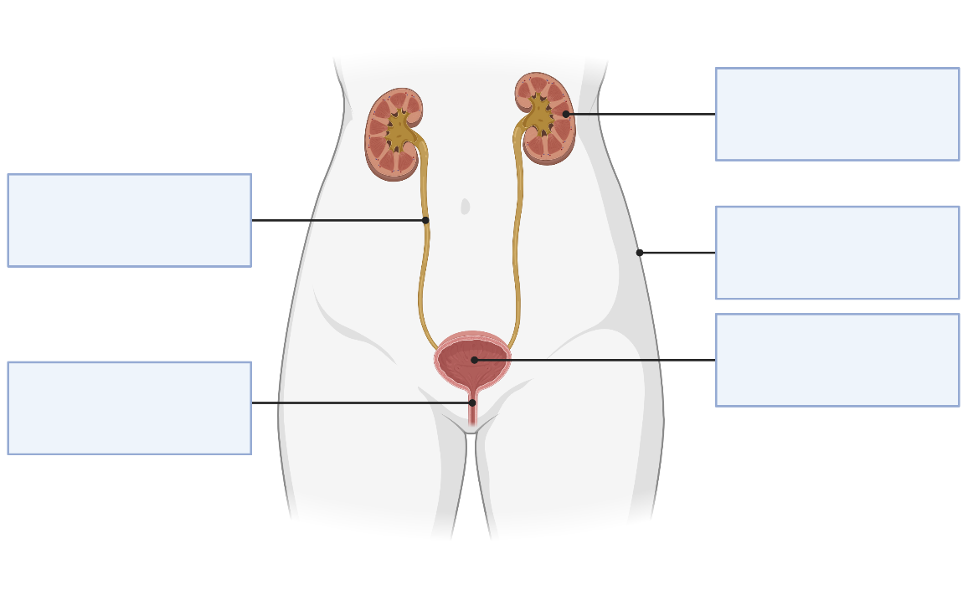
Figure 1 – a diagram of the excretory system

This work has been generated using BioRender.com. Any copyright subsisting in this work is owned by © State of New South Wales (Department of Education) 2025.

Modelling the processes and function of the excretory system
The purpose of this activity is to examine the wastes produced and the excretion pathways of the excretory system in more depth. Students will then annotate these pathways on a diagram (model).
- Provide students with the Student resource – excretion pathways in humans text and Student resource – the processes and functions of the excretory system.
- Review how to extract and summarise key points. (This is not the first instance in this focus area where students are extracting and summarising key points. If required, refer to 1.2 The digestive system – structure and role of the digestive system and 1.3 The respiratory system – Relating structures and specialised cells in the respiratory system to function for further instruction and support in extracting and summarising key points from a text).
- Inform students that they will need to extract and summarise key points related to the organs and structures of the excretory system, the wastes produced, and the excretion pathway of the waste from the organ/structure. Engage with the text as a class and use the principles of gradual release of responsibility to extract and summarise relevant key points to complete Student resource – the processes and functions of the excretory system model.
- Use LIV PPT ‘1.5 Excretion pathways in the excretory system’ to demonstrate how to draw a flow chart for the skin's excretory pathway. If needed, review what flow charts are and their purpose. Additional support for students is available in ‘1.2 Modelling the processes and function of the digestive system – practical investigation’)
- Continue to model, jointly construct, or have students independently complete the remainder of the excretion pathway flow charts for the lungs, which eliminate carbon dioxide, and the kidneys, which remove wastes as urine.
- Use the completed excretion pathways in Figure 17 or LIV PPT ‘1.5 Excretion pathways in the excretory system’ to check student understanding of the excretory pathways for the lungs and kidneys (urinary system).
Differentiation: give students the boxes and outlines of the flow charts for each excretory pathway and support them with the number of steps in each pathway. Additionally, a sentence starter can be provided for each box. The scaffold has been provided in LIV PPT ‘1.5 Differentiation: Excretion pathways’.
Checkpoint 2: give students a cloze passage to test their understanding of the excretory system's structures, processes and functions. This is in LIV PPT ‘1.5 Checkpoint 2’. A sample response is provided in Figure 16 and on the slide.
Figure 16 – checkpoint 2 sample response
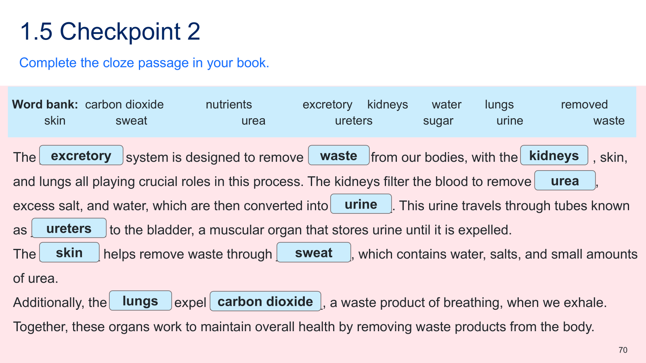
Figure 17 – sample response for excretion pathways in the excretory system
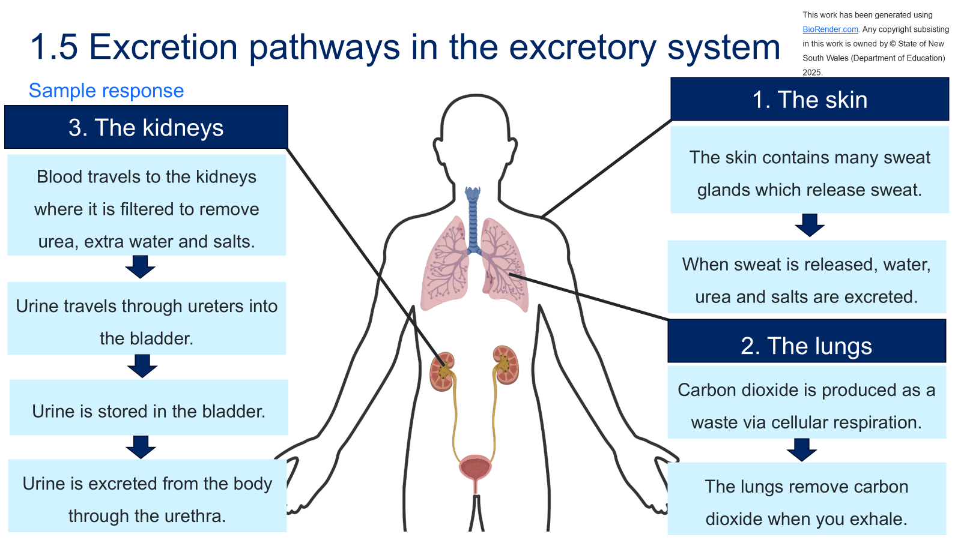

Student resource – excretion pathways in humans text
Your body is like a busy city. Every cell is constantly working, using up energy and making waste products. Just as a city needs rubbish collection to stay clean, your body needs systems to remove waste. This process is called excretion. Excretion is different from egestion, which involves the removal of undigested food as faeces through the digestive system. Excretion is the removal of wastes that are produced inside your body’s cells.
One of the most important excretory organs is the kidney. When cells break down proteins, they produce a toxic substance called urea. The kidneys filter urea, along with excess water and salts, from the blood to form urine. Urine then travels down tubes called the ureters and collects in the bladder, where it is stored. Finally, urine leaves the body through the urethra. This process keeps the blood free of harmful wastes. |  |  | 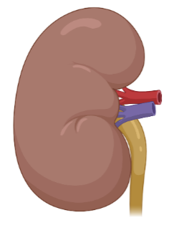  Figure 1 – an unlabelled diagram of the kidney
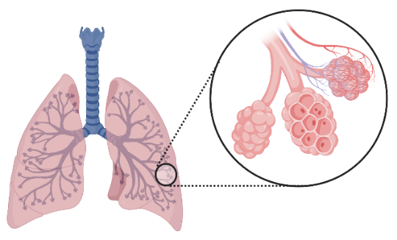  Figure 2 – an image of the lungs and alveoli | The lungs are also excretory organs. Inside your body, cells generate energy through a process called cellular respiration, which uses oxygen and produces carbon dioxide as a waste gas. If carbon dioxide builds up in the blood, it can become toxic. The lungs remove this waste gas when you breathe out, or exhale. Every breath you take helps maintain the proper balance of oxygen and carbon dioxide, keeping the body's internal environment stable.
The skin also plays a role in excretion. Tiny sweat glands in the skin release water, salts and urea as sweat. This helps remove some waste, but it also has another important function: cooling the body.  Together, the kidneys, lungs and skin form a system of organs that keep the body clean by removing harmful wastes. Without excretion, waste products would build up and damage the body’s cells and organs. |  | Figure 3 – diagram of the skin with sweat glands  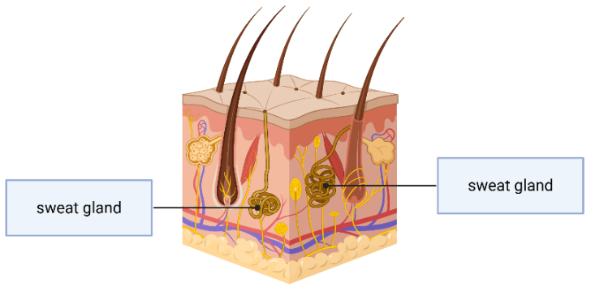
The images in this work have been generated using BioRender.com. Any copyright subsisting in this work is owned by © State of New South Wales (Department of Education) 2025.
The text int this work has been generated using artificial intelligence. Any copyright subsisting in this work is owned by © State of New South Wales (Department of Education) 2025.

Student resource – the processes and functions of the excretory system model
Instructions: engage with the ‘excretion pathways in humans’ text and annotate the excretion pathways on the image below.
Figure 1 – the outline of a human body with lungs and the urinary system inside the body
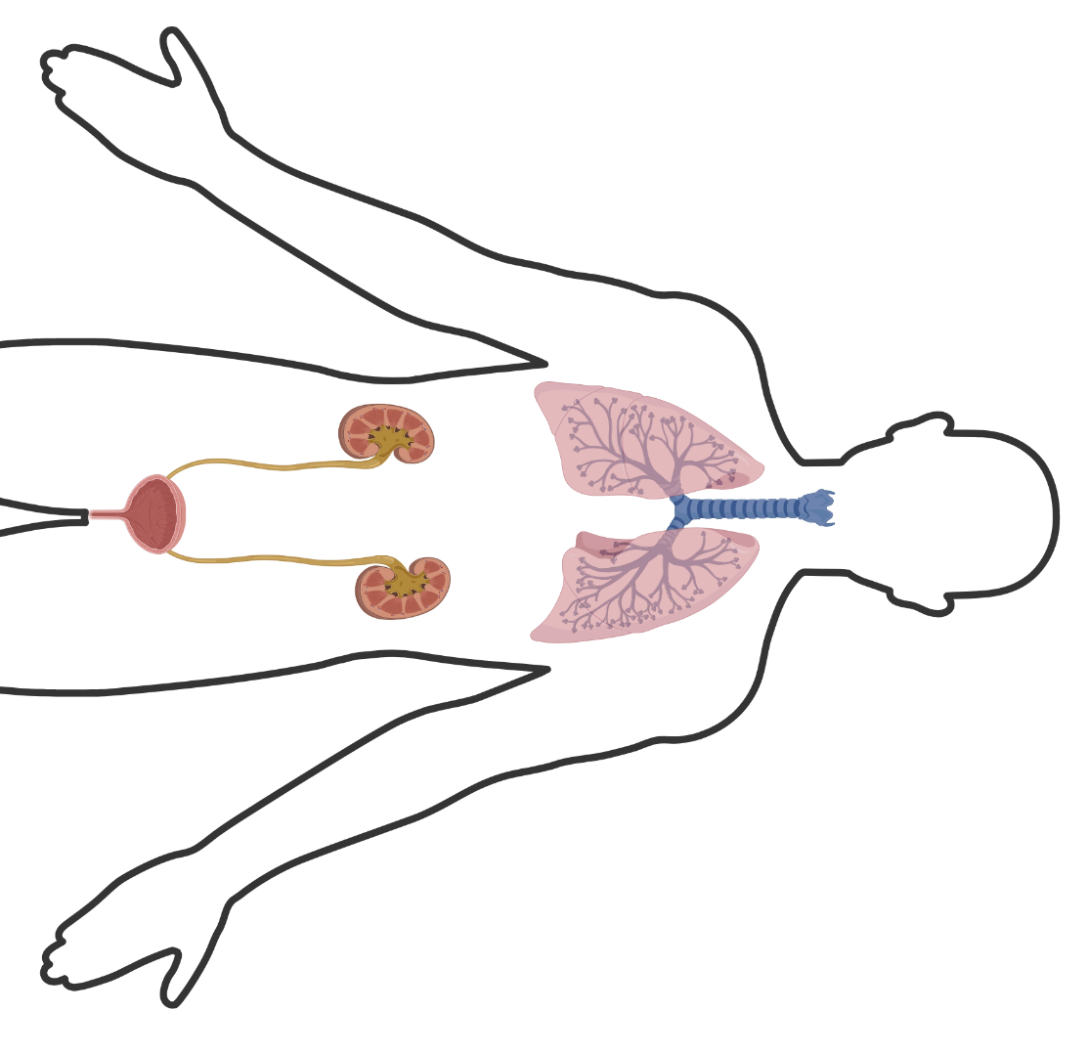
This work has been generated using BioRender.com. Any copyright subsisting in this work is owned by © State of New South Wales (Department of Education) 2025.

Relating the structures and specialised cells to function
- Review the organs and structures in the excretory system.
- Provide students with the Student resource – relating structures and specialised cells to function in the excretory system.
- Teach students about the structure and function of the kidneys using Table 1 in the Student resource – relating structures and specialised cells to function in the excretory system. Demonstrate how to link the kidney's structure to its function.
- Continue to model, jointly construct or have students independently work through the remaining organs, structures and specialised cells in Table 1 in the student resource. Use the structure, diagram and function columns to write an explanation of how the structure relates to its function to complete the table.
Differentiation: give students a cloze passage with a list of words to relate the structure-to-function of the components of the excretory system. This can be adapted from the completed sample response.
- Facilitate class discussion to check students’ understanding of how structure relates to function in the excretory system using Table 19.

Table 19 – sample response to relate structure to function in the excretory system
Organ/structure/cell | Description of structure | Diagram | Outline the function of the excretory system | How structure relates to function
Kidneys | Two bean-shaped organs about the size of a fist, located just below the ribs on either side of the spine. They contain many tiny filters connected to tubes and numerous blood vessels. | 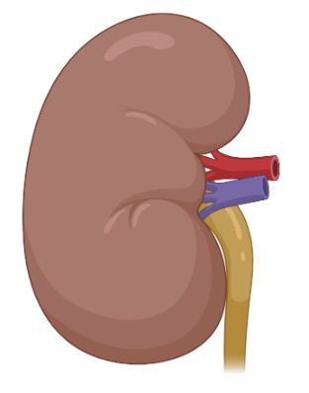  Figure 1 – an unlabelled diagram of the kidney | Remove wastes (such as urea) from the blood and regulate the balance of water and salts by producing urine. | The large blood supply delivers waste-filled blood for cleaning, while the internal structure with many small filters provides a large surface area for efficient waste removal.
Lungs | Two soft, spongy organs in the chest cavity. They are made up of millions of tiny air sacs called alveoli, each surrounded by a fine network of capillaries. | Figure 2 – an unlabelled diagram of the lungs  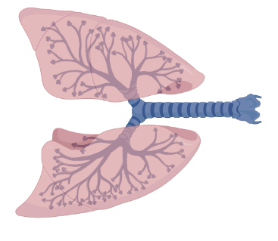 | Remove carbon dioxide from the blood during exhalation. | The millions of alveoli provide a large surface area, and their thin walls and close proximity to capillaries allow gases to diffuse rapidly between the air and blood, facilitating the efficient removal of gaseous waste.
Skin | The outer covering of the body. The dermis layer contains many coiled sweat glands, each connected to the skin's surface by narrow ducts and pores. | Figure 3 – diagram of the skin with sweat glands  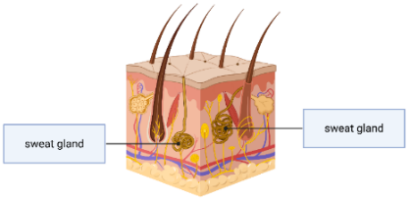 | Releases sweat containing water, salts and small amounts of urea, helping to control body temperature. | The coiled glands in the dermis produce sweat, and the ducts and pores provide a direct pathway for waste products to leave the body surface.
Specialised cell – sweat gland clear cell | Specialised cells are found in the coiled part of sweat glands. They have large surfaces and many channels for the movement of substances. | Figure 4 – image of a sweat gland clear cell  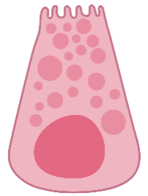 | Produce sweat, which is later released through ducts to the skin surface. | The many channels help move large volumes of water and salts efficiently, while their position in the coiled gland allows sweat to be collected and pushed out through the ducts.
Specialised cell – alveolar cell | Very thin, flat cells that make up the walls of the alveoli. | Figure 5 – image of an alveolar cell in the lungs  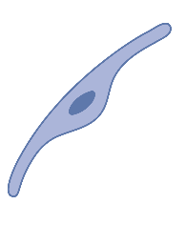 | Allow gases such as carbon dioxide to pass from the blood into the air spaces of the lungs. | Their extremely thin structure means gases travel only a short distance, making gas exchange fast and efficient.
This work has been generated using BioRender.com. Any copyright subsisting in this work is owned by © State of New South Wales (Department of Education) 2025

Student resource – relating structures and specialised cells to function in the excretory system
Instructions: use the information from the structure and function columns to explain how structure supports function in the excretory system.
Table 1 – relating structures and specialised cells to their function
Organ/structure/cell | Description of structure | Diagram | Outline the function of the excretory system | How structure relates to function
Kidneys | Two bean-shaped organs about the size of a fist, located just below the ribs on either side of the spine. They contain many tiny filters connected to tubes and numerous blood vessels. | 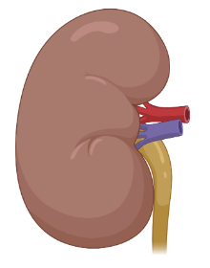  Figure 1 – an unlabelled diagram of the kidney | Remove wastes (such as urea) from the blood and regulate the balance of water and salts by producing urine.
Lungs | Two soft, spongy organs in the chest cavity. They are made up of millions of tiny air sacs called alveoli, each surrounded by a fine network of capillaries. | Figure 2 – an unlabelled diagram of the lungs  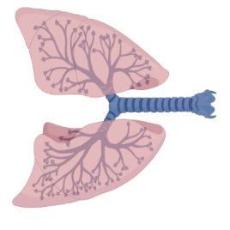 | Remove carbon dioxide from the blood during exhalation.
Skin | The outer covering of the body. The dermis layer contains many coiled sweat glands, each connected to the skin's surface by narrow ducts and pores. | Figure 3 – diagram of the skin with sweat glands  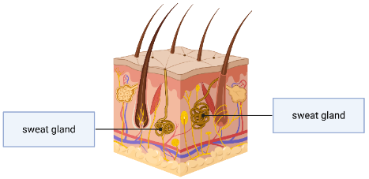 | Releases sweat containing water, salts and small amounts of urea, helping to control body temperature.
Specialised cell – sweat gland clear cell | Specialised cells are found in the coiled part of sweat glands. They have large surfaces and many channels for the movement of substances. | Figure 4 – image of a sweat gland clear cell  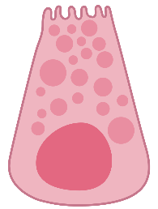 | Produce sweat, which is later released through ducts to the skin surface.
Specialised cell – alveolar cell | Very thin, flat cells that make up the walls of the alveoli. | Figure 5 – image of an alveolar cell in the lungs | Allow gases such as carbon dioxide to pass from the blood into the air spaces of the lungs.
This work has been generated using BioRender.com. Any copyright subsisting in this work is owned by © State of New South Wales (Department of Education) 2025.

1.6 Body systems working together
Table 20 – learning intentions and success criteria for ‘1.6 Body systems working together’
We are learning: | I can:
- to describe how body systems function | - identify the needs of humans as multicellular organisms: including their intake of oxygen and nutrients and excretion of wastes  - recall the role and purpose of the respiratory system, circulatory system, digestive system, excretory system and their components  - outline the requirements provided by each body system, for example, the digestive system provides nutrients  - describe how components of the systems work together
- to communicate scientific ideas in a written text. | - construct a written text to communicate the interactions between body systems and their components  - use relevant and precise scientific terminology in a written text.

Providing needs for organisms
Students have learned about individual body systems, their processes and functions. In this activity, students will identify organisms' needs and examine how their systems interact to meet those needs.
- Teach students the needs of multicellular organisms such as humans to ensure efficient functioning using LIV PPT ‘1.6 What do our bodies need?’ Outline that organs and body systems need to work together to achieve this.
Checkpoint 1: assess students’ understanding of the needs of organisms using LIV PPT ‘1.6 Checkpoint 1’.
Identify the needs of organisms.
A. Intake nutrients, intake oxygen, intake waste.
B. Intake nutrients, intake oxygen, and excrete waste.
C. Excrete nutrients, intake oxygen, and intake waste.
D. Excrete nutrients, excrete oxygen, intake waste.
Table 21 – checkpoint response explanation
Response | Explanation
A | This is incorrect because organisms do not take in waste. Waste products are by-products of metabolism and need to be removed from the body, not absorbed. Taking in waste would actually be harmful.
B | This is the correct response.
C | This is incorrect because organisms need to keep nutrients (not excrete them) for energy, growth and repair. It’s also wrong because, again, organisms do not take in waste; they excrete it.
D | This is incorrect because organisms do not excrete nutrients; they need to retain them. It is also incorrect because most animals need to intake oxygen, not excrete it (plants excrete oxygen, but they still need carbon dioxide and nutrients), and no organism intakes waste; they excrete it.

Interactions between body systems
- Use vocabulary dominoes to review students' understanding of the body systems and the organs/structures of the body systems.
Note: the vocabulary dominoes – body systems resource may be printed, laminated and cut out before class and reused as required.
- Instruct students to work in pairs or groups of 3. Provide each group with a copy of vocabulary dominoes – body systems (Canva presentation) with key terms and definitions.
- Guide students to interact with each vocabulary domino. There is a clear starting point, the domino with ‘Start’ in green, and a clear stopping point, the domino with ‘Stop’ in red. Let students know that only one pathway can be constructed.
- Use LIV PPT ‘1.6 Vocabulary dominoes’ (2 slides) to model an example of how to join the vocabulary dominoes. Continue to model or jointly construct, or students independently complete the remainder of the dominoes pathway.
- Facilitate a class discussion of the completed vocabulary dominoes using LIV PPT ‘1.6 Vocabulary dominoes’ (2 slides) to check students' understanding of the body systems and their components.
- The completed vocabulary dominoes begin with what a body system is, then form a single chain that defines each of the body systems (respiratory, circulatory, digestive and excretory), the organs within each system, and the functions of each organ in the system. The stop domino indicates the final piece.
Note: if students are still having difficulty understanding the role, structure and function of the body systems and their components, additional instruction may be needed to improve their comprehension before progressing to how the systems interact to support the efficient functioning of the human body.
- Recall that multicellular organisms, such as humans, require the intake of nutrients (preformed foods), oxygen and the excretion of wastes to ensure efficient functioning of the body.
- Provide students with the Student resource – the needs provided by body systems.
- Instruct students to identify the body systems in the student resource, then outline how each body system provides one of the ‘needs’ of multicellular organisms. Model this using the digestive system in LIV PPT ‘1.6 Requirements provided by body systems’.
- Continue to model or jointly construct, or have students independently complete the remainder of the Student resource – the needs provided by body systems.
- Facilitate class discussion of the completed student resource to check student understanding of the requirements provided by each of the body systems using the slide and speaker notes LIV PPT ‘1.6 Requirements provided by body systems.’ Key discussion points include:
- The digestive system provides the body with the nutrients it requires by breaking down food.
- The respiratory system brings oxygen into the body when air is inhaled.
- The circulatory system provides cells in the body with oxygen, nutrients and other substances, and removes waste products.
- The excretory system removes wastes such as carbon dioxide, excess salts and urea from the body.
- Inform students that the systems need to work together to provide organisms with what they need and to allow efficient functioning of the organism. Use LIV PPT ‘1.6 Body systems working together’ to ask students what happens when food is eaten, and air is breathed in and out.
- Provide students with Student resource – body systems working together. Inform students that the text explains how the digestive, circulatory, respiratory and excretory systems work together to maintain an organism's efficient functioning.
- Engage with the An apple’s journey text with students, highlighting the role of each system in a different colour. For example, yellow highlighter = digestive system, green highlighter = respiratory system and so on.
- Provide students with the Student resource – describing how the systems interact and unpack the question to plan a response. A sample response has been given in Sample response: Student resource – describing how the systems interact.
- Model how to create the written text using the plan outlined. A sample response has been given in Sample response: Student resource – describing how the systems interact.
- Use the marking criteria in LIV PPT ‘1.6 The interrelatedness of body systems’ to model how to mark responses and provide specific feedback to help improve. Instructions for doing this for the provided sample written response are in the speaker notes of the slide LIV PPT ‘1.6 The interrelatedness of body systems’.
Differentiation: sentence starters or a cloze passage can be adapted from the sample response and used with students to support them in writing their own responses.
Checkpoint 2: determine student understanding of how body systems work together using LIV PPT ‘1.6 Checkpoint 2.’
Which of the following best explains how the respiratory and circulatory systems work together to support the functioning of the body?
A. The respiratory system pumps blood to the lungs, which then absorb oxygen from the air.
B. The circulatory system transports oxygen from the lungs to the body’s cells and carries carbon dioxide back to the lungs to be removed by exhalation.
C. The respiratory system digests food and sends nutrients to the circulatory system for distribution.
D. The circulatory system filters waste products from the blood and sends oxygen-rich blood directly to the brain.
Table 22 – checkpoint 2 response explanation
Response | Explanation
A | The option mentions pumping blood and lungs, so it appears related to the respiratory and circulatory systems. Students may confuse the functions of these systems. The respiratory system does not pump blood; the heart (part of the circulatory system) does. The lungs absorb oxygen, but they don’t pump blood.
B | This is the correct response.
C | Students might confuse the digestive system with the respiratory system, thinking both are involved in nutrient transport. The respiratory system does not participate in digestion or nutrient absorption. Nutrient transport is a role of the digestive and circulatory systems, not the respiratory system.
D | The mention of filtering waste and sending oxygen-rich blood to the brain might confuse students who understand that the circulatory system moves blood and that the kidneys filter waste. Waste filtering is mainly a function of the excretory system (kidneys), not the circulatory system. Additionally, oxygen-rich blood is delivered to all body cells, not just the brain.
Sample response: Student resource – describing how the systems interact
- Plan for the response.
Introductory sentence to name the systems and set up the big idea.
Describe the interaction between the digestive and circulatory systems for nutrient intake.
Describe the interaction between the respiratory, circulatory and excretory systems for carbon dioxide removal.
Describe the interaction between the circulatory and excretory systems for urea removal.
Concluding statement to make the link to the needs of organisms clear.
- Answer the question in the box below.
The human body relies on the digestive, respiratory, circulatory and excretory systems working together to meet the needs of cells. The digestive system breaks down food, and the small intestine absorbs nutrients, which the circulatory system carries to body cells. The respiratory system brings in oxygen at the alveoli, where it diffuses into the capillaries and is transported to cells. The circulatory system also returns carbon dioxide to the lungs, where it is breathed out. To remove wastes, the circulatory system carries urea in the blood to the kidneys in the excretory system, where it is filtered into urine. These interactions ensure the organism takes in the nutrients and oxygen it needs and removes carbon dioxide and urea, keeping conditions stable and allowing the organism to function efficiently.

Student resource – the needs provided by body systems
Instructions: label each body system and identify the requirements each system provides for humans.
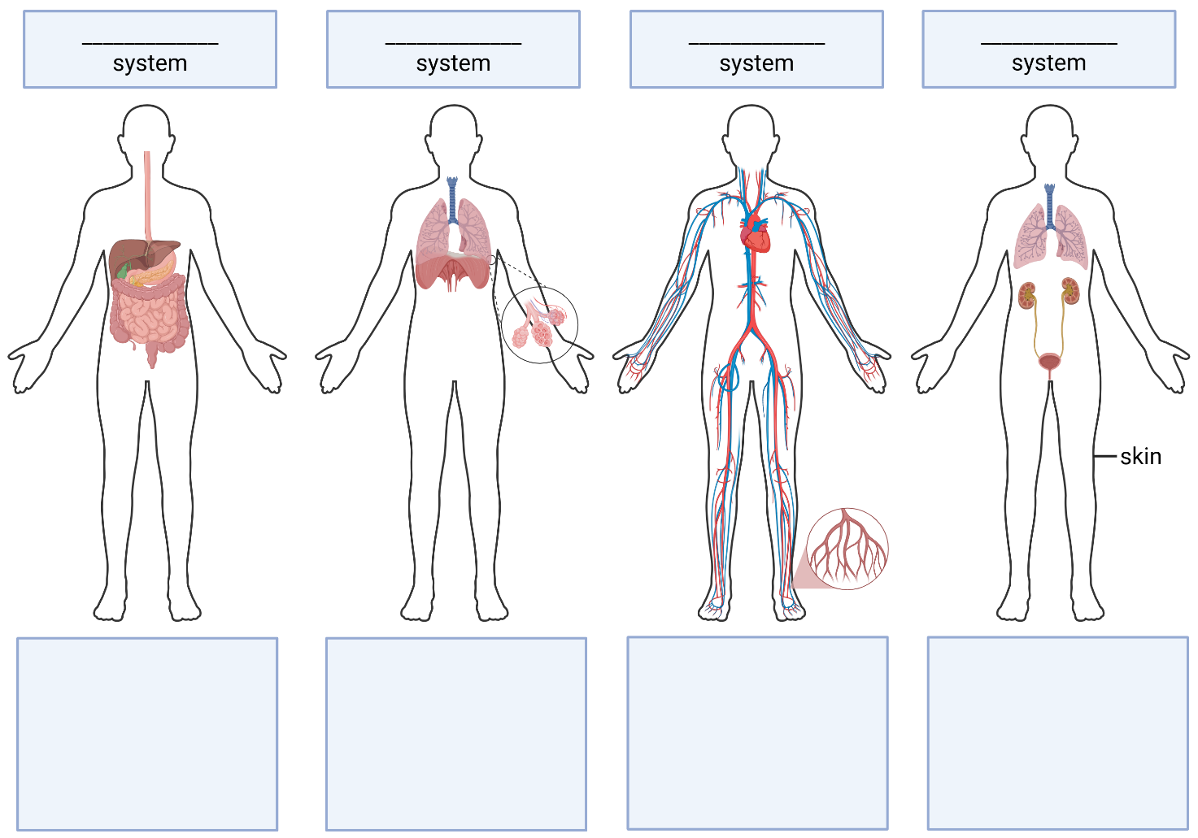
This work has been generated using BioRender.com. Any copyright subsisting in this work is owned by © State of New South Wales (Department of Education) 2025.

Student resource – body systems working together
Instructions: engage with the text below. Use 4 different colours to highlight the role each body system plays in the apple’s journey.

An apple’s journey
Once upon a time, in a sunny orchard, a bright red apple hung from a tree branch, swaying gently in the breeze. One day, a hungry person walked by and picked the apple, ready to enjoy its delicious sweetness. Little did they know that this apple was about to embark on an incredible journey through the human body, interacting with several intricate systems along the way.
As the person took a big bite, the apple chunk was greeted by the warm, moist environment of the mouth. The teeth crunched down, breaking the apple into smaller pieces, while saliva mixed with it, initiating the digestive process. Salivary enzymes began breaking down the apple's carbohydrates, turning it into a mushy pulp. With a satisfied swallow, the chewed apple travelled down the oesophagus, a muscular tube that led to the stomach.
Once the apple reached the stomach, it was subjected to vigorous churning, mixing it with powerful gastric juices. These gastric juices work tirelessly to break down the apple further, turning it into a semi-liquid. After some time, the semi-liquid form was ready to move on, entering the small intestine.
In the small intestine, food from the stomach is further digested (small intestine is the primary site for chemical digestion) by enzymes, bile and intestinal juices. The nutrients – vitamins, minerals and sugars – were released from the apple. The tiny villi lining the intestinal walls then absorbed these nutrients into the bloodstream. As the nutrients entered the bloodstream, they began their journey through the circulatory system. Nutrients are carried in the blood plasma, while oxygen is carried by red blood cells. Thus, blood in the circulatory system collects nutrients from various body systems (digestive and respiratory) and delivers them to all cells in the body. The heart pumped vigorously, ensuring that the nutrient-rich blood reached every corner of the body.
To release energy via cellular respiration, cells need oxygen. Oxygen is delivered to cells by red blood cells (a component of the circulatory system). During gas exchange in the lungs (respiratory system), oxygen is transferred from inhaled air into red blood cells, which then circulate throughout the body. Thus, blood transports both nutrients and oxygen to cells, where respiration occurs.
However, with the production of energy came the creation of waste – carbon dioxide. The cells released this gas, which entered the bloodstream and was transported back to the lungs. There, the carbon dioxide was exchanged for oxygen during the next breath, illustrating the seamless cooperation between the respiratory and circulatory systems.
Meanwhile, not all parts of the apple were absorbed. The faeces, solid or semi-solid remains of food that could not be digested or absorbed in the small intestine, are egested through the anus. The kidneys filter the blood, removing excess substances and waste. The kidneys formed urine, which would eventually be stored in the bladder.
When the time was right, the body excreted urine, completing the waste removal process. The journey of the apple, from a delicious snack to nourishing the body, showcases the intricate dance of the digestive, circulatory, respiratory and excretory systems working together in harmony.
This work has been generated using artificial intelligence and modified by the authors. Any copyright subsisting in this work is owned by © State of New South Wales (Department of Education) 2025.

Student resource – describing how the systems interact
Instructions: as a class, deconstruct the question below, outline a plan and construct a suitable response. Use the marking guidelines to reflect on the quality of the response.
Describe how body systems interact to maintain the efficient functioning of the human body. In your response, include at least 2 examples of how these systems depend on each other.
- Plan for the response.
- Answer the question in the box below.

1.7 Body systems malfunction
Table 23 – learning intentions and success criteria for ‘1.7 Body systems malfunction’
We are learning: | I can:
- to describe how body systems function | - define disorder and disease  - describe how kidney disease impacts the excretory system and the human body as a whole  - identify disorders, diseases and components of body systems that may be removed  - explain how a disorder, disease or organ removal impacts a body system and the human body as a whole
- to create written texts to communicate scientific understanding. | - describe the conventions of an explanatory text in science  - use causal connectives to demonstrate cause and effect  - construct explanatory texts about the impacts of a disease, disorder or organ removal on a body system and the human body as a whole.

Diseases and disorders in body systems
Note: there may be students in the class who have the diseases mentioned in this activity, or a family member/relative with those conditions. Ensure these students are considered, and select an alternative example of a disease or disorder if required.
- Review the idea that components of body systems work together to ensure the efficient functioning of organisms.
- Inform students that if components of body systems malfunction or are removed, this can affect other body systems and the overall functioning of the organism.
- Define disorder and disease using LIV PPT ‘1.7 Defining key terms’.
- Inform students that diseases or disorders that affect parts of body systems, or the removal of components of a body system, can influence how the system and the organism function.
- Define kidney disease, the types of kidney disease and the effects of kidney disease using LIV PPT ‘1.7 Kidney disease’ (2 slides).
- Show students ‘What is Kidney Disease?’ (2:44) video on LIV PPT ‘1.7 The effects of kidney disease’, pausing at points to elaborate on the content. Work with students, pausing the video at intervals, to extract and summarise key points that describe the impact of kidney disease on the excretory system and on the human organism.
- Facilitate a class discussion to check students’ understanding of the impact of kidney disease on the excretory system and on the human body as a whole. This includes
- Damage to the kidneys reduces their ability to eliminate waste and excess water, leading to a build-up of these substances in the body. This disrupts the balance of nutrients and electrolytes, affecting the body's overall chemical stability and the regulation of hormones that control blood pressure, blood volume and bone health.
- Impacts on the organism as a whole include weakened bone health due to impaired hormone regulation, putting cardiovascular health at risk and increasing the likelihood of heart disease and stroke. Overall health can also decline if the disease worsens, potentially leading to kidney failure.

Investigating impacts on body systems and the organism (secondary-source investigation)
Note: students will need access to a computer or laptop to complete the activity. It is recommended that the Student resource – tips for conducting secondary-source research be shared with students via a digital platform, such as Microsoft Teams or Google Classroom, to facilitate collaboration.
In this activity, students will be taught how to conduct a secondary-source investigation to extract and summarise key points and to communicate their findings in a conventional scientific text structure: an explanatory text. The text will explain how a disease, disorder or the removal of a component of a body system can affect the body system and the organism as a whole.
- Working in pairs, students select from the list below (preferably not the same as any other pair where possible) to conduct secondary-source research.
- Coronary heart disease | - Asthma
- Heart valve removal | - Lung cancer
- Gall bladder removal | - Whooping cough
- Stomach flu (gastroenteritis) | - Kidney stones
- Celiac disease | - Urinary tract infection (UTI)
- Engage with the ‘Tips for conducting secondary-source research’ in the Student resource – tips for conducting secondary-source research. Model how to conduct online research using keywords and phrases in a search engine's search bar, using pneumonia as an example.
Conducting research online provides more tips on using keywords to find specific information. This can be shared with students.
- Provide students with the Student resource – conducting secondary-source research (one per pair can be given, particularly if provided digitally so that both students can edit at the same time.)
- Depending on students’ abilities, you may need to continue modelling or jointly constructing how to research, extract and summarise key points. A ‘Sample student response: Student resource – conducting secondary source research’ has been provided using the example of pneumonia.
- Using the LIV PPT ‘1.7 What does it mean to ‘explain?’ and LIV PPT ‘1.7 Conventions of an explanatory text’ teach students what is required for a response that asks them to ‘explain’.
Refer to the Science – Syllabus QRG – Quick Reference Guide – Linking Writing in Secondary (WiS) resources to syllabus advice for writing (PDF 200KB), which maps the WiS resources to the relevant Science 7–10 Syllabus (2023) content. For additional support in explicitly teaching writing, see the ‘Teaching writing’ WiS webpage.
- Use LIV PPT ‘1.7 Writing an explain response’ (5 slides) to model how to write an explanatory response using the impact of pneumonia on the respiratory system and the organism as a whole as an example (Questions 5 and 6 in ‘Sample student response: Student resource – conducting secondary source research’). Non-examples have also been provided to support further student understanding of the structure of an explanatory text.
Differentiation: provide students with the scaffold below, also on LIV PPT ‘1.7 Differentiation’, to support in writing an explanation for questions 5 and 6 in Student resource – conducting secondary-source research.
Students use the scaffold to construct their text by including relevant information in the bolded square brackets.
For example:
Question 5
The disease/disorder/body part removed causes [insert cause] in the [insert body system].
Because of this, the [insert body system or its components] cannot [insert function impacted] as effectively, resulting in the [insert component of body system affected] being less able to [insert function affected].
Question 6
Due to the [insert body system] not working properly, the body as a whole experiences [insert effect on the whole body].
This causes other systems, such as [insert system], to [insert negative effect on body system or its components].
As a result, the organism cannot [insert function affected] effectively, leading to [insert effect of impaired function].
This occurs because [insert cause or why the component of the body is impaired].
- Students work in pairs to conduct a secondary-source investigation to complete the Student resource – conducting secondary-source research . Remind students that information should be summarised in their own words and not copied directly from source texts.
Checkpoint: assess student understanding of explanatory texts by providing a true or false statement with a sample text (LIV PPT ‘1.7 Checkpoint’).
True or false: The text below is not an example of an explanatory text about how the common cold impacts an organism.
The common cold causes swelling and extra mucus in the nose and throat, which blocks normal airflow in the respiratory system. As a result, the body receives less oxygen, leading to tiredness and difficulty concentrating.
This is false. The text is explanatory because it uses causal connectives to clearly show how the common cold affects the respiratory system and the whole body. It also explains the cause-and-effect chain in the present tense, using relevant scientific terminology, making the explanation clear and scientific.
Sample student response: Student resource – conducting secondary source research
- Name the disease, disorder or body part being removed.
Pneumonia.
- Identify the main organ/s affected.
The lungs.
- Identify the body system the organ/s belong to.
The respiratory system.
- Describe what the organ/s and body system normally do.
The lungs normally bring oxygen into the body and remove carbon dioxide. In the lungs, oxygen passes into the bloodstream through tiny air sacs called alveoli. The circulatory system then carries this oxygen to all cells, which use it to release energy from food. At the same time, carbon dioxide, a waste gas, is carried back to the lungs for exhalation.
- Explain what the disorder/disease/organ removal does to the body system and its components.
The disease pneumonia causes a buildup of fluid and inflammation in the alveoli (air sacs) in the respiratory system. Because of this, the lungs cannot exchange oxygen and carbon dioxide as effectively, resulting in the alveoli being less able to allow normal airflow. As a result, the respiratory system’s normal function of completion of gas exchange is reduced, leading to shortness of breath, coughing and reduced efficiency of the lung.
- Explain how the disorder/disease/organ removal affects the rest of the body as a whole.
Due to problems in the respiratory system, the body experiences a drop in blood oxygen levels and a build-up of carbon dioxide. This causes extra work for other systems, such as the circulatory system, through an increase in heart rate to maintain oxygen delivery to tissues. As a result, the efficiency of cellular respiration is reduced, causing tiredness and shortness of breath. This happens because body cells do not get enough oxygen for energy production. Overall, the reduced oxygen supply and decreased energy production affect the whole organism, limiting its ability to carry out normal activities and maintain health.
- In Table 1, indicate the sources used to gather information about the chosen disease, disorder or body part being removed.
Table 1 – sources of information for the chosen disease, disorder or body part being removed
Title | Author | Year published | URL
Pneumonia | Better Health Channel | 2025 | https://www.betterhealth.vic.gov.au/health/conditionsandtreatments/pneumonia
Pneumonia | Mayo Clinic | 2020 | https://www.mayoclinic.org/diseases-conditions/pneumonia/symptoms-causes/syc-20354204
Pneumonia | Lung Foundation Australia | 2025 | https://lungfoundation.com.au/lung-diseases/respiratory-infections/pneumonia/

Student resource – tips for conducting secondary-source research
Instructions: engage with the tips to inform your approach to secondary-source research.
Tips for conducting secondary-source research
- Use specific keywords and phrases in a search engine to identify better sources of information related to your topic.
- Read your topic widely using the internet, books and scientific journals.
- Check resources for accuracy, reliability and validity. Note any valid references you find useful.
- Add references to your reference list as you go. Do not leave your reference list until the end; you may have trouble finding the resource again, particularly if it is online.

Student resource – conducting secondary-source research
Instructions: conduct secondary-source research to complete the questions below.
NESA key term definitions
Identify: recognise and name.
Describe: provide characteristics and features.
Explain: relate cause and effect; make the relationship between things evident; provide why and/or how.
NESA Glossary (n.d.)
- Name the disease, disorder or body part being removed.
- Identify the main organ/s affected.
- Identify the body system the organ/s belong to.
- Describe what the organ/s and body system normally do.
- Explain what the disorder/disease/organ removal does to the body system and its components.
- Explain how the disorder/disease/organ removal affects the rest of the body as a whole.
- In Table 1, indicate the sources used to gather information about the chosen disease, disorder or body part being removed.
Table 1 – sources of information for the chosen disease, disorder or body part being removed
Title | Author | Year published | URL
*Add more rows to the table as required

1.8 Plant systems
Table 24 – learning intentions and success criteria for ‘1.8 Plant systems’
We are learning: | I can:
- to describe the role, structure and function of plant systems and their components | - label a plant diagram to identify its components  - outline the function of plant parts: roots, stem, xylem, phloem, leaf, flower, fruit and seed.  - identify components of a flower  - relate parts of a flower to reproduction in flowering plants  - describe the function of specialised cells: root hair cells and guard cells, and tissues: xylem and phloem  - describe how plant components work together to help plants survive
- to process data and information from secondary sources. | - skim and scan a text to extract relevant information to answer questions about cellular respiration and photosynthesis  - summarise key information in short response questions  - identify appropriate units for length as µm, mm, cm and m  - convert measurements between different units.
Checkpoint 1 (LIV PPT): determine students’ prior knowledge of the purpose of flowers, fruit, leaves, roots and stems of plants (Early Stage 1) and of how flowers, fruit and seeds are used for reproduction in plants (Stage 3) using LIV PPT ‘1.8 Checkpoint 1.’ A sample response has been provided in Figure 18.
Figure 18 –checkpoint 1 sample response
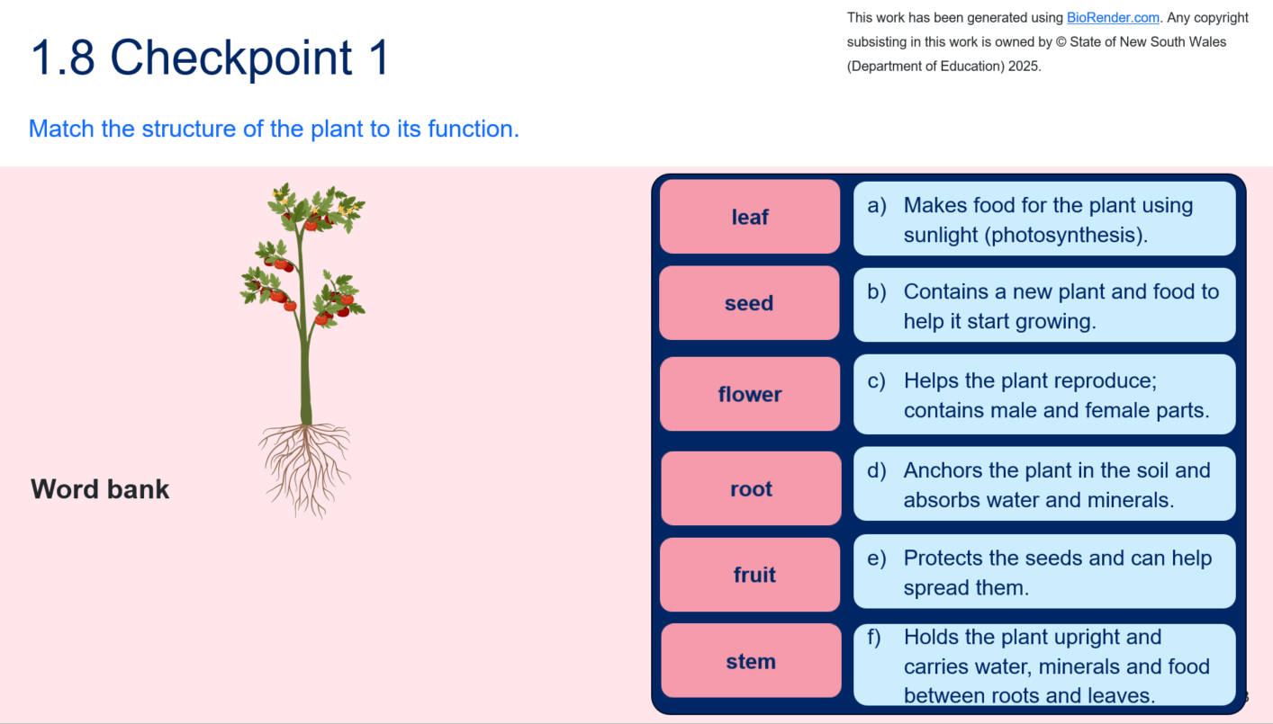
- Recall that plants are multicellular organisms that also require intake and excretion of substances to maintain themselves. Use LIV PPT ‘1.8 What do plants need?’ to identify the needs of plants.
- Recall how to extract and summarise key points from a text to answer questions.
- Engage with the Student resource – plant components text as a class, by highlighting key points related to the comprehension questions and the plant diagram in the student resource.
- Model or jointly construct strategies for labelling the plant diagram and respond to the short answer comprehension questions (students can independently do this if capable).
- Facilitate class discussion to check student understanding of the components of the plant, their function and their role in maintaining plants as a multicellular organism using LIV PPT ‘1.8 Plant parts’ and the sample response below.
Sample response: Student resource – plant components text
- Match the term with the function.
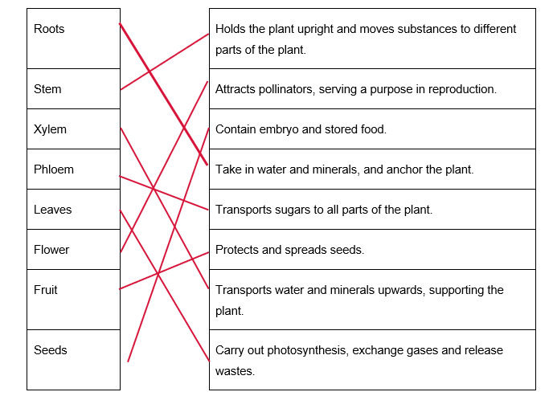
- Identify the structure that allows leaves to take in carbon dioxide and release oxygen and water vapour. Why is this important?
Leaves have stomata, small openings that allow carbon dioxide to enter and oxygen and water vapour to escape. This is important because it enables the plant to make food through photosynthesis and to remove waste.
- How do the flowers, fruits and seeds help the plant continue its life cycle?
Flowers enable pollination and fertilisation, allowing seeds to develop. Fruit protects the seeds and aids their dispersal to new locations. Seeds contain the embryo and a food reserve to support germination. Together, these parts enable the plant to reproduce and ensure the next generation can grow.
- How does the structure of the 3 components of the plant support their functions?
Roots: roots have a branching structure with tiny root hairs that increase surface area. This allows them to absorb water and minerals efficiently and anchor the plant.
Leaves: leaves contain chloroplasts for photosynthesis and stomata for gas exchange. These structures allow them to produce energy and remove waste.
Xylem: xylem consists of hollow, lignin-strengthened tubes. This allows water and minerals to move upwards and provides support to the plant.
- How do all the components work together to help plants survive as multicellular organisms?
All the plant’s components work together as an interconnected system. Roots absorb water and minerals from the soil, anchor the plant, and provide resources and stability. This water and the dissolved minerals are transported upward by xylem to the leaves, where they are used in photosynthesis to make glucose. Leaves capture sunlight and, through their chloroplasts and stomata, produce energy and exchange gases. The glucose produced is carried by phloem to the rest of the plant, ensuring all cells receive energy. The stem supports the leaves and flowers, positioning them to capture sunlight and attract pollinators, and also serves as a conduit between the roots, leaves and reproductive organs. Flowers, fruit and seeds allow reproduction, ensuring the species continues to exist. Together, these specialised structures, tissues and organs enable the plant to take in water and nutrients, make and distribute energy, exchange gases, support itself physically and reproduce – all of which are essential for the survival and growth of a multicellular organism.

Student resource – plant components text
Instructions: read through the text to extract and summarise key points to label the components of a plant on the diagram and answer the comprehension questions.
Plants are multicellular organisms, composed of many specialised cells organised into tissues and organs. Each plant organ has a structure (what it looks like and is made of), a function (what it does), and a role (how it helps the plant survive and reproduce). Together, these parts enable plants to meet their needs: intake of water, minerals and gases; generation of energy; removal of wastes; and reproduction.
Roots grow underground and are usually long and branching, as shown in Figure 1. They have tiny extensions called root hairs that increase the surface area. Roots anchor the plant in the soil and absorb water and minerals, which are then transported through the xylem to the rest of the plant. This provides the resources every cell needs, keeping the plant supplied as a multicellular organism. | 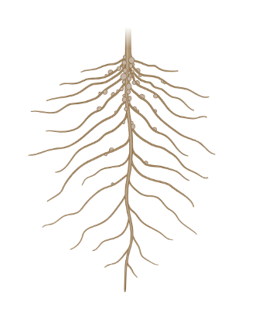  Figure 1 – a plant's root system

  Figure 2 – a stem of a plant |  | The stem, as shown in Figure 2, is an upright structure that contains vascular tissue (xylem and phloem). The stem’s strong structure supports the leaves and flowers, holding them towards sunlight and pollinators. This ensures all parts of the plant are connected and supported.
The xylem consists of hollow, dead cells joined to form long tubes. These tubes have strong walls containing lignin, the hardening component of plant cell walls. The xylem transports water and minerals from the roots to the leaves. It also gives the plant strength and support. The phloem consists of living cells joined end to end, with holes between them. The phloem transports sugars made in the leaves to the rest of the plant, both upwards and downwards. This distributes substances so all organs have what they need to function. |  |  | Figure 3 – a labelled diagram of the xylem and phloem with the roots of the plant at the bottom of the diagram and the leaves at the top  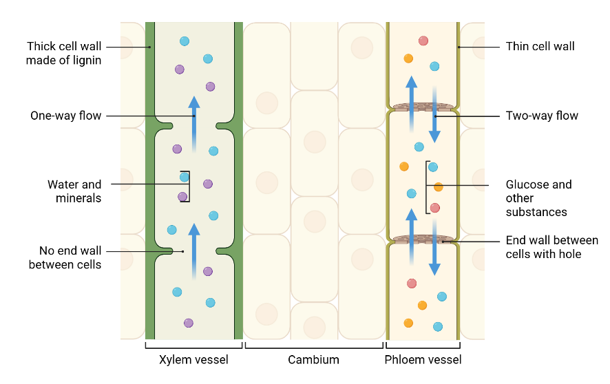
  Figure 4 – images of different-shaped leaves |  | Leaves are green structures on a plant that are generally flat and thin, with many chloroplasts for photosynthesis and small openings called stomata that allow gas exchange. Figure 4 shows some of the varieties of leaves in plants. Leaves capture sunlight and convert carbon dioxide and water into glucose. The phloem then transports the glucose to other parts of the plant. This process provides the energy that all plant cells need to carry out their functions.
Flowers are the reproductive organs of plants. They contain petals (to attract pollinators), stamens (male parts that produce pollen), and carpels (female parts, including the stigma, style and ovary). Flowers enable pollination and fertilisation, allowing seeds to form. This ensures the continuation of the species. |  |  |  | 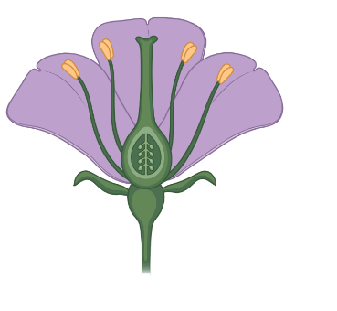  Figure 5 – an image of a purple flower
  Figure 6 – an apple | Fruit develops from the ovary after fertilisation. It protects the seeds and often becomes fleshy or develops other adaptations to aid seed dispersal by animals, wind or water. Fruit is important for dispersing offspring so that new plants can grow in different places.
Seeds contain the embryo (a tiny plant), a food store and a protective coat. The food store provides the young plant with energy for germination until it can photosynthesise on its own. Seeds ensure the plant’s life cycle continues. |  |  |  |  | 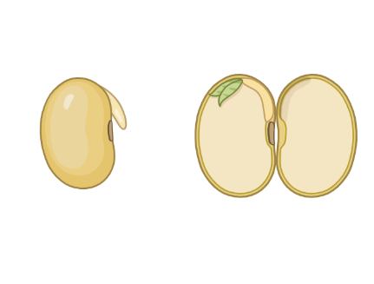  Figure 7 – an intact soybean and one that is cut open, showing the embryo
The images in this work have been generated using BioRender.com. Any copyright subsisting in this work is owned by © State of New South Wales (Department of Education) 2025.
The text in this work has been generated using artificial intelligence. Any copyright subsisting in this work is owned by © State of New South Wales (Department of Education) 2025.

Labelling components of a plant – word bank
seeds | stem | phloem | flower
leaf | roots | xylem | fruit
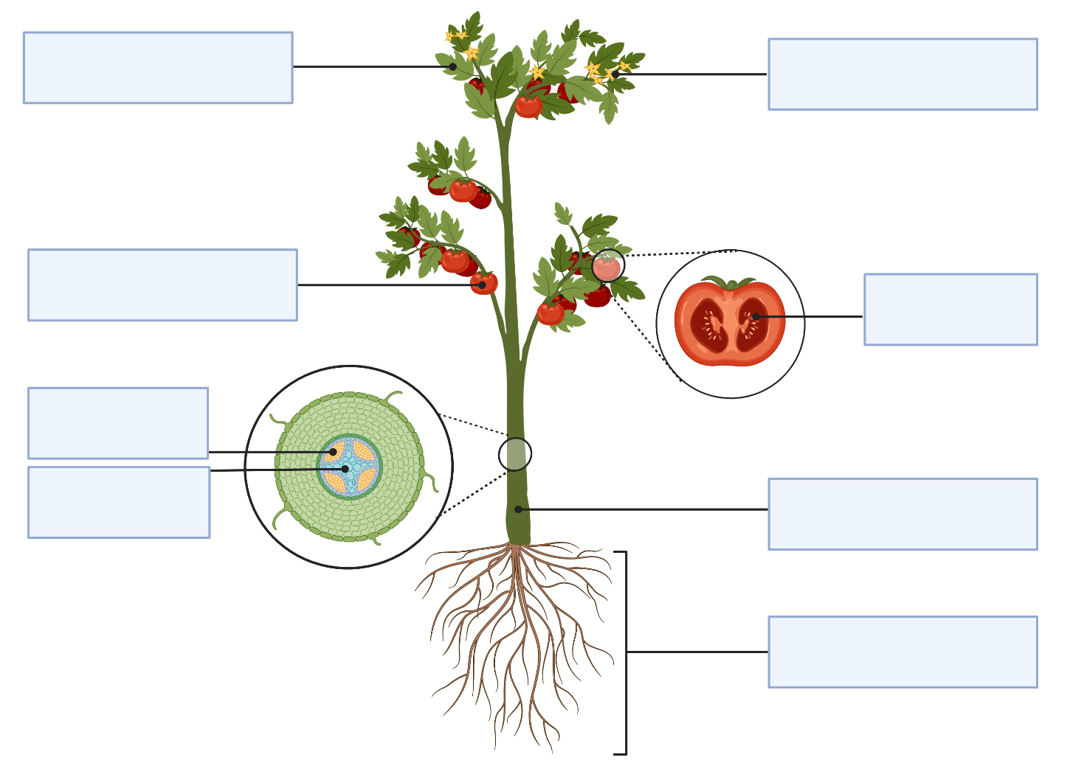
This work has been generated using BioRender.com. Any copyright subsisting in this work is owned by © State of New South Wales (Department of Education) 2025.
Comprehension questions
- Match the term with the function.
Roots |  | Holds the plant upright and moves substances to different parts of the plant.
Stem |  | Attracts pollinators, serving a purpose in reproduction.
Xylem |  | Contain embryo and stored food.
Phloem |  | Take in water and minerals, and anchor the plant.
Leaves |  | Transports sugars to all parts of the plant.
Flower |  | Protects and spreads seeds.
Fruit |  | Transports water and minerals upwards, supporting the plant.
Seeds |  | Carry out photosynthesis, exchange gases and release wastes.
- Identify the structure that allows leaves to take in carbon dioxide and release oxygen and water vapour. Why is this important?
- How do the flowers, fruits and seeds help the plant continue its life cycle?
- How does the structure of the 3 components of the plant support its function?
- How do all the components work together to help plants survive as multicellular organisms?

Flower dissection – practical investigation
To complete this practical investigation, equipment will need to be ordered in advance for groups of 3–4 students each. Order the following per group:
- 1 x fresh flower (lilies work well)
- 1 x dissecting tray
- 1 x scalpel
- 1 x forceps
- 1 x magnifying glass
Note: inform students that flowers vary across flowering plants and that there may be reasons for this. For example, sunflowers attract bees and butterflies with large, landing-pad-like flowers, while orchids use scent to draw specific bees. Regardless of the flowering plant selected for this activity, students should be able to identify the same plant parts in each plant. That is, each flowering plant should have a stem, leaves and so on.
- Provide students with the Student resource – flower dissection procedure.
- Engage with the materials list and procedure with students, discussing the risk assessment to ensure students safely conduct the practical investigation.
- Unpack the components of a flower using LIV PPT ‘1.8 Parts of a flower’ to support students with identifying parts of the flower during the dissection.
- Inform students they will need to complete ‘Table 1 – observations of the flower’ in the Student resource – flower dissection observations and questions. Instruct students to gather equipment for their group of 3–4 to conduct the practical investigation and complete the student resource safely.
- Facilitate a class discussion to determine student understanding of the parts of the flower using Table 25. Use the discussion points in the grey callout boxes within the sample student response to unpack the importance of these components in sustaining a flowering plant as a multicellular organism.
- Work with students to complete the discussion questions Student resource – flower dissection observations and questions.
- Facilitate class discussion of the discussion questions using ‘Sample response: Student resource – flower dissection observations and questions’.
Checkpoint 2: use the true-or-false questions in LIV PPT ‘1.8 Checkpoint 2’ to determine student understanding of flower parts and their function.
True or False
Petals are brightly coloured to attract pollinators, helping the plant reproduce. True
Sepals protect the flower bud before it opens. True
The stamen is the female part of the flower that produces pollen. False – the stamen is the male part of the flower. It consists of the anther, which produces pollen, and the filament, which supports the anther.
The stigma is sticky, allowing it to catch and hold pollen grains during pollination. True
The ovary contains ovules, which can develop into seeds after fertilisation. True
The filament is wide and flat, allowing it to catch pollen grains. False – the filament is a thin stalk that supports the anther (where pollen is made). It is not designed to catch pollen; its role is to position the anther so pollen can be easily transferred to pollinators or the wind.
Sample response: Student resource – flower dissection observations and questions
Table 25 – sample student response for the flower dissection
Component of a flower | Image | Description
Step 2: whole flower – observe petals and sepals | Figure 1 – the whole lily flower  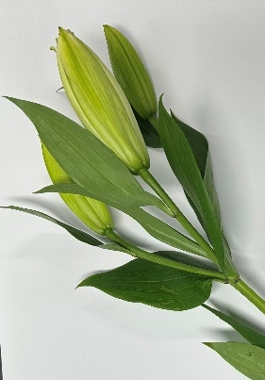 | - The lily has large, white petals arranged in a circular pattern. The petals are soft and smooth.  - The sepals are green and leaf-like, found at the base of the flower.  - The sepals protect the flower when it is in bud.  Note: discussion points  These structures are important because they protect the reproductive organs and help ensure pollinators visit, supporting reproduction in the plant.
Step 3: stamen | Figure 2 – an image of the partially dissected lily  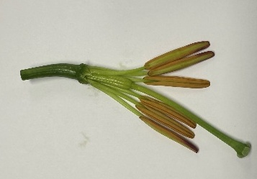 | Stamens are long, thin filaments with anthers at their tips. Six stamens surround the central carpel.  Note: discussion points  They are positioned to allow pollen to be easily transferred to pollinators. As specialised reproductive structures, stamens produce pollen grains that contain male sex cells, which are essential for fertilisation and the continuation of the plant species.
Step 4: anther, filament and pollen grains | Figure 3 – a dissected filament showing pollen grains  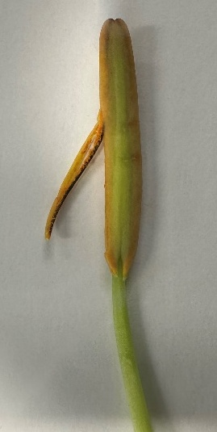 | The filament is green, slender and flexible, supporting the anther. The anther is a long, brownish/orange structure at the filament's tip. When cut open, the anther releases fine yellow/orange pollen grains, which are the male sex cells. Pollen is very small and appears as a dust-like substance.  Note: discussion points  - This is important because pollen grains carry the genetic material needed to fertilise ovules, enabling reproduction in these multicellular organisms.
Step 5: carpel | Figure 4 – the carpel of the flower  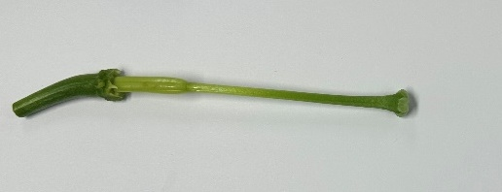 | The carpel is the central green structure, larger than the stamens, and pale green. It consists of a broad base (the ovary), a long, tube-like style, and a stigma at the top.  Note: discussion points  The carpel’s size and position at the centre make it well placed to receive pollen, allowing fertilisation of the ovules inside the ovary.
Step 5: stigma | Figure 5 – an image of the stigma showing that it is sticky  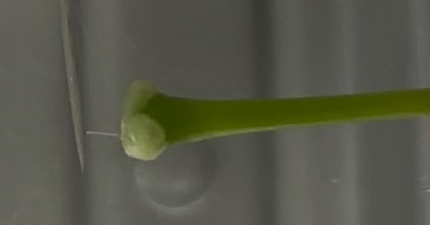 | The stigma is found at the tip of the style. It appears slightly swollen and sticky to the touch.  Note: discussion points  Its sticky surface is important for trapping pollen grains when they land. This is critical for reproduction, as it ensures pollen can reach the ovules.
Step 6: ovary and ovules | Figure 6 – an image of the ovary and ovules in the lily  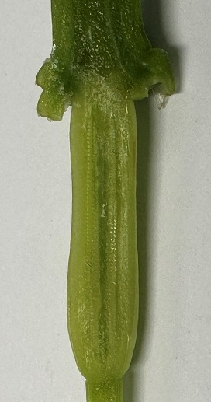 | The ovary is located at the swollen base of the carpel. When cut lengthwise, it reveals multiple small, round ovules arranged inside. Ovules are white to cream-coloured dots that can be counted. Estimated number: 20–30 ovules per ovary.  Note: discussion points  The ovary protects the ovules, and after fertilisation, these ovules develop into seeds, ensuring the plant reproduces and maintains its life cycle.
Sample response: Student resource – flower dissection observations and questions
Discussion questions
- How do the different flower parts (stamen, carpel, petals, sepals) work together for reproduction?
The petals attract pollinators to the flower, bringing them close to the stamens that produce pollen. The pollen can then be transferred to the sticky stigma of the carpel, where it remains so fertilisation can occur. Inside the ovary, the ovules are fertilised to form seeds. Each part of the flower depends on the others, and together they ensure successful reproduction.
- How does the flower help the plant function as a multicellular organism?
The flower plays a key role in reproduction, enabling the plant to produce seeds that grow into new plants. This ensures the survival of the species, just as other plant organs, such as roots, stems and leaves, meet the plant’s needs for water, food and support. By enabling reproduction, the flower works with the other plant parts to keep the plant functioning as a multicellular organism.

Student resource – flower dissection procedure
Materials
- 1 x fresh flower
- 1 x dissecting tray
- 1 x scalpel
- 1 x forceps
- 1 x magnifying glass
Risk assessment
Hazard | Risk | Controls/precautions
Using the scalpel to cut parts of the flower | Cuts/lacerations to the skin. | Use proper cutting technique: cut away from the body and keep fingers out of the way of the scalpel blade.  Keep the blade capped when not in use.  Notify the teacher immediately if cut with the scalpel.
Exposure to pollen | Allergic reaction causing skin and/or eye irritation. | If allergic, do not handle the flower, or choose a low-pollen variety. Alert the teacher immediately if there are any signs of an allergic reaction.  Avoid touching the face/eyes during the dissection.  Wear gloves and wash your hands after use.
Eye exposure to dust or pollen | Irritation of the eye. | Do not blow on specimens.  Tap the anthers gently.  Wear appropriate PPE such as safety goggles.  If eye is exposed to dust or pollen, report to the teacher and wash out with the eye wash.
Procedure
- Place the flower in the centre of the dissecting tray.
- Observe the entire flower. Take note of its colour, shape, and how the petals and sepals are arranged.
- Students label the petals and sepals shown in Figure 1 in the table and record a description of the petals and sepals of the flower.
- Gently remove the sepals and petals with forceps, then make further observations to record in the table.
- Identify the stamens in the lily flower (these are the male parts). Count the number of stamens and record this in the table along with other descriptions of the stamen.
- Remove one stamen with forceps, observe the anther and the filament. Record observations of the anther and filament.
- Place the anther on the dissecting tray and use the scalpel to make a shallow cut along the length of the anther to open it.
- Use the magnifying glass to look inside; you should be able to see pollen grains (fine yellow/orange dust) spilling out. Record observations of the pollen grains in the table.
- Remove the stamen using the scalpel, leaving behind only the carpel (this contains the female structures).
- Describe the carpel, recording observations in the table.
- Identify the stigma, style and ovary as components of the carpel.
- Using the scalpel carefully, touch the tip of the stigma with the scalpel and slowly pull it away. Record observations in the table.
- Place the ovary flat on the dissecting tray. Using the scalpel, make a slow cut lengthwise through the ovary to open it.
- Observe the ovules (small bead-like structures) inside the ovary chambers. Count or estimate the number of ovules and describe the ovary and ovules in the table.

Student resource – flower dissection observations and questions
Instructions: complete the results table and discussion questions as you complete the flower dissection.
Results
Table 1 – observations of the flower
Component of a flower | Image | Description
Step 2: whole flower – observe petals and sepals | Figure 1 – the whole lily flower
Step 3: stamen | Figure 2 – an image of the partially dissected lily
Step 4: anther, filament and pollen grains | Figure 3 – a dissected filament showing pollen grains
Step 5: carpel | Figure 4 – the carpel of the flower
Step 5: stigma | Figure 5 – an image of the stigma showing that it is sticky
Step 6: ovary and ovules | Figure 6 – an image of the ovary and ovules in the lily
Discussion questions
- How do the different flower parts (stamen, carpel, petals, sepals) work together for reproduction?
- How does the flower help the plant function as a multicellular organism?

Observing specialised cells and tissues in plants – practical investigation
The activity instructions are split into:
- Teacher preparation (to be done before activity implementation with students)
- Facilitating the activity (so that the activity is completed within class time).

Teacher preparation
- Print 2–3 copies of Plants: station work. You will also need to order equipment for each station, as listed on the station cards, along with the materials and procedures.
- To complete the station work activity, some lab preparation is necessary before the lesson. The information to prepare each station is listed below (this will need to be done for more than one celery stalk and other equipment, depending on how many of each station there are). You may need 2–3 of each station, depending on class size.
Table 26 – teacher preparation for station work to observe plant tissue and specialised cells
Station number | Preparation before the lesson
1 – vascular tissue: xylem and phloem | Obtain a 250mL beaker. Fill the beaker with 100mL of water and add 3–5 drops of red or blue food colouring. Yellow or green should be avoided because it’s hard to distinguish from the colour of the celery. Break off a single stalk of fresh celery from the bunch using a single-edged razor blade to make a clean cut across the base of the stalk. Place the celery stalk in the food colouring solution and leave overnight (Figure 19).  Figure 19 – a stalk of celery in a solution of water and food dye  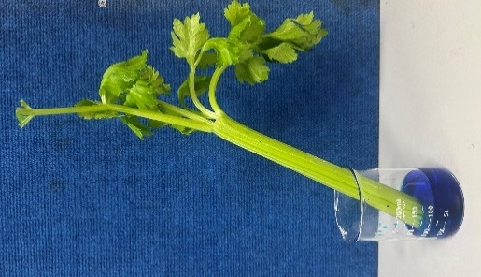  The next day, cut a 2 cm piece off the stalk to show students the vascular bundles in the station activity.  Slice off a very thin cross-section of the stalk to create a prepared slide, and cover the celery stalk sample with a cover slip.
2 – roots and root hair cells | Obtain root samples from around the school – varied root systems would be good for students to observe.  Attain a prepared slide of a root, showing root hair cells.
3 – stomata and specialised guard cells | Obtain leaf samples from around the school (smooth leaves with few leaf hairs are usually best). On one of the leaves, apply a thin layer of clear nail polish to a 2 cm x 2 cm area on the underside of the leaf, as shown below.  Figure 20 – the underside of a leaf with clear nail polish  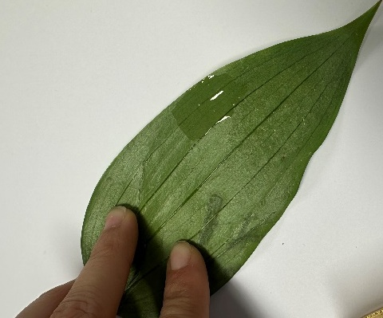  Leave it to dry, then place a strip of clear sticky tape over the nail polish. Press the tape down to make a good connection with the nail polish.  Figure 21 – the underside of a leaf with clear nail polish and a strip of sticky tape  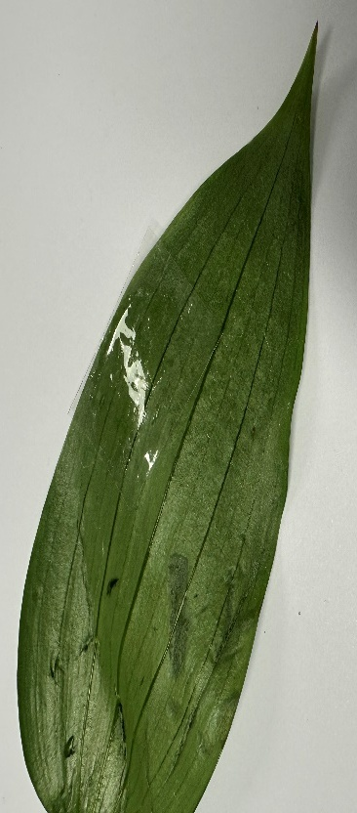  Peel off the sticky tape; the nail polish layer should come away with it. Place the tape with the leaf impression on a microscope slide. Use a razor blade to trim any excess sticky tape from the edge of the slide, if necessary. Label the slide with ‘lower surface of a leaf’.

Facilitating the activity
- Review student understanding of the parts of a plant and their function in maintaining plants as multicellular organisms, in particular the xylem, phloem, roots and root hair cells. LIV PPT ‘1.8 Plant parts’ may be used to support in reviewing this understanding.
- Provide students with the Student resource – observing plant structures, specialised cells and tissues station work.
- Briefly outline the procedure and safety requirements for each station using Plants: station work.
Note: there are 2 pages of notes for each station. The page outlining materials, procedures and safety is intended to support unpacking the requirements for each station. The page covering tissues and specialised cells is intended to support students in responding to the questions for each station.
- Allow students 15 minutes to complete each station and complete the corresponding station resource in the Student resource – observing plant structures, specialised cells and tissues station work.
- Once students have rotated through each station, instruct students to clean up the lab bench they last worked on.
- Using the Sample student response: Student resource – observing plant structures, specialised cells and tissues station work, facilitate class discussion on how specialised tissues such as the xylem and phloem, and specialised cells such as the root hair cell and guard cell, contribute to maintaining plants as multicellular organisms.
Checkpoint 3: determine students' understanding of the role of the specialised tissues, xylem and phloem using the multiple-choice question in LIV PPT ‘1.8 Checkpoint 3’.
Which of the following correctly describes the difference between xylem and phloem?
A. Xylem transports sugars towards the roots, and phloem transports water towards the leaves.
B. Xylem is composed of living cells, while phloem is composed of dead cells.
C. Xylem transports water and minerals in one direction, from roots to the leaves, while phloem transports sugars in multiple directions, from leaves to all organs in the plant.
D. Xylem stores water, and phloem stores food for the plant.
Information on why students may have selected incorrect responses is provided below and in the slide's speaker notes.
Table 27 – checkpoint 3 response explanation
Response | Explanation
A | Students may flip the roles of xylem and phloem, assuming one is just ‘up’ and the other is ‘down.’
B | Misconception that xylem must be alive to ‘pump’ water, when in fact xylem cells are dead and hollow.
C | This is the correct response.
D | Misconception that vascular tissues are for storage instead of transport.
Sample student response: Student resource – observing plant structures, specialised cells and tissues station work
Station 1 – sample responses
- What do you notice about the coloured streaks in the celery?
The streaks are bright and run along the length of the celery. They are narrow tubes, and some have rings in their cross-sections.
- How are the xylem vessels (the coloured dots/rings) arranged in the cross-section?
The xylem vessels are arranged in a circular pattern, usually at the centre of the vascular bundle. This arrangement strengthens the stem and makes it easier for water to move up through the plant.
- Draw the vascular bundle as observed under the microscope. Label the xylem and phloem.
Figure 22 – an unlabelled image of a vascular bundle showing the xylem and phloem
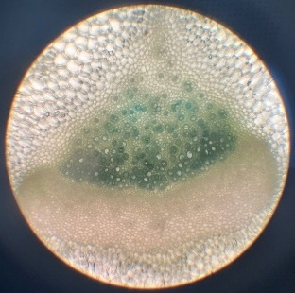
The xylem is the central region of the vascular bundle, containing larger, hollow, circular structures (stained darker blue because of the food colouring). The phloem consists of smaller, more compact cells arranged around the xylem.
- What do you notice about the arrangement of the xylem and phloem in the vascular bundle?
The xylem is located in the centre, while the phloem surrounds it. This arrangement makes sense because water and minerals must be transported from the roots to the leaves through the stem, while sugars in the phloem must move in all directions to reach all organs.
- How does the hollow, tube-like structure help xylem transport water?
Because the xylem cells are joined end-to-end without walls, they form long tubes through which water can flow easily. They contain a sticky substance called lignin, which makes them strong and prevents them from collapsing as water moves upward.
- How do xylem and phloem work together to help the plant survive and grow?
Xylem transports water and dissolved minerals to the leaves, enabling photosynthesis. Phloem transports the sugars produced during photosynthesis to other parts of the plant. Together, they ensure every cell receives the water, minerals and energy it needs.
Station 2 – sample responses
- Draw and label the root tip with root hair cells.
Figure 23 – an unlabelled image of a root with root hair cells under the microscope
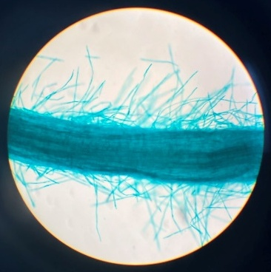
- The root hairs are all the thin projections coming from the root.
- What do root hairs look like, and why are they long and thin?
They are tiny, finger-like projections. Their length and thinness provide more surface area to absorb water and minerals from the soil.
- Why are roots important for plant survival and growth?
Roots anchor the plant in the soil and absorb water and minerals. Without roots, the plant would be unstable and unable to supply its cells with the nutrients they need to survive.
Station 3 – sample responses
- Draw and label the stomata and guard cells observed under the microscope.
Figure 24 – an unlabelled image of stomata and guard cells under a microscope
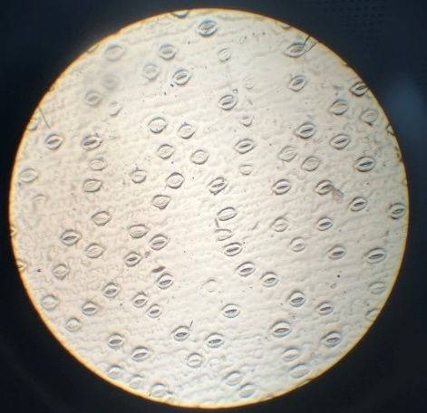
Small oval stomata with guard cells labelled around the opening.
- Where are stomata mostly found on the leaf? Why?
Stomata are mainly located on the underside of the leaf. This shields them from excessive direct sunlight, minimising water loss while still allowing gas exchange.
- How do guard cells help the leaf manage water and gases?
Guard cells swell to open the stomata when the plant needs carbon dioxide and shrink to close them when the plant needs to conserve water. This means they regulate both gas intake and water loss.
- Why is this important for the plant to survive as a multicellular organism?
Gas exchange through stomata enables the plant to absorb carbon dioxide for photosynthesis and to release oxygen and water vapour. Without this process, the plant couldn't produce food or eliminate waste, so its cells couldn't survive.

Student resource – observing plant structures, specialised cells and tissues, station work
Instructions: complete the worksheet for each station about some of the tissues and specialised cells in plants.

Station 1 – student observations and discussion questions
- What do you notice about the coloured streaks in the celery?
- How are the xylem vessels (the coloured dots/rings) arranged in the cross-section?
- Draw the vascular bundle as observed under the microscope. Label the xylem and phloem.
- What do you notice about the arrangement of the xylem and phloem in the vascular bundle?
- How does the hollow, tube-like structure help xylem transport water?
- How do xylem and phloem work together to help the plant survive and grow?

Station 2 – student observations and discussion questions
- Draw and label the root tip with root hair cells.
- What do root hairs look like, and why are they long and thin?
- Why are roots important for plant survival and growth?

Station 3 – student observations and discussion questions
- Draw and label the stomata and guard cells observed under the microscope.
- Where are stomata mostly found on the leaf? Why?
- How do guard cells help the leaf manage water and gases?
- Why is this important for the plant to survive as a multicellular organism?

Comparing like-for-like
Checkpoint 4: determine student prior understanding of units for length using a multiple-choice question in LIV PPT ‘1.8 ‘Checkpoint 4.’
Which of the following is not a unit for measuring length?
A. Millimetres (mm)
B. Centimetres (cm)
C. Micrometres (µm)
D. Litres (L)
Information on why students may have selected incorrect responses is provided below and in the slide's speaker notes.
Table 28 – checkpoint 4 explanation
Response | Explanation
A | This is correct as a unit of length. Millimetres are used to measure very small lengths, like the thickness of a coin.
B | This is correct as a unit of length. Centimetres are commonly used for everyday measurements, such as the height of a book or a person.
C | This is correct as a unit of length. Micrometres are used to measure objects too small to see with the naked eye, such as cells or bacteria.
D | This is the correct response. Litres are a measure of volume, not length.
- Inform students of the importance of using ‘like’ units to make valid comparisons between the size of objects.
- If different units are used, the comparison can be misleading or incorrect. For example, comparing the length of one object measured in centimetres with another measured in metres makes it difficult to tell which is actually longer unless both are converted to the same unit. Consider a desk that is 120 cm long and a whiteboard that is 2 m long. If these measurements are compared directly, students might think that because 120 is larger than 2, the desk must be longer. This leads to an incorrect conclusion because the numbers are being compared without considering the units. When unlike units are used, the comparison is not valid. The numbers alone are misleading, and it becomes easy to make errors.
- To make a valid comparison, both measurements must be converted into ‘like’ units. When this is done, the desk remains 120 cm, and the whiteboard becomes 200 cm. It is now clear that the whiteboard is longer. This shows that using like units makes comparisons valid, because both objects are being measured on the same scale.
- Teach students how to convert between units of length, from micrometre to metre and vice versa, using LIV PPT ‘1.8 Converting between units.’
- When going from micrometre (µm) to millimetre (mm), divide by 1000 because 1 mm = 1000 µm. For example, 5000 µm ÷ 1000 = 5 mm
- When going from millimetre (mm) to centimetre (cm), divide by 10 because 1 cm = 10 mm. For example, 5 mm ÷ 10 = 0.5 cm
- When going from centimetre (cm) to metre (m), divide by 100 because 1 m = 100 cm. For example, 0.5 cm ÷ 100 = 0.005 m
- When going from metre (m) to centimetre (cm), multiply by 100 because 1 m = 100 cm. For example, 0.005m x 100 = 0.5 cm
- When going from centimetre (cm) to millimetre (cm), multiply by 10 because 1 cm = 10 mm. For example, 0.5 cm x 10 = 5 mm
- When going from millimetre (mm) to micrometre (µm), multiply by 1000 because 1 mm = 1000 µm. For example, 5 mm x 1000 = 5000 µm
- Unpack what a palisade cell is using LIV PPT ‘1.8 Palisade cells’. Teach students how to convert between units of length using the width and length of palisade cells as an example in LIV PPT ‘1.8 Converting between units for cell size.’
Note: use principles of gradual release of responsibility to determine when to progress through modelled, guided and independent practice for converting between units.
- Use LIV PPT ‘1.8 Scenario’ to further teach students how to convert between units of measurement for length, emphasising the importance of using the same units to make comparisons between objects.
- Inform students about the importance of comparing object sizes using the same units of measurement to ensure accuracy. If 2 measurements are in different units (for example, cm versus mm), the numbers do not directly reflect the same scale. For example, 1 cm is not the same as 1 mm, so comparing 1 cm to 1 mm without converting can be misleading. Converting to a common unit places all measurements on a common scale, making comparisons valid. Using the same unit also helps prevent mistakes; working with different units can lead to errors in calculations, conclusions or size rankings.
Checkpoint 5: use LIV PPT ‘1.8 Checkpoint 5’ to check students’ ability to convert between units of length.
A leaf is 0.002 m wide. Express its width in centimetres. 0.2 cm
The root hair of a plant is about 0.0002 m long. Express its length in micrometres. 200 μm
A tall eucalyptus tree is approximately 12,000 mm tall. Convert this height to metres. 12 m

Evidence base
This resource contains NSW Curriculum and syllabus content. The NSW Curriculum is developed by the NSW Education Standards Authority (NESA). This content is prepared by NESA for and on behalf of the Crown in right of the State of New South Wales. The material is protected by Crown copyright.
Please refer to the NESA Copyright Disclaimer for more information https://www.nsw.gov.au/education-and-training/nesa/copyright.
NESA holds the only official and up-to-date versions of the NSW Curriculum and syllabus documents. Please visit NESA https://www.nsw.gov.au/education-and-training/nesa and NSW Curriculum https://curriculum.nsw.edu.au/.
Science 7–10 Syllabus © NSW Education Standards Authority (NESA) for and on behalf of the Crown in right of the State of New South Wales, 2023.
Academic Phrasebank (2024) Describing trends, The University of Manchester, accessed 27 March 2025.
AITSL (Australian Institute for Teaching and School Leadership Limited) (n.d.) Learning intentions and success criteria [PDF 251 KB], AITSL, accessed 27 March 2025.
Australian National Botanic Gardens (2025) Plant Structure, Australian National Botanical Gardens, accessed 8 September 2025.
Better Health Channel (2012) Urinary system, Department of Health, Victorian Government, accessed 27 August 2025.
Better Health Channel (2025) Pneumonia, Department of Health, Victorian Government, accessed 4 September 2025.
Bio Ninja (n.d.) Xylem versus Phloem, Bio Ninja, accessed 8 September 2025.
Britannica Kids (2025) enzyme, Encyclopaedia Britannica, accessed 9 July 2025.
BBC (British Broadcasting Corporation) (2025) Exchange surfaces and transport systems - AQA Synergy, BBC, accessed 3 July 2025.
Brookhart SM (2018) ‘Appropriate Criteria: Key to Effective Rubrics’, Frontiers in Education, volume 3(22):1–12, doi:10.3389/feduc.2018.00022, accessed 27 March 2025.
CESE (Centre for Education Statistics and Evaluation) (2020) What works best: 2020 update, NSW Department of Education, accessed 27 March 2025.
——(2020) What works best in practice, NSW Department of Education, accessed 27 March 2025.
——(2021) Growth goal setting – what works best in practice, NSW Department of Education, accessed 27 March 2025.
Cleveland Clinic (2022) Peristalsis, Cleveland Clinic, accessed 9 July 2025.
——(2024) Carbohydrates, Cleveland Clinic, accessed 9 July 2025.
——(2024) Digestive System, Cleveland Clinic, accessed 3 July 2025.
——(2024) Respiratory System, Cleveland Clinic, accessed 3 July 2025.
Data Book: Science 7–10 © NSW Education Standards Authority (NESA) for and on behalf of the Crown in right of the State of New South Wales, 2023.
Fisher D and Frey N (1 November 2009) ‘Feed Up, Back, Forward’, ASCD (Association for Supervision and Curriculum Development): Educational Leadership magazine, 67(3), accessed 27 March 2025.
Griffin P (2017) Assessment for Teaching, Cambridge University Press, Port Melbourne, Victoria.
Harwood J and Wilkin D (2025) 11.36 Excretory system, Ck-12 Foundation, accessed 26 August 2025.
Hattie J and Timperley H (2007) ‘The Power of Feedback’, Review of Educational Research, 77(1): 81–112, doi:10.3102/003465430298487.
Health Direct (2024) Skin, Health Direct, accessed 27 August 2025.
Kids Health (2022) Fats, Nemours Kids Health, accessed 9 July 2025.
——(2023) Your Urinary System, Nemours Kids Health, accessed 26 August 2025.
——(2025) What's Protein?, Nemours Kids Health, accessed 9 July 2025.
LibreTexts (n.d.) Laboratory Equipment, LibreTexts, accessed 3 July 2025.
Lung Foundation Australia (2025) Pneumonia, Lung Foundation Australia, accessed 4 September 2025.
Mayo Clinic (2020) Pneumonia, Mayo Clinic, accessed 4 September 2025.
McLaren N (2023) Urinary system, Kenhub, accessed 3 July 2025.
Medline Plus (2021) What is a cell?, NHI, accessed 3 July 2025.
Miracle Learning Centre (2022), Learning About the Amazing World of Plant Systems. Miracle Learning Centre, accessed 7 July 2025.
National Cancer Institute (2025) Circulatory system, NIH, accessed 3 July 2025.
——(2025) Digestion, NIH, accessed 9 July 2025.
National Geographic (2025) Unicellular vs. Multicellular, National Geographic, accessed 3 July 2025.
National Kidney Foundation (13 May 2022) ’What is Kidney Disease? | The Kidney Disease, Heart Disease, and Diabetes Connection | NKF [video]’, National Kidney Foundation, YouTube, accessed 2 September 2025.
Nemours KidsHealth (18 May 2016) ‘How Your Lungs Work [video]’, Nemours KidsHealth, YouTube, accessed 01 August 2025.
NSW Department of Education (2025) Digital Learning Selector, NSW Government, accessed 3 July 2025.
Panadero E and Jonsson A (2013) ‘The use of scoring rubrics for formative assessment purposes revisited: A review’, Educational Research Review, 9:129–144, doi:10.1016/j.edurev.2013.01.002, accessed 27 March 2025.
Parent E (n.d.) The Living Systems Theory of James Grier Miller, Concordia University, accessed 7 July 2025.
Principles of Biology (2016) Energy, Open Oregon Educational Resources, accessed 27 March 2025.
Rowden A (2023) What to know about chemical digestion, Medical News Today, accessed 9 July 2025.
Sadler E (2024) Patterns in Science: A Quick Guide to the Crosscutting Concept, Sadler Science, accessed 27 March 2025.
Science Learning Hub (2011) Body systems, Science Learning Hub, accessed 3 July 2025.
Sherrington T (2019) Rosenshine’s Principles in Action, John Catt Educational Limited, Melton, Woodbridge.
Tarsi K and Tuff T (2012 Introduction to Population Demographics, The Nature Education Knowledge Project, accessed 27 March 2025.
Trochim WMK (2025) Types of Relationships, Conjointly, accessed 27 March 2025.
Wiliam D (2017). Embedded Formative Assessment, 2nd edn, Solution Tree Press, Bloomington, IN.

© State of New South Wales (Department of Education), 2026
The copyright material published in this resource is subject to the Copyright Act 1968 (Cth) and is owned by the NSW Department of Education or, where indicated, by a party other than the NSW Department of Education (third-party material).
Copyright material available in this resource and owned by the NSW Department of Education is licensed under a Creative Commons Attribution 4.0 International (CC BY 4.0) license.

This license allows you to share and adapt the material for any purpose, even commercially.
Attribution should be given to © State of New South Wales (Department of Education), 2026.
Material in this resource not available under a Creative Commons license:
- the NSW Department of Education logo, other logos and trademark-protected material
- material owned by a third party that has been reproduced with permission. You will need to obtain permission from the third party to reuse its material.
Links to third-party material and websites
Please note that the provided (reading/viewing material/list/links/texts) are a suggestion only and implies no endorsement, by the New South Wales Department of Education, of any author, publisher, or book title. School principals and teachers are best placed to assess the suitability of resources that would complement the curriculum and reflect the needs and interests of their students.
If you use the links provided in this document to access a third-party's website, you acknowledge that the terms of use, including licence terms set out on the third-party's website apply to the use which may be made of the materials on that third-party website or where permitted by the Copyright Act 1968 (Cth). The department accepts no responsibility for content on third-party websites.

