Science Stage 4 (Year 8) – sample assessment task
Living systems
Creation date: 27 January 2026

Contents
About this assessment task 2
Purpose of the resource 2
When and how to use 2
Assessment task notification 8
Task description 8
Marking rubric 11
Student support material 17
Appendix A – sample responses 23
Evidence base 27

About this assessment task

Purpose of the resource
This assessment task is linked to the Living systems program of learning for Stage 4 students. The task is designed to assess students’ understanding of the impact of an introduced species on an ecosystem and their skills in making predictions, processing data and communicating information in a scientific poster.

When and how to use
In this assessment task, students will complete a simulation and interpret data on population changes resulting from an introduced species. Students will then present their findings as a scientific poster.
This assessment task should be delivered over approximately 2 lessons to allow students to read background information, complete the simulation, process the collected data, and communicate information using the conventional scientific text structure: a scientific poster. Students complete this assessment task individually.
The Common Grade Scale can be used to report student achievement in both primary and junior secondary years in all NSW schools.

Equipment requirements
To complete this task, students will require the following equipment:
- 1 x die or digital dice
- access to a computer
- access to the Living systems assessment task Microsoft Excel workbook
- access to the Scientific poster template on Canva.

Steps to unpack the task
- Hand out and unpack the assessment task notification with students. Unpack the task description and the marking rubric to explicitly explain to students the expectations for each component of the task.
- Provide students with the student support material, including the background information on unmanaged domestic cats and the task scenario. Ensure students have time to read and process this information.
- Read out the food web and ecological energy pyramid instructions and Table 3 – a list of organisms for the food web and what they eat.
- Ask students to construct the pre-cat introduction food web. This food web should represent the ecosystem before the introduction of the unmanaged domestic cat.
- Ask students to construct the pre-cat introduction ecological energy pyramid, including trophic levels. This ecological energy pyramid should represent the ecosystem before the introduction of the unmanaged domestic cat.
- Read out the post-cat introduction, food web and ecological energy pyramid instructions and Table 4 – introducing the cat to the food web and what it eats.
- Ask students to construct the draft food web (including the unmanaged domestic cat). This food web should represent the ecosystem after the introduction of the unmanaged domestic cat.
- Ask students to construct a draft ecological energy pyramid (including the unmanaged domestic cat), with trophic levels. This ecological energy pyramid should represent the ecosystem after the introduction of the unmanaged domestic cat.
- Show students the ‘Ecosystem data – pre-cat’ tab in the Living systems assessment task Microsoft Excel workbook and the graph showing changes in population numbers over 5 generations (see Figure 1 below). Questions can be asked to prompt students to identify trends in the graph for the different species. Questions with sample responses have been provided at the end of this section in Table 1 – questions to support student understanding of the trends in the graph in the ‘Ecosystem data – pre-cat’ tab in the Living systems assessment task Microsoft Excel workbook.
Figure 1 – screenshot of the ‘ecosystem data – pre-cat’ tab of the Living systems Excel workbook
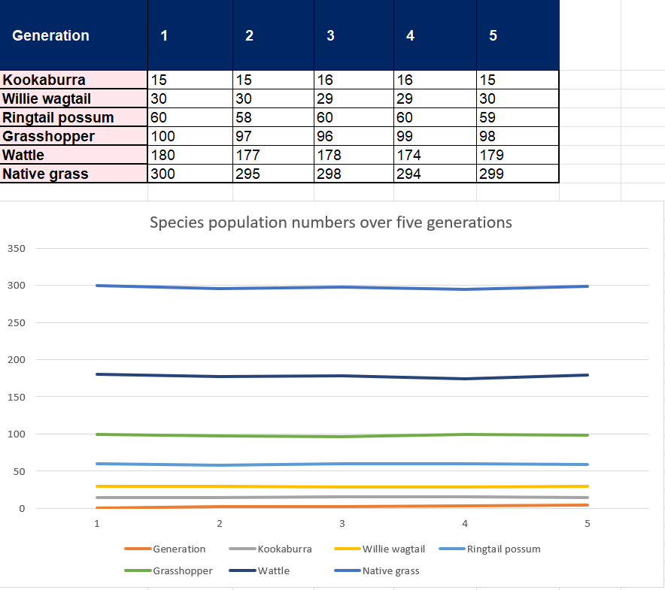
Note: both sheets in the Living systems assessment task Microsoft Excel workbook are locked. The exceptions to this are the yellow-highlighted cells in the ‘Cat introduced’ tab. These are for students to enter the number rolled on the die. If required, the password to unlock each sheet is 1234.
- Students access the template for the scientific poster. Students select an organism from the native ecosystem and develop an inquiry question and a prediction about how its population will be affected by the introduction of an unmanaged domestic cat into the ecosystem.
Note: the scientific poster template can be provided digitally to students so they can type directly into the fields. The template is designed for A3 size. Students can edit the template using this online version. The template can be edited online using Canva. To download a copy of the scientific poster template, use this link: Assessment scientific poster template. Click File, then Make a copy, to allow students to edit this document.
- Show students the ‘Cat introduced’ tab in the Living systems assessment task Microsoft Excel workbook. Inform them that the starting population is taken from the final generation in the ‘pre-cat’ tab data.
Note: unpack the simulation further with students by providing the following information. The purpose of the simulation is to model the impact of introducing an unmanaged domestic cat on species in a food web.
To start, students are given a table listing the initial populations for each species in the ecosystem (taken from the final generation of population data in the ‘pre-cat’ tab of the Living systems assessment task Microsoft Excel workbook). The unmanaged domestic cat is ‘introduced’ to students, who roll a die to determine how many cats are added to the ecosystem each generation. For example, a roll of 4 adds 4 unmanaged domestic cats. Students enter the number rolled on the die in the relevant yellow-highlighted cell. The rest of the column will fill out automatically based on this number, with rules outlined below:
- Each cat introduced, directly or indirectly, affects other species in the ecosystem, as outlined. For example, rolling a one on the dice adds one unmanaged domestic cat.
- If one unmanaged domestic cat is added, the populations of willy wagtails, kookaburras, ringtail possums and grasshoppers will decrease according to the die roll. That is, if one unmanaged domestic cat is added, one of each of these organisms is removed.
- When the populations of willy wagtails, kookaburras, ringtail possums and grasshoppers decrease as a result of adding unmanaged domestic cats, the populations of wattle and native grass will each increase by the same amount.
- Inform students that the simulation will run for 10 generations. Students will roll the die, add the result to the column labelled ‘1’, and repeat this until they have completed all 10 generations.
Note: there are limitations to this simulation, some of which students will need to include in their discussion. Note that the focus of this simulation is not on the predator–prey relationship but on how introduced species can affect native species in ecosystems.
- Tell students they only need to fill in the row highlighted in yellow; the rest of the sheet has been pre-filled with ‘rules’, so it automatically fills based on the value of the dice rolled.
- Provide each student with a physical die or a digital dice and ask them to complete the simulation.
Figure 2 – screenshot of the ‘cat introduced’ tab of the Living systems Excel spreadsheet with sample data entered
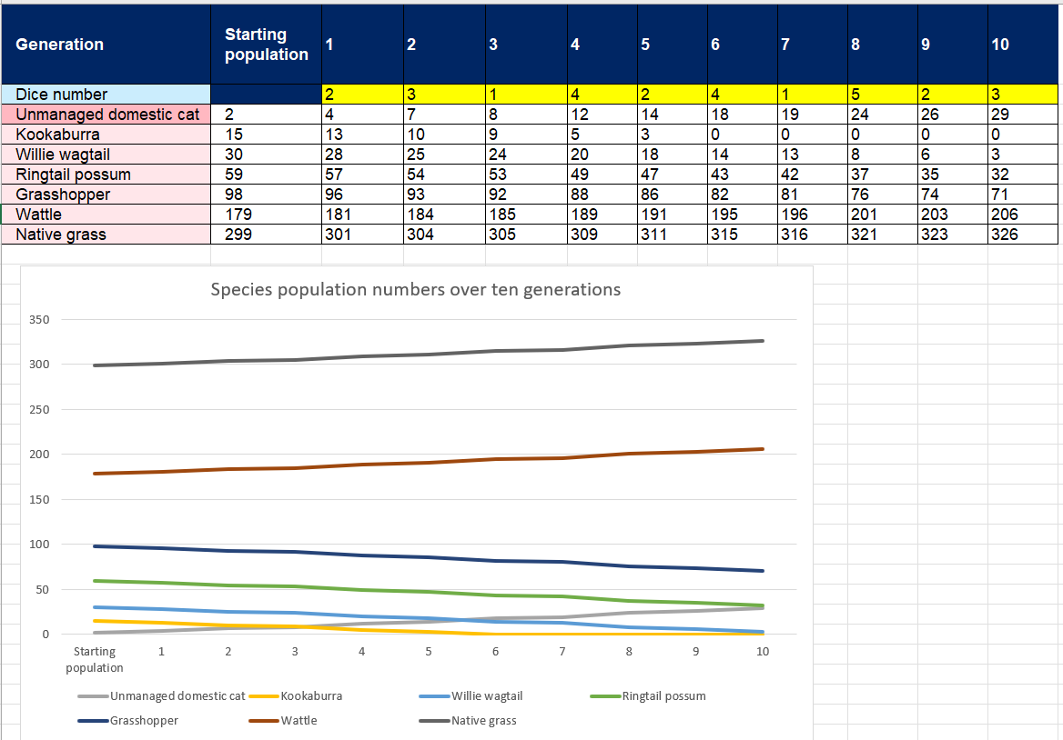
- Students construct a summary table using the starting population and generation 10 data from the spreadsheet, then present the information in a suitable graph.
- Students complete the remaining components of the scientific poster.
Table 1 – questions to support student understanding of the trends in the graph in the ‘Ecosystem data – pre-cat’ tab in the Living systems assessment task Microsoft Excel workbook
Question | Sample response
What do you notice about the population of each species across the 5 generations? | - Most species show small changes in their population over 5 generations.  - The kookaburra population remains stable, increasing slightly from 15 to 16 in generations 3 and 4, then returning to 15. The willie wagtail population is also stable, decreasing slightly from 30 to 29 in generations 3 and 4, before returning to 30.  - The ring-tailed possum drops from 60 to 58 in generation 2, then increases to 60 before falling slightly to 59.  - The grasshopper population decreases from 100 to 96 by generation 3, then rises slightly to 99 and 98.  - The wattle population gradually decreases from 180 to 174, then recovers slightly to 179. Similarly, native grass decreases from 300 to 294, before increasing again to 299.  - Overall, all populations show small increases and decreases over the 5 generations.
Do the animal species show greater changes in population than the plant species? Why might this be? | No, the animal species do not show greater changes than the plant species. Both plants and animals show small changes in their numbers. For example, grasshoppers change by only 4 individuals (from 100 to 96), while wattle changes by 6 (from 180 to 174). These small changes indicate that both plants and animals are maintaining balance in this ecosystem. This could be due to factors such as sufficient food sources and habitats that support each species' populations, keeping numbers relatively steady over time.
What could explain the small changes in population numbers across generations? | The small changes could be due to shifts in food availability or seasonal conditions. There are no new predators introduced or major environmental changes mentioned, so the species’ populations can remain relatively stable over time.

Assessment task notification
Name of task: The impact of introduced species on ecosystems
Type of task: Simulation and scientific poster
Weighting: [The weight of the assessment task is a school-based decision].
Submission details: [schools complete this section – include any important details about submission, format of the task, word limits and submission procedures]
Outcomes being assessed:
A student:
- describes the role, structure and function of a range of living systems and their components SC4-LIV-01
- identifies questions and makes predictions to guide scientific investigations SC4-WS-02
- uses a variety of ways to process and represent data SC4-WS-05
- communicates scientific concepts and ideas using a range of communication forms SC4-WS-08
Science 7–10 Syllabus © NSW Education Standards Authority (NESA) for and on behalf of the Crown in right of the State of New South Wales, 2023.

Task description
In this task, you will examine the interactions among organisms within an ecosystem, as represented by a food web and an ecological energy pyramid, including whether and how these interactions change as a result of introducing the unmanaged domestic cat. Using a simulation model, you will observe what happens when unmanaged domestic cats are introduced into the ecosystem. Your findings will be communicated in a scientific poster to inform the audience using relevant scientific terms and diagrams.
Your scientific poster should include:
Component of the poster | Description of component
Inquiry question | The inquiry question is relevant to the impact of unmanaged domestic cats on a named species and aligns with the poster's content.
Food web diagram | Use the information in Table 3 – a list of organisms for the food web and what they eat, in the student support material, to construct a food web diagram.
Ecological energy pyramid | Use the information in Table 3 – a list of organisms for the food web and what they eat, to create an ecological energy pyramid. Ensure all organisms are represented in their trophic levels on the diagram.
Prediction | Choose one organism from the food web and predict how its population will be affected by the introduction of an unmanaged domestic cat.
Results | Create a table to display summary data collected from the simulation. The summary table should include data from the starting population and the final-generation population (generation 10) from the ‘Cat introduced’ sheet in the Living systems assessment task Microsoft Excel workbook.  Create a suitable graph to display the data from the summary table.
Discussion | Compare population trends and relationships between 2 graphs (before and after the introduction of the unmanaged domestic cat). To do this:  - Describe the trend in species’ populations before the cat is introduced, and determine whether they are increasing, decreasing or remaining stable. Identify which species had the largest and smallest populations.  - The pre-cat graph can be seen in the ‘Ecosystem data – pre-cat’ tab in the Living systems assessment task Microsoft Excel workbook.  - Describe the trend in species’ populations after the cat is introduced, and determine whether they are increasing, decreasing or remaining stable. Identify which species had the largest and smallest populations.  - The post-introduction graph can be found in the ‘Cat introduced’ tab of the Living systems assessment task Microsoft Excel workbook. You may also use the graph you constructed to describe trends and patterns.  - Compare the trends in both datasets to determine how population trends changed as a result of the cat's introduction. Identify which species’ populations may have decreased the most after the cat appeared, and whether any species were unaffected or increased in population.  - Describe the relationship between species to indicate how a change in one species can affect another.  - For example, how did the introduction of the cat affect animal species such as the willie wagtail or the ring-tailed possum?  - Consider how a change in a species' population affects the population of other species.  - Describe whether there were indirect effects on the population of plant species.  Explain how the introduction of the unmanaged domestic cat affected your selected organism and other species in the food web, using data to show how these changes affected the ecosystem over time.  Outline the limitations of the simulation in representing a real ecosystem.
Conclusion | State whether your prediction was supported using evidence.  Draw an evidence-based conclusion about the impact of introduced species on living systems.

Marking rubric
Table 2 – rubric for assessment
Criteria | Not achieved | Level 1 | Level 2 | Level 3 | Level 4
Inquiry Question  SC4-WS-02 | No valid inquiry question included. | The inquiry question is mostly incorrect, incomplete or hard to understand. | The inquiry question is partially complete or includes a species unrelated to the prediction and discussion presented. | The inquiry question is clearly constructed and relevant to the information presented in the rest of the scientific poster.
Food web  SC4-LIV-01  SC4-WS-08 | No food web is included, or it lacks scientific relevance. | The food web is mostly incorrect, incomplete or hard to understand. | The food web diagram is partially completed or contains several directional errors. | The food web diagram is mostly correct and easy to follow, with minor errors in arrow direction or layout. | The food web diagram is correctly constructed, with arrows pointing in the right direction, and is easy to interpret.
Ecological energy pyramid  SC4-LIV-01  SC4-WS-08 | No ecological energy pyramid is included, or the one that is included lacks scientific relevance. | The ecological energy pyramid identifies very few, if any, correct trophic levels or organisms. | The ecological energy pyramid identifies trophic levels and the organisms within them. | The ecological energy pyramid correctly identifies most trophic levels and organisms. | The ecological energy pyramid is correctly constructed and accurately identifies the trophic levels and the organisms present in the ecosystem.
Prediction  SC4-WS-02 | No valid prediction provided (prediction is irrelevant). | Makes a simple, relevant prediction but lacks scientific support. | Makes a relevant prediction about the effect of the unmanaged domestic cat on a named species in the food web, supported by general scientific reasoning. | Makes a relevant prediction about the effect of the unmanaged domestic cat on a named species in the food web.  Prediction is based on scientific understanding of food webs and organism interactions.
Results – summary table  SC4-WS-05 | Data is not presented in a table. | Raw data is displayed in a table.  Key information might be missing, such as headings. | Data is displayed in a summary table.  The summary table includes all relevant data (from the starting population and generation 10 in the ‘Cat introduced’ tab of the workbook) but may also include unnecessary information (for example, data from other generations). | The table’s title is concise, reflecting the table's content.  The summary table has an appropriate structure (for example, borders and an appropriate number of columns and rows) and is easy to read. All columns and rows are clearly labelled.  The table includes all relevant data and excludes unnecessary information (for example, units are not entered in the data cells; only data from the starting population and the final generation are included).
Results – graph  SC4-WS-05 | A graph has not been included, or the graph might contain significant omissions or errors, such as incorrect plotting of data or scale. | The results are presented in a graph; however, some key components may be missing, such as an axis scale or a key, making the graph difficult to interpret. | The results from the summary table are presented in an appropriate graph; however, some minor components may be missing, such as axis labels and headings. | The results from the summary table are presented accurately and clearly in an easy-to-understand graph.  The graph has correctly labelled axes, headings, units (if appropriate), a title, an appropriate scale, and a key (if relevant).
Discussion  SC4-LIV-01  SC4-WS-08 | No discussion is included, or the content is unrelated to the data or task. | Identifies a population trend and/or relationship in a graph, but may not include data.  Identifies a change in the ecosystem resulting from the introduction of an unmanaged domestic cat.  Identifies a limitation of the simulation that may not be related to how the simulation represents a real ecosystem. | Outlines a population trend and/or relationship in a graph, but may not include data.  Outlines the impact of the unmanaged domestic cat on an organism.  Outlines the changes in the ecosystem resulting from the introduction of an unmanaged domestic cat.  Identifies a limitation of the ecosystem in representing a real ecosystem. | Describes the population trend and relationship in the graphs using data.  Describes the impact of the unmanaged domestic cat on one or more organisms with some use of data.  Describes how introducing the unmanaged domestic cat changed the structure of the ecosystem.  Outlines a limitation of the simulation in representing a real ecosystem. | Compares the trend and relationship between populations in the 2 graphs using data.  Explains the impact of the unmanaged domestic cat on a named organism and other organisms in the food web using scientific reasoning and data.  Explains how the introduction of the unmanaged domestic cat changed the ecosystem's structure.  Outlines the limitations of the simulation in representing a real ecosystem.
Conclusion  SC4-LIV-01  SC4-WS-08 | No conclusion is included, or the content is unrelated to the data or task. | Identifies whether the prediction is supported.  Attempts to draw a conclusion that may be irrelevant. | Identifies whether the prediction is supported, but may be inconsistent with the simulation results.  Draws a conclusion that may not be based on the simulation results. | Identifies whether the prediction is supported by the data collected from the simulation.  Draws a conclusion about the impact of introduced species on living systems that is consistent with the simulation results. | Uses data to determine whether the prediction is supported.  Draws an evidence-based conclusion about the impact of introduced species on living systems, consistent with the simulation results.
Scientific poster  SC4-WS-08 | Information is not presented in a poster format.  Lacks scientific content and structure. | Poster has minimal structure.  Lacks clarity and contains few or irrelevant scientific terms or diagrams. | The poster includes relevant subheadings to structure the content.  Communicates basic scientific ideas with limited use of appropriate terminology and diagrams. | The poster includes subheadings and most of the required sections to structure the content.  It communicates scientific ideas using appropriate terminology and visual clarity. | The poster is logically structured, with an inquiry question and subheadings for the food web diagram, ecological energy pyramid, prediction, results, discussion and conclusion.  The poster is visually clear and effectively communicates scientific ideas, using scientific terminology and diagrams tailored to the audience and purpose.

Student support material

Background information
Unmanaged domestic cats
An unmanaged domestic cat refers to a pet cat that is allowed to roam freely and enter local native ecosystems.  Unmanaged domestic cats are a major threat to native Australian wildlife. On average, each domestic cat that is allowed to roam freely into ecosystems kills more than 186 animals per year. This includes 110 native animals (40 reptiles, 38 birds and 32 mammals). | 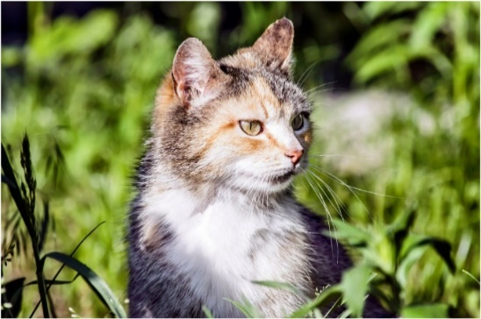
Pet cats kept indoors or in an enclosure do not negatively impact native wildlife. It is estimated that 71% of pet cats in Australia are unmanaged, meaning they are allowed to roam and enter local ecosystems. These unmanaged domestic cats often cause the most harm when the housing area is near a native ecosystem.
Some housing estates can take action during the development phase to try to prevent the impact of unmanaged domestic cats on the local ecosystem. A covenant on a housing estate is a legally binding agreement registered on a property's title that imposes restrictions on how the land can be used or developed. Including a covenant prohibiting cat ownership in the purchase agreement for homes in the area protects native wildlife. | 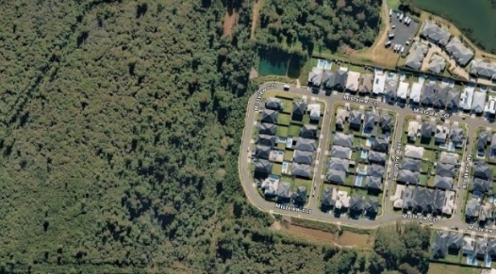  Source: Airbus, Map data – Google Maps 2025.
Source:
Invasive Species Council (2023) Fact sheet: The impact of roaming pet cats on Australian wildlife (Factsheet), accessed 2 September 2025.
Woinarski J, Murphy B and Legge S (2020) The impact of cats in Australia (Fact sheet), accessed 2 September 2025.
Task scenario:
You are an ecologist working on a team studying the site of a proposed new housing estate. The proposed housing estate would be located next to an ecosystem that includes many native plant and animal species
The local community and local wildlife groups have raised concerns about the introduction of unmanaged domestic cats into the ecosystem if the housing estate is built, and about owners not being responsible for containing their pets. There is a call to implement a covenant prohibiting cat ownership for the new houses being built in this estate to protect native wildlife.
Your role as the ecologist is to model (simulate) the impact of unmanaged domestic cats on the native ecosystem. You will then communicate your findings to the developers of the housing estate on the effects of unmanaged domestic cats on the native ecosystem. Your findings will support the developers in their decision-making regarding establishing a covenant prohibiting cat ownership as the housing estate is built.

Food web and ecological energy pyramid
As the first step in preparing your scientific poster for the housing estate developers, you need to create a food web and an ecological energy pyramid to show the interactions among the ecosystem's biotic components before the introduction of unmanaged domestic cats.
Use the information from Table 3 to construct a food web and an ecological energy pyramid.
Table 3 – a list of organisms for the food web and what they eat
Organism | What it eats
Willie wagtail | Grasshopper
Grasshopper | Native grass and wattle seeds
Ringtail possum | Wattle
Kookaburra | Grasshopper and native grass
Native grass | Makes its own food via photosynthesis
Wattle | Makes its own food via photosynthesis
Pre-cat introduction food web
Pre-cat introduction ecological energy pyramid
Now, you need to demonstrate the impact of the introduction of the unmanaged domestic cat on the native ecosystem. Use the information in Table 4 to add the unmanaged domestic cat to your food web and ecological energy pyramid.
Table 4 – introducing the cat to the food web and what it eats
Organism | What it eats
Unmanaged domestic cat | Ringtail possum, grasshopper, willie wagtail and kookaburra
Note: The space below is provided in case you cannot change your draft food web and ecological energy pyramid above to include the unmanaged domestic cat. You do not need the space below if your previous food web and ecological energy pyramid can be easily amended to include the unmanaged domestic cat.

Draft food web (including unmanaged domestic cat)
Draft ecological energy pyramid (including unmanaged domestic cat)

Scientific poster template
Note: The scientific poster template is designed for A3 size. You can edit the scientific poster template online using Canva. To download a copy of the scientific poster template, use this link: Assessment scientific poster template. Click File, then Make a copy, to be able to edit this document.
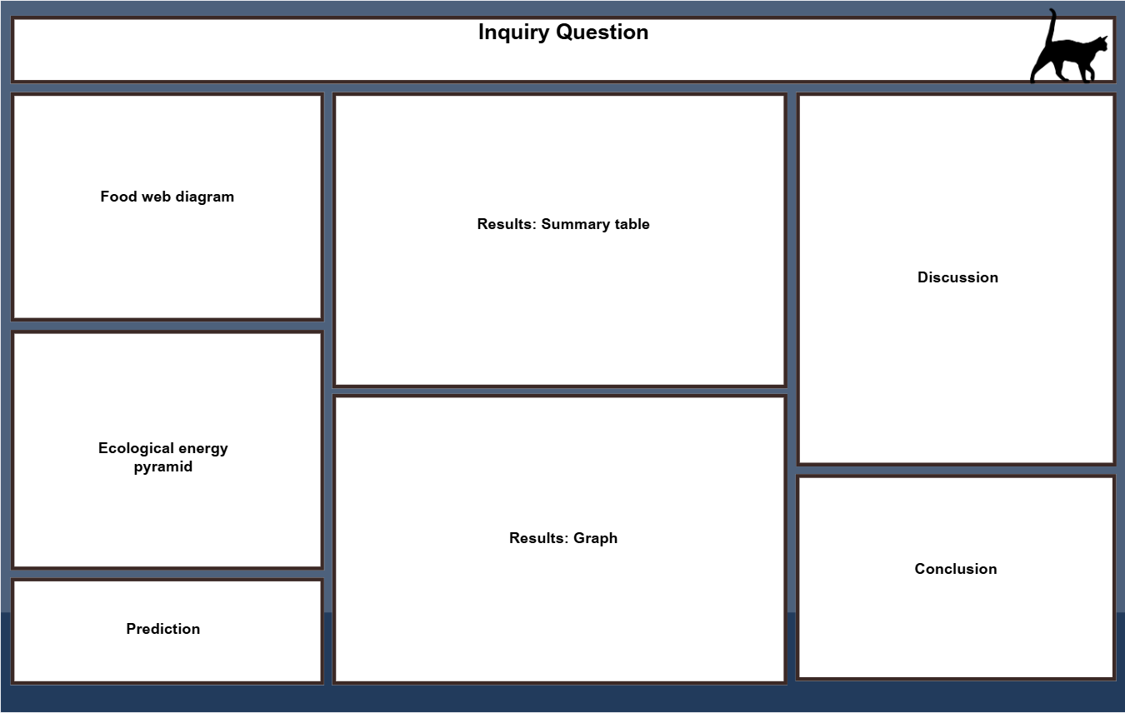

Appendix A – sample responses
Teachers may use the information in this appendix to support their marking of this task. It provides an answer key for each component of the scientific poster. For accessibility, a sample response for each section is included separately. Please note that students should present their work on the scientific poster template.
Inquiry question – sample response
How do unmanaged domestic cats impact the kookaburra population?
Food web – sample response
Figure 1 – answer key for student food web, including the cat
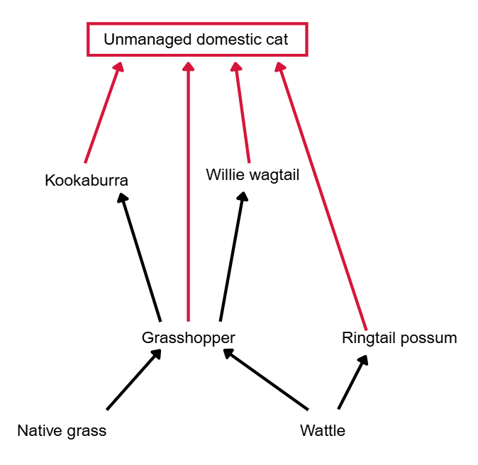

Ecological energy pyramid – sample response
Figure 2 – answer key for student ecological energy pyramid, including the cat.
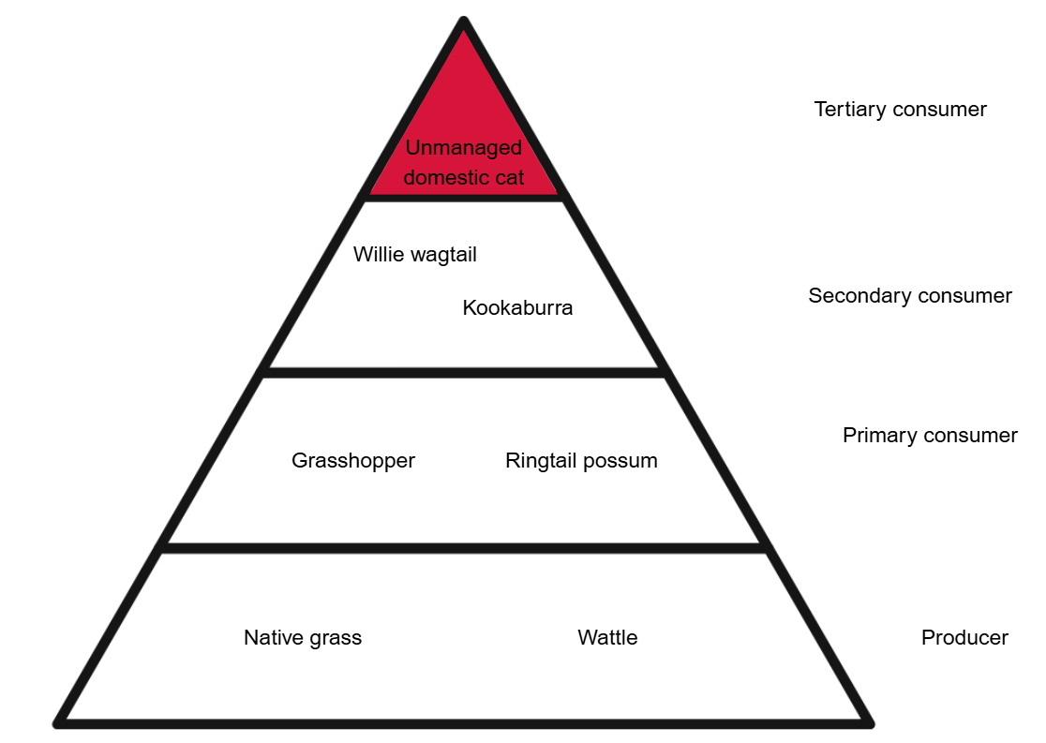
Prediction – sample response
The introduction of unmanaged domestic cats into the ecosystem will reduce the kookaburra population. The unmanaged domestic cat becomes a predator of kookaburras, hunting and killing them, leading to a decline in their population.
Results: Summary table – sample response
Table 1 – sample response of the summary table of the sample data
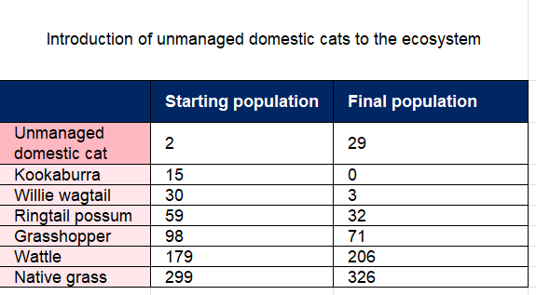

Results: Graph – sample response
Figure 3 – sample response of the graph of the sample data

Discussion – sample response
As the unmanaged domestic cat population increased, other consumer organisms in the food web declined. A specific example is the kookaburra population, which started at 15 and ended at zero after the introduction of an unmanaged domestic cat into the ecosystem.
Overall, the data show that the introduction of the unmanaged domestic cat adversely affected the kookaburra population, causing it to decline to a level where it was no longer present in the ecosystem (zero individuals).
This is because, once introduced, the unmanaged domestic cat becomes a predator of the kookaburra, willy wagtail, ringtail possum and grasshopper. As a result, all consumers below the tertiary trophic level see a decrease in overall population.
The limitations of this model include its inability to account for other factors that may affect populations, such as disease or natural disasters. It also does not account for the many other organisms in this ecosystem that are not shown on the food web but would interact with the species within the ecosystem.
Conclusion – sample response
The prediction that the introduction of unmanaged domestic cats would reduce the kookaburra population was supported, as the data showed a starting population of 15 and a final population of zero.
It can be concluded that the introduction of unmanaged domestic cats would negatively impact this ecosystem, as data show a reduction in the populations of all consumer organisms that became prey for the introduced cats.

Evidence base
This resource contains NSW Curriculum and syllabus content. The NSW Curriculum is developed by the NSW Education Standards Authority (NESA). This content is prepared by NESA for and on behalf of the Crown in right of the State of New South Wales. The material is protected by Crown copyright.
Please refer to the NESA Copyright Disclaimer for more information https://www.nsw.gov.au/education-and-training/nesa/copyright.
NESA holds the only official and up-to-date versions of the NSW Curriculum and syllabus documents. Please visit NESA https://www.nsw.gov.au/education-and-training/nesa and NSW Curriculum https://curriculum.nsw.edu.au.
Science 7–10 Syllabus © NSW Education Standards Authority (NESA) for and on behalf of the Crown in right of the State of New South Wales, 2023.
Brookhart SM (2018) ‘Appropriate Criteria: Key to Effective Rubrics’, Frontiers in Education, volume 3(22):1–12, doi:10.3389/feduc.2018.00022, accessed 27 March 2025.
CESE (Centre for Education Statistics and Evaluation) (2020) What works best: 2020 update, NSW Department of Education, accessed 27 March 2025.
——(2020) What works best in practice, NSW Department of Education, accessed 27 March 2025.
——(2021) Growth goal setting – what works best in practice, NSW Department of Education, accessed 27 March 2025.
Fisher D and Frey N (1 November 2009) ‘Feed Up, Back, Forward’, ASCD (Association for Supervision and Curriculum Development): Educational Leadership magazine, 67(3), accessed 27 March 2025.
Griffin P (2017) Assessment for Teaching, Cambridge University Press, Port Melbourne, Victoria.
Hattie J and Timperley H (2007. ‘The Power of Feedback’, Review of Educational Research, 77(1): 81–112, doi:10.3102/003465430298487, accessed 27 March 2025.
Invasive Species Council (2023) Fact sheet: The impact of roaming pet cats on Australian wildlife (Factsheet), accessed 2 September 2025.
NESA (NSW Education Standards Authority) (2023) ‘Data Book: Science 7–10', Teaching resources, NESA, accessed 22 February 2026.
Panadero E and Jonsson A (2013) ‘The use of scoring rubrics for formative assessment purposes revisited: A review’, Educational Research Review, 9:129–144, doi:10.1016/j.edurev.2013.01.002, accessed 27 March 2025.
Sherrington T (2019) Rosenshine’s Principles in Action, John Catt Educational Limited, Melton, Woodbridge.
Wiliam D (2017) Embedded Formative Assessment, 2nd edn, Solution Tree Press, Bloomington, IN.
Woinarski J, Murphy B and Legge S (2020) The impact of cats in Australia (Fact sheet), accessed 2 September 2025.

© State of New South Wales (Department of Education), 2026
The copyright material published in this resource is subject to the Copyright Act 1968 (Cth) and is owned by the NSW Department of Education or, where indicated, by a party other than the NSW Department of Education (third-party material).
Copyright material available in this resource and owned by the NSW Department of Education is licensed under a Creative Commons Attribution 4.0 International (CC BY 4.0) license.

This license allows you to share and adapt the material for any purpose, even commercially.
Attribution should be given to © State of New South Wales (Department of Education), 2026.
Material in this resource not available under a Creative Commons license:
- the NSW Department of Education logo, other logos and trademark-protected material
- material owned by a third party that has been reproduced with permission. You will need to obtain permission from the third party to reuse its material.
Links to third-party material and websites
Please note that the provided (reading/viewing material/list/links/texts) are a suggestion only and implies no endorsement, by the New South Wales Department of Education, of any author, publisher, or book title. School principals and teachers are best placed to assess the suitability of resources that would complement the curriculum and reflect the needs and interests of their students.
If you use the links provided in this document to access a third-party's website, you acknowledge that the terms of use, including licence terms set out on the third-party's website apply to the use which may be made of the materials on that third-party website or where permitted by the Copyright Act 1968 (Cth). The department accepts no responsibility for content on third-party websites.

