Science Stage 4 (Year 8) – Data science 1
Teacher resource book 1 of 2 (TRB1)
1. How is data generated, collected and evaluated to ensure its quality and usefulness?
Creation date: 4 September 2025.
Contents
Overview 2
Glossary 2
1.1 Scientific questions 5
Classifying questions 5
What do we mean by ‘better’? 11
1.2 Analysing data 15
Describing data 15
Analysing frequency histograms 17
Analysing line graphs 26
1.3 Analysing primary data 34
Arm length ratio 34
Coin toss 39
Determining acceleration due to gravity (g) 44
1.4 Generating and using data 50
What is data science? 50
Classifying data 57
Selecting the best source of data 58
1.5 Creating a scientific poster – depth study 65
Presenting data analysis 65
1.6 Your digital footprint 69
What is your brand? 69
1.7 Assessment task 72
Evidence base 73

Overview
Stage and learning area: Stage 4 Science
Description: this resource complements the Data science 1 program of learning. It aims to serve as a teacher reference, offering practical strategies and ideas to enrich teaching practices and create engaging learning environments. The activities should be adapted to suit the students' needs.
Duration: while timing will vary based on the mode of delivery, differentiation strategies employed, and class or school context, this series of activities should take approximately 13 hours. Note that Data science 1 has been split into 2 sections in the sample Science Stage 4 – scope and sequence. Part A, corresponding to this TRB1 content, is taught at the start of Term 1 Year 8, and Part B, which corresponds to TRB2 content, is taught at the end of Year 8.
Risk management: teachers are advised to undertake a risk assessment before conducting any classroom investigation or experiment. For more information on developing risk assessments, see Risk Assessment – a pre-requisite for risk control.
This resource book elaborates on many of the activities in the Data science 1 sample program of learning. Some activities also reference the Data science 1 slide deck (identified as DA1 PPT throughout this document).

Glossary
Tier 3 words are those that are relevant for subject-specific content. More information is provided in the ‘Vocabulary in context’ document on the Stage 5 reading – Vocabulary in context page. A glossary containing Tier 3 vocabulary related to the essential questions ‘How can we collect and evaluate the quality of our data?’ and ‘How is data generated, sourced and used in our daily lives?’ has been provided below. The Guide for planning and implementing explicit vocabulary instruction can be used by teachers across all curriculum areas.
Table 1 – glossary of key terms for Data science 1 TRB1
Term | Definition
Accuracy | The extent to which measurements are considered to be close to the true value (NESA 2025).
Digital footprint | Your digital footprint is the trail of information you leave online. Including what you post, share, search and what others post about you. It can last forever and affect how people view you.
Inference | An inference is a conclusion or explanation you make based on your observations and prior knowledge.
Mean | The sum of values in a dataset divided by the total number of values in the dataset. Also called the average (NESA 2025).
Mode | The most frequently occurring value in a set of data (NESA 2025).
Observation | To see, watch, perceive or notice. Observations can be made using all 5 senses as well as digital and non-digital tools that extend our senses (NESA 2025).
Range (of a dataset) | The difference between the highest and lowest values in a dataset (NESA 2025).
Reliability | The extent to which repeated observations and/or measurements taken under identical circumstances will yield similar results (NESA 2025).
Scientific question | A scientific question is one that can be tested or investigated by collecting evidence through observation or experiment.
Variable | A factor that can be changed, kept the same or measured in an investigation (NESA 2025).

Data talks: the Appendix in the Data science 1 sample program of learning highlights the benefits of regular conversations about data, which pique students’ curiosity and encourage questioning. Examples of questions to initiate data talks include ‘What do you notice?’ and 'What do you wonder?’, which are found in DA1 PPT ‘Appendix – data talks’. These could be used at the start of a lesson to support thinking and engagement for tasks that follow.

1.1 Scientific questions
Table 2 – learning intentions and success criteria for ‘1.1 Scientific questions’
We are learning: | I can:
- how data is used by scientists | - write a clear, testable scientific question  - plan a method for collecting relevant data to address the question  - select appropriate tools and techniques to ensure data accuracy
- to identify trends, patterns and relationships, and draw conclusions. | - identify data that could be used to support or refute a testable question.

Classifying questions
Checkpoint: review prior knowledge by asking students to make one observation and one inference about the image in DA1 PPT ‘1.1 Checkpoint – observations and inferences’
Sample response
- Observations: these are the facts or data that you gather through your senses or scientific instruments. Observations are objective and can be measured or quantified. For example, noticing that a plant's leaves are turning yellow is an observation.
- Inferences: an inference is an explanation you make based on your observations and prior knowledge. Inferences involve reasoning, and they go beyond what you observe. For example, you might infer that a plant is not getting enough water because its leaves are yellow.
- Students make observations and inferences in response to a stimulus image or video and then pose a question about something they wonder. An example is provided in DA1 PPT ‘1.1 See, think, wonder’. Sample responses are in the slide’s speaker notes section.
- Outline the characteristics of a good, testable scientific question. A testable question should be objective, have clear criteria and be supported with data and statistics, not opinion. A testable scientific question should also focus on natural phenomena. Scientific questions are based on scientific ideas and concepts (which are ideas and concepts that are accepted by the scientific community).
- Display DA1 PPT ‘1.1 Testable questions’ and discuss to illustrate the difference between a testable and a non-testable question using 2 example questions.
- Display DA1 PPT ‘1.1 Classifying questions’ to unpack examples of scientific and nonscientific questions with students.
- Hand out Student resource – classifying questions.
- With teacher support, if needed, students complete Question 1, a Frayer diagram, to define and outline the key characteristics of scientific questions. A template and sample answer are provided in DA1 PPT ‘1.1 Frayer diagram – scientific questions’. Share student responses for their Frayer diagrams and ask students to give their reasoning (‘Why do you say that?’).
- Students apply their knowledge about scientific questions to classify each of the questions in Student resource – classifying questions (question 2, Table 1) as either testable (Y) or not-testable (N).
- Outline what data might need to be collected to address each question categorised as scientific (S).
- Students complete question 3. This could be completed as a think-pair-share activity.
- The purpose of questions 4 and 5 is to highlight how data can be collected for a scientific question. These surveys can be completed as a whole-class activity. Discuss how results could change based on who is surveyed.
Checkpoint: revisit DA1 PPT ‘1.1 See, think, wonder’ and complete the last row of the table by writing a testable question that relates to the stimulus.
Read more about what science is on A science checklist (UCMP 2022). This site highlights that science cannot be absolutely defined; however, it focuses on natural phenomena and processes and can be recognised by a set of key characteristics outlined in a science checklist.
Sample response: Student resource – classifying questions
- Complete the following Frayer diagram.
Figure 1 – Frayer diagram for scientific questions – sample answers
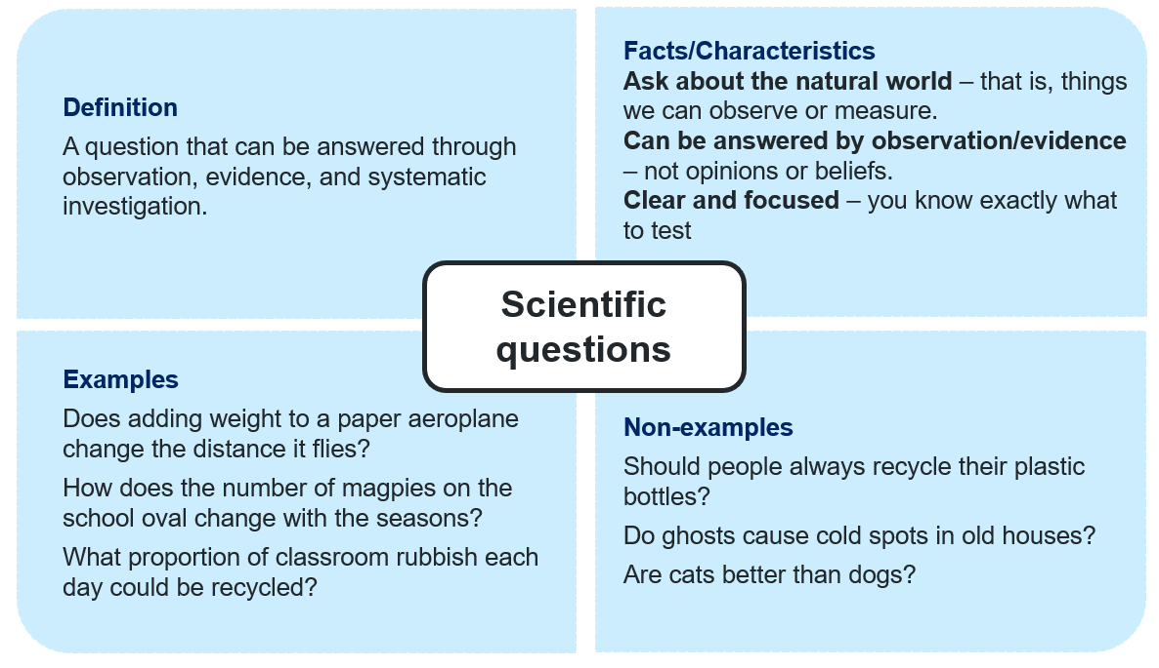
- Classify the following questions as testable or not testable. For those considered testable, identify the type of data that needs to be collected. Write N/A in this column if the question is not testable.
Table 3 – classifying scientific and nonscientific questions
Question | Testable | Data to collect
How does the addition of salt affect the boiling point of water? | Y | Boiling points of pure water and solutions with varying concentrations of salt
Are dogs better than cats? | N | N/A
Does Coke taste better than Pepsi? | N | N/A
Who in the class has the fastest reaction time? | Y | Repeated measures of ruler drop activity
What temperature makes tomato plants grow best? | Y | Grow similar tomato plants under similar conditions at different temperatures and measure their growth (height, number of tomatoes)
Is it wrong to eat meat? | N | N/A
Is a bat flip a fair way to decide who bats in T20 cricket? | Y | Repeated bat flips to record the percentage of hills and flats
Is the ratio of height to arm span the same for all Year 8 students? | Y | Measure the length of the arm span and height of each student
Write your own testable question: Does light intensity affect the height at which red flowers grow? | Y | Place identical, red-flowered seedlings under lights of 3 different intensities and measure their growth over time
- How could you modify the question, ‘Is netball more popular than rugby league?’ to make it a testable one that can be measured at school?
Do students in the class prefer watching netball or rugby league?
Survey the class to answer the following questions:
- Do students in the class play rugby league or netball more?
Responses will vary with class.
- What do students in the class prefer to watch, rugby league or netball?
Responses will vary with class.

Student resource – classifying questions
- Complete the following Frayer diagram.
Figure 1 – Frayer diagram for scientific questions
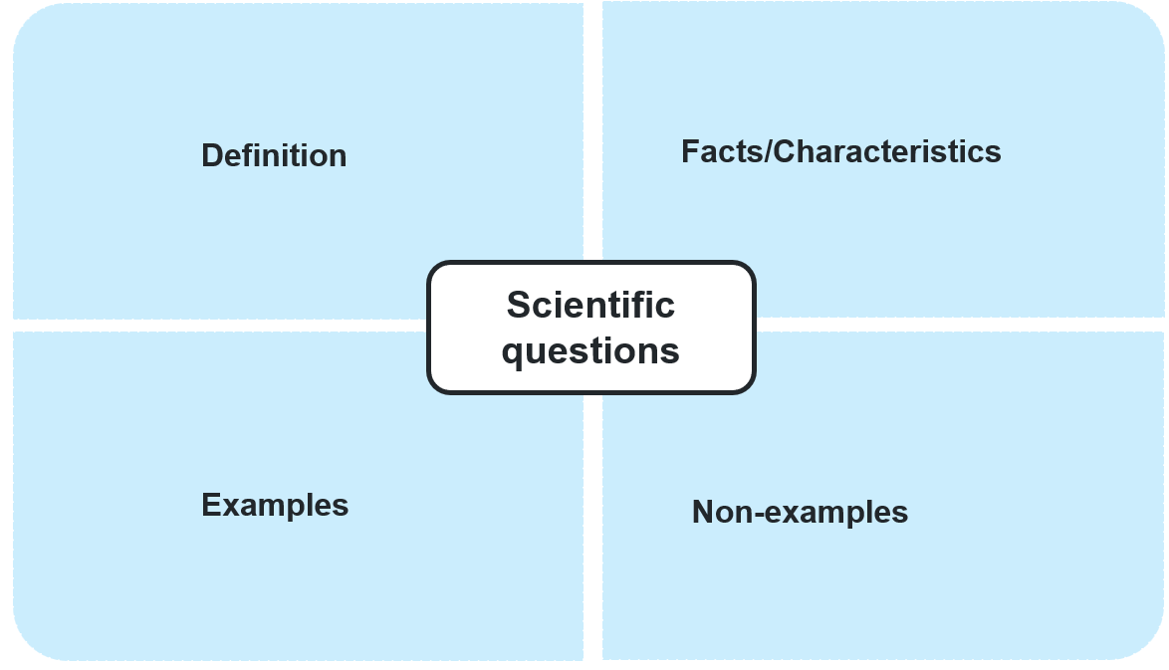
- Classify the following questions as testable or not testable. For those considered testable, identify the type of data that needs to be collected. Write N/A in this column if the question is not testable.
Table 1 – classifying scientific and nonscientific questions
Question | Testable | Data to collect
How does the addition of salt affect the boiling point of water?
Are dogs better than cats?
Does Coke taste better than Pepsi?
Who in the class has the fastest reaction time?
What temperature makes tomato plants grow best?
Is it wrong to eat meat?
Is a bat flip a fair way to decide who bats in T20 cricket?
Do taller people have longer arm spans?
Write your own testable question.
- How could you modify the question, ‘Is netball more popular than rugby league?’ to make it a testable one that can be measured within the class?
Survey the class to answer the following questions:
- Do more students in the class play rugby league or netball?
- What do students in the class prefer to watch, rugby league or netball?

What do we mean by ‘better’?
The purpose of this activity is to review the characteristics of a fair test and to illustrate the importance of establishing appropriate criteria to answer a testable question.
- Review the question with the whole class ‘At what temperature do tomato plants grow better?’ Discuss: What do we mean by better? More fruit? Growth rate? Germination rate? Note that a scientific question needs to be specific, and the word better is not specific. Also, an investigation to test the question requires controlling variables, as the following activity illustrates.
- Launch the Fair Test Lab simulation and select the first email request with the subject ‘Greenhouse tomatoes’.
- Students follow the instructions on screen and complete the Student resource – What do we mean by better? DA1 PPT ‘1.1 Fair Test Lab simulation’ provides details on how to operate the online simulator.
Figure 2 – sample results from the simulation
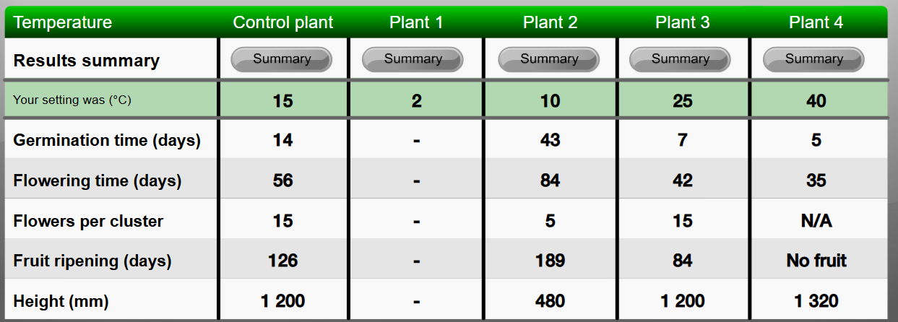
This material by ESA is used under a CC BY 4.0 licence.
Sample responses: Student resource – What do we mean by better?
- What variables did you control?
Amount of nitrogen, light intensity, and light duration.
- What was your conclusion?
25 °C was the best temperature for ripening tomatoes.
- What temperature resulted in the fastest germination?
40ºC
- What temperature resulted in the tallest plant?
40ºC
- What criteria did you use to determine the best?
Flowers per cluster.
- Rewrite the question, ‘What temperature makes tomato plants grow better?’ So that it clearly addresses the criteria you used.
What temperature will produce the most fruit on a tomato plant?
- Justify why this is now a scientific question.
It is a question that can be investigated and answered with evidence. The dependent variable, which is measured, is now clear (the number of fruit).
Note: questions 8 to 11 will have various answers.
Checkpoint: students modify the following question to make it testable. ‘Are Brand A batteries better than Brand B?’
Sample responses
- Do Brand A batteries last longer than Brand B when running a remote-control car?
- Are Brand A batteries cheaper than Brand B?
- Do Brand A batteries have a longer shelf life than Brand B?

Student resource – What do we mean by better?
Launch the Fair Test Lab simulation (https://www.scootle.edu.au/ec/viewing/L540/L540/index.html) and select the first email request with the subject ‘Greenhouse tomatoes’.
Read the email request and develop a fair test to determine the best temperature for growing tomatoes.
- What variables did you control?
- What was your conclusion?
- What temperature resulted in the fastest germination?
- What temperature resulted in the tallest plant?
- What criteria did you use to determine the best?
- Rewrite the question, ‘What temperature makes tomato plants grow better?’ So that it clearly addresses the criteria you used.
- Justify why this is now a scientific question.
- Select another scenario from the simulation and write a testable question that addresses the emailed request.
- What variables did you control?
- What data did you use to support your conclusion?
- What was your conclusion?

1.2 Analysing data
Table 4 – learning intentions and success criteria for ‘1.2 Analysing data’
We are learning: | I can:
- to explain how data is used by scientists | - calculate the mean and range of a dataset  - interpret frequency histograms and line graphs
- use data to identify relationships. | - identify relationships represented in graphs.

Describing data
- Define range, mean and mode using DA1 PPT ‘1.1 Introducing statistics (1 of 2)’.
- Calculate the range, mean and the mode of a small dataset. A dataset is provided in DA1 PPT ‘1.2 Introducing statistics’ and Student resource – describing data.
- Repeat calculations using Microsoft Excel following the instructions in DA1 PPT ‘1.2 Determining mean, mode and range in Excel (1-5)’. These slides show how to use the formula function to calculate the mean and mode. Note that Excel refers to the ‘mean’ as the ‘average’. Our resources will use ‘mean’ to reflect wording in the syllabus. The range cannot be calculated directly in Excel; the maximum and minimum values must be identified and subtracted to obtain it.
Sample responses: Student resource – describing data.
- What is the range of these values? 7
- What is the mean? 5.2
- What is the mode? 4

Student resource – describing data
Definitions
Range is the difference between the highest and lowest values in a dataset.
Mean is the sum of values in a dataset divided by the total number of values in the dataset. Also called the average.
Mode is the value that occurs most frequently in a dataset.
Two dice were rolled 5 times, and the total of the 2 dice was recorded for each roll.
Table 1 – results of the die roll
Roll | Total
1 | 4
2 | 7
3 | 4
4 | 9
5 | 2

- What is the range of these values?
- What is the mean?
- What is the mode?

Analysing frequency histograms
- Unpack the major features of a frequency histogram DA1 PPT ‘1.2 Annotated histogram’. Tell students:
- a frequency histogram is a type of bar graph used to represent the distribution of numerical data
- it displays the frequency of data points within specified intervals, known as bins
- each bar in the histogram represents the number of data points that fall within a particular range.
- Display slide DA1 PPT ‘1.2 Interpreting histograms (1 of 2)’ and guide students to answer questions 1 to 7 in Student resource – analysing frequency histograms.
- After completing the questions, discuss the benefits of repetition in terms of accuracy and reliability.
- Display slide DA1 PPT ‘1.2 Interpreting histograms (2 of 2)’ and complete questions 8 to 9 in Student resource – analysing frequency histograms.
Checkpoint: DA1 PPT ‘1.2 Checkpoint – interpreting histograms 1’
Question stem: in 2024, there were 205 games played with a total of 9607 points scored. The highest combined total in a game was 86 (Eels 60, Tigers 26), and the lowest was 8 (Storm 8, Panthers 0).
Figure 3 – histogram of total points scored in 2024 NRL matches
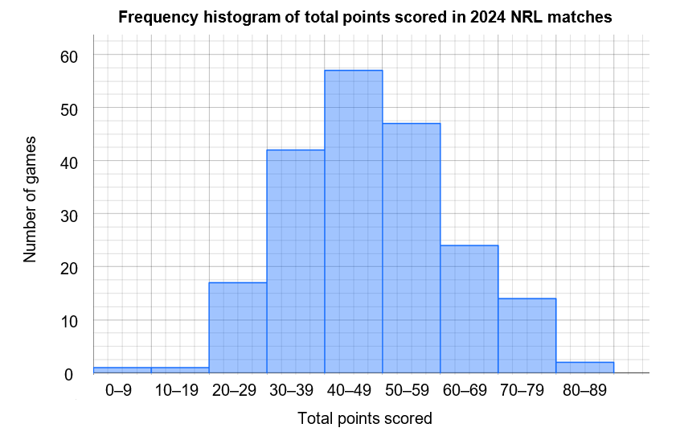
Data source: 2024 NRL Telstra Premiership - RLP
Note: as these are simple numerical responses, displaying the PPT slides and asking students to respond using mini whiteboards or similar devices would be an effective way to gauge understanding.
Questions and sample responses for Checkpoint: DA1 PPT ‘1.2 Checkpoint – interpreting histograms 1’.
- In how many games were fewer than 20 points scored?
2 games.
- In how many games was the total number of points scored greater than 60?
40 games.
- What was the range of total points scored?
Range = highest score (86) – lowest total score (8) = 78.
- What was the mean number of points scored?
46.9 points.
Checkpoint: display DA1 PPT ‘1.2 Checkpoint – interpreting histograms 2’ to display the histogram of Sam Konstas’ Sheffield Shield scores (also in Figure 4) and questions. Sample responses are provided in the slide notes.
Figure 4 – Sam Konstas’s scores in Sheffield Shield (2024/25)
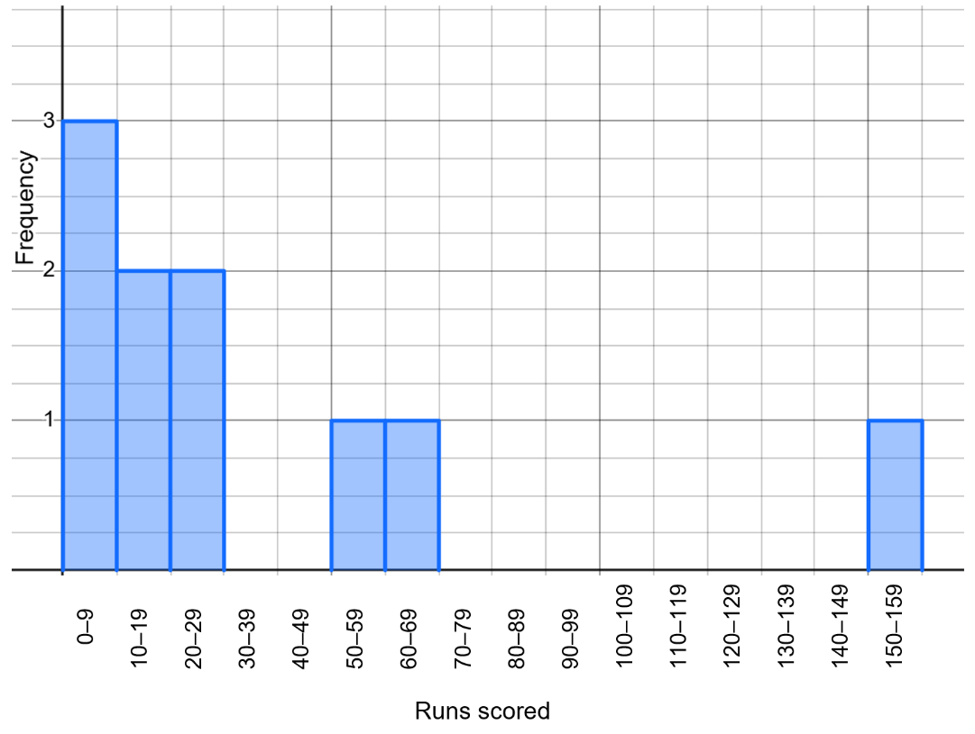
Data source: ESPN cricinfo Sam Konstas stats
Checkpoint sample response:
- How many times did Sam bat in the Sheffield Shield?
10
- How many times did he score over 30?
3
Sample responses: Student resource – analysing frequency histograms
- What was the most commonly-rolled sum? This is also called the mode.
The mode is 7.
- Which totals are least frequent?
2, 11 and 12.
- How often does the total of 12 appear in this dataset?
4
- What is the range of values?
10
- What would you estimate the mean to be to the nearest whole number?
7
- Calculate the mean sum when rolling 2 dice. How does this compare to your estimate?
$Mean= \frac{1+2+3+4+5+6}{6}= \frac{21}{6}=3.5 x 2=7$. This is the same as my estimate (note this comparison will differ).
- The mean for the 100 rolls is 6.57. How does this compare to the mean when it was only rolled 5 times in the previous activity in the Student resource – describing data?
This result is higher than 5.2 and closer to the expected value.
- If you rolled the 2 dice again, 1000 times, what do you think the mean will most likely be? Explain your thinking.
7 – as you increase the number of rolls, the mean will get closer and closer to 7.
Note: the purpose of the histogram on slide DA1 PPT ‘1.2 Interpreting histograms (2 of 2)’, is to illustrate a frequency histogram where the mode does not match the mean. This illustrates situations where different measures of central tendency are appropriate.
- If you were to predict Steve’s score in the next innings, which aspect of the histogram would you rely on? Why do you say that?
Mode. This is the most common score that he achieves, so it is the most likely outcome for a single event.
- Predict how many runs he would score in total in the next ten innings. Justify your answer.
580. This is using his mean, which better reflects the runs scored over multiple innings.

Student resource – analysing frequency histograms
The histogram below represents the distribution of totals when the 2 dice were rolled 100 times.
Figure 1 – frequency histogram of the sum of 2 dice
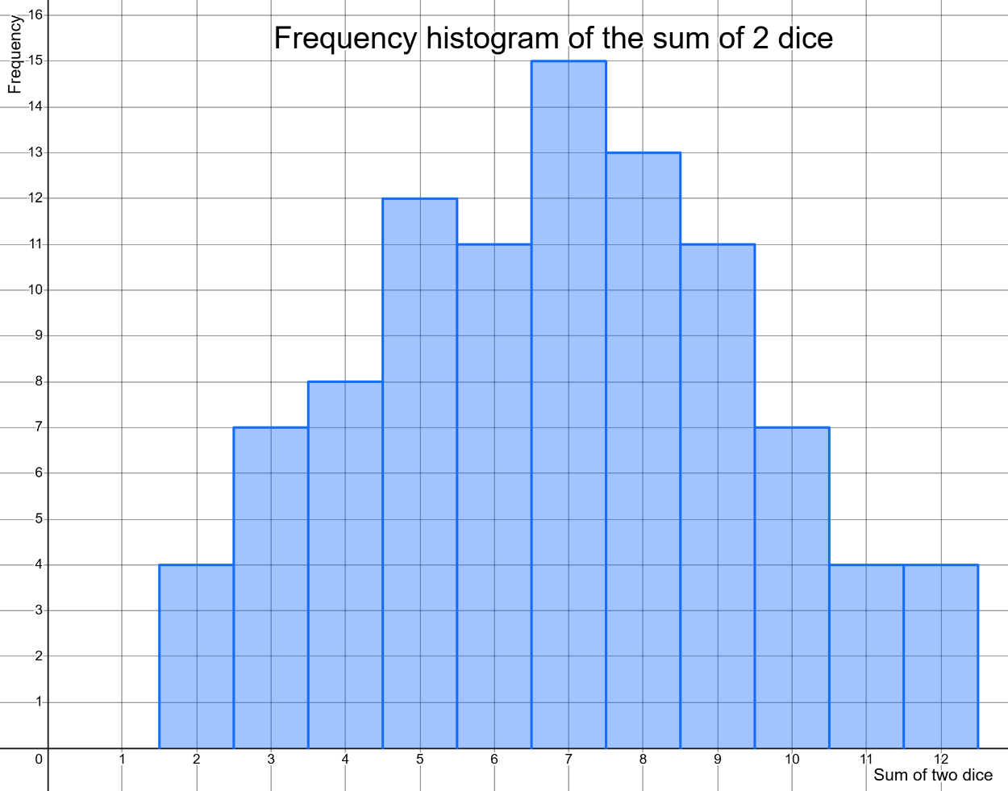
Data source: student investigation
- What was the most commonly-rolled sum? This is also called the mode.
- Which totals are least frequent?
- How often does the total of 12 appear in this dataset?
- What is the range of values?
- What would you estimate the mean to be to the nearest whole number?
- Calculate the mean sum when rolling 2 dice. How does this compare to your estimate?
- The mean for the 100 rolls is 6.57. How does this compare to the mean when it was only rolled 5 times in the previous activity in the Student resource – describing data?
- If you rolled the 2 dice again, 1000 times, what do you think the mean will most likely be? Explain your thinking.
Figure 2 – histogram of Steve Smith’s last 20 test innings as of May 2025
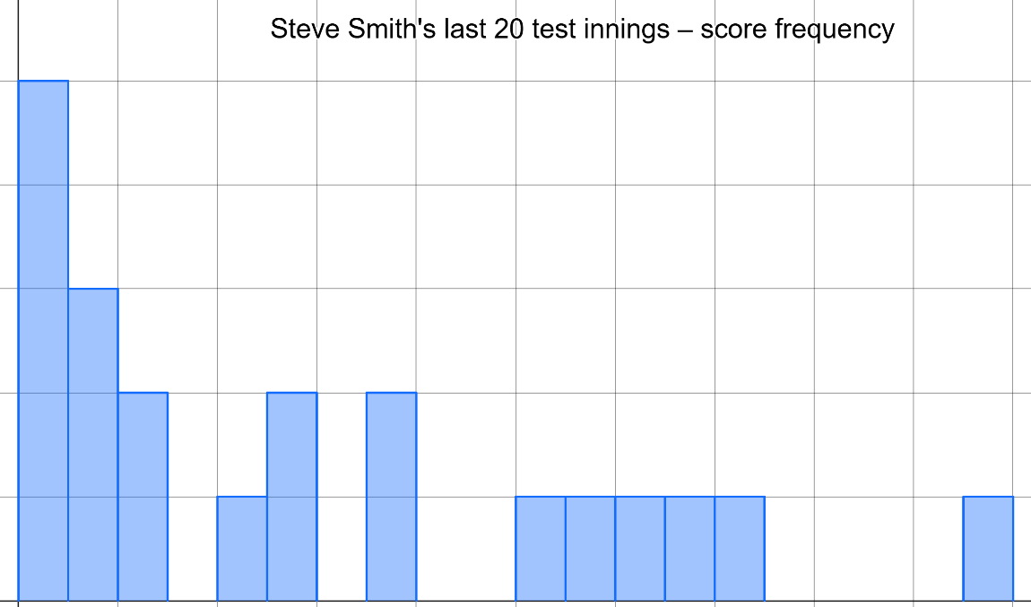
0–9
10–19
20–29
30–39
40–49
50–59
60–69
70–79
80–89
90–99
100–109
110–119
120–129
130–139
140–149
150–159
160–169
170–179
180–189
190–199
Runs scored
5
4
3
2
1
0
Frequency
Data source: ESPN Cricinfo Steve Smith statistics
In the previous example, the mode and mean were the same; however, this distribution shows that Steve most commonly scores between 0 and 9 runs per inning, while his mean over these 20 innings is 58.
- If you were to predict Steve’s score in the next innings, which aspect of the histogram would you rely on? Why do you say that?
- Predict how many runs he would score in total in the next 10 innings. Justify your answer.

Analysing line graphs
The purpose of this activity is to guide students through the process of analysing line graphs. It follows on from the context of plant growth from the simulations. It compares the growth rate of 2 different types of tomato plants treated under the same conditions.
- Set the scene. Farmers have bred a new blue tomato and want to compare its growth rate to that of a normal orange tomato.
- Unpack the characteristics of a line graph DA1 PPT ‘1.2 Annotated line graph’.
Note: the discussion is limited to time-scale line graphs.
- Guide discussion with students to analyse the graphs of the growth rate of the plants DA1 PPT ‘1.2 – Interpreting data from graphs (2 slides)’ as they complete the questions in Student resource – analysing line graphs. Note that sample responses are also in the teacher notes of both slides, and sample responses on the graphs are provided as an animation.
Note: in this investigation, the growth rate is measured as the plant's height. Other ways of measuring growth could be discussed, including fruit size and number, leaf number and plant mass.
Checkpoint: display DA1 PPT ‘1.2 Interpreting data from graphs checkpoint’ to present a graph of plant growth (also provided in Figure 6) over time and related questions. Students respond to the questions using mini whiteboards. For question 6, a student could annotate the graph on the board, or printed copies could be shared.
Questions and sample responses for DA1 PPT ‘1.2 Interpreting data from graphs checkpoint’:
- How tall did the plant get? 80 cm
- Approximately when did it stop growing? After 32 to 34 days
- How long did it take to reach a height of 40 cm? 21 days
- When was it growing the fastest? Between 18 and 22 days
- When did its growth rate start slowing? 22 days
- Another plant grew at a constant rate of 20 cm every 10 days for 40 days. Sketch a line on the graph to represent this growth. The red line is the sample answer (see Figure 7).
Figure 6 – graph of plant growth
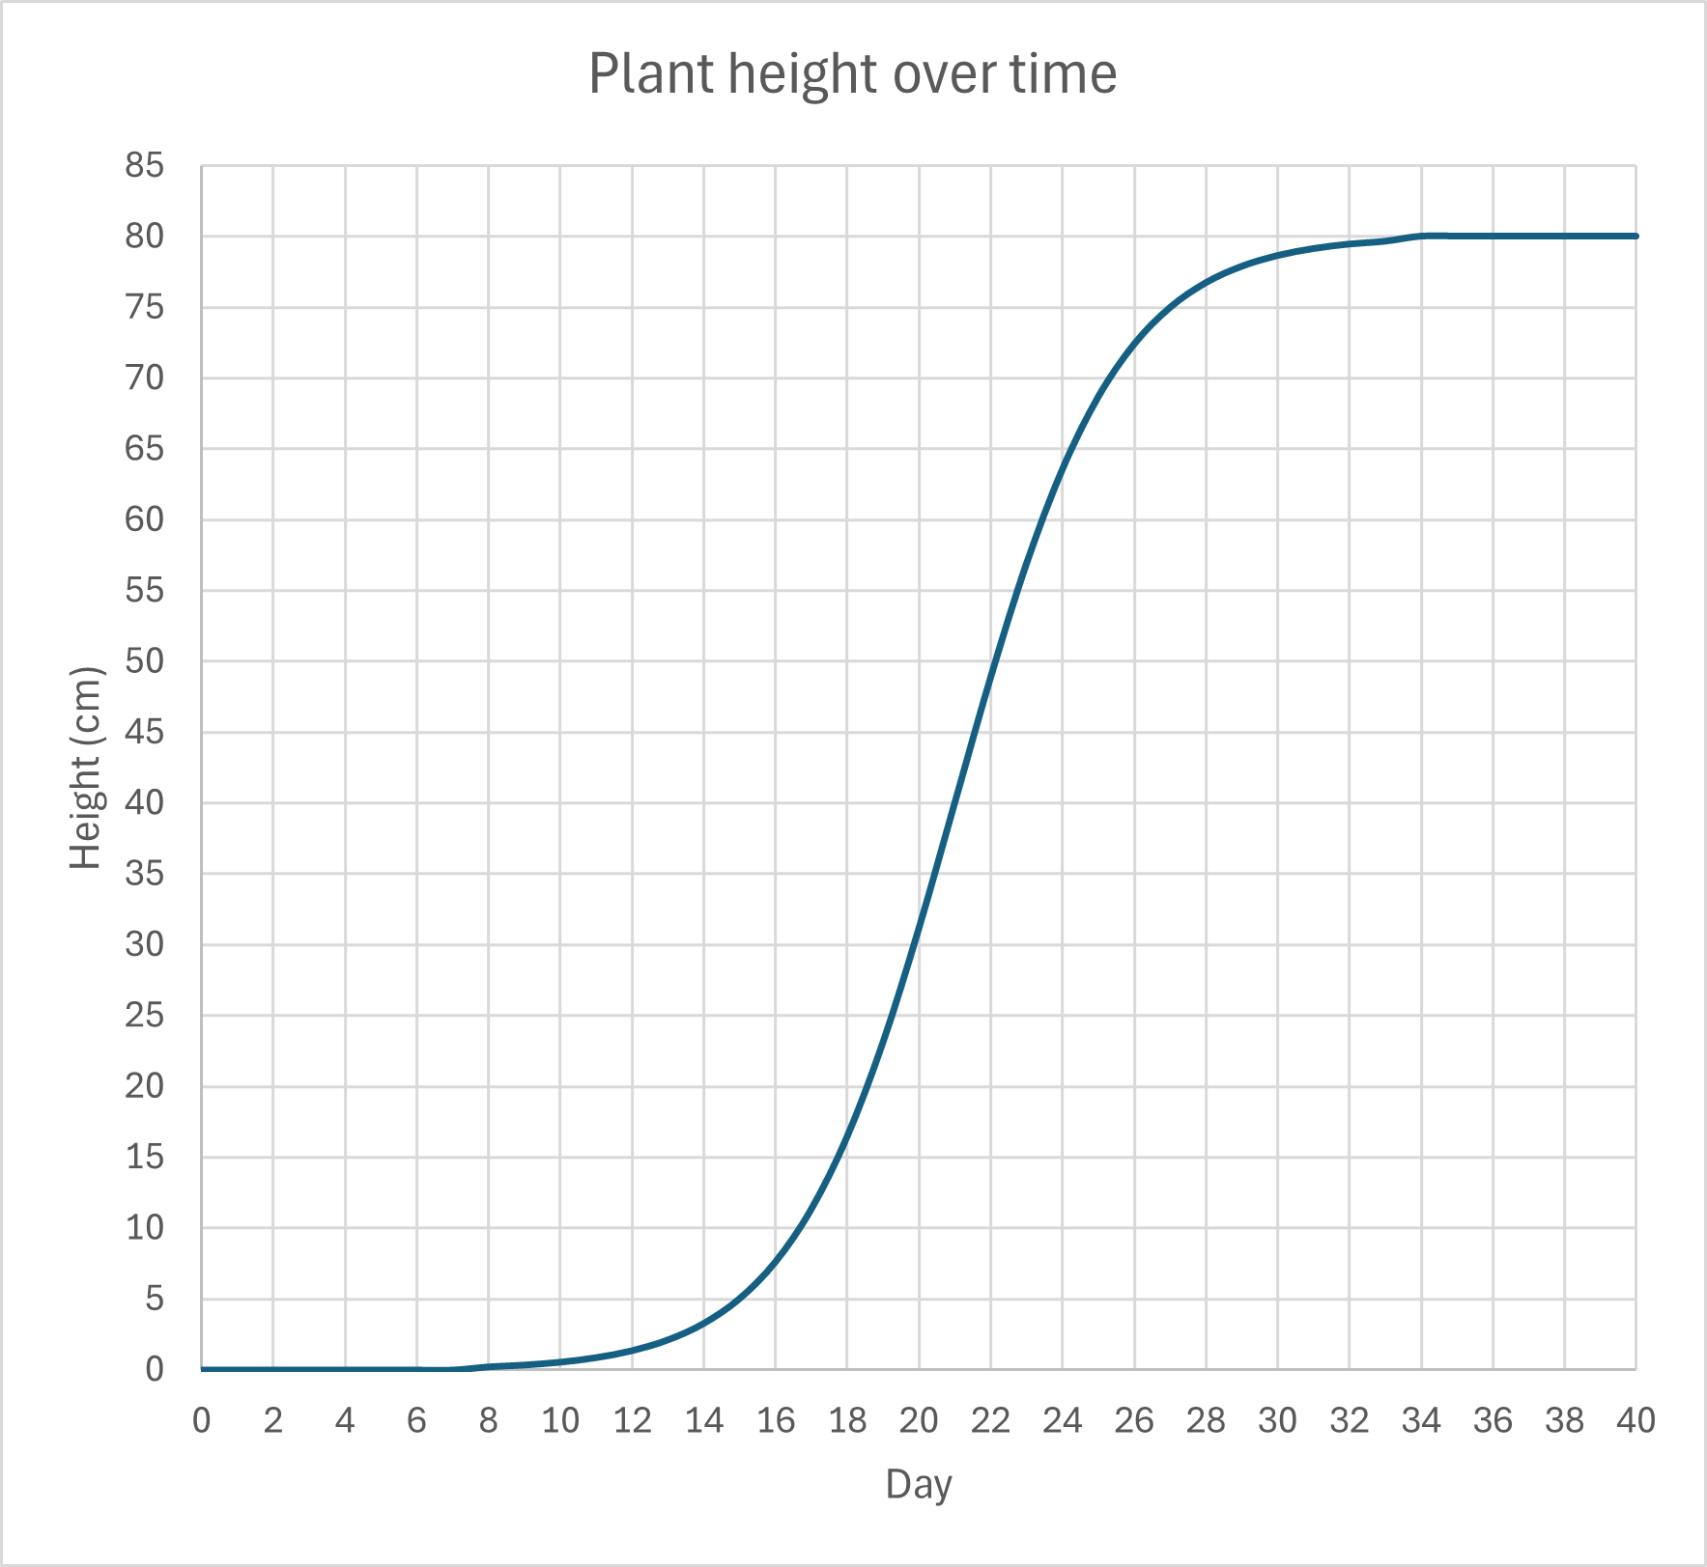
Source: student investigation
Figure 7 – sample student response for checkpoint
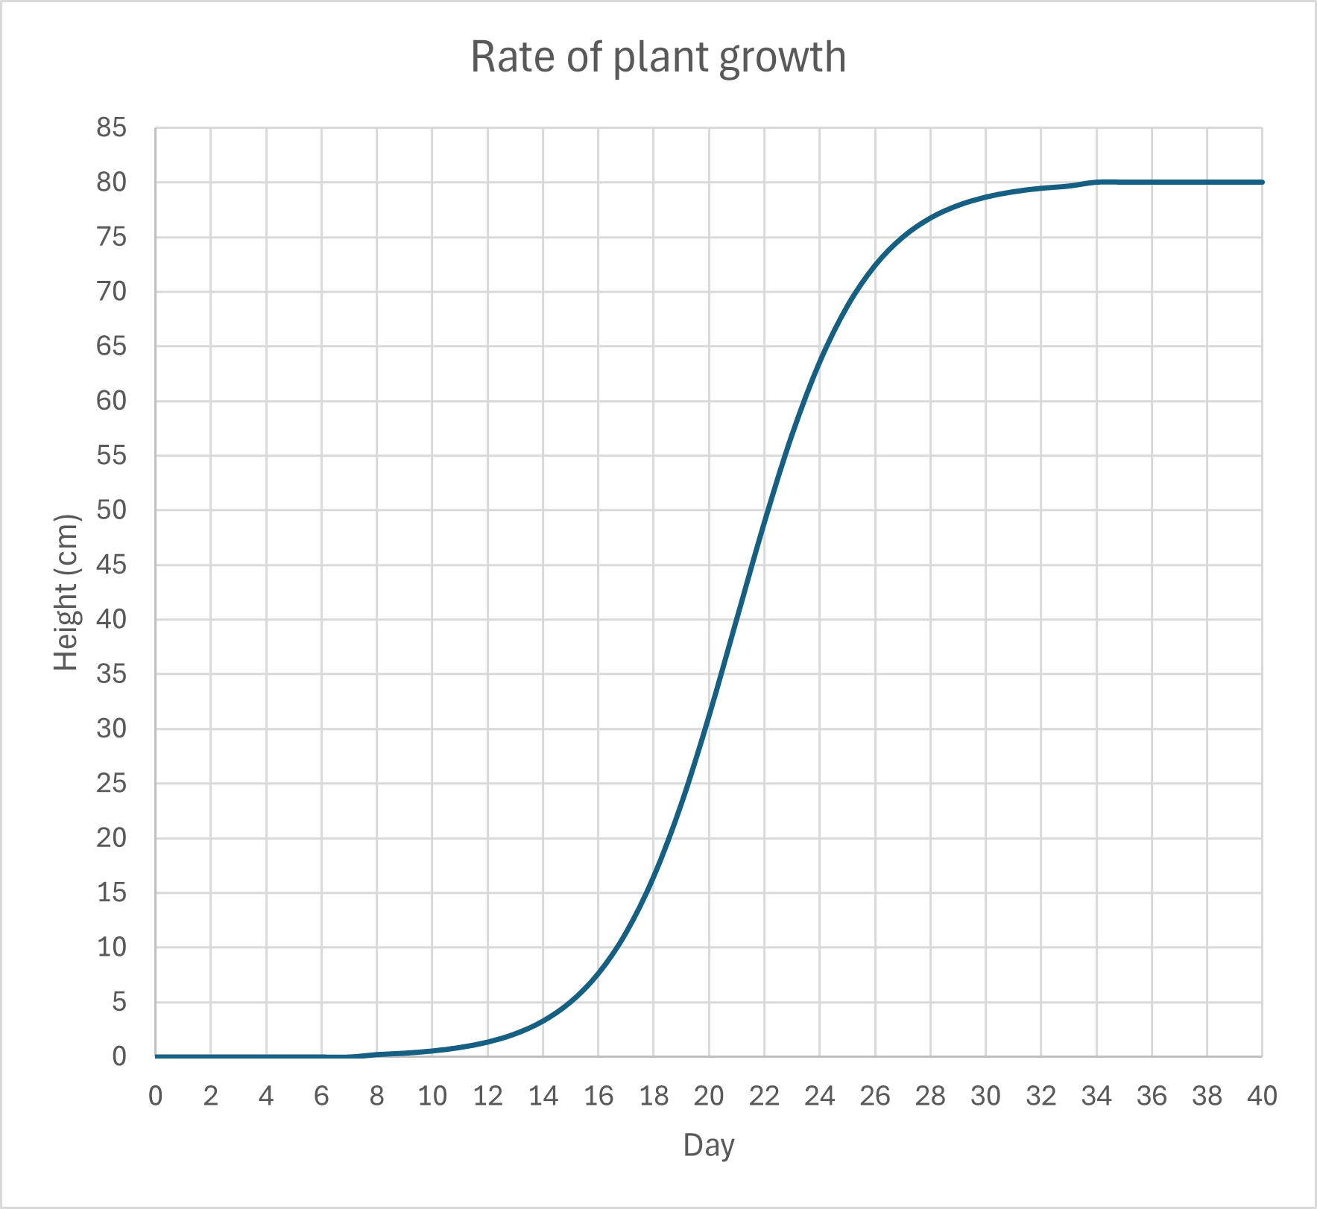
Source: student investigation
Sample responses: Student resource – analysing line graphs
Growth rate of the blue plant.
- How long did they measure the growth for?
10 days.
- How tall did the plant get during that time?
20 cm.
- How much did it grow in the first 2 days?
4 cm.
- How much did it grow in the last 2 days?
4 cm.
- What does the straight line tell you?
It grew at a constant rate.
- What was the height of the plant after 7 days?
14 cm.
- Calculate the mean growth rate for the blue plant for the 10 days in cm per day.
$Average growth rate= \frac{Final height(cm)}{Time (days)}= \frac{20 cm}{10 days}=2cm/day$.
Growth rate of the orange plant.
- How tall did this plant grow in 10 days?
42 cm.
- How much did it grow in the first 2 days?
2 cm.
- How much did it grow in the last 2 days?
15 cm.
- What does the shape of the curve tell you about the growth rate of the plant over time?
The rate of growth is increasing.
- What was the height of the plant after 7 days? Show your work on the graph.
21 cm.
- On the graph, sketch a line to show what the graph would look like for a plant that started growing quickly but slowed down.
Figure 5 – sample response for question 13
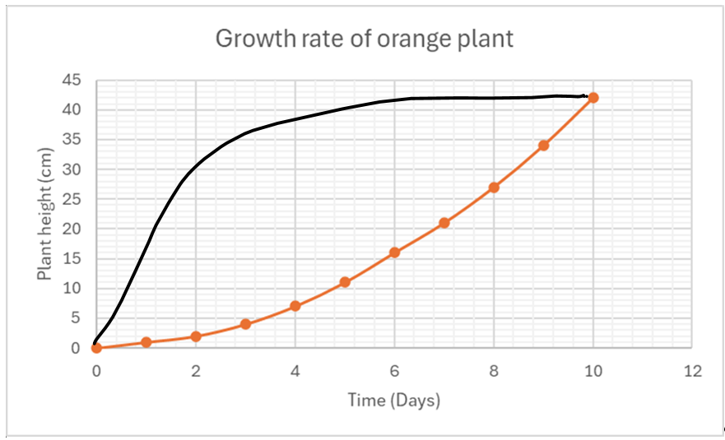
- When does the orange plant start growing faster than the blue plant? Justify your response.
After 3 days. This is when the slope of the orange line becomes greater than the slope of the blue line.
- Compare the growth rate of the orange and blue plants over the 10-day period.
At the beginning, the blue plant was growing faster than the orange plant. It grew 4 cm in the first 2 days, whereas the orange plant only grew 2 cm in that time. The blue plant continued to grow at a steady rate of 2 cm per day, whereas the orange plant's growth rate increased, growing 15 cm in the last 2 days.
Differentiation: alternative cloze passage for students requiring support in responding to this question.
Word/number bank: 15, 4, 2, constant, faster, increase
At the beginning the blue plant was growing ________ than the orange plant. It grew __cm in the first 2 days, whereas the orange plant only grew __ cm in that time. The blue plant continued to grow at a _______ rate of 2 cm per day, but the growth rate of the orange plant continued to _______ and grew __ cm in the last 2 days.

Student resource – analysing line graphs
Farmers have bred a new blue tomato and want to compare its growth rate to that of a normal orange tomato. In this investigation, the growth rate is measured as the plant's height.
Analyse the graph of the growth rate of the blue plant and answer the following questions.
Figure 1 – growth rate of the blue plant
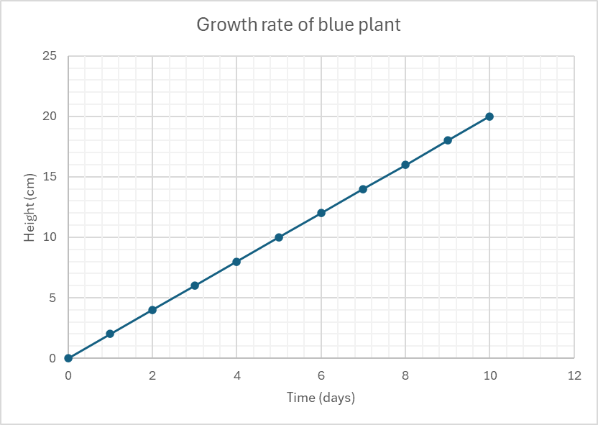
Source: student investigation
- How long did they measure the growth for?
- How tall did the plant get during that time?
- How much did it grow in the first 2 days?
- How much did it grow in the last 2 days?
- What does the straight line tell you?
- What was the height of the plant after 7 days?
- Calculate the mean growth rate for the blue plant for the 10 days in cm per day.
Analyse the graph of the growth rate of the orange plant and answer the following questions.
Figure 2 – growth rate of the orange plant
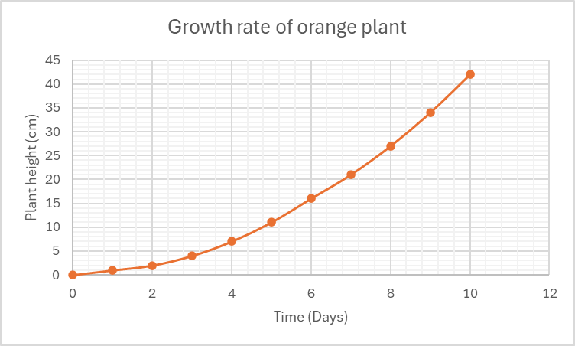
Source: student investigation
- How tall did this plant grow in 10 days?
- How much did it grow in the first 2 days?
- How much did it grow in the last 2 days?
- What does the shape of the curve tell you about the growth rate of the plant over time?
- What was the height of the plant after 7 days? Show your working on the graph.
- On the graph (Figure 2) sketch a line to show what the graph would look like for a plant that started growing quickly but slowed down.
- When does the orange plant start growing faster than the blue plant? Justify your response.
- Compare the growth rate of the orange and blue plants over the 10-day period.

1.3 Analysing primary data
Table 5 – learning intentions and success criteria for ‘1.3 Analysing primary data’
We are learning: | I can:
- to use data to make predictions | - compare observed results against my initial predictions  - use evidence from data to support or modify my scientific explanations
- to use data to identify patterns and relationships. | - identify patterns or relationships within datasets  - propose an inference based on the data I have collected  - evaluate the reliability and accuracy of firsthand data.

Arm length ratio
All activities in this section are designed to be quick data-collection exercises using readily available classroom resources. The goal of this activity is to gather primary data to demonstrate the concepts of range and mean. Students do not need to understand concepts like arm length ratio, coin tosses, or gravity. Feel free to modify the activities but keep the focus on the skills.
- Divide students into groups of 4.
- Explain that each student is to measure on themselves length A (elbow to wrist) and length B (wrist to tip of middle finger) as shown in Figure 8 and DA1 PPT ‘1.3 Arm length ratio’. Define and discuss what a ratio is: A ratio is a way of comparing 2 or more quantities to show how much of one quantity there is compared to another. Explain that the class is exploring the ratio of length A to length B.
- Students complete Table 1 for their group, and answer questions 1 and 2 in the Student resource – arm length ratio.
Note: class responses will vary, so sample responses are not provided for this student resource. See Figure 9 – example of class histogram for sample data if required.
Figure 8 – arm measurements for determining the arm length ratio
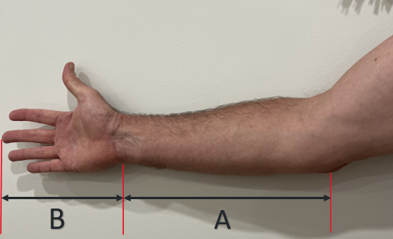
- Each student then writes their own value for A/B on a sticky note and places it on a class histogram. To create the class histogram, you can project DA1 PPT ‘1.3 Class histogram’ or draw up the bins as shown on the slide. Figure 8 shows what this histogram might look like.
Figure 9 – example of class histogram
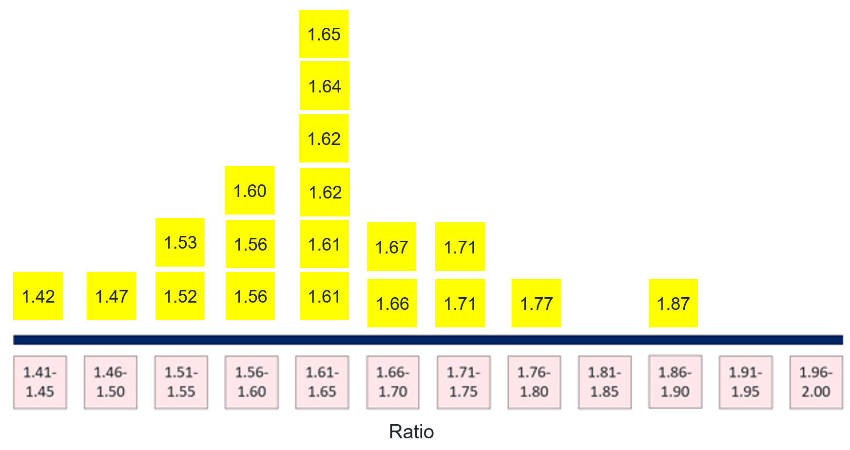
- As a class, answer questions 3 and 4. When addressing question 3, identify the challenges associated with manual methods of calculating mean and highlight the benefits of using software such as Microsoft Excel.
- When complete, introduce the concept of the ‘golden ratio’ and discuss if the class results are consistent with it.
The golden ratio, 1.618, is linked to the Fibonacci sequence. It is often seen in nature. This Scientific American video, The Mind-Blowing Mathematics of Sunflowers (2:38), sums up the connection between the golden ratio, the golden number and the Fibonacci sequence and can be viewed on DA1 PPT ‘1.3 Golden ratio’. The example in nature explored in this activity is the ratio of the length from your elbow to your fingertip compared to the length from your wrist to your fingertip. Other examples include the face-to-width ratio and joint ratios in the fingers. These could be explored based on time and student interest.
Checkpoint: calculate the mean and range of a set of results using DA1 PPT ‘1.3 Analysing primary data checkpoint 1’.
Sample responses:
Range = 1.80 – 1.55 = 0.25.
Mean = (1.55+1.75+1.65+1.80+1.70)/5 = 1.69.

Student resource – arm length ratio
For each student in the group, measure length A (elbow to wrist) and B (wrist to tip of middle finger) and complete Table 1.
Figure 1 – arm length ratio
Table 1 – results
Student | Length A (cm) | Length B (cm) | A/B
Mean
- What was the mean value of the ratio, A/B?
- What was the range of values for A/B?
Write your own value of A/B on a sticky note and place it on the histogram on the board.
- What was the class mean?
- What was the range of class values?

Coin toss
Students in small groups investigate the probability of getting heads on a coin toss. The purpose of this activity is to introduce the concepts of reliability and accuracy, as well as the effect of repetition.
- Display slide DA1 PPT ‘1.3 Reliability and accuracy’ to define accuracy and reliability.
- Guide students to set up a Microsoft Excel spreadsheet with the column and row headings shown in Figure 10.
Figure 10 – screenshot of spreadsheet setup for coin toss activity
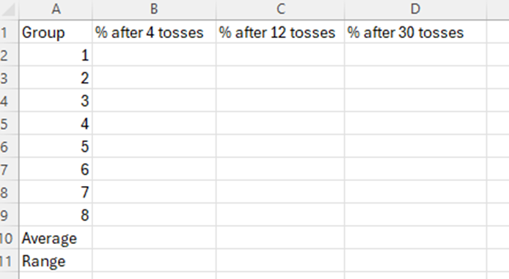
Note: data collection and processing can be done in various ways, depending on available technology. The teacher might set up the spreadsheet in advance and share it with the class, have students enter their data, or collect students' data and display it on the board.
- Each group tosses a coin 4 times and records the result as a percentage. Slide DA1 PPT ‘1.3 Calculating a percentage from coin tosses’ provides the steps required to calculate the percentage.
- Each group repeats for 12 and 30 tosses.
- Collect each group's results and enter them into the spreadsheet.
Note: Microsoft Excel can calculate the range using the MAX and MIN formulas, but for this small sample, it can be done with a calculator.
- Students evaluate the accuracy and reliability of results from 4, 12 and 30 tosses by completing questions in the Student resource – coin toss.
Sample response: Student resource – coin toss
- Predict how many times heads would come up if you tossed a coin 4 times.
2 or 50%.
- Toss the coin 4 times and record the number of times it came up heads and convert to a percentage.
Results will vary with class.
- Toss the coin 12 times and record the number of times it came up heads and convert to a percentage.
Results will vary with class.
- How does this compare to your prediction?
Results will vary with class.
- Toss the coin 30 times and record the number of times it came up heads and convert to a percentage.
Results will vary with class.
- How did the mean change with more repetition?
It got closer to 50%.
- How did the range between groups change with more repetition? Include data to support your answer.
The range was reduced. For 4 tosses, the range was 18%. For 30 tosses, the range was 4%.
- Compare the accuracy of each of your results.
The accuracy increased with repetition. The trial with 30 repeats was the most accurate, producing results closest to the expected 50%. In contrast, the results from the 4 trials were the least accurate.
- Enter your results into the class spreadsheet and calculate the range and mean for each trial.
No sample response for this question.
- Evaluate the reliability of each set of trials. Comment on the number of coin tosses and the number of groups.
In each successive trial (4×, 12×, and 30×), the range of values within the class was smaller and more accurate, indicating increased reliability.
By calculating the mean and range from 8 groups, we also increased the reliability of the data. Adding data from more groups would increase the reliability of the trials.

Student resource – coin toss
Investigating the probability of heads coming up when you toss a coin.
- Predict how many times heads would come up if you tossed a coin 4 times.
- Toss the coin 4 times and record the number of times it came up heads and convert to a percentage.
- Toss the coin 12 times and record the number of times it came up heads and convert to a percentage.
- How does this compare to your prediction?
- Toss the coin 30 times and record the number of times it came up heads and convert to a percentage.
- How did the range between groups change with more repetition? Include data to support your answer.
- How did the range change with more repetition?
- Compare the accuracy of each of your results.
- Enter your results into the class spreadsheet and calculate the range and mean for each trial.
- Evaluate the reliability of each set of trials. Comment on the number of coin tosses and the number of groups.

Determining acceleration due to gravity (g)
This small-group activity is designed to reinforce the concepts of accuracy and reliability, as well as the impact of experimental design on these concepts.
- Students drop a ball from a height of 1 m and record the time taken to hit the ground.
- Then use the formula $a= \frac{2s}{t^{2}}$ (where s = height dropped from in meters and t = time to hit ground in seconds) to determine the acceleration due to gravity.
- Students write their value on a blue sticky note and place it on the class histogram, similar to the activity in the arm length ratio activity. DA1 PPT ‘1.3 – Determining acceleration due to gravity (g) histogram’.
- Teacher collates data (using Microsoft Excel or on the board) to determine the class mean, then students answer the questions from the Student resource – determining the acceleration due to gravity (g).
- Students repeat until they have 10 values each, then write their mean value on a pink sticky note and place it over the first histogram.
Note: this highlights the benefits of averaging and repeating, ideally resulting in something like Figure 11, where the blue graph shows the original histogram from a single trial, and the pink graph shows the second histogram from repeated trials.
Figure 11 – histogram comparing the mean and range of single versus repeated trials
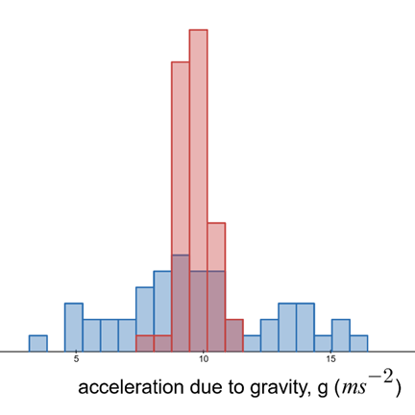
Single trials only
Repeated trials
Source: student investigation
- Students then repeat from a height of 3 m and discuss the impact that this has on accuracy.
Differentiation: students familiar with Microsoft Excel can complete the activity by inputting a formula in the spreadsheet to determine acceleration.
Checkpoint: see DA1 PPT ‘1.3 Analysing primary data checkpoint 2’ where students observe trial data and determine which method is more reliable and which is more accurate.
Sample response:
Method 1 is more reliable, as the range of results across successive trials is smaller (0.02) than in Method 2 (0.2). However, Method 2 produced a more accurate result after averaging, as it was closer to the theoretical or true value for the density of water (1.0 g/mL).
Sample responses: Student resource – determining the acceleration due to gravity (g)
Note: responses to questions 1 to 3 and 5 to 6 will depend on class results. Therefore, sample responses are provided for questions 4 and 7 to 10 below.
- What is the source of variation in these results? How is this different to the source of variation in the arm length ratio activity?
The source of error (variation) in this activity is due to experimental errors resulting from factors such as measuring the time it takes for the object to hit the ground. The variation in the arm length ratio exercise was mainly due to natural biological variation.
- Describe the differences between the 2 histograms.
Both have a similar mean, but the second histogram has a smaller range.
- Explain the difference between the 2 histograms.
Repetition and averaging reduce the effect of random error, bringing the calculated value of g closer to its expected value.
- Compare the accuracy of the results of the calculated values of gravity when dropped from 1 m and 3 m.
Answers will vary, but ideally, the result from 3 m should be more accurate.
- Account for the difference in the accuracy of the calculated values of gravity (1 m versus 3 m).
The percentage error in the time-to-fall measurement is greater for the 1 m drop than for the 3 m drop, making the 3 m drop results more accurate.

Student resource – determining the acceleration due to gravity (g)
Drop a ball from a height of 1 m and record how long it takes to hit the ground.
Use the formula $a = \frac{2s}{t^{2}}$ (where s = height dropped from in meters and t = time to hit ground in seconds) to determine the acceleration ($a)$ due to gravity. Write your answer on a sticky note and place it on the class histogram. Collate a class dataset (your teacher may do this using Microsoft Excel) and answer the following questions.
- What was the mean value of the class?
- What was the mode?
- What was the range of values?
- What is the source of variation in these results? How is it different to the source of variation in the arm length ratio activity?
Repeat the ball drop 9 times, for a total of 10 attempts.
Table 1 – ball drop acceleration at 1 m
Attempt | 1 | 2 | 3 | 4 | 5 | 6 | 7 | 8 | 9 | 10 | Mean | Range
Time (s)
G
(ms⁻²)
- Calculate your mean value for g.
- Calculate your range of values.
Place your mean on a sticky note and place it on the class histogram above the first one.
- Describe the differences between the 2 histograms.
- Explain the differences between the 2 histograms.

Repeat the above procedure, but drop from 3 m.
Table 2 – ball drop acceleration at 3 m
Attempt | 1 | 2 | 3 | 4 | 5 | 6 | 7 | 8 | 9 | 10 | Mean | Range
Time (s)
g
(ms⁻²)
- Compare the accuracy of the results of the calculated values of gravity when dropped from 1 m and 3 m.
- Account for the difference in the accuracy of the calculated values of gravity (1 m versus 3 m).

1.4 Generating and using data
Table 6 – learning intentions and success criteria for ‘1.4 Generating and using data’
We are learning: | I can:
- to use data to draw conclusions | - identify what data science is  - identify and describe different data sources  - explain how a data source may be used to investigate or solve scientific questions  - describe what data science is and how it is used in an everyday situation
- to identify problems and propose solutions. | - identify a problem that can be addressed with generated data  - describe how I could use data to solve a problem  - evaluate the suitability of my strategy or solution

What is data science?
- Hand out the Student resource – What is data science? and review the definitions of key terms used to describe data science.
- Complete the cloze exercise and matching activity to practice using these terms in a sentence and connect terms to common examples.
- Students create a response to the question ‘What is data science and how is it used in our daily lives?’
Sample responses: Student resource – What is data science?
Cloze exercise – complete each of these sentences using the key terms found in the student resource.
In modern research, many scientists rely on algorithms to handle large amounts of information. The field of data science is an interdisciplinary area that combines computer science, mathematics, and subject-specific expertise to extract information.
Researchers often apply scientific methods and processes to organise and analyse information, using statistics to identify patterns. With these tools, scientists can extrapolate results beyond the data they have collected.
Because science is not just about facts but also about methods, students must learn the scientific methods and processes to develop knowledge about the natural world and the many systems that interact within it.
Comprehension questions
- Highlight 2 everyday-life examples of where data science is used.
Planning travel routes, recommending music or adjusting traffic light timing.
- Name one use of an algorithm.
Algorithms are used to recommend music based on prior listening patterns.
- True or false? ‘Extrapolation is always accurate’. Explain your reasoning.
False. Beyond the data we have measured, patterns and trends may change, leading to inaccurate predictions and conclusions.
- Identify a decision made at home, school or in the community that could benefit from data science.
Data science could be used to set homework reminders, monitor student attendance or inform decisions about traffic management.
Summary
What is data science, and how is it used in our daily lives?
Data science combines ideas from science, maths and computing. It uses scientific methods to collect reliable data, uses statistics to identify patterns, employs algorithms to automate processes, and builds systems to transfer data from data sources to users.
In life, data science leverages large volumes of data to streamline routine tasks and make them more efficient. For example, data science aids in planning efficient travel routes using phone-based apps, recommends music based on listening habits, and assists in ordering canteen stock. We extract meaning and sometimes extrapolate trends. The purpose is to develop knowledge and generate insights that enhance everyday decision-making.

Student resource – What is data science?
Term | Definition
Algorithms | A step-by-step procedure a computer (or person) can follow to solve a problem.
Data science | A field of study that involves collecting, analysing and interpreting large amounts of data to gain insights and make decisions.
Extract | Choosing relevant, appropriate, and/or useful information from messy data.
Extrapolate | Extending a pattern beyond the existing data to make predictions.
Insights | The ‘so what’ ideas or patterns that help decisions.
Interdisciplinary | Combining ideas and tools from different subjects (for example, mathematics, science, computing).
Scientific methods and processes | Planning fair tests, collecting reliable data, analysing results, drawing conclusions.
Statistics | A collection of numerical facts or other data (for example, mean, median, range).
Systems | Connected parts that interact or work together (devices, people, software, data flows).

Cloze exercise – complete each of these sentences using the key terms above.
In modern research, many scientists rely on _________________ to handle large amounts of information. The field of ___________________ is an ___________________ area that combines computer science, mathematics, and subject-specific expertise to __________ information.
Researchers often apply _____________________________________ to organise and analyse information, using ________________ to identify patterns. With these tools, scientists can __________________ results beyond the data they have collected.
Because science is not just about facts but also about methods, students must learn the _________________________________ to develop knowledge about the natural world and the many _____________ that interact within it.

Comprehension: read the following passage and answer questions 1 to 4.
Data science is interdisciplinary. It combines scientific methods to collect trustworthy measurements, statistics to identify patterns, algorithms to automate steps and systems that transfer data from sensors to users. In daily life, it helps us route our journeys, recommend music, plan canteen orders and manage traffic lights. We extract meaning from messy datasets and sometimes extrapolate carefully to estimate beyond what we measured. The purpose is to develop knowledge and produce insights that improve everyday decisions.
- Highlight 2 everyday-life examples of where data science is used.
- Name one use of an algorithm.
- True or false? ‘Extrapolation is always accurate’. Explain your reasoning.
- Identify a decision made at home, school or in the community that could benefit from data science.
Summary
What is data science, and how is it used in our daily lives?

Classifying data
- Use DA1 PPT ‘1.4 Classifying data’ to unpack the definitions of primary and secondary data. Discuss examples of each type of data.
- Display DA1 PPT ‘1.4 Data sources 1 and 2’ to share 2 example data sources that include temperature data. For each of the 2 scenarios, ask students to suggest scientific (testable) questions the data could address.
Sample responses: DA1 PPT ‘1.4 Data sources 1 and 2’.
Data source 1 – thermal image of the school playground (from Program asks how Western Sydney school students would solve urban heat, ABC News)
- Which areas of the playground are the hottest at midday, and why might that be?
- How much cooler is the synthetic-turf area compared to the concrete basketball court?
Data source 2 – BOM monthly mean weather observations for Penrith Lakes AWS from 1996 to 2025 (from BOM Climate Data Online)
- Has the mean maximum temperature in Penrith Lakes during February increased over the past 30 years?
- Was summer in 2025 warmer than the long-term mean?
Checkpoint: ask students using given scenarios to identify the source of data, either primary, secondary or tertiary DA1 PPT ‘1.4 Checkpoint – investigating screen time’.
Scenario sample response:
- You keep a log of the time you personally spend on social media for one day. (Primary)
- Your class runs a lunch‑time survey asking 50 students how many hours they played video games last weekend. (Primary)
- A news article quotes last year’s eSafety Commission report on the mean Australian teen screen time. (Secondary)

Selecting the best source of data
- Share Student resource – selecting the best source of data. Review the evaluation criteria for selecting data sources with the class.
- With the class review, each of the criteria in Table 1 – evaluation criteria for selecting data sources and reflect on the ‘Ask yourself…’ column. Then, discuss and have the students fill in the ‘When primary data is the better pick’ and ‘When secondary data is the better pick’ columns to reinforce examples of each criterion. Sample responses for this are provided in DA1 PPT ‘1.4 Selecting the best source of data (1 to 2)’.
- Students complete a blank table to assess the suitability of each data source for answering the given question and determine which one (or both) is most appropriate.
- Examine various data sources that could support an investigation, answer a question or solve a problem. For example, design the safest bike route to school. How has rainfall in NSW changed over the last decade? Are there more magpies in my area than there were last year?
Sample responses: Student resource – selecting the best source of data
Table 7 – evaluation criteria for selecting data sources
Criteria | Ask yourself … | When primary data is the better pick –example | When secondary data is the better pick –example
Direct fit | Does it answer my exact question? | You need the temperature of the playground today ➜ snap a thermal image. | You need 30 years of Penrith rainfall ➜ download BoM records.
Currency | How up to date must the data be? | Do you want lunchtime noise levels today? ➜ measure them yourself. | Historical trend is fine ➜ past reports work.
Trust and control | Do I need to be sure how it was collected? | You design the method, so you control the variables and the accuracy. | A trusted agency (BoM, NASA) has already followed strict methods.
Effort and time | How long will it take to gather? | A small, quick sample (for example, class arm spans) is doable. | A large or long-term study would take ages ➜ use existing datasets.
Scope (local versus big picture) | Do I need local detail or a big overview? | Investigating heat spots on one oval ➜ collect locally. | Comparing climate across decades or regions ➜ use broader data.
Scenario 1 – Has the new COLA (Covered Outdoor Learning Area) reduced the temperature of the basketball court?
Data type: Primary data
Direct fit: The question is about our basketball court, so we cannot use data from somewhere else.
Currency: We need measurements both before and after the COLA was built.
Trust and control: The temperature measurements must be taken in the same manner before and after, allowing us to compare the results.
Effort and time: We can quickly measure the temperatures before and after using the equipment we have at our school.
Scope: We are only concerned with our school’s basketball court, so we do not need to test other areas around the school or collect data from other schools.
Scenario 2 – picking the correct shoe sizes to stock for a uniform shop
Data type: Use both primary and secondary data
Direct fit: School survey (primary): Directly measures the shoe sizes of our students, allowing us to order the correct stock for this term.
Currency: State size charts (secondary): Show the sizes that are currently popular across NSW, helping us plan for next year or online sales.
Trust and control: We trust the survey because we collect the data ourselves. Charts come from reliable companies.
Effort and time: The survey takes a day, while downloading charts takes only minutes.
Scope: Local data helps short‑term; big‑picture data helps long‑term.

Student resource – selecting the best source of data
- Read the criteria in Table 1 for selecting data sources and then complete the ‘Ask yourself…’ reflection question.
- Then complete the table with examples of when primary data is the better pick to use and when secondary data is the better pick to use.
Table 1 – evaluation criteria for selecting data sources
Criteria | Ask yourself… | When primary data is the better pick – example | When secondary data is the better pick – example
Direct fit | Does it answer my exact question?
Currency | How up to date must the data be?
Trust and control | Do I need to be sure how it was collected?
Effort and time | How long will it take to gather?
Scope (local versus big picture) | Do I need local detail or a big overview?
- Use information in this table to determine why primary, secondary or a combination of data is used in 2 different scenarios.
Remember: in both scenarios, the learning goal is picking the data source that best answers the question. Stay focused on that and avoid unnecessary details.
Scenario 1 – Has the new COLA (Covered Outdoor Learning Area) reduced the temperature of the basketball court?
Imagine you want to find out whether the new COLA installed to cover your school’s basketball court has affected the court's temperature during lunchtime.
What gets measured? Temperatures of the court surface or the air a short distance above it.
Why does it matter? Keeping the basketball court cooler will encourage more students to use it for games and reduce the risk of heatstroke in the hotter months.
Data choice challenge:
- Primary data: measuring the temperature one metre above the centre of the basketball court for a week before the COLA is built and the week afterwards.
- Secondary data: detailed measurements have been taken for other schools to test a similar question when they built a new covered basketball court to replace their old one.
Your job is to determine which type (or combination) of data will best answer your very specific question without wasting time or resources. Justify your choice by using the evaluation criteria for selecting data sources.
Data type:

Direct fit:

Currency:

Trust and control:

Effort and time:

Scope (local versus big picture):

Scenario 2 – picking the correct shoe sizes to stock for a uniform shop
You manage a school uniform shop and need to order a variety of shoe sizes so that most students can find a pair of shoes that fits.
What gets measured? Foot widths and lengths (or simply the shoe sizes students usually buy). You might gather this with a quick anonymous class survey.
Why does it matter? If you guess wrong, you will have lots of unwanted sizes left over and unhappy customers.
Data choice challenge:
- Primary data: measuring or surveying students at your school tells you exactly which sizes will sell here and now.
- Secondary data: clothing industry charts and big-store sales reports show the most popular sizes across NSW, which helps if you later sell online or in other towns.
Your job is to evaluate effort versus usefulness and select the data source (or combination) that yields smart, cost-effective ordering. Justify your choice using the evaluation criteria for selecting data sources.
Data type:

Direct fit:

Currency:

Trust and control:

Effort and time:

Scope (local versus big picture):

1.5 Creating a scientific poster – depth study (2 hours)
Table 8 – learning intentions and success criteria for ‘1.5 Creating a scientific poster’
We are learning: | I can:
- to use data like a scientist | - design or select a method that gathers the data needed to test the claim
- to use data to draw conclusions | - identify any pattern or relationship shown by the results
- to identify strategies for solving problems. | - spot any limitations in a plan or data and propose realistic fixes or alternative approaches.

Presenting data analysis
This activity allows students to quickly and easily collect, present and analyse various data in the classroom. The data collection and poster should be completed within one lesson and then displayed for assessment in the following lesson. Students are provided with Student resource – creating a scientific poster.
- Groups of students choose to investigate one of the following statements or one of their own:
- A bat flip is used to decide the toss in the Big Bash League (BBL).
- Salt changes the surface tension of water. (Guide students by suggesting that a measure of surface tension could be the number of drops that fit on a 5-cent piece)
- The golden ratio is present in some anatomical measurements.
- Students formulate a testable question, make a prediction and plan and collect the appropriate data to address the question.
Note: a quick internet search should be sufficient for students to gather information to support their predictions. Present the options before the lesson so you can organise materials.
- Each group presents their findings as an A3 scientific poster which will be displayed around the room.
Note: a basic poster template is provided in DA1 PPT ‘1.5 Scientific poster template’; however, students may prefer to use Canva or similar software to design their own posters. This is fine, as long as they include each of the headings. They can submit their posters, whether hand-drawn or word-processed, in digital or hard copy for display in the next lesson.
- Each student evaluates 2 to 3 other posters using the poster evaluation template.
Note: if students decide that the poster has not met one or more of the criteria, they should indicate how it can be improved. Emphasise that they are not allowed to disagree without suggesting an improvement.
Differentiation: this task allows for differentiation of content. For example, provide students with a testable question and data, vary the size of the dataset to be collected or offer scientific readings for data extraction.
This task also allows for product differentiation. For example, offer choices in how to present and publish information and demonstrate understanding, such as through multimedia, verbal presentations or broader school-community presentations.

Student resource – creating a scientific poster
Select from one of the following scenarios and:
- write a testable question for a simple problem
- make a justified prediction
- design and carry out a simple experiment to gather the data necessary to address your questions
- present your data in an appropriate format
- write a conclusion
- evaluate the reliability of your data by referring to the mean and range
- present this as a scientific poster that can be evaluated by your peers using the criteria in Table 1 – evaluation criteria below.
Scenarios
- A bat flip is used to decide the toss in the Big Bash League (BBL).
- Salt changes the surface tension of water. (Guide students by suggesting that a measure of surface tension could be the number of drops that fit on a 5-cent piece.)
- The golden ratio is present in some anatomical measurements.
- Choose one of your own.
Poster evaluation
Group: Question:
Prediction:
Table 1 – evaluation criteria
Criteria | Could be improved by | Agree | Strongly Agree
The prediction is justified.
The data collected is appropriate.
The data is presented appropriately.
The data supports the conclusion.
The results are reliable.
The poster is well presented.
Further feedback
One question | One suggestion

1.6 Your digital footprint
Table 9 – learning intentions and success criteria for ‘1.6 Your digital footprint’
We are learning: | I can:
- how data can be used to make predictions | - define digital footprints  - identify ways in which my data is collected and used  - outline strategies to protect personal data and privacy online  - discuss the implications of sharing data publicly and ways to stay safe in digital environments
- to identify problems and propose solutions. | - identify online activities and the digital footprint they create  - propose ways of engaging safely with digital systems.

What is your brand?
Background information
The ‘Best Footprint Forward’ project involved a survey of digital experts and career advisers to get their perspectives on digital footprint education in the Australian school context. This article reports on the following research questions:
- What do experts know about digital footprint management?
- What are their suggestions for education?
Expert insights into education for positive digital footprint development (PDF 1.9 MB) (Buchanan et al. 2018). Note: this article is the second in this document, spanning pages 8 to 19.
Additionally, resources such as ‘Leaving a digital footprint’ (State of New South Wales 2025) and ‘Digital footprint’ (Commonwealth of Australia 2024) offer background information and practical strategies for managing digital footprints, as well as resources for teachers.
Preparation
To complete the following activities, you will need to:
- download a copy of the 'What’s your brand?' slides and lesson plan from the eSafety Commissioner site
- ensure that students can access the internet.
Instructions
In this activity, students explore their digital footprint and its impact on their digital ‘brand’. They are encouraged to reflect on their online activities and are provided with practical strategies to build and maintain a positive digital brand. Sample responses are included in the lesson plan PDF.
- Display and follow the 'What’s your brand?' slides.
- Complete the discussion questions and activities outlined in the lesson plan:
- What is a brand? As a class, brainstorm what you think ‘a brand’ is. Share examples.
- Creating a brand: with 1 to 2 of your peers, identify 3 of your favourite brands and discuss what elements of those brands make them recognisable or popular.
- Damaging your own brand: discuss with peers 3 ways in which you can damage your own digital reputation.
- The importance of a good personal brand: imagine yourself as an employer or recruiter and perform a Google search of your own name. Then, discuss with a classmate what kind of impression the search results give and how that compares to who you truly are.
Note: encourage students to search for:
- their full name (with and without quotation marks)
- their name + school or suburb
- other online usernames
Use ‘Incognito’ or ‘Private’ mode to get a neutral view.
- Building a positive digital brand: identify 2 celebrities or sports stars (one male and one female) that a company sponsors and explain why the company associates with them. Do the same for a celebrity or sports star whose sponsorship has been dropped. Investigate why the company made this decision.
- Strategies to control your online information: as a class, discuss some things you might be able to do to control your information and images.
- Personal reflection:
    - What are some of the strengths of your personal brand?
    - Are there any potential weaknesses?
    - Where can you go for help if someone does something to damage your personal brand?
- Define ‘digital footprint’ DA1 PPT ‘1.6 What is a digital footprint?’
Checkpoint: DA1 PPT ‘1.6 Checkpoint – managing your brand’
Scenario: your friend just posted a short video of your group being silly at school. You are tagged in the video, and it is publicly viewable. Someone you do not know comments on it.
What is the best thing you should do next?
- Do nothing – it is just a joke, and everyone posts like that.
- Un-tag yourself and ask your friend to change the post settings to private.
- Leave a comment joking back to show you are not bothered.
- Repost it to your own account, so it looks like you are in control.
Sample response: B
Reason: un-tagging and requesting to make it private shows you are managing your digital footprint and taking control of your online presence. It is also a respectful way to deal with a friend’s post that concerns you.

1.7 Assessment task
The Science Stage 4 (Year 8) sample assessment task ‘Analysing scientific data’ is designed to assess students' understanding of how scientists use data to model and predict phenomena, alongside their skills in data analysis and problem-solving.
Detailed information on this task can be found in the Assessment task – Data science 1 on the Planning, programming and assessing Science 7–10 webpage.

Evidence base
This resource contains NSW Curriculum and syllabus content. The NSW Curriculum is developed by the NSW Education Standards Authority. This content is prepared by NESA for and on behalf of the Crown in right of the State of New South Wales. The material is protected by Crown copyright.
Please refer to the NESA Copyright Disclaimer for more information https://educationstandards.nsw.edu.au/wps/portal/nesa/mini-footer/copyright.
NESA holds the only official and up-to-date versions of the NSW Curriculum and syllabus documents. Please visit the NSW Education Standards Authority (NESA) website https://educationstandards.nsw.edu.au and the NSW Curriculum website https://curriculum.nsw.edu.au.
Science 7–10 Syllabus © NSW Education Standards Authority (NESA) for and on behalf of the Crown in right of the State of New South Wales, 2023.
ABC (Australian Broadcasting Corporation) (2025) ‘Program asks how Western Sydney school students would solve urban heat’, ABC News, accessed 22 August 2025.
AITSL (Australian Institute for Teaching and School Leadership Limited) (n.d.) Learning intentions and success criteria [PDF 251 KB], AITSL, accessed 18 July 2024.
Berkeley University (n.d.) Understanding Science 101, UC Museum of Palaeontology, accessed 22 August 2025.
BOM (Bureau of Meteorology) (n.d.) Climate Data, Bureau of Meteorology website, accessed 22 August 2025.
Brookhart SM (2018) ‘Appropriate Criteria: Key to Effective Rubrics’, Frontiers in Education, volume 3(22):1–12, doi:10.3389/feduc.2018.00022, accessed 6 February 2025.
Buchanan R, Southgate E, Scevak J and Smith SP (2018) Expert insights into education for positive digital footprint development (PDF 1.9 MB), SCAN, 37(2):8–19, accessed 22 July 2025.
CESE (Centre for Education Statistics and Evaluation) (2020) What works best: 2020 update, NSW Department of Education, accessed 18 July 2024.
——(2020) What works best in practice, NSW Department of Education, accessed 18 July 2024.
——(2021) Growth goal setting – what works best in practice, NSW Department of Education, accessed 6 February 2025.
Commonwealth of Australia (2024) Digital footprint, eSafety website, accessed 22 July 2025.
Education Services Australia (2016) Fair test. Scootle website. Accessed 22 August 2025.
Fisher D and Frey N (1 November 2009) ‘Feed Up, Back, Forward’, ASCD (Association for Supervision and Curriculum Development): Educational Leadership magazine, 67(3), accessed 18 July 2024.
Griffin P (2017) Assessment for Teaching, Cambridge University Press, Port Melbourne, Victoria.
Hattie J and Timperley H (2007) The Power of Feedback. Review of Educational Research, 77(1): 81–112, doi:10.3102/003465430298487.
NASA (National Aeronautics and Space Administration) (n.d.) Global Temperature: Vital Signs of the Planet, NASA website, accessed 22 August 2025.
Panadero E and Jonsson A (2013) ‘The use of scoring rubrics for formative assessment purposes revisited: A review’, Educational Research Review, 9:129–144, doi:10.1016/j.edurev.2013.01.002, accessed 18 July 2024.
Scientific American (23 January 2014) 'The Mind-Blowing Mathematics of Sunflowers - Instant Egghead #59' [video], Scientific American, YouTube, accessed 14 October 2025.
Sherrington T (2019) Rosenshein’s Principles in Action, John Catt Educational Limited, Melton, Woodbridge.
State of NSW (2025) Leaving a digital footprint, Digital Citizenship website, accessed 22 July 2025.
UCMP (University of California Museum of Palaeontology) (2022) Understanding Science [website], accessed 26 June 2025.
Wiliam D (2017) Embedded Formative Assessment, 2nd edn, Solution Tree Press, Bloomington, IN.

© State of New South Wales (Department of Education), 2025
The copyright material published in this resource is subject to the Copyright Act 1968 (Cth) and is owned by the NSW Department of Education or, where indicated, by a party other than the NSW Department of Education (third-party material).
Copyright material available in this resource and owned by the NSW Department of Education is licensed under a Creative Commons Attribution 4.0 International (CC BY 4.0) license.

This license allows you to share and adapt the material for any purpose, even commercially.
Attribution should be given to © State of New South Wales (Department of Education), 2025.
Material in this resource not available under a Creative Commons license:
- the NSW Department of Education logo, other logos and trademark-protected material
- material owned by a third party that has been reproduced with permission. You will need to obtain permission from the third party to reuse its material.
Links to third-party material and websites
Please note that the provided (reading/viewing material/list/links/texts) are a suggestion only and implies no endorsement, by the New South Wales Department of Education, of any author, publisher, or book title. School principals and teachers are best placed to assess the suitability of resources that would complement the curriculum and reflect the needs and interests of their students.
If you use the links provided in this document to access a third-party's website, you acknowledge that the terms of use, including licence terms set out on the third-party's website apply to the use which may be made of the materials on that third-party website or where permitted by the Copyright Act 1968 (Cth). The department accepts no responsibility for content on third-party websites.

