Science Stage 4 (Year 7) – Cells and classification
Teacher resource book 2 of 2 (TRB2)
2 What are the features of cells, and how does their structure relate to their function?
Creation date: 25 March 2025.
Contents
Overview 2
Glossary 2
Cells – alternative conceptions 7
2.1 What are cells? 8
Moving from the macro world to the micro world 8
The foundations of life 11
2.2 Cells have different structures 13
Structures and organelles in plant and animal cells 13
Constructing a response to compare the structure of plant and animal cells 20
2.3 Cellular processes 27
Cellular respiration and photosynthesis 27
2.4 Single-celled organisms 33
Can a living thing be made of one cell? 34
How to use a light microscope (practical investigation) 39
Single-celled organisms (practical investigation) 42
2.5 Multicellular organisms 47
Multicellular organisms 48
Relationship between the structures and functions of specialised cells (secondary source investigation) 49
Multicellular organisms and cell specialisation (practical investigation) 57
Optional activity – multicellular organisms as a city analogy 64
2.6 Cells in the Kingdoms of life 70
Cells share the same basic structure 70
Comparing cells in the Kingdoms of life (secondary source investigation) 71
Evidence base 80

Overview
Stage and learning area: Stage 4 Science
Description: this resource complements the Cells and classification program of learning. It aims to serve as a teacher reference, offering practical strategies and ideas to enrich teaching practices and create engaging learning environments. The activities should be adapted to suit the students’ needs.
Duration: while timing will vary based on the mode of delivery, differentiation strategies employed, and class or school context, this series of activities in TRB2 should take approximately 12 hours.
Risk management: teachers are advised to undertake a risk assessment before conducting any classroom investigation or experiment. For more information on developing risk assessments, see Risk Assessment – a pre-requisite for risk control.
This resource book elaborates on many of the activities in the Cells and classification sample program of learning. Some activities also reference the Cells and classification slide deck (identified as CLS PPT throughout this document).

Glossary
Tier 3 words are those that are relevant for subject-specific content. More information is provided in the ‘Vocabulary in context’ document found at the Stage 5 reading strategies page. The Guide for planning and implementing explicit vocabulary instruction can be used by teachers across all curriculum areas.
Differentiation: to support EAL/D learners with vocabulary development, refer to EAL/D learners and reading vocabulary. An additional column may be added to the glossary table for EAL/D students to write the definition in their home language.
Table 1 – glossary of Tier 3 words in the cells component of the Cells and classification focus area
Term | Definition
Bacteria | Bacteria are single-celled (unicellular) prokaryotic organisms.
Body system | A body system is a group of organs that work together to perform a specific function. For example, the digestive system includes organs such as the mouth, stomach, intestines and associated glands. Its job is to break down food and absorb nutrients that the body needs for energy and other functions.
Cell | The fundamental building block of living organisms. All cells consist of a fluid-filled interior encased by a membrane. Cells may contain internal structures called organelles and external structures such as cell walls. Cells are classified as prokaryotes or eukaryotes (these are explained later).
Cell membrane | The boundary of a cell, which acts as a semipermeable barrier that controls the movement of substances into and out of the cell.
Cellular respiration | The process by which a living organism or cells break down organic molecules to release energy. Cellular respiration can be aerobic (with oxygen) or anaerobic (without oxygen) (NESA 2025).
Cell wall | A rigid structure that surrounds the cell membranes of plant, fungal and bacterial cells.
Chlorophyll | Chlorophyll is a green pigment in cells that absorbs light energy for photosynthesis. In plants, chlorophyll is found in organelles called chloroplasts.
Chloroplast | The chlorophyll-containing organelle in the cells of plants and algae, where photosynthesis occurs (NESA 2025).
Controlled variable | A variable that is kept constant (or changed in constant ways) during an investigation. For example, the same amount of water would be a controlled variable in an investigation comparing solubility (NESA 2025).
Cytoplasm | The fluid-filled interior of cells consists mainly of water, proteins and salts. Many cellular processes take place in the cytoplasm. In eukaryotic cells, the cytoplasm contains various membrane-bound structures known as organelles.
Dependent variable | The factor in an experiment that changes in response to changes to the independent variable (NESA 2025).
DNA | The abbreviated name for the molecule that carries genetic information in cells – deoxyribonucleic acid.
Eukaryote | Eukaryotes are cells that have a membrane-bound nucleus and other membrane-bound organelles. Eukaryotes can be single-celled or multicellular. Many eukaryotic cell types go through differentiation and specialise.
Fungi | Fungi are a kingdom of non-motile, non-photosynthetic organisms. They are heterotrophs (consume foods). Fungi may be single-celled, such as yeasts, or multicellular such as mushrooms.
Independent variable | The variable that is deliberately changed, often through a series of pre-set values (NESA 2025).
Microscope | A microscope is an instrument that produces enlarged images of objects. Unlike magnifying glasses, microscopes are complex tools that use multiple lenses and advanced optics to produce highly magnified images. Examples include light and electron microscopes.
Mitochondria | Organelles that are the sites of aerobic respiration and energy (ATP) generation. Mitochondria are double-membraned organelles.
Multicellular organism | Multicellular organisms consist of many specialised cells arranged into tissues, organs and body systems. These specialised cells work cooperatively to perform various life functions.
Nucleus | A large, double-membraned organelle that contains chromosomes. The genetic information contained in the DNA within cells' nuclei is critical for their normal functioning.
Observation | To see, watch, perceive or notice. Observations can be made using all 5 senses as well as digital and non-digital tools that extend our senses (NESA 2025).
Organ | Organs are structures within organisms designed for specific functions. Each organ is made up of different tissues that work together. For example, the kidneys of mammals are organs involved in excretion (the removal of metabolic wastes).
Organelle | Organelles are membrane-bound structures that carry out specific functions within cells. The molecules necessary for these functions are stored inside the organelles.
Organism | An organism is a living thing that can be made up of one cell (like bacteria) or many cells (like plants and animals). Organisms show characteristics of life, such as movement and response to stimuli.
Paramecium | A Paramecium is a single-celled microorganism. It is a eukaryote and its outer surface is lined with cilia. Paramecia are motile and move by rhythmically beating their cilia.
Photosynthesis | The process of making glucose from carbon dioxide and water. The energy for this process comes from light energy, which is captured by chlorophyll. Another product of photosynthesis is oxygen gas, which is released into the environment.
Prokaryote | A simple, single-celled organism that lacks a nucleus and membrane-bound organelles. For example, bacteria such as E. coli. (LibreTexts Biology (n.d.)
Senses | Perceptions that a living organism uses to take in information about its surroundings. The 5 main senses are hearing, sight, touch, taste and smell (NESA 2025).
Single-celled organism | An organism that consists of only one cell.
Tissue | An organised collection of similar specialised cell types, such as nervous tissue and connective tissue.
Vacuole | A fluid-filled organelle in cells. Vacuoles in plant cells are larger than those in animal cells. Plant vacuoles often function as storage organelles.

Cells – alternative conceptions
The list of alternative conceptions is not intended to be comprehensive, but rather to provide a starting point. Alternative conceptions should be identified and addressed throughout the teaching and learning process.
Table 2 – alternative conceptions and their corresponding accepted conceptions
Alternative conception | Accepted conception
Living things grow because their cells get bigger (increase in size). | Living things grow because their cells reproduce (increase in cell number).
Plants make energy. | Plants use the light energy from the sun to photosynthesise and generate chemical energy.
Plants get their food/energy from the ground. | Plants obtain water from the ground (and trace nutrients) but use the water and carbon dioxide in sunlight to produce glucose and oxygen (photosynthesis).
Only leaves photosynthesise. | Some non-woody green stems can photosynthesise.
Biological science conceptions by Primary Connections, available under ShareAlike 4.0 International (CC BY-NC-SA-4.0).

2.1 What are cells?
Table 3 – learning intentions and success criteria for 2.1 What are cells?
We are learning: | I can:
- to describe the features of cells in living things | - define cells as the most basic unit of life  - outline cell theory  - recognise that advances in technology have increased our understanding of cells
- to extract and summarise information from secondary sources. | - identify key points in a text about cell theory and the developments in microscope technology  - summarise key points in my own words to respond to comprehension questions.

Moving from the macro world to the micro world
- Show CLS PPT ‘2.1 Moving from macro world to the micro world’ to recall what students have learnt about classifying organisms. Outline how this approach focuses on the big picture to provide an understanding of the diversity of life. Students learnt about the macroscopic world (the word macro means ‘large’ or ‘big’). To fully understand organisms and how they are classified, zoom in on the microscopic world (micro means ‘small’).
- Show CLS PPT ‘2.1 Zooming in to the micro world’ and play Zoom on an Animal Cell (1:03) to show students the level of detail that can be seen when we zoom in or magnify something.
- Show CLS PPT ‘2.1 Scientific equipment for magnifying objects’. Use the speaker notes to outline how these tools help scientists observe the world more closely.
- Show CLS PPT ‘2.1 Using scientific equipment to make observations’ to demonstrate the difference in detail that can be observed with different scientific tools. Use the speaker notes to unpack each image.
- Facilitate a class discussion using the questions:
- What did humans know about organisms before the discovery of scientific equipment such as the microscope?
Before the invention of scientific equipment like the microscope, our understanding of organisms was simpler. Scientists and people in general were aware of living things they could see with their eyes, such as plants, animals and fungi, but they had no idea about the invisible world of microorganisms.
- How did scientists make those observations before the invention of the microscope?
Scientists would have relied on their 5 senses to make observations. For example, they could describe what they saw when they dissected larger animals or plants. They might have noticed changes in the environment, such as the way food spoiled or diseases spread, but they could not understand why these things happened because they could not see these tiny organisms.
Knowledge was limited to what could be observed directly, and much of science was based on what people could explain from these observations.
It was only after the invention of microscopes that scientists realised there were many more tiny organisms living in places they never imagined, like in water, soil, or even on our skin.
- Show CLS PPT ‘2.1 Development of scientific understanding over time’ and play the video The History of the Microscope (3:07). Students respond to the following questions in their notebooks:
- Identify the person who invented the first microscope. Outline their observations.
Robert Hooke developed the first microscope in 1665. He was able to observe that plant tissue (cork) was made up of many tiny individual building blocks. He named these building blocks cells.
- Identify the scientist who observed the first living microorganism under a microscope. Outline the developments in the microscope that allowed him to do this.
The first person to observe a live cell under a microscope was Anton (Antonie) Van Leeuwenhoek. He was able to develop glass lenses that could magnify objects by several 100 times. A screw was used to adjust the focus of the view.
Checkpoint 1 (CLS PPT): Show students an image that shows the cells that make up the root of an onion plant. Ask ‘What tool would you use to see these tiny structures in the onion root?’
- a magnifying glass
- a microscope
- a telescope
- my eyes

The foundations of life
- Define the terms cell and organism for students using the CLS PPT ‘2.1 Defining key terms’.
- Recall that Hooke coined the word ‘cell’ through his observations of cork samples viewed under a microscope. Tell students that nearly 2 centuries later, the botanist Matthias Schleiden and the zoologist Theodor Schwann determined that cells were the fundamental units of life. Rudolf Virchow added that ‘all cells arise from preexisting cells’ (Virchow 1885). Together, their work established classical cell theory. However, as we zoom in to explore the micro level, we find that cells are more than just the smallest units of life.
- Show CLS PPT ‘2.1 Cell theory’. As a class, watch The wacky history of cell theory – Lauren Royal-Woods (6:11) video to answer the questions on the slide.
- Inform students that cell theory explains why all living organisms, no matter how diverse, share certain common features at the cellular level. The first 3 points below are from classical cell theory, and the remaining points have been added due to modern understanding of cells.
- All living things are made of cells. Living things may be single-celled or multicellular (composed of many cells).
- The cell is the basic unit of structure and function of living things. Cells are the smallest units that can carry out all the processes of life. All the functions that an organism needs to stay alive, such as taking in nutrients, eliminating waste and reproducing, occur within cells.
- All cells come from pre-existing cells. New cells are created through the division of existing cells, not by spontaneous generation (they do not appear spontaneously).
- All cells contain genetic material (DNA). DNA is passed on during cell division. Genetic information controls all cell activities and is inherited from the parent cell.
- Energy flow occurs in cells. Cells are where energy is stored, released and used.
- All cells have the same basic chemical makeup. All plant cells have a very similar makeup, all animal cells have a similar makeup, and all bacterial cells have a similar makeup.
- Teach students that the knowledge of cell theory helps us classify all living things, like plants, animals or bacteria. For example, the way cells are built and work (cellular structure and function) provide important clues to the similarities and differences between organisms. For example, the highest level of biological classification (Domain or Kingdom) is based on cellular features.
- Recap how organisms are grouped based on similar characteristics. Inform students that an increased understanding of organisms, including at the cellular level, resulted in changes in classification. Read out the following information to students:
- The discovery of cells and further advances in microscopy revealed key differences between organisms at the cellular level. For example, Carl Linnaeus classified fungi and algae in the plant kingdom. Later, when scientists noted key differences in the cell structures of these groups, algae and fungi were reclassified into different kingdoms.
- With further advancements in technology and increased scientific understanding, the Linnaean classification system was expanded to 3 kingdoms (Protista, Plantae and Animalia), then 4 (Monera, Protista, Plantae and Animalia), then 5 (Monera, Protista, Fungi, Plantae and Animalia).
Checkpoint 2 (CLS PPT): Pose the scenario: ‘Imagine that an alien spaceship is firing death rays at Earth! The death rays will destroy everything composed of cells. Things that are not made of cells will not be affected.’ Give students a range of statements related to living, non-living and dead things (once were living), and ask them to determine whether the item will be destroyed or not. Student responses may be observed using mini whiteboards. Sample responses and explanations are provided on the slides.
This question tests the idea that being made up of cells is a (structural) criterion for deciding what a living organism is, in addition to the characteristic processes of living organisms. It explores students’ ideas about what types of things are made of cells. Students are presented with a variety of examples, including living and dead organisms of various sizes, and parts of organisms.

2.2 Cells have different structures
Table 4 – learning intentions and success criteria for 2.2 Cells have different structures
We are learning: | I can:
- to describe the unique features of cells in living things | - label the organelles in plant and animal cells  - identify common cell structures and organelles in plant and animal cells  - outline the similarities and differences in the structures of plant and animal cells  - describe the function of the cell membrane, nucleus, chloroplast, cytoplasm and mitochondria  - identify and label the organelles in a plant and animal cell
- how to communicate scientific information in a written text. | - deconstruct an exam-style question using the Verb, Content, Focus, Singular strategy (VCFS)  - construct a written response to ‘compare and contrast’ plant cells and animal cells  - use correct and precise scientific terminology  - use connectives/cohesive devices to create cohesion.

Structures and organelles in plant and animal cells
- Hand out the Student resource – plant and animal cells, one per student. Inform students that by the end of the activity, they should be able to recall the different organelles, identify whether the organelles are found in plant cells, animal cells, or both, and describe the structure of plant and animal cells by correctly identifying cell A and B in the student resource with appropriate justification.
- Outline the different organelles by going through the CLS PPT ‘2.2 Plant and animal cell structure and function’ slides (8 slides). While going through these slides, students label the organelles on their cell diagrams.
- Facilitate class discussion to support students in correctly identifying Cell A as the plant cell and Cell B as the animal cell. Sample responses have been provided in the CLS PPT ‘2.2 Identifying an unknown cell 1–2’.
- Display CLS PPT ‘2.2 Organelle functions’. Go through one function at a time and have students identify the matching organelle on mini whiteboards. Click on the correct organelle to move it next to the function on the slide. Identify students who are incorrectly identifying the organelle and its function, and support them in closing any knowledge gaps.
Checkpoint (CLS PPT): Display CLS PPT ‘2.2 Checkpoint 1’. Students respond to a range of statements related to cells and their role in sustaining life. Use mini whiteboards to check students' understanding of each statement. The answers are provided in the CLS PPT. A printable handout alternative to this checkpoint is provided in Student resource – checkpoint: Sustaining life. Table 5 provides elaborations for each statement so that a discussion can be facilitated to provide feedback to students.
Table 5 – student resource (Checkpoint: sustaining life), teacher elaborations
Statements | Teacher explanation
A single cell can take in food and other nutrients. | Single-celled organisms, like bacteria and protists (for example, amoebas), can absorb nutrients from their environment. They do this through processes like diffusion or engulfing food (phagocytosis in amoebas).
A single cell can get energy from food. | Cells use cellular respiration (or sometimes fermentation) to break down glucose and release energy in the form of adenosine triphosphate (ATP). Single-celled eukaryotes have mitochondria, and prokaryotes use their cell membrane to release energy.
A single cell can eliminate waste. | Cells produce waste products during their activities. Single-celled organisms can remove these wastes by diffusion through the cell membrane or via other specialised structures, such as the contractile vacuole in some protists which expels excess water.
A single cell can make new cells. | Single-celled organisms reproduce by dividing into 2. One parent cell produces 2 identical daughter cells.
A single cell can respond to its surroundings. | Single cells can respond to various stimuli, including light, temperature, chemicals or touch. For example, Paramecia change their direction of movement when they bump into an obstacle, and bacteria can move toward nutrients.
A single cell is a living thing. | According to the cell theory, the cell is the smallest unit of life. Many organisms, such as bacteria, archaea and protists, consist of a single cell and carry out all life processes; therefore, they are classified as living organisms.
Sample response: Student resource – plant and animal cells
Figure 1 – sample response Cell A
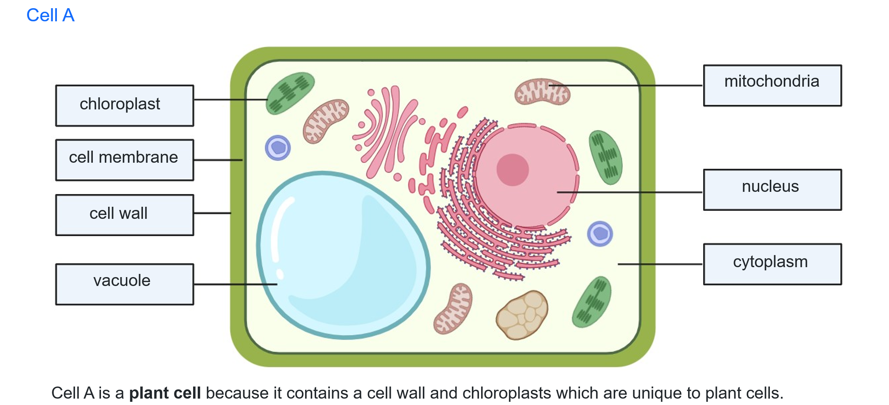
This work has been generated using BioRender.com. Any copyright subsisting in this work is owned by © State of New South Wales (Department of Education), 2024.
Figure 2 – sample response Cell B
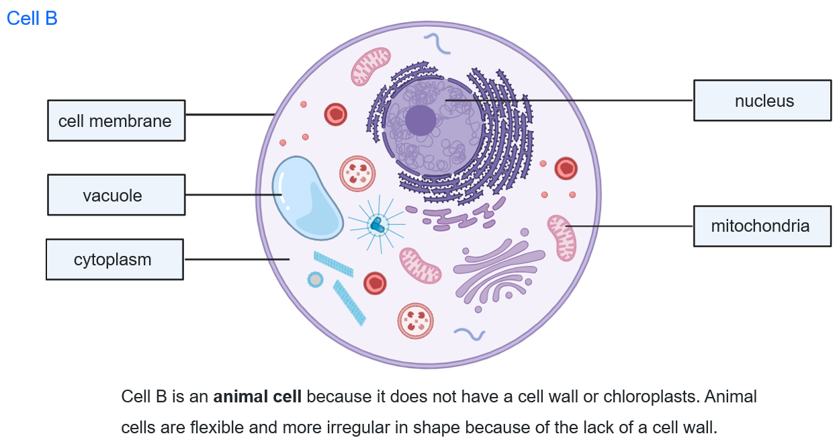
This work has been generated using BioRender.com. Any copyright subsisting in this work is owned by © State of New South Wales (Department of Education), 2024.

Student resource – plant and animal cells
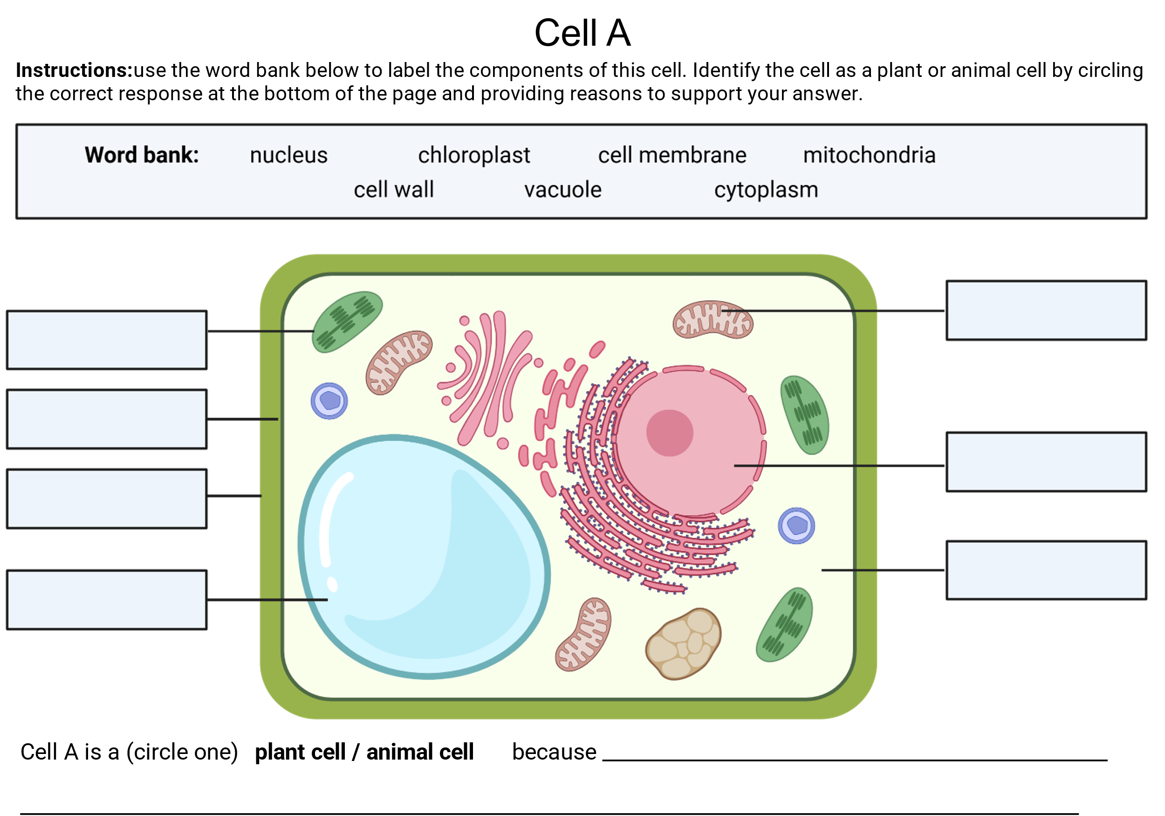
This work has been generated using BioRender.com. Any copyright subsisting in this work is owned by © State of New South Wales (Department of Education), 2024.
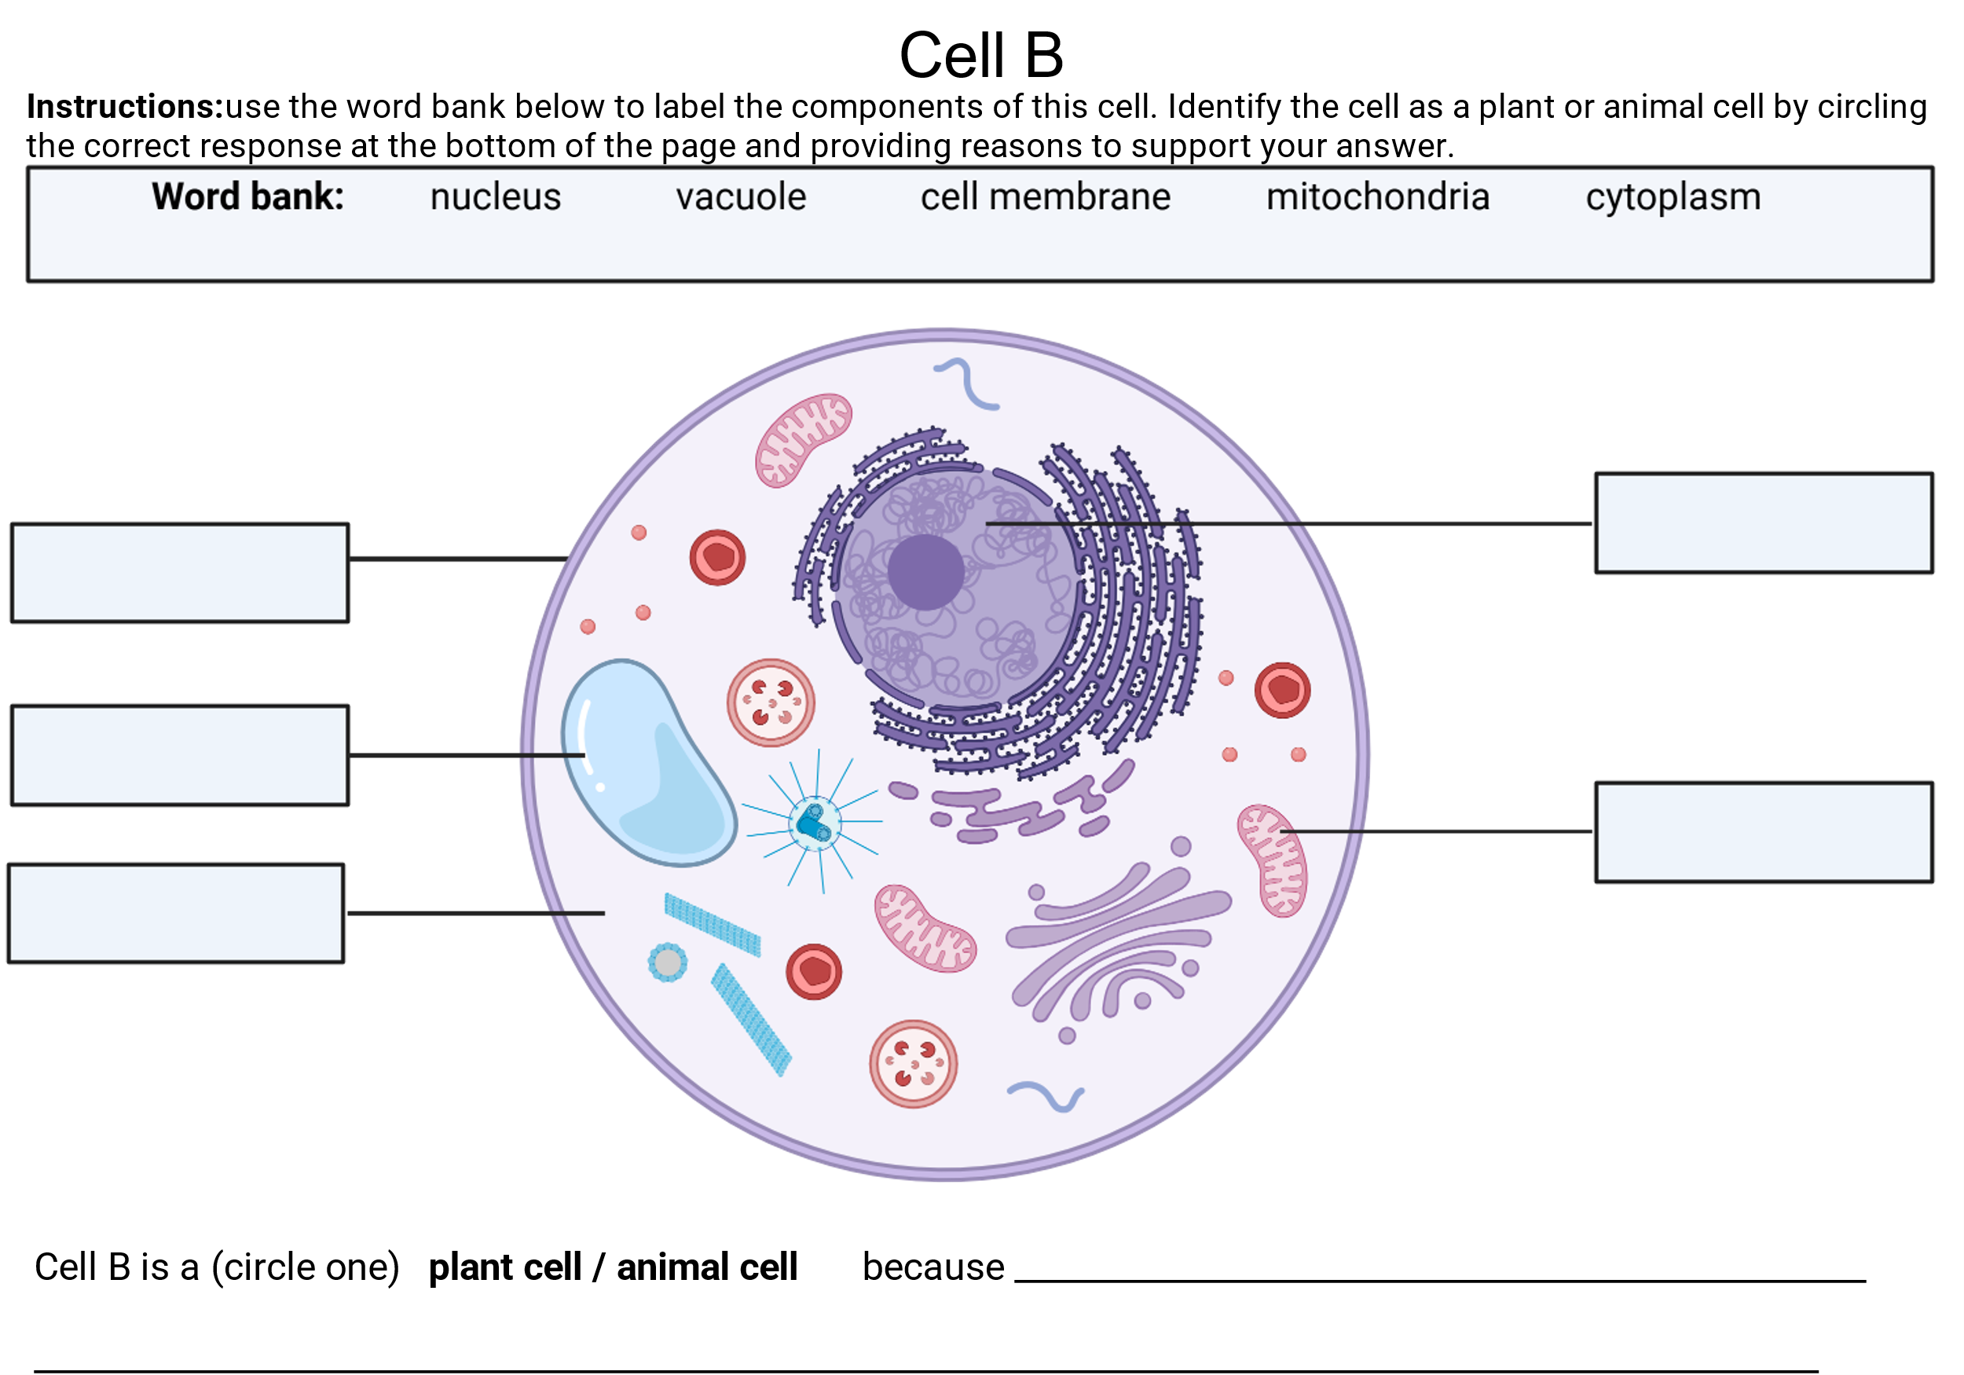
This work has been generated using BioRender.com. Any copyright subsisting in this work is owned by © State of New South Wales (Department of Education), 2024.

Student resource – checkpoint: Sustaining life
The drawing shows a single cell. Parts of the cell have been cut away to reveal its internal structures.
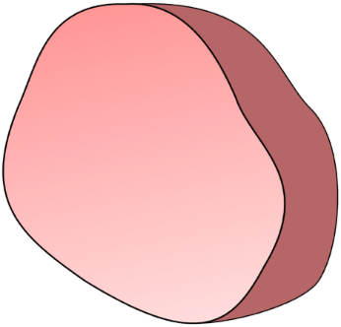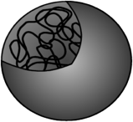
A diagram of a cell from Best Evidence Science Teaching, licensed under CC BY-NC 4.0.
Look at the statements in the table below. How confident are you that each statement is right or wrong (put a tick in the box to show your answer)?
 | Statements | I am sure this is right | I think this is right | I think this is wrong | I am sure this is wrong
1 | A single cell can take in food and other nutrients.
2 | A single cell can get energy from food.
3 | A single cell can eliminate waste.
4 | A single cell can make new cells.
5 | A single cell can respond to its surroundings.
6 | A single cell is a living thing.

Constructing a response to compare the structure of plant and animal cells
In this activity, students are taught how to break down a question using the Verb, Content, Focus, Singular (VCFS) strategy outlined in the CLS PPT ‘2.2 Unpacking the VCFS strategy’ slide. An example of this strategy to deconstruct a question has been provided in CLS PPT ‘2.2 Annotated example of VCFS’. This strategy helps students understand what the question is asking them and plan their response.
Suggested activity structure
- Complete Checkpoint 2 to ensure students know how to distinguish between plant and animal cells.
Checkpoint 2 (CLS PPT): Use the Cells Unit: Modelling Cell Structure and Function simulation to determine student understanding of the structures and organelles in a plant cell and an animal cell. This online checkpoint requires students to complete a double Venn diagram to compare the structures and organelles in plant cells and animal cells.
Students will need access to a laptop to complete this checkpoint activity. Students receive feedback throughout the activity from the online model; however, walk around and check student work as they are completing it for additional feedback on their understanding of the structures and organelles in plant and animal cells.
Give students instructions as outlined below. Some instructions have been given on the slide, CLS PPT ‘2.2 Checkpoint 2’.
Note: The Checkpoint 2 activity does not include vacuoles or require students to compare the structure of plant and animal cells as irregular or box-like. Ensure that students have acquired this knowledge to complete the written activity comparing plant and animal cells.
The model also shows the nuclear membrane as a structure. Inform students that it surrounds the nucleus.
- Provide students with a copy of the Student resource – deconstructing a question.
- Introduce students to the table in their handout, which outlines the VCFS strategy for deconstructing exam-style questions and planning a response. There is supporting information on the CLS PPT ‘2.2 Unpacking the VCFS strategy’.
- Use the VCFS strategy and the sample annotations to model for students if and how the provided example has been appropriately deconstructed (see CLS PPT ‘2.2 Annotated example of VCFS’).
Note: When writing a response to compare and contrast, compare features that are ‘like-for-like’. For example, a prokaryotic cell is typically smaller, measuring 1 to 5 µm, whereas eukaryotic cells are typically larger, ranging from 10 to 100 µm. Another example is that a prokaryotic cell has no membrane-bound organelles. In contrast, eukaryotic cells contain membrane-bound organelles such as the mitochondria.
- Project CLS PPT ‘2.2 Compare and contrast question’ on the board. Students should use the VCFS strategy to unpack the question in the Student resource – deconstructing a question.
- Discuss the deconstruction of the question using VCFS. Link the points below to planning a response.
- First, look at the verb(s). Compare means to show how things are similar or different. Contrast means to show how things are different or opposite; therefore, the written response needs to focus on both similarities and differences.
- The content identified is plant cells and animal cells. This means we will need to make statements comparing the similarities and differences between plant cells and animal cells.
- The focus has been identified as ‘structures’. This means we are examining the structures in both plant cells and animal cells, which include organelles.
- The words (structures, cells, similarities and differences) given in the question are plural. For example, the use of ‘and’ between plant cells and animal cells and the use of an ‘s’ after cells indicate you must talk about both types of cells in your response. The question also specifies that 2 similarities and 2 differences should be identified.
- Model how to plan to write the response, taking into consideration the points above.
- Identify structures that can be compared in the plant cells and animal cells.
- Determine the similarities between plant and animal cells, and the differences between plant and animal cells (Students need to identify 2 similarities and 2 differences as specified in the question).
- Write a statement for each that outlines the similarity/difference. Remind students that they are comparing and contrasting ‘like-for-like’.
- Deconstruct ‘Sample response 1’ as a class against the marking criteria (in the student resource and CLS PPT ‘2.2 Sample response 1’). Students annotate how the response does and does not meet the criteria. Highlight where connectives (cohesive words) have been used to indicate a similarity or difference, and in a different colour, annotate the use of correct and precise scientific terminology (teacher annotated samples are in the CLS PPT ‘2.2 response 1 annotated’).
- Deconstruct Sample 2 as a class against the marking criteria, annotating how the response does and does not meet the criteria (CLS PPT ‘2.2 Sample response 2’). Highlight where cohesive words have been used to indicate a similarity or difference, and in a different colour, annotate the use of correct and precise scientific terminology. A sample response is provided in CLS PPT ‘2.2 Sample response 2 annotated’.
- Display CLS PPT ‘2.2 Improving written responses’ to provide students with a list of connectives (cohesive words) for comparing and contrasting, and a list of scientific terminology.
- Students draftJointly construct an improved response based on the feedback annotated on sample response 2; this should be like sample response 1. Highlight where connectives (cohesive words) and correct and precise scientific terminology have been used.
- Link the differences between plant cells and animal cells to their classification into the respective kingdoms of Plantae and Animalia by reading out the following to students:
- Plant and animal cells look and work differently. These differences help scientists group them into the kingdoms Plantae (plants) and Animalia (animals).
- Plant cells have a cell wall which helps to maintain their shape, chloroplasts to make their own food using sunlight (photosynthesis), and a big vacuole to store water and help the cell keep its shape.
- Animal cells do not have a cell wall or chloroplasts, and they have small vacuoles. Animal cells do not require a cell wall, as they need to be flexible, move and form different shapes and tissues required for complex body functions. Animals need to eat food to supply the energy source for their cells.

Student resource – deconstructing a question
Deconstruct the question below using Table 1. Use highlighters to identify the ‘verb(s), content, focus and singular/plural’ features.
Compare and contrast the structures in plant cells and animal cells. In your response, provide 2 similarities and 2 differences that highlight key features of the cells.
Table 1 – requirements for deconstructing a question using VCFS
Component | Criteria
Verb | - Identify the verb(s) and the requirements of the verb.
Content | - Identify the content.  - Circle and annotate keywords that relate to what you have learnt. Identify the topic/focus area from which it originated.
Focus | - Outline the focus of the question.  - Is it related to a particular context or the stimulus?  - Are there relationships (how and why?)
Singular | - Identify if words are singular or plural.

Planning your response
As a class, plan a response to the deconstructed question.

Deconstructing sample responses
Engage with the marking criteria below for the question: ‘Compare and contrast the structures in plant cells and animal cells. In your response, provide 2 similarities and 2 differences that highlight key features of the cells.’ You will use it to assess sample responses and make improvements to them.
Table 2 – marking criteria for the question
Marks | Criteria
4 | - Compares and contrasts the structure of plant cells and animal cells, highlighting multiple similarities and differences  - Constructs a cohesive written response that effectively uses connectives to illustrate comparison and contrast  - Effective use of correct and precise scientific terminology to provide detail and show understanding of structures and organelles in plant cells and animal cells
3 | - Compares and contrasts the structure of plant cells and animal cells by identifying a similarity and a difference  - Constructs a written response that effectively uses connectives to illustrate comparison and contrast  - Use of correct scientific terminology to provide detail
2 | - Compares the structure in plant cells and animal cells by providing a similarity or difference  OR  - Outlines features of plant cells and/or animal cells
1 | - Outlines a feature of plant cells and/or animal cells

Deconstruct and annotate the response below.
Sample response 1:  Plant and animal cells are similar because they both have a nucleus, which controls the cell’s activities, and a cell membrane, which regulates what enters and leaves the cell. Similarly, both types of cells have cytoplasm, where chemical reactions occur. However, plant cells have a cell wall that provides structure and support, unlike animal cells, which lack cell walls. Plant cells contain chloroplasts, which are organelles used for photosynthesis, while animal cells lack these structures. | Annotations:

Sample response 2:  Plant cells have a nucleus, a cell membrane, a cell wall and chloroplasts. Animal cells have a nucleus and a cell membrane but do not have a cell wall or chloroplasts. | Annotations:
Engage with writing skills to recreate sample response 2 in the box below, addressing the feedback you annotated in class. Use the plan you made earlier to help you construct a complete response.
Compare and contrast the structures in plant cells and animal cells. In your response, provide 2 similarities and 2 differences that highlight key features of the cells.

2.3 Cellular processes
Table 6 – learning intentions and success criteria for 2.3 Cellular processes
We are learning: | I can:
- to describe the unique features of cells in living things | - define cellular respiration and photosynthesis  - identify the specialised organelles where respiration and photosynthesis take place  - outline the processes of respiration and photosynthesis  - outline the importance of these processes for organisms
- to extract and summarise information from secondary sources. | - skim and scan a text to extract relevant information to answer questions about cellular respiration and photosynthesis  - summarise key information in short response questions.

Cellular respiration and photosynthesis
- Recall how to extract and summarise key points from a text to answer questions.
- Read through the Student resource – cellular respiration and photosynthesis text as a class, supporting students with highlighting key points related to the comprehension questions in the student resource.
- Model or jointly construct how to respond to the short answer comprehension questions (students can independently do this if they can).

Sample response: student resource – cellular respiration and photosynthesis text
- Which organelle is responsible for cellular respiration? Mitochondrion
- What are the products of cellular respiration? Carbon dioxide, water and energy
- Photosynthesis takes place in the chloroplasts of plants.
- The green pigment that absorbs sunlight is called chlorophyll.
- Cellular respiration occurs in the mitochondria of both plant and animal cells.
- Match the term with the description.
Stomata |  | A green pigment that absorbs sunlight.
Glucose |  | The sugar that is made during photosynthesis.
Chlorophyll |  | Energy in the form of light that comes from the sun.
Sunlight |  | Tiny openings in leaves through which gases enter and exit.
- Outline why cellular respiration is important for cells and identify where in the cell it occurs.
Cellular respiration is important because it provides the energy that cells need to perform essential functions, such as growth, repair and the execution of chemical reactions. It occurs in the mitochondria, which are the powerhouses of the cell. The mitochondria break down glucose and oxygen to release energy.
- Why do plants need both chloroplasts and mitochondria? Explain how these organelles help the plant survive.
Plants require chloroplasts to perform photosynthesis, which enables them to produce their own food (glucose) using sunlight, carbon dioxide and water. However, producing food alone is not sufficient; plants must also use that food to obtain energy. That is why plants also need mitochondria. Mitochondria carry out cellular respiration, which breaks down glucose produced during photosynthesis to release energy. This energy powers the plant's growth, repair, reproduction and all other cellular activities.
So, chloroplasts produce glucose, and mitochondria convert that glucose into usable energy. Both organelles are essential for the plant to survive and function.
- Extension: outline why photosynthesis is important for animals, not just plants, even though photosynthesis does not take place in animal cells.
Photosynthesis is important for animals because it produces oxygen, which animals need to breathe, and glucose, which begins the food chain. Even though animals cannot photosynthesise, they depend on plants for food and air.
Plants synthesise glucose through photosynthesis, which is then converted into starches for storage. When animals consume the plants, the starches are digested to form glucose. Glucose is then broken down in animal cells to release energy for life functions. Photosynthesis also releases oxygen into the air, which is essential for cellular respiration in animal cells. Without photosynthesis, animals would have no oxygen to breathe and no food to eat.

Student resource – cellular respiration and photosynthesis text
All living things carry out essential life processes to survive. Two of the most important processes are cellular respiration and photosynthesis. These processes happen inside organelles, which are specialised parts of the cell that perform specific jobs.
Photosynthesis
Photosynthesis is the process by which plants, algae and some bacteria make their own food using sunlight, carbon dioxide from the air, and water from the soil. The energy from sunlight is absorbed by a green pigment called chlorophyll, which is found in the chloroplasts of plant cells.
Figure 1 – a chloroplast, the site of photosynthesis  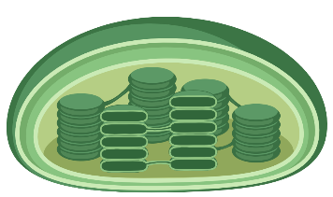 | The equation for photosynthesis can be summarised as:  $$Carbon dioxide +water \underset{→}{sunlight} Glucose+Oxygen$$  This process produces food (glucose) for the plant and releases oxygen as a byproduct, which is essential for the survival of most living organisms.
The carbon dioxide for photosynthesis enters a plant through the stomata, which are made of specialised guard cells. The carbon dioxide is then absorbed by the plant cells. Waste products (water and carbon dioxide) are removed from the cells and exit the plant through the stomata into the atmosphere. This allows all living things to obtain oxygen. | Figure 2 – leaf tissue showing the exchange of gases involved in photosynthesis  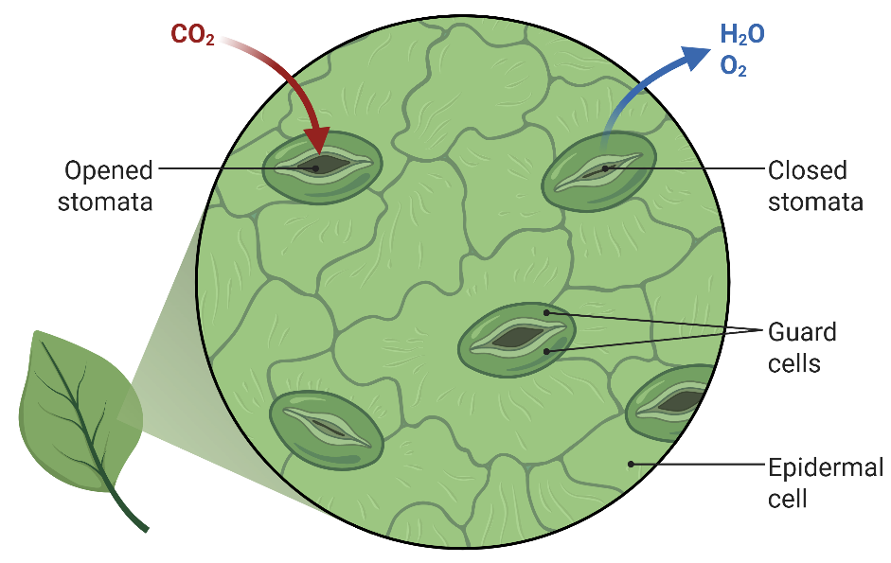
Cellular respiration
Cellular respiration occurs in an organelle called the mitochondrion (plural: mitochondria), which is often referred to as the powerhouse of the cell. Mitochondria break down glucose (a type of sugar) and oxygen to release energy. This energy is used by the cell to perform various functions, such as growth, repair, movement and other cellular processes.
The process of cellular respiration can be summarised in the equation:  $$Glucose +Oxygen →Carbon dioxide+water+energy$$  This means that glucose (from food) and oxygen (from the air) react, releasing energy, and carbon dioxide and water are produced as waste products. | Figure 3 – a mitochondrion, the organelle where respiration takes place in the cell  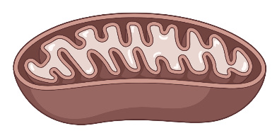
Why are these cellular processes important?
Cellular respiration and photosynthesis are important because they provide the energy and materials that living things need to survive.
- Cellular respiration is how cells release energy from glucose. Every cell in your body needs energy to function. Without cellular respiration, cells would be unable to grow, divide, repair themselves or carry out any of the processes necessary to sustain an organism's life.
- Photosynthesis is important because it allows plants to make their own food using sunlight. It also produces oxygen, which is essential for most living things to breathe. Photosynthesis is the starting point of almost all food chains because it creates the glucose that plants use for energy, and that animals get by eating plants.
The images in this work have been generated using BioRender.com. Any copyright subsisting in this work is owned by © State of New South Wales (Department of Education), 2025.
Comprehension questions
- Which organelle is responsible for cellular respiration? _____________________________
- What are the products of cellular respiration? _____________________________________
- Photosynthesis takes place in the __________________ of plants.
- The green pigment that absorbs _________________ is called chlorophyll.
- Cellular respiration occurs in the __________________ of both plant and animal cells.

- Match the term with the description.
Stomata |  | A green pigment that absorbs sunlight.
Glucose |  | The sugar that is made during photosynthesis.
Chlorophyll |  | Energy in the form of light that comes from the sun.
Sunlight |  | Tiny openings in leaves through which gases enter and exit.
- Outline why cellular respiration is important for cells and identify where in the cell it occurs.
- Why do plants need both chloroplasts and mitochondria? Explain how these organelles help the plant survive.
- Extension: outline why photosynthesis is important for animals, not just plants, even though photosynthesis does not take place in animal cells.

2.4 Single-celled organisms
Table 7 – learning intentions and success criteria for 2.4 Single-celled organisms
We are learning: | I can:
- to describe the unique features of cells in living things | - define single-celled organisms and multicellular organisms  - describe how single-celled organisms embody the characteristics of living things
- to use scientific equipment to make accurate observations | - make accurate observations of single-celled organisms  - draw scientific diagrams of cells  - calculate the magnification used to view cells
- to follow a procedure to undertake a safe investigation using microscopes | - identify the parts of a microscope  - identify the correct sequence of steps to use a microscope  - use a microscope safely  - focus the microscope to view clear images of cells  - manage any risks as they occur
- to communicate scientific ideas in diagrams and descriptions of living things. | - identify components of a quality scientific cell diagram  - draw scientific cell diagrams using observations of cells under the microscope  - use scientific terms to describe observations of cells under the microscope.

Can a living thing be made of one cell?
- Facilitate class discussion for the following question: If cells are the building blocks of life, can a single cell be an entire living organism?
- Recall MRS GREN (Move, Respire, Sense, Grow, Reproduce, Excrete, Nutrients) with students through facilitated class discussion to recap the characteristics of living things.
- Introduce students to single-celled Paramecium using the definition, information, labelled images and diagram in CLS PPT ‘2.4 Paramecium’. Show students the ‘Paramecium under the microscope’ (0:27) video to further support their understanding of what a Paramecium is.
- Provide students with Student resource – Is a single-celled Paramecium a living thing?
- Read through the text as a class and support students in highlighting key points that can be summarised to complete Table 1 in the resource.
- Model how to use highlighted key points from the text to summarise information to complete the ‘Move’ row in the ‘Does a Paramecium embody the characteristics of living things?’ table.
- Based on the capabilities of your students, either continue to model, jointly construct or instruct students to independently complete the remainder of the table.
- Discuss the completed table as a class. CLS PPT ‘2.4 Is a Paramecium living?’ can be used to facilitate the discussion with sample responses.
- Students write a response to justify whether the Paramecium is a living thing. To construct a response, inform students to draw a conclusion about whether the Paramecium is living or not living, then provide a reason(s) to support their conclusion, including examples. A sample response is provided in CLS PPT ‘2.4 Justify if the Paramecium is a living thing’.
Differentiation (CLS PPT): provide students with a cloze passage to support their writing of a response that justifies whether the single-celled Paramecium is a living thing.
- Consolidate student understanding that the smallest unit of life is a cell, and that a single-celled organism is a living thing.
- Single-celled organisms are the smallest organisms capable of surviving on their own. As single-celled organisms are composed of a single cell, this cell must carry out all the life functions.
- We have just looked at how the Paramecium does this; however, how other single-celled organisms perform these basic functions may be different according to their structure and environment.
Sample response: student resource – Is a single-celled Paramecium a living thing?
Table 8 – sample response ‘Does a Paramecium embody the characteristics of living things?’
Characteristic of a living thing | Does a Paramecium do this? | An example of how the Paramecium does this.
Move | Yes | Their cilia rhythmically beat to move the Paramecium.
Respire | Yes | Using products of digested food and oxygen from their surroundings, cells generate energy.
Sense | Yes | It can sense when it has hit something, which triggers it to move in a different direction.
Grow | Yes | Paramecia absorb nutrients to facilitate rapid growth from a small cell to a fully developed organism.
Reproduce | Yes | A fully grown cell will split into 2 identical smaller cells.
Excrete | Yes | Food wastes are removed through the anal pore.
Nutrients | Yes | It obtains nutrients by consuming foods such as bacteria and algae.
Justify whether the single-celled Paramecium is a living thing.
A Paramecium is a living thing because it carries out all the basic life functions: movement, respiration, sensing, growth, reproduction, excretion and nutrition. It moves using cilia, undergoes cellular respiration to generate energy, reproduces by dividing into 2 identical cells, excretes waste through an anal pore, and obtains nutrition from food sources such as bacteria and algae.

Student resource – Is a single-celled Paramecium a living thing?
All living things carry out 7 basic functions to survive.  A Paramecium is a single-celled organism. Can it possibly do all those processes when it is only 0.05 to 0.32 mm in size? If so, how does it do this? | Figure 1 – a labelled drawing and a microscope image of a single-celled Paramecium  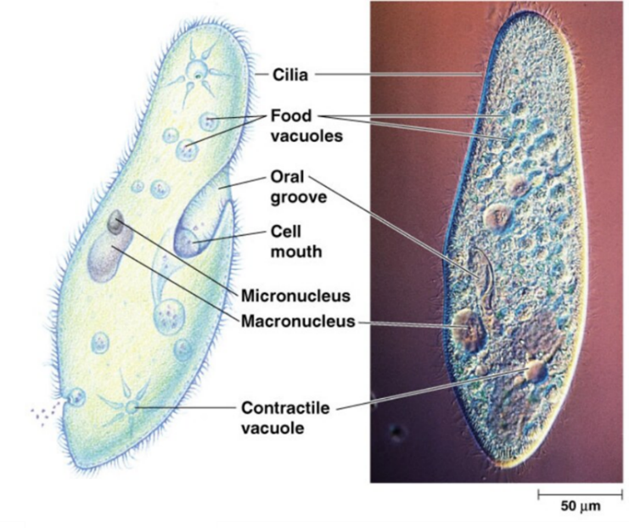  A Paramecium by fickleandfreckled, licensed under CC BY 4.0.
A Paramecium is surrounded by tiny hair-like structures called cilia. These hair-like structures beat together in a rhythmic motion, allowing the Paramecium to move around and change its direction when it senses obstacles in its environment. They capture bacteria, algae and other food sources using their cilia, which move their prey into their oral groove (like a mouth in an animal). This food is broken down, and waste material is excreted through the anal pore.
Paramecia (plural) belong to a group of organisms called protists, which are eukaryotic. This means their cells have a nucleus. A Paramecium has 2 nuclei: a bigger one (macronucleus) and a smaller one (micronucleus). It cannot survive without these 2 nuclei, which control the cell's activities, including growth, metabolism and reproduction. Paramecia reproduce by dividing into 2 identical cells, a process that can occur up to 3 times a day. Figure 2 shows the daughter Paramecium cells right before they split into 2. The smaller daughter Paramecium cells will take in nutrients to grow to the adult cell size before dividing again.
Like other organisms, Paramecia undergo a process called cellular respiration to generate the energy they need to undertake life’s processes. A paramecium takes in oxygen from the surrounding water and excretes carbon dioxide through its body surface. This process provides the cell with the energy it needs to survive.
Figure 2 – a single-celled Paramecium dividing into 2 identical single-celled Paramecia
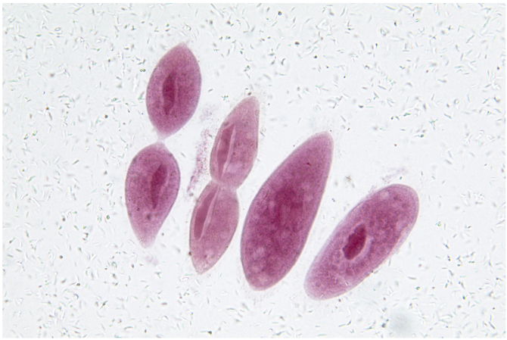
Table 1 – Does a Paramecium embody the characteristics of living things?
Characteristic of a living thing | Does a Paramecium do this? | An example of how the Paramecium does this.
Move
Respire
Sense
Grow
Reproduce
Excrete
Nutrients
Justify whether the single-celled Paramecium is a living thing.

How to use a light microscope (practical investigation)
- Teach students the parts of a microscope and what microscopes do using the physical microscope in the classroom and the CLS PPT ‘2.4 Parts of a microscope’. Students label the parts on the microscope diagram in the Student resource – parts of a microscope.
Note: the school microscope may differ from the one depicted in the diagram. When labelling the diagram, ensure it is clear where the parts are on the school microscope.
- Show CLS PPT ‘2.4 Conducting the investigation safely’ to unpack safe work practices, hazards, risks and risk mitigation when working with microscopes.
- Tell students how to hold and carry the microscope to their bench by grasping the microscope arm with one hand and placing the other under the base.
- Once students have a microscope at their workbench, display CLS PPT ‘2.4 How to use a microscope’ slides to step students through using the microscope. Provide students with a slide mounted with a small piece of newspaper writing. Student resource – how to use a microscope can be provided to students so they have a clear set of steps to follow for future microscope work.
To learn how to use a microscope, or to provide students with a digital simulation to complete microscope work, use Virtual Microscope. Where possible, students should be allowed to do the microscope work in the laboratory. The Virtual Microscope resource offers a suitable alternative for students who are absent.
Checkpoint (CLS PPT): tell students how to calculate the magnification of an object under the microscope by multiplying the eyepiece magnification by the objective lens magnification. Check students’ calculations using the examples in CLS PPT ‘2.4 Checkpoint’.

Student resource – parts of a microscope
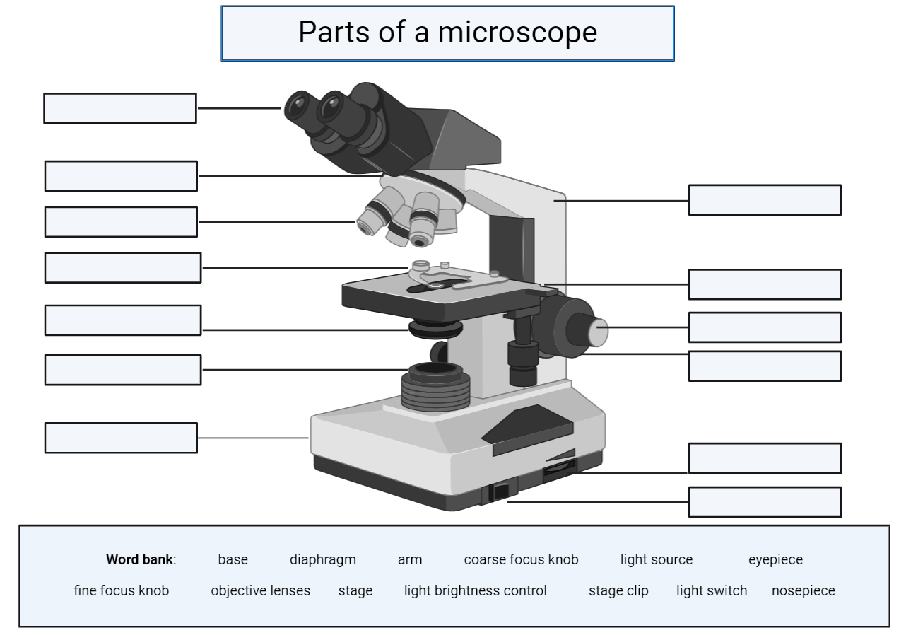 | - What is the magnification of the eyepiece on the school microscope?  _____X  - List the objective lens magnifications from smallest to largest.  _______________  _______________
This work has been generated using Biorender.com. Any copyright subsisting in this work is owned by © State of New South Wales (Department of Education), 2024.

Student resource – how to use a microscope
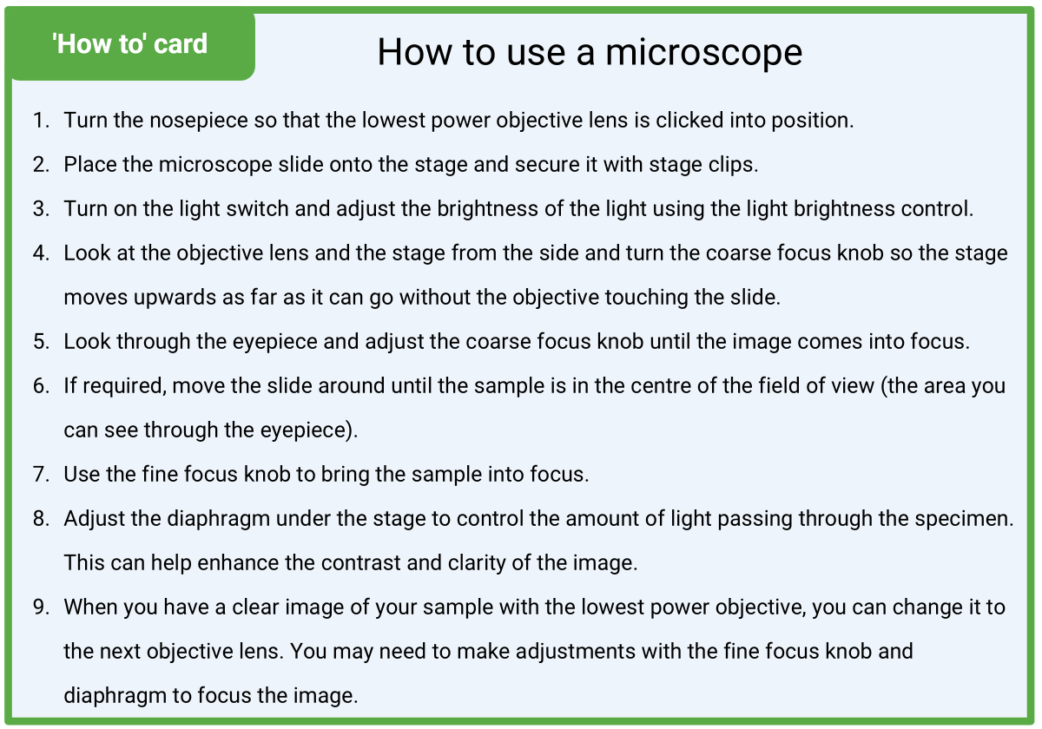
This work has been generated using Biorender.com. Any copyright subsisting in this work is owned by © State of New South Wales (Department of Education), 2025

Single-celled organisms (practical investigation)
Preparing for the activity
Order equipment below for each group in the class:
- 1 × light microscope
- 2 × prepared slides of single-celled organisms (for example, protozoa, bacteria, single-celled algae, single-celled fungi)
Print the Student resource – drawing cell diagrams of organisms.
Facilitating the activity
- Provide students with the Student resource – drawing cell diagrams of organisms and read through ‘Drawing scientific cell diagrams’ with the class.
Note: onion cells, when viewed under a microscope, are used to teach students how to draw scientific cell diagrams. Inform students that onions are not composed of a single cell, but rather, many cells.
- Look at the labelled image of the onion cells under the microscope and facilitate class discussion for students to describe the features of onion cells. Sample answers are provided below.
- Onion cells are rectangular and are packed together in a grid-like pattern.
- A thick cell wall surrounds each cell.
- The cytoplasm appears as a faint, transparent substance within the cell.
- Teach students how to draw a scientific diagram of onion cells, and have students follow along in the ‘scientific diagram’ column of Table 1 in the student resource. A sample has been provided in Figure 3.
Figure 3 – a scientific drawing of onion cells under a light microscope
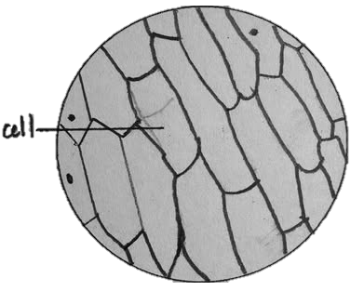
- Ask students if their drawn diagram satisfies the scientific cell diagram criteria in the Student resource – drawing cell diagrams of organisms.
- Give students the following instructions:
- Collect a light microscope, a ruler, a sharp pencil and prepared slides of single-celled organisms.
- Use the microscope to focus the specimen with the 4x objective lens. Inform students that the magnification of the objective lens is 4x and that of the eyepiece is 10x. Tell students to multiply these numbers together, indicating the specimen is being viewed at 40 times (40x) magnification. Students draw a scientific diagram of what they see under the microscope and write a description.
- Use the microscope to focus the specimen with the 10x objective lens. Inform students that the magnification of the objective lens is 10x, but the eyepiece magnification is unchanged (10x). Tell students to multiply these numbers together, indicating the specimen is being viewed at 100 times (100x) magnification.
- Use the microscope to focus the specimen with the 40x objective lens. Inform students that the magnification of the objective lens is 40x, but the eyepiece magnification is unchanged (10x). Tell students to multiply these numbers together, indicating the specimen is being viewed at 400 times magnification.
Note: it is worth reminding students that they should only use the fine focus knob when moving from the 10x to the 40x objective lens. This will minimise the chance of breaking the slide.
- Students draw a scientific diagram of what they see under the microscope and write a description for either the 100x or 400x magnification, whichever provides a clearer image of the specimen.
- Students repeat the above steps with another single-celled organism.
- Ask students to pack away the specimens and equipment when they have completed the practical activity.
- Facilitate a class discussion about what students observed under the microscope for their single-celled organisms under different magnifications. Compare the details observed under the lower versus the higher magnification.

Student resource – drawing cell diagrams of organisms
Drawing scientific cell diagrams
When scientists use a microscope to observe cells, they often draw a scientific diagram to record their observations. They may also provide a written description of what they see. When producing a scientific drawing, it is important to consider the following:
- use a sharp pencil  - only draw what you see  - make the drawing large and fill as much of the field of view as you can  - use solid lines to draw – do not sketch  - do not shade in the drawing | - use a ruler to draw any label lines  - make sure label lines do not overlap  - indicate the magnification  - include a title
Follow along with the teacher as they draw a scientific diagram of cells viewed under the microscope.
Table 1 – scientific diagram of onion cells as seen under a light microscope
Under the microscope | Scientific diagram
Figure 1 – labelled image of an onion cell under 200x magnification  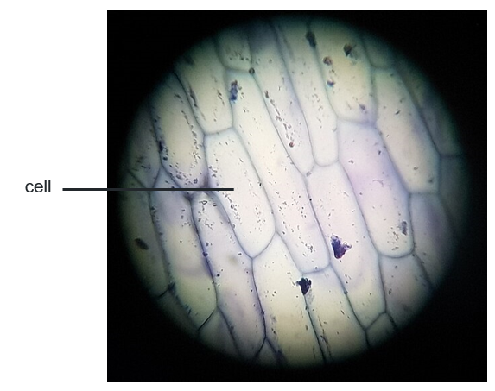  Onion cell 200x by Alvy16, licensed under CC BY 4.0. | Figure 2 – labelled onion cells viewed under 200x magnification

Observing single-celled organisms under the microscope
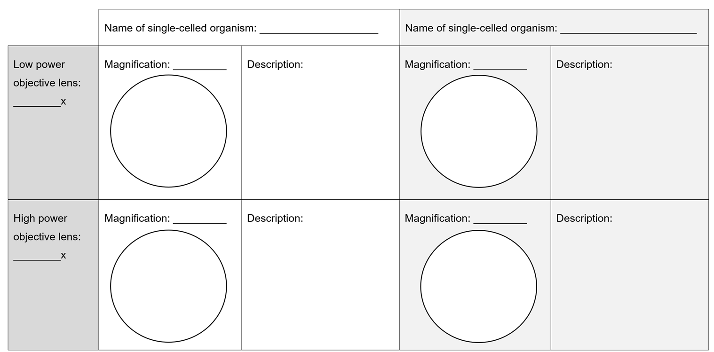

2.5 Multicellular organisms
Table 9 – learning intentions and success criteria for 2.5 Multicellular organisms
We are learning: | I can:
- to describe the unique features of cells in living things | - describe the characteristics of multicellular organisms  - outline the organisation of life from cell to organism  - describe the role of specialised cells in a multicellular organism  - identify examples of specialised cells and their related tissues and organs in a plant and animal example  - describe how the structure of specialised cells is related to their function  - explain the need for specialised cells in a multicellular organism
- to use scientific equipment to make accurate observations | - make accurate observations of multicellular organism tissues  - draw scientific diagrams of cells and tissues  - calculate the magnification used to view multicellular tissues  - measure the surface area of root hair cells
- to follow a procedure to undertake a safe investigation using microscopes. | - identify the correct sequence of steps to use a microscope  - use a microscope safely  - focus the microscope to view clear images of cells.  - manage any risks as they occur
- to communicate scientific ideas as diagrams using relevant scientific terms. | - identify components of a quality scientific cell diagram  - draw scientific cell diagrams using observations of cells under the microscope  - use scientific terms to describe observations of cells under the microscope.

Multicellular organisms
- Recall the definition of multicellular organisms using the CLS PPT ‘2.5 Multicellular organisms’.
- Describe some of the characteristics of multicellular organisms using the slides, CLS PPT ‘2.5 Characteristics of multicellular organisms 1–7’. There are speaker notes on each slide to facilitate the explanation for students.
- Show students the image of children on the CLS PPT ‘2.5 Am I made up of one or more cells?’. Ask students if they think that they are a single-celled or multicellular organism. Facilitate class discussion to ask them why. Read the speaker notes on the slide to inform students that they are multicellular organisms and provide reasons why.
Checkpoint: show students the images on the CLS PPT ‘2.5 Checkpoint’ slides. Ask them if they think the organisms are single-celled or multicellular to determine if students understand the difference between single-celled and multicellular organisms. Facilitate class discussion for each organism. Sample answers are animated to come up on the slides.
- Recall the following information: in multicellular organisms, specialised cells perform specific functions that contribute to the survival and proper functioning of the organism. Each specialised cell has a unique structure that allows it to carry out its role efficiently.
- Teach students what specialised cells are and the different specialised cells in humans and plants using the specialised cell Canva presentation.
Note: to modify this presentation, make a copy or download it. A range of specialised cells has been provided; however, you may adjust the presentation to include fewer specialised cells to accommodate the students' capabilities in your class.

Relationship between the structures and functions of specialised cells (secondary source investigation)
Note: students will need access to a computer or laptop to complete this activity. Assign Student resource – specialised cells in humans to students digitally.
This research activity applies skills learned in 1.7 Adaptations in Australian organisms in TRB1. Use principles of gradual release of responsibility to determine the best mode of delivery for this lesson.
- Facilitate class discussion to recall the different types of specialised cells. Tell students that this activity focuses on specialised animal cells and how their structure relates to their function.
- Read through ‘Tips for conducting secondary source research’ in the student resource.
- Model how to research online using keywords and phrases in a search bar of a search engine to find information about the structure and function of muscle cells.
- Model how to complete the muscle cell row in Table 1 of the student resource by extracting and summarising relevant information from a source. Sample responses have been provided in Table 10.
- Model, jointly construct, or ask students to complete the remainder of the task independently. Facilitate class discussion about the structure and function of each of the specialised animal cells to determine student understanding.
- Jointly construct a response to relate the structure of each of the specialised cells to their functions. Sample responses have been provided to guide discussion in Table 10.
Note: students are not yet completing the column that relates the structure to function. This will be completed as a class.
- Provide students with a copy of the Student resource – arrangement of specialised cells in roots.
- Tell students that plants, like animals, have organs and tissues. Plant organs include the roots, stem, leaves and flowers. Each of these organs is composed of specialised tissues and cells that play a role in maintaining the plant as a living organism.
- Show students either a live plant or a clear image of a plant (above ground and with roots exposed) using CLS PPT ‘2.5 Root systems in plants’. Facilitate class discussion to answer questions in the student resource.
Sample response: student resource – specialised cells in humans
Table 10 – sample student responses to determine the relationship between the structure and function of specialised cells
Specialised cell | Describe the structure | Outline the function | Relate the structure to the function
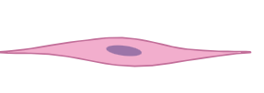  Muscle cell | They are long and thin, containing many mitochondria. They have special proteins. | Special proteins help the muscles change shape, which allows the organism to move. | The stretchy, long shape allows the cell to shorten (contract) and lengthen (relax) easily, enabling the body to move. They have many mitochondria, providing the energy needed for muscle contractions.
  Red blood cell | Round, flat disc shape, and biconcave (dimpled) with no nucleus. It contains a protein called haemoglobin. | Haemoglobin binds to oxygen. The cell transports oxygen around the body and removes carbon dioxide from tissues. | The disc shape increases the surface area, allowing more oxygen to be absorbed in the lungs. There is no nucleus, which allows more space to carry oxygen.
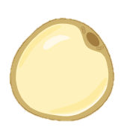  Fat cell | Round with a large fat droplet. | Stores energy and helps insulate the body. | The cell membrane of a fat cell is flexible, allowing the cell to expand as it stores more fat. This allows the cell to store varying amounts of fat depending on the body's needs.
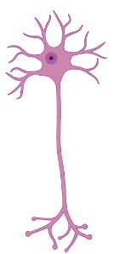  Nerve cell | Long and thin, with branches at both ends. | Carries electrical messages around the body. | Nerve cells are thin and very long, so they can carry messages over long distances in the body.  They have branched connections, enabling them to pass messages to other cells throughout the body.
  Egg cell | Large, round and full of cytoplasm. | The female reproductive cell provides half the genetic information needed for a baby. | The egg cell is quite large, allowing it to store nutrients in the cytoplasm needed for early development after fertilisation. The egg cell has a large nucleus to hold the genetic material.
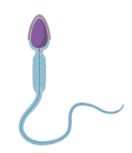  Sperm cell | Small, with a head containing DNA and a long tail. | Swims to the egg to deliver genetic material (DNA) during fertilisation. | The tail allows the sperm to move quickly, and the streamlined shape helps it swim efficiently toward the egg.
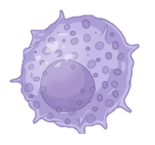  White blood cell | Irregular in shape and capable of changing shape. | Protects the body by attacking and destroying harmful germs (for example, bacteria and viruses) | The ability to change shape helps the cell move through tissues and engulf or destroy harmful invaders.
Ciliated cell  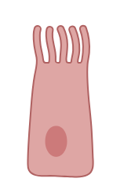 | Column-shaped with tiny hair-like structures on the surface. | Moves mucus and trapped particles out of the airways. | Ciliated cells have tiny hairs, called cilia, on their surface, which beat in a rhythmic motion. This supports their primary function of moving substances through a tissue or organ.
The images have been generated using BioRender.com. Any copyright subsisting in this work is owned by © State of New South Wales (Department of Education), 2024.
Sample response: student resource – arrangement of specialised cells in roots
- Label one cell, one tissue and the organ (root) on the diagram.
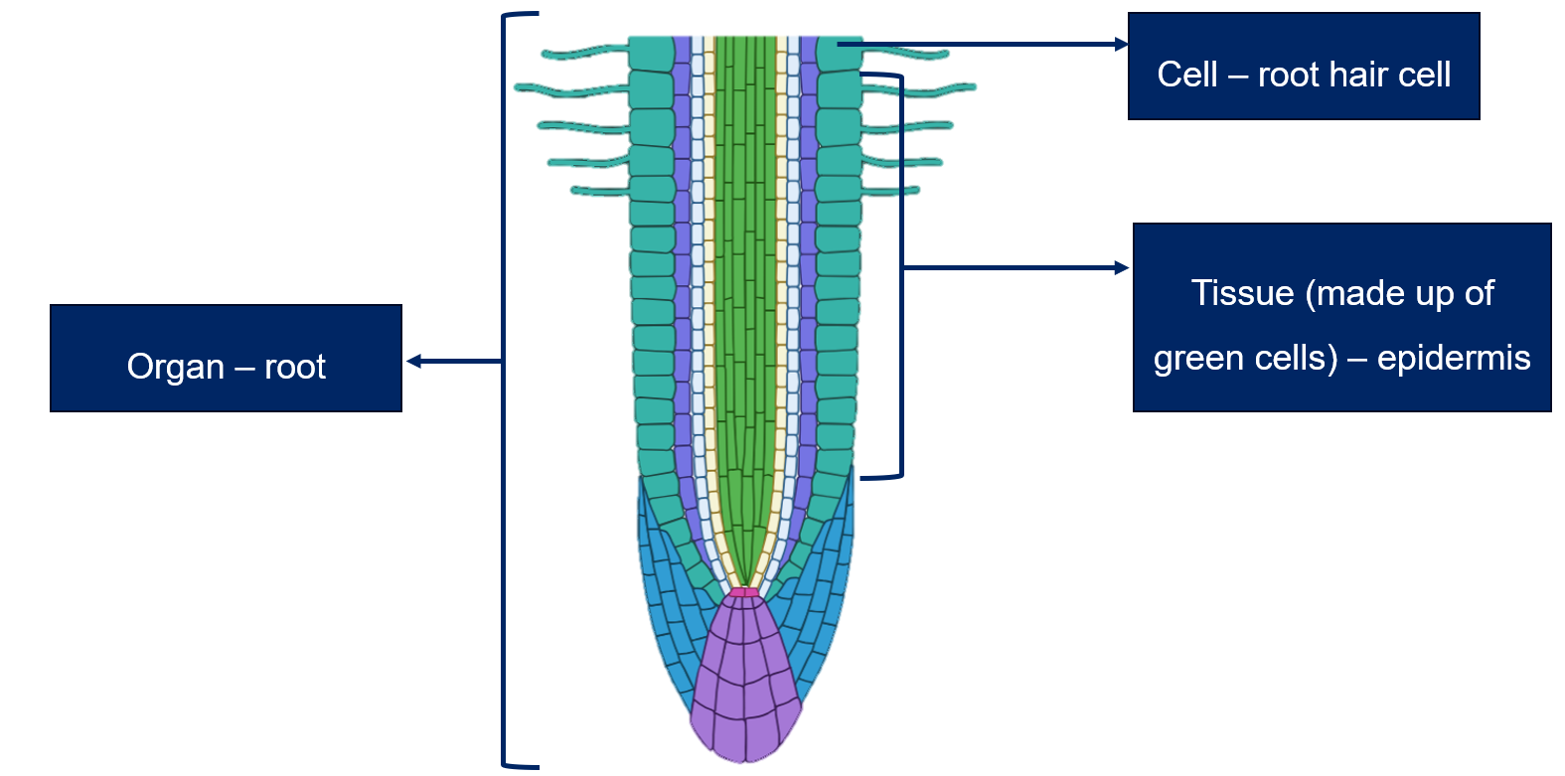
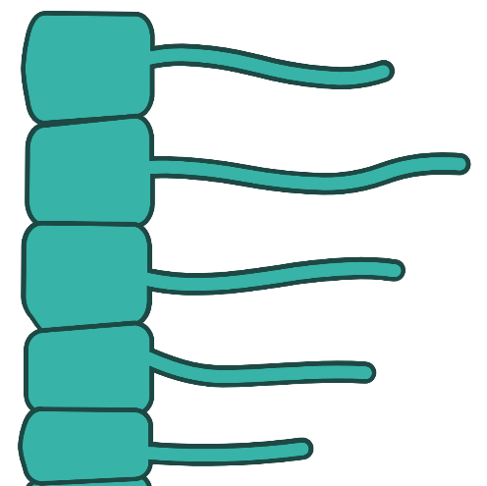 | - Measure the surface area (SA) of the root hair cells and then compare it to the surface area of those cells that do not have the ‘hair-like’ projection.  SA of cells without root hair = approximately 53 mm  SA of cells with root hair = approximately 322 mm  The root hairs significantly increase the surface area of the cell that is exposed to the soil. The root hairs increase the surface area by more than 6 times (322/53).
- What would happen if there were no root hair cells on the plant roots?
Root hair cells increase the surface area of the root, allowing it to absorb much more water. If a plant had no root hair cells, it would struggle to survive because it would be unable to absorb as much water from the soil. Water is essential for plant processes such as photosynthesis.

Student resource – specialised cells in humans
Tips for conducting secondary source research
- Use specific keywords and phrases to identify better sources of information related to your topic using a search engine.
- Read your topic widely using the internet, books and scientific journals.
- Check potential resources for accuracy, reliability and validity. Take note of any valid references that you find useful.
- Add to your reference list as you go. Do not leave your reference list until the end; you may have trouble finding the resource again, particularly if it is online.
The structure and function of specialised animal cells
Table 1 – summary of the structure and function of specialised cells in humans
Specialised cell | Describe the structure | Outline the function | Relate the structure to the function
Muscle cell
Red blood cell
Fat cell

Nerve cell
Egg cell

Sperm cell
White blood cell
Ciliated cell
This work has been generated using BioRender.com. Any copyright subsisting in this work is owned by © State of New South Wales (Department of Education), 2025.

Student resource – arrangement of specialised cells in roots
The roots of a plant are an important organ involved in absorbing water from the soil. The root has several specialised cells, including, but not limited to, the:  - meristem cells – these cells divide rapidly and are found just above the root cap  - root cap cells – the root cap cells protect the delicate meristem tissue as the root pushes through the soil  - root hair cells – contain a long, thin hair-like structure that increases water absorption from the soil. Root hair cells make up part of the epidermis tissue of the root. | - Label one cell, one tissue and the organ (root) on the diagram.  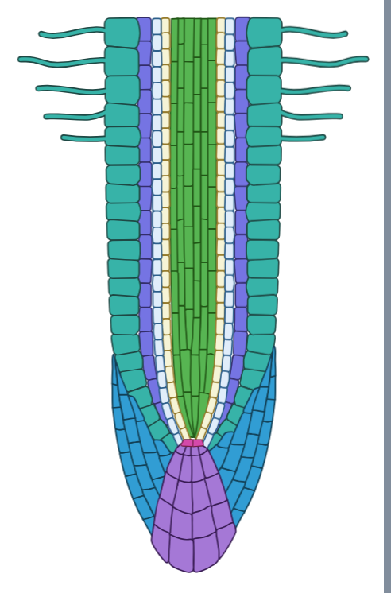  This work has been generated using BioRender.com. Any copyright subsisting in this work is owned by © State of New South Wales (Department of Education), 2025.

- Measure the surface area (SA) of the root hair cells and then compare it to the surface area of those cells that do not have the ‘hair-like’ projection.
- What would happen if there were no root hair cells on the plant roots?

Multicellular organisms and cell specialisation (practical investigation)
Preparing for the activity
Order equipment for each group in your class as outlined below:
- 1 × light microscope
- a range of prepared slides of specialised cells (for example, root hair cells, red blood cells, muscle cells).
Note: ensure that each group has a minimum of one specialised plant cell and one specialised animal cell.
Facilitating the activity
- Recall how to safely and properly use a microscope to make observations by engaging with the Student resource – using a microscope. Instruct students to self-assess their ability to use a microscope during this activity using the provided checklist.
Note: where possible, walk around to student benches as they use microscopes during lessons and use the checklist to provide student feedback.
- Engage with the Student resource – observing and comparing specialised cells to outline what students are required to do in the practical activity. Discuss safety considerations, including any potential risks that may arise, and outline strategies to mitigate them.
- Recall how to draw scientific cell diagrams. Refer to Student resource – drawing cell diagrams of organisms if required.
- Allow time for students to conduct the investigation to draw and describe their observations of the specialised cells.
- Facilitate class discussion for the discussion questions in the Student resource – observing and comparing specialised cells. A sample response has been provided below to support student discussion (please note that not all the specialised cells are discussed in the sample responses).
- Explain the need for multicellular organisms to have specialised cells by reading out the information below:
- In multicellular organisms, different cells are needed to perform specific tasks because no single cell can do everything. Specialised cells work together in tissues, organs and systems to keep the organism alive and functioning efficiently. This division of labour ensures:
- greater efficiency, as each cell is adapted to its job
- complex processes like movement, respiration, and nutrient transport are carried out effectively
- the organism can grow, survive and respond to its environment.
- Without specialised cells, multicellular organisms could not carry out all the processes needed for survival, as a single unspecialised cell could not perform all the functions at once.
Checkpoint (CLS PPT ‘2.5 Checkpoint 2’): Which of the following statements about specialised cells is correct?
A) Specialised cells can perform multiple functions at once to maintain body functions.
B) Specialised cells are found only in single-celled organisms.
C) Specialised cells have a specific structure that helps them perform a particular function.
D) Specialised cells are always identical to each other, regardless of their function.
Table 11 contains the answer and an explanation of why students may select the incorrect answer. If there is a range of answers, you may choose to respond through structured class discussion.
Table 11 – explanation of the understanding and misconceptions students may have based on their response to the question
Response | Explanation
A | Students might assume that specialised cells, because they are adapted to specific roles, must be capable of performing more than one function. They may think that the more specialised a cell is, the more efficient it becomes at handling different tasks.
B | Students might think that specialised cells are only found in single-celled organisms because they may confuse the idea of ‘specialised’ with the idea of cells performing multiple functions. They might believe that since single-celled organisms like bacteria carry out all essential life processes within one cell, that cell must be ‘specialised’ to do everything. This misunderstanding could lead them to think that only single-celled organisms can have specialised cells that perform all functions within that single cell.
C | This is the correct response.
D | Students might think that all specialised cells are the same in structure because they are all classified as specialised cells. They might not realise that different types of specialised cells vary from each other because they are adapted to perform specific roles.
Sample response: student resource – observing and comparing specialised cells
- Pair up with another person in the class who has observed different specialised cells. How are the specialised cells that you and your partner observed similar and/or different?
My observed cells: Red blood cells (RBC) and muscle cells
My partner's observed cells: Root hair cells and photosynthetic cells
All the cells we observed had a clear outer boundary visible under the microscope, which is the cell membrane. Each cell contained a gel-like substance within the boundary, likely the cytoplasm.
There were many differences between the specialised cells observed, including in their:
- Shape and size
- The red blood cell was small and round, with no visible central structure (no nucleus).
- The muscle cell was long and fibrous.
- The root hair cell had a thin, extended projection (the root hair).
- The photosynthetic cell was rectangular and tightly packed in structure.
- Organelles
- The root hair cell and photosynthetic cell showed a rigid outer layer (cell wall), while the red blood cell and muscle cell did not.
- The photosynthetic cell had visible green, oval-shaped structures (chloroplasts), which were not observed in any of the other cells.
- The red blood cell lacked visible internal structures like a nucleus, while the other cells had central darker regions that appeared to be nuclei.
- Why do you think the specialised cells have different structures and features?
Specialised cells have different structures and features because their shapes and organelles are uniquely suited to their specific functions. For example, red blood cells are disc-shaped and lack a nucleus, allowing them to carry oxygen efficiently. In contrast, root hair cells have long extensions that absorb water and nutrients. These structural differences allow each cell to perform its role effectively.
If specialised cells were not structured differently, they could not perform their specific functions efficiently. Without specialised structures, organisms would not function properly, as their cells would be unable to complete their unique roles, leading to inefficiency or failure of the cell to complete essential processes. Without specialised cells, multicellular organisms would be unable to carry out all the processes needed for survival, as a single unspecialised cell could not perform all the functions simultaneously.

Student resource – using a microscope
I can use a microscope safely and properly by:
- carrying the microscope with 2 hands, one on the arm of the microscope and one on the base
- placing the microscope on a flat, stable surface before using it
- identifying key microscope parts, including eyepiece, objective lenses, stage, focus knobs and light source
- securing the slide on the stage and positioning it under the objective lens by adjusting the stage or stage clips
- turning the light source on and off using the switch
- aligning my eyes with the eyepiece without tilting the microscope
- adjusting the objective lenses properly using the nosepiece to change the magnification
- beginning with the lowest magnification, using the coarse focus knob to find and focus the specimen while ensuring I am keeping an eye on the stage from the side to make sure the objective does not touch the slide
- moving the slide around on the stage until the sample is in the centre of the field of view
- using the fine focus knob to sharpen the image at higher magnifications
- adjusting the diaphragm or light source to ensure the best light levels
- resetting the microscope objective lens to the lowest magnification and covering it with the dust cover for storage
- describing or drawing observations accurately, including noting total magnification levels (eyepiece magnification × objective lens magnification).

Student resource – observing and comparing specialised cells
Aim: to observe and compare the structure and features of specialised cells.
Table 1 – diagrams and descriptions of specialised cells viewed under the microscope.
Specialised cell | Diagram of the cell | Description of the cell
________________________

____x
________________________

____x
Discussion questions
- Pair up with another person in the class who has observed different specialised cells. How are the specialised cells that you and your partner observed similar and/or different?
- Why do you think the specialised cells have different structures and features?

Optional activity – multicellular organisms as a city analogy
Differentiation: the activity outlined here is an extension activity designed to enhance students' understanding of the need for specialised cells in multicellular organisms; it is not mandatory to complete.
- Recall that all multicellular organisms begin as one cell that divides and grows into trillions of specialised cells that perform different functions.
- Show students the image of the city on the slide, CLS PPT ‘2.5 Multicellular organisms as a city (1 of 2)’. Ask students to ‘Think of a big city. What makes a city function smoothly? What are some important parts of the city, and what do they do?’
- Ask students to ‘List key parts of a city. How do these parts work together to keep the city running?’ Potential student responses have been added to the speaker notes of the slide to facilitate discussion.
- Ask students ‘What would happen if one of these parts stopped working? For example, if the people disappeared, the roads were blocked, or the schools were shut down.’ Potential student responses have been added to the speaker notes of the slide to facilitate discussion.
- Explain the city analogy to students by reading out the speaker notes on the ‘multicellular organisms work like a city’ slide.
- Divide students into small groups and allocate each group a specialised cell using the slide, CLS PPT ‘2.5 Multicellular organisms as a city (2 of 2)’. It is best to allocate one cell per group before specialised cells are duplicated. In groups, students complete questions 1 to 3 in the Student resource – specialised cells in multicellular organisms for their allocated specialised cell. Sample responses have been provided.
Note: student responses will vary depending on the specialised cell their group selects.
The work related to the structure and function of the specialised cell is a review of the Relationship between the structures and functions of specialised cells activity. However, if required, reteach these concepts.
- Groups present information about their specialised cell to the class.
- Introduce the concept of cell efficiency by reading the following to students:
- In a city, having different areas designed for specific jobs makes the city run smoothly. By allocating specific areas of the city to particular functions, the city can run effectively and thrive. Similarly, in a multicellular organism, having specialised cells allows the body to be more efficient. Specialised cells are designed to do a specific job very well, which keeps the body organised and helps the whole organism function better.
- But what would happen if there were no specialised areas in a city or no specialised cells in the body? For example, what would happen if every part of the city tried to do the same job, like everyone running grocery stores, but no hospitals? Similarly, what would happen if all cells in the body were skin cells?
- Ask students to answer questions 4 to 7 in the Student resource – specialised cells in multicellular organisms to summarise the activity. Sample responses to all the questions are given below.
Sample response: student resource – specialised cells in multicellular organisms
- Identify your group's allocated specialised cells. Identify whether it exists in a plant or an animal.
Muscle cell. Muscle cells are found in all animals.
- Draw a diagram of the specialised cell. Describe the structure and function of the specialised cell, including how its structure relates to its function.
Muscle cells are long and thin and contain many mitochondria. They help the body move by contracting and relaxing.
The stretchy, long shape allows the cell to shorten (contract) and lengthen (relax) easily, enabling the body to move. They have many mitochondria, providing the energy needed for muscle contraction.
- Relate your specialised cell to part of a city.
Muscle cells are like the roads and transport systems of a city. They facilitate movement, just like roads and transportation systems enable people and goods to travel from one place to another. Without them, nothing in the city or the body would function properly because movement is essential for daily activities.
- Why do you think multicellular organisms, like humans, need so many different types of specialised cells?
Multicellular organisms need different types of specialised cells because each type performs a specific function that keeps the body working efficiently. For example, muscle cells facilitate movement, nerve cells convey messages, and red blood cells transport oxygen. Without this specialisation, the body would not be able to function properly.
- If all the workers in a city did the same job, how would that affect the city’s efficiency? What might happen if every cell in a multicellular organism did the same job instead of specialising?
If all the workers in a city did the same job, such as if everyone was a bus driver but no one maintained the roads, ran shops, or provided medical care, the city would not function well. Similarly, if all the cells in a multicellular organism did the same job, the body wouldn’t be able to survive. For example, if every cell in the body were a muscle cell, there would be no nerve cells to send signals, no red blood cells to carry oxygen, and no skin cells to protect the body.
- Imagine your city was reduced to one component, a person. However, the city still needs to perform all the tasks it did before. Could this one person handle all the jobs and maintain a city of this size? Why?
No, one person wouldn’t be able to do all the jobs needed to run a city. A city requires a diverse range of professionals, including police officers, teachers, doctors and engineers. If only one person had to do all these jobs, they wouldn’t be able to keep up, and the city would fall apart.
- Similarly, what would happen to an organism if it were made up of only one type of cell, like a single-celled organism, instead of having many specialised cells working together, like in a multicellular organism?
If an organism were made up of only one type of cell, it would have to do all the jobs needed to survive on its own, just like a single-celled organism does. This would make it much less efficient than a multicellular organism, where specialised cells work together. A single-celled organism can survive, but it is limited in size and complexity because one cell can only do so much. Multicellular organisms can grow larger and perform more complex functions because their specialised cells share the workload.

Student resource – specialised cells in multicellular organisms
- Identify your group's allocated specialised cells. Identify whether it exists in a plant or an animal.
- Draw a diagram of the specialised cell. Describe the structure and function of the specialised cell, including how its structure relates to its function.
- Relate your specialised cell to part of a city.
- Why do you think multicellular organisms, like humans, need so many different types of specialised cells?
- If all the workers in a city did the same job, how would that affect the city’s efficiency? What might happen if every cell in a multicellular organism did the same job instead of specialising?
- Imagine your city was reduced to one component, a person. However, the city still needs to perform all the tasks it did before. Could this one person handle all the jobs and maintain a city of this size? Why?
- Similarly, what would happen to an organism if it were made up of only one type of cell, like a single-celled organism, instead of having many specialised cells working together, like in a multicellular organism?

2.6 Cells in the Kingdoms of life
Table 12 – learning intentions and success criteria for 2.6 Cells in the Kingdoms of life
We are learning: | I can:
- to describe the unique features of cells in living things | - identify the organelles present in different types of cells  - outline the similarities and differences between plant, animal, bacteria and fungi cells  - relate the differences in structure to the different functions of organisms and their classification
- how to make observations to compare cells that make up different types of living things. | - make observations of structures in cells using images of cells under a light and electron microscope  - identify similar and unique structures in plant, animal, bacteria and fungi cells using observations.

Cells share the same basic structure
- Recall structures and features of cells by facilitating class discussion.
- Show students CLS PPT ‘2.6 Think-pair-share: What do all cells share?’ and ask students to think-pair-share to answer the question on the slide to determine if the cells have anything in common. Read the information in the notes section of the slide to inform students that all cells are built upon a shared foundation of structures and processes, making them the basic unit of life. Whether in plants, animals, fungi or bacteria, these similarities underscore how all living things are interconnected and share a common ancestor.
- Inform students that the next activity, Comparing cells in the Kingdoms of life, focuses on examining cells from the Kingdoms of life and observing their similarities and differences.

Comparing cells in the Kingdoms of life (secondary source investigation)
- Reiterate that all cells have the same basic structure; however, despite their similarities, some of the differences between them are key to determining the kingdom of life to which they belong. Inform students that they will investigate these similarities and differences during this activity.
- Set up 2 lots of stations around the classroom (total of 8 stations) for students to observe and compare bacteria, fungi, plant and animal cells.
- Students work in groups of 3 to 4 to engage with one of the texts from the Student resource – cells of the kingdoms station cards.
- Students extract and summarise information to complete the table in the Student resource – comparing cells in the Kingdoms of life to observe and record similarities and differences between the cells. Students will need to rotate through the 4 stations to complete the table.
- Facilitate class discussion to ascertain student understanding of the similarities and differences between cells in the Kingdoms of life using CLS PPT, ‘2.6 Cells in the Kingdoms of life’.
- Inform students that the presence or absence of specific organelles and structures in different cell types reflects their specific needs and functions. Each feature serves a vital purpose tailored to the organism's energy needs, structural requirements or interactions with its environment.
Note: students will need to draw from their understanding of the function of organelles to complete the questions in the student resource. The Structures and organelles in plant and animal cells activity, from 2.2 Cells have different structures, can be used to review or consolidate student understanding of organelles.
- Jointly construct responses to the questions in the Student resource – comparing cells in the Kingdoms of life related to the presence of organelles in cell types and their function. Sample responses are provided below.
Checkpoint: provide students with statements to complete about cell types to determine student understanding of organelles in cell types in Kingdoms (CLS PPT, ‘2.6 Cells in the Kingdoms of life’).
Sample response: student resource – comparing cells in the Kingdoms of life
- Use the table to identify the structures common to all cell types. Why are these essential?
All cell types have a cell membrane and cytoplasm because these structures are essential for maintaining life. The cell membrane acts as a selective barrier, controlling what enters or exits the cell. This allows the cell to control what’s inside the cell and exchange nutrients, gases and waste with its surroundings. Without the cell membrane, cells cannot survive. The cytoplasm is essential as the site for chemical reactions, nutrient transport and waste processing. It provides a medium for organelles or cellular components to function.
- Why do some cell types have a cell wall, mitochondria or chloroplasts, but others do not?
Different cell types have different structures because each type of cell is adapted to its specific function.
Plants, fungi and many bacteria have a cell wall to provide structural support, shape and protection. In contrast, animal cells lack a cell wall because they require flexibility for movement and the formation of complex tissues.
Bacteria do not have membrane-bound organelles, such as mitochondria and chloroplasts. All of their cellular functions happen in the cytoplasm and the cell membrane.
Chloroplasts are only found in plant cells because plants use photosynthesis to produce their own food, while fungi, bacteria and animals obtain energy in other ways.
- Why do all cell types listed in the table except bacteria have a nucleus and mitochondria?
Fungal, plant and animal cells require a nucleus to store and protect their DNA. In contrast, the DNA in bacteria is found free-floating in the cytoplasm. It does not require a nucleus because it is simpler in structure, allowing direct interaction between the free-floating DNA and the other cellular components.
Instead of mitochondria, bacteria use their cell membrane to help generate energy. In contrast, fungal, plant and animal cells are eukaryotic, meaning they have a nucleus to store and organise their genetic material and mitochondria to generate energy through cellular respiration efficiently.

Student resource – cells of the kingdoms station cards

Station 1 – bacterial cells
Bacteria are single-celled organisms that conduct all of life’s processes. They are classified in the Kingdom Monera.  Under a light microscope, bacterial cells appear as small, simple shapes such as rods, spirals or spheres. Due to their small size and simplicity, organelles like the nucleus or mitochondria cannot be observed directly. However, the shape and presence of a cell wall and membrane can be seen, especially with the aid of staining. | Figure 1 – a labelled image of bacterial cells under a light microscope  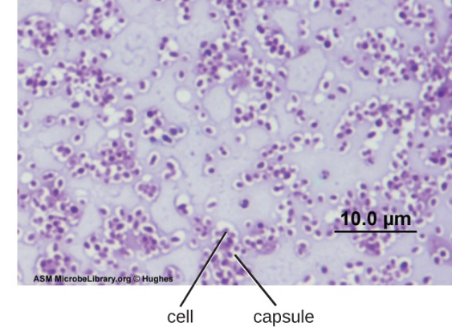  OSC Microbio 03 03 Capsules by CNXOpenStax, licensed under CC BY 4.0.
Figure 2 – a bacterial cell dividing viewed under an electron microscope.  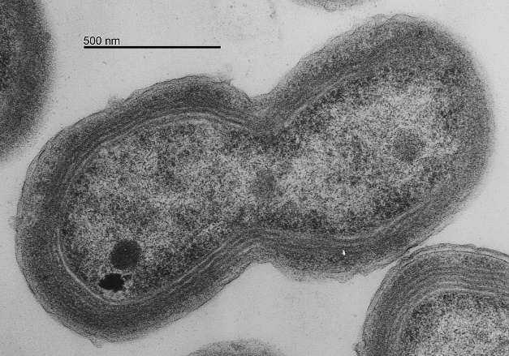  Prochlorococcus by Chisholm Lab is in the public domain. | An electron microscope enables scientists to visualise extremely small structures within bacteria. With an electron microscope, you can see fine structural details such as the cell wall, cell membrane, free-floating circular DNA, and sometimes flagella used for movement.
Bacterial cells have specialised features:  - a cell wall to provide strength and protection  - a cell membrane to support energy production and nutrient exchange  - flagella (tail-like structures) for movement  - free-floating DNA in the cytoplasm because they have no nucleus. | 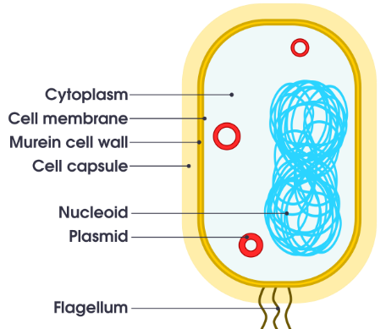  Figure 3 – a labelled diagram of a bacterial cell  Labelled bacterium cell by domdomegg, licensed under CC BY 4.0.

Station 2 – fungi cells
Fungal cells comprise all the different types of fungi, classified within the Kingdom Fungi.  Under a light microscope, fungal cells appear larger than bacterial cells and are typically oval or rectangular in shape. You can observe the thick cell wall, as well as the nucleus and vacuoles, depending on the sample. Figure 1 clearly shows the large vacuole in the fungal cell. | Figure 1 – fungi cells under a light microscope  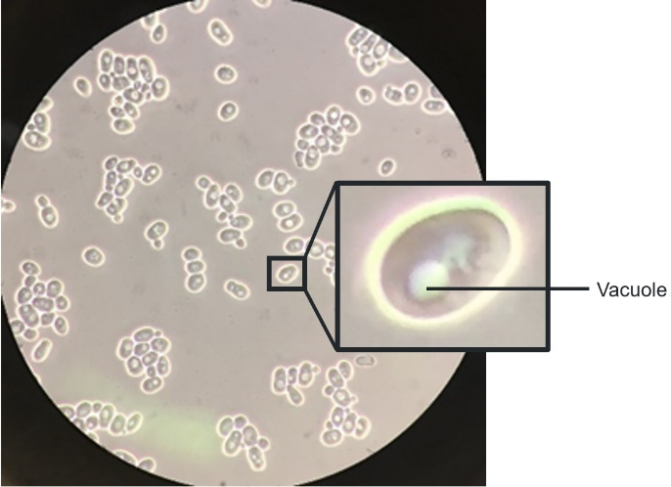  Saccharomyces cerevisiae by Pilarbini, licensed under CC BY-SA 4.0.
Figure 2 – yeast cells under an electron microscope  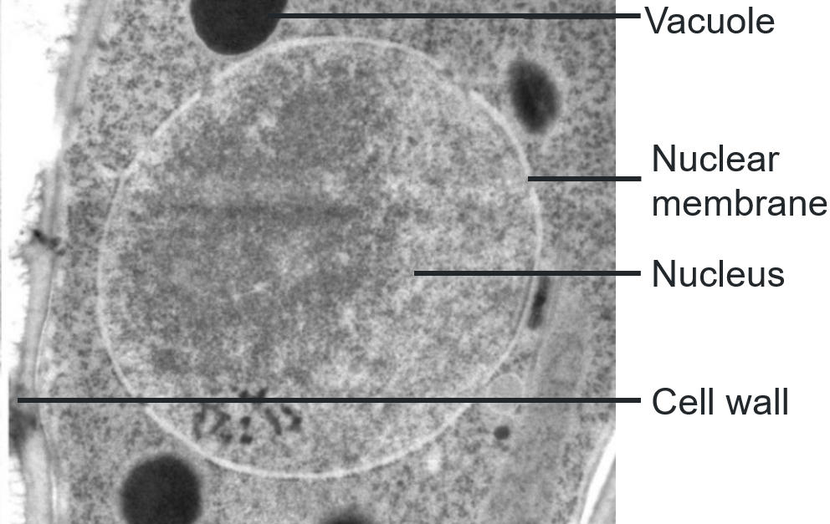  Schizosaccharomyces pombe tsentrosoom by Tiina Tamm, licensed under CC BY-SA 4.0. | The electron microscope reveals more organelles and greater detail, including the nucleus, mitochondria, vacuoles and a complex cell wall.  Figure 3 – a labelled diagram of a fungal cell  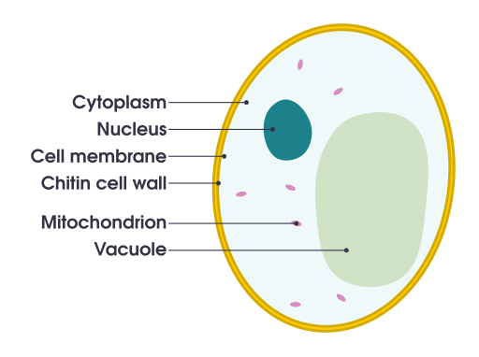  Labelled simple diagram of yeast cell (en) by domdomegg, licensed under CC BY 4.0.
Fungal cells have specialised features:
- A cell wall provides strength and structure, enabling them to break down and absorb nutrients from organic material in their surroundings.
- Although fungi do not photosynthesise like plants, they also use mitochondria to produce energy from nutrients they consume.

Station 3 – plant cells
Plant cells comprise all the different types of plants, classified within the Kingdom Plantae.  Under a light microscope, plant cells appear rectangular with clear cell walls. With staining, you can often identify the nucleus, large central vacuole and chloroplasts. The cells are tightly packed. | Figure 1 – many leaf cells under a light microscope  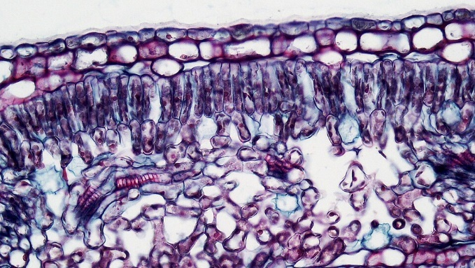  Angiosperm Leaf Mesophyll is in the public domain.
Figure 2 – transmission electron micrograph of a chloroplast in a leaf cell  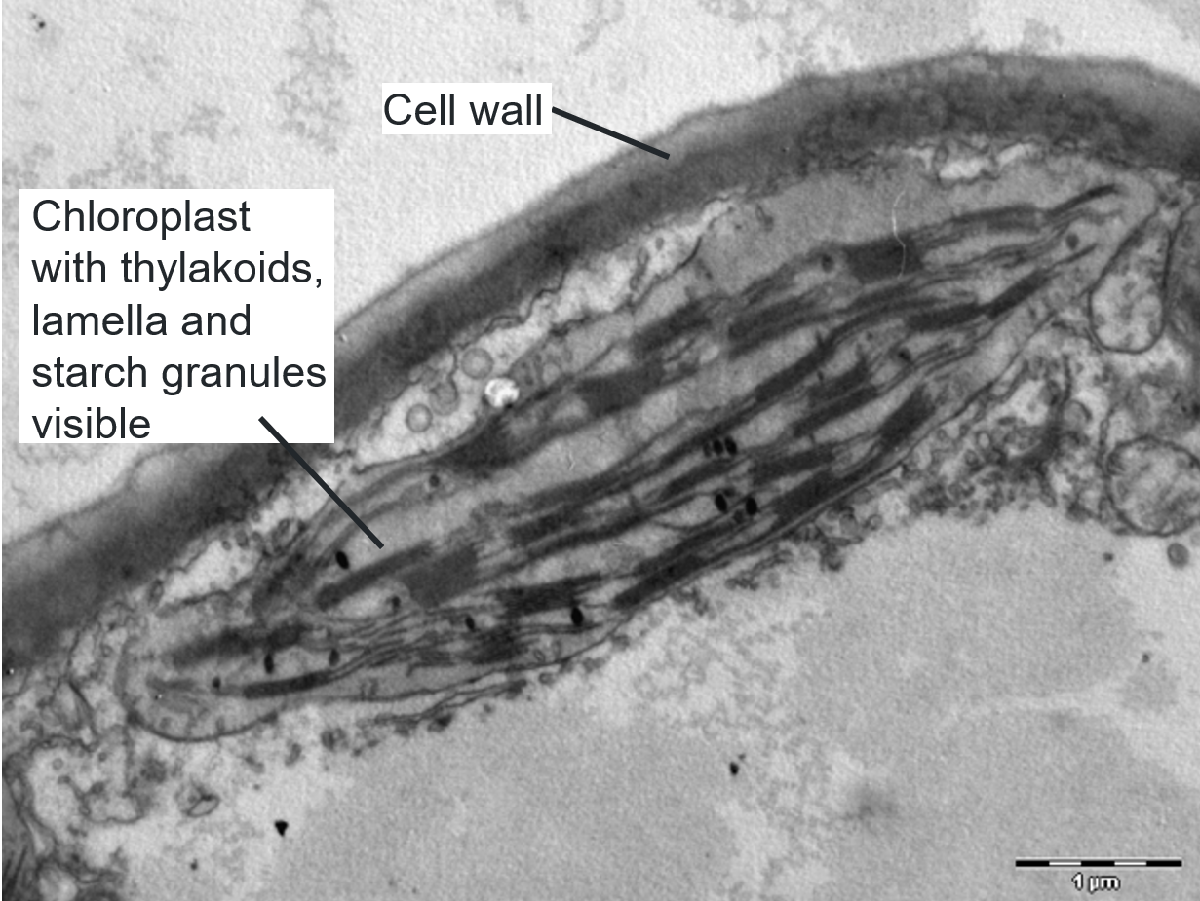  Chloroplast in leaf by and3K and caper437, licenced under CC BY-SA 4.0. | The electron microscope reveals more structural details, including chloroplasts, mitochondria, a rigid, multilayered cell wall, a large central vacuole, and the nucleus. These details are vital to understanding plant cell functions. Figure 2 shows the detail inside a chloroplast that can be seen with a transmission electron microscope.
Plant cells have specialised features:  - a cell wall for structural support  - a large vacuole that stores water and nutrients  - chloroplasts contain chlorophyll that captures light energy during photosynthesis. | Figure 3 – a labelled diagram of a plant cell  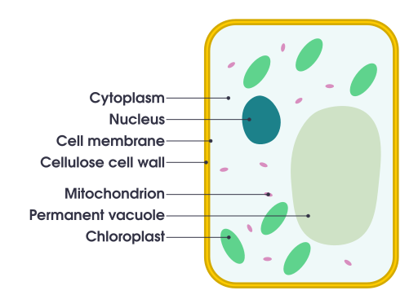  Simple diagram of plant cell (en) by domdomegg, licensed under CC BY 4.0.

Station 4 – animal cells
Animal cells comprise all the different types of animals, classified into the kingdom Animalia.  Animal cells are typically round or irregular in shape and do not have a cell wall. Under a light microscope, the nucleus is often visible, and in some cases, small vacuoles and mitochondria can be observed with the aid of special stains. | Figure 1 – cheek cells under a light microscope  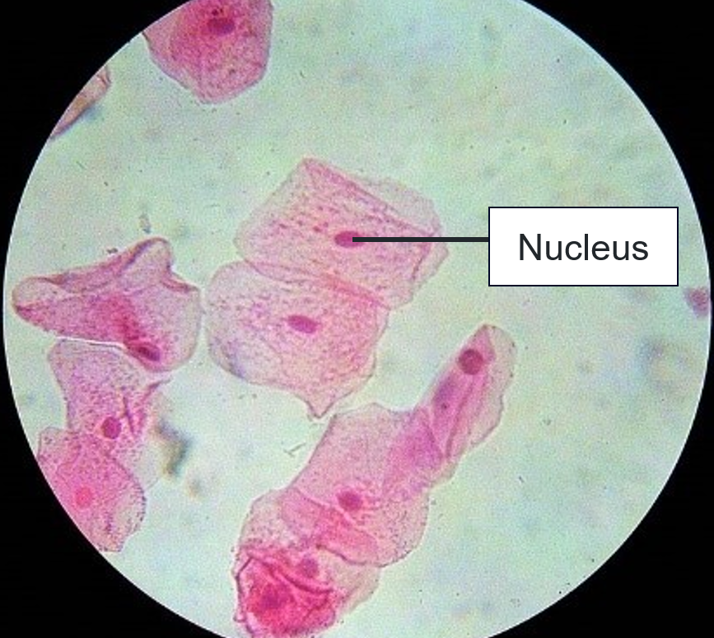  Cheekcells stained by Mulletsrokk, licensed under CC BY-SA 4.0.
Figure 2 – spermatic cell viewed with a transmission electron microscope  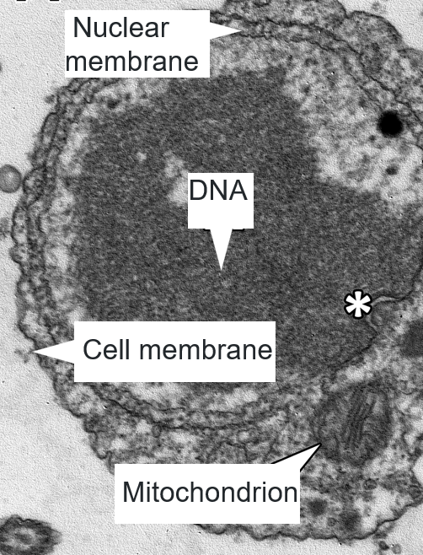  Spermatid by Rasbak licensed under CC BY 4.0. | The electron microscope reveals many organelles, including the DNA inside the nucleus, mitochondria and the flexible cell membrane. This complex structure supports a wide range of cell functions in animals.  Animal cells have specialised features:  - lack of a cell wall makes their cells more flexible and better suited for movement  - mitochondria convert food consumed into usable energy.
Figure 3 – a labelled diagram of an animal cell
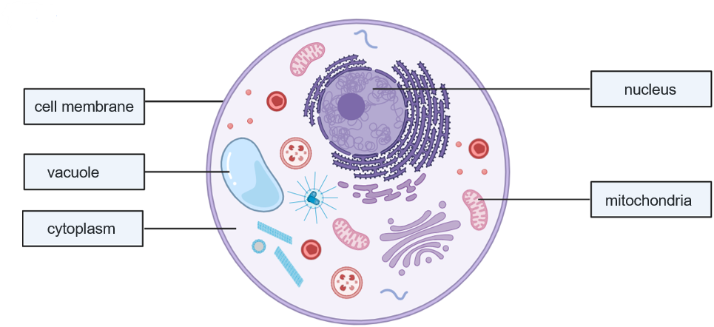 | This work has been generated using BioRender.com. Any copyright subsisting in this work is owned by © State of New South Wales (Department of Education), 2024.

Student resource – comparing cells in the Kingdoms of life
Comparing cell types
Place a tick next to the features present in each type of cell.
Table 1 – identifying similarities and differences in the cell types
Feature | Bacteria | Fungi | Plant | Animal
Cell membrane
Cell wall
Cytoplasm
Nucleus
Mitochondria
Chloroplasts
Instructions: answer the questions below using your understanding of organelle function, the organism and the completed table above.
- Use the table to identify the structures common to all cell types. Why are these essential?
- Why do some cell types have a cell wall, mitochondria or chloroplasts, but others do not?
- Why do all cell types listed in the table except bacteria have a nucleus and mitochondria?

Evidence base
This resource contains NSW Curriculum and syllabus content. The NSW Curriculum is developed by the NSW Education Standards Authority. This content is prepared by NESA for and on behalf of the Crown in right of the State of New South Wales. The material is protected by Crown copyright.
Please refer to the NESA Copyright Disclaimer for more information https://educationstandards.nsw.edu.au/wps/portal/nesa/mini-footer/copyright.
NESA holds the only official and up-to-date versions of the NSW Curriculum and syllabus documents. Please visit the NSW Education Standards Authority (NESA) website https://educationstandards.nsw.edu.au and the NSW Curriculum website https://curriculum.nsw.edu.au.
Science 7–10 Syllabus © NSW Education Standards Authority (NESA) for and on behalf of the Crown in right of the State of New South Wales, 2023.
AITSL (Australian Institute for Teaching and School Leadership Limited) (n.d.) Learning intentions and success criteria [PDF 251 KB], AITSL, accessed 18 November 2024.
Bainofyourlife (13 March 2013) ‘Paremecium under the microscope’ [video], Bainofyourlife, YouTube, accessed 15 October 2024.
BBC (British Broadcasting Corporation) (2024) Practical - Making slides and observations, BBC Bitesize, accessed 1 October 2024.
——(2025) Exchange surfaces and transport systems - AQA Synergy, BBC, accessed 10 January 2025.
Beck I, McKeown M and Kucan L (2013). Bringing words to life: Robust Vocabulary Instruction, Guilford Publications, New York.
BEST (Best Evidence Science Teaching) (2024) Big idea: The cellular basis of life, University of York Science Education, accessed 25 September 2024.
Brookhart SM (2018) ‘Appropriate Criteria: Key to Effective Rubrics’, Frontiers in Education, volume 3(22):1–12, doi:10.3389/feduc.2018.00022, accessed 15 October 2024.
CESE (Centre for Education Statistics and Evaluation) (2020) What works best: 2020 update, NSW Department of Education, accessed 18 November 2024.
——(2020) What works best in practice, NSW Department of Education, accessed 18 November 2024.
——(2021) Growth goal setting – what works best in practice, NSW Department of Education, accessed 18 November 2024.
EPA Victoria (Environmental Protection Agency Victoria) (2021) Risk management process, EPA Victoria, accessed 3 December 2024.
Exploring Our Fluid Earth (n.d.) Growth, Development, and Reproduction, University of Hawai‘i, accessed 14 January 2025.
Fisher D and Frey N (1 November 2009) ‘Feed Up, Back, Forward’, ASCD (Association for Supervision and Curriculum Development): Educational Leadership magazine, 67(3), accessed 18 November 2024.
Fiveable Inc (2024) 6.1 Plant cell wall structure and biosynthesis, Fiveable website, accessed 10 December 2024.
FuseSchool – Global Education (18 April 2018) ‘Unicellular vs Multicellular | Cells | Biology | FuseSchool’ [video], FuseSchool – Global Education, YouTube, accessed 14 January 2025.
Griffin P (2017) Assessment for Teaching, Cambridge University Press, Port Melbourne, Victoria.
Hattie J and Timperley H (2007) ‘The Power of Feedback’, Review of Educational Research, 77(1): 81–112, doi:10.3102/003465430298487.
Joao’s Lab (29 February 2024) Cell theory: definition and principles [video], Joao’s Lab, YouTube, accessed 24 July 2024.
Khan Academy (2024) Cellular organelles and structure, Khan Academy, accessed 26 September 2024.
——(2025a) Intro to eukaryotic cells, Khan Academy, Accessed 13 January 2025.
——(2025b) Prokaryotic cells, Khan Academy, accessed 13 January 2025.
LibreTexts Biology (n.d.) 4.2: Prokaryotic Cells, LibreTexts, accessed 13 February 2025.
LSG Science (3 October 2016) 'The History of the Microscope' [video], LSG Science, YouTube, accessed 22 July 2024.
Medline Plus (2021) What is a cell?, NIH website, accessed 25 September 2024.
Biga L M, Bronson S, Dawson S, Harwell A, Hopkins R, Kaufmann J, LeMaster M, Matern P, Morrison-Graham K, Oja K, Quick D and RUnyeok J (n.d.) 3.3 The Nucleus and DNA Replication, Oregon State University website, accessed 10 December 2024.
Panadero E and Jonsson A (2013) ‘The use of scoring rubrics for formative assessment purposes revisited: A review’, Educational Research Review, 9:129–144, doi:10.1016/j.edurev.2013.01.002, accessed 18 July 2024.
Australian Academy of Science (2024) Biological science conceptions, Primary Connections website, accessed 14 January 2025.
Science Learning Hub Akoranga Pῡtaiao (2011) Body systems, Science Learning Hub website, accessed 10 December 2024.
Scitable (2014) What Is a Cell?, Nature Education website, accessed 25 September 2024.
Sherrington T (2019) Rosenshine’s Principles in Action, John Catt Educational Limited, Melton, Woodbridge.
Southern Biological (n.d.) Introduction to Paramecium, Southern Biological website, accessed 15 October 2024.
State of NSW (Department of Education) (2024) Digital Learning Selector, NSW Department of Education website, accessed 22 July 2024.
The University of Western Australia (2024) ‘Bara boodie’, Introducing adaptations, UWA, accessed 22 July 2024.
UK Health Security Agency (2024) Carbon Dioxide: general information, UK Health Security Agency website, accessed 10 December 2024.
Vidyasagar A (2022) Paramecium: Characteristics, biology and reproduction, Live Science website, accessed 10 December 2024.
Wiliam D (2017) Embedded Formative Assessment, 2nd edn, Solution Tree Press, Bloomington, IN.
Work Safe ACT (n.d.) Safe work procedures, Work Safe ACT website, accessed 3 December 2024.
© State of New South Wales (Department of Education), 2025
The copyright material published in this resource is subject to the Copyright Act 1968 (Cth) and is owned by the NSW Department of Education or, where indicated, by a party other than the NSW Department of Education (third-party material).
Copyright material available in this resource and owned by the NSW Department of Education is licensed under a Creative Commons Attribution 4.0 International (CC BY 4.0) license.

This license allows you to share and adapt the material for any purpose, even commercially.
Attribution should be given to © State of New South Wales (Department of Education), 2025.
Material in this resource not available under a Creative Commons license:
- the NSW Department of Education logo, other logos and trademark-protected material
- material owned by a third party that has been reproduced with permission. You will need to obtain permission from the third party to reuse its material.
Links to third-party material and websites
Please note that the provided (reading/viewing material/list/links/texts) are a suggestion only and implies no endorsement, by the New South Wales Department of Education, of any author, publisher, or book title. School principals and teachers are best placed to assess the suitability of resources that would complement the curriculum and reflect the needs and interests of their students.
If you use the links provided in this document to access a third-party's website, you acknowledge that the terms of use, including licence terms set out on the third-party's website apply to the use which may be made of the materials on that third-party website or where permitted by the Copyright Act 1968 (Cth). The department accepts no responsibility for content on third-party websites.

