Science Stage 4 (Year 7) – Cells and classification
Teacher resource book 1 of 2 (TRB1)
1 How does biological classification help in understanding the diversity of life on Earth?
Creation date: 25 March 2025.
Contents
Overview 3
Glossary 3
1.1 Characteristics of living things 6
Teacher background information 6
Alive, dead or never been alive 8
What is life? 8
1.2 Why do we classify living things? 14
The role of classification 14
Diversity of life on Earth 16
1.3 Classification systems 21
Teacher background information 21
The Linnean classification system 22
Naming species 24
The diversity of living things 26
1.4 Classification of organisms 31
Classifying Arthropoda 32
Species investigation 35
1.5 Aboriginal and Torres Strait Islander People’s classification of plants and animals 41
Aboriginal and Torres Strait Islander peoples’ naming of animals 42
Aboriginal and Torres Strait Islander peoples’ classification of plants 45
Aboriginal and Torres Strait Islander peoples’ ways of grouping living things 49
1.6 Dichotomous keys 57
Classification using dichotomous keys 58
Classifying terrestrial mammals 68
1.7 Adaptations in Australian organisms 72
Part 1 – defining adaptations 73
Part 2 – learning how to conduct secondary-source research 74
Part 3 – annotating a report on the waratah 91
Part 4 – constructing a scientific report about the bare-nosed wombat 100
1.8 Classification assessment task 116
Evidence base 117

Overview
Stage and learning area: Stage 4 Science
Description: this resource complements the Cells and classification program of learning. It aims to serve as a teacher reference, offering practical strategies and ideas to enrich teaching practices and create engaging learning environments. The activities should be adapted to suit students’ needs.
Duration: while timing will vary based on the mode of delivery, differentiation strategies employed, and class or school context, this series of activities in TRB1 should take approximately 20 hours.
Risk management: teachers are advised to undertake a risk assessment before conducting any investigation or experiment in their classrooms. For more information on developing risk assessments, see Risk Assessment – a pre-requisite for risk control.
This resource book elaborates on many of the activities in the Cells and classification sample program of learning. Some activities also reference the Cells and classification slide deck (identified as CLS PPT throughout this document).

Glossary
Tier 3 words are relevant to subject-specific content. More information is provided in the ‘Vocabulary in context’ document found at the Stage 5 reading strategies page. The Guide for planning and implementing explicit vocabulary instruction can be used by teachers across all curriculum areas.
Differentiation: to support students learning English as an additional language or dialect (EAL/D) with vocabulary development, refer to EAL/D learners and reading vocabulary. An additional column may be added to the glossary table for EAL/D students to write the definition in their home language.
Table 1 – glossary of terms in the classification component of the Cells and classification focus area
Term | Definition
Biological adaptation | Biological adaptations are traits that enable organisms to survive and thrive in their natural environments. These changes happen over time and can be passed down to future generations (evolution). There are 3 main types of adaptations:  - behavioural – how an organism acts in response to environmental stimuli  - structural – physical features of the organism  - physiological – how the organism's body functions.  These adaptations enable organisms to live and thrive in their natural environments.
Binomial nomenclature | A system of naming living things using 2 Latin names, consisting of a generic (genus) name followed by a specific (species) name. For example, Homo sapiens.
Characteristic | A distinguishing aspect (including features and behaviours) of an object, material, living thing or event (NESA 2025).
Classify | The organisation of objects into groups based on observed similarities and differences. For instance, in modern biological classification, organisms are categorised into hierarchical groups that reflect their evolutionary relationships.
Dichotomous key | A dichotomous key is a tool used to classify living things into separate groups. The word ‘dichotomous’ means splitting into 2 branches, creating two distinct groups. The ‘key’ refers to paired questions that guide the branching process repeatedly.
Excretion | The processes by which living things remove metabolic waste (not food waste) from their bodies.
Invertebrate | Invertebrates are animals that lack a backbone (or spine). Insects, molluscs and worms are invertebrates.
Organism | An organism is a living thing that can be made up of one cell (like bacteria) or many cells (like plants and animals). Organisms show characteristics of life, such as movement and response to stimuli.
Scientific model | A mathematical, conceptual or physical representation that describes, simplifies, clarifies or provides an explanation of the structure, workings or relationships within an object, system or idea. Models can provide a means of testing and predicting behaviour within limited conditions. Models may be physical or exist in digital form (NESA 2025).
Vertebrate | An animal that has a backbone or spine. Birds and reptiles are examples of vertebrates.

1.1 Characteristics of living things
Table 2 – learning intentions and success criteria for 1.1 Characteristics of living things
We are learning: | I can:
- to describe how characteristics can be used to classify organisms | - distinguish between living and non-living things  - list the 7 characteristics of living things  - justify objects or things as living or non-living using the characteristics of living things
- to make scientific observations using our senses. | - make scientific observations of objects and things  - compare the similarities and differences between living and non-living things.

Teacher background information
Living things all share the following characteristics. Note that some examples are less obvious and require careful observation and interpretation by students.
All living things:
- Move – either the entire organism or its parts can move to new locations or spread out. Plants also shift position, for example, through geotropism and phototropism.
- Respire – this is the process of extracting usable energy from food molecules.
Note: it is important to distinguish between respiration and breathing. If not clearly defined, some students may confuse the 2 terms and incorrectly suggest that plants do not respire because they lack lungs.
- Sense – they will detect changes in their environment and respond by performing a predictable action.
- Grow – they become larger because of growth, but the timescale of this growth can vary greatly between different living things.
- Reproduce – to create new offspring. The timescale and mechanism of reproduction vary among different types of living organisms.
- Eliminate wastes – they excrete waste materials; the mechanism, type and amount of waste excreted vary between different living things. Mammals eliminate waste products through their lungs (carbon dioxide), through their digestive systems (faeces) and their urinary systems (urine). Plants eliminate waste (oxygen) through their stomata.
- Obtain nutrients – all living things absorb nutrients (a component of our food) from their surroundings; the mechanism, type and amount of nutrients absorbed vary between different living things.
The traits of living things mentioned earlier – such as movement, respiration, sensitivity, growth, reproduction, waste elimination and nutrient intake – are not rigid. These characteristics have been expanded as scientists gain more knowledge about the diverse organisms on Earth. As research progresses, the list of features describing living things continues to grow and includes:
- Cellular organisation – living organisms are composed of cells, the fundamental units of life. These cells can be simple (prokaryotic) or more complex (eukaryotic).
- Genetic code – the instructions for constructing and operating a living organism are encoded in DNA.
- Homeostasis – living organisms sustain a fairly stable internal environment despite variations in their external surroundings. This requires regulating factors such as temperature, water balance, and chemical concentrations.
Note: cellular organisation is covered in Essential Question 2 of the program. The genetic code and homeostasis are beyond the focus area's requirements but may be addressed as an extension opportunity.

Alive, dead or never been alive
Assess students’ prior understanding of living and non-living things by providing them with a series of picture prompts and asking them to decide whether the item is alive, dead, or has never been alive. Students should provide their reasoning for each item. Stimulus material for this activity is provided in the CLS PPT ‘1.1 Alive, dead or never been alive’ slides. These images include:
- an evergreen tree (alive)
- a deciduous tree during autumn/winter with leaves on the ground (alive)
- a mountain range (never been alive)
- a preserved specimen of a Tasmanian tiger (dead/once was living).
Note: while matter is usually classified as ‘living’ and ‘non-living’, this terminology has recently changed. A third category, ‘once living’, is now used to describe matter that was once alive but is now dead. Non-living matter refers to matter that has never been alive.

What is life?
This activity uses the gradual release of responsibility to support students' understanding of the characteristics of living things and how to identify them in various scenarios. For more information on implementing this strategy, go to Gradual release of responsibility.
- Provide students with a copy of the Student resource – Is it alive? checklist. Unpack the characteristics of living things by first clarifying what a characteristic is; a characteristic is a distinguishing feature, trait or quality of an individual or thing. Then, as a class, read through the description for each characteristic. Unpack these terms further for the class using information from the Teacher background information.
- Show CLS PPT ‘1.1 What is life?’ (1 of 2) and work through the characteristics to determine if ‘human’ is living or non-living. Demonstrate how a human meets each of the characteristics on the board to model the types of annotations students will make in the student resource.
- Show CLS PPT ‘1.1 What is life?’ (2 of 2) and work through the characteristics with students. This example is of fire, which exhibits some of the characteristics of a living thing, promoting critical thinking. Ask students to write down their observations of fires that they have seen in the student resource. Use the information in Table 3 to lead a discussion on the characteristics of living things in the context of a fire, to establish that it is not a living thing.
- Direct students to make observations of 2 items to determine if they are living or non-living based on the characteristics of living things. Move around the room and assist students as required.
Checkpoint: check students’ understanding of the characteristics of living things by displaying the checkpoint slides CLS PPT ‘1.1 Checkpoint’ (3 slides). Students identify if the items are living, non-living or dead.
Table 3 – sample student observations of fire against the characteristics of living things and sample teacher explanations of why fire is not a living thing
Characteristic | Observations of fire | Teacher explanation
Move | Fire spreads to other areas. | Fire seems to move, but it cannot control its movements like living things do. It only spreads when there is fuel nearby.
Respire | Fire consumes oxygen from the air as it burns, releasing energy from the fuel it burns. | Fire needs oxygen (and fuel) to keep burning. This occurs through a reaction called combustion, not respiration, like in living things.
Sense | When the wind blows on fire, it changes direction. | Fire lacks sense organs, such as eyes or skin, to detect environmental changes. It is not ‘sensing’ or ‘feeling’ the shift in wind direction.
Grow | Fires get bigger over time. | Living things grow through cell division. Fire does not have cells, but it seems to grow as it spreads to new fuel sources.
Reproduce | One fire can start another fire. | Fire can cause new fires, but this is not reproduction through genetic material or cell division as in living things.
Eliminate waste | Fire produces smoke | Fire releases waste products such as smoke and gases, but this is not controlled elimination of waste like in living things.
(Obtain) Nutrients | Fire needs fuel and combustible material to burn | Fire consumes fuel for energy, but it does not take in nutrients or digest like living things.
Note: an additional problematic example has been included in Table 4. This may be used in later lessons to consolidate student understanding when they have covered more of the content in this unit.
Table 4 – additional problematic example, plant seeds
Characteristic | Observations of seeds | Teacher explanation
Move | Seeds do not move. | A seed contains no organs for locomotion. Any movement you see (blowing in the wind or floating in water) is passive dispersal, not active movement generated by the seed itself.
Respire | Seeds do not visibly respire. | Living seeds are in a dormant state but still carry out cellular respiration at a very slow rate. This can be shown with a device that detects the tiny amount of CO₂ they release. When germination begins, their respiration rate rises sharply.
Sense | Seeds do not respond to changes in their environments. | Dormant seeds lack visible responses, but they can ‘sense’ cues such as water, oxygen, temperature and sometimes light.
Grow | Seeds can grow into plants over time if they are planted and watered. | Seeds will begin to grow once they are exposed to water; until then, they remain dormant.
Reproduce | Seeds do not reproduce. | A seed is the product of sexual reproduction in a plant. Once it has grown into a mature plant, it will be able to reproduce.
Eliminate waste | Seeds do not visibly eliminate waste. | Because the seed is dormant, it produces very little waste. Once it starts to germinate, it will begin to release carbon dioxide, a byproduct of cellular respiration.
(Obtain) Nutrients | Seeds do not visibly take in nutrients from their environment. | The seed contains stored nutrients; external nutrient uptake does not occur until after germination, when the root establishes contact with the soil.

Student resource – Is it alive? checklist
Work through each characteristic to determine if something is living or non-living.
Table 1 – checklist for characteristics of living things
Characteristic | Observations of fire | [insert object/thing] | [insert object/thing]
Movement
All living things move in some way; either the entire organism or individual parts can shift location or spread to new locations.
Respire
All living things undergo respiration, a process that extracts usable energy from food to power all the processes within the living thing.
Sense
All living things sense and respond to their surroundings; they will detect changes in their environment and respond by completing a predictable action.
Growth
All living things grow over time; they become larger because of growth, but the timescale of this growth can vary greatly between different living things.
Reproduce
All living things reproduce to create new offspring; the timescale and mechanism of reproduction vary between types of living things.
Eliminate waste
All living things excrete waste materials; the mechanism, type and amount of waste eliminated vary between different living things.
(Obtain) Nutrients
All living things absorb nutrients (components of our food) from their surroundings; the mechanism, type, and amount of nutrients absorbed vary between living things.
Living or non-living?

1.2 Why do we classify living things?
Table 5 – learning intentions and success criteria for 1.2 Why do we classify living things?
We are learning: | I can:
- to describe how structural features can be used to classify organisms. | - describe how to use and improve classification systems  - describe the use of classification in everyday life  - describe the role of classification in science  - identify the need for classification systems to describe the similarities between organisms  - identify the need for classification systems to describe the variety of life on Earth.

The role of classification
Sensemaking is a core function of the human mind. We tend to organise new information into related idea groups. In science, this process is known as classification.
Many real-life examples of classification demonstrate our human tendency to organise. Libraries, music genres, and supermarket shelving are everyday examples of classification. Classification lowers the mental effort needed to make sense of our environment. Cluttered, disorganised spaces are hard to interpret, making the brain work harder. This is why we often feel more relaxed and comfortable in a tidy, well-organised space.
- Go to the OneZoom Tree of Life webpage to introduce students to the idea that all organisms can be classified into groups, and to show the diversity of life on Earth. The following steps are a useful way to demonstrate this to students:
- Hover the mouse cursor in the search box at the top of the page. A dropdown list of some organisms should appear. Select human (Homo sapiens).
- Watch the animation that guides you through the different branches of the Tree of Life until you arrive at the human branch. Then, using the scroll wheel on your mouse, slowly trace back to the main trunk of the Tree of Life (follow the blue path back to the trunk that displays ‘All life’). Observe how humans are biologically connected to many other organisms on Earth.
- Click on the black button next to the left of the search box at the top of the page. In the upper box, type or select ‘human’. In the lower box, type or select ‘chimpanzee’. Then, click on the ‘common ancestor button’. The animation will take you to the branches showing ‘human (blue path)’ and ‘chimpanzee (pink path)’. Note that the human branch of the Tree of Life separated from the chimpanzee branch 1.6 million years ago. Explore the other primate branches. For example, the graphic shows that African apes diverged into 2 branches 8 million years ago – one that leads to the gorillas, and the other that leads to humans and chimpanzees.
- Click on the green ‘X’ next to the search box at the top of the page. This will reset the search. Conduct any other searches that interest the students. For example, explore the evolutionary relationship between humans and pets by selecting the human and Canis (the genus name for dogs) or Felis (the genus name for domestic cats).
- Tell students that humans are related to all other life forms on Earth, including plants and bacteria. If all living things are related, how will we organise them meaningfully? Although it has taken scientists more than 300 years, the current biological classification system categorises organisms based on shared characteristics. That means that organisms within a group share specific characteristics. This classification system is also hierarchical, meaning that it has levels of group
- Show CLS PPT ‘1.2 Organisation’ to lead a discussion about why we strive for order in our everyday lives. The slide contains a picture of a messy bedroom and is animated to bring up an organised bedroom. Use this as a stimulus to discuss why organisation is important in our everyday lives.
- Show CLS PPT ‘1.2 The role of classification – wardrobe’. Emphasise that personal preference greatly influences where clothes are stored in a bedroom wardrobe. Organising the wardrobe helps us find and access our clothes more easily. Ask students to Think-Pair-Share to discuss how clothing items should be organised within the wardrobe.
- Tell students that supermarkets use a rigorous process to organise products into categories based on their use. This helps people find what they are looking for more easily. Similar products are also grouped together, allowing shoppers to compare brands of the same item more easily. CLS PPT ‘The role of classification – supermarket’ contains images (and speaker notes) that can be used as a stimulus for this activity. Discuss what these products have in common that leads them to be placed in one location, and how this makes it easier for customers.
Checkpoint: What would the impact be of not organising products into categories in a supermarket? What if they were arranged in alphabetical order instead?
Sample response: if the products were not well-organised, finding what you need would be more difficult, making shopping slower and more frustrating. Organising the products alphabetically might seem logical at first, but this could place toilet paper and tomatoes next to each other rather than cucumbers and tomatoes (both fruits), which wouldn’t be as helpful for shoppers.

Diversity of life on Earth
- Show CLS PPT ‘1.2 Diversity of life on Earth’ and use the speaker notes to tell students about the various felines (Felidae) and canines (Canidae) depicted. Inform students that these cats share certain features. Tell students that the canines depicted also exhibit similar features.
- Show CLS PPT ‘1.2 Characteristics of felines and canines’ to outline the similarities of the organisms that sit in the Felidae family and then the Canidae family.
- Provide students with a copy of the Student resource – Why do we classify things?. Students engage with the text to respond to the comprehension and inference questions.

Sample response: Student resource – Why do we classify things?
- Match the word to its meaning.
Note: the colours match the term with the correct meaning.
Classification |  | A scientist who studies living things.
Species |  | A living thing from which others have descended.
Characteristics |  | The process of sorting things into groups.
Ancestor |  | A feature or trait of a living thing.
Biologist |  | A group of living things with shared features that can reproduce together.
Comprehension questions:
- What is biological classification, and why is it useful?
Classification is the process of grouping living things based on their shared characteristics. It is useful because it helps scientists organise the large number of species on Earth and makes it easier to study and understand them. For example, knowing that an organism is a mammal conveys a significant amount of information without needing to specify the traits common to all mammals.
- How does classification help scientists around the world communicate?
Classification offers a standardised system of naming (nomenclature) and scientific names that researchers worldwide use. This helps prevent confusion caused by the use of various common names in different languages or regions.
- Why do scientists use scientific names instead of common names?
Scientific names are used because common names can differ across countries and languages. Scientific names are universal, ensuring scientists know they are discussing the same species.
- Give one example of how classification is useful in real life.
In medicine, classification helps doctors identify the bacteria or viruses infecting humans and select the appropriate treatment.
Thinking beyond the text
- If a new animal species were discovered, how would classification help scientists understand it?
Scientists can compare its features with those of known species to determine where it fits within the classification system. This would help them learn about its behaviour, diet, and how it might interact with other organisms.

Student resource – Why do we classify things?
Read the passage on why we classify living things and then answer the questions.
There are millions of different living things on Earth, and new species are being discovered every year. Without a way to organise them, studying life would be extremely confusing. That is why scientists use a system called classification to group organisms based on their similar characteristics.
This system begins with large groups, such as kingdoms, and becomes more specific, eventually breaking down to species. The most widely used system today is based on the work of Carl Linnaeus. This method enables scientists to describe, compare, and gain a deeper understanding of organisms.
Classification is more than just naming things; it helps scientists communicate clearly, especially when studying species in different parts of the world. For example, the animal commonly referred to as a ‘mountain lion’ in North America is the same species as the ‘puma’ in South America. Its scientific name, Puma concolor, avoids confusion.
Classification also reveals relationships between species. For example, humans and chimpanzees are in the same group of mammals, meaning they share common features and a common ancestor.
Understanding classification is important in medicine, farming, and environmental science. It allows scientists to identify useful traits, predict how living things might behave, and recognise the role each species plays in the environment.
- Match the word to its meaning.
Classification |  | A scientist who studies living things.
Species |  | A living thing from which others have descended.
Characteristics |  | The process of sorting things into groups.
Ancestor |  | A feature or trait of a living thing.
Biologist |  | A group of living things with shared features that can reproduce together.
Comprehension questions
- What is classification, and why is it useful?
- How does classification help scientists around the world communicate?
- Why do scientists use scientific names instead of common names?
- Give one example of how classification is useful in real life.
Thinking beyond the text
- If a new animal species were discovered, how would classification help scientists understand it?

1.3 Classification systems
Table 6 – learning intentions and success criteria for 1.3 Classification systems
We are learning: | I can:
- to classify living things based on their structural features | - identify the hierarchy of taxa in the Linnean classification system as Kingdom, Phylum, Class, Order, Family, Genus and Species  - justify the classification of organisms based on their structural features  - outline the use of the binomial naming system in classification  - distinguish between vertebrates and invertebrates using structural features  - outline the features of various groups of organisms, such as reptiles.
- to extract and process information from secondary sources. | - extract relevant information from a video to respond to questions  - use a mnemonic to recall information.

Teacher background information
The Linnean system of taxonomy offers a framework for categorising living things. There are still some issues with how these taxonomic groups are organised, and this model is constantly being revised and adjusted, as we will discuss in the upcoming lessons.
Note: a range of other terms (tribe, division, super-/infra-/sub-, clade) are sometimes used when describing the biological classification system. These terms provide additional layers to refine the classification system further, as our understanding of living things has increased. However, these terms will not be addressed in this learning sequence.
The hierarchy of the 7 taxonomic ranks within the Linnean classification system (Kingdom, Phylum, Class, Order, Family, Genus, and Species) has each taxon nesting within its parent (see Figure 1). Thus, a Kingdom consists of several Phyla, and each Phylum is made up of several Classes. All animals are grouped within the kingdom Animalia, regardless of how they are classified in the lower taxa.
Figure 1 – taxonomic hierarchy in the Linnean system of classification
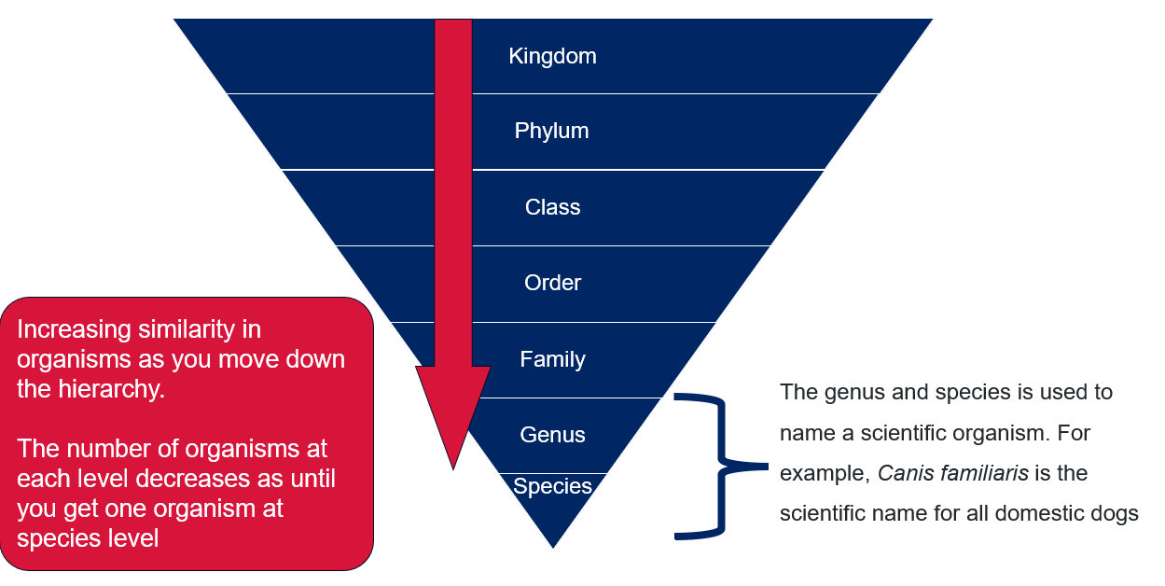
Note: the taxa of ‘domain’ is omitted from this focus area content group as we are only classifying macroscopic life from the domain Eukaryota.

The Linnean classification system
- Outline how scientists classify living things using the seven main levels of classification: Kingdom>Phylum>Class>Order>Family>Genus>Species, using CLS PPT ‘1.3 The Linnean system (1 of 8)’.
- Tell students that from Kingdoms down to Species, each level provides more detail about what makes an organism unique. Ask students to draw a three-column table in their book.
- Column 1: The heading is ‘taxon’
- Column 2: The heading is ‘Dingo classification’
- Column 3: The heading is ‘What are the features of this organism that make it fit into this taxonomic classification level?’. An example is shown in the sample response.
- The CLS PPT ‘1.3 The Linnean classification system’ slides 2 to 8 contain information about each level of the classification system and include teacher notes to facilitate the unpacking of each taxonomic rank. The slides also provide a specific example at each level of classification. Students complete the table about the dingo’s classification as the information is presented to them by the teacher.
Sample response
Table 7 – a sample student response to justify the classification of the dingo
Taxon | Dingo classification | What are the features of this organism that make it fit into this taxonomic classification level?
Kingdom | Animalia | Dingos are animals. They eat other organisms for energy (instead of making their own food like plants) and are made up of many cells.
Phylum | Chordata | The dingo has a backbone and spinal cord.
Class | Mammalia | Dingos have fur on their bodies, are warm-blooded, give birth to live young and produce milk for their young.
Order | Carnivora | Dingos mostly eat other animals; they have well-developed, sharp canine teeth for hunting and tearing meat. They also typically have strong, sharp claws.
Family | Canidae | The dingo is a canine with a long snout, sharp teeth, and strong legs for running. They are also very good at smelling and hearing.
Genus | Canis | Dingos are medium-sized animals with long legs built for endurance running. They have strong jaws to capture and consume prey. Dingos hunt in packs and mark their territories.
Species | Canis lupus | Dingos are a subspecies of the grey wolf, called Canis lupus dingo. This means they are a unique type of wolf that has lived in Australia for thousands of years, developing special features to survive in this environment.
- Describe mnemonics as a memory device, such as a pattern of letters, ideas, or associations, that assists in remembering something more complex. With the complex nomenclature in the Linnean Classification system, mnemonics are a simple and effective way to remember the names and order of the taxa, allowing individuals to memorise this information in their brain using a simple sentence or rhyme. Demonstrate the mnemonic sample shown in CLS PPT ‘1.3 Mnemonics’ (4 slides). Students could try creating their own mnemonic device to remember the taxonomic levels.
Table 8 – an example of a mnemonic for remembering the order of taxa
Mnemonic | Zoology term
King | Kingdom
Phillip | Phylum
Came | Class
Over | Order
For | Family
Good | Genus
Spaghetti | Species

Naming species
Binomial names are scientific terms with a specific structure. Inform students to use proper capitalisation for the genus and lowercase for the species, with the entire binomial name in italics – Genus species. When a shorter form is needed, the genus can be abbreviated to an initial followed by the species name – G. species.
- Show CLS PPT ‘1.3 Binomial naming system’ to outline how the genus and species are used to give an organism its unique scientific name. Explain why this naming system is useful, drawing on the information provided on the slide.
- Show CLS PPT ‘1.3 Mountain chicken’ (Leptodactylus fallax) and ask students to draw a diagram of what they think this organism might look like. Then, show students a Google Image search of the Leptodactylus genus, which will display a wide range of frog species that fall within this genus. Lead a discussion about what they now think the mountain chicken organism will look like. Students should now understand that it likely has very similar features to the frog species from the Google image search.
- Show CLS PPT ‘1.3 Naming species’ (4 slides) to outline some specific examples of organisms’ common and scientific names. Speaker notes are included to provide an explanation of the naming on each slide. These slides highlight the often misleading nature of the common names of organisms. Some interesting examples to investigate are – Red panda (Ailurus fulgens) is not a panda, Electric eel (Electrophorus electricus) is not an eel, Mountain goat (Oreamnos americanus) is not a goat, King cobra (Ophiophagus Hannah) is not a cobra. The Peacock mantis shrimp (Odontodactylus scyllarus) is not a shrimp.
- Show CLS PPT ‘1.3 Scientific names of Australian species’. Students use internet research to look up the scientific names of some plant and animal species commonly found in Australia. Prompt students to identify the 2 species in the list that are likely to be closely related to each other. Students should recognise that the genus of the blue gum and red river gum is the same, and therefore, they are likely to be more closely related compared to the other plants listed.
Differentiation: challenge students to explore the Latin origin for the scientific names of a range of shark species by exploring Activity: What’s in a Name?
Table 9 – solutions to the binomial naming activity
Common name | Binomial name
Red Kangaroo | Macropus rufus
Koala | Phascolarctos cinereus
Emu | Dromaius novaehollandiae
Platypus | Ornithorhynchus anatinus
Tasmanian Devil | Sarcophilus harrisii
Common Brushtail Possum | Trichosurus vulpecula
Laughing Kookaburra | Dacelo novaeguineae
River red gum | Eucalyptus camaldulensis
Waratah | Telopea speciosissima
Blue Gum | Eucalyptus globulus

The diversity of living things
- Watch the video Animal Classification for Children: Classifying Vertebrates and Invertebrates for Kids - FreeSchool (6:51).
- Provide students with the Student resource – the diversity of living things. Read the questions with students and then replay the video, pausing it periodically. Students should extract information on the characteristics of various groups of vertebrates and invertebrates to respond to comprehension questions in the resource.
Sample response: Student resource – diversity of living things
- In biological classification, what are the 2 main groups of animals? Vertebrates and invertebrates
- What is the key difference between vertebrates and invertebrates?
Vertebrates have backbones (spines) and invertebrates do not.
- What percentage of animals are vertebrates? <5%
- Which group of vertebrates uses gills to breathe? Fish
- Name the five main classes of vertebrates discussed.
Amphibians, reptiles, birds, fish and mammals.
- What do all mammals feed their babies? Milk
Understanding (Summarising and Interpreting)
- Why do some invertebrates grow larger in water than on land?
In water, the body is supported more easily, so invertebrates can grow larger even without a skeleton.
- How do you know if an animal is a reptile and not an amphibian?
Reptiles have dry, scaly skin and lay leathery eggs on land, while amphibians have moist skin and lay jelly-covered eggs in water.
- How are amphibians and fish alike? How are they different?
Fish and amphibians are cold-blooded. Both live in water. However, amphibians can also live on land. Fish have scales, whereas amphibians have moist skin.
Application and analysis
- A penguin cannot fly but has feathers, lays hard-shelled eggs and is warm-blooded. What group does it belong to? Provide your reasoning.
A penguin is a bird. Only 2 classes of vertebrates are warm-blooded, which means they must be either birds or mammals. Birds are the only type of vertebrate that have feathers. Birds and reptiles lay eggs, but only birds lay eggs with hard shells.
Note: monotremes also lay eggs, but this is not discussed in the video.
- A sea lion breathes air, has fur and feeds milk to its young. What vertebrate class does it belong to, and why?
A sea lion is a mammal because mammals have fur or hair and produce milk for their offspring.
- If you found an animal with no backbone and a soft body, which group would it likely belong to?
This animal would be classified as an invertebrate because it lacks a backbone.
- Why do scientists classify animals into taxonomic groups? How does this help us?
Classification helps to communicate large amounts of information about an organism's characteristics succinctly.
- Imagine a newly discovered animal that lays jelly-like eggs in water, breathes through gills when young and lungs when adult, and has moist skin. What group would you classify it into? Justify your choice.
I would classify this organism as an amphibian because, like other amphibians, it undergoes metamorphosis as it grows into an adult, it has moist skin, and it lays its jelly-like eggs in water.

Student resource – the diversity of living things
Watch the video Animal classification for children: Classifying Vertebrate and invertebrates for Kids (6:51) and answer the following comprehension questions.
Recall (literal understanding)
- In biological classification, what are the 2 main groups of animals?
- What is the key difference between vertebrates and invertebrates?
- What percentage of animals are vertebrates? __________
- Which group of vertebrates uses gills to breathe? _____________
- Name the 5 main classes of vertebrates discussed.
- What do all mammals feed their babies? _____________
Understanding (summarising and interpreting)
- Why do some invertebrates grow larger in water than on land?
- How do you know if an animal is a reptile and not an amphibian?
- How are amphibians and fish alike? How are they different?
Application and analysis
- A penguin cannot fly but has feathers, lays hard-shelled eggs and is warm-blooded. What group does it belong to?
- A sea lion breathes air, has fur, and feeds milk to its young. What vertebrate class does it belong to, and why?
- If you found an animal with no backbone and a soft body, which group would it likely belong to?
- Why do scientists classify animals into taxonomic groups? How does this help us?
- Imagine a newly discovered animal that lays jelly-like eggs in water, breathes through gills when young and lungs when adult and has moist skin. What group would you classify it into? Justify your choice.

1.4 Classification of organisms
Table 10 – learning intentions and success criteria for 1.4 Classification of organisms
We are learning: | I can:
- to classify living things based on their structural features | - identify structural features of organisms that allow them to be grouped  - make observations of living things to classify them into groups  - identify the distinguishing features of organisms classified as Insecta, Arachnida, Crustacea and Myriapoda  - compare the features of organisms from the same genus in a Venn diagram  - compare the features of organisms from the same family in a triple Venn diagram
- to make observations of living things using the senses | - identify distinguishing features of invertebrate organisms  - identify structural features of a range of organisms
- to undertake a secondary source investigation. | - locate and select relevant websites to find information on organisms  - identify the title, author and URL of a webpage  - extract and summarise relevant information from websites.

Classifying Arthropoda
- Provide students with a copy of the Student resource – classifying Arthropoda.
- Tell students that Arthropoda is a large phylum of invertebrate animals that includes insects, spiders, crustaceans and their relatives. Arthropods are characterised by having a hard exoskeleton and jointed appendages.
- Tell students that the Arthropoda phylum contains a large range of organisms from tiny mites to lobsters. Arthropods can be further divided into 4 main classes: Insecta, Arachnida, Crustacea and Myriapoda (see Table 1 in the Student resource – classifying Arthropoda).
- Use the Student resource – classifying Arthropoda to unpack the features of each Arthropoda class. Students then observe the provided organisms and classify them into their respective classes.
Sample response: Student resource – classifying Arthropoda
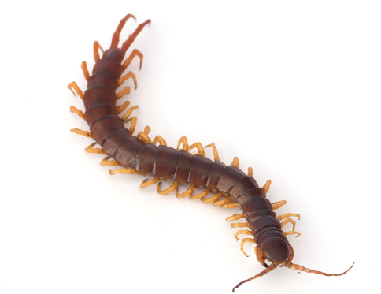  Lithobius forticatus (Garden centipede)  Class: Myriapoda | 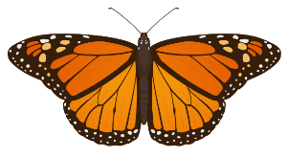  Danaus plexippus (Monarch butterfly)  Class: Insecta
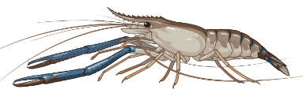Macrobrachium rosenbergii (Giant freshwater prawn).  Class: Crustacea | 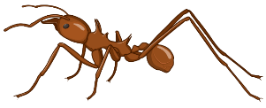  Atta cephalotes (leaf-cutter ant)  Class: Insecta
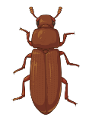  Tribolium cataneum (Red flour beetle)  Class: Insecta | 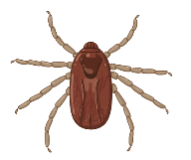  Rhipicephalus microplus (Cattle tick)  Class: Arachnida
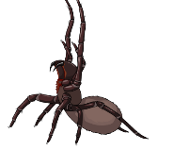  Hadronyche modesta (Australian funnel web)  Class: Arachnida | 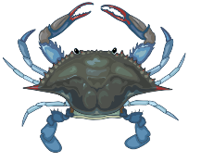  Callinectes sapidus (Blue crab)  Class: Crustacea

Student resource – classifying Arthropoda
The Arthropoda phylum can be divided into a number of classes. Arthropods are classified based on features such as body segments, the number of legs and the presence of antennae.
Table 1 – key features of various classes of Arthropoda
Feature | Insecta | Arachnida | Crustacea | Myriapoda
Body segments | 3 | 2 | 2 or more | many
Number of legs | 6 (3 pairs) | 8 (4 pairs) | 10 or more | 1 or 2 pairs per segment
Antennae | 1 pair | None | 2 pairs | 1 pair
Eyes | Compound and/or simple eyes | Simple eyes (usually) | Compound eyes | Simple eyes
Wings | Often have 1 or 2 pairs | No wings | No wings | No wings
Habitat | Mostly terrestrial | Mostly terrestrial | Mostly aquatic (some terrestrial) | Terrestrial
Examine the images and refer to Table 1 to determine to which class the organism belongs. Write the class under the name of each organism.
Lithobius forticatus (Garden centipede)  Class: ______________________________ | 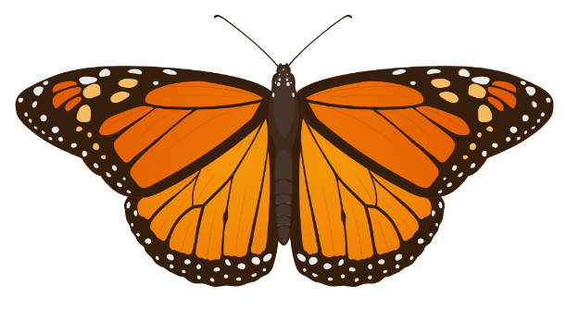  Danaus plexippus (Monarch butterfly)  Class: ______________________________
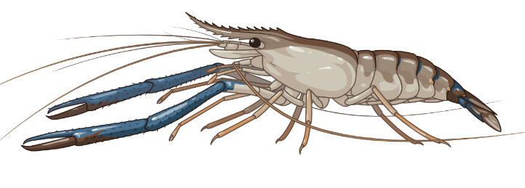  Macrobrachium rosenbergii (Giant freshwater prawn)  Class: ______________________________ | 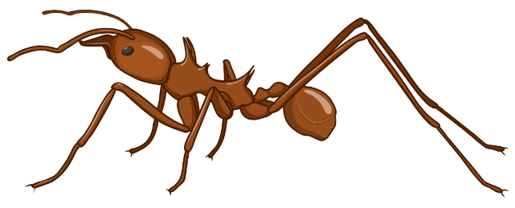  Atta cephalotes (leaf-cutter ant)  Class: ______________________________
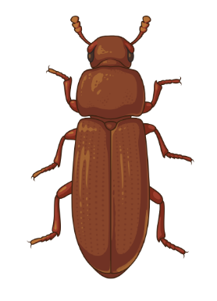  Tribolium cataneum (Red flour beetle)  Class: ______________________________ | 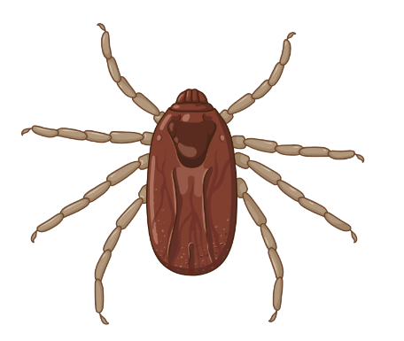  Rhipicephalus microplus (Cattle tick)  Class: ______________________________
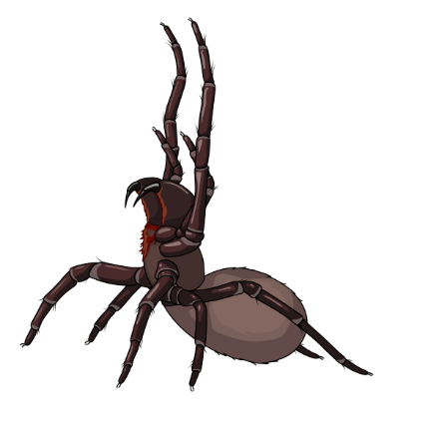  Hadronyche modesta (Australian funnel web)  Class: ______________________________ | 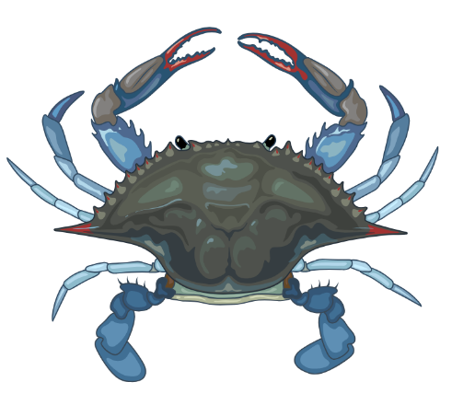  Callinectes sapidus (Blue crab)  Class: ______________________________
This work has been generated using BioRender.com. Any copyright subsisting in this work is owned by © State of New South Wales (Department of Education) 2025.

Species investigation
- Provide students with a copy of the Student resource – species investigation.
- Tell students that they will conduct a secondary-source investigation on the structural features of a chosen organism. They will then compare it to an organism in the same Genus and another organism in the same Family. Model what a good one looks like by showing the students CLS PPT ‘1.4 Species investigation’ slides which compare the American bison (Bison bison) with the European bison (Bison bonasus), which is in the same genus – Bison, and then the Bongo antelope (Tragelaphus eurycerus), which is in the same family – Bovidae.
Note: the aim of this species investigation is to consolidate students' understanding of how, as we move down the classification hierarchy (from kingdom to genus), organisms become more similar in their characteristics.
- Support students as they identify organisms to research and compare in this secondary source activity. Ensure that students have selected organisms from the same taxonomic family and that 2 of them are also in the same genus.

Student resource – species investigation
Follow the steps in this resource to research how organisms fit into their classification levels and to compare their structural features.
Remember to list all sources for this information in your bibliography, as provided in the table.
Step 1 – identify an organism
Common name | Binomial name | Why I chose this organism

Image of my chosen organism | Taxonomy
Kingdom:
Phylum:
Class:
Order:
Family:
Genus:
Species:

Step 2 – outline the structural features of your chosen organism
Table 1 – structural features of [insert name of organism]
Structural feature | Image

Step 3 – identify another organism in the same genus and compare its structural features by completing the Venn diagram
Figure 1 – Venn diagram template
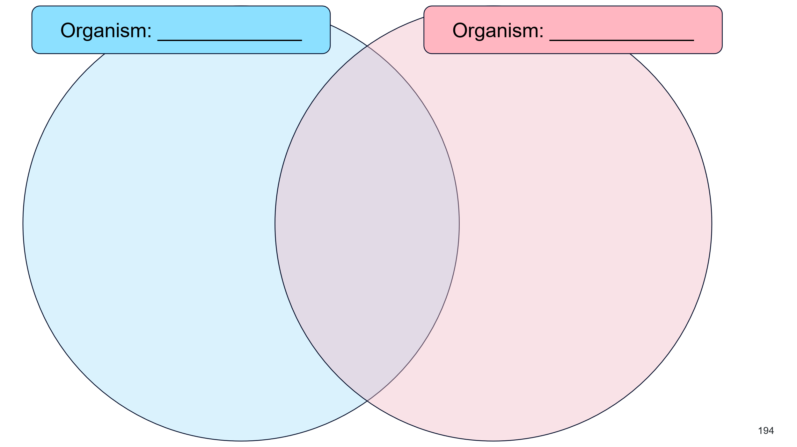
Step 4 – comparison within the family
Figure 2 – triple Venn diagram template
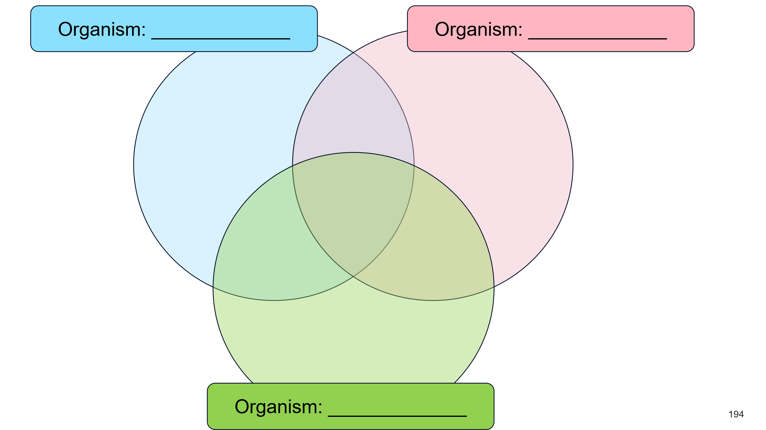

Bibliography
Table 2 – bibliography
Source name | Source location | Date accessed

1.5 Aboriginal and Torres Strait Islander People’s classification of plants and animals
Table 11 – learning intentions and success criteria for 1.5 Aboriginal and Torres Strait Islander People’s classification of plants and animals
We are learning: | I can:
- how the features and uses of living things can be used to classify organisms | - describe how Aboriginal peoples use observations to name organisms  - explain how Aboriginal knowledge was used to name animals based on their characteristics  - construct a Venn diagram that classifies plants into classification groups used by Aboriginal People, showing how some plants fit into multiple groups
- to make observations using our senses. | - make observations about an organism’s physical appearance, the sounds they make and their behaviours.
Aboriginal and Torres Strait Islander Histories and Cultures
When planning and programming content relating to Aboriginal and/or Torres Strait Islander histories and cultures, teachers are encouraged to:
- involve local Aboriginal communities and/or appropriate knowledge holders in determining suitable resources, or use Aboriginal and/or Torres Strait Islander-authored or endorsed publications
- read the principles and protocols relating to teaching and learning about Aboriginal and/or Torres Strait Islander histories and cultures and the involvement of local Aboriginal communities.
The Australian Institute of Aboriginal and Torres Strait Islander Studies (AIATSIS) Guide to evaluating and selecting education resources has been developed to assist teachers in selecting appropriate resources for teaching about Aboriginal and Torres Strait Islander histories, cultures, and languages respectfully and effectively.
Classification systems help people make sense of the living world by grouping organisms based on shared characteristics. Scientists often use systems based on structural features or genetic relationships, but these are not the only ways to classify living things. Aboriginal and Torres Strait Islander People have long used classification systems rooted in deep cultural knowledge, ecological roles and the uses of organisms for food, medicine and ceremony. No classification system is inherently superior to another; each is shaped by the knowledge, needs and values of the people who use it.

Aboriginal and Torres Strait Islander peoples’ naming of animals
- Recall that the aim of classification is to recognise and arrange living things systematically. Show CLS PPT ‘1.5 Different classification systems’ and use the speaker notes to discuss how different classification systems can be used for different purposes, and that no classification system is necessarily better than another.
- Inform students that when naming organisms, Aboriginal people often base names on their characteristics, such as appearance, vocalisations and behaviours.
- Use the provided examples in CLS PPT ‘1.5 Traditional naming of animals’ to demonstrate the Australian animals whose names are derived from Aboriginal languages and are inspired by their features. Emphasise to students that observable characteristics go beyond just physical appearance and include the way they sound and even taste.
- Biliby: the form bil-bi has been recorded in Yuwaalaraay, the language of central and northern New South Wales. It means ‘long-nosed rat’.
- Kookaburra: the word kookaburra comes from the Wiradjuri (Weir-rad-jury) people of central west New South Wales. Their word for kookaburra was guuguubarra (which sounds like the kookaburra’s call).
- Budgerigar: this name is thought to come from the Gamilarray (Ga-mill-a-ray) language of central and northern New South Wales. It was a mispronunciation of the word gidjirrigaa. It means ‘good eating’.
- Provide students with the Student resource – naming the Willie Wagtail. Show CLS PPT ‘1.5 The Willie Wagtail’ and play the video of the Willie Wagtail for students. Ask students to complete the observation table and questions in the Student resource – naming the Willie Wagtail.
Sample response: Student resource – naming the Willie Wagtail
- Make observations of the Willie Wagtail and record them in the table.
Table 12 – Willie Wagtail observations
How it looks | How it sounds | How it behaves
The Willie Wagtail is a small, black-and-white bird. It has a white belly and a black head and back. Its tail is long and fan-shaped. | It makes a sharp, chattering sound like ‘chit-chit-chit’. The sound is quick and repetitive, especially when the bird is in motion. | It flicks its tail from side to side while sitting.
- Where do you think the Willie Wagtail got its name?
The bird wags its tail from side to side repeatedly, which explains the name ‘wagtail’.
- Where do you think the Wiradjuri name Dyirridyirri comes from?
Dyirridyirri is an onomatopoeic term, mimicking the sound of the Willie Wagtail’s call.
Note: This linguistic connection highlights the deep observational relationship Aboriginal and Torres Strait Islander peoples have with country, where the distinctive characteristics and behaviours of wildlife often inspire names.

Student resource – naming the Willie Wagtail
The Willie Wagtail is a common bird found across most of Australia. The Wiradjuri (Weir-rad-jury) word for the willie wagtail is dyirridyirri (pronounced jee-ree jee-ree). In the Noongar language dialects of south-western Western Australia, the willie wagtail is known as the Djiti-Djiti (pronounced ‘chitti-chitti’).  Willie wagtail by Josve05a is licensed under CC BY 2.0 | 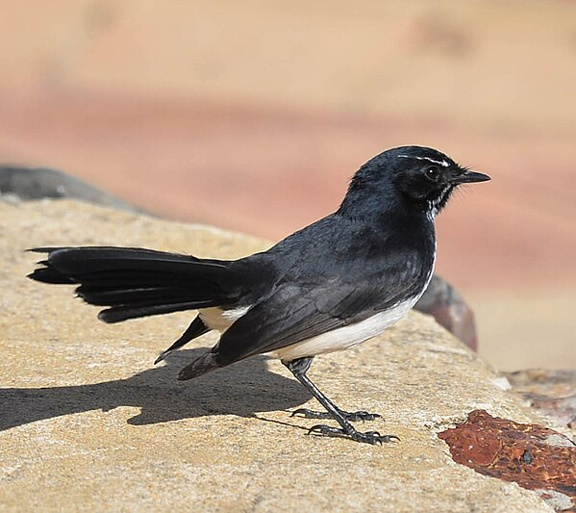
- Make observations of the Willie wagtail and record them in the table.
Table 1 – Willie Wagtail observations
How it looks | How it sounds | How it behaves
- Where do you think the Willie Wagtail got its name?
- Where do you think the Wiradjuri name Dyirridyirri comes from?

Aboriginal and Torres Strait Islander peoples’ classification of plants
- Inform students that Aboriginal and Torres Strait Islander People classify plants based on their traditional uses, such as food, medicine, tools and weapons. Many plants serve multiple purposes, reflecting a deep understanding of the natural environment.
- Using CLS PPT 1.5 Traditional classification of plants, model for students how to analyse the Dharug People’s use of the Galangara (Lily Pilly). Speaker notes are provided on the slide.
- Provide students with Student resource – plant use cards to complete the classification activity by identifying the plant, its uses and whether its uses relate to food, medicine, and/or tools and weapons.
- Students record their findings in the Student resource – Dhurug People’s classification of plants, also shown on the CLS PPT ‘1.5 Traditional classification of plants Venn diagram’.
- Facilitate class discussion to ensure students have correctly identified the uses of each of the plants.
Sample response: Student resource – Dhurug People’s classification of plants
Figure 2 – Sample Venn diagram
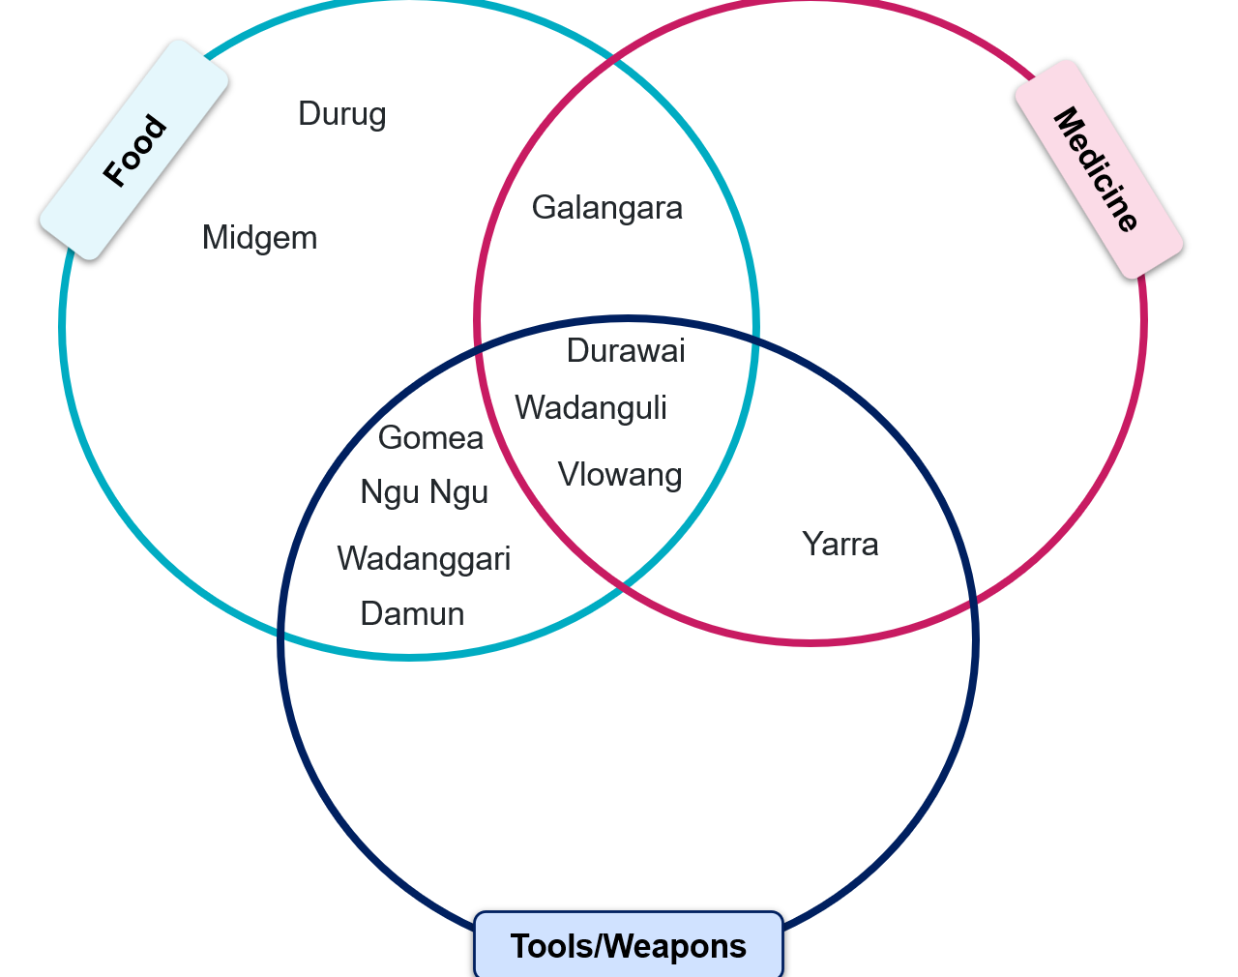

Student resource – plant use cards
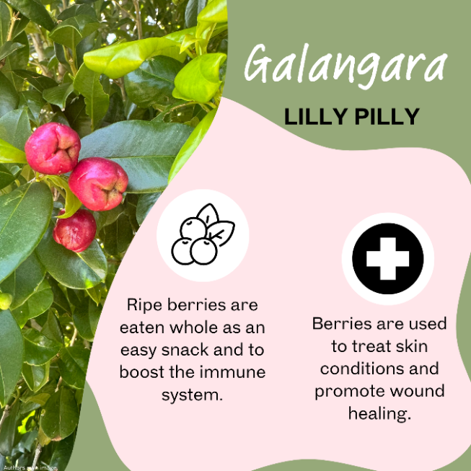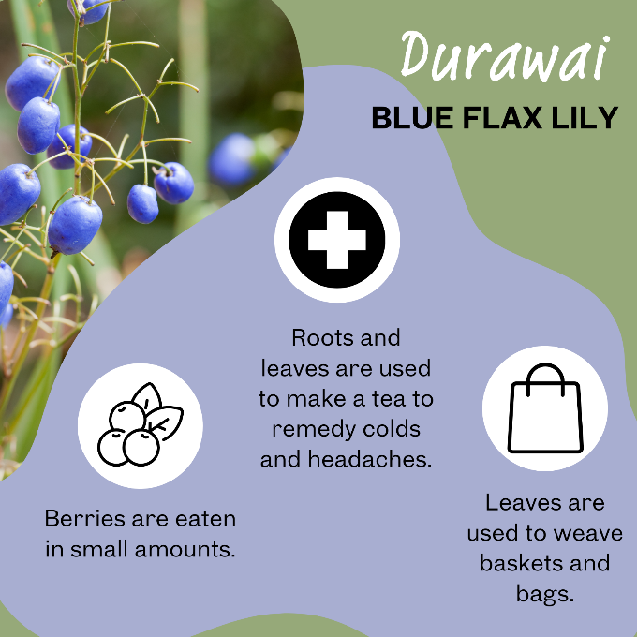
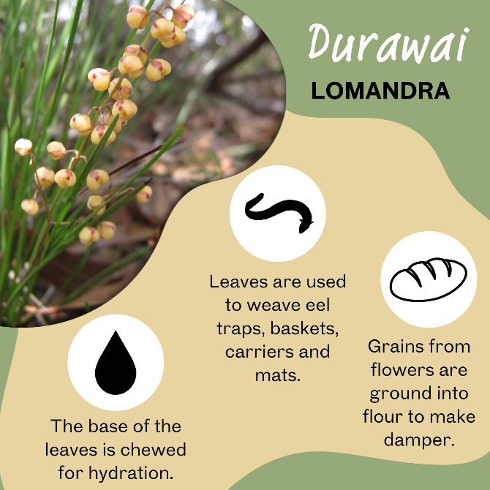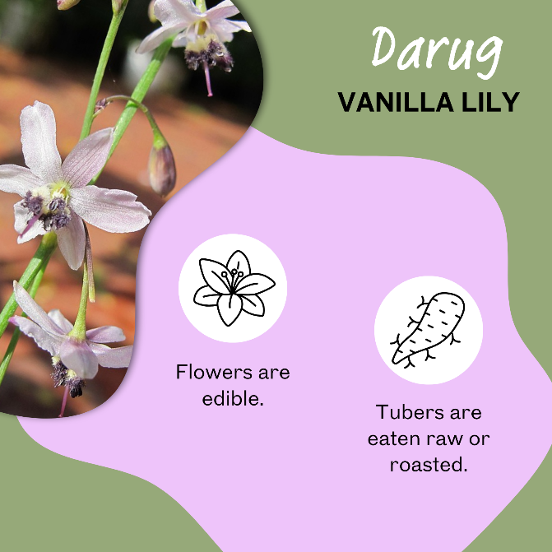
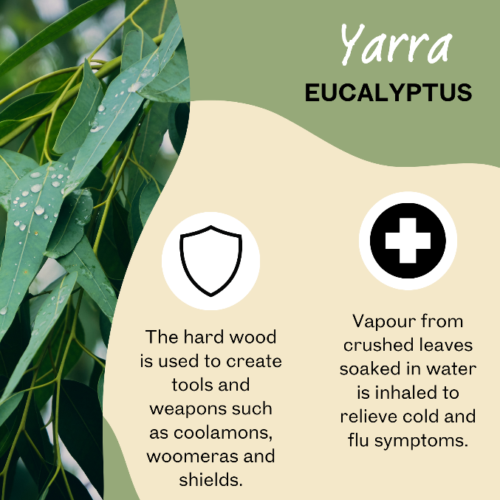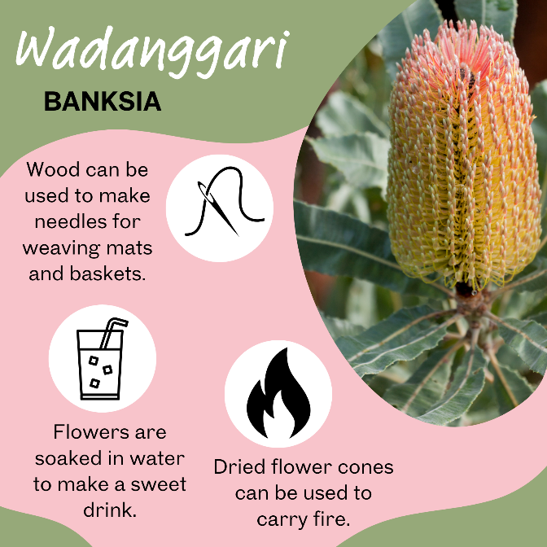
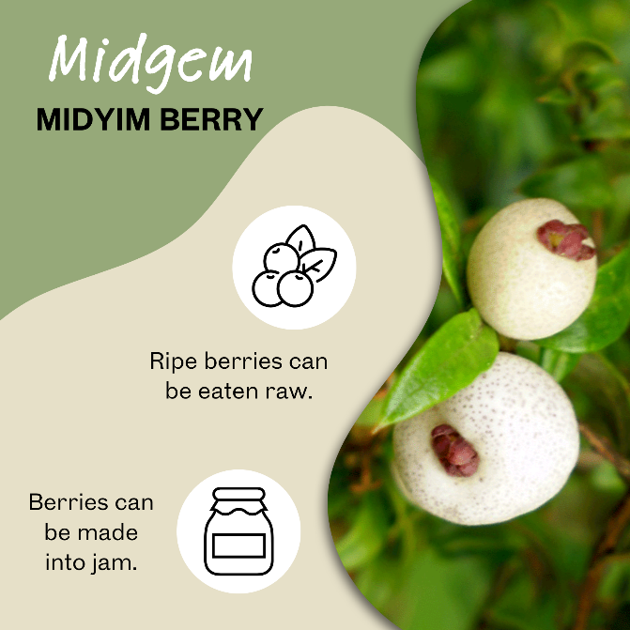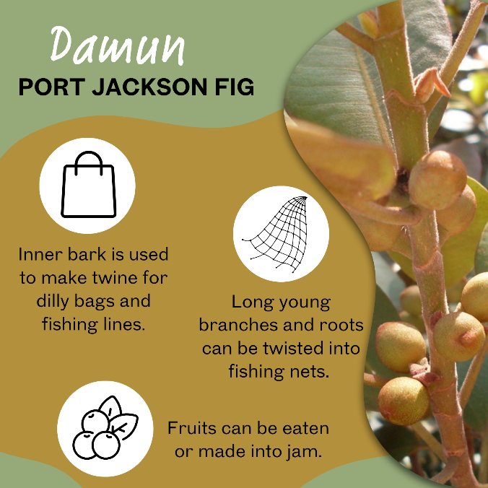
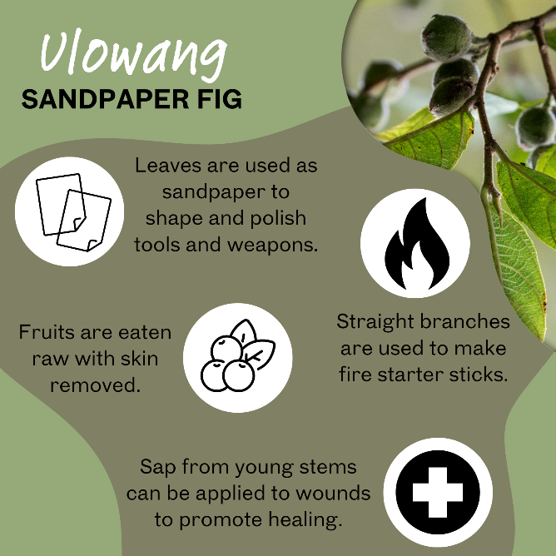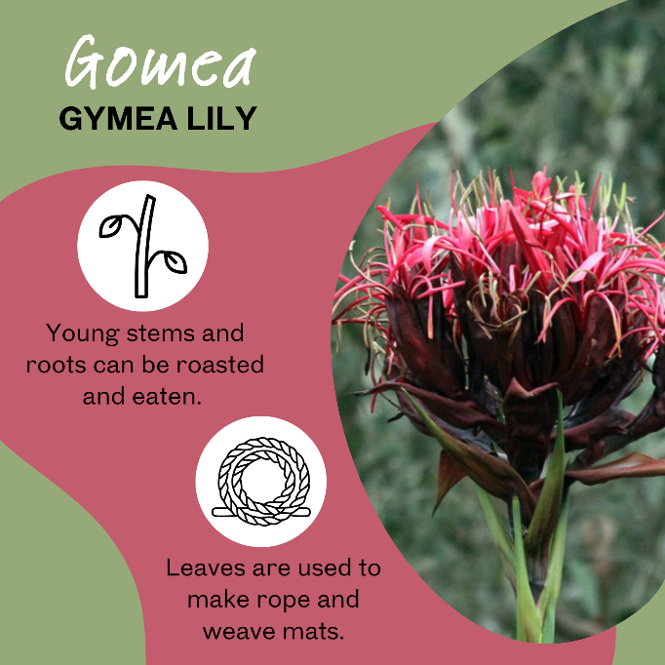
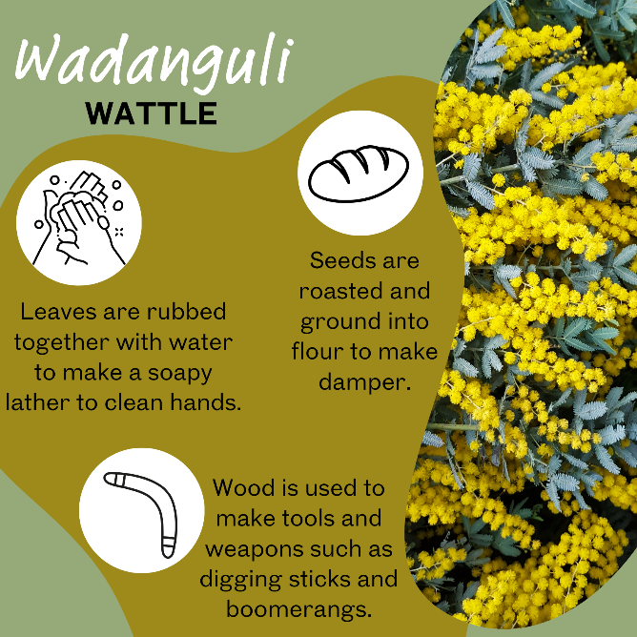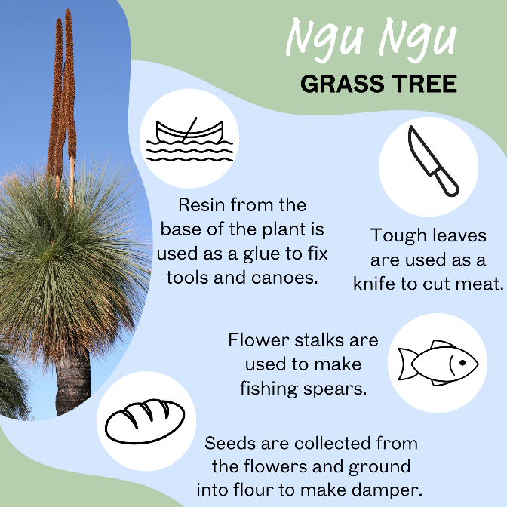

Student resource – Dhurug People’s classification of plants
The Dharug people developed a sophisticated system for classifying plants based on their practical uses. Rather than grouping plants by appearance or scientific traits, they categorised them according to their function in daily life. Some plants were known for their nutritional value and used as food sources. Others were valued for their healing properties and used as medicine to treat illness or injury. Certain plants were recognised for their strength or durability and were used to make tools, weapons, or shelters. This functional classification reflects a deep understanding of the environment and a close relationship with Country, passed down through generations via oral knowledge and cultural practices.  Read the plant use cards and classify them as food, medicine, tools or weapons. Some may sit in more than one category. | 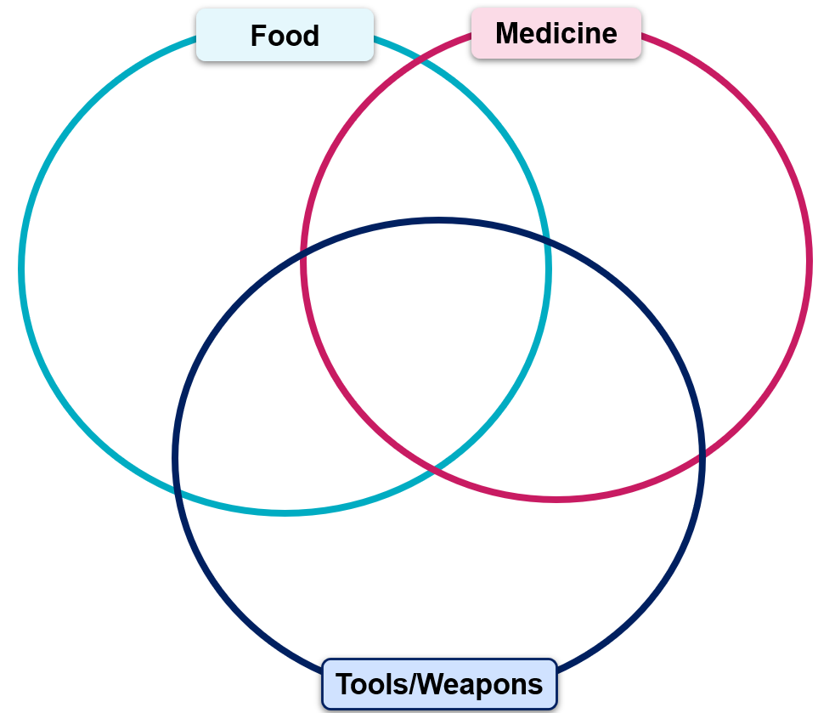

Aboriginal and Torres Strait Islander peoples’ ways of grouping living things
- As a class, engage with the Student resource – classification by Aboriginal and Torres Strait Islander peoples’ text (refer to the literal comprehension resource for more on skimming and scanning).
- Model identifying keywords with a highlighter and how to locate and interpret information by navigating the text.
- Explicitly teach students how to summarise information using the identified key points to respond to the written responses.
- As a class, employ the scanning method to highlight specific information and keywords in the text to answer questions. Emphasise that information needs to be summarised in the students’ own words, not copied word for word from the text, for the written responses.
- Support students with highlighting and extracting information from the text relevant to the questions. Ask students to complete the comprehension questions.
- Facilitate class discussion for the comprehension questions to ascertain student understanding. Sample responses have been provided.
Differentiation: to provide additional support for EAL/D learners with the comprehension of texts, refer to EAL/D learners and reading comprehension.
Sample response: Student resource – classification by Aboriginal and Torres Strait Islander peoples

- B
- C
- B
- B
- C
- B
- B
- B

- List 2 other ways Aboriginal and Torres Strait Islander People’s systems might group a plant or animal besides how it's used or its age.
Other factors include the stage in the life cycle, sex (gender), social status, totemic association, and the location where it lives (coastal or inland).
Note: any 2 of the responses may be awarded a mark.
- The text mentions that turtles, barramundi and dugongs are grouped together because they are aquatic and have fins or flippers. Why is this different from how science (Linnaean system) groups them?
It is different because their scientific grouping is based on biology (turtles are reptiles, barramundi are fish, and dugongs are mammals), unlike the criteria used by the Dharug people (these animals all live in water and swim).
- Give one example from the text that shows how detailed Aboriginal and Torres Strait Islander peoples’ classification can be.
One example is the Yanyuwa people's use of at least 16 different names for dugongs, depending on their age, size, gender, or status. (Or the Meriam people's use of different names for green turtles as they grow.)
- What sometimes happened when early European scientists ignored the knowledge of the Aboriginal and Torres Strait Islander peoples?
They sometimes made mistakes, such as thinking they had discovered a 'new' species that First Nations peoples already knew well, or had dangerous encounters because they lacked local knowledge about plants and animals.
- What is the main point of the last paragraph about studying different classification systems?
The main point is that studying different systems helps us understand that Aboriginal and Torres Strait Islander peoples have complex ways of classifying and that all classification systems reflect the knowledge and values of the people who created them.
Challenge questions
- Describe one way in which Aboriginal and Torres Strait Islander peoples’ ways of grouping living things differ from scientific biological classification.
Aboriginal and Torres Strait Islander peoples’ ways of classification often focus on practical aspects, such as how plants or animals are used, their role in culture, or their relationships. In contrast, the scientific way mainly focuses on how organisms are related through evolution.
- Why is it useful to know that there are different ways to classify and understand the natural world?
It is useful because it shows respect for different cultures and their knowledge. It helps us see many valid ways to understand the world, not just the scientific way, and teaches us about various people’s connection to nature.

Student resource – classification by Aboriginal and Torres Strait Islander peoples
Aboriginal and Torres Strait Islander peoples have different ways of classifying living things than the scientific system (also called the Linnaean system). They often include criteria like the organism’s use, age, life stage, sex, social status and totemic association. For example, they might classify plants and animals as edible, inedible, totemic or non-totemic. Like the scientific system, their classification systems can be hierarchical, grouping organisms at different levels.
Many living things are grouped based on their use. There is a wealth of knowledge about how living things can be used while alive, such as using fresh plant sap for medicinal purposes. Equally important is the knowledge of what once-living things can be used for, such as trees for making spears, strings, shields, canoes and resin. Sometimes, living things are grouped based on their form and function, not necessarily their relatedness. For example, some Aboriginal and Torres Strait Islander peoples' groups classify turtles, barramundi, and dugongs together because they are all aquatic and have fins or flippers, unlike the scientific system, which classifies them differently.
The classification systems of Aboriginal and Torres Strait Islander peoples can change depending on the context or usage. For example, the Yanyuwa people in the Northern Territory have 2 broad categories: coastal and marine, or inland. Animals and plants can be classified into these categories depending on the situation. The Yanyuwa language has a single term for all dugongs and sea turtles, but this category is broken down into at least 16 names to distinguish between dugongs based on age, size, gender and status. Similarly, the Meriam language of the Torres Strait has one word for a green turtle but different words for its various life stages.
These classifications highlight the significance of certain plants or animals to a specific cultural group. They reflect the deep knowledge of Aboriginal and Torres Strait Islander peoples regarding an organism’s lifecycle, interactions, relationships, cultural significance and uses, including as food, medicine, tools, clothing, or other resources.
The detailed knowledge of Aboriginal and Torres Strait Islander peoples about Australian native plants and animals has helped scientists use Western scientific classification systems. Early European naturalists often ignored this knowledge, sometimes leading to dangerous encounters. There are many examples of scientists thinking they discovered a new species, only to discover that Aboriginal and Torres Strait Islander peoples already had names and detailed understandings of these organisms.
When Europeans colonised Australia, they wanted to explore and classify the continent’s biota using the Western system. Many scientific expeditions relied on contributions from Aboriginal people. For example, an Aboriginal member of the 1872 'Northern Expedition' to southern Cape York Peninsula made possible the first inclusion of Bennett's tree kangaroo into the Linnaean taxonomy.
By learning about Aboriginal and Torres Strait Islander peoples’ classification systems, we gain a deeper appreciation of the diverse ways humans organise and understand the natural world. These systems are not only practical but are deeply embedded in cultural knowledge, values, relationships and ways of living. They highlight that classification is not a neutral or universal process, but one shaped by context, purpose, and worldview.
Note: adapted from First Nations Australians’ classification systems © Australian Curriculum, Assessment and Reporting Authority (ACARA) 2010 to present. Licensed under a Creative Commons Attribution 4.0 International (CC BY) licence (Creative Commons li
cence).
Part 1: choose the best answer
Circle the best answer for each question.
- Aboriginal and Torres Strait Islander Peoples’ ways of grouping living things often look at things like:
- how heavy the animal is
- how the organism is used, its age, or if it is special (totemic)
- only the colour of the plant or animal
- only its scientific Latin name
- What's a simple ‘2-group’ way of classifying mentioned in the text?
- tall plants and short plants
- animals that live on land or in water
- things that are edible (can be eaten) or inedible (cannot be eaten)
- animals with fur or feathers
- How are some Aboriginal and Torres Strait Islander peoples’ ways of grouping like the scientific way (Linnaean)?
- They both only group animals, not plants.
- They can both have big groups with smaller groups inside them (like folders).
- They both started in Australia.
- They both use the same names for everything.
- Why are trees sometimes called ‘spear trees’ or ‘canoe trees'?
- Because they look like spears or canoes.
- It's based on how the wood is used after the tree is no longer living.
- It's their scientific name.
- Because animals use them as homes.
- Why might some Aboriginal and Torres Strait Islander peoples’ put turtles, barramundi (a fish), and dugongs (a sea mammal) in the same group?
- Because they taste the same.
- Because they are all mammals.
- Because they all live in water and have fins or flippers.
- Because they are all reptiles.
- What does it mean if a classification can have ‘categorical shifts’?
- The groups never change.
- An animal or plant can sometimes move to a different group depending on the situation.
- Scientists change the groups every year.
- Only plants can shift groups, not animals.
- The very detailed ways Aboriginal and Torres Strait Islander peoples’ classify things (like having 16 names for dugongs) show they have:
- too many words
- a deep understanding of the organism's life, relationships and importance
- forgotten the scientific names
- only studied dugongs
- How did the knowledge of Aboriginal and Torres Strait Islander peoples’ help European scientists?
- It did not really help them.
- It was very helpful for finding and naming Australian plants and animals.
- It helped them build better ships.
- It taught them how to speak Aboriginal and Torres Strait Islander peoples’ languages.
Part 2: short answers
- List 2 other ways Aboriginal and Torres Strait Islander People’s systems might group a plant or animal besides how it's used or its age.
- The text mentions that turtles, barramundi and dugongs are grouped together because they are aquatic and have fins or flippers. Why is this different from how science (Linnaean system) groups them?
- Give one example from the text that shows how detailed Aboriginal and Torres Strait Islander peoples’ classification can be.
- What sometimes happened when early European scientists ignored the knowledge of the Aboriginal and Torres Strait Islander peoples?
- What is the main point of the last paragraph about studying different classification systems?
Challenge questions
- Describe one way in which Aboriginal and Torres Strait Islander peoples’ ways of grouping living things differ from the scientific way taught in schools.
- Why is it useful to know that there are different ways to classify and understand the natural world?

1.6 Dichotomous keys
Table 13 – learning intentions and success criteria for 1.6 Dichotomous keys
We are learning: | I can:
- to classify living things based on their structural features | - group things logically to allow efficient identification  - apply a ‘branching dichotomous key’ to identify organisms  - apply a ‘paired statement dichotomous key’ to identify organisms  - outline the distinguishing characteristics of mammals
- to make observations of living things | - identify observable features of an organism  - use observations to identify an organism using a key
- to extract information from secondary sources. | - identify observable features of organisms in a photograph  - extract information from texts about the features of organisms  - use a dichotomous key to identify organisms correctly.
Australia’s rich diversity of species can be identified using a dichotomous key, which poses thoughtful questions to highlight their differences. Meticulously collecting data about each animal and recognising the limitations of this data are important steps in using a dichotomous key effectively for correct identification. Many digital resources are available for identifying Australian organisms. For example:
- Birds in Backyards is useful for identifying the types of birds found in Australian ecosystems.
- South Australian reptile keys are useful for identifying a range of lizards and snakes.
- EUCLID Eucalypts of Australia is useful for identifying eucalypts.
- What shark is that? is a useful activity for identifying different types of sharks. This is a digital classroom resource rather than a field dichotomous key.
- Identification Guide to the Australian Odonata (PDF 8.7 MB) is a large dichotomous key that can be used to identify over 300 species of Odonata.

Classification using dichotomous keys
- Show CLS PPT ‘1.6 Classification using a key’, to define the term ‘dichotomous key’ and show students the 2 ways a dichotomous key can be represented using an example. This example illustrates how vertebrates can be categorised into 5 main groups: mammals, birds, amphibians, fish and reptiles.
- Complete the Sorting a deck of cards activity to teach students about using groupings to eliminate members of a population so that a quick identification can be made.
- Students learn to use the 2 types of dichotomous keys, a branching flowchart or a series of paired statements using:
- Classifying Australian invertebrates
- Classifying Pamishan aliens

Sorting a deck of cards
- Tell students this activity aims to develop the most efficient set of questions to classify the group of objects in the fewest turns. Consider the board game ‘Guess Who’. One strategy to identify the target character is to call out the names of all characters one at a time. This method is inefficient as it requires as many turns as there are people (3 rows of 8 people = 24 on the traditional game board). A better method would be to ask questions to eliminate half the characters on the board each time (for example, “Is your character a male?”). This strategy could enable the player to win in as few as 4 moves, compared to the first strategy, which potentially requires 23 moves. This is demonstrated in Figure 3.
Figure 3 – an example ‘guess who’ elimination flowchart

Note: Free Guess Who Template for Teachers and Printable Guess Who? Game Templates for the Classroom offers a range of templates to develop a series of alternative guessing games that can be used to practise the development of effective questioning techniques to sort objects.
- Provide students with the Student information – sorting a deck of cards and display CLS PPT ‘1.6 Sorting a deck of cards’. Students develop a sequence of questions to uncover the opposing player’s card.
- Ask students which questions improve their chances of winning quickly?
- Tell students the reduction of the possible cards in each step, represented as a percentage, and can be used to validate the effectiveness of the sorting question at each step. Demonstrate how to do this on the board before asking students to complete the table in the student resource for their set of questions.
Sample response: Student resource – sorting a deck of cards
Table 14 – question sequence for the card guessing game
Question | Start population | Included | Excluded | Percent excluded
Is your card a face card? This includes the Jack, Queen, and King of all suits while excluding all numerical cards. The 52 cards are divided into 12 face cards and 40 numerical cards. | 52 | 12 | 40 | $$\frac{40}{52}×100=77\%$$
Is your card a Diamond? This includes all numerals and face cards of that suit. The remaining 12 face cards consist of 3 Diamond face cards and 9 face cards from the other suits. | 12 | 3 | 9 | $$\frac{9}{12}×100=75\%$$
Is your card the Jack of Diamonds? This includes only the Jack of Diamonds and excludes the Queen and King of Diamonds. | 3 | 1 | 2 | $$\frac{2}{3}×100=67\%$$
Each step in this sequence reduced the population by over 50%, indicating a highly effective sequence of questions for the Jack of Diamonds card. Compare the percentage reduction in the population for a series of questions for different selected cards.
Note: Guiding the selection of sorting questions to ones that result in the population dividing into 2 groups will strengthen the connection of this learning to the subsequent sequence using dichotomous keys.

Student resource – sorting a deck of cards
Come up with a series of questions that you could use to identify your partner’s card. Each time you ask a question, record the size of the population before the question response, and then record the number of cards remaining and the number of cards you were able to exclude. To calculate the percentage of the population excluded, use the formula:
$$\%=\frac{Excluded}{Start population} x 100$$
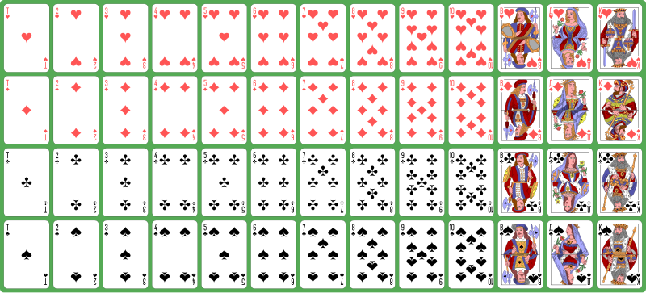
Atlasnye playing cards deck by Dmitry Fomin, licenced under CC0
Table 1 – sorting questions used for playing cards
Question | Start population | Remaining population | Excluded | Percent excluded

Classifying Australian invertebrates
- Provide students with a copy of the Australian Museum’s Leaf litter dichotomous key. This is a branching dichotomous key that requires students to identify features of the organism and trace the characteristics through the branches to identify the type of invertebrate.
- Recall that invertebrates are animals that lack a backbone; in fact, they do not have any bones. Tell students that invertebrates make up more than 95% of all known animal species. Recall that Arthropoda is a large phylum of invertebrate animals that includes insects, spiders, crustaceans and their relatives. Arthropods are characterised by having a hard exoskeleton and jointed appendages. (Students learnt this in 1.4 Classifying Arthropoda).
- Show CLS PPT ‘1.6 Australian invertebrates’ (8 slides). Students look at the features of each organism and use the key to classify the type of invertebrate. Speaker notes are provided on each slide to facilitate the identification of each organism.

Classifying Pamishan aliens
- Show CLS PPT ‘1.6 Pamishan aliens’. Tell students that this group of fictitious alien species is depicted using a range of structural features that can be used to classify them, such as antennae, head shape, hair, number of eyes, mouth shape, body shape, and body markings.
- Provide students with a copy of the Student resource – Pamishan alien classification. Students observe each alien and use a dichotomous key to determine the genus and species of the aliens. Students then respond to questions that can be used to check students’ understanding of binomial naming and how dichotomous keys can be used to identify organisms.
Sample response: Student resource – Pamishan alien classification
Table 15 – solutions to the Pamishan alien activity
Alien number | Name
1 | Narrowus portus
2 | Broadus archus
3 | Narrowus plainus
4 | Broadus hairyemmus
5 | Broadus hairus
6 | Broadus anderson
7 | Narrowus montanian
8 | Narrowus georginia
9 | Narrowus blankus
10 | Broadus emmus
11 | Narrowus cyclops
12 | Broadus hairystarus
13 | Narrowus beardus
14 | Broadus walter
15 | Broadus plainus
16 | Broadus kiferus
17 | Narrowus starboardus
18 | Broadus tritops
19 | Narrowus wolfus
20 | Narrowus fuzzus
Questions
- How many species of Pamishan aliens were identified in this activity? 20
- How many different genera (plural of genus) of Pamishan aliens are there? How do you know?
There are 2 genera of Pamishan aliens. The aliens are named using the binomial system, which consists of the genus and species. For example, Broadus (genus) hairus (species).
- What is the key distinction between the 2 genera of Pamishan aliens?
The key distinguishing characteristic of the 2 genera is the size of the heads. The wider head is classified into the Broadus genus, and the narrower heads are classified into the Narrowus genus.

Student resource – Pamishan alien classification
Scientists have discovered several new creatures on the planet Pamishan. They need your help to identify and classify them. Use the dichotomous key to identify each organism in Table 1.
A key to Pamishan aliens
1. a. The creature has a large wide head............................................go to 2
b. The creature has a small narrow head........................................go to 11
2. a. It has 3 eyes ...............................................................................go to 3
b. It has 2 eyes ...............................................................................go to 7
3. a. There is a star in the middle of its chest......................................go to 4
b. There is no star in the middle of its chest ...................................go to 6
4. a. The creature has hair spikes ......................................................Broadus hairus
b. The creature has no hair spikes..................................................go to 5
5. a. The bottom of the creature is arch‐shaped ................................Broadus archus
b. The bottom of the creature is M‐shaped ....................................Broadus emmus
6. a. The creature has an arch‐shaped bottom ..................................Broadus plainus
b. The creature has an M‐shaped bottom.......................................Broadus tritops
7. a. The creature has hairy spikes ....................................................go to 8
b. The creature has no spikes.........................................................go to 10
8. a. There is a star in the middle of its body .....................................Broadus hairystarus
b. There is no star in the middle of its body .......................................go to 9
9. a. The creature has an arch-shaped bottom ..................................Broadus hairyemmus
b. The creature has an M-shaped bottom…………………………..Broadus kiferus
10. a. The body is symmetrical ............................................................Broadus walter
b. The body is not symmetrical.......................................................Broadus anderson
11. a. The creature has no antennae ...................................................go to 12
b. The creature has antennae ........................................................go to 14
12. a. There are spikes on the face ......................................................Narrowus wolfus
b. There are no spikes on the face .................................................go to 13
13. a. The creature has no spike anywhere .......................................Narrowus blankus
b. There are spikes on the right leg .............................................Narrowus starboardus
14. a. The creature has 2 eyes...........................................................go to 15
b. The creature has 1 eye.............................................................Narrowus cyclops
15. a. The creature has a mouth.........................................................go to 16
b. The creature has no mouth.......................................................go to 17
16. a. There are spikes on the left leg ...............................................Narrowus portus
b. There are no spikes at all ........................................................Narrowus plainus
17. a. The creature has spikes ..........................................................go to 18
b. The creature has no spikes .....................................................Narrowus georginia
18. a. There are spikes on the head ..................................................go to 19
b. There are spikes on the right leg..............................................Narrowus montanian
19. a. There are spikes covering the face .........................................Narrowus beardus
b. There are spikes only on the outside edge of head ................Narrowus fuzzus
Taxonomy, Classification, and Dichotomous Keys by Biology Corner CC BY-NC-SA 4.0
Questions
Complete these questions after you have identified each of the Pamishan aliens in Table 1.
- How many species of Pamishan aliens were identified in this activity? ____________
- How many different genera of Pamishan aliens are there? How do you know?
- What is the key distinction between the 2 genera of Pamishan aliens?

Table 1 – identification of the Pamishan name
Alien | Name |  | Alien | Name |  | Alien | Name |  | Alien | Name
1 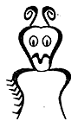 |  |  | 6. |  |  | 11.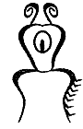 |  |  | 16. 
2 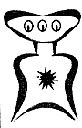 |  |  | 7. 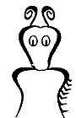 |  |  | 12.  |  |  | 17. 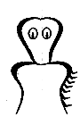
3 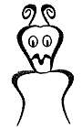 |  |  | 8. |  |  | 13. 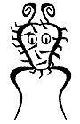 |  |  | 18. 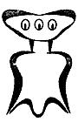
4 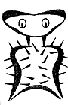 |  |  | 9.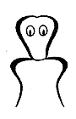 |  |  | 14. 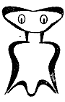 |  |  | 19. 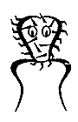
5 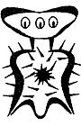 |  |  | 10.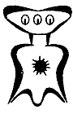 |  |  | 15. 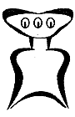 |  |  | 20. 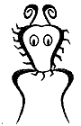
Adapted from Taxonomy, Classification, and Dichotomous Keys by Biology Corner CC BY-NC-SA 4.0

Classifying terrestrial mammals
- Tell students that all animals in the Mammalia class have some common features that allow them to be grouped together. Mammals:
- are vertebrates
- are warm-blooded
- have hair or fur
- secrete milk for the nourishment of young (females)
- typically give birth to live young, except monotremes such as echidnas and the platypus, which lay soft leathery eggs.
- Provide students with a copy of the Student resource – classifying terrestrial mammals.
- Students observe the photographs and read information about a range of terrestrial mammals from the Southwest Slopes and Upper Murray regions of New South Wales. Students then use the dichotomous key to identify the organism's common name.
- Show CLS PPT ‘1.6 Classifying terrestrial mammals’ (multiple slides) to go through each organism and unpack the correct identification of each organism. The scientific name of each organism is provided on the slide for students to note down.
Differentiation: The CLS PPT ‘1.6 Classifying terrestrial mammals’ slides can be used to step students through the identification of each organism using the key.
Note: The dichotomous key allows for the identification of more animals than those outlined in the CLS PPT and the student resource. Additional animals could be added.
Differentiation: Challenge students to identify the distinguishing features of a range of local species selected from the Atlas of Living Australia Explore Your Area. Develop a dichotomous key to distinguish between organisms in your local area.

Student resource – classifying terrestrial mammals
In this activity, you will identify the common name and scientific name of a range of terrestrial mammals that are found in the Southwest Slopes and Upper Murray region of New South Wales.  Use the dichotomous key to identify terrestrial mammals. Observe key external features in photos such as body size, tail shape, fur colour, and special adaptations like gliding membranes or claws. | 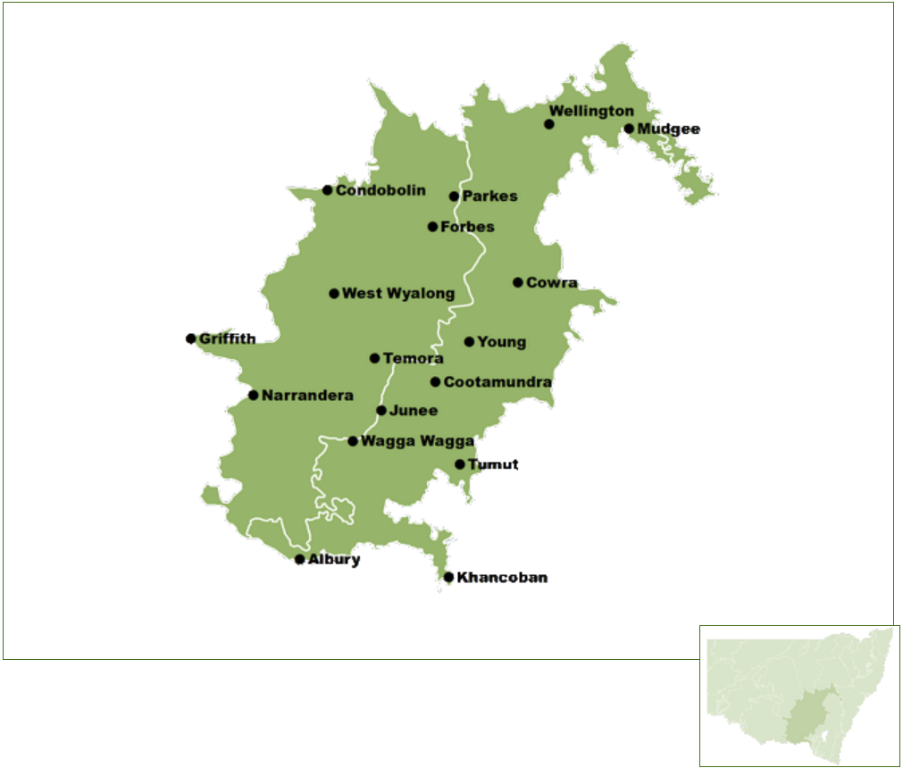  Source: State of New South Wales (Department of Climate Change, Energy, the Environment and Water)
Dichotomous key for identifying terrestrial mammals in the South West Slopes and Upper Murray regions of New South Wales
1a. Animal has a gliding membrane between limbs (look for a skin flap)……………………… go to 2
1b. No gliding membrane……………………………………………………………………………. go to 6
2a. Animal is mouse-sized with a flat, feather-like tail……………………….……...Feathertail Glider
2b. Animal is larger than mouse-sized, tail not feather-like……………………………………….go to 3
3a. Body is pale grey with black stripe from nose to mid-back; about 30 cm long……. Sugar Glider
3b. No mid-back stripe or glider is larger……………………………………………………………go to 4
4a. Large glider, fluffy tail, creamy to orange underside; known for V-shaped tree scars…………………………………………………………………………………Yellow-bellied Glider
4b. Smaller or similarly sized, not orange underneath……………………………………………go to 5
5a. Large ears, fluffy grey or mottled body, whitish underside, glides up to 100 m….Greater Glider
5b. Blue-grey to brown-grey with black-tipped bushy tail; dark facial stripe……..…. Squirrel Glider
6a. Animal has sharp claws, short legs, and a stocky body………………………………………go to 7
6b. Animal has long hind legs and a long tail used for hopping………………………………...go to 10
7a. Animal has spines/quills on back……………………………………………………….…….Echidna
7b. No spines…………………………………………………………………………………………..go to 8
8a. Tail bushy like a bottlebrush, grey fur above and pale below…………Brush-tailed Phascogale
8b. Tail not bushy or bottlebrush-shaped………………………………………………………….. go to 9
9a. Thick grey fur, white underbelly, white-tipped prehensile tail, 2 thumbs per front foot …………………………………………………………………………………..………….Ringtail Possum
9b. Larger possum with pointed ears and black band across snout; bushy tail with hairless patch ……………………………………………………………………………………….….. Brushtail Possum
10a. Animal very large (up to 2 m tall), soft grey coat, muscular ……..……Eastern Grey Kangaroo
10b. Smaller than 2 m ……………………………………………………………………………... go to 11
11a. Reddish tinge on back and shoulders, white cheek markings ……..…….Red-necked Wallaby
11b. Black face, reddish-orange belly, coarse dark fur ………………..……………..Swamp Wallaby
12a. Animal is cat-sized, grey-brown with a long snout and hunched posture ………………………………………………………………………………...……Long-nosed Bandicoot
12b. Animal is cat-sized with spotted fur ………………………………………….Spotted-tailed Quoll
Terrestrial mammals for identification
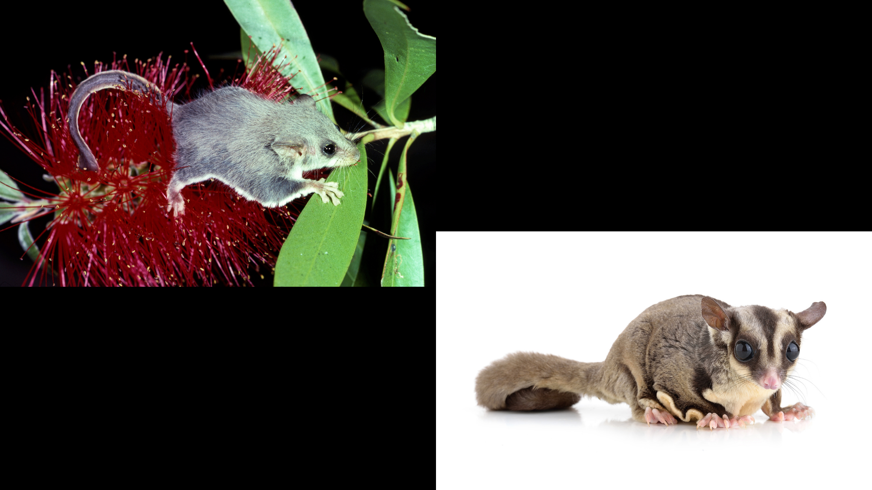 | Common name: _____________________  Scientific name: _____________________  Characteristics: This organism is the smallest gliding marsupial known to exist in the world. It has a grey/brown back and white belly. It lives in trees. It measures approximately 8 cm in length and features a unique tail that resembles a feather, which it uses as a rudder during gliding.
Common name: _____________________
Scientific name: _____________________
Characteristics: This organism has a greyish brown coat with a paler cream or white belly. It has darker brown to black markings around the eyes and the centre of the head and down its back. It has prominent gliding membranes between its forearms and hind legs. It lives in trees.
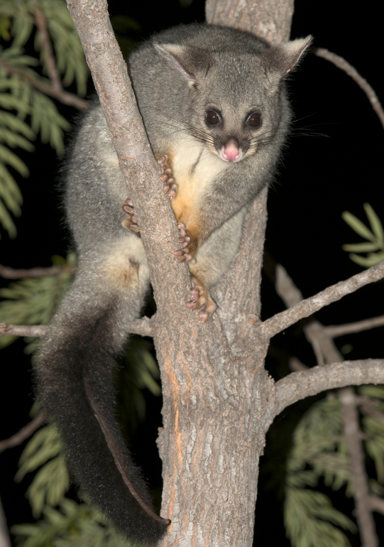 | Common name: _____________________  Scientific name: _____________________  Characteristics: This organism is larger than other possums. It has a bushy tail with a prehensile tip. It has grey fur with a dark band across its nose and a darker tail. It has sharp claws. Its belly ranges from white to yellowish brown.
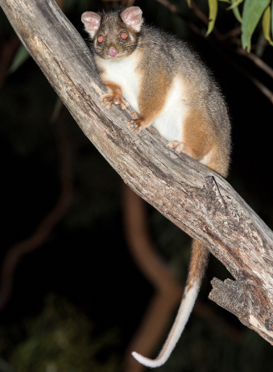 | Common name: _____________________  Scientific name: _____________________  Characteristics: This organism inhabits trees, rarely leaving them, and is approximately the size of a cat. It has a long, white-tipped, prehensile tail (capable of grasping). Its fur is grey-brown and it has a white belly.
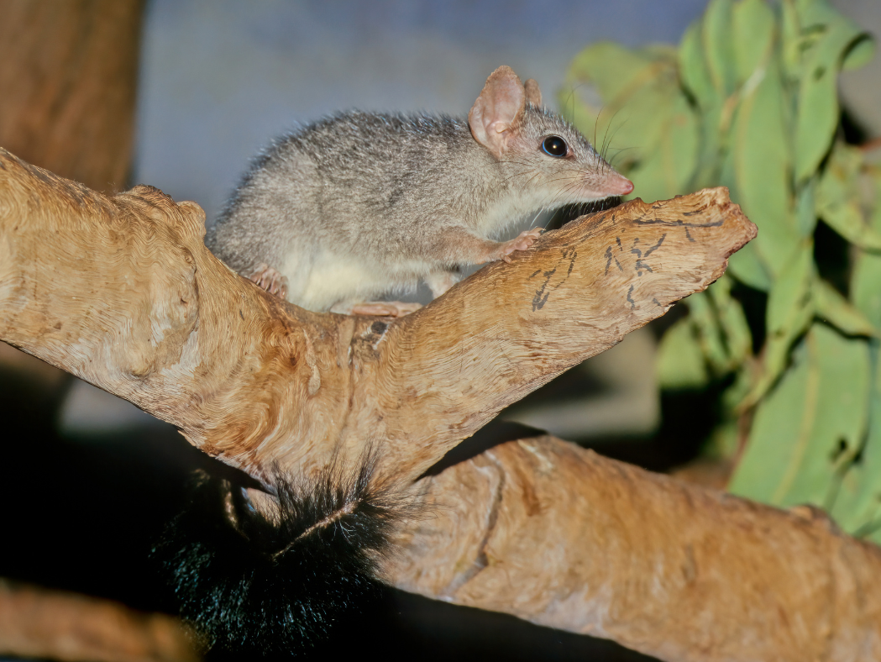 | Common name: _____________________  Scientific name: _____________________  Characteristics: This organism is a carnivorous marsupial. It has a body length of approximately 20 cm, with a characteristic black, bushy tail that resembles a bottle brush. It has grey to dark grey fur with a paler belly. It has an elongated snout. It has sharp teeth for biting and cutting.

1.7 Adaptations in Australian organisms
Table 16 – learning intentions and success criteria for 1.7 Adaptations in Australian organisms
We are learning: | I can:
- to describe how organisms in an Australian habitat are adapted to their environment | - define the terms adaptation, structural adaptation and behavioural adaptation  - identify structural and behavioural adaptations of organisms in an Australian habitat  - relate the structural and behavioural adaptations of the organisms to their survival in their environment
- to undertake a secondary source investigation | - identify and use reliable secondary sources to collect information about adaptations of organisms  - use an appropriate referencing technique to acknowledge sources
- to communicate scientific ideas in a scientific information report. | - write a scientific information report using relevant scientific terms  - use subheadings to structure a scientific information report  - write a scientific report suitable for the target audience and purpose  - use quality criteria to assess a scientific information report and provide feedback to a peer.
Note: This activity is broken into four parts:
- Part 1: Students learn about adaptations
- Part 2: Students learn how to collect appropriate scientific information about the Waratah. Students also learn how to acknowledge their sources of information.
- Part 3: Students are given a report on the Waratah and asked to annotate how the report meets the quality criteria for a good report.
- Part 4: Students are given information that was extracted from secondary sources, and they construct a report on the Bare-nosed wombat.
The learning in these 4 activities prepares students for the assessment task provided for the Cells and classification focus area.

Part 1 – defining adaptations
- Show CLS PPT ‘1.7 Defining key terms’ to define ‘adaptation’, ‘structural adaptation’ and ‘behavioural adaptation’.
- Facilitate class discussion to recall some Australian organisms and their features. For example, the blue-tongued lizard has a broad, triangular head and a blue tongue. It has small legs and silvery-grey to brown scales with dark stripes on its body and tail.
- Show CLS PPT ‘1.7 Australian animals’ and complete a Think-Pair-Share to answer the following question: What features or behaviours do you think help these animals survive in their environment? Facilitate class discussion for the share component of the Think-Pair-Share. Sample responses are provided in the slide notes and can be used to help drive the discussion. Inform students that the features observed in those Australian animals are structural adaptations, and the behaviours discussed are behavioural adaptations that enable the organism to survive in its environment. Explain that plants also have adaptations to help them survive in their environment.
Differentiation: Physiological adaptations have not been addressed in the learning in this unit. Exploring physiological adaptations will provide students with an extensive array of more complex adaptations. Examples include venomous animals producing poisons to catch their prey or defend themselves, and plants with water storage systems to survive in hot, dry climates.

Part 2 – learning how to conduct secondary-source research
Note: Students will need access to a computer or laptop to complete the activity. It is recommended that the Student resource – conducting secondary-source research be shared with students on a digital platform, such as Microsoft Teams or Google Classroom, to facilitate collaboration among students.
- Tell students that they will be researching the waratah, Telopea speciosissima and deconstructing a scientific report about its classification and adaptations.
- Show students CLS PPT '1.7 Telopea speciosissima’ to familiarise students with the waratah.
- Read through ‘Tips for conducting secondary-source research’ in the Student resource – conducting secondary-source research. Model how to conduct research online using keywords and phrases in a search engine search bar.
- Inform students that not all the sources in a search will be reliable. Use the information in the CLS PPT ‘1.7 Definition and criteria for secondary source reliability’ to define reliability for students. Teach students what it means for a secondary source to be reliable using the Student resource – Is the secondary source reliable?
- Teach students to determine if a secondary source is reliable by reading the Telopea speciosissima webpage as a class and then completing the questions in the Student resource – Is the secondary source reliable?. A sample response is included below (see Sample response – Is the secondary source reliable, accurate and valid?). CLS PPT ‘1.7 Criteria for secondary source reliability’ provides a modified checklist for students when they no longer require the scaffold.
Conducting research online provides more tips on using keywords to find specific information. This can be shared with students.
- Outline what students need to research using the Student resource – about the waratah. Inform students that they need the title of the webpage, the author, the year it was published, and the URL to reference it. This can be recorded in the relevant tables in the student resource.
- Students work in groups of 3 to conduct a secondary-source investigation to complete the Student resource – about the waratah. Remind students that information should be summarised in their own words and not copied directly from source texts. Depending on the capability of the class, you may need to model or jointly construct how to research, extract and summarise key points to complete the student resource.
Note: Students will allocate an ‘adaptation’ to each group member. Each group will describe a total of three adaptations for the organism, one per group member.
- Facilitate a class discussion about the completed Student resource – about the waratah. A sample student response has been provided for this activity (see sample response in Student resource – about the waratah).
Sample response – Is the secondary source reliable, accurate and valid?
- What is the question/problem/idea that you are addressing?
Binomial (scientific) name of the waratah.
Table 17 – sample student responses for assessing the reliability of secondary sources
Question | Answer (Yes/No/Cannot be determined) | Evidence to support
Do the authors of the source possess appropriate scientific backgrounds? What are their qualifications? | Yes | The page credits M.D. Crisp and P.H. Weston (1995) as authors, with editing by K.L. Wilson in October 2007. These individuals are affiliated with the National Herbarium of New South Wales, demonstrating their expertise in botany.
Is the source published on a credible medium? | Yes | The information is hosted on PlantNET, a website managed by the Botanic Gardens of Sydney, a reputable institution in botanical research.
Is the information current? (Consider the topic investigated and research conducted in the field) | Yes | Although the main text dates back to 1995, it was revised in 2007. Botanical descriptions often remain accurate over extended periods, and the page is part of an actively maintained database.
Is the information consistent with at least 2 other reliable sources? | Yes | The information on this website aligns with information from the Australian National Botanic Gardens and Australian Plants Society NSW, both reputable and reliable sources on Australian flora.
Conclusion |  | The source is:  R reliable  ☐ not reliable

Sample response: Student resource – about the waratah
Naming the organism
Write the common name and binomial name for Telopea speciosissima.
Common name: | Waratah
Scientific name: | Telopea speciosissima
Indicate the source(s) used to gather information about the name of your organism.
Table 18 – sources of information for naming the organism sample response
Title | Author | Year published | URL
Telopea speciosissima (Sm.) R.Br. | PlantNET | n.d. | https://plantnet.rbgsyd.nsw.gov.au/cgi-bin/NSWfl.pl?page=nswfl&name=Telopea~speciosissima&lvl=sp
Classification
Table 19 – classification of the waratah sample response
Taxon | Your organism | What are the features of this organism that make it fit into this taxonomic classification level?
Kingdom | Plantae | It is a plant because it is composed of more than one cell and undertakes photosynthesis.
Phylum | Angiosperms | It is an angiosperm because it produces flowers with both male and female reproductive organs and has seeds enclosed within a fruit. These are typical characteristics of angiosperms (flowering plants).
Class | Eudicots | It belongs to eudicots because it has 2 seed leaves at germination, flower parts in multiples of four or five, broad leaves with net-like veins, and seeds that split into 2 parts.
Order | Myrtales | This plant belongs to the Myrtales order due to its characteristic woody structure and leaves that have translucent dots.
Family | Proteaceae | It belongs to the Proteaceae family and is known for its large, often colourful flowers, which are important for attracting pollinators such as birds and insects. It also has leathery, green leaves.
Genus | Telopea | The genus Telopea is known for its large, striking red or pink flowers that appear in clusters and are a characteristic feature of the species within this genus, including T. speciosissima.
Species | Telopea speciosissima | This species is specifically known for its large, red flowers, making it one of the most iconic Australian native plants, particularly in coastal and inland New South Wales.
Indicate the sources used to gather the information on the classification of your organism.
Table 20 – sources of information for the classification sample response
Title | Author | Year published | URL
Telopea speciosissima | Jen Taylor | 2011 | https://www.anbg.gov.au/gnp/interns-2011/telopea-speciosissima.html
Waratah | NSW National Parks and Wildlife Service | 2025 | https://www.nationalparks.nsw.gov.au/plants-and-animals/waratah
Family Myrtaceae | Peter Wilson | 2020 | https://plantnet.rbgsyd.nsw.gov.au/cgi-bin/NSWfl.pl?page=nswfl&lvl=fm&name=MYRTACEAE
Characteristics of living things
Table 21 – characteristics that make the organism a living thing: sample response
Living things can: | How does your organism embody this characteristic?
move | The Waratah exhibits phototropism, which means it grows towards light sources.
respire | Waratah carries out cellular respiration, converting sugars (produced in photosynthesis) and oxygen to energy.
sense | Although it lacks sensory organs, it detects light. This is evident in its ability to exhibit phototropism, through which it grows towards the light to maximise photosynthesis.
grow | The plant grows into a shrub or small tree, typically reaching a height of 1.5 to 4 meters. This vertical growth allows it to access sunlight more effectively in its open habitat.
reproduce | It produces large, vibrant flowers in clusters that are mainly red. These flowers attract pollinators, especially birds, ensuring successful pollination and seed set.
eliminate waste | It eliminates waste products, such as excess water and oxygen, primarily through its leaves. Additionally, the plant releases carbon dioxide, a byproduct of cellular respiration.
obtain nutrients | The plant obtains nutrients from the soil through its root system.
Indicate the sources of this information used to explain how your organism embodies all the characteristics of living things.
Table 22 – sources of information for characteristics of living things: sample response
Title | Author | Year published | URL
Telopea speciosissima | Jen Taylor | 2011 | https://www.anbg.gov.au/gnp/interns-2011/telopea-speciosissima.html
Waratah | NSW National Parks and Wildlife Service | 2024 | https://www.nationalparks.nsw.gov.au/plants-and-animals/waratah
Waratah Flower Facts And Care Guide | Jamie Donovan | 2021 | https://lawn.com.au/waratah-flower/
Habitat
Habitat image | Description of habitat
Figure 1 – the waratah plant in its habitat  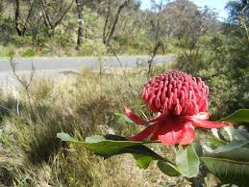  Waratah near Bunjaree Cottages by Stilgherrian, licensed under CC BY 4.0 | Telopea speciosissima is native to the coastal regions of New South Wales, especially in open grasslands (areas with minimal tall trees) and woodland areas (landscapes with spaced-out trees that allow plenty of sunlight and open space). It grows in soils composed of sand and clay and is typically found in areas that receive ample sunlight. The plant prefers environments that are not waterlogged and is commonly found in sandy or gravelly soils. Waratahs are adapted to survive in regions with regular rainfall and moderate temperatures.
The sources used to gather this information are below.
Table 23 – sources of information for habitat sample response
Title | Author | Year published | URL
Waratah | NSW National Parks and Wildlife Service | 2024 | https://www.nationalparks.nsw.gov.au/plants-and-animals/waratah
Waratah Facts | Interflora | n.d | https://www.interflora.com.au/blog/waratah-facts
Adaptations
Describe adaptations that the organism has that make it suited to its environment.
- Bright red flowers to attract pollinators for reproduction
- Robust root system that allows it to resprout after bushfires.
- The waratah has leathery, waxy leaves to help prevent water loss.
In the spaces below, each student should outline the information about their chosen adaptation. Each student must record their sources of information in the relevant table as well.
Adaptation 1 – student 1
Who will do the research for this adaptation? | Alexander
Describe the adaptation. | The waratah produces large, dome-shaped flower heads composed of up to 100 smaller, individual red flowers. These are held on tall stems above the foliage.
Explain how the adaptation helps the organism survive in its habitat. | These flowers are adapted to attract nectar-feeding birds, especially honeyeaters, which are common in their habitat. The bright red colour and clustered form make them easy for birds to spot. When birds feed on the nectar, they transfer pollen between flowers, helping the waratah reproduce and maintain its population in the wild.
Table 24 – sources of information for this adaptation sample response
Title | Author | Year published | URL
Telopea speciosissima and Cultivars | Australian Native Plants Society | 2025 | https://anpsa.org.au/plant_profiles/telopea-speciosissima-and-cultivars/
Adaptation 2 – student 2
Who will do the research for this adaptation? | Ricardo
Describe the adaptation. | The waratah has a deep, robust root system that stores carbohydrates and nutrients. After a fire, new shoots grow from buds hidden in this structure.
Explain how the adaptation helps the organism survive in its habitat. | The waratah has a specialised underground structure that stores energy and nutrients. After a bushfire, when the above-ground parts are damaged or destroyed, this structure allows the plant to regrow quickly. This is a vital survival strategy in fire-prone environments, ensuring the waratah can recover and continue to grow even after extreme events.
Table 25 – sources of information for this adaptation sample response
Title | Author | Year published | URL
Waratah blooms after the bushfires | Botanic Gardens of Sydney | 2020 | https://www.botanicgardens.org.au/node/1556#:~:text=Waratahs%20are%20a%20%27resprouting%27%20species,be%20arising%20from%20the%20ashes.
Adaptation 3 – student 3
Who will do the research for this adaptation? | Priya
Describe the adaptation. | The waratah’s leaves are thick, leathery, and dark green with a glossy, waxy surface. They are arranged alternately on the stem and can be up to 15 cm long.
Explain how the adaptation helps the organism survive in its habitat. | The thick cuticle and leathery texture help minimise water loss. This is essential for surviving in nutrient-poor, sandy soils where water isn't always easily available. The waxy surface also guards against water evaporation during hot, dry periods, including droughts.
Table 26 – sources of information for this adaptation sample response
Title | Author | Year published | URL
Waratah | Taronga Zoo | n.d. | https://tarongazooaustraliananimals.weebly.com/waratah.html\
How plants lose water | The Royal Horticultural Society | 2025 | https://www.rhs.org.uk/advice/understanding-plants/how-plants-lose-water

Student resource – conducting secondary-source research
Tips for conducting secondary-source research
- Use specific keywords and phrases in a search engine to identify better sources of information that are related to your topic.
- Read your topic widely using the internet, books and scientific journals.
- Check resources for accuracy, reliability and validity. Take note of any valid references that you find useful.
- Add to your reference list as you go. Do not leave your reference list until the end; you may have trouble finding the resource again, particularly if it is online.
Is the secondary source reliable?
What is the question/problem/idea that you need to collect key points for?
Table 1 – a scaffold to assess the reliability of secondary sources
Question | Answer (Y/N/Cannot be determined) | Evidence to support
Do the authors of the source possess appropriate scientific backgrounds? What are their qualifications?
Is the source published on a credible medium?
Is there evidence of bias?
Is the information current? (Consider the topic investigated and research conducted in the field)
Is the information consistent with at least 2 other reliable sources?
Conclusion |  | The source is:  ​​☐​ reliable  ​​☐​ not reliable

Student resource – about the waratah
This activity requires everyone to contribute to the research. To complete the tables about the waratah, your group will need to access reliable secondary sources to find the relevant information and summarise it into your own words.
Naming the organism
Write the common name and binomial name for the selected organism.
Common name:
Scientific name:
Indicate the source(s) used to gather information about the name of your organism.
Table 1 – sources of information for naming the organism
Title | Author | Year published | URL
*Add more rows to the reference tables as needed.
Classification
Table 2 – classification of the waratah
Taxon | Your organism | What are the features of this organism that make it fit into this taxonomic classification level?
Kingdom
Phylum
Class
Order
Family
Genus
Species
Indicate the sources used to gather the information on the classification of your organism.
Table 3 – sources of information for classification
Title | Author | Year published | URL
Characteristics of living things
Table 4 – characteristics that make the organism a living thing
Living things can: | How does your organism embody this characteristic?
move
respire
sense
grow
reproduce
eliminate waste
obtain nutrients
Indicate the sources of this information used to explain how your organism embodies all the characteristics of living things.
Table 5 – sources of information for characteristics of living things
Title | Author | Year published | URL
Habitat
Habitat image | Description of habitat
The sources used to gather this information are below.
Table 6 – sources of information for habitat
Title | Author | Year published | URL
Adaptations
Describe adaptations that the organism has that make it suited to its environment.

In the spaces below, each student should outline the information about their chosen adaptation. Each student must record their sources of information in the relevant table as well.
Adaptation 1 – student 1
Who will do the research for this adaptation?
Describe the adaptation.
Explain how the adaptation helps the organism survive in its habitat.
Table 7 – sources of information for this adaptation
Title | Author | Year published | URL
Adaptation 2 – student 2
Who will do the research for this adaptation?
Describe the adaptation.
Explain how the adaptation helps the organism survive in its habitat.
Table 8 – sources of information for this adaptation
Title | Author | Year published | URL
Adaptation 3 – student 3
Who will do the research for this adaptation?
Describe the adaptation.
Explain how the adaptation helps the organism survive in its habitat.
Table 9 – sources of information for this adaptation
Title | Author | Year published | URL

Part 3 – annotating a report on the waratah
- Provide students with the Student resource – scientific report about the waratah. Inform students that the blank space on the right-hand side of the report is for their annotations.
- Read through the report once with students, pausing to define any scientific terminology as needed for students in the class.
- Provide the quality criteria for the report to students. Deconstruct the scientific report to unpack its contents and assess its quality. Use Table 27 to guide discussion and support students' understanding of the report quality.
Table 27 – using quality criteria to assess report quality
Quality criteria | Questions to support student thinking | How does it meet the criteria, with examples from the report
A descriptive title provides the reader with an idea of the report's contents. | - Does the title give the reader a clear idea of the content of the report?  - Discuss how an effective title should reflect the subject (bare-nosed wombat) and the focus of the report (classification, description, adaptations). | The title, ‘Classification and adaptations of Telopea speciosissima (waratah),’ effectively conveys the focus of the report by mentioning both classification and adaptations, giving the reader a clear expectation of its content.
Logically structured with suitable subheadings to guide the reader. | - How does the report use subheadings to organise information?  - Ask students how sub-headings like ‘Classification of the waratah’ help readers navigate the content.  - Discuss the importance of clear and meaningful subheadings for structure. | The report has well-structured sub-headings, such as ‘Description of the waratah and its habitat,’ ‘Classification of the waratah’ and ‘Adaptations that support its survival in its habitat.’ These guide the reader through the different aspects of the topic logically.
The information is well-organised, with clear topic sentences and a logical progression of ideas. | - Can students identify how each section begins with a clear topic sentence that sets the focus of that paragraph?  - Discuss how each paragraph builds on the previous one to create a coherent report. | Each section starts with a clear topic sentence that introduces the key idea. For example, ‘The waratah exhibits several adaptations that contribute to its survival in its habitat.’ This ensures a smooth transition into the specific details of each adaptation.
Specific examples are provided to demonstrate the depth of understanding of scientific content. | - Which specific examples in the report show a deep understanding of the waratah? | The report includes specific examples, such as the waratah's ‘specialised root system, which enhances absorption from nutrient-poor, sandy soils,’ demonstrating an understanding of how adaptations function in the plant’s survival.
Information in the report is factually accurate and based on reliable sources. | - Encourage students to assess whether the information provided in the report is scientifically reliable.  - Discuss how they can cross-check facts with reliable sources to ensure the information is trustworthy, like the ones cited in the references. | The information aligns with reliable sources, such as the Australian National Botanic Gardens and PlantNET, supporting its accuracy.
Relevant scientific terminology is used correctly and appropriately. | - Ask students to identify scientific terms used in the report, such as ‘phototropism,’ ‘angiosperms’ or ‘eudicots’. (There are many more terms in this report.)  - Is the terminology used relevant? Has it been used correctly and appropriately?  - Discuss how correct terminology enhances the scientific tone and clarity of the report. | Terms such as ‘phototropism,’ ‘angiosperms,’ ‘eudicots’ and ‘pollinators’ are relevant to the report and are used correctly, demonstrating appropriate scientific language.
Information in the report has been summarised in the writer’s own words, not copied directly from the text. | - If you compare components of the report to the source of information, does the information appear copied from the text, or is it summarised/paraphrased? | The content appears paraphrased rather than copied directly from the sources, maintaining originality while presenting key facts.
Sources of information have been referenced in the ‘References’ component of the report. | - Inform students that they are referencing using the title and then the URL written in the format in the report.  - Ask students how the reference is written in the references section. | A reference list is provided, including multiple sources.
Visual representations, such as tables, graphs, or diagrams, are used where appropriate and are labelled. | - Are there any visuals used in this report? What type?  - How have they been labelled? | This report has 2 visuals used (images). They have both been captioned with the figures being written in numerical order. For example, the first figure is Figure 1, and the second is Figure 2. The caption used indicates what the figure is.
The writing maintains a formal (no personal pronouns), scientific tone while being accessible to the intended audience. | - What is the purpose of this report?  - Are personal pronouns used in this report? How does this support the report remaining professional and objective?  - Has a formal tone been used?  - Who is the intended audience? | Inform students that the purpose of this report is to provide the audience with information. The intended audience is Year 7 science students and the teacher. Therefore, it is written in a formal, scientific tone, using no personal pronouns. Appropriate scientific language and examples are used to inform the audience; however, is it still accessible?
Checkpoint: ascertain student understanding of communicating formally in a scientific report using a multiple-choice question (CLS PPT ‘1.7 Writing a scientific report’)
Which of the following is the most appropriate way to describe an adaptation of Telopea speciosissima in a scientific report?
A) The waratah looks pretty and grows tall so that everyone can see it.
B) The waratah has bright red flowers that attract birds, which helps with pollination, increasing reproductive success.
C) This plant is red, so it stands out and makes the environment look nice.
D) Waratahs are super cool because they grow back after bushfires.
Table 28 – explanation of the checkpoint multiple-choice responses
Response | Explanation
A | This is not suitable for a scientific report because it employs subjective language and fails to address the plant's ecological function.
B | This is the correct response. This option uses scientific language to identify an adaptation (bright red flowers), its function (attracting birds), and the benefit to the plant (increased pollination and reproductive success). This response uses objective language.
C | This response does identify an adaptation (the plant is red), but it does not relate it to its ecological function. The statement focuses instead on its aesthetic value. This response is not appropriate in a scientific report.
D | This response suggests that the plant may be able to adapt and grow back after bushfires. It does not use scientific language and lacks detail.

Student resource – scientific report about the waratah
Classification and adaptations of Telopea speciosissima (waratah)  Description of the waratah and its habitat  Telopea speciosissima, commonly known as the waratah, is an iconic Australian plant native to the coastal regions of New South Wales. It thrives in open grasslands and woodland areas where trees are spaced apart, as shown in Figure 1, allowing ample sunlight to reach the ground.  Figure 1 – a waratah in a woodland habitat  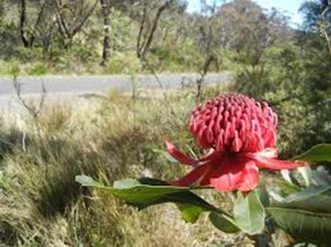  Waratah near Bunjaree Cottages by Stilgherrian, licensed under CC BY 4.0  The plant is well-suited to sandy or gravelly soils with a mix of clay, typically found in environments that receive moderate rainfall. Waratahs prefer well-drained soils and do not tolerate waterlogged conditions. They are particularly adapted to fire-prone regions, with the ability to regenerate from their root system following bushfire events. This adaptation helps ensure their persistence in their natural habitat, contributing to their ecological resilience.  Classification of the waratah  Telopea speciosissima belongs to the Kingdom Plantae, as it is a multicellular organism that performs photosynthesis. It falls under the Phylum, Angiosperms, because it produces flowers with enclosed seeds. Within the Class, Eudicots, the waratah exhibits defining characteristics such as broad leaves with net-like veins and flower parts arranged in multiples of four or five. It belongs to the Order Myrtales, recognised for woody plants with translucent-dotted leaves. The Family Proteaceae comprises species with large, striking flowers that are designed to attract pollinators. Within the Genus, Telopea, this species is distinguished by its vibrant red flowers, which make it one of Australia’s most recognisable native plants.  Adaptations that support its survival in its habitat  The waratah exhibits several adaptations that contribute to its survival in its habitat. It demonstrates phototropism, growing towards light to maximise photosynthesis, ensuring efficient energy production.  The waratah is highly fire-adapted, with a robust root system that enables it to resprout after bushfires. This allows the plant to recover and regenerate, even after extensive fire damage.  An adaptation to support reproduction in Telopea speciosissima relies on its striking red flowers, shown in Figure 2, which grow in dense clusters and are specifically designed to attract nectar-feeding birds, particularly honeyeaters. These birds serve as key pollinators, ensuring the successful production and dispersal of seeds.  Figure 2 – the striking, red flowers of the waratah plant  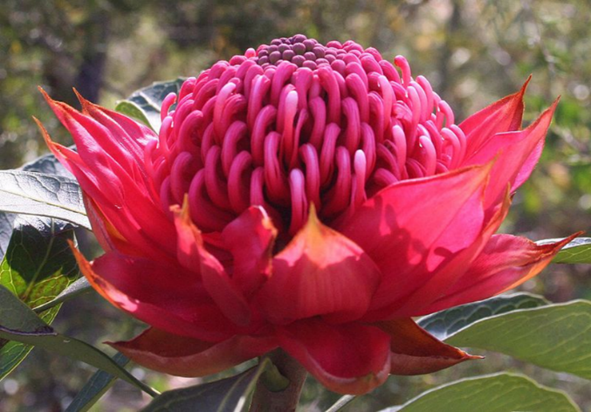  Telopea speciosissima Ingar Falls crop by Casliber, licensed under CC BY-SA 4.0  To obtain essential nutrients, the waratah relies on a specialised root system, which enhances absorption from nutrient-poor, sandy soils. The presence of dense clusters of short roots allows it to extract sufficient nutrients, contributing to its ability to thrive in challenging environmental conditions.  To support survival in periods of drought, the waratah has leathery, waxy leaves. These leaves help the plant reduce water loss, an essential adaptation for survival during droughts.  References  Australian Native Plants Society (2025) ‘Telopea speciosissima and Cultivars’, https://anpsa.org.au/plant_profiles/telopea-speciosissima-and-cultivars  Botanic Gardens of Sydney (2020) ‘Waratah blooms after the bushfires’, https://www.botanicgardens.org.au/node/1556#:~:text=Waratahs%20are%20a%20%27resprouting%27%20species,be%20arising%20from%20the%20ashes.  Donovan J (2021) ‘Waratah Flower Facts And Care Guide’, https://lawn.com.au/waratah-flower/  Interflora (n.d.) ‘Waratah facts’, https://www.interflora.com.au/blog/waratah-facts  NSW National Parks and Wildlife Service (2025) ‘Waratah’, https://www.nationalparks.nsw.gov.au/plants-and-animals/waratah  PlantNET (n.d.) ‘Telopea speciosissima (Sm.) R.Br.’, https://plantnet.rbgsyd.nsw.gov.au/cgi-bin/NSWfl.pl?page=nswfl&name=Telopea~speciosissima&lvl=sp  Taronga Zoo (n.d.) ‘Waratah’, https://tarongazooaustraliananimals.weebly.com/waratah.html\  Taylor J (2011) ‘Telopea speciosissima’, https://www.anbg.gov.au/gnp/interns-2011/telopea-speciosissima.html  The Royal Horticultural Society (2025) ‘How plants lose water’, https://www.rhs.org.uk/advice/understanding-plants/how-plants-lose-water  Wilson P (2020) ‘Family Myrtaceae’, https://plantnet.rbgsyd.nsw.gov.au/cgi-bin/NSWfl.pl?page=nswfl&lvl=fm&name=MYRTACEAE | Space for annotations

Quality criteria – science information report
- A descriptive title provides the reader with an idea of the contents of the report.
- Logically structured with suitable subheadings to guide the reader.
- Information is well-organised with clear topic sentences and a logical progression of ideas.
- Specific examples are provided to demonstrate the depth of understanding of scientific content.
- Information in the report is factually accurate and based on reliable sources.
- Relevant scientific terminology is used correctly and appropriately.
- Information in the report has been summarised in the writer’s own words, not copied directly from the text.
- Sources of information have been referenced in the ‘References’ component of the report.
- Visual representations such as tables, graphs or diagrams are used where appropriate, and they are labelled.
- The writing maintains a formal (no personal pronouns), scientific tone while being accessible to the intended audience.

Part 4 – constructing a scientific report about the bare-nosed wombat
- Inform students that they will now use the provided information (Student resource – information about the bare-nosed wombat) summarised and collated from secondary sources to construct a written report about the classification and adaptations of the bare-nosed wombat.
- Inform students that reliable secondary sources were used to summarise and collate information in the Student resource – information about the bare-nosed wombat.
- Read through the Student resource – information about the bare-nosed wombat and use the Student resource – scientific report about the waratah to construct a title and subheadings for the report. The Waratah report serves as a worked example to support students in constructing their report on the bare-nosed wombat.
- Model how to write the ‘Description of the bare-nosed wombat and its habitat’ paragraph of the report in their book.
- Jointly construct or have students independently complete the remainder of the scientific report.
- Students swap reports with the person next to them. Students deconstruct the scientific report to unpack the contents, determine if it is a quality report, and provide feedback using the quality criteria. A sample student response has been provided in Table 29.
- Remind students they will need to conduct a secondary-source investigation in their assessment task for their chosen organism to find the same type of information they researched and used for the waratah and bare-nosed wombat.
- Facilitate class discussion to outline what is meant by purpose and audience when communicating information in texts. Refer to slide, CLS PPT ‘1.7 Audience and purpose’ to unpack this with students and identify the audience and purpose of the scientific reports constructed about the waratah and bare-nosed wombat.
To support students further in identifying audience and purpose, refer to Stage 4 reading – Audience and purpose.
The audience of a text is those who read, listen to or engage with the text. To identify the audience, consider the text's components, including the images used, the vocabulary employed, and the subject matter.
Outline to students that when we talk about the purpose of a text, it refers to the reason for communicating the information in that text. To understand the purpose of a text, consider whether the author wants to inform, persuade or entertain their audience.
To further unpack features of an informative text, refer to Stage 4 reading – Text structure and Stage 4 reading – Text structure.
- Discuss how the audience and purpose of the scientific reports differ from what students will need to do in their assessment task, where they will conduct a secondary-source investigation and communicate findings as a children’s book about their chosen organism. Facilitate a class discussion about how this will impact the way the information is communicated in their text.
Sample student response: scientific report about the bare-nosed wombat
Classification and adaptations of the bare-nosed wombat
Description of the bare-nosed wombat and its habitat
The bare-nosed wombat is a four-legged marsupial characterised by thick, brown or grey fur. It has strong front claws for digging and large, continuously growing teeth that are suited for chewing through tough vegetation. Unlike many marsupials, its pouch faces backward to prevent soil from entering while burrowing.
This species is found in southeastern Australia and Tasmania, living in forests, grasslands, and hilly areas. Bare-nosed wombats prefer places with soft soil, which allows them to dig deep and complex burrow systems. These burrows, as shown in Figure 1, provide shelter from extreme temperatures and predators, making them essential for the survival of these animals.
Figure 1 – Wombat sleeping in a burrow
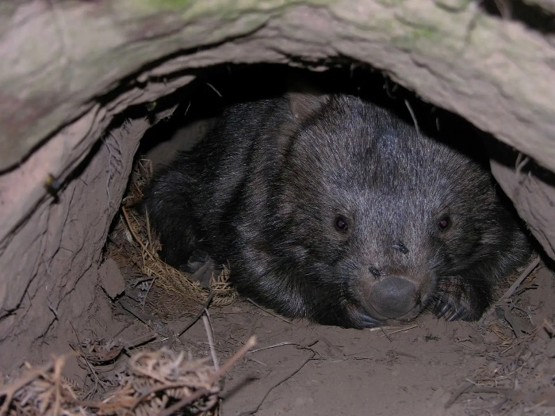
Wombat resting by Alan Couch, licensed under CC BY 4.0
Classification of the bare-nosed wombat
The bare-nosed wombat (Vombatus ursinus) is a marsupial, meaning it carries its young in a pouch. Scientists classify organisms based on shared characteristics, and the bare-nosed wombat belongs to the following groups: it is in the Kingdom, Animalia, because it is a living organism made of multiple cells that consumes other organisms for energy. It belongs to the Phylum Chordata, as it possesses a backbone, a key feature of vertebrates. As a mammal, it has fur, gives birth to live young, and produces milk to nourish its offspring. Within the Order, Diprotodontia, it is grouped with other marsupials that have 2 large, forward-facing incisors in the lower jaw. The Family Vombatidae includes wombats, which are well-adapted for burrowing and have backward-facing pouches to protect their young from dirt and debris. The Genus Vombatus separates the bare-nosed wombat from other wombat species because of its smooth nose.
Adaptations that support its survival in its habitat
The bare-nosed wombat has developed several key adaptations that enable it to survive in its natural habitat. One significant adaptation is its burrowing behaviour. With strong limbs and sharp claws, the wombat digs extensive underground burrows that offer protection from predators and extreme weather conditions. These burrows also provide a safe and stable environment for resting and raising young.
Another important adaptation is the wombat’s nocturnal lifestyle. By being active at night, the wombat avoids the heat of the day, reducing water loss and the risk of overheating. This behaviour also decreases its chances of being encountered by predators.
Lastly, the wombat’s toughened rear end is a structural adaptation that serves as a defence mechanism. Composed of thick skin and cartilage, the wombat’s rear acts like a protective shield. When threatened, it dives into its burrow and blocks the entrance with its hardened rump, preventing predators from attacking or entering. These adaptations work together to increase the wombat’s chances of survival in the wild.
References
Australian Geographic (2018), ‘Fact file: bare-nosed wombat (Vombatus ursinus)’, https://www.australiangeographic.com.au/fact-file/fact-file-bare-nosed-wombat-vombatus-ursinus
Australian Museum (2025) ‘Bare-nosed wombat’, https://australian.museum/learn/animals/mammals/bare-nosed-wombat/
Australian Wildlife Conservancy (n.d.) ‘Wombats’, https://www.australianwildlife.org/wombats/
Billabong Sanctuary (2025), ‘Bare-Nosed Wombat’, https://www.billabongsanctuary.com.au/bare-nosed-wombat/
NSW Government (2024) ‘Wombats’, https://www.environment.nsw.gov.au/topics/animals-and-plants/native-animals/native-animal-facts/land-mammals/wombats
Rivers of Carbon (2021) ‘Wombat behaviour: burrows and being neighbours’, https://riversofcarbon.org.au/wombat-behaviour-burrows-and-being-neighbours
San Diego Wildlife Alliance (2025) ‘Wombats (Vombatus and Lasiorhinus spp.) Fact Sheet: Taxonomy & History’, https://ielc.libguides.com/sdzg/factsheets/wombats/taxonomy
Tasmanian Parks and Wildlife Service (2020) ‘Wombats’, https://parks.tas.gov.au/explore-our-parks/maria-island-national-park/wombats
Sample student response – using quality criteria to assess report quality
Table 29 – using quality criteria to assess report quality
Quality criteria | Questions to support student thinking | How does it meet the criteria, with examples from the report
A descriptive title provides the reader with an idea of the report's contents. | - Does the title give the reader a clear idea of the content of the report?  - Discuss how an effective title should reflect the subject (bare-nosed wombat) and the focus of the report (classification, description, adaptations). | This title, ‘Classification and adaptations of the bare-nosed wombat’, clearly reflects the content of the report, indicating that it focuses on the bare-nosed wombat and provides the reader with an understanding of what to expect.
Logically structured with suitable subheadings to guide the reader. | - How does the report use subheadings to organise information?  - Ask students how sub-headings like ‘Classification of the bare-nosed wombat’ help readers navigate the content.  - Discuss the importance of clear and meaningful subheadings for structure. | The subheadings, ‘Description of the bare-nosed wombat and its habitat,’ ‘Classification of the bare-nosed wombat,’ and ‘Adaptations that support its survival in its habitat’ provide clear sections that guide the reader through different aspects of the topic, helping to organise the content logically.
Information is well-organised with clear topic sentences and a logical progression of ideas. | - Can students identify how each section begins with a clear topic sentence that sets the focus of that paragraph?  - Discuss how each paragraph builds on the previous one to create a coherent report. | Paragraphs begin with a topic sentence that sets the focus of the section. For example, ‘the bare-nosed wombat (Vombatus ursinus) is a marsupial, meaning it carries its young in a pouch.’ This opening sentence introduces the classification topic and the first main idea about the wombat’s features. Each section begins with a clear topic sentence that sets the paragraph’s focus, ensuring the report flows logically from one idea to the next.  Guide students to see how the ideas flow logically, from description to classification to adaptations.
Specific examples are provided to demonstrate a depth of understanding of scientific content. | - Which specific examples in the report show a deep understanding of the bare-nosed wombat?  - Ask students to point out scientific facts, such as the wombat's backward-facing pouch or cube-shaped faeces, that demonstrate their understanding of adaptations and classification. | In the sentence ‘The Family Vombatidae includes wombats, which are well-adapted for burrowing and have backward-facing pouches to protect their young from dirt.’ This specific example not only demonstrates an understanding of the classification of the wombat but also highlights the unique features of its anatomy, such as the backward-facing pouch, showcasing depth in scientific knowledge.  Note that this report includes several additional examples to support these quality criteria.
Information in the report is factually accurate and based on reliable sources. | - Encourage students to assess whether the information provided in the report is scientifically reliable.  - Discuss how they can cross-check facts with reliable sources to ensure the information is trustworthy, like the ones cited in the references. | Statements made in the report are factually accurate and have been obtained from reliable references. For example, ‘Bare-nosed wombats produce cube-shaped faeces, which prevents rolling and helps them mark their territory effectively.’ This statement is scientifically accurate and relies on factual information about the wombat’s behaviour. It has been obtained from a reliable source, as indicated in the references, and can be further verified by comparing it with other reputable and reliable sources.
Relevant scientific terminology is used correctly and appropriately. | - Ask students to identify scientific terms used in the report, such as ‘Phylum,’ ‘marsupial’ or ‘Diprotodontia.’ (There are many more terms in this report.)  - Is the terminology used relevant? Has it been used correctly and appropriately?  - Discuss how correct terminology enhances the scientific tone and clarity of the report. | In the sentence, ‘The bare-nosed wombat belongs to the Phylum, Chordata since it has a backbone, which is a key feature of vertebrates.’, relevant scientific terminology has been used correctly and appropriately. The use of terms like ‘Phylum’ and ‘Chordata’ is appropriate and demonstrates correct scientific terminology related to classification.  Note that there are several other uses of scientific terminology in this report that could be unpacked with students.
Information in the report has been summarised in the writer’s own words, not copied directly from the text. | - If you compare components of the report to the source of information, does the information appear copied from the text, or is it summarised/paraphrased? | The sentence, ‘These burrows provide shelter from extreme temperatures and predators, making them essential for survival,’ is a paraphrased idea based on one of the sources in the reference list but rewritten in the student’s own words to convey the key point about the wombat’s burrows.
Sources of information have been referenced in the ‘References’ component of the report. | - Inform students that they are referencing using the title and then the URL written in the format in the report.  - Ask students how the reference is written in the references section. | The references section cites sources where the information was obtained, adhering to academic standards for acknowledging external sources. For example, ‘Wombats’, https://ielc.libguides.com/sdzg/factsheets/wombats/taxonomy
Visual representations, such as tables, graphs, or diagrams, are used where appropriate and are labelled. | - Are there any visuals used in this report? What type?  - How have they been labelled? | This report has 2 visuals used (images). They have both been captioned with the figures being written in numerical order. For example, the first figure is Figure 1 and the second is Figure 2. The caption used indicates what the figure is.
The writing maintains a formal (no personal pronouns), scientific tone while being accessible to the intended audience. | - What is the purpose of this report?  - Are personal pronouns used in this report? How does this support the report remaining professional and objective?  - Has a formal tone been used?  - Who is the intended audience? | Inform students that the purpose of this report is to provide the audience with information. The intended audience is Year 7 science students and the teacher. Therefore, it is written with a formal, scientific tone. Appropriate scientific language and examples are used to inform the audience, making the content accessible.

Student resource – information about the bare-nosed wombat
Naming the organism
Write the common name and binomial name for the selected organism.
Common name: | Bare-nosed wombat (also known as common wombat)
Scientific name: | Vombatus ursinus
Indicate the source(s) used to gather information about the name of your organism.
Table 1 – sources of information for naming the organism
Title | Author | Year published | URL
Wombats | NSW Government | 2024 | https://www.environment.nsw.gov.au/topics/animals-and-plants/native-animals/native-animal-facts/land-mammals/wombats
*Add more rows to the reference tables as needed.
Classification
Table 2 – classification of the organism
Taxon | Your organism | What are the features of this organism that make it fit into this taxonomic classification level?
Kingdom | Animalia | The bare-nosed wombat is a multicellular organism that lacks cell walls and obtains energy by consuming other organisms (heterotrophic). It also lacks a cell wall, unlike plants or fungi.
Phylum | Chordata | All animals in this group have a spinal cord (a bundle of nerves running down their back) at some point in their life. The wombat has a backbone, which makes it a vertebrate.
Class | Mammalia | Wombats are mammals because they have fur, give birth to live babies instead of laying eggs, and mothers feed their young with milk from special glands called mammary glands.
Order | Diprotodontia | This order includes marsupials that have 2 big front teeth in their lower jaw. Wombats belong to this group due to their unique teeth and the distinctive shape of their jaw.
Family | Vombatidae | Wombats are placed in this family because they are strong, burrowing marsupials with short legs, thick fur, and a backward-facing pouch. The pouch faces backward so dirt doesn’t get inside while digging.
Genus | Vombatus | The bare-nosed wombat belongs to the genus Vombatus because it has a smooth nose, unlike the hairy nose of other wombat species. It also has coarse fur and a strong, sturdy body.
Species | Vombatus ursinus | Early European settlers believed the wombat resembled a bear. ‘Ursus’ is the Latin word for bear, and ‘ursinus’ means ‘bear-like’.
Indicate the sources used to gather the information on the classification of your organism.
Table 3 – sources of information for classification
Title | Author | Year published | URL
Bare-nosed wombat | Australian Museum | 2025 | https://australian.museum/learn/animals/mammals/bare-nosed-wombat/
Wombats (Vombatus and Lasiorhinus spp.) Fact Sheet: Taxonomy & History | San Diego Zoo Wildlife Alliance | 2025 | https://ielc.libguides.com/sdzg/factsheets/wombats/taxonomy
Bare-Nosed Wombat | Billabong Sanctuary | 2025 | https://www.billabongsanctuary.com.au/bare-nosed-wombat/
Characteristics of living things
Table 4 – characteristics that make the organism a living thing
Living things can: | How does your organism embody this characteristic?
move | They have short, powerful limbs with strong claws, enabling them to dig extensive burrow systems for shelter and protection.
respire | Bare-nosed wombats perform cellular respiration by breaking down glucose (sugar) from their diet in the presence of oxygen to release energy for bodily functions.
sense | They possess a keen sense of smell and hearing, which helps them detect predators and locate food sources, especially during nocturnal activities.
grow | Wombats grow from small, underdeveloped joeys into fully developed adults over several years, gaining muscle mass and developing strong bones that enable them to dig and survive.
reproduce | The bare-nosed wombat reproduces and gives birth to live young. Female wombats have a backward-facing pouch; the joey remains in the pouch for about 5 months before emerging.
eliminate waste | Wombats produce distinctive cube-shaped faeces.
obtain nutrients | As herbivores, they graze on a variety of vegetation, including grasses, roots, and bark. They need to consume (eat) to gain nutrients.
Indicate the sources of this information used to explain how your organism embodies all the characteristics of living things.
Table 5 – sources of information for characteristics of living things
Title | Author | Year published | URL
Wombat behaviour: burrows and being neighbours | Rivers of Carbon | 2021 | https://riversofcarbon.org.au/wombat-behaviour-burrows-and-being-neighbours
Fact file: bare-nosed wombat (Vombatus ursinus) | Australian Geographic | 2018 | https://www.australiangeographic.com.au/fact-file/fact-file-bare-nosed-wombat-vombatus-ursinus
Wombats | Tasmanian Parks and Wildlife Service | 2020 | https://parks.tas.gov.au/explore-our-parks/maria-island-national-park/wombats
Wombats | Australian Wildlife Conservancy | n.d. | https://www.australianwildlife.org/wombats/
Habitat
Habitat image | Description of habitat
Figure 1 – a bare-nosed wombat in a mountain habitat  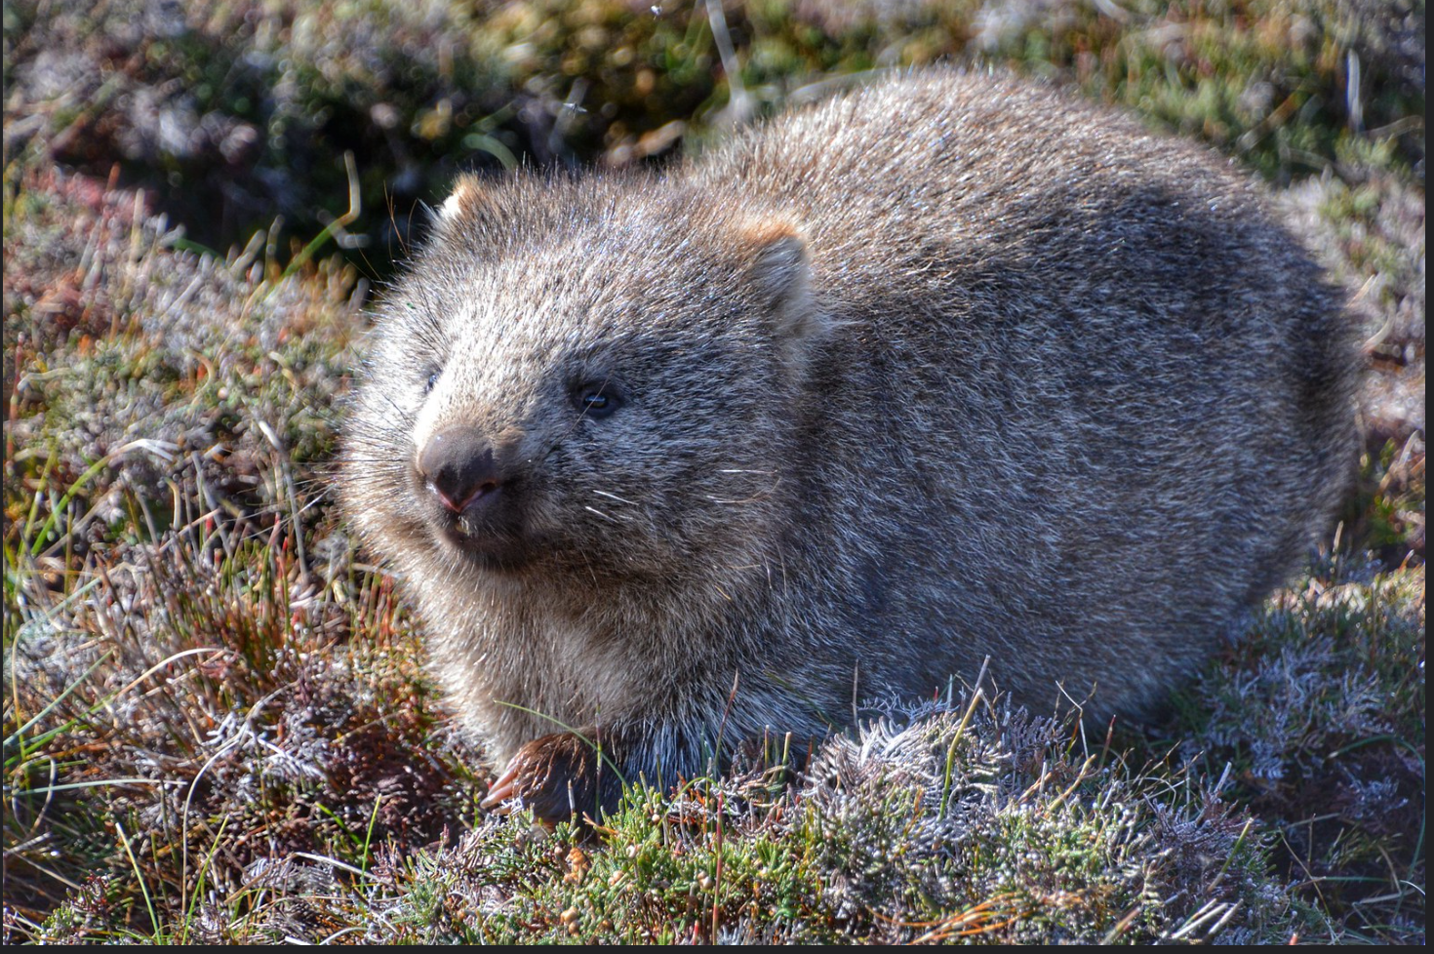  Common Wombat, Cradle Mountain, Tasmania by John Morton, licensed under CC BY 4.0 | The bare-nosed wombat inhabits wet, partly forested areas along the coast, as well as grasslands and mountain regions. They prefer well-drained, loose, and moist soils that facilitate the digging of extensive burrow systems, which can be up to 30 meters long and several meters deep.
The sources used to gather this information are below.
Table 6 – sources of information for habitat
Title | Author | Year published | URL
Wombats | NSW Government | 2024 | https://www.environment.nsw.gov.au/topics/animals-and-plants/native-animals/native-animal-facts/land-mammals/wombats
Adaptations
Describe adaptations that the organism has that make it suited to its environment.
- The bare-nosed wombat possesses strong, muscular limbs equipped with sturdy claws, enabling it to dig extensive burrow systems underground.
- The bare-nosed wombat is primarily nocturnal, meaning it is most active during the night.
- The bare-nosed wombat has a very tough, thick-skinned rear made mostly of cartilage and fat.
In the spaces below, each student should outline the information about their chosen adaptation. Each student must record their sources of information in the relevant table as well.
Adaptation 1 – student 1
Who will do the research for this adaptation? | Fatima
Describe the adaptation. | The bare-nosed wombat possesses strong, muscular limbs equipped with sturdy claws, enabling it to dig extensive burrow systems underground. These burrows can be complex, featuring multiple entrances and chambers, providing shelter and a stable environment.
Explain how the adaptation helps the organism survive in its habitat. | Burrowing offers the wombat protection from predators and extreme weather conditions. The underground environment maintains a more constant temperature, shielding the wombat from the heat of the day and cold nights. Additionally, burrows serve as a safe place for resting and rearing young, enhancing the wombat's chances of survival and reproduction.
Table 7 – sources of information for this adaptation
Title | Author | Year published | URL
Wombat behaviour: burrows and being neighbours | Rivers of Carbon | 2021 | https://riversofcarbon.org.au/wombat-behaviour-burrows-and-being-neighbours
Adaptation 2 – student 2
Who will do the research for this adaptation? | Sarah
Describe the adaptation. | The bare-nosed wombat is primarily nocturnal, meaning it is most active during the night. It emerges from its burrow after dusk to forage for food, primarily grazing on grasses and other vegetation.
Explain how the adaptation helps the organism survive in its habitat. | Being nocturnal allows the wombat to avoid the heat of the day, reducing water loss and the risk of overheating. Nighttime activity also decreases the likelihood of encountering predators and competition for food, as fewer animals are active during these hours. This behaviour enhances the wombat's ability to conserve energy and maintain hydration in its environment.
Table 8 – sources of information for this adaptation
Title | Author | Year published | URL
Fact file: bare-nosed wombat (Vombatus ursinus) | Australian Geographic | 2018 | https://www.australiangeographic.com.au/fact-file/fact-file-bare-nosed-wombat-vombatus-ursinus
Adaptation 3 – student 3
Who will do the research for this adaptation? | Max
Describe the adaptation. | The bare-nosed wombat has a very tough, thick-skinned rear made mostly of cartilage and fat. This hardened backside acts almost like a shield and is visibly flat and firm compared to the rest of its body.
Explain how the adaptation helps the organism survive in its habitat. | This tough rear end protects the wombat when it retreats into its burrow from predators. If a predator tries to follow, the wombat can block the entrance with its backside. It can also crush intruders against the roof or walls of the burrow using its strong body, making this a powerful defence mechanism.
Table 9 – sources of information for this adaptation
Title | Author | Year published | URL
Wombats | Australian Wildlife Conservancy | n.d. | https://www.australianwildlife.org/animals/bare-nosed-wombat

1.8 Classification assessment task
Note: the sample assessment task for the Cells and classification focus area can be found on the Cells and classification – Stage 4 science website. The instructions for facilitating the assessment task are outlined in the assessment task – Cells and classification document.
Audience and purpose of a text
The audience of a text is those who read, listen to or engage with the text. To identify the audience, consider the components of the text, such as the images used, the vocabulary employed, and the subject matter. The purpose of a text refers to the reason for communicating the information in that text. To understand the purpose of a text, consider whether the author wants to inform, persuade or entertain their audience.
To support students further in identifying audience and purpose, refer to Stage 4 reading – Audience and purpose.

Evidence base
This resource contains NSW Curriculum and syllabus content. The NSW Curriculum is developed by the NSW Education Standards Authority. This content is prepared by NESA for and on behalf of the Crown in right of the State of New South Wales. The material is protected by Crown copyright.
Please refer to the NESA Copyright Disclaimer for more information https://educationstandards.nsw.edu.au/wps/portal/nesa/mini-footer/copyright.
NESA holds the only official and up-to-date versions of the NSW Curriculum and syllabus documents. Please visit the NSW Education Standards Authority (NESA) website https://educationstandards.nsw.edu.au and the NSW Curriculum website https://curriculum.nsw.edu.au.
Science 7–10 Syllabus © NSW Education Standards Authority (NESA) for and on behalf of the Crown in right of the State of New South Wales, 2023.
Data Book: Science 7–10 © NSW Education Standards Authority (NESA) for and on behalf of the Crown in right of the State of New South Wales, 2023.
First Nations Australians’ classification systems © Australian Curriculum, Assessment and Reporting Authority (ACARA) 2009 to present, unless otherwise indicated. This material was downloaded from the ACARA website (accessed 21 August 2025) and was modified. The material is licensed under CC BY 4.0. ACARA does not endorse any product that uses ACARA material or make any representations as to the quality of such products. Any product that uses material published on this website should not be taken to be affiliated with ACARA or have the sponsorship or approval of ACARA. It is up to each person to make their own assessment of the product.
The Australian Institute of Aboriginal and Torres Strait Islander Studies (AIATSIS) (2022) AIATSIS Guide to evaluating and selecting education resources, AIATSIS website, accessed 2 August 2024.
AITSL (Australian Institute for Teaching and School Leadership Limited) (n.d.) Learning intentions and success criteria [PDF 251 KB], AITSL, accessed 18 July 2024.
The Australian Museum (2024) Dingo, The Australian Museum website, accessed 25 February 2025.
——(2025) Leaf litter dichotomous key, The Australian Museum website, accessed 25 February 2025.
Botanic Gardens of Sydney (2020) Waratah blooms after the bushfires, Botanic Gardens of Sydney website, accessed 10 February 2025.
——(2025) What are adaptations?, Botanic Gardens of Sydney website, accessed 25 February 2025.
Britannica Kids (2025a) Dichotomous key, Encyclopaedia Britannica website, accessed 25 February 2025.
——(2025b) dingo, Encyclopaedia Britannica website, accessed 25 February 2025.
CESE (Centre for Education Statistics and Evaluation) (2020) What works best: 2020 update, NSW Department of Education, accessed 18 July 2024.
—— (2020) What works best in practice, NSW Department of Education, accessed 18 July 2024.
——(2021) Growth goal setting – what works best in practice, NSW Department of Education, accessed 18 July 2024.
Department for Environment and Water (n.d.) Wombats, Government of South Australia website, accessed 10 February 2025.
Dewey T and Smith J (2020) Canis lupus, University of Michigan: Museum of Zoology website, accessed 25 February 2025.
Divljan A (2024) Bare-nosed Wombat, Australian Museum website, accessed 10 February 2025.
Fisher D and Frey N (1 November 2009) ‘Feed Up, Back, Forward’, ASCD (Association for Supervision and Curriculum Development): Educational Leadership magazine, 67(3), accessed 18 July 2024.
Griffin P (2017) Assessment for Teaching, Cambridge University Press, Port Melbourne, Victoria.
Hattie J and Timperley H (2007) ‘The Power of Feedback’, Review of Educational Research, 77(1): 81–112, doi:10.3102/003465430298487.
Interflora Australia (n.d.) Waratah Facts, Interflora website, accessed 10 February 2025.
State of New South Wales (Department of Climate Change, Energy, the Environment and Water) (2024) Wombats, NSW Department of Environment and Heritage website, accessed 10 February 2025.
State of New South Wales and Department of Climate Change, Energy, the Environment and Water (DCCEEW) (n.d.) Waratah, NSW National Parks and Wildlife Service website, accessed 10 February 2025.
Panadero E and Jonsson A (2013) ‘The use of scoring rubrics for formative assessment purposes revisited: A review’, Educational Research Review, 9:129–144, doi:10.1016/j.edurev.2013.01.002, accessed 18 July 2024.
PlantNET (n.d.) Telopea speciosissima (Sm.) R.Br., PlantNET website, accessed 10 February 2025.
San Diego Zoo Wildlife Alliance (2024) Wombats (Vombatus and Lasiorhinus spp.) Fact Sheet: Taxonomy & History, San Diego Zoo Wildlife Alliance website, accessed 10 February 2025.
Sherrington T (2019) Rosenshine’s Principles in Action, John Catt Educational Limited, Melton, Woodbridge.
Australian Government (Slopes to Summit project) (2018) Terrestrial Mammals of the Southwest Slopes & Upper Murray Region of NSW – An identification and habitat management guide, Holbrook Landcare Network website, accessed 28 June 2025.
Taylor J (2011) Telopea speciosissima, Australian National Herbarium website, accessed 10 February 2025.
Wiliam D (2017) Embedded Formative Assessment, 2nd edn, Solution Tree Press, Bloomington, IN.

© State of New South Wales (Department of Education), 2025
The copyright material published in this resource is subject to the Copyright Act 1968 (Cth) and is owned by the NSW Department of Education or, where indicated, by a party other than the NSW Department of Education (third-party material).
Copyright material available in this resource and owned by the NSW Department of Education is licensed under a Creative Commons Attribution 4.0 International (CC BY 4.0) license.

This license allows you to share and adapt the material for any purpose, even commercially.
Attribution should be given to © State of New South Wales (Department of Education), 2025.
Material in this resource not available under a Creative Commons license:
- the NSW Department of Education logo, other logos and trademark-protected material
- material owned by a third party that has been reproduced with permission. You will need to obtain permission from the third party to reuse its material.
Links to third-party material and websites
Please note that the provided (reading/viewing material/list/links/texts) are a suggestion only and implies no endorsement, by the New South Wales Department of Education, of any author, publisher, or book title. School principals and teachers are best placed to assess the suitability of resources that would complement the curriculum and reflect the needs and interests of their students.
If you use the links provided in this document to access a third-party's website, you acknowledge that the terms of use, including licence terms set out on the third-party's website apply to the use which may be made of the materials on that third-party website or where permitted by the Copyright Act 1968 (Cth). The department accepts no responsibility for content on third-party websites.

