Science 7–10 sample explanatory text marking criteria
This resource contains a sample question and marking criteria for Stage 4 content in the Science 7–10 Syllabus (2023). It focuses on assessing and giving feedback on students’ ability to write an explanatory text about energy pyramids and the flow of energy and matter through trophic levels. Before attempting this task, model the writing of an explanatory text and unpack the scientific content and required vocabulary.
The marking guidelines can be used as:
- an assessment tool to provide a structured way to mark and give feedback on an extended writing task
- a teaching guide that highlights the key elements of a strong scientific explanation (content knowledge, use of scientific vocabulary, text structure and communication for a purpose and audience)
- explicit success criteria when attempting the extended writing task
- adaptable criteria for when teaching extended writing for different curriculum content to ensure consistency in writing expectations.

Stage 4 syllabus content

Living systems (SC4-LIV-01)
- Create written texts to explain how energy pyramids show the amount of energy or matter at each trophic level

Communicating (SC4-WS-08)
- Present findings and ideas in a range of communication forms, including using relevant scientific terms, as appropriate to audience and purpose
- Create written texts to communicate scientific concepts, ideas or investigations using conventional scientific text structures

Writing task
Write an explanation of how this energy pyramid shows the amount of energy and matter at each trophic level. (9 marks)
Figure 1 – energy pyramid
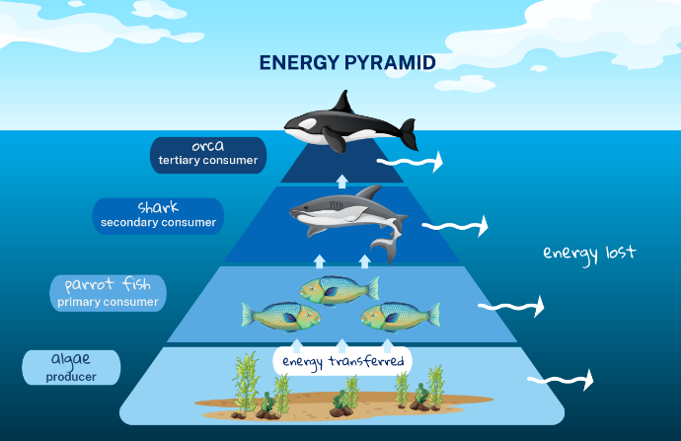

Sample marking criteria
Criteria | Marks – descriptors | Syllabus outcome and content
Understanding of living systems  Scientific explanation of energy transfer, trophic levels and roles of organisms in food chains | 3 – demonstrates a comprehensive understanding of the function and relationships of organisms within ecosystems, including energy transfer and biomass across trophic levels.  2 – demonstrates sound understanding with minor omissions or inaccuracies.  1 – demonstrates limited understanding with underdeveloped or partially correct ideas.  0 – no relevant scientific understanding shown. | SC4-LIV-01  - Create written texts to explain how energy pyramids show the amount of energy or matter at each trophic level
Use of scientific vocabulary  Appropriate Tier 2 and 3 vocabulary | 2 – uses scientific vocabulary appropriately and consistently (for example, ‘producers’, ‘consumers’, ‘energy transfer’, ‘biomass’, ‘trophic level’).  1 – some appropriate vocabulary used, though with minor errors or inconsistencies.  0 – minimal or inaccurate use of scientific terminology. | SC4-WS-08  - Present findings and ideas in a range of communication forms, including using relevant scientific terms, as appropriate to audience and purpose
Structure of a written explanatory text  Follows conventional explanation structure: introduction, body and conclusion | 2 – follows a clear and logical structure appropriate to a scientific explanation (introduction, body [cause/effect/why], conclusion).  1 – mostly follows scientific text structure, with some structural lapses or weak transitions.  0 – lacks structure or presents information in an illogical or incomplete format. | SC4-WS-08  - Create written texts to communicate scientific concepts using conventional scientific text structures
Communication of ideas for purpose and audience  Clarity, flow and appropriate tone for a scientific audience | 2 – communicates clearly and logically with ideas suited to a scientific audience; maintains appropriate tone and coherence throughout.  1 – communicates some ideas clearly but may lack consistency in tone, clarity or flow.  0 – lacks clear communication; difficult for the audience to follow. | SC4-WS-08  - Present findings and ideas in a range of communication forms as appropriate to audience and purpose.

References
This resource contains NSW Curriculum and syllabus content. The NSW Curriculum is developed by the NSW Education Standards Authority. This content is prepared by NESA for and on behalf of the Crown in right of the State of New South Wales. The material is protected by Crown copyright.
Please refer to the NESA Copyright Disclaimer for more information https://educationstandards.nsw.edu.au/wps/portal/nesa/mini-footer/copyright.
NESA holds the only official and up-to-date versions of the NSW Curriculum and syllabus documents. Please visit the NSW Education Standards Authority (NESA) website https://educationstandards.nsw.edu.au and the NSW Curriculum website https://curriculum.nsw.edu.au.
Science 7–10 Syllabus © NSW Education Standards Authority (NESA) for and on behalf of the Crown in right of the State of New South Wales, 2023.

© State of New South Wales (Department of Education), 2025
The copyright material published in this resource is subject to the Copyright Act 1968 (Cth) and is owned by the NSW Department of Education or, where indicated, by a party other than the NSW Department of Education (third-party material).
Copyright material available in this resource and owned by the NSW Department of Education is licensed under a Creative Commons Attribution 4.0 International (CC BY 4.0) license.

This license allows you to share and adapt the material for any purpose, even commercially.
Attribution should be given to © State of New South Wales (Department of Education), 2025.
Material in this resource not available under a Creative Commons license:
- the NSW Department of Education logo, other logos and trademark-protected material
- material owned by a third party that has been reproduced with permission. You will need to obtain permission from the third party to reuse its material.
Links to third-party material and websites
Please note that the provided (reading/viewing material/list/links/texts) are a suggestion only and implies no endorsement, by the New South Wales Department of Education, of any author, publisher, or book title. School principals and teachers are best placed to assess the suitability of resources that would complement the curriculum and reflect the needs and interests of their students.
If you use the links provided in this document to access a third-party's website, you acknowledge that the terms of use, including licence terms set out on the third-party's website apply to the use which may be made of the materials on that third-party website or where permitted by the Copyright Act 1968 (Cth). The department accepts no responsibility for content on third-party websites.

