Respectful Relationships Education
School-based practice indicators

Purpose
This resource outlines the observable practice indicators in Respectful Relationships Education (RRE) across the 6 components of a whole school approach.
Figure 1 – six components of a whole school approach to RRE
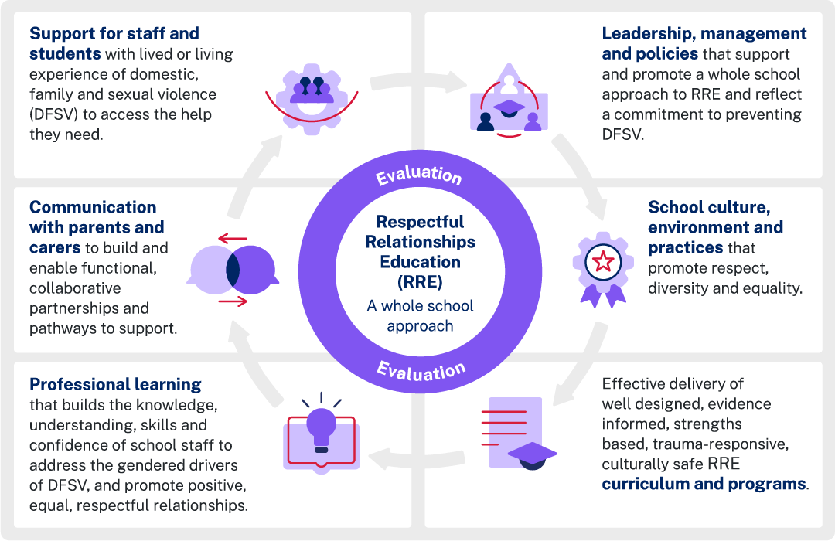
The practice indicators are designed for 3 key audiences – leaders, school staff and students.
Observable practice indicators for RRE help schools to:
- recognise strengths in the components of the current whole school approach identify the school’s starting point and progress
- guide evidence and measures of success for a school implementation or action plan
- promote continuous improvement in RRE implementation.
Practice indicators can supplement the exemplar and examples provided in the RRE Strength Assessment Tool.

Structure
This document includes the practice indicators across the 6 components of a whole school approach to RRE. For each component, you will find an overview, the focus for each audience, an exemplar and the indicators.

Leadership, management and policies

Overview
Leadership, management and policies support and promote a whole school approach to RRE and reflect a commitment to preventing domestic, family and sexual violence (DFSV).

Audience focus
The emphasis for leaders is on commitment, resource allocation, modelling respectful behaviour, communication, data review, collaboration and empowerment of student voice.
The whole school focus is on coordination, professional learning, consistent policy implementation, respectful modelling, intervention and positive reinforcement.
Students are encouraged to use inclusive language, constructively negotiate, l report, and self-reflect to support a respectful school environment.

Leaders – indicators
L1.1 Integrate RRE priorities into school’s School Excellence Plan.
L1.2 Ensure school RRE practices enable and support department policy implementation, including anti-bullying, anti-racism, gender equality, respect and anti-violence.
L1.3 Embed RRE into the School Behaviour Support Management Plan.
L1.4 Allocate appropriate financial and staffing resources to support RRE activities.
L1.5 Consistently model respectful, inclusive and equitable behaviour in all interactions with staff, students, families and the community.
L1.6 Communicate clear expectations for RRE through assemblies, newsletters, social media and community events.
L1.7 Ensure all staff access RRE-focused professional learning to build shared understanding and capacity for implementation.
L1.8 Provide support structures for staff who might find RRE content confronting or challenging, including wellbeing measures.
L1.9 Collect and review student internal and external wellbeing data to assess the impact of RRE initiatives. For example, Sentral reports, attendance and student surveys.
L1.10 Regularly review data and adjust strategies to address emerging needs within the school community.
L1.11 Share innovative strategies and collaborate with networks of schools to influence practices beyond the school context.
L1.12 Engage parents, carers, students, staff and any relevant community groups in RRE initiatives, seeking their input and feedback.
L1.13 Empower student voice in reviewing, co-designing and leading RRE activities and problem-solving.

Whole school – indicators
WS1.1 School RRE committee coordinates and monitors RRE implementation.
WS1.2 All staff access RRE-focused professional learning to build shared understanding and capacity for implementation.
WS1.3 Consistently implement policies and procedures to address all forms of online and offline discrimination, harassment, bullying, violence and other harmful behaviours among staff and students.
WS1.4 Model respectful, caring and inclusive behaviour with students and each other always.
WS1.5 Uphold and actively refer to classroom and school-wide rules around respect and safety.
WS1.6 Acknowledge and praise positive relationship behaviours and examples of respect among students.
WS1.7 Intervene firmly, promptly and fairly to address any incidents of disrespect, bullying or harassment.

Students – indicators
St1.1 Use inclusive language, listen to others and negotiate differences respectfully.
St1.2 Contribute to class and school discussions about respect, relationships and problem-solving.
St1.3 Take leadership in peer-led activities supporting respect, for example, student ambassador programs, RRE events.
St1.4 Report disrespectful or unsafe behaviour to adults and support each other to uphold agreed standards.
St1.5 Reflect on and improve their own behaviour, taking responsibility for mistakes in a supportive environment.

School culture, environment and practices

Overview
The whole school community demonstrates a commitment to fostering a positive school culture centred on an environment and practices that promote respect, diversity and equality.

Audience focus
For leaders, the focus is on recognising and enhancing respectful culture by using data, communicating vision, policy review, inclusive decision-making and community engagement. This reflects leadership's role in shaping school culture.
Whole school emphasis on respectful interactions, upholding standards, inclusive teaching, diverse materials, community involvement, prompt response to incidents and support for participation aligns with fostering a respectful environment.
Students are encouraged to use equitable language, welcome diversity, participate in cultural events, lead initiatives, challenge disrespect and cooperate across differences, reinforcing a positive school culture.

Leader – indicators
L2.1 Recognise the school’s respectful culture through the Self-assessment Survey (SEF-SaS) as excelling.
L2.2 Use data and insights from the NSW Public Schools Surveys to enhance understanding of effective practices related to school culture.
L2.3 Use school-based data to inform decisions regarding RRE initiatives.
L2.4 Actively implement changes to RRE programs and practices based on feedback from members of the school community.
L2.5 Publicly communicate a vision of respect, diversity and equality in all school documents, policies and events.
L2.6 Regularly review and update policies to ensure they promote equity and inclusion.
L2.7 Involve diverse representatives (staff, students, families, community members) in decision-making processes.
L2.8 Attend and lead school events celebrating different cultures and identities.
L2.9 Share practices with other schools through events, forums and professional learning.

Whole school – indicators
WS2.1 Interact respectfully and equitably with all students and colleagues, including the use of preferred pronouns.
WS2.2 Uphold and reinforce clear standards for respectful language and behaviour.
WS2.3 Implement inclusive teaching strategies (for example question box) and differentiated instructional techniques to meet all learning needs.
WS2.4 Display diverse and inclusive materials (posters, books, student work) reflecting various identities.
WS2.5 Invite community members to share cultural experiences.
WS2.6 Respond promptly and constructively to incidents of disrespect or exclusion.
WS2.7 Provide extra support or adjustments to ensure full participation of all students.
WS2.8 Support student-led diversity and respect initiatives.

Students – indicators
St2.1 Use language that is equitable and respectful, including the use of preferred pronouns.
St2.2 Welcome new or different students into groups and activities.
St2.3 Participate in school diversity events, cultural celebrations, and respect-focused campaigns or initiatives.
St2.4 Suggest and lead initiatives that support respect, equality and inclusion.
St2.5 Speak up against disrespect, discrimination or exclusion.
St2.6 Share personal perspectives in a way that values others' differences.
St2.7 Work respectfully with students from different backgrounds.
St2.8 Cooperate in mixed groups and appreciate the contributions of all.
St2.9 Support peers to repair harm and uphold the school's respectful culture by encouraging accountability and restorative practices.

RRE curriculum and programs

Overview
There is effective delivery of well-designed, evidence-informed, strengths-based, trauma-responsive, culturally safe RRE curriculum and programs.

Audience focus
Leaders focus on resource allocation, professional learning, communication with families, curriculum integration and review, and ensuring diverse representation, consistent with curriculum leadership.
Whole school focus on co-design, relationship-building, respectful learning environments, strengths-based pedagogy, collaboration, and adaptation for diverse needs aligns with effective curriculum delivery.
Students play a key role through active engagement, peer support roles, communication skills, empathy, initiating conversations, self-reflection and feedback provision.

Leader – indicators
L3.1 Allocate sufficient resources to RRE curriculum planning, delivery and evaluation, including access to professional learning, time and specialist staff.
L3.2 Provide regular, whole-school professional learning on trauma, strengths-based practice and cultural safety to upskill staff and complement curriculum delivery.
L3.3 Communicate with parents and carers on RRE curriculum and program timing, content and resources, allowing for concerns to be raised and addressed.
L3.4 Ensure RRE is explicitly taught in PDHPE and integrated across KLAs.
L3.5 Evaluate and review RRE programs to ensure content and modes of delivery are best practice, relevant and effective.
L3.6 Ensure diverse representation of all identities and experiences within curriculum content and teaching materials, including Aboriginal and Torres Strait Islander individuals, people from culturally diverse backgrounds, LGBTQIA+ individuals, and people with disability.

Whole school – indicators
WS3.1 Co-design high-quality RRE curriculum with student input into content, learning experiences and assessment.
WS3.2 Build strong, trusting relationships with students, characterised by emotional safety, empathy and respect.
WS3.3 Create learning environments that build respect, collaboration and engagement, including class agreements and student input.
WS3.4 Embed a strengths based, critical inquiry focused pedagogy in all RRE lessons.
WS3.5 Participate in collaborative planning, feedback cycles and curriculum review to ensure evidence-informed continuous improvement.
WS3.6 Adapt RRE curriculum and teaching for individual learning needs, backgrounds and experiences, using trauma-informed and culturally responsive approaches.
WS3.7 Use student wellbeing and learning data to inform ongoing adjustments and improvements to RRE curriculum and teaching practices.

Students – indicators
St3.1 Engage actively in discussions, role-plays and group activities, demonstrating their willingness to learn and share perspectives on respectful relationships.
St3.2 Adopt roles as peer mentors or buddies, helping to support peers’ understanding and practising respectful behaviours.
St3.3 Practise and model effective communication skills, such as actively listening, expressing thoughts and feelings respectfully, and using non-verbal communication appropriately.
St3.4 Show empathy by recognising and validating the feelings of others and offering understanding and support to peers in diverse situations.
St3.5 Initiate conversations about respectful relationships and encourage peers to adopt positive behaviours.
St3.6 Engage in self-reflection about their own behaviours and relationships, identifying areas for personal growth and setting goals to improve their interactions with others.
St3.7 Provide constructive feedback on the curriculum and programs to share their insights on what works well.

Professional learning

Overview
Professional learning builds the knowledge, understanding, skills and confidence of school staff to address the gendered drivers of DFSV, and promote positive, equal, respectful relationships.

Audience focus
Leaders prioritise sustained learning on gendered DFSV drivers, reflection, setting clear expectations, regular check-ins, resource allocation, and communication. This reflects leadership in professional capacity building.
Whole school engagement in ongoing learning, reflecting on biases, delivering relevant lessons, challenging stereotypes, and modelling respectful conduct and trauma-informed practices aligns with staff professional responsibilities.
Students focus on articulating concepts of respectful relationships, challenging stereotypes, participating in action groups and help-seeking, demonstrating the student role in reinforcing learning outcomes.

Leader – indicators
L4.1 Prioritise sustained professional learning on gendered DFSV drivers and respectful relationships.
L4.2 Attend, participate in and reflect publicly on their learning about gender, power and violence prevention.
L4.3 Set clear, explicit expectations for staff application of new knowledge in daily routines, curriculum and wellbeing programs.
L4.4 Engage in regular check-ins with staff (surveys, discussions) to gauge confidence and identify ongoing learning needs.
L4.5 Allocate time and resources (for example, coaching, peer support) to reinforce and embed practice improvements.
L4.6 Communicate a strong, values-driven message about equality, respect and non-violence through newsletters, meetings and whole-school events.

Whole school – indicators
WS4.1 Consistently engage in professional learning aligned to DFSV prevention, with follow-up reflection and mentoring to support implementation.
WS4.2 Collaboratively reflect on and improve teaching and behaviour guidance, considering how implicit biases and school culture may reinforce harmful gender stereotypes.
WS4.3 Explicitly deliver lessons and facilitate discussions about gender equality, respect and consent in age-appropriate, relevant ways across KLAs.
WS4.4 Recognise and proactively challenge gendered language, behaviours and stereotypes among students and colleagues in everyday interactions.
WS4.5 Intentionally model equitable and respectful relationships in their professional conduct demonstrating respect, sharing power and fostering inclusion.
WS4.6 Use trauma-informed and sensitive approaches and follow clear protocols for referral and reporting students who disclose risk of harm.

Students – indicators
St4.1 Articulate what makes a relationship equal, safe and respectful, and can identify gendered stereotypes and their potential harm.
St4.2 Demonstrate respectful and inclusive language, actively challenge gender-based teasing or exclusion, and participate in campaigns or activities that promote equality.
St4.3 Lead or join student action groups and peer support or mentoring programs focused on respectful relationships.
St4.4 Feel confident to seek help from trained staff if they witness or experience disrespect or violence.
St4.5 Apply knowledge and skills gained from learning in everyday interactions, demonstrating respectful and inclusive behaviours consistently.

Communication with parents and carers

Overview
Communication with parents and carers builds and enables functional, collaborative partnerships and pathways to support.

Audience focus
Leaders focus on accessible, respectful and inclusive communication, inviting input and responsiveness, aligning with leadership role in community engagement.
Whole school focuses on effective communication practices, including providing clear feedback, consulting on sensitive issues, celebrating successes, involving diverse families, actively listening, and offering follow-up support.
Students are encouraged to use prompts at home, speak positively about families, participate in events, and contribute to inclusive engagement, reflecting their role in school-family partnerships.

Leader – indicators
L5.1 Provide regular, accessible updates to families about school values, respectful relationships curriculum, and key events via multiple channels (newsletters, translations, digital platforms, face-to-face meetings).
L5.2 Use communication that is respectful of all family structures, languages and cultures, accessing interpreters or providing translated materials where needed.
L5.3 Invite parent and carer input on school policies and programs through forums, surveys and advisory groups.
L5.4 Be visible, approachable and responsive to parent concerns, modelling openness and respect.
L5.5 Make information accessible for all parents, including visuals, digital formats and translated documents, and checks understanding.

Whole school – indicators
WS5.1 Provide honest, strengths-based feedback about student learning and social development, using clear, jargon-free language.
WS5.2 Consult parents and carers on classroom issues, individual needs, or when addressing sensitive topics.
WS5.3 Celebrate successes, acknowledge concerns and offer practical resources for families, including home activities supporting RRE.
WS5.4 Actively involve and consult families and community leaders from diverse backgrounds to make them feel included, valued and comfortable expressing views.
WS5.5 Actively listen to parents’ expertise about their child, summarise and check understanding, and follow-up.

Students – indicators
St5.1 Provide home learning prompts, discussion starters, and invitations for families to participate in relevant RRE initiatives, where appropriate.
St5.2 Talk positively about their parents and carers as partners in learning.
St5.3 Demonstrate pride when sharing their successes at school and home.
St5.4 Actively participate in school events where families are present and engaged, fostering a sense of school community.

Support for staff and students

Overview
Support is communicated and provided for staff and students with lived or living experience of DFSV to access the help they need.

Audience focus
Leaders focus on policy commitment, confidential pathways, awareness of support programs, managing safety plans, external collaboration, regular review, and fostering a supportive climate. This aligns with leadership in wellbeing support.
Whole school emphasis on respectful listening, trauma-informed response, clear communication about confidentiality, empathy, providing support information, and normalising help-seeking aligns with staff support roles.
Students focus on developing skills to challenge harmful attitudes, participating in community events, engaging in supportive listening, and accessing support pathways.

Leader – indicators
L6.1 Commit publicly to a safe, supportive environment for those impacted by DFSV, through clear policies and frequent communication.
L6.2 Establish and maintain confidential reporting and referral pathways for students and staff.
L6.3 Make staff aware of Employee Assistance Programs (EAP), flexible leave options and workplace adjustments if experiencing DFSV.
L6.4 Securely manage legal orders and safety plans, upholding confidentiality at all times, subject to mandatory reporting protocols.
L6.5 Build networks with external DFSV and wellbeing services to provide timely specialist referrals and support for staff, students and families.
L6.6 Conduct regular reviews of support practices and gather anonymous feedback to continuously improve services offered.
L6.7 Foster a whole-school climate where disclosures are met with empathy, not stigma or fear.

Whole school – indicators
WS6.1 Listen respectfully, believe the individual, and respond without judgment when there is a disclosure of DFSV.
WS6.2 Follow trauma-informed practice: prioritise safety, respect privacy and avoid pressing for unnecessary details.
WS6.3 Staff listen actively and quietly without interruption, judgment or asking for unnecessary details when someone seeks help.
WS6.4 Explain their role in mandatory reporting and their limits of confidentiality up front for students.
WS6.5 Offer empathy and avoid criticising choices, offering advice or making judgmental comments if colleagues disclose DFSV living experience.
WS6.6 Provide information about both internal and external support and referral services to colleagues who disclose DFSV living experience (for example, school counsellors, 1800 RESPECT, local family violence services).
WS6.7 Communicate regularly to help make support pathways known to all students and staff, normalising help-seeking and reducing stigma.

Students – indicators
St6.1 Develop skills to recognise, safely challenge and intervene in instances of sexism, racism and discrimination among peers.
St6.2 Actively challenge violence-supportive attitudes and gender stereotypes, thereby contributing to the prevention of gender-based violence.
St6.3 Listen actively and quietly without interruption, judgment or asking for unnecessary details and help their peer to access support.
St6.4 Recognise and access support pathways as required.

References
This resource contains NSW Curriculum and syllabus content. The NSW Curriculum is developed by the NSW Education Standards Authority. This content is prepared by NESA for and on behalf of the Crown in right of the State of New South Wales. The material is protected by Crown copyright.
Please refer to the NESA Copyright Disclaimer for more information https://educationstandards.nsw.edu.au/wps/portal/nesa/mini-footer/copyright.
NESA holds the only official and up-to-date versions of the NSW Curriculum and syllabus documents. Please visit the NSW Education Standards Authority (NESA) website https://educationstandards.nsw.edu.au and the NSW Curriculum website https://curriculum.nsw.edu.au.

© State of New South Wales (Department of Education), 2025
The copyright material published in this resource is subject to the Copyright Act 1968 (Cth) and is owned by the NSW Department of Education or, where indicated, by a party other than the NSW Department of Education (third-party material).
Copyright material available in this resource and owned by the NSW Department of Education is licensed under a Creative Commons Attribution 4.0 International (CC BY 4.0) license.

This license allows you to share and adapt the material for any purpose, even commercially.
Attribution should be given to © State of New South Wales (Department of Education), 2025.
Material in this resource not available under a Creative Commons license:
- the NSW Department of Education logo, other logos and trademark-protected material
- material owned by a third party that has been reproduced with permission. You will need to obtain permission from the third party to reuse its material.
Links to third-party material and websites
Please note that the provided (reading/viewing material/list/links/texts) are a suggestion only and implies no endorsement, by the New South Wales Department of Education, of any author, publisher, or book title. School principals and teachers are best placed to assess the suitability of resources that would complement the curriculum and reflect the needs and interests of their students.
If you use the links provided in this document to access a third-party's website, you acknowledge that the terms of use, including licence terms set out on the third-party's website apply to the use which may be made of the materials on that third-party website or where permitted by the Copyright Act 1968 (Cth). The department accepts no responsibility for content on third-party websites.

