PDHPE Year 9 – thriving in health and wellness
Teaching and learning program
Contents
About this resource 4
Overview 4
Syllabus outcomes 6
Content 6
Focus area – Safe, active and healthy lifestyle choices 6
Focus area – Health and wellbeing through physical activity 8
Related support materials 8
Teacher notes 8
Learning sequence 1 – holistic health habits 10
Learning sequence 2 – fuelling for health 26
Learning sequence 3 – a positive state of mind 48
Learning sequence 4 – navigating risk – drugs and alcohol 73
Appendix 1 – holistic health mapping 89
Appendix 2 – health impact scenarios 91
Appendix 3 – health impact scenario analysis worksheet 92
Appendix 4 – health influences table 94
Appendix 5 – surviving to thriving support services 95
Appendix 6 – nutritional information table 96
Appendix 7 – clickbait or credible stimulus cards 97
Appendix 8 – positive and negative influences table 98
Appendix 9 – dietary guidelines research worksheet 99
Appendix 10 – influences on food habits worksheet 102
Appendix 11 – student lunchbox sample 104
Appendix 12 – plate worksheet 105
Appendix 13 – energy drink analysis worksheet 107
Appendix 14 – persuasive techniques 109
Appendix 15 – emotional response scenarios 110
Appendix 16 – ripple effect template 111
Appendix 17 – ripple exit ticket 112
Appendix 18 – eating disorder statement cards 114
Appendix 19 – eating disorders worksheet 115
Appendix 20 – eating disorder case-study profiles 117
Appendix 21 – self-care squares worksheet 118
Appendix 22 – resilience toolkit 120
Appendix 23 – myths and misconceptions statement bank 122
Appendix 24 – drugs and alcohol data analysis worksheet 123
Appendix 25 – Liam and Zoe’s story 125
Appendix 26 – decision-making tree 127
Appendix 27 – decision tree scenarios 128
Appendix 28 – role-play scenarios 129
Program feedback 130
Support and alignment 131
References 132

About this resource
This teaching and learning program has been developed to assist teachers in NSW Department of Education schools to create learning experiences that are contextualised to their students’ needs, interests and abilities for the Personal Development, Health and Physical Education 7–10 Syllabus (NESA 2024). It provides an example of one way to approach programming through a conceptual lens. Teachers are encouraged to take an adopt and adapt approach to the learning activities outlined in this program.

Overview
Description: this teaching and learning program equips students with the knowledge, skills and strategies to make informed decisions that enhance and promote personal health and wellbeing. Students will critically examine various sources of nutritional information, explore factors influencing food choices and evaluate eating practices in relation to individual nutritional needs and the Australian Government’s dietary guidelines. They will investigate the complex influences of mental health and body image perceptions on wellbeing, and develop, implement and evaluate actions that promote positive mental health and wellbeing for themselves and others. They will identify and practise safety strategies and explore the role of support networks in addressing challenges related to drug and alcohol use. Additionally, students will examine reasons behind young people’s decisions around drug and alcohol use, and evaluate strategies that support healthy, informed choices.
By the end of the program, students will be empowered to take greater responsibility for their own health and the health of others.
Duration: approximately 9 hours and 30 minutes.
Explicit teaching: suggested learning intentions and success criteria are available for each learning sequence. Learning intentions and success criteria are most effective when they are contextualised to meet the needs of students in the class. The examples provided in this document are generalised to demonstrate how learning intentions and success criteria could be created.
Assessment: suggested formative assessment opportunities are outlined throughout the program.

Syllabus outcomes
A student:
- evaluates and adapts self-management and interpersonal skills to manage complex situations PH5-SMI-01
- analyses the interrelationship between contextual factors, attitudes and behaviours to promote safety, health and wellbeing PH5-SHW-01
- evaluates the effectiveness and suitability of health information, products and support services for improved individual and community safety, health and wellbeing PH5-IPS-01
Personal Development, Health and Physical Education 7–10 Syllabus © NSW Education Standards Authority (NESA) for and on behalf of the Crown in right of the State of New South Wales, 2024.

Content

Focus area – Safe, active and healthy lifestyle choices
Enhancing wellbeing through healthy lifestyles
- Analyse how social, cultural and economic factors influence health behaviours
- Analyse the interrelated nature of the dimensions of health and the influence they have on the health and wellbeing of the individual and the community
- Explain the connection between nutrition, mental health, physical activity and wellbeing, and propose ways these can be enhanced using a balanced lifestyle approach
- Examine sources of nutritional information and investigate factors that influence food choices and habits
- Design, implement and evaluate strategies to apply the Australian Government’s dietary guidelines to everyday contexts and daily food and drink choices
- Evaluate a range of eating practices and examine how they address nutritional needs and individual health and wellbeing
- Examine perceptions of mental health and body image and consider how these influence health and wellbeing
- Propose, implement and evaluate strategies and actions that enhance their own and others’ mental health and wellbeing
Managing risk and enhancing safety
- Investigate contextual factors that influence risk-taking behaviours and decision-making, and assess their impact on safety, health and wellbeing
- Analyse and practise skills and strategies that enhance the safety of themselves and others in relevant contexts including parties, water, road and traffic environments
- Recognise signs of addiction and investigate strategies to support themselves and others
- Assess the impact of drug use on the individual and the community
- Examine support networks and strategies that can assist themselves and others with drug use
- Explain why young people choose to make healthy decisions related to drug and alcohol use
Thinking critically to enhance health and wellbeing
- Investigate how health knowledge, services and support networks combine to enhance safety, health and wellbeing

Focus area – Health and wellbeing through physical activity
Enhancing fitness and physical activity levels for health and wellbeing
- Reflect on the positive impacts physical activity and fitness can have on emotions, attitudes and wellbeing

Related support materials
This teaching and learning program aligns with the following support materials:
- student-facing PowerPoint – PDHPE Year 9 – thriving in health and wellness – slide deck
- PDHPE Years 9–10 – sample scope and sequence.
All resources associated with this program can be found on the Planning, programming and assessing PDHPE 7–10 webpage.

Teacher notes
This teaching and learning program contains content that addresses potentially controversial issues and diverse perspectives on sensitive topics. The activities and resources in this program form part of the learning entitlement outlined by NESA in the Personal Development, Health and Physical Education 7–10 Syllabus (2024) and are designed to encourage critical thinking, foster respectful dialogue and promote understanding among students.
The NSW Department of Education’s Controversial issues in schools procedures provide a framework for how schools manage these topics in a way that is age-appropriate and aligned to the curriculum.
Teachers are expected to support student engagement by creating a supportive learning environment, respecting the diverse views, values and experiences of all students, and by approaching discussions in an impartial manner that is free from harassment or discrimination. Content should be tailored to suit the unique needs of students, and delivered in a way that supports their wellbeing. For additional guidance on creating a supportive learning environment, please refer to the NSW Department of Education’s Learning environment resources.
Teachers should use strategies to avoid public disclosures and should be aware of their mandatory reporting requirements. Teachers must review, before use, all teaching and learning resources and extra-curricular activities and associated materials that are referenced, distributed or shown to students. All educational content and materials from external providers, contractors, volunteers and visitors that are reasonably likely to contain controversial issues must be reviewed and approved by the school principal before delivery.
Where appropriate and in accordance with the principal’s professional judgement, parents and carers should be informed in advance about PDHPE programs that may include topics considered sensitive or controversial within the school community. This allows them the opportunity to raise any concerns with the most appropriate school staff. Each school will determine when and how they inform and consult with their school community. Sample information letters are available to assist in communicating with your school community about teaching and learning initiatives.
For any questions or assistance with this resource, please contact the PDHPE Secondary Curriculum team by emailing PDHPEcurriculum@det.nsw.edu.au.

Learning sequence 1 – holistic health habits
Note: the section ‘Holistic health habits’ in the PowerPoint – PDHPE Year 9 – thriving in health and wellness – slide deck can be used to support Learning sequence 1. The duration of this learning sequence is approximately 1 hour and 30 minutes.
Table 1 – teaching and learning program
Outcomes and content | Teaching and learning activities
Outcomes  PH5-SMI-01, PH5-SHW-01  Content  Focus area – Safe, active and healthy lifestyle choices  Enhancing wellbeing through healthy lifestyles  - Analyse how social, cultural and economic factors influence health behaviours  - Analyse the interrelated nature of the dimensions of health and the influence they have on the health and wellbeing of the individual and the community | Learning intentions  We are learning to:  - explore the holistic, interrelated nature of health and the connection between the 5 dimensions  - investigate how social, cultural and economic factors shape health behaviours and wellbeing.  Success criteria  I can:  - describe the dimensions of health and explain the ways in which the dimensions of health influence and connect with each other  - recognise and categorise social, cultural and economic factors that influence health behaviours in various contexts.  What is health?  Introduce the concept of health as something that has been defined in many different ways across time, cultures and contexts. Ask students:  - When you hear the word health, what do you think of first?  - Do you think health means the same thing to everyone? Why?  Display the World Health Organisation’s (n.d.) definition of health: ‘a state of complete physical, mental and social well-being and not merely the absence of disease or infirmity’.  Ask students to ‘turn and talk’ to a partner to discuss what they like about this definition and what they wonder about the definition.  Bring the class back together and record student responses on the board under ‘likes’ and ‘wonderings’. Discuss and address any further wonderings that students have.  Repeat the process using varying definitions of health. For example, dictionary definitions, historical definitions and cultural definitions.  Lead a discussion and reflection on the various definitions. Use prompting questions such as:  - How have our ideas about health changed over time or between cultures?  - Which definition do you think is the most accurate or useful?  - If you were to create your own definition of health, what would you include?  What is wellbeing?  Explain to students that wellbeing is ‘a sustainable state characterised by predominantly positive feelings, attitudes and relationships. It involves resilience, self-efficacy and a high level of satisfaction with self’ (NESA 2024).  Note: this definition is accessible via the PDHPE 7–10 Syllabus Glossary.  Students draw a Venn diagram, labelling one circle ‘health’ and the other ‘wellbeing’. Explain the use of a Venn diagram to explore the similarities and differences between these 2 ideas. Students write down key words, ideas or examples that come to mind for each term and those common to both.  Conduct a class discussion, using prompting questions to highlight the idea that health and wellbeing are deeply connected, but not the same.  - What is the relationship between health and wellbeing?  - What kinds of things did you place in the overlap? Why?  - Do you think someone can be healthy without feeling a sense of wellbeing? Or have a sense of wellbeing without being fully healthy?  Dimensions of health conversation stations  Display the 5 dimensions of health on the board – physical, social, spiritual, mental and emotional.  Lead a whole-class discussion that revisits students’ prior learning about the dimensions. Pose questions including:  - What words come to mind when you think of each dimension?  - What are examples of health promoting behaviours for each dimension?  - What are examples of negative health behaviours for each dimension?  - What is an example of how health in one dimension impacts health in another dimension?  Write key responses on the board under the relevant dimension.  Place 5 A3 sheets of paper around the room, each with a different dimension of health listed on it. Explain to students that these will be the ‘conversation stations’.  Divide students into groups of 3 to 4. Each group begins at a different station.  Students record their collective understanding of the specific dimension of health under the following headings:  - definition  - examples of relevant health promoting behaviours and activities  - relationship with other dimensions of health.  After 5 minutes, groups rotate to the next station and repeat the process, adding or responding to ideas recorded by the previous group.  At the final station, students review the contributions of all groups and write a short summary of that dimension including any important information.  One student from each group presents their summary to the class.  Facilitate a whole-class discussion that highlights the important points from each dimension and reinforces the concept of health as an holistic concept. Questions may include:  - Why is it important to think about health as more than just being physically well?  - How can understanding all 5 dimensions of health help us make better choices in our daily lives?  - Do you think everyone experiences or values the 5 dimensions of health the same way? Why?  Holistic health impacts  Students remain in their small groups from the previous activity.  Provide each group with an A3 piece of paper with each of the dimensions of health listed around the outside and a series of positive and negative health behaviour examples on the inside. See Appendix 1 – holistic health mapping.  Students work together to discuss each health behaviour and use coloured pens to connect each behaviour to the dimension(s) of health that it impacts. For example, ‘regular exercise’ might connect to physical health and mental health. Similarly, ‘friendship breakdown’ might connect to social and emotional health to show the relationship that exists.  Conduct a whole-class discussion to compare the connections made by different groups. Use targeted questioning for students to explain and justify their placements and the thinking behind the connections they are creating:  - How do you think each behaviour might affect the different dimensions you’ve connected it to?  - Do you think some behaviours could link to any other dimensions as well?  - Are there any behaviours that seem tricky to place because they influence lots of dimensions?  Conclude by explaining to students that the interconnectedness that exists between the dimensions of health is why we refer to health as ‘holistic’.  Holistic health impacts – scenarios  Note: preparation of simple scenarios or stories are required for this activity. NSWEduChat can be used to assist with the development of suitable stimulus material. Visit the Prompt Library for more guidance on generating effective outputs.  Display a sample scenario on the board. For example:  - Alex broke his leg playing basketball and now must take a break from sports for several months. He feels frustrated because his social life revolves around the basketball team. Being unable to play, Alex notices he’s gaining weight and feels more tired during the day. His mood has also been low, and he’s finding it harder to focus on schoolwork.  Lead a class discussion and analysis of the scenario. As part of the class discussion, facilitate a ‘think aloud’ as you work to answer the following questions:  - Which dimension of health is being immediately impacted by the injury?  - Which other dimensions of health are influenced by the injury?  Talk through the thinking process, and as students respond, prompt them to explain and justify their contributions.  Provide each student with a scenario or short story stimulus, and a ‘scenario analysis’ worksheet. Refer to Appendix 2 – health impact scenarios and Appendix 3 – health impact scenario analysis worksheet.  Note: ensure more than one student is allocated to each scenario.  Students read and analyse the scenario and use it as a stimulus to answer the relevant questions on the worksheet.  Students form small groups with others who received the same scenario. Have students share and compare their responses, using examples from the scenario to support their thinking.  My health over time  Ask students to individually reflect and write down 3 events or occurrences in their life that have impacted their health, considering both positive and negative examples. Ask students to identify the dimensions of health that each of those events or occurrences have had an impact on.  Students individually complete a written reflection to the stimulus: ‘To what extent can a change in one dimension of health influence the other dimensions of health?’  Note: sentence stems can be provided to assist students in the development of their texts. For example:  - Although it may seem as though the dimensions of health are separate, the truth is …  - One clear example of how one dimension of health influences another is seen through …  - If a person’s … health declines, the impact on their … health could be …  - For many people, improving … dimension of health can also lead to a significant improvement in …  Formative assessment:  Outcomes  - evaluates and adapts self-management and interpersonal skills to manage complex situations  PH5-SMI-01  - analyses the interrelationship between contextual factors, attitudes and behaviours to promote safety, health and wellbeing PH5-SHW-01  Student’s written responses can be collected and used to assess their ability to communicate effectively with others, and to identify and explain the ways in which the dimensions of health are interrelated and can influence one another.  A balanced lifestyle  Divide students into groups of 3 to 4. Provide each group with a large sheet of paper and pens. Alternatively, this activity can be completed using a shared, online collaborative document.  In their groups, students brainstorm and record what they know and understand about the concept of a balanced lifestyle. This can include definitions, behaviours and personal values that are necessary for achieving balance.  As students work, prompt each group with questions to drive deeper thinking:  - What words or phrases come to mind when you think of a balanced lifestyle?  - How would you define a ‘balanced lifestyle’ in your own words?  - Are there any personal values or attitudes that support a balanced lifestyle?  Each group presents their ideas to another group of students. The presenting group should provide a summary of their thoughts, highlighting:  - the key components of a balanced lifestyle they identified  - the behaviours that they feel support balance  - the personal values that underpin these behaviours.  The 2 groups then discuss their ideas and identify the key points from both brainstorms.  Gather a summary of ideas from each group to create a collection of class responses on the board.  Lifestyle behaviours pie chart  Ask students to consider a typical week and to add up the time they spend on each of the following activities:  - sleeping  - exercising (this can be split into light activity for things like walking and moderate to vigorous activity for things like sport)  - sedentary activities (not including time spent on screens)  - screen time  - socialising (this can be split into family and friends).  Encourage students to add any additional activities that are also part of their regular lifestyle.  Guide students to create a pie chart of these activities using software such as Microsoft Word or Microsoft Excel.  Note: teachers can refer to this Microsoft support article on adding pie charts in Office for step-by-step instructions on how to create and customise pie charts in Excel, Word or PowerPoint.  Students reflect on their completed pie chart and propose up to 5 specific recommendations on how they could achieve a more balanced lifestyle, or, if they determine that their lifestyle is already well-balanced, how they can ensure they are able to maintain it.  For each recommendation, students write any potential barriers that may impact them from being able to achieve or maintain a balanced lifestyle, and for each barrier, they propose a realistic solution.  Allocate students into small groups to discuss their pie charts, recommendations, potential barriers and solutions. Encourage students to provide feedback and further suggestions to one another during their discussions.  Factors influencing health  Divide students into groups of 3 to 4.  Provide each group with a large sheet of paper. Students write the word ‘Health’ in the centre.  Students brainstorm any factors that influence health, and record these around the page. Examples could include, peer influences, individual’s knowledge and understanding, family and cultural background, gender expectations, cost and geographic location.  Students then categorise each factor as being either an individual, social, cultural or economic influence on health. These can be identified with different coloured highlighters.  Students rank the factors within each category in order of the significance of their influence on health behaviours.  Conduct a class discussion for students to hear alternate perspectives from their peers. Use prompting questions such as:  - Which factors did you rank as being most influential?  - How might social, cultural or economic influences affect us in different ways?  - Do you think there are some influences that both help, and other times hinder, our health behaviours and decision-making?  - How do the different categories impact one another?  - How can recognising these influences help you make healthier choices in your own life?  Health influences table  Provide students with a copy of Appendix 4 – health influences table to identify the social, economic and cultural influences on different areas of health.  Model the use of the health influences table for students. Select a simple health behaviour, such as ‘dietary choices’ or ‘attitudes towards physical activity’ and lead a ‘think aloud’ to demonstrate how this behaviour might be influenced by social, cultural and economic factors, such as our relationships, level of education, attitudes and values, income level and access to services.  Students record examples of how social, cultural and economic factors may shape decision-making in each health behaviour. Encourage students to think of both positive and negative influences.  As students work, prompt deeper thinking with targeted questions such as:  - Which of the 3 factors feels most influential in shaping each behaviour?  - Do you notice any overlaps between categories?  - Could these influences affect different people in different ways?  Students individually complete a written reflection to the prompt: ‘Select one of the key influences on health behaviours. Assess the impact of this influence on your health behaviours.’  From surviving to thriving  Explain to students that at different times in our lives we may need to access support services to help us maintain good health and support a balanced lifestyle. Emphasise that seeking help is a sign of strength.  Allocate students into 5 groups and allocate each group a dimension of health. Provide students with a list of support services that are related to their allocated dimension of health. Refer to Appendix 5 – surviving to thriving support services for some examples.  Each student individually researches one support service from the list that is relevant to their dimension of health and completes a PMI chart. They will record the benefits and positive elements of the service (plus), any limitations or potential gaps (minus), and any surprising or unique aspects of the service (interesting).  Students reconvene in their group, with each student presenting an overview of the support service that they researched.  As a group, students then evaluate the services and rank them in order of which would be most effective and suitable for young people.  Each group presents back to the whole class, highlighting the top ranked support service for their dimension of health. Questions to shape the presentation include:  - What types of support does the service provide?  - What makes it better than other services that were researched?  - What are the limitations of the service, and where else might you need to go for support?
Adjustments, evaluation and registration
[Classroom teacher to complete.]

Learning sequence 2 – fuelling for health
Note: the section ‘Fuelling for health’ in the PowerPoint – PDHPE Year 9 – thriving in health and wellness – slide deck can be used to support Learning sequence 2. The duration of this learning sequence is approximately 2 hours and 30 minutes.
Table 2 – teaching and learning program
Outcomes and content | Teaching and learning activities
Outcomes  PH5-SHW-01, PH5-IPS-01  Content  Focus area – Safe, active and healthy lifestyle choices  Enhancing wellbeing through healthy lifestyles  - Analyse how social, cultural and economic factors influence health behaviours  - Examine sources of nutritional information and investigate factors that influence food choices and habits  - Design, implement and evaluate strategies to apply Australian Government’s dietary guidelines to everyday contexts and daily food and drink choices  - Evaluate a range of eating practices and examine how they address nutritional needs and individual health and wellbeing  Thinking critically to enhance health and wellbeing  - Investigate how health knowledge, services and support networks combine to enhance safety, health and wellbeing | Learning intentions  We are learning to:  - explore the factors that influence food choices and understand how nutrition impacts health and wellbeing  - evaluate the credibility and reliability of different sources of nutritional information  - deepen our understanding of the Australian dietary guidelines and the nutritional needs of different groups.  Success criteria  I can:  - identify the factors that influence food choices and describe the role of nutrition in shaping our health and wellbeing  - assess the credibility and reliability of nutritional information sources  - apply the Australian Government’s dietary guidelines to plan and adapt meals to suit the needs of different groups.  Introduction to nutrition and food choices  Explain to students that food choices and good nutrition play a significant role in supporting health and wellbeing.  Introduce the ‘KWLH’ or activating prior knowledge process to the class and distribute individual copies of the template to each student. Explain that it is a tool to help them organise their thoughts, activate their prior knowledge and track their learning and development.  Note: teachers may choose to print and distribute individual paper copies of the ‘activating prior knowledge’ chart for students to engage with, or they may choose to facilitate this activity in a more collaborative way using a digital platform such as Microsoft Whiteboard. Refer to the activating prior knowledge webpage for Whiteboard templates.  Students individually complete the ‘K’ and ‘W’ columns of the chart.  They record what they know about healthy eating, including definitions, examples and personal experiences, in the K column of the chart. Students record what they would like to learn about healthy eating and any curiosities they have in the W column of the chart.  Explain that the L (What did I learn) and H (How can I learn more?) sections will be completed at the end of the lesson.  Facilitate a whole-class discussion, posing the following questions:  - What does the term ‘healthy eating’ mean to you?  - Why do you think food choices matter?  - What’s something you already feel confident about when it comes to food?  - What’s something you’d like to understand more deeply?  Sources of nutritional information  Direct the focus of the discussion towards where students source their information about eating, healthy food habits and nutrition:  - Where do you think most young people get their ideas about nutrition, food choices and what they should be eating?  Note: explain to students this can include sources that they know are not high quality or reputable.  - Who or what do you trust most when it comes to advice about food and nutrition? Why is that?  - How do you know what sources of information are accurate and reliable?  Provide each student with a nutritional information table template. Refer to Appendix 6 – nutritional information table.  Working individually, students explore the list of common sources of nutritional information in the left-hand column and then make a judgement as to whether each source is reliable and valid or not. In the right-hand column, students then explain their judgement.  Bring the class back together for a whole-class discussion and reflection. Guide the discussion with prompting questions:  - Why are some sources of nutrition and healthy eating information more reliable than others?  - What qualities, skills or qualifications should we look for when deciding if nutritional information is trustworthy?  - What could the consequences be if someone follows inaccurate or misleading nutritional information?  Clickbait, or credible?  Divide the class into small groups of 3 to 4. Provide each group with a set of stimulus cards, each representing a different source of nutritional information. Refer to Appendix 7 – clickbait or credible stimulus cards for suggested examples.  Note: review stimulus cards for relevance, these will also be used in the following activity.  Students sort the cards from most reliable to least reliable, based on their assessment of the source’s credibility and validity.  Each group shares their work with the class. They justify their judgments and reasoning, including any criteria that they used to make their determinations. Prompt further discussion through targeted questioning:  - What made you rank this source as the most or least trustworthy?  - What criteria did your group use to decide if a source was credible or not?  - Can a source have both a positive and negative impact on young people, regardless of whether we’ve classified it as reliable or unreliable?  Note: teachers can use this discussion point to work on the co-construction of a ‘credibility checklist’, which includes consideration of factors such as the currency, purpose, authority, relevance and accuracy of the source.  Provide each group with a positive and negative influences table. Refer to Appendix 8 – positive and negative influences table. For each source from their original stimulus cards, students identify an example of a positive impact the source could have on young people, as well as a negative impact example.  Working individually, students develop short, written responses to the following questions:  - Which sources of nutritional information do you trust most? Has your opinion on certain sources changed as a result of today’s activities?  - How could unreliable nutritional information affect the health of young people?  - What strategies could you use to check if nutritional information is credible before acting on it?  Formative assessment:  Outcome  - evaluates the effectiveness and suitability of health information, products and support services for improved individual and community safety, health and wellbeing PH5-IPS-01  Student’s involvement in the group work component of this activity, and the written responses developed at the conclusion of the task, can be used to inform teacher judgements about their ability to evaluate and verify the credibility and reliability of different sources of health information, using a structured approach or checklist. This task also provides scope for assessing student’s understanding of the potential impacts of these sources of information on the health behaviours and decision-making of young people.  Australian guide to healthy eating  Display a modified version of the Australian guide to healthy eating poster for students with the segment labels missing, such as ‘grains’ or ‘vegetables and legumes/beans’.  Ask students to discuss with a partner what the missing labels are. Encourage students to carefully consider the types of foods displayed in each category.  Note: this activity assumes prior knowledge and understanding of the Australian Guide to Healthy Eating. The activity may need to be modified if students have not seen this poster in previous teaching and learning programs in Stage 4.  Conduct a quick quiz to remind students of the importance of each of the nutrients on the poster. Example questions can be found in the student-facing PowerPoint.  Australian dietary guidelines  Provide each student with a copy of the dietary guidelines research worksheet. Refer to Appendix 9 – dietary guidelines research worksheet.  Working individually, students use the Australian Government’s eat for health website to research the background, purpose and function of the Australian Government’s dietary guidelines and complete the appropriate questions on their worksheet.  Students turn to a partner for a ‘turn and talk’. Each student shares their completed worksheet responses. Encourage them to discuss the similarities and differences in their answers, and to clarify any misconceptions or points of confusion.  Conduct a whole-class discussion including:  - How do the dietary guidelines help individuals make informed food choices?  - Why does Australia need national dietary guidelines?  - Can you think of any challenges people might face when trying to follow the guidelines?  - How can understanding the guidelines help you make healthier choices in your own life?  Note: when discussing the ‘why’ behind the dietary guidelines, ensure that students are prompted to consider the role of a healthy diet in improving quality of life and wellbeing, and protecting against diet-related chronic diseases which are a major cause of death and disability among Australians.  Young people’s dietary patterns  Explain to students that the statistics in relation to food habits indicate that many young people are not meeting some of the dietary guidelines.  Display current statistics in relation to key food behaviours by young people, such as those related to the consumption of fruits, vegetables and discretionary foods.  Note: statistics can be sourced from credible and reliable sources, such as the Australian Institute of Health and Welfare’s (AIHW) Australia’s youth: Nutrition webpage.  Students ‘turn and talk’ with a partner about the main factors that they believe are contributing to the trends evident in the statistics.  Conduct a brief whole-class discussion to explore students’ thoughts on these reasons.  Factors influencing nutrition  Note: preparation of simple scenarios or stories are required for this activity. NSWEduChat can be used to assist with the development of suitable stimulus material. Visit the Prompt Library for more guidance on generating effective outputs.  Revisit and remind students of the factors influencing health from Learning sequence 1. Remind students that these influences can be grouped into 3 main categories: social, cultural and economic.  Write each category as a heading on the board. As a class, brainstorm examples of influences that could fall under each heading in relation to nutrition. Record student responses.  Allocate students into small groups of 3 to 4. Provide each group with a series of scenarios relating to eating habits. Refer to Appendix 10 – influences on food habits worksheet.  In their groups, students read each scenario and identify the key influences that may be impacting the individual’s food choices. These influences must then be classified under the appropriate category (social, cultural or economic). Students then develop realistic suggestions for how the individual in each scenario can make more positive or health-promoting food choices.  Lunchbox audit – the Australian dietary guidelines in action  Divide students into their groups of 3 to 4 from earlier in the learning sequence.  Provide each group with a sample lunchbox. Refer to Appendix 11 – student lunchbox sample for an example.  Note: ensure that the sample lunchbox provided to students includes a variety of elements – some that align well with the guidelines and some that could be improved – to allow for a more meaningful audit and evaluation.  Students assess the contents of the lunchbox against the first 3 of the Australian dietary guidelines. For each guideline, students:  - allocate a score on a scale of 1 to 5 for how well the contents of the lunchbox aligns with each guideline, with 1 being poorly aligned and 5 being strongly aligned  - provide a short, written justification explaining their score and the reasoning behind their assessment.  Direct students to access the Cancer Council’s Lunch box builder website, which is an interactive platform that can assist parents and students in packing a healthy lunch box.  In their groups, students use the lunch box builder to identify a series of simple swaps or changes to the contents of the lunchbox that would improve its alignment with the guidelines. Encourage students to focus on small, achievable changes rather than complete overhauls.  Bring the class together for a short discussion, using prompting questions such as:  - Were there elements of your lunchbox that already aligned strongly to the guidelines?  - What simple swaps or additions could make the lunchbox healthier while keeping it both practical for parents and appealing for young people?  - What role might things like convenience, cost or personal preference play in the choices young people make about food and nutrition?  Research task – a range of nutritional needs  Explain to students that while the Australian dietary guidelines are designed to meet the needs of the average person, some individuals may have different needs. Ask students to think of any groups of people who may have different nutritional needs or restrictions.  Assign each student to an ‘expert group’ focused on one of the following population groups: elite athletes, women during pregnancy and people with specific dietary requirements or intolerances, such as vegans and those with coeliac disease.  Working individually, students prepare a one-page report or fact sheet on their assigned group which summarises their findings in relation to:  - their specific nutritional needs  - the common challenges or barriers these individuals may face in meeting their nutritional requirements  - strategies and other adaptations that can help them in maintaining a balanced diet.  Students form their ‘expert group’ by joining with other students from across the class who researched the same group. Students share their findings, clarify any misconceptions and develop a group summary of the key information in an electronic document.  Each expert group presents their findings to the class, highlighting the nutritional needs of their group, as well as the challenges they face and strategies which can assist them in maintaining a balanced diet which meets their needs.  Conduct a class discussion to consolidate understanding.  - Are there any obvious similarities or differences in the needs of the different groups?  - Which population group do you think faces the greatest challenges in meeting their nutritional needs? Why?  - Does learning about these differences change the way you think about your own diet and food choices?  What’s on their plate?  Provide each student with a blank plate worksheet. Refer to Appendix 12 – plate worksheet.  Working individually, students design a balanced meal that is nutritionally appropriate for the specific needs of their assigned group from the previous activity. Ensure that students include nutritionally appropriate food choices and consider portion sizes in their response.  Students write a short justification for their choices. This can be recorded directly onto the provided worksheet.  Students exchange their completed plate worksheet with a student from a different expert group.  Each student reviews the plate they receive and evaluates its suitability for their own assigned population group. They then determine whether the meal meets the key nutritional needs of their group as well, or identify any gaps or shortcomings, and suggest any adjustments or improvements.  Bring the class together for a discussion and reflection. Prompt students with questions such as:  - What does comparing the plates across different groups reveal about the diversity of our nutritional requirements?  - If you were designing a general healthy eating message for all Australians, how could you account for these differences?  ‘We are what we eat’ – understanding nutritional labels  Provide each student with a copy of the labels and nutritional information from 2 similar, ‘everyday’ food products. For example, breakfast cereal, canned tomatoes or pasta sauce.  Note: suitable product labels or nutritional information can be sourced online from supermarket and brand websites. Ensure that the labels chosen for the activity show contrasting nutritional profiles to support meaningful comparison and discussion.  Guide the class through a step-by-step reading of the nutritional information for both items, highlighting what to look for and why each factor is important. Explain to students that the goal is not just to spot differences but to assess which product offers greater nutritional value and how well each item aligns with the dietary guidelines.  Explain the importance of key elements of the nutritional information as you go, including serving size and portion size, energy (kilojoules), macronutrients (protein, carbohydrate, fat), sugar, sodium and percentage of recommended daily intake (RDI).  Using a ‘think aloud’, model the process of comparing the 2 products and deciding which item is an healthier option.  Facilitate a whole-class discussion about the process, and encourage student participation with targeted questioning:  - What differences immediately stand out when you compare these labels?  - Were there any terms or numbers on the labels that were particularly confusing or difficult to interpret?  - What criteria did you use to weigh the positives and negatives of each product?  - How confident are you in using your understanding of nutritional labels to make healthier choices? What questions do you still have?  Additional activity – energy drinks case study  View the Illegal Energy Drinks – Behind the News (3:53) video, which explores the prevalence of energy drink consumption among young people, and the effects of caffeine as a primary ingredient in energy drinks.  Lead a quick-fire brainstorming activity using sticky notes. Display the following prompts on the board:  - What are energy drinks?  - What ingredients are in energy drinks?  - Why do young people drink energy drinks?  Students write their ideas on individual sticky notes and place them under the appropriate question.  Facilitate a whole-class discussion to consolidate the key ideas and correct any misconceptions or misunderstandings. Highlight key points such as their knowledge of the ingredients and the common reasons for use among young people. Prompt student thinking with direct questioning:  - How aware do you think we are of the common ingredients being used in energy drinks?  - Why do you think energy drinks are popular among young people? What role do things like advertisements, brand endorsements and social media influencers play in this space?  - Do you think energy drinks are safe for young people to consume? What factors might influence your response?  Distribute copies of the nutritional information from 3 common energy drinks and provide each student with an energy drink analysis worksheet. Refer to Appendix 13 – energy drink analysis worksheet.  Students select one energy drink and use the prompts on the worksheet to conduct an analysis of the nutritional information of the product.  Pair students up with someone who analysed a different energy drink. Students share their findings, focusing on caffeine content, sugar levels and the ingredients that they didn’t immediately recognise. Encourage students to draw direct comparisons between the products and discuss which aspects of the nutritional information were surprising or concerning.  Bring the class together for a whole-class discussion to consolidate the key points from the activity. Use questions such as:  - Which energy drink had the highest caffeine or sugar content?  - How do these products generally compare to the recommended daily limits for adolescents?  - How might regular consumption of energy drinks influence someone’s health?  - Would you recommend that young people consume these drinks? Why?  Provide each student with access to a range of information sources related to energy drinks.  Note: aim to provide a diverse mix of sources that includes marketing and promotional materials with evidence-based health information. For example, a social media post, brand endorsement video, NSW Health – Energy drinks and caffeine fact sheet, journal article extract or news report.  Students critically review these sources through the lens of the ‘credibility checklist’ developed earlier in the learning sequence. Encourage students to apply the criteria and consider a variety of factors such as the currency, purpose, authority, relevance and accuracy of the source.  Students record a short, written response to the following questions:  - What message is the source material communicating about energy drinks?  - Who is the intended audience of this material?  - How might this information influence young people’s perceptions or behaviours? Why?  - How trustworthy and credible is this source of information? What makes you say that?  - What motivation does the source have for sharing this messaging?  Bring the class together for a discussion on the impact of conflicting messages and a potential lack of understanding about energy drinks among young people. Use questioning to drive student engagement and critical thinking:  - How do these messages compare or conflict with what you’ve learned today about the actual nutritional content of energy drinks?  - How could mixed or conflicting information make it harder for young people to make healthy choices?  - What might be the risks if the most visible or popular sources of information are also the least reliable?  - What could be done to help make credible sources of information more visible to young people?  Persuasive writing task  Display the following prompt for students:  - Your school’s canteen is considering selling energy drinks. You’ve been asked to join a student advisory group who is providing feedback to the canteen operators about the proposal. What is your recommendation?  Students write a persuasive response which clearly states their position, including at least 3 reasons to support their stance, and using evidence from the Australian Government’s dietary guidelines or other credible sources to justify their arguments.  Have students consider the following elements in their writing.  - A clear introduction that states their position on the matter  - Clear judgement statements that are supported by sound reasoning and evidence  - The use of persuasive techniques, such as rhetorical questions, expert opinions, repetition and punctuation  - A cohesive conclusion that reinforces their position  Note: for more specific guidance on persuasive writing techniques, refer to Appendix 14 – persuasive techniques. Sentence stems can also be provided to assist students in the development of their texts. For example:  - I strongly believe that our canteen should/should not sell energy drinks because …  - According to the Australian Government’s dietary guidelines, young people …  - Allowing energy drinks to be sold at school would mean that …  - For these reasons, I recommend that …  Formative assessment:  Outcomes  - evaluates and adapts self-management and interpersonal skills to manage complex situations  PH5-SMI-01  - analyses the interrelationship between contextual factors, attitudes and behaviours to promote safety, health and wellbeing PH5-SHW-01  - evaluates the effectiveness and suitability of health information, products and support services for improved individual and community safety, health and wellbeing PH5-IPS-01  Student responses to the persuasive writing task can be used to assess their ability to apply their self-management and interpersonal skills in communication, self-awareness, advocacy and social awareness within the context of written prose. This is demonstrated as they critically analyse the potential health effects of energy drinks and apply evidence from credible sources, such as the Australian Government’s dietary guidelines, to support their position.
Adjustments, evaluation and registration
[Classroom teacher to complete.]

Learning sequence 3 – a positive state of mind
Note: the section ‘A positive state of mind’ in the PowerPoint – PDHPE Year 9 – thriving in health and wellness – slide deck can be used to support Learning sequence 3. The duration of this learning sequence is approximately 2 hours and 30 minutes.
Table 3 – teaching and learning program
Outcomes and content | Teaching and learning activities
Outcomes  PH5-SMI-01, PH5-SHW-01  Content  Focus area – Safe, active and healthy lifestyle choices  Enhancing wellbeing through healthy lifestyles  - Analyse how social, cultural and economic factors influence health behaviours  - Analyse the interrelated nature of the dimensions of health and the influence they have on the health and wellbeing of the individual and the community  - Examine perceptions of mental health and body image and consider how these influence health and wellbeing  - Propose, implement and evaluate strategies and actions that enhance their own and others’ mental health and wellbeing | Learning intentions  We are learning to:  - understand how our emotions can influence our thoughts and behaviours  - identify strategies that can support positive mental health and wellbeing  - build confidence in using support networks to maintain positive mental health.  Success criteria  I can:  - identify and describe different emotions and how they influence my thoughts and actions  - recognise and apply strategies that support positive mental health and wellbeing  - identify trusted people and services I can turn to for help and describe how to access support when needed.  Understanding our emotions  Note: preparation of simple scenarios or stories are required for this activity. NSWEduChat can be used to assist with the development of suitable stimulus material. Visit the Prompt Library for more guidance on generating effective outputs.  Provide each student with a copy of a ‘feelings wheel’.  Note: a PDF copy of a suitable feelings wheel can be accessed via the Calm website.  Explain to students that a ‘feelings wheel’ is a tool designed to help individuals identify and articulate their emotions more precisely. It splits emotions into core emotions which represent our basic feelings, such as happiness, sadness, anger and fear, with secondary and tertiary emotion circles to provide more detail on the emotional experience.  Students individually reflect on the feelings wheel and note down key points under the headings: ‘what I see’, ‘what I think’, and ‘what I wonder’.  Conduct a class discussion:  - What are the benefits of being able to identify and express our emotions clearly?  - Who might benefit from a ‘feelings wheel’?  - When would a ‘feelings wheel’ be useful for young people?  - What do you ‘wonder’ about the ‘feelings wheel’?  Allocate students into groups of 3 to 4 and provide each group with a series of scenario cards designed to evoke a range of emotional responses. Refer to Appendix 15 – emotional response scenarios for an example.  Students review each scenario and discuss which emotion(s) might be felt in each scenario. Encourage students to use the language from the ‘feelings wheel’ when identifying emotions, and to record the key emotions they identify for each scenario.  Conduct a class discussion:  - How did the ‘feelings wheel’ assist you in communicating about feelings and emotions?  - Why might we experience different feelings to others for the same scenario?  - How can recognising our emotions, and those of others, help us make more positive and supportive decisions?  Working individually, students complete a short, written reflection for one scenario using the following prompts:  - What emotions or feelings would I have in this situation?  - How might these emotions or feelings impact my thinking and behaviour?  - What strategies could I use to respond in a positive way?  Managing our emotions  Explain to students that, due to the very individual nature of our emotions, the way we can manage negative emotions is also very individual.  Encourage students to spend some time exploring several reputable online sources of information for realistic and suitable ‘coping strategies’. Examples may include:  - Beyond Blue – Look after your mental health and mental wellbeing  - Kids Helpline – Coping strategies: As told by you!  - ReachOut – Self-care  Ask students to select 4 emotions from the ‘feelings wheel’ that they find uncomfortable or challenging. For each emotion, students list 2 to 3 healthy coping strategies they currently use, or could use, to help them manage that feeling in a positive way.  Divide students into small groups of 3 to 4. Students take turns sharing the emotions they selected and the strategies they use to cope. Encourage them to provide advice and additional strategies to one another.  Write the heading ‘healthy coping strategies’ on the board. Ask students to propose the most effective strategies for coping with negative emotions from their reflection and the group discussions.  Note: ensure a broad range of strategies are represented to account for a variety of individual preferences.  Facilitate a short, reflective discussion:  - Which coping strategies seem to be most effective across different emotions?  - How do ‘healthy’ coping strategies differ from ‘unhealthy’ or unhelpful ones?  - Why is it important to have more than one way to manage difficult emotions?  Unpacking mental health  Display a definition of mental health on the board, such as the following definition from the World Health Organisation (2025):  - ‘Mental health is a state of mental well-being that enables people to cope with the stresses of life, realize their abilities, learn and work well, and contribute to their community.’  Explain to students that, as with all dimensions of health, mental health can be viewed on a continuum – it is not just a matter of well versus unwell or healthy versus unhealthy.  Working in pairs, ask students to write down the definition of mental health from the board and draw a continuum below it, labelling one end ‘languishing’, the middle ‘surviving’ and the other end ‘thriving’. Ask students to write examples of an individual’s behaviour at each of the different points along the continuum.  Lead a whole-class discussion, using the following questions to consolidate student thinking:  - Is our mental health a fixed state, or is it constantly shifting?  - For behaviours that are towards the ‘languishing’ end of the continuum, what would some realistic, practical coping or support strategies be?  - For behaviours that are towards the ‘flourishing’ end of the continuum, what could we do to sustain and support them?  Highs and lows  Ask students to revisit the scenarios from the ‘understanding our emotions’ activity. Refer to Appendix 15 – emotional response scenarios.  Working in their groups of 3 to 4 from the ‘managing our emotions’ activity, students complete a flow chart that links the scenario to the emotion experienced, then to the impact it might have on mental health.  When a negative impact is identified, students propose a realistic solution for how the situation could be managed and overcome.  When a positive impact is identified, students propose ways to maintain or extend upon this state of mind.  The impact of mental health on our holistic health  Remind students of the holistic nature of health, and the interrelationships that exist between the dimensions of health.  Working individually, students select 2 scenarios from the previous activity and write a brief reflection which explores how the holistic health of the individual might be affected as a result of the circumstances in the scenario. Students explain their thinking and refer to other relevant dimensions of health as part of their response.  Body image  Explain to students that another aspect of mental health is body image, which is the way you see your body, and your thoughts, attitudes and feelings about your physical self. This can influence us in a positive or a negative way.  Students individually brainstorm all the influences they can think of that might affect body image, including where we get ideas about what bodies should look like.  Students discuss their thinking with a partner.  Conduct a short, reflective whole-class discussion. Each pair shares 1 or 2 influences they discussed that they feel are particularly important or relevant. These can be recorded on the board to create a consolidated class list.  Note: ensure a broad range of influences are addressed including media, social media, family, friends and other people we interact with.  After each pair has shared their thinking, use questioning to drive a whole-class reflection:  - Which influences do you think affect body image the most?  - Which influences do you think are most relevant to students your age?  - Can some influences be both positive and negative depending on the situation?  Consolidate the class responses into a list of the 7 most common influences.  For each influence, students create a positive and negative ‘branch’. For example, a positive branch for social media could be ‘exposure to a range of different body types’, and a negative branch could be ‘over exposure to models who have unrealistic bodies’.  How perceptions of body image affect us  Display the following statement on the board:  - Body image is more than just how we look – it influences how we feel, how we think, how we act and how we connect with others.  Divide students into pairs. Provide each pair with a blank ripple effect template. Refer to Appendix 16 – ripple effect template.  Students consider both negative and positive emotions and thoughts associated with body image. They write negative emotions in the right-hand side of the inner circle and positive emotions on the left-hand side. Then, they consider how each emotion may influence a person’s behaviour, recording their ideas in the outer circle. For example, low confidence levels leading to not attending social events with friends.  Working individually, students complete a short, written reflection on the activity as an exit ticket. Refer to Appendix 17 – ripple exit ticket.  Formative assessment:  Outcome  - analyses the interrelationship between contextual factors, attitudes and behaviours to promote safety, health and wellbeing PH5-SHW-01  Exit ticket responses developed at the conclusion of the ripple effect activity can be collected and used to assess each student’s ability to articulate their understanding of the various factors that influence a person’s perceptions of body image, the influence of these perceptions on different aspects of a person’s life, and the strategies that could be used to overcome negative outcomes and enhance positive ones.  Eating disorders – fact versus fiction  Note: the following activity sequence asks students to explore the nature of eating disorders and various mental health conditions, as well as the factors influencing the mental health of themselves and others. Please consider the contextual needs of your students before delivering this content.  It’s important to provide students with information about how they can access help from various supports, including year advisers and school wellbeing staff, if needed.  For more information and guidance on creating a supportive learning environment, visit the PDHPE Curriculum team’s Learning environment webpage.  View the Butterfly Foundation’s Let’s Talk Eating Disorders (4:56) video, which provides an introductory overview of eating disorders – what they are, who they impact, risks and warning signs, and how to reach out for support.  Divide students into small groups of 2 to 3.  Provide each group with a set of statement cards which include statements that are true, false and potentially ambiguous. Refer to Appendix 18 – eating disorder statement cards for examples.  Note: it is suggested that you tailor the statements to suit the unique needs and context of your class.  Students work together in their groups to sort the statements into piles labelled ‘True’, ‘Untrue’ or ‘Not Sure’.  Bring the class together for a whole-class discussion and reflection. Ask a representative from each group to contribute 1 or 2 statements from each of their piles and explain the reasoning behind their group’s decision-making for each one. As each group shares, facilitate the discussion by prompting students with targeted questioning:  - What evidence or knowledge are we commonly drawing on to make our decisions? Are our beliefs mostly based on personal experience, things we’ve seen on social media or real facts and research?  - Did discussing and debating the statements in your group change the way you thought about any of them?  - Why is it important to challenge and clarify these myths and misconceptions around eating disorders?  Eating disorders – deepening our understanding  Provide each student with an eating disorders worksheet. Refer to Appendix 19 – eating disorders worksheet.  Students work individually to explore HealthDirect’s Eating disorders webpage and summarise what eating disorders are, who is at risk, the common types of eating disorders and the specific signs and symptoms of one type of eating disorder.  Students record this information on their worksheet as a summary of their learning.  Students find a classmate who explored the specific signs and symptoms of a different type of eating disorder. Students share their findings with each other, discussing the similarities and differences in signs and symptoms across both disorders.  This process is repeated until all students have had the opportunity to share and discuss their findings with peers who explored each of the 4 eating disorders covered by the HealthDirect website.  Bring the class together for a whole-class reflection. Use questioning to drive the discussion:  - What similarities or differences did you notice between the disorders?  - Why is it important to recognise warning signs early and be aware of potential risk factors?  - How can understanding the signs and symptoms of multiple eating disorders help us in supporting others?  - What do you think the day-to-day impact of these disorders might be?  Working individually, students then complete a short, written reflection in response to the following prompts:  - How can an eating disorder affect a person’s health? Consider the holistic nature of health in your response.  - What are some factors that might increase a person’s risk of developing an eating disorder, and how could understanding these risk factors help in prevention or early intervention?  - Why is it important to recognise the signs and symptoms of an eating disorder early, and how could this knowledge help you support someone who may be struggling?  Eating disorders – case-study analysis  Note: preparation of simple scenarios or stories is required for this activity. NSWEduChat can be used to assist with the development of suitable stimulus material. Visit the Prompt Library for more guidance on generating effective outputs.  Divide students back into their small groups of 2 to 3.  Provide each group with a case-study profile. Refer to Appendix 20 – eating disorder case-study profiles for suggested examples.  In their groups, students analyse their case study and identify the following:  - warning signs (for example, the physical, psychological or behavioural signs that the person may be at risk of an eating disorder)  - risk factors (for example, the social-cultural, personal and psychological risk factors that might increase the person’s vulnerability)  - support strategies (for example, the actions or resources that could help this person. Consider trusted adults, school counsellors, health professionals or support services).  Note: students can use the resources available via the Butterfly Foundation’s Eating Disorders & Body Image webpage to help inform their responses.  Bring students together for a whole-class discussion and reflection. Ask each group to share one key insight from their case study, such as a significant warning sign, risk factor or support strategy that was relevant to their case-study profile. Guiding questions include:  - Were there any warning signs or risk factors that surprised you?  - How did you use the Butterfly Foundation website to validate or inform your thinking?  - Was it the case that different factors were interacting to increase the person’s risk?  - How could you use this knowledge to support a friend or family member?  Supporting positive body image  Provide each student with a copy of the ‘self-care’ worksheet. Refer to Appendix 21 – self-care squares worksheet.  Explain to students that the 4 quadrants represent different ways we can support positive body image, mental health and wellbeing through positive lifestyle choices.  Working individually, students record as many ideas as they can for each square. The following prompts can be provided as a guide:  - What I do – daily actions, habits or activities.  - What I think – beliefs, attitudes or perspectives.  - What I avoid – behaviours, thoughts and influences.  - Who I talk to – people and support structures.  Students form small groups of 3 to 4 and share their responses. Have them compare their ideas, make note of any new strategies they might not have thought of before and discuss which strategies feel the most realistic and helpful for people their age.  Mental wellness  Explain to students that sometimes we are unable to cope with mental health issues on our own or with our first layer of support and we may need to seek help from a professional. There are a range of diagnosable mental health issues which require support from a medical professional, similar to when you have a physical illness that requires seeing a doctor or specialist.  Students ‘turn and talk’ to discuss the following question:  - What are the barriers to seeking help for mental health related concerns and issues?  Ask students to share in a whole-class discussion.  For each barrier that is suggested, ask students to suggest or propose a strategy which could be used to overcome it.  Understanding mental illness  Divide students into small groups of 3 to 4 and assign each group a common mental health illness to research, such as depression, anxiety and obsessive-compulsive disorder (OCD).  In their groups, students research and prepare a one-page report or fact sheet which summarises their findings in relation to:  - signs and symptoms  - causes  - effects  - specific support services and treatment options.  Each group then presents their findings to the class, highlighting the key information and any interesting points relevant to their assigned topic.  Following the presentations, explain to students that understanding specific mental illnesses is only one part of building mental health awareness. Emphasise that mental health is experienced on a continuum, and that there are key protective behaviours that can play an important role in staying well.  The role of resilience  Introduce the concept of ‘resilience’, which refers to our ability to recover and ‘bounce back’ from challenges, stress or change.  Ask students to think about a situation where someone is facing a challenge. For example, failing a test, arguing with a friend or missing selection for a representative team. Facilitate a whole-class discussion and ask students to consider the following questions:  - What would ‘resilience’ look like in this situation?  - What strategies or support networks could help this person bounce back?  Provide each student with a blank resilience toolkit. Refer to Appendix 22 – resilience toolkit. Students work individually to complete their toolkit as follows:  - In the ‘My strengths’ section, they identify 3 personal qualities that help them cope with challenges.  - In the ‘My supports’ section, they identify 3 trusted people or networks they can turn to when they need help.  - In the ‘My strategies’ section, they identify 3 coping techniques that they can use when facing a challenge.  - In the ‘My reminders’ section, they identify 3 short affirmations or quotes which can help them stay positive when things are tough.  Levels of support  Explain to students that we’re experiencing emotions consistently all day in response to events and thoughts, whether that is missing our wake-up alarm, sitting an exam, being complimented on our hair or randomly remembering something embarrassing that happened last week, and most of the time, we process these emotions quite quickly.  Explain to students that sometimes we are more affected and take longer to process some emotions, and sometimes we need additional support. When we cannot cope with something individually, we need to go to our next layer of support, which may be friends or family, and then we can progress onto the next, or ‘deeper’ layers beyond that.  In the centre of a piece of paper, students draw a circle and write their name inside it.  Then, they draw a second, larger circle around the first one. In this circle, students list the people they identified in the previous activity who they go to if they are struggling to deal with a situation by themselves.  Students then draw another larger circle, and in this circle, they list the next layer of support that they can access. For example, school counsellors, General Practitioner (GP), help lines or other trusted people.  Explain to students that reflecting on your support network and considering who you can go to in different situations can help you feel more empowered to make positive help-seeking decisions when required.  Mental fitness into the future  Working individually, students predict a situation that is likely to affect their mental health and wellbeing positively, and a situation that is likely to affect their mental health negatively in the next:  - two years  - five years.  Students then brainstorm some of the factors within these situations that cause a person’s mental health and wellbeing to fluctuate up and down the continuum. For example, a loss of security, self-confidence, feelings of happiness and optimism about the future, the availability and strength of their support network, feelings of isolation or disconnection, past experiences or feelings of loss.  Reflecting on their own resilience toolkits from the earlier activity, students turn to a partner to:  - discuss the personal qualities that could help them to manage challenges, and explain how these strengths could help them to deal with these challenging situations effectively  - identify who or where they may be able to turn to for support and advice if they were experiencing one of these challenging situations, and provide reasons why they have selected these specific avenues for help.  Staying mentally fit  Ask students to reflect on each of the coping strategies and support services they have learned about to complete the following sentences with a supportive strategy:  - If I am feeling stressed about schoolwork, I can …  - If I am feeling sad and have a low mood, I can …  - If I am feeling frustrated about a friendship situation, I can …  - If I notice I am engaging in negative self-talk, I can …  Ask the expert – group research and design task  Divide students into small groups of 3 to 4.  Assign each group a different health service to research and become the ‘expert’ on. Examples of services could include school counsellors, a local GP, Kids Helpline, Headspace, Black Dog Institute, Butterfly Institute and Beyond Blue.  Students research and develop their understanding of:  - What the service provides – the types of support, advice or programs offered.  - Who the service is for – the target audience or eligibility criteria.  - How to access it – contact details, locations, online options, hours of availability.  - When it’s most helpful to use the service – situations or issues that might prompt someone to seek support.  - Any costs involved – free or fee-based service.  - One key takeaway – something memorable or surprising about the service.  Students create a health promoting resource, such as an infographic, poster, newsletter item, short video, blog article or short story, which communicates key information about the service in a way which is relevant, engaging and easy to understand for young people.  These designs can then be displayed in the classroom and around the school, allowing others to learn about the range of services available to them and the practical ways in which they can access support for their mental health, body image and general wellbeing.  Note: a checklist or scaffold can be developed to ensure students have a clear understanding of what is expected of them. Consider stipulating that each design must include:  - a specific overview of at least 2 programs or avenues of support offered by the service  - a breakdown of the costs involved in accessing the service  - clear guidance for young people on how to access the service, including opening hours, contact details and locations.  Each group pairs up with another group and takes turns ‘pitching’ their service to their partner group, detailing what they know about the service and the benefits it could offer young people looking for support.  While one group presents, the other group listens, asks clarifying questions and makes notes about what they have learned. Rotate the groups so that each group gets to share and hear about as many support services as possible.  Bring the class together for a whole-class reflection. The following questions can be used to guide the discussion:  - Were you familiar with any of these services before today? Which services were you least familiar with?  - How could knowing about these services help someone that is looking for support with mental health, body image and their general wellbeing?  - Why is it important to know about different health services when thinking about overall wellbeing?  - Which service would you personally find most useful? Why?  Students complete a short, written response to the following prompt:  - Choose one ‘new’ service you heard about today. Explain why it could be useful for young people and describe how you or someone you know could access it if needed.  Formative assessment:  Outcomes  - evaluates and adapts self-management and interpersonal skills to manage complex situations  PH5-SMI-01  - evaluates the effectiveness and suitability of health information, products and support services for improved individual and community safety, health and wellbeing PH5-IPS-01  Student contributions to the group research ‘ask the expert’ task can be used to assess their ability to apply their self-management and interpersonal skills in communication, collaboration, decision-making and problem solving in a group work context. Student engagement in whole-class discussions and their individual written responses provides insight into their ability to evaluate the effectiveness and suitability of health information and specific support services for young people.
Adjustments, evaluation and registration
[Classroom teacher to complete.]

Learning sequence 4 – navigating risk – drugs and alcohol
Note: the section ‘Navigating risk – drugs and alcohol’ in the PowerPoint – PDHPE Year 9 – thriving in health and wellness – slide deck can be used to support Learning sequence 4. The duration of this learning sequence is approximately 2 hours and 30 minutes.
Table 4 – teaching and learning program
Outcomes and content | Teaching and learning activities
Outcomes  PH5-SMI-01, PH5-SHW-01, PH5-IPS-01  Content  Focus area – Safe, active and healthy lifestyle choices  Managing risk and enhancing safety  - Investigate contextual factors that influence risk-taking behaviours and decision-making, and assess their impact on safety, health and wellbeing  - Analyse and practise skills and strategies that enhance the safety of themselves and others in relevant contexts including parties, water, road and traffic environments  - Recognise signs of addiction and investigate strategies to support themselves and others  - Assess the impact of drug use on the individual and the community  - Examine support networks and strategies that can assist themselves and others with drug use  - Explain why young people choose to make healthy decisions related to drug and alcohol use  Enhancing wellbeing through healthy lifestyles  - Analyse how social, cultural and economic factors influence health behaviours  Thinking critically to enhance health and wellbeing  - Investigate how health knowledge, services and support networks combine to enhance safety, health and wellbeing | Learning intentions  We are learning to:  - investigate the factors that influence decision-making and risk-taking behaviours related to drugs and alcohol  - examine the nature, cause and cost of addiction and explore strategies to support ourselves and others  - develop practical skills in decision-making and communication to make positive, safe choices in situations involving drugs and alcohol.  Success criteria  I can:  - identify and analyse the factors that influence the decision-making and risk-taking behaviours of young people  - explain the nature, cause and cost of addiction and propose strategies to support health and wellbeing  - apply practical skills in decision-making, communication and assertiveness to make safe and responsible choices in situations involving drugs and alcohol.  Myths and misconceptions – drugs and alcohol edition  Read out a series of drug and alcohol-related statements one at a time. Refer to Appendix 23 – myths and misconceptions statement bank.  Note: statements should be reviewed and tailored to suit the unique needs and context of your class.  For each statement, direct students to stand if they believe the statement is true or remain seated if they believe it is false.  After each round, prompt a reflection and discussion with targeted questioning to students on both sides of the response spectrum. For example:  - Why did you choose to sit or stand for this statement?  - Where do you think your beliefs or understanding of this topic come from?  - What makes this sort of statement seem so believable?  - What kind of evidence or information could help us make a more accurate and informed decision?  Once all statements have been explored, bring the class together for a whole-class discussion to consolidate the activity and drive more critical and reflective thinking. Use prompting questions to guide the discussion:  - Were there any statements that surprised you?  - Why do you think myths and misconceptions about alcohol and drugs are so common?  - How can challenging these myths and misconceptions help you, or people your age, to feel more confident about making positive choices?  Facts and figures – statistical analysis  Direct the focus of the discussion towards understanding the actual data and evidence about alcohol and drug use among young people. Explain to students that the purpose of the activity is to analyse data about substance use among young Australians, to challenge myths and misconceptions, and to develop a deeper understanding of risk behaviours in young people.  Provide each student with a copy of the data analysis guiding questions. Refer to Appendix 24 – drugs and alcohol data analysis worksheet.  Students access the AIHW’s Young people’s use of alcohol, tobacco, e-cigarettes and other drugs resource and engage in an analysis of the data using the guiding questions from their data analysis worksheet. Students record their responses in their workbooks.  Students ‘turn and talk’ with a partner to discuss their findings. Encourage them to check their analysis for any misconceptions or misunderstandings, and discuss interesting or surprising figures and trends, as well as the patterns they noticed between age groups and genders across the categories.  Students complete a short, written reflection using the following prompts:  - Which statistic or piece of data surprised you the most? Why?  - What does the evidence suggest about the majority of young people’s choices and behaviours?  - How do the results of your analysis compare with some of the common myths and misconceptions that we discussed earlier?  - Why do you think the overwhelming majority of young people are choosing to make health decisions related to drug and alcohol use?  Mind map and gallery walk – revisiting and extending prior knowledge  Divide students into small groups of 3 to 4.  Provide each group with a large sheet of paper and pens. Alternatively, this activity can be completed using a shared, online collaborative document.  On their paper, students create a central point labelled ‘Types of drugs’ and then add branches for each of the following drug categories: stimulants, depressants and hallucinogens. In their groups, students research each of the drug categories and complete additional branches for:  - short-term health effects (what happens immediately, for example, euphoria, increased heart rate, impaired judgement)  - long-term health effects (what happens with prolonged use, for example, organ damage, dependency)  - examples (specific drugs that fall into this category, for example, caffeine, cannabis, heroin).  Note: direct students to the Department of Health, Disability and Ageing’s Types of drugs webpage as a starting point for their research. Invite students to look beyond this website for further information. It may be necessary to remind students of the need for critical health literacy skills when accessing alternative sources of health information. Students should use the skills and understanding developed in previous learning sequences to assess sources of information for credibility and reliability.  Ask students to add the following headings on their page ‘social effects’ and ‘economic effects’. Students then brainstorm and conduct further research into the secondary impacts of drug use. For example, criminal activity, driving under the influence of alcohol or other drugs, expenses associated with drugs, absenteeism from work.  Once each group’s mind map is complete, have students display their work at stations around the room.  Provide each student with sticky notes. Students circulate around the room to review the other groups’ mind maps. At each station, students use their sticky notes to:  - add any extra details or clarifications, such as examples, effects or harms that have been overlooked  - suggest protective behaviours and harm-minimisation strategies to avoid or limit the impact of the effects and harms that have been identified.  Bring the class together for a whole-class discussion to consolidate their learning. Guiding questions such as the below can be used to encourage deeper, more critical thought:  - What connections did you notice between the short-term and long-term effects of the various drugs?  - If you were to rank the various risks and harms, which do you think are the most serious?  - Which risks and harms do you think are most commonly overlooked by young people?  - Did you see any examples of protective behaviours and harm-minimisation strategies that you hadn’t considered before?  - How can understanding both the short-term and long-term effects of drug use help young people weigh up the consequences of drug use more thoroughly?  Students use the evidence from their research and mind maps to develop a half-page argument for or against the following statement:  - Harm-minimisation strategies and protective behaviours can make drug use safe for young people.  Note: students can be provided with a series of prompts to assist in the development of their response. For example:  - What is your position on the statement? Are you for or against it?  - What evidence from your initial research and mind map supports your point of view?  - Are there any risks or harms that can’t be addressed through protective behaviours and harm-minimisation strategies?  Understanding addiction – peer-teaching jigsaw and gallery walk  Initiate a whole-class discussion which introduces the concept of addiction to students and activates prior knowledge.  Students ‘turn and talk’ with a partner and consider the following question:  - What does addiction look, sound and feel like?  As the pairs contribute their responses to a broader class-discussion, record their key points and ideas on the board.  Divide students into groups of 4. Each member of the group researches and becomes an ‘expert’ on one specific focus question related to addiction:  - What is addiction? (For example, a definition of key terms and explanation of the types of addiction.)  - What to look out for? (For example, signs and symptoms of addiction.)  - What causes addiction and how is it treated?  - Where can people go to access support and guidance?  Students can access the HealthDirect What is addiction? webpage as a starting point for their research.  Note: students may wish to look beyond the HealthDirect website for further information. As such, it may be necessary to discuss the health literacy skills needed to select appropriate sources.  Each ‘expert’ student then returns to their home groups. Students take turns in teaching and sharing their understanding of their assigned focus question to their peers, building a collective understanding of the different dimensions of addiction.  View the Drug, alcohol and smoking addiction costing Australia billions, new report shows (1:55) video, which explores the findings of a report into the cost of addiction to the Australian economy.  Engage students in a discussion which begins to explore the impacts of addiction on the individual and the community. Prompt students to consider the costs across different domains, such as at the personal, social, financial and community level. Use targeted questioning to guide student thinking:  - Do we think the cost of addiction, whether to the individual or the community, is just financial?  - What are the potential impacts of addiction on a person’s relationships with family, friends and peers? Do families, friends and peers also endure a cost or burden themselves?  - How could addiction influence someone’s education, work or general day-to-day responsibilities?  - What are some indirect or hidden costs of addiction that might not be immediately visible?  Set up the classroom with posters around the room, each labelled with one of the key domains impacted by addiction: health and wellbeing, legal consequences, relationships and social life, community and finances.  Students circulate around the room, recording examples of how addiction can influence each domain as they go. Encourage students to consider direct and indirect consequences, short-term and long-term effects, and the broader impact on both the individual and those around them.  As the students move around the room, prompt deeper and more critical thought through targeted questioning:  - Across which domain do you think the impact of addiction is the most immediate or visible?  - Do the impacts take longer to appear in certain domains? Why is that?  - How can the consequences evident in one domain influence what is experienced in other domains?  - How might knowing about these potential consequences influence the choices young people make?  - How do these costs highlight the importance of accessible resources and support services for those who may be struggling with addiction?  What influences our decision-making with drugs and alcohol?  Provide each student with a scenario or case study that explores a risky situation involving young people, drugs and alcohol.  Note: scenarios can be purposefully developed for this activity or sourced from a suitable newspaper article or media outlet. Ensure the scenarios are varied in nature, relevant to the focus areas for the teaching and learning program and provide scope for students to analyse the factors influencing the decisions being made. Refer to Appendix 25 – Liam and Zoe's story for an example.  Working individually, students analyse the story and annotate it for the decisions being made by the characters in the story, as well as the various factors that they believe are influencing the decision-making processes throughout.  Students form pairs for the purpose of a share and reflection. Each student provides their partner with a summary of their scenario, as well as an overview of the various influences on decision-making that they identified and the reasoning behind their observations. Encourage students to also reflect on any challenges they faced throughout the process, such as identifying the factors that were influencing each decision.  Bring the class together for a discussion and wrap-up. Use targeted questioning to draw out student thinking and highlight the key elements of the activity. Questions could include:  - What were some of the main factors influencing the decision-making of the characters in your scenario?  - What harm-minimisation strategies and protective behaviours were used, or could have been used, in this situation?  - How might the outcome of the story have changed if different decisions were made? Think both positively and negatively.  Students write a short, individual reflection in their workbooks which responds to these discussion questions.  Formative assessment:  Outcome  - analyses the interrelationship between contextual factors, attitudes and behaviours to promote safety, health and wellbeing PH5-SHW-01  Student annotations and their written responses to the reflection prompts can be used to assess their understanding of the various contextual factors influencing decision-making in their given scenario, as well as their ability to evaluate the risks within the scenario and propose strategies and behaviours to reduce harm and promote safety, health and wellbeing.  Decision-making tree  Display and introduce the decision-making tree framework as a practical tool for navigating through a dynamic scenario. Refer to Appendix 26 – decision-making tree.  Model for students how the decision-making tree is used. Use a simple scenario as a stimulus, such as:  - You are at a party where alcohol is available. Some of your friends are drinking. You are offered a drink. What happens next depends on the choices you make.  Use a ‘think aloud’ to show how you can identify the decision point of the scenario, the various options available to the characters, as well as the specific details of these choices, and the potential outcomes to follow.  Provide each group with a blank decision-making tree template and a simple drug and alcohol-related scenario. Refer to Appendix 27 – decision tree scenarios for examples.  Students consider their scenario and complete both sides of the decision-making tree. They identify the decision point in the scenario and the various options available to the characters. For each option, they outline the specific details of the choice and the potential outcomes that may follow.  Have students form small groups of 3 to 4.  Each student takes a turn to share their scenario, the choices they outlined, the potential outcomes they identified and what they ultimately determined to be the most suitable course of action. Encourage students to discuss the reasoning behind their decisions, as well as any challenges they encountered, such as accurately predicting the outcomes of each option.  Bring the class back together for a discussion and reflection. Questions could include:  - What criteria did you use to determine the most suitable course of action? Did you weigh up the impact of the decision on other stakeholders, such as family and friends?  - How practical and realistic do you think a decision-making tree is for young people when making real-life choices?  - If young people aren’t going to use a formal decision-making tree in their day-to-day lives, what other strategies could you recommend for weighing up your options meaningfully?  - What skills are important for making good decisions, beyond just knowing your options? For example, problem-solving, communication and self-awareness.  Role-play scenarios  Have students join back up with their groups of 3 to 4 from the previous activity. Provide each group with a role-play scenario. Refer to Appendix 28 – role-play scenarios.  Students work in their groups to read through their assigned scenario and plan a short role-play. The aim is to act out the situation and show how it could be handled effectively, using skills such as assertive communication, self-control, negotiation, resilience and decision-making skills.  Following each role-play, the presenting group must provide a summary of their approach to the scenario or story, explaining the key considerations from their scenario that were identified beforehand, and which skills or strategies they feel were most useful in addressing the situation.  Bring the class together for a reflective discussion and wrap-up:  - Which skills were most helpful in managing the scenario effectively?  - What makes it hard to speak up when a friend is making risky choices or acting in a way you don’t agree with?  - Were there moments in the role-play where you felt unsure or uncomfortable? How did you manage those feelings?  - What strategies can help you communicate assertively while maintaining respect for your friend?  - How realistic do you think these scenarios are for young people, and what strategies could you actually use in real-life situations?
Adjustments, evaluation and registration
[Classroom teacher to complete.]

Appendix 1 – holistic health mapping
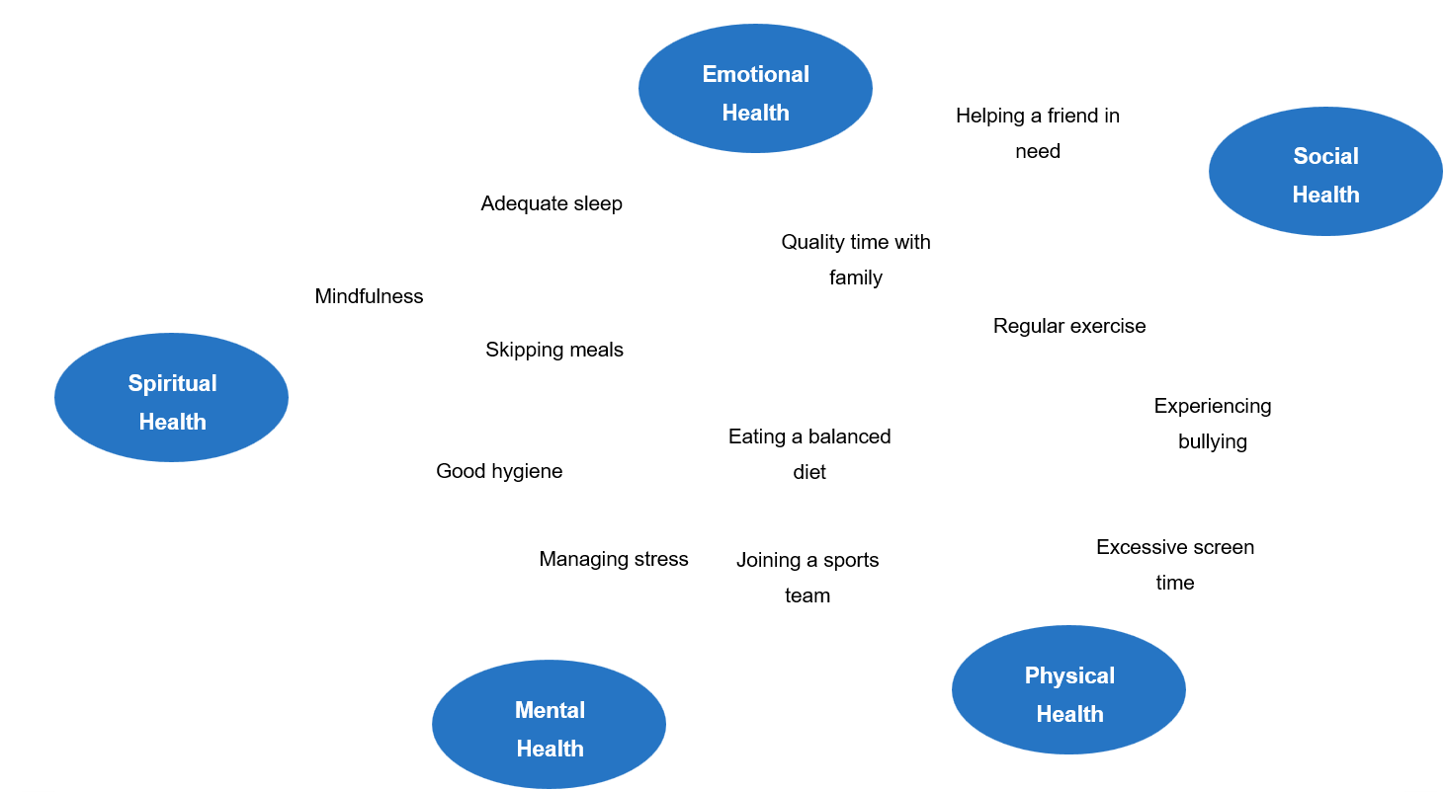
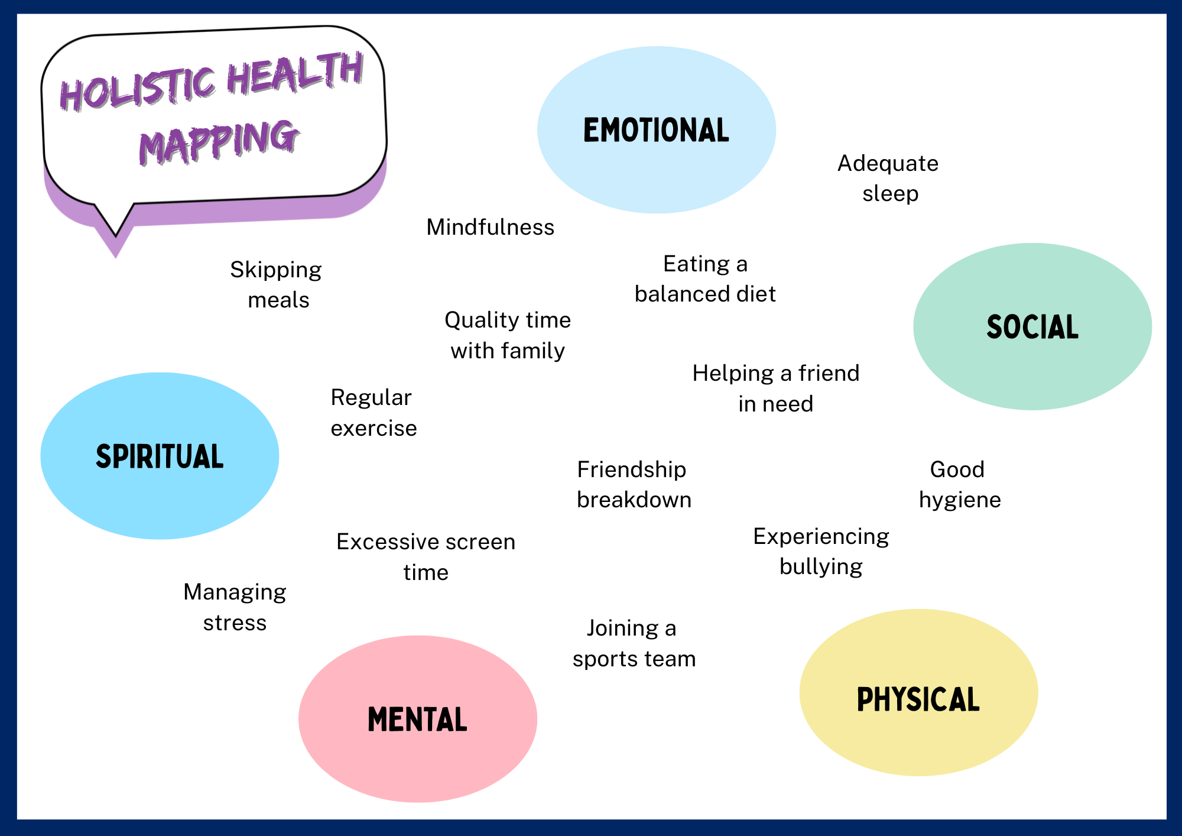

Appendix 2 – health impact scenarios
Jayden recently moved to a new town and started at a new high school. He struggles to make friends and often eats lunch alone. His parents work long hours to make ends meet, so he sometimes skips meals or grabs fast food on the way home. He used to play soccer regularly but hasn’t joined a team yet. Lately, Jayden has been feeling anxious before school and finds it hard to concentrate in class.
Sarah works every afternoon and most weekends at her part-time job. She enjoys the extra money and independence, but she often feels too tired to cook healthy meals or exercise regularly after work. Often in a rush, Sarah tends to grab any quick food option that she can. She also doesn’t have time for weekend sport anymore, so she recently quit her netball team. Her friends are mostly available in the evenings, so she tends to miss out on spending time with them away from school.
Ahmed’s family places strong emphasis on adhering to a cultural diet that involves traditional foods and deserts which are high in sugar and fat. He enjoys sharing these meals with his friends and family. However, he sometimes struggles to balance these meals with healthier options, and occasionally feels sluggish after heavy meals. Ahmed tries to stay active by walking to school and playing soccer with friends on weekends, but his busy study schedule sometimes prevents regular exercise.
Mia has always been passionate about music and recently joined her school’s band. She enjoys practising, but rehearsals often run late into the evening, leaving her with less time for homework and sleep. As a result, she sometimes feels tired during the day and struggles to stay focused in class. Mia’s close friends aren’t in the band, so she sees them less often, but she has started to build strong connections with other band members. To save time, she usually skips breakfast and buys snacks from the canteen.

Appendix 3 – health impact scenario analysis worksheet
Use your scenario as a stimulus to answer the following questions:
What problems are being faced by the character in your scenario? Provide a brief overview.
Which dimensions of health is being immediately impacted?
Which other dimensions of health are being impacted? Explain your response.
What positive strategies or health behaviours would you suggest for this person to manage the negative impacts of their situation?
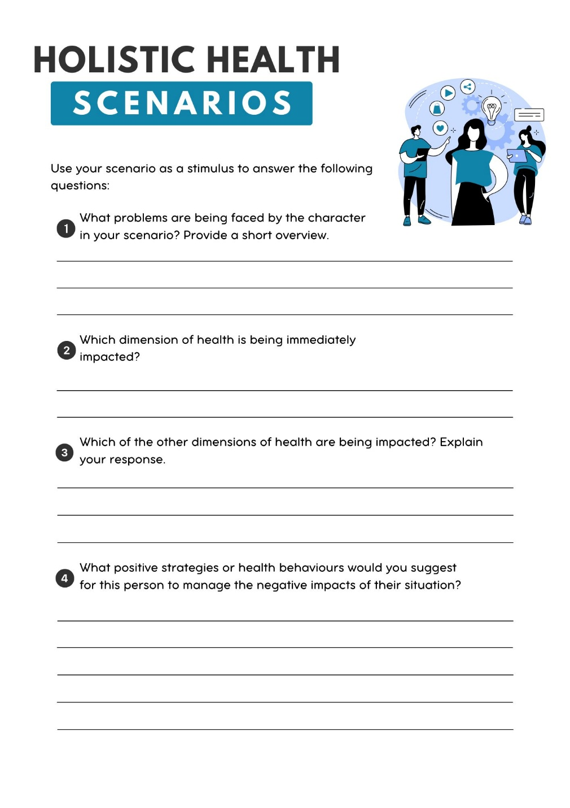

Appendix 4 – health influences table
 |  |  | Influence
 |  | Social | Economic | Cultural
 | Dietary choices
Behaviours | Attitude towards physical activity
Health | Substance use
 | Sleep habits
 | Body image and mental health

Appendix 5 – surviving to thriving support services
Social | Physical | Emotional | Mental | Spiritual
- Open Support’s ‘Community Connections Program’  - MateLine  - Australian Men’s Shed Association  - Relationships Australia  - PCYC  - Country Women’s Association | - NSW Health’s ‘Get Healthy’ service  - ‘Keeping the Body in Mind’ program  - Physiotherapist  - General practitioner (GP)  - Aboriginal Community Controlled Health Organisations (ACCHOs)

Appendix 6 – nutritional information table
Source | Accurate (Yes/No) | Reasoning
Parent(s) or carer(s)
Siblings
Friends
Sports coach
PDHPE teacher
Nutritionist
Doctor

Appendix 7 – clickbait or credible stimulus cards
A popular social media influencer sharing daily meal plans and supplement recommendations. | A cookbook by a famous actress with healthy recipes and personal diet tricks and tips. | A professional dietitian’s personal blog with evidence-based nutritional advice and meal suggestions.
A government website providing information on the dietary guidelines and recommended daily intakes. | A peer-reviewed, published scientific study on the effects of energy drink consumption on adolescent health. | A close friend passing on what they read online or heard from someone about dieting trends.
An online video with information on the ‘5 superfoods that will transform your body in a week’. | A viral 30-second clip from a male model showing off the ‘green smoothie for instant abs’. | Daily push notifications from your fitness app that promote calorie-cutting challenges and meal hacks.

Appendix 8 – positive and negative influences table
Stimulus | Example of positive influence on young people | Example of negative influence on young people

Appendix 9 – dietary guidelines research worksheet
Use the ‘eat for health’ website to answer the following questions:
What are the Australian Government’s dietary guidelines?
How were the guidelines developed?
Why do we need dietary guidelines?
What is the difference between the dietary guidelines and the Australian Guide to Healthy Eating?
What foods do Australians need to eat more and less of?
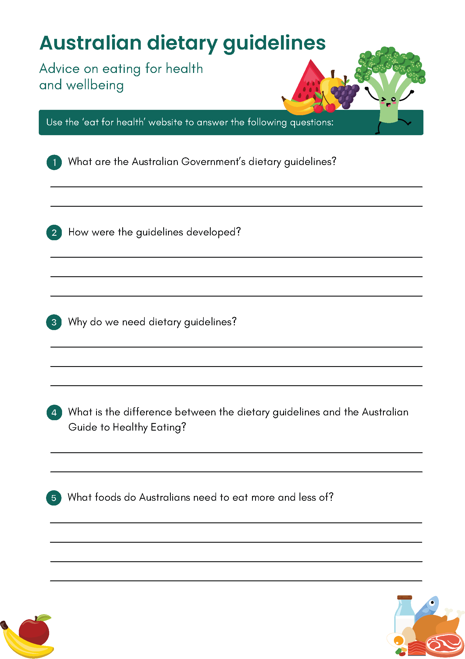

Appendix 10 – influences on food habits worksheet
Scenario | Influencing factors | Suggestion
Emma is a 16-year-old who recently became more health-conscious after learning about nutrition in school. She decides to start eating more vegetables and cutting down on sugary snacks. However, she struggles with cravings for comfort foods when she feels stressed during exams.
Liam loves hanging out with his friends at fast-food outlets after school. Most of his friends prefer burgers and fries, so he often chooses similar meals to fit in socially, even though he knows healthier options are available.
Ayesha’s family follows traditional cultural practices that include cooking with rich spices and a variety of lentils and grains. During family meals, they share dishes that have been passed down through generations, reinforcing cultural identity and connection.
Jackson’s family has a tight budget, so they often buy inexpensive, processed foods that have a longer shelf life. Fresh fruits and vegetables are seen as less affordable, and this limits Jackson’s access to a varied, nutritious diet.
Maya wants to eat healthier but lives in a neighbourhood with limited access to fresh produce stores. Her cultural background values home-cooked meals, but time constraints from her part-time job make convenience foods necessary. Additionally, her friends prefer eating out at fast-food places.

Appendix 11 – student lunchbox sample
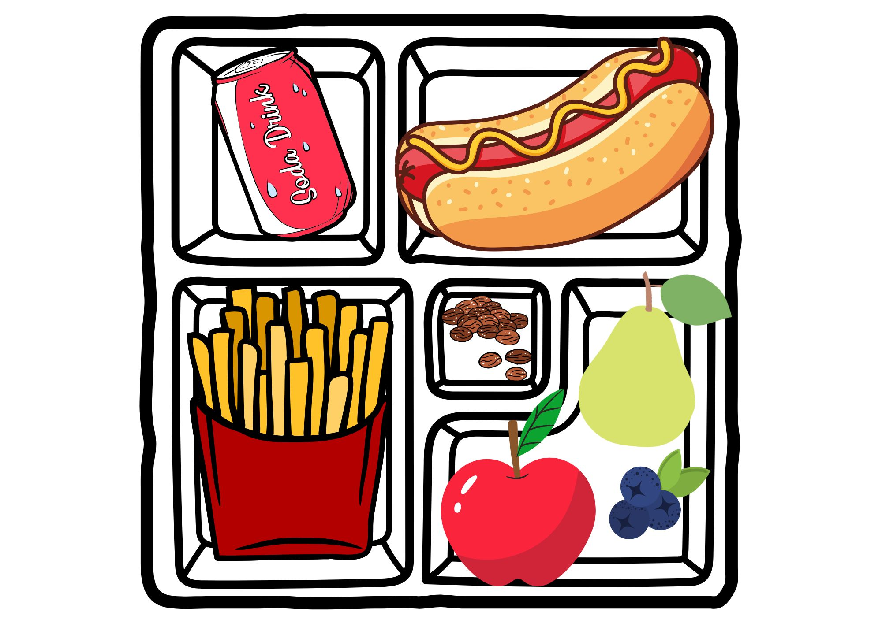

Appendix 12 – plate worksheet
Use the space below to design a nutritionally balanced meal for your group. Draw or list the foods you would include on the plate. Be sure to think about portion sizes and food variety!
How does this meal meet the needs of your group? Justify your choices below.
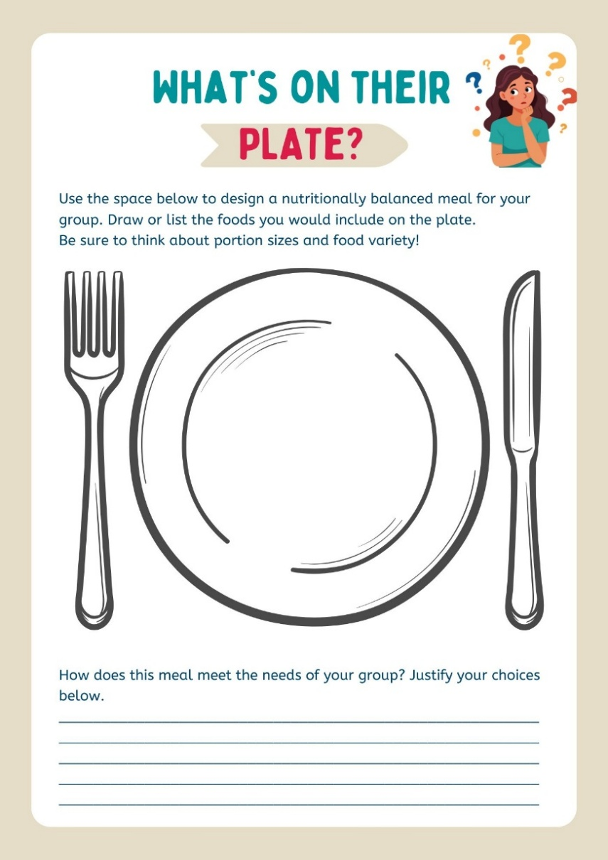

Appendix 13 – energy drink analysis worksheet
Use the space below to record your observations.
What is the caffeine content per serve? How does this compare to the recommended daily limit for adolescents?
How much sugar is included per serve? How does this compare to the recommended daily limit for adolescents?
What other ingredients are included in the drink? Research 2 ingredients you are unfamiliar with – what are they, what do they do and what are safe consumption levels?
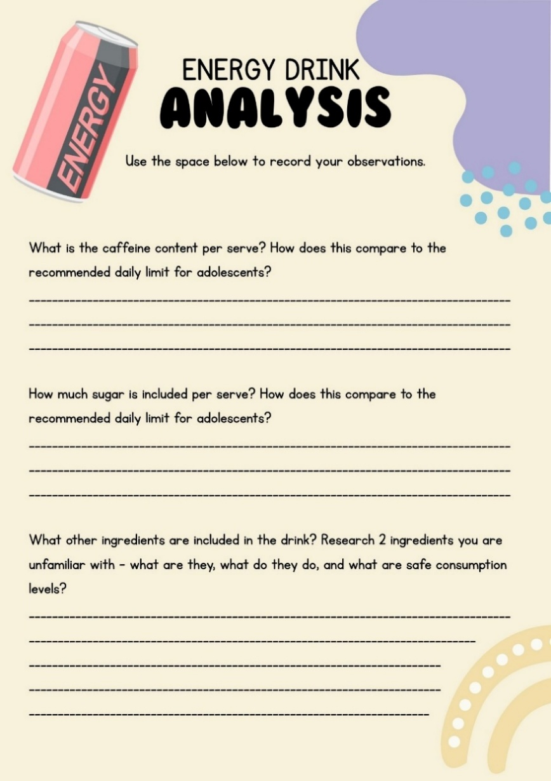

Appendix 14 – persuasive techniques
Persuasive – to convince, influence or motivate the audience to act, feel, or buy
Technique | Purpose | Example
Overall structure | Present a clear and cohesive argument | Clear introduction, body paragraphs and conclusion. The idea is introduced clearly and sustained throughout.
Facts and statistics | Provide evidence and credibility | Numbers, percentages, comparisons, tables, charts.
Emotive language | Appeal to a reader’s feelings and perceptions | Words with strong positive or negative connotations (for example, life-changing, heartbreaking, vile, unacceptable).
Rhetorical questions | Have the reader consider and agree with your point | ‘How long can we continue to ignore our own health?’
Authoritative tone | Shows ownership and confidence in the argument | Created with the imperative verb form (for example, ‘Save the dolphins!’) and high modality language (for example, ‘must’, ‘will’ as opposed to ‘should’ or ‘might’).
Repetition | Make ideas memorable | Repeating words, slogans or key phrases.

Appendix 15 – emotional response scenarios
You’ve been training hard for weeks for the school athletics carnival. The day before the event, you injure your ankle during PE and are told you won’t be able to compete. Your friends try to encourage you, but it’s difficult watching everyone else prepare for the big day.
You’re part of a private group chat with some of your friends. One afternoon, people start sharing jokes and memes about another student in your class. You notice that the comments are becoming a bit rude and very personal, and you begin to wonder whether you should say something or stay quiet.
After a long week, you forget to complete a chore that your parents asked you to do. When they ask about it, the conversation quickly turns into an argument. Voices are raised, and you walk away before the conversation is finished.
You’re working on a group assignment, but one of your teammates isn’t doing their share of the work. The deadline is getting closer, and the rest of the group is feeling the pressure.
A close friend confides in you about something personal they’re struggling with. They ask you not to tell anyone, even though you think they might need extra help or support. You’re unsure what to do next.
You post a photo on social media that you really like. A few hours later, someone leaves a comment that surprises you. It’s not directly rude, but it makes you second-guess yourself and wonder how others see you online.

Appendix 16 – ripple effect template
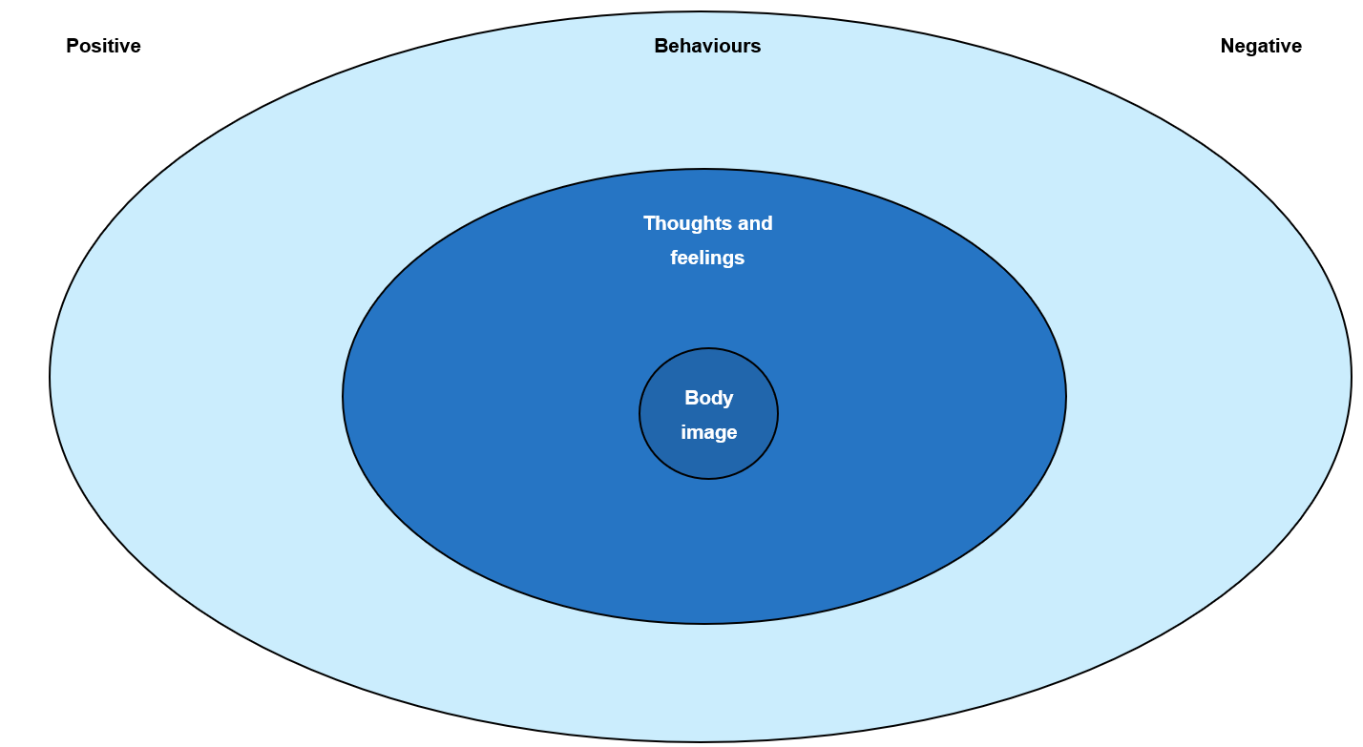

Appendix 17 – ripple exit ticket
What is one way body image can influence a person’s life, and what strategies could someone use to reduce negative ripple effects and enhance positive ones?

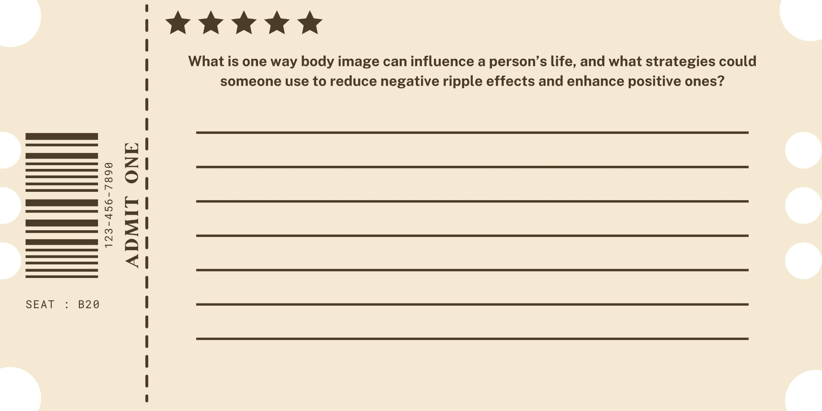

Appendix 18 – eating disorder statement cards
Example myths and misconceptions statements could include:
- Eating disorders only affect girls. (False.)
- It’s possible to manage and even recover from an eating disorder with the right support. (True.)
- Only people who are underweight can have an eating disorder. (False.)
- Eating disorders are classified as mental health conditions. (True.)
- Body dissatisfaction is a risk factor for developing an eating disorder. (True.)
- Recovery from an eating disorder happens quickly and easily. (False.)
- Friends and family can play a role in supporting someone with an eating disorder. (True.)
- Only teenagers develop eating disorders. (False.)
- Eating disorders affect people of all body types and sizes. (True.)
- People with eating disorders often feel shame, anxiety or guilt around eating. (True.)
- Talking openly about eating disorders can help reduce stigma and encourage people to seek help. (True.)

Appendix 19 – eating disorders worksheet
What are eating disorders?
Who is at risk for eating disorders?
One common type of eating disorder is:
Signs:
Symptoms:
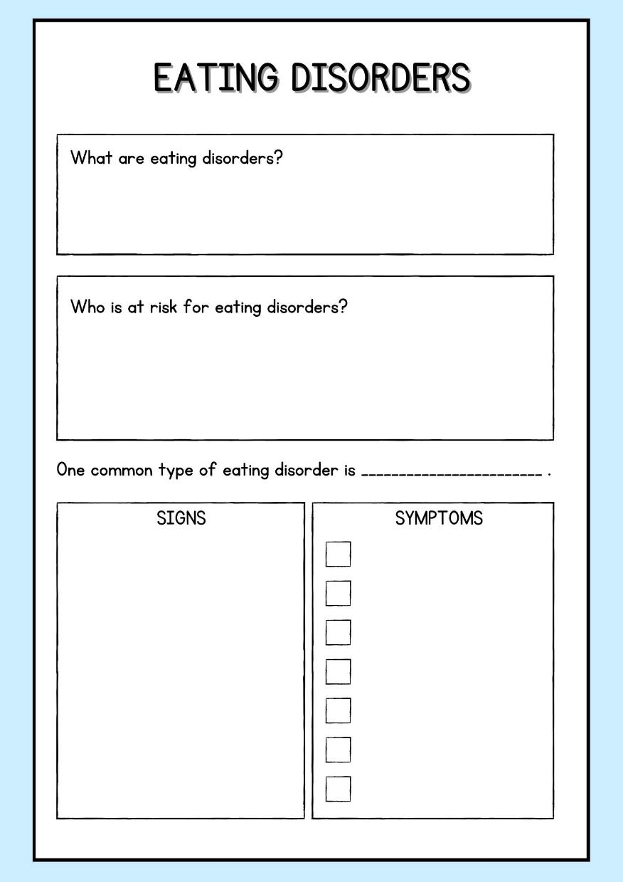

Appendix 20 – eating disorder case-study profiles
Emma is 15 years old and is enjoying her membership at the new gym in town. Her friends have noticed that she’s recently started to skip lunch at school and avoids social events where food is involved. At home, she often eats alone in her room and exercises at the gym for over an hour every day. She expresses frustration about her body shape, frequently comparing herself to influencers on social media. Her parents notice she has lost weight quickly over the past few months, and she sometimes avoids family meals.
Lucas is a 16-year-old boy who has recently become very focused on ‘clean eating’ and ‘tracking macros’. He’s a keen footballer, but was rejected earlier in the year from a representative academy team for failing to meet their skin fold targets. He avoids certain food groups, claims he feels ‘bloated’ if he eats carbs, and has become irritable during family meals. He spends hours at the gym and gets anxious if he misses a workout. His friends have noticed he eats very little when they hang out together.
Zara is an avid dancer and has always been conscious of her body shape for her performances. Lately, she has started skipping meals and counting every calorie she consumes. She refuses certain foods she used to enjoy, saying they will make her ‘too heavy’, but doesn’t exercise excessively. She reports feeling anxious before competitions and often compares her body to the other dancers in her ensemble.
Noah struggles with binge eating but hides it from his friends and family. He eats large amounts of food when he’s stressed or upset and then feels ashamed afterward. He feels embarrassed about his eating habits and tends to spend more time alone than hanging out with other people. Noah also experiences low self-esteem and feels pressure to be fit because of images he sees on social media.

Appendix 21 – self-care squares worksheet
What I do | What I think
What I avoid | Who I go to

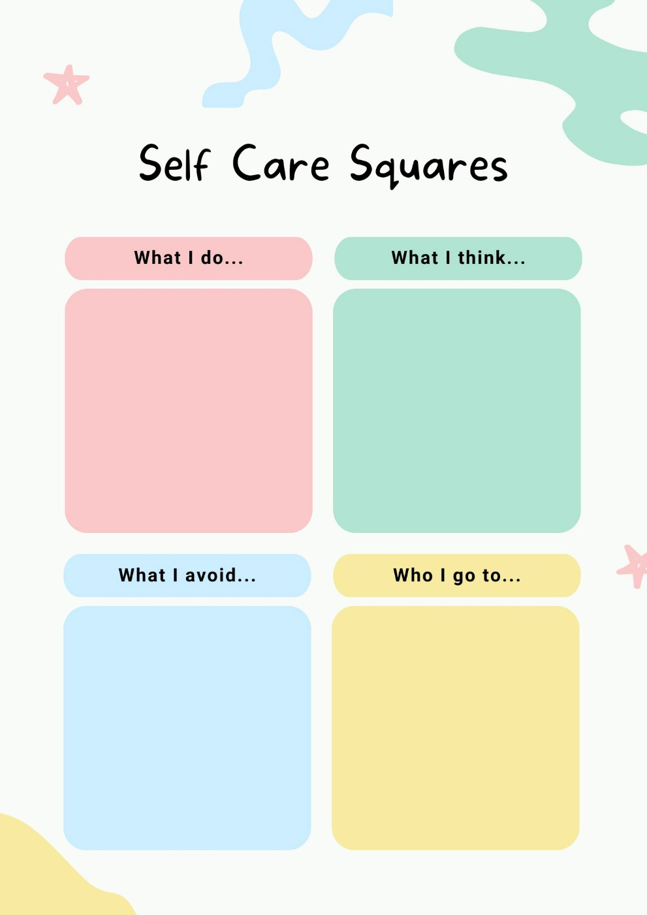

Appendix 22 – resilience toolkit
My strengths | My strategies
My supports | My reminders

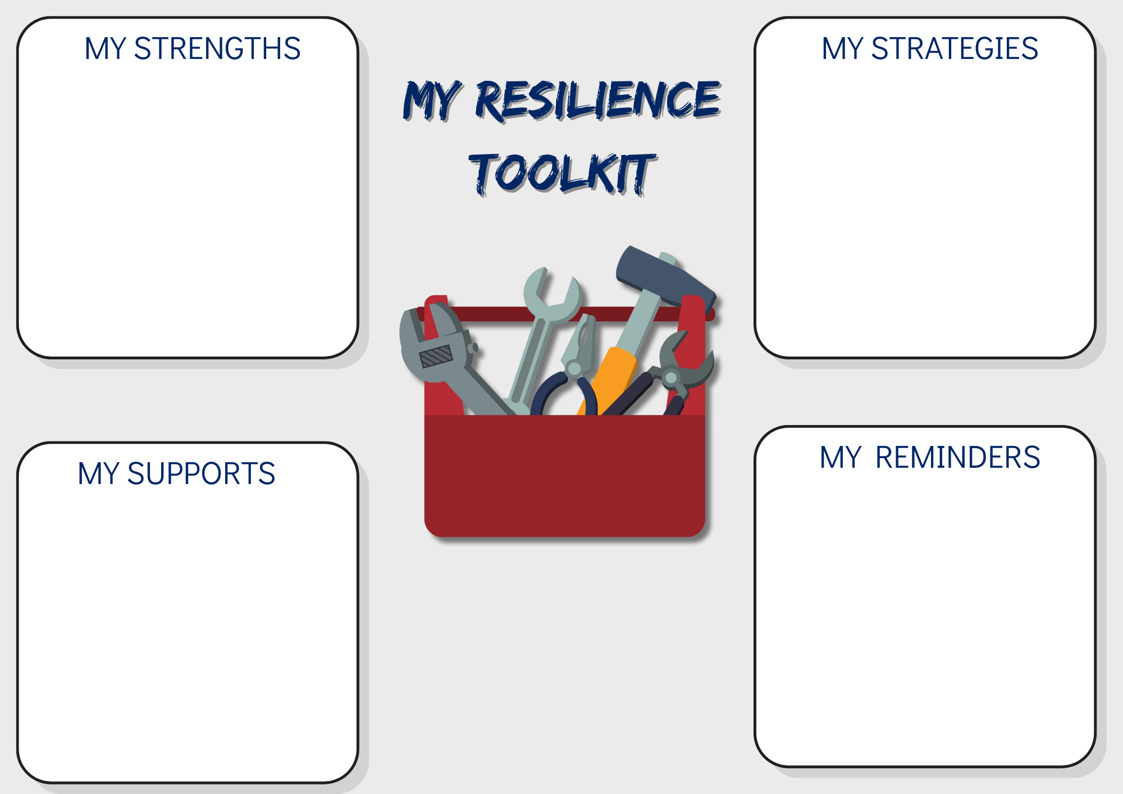

Appendix 23 – myths and misconceptions statement bank
Example myths and misconceptions statements could include:
- Most teenagers in Australia drink alcohol regularly. (False.)
- Nicotine is addictive in cigarettes but not if it comes from a vape. (False.)
- Everyone experiments with drugs at some point – it’s a normal part of growing up. (False.)
- You can’t get addicted to cannabis like you can with other drugs. (False.)
- Not everyone who drinks alcohol or tries drugs will develop a problem – but your risk increases with use. (True.)
- Saying ‘no’ to drugs and alcohol is actually more common among teenagers in Australia than saying ‘yes’. (True.)
- Illegal drugs are always more dangerous than legal ones. (False.)
- Most young people either smoke, vape or drink alcohol. (False.)
- Education, and support from friends, family or professionals, can help young people make positive choices. (True.)
- Having 1 or 2 drinks when you’re underage is fine. (False.)
- People who don’t drink or experiment with drugs are boring. (False.)

Appendix 24 – drugs and alcohol data analysis worksheet
Use the following questions to guide your analysis of the AIHW’s ‘Young people’s use of alcohol, tobacco, e-cigarettes and other drugs’ resource. Record your responses in your workbooks.
- Why were young people identified as one of the priority groups in the 2017–2026 National Drug Strategy?
- What percentage of young people smoke tobacco daily? How has this changed over time?
- What percentage of young people currently use e-cigarettes? Are there any differences between males and females?
- What is the observable trend in the proportion of young people drinking alcohol at risky levels between 2019 and 2023?
- What percentage of young people (12 to 17 years and 18 to 24 years) consumed alcohol at risky levels? Have these numbers been declining or increasing over time?
- What percentage of young people aged 14 to 17 have used an illicit drug in their lifetime? How has this changed over time?
- What percentage of young people aged 18 to 24 have used an illicit drug in their lifetime? How has this changed over time?
- Illicit drug use among young females aged 14 to 17 has increased substantially in recent years. What percentage of females in this age group have used illicit drugs recently? How does this compare to males in the same age group?
- Which illicit substances are most likely to be used by young people? How has this changed over time?
- Across the statistics for use of alcohol, tobacco, e-cigarettes and illicit drugs, what do you notice about the differences between the 14 to 17 and 18 to 24 age groups?
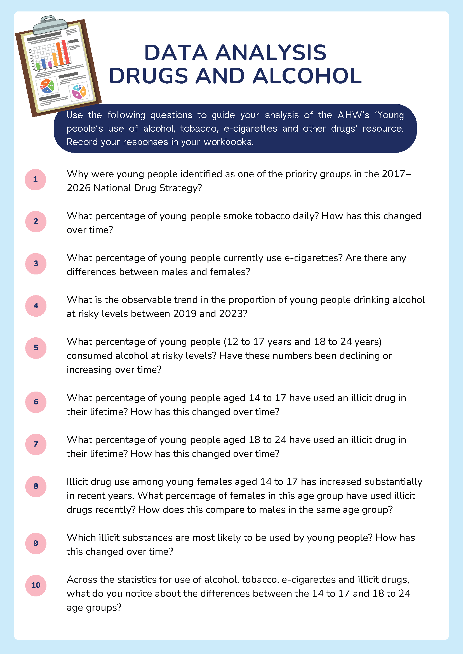

Appendix 25 – Liam and Zoe’s story
Fifteen-year-old Liam and his friend Zoe were excited as they walked to a weekend party at Georgia’s house. Georgia’s parents are away for work a lot, and her parties are well-known at school for having loud music, lots of people and often some alcohol.
Zoe smiled as she slipped a small bottle into her bag. ‘I heard there’ll be alcohol there,’ she said. ‘It’s going to be fun!’
Liam was immediately concerned. ‘I don’t know, Zoe. I’ve never drunk before, and I have soccer training early tomorrow morning. I don’t want to mess that up. We’ve got an important game this week.’
Zoe rolled her eyes. ‘Everyone’s going to be drinking, Liam. You don’t want to look boring or like you can’t handle it, do you? Everyone will think you’re scared,’ she laughed.
Liam felt the pressure building. He thought about what his parents had told him about making safe choices and the dangers of alcohol. He also remembered his coach’s advice about staying focused on training this season.
As they arrived, the house was packed. Loud music thumped from the speakers, and groups of students laughed and danced. Zoe quickly found a group passing around drinks and took a sip from a cup.
‘What’s in that?’ asked Liam.
‘Alcohol, duh!’ replied Zoe. ‘Don’t worry so much, this is going to be fun!’
Liam stayed near the edge of the room, sipping on a soft drink and talking to a few friends from his soccer team. Most of them were also sticking to soft drinks, knowing they had some really important games coming up.
Zoe was dancing and having a great time when she was approached by another student holding a small bag of pills. Zoe recognised her from school, but she was in the year above. ‘These will make the night even better,’ the student said with a grin. ‘We’re all doing it!’
Zoe hesitated. She wasn’t sure what the pills were or what they would do, and she remembered what she had learned in PDHPE about the dangers of unknown substances. Zoe was panicked – there was a group of older students watching, and she didn’t want to miss out or seem like she was afraid. ‘Hurry up, Zoe – it’s not a test, just do it!’ one said. After a moment, she took a pill.
Liam came back into the main room and immediately noticed Zoe was acting weird. She was laughing loudly, sweating, stumbling as she walked and her words didn’t make sense. He immediately felt worried and uncomfortable.
He pulled out his phone and texted his older sister: ‘Can you come pick me up? Zoe’s not doing well.’
While waiting outside, Liam saw some other students who looked tired and shaky, some sitting on the front lawn with their heads in their hands and vomiting. He started to realise that maybe the party wasn’t as fun as it seemed earlier.
When his sister arrived, Liam helped Zoe into the car. Zoe looked pale and said she felt sick. ‘Just don’t tell my parents,’ she whispered.
They took her home and while Zoe’s mum was getting her inside, Liam told Zoe’s dad what he knew. He was worried about betraying Zoe’s trust but knew that it was important that an adult was aware of what had happened.
The next day, Liam went to soccer training feeling proud he had stuck to his decision. He felt strong and ready to play.
Zoe stayed home for the weekend, recovering and thinking about what had happened. She felt embarrassed and was in big trouble with her parents.
On Sunday evening, Zoe messaged Liam. They talked about how wanting to fit in had influenced her to take risks and how having clear goals and support had helped Liam make safer choices.
They agreed to look out for each other in the future and to think carefully before making decisions that could affect their health and safety.

Appendix 26 – decision-making tree
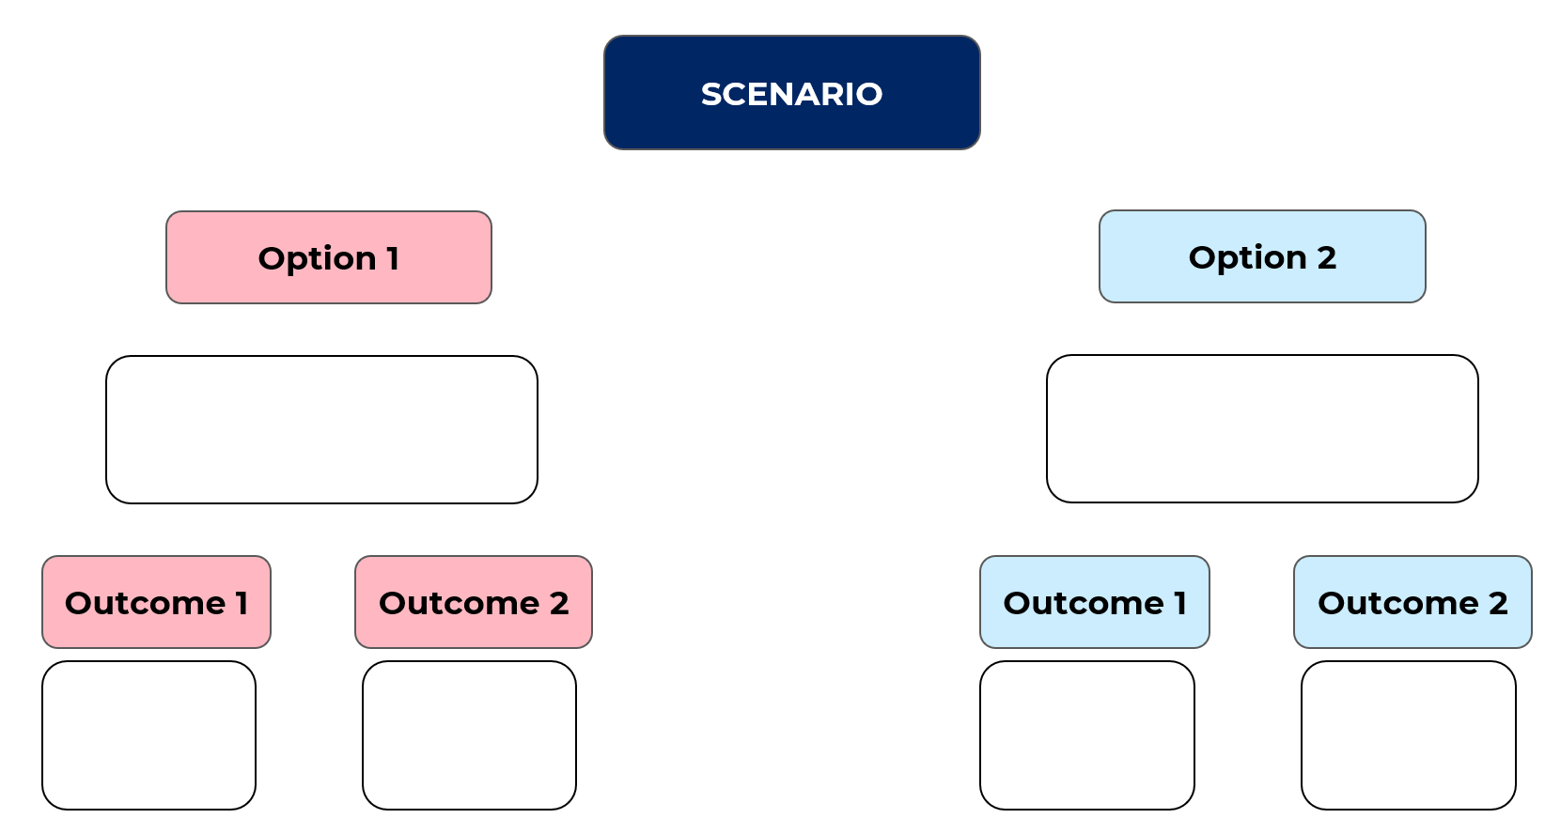

Appendix 27 – decision tree scenarios
A group of your friends are sneaking out the school gate at lunch to vape at the park down the road. They invite you to join.
A friend invites you to a party at their house on Friday night. They say that their parents are away, and their older brother can get alcohol for everyone.
Your older cousin pulls you aside at a family BBQ and says that he has some cannabis in the car. He asks if you want to smoke with him.
You get called up into the Under 18’s team for the weekend’s game. Afterwards, they’re having drinks to celebrate and asked if you want one.
You’ve been tagged in a viral video on social media which encourages you to smoke or drink on camera and then tag 5 friends to do the same.
You’ve had a rough week with assessment tasks and exams, and a friend offers you a cigarette at the train station to unwind.

Appendix 28 – role-play scenarios
Scenario | Details
1 | One of your friends, Jake, has started vaping. Your group of friends is hanging out on the weekend, and Jake starts encouraging everyone to try it out. You’re not interested and don’t want to join in. One of your other friends says that he’s happy to try it and tells you not to be so scared.
2 | Your best friend’s older brother is having a big party for their 21st birthday. Your friend lets everyone in the group know that they’re welcome to come along and says there will be plenty of food and drinks.  At the party, one of your friends finds the alcohol and says they’re going to have a few drinks. They end up drinking too much and blacking out in the front yard.
3 | You and a group of friends have been hanging out at the beach in the afternoon. Some friends have been drinking a few beers that they stole from home. As the sun starts to set, a few in the group suggest going for a swim in the ocean. You’re not sure it’s a good idea, but your friends say it’ll be fine and start heading towards the water.
4 | You’re at a small gathering at a friend’s house after school. One of the older kids in the group offers you a cigarette and encourages you to try it. A couple of your friends look like they might try it too. You’re unsure and don’t want to, but you feel pressure to join in so you don’t feel left out.


Program feedback
We value your feedback. If you use this teaching and learning program in your faculty and school context, please complete the PDHPE 7–10 resource evaluation form. If you have further comments or suggestions, please email PDHPEcurriculum@det.nsw.edu.au.

Support and alignment
Resource evaluation and support: all curriculum resources are prepared through a rigorous process. Resources are periodically reviewed as part of our ongoing evaluation plan to ensure currency, relevance and effectiveness. For additional support or advice, or to provide feedback, contact the PDHPE Secondary Curriculum team by emailing PDHPEcurriculum@det.nsw.edu.au.
Differentiation: further advice to support Aboriginal and/or Torres Strait Islander students, students learning English as an additional language or dialect (EAL/D), students with a disability and/or additional needs and high potential and gifted students can be found on the Planning, programming and assessing 7–12 webpage. This includes the Inclusion and differentiation advice 7–10 webpage.
Assessment: further advice to support formative assessment is available on the Planning, programming and assessing 7–12 webpage. This includes the Classroom assessment advice 7–10. For summative assessment tasks, the Assessment task advice 7–10 webpage is available.
Explicit teaching: further advice to support explicit teaching is available on the Explicit teaching webpage. This includes the CESE Explicit teaching – Driving learning and engagement webpage.
Consulted with: Curriculum and PDHPE subject matter experts
Alignment to system priorities and/or needs: School Excellence Policy, Our Plan for NSW Public Education
Alignment to the School Excellence Framework: this resource supports the School Excellence Framework elements of curriculum (curriculum provision) and effective classroom practice (lesson planning, explicit teaching).
Alignment to Australian Professional Standards for Teachers: this resource supports teachers to address Proficient Teacher Standard Descriptors 2.1.2, 2.2.2, 2.3.2, 2.5.2, 3.1.2, 3.2.2, 3.3.2, 4.4.2.
Creation date: 26 September 2025

References
This resource contains NSW Curriculum and syllabus content. The NSW Curriculum is developed by the NSW Education Standards Authority (NESA). This content is prepared by NESA for and on behalf of the Crown in right of the State of New South Wales. The material is protected by Crown copyright.
Please refer to the NESA Copyright Disclaimer for more information https://www.nsw.gov.au/education-and-training/nesa/copyright.
NESA holds the only official and up-to-date versions of the NSW Curriculum and syllabus documents. Please visit NESA https://www.nsw.gov.au/education-and-training/nesa and NSW Curriculum https://curriculum.nsw.edu.au.
Personal Development, Health and Physical Education 7–10 Syllabus © NSW Education Standards Authority (NESA) for and on behalf of the Crown in right of the State of New South Wales, 2024.
Australian Government Department of Health, Disability and Ageing (AGDHDA) (n.d.) ‘Australian Guide to Healthy Eating’, Eat for Health, AGDHDA website, accessed 1 August 2025.
——(n.d.) ‘The guidelines’, Eat for Health, AGDHDA website, accessed 5 August 2025.
——(2021) Types of drugs, AGDHDA website, accessed 30 July 2025.
Australian Institute of Health and Welfare (AIHW) (2021) Australia’s youth: Nutrition, AIHW website, accessed 4 August 2025. https://www.aihw.gov.au/reports/children-youth/nutrition
AIHW (2024) Young people’s use of alcohol, tobacco, e-cigarettes and other drugs, AIHW website, accessed 5 August 2025.
Behind the News (10 August 2024) ‘Illegal Energy Drinks – Behind the News (3:53)’, Behind the News, YouTube, accessed 22 January 2026.
Calm (n.d.) The Feelings Wheel, Calm website, accessed 1 August 2025.
Cancer Council NSW (2024) Lunch box builder, Cancer Council website, accessed 30 July 2025.
HealthDirect (2023) Eating disorders, HealthDirect website, accessed 13 August 2025.
HealthDirect (2025) What is addiction?, HealthDirect website, accessed 11 August 2025.
NESA (NSW Education Standards Authority) (2024) ‘Glossary’, Personal Development, Health and Physical Education 7–10 Syllabus, NSW Curriculum website, accessed 22 January 2026.
NSW Health (2017) Energy drinks and caffeine, NSW Health website, accessed 28 July 2025.
The Butterfly Foundation (n.d.) Eating Disorders & Body Image, The Butterfly Foundation website, accessed 13 August 2025.
World Health Organization (n.d.) Constitution, World Health Organization website, accessed 30 July 2025.
World Health Organization (2025) Mental health, World Health Organization website, accessed 30 July 2025.

© State of New South Wales (Department of Education), 2026
The copyright material published in this resource is subject to the Copyright Act 1968 (Cth) and is owned by the NSW Department of Education or, where indicated, by a party other than the NSW Department of Education (third-party material).
Copyright material available in this resource and owned by the NSW Department of Education is licensed under a Creative Commons Attribution 4.0 International (CC BY 4.0) license.

This license allows you to share and adapt the material for any purpose, even commercially.
Attribution should be given to © State of New South Wales (Department of Education), 2026.
Material in this resource not available under a Creative Commons license:
- the NSW Department of Education logo, other logos and trademark-protected material
- material owned by a third party that has been reproduced with permission. You will need to obtain permission from the third party to reuse its material.
Links to third-party material and websites
Please note that the provided (reading/viewing material/list/links/texts) are a suggestion only and implies no endorsement, by the New South Wales Department of Education, of any author, publisher, or book title. School principals and teachers are best placed to assess the suitability of resources that would complement the curriculum and reflect the needs and interests of their students.
If you use the links provided in this document to access a third-party's website, you acknowledge that the terms of use, including licence terms set out on the third-party's website apply to the use which may be made of the materials on that third-party website or where permitted by the Copyright Act 1968 (Cth). The department accepts no responsibility for content on third-party websites.

