PDHPE Year 10 – own the zone
Teaching and learning program
Contents
About this resource 3
Overview 3
Syllabus outcomes 4
Content 4
Focus area – Movement skills and strategies 4
Related support materials 5
Teacher notes 6
Learning sequence 1 – territory games stations 7
Learning sequence 2 – Ultimate flying disc defence 14
Learning sequence 3 – Ultimate flying disc attack 24
Learning sequence 4 – basketball defence 33
Learning sequence 5 – basketball attack 42
Learning sequence 6 – touch or tag football defence 47
Learning sequence 7 – touch or tag football attack 55
Learning sequence 8 – assessment 61
Summative assessment task 67
Appendix 1 – activity cards 68
Station 1 – basketball (4 versus 4) 68
Station 2 – touch or tag football (4 versus 4) 70
Station 3 – Ultimate flying disc (4 versus 4) 72
Program feedback 74
Support and alignment 75
References 76

About this resource
This teaching and learning program has been developed to assist teachers in NSW Department of Education schools to create learning experiences that are contextualised to their students’ needs, interests and abilities for the Personal Development, Health and Physical Education 7–10 Syllabus (NESA 2024). It provides an example of one way to approach programming through a conceptual lens. Teachers are encouraged to take an adopt and adapt approach to the learning activities outlined in this program.

Overview
Description: in this teaching and learning program, students refine and apply movement skills and offensive and defensive strategies through participation in a variety of territory games.
Through practical gameplay and cooperative challenges, students are provided opportunities to collaborate and communicate effectively, adapt strategies dynamically and respond to changing contexts within games.
Throughout this program, students are provided opportunities to take on leadership and self-officiating roles, reflect on their contributions and explore how resilience, motivation and respectful behaviour support positive and inclusive participation.
Duration: approximately 9 hours and 30 minutes.
Explicit teaching: explicit teaching strategies are embedded in this resource. Further information on these strategies can be found on the Explicit teaching strategies webpage.
Assessment: PDHPE Year 10 –own the zone – sample assessment task notification.

Syllabus outcomes
A student:
- refines and transfers movement skills and concepts for adaptation in a range of dynamic movement environments PH5-MSS-01
- selects, implements and justifies strategies and actions to solve movement challenges PH5-MSS-02
- evaluates and adapts self-management and interpersonal skills to manage complex situations PH5-SMI-01
Personal Development, Health and Physical Education 7–10 Syllabus © NSW Education Standards Authority (NESA) for and on behalf of the Crown in right of the State of New South Wales, 2024.

Content

Focus area – Movement skills and strategies
Enhancing and valuing movement
- Refine and adapt fundamental and specialised movement skills to predictable and dynamic situations
- Participate in target, net and court, striking and fielding, and territory games to investigate how to adapt movement skills and strategies to solve problems in gameplay
- Select and transfer similar movement skills and strategies to different movement environments
- Apply and evaluate a range of attacking and defending strategies to enhance individual and team performance in gameplay
- Examine and demonstrate how communication and movement concepts can assist with anticipation, decision-making and the manipulation of space and time
- Analyse and practise how connections between communication, skill execution, movement concepts, teamwork, strategy and involvement can improve outcomes in gameplay
- Provide and apply feedback to refine specialised movement skills, concepts and strategies
Applying self-management and interpersonal skills to movement
- Apply and evaluate attitudes and behaviours that encourage enjoyable, ethical, respectful and inclusive movement experiences
- Evaluate how personal strengths and contributions can enhance teamwork, leadership and enjoyable participation
- Examine and apply strategies to increase resilience, persistence and motivation for themselves and others, including positive self-talk and encouragement
- Apply and refine communication, problem-solving and decision-making skills to dynamic movement situations
- Demonstrate leadership and collaboration skills and evaluate how they promote successful outcomes in team environments

Related support materials
This teaching and learning program aligns with the following support materials:
- assessment task – PDHPE Year 10 – own the zone – sample assessment task notification
- PDHPE Years 9–10 – sample scope and sequence.
All resources associated with this resource can be found on the Planning, programming and assessing PDHPE 7–10 webpage.

Teacher notes
This teaching and learning program builds on learning from prior territory game programs, fundamental movement skill development and sports explored in PDHPE Year 9 –the real MVPs –behind the scenes in sport to inform and extend student learning. Adaptations made to these learning experiences in earlier years should be considered prior to implementation. Throughout the program, students build on previously developed knowledge and skills to deepen their understanding of strategies and tactics, and to compare how these are applied across different territory games. Activities are structured to allow students to remain in consistent teams wherever possible, supporting opportunities to evaluate how personal strengths and contributions enhance teamwork. The activities also allow students to apply and refine communication, problem-solving and decision-making skills that promote successful outcomes in team environments.

Learning sequence 1 – territory games stations
Note: this is a practical learning sequence. The duration of this learning sequence is approximately one hour.
Table 1 – teaching and learning program
Outcomes and content | Teaching and learning activities
Outcomes  PH5-MSS-01, PH5-MSS-02,  PH5-SMI-01  Content  Focus area – Movement skills and strategies  Enhancing and valuing movement  - Refine and adapt fundamental and specialised movement skills to predictable and dynamic situations  - Select and transfer similar movement skills and strategies to different movement environments  - Examine and demonstrate how communication and movement concepts can assist with anticipation, decision-making and the manipulation of space and time  Applying self-management and interpersonal skills to movement  - Apply and evaluate attitudes and behaviours that encourage enjoyable, ethical, respectful and inclusive movement experiences | Learning intentions  We are learning to:  - use movement to create space in different territory games  - communicate with teammates to support play  - make good decisions when attacking and defending.  Success criteria  I can:  - move into space to help my team keep possession  - use clear communication to support teammates  - choose effective actions when in attack and defence.  Note: these sport choices build on prior learning from the Year 8 and 9 sequences. Activities are organised into modules, allowing for flexibility depending on students’ previous experience. The aim of this learning sequence is to highlight 3 different types of territory games: line-based (touch or tag football), small court-based (basketball) and large field-based (Ultimate flying disc). Any changes to the sports should remain focused on these categories.  Throughout activities, keep students in consistent teams where possible to evaluate how their strengths contribute to teamwork, while refining communication, problem-solving and decision-making for successful outcomes.  Students begin the learning sequence by rotating through 3 modified small-sided territory games. The aim is to activate prior knowledge, establish common tactical language and recognise similarities and differences across games. Activities emphasise cooperation, movement into space, participation, movement quality and decision-making.  Territory games stations  Divide the class into 3 groups of 8 students. Within each group, split the students into 2 teams to begin participating in the station activity as follows:  - Group 1 – Teams 1A and 1B begin playing basketball.  - Group 2 – Teams 2A and 2B begin playing touch or tag football.  - Group 3 – Teams 3A and 3B begin playing Ultimate flying disc.  Students rotate through 3 stations, spending 12 to15 minutes at each. Halfway through each station, pause the game for students to complete the questions on their activity card, then resume play before rotating to the next station.  - Station 1 – basketball (4 versus 4):  - Students use a basketball court to play a 4-versus-4 modified game.  - Teams must complete 3 passes before attempting to score, encouraging movement off the ball and controlled possession.  - Players without the ball reposition to create passing options and support the ball carrier.  - Defenders apply safe, controlled pressure without physical contact.  - The attacking team moves into open passing lanes.  - The attacking team uses quick pivots to protect possession.  - Station 2 – touch or tag football (4 versus 4):  - Students use a 12 metre by 15 metre field to play a 4-versus-4 touch or tag game.  - Teams have 4 touches or tags to score, encouraging quick decision-making and purposeful movement.  - After each touch or tag, the defensive team resets their line to maintain defensive structure and spacing.  - Attackers are encouraged to use quick passes and angled runs to create space.  - Defenders focus on lateral movement to track attackers, applying touch or tag by staying balanced and avoiding reaching.  - Play is reset from the middle when a try is scored.  - Station 3 – Ultimate flying disc (4 versus 4):  - Students use a 14 metre by 20 metre field with 2 end zones to play a 4-versus-4 Ultimate flying disc game.  - Players must pass to gain advantage and are not permitted to run with the disc.  - If the disc is dropped or intercepted, possession immediately turns over.  - Teams score by catching the disc inside the end zone.  - Attackers are encouraged to position themselves into space to receive the disc.  - Play is reset after each score by a pull.  Whole-class discussion  Use discussion questions to guide students in evaluating how their attitudes and behaviours influenced enjoyment, inclusion, fairness and respect across the games. Ask students to identify what worked well, what could improve and how communication and decision-making impacted team experiences. The following questions have been provided as an example:  - Did your team create an inclusive environment where everyone had opportunities? How do you know?  - When did behaviour become less respectful or ethical? What could be improved?  - Which attitudes helped make the game more enjoyable for everyone?  - How effectively did your team self-regulate honesty and fairness?  - What behaviours encouraged inclusion?  - How did your communication impact team enjoyment and success?  - How well did your team uphold the ‘spirit of the game’?  - When conflicts occurred, how were they resolved respectfully?  - What behaviours made the game more enjoyable?  Comparative reflection questions  Use reflection questions to guide students in consolidating their learning by comparing how space, communication, and strategy are applied across the 3 territory games. Ask students to identify common principles, such as creating passing options, maintaining defensive structure and communicating to teammates, while also recognising differences in rules and movement that influence team strategies and decision-making. The following questions have been provided as an example:  - What similarities and differences did you notice in how teams create and use space?  - How did communication differ between the games, and how did it support your team?  - How did defensive strategies vary depending on the game’s rules or structure?  - What strategies or principles from one game could be applied to another to improve performance?  - How effectively did your attitudes and behaviours contribute to creating an enjoyable, ethical, respectful and inclusive experience across all activities?  Formative assessment: formative assessment is embedded through targeted teacher questioning to monitor how students adapt and transfer movement skills and strategies, use communication and movement concepts to support decision-making and the effective use of space.  Outcome  - refines and transfers movement skills and concepts for adaptation in a range of dynamic movement environments PH5-MSS-01
Adjustments, evaluation and registration
[Classroom teacher to complete.]

Learning sequence 2 – Ultimate flying disc defence
Note: this is a practical learning sequence. The duration of this learning sequence is approximately 2 hours.
Table 2 – teaching and learning program
Outcomes and content | Teaching and learning activities
Outcomes  PH5-MSS-01, PH5-MSS-02,  PH5-SMI-01  Content  Focus area – Movement skills and strategies  Enhancing and valuing movement  - Participate in target, net and court, striking and fielding, and territory games to investigate how to adapt movement skills and strategies to solve problems in gameplay  - Analyse and practise how connections between communication, skill execution, movement concepts, teamwork, strategy and involvement can improve outcomes in gameplay  - Apply and evaluate a range of attacking and defending strategies to enhance individual and team performance in gameplay  - Examine and demonstrate how communication and movement concepts can assist with anticipation, decision-making and the manipulation of space and time  Applying self-management and interpersonal skills to movement  - Apply and refine communication, problem-solving and decision-making skills to dynamic movement situations  - Evaluate how personal strengths and contributions can enhance teamwork, leadership and enjoyable participation | Learning intentions  We are learning to:  - apply different defensive strategies to limit attackers and force turnovers  - communicate and make decisions to work effectively as a team in defence.  Success criteria  I can:  - use either person-to-person or zone defence to apply pressure and protect space  - communicate with my teammates to stay organised and make better defensive decisions.  The disc hive – warm-up  In groups of 16, divide students into pairs and work within a 20 metre by 20 metre field.  Two lots of pairs are designated as defenders (‘the hornets’)’ and wear bibs.  All remaining pairs are attackers (‘the hive’).  Four discs are distributed among the hive pairs.  The activity begins with the hive moving around the field and passing the discs continuously.  Pairs in possession must move to space and support each other to maintain possession.  - Attackers cannot hold a disc for longer than 3 seconds, encouraging quick decision-making and constant movement.  - The hornets or defenders move throughout the grid attempting to tag any player who is holding a disc.  - If a hive player is tagged while holding a disc, or if a disc is dropped, roles immediately change and the pair becomes the hornets and puts on the bibs.  Glue and force  Demonstrate person-to-person defensive concepts by highlighting how defenders can both mark their players and influence the flow of play. Explain the following concepts:  - The glue: each defender is responsible for one attacker and marks them closely at all times to deny space.  - The force: defenders position themselves on the inside shoulder of their attacker (closest to the centre of the field) to influence play towards the sidelines.  Students return to their teams of 4, with 4 attackers and 4 defenders and are allocated a 15 metre by 30 metre playing area with end zones marked at each end and a central channel through the middle of the field.  Figure 1 – set-up for Ultimate glue challenge  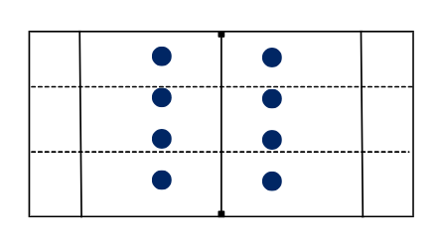  Attackers begin with possession of the disc and attempt to pass and score by completing a catch in either:  - the end zone  - the central channel.  Defenders are each assigned one attacker and must remain matched to that player for the duration of the activity. Defenders are not permitted to leave their assigned opponent to assist others.  Defenders apply pressure by:  - staying on the inside shoulder of their attacker to limit access to central space  - using controlled footwork and body positioning to guide attackers towards the sideline  - maintaining visual awareness of both their opponent and the disc.  Attackers attempt to create space and passing options by moving off the disc and using width and use timing cuts to access the central channel.  Scoring is applied to reinforce the learning focus:  - Attackers are awarded 2 points for a successful catch in the end zone.  - Attackers are awarded 1 point for a successful catch in the central channel.  - Defenders are awarded 2 points if they force an attacker to drop the disc or throw the disc out of bounds along the sideline.  The diamond wall  Introduce students to zone defence using a diamond shape, demonstrating how defenders work together to protect the centre of the field and control where attackers can pass or move. In this structure, defenders do not mark individual players. Instead, they form a moving diamond shape that protects the middle of the field and restricts direct passing options.  Students are divided into groups of 8 and return to their teams of 4 attackers and 4 defenders. Allocate a 15 metre by 40 metre playing area with 2 end zones.  Defenders begin by setting up in a diamond formation in the following positions:  - The mark (1 player): positioned approximately 3 metres from the thrower. Their role is to block one side of the thrower and force the pass in a specific direction.  - The wingers (2 players): positioned around 5 metres behind the mark and slightly to the left and right of the mark. Their role is to deny inside passing lanes and support the mark.  - The safety (1 player): positioned approximately 10 metres behind the mark, centrally. Their role is to read play and cover long or overhead passes.  Figure 2 –diamond wall positioning  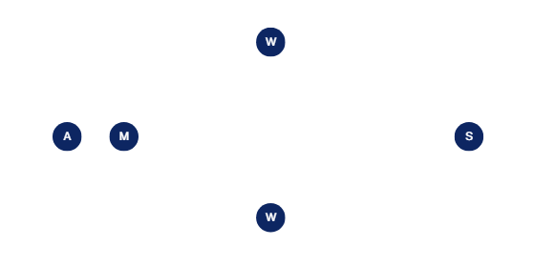  As the disc moves, instruct defenders to adjust their shape using a pendulum-style shift. For example:  - when the disc is passed towards the sideline, the nearest winger steps up to become the new mark  - the original mark drops back to become a winger  - the safety slides to remain central in relation to the disc.  Figure 3 – diamond wall positioning transition  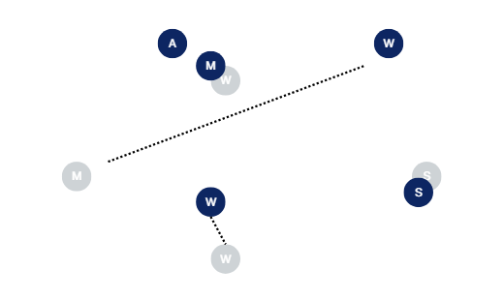  Defenders focus on maintaining the diamond shape, preventing passes through the centre and forcing attackers to attempt longer or higher risk throws towards the sidelines.  Points are awarded for the following reasons:  - Attackers are awarded 2 points for a successful catch in the end zone.  - Attackers are awarded 1 point for a successful catch in the central channel.  - Defenders are awarded 2 points if they force an attacker to drop the disc or throw the disc out of bounds along the sideline.  Attack and defending teams rotate through roles after each score.  Reflection questions:  - How did your role and responsibilities differ between person-to-person defence and the diamond zone defence? Which required more awareness of teammates and why?  - How effective was each defensive structure at protecting the central channel? What positioning or movement made the biggest difference?  - When were you more successful at forcing play towards the sideline, and how did your positioning change between the 2 approaches?  - How did communication differ between person-to-person and zone defence, and how did this impact your team’s ability to apply pressure and prevent scoring opportunities?  Ultimate turnover defensive challenge  Students combine teams of 4 to create 2 teams of 8 and are allocated a 40 metre by 20 metre playing area with clearly marked end zones.  The attacking team attempts to advance the disc and score by completing a catch inside the opponent’s end zone. Defenders aim to prevent passes through the centre, limit forward progress and force mistakes.  Remind students to choose and maintain a defensive structure that suits their team – either person-to-person or zone defence – and to communicate continuously to coordinate coverage, call switches in position and provide support.  Explain to students that this activity aims to reward good defence. This includes:  - two points for the defensive team for a forced turnover (interception or dropped disc).  - one point for the defensive team if the attackers are stalled for 5 seconds without completing a pass.  - standard attacking scores still earn one point.  After a score or turnover, play restarts from midfield, with the non-scoring team in possession.  Reflection questions:  - How did your team use space and positioning to stop the other team from moving the disc?  - What ways of talking and signalling helped your team stay organised on defence?  - Did your team use person-to-person or zone defence? How did that choice make it easier or harder for the attacking team?  - How did your team use what you learned to make better decisions in attack during the final game?
Adjustments, evaluation and registration
[Classroom teacher to complete.]

Learning sequence 3 – Ultimate flying disc attack
Note: this is a practical learning sequence. The duration of this learning sequence is approximately 2 hours.
Table 3 – teaching and learning program
Outcomes and content | Teaching and learning activities
Outcomes  PH5-MSS-01, PH5-MSS-02,  PH5-SMI-01  Content  Focus area – Movement skills and strategies  Enhancing and valuing movement  - Participate in target, net and court, striking and fielding, and territory games to investigate how to adapt movement skills and strategies to solve problems in gameplay  - Analyse and practise how connections between communication, skill execution, movement concepts, teamwork, strategy and involvement can improve outcomes in gameplay  - Apply and evaluate a range of attacking and defending strategies to enhance individual and team performance in gameplay  - Examine and demonstrate how communication and movement concepts can assist with anticipation, decision-making and the manipulation of space and time  Applying self-management and interpersonal skills to movement  - Apply and refine communication, problem-solving and decision-making skills to dynamic movement situations  - Evaluate how personal strengths and contributions can enhance teamwork, leadership and enjoyable participation | Learning intentions  We are learning to:  - use movement and positioning to create space and support possession in Ultimate flying disc  - communicate and make decisions to work effectively as a team in attack.  Success criteria  I can:  - move into open space and use cuts or leads to become a good passing option  - communicate with my teammates to stay organised and make better attacking decisions.  Box shuffle – warm-up  Set up the field with cones to create 3 zones or boxes: box 1 (defensive zone), box 2 (middle zone) and box 3 (attacking or scoring zone).  Students are divided into 2 teams of 4 for each game.  Explain the rules:  - The attacking team starts with the disc in box 1. They must complete 3 successful passes inside box 1 before they are allowed to throw into box 2.  - Once in box 2, they must complete 3 successful passes inside that zone before throwing into box 3.  - In box 3, the team must complete 3 successful passes to score a point.  - If the disc hits the ground or is intercepted, it is a turnover and the other team gains possession.  - After a successful score, possession automatically changes to the non-scoring team, who restart play from box 1.  Four-play attack  Introduce and demonstrate to students attacking movements such as cutting, timing the lead and creating space, explaining how attackers use these to become effective passing options.  Cutting: the attacker moves away from the disc, then sharply changes direction to cut back into space.  Timing the lead: attackers cut at the right moment so the thrower can pass into space.  Creating space: attackers move into open areas, not towards defenders.  For more information on cutting, refer to The Australian Flying Disc Association Limited (AFDA).  The teacher also introduces 2 common attacking formations that students can use to organise themselves before each play.  - Horizontal stack: attackers spread across the width of the field in a line. This creates space in front of the thrower and allows cutters to move forward into open space.  Figure 4 – horizontal stack positioning  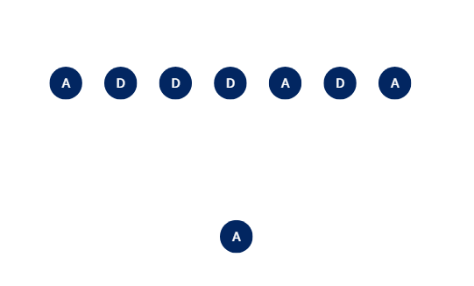  - Vertical stack: attackers line up in a single line down the middle of the field. This creates space on both sides of the field for cutters to break left or right.  Figure 5 – vertical stack positioning  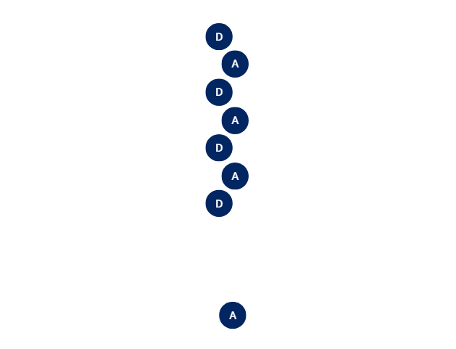  Students form groups of 8 and return to their teams of 4 attackers and 4 defenders. Allocate each group to one half of a full-sized 80 -metre field, divided lengthways along the centre line. Mark an end zone at each end.  One attacker starts as the thrower, positioned midway between their own end zone and the halfway line, and must remain stationary.  The remaining attackers set up in either a horizontal or vertical stack before each play, while defenders mark one attacker each using person-to-person defence.  The activity uses a gridiron football-style possession system. Each team is given 4 attempts to move the disc into the end zone. A new set of attempts begins every time possession changes.  Attackers aim to create space using cuts and leading runs, while defenders apply close pressure and adjust their positioning throughout play. The attacking team has a maximum of 4 attempts to reach the end zone, with each pass counting as one attempt. Between attempts, teams pause briefly to discuss and adjust their strategy before continuing play. During play:  - if a pass is completed, play continues from that spot and the next attempt begins  - if a pass is dropped, intercepted or goes out of bounds, the attempt is lost and play resets to the previous spot  - if the attacking team reaches the end zone within 4 attempts, they score and a new play series starts from the beginning  - if the attacking team does not reach the end zone after 4 attempts, possession changes.  Reflective questions:  - When did you get free the easiest, and what did you do to make that happen?  - How did using a cut or changing direction help you create space from your defender?  - What could your team do better next time to move the disc closer to the end zone?  - How does each formation create space differently for attackers?  Thumbs up, thumbs down  Use gesture voting to check understanding of cutting and timing the lead. Ask a series of true-or-false questions and have all students respond at the same time using gestures, thumbs up for ‘true’ thumbs down for ‘false’.  The following statements have been provided as an example:  - Cutting means moving randomly to get free.  - A good cut involves a sharp change of direction to create space.  - Timing the lead means cutting whenever you feel ready.  - Attackers should cut when the thrower is ready to pass.  - Cutting into open space helps create passing options.  - Two attackers cutting to the same space improves the chance of a pass.  - Good timing allows the disc to be passed into space rather than to a stationary player.  Attacking the disc  Next, students combine their teams of 4 to create 8 versus 8. They play a game of Ultimate flying disc on a full field with end zones marked at each end.  Play follows the following rules:  - No running with the disc is allowed.  - The disc is turned over on drops.  - Interceptions can take place by the defensive team.  - No out of bound passes are allowed.  To support the learning intentions, the game uses a scoring system that rewards effective attacking movement.  The game begins with a pass in the middle of the field. As play develops, attackers are encouraged to use cuts, change speed and attack space to get free, while defenders apply pressure.  Points are awarded using the following structure:  - One point is awarded if a player receives a pass after making a clear V-cut that creates visible space from their defender. This encourages purposeful movement before the catch.  - One point is awarded if a pass is completed into open space rather than to a stationary player. This reinforces the importance of timing leads and throwing to space.  - One point is awarded for a completed pass into the end zone. This keeps the main goal of scoring, while still valuing the process of getting there.  - A team can score up to 3 points in one possession if they demonstrate strong movement and decision-making before finishing in the end zone.  At the conclusion, use the following reflection questions:  - How did what you practised earlier help you play better in the last game?  - What did you understand about creating space by the end of the lesson that you didn’t understand at the start?  - How did your team use what you learned to make better decisions in attack during the final game?  Formative assessment: formative assessment is supported through observation and questioning to monitor how students participate in a range of games to adapt movement skills and strategies to:  - solve gameplay problems, apply and evaluate attacking and defensive strategies to improve performance  - refine communication, problem-solving and decision-making skills in dynamic movement situations.  Outcome  - selects, implements and justifies strategies and actions to solve movement challenges PH5-MSS-02
Adjustments, evaluation and registration
[Classroom teacher to complete.]

Learning sequence 4 – basketball defence
Note: this is a practical learning sequence. The duration of this learning sequence is approximately 2 hours.
Table 4 – teaching and learning program
Outcomes and content | Teaching and learning activities
Outcomes  PH5-MSS-01, PH5-MSS-02,  PH5-SMI-01  Content  Focus area – Movement skills and strategies  Enhancing and valuing movement  - Select and transfer similar movement skills and strategies to different movement environments  - Apply and evaluate a range of attacking and defending strategies to enhance individual and team performance in gameplay  - Participate in target, net and court, striking and fielding, and territory games to investigate how to adapt movement skills and strategies to solve problems in gameplay  Applying self-management and interpersonal skills to movement  - Demonstrate leadership and collaboration skills and evaluate how they promote successful outcomes in team environments | Learning intentions  We are learning to:  - apply defensive strategies to gain advantage and protect space  - communicate and make decisions to work effectively as a defensive team.  Success criteria  I can:  - apply positioning in defence to create opportunities and apply pressure  - communicate clearly to support my team in making effective defensive decisions.  Snack man tag – warm-up  Allocate 2 students to be taggers.  All other students spread out around a basketball court, each with a basketball and positioned on the lines of the court.  - All students (including taggers) may only move along the lines of the court while dribbling the ball.  - Students can change direction but must continue to always follow the lines of the court.  - If a student is tagged by the tagger, they must complete a dynamic movement or stretch on the sideline before returning to play.  Rotate taggers every few minutes to keep the warm-up game flowing.  Person-to-person defence  Demonstrate person-to-person defence by showing defenders how to stay with their allocated attacker, apply close pressure on the ball and adjust their positioning to maintain vision of both the ball and their player.  Students form groups of 8 and return to their teams of 4 attackers and 4 defenders and are allocated half of a basketball court.  One team begins as attackers and the other as defenders.  Each defender is allocated one attacker to mark.  Attackers are distributed around the outside of the court, while defenders begin in the centre.  Figure 6 – person-to-person defence diagram  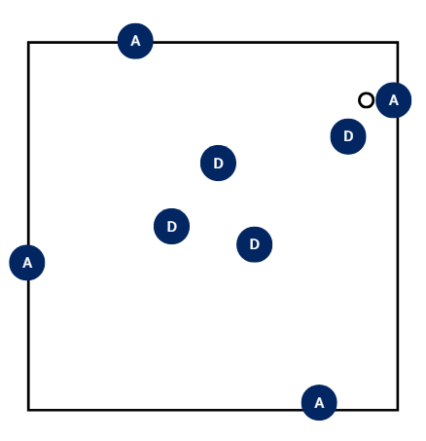  Attackers must pass the ball with no dribbling or shooting.  The ball starts with an attacker and their allocated defender positioned at arm’s length away.  As the ball is passed, defenders adjust their positioning so that:  - the on-the-ball defender creates close pressure  - the remainder of the defensive team move towards the centre of the court, maintaining vision of the ball carrier and their assigned player.  Students continue passing and changing shape until the teacher’s whistle.  Once complete, teams rotate between attack and defence.  Once students are comfortable with positioning, introduce the rule that if a defender intercepts the ball, they immediately switch roles, move to the perimeter of the court and become an attacker.  Consecutive successful passes are counted to increase competition and challenge.  Shell zone defence  The teacher introduces and demonstrates zone defensive concepts, highlighting how defenders guard an area of the court and move together to protect the basket.  The shell: the defensive shape used to protect the key and restrict scoring opportunities (see Figure 7).  On a string: all defenders are connected and move together. When the ball moves, the defensive unit shifts the same distance to maintain shape and coverage.  For the activity, students remain in groups of 4 attackers and 4 defenders and are allocated half of a basketball court.  Attackers are positioned around the 3-point line, while defenders begin in a box formation near the key.  Defenders must always remain inside the 3-point line.  Figure 7 – shell zone defence set-up  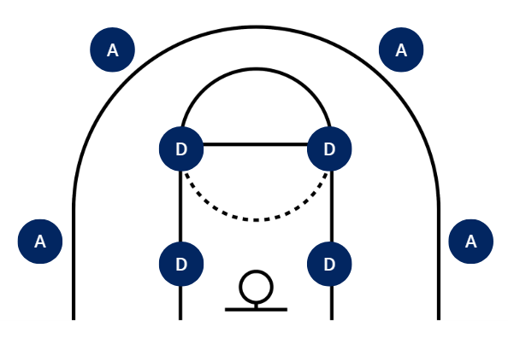  The activity begins with attackers passing the ball around the perimeter.  As the ball is passed, defenders adjust their positioning so that:  - the defender closest to the ball steps up to apply pressure  - the remaining defenders shift in the same direction to maintain the shell shape and protect the key.  Encourage defenders to move while the ball is in the air and communicate effectively to support coordinated movement and coverage.  Note: as a progression, use the following rules and scoring structure to increase challenge and reinforce the learning focus.  The game is played to 3 points, with points awarded to the attacking team when defensive breakdowns occur:  - One point is awarded to the attacking team if a player gets inside the key by placing at least one foot inside the key with the ball in hand. This encourages attackers to drive into space and challenges defenders to protect the key.  - One point is awarded to the attacking team for scoring a basket inside the 3-point line, reinforcing the importance of defending high-percentage scoring areas.  - One point is awarded to the attacking team if a 3-point shot is taken and hits the rim or scores. This rule requires defenders to place pressure on goal shooters and protect the basket, supporting effective defensive spacing and decision-making.  Reflection questions:  - How does zone defence differ from person-to-person defence?  - How does moving ‘on a string’ help limit passing and driving options for attackers?  Small-sided defensive strategy game  Students form groups of 8 and return to their teams of 4 attackers and 4 defenders and are allocated half of a basketball court. The activity is designed to reinforce defensive positioning, communication and decision-making through a defence-first scoring structure.  Teams play 4 versus 4 on half of a court with one basket.  The offensive team starts with the ball at the top of the key.  - Players may move and pass freely within the half-court.  - Out-of-bounds or turnovers result in possession changing to the defensive team.  - Scoring in the basket counts as a standard scoring for the offence but is secondary to defensive scoring.  Use the following scoring structure to shape play and reinforce the learning focus, with points awarded to the defensive team:  - One point is awarded to the defensive team for forcing a missed shot, encouraging effective contesting and shot pressure.  - Two points are awarded for intercepting a pass, reinforcing anticipation, positioning and communication.  - Three points are awarded for forcing a turnover or poor shot selection, such as rushed or heavily contested shots, highlighting collective defensive effort and decision-making.  Reset possession from beyond the 3-point line after an out of bounds, turnover or defensive score.  Reflection questions:  - Which defensive actions worked best as a team?  - How did leadership and communication affect your defensive success?  - When did you decide to contest the ball versus help a teammate?  - How could these defensive strategies transfer to other territory games?
Adjustments, evaluation and registration
[Classroom teacher to complete.]

Learning sequence 5 – basketball attack
Note: this is a practical learning sequence. The duration of this learning sequence is approximately 2 hours.
Table 5 – teaching and learning program
Outcomes and content | Teaching and learning activities
Outcomes  PH5-MSS-01, PH5-MSS-02,  PH5-SMI-01  Content  Focus area – Movement skills and strategies  Enhancing and valuing movement  - Select and transfer similar movement skills and strategies to different movement environments  - Apply and evaluate a range of attacking and defending strategies to enhance individual and team performance in gameplay  - Participate in target, net and court, striking and fielding, and territory games to investigate how to adapt movement skills and strategies to solve problems in gameplay  Applying self-management and interpersonal skills to movement  - Demonstrate leadership and collaboration skills and evaluate how they promote successful outcomes in team environments | Learning intentions  We are learning to:  - use movement and ball control to create and use space in attack  - communicate and make decisions to work effectively as an attacking team.  Success criteria  I can:  - control the ball while moving to create space and respond effectively in game situations  - communicate clearly to support my team in making effective attacking and defensive decisions.  Cut, pass, replace – warm-up  This activity develops attacking movement by focusing on creating space and maintaining ball flow through purposeful off-the-ball movement.  Students work in groups of 4 on half of a basketball court with one ball, positioned inside the perimeter of the court. The ball starts at the top of the key.  Students are positioned around the perimeter of the court.  The ball begins with one attacker positioned at the top of the key.  - Students must pass the ball only, with no dribbling permitted.  - After making a pass, the passer must ‘cut’ directly towards the basket to draw a defender and create space for others.  - Once the cut is completed, the attacker must ‘replace’, meaning they move out to an open space on the perimeter to receive a pass.  As the ball is passed, attackers adjust their positioning so that:  - the passer moves immediately after releasing the ball  - cuts are made with purpose towards the basket  - empty spaces on the perimeter are filled to maintain width and passing options.  Once students are comfortable with the movement pattern, introduce the rule that attackers may use one dribble only to improve passing angles and decision-making.  Decide on the drive  Students remain in their teams of 4 with 4 versus 2 on the half-court, consisting of 4 attackers and 2 defenders.  Attackers are attempting to score, while defenders apply pressure.  The ball must be driven into the key before a shot is taken. Explain to students that a drive means the ball carrier moves aggressively towards the basket to force a defender to step in and help.  When a drive occurs, off-ball attackers are expected to move into space by:  - drifting (moving slightly wider towards the sideline)  - cutting (moving quickly towards the basket)  - lifting (moving away from the basket to create a safer passing angle).  If the defence successfully stops the drive, the ball must be passed out and moved quickly to create a new attacking option.  Defenders are rotated every 60 to 90 seconds to maintain intensity.  Attacking strategy – 4 versus 4  Students remain in their 2 teams of 4 using half of a basketball court.  The game is played as a 4 versus 4 with one team attacking and the other defending.  To begin each possession, the ball is checked at the top of the key.  - Attackers are free to pass, dribble and shoot, however, a shot may only be taken once the attacking team has created an advantage.  - An advantage is created when the ball enters the key in one of the following ways:  - a drive, where the ball carrier moves towards the basket and forces a defender to step into the key  - a cut, where an attacker moves towards the basket without the ball to receive a pass  - a post touch, where an attacker receives the ball with their back to the basket inside the key.  - If attackers do not enter the key any basket scored does not count.  - If the defence gains possession through a rebound, interception or turnover, teams immediately switch roles.  Reflection questions:  - How did your team create an attacking advantage before shooting, and which movements were most effective in drawing defenders out of position?  - How did your team communicate and work together to support the ball carrier, and how did this collaboration help you make better attacking decisions?  - In what ways did leadership within your team (calling movements, directing spacing or organising resets) contribute to successful outcomes?
Adjustments, evaluation and registration
[Classroom teacher to complete.]

Learning sequence 6 – touch or tag football defence
Note: this is a practical learning sequence. The duration of this learning sequence is approximately 2 hours.
Table 6 – teaching and learning program
Outcomes and content | Teaching and learning activities
Outcomes  PH5-MSS-01, PH5-MSS-02,  PH5-SMI-01  Content  Focus area – Movement skills and strategies  Enhancing and valuing movement  - Examine and demonstrate how communication and movement concepts can assist with anticipation, decision-making and the manipulation of space and time  - Analyse and practise how connections between communication, skill execution, movement concepts, teamwork, strategy and involvement can improve outcomes in gameplay  Applying self-management and interpersonal skills to movement  - Examine and apply strategies to increase resilience, persistence and motivation for themselves and others, including positive self-talk and encouragement | Learning intentions  We are learning to:  - apply defensive strategies to close gaps and limit attacking options  - communicate and make decisions to work effectively as a team in defence.  Success criteria  I can:  - use defensive positioning, timing and pressure to protect key areas  - communicate clearly with my team to stay organised and make better game decisions.  Close the gap – warm-up  Divide the class into 2 teams.  The attacking team starts 5 metres back from the try line.  The defensive team lines up opposite, directly on the try line.  The whistle is blown and attacking players attempt to run forward and cross the try line without being tagged.  - Defensive players must remain on the try line and can only move one metre forward to make a tag.  - Limiting movement encourages defenders to focus on timing, footwork and reading the attacker’s direction.  - If an attacking player is tagged before crossing the line, the point does not count.  - If they successfully cross without being tagged, they score.  After several attempts, swap roles so both teams experience attacking and defending.  Progress the game to a full field and have the defending team line up along the halfway line and attacking team on one try line.  The whistle is blown and students attempt to run past the defenders to the opposite try line.  - Attackers are safe if they reach the other try line.  - If an attacking player is tagged, they join the defensive team, increasing pressure on the remaining attackers.  Students are encouraged to communicate and work together to close gaps and prevent attackers from crossing.  MVP protection  Explain to students that effective defensive movement, spatial awareness and communication are used to manage attacking threats in territory games.  Students return to groups of 4 attackers and 4 defenders and are allocated a 30 metre by 15 metre field.  Each attacking team nominates one player as the MVP using a different coloured bib.  The activity begins with the attacking team in possession, attempting to score a try.  - A standard try is worth one point, while a try scored by the MVP is worth 5 points.  - If the MVP is successfully tagged or touched, the defensive team is awarded 2 bonus points.  - Defenders apply defensive strategies by:  - identifying the MVP early and assigning one defender to apply ongoing defensive pressure  - maintaining defensive shape and spacing to limit attacking options  - communicating and adjusting positioning in response to ball movement and attacker support play.  Defenders are encouraged to move together and communicate to coordinate defensive effort and decision-making.  After each try, interception or knock-on, the non-scoring team nominates their MVP, teams swap roles and play restarts.  Reflection questions:  - How did defenders use space and positioning to limit attacking options?  - What types of communication were most effective when managing the MVP?  - How did maintaining defensive shape and spacing influence decision-making for both attackers and defenders in this activity?  - In what ways did the MVP role change how the defensive team prioritised threats?  Defensive strategy game  Students remain in groups of 4 attackers and 4 defenders and are allocated the same sized playing area, 30 metres by 15 metres.  Attackers begin spread across the field to simulate realistic attacking patterns.  Defenders start in a line across the field, maintaining spacing to cover passing lanes and protect key areas.  The activity begins with attackers moving the ball and attempting to advance.  Defenders adjust their positioning according to the movement of the ball and attackers to maintain their defensive structure by having:  - the player closest to the ball apply pressure through a controlled tag  - remaining defenders shift laterally to maintain line integrity and cover passing options  - continuous communication is encouraged to support coordinated defensive effort and awareness.  Figure 8 – defensive strategy game set-up  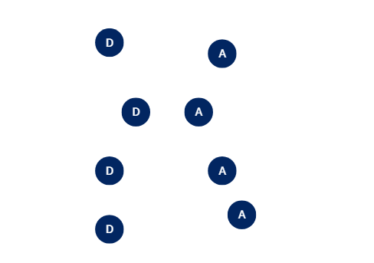  Include the following scoring progression to shape play and reinforce defensive focus:  - One point is awarded for a successful tag, reinforcing accurate marking and tracking.  - Two points are awarded for an intercepted pass, rewarding anticipation and reading the play.  - Three points are awarded for forcing attackers into mistakes or backward passes, highlighting coordinated defensive pressure and decision-making.  Play is reset at the halfway line after a score or, turnover. Students continue until the defensive team reaches a set score or the time limit is reached. Monitor and reinforce positioning, communication and teamwork throughout the activity.  Reflection questions:  - How did you position yourself to limit attacking options?  - When did you decide to commit to a touch or tag versus cover a support runner?  - How did your communication influence team defence?  - Which defensive strategy worked best and why?  - How could these defensive skills transfer to other territory games?  Formative assessment: evaluate how students examine and apply strategies to develop resilience, persistence and motivation for themselves and others, and how they use communication and movement concepts to support anticipation, decision-making and the effective manipulation of space and time through use of teacher questioning and observation.  Outcomes  - evaluates and adapts self-management and interpersonal skills to manage complex situations  PH5-SMI-01
Adjustments, evaluation and registration
[Classroom teacher to complete.]

Learning sequence 7 – touch or tag football attack
Note: this is a practical learning sequence. The duration of this learning sequence is approximately 2 hours.
Table 7 – teaching and learning program
Outcomes and content | Teaching and learning activities
Outcomes  PH5-MSS-01, PH5-MSS-02,  PH5-SMI-01  Content  Focus area – Movement skills and strategies  Enhancing and valuing movement  - Examine and demonstrate how communication and movement concepts can assist with anticipation, decision-making and the manipulation of space and time  - Analyse and practise how connections between communication, skill execution, movement concepts, teamwork, strategy and involvement can improve outcomes in gameplay  Applying self-management and interpersonal skills to movement  - Examine and apply strategies to increase resilience, persistence and motivation for themselves and others, including positive self-talk and encouragement | Learning intentions  We are learning to:  - use movement and space to create attacking opportunities in territory games  - communicate and make decisions to work effectively as a team in both attack and defence.  Success criteria  I can:  - move into space and support my teammates to help create scoring chances  - communicate clearly with my team to stay organised and make better game decisions.  Ball tag – warm-up  Students are organised into 2 even teams and are allocated a 10 metre by 10 metre grid.  Attackers start in possession of the football and aim to tag defenders by passing in any direction to a teammate positioned close enough to make contact.  - A tag is performed by holding the ball in 2 hands and touching a defender.  - Once in possession of the ball, taggers cannot run.  Play continues for a set time, with the team achieving the most tags declared the winner.  After the period, roles are rotated so all students experience both attacking and defending responsibilities.  To progress the activity, introduce a second ball to increase decision-making, movement and communication under pressure.  Note: during the activity, encourage attackers to:  - move into space to create passing options  - support the ball carrier  - maintain lines for effective tagging  - work collaboratively to corner defenders and create scoring opportunities  - communicate early and clearly to coordinate movement.  Encourage defenders to:  - move continuously to avoid being tagged  - maintain awareness of the ball and supporting attacker  - communicate with teammates to cover space  - anticipate attacking movement.  Draw, pass, support – 4 versus 3  Students return to their teams of 4, with one team rotating a player out so the activity starts as 4 attackers versus 3 defenders in a 15 metre by 20 metre field.  Attackers start with the ball at one end of the field. Defenders start at the centre of the field ready to apply light pressure.  - Attackers begin running with the ball. The ball carrier must draw a defender before passing to a teammate in space, moving into open lines and calling for the ball.  - Defenders move side to side to cover attackers, track the ball carrier and stay aware of supporting players, while talking to each other to keep the defence organised.  - After each length, the rotating player swaps in. After all rotations are made, the defenders and attackers swap roles.  To add progression and increase the level of difficulty, add the fourth defender back in to make attackers make faster decisions, run more effective lines and use support more effectively.  Attacking strategy game  Students are organised into 2 teams of 8 and play small-sided touch or tag football games on half of a field per game.  Introduce and demonstrate the X and Y shapes as a structured attacking option that uses coordinated running lines to create pressure on defenders and open space.  In the X shape, 2 attackers time their runs to cross over each other. The ball carrier engages the defence while a supporting player moves behind or across them to receive a pass. This movement forces defenders to decide whether to stay with their original player or adjust, often creating a gap.  In the Y shape, the ball carrier is supported by 2 attackers running different lines. One attacker offers a short option close to the ball, while the other provides a wider or deeper option. This gives the ball carrier multiple choices and requires defenders to make quick decisions about which option to cover.  The activity begins with one team in possession of the ball, attacking towards the try line, while the other team defends.  Scoring is based on the type of try:  - one point for a standard try  - two points for a try scored following a draw-and-pass.  - three points for a try scored following a planned set move using X or Y shape.  After each score, play is restarted from halfway, with the non-scoring team in possession.  Between plays, encourage reflection and strategic planning using the following questions:  - How did your running line help draw the defender?  - Where was the space and how did your team create it?  - What changed when you passed late instead of early?  - How does using an X or Y shape in touch or tag football compare to cutting and timing the lead in Ultimate flying disc when creating space and passing options?  - How did positive self-talk help you improve your performance?  Formative assessment: evaluate how students examine and apply strategies to develop resilience, persistence and motivation for themselves and others, and how they use communication and movement concepts to support anticipation, decision-making and the effective manipulation of space and time through use of teacher questioning and observation.  Outcomes  - evaluates and adapts self-management and interpersonal skills to manage complex situations  PH5-SMI-01
Adjustments, evaluation and registration
[Classroom teacher to complete.]

Learning sequence 8 – assessment
Note: this is a practical learning sequence. The duration of this learning sequence is approximately 2 hours and 30 minutes.
Table 8 – teaching and learning program
Outcomes and content | Teaching and learning activities
Outcomes  PH5-MSS-01, PH5-MSS-02,  PH5-SMI-01  Content  Focus area – Movement skills and strategies  Enhancing and valuing movement  - Provide and apply feedback to refine specialised movement skills, concepts and strategies  - Apply and evaluate a range of attacking and defending strategies to enhance individual and team performance in gameplay  Enhancing and valuing movement  - Apply and evaluate attitudes and behaviours that encourage enjoyable, ethical, respectful and inclusive movement experiences  - Demonstrate leadership and collaboration skills and evaluate how they promote successful outcomes in team environments | Learning intentions  We are learning to:  - provide and apply feedback to refine and adapt our movement skills in different game situations  - apply strategies to improve our team’s performance  - use teamwork and communication to make effective decisions and support each other.  Success criteria  I can:  - use my movement skills effectively and adjust them when the game changes  - select and use strategies that create advantages in attack or limit the opposition in defence  - communicate, collaborate and contribute to my team’s success.  Strategy planning  Explain to students that the purpose of the activity is to inform their final assessment. Students will work in groups of 4 to develop a short attacking and defending game plan for a sport studied in this program. This strategy will serve as the basis for their assessment, as they will be required to apply and evaluate its effectiveness during active gameplay.  Each team selects one sport studied in the program and decides whether their focus will be attacking or defending. Teams are reminded that their game plan will be performed against another team and observed by peers, so strategies must be clear, achievable and easy to communicate.  Within their groups, students discuss and agree on a simple game plan and identify:  - how the team will use space (for example, maintaining width in attack or protecting central areas in defence)  - how players will communicate during play (for example, calling movements, directing teammates, providing feedback)  - how players will move in relation to the ball and each other to support decision-making.  Students draw on strategies practised earlier in the sequence, such as supporting the ball carrier, applying defensive pressure, shifting as a team or creating passing options. Teams document their game plan using dot points, diagrams and brief written descriptions so it can be clearly shared with teammates and understood by peers during assessment.  Note: an example planning document can be found in the PDHPE Year 10 –own the zone – sample assessment task notification.  Strategy performance  The Strategy performance activity is structured as a 3-way rotation to allow teams to apply their game plans while simultaneously engaging in peer assessment and opposing play. There will be:  - a performing team that applies and executes their specific game plan  - an opposing team that acts as the active opposition to test the strategy  - an assessing team that monitors the performance and completes the peer assessment, focusing on strategy use, communication, leadership and teamwork.  During gameplay, the performing team:  - applies their selected attacking or defending strategies consistently  - communicates clearly to organise teammates and support decision-making  - demonstrates leadership by directing movement, calling for adjustments and encouraging teammates  - adapts their strategy in response to the actions of the opposition.  The opposing team:  - plays with intent and intensity to create realistic game conditions  - applies pressure that challenges the performing team’s strategy  - communicates and works together to maintain structure and game flow.  The assessing team evaluates:  - how effectively the performing team applies their attacking or defending strategy  - how communication supports anticipation, movement and decision-making  - how leadership and collaboration influence team organisation and performance.  At the end of each game, the assessing team provides specific, constructive feedback to the performing team, highlighting strengths and identifying one area for improvement.  Teams rotate roles so that each group can perform, oppose and assess. This rotation continues until all teams have experienced each role.  After completing the strategy performance, students engage in a structured reflection, discussing guided prompts as a group to support and inform their written assessment.  Discussion prompts:  - Describe your chosen attacking or defending strategy.  - Explain how the strategy was applied during gameplay.  - Identify key decisions made by the team in response to game situations.  - Evaluate how effective the strategy was in achieving successful outcomes.  Peer feedback is incorporated into the reflection, allowing students to consider strengths, areas for improvement, and how leadership, communication and teamwork contributed to performance.  Summative assessment: students complete all sections of the summative assessment task, demonstrating refined movement skills, the application and justification of strategies, and the evaluation and adaptation of self-management and interpersonal skills.  Outcomes  - refines and transfers movement skills and concepts for adaptation in a range of dynamic movement environments PH5-MSS-01  - selects, implements and justifies strategies and actions to solve movement challenges PH5-MSS-02  - evaluates and adapts self-management and interpersonal skills to manage complex situations  PH5-SMI-01
Adjustments, evaluation and registration
[Classroom teacher to complete.]

Summative assessment task
The summative assessment task in the PDHPE Year 10 – own the zone – sample assessment notification has been developed to assess students’ understanding of the content covered within this teaching and learning program. This assessment task can be accessed on the Planning, programming and assessing PDHPE 7–10 webpage.

Appendix 1 – activity cards

Station 1 – basketball (4 versus 4)
Rules
- Play 4 versus 4
- Make at least 3 passes before you shoot
- Do not travel (keep one foot still when holding the ball)
- Do not double dribble
- Stay inside the court lines
- Defend safely (no contact allowed)
- If the ball goes out or is intercepted, the other team takes possession
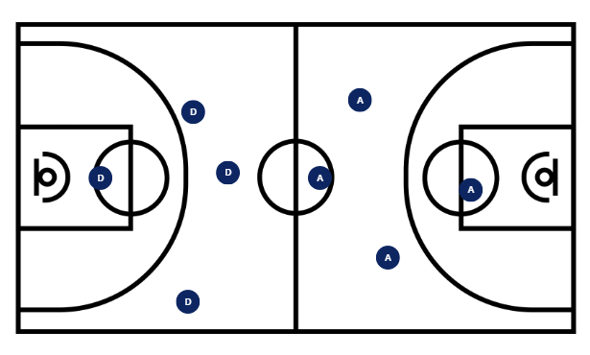
Questions
- How are you creating space to receive or pass the ball?
- How can you involve all teammates in the offence?
- How does your team communicate to support the ball carrier?
- How is your defensive team adjusting when the ball moves?

Station 2 – touch or tag football (4 versus 4)
Rules
- Play 4 versus 4 on a 12 metre by 15 metre field
- You have 4 touches or tags to score
- After each touch or tag, the defending team must reset their line
- If the 4 touches are used, the other team gets the ball
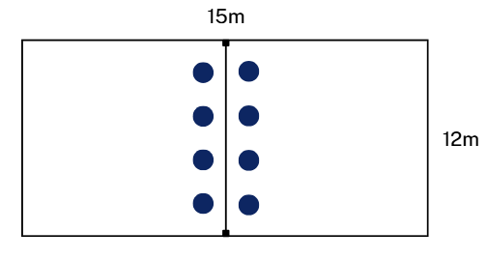
Questions
- How do you use space to support teammates and maintain attacking flow?
- How does your defensive team reset and maintain structure after each touch or tag?
- What movement patterns help create passing opportunities?

Station 3 – Ultimate flying disc (4 versus 4)
Rules
- Play 4 versus 4 on a 14 metre by 20 metre field with end zones
- Do not run with the disc – pass to move it
- If the disc is dropped or intercepted, it is a turnover
- Score by catching the disc in the end zone
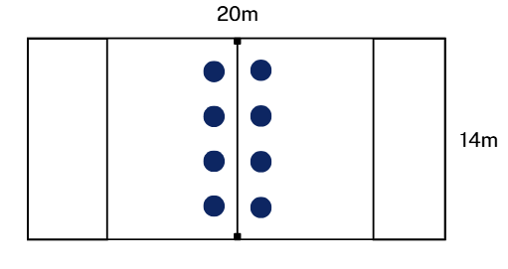
Questions
- How do you use the field to create space for passing?
- How do you signal to teammates that you are available for a pass?
- How does your defensive team track attackers and protect passing options?


Program feedback
We value your feedback. If you use this teaching and learning program in your faculty and school context, please complete the PDHPE 7–10 resource evaluation form. If you have further comments or suggestions, please email PDHPEcurriculum@det.nsw.edu.au.

Support and alignment
Resource evaluation and support: all curriculum resources are prepared through a rigorous process. Resources are periodically reviewed as part of our ongoing evaluation plan to ensure currency, relevance and effectiveness. For additional support or advice, or to provide feedback, contact the PDHPE Secondary Curriculum team by emailing PDHPEcurriculum@det.nsw.edu.au.
Differentiation: further advice to support Aboriginal and/or Torres Strait Islander students, students learning English as an additional language or dialect (EAL/D), students with a disability and/or additional needs and high potential and gifted students can be found on the Planning, programming and assessing 7–12 webpage. This includes the Inclusion and differentiation advice 7–10 webpage.
Assessment: further advice to support formative assessment is available on the Planning, programming and assessing 7–12 webpage. This includes the Classroom assessment advice 7–10. For summative assessment tasks, the Assessment task advice 7–10 webpage is available.
Explicit teaching: further advice to support explicit teaching is available on the Explicit teaching webpage. This includes the CESE Explicit teaching – Driving learning and engagement webpage.
Consulted with: Curriculum and subject matter experts.
Alignment to system priorities and/or needs: School Excellence Policy, Our Plan for NSW Public Education
Alignment to the School Excellence Framework: this resource supports the School Excellence Framework elements of curriculum (curriculum provision) and effective classroom practice (lesson planning, explicit teaching).
Alignment to Australian Professional Standards for Teachers: this resource supports teachers to address Proficient Teacher Standard Descriptors [3.1.2, 3.2.2, 3.3.2. 3.4.2, 5.1.2].
Creation date: 15 March 2026

References
This resource contains NSW Curriculum and syllabus content. The NSW Curriculum is developed by the NSW Education Standards Authority (NESA). This content is prepared by NESA for and on behalf of the Crown in right of the State of New South Wales. The material is protected by Crown copyright.
Please refer to the NESA Copyright Disclaimer for more information https://www.nsw.gov.au/education-and-training/nesa/copyright.
NESA holds the only official and up-to-date versions of the NSW Curriculum and syllabus documents. Please visit NESA https://www.nsw.gov.au/education-and-training/nesa and NSW Curriculum https://curriculum.nsw.edu.au.
Personal Development, Health and Physical Education 7–10 Syllabus © NSW Education Standards Authority (NESA) for and on behalf of the Crown in right of the State of New South Wales, 2024.

© State of New South Wales (Department of Education), 2026
The copyright material published in this resource is subject to the Copyright Act 1968 (Cth) and is owned by the NSW Department of Education or, where indicated, by a party other than the NSW Department of Education (third-party material).
Copyright material available in this resource and owned by the NSW Department of Education is licensed under a Creative Commons Attribution 4.0 International (CC BY 4.0) license.

This license allows you to share and adapt the material for any purpose, even commercially.
Attribution should be given to © State of New South Wales (Department of Education), 2026.
Material in this resource not available under a Creative Commons license:
- the NSW Department of Education logo, other logos and trademark-protected material
- material owned by a third party that has been reproduced with permission. You will need to obtain permission from the third party to reuse its material.
Links to third-party material and websites
Please note that the provided (reading/viewing material/list/links/texts) are a suggestion only and implies no endorsement, by the New South Wales Department of Education, of any author, publisher, or book title. School principals and teachers are best placed to assess the suitability of resources that would complement the curriculum and reflect the needs and interests of their students.
If you use the links provided in this document to access a third-party's website, you acknowledge that the terms of use, including licence terms set out on the third-party's website apply to the use which may be made of the materials on that third-party website or where permitted by the Copyright Act 1968 (Cth). The department accepts no responsibility for content on third-party websites.

