PDHPE Year 7 – safety never takes a holiday
Teaching and learning program
Contents
About this resource 3
Overview 3
Syllabus outcomes 4
Content 4
Focus area – Safe, active and healthy lifestyle choices 4
Focus area – Respectful relationships 6
Related support materials 6
Teacher notes 7
Learning sequence 1 – understanding risk, responsibility and safety 8
Learning sequence 2 – water wise 28
Learning sequence 3 – road smart – safety in motion 46
Learning sequence 4 – navigating online spaces 62
Learning sequence 5 – health help – support and information you can trust 81
Appendix 1 – risk, responsibility and safety scenario cards 92
Appendix 2 – influencing factors worksheet 93
Appendix 3 – Malik and Tiana’s story 94
Appendix 4 – risk matrix scenarios 96
Appendix 5 – risk assessment matrix 97
Appendix 6 – First Aid and DRSABCD worksheet 98
Appendix 7 – four corners statements 100
Appendix 8 – water-based first aid scenarios 101
Appendix 9 – first aid scenario response card 102
Appendix 10 – road safety statistics worksheet 104
Appendix 11 – safe travel audit worksheet 106
Appendix 12 – blank digital footprint 108
Appendix 13 – spot the risk online messages 109
Appendix 14 – screen time scenarios 110
Appendix 15 – value statements for online spaces 111
Appendix 16 – health literacy text messages 112
Program feedback 113
Support and alignment 114
References 115

About this resource
This teaching and learning program has been developed to assist teachers in NSW Department of Education schools to create learning experiences that are contextualised to their students’ needs, interests and abilities for the Personal Development, Health and Physical Education 7–10 Syllabus (NESA 2024). It provides an example of one way to approach programming through a conceptual lens. Teachers are encouraged to take an adopt and adapt approach to the learning activities outlined in this program.

Overview
Description: in this teaching and learning program, students develop their understanding of responsibility, risk-taking and safety. Students learn to identify, assess and apply a range of protective behaviours and strategies to manage their responsibilities and mitigate risk across varying contexts with a focus on online environments, road use and water environments. They also develop an understanding of contextual factors that may influence decision-making and the level of risk in a range of scenarios.
Duration: approximately 9 hours and 30 minutes.
Explicit teaching: suggested learning intentions and success criteria are available for each learning sequence. Learning intentions and success criteria are most effective when they are contextualised to meet the needs of students in the class. The examples provided in this document are generalised to demonstrate how learning intentions and success criteria could be created.
Assessment: suggested formative assessment opportunities are outlined throughout the program.

Syllabus outcomes
A student:
- refines and applies self-management and interpersonal skills to manage complex situations PH4-SMI-01
- assesses the influence of contextual factors on attitudes and behaviours to propose strategies that enhance safety, health and wellbeing
PH4-SHW-01
- investigates and uses health information, products and support services to propose strategies that enhance safety, health and wellbeing
PH4-IPS-01
Personal Development, Health and Physical Education 7–10 Syllabus © NSW Education Standards Authority (NESA) for and on behalf of the Crown in right of the State of New South Wales, 2024.

Content

Focus area – Safe, active and healthy lifestyle choices
Managing risk and enhancing safety
- Investigate risk-taking, challenging and unsafe scenarios and create plans or responses to enhance safety for themselves and others
- Explain how contextual factors can influence decision-making and risk-taking in offline and online environments
- Devise and practise protective behaviours and strategies to manage and mitigate risk in a range of contexts
- Explain how harm-minimisation strategies such as making informed decisions, being assertive, distancing or encouraging someone to seek help can improve safety, health and wellbeing
- Identify and describe basic water survival strategies and techniques
- Assess emergency situations and demonstrate strategies that enhance the safety of themselves and others, including communicating clearly when giving information to emergency services
- Describe and demonstrate the skills required to assist with first aid, including DRSABCD (danger, response, send for help, airways, breathing, cardiopulmonary resuscitation and defibrillation) and the management of asthma, allergies and anaphylaxis
- Identify and plan preventive health practices and behaviours that assist in protection against disease, including communicable respiratory diseases, bloodborne viruses and sexually transmissible infections
- Examine road safety responsibilities and develop strategies to support the safety of themselves and others in road and transport environments, including as pedestrians, passengers, riders and drivers
Thinking critically to enhance health and wellbeing
- Access and assess information, resources and services that support young people to seek help and manage relevant health and safety issues
- Investigate the reliability and credibility of health information from various sources

Focus area – Respectful relationships
Keeping safe and being respectful online
- Understand rights, responsibilities and social implications of communicating online
- Understand rights, responsibilities and social implications of taking or sharing information, images and videos online
- Assess and demonstrate strategies to regulate screen time and enhance safety and enjoyment in the digital environment
- Identify and practise protective strategies to prevent and manage power imbalances online, including cyberbullying, abuse, grooming, sexual extortion, image-based abuse and negative social interactions
- Explain the impact online content can have on perceptions, behaviours and attitudes

Related support materials
This teaching and learning program aligns with the following support materials:
- student-facing PowerPoint – PDHPE Year 7 – safety never takes a holiday – slide deck
- PDHPE Stage 4 (Years 7–8) – sample scope and sequence.
All resources associated with this resource can be found on the Planning, programming and assessing PDHPE 7–10 webpage.

Teacher notes
This teaching and learning program addresses the concepts of risk, safety and responsibility in the contexts of water safety, road safety and safety online. Lesson sequences 2, 3 and 4 may be delivered in any order, encouraging teachers and schools to adopt and adapt the sequence of learning and delivery of the program to suit the specific needs and context of their students and community.
Schools are encouraged to consider the benefits of incorporating excursions or off-site activities to enrich the learning experiences in this program. Opportunities such as visits to a local pool or beach for practical water safety education can provide valuable, real-world connections to the content and learning. Teachers are advised to refer to the School Sport Unit for further information and support regarding swimming and water safety programs in schools. Refer to School Sport Unit – Swimming and water safety.

Learning sequence 1 – understanding risk, responsibility and safety
Note: the section ‘Understanding risk, responsibility and safety’ in the PowerPoint – PDHPE Year 7 – safety never takes a holiday – slide deck can be used to support this learning sequence. The duration of this learning sequence is approximately 2 hours and 30 minutes.
Table 1 – teaching and learning program
Outcomes and content | Teaching and learning activities
Outcomes  PH4-SMI-01, PH4-SHW-01  Content  Focus area – Safe, active and healthy lifestyle choices  Managing risk and enhancing safety  - Explain how contextual factors can influence decision-making and risk-taking in offline and online environments  - Explain how harm-minimisation strategies such as making informed decisions, being assertive, distancing or encouraging someone to seek help can improve safety, health and wellbeing  - Devise and practise protective behaviours and strategies to manage and mitigate risk in a range of contexts | Learning intentions  We are learning to:  - develop an understanding of risk, responsibility and safety  - explore the concepts of protective behaviours and harm-minimisation strategies  - develop an understanding of basic first aid principles and emergency response procedures.  Success criteria  I can:  - explain the concepts of risk, responsibility and safety  - propose protective behaviours and harm-minimisation strategies and evaluate their effectiveness in managing risk  - explain the basic principles of first aid and the importance of the DRSABCD emergency response procedure.  Introduction to risk, responsibility and safety  Initiate a whole-class discussion that introduces the concepts of risk, responsibility and safety as a focus for learning. Encourage students to draw upon personal experiences or scenarios as they consider what these terms mean, and how these concepts apply in everyday situations. Questions may include:  - What does the term ‘risk’ mean to you?  - What are some of the most common risks you face? Are they always negative, or can risks sometimes be positive?  - What does ‘being responsible’ look like in your daily life? Is responsibility the same thing as safety, or does one lead to the other?  - How are risk, responsibility and safety connected?  Pair students for a ‘turn and talk’ activity. In their pairs, they consider the following questions.  - Who is responsible for keeping us safe in different environments?  - What kinds of risks are okay to take, and which ones should we avoid?  - How can we support our friends to make safe and responsible choices?  In their pairs, students discuss and brainstorm the words they associate with the key terms of ‘risk’, ‘responsibility’ and ‘safety’. They use their brainstorming as the foundation for the development of a definition for each term that includes key characteristics and specific examples.  Invite students to share their definitions. Lead a classroom discussion to discuss similarities and differences between different definitions.  Introduce the activating prior knowledge (KWLH) activity to the class and distribute individual copies of the template to each student.  Students individually complete the ‘K’ and ‘W’ columns of the chart. Recording what they know about ‘risk’, ‘responsibility’ and ‘safety’, including definitions, examples and personal experiences, in the K column of the chart. Students record what they would like to learn about these 3 terms and any curiosities they have, in the W column of the chart.  Explain that the L (What did I learn?) and H (How can I learn more?) sections will be completed at the end of the lesson.  Conduct a whole-class discussion posing the following question:  - How does risk, responsibility and safety relate to your daily life?  Note: responses could include:  - Risk – the possibility of harm, taking a chance or making a choice that might lead to negative consequences.  - Responsibility – being accountable for our actions, making informed decisions or doing what is right even when it’s difficult.  - Safety – protecting ourselves and others, following rules, being aware of potential dangers and making smart choices.  - What are the qualities or attributes of people who act responsibly and manage risky situations well?  Note: responses may include awareness, information, experience, self-control and respect for others.  - How does understanding risk and acting responsibly help individuals make informed choices and protect themselves and others from harm?  Risky, riskier, riskiest! The risk continuum  Choose a wall or space in the classroom to create a continuum. Identify one end as ‘low risk’ and the opposite end as ‘high risk’.  Explain that risk in different scenarios isn’t just risky or not risky, it lies on a continuum, and that everyone will view levels of risk differently due to a range of factors, including knowledge and prior experience.  Read a series of statements relating to risk aloud. After hearing each statement, students take up a position along the continuum where they think the risk fits, based on their assessment and personal judgement. Example risk statements could include:  - drinking a large energy drink before school  - diving into a shallow pool  - trying an older friends vape  - crossing the road while on the phone  - posting personal information online  - riding a bike without a helmet  - going to a friend’s place without asking your parents  - drinking alcohol at a family event.  Note: it is suggested that you tailor the risk scenarios to suit the unique needs and context of your class.  After each round, students find a partner from another position on the continuum. Students explain to their partner why they took up their position and compare the similarities and differences in their perspectives. Questions for students could include:  - How did you judge whether this scenario was low, medium or high risk?  - What factors influenced your decision? Personal experience, things you’ve heard or something else?  Conduct a whole-class discussion and recap for students to reflect on the continuum activity, and to share something interesting or surprising from their peer conversations. Questions may include:  - Was there a risk that everyone seemed to agree on? Why do you think that is?  - Did talking with someone else change your mind about where you stood for any of the risks? Why?  - Were your reasons for standing at different points on the line determined more by facts and knowledge, or feelings?  Explain to students that the way we assess risk is often shaped by our personal experiences, values and what we know, and that different people may see the same situation very differently.  The relationship between risk, responsibility and safety  Allocate students into groups of 4 to 5. Assign one ‘risk’ scenario to each group from Appendix 1 – risk, responsibility and safety scenario cards.  Provide each group with a large sheet of paper.  Students write their scenario at the top of the paper, then brainstorm the potential risks associated with the scenario and record these below the scenario.  For each risk that has been identified, students brainstorm responsible actions that could be taken to mitigate the risk, recording these below.  Students draw a circle at the bottom of the page labelled ‘safety’ and draw lines from each responsible action to the circle.  Each group then presents their web to another group of students. The presenting group must provide a summary of their approach to the scenario, unpacking the key risks that were identified, and which responsible actions and behaviours addressed these risks.  Students write a short paragraph explaining safe behaviours in relation to their risk scenario and how these minimise potential risks. Sentence stems can be provided to students to support them in organising and communicating their ideas clearly:  - In this situation, a safe behaviour could be ...  - In this situation, it is important to … because …  - One action that could be taken to stay safe in this scenario is …  - This behaviour reduces the risk of … because …  Formative assessment:  Outcome  - assesses the influence of contextual factors on attitudes and behaviours to propose strategies that enhance safety, health and wellbeing PH4-SHW-01  A student’s involvement and participation in group discussions, and their written response developed at the conclusion of the the relationship between risk, responsibility and safety, can be collected and used to assess their ability to identify risk and propose suitable strategies that enhance the safety, health and wellbeing of themselves and others.  Introduction to protective behaviours and harm-minimisation strategies  Protective behaviours place an emphasis upon proactive actions which prevent the risk of harm by eliminating or avoiding risky behaviours and scenarios.  Harm-minimisation strategies are those actions and behaviours which can limit the potential for harm or negative consequences in risky situations. They focus on reducing harm rather than eliminating risk entirely.  Explain the terms ‘protective behaviours’ and ‘harm-minimisation strategies’ to students.  Use a Think-Pair-Share approach for students to identify as many protective behaviours and harm-minimisation strategies as they can, writing key responses on the board during the ‘share’ component.  Contextual factors influencing our decision-making  Key terms:  Personal factors refer to individual characteristics such as age, gender and previous experiences.  Social factors include societal norms and expectations, and influences from our peers, friends and family.  Emotional factors are the feelings and emotional dispositions which influence our thinking, such as excitement, stress and anxiety.  Environmental factors include considerations such as the physical location and our proximity to support and resources.  Explain to students that there are a range of factors that influence our decision-making in risky scenarios. These contextual influences can be classified as personal, social, emotional and environmental.  Provide each student with an ‘influencing factors’ worksheet. Refer to Appendix 2 – influencing factors worksheet.  Students individually brainstorm influences that relate to each category. They then share their responses in a class discussion, adding to their own worksheet as they go.  Conduct a class discussion about how each factor can influence decision-making in real-life or hypothetical situations. Discussion questions may include:  - How can something like stress impact a person’s decision-making?  - What role do friends and family play in influencing a risky choice?  - How do someone’s past experiences impact their attitudes towards risk?  Divide the class back into their small groups of 3 to 4 students. Provide each group with a scenario or case study that involves a risky situation.  Note: scenarios can be purposefully developed for this activity or sourced from a suitable newspaper article or media outlet. Ensure the scenarios are varied in nature, relevant to the focus areas for the program of learning and include details of specific contextual factors influencing the decision-making of the characters. Refer to Appendix 3 – Malik and Tiana’s story for an example.  Students analyse their case study and identify the personal, social, emotional and environmental factors which they can see as having influenced the decision-making in the scenario. Students highlight the elements of the case study which relate to each category in a different colour as they read.  Students write down a range of protective behaviours and harm-minimisation strategies that could have minimised or eliminated the risk of harm and negative consequences.  As a group, students discuss and rank these protective behaviours and harm-minimisation strategies in order of how likely they would be to use them in a real-life situation. Students consider various influencing factors in justifying their rankings, such as the practicality of the suggestion, social acceptance and perceived effectiveness.  Each group shares their work with the class. Students briefly summarise their scenario, highlight the key contextual factors that influenced the decision-making in the scenario, and outline the protective behaviours and harm-minimisation strategies that they feel could have limited or avoided the risk of harm in this instance.  Individually, students write an alternate ending to their assigned scenario, using the protective behaviours or harm-minimisation strategies they identified to achieve a different outcome.  Note: the alternate endings developed by each student can then be shared back to the group to compare how the protective behaviours or harm-minimisation strategies were implemented by each student.  Formative assessment:  Outcome  - assesses the influence of contextual factors on attitudes and behaviours to propose strategies that enhance safety, health and wellbeing PH4-SHW-01  Individual responses to the alternate ending component of this activity can be used to assess student’s understanding of contextual factors influencing decision-making, and their ability to propose suitable protective behaviours and harm-minimisation strategies that can enhance the safety, health and wellbeing of themselves and others in unique contexts.  Risk matrix – understanding risk assessment and mitigation  Explain that a risk assessment matrix is a tool used to evaluate the level of risk associated with different scenarios by considering the likelihood of it occurring and the severity of the consequence if it does. Emphasise that not all risks are the same – some are more likely than others, and some are potentially more dangerous than others.  Model to students how the risk matrix can be used to assess the level of risk in different scenarios. Use a simple scenario as a stimulus, such as ‘riding a bike without a helmet near a busy road’ or ‘going for a swim with friends at an unpatrolled beach’.  Lead a ‘think aloud’ to demonstrate how to assess the likelihood of an incident occurring, followed by a judgement as to the severity of the potential consequences if an incident does occur.  Note: for more information on the ‘think aloud’ technique, refer to the ‘modelling’ technique guide for the explicit teaching strategy of gradual release of responsibility.  Assign the situation a likelihood score out of 5 and a consequence score out of 5, plot these judgements on the risk matrix, and then demonstrate the process for calculating the ‘risk score’, which will be a total number out of 25.  Note: a risk score can be calculated by multiplying the ‘likelihood score’ by the ‘consequence score’.  Divide students into pairs and provide each student with a risk assessment matrix, and each pair with a set of scenario cards. Refer to Appendix 4 – risk matrix scenarios and Appendix 5 – risk assessment matrix.  Students work collaboratively to evaluate each scenario and make a decision regarding the likelihood of an incident occurring, and the severity of the potential consequences for each one. They then plot each scenario on the risk assessment matrix.  Students calculate a risk score for each scenario using the ‘likelihood score multiplied by consequence score’ formula.  Facilitate a class discussion about the scenarios and their scores. Consider questions such as:  - Which scenario had the highest risk scores?  - What contextual factors do you think contributed to the higher risk scores?  - Did you agree with your partner’s assessment of each risk? Why or why not?  - Is there anything we could do to lower the risk scores of particular scenarios?  Working in their pairs, students propose harm-minimisation strategies and/or protective behaviours for each scenario. Students must identify a relevant strategy or behaviour and decide whether it is going to reduce the score for likelihood, severity or both factors.  Students then re-plot the scenarios on the risk matrix and re-calculate the risk scores for each scenario based on the integration of their protective behaviours and/or harm-minimisation strategies. Students can then calculate the percentage change in risk score following their risk management intervention.  Note: the percentage change in risk score can be calculated by:  - subtracting the ‘new’ risk score from the ‘original’ risk score  - dividing that number by the ‘original’ risk score  - multiplying the result by 100.  Lead a whole-class discussion and reflection that encourages students to consider their approach to risk management, and the value of being able to identify potential risks and implement strategies to minimise them. Questions could include:  - What were the most effective risk management strategies?  - Which scenario had the largest improvement in overall risk score?  - How can we implement this learning into our everyday lives?  Activating prior learning charts – revisited  Students revisit their activating prior knowledge (KWLH) charts from earlier and complete the L column (What did I learn?) and H (How can I learn more?) column.  Ask students to review their W (What do I want to learn?) and L (What did I learn?) columns and share any remaining curiosities or questions that they have about the work.  Introduction to first aid  Display the following question on the board: What do you think ‘first aid’ means?  Divide students into pairs or small groups. In their groups, students brainstorm what they already know about first aid, including what first aid involves, everyday situations where first aid might be needed and who might be involved in providing it.  Initiate a class discussion to bring students’ initial thoughts together and check for understanding.  Provide each student with a blank worksheet. Refer to Appendix 6 – First Aid and DRSABCD worksheet.  Ask each group to brainstorm their own definition of first aid.  Each group then shares some of the key ideas from their brainstorm with the class. These can be recorded on the board as a visible list. Facilitate a guided discussion around the shared responses, prompting students with questions such as:  - What themes or similarities can we see across the class?  - Is there anything we’ve missed that should be included in our thinking?  - How could we bring all of these ideas together into one clear definition?  Co-construct a class definition of first aid, recording the final version on the board. Ensure the definition highlights the meaning of first aid as the immediate care provided to someone who is injured or unwell before professional help is available.  Students can then record this class definition on their worksheet.  Understanding the DRSABCD action plan  Note: an exemplar DRSABCD action plan – fact sheet can be accessed via the St John Ambulance Australia website. The St John WA DRSABCD action plan explained! (2:47) video can be shown to students as a clear and engaging overview of the action plan process.  Display the DRSABCD acronym on the board or screen.  Explain to students that DRSABCD is a simple, step-by-step action plan used in emergency situations to assess and respond to the situation when someone is unconscious or in need of immediate help.  Using the exemplar displayed on the board or screen, work through each letter in the acronym and provide an outline of the steps involved for students to complete their DRSABCD worksheet.  Note: the St John WA First Aid Facts: CPR (2:09) and How to do CPR and use a defibrillator (3:52) videos can be shown to students as part of the learning activity. These resources provide a more detailed overview of the process for administering CPR and using an automated external defibrillator, and allow for deeper discussion and understanding of the important points to consider at this stage of the DRSABCD process.  Check for understanding and prompt discussion with targeted questioning for each step in the process. For example:  - What can you say or do to check if the person is responsive?  - What information do you need to provide to emergency services when calling for help?  - How do you know if someone is breathing? What should you look, listen and feel for?  - How many chest compressions do we administer? How many rescue breaths?  - Is it necessary to administer rescue breaths?  - Where might you find an automated external defibrillator?  Note: emphasise the importance of a post-incident debrief following any potentially traumatic or high-stress first aid event. The debrief should be a structured process that involves a review of the actions taken, proposed improvements for next time and revisits the importance of accessing additional professional support and resources.  After completing the worksheet independently, ask students to pair up and compare their responses. Facilitate student thinking with questions such as:  - Which step do you both feel most confident about?  - Was there a step you explained in different ways? Why do you think that is?  - How does talking about your answers with a partner help you feel more confident about DRSABCD?  Conclude with a short reflection and whole-class discussion. Questions for students include:  - Why is it helpful to have a clear plan to follow in case of an emergency?  - How can understanding the DRSABCD action plan help you keep yourself and others safe?  - If you could teach one part of the action plan to someone else, which part would it be? Why?  Note: contextual, scenario-based application of this learning will take place throughout Learning sequences 2 and 3.
Adjustments, evaluation and registration
[Classroom teacher to complete.]

Learning sequence 2 – water wise
Note: the section ‘Water wise’ in the PowerPoint – PDHPE Year 7 – safety never takes a holiday – slide deck can be used to support this learning sequence. Learning sequences 2 to 4 are designed to be flexible and may be delivered in any order, allowing schools to tailor the program to suit their unique context and needs. The duration of this learning sequence is approximately 2 hours.
Table 2 – teaching and learning program
Outcomes and content | Teaching and learning activities
Outcomes  PH4-SMI-01, PH4-SHW-01  Content  Focus area – Safe, active and healthy lifestyle choices  Managing risk and enhancing safety  - Identify and describe basic water survival strategies and techniques  - Explain how contextual factors can influence decision-making and risk-taking in offline and online environments  - Explain how harm-minimisation strategies such as making informed decisions, being assertive, distancing or encouraging someone to seek help can improve safety, health and wellbeing  - Devise and practise protective behaviours and strategies to manage and mitigate risk in a range of contexts  - Investigate risk-taking, challenging and unsafe scenarios and create plans or responses to enhance safety for themselves and others  - Assess emergency situations and demonstrate strategies that enhance the safety of themselves and others, including communicating clearly when giving information to emergency services  - Describe and demonstrate the skills required to assist with first aid, including DRSABCD (danger, response, send for help, airways, breathing, cardiopulmonary resuscitation and defibrillation) and the management of asthma, allergies and anaphylaxis  - Identify and plan preventive health practices and behaviours that assist in protection against disease, including communicable respiratory diseases, bloodborne viruses and sexually transmissible infections | Learning intentions  We are learning to:  - identify and respond to common risks and hazards in a variety of water-based environments  - apply our knowledge of the DRSABCD action plan and principles of first aid to a realistic emergency scenario.  Success criteria  I can:  - assess hazards and risks in water-based environments and propose suitable protective behaviours and harm-minimisation strategies to keep myself and others safe  - use my knowledge of the DRSABCD action plan and principles of first aid to respond appropriately to an emergency scenario.  Introduction to water safety – activating prior knowledge  Lead a whole-class discussion and recall activity to activate prior learning from Learning sequence 1.  Provide each student with a blank sheet of paper and ask them to divide their paper into quadrants and write the words ‘Water Safety’ in the middle of the page. Display the following questions on the board, and ask students to work independently to record a response to each one in a separate quadrant:  - What are 3 things you know about water safety?  - What are 3 risks we might encounter in and around different water environments?  - How might safety rules change depending on where you are, such as a swimming pool versus the beach?  - What water activities do you enjoy? What safety considerations are important for those activities?  Following the independent working time, pose the same questions to the class and have students report back with their responses. Use targeted questioning to encourage broader involvement and a wider range of perspectives.  Students can add to their own responses in each quadrant as other students make their contributions to the discussion.  Four corners debate  Designate each corner of the classroom one of the 4 student response options – strongly agree, agree, disagree, strongly disagree.  Read a statement related to water safety behaviours. Refer to Appendix 7 – four corners statements.  Students move into the corner of the room that best represents their view of the statement.  Once students have moved to the appropriate corner of the room, they discuss their opinions with others in the same corner to develop a shared point of view.  Select a representative from each corner to share their group’s thoughts with the whole class. Consider targeted questioning to drive deeper and more critical thought:  - Why did you choose that corner?  - What factors do you think might have influenced your choice? Do you think your own personal swimming ability makes a difference here?  - Does everyone in the group feel the same way? Were your reasons different?  Encourage debate between students from different corners of the room. For example, you can ask students in the ‘agree’ corner why they might feel differently to those in the ‘disagree’ corner. Allow students to shift corners if they change their opinions based on the discussion.  Conduct a class discussion using the following questions:  - What’s one opinion you heard today that made you think differently? Did discussing your opinion with others make your ideas stronger or more uncertain?  - Did you feel influenced by where your friends went? How did you handle that?  - Did you recognise any biases in your own thinking about water safety? How can you address those in the future?  Note: emphasise the importance of risk awareness, personal responsibility and safe behaviours.  Students complete a short, written reflection for each of the discussion questions.  Formative assessment:  Outcome  - refines and applies self-management and interpersonal skills to manage complex situations  PH4-SMI-01  Student responses and contributions during the Four corners activity can be used to assess students’ ability to consider different perspectives and adapt their thinking based on new information. This activity also provides insight into students’ ability to reflect on their personal assumptions, communicate respectfully and evaluate how different beliefs and behaviours influence safety outcomes.  Hazard identification in different contexts  Divide students into small groups of approximately 4 to 5 students, provide each group with a sheet of A3 paper and assign them a different water environment or context – beaches, boating, rivers, lakes and pools.  Each group brainstorms and records a list of hazards and potential risks associated with their assigned environment or context.  After a short period of time, show students the School Sport Unit’s How To Stay Safe In and Around Water (3:57) video to prompt student thinking. The video provides a concise overview of key water safety messages across a range of aquatic environments. Encourage students to watch closely and consider the different environments featured, and what potential dangers or safety concerns might be present.  Note: for more information on swimming and water safety in schools, including a detailed catalogue of teaching and learning resources, visit the School Sport Unit website.  Provide students with a chance to add to their original brainstorm.  Each group swaps their A3 sheet with another group. Groups review the work of their peers and add any risks or hazards that they believe were overlooked.  For each risk or hazard, students annotate the list with suggested protective behaviours and harm-minimisation strategies to minimise or eliminate each risk that has been identified.  Each group then returns the annotated list to the original group. Students review the additions and suggested protective behaviours and harm-minimisation strategies. Use targeted questioning to drive critical thinking:  - Did the other group identify something your group had completely overlooked? Why do you think that happened?  - Are the suggested protective behaviours and harm-minimisation strategies practical? Would they work in real life?  - Which risk management strategy do you think would be hardest for people your age to follow? Why?  Following the review and reflection, bring the whole class back together for a guided discussion to consolidate the learning. Invite groups to share their thoughts and key insights. Consider questions such as:  - Was there one hazard and a matching protective behaviour or harm-minimisation strategy that your group found especially important?  - Did any groups find it difficult to come up with strategies for a specific hazard?  - What risks were common across all environments?  - Why is it important to adapt your behaviours to suit different water environments or contexts?  Having a safe beach day – whole-class discussion and brainstorm  Direct the discussion towards the topic of beach safety and encourage students to share what they already know about common risks and hazards at the beach. As a starting point, these can be drawn from the work of the small groups in the previous activity and then expanded upon.  Facilitate a class brainstorm using a Think-Pair-Share approach where students can reflect individually, then discuss with a partner and finally share with the class.  Prompt students to consider risks and hazards such as sun exposure, changing weather conditions, bluebottles, marine life, rips and currents. Record student contributions on the board.  Ask students to use sticky notes to write down protective behaviours and harm-minimisation strategies that could be used in response to the risks and hazards that were identified during the discussion.  Students can place the sticky notes next to the risk or hazard on the board at the front of the room to build a shared bank of ideas.  Building a beach profile  Introduce Surf Life Saving Australia’s Beach Safe website as a practical tool for planning a safe beach day.  Model to students how the website can be used. Use a familiar or well-known beach as the stimulus and walk through the process of gathering key information about the location, weather forecast, facilities, regulations and hazards present.  Engage in a ‘think aloud’ routine as you navigate the Beach Safe website, and model how to assess beach safety. Identify the factors influencing the decision-making process, such as lifeguard patrols, weather conditions and hazards.  Talk through the various options a beachgoer might have as concerns are encountered, such as choosing a different beach, picking another day or taking extra precautions.  Encourage students to consider why this information is important and valuable for making safe, informed decisions when visiting the beach and protecting themselves and others. Pose questions such as:  - Why do you think Surf Life Saving Australia makes this information available to the public?  - If you were planning a beach day with friends or family, what information from this site would be most important to you? Why?  - What makes this site a more reliable source than just checking a weather app or reading beach reviews on social media?  Students individually access the Beach Safe website, select a beach and create their own ‘beach profile’, which includes the name of the beach, as well as the location, information about patrols, available facilities, local regulations and known hazards. Students must also include a current weather report for their beach, including air and water temperature, the UV index and swell size.  Facilitate a class discussion that encourages students to consider what their beach’s current UV rating means in terms of safety. Questions to prompt discussion and engagement include:  - Is this a high-risk time to be at the beach? How do you know?  - Do you think the average beachgoer sees the UV index as a hazard, or is their focus primarily on the water?  - What sun-safety protective behaviours and harm-minimisation strategies would you recommend to someone visiting this beach today?  Students create a ‘Protection plan’ for sun safety, tailored to their chosen beach and the forecast conditions. The plan should include clothing recommendations (for example, hat, sunglasses), timing considerations (for example, avoiding the window between 11 am and 3 pm), sun protection products (for example, sunscreen, lip balm), and a hydration strategy (for example, one bottle of water per person per hour).  Students turn to a partner for a ‘turn and talk’. Each student discusses their completed beach profiles and protection plans for sun safety. Encourage students to explain the reasoning behind the points they included in their sun safety plan and to share any interesting findings from the development of their beach profile.  Formative assessment:  Outcome  - assesses the influence of contextual factors on attitudes and behaviours to propose strategies that enhance safety, health and wellbeing PH4-SHW-01  Individual student responses to the sun safety ‘protection plan’ component of this activity can be used to assess their ability to propose suitable protective behaviours and harm-minimisation strategies that can enhance the safety, health and wellbeing of themselves and others in unique contexts.  Beach safety – recognising and escaping a rip current  Display 5 different images of beaches, each showing a visible rip current (refer to slides 32–36 in the PDHPE Year 7 – safety never takes a holiday – slide deck for examples). Working in pairs, students examine each image and decide where they believe the safest place to swim would be and why.  View the How to spot a rip (4:24) video, which explores the nature, formation and identification of rip currents.  Display the same 5 beach images again and allow students the opportunity to revisit and adjust their original thoughts around the safest swimming places. As each image is shown, facilitate a discussion using guiding questions, such as:  - What are the signs of a rip current in this image? What clues did you miss the first time?  - What does the water look like where the rip is? How is it different from the rest of the beach?  - What would you say to someone who thought the rip current area looked like the safest spot?  - Would you feel confident advising a friend or family member where to swim based on what you know now?  Direct the discussion towards escaping a rip current and what can be done if you or someone you know is caught in a rip current. Ask students what they believe their options are if they become caught.  View the How to escape a rip NSW Ed (4:58) video, which unpacks several escape strategies for getting out of different types of rip currents.  In a whole-class discussion, ask students to recall the recommended escape strategies from the video (for example, staying calm, floating with the rip current, signalling for help or swimming parallel to the shore).  Use targeted questioning to prompt students to consider the protective behaviours and harm-minimisation strategies that they would recommend for managing the risks associated with rip currents (for example, swimming at patrolled beaches, staying between the red and yellow flags, checking beach conditions before entering the water or swimming with a friend).  Summarise the discussion by reinforcing that while rip currents can be dangerous and are one of the greatest and most common hazards on Australian beaches, being able to recognise them and respond safely is a key part of responsible beach behaviour.  DRSABCD – brain dump  Provide each student with a blank sheet of paper. Ask them to complete a ‘brain dump’ of everything they remember about the DRSABCD process and responding to emergencies. Prompt students to recall the meaning of each letter in the acronym, as well as the important considerations for each step, and any specific considerations they think may be relevant to a water environment.  Following the individual working time, invite students to share their thoughts aloud with the class. These contributions can be recorded on the board as part of a whole-class ‘brain dump’. Encourage students to add to their own lists with the ideas and contributions of others as they are suggested.  Use targeted questioning to drive student thinking about how the DRSABCD and emergency response process might be adapted to suit an emergency in a water-based environment.  - Which steps in the DRSABCD process might look slightly different when we are around water? Why?  - How might the dangers be different in a water environment compared to other environments?  - Which parts of the process stay the same regardless of where we are? Why are they still important?  - How do we protect ourselves against disease transmission when administering first aid? For example, when someone is bleeding.  Water rescues  Direct the discussion towards assisting or rescuing people in a water-based emergency. Use the following prompt to shape the discussion:  - If you saw someone struggling in the water, what would you do?  Encourage students to reflect on their initial instincts, as well as the potential risks in water rescue situations, who might be involved in helping and why acting safely is essential.  View the School Sport Unit’s Rescue Safely (1:26) video, which unpacks some of the basic guidelines and principles for performing a water rescue. Students consider the key messaging in the video, as well as the advice being provided and techniques used by the rescuers.  Use targeted questions to drive critical thinking and deeper understanding:  - What types of rescue techniques were being used?  - What risks did the rescuers need to manage? How did they do that?  - Why do you think they used those specific techniques instead of jumping straight in?  Check for understanding by reading out a series of statements related to safe water rescues and having students respond using thumbs up if they agree with the statement or feel it is true, and thumbs down if they don’t agree or feel it is untrue.  Pause after each statement to clarify or correct as needed. Example statements include:  - If someone is drowning, the best thing to do is jump in and swim to them.  - Using a stick or towel to reach someone is a safe first option.  - Calling for help is the most important step in any rescue.  - It’s okay to attempt a rescue even if you don’t feel confident.  - Throwing something that floats can help someone stay above water.  - Only lifeguards and emergency workers can perform rescues.  Practical activity (optional)  Note: preparation is required for this activity. Teachers will need to source suitable pieces of rescue equipment, such as a weighted rope, sports balls or flotation device.  Pool access or appropriate dry-land space permitting, students will be provided with an opportunity to practise the technique for performing a throw rescue.  Demonstrate the correct technique for students using a weighted rope, towel or other suitable piece of equipment. Emphasise important cues, such as calling for help, lying down or kneeling for safety, and securing the victim to the edge.  Organise students into small groups or pairs and have them take turns rotating through the roles of rescuer and person being rescued.  Note: more information on the teaching cues for a throw rescue are available from the Royal Life Saving Society’s Dry Rescue Award Guide.  Responding to a first aid or emergency scenario – short stories  Explain that students will apply their learning to common first aid and emergency scenarios around water.  Divide students into groups of 4 to 5. Provide each group with a water-based first aid scenario (Appendix 8 – water-based first aid scenarios) and a blank response card (Appendix 9 – first aid scenario response card).  Each group must outline the first aid concern and the appropriate response and treatments required for their scenario on their response card.  Note: students can use the resources available on the St John Ambulance First Aid Fact Sheets webpage to help inform their responses. Engage students in a discussion regarding the reliability and credibility of sources. Prompt discussion with the question:  - How do we know we’re using a reliable and credible source when looking for first aid information?  Prompt students to consider if further assistance is needed, and what information emergency services would require. Questions could include:  - What key information would you need to give? (For example, information about your location, the casualty, injuries and first aid that has been provided.)  - How would you describe your location if you weren’t near a road or well-known landmark?  - How would you describe the person’s condition? What information do you think the emergency services might need to know?  Each group then shares a summary of their scenario and response with the class. The summary must include a brief overview of the scenario, key response considerations using the DRSABCD action plan and any first aid treatment or further assistance required.  Facilitate a guided discussion around each group’s responses, prompting students with questions such as:  - How did the DRSABCD process help your group make decisions?  - How do we protect ourselves against disease transmission when administering first aid? For example, when someone is bleeding.  - How do we know we’re using a reliable source when looking for first aid information?  Formative assessment:  Outcomes  - assesses the influence of contextual factors on attitudes and behaviours to propose strategies that enhance safety, health and wellbeing PH4-SHW-01  - refines and applies self-management and interpersonal skills to manage complex situations  PH4-SMI-01  Individual student responses across the DRSABCD action plan activity and scenario group-work task can be used to assess their understanding of the steps involved in responding to an emergency and their ability to apply these steps in realistic contexts. Targeted questioning and observation of student discussions provides insight into their ability to communicate their understanding with clarity and precision, as well as their capacity to collaborate and make informed decisions in the interest of the safety and wellbeing of themselves and others.
Adjustments, evaluation and registration
[Classroom teacher to complete.]

Learning sequence 3 – road smart – safety in motion
Note: the section ‘Road smart – safety in motion’ in the PowerPoint – PDHPE Year 7 – safety never takes a holiday – slide deck can be used to support this learning sequence. Learning sequences 2 to 4 are designed to be flexible and may be delivered in any order, allowing schools to tailor the program to suit their unique context and needs. The duration of this learning sequence is approximately 2 hours.
Table 3 – teaching and learning program
Outcomes and content | Teaching and learning activities
Outcomes  PH4-SMI-01, PH4-SHW-01  Content  Focus area – Safe, active and healthy lifestyle choices  Managing risk and enhancing safety  - Examine road safety responsibilities and develop strategies to support the safety of themselves and others in road and transport environments, including as pedestrians, passengers, riders and drivers  - Investigate risk-taking, challenging and unsafe scenarios and create plans or responses to enhance safety for themselves and others  - Explain how contextual factors can influence decision-making and risk-taking in offline and online environments  - Explain how harm-minimisation strategies such as making informed decisions, being assertive, distancing or encouraging someone to seek help can improve safety, health and wellbeing  - Devise and practise protective behaviours and strategies to manage and mitigate risk in a range of contexts  - Assess emergency situations and demonstrate strategies that enhance the safety of themselves and others, including communicating clearly when giving information to emergency services  - Describe and demonstrate the skills required to assist with first aid, including DRSABCD (danger, response, send for help, airways, breathing, cardiopulmonary resuscitation and defibrillation) and the management of asthma, allergies and anaphylaxis  - Identify and plan preventive health practices and behaviours that assist in protection against disease, including communicable respiratory diseases, bloodborne viruses and sexually transmissible infections | Learning intentions  We are learning to:  - identify and respond to common risks and hazards in a variety of road and transport environments  - apply our knowledge of the DRSABCD action plan and principles of first aid to a realistic emergency scenario.  Success criteria  I can:  - assess hazards and risks in road-based environments and propose suitable protective behaviours and harm-minimisation strategies to keep myself and others safe  - use my knowledge of the DRSABCD action plan and principles of first aid to respond appropriately to an emergency scenario.  Note: this learning sequence explores the concept of road safety and provides opportunities for students to analyse transport accident and casualty data.  It is important to consider the unique needs, experiences and circumstances of your students, and ensure that they are aware of the potentially confronting and sensitive nature of the intended learning. You may wish to consider providing options for students to withdraw, take a break or access further support if they find any of the content personally challenging.  More information on creating safe and inclusive learning environments is available via the PDHPE Curriculum team’s Learning environment webpage.  Road safety round-robin – 5 W’s  Divide the class into small groups of 4 to 5.  In their groups, students respond to the 5 W’s. These W’s are the guiding questions designed to prompt critical thinking and reflection:  - What – What is road safety?  - Who – Who does road safety apply to?  - When – When is road safety awareness important?  - Where – What environments does road safety apply to?  - Why – Why is road safety awareness important?  Provide students time to consider the 5 W’s individually before beginning the group discussion.  Begin the round-robin discussion by selecting a student to start with the first W. Each student in the circle takes a turn contributing their ideas on the current W. Encourage students to add new ideas to another’s responses, provide counter arguments or ask questions to challenge their peer’s thinking.  Continue this process until all 5 W’s have been explored.  Bring the class back together for a final reflection and debrief. Questions to consider as part of the reflection include:  - What were some common themes that came up in your discussions?  - Where do you think people’s knowledge and ideas about road safety come from?  - Did you have similar perspectives to your peers for all 5 W’s? Were some of the W’s more controversial than others?  - Did hearing other people’s views challenge you to think differently? Why is it important to challenge your thinking with other ideas?  - Do you think we could reach a consensus for a class definition of road safety?  Hot seat – statistics deep dive  Introduce the following overarching question that will frame this activity. This can be displayed on the board: How well do we understand what’s really happening on and around our roads?  Encourage students to share initial thoughts or assumptions they have in a class discussion. Use prompts such as:  - Which category of road user do you think are most at risk? For example, young drivers, pedestrians or motorcyclists. Why do you think this is the case?  - What age group and gender do you believe are most impacted by road use incidents? How do you know?  - Are road use incidents common in our local community? What makes you think that?  Provide each student with a road safety statistics worksheet. Refer to Appendix 10 – road safety statistics worksheet.  Assign students one of the following statistical categories: passengers, pedestrians, cyclists, drivers or Local Government Area (LGA).  Individually, students access The Big Picture animated statistics resource via the Student Resources tab on the Transport for NSW On The Move – The Big Picture webpage., Using this and the Transport for NSW Interactive crash statistics webpage students answer a series of questions related to their category of road user.  Provide students with guiding questions to support their analysis. Students can use these questions to frame their research and respond to the questions on their worksheet.  - What are the key road safety statistics for this category?  - Do more incidents occur in metro or country areas?  - Does a person’s age or gender make them more or less likely to be involved in an incident?  - What do you think might be behind some of these patterns and trends in the data?  Students assigned to the LGA category are to focus their research on the data related to their local community. The following guiding questions can be provided to assist them in structuring their analysis:  - What does the data reveal about road safety in your local area?  - Who is most at risk? Which group of road users are most impacted by incidents in this community?  - Are there any patterns regarding the age and gender of those involved?  - What do you think might be behind some of these patterns and trends in the data?  Students form ‘expert groups’ with others who investigated the same category of road user. Within their groups, students consolidate their findings and develop a short group summary that captures the key points from their research.  Each group then takes a turn in the ‘hot seat’ at the front of the room. Students in the hot seat must present a summary of their findings to the rest of the class, and then the audience are given the opportunity to ask questions of those in the ‘hot seat’.  Encourage thoughtful, open-ended questions that probe further into the information presented in the summary and drive critical thinking and a deeper understanding of the content. Group summaries can then be compiled and shared with class members.  What is safe travel?  Pose the following question to students: What does safe travel look, sound and feel like?  Students turn and talk with a partner or small group of peers to discuss their initial thoughts.  Working collaboratively in their small groups of 2 to 3, students complete a Y-Chart responding to the overarching question.  Invite each group to share one or 2 key points from each section of their Y-chart. Ask students to explain their reasoning for the points they included in each section and to share any interesting thoughts that emerged during the working time.  Facilitate a whole-class discussion, asking:  - What common themes emerged across the charts from each group?  - Why are there similar and differing perspectives and ideas for the concept of safe travel?  Safe travel audit  Conduct a quick survey of the class to find out how students travel to school. For example, walk, ride a bike or e-bike, catch public transport or driven as a passenger.  Model for students how to access the Transport for NSW Road users webpage. Guide students through the layout of the website, highlighting key features, functionality and the scope of information available.  Note: the NSW Department of Education’s Safe travel website also provides valuable information on safe bus travel, safe car travel and walking and riding safely to school.  Direct students to use their devices to navigate to the Road users webpage. Provide time for them to explore and engage with the content on the page.  Students are to access the webpage tile which corresponds with the method of transport that best reflects how they travel to school. For example, students who walk to school should access the ‘Pedestrians’ page, and those who ride their bike to school should access the ‘Bicycle riders’ page.  Note: if students aren’t able to find information related to their specific method of travel, instruct them to research more broadly to find safety tips that are more relevant to them. For users of public transport, Transport NSW have a dedicated Safety and security hub for accessing specific public transport safety information.  Students complete a safe travel audit worksheet. Refer to Appendix 11 – safe travel audit worksheet, which includes 3 columns:  - My safe behaviours include …  - My unsafe behaviours include …  - One way I could be safer is …  Ask students to review the ‘unsafe behaviours’ column of their audit and consider the possible risks or unsafe situations that they encounter as part of their travel habits. Students then review the harm-minimisation strategies or protective behaviours that could be implemented to mitigate these risks. Students record these strategies and behaviours in the ‘One way I could be safer’ column of their worksheet.  Students then regroup in their original pairs or small groups from the previous activity for a short, reflective discussion. Ask students to share with one another:  - something they are doing well in terms of safe travel behaviours  - one area for improvement that they identified in their current behaviours  - a protective behaviour or harm-minimisation strategy they plan to implement because of the audit.  Formative assessment:  Outcomes  - assesses the influence of contextual factors on attitudes and behaviours to propose strategies that enhance safety, health and wellbeing PH4-SHW-01  - refines and applies self-management and interpersonal skills to manage complex situations  PH4-SMI-01  Student responses throughout the safe travel audit activity can be used to assess their level of self-awareness and capacity for reflective practice. Their understanding of the contextual factors influencing decision-making and health behaviours can be assessed. Additionally, their ability to propose suitable protective behaviours and harm-minimisation strategies to enhance the safety, health, and wellbeing of themselves and others in unique contexts can also be assessed.  E-bikes and e-scooters – What’s the go?  Begin with a ‘show-of-hands’ activity which captures student’s existing experiences with, and knowledge of, e-bikes and e-scooters. Read a series of statements to the class and ask students to raise their hand if it’s something that applies to them. For example:  - I have ridden an e-bike or e-scooter before.  - I have rented an e-bike or e-scooter before.  - I know someone who owns an e-bike or e-scooter.  - I have seen an e-bike or e-scooter being used in my local area.  - I have read or heard a news story about e-bikes or e-scooters recently.  Provide each student with a PMI chart worksheet, Stage 4 – Student worksheet – E-bike regulations, which can be downloaded from Transport for NSW’s On The Move website.  Using the Transport for NSW Road rules for bicycle riders webpage and Bikes, e-bikes and e-scooters resource, students review the current rules, regulations and restrictions that apply to e-bike and e-scooter usage in New South Wales and record their observations and insights on the PMI chart.  Note: it is important to highlight to students that it is illegal to ride an e-scooter in a public place in New South Wales.  Ask students to form small groups of 3 to 4. Within their groups, students take turns sharing their PMI responses and explaining the thinking behind their decisions. Each group must identify one ‘Plus’, one ‘Minus’ and one ‘Interesting’ point that they feel is most representative of their collective thoughts.  Invite one student from each group to explain the points they chose for each category, and the reasoning of their choices to the whole class. Facilitate the discussion by drawing out the similarities and differences in what is shared and any contrasting opinions and differing perspectives as they arise.  Individually, students write a brief paragraph to summarise:  - one key idea they learned about e-bike or e-scooter safety  - one question or concern they still have about the rules  - how they might apply what they have learned to their own behaviour or the advice they give to others.  Hazard identification – What’s your view?  Provide each student with a copy of the Stage 4 – Student worksheet – Road safety risks from the Student Resources dropdown on the On The Move What’s your view? webpage.  Model for students how to access the What’s your view? For students animated village via the Transport for NSW On The Move website, as well as how to move through the village and interact with the various risks and hazards they encounter.  Note: further instructions for navigating the village are available under the Student Resources dropdown.  Students navigate around the animated village, paying close attention to the actions and behaviours of different road users. Each time they identify a potential hazard or risky situation, they drop a numbered pin in the app and record the details on their worksheet.  For each hazard or risky situation, students provide a clear written description of the situation, identify the possible consequences for those involved, and suggest protective behaviours or harm-minimisation strategies that could be used to manage or eliminate the risk.  Students work in pairs to share one hazard that they identified in the animated village. Students discuss:  - the scenario  - an outline of the potential consequences associated with the behaviour  - the protective behaviours or harm-minimisation strategies that could be used to manage or eliminate the risk.  After both students have shared, they join with another student to form a new pair. Each student presents their hazard to their new partner. Encourage students to consider the similarities or differences in thinking, as well as the validity of the protective behaviours and harm-minimisation strategies being proposed.  Bring the whole class back together for a review and debrief. Invite students to share:  - the hazard their group felt was most significant  - an outline of the potential consequences for that scenario  - the protective behaviours or strategies to manage or eliminate the risk.  DRSABCD – brain dump  Provide each student with a blank sheet of paper. Ask them to complete a ‘brain dump’ of everything they remember about the DRSABCD process and responding to emergencies. Prompt students to recall the meaning of each letter in the acronym, as well as the important considerations for each step.  Following the individual working time, invite students to share their thoughts aloud with the class. These contributions can be recorded on the board as part of a whole-class ‘brain dump’. Encourage students to add to their own lists with the ideas and contributions of others as they are suggested.  Use targeted questioning to drive student thinking about how the DRSABCD and emergency response process might be adapted to suit an emergency in a road-based environment:  - Which steps in the DRSABCD process might look slightly different when we are around roads? Why?  - How might the dangers be different in a road-based environment compared to other environments?  - Which parts of the process stay the same regardless of where we are? Why are they still important?  - How do we protect ourselves against disease transmission when administering first aid? For example, when someone is bleeding.  Responding to an emergency  Provide each student with a stimulus response card. Refer to Appendix 9 – first aid scenario response card.  Each student is to revisit their Stage 4 - Student worksheet - Road safety risks from earlier in the learning sequence. They must select one hazard or risk scenario from the animated village, outline the nature of a potential first aid situation that could arise from the identified risk, and work through the process of detailing their response to the scenario, using the DRSABCD process and relevant first aid principles. This information can be recorded directly onto their response card.  Note: students can use the resources available on the St John Ambulance First Aid Fact Sheets webpage to help inform their responses.  Prompt students to consider if further assistance is needed, and what information emergency services would require if so. Questions could include:  - What key information would you need to give? (For example, information about your location, the casualty, injuries and first aid that has been provided.)  - How would you describe your location? What could you use to describe where you are if you are unfamiliar with the street names?  - How would you describe the person’s condition? What information do you think the emergency services might need to know?  Students share a summary of their scenario and response with a partner. The summary must include a brief overview of the scenario, key response considerations and any first aid treatment or further assistance required.  Formative assessment:  Outcomes  - assesses the influence of contextual factors on attitudes and behaviours to propose strategies that enhance safety, health and wellbeing PH4-SHW-01  - refines and applies self-management and interpersonal skills to manage complex situations  PH4-SMI-01  Individual student responses across the DRSABCD action plan activity and scenario group-work task can be used to assess their understanding of the steps involved in responding to an emergency and their ability to apply these steps in realistic contexts. Targeted questioning and observation of student discussions provides insight into their ability to communicate their understanding with clarity and precision, as well as their capacity to collaborate and make informed decisions in the interest of the safety and wellbeing of themselves and others.
Adjustments, evaluation and registration
[Classroom teacher to complete.]

Learning sequence 4 – navigating online spaces
Note: the section ‘Navigating online spaces’ in the PowerPoint – PDHPE Year 7 – safety never takes a holiday – slide deck can be used to support this learning sequence. Learning sequences 2 to 4 are designed to be flexible and may be delivered in any order, allowing schools to tailor the program to suit their unique context and needs. The duration of this learning sequence is approximately 2 hours.
Table 4 – teaching and learning program
Outcomes and content | Teaching and learning activities
Outcomes  PH4-SMI-01, PH4-SHW-01  Content  Focus area – Respectful relationships  Keeping safe and being respectful online  - Understand rights, responsibilities and social implications of communicating online  - Understand rights, responsibilities and social implications of taking or sharing information, images and videos online  - Assess and demonstrate strategies to regulate screen time and enhance safety and enjoyment in the digital environment  - Identify and practise protective strategies to prevent and manage power imbalances online, including cyberbullying, abuse, grooming, sexual extortion, image-based abuse and negative social interactions  - Explain the impact online content can have on perceptions, behaviours and attitudes  Focus area – Safe, active and healthy lifestyle choices  Managing risk and enhancing safety  - Explain how harm-minimisation strategies such as making informed decisions, being assertive, distancing or encouraging someone to seek help can improve safety, health and wellbeing  - Devise and practise protective behaviours and strategies to manage and mitigate risk in a range of contexts  - Investigate risk-taking, challenging and unsafe scenarios and create plans or responses to enhance safety for themselves and others | Learning intentions  We are learning to:  - make safe, respectful and informed choices when communicating online  - identify and reflect on our behaviours, experiences and exposure to risks in online spaces  - collaborate respectfully with others to develop shared expectations for positive online behaviours.  Success criteria  I can:  - explain how my online behaviour impacts myself and others, including the long-term implications of my digital footprint  - assess risks and propose protective behaviours and harm-minimisation strategies to manage privacy, screen time and wellbeing in digital environments  - work with others to create shared guidelines for safe and respectful online behaviour.  Sticky-note brainstorm  Divide the board at the front of the room into 3 clear categories – ‘Something I do online’, ‘Something I enjoy online’ and ‘Something that could be risky online’.  Provide each student with 3 sticky notes in different colours. Each note will correspond to a different prompt:  - ‘Something I do online’  - ‘Something I enjoy online’  - ‘Something that could be risky online’.  Students record one idea per sticky note and then place their 3 sticky notes on the board under the appropriate heading.  Note: you may choose to model a few examples before students begin. For example, ‘playing online games’, ‘emailing family overseas’, ‘using social media’ or ‘watching videos’.  Guide the class through a review of the responses and conduct a class discussion to explore patterns, repeated ideas or surprising answers (for example, activities that are both enjoyable and risky) using the following prompts.  - Are there some activities that appear under more than one heading? Why might that be?  - Can something be fun and risky at the same time? Why is it important to be aware of that?  Direct the discussion towards the concepts of safety, risk and responsibility, for example:  - We’ve said that some activities might be risky. What kind of risks are we talking about?  - Are these risks to our privacy? Our safety? Our feelings? Our reputation?  - Are these risks unavoidable? Is there a level of risk that we’re happy to accept?  - What can we do to make ourselves safer while we’re online?  Understanding our digital footprint  Explain to students that the lasting impact of our online actions is something we must be aware of. Explain that the focus of the next activity is on developing an understanding of our ‘digital footprint’.  Watch the eSafety Commissioner’s Digital DNA (4:33) video to prompt student thinking. The video provides a concise overview of the concept of a digital footprint, and the need for mindfulness when using online spaces and services.  Facilitate a class discussion and reflection on the video stimulus, and the concept of a digital footprint. Consider open-ended questions such as:  - Is your digital footprint something you think about when you’re online?  - How much control do you think we really have over our digital footprints?  - Do you think it’s possible to create a positive digital footprint on purpose? What would that look like?  Provide each student with their own digital footprint. Refer to Appendix 12 – blank digital footprint. Students divide their blank footprint template into 3 sections.  - In the first section, students add images or words which reflect how they spend most of their time online. For example, chatting with friends, completing homework and watching videos.  - In the second section, students add images or words which capture their favourite online activities. For example, playing online games, sharing memes and filming dance videos.  - In the third section, students unpack the ways in which they act responsibly online. For example, only leaving kind comments on social media posts, keeping accounts private and not sharing photos or videos without permission.  Note: for more information on digital footprints and strategies for managing a digital footprint, visit the eSafety Commissioner’s Digital footprint webpage.  Students display their footprints around the room. Provide time for students to view others’ footprints and consider the similarities and differences in people’s online behaviours and habits.  Bring the class back together for a discussion and debrief. Consider questions such as:  - What kinds of stories do these footprints tell about us?  - What are you proud of in your online behaviour?  - What’s one responsible action or behaviour you noticed in someone else’s footprint?  - Based on this activity, what’s something you’d like to try doing more of when you’re online?  Students reflect individually on what they’ve learned and discussed and make a personal commitment to responsible digital behaviour. Using the following prompts, students write a thoughtful response to each sentence starter:  - One thing I learned about digital footprints is …  - A responsible choice I admire in someone else’s footprint is …  - One way I will act more responsibly online is …  Formative assessment:  Outcomes  - assesses the influence of contextual factors on attitudes and behaviours to propose strategies that enhance safety, health and wellbeing PH4-SHW-01  - refines and applies self-management and interpersonal skills to manage complex situations  PH4-SMI-01  Individual student responses across the digital footprint activity can be used to assess their understanding of their rights and responsibilities in online spaces, as well as the potential social implications of communicating online. Targeted questioning and observations of student engagement in whole-class discussions can provide insight into their ability to communicate their understanding with clarity and precision, as well as their level of self-awareness regarding their values, attitudes and influences.  Privacy settings exploration  Note: teachers will need to prepare a series of sample privacy settings images, drawn from popular apps and online platforms as resources for this activity. A comprehensive list of apps and platforms can be found via the eSafety Commissioner’s eSafety Guide webpage. Each group will need one privacy setting image to work with.  Lead a whole-class discussion which explores the importance of privacy settings and managing personal information online. Explain to students that being responsible online means not only thinking about what we post but also knowing how to control who can see our information and how to stay safe.  - Why do you think websites and apps offer us privacy settings?  - What could happen if our privacy settings aren’t enabled or aren’t strict enough?  - How can you check or change privacy settings on apps or websites you use?  - Are privacy settings enough for us to stay in control of our online identity, or do we also need to act responsibly online with the sharing of our personal information?  Divide students into groups of 4 to 5. Provide each group with a sample privacy setting image from an app or online platform.  Students examine the privacy setting images, and make a note of:  - the personal information that is visible with the current settings  - the safety features that are available to users (for example, blocking, comment filters, ‘friends only’ mode for online games, location sharing)  - the settings that can be adjusted to improve privacy.  Conduct a whole-class discussion to share findings with questions such as:  - What surprised or concerned you about these settings?  - Which settings would you recommend changing in this instance? Why?  - How easy or hard do you think it is for someone to find and change these settings themselves? Do you think it’s something that people do?  - How might privacy settings affect your digital footprint?  Working in their groups, students visit the eSafety Commissioner’s eSafety Guide webpage and find their app or online platform on the list.  Students review the eSafety Guide, to develop an ‘App profile’, which is aimed at improving the online safety of young people. The profile can be presented via a medium of their own choosing, for example, a poster, newspaper article or short video.  The profile must include:  - the name of the app or online platform  - potential risks associated with using the app or online platform  - steps for reporting harmful content or other safety concerns  - recommended privacy settings for users to check  - three key safety tips for new users.  Invite groups of students to share their completed app profiles. Encourage them to explain and unpack the points they included in each section and to share any interesting thoughts or findings that emerged as they were working.  Spot the risk – online safety awareness  Explain to students that the focus of this activity is on recognising when an online interaction doesn’t feel right, and how best to respond in those circumstances.  Show students a fictional online message. For example:  - Hey, I go to a school near yours. I think I’ve seen you at the station before. What’s your last name? I’m sure we would know each other.  Ask students for their initial thoughts:  - What parts of this message feel potentially unsafe or concerning?  - What could you do to keep yourself safe in this situation?  Model the process of analysing and responding to the online message.  Using a think aloud process, highlight the different elements that make the message feel unsafe or concerning, such as the unknown sender trying to build trust too quickly or asking for personal information, and propose a safe action, such as not responding, blocking the sender, reporting the account, leaving the chat or speaking to a trusted adult.  Divide students into small groups of 3 to 4. Provide each group with a set of fictional online messages. Refer to Appendix 13 – spot the risk online messages for examples. In their groups, students examine their message to:  - identify which parts of the message feel unsafe or concerning  - propose a suitable action in response which will keep themselves safe.  Bring the class together for a discussion and reflection. Have a representative from each group share one of their messages and their findings with the class. Ask students to justify what they identified as being unsafe or concerning, as well as the actions they decided to undertake in response. Consider questions such as:  - Why did your group think that was a warning sign?  - Why do you believe that’s the best way to respond? Are there other actions that could also keep someone safe in this situation?  Direct the discussion back towards safety, risk and responsibility. Prompt student responses with targeted questioning:  - What kinds of things can we do to help ensure we know who we’re talking to online?  - Why is it important to check or verify someone’s identity online if you’re unsure?  - What should you do if someone makes you feel uncomfortable online?  - How can protective actions like blocking, reporting, leaving the chat or talking to a trusted adult help keep us safe?  Screen time – discussion stations  Set up a series of ‘discussion stations’ around the room. Write the following questions on separate pieces of A3 paper and place one piece of paper at each station:  - How do you decide what counts as ‘too much’ time online? Who gets to decide what’s healthy or unhealthy?  - Can screen time ever be good for us? How might it be harmful or helpful?  - What strategies or changes actually work when you’re trying to ‘unplug’?  - What do you think makes it hard for some people to put their devices down? Can anything be done about that?  Divide students into small groups of 3 to 4. Each group begins at a different station and discusses the question while recording their ideas on the sheet of paper provided.  Every 5 minutes, groups rotate to the next discussion station and repeat the process for the new question, using their own knowledge, experiences and understanding to add to or respond to the ideas already recorded by the previous group.  At the final station, students reflect on the responses of the rest of the class and develop a short summary which captures the key points from the discussions.  Invite students to walk around the room and read the summaries from each station. Encourage them to add any final thoughts or comments directly on the sheets as they move around the room.  In their groups, direct students to the eSafety Commissioner’s How to manage your screen time webpage. Students review the key points, recommendations and practical strategies for managing screen time, and rank them according to their practicality and usefulness for young people.  Conduct a whole-class discussion to reflect on students earlier ‘discussion station’ notes. Encourage students to consider how their initial ideas and comments compare with the advice and guidance provided by the eSafety Commissioner. Use open-ended questioning to drive student thinking:  - How does the advice from the eSafety Commissioner align with your thoughts from earlier?  - Are there any new strategies or ideas that you hadn’t considered before?  - How might you apply this expert advice to improve your own screen time habits?  Screen time scenarios – We Do  Display a screen time scenario on the board. For example:  - Matt is always checking his phone when hanging out with friends, even in the middle of a conversation.  Lead a class discussion and analysis of the scenario. As part of the class discussion, facilitate a ‘think aloud’ as you work to answer the following questions:  - What’s the issue with Matt’s behaviour?  - What impact might this have on Matt and those around him?  - What could Matt do differently in this situation? Consider a variety of protective behaviours and harm-minimisation strategies that he could apply.  As students respond and engage in the process, encourage critical thinking by prompting them to explain and justify their contributions.  Screen time scenarios – You Do  Provide each student in the class with a screen time scenario. Refer to Appendix 14 – screen time scenarios for samples. Some students will be working on the same scenario as others in the class.  Students read their assigned scenario and develop a short, written response to the following questions:  - What is the issue in this scenario?  - What is the impact of the behaviour – both for the individual and for others involved?  - What could be done differently? Identify and explain possible protective behaviours or harm-minimisation strategies that would support a more positive outcome.  Note: students should use the eSafety Commissioner’s guide to Balancing your time online to help shape their thinking and inform the development of their responses.  Students pair up or form small groups with other students who received the same scenario. In their small groups, students compare their responses, discuss the similarities and any differences in their thinking, and then collaborate to develop a group response to the 3 questions.  Each group then presents their scenarios and question responses to the class. Encourage students to provide reasons for their judgements and decisions as part of their presentation. Use open-ended questions to support deeper thinking and discussion, such as:  - What did you learn from analysing your scenario?  - Did your thinking change after getting together with others who had worked on the same scenario?  - Thinking about your own lives – what’s one screen time habit you’d like to change? Why?  Introduction to cyberbullying  View the eSafety Commissioner’s Good choices and good behaviour (1:31) video, which provides an introduction and overview of the nature and potential implications of cyberbullying, highlighting how our actions online can affect others, and the importance of making respectful choices online.  Facilitate a brief reflection on the nature and contents of the video. Use open-ended questions to prompt engagement and deeper thinking:  - What are some common ways people might bully others online?  - Is there a difference between bullying and just being rude or unkind?  - If we were to create a class agreement for respectful online behaviours, what values or behaviours do you think it should include?  Walk the line values activity  Construct a continuum in the classroom. Label one end ‘Strongly agree’, the middle ‘Neutral’ and the other end ‘Strongly disagree’.  Explain to students that you are going to read a series of statements related to online behaviour and cyberbullying. After each statement, students move to a point on the line that best represents their opinion. Refer to Appendix 15 – value statements for online spaces.  After each statement has been read out and students have moved to a space along the line, invite students from different points along the line to explain why they chose that position.  Once the full list of statements has been heard, bring the group back together and reflect as a class:  - Did anything surprise you in hearing different views from across the class?  - Did anyone change their mind after hearing someone else’s perspective?  - Which statements were the most difficult to respond to? Why?  - What values or principles seemed to come up most commonly?  Online agreement  Divide students in pairs or small groups of 3 to 4 students.  Each group is to develop 3 statements, behavioural expectations or key principles that they believe should be included as part of a class agreement for respectful online behaviour.  Note: sample statements and behavioural expectations can be shown to students as an exemplar to guide their thinking. Consider things such as:  - treating others with respect and kindness in all online spaces  - respecting the privacy of others by not sharing videos, images or messages without their permission  - speaking up if someone is being treated unfairly online.  Invite each group to present their 3 statements to the class. As each group shares, record their contributions on the board or in a shared digital document.  Use guided questions to support whole-class reflection and decision-making:  - Which statements best reflect the kind of online environment we want to create?  - Are there any ideas we heard more than once? Why might those be especially important?  - Are there any behaviours or principles missing that we should consider including?  - How can we keep the final agreement clear, realistic and meaningful?  As a class, refine the full list of ideas down into a series of clear, inclusive and practical statements that the whole class agrees to uphold and adhere to. This can then be consolidated, printed and displayed in the classroom as a resource which can be referred to as needed.  Formative assessment:  Outcomes  - assesses the influence of contextual factors on attitudes and behaviours to propose strategies that enhance safety, health and wellbeing PH4-SHW-01  - refines and applies self-management and interpersonal skills to manage complex situations  PH4-SMI-01  Individual student responses across the digital footprint activity can be used to assess their understanding of their rights and responsibilities in online spaces, as well as the potential social implications of communicating online. Targeted questioning and observations of student engagement in whole-class discussions can provide insight into their ability to communicate their understanding with clarity and precision, as well as their level of self-awareness and capacity for acknowledging and appreciating the perspectives of others.
Adjustments, evaluation and registration
[Classroom teacher to complete.]

Learning sequence 5 – health help – support and information you can trust
Note: the section ‘Health help – support and information you can trust’ in the PowerPoint – PDHPE Year 7 – safety never takes a holiday – slide deck can be used to support this learning sequence. The duration of this learning sequence is approximately 1.5 hours.
Table 5 – teaching and learning program
Outcomes and content | Teaching and learning activities
Outcomes  PH4-IPS-01, PH4-SMI-01, PH4-SHW-01  Content  Focus area – Safe, active and healthy lifestyle choices  Thinking critically to enhance health and wellbeing  - Access and assess information, resources and services that support young people to seek help and manage relevant health and safety issues  - Investigate the reliability and credibility of health information from various sources  Managing risk and enhancing safety  - Explain how harm-minimisation strategies such as making informed decisions, being assertive, distancing or encouraging someone to seek help can improve safety, health and wellbeing  - Devise and practise protective behaviours and strategies to manage and mitigate risk in a range of contexts  - Investigate risk-taking, challenging and unsafe scenarios and create plans or responses to enhance safety for themselves and others | Learning intentions  We are learning to:  - understand the concept of health literacy and the role it plays in helping us make informed health decisions  - identify the key features of reliable and credible sources of health information  - apply our health literacy skills to real-life situations to support the health and safety of ourselves and others.  Success criteria  I can:  - explain what health literacy is and describe how it helps us make informed decisions  - access and assess health information sources and explain why some are more reliable than others  - use my knowledge of reliable health information to respond to real-life situations with helpful, accurate advice.  What is health literacy?  Write the following definition of health literacy on the board: ‘knowing how to find, understand and use information about health so you can make safe and smart choices’.  Emphasise to students that it is a skill that is important for making judgements about the health information we receive from various sources, like doctors, teachers or the internet.  Pose the following questions for students to turn and talk, then share in a class discussion:  - Where do you go to get health information?  - How do you know what a ‘good’ source of health information is?  - How is ‘being health literate’ different to ‘being healthy’?  - What skills or knowledge does someone need to make good health choices? For example, fact checking, asking questions, reading labels or thinking critically.  - Why do you think being able to access and understand health information from various sources is important for people your age?  Quiz master literacy activity  Students read the Consumer Healthcare Products Australia article Australia’s digital ‘health literacy’ dilemma.  Note: NSWEduChat can be used to adjust the reading age of texts to better suit the individual needs of your students. If this text appears too challenging for your class, you may consider using the following prompt:  ‘You are a Stage [insert number/subject] teacher. You have a class with a diverse range of learners. Differentiate this text, ensuring we build students’ capacity to understand academic language. Work step by step. First, create a glossary to identify the most relevant (number of key terms) Tier 2 and Tier 3 words. Then, create a simplified text version that must include all Tier 2 and Tier 3 words (labelled in bold) but otherwise has a reading age of [reading age level]. Also include suggestions for introducing ample message abundance, including visual support, and suggest learning activities that use oral language (talking to learn).  Text: (Copy and paste text here)’  Where a modified version of an existing third-party text has been created using an AI platform, teachers should label the modified material as follows:  ‘This work was generated using [insert name of AI tool] and has been [copied/made available to you] under the educational provisions of the Copyright Act. Any copyright subsisting in this work is owned by © State of New South Wales (Department of Education) 2026. Do not remove this notice.’  Students work independently and colour code, using highlighters or pens:  - statistics and facts  - definitions and explanations  - other interesting or surprising points.  Encourage students to add short notes, annotations or questions in the margins to show their thinking following each paragraph or section of the text. Sentence stems can be provided, such as:  - This section is mainly about ...  - I think the author wants us to know that ...  - A question I have about this is ...  Students develop 3 to 5 short-answer ‘quiz questions’ which will later be answered by another student. Encourage students to include questions which require deeper, more evaluative thinking, as well as simpler, recall-style questions.  Students swap their questions with a partner. Each student answers their partner’s questions, using the article to check their understanding. After answering, students can discuss their responses with their partner and clarify any issues or misunderstandings.  Facilitate a class discussion about the article. Directed questions can be used to shape the discussion, such as:  - What are some examples of digital health tools or technologies Australians are using?  - What is meant by ‘verified and easy-to-access digital health sources’? Why are these important?  - What do you think makes health information online hard to understand for many people?  Direct the discussion towards the reliability and validity of the source itself. Ask students:  - What was the purpose of this article? Is it looking to inform us or persuade us?  - What makes this article trustworthy? Do we have any concerns about the reliability and validity of it?  - If we wanted to check that this article is reliable and valid, what actions could we take?  Trustworthy or not?  Designate one side of the classroom as ‘Yeah, I’d trust that’ and the other as ‘Nah, I wouldn’t trust that’.  Show students a list of potential sources of health information. These could include specific platforms, people or organisations. For example, a social media influencer, the NSW Health website, a GP, an online advertisement and a government agency brochure.  As each example is read out, students must decide whether they would or would not trust that example as a reliable and credible source of health information. They must then move to the side of the classroom that corresponds with their decision.  Note: the sources of health information used as stimulus for this activity can be presented simply as names or short statements (for example, NSW Health, a social media influencer) alternatively, this element of the learning sequence can be supported with real-world examples, such as screenshots, video snippets or sample social media posts. Choose examples that are relevant, realistic and appropriate for your context to prompt deeper thinking and discussion.  After each round, ask students from each side to briefly justify their decision. Encourage students to consider the criteria they are using to make their decisions. Prompt deeper thinking through targeted questions such as:  - What could you do if you weren’t sure whether to trust this source?  - How could you check if the information from this source is accurate?  Once the full list of examples has been explored, bring the class back together for a short reflection and discussion. Consider questions such as:  - What patterns did we notice in the types of sources people trusted or didn’t trust?  - What makes a source of health information reliable? What makes it unreliable?  - What do we need to look for when deciding if we can trust a source?  - Why is it important to be careful about where we get our health information from?  Text message response – helping a friend  Have students form small groups of 3 to 4. Provide each group with a large piece of blank paper, some pens or markers, and a set of ‘text messages’ from friends who are seeking guidance or further information on various topics. Refer to Appendix 16 – health literacy text messages.  Students read, discuss and respond to each text message scenario. For each message, they must:  - identify the type of help or support the person requires  - outline where to find reliable and accurate information or support  - compose a short, clear reply message to offer advice and suggest a trusted source of further information.  Invite each group to share one or 2 of their responses with the class. This should include an overview of the original message, their suggested reply and a justification for the sources of information that they recommended.  Use questioning and reflective prompts to drive meaningful reflection and discussion from each group.  - What was the most challenging scenario your group worked on?  - Were there any scenarios where it was hard to know what kind of help was needed?  - How did you know what sources of information to recommend in each instance? Did you go back to sources we’ve discussed in previous lessons?  - Would you feel confident to respond in the same way if a friend came to you with a problem like the ones in the scenarios?  Formative assessment:  Outcomes  - assesses the influence of contextual factors on attitudes and behaviours to propose strategies that enhance safety, health and wellbeing PH4-SHW-01  - investigates and uses health information, products and support services to propose strategies that enhance safety, health and wellbeing PH4-IPS-01  Student contributions and responses across the ‘text message response’ activity can be used to assess their ability to apply their health literacy skills in realistic scenarios. Observing how students interpret messages and consider contextual factors before responding provides insight into their ability to assess the reliability and credibility of health information. Additionally, this process demonstrates their capacity to propose strategies that enhance the safety, health, and wellbeing of others.  Optional – design task  Note: this section is an optional design task which can accompany the learning sequence. The anticipated duration of the design task is approximately one hour.  Working individually, students create a health promoting resource, such as an infographic, poster, newsletter item, social media reel, blog article or short story, which focuses on one of the key safety topics explored throughout the unit – road safety, water safety or online safety.  Explain that the goal of this task is to help others understand where to go for help and how to know if the information they’re using is valid, reliable and accurate. Encourage students to consider the key messaging of their design, as well as the target audience and how best to communicate their message in a way which is appropriate for the purpose of the task.  Note: a checklist or scaffold can be developed to ensure students have a clear understanding of what is expected of them. Consider stipulating that each design must include:  - at least 3 pieces of practical safety advice relevant to the topic of their choosing  - at least 2 valid and reliable sources of information relevant to the topic of their choosing  - clear guidance for others to follow when verifying the reliability and credibility of sources.  Invite students to share their completed designs with the class. Use targeted questioning to drive critical thinking deeper, and have students reflect meaningfully on their design choices. For example:  - What drew you to your chosen topic?  - Explain your design process. What was the thinking behind your final design?  - What sources of information or support did you include? Why did you choose those?  - How does your resource encourage others to think critically about the information they find?  - Why do you think it’s important for people your age to have access to credible, valid and reliable information?
Adjustments, evaluation and registration
[Classroom teacher to complete.]

Appendix 1 – risk, responsibility and safety scenario cards
You are at an older friend’s party and alcohol is being served. | You want to ride your bike to the park but can’t find your helmet. | You receive a follow request on social media from someone you don’t know.
You are running late for the train and need to cross a busy road. | You find a website that is offering free movie and music downloads. | You want to go to the beach with friends, but you are not a strong swimmer.
Your friends are running and diving into the pool and start encouraging you to join in. | You are in your older cousin’s car, and they start to respond to a text at the lights. | You are playing a game online and a stranger asks where you are from.

Appendix 2 – influencing factors worksheet
Personal | Social | Emotional | Environmental
 | 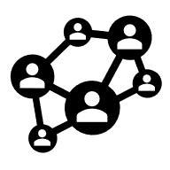 |  | 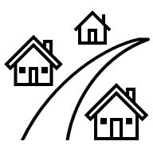

Appendix 3 – Malik and Tiana’s story
Twelve-year-old Tiana and her best friend Malik walked home from school the same way every day. Their usual route was very safe – it followed one of the main roads in town and passed by the corner shop where they sometimes bought a snack on the way home.
But today was different. Dark clouds covered the sky, and the wind was getting stronger. Malik’s phone buzzed with a text message warning: ‘Severe storm predicted.’
‘We need to hurry,’ Tiana said as she pulled her hood up. ‘I don’t want to get caught in the rain.’
Malik looked towards the trail through the nearby bush. ‘What if we take the shortcut past the old quarry? We’d get home way faster.’
Tiana wasn’t sure. The path was overgrown, slippery and not many people used it anymore. ‘I’d rather not, you never know what’s down there,’ she said.
‘But if it starts pouring, we’ll be soaked!’ Malik replied.
Tiana bit her lip. She hated storms but didn’t want to seem scared. ‘Okay,’ she said, ‘but we have to be quick. I get a bit scared of that trail sometimes.’
‘Don’t be ridiculous,’ laughed Malik.
They pushed open the gate and headed down the path. At first, it was fun. They laughed as they jumped over puddles and ducked under branches. But soon, the path got harder to follow. The bush had started to grow thick over the trail, making it hard to see which direction they should be heading. Then, the first crack of thunder sounded above them.
‘Let’s get out of here,’ said Tiana. ‘We should make a run for it!’
They started to fight their way through the branches as quickly as they could. Suddenly, Malik slipped on some mud and fell. ‘Ow!’ he said, holding his ankle.
Tiana helped him up. ‘Can you walk?’ she asked.
‘Barely,’ said Malik.
The storm came faster than they expected. Rain poured down and there was lightning all around. Tiana checked her phone, but it had no signal. Her heart raced with worry and guilt.
‘We should have stayed on the main road,’ she said. Malik nodded, a concerned look on his face.
They found a big tree to hide under. Tiana took off her jumper and wrapped it around Malik’s ankle. They waited in the cold rain, quiet and scared.
After about twenty minutes, the rain slowed. With Tiana’s help, Malik limped out of the trees and onto the footpath. Tiana pulled out her phone and dialled her sister’s number.
‘Amy, we need a lift home!’ she shouted.
When Tiana and Malik made it home, their parents were worried but relieved they were safe. That night, Tiana and Malik hopped online to chat. They talked about their choices from earlier, and how taking risks can sometimes lead to trouble.

Appendix 4 – risk matrix scenarios
Gisele is riding her bike to school for the first time. She has to cross a number of busy intersections. | Salma really wants to have a pool party for her birthday, but her parents have told her no. She decides to invite her friends over for a swim while her parents are out one Saturday. | Jamal’s father has organised a fishing trip on the boat for Jamal and his friends. There aren’t enough life jackets for everyone.
Monica and her friends are carpooling to their weekend netball game. There’s 6 of them and only 5 seats, so they decide to squish up in the back seat. | Michael and Eric are running late for school. Instead of using the footbridge to cross the road, Eric suggests making a run for it when there’s a gap in traffic. | Alex is walking to his new high school, which is on the other side of a busy country road. There’s no footpath and no pedestrian crossings.

Appendix 5 – risk assessment matrix
 |  |  |  | Consequence
 |  | Insignificant (1)  No injuries | Minor (2)  First-aid required | Moderate (3)  Medical treatment | Major (4)  Hospital, serious injury | Catastrophic (5)  Death or permanent injury
Rare (1)
Almost never happens
Unlikely (2)
Probably won’t happen
Likelihood | Possible (3)  Is known to happen sometimes
Likely (4)
Could easily happen
Almost certain (5)
Expected to happen

Appendix 6 – First Aid and DRSABCD worksheet
What is first aid?
Use the table to record your notes about the DRSABCD plan.
Acronym | What it stands for | What it involves
D
R
S
A
B
C
D
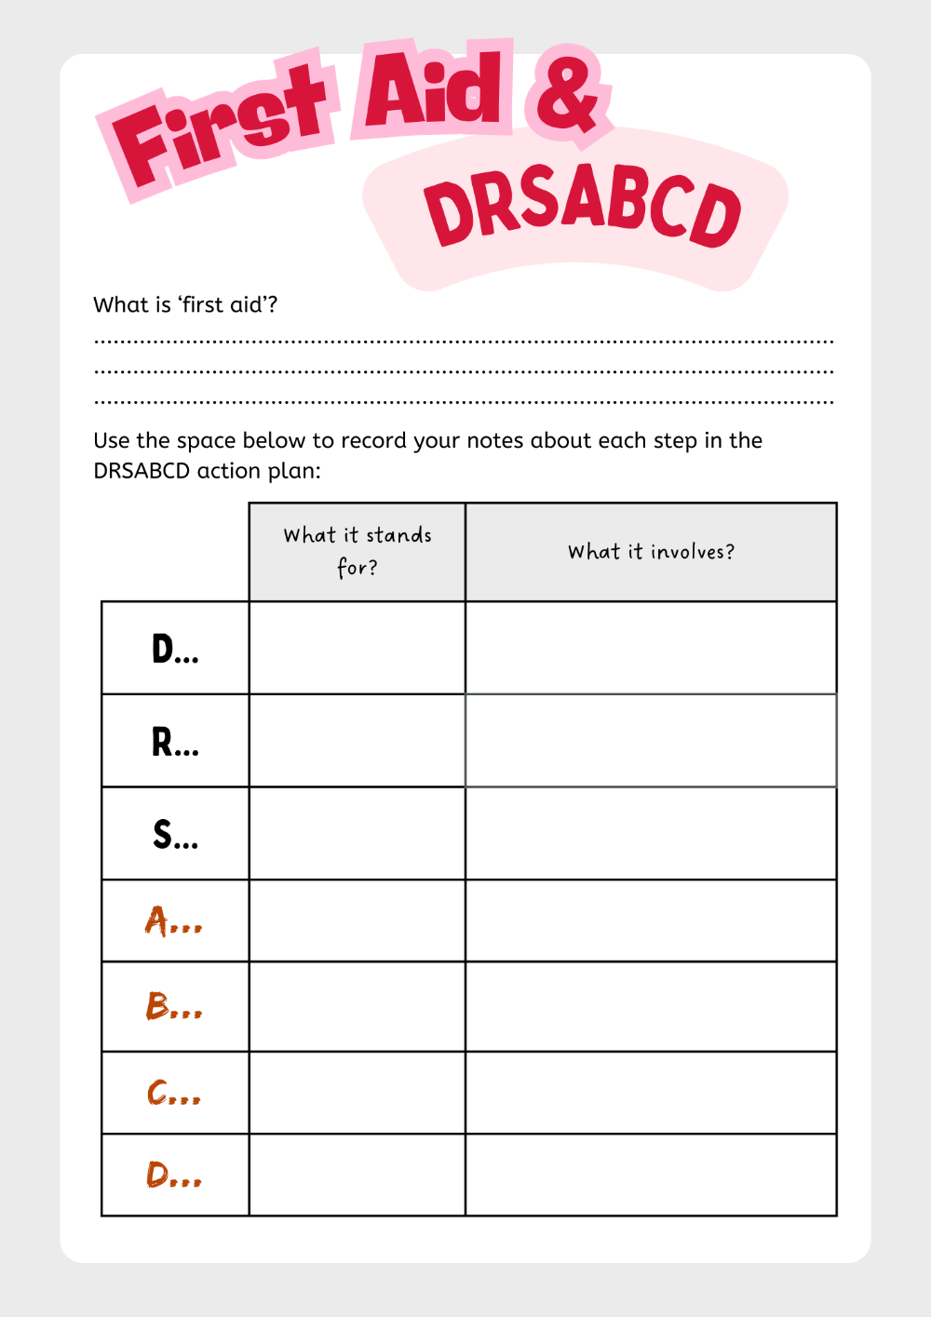

Appendix 7 – four corners statements
Teachers read out each of the following scenarios to the class:
- Swimming lessons should be mandatory.
- It is safe to swim alone if you’re a strong swimmer.
- Lifeguards have a responsibility to keep us safe while we are swimming.
- Sun safety is just as important as water safety.
- Swimming in the ocean is more dangerous than swimming in a pool.
- Adults do not need life jackets – they should be for children only.
- If you are a confident swimmer, you can try to rescue someone who is in trouble.
- You should not dive into dark or murky waters.
- There are too many rules for swimming and water safety. People just need to be careful.

Appendix 8 – water-based first aid scenarios
You and your friend Liam have planned a day out at the local beach. Liam is swimming near the shore when he suddenly feels a sharp, burning sensation on his arm. He looks at the water and sees a bluebottle floating nearby. He runs up towards you on the beach and shows you his arm. It is red, swollen and covered in sting marks.
You’re at the local pool with a group of friends in the summer holidays. Alex starts a chasing game with Olivia and starts running around the edge of the pool trying to catch her to throw her into the water. Alex slips on the wet concrete, landing heavily and hitting his head. He doesn’t move after he’s fallen. You are the first person to get to him. You notice a lump on his chin that is bleeding lightly.
It’s a warm afternoon and you are swimming down at the local lake. There are no lifeguards on duty and there’s only a few other people in the area. Someone notices a young girl, who had been swimming near the jetty, is no longer visible. Suddenly, you see another swimmer calling out to you for help as they drag the young girl from the water. Some people start to gather nearby, looking panicked but unsure what to do.
You and your friend Jake are at a popular water park. Jake decides to go on a fast water slide, but as he reaches the end, he hits the water awkwardly and struggles to swim back to the edge. He coughs a lot and says he feels like he’s swallowed water. You notice he’s looking very tired and having trouble keeping his head above water.
You and your friend Zoe are playing on the rocks at the local beach. Zoe slips and falls into the shallow water, hitting her leg hard against the rocks. She cries out in pain and can’t stand up. You notice her leg is bleeding and she looks scared and cold from the water.
At a community pool, a friend, Ethan, dives into the shallow end of the pool and hits his head on the bottom. He comes up coughing and holding his neck, complaining of a shooting pain in his shoulder. When you try and talk to him, you notice that he appears confused and isn’t making any sense when he talks.

Appendix 9 – first aid scenario response card
For your first aid scenario
Questions | Student response
What is the identified risk?
If things went wrong, what could a first aid scenario look like?
What steps do you need to take in responding to the situation?
What are the next steps for the casualty?
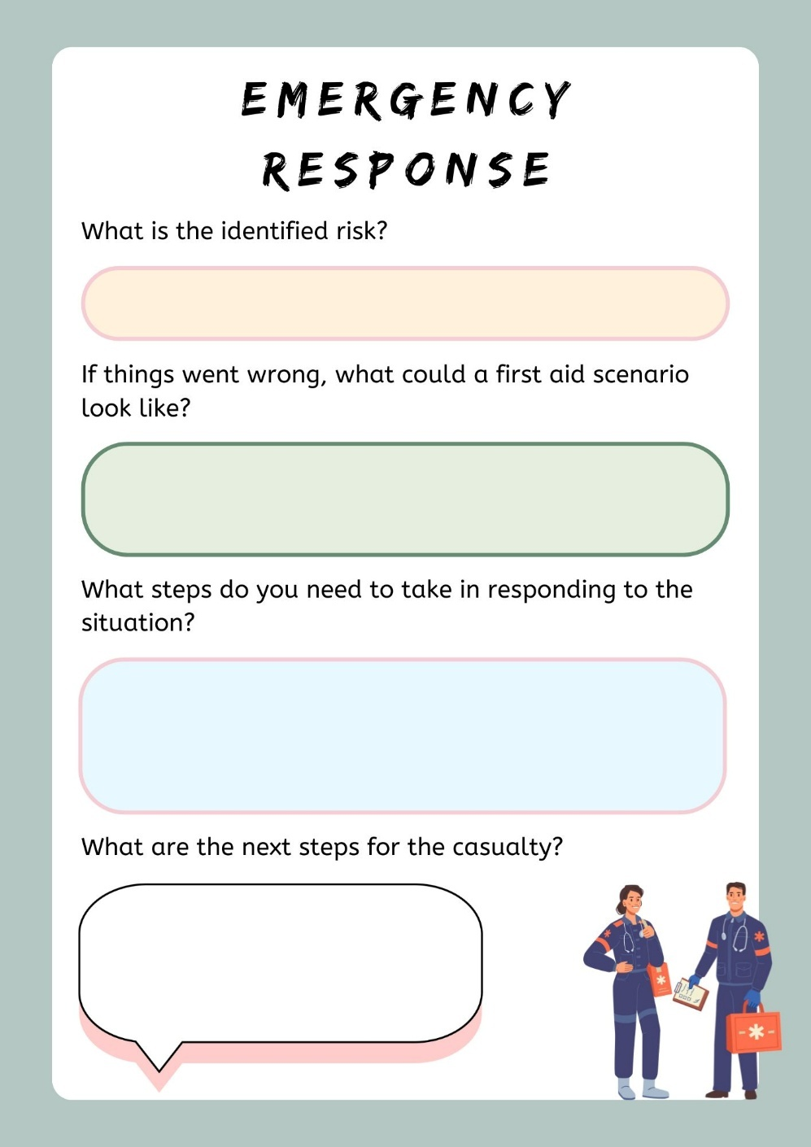

Appendix 10 – road safety statistics worksheet
The category of road user I am focusing on is …
Some of the key statistics for this category of road user are:
Are crashes more common in metropolitan or country areas?
What do the statistics indicate about involvement in incidents for males and females?
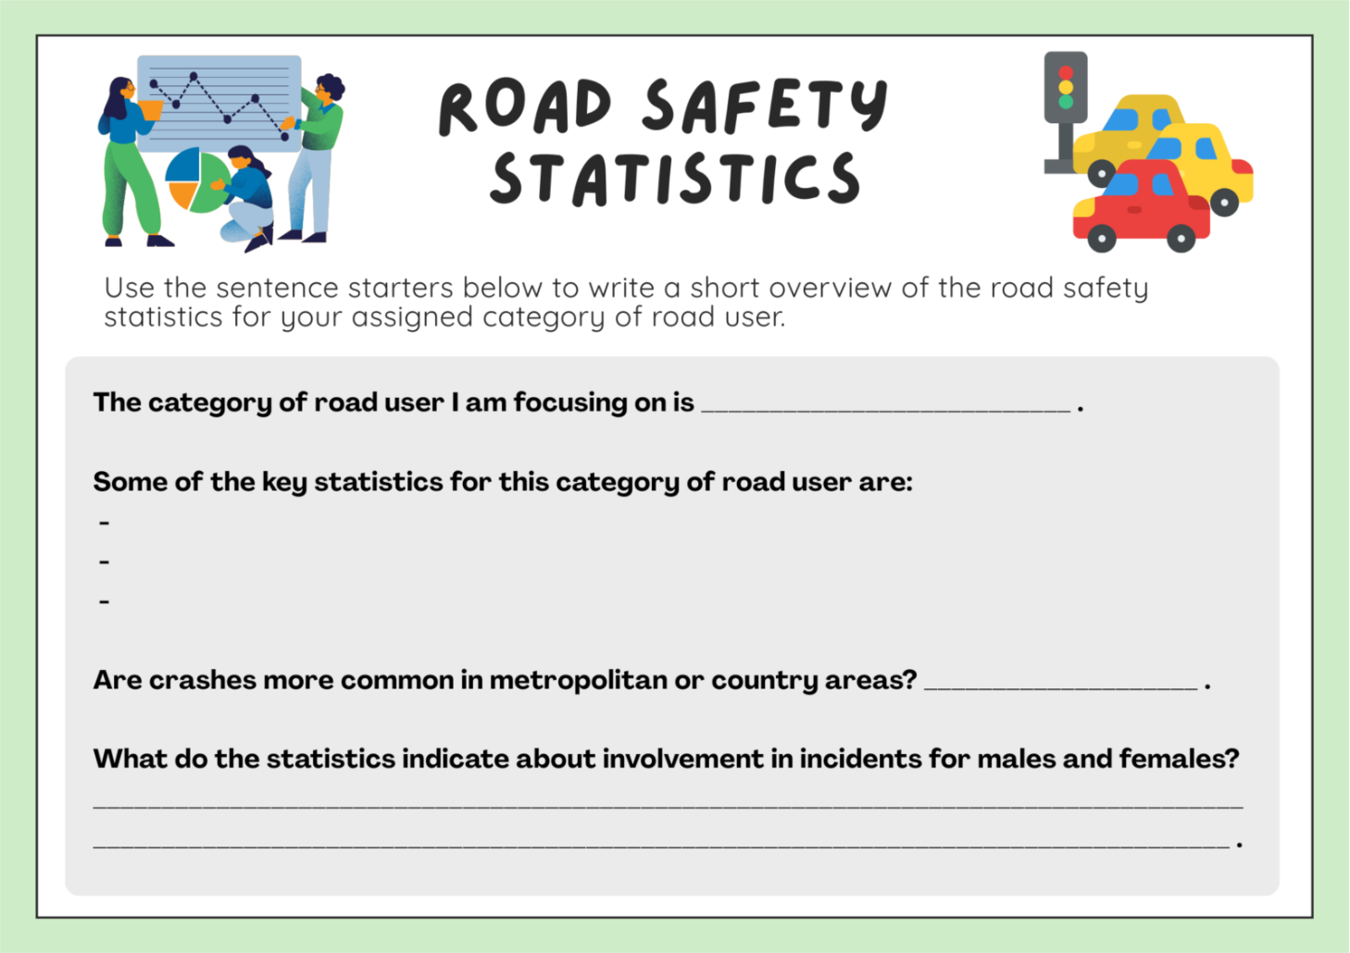

Appendix 11 – safe travel audit worksheet
My safe behaviours include … | My unsafe behaviours include … | One way I could be safer is …
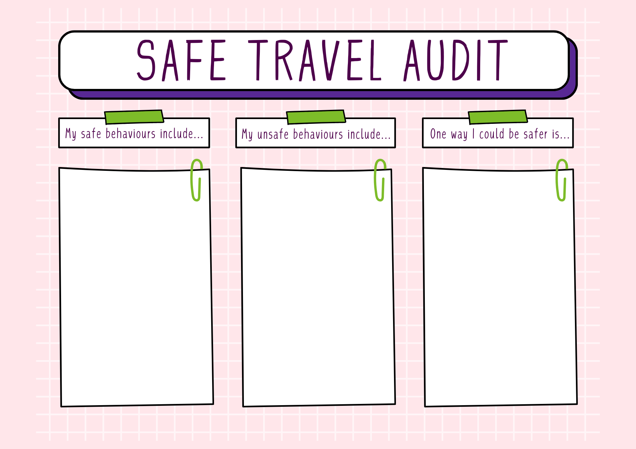

Appendix 12 – blank digital footprint
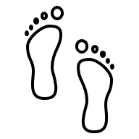

Appendix 13 – spot the risk online messages
- Hey, I go to a school near yours. I think I’ve seen you at the station before. What’s your last name? I think we might know each other.
- We don’t know each other, but I think your profile picture is really cool! Can you send me another one? I won’t tell anyone, I promise.
- Hey! It’s Alex! I made a new account because my old one got locked. Add me here instead. Don’t worry if the name looks different. Can you send me your mobile number as well? I’ll add it to my contacts.
- Hi! I noticed you were in the same game as me yesterday. You seem really good at it. Do you want to move to another app where we can chat privately? It’ll be easier to talk there.
- Hello! I’m the same age as you and I think we might know some of the same people from the area. Can you tell me what school or class you’re in so I can check?
- Hey! I’m making a private group just for the best players. Can you join? You’ll get exclusive content and some in-game bonuses. The only rule is that you can’t tell anyone else about it.

Appendix 14 – screen time scenarios
Liam is part of a group chat with his friends that keeps him constantly engaged. He feels the need to respond immediately to messages and checks his phone constantly to make sure he isn’t missing out on anything.
Zayne has a habit of binge-watching shows online. He often spends an entire weekend watching multiple episodes at once and chatting with people online who enjoy the same shows.
Araina carries her tablet everywhere she goes and often uses it during her free time at school and home. She loves playing games and watching videos whenever she gets the chance.
Jack is an avid gamer who plays pretty much every night with his friends online. He spends hours immersed in gameplay, always eager to level up and complete challenges with his team.
Salma uses her tablet to keep up with the latest news and trends. She is constantly spending her free time browsing articles and watching news clips to stay up to date with current events.

Appendix 15 – value statements for online spaces
Teachers read out each of the following scenarios to the class:
- My digital footprint could impact me in the future.
- Being anonymous online means that I’m not accountable for what I say or do.
- It’s okay to share photos of my friends and family without asking.
- If someone finds my jokes offensive, that’s their problem.
- If someone shares their images online, then they should expect to receive negative comments.
- You should be able to post whatever you want online, regardless of how other people feel.
- It’s okay to share private messages with friends, so long as you’re not being nasty.
- How you behave online isn’t as important as how you behave in real life.
- It’s important to call out cyberbullying online.
- If an online message makes me feel uncomfortable, I should stop the conversation and talk to a trusted adult.
- It’s impossible for someone to pretend to be someone else online.

Appendix 16 – health literacy text messages
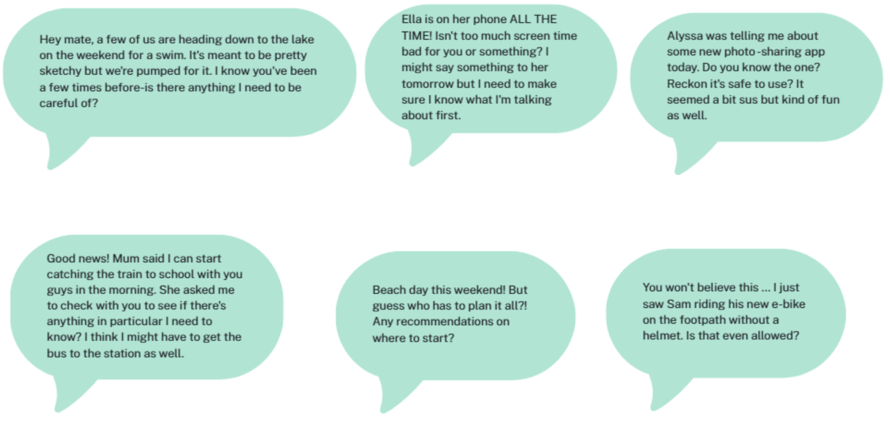


Program feedback
We value your feedback. If you use this teaching and learning program in your faculty and school context, please complete the PDHPE 7–10 resource evaluation form. If you have further comments or suggestions, please email PDHPEcurriculum@det.nsw.edu.au.

Support and alignment
Resource evaluation and support: all curriculum resources are prepared through a rigorous process. Resources are periodically reviewed as part of our ongoing evaluation plan to ensure currency, relevance and effectiveness. For additional support or advice, or to provide feedback, contact the PDHPE Secondary Curriculum team by emailing PDHPEcurriculum@det.nsw.edu.au.
Differentiation: further advice to support Aboriginal and/or Torres Strait Islander students, students learning English as an additional language or dialect (EAL/D), students with a disability and/or additional needs and high potential and gifted students can be found on the Planning, programming and assessing 7–12 webpage. This includes the Inclusion and differentiation advice 7–10 webpage.
Assessment: further advice to support formative assessment is available on the Planning, programming and assessing 7–12 webpage. This includes the Classroom assessment advice 7–10. For summative assessment tasks, the Assessment task advice 7–10 webpage is available.
Explicit teaching: further advice to support explicit teaching is available on the Explicit teaching webpage. This includes the CESE Explicit teaching – Driving learning and engagement webpage.
Consulted with: Curriculum, Road Safety Education and subject matter experts.
Alignment to system priorities and/or needs: School Excellence Policy, Our Plan for NSW Public Education
Alignment to the School Excellence Framework: this resource supports the School Excellence Framework elements of curriculum (curriculum provision) and effective classroom practice (lesson planning, explicit teaching).
Alignment to Australian Professional Standards for Teachers: this resource supports teachers to address Proficient Teacher Standard Descriptors 2.1.2, 2.2.2, 2.3.2, 2.5.2, 3.1.2, 3.2.2, 3.3.2, 4.4.2.
Creation date: 8 August 2025

References
This resource contains NSW Curriculum and syllabus content. The NSW Curriculum is developed by the NSW Education Standards Authority (NESA). This content is prepared by NESA for and on behalf of the Crown in right of the State of New South Wales. The material is protected by Crown copyright.
Please refer to the NESA Copyright Disclaimer for more information https://www.nsw.gov.au/education-and-training/nesa/copyright.
NESA holds the only official and up-to-date versions of the NSW Curriculum and syllabus documents. Please visit NESA https://www.nsw.gov.au/education-and-training/nesa and NSW Curriculum https://curriculum.nsw.edu.au.
Personal Development, Health and Physical Education 7–10 Syllabus © NSW Education Standards Authority (NESA) for and on behalf of the Crown in right of the State of New South Wales, 2024.
Consumer Healthcare Products Australia (2022) Australia’s digital ‘health literacy’ dilemma, Consumer Healthcare Products Australia website, accessed 21 July 2025.
eSafety Commissioner (n.d.) The eSafety Guide, eSafety Commissioner website, accessed 15 July 2025.
——(2024) Balancing your time online, eSafety Commissioner website, accessed 15 July 2025.
——(2024) Digital footprint, eSafety Commissioner website, accessed 15 July 2025.
——(2024) How to manage your screen time, eSafety Commissioner website, accessed 15 July 2025.
On The Move (n.d.) On The Move [website], accessed 2 July 2025.
Royal Life Saving Australia (2019) Dry Rescue Award Guide, Royal Life Saving Australia website, accessed 3 July 2025.
St John Ambulance Australia (n.d.) First Aid Fact Sheets, St John Ambulance Australia website, accessed 3 July 2025.
State of New South Wales (Department of Education) (n.d.) ‘School swimming and water safety’, School Sport Unit, NSW Department of Education website, accessed 2 July 2025.
State of New South Wales (Department of Education) (2025) ‘Promoting safe travel’, Road safety education, NSW Department of Education website, accessed 2 July 2025.
Surf Life Saving Australia (n.d.) Beach safe [website], accessed 4 July 2025.
Transport for NSW (n.d.) Interactive crash statistics, Transport for NSW website, accessed 10 July 2025.
——(n.d.) Road rules for bicycle riders, Transport for NSW website, accessed 10 July 2025.
——(2023) Bikes, e-bikes and e-scooters, Transport for NSW website, accessed 10 July 2025.

© State of New South Wales (Department of Education), 2026
The copyright material published in this resource is subject to the Copyright Act 1968 (Cth) and is owned by the NSW Department of Education or, where indicated, by a party other than the NSW Department of Education (third-party material).
Copyright material available in this resource and owned by the NSW Department of Education is licensed under a Creative Commons Attribution 4.0 International (CC BY 4.0) license.

This license allows you to share and adapt the material for any purpose, even commercially.
Attribution should be given to © State of New South Wales (Department of Education), 2026.
Material in this resource not available under a Creative Commons license:
- the NSW Department of Education logo, other logos and trademark-protected material
- material owned by a third party that has been reproduced with permission. You will need to obtain permission from the third party to reuse its material.
Links to third-party material and websites
Please note that the provided (reading/viewing material/list/links/texts) are a suggestion only and implies no endorsement, by the New South Wales Department of Education, of any author, publisher, or book title. School principals and teachers are best placed to assess the suitability of resources that would complement the curriculum and reflect the needs and interests of their students.
If you use the links provided in this document to access a third-party's website, you acknowledge that the terms of use, including licence terms set out on the third-party's website apply to the use which may be made of the materials on that third-party website or where permitted by the Copyright Act 1968 (Cth). The department accepts no responsibility for content on third-party websites.

