PDHPE Year 7 – grip it and hit it
Teaching and learning program
Contents
About this resource 3
Overview 3
Syllabus outcomes 4
Content 4
Focus area – Movement skills and strategies 4
Focus area – Health and wellbeing through physical activity 5
Related support materials 6
Teacher notes 6
Learning sequence 1 – foundations of striking 7
Learning sequence 2 – foundations of fielding 16
Learning sequence 3 – offensive play and decision making 24
Learning sequence 4 – defensive play and decision making 37
Learning sequence 5 – tactical development and team strategy 51
Learning sequence 6 – application, feedback and performance 59
Appendix 1 – striking games knowledge test 67
Appendix 2 – teacher formative assessment batting 69
Appendix 3 – student self-assessment batting 70
Appendix 4 – student peer assessment batting 71
Appendix 5 – teacher formative assessment fielding 72
Appendix 6 – student self-assessment fielding 73
Appendix 7 – student peer assessment fielding 74
Appendix 8 – student team assessment 75
Program feedback 76
Support and alignment 77
References 78

About this resource
This teaching and learning program has been developed to assist teachers in NSW Department of Education schools to create learning experiences that are contextualised to their students’ needs, interests and abilities for the Personal Development, Health and Physical Education 7–10 Syllabus (NESA 2024). It provides an example of one way to approach programming through a conceptual lens. Teachers are encouraged to take an adopt and adapt approach to the learning activities outlined in this program.

Overview
Description: in this teaching and learning program, students develop and refine fundamental and specialised movement skills by participating in a range of modified striking and fielding games. Students are provided opportunities to enhance their ability to manipulate equipment with accuracy, power and control as they engage in striking games that require the use of different implements for striking in increasingly dynamic environments. They apply movement concepts to a variety of striking game situations, evaluating their performance and identifying actions to increase success individually and as a team.
Duration: approximately 9.5 hours.
Explicit teaching: suggested learning intentions and success criteria are available for each learning sequence. Learning intentions and success criteria are most effective when they are contextualised to meet the needs of students in the class. The examples provided in this document are generalised to demonstrate how learning intentions and success criteria could be created.
Assessment: suggested formative assessment is outlined throughout this teaching and learning program.

Syllabus outcomes
A student:
- transfers movement skills and concepts for use in a range of dynamic movement environments PH4-MSS-01
- demonstrates how strategies and actions can be transferred to solve movement challenges PH4-MSS-02
- plans for and uses strategies to participate in activities that encourage safety, health and lifelong physical activity PH4-SHP-01
Personal Development, Health and Physical Education 7–10 Syllabus © NSW Education Standards Authority (NESA) for and on behalf of the Crown in right of the State of New South Wales, 2024.

Content

Focus area – Movement skills and strategies
Enhancing and valuing movement
- Practise and refine fundamental and specialised movement skills in predictable and dynamic situations
- Demonstrate how to enhance balance, power and accuracy in movement contexts
- Use equipment to control and manipulate objects in dynamic movement environments
- Participate in movement activities that demonstrate and transfer similar skills and strategies to different forms of gameplay, including target, net and court, striking and fielding, and territory games
- Apply and transfer movement concepts in a range of movement contexts
- Evaluate decisions and actions when solving movement challenges
- Provide and apply feedback to improve body control, coordination, skill execution and strategy
Applying self-management and interpersonal skills to movement
- Recognise and apply attitudes and behaviours that encourage enjoyable, ethical, respectful and inclusive movement experiences
- Assess the effectiveness of teamwork, cooperation, problem-solving and personal responsibility when involved in team building, initiative games and other forms of physical activity
- Apply strategies to enhance resilience and perseverance during physical activity to manage challenging or unfamiliar movements
- Provide and respond to verbal, physical or situational cues to enhance communication, performance and team cohesion

Focus area – Health and wellbeing through physical activity
Participating safely
- Explain and apply specific warm-up and cool-down activities to a range of physical activities
- Demonstrate and explain how protective equipment and environmental and individual factors can influence safety during physical activity

Related support materials
This teaching and learning program aligns with the following support materials:
- PDHPE Years 7–10 – sample scope and sequence.
All resources associated with this resource can be found on the Planning, programming and assessing PDHPE 7–10 webpage.

Teacher notes
All activities within this teaching and learning program have been designed to allow flexibility in the selection of bat and ball types, tailored to suit individual student abilities, school context and the learning environment. This approach ensures that all students can participate safely, develop confidence and experience success while building the fundamental skills, tactics and strategies of striking and fielding.

Learning sequence 1 – foundations of striking
Note: the duration of this learning sequence is approximately 1 hour.
Table 1 – teaching and learning program
Outcomes and content | Teaching and learning activities
Outcomes  PH4-MSS-01, PH4-MSS-02  Content  Focus area – Movement skills and strategies  Enhancing and valuing movement  - Practise and refine fundamental and specialised movement skills in predictable and dynamic situations  - Use equipment to control and manipulate objects in dynamic movement environments  - Apply and transfer movement concepts in a range of movement contexts  Focus area – Health and wellbeing through physical activity  Participating safely  - Demonstrate and explain how protective equipment and environmental and individual factors can influence safety during physical activity | Learning intentions  We are learning to:  - practise and improve our movement skills in different situations  - use equipment to control and move objects while being active  - use movement ideas in different activities.  Success criteria  I can:  - recognise when my batting technique needs changing  - change the speed, force and height of my hit  - place the ball into space or away from fielders when I am under pressure.  Striking games knowledge test-baseline (optional)  Assess students’ understanding of striking and fielding games through a scenario and knowledge-based questionnaire (Appendix 1 – striking games knowledge test), including parts of play, challenges, skills with and without the bat or ball, team tactics, and connections to other sports. The results inform teaching foci, and it is repeated at the end of the program to measure growth in knowledge, tactical understanding and decision-making.  Warm-up game – yes, no, wait  Note: students start developing decision-making through simple movement responses, the teacher highlights listening, reacting quickly and making early tactical choices.  Set up 2 lines of cones 20 metres apart.  Have students form pairs and stand facing their partner, with one student from each pair behind each cone line.  On the teacher’s signal, pairs respond to the following commands:  - ‘Yes’ – both students run to the opposite cone line, swapping places with their partner.  - ‘No’ – both students stay where they are and raise their hand.  - ‘Wait’ – both students take 2 steps forward and pause. Then listen for the next instruction  - If the teacher says ‘Yes’, they continue running to swap places.  - If the teacher says ‘No’, they stop and raise their hand.  Yes, no, wait progression – decision making with fielders  Introduce 3 fielders, with the teacher standing to the side and throwing or rolling the ball into play.  Fielders collect and return the ball to the teacher as fast as possible.  Figure 1 – set up for yes, no, wait progression – decision making with fielders  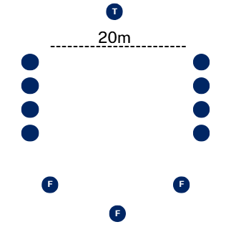  Pairs now decide whether to run and how many runs to attempt before the ball is returned to the teacher.  If the ball beats a runner to a cone line, the pair lose a run.  Strike and run  Note: students begin building striking and base-running skills with controlled hits from a tee, while the teacher focuses on contact, placement and safe running patterns.  Mark out a diamond with a tee and cones for bases, with 10 metres between them.  Split students into 2 even groups with each student pairing up with a partner from their group.  Position fielders around the diamond and strikers to the side at a safe location.  Figure 2 – set up for strike and run  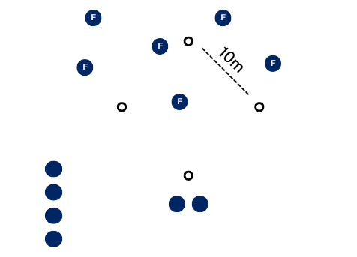  The striker hits the ball into the field using a tee, both members of the pair run around the bases with one point allocated to each base.  Fielders work together to retrieve the ball and return it to home base as quickly as possible.  If the striking team are between bases when the ball is returned, they receive no runs.  The striking and fielding teams swap roles after both members of the striking team have had a chance to hit.  Points accumulate over multiple rounds.  Throughout this activity use the following questions to deepen understanding of lesson outcomes:  - How did you adjust your body position to hit the ball into space?  - What type of contact (hard/soft) helped you control where the ball went?  - Where was the best place to hit the ball to give you more time to run? How could you use this same striking tactic in a game like cricket or softball?  Six station scramble  Note: students engage in continuous play, focusing on striking into space and adapting to varied deliveries. The teacher provides feedback to develop anticipation, shot placement and awareness of fielders. After the activity, teachers complete the formative assessment in Appendix 2 – teacher formative assessment batting, and students complete the self-assessment in Appendix 3 – student self-assessment batting.  Mark out a 12 metre pitch with stumps or a target at both ends.  Place 6 cones around the pitch to create 6 bowling stations.  Position one batter at each end of the pitch.  All remaining students spread out as fielders.  Figure 3 – set up for six station scramble  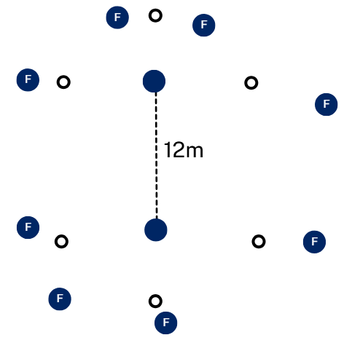  Fielders can bowl from any of the 6 bowling stations or directly from the stumps.  Bowlers may bowl at any time from any station – the game is continuous and unpredictable.  Batters hit the ball into the field and must run if the ball is hit.  Runs are scored by running between the stumps.  If a batter is caught or bowled, they score no runs, and the fielder who gets them out earns 2 points.  Each batter faces 6 deliveries, aiming to score as many runs as possible.  After 6 balls, rotate batters and fielders so all students have a turn.  Throughout this activity use the following questions to deepen understanding of lesson outcomes:  - When you hit the ball, what helps you make it travel far enough to reach the other wicket safely?  - Where did you try to place the ball so the fielders would take longer to return it to pitch? How was this different to the previous game?  - How do the fielders’ positions make you change where you aimed your strike?  Formative assessment:  Outcomes  - transfers movement skills and concepts for use in a range of dynamic movement environments  PH4-MSS-01  - demonstrates how strategies and actions can be transferred to solve movement challenges  PH4-MSS-02  Teachers use the formative assessment rubric (Appendix 2 – teacher formative assessment batting) to observe and provide feedback on technique, accuracy and decision-making, ensuring students are supported as they refine their skills. Students use the self-assessment rubric (Appendix 3 – student self-assessment batting) to reflect on their own performance, identify strengths and set goals for improvement.
Adjustments, evaluation and registration
[Classroom teacher to complete.]

Learning sequence 2 – foundations of fielding
Note: the duration of this learning sequence is approximately 1 hour.
Table 2 – teaching and learning program
Outcomes and content | Teaching and learning activities
Outcomes  PH4-MSS-01, PH4-MSS-02  Content  Focus area – Movement skills and strategies  Enhancing and valuing movement  - Practise and refine fundamental and specialised movement skills in predictable and dynamic situations  - Use equipment to control and manipulate objects in dynamic movement environments  - Apply and transfer movement concepts in a range of movement contexts  Focus area – Health and wellbeing through physical activity  Participating safely  - Demonstrate and explain how protective equipment and environmental and individual factors can influence safety during physical activity | Learning intentions  We are learning to:  - practise and improve our movement skills in different situations  - use equipment to control and move objects while being active  - use movement ideas in different activities.  Success criteria  I can:  - notice mistakes in my fielding technique and work on fixing them  - catch or collect balls that come at me high, low or fast, even when under pressure  - throw or bowl the ball with the right speed, power and direction to limit runs or get a batter out.  Warm-up game – catch and release  Students practise basic fielding awareness and teamwork while supporting each other in play, with the teacher reinforcing safe movement, accurate throwing and cooperation.  Mark out a playing area suitable for the class size using cones.  Choose 2 to 4 students to be ‘taggers’ and 2 to 3 students to be ‘releasers’, each with a soft foam ball.  Remaining students are ‘runners’ who move around the space, avoiding being tagged.  Figure 4 – set up for catch and release  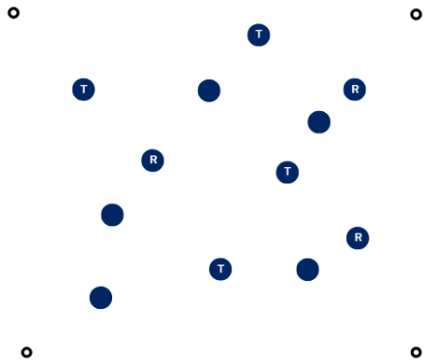  When tagged, ‘runners’ freeze on the spot with arms raised.  ‘Releasers’ unfreeze players by throwing them the ball. If caught and returned, the frozen player is released and rejoins the game.  If the ball is dropped, the player remains frozen, and the ‘releaser’ must try again or move to another player.  ‘Releasers’ cannot run with the ball and must throw from where they stand.  ‘Taggers’ cannot tag ‘releasers’.  Rotate roles every few minutes.  Fielding relay  Note: students practise throwing, catching and accuracy under simple team pressure, while the teacher guides technique, control and teamwork to support fielding development.  Divide the class into teams of 5 to 6 students.  Each team lines up in a straight line.  Place a hoop or bucket 10 metres in front of the first player in each line.  Give each team one soft ball.  Figure 5 – set up for fielding relay  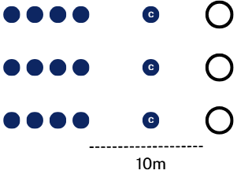  One player from each team stands at the front as the ‘captain’ between the target (hoop or bucket) and their line.  The remaining players form a line facing their captain.  The first player throws the ball to the captain, then squats down.  The captain returns the ball to the next player in line.  Each player repeats the process. They throw to the captain, then squat down once they’ve thrown.  When the ball reaches the last player in the line they throw the ball into the target.  If the ball lands in the target, the team scores one point.  Teams quickly reset, rotating captains so everyone has a turn in the role.  The first team to score 5 successful target throws wins.  Throughout this activity use the following questions to deepen understanding of lesson outcomes:  - What helped you make your throw more accurate so your teammate could catch it easily?  - What throwing technique gives your team the best chance of hitting the target?  - How could the skills you practised here help you field effectively in games like softball, cricket or  tee-ball?  Diamond run  Note: students apply early striking and running skills in a game-like setting, while the teacher supports timing, decision-making and cooperative fielding.  Divide the class into 2 teams per diamond – batting and fielding.  Set up a diamond-shaped field with a base at each corner.  Figure 6 – set up for diamond run  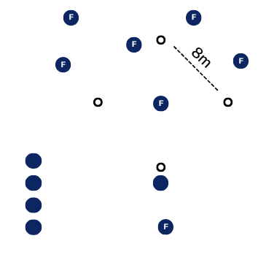  The batting team takes turns hitting the ball and running around the diamond.  After hitting, the batter completes 2 full circuits of the bases, finishing where they began.  Fielders collect the ball quickly, return it to the thrower, and pass it around each base.  If the batter reaches home before the ball completes the circuit, they score one run.  Teams swap roles after all batters have had a turn.  The team with the most runs at the end of the game wins.  Throughout this activity use the following questions to deepen understanding of lesson outcomes:  - How could you adjust your body to make sure your throw reached the right height and speed?  - When the ball is hit, how do you decide whether to field it with one hand or 2?  - How does the speed of the batter’s running change the way you field or throw?  Formative assessment:  Outcomes  - transfers movement skills and concepts for use in a range of dynamic movement environments  PH4-MSS-01  - demonstrates how strategies and actions can be transferred to solve movement challenges  PH4-MSS-02  Teachers use the formative assessment rubric (Appendix 5 – teacher formative assessment fielding) to observe and provide feedback on technique, accuracy and decision-making, ensuring students are supported as they refine their skills. Students use the self-assessment rubric and (Appendix 6 – student self-assessment fielding) to reflect on their own performance, identify strengths and set goals for improvement.
Adjustments, evaluation and registration
[Classroom teacher to complete.]

Learning sequence 3 – offensive play and decision making
Note: the duration of this learning sequence is approximately 2 hours.
Table 3 – teaching and learning program
Outcomes and content | Teaching and learning activities
Outcomes  PH4-MSS-01, PH4-MSS-02, PH4-SHP-01  Content  Focus area – Movement skills and strategies  Enhancing and valuing movement  - Demonstrate how to enhance balance, power and accuracy in movement contexts  - Use equipment to control and manipulate objects in dynamic movement environments  - Apply and transfer movement concepts in a range of movement contexts  - Evaluate decisions and actions when solving movement challenges  Focus area – Health and wellbeing through physical activity  Participating safely  - Explain and apply specific warm-up and cool-down activities to a range of physical activities | Learning intentions  We are learning to:  - develop effective batting and hitting strategies to make accurate and strategic decisions under pressure  - enhance striking accuracy and ball placement, during dynamic play  - apply movement concepts and decision-making strategies to adapt and perform effectively in dynamic and challenging physical activities.  Success criteria  I can:  - recognise when my batting technique needs changing and adjust how I stand, swing or follow-through  - change the speed, force and height of my hit depending on where the ball is and where I want it to go  - strategically place the ball into space or away from fielders when I am under pressure.  Warm-up – student developed  Briefly explain the rules of the following game in this learning sequence ‘target smash’.  Highlight the key physical demands:  - throwing accuracy – consistent underarm pitching to the batter  - batting control – aiming for close or distant targets  - balance and timing – adjusting stance and swing to direct the ball.  Divide students into teams of 6 to 8.  Each team decides how they will warm up to prepare for the game.  Teams must include:  - arm and shoulder movements to improve pitching accuracy  - dynamic movements to improve balance and coordination for batting  - reaction and timing drills to prepare for hitting moving balls.  Teams have 10 minutes to design a warm-up routine using cones, balls or bases.  Each team explains their warm-up to the class and provides reasons for how it will prepare them based on the key physical demands.  As a class, decide which warm-up elements to use before starting the game.  Perform the chosen warm-up together.  Target smash  Note: students practise striking for accuracy and power by aiming at targets, while the teacher encourages balanced stance, swing control and decision-making between easier and harder options.  Set up a series of targets at varying distances.  Divide the class into pairs.  One pair pitches underarm to another pair who bats.  The batting pair aims to hit or ‘smash’ the targets with the following scoring:  - 15 points for a direct target hit on deeper targets  - 10 points for a direct target hit on closer targets  - 5 points for any bat-on-ball contact.  After 2 turns, pairs switch roles and rotate to challenge new pairs.  Play continues until one pair reaches 100 points.  Throughout this activity use the following questions to deepen understanding of lesson outcomes:  - When aiming for a target, how do you decide whether to go for a close, easier target or a distant, higher-scoring one?  - How does your stance affect your ability to stay balanced when swinging at different targets?  - What do you notice about timing, hitting early versus late, and how that changes where the ball travels?  Over the zone  Note: students learn to strike with control under pressure by aiming to clear a central zone, while the teacher focuses on stance, timing and tactical choices between power and placement.  Divide the class into teams of 4.  For each game, mark out a rectangular field of play with a central zone running across it.  Figure 7 – set up for over the zone  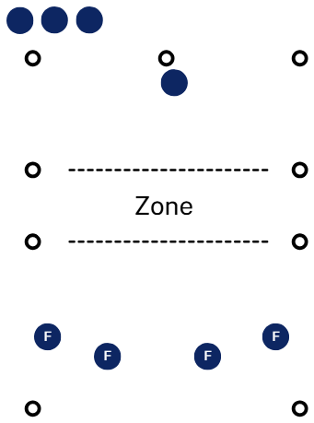  Teams take turns batting and fielding.  A feeder lobs or bounces the ball to the batter.  The batter strikes using a hand or paddle bat, aiming to hit the ball over the zone, but below head height.  Batters score one point if the ball lands in the playing area and is not caught on the full.  An innings ends after 3 outs or when all batters have had 2 turns.  Throughout this activity use the following questions to deepen understanding of lesson outcomes:  - What stance helped you stay balanced when preparing to strike the ball?  - How did you change your swing to keep the ball below head height?  - What worked better under pressure? Aiming for space, or hitting with maximum power? Why?  - How could the tactic you used here transfer to batting in cricket, tee-ball or softball?  Warm-up – Noongar Wana  Share with your students that Noongar Wana is a First Nations game from the Noongar people of southwest Western Australia. As First Australians, Aboriginal and/or Torres Strait Islander peoples were the original inventors and players of striking and fielding games. The continued enjoyment of these games today is a testament to their creativity and to the enduring importance of games in fostering both enjoyment and community connection.  Note: students explore striking to defend a target by adjusting timing and deflections, while the teacher reinforces quick reactions, safe contact and consistency under pressure.  Split the class into groups of 8.  Set up a 5-metre safety circle with a central target, surrounded by a larger 12 metre circle.  One batter stands inside the inner circle with a bat.  Fielders position themselves outside the larger circle with 2 balls.  Figure 8 – set up for Noongar Wana  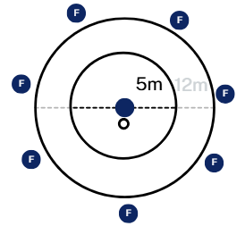  Fielders roll or underarm throw the balls, aiming to hit the target. Balls must bounce or roll (no full throws).  The batter deflects the balls to protect the target.  Fielders must throw within 3 seconds of fielding.  The batter is out if they:  - hit too hard  - block the ball inside the circle  - are caught on the full.  Rotate batters regularly. Play individually or in teams, using modified scoring rules.  Slatsy’s cricket  Note: students apply decision-making in a fast-paced batting and running context, while the teacher emphasises reading the field, choosing placement and balancing risk.  Divide the class into 2 teams — batting and fielding.  Create a 10 metre cricket pitch with a batting circle.  Divide students into teams of 5 to 6.  Batters line up on the side with fielders spread out throughout the playing area.  Figure 9 – set up for Slatsy’s cricket  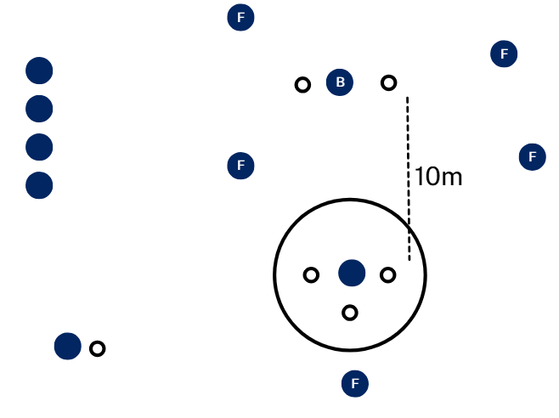  A bowler delivers the ball to the batter.  The batter strikes the ball and runs to the bowler’s base and then returns to the end of the batting lineup.  The fielding team retrieves the ball and returns it to the bowler who may bowl as soon as they receive the ball.  If the batter reaches the base before the ball is returned, they are safe and score a point. If not, it counts as an out.  After 3 outs, teams swap roles. Continue alternating innings with an accumulative score count.  Throughout this activity use the following questions to deepen understanding of lesson outcomes:  - What did you look for in the field before choosing where to hit the ball?  - What batting strategy gave you the best chance of scoring safely? Aiming for gaps, using softer shots or hitting harder?  - How did you encourage yourself or your teammates after an out?  Paddle bases  Note: students practise tactical decision-making by striking into play and choosing when to advance or hold at a base, while the teacher highlights awareness, teamwork and risk-taking.  Divide the class into 2 teams of 6 – batting and fielding.  Set up 4 runner’s bases in a diamond shape, around 10 metres apart for each field.  Figure 10 – set up for paddle bases  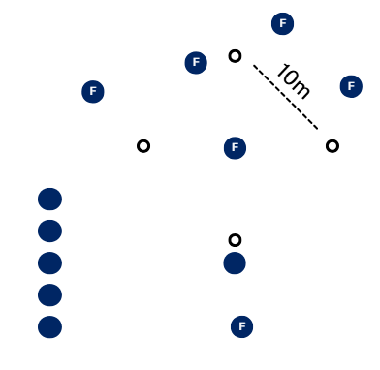  A pitcher delivers the ball to the batter.  The batter strikes with a paddle bat and runs around the runner’s bases.  The batter may choose to return home to score one point.  Fielders retrieve the ball and return it to the pitcher, who calls ‘freeze’.  If the runner is between bases they are out and score zero points for the team.  Multiple players may wait on the runner’s bases.  Batters must decide when to stay or run, using teamwork and tactics.  Teams swap roles after each innings.  Throughout this activity use the following questions to deepen understanding of lesson outcomes:  - What did you look for before deciding whether to keep running or stop at a base?  - When the pitcher called ‘freeze’, what made it easier or harder for you to be safe on a base?  - How did you stay focused and positive when you weren’t sure if you’d make it home?  Formative assessment:  Outcomes  - transfers movement skills and concepts for use in a range of dynamic movement environments  PH4-MSS-01  - demonstrates how strategies and actions can be transferred to solve movement challenges  PH4-MSS-02  Teachers use the formative assessment rubric (Appendix 2 – teacher formative assessment batting) to observe technique, accuracy and decision-making, providing targeted feedback to guide skill development. At this point, formative assessment data may indicate a need to introduce skill drills or activities to practise and refine specific batting skills. Students engage in peer assessment (Appendix 4 – student peer assessment batting), using the structured rubric to give constructive feedback on teammates’ movement skills and tactical decisions, helping to build awareness of effective performance.
Adjustments, evaluation and registration
[Classroom teacher to complete.]

Learning sequence 4 – defensive play and decision making
Note: the duration of this learning sequence is approximately 2 hours.
Table 4 – teaching and learning program
Outcomes and content | Teaching and learning activities
Outcomes  PH4-MSS-01, PH4-MSS-02, PH4-SHP-01  Content  Focus area – Movement skills and strategies  Enhancing and valuing movement  - Practise and refine fundamental and specialised movement skills in predictable and dynamic situations  - Evaluate decisions and actions when solving movement challenges  - Apply and transfer movement concepts in a range of movement contexts  Applying self-management and interpersonal skills to movement  - Apply strategies to enhance resilience and perseverance during physical activity to manage challenging or unfamiliar movements | Learning intentions  We are learning to:  - field the ball effectively and position ourselves smartly to stop runs and help our team defend  - make quick and confident decisions when fielding or defending, especially when under pressure during games  - work well with our teammates, show resilience and take responsibility for our role in the team  - warm up and cool down safely and effectively.  Success criteria  I can:  - notice mistakes in my fielding technique and work on fixing them  - catch or collect balls that come at me high, low or fast, even when under pressure  - throw or bowl the ball with the right speed, power and direction to limit runs or get a batter out  - adjust how I move, throw or position myself based on where the batter is hitting the ball  - explain and perform appropriate warm-up and cool-down activities relevant to defensive play.  Warm-up – Koolchee  Note: students begin practising defensive positioning and reactive fielding while attempting to knock down opponent skittles, and the teacher emphasises anticipation, throwing accuracy and using the ball to block incoming shots.  Split players into teams of 4 to 6.  Each team sets up their skittles a few metres in front of them, with each player holding a small ball (Koolchee).  On ‘go’, all players bowl their Koolchees underarm at the opposing team’s skittles at the same time.  Teams can also defend by using their Koolchees to deflect incoming balls.  Points are awarded each round to the team with the most skittles still standing.  Continue for a set number of rounds or time.  In the zone  Note: students start learning to field strategically by choosing zones and returning the ball efficiently, while the teacher focuses on placement, body position and motivating team communication. Batters hit into scoring zones and fielders aim to prevent points by catching or returning the ball quickly.  Divide students into groups of 8.  Mark out a 30 metre x 30 metre square playing area.  Set up designated scoring zones on the field.  Figure 11 – set up for in the zone  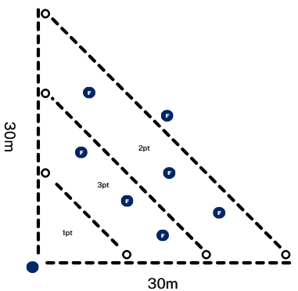  Position one batter in the hitting area and fielders around the zones.  Fielders are given the choice of which zone they will field in.  The bowler delivers the ball underarm to the batter, who attempts to hit it into the scoring zones to earn points based on where it lands.  If the ball is caught on the full, the batter scores zero.  After 5 hits, players rotate roles, so the batter becomes the bowler, the bowler joins the fielders and the fielders take turns batting.  Fielders return the ball to the bowler after each hit, and individual points are tallied at the end of each round.  Throughout this activity use the following questions to deepen understanding of lesson outcomes:  - How did your team’s field placement impact the batter’s decisions?  - What throwing technique helped you return the ball to the bowler quickly and accurately?  - What strategies did you use to stay motivated when fielding in a less active zone?  In the zone modification – rapid fire  Note: students practise reacting under pressure and making fast defensive decisions while fielding multiple balls, and the teacher guides footwork, positioning and clean collection.  Use the same rules and set up as ‘in the zone’.  Batters face 5 balls each and are fed balls as quickly as they can be hit.  Fielders return balls by rolling them down one side through a gate to a collector from the batting team.  Figure 12 – set up for in the zone modification – rapid fire  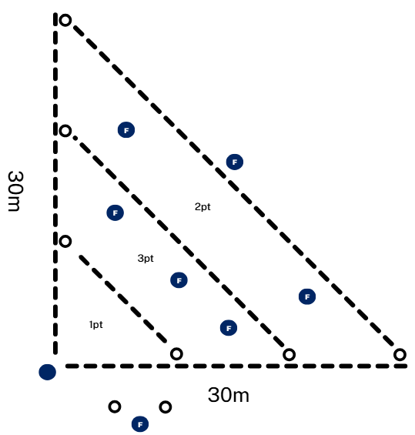  If a fielder misses the gate, the batter earns an extra point.  Fielders are not allowed to hold onto balls, they must roll immediately.  If the ball is caught on the full, the batter scores zero.  Throughout this activity use the following questions to deepen understanding of lesson outcomes:  - How did your fielding position affect your chance of preventing the batter scoring extra points?  - What body position or footwork helped you field the ball cleanly under pressure?  - What options did you have when the ball was hit close to another fielder? How did you decide who should collect it?  Warm-up – student developed  Note: students begin connecting warm-up movements to defensive play, practising throwing, agility and stopping skills, while the teacher emphasises accuracy, coordination and readiness for game play.  Briefly explain the rules of the following game in this learning sequence ‘base chase throwdown’.  Highlight the key physical demands:  - throwing accuracy – underarm throws must land in the circle  - agility and speed – running quickly and efficiently between bases  - fielding and stopping the ball – collecting and passing to stop spots.  Divide students into teams of 6 to 8.  Each team decides how they will warm up to prepare for the game.  Teams must include:  - arm and wrist movements to improve throwing accuracy  - running and agility movements to prepare for moving between bases  - fielding movements to practise stopping and passing the ball.  Teams have 10 minutes to design a warm-up routine using cones, balls or bases.  Each team explains their warm-up to the class providing reasoning to how it prepares them based on the key physical demands.  As a class, decide which warm-up elements to use before starting the game.  Perform the chosen warm-up together.  Base chase throwdown  Note: students apply defensive decision-making by fielding, stopping and passing the ball to prevent runs, and the teacher encourages quick choices about which stop spot to use and how to collaborate with teammates.  Mark out a 15 metre diameter circle using 8 cones as bases.  Place one cone at home plate and another directly behind it as the catcher’s base.  Select 2 to 3 bases to act as stop spots where fielders can end play.  Divide students into teams of 6 to 8, with one team batting and the other fielding.  Figure 13 – set up for base chase throwdown  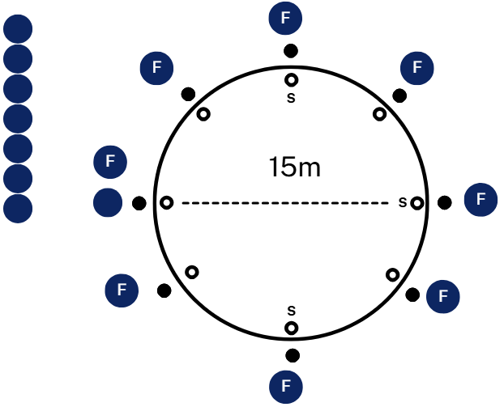  The first batter starts at home plate and throws the ball underarm into the circle.  The ball must land inside the circle to be in play; if it goes outside, it is a foul, and runners return to their last base.  After throwing, the batter immediately runs around the bases in order.  Fielders collect the ball and pass it to a player standing on a stop spot.  When the ball reaches a stop spot, play stops, and the batter must return to the last base touched.  Multiple batters may share a base at the same time.  If a runner completes a full lap and returns to home plate, they score one point for their team.  After each turn, fielders rotate clockwise so that everyone experiences different positions.  Once all 6 batters have had a turn, the teams switch roles.  Throughout this activity use the following questions to deepen understanding of lesson outcomes:  - What influenced your decision about whether to pass or run the ball to a stop spot?  - How did you decide which stop spot was the quickest option to end the play?  - How did you adapt if the batter was already close to a base when you gained possession?  Progression – base chase hit out  Note: students progress to defensive reactions against struck balls, making fast decisions to intercept and pass, while the teacher highlights adjusting positions, reading the ball and responding to speed changes.  Use the same set up and teams as the previous activity, ‘base chase throwdown’.  A pitcher from the batting team stands in the centre of the circle and gently throws the ball underarm to their batter at home plate.  Figure 14 – set up for base chase hit out  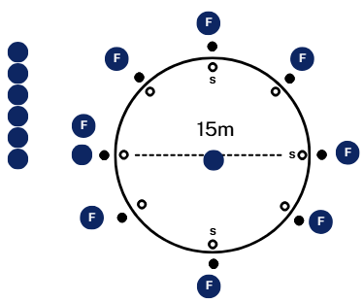  The batter strikes the ball with a bat into the field of play.  The ball may be hit anywhere provided it is not hit behind the batter.  If the ball is hit behind, it is a foul, and runners return to their last base.  After striking, the batter immediately runs around the bases in order.  Fielders collect the ball and pass it to a player standing on a stop spot.  When the ball reaches a stop spot, play stops, and the batter must return to the last base touched.  Multiple batters may share a base at the same time.  If a runner completes a full lap and returns to home plate, they score one point for their team.  After each turn, fielders rotate clockwise so that everyone experiences different positions.  Once all 6 batters have had a turn, the teams switch roles.  Throughout this activity use the following questions to deepen understanding of lesson outcomes:  - How did you adjust your position once the ball was struck instead of thrown?  - When the ball travelled faster off the bat, how did that change your choice of stop spot?  - What was harder about fielding in this progression compared to the initial activity?  Formative assessment:  Outcomes  - transfers movement skills and concepts for use in a range of dynamic movement environments  PH4-MSS-01  - demonstrates how strategies and actions can be transferred to solve movement challenges  PH4-MSS-02  Teachers use the formative assessment rubric (Appendix 5 – teacher formative assessment fielding) to observe technique, accuracy and decision-making, providing targeted feedback to guide skill development. At this point, formative assessment data may indicate a need to introduce skill drills or activities to practise and refine specific fielding skills. Students also engage in peer assessment (Appendix 7 – student peer assessment fielding), using the structured rubric to give constructive feedback on teammates’ movement skills and tactical decisions, helping to build awareness of effective performance.
Adjustments, evaluation and registration
[Classroom teacher to complete.]

Learning sequence 5 – tactical development and team strategy
Note: the duration of this learning sequence is approximately 2 hours.
Table 5 – teaching and learning program
Outcomes and content | Teaching and learning activities
Outcomes  PH4-MSS-01, PH4-MSS-02, PH4-SHP-01  Content  Focus area – Movement skills and strategies  Enhancing and valuing movement  - Practise and refine fundamental and specialised movement skills in predictable and dynamic situations  Applying self-management and interpersonal skills to movement  - Assess the effectiveness of teamwork, cooperation, problem-solving and personal responsibility when involved in team building, initiative games and other forms of physical activity  - Provide and respond to verbal, physical or situational cues to enhance communication, performance and team cohesion | Learning intentions  We are learning to:  - practise and refine striking, running and movement skills while making tactical decisions in team-based games  - apply teamwork and communication skills to develop and implement effective game strategies  - assess and adapt our approach to enhance team performance under dynamic and competitive conditions.  Success criteria  I can:  - make informed decisions about striking, running and movement to achieve tactical advantages  - work collaboratively with my team, communicating clearly and supporting teammates in executing strategies  - reflect on the effectiveness of our strategies and adjust my actions to improve team performance.  Warm-up – chuck the chicken  Note: students begin practising movement, coordination and teamwork in a fun, dynamic context, while the teacher emphasises timing, spatial awareness and collaborative decision-making.  Divide students into 2 teams.  Team A starts by throwing the rubber chicken as far as possible into the open space and calls out ‘chuck the chicken!’  Team B runs to retrieve the chicken and forms a line, passing it overhead and between legs (over then under) until it reaches the end of the line.  Team A forms a group, and one player runs around the outside, counting how many laps they can complete before Team B yells, ‘chuck the Chicken!’ Let teams discover that this is most efficient when they make the smallest group possible, promoting collaborative decision making, leadership and teamwork. Each lap completed by the runner earns one point for the team.  Figure 15 – set up for chuck the chicken  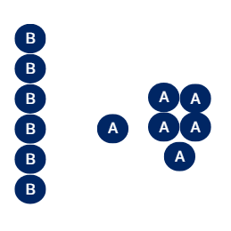  When the chicken reaches the end of Team B’s line, the last player throws the chicken anywhere they like.  Teams switch roles, Team B has a team member complete laps around their group while Team A completes the under, over challenge.  Pause after a round or 2 to allow teams to refine their strategy.  The team with the most points at the end wins.  Power play party  Note: students practise tactical decision making and shot execution, then during play the dynamic decision making needed to decide if they should run for extra points or not.  Divide the class into smaller groups so multiple games can run simultaneously.  Each game is played with 2 teams of 6 to 8 players, one team batting, the other fielding.  Set up a batting zone at one end of the field and a runner’s lane along the baseline.  Mark 3 scoring zones with cones: close, middle and deep.  Allocate fielders the following roles:  - 1 bowler  - 1 to 2 close zone fielders  - 2 to 3 middle zone fielders  - 1 to 2 deep zone fielders.  Figure 16 – set up for power play party  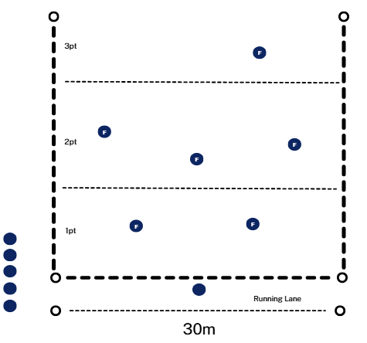  The bowler delivers an underarm ball to the batter.  The batter strikes the ball into one of the zones and chooses to stay for zone points or run the lane for bonus points.  Fielders collect the ball, make 2 passes between teammates, and return it to the bowler.  If the bowler receives the ball before the batter finishes their run, zone points are lost.  Each batter has 3 turns before swapping roles.  Rotate positions so all players experience batting, bowling and each fielding zone.  Throughout this activity use the following questions to deepen understanding of lesson outcomes:  - How did your team decide where to place fielders in each zone?  - When the batter hit into a particular zone repeatedly, how could you adjust your team strategy?  - How did your team include everyone so that all fielders felt involved in the play?  Power play challenge  Note: students progress to advanced decision-making under pressure, balancing risk and reward with target and zone strategies, while the teacher highlights leadership, communication and strategic adjustments.  Continue using the same scoring zones, teams and rules from the previous activity, ‘power play party’.  Introduce targets in each zone and name them ‘power spots’. Note: hitting a ‘power spot’ doubles the points.  Assign a ‘captain’ for the fielding team, rotate this role after each batter.  The ‘captain’ chooses the team formation before each batter and communicates it to teammates.  Batters now decide whether to aim for ‘power spots’ for high points or hit safer zones for guaranteed points, and whether to run the lane for bonus points.  Fielders must execute the captain’s strategy while collecting and relaying the ball back to the bowler.  Rotate all fielding positions and the captain role after each batter to ensure everyone experiences batting, bowling, fielding in each zone and leadership.  Throughout this activity use the following questions to deepen understanding of lesson outcomes:  - What strategies worked best against batters aiming for ‘power spots’?  - How did fielders adjust their positioning to follow the captain’s plan?  - How did the captain communicate the strategy, so everyone understood their role?  - How effective was your team’s tactical plan overall?  Formative assessment:  Outcomes  - transfers movement skills and concepts for use in a range of dynamic movement environments  PH4-MSS-01  - demonstrates how strategies and actions can be transferred to solve movement challenges  PH4-MSS-02  In this sequence, students apply tactical decision-making and team strategies in dynamic, team-based striking and fielding games. Students use the peer assessment rubrics (Appendix 4 – student peer assessment batting and Appendix 7 – student peer assessment fielding) to evaluate how effectively teammates communicate, follow strategies and support each other in their roles. They also use the self-assessment rubrics (Appendix 3 – student self-assessment batting and Appendix 6 – student self-assessment fielding) to reflect on their own contributions and decision-making, identifying strengths and areas for improvement to enhance overall team performance.
Adjustments, evaluation and registration
[Classroom teacher to complete.]

Learning sequence 6 – application, feedback and performance
Note: the duration of this learning sequence is approximately 2.5 hours.
Table 6 – teaching and learning program
Outcomes and content | Teaching and learning activities
Outcomes  PH4-MSS-01, PH4-MSS-02, PH4-SHP-01  Content  Focus area – Movement skills and strategies  Enhancing and valuing movement  - Participate in movement activities that demonstrate and transfer similar skills and strategies to different forms of gameplay, including target, net and court, striking and fielding, and territory games  - Provide and apply feedback to improve body control, coordination, skill execution and strategy  Applying self-management and interpersonal skills to movement  - Assess the effectiveness of teamwork, cooperation, problem-solving and personal responsibility when involved in team building, initiative games and other forms of physical activity  - Provide and respond to verbal, physical or situational cues to enhance communication, performance and team cohesion | Learning intentions  We are learning to:  - apply striking, running and fielding skills in game situations to achieve individual and team goals  - use tactical decision-making to respond effectively to dynamic game situations  - evaluate our own and peers’ performance to improve skills, teamwork and game strategy.  Success criteria  I can:  - perform striking, running and fielding skills accurately and adapt them in real-game contexts  - make decisions during play that support my team’s strategy and contribute to achieving goals  - provide constructive feedback to peers and use feedback to enhance my own and my team’s performance.  Four wicket cricket  Divide the class into smaller groups so multiple games can run simultaneously.  Mark out a diamond-shape for each field with a set of stumps (bins or buckets) at each of the 4 bases.  Position a bowler in the centre of the diamond to deliver the ball.  Place 4 wicket keepers (backstops) at each base, with the rest of the fielding team spread around the field.  The batting team sends in 4 batters at once, with the rest wait on the sideline.  Figure 17 – set up for four wicket cricket  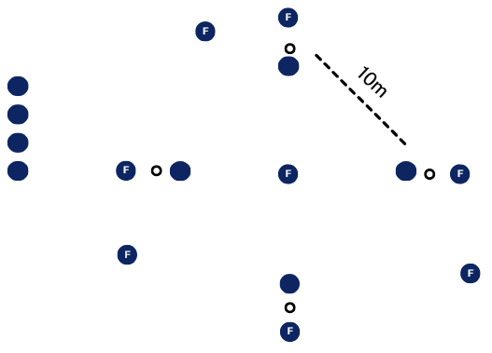  When the ball is bowled and hit, all 4 batters run anti-clockwise to the next base. Batters may choose to keep running multiple bases.  Batters can be dismissed by being:  - caught  - bowled out (3 strikes)  - hit wicket  - run out (multiple batters can be dismissed in one play, for example, one caught and another run out).  Teams carry the bat while running.  The batting team continues until all batters are out or for a set time limit.  Teams swap roles and the team with the most runs wins.  During this activity, students who are waiting to bat engage in peer assessment using the criteria outlined in Appendix 4 – student peer assessment batting. While observing their teammates at bat, students provide feedback on key performance elements, such as batting technique and decision-making when running between bases. Between innings, students use Appendix 7 – student peer assessment fielding to peer assess the fielding team, evaluating skills such as positioning, communication and effectiveness in dismissing batters. This process helps students develop their ability to analyse skills and support their peers in improving performance.  Slam ball  Note: slam ball is introduced in the Year 7 Exploring my strengths and identity teaching and learning program. In this program, students explore how their skills have progressed. Students apply their batting, running and fielding skills in a game setting, and between innings complete Appendix 8 – student team assessment to evaluate their team’s performance and reflect on strategies for improvement.  Set up a baseball or softball diamond with 3 tee-ball stands at the home base. This game works best when flat patches are used to mark the bases not padded cushions. Make a one metre by one metre square with cones to the side of the home base.  Figure 18 – set up for slam ball  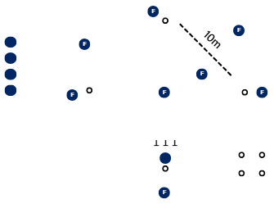  Allocate students into 2 teams and explain the rules of slam ball.  - There is a batting team and a fielding team.  - One person bats at a time and they hit all 3 balls of all 3 tee-ball stands (fielders can only move once the third ball is hit).  - Once the student has hit the third ball, they place the bat down and run the diamond in the direction of first base (they can choose to stop where they would like, including home base).  - The next batter then bats.  - Each student can accumulate up to 5 runs before they retire.  - Students do not need to run on any base – if staying at home base, they need to stand in the square to the side for safety.  - There is no stealing bases allowed.  - Fielders aim to return the 3 balls to the tee-ball stands as quickly as possible.  - Any batter who is between bases when the third ball is returned are out.  Striking games knowledge test – post-program (optional)  At the conclusion of the program, students complete the same scenario and knowledge-based questionnaire used at the start (Appendix 1 – striking games knowledge test).  Note: this post-program assessment evaluates their growth in understanding of striking and fielding games, including parts of play, common challenges, key skills with and without the bat or ball, team tactics, and connections to other sports. Comparing baseline and post-program results allows students and teachers to identify improvements in knowledge, tactical awareness and decision-making.  Formative assessment:  Outcomes  - transfers movement skills and concepts for use in a range of dynamic movement environments  PH4-MSS-01  - demonstrates how strategies and actions can be transferred to solve movement challenges  PH4-MSS-02  In this sequence, students consolidate and apply their striking, running and fielding skills in full game contexts. Teachers use the formative assessment rubrics (Appendix 2 – teacher formative assessment batting and Appendix 5 – teacher formative assessment fielding) to monitor technical execution, tactical decision-making and overall team performance, providing targeted feedback. Students engage in peer assessment (Appendix 4 – student peer assessment batting and Appendix 7 – student peer assessment fielding), observing and providing constructive feedback on teammates’ skills, positioning and communication to help refine performance and improve team strategy. At the end of each game, teams complete a reflection (Appendix 8 – student team assessment), discussing what strategies worked, how roles were executed and how they can improve collaboration and overall performance in future games.
Adjustments, evaluation and registration
[Classroom teacher to complete.]

Appendix 1 – striking games knowledge test
- What are the 2 main parts of play in a striking and fielding game? Describe what each part involves.
(Hint: think about what players do when their team is batting and when their team is fielding. What is the goal for each team during these times?)
- What are 3 challenges players might have when:
- batting (hitting and running)
- fielding (catching and throwing)?
- List 5 skills players use when they are using the bat or ball.
(For example, hitting, bowling or pitching, throwing, catching, stopping the ball.)

- List 5 skills players use when they are playing without the bat or ball.
(For example, running between bases, moving into the right position, backing up a teammate, calling out to others, watching the play to stay ready.)
- Describe 3 tactics or team strategies that can help your team do well.
(For example, placing fielders in smart positions, choosing when to run, working together to get someone out.)
- Can you think of another sport where one of these strategies might be used? Explain how it works in both sports.
- What protective equipment can players use in striking and fielding games to stay safe?
- How can environmental factors (such as weather or playing surface) and individual factors (such as skill level) affect safety during the game?

Appendix 2 – teacher formative assessment batting
Criteria | Yes | Mostly | Sometimes | Few times | No
Recognises errors in striking technique (for example, mistimed hits, poor stance, over-hitting) and identifies modifications to improve future attempts.
Varies the speed, force and trajectory of strikes based on ball placement and game situation.
Propels the ball with suitable force and placement under pressure.
Experiments with different shot selections and hitting strategies to adapt to opposition tactics and scoring opportunities.
Uses external feedback (peer, teacher or knowledge of results) to refine batting technique for greater accuracy, timing and control.

Appendix 3 – student self-assessment batting
Criteria | Yes | Mostly | Sometimes | Few times | No
I can recognise when my batting technique needs changing and adjust how I stand, swing or follow-through.
I can change the speed, force and height of my hit depending on where the ball is and where I want it to go.
I can place the ball into space or away from fielders when I am under pressure.
I can try different shot types and strategies to create scoring chances.
I can use feedback from others to improve my hitting accuracy and control.

Appendix 4 – student peer assessment batting
Criteria | Yes | Mostly | Sometimes | Few times | No
Did they adjust their technique when needed (stance, swing, follow-through)?
Did they vary speed, force or height of their hits depending on the situation?
Did they place the ball into space or away from fielders?
Did they try different shot types or strategies to create scoring chances?
Did they use feedback to improve their hitting?

Appendix 5 – teacher formative assessment fielding
Criteria | Yes | Mostly | Sometimes | Few times | No
Recognises errors in fielding technique (for example, poor catching position, inaccurate throws) and identifies or applies corrections.
Receives the ball from a range of levels and pathways (for example, high catches, low ground balls, fast throws) with and without equipment, even under opposition or time pressure.
Propels the ball (throwing, bowling, returning) with varied force, speed and trajectory to restrict scoring opportunities or create dismissals.
Experiments with fielding strategies by adjusting speed, positioning and force to adapt to batter placement and game flow.
Uses external feedback to refine bowling, catching and throwing accuracy and consistency.

Appendix 6 – student self-assessment fielding
Criteria | Yes | Mostly | Sometimes | Few times | No
I can notice mistakes in my fielding technique and work on fixing them.
I can catch or collect balls that come at me high, low or fast, even when under pressure.
I can throw or bowl the ball with the right speed, power and direction to limit runs or get a batter out.
I can adjust how I move, throw or position myself based on where the batter is hitting the ball.
I can use feedback to improve how I bowl, catch and throw.

Appendix 7 – student peer assessment fielding
Criteria | Yes | Mostly | Sometimes | Few times | No
Did they notice and correct mistakes in their fielding technique?
Did they successfully catch or collect balls from different heights and speeds?
Did they throw or bowl with the right speed, power and direction to stop runs or get an out?
Did they adjust their movement or positioning based on where the ball was hit?
Did they use feedback to improve their bowling, catching or throwing?

Appendix 8 – student team assessment
Criteria | Yes | Mostly | Sometimes | Few times | No
Teamwork – our team helped each other and communicated well
Cooperation – everyone shared ideas and took turns
Problem-solving – our team found solutions and used smart strategies
Team responsibility – our team followed rules and looked after each other
- What did our team do really well today?
- What challenges did our team face, and how did we solve them?
- What could our team do differently next time to work better together?


Program feedback
We value your feedback. If you use this teaching and learning program in your faculty and school context, please complete the PDHPE 7–10 resource evaluation form. If you have further comments or suggestions, please email PDHPEcurriculum@det.nsw.edu.au.

Support and alignment
Resource evaluation and support: all curriculum resources are prepared through a rigorous process. Resources are periodically reviewed as part of our ongoing evaluation plan to ensure currency, relevance and effectiveness. For additional support or advice, or to provide feedback, contact the PDHPE Secondary Curriculum team by emailing PDHPEcurriculum@det.nsw.edu.au.
Differentiation: further advice to support Aboriginal and/or Torres Strait Islander students, students learning English as an additional language or dialect (EAL/D), students with a disability and/or additional needs and high potential and gifted students can be found on the Planning, programming and assessing 7–12 webpage. This includes the Inclusion and differentiation advice 7–10 webpage.
Assessment: further advice to support formative assessment is available on the Planning, programming and assessing 7–12 webpage. This includes the Classroom assessment advice 7–10. For summative assessment tasks, the Assessment task advice 7–10 webpage is available.
Explicit teaching: further advice to support explicit teaching is available on the Explicit teaching webpage. This includes the CESE Explicit teaching – Driving learning and engagement webpage.
Consulted with: PDHPE subject matter experts
Alignment to system priorities and/or needs: School Excellence Policy, Our Plan for NSW Public Education
Alignment to the School Excellence Framework: this resource supports the School Excellence Framework elements of curriculum (curriculum provision) and effective classroom practice (lesson planning, explicit teaching).
Alignment to Australian Professional Standards for Teachers: this resource supports teachers to address Proficient Teacher Standard Descriptors 2.1.1, 2.1.2, 2.2.1, 2.2.2, 2.3.1, 2.3.2, 3.1.1, 3.1.2, 3.2.1, 3.2.2, 3.3.1, 3.3.2, 4.1.1, 4.2.1, 4.4.1, 4.4.2.
Creation date: 9 October 2025

References
This resource contains NSW Curriculum and syllabus content. The NSW Curriculum is developed by the NSW Education Standards Authority. This content is prepared by NESA for and on behalf of the Crown in right of the State of New South Wales. The material is protected by Crown copyright.
Please refer to the NESA Copyright Disclaimer for more information https://educationstandards.nsw.edu.au/wps/portal/nesa/mini-footer/copyright.
NESA holds the only official and up-to-date versions of the NSW Curriculum and syllabus documents. Please visit the NSW Education Standards Authority (NESA) website https://educationstandards.nsw.edu.au and the NSW Curriculum website https://curriculum.nsw.edu.au.
Personal Development, Health and Physical Education 7–10 Syllabus © NSW Education Standards Authority (NESA) for and on behalf of the Crown in right of the State of New South Wales, 2024.
Cricket Australia (2023) ‘Health & PE – Secondary School’, Secondary - HPE Handbook, Play Cricket website, accessed 19 December 2025.

© State of New South Wales (Department of Education), 2025
The copyright material published in this resource is subject to the Copyright Act 1968 (Cth) and is owned by the NSW Department of Education or, where indicated, by a party other than the NSW Department of Education (third-party material).
Copyright material available in this resource and owned by the NSW Department of Education is licensed under a Creative Commons Attribution 4.0 International (CC BY 4.0) license.

This license allows you to share and adapt the material for any purpose, even commercially.
Attribution should be given to © State of New South Wales (Department of Education), 2025.
Material in this resource not available under a Creative Commons license:
- the NSW Department of Education logo, other logos and trademark-protected material
- material owned by a third party that has been reproduced with permission. You will need to obtain permission from the third party to reuse its material.
Links to third-party material and websites
Please note that the provided (reading/viewing material/list/links/texts) are a suggestion only and implies no endorsement, by the New South Wales Department of Education, of any author, publisher, or book title. School principals and teachers are best placed to assess the suitability of resources that would complement the curriculum and reflect the needs and interests of their students.
If you use the links provided in this document to access a third-party's website, you acknowledge that the terms of use, including licence terms set out on the third-party's website apply to the use which may be made of the materials on that third-party website or where permitted by the Copyright Act 1968 (Cth). The department accepts no responsibility for content on third-party websites.

