PDHPE Year 7 – creating my toolkit for change
Teaching and learning program

Contents
About this resource 3
Overview 3
Syllabus outcomes 4
Content 4
Focus area – Respectful relationships 4
Focus area – Identity, belonging and change 5
Related support materials 6
Teacher notes 6
Learning sequence 1 – changing times, changing me 8
Learning sequence 2 – signalling change – the role of hormones 23
Learning sequence 3 – stronger than yesterday – mastering your mind and mood 38
Learning sequence 4 – communication, conflict and respectful relationships 57
Appendix 1 – types of change activity cards 83
Appendix 2 – character snapshots on puberty 85
Appendix 3 – hormone hustle change cards 86
Appendix 4 – understanding the female reproductive system 89
Appendix 5 – understanding the male reproductive system 92
Appendix 6 – character puberty scenarios 94
Appendix 7 – skills toolkit image 98
Appendix 8 – toolkit skills reflection 99
Appendix 9 – toolkit skills cards 105
Appendix 10 – character ‘what to do?’ scenarios 106
Appendix 11 – loss cards 109
Appendix 12 – character grief and loss scenarios 110
Appendix 13 – ‘Picture Perfect’ stimulus material 114
Appendix 14 – communication role-play scenarios 118
Appendix 15 – decision-making tree 120
Appendix 16 – conflict resolution scenarios 121
Appendix 17 – the 3 R’s of relationships 124
Program feedback 127
Support and alignment 128
References 129

About this resource
This teaching and learning program has been developed to assist teachers in NSW Department of Education schools to create learning experiences that are contextualised to their students’ needs, interests and abilities for the Personal Development, Health and Physical Education 7–10 Syllabus (NESA 2024). It provides an example of one way to approach programming through a conceptual lens. Teachers are encouraged to take an adopt and adapt approach to the learning activities outlined in this program.

Overview
Description: students will explore the changes occurring in their lives including social, emotional and physical changes. Students will learn about strategies to support their health and wellbeing during times of change and supports that are available.
Duration: approximately 9 hours and 30 minutes.
Explicit teaching: suggested learning intentions and success criteria are available for each learning sequence. Learning intentions and success criteria are most effective when they are contextualised to meet the needs of students in the class. The examples provided in this document are generalised to demonstrate how learning intentions and success criteria could be created.
Assessment: suggested formative assessment has been outlined within this unit.

Syllabus outcomes
A student:
- refines and applies self-management and interpersonal skills to manage complex situations PH4-SMI-01
- assesses the influence of contextual factors on attitudes and behaviours to propose strategies that enhance safety, health and wellbeing
PH4-SHW-01
- explains and applies strategies for promoting safe and respectful relationships in a range of contexts PH4-RRL-01
Personal Development, Health and Physical Education 7–10 Syllabus © NSW Education Standards Authority (NESA) for and on behalf of the Crown in right of the State of New South Wales, 2024.

Content

Focus area – Respectful relationships
Building and managing respectful relationships to support health and wellbeing
- Examine the changing nature of relationships and propose strategies that build and maintain respectful relationships
Applying self-management and interpersonal skills to enhance respectful relationships
- Explain how rights and responsibilities contribute to safe and respectful relationships
- Demonstrate and explain how respect, sympathy and empathy can be expressed to positively influence relationships
- Evaluate and practise communication skills that build and maintain respectful relationships, including active listening
- Demonstrate how decision-making, negotiation and problem-solving skills can help resolve conflict
- Explain how emotional responses can impact relationships and propose strategies to facilitate positive outcomes in a range of situations
- Identify attitudes and practise skills that enhance resilience, perseverance and adaptability to change

Focus area – Identity, belonging and change
Managing growth and change
- Refine skills and strategies for managing changing roles and responsibilities
- Explain strategies that enhance resilience, health and wellbeing in response to stress, loss and grief
- Examine the impact of change, including adolescence and puberty, and select strategies to support themselves and others through these changes
- Describe the anatomy and function of the reproductive system including its role in reproduction, menstruation and fertilisation

Related support materials
This teaching and learning program aligns with the following support materials:
- student-facing PowerPoint – PDHPE Year 7 – creating my toolkit for change – slide deck
- PDHPE Years 7–8 – sample scope and sequence.
All resources associated with this program can be found on the Planning, programming and assessing PDHPE 7–10 webpage.

Teacher notes
This teaching and learning program contains content that addresses potentially controversial issues and diverse perspectives on sensitive topics. The activities and resources in this program form part of the learning entitlement outlined by NESA in the Personal Development, Health and Physical Education 7–10 Syllabus (NESA 2024) and are designed to encourage critical thinking, foster respectful dialogue and promote understanding among students.
The NSW Department of Education’s Controversial issues in schools procedure provides a framework for how schools manage these topics in a way that is age-appropriate and aligned to the curriculum.
Teachers are expected to support student engagement by creating a supportive learning environment, respecting the diverse views, values and experiences of all students, and by approaching discussions in an impartial manner that is free from harassment or discrimination. Content should be tailored to suit the unique needs of students and delivered in a way that supports their wellbeing. For additional guidance on creating a supportive learning environment, please refer to the NSW Department of Education’s Learning environment resources.
Teachers should use strategies to avoid public disclosures and should be aware of their mandatory reporting requirements. Teachers must review, before use, all teaching and learning resources and extra-curricular activities and associated materials that are referenced, distributed or shown to students. All educational content and materials from external providers, contractors, volunteers and visitors that are reasonably likely to contain controversial issues must be reviewed and approved by the school principal before delivery.
Where appropriate and in accordance with the principal’s professional judgement, parents and carers should be informed in advance about PDHPE programs that may include topics considered sensitive or controversial within the school community. This allows them the opportunity to raise any concerns with the most appropriate school staff. Each school will determine when and how they inform and consult with their school community. Sample information letters are available to assist in communicating with your school community about teaching and learning initiatives.
For any questions or assistance with this resource, please contact the PDHPE Secondary Curriculum team at PDHPEcurriculum@det.nsw.edu.au.
This teaching and learning program integrates recurring fictional characters which provide a safe and neutral context for addressing sensitive topics. By interacting with these characters, students can explore complex issues and share their thoughts openly, without the worry of being personally exposed or judged. These characters help students understand different viewpoints by offering insights into lives and experiences that may be different from their own. This process builds empathy, promotes inclusivity and encourages respect for diversity among all students.

Learning sequence 1 – changing times, changing me
Note: the section titled ‘Changing times, changing me’ in the PowerPoint – PDHPE Year 7 – creating my toolkit for change – slide deck can be used to support Learning sequence 1. The duration of this learning sequence is approximately 2 hours.
Table 1 – teaching and learning program
Outcomes and content | Teaching and learning activities
Outcomes  PH4-SMI-01, PH4-SHW-01  Content  Focus area – Respectful relationships  Building and managing respectful relationships to support health and wellbeing  - Examine the changing nature of relationships and propose strategies that build and maintain respectful relationships  Applying self-management and interpersonal skills to enhance respectful relationships  - Explain how emotional responses can impact relationships and propose strategies to facilitate positive outcomes in a range of situations  Focus area – Identity, belonging and change  Managing growth and change  - Examine the impact of change, including adolescence and puberty, and select strategies to support themselves and others through these changes | Learning intentions  We are learning to:  - understand the nature of change during adolescence and the impact this can have on relationships  - recognise emotional responses to change.  Success criteria  I can:  - identify how relationships may can change over time  - explain how common activities may change over time with growing independence  - outline how changes associated with puberty may impact relationships  - identify a range of emotions that may be felt when navigating change  - apply realistic and appropriate self-management skills to manage change.  Class norms  Explain the importance of having norms for respectful discussions. Tell students that these norms will help maintain a safe and respectful classroom environment.  Ask students to think individually about one norm they believe is important for discussing sensitive topics. Encourage them to consider respect, active listening and thoughtful responses.  Invite a few students to share their ideas with the class. Write each idea on the whiteboard as they are shared. Aim to gather around 5 key norms.  Facilitate a class discussion to ensure everyone understands and agrees with the proposed norms. Make any necessary adjustments based on student feedback.  Summarise the agreed-upon norms and display them in the classroom. Encourage students to keep these norms in mind during future discussions.  Introduction  Pose the question ‘What are relationships?’. Discuss as a class and draw out common themes and ideas.  Ask students to share examples of different types of relationships. Record student responses on the board as these will be referred to in subsequent activities. Responses can include parents, sibling, grandparents, aunties or uncles, close friends, friends, teachers, Year Advisors, sports coaches.  Introduce the concept of how things, including relationships, change over time, particularly focusing on the transition from infancy to adolescence.  Group activity – What’s changed?  Divide students into small groups and provide each group with a sheet of A3 paper.  Instruct students to create a timeline as a group that outlines key periods of growth from infancy (0–5 years) to childhood (6–11 years), adolescence (12–18 years) and adulthood (18+). See slide 7 of the PDHPE Year 7 – creating my toolkit for change PowerPoint for a visual sample of the timeline.  Encourage students to add any significant changes in relationships at each stage of development on the timeline, using the relationships identified in the discussion from the previous activity (parents, siblings, friends).  Encourage students to consider changes in social interactions and independence during the activity.  Note: pre-printed timelines can be distributed to the class, or a digital alternative used like Microsoft Whiteboard.  This activity will support class discussions around the changing nature of relationships, and the influence of growing independence on daily activities and relationships in the following 3 teaching and learning activities.  Class discussion  Select one group to present their timeline to the class.  Facilitate a class discussion, with reference to the group presentation prompting students to consider:  - Did some relationships change more than others? Why or why not?  - How might relationships with parents change as children grow?  - What role might friendships play in adolescence compared to childhood?  - How might peer influences start to emerge?  Introduce the concept that transitioning from being dependant on others in childhood to becoming increasingly independent during adolescence is a natural and important part of growing into a self-sufficient and resilient adult.  Time traveller  Display a list of common activities relevant to students on the board, including:  - packing school bag  - packing own lunch  - selecting clothing  - completing homework  - going to the movies or shopping  - going to a birthday party  - personal hygiene  - decision making.  Students discuss the following questions in pairs:  - How have these common activities changed over time?  - How could growing independence also impact how these activities change in the future?  Students select 2 activities from the list and complete a written reflection about changes that occur in relation to these activities at different life stages.  Class discussion  Select one group to present their written reflection from the previous activity, and their analysis of how it has changed or not changed over time. Ask the class if this was similar or different to what they reflected on when examining their 2 activities.  Emphasise that not only can relationships change as we grow older, but so do our responsibilities, largely around the time of puberty and adolescence.  Note: students’ responses from class discussion can be used to formatively check for understanding.  The teacher could call on groups that looked at specific changes, like decision-making or personal hygiene to support the teacher to create a natural segue around changes in the context of puberty and adolescence.  Changes in puberty  Show the video clip Adolescent development: The art of growing up (3:31) which provides a brief overview on puberty and the associated physical, emotional and social changes.  In small groups, students complete a matching activity where they are provided with examples of changes. Students categorise each example as physical, social or emotional changes that can occur with puberty. See Appendix 1 – types of change activity cards for a sample of changes that could be used.  Note: changes can be displayed on the board and students can identify the type of change on a mini whiteboard to check for understanding.  The teacher then poses the following questions for a whole-class discussion:  - Which category was easiest to sort? Which was hardest?  - Where there any cards that were specific to female changes, or male changes? Which were they?  - Were there any cards you felt could belong in more than one category? Why?  - How do these changes sometimes connect or overlap? Can you give an example of this?  Physical, social and emotional changes  Note: character profiles are developed throughout this teaching and learning program to complement student learning. Example characters have been provided in the relevant appendices which are linked to relevant activities.  Provide students with a series of short character snapshots that provide first person experiences of the changes associated with puberty. Appendix 2 – character snapshots on puberty can be used for this activity.  In small groups, students review the character snapshots, then highlight or code examples of:  - physical changes  - emotional responses  - social relationship changes.  After the 4 snapshots are coded, discuss the following with the class:  - What experiences were the same for all characters?  - How do physical changes sometimes lead to emotional or social challenges?  - Why is it important to understand that everyone experiences these changes at different times?  Emotional mapping – building empathy  Discuss with students that we all feel emotions – and during times of change like puberty, these emotions can sometimes feel stronger, confusing or new. Pose the following questions:  - What are some emotions you know of?  - Can 2 people feel different emotions in the same situation? Why or why not?  Note: the ‘character snapshots on puberty’ cards can be used to help students identify emotions.  Tell students that it is important to be able to accurately identify emotions, to propose and implement realistic and appropriate strategies to manage change.  Pose the following questions to the students:  - What is empathy?  - Why is empathy important in friendships and family relationships?  - In what ways can showing empathy help us support our friends and family when they are going through a change or challenge?  Note: if students need additional support to broaden their emotional vocabulary use Emotion cards, emotion wheels or feelings charts to assist students to respond to stimuli like scenarios.  Display one or 2 character snapshots from the previous activity, ‘physical, social and emotional changes’. See Appendix 2 – character snapshots on puberty for sample scenarios.  Read the snapshot to the class and do a think-aloud to model to the students the events in the story and how they might make a person feel. In the think-aloud use the following prompts to support a Think-Pair-Share discussion:  - What might this character be feeling at different moments in the story?  - What tells us that – what words, thoughts or actions give us clues?  - Why might they be feeling like this?  Ask the students to revisit one of the 3 remaining snapshots (see Appendix 2 – character snapshots on puberty for samples, or create your own) and reflect on the following questions:  - What might this character be feeling at different moments in the story?  - What tells us that – what words, thoughts or actions give us clues?  - Why might they be feeling like this?  Discuss the following as a whole class:  - How might a character’s personal identity influence their emotions or feelings in the snapshots?  - Why is it important to understand that different people might experience the same change differently?  Note: for more information on ‘think-alouds’ see the ‘modelling’ technique guide for the explicit teaching strategy of gradual release of responsibility.  To extend understanding, students could compare their responses with a peer and analyse the differences, proposing reasons for these differences.  Formative assessment:  Outcome  - refines and applies self-management and interpersonal skills to manage complex situations  PH4-SMI-01  As students engage in the ‘physical, social and emotional changes’ and ‘emotional mapping – building empathy’ activities, create a checklist to assess the extent to which students can meet the Learning sequence 1 learning intention of ‘we are learning to recognise emotional responses to change’ and the following success criteria:  - outline how changes associated with puberty may impact relationships  - identify a range of emotions that may be felt when navigating change.  Teachers create a checklist to indicate how well students can:  - identify physical, social and emotional changes in a text  - explain types of changes characters experience  - connect how different types of changes influence each other  - name and describe a range of emotions  - use clues in texts to infer emotions  - recognise that emotional responses between individuals may vary.  The impact of changes on relationships  Discuss with students that physical, social and emotional changes can influence how we think and interact in relationships. Discuss the following:  - everyone changes at a different pace  - emotions can feel more intense or unpredictable for some  - interests and priorities can shift in this time  - confidence can be impacted  - perceptions of social expectations and pressures can occur.  Emphasise that while change is not always ‘good’ or ‘bad’, different people can have different experiences.  Draw a table with 3 columns on the board, naming the columns as follows:  - column one – ‘Change’  - column 2 – ‘Think, act, feel’  - column 3 – ‘Impact on relationships’.  Model to students how to complete a cause-effect table using an example of the changes explored previously in the learning sequence. Perform a ‘think-aloud’ to demonstrate the processes of identifying a cause (the change) and the associated effects (how the change influences how students think, act or feel and how it impacts on relationships). Students individually complete the table with additional physical, social and emotional changes associated with puberty.  Note: character snapshots can be used to support students in this activity.  Students explain their cause-effect tables in small groups, comparing any similarities or differences.  Students discuss the following questions in their groups:  - Did the changes have a more positive of negative impact on relationships? In what way?  - What accounts for the similarities and differences between tables in the group?  - What does this cause-effect table tell us?  Note: to extend student learning, add a fourth column to the cause-effect table titled ‘What could help?’ for students to consider support or coping strategies to address the impacts.  Formative assessment:  Outcome  - refines and applies self-management and interpersonal skills to manage complex situations  PH4-SMI-01  Check for students’ understanding of how self-management and interpersonal skills can help them manage complex situations relating to changes associated with puberty using the following self-assessment activity.  - Display success criteria to students for them to use the following gestures to communicate their self-assessment  - 3 fingers – I can do this  - 2 fingers – I am on my way  - 1 finger – this is a work in progress for me  - fist – I would like some support please.
Adjustments, evaluation and registration

Learning sequence 2 – signalling change – the role of hormones
Note: the section titled ‘Signalling change – the role of hormones’ in the PowerPoint – PDHPE Year 7 – creating my toolkit for change – slide deck can be used to support Learning sequence 2. The duration of this learning sequence is approximately 2 hours.
Table 2 – teaching and learning program
Outcomes and content | Teaching and learning activities
Outcomes  PH4-SMI-01, PH4-SHW-01  Content  Focus area – Identity, belonging and change  Managing growth and change  - Examine the impact of change, including adolescence and puberty, and select strategies to support themselves and others through these changes  - Describe the anatomy and function of the reproductive system including its role in reproduction, menstruation and fertilisation | Learning intentions  We are learning to:  - understand how hormones cause changes during puberty, including their role in the reproductive system  - select appropriate strategies to manage and support change(s) during puberty.  Success criteria  I can:  - outline the relationship between hormones and physical, emotional and social changes during puberty  - identify reproductive organs and outline their function  - describe the process of menstruation and fertilisation or conception  - select realistic strategies to support myself and others in a range of complex situations.  Introduction  Recap that we have been exploring physical, emotional and social changes that can occur during puberty. Pose the following question for students to think about: ‘So we know what the changes are, but why are all these changes happening? What causes it?’  Show students the Puberty Alarm Scene (3:27) from Inside Out 2 (2024). After reviewing the clip, pose the following questions:  - What do you notice happening when the puberty alarm goes off, and how do the emotions in the scene react?  - How does the scene help us understand what changes are happening inside the brain during puberty?  - Why do you think the puberty alarm suddenly turned on at that moment? What might have caused it?  Note: support students to identify that hormones trigger the start of puberty, much like the alarm was signalling in the clip. Highlight that hormones are chemical messengers made by specific glands in the body. During puberty, our brain tells these glands (especially the pituitary gland) to start releasing more hormones, which begin a chain reaction of changes in your body, feelings and behaviour.  Hormone hustle  Explain the function of the following glands: pituitary gland, ovaries and testes. Identify the hormones responsible for puberty, including: estrogen, progesterone, testosterone, growth hormone and follicle-stimulating hormone (FSH) and luteinising hormone (LH).  Ask the students ‘Which gland do you think starts the whole puberty process? Why?’  Note: for more information on hormones, see the fact sheets on the pituitary gland, ovaries and testes from the ‘resources’ tab on the Hormones Australia website.  Split the students into small groups. Give each group a small card with a hormone name on it. Each hormone should be printed on a different coloured card (for example progesterone – pink, growth hormone – green).  Read out a series of change cards to the class (see Appendix 3 – hormone hustle change cards). Groups hold up the hormone card they think is responsible for the change. Confirm the correct hormone(s). Pose the following questions to deepen thinking:  - Where in the body does this hormone come from?  - Is this hormone active in males, females or both?  Repeat with other change cards.  Note: for more information on hormones, see the fact sheets on the pituitary gland, ovaries and testes from the ‘resources’ tab on the Hormones Australia website.  Recap that hormones are chemical messengers in our body that work together and can influence change during puberty in the following ways.  - Physical changes – hormones signal different body parts (like ovaries or testicles) to start producing other hormones that trigger a range of physical changes, including reproductive changes.  - Emotional changes – hormones influence brain chemicals that control emotion, while your brain is still developing. That’s why emotions may feel stronger or less predictable. The newness of the change also means it can be harder to control emotions.  - Social changes – hormones influence brain development in areas that control decision-making, risk-taking and social awareness, which can lead to changes in friendships, communication and relationships.  Highlight that everyone experiences these changes differently and at different times. These changes – even the uncomfortable ones – are signs that you’re growing, developing and becoming more of who you are, and the more we understand what’s going on inside, the easier it is to take care of ourselves and respect others going through the same thing.  The reproductive systems  Explain to students that many of the physical changes caused by hormones occur to prepare the body to be able to reproduce (have children), but before understanding how the reproductive system works, we need to be able to identify the parts of the male and female reproductive system and understand their functions.  Note: remind students of any class norms established when exploring sensitive topics and encourage the use of appropriate language and terminology when discussing the reproductive system. Emphasise that while some people find this topic challenging to talk about, it is a normal part of human bodies, and developing an understanding supports ongoing health and wellbeing.  Provide students with:  - an unlabelled diagram of the internal and external female reproductive system  - a list of the parts of the internal and external female reproductive system  - a list of the functions of the internal and external female reproductive system.  Ask students to match and label the parts and functions to the diagram. See Appendix 4 – understanding the female reproductive system for sample labelling and matching worksheets. Check student responses prior to progressing.  Repeat the above activity, but for the male reproductive system. See Appendix 5 – understanding the male reproductive system for sample labelling and matching activities. Check student responses prior to progressing.  Moving through change – female reproductive system  Explain to students that many of the physical changes caused by hormones occur to prepare the body to be able to reproduce (have children). During puberty, parts of the reproductive system start to mature, and this is known as reproductive maturity. While reproductive maturity means the body is physically capable of having a baby, discuss that the physical maturation happens much earlier than emotional or social maturation. Physical maturation does not mean actual ‘readiness’ to have a baby, but rather it is one of the first changes in preparation for adulthood.  As a class, students create a body map of a human, including the female reproductive system. Place pictures or props to represent the internal parts of the female reproductive system on the floor or within the map. These include fallopian tubes, ovaries, uterus, cervix, vagina, vaginal opening.  Place several tennis balls within the ovaries. Highlight that the tennis balls represent that there are many eggs already within the ovaries, which are there from birth. Provide the context that the students will physically move through this body map adopting the journey of an egg as the process is explained.  Explain to the students that this activity involves looking at the female reproductive system from the perspective of an egg.  Read out the following line by line. As it is read out loud, students replicate the process, using the props provided to model the process.  - The female hormone estrogen begins being produced by the ovaries, which triggers the start of puberty.  - When a female reaches puberty, the ovaries begin to release an ovum (egg) each month. This is known as ovulation.  - Once the egg is released from the ovary, the egg travels down the fallopian tube until it reaches the uterus.  - The lining of the uterus (made up of blood and tissue) gradually gets thicker to support the development of a fertilised egg.  - If the egg is fertilised by male sperm it will travel into the uterus and implant in the uterine lining. This means the female is pregnant and a baby will start to form and grow here.  - If the egg is not fertilised by male sperm, the female is not pregnant. The egg will begin to dissolve, as it and the uterine lining are no longer needed.  - The egg, blood and tissue from the uterine lining pass out of the vagina as a monthly period and the cycle begins again.  - This whole cycle is usually around 28 days and can vary between females, with some taking up to 35 days. This is counted from the first day of one period to the first day of the next period. It can take a while for females to develop a regular and predictable cycle when they first start menstruating.  - Females continue to menstruate until they are around 45 to 55 years old with the end of menstruation being known as menopause.  Note: images or props can represent the different parts of the female reproductive system to enhance the kinaesthetic learning activity. For example: skipping ropes to represent fallopian tubes, hoops to represent ovaries, tennis balls to represent eggs within ovaries, red braids to represent lining of the uterus.  The activity can be adapted into a sequencing activity for students. Cut out paper strips with the processes that the egg goes through and provide them to students to sequence in the correct order.  After the activity, pose the following questions to students:  - What is the purpose of puberty for females?  - Where does the egg travel after it is released from the ovary?  - Why do you think the body creates a thick uterus lining each month?  - What happens to the uterus lining if the egg is not fertilised?  - Why is it important to understand how the menstrual cycle works?  Moving through change – male reproductive system  Explain to students they will do the same activity however with the male reproductive system using the perspective of sperm. Using the same body map as the previous activity place pictures or props to represent the internal and external parts of the male reproductive system on the floor or within the map. These include testicles, epididymis and vas deferens (sperm duct), seminal vesicle, prostate gland, urethra, penis.  Place several white pipe cleaners or table tennis balls (or alternative) within the testicles, to represent the sperm cells. This is to show that there are millions of cells which start to form into sperm cells (with a head and tail) because of hormones (testosterone) during puberty.  Read out the following line by line. As it is read out loud, students replicate the process, using the props provided to model the process.  - The male hormone testosterone begins being produced by the testicles, which triggers the start of puberty.  - The testicles sit within a sack of skin called the scrotum which helps regulate the temperature of the testicles for ideal sperm production. The scrotum moves to regulate temperature. It shrinks when the body is cold to maintain body heat and when warmer it gets larger and drops to expel heat. This is involuntary, which means it happens with the male not having to think about it.  - Sperm is released from the testicles into the epididymis where they mature further and complete their development.  - Sperm then travels up the vas deferens (otherwise known as the sperm ducts).  - The seminal vesicle and prostate glands release a whitish coloured fluid known as seminal fluid into the sperm ducts. This nourishes the sperm as it travels through and helps lubricate the vas deferens for the sperm to travel.  - Sperm cells mix with this seminal fluid (to make semen) which then travels through the system.  - When a male is aroused or excited, the penis becomes erect as the tissues surrounding the penis attract more blood.  - When an erect penis is stimulated, the muscles around the reproductive organs contract and force the semen to travel along the urethra. This is a channel that runs through the penis to the outside of the body.  - The process of the sperm travelling from the testicles, along the sperm ducts and out the urethra is known as ejaculation.  - When ejaculation occurs, it releases millions of sperm.  Based on their knowledge of the process just explained, have students answer the questions suggested in the ‘Moving through change – male reproductive system’ activity in Learning sequence 2.  After the activity, pose the following questions to students:  - What hormone is responsible for starting puberty in males?  - What is the role of the testicles during puberty?  - How does sperm travel through the male reproductive system?  - What is the role of the seminal vesicle and prostate gland?  - Why do you think the body needs to regulate the temperature of the testicles?  Fertilisation  Explain that fertilisation occurs when a male sperm makes contact with a female egg. This results in a fertilised egg (known as an embryo) implanting itself into the uterine lining. Over a 40-week period, the embryo grows and develops into a baby. Highlight the process of fertilisation through sexual intercourse, and also IVF.  Note: it is important to be sensitive and inclusive during an explanation as the process of new life today can occur in many ways. For example, sexual intercourse, IVF, surrogacy. Considerations should be given to creating a supportive learning environment prior, during and after this teaching and learning experience.  Formative assessment:  Outcome  - refines and applies self-management and interpersonal skills to manage complex situations  PH4-SMI-01  As students engage in the ‘moving through change’ activities and class discussion, teachers can use the students’ responses formatively to gauge the extent to which they have met the Learning sequence 2 learning intention of ‘we are learning to understand how hormones cause changes during puberty, including the role in the reproductive system’ and the success criteria:  - identify reproductive organs and outline their function  - describe the process of menstruation and fertilisation or conception.  Gallery walk – applying strategies to manage change  Note: this activity reintroduces the characters from Learning sequence 1 as an example.  Place 4 printed scenarios that detail challenging situations associated with puberty around the room (see Appendix 6 – character puberty scenarios).  In 4 groups, students move around the room and read the puberty-based scenarios and discuss the questions attached to the scenarios.  After the scenarios have been explored, pose the following questions in a whole-class discussion:  - What did the characters in the stories have in common?  - Thinking back to our program of learning on ‘Exploring my strengths and identities’, did you note any characters displaying strengths in the scenarios? Why might knowing our own strengths and identity be important when navigating changes or challenges?  - What kinds of strategies were helpful across different situations?  - Why is being supportive during puberty important for us and others?  Note: to extend student learning, additional related activities could include:  - creating a puberty ‘support card’ for one character  - role-playing a peer support conversation  - building a class list of respectful responses and realistic strategies for managing puberty-related challenges.  Formative assessment:  Outcome  - refines and applies self-management and interpersonal skills to manage complex situations  PH4-SMI-01  As students engage in the ‘applying strategies to manage change’ activities, teachers can use the students’ responses formatively to gauge the extent to which they have met the success criteria of ‘I can select realistic strategies to support myself and others in a range of complex situations’.
Adjustments, evaluation and registration

Learning sequence 3 – stronger than yesterday – mastering your mind and mood
Note: the section titled ‘Stronger than yesterday – managing your mind and mood’ in the PowerPoint – PDHPE Year 7 – creating my toolkit for change – slide deck can be used to support Learning sequence 3. The duration of this learning sequence is approximately 2 hours.
Table 3 – teaching and learning program
Outcomes and content | Teaching and learning activities
Outcomes  PH4-SMI-01, PH4-SHW-01, PH4-RRL-01  Content  Focus area – Respectful relationships  Applying self-management and interpersonal skills to enhance respectful relationships  - Demonstrate and explain how respect, sympathy and empathy can be expressed to positively influence relationships  - Explain how emotional responses can impact relationships and propose strategies to facilitate positive outcomes in a range of situations  - Identify attitudes and practise skills that enhance resilience, perseverance and adaptability to change  Focus area – Identity, belonging and change  Managing growth and change  - Refine skills and strategies for managing changing roles and responsibilities  - Explain strategies that enhance resilience, health and wellbeing in response to stress, loss and grief | Learning intentions  We are learning to:  - identify and develop attitudes and behaviours that foster coping skills, resilience, adaptability and persistence in the face of challenges  - refine skills to effectively manage and adapt to changing roles and responsibilities, demonstrating flexibility and growth  - explore strategies to support self and others to enhance emotional well-being during periods of stress, loss or grief, promoting mental readiness.  Success criteria  I can:  - describe positive attitudes that allow me to cope with changes or challenges  - recognise the strategies that allow me to stay calm in stressful situations  - describe how I responded to change by adjusting my thinking or behaviour  - select appropriate strategies for dealing with stress or loss and help support others.  The change game  Note: this activity offers students a hands-on opportunity to explore the concept of change. The central message is that grasping the nature of change, recognising its impact on our lives, and accepting its inevitability are crucial steps in managing the stress and fear that often accompany it.  Invite students to do the following:  - cross your arms – now try crossing your arms the other way  - try writing with your non dominant hand – write your name OR write your name backwards with your dominant hand  - swap seats with someone on the other side of the room away from the people you were originally sitting with.  Pose the following questions in a whole-class discussion:  - How did it initially feel to do something differently?  - What were the limitations to making the change?  - What are the benefits to embracing the change?  How full is my toolkit?  Introduce the concept of a skills toolkit. The toolkit concept involves our own collection of essential self-management skills that we can draw on as needed, much like tools in a toolbox. Explain the idea that we can ‘dip in’ and use the most appropriate skill for the situation, and that they will have access to practising and rehearsing these skills in PDHPE to build confidence and independence.  Distribute a copy of the toolkit skills image document (see Appendix 7 – skills toolkit image).  Students are to record the skills that they already have that can help them manage change in the toolkit.  Explain to students that the next few activities will help students to continue to recognise what skills they already have in their toolkit, and what skills they might like to develop or refine to help them manage change now and in the future. Students will have opportunities to revisit this toolkit throughout the program.  Skills toolkit reflection  Set the context that the following activity is designed for students to reflect on their current skills in their toolkit and consider their competencies in applying skills in context. The skills reflection involves a combination of both self-management and interpersonal skills.  Distribute a copy of the toolkit skills reflection document (see Appendix 8 – toolkit skills reflection) to students. Ask the students to indicate on the document whether they demonstrate the skills always, sometimes or never.  Students add up their scores in each of the skills domains, total their overall scores and use this information to consider the following reflection questions:  - What might this be telling you?  - Which skill domains are stronger than others? Why might that be?  - Which skill domains require some further development or practise?  Pose the following questions to the class:  - Which skill domain was your highest?  - Did you already know that this was a strength, or is this a new learning?  - Why might different people have different strengths?  - What is the benefit of having a variety of strengths in interpersonal skills across groups of people?  - What could be some challenges of having varied strengths in interpersonal skills across groups of people?  - What could happen if we changed the context for applying the skills? For example, do you consistently demonstrate that skill, or does it depend on the situation?  Invite the students to return to their ‘toolkit skills image document’ from the ‘How full is my toolkit?’ activity. Students add the skills they have identified from the last activity into the toolkit, and any additional strengths they identified in the program of learning on ‘Exploring my strengths and identities’.  Note: ensure a supportive learning environment for students by referring back to the relevant class norms established in Learning sequence 1 regarding respect, active listening and constructive feedback.  Resilience  Highlight that the skills toolkit reflection they just completed has a section on resilience. Pose the following questions for the student to develop a shared understanding of this key skill:  - What do you think resilience means?  - What does it mean to ‘bounce back’ from a difficult situation?  - How can keeping going (perseverance) help when things get hard?  - What are some situations where you might need to show resilience?  - Why might resilience be required to navigate some of the changes we have talked about in this program of learning so far?  Students write a short reflection on resilience by answering the following questions:  - When was a situation that you were resilient?  - What did you do to demonstrate resilience?  - Is there anything else you would do differently next time?  Reiterate that resilience is a key skill that is needed to learn and grow through challenging situations. It is a skill that helps us navigate change, and one we need to consciously practise. Tell students that we will revisit this concept in upcoming activities.  What to do?  Note: this activity can reintroduce the characters from Learning sequence 1.  Set the context that there are many different skills that we can use to navigate change. Some are already in our toolkit, and others are waiting to be developed.  Provide students with a set of self-management and interpersonal skills. See Appendix 9 – toolkit skills cards for samples.  Place students into small groups and distribute character scenarios with embedded real-life challenges to solve. See Appendix 10 – character ‘what to do?’ scenarios for samples.  Students read the scenario and use the toolkit skills cards to select a skill or skills to support the character to respond appropriately and effectively to the situation they are experiencing. Students then discuss the accompanying questions for each scenario in small groups.  Note: this activity can alternatively be performed as role plays. Scene one can be the context of the scenario, and scene 2 shows the application of self-management or interpersonal skills.  After the scenarios have been explored, pose the following questions in a whole-class discussion:  - Did you find your group selecting one skill or a few in each scenario. Why?  - Were there any skills that were able to be used across the scenarios? What were they?  - Thinking back to Maya, what could she have done differently if she got a ‘redo’? Why is it important to acknowledge that she had other options?  Individual reflection  Ask students to review the skills cards on self-management and interpersonal skills from the previous activity. Tell them to code the skills using a traffic light system: shade skills they possess (green), skills that need some further fine tuning (orange) and skills that they are developing (red).  Invite the students to return to their ‘toolkit skills image document’ from the ‘How full is my toolkit?’ activity. Instruct students to select 5 more skills to put in their skills toolkit. Students can select a mix of skills they have or would like to develop further. Ask students to write a supporting sentence to justify their inclusion. For example, Open mindedness – I appreciate that my friends and family are very different and have differing opinions. This can help me see problems and find solutions from different perspectives. I maintain an open mind to try and understand their perspective without bias or judgement.  Conclude the activity by highlighting that each student will have different skills in their toolkit, with some being well refined, and others being a work in progress. Reiterate that interpersonal skills will often need continual refining across different situations or settings, and this is why we practise applying them through scenarios and role plays in class. It is also why it is important for students to be practising these skills in their lives and seeing the positive impact they can have on supporting relationships.  Formative assessment:  Outcome  - explains and applies strategies for promoting safe and respectful relationships in a range of contexts PH4-RRL-01  Determine if you want to formatively assess as a group, or individually. Group students accordingly.  Ask students to select one of the 3 scenarios from the ‘What to do? Applying toolkit skills to solve problems ‘activity.  Provide students with a the ‘5 whys’ thinking skills template. Unpack the process using a ‘think aloud’ of the example provided or create a more specific modelled response.  Formatively assess student’s understanding of self-management and interpersonal skills by demonstrating how the skills they selected from the toolkit skills cards can support a respectful relationship relevant to the selected scenario. Students work through the template and propose 5 reasons why these skills can support respectful relationships, with substantiations to support their judgements.  Wrap up  Highlight the following key concepts to wrap up the ideas from the previous activities and bridge the next activities in the learning sequence:  - Clear and open communication is very important when dealing with challenges because it builds trust, reduces misunderstandings and helps people work through problems together.  - Sometimes, conflict may occur, or we may need additional support to effectively manage a situation. Negotiation and conflict resolution are essential skills to support positive peer relationships as they promote effective communication, empathy and mutual respect. By addressing disagreements constructively, these skills help individuals understand diverse perspectives, reducing misunderstandings and building trust.  - To diffuse stressful situations and maintain positive relationships, several key skills are needed. These include clear communication, active listening, empathy, problem-solving and applying self-regulation skills.  - Coping with challenges is less stressful when we are aware of how we feel and then choose healthy ways to respond. It’s also important to be kind to ourselves and give ourselves time to adjust.  - Resilience allows us to be adaptable and flexible in coping with new situations, it helps us recover from setbacks and assists our self-management skills.  ‘Sit down if …’ activity  The following activity is designed to show students that they have all navigated some form of change.  Ask the students to stand up where they are. Tell the students that a series of changes will be read out. If a change applies to them, they are to sit down.  Note: the intention is that most, if not all students will sit down at some point in response to a change statement, highlighting that it is common and something that we all go through. Adjust the statements to suit your class and school context.  Read the following changes out, pausing for students to respond to it before moving onto the next one.  Sit down if:  - you have attended 2 different primary schools  - you have a stepbrother or stepsister  - you have been in a class different to your friendship group  - you moved house in the past 5 years  - your taste in music has changed since you started school  - you have more independence compared to when you were in primary school  - you have a different dress sense compared to when you started school.  Introduce the idea that sometimes, change can also bring about a feeling of loss. Explain that loss is when something or someone that is important to us, is no longer in our lives in the same capacity as they were before. This can make us feel sad, confused or hurt.  Communicate that it is common for people to experience the same event, but some don’t feel a sense of loss, while others might.  Reiterate that while change is inevitable, sometimes change can be difficult when we feel a sense of loss and are grieving that loss.  Understanding loss  Note: familiarity with the concept of dealing with grief and loss is important, and specifically the examples of loss in this activity. Consider students experiences and circumstances to determine if modifications are required to the examples to respect the sensitive nature of this topic.  Distribute ‘loss cards’ to the students with different examples of loss. See Appendix 11 – loss cards for a sample.  Ask students to sort the examples into the following categories:  - loss that changes daily life  - loss that’s long lasting  - loss that’s unexpected.  Pose the following questions to the students:  - Were there examples that fit across multiple categories? What might this suggest about the complexity of the loss?  - Which of these losses might be hardest to talk about? Why?  Inform the students that in the next activity, we will explore some ways we can support ourselves if navigating change and loss situations.  Support network activity  Students trace one hand onto a piece of paper. On each finger, students write one support that can help them manage change or challenge. The following can guide students to consider a range of supports available:  - thumb – a family member (for example, mum, dad, carer, sibling)  - pointer finger – a trusted adult who is not immediate family (for example, teacher, coach, neighbour)  - middle finger – a friend (for example, best friend, classmate, peer support buddy)  - ring finger – a community or cultural connection (for example, Elder, sports coach)  - pinkie finger – a professional support service (for example, Kids Helpline, school counsellor).  Students complete a Think-Pair-Share activity by discussing the following questions:  - Why is it important to have different kinds of people in our support network?  - Who could you talk to if you were feeling overwhelmed or unsure about something?  Responding to loss  In small groups, students select 3 ‘loss cards’ from the previous activity.  Pose the following questions for the students to discuss in their groups:  - What might a person experiencing this loss be feeling?  - How could a person apply the skill of resilience when dealing with this loss? See the second column of the Appendix 8 – toolkit skills reflection activity for examples of resilience skills if required.  - What else could support a person experiencing this loss?  Facilitate a whole-class discussion looking at key ideas and takeaways. Use student responses to highlight healthy responses to loss.  Let students know that there are no ‘right’ or ‘wrong’ emotions when it comes to losing someone. Each person reacts differently. Strong emotions are normal and may be used to tell us what we need. Common emotions include intense feelings of sadness, anger, fear, despair, loneliness, guilt, resentment, relief, regret and irritability. It is also common to feel numbness, withdrawal, disbelief and to have difficulty concentrating. Reinforce the key message that an appropriate response to loss can be dependant on the situation and the person, so there is no one size fits all approach.  Unpacking loss and grief  Unpack the concept of grief being a normal and natural response to loss.  Introduce that we will be watching a video to unpack grief in loss. Provide the context that in this video, they are talking about a loved one, but we can look at this just as one example of loss, knowing that loss can include people, place, identity, pets or changes.  Show students the Loss and the grieving process (2:52) video.  Note: consider the appropriateness of the video in your context. You might like to provide a space that students can take time out in during the video if required. Emphasise this in the context that grief is different for everyone.  Students complete a Think-Pair-Share activity by discussing the following questions:  - What is the difference between ‘loss coping’ and ‘restoration coping’?  - Why are both important?  - What strategies could be used in the restoration loss phase of grief?  Note: ensure a range of strategies are covered including physical, social and mindfulness activities. For example, creating new rituals or traditions, engaging in hobbies or activities that bring joy, providing moments to capture fond memories, for example, journaling, engaging in self-care such as exercising, listening to music or meditating.  It is important to consider help-seeking also, if your own strategies are not supporting you as much as you would like. Students can refer back to the supports they identified in the ‘Support network activity’ earlier.  How can we support someone else who has experienced loss or is grieving?  Provide the context that we have explored strategies for individuals to cope with loss and grief, but now we are going to look at how we might support others who may be experiencing loss or who are grieving.  Discuss with the class that there are many ways to support someone who is experiencing loss or grieving. It is important to know to that everyone’s experience is different. It is normal to feel a little helpless, but you can support someone who is grieving by asking them what they need or want. By being there and showing you care, you can provide them with comfort and support.  Pose the following questions to the students:  - What things can we do to support someone else who is experiencing loss or grief?  - How might we use the skill of empathy to support someone?  - How might we know if a person needs more support than our role can offer?  Note: some ideas for supporting someone could include being available for them; being a good listener, acknowledging and accepting their feelings; offering comfort; encouraging them to accept help and medical care if needed; providing practical assistance.  Gallery walk – loss and grief skills application  Note: this activity can reintroduce the characters from Learning sequence 1. See Appendix 12 – character grief and loss scenarios.  Place 4 printed scenarios around the room that detail dealing with loss and grief.  In 4 small groups, students move around the room and consider the scenario and reflect on the questions attached to the scenario.  Note: this activity could alternatively be performed as a role play.  After the scenarios have been explored, pose the following questions in a whole-class discussion:  - Does a person who is grieving always need to accept help or support from others? Why or why not?  - How might you show support to a friend who might not feel ready to talk or accept help right away?  - Why is listening often more helpful than giving advice when someone is grieving?  - Why might it be important to take care of yourself while supporting a friend who is dealing with loss? What could this look like?  Formative/summative assessment:  Outcome  - refines and applies self-management and interpersonal skills to manage complex situations  PH4-SMI-01  Think-Pair-Share activity  Ask the students to think about a specific skill that will help them cope more effectively with loss or grief. Ask them to think about how they could develop this skill further.  Ask the students to pair with another peer. Students compare their selected skill and explain how they might develop the skills further. Peers can offer some feedback and suggestions.  Students individually complete an exit ticket by responding to the following statement: ‘The skills I will use in my toolkit to overcome a sense of loss are … these skills will help me by …’. Teachers might like to do this via a Microsoft Form.
Adjustments, evaluation and registration

Learning sequence 4 – communication, conflict and respectful relationships
Note: the section titled ‘Communication, conflict and respectful relationships’ in the PowerPoint – PDHPE Year 7 – creating my toolkit for change – slide deck can be used to support Learning sequence 4. The duration of this learning sequence is approximately 3 hours and 30 minutes.
Table 4 – teaching and learning program
Outcomes and content | Teaching and learning activities
Outcomes  PH4-SMI-01, PH4-SHW-01, PH4-RRL-01  Content  Focus area – Respectful relationships  Building and managing respectful relationships to support health and wellbeing  - Examine the changing nature of relationships and propose strategies that build and maintain respectful relationships  Applying self-management and interpersonal skills to enhance respectful relationships  - Explain how rights and responsibilities contribute to safe and respectful relationships  - Demonstrate and explain how respect, sympathy and empathy can be expressed to positively influence relationships  - Evaluate and practise communication skills that build and maintain respectful relationships, including active listening  - Demonstrate how decision-making, negotiation and problem-solving skills can help resolve conflict  Focus area – Identity, belonging and change  Managing growth and change  - Refine skills and strategies for managing changing roles and responsibilities | Learning intentions  We are learning to:  - understand and apply the elements of effective communication in varied contexts  - explore the nature and impact of conflict and evaluate strategies to resolve it effectively  - reflect on the roles and shared responsibilities within respectful relationships, and the skills that support these connections.  Success criteria  I can:  - identify, explain and apply effective verbal and non-verbal communication skills and adapt communication strategies to suit different audiences and situations  - select and apply decision-making, problem-solving and negotiation skills to manage conflict and maintain respectful relationships with others  - identify and reflect on personal strengths and skills and explain how they can be used to adapt to current and future challenges and changes.  Communication  Initiate a whole-class discussion that introduces the concept of communication as a focus for the lesson and explores what communication is and why it’s valuable in building relationships and managing our changing roles and responsibilities.  Display the activating prior knowledge (KWLH) chart to the class and distribute individual paper copies of the chart to each student. Explain that it is a tool to help them organise their thoughts, activate their prior knowledge and track their learning and development.  Note: a digital platform such as Microsoft Whiteboard can be used.  Students complete the ‘K’ and ‘W’ columns of the chart in relation to communication.  Explain that the L (What did I learn about communication?) and H (How can I learn more about communication?) sections will be completed at the end of the lesson.  Engage students in a whole-class discussion using their KW chart addressing the following:  - What do you think communication is and what does it involve? Responses could include  - communication is – a way to facilitate the delivery of a message, provide information, persuade others or share thoughts and feelings  - communication involves – sender and receiver, use of body language and spoken words, active listening, facial expressions.  - What are the qualities or attributes of the most effective communicators that you know? Responses may include confidence, clarity, empathy, honesty and respect.  Note: encourage students to draw upon examples and experiences from their own lives. Teachers can also introduce different types of communication (verbal, non-verbal, written, visual) to the discussion and have students reflect on the way in which effective communicators use different modes of communication to suit different purposes and needs.  Direct the discussion towards the importance of communication in everyday life as a tool which helps us build relationships, solve problems and navigate changes and challenges.  Ask students to articulate what they would like to learn about communication, which can help to inform the considerations for this lesson and any future planning. Ask students to record these in the ‘W’ column of the ‘activating prior learning’ chart.  ‘Picture perfect’ – communication and active listening task  Group students in pairs.  Follow the process below:  - Assign one student as the ‘Describer’ and the other as the ‘Drawer’ in each pair. The 2 students must sit back-to-back so that their work is not visible to their partner.  - Each ‘Drawer’ is provided with blank paper and drawing materials and each ‘Describer’ is provided with one of the pre-prepared stimulus material images or shapes. See Appendix 13 – ‘Picture Perfect’ stimulus material.  - Explain that the ‘Describer’ is to describe the image or shape to their partner using only verbal instructions and without showing the image, while their partner, the ‘Drawer’, attempts to draw the image based on what they hear. They cannot ask questions or clarify the instructions at all.  - After each pair has finished, have the students switch roles with a new stimulus image or shape.  - Provide the following questions for each pair to discuss  - What were the challenges you faced during the activity?  - What strategies or skills did you use to assist you in providing clear and effective descriptions?  - What would you do differently next time? How might that help?  - Collate the suggested strategies, tactics and skills on the board or via an electronic platform to establish a collaborative class list of the essential characteristics of effective communication. As the responses are offered, highlight the importance of clear communication and active listening, and ask them to begin considering how these skills can be relevant to real-life situations.  Role-play scenarios  Note: this activity invites students to provide feedback on their peers’ work. To support a respectful and productive environment, refer to or establish clear class norms for giving and receiving feedback. Emphasise the value of constructive feedback by encouraging students to identify both strengths and areas for improvement. To help maintain a respectful and objective tone, remind students to provide feedback on subject concepts using statements like ‘I wonder if …’ or ‘I noticed that …’ , which focus attention on the content rather than the individual.  Provide each group with one scenario or story. See Appendix 14 – communication role-play scenarios for samples.  In groups, students are allocated working and planning time during which they must prepare a short role-play of their scenario or story, focusing on managing the situation and reaching a resolution using the skills associated with effective communication that were discussed earlier in the lesson.  Each group presents their role-plays to the class. Encourage students to give some context and set the scene briefly before starting the role-play, explaining the situation and the characters involved.  Following each role-play, the presenting group must provide a summary of their approach to the scenario or story, explaining the key considerations from their scenario that were identified beforehand, and which communication strategies they used and why.  Invite students to provide specific feedback on the communication skills and strategies they noticed being used during the role-play, and their effectiveness, as well as some possible ideas and improvements for the next time a similar situation is encountered.  Pose the following questions to the class:  - What communication skills did you use as part of your role play? Did you draw upon the skills we explored earlier in the lesson, or program of learning?  - Were there any challenges faced when deciding on your communication approach? How were these overcome?  - How did your group adapt the communication style to fit the situation? Why was this necessary?  - Would you communicate the same way if a different person was involved?  Highlight that the skills students have practised and applied are not only important for school but also for their future interactions in various aspects of life, especially when navigating changes and challenges into adolescence and beyond.  Formative assessment:  Outcomes  - refines and applies self-management and interpersonal skills to manage complex situations  PH4-SMI-01  - assesses the influence of contextual factors on attitudes and behaviours to propose strategies that enhance safety, health and wellbeing PH4-SHW-01  - explains and applies strategies for promoting safe and respectful relationships in a range of contexts PH4-RRL-01  As students engage in the ‘picture perfect’ and ‘role-play scenarios’ activities, use a checklist to assess how well students can skilfully deploy elements of effective communication, demonstrate adaptability in the application of self-management and interpersonal skills, and evaluate the suitability of various approaches to communication to meet the needs of different relationships and contexts. Teachers use a checklist to indicate how well students can:  - use simple, clear and precise language (describer)  - speak at a suitable pace for the listener and task (describer)  - adjust communication style based on listener feedback or task demands (describer)  - listen carefully and respectfully when partner speaks (drawer)  - demonstrate patience and remain calm when communication challenges arise (both roles)  - maintain focus and attention during the activity (both roles).  Activating prior learning charts – revisited  Students revisit their activating prior knowledge (KWLH) charts from earlier in the lesson sequence.  Students complete the L column (What did I learn about communication?) and H (How can I learn more about communication?) columns.  Invite students to share their thoughts on the KWLH chart with the class. Ask students to speak to what they were hoping to learn (W column) and what they did learn (L column), as well as how they plan to learn more and continue to develop their skills moving forward (H column).  Understanding conflict  Reintroduce the concept of conflict by asking students what they remember about it from previous lessons.  Pose the following questions, noting responses in a mind-map on the board:  - What comes to mind when you hear the word ‘conflict’?  - What does it involve?  - Why might it occur?  - What are some common issues that might cause conflict between people?  Note: support students to understand that our emotions or differences in perspectives and values can contribute to conflicts.  Display and introduce the Frayer diagram as a graphic organiser which will help students break down the concept of conflict into key components and capture their existing knowledge and understanding of the concept.  Students work in pairs to develop:  - a clear definition and/or explanation of the term ‘conflict’ in the ‘Definition’ quadrant  - key characteristics of conflict – such as the nature, causes, influencing factors and impacts in the 'Characteristics’ quadrant  - specific examples of conflict, drawn from situations they may be familiar with in the ‘Examples’ quadrant  - a list of situations which are not conflict, helping them differentiate conflict from other types of interactions, in the ‘Non-examples’ quadrant.  In a whole class discussion, encourage student pairings to share their work and explain some of their inclusions for each quadrant of the diagram.  Note: use the student responses during the discussion to consolidate key ideas, drive learning deeper and clarify misconceptions and misunderstandings which the students may have.  ‘We do’ – decision-tree activity  Display and introduce the decision-tree framework as a practical tool for navigating a conflict scenario, see Appendix 15 – decision-making tree.  Model to students how the decision-making tree can be used. Use a simple scenario as a stimulus, like ‘a disagreement over a group project’ or ‘a misunderstanding over a social media post’. In discussion with the class, perform a ‘think aloud’ to show how you can identify the decision point of the scenario, the various options available to the characters, as well as the specific details of these choices, and the potential outcomes to follow. Encourage critical and creative thinking by asking students to explain and justify their reasoning for each option and choice as the activity progresses.  Pose the following questions to the class:  - Was it helpful to use the decision-tree to resolve this conflict? Why or why not?  - Did visualising the choices and potential outcomes help you to better understand the options better? In what ways?  - Why do you think it’s important to consider multiple options and outcomes when resolving conflicts?  - Do you think this process would be easier to manage independently, or was it helpful to have others to collaborate with?  ‘You do’ – decision-tree activity  Note: this activity can reintroduce the characters from Learning sequence 1.  Divide students into pairs or small groups. Provide each group with a blank decision-tree (see Appendix 15 – decision-making tree) and a scenario demonstrating conflict (see Appendix 16 – conflict resolution scenarios for samples).  Note: read through the scenarios to check appropriateness for context before use.  Students consider the conflict scenario and complete the decision-making tree to decide on an action.  Each group presents their scenarios and completed decision trees to the class. During the presentation, encourage students to provide reasons for their judgements and decisions. You might like to ask for feedback from other students in response to strengths, challenges, likely success of the decision and any questions or wondering they may have.  Understanding conflict  Explain to students that conflict can take many forms, arise from various causes and can be approached in different ways. Lead students through an exploration of the types of conflict (intrapersonal, interpersonal, group), common causes (miscommunication, differing values, personality clashes, bullying, jealousy, stress and so on), and the styles of resolution (avoiding, accommodating, compromising, competing and collaborating).  ‘You do’ – decision-tree activity (revisited)  Students return to their pairs or small groups from earlier to revisit their decision-tree scenario and annotate it for the type of conflict, its cause and the resolution style used. Have students use different colours or symbols to annotate their decision trees for each of the 3 elements. Once students have completed their annotations, bring the class together and invite a few pairs or groups of students to share their updated, annotated decision trees.  Pose the following questions to the class for discussion:  - How did annotating your decision tree enhance your understanding of the conflict?  - Did recognising and categorising the cause of the conflict change your perspective on the situation?  - Which conflict resolution style do you think you naturally gravitate towards? Do you think it is effective? Why or why not?  - If you were asked to select another conflict resolution style for the same conflict, what style would you choose and why?  Formative assessment:  Outcomes  - refines and applies self-management and interpersonal skills to manage complex situations  PH4-SMI-01  - assesses the influence of contextual factors on attitudes and behaviours to propose strategies that enhance safety, health and wellbeing PH4-SHW-01  - explains and applies strategies for promoting safe and respectful relationships in a range of contexts PH4-RRL-01  Student responses to the decision-tree activity and contributions to whole-class discussions can be used to assess how well students can apply strategies for the purpose of managing conflict scenarios and promoting safe and respectful relationships, demonstrate adaptability and flexibility in the application of self-management and interpersonal skills, and evaluate the suitability of various approaches to conflict resolution to meet the needs of different contexts.  Check-in and next steps  Reiterate the importance of understanding the nature, causes and methods of resolving conflict that are available to us. Encourage students to think about how the skills and concepts they’ve learned can be applied to their own lives and experiences into the future.  Pose the following questions to the class for reflection:  - What was the most valuable insight you gained from these activities?  - How has the decision-tree process influenced your thinking about resolving conflicts in your own life?  - Thinking back to our earlier learning in this program, which skills could you draw upon from your toolkit, such as the ability to recognise and manage your emotions or communicate effectively, to more confidently manage conflict scenarios?  Respectful relationships  Divide students into small groups of approximately 3 or 4 and provide each group with a blank Y-Chart. Ask students to title the Y-Chart ‘respectful relationships’ and label sections of the Y-Chart as ‘looks like’, ‘sounds like’ and ‘feels like’.  Students then discuss each section of the Y-Chart and populate the chart. ‘Looks like’ is where students consider the visible actions and behaviours associated with respectful relationships, ‘sounds like’ is where students can consider the language and communication styles used in respectful relationships, and ‘feels like’ is where students can reflect on the emotions and feelings experienced in respectful relationships.  At the conclusion of the allocated working time, reconvene the class together and invite groups of students to share their completed Y-charts. Encourage students to explain their reasoning behind the points they included in each section and to share any interesting thoughts that emerged during the working time. Allow time for questions and feedback from the audience following each presentation.  After all groups have presented, facilitate a brief discussion to reflect on the Y-Chart activity. Ask students to consider the common themes that emerged across the charts from each group, any surprising or unique inclusions they noticed and how the learning from the Y-Chart activity can be applied to their own lives.  Use a Think-Pair-Share activity to address the following questions to the students:  - What do you think makes a relationship respectful?  - Are there certain ‘ingredients’ required for a respectful relationship?  - How is communication used to support positive and respectful communication?  - Why do you think respect is important in relationships?  On the board, create a 2-column chart with one side labelled ‘Characteristics’ and the other ‘Examples’. As the student’s make their contributions to the ‘share’ part of the Think-Pair-Share, record their thoughts in the appropriate column.  Rights, responsibilities and roles  Begin by explaining that every relationship involves different rights, responsibilities and roles that each party must fulfil and uphold to create and foster respectful relationships. Clarify the definition and provide examples of rights, responsibilities and roles in relationships.  Pose the following questions to the class:  - Which responsibilities do we all share, no matter the relationship?  - Why are these responsibilities essential for respectful relationships?  Distribute a copy of the rights, responsibilities and roles document (see Appendix 17 – the 3 R’s of relationships).  Students complete an individual reflection by recording one to 2 sentences for the following stimulus:  - A right I have in friendships is …  - A responsibility I have in school is …  - A role I play in my family is …  Students are arranged into small groups of 3 to 4 students.  In their small groups, students consider a range of statements and categorise them as either a ‘right’, ‘responsibility’ or ‘role’ by placing a tick in the corresponding column.  Review the answers as a class. Acknowledge that some statements can fit into more than one category depending on the context. If groups identify a statement belongs in multiple categories, ask them to explain their reasoning for their selection, especially when:  - responsibilities are closely linked to roles (for example, being a sibling or captain)  - rights are practised through responsible behaviour (for example, keeping passwords private shows understanding of privacy).  Reintroduce the concept that transitioning from being dependant on others in childhood to becoming increasingly independent during adolescence is a natural and important part of adolescence (link to prior knowledge from the ‘Time traveller’ activity from Lesson sequence 1). Explain that with growing independence comes new responsibilities and sometimes changing roles in relationships.  Pose the following question to each group:  - How might our roles in relationships change as we grow through adolescence?  Give students time to think about their response, and provide examples as stimulus to guide the conversation, such as organising friendship catch-ups, selecting clothes, helping with chores, cleaning your bedroom.  Ask each group to consider the following question:  - What is one thing you’re allowed or expected to do now that you weren’t allowed or expected to do in Year 5 or 6?  In their groups, students share their response to the above question.  Display the following questions on the board for students to discuss in their small groups:  - How can you see responsibilities shift as roles start to change?  - What are some expectations that become more important as we get older?  - How might self-identity influence relationship roles with family or friends?  Wrap up key ideas from groups in a whole class discussion. Tell students that when we understand rights, responsibilities and roles, we are more likely to build respectful relationships and handle conflict in a positive way.  Students complete a written reflection to apply their learning to the context of respectful relationships, by responding to the following questions:  - List 2 responsibilities you think are important in every relationship. Why are they important?  - How can being clear about roles and responsibilities help a relationship stay respectful and fair?  - What could you do if someone in a relationship isn’t meeting their responsibilities?  Toolkit reflection – skills for respectful relationships  Explain to students they will revisit the metaphorical toolkit from earlier in the program of learning. Students can return to their ‘toolkit skills image document’ from the ‘How full is my toolkit?’ activity.  Pose the following question to the students: ‘How can the skills in your toolkit help you in establishing and nurturing respectful relationships?’ Ask students to individually identify at least 3 self-management or interpersonal skills and complete a written reflection on how each skill could support their ability to establish and maintain respectful relationships across a variety of contexts.  Note: it may be necessary to provide students with a list of skills to consider and a series of accompanying, guiding questions. For example, ‘Empathy. How can understanding and appreciating someone else’s feelings promote a sense of respect in my relationship with them?’  Invite students to share their reflections with the class. Highlight common themes or unique insights that emerge from the reflections. Facilitate the discussion and reflection by summarising the examples of how the toolkit of skills can be applied in everyday interactions to build and maintain respectful relationships.  Conclude the activity by emphasising that the skills they’ve reflected on are essential tools they can use throughout their lives to build and maintain respectful relationships.  Optional – design task  Note: this section is an optional design task which can accompany and compliment this learning sequence. The anticipated duration of the design task is approximately one hour.  Provide students with a copy of the following design brief or display it at the front of the room as needed: ‘Our Year Advisor has sent an important email to all Year 7 students asking for creative ideas to help promote respectful relationships at our school. This is a chance for you to make a real difference in how we treat each other in our school community.’  Allocate students into small groups to design a creative solution for encouraging respectful relationships among Year 7 students at the school. This could include things such as a poster, newsletter item, social media reel, blog article or short story. Highlight that the audience must be considered when designing their task.  Brainstorm possible considerations to developing the creative product like key message, audience, language, visuals and ideas that they feel would resonate most closely with their peers. Highlight to the students that they might like to take note of some of the answers in the brainstorm, as part of the task is to submit a short justification (approximately 3 to 4 sentences) to accompany their final product which articulates the thinking behind their design. This will need to address:  - the main message that they would like to convey through their design  - why they chose their specific format and why they believe it is the most suitable for their purpose and audience  - how their product meets the brief to promote respectful relationships among Year 7.  Students present their finalised design and justification to the class. Encourage students to provide specific feedback on the messaging and design of the final product, as well as its function and suitability.  Formative assessment:  Outcomes  - refines and applies self-management and interpersonal skills to manage complex situations  PH4-SMI-01  - explains and applies strategies for promoting safe and respectful relationships in a range of contexts PH4-RRL-01  Student work produced as part of the design task activity, and their contributions to the gallery walk activity, can be used to assess how well they can explain and apply strategies for building and maintaining respectful relationships in unique contexts, and demonstrate adaptability and flexibility in their understanding and application of self-management and interpersonal skills.  Learning reflection  Initiate a whole-class discussion and reflection that encourages students to consider their learning across the program, with specific reference to the metaphorical toolkit of skills they have developed. Pose the following questions to students:  - How have your perspectives on change shifted and evolved since the beginning of this program?  - What do you think of now when you hear the term ‘toolkit’? How would you define it?  - What skills do you believe are essential for navigating changes and challenges in our lives?  Remind students that the toolkit is a metaphor for students’ personal capabilities and skills. Introduce that the next activity will require students to consider the ‘tools’ that they have been able to add to their toolkits across the program of learning, and how they think these skills empower them in facing and overcoming changes and challenges in their lives.  Invite the students to return to their ‘toolkit skills image document’ from the ‘How full is my toolkit?’ activity. Students record any additional skills they have developed across the program.  Students annotate how they have applied and used their skills, and why they see it as important for future changes and challenges they may encounter.  Students discuss with a partner, key skills that they have worked on developing during this program of learning or are particularly proud of and how they see them benefiting them into the future.  Future challenges letter writing  Note: NESA’s Advice on writing: PDHPE 7–10 document on the Teaching and learning support tab offers guidance and strategies for supporting teachers in the explicit teaching of writing.  Explain to students that they will be writing a reflective letter to their future selves which highlights their learning and personal growth throughout this program of learning. The letter is intended to serve as a guide for navigating future changes and challenges using the skills they have identified in the previous toolkit activity.  Encourage students to think about what advice they would give themselves and what reminders they would want for handling future challenges. Students may also need to brainstorm potential challenges they might face in the coming years, such as their HSC, friendship issues and changes in their family lives, to give more context to their thinking and planning.  Lead a discussion and brainstorm with the class regarding the key components to be included in the letter. This may include both formatting and content considerations, including the audience and purpose of the text.  Note: while the exact nature of the task is flexible and can be adapted to suit the specific context and needs of the class, it is recommended that students are required to adhere to a checklist of specific requirements which would allow them to demonstrate and communicate the full extent of what they have learned throughout the program of learning. This might include a requirement to reflect on the skills that they have developed, identify personal strengths, offer advice relevant to a specific challenge and propose strategies for seeking help and further guidance.  After the peer-sharing exercise, facilitate a brief whole-class discussion to reflect on the letter writing activity. Directed questions can be used to shape the discussion, such as:  - What advice did you feel was most important to share with your future self?  - Did writing this letter help you clarify your thoughts about navigating future changes and challenges? How so?  - What lessons do you hope to remember when ‘future you’ revisits this letter?  Formative assessment:  Outcomes  - refines and applies self-management and interpersonal skills to manage complex situations  PH4-SMI-01  - explains and applies strategies for promoting safe and respectful relationships in a range of contexts PH4-RRL-01  Student responses to the toolkit annotation activity and future challenges letter writing task can be collated and used to assess how well students can identify and apply skills and strategies for managing changing roles, relationships and responsibilities, and demonstrate adaptability and flexibility in the application of self-management and interpersonal skills.
Adjustments, evaluation and registration

Appendix 1 – types of change activity cards
Cut around the dotted lines to create a set of types of change cards.
Growth spurt | Increased mood swings | Changes in friendships (new dynamics, peer influence) | Development of breasts
Heightened sensitivity and self-consciousness | Interest in romantic relationships | Growth of body hair (underarms and pubic area) | Development of stronger feelings and attractions
Greater concern about appearance | Changes in skin (increased oiliness, acne) | Desire for more independence | Desire to fit in with peers
Voice deepens | Increased emotional intensity (happiness, sadness, anger) | Exploration of identity and self-image | Development of muscles
Menstruation begins | Enlargement of the testicles and penis

Appendix 2 – character snapshots on puberty
Character snapshot 1 – Maya
Maya has recently noticed some changes in her body and energy levels. Some days, she feels full of energy and others she feels more tired or easily overwhelmed. She’s also noticed she’s reacting more strongly to things that wouldn’t usually bother her. At school, she found out her friends organised a group hangout and she wasn’t included. Maya isn’t sure whether to ask them about it or leave it alone. She’s started writing in her journal more to process her feelings.
Character snapshot 2 – Alex
Alex has noticed that his voice is sounding different. Sometimes it changes pitch during class, which makes some people laugh. Even though he smiles along, Alex feels nervous about speaking in front of others. He hasn’t told anyone, not even his older brother, who went through similar changes. Alex has noticed he is not contributing as much to class discussion as he used to.
Character snapshot 3 – Jordan
Jordan enjoys playing games during lunch and watching animated shows after school. Lately, their friends seem more interested in relationships and social media, and Jordan sometimes feels like they don’t quite fit in. They’ve started wondering if they’re ‘behind’ compared to others, even though they’re happy doing what they enjoy.
Character snapshot 4 – Priya
Priya has been exploring new interests lately, especially learning about climate action and the environment. She spends time reading and joined a group focused on community projects. Some of her classmates say she’s changed and aren’t inviting her to group chats as much. Priya is unsure whether to continue with her interests or try to reconnect with those friends.

Appendix 3 – hormone hustle change cards
Cut around the dotted lines to create a set of hormone cards. You may like to print these on different coloured paper.
Estrogen | Progesterone | Testosterone
Growth Hormone | Follicle Stimulating Hormone (FHS) | Luteinising Hormone (LH)

Cut around the dotted lines to create a set of change cards. You may like to print these on a different coloured paper to the colour that the hormone cards were printed on.
Bones become stronger | Hair grows under arms and around genitals | Hips become wider | Voice deepens
Breasts start to develop | Facial hair appears | Periods begin | Muscles grow
Body grows taller quickly (growth spurt) | Testes begin to make sperm | Ovaries begin to release eggs | Menstrual cycle begins
Energy and mood begin to change | Penis and testes grow larger | Mood becomes more sensitive or emotional | Risk-taking and confidence increase
Uterus prepares for a possible pregnancy | Ovulation (release of an egg) begins

Appendix 4 – understanding the female reproductive system
- In the table provided, write the number from the internal and external female reproductive system images that corresponds with the body part.
 | Part | Number
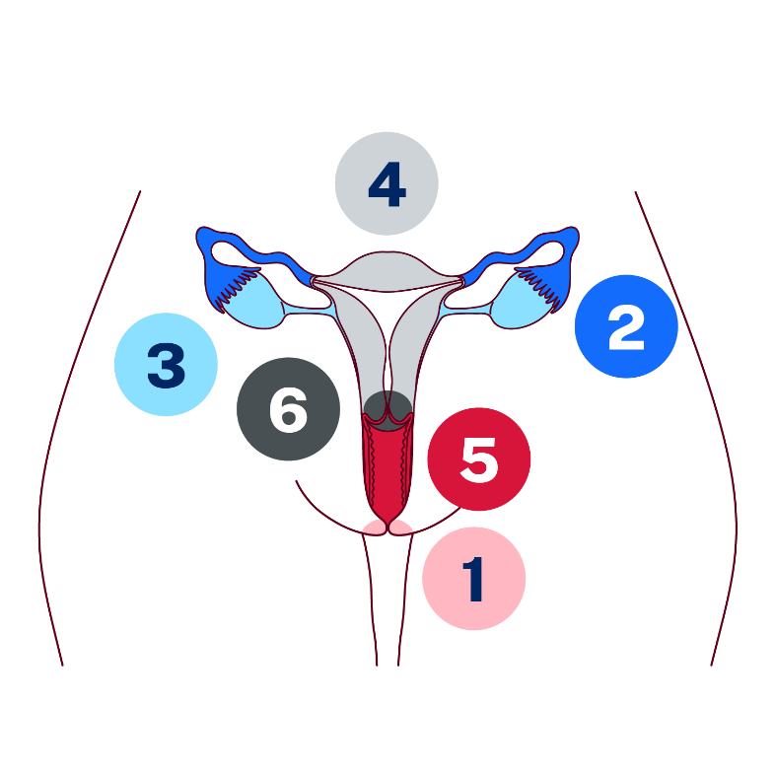 | Cervix
 | Uterus
 | Fallopian tubes
 | Vagina
 | Ovary
 | Vulva

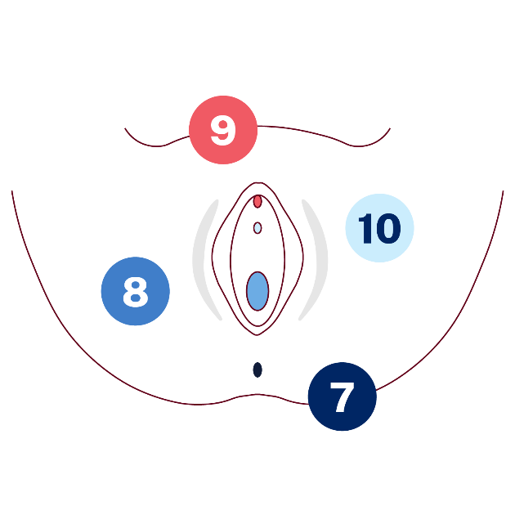 | Part | Number
 | Clitoris
 | Urethra
 | Anus
 | Vagina

- Match the part of the female reproductive system to the function by drawing a line.
Part |  | Function
Vagina |  | Two small organs about the size and shape of an almond that produce eggs (ova) and hormones like oestrogen. During puberty the eggs start to mature, and a dominant egg is released each month during a menstrual cycle.
Cervix |  | A hollow, muscular organ where a fertilised egg can grow and develop into a baby during pregnancy. It also sheds its lining each month if pregnancy does not occur, resulting in menstruation.
Ovary |  | A muscular tube that connects the outside of the body to the cervix. It is sometimes called the birth canal.
Uterus |  | These are 2 of these thin tubes that connect the ovaries to the uterus. They are the place where fertilisation happens when a sperm meets an egg.
Fallopian tube |  | This is found in the lower part of the uterus that opens into the vagina. It helps keep the uterus closed during pregnancy and allows menstrual fluid to exit the body.
Uterine lining |  | Also known as the endometrium, this tissue thickens every month in preparation for a possible pregnancy. If the egg is not fertilised, this tissue (including blood) is shed during menstruation.
Vulva |  | Often called vagina in error. It is the name for all the outside body parts between a female’s legs.

Appendix 5 – understanding the male reproductive system
- In the table provided, write the number from the internal and external male reproductive system image that corresponds with the body part.
 | Part | Number
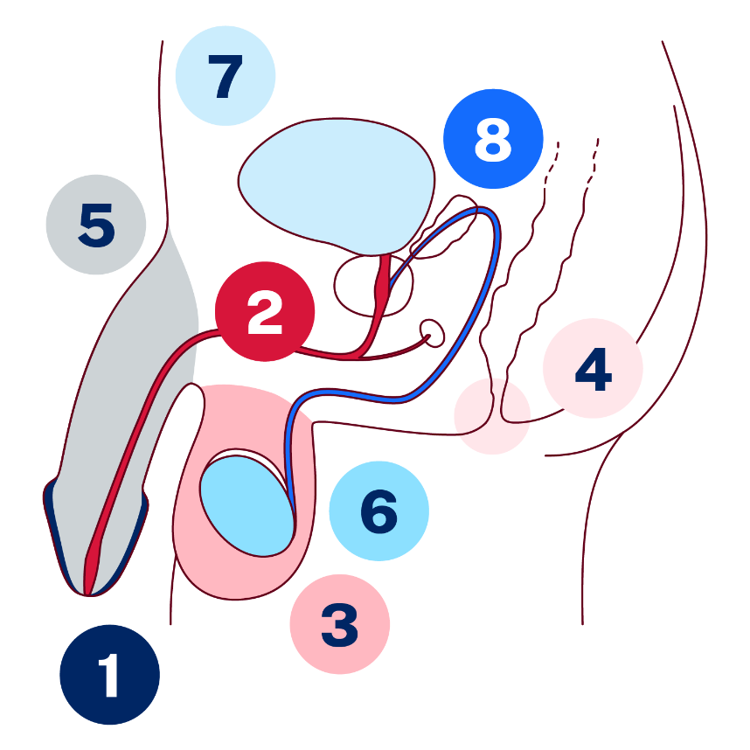 | Penis
 | Scrotum
 | Testicles
 | Urethra
 | Foreskin
 | Anus
 | Vas deferens
 | Bladder
- Match the part of the male reproductive system to the function by drawing a line.
Part |  | Function
Penis |  | This is a pouch of skin that holds and protects the testicles, helping to keep them at the right temperature for producing sperm.
Scrotum |  | Males have 2 of these. They are small organs that produce sperm and hormones like testosterone, which is important for male development. They need to be at the right temperature for producing healthy sperm.
Testicles |  | This is the fold of skin that covers the tip of the penis. It can be removed in a procedure called circumcision. Some boys are circumcised (foreskin is removed at birth, when young or in their teens) for cultural, religious or medical reasons.
Urethra |  | This is a tube that carries urine from the bladder out of the body and also carries sperm during ejaculation. Both semen and urine cannot come out at the same time, as a valve near the bladder shuts off this tube when a male has an erection.
Foreskin |  | This is a hollow organ that stores urine until it is released from the body through the urethra.
Anus |  | This is the external organ between the males’ legs. It is used for sexual intercourse and for the release of urine from the body. When a man is sexually aroused or excited, blood rushes here, which makes it stand up and out from the body. This is called an erection.
Vas deferens |  | This is the opening at the end of the digestive tract where solid waste leaves the body.
Bladder |  | This is a tube that carries sperm from the testicles to the urethra, where it can be expelled during ejaculation as semen.

Appendix 6 – character puberty scenarios
Scenario 1 – Maya’s first period at school
Maya had been feeling strange all morning – tired and a bit off in the tummy, almost like cramps. After PE, her friend quietly told her there was a stain on her shorts. Maya rushed to the bathroom and realised she’d gotten her first period. She didn’t have any hygiene products like a pad or period undies, felt embarrassed, and wasn’t sure who to talk to. She wrapped her jumper around her waist and avoided eye contact the rest of the day.
Discuss the following as a group:
- What kind of change is Maya going through?
- What could Maya do to manage this situation in the moment? How would that help her?
- What could she do in the future to feel more prepared?
- How supportive was the friend, and how might this have influenced Maya’s experience?
- Who might she speak to for support, and how can they respond helpfully?

Scenario 2 – Alex’ classroom challenge
Alex was sitting in maths class when he noticed he had an erection. There was no reason he could think of, and definitely not something he could control. It wasn’t something he expected, and it made him feel uncomfortable. He quietly shifted in his seat and placed his workbook on his lap. When the teacher asked if he wanted to show his working out on the board, he hesitated and stayed seated pretending he didn’t hear, unsure of what to do. Later, he wondered why it had happened and if anyone else had noticed.
Discuss the following as a group:
- What kind of change is Alex going through?
- Why do unexpected erections happen in puberty?
- How can we help normalise body changes?
- If you were a friend that noticed this for Alex, how could you respond? How might this response influence Alex’s experience?
- Who might he speak to for support, and how can they respond helpfully?

Scenario 3 – Jordan’s breakout
Jordan had started noticing more pimples on their face, especially around their forehead and chin. Most mornings, they looked in the mirror and hoped the spots would clear up soon. Lately, they’d been feeling a bit uncomfortable about their appearance. In class, they found themselves speaking up less, and during group photos, they tried to stand at the back or turn slightly away. Their friends hadn’t said anything, but Jordan still felt a bit self-conscious.
Discuss the following as a group:
- What kind of change is Jordan going through?
- Why might Jordan be feeling this way about their skin?
- What are some ways to care for confidence during puberty?
- How can friends help make things feel more normal and supportive?

Scenario 4 – Priya’s emotional rollercoaster
Priya felt like she was always on edge lately. One moment she was fine, and the next she was snapping at her younger brother or tearing up over something small. At school, she walked out of a group project when she felt like no one was listening to her. Her friends were confused, and Priya didn’t really know how to explain what was going on – even to herself. She felt guilty, overwhelmed and a bit alone.
Discuss the following as a group:
- What emotional changes might Priya be going through?
- What strategies could help Priya better understand or manage her emotions?
- What could Priya do to help restore the relationship with her group after walking out?
- How can her friends and teachers show support without judging?

Appendix 7 – skills toolkit image
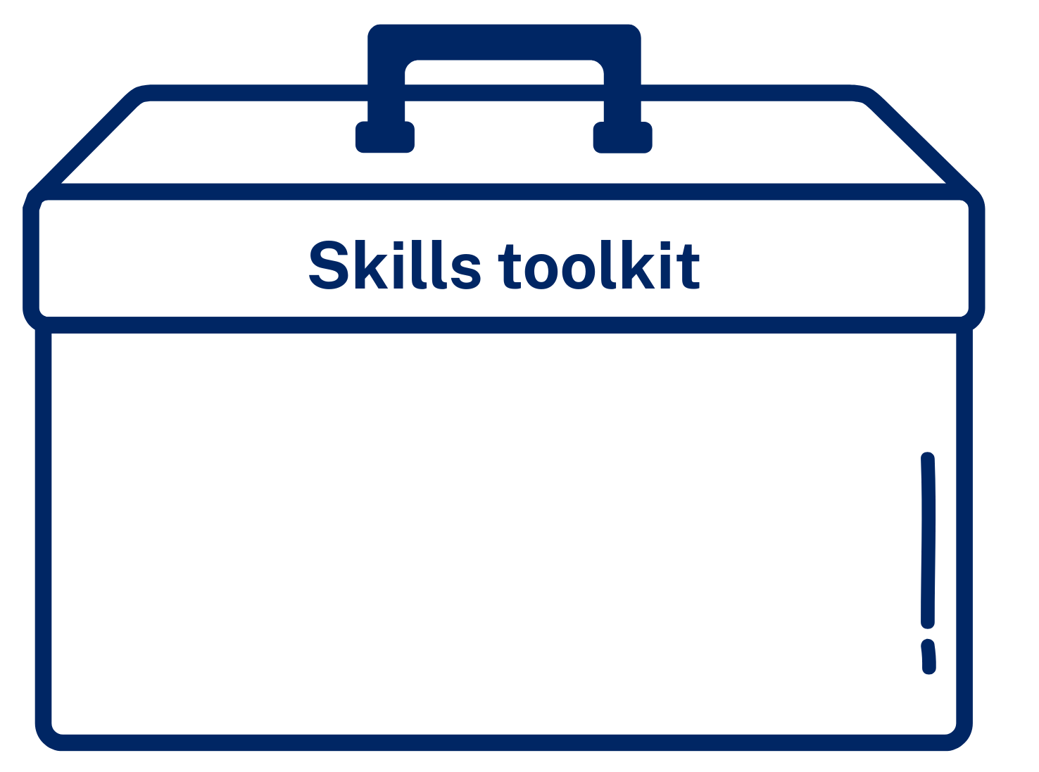

Appendix 8 – toolkit skills reflection
Respond to the statements below by indicating always, sometimes, hardly ever. Tally your score when completed.
Skill statements | Always  = 5 points | Sometimes  = 3 points | Hardly ever  = 1 point
I clearly express my thoughts and feelings
I am an active listener and do not interrupt others
I ask for help when I don’t understand something
Communication scores
I understand my emotions and behaviours
I can manage and control my emotions
I understand how my emotions can impact on others
Social and emotional scores
I manage stress effectively
I maintain a positive attitude even when things don’t go my way
I seek support to overcome difficulties
Resilience scores
I am open to new ideas and approaches
I embrace change and can adjust my plans if needed
I am comfortable stepping out of my comfort zone
Adaptability scores
I offer support in times of need
I listen to others’ concerns without judgement
I consider other perspectives before making decisions
Empathy scores
I am comfortable asking for help when I need it
I view seeking help as a strength not a weakness
I have a support network I can rely on
Help seeking scores
I feel confident when making decisions
I reflect on past experiences to guide my choices
I seek advice from others when faced with significant decisions
Decision making scores
I break down complex issues into manageable parts
I learn from mistakes and adjust my approach accordingly
I collaborate with others to find effective solutions
Problem solving scores
Total
Which domains did you score highest?
Which domains could you score higher?

Appendix 9 – toolkit skills cards
Communication | Resilience | Adaptability | Empathy | Decision making | Problem solving
Active listening | Maintains a positive outlook | Willing to make compromise or changes | Feels concern for others | Learns from experiences | Can recognise when there is a problem
Public speaking | Manages emotions when stressed | Open minded | Accepting of others | Can see potential  risks to avoid | Brainstorms solutions
Addressing disagreements constructively | Seeks support when required | Learning agility (quick to learn new skills) | Can see other viewpoints | Can see consequences of own actions | Assesses the outcomes of the solutions
Non-verbal communication | Shows perseverance (does not quit) | Comfortable in new environments | Provides emotional support to others | Is clear on choices | Actions a good  solution

Appendix 10 – character ‘what to do?’ scenarios
Scenario 1 – Priya’s disappointment
Priya didn’t make the basketball team, even though she had practised every afternoon and felt she gave her best at tryouts. She watched quietly as her friends celebrated their spots in the group chat, posting excited messages and planning team snacks. Priya typed ‘congrats’ with a smiley face, but her chest felt heavy. She didn’t want to ruin their moment, but deep down, she felt disappointed and left out.
Discuss the following as a group:
- What other emotions, other than disappointed, might Priya be feeling?
- What is Priya doing well in this situation?
- Identify which skills card(s) might help Priya in this situation?
- How would this skill(s) help Priya to navigate the situation effectively?

Scenario 2 – Maya snaps
During a group project in class, Jordan asked Maya if they could borrow a pen. Maya snapped, ‘Can’t you just bring your own stuff for once?’ even though he had asked politely. Jordan looked hurt and quietly walked away. Maya stared at her work, feeling a mix of frustration and regret, unsure why she’d reacted that way.
Discuss the following as a group:
- What might Jordan be feeling?
- What toolkit skills card(s) might Jordan consider using in this situation?
- How would this skill(s) help Jordan to navigate the situation effectively?
- What skill card(s) might Maya consider using to repair the relationship with Jordan? Why?
- What if Jordan is not ready to repair the relationship yet? What should Maya do?

Scenario 3 – Chris and the group chat
Chris saw a rumour about Alex being shared in a group chat and felt sick to his stomach. He started to wonder if someone in their own friend group had started it. As new messages popped up, Chris stayed silent, watching the chat. The group joked like usual, but Chris felt tense, unsure who he could trust.
Discuss the following as a group:
- Why might Chris be feeling unsure who he can trust?
- What impact might this have on which skill(s) he chooses to apply in this situation?
- What are some of the choices that Chris has in this situation?
- What toolkit skills card(s) might Chris consider applying in this situation? How would this skill(s) help him to navigate the situation effectively?
- What other support could Chris use if the situation continues?

Appendix 11 – loss cards
Loss of a loved one | Loss of a distant family member | Losing the family pet | Losing a friend
Losing a close friend | Moving to a new community | Changing schools | Losing trust in someone
Losing your privileges/being grounded | Divorce | Losing your mobility through injury | Losing a job
Losing your mobile phone | Break up of a boy/girl friend | Loss of finances | Losing your position in a sporting team

Appendix 12 – character grief and loss scenarios
Scenario 1 – Maya moving groups
Maya and Jordan have been best friends for years, but recently Maya has started spending more time with a new group of friends and has been ignoring Jordan. Jordan feels hurt and left out, wondering if Maya doesn’t want to be friends anymore. Jordan is struggling with feelings of loss and sadness about the change in their friendship.
Discuss the following as a group:
- Is Maya in the wrong? Why or why not?
- What could Maya do to be more considerate of Jordan?
- Is it normal to feel angry after a friendship loss?
- What are some healthy ways Jordan could cope with their feelings of loss?
- Jordan comes to you for advice on how to handle the situation. What might you say?

Scenario 2 – Alex and his dog
Alex’s family dog, Max, has been part of his life since he was 3 years old. Lately, Max has been getting older and isn’t as energetic as before. Alex notices Max seems tired more often and can’t go on their usual walks, which makes him feel worried and sad. He’s starting to think about what it might be like when Max is no longer with him, and this brings up a lot of different strong feelings.
Discuss the following as a group:
- Is this a grief situation? Why or why not?
- How do you think Alex feels about Max getting older and sick?
- How might Alex support himself during this time?
- What might Alex do to get more support for the strong feelings he is experiencing, if his own support strategies and skills aren’t making the difference he hoped for?

Scenario 3 – Jordan is moving
Jordan’s family is moving to Brisbane next year because of a job change. They feel sad about leaving their neighbourhood, school and friends behind, especially Maya, who used to be their best friend. They’re worried about starting over somewhere new and missing the people they care about. Jordan is trying to figure out how to cope with these feelings.
Discuss the following as a group:
- How do you think Jordan feels about moving away from their friends and home? Give some reasons to justify your judgements.
- What are some ways Jordan could talk about their feelings with family or friends?
- If you were Jordan’s friend, how could you support them during this change?
- What skills or strategies could Jordan use to manage their feelings and adjust to the new place when it happens next year?

Scenario 4 – Priya and her parents’ separation
Priya’s parents have recently separated, and now she spends time living between 2 homes – her mum’s house and her dad’s house. The change feels confusing and stressful for her, and sometimes she feels overwhelmed trying to adjust to 2 different places. Because of this, Priya often forgets to bring her school equipment like books and stationery, which makes her feel frustrated and embarrassed at school. She wants to find ways to manage her feelings and remember her things so she can do well despite the changes at home.
Discuss the following as a group:
- How do you think Priya might be feeling about having to live in 2 different homes?
- What are some ways Priya could talk about her feelings? Who might be the appropriate people to do this with?
- What are some things Priya could do to help herself remember her school things and feel more prepared?
- If you were Priya’s friend, how could you support her when she feels upset or embarrassed?

Appendix 13 – ‘Picture Perfect’ stimulus material


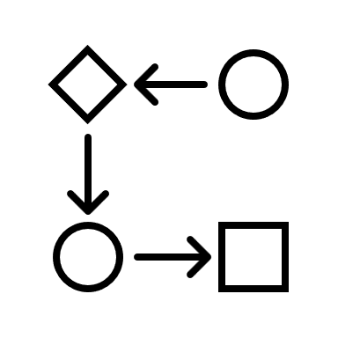



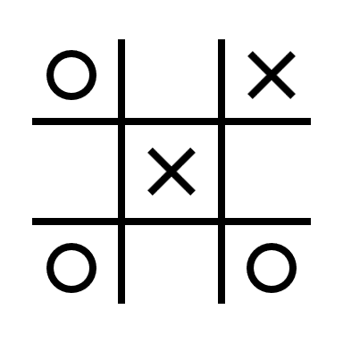

Appendix 14 – communication role-play scenarios
Role play 1 – homework hassles
Maya was struggling to understand an important part of her Year 7 assessment. Alex, who she hasn’t spoken to much before, met her in the library at lunchtime and explained things clearly, helping Maya make a plan to finish on time. Maya wants to thank Alex for the support but isn’t sure what to say or how to show her appreciation.
Role play 2 – basketball blues
Georgia has received the exciting news that she has been chosen for the school’s touch football team. She’s been working hard at training and is extremely proud of her selection. Georgia wants to share and celebrate her success with her best friend, Priya. However, Georgia knows that Priya’s upset as she also trialled for the team but was not selected by the coach.
Role play 3 – party problem
Priya has been invited to her friend Ashlee’s birthday party, but it’s on a school night and ends late. She really wants to go, but her parents have strict rules about weeknight outings. Priya wants to talk to her parents and maybe find a compromise, but she’s unsure how to start the conversation or ask for permission.
Role play 4 – workload woes
Alex has been feeling overwhelmed by all the schoolwork. He has been staying up late and feeling really tired. His family expects him to do well, but Alex wants to talk to his mum about how stressed he’s feeling. Alex isn’t sure how to start the conversation or explain what he is going through.

Role play 5 – science situation
Jordan forgot their science book at school and couldn’t finish their homework. Their teacher, Ms Thompson, asked to speak with them after class. Jordan feels nervous and wants to explain honestly what happened without making excuses, but they’re worried about getting into trouble for forgetting and missing the deadline.
Role play 6 – drama dramas
Priya has recently started liking drama and is thinking about auditioning for the school play. She feels nervous because she hasn’t done anything like this before and worries about what her friends might say. She also wants to talk to her dad, who prefers Priya focus on sports, like basketball, but she’s worried he won’t take her seriously.
Role play 7 – rumour rumble
Alex has found out that someone in his class has been spreading a rumour about him that isn’t true. He’s feeling very hurt and embarrassed by the story, which he knows has also been shared around on social media to students at other schools. He wants to talk to his Year Advisor about it but doesn’t know how to explain the situation without sounding like he’s just complaining or trying to get someone in trouble.
Role play 8 – welcome worries
Ben has just started at a new school after his parents moved for work. Alex, who is in Sam’s new Year 7 class, notices him sitting alone at lunchtime. Alex wants to introduce himself to Ben and make him feel welcome, but he doesn’t know how to approach Ben and initiate a conversation.

Appendix 15 – decision-making tree
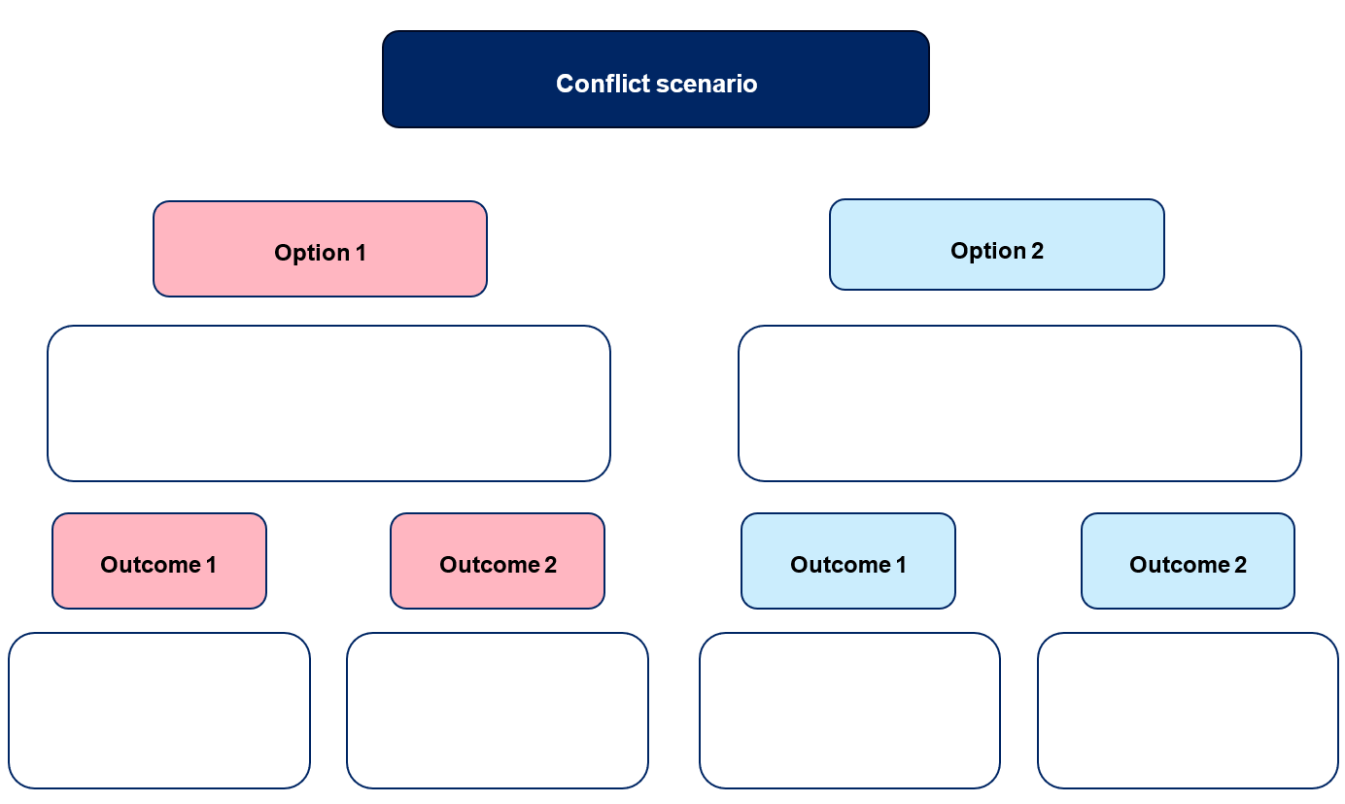

Appendix 16 – conflict resolution scenarios
Scenario 1 – Maya’s misunderstood joke
Maya posted a joke in the class group chat that she thought was harmless, but her friend Alex took offence to what was said. Alex shared the joke and an angry comment on their Instagram story, and now other kids at school have begun sending Maya nasty messages about what was said. Maya feels quite upset and thinks Alex betrayed her trust by publicly sharing what was said in their private group chat.
Scenario 2 – Jordan’s art supplies conflict
Jordan has been working hard in visual arts to get their painting assignment finished on time. There’s one lesson before the due date, and when Jordan arrives to class, they find Alex using the paint and brushes that they need. Jordan knows Alex has already finished his assignment and doesn’t need the paint and brushes, but when Jordan asks if they can have the equipment, Alex responds rudely and says he got there first and wants to use them.
Scenario 3 – Priya’s plagiarism problem
Priya and Maya have been friends since primary school and are now in some of the same classes at their new high school. Priya tells Maya that she is struggling with her English assessment task and asks to see Maya’s work to get an idea of what she needs to do. Priya really likes how Maya wrote and presented her work, so she borrows some ideas for her own task. After the tasks are submitted, Maya’s teacher accuses her of plagiarising because her work is very similar to Priya’s. Maya is told she will get a mark of zero.

Scenario 4 – Jordan’s exclusion
Jordan is late out to recess because they had to visit the PDHPE staffroom to drop off a permission note. When Jordan gets to the playground, they notice their friendship group has moved from their usual spot. Jordan asks their friend Maya in their next class where the group is, but Maya rolls her eyes and walks off without responding. Jordan later finds out that the group had moved to the library, and Maya had told the others not to let Jordan know where they were.
Scenario 5 – Alex’s birthday exclusion
Alex invites several friends to his birthday party on the weekend but doesn’t invite Jordan, who has been his friend since primary school. Jordan finds out about the party when pictures are posted online. They feel hurt and embarrassed by being left out and wonder why Alex didn’t include them. On Monday at school, Alex ignores Jordan and tells other people he doesn’t want to be friends with Jordan anymore.
Scenario 6 – Priya’s team trouble
During PE, the class is asked to form teams for a group activity. When Priya tries to join a team with her friends, they say the team is full and she needs to find another group. Later in the changerooms, Priya overhears one of her friends telling another student that they didn’t want Priya on their team because she’s annoying and takes the game too seriously.
Scenario 7 – Maya’s photo problem
While hanging out on the weekend, Maya takes a funny photo of her friend Priya pulling a silly face while eating. They both laugh about it, and Priya assumes it was just for fun between them, but she asks Maya not to share it. Later that night, Maya sends the photo to another friend, and by Monday most students at school have seen it and are sharing it around. Some have even added captions and drawings to make fun of Priya.

Scenario 8 – Jordan’s test trouble
Jordan has been busy lately with sporting commitments and a new part-time job. They forgot to study for their maths test and got a poor mark. Without telling Jordan, their mum emailed their Year Advisor and maths teacher to explain how busy Jordan has been and to ask for a second chance at the test. Jordan only finds out about the email when their teacher asks to speak with them and the Head Teacher after class. Jordan feels embarrassed and annoyed that their mum stepped in without telling them.

Appendix 17 – the 3 R’s of relationships
Rights are things that every person is entitled to. In relationships, this includes respect, safety, privacy, choice and equality.
Responsibilities are things you are expected to do to help the relationship stay healthy and respectful. They include respecting others, being honest and kind, listening when others speak and taking responsibility when you hurt someone’s feelings.
Roles are the part(s) you play in a relationship – and this can change as you grow. Your role can shift depending on age and maturity, the type of relationship and life situations.
- Quick write. Write one to 2 lines to complete the following sentences:
A right I have in friendships is …
A responsibility I have in school is …
A role I play in my family is …
- Sort it out. With a partner, consider the statements below and categorise them as being a ‘right’, ‘responsibility’ or ‘role’ by placing a tick in the corresponding column(s).
Statement | Right | Responsibility | Role
You feel safe when talking to your teacher
You are expected to help pack away equipment after a PE lesson
You are a good listener when your friend is upset
You help your younger sibling with their homework
You are allowed to keep a password private
You take turns in group discussions
You are the team captain in soccer
You stand up for a friend being left out

- Reflection. Write a response to the following questions.
List 2 responsibilities you think are important in every relationship. Why are they important?
How can being clear about roles and responsibilities help a relationship stay respectful and fair?
What could you do if someone in a relationship isn’t meeting their responsibilities?


Program feedback
We value your feedback. If you use the teaching and learning program in your faculty and school context, please complete the PDHPE 7–10 resource evaluation form. If you have further comments or suggestions, please email PDHPEcurriculum@det.nsw.edu.au.

Support and alignment
Resource evaluation and support: all curriculum resources are prepared through a rigorous process. Resources are periodically reviewed as part of our ongoing evaluation plan to ensure currency, relevance and effectiveness. For additional support or advice, or to provide feedback, contact the PDHPE Secondary Curriculum team by emailing PDHPEcurriculum@det.nsw.edu.au.
Differentiation: further advice to support Aboriginal and/or Torres Strait Islander students, students learning English as an additional language or dialect (EAL/D), students with a disability and/or additional needs and high potential and gifted students can be found on the Planning, programming and assessing 7–12 webpage. This includes the Inclusion and differentiation advice 7–10 webpage.
Assessment: further advice to support formative assessment is available on the Planning, programming and assessing 7–12 webpage. This includes the Classroom assessment advice 7–10. For summative assessment tasks, the Assessment task advice 7–10 webpage is available.
Explicit teaching: further advice to support explicit teaching is available on the Explicit teaching webpage. This includes the CESE Explicit teaching – Driving learning and engagement webpage.
Consulted with: Curriculum and subject matter experts
Alignment to system priorities and/or needs: School Excellence Policy, Our Plan for NSW Public Education
Alignment to the School Excellence Framework: this resource supports the School Excellence Framework elements of curriculum (curriculum provision) and effective classroom practice (lesson planning, explicit teaching).
Alignment to Australian Professional Standards for Teachers: this resource supports teachers to address Proficient Teacher Standard Descriptors 3.1.2, 3.2.2, 3.3.2. 3.4.2, 5.1.2
Creation date: 25 July 2025

References
This resource contains NSW Curriculum and syllabus content. The NSW Curriculum is developed by the NSW Education Standards Authority. This content is prepared by NESA for and on behalf of the Crown in right of the State of New South Wales. The material is protected by Crown copyright.
Please refer to the NESA Copyright Disclaimer for more information https://educationstandards.nsw.edu.au/wps/portal/nesa/mini-footer/copyright.
NESA holds the only official and up-to-date versions of the NSW Curriculum and syllabus documents. Please visit the NSW Education Standards Authority (NESA) website https://educationstandards.nsw.edu.au/ and the NSW Curriculum website https://curriculum.nsw.edu.au.
Personal Development, Health and Physical Education 7–10 Syllabus © NSW Education Standards Authority (NESA) for and on behalf of the Crown in right of the State of New South Wales, 2024.
Body Talk (2025) Girl bodies, Body Talk website, accessed 20 August 2025.
Headspace (2024) dealing with grief and loss, headspace website, accessed 20 August 2025.
Hormones Australia (2018) Patient Resources, Hormones Australia website, accessed 20 August 2025.
Irish Hospice Foundation (19 November 2022) ‘Loss and the Grieving Process’ [video], Irish Hospice Foundation, YouTube, accessed 20 August 2025.
JoBlo Animated Videos (16 July 2024) ‘Puberty Alarm Scene ꞁ INSIDE OUT 2 (2024) Movie CLIP HD’ [video], JoBlo Animated Videos, YouTube, accessed 20 August 2025.
MindMattersAustralia (27 March 2015) ‘Module 2.1s Adolescent development: The art of growing up’ [video], MindMattersAustralia, YouTube, accessed 20 August 2025.
State of New South Wales (Department of Education) (n.d.) Digital Learning Selector, NSW Department of Education website, accessed 20 August 2025.
——(2021) ‘Emotion cards’, Inclusive Practice hub, NSW Department of Education website, accessed 20 August 2025.
——(2025) ‘Gradual release of responsibility’, Explicit teaching strategies, NSW Department of Education website, accessed 20 August 2025.
——(2025) ‘Planning, programming and assessing PDHPE 7–10’, PDHPE K–12, NSW Department of Education website, accessed 20 August 2025.

© State of New South Wales (Department of Education), 2025
The copyright material published in this resource is subject to the Copyright Act 1968 (Cth) and is owned by the NSW Department of Education or, where indicated, by a party other than the NSW Department of Education (third-party material).
Copyright material available in this resource and owned by the NSW Department of Education is licensed under a Creative Commons Attribution 4.0 International (CC BY 4.0) license.

This license allows you to share and adapt the material for any purpose, even commercially.
Attribution should be given to © State of New South Wales (Department of Education), 2025.
Material in this resource not available under a Creative Commons license:
- the NSW Department of Education logo, other logos and trademark-protected material
- material owned by a third party that has been reproduced with permission. You will need to obtain permission from the third party to reuse its material.
Links to third-party material and websites
Please note that the provided (reading/viewing material/list/links/texts) are a suggestion only and implies no endorsement, by the New South Wales Department of Education, of any author, publisher, or book title. School principals and teachers are best placed to assess the suitability of resources that would complement the curriculum and reflect the needs and interests of their students.
If you use the links provided in this document to access a third-party's website, you acknowledge that the terms of use, including licence terms set out on the third-party's website apply to the use which may be made of the materials on that third-party website or where permitted by the Copyright Act 1968 (Cth). The department accepts no responsibility for content on third-party websites.

