PDHPE Year 7 – building a balanced and healthy lifestyle
Teaching and learning program
Contents
About this resource 4
Overview 4
Syllabus outcomes 5
Content 5
Focus area – Safe, active and healthy lifestyle choices 5
Related support materials 7
Teacher notes 7
Learning sequence 1 – understanding health and wellbeing 8
Learning sequence 2 – balanced lifestyles 29
Learning sequence 3 – recommendations for a balanced and healthy lifestyle 39
Learning sequence 4 – influences on health choices 59
Learning sequence 5 – understanding sources of health information 66
Summative assessment task 79
Appendix 1 – dimensions of health 80
Appendix 2 – dimensions of health cards 81
Appendix 3 – mind, body, spirit carousel activity 83
Appendix 4 – perceptions of health reflection 99
Appendix 5 – understanding health and wellbeing exit ticket 100
Appendix 6 – components of a balanced lifestyle 101
Appendix 7 – lifestyle snapshot activity 102
Lifestyle snapshot character cards 102
Lifestyle snapshots activity worksheet 104
Appendix 8 – nutrition jigsaw activity cards 107
Appendix 9 – Maya’s meals 109
Appendix 10 – my meals 112
Appendix 11 – hydration requirements 115
Appendix 12 – drink choice decisions activity 116
Appendix 13 – label detectives activity worksheet 128
Appendix 14 – Australian physical activity and exercise guidelines worksheet 129
Appendix 15 – physical activity, screen time and sleep graffiti walk station cards 132
Station 1 – physical activity 132
Station 2 – barriers to being active 133
Station 3 – enablers and strategies to support movement 134
Station 4 – movement for emotion management 136
Station 5 – screen time 137
Station 6 – sleep 138
Appendix 16 – physical activity, screen time and sleep self-reflection worksheet 139
Appendix 17 – balanced lifestyle self-reflection 141
Appendix 18 – SMART goal template 143
Appendix 19 – balanced lifestyle choices exit ticket 144
Appendix 20 – explain this – modelled example 145
Appendix 21 – contextual factors scenario activity 146
Appendix 22 – health information checklist 150
Appendix 23 – evaluating health information activity 152
Appendix 24 – Generative AI sample response to a health question 154
Appendix 25 – ABCD cards 157
Appendix 26 – informative and persuasive techniques 159
Program feedback 161
Support and alignment 162
References 163

About this resource
This teaching and learning program has been developed to assist teachers in NSW Department of Education schools to create learning experiences that are contextualised to their students’ needs, interests and abilities for the the Personal Development, Health and Physical Education 7–10 Syllabus (NESA 2024). It provides an example of one way to approach programming through a conceptual lens. Teachers are encouraged to take an adopt and adapt approach to the learning activities outlined in this program.

Overview
Description: students learn about the holistic nature of health through exploring the dimensions of health and how these interrelate to influence overall wellbeing. Students learn that health is more than just the absence of illness. It is a dynamic and relative state that can vary between individuals and across life stages. Students examine what it means to live a balanced and healthy lifestyle, and develop strategies and critical health literacy skills to support them in making informed decisions to improve and maintain their own health.
Duration: approximately 9 hours and 30 minutes.
Explicit teaching: explicit teaching strategies are embedded in this resource. Further information on these strategies can be found on the Explicit teaching strategies webpage.
Assessment: this teaching and learning program aligns to the hand-in PDHPE Year 7 – building a balanced and healthy lifestyle – sample assessment task notification.

Syllabus outcomes
A student:
- refines and applies self-management and interpersonal skills to manage complex situations PH4-SMI-01
- assesses the influence of contextual factors on attitudes and behaviours to propose strategies that enhance safety, health and wellbeing
PH4-SHW-01
- investigates and uses health information, products and support services to propose strategies that enhance safety, health and wellbeing
PH4-IPS-01
Personal Development, Health and Physical Education 7–10 Syllabus © NSW Education Standards Authority (NESA) for and on behalf of the Crown in right of the State of New South Wales, 2024.

Content

Focus area – Safe, active and healthy lifestyle choices
Enhancing wellbeing through healthy lifestyles
- Investigate the dimensions of health and discuss how they impact wellbeing
- Describe the dynamic nature of health and examine different perceptions of health
- Recognise the value of the mind, body and spirit approach to health and wellbeing for Aboriginal and Torres Strait Islander Peoples and across a diverse range of cultures
- Explain how a balanced lifestyle benefits health and wellbeing
- Describe how the components of a balanced lifestyle can be applied to a weekly routine
- Examine the Australian Government’s physical activity and exercise guidelines for young people and propose strategies to enhance motivation and engagement in physical activity
- Investigate the nutritional value of a variety of foods and drinks and how they support health, wellbeing and movement
- Describe and apply proactive strategies, help-seeking behaviours and coping strategies that support health and wellbeing for mental health and positive body image
Thinking critically to enhance health and wellbeing
- Outline the role of health promotion and health literacy in enhancing health and wellbeing
- Investigate the reliability and credibility of health information from various sources
- Create written texts to explain and advocate for aspects of safety, health and wellbeing for a range of audiences
- Use subject-specific language to communicate concepts of physical activity, safety, health and wellbeing

Related support materials
This teaching and learning program aligns with the following support materials:
- student-facing PowerPoint – PDHPE Year 7 – building a balanced and healthy lifestyle – slide deck
- assessment task – PDHPE Year 7 – building a balanced and healthy lifestyle – sample assessment task notification
- PDHPE Years 7–8 – sample scope and sequence.
All resources associated with this resource can be found on the Planning, programming and assessing PDHPE 7–10 webpage.

Teacher notes
This teaching and learning program reintroduces recurring fictional characters from the PDHPE Year 7 – creating my toolkit for change – theory program, which provide a safe and neutral context for addressing sensitive topics. By interacting with these characters, students can explore complex issues and share their thoughts openly, without the worry of being personally exposed or judged. These characters help students understand different viewpoints by offering insights into lives and experiences that may be different from their own. This process builds empathy, promotes inclusivity and encourages respect for diversity among all students.
For any questions or assistance with this resource, please contact the PDHPE Secondary Curriculum team at PDHPEcurriculum@det.nsw.edu.au.

Learning sequence 1 – understanding health and wellbeing
Note: the section ‘Understanding health and wellbeing’ in the PowerPoint – PDHPE Year 7 – building a balanced and healthy lifestyle – slide deck can be used to support this learning sequence. The duration of this learning sequence is approximately 2 hours.
Table 1 – teaching and learning program
Outcomes and content | Teaching and learning activities
Outcome  PH4-SHW-01  Content  Focus area – Safe, active and healthy lifestyle choices  Enhancing wellbeing through healthy lifestyles  - Investigate the dimensions of health and discuss how they impact wellbeing  - Describe the dynamic nature of health and examine different perceptions of health  - Recognise the value of the mind, body and spirit approach to health and wellbeing for Aboriginal and Torres Strait Islander Peoples and across a diverse range of cultures | Learning intention  We are learning to:  - understand health and wellbeing as a dynamic, multidimensional and culturally influenced concept.  Success criteria  I can:  - identify and describe the 5 dimensions of health and how they impact overall wellbeing  - discuss how health and wellbeing can change over time and in different situations  - explain how cultural perspectives shape people’s understanding of health and wellbeing.  What is health?  Group students in pairs.  Pose the following question to the class for discussion:  - What does it mean to be healthy?  Pairs record their responses on paper or mini whiteboards.  Write the following dimensions of health headings on the board: physical, mental, emotional, spiritual and social.  Ask students to share their recorded ideas. Write responses on the board under the dimension of health they correspond to. For example, ‘keeping fit’ would be written under the ‘physical’ heading.  Dimensions of health  Explain that health is more than just ‘not being sick’. It is about how you feel and function. Tell students that the headings on the board are the dimensions of health.  Distribute a copy of the Appendix 1 – dimensions of health worksheet to each student.  Revisit each dimension of health listed in the previous activity and provide a simple definition for each dimension to support students to build their knowledge. Ask students for additional examples to match the dimension of health and record these under the corresponding heading. For example:  - Physical health: this is about your body – how well it works and how you look after it  - examples can include eating nutritious food, getting enough sleep, being active (like playing sport, dancing or walking), staying clean and looking after your body, going to the doctor or dentist when needed.  - Mental health: this is about the functions of your brain – it includes how you think, learn, cope and make decisions  - examples can include concentrating in class, solving problems, staying focused, learning new things, staying calm when things are tricky.  - Emotional health: this is about your feelings – understanding and managing your emotions  - examples can include feeling happy, sad, worried, excited and everything in between, expressing your feelings, handling stress or anger, demonstrating resilience and maintaining a realistic perspective on situations.  - Spiritual health: this is about your values, beliefs and sense of purpose – what gives your life meaning  - examples can include feeling connected to something bigger than yourself, it could mean having a strong culture or faith, spending time in nature or with loved ones, knowing who you are and what matters to you.  - Social health: this is about your relationships – how you connect with others  - examples can include having friends, getting along with family, being a good teammate or classmate, communicating respectfully, feeling included and safe.  Encourage students to record examples of each dimension of health on their worksheet.  Checking for understanding  Distribute mini whiteboards or paper to students.  Display the following behaviours one at a time:  - talking to a friend when you are upset  - going for a run after school  - trying again after making a mistake  - spending time doing something that gives you purpose.  Students write down the dimension of health they think the example aligns with.  Students hold response in the air and the teacher scans the class answers, confirming accurate thinking or clarifying misconceptions.  How do the dimensions of health work together?  Introduce the idea that health is multidimensional (many parts), dynamic (changing) and contextual (shaped by life, culture and community).  Explain to students that if one dimension of your health changes, then others can too. Provide examples, such as:  - if you are sick (physical), you might feel frustrated (emotional) or miss your friends (social)  - if you are feeling anxious (emotional), it might be hard to concentrate (mental).  Students work in pairs to develop a scenario that shows how the dimensions are interrelated and work together (like the examples provided above).  Each pair joins another pair to form a group of 4. The first pair reads their scenario and the other pair identifies the dimensions of health, giving reasons for their answers. The pairs swap roles and repeat the process.  Pose the following questions to students:  - Did you find that multiple dimensions of health were evident in the example?  - What does this tell us about how the dimensions of health work together?  Discuss responses as a class, using student responses to check in on the extent to which students have met the Learning sequence 1 success criteria of: ‘Identify and describe the 5 dimensions of health and how they impact overall wellbeing’.  Health and wellbeing  Tell students that ‘health’ and ‘wellbeing’ are terms that are often used interchangeably, but they are different.  Provide students with a definition of ‘health’ and ‘wellbeing’.  Health: the overall condition of your body and mind. It is not just about not being sick, it is about how you feel and function.  Wellbeing: the degree of satisfaction you have about the quality of your life.  To support students to see the difference between ‘health’ and ‘wellbeing’, introduce the car analogy:  - ‘health’ is like the different parts of a car working together  - the engine (physical)  - the steering (mental)  - the dashboard lights (emotional)  - the passengers you share the ride with (social)  - and the reason you are driving somewhere (spiritual)  - ‘wellbeing’ is how smoothly the whole car runs and how much you enjoy the journey.  Health and wellbeing scenario  Reintroduce ‘Priya’, a character from the PDHPE Year 7 – creating my toolkit for change – theory program. Display Priya’s backstory on the board (refer to slide 11 in the PowerPoint – PDHPE Year 7 – building a balanced and healthy lifestyle – slide deck). Then, tell students of some events that happened to Priya last term. These events can include: the first day of term, announced as the lead role in the school musical, caught a cold, had an argument with her best friend, learned how to cook a traditional dish, completed 3 assignments all due in the same week, went on a weekend away with her family. Students will then explore these events and how they impacted Priya’s health and wellbeing after the teacher performs a ‘think-aloud’.  Allocate students in groups of 3 or 4. Distribute a coloured set of cards labelled ‘physical’, ‘mental’, ‘emotional’, ‘social’ and ‘spiritual’ to each group (refer to Appendix 2 – dimensions of health cards for sample cards).  Read the first event out – ‘The first day of term’. Perform a ‘think-aloud’ to model the identification of the relevant dimensions of health, and whether it may have a positive, negative or mixed impact on health by using the following sample script:  - ‘Remember, that in this activity, our job is to  - consider the event that has happened to Priya  - decide which dimensions of health may be affected  - determine whether the impact on the dimension of health is positive, negative or mixed  - explain why, using evidence from the event.’  - ‘The event we are considering is “The first day of term”. So, I am now asking myself: “What parts of a person’s health might change on the first day back at school”?’  - (Hold up the ‘mental’ dimension of health card) ‘I am choosing this card because the first day of term usually involves thinking and focus – like learning new routines, remembering expectations, finding classrooms and planning what you need. It can also affect your concentration because there is a lot going on.’  - (Hold up the ‘emotional’ dimension of health card] ‘I am also choosing this card because the first day of term can bring feelings – excitement, nerves, stress or even dread. People can feel confident … or worried about friendships, teachers, workload or fitting in.’  - [Hold up the ‘social’ dimension of health card] ‘I am definitely choosing this card because you are interacting with other people again – classmates, teachers, new peers. Social health is about relationships, belonging and feeling connected and the first day can really affect that.’  - ‘Next, I ask: “Is the impact positive, negative or mixed?”. For this event, I am leaning towards mixed because the same event can affect different people differently – and even the same person can feel both good and not-so-good at once.’  - [Hold up the ‘mental’ dimension of health card] ‘Mentally, it might be positive because structure and routine can help people feel organised and ready to learn. But it can also be negative if there is information overload, pressure or difficulty concentrating due to stress. So, the impact on the mental dimension of health is mixed.’  - [Hold up the ‘emotional’ dimension of health card] ‘Emotionally, it might be positive if someone feels excited to see friends, start fresh or enjoy school. But it could be negative if someone feels anxious, overwhelmed or worried about being judged. So, for emotional, I am saying mixed impact.’  - [Hold up the ‘social’ dimension of health card] ‘Socially, it could be positive if you reconnect with friends, feel welcomed and have supportive relationships. It could be negative if someone feels left out, faces conflict or feels uncertain about where they fit. So, the impact for the social dimensions of health is also mixed.’  - ‘Notice what I did: I did not just pick cards – I explained why the event connects to that dimension, and I justified whether it was positive, negative or mixed. Now it is your turn. In your group, you will get the next event. You will hold up the cards you think apply, and you must be ready to explain your reasoning using the same thinking steps I just modelled.’  Note: for more information on ‘think-alouds’, see the ‘Modelling (I do, we do) – technique guide’ for the explicit teaching strategy of Gradual release of responsibility.  Read the rest of the events out aloud, one at a time. Pause after each event and ask students to identify which dimensions of health are affected by the event and hold up the relevant dimension of health card. Encourage students to select as many dimensions of health as they feel reflect the event.  Observe the responses by each group and give commentary on the dimensions of health cards selected. For example, ‘I can see many groups have identified physical health for that event, and some have also selected the emotional health too. I also see a couple of spiritual health cards’. Direct a discussion and cold call a few groups, asking them the following questions:  - Which dimensions of health cards did you select for this event?  - What were the reasons that informed your selection?  Look for opportunities to lead the class discussion in a way that compares group similarities and differences by intentionally selecting similar responses and then highlighting a different response to the majority so that students are exposed to different perspectives.  Give students an opportunity to review their card choices and change their selection after the discussion before moving on to the next event.  Using a group-share approach, pose the following questions to the groups, then discuss as a class:  - During this activity, did any of the events match to more than one dimension? Why do you think that could be?  - What does this tell us about how health works?  In groups, display the following 2 ‘what if’s’ on the board:  - Week 5 – original event: caught a cold. What if Priya needed to get treatment in hospital for a few days for her illness?  - Week 6 – original event: had an argument with her best friend. What if Priya’s friend apologised that afternoon?  Students select one ‘what if’ as a group and discuss how changing a variable in one event can change the dimensions of heath impacted for Priya.  Students find another group that considered the same ‘what if’ and compare responses, explaining their reasoning and logic to each other.  Discuss as a class if perceptions of the event were similar or different between groups.  Tell students that we will now examine how Priya’s health over the term has influenced her wellbeing. Next to each event displayed on the board, create a visual map of how a Priya’s wellbeing has shifted across the term by recording the dimensions the event affected and use ‘plus’, ‘minus’ or ‘mixed’ to indicate the type of change. To do this, ask groups to use the following gestures to indicate the events’ influence on Priya’s wellbeing:  - thumbs up – positive influence  - thumbs down – negative influence  - thumbs to the side – mixed influence.  Students discuss and make a judgement as a group.  Invite groups to display the corresponding gesture to indicate their judgement of the impact that the event had on Priya’s wellbeing. Cold call different groups and ask them to substantiate their judgement by providing reasons for their selection.  After each event has been evaluated, indicate which event likely had the biggest impact on Priya’s wellbeing from the visual map created on the board. Pose the following questions as a class discussion:  - Did the event have a positive, negative or mixed impact on Priya’s overall wellbeing?  - Which dimensions of health did it affect?  - Do you agree that this was the event that had the biggest impact on Priya’s wellbeing? Substantiate your position with some reasons.  Emphasise that:  - health and wellbeing are always changing  - the dimensions of health are interconnected  - the same event can affect people in different ways because everyone has unique experiences, perspectives and circumstances  - understanding the different dimensions of health helps us to recognise these differences and respond with empathy and respect.  Students turn and talk to a partner to finish the following sentence ‘Health is dynamic means …’ Move around the room and use student responses to check in on the extent to which students have met the Learning Sequence 1 success criteria of: ‘discuss how health and wellbeing can change over time and in different situations’.  Mind, body and spirit – introduction  Note: prior to this activity, revisit or establish classroom norms to ensure all students understand and commit to behaviours that support respectful conversations, active listening and open-minded perspective-taking.  Explain to students that there is another approach for viewing health – the ‘mind, body and spirit’ approach. Tell students that the ‘mind, body and spirit’ approach is like looking at health as a triangle where each side depends on the other 2. The ‘dimensions of health’ model is like looking at health as different but connected building blocks that all need to be in place for you to be healthy.  Show students a visual diagram of the ‘mind, body and spirit’ approach. Outline the following components:  - Mind – your thoughts, feelings and how your brain works to process information and make decisions. Good mental health helps you handle stress, stay positive and focus.  - Body – how well your body works, including your fitness, nutrition, sleep, and how your organs and systems function. A healthy body can boost your mood and energy, which also supports your mind and spirit.  - Spirit – a person’s sense of purpose, meaning, and connection to people, culture or the world around you. Spiritual health can be found through religion, time in nature, cultural traditions or being part of a community.  ‘Mind, body and spirit’ carousel activity  Set up 4 stations around the classroom that represent a snapshot of a culture and practices that reflect the value of the ‘mind, body and spirit’ approach to health (refer to Appendix 3 – mind, body, spirit carousel activity cards) for sample station cards. The stations include various health perspectives or practices from: Aboriginal and Torres Strait Islander culture, Pacific Islander cultures, Western cultures and Traditional Eastern cultures.  Note: the station cards can be adapted to a culture relevant to your context.  Divide the class into 4 even groups (5 to 6 students per group) and assign each group a different station.  Explain to students that each station reflects a small glimpse into how different cultures value the ‘mind, body and spirit’ approach to health and wellbeing. It is important to note that these are just examples, and they do not represent entire cultures or personal choices.  Revisit class norms to support respectful and sensitive interactions during the activity.  Students review and engage with the materials at their station and discuss the question as a group. Students can choose 1 to 3 discussion prompts to share their insights and perspectives about per station card.  Groups spend approximately 8 minutes at each station before rotating clockwise to the next station.  Note: teachers may model one station prior to assigning students groups to a station to communicate the procedure and expectations, and show what respectful discussions look like in this activity.  Perceptions of health reflection  Distribute a copy of Appendix 4 – perceptions of health reflection worksheet to each student.  Students engage in a written reflection on their understanding of health by completing the following sentences:  - I used to think health was …  - Now I think health is …  - Something that influences how I feel about health is …  - Different people can have a different perception of health because …  Emphasise that health is experienced and expressed differently across cultures, and these views influence the actions individuals and communities take to stay well.  Yarning Circle  Note: contact and collaborate with the school’s Aboriginal Education Officer (AEO) and/or local Elders and/or Aboriginal community representatives to plan an authentic and culturally respectful Yarning Circle.  For additional information, see Yarning Circles: Indigenous Practices.  Tell students that we are going to look at an Aboriginal and Torres Strait Island cultural practice mentioned in the previous activity – Yarning Circles.  Use your school Yarning Circle if available or a comfortable space outside or a quiet room.  Explain that Yarning Circles can be used for different purposes like sharing knowledge, building relationships, problem-solving or making collective decisions in a culturally safe environment. Explain that the Yarning Circle we will participate in today has a purpose of sharing our perspectives. That means that we listen to each other. There is no need to disagree or challenge someone else’s perceptions. Just listen and become aware of other ideas about health.  Explain the respectful way to conduct a Yarning Circle. This includes sitting together in a circle and taking turns speaking. Protocols may use a ‘Talking stick’, which is an object used to identify the speaker that is passed around the circle. Engage in a Yarning Circle, observing protocols for talking and listening, including:  - listen with respect – listening is as important as speaking – show engagement by giving your full attention to the speaker  - respect cultural knowledge – stories and knowledge shared in the Yarning Circle must be treated respectfully – do not share them outside the Yarning Circle without permission  - equal voices – there is no hierarchy in the Yarning Circles – everyone is equal and all contributions are valued  - safe space – the Yarning Circle is a safe place for open, honest and respectful sharing – power dynamics and biases should be set aside  - participation – everyone is encouraged to contribute, but silence or choosing not to share is also respected  - truth and responsibility – speak your truth with honesty – share in a way that benefits the whole Yarning Circle, not just yourself or a specific group  - respect experiences – recognise that your story becomes part of others’ experiences share in a way that supports wellbeing.  In the Yarning Circle, give a student the talking stick to indicate that it is their turn to speak. Ask students to discuss ‘Why is health viewed differently by different people?’ Students can use their reflections from the ‘Reflecting on perceptions of health’ activity. Open-ended prompts related to perceptions of health can be used to develop the conversation, including:  - What does health mean to you?  - How do cultural practices shape our understanding of health?  - What role do community and family play in health from your perspective?  To yarn about this, consider the following:  - Give a student the talking stick or a nominated implement to indicate that it is their turn to talk.  - When the student has finished talking, they pass the talking stick to the next person in the circle to indicate it is their turn.  - If a student does not want to yarn, that is respected and they then can pass the sticks to the next person in the circle.  Conclude the Yarning Circle by thanking students for their participation.  Yarning Circle reflection  Distribute 3 different coloured sticky notes to each student.  Display a series of reflective questions on the board for students to consider and answer on the corresponding sticky note. The questions can include:  - What is something you found interesting when listening to others today?  - What is something you came to appreciate from hearing different perspectives?  - What is your view of health now, after the Yarning Circle?  Students place their notes under the corresponding question on the board.  Students read the reflections of the class. Use student responses to check in on the extent to which students have met the Learning sequence 1 success criteria of: ‘explain how cultural perspectives shape people’s understanding of health and wellbeing’.  Optional: Dreamtime stories can be used to show how the Aboriginal and Torres Strait Islander practice of Storytelling connects the mind, body and spirit. An example of this might be the Bush Yam dreaming Yara story which is depicted through artworks found on the Bush Medicine Leaves Dreaming webpage or a Dreamtime story relevant to your context. The story can be shared with the class and questions posed to support students to draw out the dimensions of health from the story.  Wrap-up  Display on the board a summary of key concepts from the lesson sequence (refer to slide 21 in the PowerPoint – PDHPE Year 7 – building a balanced and healthy lifestyle – slide deck) and emphasise their importance to bring the learning together.  Exit ticket  Distribute the Learning sequence 1 exit ticket to students (refer to Appendix 5 – understanding health and wellbeing exit ticket.  Students complete the exit ticket by responding to the following prompts:  - 3 things I learned about health …  - 2 ideas about health I had not thought about before …  - 1 way culture can influence the way a person understands health and wellbeing …
Adjustments, evaluation and registration

Learning sequence 2 – balanced lifestyles
Note: the section ‘Balanced lifestyles’ in the PowerPoint – PDHPE Year 7 – building a balanced and healthy lifestyle – slide deck can be used to support this learning sequence. The duration of this learning sequence is approximately 1 hour and 30 minutes.
Table 2 – teaching and learning program
Outcomes and content | Teaching and learning activities
Outcomes  PH4-SMI-01, PH4-SHW-01  Content  Focus area – Safe, active and healthy lifestyle choices  Enhancing wellbeing through healthy lifestyles  - Explain how a balanced lifestyle benefits health and wellbeing  - Describe how the components of a balanced lifestyle can be applied to a weekly routine | Learning intention  We are learning to:  - identify and explain the components of a balanced lifestyle and how they support our health and wellbeing.  Success criteria  I can:  - describe the key components of a balanced lifestyle  - explain how each component influences health and wellbeing.  Components of a balanced lifestyle  Introduce the concept of a ‘balanced lifestyle’ in the context of health and wellbeing. A ‘balanced lifestyle’ means giving time and attention to the key activities and behaviours that keep us healthy, happy and functioning well. It does not mean being perfect every day – it means making choices that support overall wellbeing across different components.  Display the following components of a balanced lifestyle on the board, including:  - nutrition  - physical activity  - sleep  - social interactions  - activities outside  - screen time.  Distribute a copy of Appendix 6 – components of a balanced lifestyle to each student. In pairs, students draw a line to match each component of a balanced lifestyle to its description. Check student responses prior to progressing to the next activity.  The balanced lifestyle wheel  Remind students of the health and wellbeing car analogy, which looks at ‘health’ like the different parts of the car working together, and ‘wellbeing’ as how smoothly the whole car runs and how much you enjoy the journey.  Extend the analogy and tell the students that a balanced lifestyle is like the wheels on a car, in that:  - without wheels, it does not matter how good the engine (physical health) or steering (mental health) is – you will not get far  - if all wheels are inflated and balanced, the car moves smoothly and reliably but if one wheel is flat (like not getting enough sleep or exercise, or sleeping too much so you do not have enough time to do the other things that support a balanced lifestyle), the ride becomes bumpy and harder to control which influences our wellbeing.  Pose the following questions as a class discussion:  - Which of these components do you think is the easiest to keep balanced for young people?  - Which is the hardest?  Students turn and talk to the person next to them and respond to the questions. Encourage students to provide reasons for their answers.  Direct a whole-class discussion asking pairs for their response and their reasons. Look for opportunities to lead the class discussion in a way that highlights similarities and differences in responses and reasoning so that students are exposed to different perspectives. Reiterate that not investing enough time or behaviours in a component, or investing too much, can impact the overall balance a person feels.  Emphasise that a balanced lifestyle does not mean being ‘perfect’ – it means making choices that help all parts of your health and wellbeing to work well together.  Balanced lifestyle snapshot – modelled example  Distribute a copy of Appendix 7 – lifestyle snapshot activity worksheet to each student.  Display Priya’s snapshot on the board (refer to slide 27 in the PowerPoint PDHPE Year 7 – building a balanced and healthy lifestyle – slide deck, and follow the process below to model the activity and thinking to students.  - Read through Priya’s lifestyle snapshot as a class.  - Read through the snapshot again, looking for examples of the components of a balanced lifestyle. On the board, underline or highlight text that demonstrates a component of a balanced lifestyle and write which specific component it is (for example, sleep, nutrition, physical activity, screen time, social interactions, outdoor activities).  - Pose the following question to the class for discussion  - What does balance mean? (Possible answers may include: balance means giving the right amount of time and energy to all lifestyle components so that no one area takes over or is neglected. When your lifestyle is balanced, you feel healthy, happy and are able to cope with everyday demands.)  - Draw a simple 3-point scale on the board with the following labels: ‘balance achieved’, ‘almost there’ and ‘not there yet’. Model to students where the lifestyle component of ‘sleep’ might sit on the sliding scale, justifying the spot selected on the scale with evidence from the scenario. Repeat this with the remaining lifestyle components (sleep, nutrition, physical activity, screen time and social connection), asking for student input as to where on the scale the component should be, and why.  - Ask students the following question  - Can spending too much time in one lifestyle component impact balance? (Answers may include: it is possible to have ‘too much of a good thing’, as this may lead to imbalance. When this happens, it makes it harder to satisfy the other components of a balanced lifestyle. For example, too much time spent on social connection late into the night might limit the time available for them to also get restorative sleep. So even though one component may be satisfied, it can come at the detriment to others.)  - Tell students that we will transfer this understanding of balance and the concept of ‘too much’ and ‘too little’ to a balanced lifestyle wheel. Show students the balanced lifestyle wheel. Tell students that the wheel shows how much evidence there is of balance, and that if a component is too high or too low, we can see that in how the wheel becomes uneven.  - Co-construct a criterion for each lifestyle component based on the categories of ‘balance achieved’, ‘almost there’ and ‘not there yet’ board (refer to slide 29 in the PowerPoint PDHPE Year 7 – building a balanced and healthy lifestyle – slide deck).  - Demonstrate how to use the text in the snapshot to shade in the wheel using co-constructed criteria.  - Inner circle only – not there yet: the behaviours or choices show an imbalance in this component. There may be significant gaps, or there may be too much of something that disrupts overall balance  - Inner circle to middle circle – almost there: some behaviours support balance in this component, but a few factors may still be preventing full balance.  - Inner circle to outer circle – strong evidence: clear behaviours indicate that balance is being achieved for this component.  - Model how to apply the criteria to each component of a balanced lifestyle in Priya’s lifestyle snapshot and shade the relevant segment of the wheels.  - Show students the 3 questions that accompany the snapshot:  - Which components of the character’s lifestyle are strong?  - Which components could be more balanced?  - What impact could the current state of balance have on the character’s wellbeing?  - Pose the questions above to students, one at a time. Have students turn and talk to the person next to them. Lead a class discussion to elicit responses from students. During the discussion, confirm accurate thinking and highlight the reasoning given for responses, using evidence from the balanced lifestyle wheel to substantiate judgements.  - Model responses to the above questions in the worksheet on the board.  - Students take notes and complete Priya’s lifestyle snapshot sections of the worksheet.  Balanced lifestyle snapshots  Summative assessment: this activity supports students to complete the summative assessment task aligned to this teaching and learning program – PDHPE Year 7 – building a balanced and healthy lifestyle – sample assessment task notification.  Students use the modelling from the previous activity Balanced lifestyle snapshot – modelled example to complete the 3 remaining character snapshots for Jordan, Maya and Alex.  Distribute the remaining lifestyle snapshots and blank worksheets to the students (refer to Appendix 7 – lifestyle snapshot activity).  In pairs, students are to:  - record the co-constructed criteria on their worksheet  - read through each lifestyle snapshot  - underline or highlight text that demonstrates a component of a balanced lifestyle and write which specific component it is  - shade the balanced lifestyle wheel to reflect the character snapshot using the co-constructed criteria  - discuss and respond to the following questions  - Which components of the character’s lifestyle are strong?  - Which components could be more balanced?  - What impact could the character’s current state of balance have on their wellbeing?  Pose the following questions to students for a class discussion:  - Which snapshot was the most balanced? What tells you that?  - Why is Maya’s lifestyle not considered the most balanced?  - Which one is most like a ‘typical Year 7 student’?  Formative assessment:  Outcome  - investigates and uses health information, products and support services to propose strategies that enhance safety, health and wellbeing PH4-IPS-01  Teachers use students’ responses from the previous activity to formatively assess the extent to which they have met the Learning sequence 2 success criteria:  - describe the key components of a balanced lifestyle  - explain how each component influences health and wellbeing  Teachers use this information to confirm accurate understanding and application of knowledge, check for misconceptions, plan for any additional teaching and learning activities to support students to achieve the relevant learning intention for the lesson sequence. This activity supports students to access the upcoming summative task.
Adjustments, evaluation and registration

Learning sequence 3 – recommendations for a balanced and healthy lifestyle
Note: the section ‘Recommendations for a balanced and healthy lifestyle’ in the PowerPoint – PDHPE Year 7 – building a balanced and healthy lifestyle – slide deck can be used to support this learning sequence. The duration of this learning sequence is approximately 3 hours.
Table 3 – teaching and learning program
Outcomes and content | Teaching and learning activities
Outcomes  PH4-SMI-01, PH4-SHW-01, PH4-IPS-01  Content  Focus area – Safe, active and healthy lifestyle choices  Enhancing wellbeing through healthy lifestyles  - Explain how a balanced lifestyle benefits health and wellbeing  - Describe how the components of a balanced lifestyle can be applied to a weekly routine  - Examine the Australian Government’s physical activity and exercise guidelines for young people and propose strategies to enhance motivation and engagement in physical activity  - Examine the Australian Government dietary guidelines for young people and explain how contextual factors can influence food choices and eating habits  - Investigate the nutritional value of a variety of foods and drinks and how they support health, wellbeing and movement  - Describe and apply proactive strategies, help-seeking behaviours and coping strategies that support health and wellbeing for mental health and positive body image | Learning intention  We are learning to:  - use health information to make informed choices and propose strategies to support a healthy lifestyle.  Success criteria  I can:  - identify features of credible health information  - use credible health information to evaluate health behaviours and choices related to a balanced lifestyle  - propose strategies to support a balanced and healthy lifestyle.  Activating prior knowledge – nutrition  Explain to students that we will now look at nutrition and credible advice available in more depth to support us to make healthy and informed decisions around food and hydration.  Students complete an Activating prior knowledge (KWLH) chart. Explain that it is a tool to help them organise their thoughts, activate their prior knowledge and track their learning and development.  Display a series of prompting questions for students to consider as they complete the ‘K’ column of the chart in relation to nutrition and healthy eating. (refer to slide 33 in the PowerPoint PDHPE Year 7 – building a balanced and healthy lifestyle – slide deck). Questions could include:  - What are the 5 food groups?  - Can you give one example for each food group?  - What does ‘balanced eating’ mean?  - What are some foods we should eat ‘less of’?  - What are the benefits of drinking water for your body?  Students complete the ‘W’ column of the chart.  Explain that the ‘L’ column (What did I learn about communication?) and the ‘H’ column (How can I learn more about communication?) will be completed at the end of the lesson.  Australian guide to healthy eating  Arrange students in groups of 3 to 4.  Distribute a copy of the Healthy eating for children – Brochure to each student. Provide time for students to read the guidelines.  Pose the following questions to students to discuss in their groups:  - Who created this brochure?  - Why might the government publish a resource like this?  - Can we trust the information in this brochure? Why or why not?  - What makes this brochure different from information we might find on social media or a blog?  - What are the limitations of this brochure? (For example, language barriers, cultural food differences.)  - Where else could you go to double-check this information? (For example, doctors, nutritionists, official health websites.)  Distribute each group a question card from Appendix 8 – nutrition jigsaw activity cards.  In groups, students:  - review the question card  - discuss the questions and possible responses  - formulate a response with clear reasoning to share back with the class.  Note: groups should be matched to the challenge level of the card as required.  Groups report back to the class, giving reasons for their thinking.  Display the Healthy eating for children – Brochure on the screen and direct students’ attention to the recommended daily serves information.  Pose the following question to students for discussion:  - Why might a 9-year-old girl need 4 serves of grain (cereal) foods a day, but a 14-year-old girl needs 7 serves a day?  Students discuss the response in their groups.  Lead a whole-class discussion asking groups for their responses. Emphasise that it is important to eat healthy food at any age, but your body needs different amounts of nutrients, depending on your age and circumstances.  Broaden the discussion to include other examples of when nutrition will vary, which may include:  - children and young people need foods that help their body grow and give them extra energy, as they are generally more active  - pregnant or breastfeeding women need foods that have a lot of nutrients to support the development of the baby  - athletes have different energy requirements from foods aligned with their training schedules and to optimise performance.  Meals and daily nutritional requirements  Explain how meals contribute to our daily nutritional requirements. Display Alex’s standard breakfast on the screen (refer to slide 37 in the PowerPoint PDHPE Year 7 – building a balanced and healthy lifestyle – slide deck). The breakfast includes one bowl of wholegrain cereal with milk and a handful of berries.  In pairs, students discuss their answers to the following questions:  - What food groups are included in this meal?  - What if Alex skipped breakfast? What might this mean for his nutritional requirements?  Balanced nutrition scenario – Maya’s meals  Distribute a copy of Appendix 9 – Maya’s meals to each student. Individually, students review the meals eaten by Maya.  Using the Healthy eating for children – Brochure, students indicate how many serves of each food group were reflected in the meals.  Note: unpacking of serving sizes using examples and the ‘Healthy eating for children’ brochure before this activity may be used if additional numeracy support is needed.  Students consider and answer the following questions:  - Which food group(s) does Maya reach the recommended food servings for 12 to 13-year-olds?  - Which food groups are underrepresented in this snapshot of Maya’s diet?  - Which meal could contribute the most to the missing food groups?  - What is one suggestion you could make to Maya to strengthen her food choices further?  Balanced meal reflection  Distribute a copy of Appendix 10 – my meals to each student.  Students record the meals they consumed yesterday.  Using the Healthy eating for children – Brochure, students indicate how many serves of each food group were reflected in the meals.  Students then consider and respond to the following questions:  - Which food group(s) did you reach the recommended food servings for 12 to 13-year-olds?  - Which food groups are underrepresented in this snapshot of your diet?  - What is one suggestion you could make to strengthen your food choices further?  Hydration  Explain that, as well as meeting our nutritional needs, we also need to ensure we are meeting our hydration requirements.  Pose the following question to the class for discussion:  - Why is water important for our body?  Use student responses to emphasise the importance of adequate hydration for health, including:  - cellular function – each cell requires water to work  - focus and concentration – even mild dehydration can reduce attention span and memory  - energy and performance – water is needed to support the process of converting food into energy and supports exercise endurance  - temperature control – prevents overheating during activity  - digestion and nutrient absorption – water aids nutrients to move through the body and helps waste removal  - mood regulation – adequate hydration supports better mood regulation and reduced fatigue.  Hydration requirements  Display the hydration requirements for young people (refer to slide 41 in the PowerPoint PDHPE Year 7 – building a balanced and healthy lifestyle – slide deck. Distribute a copy of Appendix 11 – hydration requirements to each student.  Pose the following questions to the class for students to complete a written self-reflection:  - Do you think you meet the recommended hydration recommendations for your age range?  - What is one small change you could make to meet your hydration goals more effectively?  - Why do you think that boys and girls have different hydration requirements?  Drink choice decisions activity  Arrange students in groups of 3 to 4.  Distribute a copy of Appendix 12 – drink choice decisions activity examples to each group.  Groups review the information on different drink types, then rank them in an order from the most to least supportive health choice.  Note: for increased engagement, teachers may wish to bring in examples of a range of relevant drink types or ask students to find a drink label for each of the drink types on the internet.  Students discuss and justify their decision by providing reasons to support their judgements.  Pose the following question to the class for discussion:  - What criteria did you use to make your judgements?  Being a label detective  Emphasise that just like with food, it is important to consider ‘balance’ in the types of drinks we select. But when we are standing in the supermarket, how can we quickly determine which choice might be more supportive of our health and wellbeing?  Introduce the concept of being a ‘label detective’ to help us make more informed decisions about food and drink. Display considerations for becoming a label detective on the screen, including Health Star Rating, ingredients list and nutritional information.  Label detectives – modelled example  Display the following items for a generic breakfast drink on the screen:  - image of the product  - Health Star Rating, if available  - ingredients list  - nutritional information.  Model to students how to apply knowledge of food and drink labels by performing a ‘think-aloud’ using a breakfast drink as an example.  The following may be included in the ‘think-aloud’:  - Health Star Rating – the product displays a 5-star Health Star Rating, indicating it is considered a healthier choice compared to similar products. Considerations: while the 5-star rating suggests a healthier option, it is essential to evaluate the full nutritional profile and ingredients to ensure it aligns with individual dietary needs.  - Ingredients list – the product’s top 3 ingredients include water, skim milk powder and soy protein. There are other ingredients which are unfamiliar or sugars, for example, cane sugar and fructose. The presence of these and vegetable oils may be a concern for those monitoring sugar intake or seeking to avoid certain additives.  - Nutritional information – the drink is high in protein and provides a significant amount of energy. The sugar content is relatively high, especially in a single serving, which may be a consideration for those monitoring their sugar intake.  - Marketing – this product is marketed as a convenient, high-protein breakfast drink designed to fuel busy mornings. While it offers a quick and portable option which may be preferable to skipping breakfast, the high sugar content may not make it suitable for regular consumption, especially for individuals with specific dietary goals or health concerns. It also may mean that other food groups are harder to balance across the day if this is the only item eaten for breakfast.  Label detectives activity  Regroup students in the same pairs as the previous ‘Drink choice decisions’ activity.  Distribute a copy of Appendix 13 – label detectives activity worksheet to each student.  In pairs, students:  - review the ranking from the previous activity  - apply their knowledge of Health Star Ratings, ingredients list, nutritional information and context to reassess their ranking  - complete the table on the worksheet, indicating the revised ranking order and justification for each judgement.  Students join with another pair and compare rankings and reasons.  Lead a whole-class discussion by posing the following questions:  - Did your rankings change this time around? What accounted for this?  - Were your rankings the same as other groups? Why might this be?  Activating prior learning charts – revisited  Students revisit their activating prior knowledge (KWLH) charts from earlier in the learning sequence.  Students complete the ‘L’ column (What did I learn about communication?) and the ‘H’ column (How can I learn more about communication?)  Invite students to share their thoughts on their activating prior knowledge (KWLH) chart with the class. Ask students to speak to what they were hoping to learn (‘W’ column) and what they did learn (‘L’ column), as well as how they plan to learn more and continue to develop their skills moving forward (‘H’ column).  Nutrition recap  Display on the board a summary of key concepts related to nutrition and reiterate their importance (refer to slide 47 in the PowerPoint PDHPE Year 7 – building a balanced and healthy lifestyle – slide deck).  Physical activity and exercise guidelines  Remind students of the components of a balanced lifestyle wheel and introduce that the next activities will look at physical activity, screen time limits and sleep requirements for health and wellbeing in more detail.  Provide students access to the Australian Government’s physical activity and exercise guidelines For children and young people (5 to 17 years).  Note: access to the Australian Government’s physical activity and exercise guidelines for children and young people (5 to 17 years) can be provided via internet on devices, or teachers can print a copy of the guidelines from the webpage and distribute these to students.  Distribute a copy of the Appendix 14 – Australian physical activity and exercise guidelines worksheet to each student.  In pairs, students read the Australian physical activity and exercise guidelines for young people and record their answers to the questions.  Once complete, pose the following question to the class for discussion:  - Why do you think the guidelines focus on a balance of physical activity, screen time and sleep rather than just exercise alone?  Physical activity, screen time and sleep graffiti walk  Using Appendix 15 – physical activity, screen time and sleep graffiti walk station cards, set up 6 stations around the classroom. Stations include:  - physical activity  - barriers to being active  - enablers and strategies to support movement  - movement for emotion management  - screen time  - sleep.  Distribute students evenly across the stations.  Individually, students review and complete the questions attached to each station card, moving around the room clockwise until they have engaged with all 6 stations.  Students complete another lap around the classroom, reviewing responses at each station.  At the conclusion of the lap, pose the following questions for a turn and talk followed by a whole-class discussion:  - What did you notice?  - Was anything a surprise?  - How can physical activity support us to manage and regulate our emotions? Are there any other components of a balanced lifestyle that might also support us to manage and regulate our emotions?  - How do physical activity, screen time and sleep interact to affect overall wellbeing?  Lead a class discussion to share perspectives, insights and knowledge around the relationship between the components of a balanced lifestyle. Direct the conversation so that students can appreciate that all components can influence health and wellbeing, including mental health. Support students to consider the positive and negative effects that these components of a balanced lifestyle may have on wellbeing, acknowledging that context matters at any given point in time.  Formative assessment:  Outcome  - investigates and uses health information, products and support services to propose strategies that enhance safety, health and wellbeing PH4-IPS-01  Teachers can use classroom observations of students’ responses to formatively assess the extent to which students have met the Learning sequence 3 success criteria:  - use credible health information to evaluate health behaviours and choices related to a balanced lifestyle  - propose strategies to support a balanced and healthy lifestyle.  Teachers use this information to confirm accurate understanding and application of knowledge, check for misconceptions, plan for any additional teaching and learning activities to support students to achieve the relevant learning intention for the lesson sequence and support students to access the upcoming summative task.  Physical activity, screen time and sleep self-reflection  Distribute a copy of Appendix 16 – physical activity, screen time and sleep self-reflection worksheet to each student.  Individually, students respond to prompts that encourage reflection on the components of a balanced lifestyle, including:  - physical activity  - screen time  - sleep.  Students identify potential challenges they may face in trying to achieve the recommended guidelines for the 3 components of a balanced lifestyle explored in the activity and identify the benefit they expect to see when implementing the strategies.  Balanced lifestyle self-reflection  Distribute a copy of Appendix 17 – balanced lifestyle self-reflection to each student.  Individually, students are to:  - consider their knowledge and understanding of the components of a balanced lifestyle and recommended guidelines  - use the co-constructed criteria developed in Learning sequence 2 to shade the balanced lifestyle wheel to reflect the student’s lifestyle at this point in time  - respond to the following questions  - Which components of your lifestyle are strong?  - Which components could be more balanced?  Emphasise that achieving a balanced lifestyle requires a series of consistent intentional choices. Explain that to keep the importance of our choices in mind, we can use a goal-setting approach to refine some behaviours or actions that can support greater balance.  Lead a class discussion to support students to understand that effective goals are specific, measurable, achievable, relevant and time-bound (SMART). Emphasise that SMART goals can support us to monitor and measure progress towards meaningful goals.  Distribute a copy of Appendix 18 – SMART goal template to each student.  Individually, students use their balanced lifestyle self-reflections to:  - identify one goal they can implement to support a balanced lifestyle  - complete the table that identifies how the goal is specific, measurable, achievable, relevant and time-bound.  Balanced and healthy lifestyles wrap-up  Display a summary of key concepts from Learning sequence 2 and Learning sequence 3 on the board.  Formative assessment:  Outcome  - assesses the influence of contextual factors on attitudes and behaviours to propose strategies that enhance safety, health and wellbeing PH4-SHW-01  Distribute the Learning sequence 3 exit ticket to students (refer to Appendix 19 – balanced lifestyle choices exit ticket).  Students complete the exit ticket by responding to the following prompts:  - 3 things I learned about balanced lifestyles  - 2 strategies or actions I can take to support my lifestyle balance  - 1 question I still have about balanced lifestyle choices.  Teachers use students’ responses to the exit ticket activity, to formatively assess the extent to which they have met the Learning sequence 2 success criteria:  - explain how each component influences health and wellbeing  - propose strategies to support a balanced and healthy lifestyle.
Adjustments, evaluation and registration

Learning sequence 4 – influences on health choices
Note: the section ‘Influences on health’ in the PowerPoint – PDHPE Year 7 – building a balanced and healthy lifestyle – slide deck can be used to support this learning sequence. The duration of this learning sequence is approximately 1 hour and 30 minutes.
Table 4 – teaching and learning program
Outcomes and content | Teaching and learning activities
Outcomes  PH4-SHW-01, PH4-SMI-01  Content  Focus area – Safe, active and healthy lifestyle choices  Enhancing wellbeing through healthy lifestyles  - Explain how contextual factors can influence healthy lifestyle choices and propose strategies to overcome barriers to good health  - Examine the Australian Government dietary guidelines for young people and explain how contextual factors can influence food choices and eating habits | Learning intention  We are learning to:  - understand how different factors can influence lifestyle choices.  Success criteria  I can:  - describe factors that influence lifestyle choices  - explain how factors can make healthy choices easier or harder  - propose strategies to support a balanced and healthy lifestyle.  Explain this – modelled example  Summative assessment: this activity supports students to complete the summative assessment task aligned to this teaching and learning program – PDHPE Year 7 – building a balanced and healthy lifestyle – sample assessment task notification.  Inform students that their upcoming assessment task requires them to address the key word of ‘explain’.  Display the following question on the board:  - Can you explain how sleep can impact school achievement?  Unpack the key word of ‘explain’.  Model the thinking and response to the question: Can you explain how sleep can impact school achievement? (refer to Appendix 20 – explain this – modelled example for a sample script).  Explain this – practice activity  Allocate students into pairs.  Students apply the learning from the previous activity to respond to the following question:  - Can you explain how money may influence a family’s ability to meet their recommended serves of fruit and vegetables per day?  In pairs, students:  - Discuss the question.  - Formulate a verbal response using the following steps  - show how one thing leads to another  - provide the how and why  - back it up with an example.  - Repeat the process above using an alternate viewpoint.  - Self-assess their response using the steps on the board and refine their response.  Students then join with another pair and share responses.  Note: students may prefer to draft a written response first to support them providing a verbal response.  Factors that influence our choices  Explain to students how the characters in the previous activity likely had the knowledge to make the healthy choice in the scenario, but not always the means. This is because there are many factors in our life and environment that affect the decisions we make, the choices we have, and how easy or hard it is to be healthy – these are called ‘contextual factors’. They include personal, social, cultural, economic, environmental and political factors, which affect people in different ways and can make choices easier or harder.  Display a range of examples of contextual factors on the board for students to consider, including:  - time – how much time you have for exercise, sleep or cooking healthy meals  - money – what you can afford to buy, like healthy food or gym memberships  - family – routines, rules or support at home that influence your habits  - culture – traditions, values or beliefs that guide what you eat or how you stay active  - access – what is nearby or available, such as shops, transport, parks or sports facilities  - media – messages from TV, social media, advertisements or influencers that can shape what you eat, buy or how you stay active.  Contextual factors scenario activity  Arrange students in small groups of 3 to 4.  Distribute a character card worksheet to each group (refer to Appendix 21 – contextual factors scenario activity worksheet for samples).  In groups, students:  - review the scenario  - identify the contextual factors in the scenario, indicating if they are positive or negative influences  - provide evidence to substantiate the judgements made  - suggest one way the character could overcome a barrier and make a healthier choice.  Lead a class discussion to share perspectives, insights and knowledge around the relationship between the contextual factors and balanced and healthy lifestyles. Direct the conversation so that students can appreciate that all contextual factors can be both positive or negative, and different for each person.  Wrap up the discussion by confirming that contextual factors are the ‘background conditions’ in your life that can make healthy choices easier and other choices harder.  Formative assessment:  Outcome  - assesses the influence of contextual factors on attitudes and behaviours to propose strategies that enhance safety, health and wellbeing PH4-SHW-01  Teachers collect the worksheet or use students’ responses during the class discussion to formatively assess the extent to which they have met the Learning sequence 4 success criteria:  - explain how factors can make healthy choices easier or harder  - propose strategies to support a balanced and healthy lifestyle.  Teachers can use this information to confirm accurate understanding and application of knowledge, check for misconceptions, plan for any additional teaching and learning activities to support students to achieve the relevant learning intention for the lesson sequence and support students to access the upcoming summative task.  Contextual factors reflection  Students engage in a self-reflection by thinking about the following statements:  - One thing that makes healthy choices easier for me is …  - One thing that makes healthy choices harder for me is …  Contextual factors recap  Display on the board a summary of key concepts regarding contextual factors and their influence on decision-making and reiterate their importance (refer to slide 60 in the PowerPoint PDHPE Year 7 – building a balanced and healthy lifestyle – slide deck).
Adjustments, evaluation and registration

Learning sequence 5 – understanding sources of health information
Note: the section ‘Understanding sources of health information’ in the PowerPoint – PDHPE Year 7 – building a balanced and healthy lifestyle – slide deck can be used to support this learning sequence. The duration of this learning sequence is approximately 1 hour and 30 minutes.
Table 5 – teaching and learning program
Outcomes and content | Teaching and learning activities
Outcomes  PH4-SMI-01, PH4-SHW-01, PH4-IPS-01  Content  Focus area – Safe, active and healthy lifestyle choices  Thinking critically to enhance health and wellbeing  - Outline the role of health promotion and health literacy in enhancing health and wellbeing  - Investigate the reliability and credibility of health information from various sources  - Create written texts to explain and advocate for aspects of safety, health and wellbeing for a range of audiences  - Use subject-specific language to communicate concepts of physical activity, safety, health and wellbeing | Learning intentions  We are learning to:  - understand the concept of ‘health literacy’ and the role it plays in helping us make informed health decisions  - identify the key features of reliable and credible sources of health information.  Success criteria  I can:  - explain what ‘health literacy’ is and describe how it helps us make informed decisions  - access and assess health information sources and explain why some are more reliable than others  - identify the purpose of heath information and specific techniques used to achieve it.  What does ‘health literacy’ mean?  Write the word ‘literacy’ on the board.  Pose the following questions for students to discuss in pairs:  - What does being literate mean?  - What kinds of things can someone do if they are literate?  - How does literacy help in everyday life?  Invite a few pairs to share their responses.  Record responses on the board. Answers may include: reading, writing, understanding, interpreting, communicating and thinking critically.  Pose the following questions to the class for discussion:  - If literacy is about understanding information, what might health literacy be about?  - Why might health literacy be an important skill for young people to develop?  Use student responses to draw out the idea that health literacy involves being able to find, understand and use health information to make good choices for ourselves and others.  Investigating health information  Ask students to recall back to when we looked at the Healthy eating for children – Brochure and pose the following questions:  - What things did we look for to check that the information could be trusted? Responses could include  - Who is the author?  - Could the information be checked somewhere else?  - Why do we need to think about these questions when we look at different sources of health information?  Use student responses to indicate that this is all part of a concept called ‘health literacy’. Explain that ‘health literacy’ is about how well we can find, understand and use health information to make good choices for ourselves and others.  Display a health information checklist on the board (refer to slide 63 in the PowerPoint PDHPE Year 7 – building a balanced and healthy lifestyle – slide deck for a sample checklist) and indicate to students that while we are learning the skills needed to become health literate, we can use a checklist to investigate how much we can trust different sources of information.  Unpack each criterion of the checklist with students, including currency, relevance, authority, accuracy and purpose.  Pose the following questions to students as a class discussion:  - For a source of health information to be credible and reliable, which column would we want to see more highlighting in? Why?  - What if a source met partial criteria? Does this mean we cannot trust it? Why? What might we do next to check the information?  Inform students that they are now going apply the criteria to a piece of health information.  Arrange students into pairs.  Distribute a copy of Appendix 22 – health information checklist to each pair.  Students access a copy of the Australian Government’s Department of Health, Disability and Ageing’s 24-hour movement guidelines – children and young people (5 to 17 years) – brochure.  Note: access to the Australian Government’s Department of Health, Disability and Ageing’s 24-hour movement guidelines – children and young people (5 to 17 years) – brochure can be provided via internet on devices, or teachers can print a copy of the guidelines from the webpage and distribute these to students.  In pairs, students:  - review the Australian Government’s Department of Health, Disability and Ageing’s 24-hour movement guidelines – children and young people (5 to17 years) – brochure  - check the guidelines against the health information checklist and highlight the extent to which the health information meets each criterion  - highlight the relevant judgment on the reliability and credibility of the piece of health information and its likeliness to support young people in making informed health choices.  During the activity, check in on pairs, asking questions to drive their thinking deeper or to guide students to apply the checklist with accuracy.  After the completion of Appendix 22 – health information checklist, each pair joins with another pair and compares responses, giving reasons for their judgements.  Pose the following questions to students as a class discussion:  - What did you find helpful about using the checklist?  - Was there anything that was challenging?  - How could asking the questions in the checklist help us to determine if we can trust a piece of health information?  Emphasise the importance of being health literate in the context of making informed choices that support our health and wellbeing.  Rapid write  Students write an answer to the following question: Why is it important that we consider whether or not we can trust health information?  Provide students with one minute of thinking time before providing students with a set time (for example, 5 minutes) to complete their response.  Formative assessment:  Outcome  - investigates and uses health information, products and support services to propose strategies that enhance safety, health and wellbeing PH4-IPS-01  Teachers collect individual student responses from the ‘Rapid write’ activity to formatively assess the extent to which they have met the Learning sequence 5 success criteria:  - access and assess health information sources and explain why some are more reliable than others.  Teachers use this information to confirm accurate understanding and application of knowledge, check for misconceptions, plan for any additional teaching and learning activities to support students to achieve the relevant learning intentions for the lesson sequence and support students to access the upcoming summative task.  Evaluating health information activity  Arrange students into groups of 3 to 4.  Provide each group with 4 different sources of health information, including: YouTube clips, product advertisements (refer to Appendix 23 – evaluating health information activity for sample stimuli and reasons for selection), a Generative AI response to a health question (refer to Appendix 24 – Generative AI sample response to a health question) and government guidelines.  Distribute 4 copies of Appendix 22 – health information checklist to each group.  In groups, students:  - review each piece of health information  - evaluate each piece by using the health information checklist, using the same process as in the previous activity.  After students have completed their evaluations, complete a room walk activity by posing the following question to students:  - Which piece of health information is the best?  Assign each corner of the room to a piece of health information.  Instruct students to go and stand in the corner that matches the piece of health information they thought was the best.  Provide students with an opportunity to provide the reasons for their judgements with people in the same corner.  Lead a whole-class discussion to draw out judgements and perspectives and contrast the overall effectiveness of the piece of information to make informed health choices.  Repeat this process with the following question: Which piece of information might not help you make informed health choices?  Formative assessment:  Outcome  - investigates and uses health information, products and support services to propose strategies that enhance safety, health and wellbeing PH4-IPS-01  Teachers collect the worksheet from the ‘Evaluating health information’ activity or use students’ responses during the class discussion to formatively assess the extent to which they have met the Learning sequence 5 success criteria:  - access and assess health information sources and explain why some are more reliable than others.  Teachers use this information to confirm accurate application of knowledge, check for misconceptions and plan for any additional teaching and learning activities to support students’ understanding.  Purpose – informative or persuasive?  Arrange students in groups of 3 to 4.  Note: these can be the same or different groups to the previous activity.  Remind students that when they used the Appendix 22 – health information checklist, the last criteria they evaluated was ‘purpose’. This was one measure used to determine the reliability and credibility of health information and could be judged by considering if it was aiming to inform or persuade or sell something.  Pose the following questions to students for a class discussion:  - What is the difference between informing and persuading? Responses may include  - Informing – giving facts, providing evidence, teaching.  - Persuading – convincing you, changing your opinion, selling a product.  - Can something be both informative and persuasive?  Distribute the following to each group:  - a set of ABCD cards (refer to Appendix 25 – ABCD cards for a sample)  - a copy of Appendix 26 – informative and persuasive techniques to each student.  Provide students time to review informative and persuasive techniques.  Explain to students that each letter in their ABCD card deck matches one of the 4 stimulus sources from the previous ‘Evaluating health information’ activity. For example:  - Card A – YouTube clip  - Card B – a Generative AI response to a health question  - Card C – government guidelines for children  - Card D – product advertisements.  Inform students that they will use these cards to show which health information source(s) they believe best answer the questions that will be posed in the next activity.  Provide time for students to review the health information stimulus used in the last activity (refer to Appendix 23 – evaluating health information activity for sample stimulus) and identify key examples of informative and persuasive techniques.  Pose the following questions one at a time to support a class discussion:  - Which piece(s) of health information were only informative? What techniques were used?  - Which piece(s) of health information were only persuasive? What techniques were used?  - Which piece(s) of health information were both informative and persuasive?  In groups, students:  - discuss their response to the questions  - decide which source(s) fit each question  - hold up the corresponding ABCD card to show their answer.  Select one or 2 groups for each question to share their reasoning with the class. Ask them to:  - explain why they chose that source  - identify the techniques they noticed and how these influence the message or audience.  Facilitate a whole-class discussion that compares different group responses. Use prompts such as:  - What similarities or differences do you notice between the sources?  - How might the techniques used change how people respond to the message?  - Was one technique better than another? Why or why not?  Health information recap  Display on the board a summary of key concepts from the lesson sequence and reiterate their importance (refer to slide 67 in the PowerPoint PDHPE Year 7 – building a balanced and healthy lifestyle – slide deck).  Learning reflection  Students complete a thinking routine like Harvard’s Project Zero’s thinking routine I Used to Think… Now I Think… to reflect on their learning.  Optional: students can share their responses with a partner.
Adjustments, evaluation and registration

Summative assessment task
The summative assessment task in the PDHPE Year 7 – building a balanced and healthy lifestyle – sample assessment notification has been developed to assess students’ understanding of the content covered within this teaching and learning program. This assessment task can be accessed on the Planning, programming and assessing PDHPE 7–10 webpage.

Appendix 1 – dimensions of health
The dimensions of health are the different parts that make up our overall health. Together, these dimensions connect to shape your wellbeing.
Dimensions of health
Physical health | Mental health | Emotional health | Spiritual health | Social health
Physical health is about your body – how well it works and how you look after it. | Mental health is about the functions of your brain – it includes how you think, learn, cope and make decisions. | Emotional health is about your feelings – understanding and managing your emotions. | Spiritual health is about your values, beliefs and sense of purpose – what gives your life meaning. | Social health is about your relationships – how you connect with others.
Examples include: | Examples include: | Examples include: | Examples include: | Examples include:

Appendix 2 – dimensions of health cards
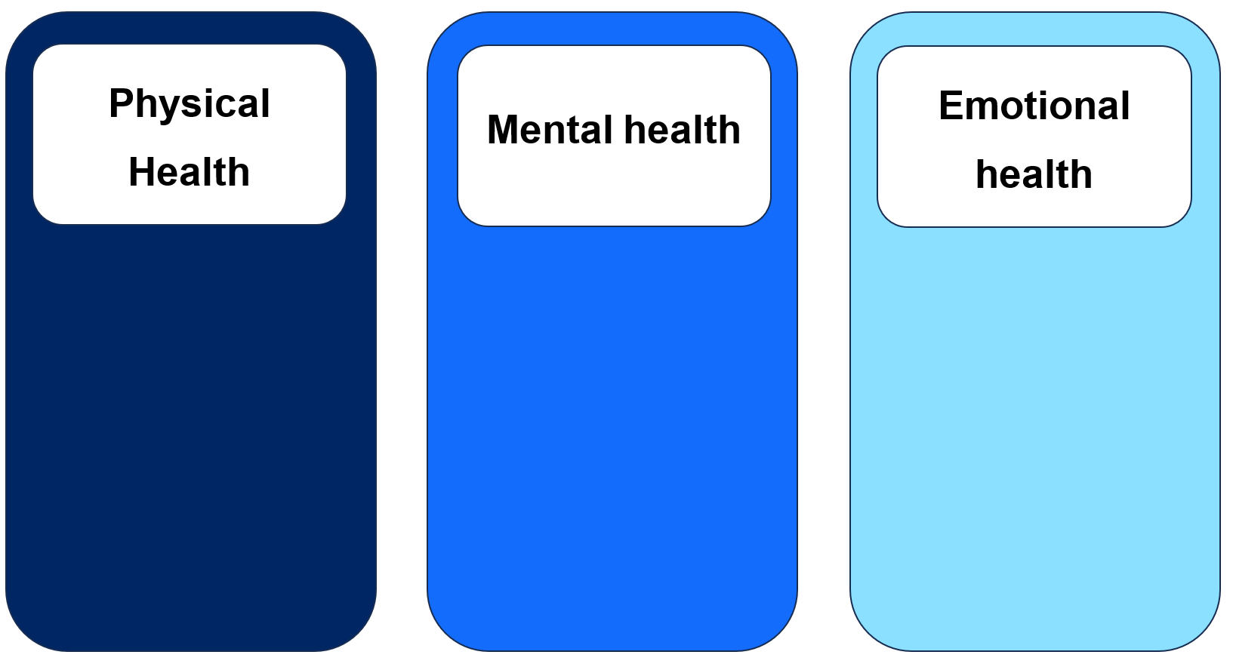
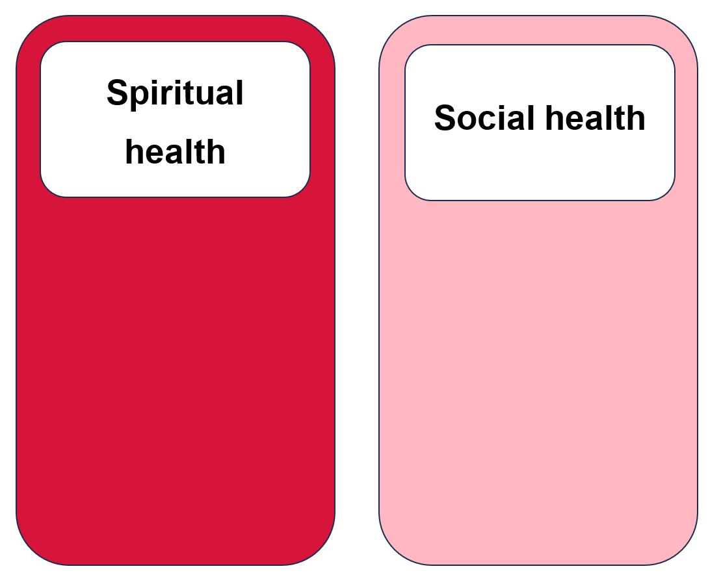

Appendix 3 – mind, body, spirit carousel activity
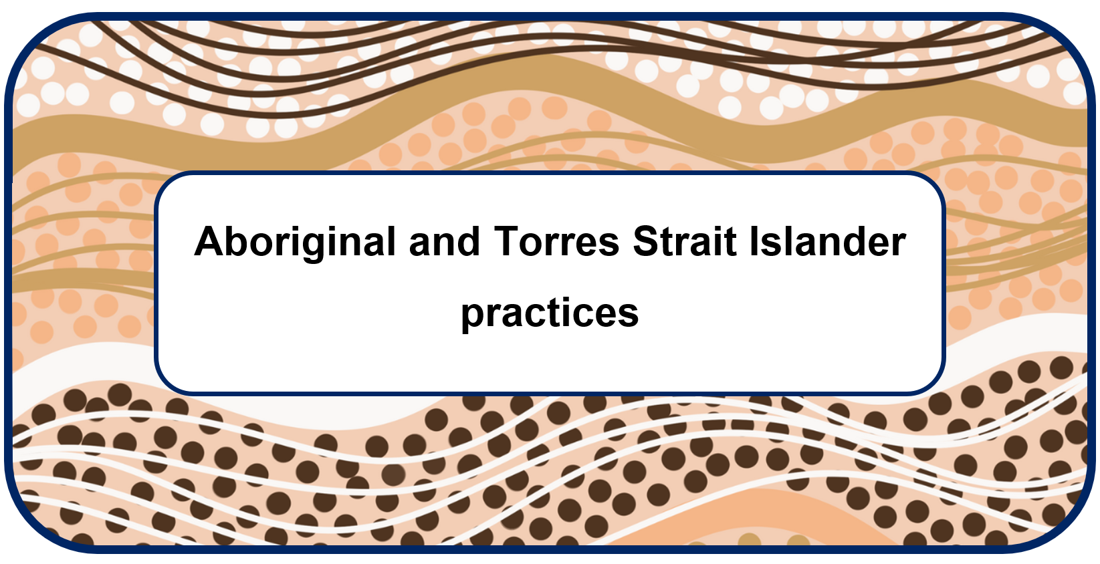

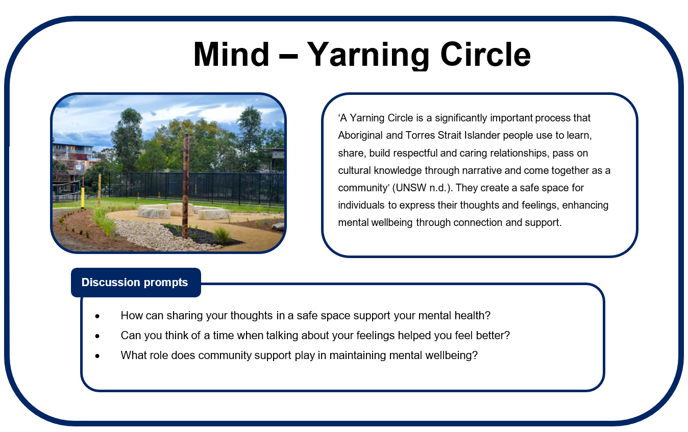
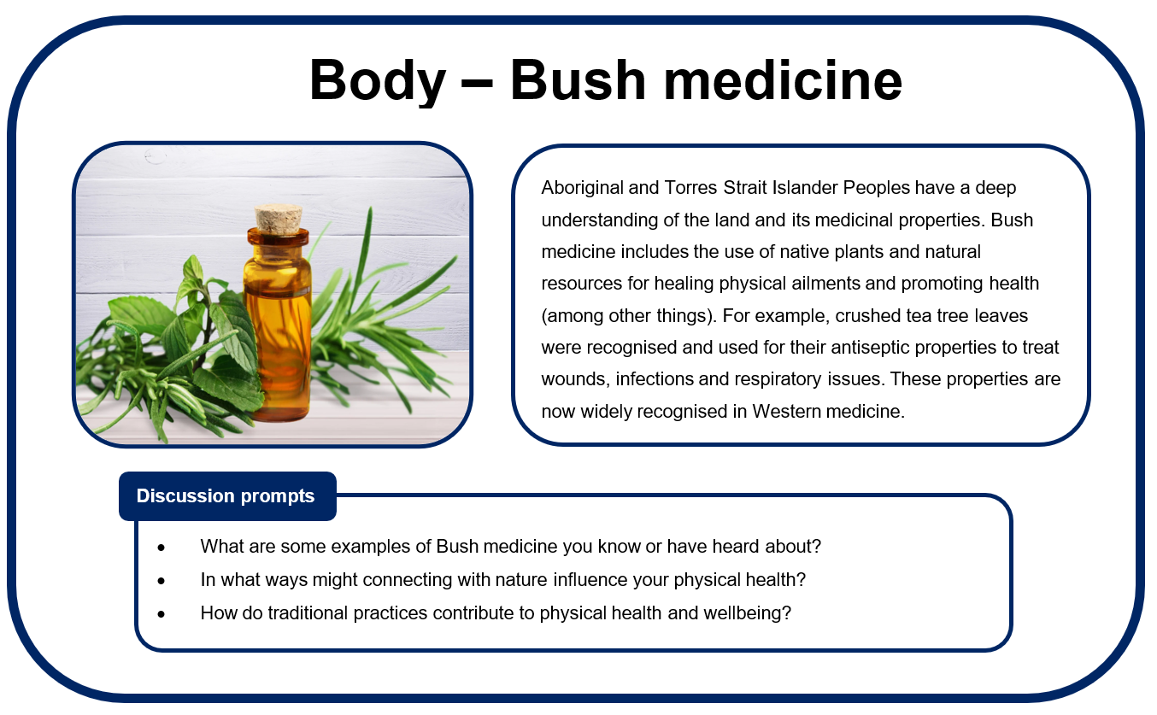

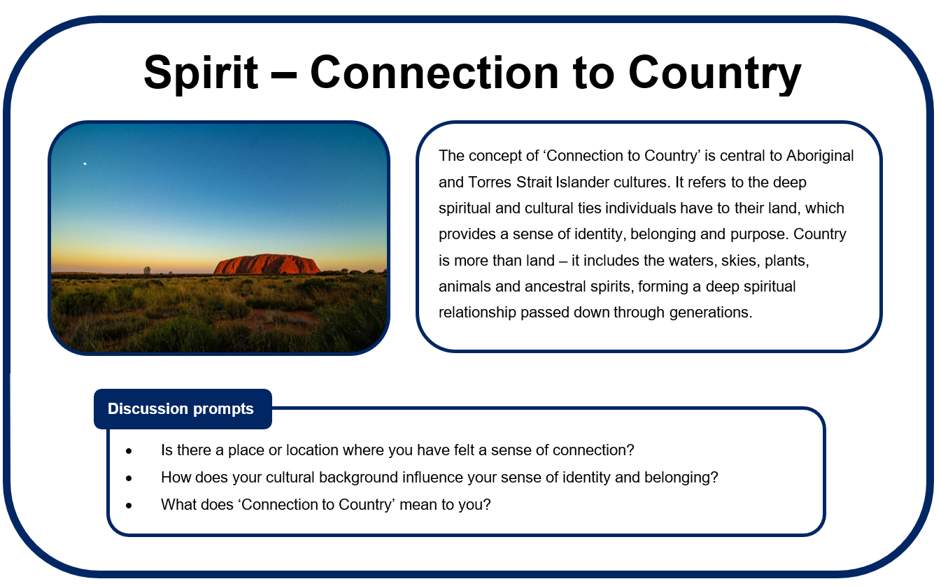
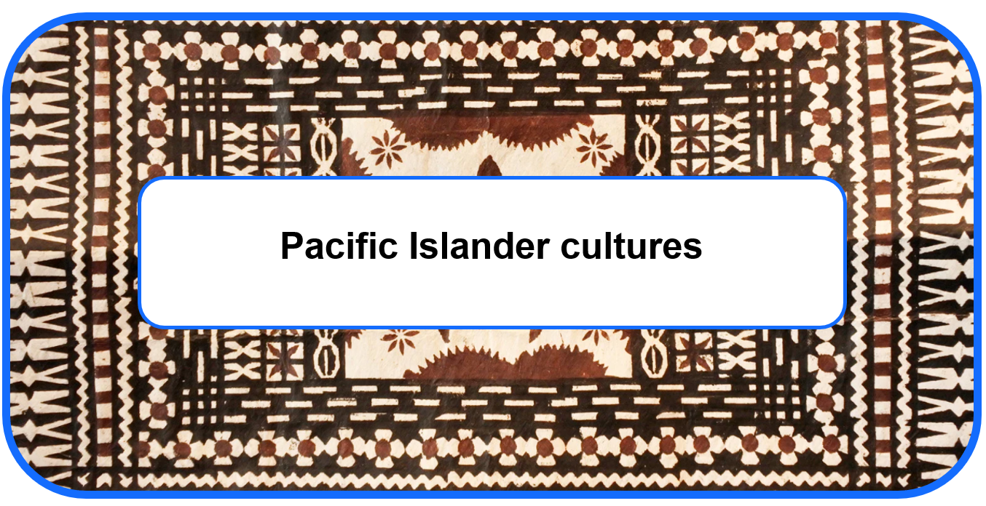

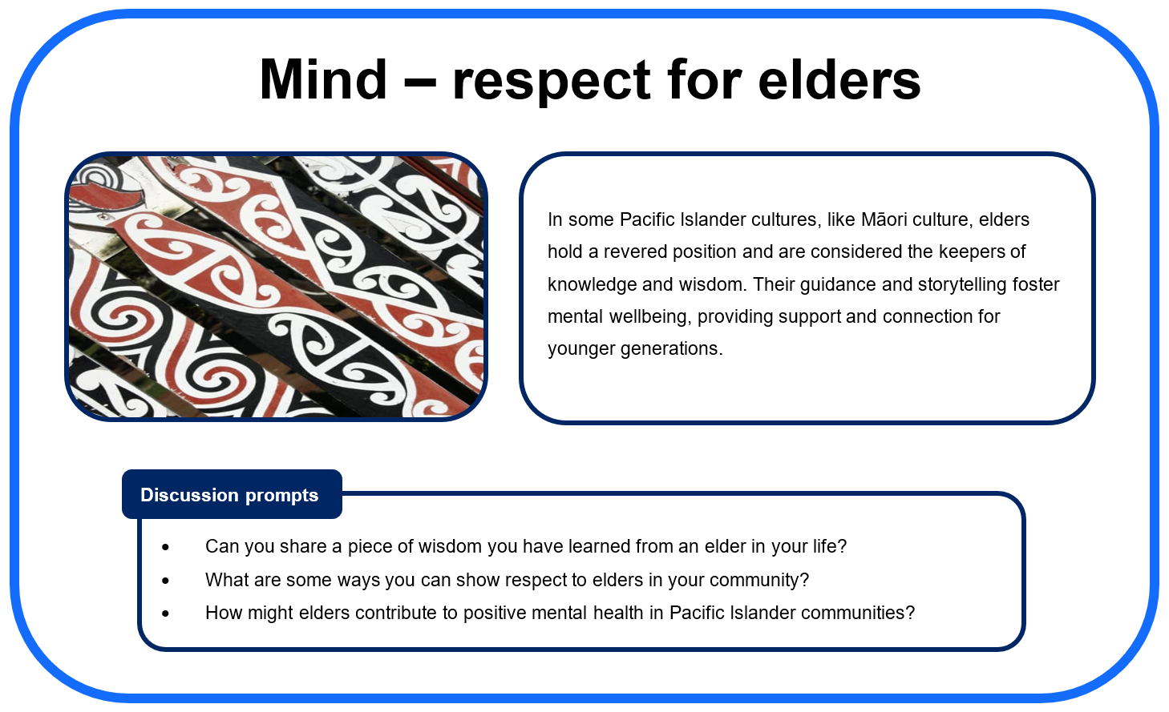
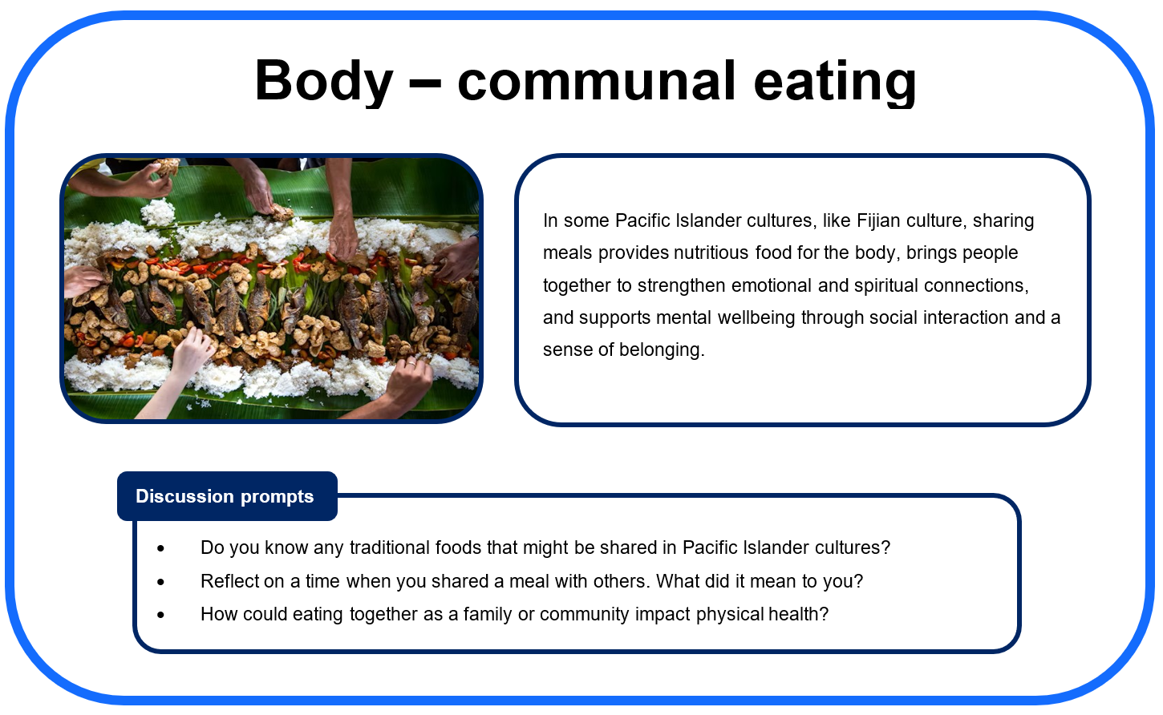
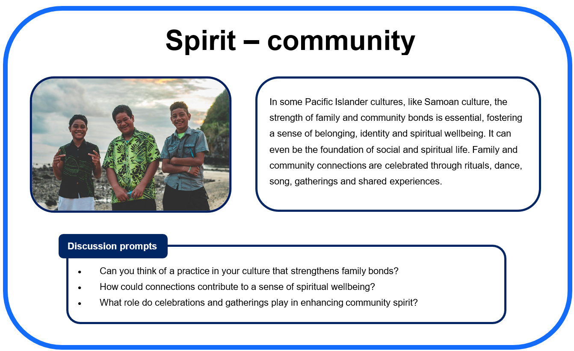
Image licensed under Unsplash License.
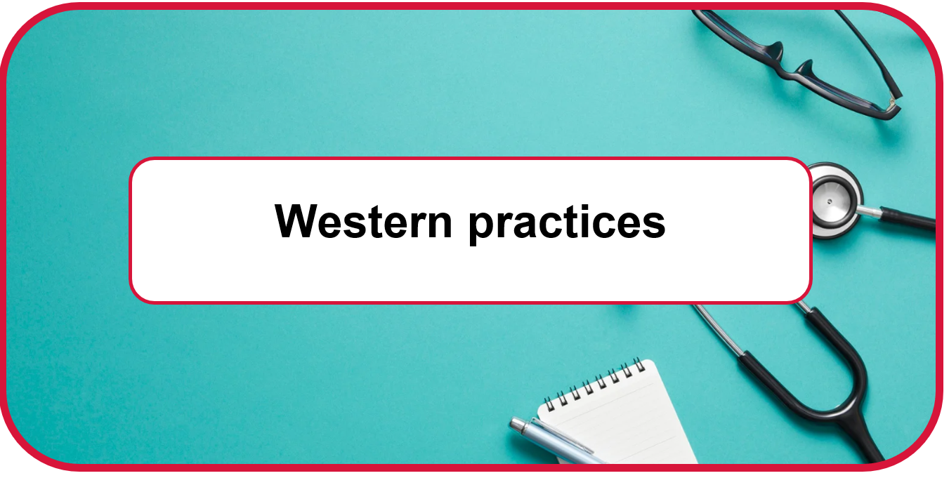

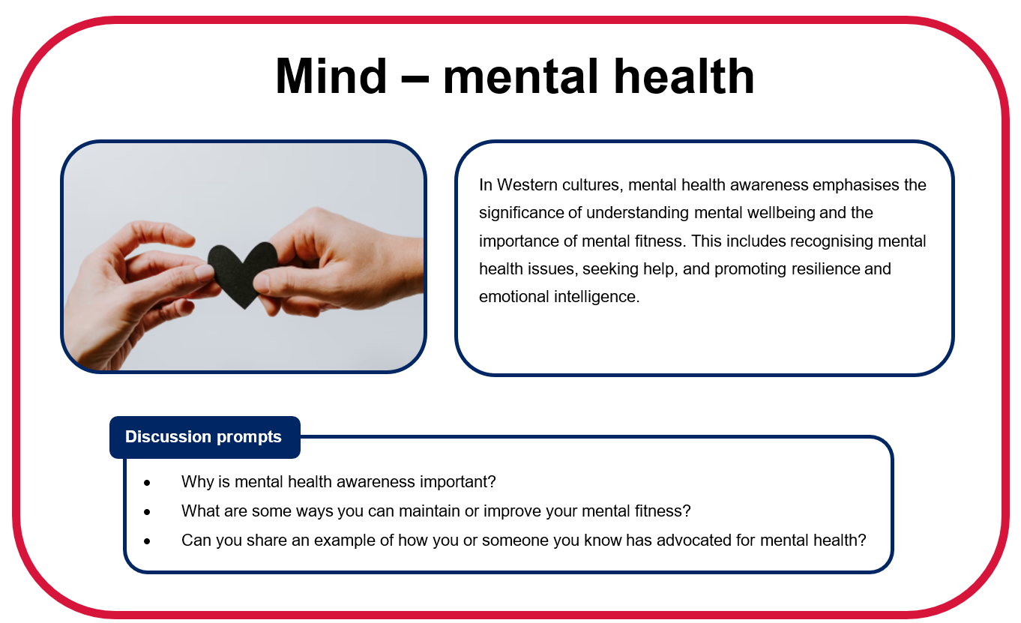

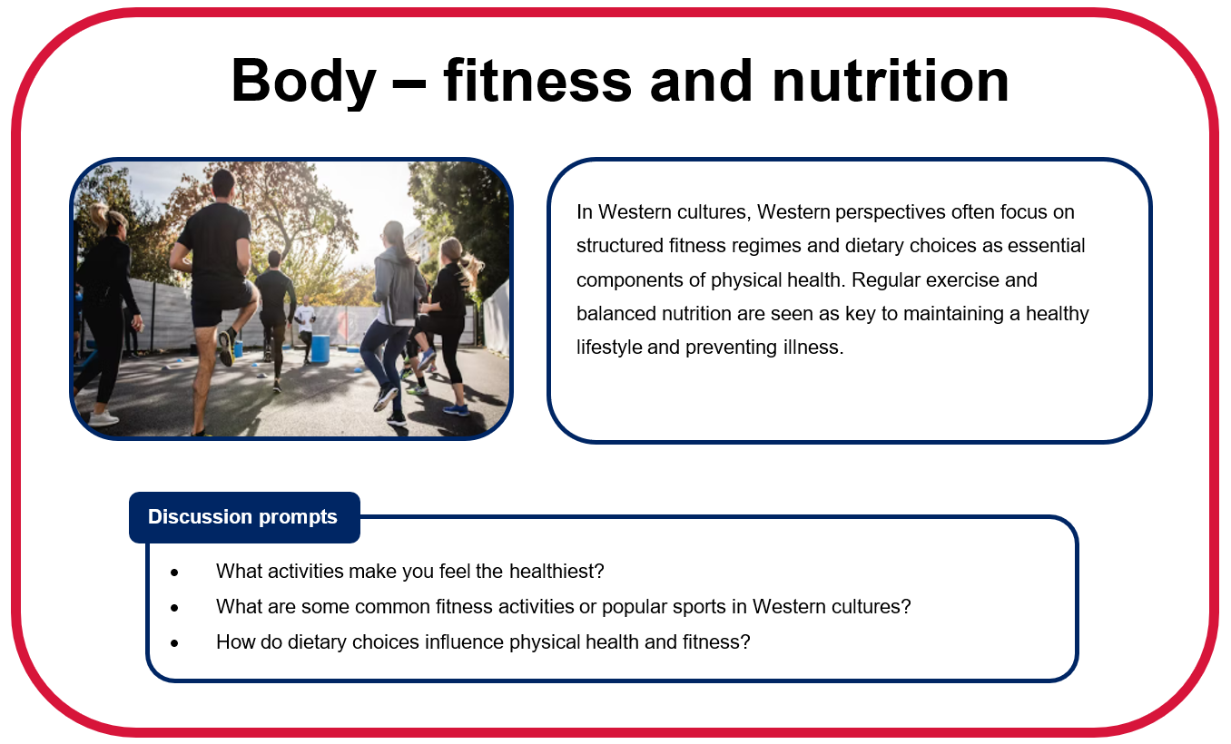

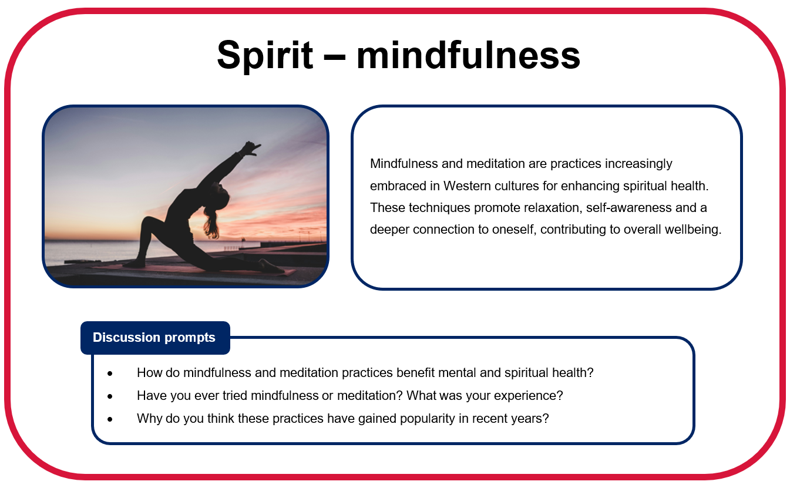

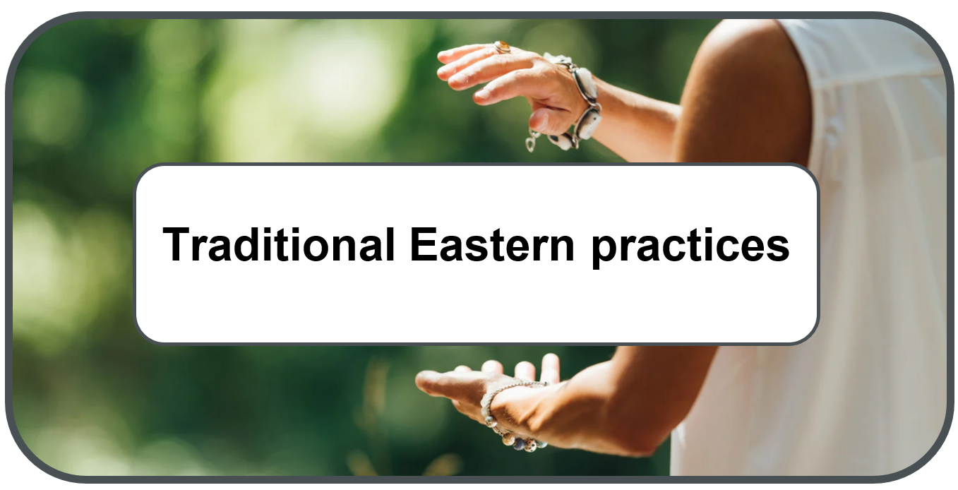

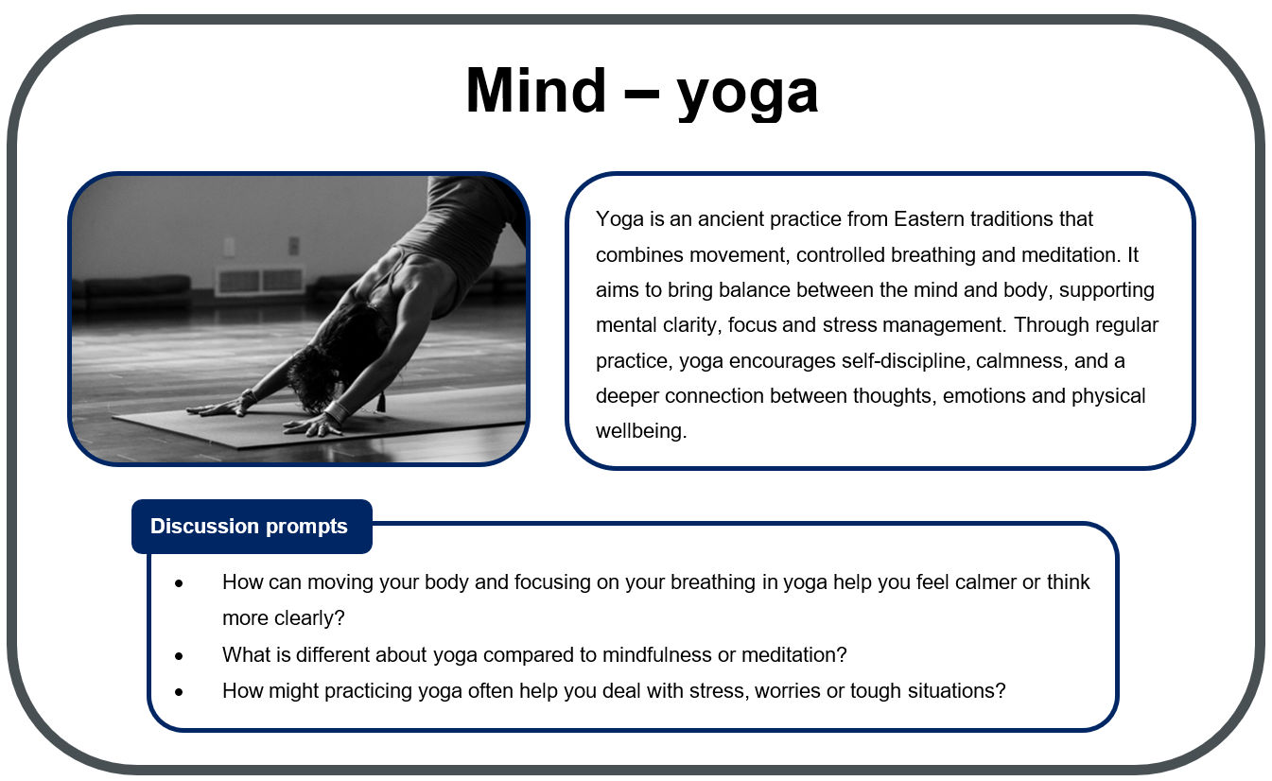

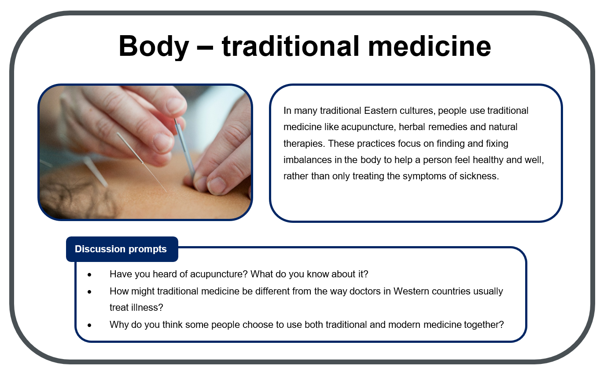

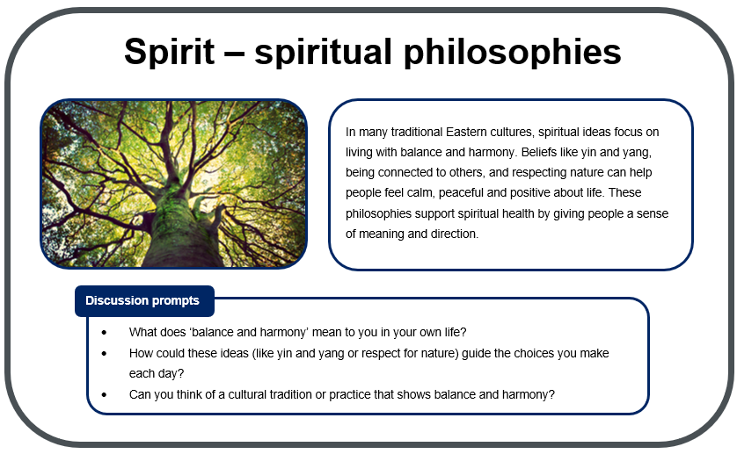

Appendix 4 – perceptions of health reflection
Write a reflection on your current understanding of health by completing the following sentences:
I used to think health was …
Now, I think health is …
Something that influences how I feel about health is …
Different people can have a different perception of health because …
Optional – other reflections:

Appendix 5 – understanding health and wellbeing exit ticket
Name: |  | Class: |  | Date:
Write a response to the following prompts:
Prompt | Response
3 things I learned about health … | - [Student to complete]  - [Student to complete]  - [Student to complete]
2 ideas about health I had not thought about before … | - [Student to complete]  - [Student to complete]
1 way culture can influence the way a person understands health and wellbeing … | - [Student to complete]

Appendix 6 – components of a balanced lifestyle
Match the component of a balanced lifestyle to the correct description by drawing a line to connect them:
Component |  | Description
 |  | What it involves | Why it is important for health and wellbeing
Activities outside |  | Eating a mix of healthy foods such as fruits, vegetables, grains, proteins (meat, eggs, beans) and dairy. Ensuring adequate hydration. | This can provide energy, help us to concentrate at school, support growth and reduce the risk of health problems later in life.
Sleep |  | Being active – for example, playing sport, walking, dancing, riding bikes or just moving around for at least 60 minutes each day. | This can strengthen the heart, muscles and bones. It can improve mood and mental health, and help students have fun and connect with others.
Physical activity |  | Getting enough rest – usually about 8 to 10 hours of sleep each night for Year 7 students. Establishing a consistent routine is important. | This can can improve memory, mood, focus and energy levels. It also supports growth, repair and helps us to cope with stress.
Screen time |  | Spending time and communicating with friends, family and others in a positive way. | This can build confidence, provide opportunities for emotional support and develop teamwork and respect.
Nutrition |  | Taking part in activities outdoors, such as walking, swimming, meditation, playing sports, riding bikes or enjoying nature. | This can improve physical health, reduce stress, boost moods and provide opportunities for socialising and fun.
Social interactions |  | Time spent using devices like phones, tablets, computers or TVs for activities like games, social media and watching shows. | Management of this can help prevent sleep problems, support physical activity opportunities and improve concentration and wellbeing.

Appendix 7 – lifestyle snapshot activity
Note: distribute one lifestyle snapshot character card to each group and a copy of the worksheets that follows.

Lifestyle snapshot character cards
Priya’s lifestyle snapshot
Priya is 13 years old and in Year 7. She loves computer games and spends about 3 hours gaming on most afternoons. Even though that is a lot of screen time, she also plays basketball twice a week and has training after school 3 days a week. She sometimes forgets to eat breakfast, but usually eats fruit, sandwiches and snacks during the day and has dinner with her family. Priya sometimes stays up late on weekends, but she gets 8 hours of sleep on most school nights. She hangs out with her basketball friends and her cousins on most weekends, and when she feels stressed, she chats with her older sister.
Alex’s lifestyle snapshot
Alex is 12 years old and in Year 7. He sleeps for about 6 hours on most nights and wakes up feeling rested. He plays soccer twice a week and walks his dog after school each day. He is active at school in physical education (PE) lessons, plays handball at lunch and enjoys riding his bike on the weekend with his friends. For meals, he usually eats breakfast, has a sandwich, fruit and water for lunch and eats dinner with his family. He enjoys weekend hangouts with friends, and when he feels stressed, he listens to music or draws. He spends around one hour on his tablet each night for homework and some gaming but turns it off before bed.
Jordan’s lifestyle snapshot
Jordan is 13 years old and in Year 7. They love computer games and spend about 3 hours gaming on most afternoons. Even though that is a lot of screen time, they also play touch football twice a week and have training after school on most days. They sometimes forget to eat breakfast, but usually eat fruit, sandwiches and snacks during the day and has dinner with their family. Jordan sometimes stays up late on weekends, but they get 8 hours of sleep on most school nights. They hang out with their touch football and school friends and cousins, and when Jordan feels stressed, they chat with their mum.
Maya’s lifestyle snapshot
Maya is 12 years old and in Year 7. She often stays up until midnight on her phone and struggles to wake up for school. On most mornings, she skips breakfast and grabs an energy drink. At school, she feels tired in her physical education (PE) lessons and usually sits out. She does not play a sport or do regular activity outside of school. Maya buys chips and a soft drink at the canteen on most days and often eats dinner alone in her room while watching YouTube. She spends more than 5 hours a day on her phone and does not consistently see her friends outside of school but chats to them online on most nights. When she feels stressed, she likes to use her phone to distract her from her thoughts.
Ethan’s lifestyle snapshot
Ethan is a 12-year-old who is a talented competitive swimmer. He trains before and after school every day, waking up at 4:30 am to get to the pool. Ethan eats a healthy diet to fuel his training, stays hydrated and is extremely fit. Because of his busy schedule, Ethan often feels tired in class and sometimes struggles to concentrate. He usually goes to bed around 10 pm, so he only gets about 6 hours and 30 minutes of sleep each night. Ethan also finds it hard to see his friends outside of training, and his social life is mostly limited to his swimming squad.

Lifestyle snapshots activity worksheet
- Co-construct a criterion for each lifestyle component based on the categories: ‘balanced achieved’, ‘almost there’ and ‘not there yet’. Record these in the table below:
Lifestyle component | Balanced achieved  Inner circle to outer circle | Almost there  Inner circle to middle circle | Not there yet  Inner circle only
Nutrition
Physical activity
Sleep
Social interactions
Activities outside
Moderating screen time
- Read your assigned character’s lifestyle snapshot. Underline or highlight text that demonstrates a component of a balanced lifestyle and write which specific component it is (for example, sleep, nutrition, physical activity, screen time, social interactions, outdoor activities).
- Use the character snapshot annotations to shade in the balanced lifestyle wheel for all components except screen time using the co-constructed criteria:
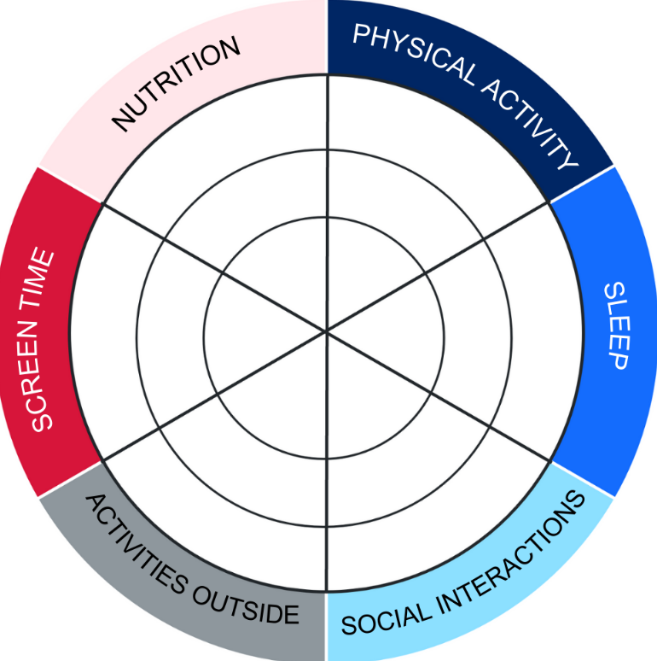
- Answer the following questions, using the structure below:
- say it – identify the components that are strong or needs more balance
- show it – highlight evidence from the scenario or your balance wheel to show your reasoning and substantiate your judgement.
Which components of the character’s lifestyle are strong?
Which components could be more balanced?
What impact could the current state of balance have on the character’s wellbeing?

Appendix 8 – nutrition jigsaw activity cards
A – understanding the guidelines  - What are the ‘Five Food Groups’ mentioned and why is eating a wide variety of them important for health?  - What does the brochure say about ‘discretionary foods’? Why do you think these are recommended only ‘sometimes and in small amounts’? |  | B – contextual influences and personal choices  - Name one example from the brochure of how families can encourage healthy eating at home.  - Think of a time when you or someone you know chose a snack or drink that might not follow the guidelines. What factors might have affected your decisions? Suggest several factors and how they influence food choices.

C – nutritional value and supporting wellbeing  - According to the brochure, why is drinking plenty of water recommended over sugary drinks?  - Find one example in the brochure of how eating certain foods helps our growth, movement or wellbeing. |  | D – serving sizes and practical application  - How do ‘serve size’ and ‘portion size’ differ, based on the brochure’s explanation?  - Why might 2 children of the same age need different numbers of serves per day?
E – big‐picture thinking
- What might happen over time if someone eats too many discretionary foods and not enough from the Five Food Groups?
- What behaviours can families encourage to support healthy eating?
This activity has been adapted from Healthy eating for children – Brochure from Eat for Health by National Health and Medical Research Council.

Appendix 9 – Maya’s meals
Maya, a 13-year-old student in Year 7 ate the following meals yesterday:
Breakfast | - 2 slices of white toast with 2 g of butter and half a teaspoon of vegemite  - 1 glass of orange juice
Lunch | - Chicken wrap with 1 piece of flat bread, half a cup of lettuce, 1 slice of cheese and 1 tablespoon of mayonnaise  - 1 can of soft drink
Snacks | - 1 packet of salt and vinegar chips
Dinner | - 100 g of grilled fish  - Salad (half a tomato, half a cup of lettuce and a quarter cup of cucumber)  - Half a cup of white rice  - 1 glass of water
Consider the Maya’s meals and use the Healthy eating for children – Brochure to determine if Maya has met her recommended serves per day for each food group. Complete the table below:
Recommended serving per day for a 12 to 13-year-old
Food group | Number of serves | Does this meet Maya’s daily requirement?
Vegetables, legumes and beans (5 and a half serves)
Fruit (2 serves)
Grain foods (6 serves)
Lean meats and poultry or alternatives (2 and a half serves)
Milk, yoghurt, cheese and/or alternatives, mostly reduced fat (3 and a half serves)
This table has been adapted from Healthy eating for children – Brochure from Eat for Health by the National Health and Medical Research Council.
Respond to the following questions:
Which food group(s) does Maya reach the recommended food servings for 12 to 13-year-olds?
Which food groups are underrepresented in this snapshot of Maya’s diet?
Which meal could contribute the most to the missing food groups?
What is one suggestion you could make to Maya to strengthen her food choices further?

Appendix 10 – my meals
Record the foods you consumed yesterday in the table below:
Breakfast
Lunch
Snacks
Dinner
Reflect on your meals and use the Healthy eating for children – Brochure to determine if you have met your recommended serves per day for each food group. Tick each serve consumed in the table below.
Recommended serving per day for a 12 to 13-year-old
Food group | Number of serves | Does this meet Maya’s daily requirement?
Vegetables, legumes and beans (5 and a half serves)
Fruit (2 serves)
Grain foods (6 serves)
Lean meats and poultry or alternatives (2 and a half serves)
Milk, yoghurt, cheese and/or alternatives, mostly reduced fat (3 and a half serves)
This table has been adapted from Healthy eating for children – Brochure from Eat for Health by the National Health and Medical Research Council.
Respond to the following questions:
Which food group(s) do you meet the recommended food servings for 12 to 13-year-olds?
Are there any food groups underrepresented in this snapshot of your diet?
What is one suggestion you could make strengthen your food choices further?

Appendix 11 – hydration requirements
Consider the hydration guidelines below:
Age group | Boys | Girls
9 to 13 years | 1.6 L (6 cups) | 1.4 L (5 to 6 cups)
14 to 18 years | 1.9 L (7 to 8 cups) | 1.6 L (6 cups)
Respond to the following questions:
Do you think you meet the recommended hydration amounts for your age range on most days?
What is one small change you could make to meet your hydration goals more effectively?
Why do you think that boys and girls have different hydration requirements?

Appendix 12 – drink choice decisions activity
Review the following drink options and rank them in order of the healthiest to the unhealthiest.
Option 1 – sports drink
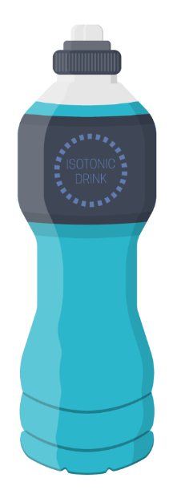
Ingredients: water, sucrose, glucose, food acids, flavour, monopotassium phosphate, sodium chloride.
Nutrition information
Servings per pack | Serving size
1.00 | 600.0 mL

Nutritional facts | Quantity per serving | Quantity per 100 g/100 mL
Energy | 618.0 kJ | 103.0 kJ
Protein | 0.0 g | 0.0 g
Fat (total) | 0.0 g | 0.0 g
Saturated | 0.0 g | 0.0 g
Carbohydrate | 36.0 g | 6.0 g
Sugars | 36.0 g | 6.0 g
Dietary fibre | 0.0 g | 0.0 g
Sodium | 306.0 mg | 51.0 mg

Option 2 – flavoured milk
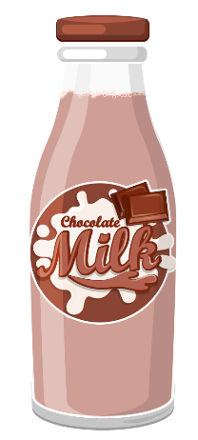
Ingredients: whole milk (90%), sugar, cocoa (2%), maltodextrin, flavours, stabiliser, salt, colours.
Nutrition information
Servings per pack | Serving size
2.00 | 300.0 mL

Nutritional facts | Quantity per serving | Quantity per 100 g/100 mL
Energy | 1128.0 kJ | 376.0 kJ
Protein | 10.5 g | 3.5 g
Fat (total) | 10.2 g | 3.4 g
Saturated | 6.6 g | 2.2 g
Carbohydrate | 33.0 g | 11.0 g
Sugars | 31.8 g | 10.6 g
Dietary fibre | n/a | 0.6 g
Sodium | 150.0 mg | 50.0 mg

Option 3 – fruit juice
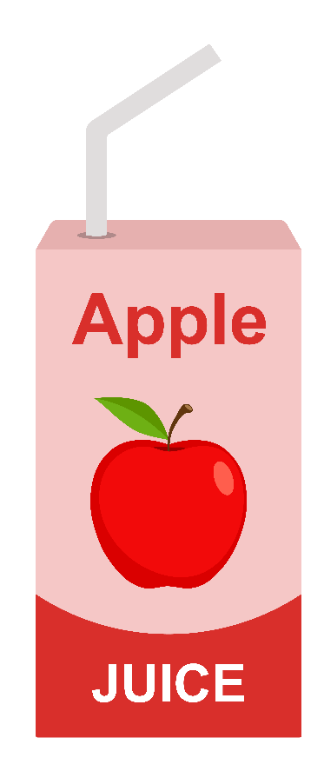
Ingredients: reconstituted apple Juice (98.9%), acidity regulator, vitamin C, natural flavour.
Nutrition information
Servings per pack | Serving size
1.00 | 200.0 mL

Nutritional facts | Quantity per serving | Quantity per 100 g/100 mL
Energy | 368.0 kJ | 184.0 kJ
Protein | <2.0 g | 1.0 g
Fat (total) | <2.0 g | 1.0 g
Saturated | 0.0 g | 0.0 g
Carbohydrate | 21.0 g | 10.5 g
Sugars | 20.2.8 g | 10.1 g
Dietary fibre | 0.2 g | 0.1 g
Sodium | 16.0 mg | 8.0 mg

Option 4 – spring water
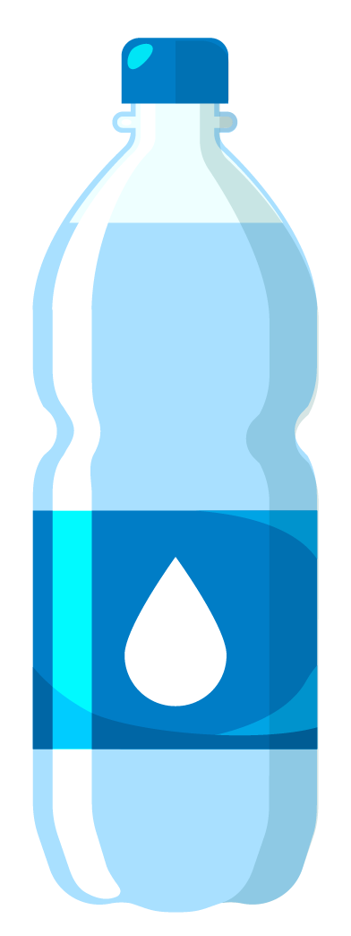
Ingredients: spring water.
Nutrition information
Servings per pack | Serving size
1.00 | 750.0 mL

Nutritional facts | Quantity per serving | Quantity per 100 g/100 mL
Energy | 0.0 kJ | 0.0 kJ
Protein | 0.0 g | 0.0 g
Fat (total) | 0.0 g | 0.0 g
Saturated | 0.0 g | 0.0 g
Carbohydrate | 0.0 g | 0.0 g
Sugars | 0.0 g | 0.0 g
Dietary fibre | n/a | n/a
Sodium | 38.0 mg | 5.0 mg

Option 5 – cola drink
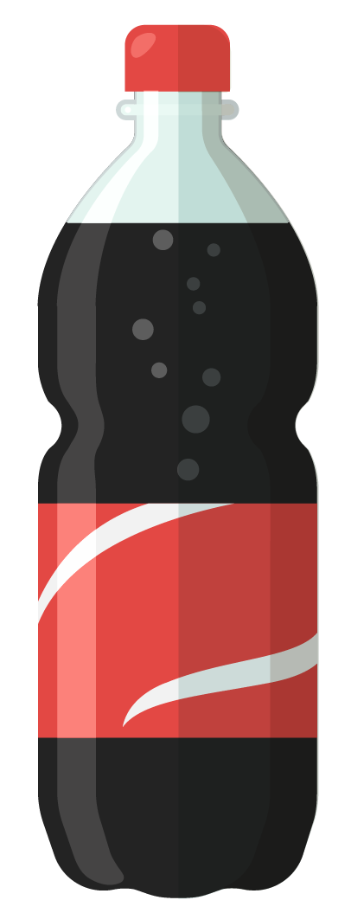
Ingredients: carbonated water, sugar, colour, food acid, flavour, caffeine.
Nutrition information
Servings per pack | Serving size
1.00 | 750.0 mL

Nutritional facts | Quantity per serving | Quantity per 100 g/100 mL
Energy | 1080.0 kJ | 180.0 kJ
Protein | 0.0 g | 0.0 g
Fat (total) | 0.0 g | 0.0 g
Saturated | 0.0 g | 0.0 g
Carbohydrate | 64.0 g | 10.6 g
Sugars | 64.0 g | 10.6 g
Dietary fibre | n/a | n/a
Sodium | 60.0 mg | 10.0 mg

Option 6 – energy drink
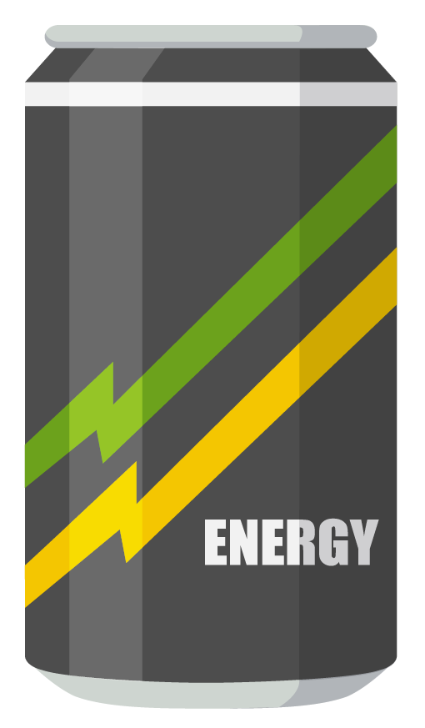
Ingredients: carbonated water, acidity regulators (citric acid, sodium citrate), sweeteners (erythritol, sucralose, acesulphame potassium), taurine, flavours, ginseng root extract, preservatives (sorbic acid, benzoic acid), caffeine, vitamins niacin (B3), vitamin B5, vitamin B6, vitamin B12, stabiliser (glycerol ester of wood rosin), inositol, guarana seed extract, D-glucuronolactone, colours.
Nutrition information
Servings per pack | Serving size
1.00 | 500.0 mL

Nutritional facts | Quantity per serving | Quantity per 100 g/100 mL
Energy | 60.0 kJ | 180.0 kJ
Protein | 0.0 g | 0.0 g
Fat (total) | 0.0 g | 0.0 g
Saturated | 0.0 g | 0.0 g
Carbohydrate | 6.5 g | 1.3 g
Sugars | 0.0 g | 0.0 g
Dietary fibre | n/a | n/a
Sodium | 395.0 mg | 79.0 mg

Appendix 13 – label detectives activity worksheet
Review the drink choices from the previous activity. Apply your label detective knowledge of Health Star Ratings, ingredients list, nutritional information and relevant contexts to reconsider the drink choices.
Complete the table below:
Drink type | Ranking (1 – the healthiest to 5 – the unhealthiest) | Justify your ranking (provide reasons to support your judgement)
Sports drink
Flavoured milk
Fruit juice
Water
Soft drink
Energy drink

Appendix 14 – Australian physical activity and exercise guidelines worksheet
Part A – extract the facts
Read the Australian Government’s physical activity and exercise guidelines For children and young people (5 to 17 years) and find and record the answers to the following questions:
How many minutes of physical activity should young people aim for each day?
What type of activities should be included each day?
How often should muscle and bone strengthening activities be done?
What is the recommended limit for recreational screen time each day?
How much sleep should young people get each night?

Part B – think deeper
Answer the following questions:
Why do you think the guidelines include a balance of physical activity, limited screen time and sleep?
Do you think most young people meet these guidelines? Why or why not?

Part C – self-reflection
The category that would be the easiest for me to meet the recommendations for would be … (place a tick in the relevant category):
Physical activity | Strengthening | Screen time limits | Sleep
Provide reasons for your selection:
The category that would be the hardest for me to meet the recommendations for would be … (place a tick in the relevant category):
Physical activity | Strengthening | Screen time limits | Sleep
Provide reasons for your selection:

Appendix 15 – physical activity, screen time and sleep graffiti walk station cards

Station 1 – physical activity
Place a tick on the scale below to indicate how many minutes of activity you do on an average day:
Minutes of physical activity per day (on average)
0 | 5 | 10 | 15 | 20 | 25 | 30 | 35 | 40 | 45 | 50 | 55 | 60 | 65+
List as many types of activities that make up your movement, for example, walking to school, soccer training and so on (note: if someone has already written an activity you do, place a tick beside it to indicate you also do this.

Station 2 – barriers to being active
List as many barriers or things that might make it more challenging for students to meet the physical activity and exercise guidelines. If you see a barrier you agree with, give it a tick.
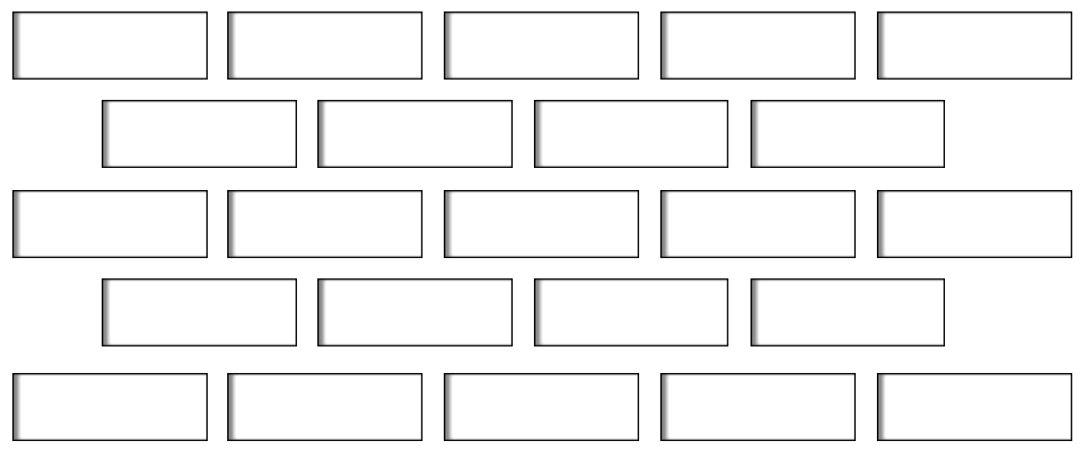

Station 3 – enablers and strategies to support movement
Consider the list of barriers in the table below and propose a strategy to overcome them. You can have more than one strategy for a barrier.
Barrier | Strategy that might help treat the barrier
Not enough time
Cost (sport, gym, gear)
Low motivation
Too much screen time
No access to facilities
Weather or environment
Lack of confidence or skills
Feeling tired or low energy
Competing priorities (school and other activities)
Other:
Other:
Other:

Station 4 – movement for emotion management
Consider feelings or emotions on the left-hand side of the table below and propose a movement that might help you overcome it. You can have more than one strategy for a barrier.
Using movement to support emotional regulation
Feeling or emotions | Suggest a movement that may support this emotion
Stressed | Example – go for a walk around the block, put on your favourite song and dance.
Happy
Angry
Bored
Sad
Other:

Station 5 – screen time
Place a tick on the scale below to indicate how many hours of screen time you would have on an average day (not including school or homework):
Hours of screen time per day (on average)
0 | 0.5 | 1 | 1.5 | 2 | 2.5 | 3 | 3.5 | 4 | 4.5 | 5 | 5.6 | 6 | 6.5+
Contribute to the table below (note: if someone has an answer you agree with, place a tick beside it):
Things I like about screen time | Things I find difficult about screen time

Station 6 – sleep
Place a tick on the scale below to indicate how many hours of sleep you have on an average day:
Hours of sleep per day (on average)
1 | 2 | 3 | 4 | 5 | 6 | 7 | 8 | 9 | 10 | 11 | 12 | 13+
Contribute to the table below (note: if someone has an answer you agree with, place a tick beside it):
When I get enough sleep, I feel … | When I do not get enough sleep, I feel …

Appendix 16 – physical activity, screen time and sleep self-reflection worksheet
Complete the following self-reflection by using the prompts below:
Physical activity
How many minutes per day on average am I currently engaging in physical activity or exercise?
What types of movement do I do the most?
Is there anything missing?
What movement or activity might help me manage my emotions the best?
How might this help?

Physical activity, screen time and sleep
Complete the table below:
Component | One challenge I face … | One strategy I could try … | One benefit I expect …
Physical activity
Screen time
Sleep

Appendix 17 – balanced lifestyle self-reflection
- Consider what you have learned about balanced lifestyles.
- Scan your responses to the following completed worksheets from previous activities, including ‘My meals’, ‘Hydration requirements’ and the ‘Physical activity, screen time and sleep self-reflection worksheet’.
- Use your knowledge and reflections and your constructed criteria for each lifestyle component based on the categories: ‘balanced achieved’, ‘almost there’ and ‘not there yet’ (from Learning sequence 2) to shade in the balanced lifestyle wheel:
Answer the following questions, using the structure below:
- say it – identify the components that are strong or need more balance
- show it – highlight evidence from the scenario or your balance wheel to show your reasoning and substantiate your judgement.
Which components of your lifestyle are strong?
Which components could be more balanced?
What impact could the current state of balance have on your wellbeing?

Appendix 18 – SMART goal template
One goal I will implement to support me to achieve a balanced lifestyle is:
Complete the following table to explain how your goal meets the SMART goal criteria:
Criteria | Definition | Explanation
Specific | The goal is clear and detailed (who, what, when, where, how). | [Student to complete]
Measurable | There is a clear way to measure your progress and know if you have improved or achieved your goal (this will often be a number). | [Student to complete]
Achievable | The goal is something that can actually be done. | [Student to complete]
Relevant | The goal is worthwhile and relevant to you. | [Student to complete]
Time-bound | The goal has a timeline. | [Student to complete]

Appendix 19 – balanced lifestyle choices exit ticket
Name: |  | Class: |  | Date:
Write a response to the following prompts:
Prompt | Response
3 things I learned about balanced lifestyles … | - [Student to complete]  - [Student to complete]  - [Student to complete]
2 strategies or actions I can take to support my lifestyle balance | - [Student to complete]  - [Student to complete]
1 question I still have about balanced lifestyles … | - [Student to complete]

Appendix 20 – explain this – modelled example
Model the thinking and response to the question: Explain how sleep can impact school achievement.
A sample script could include:
- Say I am asked to explain how sleep can impact a school achievement, I would need to be able to relate cause and effect, and that means showing how one thing leads to another. So, I might start by saying that not getting enough sleep leads to feeling tired during the day.
- Then, I would need to provide the ‘why’ or ‘how’. This means that I need to go beyond just describing. I need to communicate why something happens or how it works. So, for example, I could say that ‘This happens because your body and brain do not get enough rest to recharge.’
- I would then give an example to show what this looks like. For example, if you only sleep 5 hours, you might struggle to stay awake in class, and this may impact learning and school achievement.
- But it is then important to realise that the question did not ask how a lack of sleep impacts school achievement – it simply asks how sleep impacts it. So, I would then need to follow as similar process above with the alternate viewpoint, which in this case is how adequate sleep could support school achievement.
- So, following the same process, I would say something like ‘On the other hand, getting enough sleep leads to better memory and learning. This is because during sleep, your brain processes and stores the information learned in the day. For example, if you have adequate sleep, you are more likely to access your learning when you need it – like in class or for a test – which may be harder to do when you are tired.’

Appendix 21 – contextual factors scenario activity
Priya’s contextual factors
Read the character’s contextual factors scenario card below.
Priya loves cooking healthy meals but has after-school dance classes 3 times a week. Her parents work long hours, so she often must make dinner herself. Sometimes she chooses quick snacks instead of balanced meals because she is short on time. She enjoys spicy foods and tries to make healthy meals that match her taste. Priya often stays up late scrolling on social media, which affects her sleep.
Tick the relevant contextual factors identified below. Use one colour to indicate if the contextual factor has a negative influence and a different colour to show positive influence:
Time | Money | Family | Culture | Access | Media
Provide reasons you identified these factors:
Propose a strategy to support the character to overcome a barrier and make a healthier choice:

Maya’s contextual factors
Read the character’s contextual factors scenario card below.
Maya wants to eat more fruits and vegetables, but her local shop does not always have fresh produce. Fresh foods are expensive, and to get into town to buy fresh produce will take 2 hours to get there. Maya follows social media influencers who post about healthy snacks and sometimes she tries to recreate those snacks for herself.
Tick the relevant contextual factors identified below. Use one colour to indicate if the contextual factor has a negative influence, and a different colour to show positive influence:
Time | Money | Family | Culture | Access | Media
Provide reasons you identified these factors:
Propose a strategy to support the character to overcome a barrier and make a healthier choice:

Alex’s contextual factors
Read the character’s contextual factors scenario card below.
Alex comes from a family with strong cultural food traditions and enjoys home cooked meals every night. Alex has recently preferred plant-based lunches, but the canteen does not offer these, so he sometimes skips lunch.
Tick the relevant contextual factors identified below. Use one colour to indicate if the contextual factor has a negative influence and a different colour to show positive influence:
Time | Money | Family | Culture | Access | Media
Provide reasons you identified these factors:
Propose a strategy to support the character to overcome a barrier and make a healthier choice:

Jordan’s contextual factors
Read the character’s contextual factors scenario card below.
Jordan loves sports and wants to be active every day. The oval is next to his house and has some outdoor fitness equipment. Jordan has been watching social media accounts of park workouts, which he enjoys. Jordan’s mother works shift work so they eat dinner at 9:30 pm, which can make Jordan very tired the next day.
Tick the relevant contextual factors identified below. Use one colour to indicate if the contextual factor has a negative influence, and a different colour to show positive influence:
Time | Money | Family | Culture | Access | Media
Provide reasons you identified these factors:
Propose a strategy to support the character to overcome a barrier and make a healthier choice:

Appendix 22 – health information checklist
For each criterion, highlight if the source of health information ‘meets’, ‘partially meets’ or ‘does not meet’ the criteria.
Aspect of health information | Meets the criteria | Partially meets the criteria | Does not meet the criteria
Currency | The information is current (within the last 5 years). | No date is provided or it is unclear when it was created. | The information is not current (more than 5 years old).
Relevance | The information is clearly relevant to my age, health needs or context. | The information is somewhat relevant to my age but only partially applies to my situation. | The information is not relevant for my age or health needs.
Authority | The source is a credible expert or official organisation (for example, government, health professional). | The source is unclear, but it cites statistics or information from other credible sources. | The source is written by someone whose expertise is not quantified.
Accuracy | The information is supported by evidence, facts or research and can be verified. | Some evidence or facts are provided, but it is incomplete or unclear. | The information is opinion-based and cannot be verified.
Purpose | The information is created to inform or educate, without bias or commercial intent. | The purpose is unclear or partially persuasive. | The information is designed to sell, persuade or manipulate, rather than inform.
Highlight the criteria below that best represents the overall credibility and reliability of the source of information:
Judgement level | Descriptions and notes
Highly credible and reliable information | - Meets almost all criteria  - Information is evidence-based with clear authority, is current and relevant, and has a purpose to educate or inform  - Likely to help the reader make healthy, informed choices
Mostly credible and/or reliable information | - Meets most criteria  - May have minor issues with currency, authority or relevance  - Can be used with some caution when making health choices
Limited credibility and/or reliability of information | - Meets some criteria but has noticeable gaps (for example, the purpose is to sell, it is outdated, there is limited evidence, the source is unclear)  - Information may not be helpful for making health choices

Appendix 23 – evaluating health information activity
The following are samples of stimulus you could use in the ‘Evaluating health information activity’ in Learning sequence 5. The reasons behind their selection have been included to support you to select alternate stimulus as relevant to your context.
Source of health information | Link | Reason for the stimulus selection
YouTube product ranking | Ranking Sports Drinks! (00:51) | - Partially meets some criteria in the health information checklist  - Reflects a platform teens engage with  - Can open discussion around persuasive techniques, popularity versus reliability and how entertainment blurs into health information
Generative AI – response to a health question | Appendix 24 – Generative AI sample response to a health question | - Partially meets some criteria in the health information checklist  - Generative AI is cited as an increasing source of information for young people, so investigating it will allow conversations around the importance of fact-checking AI responses and the nature of the software being geared to having to produce an answer (even if it is incorrect)
Government guidelines for children | 24-hour movement guidelines – birth to 5 years – brochure | - Partially meets some criteria in the health information checklist  - This seems like a gold standard trusted source, but it is not relevant to the target audience. This could open discussion around the importance of health information being relevant to a given context  - Providing this as a source will allow students to contrast trusted sources with popular sources (social media, AI) which can support the development of health literacy
Influencer health product paid advertisement | Garnier pimple patches have got me covered (01:21) | - Partially meets some criteria in the health information checklist  - Discussions around purpose and the fact the influencer is paid to sell you a product and how marketing can blur into health advice  - Encourages critical thinking about whether this is health information or a health product or both

Appendix 24 – Generative AI sample response to a health question
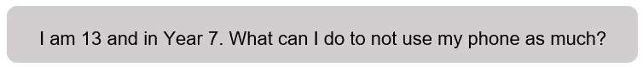
Got it! You want to use your phone less—totally doable. Here are some practical, age-appropriate strategies for a Year 7 student like you:
- Set clear limits
- Decide how much time you want to spend on your phone each day
- Use your phone’s built-in screen time tracker to monitor usage
- Create phone-free times
- Pick certain times of the day to be phone-free, like
- during meals
- before bed
- while doing homework
- You can even charge your phone outside your bedroom at night.
- Replace phone time with something else
- Find activities you enjoy that do not need a screen, such as
- reading a book
- drawing or crafting
- going for a walk or playing outside
- listening to music or podcasts offline
- Hanging out with family or friends in person.
- Remove distractions
- Turn off notifications for apps that make you scroll a lot
- Move distracting apps to a separate folder or off your home screen
- Try deleting apps that you do not really need
- Use apps that help
- Some apps block social media for set periods to help you focus
- Set goals and reward yourself
- Start small – maybe be phone-free for 30 minutes at a time
- Reward yourself with a small treat or a fun activity when you meet your goal
- Get support
- Tell a friend or family member about your goal—they can check in with you
- Sometimes having someone else know helps you stick to it

Appendix 25 – ABCD cards
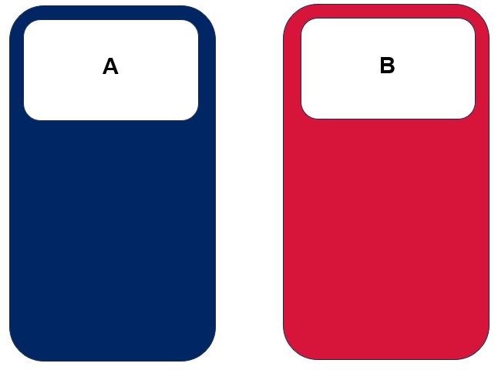
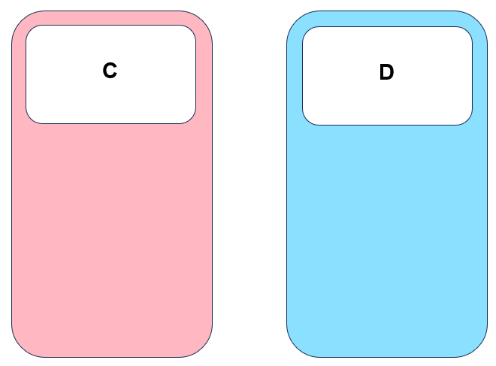

Appendix 26 – informative and persuasive techniques
The following tables list a series of techniques that may be used in sources of health information to inform or persuade the audience for a purpose.
Informative – to educate, explain or provide facts so the reader can make informed decisions
Technique | Purpose | What you might see
Facts and statistics | Provide evidence and credibility | Numbers, percentages, comparisons, tables, charts
Clear explanations | Help the reader understand | Step-by-step instructions, sequencing words (first, next, finally), cause-and-effect language
Examples | Show real-world application | ‘For example …’, ‘such as …’, case studies
Diagrams or visuals | Clarify information visually | Labels, captions, arrows, infographics
References or sources | Show reliability | Author names, institution, publication dates, hyperlinks
Neutral language | Maintain objectivity | Formal tone, precise vocabulary, avoids exaggeration or opinion
Student tip: look for language that teaches or explains, not tries to sell or convince.
Persuasive – to convince, influence or motivate the audience to act, feel or buy
Technique | Purpose | What you might see
Emotional appeal | Make the audience feel something | Adjectives or adverbs with strong emotion, exclamation marks or personal stories
Celebrity endorsement | Encourage imitation | Names, pictures, quotes from influencers or famous people
Catchy visuals and music | Grab attention, reinforce message | Bright colours, bold text, upbeat music, rapid cuts
Repetition | Make ideas memorable | Repeating words, slogans or hashtags
Loaded language | Influence perception | Words with strong positive or negative connotations (for example, life-changing, best ever, fail)
Before-and-after pictures | Show dramatic results | Contrasting images, captions emphasising transformation
Bandwagon effect | Persuade by popularity | Phrases like ‘everyone is using it’, ‘join the trend’
Special offers or urgency | Prompt immediate action | Words like ‘limited time’, ‘hurry’, ‘do not miss out’
Appealing to trends | Make the product or message attractive | References to current fashion, memes, challenges or social media trends
Student tip: look for language and visuals that influence feelings or actions, not just provides information.


Program feedback
We value your feedback. If you use this teaching and learning program in your faculty and school context, please complete the PDHPE 7–10 resource evaluation form. If you have further comments or suggestions, please email PDHPEcurriculum@det.nsw.edu.au.

Support and alignment
Resource evaluation and support: all curriculum resources are prepared through a rigorous process. Resources are periodically reviewed as part of our ongoing evaluation plan to ensure currency, relevance and effectiveness. For additional support or advice, or to provide feedback, contact the PDHPE Secondary Curriculum team by emailing PDHPEcurriculum@det.nsw.edu.au.
Differentiation: further advice to support Aboriginal and/or Torres Strait Islander students, students learning English as an additional language or dialect (EAL/D), students with a disability and/or additional needs and high potential and gifted students can be found on the Planning, programming and assessing 7–12 webpage. This includes the Inclusion and differentiation advice 7–10 webpage.
Assessment: further advice to support formative assessment is available on the Planning, programming and assessing 7–12 webpage. This includes the Classroom assessment advice 7–10. For summative assessment tasks, the Assessment task advice 7–10 webpage is available.
Explicit teaching: further advice to support explicit teaching is available on the Explicit teaching webpage. This includes the CESE Explicit teaching – Driving learning and engagement webpage.
Consulted with: Curriculum Implementation Provision, Aboriginal Education team; Curriculum and subject matter experts
Alignment to system priorities and/or needs: School Excellence Policy, Our Plan for NSW Public Education
Alignment to the School Excellence Framework: this resource supports the School Excellence Framework elements of curriculum (curriculum provision) and effective classroom practice (lesson planning, explicit teaching).
Alignment to Australian Professional Standards for Teachers: this resource supports teachers to address Proficient Teacher Standard Descriptors 2.1.1, 2.1.2, 2.2.1, 2.2.2, 2.3.1, 2.3.2, 3.1.1, 3.1.2, 3.2.1, 3.2.2, 3.3.1, 3.3.2, 4.1.1, 4.2.1, 4.4.1, 4.4.2.
Creation date: 17 September 2025

References
This resource contains NSW Curriculum and syllabus content. The NSW Curriculum is developed by the NSW Education Standards Authority (NESA). This content is prepared by NESA for and on behalf of the Crown in right of the State of New South Wales. The material is protected by Crown copyright.
Please refer to the NESA Copyright Disclaimer for more information https://www.nsw.gov.au/education-and-training/nesa/copyright.
NESA holds the only official and up-to-date versions of the NSW Curriculum and syllabus documents. Please visit NESA https://www.nsw.gov.au/education-and-training/nesa and NSW Curriculum https://curriculum.nsw.edu.au.
Personal Development, Health and Physical Education 7–10 Syllabus © NSW Education Standards Authority (NESA) for and on behalf of the Crown in right of the State of New South Wales, 2024.
National Health and Medical Research Council (n.d.) ‘Healthy eating for children – Brochure’, Eat for Health, National Health and Medical Research Council, accessed 27 January 2026.
UNSW (University of New South Wales) (n.d.) Yarning Circles: Indigenous Practices, UNSW website, accessed 20 January 2026.

© State of New South Wales (Department of Education), 2026
The copyright material published in this resource is subject to the Copyright Act 1968 (Cth) and is owned by the NSW Department of Education or, where indicated, by a party other than the NSW Department of Education (third-party material).
Copyright material available in this resource and owned by the NSW Department of Education is licensed under a Creative Commons Attribution 4.0 International (CC BY 4.0) license.

This license allows you to share and adapt the material for any purpose, even commercially.
Attribution should be given to © State of New South Wales (Department of Education), 2026.
Material in this resource not available under a Creative Commons license:
- the NSW Department of Education logo, other logos and trademark-protected material
- material owned by a third party that has been reproduced with permission. You will need to obtain permission from the third party to reuse its material.
Links to third-party material and websites
Please note that the provided (reading/viewing material/list/links/texts) are a suggestion only and implies no endorsement, by the New South Wales Department of Education, of any author, publisher, or book title. School principals and teachers are best placed to assess the suitability of resources that would complement the curriculum and reflect the needs and interests of their students.
If you use the links provided in this document to access a third-party's website, you acknowledge that the terms of use, including licence terms set out on the third-party's website apply to the use which may be made of the materials on that third-party website or where permitted by the Copyright Act 1968 (Cth). The department accepts no responsibility for content on third-party websites.

