Health and movement science Stage 6 (Year 11)
Road safety as a health issue for young people

Contents
Overview 3
Prior learning 3
Purpose 3
Syllabus 4
Outcomes 4
Content 4
Learning sequence 1 – road safety as a health issue for young people 6
Learning intentions and success criteria 6
Success criteria 6
Research ONE health-related issue for young people 7
Appendix 1 – brainstorming template 28
Appendix 2 – leading underlying causes of death by age 29
Appendix 3 – transport accidents – age and sex 30
Appendix 4 – transport accidents – First Nations people 32
Appendix 5 – transport accidents – remoteness 34
Appendix 6 – road users by gender 35
Appendix 7 – road users by urbanisation group 36
Appendix 8 – Learner, P1 and P2 driver casualty crashes 37
Appendix 9 – disease or injury-specific summary of disease burden in Australia 38
Appendix 10 – What injuries occur? 40
Appendix 11 – cost of road trauma 41
Appendix 12 – See Think Wonder template 42
Appendix 13 – young drivers or riders involved in fatal crashes 43
Appendix 14 – Plus, Minus, Interesting (PMI) template 44
Appendix 15 – graduated licence scheme 45
Appendix 16 – SWOT analysis template 46
Appendix 17 – question formulation technique – Think-Pair-Share template 47
Additional information 48
Support and alignment 48
References 50
This resource has been developed to assist teachers in NSW Department of Education schools to create learning that is contextualised to their classroom. It can be used as a basis for the teacher’s own program, assessment, or scope and sequence, or be used as an example of how the new curriculum could be implemented. The resource has suggested timeframes that may need to be adjusted by the teacher to meet the needs of their students.

Overview
This learning program is intended to be completed in Year 11 as part of Focus area 1 – Health for individuals and communities.
Three hours have been allocated to this program of learning.

Prior learning
Before undertaking this learning program, students should have demonstrated sound understanding of the:
- interactions between the dimensions of health and how an individual’s circumstances can affect their health
- use of epidemiology, mortality, infant mortality, morbidity, incidence and prevalence to explain the health status of Australians
- health status of young people, including Aboriginal and Torres Strait Islander young people, using Australia’s Health and other health reports, graphs and tables, including
- the trends in key health issues
- causes and protective factors of key health issues.

Purpose
In Australia, road-related crashes are a leading cause of death and serious injury for children and young people.
This learning program supports students to research road safety as a health issue affecting young people. Students will examine and interpret data that illustrates the significance of road safety as a health issue for young people, enhancing student understanding of road trauma. They will analyse effective strategies and protective behaviours aimed at minimising road trauma and use their knowledge to consider new approaches and advocate for improved road safety.

Syllabus
The following syllabus outcomes and content are addressed if all the teaching activities are completed. Teachers are to use their professional judgement to ensure that the suggested syllabus content is addressed.

Outcomes
A student:
- interprets meanings, measures and patterns of health experienced by Australians HM-11-01
- analyses methods and resources to improve and advocate for the health of young Australians HM-11-02
- Research: analyses a range of sources to make conclusions about health and movement concepts HM-11-10
Health and Movement Science 11–12 Syllabus © NSW Education Standards Authority (NESA) for and on behalf of the Crown in right of the State of New South Wales, 2023.

Content
Health for individuals and communities
What key issues affect the health of young people and how can they protect and promote good health?
- Research ONE health-related issue for young people
Including:
- what is the nature of the issue?
- what does the data tell us?
- why is this an issue?
- what are the protective factors to prevent the issue?
- what strategies are currently in place to improve the health of young people?
- what new strategies would be most effective to improve young people’s health?
- what further research questions could be explored to build understanding and advocacy?

Learning sequence 1 – road safety as a health issue for young people
This learning sequence is intended to support the teaching of Year 11 Focus area 1 – Health for individuals and communities: What key issues affect the health of young people and how can they protect and promote good health?
Teachers can select, modify or adapt activities in each content point and choose the most suitable method of delivery – teacher facilitated, small group work and/or independent learning – to meet their students' learning needs.
All data and learning templates are hyperlinked throughout the lesson plan. For non-digital versions of these resources, refer to the appendices.
The department’s Numeracy teaching advice guides – Interpreting column graphs and Interpreting line graphs in PDHPE can be used to support teaching and learning.

Learning intentions and success criteria
Explicit teaching note: learning intentions and success criteria are most effective when they are contextualised to meet the needs of students in the class. The examples provided in this document are generalised to demonstrate how learning intentions and success criteria could be created.
Through these activities, students will:
- research a health-related issue for young people using Australia's Health and other health reports, graphs and tables.

Success criteria
By completing this learning sequence, students will:
- define key road trauma terms
- interpret road trauma data by age group, gender, Indigenous status, injury severity, geographic location, road user and licence holder type to determine trends
- explore the burden of road trauma and explain the impact on young people's health
- outline protective factors that can prevent road trauma
- describe road safety strategies and analyse their effectiveness in improving young people’s health
- propose research questions that could help build understanding of and advocacy for road safety.

Research ONE health-related issue for young people
Students will research road safety as a health-related issue for young people using a range of sources to develop a more holistic understanding of the health status of young people. According to Health of young people report by the Australian Institute of Health and Welfare (AIHW), precise age ranges used for reporting the health of young people varies between data sources but generally includes teenagers and young adults up to the age of 24 (AIHW 2024a).

What is the nature of the issue?
- Students brainstorm and discuss what they already know about road safety for pedestrians, passengers, riders and drivers using the brainstorming template (see Appendix 1).
Note: students will have prior knowledge of road safety from Stage 4 and Stage 5 PDHPE. Refer to pages 4 to 8 in PDHPE K–10 syllabus – Road safety education – explicit content for syllabus content points and examples.
Use an alternate brainstorming template if required.
- Students define key terms associated with road trauma using the Statistics webpage from NSW Centre for Road Safety. Navigate to the How to use this information section and access the Definitions and notes drop-down menu.
Key terms: casualty, crash, fatal crash, fatality, road user, serious injury
Road trauma definitions:
- casualty – any person killed or injured because of a crash
- crash – any unplanned event involving a road vehicle on a road that results in death, injury or towed vehicle and is reported to the police
- fatal crash – a crash in which there is at least one fatality
- fatality – a person who dies within 30 days from injuries received in a road traffic crash
- road user – the class of road user (for example, driver, pedestrian)
- serious injury – a person injured in a road crash who needed to be admitted to hospital and who did not die within 30 days of the crash.
(TfNSW n.d.a)

What does the data tell us?
- Students access Deaths in Australia: Leading causes of death by AIHW to review the leading underlying causes of death by age (see Appendix 2). Students determine the significance of land transport crashes as an underlying cause of death for young people by answering the following questions:
- What is the ranking of land transport crashes for people aged between one to 14 years?
Sample answer: land transport crashes are the leading cause of death for one to 14-year-olds.
- What is the ranking of land transport crashes for people aged between 15 to 24 years?
Sample answer: land transport crashes are the second leading cause of death for 15 to 24-year-olds.
- Does the data surprise you? Why or why not?
Note: the Deaths in Australia: Leading causes of death data uses the term ‘accident’; however, the preferred term is ‘crash’. The term ‘accident’ risks making crashes seem inevitable and unavoidable, which is often not true and inaccurate (Road Trauma Support Group NSW 2024).
- Students access Injury in Australia: Transport accidents by AIHW and navigate to the graphs under the Age and sex section (see Appendix 3). Provide a factual statement for each of the following:
- transport injury hospitalisations for the 15 to 24-year-old age bracket
Sample answer: 15 to 24-year-olds have a higher hospitalisation rate for transport injuries than all other age groups. The hospitalisation rate for 15 to 24-year-olds for transport injuries significantly decreased between 2020–2021 and 2022–2023.
- transport injury hospitalisations by sex
Sample answer: males have more than double the rate of transport injury hospitalisations than females.
- transport injury deaths for the 15 to 24-year-old age bracket
Sample answer: 15 to 24-year-olds have the second highest death rate, following the 65 and up age group.
- transport injury deaths by sex.
Sample answer: in 2022–23, males were almost 3 times more likely to be killed in transport crashes than females.
- Students research factors that may contribute to the hospitalisation and transport death data by age (15 to 24-year-olds) and sex in Australia. Suggested resources:
- Centre for Accident Research and Road Safety – Queensland (CARRS-Q): Young drivers Fact Sheet
- National Road Safety Partnership Program (NRSPP): NRSPP Q&A: Road Trauma and Young Drivers – Does Gender Make a Difference?
Sample answer: factors contributing to higher hospitalisation and death rates for 15 to 24-year-olds include increasing independence, overconfidence – overestimating their driving skills and abilities, inexperience, increased risk-taking behaviours (such as speeding and drink driving), underestimating the risks and hazards associated with different road environments, driving behaviours such as mobile phone use, impulsiveness and lack of neurological development (CARRS-Q 2020).
Factors contributing to higher hospitalisation and death rates for males include young men being more likely to engage in risk-taking behaviour such as speeding and drink driving, less likely to believe that they will get hurt when taking risks and are more likely to see injury as a product of bad luck rather than a result of controllable behaviours. They perceive behaviours as less risky, are less sensitive to outcomes and show less social anxiety when taking risks (NRSPP 2018).
- Students access Injury in Australia: Transport accidents by AIHW and navigate to the graphs under the First Nations people section (see Appendix 4). Answer the following questions:
- Compare crude rates of transport injury hospitalisations among First Nations people, by age and sex, in Australia.
Sample answer: Indigenous males were 2.2 times as likely as females to be hospitalised (513.1 and 233.2 per 100,000 population) and hospitalisation rates were highest among people aged 15–24 (AIHW 2023b).
- Compare crude rates of transport injury hospitalisations, by indigenous status, for 15 to 24-year-olds.
Sample answer: First Nations people have a higher transport injury hospitalisation rate than non-indigenous Australians, with 15 to 24-year-olds 1.6 times more likely to be hospitalised (AIHW 2023b).
- Propose reasons for the differences.
Sample answer: according to Transport for NSW, Aboriginal people are more likely to face barriers to completing the Graduated Licensing Scheme pathway because of limited access to supervising drivers, roadworthy vehicles and other supports and are underrepresented in obtaining a driver’s licence. Many road safety factors are also disproportionately higher for Aboriginal people compared to other road users, including illegal blood alcohol, fatigue, speeding, restraint non-use, unauthorised driving and unregistered driving (TfNSW 2023:28).
- Students access Injury in Australia: Transport accidents by AIHW and navigate to the graphs under the Remoteness section (see Appendix 5).
- Outline the trend between geographic location and transport injury hospitalisations.
Sample answer: there is an increase in the rate of transport injury hospitalisations with the increase in remoteness.
- Propose reasons for the trend.
Sample answer: reasons for higher rates of injury in regional and remote areas may include higher speed limits on rural roads, lower quality roads, longer journey distance or times, lack of alternative transport, more wildlife, fewer road safety treatments such as safety barriers and rumble strips, lower levels of enforcement, larger proportion of older or lower safety rating vehicles, greater delays in post-crash emergency response (National Road Safety Strategy n.d.).
- Students examine the NSW Centre for Road Safety interactive crash statistics Road user by gender or region (see Appendix 6) and answer the following questions to determine the influence of gender on serious road injuries and deaths for each type of road user: driver, passenger, motorcyclist, pedestrian, pedal cyclist.
Adjust the drop-down menus by selecting:
- Reporting Year: 2023
- Display By: gender
- Casualty Severity: seriously injured
- Age Group: 17 to 20 and 21 to 25.
- Which gender has a larger number of serious injuries for each type of road user: driver, passenger, motorcyclist, pedestrian, pedal cyclist?
Sample answer: males have a larger number of serious injuries than females for each type of road user driver, passenger, motorcyclist, pedestrian and pedal cyclist, particularly for motorcyclist.
- Are there any significant differences in serious injuries between each type of road user?
Sample answer: driver and motorcyclist serious injuries are overrepresented.
Adjust the drop-down menus by selecting:
- Reporting Year: 2023
- Display By: gender
- Casualty Severity: killed
- Age Group: 17 to 20 and 21 to 25.
- Which gender has a larger number of killed casualties for each type of road user: driver, passenger, motorcyclist, pedestrian, pedal cyclist?
Sample answer: males have a larger number of killed casualties than females for each type of road user: driver, passenger, motorcyclist and pedestrian, particularly for driver.
- Are there any significant differences in killed casualties between each type of road user?
Sample answer: driver deaths are overrepresented in the data.
- Students examine the NSW Centre for Road Safety interactive crash statistics Road user by gender or region (see Appendix 7) to determine the influence of urbanisation on serious road injuries and deaths for each type of road user: driver, passenger, motorcyclist, pedestrian, pedal cyclist.
Adjust the drop-down menus by selecting:
- Reporting Year: 2023
- Display By: urbanisation group
- Casualty Severity: seriously injured
- Age Group: 17 to 20 and 21 to 25.
- Which urbanisation group (metropolitan or country) has a larger number of serious injuries for each type of road user: driver, passenger, motorcyclist, pedestrian, pedal cyclist?
Sample answer: metropolitan areas have a higher number of serious injuries for motorcyclists, pedestrians and pedal cyclists.
- Discuss reasons for the differences.
Sample answer: these built-up areas have a higher traffic density with greater congestion and a larger number of people commuting as a pedestrians or pedal cyclists on shared pathways and roads with lower speed limits (TfNSW n.d.b).
Adjust the drop-down menus by selecting:
- Reporting Year: 2023
- Display By: urbanisation group
- Casualty Severity: killed
- Age Group: 17 to 20 and 21 to 25.
- Which urbanisation group (metropolitan or country) has a larger number of killed casualties for each type of road user: driver, passenger, motorcyclist, pedestrian, pedal cyclist?
Sample answer: country areas have a higher number of killed casualties for drivers, passengers, pedestrians and pedal cyclists.
- Discuss reasons for the differences.
Sample answer: these open spaces have a larger number of people commuting as drivers at higher speeds and on poorer road conditions (TfNSW n.d.b).
- Students view the Learner, P1 and P2 drivers in casualty crashes graph on page 31 of the Road User Handbook (see Appendix 8).
- Identify the type of licence holder that is most involved in casualty crashes.
Sample answer: P1 licence plate holders are most involved in casualty crashes.
- Does this data surprise you? Why or why not?
Note: According to the 2026 Road Safety Action Plan, younger drivers represent almost a quarter of annual road fatalities, despite making up only around 15 per cent of all licence holders. At greatest risk are young novice drivers in their first 12 months of unsupervised driving (provisional P1 phase) who are 8 times more likely than a learner driver to be involved in a casualty crash (TfNSW 2023:27).

Why is this an issue?
- Explain to students that road safety is an issue for young people because of the burden of road trauma for their age group. Students use Australian Burden of Disease Study 2023 to define ‘burden of disease’.
Burden of disease – burden of disease analysis measures the impact of disease and injury in a population by estimating the years of life lost (YLL, fatal burden) and years lived with disability (YLD, non-fatal burden). The sum of non-fatal and fatal burden equates to the total burden (disability-adjusted life year, DALY) (AIHW 2023c).
- Students explore Disease/injury-specific summary (see Appendix 9) to determine which age group and sex experiences the highest number of disability-adjusted life years (DALY) for different road users.
Students need to select the following categories from the Select a disease or injury drop-down menu:
- Road traffic injuries – motor vehicle occupants
- Road traffic injuries – motorcyclists
- Road traffic injuries – pedal cyclists
- Road traffic injuries – pedestrians.
Sample answer: young people (aged 15 to 24) experience a higher number of DALY for motor vehicle occupants, pedal cyclists and pedestrians. Males experience significantly higher number of DALY in each of the 4 road user categories.
- Students access Injury in Australia: Transport accidents by AIHW and navigate to the figures under What injuries occur? (see Appendix 10).
- Identify the common body parts injured and the types of injuries sustained as a result of transport crashes.
Sample answer: common injuries include: fractures to the head, neck, upper body, hips and legs; internal organ injuries.
- Describe how experiencing a short-term or long-term serious injury can affect the dimensions of health – physical, social, mental, emotional and spiritual.
Sample answer:
Physical – pain or discomfort, physical disability, the need for rehabilitation, requiring assistance to perform daily tasks.
Social – having time off school or work, loss of independence, not able to drive, missing out on social events.
Mental or emotional – feeling anxious or depressed, experiencing post-traumatic stress disorder (PTSD), guilt, shame, unhealthy coping mechanisms.
Spiritual – loss of a sense of purpose, questioning beliefs.
Note: point out to students that the human body can only withstand limited forces before injury or death occurs (TfNSW 2023:14).
- Students read and reflect on the following quotes from victims of road trauma included in The human impact of fatal road crimes in NSW (Road Trauma Support Group NSW 2024):
‘My close friend was driving home from work when a drunk driver ran a red light, hit my friend at a high rate of speed, leaving her with fatal head injuries.’
‘My daughter was changing a tyre on the side of the road when she was hit by a truck. The truck was travelling 50 km over the speed limit and the driver lost control, hitting my daughter and killing her instantly.’
‘My 18-year-old daughter was an innocent passenger in a car driven by her 17-year-old friend. He had only had his license for 3 months and drove like a maniac on a dangerous country road. It was dark. They came to a sharp corner doing 45 km over the limit. The driver lost control and collided head-on with a car coming the other way. My daughter was ejected from the car and died instantly. Everyone else survived with barely any injuries.’
‘I was working on a job site and had a feeling something had happened to my son. It turns out he had been killed that afternoon. Ever since, it’s been one hell of a nightmare. Even today, it’s almost 4 years since he was killed but I still break down in tears. Missing him is the most terrible pain any parent could go through. I get by with the thought that someday we will be together again, I just have to hold on until that time comes.’
- Students consider the impact of road trauma on young people from multiple perspectives using the Circle of Viewpoints critical and creative thinking routine (Project Zero 2015):
- Brainstorm a list of different perspectives.
- Choose one perspective to explore using these sentence starters:
- I am thinking of ‘road trauma’ from the viewpoint of ... [the viewpoint you’ve chosen]
- I think ... [describe the topic from your viewpoint. Be an actor—take on the character of your viewpoint]
- A question I have from this viewpoint is ... [ask a question from this viewpoint].
Note: perspectives could include a:
- driver of a vehicle who has seriously injured another road user or killed their passenger
- friend or family member of the person who has been seriously injured or killed
- first responder to the scene of the crash (ambulance, police, state emergency service [SES])
- person who has witnessed a serious injury and/or death
- nurse or doctor from the hospital emergency department
- coach or teammate of the person killed by a road crash
- local government representative.
- Explain to students that fatalities and serious injuries not only have a devastating effect on the lives of young people and their families but also impact the economy and health care system (NRSPP 2018:1).
Students read the information and data on page 9 from Summary Report – Cost of Road Trauma in Australia (see Appendix 11) by the Australian Automobile Association (AAA) and apply the See Think Wonder thinking routine (see Appendix 12) for economic impacts.

What are the protective factors to prevent the issue?
- Students copy down the definition for protective factors.
Protective factors – factors that enhance the likelihood of positive outcomes and lessen the chance of negative consequences from exposure to risk (AIHW 2024b).
- Students interpret the ‘Young drivers/riders involved in fatal crashes’ graph (see Appendix 13) from the Road User Handbook (page 30) and:
- identify the major behavioural factors for young drivers or riders involved in fatal crashes
Sample answer: speed, illegal drugs, alcohol, fatigue
- identify other behavioural factors that may contribute to serious injury and/or fatality
Sample answer: mobile phone use, non-seatbelt use, distractions
- brainstorm protective factors that could reduce the prevalence of each major behavioural factor.
Sample answer:
Speed – drive at or below the posted speed limits, drive to the road conditions, ignore peer pressure to speed.
Illegal drugs or alcohol – have a Plan B, seek alternatives to driving if planning to drink, catch a taxi or rideshare, call an adult for a lift.
Fatigue – rest before long drives, avoid driving late at night or when tired, take regular rest breaks while driving on longer trips.
Seatbelt non-usage – always wear a seatbelt, wear a seatbelt correctly, encourage other passengers to wear a seatbelt.
Mobile phone use – comply with mobile phone use licence restrictions (must not be used to make or receive a call, for music or audio functions or for navigation), turn phone off, switch to ‘do not disturb’ mode, place phone out of reach, pull over somewhere safe and park your vehicle out of the line of traffic if you need to use your phone (TfNSW n.d.c).
- Students outline a range of protective factors to reduce road trauma for other road users: passengers (car, bus, train, tram or light rail); pedestrians and riders (bike or e-bike, scooter or e-scooter, skateboard).
Note: refer to the Road safety discussion points for high school students for ideas.
- Students describe how vehicle safety features can prevent crashes and protect drivers, passengers, pedestrians and riders from being killed or seriously injured.

What strategies are currently in place to improve the health of young people?
- Introduce students to the Safe System approach (see Figure 1).
Figure 1 – Safe System approach
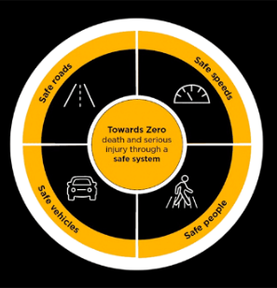
© State of New South Wales (Transport for NSW)
- State that the Safe System approach has been adopted by Transport for NSW to help achieve the ultimate goal of zero deaths and serious injuries on NSW roads. Safe roads, speeds, people and vehicles should work together to keep us safe while using our road system (TfNSW n.d.d). This approach is underpinned by the principles:
- people sometimes make mistakes – a simple mistake should not cost anyone their life
- roads, roadsides and vehicles need to be designed to minimise crashes or reduce forces if a crash happens
- road safety is a shared responsibility – everyone needs to make safe decisions on and around the road to prioritise safety (TfNSW n.d.d).
- Students watch the Safe System approach video on the Transport for NSW (2:02) website or on YouTube (2:01).
- Students reflect on the video using a Plus, Minus, Interesting (PMI) strategy (see Appendix 14).
- Highlight to students that strategies to explicitly address the safety of young people in the road traffic environment are mostly focused on the ‘Safe people’ component of the Safe System approach and include effective licensing, legislation, information and education to promote better choices on the road.
Students investigate and describe a range of strategies that have been implemented as part of the Safe System approach to reduce road trauma for young people such as:
- Licensing to support young people
- Graduated licence scheme (see Appendix 15)
- Driver licensing access program (DLAP)
- Legislation to protect young people
- Rules for Learner drivers, P1 drivers and P2 drivers. Consider speed limits, alcohol limits, mobile phone regulations, number of passengers, vehicle restrictions
- School zone regulations
- Bicycle helmet laws
- Information and education for young people
- Mandatory Road safety education for department schools as part of the Personal Development, Health and Physical Education K–10 Syllabus
- NSW Safer Drivers Course
- Transport for NSW marketing campaigns
- Re:act for change program – mobile phone and distraction campaigns designed by young people for young people
- Road safety awareness programs such as Wheelchair Sports NSW/ACT, Rotary Youth Driver Awareness (RYDA), Bstreetsmart (TfNSW 2024:36).
Note: students can research other strategies, including local initiatives.
- Students select 2 strategies and conduct research to determine the effectiveness of each strategy in reducing road trauma and improving young people’s health.
- Students use the Evaluation Criteria by the Organisation for Economic Co-operation and Development (OECD n.d.) to determine the effectiveness of each strategy
- relevance: is the intervention doing the right things?
- coherence: how well does the intervention fit?
- effectiveness: is the intervention achieving its objectives?
- efficiency: how well are resources being used?
- impact: what difference does the intervention make?
- sustainability: will the benefits last?
- Students reflect on their research to make a judgement about which strategy was more effective based on the criteria
Note: students should be encouraged to discuss the effectiveness of their strategies with other students using evaluative language such as:
- This strategy has been highly or moderately effective ...
- The strategy has had a significant, large or major impact on ...
- This strategy has played a valuable, pivotal or crucial role in ...
- The strategy has been effective to a certain extent ...

What new strategies would be most effective to improve young people’s health?
- Students rate the effectiveness of the following new strategies in reducing road trauma for young people on a scale of one to 5, with one as ‘highly effective’ and 5 as ‘not effective’. Students justify their ratings:
- adding 10 hours of driving in wet weather conditions to the logbook requirements (current requirements are 120 hours of driving, including 20 hours of nighttime driving)
- increasing the minimum age to get a provisional P1 licence (‘red Ps’) from 17 to 18
- recompleting and passing the Driver knowledge test (DKT) to progress from a P1 to P2 licence
- extending provisional P1 passenger restrictions to carrying no more than one passenger under the age of 21, at all times
- introducing a truck passenger Learner driver awareness program to gain perspectives and strategies for keeping safe when driving around trucks – Don’t #uck with a truck campaign (1:37)
- compulsory completion of the safer driver’s course, if funded by the government, before being permitted to go for a P1 licence
- government rebate for young drivers who purchase a vehicle with a 5-star Australasian New Car Assessment Program (ANCAP) or used car safety rating.
- Students propose one new strategy to reduce road trauma for young people. Students complete a SWOT analysis (see Appendix 16) to evaluate the effectiveness of their strategy by considering the strengths, weaknesses, threats and opportunities.
Students share their strategy with a partner for feedback.
Note: students requiring support may select a strategy listed in question 1.

What further research questions could be explored to build understanding and advocacy?
- Students define advocacy (consider syllabus glossary and World Health Organization definitions).
Advocacy definitions
Syllabus glossary definition – ‘advocate’ is the process of arguing in support of a cause or position or acting on behalf of yourself or another individual to ensure that your or others’ best interests are taken into account (NESA 2023).
World Health Organization (WHO) definition – ‘advocacy for health’ is a combination of individual and social actions designed to gain political commitment, policy support, social acceptance and systems support for a particular health goal or program. Advocacy is one of the three major strategies for health promotion and can take many forms including the use of the mass media and multi-media, direct political lobbying, and community mobilisation through, for example, coalitions of interest around defined issues (WHO n.d.).
- Students brainstorm and discuss examples of advocacy for road safety:
- mass media and multi-media: for example, Northern Beaches Council developed a behavioural change campaign ‘Know the e-bike code’ to encourage safe behaviour among young e-bike riders. They partnered with NSW Police, Bicycle NSW, bike shops and local schools. The social media campaign reached over 635,000 views (Northern Beaches Council n.d.).
- political lobbying: for example, advocating for seatbelts on NSW buses in regional areas following the 2023 Hunter Valley bus tragedy. This led to a Bus Industry Taskforce being put together by Transport for NSW and the NSW Government to examine safety management, seatbelt use and regulation. They have put forward recommendations to improve safety (NSW Government 2023).
- community mobilisation: for example, National Walk Safely to School Day, held during National Road Safety Week, is a community event seeking to promote road safety, health, public transport and the environment (Pedestrian Council of Australia 2025).
Note: other examples of advocacy for road safety may include:
Bicycle NSW – the peak advocacy body for bike riding in NSW who take action to influence decisions and systems, encouraging decision makers to invest in infrastructure and facilities that will help people to ride more and ride further (Bicycle NSW n.d.).
Australasian New Car Assessment Program (ANCAP) – an independent vehicle safety advocate, that provides consumers with information on vehicle safety and ratings. (ANCAP n.d.)
Australian Road Safety Foundation – a not-for-profit organisation dedicated to reducing the impacts of road trauma and saving lives through awareness programs, education, advocacy and community engagement, such as Rural Road Safety Month and Fatality Free Friday (ARSF n.d.).
Students could focus their research on organisations that advocate for road safety in their local area or region.
- As a class, discuss gaps in knowledge regarding young people and road trauma – What information don’t we know or would like to know?
- Students join with a partner and use the Question formulation technique (QFT) – Think-Pair-Share (see Appendix 17) to come up with questions that could be researched and explored to build understanding of and advocacy for road safety.
- Brainstorm as many questions as they can (step 1). Rules
- Ask as many questions as you can.
- Do not stop to judge, discuss, edit or answer any question.
- Write down every question precisely as it is asked.
- Turn every statement into a question.
- Share their questions with their partner and formulate 5 new and improved questions (step 2).
- As a class, group similar questions into themes and draw conclusions about what further research could be conducted to build understanding of and advocacy for road safety.

Check for understanding
- Students reflect on their learning in relation to the success criteria by asking if they can:
- define key road trauma terms
- interpret road trauma data by age group, gender, Indigenous status, injury severity, geographic location, road user and licence holder type to determine trends
- explore the burden of road trauma and explain the impact on young people's health
- outline protective factors that can prevent road trauma
- describe road safety strategies and analyse their effectiveness in improving young people’s health
- propose research questions that could help build understanding of and advocacy for road safety.
Note: the reflection can be conducted in a variety of ways, for example: written reflection in workbook, completion of a form or survey, responding on an exit ticket, small group discussion, completion of a mind map summary.
- Optional – students reflect on what they have learned about regarding young people and road safety and complete the ‘I used to think... Now I think...’ thinking routine. As a class, discuss how and why thinking has changed or not changed.
Formative assessment opportunity – outcomes HM-11-01 and HM-11-02
Students individually write an answer to the following exam-style question:
Choose ONE health-related issue for young people.
- What does the data tell us about this health issue? (3 marks)
- Explain how TWO strategies have been implemented to improve the health of young people. (5 marks)
Marking criteria
- What does the data tell us about this health issue? (3 marks)
Table 1 – marking criteria for exam-style question (a)
Criteria | Marks
- Describes what the data tells us about a health issue affecting young people in Australia  - Provides examples | 3
- Outlines what the data tells us about a health issue affecting young people in Australia | 2
- Provides some relevant information about a health issue | 1
Sample answer
In Australia, land transport crashes are the second leading cause of death for 15 to 24-year-olds. This age group also has the highest rate of injury hospitalisations and deaths, with males being overrepresented in the data. The hospitalisation rate also increases with remoteness and for Indigenous Australians.
In NSW, young drivers make up 15% of all licence holders but represent almost 25% of road fatalities each year. P-platers, in their first year of unsupervised driving, are 8 times more likely than a learner driver to be involved in a casualty crash. Additionally, young males are more likely to be seriously injured and killed as drivers, passengers, motorcyclists, pedestrians and pedal cyclists than females.
Marking criteria
- Explain how TWO strategies have been implemented to improve the health of young people. (5 marks)
Table 2 – marking criteria for exam-style question (b)
Criteria | Marks
- Provides a detailed explanation of how TWO strategies have been implemented to improve a health issue affecting young people  - Provides relevant examples | 5
- Provides a sound explanation of how TWO strategies have been implemented to improve a health issue affecting young people  - Provides relevant examples | 4
- Outlines how TWO strategies have been implemented to improve a health issue affecting young people  OR  - Describes TWO strategies that have been implemented to improve a health issue affecting young people  - Provides example(s) | 3
- Outlines strategy(ies) that have been implemented to improve the health of young people | 2
- Provides some relevant information | 1
Sample answer
Strategies to explicitly address the safety of young people in the road traffic environment are focused on effective licencing, legislation, information and education.
The graduated licensing scheme was introduced in NSW in 2000. It is designed to reduce the extent of crash involvement among young drivers by providing a staged approach to driver licensing to build knowledge, experience and confidence.
The first stage is the Learner Licence. Applicants must be at least 16 years old and pass a knowledge test. Learners are then required to complete a minimum of 120 hours of supervised driving, including 20 hours of night driving, that must be recorded in a logbook.
After 12 months, drivers can apply for a Provisional Licence and must pass a driver’s test. This stage includes a P1 licence for 12 months and then a P2 licence for 24 months before applying for a full licence. Provisional licence holders have restrictions on speed limits, passenger limits, mobile phone use and the driving of high-powered vehicles.
The scheme has been successful in providing young drivers with increased supervised driving hours that provides them with greater opportunity to be exposed to a range of road environments and driving conditions that enhance confidence and competence. Furthermore, stricter regulations that maximise safety have led to the reduction of casualty and fatality crashes among young drivers.
Mandatory PDHPE K–10 teaching and learning ensures that all students across NSW are receiving road safety education as part of the safety context within the curriculum. Students learn about major causal factors in road and traffic-related injuries and assess the strategies and actions to promote their own and others’ health, safety and wellbeing, for example, minimising distractions such as music and mobile phones and identifying a designated driver.
Students also propose and practise a range of realistic responses to road-use scenarios where peers are encouraging them to behave in unsafe ways. Through this, students have the opportunity to develop and apply both interpersonal and self-management skills, such as communication and decision-making skills to empower them to be safer road users, both now and into the future.
These two strategies have significantly reduced road trauma and the health of young people; however, young drivers remain as the most overrepresented group of drivers involved in crashes on NSW roads, and further education and advocacy is needed to support the goal of zero road trauma.

Appendix 1 – brainstorming template
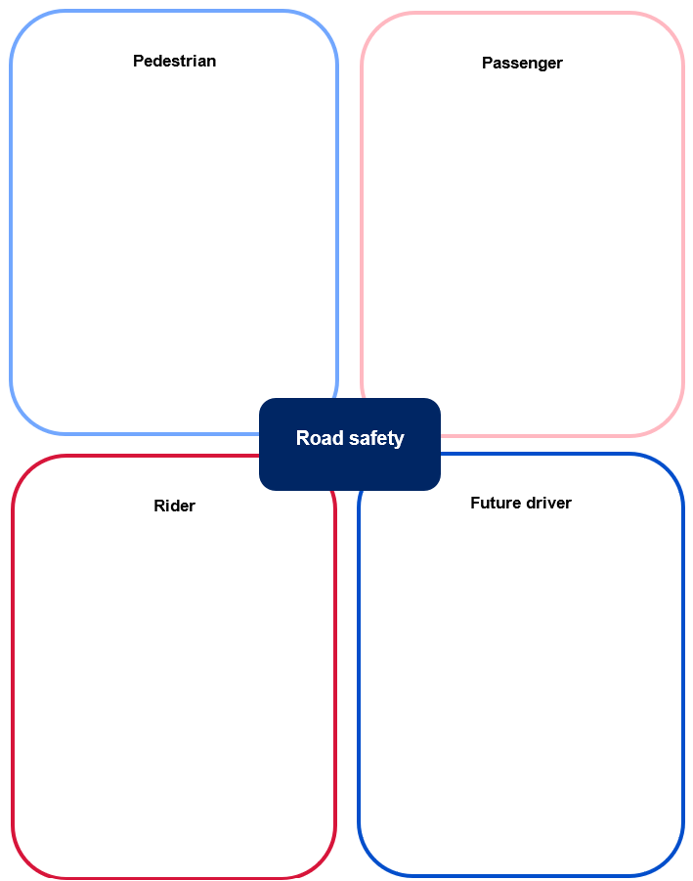

Appendix 2 – leading underlying causes of death by age
Leading underlying causes of death in Australia, by age group in 2023.
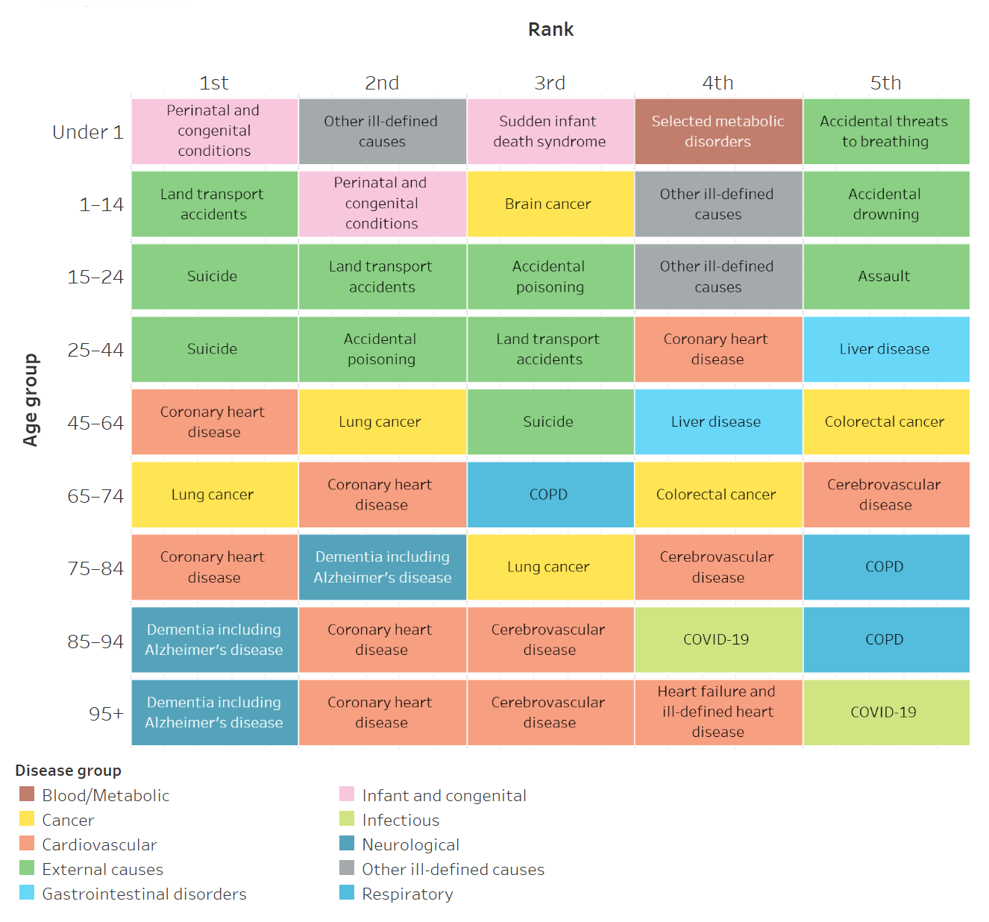
Source: Australian Institute of Health and Welfare

Appendix 3 – transport accidents – age and sex
Rates (per 100,000) of transport injury hospitalisation by type of injury, age, sex over the past decade in Australia.
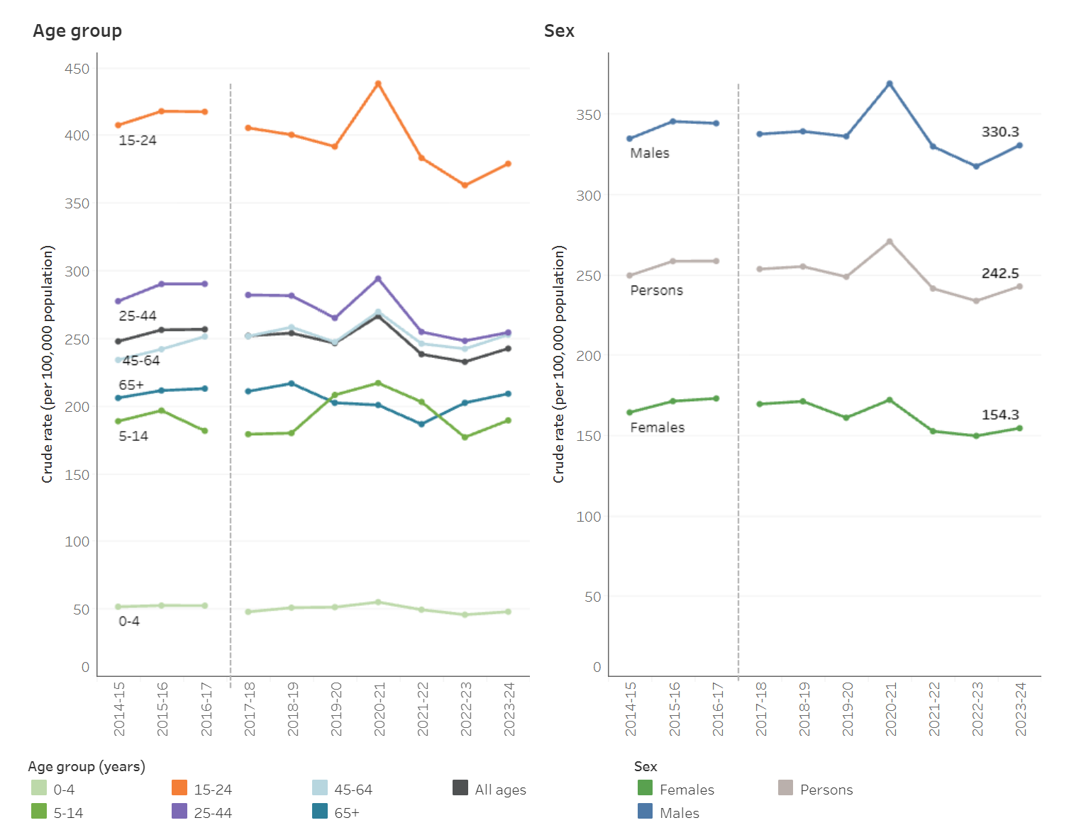
Source: Australian Institute of Health and Welfare

Rates (per 100,000) of transport injury deaths by type of injury, age, sex over the past decade in Australia.
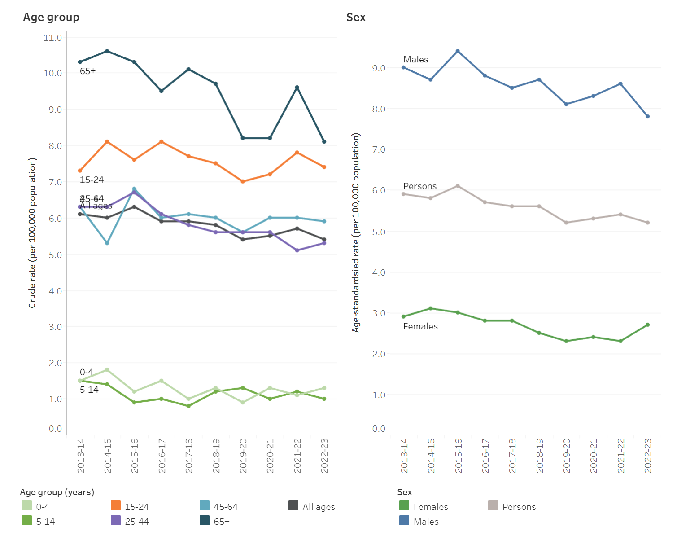
Source: Australian Institute of Health and Welfare

Appendix 4 – transport accidents – First Nations people
Number and crude rate (per 100,000) of transport injury hospitalisations among First Nations people by age and sex in Australia, 2022–23.
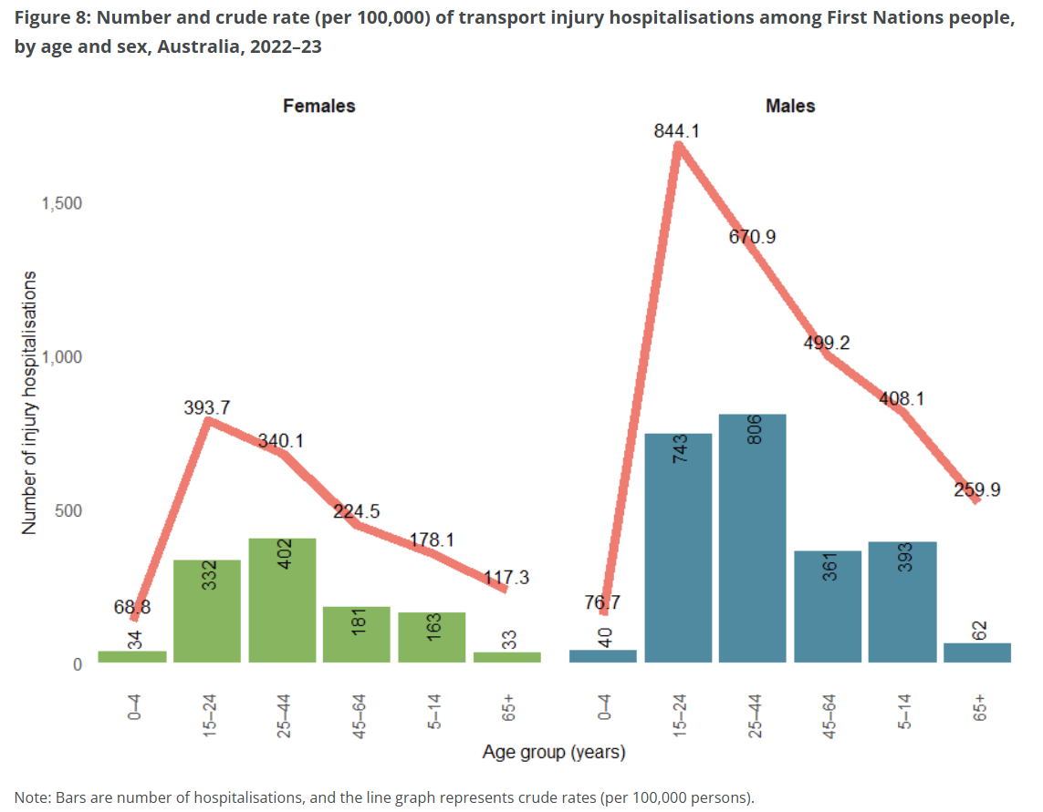
Source: Australian Institute of Health and Welfare

Crude rates of transport injury hospitalisations, by indigenous status and age group, Australia, 2023–24.
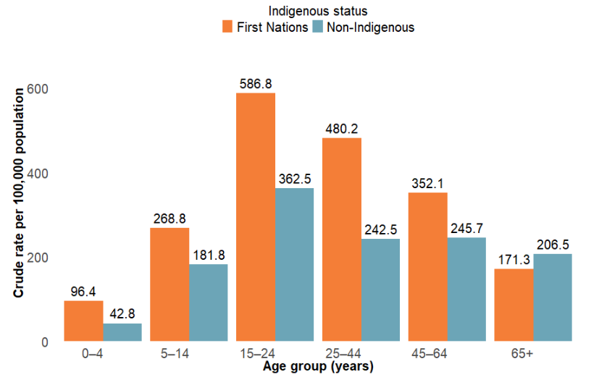
Source: Australian Institute of Health and Welfare

Appendix 5 – transport accidents – remoteness
Age-standardised rates (per 100,000) of transport injury hospitalisations by remoteness, type of transport over the past decade in Australia.
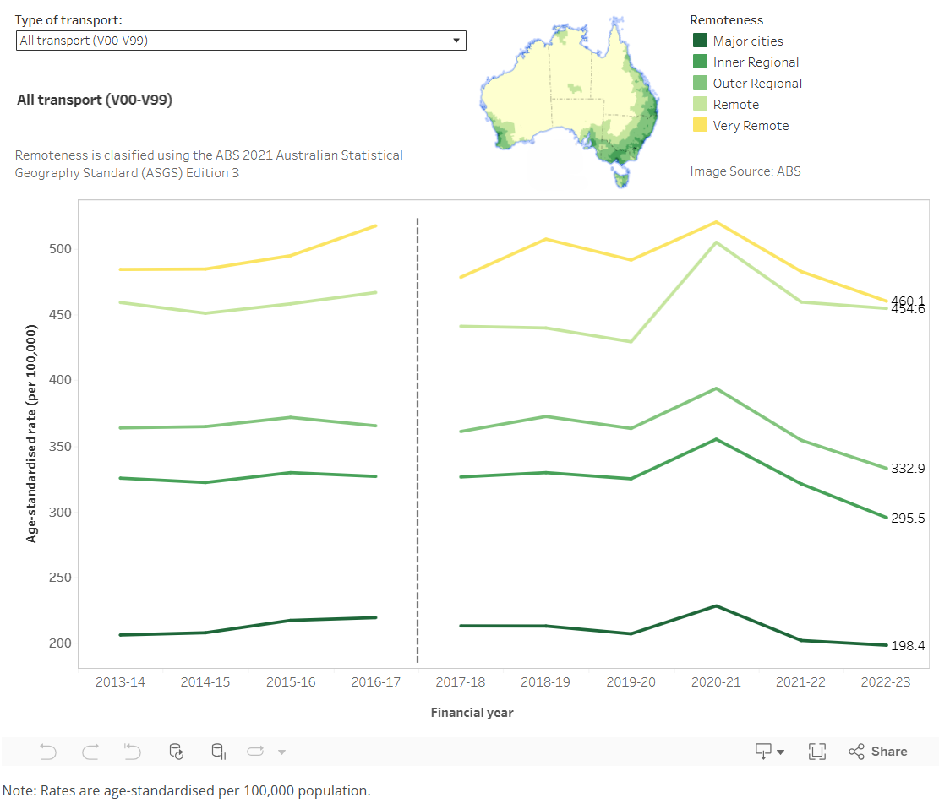
Source: Australian Institute of Health and Welfare

Appendix 6 – road users by gender
Casualty severity: seriously injured
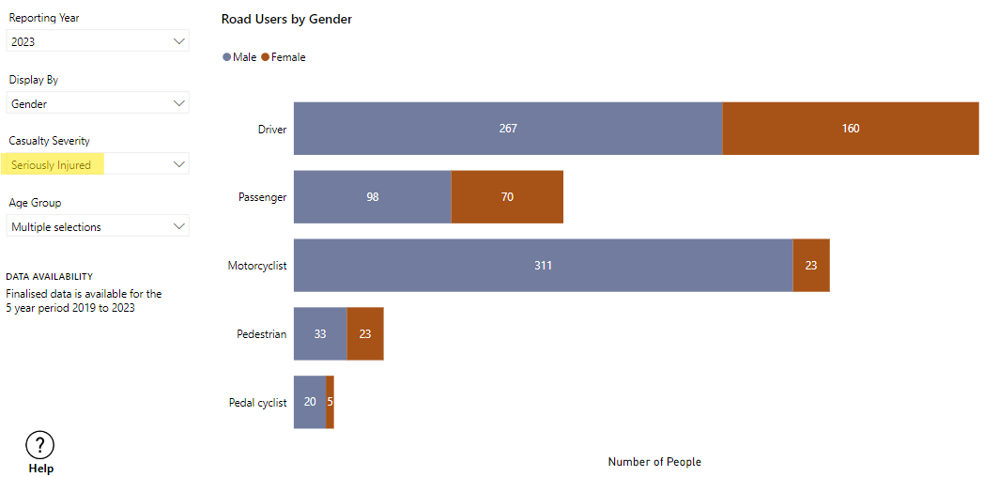
Casualty severity: killed
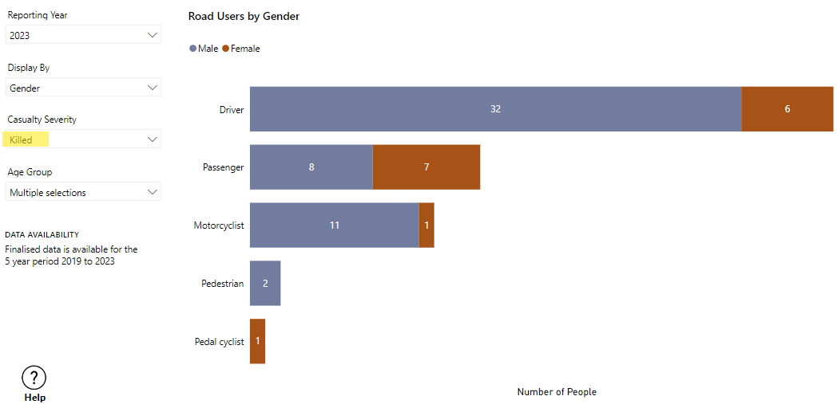
© State of New South Wales (Transport for NSW)

Appendix 7 – road users by urbanisation group
Casualty severity: seriously injured
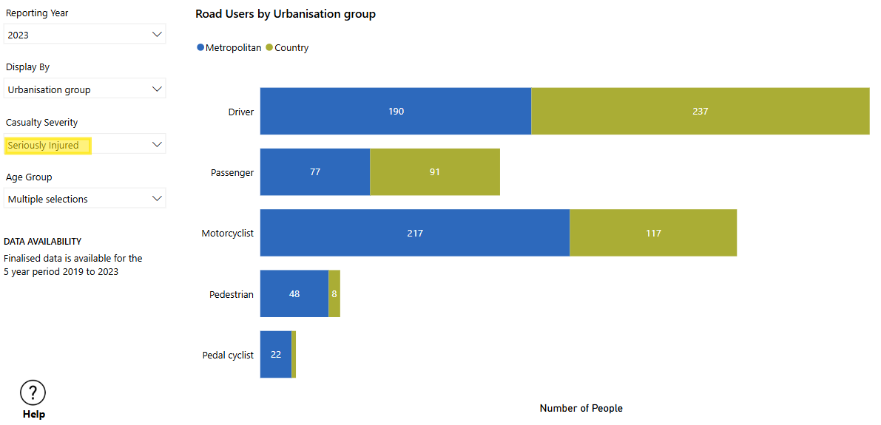
Casualty severity: killed
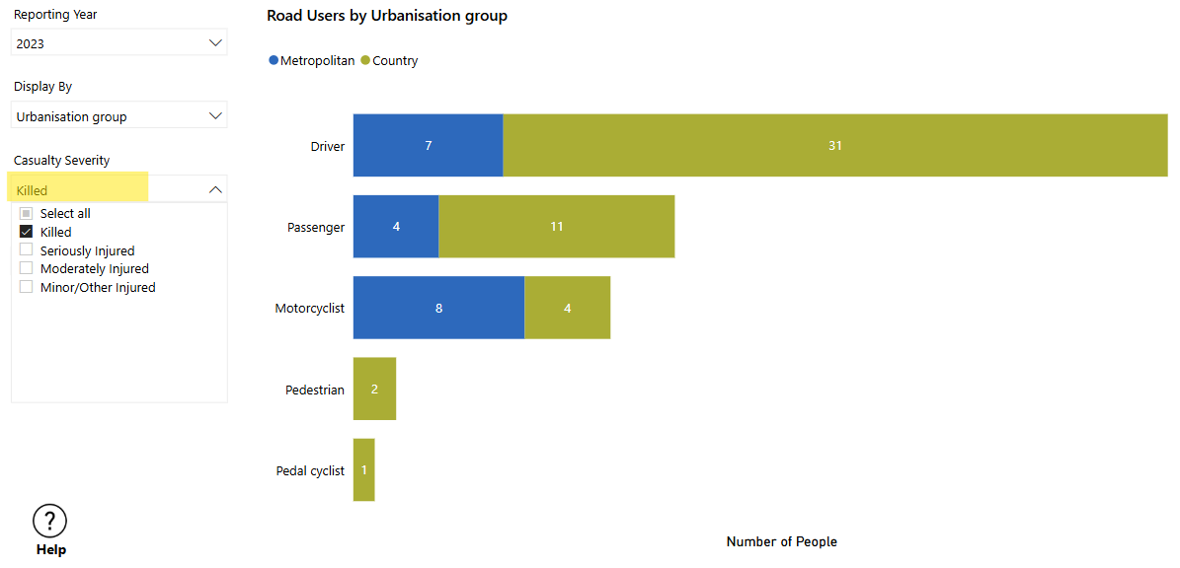
© State of New South Wales (Transport for NSW)

Appendix 8 – Learner, P1 and P2 driver casualty crashes
Road User Handbook (page 31)
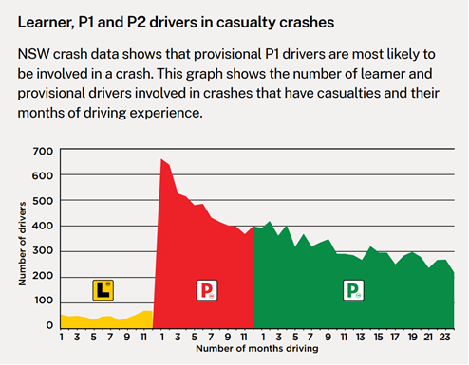
© State of New South Wales

Appendix 9 – disease or injury-specific summary of disease burden in Australia
Road traffic injuries – motor vehicle occupants
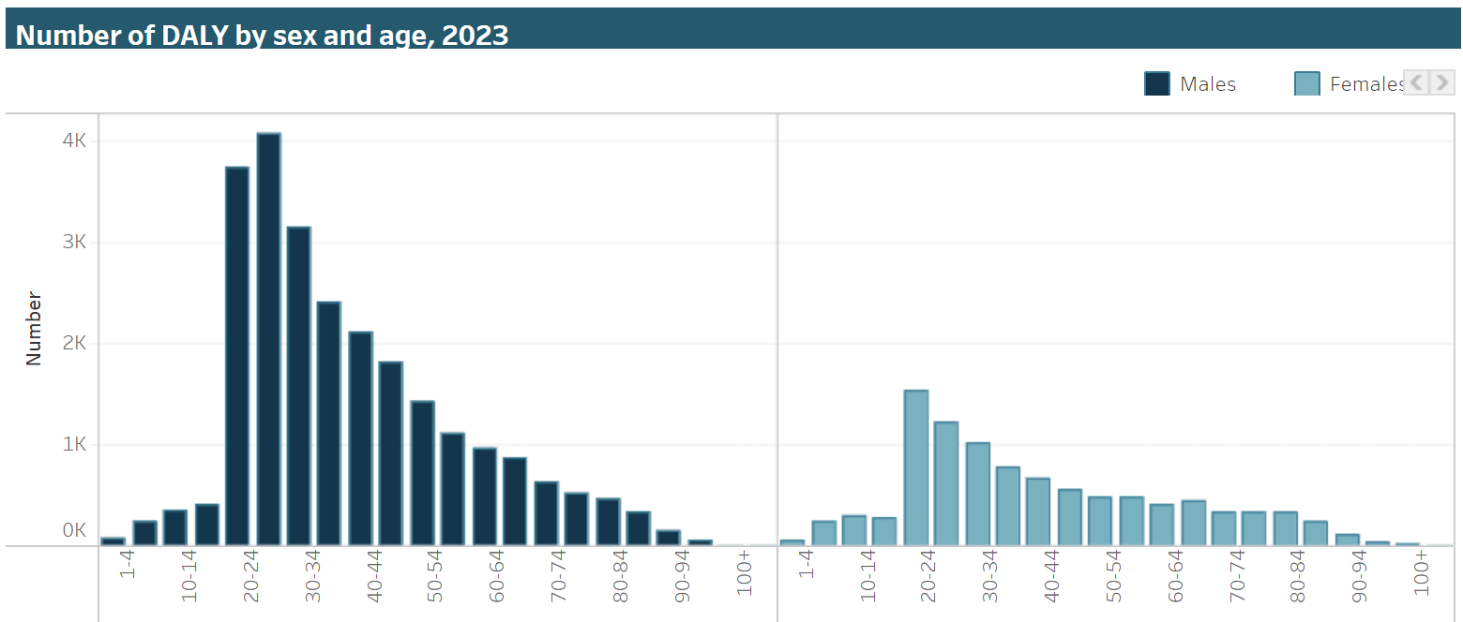
Road traffic injuries – motorcyclists
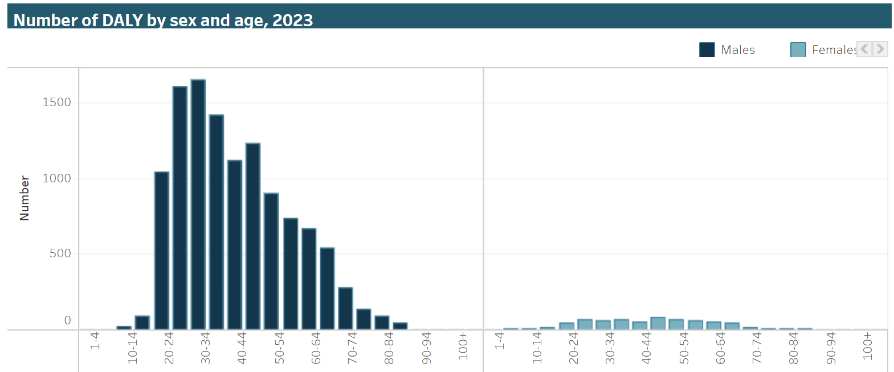

Road traffic injuries – pedal cyclists
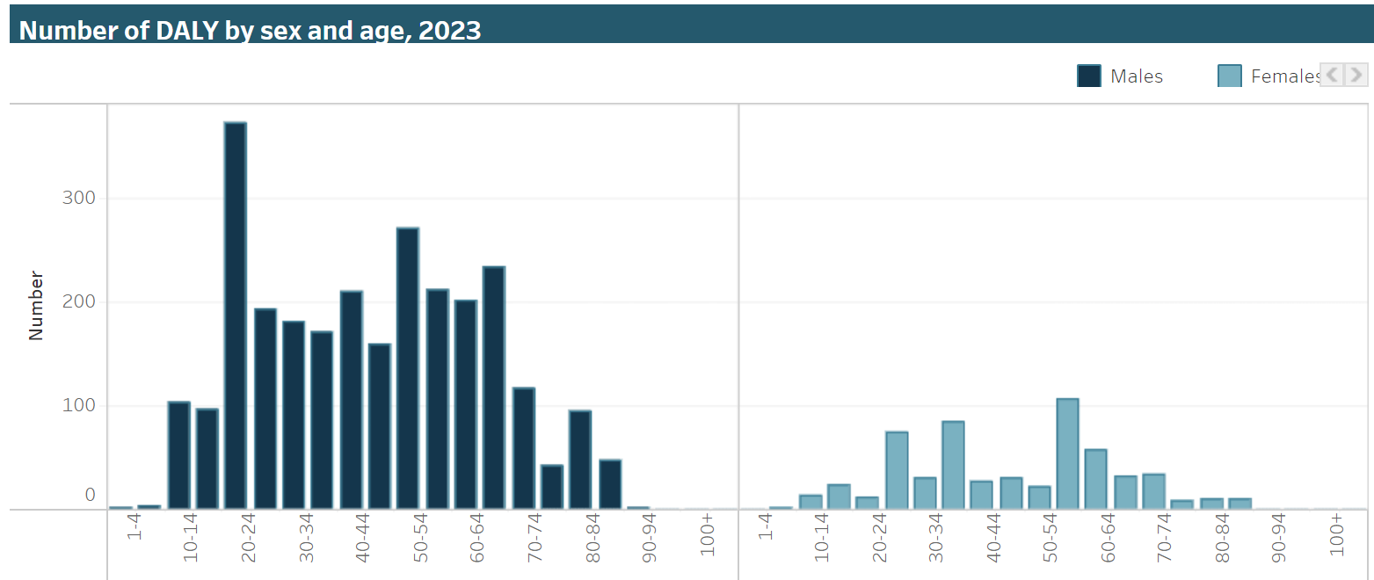
Road traffic injuries – pedestrians
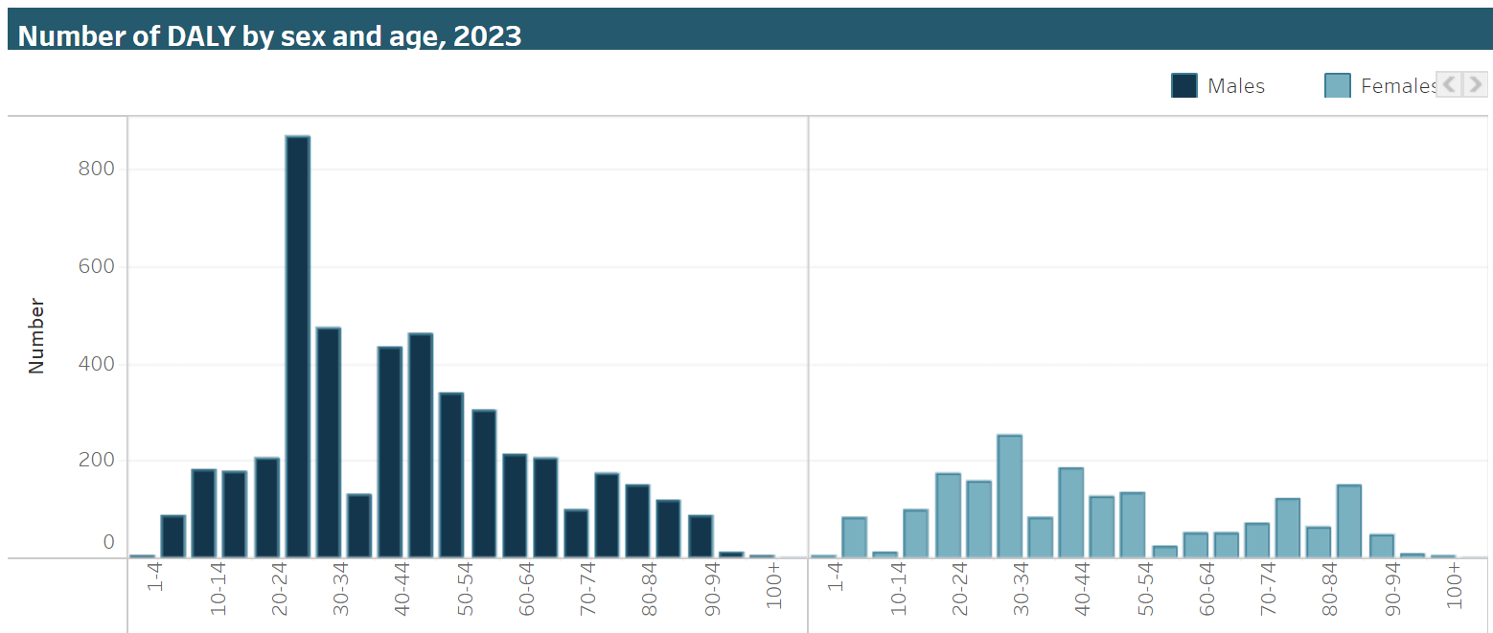
Source: Australian Institute of Health and Welfare

Appendix 10 – What injuries occur?
Transport injury hospitalisations by main body part injured in 2022–23.
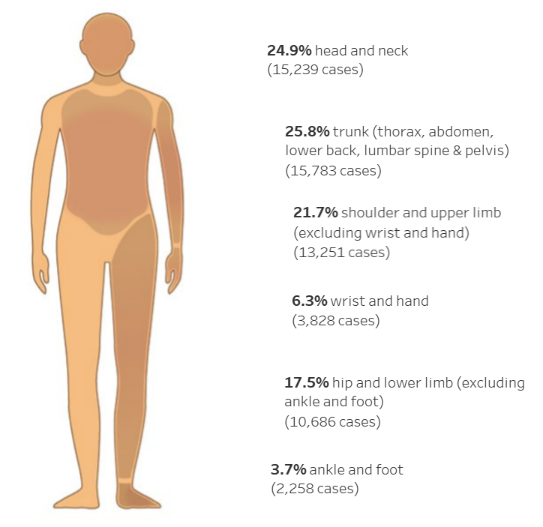
Source: Australian Institute of Health and Welfare
Age-standardised rate (per 100,000) of transport injury hospitalisations by type of injury and body part injured in Australia in 2022–23.
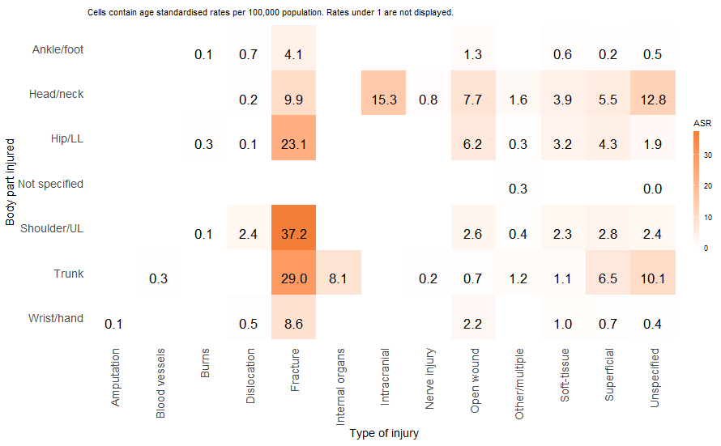
Source: Australian Institute of Health and Welfare

Appendix 11 – cost of road trauma
Cost of road trauma summary report (page 9).
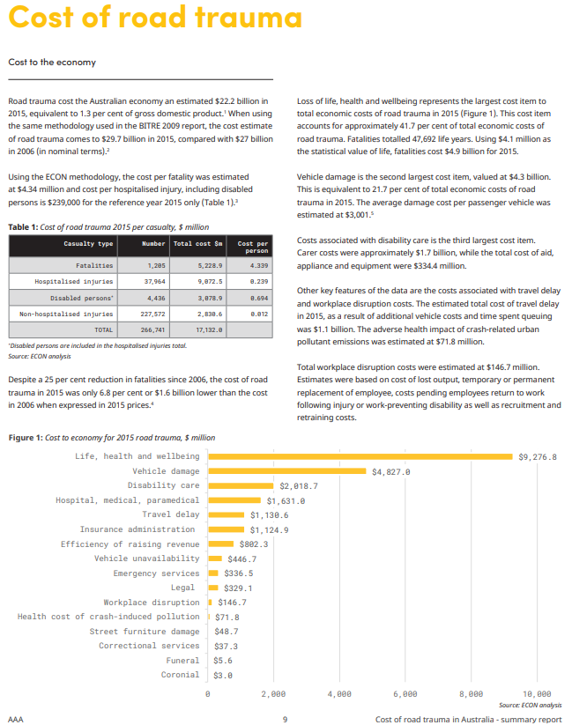
‘Summary Report – Cost of Road Trauma in Australia’ by Australian Automobile Association (AAA) is licensed under AAA Terms & Conditions.

Appendix 12 – See Think Wonder template
 | I see ...
 | I think ...
 | I wonder ...

Appendix 13 – young drivers or riders involved in fatal crashes
Road User Handbook (page 30)
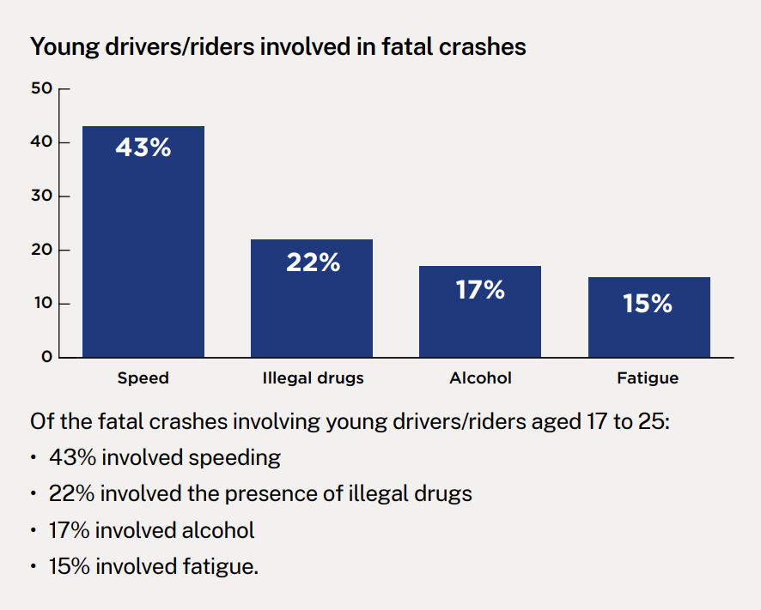
© State of New South Wales

Appendix 14 – Plus, Minus, Interesting (PMI) template
Plus

Minus

Interesting


Appendix 15 – graduated licence scheme
Road User Handbook (page 8)
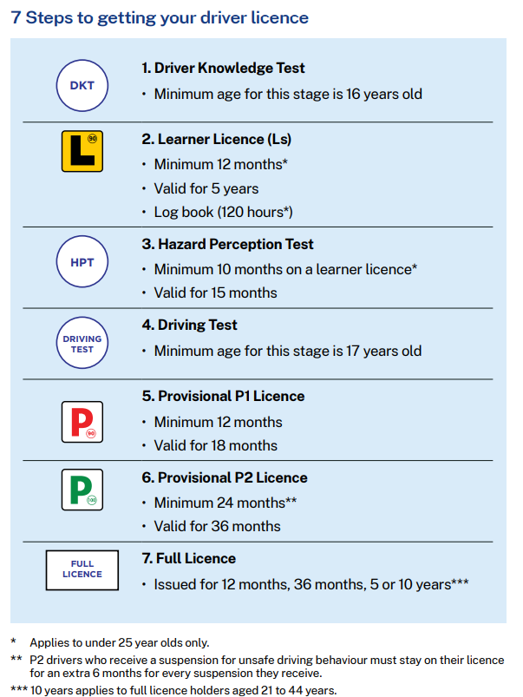
© State of New South Wales

Appendix 16 – SWOT analysis template
Strengths | Weaknesses
Opportunities | Threats

Appendix 17 – question formulation technique – Think-Pair-Share template
My questions about the topic
My partner’s questions about the topic
Our top 5 improved questions about the topic

Additional information
The information below can be used to support teachers when using this teaching resource for Health and movement science.

Support and alignment
Resource evaluation and support: all curriculum resources are prepared through a rigorous process. Resources are periodically reviewed as part of our ongoing evaluation plan to ensure currency, relevance and effectiveness. For additional support or advice, or to provide feedback, contact the Road Safety Education team by emailing RoadSafetyED@det.nsw.edu.au.
Differentiation: further advice to support Aboriginal and/or Torres Strait Islander students, students learning English as an additional language or dialect (EAL/D), students with a disability and/or additional needs and high potential and gifted students can be found on the Planning, programming and assessing 7–12 webpage. This includes the Inclusion and differentiation advice 7–10 webpage.
Assessment: further advice to support formative assessment is available on the Planning, programming and assessing 7–12 webpage. This includes the Classroom assessment advice 7–10. For summative assessment tasks, the Assessment task advice 7–10 webpage is available.
Explicit teaching: further advice to support explicit teaching is available on the Explicit teaching webpage. This includes the CESE Explicit teaching – Driving learning and engagement webpage.
Alignment to system priorities and/or needs: School Excellence Policy, Our Plan for NSW Public Education
Alignment to the School Excellence Framework: this resource supports the School Excellence Framework elements of curriculum (curriculum provision) and effective classroom practice (lesson planning, explicit teaching).
Alignment to Australian Professional Standards for Teachers: this resource supports teachers to address Proficient Teacher Standard Descriptors 3.2.2, 3.3.2.
Consulted with: subject matter experts
NSW syllabus: Health and Movement Science 11–12 Syllabus
Syllabus outcomes: HM-11-01, HM-11-02, HM-11-10
Author: Road Safety Education team
Publisher: State of NSW, Department of Education
Resource: Learning program
Related resources: further resources to support health and movement science Stage 6 can be found on the Planning, programming and assessing PDHPE 11–12 curriculum webpage.
Professional learning: relevant professional learning is available through the PDHPE statewide staffroom.
Creation date: 28 July 2025
Rights: © State of New South Wales, Department of Education.

References
This resource contains NSW Curriculum and syllabus content. The NSW Curriculum is developed by the NSW Education Standards Authority. This content is prepared by NESA for and on behalf of the Crown in right of the State of New South Wales. The material is protected by Crown copyright.
Please refer to the NESA Copyright Disclaimer for more information https://educationstandards.nsw.edu.au/wps/portal/nesa/mini-footer/copyright.
NESA holds the only official and up-to-date versions of the NSW Curriculum and syllabus documents. Please visit the NSW Education Standards Authority (NESA) website https://educationstandards.nsw.edu.au and the NSW Curriculum website https://curriculum.nsw.edu.au.
Health and Movement Science 11–12 Syllabus © NSW Education Standards Authority (NESA) for and on behalf of the Crown in right of the State of New South Wales, 2023.
AAA (Australian Automobile Association) (2017) Summary Report –Cost of Road Trauma in Australia, AAA, National Road safety Partnership Program, accessed 3 March 2025.
AIHW (Australian Institute of Health and Welfare) (2023a) ‘Deaths in Australia’, Life expectancy & deaths Series, AIHW, Australian Government, accessed 6 April 2025.
——(2023b) ‘Transport accidents’, Injury in Australia Series, AIHW, Australian Government, accessed 4 March 2025.
——(2023c) ‘Australian Burden of Disease Study 2023’, Burden of disease, AIHW, Australian Government, accessed 4 March 2025.
——(2024a) ‘Health of Young People’, Children & youth, AIHW, Australian Government, accessed 7 February 2025.
——(2024b) ‘Risk factors: Glossary’, Behaviours & risk factors, AIHW, Australian Government, accessed 7 February 2025.
ANCAP (Australasian New Car Assessment Program) (n.d.) ANCAP car safety [website], accessed 15 May 2025.
ARSF (Australian Road Safety Foundation) (n.d.) Australian Road Safety Foundation [website], accessed 9 July 2025.
Bicycle NSW (n.d.) Advocacy, Bicycle NSW website, accessed 15 May 2025.
CARRS-Q (Centre for Accident Research & Road Safety – Queensland) (2020) ‘Young drivers Fact Sheet’, CARRS-Q, QUT (Queensland University of Technology), accessed 3 March 2025.
National Road Safety Strategy (n.d.) ‘Fact sheet: Remote road safety’, National Road Safety Strategy 2021 – 30 fact sheets, National Road Safety Strategy website, accessed 3 March 2025.
NESA (NSW Education Standards Authority) (2023) ‘Glossary’, Health and Movement Science 11–12 Syllabus, NSW Curriculum website, accessed 9 July 2025.
NHVR (National Heavy Vehicle Regulator) (n.d.) Don’t Muck with a Truck, NHVR website, accessed 6 April 2025.
NRSPP (National Road Safety Partnership Program) (2018) ‘Road Trauma and Young Drivers – Does Gender Make a Difference?’, NRSPP, accessed 7 April 2025.
Northern Beaches Council (n.d.) ‘Discover how Council is helping shape e-bike safety’, E-bike safety, Northern Beaches Council website, accessed 9 April 2025.
NSW Government (21 June 2023) Bus Industry Taskforce to broaden remit to look at bus safety and seatbelts [media release], NSW Government, accessed 4 April 2025.
OECD (Organisation for Economic Co-operation and Development) (n.d.) ‘Evaluation Criteria’, Development co-operation evaluation and effectiveness, OECD website, accessed 9 April 2025.
Pedestrian Council of Australia (2025) National Walk Safely to School Day, Pedestrian Council of Australia website, accessed 8 April 2025.
President and Fellows of Harvard College and Harvard Graduate School of Education (n.d.) PZ’s Thinking Routines Toolbox, Project Zero website, accessed 4 March 2025.
President and Fellows of Harvard College and Harvard Graduate School of Education (2015) ‘Circle of Viewpoints’, PZ’s Thinking Routines Toolbox, Project Zero website, accessed 3 March 2025.
Re:act for Change (2024) 2024 Australia: Mobile phones and distraction, Re:act for Change website, accessed 7 April 2025.
Roads and Maritime Services (2024) ‘Vehicle safety features’, Vehicle safety and compliance, NSW Government website, accessed 8 April 2025.
Road Trauma Support Group NSW (2023) Australian Road Crash Reporting Guidelines: Responsible Reporting, Road Trauma Support Group NSW website, accessed 25 February 2025.
Road Trauma Support Group NSW (2024) ‘The human impact of fatal road crimes in NSW’, Advocacy & Research, Road Trauma Support Group NSW website, accessed 7 April 2025.
State of New South Wales (Department of Education [DoE]) (n.d.) Digital Learning Selector, NSW Department of Education website, accessed 10 April 2025.
——(2024a) ‘PDHPE K–10 syllabus – Road safety education – explicit content’, NSW Department of Education, accessed 3 March 2025.
——(2024b) ‘Road safety discussion points for high school students’, NSW Department of Education, accessed 3 March 2025.
——(2025a) Numeracy teaching advice guide: Interpreting column graphs, Universal Resources Hub website, accessed 12 March 2025.
——(2025b) Numeracy teaching advice guide: Interpreting line graphs in PDHPE, Universal Resources Hub website, accessed 12 March 2025.
TfNSW (Transport for NSW) (n.d.a) ‘Statistics’, Centre for Road Safety, TfNSW website, accessed 3 March 2025.
——(n.d.b) ‘Road user by gender or region’, NSW Centre for Road Safety: Interactive crash statistics, TfNSW website, accessed 2 April 2025.
——(n.d.c) ‘Road User Handbook’, TfNSW, NSW Government, accessed 6 February 2025.
——(n.d.d) ‘Safe System approach’, NSW Centre for Road Safety: What we do, TfNSW website, accessed 7 March 2025.
——(n.d.e) ‘Driver Licences’, Driver and rider licences, NSW Government website, accessed 7 March 2025.
——(n.d.f) ‘Driver Licencing Access Program (DLAP)’, Driver Licences, NSW Government website, access 7 March 2025.
——(n.d.g) ‘School zones’, NSW Centre for Road Safety: Schools, TfNSW website, accessed 28 April 2025.
——(n.d.h) ‘Wearing the right cycling safety gear’, Safety and rules for bicycle riders, NSW Government website, accessed 12 May 2025.
——(n.d.i) ‘NSW Safer Drivers Course’, Learner driver licence¸ NSW Government website, accessed 7 March 2025.
——(n.d.j) ‘Marketing Campaigns’, NSW Centre for Road Safety: Resources, TfNSW website, accessed 2 April 2025.
——(n.d.k) ‘Safety rules for bicycle riders’, Safety and rules on NSW roads, NSW Government website, accessed 12 May 2025.
——(n.d.l) ‘Serious injuries’, NSW Centre for Road Safety: Statistics, TfNSW website, accessed 17 February 2025.
——(2023) ‘2026 Road Safety Action Plan’, TfNSW, accessed 17 February 2025.
——(2024) ‘NSW Road Safety Progress Report 2023’, TfNSW, accessed 9 April 2025
WHO (World Health Organization) Regional office for South-East Asia (n.d.) ‘Health promotion’, Health topics, WHO Regional Office for South-East Asia website, accessed 6 April 2025.

© State of New South Wales (Department of Education), 2023
The copyright material published in this resource is subject to the Copyright Act 1968 (Cth) and is owned by the NSW Department of Education or, where indicated, by a party other than the NSW Department of Education (third-party material).
Copyright material available in this resource and owned by the NSW Department of Education is licensed under a Creative Commons Attribution 4.0 International (CC BY 4.0) license.

This license allows you to share and adapt the material for any purpose, even commercially.
Attribution should be given to © State of New South Wales (Department of Education), 2023.
Material in this resource not available under a Creative Commons license:
- the NSW Department of Education logo, other logos and trademark-protected material
- material owned by a third party that has been reproduced with permission. You will need to obtain permission from the third party to reuse its material.
Links to third-party material and websites
Please note that the provided (reading/viewing material/list/links/texts) are a suggestion only and implies no endorsement, by the New South Wales Department of Education, of any author, publisher, or book title. School principals and teachers are best placed to assess the suitability of resources that would complement the curriculum and reflect the needs and interests of their students.
If you use the links provided in this document to access a third-party's website, you acknowledge that the terms of use, including licence terms set out on the third-party's website apply to the use which may be made of the materials on that third-party website or where permitted by the Copyright Act 1968 (Cth). The department accepts no responsibility for content on third-party websites.

