Child Studies (Years 7–10) – sample scope and sequence
100-hour – option B
Contents
Rationale 2
Child Studies (Years 7–10) – 100-hour annual overview 3
Child Studies (Years 7–10) – 100-hour scope and sequence – option B 4
Option B – working with young children birth to 5 years 4
Support and alignment 10
References 11

Rationale
All NSW public schools need to plan curriculum and develop teaching programs consistent with the Education Act 1990 (NSW) and the NSW Education Standards Authority (NESA) syllabuses and credentialing requirements.
Scope and sequences form part of the ongoing documentation or evidence schools maintain to comply with the department’s policy, policy standards and registration requirements.
Developing a robust scope and sequence has many benefits and may help teachers and schools to:
- promote high expectations for student learning
- identify opportunities for explicit teaching
- create opportunities for students to receive feedback on their learning
- systematically plan for and undertake assessment
- differentiate curriculum delivery to meet the needs of students at different levels of achievement
- collaborate with other teachers to plan for quality teaching and learning.
This resource has been developed to assist teachers in NSW Department of Education schools to create learning that is contextualised to their classroom. It can be used as a basis for the teacher’s own program, assessment, or scope and sequence, or be used as an example of how the new curriculum could be implemented. The resource has suggested timeframes that may need to be adjusted by the teacher to meet the needs of their students.

Child Studies (Years 7–10) – 100-hour annual overview
Figure 1 – working with young children birth to 5 years – option B – annual overview
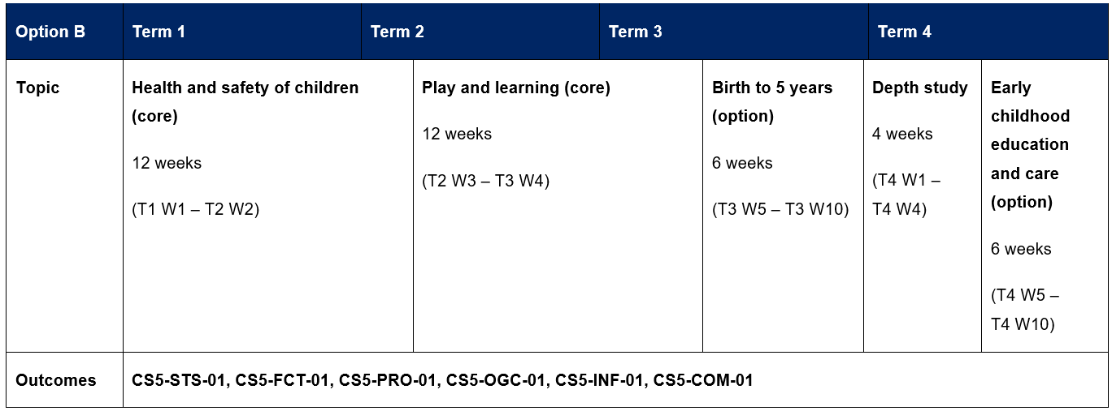
Child Studies 7–10 Syllabus © NSW Education Standards Authority (NESA) for and on behalf of the Crown in right of the State of New South Wales, 2025.

Child Studies (Years 7–10) – 100-hour scope and sequence – option B
Note: this scope and sequence provides an example of how the content of the Child Studies 7–10 Syllabus (NESA 2025) can be organised. The document includes sample assessment tasks, resources and assessment support designed to complement teaching and learning programs. Schools are best placed to develop an assessment schedule that aligns with assessment principles and suits their unique context. It is encouraged that schools adopt and adapt the details of this document to best meet their needs.

Option B – working with young children birth to 5 years
Table 1 – Child Studies Stage 5 (Year 10) – 100-hour scope and sequence – option B
Term and duration | Learning overview | Outcomes | Assessment
Terms 1 and 2  12 weeks | Health and safety of children (core)  This unit explores the health and safety needs of children and the systems that support their wellbeing. Students will learn about screening programs and immunisations as vital strategies for prevention and early detection. They will explore common childhood diseases, illnesses and conditions, and consider the impact these can have on children and their families. The role of health services and community resources in promoting and protecting child health will be investigated. Students develop an understanding of preventative health measures and the importance of medical care to ensure the safety and healthy development of children. | CS5-STS-01 examines and describes key stages of child growth and development  CS5-FCT-01 analyses the factors that contribute to child growth, development and care  CS5-PRO-01 investigates and applies strategies for promoting the growth, development and care of children  CS5-OGC-01 explains the role of organisations and communities in supporting the growth, development and care of children  CS5-INF-01 evaluates information and services relating to child growth, development and care  CS5-COM-01 communicates information about child growth, development and care for a range of purposes, audiences and contexts | Suggested formative assessment is outlined throughout this teaching and learning program.
Terms 2 and 3  12 weeks | Play and learning (core)  This unit explores the vital role of play in children’s growth, learning and development. Students investigate how play supports creativity, problem solving and social skills, as well as its role in early education. They examine different approaches to educating children within schools and early learning settings, focusing on inclusive practices that support children with diverse needs. Through observation, reflection and practical activities, students gain insight into how play and learning environments nurture the development of all children. | CS5-STS-01 examines and describes key stages of child growth and development  CS5-FCT-01 analyses the factors that contribute to child growth, development and care  CS5-PRO-01 investigates and applies strategies for promoting the growth, development and care of children  CS5-OGC-01 explains the role of organisations and communities in supporting the growth, development and care of children  CS5-INF-01 evaluates information and services relating to child growth, development and care  CS5-COM-01 communicates information about child growth, development and care for a range of purposes, audiences and contexts | This teaching and learning program has an associated summative assessment task.
Terms 3 and 4  6 weeks | Birth to 5 years (option)  This unit explores the critical early years of a child’s life, emphasising the importance of a strong start. Students explore developmental milestones and propose strategies to support children’s growth, health and wellbeing during this formative period. The unit also highlights the role of families, carers and communities in nurturing healthy development. | CS5-STS-01 examines and describes key stages of child growth and development  CS5-FCT-01 analyses the factors that contribute to child growth, development and care  CS5-PRO-01 investigates and applies strategies for promoting the growth, development and care of children  CS5-OGC-01 explains the role of organisations and communities in supporting the growth, development and care of children  CS5-INF-01 evaluates information and services relating to child growth, development and care  CS5-COM-01 communicates information about child growth, development and care for a range of purposes, audiences and contexts | Suggested formative assessment is outlined throughout this teaching and learning program.
Term 4  4 weeks | Student-directed depth study  Students will select a specific topic related to the health, safety or developmental needs of children from birth to 5 years. They will conduct an in-depth investigation into their chosen topic, exploring how it supports children’s growth and development through health practices, play or early learning environments. The study will culminate in a presentation and a written report demonstrating their understanding and insights. | CS5-STS-01 examines and describes key stages of child growth and development  CS5-FCT-01 analyses the factors that contribute to child growth, development and care  CS5-PRO-01 investigates and applies strategies for promoting the growth, development and care of children  CS5-OGC-01 explains the role of organisations and communities in supporting the growth, development and care of children  CS5-INF-01 evaluates information and services relating to child growth, development and care  CS5-COM-01 communicates information about child growth, development and care for a range of purposes, audiences and contexts | This teaching and learning program has an associated summative assessment task, involving a student-directed depth study.
Term 4  6 weeks | Early childhood education and care (option)  This unit explores the field of early childhood education and care, focusing on how services meet the diverse developmental and wellbeing needs of young children. Students will also investigate careers and opportunities within the early childhood education and care sector, developing an understanding of the skills and attributes required to work effectively with children and families. Through research, reflection and practical learning experiences, students gain insight into the value of high-quality early childhood education and care for both children and society. | CS5-STS-01 examines and describes key stages of child growth and development  CS5-FCT-01 analyses the factors that contribute to child growth, development and care  CS5-PRO-01 investigates and applies strategies for promoting the growth, development and care of children  CS5-OGC-01 explains the role of organisations and communities in supporting the growth, development and care of children  CS5-INF-01 evaluates information and services relating to child growth, development and care  CS5-COM-01 communicates information about child growth, development and care for a range of purposes, audiences and contexts | Suggested formative assessment is outlined throughout this teaching and learning program.
Child Studies 7–10 Syllabus © NSW Education Standards Authority (NESA) for and on behalf of the Crown in right of the State of New South Wales, 2025.

Support and alignment
Resource evaluation and support: all curriculum resources are prepared through a rigorous process. Resources are periodically reviewed as part of our ongoing evaluation plan to ensure currency, relevance and effectiveness. For additional support or advice, or to provide feedback, contact the PDHPE Secondary Curriculum team by emailing PDHPEcurriculum@det.nsw.edu.au.
Differentiation: further advice to support Aboriginal and/or Torres Strait Islander students, students learning English as an additional language or dialect (EAL/D), students with a disability and/or additional needs and high potential and gifted students can be found on the Planning, programming and assessing 7–12 webpage. This includes the Inclusion and differentiation advice 7–10 webpage.
Assessment: further advice to support formative assessment is available on the Planning, programming and assessing 7–12 webpage. This includes the Classroom assessment advice 7–10. For summative assessment tasks, the Assessment task advice 7–10 webpage is available.
Explicit teaching: further advice to support explicit teaching is available on the Explicit teaching webpage. This includes the CESE Explicit teaching – Driving learning and engagement webpage.
Consulted with: subject matter experts
Alignment to system priorities and/or needs: School Excellence Policy, Our Plan for NSW Public Education
Alignment to the School Excellence Framework: this resource supports the School Excellence Framework elements of curriculum (curriculum provision) and effective classroom practice (lesson planning, explicit teaching).
Alignment to Australian Professional Standards for Teachers: this resource supports teachers to address Proficient Teacher Standard Descriptors 3.2.2, 3.3.2.
Creation date: 5 September 2025

References
This resource contains NSW Curriculum and syllabus content. The NSW Curriculum is developed by the NSW Education Standards Authority. This content is prepared by NESA for and on behalf of the Crown in right of the State of New South Wales. The material is protected by Crown copyright.
Please refer to the NESA Copyright Disclaimer for more information https://educationstandards.nsw.edu.au/wps/portal/nesa/mini-footer/copyright.
NESA holds the only official and up-to-date versions of the NSW Curriculum and syllabus documents. Please visit the NSW Education Standards Authority (NESA) website https://educationstandards.nsw.edu.au and the NSW Curriculum website https://curriculum.nsw.edu.au.
Child Studies 7–10 Syllabus © NSW Education Standards Authority (NESA) for and on behalf of the Crown in right of the State of New South Wales, 2025.
NESA (NSW Education Standards Authority) (2021) ‘Advice of scope and sequences’, Programming, NESA website, accessed 4 September 2025.
State of New South Wales (Department of Education) (2022) Curriculum planning for every student – advice, NSW Department of Education website, accessed 4 September 2025.
Wiliam D (2013) ‘Assessment: The Bridge between Teaching and Learning’, Voices from the Middle, 21(2):15–20, doi:10.58680/vm201324461, accessed 4 September 2025.

© State of New South Wales (Department of Education), 2025
The copyright material published in this resource is subject to the Copyright Act 1968 (Cth) and is owned by the NSW Department of Education or, where indicated, by a party other than the NSW Department of Education (third-party material).
Copyright material available in this resource and owned by the NSW Department of Education is licensed under a Creative Commons Attribution 4.0 International (CC BY 4.0) license.

This license allows you to share and adapt the material for any purpose, even commercially.
Attribution should be given to © State of New South Wales (Department of Education), 2025.
Material in this resource not available under a Creative Commons license:
- the NSW Department of Education logo, other logos and trademark-protected material
- material owned by a third party that has been reproduced with permission. You will need to obtain permission from the third party to reuse its material.
Links to third-party material and websites
Please note that the provided (reading/viewing material/list/links/texts) are a suggestion only and implies no endorsement, by the New South Wales Department of Education, of any author, publisher, or book title. School principals and teachers are best placed to assess the suitability of resources that would complement the curriculum and reflect the needs and interests of their students.
If you use the links provided in this document to access a third-party's website, you acknowledge that the terms of use, including licence terms set out on the third-party's website apply to the use which may be made of the materials on that third-party website or where permitted by the Copyright Act 1968 (Cth). The department accepts no responsibility for content on third-party websites.

