International travel
This lesson revisits elapsed time and extends students’ understanding of calculating global time differences. Using a travel scenario and network diagrams, students explore how Coordinated Universal Time (UTC) and the International Date Line (IDL) affect flight times and arrival dates. Students practise solving real-world time zone problems.
Students will need at least one digital device per pair to interact with activities during this lesson.

Learning intention
- To learn to analyse and interpret network maps and time schedules to solve problems.

Success criteria
- I can use travel times and time differences to calculate and compare possible travel plans.
- I can use network diagrams with time elapsed to solve problems.
- I can calculate the arrival or departure time using UTC and the travel time.

Outcomes
A student:
- develops understanding and fluency in mathematics through exploring and connecting mathematical concepts, choosing and applying mathematical techniques to solve problems, and communicating their thinking and reasoning coherently and clearly MAO-WM-01
- solves problems involving time and location in practical contexts MST-11-06
- applies network techniques to solve network problems MST-11-07
Mathematics Standard 11–12 Syllabus © NSW Education Standards Authority (NESA) for and on behalf of the Crown in right of the State of New South Wales, 2024.

Associated numeracy outcomes
A student:
- applies numerical reasoning and mathematical thinking to clarify, efficiently solve and communicate solutions to problems N6-1.2
- chooses and applies efficient strategies to analyse and solve everyday problems involving metric relationships, distance and length, area, volume, time, mass, capacity and temperature N6-2.2
- chooses and applies efficient strategies to analyse and solve everyday problems involving location, space and design N6-2.5
Numeracy Stage 6 (CEC) Syllabus © NSW Education Standards Authority (NESA) for and on behalf of the Crown in right of the State of New South Wales, 2021.

Content

Time and location
Time and time differences
- Solve a variety of practical problems by calculating elapsed time
- Solve practical problems involving UTC

Networks, paths and trees
Network concepts
- Solve problems involving network diagrams in a variety of practical contexts
Mathematics Standard 11–12 Syllabus © NSW Education Standards Authority (NESA) for and on behalf of the Crown in right of the State of New South Wales, 2024.

Table 1: lesson summary
Section | Summary of activity | Teaching strategies | Teaching points
Activating prior knowledge | Display slide 4 of the PowerPoint International travel which presents a set of travel problems. Students work through the questions in pairs and then compare their answers with another group to check for consistency and resolve any differences. | Same Surface, Different Deep | Activate knowledge from previous lessons by looking at time calculations.
Connecting learning | Students are introduced to a real-world scenario travelling from Sydney to London via Singapore. Using slide 6, Appendix A and Appendix B, students analyse travel times, construct a minimum spanning tree, determine shortest paths, compare routes, calculate time proportions and design an optimal travel itinerary, culminating in presentations and class discussion. | Notice and wonder  Think-Pair-Share  Vertical non-permanent surfaces  TAG feedback strategy  Gallery walk  Pose-Pause-Pounce-Bounce | Students apply knowledge from time calculations, networks and time zones to analyse a scenario.
Releasing responsibility | Students use slides 8–11 and Appendix C to explore and compare different methods for calculating travel time through worked examples. They consolidate their understanding by creating notes in Appendix D before completing a scavenger hunt activity in Appendix E. | Comparative examples  Four quadrant notes  Scavenger hunt | Students compare different methods of solving their problems and consolidate learning through activities.
Independent practice | Students apply a rule for jet lag recovery to determine how long it would take to adjust after the trip. Students then explore Appendix F, researching and planning travel scenarios before sharing their findings in a class discussion. Finally, students consolidate their understanding by working through Appendix G with support from slide 13. | Class discussion | Students apply their skills to solve problems.

Activity structure
Please use the associated PowerPoint International travel to display images in this lesson.

Activating prior knowledge
- Display slide 4 of the PowerPoint, showing a Same Surface, Different Deep (bit.ly/S_S_D_D) question.
A train trip lasts 1 hour and 17 minutes.  If Chris leaves at 4:25 pm and travels without stopping, what time will he arrive? | A train leaves at 9:37 am and arrives at 11:15 am.  How long did Chris travel for?
A train trip lasts 1 hour and 17 minutes.  If Chris travels the same trip continually, how many times could he complete the trip in 24 hours? | A train trip lasts 1 hour and 17 minutes.  If Chris arrives at 9:55 pm and travelled without stopping, what time did he leave?
Source: this image has been adapted from Movie Times (bit.ly/movie_ssdd) by Craig Barton (2018).
- In pairs, have students work through the questions.
- Students should then compare their solutions with a neighbouring pair and discuss if there are any discrepancies.

Connecting learning
- Read the following scenario to students.
Dave is a student who is moving to London for his studies. He is travelling from Sydney (UTC+10) to London (UTC+0) with a stopover in Singapore (UTC+8). He wants to make the most of his time in Singapore, seeing some chosen sights and travelling on public transport, but he is only there for the day.
- Present pairs with the network map of Singapore from Appendix A ‘Singapore tourist network’, showing the travel times between tourist venues around Singapore. The map is also included on slide 6.
- Have students discuss what they notice and wonder (bit.ly/noticewonderstrategy) about the map.
Students may notice that to go to the Fort Siloso Skywalk and the Wings of Time fireworks display, you need to go through the Sentosa Gateway, and to go to the Gardens by the Bay, you need to go through Marina Bay. They may notice that some of the tourist venues are very short in time while others have quite longer timeframes.
Students may wonder if it is possible to visit all attractions in a day and whether there were other attractions to visit that are not mentioned.
- Ask students to create a minimum spanning tree of this network.
- Tell students, ‘The site that Dave is most keen to see is the Fort Siloso Skywalk.’ Have students find the shortest path from the airport to the Fort Siloso Skywalk and determine how long it will take.
The shortest path is Changi Airport to Merlion, then Sentosa Gateway to the Fort Siloso Skywalk. It takes 100 minutes of travel time.
- Have students compare the shortest path from the airport to the Fort Siloso Skywalk to the minimum spanning tree. Use a Think-Pair-Share (bit.ly/thinkpairsharestrategy) for students to discuss why the path is not on the minimum spanning tree.
- Ask students to consider the shortest path they identified to get from the airport to the Fort Siloso Skywalk. How many other tourist venues could be visited along this path?
- By considering the table in Appendix A, which shows the average time spent at each tourist venue and the travel times from the network diagram, ask students how much time Dave is spending at tourist venues compared to how much time he is spending travelling along the shortest path to the Fort Siloso Skywalk. Write this as a percentage.
Time spent at venues = 90 + 40 + 90 + 5 = 225 minutes
Travel time = 2 × 100 (return to airport) = 200 minutes
Total time = 225 + 200 = 425 minutes
Percentage of time spent travelling = $\frac{\text{200}}{\text{425}}\text{×100 = 47\%}$
Percentage of time spent at tourist venues =$\frac{\text{225}}{\text{425}}\text{×100} \text{=} \text{53}\text{\%}$
Almost half of the time was spent travelling to venues.
- Conduct a class discussion about the percentage of time spent travelling in relation to the time spent at the tourist venues, asking which and how many sites would be the best option for the trip.
- Distribute Appendix B ‘Plane timetable’ to each pair, which shows arrival times from Sydney into Singapore and departure times from Singapore to London.
- If the times on the timetable are the local times for departure and arrival, ask pairs to calculate the length of the flight for several of the journeys. Students can select their flights randomly. Students may need to be told that Sydney is (UTC+10), Singapore is (UTC+8) and London is (UTC+0).
For example: Southern Skies Airways 281 Sydney (SYD) to Singapore (SIN).
Departure: Sydney 2:30 am. Arrival: Singapore 8:00 am.
If it is 8 am in Singapore (UTC+8), it will be +2 hours in Sydney (UTC+10), so it will be 10 am.
Flight time: 2:30 am – 10 am = 7 hours and 30 minutes
- Considering that Dave needs a stopover and would like to visit as many places as he can, what is the best flight for him to arrive on and what would be the best flight to leave on?
Students should note that Dave doesn’t want to get accommodation and stay overnight.
- Ask students to consider how Dave can make the most of his time in Singapore by planning a day for him to be able to visit more places. Have students create the day plans, including reasoning for their choices.
Plans should include calculations of total travel time, total time at venues, time available in Singapore and any other relevant calculations, including percentages, to justify their case for their journey.
- Have pairs display their plans on a vertical surface. Students are to go on a gallery walk (bit.ly/DLSgallerywalk) and give peer feedback using the TAG feedback strategy (bit.ly/DLSpeerfeedback).
- Use the Pose-Pause-Pounce-Bounce questioning strategy (PDF 557 KB) (bit.ly/posepausepouncebounce) to initiate a class discussion about the different journeys students created. Possible questions could include:
- Were there any similar features among the pairs?
- Which group had the best travel plan? Why?
- Select several pairs to present their suggested travel plans for Dave’s trip. Ask them to explain their choices for the travel plans and reasons why they were the most suitable.

Releasing responsibility
- Distribute Appendix C ‘Comparative worked examples’ to each student
- Use slides 8–11 from the PowerPoint to display worked examples comparing different ways travel time can be calculated using the Worked examples – comparison strategy (bit.ly/supportingstrategies). Click to animate the solution on the ‘Your turn’ slides.
- Use the Pose-Pause-Pounce-Bounce questioning strategy to discuss which method students found most suitable for the questions.
There is no right answer. All methods are acceptable.
- Distribute Appendix D ‘Four quadrant notes’ to each student. Assign students to visibly random groups of 3 (bit.ly/visiblegroups) and have them complete the Four quadrant notes to their future forgetful selves (bit.ly/supportingstrategies) on vertical non-permanent surfaces (bit.ly/VNPSstrategy).
- In pairs, students complete the scavenger hunt task from Appendix E ‘Scavenger hunt’.
- Print one set of question cards, separate each card and place the cards around the room.
- Each group should start at one of the cards. The students work in pairs to solve the problem.
- Once the pair has solved the problem, they need to move around the room to find the solution on another card. Once they have found their solution, they should solve the question attached to the solution and repeat the process.
- The activity is finished once the group returns to their original card.
Cards are printed in order so the solution to one question is the answer number on the next card.

Independent practice
- Read the following scenario regarding jet lag to the class.
Generally, the rule of thumb is that for west-to-east trips, it takes one day to recover for each time zone you cross. For east-to-west trips, one day of recovery is required for each 1.5 zones crossed.
- Ask students to find out how long it will take Dave, the student from the earlier activity, to recover from their jet lag?
Travelling from Sydney to London is travelling from east to west. He travels over 10 time zones. It takes a person 1 day to recover for each 1.5 time zones, therefore, 10 ÷ 1.5 = 6.7 days.
- Distribute Appendix F ‘Birthday dilemma’ to each pair. Challenge students to select one of the scenarios and research and plan the selected trip.
Students could research airline data about flight lengths and take-off and landing times to assist them in their planning decisions.
- Conduct a class discussion for each scenario in Appendix F.
Katie could get around 40 hours for her birthday with well-timed flights.
While Lee could minimise her time on 25 April, she cannot avoid the day completely.
- Use slide 13 to remind students of the ‘Approaching questions scaffold’.
- Distribute Appendix G ‘HSC-style questions’ to each pair and have them work through each problem before comparing their solution to a neighbouring group.

Assessment and differentiation

Suggested opportunities for differentiation
Activating prior knowledge
- Provide scaffolded versions of the questions for support and allow the use of visual aids, such as number lines.
- Extend confident students by introducing variations with different durations, crossing midnight while flying or requiring justification of methods.
- Challenge students to create their own Same Surface, Different Deep question set.
Connecting learning
- Provide scaffolded network diagrams or partially completed paths for students needing support.
- Offer structured templates for time calculations and itinerary planning.
- Extend higher-achieving students by adding constraints (for example, a budget, prioritised locations or alternative routes) or requiring optimisation with justification.
- Challenge students to compare multiple valid solutions and evaluate efficiency using different criteria (for example, time, the number of locations, or the travel versus visit ratio).
Releasing responsibility
- Provide scaffolded worked examples or partially completed notes for students needing support.
- Allow use of timelines or visual aids to assist with time calculations.
- Adjust complexity of scavenger hunt questions (for example, simpler times versus crossing midnight or multiple time zones).
- Extend advanced students by requiring justification of methods or having them create their own linked problems.
Independent practice
- Provide structured prompts or partially completed examples for applying the jet lag rule.
- Allow guided research options (for example, pre-selected flight data) for students needing support.
- Adjust complexity of HSC-style questions (for example, fewer time zones versus multiple conversions).
- Extend students by requiring optimisation of travel plans or comparison of multiple scenarios with justification.
- Challenge students to come up with marking criterion for the HSC-style questions.

Suggested opportunities for assessment
Activating prior knowledge
- Use student responses to the 4 problems to assess accuracy in calculating elapsed time, start and finish times, and interpreting time in different contexts (forwards and backwards).
- Listen to pair and group discussions to identify misconceptions (for example, handling minutes, crossing hours or working backwards) and collect 1 or 2 responses as evidence of individual understanding.
Connecting learning
- Observe student progress during group activities and evaluate accuracy of minimum spanning tree construction and shortest-path calculations.
- Assess students’ ability to apply UTC conversions when determining flight times during group activities.
- Review final travel plans for correct calculations (for example, total time, percentages or feasibility).
- Use student explanations and presentations to assess reasoning, justification and interpretation of networks to check for understanding.
Releasing responsibility
- Monitor accuracy of travel time calculations across different methods during the scavenger hunt.
- Use students’ Four quadrant notes to assess their understanding of key concepts and methods.
- Observe students’ problem-solving processes and ability to connect solutions between linked questions.
- Check the completion of the scavenger sequence to ensure logical progression and correctness.

Independent practice
- Assess accuracy in applying the jet lag rule to real-world travel scenarios.
- Evaluate reasoning and feasibility in students’ researched travel plans for the birthday dilemma.
- Collect solutions to HSC-style questions as evidence of the learning of time zone calculations and problem-solving processes.
- Use class discussion and peer comparison to gauge depth of understanding and justification.

Appendix A

Singapore tourist network
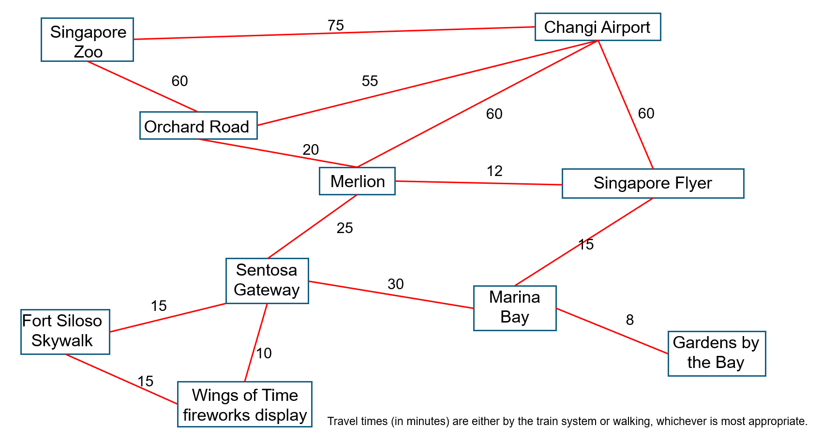

Tourist venues | Average time spent at venue
Changi Airport | 90 minutes
Singapore Zoo | 4 hours
Orchard Road | 1 hour
Merlion | 40 minutes
Singapore Flyer | 30 minutes (1 rotation)
Marina Bay | 45 minutes
Gardens by the Bay | 2 hours
Wings of Time fireworks display | 20 minutes (at night 7 pm)
Fort Siloso Skywalk | 90 minutes
Sentosa Gateway | 5 minutes

Appendix B

Plane timetable
Flight schedule from Sydney (SYD) to Singapore (SIN) | Flight time
  Southern Skies Airways 281  SYD–SIN | 2:30 am – 8 am  Every Tues
  Red Horizon Airways 15  SYD–SIN | 4:20 am – 9:25 am  Daily
Southern Skies Airways 33  SYD–SIN | 7:30 am – 12:50 pm  Every Sat
  Global Meridian Airways 212  SYD–SIN | 8:20 am – 1:20 pm  Daily
Southern Skies Airways 81  SYD–SIN | 11:30 am – 5 pm  Every Thu and Fri
Southern Skies Airways 291  SYD–SIN | 11:30 am – 5 pm  Every Mon–Wed, Sat, Sun
Global Meridian Airways 232  SYD–SIN | 12:15 pm – 5:35 pm  Daily
  Aurora International Air 15  SYD–SIN | 1:35 pm – 6:40 pm  Daily
Southern Skies Airways 83  SYD–SIN | 2:30 pm – 8 pm  Every Wed, Sat, Sun
Southern Skies Airways 291  SYD–SIN | 2:30 pm – 8 pm  Every Thu
Global Meridian Airways 222  SYD–SIN | 4:10 pm – 9:20 pm  Daily
Southern Skies Airways 1  SYD–SIN | 4:15 pm – 9:35 pm  Daily
Red Horizon Airways 16  SYD–SIN | 4:20 pm – 9:25 pm  Daily
Global Meridian Airways 242  SYD–SIN | 7:10 pm – 12:20 am⁺¹  Daily
Southern Skies Airways 331  SYD–SIN | 7:30 pm – 12:50 am⁺¹  Every Sat
Aurora International Air 17  SYD–SIN | 8:05 pm – 1:10 am⁺¹  Daily

Flight schedule from Singapore (SIN) to London, United Kingdom (all airports) | Flight time
Red Horizon Airways 14  SIN–LHR | 1:10 am – 7:30 am  Every Fri
Global Meridian Airways 306  SIN–LHR | 1:10 am – 7:40 am  Daily
Red Horizon Airways 14  SIN–LHR | 1:30 am – 7:40 am  Every Tues
Southern Skies Airways 331  SIN–LHR | 2:50 am – 9:30 am  Every Sun
Global Meridian Airways 314  SIN–LHR | 7:05 am – 3:45 pm  Every Wed
Global Meridian Airways 308  SIN–LHR | 9 am – 3:20 pm  Daily
Global Meridian Airways 318  SIN–LHR | 12:45 pm – 7:10 pm  Daily
Southern Skies Airways 209  SIN–LHR | 10:45 pm – 5:05 am⁺¹  Daily
Red Horizon Airways 16  SIN–LHR | 11:05 pm – 5:35 am⁺¹  Daily
Red Horizon Airways 12  SIN–LHR | 11:15 pm – 5:45 am⁺¹  Daily
Global Meridian Airways 322  SIN–LHR | 11:25 pm – 5:55 am⁺¹  Daily
Southern Skies Airways 1  SIN–LHR | 11:35 pm – 6:15 am⁺¹  Daily
Global Meridian Airways 312  SIN–LGW | 11:55 pm – 6:25 am⁺¹  Daily

Appendix C

Comparative worked example 1
Mason will travel from Tokyo (UTC+9) to Buenos Aires (UTC−3). The flight from Tokyo to Buenos Aires will take 20 hours. The flight will arrive in Buenos Aires at 3:00 pm on Wednesday 20 July.
On what day and at what time will Mason leave Tokyo?
Method 1 – change the time zone first
3 pm Wednesday + 12 hours = 3 am Thursday in Tokyo
+ Flight time = 3 am Thursday – 20 hours = 7 am Wednesday
Method 2 – add travel time first
3 pm Wednesday – 20 hours = 7 pm Tuesday
Time change 7 pm +12 hours = 7 am Wednesday
Method 3 – calculate the time difference
12-hour time difference – 20-hour flight = −8 hours
−8 hours from 3 pm Wednesday = 7 am Wednesday
Your turn
William will travel from Perth (UTC+8) to Fernando de Noronha (UTC−2). The flight from Perth will take 19 hours. The flight will arrive at Fernando de Noronha at 4 pm on Tuesday.
On what day and at what time will William leave Perth?

Comparative worked example 2
Jacob will travel from Cairo (UTC+2) to Beijing (UTC+8). The flight from Cairo to Beijing will take 10 hours. The flight will arrive in Beijing at 6 pm on Friday.
On what day and at what time will Jacob leave Cairo?
Method 1 – change time zone first
6 pm Friday – 6 hours = 12 pm Friday
12 pm Friday – 10 hours of travel = 2 am Friday
Method 2 – add travel time first
6 pm Friday – 10 hours of travel = 8 am Friday
8 am Friday – 6-hour time difference = 2 am Friday
Method 3 – calculate the time difference
6-hour time difference + 10 hours of travel time = 16 hours
16 hours before 6 pm Friday = 2 am Friday
Your turn
Ryan will travel from Dubai (UTC+4) to New York (UTC−5). The flight from Dubai to New York will take 18 hours. The flight will arrive in Dubai at 11 am Monday.
On what day and at what time will Ryan leave New York?

Appendix D

Four quadrant notes
Example 1  Doha is on (UTC+3) and Toronto is on (UTC−5). Lisa leaves Doha at 3:00 am on Friday and arrives in Toronto at 11:15 am Friday. How long is the flight?  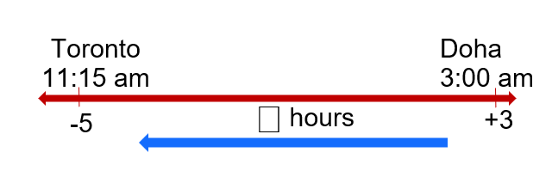  Doha is ⎕ hours ahead of Toronto.  If the plane lands in Toronto at ⎕:⎕ am, local time in Doha = 11:15 + 8 hours  = ⎕:⎕ pm  3 am –7:15 pm = ⎕ hours ⎕ minutes | Example 2  Deb is travelling from Lima (UTC−5) to Beijing (UTC+8). Her flight takes 20 hours and 30 minutes. She arrives in Beijing at 3:00 pm on Thursday.  When did Deb leave Lima?
Things to remember | Example 3

Appendix E

Scavenger hunt
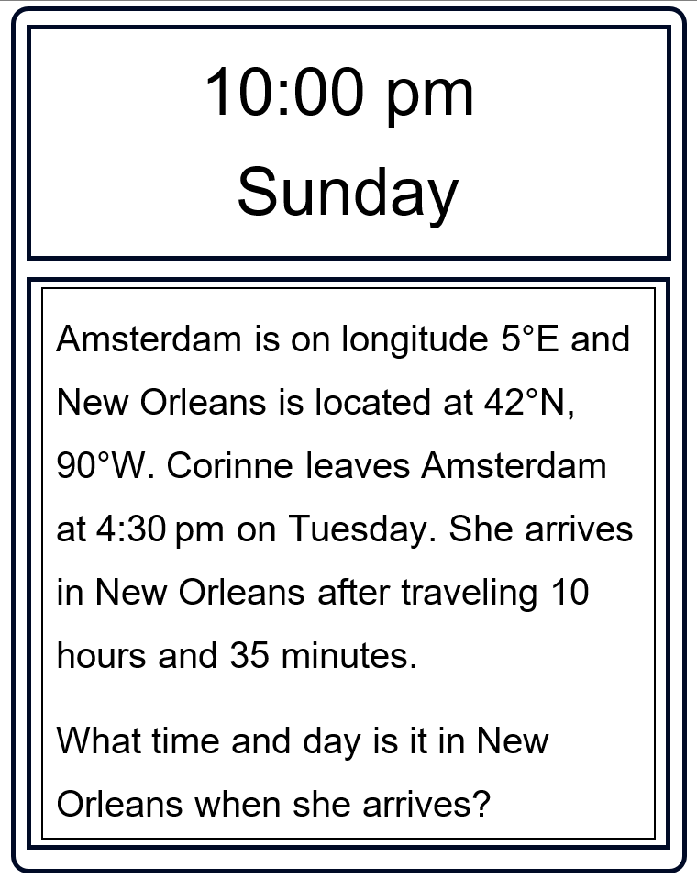

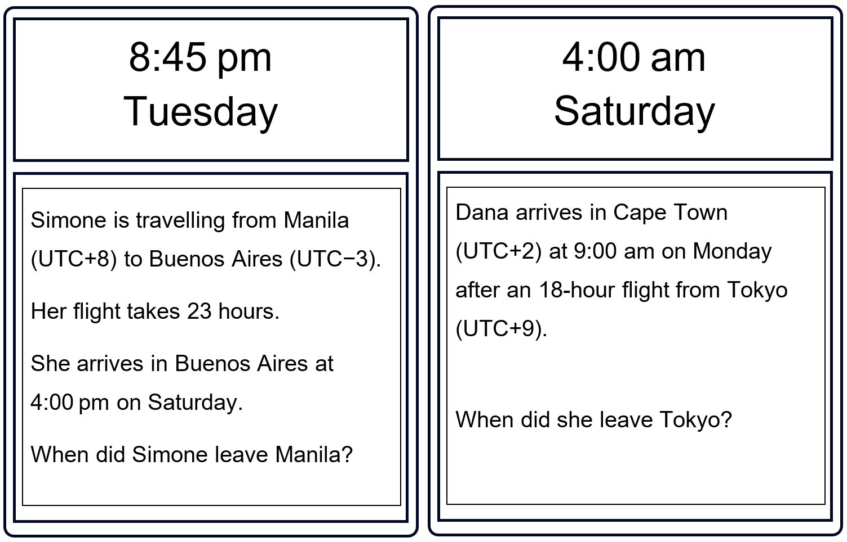
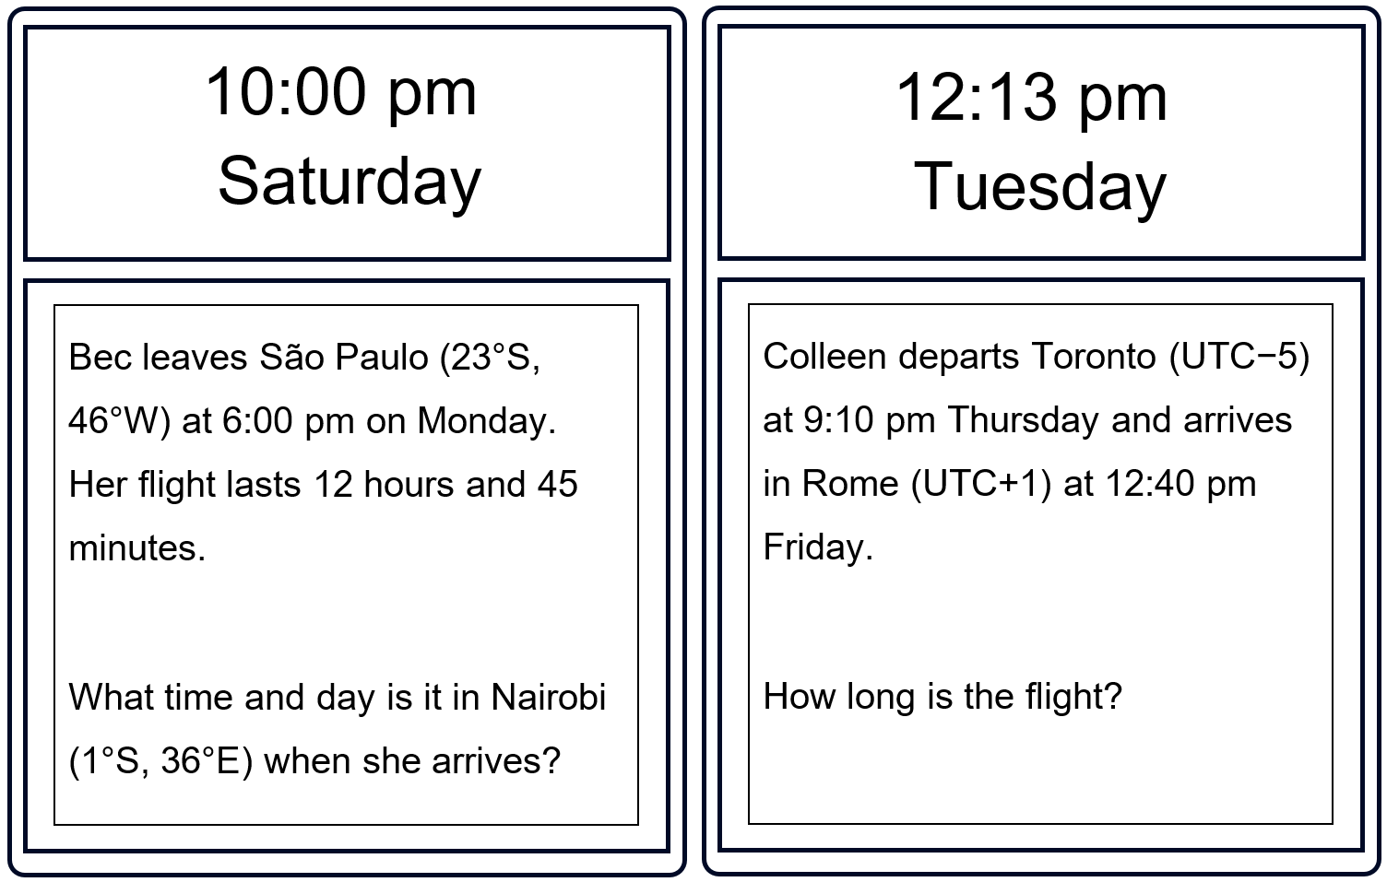
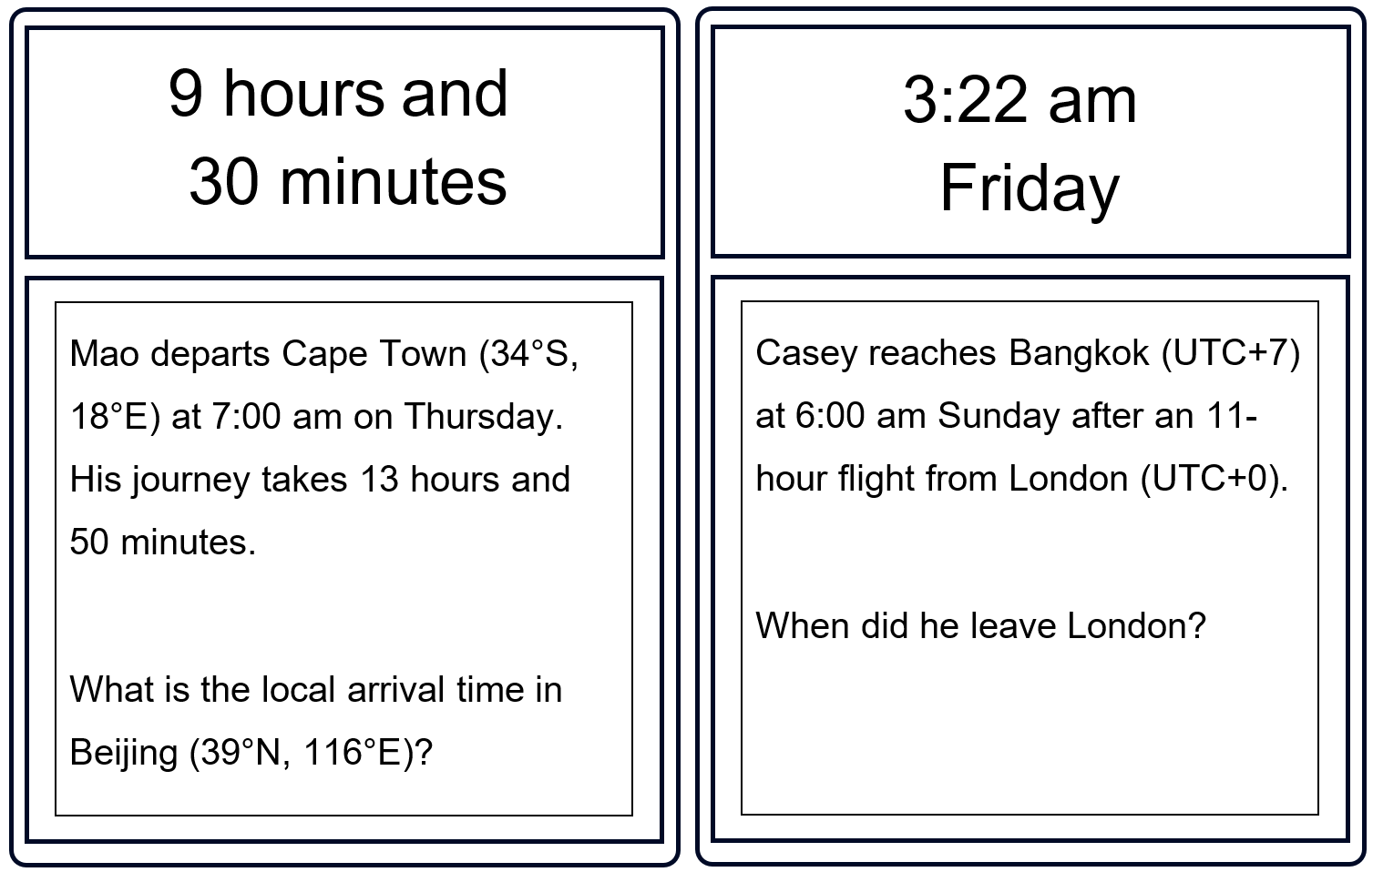
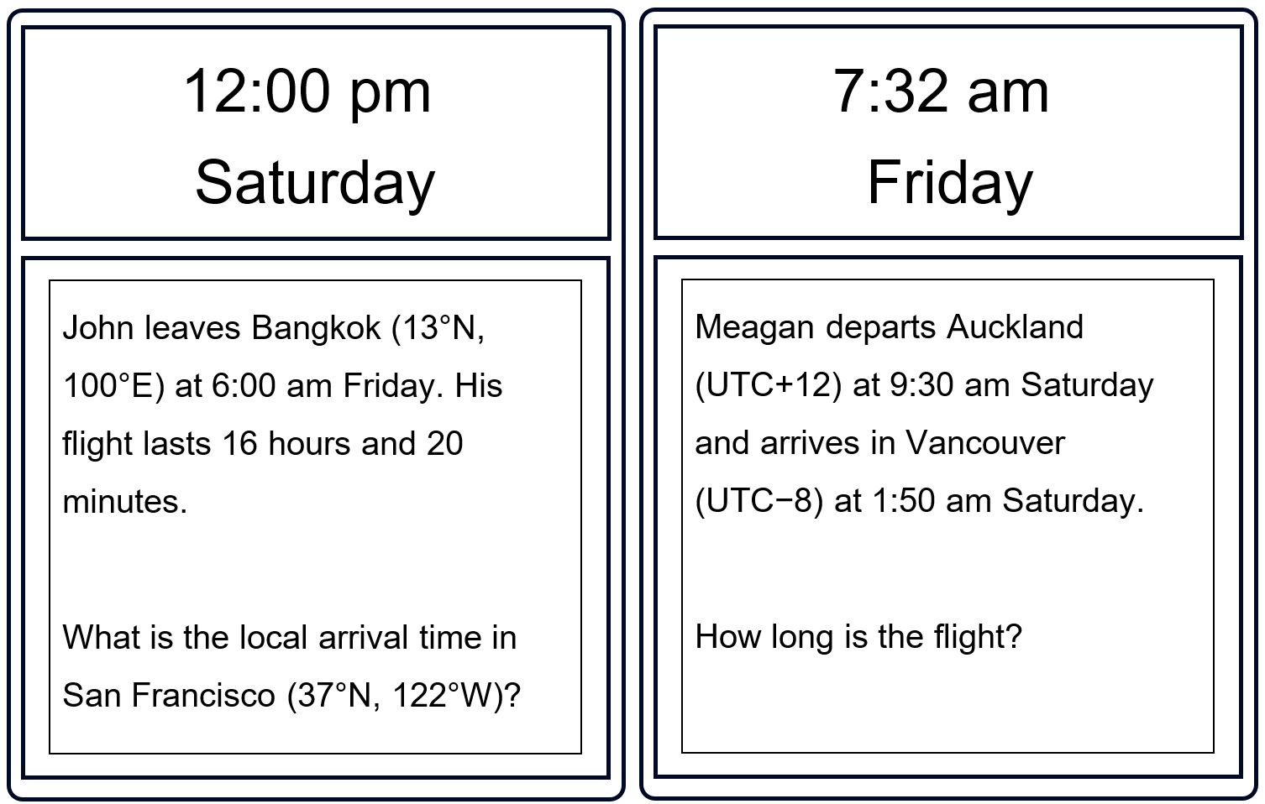
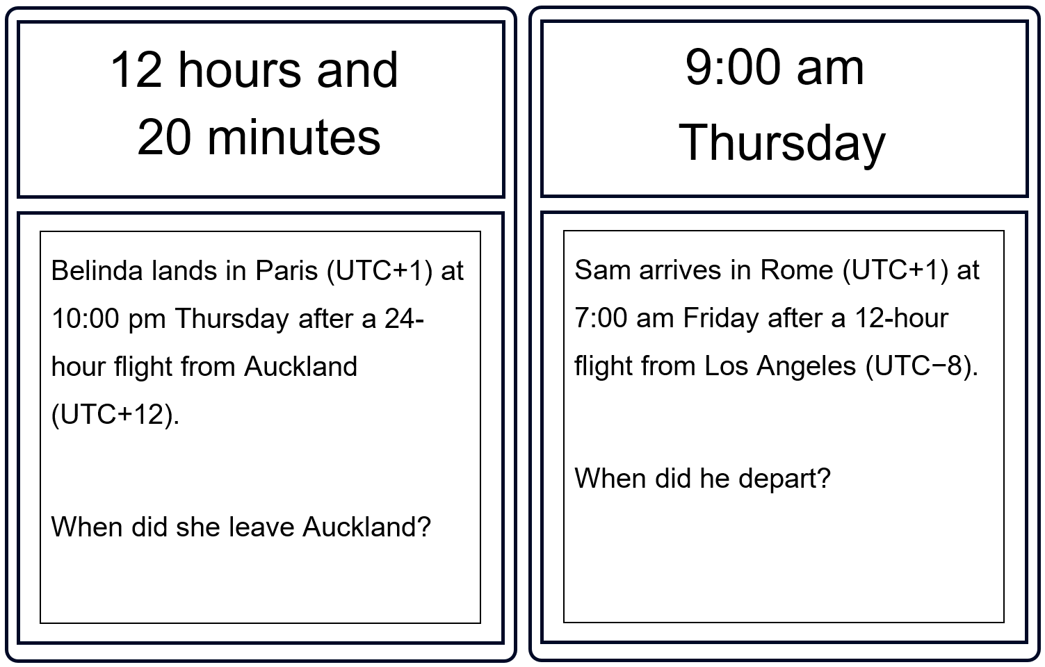
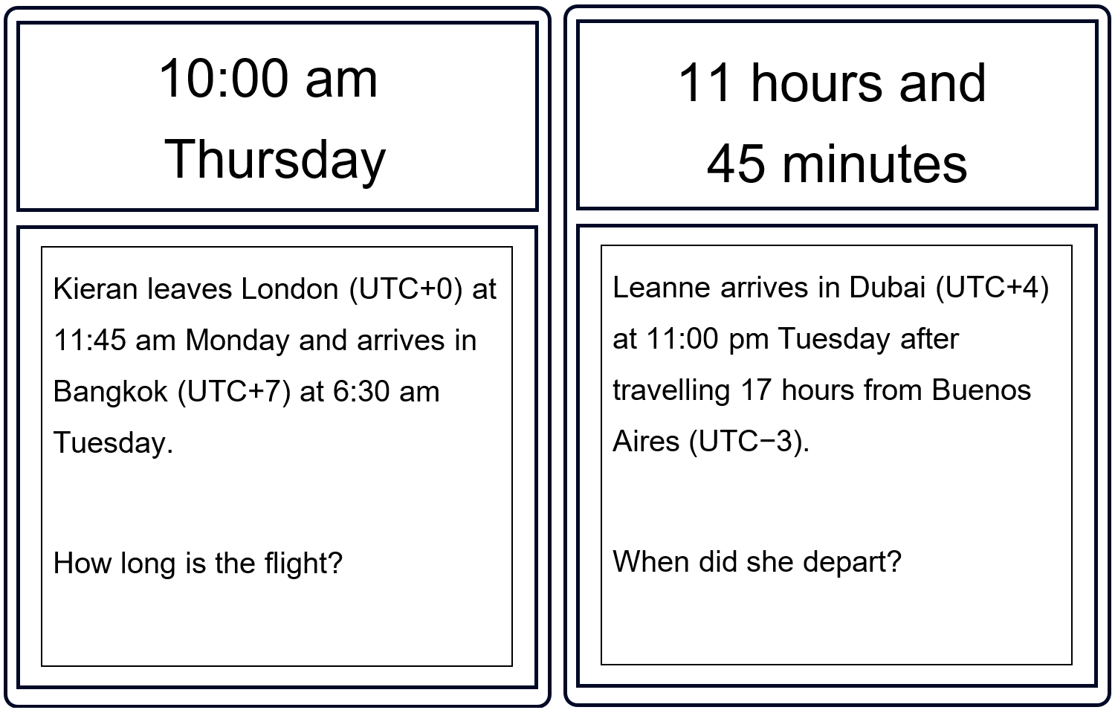
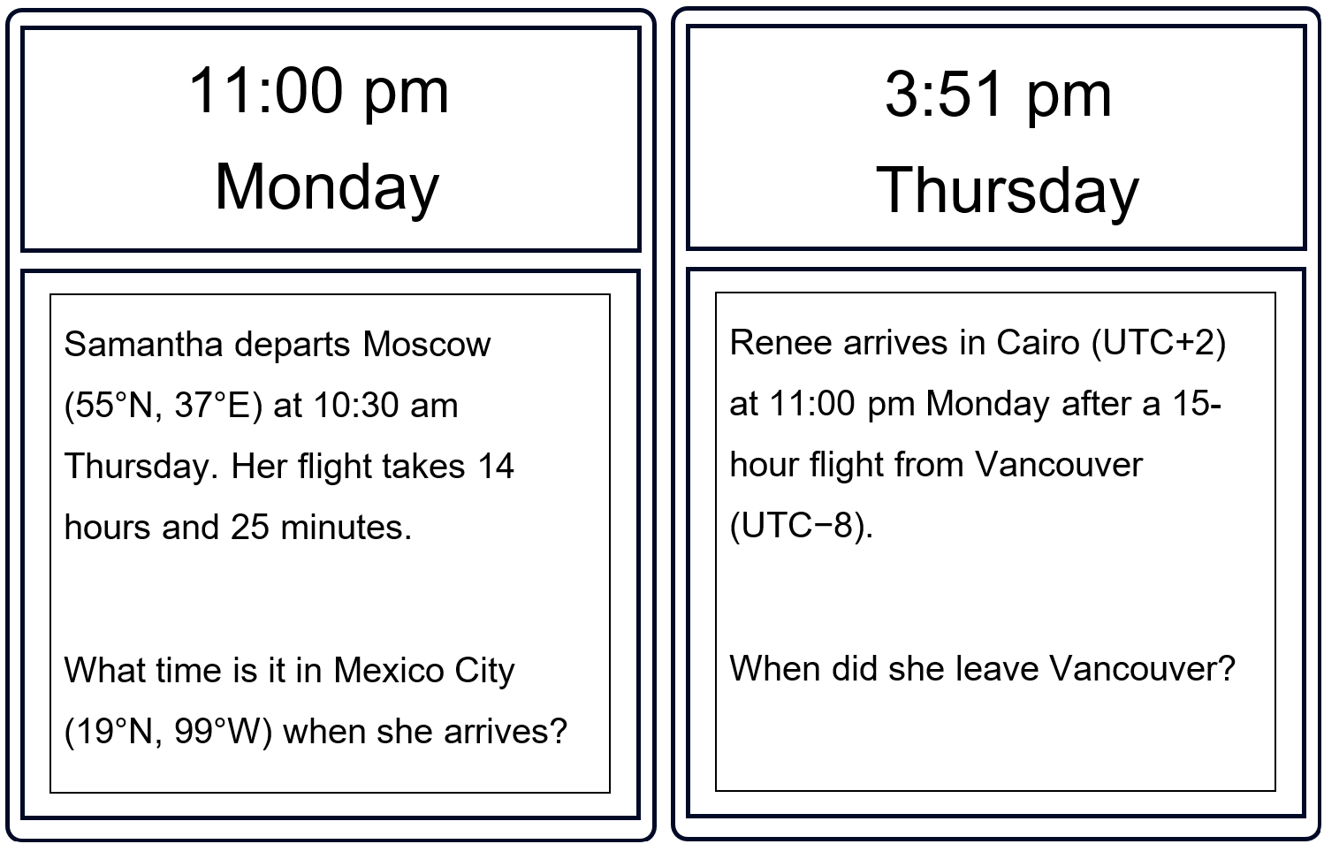

Appendix F

Birthday dilemma

Scenario 1
Katie lives in Auckland, New Zealand (UTC+13 during daylight savings). Her birthday begins at 12:00 am on 25 February. She wants to experience the longest possible birthday by travelling across time zones.
She knows that travelling eastward, especially across the International Date Line, can move her into earlier time zones, effectively giving her more birthday time.
Here is her starting point:
- Her birthday begins at 12 am in Auckland (UTC+13).
- She can fly to places such as Honolulu (UTC−10) or Papeete (UTC−10), which are among the last places on Earth to reach a new date.
Your task: help Katie design a travel plan that gives her the maximum number of hours of birthday time. You may choose any flights, routes or stopovers you like, as long as they are realistic.
In your explanation, consider:
- how crossing the International Date Line affects the date
- how flight durations influence the total birthday time
- whether multiple flights could extend her birthday even further.
How long can Katie make her birthday last, and what route should she take to achieve it? Considering the time spent in the air, is it worth it?

Scenario 2
Lee really doesn’t want to celebrate her 50th birthday.
Lee lives in Sydney (UTC+10), and she is about to turn 50 on 25 April. Her birthday will begin at 12:00 am on 25 April in Sydney. This year, she wants to try something unusual: she wants to avoid her birthday altogether by travelling in such a way that she never experiences the date 25 April in any time zone she is physically in.
She knows that travelling eastward, especially across the International Date Line, can move her into a later calendar date, which might allow her to ‘skip’ 25 April entirely.
Here is her starting point:
- Her 50th birthday begins at 12:00 am on 25 April in Sydney (UTC+10).
- Cities such as Los Angeles (UTC−8), Honolulu (UTC−10) and Papeete (UTC−10) reach 25 April much later than Sydney.
- She wonders whether she can leave Sydney late on 24 April and land somewhere where it is already 26 April, skipping the 25th completely.
Your task: help Lee design a travel plan that allows her to avoid experiencing any part of 25 April. You may choose any realistic flights, routes or stopovers.
In your explanation, consider:
- how crossing the International Date Line changes the date
- which destinations reach 26 April earliest
- how flight durations affect whether she ‘lands in the future’
- whether she needs one flight or multiple connections
- whether it is truly possible for Lee to avoid 25 April entirely.
How can Lee plan her travel so that she never experiences her 50th birthday at all?

Appendix G

HSC-style questions
Question 1
Mason is travelling from Sydney (UTC+10) to Montevideo (UTC−3).
The flight from Sydney to Montevideo will take 21 hours.
The flight will arrive in Montevideo at 6 pm on Thursday.
At what time and on what day did Mason leave Sydney?
Question 2
Los Angeles is $\text{8 hours}$ behind Coordinated Universal Time (UTC$\text{-8}$) and New Delhi is $\text{5 hours}$ ahead of Coordinated Universal Time (UTC−5).
Jacob travels from Los Angeles to New Delhi. He leaves Los Angles at 8:20 pm on Wednesday local time and flies non-stop to New Delhi, arriving at $\text{3:10 am}$ on Friday.
How long is the flight from Los Angeles to New Delhi?
Question 3
City A is on longitude $\text{5°}$E and New Orleans is located at $\text{42°}$N, $\text{90°}$W.
Ella leaves City A at $\text{4:30 pm}$ on Tuesday afternoon.
She arrives at New Orleans after travelling $\text{10 hours}$ and $\text{3}\text{5 minutes}.$
What local time and day is it in New Orleans when she arrives?
Question 4
Wil leaves a city located in UTC$\text{+10}$ and travels west.
He leaves at $\text{2 pm}$ and travels for $\text{14 hours}$ and $\text{30 minutes}$.
He arrives at $\text{8:30 pm}$.
In what UTC time zone does he arrive?
Question 5
Kiera leaves Berlin (UTC+1) at 5 pm Monday and arrives in Singapore (UTC+8) at 11:25 am Tuesday.
How long is the journey?

Sample solutions

Activating prior knowledge – Same Surface, Different Deep
A train trip $\text{1 hour}$ and $\text{17 minutes}$.  If Chris leaves at 4:25 pm and travels without stopping, what time will he arrive?  $$\text{4:25 pm + 1 hour = 5:25 pm} \\ \text{5:25 pm + 17 minutes = 5:42 pm}$$ | A train leaves at $\text{9:37 am}$ and arrives at $\text{11:15 am.}$  How long did Chris travel for?  $$\text{9:37 am to 10 am = 23 minutes} \\ \text{10}\text{ am to 11 a}\text{m = 1 hour} \\ \text{11} \text{am to 11:15 am =} \text{15 minutes}$$  Time elapsed  $$\text{1 hour + 23 minutes + 15 minutes}$$  $$\text{=} \text{1 hour and 38 minutes.}$$
A train trip lasts $\text{1 hour}$and$\text{17 minutes}.$  If Chris travels the same trip continuously, how many times could he complete the trip over $\text{24 hours}$?  $$\text{1 hour and 17 minutes = 1.2833333 hrs} \\ \text{24 hours ÷} \text{1.283333 hours = 18.7 times}$$ | A train trip lasts $\text{1 hour}$ and $\text{17 minutes}$.  If Chris arrives at $\text{9:55 pm}$and travelled without stopping, what time did he leave?  $\text{1 hour}$and$\text{17 minutes }$before$\text{9:55 am.}$  $\text{1 hour}$ before = $\text{8:55 am}.$  $\text{15 minutes}$ before = $\text{8:38 am}$.
Source: this image has been adapted from Movie Times (bit.ly/movie_ssdd) by Craig Barton (2018).

Appendix D – Four quadrant notes
Example 1  Doha is on (UTC+3) and Toronto is on (UTC−5). Lisa leaves Doha at 3:00 am on Friday and arrives in Toronto at 11:15 am Friday. How long is the flight?  Doha is 8 hours ahead of Toronto.  If the plane lands in Toronto at 11:15 am,  local time in Doha =11:15 + 8 hours  = 7:15 pm  3 am – 7:15 pm = 16 hours and 15 minutes | Example 2  Deb is travelling from Lima (UTC−5) to Beijing (UTC+8). Her flight takes 20 hours and 30 minutes. She arrives in Beijing at 3:00 pm on Thursday.  When did Deb leave Lima?  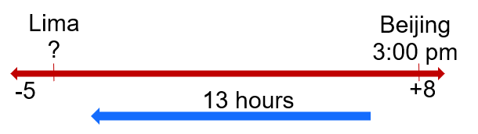  Beijing is 13 hours ahead of Lima.  If the plane arrives in Beijing at 3 pm.  Local time in Lima 3 pm – 13 hours = 2 am.  2 am – 20 hours 30 mins = 5:30 am, the day before Wednesday.

Appendix G – HSC-style questions
Question 1
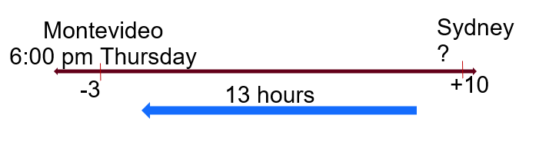
Plane arrives in Montevideo at 6 pm Thursday (local time).
Time in Sydney = 6 pm Thursday + 13-hour time difference = 7 am Friday
21 hours before arrival time = 7 am Friday – 21 hours = 10 am Thursday
Question 2
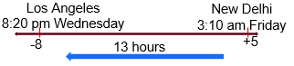
Plane arrives in Los Angeles at 8:20 pm Wednesday (local time).
Time in New Delhi = 8:20 pm Wednesday + 13-hour time difference = 9:20 am Thursday
Time difference between 9:20 am Thursday and 3:10 am Friday = 17 hours and 50 minutes
Flight time is 17 hours and 15 minutes.
Question 3
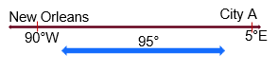
Angular distance = 5 + 90 = 95°
95 ÷ 15 = 6.33333 hours = 6 hours and 20 minutes
Local New Orleans time for departure = 4:30 pm Tuesday – 6 hours and 20 minutes = 10:10 am
10:10 am plus travel time = 10:10 am Tuesday + 10 hours and 35 minutes = 8:45 pm Tuesday
Question 4
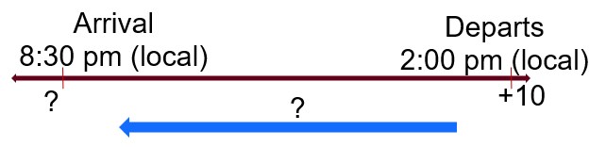
Plane departs at 2 pm.
It travels for 14 hours and 30 minutes.
Local time from the departure city when the plane lands = 2 pm + 14 hours and 30 minutes = 4:30 am next day.
Time difference = 8:30 pm – 4:30 am next day = 8-hour time difference.
UTC+10 – 8 hours = UTC+2.
Question 5
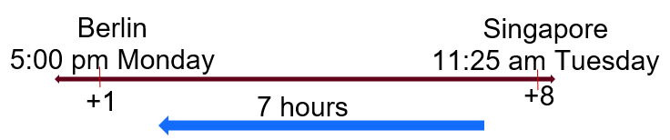
Plane departs Berlin at 5 pm and arrives at 11:25 am Singapore time.
Berlin local time when plane arrives = 11:25 am – 7 hours = 4:25 am.
Time difference = 5 pm – 4:25 am next day = 11 hours and 25 minutes.

References
This resource contains NSW Curriculum and syllabus content. The NSW Curriculum is developed by the NSW Education Standards Authority (NESA). This content is prepared by NESA for and on behalf of the Crown in right of the State of New South Wales. The material is protected by Crown copyright.
Please refer to the NESA Copyright Disclaimer for more information https://www.nsw.gov.au/education-and-training/nesa/copyright.
NESA holds the only official and up-to-date versions of the NSW Curriculum and syllabus documents. Please visit NESA https://www.nsw.gov.au/education-and-training/nesa and NSW Curriculum https://curriculum.nsw.edu.au/.
Mathematics Standard 11–12 Syllabus © NSW Education Standards Authority (NESA) for and on behalf of the Crown in right of the State of New South Wales, 2024.
Numeracy Stage 6 (CEC) Syllabus © NSW Education Standards Authority (NESA) for and on behalf of the Crown in right of the State of New South Wales, 2021.
Barton C (2018) ‘Movie Times’, SSDD Problems, SSDD Problems website, accessed 2 June 2026.

© State of New South Wales (Department of Education), 2026
The copyright material published in this resource is subject to the Copyright Act 1968 (Cth) and is owned by the NSW Department of Education or, where indicated, by a party other than the NSW Department of Education (third-party material).
Copyright material available in this resource and owned by the NSW Department of Education is licensed under a Creative Commons Attribution 4.0 International (CC BY 4.0) license.

This license allows you to share and adapt the material for any purpose, even commercially. Attribution should be given to © State of New South Wales (Department of Education), 2026.
Material in this resource not available under a Creative Commons license:
- the NSW Department of Education logo, other logos and trademark-protected material
- material owned by a third party that has been reproduced with permission. You will need to obtain permission from the third party to reuse its material.
Links to third-party material and websites
Please note that the provided (reading/viewing material/list/links/texts) are a suggestion only and implies no endorsement, by the New South Wales Department of Education, of any author, publisher, or book title. School principals and teachers are best placed to assess the suitability of resources that would complement the curriculum and reflect the needs and interests of their students.
If you use the links provided in this document to access a third-party's website, you acknowledge that the terms of use, including licence terms set out on the third-party's website apply to the use which may be made of the materials on that third-party website or where permitted by the Copyright Act 1968 (Cth). The department accepts no responsibility for content on third-party websites.

