International time zones
This lesson extends students’ understanding of time zones by exploring their global purpose, structure and variation. Students learn about Coordinated Universal Time (UTC) and connect it to longitude before applying their knowledge to solve time difference problems.

Learning intention
- To know how to calculate the time difference between 2 locations using Coordinated Universal Time (UTC).

Success criteria
- I can use UTC to consider the relative position of locations.
- I can calculate the time difference between 2 locations using UTC.

Outcomes
A student:
- develops understanding and fluency in mathematics through exploring and connecting mathematical concepts, choosing and applying mathematical techniques to solve problems, and communicating their thinking and reasoning coherently and clearly MAO-WM-01
- solves problems involving time and location in practical contexts MST-11-06
- applies network techniques to solve network problems MST-11-07
Mathematics Standard 11–12 Syllabus © NSW Education Standards Authority (NESA) for and on behalf of the Crown in right of the State of New South Wales, 2024.

Associated numeracy outcomes
A student:
- applies numerical reasoning and mathematical thinking to clarify, efficiently solve and communicate solutions to problems N6-1.2
- chooses and applies efficient strategies to analyse and solve everyday problems involving metric relationships, distance and length, area, volume, time, mass, capacity and temperature N6-2.2
- chooses and applies efficient strategies to analyse and solve everyday problems involving location, space and design N6-2.5
Numeracy Stage 6 (CEC) Syllabus © NSW Education Standards Authority (NESA) for and on behalf of the Crown in right of the State of New South Wales, 2021.

Content

Time and location
Time and time differences
- Represent time difference between locations using Coordinated Universal Time (UTC)
- Solve practical problems involving UTC
Mathematics Standard 11–12 Syllabus © NSW Education Standards Authority (NESA) for and on behalf of the Crown in right of the State of New South Wales, 2024.
Table 1: lesson summary
Section | Summary of activity | Teaching strategies | Teaching points
Activating prior knowledge | After reviewing the Australian time zones on slide 4 of the PowerPoint International time zones, students begin by working together to design their own global time-zone systems using the world map in Appendix A. | Notice and wonder  Pose-Pause-Pounce-Bounce  Visibly random groups of 3  Vertical non-permanent surfaces  TAG feedback strategy | Students consider how time zones could be constructed.
Connecting learning | Students compare their ideas with the official UTC time-zone map on slide 6 and Appendix B, noticing features such as irregular boundaries, differing zone sizes and the role of the International Date Line. Finally, students watch ‘Samoa to skip Friday in time zone change’ (2:15) (bit.ly/Samoa_timezone) shifting time zones and investigate other countries that may have made similar decisions. | Notice and wonder  Class discussion | Students analyse how the time zones are created. They also examine some unique situations of time zones across the world.
Releasing responsibility | Students are introduced to UTC on slide 8 and then compare cities such as Sydney, Perth and Adelaide on slides 9–12 to understand how local times relate to their UTC offsets. Working in pairs, they match cities and coordinates to their UTC values in Appendix C, place chosen cities on a number line and determine the time differences between them. They then check their work with another pair and finish by creating notes in Appendix D that capture what they need to remember about using UTC. | Worked examples (Your turn)  Four quadrant notes  Card sort | Students perform calculations on time difference using UTC differences.
Independent practice | Students practise skills using HSC-style questions from Appendix E. |  | Students apply skills from the lesson to questions.

Activity structure
Please use the associated PowerPoint International time zones to display images in this lesson.

Activating prior knowledge
- Display slide 4 of the PowerPoint showing the Australian time zone map. Students learned about Australian time zones in Lesson 7 – Australian time zones. In a class discussion, invite students to recall why Australia’s time zones are arranged as they are.
- Distribute an A3 copy of Appendix A ‘World map’ in a plastic A3 sleeve and adhesive putty to visibly random groups of 3 (bit.ly/visiblegroups) at vertical non-permanent surfaces (bit.ly/VNPSstrategy). Ask students to determine their own system of time zones by dividing the Earth into equal time zones and justifying their choices using calculations.
- Students are to go on a gallery walk and give peer feedback on other groups’ time zones using the TAG feedback strategy (bit.ly/DLSpeerfeedback).
- Use the Pose-Pause-Pounce-Bounce questioning strategy (PDF 557 KB) (bit.ly/posepausepouncebounce) to discuss the strategies students used to decide on the placement of their time zones. Possible questions include:
- How did you divide up the Earth?
- When does a time zone become too big or too small?
- What are some problems with some of these time zones?
- Have students create time zones of equal size using the relationship from the reference sheet, 15° = 1 hour.
Students should use 360 degrees split into 24 time zones, represented by a series of vertical lines, from the relationship 15° = 1 hour. Some students may have already chosen to split up their time zones this way initially. The teacher may like to show this as an example to the class before students split up their map.
- Ask students what they notice and wonder (bit.ly/noticewonderstrategy) about their time zone map.
Students should notice that the lines can split countries in the middle and wouldn’t be practical.
They may wonder if the zones need to be rigid.

Connecting learning
- Display slide 6 showing a map with the Coordinated Universal Time (UTC) time zones marked on it. Distribute a copy of Appendix B ‘World time zone map’ to each student.
- Ask students, in their groups, to discuss what they notice and wonder about the time zone map.
Students should notice that the map is based around longitude – with the 0-time zone aligning to where longitude would be 0 on the number line and going to ±12 either way. Students may also notice that some lines are jagged and some zones are different sizes and wonder why that is. Some students may also notice that there are some ‘half zones’, which are coloured with diagonal lines in the colours from the neighbouring time zones.
- Ask students where the Prime (Greenwich) meridian would be on their map and to draw it in.
Students may need to be reminded that it is where longitude is 0 degrees. It goes through the middle of UTC+0 time zone.
- Ask students where the International Date Line would be on the map.
The International Date line is an imaginary line on the Earth’s surface at approximately 180° longitude, where the calendar date changes by one day. If you cross it West to East, you go back one day. If you cross it East to West, you go forward a day.
The International Date Line occurs where the time zone changes from +12 to –12. As it is a different day on either side of the line, it is jagged as it goes around the borders of countries rather than across them.
- Show students the clip ‘Samoa to skip Friday in time zone change’ (2:15) (bit.ly/Samoa_timezone) about Samoa moving from one side of the International Date Line to the other.
- Conduct a class discussion about why Samoa made the decision to move into a different time zone.
- In their groups, ask students to look at the time zone map and determine if there are other places that may have made decisions to have variations to time zones. Interesting examples you can suggest to students include:
- France
- Russia
- China.
Teachers can show the video ‘These Are the World’s Strangest Time Zones’ (6:01) (from 0:07–5:25) (bit.ly/world-time-zones) which shows an overview of some of the different time zones across the world.
France stretches over 12 time zones, because of all its overseas territories. Watch ‘Country with the most Time Zones’ (0:58) (bit.ly/France_time_zone).
Russia stretches from approximately 19° E to 169° W, meaning the country spans the 180° meridian and therefore crosses the International Date Line. Students can explore how such a large country manages time and date differences and consider whether it would be practical for parts of the same country to operate not only several hours apart but on different calendar days. Watch ‘The Insane Geography of Russia’ (14:37) (from 0:00–1:23) (bit.ly/Russia_time_zone).
Despite spanning a wide range of longitudes that would naturally suggest several time zones, China operates on a single national time zone. Students can investigate the implications of this decision. For example, if sunrise occurs around 6 am in eastern China, it may still be dark at the same official time in the far west. This raises questions about daily routines, working hours and the potential long-term impacts on people’s health and wellbeing. Watch ‘Why Does China Have One Time Zone’ (0:56) (bit.ly/China_time_zones).

Releasing responsibility
- Display slide 8 to introduce Coordinated Universal Time (UTC) as the time system we use across the world to describe the relationship between the time zones.
- Display slide 9 which shows the example of Sydney and Perth from Lesson 7, making a connection to ahead and behind times and UTC. Sydney is 2 hours ahead of Perth. Sydney is (UTC+10) and Perth is (UTC+8)
- Display slide 10 which shows the example of Sydney and Adelaide. Sydney is 30 minutes ahead of Adelaide. Sydney is (UTC+10) and Adelaide is (UTC+9.5).
- Use slides 11–12 from the PowerPoint to model worked examples of international time zones using the Worked examples (Your turn) method (bit.ly/supportingstrategies).
- Working in pairs, students use the cards from Appendix C ‘Card sort’ to match the place, its latitude and longitude and the UTC.
The city and coordinates cards are from Lesson 6. Teachers can choose to use the cards already produced or reprint a new set of cards.
- Working in pairs, ask students to pick 2 places from the cards. Using mini whiteboards, students write the names of the cities on a number line in their relative positions before using the UTC to find the time difference between the cities. Pairs should make a final statement to sum up their findings. For example, Sydney (UTC+10) is 2 hours ahead of Perth (UTC+8).
Students could also write the statement using ‘behind’, for example, Perth is 2 hours behind Sydney.
- Have neighbouring pairs check each other’s answers. Neighbouring pairs should focus on whether the cities are in the correct relative positions on the number line and whether the time difference calculation and final statement is correct.
- Distribute Appendix D ‘Four quadrant notes’ to each student. Back in their groups of 3 at vertical non-permanent surfaces, have students complete the four quadrant notes to their future forgetful selves (bit.ly/supportingstrategies).

Independent practice
- Use slide 14 to remind students of the ‘Approaching questions scaffold’.
- Distribute Appendix E ‘HSC-style questions’ to each student and have them work through each problem in pairs before comparing their solutions with a neighbouring pair.

Assessment and differentiation

Suggested opportunities for differentiation
Activating prior knowledge
- Provide a scaffold showing that 360° ÷ 24 = 15° per hour and encourage students to use this relationship when creating equal time zones.
- Provide a partially marked world map with some longitude lines already labelled to help students visualise how the zones might be divided.
Connecting learning
- Provide a partially marked world map with the Prime (Greenwich) meridian and International Date line already labelled to help students visualise how the zones might be divided.
Releasing responsibility
- Extend students by having them design their own time zone problems and swap them with a partner.
- Provide sentence frames such as:
- ⎕ (UTC ⎕) is ⎕ hours ahead of ⎕ (UTC ⎕).
- The time difference is ⎕ hours because …
- Encourage students to physically place cards on the number line before calculating the time difference, reinforcing the conceptual link between UTC values and position.
Independent practice
- Scaffolded questions could assist students’ conceptual understanding before they develop mastery of time zones.

Suggested opportunities for assessment
Activating prior knowledge
- Pose-Pause-Pounce-Bounce discussions allow teachers to assess students’ understanding of time zones.
- While students work in visibly random groups of 3 at vertical non-permanent surfaces, teachers can observe how students justify their proposed time zone systems and assess whether students correctly apply the relationship between 360° of longitude and 24 hours when dividing the Earth into equal time zones.
Connecting learning
- Teachers can assess students’ ability to connect mathematical calculations with real-world decisions about time zones by listening to peer discussions.
- Teachers can ask groups to explain the reasoning behind their original time zone design during the gallery walk and assess the students’ ability to justify their choices using mathematical calculations (degrees and time) and practical considerations such as population centres and country borders.
Releasing responsibility
- While modelling the worked examples, ask students to explain how the UTC values determine whether a location is ahead of or behind another. Listen for students correctly interpreting positive and negative UTC values on the number line and linking these to time differences.
- Use students’ future forgetful selves notes as a reflective assessment to determine what key ideas they have understood about UTC, number lines and calculating time differences between locations.
Independent practice
- HSC-style questions could be collected as a sample of student mastery.
- One of the HSC-style questions could be used as an exit ticket.

Appendix A

World map
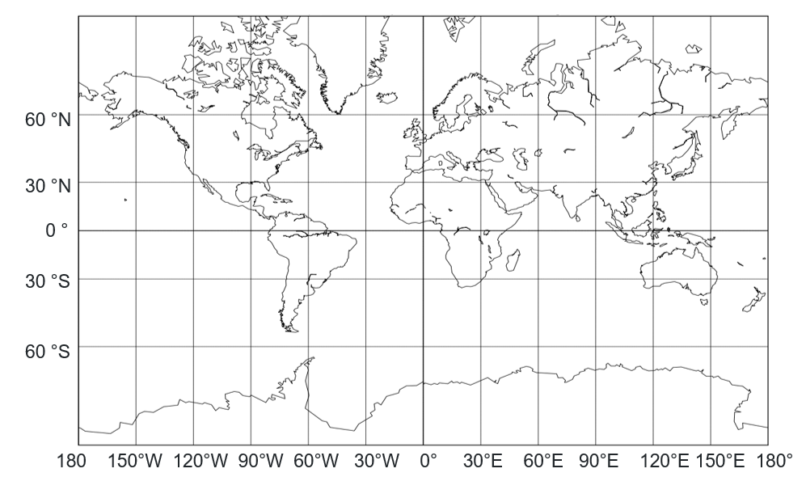

Appendix B

World time zone map
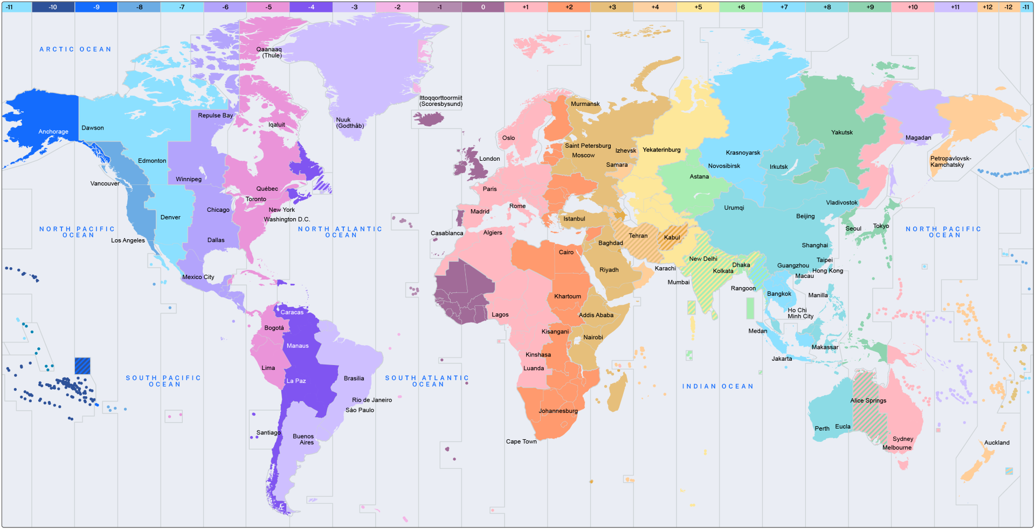

Appendix C

Card sort
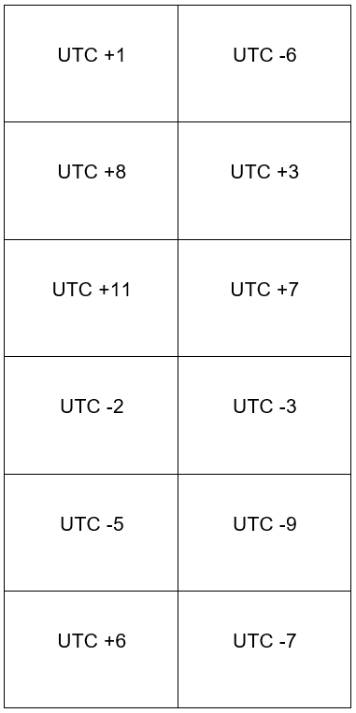

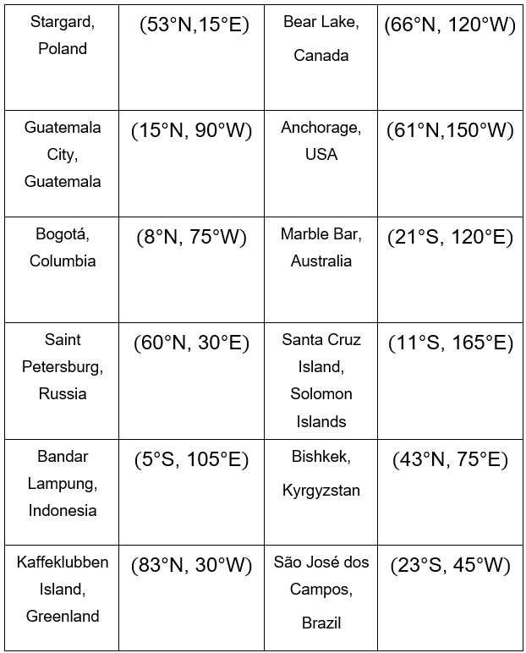

Appendix D

Four quadrant notes
Example 1  Los Angeles operates on UTC−8 and Noumea operates on UTC+11.  If it is 1800 Tuesday in Los Angeles, determine the time and day in Noumea.  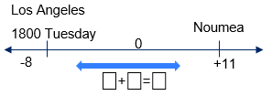Noumea is ⎕ hours ahead of Los Angeles.  18:00 Tuesday + ⎕ hours = ⎕00.  3700 – 2400 = ⎕00 the next day.  $∴$Los Angeles time = ⎕ (⎕ pm) Wednesday. | Example 2  Chicago operates on UTC−6 and Manila operates on UTC+8.  If it is 1430 Monday in Chicago, determine the time and day in Manila.
Things to remember | Example 3

Appendix E

HSC-style questions
Question 1
Caracas operates on UTC−4 and Nairobi operates on UTC+3. A call is scheduled for 1500 UTC 0.
- What time will the call take place in Caracas?
- What time will the call take place in Nairobi?
- How many hours difference is there between the 2 cities?
Question 2
The World Cup soccer final is being broadcast live from New York (UTC–4) on Tuesday 8 pm local time.
What is the time and day in Sydney (UTC+10) when the game starts?
Question 3
Lisa lives in Vancouver, Canada (UTC–8) and wants to call a friend who is holidaying in Noumea, New Caledonia (UTC+11).
If it is 7 pm Tuesday in Vancouver, what time and day is it in Noumea?
Question 4
Tokyo operates on UTC+9. Honolulu is 19 hours behind Tokyo.
- Determine the UTC of Honolulu.
- If it is 1800 in Tokyo, what is the local time in Honolulu?
Question 5
A research team in Sydney (UTC+10) is coordinating a live satellite link with a team in Nairobi (UTC+3). The satellite is scheduled to transmit data at 1418 (UTC+0). The 2 research teams need to begin a systems check 2 hours before the satellite transmission and they must receive the transmission at the same time.
What is the local time in both Sydney and Nairobi when they need to begin their system checks?
Question 6
A company needs to schedule an online meeting for staff based in Toronto (UTC–5), Berlin (UTC+1) and Dubai (UTC+4). The meeting must start during work hours of 8 am – 6 pm, local time.
What time could the meeting be scheduled for so that all 3 offices are able to attend the meeting during their work hours.
Question 7
A charity marathon in Paris (UTC+1) begins at 7 am and is simultaneously run worldwide. A runner in Honolulu (UTC–10) starts exactly on time and finishes in 4 hours and 27 mins.
What time does the runner finish in Honolulu?
Question 8
An astronomer in Dubai (UTC+4) wants to observe a rare comet that will be visible at 2310 in London (UTC+0).
- What is the local time in Dubai when the comet becomes visible?
- A colleague in Santiago (UTC−4) claims the comet will appear for them on the previous day.
Determine whether this is correct, showing all reasoning.
Question 9
A global organisation is planning a live webinar. The keynote speaker is in London (UTC+0) and is only available at 3 pm London time.
Participants will join from:
- Perth (UTC+8)
- Johannesburg (UTC+2)
The Perth team must log in 45 minutes before the webinar begins (Perth time).
What time will it be in Johannesburg when the Perth team logs in?
Question 10
A scientist in Dubai (UTC+4) schedules a live online briefing for 11:30 am Dubai time. A colleague in London (UTC+0) needs to join the briefing but mistakenly believes Dubai is only 3 hours ahead of London.
What time will the colleague in London join the briefing if they rely on this incorrect time difference, and how late or early will they be?

Sample solutions

Appendix C – card sort
City | Coordinate | UTC
Stargard, Poland | $$\left(\text{53°N,15°E}\right)$$ | UTC+1
Bear Lake, Canada | $$\text{(66°N, 120°W)}$$ | UTC–7
Guatemala City, Guatemala | $$\text{(15°N, 90°W)}$$ | UTC–6
Bogotá, Columbia | $$\text{(8°N, 75°E)}$$ | UTC–5
Bandar Lampung, Indonesia | $$\text{(5°S, 105°E)}$$ | UTC+7
Saint Petersburg, Russia | $$\text{(60°N, 30°E)}$$ | UTC+3
Santa Cruz Island, Solomon Islands | $$\text{(11°S, 165°E)}$$ | UTC+11
Anchorage, USA | $$\left(\text{61°N,150°W}\right)$$ | UTC–9
Marble Bar, Australia | $$\text{(21°S, 120°E)}$$ | UTC+8
Bishkek, Kyrgyzstan | $$\text{(43°N, 75°E)}$$ | UTC+6
Kaffeklubben Island, Greenland | $$\text{(83°N, 30°W)}$$ | UTC–2
São José dos Campos, Brazil | $$\text{(23°S, 45°W)}$$ | UTC–3

Appendix D – Four quadrant notes
Example 1  Los Angeles operates on UTC−8 and Noumea operates on UTC+11.  If it is 1800 Tuesday in Los Angeles, determine the time and day in Noumea.  Los Angeles  1800 Tuesday  Noumea  0  8 + 11 = 19  –8  +11  Noumea is 19 hours ahead of Los Angeles.  1800 Tuesday + 19 hours = 3700  3700 – 2400 = 1300 the next day.  $∴$Los Angeles time = 1300 (1 pm) Wednesday | Example 2  Chicago operates on UTC−6 and Manila operates on UTC+8.  If it is 1430 Monday in Chicago, determine the time and day in Manila.  Chicago  14:30 Monday  Manilla  0  6 + 8 = 14  –6  +8  Manilla is 14 hours ahead of Chicago.  14:30 Monday + 14 hours = 28:30  28:30 – 24:00 = 04:30 the next day  $∴$ Manilla time = 04:30 (4:30 am) Tuesday

Appendix E – HSC-style questions
Question 1
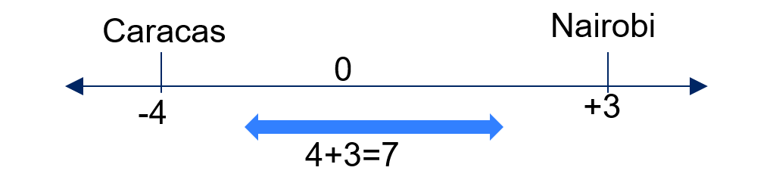
- 1500 – 4 hours = 11 am.
- 1500 + 3 hours = 6 pm.
- Time difference = 4 + 3 = 7 hours.
Question 2
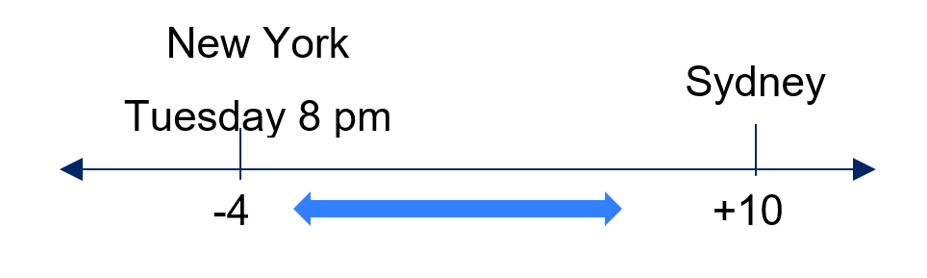
$$\text{Time difference}=\text{4} \text{+} \text{10} \\ =\text{14 hours}$$Sydney is east of New York so ahead of New York$.$$$\text{Sydney }= \text{Tuesday} \text{8} \text{pm + 14 hours } \\ =\text{10 am Wednesday}\text{.}$$
Question 3
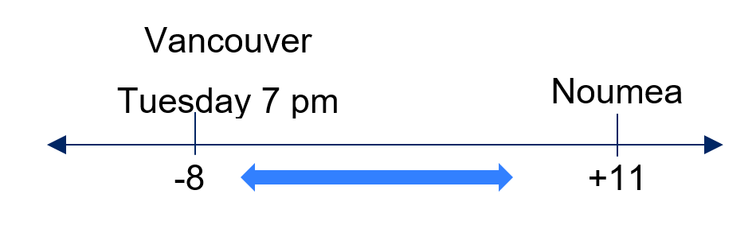

$$\text{Time difference}=\text{8} \text{+} \text{11} \\ =\text{19 hours}$$Noumea is east of Vancouver so ahead of Vancouver.$$\text{Noumea }= \text{Tuesday} \text{7} \text{pm + 19 hours } \\ =\text{2 pm Wednesday}$$
Question 4
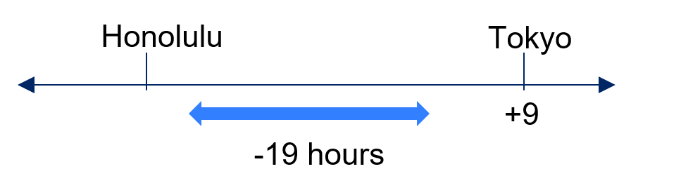

- Honolulu is west of Tokyo so behind Tokyo.$$\text{Honolulu }= \text{9} \text{–}\text{ 19 hours } \\ =\text{UTC }\text{–}\text{10}$$
- 1800 – 19 hours = 2300 the day before.
Question 5
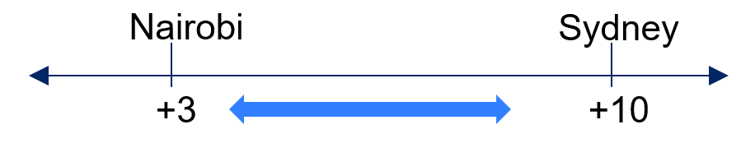
$$\text{Sydney time}=\text{1418 + 10 hours }\text{–}\text{ 2} \text{hours} \\ =\text{2218} \\ \text{Nairobi time} =\text{1418 +} \text{3 hours }\text{–} \text{2} \text{hours} \\ =\text{1518.}$$
Question 6
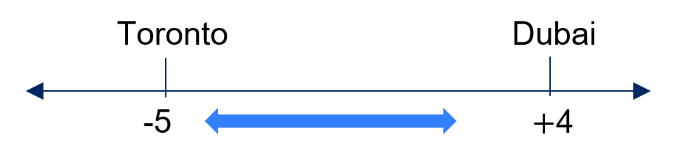
$$\text{Time difference}=\text{5} \text{+} \text{4}=\text{9 hours} \\ \text{Toronto}=\text{8} \text{am + 9 hours} \\ = \text{5} \text{pm}$$Toronto = 8 – 9 am
Berlin = 8 am + 6 hours = 2 pm = 2 – 3 pm$$\text{Dubai} \text{= 5} \text{–} \text{6} \text{pm }$$
Question 7
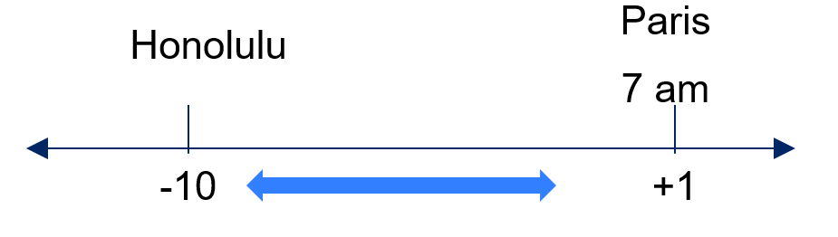
$$\text{Time difference} =\text{10} \text{+} \text{1} \\ =\text{11 hours}$$Paris is east of Honolulu so ahead of Honolulu$$\text{Honolulu }= \text{7} \text{am }\text{–} \text{11 hours } \\ =\text{8 pm previous day} \\ \text{Plus travel time = 8} \text{pm +} \text{4 hours 27 mins} \text{=} \text{12:27} \text{am}$$
Question 8
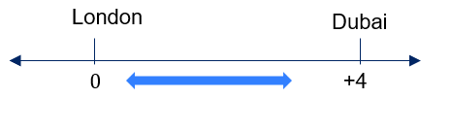
- Dubai is east of London so $\text{4 hours }$ahead of London $$\text{Dubai }= \text{2310 + 4 hours } \\ =\text{0310 next day}$$
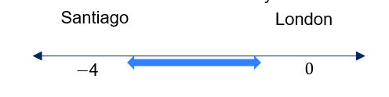
- $\text{Santiago} = \text{2310 }\text{–}\text{ 4 }\text{hours}$$$= \text{1910 same day}$$Incorrect, it appears the same day.

Question 9
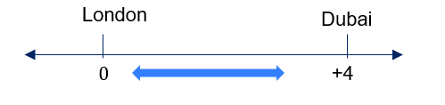
$$\text{Perth }= \text{3} \text{pm + 8 hours } \\ =\text{11} \text{pm}$$$\text{Johannesburg} = \text{3} \text{pm + 2 hours}=\text{5} \text{pm}$
$$\text{Perth login: 10:15} \text{pm}$$
$$\text{Take off 8 hours} = \text{2:15} \text{pm} \\ \text{Johannesburg} = \text{2:15} \text{pm + 2 hours} \\ = \text{4:15} \text{pm}$$
Question 10
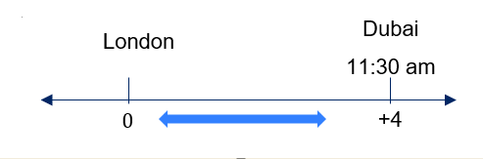
$$\text{Time difference} =\text{4 hours}$$Dubai is east of London so ahead of London$$\text{London }= \text{11:30} \text{am }\text{–}\text{ 4 hours } \\ =\text{7:30} \text{am}$$But they joined at 11:30 – 3 hours = 8:30 am London time – 1 hour late.

References
This resource contains NSW Curriculum and syllabus content. The NSW Curriculum is developed by the NSW Education Standards Authority (NESA). This content is prepared by NESA for and on behalf of the Crown in right of the State of New South Wales. The material is protected by Crown copyright.
Please refer to the NESA Copyright Disclaimer for more information https://www.nsw.gov.au/education-and-training/nesa/copyright.
NESA holds the only official and up-to-date versions of the NSW Curriculum and syllabus documents. Please visit NESA https://www.nsw.gov.au/education-and-training/nesa/copyright and NSW Curriculum https://curriculum.nsw.edu.au.
Mathematics Standard 11–12 Syllabus © NSW Education Standards Authority (NESA) for and on behalf of the Crown in right of the State of New South Wales, 2024.
Numeracy Stage 6 (CEC) Syllabus © NSW Education Standards Authority (NESA) for and on behalf of the Crown in right of the State of New South Wales, 2021.

© State of New South Wales (Department of Education), 2026
The copyright material published in this resource is subject to the Copyright Act 1968 (Cth) and is owned by the NSW Department of Education or, where indicated, by a party other than the NSW Department of Education (third-party material).
Copyright material available in this resource and owned by the NSW Department of Education is licensed under a Creative Commons Attribution 4.0 International (CC BY 4.0) license.

This license allows you to share and adapt the material for any purpose, even commercially. Attribution should be given to © State of New South Wales (Department of Education), 2026.
Material in this resource not available under a Creative Commons license:
- the NSW Department of Education logo, other logos and trademark-protected material
- material owned by a third party that has been reproduced with permission. You will need to obtain permission from the third party to reuse its material.
Links to third-party material and websites
Please note that the provided (reading/viewing material/list/links/texts) are a suggestion only and implies no endorsement, by the New South Wales Department of Education, of any author, publisher, or book title. School principals and teachers are best placed to assess the suitability of resources that would complement the curriculum and reflect the needs and interests of their students.
If you use the links provided in this document to access a third-party's website, you acknowledge that the terms of use, including licence terms set out on the third-party's website apply to the use which may be made of the materials on that third-party website or where permitted by the Copyright Act 1968 (Cth). The department accepts no responsibility for content on third-party websites.

