Australian time zones
Students are introduced to the concept of time zones and perform simple time calculations.

Learning intentions
- To be able to calculate the time difference between 2 places in Australia using time zones.
- To be able to perform time calculations using 12-hour and 24-hour time.

Success criteria
- I can convert between 12-hour and 24-hour time.
- I can solve problems using Australian time zones, including daylight saving time.

Outcomes
A student:
- develops understanding and fluency in mathematics through exploring and connecting mathematical concepts, choosing and applying mathematical techniques to solve problems, and communicating their thinking and reasoning coherently and clearly MAO-WM-01
- solves problems involving time and location in practical contexts MST-11-06
Mathematics Standard 11–12 Syllabus © NSW Education Standards Authority (NESA) for and on behalf of the Crown in right of the State of New South Wales, 2024.

Associated numeracy outcomes
A student:
- applies numerical reasoning and mathematical thinking to clarify, efficiently solve and communicate solutions to problems N6-1.2
- chooses and applies efficient strategies to analyse and solve everyday problems involving metric relationships, distance and length, area, volume, time, mass, capacity and temperature N6-2.2
- chooses and applies efficient strategies to analyse and solve everyday problems involving location, space and design N6-2.5
Numeracy Stage 6 (CEC) Syllabus © NSW Education Standards Authority (NESA) for and on behalf of the Crown in right of the State of New South Wales, 2021

Content

Time and location
Time and time differences
- Represent and convert between 12-hour and 24-hour time formats
- Solve problems involving time zones in Australia, making necessary allowances for daylight saving
Mathematics Standard 11–12 Syllabus © NSW Education Standards Authority (NESA) for and on behalf of the Crown in right of the State of New South Wales, 2024.

Table 1: lesson summary
Section | Summary of activity | Teaching strategies | Teaching points
Activating prior knowledge | Students use Appendix A to sort towns by longitude on a number line before finding the time difference between 2 towns. They then determine the time difference between Sydney and Orange before considering whether that time difference is realistic or practical. | Pose-Pause-Pounce-Bounce | Students connect geographic position to time differences, reinforcing how longitude influences local time and why some calculated differences may not be practical in real-world contexts.
Connecting learning | Students use Appendix B to compare flight times between major Australian cities and discuss why travel in opposite directions can have different recorded durations. They then design and refine their own Australian time zones, before comparing them with the 3 main time zones shown on slide 4 of the PowerPoint Australian time zones and the extended set of zones on slide 5.  Students watch a video bit.ly/Daylightsavings_time (1:53) about how daylight saving affects different states. Using slides 6–7, students explore how daylight-saving affects border towns like Tweed Heads and Coolangatta, and solve time-difference scenarios between states and territories. | Notice and wonder  Think-Pair-Share  Vertical non-permanent surface  Visibly random groups of 3  Gallery walk  TAG feedback  Pose-Pause-Pounce-Bounce  Mini whiteboards | Students develop a purpose and understand how geography, time zones and flight paths influence travel times. By designing and comparing time-zone systems and exploring daylight-saving impacts, they build a practical understanding of why time varies across Australia and how these differences affect real-world situations.
Releasing responsibility | Students revisit their earlier Sydney–Perth flight-time calculations and redo them while accounting for time-zone changes, noticing that the adjusted times differ from the originals. Using slides 9–12, they work through modelled time-zone examples before completing the scavenger-hunt activity from Appendix C and then use Appendix B to determine indirect flight routes from Adelaide to Canberra. Finally, they calculate the total travel times for both possible routes and record their working. | Worked example  Visibly random groups of 3  Scavenger hunt  Mini whiteboards | Students recognise how time-zone differences affect real travel durations and why calculations must be adjusted when crossing zones.  By revisiting earlier work, students develop a more accurate and flexible grasp of time-difference reasoning in authentic travel contexts.
Independent practice | Students use slide 14 to revisit the ‘Approaching questions scaffold’ before completing the HSC-style questions from Appendix D. |  | Students practice HSC-style questions, strengthening their confidence, accuracy and ability to structure solutions effectively.

Activity structure
Please use the associated PowerPoint Australian time zones to display images in this lesson.

Activating prior knowledge
- Distribute Appendix A ‘Australian towns’ to each pair of students.
- In pairs, have students cut up the cards at the base of the page showing Australian towns and their longitudes and line them up along the number line in order.
- Ask students to select 2 places and calculate the time difference between the 2 places and complete the statement above the timeline.
Students should find that their answer is not a whole number of hours and they should round their answer to the nearest minute using their calculators.
- Students swap their 2 town cards with a neighbouring pair. The receiving pair then calculates the time difference and checks the original solution.
- Ask students to calculate the time difference between Sydney and Orange.
- Use the Pose-Pause-Pounce-Bounce questioning strategy (PDF 557 KB) (bit.ly/posepausepouncebounce) to discuss whether this time difference is possible or practical.
Teachers could use local towns in proximity across the state to suit local context.

Connecting learning
- Distribute Appendix B ‘Australian flight paths.’
- In pairs, ask students to find the flight times (in both directions) between Sydney and Brisbane, Melbourne and Canberra and Sydney and Perth.
- Brisbane to Sydney (both directions) = 1$\text{ hour} \text{and} \text{30 minutes}$
- Canberra to Melbourne (both directions) = $\text{1 hour} \text{and} \text{5 minutes}$
- Sydney to Perth = $\text{3 hours}$
- Perth to Sydney = $\text{6 hours}$ $\text{and 15 minutes}$
- In pairs, ask students to consider what they notice and wonder (bit.ly/noticewonderstrategy) about the flight time lengths.
Students should notice that Sydney and Perth have different flight time lengths depending on direction and may wonder why the times are different when they are travelling the same distance. Some students may acknowledge that different states have different times (time zones).
- In a Think-Pair-Share (bit.ly/thinkpairsharestrategy), ask students to consider the question ‘What if the time was the same all over Australia?’ Prompting questions include:
- If it is 6 am in Sydney (34°S,151°E), what would it be like outside? (For example, would the sun have risen?)
- What would it be like outside in Perth (32°S, 116°E)?
- How might this difference affect businesses and schools?
- How could these problems be addressed?
- If 15°= 1 hour, what would be the time difference between Sydney and Perth?
Teachers could show students the clip ‘Day and Night Explained in One Minute’ (1:00) (bit.ly/explain_day_night) if students cannot conceive the idea that it would be dark in Perth. Or, teachers could turn questioning around: ‘If we operated on Perth time, at 4 pm in winter, the sun would be up in Perth. Would it be light or dark in NSW? Why?’
Time difference = 151−116 = 35, 35 ÷ 15 = 2 hours and 20 minutes.
Introduce the concept of time zones across Australia if students do not suggest it as a solution.
- By working in visibly random groups of 3 (bit.ly/visiblegroups) at vertical non-permanent surfaces (bit.ly/VNPSstrategy), ask students to create their own time zones for Australia, making points to justify why they have located the time zones where they have.
Students could use 15°=1 hour or population areas to divide up their zones.
- Students are to go on a gallery walk (bit.ly/DLSgallerywalk) and give peer feedback via the TAG feedback strategy (bit.ly/DLSpeerfeedback). They should then return to their original groups and consider the feedback and ideas from other groups before refining their time zones.
- Use the Pose-Pause-Pounce-Bounce questioning strategy to initiate a class discussion about suitable time zones for Australia. Possible questions could include:
- What were the common features among the groups’ time zones?
- Were there things that people did differently?
- What were the areas that needed special consideration?
Students may have followed state lines to create their time zones or considered an east or west time zone. Some students may have brought up daylight saving or other Australian Territories.
- Display slide 4 of the PowerPoint, showing the 3 main time zones in Australia that follow the state boundaries.
- Continue the Pose-Pause-Pounce-Bounce discussion about time zones. Possible questions include:
- What would be some of the benefits of following the state lines for the time zone boundaries in Australia?
- What could be some of the disadvantages of following the state lines for some places?
- What is meant by 2 hours ahead or 2 hours behind? How could we represent this visually?
- The map has the eastern states as 0 hours. Could the western states be at 0 hours? What would the rest of the map look like?
Some of the places that could be discussed include:
- Broken Hill runs on ACST despite being in NSW, as it is closer to Adelaide
- Eucla and other SA/WA border towns run on Australian Central Western Time, which is 45 minutes ahead of AWST
- Kiwirrkurra and Tjukurla in WA are remote Indigenous communities that often align with ACST and Adelaide rather than Perth for functional reasons.
If AWST is at 0, ACST would be +1.5 hours and AEST would be +2 hours.
- Display the wider map showing all the time zones in Australia on slide 5. Briefly discuss the ‘other’ minor time zones in Australia
- In a class discussion, ask:
- Why do we have these additional time zones?
- How would you approach questions involving other time zones? Are they different or would the process be the same?
- To check for understanding, ask students to simultaneously show their answers to the following questions on mini whiteboards (bit.ly/miniwhiteboards):
- If it is 9 am in Sydney (AEST), what time is it in Perth (AWST)?
- If it is 9 am in Perth, what time is it in Sydney?
- If it is 9 am in Sydney, what time is it in Adelaide (ACST)?
- If it is 9 am in Sydney, what time is it on Christmas Island?
- If it is 9 am in Sydney, what time is it on Lord Howe Island?
Perth 7 am, Sydney 11 am, Adelaide 8:30 am. Christmas Island 6 am, Lowe Howe Island 9:30 am.
- Show the clip ‘Australia's cursed daylight-saving time zones explained’ (1:53) (bit.ly/Daylightsavings_time).
- Display slide 6 showing the time zones in Australia with daylight saving added.
- In pairs, have students discuss the questions on the slide.
- Present students with the scenario of Tweed Heads and Coolangatta on the NSW–Queensland border during daylight saving time. Display slide 7 showing one side of the road being NSW and the other side of the road being Queensland. Read one of the scenarios below to the students.
Sam lives in Tweed Heads, NSW. She is flying to Sydney via Coolangatta airport, QLD. Her flight leaves Coolangatta at 7 am.
OR
Mao was travelling to Coolangatta airport. He entered the details of the airport into his GPS and it gave him an arrival time at the airport of 7:15 am. However, the flight was scheduled to leave at 6:45 am.
- Conduct a class discussion about some problems that could arise from these scenarios? How could these problems be solved?
- Use mini whiteboards for students to simultaneously show their answers to the following questions to check for understanding:
- If it is 9 am in NSW during daylight saving time, what time is it in QLD?
- If it is 9 am in Sydney during daylight saving time, what time is it in Darwin (ACST) if the Northen Territory (−0.5 hrs) does not follow daylight saving?
- Ask students to use their mini whiteboards to revisit the calculations from step 2 in the Connecting learning section, where they found the flight times between Sydney and Perth and return. Have them recalculate the flight times but this time taking into consideration the change of time zones in the calculation.
- Ask groups what they notice about these results.
The flight times are still not the same – this is because of wind or jet streams and the Earth’s rotation.

Releasing responsibility
- Use slides 9–12 from the PowerPoint to model worked examples of time zone calculations using the Worked examples (Your turn) method (bit.ly/supportingstrategies).
- Assign students to new visibly random groups of 3 to complete the scavenger hunt task from Appendix C ‘Scavenger hunt’.
- Print one set of question cards, separate each card and randomly place the cards around the room.
- Each group should start at one of the cards. Students work in their groups of 3 to solve the problem.
- Once a group has solved the problem, they need to move around the room to find the solution on another card. Once they have found their solution, they should solve the question attached to the solution and repeat the process.
- The activity is finished once the group returns to their original card.
The cards are in order. The solution to one question is the answer number on the next card.
- Using the table and network from Appendix B, ask students to find the flights from Adelaide to Canberra.
Students should notice that there is no direct flight from Adelaide to Canberra, as it goes through either Melbourne or Sydney.
- Ask students to calculate the flight time from Adelaide to Canberra via both routes. Have students show the teacher their response on a mini whiteboard.
Teachers may need to prompt students that the times in the table are local times to each location.
Adelaide to Melbourne to Canberra $=\text{1 hour and 25 minutes + 1 hour and 5 minutes = 2 hours and 30 minutes}$.
Adelaide to Sydney to Canberra $\text{= 2} \text{hours + 55} \text{minutes = 2} \text{hours} \text{and} \text{55 minutes}$.

Independent practice
- Use slide 14 to remind students of the ‘Approaching questions scaffold’.
- Distribute Appendix D ‘HSC-style questions’ to each student and have them work through each problem before comparing their solutions with a neighbouring student.

Assessment and differentiation

Suggested opportunities for differentiation
Activating prior knowledge
- Provide partially completed examples on the worksheet to scaffold time calculations.
- Encourage students to use number lines or timelines to visualise time changes.
- Provide prompt cards showing strategies such as the ‘jump’ or ‘compensation’ methods.
Connecting learning
- Allow some students to calculate travel times without daylight saving initially, introducing Daylight Saving Time (DST) once confidence is established.
- Provide guiding questions to support the design of time zones, such as:
- Where does the sun rise first?
- How might travel or communication affect time zone boundaries?
- Use visual models such as number lines or day/night apps to support conceptual understanding.
Releasing responsibility
- Challenge students to design their own multi-leg Australian flight and justify the total travel time using time-zone reasoning.
- Allow some students to complete fewer scavenger hunt cards or work with a reduced time-zone set before progressing to all questions.
- Challenge students to create an additional scavenger hunt card involving daylight saving or multi-leg journeys and justify the solution.
Independent practice
- Challenge students to write an additional HSC-style question based on the content and outline a marking guideline.
- Allow students to demonstrate understanding through diagrams, annotations or concise written explanations, in addition to full solutions.

Suggested opportunities for assessment
Activating prior knowledge
- Teachers can circulate and note how accurately students apply time conversions and how they explain patterns across the various questions.
- Teachers can ask pairs to justify why an answer changes or stays the same across questions to assess conceptual understanding, not just calculations.
- Teachers can monitor student discussions about the meaning of ‘ahead’ and ‘behind’ to assess their understanding of time differences and sequencing of time.
Connecting learning
- Evaluate how students justify their time zone placements and their understanding of the reasons for Australia’s time zone structure.
- Simultaneous responses using mini whiteboards allow for quick formative assessment of students’ ability to determine times across different zones.
- Use the Pose-Pause-Pounce-Bounce questioning strategy to assess conceptual understanding of ‘ahead’, ‘behind’, and ‘daylight saving’ and why travel times differ for the same route.
Releasing responsibility
- Assess students’ ability to make connections between the network map, timetable and calculated travel times through their paired explanations.
- Observe group movement and problem-solving during the scavenger hunt to assess fluency, collaboration and persistence, noting where misconceptions arise.
Independent practice
- Students’ responses to the HSC-style questions can be collected and used as evidence of learning of time calculations.
- Monitor group work to assess accuracy, use of mathematical language and quality of reasoning made visible on the boards.

Appendix A

Australian towns
________________________ is ahead of ________________________. ________________________ is behind ________________________.
A | Adelaide 139°E | B | Alice Springs 133°E | C | Albany 118°E | D | Broken Hill 142°E | E | Broome 122°E
F | Exmouth 114°E | G | Kalgoorlie 121°E | H | Orange 149°E | I | Swan Hill 144°E | J | Sydney 151°E

Appendix B

Australian flight paths
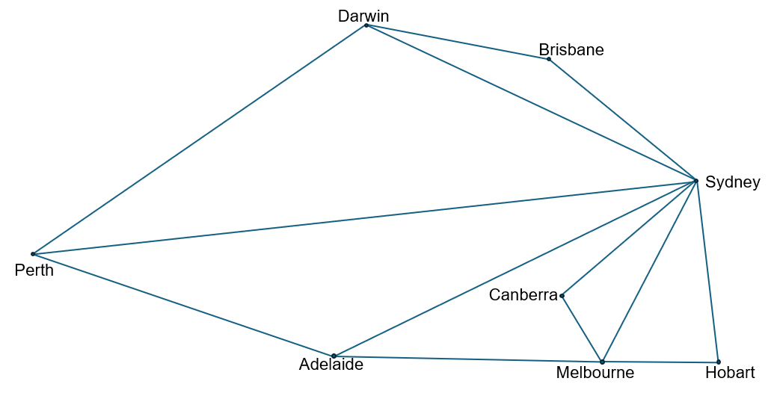

Departure | Departure (local time) | Destination | Arrival (local time)
Perth | $$\text{1400}$$ | Sydney | $$\text{2015}$$
Perth | $$\text{1430}$$ | Adelaide | $$\text{1845}$$
Perth | $$\text{1500}$$ | Darwin | $$\text{2015}$$
Adelaide | $$\text{1200}$$ | Sydney | $$\text{1430}$$
Adelaide | $$\text{1230}$$ | Melbourne | $$\text{1425}$$
Adelaide | $$\text{1300}$$ | Perth | $$\text{1445}$$
Darwin | $$\text{1500}$$ | Perth | $$\text{1720}$$
Darwin | $$\text{1530}$$ | Sydney | $$\text{1945}$$
Darwin | $$\text{1600}$$ | Brisbane | $$\text{2045}$$
Brisbane | $$\text{1000}$$ | Sydney | $$\text{1130}$$
Brisbane | $$\text{1030}$$ | Darwin | $$\text{1400}$$
Sydney | $$\text{0900}$$ | Perth | $$\text{1200}$$
Sydney | $$\text{1000}$$ | Melbourne | $$\text{1135}$$
Sydney | $$\text{0830}$$ | Canberra | $$\text{0925}$$
Sydney | $$\text{1030}$$ | Hobart | $$\text{1230}$$
Sydney | $$\text{0930}$$ | Darwin | $$\text{1330}$$
Sydney | $$\text{1100}$$ | Brisbane | $$\text{1230}$$
Sydney | $$\text{1130}$$ | Adelaide | $$\text{1300}$$
Melbourne | $$\text{1730}$$ | Sydney | $$\text{1905}$$
Melbourne | $$\text{1800}$$ | Adelaide | $$1855$$
Melbourne | $$\text{1830}$$ | Canberra | $$\text{1935}$$
Melbourne | $$\text{1900}$$ | Hobart | $$\text{2015}$$
Canberra | $$\text{2000}$$ | Melbourne | $$\text{2105}$$
Canberra | $$\text{2030}$$ | Sydney | $$\text{2125}$$
Hobart | $$\text{2100}$$ | Sydney | $$\text{2255}$$
Hobart | $$\text{2130}$$ | Melbourne | $$\text{2245}$$

Appendix C

Scavenger hunt
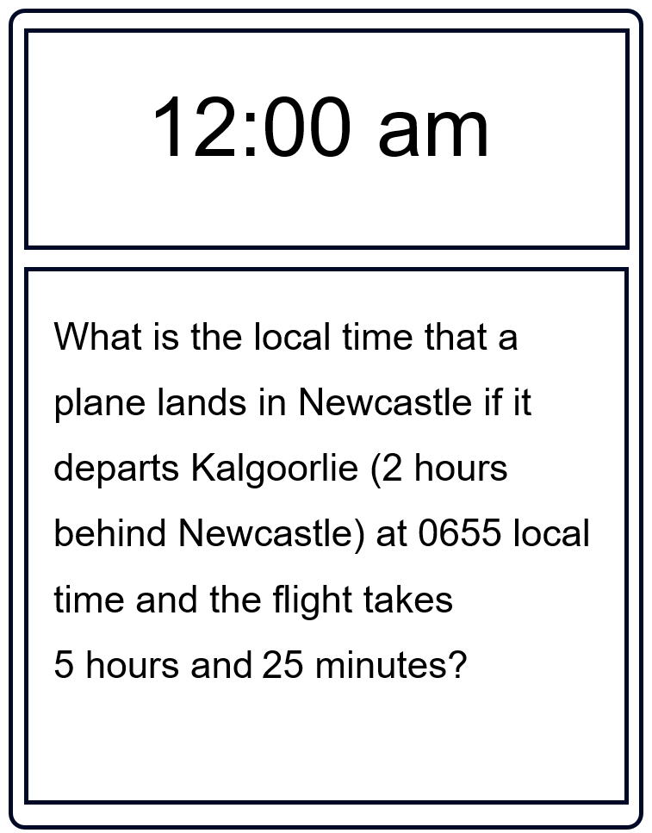
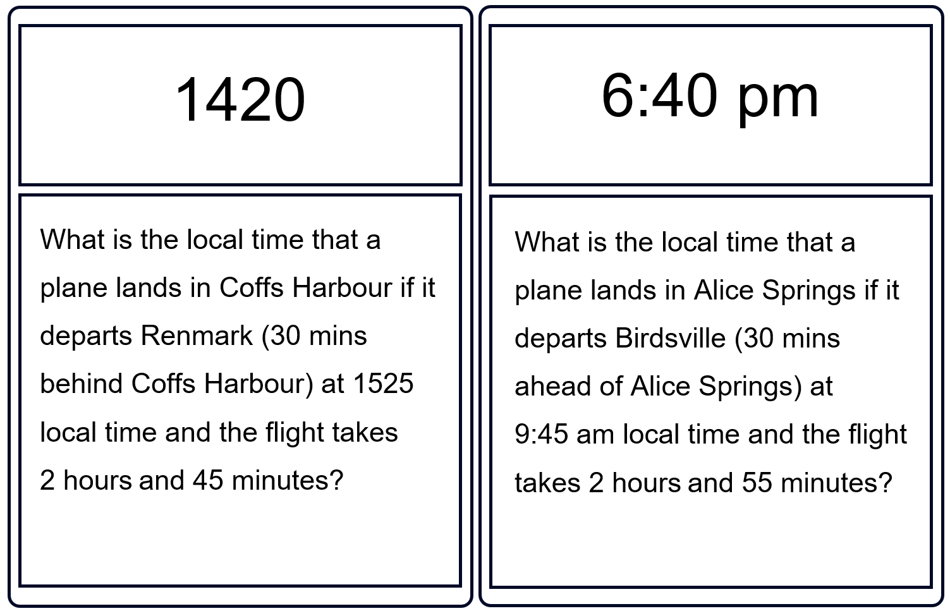
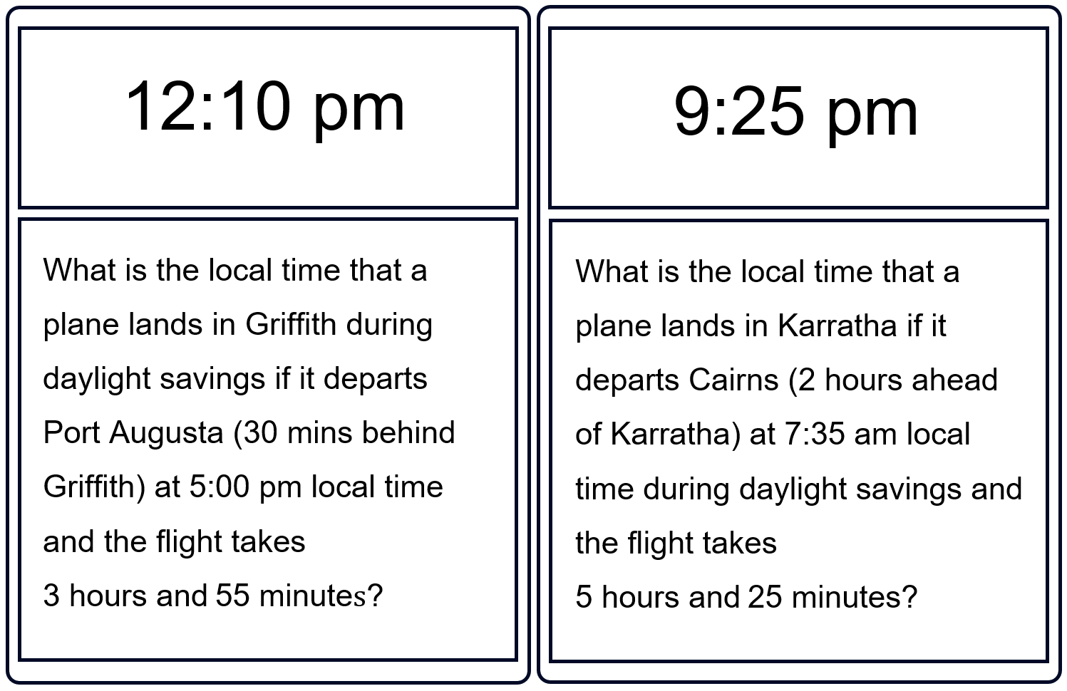
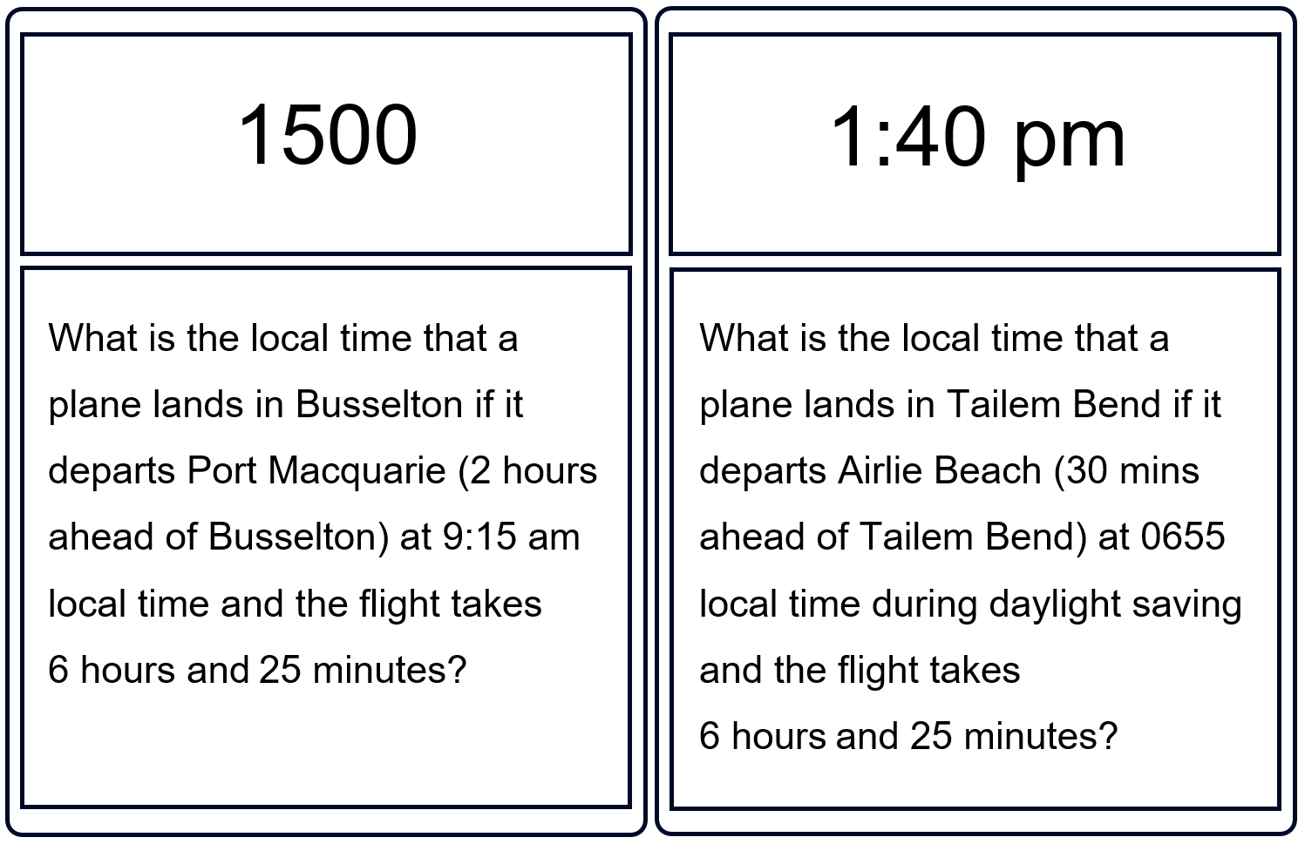
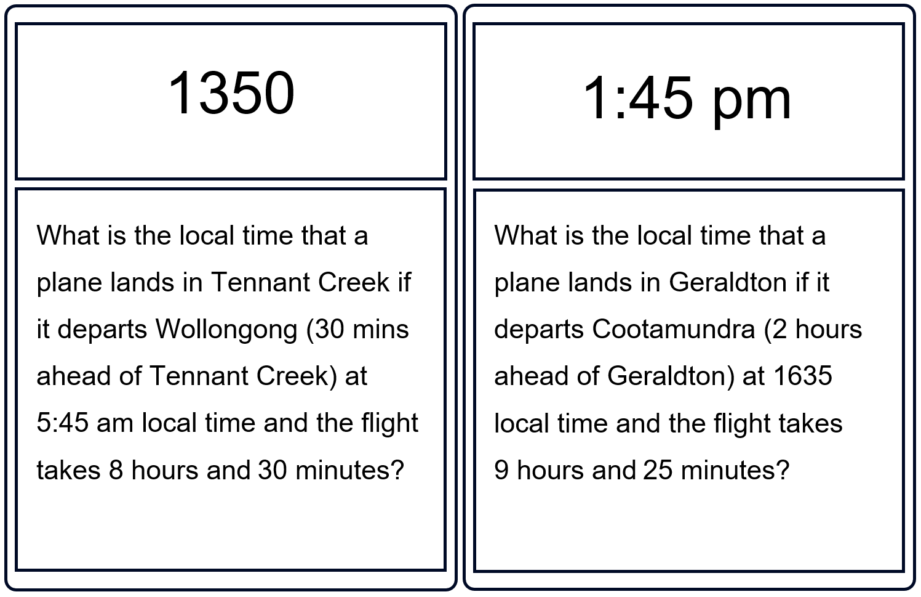

Appendix D

HSC-style questions
Question 1
It is 3 pm on Tuesday in Carnarvon, Western Australia, which is 2 hours behind NSW. What time and day is it in Coffs Harbour, NSW if NSW is additionally observing daylight saving time?
Question 2
A flight departs Melbourne at 9 am, heading towards Broome. The flight time is 4 hours and 40 minutes. Broome is 2 hours behind Melbourne
What is the local time in Broome when the plane arrives?
Question 3
A flight departs Sydney at 9:15 am and arrives in Adelaide 2 hours and 10 minutes later. If Adelaide is 30 minutes behind Sydney, what is the local arrival time in Adelaide when the plane arrives?
Question 4
A train departs Darwin at 7:40 pm on Tuesday. It travels to Brisbane, with the journey taking 15 hours and 25 minutes.
What is the local arrival time and day in Brisbane? (Brisbane is 30 minutes ahead of Darwin)
Question 5
A long-distance driver leaves Geraldton at 5:20 am Monday and drives to Port Augusta. The journey takes 28 hours and 40 minutes, including rest stops. If Geraldton is 1.5 hours behind Port Augusta, what is the local arrival time and day in Port Augusta?

Sample solutions

Appendix D – HSC-style questions
Question 1
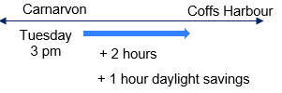
$$\text{Coffs Harbour}=\text{Tuesday 3} \text{pm + 3 hours} \\ =\text{Tuesday 6} \text{pm}\text{.}$$
Question 2
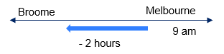
Melbourne is east of Broome, so it is 2 hours ahead of Broome.$$\text{Broome }= \text{9} \text{am – 2} \text{hours } \\ =\text{7} \text{am} \\ \text{Plus travel time = 7} \text{am +} \text{4} \text{hours} \text{and} \text{40} \text{minutes} \text{=} \text{11:40} \text{am}\text{.}$$
Question 3
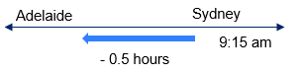
Sydney is east of Adelaide, so it is 0.5 hours ahead of Adelaide.$$\text{Adelaide }= \text{9:15} \text{am }\text{–}\text{ 0.5} \text{hours } \\ =\text{8:45 am}$$$\text{Plus travel time = 8:45} \text{am +} \text{2 hours and} \text{10 minutes} \text{=} \text{10:55} \text{am}$.

Question 4
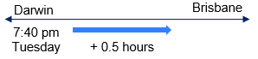
Brisbane is east of Darwin, so it is 0.5 hours ahead of Darwin.$$\text{Brisbane }= \text{7:40} \text{pm + 0.5} \text{hours } \\ =\text{8:10 pm}$$$\text{Plus travel time = 8:10 pm +} \text{15} \text{hours} \text{and 25} \text{minutes} \text{=11:35} \text{am} \text{Wednesday}$.
Question 5
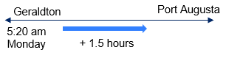
Port Augusta is east of Geraldton, so it is 0.5 hours ahead of Geraldton.$$\text{Port Augusta }= \text{5:20 am + 1.5} \text{hours } \\ =\text{6:50 am}$$$\text{Plus travel time = 6:50} \text{am +} \text{28} \text{hours and} \text{40} \text{minutes} \text{=11:30} \text{am} \text{Tuesday}$.

References
This resource contains NSW Curriculum and syllabus content. The NSW Curriculum is developed by the NSW Education Standards Authority (NESA). This content is prepared by NESA for and on behalf of the Crown in right of the State of New South Wales. The material is protected by Crown copyright.
Please refer to the NESA Copyright Disclaimer for more information https://www.nsw.gov.au/education-and-training/nesa/copyright.
NESA holds the only official and up-to-date versions of the NSW Curriculum and syllabus documents. Please visit NESA https://www.nsw.gov.au/education-and-training/nesa and NSW Curriculum https://curriculum.nsw.edu.au.
Mathematics Standard 11–12 Syllabus © NSW Education Standards Authority (NESA) for and on behalf of the Crown in right of the State of New South Wales, 2024.
Numeracy Stage 6 (CEC) Syllabus © NSW Education Standards Authority (NESA) for and on behalf of the Crown in right of the State of New South Wales, 2021.

© State of New South Wales (Department of Education), 2026
The copyright material published in this resource is subject to the Copyright Act 1968 (Cth) and is owned by the NSW Department of Education or, where indicated, by a party other than the NSW Department of Education (third-party material).
Copyright material available in this resource and owned by the NSW Department of Education is licensed under a Creative Commons Attribution 4.0 International (CC BY 4.0) license.

This license allows you to share and adapt the material for any purpose, even commercially.
Attribution should be given to © State of New South Wales (Department of Education), 2026.
Material in this resource not available under a Creative Commons license:
- the NSW Department of Education logo, other logos and trademark-protected material
- material owned by a third party that has been reproduced with permission. You will need to obtain permission from the third party to reuse its material.
Links to third-party material and websites
Please note that the provided (reading/viewing material/list/links/texts) are a suggestion only and implies no endorsement, by the New South Wales Department of Education, of any author, publisher, or book title. School principals and teachers are best placed to assess the suitability of resources that would complement the curriculum and reflect the needs and interests of their students.
If you use the links provided in this document to access a third-party's website, you acknowledge that the terms of use, including licence terms set out on the third-party's website apply to the use which may be made of the materials on that third-party website or where permitted by the Copyright Act 1968 (Cth). The department accepts no responsibility for content on third-party websites.

