Latitude and longitude
Students examine the Earth’s latitude and longitude and use coordinates to locate places around the world. They connect differences in longitude to time to calculate time differences between locations.
Students will need at least one digital device per pair to interact with the activities during this lesson.

Learning intentions
- To understand how latitude and longitude are used to locate places on Earth.
- To understand the relationship between longitude and time.

Success criteria
- I can identify locations using latitude and longitude.
- I can identify whether a place is ahead or behind another place in time.
- I can calculate the time differences between locations using longitude.

Outcomes
A student:
- develops understanding and fluency in mathematics through exploring and connecting mathematical concepts, choosing and applying mathematical techniques to solve problems, and communicating their thinking and reasoning coherently and clearly MAO-WM-01
- solves problems involving time and location in practical contexts MST-11-06

Associated numeracy outcomes
A student:
- applies numerical reasoning and mathematical thinking to clarify, efficiently solve and communicate solutions to problems N6-1.2
- chooses and applies efficient strategies to analyse and solve everyday problems involving metric relationships, distance and length, area, volume, time, mass, capacity and temperature N6-2.2
- chooses and applies efficient strategies to analyse and solve everyday problems involving location, space and design N6-2.5
Numeracy Stage 6 (CEC) Syllabus © NSW Education Standards Authority (NESA) for and on behalf of the Crown in right of the State of New South Wales, 2021.

Content

Time and location
Positions on the Earth’s surface
- Identify a location on the Earth's surface using latitude, longitude and position coordinates, with and without using digital tools
- Apply $15°=1$ hour time difference to calculate the time differences between locations on Earth given the relevant longitudes
Mathematics Standard 11–12 Syllabus © NSW Education Standards Authority (NESA) for and on behalf of the Crown in right of the State of New South Wales, 2024.

Table 1: lesson summary
Section | Summary of activity | Teaching strategies | Teaching points
Retrieval practice | Students complete an online activity nrich.maths.org/treasurehunt/responsive.htm l revising coordinates, then use Appendix A to explore ideas about ‘ahead’ and ‘behind’ in time and share their approaches.  Students use slide 4 of the PowerPoint Latitude and longitude to locate points on a Cartesian plane before using slides 5–6 to connect these coordinates to latitude and longitude on a world map. Using slide 7 and Appendix B, students identify the locations of given coordinates and show their answers to check understanding. Students complete the card-sort activity from Appendix C. | Variation theory  Think-Pair-Share  Mini whiteboards  Card sort | Students revise finding coordinates and reading basic time and calculations.  Students make the connection between the Cartesian plane and latitude and longitude. They then revise prior knowledge from Geography on latitude and longitude.
Activating prior knowledge | Students watch ‘Nedd Brockmann Completes 4,000km Run Across Australia | 10 News First’ (bit.ly/Nedd_Brockman) (3:55) and use slide 9 to explore finding an exact location. They then use Google Maps to investigate how coordinates are displayed and connect this to how the Earth rotates and how longitude relates to time. | Class discussion  Think-Pair-Share  Pose-Pause-Pounce-Bounce | Students look at latitude and longitude using digital tools.
Connecting learning | Students watch ‘The Origin of Degrees and Radians’ from 0:00–2:46 (bit.ly/degrees-to-radians-video) before developing the relationship that the Earth rotates 15° per hour. Using slides 11–13, students apply the relationship to determine time differences based on longitude. | Think-Pair-Share  Pose-Pause-Pounce-Bounce | Students develop the relationship 15° = 1 hour.
Releasing responsibility | Using slides 15–18, students complete worked examples. Finally, students create Four quadrant notes (Appendix D) summarising what they want to remember about the process. | Worked example  Vertical non-permanent surfaces  Visibly random groups of 3  Four quadrant notes | Students look at worked examples and make notes.
Independent practice | Students use slide 20 to revisit the ’Approaching questions scaffold’ before completing the HSC-style questions from Appendix E. |  | Students practise HSC-style questions.

Activity structure
Please use the associated PowerPoint Latitude and longitude to display images in this lesson.

Retrieval practice

Cartesian plane
- In pairs and with at least one digital device between them, have students navigate to nrich.maths.org/treasurehunt/responsive.html and complete the Treasure Hunt game. This game requires students to find the coordinates of the treasure, using clues for how far away the guess is from the treasure. Students can make marks on the grid to plan their solution or mark it on a printed grid.
Students should not go past Level 3 as Level 4 introduces the $z$-coordinate.

Time calculations
- In a Think-Pair-Share (bit.ly/thinkpairsharestrategy) ask students what they think is meant by ‘ahead’ and ‘behind’ in relation to time.
Students should make the connection that times are added on when a location is ‘ahead’ and subtracted when they are ‘behind’.
- Distribute to each pair a copy of Appendix A ‘Variation time’. This appendix has been modified from the Variation theory activity ‘Time: Fill in the gaps’ (bit.ly/variation_time).
- Have pairs compare their answers with their neighbours and discuss any discrepancies.
- Select students to demonstrate a variety of methods you observed while the students were working on the activity. Students could have used the ‘jump method’, ‘split strategy’ or ‘compensation method’.

Latitude and longitude
- Display slide 4 of the PowerPoint, showing a Cartesian plane with 4 quadrants, and ask students to find the 4 points, one in each quadrant.
A (9,5), B (−4, -1), C (−7, 3), D (2, −1)
- Display slide 5, showing an overlay of the Cartesian plane onto the world map with the $x$ axis lining up with the equator and 0° longitude lining up with $y$ axis.
- Direct students to look at the points and ask how we could describe the points using latitude and longitude.
Most students should be familiar with the concept of latitude and longitude from Stage 4 Geography (bit.ly/stage4_lat_long).
- Show slide 6, which revises latitude and longitude and how we write coordinates.
Teachers should make sure that students are aware that by convention, ordered pair coordinates are always written as ($x, y$) but location coordinates are written with latitude (north or south) first.
- Distribute Appendix B ‘World map’ to each student. This is also shown on slide 7 with some locations marked on it.
- Using mini whiteboards (bit.ly/miniwhiteboards), ask students to simultaneously show their answers to check for understanding of latitude and longitude of the given locations. What letter is at:
- (65°N,150°E)
- (55°N, 120°W)
- (18°S, 31°E)
- (12°$\text{S}$, 77°W)?
A (65°N,150°E), B (12°$\text{S}$, 77°W), C (55°N, 120°W), D (18°S, 31°E). Students cannot judge the exact position of the latitude and longitude, so if asking the question, ‘What is the latitude and longitude of point A?’ you would need to accept approximate values.
Students will use the marked locations in the next activity.
- Distribute Appendix C ‘Card sort’ to pairs of students. Have students match the city to the correct latitude and longitude using Appendix B as a reference.
Cards are in the correct order, so teachers could cut up the cards before the lesson and place them in resealable plastic bags. The paired cards are used again in the ‘Releasing responsibility’ section and again in Lesson 8.
Students should keep pairs of cards together as they will be using them again later in the lesson.

Activating prior knowledge
- Show students the video ‘Nedd Brockmann Completes 4,000 km Run Across Australia | 10 News First’ (3:55) (bit.ly/Nedd_Brockman).
- Read the following scenario to the students.
Nedd is an ultramarathon runner. He is running along some remote tracks when he finds himself in need of medical assistance. He contacts emergency services who ask, ‘What is your location?’
- Conduct a class discussion about how Nedd could accurately inform emergency services of how to find him.
Discussion points could include apps on his phone that are able to pinpoint his location using latitude and longitude within about a 10-metre radius.
- Provide the next part of the scenario by showing slide 9.
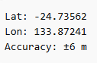
Nedd’s app said that his location was as shown above.
- In a Think-Pair-Share, ask students to discuss what the information shown might mean. Possible sharing prompts could include:
- What does the negative number represent in the latitude? How do we show the negative direction in latitude?
- Why doesn’t the longitude have a negative? How do we normally write direction in longitude?
- Why are the numbers decimals and not in degrees, minutes and seconds?
- Have students go to Google Maps (bit.ly/Maps__Google) and find their school or somewhere of local interest to them. Have students use the Zoom tool (located on the lower right corner of the page with a + and – symbol) to assist them in finding their chosen location, not by entering an address into the search bar.
- Have students click on their place of interest so a grey ‘pin’ becomes visible.
If the large red ‘pin’ comes up when a place is selected, have students chose a space next to the red pin to click until the grey pin comes up.
- Have students notice what appears in the pop-up window about their selected location.
It is the pinpoint latitude and longitude. (For example, -34.630880, +148.021474).
- Students should then click on the coordinates as shown in Figure 1. Ask students what they notice?
Figure 1: coordinates example
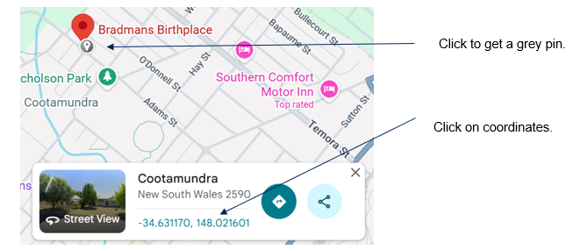

Source: image adapted from Google Maps(© Google), accessed 2 June 2026.
Students should notice that the measurement changes from negative and positive to an east and west measurement that contains degrees, minutes and seconds rather than a decimal.
Students may need to right-click the grey pin and copy the coordinates into the search bar to get it to convert to a compass bearing format or the coordinates.
- Have students add in a random latitude and longitude from around the world into the search bar in Google Maps using compass directions, for example, 34°S, 151°E. Students should use Appendix B as a guide for choosing their points so they do not choose a point in the middle of the ocean.
- Have students observe where they are and how their location is written both as decimals and with compass directions in degrees, minutes and seconds.
- Using the Pose-Pause-Pounce-Bounce questioning strategy (PDF 557 KB) (bit.ly/posepausepouncebounce) and referring to the world map from Appendix B, initiate a class discussion to connect prior knowledge. Questions could include:
- Why does the map only go 180° to the east and 180° to the west?
- What is the line where 180° east meets $\text{180°}$ west called and why is it significant?
- Issue a spherical object, such as a balloon, to each pair of students to simulate the globe. Have students mark the equator, Prime (Greenwich) meridian and International Date Line (IDL) on the sphere.
Students could use a circular balloon to simulate the earth or they could a different spherical object, such as a ball or a polystyrene sphere.
- From the Prime (Greenwich) meridian mark at 90°E and 90°W, the points are halfway between the Prime (Greenwich) meridian and the International Date Line on either side. Show that the lines of longitude go from 0° to 180° in both the east and west direction.
- Ask students to consider the equator. In a class discussion, ask students how they would mark the lines of latitude on the sphere.
- Using a Pose-Pause-Pounce-Bounce questioning strategy, ask students why the latitude only goes from 90°N to 90°S when latitude goes from 180°E to 180°W.
The latitude is 180° from north to south on each side of the globe, equalling 360°.

Connecting learning
- Show students the video ‘The Origin of Degrees and Radians’ from 0:00–2:46 (bit.ly/degrees-to-radians-video).
- In a Think-Pair-Share, ask students to consider how many degrees the Earth would rotate in an hour.
Students should connect that the Earth rotates 360° in 24 hours, so 360°$÷\text{24 =}$ 15° in 1 hour.
- Challenge students to consider in a Think-Pair-Share how long it takes the Earth to rotate 1°.
The Earth takes 1/15th of an hour, or 4 minutes to rotate 1°. It is not a requirement of the syllabus that students remember that 1°= 4 minutes.
- Display slide 11 and ask students to consider the 2 places on the map: Kalgoorlie (31°S, 121°E) and Tamworth (31°S, 151°E).
- Using a Pose-Pause-Pounce-Bounce questioning strategy, ask students how they could use the relationship from above to work out the time difference between the 2 places. Possible prompting questions include:
- Would 9 am be the same time at both places or would there be a time difference?
- Which measurement should be used to find out the time difference?
- How could we find the time difference?
- What is the time difference between Kalgoorlie and Tamworth?
The time difference is 2 hours.
- Display slide 12, showing Cairo (30°N, 30°E) and Coober Pedy (29°S, 135°E). Ask students to determine how long it would take for the Earth to rotate from Cairo to Coober Pedy. Students could be prompted to consider: ‘If 15°= 1 hour, which measurement, would you use: latitude or longitude?’
Students should consider that the Earth rotates on an axis from the North to South Poles so the Earth spins east-west. The Earth spins from 135° east to 30°east, equalling a 105° difference (105 ÷ 15 = 7 hours).
- Display slide 13, showing where 15° = 1 hour is listed on the NESA Mathematics Standard 1 and 2 – HSC reference sheet.

Releasing responsibility
- Use slides 15–18 of the PowerPoint to model worked examples of time differences using the Worked examples (Your turn) method (bit.ly/supportingstrategies).
- In pairs and using the cards from the ‘Activating prior knowledge’ activity, have students select 2 places they would like to visit and find the time difference between them.
- Have students label their 2 places ‘city A’ and ‘city B’. Tell students they want to call someone in city B from city A, where it is currently 2 pm. What would the time be in city B?
- Have students swap questions with a neighbouring pair to complete the activity and have groups compare solutions. If solutions vary, have students justify their solution to come up with a shared consensus.
- Repeat steps 3 and 4 with a different pair of places.
- Assign students to visibly random groups of 3 (bit.ly/visiblegroups), and ask them to complete four quadrant notes to their future forgetful selves (bit.ly/supportingstrategies) from Appendix D ‘Four quadrant notes’ on a vertical non-permanent surface (bit.ly/VNPSstrategy), before writing their own copy of four quadrant notes.

Independent practice
- Use slide 20 to remind students of the ‘Approaching questions scaffold’.
- Distribute Appendix E ‘HSC-style questions’ to each group of 3 at vertical non-permanent surfaces and have them work through each problem before comparing their solution with a neighbouring group.

Assessment and differentiation

Suggested opportunities for differentiation
Activating prior knowledge
- Challenge students to investigate real-world emergency services Global Positioning System coordinates and convert between decimal coordinates and degrees-minutes-seconds.
Connecting learning
- Allow students to use reference prompts, such as:
- 360° = 24 hours
- 15° = 1 hour.
- Encourage students to use a number line or sketch of the globe to visualise movement east or west.
Releasing responsibility
- Challenge students to create their own coordinate or time-difference problem for another group to solve.
- Ask students to determine the time difference between cities aligned to multiples of 15°, not requiring calculations involving partial hours until the concept is fully understood.
Independent practice
- Challenge students to create their own HSC-style question for another group to solve.

Suggested opportunities for assessment
Activating prior knowledge
- The simultaneous display of mini whiteboards allows the teacher to gauge student understanding.
- Monitor student explanations during the Think-Pair-Share when interpreting latitude and longitude and when reasoning about Earth’s rotation.
- Teachers can assess students’ understanding of latitude and longitude during the card-sort activity.
Connecting learning
- Monitor student explanations during discussions on time differences to determine their conceptual understanding of the relationship between angular distance and time.
Releasing responsibility
- Observe student responses during the ‘Your turn’ section of the worked examples to gauge understanding.
- When groups compare their solutions with neighbouring groups, students could critique reasoning and refine their understanding.
- Four quadrant notes could be reviewed to assess understanding of the concepts of time.
Independent practice
- During the HSC-style questions, the teacher can quickly scan student work across the room, identify common errors and prompt groups to justify their reasoning.
- One of the HSC-style questions could be used as an exit ticket.

Appendix A

Variation time
Time (am or pm) | 24-hour time | $\text{2 hours 30 mins}$ ahead | $\text{1 hour 45 mins}$ behind | Time until $\text{9 pm}$ | Time since $\text{2:15 am}$
$$\text{3 am}$$
 | $$\text{0900}$$
 |  | $$\text{8:30 am}$$
 |  |  | $$\text{7:45 pm}$$
$$\text{5 hours}$$
$$\text{15 minutes}$$
$$\text{15 hours}$$
$$\text{45 minutes}$$
Source: this table has been adapted from ‘Time: Fill in the gaps’ by Craig Barton (2020).

Appendix B

World map
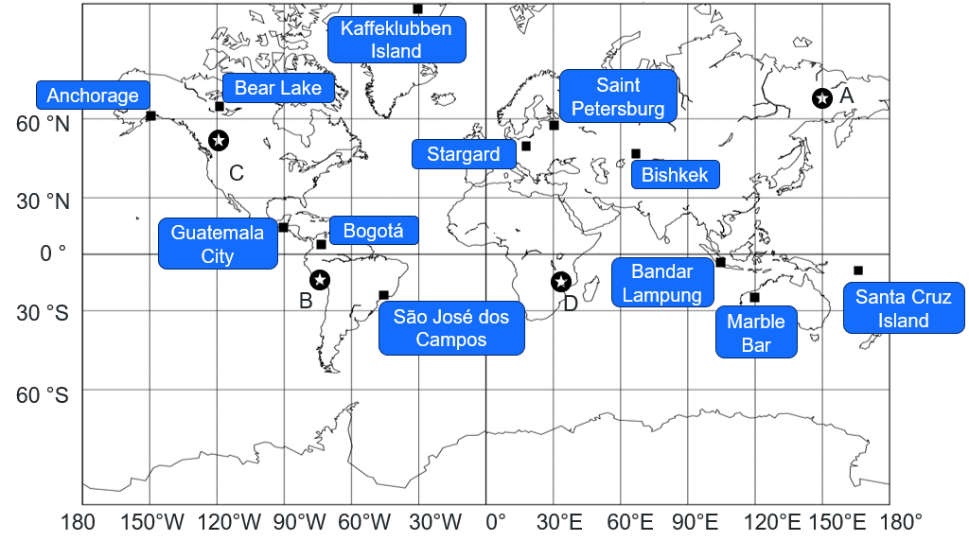

Appendix C

Card sort
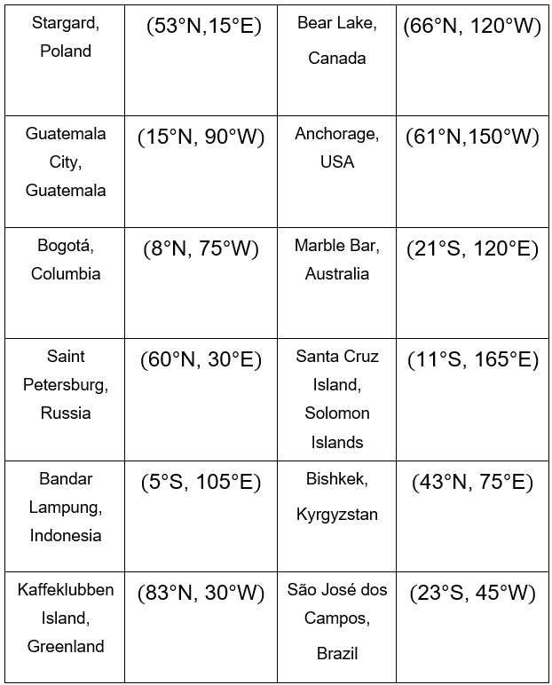

Appendix D

Four quadrant notes
Example 1  What is the time difference between Wānaka, New Zealand $\text{(45°S, 169°E})$ and Budapest, Hungary $\text{(47°N, 19°E})$?  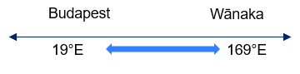  $$\text{Angular distance}=⎕-⎕ \\ =\text{150°} \\ \text{Time difference} =⎕ \text{÷} \text{15} \\ =⎕ \text{hours}\text{.}$$ | Example 2  If it is 7 pm in Bangkok, Thailand $(\text{14°N, 100°E})$, what time is it in Jacksonville, USA$(\text{14°N, 95°W})$?
Things to remember | Example 3

Appendix E

HSC-style questions
Answer each question, ignoring time zones and daylight savings.
Question 1
Lee wants to call home to Wagga Wagga, Australia (35$°$S, 147$°$E) from Truro, Canada (45$°$N, 63$°$W) when it is 6 pm on Wednesday in Wagga Wagga.
Give the time and day in Truro when she should make the call.
Question 2
A conference is being held in Kyiv, Ukraine (50$°$N, 31$°$E). Holly lives in Sydney, Australia (34$°$S, 151$°$E).
Holly needs to give an online presentation to her colleagues at the conference, starting at 10 am local time in Kyiv.
What time and day in Sydney should Holly make the presentation?
Question 3
Johannesburg, South Africa is at a latitude of 26$°\text{S}$ and longitude of 28$°$E. Buenos Aires is 9$°$ south and 86$°$ west of Johannesburg.
What is the latitude and longitude of Buenos Aires?
Question 4
Aranuka Island, Kiribati and Balambala, Kenya are both on the equator.
The longitude of Aranuka Island is 174$°$E and the longitude of Balambala is 39$°$E.
Nicole leaves Aranuka Island at 6 pm on Tuesday evening.
She arrives at Balambala after travelling for 19 hours and 25 minutes.
What local time and day is it at Balambala when she arrives?

Sample solutions

Appendix A – variation time
Time (am or pm) | 24-hour time | $\text{2 hours 30 mins}$ ahead | $\text{1 hour 45 mins}$ behind | Time until $\text{9:00 pm}$ | Time after $\text{2:15 am}$
$$\text{3 am}$$ | $$\text{0300}$$ | $$\text{5:30 am}$$ | $$\text{1:15 am}$$ | $$\text{18 hours}$$ | $$\text{45 minutes}$$
9 $\text{am}$ | $$\text{0900}$$ | $$\text{11:30 am}$$ | $$\text{7:15 am}$$ | $$\text{12 hours}$$ | $$\text{6 hours}$$  $$\text{45 minutes}$$
$$\text{6 am}$$ | $$\text{0600}$$ | $$\text{8:30 am}$$ | $$\text{4:15 am}$$ | $$\text{13 hours}$$ | $$\text{3 hours}$$  $$\text{45 minutes}$$
$$\text{9:30 pm}$$ | $$\text{2135}$$ | $$\text{12 am}$$ | $$\text{7:45 pm}$$ | $$\text{23 hours}$$  $$\text{30 minutes}$$ | $$\text{7 hours}$$  $$\text{15 minutes}$$
$$\text{3:45 pm}$$ | $$\text{1545}$$ | $$\text{6:15 pm}$$ | $$\text{2 pm}$$ | $$\text{5 hours}$$  $$\text{15 minutes}$$ | $$\text{13 hours}$$  $$\text{30 minutes}$$
$$\text{6 pm}$$ | $$\text{1800}$$ | $$\text{8:30 pm}$$ | $$\text{4:15 pm}$$ | $$\text{3 hours}$$ | $$\text{15 hours}$$  $$\text{45 }\text{minutes}$$

Appendix D – four quadrant notes
Example 1  What is the time difference between Wānaka, New Zealand $\text{(45°S, 169°E})$ and Budapest, Hungary $\text{(47°N, 19°E})$?  $$\text{Angular distance}=\text{169} \text{–} \text{19} \\ =\text{150°} \\ \text{Time difference} =\text{150÷15} \\ =\text{10} \text{hours}\text{.}$$ | Example 2  If it is 7 pm in Bangkok, Thailand $(\text{14°N, 100°E})$, what time is it in Jacksonville, USA $(\text{14°N, 95°W})$?  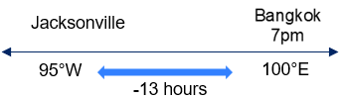  $$\text{Angular distance}=\text{100} \text{+} \text{95} \\ =\text{195} \\ \text{Time difference} =\text{195} \text{÷} \text{15} \\ =\text{13 hours} \\ \text{Jacksonville}= \text{6} \text{am}$$.

Appendix E – HSC-style questions
Question 1
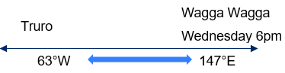
$$\text{Angular distance}=\text{147} \text{+} \text{63} \\ =\text{210} \\ \text{Time difference} =\text{210} \text{÷} \text{15} \\ =\text{14 hours}$$
$$\text{Truro is west of Wagga} \text{Wagga}\text{, so behind Wagga}\text{ Wagga}\text{.} \\ \text{Truro} =\text{6} \text{pm – 14 hours } \\ =\text{4} \text{am Wednesday}$$
Question 2
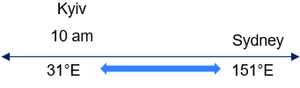
$$\text{Angular distance}=\text{151 – 31} \\ =\text{120} \\ \text{Time difference} =\text{120 ÷ 15} \\ = \text{8 hours }$$
Sydney is east of Kyiv, so ahead of Kyiv$.$$$\text{Sydney }= \text{10 am + 8 hours } \\ = \text{6} \text{pm}$$Therefore Holly should make the presentation at 6 pm, on the same day as Kyiv.

Question 3
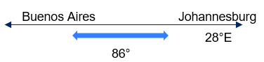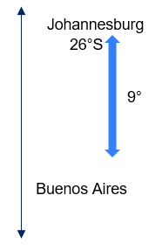
$$\text{Longitude}=\text{28°E} \text{-} \text{86°} \\ =\text{58°W} \\ \text{Latitude} =\text{26}\text{°}\text{S} \text{+ 9} \\ =\text{35°S} \\ \text{Buenos Aires }\text{(}\text{35°S}\text{, }\text{58°W}\text{)}$$
Question 4
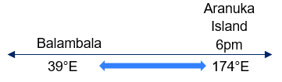
$$\text{Angular distance}=\text{174 – 39} \\ =\text{135} \\ \text{Time difference} =\text{135 ÷ 15} \\ =\text{9 hours}$$Aranuka Island is east of Balambala, so ahead of Balambala$.$$$\text{Balambala }= \text{6 pm - 9 hours} \\ =\text{3 am same day} \\ \text{Plus travel time = 3 am + 19 hours 25 min = 10:45 pm same day.}$$

References
This resource contains NSW Curriculum and syllabus content. The NSW Curriculum is developed by the NSW Education Standards Authority (NESA). This content is prepared by NESA for and on behalf of the Crown in right of the State of New South Wales. The material is protected by Crown copyright.
Please refer to the NESA Copyright Disclaimer for more information https://www.nsw.gov.au/education-and-training/nesa/copyright.
NESA holds the only official and up-to-date versions of the NSW Curriculum and syllabus documents. Please visit NESA https://www.nsw.gov.au/education-and-training/nesa/copyright and NSW Curriculum https://curriculum.nsw.edu.au/.
Mathematics Standard 11–12 Syllabus © NSW Education Standards Authority (NESA) for and on behalf of the Crown in right of the State of New South Wales, 2024.
Numeracy Stage 6 (CEC) Syllabus © NSW Education Standards Authority (NESA) for and on behalf of the Crown in right of the State of New South Wales, 2021.
Barton C (2020) ‘Time: Fill in the gaps’, Variation Theory, Variation Theory website, accessed 2 June 2026.

© State of New South Wales (Department of Education), 2026
The copyright material published in this resource is subject to the Copyright Act 1968 (Cth) and is owned by the NSW Department of Education or, where indicated, by a party other than the NSW Department of Education (third-party material).
Copyright material available in this resource and owned by the NSW Department of Education is licensed under a Creative Commons Attribution 4.0 International (CC BY 4.0) license.

This license allows you to share and adapt the material for any purpose, even commercially. Attribution should be given to © State of New South Wales (Department of Education), 2026.
Material in this resource not available under a Creative Commons license:
- the NSW Department of Education logo, other logos and trademark-protected material
- material owned by a third party that has been reproduced with permission. You will need to obtain permission from the third party to reuse its material.
Links to third-party material and websites
Please note that the provided (reading/viewing material/list/links/texts) are a suggestion only and implies no endorsement, by the New South Wales Department of Education, of any author, publisher, or book title. School principals and teachers are best placed to assess the suitability of resources that would complement the curriculum and reflect the needs and interests of their students.
If you use the links provided in this document to access a third-party's website, you acknowledge that the terms of use, including licence terms set out on the third-party's website apply to the use which may be made of the materials on that third-party website or where permitted by the Copyright Act 1968 (Cth). The department accepts no responsibility for content on third-party websites.

