Shortest path
Students find the shortest path on a network and consider why the shortest path is not necessarily on the minimum spanning tree.

Learning intentions
- To be able to find the shortest path on a network.
- To understand why the shortest path is different to the minimum spanning tree.

Success criteria
- I can identify a path between 2 vertices.
- I can identify the shortest path between 2 vertices.
- I can explain why the shortest path may not be on the minimum spanning tree.

Outcomes
A student:
- develops understanding and fluency in mathematics through exploring and connecting mathematical concepts, choosing and applying mathematical techniques to solve problems, and communicating their thinking and reasoning coherently and clearly MAO-WM-01
- solves problems involving time and location in practical contexts MST-11-06
- applies network techniques to solve network problems MST-11-07
Mathematics Standard 11–12 Syllabus © NSW Education Standards Authority (NESA) for and on behalf of the Crown in right of the State of New South Wales, 2024.

Associated numeracy outcomes
A student:
- applies numerical reasoning and mathematical thinking to clarify, efficiently solve and communicate solutions to problems N6-1.2
- chooses and applies efficient strategies to analyse and solve everyday problems involving metric relationships, distance and length, area, volume, time, mass, capacity and temperature N6-2.2
- chooses and applies efficient strategies to analyse and solve everyday problems involving location, space and design N6-2.5
Numeracy Stage 6 (CEC) Syllabus © NSW Education Standards Authority (NESA) for and on behalf of the Crown in right of the State of New South Wales, 2021.

Content

Networks, paths and trees
Network concepts
- Solve problems involving network diagrams in a variety of practical contexts
Shortest paths and spanning trees
- Identify a shortest path on a network diagram with no more than 10 vertices
- Describe a circumstance in which a shortest path is not necessarily the best path nor contained in any minimum spanning tree
Mathematics Standard 11–12 Syllabus © NSW Education Standards Authority (NESA) for and on behalf of the Crown in right of the State of New South Wales, 2024
Table 1: lesson summary
Section | Summary of activity | Teaching strategies | Teaching points
Activating prior knowledge | Students explore Appendix A, identifying all possible paths from A to L and considering how changes to the network could affect path lengths. | Visibly random groups of 3  Vertical non-permanent surfaces  Class discussion | By examining how adding or altering edges changes the number and length of paths, students begin to reason about efficiency.
Connecting learning | Students learn about geocaching through a video (bit.ly/Findgeocaching). Using a scenario and the map of Kangaroo Island on slide 4 of the PowerPoint Shortest path and Appendix B, students create a network, compare paths, determine shortest paths and identify the minimum spanning tree that connects all locations. | Notice and wonder  Visibly random groups of 3  Vertical non-permanent surfaces  Pose-Pause-Pounce-Bounce  Gallery walk | By building a network from a real map and analysing both shortest paths and minimum spanning trees, students learn that different problems require different optimisation strategies.
Releasing responsibility | Students examine multiple methods of finding the shortest paths on slides 6–7. They complete Appendix C in pairs and compare solutions with neighbouring pairs. Students add to their notes from Lesson 4 using Appendix D. | Notes to future forgetful selves | By comparing methods, students deepen their understanding of how shortest‑path problems differ from minimum spanning tree problems
Independent practice | Students revisit the ‘Approaching questions scaffold’ using slide 9 before completing Appendix E, which includes both minimum spanning tree and shortest‑path problems and then refine their notes as needed. | Approaching questions scaffold | By practising shortest path and minimum spanning tree questions side-by-side, students consolidate their understanding of when to apply each strategy, reinforcing the distinctions and HSC‑style reasoning.

Activity structure
Please use the associated PowerPoint Shortest path to display images in this lesson.

Activating prior knowledge
- Assign students to visibly random groups of 3 (bit.ly/visiblegroups) at vertical non-permanent surfaces (bit.ly/VNPSstrategy).
- Distribute Appendix A ‘Travel blocks’ in a plastic sleeve with adhesive putty to each group and have them find all the paths that exist from A to L.
Students should find that all paths are the same length and there are 12 distinct paths.
- In a class discussion, ask students how adding or changing any connections might affect the length of possible paths.
If a diagonal was added to the diagram, several shorter paths would be made.

Connecting learning
- Show the video ‘What is Geocaching?’ (1:15) (bit.ly/Findgeocaching) to students.
- Read the following scenario to the class.
Len is planning a holiday to Kangaroo Island and would like to do some geocaching while there. He has mapped out the locations of geocaches and is wondering where he could stay so he can take day trips to find each cache efficiently.
- Display slide 4 of the PowerPoint, which shows the locations of geocaches on Kangaroo Island.
- Distribute Appendix B ‘Travel times’ and ask students what they notice and wonder (bit.ly/noticewonderstrategy) about the map and the travel times.
Students may notice that the locations on the map are the same as the locations in the table and are indicated by a letter. Students may notice that there isn’t a road between all the locations.
Students may wonder how some locations are connected if there is no road on the map.
Appendix B indicates that there are 4-wheel drive roads on Kangaroo Island.
- Continuing in their groups of 3, ask students to create a weighted network diagram on their vertical non-permanent surfaces using the table and the map.
- Students should check their network with a neighbouring group to compare solutions.
- Ask students to highlight the different paths from Seal Bay to Pelican Lagoon and discuss which is the shortest path.
- Ask students to write the shortest path in a box at the bottom of their vertical non-permanent surface to be referenced later in the lesson.
- Use the Pose-Pause-Pounce-Bounce questioning strategy (PDF 557 KB) (bit.ly/posepausepouncebounce) to allow students to explain how they found the shortest path. Suggested prompts include:
- Which path looks the shortest?
- Is it quicker to travel by sealed road or the dirt 4 × 4 tracks?
- Why is the shortest path not necessarily the one that looks the shortest?
Make sure to check that students are labelling paths correctly. For example, D-J-C or D-C.
- Have students determine the minimum spanning tree that connects all the geocache locations and calculate its length.
- Draw student attention back to the path from Seal Bay to Pelican Lagoon and their minimum spanning tree.
- Use the Pose-Pause-Pounce-Bounce questioning strategy to discuss why the shortest path may not always be on the minimum spanning tree. Suggested prompts include:
- Why is the path from Seal Bay to Pelican Lagoon not on the minimum spanning tree?
- When or why does this occur?
- When would you use a minimum spanning tree?
- When would you find the shortest path?
A minimum spanning tree is used when all vertices need to be connected in the minimum possible measurement.
A shortest path is used when questions ask to find the measurement between some or all vertices in one path.
- Have students choose a location where Len could stay that gives him access to all the geocaches he needs to collect each day and then determine the shortest path from that location to the shops at Kingscote.
- Leave one student at each vertical non-permanent surface to explain the reasons for their choice. Conduct a gallery walk (bit.ly/DLSgallerywalk) to listen to explanations and compare similarities and differences.
- Students return to their vertical non-permanent surface to discuss any solutions that were different or interesting.

Releasing responsibility
- Display slide 6 which shows a scenario involving a shortest path. Students are to work in pairs to find the shortest path.
- Ask non-volunteer students to share how they found the shortest path and the solution.
Some strategies that students could use to find the shortest path are:
- find all the paths that lead from the starting vertex towards the destination vertex and then calculate them all
- eliminate obviously longer paths early
- work systematically and use colour to indicate paths you have already tested, working from the starting point or the destination point
- look at the starting vertex and find the shortest edge towards the destination vertex, following this pattern until you reach the destination vertex
- use Dijkstra’s algorithm.
- Animate slide 6 to show the solution.
- Display slide 7 which shows another example. Ask pairs of students to try a different method to find the shortest path.
- Animate slide 7 to show the solution.
- In a class discussion, ask students why there are 2 solutions to the Bali problem.
- Hand out Appendix C ‘Shortest paths’ to pairs of students for them to complete.
- Students should compare answers with a neighbouring pair and negotiate the correct solution if answers vary.
In a class discussion, ask students what sort of problems can be solved by finding a minimum spanning tree and what sort of problems can be solved by finding a shortest path.
- Students create notes to their future forgetful selves (bit.ly/notestofutureself) using the last row of Appendix D ‘Glossary of terms and conditions’. The first 4 rows of the appendix were completed in Lesson 4 – minimum spanning trees.
Teachers may wish to refer to Lesson 4 or an existing resource to complete the first 4 rows in Appendix D if teachers did not use the Lesson 4 resources.

Independent practice
- Display slide 9 to remind students how to use the ‘Approaching questions scaffold’.
- Distribute Appendix E ‘HSC-style questions’ for students to practise answering questions that involve both minimum spanning trees and shortest paths.
- Students should return to their notes to make any necessary refinements.

Assessment and differentiation

Suggested opportunities for differentiation
Activating prior knowledge
- To support students, highlight one path as an example.
- To challenge students, ask them to design their own diagram with rectangles and ask them if the paths are still all the same length.
Connecting learning
- To support students, provide a scaffold to calculate the total time of the minimum spanning tree on Kangaroo Island.
- To challenge students, ask them to investigate if the minimum spanning tree would be different if the edges represented distances instead of time.
Releasing responsibility
- To support students, scaffold the questions in Appendix C.
- To challenge students, ask them if the paths they found were on the minimum spanning tree.
Independent practice
- To support students, adjust the number of questions attempted from Appendix E.
- To challenge students, supply an incorrect solution to one diagram in Appendix E and ask students to find the error in the solution.

Suggested opportunities for assessment
Activating prior knowledge
- Take photos of students’ work on vertical non-permanent surfaces as evidence of student learning when creating a network.
- Observe student responses to the discussion on how the activity could be changed to have a shortest path.
Connecting learning
- Listen to student responses to discussions and Pose-Pause-Pounce-Bounce questioning to check for understanding of shortest paths.
- Take photos of students’ work on vertical non-permanent surfaces as evidence of learning about shortest paths.
Releasing responsibility
- Collect student responses to Appendix C and Appendix D to check for understanding of finding the shortest path.
- Monitor student understanding of shortest paths and give feedback while students are working on Appendix D.
Independent practice
- Collect Appendix E as evidence of student learning in calculating the shortest path and understanding the difference between shortest path and minimum spanning trees.

Appendix A

Travel blocks
The length of each rectangle is twice the height. Find the length of all the paths that exist from A to L.
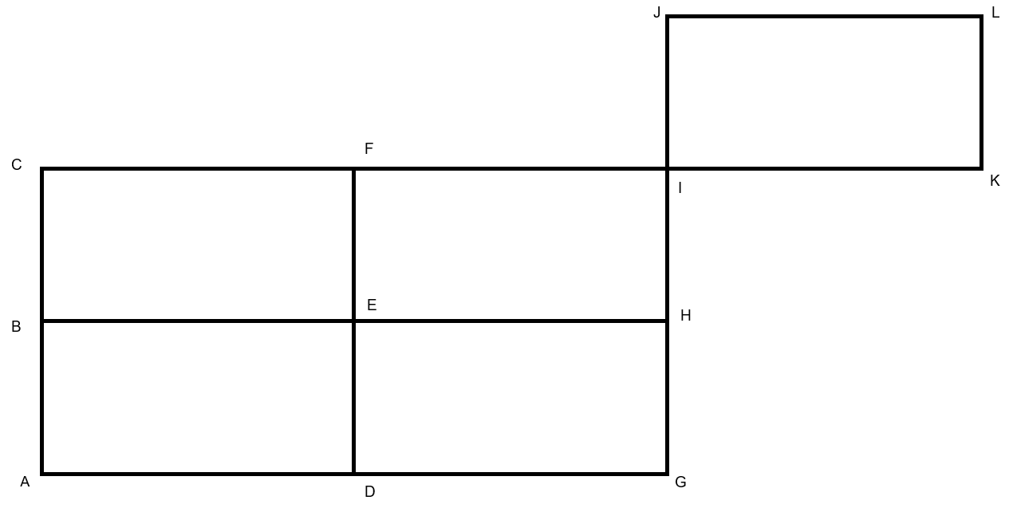

Appendix B

Travel times
Destinations | Destinations | Travel time | Road condition
Penneshaw (A) | Antechamber Bay (B) | 19 minutes | Sealed
Antechamber Bay (B) | Pelican Lagoon (C) | 28 minutes | 4 × 4 track
Penneshaw (A) | Pelican Lagoon (C) | 18 minutes | Sealed
Pelican Lagoon (C) | Cygnet River (J) | 32 minutes | Sealed
Cygnet River (J) | Kingscote (I) | 12 minutes | Sealed
Kingscote (I) | Emu Bay (H) | 16 minutes | Sealed
Emu Bay (H) | Stokes Bay (G) | 34 minutes | Sealed
Cygnet River (J) | Junction (E) | 35 minutes | Sealed
Cygnet River (J) | Seal Bay (D) | 35 minutes | Sealed
Pelican Lagoon (C) | Seal Bay (D) | 70 minutes | 4 × 4 track
Junction (E) | Seal Bay (D) | 16 minutes | Sealed
Junction (E) | Stokes Bay (G) | 28 minutes | Sealed
Junction (E) | Cape Borda (F) | 56 minutes | Sealed and 4 × 4 track
Cape Borda (F) | Stokes Bay (G) | 72 minutes | 4 × 4 track

Appendix C

Shortest paths
Question 1
Em is planning to do some sightseeing around London. The network shows the time (in minutes) that it would take for her to drive between sights.
What is the shortest path she can take between Buckingham Palace and the Tower of London.
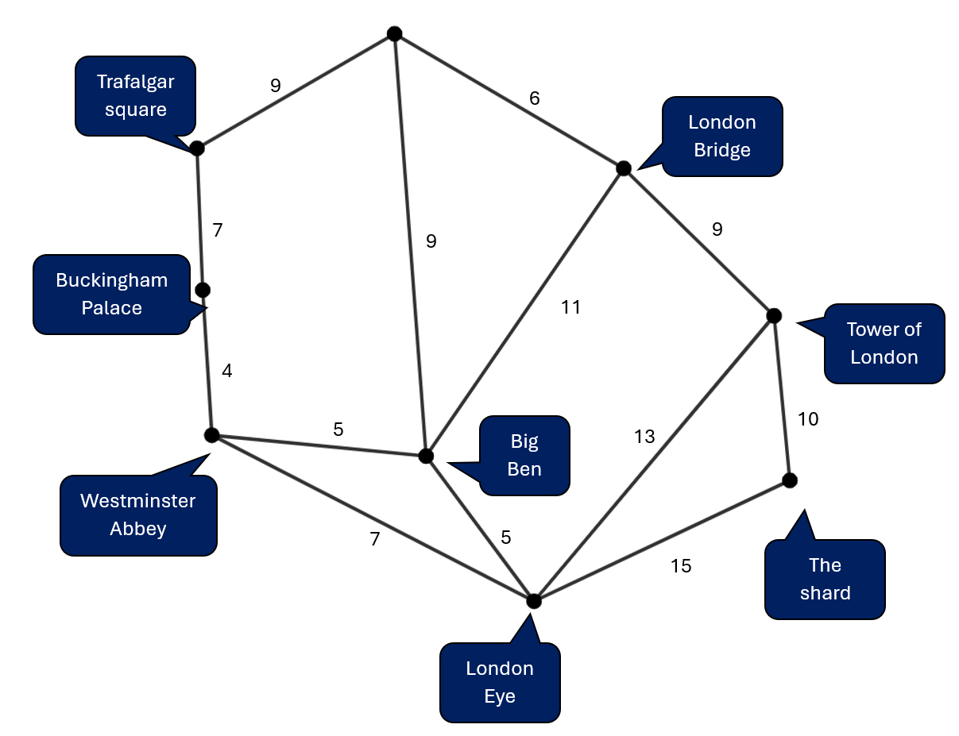

Question 2
The Oceanic Cup for athletics is set to tour Australia and the Pacific Islands. Venues include Townsville, Tonga, Samoa and the Solomon Islands.
- What is the shortest path it would take to visit these venues.
- Which parts of the tour are part of the minimum spanning tree?
- Why are some paths not on the minimum spanning tree?
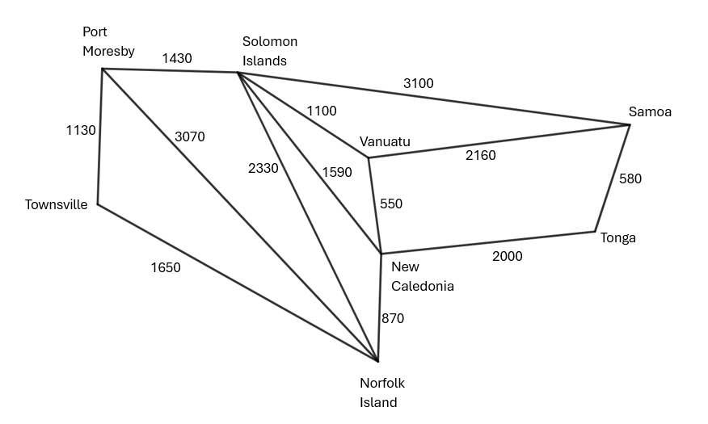

Appendix D

Glossary of terms and conditions
Term | Picture | Definition | Notes
Path | 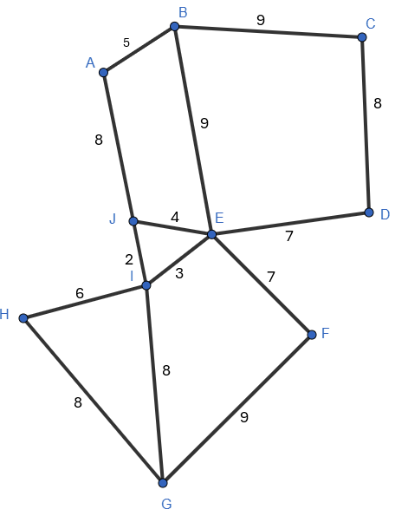
Tree
Spanning tree
Minimum spanning tree
Shortest path | 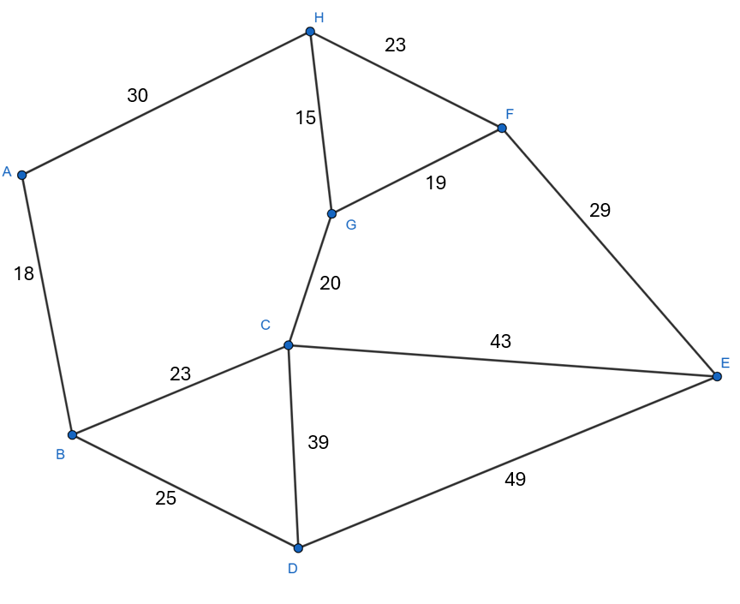

Appendix E

HSC-style questions
Question 1
A network diagram for a national park shows the walking times between points of interest in minutes. Some of the points of interest include the entrance at A, the ranger hut at H, a waterfall at E, a picnic area at D and a river crossing at C.
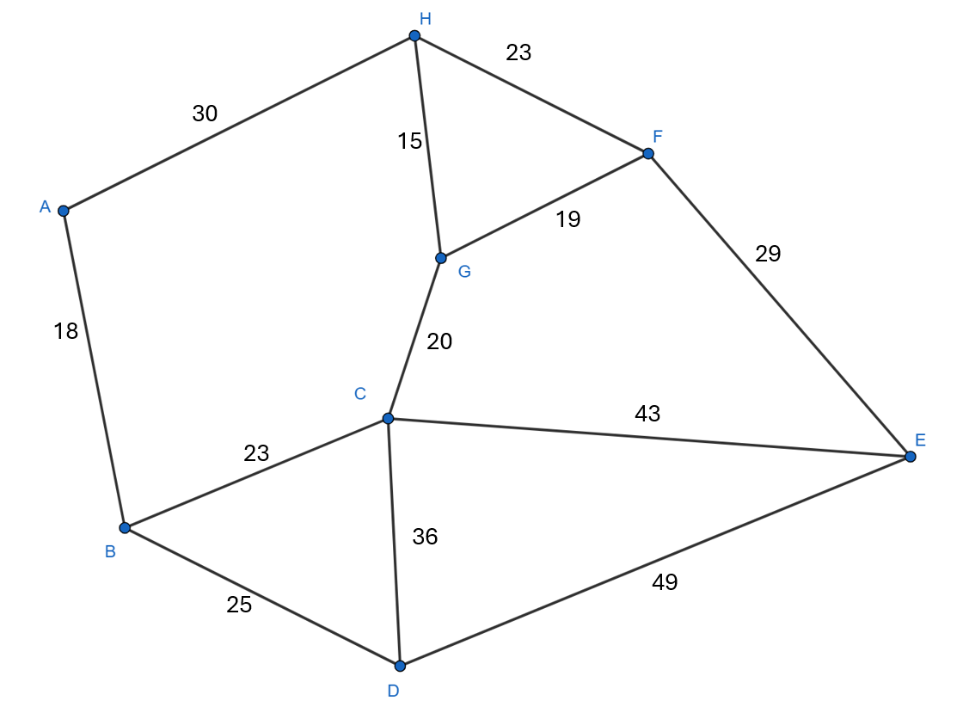
- What is the shortest path from the entrance (A) to the waterfall (E)?
- A ranger wants to travel from the ranger hut (H) to the picnic area (D) however the track from the river crossing (C) to the picnic area (D) is impassable due to flooding.
How much time is added to the ranger’s trip if he takes the next shortest path from the hut (H) to the picnic area (D) after the track closure?

Question 2
The network diagram shows the distances in kilometres between locations in Tasmania.
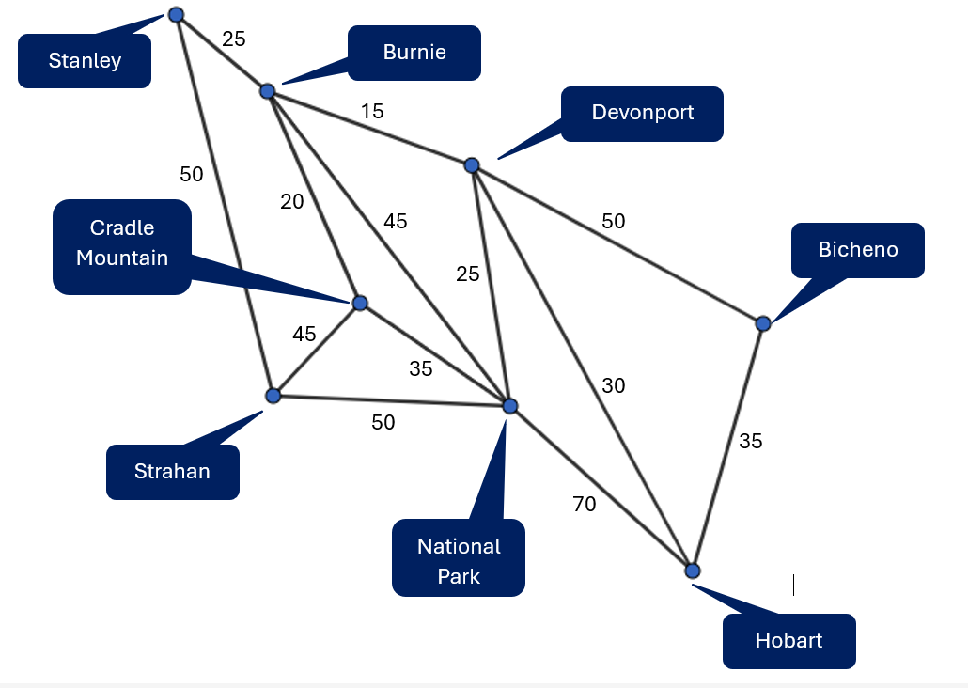
- Draw a minimum spanning tree for this network and determine its length.

- How far is it from Stanley to National Park using the shortest route?

Sample solutions

Appendix A – travel blocks
All lengths are the same – 9 times the height of the rectangle.
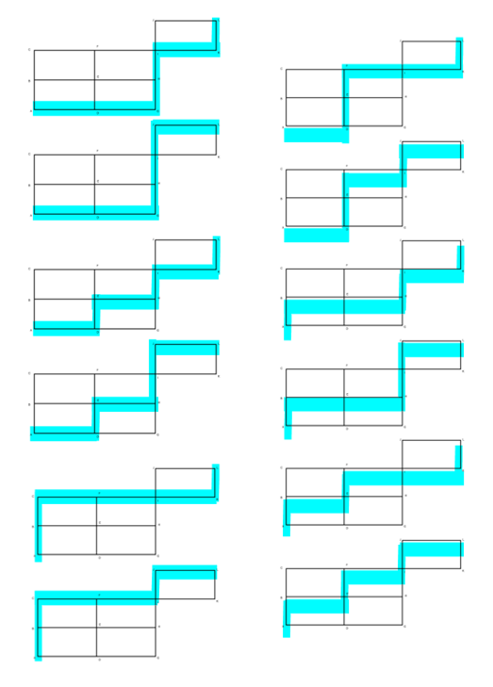

Appendix B – travel times
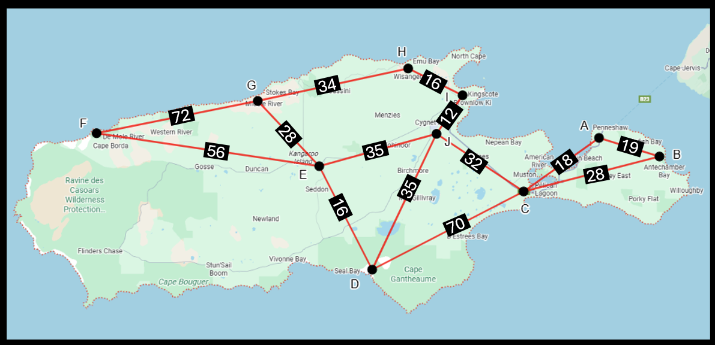
This image has been adapted from Google Maps – Kangaroo Island.

Appendix C – shortest paths
Question 1
Buckingham Palace – Westminster Abbey – London Eye – Tower of London
$$=4+7+13 \\ =24$$
Question 2
- Townsville – Port Moresby – Solomon Islands – Samoa – Tonga
$$=1130+1430+3100+580 \\ =6240$$
- Townsville – Port Moresby and Samoa – Tonga
- The minimum spanning tree does not connect Soloman Islands to Samoa as the shortest connecter to the minimum spanning tree as Vanuatu is closer at 1100 km.

Appendix D – glossary of terms and conditions
Term | Picture | Definition | Notes
Path | 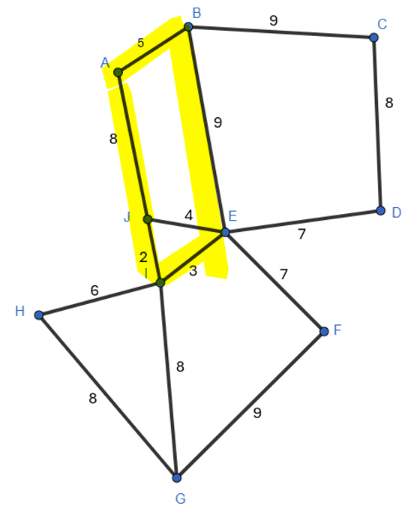 | It is a route through a network diagram in which all the edges and all the vertices are different. | A path is a route from one vertex to another.
Tree | 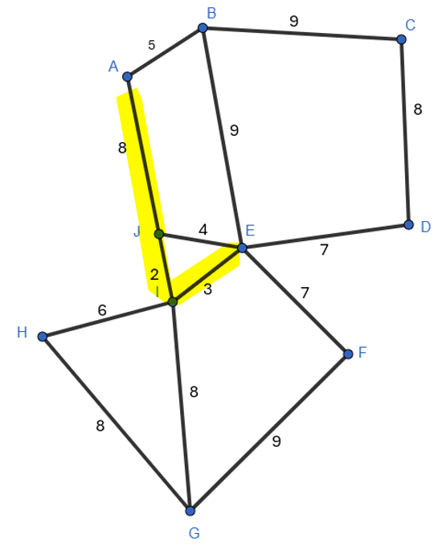 | A tree is an undirected network in which any 2 vertices are connected by exactly one path. | A tree has connected vertices but, doesn’t need all vertices connected.
Spanning tree | 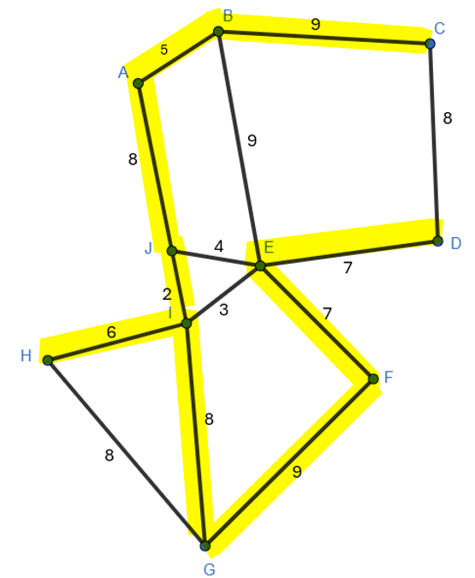 | A spanning tree of an undirected network diagram is a tree that includes all the vertices of the original network connected together, but not necessarily all the edges of the original network diagram. A network can have many different spanning trees. | A spanning tree connects all vertices once. There are lots of spanning trees in a network.
Minimum spanning tree | 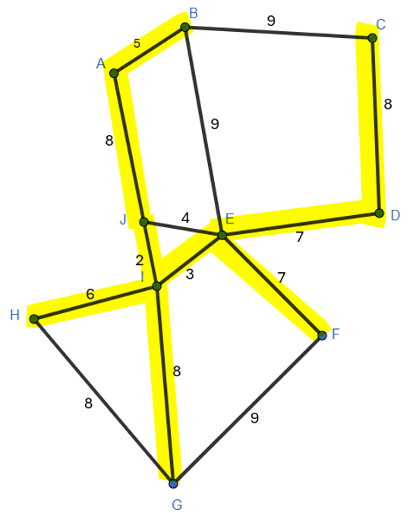 | A tree of minimum length in a connected, undirected network. It connects all the vertices together with the minimum total weighting for the edges. | A minimum spanning tree connects all vertices by the smallest edges. Can use Prim’s, Kruskal or logic to choose the smallest edges.
Shortest path | 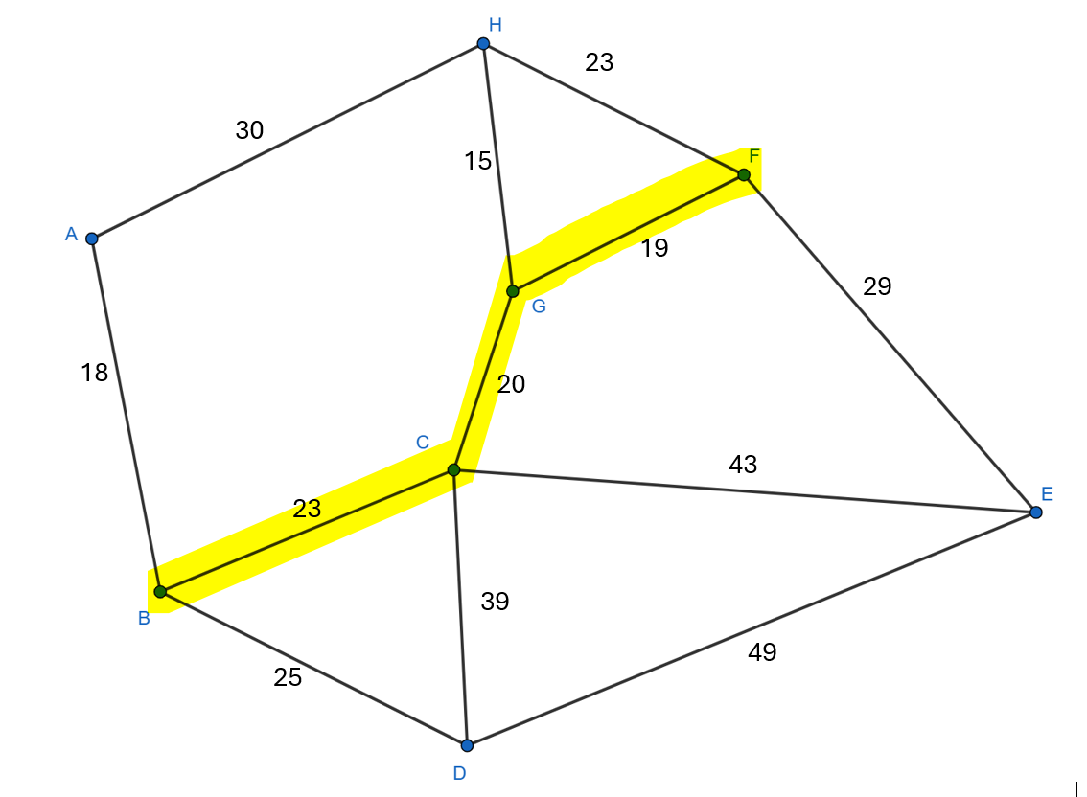 | The total length of the path must be the minimum between the vertices in the question. | The shortest path is found by choosing the route from the vertices indicated with the lowest total possible.

Appendix E – HSC-style questions
Question 1
- A – H – F – E
$$=30+23+29 \\ =82$$
- Original route H – G – C – D
$$=15 + 20 + 36 \\ = 71$$
H – A – B – D
$$=30+18+25 \\ =73$$
Extra time: $73-71=2$minutes
Question 2
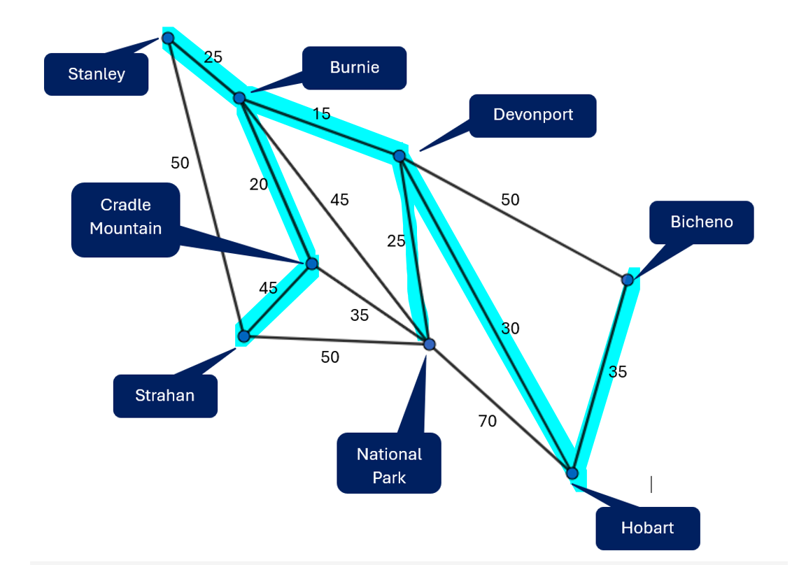
- Minimum spanning tree
$$=25+15+30+35+25+20+45$$$=195$km
- Stanley – Burnie – Devonport – National Park
$$=25+15+25 \\ =65$$

References
This resource contains NSW Curriculum and syllabus content. The NSW Curriculum is developed by the NSW Education Standards Authority (NESA). This content is prepared by NESA for and on behalf of the Crown in right of the State of New South Wales. The material is protected by Crown copyright.
Please refer to the NESA Copyright Disclaimer for more information https://www.nsw.gov.au/education-and-training/nesa/copyright.
NESA holds the only official and up-to-date versions of the NSW Curriculum and syllabus documents. Please visit NESA https://www.nsw.gov.au/education-and-training/nesa and NSW Curriculum https://curriculum.nsw.edu.au.
Mathematics Standard 11–12 Syllabus © NSW Education Standards Authority (NESA) for and on behalf of the Crown in right of the State of New South Wales, 2024.
Numeracy Stage 6 (CEC) Syllabus © NSW Education Standards Authority (NESA) for and on behalf of the Crown in right of the State of New South Wales, 2021.

© State of New South Wales (Department of Education), 2026
The copyright material published in this resource is subject to the Copyright Act 1968 (Cth) and is owned by the NSW Department of Education or, where indicated, by a party other than the NSW Department of Education (third-party material).
Copyright material available in this resource and owned by the NSW Department of Education is licensed under a Creative Commons Attribution 4.0 International (CC BY 4.0) license.

This license allows you to share and adapt the material for any purpose, even commercially. Attribution should be given to © State of New South Wales (Department of Education), 2026.
Material in this resource not available under a Creative Commons license:
- the NSW Department of Education logo, other logos and trademark-protected material
- material owned by a third party that has been reproduced with permission. You will need to obtain permission from the third party to reuse its material.
Links to third-party material and websites
Please note that the provided (reading/viewing material/list/links/texts) are a suggestion only and implies no endorsement, by the New South Wales Department of Education, of any author, publisher, or book title. School principals and teachers are best placed to assess the suitability of resources that would complement the curriculum and reflect the needs and interests of their students.
If you use the links provided in this document to access a third-party's website, you acknowledge that the terms of use, including licence terms set out on the third-party's website apply to the use which may be made of the materials on that third-party website or where permitted by the Copyright Act 1968 (Cth). The department accepts no responsibility for content on third-party websites.

