Constructing networks from a table
Students learn to construct network diagrams from a table. Students solve problems using information presented in a table or network, including problems with time. Students learn to use a calculator to add and subtract time.

Learning intentions
- To be able to find the elapsed time in a network involving real-world situations.
- To be able to use information in a table to construct a network diagram.

Success criteria
- I can use my calculator to convert units of time.
- I can construct a network diagram from a table.
- I can construct a directed network diagram from a table.
- I can analyse a network diagram with weighted edges to solve problems.

Outcomes
A student:
- develops understanding and fluency in mathematics through exploring and connecting mathematical concepts, choosing and applying mathematical techniques to solve problems, and communicating their thinking and reasoning coherently and clearly MAO-WM-01
- solves problems involving time and location in practical contexts MST-11-06
- applies network techniques to solve network problems MST-11-07
Mathematics Standard 11–12 Syllabus © NSW Education Standards Authority (NESA) for and on behalf of the Crown in right of the State of New South Wales, 2024.

Associated numeracy outcomes
A student:
- applies numerical reasoning and mathematical thinking to clarify, efficiently solve and communicate solutions to problems N6-1.2
- chooses and applies efficient strategies to analyse and solve everyday problems involving metric relationships, distance and length, area, volume, time, mass, capacity and temperature N6-2.2
- chooses and applies efficient strategies to analyse and solve everyday problems involving location, space and design N6-2.5
Numeracy Stage 6 (CEC) Syllabus © NSW Education Standards Authority (NESA) for and on behalf of the Crown in right of the State of New South Wales, 2021.

Content

Time and location
Time and time differences
- Convert between seconds (s), minutes (min) and hours (h)
- Solve a variety of practical problems by calculating elapsed time

Networks, paths and trees
Network concepts
- Construct a network diagram to represent information from a given table or map, showing weighted and directed edges
- Solve problems involving network diagrams in a variety of practical contexts
Mathematics Standard 11–12 Syllabus © NSW Education Standards Authority (NESA) for and on behalf of the Crown in right of the State of New South Wales, 2024.

Table 1: lesson summary
Section | Summary of activity | Teaching strategies | Teaching points
Retrieval practice | Students revise time conversions and practise using Appendix A. |  | This task reinforces and strengthens fluency with time conversions.
Activating prior knowledge | Students compare the table and network on slide 4 of the PowerPoint Constructing networks from a table. They use this network to identify vertices and edges before adding the travel times (weightings) to the network diagram. Students find the travel times between 2 locations. | Pose-Pause-Pounce-Bounce  Notice and wonder  Think-Pair-Share | This sequence activates students’ prior knowledge of networks terminology while addressing common misconceptions such as assuming all locations are directly connected.
Connecting learning | Students use slide 6 to build a weighted network from a table. Students compare their representations with peers, calculate travel times between destinations and answer a scenario. Students then construct a second network from slide 7, which includes directed edges. Students learn how to use a calculator to convert time as well as add and subtract time using slides 8–10. | Visibly random groups  Vertical non-permanent surfaces  Notice and wonder  Pose-Pause-Pounce-Bounce | These activities strengthen students’ understanding of how tables and networks represent the same information. They support accurate interpretation of weighted and directed edges as well as address misconceptions such as assuming all paths are two-way or that different layouts mean different networks.
Releasing responsibility | Students use slides 12–13 to analyse a Worked example (your turn) problem. Students identify errors in an incorrect network diagram on slide 14. They then use Appendix B to consolidate their understanding with four quadrant notes. | Incorrect example  Four quadrant notes | These activities formalise drawing networks from tables and using the calculator to perform time calculations.
Independent practice | Students use slide 16 to revisit the ‘Approaching questions scaffold’ before completing Appendix C, checking their responses with a neighbour after each question. | Approaching questions scaffold | Students apply the scaffold independently and refine their reasoning through peer comparison, strengthening accuracy and confidence with HSC‑style network questions.

Activity structure
Please use the associated PowerPoint Constructing networks from a table to display images in this lesson.

Retrieval practice
- Distribute Appendix A ‘Tarsia puzzle’ to each pair of students and have them complete the puzzle using their knowledge of converting between seconds, minutes and hours.
Appendix A is provided in an assembled format. Teachers can prepare this activity in small snap lock bags, or the students can cut out the pieces before completing the task. Students learned about converting time in Stage 3.

Activating prior knowledge
- Display slide 4 of the PowerPoint and use the Pose-Pause-Pounce-Bounce questioning strategy (PDF 557 KB) (bit.ly/posepausepouncebounce) to ask students what they notice and wonder (bit.ly/noticewonderstrategy) about the table and network.
- How do the table and network represent vertices?
- What might the numbers in the table represent?
- Why is a dash used in the table?
- How many ways does the network or table indicate you can leave Flinders St station?
Students might notice that the information is from Melbourne, that some locations do not have a direct route, or that the headings on the side and top of the table are the same and match the network diagram.
They may wonder if the numbers in the table correspond with the edges in the network diagram or what the numbers in the table refer to. Students may then wonder about the mode of transport between locations for the number to be so small.
- Tell students that the numbers in the table represent the time, in minutes, it takes to travel between locations by tram.
- Ask students where they should place each of the numbers on the network diagram. Encourage students to use correct terminology in their explanations.
- Animate slide 4 to reveal the weighted edges.
- In a Think-Pair-Share (bit.ly/thinkpairsharestrategy), have students consider how they could travel from Docklands to the Markets and how long it would take.
- In a class discussion, ask students which representation, the table or the network, makes the route from Docklands to Markets easiest to follow or visualise and why.

Connecting learning
- Read the following scenario to the class.
Jo is planning a trip to Melbourne and wants to determine a central location that minimises travel between destinations.
- Display slide 6 which shows a table with the time it takes to walk between each destination.
- Ask students to use the table to discuss which routes they could take and calculate how long it will take Jo to travel from the Queen Victoria markets (M) to the Botanical gardens (G).
- Assign students to visibly random groups of 3 (bit.ly/visiblegroups) at vertical non-permanent surfaces (bit.ly/VNPSstrategy) and allow students time to represent the information in the table as a network diagram.
- Have students compare with a neighbouring group to discuss similarities and differences.
- Students should return to their group and refine their networks if necessary.
- Use the Pose-Pause-Pounce-Bounce questioning strategy to discuss how students could tell if their networks were the same as the neighbouring group.
- In a class discussion, have students revisit the question ‘How long it would take Jo to travel from the Queen Victoria markets (M) to the Botanical gardens (G)’. Ask them to explain why there are 2 routes and which of the routes was the quickest.
- Ask students to discuss in their groups where Jo should stay to be in a central location to minimise travel time to these destinations.
- Use a class discussion to share ideas, drawing out why students chose their location.
- Tell students that during her stay Jo plans to walk through the Festival of Lights in the Botanical gardens.
- Display slide 7 which shows a table with the walk times between different attractions and have groups create a network from the table clearly labelling all vertices and edges.
- Have students compare with a neighbouring group to discuss similarities and differences.
- Use the Pose-Pause-Pounce-Bounce questioning strategy to deepen student understanding of tables and networks. Suggested prompts include:
- How can you know that the routes are one way?
- How can we indicate this on a network diagram?
- Why could the weightings on the edges connecting H to G be different?
- Have students discuss what questions could be asked about this network.
Possible questions include:
- How long will it take to travel from the Hoya flowers to the Greenhouses?
- What attractions would you pass when you travel from the Lasers to the Trapezoidal tunnel?
- Does where Jo starts on the network change the time it takes to see all the attractions? Explain your reasoning.
- Tell students that answering network questions often involves addition or subtraction of times and this can be easily calculated using a calculator.
- Display slide 8 which shows how to enter time on a calculator and how to convert seconds into hours.
- Display slide 9 which shows how to use a calculator to add and subtract time.
- Display slide 10 which reveals 4 multiple choice questions, one at a time. Students use a finger vote to indicate which answer is correct. Animate slide 10 to see the solution and next question.

Releasing responsibility
- Use slides 12–13 to model worked examples of constructing networks from a table using the Worked examples (your turn) method (bit.ly/supportingstrategies).
- Display slide 14 which has an incorrect worked example. Ask students to return to their vertical non-permanent surfaces to draw the correct network diagram for the incorrect worked example.
- Ask students to complete four quadrant notes to their future forgetful self (bit.ly/supportingstrategies) on a vertical non-permanent surface and make any personal notes on Appendix D ‘Four quadrant notes’.

Independent practice
- Display slide 16 to remind students of the ‘Approaching questions scaffold’.
- Distribute Appendix C ‘HSC-style questions’ to students.
- Have students compare with a neighbour after each question.

Assessment and differentiation

Suggested opportunities for differentiation
Retrieval practice
- To challenge students, ask them to convert all the times on the Tarsia puzzle to hours or seconds.
- Students may need reminding of how to convert between seconds, minutes and hours.
- To support students, adjust the number of pieces in the Tarsia puzzle.
Activating prior knowledge
- Support students by asking them how long it would take to travel each edge one at a time, of the trip from Docklands and Markets.
- To challenge students give them the opportunity to draw the network.
Connecting learning
- To support students, discuss how many vertices the network will have and identify some of the connections to prepare students to create a network.
- To challenge students, ask them to create a table using local locations and swap with a neighbouring group to create the network.
Releasing responsibility
- To support students ask them additional questions about the time taken to travel between 2 towns in Queensland.
- Challenge students to create problem-solving questions about travel times between venues, from the correct network diagram, in Paris.
Independent practice
- To challenge students, introduce the regulation that the pilot takes an hour break every 4 hours of flying.
- To support students have them complete Appendix C in groups of 3 at their vertical non-permanent surfaces.

Suggested opportunities for assessment
Retrieval practice
- Observe students completing the Tarsia puzzle to assess their ability to convert between hours, minutes and seconds.
Activating prior knowledge
- Observe student responses in the Pose-Pause-Pounce-Bounce to check for understanding of how a network can represent the same information as a table.
- Observe student responses when adding the weighting to the edges of the Melbourne network diagram to assess ability to use language and read the table.
Connecting learning
- Observe student discussions about which path to use when travelling from the Queen Victoria markets (M) to the Botanical gardens (G) to assess their use of terminology.
- Take photos of student networks from their vertical non-permanent surfaces as evidence of learning.
Releasing responsibility
- Take photos of student networks from their vertical non-permanent surfaces as evidence of learning of how to create networks with appropriate details.
- Observe and provide feedback to students as they annotate and create their notes to check for understanding of how to create a network from a table.
Independent practice
- Collect Appendix C as evidence of student ability to create networks and solve problems.

Appendix A

Tarsia puzzle
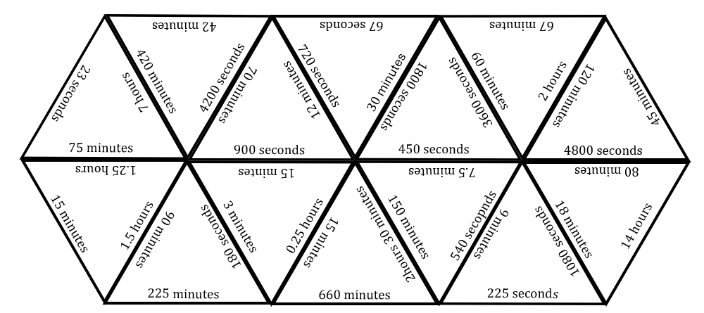

Appendix B

Four quadrant notes
Example 1  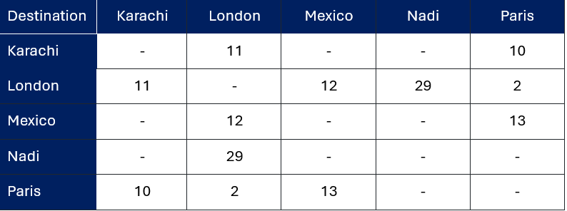  Draw a weighted network from this table, which shows travel times in hours.  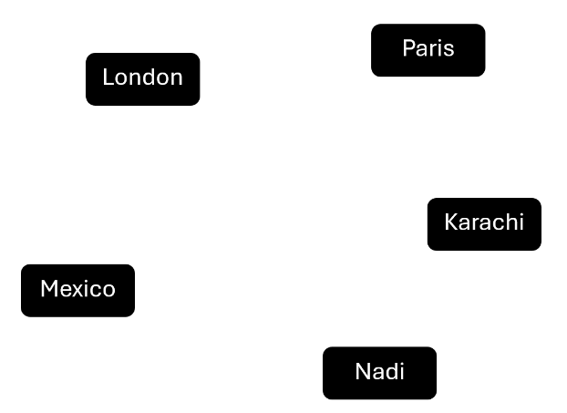 | Example 2  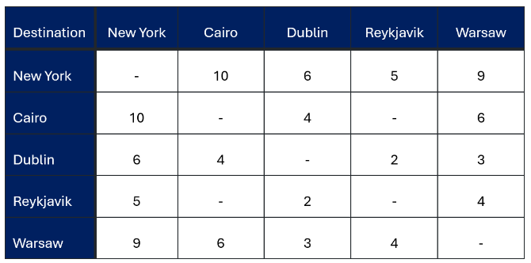  Draw a network and find the quickest time, in hours, to travel between Cairo and Reykjavik.
Things to remember | Example 3

Appendix C

HSC-style questions
Below are the travel times between some country towns by small plane.
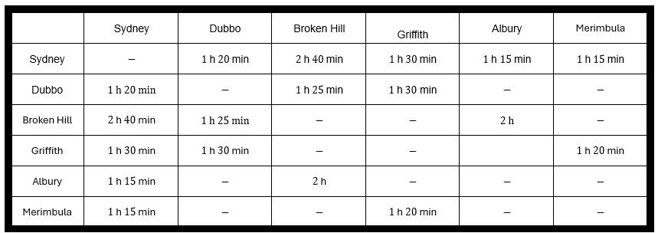
Question 1
Create a network diagram to represent the information in the table.
Question 2
A pilot, Sam, needs to have an hour break between flights. If Sam starts in Sydney at 7 am and flies to Dubbo, Broken Hill and back to Sydney, when will they arrive back in Sydney?
Question 3
Nik is a salesperson who wants to minimise total travel time. Using your network, compare the length of at least 2 possible routes from Merimbula that include Sydney, Griffith and Dubbo. Nik is holding meetings with other sales representatives that will take 1 hour 30 minutes at each of the 3 venues.
- Justify which route is most efficient.
- How long was the workday?

Sample solutions

Appendix B – Four quadrant notes
Example 1  Draw a weighted network from this table which shows travel times in hours.  .  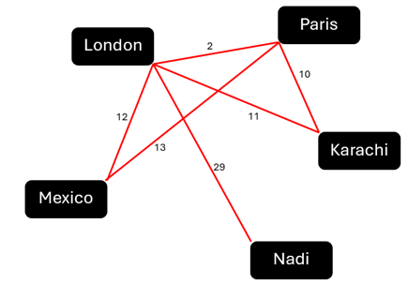 | Example 2  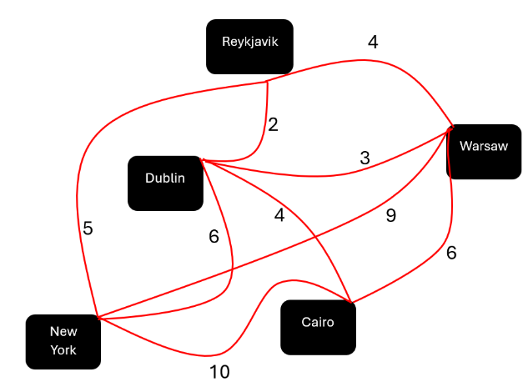  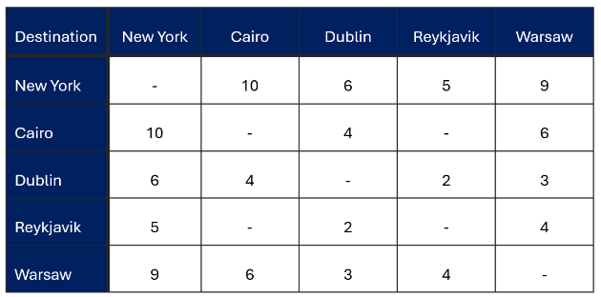  Draw a network and find the quickest time, in hours, to travel between Cairo and Reykjavik.  Cairo – Reykjavik $=$ 6 hours

Appendix C – HSC-style questions
Question 1
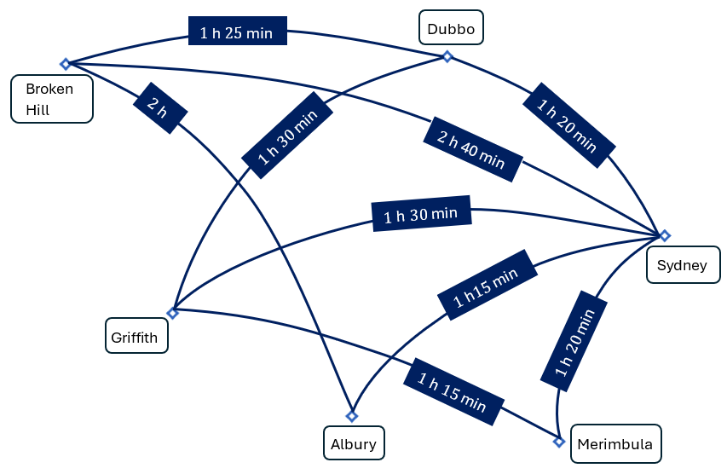
Question 2
Sydney to Dubbo = 7 am + 1 h 20 min = 8:20 am
Rest = 8:20 am +1 h = 9:20 am
Dubbo to Broken Hill = 9:20 am + 1 h 25 min = 10:45 am
Rest =10:45 am + 1 h = 11:45 am
Broken Hill to Sydney = 11:45 am + 2 h 40 min = 2:25 pm
$∴$They arrive in Sydney at 2:25 pm.
Question 3
3 meetings x 1 h 30 min = 4 h 30 min
M – G – D – S
1 h 15 min + 1 h 30 min + 1 h 20 min = 4 h 5 min
M – S – G – D
1 h 20 min + 1 h 30 min + 1 h 30 min = 4 h 20 min
M – S – D – G
1 h 20 min + 1 h 20 min + 1 h 30 min = 4 h 10 min
- $∴$Most efficient route is M – G – D – S.
- The workday is 8 h 35 min long.

References
This resource contains NSW Curriculum and syllabus content. The NSW Curriculum is developed by the NSW Education Standards Authority (NESA). This content is prepared by NESA for and on behalf of the Crown in right of the State of New South Wales. The material is protected by Crown copyright.
Please refer to the NESA Copyright Disclaimer for more information https://www.nsw.gov.au/education-and-training/nesa/copyright.
NESA holds the only official and up-to-date versions of the NSW Curriculum and syllabus documents. Please visit NESA https://www.nsw.gov.au/education-and-training/nesa and NSW Curriculum https://curriculum.nsw.edu.au.
Mathematics Standard 11–12 Syllabus © NSW Education Standards Authority (NESA) for and on behalf of the Crown in right of the State of New South Wales, 2024.
Numeracy Stage 6 (CEC) Syllabus © NSW Education Standards Authority (NESA) for and on behalf of the Crown in right of the State of New South Wales, 2021.

© State of New South Wales (Department of Education), 2026
The copyright material published in this resource is subject to the Copyright Act 1968 (Cth) and is owned by the NSW Department of Education or, where indicated, by a party other than the NSW Department of Education (third-party material).
Copyright material available in this resource and owned by the NSW Department of Education is licensed under a Creative Commons Attribution 4.0 International (CC BY 4.0) license.

This license allows you to share and adapt the material for any purpose, even commercially. Attribution should be given to © State of New South Wales (Department of Education), 2026.
Material in this resource not available under a Creative Commons license:
- the NSW Department of Education logo, other logos and trademark-protected material
- material owned by a third party that has been reproduced with permission. You will need to obtain permission from the third party to reuse its material.
Links to third-party material and websites
Please note that the provided (reading/viewing material/list/links/texts) are a suggestion only and implies no endorsement, by the New South Wales Department of Education, of any author, publisher, or book title. School principals and teachers are best placed to assess the suitability of resources that would complement the curriculum and reflect the needs and interests of their students.
If you use the links provided in this document to access a third-party's website, you acknowledge that the terms of use, including licence terms set out on the third-party's website apply to the use which may be made of the materials on that third-party website or where permitted by the Copyright Act 1968 (Cth). The department accepts no responsibility for content on third-party websites.

