Introduction to networks
Students are introduced to the concept of a network diagram, including situations where this type of representation is useful, as well as the fundamental terminology associated with network diagrams.

Learning intentions
- To understand the purpose of network diagrams.
- To be able to describe and use the key terminology associated with network diagrams.

Success criteria
- I can identify the vertices and edges in a network diagram.
- I can recognise when a network diagram is directed or has weighted edges.
- I can solve a problem from a network diagram in a real-world application.

Outcomes
A student:
- develops understanding and fluency in mathematics through exploring and connecting mathematical concepts, choosing and applying mathematical techniques to solve problems, and communicating their thinking and reasoning coherently and clearly MAO-WM-01
- solves problems involving time and location in practical contexts MST-11-06
- applies network techniques to solve network problems MST-11-07
Mathematics Standard 11–12 Syllabus © NSW Education Standards Authority (NESA) for and on behalf of the Crown in right of the State of New South Wales, 2024.

Associated numeracy outcomes
A student:
- applies numerical reasoning and mathematical thinking to clarify, efficiently solve and communicate solutions to problems N6-1.2
- chooses and applies efficient strategies to analyse and solve everyday problems involving metric relationships, distance and length, area, volume, time, mass, capacity and temperature N6-2.2
- chooses and applies efficient strategies to analyse and solve everyday problems involving location, space and design N6-2.5
Numeracy Stage 6 (CEC) Syllabus © NSW Education Standards Authority (NESA) for and on behalf of the Crown in right of the State of New South Wales, 2021

Content

Networks, paths and trees
Network concepts
- Describe a network as a collection of objects (vertices) interconnected by lines (edges) that can represent systems in the real world
- Define and use the network terminology: vertex, edge, degree, directed networks and weighted edges
- Examine circumstances in which networks are used in a variety of real-world applications
Mathematics Standard 11–12 Syllabus © NSW Education Standards Authority (NESA) for and on behalf of the Crown in right of the State of New South Wales, 2024.
Table 1: lesson summary
Section | Summary of activity | Teaching strategies | Teaching points
Activating prior knowledge | Students explore how people navigate unfamiliar places by examining a scenario of a group of friends traveling to Perth to see a band. They examine how the journey is represented on a traditional map compared with a navigation‑app. Using slides 4–5 of the PowerPoint Introduction to networks, students identify which information is useful for planning efficient routes and why. | Think-Pair-Share  Pose-Pause-Pounce-Bounce  Notice and wonder | Students learn that different representations emphasise different aspects of a journey and this insight helps them understand why network diagrams are such powerful tools for analysing routes.
Connecting learning | Students identify the features of a simple network diagram on slide 7, showing the first scenario. Using slide 8 and Appendix A, students look at possible routes to pick up Bernie’s friends. They identify vertices, edges, weighted edges and directed edges. | Visibly random groups of 3  Vertical non‑permanent surfaces  Gallery walk  Pose-Pause-Pounce-Bounce | Students see how simplifying real‑world situations into network diagrams reveals important information, supports efficient route‑planning and prepares them for formal concepts.
Releasing responsibility | Students identify features of a network diagram using Appendix A, slide 10 and the NESA definitions on slides 11 and 12. They annotate these features on Appendix B. | Class discussion | These activities help students to move between informal understanding and formal terminology.
Independent practice | Students apply network concepts by completing Appendix C before analysing the mathematical structure of networks by playing the game ‘Sprouts’ https://nrich.maths.org/games/sprouts. Slide 14 is used to discuss how networks affect the outcome of the game. | Pose-Pause-Pounce-Bounce | Students explore how constraints, such as degree limits and starting vertices affect the number of edges, the final network diagram and the winning strategy.

Activity structure
Please use the associated PowerPoint Introduction to networks to display images in this lesson.

Activating prior knowledge
- Read the following scenario to students.
Bernie and their group of 6 friends are going to see a band in Perth. They are staying at The Westin hotel in Perth, eating at the Blasta Collective and then seeing the band at Optus Stadium before returning to the hotel.
Bernie has a 7-seater car and needs to pick up all 6 friends from their homes to check in to the hotel in the shortest possible time before the concert.
- Display slide 4 of the PowerPoint, which shows the locations of the hotel, the Blasta Collective and Optus Stadium.
- In a Think-Pair-Share (bit.ly/thinkpairsharestrategy), ask students, ‘What is the most efficient route to take?’ Prompting questions could include:
- How many possible routes are there?
- How are you deciding which route is best?
- How confident are you that your route is the most efficient?
- Use the Pose-Pause-Pounce-Bounce questioning strategy (PDF 557 KB) (bit.ly/posepausepouncebounce) to discuss the difficulty of using the map. Suggested prompts include:
- What made this task difficult?
- What information on the map helped you? What didn’t?
- How easy is it to compare different routes using this map?
Students may suggest that there are too many roads and details, it is hard to compare multiple routes, there is no clear way to track total time or distance, or that the map is realistic but not efficient for decision-making.
- Display slide 5 which shows 2 routes from a navigation app. Ask students to discuss what they notice and wonder (bit.ly/noticewonderstrategy).
- Use the Pose-Pause-Pounce-Bounce questioning strategy to share students’ thoughts. Prompts may include:
- How is this different from the map?
- What has been simplified?
- What decision does this help us make more easily?
- Does this show us all possible routes between the locations?
Students should identify that the app selects and highlights routes. It also provides the total time or distance and reduces unnecessary information.
- Explain to students that mathematicians often simplify real-world situations by removing unnecessary detail and keeping only what helps us make decisions.
- Discuss with students what information Bernie needs to plan their trip. What information could be removed?
Draw out through the discussion that Bernie only needs the locations and the time to travel between them. All other information is unnecessary.

Connecting learning
- Display slide 7 and tell students that this is called a ‘network diagram’. Instead of focusing on roads, maps and landmarks, it represents only the key locations and the connections between them. It also shows the time it takes to travel between the 3 locations.
- Read the following scenario to the class.
Bernie has a 7-seater car and needs to pick up all 6 friends in the shortest possible time before the concert.
- Display slide 8 which shows a map of Coodanup, which is one hour south of Perth, where the friends live.
- In a Think-Pair-Share (bit.ly/thinkpairsharestrategy), ask students to consider what route Bernie might take to pick up the friends, given no restrictions.
- Introduce some conditions to students by stating that Riley lives on a street with a concrete barrier and can only be picked up from one side of the road and when leaving Riley’s place, Bernie can only drive to Skye’s place.
- Ask students to discuss how this information might be represented on a network diagram.
- Assign students to visibly random groups of 3 (bit.ly/visiblegroups) at vertical non-permanent surfaces (bit.ly/VNPSstrategy). Hand out Appendix A ‘Friends network’ in an A3 plastic sleeve with adhesive putty and ask students to compare it with the map displayed on slide 8.
- Draw student attention to how arrows have been used to indicate that Bernie can only travel in a particular direction on certain roads.
- Working in their groups, have students highlight the route Bernie could take to pick up their friends and the distance travelled and write down the route they would take.
Students may list the names of the friends to write the route they would take. For example, Bernie – Ash – Taylor – Cameron and so on.
Students could use the first letter of the name if there are no repeated letters. For example, B – A – T – C and so on.
- Conduct a gallery walk (bit.ly/DLSgallerywalk) for students to see different strategies.
- Use the Pose-Pause-Pounce-Bounce questioning strategy to discuss the network diagram and the strategies students used to find the best route for Bernie. The following are some suggested prompts:
- If Bernie had more friends to pick up, what would happen?
- How might the numbers and the arrows influence the route Bernie chooses?
- Why do you think the lines are drawn as straight lines? Could they be curved?
- When solving this problem, was the map or the network diagram more helpful and why?

Releasing responsibility
- Display slide 10 which highlights the terms ‘vertex’, ‘edge’, ‘weighted edge’ and ‘degree’ on the Friends network diagram.
- In a class discussion, have students describe the given terms in their own words.
- Returning to Appendix A in their groups, have students describe and identify all the vertices and their degree, and the weights on each edge.
- Use slides 11 and 12 to show the NESA glossary definitions of each term.
- Discuss the difference between a network and a directed network, referring to slide 10 and the Friends network if necessary.
- Distribute Appendix B ‘Network diagram’ to each student.
- Have students annotate the marked features of the network diagram, naming each part and writing a definition of each feature in their own words.

Independent practice
- Working in pairs, ask students to complete Appendix C ’Practice questions’.
Encourage students to use a highlighter to answer any questions that requires a route.
- Students compare solutions with a neighbouring pair and negotiate any differences.
- Have students continue to sit in pairs with a blank piece of paper and explain the game of ‘Sprouts’ (https://nrich.maths.org/games/sprouts).
- Start with 2 dots on the page. Each dot represents a vertex.
- Players take turns drawing an edge connecting 2 vertices (this may be the same vertex connected to itself).
- Place a new vertex somewhere along the edge you have drawn.
- For this game, the edges cannot cross any other edges.
- The vertices cannot have a degree of more than 3.
- The player who makes the last legal move wins.
- Students play enough rounds to be able to predict with certainty who will win.
- As students are playing, ask students to analyse the game.
- How many vertices are present at the end of the game?
- How many edges were drawn?
- Who won, the first or the second player?
Optional: display slide 14 which shows the 3 questions for students to reference while they play.
- Once students are confident of their answers, they can move to play with 3 dots. Students observe the effect this has on the final number of vertices and edges, and who would win. Students could look at starting with 4 or 5 vertices to see if a pattern arises.
- Use the Pose-Pause-Pounce-Bounce questioning strategy to ask students to analyse the game again:
- What do you expect the number of vertices and edges would be at the end of a game with 3, 4 and 5 dots?
- When might the first player win and when might the second player win?
- Have students return to the game with 2 dots but this time allow a degree of 4 at each vertex. Ask student how this changed the number of vertices, edges and who would win.

Assessment and differentiation

Suggested opportunities for differentiation
Activating prior knowledge
- To challenge students, create additional venues for the friends to visit.
- Support students by allowing the use of a digital device to examine Google maps.
Connecting learning
- Encourage the use of colour when indicating the route Bernie should take.
- To challenge students, ask them to identify all the possible routes that Bernie could take.
Releasing responsibility
- To support students, supply students with the terms they need to place in Appendix B.
- To challenge students, have them describe where to find each of the terms in an unknown network diagram.
Independent practice
- Provide a worked example of the game of ‘Sprouts’ prior to students playing.
- Encourage the use of coloured markers when completing Appendix C.

Suggested opportunities for assessment
Activating prior knowledge
- Listen and give feedback on how students determine the efficiency of the route they discuss.
- Listen for students identifying relevant and irrelevant map information to assess their understanding of route planning.
Connecting learning
- Observe whether students can correctly interpret directed edges and weighted edges.
- Observe students’ ability to label a route for Bernie to use.
Releasing responsibility
- Collect Appendix B to check student understanding of the definitions for clarity and accuracy.
- Listen and give feedback for accuracy and reasoning when students identify the vertices, edges, weightings and directions in Appendix A and B.
Independent practice
- Listen for students during the game of ‘Sprouts’ to assess for the correct use of terminology.
- Collect Appendix C as evidence of learning.

Appendix A

Friends network
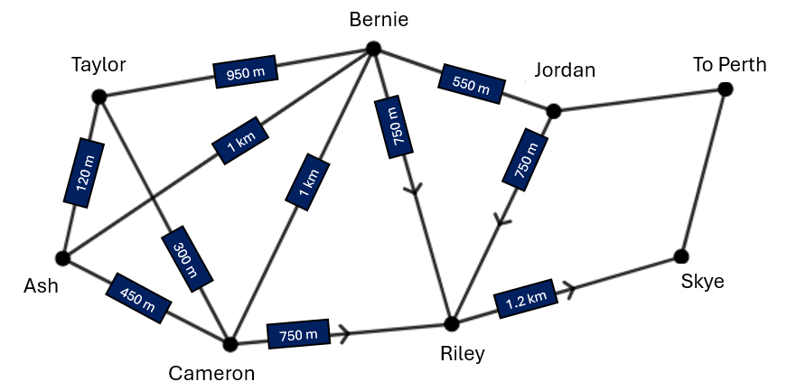

Appendix B

Network diagram
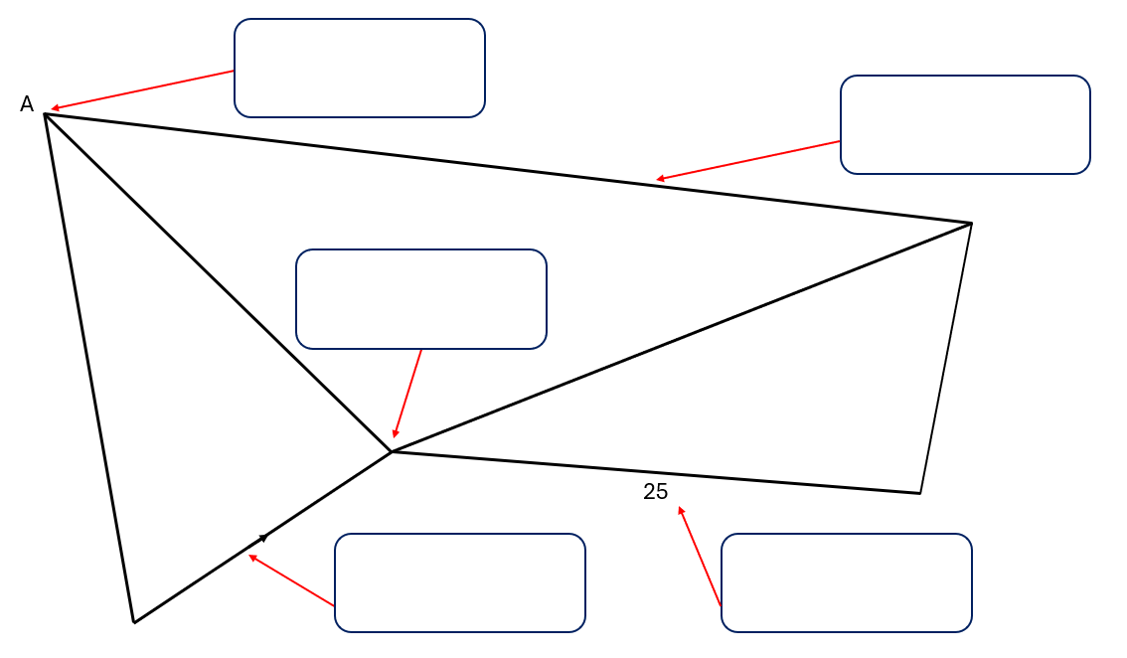

Appendix C

Practice questions

Question 1
A network diagram shows running tracks joining a selection of gym equipment. The diagram shows the time taken for Lee to run between each exercise, in minutes. 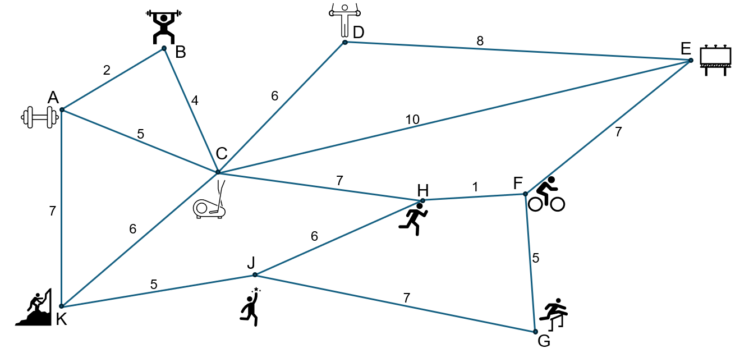
- Which vertex has the highest degree?
- Identify a route where each exercise is only visited once.
- What is the quickest route from A to G?
- The track from H to F has been blocked. What is the shortest alternate route from B to G?

Question 2
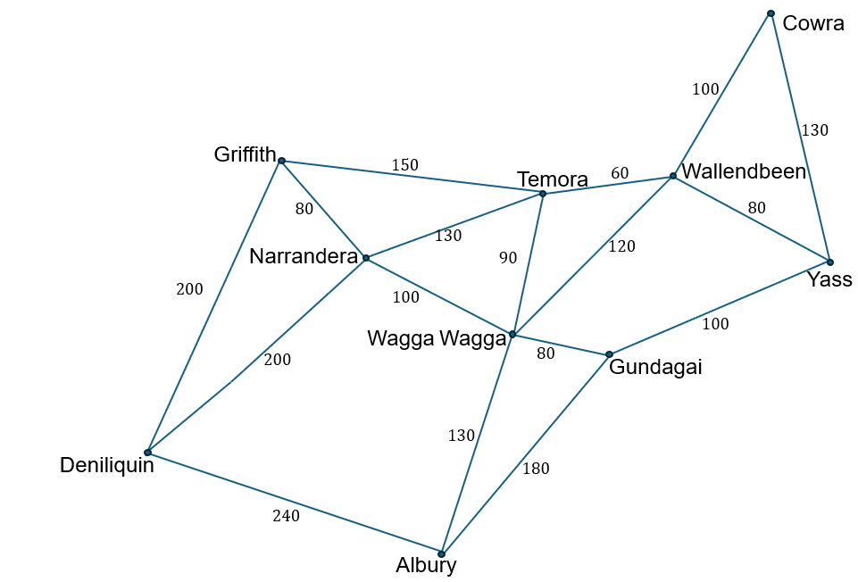
The network diagram shows towns and the approximate distances along major highways in kilometres.
- What is the highest weighted edge?
- Name 2 different ways you could travel from Griffith to Yass and the total distance for each trip.
- A bridge at Wallendbeen has been wiped out by a truck, resulting in no traffic being able to pass through Wallendbeen.
Keeping to the major highways, how could a truck travel from Deniliquin to Cowra and how many extra kilometres will the detour add to the trip?

Sample solutions

Appendix A – friends network
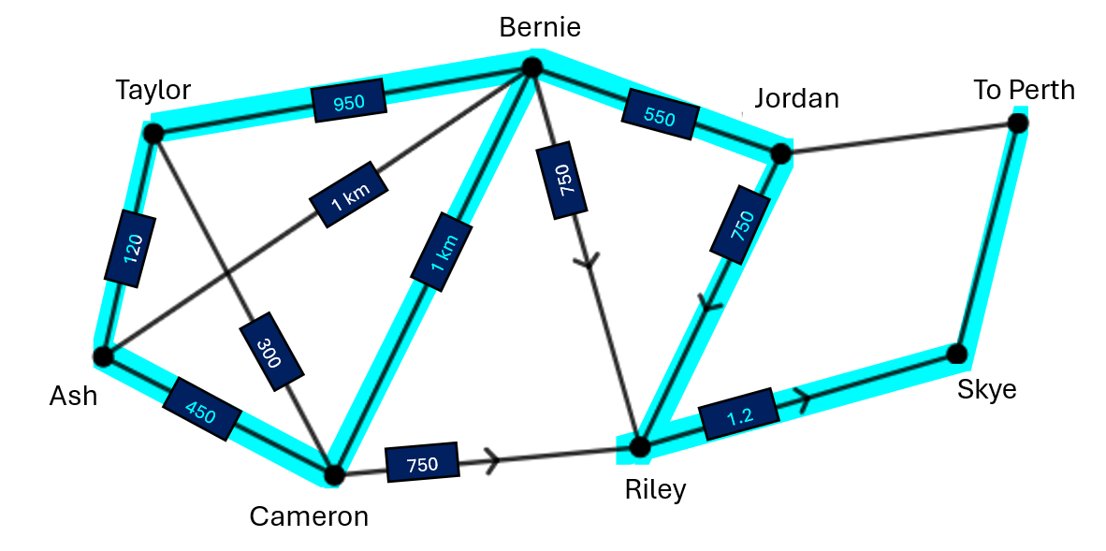

Appendix B – network diagram
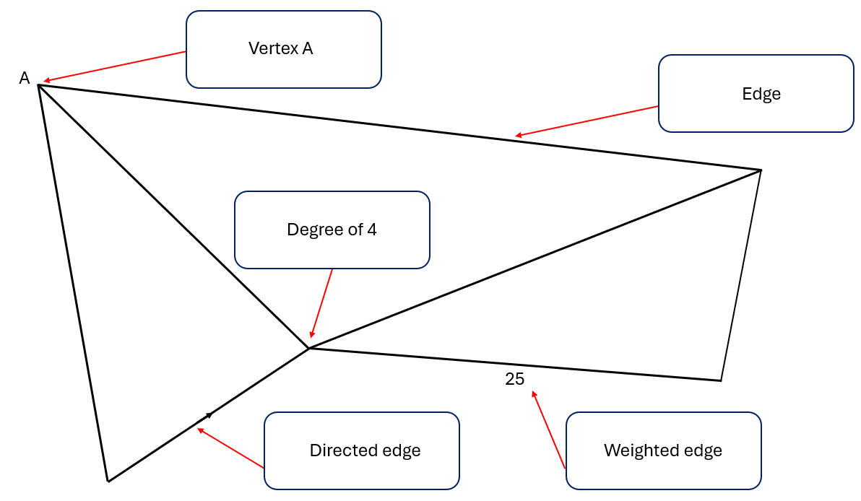

Appendix C – practice questions

Question 1
- Vertex C has the highest, with a degree of 6.
- One possible route is B-A-K-J-G-F-H-C-D-E.
- The quickest route is A-C-H-F-G.
- The shortest alternate route is B-A-K-J-G.

Question 2
- The highest weighted edge is Deniliquin to Albury at 240 km.
- Way 1: Griffith-Temora-Wallendbeen-Yass = 290 km.
Way 2: Griffith-Narrandera-Wagga Wagga-Gundagai-Yass = 360 km.
- Deniliquin-Narrandera-Temora-Wallendbeen-Cowra = 490 km.
Deniliquin-Narrandera-Wagga Wagga-Gundagai-Yass-Cowra = 610 km.
The trip is 120 km longer.

References
This resource contains NSW Curriculum and syllabus content. The NSW Curriculum is developed by the NSW Education Standards Authority (NESA). This content is prepared by NESA for and on behalf of the Crown in right of the State of New South Wales. The material is protected by Crown copyright.
Please refer to the NESA Copyright Disclaimer for more information https://www.nsw.gov.au/education-and-training/nesa/copyright.
NESA holds the only official and up-to-date versions of the NSW Curriculum and syllabus documents. Please visit NESA https://www.nsw.gov.au/education-and-training/nesa and NSW Curriculum https://curriculum.nsw.edu.au.
Mathematics Standard 11–12 Syllabus © NSW Education Standards Authority (NESA) for and on behalf of the Crown in right of the State of New South Wales, 2024.
Numeracy Stage 6 (CEC) Syllabus © NSW Education Standards Authority (NESA) for and on behalf of the Crown in right of the State of New South Wales, 2021.

© State of New South Wales (Department of Education), 2026
The copyright material published in this resource is subject to the Copyright Act 1968 (Cth) and is owned by the NSW Department of Education or, where indicated, by a party other than the NSW Department of Education (third-party material).
Copyright material available in this resource and owned by the NSW Department of Education is licensed under a Creative Commons Attribution 4.0 International (CC BY 4.0) license.

This license allows you to share and adapt the material for any purpose, even commercially.
Attribution should be given to © State of New South Wales (Department of Education), 2026.
Material in this resource not available under a Creative Commons license:
- the NSW Department of Education logo, other logos and trademark-protected material
- material owned by a third party that has been reproduced with permission. You will need to obtain permission from the third party to reuse its material.
Links to third-party material and websites
Please note that the provided (reading/viewing material/list/links/texts) are a suggestion only and implies no endorsement, by the New South Wales Department of Education, of any author, publisher, or book title. School principals and teachers are best placed to assess the suitability of resources that would complement the curriculum and reflect the needs and interests of their students.
If you use the links provided in this document to access a third-party's website, you acknowledge that the terms of use, including licence terms set out on the third-party's website apply to the use which may be made of the materials on that third-party website or where permitted by the Copyright Act 1968 (Cth). The department accepts no responsibility for content on third-party websites.

