Mathematics Standard Stage 6 (Year 11) – sample assessment task
Going places
Contents
About this resource 2
Outcomes being assessed 3
Task description 3
Section 1 – Aboriginal songlines and star maps 4
Part A – connecting songlines and star maps to networks 4
Suggested resources for research 4
Part B – songline networks 6
Section 2 – global travel networks 8
Part A – building your travel network 8
Part B – network analysis 9
Part C – time zones 9
Submission details 10
Due date 10
What you will submit 10
What is the teacher looking for? 10
Submission process 10
Non-completion of the task 10
Marking guidelines 11
References 14

About this resource
This document is Part 2 of an assessment package designed to assess the outcomes from Unit 5 – going places of the Department of Education’s Stage 6 Year 11 sample scope and sequence.

Outcomes being assessed
A student:
- develops understanding and fluency in mathematics through exploring and connecting mathematical concepts, choosing and applying mathematical techniques to solve problems, and communicating their thinking and reasoning coherently and clearly MAO-WM-01
- applies network techniques to solve network problems MST-11-07
- solves problems involving time and location in practical contexts MST-11-06
Mathematics Standard Stage 6 Syllabus © NSW Education Standards Authority (NESA) for and on behalf of the Crown in right of the State of New South Wales, 2024.

Task description
Type of task: Networks investigation
Suggested weighting: 20%
You will apply your knowledge of networks and time to complete investigations into Aboriginal songlines and star maps, along with international travel routes.

Section 1 – Aboriginal songlines and star maps
For thousands of years, Aboriginal and Torres Strait Islander peoples have traditionally used songlines and star maps as sophisticated navigational systems. These knowledge systems encode geography, culture, ecology and spiritual meaning through song, story, art and dance. Many modern highways still follow these ancient pathways, showing their efficiency and importance. In this section of the task, you will explore how these cultural knowledge systems can be linked to mathematical ideas of networks and spanning trees.

Part A – connecting songlines and star maps to networks

Suggested resources for research
You will need to refer to the following resources (or similar) to support your answers to Part A.
- The Conversation: How ancient Aboriginal star maps have shaped Australia’s highway network (bit.ly/MathsStarMaps)
- Australian Indigenous Astronomy: Navigation & Star Maps (bit.ly/MathsStarMaps2)
- ‘What are song lines?’ (1:52) (bit.ly/MathsSonglines)
- You have recently been learning about networks in Mathematics Standard. Four important terms are:
- vertices
- edges
- paths
- trees.
Define each of these terms in your own words and give an example of how each one could be represented in Aboriginal songlines or star maps.

- Using the image below (from Australian Indigenous Astronomy (bit.ly/MathsStarMaps2)), create a network diagram.
Figure 1 – star map
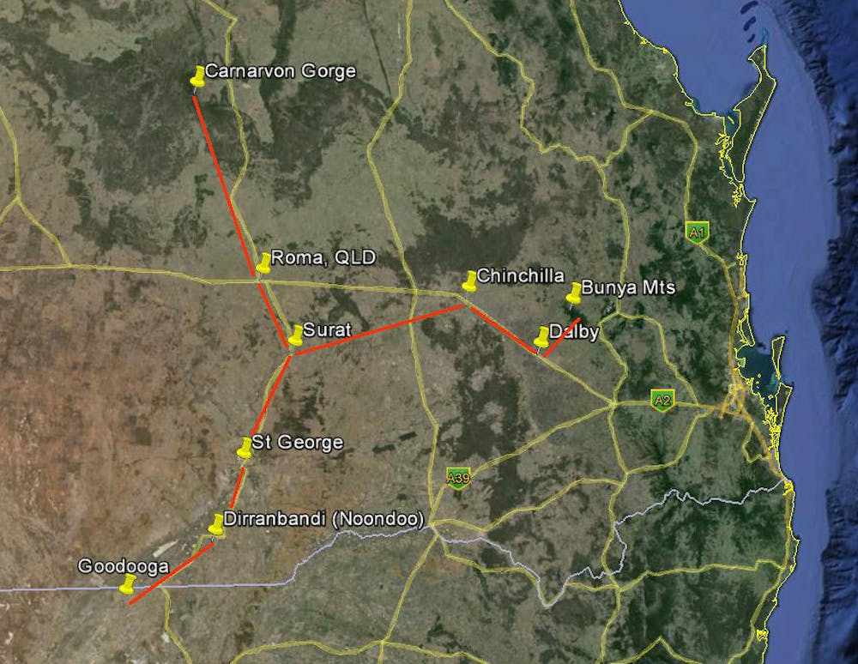
- Add distances by road (weights) between each vertex, using technology (for example, Google Maps). Provide your data source.
- Using technology, add 3 additional edges (roads) that connect places on this map. Provide your data source.
- Draw a minimum spanning tree for your network in Part C. Is it the same as the original map? Why do you think this might be the case?

Part B – songline networks
The list of connections below shows a simplified songline connecting landmarks.
Sites: Waterhole (W), Meeting Place (M), Rock Shelter (R), Hunting Ground (H), Camp (C), River Crossing (X), Lookout point (L), Valley (V), Sand Dune (S) and Trading Place (T)
Connections (edges):
- H ↔ M (7 km)
- M ↔ R (12 km)
- R ↔ W (9 km)
- M ↔ C (15 km)
- C ↔ W (16 km)
- R ↔ X (14 km)
- X ↔ L (16 km)
- W ↔ T (21 km)
- L ↔ T (14 km)
- C ↔ V (22 km)
- W ↔ V (5 km)
- W ↔ X (18 km)
- V ↔ T (14 km)
- V ↔ S (12 km)
- S ↔ T (11 km)

- Represent the above information as a:
- table
- network diagram.
- What is the shortest path (by distance) from the Hunting ground (H) to the Trading place (T)? Show the path and total distance.
- Find the shortest path from Meeting place (M) to Sand dune (S).
- Plan a route from Lookout point (L) to Hunting ground (H) that must pass through the waterhole (W). What is the minimum distance?
- If the Waterhole to Valley (W-V) (5 km) and Waterhole to Rock shelter (W–R) (9 km) tracks are flooded and can’t be accessed, what is the new shortest path from the Hunting ground (H) to the Trading place (T)? How much longer is it?
- Construct a Minimum Spanning Tree connecting all sites and list the edges chosen and the total route length.
- The average walking speed is 5 km/h, however, hilly sections slow travel by 25% (that is, any path moving directly away from the Valley (V) or directly towards the Lookout point (L) or Sand dune (S)). The river crossing at X adds an hour to a journey.
Note: Time taken can be calculated using the formula $Time=\frac{Distance}{Speed}$
- Find the shortest path from the Camp (C) to the Lookout point (L).
- Is the shortest path (by distance), the fastest route? Justify your answer with relevant calculations.
- The shortest path (by distance) from Hunting ground (H) to the Trading place (T) was found earlier in Question 2. Suppose travellers prefer routes that pass through Camp (C) if the total travel time is no more than 15% longer than a faster path. Using any speed assumptions provided, calculate the travel time for each route. Which is the preferred path from Hunting ground (H) to the Trading place (T)? Does a ‘via C’ route meet this preference?

Section 2 – global travel networks
In this investigation, you will design and explore your own global travel network. You will select 9 cities (at least one Australian city with an international airport must be included) from at least 4 different continents and investigate the connections, travel times, costs and time zones between them.
This section of the task will allow you to apply mathematical network concepts, time zone calculations, and financial comparisons to a real-world scenario.

Part A – building your travel network
Select 9 cities across at least 4 continents, including an Australian city with an international airport. A maximum of 3 cities should be able to be reached in one direct flight from your Australian city.
- Research which cities in your set have direct flights to each other. Draw a network diagram with cities as vertices and flights as edges. Label edges with flight distances (to the nearest 100 km).
- Repeat the network, this time labelling the edges with flight times.
- Repeat the network, this time labelling the edges with cost per flight. Use Skyscanner (http://bit.ly/4be0zkL) to find the lowest cost direct flight between the cities in your network. When searching, use the same date for each flight for one Adult economy ticket and select the cheapest one-way price.
Clearly document your data sources (websites, airline pages, flight comparison tools).

Part B – network analysis
Answer questions using your network:

- Identify the degree of each vertex.
- Which city has the most connections?
- Using your network with distances, find a shortest path from your chosen Australian city to 3 of your cities which do not have direct flights from your chosen Australian city.
- Determine a minimum spanning tree for each network. Are they all the same? What does this represent in your scenario?
- According to your network diagram, which city has the furthest travel distance from your chosen Australian city? Is the quickest route from your chosen Australian city to this destination on the minimum spanning tree?

Part C – time zones
- Using your chosen cities, answer time-related questions (ignoring daylight savings times):
Find the time zone relative to UTC for each city in your network.
- Identify the city which is closest to a UTC of zero. If a live sporting event begins at 7:00 pm Saturday local time in that city, what time would someone need to turn on their TV to watch in each of the other cities in your network?
- If a flight leaves your chosen Australian city at a 5:00 pm Monday local time, what is the arrival time and day in:
- a city which can be flown to directly from your chosen Australian city
- a city which requires a change of flight (assume a one hour over stop).
- Which cities could you land in on a Monday (local time to the destination), assuming a one hour stop over for any change of flight?

Submission details

Due date
[insert date here] at [insert time here]. Note: all components are due on the same day.

What you will submit
All components are due on the same day.
- Answers to all sections and parts
- Network diagrams should be hand drawn
- Include screenshots of where you have used technology to find distances, times or costs

What is the teacher looking for?
The teacher is looking to see how well you:
- draw and interpret information to create network diagrams
- calculate shortest paths
- create minimum spanning trees
- draw conclusions and justify your results.

Submission process
- {School to insert their submission process}

Non-completion of the task
- {School to insert their process for non-completion of a task}

Marking guidelines
This rubric helps your teacher assess your work and provide feedback. It shows what you did well, what led to your overall grade, and how you can improve. The rubric is cumulative – the more criteria you meet, the higher your grade will be.
Table 1 – student-facing rubric
Criteria | Working towards developing | Developing | Developed | Well developed | Highly developed
Network concepts (MST-11-07, MAO-WM-01) | Defines some network terms using informal language and represents simple connections in diagram or table form. Makes a basic link between cultural contexts (songlines/star maps) and networks (unfamiliar context). | Defines vertices, edges, paths and trees in own words with emerging accuracy. Creates network diagrams and tables that represent given information with mostly correct structure. Identifies connections between songlines/star maps and network representations (unfamiliar context). | Accurately defines network terminology and applies it correctly in both cultural and travel contexts. Constructs clear, labelled network diagrams and tables from given data. Accurately determines vertex degree and identifies highly connected cities. | Demonstrates clear mathematical working when constructing and interpreting multiple networks (distance, time, cost). Analyses and compares structural features such as degree and connectivity. Explains similarities and differences between original networks and derived structures using logical reasoning. | Provides precise and consistent use of terminology across both investigations. Evaluates how network structure influences travel, connectivity and cultural representation. Justifies conclusions using well-structured mathematical reasoning and clear representations. Demonstrates insight when interpreting the meaning of network measures in context.
Shortest paths and spanning trees  (MST-11-07, MAO-WM-01) | Identifies possible routes within a network and attempts to calculate total distances. Constructs a spanning tree with emerging structure. | Calculates shortest paths in simpler scenarios with partial accuracy. Constructs a minimum spanning tree that connects all vertices, with some correct edge selection. Attempts multi-condition routes (via W or C). | Correctly determines shortest paths between specified locations and calculates total distances accurately. Constructs a correct minimum spanning tree and lists selected edges with total weight. Applies constraints (flooded tracks, required stopovers, preference conditions) with accurate recalculation. | Clearly shows and communicates systematic working when applying shortest path reasoning across multiple scenarios (distance, restricted edges, required intermediate vertices). Correctly determines and compares minimum spanning trees across distance, time and cost networks, and justifies whether they are the same or different. Explains whether the shortest path is also the fastest route using accurate calculations. | Evaluates multiple route options under layered constraints (speed changes, stopovers, preferences within 15%). Integrates distance, time and structural reasoning fluently. Provides comprehensive justification supported by clear, logical working and interprets what spanning tree results represent in both cultural and global travel contexts.
Time and time differences (MST-11-06, MAO-WM-01) | Identifies UTC offsets or recognises time differences between locations. Attempts simple time calculations. | Calculates time differences between cities with emerging accuracy. Applies the formula $\text{Time}=\frac{\text{Distance}}{\text{Speed}}$ in straightforward contexts. | Accurately calculates travel times using adjusted speeds and additional conditions (hilly terrain, river crossing delay). Correctly determines UTC values and converts times between multiple cities. Determines arrival times including stopovers with correct day adjustments. | Solves multi-step time problems involving changes in speed, added delays, time zones and flight changes, showing clear and logical working. Justifies whether shortest distance corresponds to fastest time. Accurately determines which cities can be reached on a specified day. | Analyses complex, multi-zone travel scenarios fluently and efficiently. Selects appropriate strategies for layered time calculations and clearly communicates reasoning. Evaluates the impact of structural network choices on arrival times and scheduling outcomes, with precise and logically structured working.

References
This resource contains NSW Curriculum and syllabus content. The NSW Curriculum is developed by the NSW Education Standards Authority (NESA). This content is prepared by NESA for and on behalf of the Crown in right of the State of New South Wales. The material is protected by Crown copyright.
Please refer to the NESA Copyright Disclaimer for more information https://www.nsw.gov.au/education-and-training/nesa/copyright.
NESA holds the only official and up-to-date versions of the NSW Curriculum and syllabus documents. Please visit NESA https://www.nsw.gov.au/education-and-training/nesa and NSW Curriculum https://curriculum.nsw.edu.au.
Mathematics Standard 11–12 Syllabus © NSW Education Standards Authority (NESA) for and on behalf of the Crown in right of the State of New South Wales, 2024.

© State of New South Wales (Department of Education), 2026
The copyright material published in this resource is subject to the Copyright Act 1968 (Cth) and is owned by the NSW Department of Education or, where indicated, by a party other than the NSW Department of Education (third-party material).
Copyright material available in this resource and owned by the NSW Department of Education is licensed under a Creative Commons Attribution 4.0 International (CC BY 4.0) license.

This license allows you to share and adapt the material for any purpose, even commercially.
Attribution should be given to © State of New South Wales (Department of Education), 2026.
Material in this resource not available under a Creative Commons license:
- the NSW Department of Education logo, other logos and trademark-protected material
- material owned by a third party that has been reproduced with permission. You will need to obtain permission from the third party to reuse its material.
Links to third-party material and websites
Please note that the provided (reading/viewing material/list/links/texts) are a suggestion only and implies no endorsement, by the New South Wales Department of Education, of any author, publisher, or book title. School principals and teachers are best placed to assess the suitability of resources that would complement the curriculum and reflect the needs and interests of their students.
If you use the links provided in this document to access a third-party's website, you acknowledge that the terms of use, including licence terms set out on the third-party's website apply to the use which may be made of the materials on that third-party website or where permitted by the Copyright Act 1968 (Cth). The department accepts no responsibility for content on third-party websites.

