Mathematics Standard Stage 6 (Year 11) – assessment task sample solutions
Going places
Contents
About this resource 2
Sample solutions 3
Section 1 – Aboriginal songlines and star maps 3
Part A – connecting songlines and star maps to networks 3
Part B – songline networks 6
Section 2 – global travel networks 9
Part A – building your travel network 9
Part B – network analysis 11
Part C – time zones 14
Marking guidelines 16
References 20

About this resource
This document is Part 3 of an assessment package designed to assess the outcomes from Unit 5 – going places of the Department of Education’s Stage 6 Year 11 sample scope and sequence.

Sample solutions

Section 1 – Aboriginal songlines and star maps

Part A – connecting songlines and star maps to networks

Vertices
A vertex is a point or location in a network where edges (connections) meet.
In Aboriginal songlines, a vertex could represent a significant place such as a waterhole, sacred site, or meeting place along a journey. In star maps, a vertex might be a star that acts as a reference point for navigation.
Edges
An edge is a line that connects 2 vertices in a network, showing a path or relationship between them.
In a songline, an edge could represent the pathway or travel route between 2 landmarks or sacred sites. On a star map, an edge could be the imaginary line connecting stars that make up a constellation or a route used for navigation.
Paths
A path is a connected sequence of edges that shows a route between 2 or more vertices.
A path in a songline might trace the journey of an ancestral being as they travelled across Country, linking sites that tell a story. In a star map, a path could represent the direction a traveller follows by using certain stars in order.
Trees
A tree is a type of network with no loops, meaning there is only one way to travel between any 2 vertices.
A tree could represent a network of sacred sites connected by unique routes in which each site links to others without any repeated paths. In a star map, it might show a branching set of navigation routes from a central starting star to different destinations

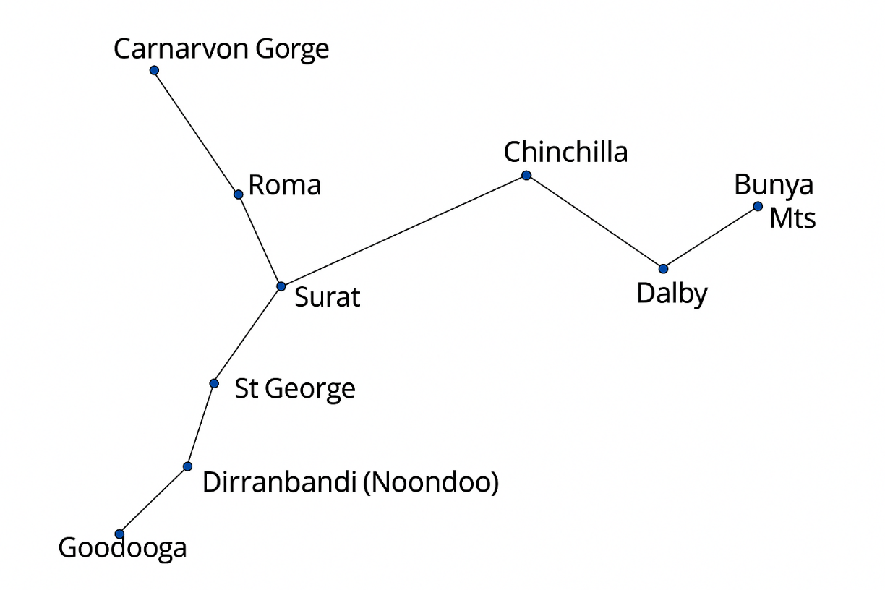
Data sourced from Google Maps.

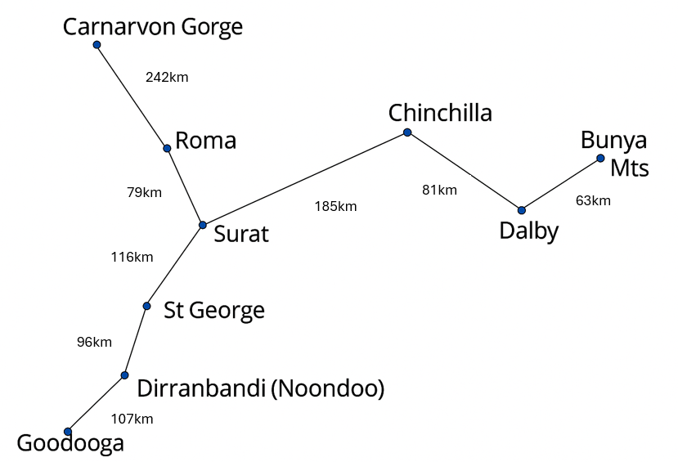
Data sourced from Google Maps.

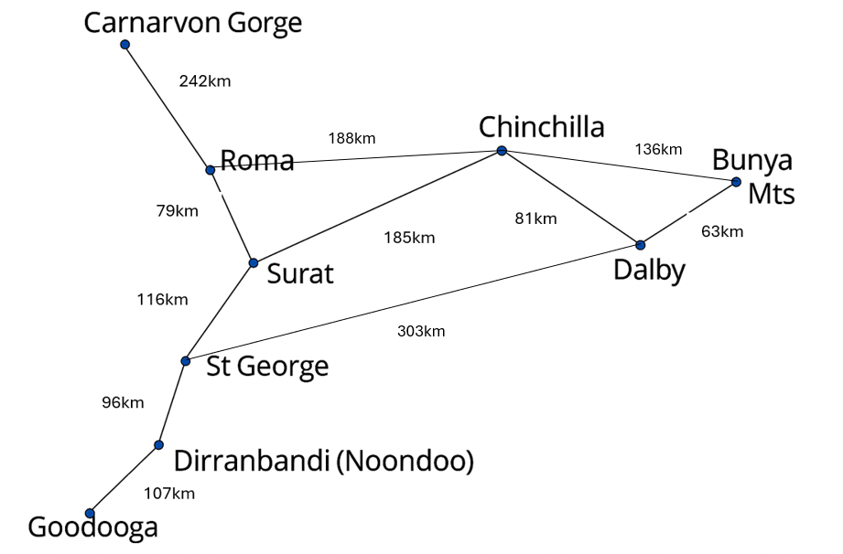
Data sourced from Google Maps.

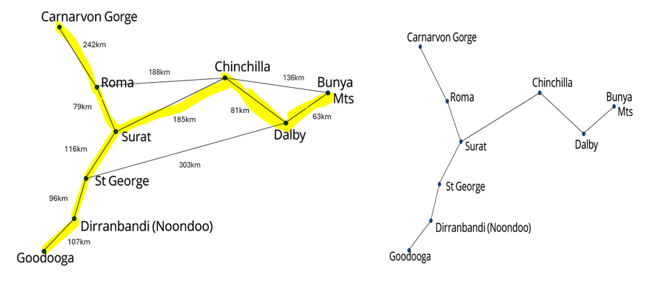
185km
96km
Data sourced from Google Maps.
Yes, the minimum spanning tree is the same as the original map. This could be because over thousands of years, Aboriginal Peoples created paths and routes which were regularly travelled on. When roads were built in more modern times, it was easier to follow the paths that had already been created. It also shows that the Aboriginal Peoples often had designed the quickest routes between places.
This is a sample answer. Students may have used different technology and found different accessible roads, which may have changed their solution to ‘no’. If they justify why this may be the case, they can successfully answer this section.

Part B – songline networks

- All measurements are in kilometres (km).
 | W | M | R | H | C | X | L | V | S | T
W | - |  | 9 |  | 16 | 18 |  | 5 |  | 21
M |  | - | 12 | 7 | 15
R | 9 | 12 | - |  |  | 14
H |  | 7 |  | -
C | 16 | 15 |  |  | - |  |  | 22
X | 18 |  | 14 |  |  | - | 16
L |  |  |  |  |  | 16 | - |  |  | 14
V | 5 |  |  |  | 22 |  |  | - | 12 | 14
S |  |  |  |  |  |  |  | 12 | - | 11
T | 21 |  |  |  |  |  | 14 | 14 | 11 | -

- All distances are in km.
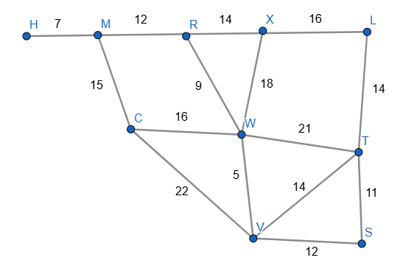
This student has made a calculation error and has not found the shortest path going through the Waterhole.
(L X W R M H)
- Path H M R W V T = 47 km (7 + 12 + 9 + 5 + 14)
- Path M R W V S = 38 km (12 + 9 + 5 + 12)
- Path L T W R M H = 63 km (14 + 21 + 9 + 12 + 7)
- Path H M C V T = 58 km (7 + 15 + 22 + 14)
This path is 11 km more than the previous shortest path (from part 2).

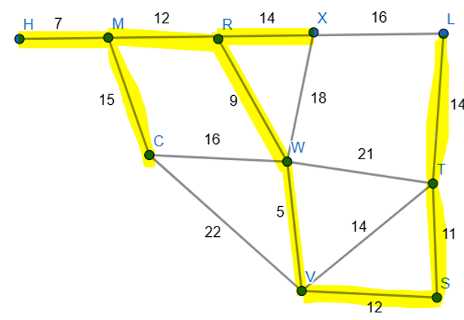
Total route length not included.
The minimum spanning tree includes connections: HM, MR, RX, MC, RW, LT, TS, VS, WV

- The shortest path from C to L is 50 km and can be done in 2 ways.
CVTL and CWXL are both 50 km.
Student has overlooked a shorter path of 49 km CWVTL. This should also be the fastest route of 11 hours 40 mins for Part B.
- Walking pace = 5 km/h; hilly walking pace = 0.75 x 5 = 3.75 km/h
CVTL:
CV = 22 km. $\frac{22}{5}=$ 4 hours 24 mins
VT = 14 km. $\frac{14}{3.75}=$ 3 hours 44 mins
TL = 14 km. $\frac{14}{3.75}=$ 3 hours 44 mins
Total CVTL = 11 hours 52 mins
CWXL:
CW = 16 km. $\frac{16}{5}=$3 hours 12 mins
WX = 18 km. $\frac{18}{5}=$ 3 hours 36 mins
XL = 16 km. $\frac{16}{3.75}=$ 4 hours 16 mins
Add one hour for river crossing
Total CWXL = 12 hours 4 mins
$∴ CVTL$is the fastest route
- Path H M R W V T = 47 km is the shortest path H to T.
Shortest path including C is HMCWVT = 57 km
An alternate path is HMCWT = 59 km
Path HMRWVT = 47 km (14 of which are away from the Valley). $\frac{33}{5}+\frac{14}{3.75}=10 hours 20 mins$
10 hours 20 mins $×$ 115% = 11 hours 53 mins.
Path HMCWVT = 57 km (14 of which are away from the Valley). $\frac{43}{5}+\frac{14}{3.75}=12 hours 20 mins$
Path HMCWT = 59 km. $\frac{59}{5}=11 hours 48 mins$
Therefore, travellers would prefer the path HMCWT, as it takes less than 15% more time than the shortest path and passes through the campsite.

Section 2 – global travel networks

Part A – building your travel network
- All distances are in kilometres and rounded to the nearest 100 km.
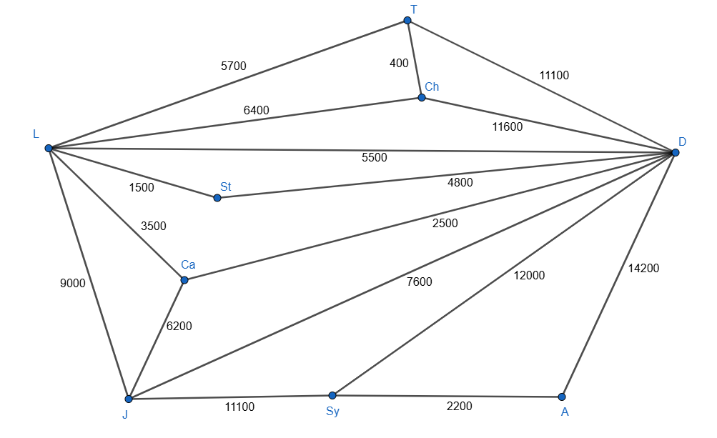
Data sourced from https://www.airmilescalculator.com/.

- All times are in hours and minutes, rounded to the nearest 15 minutes.
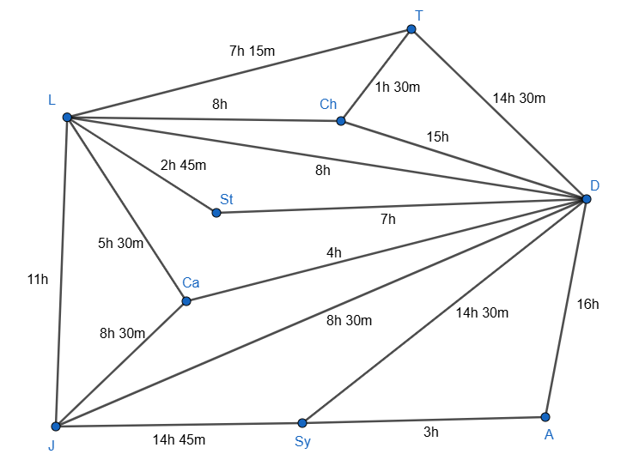
Data sourced from https://www.airmilescalculator.com/.
- Direct flight prices for 1 February 2026.
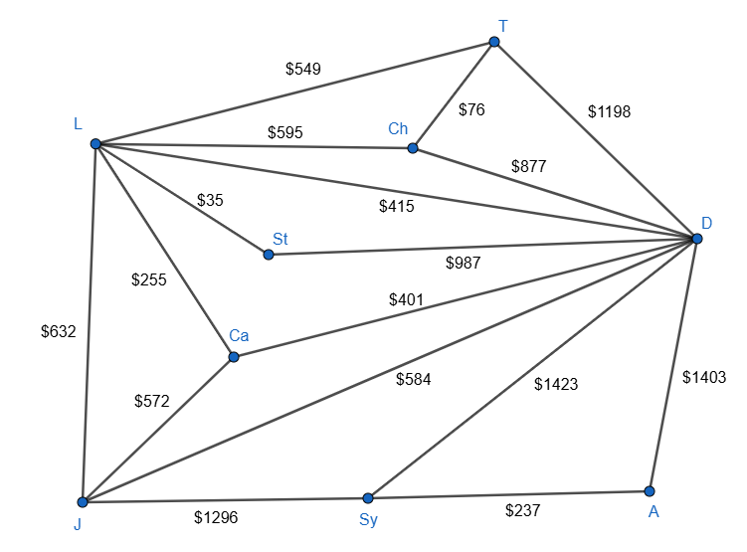
Data sourced from https://www.skyscanner.com.au/.

Part B – network analysis

- Sydney = degree of 3
Auckland = degree of 2
Johannesburg = degree of 4
Cairo = degree of 3
London = degree of 6
Stockholm = degree of 2
Chicago = degree of 3
Toronto = degree of 3
Dubai = degree of 8
- Dubai has the most connections; it connects directly with every other city in this network.

Shortest Path Sydney to London = Sydney Dubai London = 17 500 km
Shortest Path Sydney to Cairo = Sydney Dubai Cairo = 14 500 km
Shortest Path Sydney to Toronto = Sydney Dubai Toronto = 23 100 km

There are 9 cities, so each minimum spanning tree requires 8 edges.
The minimum spanning tree for distances has the following connections: Chicago-Toronto, Toronto-London, London-Stockholm, London-Cairo, Cairo-Johannesburg, Cairo-Dubai, Johannesburg-Sydney and Sydney-Auckland.
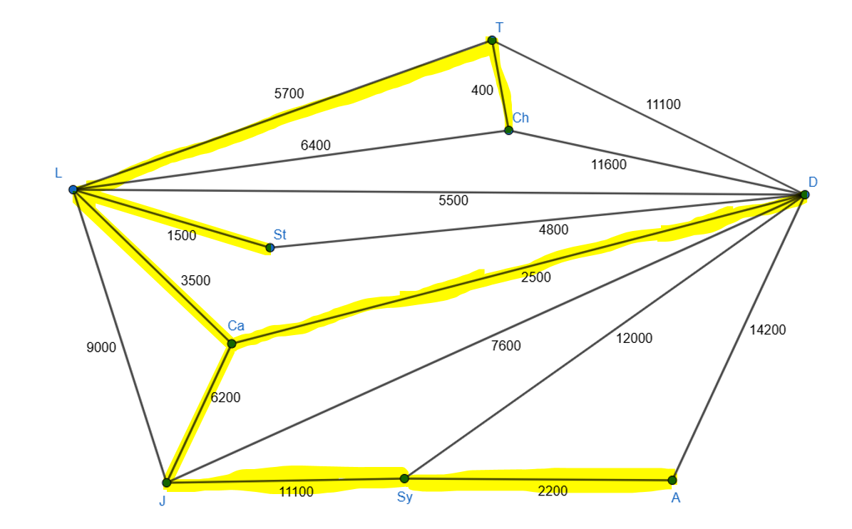
The minimum spanning tree for time has the following connections: Chicago-Toronto, Toronto-London, London-Stockholm, London-Cairo, Cairo-Johannesburg (could be replaced with Dubai-Johannesburg), Cairo-Dubai, Dubai-Sydney and Sydney-Auckland.
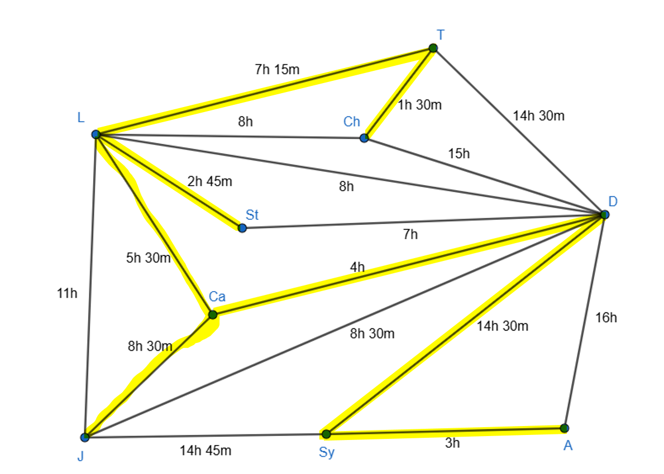
The minimum spanning tree for cost has the following connections: Chicago-Toronto, Toronto-London, London-Stockholm, London-Cairo, Cairo-Johannesburg, Cairo-Dubai, Johannesburg-Sydney and Sydney-Auckland.
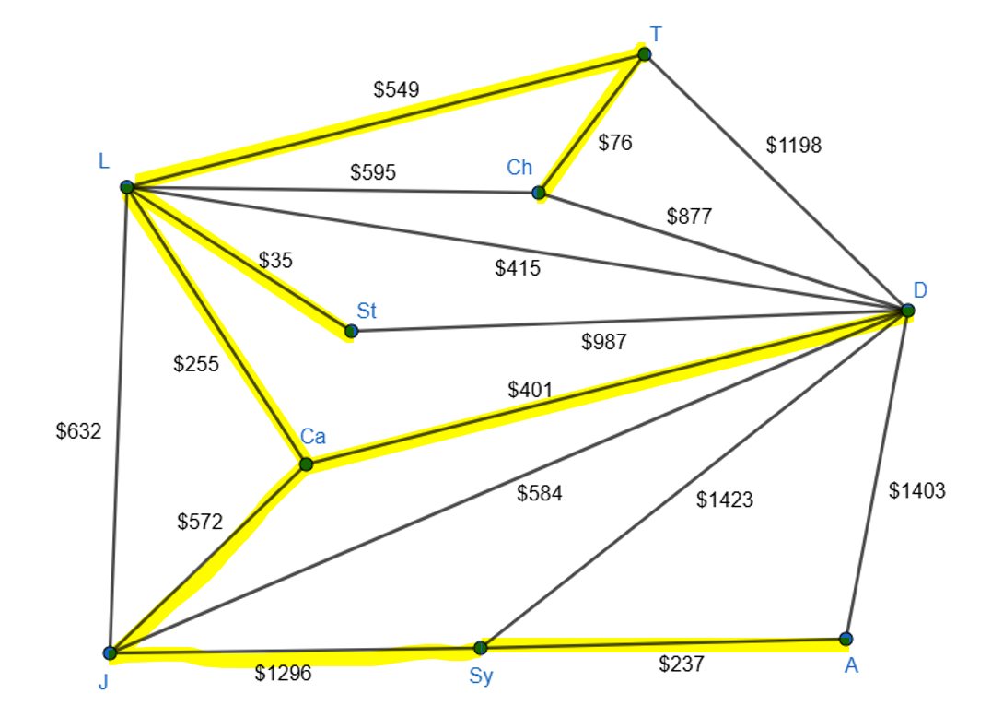
The distance and cost MSTs are the same as each other, the time MST has only one slightly different connection (Dubai-Sydney instead of Johannesburg-Sydney) but is very similar. This shows that the cost of an airline ticket is closely linked to the distance and time taken to fly between the 2 cities.
- Chicago is the furthest city from Sydney, the shortest path from Sydney to Chicago is 23 600 km, which is greater than the shortest path to any of the other cities in the network. The fastest, shortest or cheapest paths from Sydney to Chicago are not on the MST.

Part C – time zones
- Time zones
Auckland | UTC+12  Student has given time zone while observing daylight savings.
Sydney | UTC+10
Dubai | UTC+4
Cairo | UTC+3
Johannesburg | UTC+2
Stockholm | UTC+1
London | UTC$±0$
Chicago | UTC – 5
Toronto | UTC – 5
- London has a UTC of zero. If a sporting match begins at 7:00 pm Saturday local time in London, the time to watch in each of the cities is as follows:
Auckland | 7:00 am Sunday
Sydney | 5:00 am Sunday
Dubai | 11:00 pm Saturday
Cairo | 10:00 pm Saturday
Johannesburg | 9:00 pm Saturday
Stockholm | 8:00 pm Saturday
Chicago | 2:00 pm Saturday
Toronto | 2:00 pm Saturday

- Auckland
Leave Sydney 5:00 pm (7:00 pm Auckland time). Flight time 3 hours.
Arrive 10:00 pm Monday Auckland time.

- Cairo
Leave Sydney 5:00 pm (10:00 am Cairo time). Flight 14 hours 30 mins to Dubai, plus one hour change over. Flight 4 hours Dubai to Cairo (total 19 hours 30 mins).
Arrive 5:30 am Tuesday Cairo time.
- Auckland – arrive 10:00 pm Monday (as per part 3a)
Johannesburg
Leave Sydney 5:00 pm (9:00 am Johannesburg time). Flight time 14 hours 45 mins.
Arrive 11:45 pm Monday
Student has found one city, not all cities they could land in on a Monday.

Marking guidelines
Table 1 – student-facing rubric
Criteria | Working towards developing | Developing | Developed | Well developed | Highly developed
Network concepts (MST-11-07, MAO-WM-01) | Defines some network terms using informal language and represents simple connections in diagram or table form. Makes a basic link between cultural contexts (songlines/star maps) and networks (unfamiliar context). | Defines vertices, edges, paths and trees in own words with emerging accuracy. Creates network diagrams and tables that represent given information with mostly correct structure. Identifies connections between songlines/star maps and network representations (unfamiliar context). | Accurately defines network terminology and applies it correctly in both cultural and travel contexts. Constructs clear, labelled network diagrams and tables from given data. Accurately determines vertex degree and identifies highly connected cities. | Demonstrates clear mathematical working when constructing and interpreting multiple networks (distance, time, cost). Analyses and compares structural features such as degree and connectivity. Explains similarities and differences between original networks and derived structures using logical reasoning. | Provides precise and consistent use of terminology across both investigations. Evaluates how network structure influences travel, connectivity and cultural representation. Justifies conclusions using well-structured mathematical reasoning and clear representations. Demonstrates insight when interpreting the meaning of network measures in context.
Teacher notes: uses network terminology accurately and consistently when defining and applying concepts such as vertices, edges, paths and trees. Constructs clear network representations and correctly determines vertex degrees within the travel network. Demonstrates insight when linking Aboriginal songlines and star maps to mathematical network structures and when interpreting connectivity within the global travel network. Conclusions are justified with clear explanations and well-structured mathematical reasoning.

Criteria | Working towards developing | Developing | Developed | Well developed | Highly developed
Shortest paths and spanning trees  (MST-11-07, MAO-WM-01) | Identifies possible routes within a network and attempts to calculate total distances. Constructs a spanning tree with emerging structure. | Calculates shortest paths in simpler scenarios with partial accuracy. Constructs a minimum spanning tree that connects all vertices, with some correct edge selection. Attempts multi-condition routes (via W or C). | Correctly determines shortest paths between specified locations and calculates total distances accurately. Constructs a correct minimum spanning tree and lists selected edges with total weight. Applies constraints (flooded tracks, required stopovers, preference conditions) with accurate recalculation. | Clearly shows and communicates systematic working when applying shortest path reasoning across multiple scenarios (distance, restricted edges, required intermediate vertices). Correctly determines and compares minimum spanning trees across distance, time and cost networks, and justifies whether they are the same or different. Explains whether the shortest path is also the fastest route using accurate calculations. | Evaluates multiple route options under layered constraints (speed changes, stopovers, preferences within 15%). Integrates distance, time and structural reasoning fluently. Provides comprehensive justification supported by clear, logical working and interprets what spanning tree results represent in both cultural and global travel contexts.
Teacher notes: applies shortest path reasoning correctly across multiple scenarios and appropriately incorporates constraints such as flooded tracks and required intermediate locations. Minor calculation errors are present and some minimum spanning trees contain incorrect edge selections, with not all possible routes considered. The student compares route options appropriately and communicates their reasoning clearly. Overall, the working demonstrates a systematic approach and well-developed understanding of the concepts.
Criteria | Working towards developing | Developing | Developed | Well developed | Highly developed
Time and time differences (MST-11-06, MAO-WM-01) | Identifies UTC offsets or recognises time differences between locations. Attempts simple time calculations. | Calculates time differences between cities with emerging accuracy. Applies the formula $\text{Time}=\frac{\text{Distance}}{\text{Speed}}$ in straightforward contexts. | Accurately calculates travel times using adjusted speeds and additional conditions (hilly terrain, river crossing delay). Correctly determines UTC offset values and converts times between multiple cities. Determines arrival times including stopovers with correct day adjustments. | Solves multi-step time problems involving changes in speed, added delays, time zones and flight changes, showing clear and logical working. Justifies whether shortest distance corresponds to fastest time. Accurately determines which cities can be reached on a specified day. | Analyses complex, multi-zone travel scenarios fluently and efficiently. Selects appropriate strategies for layered time calculations and clearly communicates reasoning. Evaluates the impact of structural network choices on arrival times and scheduling outcomes, with precise and logically structured working.
Teacher notes: solves multi-step time problems involving speed changes, stopovers and time zone differences with clear and logical working. Travel times are calculated using appropriate formulas and arrival times are determined for multiple travel scenarios. One minor UTC offset error is present and the final question identifying all cities reachable on a specified day was only partially completed. Overall, reasoning is clearly communicated and the student demonstrates a strong understanding of time calculations in travel contexts.

References
This resource contains NSW Curriculum and syllabus content. The NSW Curriculum is developed by the NSW Education Standards Authority (NESA). This content is prepared by NESA for and on behalf of the Crown in right of the State of New South Wales. The material is protected by Crown copyright.
Please refer to the NESA Copyright Disclaimer for more information https://www.nsw.gov.au/education-and-training/nesa/copyright.
NESA holds the only official and up-to-date versions of the NSW Curriculum and syllabus documents. Please visit NESA https://www.nsw.gov.au/education-and-training/nesa and NSW Curriculum https://curriculum.nsw.edu.au.
Mathematics Standard 11–12 Syllabus © NSW Education Standards Authority (NESA) for and on behalf of the Crown in right of the State of New South Wales, 2024.
Air Miles Calculator (n.d.) Air Miles Calculator [website], accessed 20 March 2026.
Skyscanner (n.d.) Skyscanner [website], accessed 17 March 2026.

© State of New South Wales (Department of Education), 2026
The copyright material published in this resource is subject to the Copyright Act 1968 (Cth) and is owned by the NSW Department of Education or, where indicated, by a party other than the NSW Department of Education (third-party material).
Copyright material available in this resource and owned by the NSW Department of Education is licensed under a Creative Commons Attribution 4.0 International (CC BY 4.0) license.

This license allows you to share and adapt the material for any purpose, even commercially.
Attribution should be given to © State of New South Wales (Department of Education), 2026.
Material in this resource not available under a Creative Commons license:
- the NSW Department of Education logo, other logos and trademark-protected material
- material owned by a third party that has been reproduced with permission. You will need to obtain permission from the third party to reuse its material.
Links to third-party material and websites
Please note that the provided (reading/viewing material/list/links/texts) are a suggestion only and implies no endorsement, by the New South Wales Department of Education, of any author, publisher, or book title. School principals and teachers are best placed to assess the suitability of resources that would complement the curriculum and reflect the needs and interests of their students.
If you use the links provided in this document to access a third-party's website, you acknowledge that the terms of use, including licence terms set out on the third-party's website apply to the use which may be made of the materials on that third-party website or where permitted by the Copyright Act 1968 (Cth). The department accepts no responsibility for content on third-party websites.

