Infographics
Students analyse real-world road safety data through infographics, evaluating how effectively the information is communicated. They then redesign to improve clarity of the information and highlight key safety messages.
Students will need at least one digital device per pair to interact with websites such as Canva (canva.com) during this lesson.

Learning intentions
- To understand how data can be represented effectively in an infographic.
- To be able to evaluate and choose effective graphs for presenting data in an infographic.

Success criteria
- I can interpret trends and key messages from an infographic.
- I can re-create selected data using different graph types suitable for the dataset.
- I can explain how the choice of graph influences the meaning or message conveyed.
- I can justify my choice of graphs and suggest improvements for clearer data representations.

Outcomes
A student:
- develops understanding and fluency in mathematics through exploring and connecting mathematical concepts, choosing and applying mathematical techniques to solve problems, and communicating their thinking and reasoning coherently and clearly MAO-WM-01
- displays and analyses datasets using summary statistics and graphical representations
MST-11-08
Mathematics Standard 11–12 Syllabus © NSW Education Standards Authority (NESA) for and on behalf of the Crown in right of the State of New South Wales, 2024.

Associated numeracy outcomes
A student:
- recognises and applies functional numeracy concepts in practical situations, including personal and community, workplace and employment, and education and training contexts N6-1.1
- applies numerical reasoning and mathematical thinking to clarify, efficiently solve and communicate solutions to problems N6-1.2
- chooses and applies efficient strategies to analyse and solve everyday problems involving data, graphs, tables, statistics and probability N6-2.3
- chooses and uses appropriate technology to access, organise and interpret information in a range of practical personal and community, workplace and employment, and education and training contexts N6-3.1
Numeracy CEC Stage 6 Syllabus © NSW Education Standards Authority (NESA) for and on behalf of the Crown in right of the State of New South Wales, 2021.

Content

Display and interpret grouped and ungrouped data
- Analyse a statistical infographic and justify the choice of graphical representations used for the relevant dataset
- Interpret and consider limitations of graphical representations to make conclusions and predictions
- Explain why a given graphical representation can lead to a misinterpretation of data
Mathematics Standard 11–12 Syllabus © NSW Education Standards Authority (NESA) for and on behalf of the Crown in right of the State of New South Wales, 2024.

Table 1: lesson summary
Section | Summary of activity | Teaching strategies | Teaching points
Activating prior knowledge | Students watch an advertisement about distracted driving and use it as a stimulus to discuss common driving distractions and times of the year when car accidents are more frequent. | Think-Pair-Share | This activity encourages students to consider the factors that contribute to car accidents and the associated risks on the road.
Connecting learning | Using slide 4 of the PowerPoint Infographics and Appendix A, students analyse an infographic to explore its first impressions, trends, and overall messages. They identify the types of graphs used, then work in pairs to re-create the infographic using alternate visual representations and discuss their design choices. | Pose-Pause-Pounce-Bounce  Turn and talk  Gallery walk | This activity asks students to critically analyse a given infographic, focusing on the effectiveness of its design, graphs and messaging, in preparation for creating their own infographic and evaluating their peers’ work.
Releasing responsibility | Students are given another infographic on slide 6 and identify it as cluttered, visually overwhelming and unclear in its message. They then compare an example and non-example using slide 7. From this, they determine the features of an effective infographic and further analyse their re-created infographic, before creating a SWOT analysis. | Think-Pair-Share  SWOT analysis | Examining a poor infographic reinforces students’ understanding of what makes an effective infographic and promotes deeper analysis of their own creations.
Independent practice | Students create their own infographic using real-world monthly crash data relevant to their context. Slide 6 outlines the criteria and provides an example dataset. The completed infographics are then analysed and discussed. | Gallery walk | This section gives students the opportunity to create an infographic based on data relevant to them, addressing a driving question. They then apply their understanding of infographics to discuss how the data and visualisations respond to the question.

Activity structure
Please use the associated PowerPoint Infographics to display images in this lesson.

Activating prior knowledge
- Show the class the video ‘The Dive – Really Scary’ (0:30) (bit.ly/TheDive–ReallyScary).
- Initiate a class discussion about common driving distractions and how they can affect a driver’s focus and safety.
Students may discuss distractions such as mobile phones, loud music, talking to passengers, eating, adjusting controls or dealing with children in the car.
Students may explain that distractions can slow reaction times, increasing braking distance or cause mistakes or the increased risk of accidents.
- In a Think-Pair-Share (bit.ly/thinkpairsharestrategy) ask students to consider whether there are times of the year when more accidents happen and how distractions and factors might play a role.
Students may suggest holidays, long weekends or school holidays when drivers may be more distracted by passengers, food, phones or stress. Encourage them to think about how higher traffic, excitement or fatigue can increase the likelihood of accidents caused by inattention.
- Explain to the class that they will investigate whether there are times of the year when road accidents are more likely and why drivers might be at a greater risk.

Connecting learning
This resource includes references to road trauma and road deaths. Schools may wish to review the material in advance, particularly if students or staff have been recently affected by such events.
- Display slide 4 of the PowerPoint which shows Appendix A ‘Infographic – Australian Road Safety Foundation’, or alternatively, have Appendix A printed for each student.
- Allow students, in pairs, to analyse the infographic provided. Ask students to consider what their first impression is and what message it is sending.
- Use the Pose-Pause-Pounce-Bounce questioning strategy (PDF 557 KB) (bit.ly/posepausepouncebounce) to guide students’ discussion of the infographic. Some suggested prompts include:
- What overall patterns or trends do you notice in the infographic?
- What general message do you think the infographic is sending about road safety?
- Continue the class discussion by asking students to consider why the infographic focuses on December.
Remind students of their earlier ideas from the ‘Activating prior knowledge’ section about times of the year when accidents are more likely. Encourage them to think about what makes December different, that is, increased travel for holidays, parties, shopping, fatigue, stress or distractions from passengers.
- Click to animate slide 4 to display some questions. Ask pairs of students to discuss and answer these questions in a turn and talk (bit.ly/classroomtalkmoves). They may like to record these in their workbooks.
- Conduct a class discussion to share some students’ insights to these questions.
- Click to animate and explain to the class that they will select 2–3 graphs from the infographic and re-create each using a different type of graph.
Students can choose how to complete this task. It can be done in pairs or individually. Students could create these graphs by hand or by using digital tools such as the website ‘Canva’ (canva.com) or a spreadsheet.
Some of the graphs that students create will be used later in the lesson, so be sure to collect them.
- Once students are nearing completion, have the class do a gallery walk (bit.ly/DLSgallerywalk) to view other students’ graphs. Students should consider:
- which types of graphs were most effective at conveying the original infographic’s messaging
- how changing the graph affected the message or clarity of the data.
- Lead a class discussion to:
- explore how the choice of graphical representation may influence a viewer’s understanding in an infographic
- highlight the importance of selecting appropriate graphs when presenting data
- identify any limitations in the original infographic and discuss how different graph types could address these.

Releasing responsibility
- Display the infographic on slide 6 of the PowerPoint for the class.
- In a Think-Pair-Share ask students to consider the infographic and whether it is clear to a viewer.
Students may observe that the infographic is cluttered, visually overwhelming and unclear in its message.
- Use slide 7 to display an example and non-example of an infographic and facilitate a class discussion comparing their features, clarity, layout and effectiveness in communicating a clear message.
- In a Think-Pair-Share have students list 3–5 features of an effective infographic.
Students may observe that colour is used to make the infographic visually appealing, graphs help make data easier to read, the layout follows a logical order, percentages provide clarity, and font size is used to emphasise key points.
- With reference to the original infographic graphs from slide 4, display some of the graphs that students created. As a class, discuss whether any graphs limit the information being conveyed, making it difficult for viewers to draw accurate conclusions.
Students may refer to the ‘more than 5 in 10’ statement and how this relates to the divided bar chart. They may also reference the road signs data and how this information may be unclear to viewers.
- Encourage students to complete a SWOT analysis for infographics (bit.ly/dlsSWOTanalysis). Students may discuss the strengths, weaknesses, opportunities and threats of different graphical representations, how effectively they communicate data, why they are chosen, and their limitations when drawing conclusions or making predictions.
The link in step 5 provides templates that can be used for the SWOT analysis.

Independent practice
- Explain to the class that they will now create, in pairs, an infographic to be titled ‘When are you most at risk on the road?’. Students could choose to do this using Canva (canva.com).
- Supply students with real-world monthly crash data. A useful source is the ‘Monthly bulletin of preliminary traffic crash data – Towards zero’ by Transport NSW (bit.ly/TFNSWTowardsZero), which includes a monthly comparison table.
- Use slide 9 of the PowerPoint to outline the criteria for their infographic. This slide also contains an example dataset that students could use.
- Have students complete a gallery walk to view each other’s infographics, noting strengths and limitations.
- Select a few infographics to display and discuss, as a class, how the data and visualisations answer the question: When are we most at risk on the road?

Assessment and differentiation

Suggested opportunities for differentiation
Activating prior knowledge
- For the Think-Pair-Share, provide students with sentence starters or extra time for students who need more help generating ideas or articulating their thoughts.
Connecting learning
- Students can be provided with suggested graphs that they can used when re-creating graphs from the infographic.
- When discussing the findings from the gallery walk, students can be given prompts or suggested features to focus on.
Releasing responsibility
- Allow students to share their observations verbally, write them down, or use visual symbols (for example, thumbs up/down) if they find verbal explanation challenging.
- Challenge students to explain why each feature enhances communication.
Independent practice
- Students can be supported by providing a partly-completed infographic as a scaffold.
- Extend students by having them complete an additional infographic for a context that is unfamiliar to them.

Suggested opportunities for assessment
Activating prior knowledge
- The teacher could facilitate class discussions and observe students’ reasoning and justification in response to the provided prompts.
- A Think-Pair-Share provides students with the opportunity to reflect on their understanding.
Connecting learning
- Monitor responses in class discussions to check for student understanding of the features of the infographic.
- During the gallery walk, analyse student’s graphs and monitor conversations.
Releasing responsibility
- Students give each other peer feedback, before sharing with the class in a Think-Pair-Share.
- Collect students SWOT analysis to assess their depth of their understanding.
Independent practice
- Students will demonstrate their Working mathematically skills in discussions and justifications.

Appendix A

Infographic – Australian Road Safety Foundation
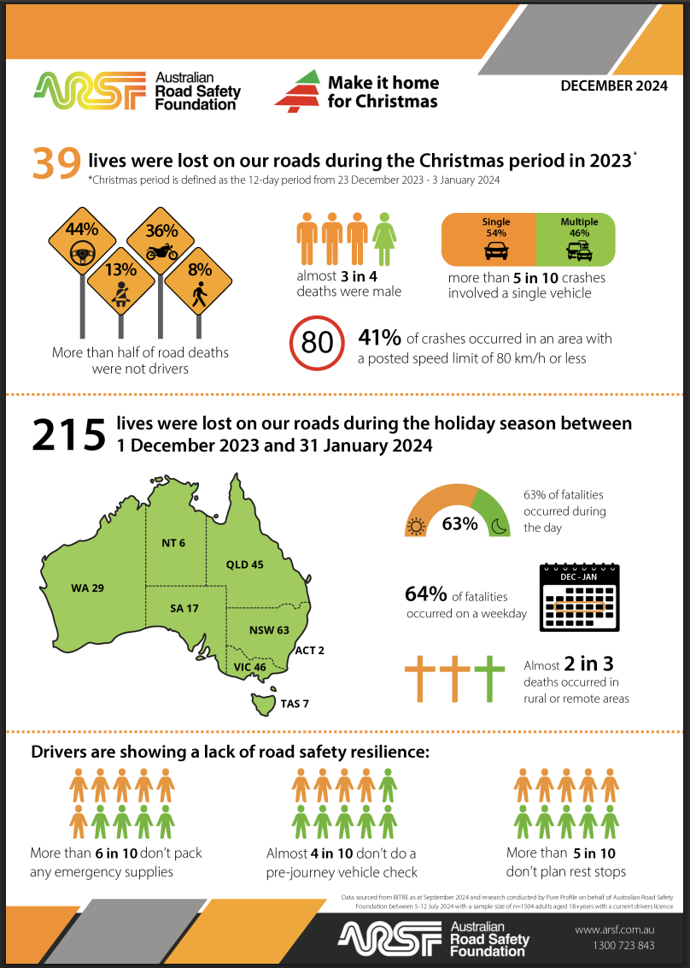
Christmas infographic by Australian Road Safety Foundation accessed 23 March 2026.

References
This resource contains NSW Curriculum and syllabus content. The NSW Curriculum is developed by the NSW Education Standards Authority (NESA). This content is prepared by NESA for and on behalf of the Crown in right of the State of New South Wales. The material is protected by Crown copyright.
Please refer to the NESA Copyright Disclaimer for more information https://www.nsw.gov.au/education-and-training/nesa/copyright.
NESA holds the only official and up-to-date versions of the NSW Curriculum and syllabus documents. Please visit NESA https://www.nsw.gov.au/education-and-training/nesa and NSW Curriculum https://curriculum.nsw.edu.au.
Mathematics Standard 11–12 Syllabus © NSW Education Standards Authority (NESA) for and on behalf of the Crown in right of the State of New South Wales, 2024.

© State of New South Wales (Department of Education), 2026
The copyright material published in this resource is subject to the Copyright Act 1968 (Cth) and is owned by the NSW Department of Education or, where indicated, by a party other than the NSW Department of Education (third-party material).
Copyright material available in this resource and owned by the NSW Department of Education is licensed under a Creative Commons Attribution 4.0 International (CC BY 4.0) license.

This license allows you to share and adapt the material for any purpose, even commercially.
Attribution should be given to © State of New South Wales (Department of Education), 2026.
Material in this resource not available under a Creative Commons license:
- the NSW Department of Education logo, other logos and trademark-protected material
- material owned by a third party that has been reproduced with permission. You will need to obtain permission from the third party to reuse its material.
Links to third-party material and websites
Please note that the provided (reading/viewing material/list/links/texts) are a suggestion only and implies no endorsement, by the New South Wales Department of Education, of any author, publisher, or book title. School principals and teachers are best placed to assess the suitability of resources that would complement the curriculum and reflect the needs and interests of their students.
If you use the links provided in this document to access a third-party's website, you acknowledge that the terms of use, including licence terms set out on the third-party's website apply to the use which may be made of the materials on that third-party website or where permitted by the Copyright Act 1968 (Cth). The department accepts no responsibility for content on third-party websites.

